

iiiiSilill



FOR ENVIRONMENT AND DEVELOPMENT
A TIBETAN TRAGEDY DEVELOPMENT DHARMA
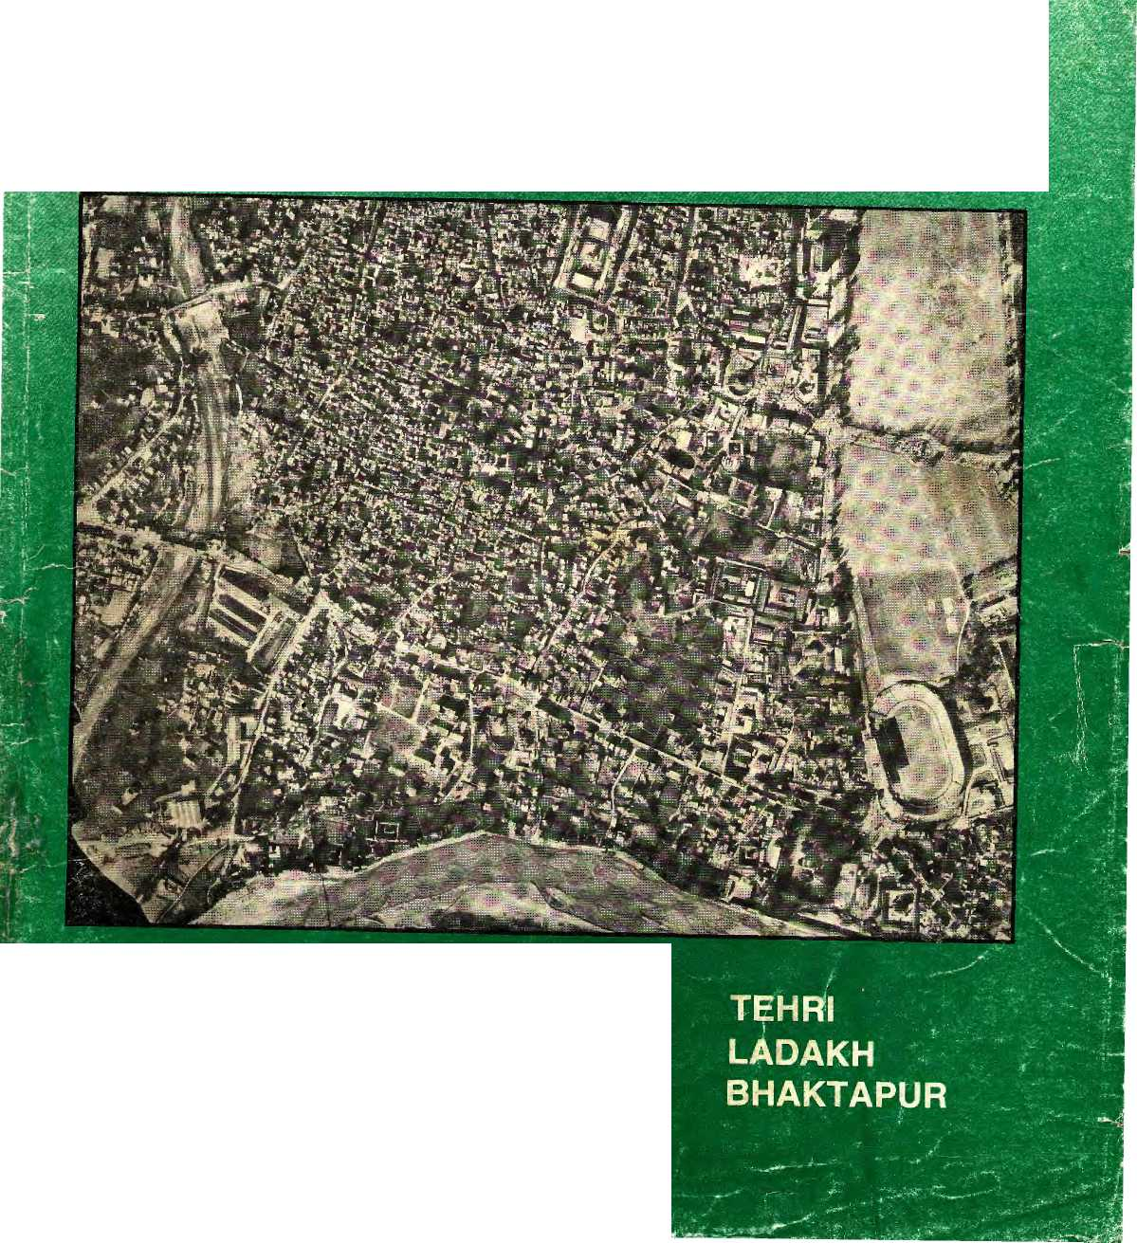
MAY 1987

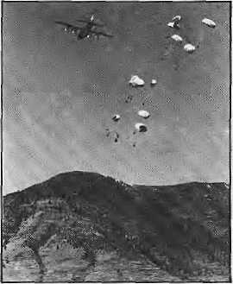

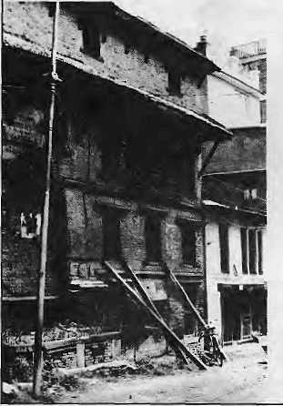

INSIDE
COVER
The Valley Chokes
3 Pollution in Kathmandu
Tehri
9 Temple or Tomb?
ICIMOD
10 Searches for its soul
Budiama
14 Radio grandma fulfils her mission
- A Tibetan Tragedy
- Many Babies Die in Nepal
26 Lights Go on in Nepali Villages
28 Ladakh towards Sustainable Development
VIEWS
15 No Thought for Women 17 Development Dharma

 | PROJECTS
18 | Bhaktapur
20 | Mahendra Trust
29 | NEW BOOKS
31 | MAIL
32 | BRIEFS
34 | ABSTRACTS
35 | INTRODUCTIONS
40 | Abominably yours
Credits
Gemini News, The Statesman, Sierra, Inter Press
Service, Animal Kingdom, Contributions
to Nepalese Studies

MAY 1987
Vol. 0 No. 0
The abode of Gods, King of
mountains, Himalaya
You bound the oceans from the east
to west
A northern yardstick
To measure this Earth
- Kalidasa (Kumar Sambhava)
Editor and Publisher Kanak Mani Dtxit
News Editor
Feature Editor
Art Editor
Advisory Panel
Anita Artand, Women's Feature Service, Rome Kinley Dorje, Kuensei, Thtmpu Harka Bahadur Gurung, Kathmandu
B ha rat D. Koirafa, Nepal Pres Institute, Kathmandu
Ram Chand Maihotra, IFAD/Society for International Development, Rome
Hemanta Mishra, King Mahendra Trust \ar? Nature Conservation, Kathmandu
Don aid Shanor, Columbia University School of Journalism, New York
Jon Tinker, The Panos Institute, London
B. G. Verghese, institute for Policy Studies, New Delhi
Srinagar
New Delhi
Pokhara
Thimpu

Correspondents
Dharmasala Islamabad Naini Tai Darjeeling
-

Cover picture of Katmandu's city core from the air by National Remote Sensing Centre
Address P.O. Box 42 Lalitpur, 44702 Nepal

^ Volley^
. Dhoramialo j
Kathmandu Volley'
DqrjaftliTtg

Jon
Joy Chen I98T

I
T has been an invigoratingly busy last two months for the skeleton crew of HIMAL, volunteering their time to put together a newsmagazine from scratch with an eye on what's to be. Besides the obvious reporting and writing that went into this protype issue, an enormous
I amount of background legwork was involved. Starting from conception in New York and gathering intellectual support in Delhi and Kathmandu, work culminated in layout, design and printing and in a city far removed from the
| snows - Colombo, Sri Lanka.
There was an understandable amount I of scepticism about the viability of an English monthly on the Himalaya that would deal exclusively with development broadly understood and environmental I issues. We hope their doubts will be set I to rest as they read on. We were bouyed along, overwhelmingly, by the I encouragement we received from those [who saw the possibilities. Many chipped I in by providing articles, maps and photographs and helped with layout, | designs and word processing.
This prototype was produced to I indicate that there are stones out there | waiting to be written and that 'development journalism" need not be In dull recitation of how many schools land health posts were opened in the llast five year plan (rather than focus on Ithe attendance rates or the lack of basic 1 drugs). We feel that there is an excess I of commentary and not enough reportage
in the region (and particularly in Nepal) and intend to fill the gap.
There will still be enough subjective views presented in our opmion column - the last we hope to emphasise as one of the most important features in a magazine such as ours.
HIMAL is not into advocacy
journalism and we will willingly
juxtapose conflicting news and views.
Without taking ourselves too seriously,
we do nevertheless hope to play a
significant role in furthering
communications between one
Himalayan valley and the next. In journalist parlance, there are an awful lot of good stories that go unwritten and unrecorded. Every other Ph.D. thesis, consultant's report or project evaluation has news value. We will dig them up.
In this prototype issue, we have chosen as our cover story increasing pollution in the largest urban centre in the Himalaya, which threaten the unique social and physical environments of the towns of Kathmandu, Patan and Bhaktapur. Prakash Khanal and Anil Chitrakar faced the problem that reporters of HIMAL will face over and over again in coming years - the lack of basic information which should be available at a journalist's fingertips before even starting out on a story. Under the circumstances Khanal and Chitrakar have done a remarkable job of it and their solid achievement should
be a standard for future issues. Constrained by time and money and lacking a network, we have had to rely on secondary sources for some of our stories. These sources are credited in the preceding page. Neither does this prototype do justice to the whole region - pictured in the map above by Joy Chen, As we establish a network of stringer correspondents, throughout the Himalayan crescent future issues will reflect this geographical balance.
Our coverage every month will be an independent and unofficial forum to facilitate constructive dialogue among individuals engaged in Himalayan development. HIMAL will address the inter-related aspects of the region's activities including population, migration, family life, agriculture, industry, conservation, wildlife, mountaineering, forestry, tourism while at the same time making the subjects appealing to the general readership.
In time, we expect subscription and advertising revenue to sustain this publication. This prototype must excite the interest of a sample target audience, advertisers and prospective funders. We hope to be in touch with you again in these pages within a year. And with your support and of those who share our concern for the Himalaya, we are sure you will see us again.
1/
4-

r

WE ARE DEVELOPMENT BANKERS OVR GOAL MS INDUSTRIALISATION OUR MEANS IS THROUGH THE PRIVATE SECTOR
We started 27 years ago in a country with virtually no industrial history. Since then* we have
helped 900 entrepreneurs establish and run industries.
We provide technical and financial assistance for the creation₉ expansion or modernisation of industrial enterprises in the private sector.
NEPAL INDUSTRIAL DEVELOPMENT CORPORATION
Post Box No. 10, Kathmandu Teh 411-322 Telex: 2369NP
HIMAL 2

COVER

E
XCEPT perhaps some centuries ago, when town planners under the Mallas still had their say, the three urban centres of Kathmandu Valley have always been dirty. Stagnant sewers, mounds of solid wastes, open-air latrines and drinking water swarming with bacteria have always been a part of the Kathmandu, Patan and Bhaktapur ecosystem.
While things have been slowly worsening further since the turn of the century, during the past decade the Valley has slipped into an environmental tail-spin. The situation has become desperate as air, water, solid-wastes, and even air pollution choke the three town cores as well as the urban sprawl neighbourhoods. This deterioration has been fueled by the Valley-centric development of the country, a near-total absence of planned expansion, a tripling in the number of poorly-maintained motor vehicles, the only cement factory in the world located four kilometres from a city center, a micro-climate that tends to retain atmospheric pollutants, the lack of pollution standards, and a largely pliant academic and journalistic community that does not demand enough.
Surprisingly, there have been no official studies commissioned to check how bad the quality of environmental life actually become for the hundred of thousands of Valley residents. Neither the Department of Meteorology nor Tribhuvan University keeps a simple device that can measure air quality and there are not even facilities for rudimentary samplings of effluents and ambient air and water. In 1983, officials at the Royal Drugs Research Laboratory even refused to test the water from the Dhobi Khola rivulet for fear that their equipment would be damaged by the heavily polluted samples.
While funded studies are lacking, however, there is no dearth of professionals: doctors, scientists and others who are concerned and have kept track of the decline. Even lay observers have noticed that there is more haze over Kathmandu every year. "What can you say of a situation where fecal matter comes out of water taps, as it did in
The Valley Chokes
Pollution in Kathmandu
Reported by Praksash Khanal and Anil Chitrakar and written by Kanak Mani Dixit

; |  | ■ ;: ■ 1
1BJ.
. - :: ■■■' | ■.':■ . - Jjfct | i, M
 |  | ; 4
\—
 | ' ' ■ ■ :.■■■ f | ■
i
? ■'
 |  | :
 | Chobhar plant and Ganesh temple: | holy smoke

HIMAL 3

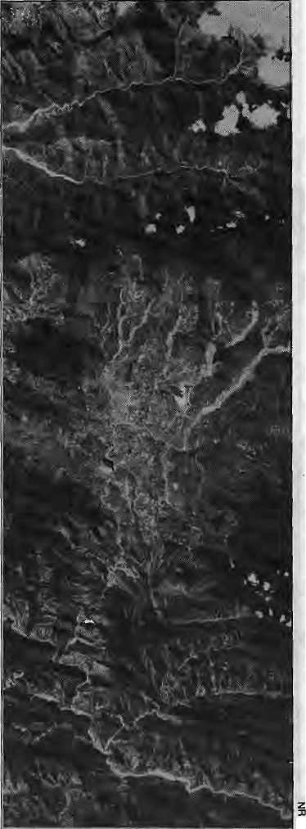
Samakushi (a Kathmandu
neighbourhood)?" asks Dr, Damodar Upadhaya, Chief of the Health Ministry's Epidemiology Divisions. According to Upendra Man Malla, the member of the newly reconstituted National Planning Commission responsible for environment and coriservation matters, when he goes up Nagarkot hill these days and looks down at the brown blanket of smog over the capital city, he feels, "kay bhayeko jasto lagchha (what has happened)!"
"After eleven years away from Kathmandu, I find the city unrecognisable," says Nara Oja, who now lives and works in Hawaii and is visiting with his wife Marietta, "It used to be when the winter fog lifted you could see the Himalaya to the north."
"Now I can barely make out the
surrounding hills." The Ojhas' concerns
are a daily worry for Kathmandu's hotel
owners, who have begun to notice tourists
are loathe to tarry around in Kathmandu
if they can help it."It's true, we wish
we had trekked a few days longer and
left Kathmandu for the middle of the
monsoon," says Londoner
Christine-Anne Horton, who with her husband, Donald Hirsch, suffered from raw throats and sinuses while bicycling Kathmandu streets through dust and dies el smoke.
Fertile floor
Kathmandu Valley covers an area of 597 sq km and is unusual for its size and nature. A fertile floor and an entrepot nature made it the foremost urban centre in the Himalaya, and even today it has the largest population concentration in the region. Its old towns show sophistication in planning, with sewer systems, community waterspouts and streets paved with granite slabs polished by the soles of ages. Urban clusters were concentrated fields and vegetable patches. "Modernity" has changed all that. The old community based waste disposal system has collapsed and the demands of the swelling population has far outripped the ability of the ancient infrastructures to cope. "The first impression of foreigners is that Nepal is beautiful but so dirty. Kathmandu gives the whole country a bad name," says a United Nations official stationed here.
Half of the Valley's present population of about 800,000 lives in the three towns and the other half is divided among 100 villages. In the city core, the population
HIMAL 4
density is as high as 1,200 persons per hectare. Between 1954 and 1981, "Greater Kathmandu" (comprising only Kathmandu and Patan. Bhaktapur is a distance.) tripled in size, according to a urban land policy study completed last April. It says that in the absence of land use regulations, the urban growth has been very haphazard. Even if land use regulations were enacted, however, the enforcement problems would be "formidable", the report states.
Greater Kathmandu is the only city, its size which does not have a major

Satellite portrait of Kathmandu Valley, Dec 1985
river flowing through it, an ironic situation for a country with huge snow and monsoon-fed rivers such as the Kosi, Gandaki and Karnali. The Bagmati watercourse, with a mountain spring as its source barely 25 kilometres upstream from the city, becomes a mere rivulet in winter and has lately taken on the characteristics of a sewer. Especially in the dry season, wastes never get flushed out of the city. A Southeast Asian travel magazine put it rather viciously when it called the- Valley "the toilet bowl of Asia". Taking each of kind of pollution separately - solid wastes, water and air - and even being a proud resident of ''Nepal khaldo", one could agree that the magazine was not far from the truth.
Talking statistics, the Valley produces 138 tons of solid wastes a day, of which 70 tons are carted away by the West German aided Solid Waste Management Committee to a dump at Teku. Organic waste is processed to make fertiliser, which is in high demand. Metal and glass wastes are sold to middlemen for recycling in India, says D. B. Rayamajhi, Chairman of the Committee. About 21 tons of wastes are picked up by the three Town Panchayats, who hire more than 1000 sweepers, many of whom still use buffalo-rib scoops - "appropriate technology" — to pick up refuse. The remaining 48 tons of daily waste do not get picked, until piles get so high that it becomes an embarrassment to the city fathers and mothers, or HMG.
Rotting corpses
Water pollution in the Valley is primarily a result of the inability of the existing rivers to carry away and dilute organic and toxic wastes. Untreated sewage is directly released into the Bagmati and its primary tributary, the Btshnumati. Solid wastes are dumped by the riverside. The ashes of the departed, and the rotting corpses of dead dogs, wastes of slaughter houses all meet at the river. This is the same water - "fluid" might be a better description - that is used to wash most of the vegetable sold in Kathmandu markets. "The water is okay, I just have to get this mud off the radishes and have them clean," says Astamaya Maharjan, stopping by at the Bishnumati bank on her way to the Ranamukteswar market. She works in the early morning mist, but this is also where clothes will ™ be washed and kids will frolic and get bathed later in the day.
Aehyut Sharma, Accociate Professor

of Microbiology at Tribhuvan University, says the World Health Organisation recommends rejection of water that has even one colony of E. Coli bacteria in one ml of water. Studies in Kathmandu have found up to 4,800 colonies of bacteria per ml. Comparing notes from research he did in 1978 and in 1985, Sharrna says he found the water quality in Kathmandu going from bad to worse.
The poorer segment of the inner city population use open toilets, out by the ponds and rivulets. Even in newer neighbourhoods, toilet outflow lets out directly into the shallow drains, whence it often bubbles out into the street. Sewer and water pipes often run scandalously side by side. Kathmandu's intermittent water supply creates suctions in the pipe so that pure untreated bathroom waste gets sucked directly into kitchen tap water. "In such a situation, you have infective hepatitis, dysentry,
typhoid and every water-bome disease in the text book," says Upadhaya.
While surface water might be polluted beyond recognition, the purity of groundwater is also of concern because of the large numbers of spring fed community waterspouts in the city cores. While, again, detailed studies are lacking, Sharma says that the proliferation of septic tanks (dug because there is no sewerage) in the thousands of new houses built annually have an adverse effect on ground water. Industry is also to blame, he says, citing as an example the Jawalakhel Distillery in Patan, which has "destroyed the water at Dhobi Ghat".
Sharma says the Bansbari Leather and Shoe Factory's untreated discharge of toxic sulphide and chromimum compounds into the Dhobi Khola has destroyed the ecosystem of that rivulet, which flows right through the centre of
Kathmandu town. Often, the effluents do not even reach Dhobi Khola because it is channeled by local farmers for irrigation. Those coming in contact with these wastes are in danger of contracting anthrax, which can lead to lesions of the lungs. The leather factory presently soaks about 400 cattle and buffalo hides per day, 40 percent of which goes as solid or liquid waste. Ajit Thapa, Bansbari's General Manager, says the factory is aware of the problem of pollution and is contemplating primary treatment measures.
While solid wastes and water pollution have had a long history of bringing filth and disease to the lives of Kathmandu residents, it is only in more recent times that air pollution has made its presence felt. Especially during calm winter days, Greater Kathmandu has air quality that international travelers compare to Tokyo and Los Angeles. The otherwise idyllic

A vanishing ecosystem

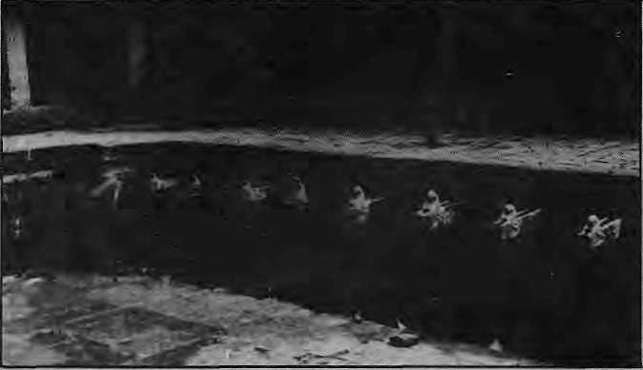
conferences
environmental Kathmandu.
in
And amidst all this spectacular destruction, foreign heads of state visiting Nepal roll through in motorcades to ceremonially plant trees at the Royal Botanical Gardens. Meanwhile, Godavari resounds with the sounds of war - deep booms of dynamite rent the air as oblivious urban picnicers sing drunken songs in the artificially symmetrical gardens. It rains rocks at a nearby high school when the dynamites go off at the increasingly mechanised marble quarry.
Mine holy spouts at Naudhara: only tour work
Godavari, 15km southeast of Patan, today represents in a microcosm the ecological degradation and mindless "development" that is going on in the rest of the Himalaya. It's all there - a balding hill, slopes clawed by the red scars of landslides, springs going dry, vanishing birds and mammals, charcoal traders committing arson on the ridges, quarrying that has opened a gaping wound at the base of the mountain, shantytowns of workers and their families where rhododendrons once bloomed.
An edict by the Rana rulers of Kathmandu kept most of Godavari's forest intact for the past centuries. Anyone found felling a tree here, the rule said, would be beheaded on the tree's stump, Later Rana prime ministers built summer resorts inside Godavari's jungles. The steep ridges were blanketed in' oak and rhododendron forests interspersed with lush groves of bamboo and pine - a floral mix allowed by the differing climatic zones on the more than 4,000 feet of. altitude variation.
Godavari, this valley within the valley,
has now become a prime spot for the
newly-emerging environmental groups in
Kathmandu to see ecological destruction
taking place "live", The Nepal Forum
of Environmental Journalists recently
took itself on a day's outing to Godavari
and the place is regularly visited by
delegates attending various
"Godavari is getting warmer, tropical butterflies are migrating up from the Terai," says Mahendra Limbu, an avid butterfly collector at the school.
Even trees near Phulchoki's summit
are not spared, A recent visit there
revealed giant oaks being cropped for
fodder by women who had trekked five
hours to get at the choice leaves. On
the western ridges on the Lele side,
whole hillsides have been charred by
charcoal pickers. And the ubiquitous
goats are there to nibble off the tiny
green shoots that have sprouted from
the ashes. A (Prakash Khanal)

HIMAL 5

¹
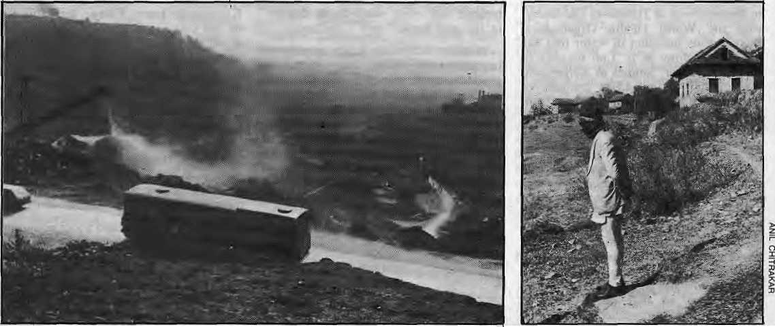
Tourist bus climbs through limestone quarry above Chobhar (left) as Manman Singh looks down at what was once his farm

setting, on a wide bowl-shaped vailey in the lap of the Himalaya, aggravates the problem. In winter, a layer of warm city air is trapped under a higher layer of cold air flowing down from the mountains. This "temperature inversion" causes smog to blanket the city all night and for most of the morning. "Kathmandu's micro-climate is such that air pollutants tend to settle down rather than get blown away," says Suresh Chalisey, a meteorologist and former Member- Secretary of the Man and Biosphere (MAB) Nepal Committee.
Kathmandu smog has become a major health hazard, says Dr. Sanjiv Dhungel, a cardiologist and Associate Professor at the Teaching Hospital. He says the percentage of patients suffering from respiratory diseases and bronchitis caused by city pollution is high, but points out that the major problem even in Kathmandu is still "indoor pollution", caused by wood-burning in closed spaces.
Another doctor at the Teaching Hospital, Subodh Pokhrel, says that even with increasing access to medical facilities, antibiotics and well trained practitioners, the incidence of lung diseases in the Valley is on the rise. He ascribes this trend to the growing air pollution, which weakens the lungs and leads to chronic diseases. He warns that "the worse is yet to come, for these pollutants will settle in different parts of the body and might ultimately give rise to carcinogenic cells, which will lead to an increase in cancer cases".
The chief whipping-boy of the ■capital
city's "cocktail environmentalist circle" is the Himal Cement Factory at Chobar, near the gorge where the Bagmati exits the Valley. Commissioned in 1974, the factory is riding the crest of the construction boom in the capital, providing 48,000 tons of Portland Cement yearly. At that rate, the factory can continue to produce and to pollute for another hundred years before the limestone deposits in Chobar run out. According to a 1983 report by the Forest Services group, Himal Cement's two vertical shaft kilns and a rotary Jdln together produce five to six tons of dust .every 24 hours. It claims that no direct stack sampling is carried out for measurement of emissions and that there is no systematic monitoring of dustfall in the area. The technology for controlling emissions, including electrostatic precipitators, can be retro-fitted into the plant, the report maintains. It says that supervisory personnel in the plant were unwilling to provide information about existing installations, "but evidence of continuing excessive emissions indicates chronic malfunctioning of abatement equipment, if any".
Indu Bahadur Shahi, the factory's Chairman and General Manager, told HIMAL that electrostatic precipitators are not appropriate for vertical shaft and kiln chimneys. However, he says, government approval has just been received for installation of 'wet scrubbers', with West German assistance, which -should reduce emissions substantially.
Asked for his reaction to the environmentalists' seige on his factory, Shahi shrugs and says that it has become fashionable to blame Himal Cement for all ills without scientific proof. "Fog gets called smong here," he says,.' "for whole days the when our kilns are closed down, the air quality remains the same, how do you acount for that? I would welcome who ever wants to come and check the factory's emissions".
Shahi's figures do not tally with those produced by Batu Krishna Upreti, of HMG's Environment Impact Study Project of HMG, who writes that Himal Cement's emissions before the factory's recent expansion were 4,5 grams per cubic metre. By comparison, the emission limits for similar factories in, West Germany and India are 120 mg and 250 mg per cubic metre. About 400 tons of dust could be prevented from being spewed into the Valley atmosphere every year if'emissions were controlled, says Upreti.
■ Upreti also states that the factory's dust has affected the health of its workers as well as those in surrounding villages. Mana Man Singh, 67, a life-long resident of Chobar village high on the ridge above the factory says he and his neighbours often reflect on how their lives have changed since the factory started. "Depending on the wind conditions, our village and Sanga village across the Bagmati are enveloped in dust - dust on our fields, our beds, our kitchen, everywhere. We cough and suffer. What to do? The factory gives

HIMAL 6

... meanwhile in other Himalayan valleys

The pollution of Kafhmandu Valley is not an isolated phenomenon. Other valleys and other towns throughout the Himalayan chain are already suffering heavily from environmental dislocation or will be.soon unless corrective action is taken. Shimla recently had a water quality scandal, and the deterioration of Darjeeling town has proceeded unchecked for more than a decade. In Srinagar, planners are worried over the preservation of Dal Lake, while further west in the Peshawar Valley, too, the problems of water supply, sanitation and health are keenly felt. Even Thimpu, with a population of only 15,000, has begun to suffer from inadequate water supply and sanitation systems, complex and narrow road networks and inappropriate land use. In Lhasa, authorities are already gearing up to cope with increased pollution as an open door policy brings more economic opportunities to the town.
The highly urbanised Doon Valley of Uttar Pradesh, with Dehra Dun as its hub, has many problems that are identical to Kathmandu's. The concentration of population and consequent urbanisation have led to deforestation, soil erosion, siltation and air pollution. LANDSAT satellite imagery has shown a twenty percent reduction in the forest cover between 1972 and 1982.
There are six factories that depend on mining operations, but the primary pollutant is the ARC Cement Factory near Rajpur, in operation since 1981.
The Uttar Pradesh Pollution Control Board had apparently issued ARC a "no-objection certificate" back in 1981. With public protests becoming more strident, the Board withdrew its certificate. Despite that, it is reported that the district administration did not have the regulatory muscle to order the plant closed.
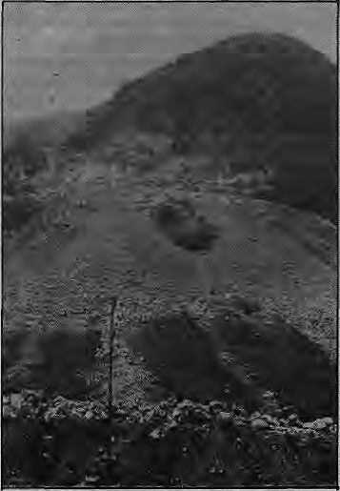
Doon quarry spells doom
Last year, Prime Minister Rajiv Gandhi asked Chief Minister Vir Bahadur Singh why polluting industries in Doon had not been closed and why, instead, the
state had commissioned its own calcium carbide plant. Following that communication, the ARC factory, among others, was ordered closed. Stormy protests followed and industrialists and lime kiln owners combined forces to form a committee to argue about implication for employment and income.
Mady Martyn, Chief Coordinator of the conservation - mfftBed Friends of Doon, says her group is not for overnight and forcible shifting of the industries and lime kilns. Alternate sites outside the valley must be made available and measures taken to mitigate unemployment, she says.
Last fall, the Doon Valley Board, at
a high-powered meeting chaired by the Centra) Minister of State for environment and Forests, recommended that the Valley be declared a pollution-free zone in which "only non-polluting industries like electronics, watch-making and assembly of instruments should be permitted". To protect Doon's fragile ecosystem, it called for concessions and subsidy to non-polluting industries and recommened that industries which did not make intensive use of water and power be encouraged. The Board also demanded that lime kilns be shifted from the Valley and that pending applications by pollution prone industries be rejected out of hand. Finally, the Board proposed the preparation of a land-use master plan for the Doon Valley region after consultation with representatives of the public.

many of the villagers employment. My two sons as well". Singh's former house and gardens were long ago swallowed by the factory's excavations. He has been moved .once after that and yet another move is threatened, to satisfy the factory's (and the country's) every increasing appetite for cement.
Hinial Cement's silica dust, ash and smoke do not remain restricted to the immediate .environs and villages, but Spread in a thin haze throughout the Valley, taking the shine off temple roofs and sometimes making the nearby Himalayan peaks nothing but vague white apparitions. Suresh Chalisey, who lias observed Chobar's smoke with a professional and despairing eye for several years, says there is a "gully effect" that keeps the haze from dispersing. He says that in the forenoon
period, the wind in Chobar blows east, turns westerly in the early afternoon, and becomes northerly later in the day. "Rarely does it blow south and away from the urban centre", he says. "East or west, the smoke and dust hug the base of the hills from Godavari to Swayambhu, then diffuse through the rest of the Valley". The local weather patterns make Kathmaodu doubly vulnerable to air pollutants, says Chalisey.
While Chobar might be one of the primary air pollutants in the Valley, exclusive focus on it has led to the neglect of other sources. Such as the two Chinese-built brick and tile factories and some hundred odd brick kiln chimneys that dot the landscape in Harisiddhi, Bafal and elsewhere. The kilns Use coal and firewood and are a significant source of smoke pollution.
Domestic use of firewood also remains one of the main traditional causes of air pollution.
Vehicles are adding to the foul air. Their number has quadrupled over the past decade, and there are 2,000 more cars, buses, trucks, autorickshaws, tractors and power tillers every year for the next decade. In February 1087,13,460 cars and jeeps were registered in Kathmandu; and 6,150 motorcycles 4,510 buses, trucks and minibuses 900 power tillers and tractors and 620 autorickshwas. That makes a total of 25,640 internal combustion engines (though not all of them might be on the roads), many of them badly maintained so that they emit more carbon, sulphur and lead. The quality of gasoline and diesel that enters Nepal makes these vehicles even more prone to pollute, say experts.
HIMAL 7


of pollution, which always existed but has recently become more pronounced, requires a change in habits and attitudes.
Prakash Khanal is a Kathmandu-based journalist snd photographer who specialises in science reporting. Anil Chitrakar is studying irtdustiial engineering in Jaipur and helped found the TREES environmentalist group in the Valley.
DISTRIBUTOR
NATIONAL TRADING LIMrTED
MACHINERY SALES >H0 FttP* IIUFNl FtF SAM5HAH PATH PH'ONE :■ 1
K;-:l:^S:-::S:::>.:^:::|:::::-:::::::-:::::?:^:^:>::
'To minimise pollution, fuel should be free of lead and should contain as little sulphur as possible", says Guna Raj Upadhaya, Executive Chairman of Nepal Oil Corporation, "We do not have a Nepali standard, so we follow the Indian standards for diesel and gasoline. Nepali fuels contain less than one per cent sulphur." That point is borne out by a study done by Diesel Kiki, a Japanese company, for Sajha Yatayat. It reported that the sulphur content of Nepali diesel was "lower and better than Japanese diesel fuel".
However, the carbon content of diesel in Nepal is high because the Barauni refinery in Bihar which processes the fuel has old equipment that leaves a high wax content. Diesel Kiki reported that the carbon residue by weight in Nepali diesel was 2 percent, while in Japanese diesel it was a mere .01 percent - which makes Nepali trucks two hundred times more prone to belch smoke. Which they do. Especially notorious are the hundreds of mini-buses sold by overland tourists to Kathmandu transporters. Badly maintained diesel engines, with defective pumps.and fuel filters, fail to propoerly ignite the fuel and leave smoke trails of carbon all over the Valley.
Nepali cars, autorikshaws and other gasoline users are also more liable to pollute, because of low octane and high lead content. Lead-free gasoline is unheard of withjn the kingdom. Fuel with high octane rating allows thorough combustion so that there is little carbon exhaust. Unfortunately, while2.93octane value gasoline does come into Nepal, only 1.87 ocatane value gasoline is available for general use.
"Carbon in the atmosphere, such as comes with Kathmandu traffic during office hours, weaken the lungs and lead to inflammation and infection", says Dr. Purushottam Shrestha, Professor of Community Medicine at the Teaching Hospital. He feels that planners must learn from the mistakes of other cities before pollution become unmanageable in the Valley. Over at the Planning Commission, Upendra Man Malla says that while there is an environmental and land use policy spelt out in Nepal's current Seventh Five Year Plan, it has not yet been put into practice. However, there is no specific legislation for the regulation of pollution. "We cannot just wait for everything to clog up before doing something", he says.
Traditional "organic pollution" on the streams and streets as well as the more recent "industrial pollution" from factory
H1MAL B
and -vehicles have brought Kathmandu Valley to the crossroads and a choice has to be made between environmental chaos and public health. The latter kind requires the government to set and enforce pollution standards on industry. It must also attempt to control the number of vehicles and begin a process of checking their emissions. The traditional variety
I
ONE MORE BELARUS T-25A is here to toil for you
T - 2SA a versatile wheeled tractor of Classical Semi-Frame constriction is deMgned for different agricultural operations, Small dimension and its 25 hp engine helps in easy manoeuverability for the Agrotechniral operations on small plow and is irreplaceable for auxiliary operations.
ITS OTHER EXCEPTIONAL FEATURES

* Number of Cylinders | 2
* Electrical Equipment- | 12V
• Brakes | Individual band-type
* Transmission | Rear Drive
* Can be equipped with other auxiliary equipment
BELARUS T - 25A — WORKS MORE THAN YOU EXPECT AND IT'S ECONOMICAL TOO!


TRAKTOROEXPORT
Moscow USSR

Tehri: Temple or Tomb?
By Rajiv Tiwari

love electricity, we love soil," reads a slogan at the construction site of the Tehri Dam, one of India's most ambitious and controversial hydro electric projects. To be finished by 1997, the 200 million dollar dam on the Himalayan river Bhagirathi will generate 2000 mw of electricity and provide irrigation to 0.27 million ha of land downstream. But critics of the project are determined to have it scrapped.
"Of what use will this be to the people here?" asks Chakradhar Tiwari, an environmental activist in Tehri. Tiwari has been agitating for community-owned micro-hydroelectric schemes in the Himalaya, saying smaller power plants are more suitable for the hills. But the real bombshell for environmentalists has been the sudden announcement that a large part of a 300 million rouble (IRs 20 billion) aid package to India agreed during the recent visit here by Soviet leader Mikhail Gorbachev would go to the Tehri project. More than half of the aid is said to be earmarked for Tehri, and observers are surprised that the Soviets had no qualms about backing a project that is caught in controversy and litigation. The Soviets were reportedly first interested in assisting India build another nuclear powerplant, but the Indian side didn't want it, and Tehri was hurriedly taken up as an alternative.
Stiff opposition
Since its inception in 1977, the Tehri Dam project has met with stiff opposition from the 70,000 inhabitants of Tehri and 92 villages upstream. They have opposed plans to displace them and submerge 5000 ha of farmland, pastures and forests in the Bhagirathi valley 200 km north of Delhi. An "Anti-Tehri Dam Struggle Committee" has challenged the project -in the Indian supreme court on technical and ecological grounds. Hearings on the case are still going on. "We have a watertight case against the project. A government working group itself has concluded that the dam will be ecologically disastrous," says Virendra Saklani, an advocate who heads the committee.
The petition before the supreme court states that the dam site is risky because
of the geomorphology of the Himalaya, where rock formations are weak and seismic activity is high. The petition also challenges the right of the state government to encroach on the fragile Himalayan ecosystem. The Botanical Survey of India has found that nearly 100 kinds of plants and herbs will be wiped out if the dam comes up. The reservoir's life-span will also be reduced to 20 years because of the Bhagirathi's high silt load.
Massive boost
Government sources refuse to comment on the allegations, saying the matter is for the supreme court to decide. Tehri's massive boost to the North Indian power grid and irrigation potential, the government hopes, will catalyse greater agricultural productivity in the plains of the Ganges. The government also feels that nearly US $140 million have been spent on the project, and it is too late to stop it. Recent reports suggest that the project will be completed ahead of schedule with Soviet assistance.
Critics charge that the government has chosen to disregard reservations expressed in the first project report. "The Tehri project is typical of lop-sided development. In wanting to generate creating a hostof problems in the hills," creating a host of problems in the hills", says H. L. Badola, editor of a regional weekly here. The government has decided to shift its power generation base from thermal plants to hydro-electricity, and since the mid-1970s, some 22 hydro-electric projects have been commissioned in the Himalaya. This policy has resulted in widespread resentment against large dam projects and has sent ripples as far away as the gigantic Narbada river valley project in central India. Local opposition is also building up against, another hydro-electric scheme in the scenic Valley of Flowers near the renowned Hindu pilgrimage spot at Badri Nath near here. The disastrous rehabilitation of people displaced by the Pong Dam in the neighbouring state of Himachal Pradesh appears to have harmed government credibility in Tehri. Only 12 out of 92 villages which will be submerged by Tehri's 45 km long reservoir have been allocated land for
rehabilitation. "The government can't manufacture land. Where will the oustees go? wherever they are sent, forests will be destroyed," says Saklani.
"The government has never paused to consider the long-term implications of its policies in the hills. First, the forests were commercialised and made into timber mines. Now, it's oct rivers," says' Sunderlal Bahuguna - the well-known crusader for conservation in the Himalaya, and leader of the "Chipko" movement. Critics of large projects like Tehri claim that such projects will always be technically infeasible, and will needlessly displace people.
Riin-of-the-river
The Struggle Committee has suggested an alternative run-of-the-river scheme which may not generate as much electricity, but will be more permanent than the dam. It will also be of immediate benefit in the hills rather than cater to the plains, they say. Similar suggestions for multi-purpose community power plants on fast-flowing Himalayan streams have also been given to the authorities in Delhi by activists like Tiwari. But the. government is sceptical of the schemes.
"Small may be beautiful, but how can a country as large as India create an industrial base? Nuclear energy is not safe, thermal plants pollute, now we're being told hydro energy displaces people, which way do we go?" asks a government official not involved with the project. The controversy is not peculiar to India. Critics say planners, engineers, contractors and politicians always unite the world over on big projects where the stakes are high. Inaugurating the country's first large hydro-electric project that led to the Green Revolution, India's former Prime Minister Jawaharlal Nehru once called large dams "temples of the modem age." Twenty years later, there are many here in Tehri who think large dams are not temples, but tombs. A
Rajiv Tiwari is a reporter for Inter Press
Service in New Delhi

HIMAL 9

ICIMOD Searches for its Soul

T
HE International Centre for Integrated Mountain Development (ICIMOD) has completed two years of operation and "is off and running", according to its Director, Colin Rosser. The difficult ground-breaking activity is complete, he says, and the Centre is already into the "second phase" of Hs existence, carrying out substantive activities which will benefit the mountain people of the Hindu-Kush Himalaya and elsewhere.
Although the Centre's work so far is appreciated, however, the course has not been set and locked. Within ICIMOD and among observers there is debate and also an undercurrent of unease as to what it is and what it should do.
"We started with a handicap right away because too much was expected of us, especially at out base here in Nepal", says a senior staff member. There are other, perhaps more serious constraints - regional politics, limited finances and the inability to attract recognised names from ouside the region because of low pay scales (by international standards). Regionally, ICIMOD has not been able to reach out to three countries named in its statutes - to Afghanistan. Bangladesh and Burma - though it is not for want of trying.
ICIMOD was inaugurated at the
culmination of a week-long symposium
in December 1983, attended by
international luminaries such as
UNESCO's embattled chief
Amadou-Mahtar M'Bow and Maurice Strong, Canada's environment and development pundit. The Centre was established to benefit the hill farming community of the Himalaya Hindu Kush and elsewhere, one of the most neglected segments of the world's population. It was decided then that the first couple of years after starting operations in September 1984 should be a period of stock-taking, and institution building.
During the time, ICIMOD had
assembled a gifted staff of 25 from the region, set up shop in a "campus" of seven buildings in Patan, organised five major international workshops (on watershed management, rural energy, "rural-urban linkages", off-farm employment and national parks), begun collaboration with other agencies,
HIMAL 10

suspicions and simmering border disputes, it would be naive to think that ICIMOD could proceed with political blinders. Looking at it positively, however, ICIMOD is the one regional centre where experts from antagonistic neighbours can interact on a daily basis in an atmosphere of professional cordiality. "If nothing else, that in itself is an achievement, though perhaps an inadvertent one," says a Nepali Foreign Ministry official with knowledge of the
awarded its first Senior Research
Fellowship (US$25,000 to Nepali botanist
Tirtha Bahadur Shrestha), and
established a computerised
documentation centre.
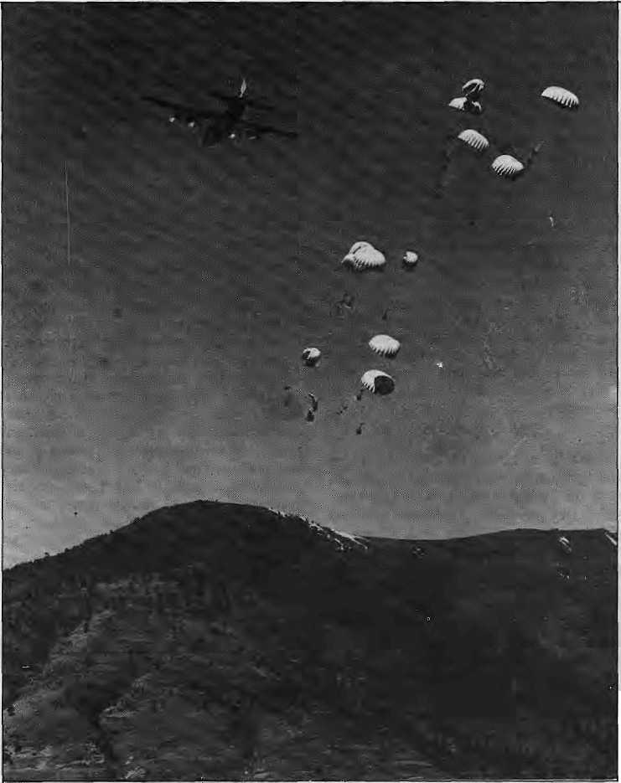
"International": As a centre for study and research, ICIMOD should not have to worry about political problems related, say, where to hold a conference or seminar or whether Giigit or some other locality is actually in India, Pakistan or China. But in a region rife with burning
RAF C-130 paradrops food over western Nepal in 1981: one of the world's most neglected segments

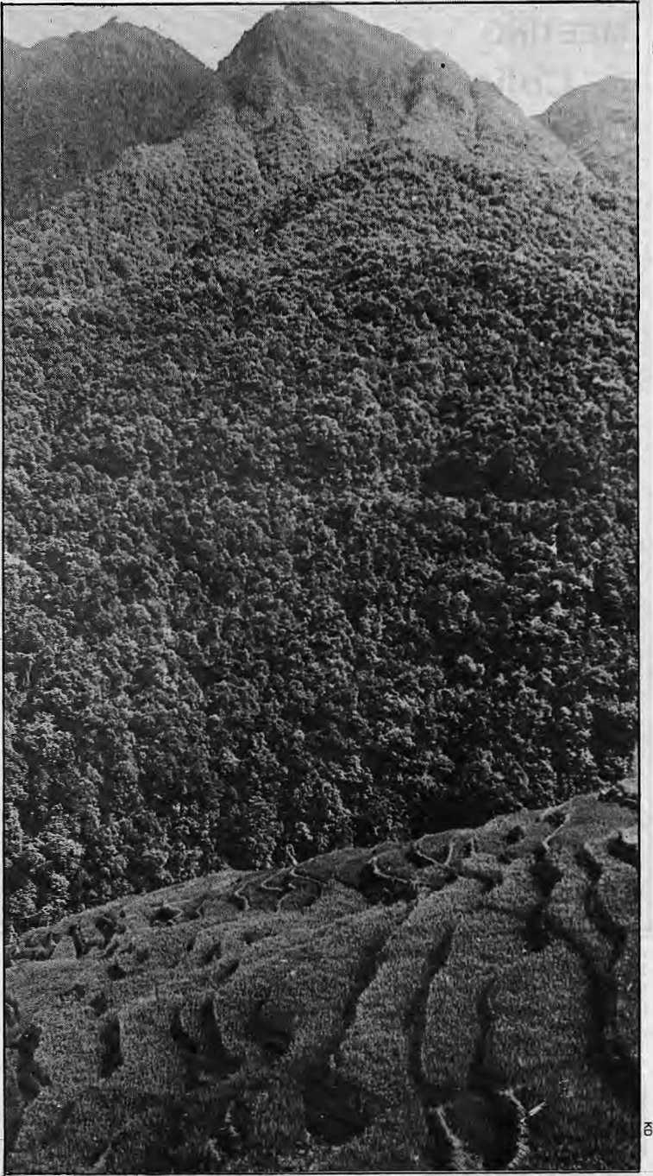
Centre's functioning.
While its character is "international",
the Centre's mandate is limited to improving the living standards of the populations in the eight countries of the region from Afghanistan to Burma. While ICIMOD has already set an impressive record of international liasons, its ability to impact on other mountain systems is restricted by funding. The Centre's annual operating budget, of US$1.5 million plus half a million in special programmes, is comparatively small. A similarly situated organisation, the International Institute for the Management of Irrigation in Colombo has a budget of US$5 million.
ICIMOD's ambition to be a "centre of excellence" requires an ability to hire the best expertise available and to go out of the region to recruit, if necessary. Because the ICIMOD member states were wary about giving United Nations salaries in a centre headquartered within the region (Nepal and India wanted to lower the pay scale, Pakistan to up it, and China thought the whole idea was ridiculous), ICIMOD finds it cannot compete in the world market for permanent professional staff. The 1981 ¹ salary scale of the Asian Institute of Technolgy in Bangkok was taken as a benchmark and ICIMOD's own scale locked to it. By paying short-term contract holders at slightly higher daily rates, the Centre is, however, able to attract international expertise, albeit for shorter stays.
"Centre": A staffer confesses, "It is not yet clear whether we are to be a think tank that will operate out of an isolated ivory tower, or an implementing agency that will compete with alt the other agencies, international NGOs and government departments." A few think that ICIMOD must "aim for the masses", and try to bring the "fruits of development" directly to the farmer on the terrace. This last proposal is largely rejected, firstly because of the enormous political difficulties that it would entail. However, there continues debate among those who feel that there must be some applied field programmes. Others would go halfway and get involved with actual projects, but at the planning and monitoring stages only.
"Integration": Debate also continues as to how best to achieve "integrated mountain development," whether ICIMOD itself should conducted integrated research or merely espouse the proper management of sectoral programmes. J. R. Dunsmore, of the
Forests merge with paddy terraces in Nepal's midhllls: sustained
symbiosis in the mounta ins

HIMAL 11

MEETING
Colin Rosser: "We're Off and Running¹

Colin Rosser, 62, a sociologist who
did research among the Newars east of Kathmandu valley more than two decades ago, is also a former British Gurkha officer with experience in India and Pakistan. In 1984, he was appointed the first chief of IC1MOD and his term expires in mid-1988. Rosser spoke on where the Centre is and where it is headed to HIMAL Editor, Kanak Mani Dixit.
HIMAL: After more than two years at the helm, do you feel ICIMOD now
has a grip on what is its calling?
Colin Rosser: Let me first explain ICIMOD's pedigree as a "third generation" international institute. First, you had institutes with a global focus like IRR[ in the Philippines, which applied science to a particular discipline. When it was realised that the social sciences could not be ignored in propagating scientific advances, a second duster of institutes were born, such as those dealing with irrigation and agro-forestry in Colombo and Nairobi. ICIMOD represents a further step, the first institute of its type, which studies the integrated development of a total eco-system. The Centre's establishment brought together the ecologists worried about mountain degradation and scientists seeking to bring about development through agriculture.
HIMAL: Do you emphasise environment or development?
Rosser: Priority must be given to development and not the enironment, especially if you see environmental activities as part of a holistic development process. I want to get away from words like "crisis", "doom" and the whole
catalogue. Rather than espouse
crisis-laden-scenarios, the Centre will focus on development efforts, taking full account of scientific advances.
HIMAL; Does ICIMOD hope to reach out of the region and become more "international"?
Rosser: The Himalaya Hindu Kush has been written into our statute. However, we do hope to make use of the available knowledge in the Andes, the Alps and the mountains of North America so as to better understand the problems of the Himalaya. There is scope for co-operation in the area of mountain crop genetics, for example. For the moment, we are a reception centre for knowledge, but in time we hope to be a transmitting centre as well.
HIMAL: Where is: the organisation headed institutionally?
Rosser: As I said, we are currently trying to become an efficient clearing house of information, looking for success stories in the mountains and propagating them. At present, one valley does not know what" is happening in the next. The loss of acquired knowledge in these mountains is eollosal! People learn and forget before others have an opportunity to benefit from their experience. We want to help preserve practical knowledge - for example, the insights of an engineer engaged for ten years with the Lamosangu-Jiri road, which you will find in no engineering manual.
We would like to do original research, but that requires a budget of US$ 5 million, as against our present spending of US$ 1.5 million. If we were to assist in opening up centres in the other major
mountain systems, that would be US$ 10 million. Of course, we're nowhere that right now.
HIMAL: So ICIMOD is going to limit itself to information transfers?
Rosser; Oh, no, that's only the¹ first step. We plan to train professionals: foresters, engineers, planners and others. Even those with degrees earned abroad are on the whole pretty poorly trained. In our second phase of work, which has already begun, we are building up a bank of case studies with which we hope to "irrigate" existing training programmes. This year, we will have case studies ready on watershed and forest management, pasture and fodder use, organisation of rural development, and districtlevel energy planning.
We are also engaged in "action research" for formulating a project on rural-urban linkages as it relates to Kathmandu's produce market. In order to increase urban access of farmers, we hope to identify the points in the commercial chain where private sector, public sector or external aid investment can be used to maximum advantage.
HIMAL: How about implementing
development projects on you own?
Rosser: With our miniscule budget, we can only hope to act as catalytic agents. The annual public investment in the Himalaya mountains is US$ 1 billion, so the problem is not one of money. We do not want to add to existing projects, but we would like -to add to their quality. "Why can't we get good projectsf" is the constant refrain of the donor agencies. We will design and monitor projects. As a think tank,

British Overseas Development Administration, had asked back at the 1983 symposium, "To what extent do we need to aim for integration of the implementation programme except in the natural resource field?" The point was whether, having once assessed the whole range of resources of an area and decided on a programme for their development, whether there was an over-riding advantage in having an integrated mode of implementation as opposed to a multi-sectoral approach.
Another criticism, from within ICIMOD, is that it boasts of a
HIMAL 12
"multi-disciplinary team with sectoral attitudes" that people trained sectorally are finding it hard to talk about integrated mountain development. Further, it is said, as ICIMOD is not an implementing agency, how is it going to prove the workability of the integrated concept?
Duplicate work
"Mountain Development": If it is not to duplicate work conducted elsewhere, some say, ICIMOD must quickly make up its mind about what issues constitute mountain-specific development, as against of "general development", which
could apply just as well to island eco-systems, the desert, the African savannah and the Indo-Gangetic plain. It is also unclear how the mountains can be completely isolated from the plains and how the "highland-lowland interactive system" can be ignored.
An observer says, "First the centre must clearly identify its primary clientele, whether they are the policy making governments, the operational line agencies, the mid-level professionals or the public at large. The region is so poor, and the intellectual pool so limited that it must get a clear focus on the

however, we can only advocate, argue and present the case.
HIMAL: Ape you in touch with other institutions in-the Himalaya?
Rosser: Clearly, we have a coordinating function. There are already over a hundred universities, research institutes and field stations all concerned with mountain development in the region. The work of many of them overlap, for example there is incredible duplication in soil erosion research. Our seminars, symposia and publications help promote h more efficient use of the available financial and intellectual resources. There is camaraderie among professionals in the field, regardless and a willingness to collaborate.
HIMAL: Who are ICIMOD's
end-users?
Rosser: The final beneficiary, of course, is the hill farming community, but we do not address them directly. We hope to gain the understanding of professionals such as economists, administrators, officials, journalists and teachers.
HIMAL: The Centre's departments are divided sectorally, so how do you achieve "integrated development"?
Rosser: The problems on the ground are integrated - the farmer does not sectorally divide his worries. As long as we remain engaged with real problems on the ground, and focus on "total development", I feel that 1CIMOD will have fulfilled its mandate.
HIMAL: There must be political constraints to your job Rosser: The Himalaya Hindu Kush is
a politically sensitive region. In dealing with social and economic aspects of development, as we do, one is talking about policies, and policies cannot be separated from politics. So there is a problem here. A centre in a region with a history of wars and continuing boundary disputes has to be constructed with

Rosser: 'waste of Intellect iscollosal'
unusual diplomatic skill - so that work can proceed on agreed priorities.
HIMAL: It seems you have been unable to convince all the countries in the region to get¹ involved in ICIMOD.
Rosser: Burma, as you know, has always remained aloof from international and regional groupings and we have not been able to open its door any more than others. Afghanistan did attend our inaugural symposia in 1983, and we hope that it will become more active when peace finally arrives. Bangladesh maintains that it is not a mountain country, but we have been trying to. emphasise the importance of the mountain-plains connection.
HIMAL: ICIMOD's salary is the talk of the town,
Rosser: It is true, the Centre is very much like a fish out of water in Nepal on that count. But bear in mind that our salaries are somewhat lower than the United Nations standard. But I ask you, should I pay a Nepali any less than a colleague from another country? Further, if our salaries can attract Nepali experts back from lucrative jobs abroad, that can only be good. As far as possible, I want to use the skills of the region.
At ICIMOD, we have as little hierarchy as possible and all staff get their pay without reference to national or regional origin. There is no north-south divide. My colleagues are encouraged to concentrate on their work untramelled by bureaucracy and hierarchy. We have no advisers or consultants. We're also trying to put Kathmandu on the world's stage as an international meeting place of repute where an independent, autonomous body such as ours can operate with ease.
HIMAL: Whereto now, forlCIMOD?
Rosser: It has been two years, and we're off and running. Remember, we started with a pedigree, but no model. Today, we're, in the institutional map of the region due to my hardworking, productive colleagues. I am not concerned about ICIMOD next year or the year after* but of what will be its character ten years from now. What is our long term future? To help provide answers, the Board of Governors is holding a brainstorming session starting 11 May, to which we will be inviting persons with recognised excellence both in running international development centres and in the area of mountain development.
In the past couple of years, we have made some mistakes and learnt some lessons. It is now time to stop and ask some fundamental questions.

mountain dimension of the work to be effective."
Geographer Harka Gurung, known for hisjorthrightness, believes ICIMOD has started on the right foot by providing an increasingly effective forum for regional development and environmental issues. His chief grouse is that ICIMOD has yet to define what the "Hinmalaya Hindu Kush is, where it ends and where it begins, what are its geographical components,"
Gurung continues, "ICIMOD still lacks a framework. If you want to be problem-oriented, you have to define
the space, and ICIMOD's fundamental scientific base is unclear. The second stage of its work must be a synthesis of what it has learnt, and that requires homework."
Homework
Much of the homework will have to be done by Director Colin Rosser, who is due to retire in mid-1988 and wants to leave his successor with a Centre that has both excellent output and focus. He has a challenging task confronting a welter of conficting demands and interpretations and emerging with an answer triat must carry, ICIMOD will into its first decade (see interview). To

HIMAL 13
help find ICIMOD's soul, Rosser is calling together its international Board of Governors, together with several prominent names in international development and mountain environment, for a brainstorming session in May 11. i KMD


BUDIAMA
Fulfils Her Mission
By Rupa Joshj


I
don't know all this centimeter stuff, you tell me how much it comes to in fingers and elbo*vs.... before you go, tell me how to get rid of those awful caterpillars in my tomato patch.... JTA babu, please walk back carefully, the path is slippery! Han Sharanam!"
Budi Ama is at it again, nagging and bullying the every tolerant JTA over Radio Nepal's farm broadcast programme, Budi Ama ra JTA ("The old woman and the agricultural extension worker"), that is aired Friday evenings. Having run without a break for twenty years over Nepal's only radio station, Budi Ama is probably the foremost media personality in the kingdom today. The targetted farmers and city slicks alike take to her whining, cajoling, nosey, cantankerous and altogether lovable image of the grandma next door.
Lovable grandma
The voice that has been backing Budi Ama through her fits of asthmatic coughing and between sighs of arthritic pain is that of Laxmi Bhusal, Who is incredibly only in her early thirties. Quiet and reticent, it is veiy difficult to connect Bhusal with her radio persona. And she began "doing" Budi Ama when she was eleven!
⁴She has come along with her sister who was applying for a job," recalls Kiran Mani Dixit, Chief of HMG's Agricultural Information Division, who was then looking for a person to play the village grandma. "It was her alertness that struck me when I first saw her. A few basic tips on how to speak and act like an old lady was all the little girl needed. Soon, she was coughing and wheezing like she had been born with asthma!" Dixit recalls.
Bhusal showed an equal knack for scriptwriting, even though her formal education was quite limited. "In the beginning, I got help to fill in the technical details, but before long I was writing my own programmes," she says. "I constantly try to update my agricultural knowledge by reading books and journals. At every instance I have to ask myself what a villager's response to a new fertiliser, seed or breed of animal or fowl would be".
HIMAL 14
Other than the news broadcasts, Bhusal ^{r}s programme has consistently held the record as Radio Nepal's most listened to broadcast. A recent Food and Agriculture Organisation (FAO) survey showed that 71 per cent of farmers questioned preferred Budi Ama's format to any other. "Our target audience are small income farmers, and we have managed to retain their interest for a score of years," says Dixit, "We struck the right social and psychological and social chord".
A factor in the programme's popularity is use of simple Nepali, which contrasts sharply with the complicated and over-sanskritised presentation of other broadcasts and also the print media. "It takes a lot of hard work to give body to a relatively "dry" subject", says Bhusal. "I speak into the mike colloquially, avoiding technical terms as far as practicable. For example, when we have to resort to new standardised metric measurements, I coax the JTA to explain them in layman's terms. A gram of fertiliser is a matchboxful. Pesticides are explained in terms of texture, colour and odour".
bhusal at mike as Budiama
Spiced with gossipy banter and the never-ending household problems of Budi
Ama, the programme has a committed urban audience as well. Chandra Kumari, 71, a Kathmandu great-grandmother, tunes in every Friday "for useful gardening hints". ShovaSharma, a widow who lives in a simple rented quarter in the capital, says, "I do not have a single square foot of land to call my own, yet I like to listen to the old woman. It is entertaining and, who knows, the knowledge might prove useful one day." The fan mail that pours into Dixit's office from farmers across Nepal makes it clear that Budi Ama mouths their problems to the JTa.
Poultry farm
When faced with the problem of how to introduce the agricultural., extension workers to the rural populace 2P;V^{ears} ago, Dixit and his colleagues hit upon the idea of an inquisitive grandmother as the natural person to accost the newly arrived JTA. Today, Budi Ama's small vegetable patch has expanded to flowing fields. The JTA has persuaded her to open a piggery and a poultry farm and she takes interest in fruit farming as well. She is increasingly knowledgable about agricultural matters and the JTA doesn't need to remind her of quarterly irrigation and how exactly to fertilise crops.
Now that farmers have been acquainted with the basic farming techniques, says Bhusal, it is just a matter of telling them about new advances in agricultural implementation. "The cycle of crops is the same from year to year, and I have to take care lest the programme become repetitive and monotonous," she says.
Budi Ama's originator, Kiran Mani Dixit, 'will be retiring soon. The old woman, too, has served her initial purpose of making the JTA household term in village Nepal, It would be narrow-minded to think that Bhusal, with her talents, should not pursue other challenges, perhaps in other media. A day might" come when the fire and the excitement dies, in Budi Ama's eyes, and. she succumbs to asthmatic complications. That will be a sad day for all Nepalis. k
Rupa Joshi writes regularly on issues that affect professional Nepali women.

VIEWS
No Thought For Women
By Bina Pradhan and Indira Shrestha

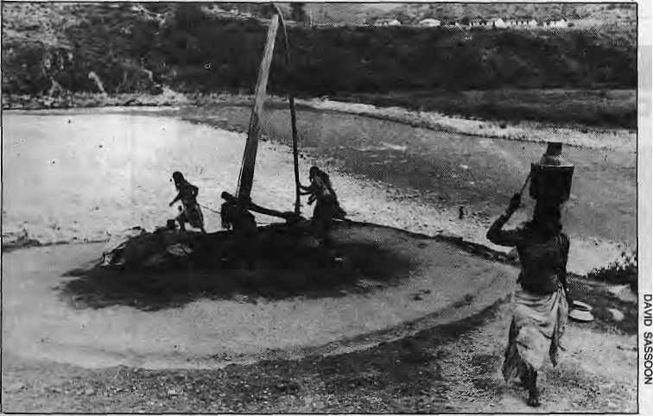

A
LL currently prevailing international academic fads make their way in time to the corridors of power and planning in Kathmandu. National policies are quick to accommodate prevailing concepts, theories and Approaches to development. Since the 1950s, our development goals have consecutively emphasised agriculture, then industry, then "balanced growth", then "regional development". Subsequently, "growth oriented" development gave way to "equity oriented" development and finally to "integrated rural". Such progression, if one might call it that, seem as inevitable as the turning of the wheel of fortune.
Recently, the focus has shifted from growth and GNP orientation to a concern for people and equity. The emphasis, on paper -at least, is to be of direct assistance to those on the lowest economic strata the rural poor, the small farmer, the deprived. Women fall in the lowest economic strata under any type of classification. The thought that development activities .directed to the rural people will automatically include
women has been borne out to be untrue. The beneficiaries of social, political, government and development activities have in fact overwhelmingly been "the male rural poor". The "trickle down effect", in this case from men to women, has worked no better at the household level than it seems to have at the national level.
Unthinking use of Western categories of "housewives" and "money earners" without looking at the Nepali rural household has ignored and distorted the actual productive roles of women. Nepali women have thus been more or less by-passed in development. The functional roles of "housewives" and "money earners" apply only to an exclusive minority of the elite, but it is the members of this small elite who are the immediate receivers or disbursers of foreign aid and development. And they are what they are either by virtue of western education and influence, or, in a few cases, the anachronistic left-overs of the elites of previous times.
Women work ...
The concept of "housewife" in Nepal assumes the woman as a leisurely lady
limiting her activities to household and domestic chores, categorised either as reproductive or unproductive. This excludes all those activities of the vast majority of Nepali women who do crucial, productive, but unpaid activities such as food processing, manufacturing for family consumption, household construction, water and fuel collection, hunting and gathering.
Foreign funds
Thus, the crucial contribution of women in the family farm enterprise and their productive inputs to the rural household system have been overlooked. With women restricted to the farm household, project aid directed to the rural poor has reached only the men, because it is they who represent the farm family and society in "outside" negotiations and activities with the Kathmandu bureaucracy and foreign donors.
With the United Nations' declaration of 1975 as the International Year of Women, foreign funds for local seminars and conferences began to flow and various women leaders journeyed far and wide to international gatherings on women and development. Subsequently, money also became available for women's programmes. Unfortunately, most such programmes continue to be in skill development (sewing, knitting and handicraft), nutrition, family planning, maternity and childcare. These activities simply extend ..the domestic role of women. Income generation for women has been limited to providing credits for chicken and goats and vegetable gardening.
Ail the seven integrated rural development projects (IRDPs) in Nepal have major agricultural components, but none are geared to women specifically. They may target "farmers", but that will never include the female farmer. There even seem to be instances of deliberate exclusion. The Koshi Hill Area IRDP has scheme for giving intensive four-year agricultural training to Grade 7 dropouts. Girls are not eligible,
HIMAL 16

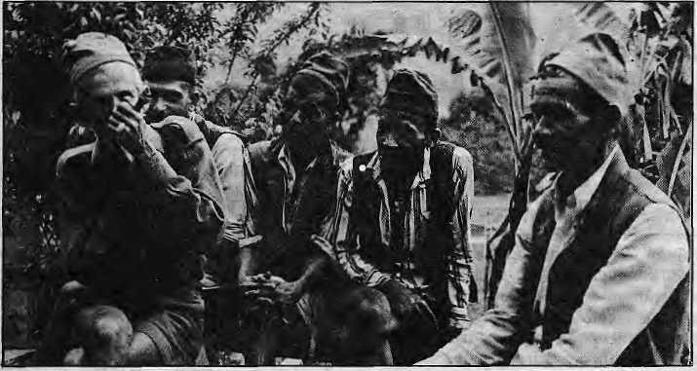
it is precisely such formal training that women lack. Asked why girls were excluded from the training scheme, a (foreign) expert said, "Do you think a 60-year-old farmer (by implication, male) would listen to a young female JTA?" The expert, and he is not unique, seemed unaware of the existence of female farmers in Nepal.
A review of IRDP activities leads us to conclude that women have not really been considered seriously. The field is barren except for a surfeit of lip service and symbolic gestures in the form of minimal funds.
In the Community Forestry Project, women are involved only in 'nurseries and in education programmes. While
.. and men sometimes have to rest
they are preferred for nursery work such as weeding and planting, in spite of better performance, the female labourers are paid less than men. In Kathmandu, the official rate is NRs 14 for men, NRs 11 for women and NRs 9 for children. In 69 village panchayats we surveyed, there were only three women nursery foremen in that better paying job. In the afforestation programme, extension workers are all male.
Our analysis of ten women-specific projects showed that most of them had inadequate training, weak implementation, no follow-up and no continuity. Most were directed towards "housewifely" activities leading to income generation. There is nothing wrong with
that per se, but the programmes seemed to be ad hoc and carried on with an air of lady-like amateurism. Only two of the ten seemed to view women as crucial contributors to the family farm enterprise. Within the total picture of development, however, the benefit by women from these women-specific project is minimal.
Almost all the projects that exist for women in Nepal are externally funded, implying a lack of seriousness and commitment in HMG to women's programmes. This exclusive dependence on external funding leads one to question what will happen when international funds dry up. It is time to correct the situation in which women have either been left out of major national development projects or relegated to peripheral activities. It is not acceptable that women are actually being displaced by men in their traditional roles in agriculture as a result of "development" activity. Women can only be reached by being specifically targetted, and they can only be reached in most cases by other women. This is the crux of the problem and has to be .squarely faced. Unfortunately, even now, while there is a growing awareness of women's right to development, most efforts seem to stop at the stage of verbalisation, i
Both writers are development consultants in Kathmandu. Bina Pradhan is with Womens Development Group and Indira Shrestha with the Integrated Development Systems.


OYPIY
iRftii
4-WHEEL DRIVE

HIMAL 16
FOR FURTHER DETAILS PLEASE CONTACT:
APOLLO INTERNATIONAL CO.
P.O.BOX648, KHtCHAPOKHAFil KATHMANDU. TELNO.2-21430,2-23739 TELEXNO, 225BKUSUM NP

VIEWS
Development Dharma
By Dipak Gyawali

T
HE doctrine of development is the dominant religion in Nepal today and its jargons the most audible liturgy. Even in remote hamlets, the word "bikas" promises a hope of salvation matched in fervour only by messianic religions in their earjy phases.
What exactly constitutes development is a question as old as philosophy. Ancient Greeks as well as ancient South Asians have debated loud and long about the nature of the "good life". The essence of this debate also lies at the root of all development thinking today, although attention is focused mainly on the means of achieving an advertised lifestyle rather than on the necesssity or the desirability of the end product.
One thing that development has meant in the Himalaya is change - rapid transformations not only in the physical surroundings but also in thinking, values and expectations. Change is inevitable, but it is its rapidity and pervasiveness that is worrisome. This modern phenomenon - only partly, described by words like "development" or "modernisation" - has put tremendous strains on perplexed Himalayites and their delicate social fabric.
Today's changes in Nepal, unlike those of the past, involve the very metamorphosis of Nepali society. In the past several millennia, Nepalis have seen changes affecting their loyalties and identities. Inter-regional wars and dynastic succession have occurred with almost monotonous regularity, but they resulted only in the transition of "managers".
But what is taking place today strikes at the root of age-old tradition and culture. A key actor in this modern drama is western technology, which brings its own software of socio-cultural values and imposes new demands on behaviour. Western technology was brought into Nepal by the wrong people for a wrong reason. In Europe, the social carriers of technology were the rising mercantile class who used it to enhance production.
In Nepal, however, it was her autocratic shoguns - the feudal Ranas - who first introduced it as an element of luxury.
Electricity was first generated in 1911 at the '500 KW Pharping Power Station south of Kathmandu Valley barely two decades after the alternating current motor was invented. It was used to illuminate Rana palaces and the houses of loyal retainers, without charge. The motor car, which made its appearance about the same time, had to be dismantled at the Churay foothills and portered over the passes and reassembled in Kathmandu. It then carried- the Ranas out for a joyride in a few kilometres of Valley roads.
A narrow-gauge railway was built in 1927 from the Indian railhead at Raxaul to Amlekhganj 43 km to the north. A ropeway was built about the same time from Bhimphedi to the capital. All this would seem 'like a productive use of technology - if one ignored the end-use, which was to ferry building material for the burgeoning industry of the day -construction of opulent stucco palaces for Rana offspring. The banishing of the mechanical inventor Gehendra Sumshere by his cousin the Rana Prime Minister showed that technology was an appendage to power, feared by the powerful and certainly not meant to empower the powerless. Without an entrepreneurial middle class, there was no manifestation of a social will to enhance production through the use of technology.
Whatever the reasons for its introduction, technology soon acquired a social life of its own in Nepal. Today, the country's socio-system groans with discomfiture as a complex set of physical as well as metaphysical changes are demanded by the use of seductive western artifacts. No one academic discipline can describe such transformation, sq infer-disciplinary measures must be used. One such way is to re-examine the ancient South Asian concept of "dharma".
"Dharma" is often mis-translated as "religion" in English. Instead, it implies a correct lifestyle, or living in harmony with one's nature in a world of perpetual change. "Dharraa" formed the basis for public policy in the past. It was a ruler's duty to up-hold it, and as such it implied maintaining harmony among the myriad elements of a complex society. Such a
truly holistic approach can better synthesise societal goals and values than approaches based on "development economics". In fact, a policy measure enforced on a "dharma" basis might find readier acquiescence from even those hurt by the policy.
A life of "dharma" can be expressed as a lifestyle in harmony in the three spheres: the philosophical, the social and the environmental. Technology's advent has brought some disharmony in all three areas.
In the social arena, technology has fueled rising expectations on a mass scale. Traditional institutions designed to allocate privileges are under tremendous stress and are increasingly unable to cope with revolutionised aspirations. Social institutions like representative democracy and the market economy that are designed to handle such demands are still at a formative stage.
In the environmental sphere, the disharmony between what nature can provide on a sustained basis and burgeoning wants have become a visible problem. Where our relations with nature used to be "flow-based" and sustainable, the advent of technology has changed them into a one-time-only exploitation. Saw-milts and trucks make it possible to manipulate nature- to a degree unprecedented in the history of Nepali society. Meanwhile, the newly imported philosphy of neo-classical economics deems any future beyond a decade as valueless.
The present "dharma" of development, with its over-emphasis on the open pursuit of want-satiation, has already come up against physical limitations in the form of a deteriorating environment. It is also straining the social fabric with unrest; and the nation's philosophic life has begun to show signs of disarray. A harmonious blance between man, nature and technology may be struck only when the question of why we do what we do and how much of it we should do, are effectively addressed, i
Dipak Gyawali Is a power engineer trained In the Soviet Union who, as a Fulbright Scholar, recently studied resource economics in the United States.

17

PROJECTS
Developments in Bhaktapur
Everything that could be done wrong —
By Todd Lewis

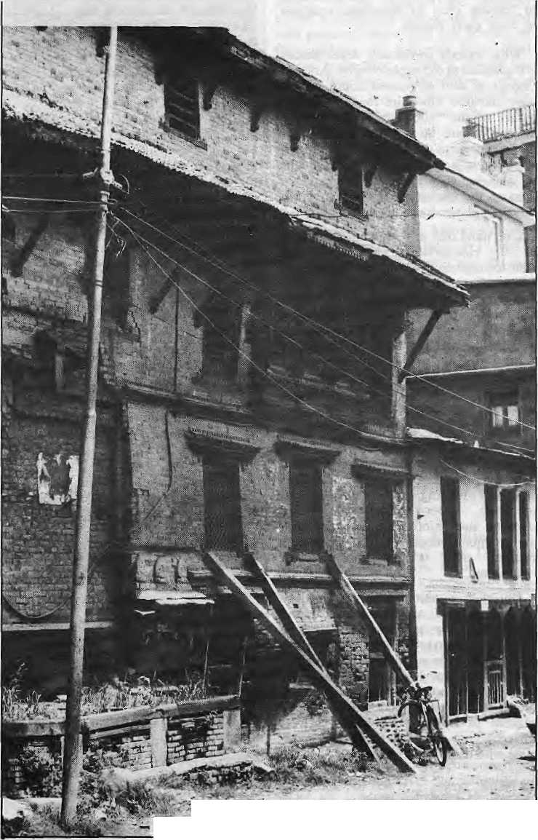
■■■- ■
Support is needed for restoration, but what kind?
I
N 1974, the Federal Republic of Germany sponsored the first major development effort in Bhaktapur, a project designed to "tackle the economic and social problems ... and to preserve the valuable cultural heritage" of this Kath-mandu Valley town inhabited by the Newar community. In its early .years. the Bhaktapur Development Project (BDP) concentrated on restoring important architectural monuments, temr pies, resthouses and historic buildings in the north-east section, and began constructing a modern water and sewerage system. Forced, in part, by the local population's protests, the BDP transi-tioned from technical, restoration to a community development project. BDP's work began to taper off in 1983 and finally ended in 1985, so' the time is now perhaps ripe to assess its record against the backdrop of the development reality in Bhaktapur.
Economic Centre
Bhaktapur's former prosperity was dependent on its role as an economic centre for surrounding village areas, especially those to the east, and this position was undermined by the new road networks that favoured Kathmandu. The BDP itself recommended that the southern outskirts of town where the main highway passes not be developed, a fact that undoubtedly contributed to Bhaktapur's failure to exploit its location. Stopping the natural economic evolution of the city because it violates the "museum aproach" to the town was a recurring error in BDP logic. Its planners failed to comprehend that unless enough new local weajth is generated, the local economy can never maintain the temples, houses aud monasteries which is haslso carefully restored.
In housing, BDP put its prestige on the line by having the local government pass ordinances that legally limited the Newars' freedom to rebuild their houses with new designs and with newer building materials such as corrugated iron and cement. The project thought that the town residents could be coerced into
HIMM. 1S

foregoing architectural change by relegating them to their own past. Despite these laws, residents have continued to rebuild using proscribed designs and materials because they refuse to live inefficiently. BDP, of course, had to backdown on such unrealistic demands.
Local regard for the project was also undermined by BDP's initial restorations, done gratis on the most historic houses in town, for the most part buildings owned by the richest residents. The middle and lower classes saw this as flagrant assault on the principle of fairness. Class insensitjvity also hindered other areas of BDP work, especially in school building and commercial development.
Expensive toilets
An analysis of BDP's work on drinking water and sewer systems shows how the project, when it finally got out of the drawing room and unto street level, so often misread the situation in Bhaktapur. The pubticy works design erred in channeling rainwater into the sewer system, thereby depriving an essential resource to farmers tilling some of the best rice fields just outside town. Those farmers soon remedied the situation by breaking open the waste pipe.
Expensive group toilets, imposed initially without consulting local women, have not been accepted. Nor is there room for an adequate waste treatment facility south of town, an omission that compromises the entire sewerage system. Those neatly repaired streets that delight the tourist cover an ill-conceived public works infrastructure which is perceived as a sucess only by the enginers employed in designing and implementing it. Why was such a costly and energy-inefficient sewerage system that uses large quantities of groundwater emphasised instead of biogas systems? BDP simply chose the easiest, most conservative and ethnocentric option: building a western-style system that does not even work on its own terms and ignores long-term issues of ecology, energy and survival.
Whatever its proponents might say, it is hard to accept the project's professed commitment to "cultural sensitivity". No one in the project's regular "foreign expert" staff ever learned to speak Newari, and few spoke Nepali. Thus, at the most fundamental level, there was a "communication gap". The job disparities and miscommunication between foreign development workers and their Nepali counterparts figure
prominently in why projects often operate so poorly or turn to folly. Cultural differences cause misunderstandings that hinder intra-project relations, distort project planning, and handicap implementation; and the Bhaktapur project was no exception.
To appreciate the Bhaktapur community's ultimate values, its ethos, and the underlying - bases of its social norms - what every development project must grapple with - requires nothing less than thoroughgoing awareness of the local religious traditions. Given its very ambitious plans for this vastly complex town of over 50,000, it is astonishing that in its initial phases BDP ignored social scientific enterprise in designing and implementing its work. Ignorance of the local society and culture and of the Newar notion of "common sense" caused many blunders that undermine relations and co-operation: garbage receptacles were placed too close to temple precincts, normal Newar ceremonial conventions were not followed when project restorations were begun, and early project plans were made without establishing relations with the most fundamental groups, the guthis.
Critical efforts
All too often, in projects such as
BDP, the institutional agenda controls
and dominates a project's performance.
Rarely do real performance evaluations,
coming years later, affect the individual
careers of the consultant planners or the
field workers. In the oral lore of
international development in
Kathmandu, there are many such examples of the individual consultants overriding the reality of project needs. The time should be long past when projects can be naive about socio-cultural realities or send in amateurs to design and implement critical efforts involving survival.^
Todd Lewis is a cultural anthropologist who did extensive ethnographic research In Kathmandu Valley from 1979 to 1982. He was also briefly a consultant with BDP.
Ecological Imperialism
The Biological Expansion of Europe 900-1900
Alfred W Crosby
Cambridge University Press
32E. 57th StTRY, NY 10022
TREK
THE
ADVENTURE
MANDALA TREKKING I! ALTITUDE ADVENTURE
£ P.O. Box: 1083, Kanti Path!*
| Katmandu, #£■!■ #*

HIMAL 19

Mahendra Trust
Emerging Environmental Watchdog

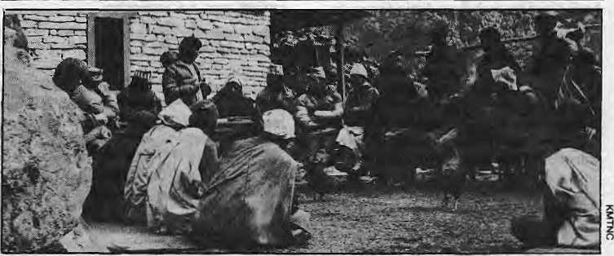
Shey-Phoksumdo National Park, a project to identify endangered Nepali plants, an appraisal of the red panda's diminishing habitat, and the movement of 27 Tadio-collared gharials. (It was learnt later that the rhino had been shot by the Bihar police.)
In September, the Trust launched a unique conservation experiment in the Annapurna region, one that hqpes to balance the needs of a local population, trekking tourism and the fragile environment. In January, the Trust used
^{r}T"^{t}HE premises are cramped and cla-J. ustrophobic, but it is a beehive of activity: a former auditorium boarded up to yield office space. It is the base camp of the King Mahendra Trust for Nature Conservation, a Nepali "NGO" on a ecological crusade (but burdened with a terrible logo, see below). It is mid-February, and the Trust's staff of fourteen are in a tizzy keeping track of the its burgeoning responsibilities.
News has just come in by wireless that a rhino from the Chitwan jungle is heading south across the border into Bihar. Fallout continues from the Trust's whistle-blowing on the the Bhrikuti Paper Factory, a day before it was to be inaugurated, for discharging untreated effluents into the Narayani river. There is discussion on how best to preserve the cloud forests of the Barun Valley in East Nepal, and follow-ups on a snow-leopard study in the
Mingma Norbu addresses Annapurnans
cranes, trucks and good Nepali ingenuity to crate nine rhinos from the Chitwan Valley to the Bardia Wildlife Reserve in an attempt to provide alternative habitat as well as to minimise conflict with villagers.
The Trust was established by a Government Act in 1982 to fill a keenly felt need to supplement the conservation-related activities of HMG. As Prince Gyanendra Bir Bikram Shah, Chairman of its Governing Board of Trustees told donors in 1984, it would

A trail of destruction
By Aditya Man Shrestha

High on a pass 3,000m above sea level, the village of Ghorepani faces a dilemma between apparent affluence and obvious breakdown. This Himalayan hamlet of hardly 250 people willingly hosts between August and May every year an estimated 10,000 trekkers hiking up Himalayan trails in search of mountain mysteries.
Ghorepani commands a spectacular view of the Annapurnas and, four days out of the roadhead town of Pokhara, few trekkers miss a night's halt here. In 1978, there was a lone teashop on the pass (deurali) and Hotel Pun Hill (actually a lodge).More than 20 lodges crowd the trail up to the pass today, 14 of them catering to tourists and the rest used by Nepali travellers, pilgrims and porters.
There is a tendency to construct more lodges not only to cash in on the tourism boom but to enhance one's standing in
the tiny community. The entrepreneurs' awareness of the impact on the local environment has been shown by studies to be minimal. Even more disturbing, the whole lodge industry seems to be continuing "just for the heck of it" and not for economic gain, as the following calculation shows.
The average tourist spends NRs 50 per night in Ghorepani. In return, he/she receives an evening meal consisting of soup, rice, lentils and vegetables, rice' pudding (pronounced "rasputin"), four cups of tea and a bottle of soft drink. For breakfast, the visitor gets a bowl of porridge, two eggs, a chapati and two cups of tea. Throw in the accommodation charge of NRs 3, which allows the weary hiker to sleep on a foam mattress, warm his toes at a central fireplace and shower With warm water.
Even by a conservative calculation, it costs NRs 35 per person for food alone.
The firewod costs NRs 12 per person (at NRs 61 for a porteY-load of 25 kilos) and NRs 1.5 for kerosene used for lighting. All told, it costs the lodge-owner at least NRs 48.50 to take care of one tourist, and the figure does not even include depreciation and investment on the buildings. So it seems clear that lodge operation leads to nil profit if not a net toss.
Yet, tourism goes on. Too late, some of the lodge-owners have realised their folly, but cannot afford to close down (many are ex-servicemen of the Indian Army or the British Gurkhas who have invested their pensions on what did not seem then the tourism gamble).
"What to do, at the time it seemed a good investment", says Buddhiman Gurung, 56, an Indian Army pensioner who largely financed an establishment run by his nephews. He says that bargaining tourists has led to desperate

HIMAL 20

have been unwise and unrealistic to ask HMG alone to grant funds to realise the prescriptions of the World Conservation Strategy, to which Nepal had subscribed.
"Our philosophy is development through conservation. We canot keep people apart while trying to preserve the environment," says Hemanta Mishra, Member Secretary of the Trust, just back from undergoing a multiple bypass operation in London. "How can you have national park isolated amidst a sea of human population? We must search for answers geared to our own situation and not copy models that might have done for national parks in colonial Africa half a century ago. If we fail to grasp that impoverished farmers outside our national parks need food, fuel, fodder and shelter, then everything will go."
Mishra is proud that it is under the Trust's aegis that the World Wildlife Fund (WWF) for the first time got involved in population and development
issues, in the Annapurna Conservation Area Project - which also represents the Trust's attempt to implement its own philosophy. The ploughing back of trekking revenue directly into local conservation efforts.
Mingma Norbu, who co-ordinates the Project for the Trust, says people's participation is essential if- the area is to escape the fate, of the degraded Everest
trail. "We try not to talk conservation with the villagers; the stress is on hard economics", he says. In fact, his real challenge came not with the villagers of Annapurna but with Kathmandu officials loathe to allow grassroots control of forest and wildlife resources.
/* TRUST FOR NATURE

<
 | A
z |  | ,—1
 |  | p
MAH |  | /
KING
NEPAL. 1982
With a simple press release on the impact of the paper factory's effluents on the Narayani's riverine wildlife, the Trust has also emerged as a watchdog for the public. Whereas the conservation - minded groups in Nepal have been scattered, disorganised and weak-kneed to date, the Trust has the clout and seems willing to use it. "We have indeed evolved as. a watchdog for the public's interest," says Mishra, "and we will be there to raise a voice if we feel uiat a highway alignment could easily bypass an existing forest; or if it is found that
a paper mill in Nepalganj or Janakpur, or rubber factory in Gorkha are* not taking reasonable measures."
The Trust is an almost totally Nepali creation, from its conception to the present operations. It has overcome the genuine credibility problem that public-spirited Nepali ventures face abroad, particularly among the funders. The Trust has successfully raised project money from organisations like the WWF and the Smithsonian Institute, and individuals such as Netherlands Prince Bernhard (who provided US$10,000 for the rhino translocation).
While money is tight, the Trust is also facing a problem of talented people and of continuity in its work. As Prince Gyanendra told the trustees last year, "I am not satisfied with, the progress made in the speedy and systematic implementation of (the Trust's) institutionalisation." He called for doing away with "discord and dissimilarity of thought" between the trustees and the secretariat.
As for the future, the Prince said that "the time has come for us to present ourselves to the Nepalese public more vigorously. The Trust must convince policy-makers, planners, aid agencies and the business community that, for their dreams to come true, there must be a built-in conservation component in all their projections." k
I

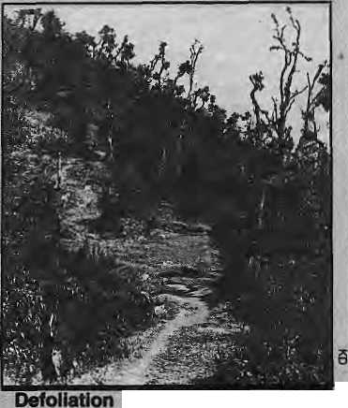
competition among lodge-owners to undercut each other.
While the advent of foreigners has brought about changes in the eating habits of the villagers (with increasing consumption of biscuits, sugar and candies) and in the local behaviour and value system, by far the most obvious impact of tourism in Ghorepani can be seen in the physical environment. Indiscriminate felling of prime rhodendron forest for construction and firewood has made the once renowned Ghorepani ukalo (uphill trail) unrecognisable within a decade.
"In eight years of hiking in this area. I have seen the demise of Ghorepani forest", says Padam Singh Ghale, a mountaineer and trekking guide who does the trail at least three times a year. "It used to be you couldn't see a few yards to the side of the trail for the trees. Today it is finished. At every turn is a lodge, a teashtip, a signboard". A volleyball court and a football field of sorts have sprouted in clearings.
Studies show that one hectare of the unique rhododendron forest is disappearing every year, fully grown rhododendron trees with their resplendant flowers (Nepal's national flower) of the sort that used to tower over the Ghorepani trail require more than two centuries to mature.
A project sponsored by the Association for Research and Environmental Aid (AREA) of Australia is making an effort to reduce firewood consumption and is introducing appropriate energy systems to reduce firewood concsumption and improve energy systems of the dwellings. AREA also seeks to upgrade the water supply, install sanitation systems, rehabilitate degraded land and introduce a community forestry programme that encourages sustainable yield from forest harvesting.
Commenting on the impact of tourism on his village, the Ghorepani-headman says, "The trekkers are like people on a honeymoon. They look at our mountains, eat our food, sit by our fire,
but they do not see out problems. They just go home and show their friends the pretty pictures", k
along the trek route
Aditya Man Shrestha heads the Nepal Forum of Environmentar Journalists, which was launched in June 1966.

HIMAL 21

A Tibetan Tragedy
Blizzard Threatens Survival of Last Great Herds
By George Shaller

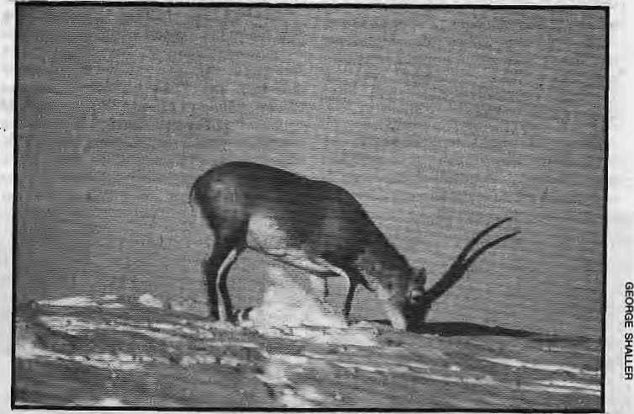
Tibetan antelope paws through snow to find forage after blizzard
N
EITHER tree nor tall shrub grows on the bleak uplands of Tibet. As far as the eye can see are barren plains and rumpled hills covered with herbage so scant it leaves only the vaguest impression. No shelter exists from freezing winds or the sun's glare. Yet in this desolation, at an elevation averaging 16,000 feet, there once lived great wild herds that rivaled those on the plains of North America. "For many miles
in every direction there
were thousands of antelope in large herds," wrote one traveler in 1900. "There was a tremendous lot of wildlife in this region, which is in effect a sort of sanctuary undisturbed by man. Herds of yaks, wild asses, and gazelles were all quite easy to get near," wrote another only 45 years ago.
Such herds are now almost gone. In recent decades, roads, mining camps, and herdsmen with livestock have penetrated even remote parts of the vast plateau. Hunters have .eliminated or reduced the numbers pf wild "animals over huge tracts. A herd of Tibetan antelope, the horns of males piercing the sky like lances, is now a rare, sight. To determine the current status of this wildlife and develop conservation strategies, Wildlife Conservation International and the China Wildlife Conservation Association began a five-year cooperative project in early 1985.
On October 17, 1985, the most severe blizzard in 30 years covered the uplands with a foot of snow. Wind and sun usually clear away snow in this high-altitude desert. This time, however, temperatures dropped to an unseasonable 30 to 40 F below zero and the snow remained. Tibetan antelope and other herbivores had to paw through a deep frozen blanket, rubing their legs raw, to find scant forage. Soon wildlife and livestock were starving.
To check on the well-being of herdsmen marooned in snowbound camps, my Chinese coworkers and I joined a rescue team of Tibetans and soldiers from the People's Liberation Army. On a tractor-pulled wagon we slowly traveled
HIMAL 22
cross-country for several hundred miles, sometimes breaking through the ice of shallow saline lakes.
Tibetan families survived without serious problems in their isolated tents. Sheepskin cloaks kept everyone warm dried yak dung provided fuel for cooking, and there was ample food. Most domestic sheep were being slaughtered because of lack of forage. Along the road that crosses the high plateau and connects the north with Lhasa, the capital city, in the south, truck drivers often shoot animals.
Herdsmen once tolerated wildlife,
sharing the uplands with wild yaks, wild asses and other creatures. Buddhism, the source of Tibet's culture and the religion to which Tibetans adhere, teaches respect for and compassion toward all life; it renounces the conquest of nature and instead seeks to develop the powers of inner perception. But as livestock markets have developed, ranges have been overstocked, overgrazed, and degraded. Little tolerance remains for wildlife that competes with domesticated animals and predators such as snow leopards and wolves are being eliminated. Wildlife products are widely used: The
hides of wild asses make sturdy cradles; antelope horn is considered medicinally valuable; and meat is always in demand.
Many creatures large and small suffered from the blizzard of 1985. We had come to study and survey wildlife, yet could only record its demise and sorrow at its plight. So little is still known about the species here. How many antelopes are there? How far do wild asses migrate? Conservation must be based on answers to such questions.
Of the wild herbivores, Tibetan gazelles suffered most. Small and lithe, with dainty legs they resemble East Africa's
Thomson's .gazelles, and seeing them
trudge through snow seemed
incongruous, as if we had strayed onto
a high-altitude Serengeti. §
Our reports on the tragedy helped to draw government attention to the threatened wildlife. As of March 1,1986, hunting has been banned for three years in areas stricken by heavy snow. There is still hope that the last wild herds will continue to migrate in security and freedom over the roof of the world, i
George Schaller is Director of Wildlife Conservation International. He has conducted wide-ranging zoological research south of the Himalaya as welt.

Many Babies Die in Nepal
By Kanak Mani Oixit

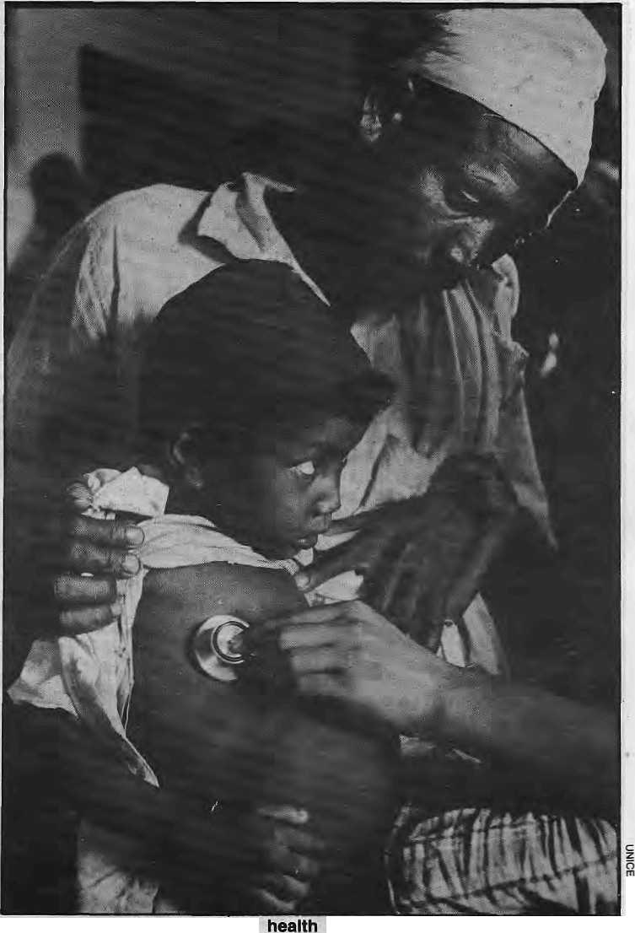
in Nepal: new disturbing statistics
Child
R
ABINDRA Thapa, 24, a community health worker associated with Save the Children (USA) is making his rounds through the communities of north Gork-ha. At the village of Archalay in Laku-ry Bot Panchayat, a five-year-old boy is clearly in the last stages of terminal pneumonia. He was breathing fast, his nostrils flared, his pulse was racing at more than 50 per minute, and Thapa could see the suction in through the rib cage as the child struggled to breathe. The lips and finger-tips were already discoloured.
The father, who was hovering over the prostrate child with incense in his hands, said the jhankri (shaman) had just been in. His son was down with the "Nepali '^yatha", he said using the term used a that area to identify mysterious dfflictions imported from Kathmandu (still "Nepal" to many villagers). Frustrated, and unable to convince the household that the child had to be taken to hospital in Gorkha, Thapa continued on his rounds. A month later, he met the father on the trail and was informed that "baccha khera gayo". The child had been "wasted".
At his moment of death, the child became part of the devastating child mortality statistics of Nepal, where more infants and children per thousand die than most other countries. But in a country jaded with development talk, numbers and charts, there is talk of the perishing children, but in a surreal atmosphere where the impact is not there. Perhaps this was what led James Grant, UNICEF's Executive Director, attempt to make the^{v} situation more graphic. Speaking to the press in Kathmandu last year, he said it was as if three Boeing 747s packed with Nepali children were crashing into the Himalaya every day during the height of the monsoon. There are 2.8 million children ■ below five in the nation.
As for the statistics, the National Diarrhea Survey of 1985 estimated that 99,000 children die annually while UNICEF estimates the figure to be 137,000 so the truth is somewhere in between. Health Ministry officials say that every year, some 45,000 die of diarrhea alone. UNICEF stated in a report last October that children under
five are the most endangered section of the Nepali population. The latest data from the Washington DC-based Population Reference Bureau show that 206 children under five out of every 1000 die. (For comparison, 329 in Afghanistan, 48 in Sri Lanka and eight
in Sweden. In February, the Registrar General estimated that that India's child mortality rate was down from 104 per thousand in 1984 to 94 presently)
While the situation is bleak, the figures are not static. Child survivability is
HIMAL 23

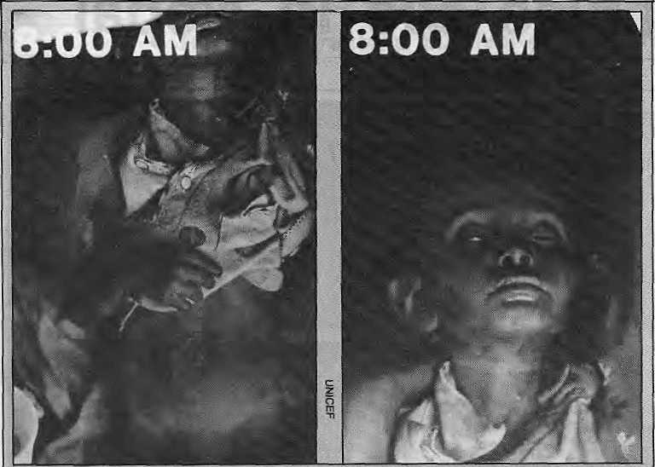
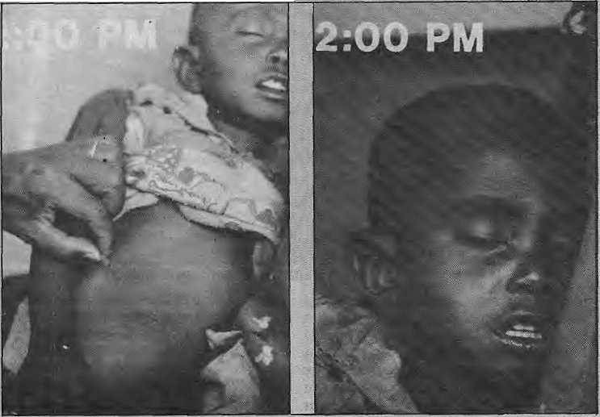
HIMAL 24
Diarrhea: A child brought into a district clinic at near-terminal stage of diarrhea-related dehydration (above), is revived by rehydra-tion therapy (below). Onty one in every 400 episodes of diarrhea prove fatal, but with each Nepali child suffering through six bouts of diarrhea every year, the odds become threatening. Diarrhea can progress from Its first signs to* death within 24 hours. Children first begin to pass excessive stool and at the same time lose their appetite.
Denied food and fluids by concerned parents, as is Invariably the case, they become less and less energetic. They cry incessantly, but no tears come. In the very young, the soft spot on the skull, called the fontanelle, is depressed. At this stage of dehydration, the skin loses its elasticity, it is pinched and it does not retract. Urine becomes dark and soon ceases altogether. The child begins to look shrunken and shrivelled. The pulse is increasingly feeble ... until it stops.
increasing as immunisation covers more of the country, sanitation and water supply improve and illiteracy among mothers is brought down to some extent so that there is increasing resort to prevention and medical cure.
But there is no cause for complacency. A review of the situation of children in Nepal, prepared for a SAARC conference on South Asian children last October, states, "If the children are suffering today, it is because people are burdened with poverty. More than five percent of the children are suffering from third degree malnutrion, which is among the highest anywhere. Malnutrition mirror mass poverty, and the preconditions for resolution is to increase the living standards."
Nutritional deficiencies, unhygienic environment, geographical factors (such as iodine deficiencies in the high valleys) and cultural problems such as food taboos and habits all combine to target the Nepali child. Diarrhea, followed closely by Acute Respiratory Infection ("ART¹, which includes pneumonia) are the two major killers.
Most of the children who die from diarrhea-related dehydration are between six months and two years of age. A "Machhapuchare of diarrhea-related deaths" in the few months preceding the monsoons takes most of the lives. Those are the months when the nutritional status of farm families is the worst because of low foodstocks. All that is required to save the 45,000 children every year is to spread the news of Oral Rehydration Therapy: the use of fluids to replace whatever a child loses.
"The use of drugs for diarrhea is useless or dangerous," says Dr. Nils Daulaire, a John Snow Institute (JSI) USAID specialist in Kathmandu, "but unfortunately many doctors prescribe antibiotics and Lomotit. Discharge is stopped, but the diarrhea is not cured, but gets absorbed. It just gets absorbed into the intestines. Lomotil should never be prescribed for children and only rarely are antibiotic essential."".
The fail-safe cure for diarrhea is simply use of the 'nun-chini-pani' formula, or the socially marketed "Jeevan Jal", but even here there are some problems. The radio commercials for nun-chini-pani advise the concerned mother to "mix a pinch of salt, a four-finger scoop of sugar and three glasses of water (to make half litre)." That leaves so many

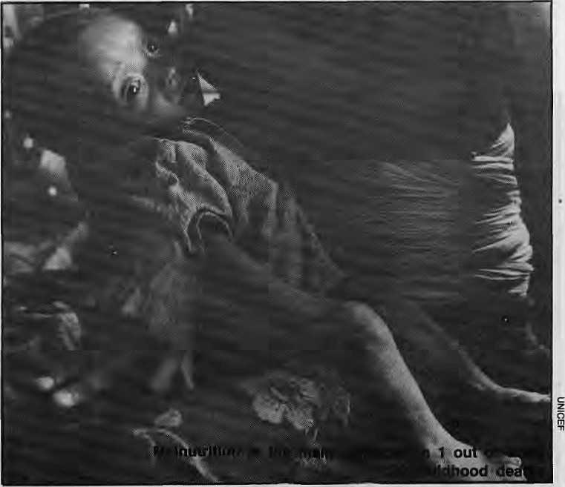
variables that the fluids might prove to be ineffectual, public health workers say. Also, a study has found that 60 per cent of the households in Nepal do not have sugar.
Even with the Jeevan J₍al packets, which comes with the salts already mixed in the right quantity, there is a problem of standardised water containers. A "national container study" is underway to find the most appropriate size of glass or aluminium measure. Field workers also say that villagers have a tendency to use only parts of a Jeevan Jal packet because the full pack makes a litre of the solution. They sifggest the marketing of smaller packets.
Less alert
On the average, a Nepali child suffers from six episodes of diarrhea a year. For every 400 cases of diarrhea, there is one death. This heavy incidence makes parents less alert so that they are slow in detecting a serious case. From its first signs, a case of diarrhea can lead to death within a day, although on the average the progression takes two to three days. Giving fluids to the child prevents death through dehydration while allowing time for the disease to run through its course.
Diarrhea is easy to identify and to treat, and social acceptance of ORS is the only problem remaining. The problems related to respiratory infection, on the other hand, are far more complex, and the cure requires medical expertise. Unfortunately, ARI is most prevalent in the remotest highland districts such as Jumla. "ARI is the big killer, but unfortunately nobody knows quite what to do about it," says Mary Taylor at Save the Children (USA). "Usually, by the time a child is brought to the clinic, he or she is in state of shock and it is too late "
Dr, Mrigendra Raj Pandey, Senior Physician at Bir Hospital, says ARI is particularly serious in Nepal because of the prevalence of household smoke and parental smoking and lack of medical facilities. For years, health planners left ARI alone because of its complexity and concentrated instead on communicable diseases, immunisations and diarrhea.
"Unfortunately, very little work has been done about ARI in developing countries," says Pandey. "It is difficult to imagine a primary health care programme that does not include an organised approach to the leading causes
of ARI-related deaths,"
A typical case of pneumonia, which is the bacterial infection of the lungs, starts with a cold. As it gets worse, the lungs start to fill with pus and the child literally suffocates. A child dying of ARI is in a lot of pain, before she/he lapses into unconsciousness. A study done by Pandey's Mrigendra Trust in Jumla District revealed some shocking details: among children up to nine years of age, the mortality rate in this terribly "backward" district was 489 in 1000, of whom 333 die of bronchial infection.
Resistance reduced
Because of the shortage of medical doctors in Jumla, the Mrigendra Trust, in association with the Nepal Red Cross and others, has begun training community health workers to diagnose ARI, based on a child's breathing rate. For the first time, serious research on ARI is being carried out in Nepal because this is where the problem is most serious at present.
Diarrhea probably kills between 40 and 45 per cent of Nepali children under five; an ARI kills about 25 percent. The other childhood deaths are measles, tuberculosis, tetanus, whooping cough, diptheria, digestive diseases, poisons and
accidental injury. Malnutrition, which weakens children and reduces their resistance can be a factor in most instances of deaths. Symptoms described by villagers as "sukeko" (dried up), "runche" (constantly crying) and "sunneko" (swollen) most probably indicate protein energy malnutrition, according to Dr, Nabarro, who has studied childhood deaths in Dhankuta and Sankhuwasabha Districts in East Nepal. "Malnutrition, described as sukeko, sunneko or runche was the main symptom related with 10 per cent of the deaths under age 10," he says, concluding that there is a need to ensure that curative and preventive health services reach the youngest of the community.
"Nepal is committed to health for all by 2000, and because 40 per cent of the population is under 14, health care services must focus on children", says Dr. Hemang Dixit, professor of pediatrics at Kathmandu's Teaching Hospital. "Unfortunately, this is not happening. As the superintendent of Kanti Hospital once said, most administrators have forgotten their childhood and their pediatricians by the time they reach positions of importance. They forget that investment in healthy children will give returns for a lifetime..A

HIMAL 25

Lights Go On in Nepali Villages - At Last

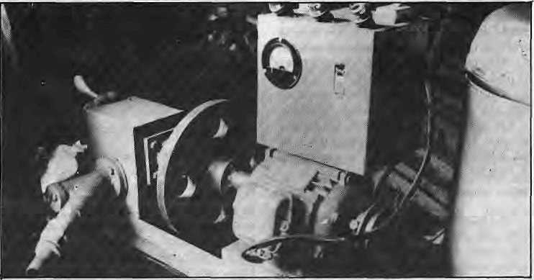
W
HEN the sun set behind the mountains in the village of Benighat in Central Nepal, Bishnu Shrestha used to board up his store and go home to bed. Today, Bishnu's store is lit up by a bright neon tube, and is open late. Even villagers from the far valley have come around - attracted to the shop like die moths that flap around the light.
Elsewhere in Benighat, children read their school books after their evening meals in the soft glow of 25 watt bulbs, and the whirr from a nearby house indicates the village tailor is working late. It has taken 'a long time for the dream of rural electrification to be realised in villages like Benighat. But the light of development is turning into a feeble dawn, here and elsewhere in the Nepali mountains.
With a total feasible hydropower potential topping 30,000 megawatts, Nepal's fast-flowing Himalayan rivers have often been called its "white gold". But only 0.05 percent of this wealth has so far been harnessed. Government plans to spread the use of cheap electricity across the Himlayan hinterland to replace firewood for cooking and to reduce the pressure on dwindling forests have been slow to catch on. Only 30 of Nepal's 75 districts have some electricity, and
Kathmandu's plans to build big dams like the six billion dollar Chisapani Project in Western Nepal have got bogged down in cost-sharing disagreements with India. Officials in Kathmandu argue that Nepal needs to "think big" because the only way it can clear its adverse trade deficit with India in the immediate future is by selling water and power to its southern neighbour.
Meanwhile, most Nepali villages continue to slumber in darkness. "A viable alternative to building large dams
The Akalman generator
is to use technology available in the country and to develop new designs for smaller affordable power plants," says Bikash Pandey, an electrical engineer with the Butwal-based Development and Consulting Services (DCS).
Power planners in Kathmandu now appear to have had second thoughts about relying entirely on big dams to light *up the villages. Transmission costs far outstrip generation expenses, and Nepal's poor and remote villages are difficult and expensive to hook up to

The Electrified Deckhi

The designers of this ingenious 200 watt electric cooker-seem to have thought of everything. The heating element is water-proof so the whole cooker can be dipped into a river for washing. The pot can withstand over five years of hard scrubbing with ash and sand. The insulation makes the cooker exceptionally heat-efficient, and is five times less expensive on electricity than a 1000 watt filament heater currently in use.
But, like all other new technolgies, the cooker designers at the Development and Consulting Services (DCS) in Butwal admit that the final test is whether the people accept it. Five prototype cookers are now being tested in Butwal, and preparations are being made to mass-produce 1,000 of them.
The basic concept is one that would
HIMAL 28
make E. F. Schumacher smile. It uses two locally made aluminum "dekchis" with a mica heating element welded underneath them. The air between the posts provides the insulation, and 200 watts is sufficient to cook rice, lentils and tea - the three main energy consuming items in the average Nepali diet.
The cooker costs NRs 300 for a two litre model (NRs 450 for seven litres). In households with 200 watt supply from a local microhydro project, spreading the cooking load is done by a combination of heat storage and low-wattage cooking.
This means water is heated during off-peak hours like afternoon or night. Cooking also has to be done in series, not simultaneously. In the villages, an average household would require three
cookers - one for rice, one for dal and one for hot water.
DCS has drawn up a "timetable" for the village family in which the low-wattage cooker must be left on all night to provide hot water for the morning meal and tea.
According to the new schedule, families will have to cook their dinners in the afternoon so they can use their 200 watt allocation for lighting purposes in* the evening.
An average household needs about NRs l_{f}20Q to buy two big and one small cooker and will be spending about NRs 75 per month for their subscription of 200 W of electricity, which includes the cost of using five 40 W bulbs. People connected to Nepal's national grid have a monthly expense for cooking of NRs

the national grid. The government
deregulated ail powerplants with capacities under 100 kilowatts two year ago, and announced subsidies of up to 50 percent on all electrical installations
"These are exciting times for village electrification," says Pandey. "We are about to see it take off." DCS installed a three kilowatt powerplant on a stream near Benighat from which Bishnu Shrestha gets his electricity. In the nearby village of Taklung, another DCS-built generator provides lights for 22 houses four hours a day. The village co-operative put up the plant for a cost of NRs 30,000 - half of it a loan from the Agriculture Development Bank (ADB/N) and the rest from Unicef. And most of the borrowed funds are now said to have been nearly paid up as households pay NRs 12 per months per lightbulb. Another imaginative entrepreneur in Mohantar village uses his converted water mill to dehusk rice during the- daytime, and at night sells electricity from a generator powered by the same turbine to the military barracks in nearby Gajuri.
Voluminous paperwork
No more do these village entrepreneurs need a license, and the previously voluminous paperwork for permission and royalty payments have been practically eliminated. DCS itself has surveyed 85 viable sites across central and western Nepal, and over 20 have been built in the last year alone. "With the subsidy and loan, most investments
are returned within one year. In some villages, the powerplants make economic sense even without subsidies", says Pandey, who got his degree from the Massassachusetts Institute of Technology (MIT).
Most power planners in Kathmandu see lighting as & "luxury" and stress other uses for it to be cost-effective in the long run. "But at the moment there is no tariff incentive to cook in electricity," says Pandey. Village microhydros would make electricity available at a flat rate - customers subscribe to a certain amount of power whether they use it or not.
Status symbol
"What is most remarkable about small power units is their cost - you can install a two kilowatt plant on a stream flowing outside your house for half the cost of a Honda generator of the same capacity that runs on gas," Says Binayak Bhadra, resource economist at ICIMOD. In Butwal, DCS is now testing a novel electrical cooker that it says is three times more efficient than normal filament heaters currently in use in the cities. Designed and crafted in its workshop, the cooker is air-insulated and has a heating element welded underneath. It can cook rice, lentils and tea, can be dipped into the river for cleaning and has a designed lifespan of over five years, (see box)
Electricity is the new status symbol in rural Nepal. The village headman in Sindhupalchowk chopped down a large
tree in his garden because people in the
valley below could not see his new electric light at night. And the engineers, surveyors and technicians who come to install the powerplants are VIPs. "They treat me like a king when I go to set up a plant, I am their 'electric man' (bijuli manchhe)," says Akkal Man Nakarmi the talented Kathmandu craftsman who designed and made the now-famous multi-purpose power unit (MPPU) that revolutionised village milling in Nepal. Nakarmi says his generators that go with the MPPUs have become very popular, and the.y are "dirt cheap". He makes the one kilowatt generators himself converting normal. electric motors in his cramped and busy workshop in Nagal, Kathmandu.
But small-scale hydropower seems to
be on the threshold of revolutionising the way village Nepal lives. Already, the whine of MPPUs and microhydels can be heard over the gurgle and splash of traditional water mills along the Kathmandu - Pokhara highway. If a village entrepreneur of co-operatives wants to go for a electrification project, all they have to do is ask one of the companies from Butwal or Kathmandu to come and survey their site. If feasible, an ADB loan is easily obtained. "It's simple and it's small. And the beautiful thing about it is that it can be easily replicated, no foreign Sompanies or consultants" explains Pandey.

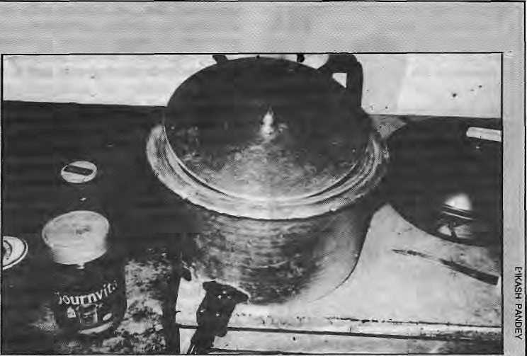
88 on an average. Firewood fop cooking can cost between NRs 60-80 in Kathmandu. As yet, there does not seem to be much incentive for people who gather their own firewood to switch to electricity for cooking. In the beginning, the manufacturer expects only those with a sizable cash income in the villages to start using the cookers.
There is' also the question of social
acceptability. Observing and stirring
cannot be done because water will not
boil with the lid out. Cooking also has
to be done in series. Rice first, then
dal then tea, instead of simultaneously.
Cooking times may also be too long for
the hungry farmer who wanted to quickly
put together a dal-bhat-tarkari. "All this
requires people to rearrange their
management of time related to household
chores," a DCS report says. KD
The native rice-cooker: come and get it

HIMAL 27

Ladakh Towards Sustainable Development
By Carolyn Hayes
A
N international development conference with a difference was held in Leh, Ladakh last fall. It was so deliberately low-key that it went wholly unnoticed elsewhere in the Himalaya. While ten nations outside India were represented, there was no international agency or national aid bureau present. Also unique was that the foreign participants, ranging from a Swedish Member of Parliament to an ecologist from the University of California, and a Nepali major-general-turned-environmentalist paid their own travel expenses to and from Leh.
In course, eating was a secondary
concern, the primary focus being on
"ecology and principles for "sustainable
development" - the subject of the
three-day conference. The whole affair
had bees sponsored by the Ladakh
Ecological Development Group (LEDeG)
and the Ladakh Project, two
organisations founded in the late seventies
by Swedish linguist Helena
Norberg-Hodgc out of her concern that
conventional development was
threatening a centuries-old, socially and
environmentally harmonious way of life.
LEDeG is locally based, while the Ladakh
Project conducts international
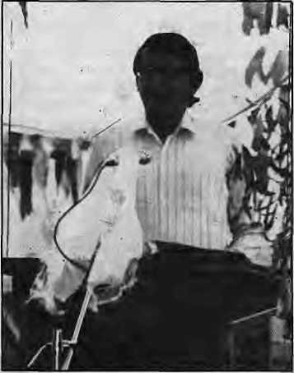
Ladakh's Development Commissioner, S. S. Kapur speaking at
conference
educational programmes on development issues and provides technical and financial support for LEDeg.
"Development is tough business," said Edmund Hillary, Everesteer and New Zealand's High Commissioner to India in his inaugural address, succinctly encapsulating the prevailing view. One speaker after another stressed that traditional societies stand to lose much by^i the uncritical adoption of modern products and technologies.
Some Ladakhi participants described some of the losses that their land had already suffered. Dr. Tsering Lhadol, a physician, said that serious health and sanitation problems were beginning to develop especially in Leh. He urged Lad'akhis to retain aspects of their traditional way of life such as vigorous exercise and a high fibre diet to ward off "imported" health problems such as lung cancer, heart disease and obesity.
The uniquely Ladakhi view of development was presented in the conference by noted poet and scholar, Tashi Rabgyias, He emphasised the ecological consciousness of Buddhist philosophy.
At the end of the conference, Ladakh's Development Commissioner K. K. Kapur announced that, in keeping with the participant's strong advocacy on renewable energy, the Indian Government had decided to provide subsidies for developing solar and wind energy.
"We are now going to finance, through a very substantial subsidy; the construction of Trombe walls (which trap the sun's rays to heat houses), greenhouses.... a solar energy village.... a wind energy village.... solar water heating systems, solar cookers, driers," Kapur said.
Speaking to HIMAL, Norberg-Hodge said the three day exercise in Leh had shown that the ecological approach was being taken seriously in Ladakh and that the Indian Government was committed to Ladakh's local development.^
Carolyn Hayes works with environmental organizations In the United Stales. She attended the Leh conference during her second visit to Ladakh.
Alternative Nobel for LEDeG
Nelena Norberg-Hodge, who joined leading Ladahki citizens seven years ago to form the Ladakh Ecological Development Group (LEDeG), on 8 December received the 1986 Right livelihood Awards at Stockholm on behalf of the Group. Known in Europe as the "alternative Nobel Prize", the annual US $100,000 award was shared by LEDeg with a North American nvui who campaigned against nuclear energy, a British physician who proved that fetal x-rays can cause childhood cancer, and an Aquaruna Indian from the Peruvian rain forest who had rallied Amazonians in defense of their culture and autonomy. The Alternative Nobels for "extraordinary acomplishments in protecting human life and livelihoods from the ravages of industrialism" were awarded by an international jury. The prizes were presented in the Swedish Parliament two days before the Nobel ceremony.

LEDeG was formed to help Ladakh's inhabitants cope with the sudden influx of foreigners when the area was suddenly opened to outsiders for the first time in 1975. It hopes to protect the region's traditional Buddhist culture and unique Himalayan environment from the onslaughts of industrialism and consumerism, without stifling change. Norberg-Hodge believes that while the people of Ladakh have an intuitive understanding of the need for ecological balance, if they are to emerge unscathed from the inevitable confrontation with modernity, then education must play a vital role. "It is crucial that people in Ladakh, who are on the brink of making enormous changes in their traditional vay of life, be aware of the possibilities of a holistic, ecologically based approach to development and to be able to learn from the mistakes - and success - of others," says Norberg-Hodge.

HIMAL 26

NEW BOOKS

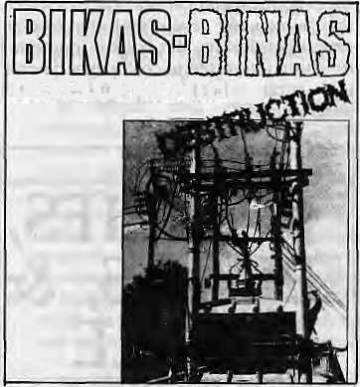
DEVELOPMENT::
The Change in Life and Environment of the Himalaya
By Kunda Dixit and Ludmilla Tuting,
Editors
Geobuch, Munich 1986
USS 9, NRs 120
Review by Rajiv Regini
T
HE book is a collection of articles, clippings, cartoons, satire, and tables. The common thread running through them all is the Himalayan environment. The theme is the juxtaposition of "bikas-" (Sanskrit: development) and "binas" (Sanskrit: destruction). Like a typographical error, one is often mistaken for the other, and the book argues that much of what is propagated as bikas in the Himalaya today brings binas.
"If there are any imperfections in the use of the language please bear in mind that most contributors are non-native speakers of English," says a note at the beginning of the book. And one wonders half-way through it if this is an apology for the abundant typos or for the slightly strident style of much of the writing selected.
The part on the Chipko reads like a PR pamphlet, and is a bit too gung-ho about the movement. The piece doesn't focus on the obstacles that countries like Nepal would face in trying to replicate something like the Chipko, for example. Bahuguna's crusade is one that has been carefully moulded around a perceived outside threat (contractors, plains businessmen, big dams planned in Lucknow). In countries like Nepal, where
the enemy is within, (the need for wood energy in order to survive) what are the lessons to be learned? Bikas-Binas is silent on the subject.
The authors must have spent several years collecting the material. This is rather glaringly obvious because some of the pieces have aged quite a bit, like Kunda Dixit's interview with Sir Ed taken five years before the book hit the stands. In fact, the book would have been more focussed and compact if the whole section on tourism had been dropped. We wouldn't have noticed the difference. "Do's and Don'ts for Tourists in Nepal", how to cope with beggars, malaria and educated urban rapists -what're subjects like that doing in a nice book like this? Speaking of which, there are some unbelievably gruesome methods suggested to dissuade Third World rapists from deflowering female tourists travelling alone. Again, good solid information, but one isn't sure what it is doing in this book.
Can I just mention one little point before turning to the book's good side? The cover. For a snappy title like that, the cover design (for which a certain Inge Meenen takes credit) is horrendous.
Now the good news. The book is immensely readable, packed with information, punctuated with some bitingly hilarious cartoons, and is required reading for everyone seriously concerned about our Himalayan surroundings. Readers also have a chance to re-read some of Kunda Dixit's "Funny Side Ups" which used to be the best reading from the Rising Nepal and memorably poignant pieces like "Crops Cannot Be Grown on Blackboards Nor Certificates Eaten" by Nicholas Bennett, "Deadly Development," by Claude Alvares, "No losses, Just the Death of a Porter," by Ludmilla Tuting and "Blindly Following the West Brings Misery" by Mike Cheney.
Rajiv Regmi is doing his masters at a university in Illinois, USA.
Mountain People
edited by Michael Tobias University of Oklahoma Press, 1986. $ 29.95 NRs. 688
Review by Keiko Ohnuma
Development of mountain willdemess is nothing new. What is new is the rate
of change. Until recently most of the world's mountains were isolated and inaccessible, and the people who lived on them evolved for millennia outside the cultural mainstream. Improved health care, relentless population increase, growing national awareness and technological advancement have now brought many montane ecosystems to the brink of collapse - often hastened by the misguided efforts of government and foreign-aid agencies.
Addressing itself to policymakers as well as the general public, this collection of essays is both a plea on behalf of those who have no voice in world politics and a call to arms to those who do. The 26 authors, many of them social scientists, make a case for including the experience and knowledge of mountain people in international planning efforts.
More than a question of suitable crops, environmental preservation, or equitable land distribution, development presents a cultural challenge - a confrontation with another time, a different world view; as art historian Hugh R. Downs puts it, another method of seeing. By allowing anthropological awareness to enlighten public policy, the authors hope to foster "widening of knowledge", a scientific approach to indigenous cultures that parallels the growing concern for ecology in land-use policy. Social scientists must remember that "there is no freedom from values and politics in science," says Gerald Berreman. A scientist's first duty must be to the "truth" - namely, the truth of the people being studied, in contrast to the exigencies of* realpolitik.
Indeed, the value system under which most governments operate measures well-being by balance of payments, wealth by the presence of modern conveniences, and progress in terms of technological advancement. Foreignaid agencies, Berreman adds, typically undertake "reform" in the name of an abstract entity - the nation - whose interests are rarely seen as congruent with those of the masses.
Opening the book with reflections on his life among the people of the American Appalachian mountain range, psychology professor Robert Coles asks, "What possible connection can there be between the moral life of a given (people), on

H1MAL 29

NEW BOOKS

the one hand, and the particular terrain they happen to call their own?"
The Goltahuaya Indians of the Bolivian Andes provide one answer. The tribes live on nine peaks, each of which is divided into low, middle, and high communities. The Indians employ a system of vertical exchange characteristic of mountain economies that allows each community to specialize in the crops and techniques best suited to its ecological niche. Accordingly, the Kaatan community of Qollahuayans cosider the mountain to be like a human body, and look to themselves to understand the mountain. All rituals center on this metaphor and the unity of the three parts, providing an important cosmological mode! for the vertical exchange and interdependence on which the economy is based.
Likewise, in many societies dependence on the land may give rise to a belief system that emphasises the mountain's natural cycles, especially the soil and water cycles. Culturally speaking, these cycles correspond to a finely tuned agricultural calendar built on the techniques of slash-and-burn, seasonal use, and rotating a wide variety of crops on small, scattered plots to minimize risk and allow equitable distribution of terrain.
Human ecologist Kenneth Hewitt explains that for many indigenous societies the landscape is tied to a cosmological map that divides land into areas sacred and profane. This allows access to be regulated by time, conditions, age, and gender. "To recognize a pilgrimage spot in nature tends to restrain acts of pollution," writes Downs. ''allowing the land to regain its significance as a reflection of oneself."
Turning a critical eye toward mountain studies themselves, several authors note the historic tension between "civilized" lowlanders and "barbaric" highlanders. Civilization always seeks to convert barbarians. Ashworth says, and in this sense mountain people share the same struggle across national, political, and cultural boundaries-just as low-landers from East and West alike seek to wrest land and resources from the mountains.
Ethnicity has subjective elements that are often underrated. One of these is the assumption by many policy makers
HIMAL 30
that, where the ecosystem is in decline, natives are part of the problem. Indigenes are seen as stupid, driven to abuse the land through ignorance and need. The fact remains that mountain people are the only ones who have learned to live off the mountain without destroying it; centuries of survival show that these cultures are in fact highly evolved.
Until recently, isolation of the mountains helped to foster romanticism, the "Heidi complex". It is important to remember that the human beings who live "up there" have not engendered this imagery, the book warns, nor do they live by it. The photogenic, docile qualities of tribal people can mask the threat of extinction, and ah outsiders need for romanticism may blind them to the very real problems of highland living.
Ecology has never been a question of complete wilderness versus complete destruction, but one of balance. In this light, the demise of native wisdom is as great a loss as the disappearance of the mountains' natural landscape.
Today the ancient struggle between the sacred and profane takes place on the level of public policy. "How tragic," says Feldman, "that those who most suffer the loss of the land are those who would have been the last to allow it."
Keiko Ohnuma is on the staff of Sierra Magazine, from which this review is excerpted.
Policies, Plans and People Culture and Health Development in Nepal
by Judith Justice
University of California Press, Berkeley 1986
Review by Dr. Laxman Poudyal
The amount of money spent over the past decades on public health in the developing world has had a limited impact - and Nepal is no exception. Small pox is eradicated. But malaria has revealed its biological strength. Integration and primary health care have been little more than an academic exercise. What went wrong? Sincere stock-taking is needed.
Judith Justice has confronted Nepal's misadventures with health development squarely, and in doing so lays bare a
socio-political and cultural maze in which the bureaucrat revels and the foreign expert gets lost in. Her book is important for those interested in costly experiments in rural health .planning and programming.
POLICIES, PLANS, & PEOPLE
Culture and Health Development
^^^^^^₌₌^=^^^₌ in Nepal
Judith Justice
It is only after 1950 that the Nepali Health Ministry was established - manned by persons with no experience in health administration. By the time they became familiar with the health problems they were transferred to other ministries. Health administration soon became the last option for an aspirant civil servant since it was both unpredictable and unrewarding.
The United States is the major donor in Nepal's health sector. Unfortunately, its assistance is flawed by political considerations and the search of lowcost implementing agencies. Certain private health agencies are hired to deliver the programmes - and the recipient country has very little to say in the selection, Ali other considerations are subordinated to the convenience of 'handling aid'. This middleman policy causes leakages so that very little reaches the recipient.
An international agency like WHO has its own procedure. While offers with strings attached from a particular country may be rejected, help from WHO is always welcome. The eradication of small pox has been the organisation's greatest achievement - an example of how to mobilise political will and money. Unfortunately the weaker member states

MAIL

of WHO do not have an efficient machinery to cope at times with the idealistic programmes originating in the Geneva headquarters.
In Nepal and other ■ developing countries, the villagers are simple, obedient and intelligent folks. They will accept anything that is reasonable. It is a matter for concern therefore that the government often does not have the ability to judge the merit of proposed projects. More often than not, anything provided is blindly accepted. Resourceful in money and trained manpower, WHO could play a more effective and dynamic role in the development of rural health.
As Ms Justice so ably argues, the problem is not only with those who give aid, of course, but also with the implementation of rural health programmes by the government. It is not easy to implant any alien concept in a society which has its own norms
and values. Factors such as ethnicity, language barriers and mass literacy all play their role. Completely decentralised
administration with strong leadership
even at the peripheral level is vital to
overcome obstacles.
Out of this jumble of international, national and rural efforts to provide better health to Nepalis, littered with corpses of good intentions, Ms Justice has produced a coherent and incisive indictment that touches upon all the actors. She has understood both the traditional pattern of Nepali administration and the foreign role. Most important, she has not neglected the services of the peon in the health post - "the invisible health worker" - who holds the lowest grade in the health services. Neither has she ignored the assistant nurse midwife, the victim of circumstance created by the cultural outlook of the villagers, idiocy of international planning without cultural considerations and the ever-dormant national health administration. The collusion of these three elements make up for the sorry state of Nepali health today.
Dr. Laxman Poudyal was for many years HMG's Director and then Secretary for Heattti.
(Not having any readers'response for this prototype issue, we have excerpted thought-provoking pieces by two well-known writers. We ask readers to make liberal use of this space to comment on, criticise or add to information apearing in this magazine. Please write in.)
I see environmental Khomeinis all over the place these days, and I ask them questions and I get shouted at. These fundamentalists seem to be against the whole development process. They are for preserving forests, but don't want to give villagers electricity so they can stop cutting trees. They are against dams (apart from earthquakes, dams are said to produce disease-carrying snails). They are against cars, colour television and computers. They go from campaign to campaign in search of a sylvan Ram Rajya, where windmills mushroom and solar energy does the cooking. Good luck to them, and I shall be the first to set up house in that paradise.
But some of these campaigns, like the one against atomic energy (after all it began long before Chernobyl) are too much like part of a cyclical campaign against Third World development. Ten years ago, at the Pugwash Conference, in Madras I questioned a number of Western scientists about nuclear energy. Almost all of them said it had no future: it had to be phased o*ut, there wasn't enough nuclear fuel in the world, there Was no way to get rid of nuclear wastes, and so on. But their own governments have gone ahead with nuclear expansion programmes. If some of them have stopped expanding in the last year or two, it's because there is no need. And they have done well. But somehow, for Third World countries, the requirements were thought to be different.
In the 1970's, the western neurosis was about the world's resources being limited. International experts and emissaries of multi-nationals went around Asian, African and Latin American capitals advising governments to go easy with their old exploration and industrialisation. Simple living and high thinking were recommended for us, the underdeveloped. I remember New Society magazine of London saying, "Why should the Indians want to manufacture motor cars? See what we in the West have done to our cities.'.'
There is an international vested interest in blocking the progress of poorer nations. especially if they want to develop their own resources, and become economically independent. This is why I deeply suspect advice that comes from foreign sources. I mistrust the Gandhism and the environmentalism that is often imparted to us from London, Bonn or Washington.
Am I being xenophobic?
Abu Abraham
Mainstream New Delhi.
Environmental questions concern people as much as anything else. The trouble is that many tend to think of the environment as an object of aesthetic delight, something that ought to be preserved unless its exploitation is absolutely necessary. But it is very much ■more than that. The best way is to treat it as the source of natural resources — land, water, atmosphere and, not the least, people themselves. Any process that damages irreversibly the nurturing of these resources - call it "development" if you like, though that is obviously a misnomer - is what constitutes an environmental threat.
The cases of the Silent Valley in Kerala, the Mathura oil refinery vis-a-vis Taj Mahal and the Thal-Vaishet fertilizer plant near Bombay quite clearly demonstrate that, far from posing a choice between environment and development, once we accept the definition of environment as a matter of resources, the two actually are two sides of the coin. To perceive the problem in terms of "ecology or economics" or "monkeys versus men" is to miss the point: if any project helps to nurture the generation of resources, it is to be environmentally and economically sound. This is not to deny that each and every big industrial project is bound to have some impact on the environment. The crux of the matter is whether it will destroy, in the long run, rather than develop.
Silent Valley, in fact, has laid down a new development paradigm in the country - the possibility of development without destruction.
Darryl D'Monte
Facets Bombay
HIMAL 31

BRIEFS

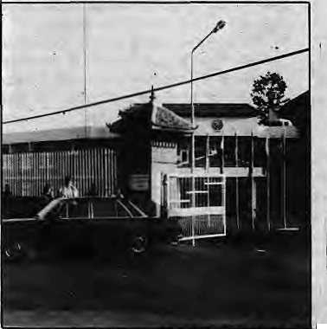
Apple State's Problem:Too Many Apples
Last year, Himachal Pradesh produced a record 300,000 tons of apples, worth IRs 550 million. The bad news is that they require nine million wooden crates to be distributed .to the far corners of India. To satisfy that demand 65,000 evergreeens, most of them more than a century old, will have to be felled. While the crates cost IRs 270 million, the Himachal Government is supplying them to growers at a subsidised rate of IRs 90 million.
The state Government of Virbhadra Singh, himself an apple man, says it is committed to conserving the 15 per cent of Himachal's total area that is still under forests. With that in mind, he had boldly decided to impose a complete ban on the felling of trees for making crates. The decision took even environmentalists by surprise, and brought him in direct confrontation with the state's powerful apple lobby.
Large orchard owners and the apple trade middlemen claim that only wooden cases will protect their fruit adequately. Some 1,000 sawmill operators and truck owners who lift 25,000 lorry-loads of apples every year also have an interest in the continued use of wood. The heavy crates also enable porters to earn more, and they are easier to handle. In the cities, the wooden crates are bought for cheap and converted into the poor man's furniture.
Environmentalists worry that with apples providing 80 percent of Himachal's horticultural wealth, forests may be sacrificed for short-term economic interests. If timber is still used by the turn of the century, the demand will be for 30 million boxes. That makes 200,000 standing conifers.
SAARC Sets Up Shop in Kathmandu
The headquarters of the South Asia Association for Regional Co-operation (SAARC) was inaugurated in Kathmandu in January. City fathers, foreign ministry
HIMAL 32
types and whoever had a stake got excited once more over prospects of an "internationalised". Kathmandu. It became the second agency after the International Centre for Integrated Mountain Development (ICIMOD) to base itself in Kathmandu.
"Before we get too excited, let us remember that SAARC and ICIMOD
had no other choice but Kathmandu", says ft political scientist in Tribhuvan University. "To be like Geneva, a host to!conferences and organisations, we've got to straighten up our act.
There are, in fact, four or five development institutes under the Economic and Social Council for Asia and the Pacific (ESCAP) that would consider a move to Kathmandu, One of them is then Asia-Pacific Centre for Transfer of Technology, which is said to find operating conditions too restrictive in Bangalore. There are also proposals to establish an international institute on glaciology and another for mountain medicine, with Kathmandu as a possible base for both.
Gates of SAARC
The prospects would seem good except that Nepal is following India's lead in forming its host country attitudes. The International Diarrhoea Research Institute in Dhaka and the International Institute for the Management of Irrigation in Colombo receive more facilities (in terms of government subsidies, tax-free premises and non-taxation of national staff) than does ICIMOD in Kathmandu.
With Delhi and Bangkok already flooded as regional hubs, and other centres like Singapore and Seoul
considered unsuitable because they are too "developed" or westward-oriented, the search is on for a politically acceptable host city. "As probably the most neutral State in the region, Nepal is a natural centre for international organs," says Colin Rosser, Director of ICIMOD. He continues, "We hope to prove to the world that, making Kathmandu a base, it is possible to maintain the highest international standards, and thereby start a trend".
A Subterranean Himalaya
Scientists have discovered a second "Himalayan" mountain range beneath central India. The hidden mountain system is about 1,500 km long and 300 wide, with a 6,000 metre peak below Amarkantak, according to the discovery by scientists of the Satellite Geophysics group of the National Geo-physical Research Institute in Hyderabad. The underground mountain range has been found to run parallel to the Himalaya range in a northwest to southeast direction. It is bounded by the Mahanadi and the Godavari rift valleys in the east and the Aravalli in the west,'according to the study reported by the institute scientists, in the prestigious American journal "Geophysical Research Letters", The mountain system is believed to have emerged due to "upwarding" of the earth's crust at a depth of less than 40 km from the surface. The deep underground mountain system is one of the largest linear structures of the sub-continent next only to the Himalaya mountain system, according to the report.
Remote Sensors Have Problems
The National Remote Sensing Centre in Kathmandu, which became fully operational in 1984 with help from USAID, boasts of one of the most sophisticated equipments in Asia to analyse data and imagery from satellite and aerial recon-naisance. It has a multidisciplinary team of scientists and engineers ready to provide assistance in forestry, agriculture, soils, geology, hydrology, meteorology, computers, cartography and photography using remote sensing techniques.
And yet, the Centre has not been able to perform as it should because of

BRIEFS

"technology resistance" among the more, conventionally trained, says it chief, Krishna Malla. The cost of raw satellite data, which suddenly nearly quadrupled last' year, was another reason given.
The Centre is equipped to analyse the US LANDSAT data, which it gets from receiving stations in Hyderabad or Bangkok. It takes fourteen frames to cover the whole country, with each frame covering an area of 185 sq km. Since the Reagan Administration sold LANDSAT to the private Earth Observation Satellite Company, the charge went up overnight from US$300 per frame to US$1000. Says Malla, "Its a real problem, because we now have to go through a tortuous trail to get funding. It took us three years to get US$10,000 to do a study on the Arun River Valley."
The Centre is currently doing a study for the national parks and wildlife office on the as-yet pristine Khaptad plateau in west Nepal: its drainage, altitude differential, vegetation and wildlife requirements. A job 'hat could take four years on the ground, but most of it can be done with the use of computers in 15 days.
An Unwelcome Pack

Naulo, the newcomer to Nepal's highly protected cigarette market has been welcoming itself all over Kathmandu in banners and billboards. While the Surya Tobacco Company has done itself credit by printing a health warning on the side of the cigarette pack, what concerns us is the public health policy of HMG.
The Janakpur Cigarette Factory, purveyor of Lali Guras and Saipatri to
the wealthy, and unfiltered Gaidas and Asha churots to the rest of the Janata,
was established with Soviet aid in 1962. Happily, no cigarette factories had opened in the two dozen years since -until Naulo. "We must be doing everything possible to discourage smoking among Nepalis", says a Nepali heart and lung specialist, "It is no consolation that the new cigarette is aimed at the upper crust market. There is such a thing as class mimicry, and also, what is to stop the factory from churning out cigarette for the villager's pocket? The upscale cigarettes do not make money in Nepal, the Janakpur people will tell you that".
Surya Tobacco has also just unleashed a second brand of cigarettes. They are called, shockingly enough, Bijuli and banners across Nepal announce you get one Bijuli free for every Naulo purchase.
Meanwhile, Janakpur Cigarette Factory has also been granted permission to open a subsidiary, it is learnt.
University Begins Study of Eastern Himalaya
The North Eastern Hill University has begun a research project on the ecological development of the Himalaya. The study, in association with the Universities of Dibrugarh, Guwahati, Jorhat and several government departments, will attempt to further understanding of the mountains of the Indian northeast.
The University hs so far secured approval for eight of its proposed 14 projects, the total cost of which is expected to come to IRs 2.25 million. As a frist step, the University is going to prepare an ecological perspective of the region, which will include the ecological history, evolution of geographic features, study of flora and fauna and the human presence through "geological time". Answers will also be sought to the "ecological predicament" confronting the region, according to a University official.
He also said that the project would aim to preserve genetic diversity and ensure effective utilisation of species and the ecosystem.
Punya Bahadur To the Rescue
Other countries might have Superman and Popeye, but now Nepal can boast of its own uniquely homegrown cartoon character. Except that our new hero, Punya Bahadur, who is a peon at an unspecified health post in a durgam chhetra locale, would be too shy to help any damsel in distress or foil a robbery at a district bank. The quiet, uncomplaining Punya Bahadur is more at ease acquainting villagers with oral rehydration salts, cleaning wounds and treating eye infections. He also sweeps the floor and brings endless cups of tea for the resident doctor, who spends his time reading Gorkhapatra, chatting with friends, and ordering tea.
Created by artist Durga Baral, an art teacher in Pokhara, Punya Bahadur is part of a cast of characters of Nava Drishya, an ambitious Unicef quarterly that hopes to bring development issues come alive for the "new literates". The second issue of the finely produced publication will be on the stands this month. Unicef hopes that, in time, the distinctive cartoon characters and the highly believable village-settings will create enough of regular readership for Nava Drishya to be a commercial success.
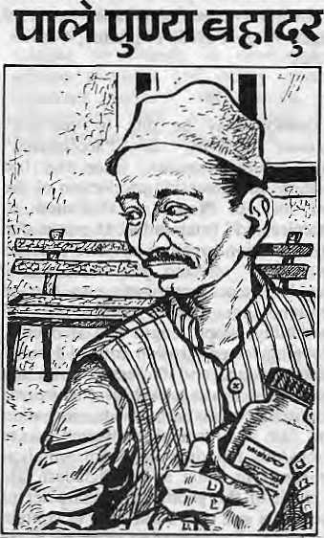

KlMAL 33

ABSTRACTS

By arrangement with Environmental
Services Group/World Wildlife
Fund-India (New Delhi), we reproduce here abstracts of recent publications that
have a bearing on the development and environment of the Himalaya.
Tilak, Raj and S. P. Baloni. ON THE RELATIONSHIP OF ALTITUDE AND FISH COMMUNITIES IN GARHWAL HILLS, UTTAR PRADESH (INDIA)
Indian JForestry. 8(3): 208-213.1985
Altitude plays an important part in the distribution of fish. The various factors which limit the distribution of fish communities in Garhwal hills are the hydroclimate, the size and the gradient of the stream, and changes in biotic conditions. The reduction of the number of species at higher altitude could be connected with the geomorphological changes brought about in the Himalaya in different geological eras. The absence of fish communities above an altitude of 1311 m in Garhwal hills could be due to the recent uplift of the Himalaya in this region.
(Zoological Survey of India, Dehra Dun 248 001, India).
Carson, Brian. EROSION AND SEDIMENTATION PROCESSES IN THE NEPALESE HIMALYA.
ICIMOD Occasional Paper No. 1,39. pages. August 1985. 17 photos, 4 tables, 6 figs.
Erosion may be due to "natural" tectonic activity or "accelerated" (man-induced) causes. Over the last century, an increasing proportion of the soil loss in Nepal is attributed to "accelerated" (man-induced) causes due to population pressure on land and has profoundly affected the economy of Nepal. Factors contributing to surface erosion, eg. rainfall erosivity, soil erodibility, slope length and steepness, cropping factor, erosion control factors, wind erosion, and factors contributing to massive wasting, such as engineering activities, vegetation, roads, irrigation and dam and reservoir construction, are discussed. Flooding and sedimentation problems in India and Bangladesh are a result of the geomorphic character of the rivers and man's attempts to contain the rivers. Deforestation probably plays
HIMAL 34
only a minor, if any role in the major monsoon flood events on the lower Ganges. Better management of existing forest lands and marginal agricultural lands is essential, however, to ensure the continued livelihood of the Himalayan hill farmer. (ICIMOD, GPO Box 3226, Kathmandu, Nepal)
Cooper, Charles F. and Joseph Gale
CARBON DIOXIDE
ENHANCEMENT OF. TREE GROWTH AT THE HIGH ELEVATIONS.
Science. 231 (4740): 859-860. 1986
The apparent acceleration of tree growth by increased atmospheric CO observed by LA MARCHE et al (Science. 225:1019.1984) and the relation of rate of photosynthesis to altitude, radiation, and the level of CO ₂ in the atmosphere, are discussed. The theories advanced are relevant because of increasing world CO₂ levels,
1986 American Association for the Advancement of Science.
Khoshoo, T. N. STRATEGY FOR PRODUCTION AND UTILISATION OF FIREWOOD IN THE HIMALAYAS.
■Energy Environment Monitor. 2 (1): 20-25. March 1986,
Different types of forests in the Himalaya, and the various factors degrading them and the extent of degradation, are reviewed. Firewood is still the staple energy resource (subsistence fuel) for 75% of the population in the developing world, for cooking and heating purposes. Against an anticipated requirement of 300-330 million tonnes (Mt) by 2000 AD, the recordable production in India is 30-40 Mt. Firewood has never been a major goal of forestry operations; it is collected free in rural areas. For successful augmentation of resources, villagers should be encouraged to plant multi-purpose trees (Agro-Si lvi-Pastoral) under Social Forestry. Conversion to charcoal can save transport and storage charges, but present production methods are wasteful. Less valuable species thinned from mixed forests could be used. Improved wood stoves and pressure cookers at subsidised rates are suggested for improving fuel efficiency. Biogas, solar energy, micro/mini hydel projects
are alternatives, but present biogas
systems are not workable above 1,000 metres, for which suitable microbes and reactor designs need to be evolved.
(Distinguished Scientist CSIR, Tata Energy Research Institute, 7 Jor Bagh, New Delhi 110003, India).
UNEP. CARRYING CAPACITY FOR TOURISM ACTIVITIES.
Industry and Environment. 9(1): 1-26. Jan/Feb/March 1986.
VIR SINGH and JAGDISH KAUR review the growth and present position of mountain tourism in the Himalaya. Tourism was expected to bridge the economic and social disparities between the highland lowland regions, but has actually widened the gap. Construction of border roads increased tourists, and provided alternative employment to Sherpas and Bhotias whose trade in crafts (and salt) was lost with the closure of the Tibet (China) border. Ladakh attracted tourists, but except for entrance fees to monuments, other earnings from tourists flows back into the Kashmir Valley and lowlands. In the Nepal Himalaya, tourism is well controlled by HMG. Garhwal has suffered from haphazard development resulting in ecological losses (Valley of Flowers, Nanda Devi, etc). Following the direction of Alpine tourism is not satisfactory. "Holistic" tourism should be developed.
86-6-0916. Abdulali, Humayum. ON EXPORTS OF FROG LEGS FROM INDIA.
J. BNHS. 82:347.1986.
It appears to be established that the frog plays an important part in the ecological cycle around the rice field and this is confirmed by an inquiry among villagers. The 15 tables covering its restricted breeding season, its growth, its readiness to breed in the year after hatching and its food at different ages and seasons etc., add new information to what is known. The small frog feeds largely on insects which have gathered together in numbers. Crabs which are harmful to rice in different ways form a large part of its diet when it grows
(Bombay Natural History Society, Hornbill House, Shahed Bhagat Singh Road, Bombay 400 023, India.)

INTRODUCTIONS
New Era

Inevery issue, HIMAL will introduce non-governmental organisations and research institutions doing work in the Himalayan region. — Editor
Development Alternatives
Development Alternatives, established in 1982, is a non-profit, multidisciplinary organisation engaged in designing, developing and delivering appropriate technology packages for sustainable development. The society designs environmentally sound and socially appropriate technologies aimed at the mass market so as to bring socio-economic change through self-supporting action at the grassroot level.
At the invitation of Sikkim's newly constituted Department of New and Renewable Sources of Energy, Development Alternatives ts organising a rural energy survey under the Integrated Rural Energy Planning (IREP) scheme so as to maximise use of existing resources. The Soreng Sub-Division in West District has been selected as the study region to develop a data-base for block level rural energy planning.
Development Alternatives plans to cover about'1,000 households in Soreng, which has a population of 34,662 spread over 62 villages. The study will assess the physical, economic and social environment relating to rural energy planning, investigate the basic needs, and attempt to understand the consumer's perception and preference regarding energy options. It will quantify available energy resources, map the consumption pattern, and suggest models to optimise use of soft woods, hard woods and other materials. As a follow-up, Development Alternatives will provide a framework for increasing progressively the net energy to be made available to the villagers of Sikkim.
Ashok Khosla, Executive Director 22, Palam Road, Vasant Vihar, New Delhi.
New ERA is a senior development consultancy in Kathmandu. In the past 15 years, it has completed nearly 150 studies and training programmes covering social and economic projects. By developing professional capability within Nepal, the group has contributed significantly to the process of replacing expensive expatriate expertise with professional Nepali know-how. In Juiy last year, New ERA adopted an enlightened policy by removing existing barriers between professional and non-professional staff members and providing uniform facilities.
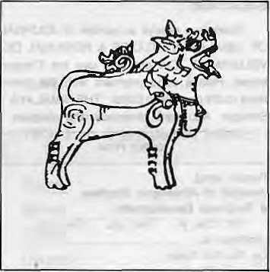
During the past year, New ERA completed 11 projects. Among other things, it studied the impact of the Nepal-Australia Forestry Project, looked into the problems of public participation in forestry development in Sindhupalchowk District, prepared an inventory of trained community health workers, suggested ways to improve hill farm productivity in Tanahu District, and estimated the fertility and mortality rates in Nepal by geographic region and socio-economic group.
Ongoing work of New ERA includes an evaluation of water supply and sanitation in the Tarai, asking why women do not use contraceptives, helping improve services to Nepali craftsmen, and preparing a strategy for involving women in natural resource management.
Bal Gopal Baidya,
Executive Director
P.O Box 722, Maharajgunj
Kathmandu.
Centre for Women and Development

Unhappy with the exclusion of women from the development process, a group of professional Nepali women got together in 1983 to give expression to their concern. The Centre for Women and Development is a non-profit "action agency" that wishes to "enable women to participate as full partners in the development of Nepal". In striving to create an environment in which women's potential is effectively used, it conducts multisectoral social science research, collects and disseminates information relating to women in development, advises planners and policy makers, organises seminars and training, and collaborates with governmental and non-governmental organisations.
The Centre is involved in translating into Nepali major works relating to women so as to make the literature more accessible locally. It has studied the representation of women in Nepali media as part of an Asia-Pacific regionwide study. It is conducting an analytical review of the impact and effectiveness of the Women' Development Programme under the Small Farmer Development Project. Work is in progress to establish within the Centre a Women and Development Information Network.
Bina Pradhan, Executive Director P.O. Box 3637 Kathmandu
HIMAL 35

CLASSIFIEDS
BOOKS
Aquaworld monthly. Deals with all aspects of
Water Resources Urban Rural Industrial Ag
ricultural Use and Pollution Control. Send self-
addressed stamped envelope for index. URJA
Post Box 3006 New Delhi H001
HOTELS
Mussorle. Acoomodation available for holiday home consisting eight to ten rooms, fully furnished, easily approachable, straight car drive. Contact manager, Hotel Anupam, Mussorie
H002
Mac h hap Lie hare Guest House, Pokhara. Reflec
tion of fish-tail on lake from veranda. Best view,
best price. Why pay through your nose for
something less classy? H003
Kakani Guest House. Breathtaking views of Ganesh Himal and Himalchuli, and Valley. Just twohoursoutofKathmandu. Phone2i0391
H004
PROPERTY
Land for sale in Summer Hill Simla (H. P.)
with a house on roadside. For details write: A.
D. S. Sadhu, Sector 36-D Chandigarh H005
Hilltop for sale at Nagarkot. Excellent site for
private bungalow or tourist guest house. Natural
spring in premises. Contact phone 241205,
Kathmandu H006
ETC
Solar Water Heaters. Quality Reliable Durable.
Balaju Yantra Shala Sanitary Engineering Ltd,
Balaju, Kathmandu 410840 H0O7
NOTICE
Nepal Forum of Environmental journalists (NFEJ) has identified some areas related to Nepal's environment for investigative reporting. The NFEJ is offering a number of short term fellowships to competent Nepalese journalists to carry out in-depth study in those specific areas. Interested mediamen are requested to contact the following for details.

Aditpa Man Shrestha Secretary-General P.O. Box; 930, Ph.AT. 410419 (Morning) 220578 (Office hours)
JOHSARD
RESEARCH IN MOUNTAIN
ECOLOGY & HILL DEVELOPMENT
THE INSTITUTE OF HIMALAYAN STUDIES & REGIONAL DEVELOPMENT, {Garhwal University) Sringar, Garhwal, publishes high content research in Mountain Ecology & Problems of Hill Area Development through its organ JOHSARD (Journal of Himalayan Studies and Regional Development) that comes out annually. Papers ae commissioned on specific Eco-problems to establish findings for sound ecological development process.
Printed on fine art paper, JOHSARD exposes problems in Himalayan Econology, Systematics, Environment and Development planning holistically by contributions from eminent resource persons and practising authorities of India and overseas.
Subscribe
Become a regular subscriber of JOURNAL OF HIMALAYAN STUDIES & REGIONAL DEVELOPMENT. Cut out and use the Coupon below. Please send payment with the order: Bank drafts payable to Editor "THE HIMALAYA", Srinagar. Add bank clearance with cheques.
ORDER FORM
Please send:
Journal of Himalayan Studies,
& Regional Development
for: One yr. Two yrs. Five yrs. Address to: Dn Tej Vir Singh, Director,
Institute of Himalayan Studies. P.B. No. 12,
SRINAGAR (GARHWAL). INDIA. Pin Code: 246174 RATES:
lnland:Rs. 20 Annual Overseas: $8 (Annual)
(Apply lor airmail)
Name: ,
Address:

enclose payment of
HOUSE.OFFICE, fl FLATS & LAND

in KATHMANDU A PATAfrJ Ar
FUTURE FEATURES
NEXT ISSUE
Cover Story: Migration from hilts of Kumaon, Garhwal and Nepal to the plains. Following Ratnasharan Thapa, who works as a domestic guard in a Delhi suburb and his son who washes dishes in a local restaurant, and their family of women, children and elders in the Nepali district of Gubni. History of migration, numbers. From people of Mustang seasonally selling sweaters in the North West India, Nepali tea plantation workers in South India, and guards for Bombay cinema houses.
Other features:
Social Marketing in the Himalaya: from contraceptives to oral rehydration salts, there is increasing use of commercial outlets to distribute products urgent for development.
Porters of die Himalaya: high-altitude mountain guides and the villager ferrying yearly rations to the homestead offer the most poignant aspect of fife and times in the Himalaya. Describe the different forms of portering. Follow a porter from Dhankuta bazaar to Taplejung - how traders use porters, tragedy of trekking porters forced to cross high passes, how lives are changing with the advent of motorable transport and even subsidised air cargo rates.
The Foreign Consultant: Brains or Drain? An extensive study of the usefulness of foreign consultants, with partisan accounts from both extremes. Use case studies of foreign-consul tan! fiascos to situations where they might be indispensable.
Why Just One Chipko? Examine the possibilities of grassroots movements throughout the Himalaya. Prospects for people-power projects throughout the Himalaya, Opinions of social-scientists and politicians. Resurgence of Malaria: Resistant strains of the mosquito has led to an ever increasing incidence of malaria in the Himalayan mid and sub hills. What is being done by the various health authorities, and to what extent is there co-ordination.
Airlines of the Himalaya: History of flying in the mountains, from World War II relics of Royal Nepal to the spanking new Dorniers of Druk Air and Vayudoot* The impact of air travel on the economy who uses the air routes, the heavy subsidy of Royal Nepal's remote district service, a study of the STOL airstrips throughout the Himalaya.
Use -of Foreign Aid in the Himalaya: A comprehensive study of how effective foreign assistance has been in the development process in the mountain regions of south-Centra! Asia. to visit Kailash, Nopali pilgrims taken by jeep from Humla to Manasarovar. The border population of nomads and traders dial have been crossing to and fro regardless of geo-political situations.
The Trans-Himalayan Passage: An informative piece on the various ways to cross over the Himalaya, from the newly opened Ksrakoram Highway to the Kodari Highway that links Kathmandu to Lhasa.

HIMAL 36

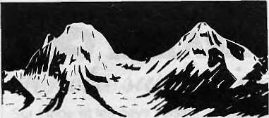
H1M&L
YES, I am interested in HIMAL Please include me in your mailing list.
Name
Street Town

Join HIM[>L
As the need for common approaches to Himalayan development becomes increasingly obvious, so does the necessity of an open-minded, independent periodical to address the issues unique to the mountain environment of south-central asia. This new monthly, HIMAL, will provide news and analysis of the issues that affect the people of the Himalayan crescent.
Join us. Please send back the attached slips that will automatically put you on our mailing list, enclose any comments you have on this prototype issue. If all slips have been taken, write:
HIMAL P.O.Box 42 Lalitpur, Nepal

Country
Postal Code
HIMOL
YES, I am interested in HIMAL Please include me in your mailing list.

Name
Street
Town
Country | Postal Code
HIM0L
■YES, I am interested in HIMAL. Please include me in your mailing list.
Name Street Town
Country
Postal Code

HIMfsL
P.O.Box 42
Lalitpur,
Nepal
HIMM,
P.O.Box 42
Lalitpur, Nepal
P.O.Box 42
Lalitpur,
Nepal

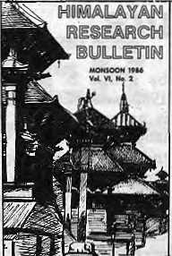

Rue Saint Paul
KAILASH
Sur I'lnde et les pays voisins: Sri Lanka, Afghanistan, Pakistan, Bangladesh, Birmanie.
Sur les pays de I'Himalaya: Tibet, Nepal, Buthan, Sikkim
Kantipath, Kathmandu P. B. 3653 Kathmandu,
^{Ne}P^{al} Une librairie
Publications from the International Potato Centre Centra International de la Papa P.O. Box: 5969, Lima, Peru.
Marketing Bhutan's Potatoes
Scott, Gregory J., 1985
Traditional Potato Production and Farmers'
Selection of,Variations in Eastern Nepal
Report No. 2, Rhoades, Robert E., 1985.
The Himalayan Re
search Bulletin facili
tates communication
and co-operation
among scholars working in the Himalayan region. It is the official publication of the Nepal Studies Association, and associated group within the As-sociaHon for Asian Studies. Membership in the Nepal Studies Association is open to anyone with an interest in the Himalayan region. Members receive the Bulletin thrice annually. Individual membership dues are VS$ IS, or VS$ 10 for students. Institutional fees are US$ 35. Please direct all correspondence to the Southern Asian Institute, 1128 International Affairs Buildings, Columbia University, New York, N. Y. 10027.


FINEST
CHINESE FOOD IN TOWN
EVERYDAY 11A.M. to 10 PM
Read
MAN & DEVELOPMENT

CENTRE FOR RESEARCH IN RURAL AND
INDUSTRIAL DEVELOPMENT 2-A, Madhya Marg, Sector 19-A,
Chundigarh-160 019 (India) Gram: CRRID Phone: 23136, 33045, 31309.

Jute is one of the main sources of our national economy. Let us put more sweat and skill in it and develop it into a
wider industrial success.
Kathmandu Nepal Ph: 215147
Biratnagar Ph:49.
JUTE DEVELOPMENT AND TRADING CORPORATION
Cable: JUDCO

HIMAL 37

Abominably Yours,

During long winter nights when I'm snowed in at my cave up the valley from Olangchunggola, there is nothing I like better than curling up in my tahr-fur cot and catching up with the region's journals. At times, the neighbours complain because my thunderous guffaws resound back and forth across the craggy ridges of the Upper Banin.
But unfortunately, most of the stuff I read is serious stuff dealing in one way or the other with the environment. Take this little item in a recent issue of the Delhi Patriot that the Langur dropped into my mailbox this morning.
"Dr Shiva Prasad Kosta, director of the Satellite Centre in Bangalore has successfully demonstrated that nature provides perfect television antennas in a wide variety of trees," says an item on page three. Kosta has appearently found that coconut, eucalyptus, mango, banana and casuarina trees all work as excellent television antennas if hooked up properly. "In fact," Kosta is quoted as saying, "they frequently "work better than conventional antennae."
This could potentially be the best news on the Himalayan environment since that scoop of yester year about a new superfly that devoured the "Banmara" (andenoforum) weed. What better way to keep our hills and valley green. Dr Kosta has found you don't even need cables - all you do is hook up the xylem of tall neighbourhood tree to the RF input socket of your VTR, and hook the aerial terminal of your TV set to the RF output socket with the DIN-DIN coaxial cable that comes with every Sony you buy. Get it? Now, join the RF input adapter to the soft spot on our tree in between the pholem and the cholorenchyma. Voila... Doordarshan on Nepal TV as if you were living 100 meters away from the transmitting station. Useful hints from Dr. Kosta: "A banana, papaya or coconut leaf can stimulate a finite dielectric antenna aperture which can tap the electromagnetic waves absorbed by the leaves much better." All I have to say to that is I guess us up here in the mountains will have to wait till Dr. Kosta brings out a new juniper on hemlock model.
And what do you say about this excellent lead paragraph in an article
by a Mr. B. K. Aryal in the Jan. 9, 1987 issue of the Still Rising Nepal: "As is generally known, the current Nepali language has made an extensive use of the ergative sentence pattern which is normally typified by a postpositional 'le' and which is capable of additionally expressing an instrumental meaning and the subject-predicate concurrence with regard to the gender and number (pause for breath here) the study of inscriptions and other texts written in the ancient (XTV-X-VI Century) and the old. (XVII-XVHIc) Nepali is good testimony that this situation existed in that language not always, and that the currently occuring ergative construction is the result of several centuries of its evolution which has undergone a whole array of phases..."
No wonder those folks up in Darjeeling feel so strongly about their ergative postpositional "le" eh?
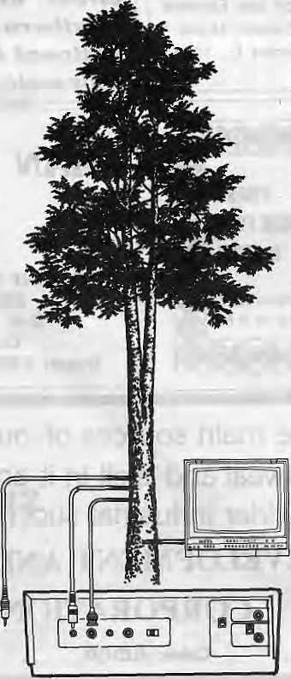

Speaking of trees, did you see that little piece in a recent Indian Express about eucalyptus being native to India? The anti-eucalyptus wallahs who complain about indigenous species being swamped by imports can look for another tree to bark up - it seems paleobotanists rummaging about the Deccan plateau have found fossils to prove there-were jungles of Eucalyptus in ancient times. This was before the British got to India - at that time India was still a part of Gondwanaland, and empire that joined Australia and India with Africa. So what if the Australian Forestry Project wants to plant eucalyptus, we had it here all a long.
And from Dehra Dun comes the astounding discovery that the jungle crow (Corvus macrrhynchos Waglar) is actually a major seed disperser of many Himalayan trees, especially the champa (Mickelia champaca L). Champa seeds apparently pass through the crow's digestive system unscathed and when jettisoned with the bird's droppings, grow into a new tree. "Seeds collected from the trees and jungle crow droppings sown within two days of collection gave 68.75 to 93.75 percentage germination," says the Wildlife Institute at Dehra Dun.
The future course of action to reforest the Himalaya is clear. Get the jungle crow to broadcast seeds, and get a better picture by hooking up with a nice eucalyptus.
Abominably Yours,

MARK.
fc

HIMAL 38

ISSUE AFTER ISSUE, OUR ONLY ISSUE IS DEVELOPMENT

THE MAGAZINE THAT IS AS INVOLVED WITH DEVELOPMENT AS YOU ARE.
As a development professional, your concerns are managing and improving conditions worldwide. Effective information exchange is vital to your day-to-day decisions and your long-range planning.
Development International is a magazine devoted to the people who make development happen around the world. It is an important new vehicle for development professionals who work to make a difference.
Six times a year, Development International's sector coverage will concentrate on the vital issues
that affect agriculture, business, education, energy, infrastructure, health and population. Included in this innovative magazine are timely features, provocative columns, and departments that focus on current advances in research and cover such areas as material and services (Resources), travel (Connections), events to attend (Professional Planner), and merchandise (Products).
Use the form below to become a charter subscriber. Help make the vision of a better world clearer. Subscribe now for yourself and for a colleague in a developing nation.

WAYS TO SUBSCRIBE TO DEVELOPMENT INTERNATIONAL:

Exp. Date.
Zip/Postal Zone.
Return with payment in U. S. funds to; DEVELOPMENT INTERNATIONAL. 1111 North 19th Street, Suite 400 Arlington, VA 22209, U.S.A.
INDIVIDUAL AND GIFT SUBSCRIPTION:
A one-year subscription brings 6 bimonthly issues to you, or to someone else as a gift.
□ lYean U.S. $2a £16.50
D 2 Year: U.S. $40 £26.50
SPONSORSHIP SUBSCRIPTION:
Development International will be sent to you and a companion subscription to a colleague in a developing nation. You may specify the gift recipient or permit us to select from our list of applicants in the developing nations. In the latter case, your gift subscription will be deductible for federal income tax purposes.
- lYear: U.S. $40 £26.50
- 2 Year: U.S. $75 £50.00
D Access □ Barclaycard □ MasterCard/Visa
Card Acct. No..
Signature
My individual/gift subscription is delivered to:
Name '
Address
Country ₌
For sponsored subscriptions, please provide us with an additional name and address for the person you want to receive DEVELOPMENT INTERNATIONAL, or instruct us to choose someone for you.
[development
INTERNATIONAL
■ 1MTCDM ATirMVI AI

-L-







The New 757 way of Royal Nepa
t*~"---
::s.s.■: ''~* "'■" '- ""' ' ^{l}
(3 , «*••••••■
*'
.§■
Royal Nepal Airlines, the friendly flag carrier of beautiful kingdom of Nepal, is introducing modern • technology Boeing 757 service to Kathmandufrom October 1987. The Ultimate 757 of Royal Nepal Airlines will fly direct to Kathmandufrom Hong Kong, Bangkok, Delhi and Singapore more quickly, safely and comfortably than ever before with 16 Executive and 174 Royal Class Guests.
Give your clients a quiet, comfortable and smooth way to Nepal. Fly Royal Nepal.
Boeing 757 Schedule: October 1987
V Singapore Service by 757 will start from October 1988
oyal Nepal l
m^^Airlines
fastest way to Nepal
Serving: Bangkok Calcutta Colombo Delhi. Dhaka Dubai Hong Kong Karachi Kathmandu Rangoon Singapore
Tel: 235-3921 298-534 573-351 321-572 317-120 238-308 3699-151 525-683 220^757 71347 225-7575
GROUP HI

 | 247 | 246 | Days | 3.5.7 | 247
1100 1800 | 1100  1500 | 1920 2030 | d Kathmand u a a Delhi d a Bangkok d a Hongkong d | 1000 0830 | 1800  1620  • | 2045 1900

Printed by Sarvodaya Vishva Lekha, Ratmalana. Sri Lanka

