

NRs20 IRs12 U$6
JULY 1988

FOR DEVELOPMENT AND ENVIRONMENT

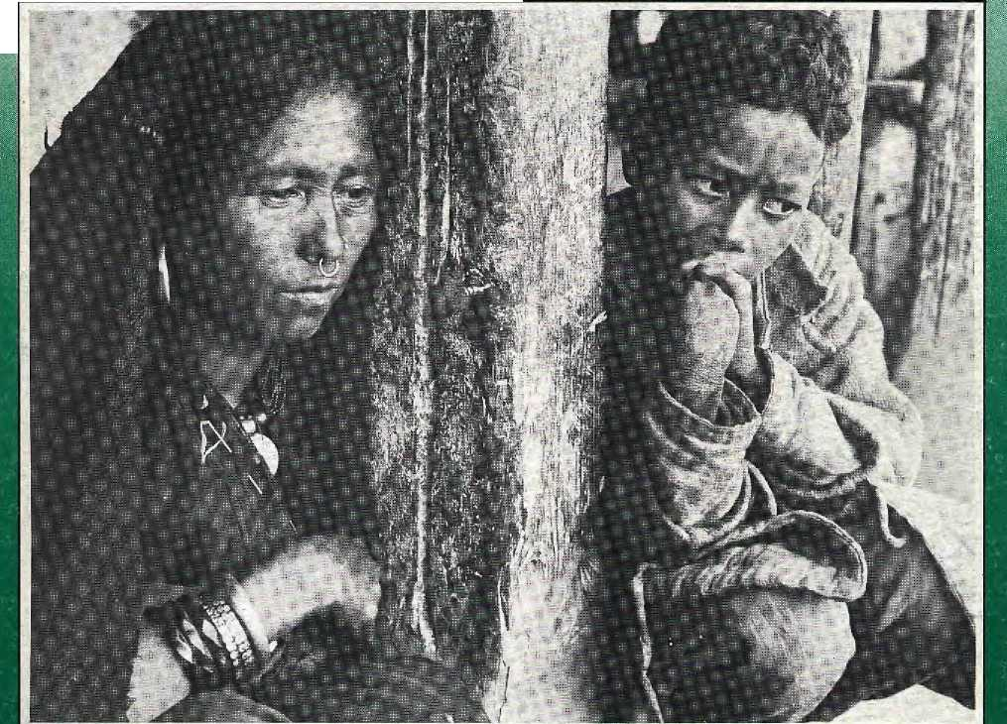
: "::'- ■:: : "'■■■:':. -'•■•■'.::: ■ *..'-■:' •" ■ ;--; -K:' ■■■ " -V -.;:: v- i■-.: •;■■ -:- ■■•■■:-::.
■ ■:■: :■::■■■■■■■ ..-. :: : :■•-•■■■:.•■••■••,•■■ ■:.-:-■■■ ■ ■ .;--i~i ::::,:■,:;. .•,:::,::

ARUNACHAL PRADESH FUEL-EFFICIENT CREMATION WILDLIFE WATCH . . .AND MORE
MIGRATION Highlanders on the Move
HIMALAYAN OZONE HOLE?
CUNNING CONSULTANTS I
PORTER PICTURES '
HILLARY INTERVIEW

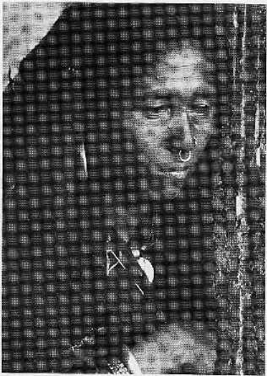
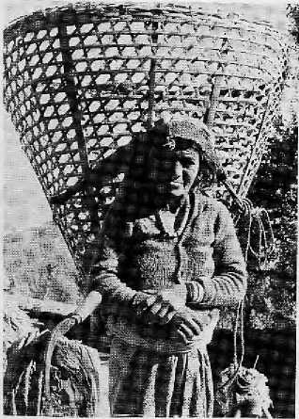
INSIDE
COVER 3 MIGRATION: Highlanders on the Move
7 Appropriate Crematoria
9 Hooch in the Hills
- Himalayan Ozone Hole?
- Consultants
14 Focus on Arunachal
17 INTERVIEW Edmund Hillary
22 PHOTO ESSAY
Portering is a hard life...
32 Nepal's Colleges in Crisis
19 VIEWS Big Dams, Small Dams Technology's New Rules Dalai Lama on Ecology Junk Commercials Typhoid Vaccine Trials
16 ON THE WAY UP...
18 GRASSROOTS
- PARKS, WILDLIFE
- BRIEFS

- NEW PUBLICATIONS
- REVIEWS
38 ABSTRACTS
40 FUTURE FEATURES 44 ABOMINABLY YOURS
HIM ;L
Vol. 1 No. 1
ftre■ £'■ wops|: yxh, <;rig-; $#;>-mountains, Himalaya You bound the ocRans from the
To measure tine Earlti
Kanak Mani Dixit for Himal Associates
Contributors to this issue
Rosha Bajracharya Binod Bhattaraf
Prakash Khanal Sudhirendar Sharma
Advisory Panel
M. Abdullah International Centre for Integrated Mountain Development,
Adlai Amor. Magsasay Foundation,
Anita Anand. -'nter Press Service,
Kinley Dorje Kuensel. Thimpu Harka Bahadur Gurung KaUirnandu Corneille Jest, Centre National dc la Recherche Scientifique Par^ Bharat D. Koirala. Nepal Press Institute. Kathmandu Ram Chandra Malhotra International Fund for Agricultural
;^ ^p ^TV ^. ^V. : .. v V: :.V:V/:::: v j Hemanta Mishra. King Mahendra Trust for Nature Conservation,
Kumar Khadga Bickram Shah

Acknowledgements
This issue was made possible by grants from The Panos Institute,
Environmental Concerns International and World Wildlife Fund/USA and also
from the Ashoka Foundation and the School for International Training. Thanks
also to: Ludwig Debuck, Claus Euler, Khagendra Gharti- Chhetri, Doug
Hand, Mana Ranjan Josse, Louise Laheurte, Sanomaiya Maharjan, Adolf
Odermatt, Anjali and Mohan Peck, Miriam Poser, Milan Rimal, Linda
Sachs, Ratna Kumar Sharma, P. Sudhakaran and Bharat Upreti.
Typeset by Robert Cohen/Affordable Word Processing. HIMAL logo designed
by George McBean.
Cover picture by Kevin Bubriski shows a mother and her son in Nepal's Mugu District Husband is a migrant worker in India,
Donald Shanor, Columbia University School of Journalism New York David Sassoon. Unicel Action lor Children, New York
B.G. Verghese. Centei for Policy Research, New Delhi
Brian Welsh, Development Forum, Newark

MAIL

HfM/L Prototype.
PROTOTYPE H1MM,
HIMAL fills an important need but it is going to be difficult to get the kind of wide circulation which is essential. In order to get real recognition, the range of subject and authors will have to be considerably enlarged and the quality oT the input kept high.
Sunil K. Roy
National Committee for Environmental
Planning
New Delhi
What superb reporting on things that matter! We wish you continued productivity and good health.
Grace and Paul Terrell, Jr.
PO Box 40
Kathmandu
Having experienced both the majesty and tragedy of today's Himalaya and her people, I found it enriching to see the emergence of a new journal focusing on these issues. You say in your editorial page that the magazine "is not into advocacy journalism" but it seems to me that the Himalaya's environmental problems warrant a fairly serious and stubborn approach to watchdogging of inappropriate development. And so HIMAL, what to do? Will you provide an aloof and objective perspective, or will you aggressively help define that elusive blend of "environment and development" as your cover proclaims?
Mac McCoy
Fund for Renewable Energy
Washington, D.C.
You say that environment and development are HIMAL's twin concerns, but HIMAL's prototype seems to highlight their contradiction instead of their convergence. Page two, for instance, has a full-blown advertisement by the National Industrial Development Corporation, while the facing page laments the pollution hazards of the
Chobar industrial plant. Also, your statement of "furthering communications between one Himalayan valley and the next" appears as ambiguous as ICIMOD's soul. I sincerely hope that Vol.0 No.O will not be the last we see of you.
Sudhindra Sharma
Agricultural Projects Services Centre
Kathmandu
HIMAL will fill a badly felt gap, and I wish you every good luck. The issues which the magazine concerns itself with are very relevant to the Natural Resources College here in Lilongwe and would go a long way in broadening the horizons of our 650 students. We would like to receive HIMAL,
Tessa M. Shaw
Principal, Natural Resources College
Lilongwe, Malawi
A journal such as HIMAL, as any other, is highly welcome at a time when the Himalayan environment is passing from bad to worse. An ideal environment is the mother of good health, mind and thought. Mankind needs such an environment. Your magazine has a great role to play.
G.S. Yon zone
Himalayan Science Association
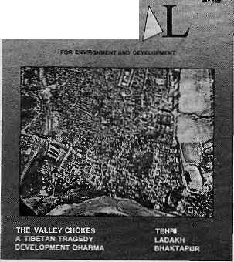
HIM
Darjeeling
The first issue of HIMAL is indicative of the objectives that the journal is going to achieve through a wide-ranging journalistic effort for projecting the problems of the Himalayan mountain region and its inter-relationship with the plains in a scientific, constructive and comprehensive manner. We in SHERPA have been doing similar work since 1985 and would like to contribute our ideas to HIMAL, as well as to utilize some of your material.
T.N.Dhar
Society for Himalayan Environmental
Rehabilitation and Peoples' Action
Luck now
I found HIMAL interesting and informative. It is hoped that future editions will be an improvement over the inaugural issue.
R.K.Gupta
Dehra Dun
Congratulations on the prototype issue. The focus, content and style are all that were promised. Because of the excellent way everything fits together, and the attractive appearance, you should have no problem meeting your subscription targets, especially in the "communication drought in the Himalaya" which you mention. Your contribution in educating administrators and opinion makers on environmental issues would be exceptional.
Ellis J. Shenk
Coordination in Development
New York
HIMAL should help raise awareness about the nature and extent of environmental degradation in the Himalayan region. Considerable governmental and community efforts are underway to improve the long-term and short-term needs of the people. It is important for a journal aimed at "professionals" to analyse these efforts and draw lessons and help stimulate greater work. It can also help establish close co-operation of a

July 1988 • HIMAL 1

practical nature in managing upland-lowland interactions and managing mountain ecosystems.
Uttam Dabholkar
UNEP
Nairobi
Himal is highly informative and readable and should be useful in meeting the needs of scholars, research organisations and government departments in the countries of the region. We look forward to future issues.
R.K.Pachauri
Tata Energy Research Institute
New Delhi
The writing was provocative and the standard of a number of articles very high, particularly the cover article on pollution in Kathmandu. You have done a fine job and I am personally delighted to see a magazine of this type under production.
Nigel Roberts
The World Bank
Washington DC
HIMAL can become a useful medium for communication in the hill areas. If you can maintain the overall range,
depth and quality of this journal, it will become an important vehicle for sustainable development issues of all kinds.
Ashok Khosla
Development Alternatives
New Delhi
KATHMANDU POLLUTION
Reading your cover story on pollution in Kathmandu Valley and threats to other Himalayan towns brings to mind a recenE news report about Mexico City, whose geographic and climatic situation is similar to that of Kathmandu. Mexico City is in a valley cupped by high mountains. It houses 18 million and its air pollution is recognized as worst of all the world's capitals. The source of the smog is largely auto exhaust and factory smoke. The National University attributes at least 50,000 deaths a year to air pollution, though activists think the figure is as high as 100,000. Mexican environmentalists, faced with ecological disaster, have formed the Mexican Ecologists' Alliance, which is patterned after Germany's successful Green Party.
Rajiv Rcgmi
Illinois
United Stales
DEVELOPMENT DHARMA
Reading Dipak Gyawali's article "Development Dharma" was like listening to the sermon of a modern Vedic bard. But unlike his forebears, who "saw" the doom of the world in the hands of fanciful gods, the modem brahmin relies on his extensive knowledge to forecast the eventual destruction of humans through a global ecological holocaust. The learned advocate of development dharma, while excellently versed in matters of philosophy and theology, does not have his history pat.
Drawing an analogy between the Rana rulers of nineteenth century Nepal and the feudal lords of pre-capitalist Europe, he deplores that there was no entrepreneurial class during that crucial period of Nepali history But the middle class in Europe was an effect and not the cause of the Industrial Revolution. This lay reader of HIMAL would have liked the erudite pundit, to have been more argumentative and less authoritative in his discourse.
Sudhir Bhattarai
Kathmandu ^

BHAKTAPUR DEVELOPMENTS
Todd Lewis' article on the German-sponsored Bhaktapur Development Project (3DP) is not in the least a useful contribution to learn from past mistakes and calls for some remarks and corrections. One only has to look at other areas of Kathmandu Valley to see how Bhaktapur might have developed without BDP,
The integrated approach taken by the Project was nothing less than revolutionary. Despite its weaknesses, that approach still serves as an example today when many projects tackle problems in an isolated manner. Jt is not that everything was done right in Bhaktapur: technical infrastructure was given priority over institutional and socio-economic issues, and in the early phases people's participation was virtually non-existent. Here Lewis is right. Lessons were learnt and the later phases of the project were redesigned on the basis of the experience gained.
Because of the outstanding historical heritage of Bhaktapur, the BDP's dual objectives were to preserve the town for future generations and to improve living conditions for the inhabitants. It was
never intended that Bhaktapurians were to live in a museum. Regulations elaborated by BDP did not aim at preventing new houses being built but only at a design appropriate to the the town's very special situation. It is a pity, of course, that all efforts to meet the housing needs of the poorer people have failed until now, but this is due lo
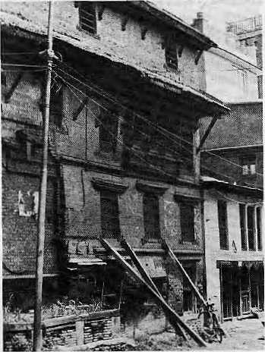
the manifold difficulties in planning town extension schemes in Nepal.
In and around an agricultural town like Bhaktapur, the competition for water is natural. I am convinced that the BDP's decision for a combined sewerage system was the right one. Nor always does "appropriate technology" mean the avoidance of "conservative western-style systems". Kathmandu city would have suffered much less from the monsoon rains if the World Bank had followed the Bhaklapur example.
In conclusion, it is certainly painful to visit Bhaktapur today and see what has happened to many of the BPD initiatives. There is need for continued efforts. The burden of preserving a monument like Bhaktapur should not rest solely on its inhabitants, but must be shared by all those who know how to appreciate this unique cultural heritage.
Hans Reiner Btihm
Integrated Development Consultants
Heidelberg, West Germany
(Dr. Bohm was involved with BDP from 1978 to 1982.)

(We ask readers to use this page to comment, criticize or add to information appearing in this magazine-should be concise and to the point. AH letters are subject to editing.)
Letters

2 HIMAL - July 1988

COVER
Highlanders on the Move

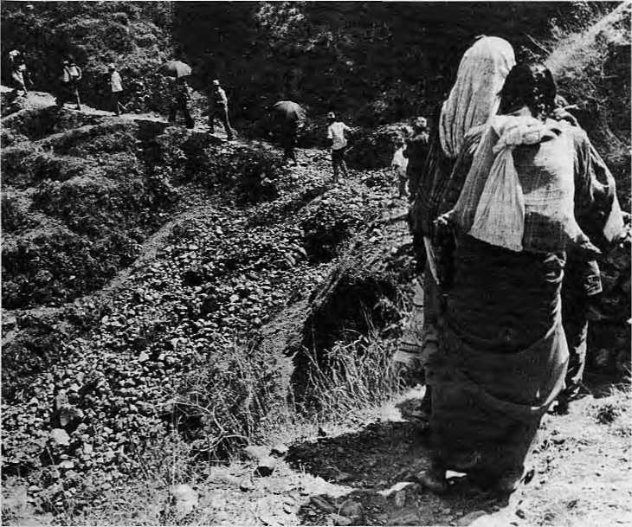
A Quest for Survival
By Kanak Mani Dixit
At the age of 16, Diwan Singh Bohra was forced to leave his village of Karan Karayal in Pithoragarh District of Uttar Pradesh. His father, Badri Singh, had only 10 bigah of degraded hilly land, which did not produce enough to support a family of six children. So, Diwan Singh went to seek his — and his family's — fortune in the bustling city of Lucknow.
Today, eight years later, Diwan Singh is 24 but looks 40. Every day, he works from break-of-dawn to dusk and earns IRs400 per month doing two jobs as a domestic servant. He sends half the money to the joint family back in Karan Karayat, including his wife, whom he can visit only once a year at Holi or Diwali and even that only if both his employers agree.
Down and out.
"I would never have come to this city if I had opportunities in my village," he says. However, the situation in Karan
Karayat has further deteriorated since he
left. "As Kshatriyas, the villagers used
to join the military, but today we are
mostly cooks and house- servants
working far away for meagre salaries, at the mercy of our employers."
For hundreds of thousands of men and women like Diwan Singh, migrating from the Himalayan highlands to the plains to find work has become a lifelong, wrenching exercise. The numbers are not precise, but the best estimates indicate that close to half a million Nepalis are absent from the country for six months or more each year.
Photo: G. McBean/Unicef
In the Uttar Pradesh Hills, 46 out of every 100 men are away on a semipermanent basis from their wives and families. Sixteen families from Kanduli, a village in Pauri Garhwal, have left for the plains and most of the remaining 60 families have their menfolk away for part of the year, leaving only 26 young
men in the village. In Jajoli, Pithoragarh District, one quarter of its 360 people are migrants, most of them in Bombay, Delhi or in the Indian Army.
One tragic dimension of the migration issue is the increasing burden on women, says Mahesh Banskota of the International Centre for Integrated Mountain Development (ICIMOD). According to him, even as life in the mountains has become harsher, with the men away, the women are heading households of the elderly and the young and managing the terraces with fewer resources.
In Almora and Pauri Garhwal, up to 40 per cent of households were headed by women, according 10 R.S. Bora, a demographer at the Institute of Economic Growth in Delhi University. "High illiteracy and existing traditions restrict the migration of females," he says.
The Human Dimension
This problem of migration is peculiar to the Nepali hills and the Indian districts immediately to the west because they, more than others, are marked by poverty, lack of development, overpopulation, decreasing soil fertility and eroded, unproductive hillsides. "Most mountain regions in the world are poor, but our mountains ire at the bottommost rung," says a Nepali economist who has long studied the economic and political aspects of migration. "And when you are the poorest, you migrate and work as menial labour, no questions asked."
Nepali migrants do not only travel to the plains. Such is the destitution in Nepal's far west that the inhabitants go to work as labourers across the border in the Garhwal. Any traveler to Naini Tal or Mussorie will be besieged by Nepali coolies in torn, work-blackened clothing and they are the lucky ones, earning IRsl5 or more a day, as porters. Others earn much less: IRs6.50 a day working on the roads; IRs6 as loggers; or 1Rs7.50 for pulling rickshaws.

July 1983
HIMAL

ON THE MOVE

While the phenomenon of migration might not extend throughout the Himalayan crescent, the human dimension is still vast. Emigrants leave sedate hill societies and loved ones for fast-paced, commercial centres like Gorakhpur, Lucknow, Delhi, Bombay and Calcutta. While some of their village kinship structures survive even in these alien environments, Nepalis, Kumaonis and Garhwalis in the plains face enormous psychological and social pressures.
No Respect
Dilli Dahal and Chaitanya Mishra, of the Centre for Nepal and Asian Studies (CNAS), recently talked to 306 Nepal-born families living in North India. The migrants said they suffered most from job insecurity, "lack of respect", and a sense of separateness from the local community. They did not have proper housing, worried over family members left behind, and, most poignantly, "they did not see how ventilating their problems to outsiders could ease the sharpness of such problems."
In addition to living generally insecure
lives economically, Nepali migrants live
in a political no-man's land. They are
free to migrate to India, but do not
have citizenship rights, or the rights
accorded to bona fide international
workers. The fuzziness between
Nepali- born migrants and the
millions of Indians of Nepali origin adds to the confusion.
"The undeclared Nepali state policy has been to tolerate cross-border migration and to regard it as a safety valve," says a political scientist from Tribhuvan University. Now, that safety valve has been used up. The expulsion from Meghalaya of people of Nepali origin has brought a problem that has long festered away from the public eye into sharp focus. "The problem can no longer be wished away. Both countries must tackle this very complex politico-economic question head on. There are no simple answers," says the scholar.
Why They Leave
Geographer Bal Kumar K.C. says that Nepali migrants cite lack of food, inequality, poverty, and miniscule land holdings as the cause for pulling up stakes (basain sarnay) in their mountain villages. In the Nepali hills, six persons must share a hectare of cultivable land. An analysis of the latest Nepali census (1981) data by the National Planning Commission showed that "the scarcity of cultivable land is one of the major reasons for exodus of the (hill) people".
The Tarai proves attractive because of 4 HIMAL ■ July 1988
the Government's resettlement programme, better pasture land, availability of off-farm employment, and access to fuelwood. Within Nepal, the greatest exodus is to the eastern Tarai, where the land is more fertile than the central and western Tarai.
According to geographer Harka Gurung, a major factor inducing highlanders to migrate is the regional disparity in development. "The five- year-plans of the last three decades have emphasized road-building and agriculture, with the lowlands having a locational advantage," says Gurung. According to his figures, the last three decades have seen a 16-fold increase of population in the Tarai.
Poverty to More Poverty
Migrants go from poverty in the hills to do menial work in the plains. The hills run on the well-known "money order economy", with remittances sent home by the husband or father or son. About 40 per cent of all Nepali emigrants work as guards or nightwatchmen in Indian towns and cities. All over India, Nepalis are also found working as restaurant boys, junior technicians, wage labourers and truck drivers and helpers. A tea-picker in Sri Lanka was the southern-most Nepali labour-migrant located.
In their study of Nepali migrants in India, Dahal and Mishra of CNAS found "not a single medical doctor, engineer or administrator". Thus, the stream of migrants represents not a "brain drain" but a "muscle drain". Yet that brawn brings awfully little remuneration, according to recent statistics by the International Labour Organization. In 1985, remittances from Pakistani migrants amounted to $2.5 billion, while the figure for Bangladesh was $395 million and for Sri Lanka, $249 million.
Nepali migrants, for all their numbers, were able to send back only $36 million. The reason for the disparity in the ability to earn, of course, is that while the others travel to the Gulf States to earn dollars, Nepalis go to work as chaukidais in Gorakhpur for IRs20 or less a day,
Nepalis in the Delhi area today fulfil the demand for lowest paying jobs, slipping into a slot left by the upscale migrants from Kumaon and Garhwal, says Ashish Bose, President of the Indian Population Studies Association, He adds, "The Kumaonis and Garhwalis have moved up the economic ladder and no longer work as domestic servants because they have other choices. For example, they can join the Border
Security Force. When they do descend to the plains, they now work in the organized Government sector, which has perks and benefits."
"Some aspects of migration, particularly for the Nepatis, are quite dehumanizing. They fill the lowest posts and can return home for only a month or so every two years. ' The migrants from the Indian hills can visit more often because of the roads," says Bose. "On the other hand, you have to remember that even this poor situation, for the Nepalis, is an improvement over the alternative. After all, migration is a human endeavour to improve the quality of life."
However, most Nepali migrants have not "made it". They may be reconciled to their situation, but migration, while it might have allowed them to survive, has not in any sense improved their quality of life. Visit a jhuggi in a Nepali settlement across the Jamuna from Old Delhi and one will find a dry and dusty semi-ghetto. There is a certain sense of security, because the inhabitants all come from the same district in west Nepal, but these Nepalis have no land or property. The occasional chaukidar owning a rickety bicycle is considered lucky. There is no electricity. The fact that the children go to school is regarded as the major — perhaps only — improvement.
Classical economic theory holds that migrants leave their place of origin in order to search for better opportunities. But what of a situation where, because of extreme poverty, the question of opportunity does not even arise? "Most out-migrants from the Nepal highlands are 'survival migrants', they leave for the sheer necessity of survival," says geographer Gurung.
"They come here youthful and healthy, but due to hard unremmiting labour they fall victim to disease and either die here or return home, there to spread the disease further," says Girish Chandra Pandey, an economist in Kumaon University. 54 per cent of the Nepali migrants he studied were ill, with fever, asthma, liver trouble or venereal disease. The migrants often have nowhere to stay and use station platforms and rock overhangs for shelter. Pandey says there is a need for providing housing and regulation to protect the interests of the migrants.
Benefits of Migration
Bikasbabu is one hill emigrant who has significantly improved his situation. Twelve years ago, he came to Bombay and drifted in and out of jobs as a tyre factory watchman and a truck-driver's

ON THE MOVE

helper. His break came when a village kinsman fell ill and "loaned" him the job of a "domestic" for a Parsi businessman in the city's affluent Malabar Hill section. The friend was never able to return and the job became his. The businessman pays well and now even allows Bikasbabu to handle the household finances.
In addition, Bikasbabu has been able to "import" many of his villagers and place them with other Parsi families in Bombay as cooks and darbans. He charges them three months' pay as commission and with some also asks for further monthly cuts. With his income, Bikasbabu has been able to buy property back in Nepal and is today his village's biggest absentee landlord.
Migration does not come without its benefits, as Bikasbabu found out. According to the scholars from CNAS, emigration has provided the hill folks with a sense of entrepTeneurship, additional skills and increased purchasing power. It has subsidized the standard of living and "has helped the mountain and the hill areas and Nepal as a whole to irudge on," they say. A sudden staunching of migration would have serious economic and political consequences at all levels of Nepali society.
In the U.P. Hills, Bora found that returning migrants who had held jobs in government were active in stimulating
community activities and good in dealing with authority. However, he says, return of military pensioners did not help bring innovation in village life because "in their jobs they only learn army rules and discipline". Others, however, say returning army personnel have brought in new ideas and used appropriate technology for the benefit of remote areas.
While noting that migration provides a safety valve for Nepal's stress- ridden hills, Dahal and Mishra warn against a "proclaimed or de facto strategy" of tolerating the situation, because it flies in the face of much-vaunted plans for national self-reliance. Official acquiescence to the situation will also intensify the "super-exploitation" of the emigrants, they say.
Looking to the Future
The Nepal Tarai has been absorbing excess population from the hills for some time but it cannot do so forever, cautions geographer Bal Gopal K.C. At the same time, recruitment into the armed forces has peaked and opportunities in the plains are stagnant. Expulsion of Nepal-born persons from north-east India has brought the matter to a head. However, migration will continue because the hills remain undeveloped and impoverished.
As lCIMOD's Banskota puts it, "The resource base of the hill farmer is decreasing dramatically. There is little
off-farm employment, agricultural productivity is down and the forests are degraded. As long as this process continues migration will continue to increase."
There is no choice for checking "this massive human outflow from the hills but to develop the Himalaya through "secondary and tertiary sector activities", says Delhi University's Bora. Participants at a recent ICIMOD workshop said it was imperative to bring "genuine development" to the hills. The agricultural land-based system must be gradually transformed into a market-oriented economy and "a hierarchy of bazaars, market towns and service centers set up to act as links between the village and the urban centre". The key is to find "off- farm employment", as subsistence agriculture can no longer sustain the population.
Real social and economic progress of
the far-flung hill communities of Uttar
Pradesh and Nepal, then, is the only
way out of the dilemma. In the
absence of sustained, grassroots
development, destitute hill people will
continue to migrate in ever increasing
numbers to face psycho-social trauma,
political rejection and poor job situations
in the plains. ft
S. Sharma, Ramendra Singh and Rupa Joshi assisted in researching this article.

Others Who Migrate

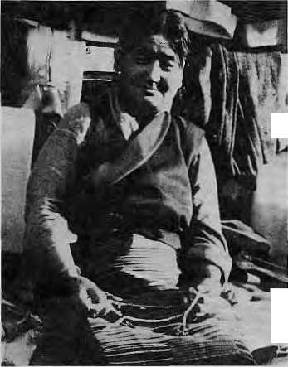
Tibetan vendors in Kodnikanal
Photo: P.S. Sudhakaran
Those who fiee extreme poverty of the hilis for work in the plains make up the largest portion of Himalayan migrants, but by no means are these "survival migrants" the only ones.
Since the early 1800s, the highlanders have been recruited into the British and subsequently the Indian armed forces. There are "economic migrants" from among the more entrepreneurial communities in the mountains. The Tibetan-speaking people of Mustang principality in northern Nepal, for example, spend spring and summer at home but in the cold months, many are down in the Indian plains, selling ^ sweaters and carrying on other kinds of trade. Come spring, they return to their walled township of Lo Mantang.
Tibetans who ieft their homeland in the late 1950s make up another large segment of highlanders .in the plains.
They live in pockets across the subcontinent, radiating out from their hub in Dharmsala, where the Dalai Lama lives.
Perhaps more politically problematic
than highlanders descending to the
populous plains is the move of plains
people to the mountain towns, as
entrepreneurs, craftsmen and skilled
workers. Unlike the hill people
descending to the plains, these
"economic migrants" are in search 'of
opportunities rather than subsistence.
"A skilled Indian plainsman working
as an electrician or bricklayer in
Kathmandu takes away more capital
than an unskilled hillman working in
India," says a Nepali economist. "On
the other hand, the skilled worker is^
providing a service demanded by an*
urban elite which the local labour
market cannot provide. So how can
you quarrel?" A

July 1988 ■ HIMAL 5

ON THE MOVE
The Historical Process

By Harka Gurung
Migration is not a new phenomenon in the mountains of South Central Asia. The Himalaya has been both a new frontier and a vestigial haven for diverse races down through the ages. For a historical record of the process one has only to look at the wide variety of languages and dialects that exists in Nepal today: 19 Tibeto-Burman tongues, 11 Indo-Aryan, two Munda and one Dravidian.
The peopling of the Himalaya was the outcome of successive waves of migration from today's Sechuan-Yunnan in the northeast and "westerners" from the Central Asian steppe. The first migrants probably came in around 2000 B.C. through north-Burma, Assam, Bhutan, Sikkim and Nepal. A second group traveled westward around 200 B.C. along the Tsangpo valley into Tibet, some of them moving further west and south across Himalayan passes.
While the Kirat {"Mongoloid") people established themselves east of the Gandak basin, the Western Himalaya became the home of an early
"Caucasoid" group, the Khasa, and of refugees fleeing successive Mohammedan onslaughts from the 10th Century onward. Tibetan influence spread in the 7th Century when the forces of Srong-tsan-sgamp-po swept down to the Ganges plain. In the east, the Shan A horns descended to the Brahmaputra valley in the early 13th Century.
Between the 12th and 18th Centuries, the Khasas spread eastward, with the population movement along the hills between the mountain barrier to the north and the malarial moat of the Tarai to the south. Moving eastward along the Gandaki basin towards more humid climes, the Khasas ultimately reached Kathmandu. Their Gorkhali heirs extended their domain and briefly ruled from the Tista to the Sutlej until thwarted by the superior arsenal of the East India Company in 1815.
Westward and Eastward
In the early 1800s, the British encouraged migration of the hill people to the eastern Himalaya for timber work in Assam and newly-opened tea plantations in Darjeeling. Some Nepali
migrants reached as far east as Burma to raise livestock. Nepalis were welcomed into Sikkim starting in 1888 to counteract Tibetan incursions. The Indian census of 1951 reported that 47 per cent of the Nepal-born population in India was to be found in the eastern states of Arunachal, Assam, Meghalaya and West Bengal.
While the population movement was
from west to east till the 1950s, in the
last three decades, the flow has been
from north to south, frdm mountain to
plain. Malaria control and government
resettlement schemes opened up the
Tarai lowlands as a new frontier. Vast
tracts of Tarai jungles were razed to
cater to people leaving hills marked by
high demographic stress and extreme
poverty. Today, because of
development focus and migration, the
Tarai has the potential of becoming the
dynamic region of Nepal. £
Harka Gurung headed a team which presented a major report on Nepal's population in 1983.

Kunst aus dem Himalaia

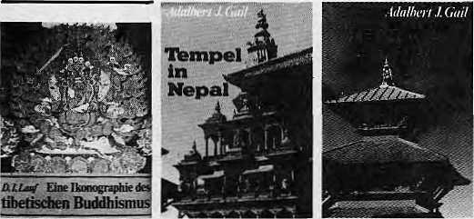

Adalbert J. Gail
Tempel in Nepal
(Bandl)
Ikonographie hinduistischer Pagoden in Patan, Kachmandutal. 104 Seiten Ton, 52 Schwaizweifr Tafeln mit 178 Abbildungen; Format: 18,5 it 27 cm, broscniejt. SS 3+5_{f} / DM 53_{f}
Adalbert], Gail
Tempelin Nepal
(Bind 2)
Ikonognphisclie L'juersuchur.gen
Kir spiten Pifode unit zum
StoHBTempei
DetleflngoLauf
Eine Ikonographie des tibetischen Buddhismus
p
78 Sciten Ten, 60 ScWzweifl-Taieln mit 182 Abbildungen; Formal: 18,5 x 27 cm, broscKert. 55345;./ DM 53,
92SeitenText,8Farb-uiid 8) Schwareweift-Tafeln; •Format: 22128,5 cm, Gaozleincn mit farbigem Schtitz-umschJa& SS 550,. /DM M_{f}
Akademische Druck- u. Verlagsanstalt A-8010 Graz/Austria
Sic finii'jn un$ere Bucher in jeder guten Buchhandlung!
Mit Ufcihreiers Buch wild dit mit Alfred Janatis SCHMUCK IN AFGHANISTAN bcgoniKM Serie von Dokumeniauonen von asiatischem Schmuck fcngestm. ^fcihreter analysiert in einem ein-ftijirendsn Teil eingehend die hin-d-jistiich;, buddhittische und xhantankische Symbolwelt, gehc ausfuhrlichaufdieverwendeten Metalle und Steine em, zeigt ihre Beziige :;i den Himmelskorpeni und zu mjajch-kosmisehen Vor-srelliingen der Himalajabewohiier u:.t. Erne Zuordnung da einzel-nea Schmucksriickc zu den ver-sdiiedenen Stilprovinzen sat ^enauso in der Smdie enihdcen, wie die Auseinandersetzung mit handwerklichen und oWnomi-sdisn Aspekan. Im Tafeltti]» den die eunelnen Stiickc (auch Riiualschmuck) im Detail bspn> chen und foiogriusch dokumen-i
kESgeami a. 120 Seiicn Tart, 48Farb- und +8 ScbwarzweiS-TaMn mil insrasunt ca. 2M bto-grafischen Aufsahmen dcs Auiors; Rirmat: 22 X 28,5 cm; Ganzleinen mit farbigem Sdiut2-umschlag. SS 980,- / DM ISO,

6 HIMAL ■ July 1988

Saving Wood at the Burning Ghats
By Sudhirendar Sharma and Rosha Bajracharya

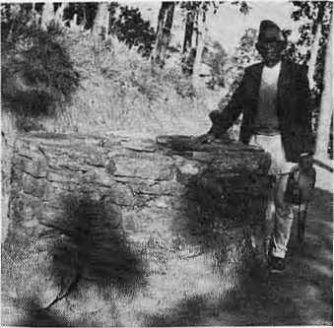
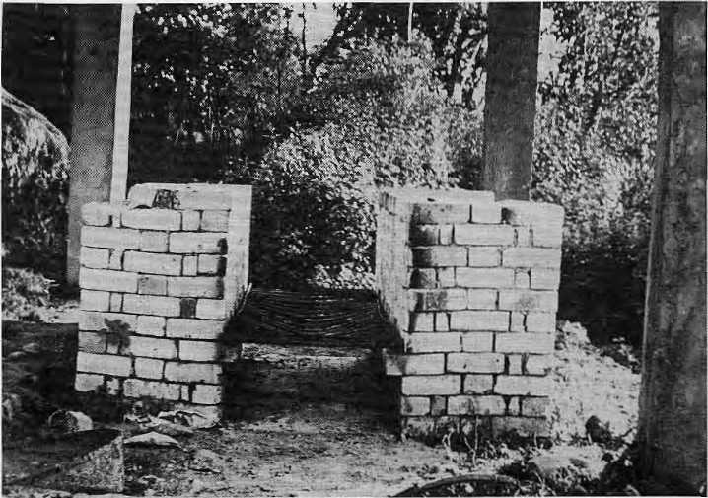
crematoria, which is not surprising
because his office is building two in the
Valley, with equipment ordered from
Bombay. "It is quite feasible and
important to establish these crematoria
for they will prevent river and air
pollution. The social problems are not
insurmountable," Dangol says, adding
that firewood can only get more
expensive. According to Dangol, an
adult body will take 30 to 40 minutes
to be consumed by the fire. The cost
of cremation? About NRs50. /
Krishna Pradhan assisted in the reporting this article.
The loss of forest cover has been blamed on villagers' need for firewood and fodder. But cremation is also a significant factor, even though some officials and en vironmentat ists understandably shy away from this delicate subject. One important reason for the receding treeline in the hills surrounding Kathmandu Valley is the demand for wood in the burning ghats of Pashupati and Sankhamool.
In Kathmandu, one response has been to build electric crematoria, but sociological and cultural factors make this remedy doubtful, according to some. In the meantime, elsewhere in Nepal and in the Indian hills, voluntary organizations and individuals have figured out ways to save precious firewood by burning more for less. "After all, why should you not try appropriate technology in the burning ghats?" asks a Nepali forester.
In Palampur, Himachal Pradesh, appropriate cremation technology takes the form of two low brick walls three feet apart and six feet long, with vents along the sides. Steel rods at six-inch intervals are placed a foot above the ground between the two walls. A wire mesh is sometimes placed above the rods. The design was perfected by the Indo-German Dhauladhar Project.
During cremation, firewood is placed atop the rods and the body above. Traditional funeral pyres involve piling up firewood on a rock platform, with no space underneath for a draft. The Palampur design, on the other hand, provides for sufficient aeration so that cremation is quicker and more efficient. The new design has passed muster with the people of Palampur, who bring their dead to one of two crematoria there.
According to World Food Programme figures, an average adult body requires 6OOkg to 650kg of wood for complete cremation. The Palampur- type units use only about 400kg. Convinced of the need to save fuel in fragile ecosystems, the WFP is spending IRs one million in Gujarat to install 250 units. At the same time, a new crematorium has been installed at Una in the Uttar Pradesh Hills by the Energy and Environment Group, a voluntary agency, and the administration has now arranged for twelve more units
to cover the entire district.
While the Palampur prototype is not in use in Nepal, the Tamang villagers of Bans Kharka in the north-eastern outskirts of Kathmandu have been using their own method for a number of years. Laxman Dong, the Pradhan Pancha, got the idea from seeing the lamas of the Sermathang Gumba in Helambu using what he calls a sola crematorium, which is a circular rock and masonry structure with an air shaft underneath.
Acutely aware of the deforestation around his village, particularly on Chihan Danda whose summit was used for cremation by the Tamangs, Dong had nine solas constructed in his village, one for each ward. The woodland's restoration followed almost immediately after the installation, according to the Pradhan Pancha, whose development philosophy is that "dharma karma (religion), economic progress and environmental conservation must go hand-in-hand".
Mohan Krishna Dangol, Assistant Engineer of the Kathmandu Town Panchayat, is a supporter of electric
Dong with sola (top_{p}) and a fuel-efficient design from Palampur.
Photos: K.k.Panday and S. Sharma

July 1988
HIMAL

THE ICIMOD PAPERS
Some recent publications of the International Center for Integrated Mountain Development:

Forestry Farming Linkages in the Mountains T.B.S. Mahat
Road Construction in the Nepal Himalaya Urs Schaffner
Erosion Processes in.the Nepalese Himalaya Brian Carson
Integrated Rural Development Projects in Nepal:
Review
Bharat B. Pradhan
Peoples' Participation in Watershed Management Anis A. Dani and J.G. Campbell
Decentralised Energy Planning and Management Deepak Bajracharya
Glacial Lake Outburst Floods in the Himalaya Jack D. Ives
Forest Management
D, Gilmour and G. Applegate
Workshop Reports:
Towns in the Mountains, March 1986 Energy for Mountain Districts, May 1986 People and Jobs in the Mountains, May 1986 Mountain Crop Genetics, February 1987

International Centre for Integrated Mountain Development
GPO Box, 3226, Kathmandu, Nepal
Telephone Telex
5-21575
2439 ICIMOD NP

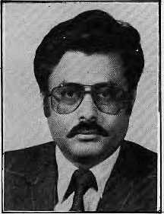


THE NEPAL OF PRESIDENT TRAVEL
Nepal, the land of legends, so rich and diverse in race, culture
and religion; of living gods and goddesses. The towering majestic
Everest in the north; to the south, nature's bounty manifested in
the richness of flora and fauna where the rivers run wild and free.
Here is true adventure!
Let President Travel & Tours show you Nepal through its prestigious packages.
WE OFFER THE FOLLOWING SERVICES:
TRAVEL &TOLBS(P)LTD.
International & Domestic Ticketing (Agent of Royal Nepal & Indian Airlines) Mountain Flights
White Water Rafting Charter Service & Cargo
Tours & Sightseeing
Hotel Reservation
Nepali Cultural Programme
PRESITIGIOUS PRESIDENTIALPACKAGES
PRESIDENT
Wildlife Safaris
Religious tours
Package Tours To Pokhara &
Lumbini
(Birthplace of Lord Buddha)
Tours to Darjeeling, Sikkirn &
Bhutan
(Requests to be sent at least 6
weeks
in Advance)
Trekking & Special Interest Tours

DURBAR MARG, G.P.O. BOX: 1307, H3ATHMANDU, NEPAL
PHONE: 220245, 221180, 221774 TELEX: 2417 PRESSI NP CABLE: PRESl
INBOUND & OUTBOUND TOUR OPERATORS
8 HIMAL ■ July 1988

Fighting Alcohol in Uttarakhand

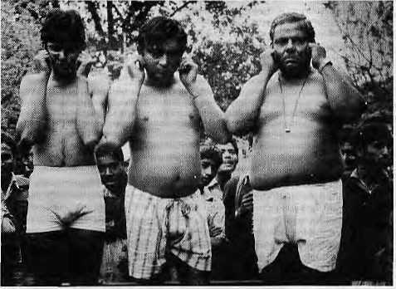
The entire region is slowly sinking into a slough of alcoholism. Districts that have been traditionally dry are being invaded by liquor stores as an underemployed male populace takes to drink. Even in the high Himalaya, where alcoholic beverages are customarily brewed or distilled, people are switching from local liquor and beer to rum, whisky, gin and "medicinal alcohol". The Utlarakhand region of Uttar Pradesh is one area where the hill people have been fighting alcoholism effectively. This report is by Shekhar Pathak, who teaches history at Kumaon University and edits the magazine Pahar.
The anti-alcoholism movement in Uttarakhand differs from earlier attempts to impose prohibition here or elsewhere in the Himalaya. Activists in Pithoragarh, Nainital, Chamoli or Pauri, who have watched alcoholism sap the vitality of hill society, do not have faith in simplistic solutions. They view the problem of alcoholism as a symptpm of the deeper malaise of predatory "development", and are confronting it as such.
The major demand of the anti-alcoholism movement has been "nashe nahin rozgar do", or employment instead of liquor. Ranged against the movement are the economic and political interests that buttress the liquor trade.
Prior to the period of British rule in India, use of alcohol was restricted to the Tarai and the Bholiya traders of the upper valleys, who distilled liqour for self-consumption. In the mid-1800s, colonial officials were surprised to find the settled hill communities virtually alcohol-free. Under colonial auspices, consumption of liquor began to spread with the paraphernalia of the Raj: soldiers, bureaucrats and the establishment of "hill stations". Soldiers were recruited into the Gorkha Rifles as early as 1858 and records show a parallel increase in liquor revenue collected in Kumaon.
Dry and Wet
By the turn of the century, alcohol was flowing freely in the hill districts of U.P. Despite several attempts at prohibition, they invariably slipped back into "wet" status. During the Second World War, recruiting agents arrived with crates of liquor as inducement. Liquor stalls were opened at fairs.
In 1962, Sohanlal Bhubhiksuk, a
Garampani contractors promise not to do it again. Photo: Pahar Collection
follower of Vinoba Bhave, started a "postcard movement" against the government's liquor policy and went on a hunger strike in Lucknow. In 1965, in Silyara, the Sarvodaya couple Sunderlal and Vimla Bahuguna started a campaign which soon engulfed large areas of Tehri District. In 1970, Tehri and Pauri were declared dry. However, the move was overturned by the Allahabad High Court following a petition by wine merchants.
The major weakness of that movement was the fragmented perceptions of its leaders, who treated alcoholism essentially as a moral issue. No attempt was made to link the liqour trade to the underlying economic and political questions. In the event, the movement faltered. Within years, the distillation of country liquor became Uttarakhand's major "cottage industry". One such "industrialist" was decorated with a Padma Shri.
The alcoholism trade, properly called, also includes a wide range of "tonics", manufactured in cities like Amriisar, Moradabad, Bareilly, PUibhit, Kanpur and Patna and trucked to the hill towns. These drinks are distributed in the remotest comers of Utlarakhand and there is a flourishing trade in empty bottles. Mrit Sanjiwini Sura, a tonic, claims 35 per cent alcohol content and Podin Hara 78.8 per cent. Both are produced by Dabur. The actual alcohol content of many tonics exceed 80 per cent and they sell too well to be for medicinal uses. A single shop in Dwarahat sells IRs.3000 of "Ashoka" bottles daily. Despite token gestures at
regulation, the authorities have not been serious about fighting alcohol abuse.
People Power
As with forestry, big dams and mining, the alcohol trade is not an isolated issue but is intimately tied to the social and cultural disintegration of hill society. The issues which underlay the decade-old Chipko A ndol a n metamorphosed into opposition to liquor. The current anti-alcoholism movement actually began on
1 February 1984 in Chaukhutia, western Almora, which was a thriving centre for illicit trade in alcohol.
Liquor shops were surrounded and officials ghcraoed. Activists fanned out into villages and demonstrations were held all over Almora. A bandh organized on 26 March the same year was effective ihroughout Kumaon. Four well-known liquor contractors were apprehended at Garampani on the Nainital-Almora road and pledged never to sell liquor again. Women led a large demonstration outside the district office at Almora, a scene reminiscent of the oppositon to the timber auctions during the heyday of the Chipko movement.
Those were the hectic days of spring 1984. The following year, the contractor system was terminated in Almora District and a co-operative society began the work of distributing liquor to permit holders. Demonstrations, foot-marches and signature campaigns against nasha continue, however, because much remains to be done.
The activists' aim is to declare the entire hill area dry. Where liquor sale cannot be avoided, they want it carried out by a government agency. All medicinal syrups with alcohol content exceeding 10 per cent must be banned and genuine syrups be distributed only at government hospitals. A viable cottage industry must be established so that it will replace the alcohol trade.
The major demand has been for
employment in place of alcohol.
However, prohibition in and by itself is
not enough to eradicate the social evil,
and must be regarded only as a first
step in a more fundamental restructuring
of hill society. £>

July 1988 • HIMAL 9

Ozone Hole over Himalaya?

In April, scientists in the United States found that the depletion of ozone gas in the world's atmosphere was at least three times more serious than had been predicted This means that more ultraviolet rays are reaching the earth past a thinning "ozone shield", increasing cancer rates and harming human vision and crop productivity. For us in the Himalaya, the immediate question is what impact the decline in atmospheric ozone will have on high mountain regions, particularly on the health of people, livestock, crops and forests. Will the hills be more affected than the plains? Hitnal's Prakash Khanal found scientists agreed on the answer: yes. His report
Trekkers on the mountain trails have known it for long. Up in the rarified atmosphere of the High Himalaya, the skin peels quicker and sunburn is instant because ultraviolet rays pierce through the thin atmosphere easily. Significant ozone depletion would mean that the higher altitudes would be much more affected by ultraviolet rays, which are sufficiently strong to break even biological molecules like the DNA, which controls heredity and cell control.
It is only in the past four years that the depletion of ozone began to be taken seriously, and studies so far have concentrated on confirming the general worldwide depletion and studying an "ozone hole" over Antartica. However, from what is known, there seems to be cause for concern in the Himalayan region because of the general thinning of the ozone shield worldwide and the strong possibility that a ozone hole similar to that over the South Pole hovers over the Himalaya.
"Naturally, increasing levels of ultraviolet radiation will affect the mountain people and crop production, the more so at higher altitudes," Sekhar Gurung, Associate Professor of Physics at Tribhuvan University. "If it is true that atmospheric ozone is being depleted, then, without doubt, the mountain environment is being affected. But more research needs to be done to determine the extent," says Suresh Chalisey, a meteorologist presently with the International Center for Integrated Mountain Development (ICIMOD),
Scientists have theorized that ozone holes probably exist over the Arctic and Greenland, and Mima! has learnt that a meteorological station in Switzerland has detected significant depletion of the gas
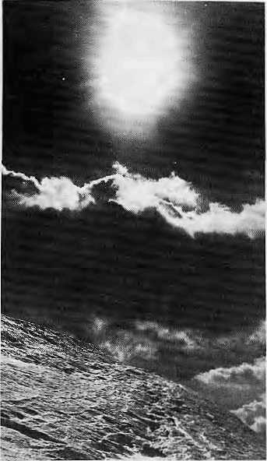
Sun, sky and ice. Photo: Duro Slota
over the Alps. If an ozone hole exists over the South Pole, and possibly over the Alps and Greenland, could there also be a similar "hole" over the Himalaya?
According to Dan Dudek of the Environmental Defense Fund in New York, ozone holes could be due to "polar stratospheric clouds" found in extremely cold regions. These clouds contain aerosol-type ice crystals that react easily with m a n m a d e chlorofluorocarbons (CFCs) in the atmosphere. The reaction between the ice crystals and CFCs uses the ozone gas in the immediate area, creating a "hole". Dudek says it is entirely possible that these conditions, known to exist over the South Pole, could also be present over the mountains of South-Central Asia.
But even without a "hole" over the Himalaya, the worldwide depletion of ozone is already reason enough to start worrying in relation to high mountain populations. As you go higher, there is less atmosphere above. In rural areas, as in the Himalaya, there is also less smog which acts as a an additional screen. As more ultra-violet rays reach the surface of the earth, in the Himalaya or elsewhere, there will be increases in cancer rates, cataract and other eye
diseases, according to Dr. Margaret Kripke, an immunologtst with the Environmental Protection Agency (EPA), which is the primary United States agency conducting research on ozone. There is also a possibility that increased exposure will negatively affect the body's immune system, which in turn might increase susceptibility to infectious disease.
No one has done region-specific calculations, but the EPA's computer models give some indication of the numbers involved. If the actions required by the 1987 Montreal CFC-control treaty were observed, the EPA says, they would avert 132 million cases of skin cancer and 27 million deaths from skin cancer that would otherwise have occured among people born before 2075. Even with the new controls, Canada's Environment Ministry estimates that there will be 7 million extra skin cancer cases among people born between now and 2075. Logic suggests that a disproportionate number of those skin cancer victims are going to come from higher climes. Moreover, these calculations were done before the April findings that ozone depiction was three times greater than previously thought.
Increased ultraviolet radiation would also affect crop production, animal life and the growth of trees. Studies have shown that two- thirds of all plant life are affected by ultraviolet radiation. Martyn Caldwell of the National Science Foundation in Washington DC, who has studied plants in arctic and alpine zones, cautions that enough specific analysis has not been carried out on the subject to make any dire predictions. However, he says, it is quite possible that ozone depletion could result in direct damage to certain plants in high altitudes and it is possible that mountain crop production and quality will go down.
The next phase of scientific
investigation, agree Dudek, Kripke and
Caldwell, should be an in-depth
worldwide examination of the ozone
problem. Going beyond the study of
global averages, the next phase of
research must relate to specific regions
by latitudes and altitudes. Nepali
scientists could not agree more. The
Himalaya offer one of the best natural
laboratories for research into the
atmospheric sciences, and the question
of ozone provides an urgency for
serious research, says ICIMOD's
Chalisey. £>

10 HIMAL ■ July 1988

The Good, the Bad, and Development Consultants

By Anil Chitrakar

The villagers of Chorkate in Gorkha District recently had a first hand experience with a development consultant and are not ready for another one soon. A foreign expert decided thai Chorkate needed to upgrade its livestock and so he flew in a strapping bull from the United States. The bull was too big for little Nepali mountain cows, which collapsed from the weight of the beefy American import before consummation could take place. Shunned by the frightened cows and unwanted by the villagers, the stud today paces the banks of the Daraundi River, alone. The consultant, meanwhile, has handed in his project report and returned to the United States.

Development consultancies are a fast-growth industry in the foreign aid haven that is present-day Kathmandu. Large foreign firms make off with the big dam, airport and highway projects while homegrown consultants do quite well nibbling the tidbits. Most consultants, foreign and local, are upright and professional, but due to the shenanigans of a few, their image by and large is one of carpetbaggers out to make a fast buck. Today, consultants build dams, build roads, plan irrigation, do soil tests, train civil servants, advise ministries and advise those who want to learn how to advise.

Swiss geologist Toni Hagen was the "proto consultant", who set an example with his diligence and creativity. Hagen crisscrossed Nepal in the early 1950s
and made the first comprehensive physical and economic survey of Nepal for what was then known as the United Nations Technical Assistance Administration. Just as Nepal needed Hagen's advice in 1954, there continues to be a genuine need for outside expertise to fuel social and economic progress. Indeed, specialized one-time duties are often best conducted by a consultant. But today consultants are engaged in every stage of a project: from pre-feasibility to final evaluation.
A Development Racket
Awarding a contract has become a racket in Kathmandu as well as in donor-country capitals and agency headquarters. There is feather-bedding, keeping the "national counterpart" happy, or deliberate delay to keep the stipend flowing. Most national consultancies have learnt to play by the local rules. When a construction project is approved, for example, the project manager who signs the papers for the Government normally expects a five per cent commission, the engineer receives four percent and the accountant one per cent. Only someone blind to loca! reality would hesitate to give the poorly paid Government staffer his cut, says a consultant.

Aid agencies are insisting that projects they support utilize consultants from abroad. Foreign consultants, unaware of local conditions and often unwilling even to leam, can turn needed projects into failures. One good example is the
Asian Development Bank (ADB) and World Bank funded Second Hill Irrigation Project, meant to provide simple upgrades to existing irrigation systems in four districts of West Nepal. The feasibility survey was conducted by Louis Berger, an American firm, which submitted a positive report and was appointed a principal implementing consultant for the project.
To fill the project's pivotal post, Louis Berger assigned an agri- engineer instead of a civil engineer, a young man who did not have the required field experience. The engineer worked from distant Kathmandu and, according to a 1 March ADB evaluation report, his designs were "too sophisticated (expensive) and did not take adequately into account the existing irrigation systems and the actual requirements of the farmers".
Concerned by the runaway costs of the wayward project, the Department of Irrigation terminated the consultancy on 9 March, but by then NRs400,000 had already been spent by each of the four local consultants that had been hired by Louis Berger. Perhaps ten times that amount was spent by the principal consultant. "For the amount wasted, they could have helicoptered the water to Doti in jerry cans," says an irrigation expert.
Failing Grades
The Resources Conservation and Utilization Project (RCUP, which imported the bull to Gorkha) is another example of how consultants can waste money and achieve little. Funded by USAID, RCUP was meant to be a "multifaceted integrated watershed project" for central Nepal. It began work in 1980 and was implemented by the Southeast Consortium for International Deveiopment (SECID), an American firm, which brought in a forester, a soil scientist, three "catchment advisors", one training specialist and a social scientist.
At the very outset, there was rancour amongst the consultants themselves. Then the advisor in Myagdi was withdrawn by SECID after problems arose with the local community. Tne overall insensitivity to local feelings and needs was exemplified by the catchment

July 1988
HIMAL
11

BREAD & BUTTER CONSULTNCY

advisor in Gorkha, who secluded himself in a sumptuous "durbar" up on a hill, rarely deigned to mingle with the folks he had come to help, and reportedly treated his Nepali co-workers with condescension and disdain. Some of the RCUP buildings designed for the upper Kali Gandaki Valley required long beams that sweep majestically through the length of the construction, RCUP was hardly conserving resources as its title proclaimed: it was cutting down the tallest trees from the alpine forests.
An evaluation report prepared by the International Science and Technology Institute in 1985 gave RCUP failing grades. Among its findings: "No model for watershed management has been developed,,,the concept of the watershed as an integrating unit has not been used...too many components were tried over too large an area too quickly". Thus, RCUP's grandiose plans have amounted to very little. $27.5 million was a lot to pay for a project that has left behind 174 empty buildings scattered across the hills and little else. The RCUP consultants were "terribly underused and overpaid", says a Nepali expert. But much of the blame, he says, rests not on the shoulders of SEC1D, or USAID, but with the Government, which has allowed consultancies, good and bad, to flourish.
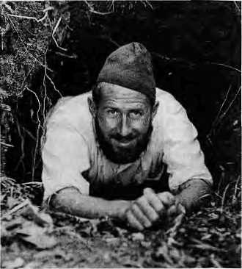
Toni Hagen (1955)
Many contrast Nepal's experience with that of India, where the Government dictates the terms to multilateral and bilateral donors and invites the participation of foreign consultants only where absolutely necessary. Because of strong technical expertise that exists within Indian departments, there is also little hiring of local experts. In January, a group meeting in New Delhi urged the Government to promulgate regulations to ensure quality in the profession. There is no such move in Nepal, even though every dilapidated doorway in Kathmandu seems to hang a
consultancy shingle. A survey by the Center for Action Research in 1983 found 146 consultancy groups in the Valley, and there are obviously many more today.
evaluations and
are written to be er dust in the
A few years ago, of Tourism could only copy of the
when challenged
Most master plans, reports by consultants shelved and gath respective ministries, the Director-General not even locate his Tourism Master Plan by a reporter.
Who Reads Them?
Not many consultants' reports break new ground. Many opuses are duplications of studies carried out by someone long gone. The head of a prominent Washington DC firm is presently advising the Ministry of Finance on programme budgeting processes and is funded by UNDP, The same adviser was consulting with the Ministry on the same subject about two decades ago, at that time reportedly supported by the Ford Foundation, "The weakness is not of the consultant for wanting the contract but of the Government for giving it to him," says a Nepali economist.
On occasion, consultants, both foreign and local, do stand up for principle and have been known to withstand pressure, A recent example is the firm of Etectrowatt from Zurich, Switzerland, which was studying surface and ground water prospects in the Eastern Tarai. The development bank reportedly had the financing ready and the Irrigation Department was also keen, but Electrowatt was convinced that the project would be unfeasible and stuck by its report.
Ram Prasad Yadav, Deputy Director of ICIMOD, feels that consultancies in Nepal are too busy just keeping alive and are not on the intellectual cutting edge. "The problem with even the respected consultancies in Nepal, such as New Era, CEDA, APROSC and ISC, is that they do little or no research. Only research can provide the analytical ammunition required for giving good advice," he says.
Externally funded projects generally run in five-year cycles. This leads planners to try to squeeze a proposal, regardless of actual time demands, into a five-year time frame. After identifying the hilt districts of Tanahu, Syangjha and Gorkha as constituting a food-deficit area, an expert recently proposed an assistance programme for food-grain production, forgetting that there were highways to transport food from nearby surplus areas. Horticultural development

 | I | 9  1 | i
would have been a much better option, but then orange trees, which grow well in the region, take more than five years to start producing.
Foreign or Local
Former Secretary of Finance Devendra Raj Pandey, a consultant known for speaking his mind, disputes the notion that foreign consultants are cut off from Nepali reality as opposed to homegrown consultants. "As long as they are alienated from the local people, what difference does it make whether they are Nepali or foreign?" he asks. "In the garb of native expertise, our experts are often as much outside the Nepali mainstream as the foreign expert."
Local experts are getting lots of work in Kathmandu nowadays, but at the same time there is no drop in the flow of awards to foreign consultancies, The lenders and donors insist on their own experts. Nepal's capability to design, administer and implement development programmes is declining even in the face of increasing financial flows. So donors say that they will implement the programmes on a tum-key basis,"which hurts the very core of technical assistance philosophy", according to Pandey.
Turn-key projects also mean expensive long-term consultants, flights by helicopter to project sites, lots of to-and-fro between foreign capitals and Kathmandu, "R and R" in Bangkok, a spacious mansion and "house staff in Kathmandu, reports to publish and officials to keep happy. Some of the largesse is also distributed among local consultants and technocrats. The real estate market, the retailers, the airlines, the hotels, the gasoline merchants, the nanny and mali markets, all benefit.
There would seem to be few losers in
the consulting game, at least in foreign
capitals and in Kathmandu. A

12 HIMAL ■ July 1988

An Expatriate Consultant in Islamabad

"You don't want Botswana. You want Pakistan!" The Korean man calling from Geneva had an explosive way of talking. "Pakistan. North-west Frontier. Beautiful place. Mountains. Never mind Botswana: you want Pakistan. Next week." It sounded like a good idea. There are so many development-aid people in Botswana you can't find anything to finance any more.
We are six on the mission to the North-West Frontier, None of us have been here before. None of us have previously met. A mix of people because this time its an international agency. We've got four weeks to come up with a project for, say, thirty million dollars. Routine.
We are all foreigners, but we are all Americans. None of us knows Pakistan but we all know what is good for it. I find the view sickening. In front of the veranda are mountain flowers, then the big river, then the mountains. If I look up, it's all snow-capped peaks, like meringue-topping. I don't want it. It's like deceit, a sneer. The people are poor, the mountains a logistical nightmare. Road building will cost twice the average. Thank God we are returning to the Intercontinental in Peshawar tomorrow.
"We want to do something for our people quickly. We don't want your six-year project; we want two years, three years. The people up there hardly know the government
exists. They see the refugees receiving all sorts of international aid and they wonder why they are not getting anything. It's a restless place. You should join these people to the rest of Pakistan. Agricultural research and improved farming are not enough. We want results. The government is ready to move. We know what we have to do. Just release the money and we will do the rest."
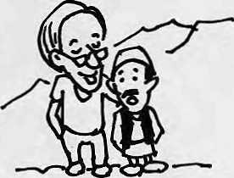
"Look, we want to lend you the money you are talking about, but one valley is not enough. One valley doesn't have the absorption capacity. We need a minimum of two, and preferably three, valleys. We want at least a million people. Otherwise Geneva won't like it. Frankly, they will say it was not worth the expense of sending out a mission. We want to give you a project but you'll have to take away some valleys from someone else and give them to us."
"We have decided we can give you two more valleys. We will give you an American valiey and one which was going to the Germans. We
want to reduce bilateral funding in favour of international donors. But we have to have assurances that you will release the money fast."
"No problem. I'll tell Geneva."
So what we'll do is this. We'll keep the six-year concept but make a four-year first phase to satisfy the government. We'll go for a small-farmer development package, with increased government staff and transport in the region, but we'll include pre-feasibility studies for the large construction projects so they can't say we ignored them, Logistically and socially the large-scale projects are bad news. We'll include them in the total package but auction them off separately to co-financing agencies. There are plenty of development agencies who would be happy to pick them up. Pakistan is a success story, don't forget: it can pay its debts. We'll put in a good-size road component, but we can't touch the ecological problems — too long-term. We're getting there. We're in business.
We've done the Himalaya, we've
done the provincial government and
we've cleared the federal
government in Islamabad, After
twenty-seven nights together, the
mission has dispersed. I try — not
very hard ~ to remember the names
of the officials in Peshawar and I
am pleased to find that already I
cannot, £>
- from "The Development Game" by Leonard Frank (Courtesy, Gran(d)

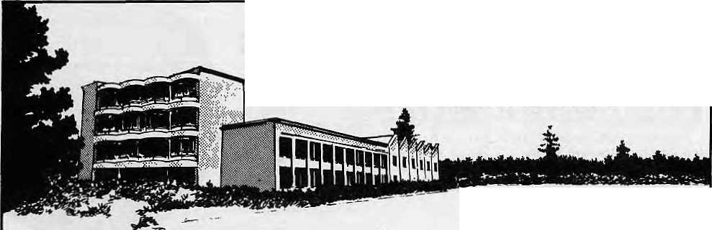
CREATIVE BUILDERS COLLABORATIVE (P) LIMITED
cr
PUm&IS RND BUIUXRS
Post Soi No. 026 BaKuntor. Kothmondu, Nepal. Phone Office 411458, Res 410870 Tta 8381 6ftSS NP.

July 1988
HIMAL
13

FOCUSlON ARUNACHAL

At the eastern tip of the Himalaya lies Arunachal, which literally means "mountains of the rising sun", now going through a process of uneasy and sometimes reluctant transition to "modernity". The following articles deal with two aspects of that transition, the rainforest, still largely pristine, and the changing status of the women of Arunachal.
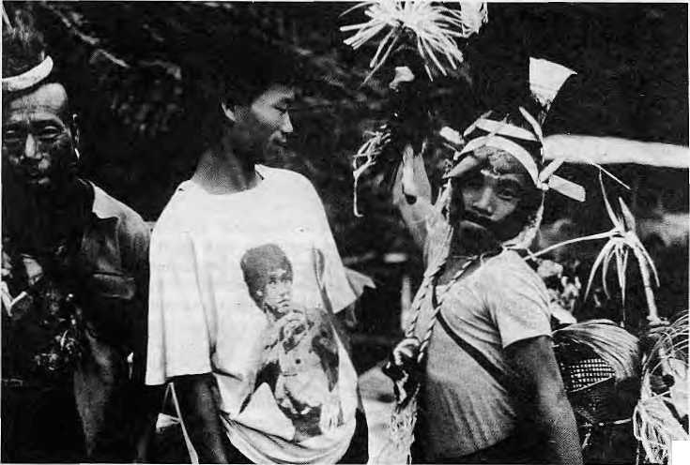
\-
There are 20 major tribal groups, encompassing about 110 sub-tribes in the Indian state's 84,000 sq km area. The majority carry out slash and burn cultivation. Culturally, there are three main divisions. The western-most district Kameng, bordering Bhutan, is influenced by Buddhism. The middle region, comprising Subansiri, Siang and Lohit, is rich in cane weaving and bamboo works. Burmese influence is apparent in the eastern-most district of Tirap.
Photo: S. Acharya
Bruce Lee meets Arunachal warrior.
Threatened Rainforest
By Sanjay Acharya
and down behind his straw skirt. By the fireside, young girls ladled large quantities of millet beer into long bamboo tankards of the victorious hunters.
I thought that this must certainly be: the last frontier. Here, in the rump of the north-eastern Himalaya, the villagers of Pongchau seemed to me oblivious to the 20th century. Yet 1 knew that most of the tribes in the region were in transition, from hunting and gathering to becoming settled agriculturists. They burn hillsides in a collective effort called jhum and cultivate crops in a shifting pattern spread over a period of a decade or so.
The thumping of log drums tore through the mountain stillness. Bare bodies glistened in the evening light as wooden clubs pounded in unison on the gnarled 100-foot hollowed out log. The message was that the youths of Pongchau had established a new Morung, or fraternity, and to celebrate the event had successfully hunted deer. The village chief arrived with due ceremony, with hornbill feathers springing majestically from his cane headdress and emblazoned with wild boar tusks. Colourful beads decorated a well-muscled chest, a leopard's jaw hung from his formidable sword and five shrunken human skults bobbed up
They gather firewood and timber from the forests and hunt deer and wild boar. An occasional leopard or even a tiger sometimes falls to the smoking barrel of a muzzle-loader manufactured by the local smithy. Whether hunter-gatherer or agriculturist, however, in either case the tradition of Arunachal Pradesh has been to preserve forests and forest wealth. The Poncahau tribals know that without these natural assets there is no survival. In these self-sufficient communities, the forests are not sold.
Lately, however, that delicate social fabric has been coming under intense pressure, as an unfamiliar cash-based economy has begun making serious inroads. Modern education is alienating youth from their roots in the tribal family; missionaries, bent on proselytizing the "pagan" animists, are destroying their identity; chiefs are becoming politicians; developers are granted concessions; government agencies have targets to meet. Sawmills and plywood factories have come up to the foothills, some of them even owned by tribal chiefs. The villagers have already been enticed by contractors from the plains to help in illegal timber operations.
These changes are inevitable not because there is no other way, but because the authorities have been too lethargic to find alternative ways of introducing integrated forms of development, designed around local needs and perceptions. There is also a vested interest in exploitation. Assam, Nagaland and Meghalaya have already lost their dense forests. Paper mill owners from Nagaland are now prowling in the forest of Arunacha! hoping to lobby for fresh contracts.
Under the thick canopy of the forest around Ponchau, it is wet and dripping even though it has not rained for days. 100-foot trees block out muph of the light and leeches wave about menacingly on the moist d^C^ying leaf litter. Giant hornbills flap '(Overhead, while troops of hoolock .gibbons loop across the tree tops and crash through the branches. The forest, reverberates with their piercing cries. Neither the wildlife, nor Arunachal's tribal society, are prepared for the lumber merchants. £
Sanjay Acharya is a Delhi-based photographer and writer.

14 HIMAL ■ July 1988

IFOCUSI
Women Look to the Future

By Kiran Mishra
The role of women eveywhere in the Himalaya is changing and women are adjusting to new exposure and opportunity. But the changes and choices confronting women of the Arunachal tribes have their own complexities. The weight of tradition is heavy and burdensome, yet women are a major force in its preservation. Change will bring about a certain amount of emancipation, but it will also disrupt personal, family and tribal life. Conflict and tension lie ahead.
Villages in Arunachal are normally made up of long houses, with up to ten families and as many hearths in one building. In "patrilineal, fraternal and polygyneous" tribal society, the eldest wife occupies the first hearth on the entrance side and the youngest is farthest in the back. The woman
enjoys a relative economic freedom because she has her own jhum fields and hearth. And yet, she has little social or political standing. The patriarch is all-powerful. The man's status is reckoned by the number of wives and mitlum cattle he possesses.
Beginning in childhood, women engage in hard labour. They do the sowing, harvesting, husking, forest gathering, domestic work and household crafts. On occasion, it is they who conduct the rituals to appease ancestors of the long house. Personal property is in the form of ornaments, called gumn, which women bring along in marriage. It is normal for the mother to give away her ornaments to her daughter, but it is the father or the brother who receive mithun cattle as the bride price.
New elements like the growing cash
economy, formation of private property,
work oppurtunities and education are
changing perceptions and expectations
among Arunachal's people. Among
other things, the role of women has
started to change. Young educated
women are sharply critical of their
elders "for selling away their daughters
as mithun to the highest bidder". These
women are spearheading radical action,
especially against polygamy, which is
central to the tribe's traditional
economic, social and family structure.
Yet the threat of tribal breakdown] does
not keep young, educated women like
Mano from saying, "We are not like a
cane basket to be unceremoniously
discarded when it wears out". $
Kiran Mishra is a Fellow of the Indian Council of Historical Research.


Macintosh

Come in for a screen test

Building Design
Associates
Sanepa, Lalitpur, Nepal. Tlx.:22TONPNATRAJ, •fel.No:522456

As these screens indicate, Macintosh¹' can do all the things you'd expect a business computer to do. A lot of things you wouldn't expect a business computer to do. And some things no business computer has even done before.
If that strikes you as amazing, prove it to yourself. Come in for a screen test. Because only seeing is believing.



Authorized Dealer
Apple and the Apple logo arc registered trademarks of Appltf Ctunpulw, Inc. Macintosh is a trademark licensed la AppEe tlomputEr, Inc.
Offering Sarviess In Various Development Reids
- Irrigation And Hydrology
- Rural Electrificctloii -Transmission Lines
- Highway — Airport Engineering
- Ruroi Wofer Supply And Sanitation
5 Water Resources Inventory Study
6. Agriculture And Soci* Economic Study 7 Topographical Survey's
- Soil And Foundation Engineering
- Master Planning - Landscape Designing
10- Construction Supervision And Management


Ugh lun
P. a. lex 3(02 Kithminitu
Phom: 1-12777 C.bl.: MICHO T.k«: NP2231THT
July 1988
HIMAL 15

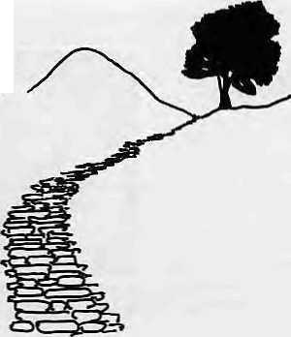
ON THE WAY UP
Talking Language
Careening on a auto-rickshaw around New and Old Delhi while researching our cover feature on migration, we discovered that you don't need English, Hindi or Punjabi to ask directions in the Indian capital. Nepali will do. With thousands of men and boys from the Nepali hills now manning the dust-ridden street corners of Delhi as chaukidars and darbans, you can simply ask "Lai Qila kata chha, dai for bhaifl" It is another matter that he might send you to Greater Kail ash.
Speaking of languages, we often get asked why Himal is in English. The very premise of this magazine is that development and environment experience must be shared region-wide. Information exchange is integral to that process but there is a communications drought in the region, noL the least because we speak different languages. As things stand, English alone can cross borders, watersheds, ridgelines and divisions of the mind. It is our hope that Himal's copy will be freely and widely used by other media and in different languages, hopefully reaching a wider grassroots audience.
We have a counterpart in Francophone West Africa, a monthly called Famille et Development. It is printed in another colonial language, French. Unlike Himal, it is able to reach the grassroots because in countries such as Senegal, Mali or Cote d'lvoire, the primary health worker or school Leacher is fluent in French. Such is not the case for English in most of the Himalaya. For better or worse, acts or ommissions by "decision makers" affect the lives of millions in our mountains. Most of Lhem speak English. We hope they subscribe.
World Traveler Himal
Those of you who read ihe fine print will have noted that the prototype issue of Himal was printed in Sri Lanka. The present issue is from New York. What's going on? Does the magazine of the Himalaya see virtue in distance? No. These interim issues were brought out as and when we were able to raise money, for ours is a not-for-profit publication. However, we hope to stop our wandering very soon so that this magazine will come to you straight from Kathmandu, as it should.
Even with only one issue out so far, we have been hit over the head many times for this magazine's "negative content". We plead guilty, up to a point, and promise to track down more good news. But it would help if there were more of it available. Readers can help in the search by sending in ideas and also continuing to hit us over the head.
Our cover now proclaims Himal as being "For Development and Environment", rather than "For Environment and Development", as we had it in the prototype issue. Has the E-word lost out to the D-word? Not really. We reversed placement only because "development"¹' is generic and covers the entire social, economic and environmental universe. However, we
Kanak Mani Dixit
continue to keep "environment" because
in these fragile, over- populated
mountains, the environment-development nexus is more important than anywhere else.
Save Sustainable Development!
If the word development (and bikas) had not become a cliche, there would have been no reason to come up with "sustainable development". Prime Minister Gro Harlem Brundtland of Norway, whose World Commission on Environment and Development gave us the new term in its 1987 report Our Common Future, defined it in a nutshell at the United Nations: "National and international strategies that offer real options, that secure and enhance incomes as well as the environment".
The Brundtland Commission has commendably kept its efforts alive by getting key groups around the world to participate in the report's implementation. But the Big Bad Cliche is lurking in the woods waiting to pounce on little Sustainable Development and drag it down to be shackled with all the others: Trickle Down, Hundred Flowers, Adjustment With A Human Face, and, the most recent arrival, Peres troika.
Having been embraced by the
international set and self-appointed
development czars, Sustainable
Development has already lost some of
its fizz. It will become really flat when
national minisiers and planning
commissioners start jostling it about.
Madam Brundtland must devise a way to
rescue S. Development. /i

S/D SUSTAINABLE INTERNATIONAL DEVELOPMENT by

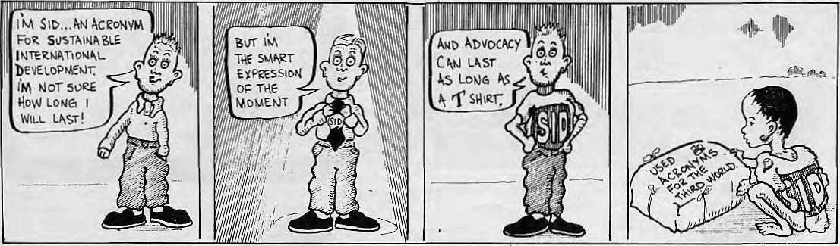

16 HIMAL ■ July 1988
George McBeaafACTION FOR CHILDREN

INTERVIEW
EDMUND HILLARY

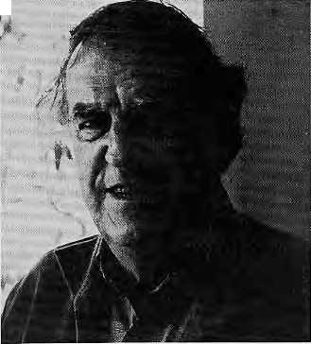
Edmund Hillary climbed Mount Everest in 1953 with his partner Tenzing Norway.
His relationship with the Himalaya has. if anything, deepened in the 35 intervening
years. Sir Edmund, presently New Zealand's envoy to India and Nepal, talked
recently in Kathmandu to HIMf'L. _{t}
Himal: Some say that there is little commonality among the Himalayan peoples. Do you agree?
Hillary: There is an enormous variety, of course. But there is a lot in common among the mountain communities. There is a strong relationship between the peoples, be they Rais, Gurungs, Tamangs or Sherpas. By and large, they have confidence in their relationship with the mountain environment. Otherwise they would not live here.
"Slowly, slowly is better."
Photo: KMD/Himai
are benefiting from tourism. The Rais are poorer. No doubt, Nepal is a poor country and it has major problems ahead. But in the hill areas, j would rather see slow and steady progress. As my Sherpa friend Mingma Tsering says, "Slowly, slowly is better."
Himal: Are you concerned over tourism's impact on our environment and peoples?
Hillary: In Nepal, there are some places that are just lousy with tourists and trekkers. The idea of tourism is good: you get to know other peoples and cultures, but one has to consider the pressure on the environment and the local culture. There has to be some discipline and control, but by that I do not mean that you immediately increase costs so that only the wealthy get to see a destination. The young and the impecunious must not lose their access. So what is required is balance in control.
Himal: You did open the tourism floodgates in Khumbu by building the Lukla airstrip in 1964.
Hillary: I believe that I am initially to blame for the flood, but console myself with the thought that it would have happened anyway. Once you get away from Lukla and the trading post of Namche, actually, the Sherpa livelihood is not very different from what it was 30 years ago. Those two villages have become extremely tourist-oriented. I say
Himal: After decades of observation, do you find cause for concern about life and environment here?
Hillary: There is immense ecological degradation across the mountains. The main problem, of course, is the increase in the number of people, which puts tremendous pressure on arable land. In the Nepal Himalaya, in Garhwal, and other areas in the Indian Himalaya, I have found cause of extreme concern.
The Chipko experience is good and seems to have worked in its specific region, but maybe every area has to develop its own techniques. Not by any means are people conservationists by nature. They have to live from day to day and life is hard. The need for firewood is immediate. It is no good saying "we want this environment unchanged for the next hundred years". The hill people live very much in the present.
Himal: What are the major challenges to development?
Hillary: Two major challenges for Nepal, at least as I see it, are family planning and reforestation. Unless much more substantial efforts are made in these two areas, slowly but steadily, the Nepal Himalaya will become a desert. Much of that is also true for the Indian hills. Bhutan is in a better state, but then there are not that many people there. The obsession with roads and big factories is misplaced. Above all, for progress, you must have the support of the ordinary man in the field.
In the Nepali mountains, the Sherpas
let Namche be ruined by the tourist, but let us protect Khumjung, Khunde and the other villages which are the real heart of Khumbu. What is needed in the Khumbu, and elsewhere, is not heavy-handed control of tourism, but better administration and lesser numbers.
Himal: Everest has been climbed siege-style, alpine-style, solo, by armies and without oxygen. It has now been traversed from both sides. What is to hecomc of the poor mountain?
Hillary: I say let the mountain alone for five years. There is so much worldwide pressure .to climb it and that affects the environment. They should close the peak and then start all over again in a controlled manner. The major expedition syndrome will not fade away, because with siege-style there is a place for television-rights, media. 1 do not like the collosal size of big expeditions. On the other hand, the big mountains of the Himalaya should not be the sole preserve of hot-shot alpinists. That is an arrogant view. Mountaineering should be for everyone who is reasonably competent.
refer
l: Do you pre olnngma", "Everest" or th"?
Himal: Do
"Chomolnngma",
"Sagarmatha"?
Hillary: I think people should use the name they prefer. But whatever it is called in Tibet and Nepal, the world will always know it as "Everest" no matter what.
Himal: Ten/ing Norgay is no more. Did you like the man with whom you made history?
Hillary: In 1953, when we climbed
Everest, we were friendly and worked
well together, but you would not have
said we had warm relationship. In the
last ten years, we came closer, and in
the last couple of years, we were really
very close. We were able to
communicate better and we talked
philosophy, for he was quite a
philosopher. Buddhism was very
important to Tenzing, and he had a
gumba on the top floor of his house.
He was very concerned for the
education of his children. He had very
little to do with the Sherpas of
Khumbu. The way of life of the
Darjeeling Sherpas and the Khumbu
Sherpas are very different. £>

July 1988
HIMAL
17

GRASSROOTS

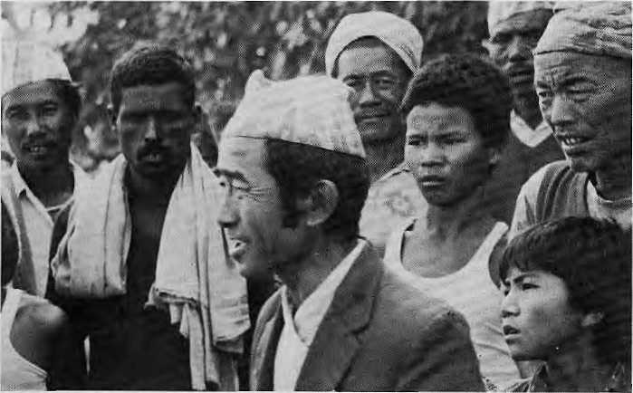
Indra Bahdur Kapchake
The news item in the papers in late January was brief and perfunctory. A 55-year-old man had been run over by a bus in the eastern Nepal Tarai, Thus was noted the passing of Indra Bahdur Kapchake in Kathmandu, but the grieving villagers of Madhubasha would have written more.
Indra Bahdur was no ordinary village leader, for he had a rare ability to inspire others into action. Indra Bahdur had given people ideas. Today, Madhubasha is a village of hope and purpose because it did not wait for largesse from the ministries, the projects or from distant lands. "Development" in Madhubasha self-ignited.
[ndra Bahdur proposed setting up a village co-operative about twenty years ago, and the neighbours agreed. The co-operative began innovating almost immediately. A bio-gas plant was setup, piped drinking water came next, and a school was built, as were a child-care centre, a forest nursery and latrines.
"You see, the people of this village do not play cards, drink or smoke. There are a few elders who still smoke but they will take the habit with them," Indra Bahdur told me just a few months ago. He said "bikas" involved not only building roads and growing more grain per hectare, but changing social mores as well.
For example, the people of Madhubasha have revised ruies for social gatherings
to Fit their pockets. Hindu marriages in Madhubashsa are not the expensive affairs they tend to be elsewhere. A groom's party is allowed to bring only a priest and three persons as witnesses.
And then, of course, there is the "Pigeon Project". Someone complained that barbers charged too much. Ever enterprising, Indra Bahdur suggested raising pigeons for profit and the members of the co-operative agreed. Before long, hair-cutting in Madhubasha was fully subsidized. The Pigeon Project, Indra Bahdur said, had convinced even the skeptics about the rewards of common effort.
The collective harmony and will to work soon brought attention. Trainee officers came to see "development happen" and farmer groups came for advice. Representatives of the international development set descended on the village, each claiming a small part of the success. The last VIP Indra Bahdur was to meet was UniceFs chief James P. Grant.
Madhubasha is today better off than most Nepali villages, and most of it was Indra Balidur's doing. He was not another statistic. By Binod Bhattarai
Prize for Chipko
Last year in these pages we reported that the Right Livelihood Award (the "Alternative Nobel") had been conferred on the Ladhak Ecological Development Group by the Swedish Parliament. This year, a Himalaya group has again been
recognized: Chipko andolan, represented at the prize-giving in Stockholm by Sunderlal Bahuguna. So something must be going right in the Himalaya.
The citation for the award stated: "In their intensifying struggle to ward off the increasing commercial pressures that are threatening to wipe out India's Himalayan forests earfy in the next century, the workers of the Chipko movement have emphasised two themes; that ecology is permanent economy and that the most important forest products are not timber but soil, water and air."
Jara Juri
The 1988 Jara Juri ("grassroots") award goes to the villagers of Sami Bhanjyang in the Central Nepal district of Lamjung, Every year, conservationist K.k. Pandey treks through the Himalayan hinterland in search of farmers who have saved the fragile mountains using their own skills and management techniques. His interviews and photographs are used by a panel of judges in making their selection.
While the rest of the country has been going through paroxysms of planting fast-growing pine and rootless eucalyptus on visible hillsides, the villagers of this small hamlet of 85 households have kept a level head. They established a forest committee which declared a wooded area of 30 hectares out-of-bounds.
The committee decreed that any collection of dry branches, removal of unproductive trees or planting of saplings has to be approved. Once a year, dry limbs and trees are collected and distributed among the villagers. Individuals are encouraged to plant their own fodder trees and bamboo in the forest. Villagers who break the ruies are fined. Committee members are fined double.
The villagers needed no expert to tell them what to do, Pandey, who established Jara Juri by setting aside the royalty of a book of his on fodder trees, says, "In fact, their work is as good as, if not better than that of trained foresters." The Award consists of a nominal cash prize and a letter of appreciation which "recognizes the spirit of self-help among the highland farmers". -B.B.

Kapchake with his folk last year.
Photo: Mrigendra Singh

18 HIMAL ■ July 1988

VIEWPOINT
Ecological Dogma in Hill and Plain
By Pran Chopra

Most hill people in India and in the mountain kingdoms of Bhutan and Nepal do not see their hydrological nexus with the plains below as symbiotic. This is because in the past the plains have been predatory and the hill people have rightfully felt robbed. In siting projects and allocating the benefits, the authorities have paid insufficient attention to the' interests of the hill areas and populations.
Immense harm has been done to the Himalayan ecology, some of it by the short-sighted exploitation of resources for the sake of the plains. Hills and valleys which have served local needs as well as those of the plains for decades are now in danger of being able to serve neither. They have been badly gouged for meeting immediate local needs for fuel, fodder and food, and by the rash construction of dams.
The answer is to insist on strict implementation of a forward-looking principle, that there be a fair sharing of any project between the upstream and downstream areas and populations. While recent studies have rightly exposed the damage done to the hills for the short-term profit of the piains, many have ignored those strategies by which the natural nexus between the hills and plains can be truly developed for the benefit of both.
There are those who balk at treating the hills and the plains as a single ecological system. They favour India's treating the hills as a self-contained and self-sufficient universe to be developed for meeting the needs of the local people. They would admit to two types of tradeoff: the plains should meet a pan of the food needs of the hills to help reduce the pressure of cultivaton in the highlands; and the hills should be cultivated in such a way that they do not add to the load of silt in the plains. But this under-estimates the scope for much bigger* and mutually beneficial tradeoffs, particularly in relation to water and gravity. This brings us to the subject of power projects and the hill-plain nexus.
It would be wrong to turn our backs upon large hydropower projects and confine the Himalaya to small units. By their very nature, micro projects have a limited radius of benefit. While they certainly are to be recommended for isolated hill communities, they are no substitute for larger projects, which can be far more beneficial not only in terms of power but in wider economic terms if the hills and plains of a river system arc treated as an integrated economic resource region.
No evidence supports the proposition that a large number of very minor projects can be linked to deliver'as much power
at a main exit point as a suitably located major project. Nor is there basis for maintaining that a major project necessarily causes more ecological damage than would a whole chain of power-equivalent micro projects scattered throughout the upstream hills. On the contrary, it is more likely that a major project, if fully mindful of the ecology, will do much less damage and in a more limited area.
It would be wrong to go back to the atavistic principle that we turn our backs upon large scale hydro-electric projects in the hills and confine the Himalaya to micro projects. The price would be much lower, and the benefits greater, if major projects were not discouraged and at the same time were required to have full regard for the ecological and economic interests of the hills and hill people.
This proposition, writ large, is also the true basis for the most profitable area of economic co-operation between India, Bhutan and Nepal. The whole case for economic co-operation hetween the three countries rests upon the symbiosis between mountains and the plains below. The true development of this inter-country symbiosis depends on the same strategies as does the nexus between Himalayan and Gangetic India. A

The Dalai Lama on Human Thought and the Environment

We excerpt below the Dalai Lama's views from an address on "human survival" he gave at Oxford University on 12 April.
"Though the human family seeks a secure future, we find ourselves confronted by many problems. The delicate balance of the earth's ecology is being eroded on land, sea and in the atmosphere. The global population is increasing while our resources are being rapidly depleted. Under the pressure of a shrinking world, no nation or community can afford to neglect the needs of its neighbours. It is no longer a matter of choice; our mutual requirements are bound to one another.
"The need for mutual respect and a sense of limitations is particularly evident in the environment. Industry has been
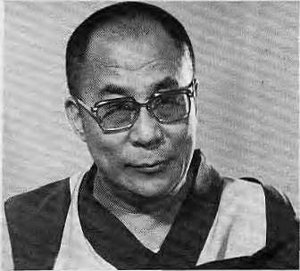
insensitive in its exploitation of nature. Although previous generations could not claim the degree of development we have achieved, at least the world they bequeathed to us was intact. It is time to examine ourselves and correct where we've gone wrong. Science and technology cannot solve all our problems.
Our faith in material progress has become too uncritical.
"We need to address our troubles at their root; within the human mind itself. Some may dismiss this as a vague or ineffective view. Ultimately, however, human history itself is nothing but the record of human thought. As one brought up in the Mahayana Buddhist tradition, I really fee! that love and compassion are the very fabric of tolerance. To me, an humanitarian approach to world problems seems the only sound basis for world peace. We have arrived at a critical juncture. We cannot create peace and a stable environment on paper. Time is short and the problems we face are great. Mutual respect is no longer an option — it is the very price of our survival." A

July 1988 > HIMAL 19

VIEWPOINT
Technology's New Rules
By Dipak Gyawali

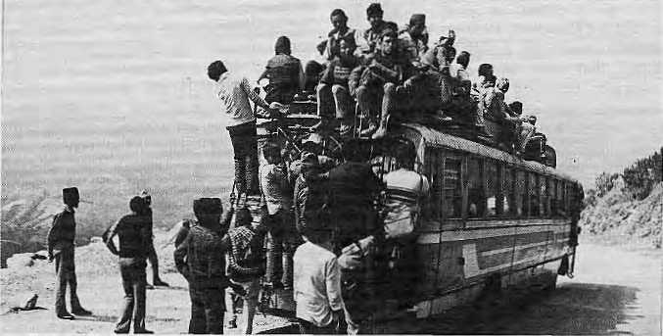
More room at the top.
Three days before the Ides of March 1988, Kathmandu experienced the most shocking mass deaths since the earthquake of 1934. Scores of football fans lost their lives and many more were injured in a stampede as a hailstorm lashed the Dasrath Ranghasala for 15 minutes.
The hailstorm was not the first in Kathmandu, and others before it have never managed to kill as many people in one fell swoop. What has changed for hailstorms that allow them to be so hazardous to public health? Of course, there have been no drastic changes in weather patterns. What is happening is that our society is adopting the trappings of "modernity" without fully understanding the process. The relationship between technological needs and traditional management is still distant.
We have yet to appreciate fully that emergency exits in cinema halls must be kept unlatched, that airplanes have load limits, and that mass exodus is the first thing to anticipate in managing a sports stadium.
The design of Dasarath Rangasala shows an adequate number of large and small exits. However, only the "back-doors" are allowed for use by the ordinary spectator. In normal times they are choking enough; in extraordinary situations they become a deadly bottleneck. The authorities failed to
draw lessons from a similar stampede a few years ago, one that luckily did not claim lives. They continued the quixotic practice of keeping the doors locked for the duration of a game and the prize-distribution and speech-making that follows. Those who want to leave a boring game, or a hailstorm, are trapped.
If there is a message in the Ranghasala disaster, it is that there are similar tragedies waiting to happen wherever modern technology and traditional management are mismatched. One only has to look at buses on the rajpath piled high with humanity; the villager who uses pesticide to kill fish in the stream; or the airstrip manager who slips an extra sack of supplies into the baggage hold of a Pilatus Porter.

Photo: O. McBean/Unicef
Nepal is moving from a "rural-diffuse"
society into an "urban-concentrated" one,
where technology is used to pack
people more densely, even while
catering to their needs. In urban living,
the laws of technology that allow so
many people to live so close together
must be respected. Stadia, like systems
of mass transit or mass production, have
their own requirements for functioning
smoothly. These mega machines
demand that extreme events like sudden
power failures or fires or earthquakes be
accounted for not only in design but in
operation. Engineers and managers
knowledgeable about such things must
be entrusted with power and
responsibility to act in emergencies. A
cavalier attitude could only lead to
further tragedies. &

Let Them Drink Coke


It is good to see fledgling Nepal-TV doing so well, but distressing to note that most of its advertising revenue seems to derive from come-hither advertisements from soda manufacturers, beer bottlers and cigarette pushers.
An American soda ad shows off scantily clad super-rich California kids wind-surfing on the Pacific coast. What kind of a message is that for poverty stricken, land-locked Nepal, even in ad-speak? No clever commercial here, just an attempt to get an unsophisticated audience to pant after what they cannot have.
Just to keep up with the foreign 20 HIMAL ■ July 1988
competition, a Kathmandu adman has produced a slick commercial showing a shapely Nepali miss going through her paces, while an off-screen voice asks, "Are you man enough?". Now that Kathmandu-wu//«/if know what a television set looks and sounds like, it is time for NTV to show some circumspection in selecting commercials.
Speaking of ads, the good news from New Delhi is that the Health Ministry is planning to ban all advertisements of cigarettes, bidis, cigars and other tobacco-based products. We hope that this plan becomes reality. Initially, the statutory warning on cigarette packs is to be extended to all the other tobacco
products. Specific warnings are to be
developed, which will refer to oral
cancer, heart problems, respiratory
diseases and life spans. t>

VIEWPOINT
Typhoid Vaccine Trials in Nepal
By Shanta Basnet


Last year, American and Nepali public health specialists successfully tested a new intramuscular typhoid vaccine. The epidemiologists reported in the New England Journal of Medicine that the prevalence of disease among those vaccinated was one fourth that of those who had not been vaccinated. It might well be (and one hopes) thai this new vaccine will prove itself by saving lives and health of thousands of Nepalis.
The intramuscular vaccine tested in the study requires only one dose, has few side effects and is 75 per cent effective. An oral vaccine tested in Chile and other countries requires three doses and also has no side effects. However, its effectiveness is 60 to 70 per cent.
Since the preliminary reports point to a major breakthrough, it is important to ask a few questions in the context of Nepali public health. If the research was done for the sole purpose of testing the vaccine, then the project was successful. But if the purpose was to initiate a programme of intramuscular
typhoid vaccine in Nepal, then the matter needs to be discussed.
The intramuscular method of vaccination requires an adequate number of trained personnel for country-wide coverage, plus syringes, vials and special facilities for distribution and storage. Given the scarcity of health professionals and equipment, the best one could do would be to run ad hoc immunization campaigns.
If past experience is any indication, in Nepal and elsewhere in the developing world, the tendency is to go for latest, high-tech interventions that look impressive on paper but are secondary in application, especially in village
systems. Top-down health planning inevitably leads one up this path.
The oral vaccine could be distributed through the village health worker, who is presently quite under-utilized due to a lack of drugs and an influential social role. The three doses can be easily administered by the health worker within his precinct at required intervals. This also provides an opportunity to monitor the effectiveness of the vaccine. Even if the oral vaccine is only 60 per cent effective, might it not be preferable to the injectable vaccine because of its much broader reach?
It might well be that after thorough
study the intramuscular method will be
found preferable. The issue has been
raised here mainly to illustrate a larger
issue for public health planners. The
best available method in a developed
country or in Kathtnandu may not be
the most advisable one for a hill
district. In any event, whichever
vaccine is found suitable must
immediately be put to use before the
next typhoid epidemic engulfs us. C>

Swapping Debt for Nature
By David Sassoon

If you imagine this planet to be a single organism with a body of its own, then tropical forests would rank as one of its most vital organs of circulation and respiration. They capture, store and recycle rain, control floods, drought and erosion, regulate the global climate and play a major role in the earth's life support system. But if present trends continue, most of these forests will be stripped bare in 20 years, and the planet will suffocate.
One major factor contributing to the wholesale murder of this planetary organism is the debt crisis, with developing countries now owing close to a trillion dollars of borrowed currency. To pay back this debt, or in many cases, just to pay back the interest, nations deplete their natural resources in a mad rush to meet payments. Forests are cut down, the earth is ripped open by mines, and the natural bounty is consumed like fast-food to generate exports and cash. The debt crisis, in
short, is blocking development and promoting the torture of the planet and its people.
Last year, an innovative approach to easing national debt problems and saving the natural environment was tried out in three Latin American countries, Bolivia, Ecuador and Costa Rica. In these deals, one US dollar can effectively "buy" multiple dollars of local currency, which is then spent on conservation and environmental protection. In Bolivia, where the swap was first tried, Conservation International, an American organization, purchased $650,000 of Bolivia's debt at the discounted price of $100,000 from a bank holding the debt notes. With the collapse of tin prices and high inflation in Bolivia, the bank had little hope of recovering the loan and so was willing to get what it could by selling at a discounted price.
In turn, Conservation international
swapped those deht certificates with the Bolivian Government in exchange for its agreement to protect 3.7 million acres of Amazonian forest and grassland by expanding the Beni Biosphere Reserve. The reserve is home to the indigenous Chimane Indians and 13 species of endangered plants and animals. In addition, the Government set up a $250,000 fund in local currency for the administration, management and protection of Beni reserve.
These debt-for-nature exchanges will not,
by themselves, cure the debt
crisis or halt deforestation. Such swaps
may be able to absorb several billion
dollars worth of debt in the long run,
but will hardly put a dent in the trillion
dollars that is owed. But these swaps
are bringing the attention of decisipn-
makers to the role of natural resources
in promoting development. As one
commentator observed, "conservationists
never had the attention of bankers, now
they do." A

July 1988 ■ HIMAL 21

PHOTO ESSAY
Portering-- "It is such a hard life..."

Pictures by Kevin Bubriski
Portering in the Nepal Himalaya is deadly serious business. It involves enormous toil for little gain; it brings on premature aging. It is among the most primitive uses of human physiology — the hauling of loads for long distances on sheer "manpower".
In Nepal, the porters are the subsistence farmers, men and women mired in extreme and general rurai poverty. In a country where underemployment is endemic, the Himalayan peasants have few means of earning cash other than by bearing wickerwork baskets up and down mountain trails: oil and salt for the village merchant, pipes and tin roofing for development projects, firewood for hill markets, fodder for cattle, provisions for trekking parties and mountaineering gear for expeditions.
Farmers from isolated corners of the country also make annual treks down to the nearest roadhead to buy the year's supply of salt, calico and cooking oil.
The porter (a bhariya or dhakray) balances the basket (dako or dhakai) on the back and uses a strap across the forehead, a namlo, to take most of the weight. The strain on the headband forces the porter to lean forward and down while taking a climb, breathing in steady, deep rhythms. The calf muscles are tense, the hands on the temples to steady the namlo, and the feet bare. Porters often have flat feet. Their soles are thicker than a shoe's and as insensitive to the touch.
A grown man carries baskets that weigh 85kgs or more. Able-bodied western
mountaineers have found it impossible even to stand upright and steady with a doko that a five-foot Rai or Tamang hillman has been carrying all day. It is partly a question of technique and partly a question of not having a choice.
Everest summitteer Edmund Hillary recalls with wonder a porter who was keeping pace with him on a trail between the east Nepal hamlets of Junbesi and Takshindu. "When we stopped for lunch, I saw he was carrying two bags of cement, all of one hundred kilograms. His body-weight must have been about 65 or 70kgs."
The tortuous steps up the steep, often dangerous trails are interrupted by short breathers, when the porter slips a thick wooden cane, called taken, under the

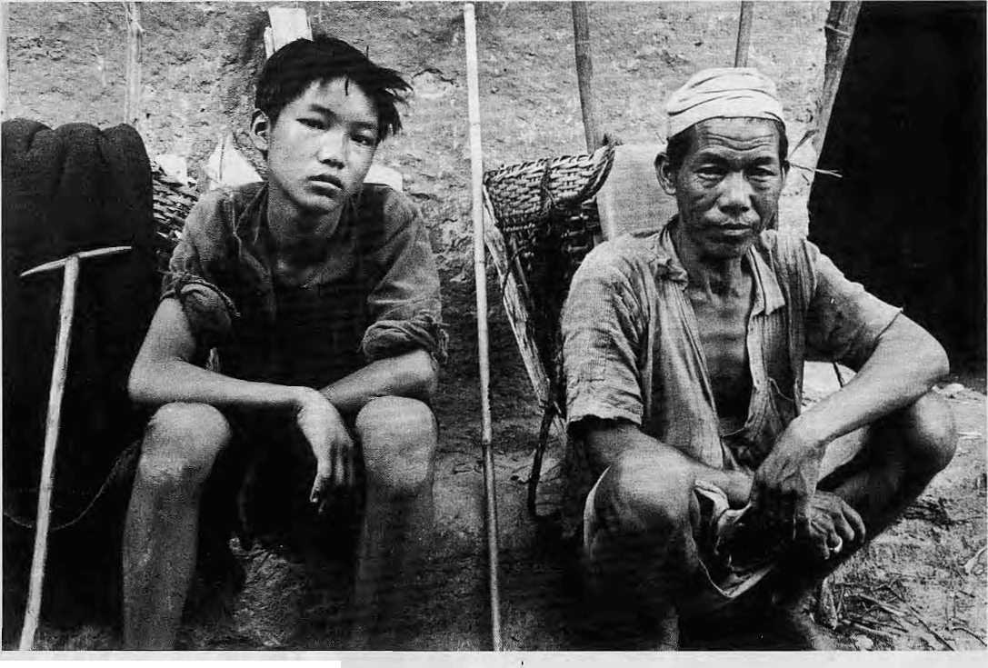
Magar father and son, porters in Baglung.
22 HIMAL ■ July 1988

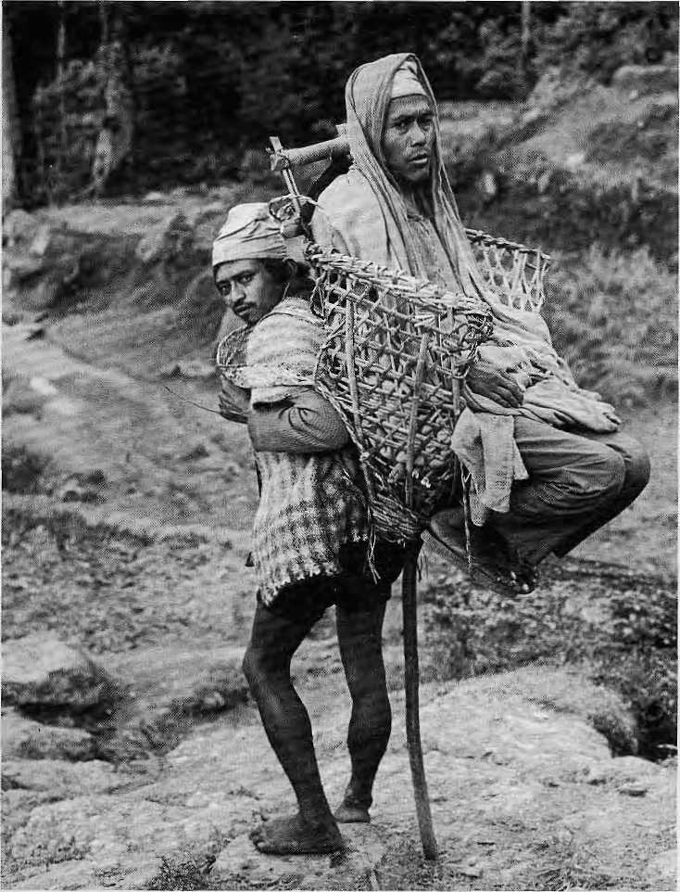
anywhere from NRs80 to NRslOO. In the Arun valley of East Nepal, still out of bounds to tourists, the average is NRs.40 a day. Off season, the prices come down all over.
Nepal's development efforts have focused on building highways to link population centers. Roads have heiped bring the mountainous country together by improving communications. The transport of bulk goods is much easier and the national economy has benefitted immensely.
basket. The porter then leans back tw make a tripod out of his legs and the cane. The balancing act is difficult to maintain for long.
If the trail is in prosperous country, there will be a ckauiara with a rock platform to place the basket on, a peepul tree that whispers in the slightest breeze to provide shade, and a diverted stream nearby for a quick drink. But the slop cannot last too long, and before the body has had time to cool off, it is time to heave the load and push off for the high pass.
Descending the other side is much more difficult, as any hillman knows. The technique perfected on the Himalayan trails is to keep the thigh muscles tense but flexible, to take quick short steps, slipping easily from one boulder to the next. Heavy footfalls, such as with heavy climbing boots, would ruin a hhariya's knees in no time.
The International Labour Organization (ILO) in 1967 recommended 55kg as the limit for loads being "manually transported" by an adult male worker. But existing rules al!ow men to carry loads ranging from 45kg in East Germany to 56kg in Mexico and 90kg in Bangladesh. In India, dock-workers have a limit of 100kg. But unlike the dock- worker, who heaves loads intermittently, a Nepali porter labours for hours at a time for days on end. (While researching this article, we could not locate a specific medical report on what years of hauling can do to the peasant's backbone or general physique.)
Diet during these long excursions consists of sattu, powdered maize or grain. At lunch break, porters bring out their ubiquitous battered aluminium pans, add water to the sattu from a nearby stream and consume the paste with the aid of red pepper and salt. This is the time for some conversation with other toilers on the trail. Even as part of a group, portering is a very lonely pursuit. While on the road, the constant heavy breadiing does not allow the peasant to sing, hum or converse. Nights on the trail are spent under a coarse homespun.
The pinnacle 'of portering is to be a climbing partner to the sahebs who need help in getting to the top of Himalayan peaks. Sherpas have had a virtual
Sick man portered four days from Upper Arun.
monopoly over this end of the trade, although other hill tribes are finally making inroads. Lately, Sherpas have begun to leave the actual portering to others as they run trekking agencies and lodges and work as sardam and high altitude guides.
Local merchants in central Nepal pay s porter NRs6U a day to carry a 80kg load of provisions. In the tourists' staging point of Pokhara, trekking agencies might pay as .little as NRs50 daily, while individual tourists pay

July 1988
HIMAL
23

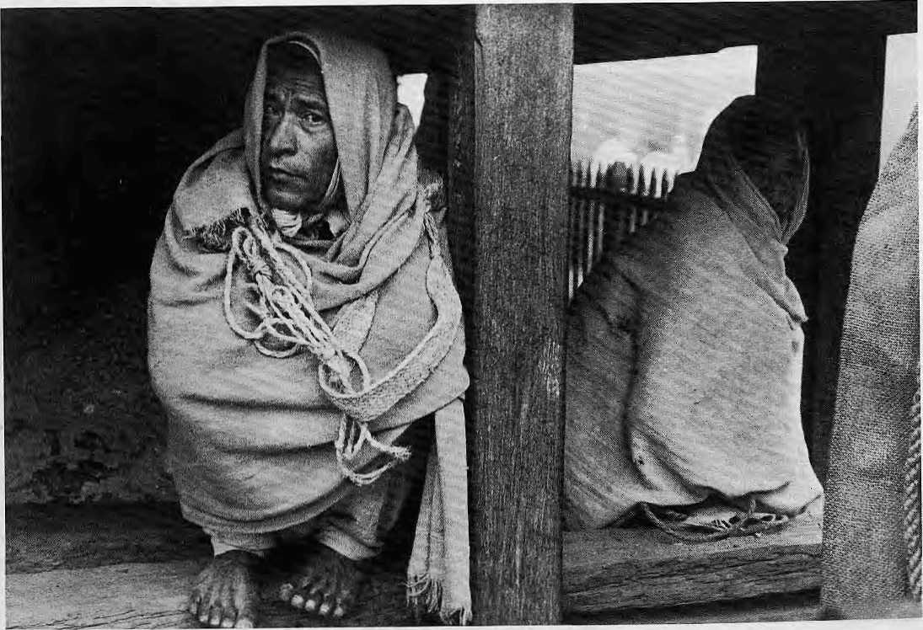

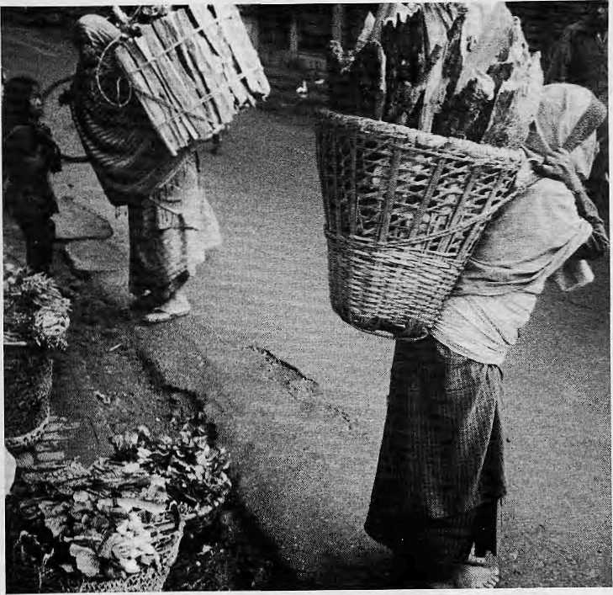
Waiting for work at Kastapmandap. Firewood for the Paten Market.
For the micro-economy of the hill villages, however, highways have been at best a mixed blessing. Very often, income that was spread fairly widely among mountain porters — all of them poor without distinctions of race, tribe or ethnicity -- has now to be shared with urban businessmen who run buses, trucks and jeeps.
Porters do use the highways, but mostly to walk on the smooth tarmac. Even the cheapest bus fares can be too expensive for some of them. In the end, ponering too is a "socio-economic indicator" -- a manifestation of the material poverty of the hill society.
"The more simple the life, the poorer
you are, the bigger the load you will
carry," says Edmund Hillary. "I believe
that portering will decline with
economic progress in the hills. It is
such a hard life." A
24 HIMAL • July 1988

A Lonely Death on Thorung La
By Padam Singh Ghaley

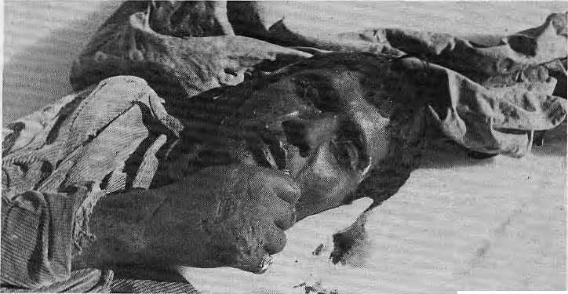
On 10 April, 1986, I was leading a trekker's party in central Nepal from Manang over the Thorang La (5330 metres) and down lo Muktinath. We had just crossed the pass when a little to the side of the trail we noticed a black and blue sleeping bag spread out on the snow. A closer look showed that the lightweight sleeping bag was but a death shroud for a young porter. Scattered around were the contents of his doko: onions, potatoes, trekking food and utensils, It seemed that he had fallen victim to frostbite and altitude sickness and died a lonely death, far from the lowland hills where he obviously belonged.
My investigations showed that the dead man was from the village of Khanchok, on the Pokhara-Dumre road. He had been hired by a trekking party of an American couple, led by a sardur from a prominent trekking agency in Kathmandu.
As a mountain guide, I am concerned with the poor treaimem often meted out lo hill porters by some parties. While most tourists and trek organisers are quite decent, a few take advantage of
the extreme poverty of our mountain peasants to take them to the limits of their endurance and capacity with little or no equipment, poor diet, and no support when they need help.
To retain and develop further the trekking trade, which forms an increasingly important part of our national economy, we must regulate and monitor it so that our image is not tarnished, neither in the eyes of foreigners nor in those of our rural compatriots.
I remember a 1984 article in the Rising
Nepal in which a Bavarian climber
was quoted saying that in his trip, "We
didn't suffer any losses, just one porter
was killed." The titie of that article
was, "No Losses: Just the Death of a
Porter". It seems as if nothing has
changed. £>
Photo: P.S. Ghaley
Padam Singh Ghaley has been climbing and leading treks in Nepal for more than a decade.

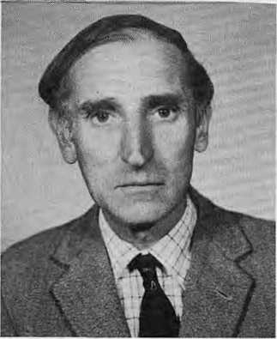
When Mike Cheney died early in the new year, a few months short of his 60th birthday, the hi!! people lost a true friend. He had come from afar and stayed, not for the money or the glamour, but because of his attachment to the people of the mountains. . After leaving the British Army in 1957, Mike managed tea estates in Darjeeling
and later helped to found the tea industry of Nepal. In 1967, he joined the trekking trade and stayed on as a thoughtfuI keeper of conscience. The best tribute is to recall some of his words, excerpted here from the book Bikas-Binas.
"At present, cases of death or injuries of porters, on treks especially, arc 'hushed up' and kept quiet. Complaints and reports are largely ignored. No enquiries are held as to why people died and how such deaths could be prevented in the future. Everybody just wants to forget ~ publicity would be bad for tourism. We in Nepal must work very hard at improving 'man skills'. There is one very good, if unorthodox way of doing this. This is by shaming those reponsible for bad management resulting in maiming or death of those in their care. Just by making public the names or individuals and organisations responsible, without any other action, will quickly lead to big
improvements." (Himalaya Conference, Munich, 1983)
"Every winter there are reports of porters carrying goods for trekkers dying because they did not have good, warm clothing. Porters increasingly tend to wear western-style clothes — thin nylon shirts, cotton shorts or thin cotton trousers, and fancy but thin nylon jackeis from Hong Kong. Daura and suruwal, your own type of clothing, is the best and warmest dress for working in the winter. So do not give it up because people in the towns who work in offices do not wear it — be proud to be Tatnang, or Gurung or Rai, dressed in your own way. There are many things we need to learn from foreigners and for which we need help from foreigners. But to learn these things we don't have to change ourselves. In The villages of Nepal, we do things differently, and better." (Radio Nepal Tourism Programme, 1984) A

July 1988 ■ HIMAL 25

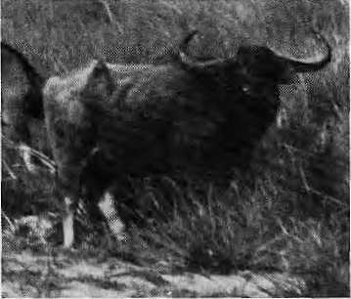
PARKS AND WILDLIFE
Fur Smuggling in Kashmir
Two conservation-minded tourists posing as buyers of rare Himalayan furs have found evidence to indicate that Kashmir is a center for a network of poachers, middlemen and shopkeepers engaged in international trade of protected animals.
Struck by the abundance of pelts on open display along the Polo Ground View Road of Srinagar, travelers Martin Berg and Rasi Damihus decided to do some investigating. Posing as rich tourists looking for the most expensive buys, they visited ten taxidermists. Their brief survey revealed 10 skins of the clouded leopard, 55 of panthers, 10 of tigers, 60 of lions and 50 of the leopard cat. Prices ranged from IRsl50 for a leopard cat to [Rs35OO for a tiger skin, with scope tor bargaining. There were 24 skins in all of the very rare snow leopard.
Berg and Demihus learnt that customers could pay through their home bank accounts. The fur was air-freighted upon notice of payment. Most of the skins found in the Srinagar shops were of species not native to Kashmir, but to other parts of India and neighbouring countries.
India ratified the Convention in International Trade in Endangered Species (CITES) in July, 1976. The Indian Wildlife (Protection) Act of 1972 prohibits commercial trade of rare species. But the two tourists learnt what many have suspected for long: in the name of pleasure and trade, Indians continue to hunt, sell, buy and export "protected" animals and their products. Preventive legislation is meaningless unless backed by strict enforcement. -Rajiv Chopra in Jammu Tawi.
Wild Buffaloes Nearly Washed Out
15 September 1987, 7 a.m.: Two exhausted ama males plough slowly through the muddy waters of the Sunkosi River, trying to return to their old homes three miies upstream in the Kosi Tappu Wildlife Reserve. What awaits them there is a vast expanse of water, no more lush grasslands and shady forests. Although normally at home in the water, the wild buffalos are not used to the Kosi in flood. The river moves in ocean-like waves, with crests of more than two metres. By sunrise the next morning, the animals are gone. Did they survive?

Photo: JJB
Arna at Kosi.
We had come to Kosi Tappu to investigate the effects of the two late-monsoon floods on its forests, grasslands and wildlife, especially the last surviving population of arna in Nepal. There were an estimated 91 arna in Kosi Tappu before the flood, and a rough estimate is that about ten per cent were lost to the Kosi. Loss of other species, such as Chittal deer and wild boar are believed to be much greater. The impact of high rainfall in the Kosi catchment area is compounded by the regulation of water flow at the Kosi Bairage downstream. During the peak of a flood in 1968, 40 to 50 percent of the ama population are thought to have perished.
The plight of the arna raises an important question: should they be left to an uncertain future without any intervention? An alternative is to select a breeding stock out of the remaining population and to translocate it to safer areas such as the Royal Chitwan National Park or the reserves further West in Bardiya or Shuklaphania. (The arna disappeared from Chitwan in the 1960s.) That option would cost money, which is scarce. But the longer we wait, the more precarious will be the existence of Nepal's surviving arnas -due to floods, inbreeding, and crossbreeding with domestic buffaloes. - J.J. Bauer, National Parks and Wildlife Office, Kathmandu.
Bustards on the Brink
Despite repeated calls to ban hunting of the endangered Houbara bustard, Pakistan continues to welcome well-heeled parties of falconers from the Middle East who have brought the migratory bird close to extinction.
Wildlife experts report a 75 percent decline in the Houbara population since 1965, when hunting parties were first allowed to track it in Pakistan.
Ruthless hunting has virtually eliminated it from many Arab countries and now an estimated 3000 are killed every year in Pakistan. Commented an official of the World Wildlife Fund in Pakistan: "They've finished them off in their own regions ... and now they are coming to do the same here."
In 1983, an international seminar on the houbara called for a five- year ban on hunting to allow time for natural replenishment. The call was ignored and wildlife authorities now say the Houbara could disappear entirely within 30 years.
Afsar Mian of Baluchistan University estimates that about 20,000 houbaras presently migrate to Pakistan but that the figure is dropping by aboul 10 per cent a year. Faced with such grim statistics, WWF/Pakistan has repeatedly called for the five-year hunting ban.
The houbara is one of 23 varieties of bustard, five of which winter in arid Baluchistan. The bird is hunted by predators flying at speeds of up to 200 mph. Its meat is considered a delicacy and an aphrodisiac. - Miriam Habib, Gemini
Almora Sanctuary
About 35 km from Almora on the" Bageshwar Road, the reserve forest known as Binsar has seen its resources depleted and wildlife decimated. Poachers in search of the black bear and red panda, contractors tapping resin and villagers carting away pine and oak have left the habitat in poor condition over the years.
But now there is ,hope, with the organisation of the Paryavaran Jan Jagran Samiti, started by over 200 pradhans from the surrounding 32 villages and by Mukti Dutta. According to Janak Singh of the Times of India, Dutta raised hell at the office of the Hill Development Secretary in Lucknow, emerging with permission to start work to convert the 100 sq km reserve forest into a wildlife sanctuary patterned after parks in Corbett, Dudhwa and Bharatpur.
The Central Government has reportedly
ordered the preparation of a detailed
five-year plan for converting Binsar
reserve into a sanctuary. The villagers'
committee is said to have drawn up a
comprehensive scheme that takes into
account their needs for fodder and
firewood. Their plan calls for a buffer
forest, leaving the main Binsar
woodlands untouched. A

26 HIMAL ■ July 1988





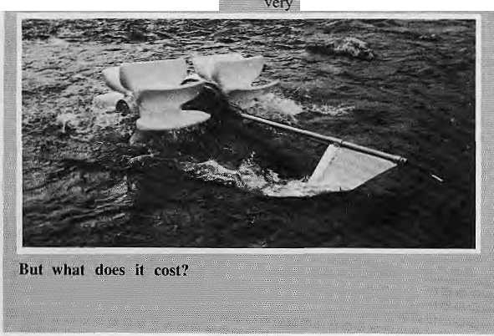


BRIEFS
And!now,
a: sunny
pthev viiiagejrs of ; -GhaL'EfeSi," 60 km west on....
the highway, from : ■:■ .......
Kathmundu, suffered an :
by six Japanese •scientists,, a delegaticm from 7 the Royal Nepa 1.. Academ y of . ;.:S;ciertcc ^nfj Technology ... ■ = (RGPslAST), arid strange .-. .; ... f- contraptions witlt paddie- ■■■. :. ■;;■ Wfeels and jruddets; They -■ I were witnessing the.. tes]ii}g;^{v} ■-±- :::Oi, hy t j raulic; devices ^recent) y
f
': 'developediin Japan with hili '.. communities .in mifid: : .,, Down into the turbulent .;.:.. Raters of the Trisuli went/ 7 7 the first device, light enough 5 pSk'gV- rovfloat.I Jhe;\yMte" ■■:■■ :..;. paddies "stinted churning, and = :«i-iver water quickly made its,. . ; way up a 15. metre
.■:. polythene pipe, impressed,"
:::the villagers looked od as,
■■': next, a generator was ■■;■
Coupled to the device: This prne, instead of pumping ...:... ,water, it generated electricity! ;■ dighting bulbs strong along 7 ?: .-"the -river bank. Here was ■ ... aii electric generator.. 'tjfat " floated, but: could the :: ".' '; villagers use it? Was: this "appropriate technology'^ RONASf Member KhiSendra 1 ;■■ ..j^... Raj-m. _{wa}g of the view
7/triiuvthe output of the ■device.¹! Was 16w, which ^{v} would Sim it their useV
^ seemed more useful t ."..the GHaP Bedims, M: lc;uit,
■:Was.,..a"syiifheiic ::fibre -and.! ..
esin fcrxy^boat on which' :: Ithey were effortlessly .■transported across the river "and back. Clever use of ' ■ rj»pjes; attached to the/ vessel ■
d the.. i.wb;;Mrte pvop^Ikd across., tfi

tlie water's ,vfk>w 7afld7ther si tie-- .fercc,.;. riufc across," 3Sid Dt. ■,.■ ■,-, a,^ leader .'.'bf fhf ::- ■■■

The prototype devicei:were- .. . sponsored by -Japan.*s7 7 7 ^{vv} " Association Tdr Tet-hnical,. Co.7
;demonstrati©rss ^^f
.success tut, tj dest i ens,-, that vremain.,--to be; iiiiswei^d^ ■■■■ Mriclude,.- Ehose. of;cost.-;; ■■■■■ "efficiency ^luring the ;'" ;;; monsoon

ri^ice slid spare-,,: parts. :> 7!?rakiish

Rescue Plan Under Fire

,■ The World Bank's U$&. 7 ^7
■■ billion..: ijiji'pfcal ■■Forests ■■■■ ■„■. ... .
Action Plan to save: tropical ■■■/■
forests' took a- beating last ■■■■ ;;
'fall at the^ Asia-Pacific J -
.:Coilf6i'5ncc ;on ^Deforestation
.and Decertification in New, ...
■' Delhi, -where.. fdCU] ;; : :" ■■ ■■
:" repreSehfariyes; calied it "mi
. old programme seekf rtg fresh
legislation to ccwrfmerciaii|e⁴ :
forests'",7reports-APPBN, 1 .7 7
Features, v, , ., .' 7 ;;; :- ;- ■■■■

The Actidh Plan, prepare^ 7 by the ^Washington D&bascd Worid Resources,. Instiiine ■■■ ...(WRI),: was erttiai7,ed for not adequately involving; ■■■■ cppirimnities; and voluntary .... .: agenetes mi^ for pnrposing |n:" ''investment .patteirr>"7trraf' ;::-■would:'rM eotirrter to the, ■■ ... interests:: of jndinaifiuS :-popuiatiorss. Moreover, tte iiOef;"Aeif©iY.. Plan'' was"
, inappjopriate:""as it -merely ouEliijed .."an approach, .■:■■:■,:
A study commissioned by
|
.Mpvepighf- maintains ,th.af...the Action PIM Has a ::-: ■■■■ ■■■,.:. 7 7 ■ctimmerctal,, and jjidustfai
₌ bia.s. ■■ ■!n:""Of!ecti..it...was just^{v;;}
■■■■ an ,,extension^{;;v}of Ihc v,y^orjd; [
■ Banfc^s? ongoing forestry ■■■■:■■ ■■■■■■■ ■■
. projects, -which has .serious
■ negative,, social" and ■■■ ■■■■ ,;, „, „
geological.,impact. ^{v;;} -;/ -■ ± „ .
Moid' HfMAL;!hafc. much gf.7
■uhe=ci;itici5m "of !^{l}h# Auti-on,,
. "vocal minority, wtth a : .liarrow point:of ..view". The Action Plan, he concedes, is inot perfect, ...and. the
...slip6cofilings are ".being .7 7 "J ~
^eorFecic^_{v}7"|ut \VRl firmly,- ,,.
;;1ie!ieves:- that -itie Actiort :Plarf-
■■Opp<irt!!jii.|y' to ■■■stimulate a,,
■■" coordinated, global effort: to ■■■.■■ address the: critical problem <jf... tropical defbresiation".
Hazelwood rejected the charge that:::WRJi has been :::: ■ iq-opted by; the Bank^ 7'Life : it, or not, the Bank: is a
major actor in ihe field and :
...iji. is iiflportant -to estabiish a" working relaiioiiship." As a fcSilt of the: Action Plan, goyeplmgnts :and-aid- ■■ ,.. .:'.' .."
■ agencies., are.", npw ■giving- ■■■■ .... greater attention to JS^GO participation in eouotry-leyel planning exercises; and fifty developing countries are ::
"'already jusirtg.... it as ":a " ^{v} ": ■■■ ■:. framework ..for .national
. actiOri, he saysc . ..
China Studies
Plateau
China-Pictorial reports that ihe :Qin|hai^Tibet Plateau ".. .'. ■Survey «f the.! Cltinese : 7Acad6my of Sciences, has begun an ambitious, five-year , project tij rhiJfp :and study (he : Karakocurn and Kunlun mouiitalns. The siiivey leanj fs made up of 60 scientists whose interests extend: from geology..:to giaeiolpgy ;to.- ,„ ■■■,.'. patlaeontology. ■ . 7
■Between, |une: arid September::
b
: eonduct^l "stiidieS -m- Xinjiang and ^wesiepi 7afid northern ,:■ .=' Tibet, lafcouriijg t(ir6ugh; ■:■:■■ ■■■■?■■■ ? deserts, dry, valleys 7arid; high :.
the .,sbadow|' of Kungaivv yKongm---- and |/Iu.4a|atan Uhe:^{v}westem^ end -.of' tjic7 Kunlun.
antelope roaming !n7tfije7 : luxuriarit grj|sslands along.' Hie Meroar Lake, 7'#'0>>ab^ ihe liighest Bnd,,,rnpst secluded paradise ..for ,wpd i in; the world.!' .,,. I
The foray wito the KwnltM ,apd; K.arakoram, comes af^f * ;the,,$i!jVey;;;completedl.,,., ,„ .7 7 ..geological,7bjologicalv and^ ..:. ,„, botatiieal slutlies Of cemtral Tijkl, including the Mount 2 Everest area] ant) the Kfngduan Mountains north ■ of Burrfla. "New vfitidings, ,,7 were reportcdiy iriaQe on-' the geological lopniation pf tfie Tibetan Plateau^ its evolutionr: -and upiifi, T^nd" ite biological 7 resowces^ .... Significantly,: ■= findings on tninerii! resources" and iheir exploitation were also said to have been -.. 7 submitted.
Peshawar Wa$ bnce an orderly garden .city, walered by'small rivers, beamiCul : enough to sfrye: as the 7 winter court of th| kings of* AfgHahistan.: Today, wh<)le ^{r} suburbs bf brick houses, are., going up without lanes, streets, sewers, proper drains or parks. Dirt and ton fusion are tiie: riile.
To try -to avert disasfef, ^prdyinciai and city- ,: ., ; ^ government officials :have : now accepted a British .." ; * Rrtii's offer to revamp the: 7 city. Thej, plan calls tpf ■" ^{K} pitying¹ land for a. 44-fcilornetre ring road and the 7 construction of new ■■■ ■■■.. .-. ... suburbs. Planner Richard ■ Mabbit'says, "It will work. The provincial government is very good. Very active. The World Bank and: the Asian Development Bank are iiere frequently. They want it io happen:"
198a

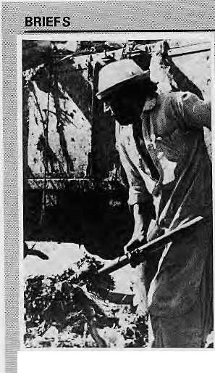
Cleaning Up,
■Pfjolo; Gemini
Mabbit's optimism, ; buying land for the ring road: and four now model suburbs is going to be a problem. The area is heavily populated and, while the Government /has powers of acquisition, large sums of money will be ■needed.
The first priority ts to 'remove the: mountains of
rubbish that clog the city*
All of Peshawar has oriiy 13
dilapidated trucks to cart
away tons of daily trash. ■One suburb of 18,000 people
has 140 s w ee pers an d only ■■:■■ tour wheelbarrows. Although
there; arc a few fly-infested
trash .containers ;m the : neighbourhoods, rubbish is
jieaped outside homes. Afghan « refugee children [K>ke around¹
looking for plastics and metal "to sell to recyclers. The
city's 30 kin of two-lane starred roads are swept by : hand;' with each sweeper :: /responsible for J5 Km..
Population has put heavy /pressure on housing; In the : poorer sections of the old walled city, families¹ are >■ packed in at more than five « to a room. Most people live:: falong the-city spine, a gently curving 1-0-knr stretch that is one/of Pakistan's main arteries. Says Mabbit, "Peshawar: is One of the ■■;■■ largest cities I know that ■ hangs off (me road". It is to lessen¹ the? pressures on. this>
...ajtery. that the ring rbaO is
■ planned... - Len Mograhe,
Gemini ": ■■»... ' = .:■ "" ■■■■ ■.■■■■■ .
The Alps in Danger
!?The most threatened.. ... ■■■■■ .... mountain system in the world" is not the Himalaya' after all, but thfe Aips. At .? ' least, tiiat' is what mountain researchers representirig" the Alpine countries concluded at : a recent meeting Organized in. Chambrcy, France,, by the International Union for Conservation pi Nature and Natural. Resources <10CN).,, ;
Several ills were Identified: forest death,, the decline of agricultural and mountain communities, excessive,'" tourism, unacceptable levels of road.traffic, air nnii water pollution, all¹ of which..affect the Alpine habitat.
When in doubt, create an institution,/ much jlike^ .:.' ■■■■■ ■■■■ .. ICIMOD in Kathinandu. So that's what the Chamberey .grbiip. suggested: 1 he."setting ■■■
■ up of an International Centre :
for the Atpjne pnviroiirrienL ;
According to t.UCN's: ■ ■■■ .. Frederic Briand_{v} cine of the obstacles to Alpine Cooperation "till- noW has been the: linguistk' barfiers^ 'Me says.the new centre/ by. virtue: of its international character, wouid bceakdown such. basTiers, -■.; . -: .,-...." ■ ■// ...
Pollution Kills
Chinese Forests
The environmental stress in :
_{a} the Himalaya- is starkly .. physical: land erosion, floods and landslides, Problerjis of : tbxicity, acid rain and polluted aquifers therefore
■tend to he neglected and thought of as affecting on|y-: industrialized societies: That, of course, is not" true. Areas contiguous to a industrial
■-centers:are "Often affected; as. the dying forests of southwest China indieatq. Tiie Hirhalaya lies just -a few-hundred miles: to the wpst. The loll owing¹ repgh iv. from
■: WprklWqieh.;.; iriagazip'c:¹ ;■ ■" ;:
;; Chinese .scietitiiits ^ire iii^ing
dramatic-■■ djc&acfcs in China's .... .loath-- ^{v}we*i .lorestsjto -- ,_{;v}'.;;' ... atrnospHeiiQ pollution and " : ■:■: itcid^rairi. TiV Sichuan's" ^ :.. J" ;;- v .Maocao.fea pine fpresl over 90 per. fent...of the ...trees have ... died. On Nanshan Kill in Chongquingi the biggest city in the region, ,a 18QD ..hectare forest of d^nse .masson.pine .... has been reduced by"half. Both regions have highiy .... acidic raiti:and elevated levels of pollutants* such as sulfur dioxide and ijarticulates; -.-.:....."
According to Chen Ziiiyuan of China's National Environiiieiital Protection .Agency, "most, of the ^{v} ■■■....
precipitation is...moderately........
acidic. The rain would be even more acidic if China did not have high .." ■- -... . ■'
atmospheric concentrations of neutralizing agents, such as ammonium and calcium ions.
The air poilutian "problem 3eriv.es alrnqsl exclusively ...from ..China's heavy, reliance on coal. In 1982, eoal accouiitedjfdr almost three".... quarters of all energy consumed and over 90 percent of the sulfur dioxide released. The. situation in. the southwest,'is aggravated/by . , the predominance of low qualily, bightsuipTiur coal, and by topography and weatlier ..."tfiat trap pollution ih'the ■■ valleys^ /' ' -■,. " ■■ , " ■ ■■ /
Tn the light of this, the passage of the country's first air 'pollution prevention law in September 1987, was a step in the right direction.
. Unfortunately, China's... . . ; jn^lijiitrialization plans iiiclude doubling the use of cop by
;;"")he year'2000. - tori Heiie: ....
Asia's Green Journalists
In. the countries of Asia, envifonmenWl information is "oftcn:;cansitic_{v}red cohfidentiai ; : b"y: goyertimsnt agencies..: .... iriTormajioft .■? relevant to the ■:. deVetopnjent ,.prbcess is: : controlled by "developers'!; At the.same lime, there is. pver-: reporting of environmental disasters and little coverage :of gi?od wprk to enhance rhe enVirprtrrtent, Journalists must hot' only ;raise environmental
— ■^■/^,: "?: ::<::. ,.' :*' ^ ..J
■consciousness ■■■■■■ but motivate ■;■:■;,...."' ;': /people into actiop. :-- ::- ■■.
These are the highlights of =
. decisions : taken at: a meeting ..
of 69 journalists from IS
Asian countries last January :
iii Bangkok. The meeting
also saw the establishment of
the "Asian Forum of .
Environmental .(ournalists
,:(AEFJ1," under' the iuspices;^{v}of 2 the Economic Commission fffr Asia and the Pacific '
"(ESCAP). According to. ... . " ABH's first,preside;)t,; A...M: i:. Shrestha (Nepal) thefdrurnf^ plans to Bring out a guidebook ...oh enviironmeiiial reporting. Other office bearers
, are: Yang Mao (China) and ,,,'; Sgcgyarto Ps. (Indonesia), : i V.ice-Chairmen. Adiai J.
"Amor (Philippines), Secretary. Chahchal Sarkar (India), Ex-Officio Member. AEFJ's address is: GPO Box 3094, Kathmandu.
AEFiFs Shresthai
Fashion
(Jnic.^f has^ teamed up with a private fiianufaclurer to ...spread, the message of its life-saving oral rehydration therapy IQRT),,known iocally as "ndofi-cihini-pani". It can :. ■BOW:Tjie found: not oniy on posters and billboards, but ,pn ' people:' .■■ ■■ :■ ." ■ ■■ .. " ■ ....
The message, and a diagrarh, are tiow being hand-printed in the traditional style on Nepali cloth and sold, by a Katlimandu manufacturer, O,P. Naulakha: 03PO Box 4421,, Kathmindu). A woman's cholq,' most popular, goes for HRs75, a mail's shirt for
sttrwal for NRsiOO, and a Nepali top! for NlRsl5; ..The. cloth itself retails at NRs22/m.
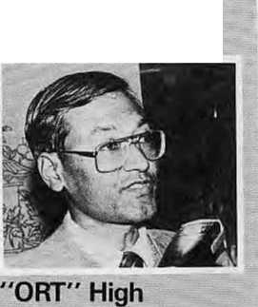

HIMAD • July 1988

BRIEFS

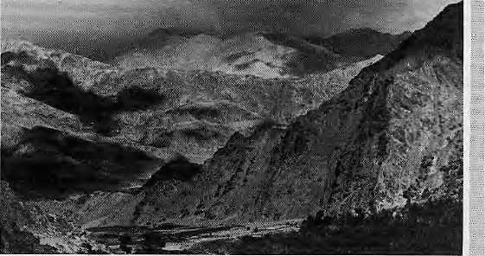
model
Classical view of Himalayan iipliPt.
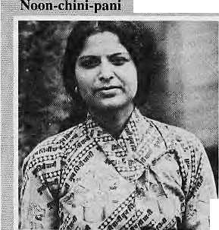

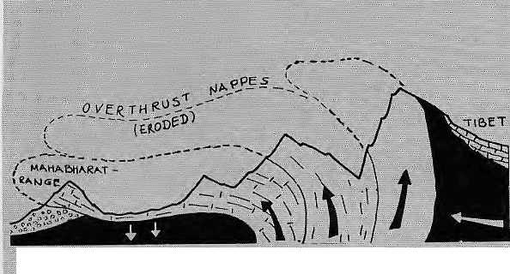

Himalayan "Tectonics

* fThe classical theory of plate
; tectonics holds that the

| Himalaya was formed when the Indian pij$tei; drifting
■a north wards, slipped beneath
■Tibet, which was part of the Eurasian plate. Not so, according to noted geologist ^{l}KiS; Valdiya of Kumaon
..University, reports Agence"
■: prance Presse.

Speaking before the Indian : Science Congress recently in s Purie, Maharashtra, Valdiya ; said that it was the Indian a plate which had bulged over ■ | toform the Himalaya. If ;; the Indian plate" had beers ) submerged under the Eurasian ? landtna,sSj the iarge Himalayan¹ i basins would have * idisappeafed; he said, adding
* 'that the presence of many
: thermal springs with heat
;".-sources just 10 kilometres ;: (six miles) below the surface could not be explained by the classical: theory. The.--. . . Hitnafaya- was made up of _{i:} the front end of the Indian I plate at the point of collision ■because of the immense [ _{s} resistance of the Eurasian ;- -plate.: ;'
Solar power in " Kabul
Afghanistan- is one of the sunniest countries in the world.
But hi- a country -whose." winter-is.:. among the harshest and which has ...always "had..-, an energy .-.-.crisis," little has;beers done to harness the abundant, solar energy'.. . ...
Now, with" UNDP help, scientists in Kabul are finally preparing to-tap solar power to alleviate their country's energy drought. .-.-■ .... ....
An Afghan planner says use of solar energy has proven ytable iri oilier "sunny" cities .such as... Tashkent in Soviet Uzbekistan and Jerusalem. "Kabul; receiving 3000 hours of sunshine annually, is in their league;,'¹¹ he says.
There is ..desperate neei... to use , every available renewable -energy source because firewood, the traditional fuel, is getting scarce. Only 1.9 million hectares, or 3" ' per cent of Afghanistan's area, remains iirjder forest cover:
Moreover,- 90.. per' ceni .oftfic " ■"
natural gas extracted is exported
and only a small quantity of the
coal milled is available for
domestic copsuifipi ion. Electricity
is ..available ..only in the major
towns........ ..." .; ■ . '" '
Under the agreement with UNDP, a Renewable Energy Research Centre will '.b$ established. It will develop cost-effective appliances based on solar energy for domesiic. industrial and agricultural uses. Research in solar energy: has already: begun in the Physics Department of .:
Kabul University ...and" irt the ■■ :.
Academy of Science, - Rita Sebastian, a Sri Larikan jnurnaiist, filed this report from Kabul- "
Photo:: a ^
i;adakh^ Blooms
Goio|el D;Sv Cheena of the Indian Aifny is :proud of what he and his men arc dmfig in Ladaikh, but it has nothing jo do with, border ■ security or high mountain warfare. He. in proud; instead,.of caulifiowers weighing six kiiograms, : ..Jersey cows that are . .... apparently happy to be ap this Jiigh in the Himalaya and poultry that think nothing of laying "eggs in.: the rarified
Cheena: is an agrictil.ture specialist who niris the Field Research Laboratory of the Afmy's Defense Research ..and Development; Organisation on the oahks of the Indus. The Laboratory's i.earri of e«perjs.,is seeking, solutions to problgins faced : "by the Ladakhi peasants, ,: which include low rainfall, rugged terrain, shallow ^pi is, low humidity and high intensity of the sun.
Qn the - other hand, Ladakh averages 300 sunny; days yearly,., prt|yMirig: ideal... conditions for research. For example; the over-siied cauliflower was possible In this environment because
: there is plenty : of shortwave solar radiation,: including infra-red--which promotes photosynthesis,
: gamma rays: which promote rnutation and alpha and beta which promote growth.
To Counter strong surface winds,' Cheena's.. men grow ■■■ "■vegetables" iii trenches,' with' ;a plastic sheet providing the : necessary temperature'' Tor
grpwth. Experiments -are iinderway to identify the best; variety of wheat,;; barley and : oilseed for the'ciimate, lri : cjji effort to reach out to the community, each year the : ± Laboratorj' organizes 3 ■ =■» farrrters" fair arid support? peasaiits who ask for assistance, - Su.dhircn.iiar Sharnrra :-.- -.... .,'. J " ;;- :-
The* Silk Route Rerriembered:
For centuries, the Silk'Route; which passed through the ' ■■■■■■:■ western extremities of the Hindu fiush-Himalaya serverj as a vital Jink between civilisations: Ii is ^:link-that Unesco seeks to commemorate beginning ihis... year as part of the United Nations Decade for Cultural Development.
Unesco's five-year project -.-will mobilize the international- scientific and cultural resources through¹ :■■■' ,: exhibitions, seminars arid = = three cxped.itiohs over the Maritime Route (5989), the Steppe; Road (1990) arid the Overland Rdad (1991). Mofcthan 35 countries wilt ;; participate in the activities.
The objective of the Decade for Cultural Development is "to enhance recognition: of the cultural dimension of ..«. development and to affirm and enrich cultural identities". This leads us to siispeci that the "Eirst Annual SilkRoad Auto Rally", which will coyer the- ... 7500 km "between Beijing* and Urumqi in October, is not part of the Decade celebrations. Car rallies tend to use exotic locales for

July 1988
HIMAL
29

Antenna fe th# roof/of :thV-Phoip; Canadiao SpaceJAgency
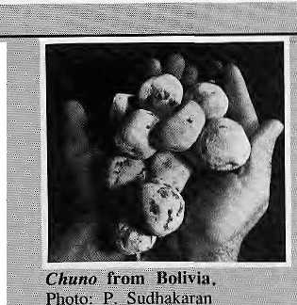

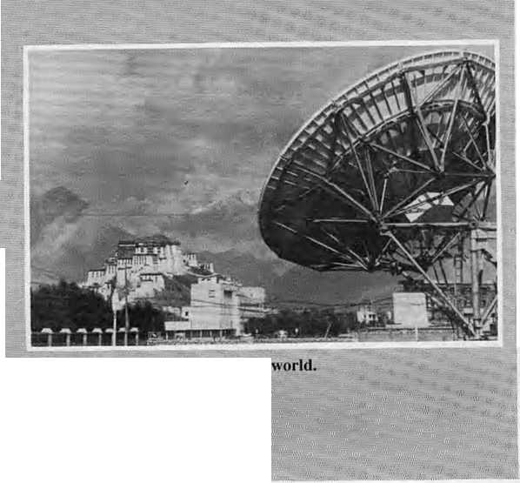
::- : briefs
: commercial purposes:.... atot. of.
gasoline burnt for little "" eultwat gain./ " ■■■■■■ ,' '" ^ „ ..' "" = „
sLadakh Project
for Bhutan
7" The Lidakh Project, known .. ■v for ils Support of- " ." ■ -, ." - ■■■■■ ■■ cnVironmtintaily sustainable
* developmentin JLeh, hasTiow; - beers ..invitee! to Tbimpu to
helpsupport■■■Bhutan's.;".'"" :: ;develppinent drive,
.::l Recording to the Project's "" ■■■■
newsletter, its Director, ■■■ .. ■ ■■■
^{s} ^He|ena;Norberg-Hodge/visited"
Tlum'pu in September to ,.'.' discuss arrangements.
. :.. ■ .:.:.. , ■
i ,The Project will provide leeHhicai assistance in the construction of wind pumps* ; iram pumps arid solar water : beating systems. Nor.berg- ... Hodge wiH a!so teach courses : :■ oil the development process
at Thimpu's recently-.' ; -established Royal Institute of
Management. It is reported ;: -that all (if Bhutan's tiivil, ■:-: service personnel and '.' £ professionals¹ will be required 'to study at the Institute for <
^^^
The "Stone Potatoes- of the Andes
Lo:rig before canning techniques .v 7 for-, food -preservatives ,were .■ .. '■ invented to conserve food and
tubers, the Aymara and ■ ' :: Quechua Indians of the;
" Bolivian apd Peruvian Andes 7 iised if technique to "freeze-dry** ^potatoes, a technique that could itlsb prove useful in the 'Hirnalaya. The Aynaaras still f.jive ..ori the. A hi piano, which ..'' means 'liigh plateau" and : averages 400d metres in * altitude. The nights are freezing and the days full of .... sunshine that £urns the skin.. ■ :This dramatic temperature : : .. difference between day and ,.. ■ night dehydrates the, potatoes. ...
1388
'After the potatoes are gathered ...ffrorri the fields in the: summer, they :are stored till the cold ., ; s mouths when they/ are brought : out'and (eft in the open for !two nights. During the : [freezing process; as the: potato : cel!s: separate from the water.
# 30: H1MAL

f...'soggy... / The . ⁼ ■■.■■ potatoes are stepped oh to squeeze, the water out, then ... left our under :the sun to dry. What h■"left after., a: few :days
...is"ehuiio.: the" freeze-dried...." ■■■■■ ■■. potatoes /of- tih.fi And^s: a ..fifth: o£ their,., original, size ..arid as... hard as pcSbfcs./ni© chfine ... can be stored for y^arsJajid dp not .deteriorate' even in ...the summer months,, ..To u$.e, ... ,.., ..they have to ..hp re^yd rated.. by soaking in ^ater oVernttgJit

; and.JboiMnJ ...the Jiexf ds^.:::-,.,/.'" Marisi Zappta in J>a Paz,
.. Bolivia. " - .... - .,, ..'■::;~ ■■■■ ....■ ^{v;} ^

■■control ■■■was' used.''" :■■ to tackle' the fruitfijes, with = liie- males attreacted itsto'large, glass jars by using::lures,... '■ i ;- thc.r'e to die. Tire fly was>_{v}, J thas£ completely controlled ■arid because the predators were not "killed, the ..scale . .;' insects' were" also contr<>lleii..^{j} .<
There remained the meaty bug. The scientists found... that the lady- bird beetle loved to piake meals of. tlie:: i
:• btig, ,s'P" they lied, sackcloth- ,.■■. around tree trunkSi which the ladybug.s .find attractive as .: ..." shelters: The beetles muved, in and wiped otil..: the mealy
ibugS- i>ighs of relief could be heard from the mango groves.
Fruitflies, scale insects and..;. mealy bugs ■ have long .... targetted Pakistani;mangos arid often destroy; half the year's crop.: Cheinicals have proved useless because they- .... also kill eff predator insects : that eat the pests. The BBC ■reports that scientistsat ■■'■ ■; .... ... Pakistani's .Agrieulijiral ..." Research Council are now. ....' using smart yet pimple ■■ ■■•■■ ..." techniques : to save tlie«. . - ■■■■■■. mangos." ■■' .. " ,; '"; „ ..■..'.^{v;;}

in
The U.N, Tibet
West' Gerrean Chancellor JHelmutjKohi;/ "■■l-9?.7..^{v}trip,'t6 ■■■■ ;^befchj^iltghtgd:;the"'ro!e ..of
lirjited-- Nations qlefelppflhent
"aetiyify ^{v}in tjie; high;' plateau: ■; " Koh!,, visited ; Yangbajain, ..; ■■■
.where,, a" joint Jl|ND Wiaiian ^{fe}pwyect is, dbveloping .some ,
resoprces...■ "; ■■■■■■. ^m ^{v}is thg ■■■ stippiicr of electricity
, According la. tlic^{v} UNDP,, ,7 " office in Beijing^ tlieit. largest projects -M China. A , large" number' af-eiigirteers;" -
■ arid¹ geologists have been...
■ trained, in the use oV
gepiheriTial energy; ■ .....
, A mission of the J^ftrtd,,.....;' ;; Tourism Organization visited
^pcoposais,for tQufisai-. J ■'■■ ■■■
planning-\anid": vacationai ^{v} :;-
ti-aining. These are being..
■ diseiissed in |lhasa,:.afld ...
■ Beijing-. ...."Soiine.. Tibcia.ns-- ■..■
have already tafeeff part, in
an ,jll>spolisor€d
couvsC'for. yp cation a I ■■:■
i in tourism.
,.!n the. soda) sector, UNPF ..h|isroxtgnaedJie!p in : ■■■ ..: encotiraging pop^taiion edt^atiorii Unicef, - ■-- .. ;" : fOliowmg'a visit by its ... ;" bifector," .fiimes Grant, has approved .six projects .. sTealing" with mateoiai-ehild
he'aith;, services, childhood, immunization and iodine
: deficieriGy f control." The:: ^{v}
-Fiind'S i
^{v}exten3 "to leadership training, support-
Jpran auidio-'visual... center . an^ an education center with special emphasis on
...nomadic populations. ... ■
The first fqpd-forework ;; 4"..:
- project ^{v}of thg World' Food:' ■*,.;
- Programme (WFP> is -
expected io start .w WS9,
concentrating on public
tvorksflike iiTigatiop; ■■■■ ... ..^{v;;;}i^a
, afforestation^ pasture,;rural ,f - roads and fencing. ;WFP ,; f
"arounit 'U$|T ■miljiiih,: JThe,. . Food iffld .Agriculture = .... j -s Organization is looking into' liie possibility of investing,,. in river regulation, ifrigaHpn* .arid agricaltural dieveippmsrjj in Ehfe area areunii Lhasa; ■■■■■■■ ~
■ iriternatioiial ..agencies have..." ■'■ alsp lielped in,, a; reruofe ■■■■■■ ^ s sensing study of the -ice ^{v:} ■#:■ . Jand snpw, cover;]n.'"the» J "■■ Htmalaya; = including/Tibet, ,,,FAO -has suggested/, ^{v} ;- ,, ■:■■ extending the .use of the--remote sejising technology- ■... to agneultuial dcveiopmeni. According ,to Manfred .... ICufesa," ONDIVs; Resident T Representative in Beijing, the United Nations agencies, are. willing to suppoit larger efforts at regional to- " operation in the study and protection" of the fragile .' Himalayan chvicpnrnent. '' ;; -.


Women Lose
Desk-top in Thimpu
'It is" .fii;idaj:'.--..and. the. srniU; ; eel i tonal teant c*f":Bhtitan's ■ -hewspaLper? Kuensel, is ■■■■ "".-.■. ■■ i rushing to iiieet its weekly deadiinef SubrEditor fCut ■ '".-.. ■iPrasad prepares graphics -op ;■■ one ;of three computers, ■while "':' compositor Raj Kumar Ghetri designs front-page layout on another In his office, Editor Kinfey Dorji makes last- ■:■■ ■::■■ minute changes < to an article... ...frorn: a. school-teacher stringer ;Bhtitanj "[,.. ■.■■ ;' '..-.. :- ^{v}
ovi Ktteijtselz.
JPhotb; ■■■R;, vMasseyLUNDP- '":.
TTiijnpriu ...is covered by. one...
reporter,... ariti stringers send... : copj^{i:} for the rg.st. of:...tter;:.....
country. PruH Ail;.....ITics. in: ...photographs for the
intcma'tioiiali...sec|iqn: from ■■■.. '.CalciiMa.'" "._{v} - ",■■■■ ^{v}'.'■'.. ■ ",. ■
Dorji got the idea of a
national "'.'newspaper when ■he ..
.•returned... to Thtmpu after "... ■■.-.■ studies, in Australia. ITie »o-
:ahead, was given by the .. ::- ■ Director of Infonriatioii and Broadcasting and a decistoij
; was -friadeto. get an' Appfe ■■■ ' Macintosh eoDiputer and laser printer ......to produce - trie::-. paper.
The jiext s|ep'■"■'was-- tq coine ....
"up With tho- rnoney....for".'.tbe^{:i}" ...-. stjttipitent,: \yhicli the United.. Nations Development ■■"....;. -:"' ^rograinme {UNiDP} "did, with
'V-gnmt ol $93,6(Ki.^{v}vfche ^{v}-v twenty-fifth day ^{v}bfLtlie^ ■■ ::\ ., seyenfti month of the Year of
; the Eire Tiger, between .10 in the morning and noon, was-the ■ ausptciaus time for the.
jatinerL Monks, held.,# full : ,
...shiigdryef.:. ajid the Social- " ..-.■'■ Sei-vices.... Minister .pressed "a : " button and'Bhitari^ "...first... ■=■"=' newspaper.v..wa% a reality... «■' ..
"The !2-pa«e issues of ... : .... ■■:■ Kuensel (The Eniighleqer) ....
^brings its readers national and international news and features, a letters: page, sporis, photographs, public notices and a: leisure section featuring
......Brtjce Lee comics and'.a,
crossword puzzle, Tl(e
I newspaper is piinted in three
'languages: Dzprtgkh'a, Englisii
iund Nepali: It is presently a weekly., but:the plan is to .
: become a semi-weekly during this .year, and ''.eventually, a
. iiifprmation officer

is ...art alarfin.ing': "...... ■■■■■■ "......
increase in the ^ivorpe t»f ^i .w^roeti ...by their. :.:.
s,. sa^s Shilu: Singh, .. of -thb Wiiraen''*$ ■■■■ '■ ."= Service of. the Nepal. Women's Organizaciofi. ....
Her. office helps poor and illiterate wotnen baridte .:..!egal matters. ..-■ '■.. ■■. ■■■■■ ..... ■■■ '....
■■■Th# trend- is a cause...:..fGr ..... ■ ■■■ special... concern, says.. Sihjh, ..because of trie social ^t|gma. attached to divorced and ■■ ■■■separated ^wooieri,:... ^erj: ^few....;■. of-whom remarry. Most. .■■■■■ ■■-divorce initiators are -irien-■■■■■■'■ who married under paJipntai :pressurei and later decided ■ that "the spouse is ■'"... ■■■ ' "unsuitable":^{v} "... ■ "",....■■'", ■.■:■ ^{v}' k
You Can Bank On Us
We are the most experienced bankers in
Nepal
Dharma Path,
Kathmandu
NEPAL

Sweeping ..changes'.have . beeji ::iritroduccd in ■■Mepal's''.... Civil- :Code Bnce;J975jtci".^ proSect ..the jnterests of ... divorced women^ buf rriQst .wornen still "reininn.....i'giipranf. of their ;.Figh'tS;-:-- - jaft .,. ■■■■ '".. .;-. Sjiaritia, Depthnews^ ■- &

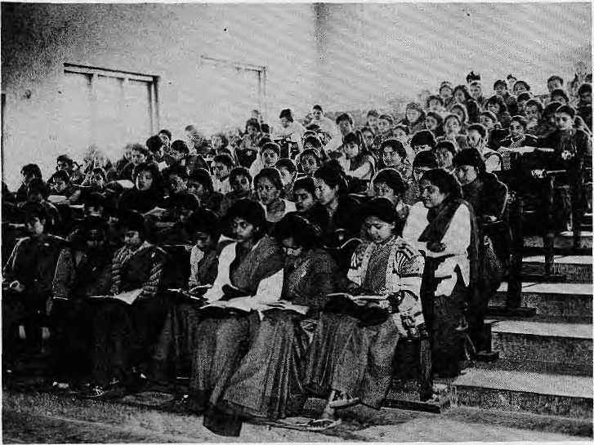
INVESTIGATION
Higher Education in Crisis
By Binod Bhattarai and Sajag Rana
Dozens of interviews with students, lecturers, and top administrators of Nepal's government-run Tribhuvan University have revealed that Nepal's higher education system is in a tailspin. The teachers are underpaid and untrained, the facilities are deplorable, the students unmotivated, and the administration drifts aimlessly like a ship without a rudder.
His Majesty's Government props up the University, providing 92 percent of its
budget. Of this, 80 percent goes into salaries, with administrators outnumbering the teachers. Besides staff and space, most University colleges have nothing else. Academic and cultural societies, clubs, seminars and conferences are virtually non-existent. Laboratories are ill-equipped, libraries are full of mutilated books and sports facilities almost unheard of. Classrooms are overcrowded and students are squeezed into benches and desks that are nothing more than roughly sanded lumber.
Among the students interviewed was Deepak Joshi, 22, an MBA student, who manages to keep up with his course
work without attending the overcrowded, unimaginative classes. "I make up for what I miss by consulting the text books," says Joshi. Sakuntala Parajuli, 21, typical of young women from traditional families, is reluctant to commute to the Kirtipur campus because she is forced to travel in an overcrowded, dilapidated bus, pressed amongst sweating bodies of strangers.
Other students, such as Hemanta Rai, 25, are sent to Kathmandu to study by their well-to-do village families once they finish high school. Rai, a political science major, admits he only attends the University because it gives him something to do and, as an out-of-towner, he values campus social life.
No Loyalty
An economics professor, who requested annonymily, says that because the students are not motivated he feels no loyalty towards them. He therefore willingly misses classes, leaving his students to chat happily in the sun outside the central cafeteria.
A campus life that is dominated by carping and confusion was described by Shanti Mishra, TU's Chief Librarian, in this way: "Those supposed to teach are not teaching and those supposed to study are not studying."
A lecture in progress at Katmandu's Pad ma Kanya Campus. Photo: P.Khanal
Tribhuvan University was created in 1959 and now has a student body of staggering proportions ~ 60,000 - up from the 250 who were attending colleges in the early 1950s.
"The system suffers from an explosion in numbers, but the quality is being compromised," says Professor Govinda Ram Agarwal.
Sole Manager
In 1971, TU absorbed all existing colleges and was declared the sole manager of education under the new National Education System Plan. The Plan, now widely acknowledged to have backfired, may in fact have triggered the downward spiralling of standards.
There is no doubt that the Plan changed the University beyond recognition and sparked an "admissions rush". The jump in enrollment led to indiscriminate recruitment of teachers, 50 per cent of whom arc not even fit to teach in high schools, according to Surya Bahadur Shakya, TU's highly-respected former Vice-Chancellor.
Under the National Education System Plan, the "classical system" of yearly exams was suddenly abandoned and surprised students and unprepared faculty were forced, without any time for adjustment, to cope with the intricacies a "semester system" v/ith "internal assessments", "comprehensive examinations" and "credit hours". Colleges were renamed "campuses", and intermediate and bachelors levels dubbed "certificate" and "diploma" levels. Students fleeing Nepali higher education had enormous difficulty being recognized in Indian universities under the newfangled names, copied mindlessly from the North American system.
The semester system was not inherently bad, but it was implemented too suddenly for teachers and students used to the "classical" system, according to former Vice-Chancellor Shakya.
Professor K.P. Malla blames the "unceremonious demise" of the plan in 1977 on a complex web of social, economic and political causes. He notes that the enormous demand for higher education, "which provides a leverage to power and position", the over-dependence of TU on government grants, and strident political posturing of students who converted the campus into an ideological battleground, all weakened the system's fragile structure.

32 HIMAL • July 1988

INVESTIGATION

Malla is also extremely critical of the open admissions policy where 98 per cent of high school graduates are allowed into college, and recommends something more stringent. "We have lo choose between quality and equality in higher education," he says.
Last Resort
One explanation for the poor quality of instruction is the extremely thin pay envelope. A professor at TU earns a mere NRs4000 monthly and it is no wonder that teaching is becoming a profession of the last resort. Since teachers are not required to stay on campus after class, they make the extra rupiya through private tutorials. "Low pay has forced teachers to be constantly on the lookout for other means to make ends meet," says Badri Dev Pandey, who works in TU's Centre for Research Innovation and Development.
According to Pandey's colleagues, another legacy of the National Education System Plan has been a dramatic decline in the quality of science and liberal arts education. The Plan attempted to correct the obvious imbalance in a country with more doctors than nurses and more engineers than overseers. It therefore gave autonomy and large independent budgets to the technical colleges, which had long been neglected. But, as more and more resources were poured into the technical institutes, pure science lagged behind. Today, the science campuses have to struggle for a piece of TU's budget pie and are not getting their fair share.
Uncontrolled Expansion
On the other hand, liberal arts education (including humanities, social sciences and fine arts) has always been the intellectual backwater of higher education in Nepal. Liberal arts campuses have served as a dumping ground, the place where aimless drifters who have failed everything else come to roost.
Even though it is financially neglected, liberal arts education is experiencing uncontrolled expansion. Most of the 55 new private colleges opened in recent years are social science institutes, which are cheaper to run and require nothing more than a small faculty and teaching space. Students in rural areas, unable to move to the cities which have science and technical institutes, have to fall back on liberal arts whedier they like it or not.
"The standard of higher education in Nepal has remained the same, that is, poor," says Suresli Raj Sharma, former
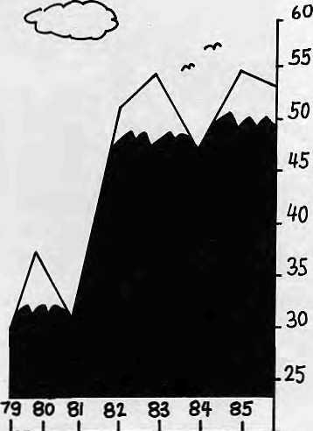
T.U. Enrolments in 'OOOs,
Member-Secretary of Education Planning, "It is the standard of Nepali and English that is slipping. The graduate of today has a weaker language base than the graduate of 20 years ago."
"Politics" is one aspect of Nepali higher education which generates excitement. Filled with leftists, centrists and rightists, TU is a beehive of crusaders. Many "student leaders" are a determined lot who have been around for years, switching subjects to remain politically active on campus. An assistant- lecturer who just had his first TU-style class disruption and political bickering, has this to say, "Everyone seems against everyone else: students versus teachers, students versus students, teachers versus teachers, teachers versus administration and administration versus students."
Zig-zag Policy
The Government's decision to go back on its earlier decision and to allow private colleges was an attempt to fulfil the country's insatiable demand for higher education. Today, out of 140 colleges in Nepal, 62 are privately run. These private campuses receive no financial assistance and follow the University calendar. They are run mostly on an ad hoc basis, on rented premises with part-time teachers. All of them are limited to the undergraduate level, so their graduates all ultimately line up at the TU door in Kirtipur.
Despite the acrimony, poor implementation of oft-changing policy, lack of facilities and inappropriate curriculum, Tribhuvan University continues to rake in SLC students and chum out graduates in ever-
increasing numbers. In a survey conducted by HIMAL at Padma Kanya Campus in March, every one of 20 girls at the first year Bachelors level wanted to go in for a Masters in "soft" subjects such as English, Home Science and Economics. Yet few can answer the question, "Why do you want a Masters?" and have only a vague idea about careers and opportunities.
What is clear is that the enormous
problems of higher education in Nepal
are not of Tribhuvan University's
making alone. They also have to do
with a social mindset about education
and the seemingly preordained and
inevitable progression from Intermediate
to Bachelors to Masters, unless
interrupted by migration, death, ill-
health, employment or (in the case of
women) marriage, TU has become the
baby-sitter for the nation, providing its
charges with "something to do" while
awaiting their adult destiny. t>
If you are interested in books on:
Nepal
Tibet
Bhutan
Sikkim
and
mountaineering
please write to us for a free catalogue.

Ratna Pustak Bhandar
Bhotahity Kathmandu

July 1988 • HIMAL 33

INVESTIGATION

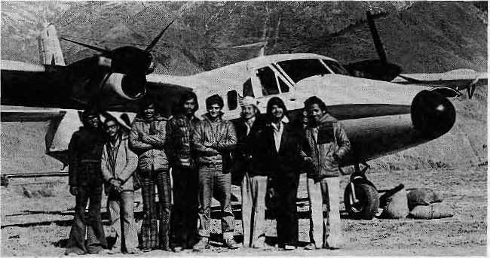
student is supposed to stay in the village for a month, which hardly allows time to interact with the community and is a far cry from the original nine months. Many students merely go through the motions of service and even copy the required "village profiles" from those who have served before in the same village. £> B.B, S.R.
A Diluted Experiment
There was a time when the National Development Service of Tribhuvan University was the most colourful feather in its cap. Today's NDS is a feeble copy of its former self.
Originally, TU required Masters-level students to spend nine months serving rural communities before receiving their degree. Relatively well-to-do students thus had their eyes opened to the pervasive poverty in the countryside and at the same time provided a boost for the development of remote areas.
However, a host of factors converged to upset the good intentions. As the number of graduates rose, the costs became more than anticipated, with monthly stipends, travel allowances, supervision and general administration. There were also problems getting support from rural Nepalis, the supposed beneficiaries, and adjustments to the tocal calendar disrupted the University's
NDS students flying high in DoLpa (1978).
own timetable. Politically polarized campus onions did not help matters and a noble plan became a political hot potato which was rapidly dropped.
The NDS in its present incarnation is regarded by students as a prerequisite evil for procuring a degree. The period of study is three months and NRs750 is provided to cover expenses. The

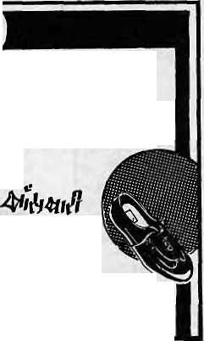


FOR GENUINE
LEATHER FOOTWEAR & LEATHER GOODS
BUT
BEST VALUE FOR YOUR MONEY
Sales ft Showroom NEAR NEW ROAD GATE
Above Qm Pharma
Faclofy: BANSBAR1 LEATHER ft SHOE FACTORY LTD, Bansbari, Kalhmandu Nepal P. O. Bon 227 (at 4-13197 4-11687. Gram ChhaJuka Tlx; 2276 HOSNG NP
TRINITY TRAVEL
Of special appeal to marine, mountaineering and wildlife enthusiasts.
Tours ' Tickets • Safaris • Treks
• Whitewater Rafting • GrayUne Tours
* Group Incentives
P.O. Box 949, Durbarmarg,
Kathmandu, Nepal
Tel. No. 222160/413303

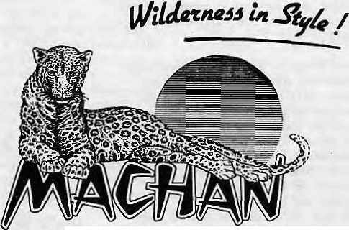
WE SAY "NAMASTE"
WHICH MEANS YOU ARE
WELCOME
Get in touch with us for all your travel needs in Nepal.
NAMASTE TRAVELS (P) LTD.
Maitighar/Ram Shah Path
Kathmandu
Cable: WOCAB Tel: 21340S, 212918
IMLPUFB &S0RT
ROYAL CHITWAN NATIONAL PARK
Durllil Marg Reservation Oftict P 0. Bos: i\1i Kalhmandu-Vival fcC 2:5M»I Ttlttl 31W ALPINE NP

July 1988
HIMAL 34

NEW PUBLICATIONS

TtfV, HfeWrij><«; DC 20l?.M
The first issue of this magazine, published by Worldwatch Institute of Washington DC, contains articles on AIDS in the Third World, the danger of future Chernobyls, and the increasing number of smokers in the developing world. The magazine hopes to address "the growing worldwide hunger for information on the fasi-changing relationship between five billion Earthlings and the natural support systems". A section on "Promising Initiatives" lauds enlightened policies while a section called "Wrong Turns" details wrong turns. Six issues a year at U$20. Contact: 1776 Massachusetts Avenue NW, Washington DC, 20036.

In its second year, this bi-monthly is providing increasingly comprehensive coverage of voluntary efforts in rural India. The first issue of 1988, in an editorial, criticizes voluntary agencies for ignoring the local community. "It is essential to first accept the basic premise that not only do people know what is good for them but that they have a right
10 decide." Published by the Council for Advancement of People's Action and Rural Technology, Guru Nanak Foundation Building, New Mehrauli Road, New Delhi 110 067. Annual subscription is IRs30.
VOICE OF CHILD WORKERS
This is a newsletter of Child Workers in Nepal, a group formed to protect the rights, welfare and dignity of working children in Nepal. The first issue (October 1987) presents a thorough report on Kathmandu's street children and also describes the work of restaurant kids {hotel kanchas). Edited by Gauri Pradhan. Annual subscription is NRs80 for individuals. Write to PO Box 4374, Kathmandu. Frequency of publication is not specified,
NETWORKER
This publication is brought out three times a year by the Centre for Women and Development, one of Kathmandu's respected research- consultancies. The inaugural number (November 1987) assesses the impact of "development" on "gender" and maintains that [he massive governmental investment on development since 1952 has created greater inequality
between the sexes, with women worse off. A writer states that alternative approaches to development can be supplemented by the private sector. "Room must be cleared for private autonomous organizations to evolve and emerge rather than leaving development solely to administrative decree," she says. Contact: PO Box 3637, Kathmandu. Annual rate; NRs 150 for institutions, NRs75 for individuals.
WORLD RIVERS REVIEW
The International Dams Newsletter is now
the the World Rivers Review. The
editorial says this shift reflects changes in
worldwide water polity and marks "the
beginning of the end of the big dam
era". The latest issue of this bimonthly,
published by the International Rivers
Network, reports on dam projects in
Tanzania, the Soviet Union, Brazil and
Malaysia, a cure for river blindness
(onchoccrciasis), a study of siltaiion in
reservoirs, and the call for "glasnost" at
the World Bank so that it will release
information on big dam projects.
Address: 300 Broadway Suite 28, San
Francisco, CA 94133, USA. U$40 for
institutions and U$15 for NGOs and
individuals. a

NGO HOTLINE

ASIA-PACIFIC PEOPLES' ENVIRONMENT NETWORK (APPEN)
APPEN was formed in 1983 by a diverse group of NGOs from the Asia- Pacific region in order to act together on issues related to development, natural resources, the environment and "human dignity". APPEN's objectives are to disseminate information on the environment among NGOs and to establish links with groups outside the region. APPEN produces a quarterly newsletter on the environment CU$1.2 annually), a bimonthly Environmental News Digest (U$40), and a directory of environmental NGOs in the Asia-Pacific region (U$15),
CONSORTIUM ON RURAL TECHNOLOGY (CORT)
Is a voluntary organization working to disseminate low-cost rural technology. It does this by linking research and development institutions, grassroots organizations and funding agencies. Recently, it decided to strengthen regional
grassroots organisations, and formed a regional consortium called Himalaya Takniki Mandal (HITAM). Through HITAM, the Consortium will disseminate and propagate technologies related to the hills. CORT: D320 Laxmi Nagar, Delhi-110092
HESCO
HESCO is a multidisciplinary group of young scientists working to create innovative, sustainable options for eco-devclopment. It is active in protecting the fragile Siwalik region of the Himalaya, where the focus has been on stabilizing land-slides with indigenous plant species. The Border Road Organisation is now using HESCO's assistance for the maintenance of high roads in other parts of Uttar Pradesh. The organisation has also initiated work towards sustainable village-level development. It has promoted the use of agave plants as fencing for village plots and also the use of agave fibre which has developed into a small-scale industry. HESCO: PO Box 7, Kotdwara - 246149, Uttar Pradesh.
SOUTH ASIA PARTNERSHIP (SAP)
Working in association with the Social Service National Coordination Council, SAP facilitates contact among NGOs in Nepal to enhance their understanding of approaches to development. SAP seeks to support small and newly established groups which work at the local level and with the neediest. To receive funding, these groups are required to have a local support base and the ability to design and implement projects. Also they must be registered NGO's with one of the Coordination Committees under the SSNCC.
The projects which pass muster are
recommended to a group of Canadian
NGOs, which select the projects they are
able to support. SAP is presently
supporting 66 projects, from piggeries to
soap-making to drinking water to print
shops. Applications for funding must be
addressed to: SAP, GPO Box 3827,
Kathmandu. fc

July 1988 ■ HI1VIAL 35

REVIEWS

Across the Himalayas through the Ages
Khcmanand Chandola Patriot Publishers IRs90
By Rashmi Pant
In this study, the author examines a variety of ancient, medieval and modern sources to advance a political claim for an Indian interest in Western Tibet today. He bases his thesis on the tributary relationships with northern Indian kingdoms in the past, common lineages, shared religious beliefs and practices, as well as close economic ties through trade. Such a political claim is questionable in its own right; it is also supported in this book by an often erroneous interpretation of historical sources.
Statements from epics, courtly chronicles, myths, travelogues, reports of colonial officials, works of historians as weli as archaeological evidence are all accepted at face value. Such uncritical use of sources has characterized almost every history of the Garhwal region. History as a professional discipline today must involve economics, geography, anthropology, structural linguistics and literary criticism,
Chandola recounts myths that trace the descent of Tibetan ruling dynasties from Indian clans such as the Licchavis and the Mallas. Rather than taking the myths literally and trying to establish biological descent, it would have been truer to the nature of myth to see them as legitimizing ideological claims. Similarly, the folk myth that Bhotiya and Huniya traders on either side of the border belong to branches of one family could be better utilized as an ideological construct.
According to Chandola, Indo-Tibetan trade is marked by pre-market exchange in which gift-giving, familial norms and exclusive partnership temper purely commercial transactions. Trading between Tibet and China is more commercial and lacks such ritual and personal ties. It would be wrong to argue from this, as the author does, that Tibet's economic ties are closer with India than with China.
In fact, the trading structure on the Chinese border even led to the rise of a Tibetan bourgeoisie which set up mediating mechanisms between individual Tibetan traders and Chinese
merchants. In the comparative framework of economic anthropolgy, the economy of Tibet would thus appear to be better integrated with China than with India, therefore requiring less support from quasi-kinship structures.
Notwithstanding his interpretation of materials, the author, a political activist in Garhwal, has great familiarity with the region. The book is replete with details that come from a long association with the people. Had the book focused on economic and social institutions within a comparative framework, it would have had greater relevance. (This review first appeared in The Times of India.)
Red Data Book of Indian Plants -Volume I
M.P. Nayar and A.R.K. Sastry Botanical Survey of India IRs 160
By Pallava Bagla
The usefulness of this much-needed book on plants of India crosses international frontiers. The format is taken from the IUCN Red Data books. The first volume lists 230 rare, vulnerable and endangered categories, encompassing 52 families of plants, both flowering and non-flowering, but mainly from among angiosperms. Most of the material for the book was provided by scientists from the Botanical Survey of India.
There is a wealth of information here. Each data sheet contains a description of the plant itself and its family, status, distribution, habitat and ecology, conservation measures taken or proposed, biology and potential value, cultivation and reference. Most species are illustrated by line-drawings and there are some colour plates. Nayar and Sastry list 78 Himalayan plants as requiring attention, of which 34 are from the Western Himalaya and 44 from the Eastern Himalaya. Forty-five varieties of orchids are identified for immediate conservation measures.
Although the book arranges plant families and individual species alphabetically, only Latin names are used. Non-botanists will therefore be at a loss. The poor quality of some sketches will hinder field identification. Future volumes should include common and vernacular name's of species and
have maps showing distribution. Algae, fungi and bryophytes should also be included, as should a few other plants that have been missed by this first volume.
Paiiava Bagla is a research associate at the Indian I nut it me of Pub lie-Administration in Delhi.
Nepal Diary
Hugh B. Wood
American Nepal Education Foundation
U$23.95
By Jayaraj Acharya
According to its author, an advisor to Nepal's National Educational Planning Commission (NEPC) in the mid-1950's, "Nepal Diary is not an autobiography....it is a biography of an event, a project, a program, a revolution."
The nine-part volume takes us through the planning and implementation of the education programme by the NEPC during the early and mid- Fifties, a time of great public enthusiasm. Popular participation in the planning process was such a priority that opinions on the direction of national education were sought even from illiterate people, who voted with their thumb-prints on questionnaires.
Nepal Diary reminds us of those days of hope, with volunteer teachers, voluntary labour to build schools, and NEPC members who "would devote from 750 to 1000 hours to their assignments without pay". In response to such enthusiasm, the NEPC defined the goals for national education for Nepal as: universal education (for children and adults), national education (one single public system) and free education (primary education and literacy immediately).
It is impossible to read this book without contrasting those early days of Nepali education with the directionless meanderings of today. The book, for example, describes the establishment of a Teacher Training Center. Yet where are the trained educators the country needs so desperately today? According to the World Bank, the literacy figure for Nepal remains at a low 20 per cent.
Wood returned to Nepal in the summer of 1961, this time with Unesco, to study Nepal's educational problems. He

36 HIMAL ■ July 1988

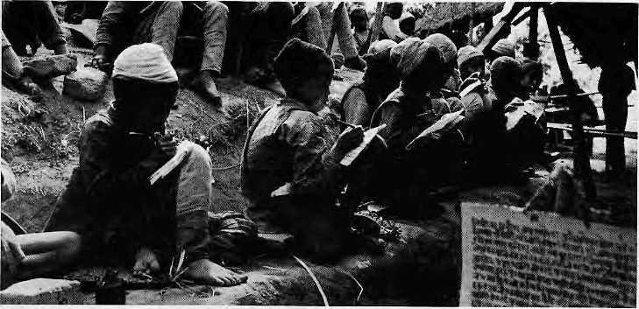
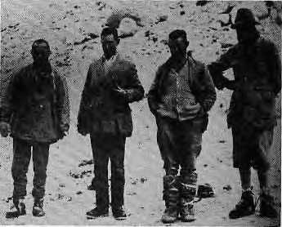
Thus, Nepal's educational progress was JayarajAcharya is a Nepali linguist.
School kids in 19S4.
found that "there was 1J00 percent growth in the number of schools from 1951 to 1961, a 1900 percent growth in the number of pupils, and an increase from 0.9 percent to 15.8 percent in the number of school-age children attending schools".
He seems to have detected a significant change in the governments education policy as well. So, in tune with this policy, he writes: "However, while not discouraging continued efforts in this direction, we pointed out the dangers of too rapid growth of primary education." The team thus "recommended maintenance of a proper balance, and postponement of the 100 per cent enrollment goal, if necessary."
Everest: The Mystery of Mallory and Irvine
Produced and Directed by David Breashears and Andrew Harvard Arcturus Films
What happened to George Mallory and Andrew Irvine up on the northern flanks of Mount Everest in 1924 is the most tantalizing mystery of Himalayan mountaineering. Did they reach the summit three decade before Edmund Hillary and Tenzing Norgay, or did they die soon alter they were seen disappearing into clouds above Camp VI by Noel Odell?
This fifty-minute historical documentary, made by two well-known American climbers in association with the BBC, asks those questions and many others. Could Mallory and Irvine have reached
Photo : UN
braked before it could gain speed and we were "saved" from the danger of "too rapid growth". A foreign adviser can give advice, regardless of its moral value. In a country with minimal literacy like Nepal, the fault of deciding not to expand primary education or literacy "too rapidly" does not lie with foreign advisors, but with ourselves. Thus ends this "biography of...a revolution", not with a bang but with a whimper.
Nepal Diary is well-written, though not without its share of typographical and statistical errors. Despite its weaknesses, the book will be instructive reading to all those who worry about education in Nepal. But who worries.
the summit at all, given their primitive climbing gear? And how about the ice axe which was found a decade later? Did a Chinese climber, now dead, actually see their bodies? Why did Mallory choose a novice, Irvine, as his partner for the summit attempt when the obvious choice was Odell?
The film faithfully recaps the story so well known to climbing enthusiasts the approach march up from Darjeeling via Dingri up to Rongbuk, Changtse and the North Col; the mountain, "a prodigious fang excrescent from the jaws of the earth", in Mallory's words; and Mallory himself, the poet and enigmatic hero, obsessed with the mountain. Breashears and Harvard intermix film taken during their successful North Ridge Expedition of 1986 with original footage taken by Jon Noel during Mallory's , 1922 and 1924 expeditions. One memorable, scratchy
sequence shows how Base Camp got
the message of the tragedy: six
blankets high up on the mountain laid
out in a cross.
The best feature of the documentary is conversations with Odel, Noel and Jack Longland, valuable because the first two have died in the past year. There is Odell insisting that the two figures he saw above 27,000 feet were not rocks, for they distinctly moved. A Mallory "expert" recites a long-winded and unbelievable theoretical replay of what might have happened to the pair. Jack Longland unexpectedly calls Mallory "a stout-hearted baby unfit to be put in charge of anything including himself". Hillary is asked "what if the two had in fact made it to the top in 1924? His answer is mock-serious but to the point: "the getting down is rather important".
The documentary is replete with such interesting vignettes, but in the end its appeal will be limited to mountaineering buffs. This is because the film literally gets lost on the mountain, with the lay viewer unable to follow the chronology of events, the succession of camps and the geography of the mountain's north face. The 1922 and 1924 footage is mixed up, and locations from the old film are not related to the current footage, which should have been easy to do.
Mallory, second from left on Everest
(1922).
Harvard and Breashears, unhappy with
cinematographers' treatment of
mountaineering, decided that it was time
climbers themselves got into the act. In
doing so, they have remained faithful to
the historical characters and the
mountain, but expect too much of a
general interest audience, for whom this
film was evidently made. However, the
documentary is a pleasure for the
initiated and, best of all, does not solve
the mystery of Mallory and Irvine. -
KMD A

July 1988 ■ HIMAL 37

ABSTRACTS

HAMARA SAMUHIK BHAVISHYA The World Commission on Environment and Development April 1988 This Hindi adaptation of the World Commission on Environment and Development's report Our Common Future was undertaken by the Energy and Environment Group of (Post Bag 4, New Delhi-66) for use by Indian nongovernmental organizations. The Commission, chaired by Gro Harlem Brundtland of Norway, called for "sustainable development" in order to tackle environmental degradation and stalled economic progress. In her foreword to the report, Brundtland calls for translating "our words into a language that can reach the minds of the people" so as to correct the course of development. This Hindi edition should prod the process along.
THE OTHER SIDE OF POLYANDRY Sidney Ruth Schuler Westview Press November 1987 This new book by anthropologist Sidney Schuler is about "property, stratification and non-marriage" in a Tibetan-speaking community near Muktinath in North-Central Nepal, where almost one-quarter of all women never marry. Discussing religious values, the author takes issue with literature which tends to romanticize and inflate the status of Tibetan women in contrast to that of Hindu women in India and Nepal. Although this contrast is not without some basis, it is misleading, she argues, because in Tibetan as well as in Hindu societies, women's access to property and wealth is through marriage.
MAP OF SOUTH-CENTRAL TIBET Stanfords International Maps 1987 The result of Rene de Milleville's paintaking research, this map is a valuable guide for overland travelers to Lhasa from Kaihmandu, although recent disturbances in Tibet might have limited its immediate use. The map gives routes that are open to foreign travelers and provides elevations: such as 560m in Dolalghat in Nepal to 4350m in Shekhar Dzong to 5300m at the Suge La pass five hours short of Lhasa. Map also provides distances, the time for travel and a rudimentary street map of Lhasa town. Besides the regular route from Shigatse to Lhasa via Gyangze, the map also sets out the "northern road" along the Tsangpo.
HAMARA PARYAVARAN Gandhi Peace Foundation 1Rs200 Due out shortly, this compendium adds to and enhances the "The State of the
Indian Environment Report", in Hindi. It also updates the earlier Hindi version of three years ago. The 400-page report was prepared with the collaboration of environmental activists throughout India and the Centre for Science and Environment in New Delhi. Among other things, the report deals with land, water, forests, dams, environment, public health, fuelwood, nuclear energy, and the role of government policy in all these areas.
ALTITUDE GEOGRAPHY Ram Kumar Pandey
Center for Altitude Geography, Kathmandu NRs250
This 408-page book contains a mass of data and information on Nepal's physical terrain, environment, climate, economy, agriculture and people. There is an unprecedented number of tables, maps and diagrams. The book is valuable for its sheer range and is a significant contribution to the field of contemporary Nepali geographical science. Somewhat unclear, however, is the precise need for a separate discipline called "altitude geography", defined in the book as "the study of spatial variation brought by elevation differences".
A D H A R B H U T ABASYAKATAHARUKO PARIPURTI KA LAG1 KARYAKRAM (B.S.2042-57)
National Planning Commission Kathmandu October 1987 This booklet summarizes the programme prepared by Nepal's National Planning Commission for achieving the basic needs for-all Nepalis by the year 2000 (B.S. 2057), according to the declared policy of His Majesty's Government. The booklet defines the basic needs requirements in terms of individual income (Nrs.4093 per annum), daily
food intake (2250 calories), clothing (II metres plus one pair of shoes or chappals) and living space (30 sq. meters). The aim is also to reduce annual population growth to below 2 per cent, child mortality to 45 per throusand, and increase longevity to 65 years. It proposes to reduce the number of Nepalis under the poverty line from 42.5% presently to nil.
STATE OF THE WORLD: 1988 WorldWatch Institute W.W. Norton & Company The fifth annual report of the Washington-based Worldwatch Institute finds the vital signs of the earth very weak. Worldwatch laments that forestry has remained the poor stepchild of ■development agenda and calls for ecological restoration of tropical forests to their original state. Millions of farmers in developing countries, unable to break the "pesticide habit", are being poisoned by chemicals. WorldWatch's President, Lester Brown, speaks with alarm of water, fodder and fire rood situations in the Subcontinent and makes a pitch for "sustainable development". Because of wholesale deterioration of the environment, officials fear that living standards may turn downwards within the next few years, following the trend in Africa, he says.
AGRICULTURAL RESEARCH IN NEPAL
Ram P. Yadav
International Food Policy Research Institute 1987
The study describes the poor state of agricultural research in Nepal, which it says has affected the country's attempts to increase productivity by adopting new technologies. Yadav, now a deputy director of the International Centre for Integrated Mountain Development (ICIMOD), says that agricultural research in Nepal is poorly funded, organized and managed. He calls for establishing a high national priority for research, unifying all agricultural research activities under an autonomous body, and motivating researchers through better personnel policies.
THE PURPOSE OF FORESTS
Tack Westoby
Basil Blackwcll
343 pages, 35 Pounds Sterling
A useful sampler of ideas in tropical
forestry over the last two decades and
more, spanning the evolution from
industrial forestry to social forestry.
Westoby, who was FAO's director of
forestry till 1974, writes, "Forestry...is

38 HIMAL ■ July 1988

Next Time on HIM^L
November 1988 Vol 1 No 2

Cover Story
HIMALAYAN MYSTICISM: IS THERE
ANYTHING THERE?
A report on mountain mysticism that
separates the real from the hype. Is
meditation any different at 16,000 feet
than ai sea level? Scientific bases for
claims. Why do high-flying godmen
inevitably invoke the Himalaya.
Features
THE DARJ TEA CUP RUNNETH OVER
The agitation in Darjeeling has reduced tea harvests by about 65 per cent in the past year. What are the prospects for Darjeeling tea, how badly are the plantations doing and what can the tea-pickers look forward to?
HIMALAYAN TOWNS: DEHRA DUN Urbanization, pollution, migration, industrialization, activism, environmentaiism and all come together in this valley town.
THE NEPALI STOCK MARKET: ANYTHING TO SELL? Prodded by a United States Ambassador who stepped righi off Wall Street, Nepal opened a stock exchange in 1985 under the aegis of the Securities Exchange Centre. But the number of stocks that change hands is negligible. Some think it's all a joke. Others argue it can work.
THE KILLER DISEASE UNDERSTOOD
Acute Respiratory Infection (ARI) is a deadly killer of Himalayan children, but has been little studied because it does not occur in developed societies. HIMAL will cover in detail the first-ever significant study on ARI, expected out later this year.
THE UNDP IN NEPAL: TAKING
STOCK
"Development is complex", a cliche well
understood by UNDP in its work in
Nepal. Projects that succeeded and
others that failed, and why.
NEGLECTED PROVIDERS OF FOOD Because oF the research bias towards food-crops from developed countries, the staple crops of the Third World have been ignored. Rice, wheat, maize, and now soya beans receive extra attention, while more modest crops such as mountain barley and millet are neglected. Other crops that can help hill people: the proso millet of China, the t'ef grain of the Ethiopian
highlands, and the amaranth and quinoa plants used by the Andean Indians.
PARKS AND WILDLIFE: HOPE FOR KASHMIR STAG
The upgrading of Kashmir's Dachigam Sancturary into a full-fledged National Park as part of Unesco's Man and Biosphere Programme significantly improves prospects for the Hangul, or Kashmir Stag.
PHOTO FEATURE; SUSPENSION BRIDGES
Some of them nearly a century old, suspension bridges across the Himalaya have served the mountain people better and longer than highways and STOL airstrips. Sadly, many are in extreme disrepair. Early in 1988, Nepal signed an agreement with SATA, the Swiss aid agency, for rejuvenating these vital communication links.
AGRICULTURE: THE POTATO Its importance for high mountain populations, problems with research and propagation, impac> of cold storage facilities on the industry. Potato diseases and the need to shift cultivation from the traditional "white potato" to better species.
PART OF THE WAY TO LHASA For the people of Kathmandu (and others) wanting to retrace the route of their trading forefathers and mothers to Lhasa, our resident trek-advisor charts a leisurely seven-day trip from the Valley to the border post of Kodari. A thinking traveler's guide to the history of this time-worn trail, made famous by Lax mi Prasad Devkota in the ballad Muna Madan. Like in the epic, today, there is tragedy along the trail but of a different kind.
POINT OF VIEW:
"The Perils of Environmental Tokenism"
By Ramachandra Guha
"Eco-Polilies" By Kama Sakya
"Himalayan Highways" By Toni Hagen
GRASSROOTS:
Pasang Sherpa of Marpha, who holds court in the upper Kali Gandaki Valley, grows apples and makes world-famous apricot brandy in small quantities. Starting out as a guide to famous anthropologist Christoph von Haimendorf, Pasang Sherpa went on to study wine-making in France and finally set up shop in the heartland of the Tbakali community.
And in Future Issues
SOCIAL MARKETING IN THE HIMALAYA: From contraceptives to oral rehydration salts, why development needs to be planned right and "sold" right.
WHY JUST ONE CHIPKO? Examine the prospects for people-power movements across the hills of South-Central Asia. Whither Chipko?
SHOULD FOREIGN AID BE
SUSPENDED? The differing experience of South Asian countries with foreign aid.
THE TRANS-HIMALAYAN PASSAGE: From the Kodari crossing in Nepal to Khunjerab in Pakistan, as wefl as the age-old routes by yak-caravans and tortuous pilgrimage trails.
FOREIGN WEEDS: The Lamana and Banmara weeds, which arrived in the Himalaya from the Americas with the PL-480 wheat shipments and today cover a significant part of former woodlands. Can the weeds be controlled, or should they be controlled? Have they reduced the severity of soil loss?
MISSIONARIES: Historical recap from Capucin monks, adventurers of centuries past to present day activities by missionaries, Jesuits, Unitarians, Maryknolls and others.
IMPROVED WOODSTOVES: Experience in the India, Nepal and Bhutan hills: best designs do not necessarily mean instant acceptance by the villager.
HIM ALAYAN HERBS AND FLOWERS: Commercial and scientific uses of Himalayan plants. Possibility of selling mountain flowers in European markets, protecting herbal plants from rampant exploitation,
BRITISH GURKHA RETRENCHMENT: With the closure of the Dharan recruitment camp, and despite strenous British protestations, it is clear that fewer Nepali hilimen will be recruited into the British Army. A report on which hill tribes and districts will most be affected, and the impact on Nepali society and economy.

40 HIMAL ■ July 1988

Next Time on HIM^L
November 1988 Vol 1 No 2

Cover Story
HIMALAYAN MYSTICISM: IS THERE
ANYTHING THERE?
A report on mountain mysticism that
separates the real from the hype. Is
meditation any different at 16,000 feet
than ai sea level? Scientific bases for
claims. Why do high-flying godmen
inevitably invoke the Himalaya.
Features
THE DARJ TEA CUP RUNNETH OVER
The agitation in Darjeeling has reduced tea harvests by about 65 per cent in the past year. What are the prospects for Darjeeling tea, how badly are the plantations doing and what can the tea-pickers look forward to?
HIMALAYAN TOWNS: DEHRA DUN Urbanization, pollution, migration, industrialization, activism, environmentalist!! and all come together in this valley town.
THE NEPALI STOCK MARKET: ANYTHING TO SELL? Prodded by a United States Ambassador who stepped right off Wall Street, Nepal opened a stock exchange in 1985 under the aegis of the Securities Exchange Centre. But the number of stocks that change hands is negligible. Some think it's all a joke. Others argue it can work.
THE KILLER DISEASE UNDERSTOOD
Acute Respiratory Infection (ARI) is a deadly killer of Himalayan children, but has been little studied because it does not occur in developed societies. HIMAL will cover in detail the first-ever significant study on ARI, expected out later this year.
THE UNDP IN NEPAL: TAKING
STOCK
"Development is complex", a cliche well
understood by UNDP in its work in
Nepal. Projects that succeeded and
others that failed, and why.
NEGLECTED PROVIDERS OF FOOD Because of the research bias towards food-crops from developed countries, the staple crops of the Third World have been ignored. Rice, wheat, maize, and now soya beans receive extra attention, while more modest crops such as mountain barley and millet arc neglected. Other crops that can help hiSl people: the proso millet of China, the t'ef grain of the Ethiopian
highlands, and the amaranth and quinoa plants used by the Andean Indians.
PARKS AND WILDLIFE: HOPE FOR KASHMIR STAG
The upgrading of Kashmir's Dachigam Sancturary into a full-fledged National Park as part of Unesco's Man and Biosphere Programme significantly improves prospects for the Hangul, or Kashmir Stag.
PHOTO FEATURE: SUSPENSION BRIDGES
Some of them nearly a century old, suspension bridges across the Himalaya have served the mountain people better and longer than highways and STOL airstrips. Sadly, many are in extreme disrepair. Early in 1988, Nepal signed an agreement with SATA, the Swiss aid agency, for rejuvenating these vital communication links.
AGRICULTURE: THE POTATO Its importance for high mountain populations, problems with research and propagation, impact of cold storage facilities on the industry. Potato diseases and the need to shift cultivation from the traditional "white potato" to better species.
PART OF THE WAY TO LHASA For the people of Kathmandu (and others) wanting to retrace the route of their trading forefathers and mothers to Lhasa, our resident trek-advisor charts a leisurely seven-day trip from the Valley to the border post of Kodari. A thinking traveler's guide to the history of this time-worn trail, made famous by Laxmi Prasad Devkota in the ballad Muna Madan. Like in the epic, today, there is tragedy along the trail but of a different kind.
POINT OF VIEW:
"The Perils of Environmental Tokenism"
By Ramachandra Guha
"Eco-Politics" By Kama Sakya
"Himalayan Highways" By Toni Hagen
GRASSROOTS:
Pasang Sherpa of Marpha, who holds court in the upper Kali Gandaki Valley, grows apples and makes world-famous apricot brandy in small quantities. Starting out as a guide to famous anthropologist Christoph von Haimendorf, Pasang Sherpa went on to study wine-making in France and finally set up shop in the heartland of the Thakali community.
And in Future Issues
SOCIAL MARKETING IN THE HIMALAYA: From contraceptives to oral rehydration salts, why development needs to be planned right and "sold" right.
WHY JUST ONE CHIPKO? Examine the prospects for people-power movements across the hills of South-Central Asia. Whither Chipko?
SHOULD FOREIGN AID BE SUSPENDED? The differing experience of South Asian countries with foreign aid.
THE TRANS-H I M ALAYAN PASSAGE: From the Kodari crossing in Nepal to Khunjcrab in Pakistan, as well as the age-old routes by yak-caravans and tortuous pilgrimage trails.
FOREIGN WEEDS: The Lantana and Banmara weeds, which arrived in the Himalaya from the Americas with the PL-480 wheat shipments and today cover a significant part of former woodlands. Can the weeds be controlled, or should they be controlled? Have they reduced the severity of soil loss?
MISSIONARIES: Historical recap from Capucin monks, adventurers of centuries past to present day activities by missionaries, Jesuits, Unitarians, Maryknolls and others.
IMPROVED WOODSTOVES: Experience in the India, Nepal and Bhutan hills: best designs do not necessarily mean instant acceptance by the villager.
HIMALAYAN HERBS AND FLOWERS: Commercial and scientific uses of Himalayan plants. Possibility of selling mountain flowers in European markets, protecting herbal plants from rampant exploitation.
BRITISH GURKHA RETRENCHMENT: With the closure of the Dharan recruitment camp, and despite strenous British protestations, it is clear that fewer Nepali hilimen will be recruited into the British Army. A report on which hill tribes and districts will most be affected, and the impact on Nepali society and economy.

40 HIMAL ■ July 1988

FOLLOW-UP

In this page, we report on significant developments regarding articles in past issues of Himal, What follows concerns articles which appeared in our prototype issue.
THE VALLEY CHOKES: The Chobar Cement Factory has doubled its daily production rate of Portland Cement to 400 metric tonnes a day, without installing scrubbers to curtail the dust and other emissions. The air pollution problem has become worse during the past year, according to experts. With increased production, the factory now employs 703 workers and is the major industrial employer in Kathmandu. The major thoroughfares of Kathmandu were spruced up for the SAARC Summit meeting last October, but overall sewerage, sanitation and waste disposal problems remain as they were last year.
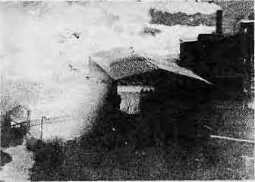
Chobar: Still smoking
LIGHTS GO ON IN NEPALI VILLAGES: HMG did not follow through with its promise to subsidize "mini-micro hydel plants" and the Agricultural Development Bank ended up paying for projects, but only those financed up to B.S. 2042-2043. There has thus been a drastic drop in orders for electrification units and communities are now looking for alternate funding sources. As for the the "electrified dekchi" developed by DCS in Butwal, three hundred of these Nepali cookers are being produced. They will be tested in a pilot scheme with the Andhi Khola Rural Electrification Programme in Syanjha District this summer.
MANY BABIES DIE IN NEPAL: Many babies continue to die because of poor nutrition, rudimentary sanitation, diarrhoea and acute respiratory infection (AR1). An 11 February Unicef report estimates that 45,000 children under the age of five die from dehydration due to diarrhoea.
Another 40,000 die from vaccine-preventable disease. A study on the extent of ARI, conducted by the Mrigendra Medical Trust, is expected to be out in 1988.
KMTNC, EMERGING ENVIRONMENTAL WATCHDOG: The Annapurna Conservation Area Project of the King Mahendra Trust for Nature Conservation, trying to cater to the needs of both villagers and tourists while protecting the environment, set up a kerosene depot at Chhomrong to popularize firewood-saving techniques. Three nurseries provided villagers with 80,000 fodder saplings and a lodge operators' training programme was held. A "Minimum Impact Code" leaflet is handed to every trekker passing through the area. It carries the motto, "Nepal is here to change you, not for you to change it".
Mingma Norbu, Director of the Project, says many villagers still mistakenly worry that the national park will displace them. Inordinate expectations arc also being placed on the Project. "On the whole, though, they are now very supportive of the Project," he says.
1CIMOD SEARCHES FOR ITS SOUL: Still searching, some would say. But Colin Rosser, Director of the International Centre for Integrated Mountain Development, says that ICIMOD is actively building up a "knowledge bank" for the Himalaya, acting somewhat like an autonomous international planning commission for the region. "The Himalaya is dominated by the 'project', and so they ask to see ICIMOD's project. But what we are trying to do is to evaluate, assess and suggest strategy," says Rosser. ICIMOD expects to open up offices elsewhere in the region. It also plans to hold training workshops for senior level officials of the region so that they are brought up to date with new technologies, such as remote sensing, new management tools and new ways of thinking.
For the next three years, ICIMOD's "area focus" will be, going eastwards, on the North West Frontier Province, Himachal Pradesh, the Uttar Pradesh Hills, Bagmati Zone in Nepal, the West Central Region of Bhutan, the Lhasa Valley Region, selected Hengduan Mountain prefectures of
China, and the Chittagong Hill Tracts in Bangladesh.
TEHRI: TEMPLE OR TOMB? The debate continues. The proponents of Tehri Dam in Garhwal emphasize its importance for the regional economy and for power in the energy-deficient region. They claim that the project, which will require up to IRs2035 crores, is cost beneficial. In opposition; the Delhi-based group INTACH estimates that for every rupee spent the return will be 56 paise.
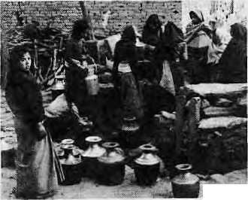
-?■■ ';.■ -
Engineers have failed to study upstream glaciers, nor have they taken into account the possibility of strong earth tremors, INTACH maintains, adding that because of siltation the lifespan of the dam cannot exceed 65 years. In October, a conference of NGOs of the Asia-Pacific region called for a moratorium on the construction of large dams, in particular the Nam Choan Dam in Thailand and the Narmadasagar and Tehri dams in India as "symbols of environmental destruction, social injustice and economic folly".
NO THOUGHT FOR WOMEN: Women's issues continue to be treated as supplementary, "almost as footnotes", to the "male-oriented" development projects, according to the Kathmandu-based Centre for Women and Development. Nepal's sixth and seventh plans are inadequate to ensure the full participation and integration of women in the overall development process, says the Centre. There has, however, been some forward movement. Over 1175 rural Nepali women have benefitted from a production credit programme launched in 1982 by the Women Development Section of the Ministry of Panchayat and Local Development. New Era, a consulting finru is preparing a strategy for "resource management with the active participation of local women". £>

July 1988 ■ HIMAL 41

In Europe:
HIMAL and
Himal
Associates
Himal Associates is a newly established non-profit group of professionals in Kathmandu. Its objective is to provide a citizen's forum for discussion and action on all areas of Himalayan "development" broadly understood, including public health, the economy, the environment, education and culture.
The organization
emphasizes the development of indigenous knowhow backed by appreciation of innovation worldwide. It supports small- scale research and applications which will directly help improve the quality of life.
Himal Associates publishes the magazine HIMAL because it takes seriously the slogan "Communications for Development". Public information is one of the scarcest commodities in the mountains and hinders progress.
Even though HIMAL is not a political newsmagazine aimed at the mass market, we expect it to ultimately earn its keep. Till then, as publisher, Himal Associates will continue to welcome contributions from individuals and foundations to help support this publication.
JOIN HIMM.!
As the need for common approaches to Himalayan development becomes increasingly obvious, so does the necessity of an open-minded, independent periodical to address the issues unique to the mountain environment of south-central Asia. This new bimonthly, HIMAL, will provide news and analysis of the issues that affect the people of the Himalayan crescent. HIMAL will bring out an interim issue in November 1988 before beginning regular bimonthly publication in January/February 1989.
Join us. Please send back the attached slip with the appropriate amount to receive a year's subscription to HIMAL (six issues). If you subscribe before September, we will send you the November 1988 issue free. Send HIMAL as a gift to a friend or colleague.
SUBSCRIPTION RATES (For six issues in 1989)
Individual Institutional
South Asia: NRsllO/IRs65 NRs500/IRs300 (or equivalent)
Abroad: U$25 U$45 (or equivalent)
Personal checks acceptable, bank drafts and money orders preferred. To pay in person in Kathmandu, call 523 845. Address subscription orders and other correspondence to:
In the South Asia:
tel: 523 845
P.O.Box 42 Lalitpur, Nepal
tel: 01 8501676
B ac henbu I acherstr.4 CH-8172 Niederglatt Switzerland
4 South Pinehurst Ave. 6A
New York, New York 10033
United States tel: 212 928 3761
In North America:
-cut here—
HIMAL
for six issues
Please enter a subscription for me. I have enclosed payment of _
of HIMAL in 1989. If I subscribe before September, I will receive the November
1988 "interim issue" as a bonus.
Name Street Town Country
Postal Code
cut here—
HIMAL

For further information, write to:
Himal Associates P.O.Box 42 Lalitpur Nepal
Please enter a subscription for me. I have enclosed payment of for six issues
of Himal in 1989. If I subscribe before September, I will receive the November 1988 "interim issue" as a bonus.
Name Street Town Country
Postal Code

42 HIMAL ■ July 1988

CLASSIFIEDS


PUBLICATIONS
NEW ENGLISH-TIBETAN DICTIONARY. New reprint of a popular and handy dictionary by Norbu Chopel. Makes maximum use of colloquial Tibetan for easier understanding. Approximately 8000 entries in 206 pages. IRs50 (U$ 9.25), packing and postage included. Write to Tibetan Library, Dharamsala 176215, INDIA
ENVIRONMENTAL RESOURCES ABSTRACTS. Quarterly journal monitors and abstracts information from Indian and overseas publications on conservation, renewable energy, wildlife, human settlements, pollution, marine resources, agriculture, appropriate technology and health. IRs200 Annually. Write to Environmental Services Group, B/l, LSC, J-Block Saket, New Delhi- 17,
HIMALAYA AT A CROSSROADS: PORTRAIT OF A CHANGING WORLD. Edited by Deepak Shimkhada. Papers on anthropology, art, environment, religion and travel. U$25 plus postage. Write to: Pacific Asia Museum, 46 North Los Robles Avenue, Pasadena, California 91101.
ENVIRONMENT COVERAGE SURVEY REPORTS. 60-page compilation of media copy on Nepali environment. Available for reference and for sale, priced according to capacity to pay. GPO Box 3094, Kaihmandu.
SERVICES
MEDJART PHOTOGRAPHICS. Track record in photography, writing and audio- visual production in all areas of social interest: health, education, culture and the environment. Address: B-231/F, Greater Kailash-1, New DeIhi-48. Tel: 6440275
DEVIII'S DAIRY: Milk, yogurt, cottage cheese supplied as per order in Lalitpur. Tel: 522614
Comfortable tourist bus service is now available From Tribhuvan International Airport to downtown Kathmandu. No more headaches!
Route: Airport - Hotel Sheraton - Hotel
Blue Star - New Road - Hotel Yellow
Pagoda - Thamel - Durbarmarg - Hotel
Woodlands - New Road Gate.
The one-way fare is NRsl5

We are always at your service.
SAJHA YATAYAT
Pulchowk Tel: 521064, 522146
SCHOOL FOR
INTERNATIONAL
TRAINING
Masters Program in Intercultural Management
Admissions Office
42 Kipling Road
Brattleboro, Vermont 05301, U.S.A.
For Careers in International Development and Educational Exchange. The program features practical training and professional internship. Students are prepared for careers as managers and trainers in international organizations such as CARE, Unicef, Save the Children and the International Rescue Committee. The School has provided more young professionals to this field than any other educational institution in the United States.


NEPAL PRESS INSTITUTE
Our job is to develop professionalism in Nepal's communication media. We offer the following services:
TRAINING : A ten-month diploma in Journalism, workshops for managers of small newspapers, seminars on population and development reporting, special fellowships for rural reporting, and training for mid-career professionals. CONSULTANCY: On all media-related issues.
PUBLICATIONS : A quarterly journal in Nepali reviewing developments in communications around the world, and an annual number in English for those interested in communications development in Nepal. Several monographs on media-related topics.
Post Box 4128 Kathmandu Tei: 215158

INFOE is a platform for those
remaining "societies" of plants, animals and people beyond the industrial civilization who are without a lobby. Infoe regards resistance to permanent loss of global ecological systems and support for ethnic minorities who fear for their lives as part of the same struggle. Ecoiogists and ethnographers who advocate the protection of these societies are both part of action anthropology.
For too long has the link between the destruction of nature and the elimination of tribes in the "Third World" been concealed.
INFOE e.V. Lockhutter Str. 143 D-4050 Monchengiadbach 1 Federal Republic of Germany
Institute for Ecology and Action Anthropology

July 1988 HIMAL 43


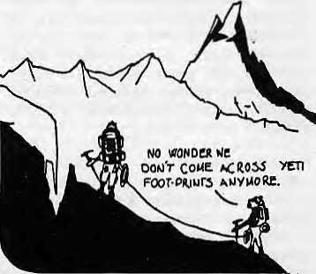
Abominably Yours,
Government clamps lid of secrecy on incredible find!
SPACE ALIEN BODIES
Up here in my little hideout on a cliff overlooking the Barun Gorge, the days drag idly by. The langur brought up the papers the other day. The good news is that they're thinking of extending the Sagarmatha National Park to down here, so more quiet days to look forward to. I remember an expedition in the mid-1970s that came to these parts in search of me. They made quite a racket, but all they found was a new species of the Himalayan Shrew.
1 hope the park extension will keep out all snoopers, including Soviet scientists who in January set up a society under the Ministry of Culture to look for the "abominable snowman". A commission for studying the "snowman problem" had evidently been set up 30 years ago by the Soviet Academy of Sciences. "However," said the press statement, "some time later it reduced its activities." More reduction please, is all I can say.
The King Mahendra Trust for Nature Conservation seems to have come to its senses and changed the name of its news bulletin from Centaur to PrakritL If there was just one way for KMTNC to banish all thought of nature conservation from the mind of a Nepaii reader, it was to name its bulletin after a genetically malformed monster out of Greek mythology. For a creature of myth, we did not have to go to the Aegean, I refer not to myself but to Narasimha or Garud, the first, Bishnu's avtar and the other, his mount.
One news item almost made me fall off this here cliff. Space alien bodies found right next door on Mount Everest! Banner headlines told of Nepali and American authorities huddled in a coverup so as not to set off "global panic". But once I saw that the cover picture mis-identified Ama Dablam as Everest, I thought it might be a hoax.
Trans-continental investigations revealed that the story had been cooked up by
the writers at the Weekly World Report, which is what they call in Big Footland "supermarket tabloid". Its reporters never leave their sofas and survive by titillating the listless American masses with made-up stories of infants reared by she-wolves, haunted toilets and organisms from Jupiter kidnapping high school principals.
Then there was the sigh of relief heard nationwide when the Italians finally confirmed that, after all, Everest was 800 feet higher than K-2. Thank you, Ardito Desio of Italy's National Research Council, otherwise this neighbourhood would have lost its market value. All 200-plus Everest summiueers would have had to slink to embarrassed crevasses and tourism revenue would have fallen off the South-West Face.
Geologists say "the Indo-Australian Plate is pushing the Eurasian Plate harder along the Eastern Axis than towards the Pamir". What this means is that Everest is rising two inches a year, while all K-2 can muster is half-an-inch. So there's no worry for the future either. Everest is also higher because of all the junk piled up at the top: oxygen canisters, tripods, Sherpa worry beads, Mao busts, Czech chocolate wrappers and assorted flags.
Actually, this sub-regional chauvinism is quite unbecoming, as I am the first to admit. After all, K-2 is also 1CIM0D territory. Speaking up for K-2, therefore, let me (quite indignantly) quote from something else the langur brought up. The February issue of China Pictorial speaks of Mount Qogir, "the main peak of the Karakorum Mountains". No quarrel there. But then a caption beneath a picture of that mountain states, without so much as a by-your-leave, "Mount Qogir, which stands at 8,611 meters (28,260 feet), is the world's second-highest peak." Well, here we go again. We'd better send Ardito Desio right over to the
Karakoram before someone comes along to claim that the pyramids of Giza are taller than Nanda Devi.
Good that the Everest-K-2 hoohah got defused, for it could have set off some nasty vibes within youthful SAARC. Actually, the spirit of SAARC long preceded its actual birth, at least in the naming of aircraft. Why else but for genuine sentiments of regional cooperation would Air India have decided 25 years ago to name its Boeing 707s after Nepali mountains - Lhotse, Makalu and Annapurna?
Sadly, these workhorses of the Air Indian fleet are being phased out, but the possibilities of SAARC-inspired regional name-swapping are endless. Druk Air could name its new HS-146 Adam's Peak, PIA could go for a Boeing 737-3CX) named Gangotri and Vayudoot could do worse than name one of its Dornier 228s - why not --Mount Qogir.
Talking of air travel, we yetis are not doing too badly ourselves. A few years ago cousin Big Foot sent over a hang-gliding kit. Now we produce our own sailplanes using dwarf juniper branches and tightly woven yak wool cloth. Trans-glacial travel is now done by air. Someone go tell the Russians that they should search for Ihermals and updrafts, not footprints.
Abominably Yours,


44 HIMAL ■ July 1988

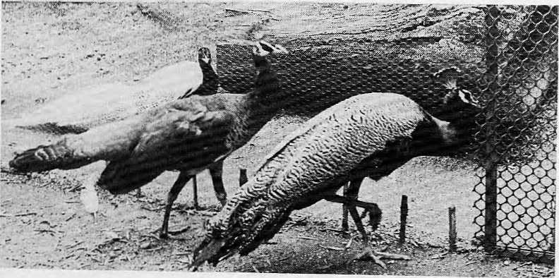
LAZIMPAT, P.O. BOX 655, KATHMANDU NEPAL CABLE : SHANGRILA, TELEX ; Z276 HOSaNG NP TEL: 412999

...andpeacowfs atuL cvneasants pmn, tfwmsefres in a prize, (winning

HOTEL SHANGRILA
■Where the environment is an art form.-
DESLA- 53


■ ■, An .exclusive experience of 'Shangrila' awatti .:
on:board;QUrnewBOENG757- KARMLIi -:..
■ 'Sharigiila' Executive Class; as (he name
. suggests, isfor the f^ple^oiook;ypQn, ;:-: ' travelling as a fine art Where: everything^ has been:
'■soraeticubusly-seleGtedthatit;will giyeanew ,: K. flying experience amidstftanquil .setting; . :; ■ ■'■■;■•;

; The subrJe decor^ny jdistinctiveinfl^h^;-. ■;'.■: services perpetuatedfrorn;the farn6us::IHep5iese:;: tradj^on; will be a:ciassic e^rienceyoti shall ; ;■ enjoy on destinations :rjetween Hongkong- ■ : '■■ ^ ^ Kathrnandu-Delhi-Bangkofc& Sngapore.: :: \ ■





wuttjm
wary to Nepal

JRoyalNepal IVtinihes

