ISSN 1012-9804
JAN/FEB1989
THE GIRL CHILD
Does She Stand A Chance?

TENGBOCHE BURNS DOWN MUKTINATH LIGHTS UP ; RENTING OUT EVEREST
ILLEGAL FURS FIGHTING PI£JE THE AM.L DEMON


INSIDE
HIM

Vo!.:2
No/ 1
Jan/Feb 1989


9 COVER
Does the Girl Child
Stand a Chance? 6 Exchanging Stocks
the Nepali Way 8 Mithuns on the Way out 18 PHOTO ESSAY
Monastery Destroyed
s
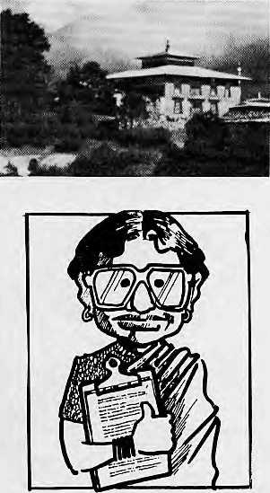
by Flames 22 Druk Air Flies On
33 VIEWS
The Doon Experience
Mountain Development Perils and Promises SOS from Bangladesh
3 BRIEFS
16 REVIEWS
23 CLIMBING
25 PARKS, WILDLIFE
- GRASSROOTS
- ENERGY
- ABSTRACTS

- HEALTH
- FOLLOWUP
40 ABOMINABLY
YOURS
Acknowledgements
This issue is made possible by grants from the Panos Institute, and the Royal Norwegian Ministry for Development Cooperation.
Cover picture by Kevin Bubriski shows a Newar girl in Kathmandu Valley, at harvest time, with brother and mother.
Himal (ISSN 1012-9804) is published six times per year by Himal Associates,
P.O. Box 42, Lalitpur, Nepal. Tel: 5-23845 © Copyright [988. Please turn to
page 38 for subscription and other information.
Edited and Published by
Kanak Mani Dixit
for Himal Associates
Contributors to this issue:
Rosha Bajracharya Binud Bhattarai Anil Chitrakar
Kupa Jushi
Prakash Khanal
Sudhindra Sharma
Sudhircndar Sharma
Rajiv Tiwari

Photo Editor: P. Sudhakaran
Advisory Panel
M. Abdhullah, University of Peshawar,
Peshawar
Adlai Amor, Magasasay Foundation,
Manila
Anita Ananti, Inter Press Service, Rome
Kinfey Dorje^ Kuensel Weekly, Thimpu
Harka Bahadur Gurung, Kathmandu
CorneiHe Jest, Centre National de la
Recherelie Seiennfique. Paris
Prem Shanker Jha, Commerce, New
Delhi .
Ram Chandra Malhotra, Internatiosial
Fund for Agricultural Development,
Rome
Hemanta Mishra, King Mahendra Trust
for Nature Conservation, Kathmandu
David Sassoon , UNICEF Action far
Children, New York
Kumar Khadga Bickram Shah, Centre
for Nepal and Asian Studies, Kathmandu
Donald Shanor, Columbia University
School of Journalism, New York
Ambica Shrestha, Nepal Business and
Professional Women's Club. Kathmandu
Vidya Stokes, Himachal Legislative
Assembly^ Shimla
B.G. Verghese, Centre for Policy
Research, New Delhi
Brian Welsh, The Holos Centre,
London

MAIL

NOON CHINI PANI
Manorama Moss suggests that the Noon Chini Pani cloth, on sale in Nepal, which displays the ingredients and measurements for the oral rehydration solution (ORS) may be "communications for its own sake" (Viewpoint Nov/Dec). A point which seems to have been lost is the fact that this form of publicity for ORS costs UNICEF no money at all. People buy the material to make everything from nursing blouses to umbrellas, health post curtains and children's vests.
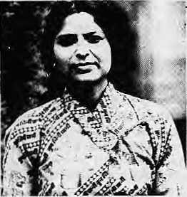
If Ms. Moss sees the Noon Chini Pani message on matchboxes in the next few months or on postage stamps, I hope she will realise the full extent of what is going on. It is not so much communications for its own sake as a small reminder, in a world of increasing commercialism, of what is important to save children's lives. This reminder is given free, and so helps release vital financial resources for the more direct communications approaches which UNICEF uses in its health and education programmes. George McBean Communications Officer UNICEF, Kathmandu
MIGRATION FOR THE BETTER
"Highlanders On The Move", your cover story on migration (July 1988), dealt exclusively with "survival migrants" -hill people who descend to the plains
to do hard labour for little gain. You missed out those who have migrated for the better. Two examples are the folks of Bandipur and the people of Thak Khola, both from central Nepal. When the Kathmandu to Pokhara highway bypassed their hilltop trading township and thus devastated their livelihood, the entrepreneurial Newars of Bandipur immediately puiled up stakes and moved down to Narayanghal. They have made Narayanghat the bustling town it is today. The resettled "Bandipurays" now operate buses and trucks (on the very highway that drove them away!) and own cinema halls, hotels, petto] stations and several industries.
The Thakali community has also proven as adaptable in migration. Today, their hometown of Tukuche at the base of Dhaulagiri looks like and is a ghost town. But there is no need to lament, for Tukuche's peopie are doing very well for themselves, as lawyers, doctors and engineers, not only in Kathmandu, but in the United States, England and Japan. Talk of survival migrants! C.K. Pradhan Pokhara
NEPALIS IN HIMACHAL
Your cover on migration stresses movement from the hills to the plains, but unequal development of hill regions can encourage migration within the hills. For decades, migration has taken place from Western Nepal to the hills of Himachal Pradesh. There are two or three thousand Nepali workers in the Shimia hills alone, out of whom about a thousand work on road construction in Shimia town. The others are employed as apple pickers, porters and agricultural workers in the rural areas.
In conversations, these Nepali workers say their main goal is to save money for the support of families in their native villages. Their earnings depend upon the nature of work. A road construction labourer, for instance, earns a Government daily wage of IRs 16.
Nepali labourers lack a sense of security, unlike other migrant labourers
here who come from the different states of India. Being foreign nationals, they cannot enjoy benefits such as ration cards, which would enable them to obtain essentials at controlled prices. Despite problems, however, the Nepalis appear to be fairly satisfied with the life they lead here, although most had hoped to do better when they first started out from their homes. Little research seems to have been done on the subject, so the question of hill migration from Nepal to Himachal is well worth investigating. Luxmi Singh Shimia
SUBSCRIBE!
If you would like to receive Himal regularly, please turn to Page 38 for subscription information. Send your payment to any of our worldwide addresses.
WHO NEEDS HELAMBU WATER?
In most developing countries, there is a tendency to adopt externally funded projects upon the advice of so-called experts hired to justify projects. Also, there are professionals and institutions who take deliberate advantage through contracts and other financial benefits once the project gets started. Such might well be the case with the scheme recommended by the British consultancy Binnie Partners, which you report (Briefs Nov/Dec), a multi-million dollar project to provide water to Kathmandu Valley by harnessing the waters of the Melamchi River in Helambu.
The project is justified by the consultants on several grounds. They state that heavy pumping to fill storage tanks in homes, hotels and businesses creates low pressure, that every significant source of surface and ground water has already been tapped, that no

Jan/Feb 1989 • HIMAL

MAIL

reasonable scheme within the Valley can provide sufficient water, and that surplus water from the Melamchi project can be diverted to cleanse the sacred waters at Pashupatinath and to reduce riverine pollution in Kathmandu. All sweeping conclusions are unjustified, but let us just lake the question of water distribution.
The scarcity of drinking water in Kathmandu is not because of inadequate supply, but primarily due to loss through leakage and wastage. According to one estimate, 65 percent of the water is lost in the pipes before it reaches taps. It is thought that if the leaks are reduced to 25 percent, Kathmandu will not feel the shortage of drinking water for the next 20 years. For this, we need metering of all house connections and enforcing a strict and progressive water tariff.
We feel that much can be done with the existing system to improve both the quality and quantity of drinking water in Kathmandu, simple improvements which will not require external advice, large funding, and involvement of big consultancies and the World Bank. Local manpower, with modest support, should be up to the task. An expensive and time-consuming project such as proposed for Melamchi would only benefit external donors, contractors and a few others. A 27 km long tunnel costing, as you report, U$ 157 million (1987 prices) will only add to the national debt. P.CJoshi
East Consult Pvt. Ltd. Kathmandu
Ramesh Manandhar University of Technology Papua New Guinea
WHO GAINED ON EVEREST?
As a participant in the China/ Japan/Nepal Friendship Expedition to Mount Everest in the Spring of 1988, 1 totally disagree with Ram Pradhan's interpretation of that venture (Viewpoint Nov/Dec). Let me elaborate.
There is no "tourist route" up Everest, as Mr. Pradhan claims. The various routes have different challenges and are constantly changing due to glacial and snow conditions. If by "tourist route" he means the Western Cwm-South Col approach, then consider the fact that from 1985 Autumn to 1987 Winter, not one expedition was successful on it.
Regarding size, the majority of expeditions climbing Everest via the South East Ridge have had large logistical support. This is, after ail, a long route. To date, the largest expedition on the mountain was that of
the Italians in 1973, consisting of 65 Italians, 100 Sherpas and even two helicopters. Our expedition had 252 members, but it was attempting a traverse with two teams. There were only 119 members on the Nepal side.
It is not correct to say that all the money for the expedition came from Japan. The Nepali Mountaineering Association (NMA) spent a iot of money and voluntary manhours, the Ministry of Tourism exempted the expedition from the customary royalty, and the Royal Nepalese Army provided helicopter assistance worth about NRs 2 million free of charge.
The idea of a joint venture was first mooted by the Chinese Mountaineering Association in consultation with the NMA. The Japanese were not so interested in the climb as in the live telecast from the summit. I do agree with Mr. Pradhan that the television coverage was biased in favour of the Japanese climbers. The Chinese and Nepali teams on the South Side were aware of this. Unfortunately, biased TV coverage is inclined to mislead viewers as to who were the "masterminds" behind the venture.
At the same time, it must be remembered that large expeditions require sponsorship. Without it, many peaks in the Himalaya, Karakoram and the Andes would simply be beyond the reach of climbers.
The benefits for Nepal were clear. Through Japanese television, Nepali climbers had the opportunity to show a vast international audience that they were climbers in their own right and not just a supporting cast for foreigners.
And let us remember that while 5 May was important for the traverse and live telecast from the summit, 10 May was the big day for Nepal, when it solely put two climbers on the top. Sundare Sherpa became the only climber in the world to reach the summit five times and the Royal Nepalese Army put its first mountaineer on the summit. Thus, the Nepal team achieved what it set out to do, even though it may have appeared to some that the achievement was mainly of the Japanese. Kunga Sherpa Kathmandu
GOOD JOB, BAD JOB
Warm congratulations to you on the publication of Himal. I am sure that the journal will prosper and develop into a prominent periodical highlighting Himalayan traditions, culture and art. V.S. Shitkla
Secretary, Bharatiya Sanskrit! Bhawan Lucknow
Your journal contains a lot of useful
and interesting reading material. 1 am
sure there is a bright future in store for
it.
Krishna Muni Gupta
Secretary, Himalaya Seva Sangh
New Delhi
I have recommended your journal to several South Asian scholars and development people working in Nepal. The journal fills a much-needed gap and serves as a channel of communication for this diverse development community. Judith Justice University of California San Francisco
Himal is a high standard, excellent
work. Congratulations!
Dilli Raj Uprety
Ambassade Royale du Nepal
Paris
Himal is truly excellent and you are
doing a remarkable job.
Jack D. Ives
President
International Mountain Society
Boulder, Colorado
You are doing a terrific and needed job.
Congratulations!
Barry Bishop
National Geographic
Washington DC
I read Himal with very great interest. I
think it is an excellent publication that
you are bringing out.
Anil Agarwal
Centre for Science and Environment
New Delhi
You have made an honest effort and I hope that you can keep it up. One point though: I do not think that there is a dearth of photographs related to the Bhakatapur Development Project. You should not have tried to fool us by showing a scene from a Patan street (Mail Nov/Dec). Shanti Badan Bhaktapur
We goofed on that one. Sorry. Editors
We ask readers to use the Mail section to comment, criticise or add to information appearing in this magazine. Letters should be concise and to the point. They are subject to editing.

HIMAL • Jan/Feb 1989


Jan/Feb 1989
BRIEFS
Ominous
Year Ahead?
If you have any respect for Tibetan astrological predictions: and the views of Jhampa Gyaltsen Drakton, Chief ::::: Astrologer at the Tibetan Medical and Astro Institute in DhararnsaJa, you would let sleeping dogs lie during the coming year. According to Professor Draktori, the Earth-Snake Year of the 17th. Rabjung Cycle, which begins on 7 February and ,goes on till 25 January 199<X is unsuited for auspicious undertakings.
Among the various astrological traditions practiced in Tibet, Professor Drakton says he favours the Yang-jar, which is derived from the Indian tradition known as Shiv Svarodaya, This tradition regards the Subcontinent as the center, with the rest of the world divided into various directions and sub-directiGns. While this traditional system does not always correspond with actual world geography, says the 50-year-old astrologer, it has helped him " achieve a fair amount of success in his predictions;
According to Professor Drakton, he had predicted Jndira Gandhi's assasiriitfion to within five days. He had forecast that 1978 would be a bad year for Hua Kuo Feng, and that was in fact the year Hua was toppled as Chairman of the Chinese Communist Party.
Professor Drakton's predictions for the rest 1989 and the first Few months of 1990 are, on the whole, quite gloomy:
"In India, there will'be shortage of rainfall from 7 April to 4 June, followed by a period of internal strife. However, there will be no acute shortage of food nor any serious harm to religious or cultural institutions. In China, the beginning of the year will be good for 'cultural developments'. Early 1990 will see the
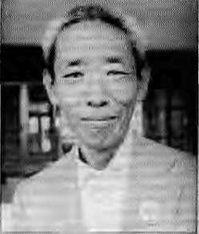
Professor Drakton
beginning of troubles in the Sotuh-Eastern regiotis'.'. The country v/ill be beset with internal problems throughout May, June and July, and this will be followed by a period of low rainfall.
"South-East Asia will be in a continuous state of war between April 1989 and April 1990. It wil! be especially tense in July and August and there will also be food problems. Europe will suffer bad harvest for a year starting April 1988 and some parts will face famine conditions in November, December and January. North America and the Soviet Union will face no serious problems in 1989, although there will be scarcity of rain in the first three months of 1990."
The Professor says that the Earth-Snake Year: has always : been considered a "black year" in Tibet. Apart from a ; general warning to be cautious, there was no big problem indicated for Tibetans both inside and '. outside Tibet in terms of livelihood and religious activities. "In other aspects, however, this year might bring Us a big loss -an irreparable loss, it Seems to me. There is also some sort of complication indicated in women's ability to: bear children:" The professor would not elaborate further, stating that his team was computing more specific predictions. - Tsering Wangyal, Tibetan Review

Foster Homes InHiamchal
Orphans and other children without support in Himachal Pradesh no longer have jo livein cold, impersonal, ill-managed orphanages and other way stations; The state : Government has just introduced a Foster Care Service in which children "bom of unwed: parents, emotionallydisturbed, oi" socially disorganised families" can be placed with foster parents.
; Himachal's Director of; Social and Women's Welfare, who has been charged with implementing the new: service, is required to ensure that foster parents are eligible to bring up a child by scrutinising their health, residential space, social beliefs and financial status. The parents: should be between 25 and 60 in age, with an anmia! income of over JRs 10,OC>0 and not have more than: three unmarried children. Preference will be given to those without offspring. The foster parents must belong to the state.
According to the scheme,, foster parents will be paid IRs 500 per month for a ;child's Upkeep. They are not to deniand unreasonable domestic service from their charges. The Director is authorised to sanction special financial aid, such as for long term medical treatment, vocational training or higher education.
The Ginkgo Roundup
Continuing Hiniat's Himalayan search for the Gitikgo, the oldest species of tree in the world, we have a sighting in Kathmandu. TraveJ executive Tek Chand Pokhrel reports thai a Gingko tree stands on the Western perimeter of Tudikhel, next to the Royal J4epa! Airlines building. The tree is said to be one of several brought back by four Nepalis who were sent to Japan for engineering training by Raria Prime Minister Chandra Shmrishere in the 1920s.
Jadibuti Centre For UP. Hills
The Utrar Pradesh Government's Hiil Department has decided to establish a centre for survey, research and training on mountain herbs. Making the announcement at a workshop organised by the High Altitude Pi an I Physiology Research Centre in Srinagar, Garhwal, a Government spokesman said the centre will be fully operational within six years, with branches in Tehri, Llttarkashi, Pauri, Ranikhet, Pithoragarh, Almora and Chamoli. He said the centre would promote the conservation and commercial use of Himalayan herbs.
Chancellor of Garhwal University, SJP, Nautiya), said that while the Himalaya are a huge storehouse of herbal plants whose utilisation should benefit the local inhabitants. Krishna Chandra Chiinekar, former head of Banaras Hindu University's Ayurveda Department, said that the "urbanisation" of medicine had undermined the importance of medicinal plants from the forest. Ayurvedic texts contained a wealth of medicinal information and must be studied.
P. Sudhakaran
HIMAL 3
The Srinagar workshop recommended that work on herbs presently being carried out in the three U.P. hi!) universities be consolidated within the new herbal centre.

BRIEFS

Tibetology Centre Running Dry
The Sikkim Research Institute of Tibetology (SRIT), marking an unremarkable thirtieth anniversary, is struggling to maintain its pre-eminence as an academic centre for Tibetology, reports UNI. The Central Government funds for this Gangtok-based centre have been drying up, crippling its research acquisitions and publication programmes.
• Jan/Feb 1989
Dam News
* Like Chukha Dam in the case of Bhutan (Nov/Dec fiimal), the Nam Ngum high dam is now the greatest foreign exchange; earner for Laos. Its hydroelectric!ly is exported to Thailand. Despite the dam's devastating impact : on Laos' unique wetlands, reports the World Rivers Review, the Government is anxious to build many more like it, which would submerge almost all of the country's major river valleys, A World Bank, UNDP and Government sponsored study concludes that another high dam woultj bring the country art additional U$ 45.8 million per year.
* The opposition to high dams in the Nannada Valley has forced the World Bank to look again at its commitments, according tb WRR. In 1985, the Bank had; approved a U$ 450 million loan for the first of 30 major dams in the valley. Following protests by n on-governmental organisations in India and the support of international groups, the Bank has now made funding of the project, Sardar Sarovar. conditional upon the quality of the programme to resettle the 80,000 tribal people who would be uprooted. The Bank has also delayed until early 1990 its decision on a second project, Narmada Sagar, which involves a US 350 million loan.
* When the Pong Dam was being built in 1962 in Himachal Pradesh's Kangra District, it displaced 16,100 families, who were promised 2.25 lakh hectares in Rajasthan, in an area to be irrigated by the dam's bounty. So far, reports the Indian Express, only 500 families have been allotted land in Rajasthan. While the authorities of Himachal and Rajasthan bicker over who's to blame, a lifetime has passed for the "development refugees" of Kangra.
HIMAL
BANGLADESH
Between The Mountain And The Sea
While many Bangladeshis have been looking to the Himalaya for a solution to their flood problem (Nov/Dec Himal), the Washington DC based World Watch institute warns that they should also be looking the other way — to the rising sea. If the computer simulations at the Woods Hole Oceanographic Institute in Massachusetts are correct, the wanning of the global atmosphere will melt enough polar ice to raise ocean levels in a manner that would be devastating for the populous Ganges Brahmaputra Delta, much of which is '; barely above sea level.
According to the Woods : Hole researchers, Bangladesh will probably experience ihe "really worst case scenario". The Bay of Bengal could rise by as much as 82 inches by 2030, in which event 18 percent of the habitable land would go underwater, displacing 17 million people. By 2100, in the worst ease scenario. 38 million Bangladeshis would have been forced to relocate. "The Sundarban coastal mangrove forests, upon which 30 percent of the country's population depends to some extent for its livelihood, will be the first victim of advancing seas. Where will those displaced by the rising seas go? asks World Watch.

A Dhaka street last September. Will it just get
worse and worse?
When the then ruling Namgyai family opened the Institute in 1958, they decided not to discriminate between Gelugpa, Sakya, Kagyu and Nyingma -- the four Mahayana sects. Because of this enlightened policy, SRIT soon gained an edge over its rivals, the Toyo Bunko in Tokyo and Leningrad's Institute of Oriental Studies. Today, SRIT collection of Tibetan literary works is said to be among the most comprehensive in the world.
There was a time when SRIT was well supported. It was Prime Minister Jawaharlal Nehru who directed that the mortal remains of the Buddha's apostles Madhyam and Kasyapagotra, when retrieved from London's Victoria and Albert Museum, he housed here: The Dalai Lama, though a Gclugpa, made valuable gifts when he came to staunchly Nyingma Sikkim for SRJT's inauguration.
♦..And
The Maldives
Too
In 2100, cartographers will likely be redrawing the coastlines of many countries, including Bangladesh says World Watch. They may also make an important deletion: by that year, if current projections are borne out, the Maldives will have been washed from the earth: The small nation, niade up of a series of 1,190 islands is nowhere higher in elevation than six feet. With a. three foot rise, well within the expected increase of the next century, a storm surge would be "catastrophic and possibly fatal", in the words of President Maumoon Abdul Gayodm.
"Few Cavities in Nepal¹¹
A Japanese dentist visiting the West Nepal village of Simikot found that although the 440 villagers he examined had never used a toothbrush in their lives, they had pearly white teeth free of cavities, reports the newspaper Asahi Simbun.
Dr. Reiko IwaLsubo believed that the villagers had healthy teeth and jaws because their meals consisted mainly of cereal and nuts; they used of rock salt instead of sugar in tea; and babies were breast fed.
About 50 per cent of the Simikotans in the 25 to 50 age group had complete sets of wisdom teeth, compared to 10 per cent for an equivalent group in Japan. The energetic use of jaws while eating provided the space needed for wisdom teeth, says Dr. Iwatsubo. The new generation in the developed countries have smaller jaws because

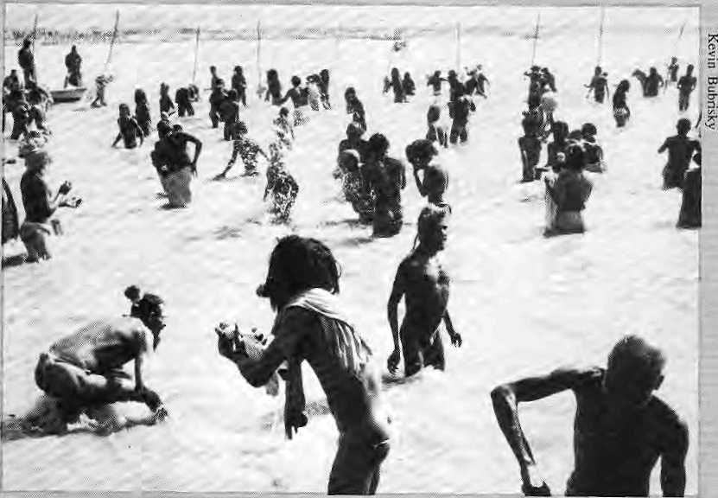
was the most auspicious day far a holy dip because that was when the key configuration invoiving the sun, the moon and Jupiter with Capricorn arid Aries took place.
On the ciawn of the February new moon, Mdwii Amavasya, the ash-clad Nagas, led the procession from their temporary tenteci '-ashrams" to the tongue of sand that sits be tweeti the Gaiiga and the
Naga Babas take a dip at Prayag.
briefs — ■;;■••;;;■:;■
food is processed and soft, requiring less strenuous chewing.
Clearly, this is something for the Export Promotion Centre to chew on. it might market chhurpi, the rock-hard cheese of the Himalaya, in the West and in Japan so that those underused developed country jaws can be rehabilitated.
The Never Never Canal
Dehra Dun's Hindi weekly Yugvani reports on a tardy canal project near the town of Tehri in Garhwal. Plans for the Kothiyara Canal were made in 1952, meant to carry water 20 km from villages of Sitakot to Saraas. 36 years later, only 16 km of canal have been built and reportedly the water does not even travel that distance because of a "reverse slope". The villagers of Saraas, Gangar, Bahedi, Kothiyara, Khola and Kot complain that the "big officers" from the headquarters are shown the canal at the source and go away with the impression that the water is following. Even the fact that Chipko's Sunderial Bahuguna 's ashram is in the area does not seem to have mattered, nor that the Deputy Development Commissioner for Garhwal is a local lad.
KumbhMela
About 30 million devotees will have bathed at the Kumbh Me!a at Prayag by (he time the massive "bathing festival", which began in January, ends on 6 March. In this last 12-year me la of the tnillenium, the Naga Babas from lonely caves and mountain retreats at the headwaters of the Ganges were out in force. 7 February
Jamuna rivers. 150 feet away from the water, the naked sadhiis burst into excited sprints, joyfully yelling Shiva's name as they cast away their marigold garlands, and likewise, their worldly karma, A 58 year old Naga Baba was quoted in the local Allahabad daily, "Nakedness ends all dichotomy in human life. There are no dualities in universal reality." - Kevin Bubriski

INTRODUCTION
Society for Himalayan Environmental Rehabilitation and People's Action (SHERPA)
SHERPA is a professional group which formed in 1985 to focus attention of governments and people "on the problem of the Himalaya, disseminating knowledge and maximising people's participation in development of the region". The organisation says its choice of acronym is deliberate, "for a Sherpa is steady and sturdy...he is prepared to face natural and man-made calamities...he is not constrained by socio-ethnic and other such limiting factors...he has grit and is willing to transcend barriers and limitation".
The objective of this Lucknow-based organisation is to monitor and understand
the human-environment relationships, generate public interest for the preservation and regeneration of the Himalayan environment and to undertake applied research on socio-economic problems.

During the past four years, SHERPA has held national level seminars on subjects such as alternate energy systems for hill areas, people's participation in watershed management, rainfed agriculture in the Himalaya and "environment-friendly"
tourism. The organisation also has an active publication programme and, with the support of the Uttar Pradesh Government,plans a quarterly newsletter that wiil be mailed to all village pradhans, block pramukhs, research institutions, voluntary groups and social workers in the Central Himalaya.
Working primarily in the Garhwal and Kumaon, SHERPA has over 200 members and more than 25 institutional members, such as the Pantnagar University for Agriculture and Technology, Garhwal University, ONGC Himalayan Association (Dehra Dun) and the Central Himalayan Environmental Association (Naini Tal). Funding is through membership subscriptions, donations and grants from the central and state governments. For further information, write to T.N. Dhar, President, 27 B/5, Lajpatrai Marg, Lucknow, Uttar Pradesh 226 001.

Jan/Feb 1989
HIMAL

Bulls, Bears And Buffaloes
Nepal's Infant Stock Market Gets Cracking
By Kadam Arjel

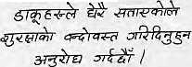
Immediately after Kathmandu's stock exchange was opened in 1984, a letter arrived from a village in West Nepal with an urgent request:
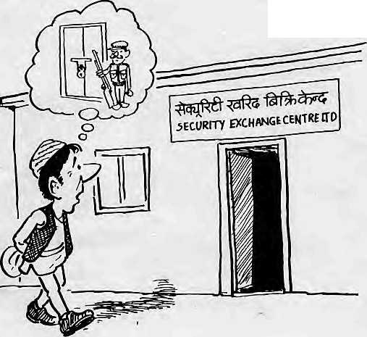
("Bandits are becoming very troublesome. Please arrange for security.") The officers of the infant agency, all primed up and eager to sell stocks and shares, were taken aback by this call for police protection. The villagers had understood the name "Securities Kharid Bikri Kendra" to mean a Government agency that somehow sold protection from thugs and bandits.
While the bewildered Pradhan Pancha. from West Nepal is certainly an extreme case, his contusion^ is not unique. What, after all, is a stock exchange doing in a country where commerce is still primitive, industry undeveloped, and where the handful of major joint stock companies date back to the times of the Ranus? And where the wallowing buffaloe and the scrawny mountain cow represent better the sluggish marketplace and the emaciated economy than the "bear" and the "bull" of the global capital markets.
THE BIG BLACKBOARD
While cynicism might be the rule when it comes to discussion of the Security Exchange Centre (SEC), however, the people who run this small outfit from Kathmandu's Dillibazar section are quite bullish. They are buoyed by recent upturns in the market. The dog days of the late 1970s are now a thing of the past, they say, pointing to hectic activity on the stock market "floor", which is actually a blackboard with the going rate of stocks scrawled with chalk.
Investors are euphoric over the availability of shares of several multinational banks. The SEC's roster has 32 companies listed, and about eight companies are added every year. The premium generated is increasing at a whopping average of 64 percent annually -- it totalled NRs 371.7 million in 1987-88. The number of shareholders in the country has risen from 4000 in 1984 to over 20,000 today.
"We might be small in comparison to other countries, but you have to admit that we are well on our way," says an SEC worker, an unlikely hybrid of Government official and stockbroker --but that is the Nepali stock market.
Today's SEC began in 1976 as the Securities Marketing Center. As a Government-sponsored institution, it was convenient and logical to organise a market for Government securities, which it did in its first years. In fact, Government bonds still make up the lion's share of total stock transactions. The new institution also served some of the functions of a merchant bank. It was only in November, 1984, that a full fledged stock exchange was inaugurated by mandating the compulsory listing of all corporate shares. The SEC is the only institution in the country which can deal in stocks and shares.
The stock exchange was established under the tutelage of the then American Ambassador to Nepal, Leon J. Weil. Like an envoy from Wai! Street, which was, in fact, where he came from, Weil played an advisory role till his term ran out in 1987, patiently explaining the concept and operation of a stock market to both Government officials and the business community. Even today, though, the Kathmandu cognoscenti still mistake "securities" for some form of bank collateral and equate the SEC to a loan providing center.
IDENTITY CRISIS
There is, in fact, some confusion in the SEC's own charter and mandate, for it started as a merchant bank and has ended up being both a stock exchange and a merchant bank at the same time. (A merchant bank deals in the primary issue of shares, while a stock exchange is where secondary transactions take place. This conflict and crisis of identity has prevented the Center from being effective as either bank or exchange.
Stock exchanges everywhere are manned by brokers, who are the spontaneous outcome of the free market. Nepal has had it backwards. The SEC began work in 1984 by clamping down on the few brokers that operated then and assuming the role of the sole stockbroker. Since 1984, the brokers have had to work clandestinely, which has led to "mutual trading" and increasing concentration, of shares in the hands of a few elite groups. Both buyers and sellers often enter the trading floor of the SEC in collusion, having been brought together by "illegal" brokers.
The SEC has realised the need to introduce brokers into the system in a controlled manner, with itself as the licensing authority. Analysts warn that the transition must be carried out with extreme care otherwise the investors' precarious confidence in the stock market will shatter.
The main problem of the stock exchange is the
low supply of shares available. This is partly because there are no brokers to provide door-to-door services, motivating buyers and sellers. "The supply of shares would rise many fold if brokers are included in the system," says retired Major Punya Bickram Rana, Nepal's pioneer broker.
Another way out, some say, is for the Govern-ent to divest the

HIMAL • Jan/Feb 1989

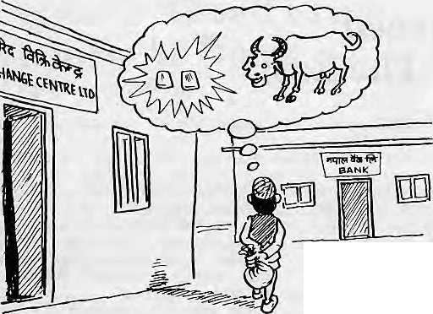

shares it currently holds in public sector undertakings. Divestment backed up with a well-thought-out and consistent privatisation policy would make an impact on the development of a healthy capital market. Of the total paid up capital of NRs 495.7 million outstanding in the market, 42 percent is in HMG's control. Individuals hold only 12,4 percent, while the remaining are owned by foreign companies and domestic institutions.
SHY TYCOONS
Those same persons who urge privatisation also ask why the big business houses such as Golchha, Dugar and Jyoti do not go public. Business houses in India such as Birla, Tata and Reliance hold less than five percent in the companies they promote. Why are the Nepali businesses content with the obvious limitations of sole ownership and why do they shy away from using public resources? Part of this reluctance is due to fear of losing control over the business.
But that is a very limiting attitude. As Ambassador Weil said in a parting address to the Kathmandu Rotarians, the expansion of the economic base can only flow from "the ingenuity, energy, and initiative of private entrepreneurs". In South East Asia, Japan and even in neighbouring India, he said, economic growth was propelled not by governments, but by vigorous private sectors.
Businessman Niranjan Tibrewala agrees, but points out that in Nepal the Government has no clearcut, stable policy regarding industries and public limited companies. That makes privatisation risky, he says.
The stock market movement of the past year shows that the people do not hesitate to invest if a project is
promising and well managed. For example, the subscription rate of multinational joint ventures such as the Grindlays Bank has gone up as much as 500 percent, while that of the Nepal Arab Bank (NAB1L) and the Nepal Indo Suez Bank has each gone up more than 200 percent.
_„. -r? ■■!— Contrast this with
the case of the public limited
companies. Market response to the Rastriya Beema Sansthan, the Nepal Industrial Development Corporation and Himal Cement was tepid, showing a clear lack of confidence.
Finance experts maintain that the only way out for HMG is to bolster the private sector giants with liberal policies and make them enter the capital market. At the same time, the public sector enterprises must be allowed to "freewheel" with minimal operational interference from the Government.
AVOIDING A CRASH
The overpricing of stocks worries Manohar Krishna Sh rest ha, finance expert and Reader at Tribhuvan University, who says that it could turn investors away if sustained long enough. This could lead to a market crash, which would take years to recover from. "At present, the prices quoted attach more value to the scarcity factor of shares than the actual performance of the company," says Shrestha. The only way out of the bind seems to be to increase the supply of shares so that it catches up with the demand, and let the laws of economics take over.
There are many hurdles before the
SEC, not the least of which is an
economy that really needs to "take off
if the stock market is to prosper and
provide an impetus to commerce and
industry as well as to provide the
public with an opportunity to invest.
The day that ready cash is converted to
stocks and shares rather than jewelry,
land in Kathmandu's hectic real estate
market or in buikiings, will be the day
when the SEC will have come into its
own. That moment will also say
something about the national economy
as a whole t\ ,
NEW PUBLICATIONS
TIBET FORUM
This is a new publication on Tibet, in Chinese, brought out by a group of Tibetan students who recently arrived in the United States. According to Tseten Wangchuk, the editor, "There has been no independent publication in Chinese discussing issues relating to Tibet and the Tibetan people. Most Chinese-speaking people do not have a clear understanding of Tibet and the complex problems which overwhelm the Tibetan plateau."
Wangchuk was educated in Tibet and China and has worked as a researcher at the Academy of Social Sciences in Beijing. His new journal, whose first issue was published in October, welcomes contributions by Tibetans and Chinese and will print or reprint articles by Chinese officials, as well as by students and scholars who live in China or abroad. Wangchuk says the publication will be distributed to selected officals, institutions, diplomats, scholars and intellectuals in China, Tibet, Hong Kong and Taiwan, as well as to institutions in Asia and in the West. Contact: PO Box 530, New York, NY 10156, USA.
INDIAN JOURNAL OF RURAL TECHNOLOGY
After having established the two successful journals, Moving Technology and People's Action, the Council for Advancement of" People's Action and Rural Technology (CAPART, New Delhi), has decided to launch its first research journal, the Indian Journal of Rural Technology. CAPART is expected to bring out the first issue in the spring, and welcomes original contributions on new technology, techniques, case studies, state-of-the-art reports, reviews and any other information on existing or defunct traditional technologies which deserve to be better known. Direct ail correspondence to Asha Joglekar, CAPART, GNF Building, New Mehrauli Road, New Delhi 110 067.

Jan/Feb 1989
HIMAL

:/
Threatened Bovines Of The East
By S.N.Mishra

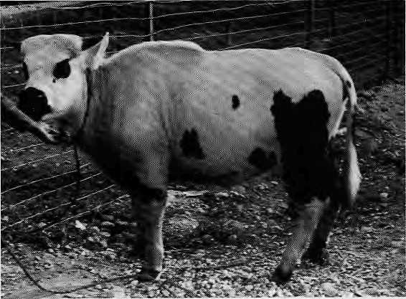
A mithun confined to a stockade.
The list of endangered species of the Himalaya includes the Royal Bengal Tiger, snow leopard and musk deer, but does not include the mithun, the semi-wild cattle that inhabit the lower hills of the Eastern Himalaya. And yet, tnithuns are also threatened: by changing tribal lifestyles and values, commercial encroachment, and loss of habitat. In more ways than one, the tribals' traditional way of life and the mithuns' survival are linked together. When one goes, so does the other.
The range of the mithun (Bas Frontaiis) extends from Bhutan through Arunachal Pradesh, U-turns south to the Chittagong Hill Tracts and Lusai hills, and extends as far down as the Arakan hills in Burma. The animal lives in the neighbourhood of shifting cultivators because it is fond of the soft and tender shoots of clearings rather than forest grasses. It takes to the high humidity which comes with the area's heavy rainfall but avoids the swampy lowlands of the foothills.
There are many tales and myths woven around the beast's origin, but in all probability it is a cross between the yak and the gaur. While it is heavily built and looks ferocious, the mithun is really a very docile animal, quite vulnerable to predators.
TABOOS AND SACRIFICES
In the Indian hills, mithun cattle are used for sacrificial rituals and, consequently, they are well regarded. They are used neither as milch cattle nor as plough animals. There are taboos attached to drinking mithun milk. The local belief is that milking the mithun means weakening its offspring, making it unfit for sacrifice. The wiyus, or spirits, can be appeased only with strong and healthy mithuns.
The wild cattle remain a major source of protein for the tribal people. The sacrificed mithun's meat and fat provide energy for the tribal population during the cold, weary winter months as well as during the rainy season, when the food supply tends to be scarce.
In addition to being a sacrificial animal for ceremonial and ritual purposes, the mithun serves as a medium of exchange. However, modernisation and the increasing role of paper money has undermined the
mithun's role as barter currency. Even today, however, many tribal families pay the brideprice in milhuns. When a marriage is settled, milhuns are transferred from the groom's to the bride's household. Families fall back on the mithun as a reserve asset during adverse times, such as a harvest failure, when the animals are traded for grain.
The Bhutanese have, since ancient times, been bartering and acquiring mithuns from their neighbours in Arunachal Pradesh. The Bhutanese have never succeeded in rearing a herd of their own. It has been observed that the strong, healthy mithuns which arrive from Arunachal gradually lose their vitality and die. One reason for this, experts feel, is that in Bhutan, mithuns are used as plough animals. The domestication of mithuns in Bhutan, where they are not allowed to run wild, also seems to a ffect the animals' health.
Mithun cattle also have prestige value. Tradi-tionally, the Nishing and their neighbouring tribes, the Apatanis, have raided each other's mithun herds. When a family's mithun is stolen, it becomes a point of honour and moral obligation for the whole village to see to it that the animal is returned to its owner.
SALT FROM THE MASTER
In their normal state in the Indian North-East, Mithun cattle are left by the villagers to fend for themselves in neighbouring woods. Once every fortnight or so, the owner goes to inspect his herd and to feed salt to the animals. So great is the mithuns' craving for salt that they often trudge many miles through heavy undergrowth to their master's "longhouse" — or tribal dwelling — for their "fix." of salt. When it comes time to shift
cultivation, the villagers burn their thatched houses and move to a new site, clearing the forest for a new crop. It is all very mysterious, but the mithuns always manage to search out their master's "longhouse" and turn up for their quota of salt.
The mithun's jungle world is no longer secure. Deforestation, the extension of road networks to the hills, the influence of the "modern" plains economy, and the tribal population's increasing move from shifting cultivation to permanent settlements, all have contributed to the animal's decline.
Recently, there has been an influx of cattle brought up from the plains for slaughter. They have spread foot and mouth disease among mithuns, much as settlers bring unknown disease to aboriginal populations.
A docile animal that is vulnerable to the slightest disturbance to its wild habitat or to its dependent relationship with humans, the mithun is at a loss in the increasing hubbub that marks the Indian North-East. Gradually, but inexorably, mithun cattle are being pushed up from their original habitat to higher elevations. Before long, they may have nowhere left to
S.N. Mishra, a professor at Delhi University's Institute for Economic Growth, specialises in the agricultural systems of the Indian North East.

8
HIMAL • Jan/Feb 1989

COVER
World Of The Girl Child
By J. Michael Luhan and Poonam Thapa

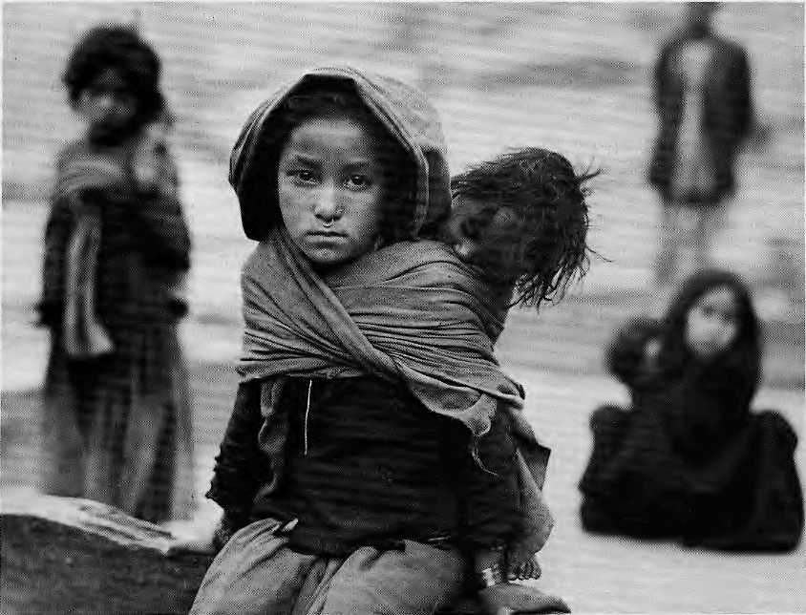
theoretical choice of having only sons or only daughters, 96 percent stated they would rather have sons. Simply put, boys are welcome and girls are not.
Rather than being a joyful moment, the arrival of a baby girl is liable to cast a pall over the family. Every person in Kathmandu knows of at least one tragicomic case in which the poor civil servant and his dejected wife continue to have child after child in an attempt to have a son and in the end are left with a brood of nine or ten daughters.
The family's preference for a male child is directly linked with the preservation of the kul, or patrilineal name. "Regardless of the economic status of the family — whether rich or poor, urban or rural — the kul tops the
When the United Nations Decade for Women ended in 1985, there was unspoken relief among many people that the "women in development thing" was finally over and life could go back to as it was before all the feministic tamasha. In reality, of course, the Decade was quite successful in focusing international attention on the status and future of humanity's female half. But in legitimising society's concern for women, even the United Nations had forgotten someone -- the girl who grows up to be the woman.
Grinding poverty, powerlessrtess and premature death mark the life of the millions of men, women, boys and girls in South Asia. However, life is invariably worst for the girl. She gets less to eat, owns little or no property, has less access to education, is sick more often — yet receives less health care — and does more chores at home. In general, she has the little or no control over the direction of her life — this in a region which has had three female prime ministers in the last fifteen years.
At their January Summit, the leaders of the South Asian Association for Regional Cooperation (SAARC) decided to observe next year, 1990, as the Year of the Girt Child. This decision was the result of a unique drive by South Asian social scientists, activists and officials —
Staying home, minding baby in Karki Bada, Mugii, West Nepal.
women and men — who had met since 1985 in seminars, workshops and informal brain storm ing sessions to discuss the urgency of the issue. In the end, they challenged the regional political leadership to try to understand the plight of the girl child and do something about it.
Coining the term "girl child" has put the spotlight on the girl as a person, not just as a daughter, sister, wife, mother ~ or chattel.
THE SON PREFERRED
Bias against the girl begins at birth. Nepal, for example, is said to have among the highest index of son-preference in the world. In a recent survey, economist Yagya Karki found 90 percent of the parents wanted two sons and then one girl. Given the

Jan/Feb 1989
HIMAL
9



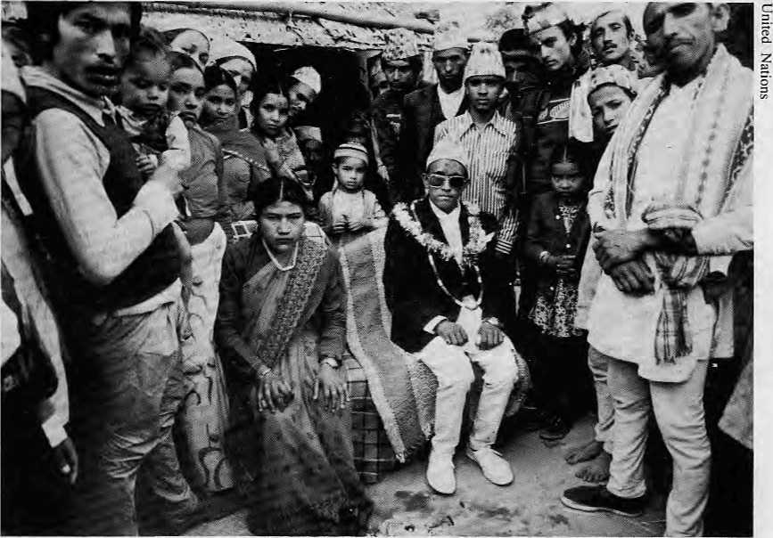
ultimate escape mechanism from cruelty, neglect and despair. And so the cycle continues.
DANGEROUS WIVES
Comparative studies on women's work in South Asia refer to a common "ideology of subjugation" which places severe restrictions on women's labour, mobility and authority. In her landmark book. Dangerous Wives and Sacred Sisters, social scientist Lynn Bennett examined the ambiguous and often contradictory roles of "high caste" Nepali women. As sisters, the are considered "sacred" Dcvis, ritually worshipped for their virgin power. But as new wives, they are considered "dangerous" because their mature sexuality can be effectively employed for the attainment of personal ends that threaten the patrilinea.1 solidarity of the husband's family.
But, if women have formidable influence in some households, only men have real power -- the power to
Joining the husband's household: faces, faces.
list of reasons for preferring sons to daughters," says Karki. Sons, in turn, are responsible for performing the all-important death rituals. These guarantee the parents' entrance into the pitr'aldk, or ancestral heavens, a service for which land inheritance is the son's due payment. And land, in Nepal, is the root of all power.
But, the preference for males does not end at birth. The man continues to benefit, at cost to the woman, in a nearly unbroken chain of privilege from infancy through old age. The girl knows this and must accept it from the start. In studying situations of extreme hardship, UN1CEF has found that young boys tend to get more and better food than do girls, and are accorded better medical attention. Result: females suffer higher mortality rates in every age category after the first year of life. On the average, a Nepali girl will live to be 51, while the boy will live a little longer, until 54.
A WEB OF POWERLESSNESS
The Status of Women in Nepal, a 1981 USAID-funded study that examined conditions in eight widely diverse rural communities, found that males worked shorter days, contributed less household income and made fewer decisions on running the household. Yet, according to law and tradition, sons alone have an indisputable right to inherit land, except under special conditions.
While the entry into adulthood of Brahmin and Chhetri boys is heralded with the festive hartaman ceremony, girls are still quarantined in unlit rooms as untouchables at the onset of menstruation. Most boys stil] go through hartaman, but the guniu cholo ceremony that marks the "coming of age" for girls has almost disappeared from Kathmandu society, perhaps because it is not regarded as important.
Girls often "graduate" from childhood to womanhood without being allowed to enjoy the relatively carefree period of adolescence available to their well-to-do
sisters. As soon as they are able to take up household chores, they become mothers' helpers or marry and become hard working daughters-in-law. Largely because they must work more at home and field, girls either do not go to school or drop out early if they do. As a consequence, literacy among Nepali females is only about one- quarter that of males, 18 per cent compared to 52 per cent.
In the countryside, while thousands of young hill boys gain prestige and fortune each year by going off to join the Gurkhas, their sisters are callously trafficked in even greater numbers to the slum brothels in Bombay and Calcutta, condemned to lives of shame as prostitutes.
Ever since Kathmandu's dailies started printing the police blotter, readers have been struck that so many of the reported suicides are of girls 18 to 22 years in age. Suicide ~ the worst portent in Hinduism for an unfavourable rebirth -- is for young women the

10
HIMAL - Jan/Feb 1989

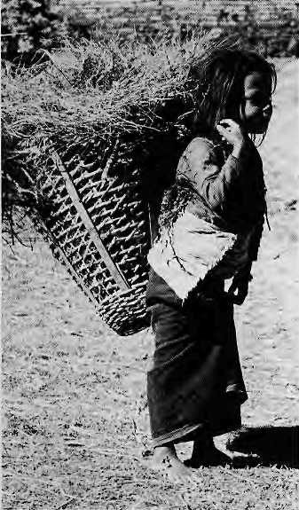
Starting work early in Kathmandu.
unilaterally pursue their interests and fulfil their aspirations. The religious and cultural values which interpenetrate Nepali society act as a web that holds women firmly in a position of powerlessness, defeating most of the piecemeal legal and economic measures that attempt to correct the imbalance.
Changing these traditions, through legislative or developmental means, tampers with the very tenets of Hinduism. Thus, beneath the question of women's rights lies a deeper and more troubling issue: can women aspire to complete parity with men and still retain their essential religious and cultural identity?
HAPPY WIVES
Interestingly, many educated Hindu women bridle at being depicted as the most downtrodden in society. Unfavourable as circumstances are, they say they feel "comfortable" with their religion and their lives, and with their ability to make important decisions for their families. The "objective" tests for the quality of life are based, they say, on Western values which fail to take into account familial relationships and traditional roles. Says one convent educated housewife in Kathmandu,
"Girls do grow up more often than not
to be well loved sisters, happy wives
and contented mothers."
= There might indeed by happy wives
§_ and contented mothers, but the question
2 is one of parity and equity. Docs the
S female, with intellectual resources equal
g to that of the male, have equal access
to opportunities? The answer to that
simple, key, question is "no" in almost
every area of Nepali society. While the
occasional woman might indeed
epitomise the role model of a housewife
and yet lead a professionally fulfilling
life, she is the lucky exception and not
the rule.
Actually, social anthropologists argue among themselves whether there is even such a thing as "the" status of women. Some of them contend that economy, religion, culture overlap to form a complex web of complimentary dimensions and relationships, so that it is not possible to peg the quality of the girl's or women's status at a certain quantifiable level.
Some say that Nepali girls and women are situated better than their sisters elsewhere. "Compared to women in many communities in India, Bangladesh and Pakistan, we have more mobility, better security, fewer restrictions and are generally better off, says Bina Pradhan, Director of the Center for Women and Development in Kathmandu.
EDUCATION, LAW AND ROLE MODELS
Indeed, the status of girls has not remained static. A great deal of progress has been made, particularly in health and education. His Majesty's Government has had notable success in reducing child mortality, bringing girls into schools, establishing more equitable laws, and offering positive role models with women.
"As a young girl I wasn't even permitted to look at books because everyone thought, 'Why does a girl need an education?' But I always wanted to study. So when a guru came to our house to teach my brother, I sat nearby overhearing and learning by rote."
This account by Sushi la Thapa put into some perspective the distance the country has traveled in 50 years. Though burdened by being denied formal education, Mrs. Thapa went on to serve for 24 years as a Member of
the Rastriya Panchayat, State Minister of Health, Chairperson of the Nepal Women's Organisation and finally, in mid-1988, became the first woman to occupy a full cabinet post as Health Minister, The visibility and power of her latest appointment is clear indication of the official encouragement women are being given to assume social service roles.
Though still a minority in the classroom, girls today are actively encouraged to enter primary school with Government incentives, such- as free tuition and textbooks, or to attend informal "cheli beti" classes if they are unable to attend school during regular hours.
JUST KNIT AND SOW
Unfortunately, according to UN1CEF, few of these new strategies have had much impact on the overall problems of the girl child. That failure is partly due to inadequate Government commitment. Most development projects, for example, still relegate women's activities to the economic periphery. Rather than programmes designed to bring women into the economic mainstream, "knitting and sewing" training course are everywhere. On the whole, education seems to be of little value.
Mostly, though, the status of the girl today is due to the long standing social customs and attitudes. Mrs. Thapa was married at age 13, for example, and 50 years later some 40 per cent of Nepali women still wed before the legal age of 16. Many orthodox families are afraid that a school-going daughter will become "uttauli", or wayward.
Parents are yet to be entirely convinced of the value of educating their daughters. Education, in fact, still offers little promise or remuneration for rural girls. As a "Save the Children" program officer in central Nepal said, "I can't imagine a girl who comes up through the school system in Gorkha actually finding a job when she finishes."
Even girls from well-to-do urban families graduate for no other purpose but to be domesticated running the households of their husbands. In a male dominated workplace, the odds are against the girl who hopes to start a career after school and college. Less than ten percent government civil servants in Nepal are women, and a

Jan/Feb 1989 • HIMAL
11

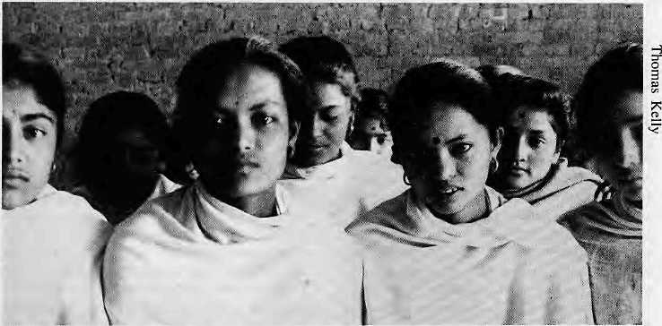
Early morning "cheli beti" class in Bhaktapur.
visit to most any business office reveals an unvarying pecking order of women secretaries and male bosses.
For that reason, Mrs. Thapa and others emphasise "education for awareness, not for employment", as a way to begin expanding girls' vision of themselves and their place in society. The term "employment" itself, for example, carries a certain connotation, since it typically refers only to jobs in the "all male" marketplace. Yet, roughly 80 percent of Nepal's economy is represented by household production, dominated by women. Because this production tends to be consumed by the household itself and has little cash value, its "use value" is invisible and largely ignored.
UNDERSTANDING "USE VALUE"
The marginal place of women in the marketplace is reflected by the experience of the Small Business Promotion Project in Kaihmandu, which helps develop small-scale entre-preneurship in seven urban centres of Nepal. Although widely recognised as a successful campaign, only one of the Project's 20 field consultants is a woman and only a few of its nearly 300 clients.
What is really needed, according to Bina Pradhan, is a change in how we view the "use value" of women's contribution to the mainstream economy, household food production, animal husbandry, fuel collection and so forth, and that must begin in the classroom. First and foremost, she says, the women themselves must be convinced of the "use value" of their work.
Expanding upon her point, Ms. Pradhan states that it is not only a
question of convincing men, but building awareness among women themselves of their rights, their potential and the crucial role they play in the economy of their country. "Even if the government passed a law that said 50 percent of workers must be women, it would not help," she says. "If one does not have an awareness that inequity exists, then it will not be removed."
As Razia Ismail from UNlCEF's Delhi office observes of India, although it could apply to any country of South Asia, "It is an intriguing challenge for any society to address. If half the children continue to get less than their fair share of food, health care, education, opportunities for growth and development, leave aside love and respect, how is India going to achieve the social and even economic goals it has set for itself?"
The leaders of SAARC, kings, prime ministers and presidents, have indicated that they are indeed aware of the inequity that exists. That is a big step forward, but the hurdles remain. Girls in South Asia enter life heavily disadvantaged, at home, school, farm and workplace, and remain so all the way to the burning ghat. If they practice what they have begun to preach, the governments of South Asia can begin to change the situation.
The biggest challenge, though, is to bring about a change in the self perception of the girl child- that she is not property, but a person, with the same potential as the "boy child"A
Poonam Thapa is a Reader in Geography at Tribhuvan University. J. Michael Luhan is a journalist based in Kathmandu. .
REVIEW
NAKUSHA
(The Unwanted Child)
Video documentary UNICEF, New Delhi 20 minutes, 1989
Nakusha is not an invented title, but the name of the fourth daughter of a rural family that is the focus of this documentary. Nakusha has been chosen as the symbol of the girl child in India, "not only invisible but also ignored and uncared for", and, all too often, "the victim of neglect that kills". The girls tell us in their own words their story of stunted lives, of the denial of childhood. We see them at work -- in the home, in cottage industry sheds, in the fields -- and, too few, and too briefly, at school. 70 percent of the Indian children not enrolled in elementary school are girls; 74 percent of girls 11 to 16 are not in school. The voices of the girls are interspersed with those of their elders: "A girl belongs to her husband's family...If she wastes her time studying how will she learn to cook?"
The professionals interviewed stress the urgent need for change in these attitudes if the statistics are to change: 10-20 percent girl child mortality in Northern India; 40.5 percent mortality rate in the first five years of life; 75 percent illiteracy. The impact of the film might have been greater if the lives of these girls had been portrayed alongside those of their brothers. Nonetheless, it provides a rare opportunity for the voice of the girl child to be heard. Summarised in the words of one small girl when asked about her dreams: "There are no dreams." - Beverly Brar

12
HIMAL • Jan/Feb 1989

INTERVIEW
Dr. Shanti Ghosh, a respected Indian pediatrician and senior health consultant with the United Nations, was one those who put "girl child" concerns squarely on the South Asian agenda. What follows are excerpts from a conversation with Dr. Ghosh in New Delhi.
HIMAL: Why is there this sudden focus on the young girl? Ghosh: In 1985, the United Nations Decade for Women had ended, but the people concerned seemed to have forgotten about the status and needs of the female child, who ultimately becomes a woman. The whole issue of boy preference was also coming into stark focus with the increasing misuse of amniocentesis to determine the fetus'sex, to abort if it were female. Out of a conversation with Razia Ismail, UNICEF's information officer in Delhi, a workshop was organised. Since then there have been several seminars and meetings and there has been a spurt in research. SAARC has now designated 1990 as the Year of the Girl Child.
HIMAL: Are people more educated now than before about the girl 'child's world?
GHOSH: I would say so. Among the professionals in the field, there is definitely an awareness. More people are iooking at what had been taken for granted before. There are more research and studies which point to the girl child's status.
HIMAL: And what exactly is the girl's status?
GHOSH: To begin with, there is quite clearly discrimination in feeding. A study in Uttar Pradesh reported that during mealtimes sons had better access to milk, eggs and butter than daughters. There is also discrimination in breastfeeding. Data show that the interval between births is shorter after the birth of a girl. In medical terms, this would indicate that the girl has been breast fed less. Among certain groups, the annaprashan ceremony arrives earlier for girls, which again means that they are weaned earlier from mother's milk.
HIMAL: What about sickness and
death?
GHOSH: Well, research shows that
while on the one hand boys are more readily taken to the doctor and to hospital, the morbidity among girls is actually higher. In one primary health clinic, on the average more than 43 boys were brought in for every 15 girls. Girls can also be taken to iess qualified village "doctors". Overall, research data, as well as anthropological and ethnographic evidence, shows that child care of female children is worse in the Northern states of India than in the South.
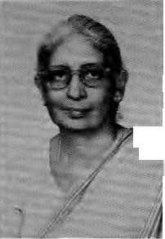
HIMAL: How much is this a function of sheer destitution? GHOSH: But this is not a question of poverty! If it were destitution, both girl and boy should suffer equally. But if their son falis ill, the parents wil-lingly sink into debt in order to treat him, but often this is not so if their daughter takes sick. No, this discrimination :jj, goes on and | on. The girl is laden with household I chores, cooking, minding the baby. She drops out of school when the demands at home become too much. She reaches adolescence and is not to go out. The pressure is then on to get her married, or to court badnami if something untoward happens. All these social, traditional pressures succeed in keeping the girl at the bottom rung.
HIMAL: So things are not getting better for the girl?
GHOSH: In many ways there is a worsening trend. Take the system of dowry. Even among communities that did not practice it before, today there is dowry. The materialism is mind-boggling. But whatever the negatives, the level of consciousness is being raised. A lot of data is being collected and thinking people are looking for an answer. Women must learn more about themselves, gain more confidence, be more self-reliant. Much of this must begin with the girl. A lot of people are trying to make this happen.^
What Will You Do?
Himal asked Bachelors level first year girl students at Kathmandu's Padma Kanya campus about their studies and their career plans. Id out of 20 respondents wanted to work after completing study; 15 wanted to do their Masters first. JO students looked forward to joining government, described variously as "government office", "service", "administration" or "HMG". Four wanted to go into teaching, three preferred "social service", and one wanted to be a businesswoman. Here is a sampling of answers 1 o our questionnaire. The numbers in brackets indicate the age of the respondent.
"Instead of Culture 1 wanted to take Economics, but everyone at home advised me to take Culture. If I get a good job in HMG then it is okay, otherwise I will join some project." (22)
"I want to continue my studies after B.A. and then take a job in a government office because it will have more facilities and we can also get a chance to go to a foreign country." (20)
"1 joined the campus to have minimum qualification for the civil service" (22)
"I want to be a mathematician. My favorite subjects are math and economics. I want to teach math in a school." (19)
"My college studies will prove my qualification and I can mix with people and of course I can be a better mother too. I don't want to stay at home doing nothing." (22)
"I do not want to spend my life in domestic services. I would take a job in any government office or a social organization." (20)
"I am taking English, but would like to have studied geography and, if possible, philosophy. I want to study beyond B.A. but sometimes I question myself why are we studying?" (18)
"I would like to major in Home Science and then stop my study. I would prefer to develop my personality and be a good, gentle, educated girl, for the sake of my family and my country." (22)

Jan/Feb 1989
HIMAL
13



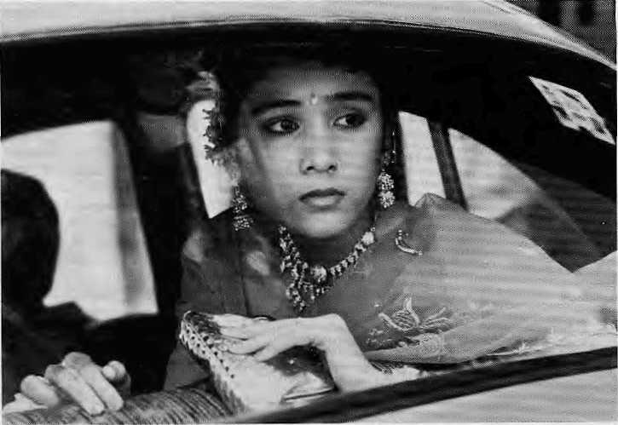
Where Is Our Daughter
Chanda Sharma as "Solasaal" in Salaam Bombay!
Bombay's red light district is notorious for being the endpoim of a flesh trade that has taken thousands of young Nepali girls from the poverty of hill villages to the raw decadence of a cosmopolitan city. The diversion, enticement and/or kidnapping of Nepali girls to Bombay has found expression in Mira Nair's internationally acclaimed film on street children, Salaam Bombay!
In the film, a Nepali virgin-prostitute known as "Solasaal" becomes the object of love Krishna, a street child and the hero of the film. Solasaal tries rebelliously to flee her kothi with Krishna, but is tamed into submission by a false promise of love from Baba, a pimp and drug dealer. Eventually, she and her purity are sold for 10,000 rupees,
"We chose to make the character a Nepali because that is what is very common in the red light district," says writer-director Mira Nair. "It's classical. And, actually, Solasaal's character is inspired by a real story,"
The last we see of Solasaal in the film is her being driven away in an Ambassador car by her purchaser (picture). Her real life counterpart, however, had a different "script". Her rebellion caused a great stir, and she was sent back to the hills of Nepal,
according to Nair.
Back in those Nepali hills, the trafficking of girl children to India is especially acute in the districts around Kathmandu — Sindhupalchowk, Kavrc and Nuwakot. These are labelled "high risk" areas by the Ministry of Labour and Social Welfare, but the crime occurs many times every day, all over the country.
When girls are sent to India they are lost, their families rarely if ever seeing or hearing from them again. On the few occasions they do return, girls today bring back, not gifts, but venereal disease, skin infections, drug addictions, mental disorders and unwan.ted pregnancies, and, almost certainly, the new disease, Acquired Immune Deficiency (AIDS).
The collaboration in trafficking usually involves village neighbors of the victim and sometimes her own family. According to case studies compiled by Prabha Basnet of the Ministry for Labour and Social Welfare, there are instances when fathers have sold their own daughters. In one case, a husband even sold his own pregnant wife. The Ministry presently houses seven girls in the "Nari Kalin Griha" who were rescued while enroute to India, the youngest of whom is 13/1
On the Streets
By Tirtha Koirala
"What age do you prefer?" "Dark or fair, skinny or well built?" "To a lodge or to your own house?" "For the afternoon or the whole night?" "I have college girls, if you want,"
The pimp is very brisk and businesslike, going through his checklist by the Gancsh Temple next to Ratna Park in downtown Kathmandu. When I show reluctance to pay the NRs 500 he demands for a one night stand, he says, "Dai, this is Kathmandu. Beware. Others will promise you girls of 15 and get you wrinkled hags. When I say a girl you get a girl." He asks for an advance because tomorrow, the Saturday holiday, is already "packed".
We tend to think of Nepali girls in prostitution mainly as a Bombay phenomenon, but there are enough of them here in our own bylanes and gullies, in Kathmandu, Pokhara, Biratnagar, Dharan and Nepalganj, girls from the sedate hills mired in the flesh trade of a dirty, impersonal, urban milieu.
Sharmila Thapa Magar, 23, is from Darjeeling District and has plied the streets of Biratnagar for three years. She has a five-year-old son from a marriage with a Rai that broke up as soon as the child was born. Why has she taken to walking the streets? "Badyata ...compulsion," she says, but does not elaborate.
Sharmila's confidante, Maya Basnet, is just 20. She says she left her home last year when her father brought home a second wife and life became unbearable. A friend named Mina introduced her to prostitution, she says. And where is Mina now? "Oh, she found a husband, a businessman. I see them around sometimes," says Maya, envy in her voice.
Both Sharmila and Maya are in custody at the Biratnagar District Police Superintendent's office after having been picked up at the Baba Guest

14
HIMAL • Jan/Feb 1989


House. They say they mostly ply their business in Dharan and Biratnagar. They charge NRs 500 per customer per session but actually get NRs 200 or less. "You think the hotelwala and the dalai would let us get away without their cut?" Sharmila spits the words out.
Asked what their principal fears are, both women cite being picked up by the police, customers who are vicious and violent, and those who disappear when the fun is over, without paying.
Sharmila and Maya do not cross the border into India, but for many other Nepali prostitutes in Biratnagar, Janakpur and Rajbiraj, this is a daily routine. There are at least a hundred prostitutes from each of these towns who actually walk the streets of India. The Indian customer seems to value Nepali prostitutes more than Indian prostitutes, and consequently is prepared to pay more. The Nepali girls and women also prefer working in India because there is less gossip, payment is in Indian currency, and they claim they are harassed less by the administration.
1 ask Sharmila and Maya what they wanted most of all. Almost in one voice, they reply, "Asa! lognay ra ramro ghar byabahar." ("A good husband and a nice household.") /
Tirtha Kuirala does interviews for the Matr'tbhumi weekly and is affiliated with the Nepal Press Institute. This article was translated from the original Nepali.
This is a new magazine, in Nepali, for the "thinking woman", according to the masthead. Edited by Susan Maskey and Anju Chhetri, Asmita {"Identity") contains analysis, news and views of superior quality. The coverage is neither strident nor simplistic and always related to the Nepali context. Asmita's writers look at the woman's status and role in Nepali society with reportorial flair. Well known Nepali women
Back To The Caves
By Manjula Giri
Perhaps the most traumatic period in the life of girls in "high caste" Hindu society is the onset of menstruation. The pubescent girl, besides having to deal with unexplained changes in her body (sex education is unheard of), has to cope with isolation. Her brothers and parents suddenly begin to appear distant. In traditional families, from this point until menopause, the girl's life will be marked by monthly seclusion and "untouchability". Possibilities of self-development are suddenly restricted. The marking of menstruation, a physiological inheritance of human evolution, is a burden both accepted and suffered by countless women of South Asia.
Among Hindus and Buddhists, as well as some Mediterranean cultures, women's "pollution" and "purity" are related to "shame". They have stigmatised a woman's reproductive powers. Menstruating women "pollute" everything they touch: water, food, green plants, deities, and even religious ceremonies and the saradha death observances.
As soon as the girl gets her first menstruation (menarche), family members perform ceremonies to show that the girl is ready for marriage and will not belong to them in the future.
professionals who figure in the most recent issue include the poetess Parijat, lawyer Shilu Singh and Satyabhama Mathema, the first Nepali woman judge. The issue covers these subjects in depth: fashion and the educated woman, legal rights, boy-pre fere nee at birth, toil in the village household, sex education and the right to choose abortion. For its seriousness and quited confidence, Asmita is a magazine to be proud of.
In other words, the ceremonies create a barrier between themselves and their daughter or sister so that she will have minimal expectation of long-term financial support. (Most families might not do so consciously, but this is what their unquestioning acceptance of ceremonies surrounding the menarche amounts to.)
When the girl discovers her condition and tells her mother or sister, she is covered with a big shawl and whisked away so that her father, brothers and uncles may not see her. If they so much as hear the young relative's voice, their lifespans are liable to be drastically reduced. Such is the fear they have of a young unknowing girl, whose only fault is to have grown up.
The girl is secluded in a dark room for 7 to 22 days in the "gupha basne" ceremony -- time in the cave. In my own case, I was secluded for 13 days in a "low-class" widow's home. During my seclusion, I was not allowed to come out from the dark room during the daytime, in order to avoid the sun and the males on the street.
"Gupha basne" is a ritual attempt to protect the girl's purity by establishing a symbolic barrier between her sexuality and her male relatives. Menarche is regarded as a potentially dangerous "outbreak" of female sexuality which can only be controlled within the male-dominated structures of kinship. Such are the societal pressures to conform that the women themselves often regard the physiological function of uterine bleeding with distaste — no matter that every woman born experiences it. (Consider also that without the much maligned menstrual cycle, there would be no progeny, no sons, no lineage.)
While we might be dulled by our unquestioning acceptance of tradition, there is no escape from the conclusion that the menarche ceremony and the menstruation countdown to menopause is but a one-sided patriarchal decision which declares women as "polluted" and therefore in need of "being controlled". It is the same mentality that expects the girl to be healthy yet sedentary; sexually attractive yet shy; hard working, but only within the household; productive, but only in terms of bearing children A
Manjula Giri is a sociologist working for a doctorate at the City University of New York.

Jan/Feb 1989
HIMAL
15

REVIEWS

Simla
Then And Now
Vipin Pubby
Indus Publishing, New Delhi
IRs 140, 1988
Review by Sudhirendar Sharma
Shimla (the spelling in vogue) occupies a unique place in the history of ihe Subcontinent. If Britishers feel nostalgic about the hill station, Indians remember having been governed from the "500th floor", as M.K. Gandhi once remarked. Shimla became the workshop of the Raj in 1850 when the summer capital was shifted from Calcutta to this Himachal town.
Not all colonists liked the move. Lord Dufferin wrote to Lady Dartrey in 1885, "We have now come up to Shimla, an absurd place situated on the narrow saddle of one of the hundred mountainous ridges that rise around us in labyrinthine complexity." It was from Shirnla's lofty heights, that Governor General Lord Amherst was able to say imperiously, "The Emperor of China and I govern half the human race and yet find time to eat breakfast."
Vipin Pubby has done extensive research on Shimla and has tried to capture the mood from !805 onwards. Enough Britishers have written about the (own, but few Indians have bothered to look at the town where so much of Indian history was made. Pubby fills the gap adequately.
The author obviously spent many hours in musty archives searching for the material to better describe the transition of Shimla from obscure hamlet to summer capital lo declining has-been tourist resort. The colonialists
SIMLA THEN & NOW

made the place worth living for the "well bred". Important conferences were held here, such as the Tripartite Conference of 1913-14, which drew the McMahon Line. The founder of the Congress, A.O. Hume, laid down the foundations of his nationalistic thinking while in Shimla. On his farewell, Hume said, "There was no nation on the face of earth that could rival India in its kindness and courtesy."
But just down the slope, the British were using the natives as forced labour to carry their belongings up from the roadhead at Kalka. Shimla was "power and glory", but it was also "picnic and adultry". For these distinctions, the town attracted its share of criticism.
Having achieved its zenith in the early decades of this century, Shimla began to slide even as the imperial government began to stagger, starting in the 1930s. This was the time when Gandhi, Nehru, Patel, Mountbatten and others held extended consultations here. The period also saw the struggle against forced labour, spearheaded by an American, Samuel Evan Stokes — the man who introduced apples to Himachal and made its future.
As the Raj wound down, the town quickly lost its glamour. Migrants from Pakistan were settled in Shimla by the Punjab government. Very soon, Himachal politicians demanded and received statehood, and Shimla became the capital. At least in aesthetic and ecological terms, however, its decline continued. Pubby recounts the uncontrolled growth of the town, rampant felling of trees, and neglect of sanitary facilities. Whole sections of the town, such as the Lakkar Bazaar area, began to sink.
While the high and the mighty no longer stop by, Shimla remains a tourist haven. Hotels, lodges and restaurants have sprouted everywhere, unplanned. The permanent population on this narrow ridgetop has topped one lakh and the decay is there for all to see. The words of an Englishman uttered decades ago are still relevant: "The whole town gave the impression of having been transported from Surrey in a badly packed parcel and accidentally dropped in Tibet."
Pubby does full justice to "Shimla Then" but misses much of "Shimla Now". While the period of the British Raj is very well recorded, the post independence narration reads much like a sketchy tourist guide.
Sudhirendar Sharma is with the Energy and Environment. Group in New Delhi.
Staying Alive Women, Ecology And Survival in India
Vandana Shiva Kali for Women IRs 60, 1988
Review by Vlalavika Karlekar Vandana Shiva's impassioned plea, "...the violence to nature, which seems intrinsic to the dominant development model, is also associated with violence to women who depend on nature for drawing sustenance for themselves, their families, their societies", is not to be taken lightly.
According to Shiva, nature is equated with the feminine principle; its degradation, colonisation and ultimately its destruction, all in the name of progress, are the outcome of a male or "patriarchal" culture. In India, the new god of development with all its manifestations has resulted in women's alienation from the land and its productive resources. An early outcome of the British colonisation was the denuding of its vast forest resources. As the collectors of minor forest produce, women and their labour were easy victims.
Relating the history of the Chipko movement of the Garhwal Himalaya, Shiva traces the involvement of women from the days of M.K. Gandhi's associate Mira Behn onwards. In the initial years, women collaborated with men to work towards providing raw material for Gandhian sawmill cooperatives and resin factories. By the 1970s, protests had begun for right of access to local resources. In Reni, women formed vigilance groups and successfully prevented the felling of trees. In Adwani, Dungari and Badiyagarh, women tied sacred threads to branches and in some cases dared axemen to approach trees which they hugged.
Shiva believes that rural women understand best the basic principles of how to nurture and manage land and forests. She is critical of afforestation, social forestry and wasteland development projects because she believes they lead to the imposition of foreign models and encourage privatisation of common land. She questions the basis on which areas are declared wastelands and maintains that so called wastelands can be put to productive use not only through elaborate projects also but by women using simple techniques.

16
HIMAL
Jan/Feb 1989

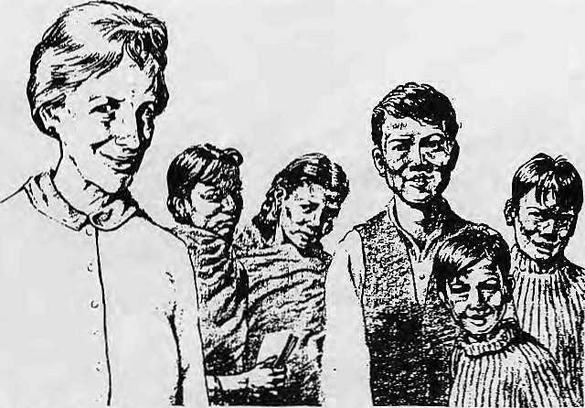
A Classful Of Gods And Goddesses
Ruth Higbie
Boxwood Press, California
U$ 12,50. 1988
Review by Jay a raj Acharya
Ruth Higbie's book is a well written persona] account of a "newly bereaved American suburban wife and mother" who, at age 58, goes as a Peace Corps volunteer to Nepal, She lands up teaching science to eighth to tenth graders in the Newar town of Banepa, ten miles east of Kathmandu Valley.
This books readership should not be limited to Nepalis and Nepal aficionados, for it is a delightfully lucid description of a "mature" Western woman confronting an "alien" Third World environment, making friends, learning-ahe inner workings of a different society, and, most importantly, rising above her predispositions to really understand and empathise. It is on a different level from the plethora of anthropological treatise on Nepal that keep emerging from various Western universities.
Ruth's description of Kathmandu, city of myths and mystery, as a prologue sets the tone of the book. She had immediately to embark on the difficult path of cross-cultural understanding. It did not help that she had been taught Nepali by her Peace Corps trainers, only to land in Banepa, where Nepali is not spoken other than in classrooms and some formal occasions.
It was during her very first days in orthodox, culture-bound Banepa, while still adjusting to life in a Newar house,
that the very observant author noticed with some amusement that students in her class all had names which were names of their own gods and goddesses: "Ram", "Krishna", "Lmmi", "Saraswati" -- hence the title of the book.
As Carleton Coon, U.S. Ambassador to Nepal till 1983, notes in his foreword, Higbie makes her friends in Banepa come real. As a result, he writes. "Inevitably, and naturally, we come to understand that these people really aren't that simple, they think differently from us in profound ways, and "made in America" solutions to their problems can look just as unreasonable and even silly to their problems as their reactions to our "solutions" look to us...this kind of perception is worth a hundred or so global theories for anyone who wants to understand what is actually going on in the Third World."
Higbie tells everything as she sees it. For example, she does not shy from dealing with the unsatisfactory sanitation conditions of Banepa, which, indeed are awful. She describes the frustrations of Headmaster Ram Bhakta when he is unable to come through with a project and use U$ 5000 that friends in California had raised for his Azad High School. Blocked by numerous administrative and other hassles, in the end he gives up and the money, after three years on hold, is sent to a Latin American country instead.
Ruth Higbie writes about experience as a Peace Corps volunteer, warts and all, and in doing so does justice to the town of Banepa, to Nepal and to the reader.
REVIEWS
....continued from previous page
The Green Revolution and scientific agriculture, which substitute renewable farm input by non renewable inputs, also come in for criticism, for favouring men and machines. Women's traditional roles are overlooked if not wiped out. Similar processes are at work with respect to access to water: deforestation, quarrying and mining lead to loss of water sources.
While Shiva says the book is an attempt to "...articulate how rural Indian women...experience and perceive ecological destruction", there is little in the form of individual perceptions here. Interviews and life histories of some women would have enlivened this otherwise well researched book. Throughout, Shiva's commitment to women and to ecology is palpable, and a re-reading of Rajni Kothari's incisive foreword helps place her work in perspective,
Shiva identifies the deeper meaning of feminity with nature (prakriti). Nonetheless, one has to agree with Kothari that equating all women with the nurturing, life-sustaining feminine principle tends at times to be overdone. While it is true that women are close to nature, this is not an inclusive, all encompassing relationship. Given the opportunity, access and training, they can and do achieve success in the male dominated world of the machine.
Finally, after a while, some of the jargon begins to pall -- "patriarchy", "ma! development", "reductionism" and so on, sit rather heavily on one's consciousness. In an otherwise well produced book, one misses an index and a bibliography/^
This review excerpted from one that first appeared in Express Magazine.
HIMAL ALERT!
Himal welcomes news reports, articles and opinion columns on any and all aspects of Himalayan
society. While all
submissions will be read
and considered, the editors
are not obliged to return
unsolicited manuscripts. For
a copy of "Writing for
Himal", please write to P.O.
Box 42, Lalitpur, Nepal.

Jan/Feb 1989
HIMAL
17

PHOTOESSAY

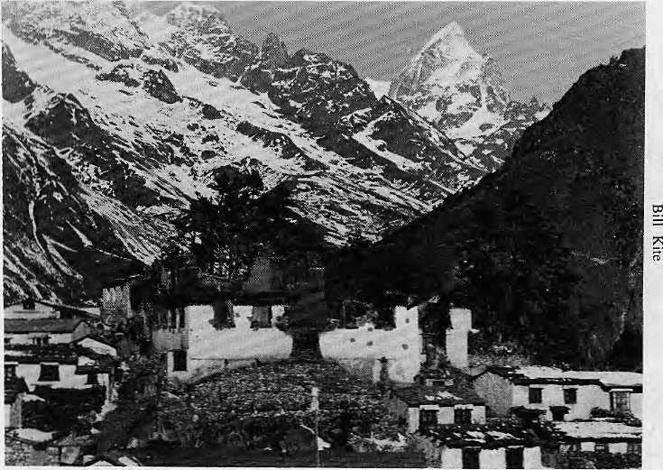
Tengboche: What Went Up In Flames?
Text by David Sassoon

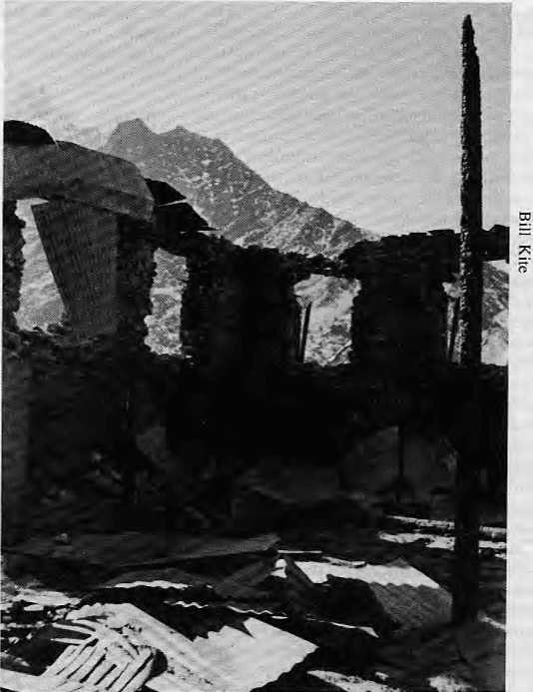
On the night of 19 January, the main building and courtyard of the Tengboche monastery in the Khumbu region caught fire and burned to the ground. The fire had begun as the result of an electrical malfunction or accident, no one is certain which, associated with the small hydro facility commissioned less than a year ago.
Had the disaster occurred 30 years ago, it would have remained a strictly local affair, an event of importance only to the Sherpa people of Khumbu. But ever since Edmund Hillary stopped there on his way to the first ascent of Everest, Tengboche has become an increasingly important international landmark, and, until last month, perhaps the world's best known and best loved functioning monastery.
While exactly what set of circumstances caused the fire will perhaps never be known, it was natural for all with ties to Tengboche to try to draw lessons from the event. They have tried to evaluate the wisdom and propriety of bringing electricity there. Was the technology appropriate? Did the project follow principles of sound community development? Is electricity there necessary, ecological and useful or is it cosmetic and extravagant?
This article, reported from New York City using the telephone, is an attempt to describe what was consumed by fire; to reveal frictions within the universe of care and concern that is focused on Tengboche; and to inform the process of rebuilding which will soon be getting underway.

18
HIMAL • Jan/Feb 1989

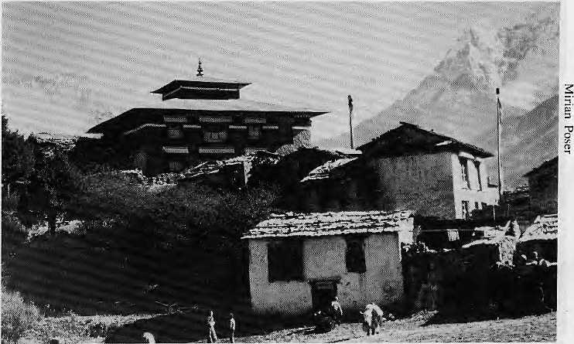
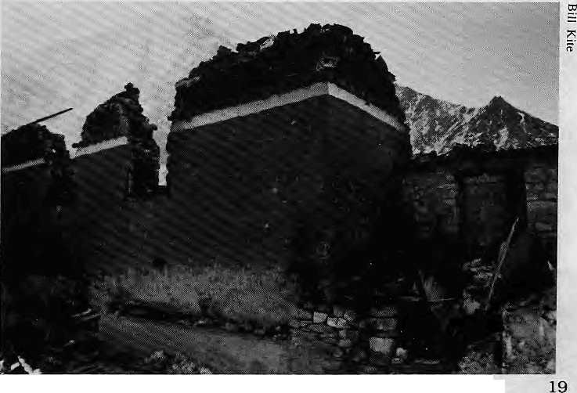
Khumbila, Kangtega, Thamserku, Ama Dablam and, of course, Lhotse and Everest. Pictures of Tengboche photographed with Ama Dablam in the background provide the most popular tourist imagery associated with Nepal. Visitors of alt kinds have developed great affection for the spot. Some return again and again, and many try to give something back in return.
The Rimpoche, or "Precious One", as the abbot is known,
Jan/Feb 1989
HIMAL
THE MONASTERY
Materially, the damage was severe. The structure was a beautiful example of classic Sherpa monastic architecture, adorned with skillfully executed frescoes. Although the holy relics of the previous incarnate abbot of the monastery were rescued, the majority of Tengboche's texts and artifacts did not survive the fire. Included in this irreplaceable inventory were costumes used in the performance of a sacred dance drama during Mani Rimdu, the most important festival of the Sherpa calendar. Some of these had come from Rongbuk monastery in Tibet, just north of Everest.
No lives were lost to the fire. The abbot, and all the monks but one, were in Kathmandu to receive the body of Dudjom Rimpoche who had died in France. Tourists who were at Tengboche helped rescue what they could, but with little water available, all were helpless in the night and could only wait for the fire to burn itself out.
Tengboche plays a very important and spiritual role in Sherpa society. Originally built in 1912, it was the first celibate monastery of the Sherpas. Destroyed by the earthquake of 1934, it was rebuilt in 1936. It has always been a pivotal institution enjoying the highest prestige, and with the decline in the number of village lamas in recent decades, the services of Tengboche's monks have been more in demand than ever. Like the monasteries of Chiwong and Thami, Tengboche was founded at the behest of the lama of Rongbuk monastery.
UNCHARTED WATERS
The intention of its founders was to keep Tengboche isolated. No one knew that this remote spot overlooking over the Imja Khola would be the stopping point for
The gumbo before the fire.
thousands of climbers and trekkers making the pilgrimage to the Everest Base Camp. "In recent years, Tengboche has been facing a challenge," says Richard Kohn, an anthropologist who has studied Sherpa culture. "How to maintain its goals as a monastic institution in the face of increased exposure to outsiders." Tengboche is arguably one of the most beautiful spots in the world, surrounded on all sides by towering snow-covered peaks:

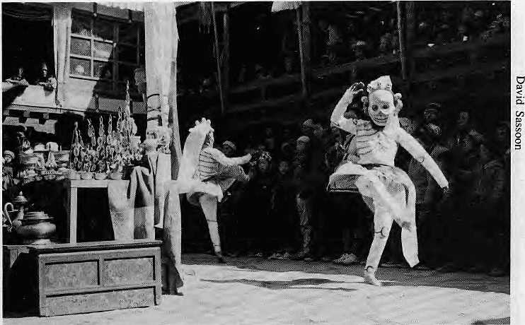
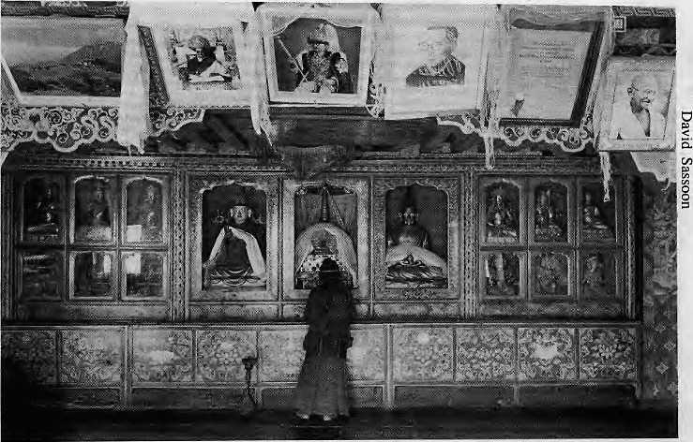
Rimpoche. "His Eminence asked Richard Blum for it," says Peggy Day, special projects coordinator of the Foundation. But Day's statement is contradicted by Blum, who is chairman of the Foundation and an investment banker. In an article he wrote for the San Francisco Chronicle after the lights went on, Blum wrote, "We had come a long way from that day in San Francisco when, only 10 months before, Dianne, my wife and the
Inside Tengboche, as it was.
Happier times: Mani Rimdu celebrations.
has been responsible for guiding Tengboche through the uncharted waters of Western inundation, and he has coordinated many development efforts previous to the electricity project. The American Peace Corps helped him and his monks install a water system. The Canadian Government paid for the installation of latrines. Cultural Survival, a group from Boston, raised money for a cultural center and additional monk quarters. And twice, the Rimpoche took his monks to Japan to perform Mani Rimdu there.
And now the Rimpoche is without a monastery.
BRINGING ELECTRICITY
The advent of electricity was celebrated with great hoopla on 27 April. The main power plant cost more than U$ 100,000 to install and generate 22 kilowatt of electricity for the monks of Tengboche. The project was funded by the American Himalayan Foundation of San Francisco and had the support of the King Mahendra Trust for Nature Conservation.
How was the hydro station built? The American Himalayan Foundation, which says it acted expressly upon the wishes of the
mayor, had conceived the idea of the power project."
Dianne Feinstein, former mayor of San Francisco, is currently running for governor for the state of California. Blum, himself a popular figure in San Francisco, was the driving force behind the Tengboche project. He arranged the financing and building of the project in an impressively short period of time.
Blum created a scheme whereby donors of U$ 5,000 or more would be given a VIP trip to Tengboche to be present for when the lights were switched on. Two weeks before the planned inauguration day, a telex was sent from Kathmandu confirming that everything was on schedule. The day before the VIPs were to arrive, the system had not yet been tested. No one knew whether it would work. Two portable Honda generators were put in the powerhouse in case anything went wrong.
The 13 VIPs who had paid for the project arrived by helicopter before 8 a.m. The system worked and the Philips light bulbs burned brightly. Speeches were made. Tea and biscuits were served. Sherpas danced in the courtyard. The VIPs helicoptered out.

20
HIMAL • Jan/Feb 1989

FIRE IN THE GUMBA
The speculation as to the cause of the Tengboche fire is that something was left unattended on a heater. No one knows for sure. Brot Coburn, who designed the electrical distribution of the system, said it was impossible that the fire was caused by faulty wiring. On every line were sealed, untamperable, extremely reliable and sensitive circuit breakers that would cut off power if anything went wrong.
"An incredibly small short circuit would throw backup circuitbreakers within thousandths of a second," Coburn says. "I'm not worried about my conscience. I'm worried about my reputation."
Few are criticising Coburn's abilities as an electrician, but many are critical of the electricity project as a whole. In the aftermath of the fire, they ask whether the effort was not misguided, inappropriate and culturally insensitive. The technological and ecological merits of the hydro facility are also points of debate.
One major justification for the project was that it would save fuelwood in a heavily deforested region. Yet when working at
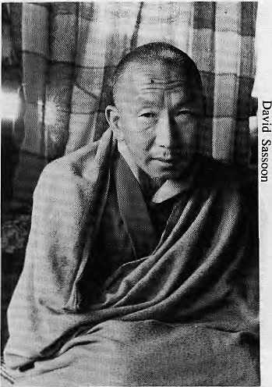
Tengboche's Rimpoche.
capacity, the system would generate enough electricity to power just a few woodstoves and heaters. The American Himalaya Foundation had promised in its letter soliciting funds, "... open hearths will disappear to be replaced by electric ovens and electric light..."
However, a visitor reported last fall that power for cooking
and heating units were not working at all, and that lights were burning throughout the night. As people stayed up later, the use of firewood is said to have increased. A technical problem had developed during the monsoon season, and was finally repaired in the second week of December. A month or so later, the fire started.
Already, the donations for rebuilding the monastery are flowing in. The Nepali authorities have made clear that the rebuilding of their lost treasure should be done only with the agreement of the monks of Tengboche and their Rimpoche. An architect from Bhutan is reportedly being considered to design the new monastery, but building cannot commence until next year because the present one is a black year on the Tibetan calendar.
But before the timber is cut and the stones are laid, a whole year is available to reflect upon what went up in flames, and what can be learnt from the ashes of Tengboche.
(This article is printed here courtesy the Himalayan Research Bulletin.)

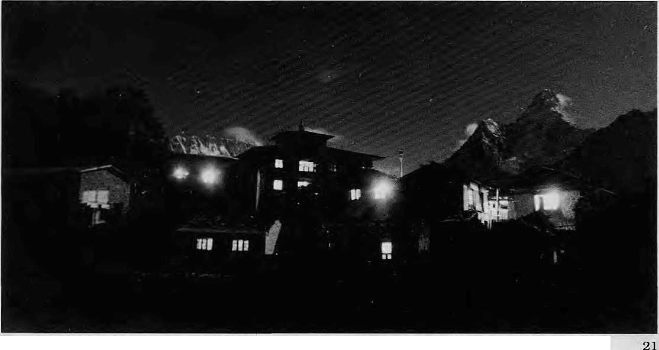
Jan/Feb 1989
HIMAL


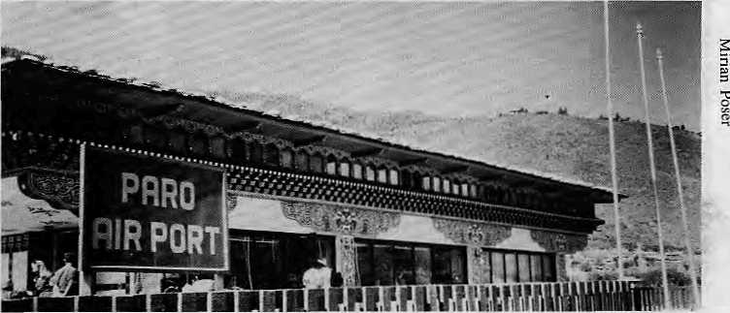
out by Thimphu.
Bhutan's civil aviation authorities have begun work on a new passenger terminal in Paro, Druk Air's increasingly important hub. A hangar is also nearing completion for engineering and maintenance works. Meanwhile, Thai International is helping train Druk Air's cabin and ground crew so that they are prepared for the expanded network.
As the new routes are being finalised, and in between the scheduled runs to Calcutta and New Delhi, Druk Air is leasing its jet to Indian Airlines, which is presently extremely short of planes.
According to Bhutanese officials, the existing air links, as well as those being planned, are part of a continuing move to strengthen cooperation within the South Asian region, and also a first step towards closer relations with South East Asia. "We have plans to eventually link Paro to all the capitals of the SAARC countries," says Druk Air Managing Director Ugen Namgyel. "Now that Bhutan has entered the jet age, who knows? The sky is the limit!"A
The Little
Airline That
Could
By Siok Sian Pek
Bhutan's infant air carrier, Druk Air, is thinking big. It is poised to begin simultaneous air links with neighbouring Nepal and beyond the South Asian region with Thailand. Having taken delivery of a brand new jet made by British Aerospace, in March Druk Air hopes to link the three Asian kingdoms at one go.
The venture has been developed jointly by the Bhutan Tourism Corporation (BTC) with Thai Internationa] airways and is simply called "Three Kingdoms". Druk Air will bring tourists in from Bangkok for three days in Bhutan and fly them on to Kathmandu. BTC hopes that the package will attract a more diverse group of tourists. Presently, visitors to Thimphu — officially restricted to only about 2,500 a year — are mostly from Japan, the United States and West Germany.
SPECTACULAR JOURNEYS
The Bhutanese airline, which started with a fleet of two 18 seater Dorniers, has been steadily expanding its reach. It began its first international flights to Calcutta in early 1983 and added Dhaka to its schedules in 1986. Flights to New Delhi's Indira Gandhi International Airport were begun in December, 1988, with the acquisition of the four-engine, 80-searer British Aerospace jet - the BAe 146.
The new aircraft, which is central to the "Three Kingdoms" package, was flown in last November by British Aerospace pilots to Paro, where Bhutan's only airport nestles among paddy fields. The inaugural flight to New Delhi took place just a few days later. The journey takes a little over two hours and is regarded as a great time saver for travelers going West who had previously to catch connections from Calcutta. As a Finnish U.N. official put it, "Once you have traveled on the new plane to Delhi, you don't want to go any other way!"
The flight from Paro to Kathmandu will be one of the most spectacular of Himalayan flights. For about an hour,
DRUK-AIR BAe 146-100
Druk Air's jet, with its distinctive national colours of saffron and orange, will cruise past the length of the Eastern Himalaya, taking into view Bhutan's own Chomolhari, then Kanchenjunga, Makalu, Everest, Gauri Shanker, and on to Kathmandu Valley.
"The flight to Kathmandu will be a real treat," says Brent Olson of Inner Asia, an American travel agency specialising in Bhutan, Nepal and Tibet, "The new Bangkok sector will make it much easier for travelers to get to Bhutan. These new routes open up the possibilities for interesting tours in the Himalaya. A possible package could include Thimphu, Kathmandu and Lhasa."
FIRST COMMERCIAL LOAN
Highflying Paro: Bhutan's only airport.
Buying a U$ 28 million aircraft was a major project for Bhutan. For this purpose, it took its first commercial loan ever from a consortium of international banks, led by the Standard Chartered Merchant Bank of London. The British Government was also involved in the transaction, which is the biggest single loan of any type taken

22
HIMAL • Jan/Feb 1989

CLIMBING

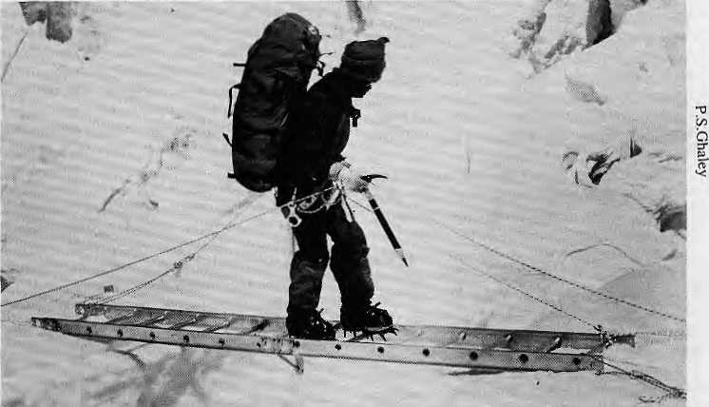
Crossing Khumbu Glacier crevasse: But have you paid the tall?
Climbers' Advisory
H.C. Sarin, President of the Indian Mountaineering Federation, speaking recently in Mussoorie about the duty of climbers in the Himalaya:
"Our advice to all climbers is to keep the mountains clean; consider other people; help protect wildlife; avoid reckless mountaineering. Mountaineering expeditions, whether Indian or foreign, must leave the mountain cleaner than they find it. They must take responsibility for each member and the porters. All Indian clubs have been advised that there will be no felling or cutting of trees or plants. Campfires are banned, and only kerosene and other similar fuels will be used. All garbage will be burned or buried and no glass, tin or plastic items will be left behind. Campsites wiil be away from lakes or streams and water will not be polluted anywhere."
Horse Trading At Base Camp
By Iman Singh Gurung
Those of us working in the mountaineering trade as sardars, guides and porters have seen a consistent pattern of commercialisation among some of those from the West who come to climb our mountains. This is especially true on Mount Everest, which holds such a fascination for climbers worldwide that (hey are willing to leave all mountaineering ethics behind at Base Camp in the rush upwards to become "conquerors of Chomolongma".
I saw the most blatant aspect of corrupt climbing this past fall on Everest, when I was sardar to the French team led by Marc Batard. Others on the mountain at the same time were a New Zealand cum Czechoslovak team, a South Korean team, a breakaway French team that was originally pan of Batard's group, and a large American team.
By the time we arrived at Base Camp from the airstrip at Lukla, the Americans and Koreans had already broken the route through the Khumbu lcefall, which is the most difficult part of climbing Everest from the South. It was the Americans who had supplied the many ice screws, ice bars, ladders and the vast lengths of rope required to cut this route. In the past, whoever broke trail had right of first use, but this was the first time my fellow Nepali climbers and I witnessed the actual charging of rent or toll for a trail up a Himalayan mountain. What we saw was the equivalent of what in the Nepali highways is known as the sawari kar.
My task for the Batard group was to set up camps up to South Col. We were told by the Americans that the icefall route had required U$ 28,000 --surely an exaggeration — and chat all expeditions must share in this cost. Ignoring the demand for payment, I forged ahead with my Nepali friends and broke the trail and established camps all the way to the South Col, When I returned to Base Camp, I learnt to my surprise that Batard had accepted the outrageous demand and handed over U$ 5,500 to the Americans, With hindsight, I believe he must have done so gladly because this made much easier his much ballyhooed goal of
climbing Everest from Base Camp within 24 hours (which he did).
Besides our group, the New Zealanders and Czechs paid U$ 7,000 and the breakaway French team is said to have paid U$ 5,000.
There was much unhappiness among the 30 or so Sherpas in the American group, from what we could overhear from the adjoining campground. Many protested the commercialisation and asked the American leader wheiher he had come to climb Chomolongma or to make money on the Icefall. 10 or 15 Sherpas even "walked out" and went down to the village of Lobuje for a few days. I think they were enticed back when the Americans promised to pay generous bonuses.
Incidentally, the route above the
Icefall, all the way along the Western Cwm to the South Col, was established by my team of Nepali climbers. All the "sahibs" used it to get to the top. We did not charge rent.
A month later in Kaihmandu, 1 still did not know who had gotten the better part of the deal, until the South Korean leader dropped by at my office. I still remember what he said: "This no good American people no give money. They take it all and go." I hear that the same American team is coming back to Manaslu this spring, perhaps to do some real climbing this timc^ Iman Singh Gurung has led treks and climbs for 15 years. He comes from Laphrak vliage in Gurkha District. This article was translated from the original Nepali.

Jan/Feb 1989 • HIMAL
23

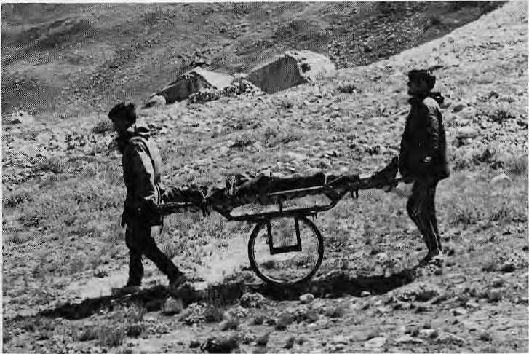
Mountain Rescue The Right Way
Mountain rescue techniques in the Himalaya have been fashioned after rescue systems in the Alps and the American Rockies. The tendency has been to concentrate on sophisticated helicopter based rescue systems whose focus is on evacuation of the dead or wounded at high cost. This often restricts rescue to fully insured Western climbers. Little time has been spent on studying alternative rescue systems tailored to Himalayan conditions, that is, until Indian climbing enthusiasts --Parmindar Brar, Mandip Singh Soin and Dr. Ranganath Pathak — decided to do something about it.
Brar is an officer at the Ministry for Energy, Soin runs a trek agency, and Dr. Pathak serves at Safdarjang Hospital -- all are from Delhi. As climbing partners in the Western Indian Himalaya, they noticed the utter lack of mountain rescue facilities and as a small effort they set up the Himalayan Evacuation and Life saving Project (HELP), with seed money from the London-based lnlaks Foundation. Edmund Hillary, Everesteer and New Zealand's High Commissioner to India, serves as HELP'S patron.
As Brar, HELP'S President, explains it, transplanting Western rescue systems to the Himalaya simply will not be very effective. In the French Alps, for example, helicopter and rescue crews are on constant standby, the climbing area is small and well mapped, radio communications are ubiquitous, rescuers are well trained, and hospitals are only minutes away by chopper.


In the Himalaya, says Brar, the area to be covered is vast and climbers are few and far between, so it is not possible to have rescue teams on standby in each valley. Cumbersome regulations and lack of equipment make communication very difficult, and training is negligible. Additionally, it
Himalayan appropriate technology.
can lake up to a week to get a helicopter rescue organised, at prohibitive cost. When an accident occurs, the most critical period is the 24 to 48 hours following, so that by the lime a helicopter arrives, most people actually requiring rescue are already beyond help.
LOW TECH RESCUE
The three climbers from Delhi decided to set up a pilot rescue system in the Himalaya. But first they first visited Scotland, Wales and Chamonix, centers for European climbing, and trained on the latest techniques in low-tech rescue off snow, ice and rock faces. They leamt the latest in pulleys, ropes, jumars and stretchers. What most impressed them was a unique stretcher-on-a-wheel. Brar made a quick pencil drawing and upon his return had it duplicated at a welding shop behind his house in New Delhi (see picture).
As a pilot project, HELP set up a rescue post at Tapovan, which is beyond Gangotri and a day's walk upstream from Gomukh. Between August and October, they trained climbers, high altitude porters and villagers from the area. The training was divided into two components: medical and rescue. The medical aspect dealt with acute mountain sickness, as well as with the rudiments of first aid, including the use of splints, bandages and drugs. The rescue training dealt with how to bring stretchers down sheer faces and through deep snow, how to make do with ropes and karabiners, and how best to evacuate out of a mountain altogether.
"There will always be a need for
helicopters, but we feel that communication and training are the key," says Brar.
BETTER COMMUNICATION
The kind of training provided by groups like HELP, or the Government mountaineering institutes in Darjeeling, Uttar Kashi and Aru (in Kashmir), combined with adequate communication, seems to be the key for the future of mountain rescue in the Himalaya.
As far as communication goes, things seem to be looking up for climbers in trie Western Indian Himalaya. It is reported that J&K Tourism is setting up a communications network which will cover the entire Nun Kun area and most of Kashmir. It is also reported that Uttar Pradesh Tourism is considering setting up a communications system. Rescue systems will be much more effective once these networks are in place.
But neither helicopters nor sophisticated radio gadgetry will be of much use without rescue training, which is where HELP hopes that its pioneering effort will act as a catalyst for the rest of the Himalaya. They are convinced that their low cost rescue alternative is the only viable one, through which more and more local people, including high altitude porters, will learn rescue techniques, not only in the western and eastern Indian Himalaya, but elsewhere: in Pakistan, Nepal and Bhutan. Ultimately, local inhabitants will benefit as much as the occasional mountaineer who has a mishap^
(For further information, contact HELP at BII4I, Safdarjang Enclave, New Delhi 110029.)

24 HIMAL • Jan/Feb 1989

PARKS AND WILDLIFE

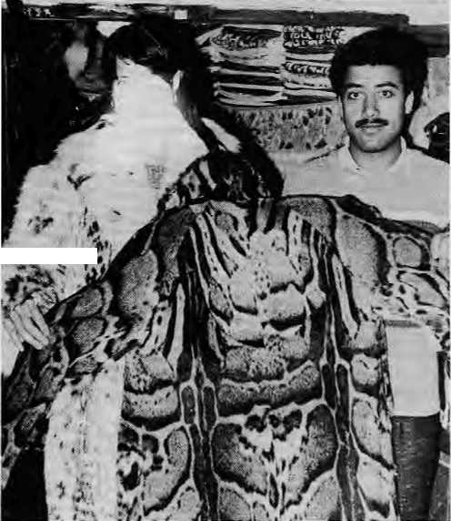
Illegal Furs On Durbar Marg
By Larry Barnes
A walk last December through downtown Kathmandu's Durbar Marg avenue was shocking to me, as someone concerned about endangered of Himalayan wildlife. The ubiquitous fur-selling shops all seemed to carry garments made out of spotted cats. Eager salesmen told me what they thought I wanted to hear: "jungle cat", "ocelot", "leopard", anything. They said they would help me smuggle the fur out of the country. A Kashmiri shopkeeper operating at Store Number 11 near the Yak and Yeti Hotel offered me a snow leopard coat for U$ 3,000.
Compelled by a need to know more, [ initiated a brief study of Kathmandu's fur market. I visited 36 fur-selling shops with a female companion (in picture with face obscured) and together we posed as a couple interested in some illegal fur shopping. We found that 86 percent of the stores carried coals made from protected species: leopard-cat (Felis bengalensis), common leopard {Panthera pardus), clouded leopard (Neofelis nebulosa), and snow leopard (Neofeli.i uncia).
The fur coats we found represent the lives of many individual animals. Leopard-cats are diminutive creatures, so at least 36 cats must give up their beautiful skins to make one full length coat. Based on all the leopard-cat coats we counted, I estimate conservatively that over 700 of these animals were killed to stock the Kathmandu shops. Similarly, over 50 common leopards, about 28 clouded leopards, and 12 snow leopards were killed as fodder for Kathmandu's fur trade. The numbers given here are indeed conservative because we missed some stores and did not go into all the large hotels, many of which have fur shops in their lobbies.
All the four species of cats whose furs are so abundantly available are protected by the Convention on International Trade in Endangered Species of Wild Flora and Fauna (CITES). Nepal became a member of CITES in 1975 and in doing so agreed to prohibit international trade in species protected by the treaty. The fur trade in
Kathmandu is "international" because the stores cater almost exclusively to tourists. (At U$ 500 to U$ 3,200 per coat, these furs are far beyond the means of most Nepalis,)
SMUGGLERS' TRICKS
The merchants explained to us how to smuggle their wares out of Nepal. They offered to sew artificial fur over illegal coats to pass them through customs. Other methods were to pack the illegal fur into an ornate pillowcase or to
attach a falsified label to the coat saying that it was old,
thereby passing it through a "grandfather" clause of CITES.
Even if Nepal's fur trade were strictly domestic (and consequently not in violation of CITES), the country would be violating its own National Parks and Wiidlife Conservation Act of 1973. Section 10 of that Act "...gives complete protection throughout the Kingdom to Schedule I (protected) species...", which include the leopard- cat, clouded leopard and snow leopard. According to the Act, hunting those species can result in fines from NRs 5,000 to NRs 15,000 and one to five years in jail.
Nepal shares its status as a CITES member and violator with both China and India. Snow leopard skins can be purchased Carefree fur from merchants in Lhasa, while a great diversity of illegal coats are sold in Srinagar (see July 1987 Himal). In fact, most of Kathmandu's fur merchants are Indians, many from Kashmir.
The CITES and the Conservation Act violations go beyond the four cat species mentioned here. Coats of Wolf (Canis lupus) and lynx (Lynx lynx), both protected species, were present in some shops. Garments made from other species of cats were found, all of which were likely from India, where aU wild felids are protected.
The overt fur trade in Kathmandu is legally indefensible. One may attempt to morally justify the trade by arguing that it brings foreign currency to an
economically impoverished country. This may be true, except that the money changes hands in large bills and only a small percentage of Nepalis receive any direct benefit.
For a CITES nation like Nepal to ignore the sale of endangered species, brazenly displayed by shopkeepers right on Kathmandu's most fashionable thoroughfare, is unfathomable. It is ironic that our study was conducted on the two days following an international CITES conference held iii Kathmandu. Compounding the irony, I found a
buying and selling.
leopard-cat coat for sale downstairs in the Hotel Himalaya while the CITES meetings were in session upstairs.
A PROPOSAL
How can the situation be changed? The authorities could start by announcing the enforcement of CITES and a programme of ongoing monitoring of the fur trade. This would help a bit, but merchants would simply move their business into the black market. They would lose the impulse buyer, but not the consumer who comes to Nepal intent on buying an illegal fur. A more desirable action, of greater benefit to the endangered species, would be to
continued on the next page....

Jan/Feb 1989 • HIMAL 25

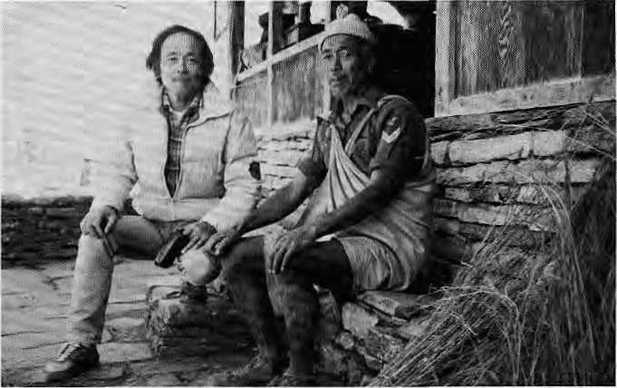
began a partnership between Chandra Bahadur and successive Japanese well-wishers. For the past 15 years, Chandra Bahadur has been fast friends with Toshio Chino. Together, they have installed four ropelines to transport wood and grass from the forests to the villages of Myagdi, several drinking water systems, one hydropower station and a "hydro ram" which provides lift irrigation.
In January, Toshio came to Sikha yet again for a rural energy survey. Chandra Bahadur was there to welcome his old friend, with a jerrycan full of fresh milk as an offering. Over a cup of tea, he was asked what he would do if war were to break out again and he was with the British Gurkhas fighting Toshio. "I would go to war, but I would fire into the air," he said A
PROFILE
Chandra Bahadur
Garbuja
By Anil Chitrakar
It was 1940, and Chandra Bahadur Garbuja dreamed of serving valiantly under the British Crown against the Japanese. He left the village of Sikha in Myagdi District in central Nepal to recruit with the Brigade of Gurkhas in Dehra Dun. After a few months of training, his battalion of 7,000 was transported by train to Madras, thence to Singapore by ship. Within four months, the Japanese had overrun Singapore and all 7,000 men, Britishers, Indians, Nepalis and some Chinese, were taken prisoner.
While his fellow POWs mourned their fate and pined for home, Chandra Bahadur quickly set about learning to read and write Japanese. His captors liked him enough to include him in a team that was headed for Burma with a load of documents for the rebel army of Indian nationalist Subash Chandra Bose. It was during this long march that Chandra Bahadur learnt the mechanical skills of building bridges and cutting trails that would prove so useful back in the Nepali hills.
After six-months as a well-regarded POW, Chandra Bahadur escaped and crossed into the advancing British lines. Soon the war was over and he was back in Dehra Dun. In 1947, tired of army life, Chandra Bahadur resigned and returned to Sikha. He went back to
Chandra Bahadur with Toshio last month in Myagdi.
the tedious and routine work of ploughing, planting and harvesting, and feeding cattle. But he had seen too much of the world to be satisfied with just that.
Chandra Bahadur noticed that the residents of the nearby villages of Swanta, Dhaskey Khoray, Pahdwar and Others were having difficulty crossing Myagdi's many torrential rivers. Reaching back to what he had learnt in his days as" a POW, Chandra Bahadur built seven bridges in the area. Today, almost four decades later, all but one of them are still in use.
In 1953, the well known Japanese professor, Jiro Kawakita, came to Nepal with a mountaineering expedition and he needed a translator. Incredibly, there was Chandra Bahadur, right in the middle of the Magar heartland of Nepal. Thus


Books
on
Ecology
...continued from previous page
confiscate furs and to prosecute shopkeepers. The enormous financial damage (an estimated U$ 15,000 in some shops) would be felt by the middlemen in the trade. All confiscated furs should be incinerated. Again, the trade would have to be continually monitored.
Nepal was one of the first countries to sign CITES and, in general, enjoys a good international reputation as a friend of conservation and proponent of the treaty. Hopefully, Nepal will act to retain its good reputation and, most importantly, to relieve some of the pressures facing the endangered populations of leopard-cats, common leopards, clouded leopards, snow leopards, and other protected species of fur-bearing animals^ Larry Barnes is a biologist from the United States.
26 HIMAL • Jan/Feb 1989

Since 1968, the only English monthly to cover all aspects of Tibetan affairs, including news from Tibet, commentaries on recent hippenings, and authoritative .articles on Tibetan history, culture. Buddhism, medicine, astrology, and personalities.
Annual subscription rates; India, Bhutan and Nepal — IRs. 48 All other countries (airmail) — IRs. !90, U$ 18 (or equivalent)
For a sample copy, please write to:
The Editor Tibetan Review D-11, East of Kailash New Delhi 110 065
We have in slock more than 300 current books on birds, butterflies, primates, wildlife photgraphy, animal behaviour, remote sensing, environmental history and law, comparative ecology, and many other environmental subjects. Plus a special offering of books on Indian forestry.
Nat raj Publishers
Publishers, Booksellers 17, Rajpur Road Dehra Dun 248 001

GRASSROOTS

Women Of Chamoli Fight Pine
By Pandurang Hegde (NFS)
Deep in the interior of Chamoli District, 40 kilometres from Kamaprayag, the barren Garhwali landscape suddenly gives way to a lush oak forest, green, in stark contrast to the surrounding barren hillsides, which are punctuated with lone pine trees. This is the forest of Nanda Sen, protected by the women of Malai village.
In 1985, this forest was nearly destroyed when the Forest Department started an "afforestation" drive in the villages of Malai and the nearby settlements of Benoli, Deval and Chaurasen using pine saplings. However, instead of placing saplings on barren land around the villages, they were planted in the Panchayati Ban, which actually had flourishing stands of broad leaf species. After the Department secured permission from the village Pradhan, the contracts for putting up boundary walls, digging pits and planting the saplings were awarded to a few village leaders, who made sizeable profits, while at the same time the existing oak forest was being destroyed.

USELESS CONIFERS
The village women approached the all-male Panchayati Ban Committee, which declared its helplessness in the face of a governmental decision to plant pine amidst the oak. The women knew the destruction of the forest would add to their woes. The conifers are of little use to villagers. The leaves are useless for fodder, the wood is bad for construction and as fuel it produces too much smoke and sticky soot. Pines do not allow
undergrowth, their needles acidify the soil and they are also more prone to forest fires.
When the people asked the District Forest Officer why pine saplings had been planted in an oak forest, he replied that four species had been planted but that only pine had survived grazing by village animals. The people retorted that almost 90 percent of the saplings had been pine, and the official had just to walk to the nearby forest to verify it. He then agreed that it had been a mistake to have planted pine at that altitude.
GRASS, FODDER, FUELWOOD
The activist women invited Chipko leader Chandi Prasad Bhatt to initiate action in February 1988, and a two-day environment camp was held in Nanda Sen, attended by about 1000 people from the surrounding villages. They issued a notice to the Forest Department to take action by July, or there would be direct action to uproot the pine saplings. At the same time, the women decided to take control of the community forests. Godavari Devi, of Malai's Mahila Mangal Dal: "We wanted to protect the forests for grass, fodder, fuelwood. So we decided to volunteer to keep watch on the forests. Some days we were in the forests from nine in the morning until ten at night."
Since the authorities had not bothered to respond to their demands, the women of Malai held a three-day camp in mid-July and decided to launch a Chipko andolan In response, the forest officials finally uprooted some pine saplings and had them planted at a lower slope. They promised to uproot all the pine saplings from Nanda Sen, if the transplanting was successful. As part of their campaign, the women also planted oaks and other broad leaf species on common village land.
Within six months of their initial meeting, the effort of the women had already paid off. The oak forest has recovered and is lush and green again. But the Mahila Mangal Dal is determined not to lower its guard. Says Godavari Devi, "If they do not remove all the pine saplings, we will have to do the job. We have to save our water source, fodder and fuelwood."^\
Pandurang Hegde, a well-known activist from Karnataka, helped organise last year's march to save the Western Ghats. "NFS" is News From The Fields And Slums, a feature service on grassroots issues.
HIMALAYAN RESEARCH
BULLETIN
An international forum for scholarly exchange among those interested in the Himalayan region. Listings of recent and upcoming publications, notices of conferences, abstracts and book reviews featured in every issue.
Membership in the Nepal Studies Associaiton includes a subscription .to the Bulletin. Annual membership dues are U$ 18 for individuals and US 40 for institutions. Please direct correspondence to:
Southern Asian Institute
School of International and Public
Affairs
Columbia University
New York, N.Y. 10027
United Slates

Let Natraj
Take Care
of You.
We will tailor your visit to your liking. Contact us for:
Accomodations
Airseats
Sightseeing
Trekking
Rafting
DURBAR MARG, P. O, BOX 495 KATHMANDU. NEPAL PHONE- 222014* 220001, 222532 TELEX- N. P. 2270 NATRAJ SIT A- KTMTOLT

Jan/Feb 1989 • HIMAL
-af

ENERGY
Power
To The People
A year ago, if you had told the pujari at Muktinath that by Dasain he would be doing his evening prayers by electric light, he would have responded, sure, and the moon is made of khuwa-haraf. But by Dasain, a light bulb did adorn the eaves of the temple, one of the last major pilgrimage spots in the Himalaya to be so lit.
It all began with an election promise made by District Panchayat Chairman Btshnu Raj Hirachand, the most avid "technophile" in the valley of the Kali Gandaki. He promised to harness the energy of the water descending from the 108 water spouts around the temple to generate electricity. The villagers of Purang and Rani Pauwa, which adjoin Muktinath, were skeptical. Decades ago, they had heard similar promises. Surveys had been carried out and the streams gauged, but when electricity arrived, it was in the district headquarters of Jomosom.
In spring 1988, Hirachand got in touch with Development Consulting Services (DCS), a Butwal-based group that has been installing small power plants in villages across Western Nepal. DCS sent a team to Muktinath, and found that the site was good for a modest unit. The water from the 108 spouts collects in a natural pond and
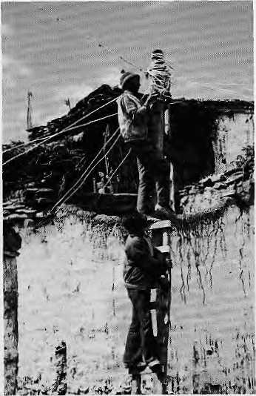
Fixing the lines in Muktinath.
then drops 60 m vertically to an irrigation canal. Up to 9 KW of power could be produced, enough to provide lighting to about 60 houses as weil as low wattage cooking (see March 1987 Himal) for about 20 houses. Kerosene would be saved and, yes, video hookups would be possible. What the villagers looked forward to most was that expensive batteries would no longer be required for their radios and cassette players.
The DCS experts estimated that the power plant would cost NRs 4.5 lakhs,
including 3.75 lakhs for the equipment. With the cost at more than NRs 5000 per household, financing might take years to get, or so they thought. To their surprise, the villagers were able to collect much of the money from among themselves within days. They demanded that the plant be operational before the monsoon. Taken aback, DCS promised "before Dasain".
The turbine was manufactured, conductors and a generator purchased, and four planeloads of equipment airlifted to Jomosom in late summer. The villagers contributed the required hard labour and construction began on 1 September. Electricity began to flow on 12 October, a week before Dasain.
Curious pilgrims to Muktinath
constantly wanted to know if this was
hamrai sarkarko yojana ho ki bideshi
sarkar ko ("Is this our government's
project or is it another government's?"}.
To which the villagers proudly replied:
"Neither, this is our own power." The
speed of construction was disconcerting
to some. The landlady of the North
Pole Hotel, fast by the temple,
wondered aloud if anything built this
quickly could last very long. Bikas
Pandey, DCS's MIT- trained
engineer, reassured her that it would last
a long time indeed, "because it was
built with the villagers' own money and
with their own ^

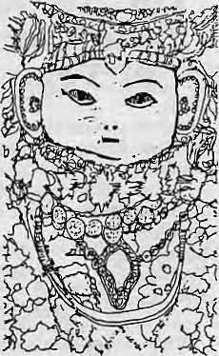
WE ARE SPECIAL.
BECAUSE WE BRING YOU FACE TO FACE WITH THE TRUE TRADITIONAL
CHARACTER OF NEPAL. SPECIAL INTEREST TOURS ARE ARRANGED TO BRING YOU CLOSER TO THE PEOPLE AND THEIR CULTURE. INDIVIDUAL TOURS FOCUS ON CRAFTS, TRIBES, TRANS-HIMALAYA, HERBAL MEDICINE, ARCHAEOLOGY, ANTHROPOLOGY AND NATURAL HISTORY.
i Nepal § Cultural
|l Experience.-

PO Box 531, Kaihmandu
Tel: 524 664, 524 944
Telex: 2262 NARANI NP


NEPAL PRESS INSTITUTE
Our job is to develop profess ions I is in in Nepal's communication media. We offer the following services:
TRAINING: A ten-month diploma in Journalism, workshops for managers of small newspapers, seminars on population and development reporting, special fellowships for rural reporting, and training for mid-career professionals. CONSULTANCY : On all media -related issues.
PUBLICATIONS; A quarterly journal in Nepali reviewing developments in communications around I he world, and an annual number in English for those interested in communications development in Nepal. Several monographs on media-related topics
Posl Box 4128 Kathmwdu Tel: 215158

28
HIMAL • Jan/Feb 1989

ABSTRACTS

HIMALAYAS
by Blanche C. Olschak, Augusto Gansser and Andreas Gruscke
Facts on File 288 pp. U$ 40, 1988 Now translated from German into English, this 288-page illustrated volume is a tour de force that deals with the Himalaya, including the trans-Himalaya and the Karakoram. The text, the 297 colour photographs and 17 maps are well integrated. The book takes the great river system of the Himalaya as its reference point and deals individually with the basins of the Brahmaputra (Yarlung Tsangpo), Indus, Sutlej, Karnali and the Ganges. There are separate sections on Bhutan, Nepal, Tibet, the Indian border regions, and Baitistan and Gilgit in Pakistan, The book is strong on Himalayan geology, cultures and economies. Gansser is a geologist who has spent most of his 77 years studying the Himalaya, and Olschak is a professor of history who specialises in Central Asia.
THE KASHMIRI PANDITS A Study of Cultural Choice by Henry Sender
Oxford University Press IRs 220, 1988
This is a loosely structured, highly readable, sociological treatise on the changing cultural attributes of the Pandits of Kashmir: the Saprus, Shivpuris, Ogras, Takrus, Nehrus, Katjus, Dars, Rainas, Kauls, Handoos, Kitchloos and Kunzrus. The book deals with the Pandits' collective memory of persecution and migration from Srinagar Valley and how they adjusted to the "host environment", be it the Mughal court, Avadh, or Ranjit Singh's court in Lahore. With the advent of the British, some became the standard bearers of Anglicised culture. There was conflict between commitment to a Brahmanical identity and a self-image of enlightenment transcending sectarianism. The Pandits adapted by surrendering older traditions, yet never integrating fully into their adopted societies. For several reasons, the Kashmiris evolved an ethos of liberal secularism, which has had a major role in the structuring of Indian secularism. (Ratan Watal)
OVER THE HIGH PASSES A Year in the Himalayas by Christina Noble
FontanalRupa
1.95 Pounds, 1988
Noble, a Scotswoman settled in Manali,
records in this book a year of travels
with the herdspeople of Himachal
Pradesh, known variously as Gujars, Bakarwals or Gaddis. From Kangra, she trekked over the Dhaula Dhar into Gadderan, the Gaddi homeland on the upper reaches of the Ravi, and from there via the Kugti Pass across to the summer pastures in Lahoul. Autumn finds her following different flocks back over the Rohtang Pass into Kulu; come winter, she is back once more at the grazing grounds of Kangra. Noble records the Gaddi's perceptions about themselves and their way of life. Encroachment by orchards and increased emphasis on forest preservation has restricted grazing. The writer comes away feeling that despite the hardships of their migratory way of life, the Gaddis are doing reasonably well and do not feel inclined to give up their way of life. She finds the Gaddi ethos flexible and forward looking enough to be capable of accommodating to lifestyle changes that may be required. (Janet Rizvi)
THE ECOLOGICAL EFFECTS OF
EUCALYPTUS
Food and Agriculture Organisation
(FAO)
IRs 75, 1988
This book carries, in condensed form, a study carried out by FAO for the Swedish International Development Agency and is an attempt to analyse "as dispassionately and objectively as possible" the available information on the ecological effects of eucalyptus. It is a response to the growing body of opinion that eucalyptus causes a variety of short and long term ills, such as degrading the soil, reducing water availability and affecting wildlife. The book discusses the large potential benefits that eucalyptus can offer to the forestry programmes of developing countries and argues in favour of its planting. (Available from Natraj Publishers, Dehra Dun.)
LADAKH:
Nubra, the Forbidden Valley by Major H.P.S.Ahluwalia
Himacha! Books, New Delhi 170 pp. IRs 395, 1988 Ahluwalia, the celebrated mountaineer and Himalayologist, describes the not very well known valley of Nubra in Ladakh. With a sensitive eye and pen, he describes the landscape and the people who live along the upper Indus, in a land "unspoilt, being insulated and unaffected by the problems and benefits of modern life". The book contains vivid descriptions of a Ladakhi wedding, the Hemis monastery, and a fine
account of the town of Leh. The presentation is enriched by colour photographs, rare maps and several archival illustrations. (TSSatyan)
SIKKIM
A Himalayan Realm


Tulsiram SharmaKashyai
SIKKIM
A Himalayan Realm
by Tulsiram Sharma "Kashyap"
Atmaram & Sons, DelhllLucknow IRs 150, 1988
This is an epic poem by Sharma, who is the Speaker of Sikkim's Legislative Assembly. While the cadences, juxtapositions and flow of the original Nepali would be impossible to retain in English, this publication, as translated by P.B.Chakravarty, nevertheless succeeds in doing justice to the central theme of the poem, the cultural and geographical variety of Sikkim. The epic is woven around the odyssey of a Lepcha youth, Lakpa, and a Nepali girl, Rajani. As it follows the two, the narrative meanders over the length and breadth of Sikkim. Sharma leaves very few aspects of Sikkim's geography and history untouched. "Kashyap" treats every constituency represented in the Sikkim Legislative Assembly individually, even including the names and antecedents of its elected members. (KMD)
SOME PROVISIONS RELATING TO MOUNTAIN TOURISM IN NEPAL
Minisiry of Tourism, Kmhmandu Available free, 1988
A very useful and up-to-date compendium of information on mountaineering in Nepal, this booklet lists all the peaks that have been opened for expeditions. They are divided

Jan/Feb 1989
HIMAL
29

ABSTRACTS

into four categories: 17 peaks are open for Nepali expeditions or joint (Nepali-foreign) expeditions with at least three Nepali members. Six peaks will be open only after they have been climbed by Nepali or joint expeditions. 81 peaks are fully open to foreign expeditions. 18 can be attempted by trekking groups with permission from the Nepal Mountaineering Association. The booklet also contains all relevant Nepali legislation relating to adventure-tourism in the country, including Chapter 4 of the Tourism Act of 1978; the Mountaineering Expedition Regulation of 1979 (including 1984 and 1985 amendments); and the Trekking and River Rafting Regulation of 1984,
NATURAL HAZARDS AND MAN-MADE IMPACTS IN THE NEPAL HIMALAYA by Chandra K. Sharma
Pushpa Sharma, Publisher (Price not given) 1988
The book points out the different kinds of natural hazards that exist in Nepal's mountains and how human impact has threatened ecological balance. Hazards identified and studied include earthquakes, glacial lake outbursts, cloud bursts, heavy rainfall, floods, drought, landslides, rock slides, "soil creep" and debris flow. Most impressive is the cover picture showing entire sections of a Himalayan highway washed away by a river in spate during the monsoon. The author provides detailed data on natural disasters and catastrophes which are accelerated by human activity. Among the information presented are loss of life and property figures for 1983-84, collected from the Ministry of Home Affairs, temperature changes in Kathmandu Valley, discharge variations of the Tatnur and Bhote Kosi Rivers, and seismic records going back to 1255 AD.
INNOCENTS ABROAD IN THE
FORESTS OF NEPAL
An Account of Australian Aid to
Nepalese Forestry
by D.M. Griffin
Anutech Pty Ltd, Canberra
A$ 4.95, 1988
This book deals first with development
co-operation between Australia and
Nepal in forest and soil conservation
since 1966. It then focuses on the last
decade's experience of the unusually
successful Nepal- Australia Forestry
Project (NAFP), which laid the standard
for community forestry projects in the
Nepali hills. Griffin, Professor of
Forestry at the Australian National
University, has been Director of the Project since 1975. In the book, he presents a personal viewpoint on policy issues and how projects should be run. The book will be useful for professional foresters, planners of rural development assistance projects and graduate students in forestry, development studies, public policy and rural sociology.
THE CHIPKO MESSAGE Chipko Information Centre
Silyara, Tehri-Garhwal IRs 50, 1987
Produced to celebrate Chipko's selection as one of four recipients of the Right Livelihood Award for !987, this booklet is a compilation of six articles, starting with "An Appeal to Save the Ecology of the Himalayas" by Swami Chidananda. Sunderlal Bahuguna and Richard S. Barbe Baker provide general background on Chipko and discuss its philosophical underpinnings. Indu Tikekar writes on women's role in the movement and V.D. Sakiani's contribution is entitled "Tehri Dam: A Dangerous Venture".
NEWSLETTER OF HIMALAYAN
BOTANY
No.4, December 1988
Editors, H. Oliba and S.B. Malta
The latest issue of this semiannual newsletter on Himalayan botany contains a preliminary report on the plant communities in the Langtang Helambu area North of Kathmandu, which is floristically one of the most unique regions in the Himalaya. Over 16,000 specimens were collected during a nine month period in 1986. Their analysis continues in laboratories in Edinburgh, Graz (Austria), Hiroshima, London and Tokyo. The newsletter also describes a Japan-Nepal botanical expedition in East and central Nepal during mid- monsoon 1988, which collected 25,000 herbarium specimins and 500 wood samples. There are reviews of new books. Flora of Bhutan and Flowers of the Himalaya, the second of which is a supplement containing 350 new species.
STATE OF THE WORLD 1989 Worldwatch Institute
Paperback, U$ 9.95
The 1989 edition of this desktop guide to the world environment sketches a portrait of a world at risk. The croplands are washing away, the forests are disappearing, and the protective ozone layer is eroding. Global temperatures seem to be rising to unprecedented levels. Even though natural systems are crumbling under the pressures of ever rising human demands,
says the Washington DC based Worldwatch Institute, environmental illiteracy is still commonplace. The Institute's researchers, led by its President, Lester Brown, present their findings in 10 concise chapters, which examine topics ranging from ozone depletion to the future of the automobile to the rising threat of AIDS. A final chapter presents a "Global Action Plan" to preserve the habitability of the planet.
BIBLIOGRAPHY OF THE
HIMALAYAS
by U.K.Gupta
D'octave IRs 200 1981 (newly available) This bibliography is helpful to researchers, planners and agencies working on Himalayan development issues. Gupta, who is affiliated with the Central Soil and Water Conservation Research and Training Institute in Dchra Dun, presents consolidated information on scientific work on the Himalaya, particularly with reference to resource use and regional development. For example, detailed information is contained on subjects such as the silling of reservoirs, hydro-electric power generation, flood control and use of renewable resources. (Available at Indian Documentation Service, Naisubzimandi, P.B. No.13, Gurgaon, 122001, Haryana.)
THE DRAGON KINGDOM
Images of Bhutan
by Blanche Olchak, Ursula Marcus-
Gansser, Augusto Gansser
Shambala Publications U$ 35, 1988
This book is richly illustrated with stunning photographs and reproductions of traditional Buddhist images in woodblock prints.
The text is by Ms. Olshak and photographs by Ms. Ursula- Gansser and Mr. Gansser. The book provides a summary of the history of Bhutan, both mystical and actual, the latter starting with the theocratic rulership of Zhabdung I (1594 to 1651 C.E). The present king, following in the footsteps of his father, is trying to lead his country, the only remaining nation with Mahayana Buddhism as the State religion, into the modern world while preserving what is good in its tradition. The author and photographers offer us a sympathetic account of this little-known kingdom. (Miriam Poser)
Names in brackets indicate the source of the abstract, if originally reviewed elsewhere.

30
HIMAL • Jan/Feb 1989

HEALTH

The Mrigendra Trust
A successful Kathmandu cardiologist who had made a name for himself treating the rich and powerful was suddenly jolted into an acute awareness of the entrenched poverty and endemic disease afflicting the people of rural Nepal. While others might have let that moment of revelation pass with nothing but a twinge of conscience, Dr. Mrigendra Raj Pandey put his money where his mind was.
In 1975, Dr. Pandey set up the Mrigendra Medical Trust, with the goal of providing medical treatment and health education, and conducting research, all for the benefit of the poor. What began as a personal crusade has, over the past decade, gained an institutional permanence, and an ability to set an agenda in a country where voluntary groups generally wither away as soon as they are born.
At first, the Trust limited its work to providing medical services to the people in the Sundarijal area North East of Kathmandu, and it also opened a clinic for diabetic patients in .the city. But the Trust soon realised that the passive distribution of drugs and medical care could even be counter productive if not supplemented by a broader programme of social awareness.
Accordingly, it organised a programme to supplement village income by providing charkha looms, encouraged village discussion groups to debate what was being done for them, provided scholarships for school children, and even organised spiritual activities to enhance the quality of life. This January, for example, the Trust coordinated a mass (hratabandha) sacred thread ceremony to avoid the economic burden of ostentatious ceremonies. The villagers, too, have met the
challenge set by the Trust. For example, the Sundarijal clinic, is now run by the community.
The Trust has also became increasingly involved in medical research. It has done pioneering work on the study of Acute Respiratory Infection (AR1). While investigating the causes of the disease, the Trust found that it could not study the problem of ARI in isolation from other killer diseases, such as diarrhea and other infections. Neither could an "intervention" remain isolated from the traditions, beliefs and expectations of the village populace. In the pilot area where it is studying ARI, the Trust hopes to bring down the infant mortality rate from 162 per one thousand presently, to 45 by the year 1990. Indications are that it will achieve that target. - Rupa Jos hi

leading causes of ARI related deaths," he said a few years ago.
GOALS FOR 2000
In Nepal, the official myopia regarding ARI has now been corrected, due in part to the pioneering work by the Mrigendra Medical Trust, which established that domestic smoke pollution is an important cause of chronic bronchitis and ARI. A National ARI Task Force which began work in
Fighting The "ARI" Demon
By Rupa Joshi
Acute Respiratory Infection (ARI) kills too many Himalayan children. It is a painful way to die: infection, either bacterial or viral, Fills the lungs with puss and the child literally suffocates to death. Unfortunately, ARI is the poor person's disease, so it has not been studied till very recently. Caused by poor housing, indoor smoke, lack of protection from the cold, poor hygiene and malnutrition, most deaths occur due to delayed diagnosis and treatment.
Severe cases of ARI, manifested as pneumonia kill as many as 720,000 children in India. In Nepal, about 25 percent of the approximately 135,000 under five children who die every year succumb to ARI. How have these crue! statistics persisted? According to Dr. Mrigendra Raj Pandey, even as medical care became more organised, health planners left ARI alone because of its complexity. They concentrated instead on communicable diseases, immunisations and diarrhea. "It is difficult to imagine a primary health care programme that does not include an organised approach to counteract the
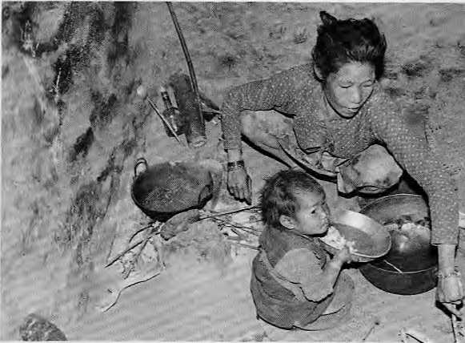
Tamang mother, son and open hearth at Shivapuri, Kathmandu.
1987 in one of Nepal's districts has expanded its 'activity to 14 districts. Combatting ARI has now been incorporated into the nation's Basic Needs Programme and the official goal is to reduce infant mortality due to ARI by 50 percent by the turn of the century. Meanwhile, ARI control was also been given high priority at scientific meetings held under the aegis of the South Asian Association for Regional Cooperation (SAARC).
c z
o m

Jan/Feb 1989 • HIMAL
31

FOLLOWUP
In this column, we report on significant developments and new ideas relating to articles which appeared in past issues.
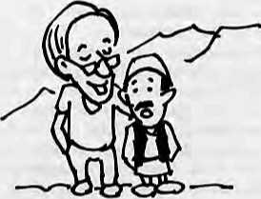
THE GOOD, THE BAD AND THE DEVELOPMENT
CONSULTANT (July 1988)
The Resources Utilisation and Conservation Project (RCUP), which came under heavy fire in our article as a wrongly planned and poorly executed project, has finally been wound up, after having spent an estimated U$ 32.5 million of USAID money over five years. According to our reporter, almost all of the wire reinforced "gaban walls" put in place by the project along the Kali Gandaki Valley have been washed away. Most of the suspension bridges are also similarly gone. An evaluation report attributed these to "natural calamity". The beautiful bungalows built by RCUP up and down the Kali Gandaki have been handed over to HMG, which is having a difficult time deciding what to do with them, and how to maintain them. In the meantime, our
reporter observed wild mushrooms growing around the buildings, for whose roof beams the tallest pines in the area were felled by RCUP's consultants.
ICIMOD GETS NEW CHIEF (Nov/Dec 1988)
Francesco di Castri, for reasons described as "personal", did not, as reported, take over as Director of the International Centre for Integrated Mountain Development (ICIMOD) in Kathmandu. It is now rumoured that ICIMOD's Board has tapped E.F. Tacke to take over from Colin Rosser, who has led ICIMOD since its founding in 1984. Tacke, a West German, is presently chief of the Asian Development Bank's section for West Asian agriculture.
SUPER POTATO! (Nov/Dec 1988)
According to Nepal's National Potato Development Programme, the nation's potato productivity has improved dramatically, from 52,000 metric tons per hectare in 1978 to 82,000 m. tons presently. Total production last year came to about 566,000 m. tons. Meanwhile, there is a seed potato glut in Himachal Pradesh, which is the premier supplier of seed potatos for North India. In January, more than 6000 m, tons of seed potatos, valued at IRs 2 crores, were stranded and rotting in various transhipment points in Himachal. With no storage space, potato sacks were piled high on both sides of the highway for kilometres on end at Shimla, Manali
and Gujarat, reports Himachal Times. The glut has been blamed on poor marketing, competition from seed growers in Punjab and Haryana, and a lax certification procedure which has undermined buyer confidence. The recent announcement that the multinational Pepsi Cola company is moving into Punjab to grow vegetables — including potatos -- is regarded as more bad news for Himachal's embattled potato farmers.
OZONE HOLE OVER HIMALAYA? (July 1988)
The Asia-Pacific People's Environment Network (APPEN), based in Penang, Malaysia, has initiated a campaign to highlight the problems that would arise due to the depletion of atmospheric ozone. Because of severe health and ecological implications of continuing depletion of the ozone layer, APPEN asks interested groups and individuals in Asia to send appeals and memoranda to the relevant government agencies in their countries. The communications should urge the government to join or abide by the Vienna Convention and the Montreal Protocols of S987, which call for international action to protect the ozone layer. According to a list provided by APPEN, Maldives is the only country in South Asia that has joined the Convention. APPEN says countries of the Asia-Pacific should establish a programme to phase out the use of cholorofluorocarbons (CFCs, which are the main culprits for ozone depletion) within ten years.

...continued from previous page
The pilot project was conducted in the Tamang villages of Chhaimale and Talku Dundechaur, whose inhabitants are predominantly illiterate farmers subsisting on hill terraces. Tobacco smoking is common among both men and women, and indoor smoke pollution is severe. Akshya Gautam, the project's field coordinator, said the Tamangs were found living in extremely unhygienic conditions. They ate a lot of stale food and even in households where cows and buffaloes were kept, the norm was to sell butter and ghee in the market rather than to let the children drink milk.
DRAMATIC UPTURN Before the project began in 1985, 162 out of every thousand infants failed to survive beyond their first year in these two villages. Of these, 43 died from
32 HIMAL • Jan/Feb 1989
ARI. The Trust was able to reduce the mortality rate to 98 per thousand, primarily by reducing ARI deaths. The reduction in deaths occurred primarily because of health education, encouragement of breast feeding, immunisation and anti-microbial treatment.
According to Dr. Pandey, the dramatic improvement was achieved mainly because all potentially life threatening infections were detected before they had become too severe and were treated with antibiotics known for their effectiveness. Almost as important was the education of the mothers which made them seek medical attention more readily, he said.
Due to its painstaking work, Dr. Pandey's team has also slowly gained the trust of the villagers, among whom superstition is rife. They blamed the visible symptoms of> ARI, chest retraction and fast and panicky
breathing, on the evil eye. Says Ram Prasad Neupane, a research officer, "We tell them to go ahead with their rituals but to please let us administer modern medicine at the same time."
And it is working. Fewer and fewer children are dying in Chhaimale and Talku Dundechaur. With the coaxing of a philanthropic organisation with medical expertise and an understanding of local conditions, the villagers are learning to defend against their evil spirits, the various infection of ARI.
By the year 2000, the whole country should be rid of these spirits, so that no more young lives are lost to the ARI demon. For that to happen, however, the Trust's success in the two Tamang hamlets will have to be repeated everywhere. As Dr. Pandey himself cautioned in a report to UNICEF, "The intensity by which we were able to work in a pilot research project can not be replicated at the national level.^{n}A

VIEWPOINT
Looking Ahead From Victory At Doon
By Jayanta Bandyopadhyay
The Indian Supreme Court's August !988 decision against limestone quarrying in Doon Valley was vindication of grassroots activism. By their awareness and action, the Valley's people have helped the cause of ecologically sustainable and socially equitable utilisation of nature's resources. This was, after all, the first major environmental public interest litigation of its kind in the Court. Perhaps it is time to draw lessons from the Doon's experience, to reflect on the past and to look at the challenges that lieahead.
Today, there are more and more public interest environmental cases being filed in the courts of India. What was the uniqueness of Doon Valley and its people that the litigation went in their favour? There was a time when environmental researchers doing village surveys had to be fearful of the limestone mafia in the Valley. Today, it is common to take the side of the environment and against limestone quarries — in fact it is risky not to do so!
The Doon Valley is a picturesque but ecologically fragile area bounded by the Himalaya to the North, the Shivalik to the South, and the life-giving Ganga and Yamuna to the East and West. Abundant water and a fine climate have provided the base for high value crops like the fragrant basmati rice and the famous green tea of Dehra Dun. So perfect was its scenic and climatic situation that in 1853 Doon was even selected as the most fitting area for the future capital of India.
While the political capital was set up elsewhere, Dehra Dun did become the "environmental capital" of India; headquarters of the Survey of India and the Imperial Forest School were set up here. Since 1947, too, it has become host to a large number of institutions engaged in natural resources research, monitoring and training.
During the 1950s, the economic picture of Doon started to change. Reliance on renewable resources gave way to the non-renewable extraction of high-grade limestone from the Valley's Northern flanks. To foster economic development of this "zero industry district", the Government supported several big limestone processing units. Limestone has a ready market in the steel, chemicals and textile industries of the plains. Dehra Dun quickly lost its tranquility and became a mining city for the "white gold".
As the quarrying grew enormously in the 1960s, the villagers' agricultural and pastoral economy was undermined. Deep social conflict soon emerged between them and the quarry operators. The authorities, meanwhile, maintained their unquestioning faith in "economic development", never asking, "Whose development and at what cost?"
Realising that their future was at stake, the villagers began to protest, only to face a violent backlash. For example, the villagers of Nahi Kala came out in non-violent protest when their land, dwelling houses, pastures, cattle and even young women fell prey to the strength of the quarrying economy. They tried to block the roads and had to face truckloads of armed goons who used brute force to clear the road for the mining economy.
It is not that the State and Union Governments were insensitive to the ecological problems, but that they were
ineffective in finding a solution. There was no clear institutional framework for ecological monitoring. Finally, in early 1983, the Department of Environment commissioned an ecosystems study of Doon Valley, which I had the opportunity to conduct. That study, and another by three socially committed journalists, K, Prasun, N, Nautial and B. Dogra, changed the course of public thinking. What had till then been just a sense of ecological destruction and economic underdevelopment had now been scientifically quantified.
Following the publication of the ecosystems research in June 1983, the Rural Litigation and Entitlement Centre (RLEC) filed a public interest suit that was accepted by the Supreme Court in July. RLEC's coordinator, Kaushal, followed the case with patience and perseverance until 30 August 1988. when the historic judgement was delivered by the Court. It called for gradually discontinuing limestone quarrying in the Valley.
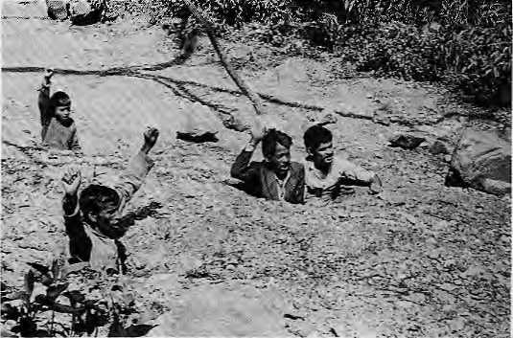
Activists "sit in" on a hill road used by trucks carrying quarried limestone in Doon Valley.
The success of the Doon Valley case was built on several strong points. The ecosystem study gathered objective information on the ecological dislocation from those people who were affected. This liberated the meaning of ecology from fashionable concepts of scenic beauty and connected it instead to human rights and to basic resource needs. The scientific information generated by the ecosystem study was most competently used in the courts.
Notwithstanding the scientific competence, the case would probably not have been accepted had not Justice P.N. Bhagwati interpreted "right to life" in a holistic and ecological way. And even when it was admitted, the case would not have drawn the interest of the Government if the people of the Valley had not continued in their protests. During the process, the villagers became so highly informed about scientific and ecological matters that they challenged Government officials who tried to be evasive.
Their victory at the courts placed before the people of Doon and the administration the question of what is to be done next. It is easy to identify ecological damage by some economic activity, but it is difficult to identify and carry out only those activities that are ecologically sustainable. The Court's judgement has pushed the people to think ahead and to search for alternative ways to live and develop.
Jayanta Bandyopadhyay is presently with ICIMOD in Kathmandu. He recently published a detailed case study on environmental management in Doon Valley,

Jan/Feb 1989
HIMAL
33

VIEWPOINT

What is Missing In Mountain Development
By Mahesh Banskota"
Like the waters that rush down these mountain slopes, many other things seem to have a penchant for moving down and out of the mountains -- the soils, the people and even the economy. Against these powerful currents of nature and the market, present-day development appears to be a feeble counter force. Everyone's complaint these days has been the rapidly escalating costs and the negligible benefit of development programmes.
What is probably worse is that development forces are themselves beginning to trigger a whole new set of, what some see as negative, consequences. The most notable of these are the effects on the fragile hill environment. Roads have increased deforestation and denudation of hillsides, leading to frequent landslides, greater penetration of the market economy, and the consequent dislocation of traditional employment and income opportunities, and in some cases even increased inequality. The effects of energy projects are less well known. Education and training have encouraged "out-migration" of younger minds. Rural development projects are said to have created a dependency syndrome amongst the hill people.
Time and again, dedicated efforts have resulted only in sporadic successes. However, because of the physical and socioeconomic factors unique to the mountain space, the few successes have not been easily replicable. They have a low "demonstration effect".
Given the difficulties encountered in mountain development, what lessons are there to be leamt? Are many of the so-called negative consequences of development projects totally bereft of positive elements? Or can any of these difficulties or obstacles be turned into positive assets as forces for change?
No matter how the different development ideologies interpret ongoing changes in mountain areas, problems such as those of unemployment, rampant rural poverty, environmental stress and migration, are quite similar to the experience of other societies. The difference is one of degree, not of kind. If the experiences are similar, then there is obviously a lot to be learned from the history of development as a whole.
Many of us admire the hill farmer for having historically surmounted innumerable odds and succeeded in taming a rugged and difficult environment. But at the same time we also question the very future of hill farming. We tend to forget very quickly that it is the farmer living in these mountains and hills who changed them yesterday and is fully capable of changing them tomorrow also. In spite of the fragility of the mountain environment, its carrying capacity has been substantially increased over the centuries by the ingenuity of the hill farmer. Like everywhere else, that carrying capacity can be constantly modified through better management and the development of human resources for harnessing new technology.
The hill farmers' capability to innovate is as strong today as it always was. This is evident from the different adaptive strategies they use, for example, in fuelwood consumption, livestock management or terracing. However, these adaptive
strategies are too slow and limited at a time when the external forces of change are so immediate and overwhelming. Under such circumstances, the tides of change can only be tamed through the development of human resources, so that the villager has the technical and managerial skills to overcome the challenge of rapid change.
Human resources development has lagged sorely behind in Nepal's hill development experience. Until such times that the technical skills of the hill people arc more fully developed and harnessed, the bulk of the infrastructure development like roads, and power projects can only provide momentary impulse of one-shot changes. In order to be sustainable, there must be a dynamic process of innovations and this is rarely possible without better human resources. So many development aid projects have been lopsided in this fundamental respect. They provide assistance for infrastructure building and for taking care of short-term problems, but they neglect the development of the human side. As the old saying goes, spoon feeding in the long run teaches us nothing but the shape of the spoon.
Mahesh Banskota is Chief Programme Coordinator at ICIMOD.
The Perils (And Promises) Of Environmental Extremism
By Ramachandra Guha
Much water -- most of it polluted — has flowed under the bridge since the Stockholm Conference of 1972, when most non-Western Governments rejected environmentalism as a Western fad. However, there is now widespread recognition that environmental degradation is pervasive in the Third World, where deforestation, soil erosion and various forms of pollution are affecting the lives and livelihoods of hundreds of millions of mostly poor people.
The history of colonial exploitation, population pressure and continuing economic dependence on the West are some of the reasons why the ecological crisis in the Third World is an issue of survival. An exaggerated concern for the protection of pristine habitats, while continuing resource-wasteful lifestyles, is the form of "environmental extremism" most characteristic of Western environmentalists.
In India over the past decades, three distinct ideologies have emerged within the environmental movement. The first, deeply influenced by Gandhiism, views environmental degradation as a moral problem caused by the ideology of materialism, which draws humans away from nature and encourages them to consume more and more resources. Gandhians argue that the essence of Eastern cultures is their relative hostility to economic trends — and that by adopting Western models of industrial development, India is, in effect, abandoning its cultural roots. They call for a return to the pre-coionial village society, which they uphold as the exemplar of ecological and social harmony. Their practical emphasis, meanwhile, has been on raising consciousness, in carrying their message of moral regeneration across the country and, indeed, the globe.

34
HIMAL • Jan/Feb 1989

VIEWPOINT

The second trend, in many ways the polar opposite of the first, is Marxist in inspiration. Marxists see the problem in political and economic terms, arguing that it is unequal access to resources, rather than the question of values, which better explains the patterns and processes of environmental degradation. In a sharply stratified society, the rich destroy nature in pursuit of profit, while the poor do so simply to survive. The creation of a more economically just society, therefore, is a logical pre-condition of social and ecological harmony. In their practical emphasis, Marxists concentrate on organising the poor for collective action and working towards the redistribution of property and wealth, which is their larger goal. Far from opposing industry, Marxists believe that in a socialist society, industrialisation can proceed much faster and without the byproducts one associates with it in its capitalist variant.
Gandhians and Marxists can be seen as the ideological and political "extremists" of the Indian environmental movement. In between, occupying the middle ground, are a number of environmental groups which are striving for a balance between industry and agriculture, West and East, consciousness-raising and political organisation. However, in their practical emphasis, these groups have focused more on constructive work at the local level, specifically on programmes of eco-restoration and generation of environmentally benign "appropriate" technologies.
All three ideological tendencies are present in the most famous of Third World environmental initiatives -- Chipko. The Gandhian trend, associated above all with the inspirational figure of Sunderlal Bahuguna, is perhaps best known outside the Himalaya. The Marxist trend within Chipko is represented by the Uttarakhand Sangharsh Vahini, a youth organisation which has coordinated several militant movements in opposition to commercial forestry, unregulated mining, and the illegal liquor trade in the hills. Finally, the "intermediate" strand is represented by the organisation under whose auspices the movement began, the Dashauli Gram Swarajya Sangh. While advocating an alternative strategy of economic development, which would be more labour intensive and energy conserving than the present model, the Sangh workers quickly realised that to consolidate the gains of the movement, struggle must be followed by constructive work. In the last decade, they have organised a major tree-planting effort in which — strikingly --the leadership was provided by women, and the survival of saplings has been very high.
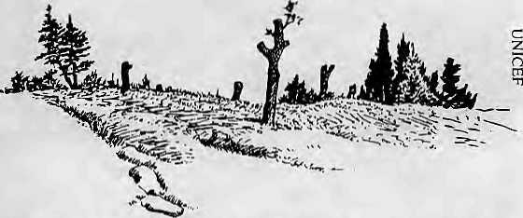
Because of their ideological purity and internal consistency, the arguments of the Gandhians and Marxists are compelling {though to different sets of people). They are able to capture the rhetorical high ground in a manner that the third, more eclectic, strand cannot. The perils of environmental "extremism", on the other hand, lie in the inability of both Gandhians and Marxists to see alternate points of view or, indeed, to change their own point of view to keep up with
changes in the social and natural environment. The promise of environmental "extremism" lies in keeping the third strand constantly on its toes. Without the Gandhians, the intermediate strand would lapse into the belief that appropriate technologies can be implemented without any change in values, and without the Marxists, into the hope that it can be done without changes in the distribution of power.
As readers would have guessed, 1 find the third strand (although, at least in this article, it goes without a name!) to incorporate the most balanced assessment and the most fruitful programme. Yet, the Gandhians and Marxists are playing an invaluable pan in widening the horizons of the debate. Environmental "extremism" has both perils and promises, although its opponents see only the former, its votaries the latter.
Ramachandra Guha recently moved from the Indian Institute of Science, Bangalore, to the Institute for Economic Growth, Delhi University.
An SOS From Dhaka
By B.M. Abbas A.T.
Every year, uncontrolled flooding in the Brahmaputra and Ganges river basins results in loss of life, damage to crops, dwellings and other properties, contamination of water supplies, the spreading of waterborne disease and disruption of orderly social and economic progress. Despite the building of barriers, dikes and levees to protect against flooding, major Hoods continue to cause extensive damage and prevent full utilisation of the land. Attempts to clear and maintain river channels, to assure the passage of water without obstruction, and to protect river banks and embankments with "river training works" have proven expensive and only marginally effective.
The future trend is likely to be one of increased flooding. Changes in the catchments beyond Bangladesh's northern and eastern borders — caused by deforestation and more intensive !and use — are increasing the sediments carried by rivers and leading to bigger and bigger floods. Concurrently with the floods, the south-west monsoon winds raise the mean tide levels in the Bay of Bengal, reducing the slope and, hence, the rivers' discharge. Other factors which contribute to flooding are heavy rainfall, flat topography of the land, siltation of riverbeds and development of the flood plains.
It is clear that flooding is on the increase year by year. There was a severe flood in 1987, followed in 1988 by a flood of catastrophic proportions. It surpassed all previous records in terms of water levels and the extent of inundation (see Nov/Dec Himal), Almost three-fourths of the country, including Dhaka, went under water. Hundreds lost their lives, railways and roads were washed away, and the loss of major crops was nearly total. Bangladesh's economy was crippled.
While flooding in Bangladesh has long been viewed as a natural phenomenon, a combination of human factors appears to have created and exacerbated the country's vulnerability to flooding. Most experts consider that the major manmade cause is deforestation in the catchments of the major rivers lying in Nepal and India. The upstream developments, including the Farakka Barrage on the Ganges about 11 miles upstream from the. border, also contribute significantly.

Jan/Feb 1989
HIMAL
35

VIEWPOINT

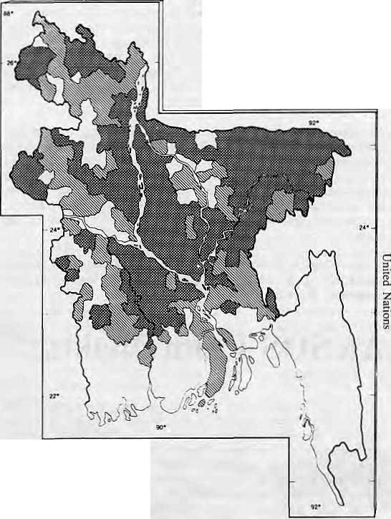
BANGLADESH 1988 FLOODS
Fully aBcctea upazilas Partially aflectw) upaalas
The control of floods requires regulation of monsoon flows. There is no possibility of storing water in the low lying delta of Bangladesh. Storage reservoirs can only be created in the hills, suitable sites for which exist in Nepal, Bhutan and India. Besides controlling floods, such storage dams will also provide for flood control, generate hydropower, augment dry season flows of rivers, allow navigation, and assist in various ways the agricultural, forestry and mineral sectors in the river basins.
About a tenth of mankind lives in the Ganges and Brahmaputra basins, among them a quarter of the world's most poor. This, despite the fact that the two basins have rich alluvial soil and tremendous energy potential in the river flow, as yet almost untapped.
The rising population is putting serious strains on resources and the question of simple survival looms large. Environmental destruction is taking place at a virtually irreversible rate. Unemployment and social tensions are growing rapidly. The time for regional action for water resources development is
B.M. Abbas A.T., an engineer by training, has worked on
the Ganges- Brahmaputra water system for
decades and has served as Bangladesh's Minister for
Water Resources. He has represented Pakistan and, after
1971, Bangladesh, as chief negotiator on water talks with
India.
The Viewpoint section is a forum for debate and dialogue. Contributions are welcome. Opinion expressed here do not necessarily reflect the point of view of Himal's editors, or of the institutions with whom the writers are affiliated.

A special feature of the 1988 flood was that the flow in the major rivers peaked within days of each other. Generally, the Meghna is at its highest in May-June, the Brahmaputra in July- August, and the Ganges in August-September -- with a time lag of 15 to 30 days between the peaks. In 1988, the Ganges achieved its peak on 31 August and the Brahmaputra on 2 September. The Meghna recorded its highest level on 10 September.
This unusual occurrence may be the result of some upheaval in the Himalayan region. Most probably, it was the result of extensive deforestation in the catchment area. The effect of topsoil washing off the Himalayan slopes is into the rivers is thai the carrying capacity of the rivers is drastically reduced. The vegetal and tree cover binds the soil and acts as an absorber of heavy rainfall. When this cover is removed, the torrential which pound the region during the monsoons can cause havoc.
Development of the river channels upstream have further compounded Bangladesh's water problem. The flood embankments constructed along the rivers prevent the rivers from spilling over into natural storage areas. Control structures built on the major rivers and their tributaries add to the problem. The Farakka Barrage, in particular, poses a dual threat to Bangladesh. On the one hand, during the dry season, a large portion of the Ganges water is diverted into the Hooghly, drastically reducing the Ganges' flow into Bangladesh. On the other hand, during the monsoon, there is a sudden rush of water into Bangladesh when it is already facing flooding conditions.

We offer you a --■-
wide range of scholarly books
on NEPAL, TIBET, SIKKIM, BHUTAN
Large collection of MOUNTAINEERING BOOKS
Variety of
TREEKING BOOKS & TREEKING MAPS
APA Guides & APA Nepal Map
And Y E S !
Complete selection of
SCHNEIDER MAPS OF NEPAL
HIMALAYAN BOOKSELLERS
Ghantaghar - Clock Tower
(next to Nataraj Travels and Tours)
G.P.O. BOX NO. 528, Kathmandu, Nepal
we accept
AMERICAN EXPRESS VISA CARD & MASTER CHARGE.
Telephone: 225484, 418666

36
HIMAL
Jan/Feb 1989


PUZZLE
By Karas Warad
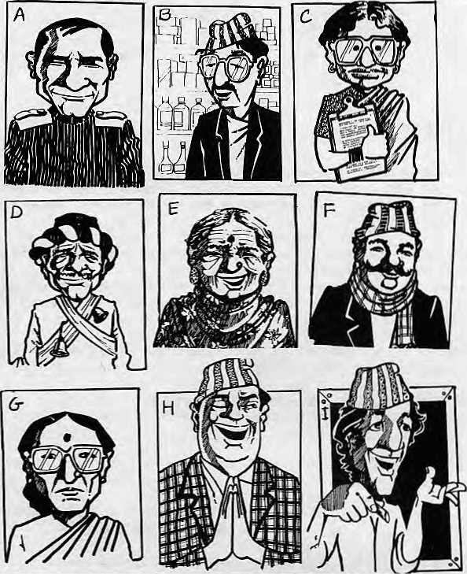
WHO'S WHO IN DEVELOPMENT
Artist Naren Basnet made these sketches for UNICEF. Each of these individuals is involved in some son of development activity. This puzzle requires you to match each picture with one of the following professions:
Daklarsaheb
I skul Ma star
Raajnitigya
Bajar Bisesagya
Udhyogpati
Gayika
Swastha Karyakarta
Exsarbhismyan

Panditbajey Radio Prasarak Majdur Sangathan Neta Pradhan Pancha Sundini
Swastha Swayansevika Bwai Iskaut
Dhami
=1
JnoqEi)
UEqpB-lJ)
:il :O d ■E
■a •o
paiija^i) uE^uiBiqqjesxg :y
■aaMSNV


Inverted Commas
"Beyond Kashmir there are countless peoples and hordes, paragnas and cultivated lands, in the mountains. As far as Bengal, as far indeed as the shores of the great ocean, the people are without break. About this procession of men no one has been able to give authentic information in reply to our enquiries and investigations. So far people have been saying that they call these hillmen kas." Mughal Emperor Babur, in Babur-Nama, his memoirs which were written in the 1520s.
"...it is arguable whether the merits of major projects should be assessed purely from the point of view of the environmentalist. It is through large irrigation and power projects and major industries that a strong resilient economy was built in the country (India) in the years immediately after independence. These projects were viewed as temples of modern India. The objective of our planning has been the economic and social development of the people. Along the way, often, hard decisions have to be taken. Should a project with sizeable economic potential be abandoned if it dislocates a few, but enriches the lives of many? The answer here would be proper rehabilitation of those affected," Editorial in the National Herald, New Delhi.
"The Ganges is not merely water. The Himalayas is not a heap of rocks, stones and soil. Lord Krishna Himself had declared: I am the Ganges among the rivers; 'I am the Himalayas among the immovable things.' The Ganges and the Himalayas are God Himself. Any harm done to them is like harm done to God. Have you ever thought over what crimes we are committing? To serve the Himalayas is to serve God." Swami Chidananda in The Chipko Message, a new publication.
"It is 38 years now since I first visited Nepal and I have developed a deep affection for the country and its people. And yet in all honesty I have to admit that there are few places where tourism has been so gravely abused. Impelled by a relentless urge for financial gain, tourism has been encouraged far beyond the ability of the country to absorb it. Forests have been denuded, tracks covered with litter, mountains cluttered up with leftover junk. Any yet somehow, despite it all, the country is still beautiful, there is still so much to see," Edmund Hillary, at an adventure-tourism conference in Kathmandu in January.
37
Jan/Feb 1989 • HIMAL

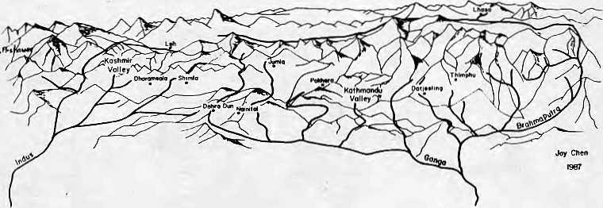
HIMAL ASSOCIATES
Himal Associates is a non profit group whose objective is to provide a citizen's forum for discussion and action on all areas of Himalayan development, including public health, the economy, environment, education and culture.
Himal Associates publishes the magazine Himal because it believes that communication and dialogue are critical for development. Public information is one of the scarcest commodities in the region and its lack hinder progress.
Himal Associates
P.O. Box 42
Lalitpur
Nepal Tel: 5-23845
HIM^L
JOIN HIMf>L !
Himal is an open-minded, independent publication devoted to the Himalayan region, tts news beat extends from the Pakistan Hindukush through Kashmir, Ladakh, Himachal, Kumaon, Garhwal, Nepal, Sikkim, Bhutan, the Indian North-East, and Tibet.
At last, you have a magazine to turn to for objective reporting and analysis of trends and events affecting Himalayan society. In its coverage, Himal espouses practical approaches to social and economic challenges in the region. It emphasizes the need to use and preserve the fragile environment for the people who live here.
Himal is current. It is readable. And it is serious. It is indispensable, if you want to keep in touch with the region.
Join us. Please send back the attached slip with your payment to receive six issues of Himal a year. Send Himal as a gift to a friend or colleague.

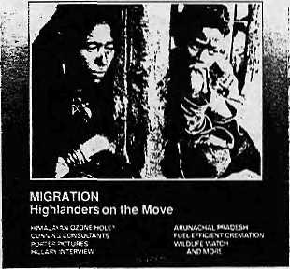
A limited number of back issues of Himai are available. Please write in for information.
ANNUAL SUBSCRIPTION RATES (SIX ISSUES)
Individual Institutional
South Asia Elsewhere
NRs 110/IRs 65 U$ 25
NRS 300/IRs 200 (or equivalent) U$ 45 (or equivalent)
Personal checks acceptable, bank drafts and money orders preferred. Address subscription orders and correspondence to:
In South Asia:
PO Box 42, Lalitpur, Nepal, or
Central News Agency, 23/90 Connaught Circus, New Delhi 110 001
In North America: 4 South Pinehurst Ave. #6A, New York, NY 10033
In Europe:
- B.Welsh, Holos Centre 139-A, Battersea High St. London SW1 (for UK)
- LDebuck,Donaustr.38, D-4100 Duisburg 29, W. Germany (FRG, NL, B)
- A.Odermatt, Winterthurerstr. 112, CH-8006, Zurich, Switz. (rest of Europe)
- C.Euler, Hagelerweg-7, CH-8055 Zurich, Switzerland (general info)

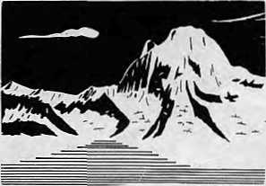
Pabil 7102ra
Please enter a subscription for me. I have enclosed payment of one year/two year subscription to Himal.
Name Street Town Country
Postal Code
as a

38 HIMAL • Jan/Feb 1989


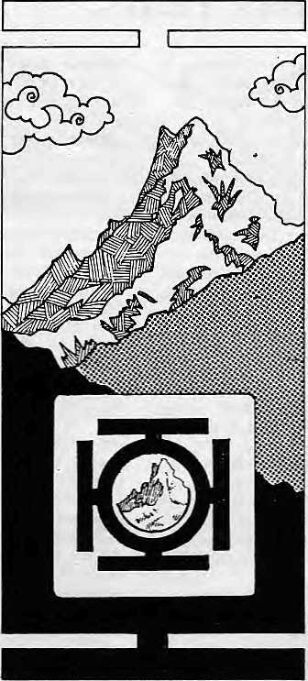
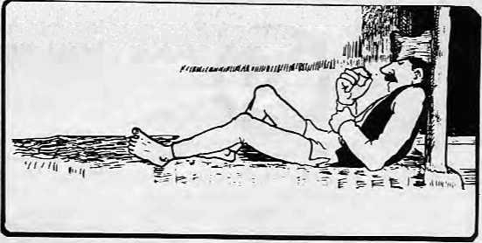
33
m 7;
YOU CAN EITHER LAZE AROUND
OR YOU CAN READ HIMAL
Ang Kami Sherpa of Kathmandu, having sent us the first
completed Karas Warad Puzzle, receives a year's
subscription to Himal
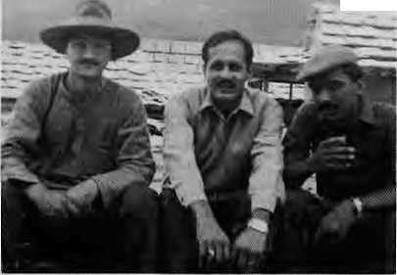
Kartak Mani Dixit We would like our readers to know that Himal is not just an environmental magazine. To clarify, Himal is a magazine on social, economic, cultural and environmental matters which affeel and afflict the people of the Himalaya. Treating this magazine only as an environmental advocacy bulletin restricts its reach and does less than justice to the enormously complex development issues our reporters and writers grapple with.
Since we never claimed to be devoted solely to ecological issues, it is interesting to speculate why we are so often pegged into that slot. One reason must be that concern for the "environment" is the fad of the moment for many journalists, administrators, development pundits and, yes, environmental gurus.
It is our view that the word "development", through overuse, has become invisible in South Asia. From the town of Galle on the southern rib of Sri Lanka to presently snowbound Leh in Ladakh, eyelids begin to droop the moment they spot the First "d" of development. So it does not help that HimaS's masthead screams "For Development and Environment". People simply
skip over the first word and end up with "environment". That is how, again, we end up being thought as an environmental journal.
The point being made, I hasten to add that we certainly have no intention of ignoring ecological issues. In reporting on the Himalayan environment, we encourage our contributors to question received wisdom and we welcome debate. There are several thought provoking articles in this issue, on illegal fur trading, high dams in the Himalaya, the Doon Valley judgement and "environmental extremism". There is enough cud to chew on here till our next issue arrives at your mailbox.
It is time to welcome and to bid farewell. Welcome to Vidya Stokes, Speaker of the Himachal Pradesh Legislative Assembly as Advisor to Himal. We look to her and others to guide us as we strive to provide increasingly comprehensive coverage of the entire region.
Farewell to George Me Bean of UNICEF Kathmandu, mastermind of the Noon Chini Pani information campaign (see Mail section), and designer of Himal's distinctive logo. We are glad, however, that the magazine has gained a reader in Barbados, which is where his next assignment takes George.
Sanjeeva Pandey is District Forestry Officer in Sarahan, Himachal Pradesh. Che tan Singh teaches history in Shimla and specialises in Medieval India. Laxman Thakur is a lecturer whose passion is studying pagoda style temples of the
-,,..,. .-.,..„.■
Himalaya. What do they have in common? That they are together, left to right, in this photograph, and that they simultaneously joined as subscribers to Himal in January. Welcome! A
SPECIALIST;
N1
Q
and
Til
RQ Box 4573 Kantipath Kathmandu Nepal Tel2i47C0. Tlx:2272 KOSHI NP Art :Manda',a Trekking

 |  |  |  | I
Ml |  |  |  | i
MA | ^l£l/ I^Vi£ | Ml |  | 'i? ■
Mm |  |  | J | //
'frlAMPlaMYI/lcM |  |  |  | a
 | IBm.- .--
 |  | MA
 | K_VL9 | V " | a | IT.
^{i}yrmmt\H\i\p\K]o\ |  |  |  | ■
SET |  | If |  | I
 |  | Rl/
HIMAL
39
Jan/Feb 1989

Abominably Yours,


ARE you still
AN) AXE?
hard-held fewer saws, 4nd chop <Jew>, _{A} fully o thir pine in F seconds flat T
All development projects need targets, which have to be fixed and then, unfortunately, met. In Nepal, the whole process of making and breaking targets has been streamlined and made painless. It is difficult not to be impressed. Target practice makes perfect, they say, and here's how.
Fixing a target: A meeting has been called for setting a target for artichoke production in the coming fiscal year: Secretary: The next item on the agenda is artichokes.
Chairman: What in heavens is an artichoke?
Member Ka: Sounds like a diesel engine spare part.
Secretary: No, this is a vegetable that can cure hunger. We've got a ten million rupiya grant assistance to propagate artichokes. Member Kha: How much of this tarkari isabjl) does that buy? Secretary: Three hundred artichoke plants for an experimental farm in Langtang. The rest of the money will be spent on acquiring overseas artichoke consultants.

fffirJB
Chairman That sounds like a good target. Three hundred it is. Member Ka: Excellent. Even if half the artichokes don't grow, that will still leave us with a 50 per cent increase in artichoke production over last year!
Member Kha: Yes, that wi!l look good on paper. Especially because the other SAARC countries have nil production of artichokes.
Meeting the target: The maize situation does not look so good. Production has fallen below target. Chairman Yes, maize. That is a tough one.
Secretary: Production fell last year by 16 per cent. There is an accumulated shortfall in our plan target of over twenty per cent.
Member Ka: I propose we maintain our target for next year and send a directive to farmers that we also want the shortfall recouped.
Member Ga: Yes, make it a strong directive. If next year's target can't be met, we can fix that next year. The important thing is to have targets.
How to show you've met target: Ingenuity is called for during the Evaluation Meeting.
Chairman All right, all right, I know half the fanners in the target population did not even get to see the improved seeds — what I want is a selective percentage of what was achieved. Secretary: {reading off his calculator) Of the five people who received the seeds, three doubled their harvest. Member Ga: Marvelous! We've overshot our target by 30 per cent!
C
And so onward to sustainable development. Another path is through use of our vast repertoire of superstitions. Let "Superstitions for Development" be the the slogan and 1991 be the SAARC Year of the Rudlbaad. UNESCO could appoint a consultant to the Ministry of Culture in order to synthesize superstitions for developmental use. Fresh superstitions could be broadcast via radio and oral history projects could collect superstitions that are on the verge of extinction. A Superstitious Commission must be set up to study the matter on auspicious days and present re commendations.
The vast power of superstition is indicated by recent reports that someone, known to have teased the holy snakes of Chabhil (Kathmandu suburb) five years ago, vomited blood, spun around three times, and died. No one has dared lease those snakes after that.
Think of the possibilities. Take population control. The Superstitous Department, coordinating closely with the family planning people, could spread a vicious rumour that the number three has suddenly turned bad, especially since the Chabhil Snake Caper. Henceforth, every third child, if a son, would grow up to be a dacoit.
Superstition should be used against official corruption. Did you know that fingers which handle ill gotten cash, cheques or commissions under the table are now liable to catch a new strain leprosy bacterium?
Over across the border in Garhwal, Chipko men and
women tired of hugging trees could spread stories of the dreaded Serpent Goddess. She would be incarnate of a young deodar, Princess of the Forest, who was chopped down in cold sap by a contractor from Kathgodam. Ever since that fateful day, so the story would go, the Serpent Goddess has slithered across the hills of Pauri, ever on the lookout for those that would make railway sleepers out of Garhwali woodlands. Just watch the miraculous regeneration of those woodlands.

1 met a commission agent recently who could appropriately be sacrificed at the altar of the Serpent Goddess of Pauri. He sells the Woodpecker Power Saw, guaranteed to "chop down a fully grown chir pine in five seconds 0at"A

40 HIMAL • Jan/Feb 1989

The most fantastic range
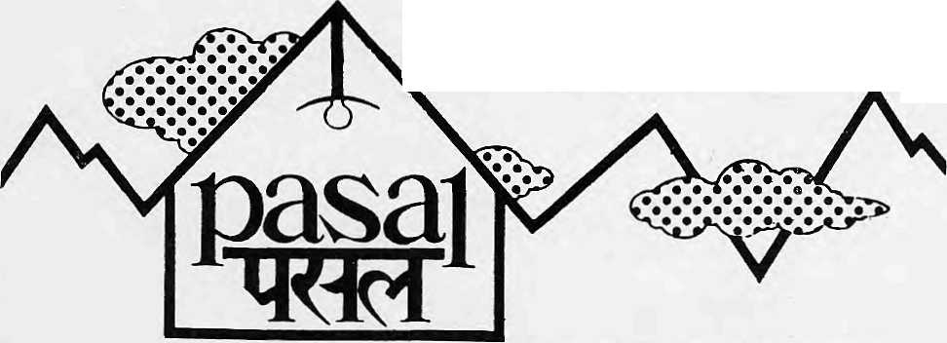
this side of the .Himalayas!


Pasal — Katmandu's top shop lor high quality hnmf products and Tun fashions. Linen, crockery, dtiaris, lamps, stationery, toys. bric-a-bntc and oodles more. Whatever you're looking for, I'asal has a nice surprise in store for you. Drop in today for a great new shopping experience.
nay a pasal
Sakyo Arcade, Darhar Marg, Kathmandti, Nepal

v

40,000V ft. BAR....
Where the ^
are as tall as the mountains
Succulent steaks and burgers taountifuLwith a vegetarian variety. Thefriendjiest bar around the most
convivial fireplace in town.
Rum doodlE
THAMEL, KATHMANDU, NEPAL
WE TREKEVEREST
EVERY WEDNESDAY S
ANNAPURNA EVERY FRIDAY
We tcke care of all your arrangement5_{r}regu!ations,
the hiring of guides and porters food and equipment-at the eleventh hourtoo
Himalayan Journeys cp
Kantipath, Kathmandu-Nepal Tel. 226138, 226139



Regd. No. Lalitpur 65/045-46
An exclusive experience of 'Shangrila¹ awaits - , : on board pur new BOEING 15V '

• 'Shangrila' Executive Glass, as the name'. suggests^ is For the peoplewho look upon travelling as'a firieart Where e^erythlng.;has been so meticu!ously:selected that it will 'give ⁽a new flying experience amidst tranquil .setting.- "

: The |ubt]e decor and distinctivejriflight ■ services perpetuated frorn'the femous hepalese: ■ tradition; will be a-classic experience you shall ■■ \ enjoy ori destinations betweeh;Hongkorig: ' Kathmahdu-Delhi'BangRdk & Singapore^""


Royal Nepal /Airlines
' '■ T ■ ■- '" :■ ^{T} !: il ■ - - ■ ^{L} I' *
Hie way to Nepal

