:i NRS20

■
ri'V'":''-: • •■■••","::•',■
IJlgjii;;--:-;®
i;;;:ISSN :i 01:2-9804
MAR/APR 1989

IRs12 iU$6

FOR DEVELOPMENT AND ENVIRONMENT
.:. ".I^{:I}... ".I''''.:: ".:■'" ::''':.: "./'.:?'.:?':: " !^'::'".:/■::' '■:"■■"■'■:'■'" : ' ■■■ - - - " ■ ■■ ■■ : ■ ": :■ :■ " .' " "."■ " " :: . " ■" " . " .".."..".■■.■■.■■ I ".."."*" -'. .'- ". " ^ \.~ .1'.. " " " ~.~ I." ". " * ~~ '/.".. '. *"■" '.'". ~\ ..'"."... I
., .- / ,„'./■..:=".: :■ :: ■ ■ .::::-.:■:■:■■■■•_■■_.■■_■■_■■_ " :: .■„"..■. : ~ \'~ . L- .: " V i:" " ■ - '■'-■"■"■■- ■■.: ....... .: ■■ - ...:.-. . ■■ ■■ ■■■ :-..-.:„ g - ■ ... ■ :.::-.. f.:-::- ■■:..: !, :

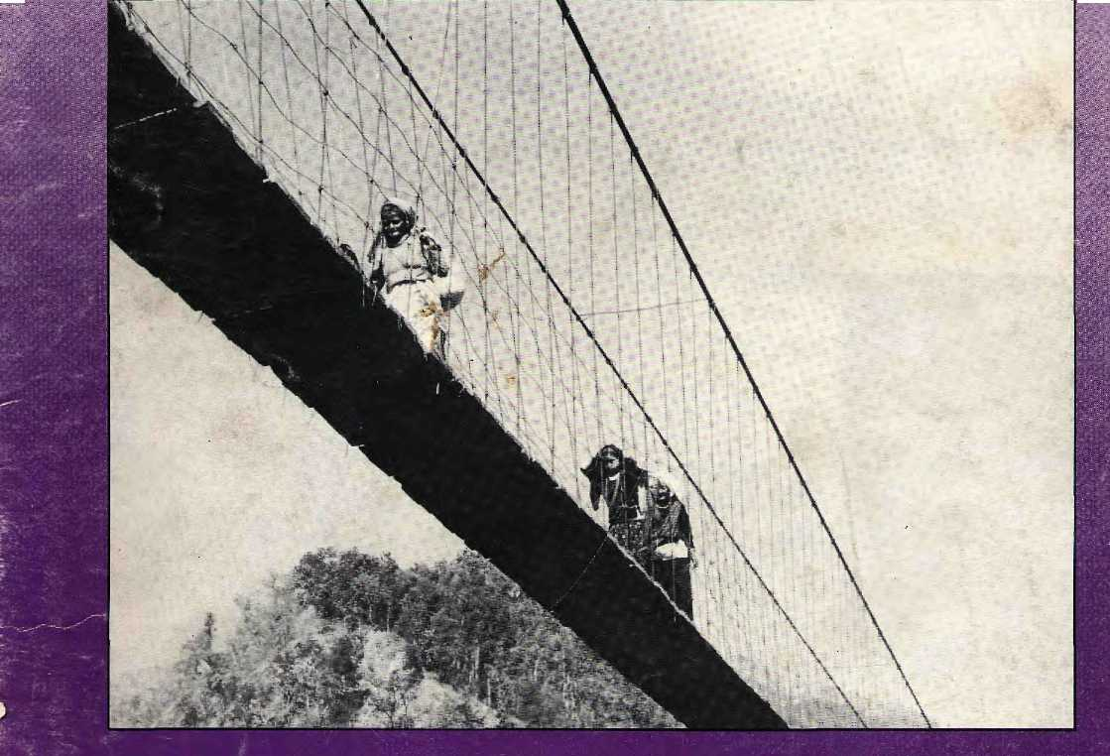

ECONOMY AT STANDSTILL PROSPEROUS HIMACHAL FOR & AGAINST EUCALYPTUS
BAGLUNG BRIDGES QUIT SMOKING RUBBISH MOUNTAIN


INSIDE

Vol. 2 No. 2 Mar/Apr 1989

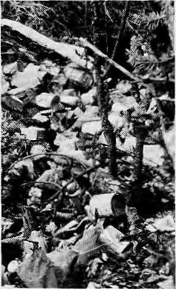
3 Baglung's Bridges
6 Cigarettes for the Masses
8 Prosperous Himachal
18 On the Garbage Trail
20 PHOTO ESSAY An Economy At Standstill
27 Debate Over Eucalyptus
The Abode of Gods, King of
Mountains, Himalaya
You bound the oceans from the
east to west
A northern yardstick
To measure the Earth
- Kalidasa (Kumar Sambhava)
Edited and Published by Kanak Mani Dixit
for Himal Associates

VIEWS

On Privatisation Gandhiji Said So Rabbits, Hillmen
and Muddy Rivers Education For Work
5 INTERVIEW
12 BRIEFS
15 FOLLOWUP
16 REVIEWS
18 CLIMBING
- DAM NEWS
- PARKS, WILDLIFE

- GRASSROOTS
- MEDIA
33 ABSTRACTS 36 ABOMINABLY YOURS
Acknowledgement
This issue is made possible in part by grants from the World Wildlife Fund USA, and the Royal Norwegian Ministry for Development Cooperation.
Cover picture by John Issac, United Nations photographer, shows village women crossing suspension bridge in western Nepal. See also Page 3.
Himal (ISSN 1012-9804) is published six times per year by Himal Associates,
P.O. Box 42, Ulitpur, Nepal, Tel: 5-23845 © Copyright 1988. Please turn to
page 24 for subscription and other information.
Kesang Tseten
Associate Editor
P. Sudhakaran
Picture Editor
Advisory Panel
M. Abdhullah, University of Peshawar,
Peshawar
Adlai Amor, Magasasay Foundation,
Manila
Anita Anand, Inter Press Service, Rome
Kinley Dorje, Kuensel Weekly, Thimpu
Harka Bahadur Gurung, Kathmandu
Corneille Jest, Centre National de la
Recherche Scientifique, Paris
Prem Shanker Jha, Commerce, New
Delhi
Bharat D. Koirala, Nepal Press
Institute, Kathmandu
Ram Chandra Malhotra, International
Fund for Agricultural Development,
Rome
He man t a Mishra, King Msihendra Trust
for Nature Conservation. Kathmandu
David Sassoon, Earthpost, New York
Kumar Khadga Bickram Shah, Centre
for Nepal and Asian Studies, Kathmandu
Donald Shanor, Columbia University
School of Journalism, New York
Ambica Shrestha, Nepal Business and
Professional Women's Club, Kathmandu
Vidya Stokes, Himachal Legislative
Assembly, Shimla
B.G. Verghese, Centre for Policy
Research, New Delhi
Brian Welsh, The Holos Centre,
London

MAIL

TASMANIAN ADVICE A si someone who works for the conservation movement in the island of Tasmania, Australia, I was pleasantly surprised by the level of ecological awareness in the Himalayan region. Himal seems to be an integral part of the area's understanding about development and the environment. I must, however, take issue with the article on Bhutan's new Chukha hydroelectric scheme (Nov/Dec ),
Your article could not heap enough praise on the Chukha scheme, but only really looked at it in terms of its engineering feats and how much gross revenue it was earning. No mention was made of what impact the scheme's IRs2,440 million cost will have on Bhutan's foreign debt, what the debt servicing payments will be like, how many locals were displaced by the dam, or how much sediment is likely to back up behind the dam. In short, the article provided a pretty blinkered analysis of a very controversial type of development.
Like the Himalaya, Tasmania is very mountainous and has massive hydroelectric potential. We have been developing that potential in earnest since the Second World War with the result that we have dammed all but one of the state's majestic wild rivers. The state also has a massive debt and precious little employment to show for it all. Countries like Bhutan have the opportunity to learn from our mistakes.
I really adore the Himalaya. Its people and its mountain wilderness have a wealth that most people Ln western countries have never known. But it really makes my heart sink to hear the same old disastrous development tunes being played again. Please take the opportunity to learn from the west's mistakes. Greg Buckman Tasmania, Australia
HIMALAYAN HIGHWAYS
I would like to inform your readers that an important thrust of my Viewpoint article {Jan/Feb) was altered during its editing. The article dealt with the effects
and threats of roads on development in the Nepal Himalaya. In my draft, I had implicitly stated several times that it is impossible to give a definite, final assessment since road impact is a matter of decades. What I was discussing, and this is important, was preliminary empirical evidence derived from a brief experience of only five years. Keeping these methodological difficulties in mind, I pointed to the need to reckon with the worst possible scenario rather than with the best possible or desirable. My point has been that in building roads under Nepali circumstances, one has to reckon with the possible negative effects.
To clear up another possible misunderstanding, the article was not based on a study carried out for ICIMOD in Kathmandu, as the blurb at the end implied. While 1 was for a period a "visiting research scholar" at ICIMOD, there is no formal link between the study and the Centre. Werner Thut Bern, Switzerland
END OF SEARCH
Your magazine is exactly the kind of publication that I have been searching for. I returned from Nepal one year ago after living there for three years, and I find that Himal really keeps me informed about events and issues concerning the Himalayan region. Public knowledge about South Asia is woefully limited in the United States. I am happy that I have access to as fine a magazine as yours. Piease continue to publish as interesting and unique articles as you have in the past. Cathy Marona Washington, D.C.
A PINE TOO IS A TREE
The article by Pandurang Hegde, "Women of Chamoli Fight Pine" (Jan/Feb), is one of many I have read recently calling the species into question. I am neither a farmer nor a forester, but an urbanite who dabbles in literature. But I feel that every animal, vegetable or mineral has something
good going for it, and so must pine. I quote her from Henry David Thoreau, American thinker, natural ist and powerful social critic (who, incidentally, also influenced M.K. Gandhi with his writings on civil disobedience): "...the pine is no more lumber than man is, and to be made into boards and houses is no more its true and highest use than the truest use of a man is to be cut down and made into manure. There is a higher law affecting our relation to pines as well as to men. A pine cut down, a dead pine, is no more a pine than a dead human carcass is a man....Every creature is better alive than dead, men and moose and pine trees, and he who understands it aright will rather preserve its life than destroy it." Debashish Mukhopadhayay Calcutta
SUBSCRIBE!
If you would like to receive Himal regularly, please turn to Page 24 for subscription information. Send your payment to any of our worldwide addresses.
SEEING RED
Your cover feature on the girl child (Jan/Feb) also had an opportunity to contribute an article, was pertinent and well focused. But I wonder if the choice red for the cover was deliberate or inadvertent. Red is taken as a woman's colour. Originally, it started out as the colour of fertility. As sources of fertility, various female deities of Hindus are offered red flowers, blood of sacrificial animals, and other religious accessories that are red in colour.
Down through history, however, red has come to signify women's subjugation. Today, a man claims a woman as his own by putting vermillion

Mar/Apr 1989
HIMAL


Views about Himal
By Siddiq Wahid
powder on her hair partition and forehead, and a red potay around her neck. Red is what the bride wears and it is the colour the woman has to give up upon widowhood. Manjula Girl
City University of New York New York
We too would want the colour red interpreted as a source of pride rather than a symbol of subjugation, Himal's covers are colour-coded, with JanlFeb red, Mar/Apr purple, and so on through grey, orange, green, and ending with blue in NovlDec. Editors.
NO ROMANTICISM, PLEASE
I have read Himal with mounting interest and admiration. If the present standard can be maintained, it will be a most valuable addition to existing journals, providing information not available elsewhere. It has successfully steered the middle road between "scientific" and "popular" journals, lending easier access to the kind of material the former carry and more accuracy to the material the latter carry. It should attract both experts and laymen interested in Himalayan issues. Coupled to this is the obvious intention to keep the journal fresh, providing the latest information.
IF I were to advise you, however, it would be to ask you to try to steer clear of environmental and cultural romanticism that has, unfortunately, taken the strength out of the arguments of the environmental movement. We may be moving away from that phase, which was all 100 evident a few years ago, a trend also noticeable in Himal. We must be aware of the fallacy of discussing present environmental processes against a wrongly supposed environmental state of "balance and harmony", a stale that has actually never existed. Ecological systems are always evolving, always unstable. The rate of change, of course, varies, and that is where the worry may be justified that the present pace is too quick. But this assumption, too, needs qualification, since there are signs that we have overestimated the suddenness of what is now happening around us. Hakan Wahlquist UN1CEF Udaipur, Rajas than
Readers are invited to comment, criticise or add to information appearing in this magazine. Letters should be short and to the point. They can be edited.
In Himal, Kanak Mani Dixit and his associates have conceived of a format to discuss "the life and times" of the pan-Himaiaya. It is a much-needed forum, and one that must be supported. Its identity is still being defined, and it is this topic that I should like to address here.
Himal, we are told, is meant to be "current", "readable" and "serious" (Nov/Dec). The thought should be to ignore the modernist imperative of being "current", to be "readable" without sacrificing content, and to take being "serious" very seriously. The magazine cannot betray its promise. Thus, the word "current" must not be a euphemism for "trendy" and the search for readability should not dilute puipose. I particularly cringed at the advertisement of the "eligible Tibetan bachelor, 32, living in the United States" who was seeking "a Tibetan match from Nepal, India or Tibet" (Nov/Dec ). Such material constitutes importing New York or Los Angeles to Kathrnandu or Thimphu. Let such content be left to magazines that seek to be exclusively "current". A publication like Himal ought to be dominated by the need to be serious, and currency must be accepted as the "necessary evil". Otherwise Himal, too, will succumb.
In order to define its purpose and find direction, Himal must address some hard questions: Who is it aimed at? Who is its speaking of and for? Perhaps the latter question is more important. And if the answer to it is that it is a forum that allows the Himalayan peopie to speak for themselves, then it is no more than an organ for the English-speaking-literate (but not necessarily educated) individuals. Such individuals, by a "strange dialectic of reinforcement", will only betray traditions, trample the community and hasten destruction, be it natural, cultural or mental.
The problems in the Himalaya are fundamental and deep. To quote the commendable extract front ah address by His Holiness the Dalai Lama: "We need to address our troubles at their root; within the human mind." (July 1988) A magazine such as Himal has the potential to bite into such advice, to address the causes that afflict the very soui of the Himalaya, not merely "inform" us of Its symptoms. There are lots of "jazzy" magazines, organisations and individuals doing the latter; Himal

should be a magazine that speaks and for that which is being destroyed.
I note that the possibility (if not yet the probability) for such an approach to Himal exists when r&ading that the magazine may decide on a theme for each issue. Such a decision would be a wise step indeed. And I would suggest that many, many themes could be preferred under the general headings of "Where have we arrived?" and "What is to be done?" in the Himalaya, be it in the realm of thought, or art or of the natural environment.
As for the question of "Who is Himal aimed at?" the fact that it is an English language magazine stipulates that if cannot pretend to address "the masses". They cannot read it; and if they were conveyed its content they would find it irrelevant. Rather, I tend to feel that Himal must address the English-medium instructed individual who has been made literate but is too often supremely uneducated. Such individuais spend too much time thinking and talking about their condition, and no time at all contemplating and doing something about it. The Himalayan population must heed the words of its common ancestor, Sage Milarepa;
Now the sun is setting Return to your homes. Since Life is short,
and death starts without warning, I who strive...
Huve no lime for useless words. Therefore, leave me to my
contemplation.
If we were to contemplate our situation more, we would see the Himalayan problems for what they really are, and in so doing we will have effected a change at the "root" of the malaise.
It is, of course, entirely probable that
a magazine that is inspired by the
thoughts set forth by the likes of
Milarepa will be too rigorous for the
modern mind and die a quick death.
But such a death would be a noble one*
and truly insignificant in the face of the
Great Dying that is being experienced
by the ^
Siddiq Wahid, who is from Ladakh, lives and works in New Delhi,

HIMAL • Mar/Apr 1989

Bridge-Building andBaglung's Blacksmiths
By Prakash Chandra Joshi and Anil Chitrakar

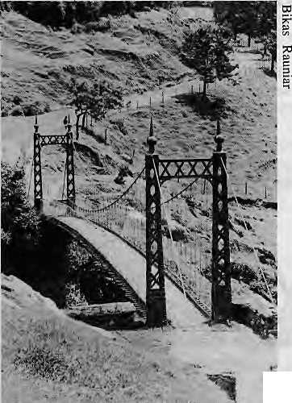
There was a time when, with great craftsmanship and skill, the village people of Nepal built their own bridges. Temporary spans were built with bamboo ropes, twisted vines and matted fibers, and lasted through the rainy season. Permanent suspension bridges were built by local blacksmiths, kamis, who used local ore to build strong iron chains which were linked together to span gorges more than 250 feet wide. With intuitive knowledge, and without help of surveyors and engineers, the villagers would choose the spot where the river cuts the steepest, where the banks were stable. The indigenous chain link bridges used no mortar or cement, and required no tempered stee! cables manufactured abroad.
■
Chandra Sumshere's Scottish Bridge.
Ironically, this tradition of indigenous engineering started to disappear when the Government began to take an interest in bridge building. The decline began when Rana Prime Minister Chandra Shumshere, who ruled from 1901 to 1928, first imported bridges from Aberdeen, Scotland. The first "government" bridge was built in 1907 in Khurkot over the Sunkosi River between Sindhuii and Ramechhap dist-ricts east of Kalhmandu. (The flood of 1985 destroyed this bridge.)
When foreign aid began to flow in the 1960s, the Government and foreign donors began looking to bridge building with renewed interest. They were guided by the development reports of Toni Hagen, the well known geologist and United Nations consultant, who trekked all over Nepal from 1953 to 1959. Yet, by his own admission, Hagen was all too ready to apply to Nepal the standards of his native Switzerland.
A sensitive advisor like Hagen, honored by then Premier B.P. Koirala as "a gifted observer and patient analyst", had failed to comprehend the appro-priateness of the centuries old chain link suspension bridges that stood so proudly and visibly, in the gorges of the midland mountains. Despite these total neglect in the rush to erect modern suspension structures, several of these old chain bridges are still standing, testimony to their durability and safety and to the craftsmanship of the villagers who built them. These traditional bridges have served the mountain people longer and better than recent highways, STOL airstrips and modern suspension bridges. And yet they are denigrated as "inferior" and "primitive". Over the past three decades, as expensive but quickly fabricated western imports replaced locally built bridges, the indigenous craft of centuries was allowed to go rusty — except in Baglung in central Nepal, where the people did not forget.
"LEARN FROM BAGLUNG"
In the 1960s and 1970s, western-educated Nepali engineers and American and Swiss advisors erected 43 "modern" bridges. Between 1975 and 1978, the people of Baglung built 62 traditional bridges. The Baglung bridges cost only NRs10,000 on the average, not counting the free labour provided by the villagers. The bridges ranged from 30 feet to 300 feet in length, and were deemed safe by the engineers who studied them.
While indigenous bridges were built elsewhere in Nepal too, Baglung's was the only instance of a large scale bridge building programme organised by the local people. Donor agencies such as UNDP, SATA, USAiD and the US Peace Corps were impressed enough to send delegations to discover Baglung's secret. "Learn from Baglung" became
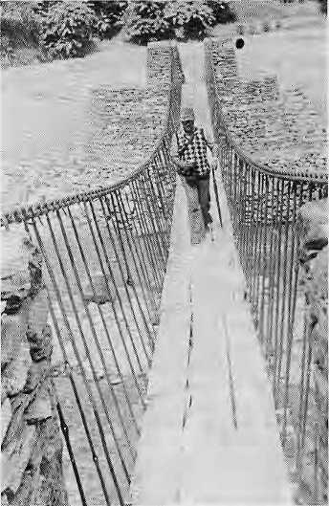
A Baglung "Suspended" Design.
the unofficial development slogan for a while.
Despite the usual professional reluctance to "learn" from villagers, the Baglung experience was so forceful that it helped reorient the nation's bridge building programme. Kathmandu engineers introduced some changes to the Baglung design and named these hybrids "suspended bridges", which were technically simpler than modern suspension bridges and more quickly constructed. The introduction of suspended bridges led to a spurt in construction. While only 61 bridges were built by the Government between 1975 and 1980, 301 bridges were thrown across Himalayan streams and rivers between 1980 and 1985.
However, even the modified traditional designs were ultimately inferior to the original chain link bridges. They needed tempered steel cables from Japan or Switzerland, and were slower to build, with no guarantee of longevity. Unlike the native suspension bridges, they too required expensive concrete foundations, struts and beams of steel, and the cost of carrying cables to the bridge site was enormous, something like NRslO per

Mar/Apr 1989
HIMAL

P.C.Joshi is a civil engineer and Anil Chitrakar a mechanical engineer. They are interested in the use of appropriate technology to alleviate hill poverty.
kilogram per day in the Pokhara area.
On the other hand, the Baglung blacksmiths used local labour, local smelting techniques and local design to provide a local service. Their work did not require foreign consultants or foreign aid. So Government paper-pushers and engineers had little to do and there were no opportunities for bridge inauguration parties to be flown in from Kathmandu at cost equal to that of the bridges themselves.
THE HONEYMOON IS OVER
After a brief honeymoon with the suspended bridge, the national bridge building programme once again got bogged down and the chain link bridge faded further in memory. Of the 53 suspension bridges which should have been buill last year, only 19 were completed. Bridges that are built have had a high "mortality rate". Of the 11 suspension bridges built by the American aided Resource Conservation and Utilisation Project (RCUP) during the past five years in the Kali Gandaki valley, "nine are already in the Bay of Bengal", said one engineer who was recently in the area.
In the end, neither the Nepali experts nor their foreign advisors could accept
HOW THE MAJORITYTRAVELS
Transportation for the majority Nepali hill population docs not mean riding on the roof of a bus, nor swopping down from the blue unto a STOL airstrip. It means strenuous walking over foot-trails from the roadhead, with heavy loads of kerosene, salt or cereals on heaving backs. According to one estimate, more than 3 million hill dwellers are on the move over the Nepali trails at any one time during the trading season from October to May.
Even a small upgrading of the trail means much more to the hill dweller than the highways he will admire but never use or the buzz of Royal Nepal Airlines turbo-prop engines high overhead. If you ask the district administrator or the local merchant for a Dasain wish-list, he will say "highway" or "hawaijdhiif,. If you ask the peasant, he or she wiH ask for a safer, broader foot-trail and a suspension bridge to shorten the portaging distance. Even if the administrator and merchant have not, the villager has realised the hollowness of the 1960s slogan, "development follows roads". {For a detailed discussion of portering, see the July 1988 Himal.)
the notion that the "primitive" blacksmiths of Baglung knew their ropes and cables better than they. If the 1970s slogan was "Learn from Baglung", the 1980s cry might .well be "Whoever heard of Baglung?"/\

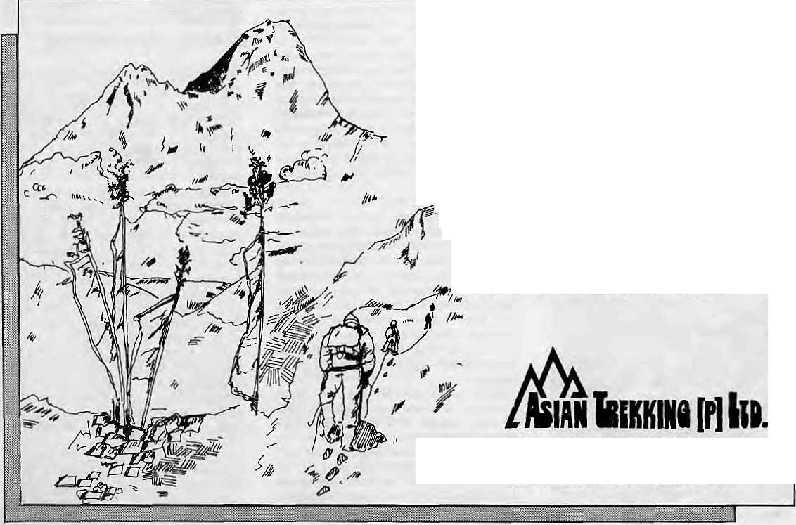
ASIAN TREKKING INVITES
YOU TO AN EXPERIENCE WITH NATURE
We take you through natural trek trails to places ^V of unending beauty and into contact with the fa friendly mountain people and their gentle living.
An experience you will never forget with our professional team to attend to all your trekking and tour arrangements with quiet efficiency.
P.O. Box: 3022, Keshar Mahal, Thamel
Kathmandu, Nepal.
Tel: 412821, Telex: NP 2276 HOSANG

HIMAL
Mar/Apr 1989

INTERVIEW

Peter Rodgers ,a Harvard University Professor of Civil Engineering, has studied water issues in the Brahmaputra and Ganges delta for several decades. He was member of a fact-finding team sent to Bangladesh by the United States following the devastating floods of 1988, Members of the Bangladesh Support Network, a U.S.-based group of Bangladeshis, spoke to Rodgers recently in Washington, D.C., and we present excerpts of their conversation.
BSN: What measures can be taken to alleviate Bangladesh's plight? RODGERS: The issue right now is how much you can do within Bangladesh ami how much international cooperation you need. Actually, a lot can be done within Bangladesh to deal with the floods, such as providing high ground in each village, constructing helipads above flood waters, improving communications and warning systems, improving the warning systems, and taking measures 10 protect food stores and industry. It is cheap and easy to protect cities like Dhaka.
BSN: How bad was the 1988 flood?
RODGERS: The 1988 flood clearly was a massive one. It was very unpleasant and people suffered for a few weeks but apparently they bounced back with amazing resilience. The flood may not even show up in the production statistics, even though it reduces the economic potential. A study of agricultural production since the late 1940s shows that big floods or small floods do not seem to make any difference to production statistics. Droughts do make a difference, though.
BSN: What are the feasible options?
RODGERS: In some places, dams and embankments have worked, but remember that rivers change course. You can stand up to the rivers when they are rivulets, but by the time they are in Bangladesh, they have a mind of their own. Dredging the main rivers is not a serious option because we are talking of billions of tons each season.
As you know, the Brahmaputra has changed its course several times. Right now the river is perched on top of its fan and is in an "unstable" position. Building a "river training" work might be all the river needs to change its course. Which would be a colossal
catastrophe. What is disconcerting is that there are plans floating around for barrages on the Brahmaputra. You could build barrages and a canal to link the Brahmaputra with the Ganges, all at prodigious expense, billions and billions of dollars. But how long will they survive? How long will the river slay put?
BSN: But there must be some things that can be done. RODGERS: One possibility is to intensify the flooding in the areas that are flooded already so that water is directed away from dry areas. You could store water in areas like the Sylhet depression by building low impact embankments. If 3 billion cubic metres of water were stored in Sylhet, that would reduce flooding impact downstream on the Meghna, So why not this scheme? Well, I sat in a minister's office in Dhaka, and he explained that it was politically impossible because people don't want to leave the land. So are the floods a serious problem? If they are not, then you don't have to do anything about it. If they are, peopLe have to take serious measures within Bangladesh.
BSN: What kind measure might work?
RODGERS: Some things can be done through the food for work programme, like the way they built big storage reservoirs in China. One on the Yangtse has a seven billion cubic metre capacity, and was built in 75 days, with 300,000 people! Now who needs the Japanese or the Americans? First of all they do not know how to deal with those numbers. It is all organisational skill and local management. Unfortunately, these available skills are not highly prised by the government sector in Bangladesh.
BSN: So how can foreigners help? RODGERS: Well, they can stop giving conflicting advice. Each high priced consultant thinks he knows the answer. So if you are sitting in Bangladesh, what would you do? What I would do is just say: "Please go away and leave us alone. We are smart enough to think out these things ourselves." Unfortunately, the international aid community does not allow people to do that. There is a lot of pressure to accept the advice of consultants and some of the things you hear would curl your hair.
Large United States agencies like the Bureau of Reclamation and the Corp of Engineers are very highly regarded, but you would have second, thoughts about
inviting them over to Bangladesh if you looked seriously at what these agencies have done in the U.S. The World Bank typically gets consultants who have worked for such agencies. Technically, these are very good agencies, but they don't have any concept of the political and social implications of what they are doing. They view issues as technical problems and invest in large structures. In the United States where we have a lot of resources we can afford it, but Bangladesh cannot.
BSN: What would you have Bangladesh do?
RODGERS: The Government needs to do some basic strategic thinking. People who can are not allowed to tackle the problems. There is a tremendous amount of bureaucratic infighting about who gets to control what. It's a Bangladeshi problem and nobody from outside can really help.
When I was there, I could not find a decent set of survey maps in Dhaka. This in a country where topography is everything. It is messy and hard to do surveys, but it's absolutely fundamental.
BSN: Are the floods increasing in severity? And what about deforestation upstream? RODGERS: I don't think deforestation is making any noticeable difference. But the floods are getting worse in economic terms, simply because the same flood affects more and more people each year. More and more people are living on the flood plains, so there's more potential for damage. Agricultural damage is predominant, it doesn't show up over time because one crop is damaged but the following crop is good. The economic damage from the floods has been increasing, but not the floods themselves. Throughout history, there have been huge floods in Bengal. About 4 meters of rain fell in five days in 1841. In 1860, 87 feet of rain fell in one spot. With so much water there must have been tremendous flooding.
So you see, progress can be achieved at relatively low cost but the question is who is going to do it? Groups in Bangladesh must press for planning by autonomous agencies and development of basic planning tools such as mapmaking. They can say these things stronger than foreigners can. Nobody else can straighten out the problems. Bangladeshis have to confront the issues themselves A
Bangladesh Support Network: PO Box 1088, Berkeley, CA 94701, USA

Mar/Apr 1989 • HIMAL

"Let Them Smoke Cigarettes"
Smoking, Policy and Health For All
By Shanta Dixit

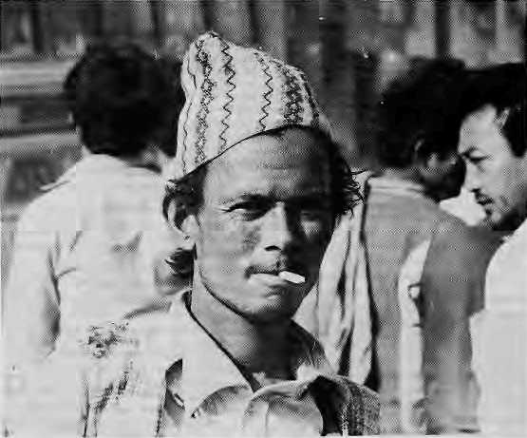
The Nepali Government's committment to providing "Health for All" by Year 2000 is a laudable aim. If there is one country that should be concerned about its citizens' health, it is Nepal. Its people are among the lowest per capita calorie consumers in the world; they have the lowest literacy rate and the lowest doctor to population ratio. The situation is even worse for poorer Nepalis due to the dire imbalance of wealth and available resources. Kathmandu Valley, home to less than five per cent of the population, retains more than half of the country's doctors. Oddly, and most inappropriately, the Government itself is the main producer and pusher of a universally acknowledged health hazard, cigarettes. The Janakpur Cigarette Factory, which until recently had a virtual monopoly over cigarette production and is still by far the largest cigarette producer, is nationally owned. Its sizeable profits go directly into the national exchequer.
ALARMING ADDICTIONS
Nepalis are addicted to tobacco in different ways: young, old, men, women and sometimes children barely out of infancy smoke bidis and hookahs, snort tobacco and chew khaini. But cigarette smoking has overtaken all these other addictions as a threat to Nepali public health, one that needs to be confronted by the Government and the public alike.
In the absence of comparable tobacco and health data for Nepal, the latest statistics from the United States can be used to help put things in perspective. More than 390,000 Americans die every year due to causes attributed to cigarette smoking. Thus, one out of every five deaths is related to smoking. It is responsible for 30 per cent of all cancer deaths, 21 per cent of all coronary heart disease deaths, 18 per cent of deaths due to stroke and 82 per cent of deaths due to chronic obstructive pulmonary diseases.
The pattern of sm ok ing-related death and disease for Nepal may be different from that of the United States, but there is no doubt that many thousands of Nepalis die every year because they smoke, and because of the interactive effect of smoking, grossly deficient diets, and unhygienic conditions such as improper ventilation. While Americans
are giving up cigarettes by the millions, smoking is an alarmingly accelerating trend among Nepalis. Worse still, Nepali cigarettes are much more hazardous than those available in the United States.
SMOKE POLLUTION
Most Nepalis are exposed to cigarette smoke from childhood even if they do not smoke. Fetuses are affected in the womb when the expectant mother pulls on a cigarette. "Passive smokers" are children, office co-workers, fellow passengers, all non smokers who remain in enclosed spaces with others who smoke. Since there is no attempt to segregate smokers at home or in public spaces, passive smokers might as well start smoking for all the difference it makes. A child growing in a house with several smokers may suffer the same consequences as if he or she were a smoker. People who smoke are less efficient utilisers of nutrients. Smoking and malnutrition interact with infectious diseases, both chronic and acute, and leave a significant part of the population disease-ridden and lethargic.
There should be no need to tell the Government about the dangers of smoking, both to the individual smoker and to the overall health of the nation. For more than 20 years, anti-smoking campaigns in the United States have justifiably portrayed cigarette manufacturers as the enemy of the people,
greedy and uncaring. The campaigns are comprehensive, encompassing research as well as public education. Scientific knowledge is used by policy makers and an informed public to change policies. Cigarette advertising, although well paying, are not carried by most newspapers, magazines and television stations.
Many governments in the west have active programmes to discourage smoking. A European anti-smoking conference held in Madrid last year adopted a ten-point strategy to eliminate tobacco-related disease. The charter adopted by the conference emphasised fresh air, free from tobacco smoke, as "an essential component of the fundamental right of a healthy unpolluted environment for all". In Nepal, there seems to be no inclination to provide that fundamental right.
It is not that there has been a lack of rhetoric in Kathmandu. In 1984, a high-level conference was held here to discuss the ill effects of tobacco use. The sincerity of the authorities was more than undermined, however, by a simultaneous announcement that the Government had given permission to open a privately-owned cigarette factory, A major reason for governmental inaction must be that cigarette sales provide a major source of revenue. The Janakpur Cigarette Factory, the biggest in Nepal and Government-owned to boot, is diver-% sifying its output » and getting more 7* aggressive in its § marketing, Janak-§" pur remains the leading producer of cigarettes, but the Surya Tobacco Company, which started production in late 1986, has already taken 13 per cent of the market. National sales figures for the last five years show a death-dealing industry that is booming.

HIMAL • Mar/Apr 1989

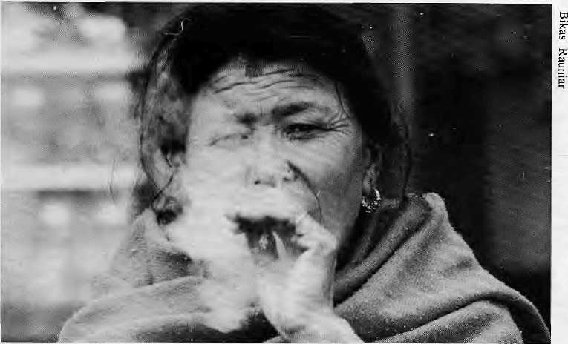
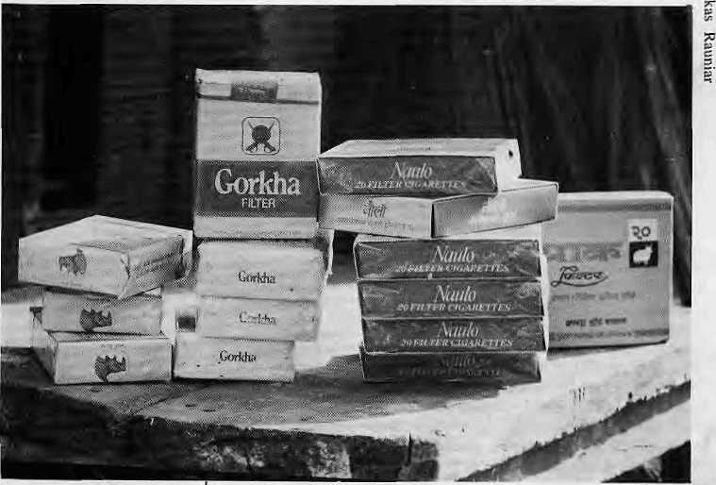
AND THE POOR GET SICKER
While the Health Ministry doubtless knows the scientific basis for discouraging smoking, the policies of the Government bespeak otherwise. The Government, as a matter of course, should be more concerned for the poor than for the rich, and the available data show that the poor are more at risk from Nepali cigarettes. The sales records of Janakpur and Surya Tobacco prove that even as the poor increasingly take to smoking, they are smoking the cheapest, lowest quality cigarettes that are moat likely to give them disease.
The most popular cigarette of Janakpur is "Deurali", followed by "Gaida". Both are iow-end, unfiltered products that make up 80 per cent of Janakpur's sales. Of the five brands produced by Surya Tobacco, there is only one brand without a filter. Yet it is this unfiltered cigarette that constitutes 65 per cent of Surya's production. Those who can least afford to smoke and contract disease are thus smoking the worst cigarettes. As someone said, "The poor get sick and the sick get poorer."
SMOKESCREENS
Many arguments have been used over the years on behalf of Nepal's cigarette industry. One is the protectionist argument that cigarettes produced in Nepal keeps money inside the country rather than enriching Indian or multinational tobacco giants. Another argument, less relevant now that there is domestic competition, is that Janakpur's profits go directly to the Government and ultimately are used for the "public good". Some go as far as to claim that cigarettes provide the only form of "escape" for much of the population and so "let them have their Gaidas and Deuralis".
These arguments are full of smoke. The Government should go out for a walk, take a deep breath of clean mountain air and look its priorities straight in the eye. If the bottom line is the people's health, then perhaps it should seriously consider a phased shutdown of the Janakpur Cigarette Factory. Also, it should make it more difficult for private entrepreneurs to start new factories.
SMOKING VS. ALCOHOLISM
Most Nepalis, while they take alcoholism seriously, treat smoking lackadaisacally. Because of lack of education and information, they do not make the direct connection between smoking and ill health, the way they do between alcoholism and the destruction of self and family. The fact is that alcohilics are relatively few in number, but smokers are found in every office,
every household. The lay person does not realise that the cigarette is an insidious killer. It has a grip on many more people, oid and young, men and women alike, than alcohol ever will.
The Nepali population is not incapable of making sacrifice. Many would stop smoking and many more would not start to smoke if properly advised about the hazards of smoking. For their part, the policymakers in Kathmandu must look at ways to benefit the population in the long run rather than making a few happy in the short run.
A TIME FOR COST BENEFIT
The Government must calculate the income it makes from pushing cigarettes and add up the millions spent in hospital care and doctors' bills for those who will end up sick as a result. Even that calculation would be incomplete because it ignores large numbers of rural smokers who become disease-ridden or die without benefit of even a diagnosis of lung cancer or other respiratory disease, much less hospital care. The costs of Government-endorsed addiction is thus not entirely quantifiable in terms of rupees and paisas. And how much healthier the average Nepali would be if the resources squandered on smoking were used for a more nutritious diet?
If the goal of achieving Health for All by Year 2000 is serious, the authorities should start a massive public information campaign to convince the people about the lethal dangers of smoking. But first, they must convince themselves. Can a government in this day and age condone smoking and still speak about health for all with a straight face? - Shanta Dixit is an epidemiologist. She does not smoke A

Mar/Apr 1989 • HIMAL

Himachal Worries In A Prosperous State
By Mana Man Singh


On a cold spring morning, if one looks up from the wide mountain highway that leads up from Kalka, the bright sunshine, striking the smoke billowing from thousands of coal fired heaters in government offices, creates the illusion that Shimla Town is on fire. The impact is dramatic and at the same time threatening. It is prosperity that allows the government to heavily subsidize the use of coal, yet its use turns the stagnant morning air into a choking brew which does enormous harm to the residents of this state capital and hill resort.
The conflicting impression of promise and threat also describes the condition of Himachal Pradesh in general. The slate has the highest living standard in the Himalayan region, belying the myth that mountain regions by their very geography must be poverty-stricken. Himachal provides its people with a higher income, better employment, superior social services and more efficient government than the adjoining regions of Uttar Pradesh or the Nepali hills beyond. According to D.S. Thakur, a researcher at the H.P. Vishva Vidyalaya in Palampur, the state has created "a new concept for the development of hill economies" through the scientific transformation of agriculture, horticulture, animal husbandry and other areas. "The development experience of Himachal offers pertinent lessons for the integrated mountain development of the entire Great Himalayan Hill Region," he says
Such is the prosperity of Himachal that a well-traveled Indian Foreign Service officer, now retired, says that Himachal "comes closest to being a Himalayan Switzerland".
However, progress has its down side. Himachai, in a sense, is walking an economic and environmental tightrope. Its economy is dependent upon the plains and the fragile ecology of the mountains. Himachalis are precariously reliant on a handful of products and industries and the market conditions in neighbouring Punjab and Haryana. Shimla politics has more and more rancorous and the civil service is widely believed to be slowly losing the "touch of the Raj", which refers to a time when the best of the Indian Civil Service came here to serve in the
summer capital of British India. In addition, Himachal's government officials have been slow to respond to problems that often come with economic growth: inequity; migration; pollution; environmental degradation; and unfulfilled expectations.
UNEQUALLED RECORD
Statistics show clearly that the 4.3 million people of Himachal have a development record that is unequalled in the Himalaya. They have a literacy rate of 43 per cent (up from 17 per cent in 1967), compared to 40 per cent for the affluent Punjab, 26 per cent for Bihar and an Indian national average of 35 per cent. More than 14,444 of the state's 16,916 villages - 85 per cent -have safe drinking water and the goal is to raise that to 93 per cent by 1990
Kullu lady with apple crop.
The state has 76,138 primary schools, 1,096 middle schools and 925 high schools. There are 38 colleges and three universities. Himachal University, which opened in Shimla only in the early 1970s, has both an engineering college and a medical college. The state also has a network of 57 hospitals, with a total of 3,800 beds available, 40 community health centres, 153 primary health care centres manned by doctors, 218 dispensaries and 1,389 sub-centres with paramedics. Further, more than 1,300 public buses ply 193 routes over 16,213 km of roads. Almost every village in Himachal has electricity.
The state domestic product (SDP) of Himachal Pradesh increased from IRs223 crores in 1970-71 to IRs301 crore in 1980-81 to IRs406 crore in 1986-87. The per-capita income of the state increased to IRs2,908 in 1986-87, up from IRs2636 the previous year, making it sixth in India after Punjab. Haryana, Maharashtra, Gujarat and West Bengal. For a planner from Kathmandu, Thimphu, Nainital or Lhasa, these healthy statistics are staggering.
GAS CANISTERS, TOPLESS MOUNTAINS
Signs of Himachal's development can be found in more than statistics, however. Shimla grocery stalls are full of affordable fresh produce. The Government ration shops dispense basic cereals at rock bottom, subsidized prices. On the Kalka-Shimla highway -wide and roomy by hill standards -there are large night-time reflectors, more commonly found on European autobahns and while natural gas is rarely found in most Himalayan urban centers, the red natural gas canisters are ubiquitous in even the most remote tehsil towns of Himachal. The street vendors of chai and samosas have discarded kerosene and firewood long ago in favour of the clean blue flame of gas.
When Shimla decided it needed an airport, so that Vayudoot's Dorniers could fly in tourists, engineers selected a nearby hill and, at considerable cost, simply lopped off the summit. Three years of blasting and earthmoving created an incongruously flat-topped mountain that can be seen for miles around
Why is Himachal doing so well? A Himachal University economist says that what Himachal had during its formative years that the other states lacked was "a political leadership with a clear perspective on hill areas development." The economist, and others, give credit for this perspective to the late Y.S. Parmar, who, as chief minister, ruled the state with an iron, but benevolent, hand through its first decade.
HILL DEVELOPMENT
Himachal became a separate stale in 1948, carved out from the Punjab hill states, and it initiated planned

8
HIMAL • Mar/Apr 1989

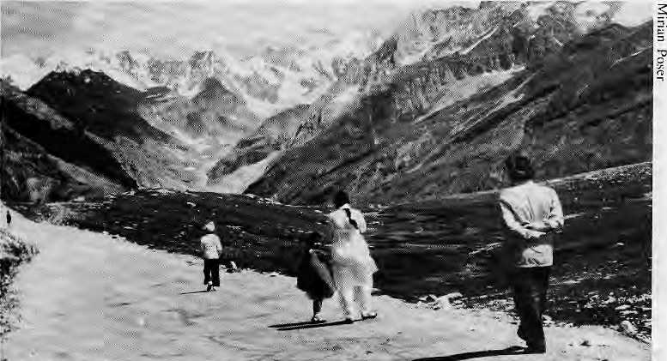
"Almost like Switzerland": Sikh family enjoys Rohtang La.
development in 1951 with its First Five Year Plan. It is currently in its seventh plan period. Initially, the highest priority was given to transport and communications until the fourth plan period (1969/74), when the emphasis was shifted to water and power development. On the whole, agriculture, social and community services and industry came next in the official planning agenda.
Highways have been central to Himachal's development. While other hill districts of India delayed road building until the Indo-Chinese war of 1961, and then allowed border roads to be built for strategic reasons under Parmar's leadership, Himachal built a network of highways that had an economic purpose.
Of course, political pragmatism alone could not have put Himachal high on the economic charts. Geography helped. Unlike other Himalayan districts, which straddle economically depressed plains such as northern Bihar and eastern Uttar Pradesh, Himachal has reaped the economic benefit of its proximity to Punjab and Haryana, among the most prosperous and dynamic of the Indian states.
Himachal is the only major state in the Indian Union which is almost entirely mountainous. This has helped focus the work of Shimla's politicians and planners. "Hill development" is the only kind of development they have to concentrate on. The eight hill districts of Uttar Pradesh, on the other hand, have to compete with sixty odd plains districts for allocations and boondoggles. As a matter of fact, says one analyst, both the U.P. hill districts and Himachal "started out in the 1950s with the same initial conditions in terms of education and infrastructure". Today, the activists of the restive U.P. hills look to Himachal's success and ask, "Why not us?"
Himachal also had Shimla. When the British anointed it their summer capital in 1850, the ridgetop gaggle of village houses was gradually transformed by the building of a railway, public works, schools, and the growth of a civil service and associated work ethic that stood it in good stead when independence and statehood arrived.
APPLES AND POTATOES
The apple is Himachal's main industry; bigger than tourism, potatoes and the income from Himachal's sons in the armed services. Introduced here by Samuel Evans Stokes, a naturalised American whose descendants are prominent Shimla residents, the apple has taken the state's economy on a roller coaster ride. Rather than develop
mountain agriculture, which, as in most hill areas, is of the subsistence variety, Himachal put all its efforts in horticulture development. In the beginning, apple cultivation was concentrated among the rich estates of Kotgarh and Jubbal, but it has now spread among middle-income farmers as well, in seven of Himachal's 12 districts. Starting from 1,200 tonnes annually in 1950, horticultural production (mostly apple) in Himachal has grown to 4.5 lakh tonnes annually. To help manage the State's horticultural produce, the Himachal Pradesh Marketing Corporation (HPMC) was started in 1974, with help of the World Bank. It has set up grading and packing houses, cold storages, fruit processing plants and transhipment centres. HPMC's processing facilities have allowed the use of low grade apples which would otherwise have gone waste. The Corporation has also been innovative in its marketing efforts. For example, it was the first to introduce juice vending machines in India, making juice available to the public at reasonable prices. HPMC has also started distributing fruit concentrates in the northern Indian states.
While apples are its chief crop, Himachal also proclaims itself the "potatoe state" of the Union. The soil and climate of the state are proper for growing virus-free potatoe tubers. Table potatoes are harvested in July, while seed potatoes are exported in September, in time for planting in the plains. Potatoe production has nearly quadrupled in the last 35 years, even though the area under cultivation has only doubled. The crop is grown in all 12 districts, but main producers are Lahaul-Spiti and Kinnaur districts. Nearly two thirds of the potatoe crop is exported to other states, in particular Gujarat, Karnataka,
Maharashtra and Madhya Pradesh. Potatoe seed export brings in about IRslO crores annually to the State economy,
Himachal might also be called the "vegetable state". Cabbage, cauliflower, peas, hill capsicum, tomato and beans are all produced during periods when they are in high demand in the plains. Ginger produced around Sirmour district is a commercial crop popular with marginal and small farmers and mushroom farming received a boost when the government established a Mushroom Centre at Solan in 1977. There' are presently 350 registered growers of mushrooms in the state, even though the actual growers are somewhat fewer. One species of mushroom exported to Europe brings IRs5 crores to Himachal.
POWER AND INDUSTRY
Himachal has 25 per cent of India's entire hydroelectric potential, another enormous advantage for the state. The Himalayan rapids of the Sutlej, Giri, Ravi, Beas and the Jamuna, have a potential of 12,000 megawatt, of which about one fourth has been tapped. In J967, Himachal generated only 3.7 million Kwh, but by 1982 that figure had jumped to 540.5 million Kwh. More than 50 per cent of the electricity is exported from the state, providing a substantial and stable source of state income. With power export such an important part of the economy, Shimla has decided to proceed with the massive Nathpa Jhakri project (see page 22), which is expected to produce 1,200 megawatts when it is completed ten years from now.
Another unique characteristic of Himachal is that, unlike many other hill areas, its has its own indigenous business community, the Soods, who

Mar/Apr 1989
HIMAL
9

AGRO-CLIMATIC ZONES OF HIMACHAL PRADESH

Wwm
1'- '■ *'' I SUB-MONTANE ANO LOW HILLS SUB-TROPICAL
I' 1 MID HILLS SUB-HUMID
EEHU HIGH HILLS TEMPERATE WET
I I HIGH HILLS TEMPERATE DRY
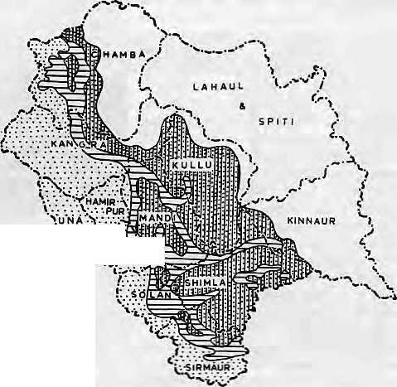
hail from the state's Kangra District. This means that much of the income from commerce and other business activity has remained in the hills and rather than be siphoned off to faraway corners in the plains.
With homegrown entrepreneurs and a government which encourages entrepreneurshijj, industries large and small are gaining a foothold. There are now 97 medium to large scale industrial firms in the state, representing investment of about IRs333 crore. There are over 16,000 small scale units, which employ 70,000 persons and represent a capital investment of IRsl70 crore. The small and large industrial sectors are becoming increasingly diversified, producing cement, engineering and electronic products, watches and fertilizer. There are more than 55,000 units which can be classified as "household industry".
UPSCALE MIGRANTS, TOURISTS
The migratory paLtern is also different in Himachal. The destitute villagers from the hills of Uttar Pradesh and western Nepal descend to the plains to work as "Gorkha" darbans, restaurant busboys and highway labourers, but the migrants from Himachal grab the high end of the market, owning and driving taxis in Delhi and Bombay, working as high priced cooks, joining the armed services and working as clerks and mid-level employees in government offices in the plains. Within Himachal, there are three lakh workers in the "modem sector", 70 per cent of them employed by government agencies. Actually, much of the menial labour work in and around Shimla are carried out by migrants from Nepal and Kashmir.
Tourism is another big money maker. Shimla caters almost exclusively to Indian visitors. Ten years ago, this hill station had 30 hotels Today it has 100. The peak period is spring and autumn, in addition to the weeks around Christmas and New Year's, when the folks from the plains come up to look at and touch snow. During New Years Eve, rooms are simply not available, for even IRs300 a night. While the tourists from the nearby plains prefer Shimla, increasing numbers of foreign and metropolitan Indian visitors prefer the northern destinations of Kullu and Manali. Dharamsala, "Little Tibet", is where the Dalai Lama holds court and the Tibetan micro-economy and its touristic cachet adds lustre to the state as a whole.
THE DOWN SIDE
For almost every bright facet to the State's good fortune, there is also a sobering aspect. Much of the state's
prosperity has been built on the basis of a few crops and industries which depend upon the vagaries of climate and the market conditions in adjacent states. For these reasons, while doing comparatively well, the economy is in a constant state of disequilibrium, pushed and pulled by events beyond its control.
"What is most worrying is that the political machine left in place by Parmar has begun to unravel and this directly affects the economic well-being," says the economist from Himachal University. In the late 1970s and through the
1980s political uncertainty and debilitating political rivalries have diverted attention from more pressing tasks of government. While the political process has become more cumbersome, the public sector has expanded exponentially, inevitably leading to a loss of government efficiency. Today there are more than one hundred public agencies packed into Shimla's ridge-top main streets. One or two additional enterprises are added every year, mostly to please particular special interest groups.
In 1987/1988, drought and floods caused severe losses in agriculture in some parts of the state. A target of 13.6 lakh tonnes of food grains haci been established, but only 9.3 lakh tonnes were produced, a decline of 20 per cent from the previous year. Industrial production was also affected and the total losses and damages from the excessive rains was estimated at IRsI72.5 crores.
APPLE BLUES
Apples, even more than most other crops, are extremely vulnerable to weather and market conditions. Mid-Juiy to mid-October is the apple picking season and the produce is often stranded because of landslides triggered by the summer rains. HPMC, the public sector marketing agency, has not been effective enough in helping derive the optimum from the apple crop. For example, while it has built processing centres and warehouses to store the apple crop, HPMC does not have the latest
equipment to wash, brush and wax the apples, which is important for proper preparation and good marketing. In the beginning, when apples were a sellers market, the marketing inefficiency did not hurt. However, the production of other hill states and the abundant production within Himachal itself has turned the apple into a buyer's market. It has not helped that the apple trade has, as one observer put it, been traditionally "ridden with manipulations, exploitation and profileering by the private traders." HPMC has not been able to supplant this system. Since the Corporation has been unable to buy up apple stocks nor market the produce effectively, individual growers with little resources often have to do their own marketing, sometimes traveling as far afield as Calcutta and Madras.
While the apple trade might have some problems, others see it as the problem. Overwhelming reliance on this one crop has got economic planners worried. Hence, they are pushing for diversification into citrus production, especially in the low hills of Una District. But the "apple lobby", made up of many prominent Himachal families and quite a few our-of-staters, is strong and benefits disproportionately from subsidies and an almost tax-free atmosphere. The large orchard owners, while they constitute only a small proportion of the state's population, are said to receive subsidies worth over 1Rs6 crores. Small apple orchards with below 100 trees are not economical, so the smallholder tends to lose

10
HIMAL
Mar/Apr 1989

disproportionately. There are also the complaints that the sizeable profits from apples are wasted in conspicuous consumption in Shimla, Chandigarh and Delhi rather that being invested to make the economy more resistant to outside forces.
POTATOES TOO
While the problem with the apple industry might be one of equity, with potatoes the question is about the very viability of the crop. The seed potatoe industry is in crisis because of increasing competition from Punjab and Uttar Pradesh, where growers have better economies of scale. Also, buyer confidence has been lost due to irregularities in the certification of seed potatoes. False labelling has ruined the reputation of the Himachal poiatoe. Poor marketing has caused further damage.
For all these reasons, this past year's potatoe seed crop went abegging. In January, more than 6,000 tons of seed potatoes, worth IRs2 crore, were rotting in mile-long stacks by the roadside in Shimla, Kiratpur and Manali. A recent agreement between Pepsico, the multinational food giant, and the Punjab government has put a further pall over the industry. Pepsico, as part of the deal, is expected to make a large investment in Punjab agribusiness, bringing prices down and driving Himachal's mountain terraces out of the market.
The other major source of revenue, tourism, has also proved a weak base upon which to build a strong economy. This is primarily because tourism is seasonal and comes to a standstill during much of the winter and the rainy season, mid-June to mid-September. Furthermore, Kullu or Manali lag far behind Ladakh, Bhutan and Kathmandu in terms of "name recognition" among foreign travelers.
Even the industrial diversification programme has run into problems and industry today accounts for only 5.3 per cent of SDP. According to some estimates, as much as 40 per cent of the small scale industrial units in the state are "sick". Economists believe the concentration of the large scale industrial activity in the geographical periphery to the south does not help economic integration. Industry is affected by the high rates for electrical power, surprising for a power surplus state such as Himachal. According to figures compiled by a Himachal industrialists' guild, the power rate is IRsl.03 per unit, which includes a winter surcharge. By comparison, it is 44 paisa in Jammu and Kashmir and 69 paisa in Punjab.
For all the advantages it might have in relation to other Himalayan hill areas,
Himachal is quite disadvantaged compared to Punjab and Haryana. This is because Himachal mostly imports finished goods while it exports unprocessed or semi-processed goods, it lacks a skilled workforce and because transportation is more difficult than in the plains. With much of the forests gone and the remaining earmarked for conservation, there is little scope for raising revenue, except by harnessing the rivers.
ENVIRONMENTAL WOES
As Himachal's economy has grown, some of the price has been paid by the state's mountain environment. The attraction of income from apple production as led to the unplanned expansion of apple to marginal areas. Mountain forests have been cut to make way for apple orchards and apple fields. In addition, as the apple export crop grows, the more of its own forests and those in neighbouring hills are cut down to make apple crates. Strict regulations are now being considered, so that wooden crates, preferred by buyers because they protect the fruits, will be replaced by cardboard boxes. However, it is not yet clear how well this shift will succeed, given the vested interest of the so-called "forest mafia" in continuing the to maintain its profits.
And not only the forests have suffered. According to one study, "unscientific methods of cultivation" have created high intensity soil erosion. As a result, it is estimated that 18.8 lakhs tonnes of topsoil is lost every year from the cultivated lands. Unregulated limestone quarrying, especially around the Sundarnagar area, have also affected the environment.
Urban areas have also been affected by the economic boom. Shimla town has changed drastically for the worst over the past three decades. Zoning laws have been ignored and a building spree has severely strained services. The bridle paths, planned by the British for sedate evening strolls, are chocked with automobiles and trucks. Every day when offices empty, outbound commuter traffic jams the two main roadways out of the town, almost to a standstill, Shimla had a forest cover of 80 per cent in the late 1970s, but today that figure is down to 45 per cent. There is rising incidence of eye disease and skin allergies, which scientists associate with the increase in smoke and carbon content in the air.
Problems abound. Yet, the government has been persistently goaded by an aware citizenry to leam from past mistakes and implement progressive programmes. In December, Chief Minister Virbhadra Singh, quoted in the
Hindustan Times , said that his government had "effectively curbed the activities of the forest mafia" and had "introduced massive afforestation and social forestry to increase green cover." Another indication of the declining influence of the timber merchants is that a previous Chief Minister was forced to resign on account of an adverse High Court judgement relating to the activities of the forest mafia.
Convinced that the local people must have a stake in afforestation drives, the government has begun a social forestry scheme known as Project Umbrella, which encourages the planting of saplings chosen by the villagers. 24,031 hectares have been planted in the past three years.
In January, in order to diversify its tourism earnings, Shimla announced a long-term plan to switch emphasis from seasonal tourism to "pilgrim tourism". To that end, it opened a IRs3.5 lakh tourism inn on the banks of the holy Rcwalsar lake in Mandi District. In yet another diversification effort, Shimla's authorities have decided to promote the breeding of rabbits for wool. They recently imported German Angorra rabbits and set up a small farm in Palampur from where to distribute to entrepreneurs. The authorities have also approved 1Rs25 crores for a ten-year development project to help improve the competitiveness of Kangra'. s tea produce.
The government is also considering addressing the unemployment problem by opening up the low-end job market to volunteer youths, thus providing 20,000 new jobs. According to a government handout, for IRs250 to IRs400 a month, young school graduates will be hired as "volunteer" teachers, panchayat librarians, and salesmen for agricultural products.
According to its critics, the Government can tinker with modest social forestry programmes and seeking alternatives to tourism, but ultimately it must direct its attention to the actual foundations of the state's economy. They say the main task is to reduce the influence of the "apple lobby", so that there is more equitable sharing of the state's income. They also call for more stringent control over government employees, who retain exceptionally high salaries, allowances and perks.
These argument were summed up by Najm-ul-Hasan, a commentator in the Times of India: "The rural majority that is the poorest of the lot in Himachal has begun to feel resentful of the privileges that the rural elite and government employees enjoy."
Trouble, it seems, does brew even in paradise A

Mar/Apr 1989
HIMAL
11

BRIEFS

Tibetans Gain Fulbright
For years, Tibetan students and scholars in Dharamsalai DeEhi and Kathmandu could only watch as Nepalis and Indians wont off to the United States on prestigious fellowships. The irony was that, as a group, Tibetans refugees are among the better educated communities; in South Asia.
The United States Congress has now made it possible for Tibetan refugees to pursue specialised study in the United States. In December 1987, it unanimously adopted legislation instructing US1A "to make available to Tibetan students and professionals who are outside Tibet" not fewer than 15 scholarships for study in institutions of higher education. US1A made available the Fulbright fellowships and asked the Tibet Fund, a New York based non-profit group, to administer the programme.
The Fund has already placed two groups of ten graduate students in American universities for Masters in journalism, political science, geography, education, business administration and in Uralic and Altaic studies. A third group is scheduled to leave for the United States in September 1989 and will concentrate on the sciences.
Thubten Samphel, who is about to complete a Masters in Journalism at New York's Columbia University, says that the Fulbrights will allow Tibetans to learn practical, technical skills for which there is a great need in the refugee community. "My only regret is that this was not done earlier," he says.
The Fulbright fellows are chosen by an independent selection committee in New Delhi, made up of Indian and American scholars and Tibetan officials. For further information, contact; Council for Tibetan Education, Gangchen Kyishong. Dharamsala, H.P. 176215.
Mountain Paparazzo
What would a successful portrait photographer with a prosperous business smaek ijr the middle of Delhi's: Connaught Place have itv common with the remotest corners of me Indian Himalaya? Plenty, if you are Ashok Dilwali
Dilwaii burst forth into the coffee-table book marker iast..'./ year with one glossy presentation -on the Gangs: and: another on Garhwal's underappreciated mountains. Suddenly, every mountain state's tourism development corporation seems to Want a Diiwaji book. With his office closet full t>f slides and negatives on the mountains "in the kgs", Dilwali is more than willing to comply. V
After a breather on the high seas, doing a book on the Andaman and Nicobar Isles, Dilwali plans to return
Geologist Charged With Fraud
Viswa Jit Gupta, a prominent professor at Punjab University, Chandigarh, has built an enviable international reputation over the last 20 years by reporting and writing on fossil discoveries in the Himalaya. His studies have helped shed light on the geological formation of- the mountain range and ace today'.' a significant part of the scientific literature on the geological history of the whole region.
Along comes John A. Talent, an Australian scientist, who accused Gupta of massive paleontological fraud. Talent says that Gupta has tainted the entire science of Himalayan geology misrepresenting discoveries of prehistoric organisms 5n Bhutan, India and Nepal,
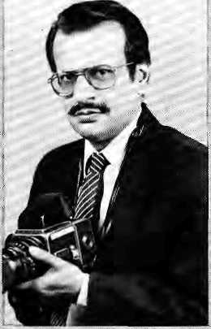
Div/aili sdf-pot rait.
t<j the mountains in May and . June to work on another^: this time on Himacha!/ He's negotiating to do a pictorial on the Kashmiri highlands, and a book on Kumauii "is ■70 per cent finished".
Believing in Gupta's findings, he says, would be like believing that kangaroos are native to Kashmir.
Talent, whose accusations appeared in the April issues of the British journal Nature ■ and the American journal Science, calls Gupta's findings a "Himalayan hpax". He accuses Gupta of : numerous suspect claims. The Australian contends that fossils of 360 million: year old organisms called coneodonts which Gupta reported to have found in India and Nepal : actually came froiti a creek in New York, In another instance, he claims ancient mollusks said by Gupta to be from the high Himalaya actually came from southern Morocco. Talent says Gupta: has failed to pinpoint the geographical location of his discoveries. Once, he says, Gupta even .claimed the very same eoncodoni specimen to
-..'. Dilwaii's: love for the : mountains had a rather mundane beginning in 1979 when a nephew booked by train for Sikkim had to cancel his plans, Dilwali used the ticket instead and it was in Gangtok that the mountain bug bit the lerisman. He has a Maruti Gypsy jeep just for: his mountain travels and goes back to the hills with his trusty Nikon again and again "to catch the right light". He has been up to Kumaun seven times from Delhi for his forthcoming book on the U.P. hill district.
Some people are unhappy that Dilwali focuses almost exclusively on landscapes and ignores people, but the portrait photographer from Delhi has a ready reply. "People I do all the time," he says; "But in the hills I am on holiday," Perhaps that's why his mountains look so enchanting.
have come from Kishtwar in India and Phuichowki in Nepal.
In an interview with The New York Times newspaper in late April, Gupta vigorously disputed the charges and accused Talent of "malicious bias and professional jealousy" based on differences between the two over the past 20 years. Even though the concodonts he unearthed had a "strong similarity" with the New York fossils, he says, eoncodonts have a very Wide natural distribution in the Himalaya.
Talent has asked for an independent panel of scientists to investigate Gupta's work. For his part, Gupta says he has sent a six-page explanatory letter to Science and that he plans further formal replies. It will Surely take a some time for the Himalayan dust to settle and the truth to he told.

12 HIMAL • Mar/Apr 1989

BRIEFS


A New Roof for Chiwong Gumba
For the past four years, the Shcrpa monks and villagers of Junbesi, Salleri and Phaplu have been restoring Chiwong Monsatery, which over the years hud fallen into extreme disrepair. Situated south and away from the main trekking route that leads up the Khumbu from Lukla airstrip, Chiwong is Solu's main seminary. It represents a classic example of Sherpa monastery architecture.
Damp and leaking roofs had threatened the monastery's magnificent frescos. The main courtyard gallery, built in the 1950s to accommodate nearly 1,000 people during the Mani Rimdu festival, was falling apart. Undermined by decades
of erosion, the monks' kitchen was about to slide down the hillside,
fn 1985, Abbot Nawang: Phintsok. and former Minister of Forests, Tsering Tenzing : Lama, and the people of Solu set up the Chiworig Gumba Samrakshan Samiti. The Samiti engaged architect: -Tohn Sanday to draw: up restoration plans. Sanday is a pioneer in using local methods and materials and was responsible for the rehabilitation of Hanuman Dhoka in Kathmandu and the Shah: kings' ancestral palace in Gorkha.
Sariday completed his survey in December 1986 and tire community rallied,: to the project. Two western filmmakers who. made a 1984 documentary on Chiwong raised modest funds abroad, but most of the restoration funds were raised locally. An enterprising iamn went to
Renovation plans.
Darjeelirig to solicit funds from Sherpas there, A retaining wall has been built around the monastery, a: new kitchen is complete, rooms for visiting lamas have been renovated, and there is : a new gallery roof.;. ■ ;■■
Chiwong is well on the way towards restoration, but a lot remains to be done. For further information, write to the Chiwong Gumba Samrakshan Samiti, Phapiu-Salleri, Solu Khumbu Jilla, Sagarmatha AnchaM

INTRODUCTION
While many international donors search oul exotic locales such as the Khombu or Thak Khola to conduct their aid activity, others shun the limelight and persevere in remote areas. One such group is the Canadian supported Nepal Schools Project (NSP), which works in a forsaken and "unglamorous" corner of the country — the Mahabharat region of Kabhre District east of Kathmandu. The project is small but effective in trying to meet the needs of the Tamangs who inhabit these dry and rugged mountains.
When the Project staff began work here in 1984, they found that the region occupied a blind spot in the eyes of planners and donors. It received virtually no development aid, perhaps due to difficult access and the minimal political clout of the Tamangs. The few schoois Chat existed were among the worst anywhere and modem health care was nonexistent. The economy consisted entirely of subsistence farming.
The NSP did not prorjitse to move mountains, and it did not make extravagant claims as if it were after the next lucrative CIDA, USAID or World Bank project. Indeed, NSP's workers seem to be in no hurry to hand in the final report: Development cannot be hurried in a region which has so much catching up to do, and even years of work might still leave the Tamangs only fractionally better off.
At the very beginning, the Project decided: to base its priorities on the expressed needs of (he community. By common consent, if began installing safe water pipelines, constructing primary schools, arid starting primary health centres. Overhead costs arc minimised so that the maximum benefit goes to the people of Kabhre, According to NSP's Director Michael Rojik, 100 per cent of all donations received by NSP from its Canadian supporters are used in the field. The Project has no salaried staff; all administrative work is done by volunteers.
NEPAL SCHOOL PROJECTS
To meet the demand, more than 50 per cent of NSP's .annual budgtet has been allocated to safe water projects. During the past year, it brought piped water to nine villages: Ahaiebanspur, Thuio Pokhara, Sirhle Gaon, Ratay Malay, Bhusule Danda, Raje Danda, Goltar, Lapche and Patle Khoia Danda. It also built five primary schools in Dandagaon, Jagathaii, Lapche Ghartichap and Ahaiebanspur.
The NSP is. presently running its eighth vocational training course to Tamang boys. Instead of importing
skilled labour from Kathmandu, NSP now uses its own "graduates". Although without formal education, the trainees have proved exceptional students, says Director Rojfk. Chakra Dhoj Tamang is field supervisor, Surje Man Tamang is the chief carpenter, Gunji Man Tamang the assistant carpenter, Narayan Tamang the youngest master carpenter. Chamar Singh: Lama makes blackboards for schools, Chitra Tamang is the master mason who constructs reservoirs and water tanks, and Kancha Man Lama is the chief plumber, responsible for: installing pipelines.
The project has now established primary health care centres in five panchayats. Training of health workers was done with the hdp of Dr. Ramesh Adhikari of Kathmandy, using for reference the Nepali version of the health care manual Where There la /y<? Doctor.
No trekkers pass through southern Kabhre's stark hill flanks; there are no snows to attract the mountaineer; no lobbying ciout to attract the politician. Jus! rugged mountains.. What Edmund Hillary did for the better off Sherpas of Solu KhumbU, the Nepal School Projects is doing for the Taniangs of KabhreJA
(NSP, G.p;0 Box 4479, Kathmandu, or 63 Perivate Crescent, Scarbofough^ Ontario M1J 2C4, Canada.)

14
HIMAL
Mar/Apr 1989

BRIEFS


A New Roof for Chiwong Gumba
For the past four years, the Shcrpa monks and villagers of Jurtbesi, Saileri and Phaplu have been restoring Chiwong Monsatery, which over the years had fallen into extreme disrepair. Situated south and away from the main trekking route that leads up the Khuinbu from Lukla airstrip, Chiwong is Solu's main seminary. It represents a classic example of Sherpa monastery architecture.
Damp and leaking roofs had threatened the monastery's magnificent frescos. The. main courtyard gallery, built in the 1950s to accommodate nearly 1,000 people during the Mani Rimdu festival, was falling apart. Undermined by decades
of erosion, the monks' kitcheii was about to .slide down the hillside.
In 1985, Abbot Nawang Phintsok and former Minister of Foresis, Tsering Tending ■ Lama, and the people of SoUi set up the Chiwong Gumiba .Samrakshan Samiti. The Samiti engaged architect John Sanday to draw up restoration plans. San day is a pioneer in using local methods and materials and was responsible for the rehabilitation of 'Harm man Dhoka in Kathmandu and the Shah kings' ancestral palace in Gorkha.
Sanday completed his survey in December 1986 and the community rallied to the project. Two western filmmakers who made a 1984 documentary on Chiwong raised modest funds abroad, but most of the restoration funds were raised locally. An enterprising iama went to
Renovation plans.
Darjeeling to solicit, funds from Sherpas these* A retaining wall has been built -around the monastery, a new kitchen is complete, rooms for visiting lamas have been renovated, aad there is a new gallery roof
Chiwong is well on the way towards restoration, but a lot remains to be done. For further information, write to the Chiwong Gumba Samrafcshan Samiti, Phaplu-Salleri, Solu Khumbu Jilla, Sagarmatha AnchaM

INTRODUCTION
While many international donors search out exotic locales such as the Khumbu or Thak Khola to conduct their aid activity, others shun the limelight and persevere in remote areas. One such group is the Canadian supported Nepal Schools Project (NSP), which works in a forsaken and "unglamorous" comer of thg country — the Mahabharat region of Kabhre District east of Kathmandu. The project is small but effective in trying to meet the needs of the Tamangs who inhabit these dry and rugged mountains.
When the Project staff began work here in 1984, they found that the region occupied a blind spot in the eyes of planners and donors. It received virtually no development aid, perhaps due to difficult access and the minimal political clout of the Tamangs. The few schools that existed were among the worst anywhere and modern health care was nonexistent. The economy consisted entirely of subsistence fanning.
The NSP did not promise to move mountains, and it did not make extravagant claims as if it were after the next lucrative CIDA, USAID or "World Bank project. Indeed, NSP's workers seem to be in no hurry to hand in the Una) report. Development cannot be hurried in a region which has so much catching up to do, and even years of work might still leave the Tamangs only fractionally better off.
At the very beginning, the Project decided to base its priorities on the expressed needs of the community. By common consent, it began installing safe water pipelines, constructing primary schools, and starting primary health centres. Overhead costs are minimised so that the maximum benefit goes to the people of Kabhre. According to NSP's Director Michael Rojfk, 100 per cent of all donations received by NSP from its Canadian supporters are used in the field. The Project has no salaried staff; all administrative work is done by volunteer.
HEPAL SCHOOL PROJECTS
To meet the demand, more than 50 per cent of NSP's annual budget has been allocated to safe water projects. During tlie past year, it brought piped water to nine villages; Ahaiebanspur, Thuio Pokhara, Simle Gaon, Ratay Matay, Bhusule Danda, Raje Danda, Goltar, Lapche and Patle Khola Danda. If also built five primary schools in Dandagaon, Jagaihali, Lapche Gharticbap and Ahalebanspur.
The NSP is presently runhjng its : eighth vocational training course to Tamarsg boys. Instead of importing
skilled labour from Kathmandu, NSP now uses its own "graduates". Although without formal education, the trainees have proved exceptional students, says Director Rojik. Chakra Dhoj Tamang is field supervisor, Sitrje Man Tamang is the chief carpenter, Gunji Man Tamang the assistant carpenter, Narayan Tamang the youngest master carpenter. Chamar Singh Lama makes blackboards for scliools, Chitra Tamang is the master mason who constructs reservoirs and water tanks, and Kancha Man Lama is the chief plumber, responsible for installing pipelines.
The project has now established primary health care centres in five panchayats. Training of health workers was done with the help of Dr. Ramesh Adhikari of Kathmandy, using for reference the Nepali version of the health care manual Where There is No Doctor.
No trekkers pass through southern Kabhre's stark hill flanks; there are no snows to attract the mountaineer; no tabbying clout to attract the politician. Just rugged mountains. What Edmund Hillary did for the better off Sherpas of Solu Khumbu, the Nepal School Projects is doing for the Tamangs of KabhreA
(NSP, G.P.0 Box 4479, Kathmandu, or 63 Perivale Crescent, Scarborough, Ontario M1J 2C4, Canada.)

14
HIMAL • Mar/Apr 1989

FOLLOWUP
In this column, we report on significant developments and new ideas relating to articles which appeared in past issues of Himal.
TENGBOCHE: WHAT WENT UP IN FLAMES? (Jan/Feb 1989)
A Tengpoche Monastery Reconstruction Committee has been set up, with a predominantly Sherpa membership and headed by the Incarnate Lama Nawong Tenzin Jangpo. Also helping will be Sir Edmund Hillary, Zeke O'Cconor of the Hillary Foundation (Canada), Richard Blum of the American Himalayan Foundation, French alpinist Maurice Herzog, Guenther Strom of the Deutsche Alpine Club, and the Japan Alpine Club. An offer has aiso come from former United States President Jimmy Carter.
Tengpoche went up in flames on 19 January, the result, it is believed, of an accident with an electrical appliance. According to Ang Tshering, the Committee's honorary secretary, about U$l million will be required for the reconstruction of the monastery. He is confident that the amount will be raised. Already, 72 Sherpa households have collected NRs4 lakhs, Hillary has raised U$30,()00 (approximately NRs8 lakhs), and the Deutsche Alpine Club has given NRs2 lakhs.
Because this is Lo Nag (Black Year), deemed inauspicious for certain activities, the reconstruction will begin next year. However, preparatory work will be begun this year, including the collection of stones, wood and other materials. It is expected that the building will be up within a year, but it may be another four years before the monastery attains its former state, with its interiors and artifacts restored or replaced. - KT Editor's note: The Reconstruction Committee and the Incarnate Lama have indicated that "Tengpoche", with a "p" rather than "b" is the preferred spelling.
ASAN: A MODEL
FOR OTHERS (Nov/Dec 1988)
Defying predictions that their cleanup effort would collapse, the businessmen of Asah market in downtown Kathmandu have continued to innovate. Their efforts have gone beyond sweeping up and have entered a marketing phase. The Bhotahity artery is now lit with five
sodium vapour lamps, bought from the Nepal Electricity Authority at below cost price. Customers now take home their purchases in white polythene shopping bags that carry the Bhotahity Bazaar Samiti's logo and advertisement. The Solid Waste Management and Resource Mobilization Centre provides wages for a cleanup staff of five. The Committee expects soon to install telephone booths for local and international calls. One kitchen garbage tin is being provided experimentally to each of 150 households in the area to see what they do with it. The Asan merchants have even decided to provide "foreign aid". They recently donated a load of red buckets to the town of Surkhet in the far west Nepal. The Asan bug is catching, it seems. It is reported that the merchants in the Kathmandu downtown tourist hub of Thamel have also decided to organize like the BBS style. - RB
OZONE HOLE OVER HIMALAYA? (JULY 1988)
It is now widely accepted by scientists that the controls imposed by the 1987 Montreal Protocols on colorofluorocarbons (CFCs) will still allow a drastic worsening of the problem of depleting atmospheric ozone. They have therefore called for a complete phaseout of CFCs by the end of the century, ratheT than the 50 per cent cut mandated at Montreal. In late April, the United Nations Environment Programme (UNEP) declared its support for such an accelerated phaseout. While CFCs have been viewed as contributing the largest share of ozone depleting ctvrlorine in the upper atmosphere, some experts are saying that restoration of stratospheric chlorine will require not only a CFC ban, but also phaseouts of two other industrial chemicals: carbon tetrachloride and methyl chloroform.
Meanwhile, a Conference on Global Warming and Climate Change was held in New Delhi in late February, the first of its kind to address the particular concerns of developing countries. The conference termed global warming as "the greatest crisis ever faced collectively by humankind", and cautioned that "climatic changes of geological proportions are occurring over timespans as short as a single human lifespan". The participants concluded that while the great bulk
of past and present cmmissions of greenhouse gases which led to global warming have come from the highly industrial nations, many of the most serious effects of global climate change would most likely occur in the developing countries. This was because developing countries were many times more dependent on natural resources and natural systems (crops, grazing lands, forests, fisheries, monsoon patterns) which are heavily affected by climate change. The poorer countries lacked the financial and technical resources to make the expensive and difficult changes that adapting to climate change would require. Also, climate disruption which reduced agricultural production in food exporting developed countries might lead to serious threat to global food security.
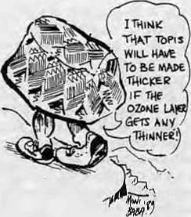
The Conference participants stated that the primary responsibility for reducing use of fossil fuels and CFCs lay with the industrial countries. Developing countries must respond to the "greenhouse challenge" in a way that enhanced, rather than diminished, development prospects. "Where these arc in conflict, priority should be given to development." Having cause the major share of the problem and possessing the resources to do something about it, the industrial countries must assist the developing countries in finding and financing appropriate responses. The response of the developing countries should be in the areas of improving energy efficiency, pioneering renewable energy use, halting deforestation and slowing population growth.
The Conference recomended that each country establish a National Climate Monitoring, Research and Management Board. Regional bodies such as SAARC and ASEAN could then set up regional boards, comprising of Chairman of the National Boards. - KMD/

Mar/Apr 1989
HIMAL
15

REVIEWS
Travels in Nepal: The Sequestered Kingdom
Charlie Pye-Smith Aurum Press, London 1988, 12.95 Pounds
Review by Miriam Poser
The title of this well-written book is very misleading. It is only marginally a travel book; it is chiefly about the impact which foreign aid has had on Nepal. In the preface, the author writes, "The assumption is that aid helps to alleviate poverty. I hope this book goes some way towards showing that often this is not the case." With examples from diverse projects, he makes his point. Along the way, Pye-Smith provides a delightfully earthy and non-condescending account of the problem-laden country and its resilient people. The British travel writer and environmentalist has clearly met the right people and asked the right questions. The result is an updated "from the inside" look at a country. The book is critical, unsentimental and thought provoking.
The book begins with a brief account of Nepali history, its bureaucracy and present day politics. Getting into "development", the author points out that Nepal seems to have been carved up for the foreign aid agencies: Khumbu for the New Zealanders and Austrians; the far west for Canadians; Rapti, Mustang and Gorkha for Americans; Dhading for Germans; the Kosi Hills for the British, and so on.
Pye-Smith's first trip was to Khumbu. He writes about deforestation and the various schemes there, including the Hotel Everest View fiasco and the dam on the Bhote Kosi at Thami which was washed away a few months after it was completed when a glacial lake burst upstream. Work was scheduled to begin again, but there had been no attempt to assess the demand for electricity in the area noT how the hydro electric plant would help the environment. The local population had neither been consulted about, nor asked to support, the project.
The author also describes the Resource Conservation and Utilisation Project (RCUP) — amply criticised in the pages of this magazine — funded by USAID in the Kali Gandaki Valley. RCUP, says Pye-Smith, ultimately "floundered in a mire of bureaucracy" and wasted huge sums.
Pakhribas, a British agriculture project in eastern Nepal, is one of few efforts
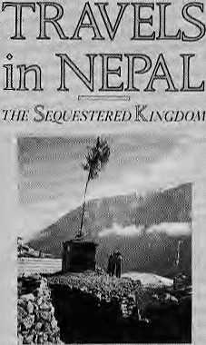
GHARIJE PYE-SMITH
that Pye-Smith praises. It was begun in 1973 as a training programme for retired Gurkhas but soon evolved to encompass 8,000 farming households in the Kosi Hills. Pakhribas provided high quality seeds, kept chemical fertiliser use to a minimum, restricted pesticides and weed killers, and employed local women. Both farm production and household income increased. The success is attributed partially to the fact that all the aid money went directly from the British Government to the project rather than get held up at the ministry and filtered off to Nepali government departments. Lest he be accused of nationality bias, Pye-Smilh is quick to criticise two other British projects, the Dharan-Dhankuta highway and the Kosi Hills Area Rural Development Programme (KHARDEP).
At Jiri, just east of Kathmandu, the author visited a lift irrigation scheme built three years before by the Japanese. No water had yet been diverted, and the only benefit so far was to the Japanese firms and contractors. Nothing Nepali was used in the project at all.
Parks and wildlife conservation are tackled in a chapter about the Tarai, which points out that the poor people who live next to a park are worried about their next meal, "not whether their grandchildren see a tiger", Pye-Smith also reminds us that one of the differences between a developed country and a developing one, such as Nepal, is that the former destroyed its wildlife habitats long ago, and that much more than conservation, vital though it is, must be considered when plans are made.
A section on the little known tribal group, the Chcpang, encapsulates the problems resulting from inequitable land holdings and the poverty and debt enslavement, Jairaj Senghai, the "yellow topiitd Brahman of Shimthali" must
have been doing well out of usury, says the author. "I love these people," says the Brahman. "My heart beats with their hearts." And this is what the author has to say, "I think he genuinely meant it, and I also believe the Chcpangs looked on him with a certain affection. Debt bondage, which is slavery under another name, kindles an odd form of reciprocal love."
The author is always quick to note ironies that abound in developing Nepal. It strikes him as outrageous, for example, that the annual salaries of expatriates who work in Nepal could be as high as U$75,000, while the Prime Minister earned NRs4,000 a month (it must be a bit more now). A Newar trader in Birganj was doing a booming business in commodes -- the sit-up variety — because it was catching on as a status symbol for the rich.
At a library at the Vajra Hotel in downtown Kathmandu he comes up with all sorts of odd tidbits of information. For example, he locates an obscure treatise on "The Use of Bamboo in a Rai Village in the Upper Amn Valley". The list includes stools, sieves for washing wool, trays for winnowing rice, baskets, combs, animal muzzles, fish traps, bows, arrows, hen baskets, spoons, pipes, chhang and tongba straws, mats, animal mangers, dokos, flutes, roofs and walls.
Pye-Smith writes with wit and charm as he incorporates a mass of detailed information in the most readable form. He includes accounts of experiencing vertigo on the climb to Namche Bazaar, conversations about cricket, discussions on current Nepali politics, and impressions of everything from Tarai towns to tasting paart, although he can't recall what it is called. Miriam Poser lives in New York and treks in South Asia.
HIMAL ALERT!
Himal welcomes news reports, articles and opinion columns on any and all aspects of Himalayan
society. While all
submissions will be read
and considered, the editors
are not obliged to return
unsolicited manuscripts. For
a copy of "Writing for
Himal", please write to P.O.
Box 42, Lalitpur, Nepal.

16
HIMAL
Mar/Apr 1989

REVIEWS

Wege und Ittwege der Entwickslungspotlitik
Das Experimentieren
an der Dritten Welt
Toni Hagen
Verlag Neue Zurcher Zeitung, Zurich
J988, 38 Swiss Francs
Review by Claus Euler
The "Third World" continues to get mired ever deeper in crisis even as the economic structures to exploit the national resources become cemented. There is increasing ecological awareness in the capitals of developing countries, but such awareness seems to have no chance against political pressures. The lives of creatures -- humans, animals and plants -- are sacrificed on the attar of the shortsighted and ruthless consumer needs of the industrialised countries and "Third World" elites.
At the end of the 1980s, aid givers and aid lakers find themselves confronted with the shattered remains of a failed development aid policy, which seems to have created its own momentum and is thoroughly incapable of learning from mistakes. Such is also the case with aid provided by Switzerland to the developing countries. "Mittelabflusswang", is one of the absurd words in development vocabulary. It refers to the need to disburse, or get rid of, aid money. Scepticism about the whole development assistance effort spreads even as opinion leaders call for a "Marshall Plan" to save the "Third World".
It is in the context of the ecology of development and the utility of foreign assistance that Toni Hagen's recent book on Swiss aided projects is most useful. The 352-page paperback, written in German, evaluates 230 projects from 24 countries around the world. 84 of the projects evaluated are those run by United Nations organizations and 79 are implemented by private non-govement organizations. Included are 20 projects from Bangladesh, India and Nepal. These last three are the only South Asian "partners" in Swiss development cooperation,
Toni Hagen, a Swiss geologist who has been "in development" since the early 1950s and has been highly decorated in Kathmandu for his contributions to Nepal's development efforts, finds that the development aid his country provides is wanting. The Swiss development aid law which insists that aid should reach the poorest of the
poor in the developing countries ends up in the waste-basket, concludes Hagen. And the bigger and more expensive the projects, he says, the more they fail.
Hagen evaluates the aid projects in 11 chapters in the first half of the book and presents case studies in the second half. He includes sections on criticism of the whole concept of development aid, the principles of successful development, and lessons to learn from the 230 projects evaluated. For easy reference, in 32 pages, Hagen also presents figures and short characterizations of the results of his study. This section can be used for an orientation before delving deeper into the book.
Regarding projects in Nepal, Hagen finds that four of the Swiss aided projects were "very successful" and five were either "doubtful" or outright "destructive". He comes out in favour of the oldest and one of the most successful demonstration projects of Swiss development aid: the "Cheese Project" in the Langtang hills north of Kathmandu. Started in 1956 with an investment of only U$66 per family, the scheme has, for 25 years, since the Swiss experts withdrew in 1964, provided 2,000 families with a yearly income of U$100.
Hagen reports that in 1985, 10 of 16 dairy stations were still operating, processing 866 tons of yak milk a year into cheese for the Kalhmandu market. Hagen ascribes the success to good economic conceptualization at the start and a smooth transition from Swiss to Nepali management. While it is true that few Nepalis can afford to buy the cheese which is thus produced, it was a small scale project to begin with and the Swiss Government did not expect more than what the project has been able to deliver. Hagen is extremely critical of the Swiss aid managers for succumbing to "Mittelabfiusszwang", forgetting successes like those achieved at Langtang, and looking for bigger and more prestigious projects.
Despite his long association with development aid to Nepal, Hagen does not shirk from criticizing projects he believes are misdirected. His views on the Kathmandu-to-Jiri road and the International Centre for Integrated Mountain Development (ICIMOD) in
Kathmandu, which has brought Hagen a lot of criticism from supporters, are also included in this book. Both projects get a "doubtful success" rating from Hagen.
This book is packed with facts and statistics which, fortunately, have been presented in a usable structure and format. However, he does have a tendency to make generalized comments that seem to be loo quick and judgmental. This also leads to ambivalence in the analysis. For example, in the concluding pages, he appeals for "boycotting everything which disturbs the social structure in the third world" and "finally destroys the environment and living conditions". At the same time, he seems to be encouraging decision makers to go about their business as usual. "If we save one human being in the third world, we already have a better world," he says.
Despite its few drawbacks, the book on the whole is thoroughly researched, well structured and a useful addition to the emerging development literature which questions the givens of past decades.
Claus Euler is with the Institute for Ecology and Action Anthropology, Zurich. He is presently working in Bangladesh/^
HIMALAYAN RESEARCH
BULLETIN
An international forum for scholarly exchange among those interested in the Himalayan region. Listings of recent and upcoming publications, notices of conferences, abstracts and book reviews featured in every issue.
Membership in the Nepal Studies Association includes a subscripiion to the Bulletin. Annual membership dues are U$ 18 for individuals and US 40 for institutions. Please direct correspondence to:
Southern Asian Institute
School of International and Public
Affairs
Columbia University
New York. N.Y. 10027
United States

Mar/Apr 1989
HIMAL
17

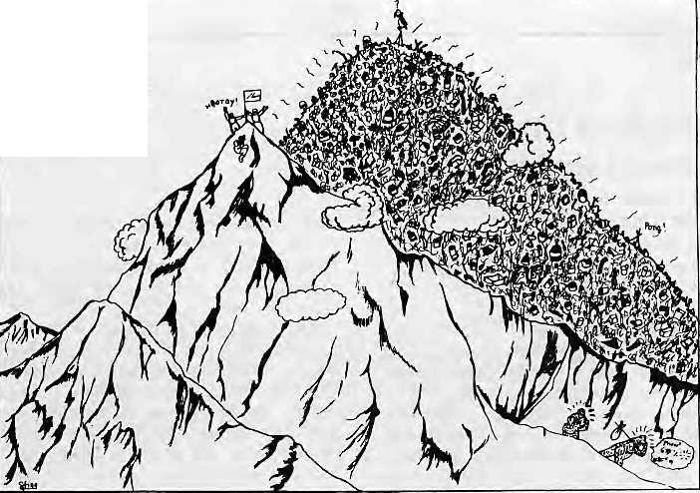
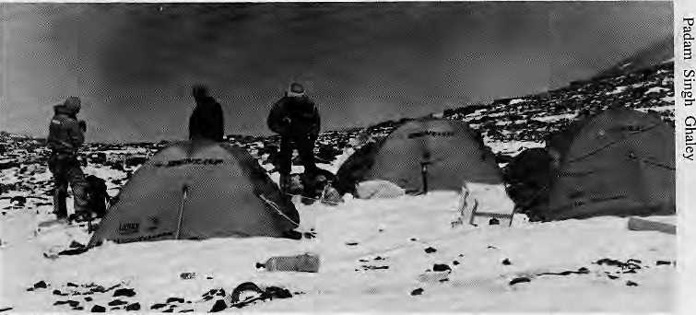
Mt. Everest
Ht. 29028ft.
CLIMBING
Following the Toilet Paper Trail
By Michael Luhan
Strange out-of-season pink blossoms sprinkle the rhododendron trail from Lukla lo Mount Everest Base Camp. But took again. What you seen is actually toilet paper, mostly Chinese brands, festooning the trailside and marking the passage of the Western Tourist.
At rest stops such as Pheriche, Lobuje and Gorakshep, accumulated garbage radiates outward like ripples in a grimy pond. At Base Camp itself, you are likely to find tents pitched atop or next to frozen landfills of discarded batteries, plastic boxes, food tins, gas cylinders and other 20th Century flotsam.
The trekking and climbing industry, which over the years has brought jobs, money and social benefits to rural Nepal, is now exacting an unsightly toll: A mass of litter spreading relentlessly over the mountains like an uncontrolled oil slick. In 1985, a British paper quoted an American tour operator about trekking north of Kalhmandu, "Langtang? Thai's the toilet paper trail!"
Since then, according to veteran sardar Padam Singh Ghaley, the problem has gotten much worse. He says what little regulations there and are flouted by the very people who would be extra scrupulous in the trails back in the American Rockies or the European Alps. Michael Yeager, who has climbed and led expeditions since 1976, agrees that the problem has reached unprecedented proportions. "This year, almost everyone I met remarked how bad the situation is along the trails and in the campsites," he said. "It is disgusting — I've even seen feces on the mani stones at Tengpoche."
Garbage does not end at the base camp, of course, but climbs up in a trail of discarded canisters, ropes, ice screws and wastes right up the mountains towards the summits. The South Col on Everest, of course, is legendary as the highest garbage dump on earth. In late 1987, then Minister of Tourism Ramesh Nath Pandey told an interviewer that things were so out of hand the Government was considering closing all the peaks over 8,000 metres until something could be done. That never happened. Meanwhile, an estimated 40,000 climbers and trekkers continue every year to add to the growing garbage pile.
ENOUGH BLAME TO GO AROUND
Yet when it is asked just who is responsible, all fingers point in different directions, and there is a chorus of "Not 1!" and "Mailay Haina!" Western trekking agency representatives generally pass the buck off to their sardars and porters, whose job it is, they say, to clean up after the sahabs and memsaabs leave camp. Respond the sardars; it is the Westerners who bring in tons of non-biodegradables and use tissue at the slightest excuse. Every sneeze, they say, harms the Himalayan environment. For out comes the Kleenex tissue, which is then discarded to the stiff mountain breeze. The paper takes much longer to biodegrade in the cold heights, say some well traveled Sherpas.
Blame is also placed on government liaison officers who do not monitor littering by expeditions they are attached to. Yet another problem is that half of the trekkers do not come in groups, and are thus much more difficult to sensitise and monitor.
South Col, world's highest dump.
When foreigners first took to the hill trails in the 1960s and 1970s and
discarded what they no longer needed, for a time, the porters and en route villagers gladly took home empty coffee tins, bottles and other castoffs. But the absorption capacity for such material reached the limit long ago. Now they are dumped into ice crevasses to be belched up at the glacial moraine in the next decade, or gathered in a pile at the corner of a campsite. At best, they are half heartedly buried into shallow pits.
Even on the rare occasion that refuse is actually carried back in d olios, aesthetic insensitivities can still intervene. Yeager recounts an Everest expedition he led which brought back a large load to Jorsale, the entrance to the Sagarmatha National Park. The park rangers congratulated him for the effort and assured him that the trash would be burned. And what would they do with the bottles and cans? One ranger replied, "Oh, we'll just toss those in the river."
Meanwhile, so long as the dollars keep flowing from the trekking business, the Ministry of Tourism seems content to lecture on the need "to leave Nepal as you found it". According to sardars

18
HIMAL
Mar/Apr 1989

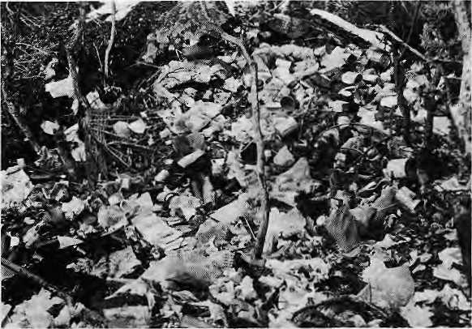
Rubbish at Tengpoche
and tourists alike, the trekking agencies on the whole continue to flout the basics of litter cleanup.
THE ANNAPURNA EXAMPLE In the middle of all this doom and gloom and garbage, the example of the Annapurna Conservation Area Project stands out. Since its inauguration in 1986, the ACAP has been conducting three-day training on rubbish pits and latrine construction for lodge owners in Dhampus, Ghandruk, Ghorepani, and other villages in the region. Afterwards, they are encouraged to form lodge management committees, through which ACAP can provide loans for building latrines. "Our philosophy is to involve locals by showing them the tangible benefits of litter maintenance," says ACAP Director Mingma Norbu Sherpa. "A clean environment means more tourists, and better service more money." Even though Annapurna draws three times as many trekkers as does Sagarmatha, Ghaley and others say it is far cleaner. Part of the reason is that in Sagarmatha the trekking is concentrated on the one route up from Lukla, the trekkers stay longer, and there are more expeditions with more porters and equipment. However, all agree that ACAP's efforts have made a significant
dif-ference, espec i al ty by impro v ing the hygienic standards in the villages. While ACAP has sponsored two annual cleanup expeditions similar to those conducted periodically in the Everest reg-i on, Mingma Norbu Sherpa does not see these as a solution. "The cleanup campaigns are useful to increase awareness about
the problem. The only systematic way to reduce litter is by encouraging local residents to set up depots along the trail and be empowered by the authorities to collect revenues for disposing of the refuse."
His suggestion makes sense, if only because all other options have been eliminated. The Government has already promulgated a host of anti littering rules, to no great effect. The trek agencies by and large continue to go
campsite.
their wayward way without picking up after themselves. The same is true of a significant number of tourists and climbers. The only way to keep a clean trail in the Himalaya might be to help the people who live on the trails to keep watch and pursue those whose actions leave the countryside dirtier than they found it.
Michael Luhan is a writer who lives in KathmanduA

'IEWP01NT

^{Y}
A Strategy
for Mountain Tourism
By Michio Yuasa
As a traveler who has come to the Nepal Himalaya over 30 times, I have studied closely the trends in Himalayan tourism, particularly as it relates to Japanese visitors. Recently, Japanese climbers have started opting for mountains in China rather than those in Nepal. The major reason for this change in climbing destination is the paperwork required by the Nepali authorities. A quick way to revive mountaineering tourism is to simplify the procedures for getting climbing permission, provide quick transportation to base camp, and control climbing cost (for example, the arbitrary setting of porters' fees). These steps will help bring some Japanese climbers back to the Nepali mountains. But this is not enough, and the market can be expanded even further.
Most Japanese trekkers would like to be able to stand on the summits of Nepali mountains. To satisfy this urge, the Nepali authorities and trek agencies could cooperate to devise proper climbing plans which would allow the tourist to stand on small peaks in about three weeks time. Such a climbing trip, if properly organised, would be even safer than trekking to Mount Everest Base Camp.
A mountain itinerary as organised by the Soviet tourism authorities in the Pamirs might be one to foliow in Nepal. According to this model, a semi permanent base camp would be established at an altitude of about 3,500 metres. Climbers would be helicoptered in from Kathmandu after a day of sight seeing in the Valley. The climbers would be provided with systematic acclimatisation for two days at base camp and given a medical check up after a day's rest. Those who are ready would then be allowed to go up the mountain on fixed ropes with good Sherpa guides. The camps on the mountain would already be set up.

I think it is possible to put such a plan into effect in the Khumbu region, leading from the Sherpa village of Pheriche to Island Peak. In Manang, Centra! Nepal, such a route could be established on peaks like Chulu or Pisang. Nepal would open up a major tourist market by making these minor Himalayan peaks more accessible. This way, many amateur Japanese climbers can go up to the tops of Himalayan mountains and their dreams would be fulfilled. Unlike the trekking tourist who is likely to go up to the Everest Base Camp only once, the climbing tourist is likely to come back again and again to seek adventure on other mountains^

Michio Yuasa is a lave professor. He is also Director of Alpine Tour Service, Tokyo. Viewpoint columns do not necessarily reflect the views of Himal.
Mar/Apr 1989 * HIMAL

PHOTOESSAY

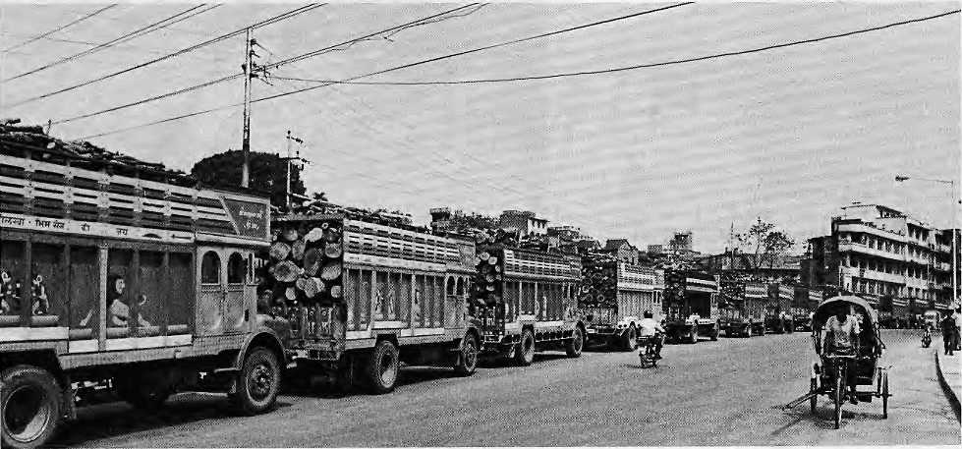
9
An
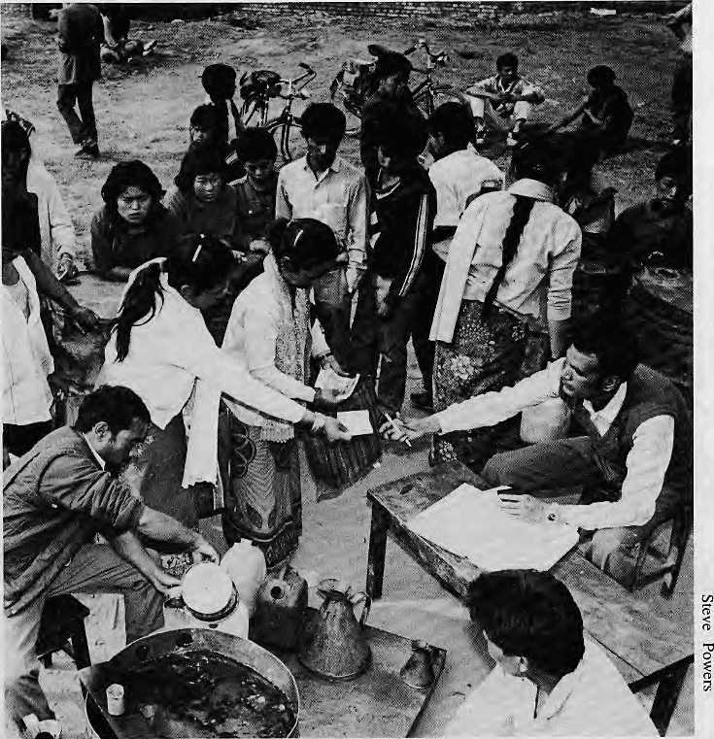
Economy At Standstill
The closure of the southern transit points by India in late March brought unprecedented crisis to landlocked Nepal. The impact was severest in Kathmandu, where two kinds of lines were most obvious: those for kerosene, and those of trucks bringing in what used to be left of the Tarai's jungles.
As the political stalemate between Kathmandu and New Delhi persisted, it was a time of uncertainty, a time to take stock. A relationship between two neighbours was being redefined.
For a privileged few, the shortages meant merely the nuisance of not being able to drive to work. It was the urban poor, those in bazaars and towns, who were hardest hit: interminable waits at the depot to collect rationed kerosene or firewood, loss of business, reduced income and shortage of vita! needs, including medicine. Hospitals were without essential supplies and only the severest cases were being treated.

20 HIMAL • Mar/Apr 1989

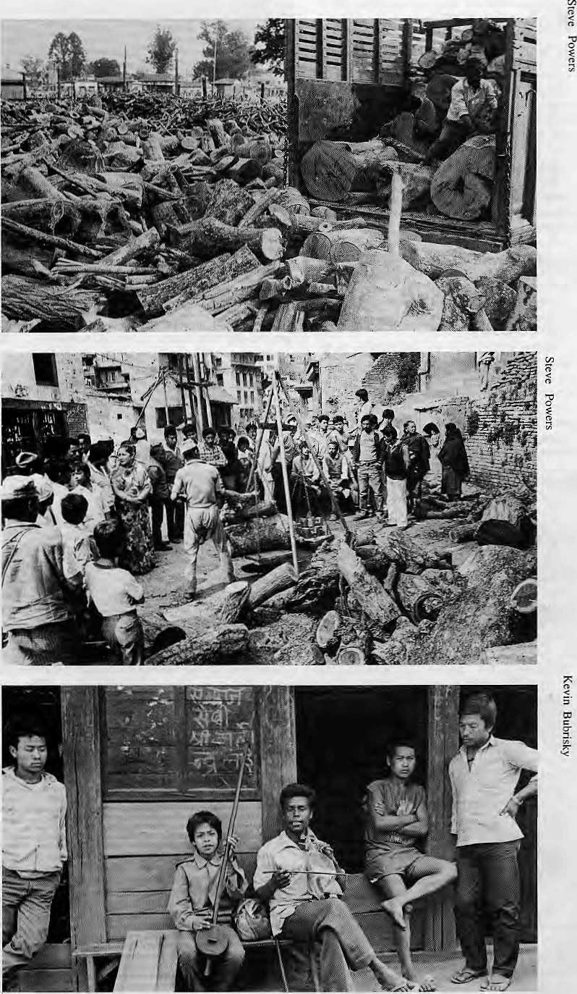
The long-term effects on the national economy was not yet apparent but the immediate impact was clear: almost every economic activity ground to a halt. Industry was at standstill. Travel agencies around the world were warning tourists to stay away. What did this do to the ambitious plans to expand tourism as the mainstay of Nepal's economy? And what was the damage to the Nepali forests this time around? A Government study showed that about 200 hectares of additional forest area was being lost every day.
Katmandu's residents
enjoyed short-term relief
from traffic congestion and
diesel exhaust and
rediscovered walking as a
means of transport.
Meteorologists were
able to take samples of pollution-free air.
Scarcity hit every community where roads had reached, in and around the urban centres as well as the bazaars in hill and Tarai. Ironically, though, the economic underdevelopment of the hinterland saved many hill people from feeling the immediate brunt of the crisis. Living outside the "modern sector", their subsistence lifestyles remained comparatively unaffected, at least till as long as the salt in the cellar lasted.
Life went on as before in Kaphal Danda Panchayat in Palpa Jilla, but Durga Bahadur Gandarva, a gainey minstrel, was not taking any chances. Durga Bahadur, seen at right with his son, says he will have a song about salt and kerosene ready by the time the shortages hit Kaphal Danda^\

Mar/Apr 1989
HIMAL
21

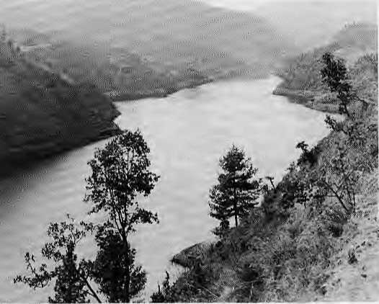
DAM NEWS
Kulekhani Lets Kathmandu Down
Load shedding was supposed to have ended in Kathmandu with the commissioning in 1982 of the Kulekhani Hydroelectric Project, Nepal's biggest and costliest power plant. This February, load shedding was back in the capital. Kulekhani had failed to deliver.
The problem was with Kulekhani's reservoir, whose capacity was down from an average of 86 million cubic metres to 65 million cu.m. There was not enough water to turn the turbines continuously, so the Nepal Electricity Authority reactivated its giant diesel generators in Kathmandu and started rationing electricity, which is expected to continue until the monsoon rains refill Kulekhani's reservoir.
Many criticisms of Kulekhani had been brushed aside in the rush to award dam-building contracts. After lying dormant for a decade, those criticisms were dredged up once again. People asked why a monsoon fed river with a relatively small catchment area had been chosen when snow fed perennial rivers were everywhere. Others questioned the need for an expensive reservoir when



Kulekhani's monsoon-fed reservoir.
"run-off schemes" could be built in practically any other river. A seismic fault was said to run right through Kulekhani's site, and other dam proposals were said to have been more economical. Besides, Kulekhani was a "peaking" station whereas the country needed a power station that provided steady base demand.
Kulekhani's woes brought sharp criticism of hydropower planning in
Nepal, which prompted former Minister for Water Resources, D.P. Adhikari to admit on television that "there could have been defective planning". That's for sure, but it is little consolation for Kathmandu's inconvenienced residents, already smarting under hardships brought about by the economic blockade. After all, there is precious little to show for the US120 million (1982 prices) that went downstream at KulekhaniA


Project Profile
Another massive hydropower scheme is coining up in the Himalaya, this lime in Himachal Pradesh: the Nathpa Jhakri Power Project.
TOTAL COST: U$1.8 billion
World Bank loan, U.$485 million; U$300 million from cofinanciers; US1
biilion from Government of India, Government of Himachal Pradesh, and
Himachal Pradesh State Electricity Board (HPSEB).
PROJECT OBJECTIVE: Construction of 1,500 MW Nathpa Jhakrt
hydropower station on the Sutlej River in Himachal; reinforcement and
expansion of transmission system in Himachal; provision of communications
facilities and a load dispatch facility for HPSEB; implementation of a
training program to strengthen the capabilities of the Central Electricity
Authority, the Central Water Commission, and other government institutions
in preparation, design, and construction supervision of hydropower projects;
training and consulting services for the implementation of the above
components.
ESTIMATED COMPLETING DATE: 1997
PROCUREMENT: ICB for civil works, US724 million; materials and
equipment: US556.9 million.
CONSULTANTS: Foreign ancJ local consultants wili be required. Consultants
should have experience in projects of similar size and design. The main
disciplines required are: underground excavating; geo-technical engineering and
rock mechanics; quality control of civil works and inspection of critical
equipment; electro mechanical engineering; general project management and
monitoring; and claims handling. A lead project adviser will be appointed
along with consultants for specialized services, as needed, and for training.
EXECUTING AGENCIES: HPSEB/Nathpa Jhakri Power Corporation,
Shimla. Tel: 2194. Contact: K.C. Mahajan, Chairman; Central Electricity
Authority, Sewa Bhavan, Ramakrishnan Puram, New Delhi 110 006. Tel:
630246. Contact: B. Chand, Chairman. (Source: Development Business)
HIMAL
22
Mar /Apr 1989
China Stalls Dam
Following environmental its' protests, Beijing has postponed till 1997 plans to build a U$10 billion dam at Three Gorges on the Yangtze River. If ever built, the project would be the largest hydropower scheme in the world, with a 607ft high dam, a reservoir that would stretch 500 miles, and a generation capacity of 18 million kw. Supporters say the project would also improve navigation and provide flood protection.
The scheme would submerge some of the China's most famous scenery, for Three Gorges contains majestic cliffs and gushing waters. More importantly, it would flood a million peasants out of their homesteads. Opponents claim that questions of silling and seismicity have not been addressed. The debate is sure to heat up between now and 1997.
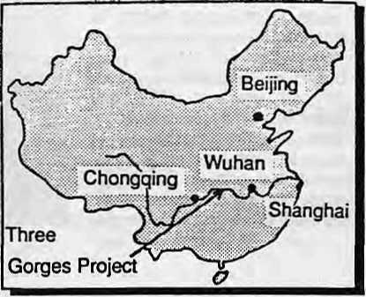

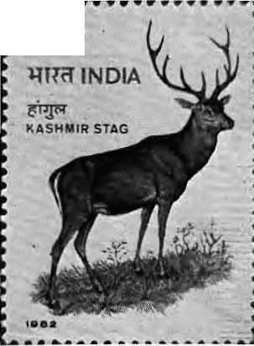
PARKS AND WILDLIFE
■ 2⁸⁵
USA, Europe:
S.S.R. Music 76 Exchange St. New Haven, CT. 06513, USA. (203) 562-6785
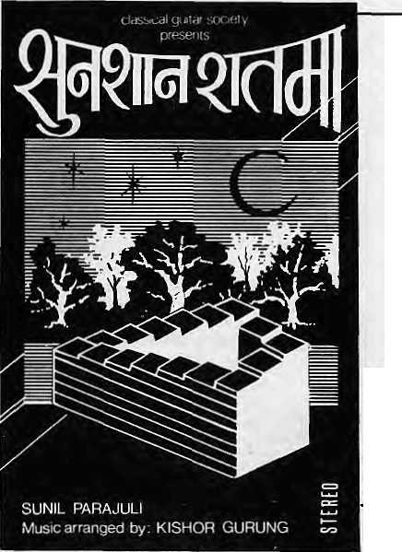
A Gain for the Rhino A Loss for the Tiger
There is heartening report about the Javanese cousins of the South Asian rhinoceros. At the same time, there is reason to worry about the Manchurian relative of the Royal Bengal Tiger.
The good news is that the a rare species of Javanese Rhinoceros facing extinction and thought to remain only in the Indonesian island of Java was located last month in the jungles of Viet Nam. The discovery was made by American naturalist George Schaller, well known for his work in the Himalaya and among the Pandas in China. The Java rhinoceros once populated all of Southeast Asia but is now the most endangered species of rhinoceros. There are only about 50 in a national park in Java. Schatler now believes that at least 10 to 15 survive in Viet Nam, even though they were decimated during the Viet Nam war.
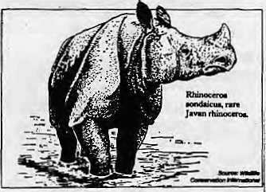
While the Javanese rhino might have retained a toehold in the mainland, the Manchurian Tiger may have become extinct in the wild according to the news agency Xinhua. It quotes Qian Yanwen, Secretary General of the Chinese Society for Animal Protection, saying that an aerial survey in 1987 spotted no Manchurian tigers in northeast China, which is their only remaining habitat. A survey conducted in the 1970s had observed only seven. More than 20 Manchurian tigers remain in Chinese zbos, but Qian believes that inbreeding could quickly lead to the extinction of the species. Healthy reproduction can only be achieved with 4,000 or more animals in the wild, says Qian.
TheHanguFs Last Stand
The recent decision by the Indian Government to upgrade the status of Dachigam Sanctuary in Kashmir and make it a national park that is part of Unesco's Man and Biosphere Reserve programme is expected to improve dramatically the Kashmir Stag's prospects for survival.
The Kashmir Stag, also known as the Hangul, has fallen victim to habitat destruction, poaching and human encroachment over the past half century. Previously common throughout the Kashmir and Himachal Pradesh regions, this unique deer species is now found only in and around the Dachigam Sanctuary.
There were about 5,000 of the animals in Kashmir 50 years ago, about 2,000 in 1947 and a mere 400 a decade later. After dipping to an all time low of 174 in 1962, their number is now said to be about 350. In 1952, the Indian Board of Wildlife put the Hangul, along with the snow leopard and the Indian lion, on the list of 13 rare fauna which required full protection.
By becoming part of the MAB reserve system, Dachigam will be linked via contiguous ridgelines to other reserves, creating a protected habitat that
extends all the way from Kolahoi Glacier to near Gulmarg. The extension will incorporate within the new park's boundaries virtually all the flora and fauna found in Kashmir. The Bangui will be able to migrate upward and downwards seasonally from 6,000 ft to 11,000 ft without coming into contact with migratory shepherds and their flocks.
Quiet Night
SunSaanRaatma

In an earlier era, as royal game, the Hangul used to receive blanket protection from the Maharaja of Kashmir. Wildlife experts hope that the extension of the hangul's habitat by governmental notification will prove as effective as a royal decree and that the Hangul will once again be secure/V Rajiv Chopra in Jammu Tawi. ^
Nepal:
Music Nepal Dilli Bazar P.O. Box 1115 Kathmandu. 2-12203

Mar/Apr 1989
HIMAL
23

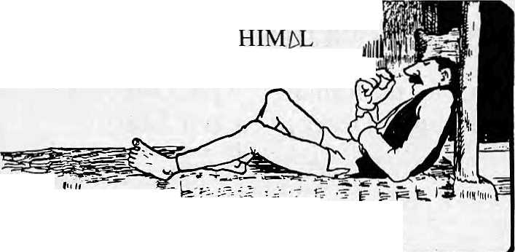
YOU CAN EITHER LAZE AROUND OR YOU CAN READ
V/'/fl
If you want to keep informed,
see below for subscription information.
HIMAL ASSOCIATES
Himal Associates is a non profit group whose objective is to provide a citizen's forum for discussion and action on all areas of Himalayan development, including public health, the economy, the environment, education and culture.
Himal Associates publishes the magazine Himat because it believes that communication and dialogue are critical for development. Public information is one of the scarcest commodities in the region and its lack hinders progress.
Himal Associates
P.O. Box 42
Lalitpur
Nepal Tel: 5-23845
HIM5L
■'■"■■:■'■-■ ii'i. : .
ji:r.:c i ■:.!;: UU
HIM5L
FDR DEVELOPMENT *Ntl ENWROHVEWT
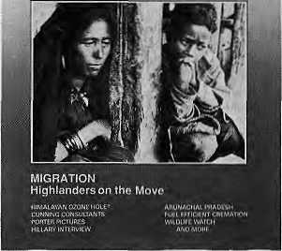
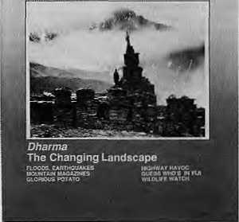
A limited number of back issues of Himal are available. Please write in for information.
Himal is an open-minded, independent publication devoted to the Himalayan region. Its news beat extends from the Pakistan Hindukush through Kashmir, Ladakh, Himachal, Kumaon, Garhwal, Nepal, Sikkim, Bhutan, the Indian North-East, and Tibet,
At last, you have a magazine to turn to for objective reporting and analysis of trends and events affecting Himalayan society. In its coverage, Himal espouses practical approaches to social and economic challenges in the region. It emphasizes the need to use and preserve the fragile environment for the people who live here.
Himal is current. It is readable. And it is serious. It is indispensable, if you want to keep in touch with the region.
Join us. Please send back the attached slip with your payment to receive six issues of Himal a year. Send Himal as a gift to a friend or colleague.
ANNUAL SUBSCRIPTION RATES (SIX ISSUES)
Individual Institutional
South Asia Elsewhere
NRs 110/IRs 65 U$ 25
NRS 300/IRs 200 (or equivalent) U$ 45 (or equivalent)
Personal checks acceptable, bank drafts and money orders preferred. Address subscription orders and correspondence to:
In South Asia:
PO Box 42, Lalitpur, Nepal, or
Central News Agency, 23/90 Connaught Circus, New Delhi 110 001
In North America: 4 South Pinehurst Ave. #6A, New York, NY 10033
In Europe:
- B.Welsh, Holos Centre 139-A, Battersea High St. London SW1 (for UK)
- L.Debuck.Donaustr.38, D-4100 Duisburg 29, W. Germany (FRG, NL, B)
- A.Odermatt, Winterthurerstr. 112, CH-8006, Zurich, Switz. (rest of Europe)
- C.Euler, Hagelerweg-7, CH-8055 Zurich, Switzerland (general info)
as a
Please enter a subscription for me. I have enclosed payment of one year/two year subscription to Himal.
Name
Street Town Country
Postal Code

24
HIMAL
Mar/ Apr 1989

IN
GRASSROOTS
The "Tukis" of Dolakha: A Return to Darkness?
By Binod Bhattarai
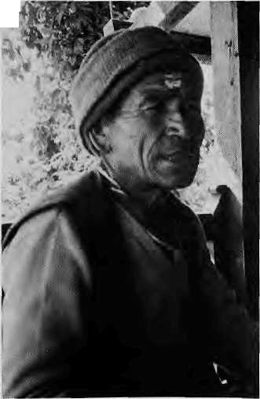
■T--
Dev Narayan Shrestha.
Tukis are traditional oil-fed lamps used to light village households. "Tukis" are also the rrailblazing villagers who serve as unique agricultural extension workers in the Doiakha and Sindhupalchok districts east of Kathmandu. As torch bearers for development, the 200 Tuki farmers in the area have for many years acted as information conduits, passing agricultural information to the villages. They have also channeled feedback from the farmers to scientists and bureaucrats. "Unfortunately, what remains of the Tuki farmers is the last bright glow. The oil is almost used up and the lamp will soon go out," says conservationist K.k. Panday, who has been involved with Tukis since the late 1970s. With the Swiss funded project scheduled to be wound up in 1990, he says it is likely that these "emissaries between the village and the project" will go their own individual ways. The villagers of the two districts will then once again slip back into dusk, if not darkness.
08
I «
I
MOVE TO CASH CROP
Dev Narayan Shrestha, as an open minded farmer, was attracted to the innovative ideas brought to his district by the Swiss experts. From them, the 54-year-old Dev Narayan learned cultivation techniques, appropriate fertilizer use, and advantageous marketing of produce. He planted a variety of fruit trees. With ever widening horizons, Dev Narayan pioneered raising pigs at home even though it was strictly taboo by caste. He recalls with a wry smile that at first he was regarded as a pariah in the village, but when the cash started flowing, the neighbours joined in enthusiastically.
"I started to think of my labour in term of cash, and everything looked different from then on," says Dev Narayan. This step up from subsistence farming to cash crop agriculture was good, he decided, so he became a Tuki in order to spread the word to his skeptical neighbours. "I wanted to show them that they too could do what I did," he says.
When Chitra Kumari Thapa returned home as the first woman Tuki, it was a completely new experience for her: "I could feel in me that I knew something which was useful," At first, the menfolk refused to accept her newfound knowledge and skills, but they fell in line when they listened more carefully to what she had to say about crop rotation, use of seeds and maintaining terraces.
WHEN THE SWISS LEAVE
The Government machinery is supposed to take over as the Swiss begin to pull out. Problems are already surfacing, however. The seeds that Thapa got from the local agriculture office did not germinate well, which has led to a credibility problem for her as a Tuki. "We are answerable to the villagers but are losing their trust," she says. "It does not help if the seeds arrive in the district office after the sowing season is over."
"The grassroots are motivated, but the administrators are the same old bunch," says a Kathmandu expert who asked not to be named. Panday, for his part, says that the voluntary nature of Tuki participation is unique and they serve as a grassroots lobby to keep the local government on its toes. Whether they will continue to be as effective will be clear by this time next year A

Since 1968, the only English monthly to cover all aspects of Tibetan affairs, including news fiom Tibet, commentaries on recent happenings, and authoritative articles pn Tibetan history, culture. Buddhism, medicine, astrology, and personalties.
Annual subscription rates: India, Bhutan and Nepal - IRs. 4S All other countries (airmail) ~ IRs. 190, UI IS (or equivalent)
For a sample copy, please write to:
The Editor Tibetan Review D-tl, East of Kailash New Delhi 110 065
WEARE THE BIGGEST BOOKSELLERS TOWN
Drop in at our showroom in downtown Kathmandu or write to us for our detailed catalogue.
We carry a wide variety of publications on the Himalaya, including large selections on Nepal, Tibet, Bhutan, Sikkim.
We also carry guide books and maps in addition to our regular selections on anthropology, commerce, management, economics, history, culture, language, folklore and politics.

Ratna Pustak Bhandar
Bhotahity Kathmandu
Through the Bibliotheca Himalayica, you have access to current and classical works on natural history and civilizations of Central Asia and the Himalaya.

Mar/Apr 1989
HIMAL
25

I-

MEDIA
At Last,
A Village Voice
By Rosha Bajracharya
Townspeople in Nepal have over 300 newspapers, both good and bad, to choose from. But so far, the people of the country's 50,000-plus villages, with over 90 per cent of the population, have had none directed specifically at them. That deficiency has now been corrected with the debut of Gaun Ghar, a wall newspaper which is emerging as an important source of information on change and development for the villager.
Posted on the wall of village schools, banks and lea shops, Gaun Ghar seems to have hit its target readership. Men and women on their way to the fields or forest increasingly slop by to go through the tabloid's large type and easy script. Children on their way home from school test themselves on what the latest Gaun Ghar has to say. The twenty inch by thirty inch poster sized newspaper sometimes does not get pasted and is passed hand to hand.
The newspaper focuses on development issues of special interest to the farmers. It carries special features onsubjects such as health, sanitation and
Reading Gaun Ghar.
the status of women. There is a comic strip across the bottom of the page. "We write and rewrite to make the sentences simple and the ideas clear and direct," says Assistant Editor Kedar Sharma. "We travel all over the hills and come back with first hand news, which makes the copy more interesting," says Sharma.
The push behind Gaun Ghar came from its Editor Hem Bahadur Bista and Bharat Dutt Koirala, Executive Director of the Nepal Press Institute (NPI). In
Koirala's words, the idea was to provide the rural people with a newspaper "in their own language". The sheet began publishing in April 1987 with the support of UNICEF, Agriculture Development Bank (ADB) and NPI. The newspaper costs NRs6 per copy but is sold at a subsidized rate of a rupee each. Voluntary groups such as Action Aid buy Gaun Ghar at cost price and spread it around. Distribution is done using the effective network of the ADB's Small Farmers Development Programme.
Two years of experience, says Koirala, has shown that Gaun Ghar provides farmers with an opportunity to use their literacy for a purpose, that is, by reading about ways to make their lives more productive. "Without a paper like Gaun Ghar, people will lapse into illiteracy. The whole rationale of education and adult education then gets wasted."
This rationale seems to be working for 150,000 villagers who read Gaun Ghar in the 5,000 hamlets where it is now posted. Recently, a farmer from Jhapa in west Nepal installed an innovative water pump after he read about another farmer using it in Chitwan in central Nepal. It thrilled the editors of Gaun Ghar no end A


Books
on Ecology
NEW PUBLICATION
Himalaya Today
This new quarterly news magazine deals with the economic, social and environmental issues facing the people of the Himalaya, but its major focus is politics. Due to the geo-political significance of the Himalaya, the importance of a magazine such as this cannot be over-emphasized. The maiden issue appeared in June 1988. The chief editor of Himalaya Today is Dil Kumari Bhandari and its patron is Sikkim Chief Minister Nar Bahadur Bhandari.
Articles in the September issue (Vol.1, No.2) deal with, among others, the Gorkhaland movement in Darjeeling and prospects of Sikkim's industrial development, child labour in Darjeeling's tea gardens, genesis of the insurgency in the Indian northeast, the Tehri Dam in Garhwal and Indo-Nepal migration. The editorial is on the Gorkhaland accord, and there is a book review section.
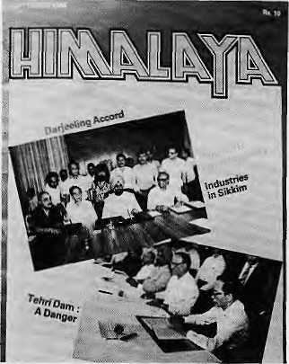
Himalaya Today, with its political focus and in-depth coverage of the Indian Himalaya is sure to help promote understanding of this neglected region. The magazine costs IRs10 per issue. Contact; Central News Agency, 23/90 Connaught Circus, New Delhi 110 001 - Sudhir Sharma
We have in stock more than 300 current books on birds, butterflies, primates, wildlife photgraphy, animal behaviour, remote sensing, environmental history and law, comparative ecology, and many other environmental subjects. Plus a special offering of books on Indian forestry.
Nat raj Publishers
Publishers, Booksellers 17, Rajpur Road Dehra Dun 248 001

26
HIMAL • Mar/Apr 1989

DEBATE

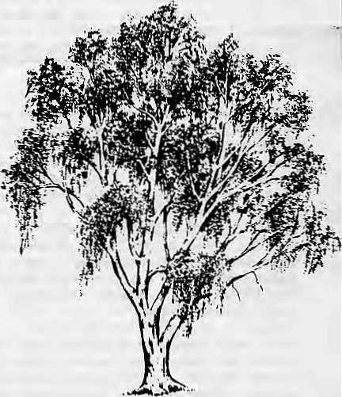
The cumulative effect of eucalyptus on soil moisture, groundwater, soil fertility and other plant life ultimately leads to desertification. It, thus, threatens the livelihood of millions of fanners.
Because of its negative social and ecological effects, all plans for eucalyptus plantations must be scrapped. The World Bank should hall all its eucalyptus projects. Governments must heed the warnings of environmentalists and indigenous people and stop the indiscriminate planting of eucalyptusA
Mar/Apr 1989 • HIMAL 27
For Eucalyptus
By Sudhirendar Sharma
Eucalyptus has been under fire for quite a few years now. Farmers, agronomists, environmentalists and scientists have all condemned the planting of the species. In 1983, Karnataka farmers uprooted eucalyptus seedlings from forest nurseries. More recently, Chipko activists in Himachal Pradesh were arrested while trying to uproot more eucalyptus. Meanwhile, to aid the activists, environmentalists marshalled evidence to prove that eucalyptus was not good for afforestation. Those ranged against eucalyptus claim that it has an insatiable appetite for water, poisons the soil, drains the soil of all nutrients, and fails to provide green manure and soil stability.
Eucalyptus species from among the 500 kinds that are native to Australia have been spread all over the world during the past hundred years. About six million hectares in over 70 countries are now under eucalyptus, making it the most widely planted commercial hardwood. And, it is being planted because it prevents soil erosion, stabilizes degraded slopes and provides some cash income to the farmer.
While it is true that eucalyptus was used to dry mosquito-infested marshes
Against Eucalyptus
Third World Network
Eucalyptus planting is a major component of so-called social forestry projects intended to improve human welfare and the environment. In reality, scientific evidence and the experience of grassroots communities has shown eucalyptus to be disastrous for the environment. It has adversely affected the water, soil and agricultural activities of poor communities. What follows is a brief description of the major problems caused by planting this alien species.
Natural forests have been destroyed to make way for eucalyptus. In Karnataka, for example, under a huge World Bank social forestry plan forests that had provided basic needs of villagers for centuries were cut down to make way for eucalyptus plantations.
Eucalyptus trees normally have deep roots which suck up too much water, depriving the land of vital moisture. This inhibits the growth of other native plants. Trees growing in dry zones, on the other hand, have shallow root
in Italy, Uganda and Israel, it has not been conclusively proven that it is a "water-pump" that dries the land. Scientists in Brazil, which has more than a million hectares under eucalyptus, confirm that 10 hectares of eucalyptus consumes less water than the same area under natural forests. Several trials in Australia have proved that eucalyptus is the most efficient utilizer of scarce water - it controls the stomatal opening according to the availability of water.
Perhaps the criticism should be directed not at the eucalyptus plant but at the way it has been popularised. "The problem in Australia is not the same as in Asia," says Ian Peter of the Rainforest Information Centre, "In Australia, eucalyptus have adapted to the soil and environment. It is a good tree. But in Asia, monocluture planting has ruined its reputation."
The problem is that eucalyptus, the world's fastest growing tree, is being planted where rich tropical forests once stood. No single tree can be expected to replace such a diverse tropical canopy, but no other tree can grow as fast as eucalyptus. Thus, the dilemma: do you want reforestation and tree cover now or do you want to wait for decades for the tropical forest to regrow?
systems that spread out and efficiently extract moisture. Long-term experiments have proven that, where rainfall is less than 1000 mm a year, soil moisture and groundwater are severely depleted by eucalyptus plantations.
Biologists have found that densely planted eucalyptus reduces the biological diversity because they shelter few indigenous animals or plants. They have also found that eucalyptus increases soil erosion and is therefore unsuitable for steep terrain.
Eucalyptus takes a lot of nutrients from the soil in order to sustain its fast growth. Compared to this high intake of nutrients, however, it returns very little to the ground through leaf litter. The species also increases toxicity of the soil, which inhibits seed germination and plant growth. This has the effect of reducing the potential yield of nearby crops. A Bangalore study confirmed that the toxicity remains for a long time, especially in low rainfall areas.
In the eucalyptus debate, a war has been waged before the problem has been understood. Technical arguments are being confused with social implications. Some environmentalists have relied on halfbaked data and taken emotional stands. As a result, the reputation of eucalyptus has been sullied and it will not be easily salvaged. At the very least, we should take note of what Australian forestry expert K.O. Eldridge, says, "Eucalyptus has existed in Australia for 20,000 years without any ecological damage."
Eucalyptus is a sturdy, multipurpose tree species that grows and matures faster than others is in itself a great advantage in many locations. We cannot just start calling eucalyptus names. What is now needed is detailed research to clearly indicate the advantages and disadvantages of eucalyptus.
Sudhirendar Sharma is with the Energy and Environment Group, New Delhi.

VIEWPOINT

A "No"to Privatisation
By Chaitanya Mishra
Recently, we have all heard declarations on the virtues of privatisation in Nepal. They come from the large Nepali business houses, the global capitalist states, and financial organisations like the World Bank and Asian Development Bank. Somewhat uncharacteristically, the Nepali Government also has joined the chorus. Two successive finance ministers, P.C. Lohani and B.B. Pradhan, have made high pitched exhortations in favour of privatisation.
Privatisation is touted as a prime remedy for various ills that face the country. It is expected to help locate viable investment sectors, mobilise private savings, create a class of national entrepreneurs, correct market distortions, help import substitution and promote exports. On the whole, it is expected to "lighten the state's burden". Some have even gone as far as to draw a premature and tenuous link between privatisation and the "basic needs programme" of the Government.
Let us first remember that privatisation has a long history in Nepal, having been pursued aggressively since the historical consolidation of the country. Privatisation of the "commons" — communal agricultural lands, forests, pastures, river banks, urban real estate - used to be the order of the day. The systematic narrowing of the domain of the commons made large fortunes for a small section of hill households, a larger section of the landed aristocracy in the Tarai, and for high officials and traders.
The cultural and political legitimacy of private property and aggressive privatisation was also recognised in post 1950 Nepal. The expansion of private agricultural land, legal sanction to a highly skewed distribution of landownership, low and regressive land taxes and absence of agricultural income taxes should have generated, under conventional wisdom, a high rate of investment in the rural areas and thus created rural agricultural-industrial entrepreneurs. In the growing urban economy, low levies for import of raw materials, low excise rates, long industrial tax holidays, nearly non-existent urban property taxes and a host of other features and measures should have led to a relatively independent class of industrial-fmancial urban bourgeoisie.
It has been three and a half decades, but none of these ''should have beens" have actually come about. Instead, the country has witnessed reduced agricultural productivity, a stagnant industrial sector, large scale import of consumer goods, a Government which has large financial resources but is fiscally irresponsible, and an accelerating rate of marginalisation of the populated hills. Most of the personal savings generated are "immobilised", kept in households or as excessive reserves in banks; hoarded in the form of gold, silver and real estate; or spent in conspicuous consumption of imported goods.
The current "edition" of privatisation essentially seeks to mobilise the financial strength of the small body of nationalist entrepreneurs, the "comprador class" and the urban middle class who recently have, in a historically relative sense, been awash with liquidity due to the income from the entrepot trade, foreign aid, kickbacks and the sky-rocketing value of urban real estate.
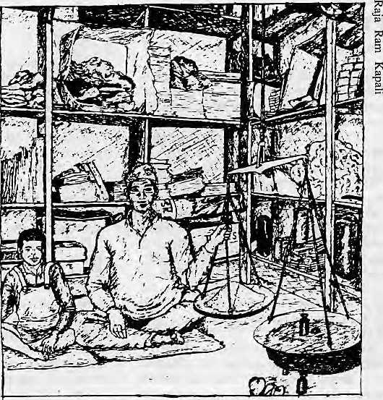
Who benefits?
The call for privatisation, at least at this phase, appears to be geared towards the divestiture of the control of profitable state enterprises -- rarities in themselves. It is not at all clear from the recent Government declarations how the majority of sick state enterprises are to be privatised. What is clear is that potentially profitable divestitures will be made, if at ail, at far below market prices, topped by large buyer subsidies.
Looking ahead to the next two decades, the central issue is whether privatisation will lead to actual expansion of the domain of private ownership; and whether it will contribute to the promotion of a nationally bounded and integrated market, decentralisation and equity. All This would prepare the ground for development.
We can expect the private sector to expand to cater, selectively, to the demand for consumption goods of the urban and middle classes. The likely expansion of the private sector will, to a certain extent, lead to import substitution and export promotion of a narrow range of consumer products. However, investment as a proportion of savings may not show an appreciable rise. Excessive liquidity of households will continue. All other hopes attached to privatisation, such as correction of market distortions, increased competitiveness of local producers, creation of nationalist entrepreneurs and "lightening of the state's burden", are unlikely to be fulfilled.
The new "privatisation show" has the small body of the urban middle and upper classes and the large business houses as its audience and potential actors. It docs not address small, rural investors and does not mobilise subsistence funds and other resources at the rural household and community levels. It is not tied in any direct way to the agrarian sector.
The Viewpoint section is a forum for debate and dialogue. Contributions are welcome. Opinions expressed here do not necessarily express the views of Himal or of the institutions with whom the writers are affiliated.

28
HIMAL
Mar/Apr 1989

VIEWPOINT

Privatisation, therefore, will not lead to the political and economic empowerment of the overwhelming proportion of producers. Instead, and to the extent that the push is successful, it will tend to concentrate the political and economic power in the "modern sector". Competition will be limited to the large business houses -- and this for privileges which the Government can distribute.
The new push, because it is inherently biased against small rural producers and because it favours the large business houses and the middle and upper income earning households, will worsen the terms of trade for low income and rural households and generate further inequities. All in all, the new push will further reduce the scope and intensity of local initiative and responsibility in the rural area.
It is thus that Nepal has been living through an extended policy impasse in the midst of !ong term and accelerating underdevelopmeni. privatisation, a long-standing historical routine and one which has expanded immensely at the expense of the common use of resources, cannot be effective in arresting this slide.

Gandhiji Was Talking Sustainable Development
By Kamala Chowdhry
This article by Chaitanya Mishra is adapted from a longer one which appeared in Sambad, a newsletter of Integrated Development Systems, Kathmandu.
Every Five Year Plan since Indian independence has focussed on eliminating poverty. Yet, 40 years later, about half of the population still lives below the poverty line. The poor are caught in a vicious downward spiral — poverty leading to impoverishment of resources, which in turn leads to increased poverty. Clearly, the interests of the poor can only be safeguarded if development planning takes into account the inter-relationship between poverty, land use policies and environmental concerns.
Jawaharlal Nehru dreamt of modern India in terms of industrialisation, steel and fertiliser plants, dams and hydroelectric power, modern agriculture, and the introduction of a scientific temper in the country. India today can boast of a broad-based scientific and industrial infrastructure. However, its contribution to the well being of the people, especially the rural poor, is in considerable doubt. Professor C.N.R. Rao, Chairman of the powerful Science Advisory Committee to the Prime Minister, in a recent report pointed to the failure of science and technology in the economic and social development of the country.
Decades ago, Gandhiji asked, "Why must India become industrial in the Western sense? The Western civilisation is urban. Small countries like England and Italy may afford to urbanise their systems. A big country like America with very sparse population cannot do otherwise. But one would think
that a big country with a teeming population with an ancient rural tradition which has hitherto answered its purposes need not, must not, copy the Western model."
If India is to attain true freedom, said Gandhiji, then sooner or later it will have to be realised that the people will have to live in villages not towns, and in huts, not palaces. The India of his dreams was a federation of small village republics providing essential needs of the community without large scale industrialisation. Such an ideology ensured sustainable development without over-exploitation of natural resources. As he said, the earth has enough for everyone's needs but not for everyone's greed.
Today, ecologisls everywhere seems to be coming around to Gandhiji's view that the world is moving in the wrong direction and in the process of destroying itself like a moth around a flame. They question the industrial way of life and say that if the biosphere is to survive, then industrialism in its present form must end.
Although Nehru's intention was to move speedily towards modernisation and to raise everyone above poverty, the strategy has instead intensified poverty. The intensive pursuit of large industries has led to large scale environmental degradation. Industrial pollution has hurt agricultural lands, lakes, rivers and seas, and tainted drinking water. Open cast mining has degraded large areas of land. The Narmada and Tchri dams have been justified in terms of development needs for electricity generation and industrial development, even though thousands of hectares of forests would be submerged and untold numbers of tribal people and others would be displaced with little hope of rehabilitation.
Even otherwise, there seems enough evidence against large dams. For instance, Prof. Ramalingaswamy, former chief of the Indian Council of Medical Research, notes that a crippling bone disease, "knock knees", has begun to appear in the Nagarjuna Sagar Dam area. He also warns that the incidence of malaria and other mosquito borne diseases would increase in and around artificial reservoirs. In Egypt, it was found that many of the prevalent diseases could be traced to the Aswan Dam. But we do not wish to learn from history.
As the economist Ivan 111ich says, development has not eliminated poverty, it has merely modernised it. The basic question is, what does progress mean? Is the tribal person of Nagaland or Mizoram less well off than the slum dweller of Calcutta? The gross national product (GNP) as a measure of economic progress is a funny thing. "You can double a country's GNP," suggests Edward Goldsmith, Editor of the British magazine The geologist, "by the simple expedient of getting every woman to cease looking after her own children for nothing and look after her neighbour's children instead — for a salary." Perhaps economics needs to be re-written to take into account social, environmental and cultural concerns and the differing assumptions of a different world view. The basic assumptions of "western" economics are not shared by the older Buddhist, Hindu, Muslim and tribal cultures.
Modernisation, industrialisation, big dams, nuclear energy and other such large scale projects can create an illusion of progress. The "iimits to growth" would depend on the limits of renewable natural resources and would vary from country to country depending on population, land, water, oil and other natural resources. What is feasible in the United States may not be feasible for India.

Mar/Apr 1989
HIMAL
29

VIEWPOINT

If the world is to be saved from doom, development must be in harmony with and not at the expense of nature. Gandhiji believed in the innate "relatedness" of things. Tribal people have always held those beliefs and many modem thinkers and ecologists are beginning to understand that philosophy. There is growing realisation that poverty, environment and development are inter-related; that economic and environmental concerns cannot be separated from ethical concerns.
Gandhiji propounded the moral principle of development, of helping the poorest of the poor. He believed that if India became heavily industrialised, beyond the sustaining capacity of its natural resources, it would inevitably be driven to exploitation and become a "curse for other nations, a menace to the world". The tendency to overproduction is inherent in the industrial mass production system itself. "God forbid," exclaimed Gandhiji, "that India should ever take to industrialism after the manner of the West. The economic imperialism of a single tiny island kingdom is today keeping the world in chains. If an entire population of 300 million (now 800 million) took to similar economic exploitation it would strip the world bare like locusts."
Kamala Chowdhry is recently retired Chairman of India's Wastelands Development Board. This column is adapted from her paper to the 1989 Internationa! Development Conference in Washington, D.C.

m | I

Of Rabbits, Hillmen and Muddy Rivers
By Dipak Gyawali
Since the early 1970s, shrill alarms have been sounded that because of deforestation Nepal is in danger of being washed away into the Bay of Bengal. Indeed, as one approaches the Bengali coastline when flying from Bangkok or Singapore, grey, turbid plumes of silt can be seen reaching out into the sea. Closer to home, the holy Ganga and her Nepali tributaries are not sparkling blue and pure, but resemble mudflow in their colour. Before the plane lands at Kathmandu's Gauchar airport, Royal Nepal's Boeing skims past the valley's rim to show mountains stripped bare of forests.
It would seem that theTe is every reason to believe the prevailing deforestation syllogism, which runs thus: all poor marginal farmers cut trees for fodder and fuel; marginal farmers breed like irresponsible rabbits; because there are more of them, these farmers have to cut more trees on higher, steeper slopes; this results in deforestation, soil erosion and, eventually, apocalypse in Bangladesh.
However, the reasoning is flawed on several counts, not the least because it blames the victims. The hill farmer knows his own needs and the productive capabilities and environmental limitations of his terraces better than the urban theorist who does not have a life-or-death commitment to the land. If the farmer does cut more trees than is ecologically sound, it is probably because of some other dynamic, such as irresponsible forest nationalisation or unfair land tenure practices.
No hill farmer is so irrational as to cut down his own survival base. In fact, there is universal acceptance in the hill villages that you cannot keep cattle if you don't have access to fodder
So what's 3 landslide doing in the middle of a forest?
and litter form the forests, and you cannot farm for very long if your fields do not get resulting fertiliser from the animal wastes. If the careful, traditional husbanding of scarce hill forest resources has broken down, replaced by the rapacious mining of forests, the culprits can probably be found in market forces that encourage it, political forces that nationalise resources and exclude those without organised clout, and the non-sustainable, energy intensive^ value system peddled by the industrial world.
As for the "rabbit theory", it simply states that the root of all underdevelopment is helpless overbreeding. Yet. the very premise of this theory is the questionable 1981 Nepali census. Entire villages in the midhills were counted from the roadside chautara, based on the report of the First passing porter. And what can you say of !2-year-old census takers who were paid 25 paisa per survey sheet? These 12-year-old counters, along with village politicians, population experts and aid agency officials, all have a stake in seeing a high population figure, and they have carried the day.
At the same time, the fecundity of the hill mothers should be the last to be blamed. How can the hill household survive as a three member nuclear family? The daily survival routine requires them to fetch water (2-3 hours), fetch fuel (2-4 hours), cook {4 hours), farm (full time), lend to cattle (almost full time), tend to young children (overtime) and earn a salary, do wickerwork or do trade where possible (full time).
Furthermore, even if the Nepali population were exploding, the people from the overburdened hills are not moving up-slope. On the contrary, the migration has been down to the urban centers and the tarai plains. The people have been living at critical ecological capacity long enough for social mechanisms to evolve. These mechanisms include migration and the sequestering of reproduction-age adults as celibate sadhus and

30
HIMAL
Mar/Apr 1989

VIEWPOINT

lamas. If there is population pressure, it probably results from a changed social and political milieu which does not allow those mechanisms to function. For example, modern lifestyles are making the ochre robe less attractive for the young.
Even if one accepts the idea that deforestation is caused by over population, no firm nexus has been established between trees, or their lack, and muddy rivers. Leading watershed authorities maintain that even if all of Nepa! was nothing but a canopy of trees, intensive rainfall would still wash a lot away. A study at ICIMOD in Kathmandu by Brian Carson indicated that suspend silt is, in volume, a very small fraction of the total mass that moves downstream in Himalayan rivers.
Surface erosion, of course, is an insidiously damaging phenomenon for the hill farmer because it robs the generally poor soil of the fertile top layer that sustains production. But do trees stop surface erosion? hi heavy downpours, such as during the monsoon, the trees do not stop sheet erosion of the topsoil. Instead, it is the lowly and much ignored grass that saves the topsoil. A hill slope below Harnok in Dang Valley has beautiful forest cover, but trekking through it is like scampering through the Chambal ravines: the forest floor is so heavily grazed that it lacked all grass cover, which resulted in eroded gullies and exposed tree roots. A study by the Nepal Australia Forestry Project concludes, in a preliminary assessment, that the Himalayan forests do not really help soak up the intense monsoon downpour any more than trampled grassland.
All this points to an uncomfortable (or unconventional) possibility. That muddy rivers in full spate are quite natural for the Himalaya. But, they could be aggravated by poor management of land.
This polemic should not be viewed as an excuse for doing away with afforestation. Even though badly managed, Nepali hill slopes -- whether forest or agricultural or pastoral grazing — are all that the hillmen and women have for their survival. Efforts to make the mountains more habitable, through belter management of fuel and fodder resources, should continue so that the people of the hills do not have to migrate to the plains. That -.- not floods -. is why we need forests. Dipak Gyawali is a resource economist and power engineer specialising on Nepal's water resources.
Education For Work
By King Beach
Raja Ram is a farmer learning to run a general store in a village in West Nepal. He had not been to school, but had learned some math from family and friends. He was now learning practical techniques from a local shopkeeper for measuring, calculating prices, counting out change and determining profit and loss.
When a customer entered, Raja Ram, using his head and fingers, rapidly totalled the order for two metres of cloth at 23 rupees and 50 paisa and four containers of tobacco at 2 rupees and 25 paisa each, "...so 2 and 4 and 8 rupees and 4 suka are 1 rupee, so 9 rupees for the tobacco and 23 rupees and 9 rupees is 23 and 10 and 33 less one is 32 rupees and 50
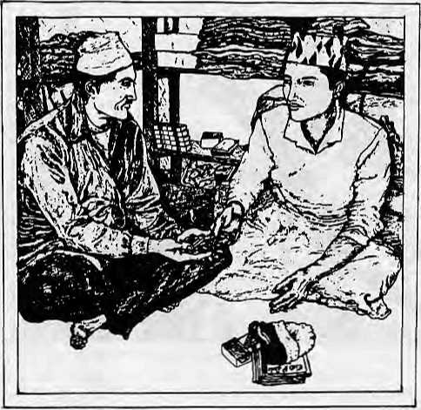
paisa." Money changed hands and before long the customer was out of the shop.
Yan Bahadur is a tenth class student who is also learning to run a general store. Using pencil and paper and taking about 20 minutes time, he figured the price of a customer's cloth order in the following way. "You need one metre and 55 centimeter of cloth and the cloth is 14 rupees a metre so...100 divided by 14 is the same as 155 divided by what? ...100 divided by 14 is 7.1429 and 7.1429 into 155 equals 21,699 rupees."
Though Yan Bahadur's answer was correct, the shopkeepeT was unimpressed. He told Yan Bahadur, "Your methods are fine for school tests, but you took too much time. And what good is 21 point 699, or whatever, rupees! Look, 1 metre is 14 rupees and half a metre is 7 rupees, so 21 rupees and 1 centimetre is 14 paisa and therefore 5 centimetres is 70 paisa, so it is 21 rupees and 70 paisa for the cloth."
Both Raja Ram and Yan Bahadur were participants in a research project looking at how math learned at school and math learned at work may transfer running a general store. The study showed that most tenth class students had difficulty, as did Yan Bahadur, in efficiently dealing with the math they encountered in a variety of shopkeeping problems.
It is clear that mathematics as it is taught and learned in school does not facilitate learning the skills necessary for doing math in the shop. The experience of Yan Bahadur also illustrates a crucial problem for Nepali education in genera! -a gap, or even a barrier, between learning at school and learning at work. Conventional wisdom suggests that increased education should eventually be reflected in increased employment and higher income. Indeed, school enrollment and the average education level of the Nepali populace has continued to increase since the inception of national education in the 1950s. However, a recent report on Nepali education and human resources indicates that the average income of rural Nepalis may actually be decreasing. Other factors decreasing land productivity, the increasing availability of ready-made goods, population growth - play a strong part in this relation between education and income. However a bottom line exists for education's role, despite the complexity of the

Mar/Apr 1989
HIMAL
31


VIEWPOINT
3C
m
7s
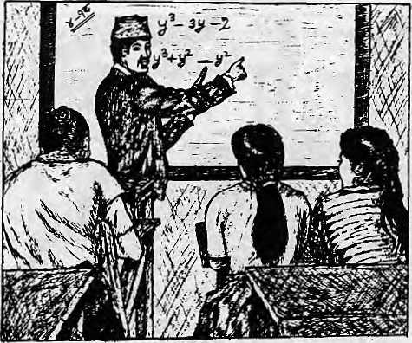
relationship. Education must be productively linked to work in Nepal's changing rural economy.
Inflated School Leaving Certificate failure rates, limited numbers of appropriate jobs for the few who obtain academic credentials, and former students locked into traditional rural work roles all contribute to the development of an educational system that serves its own ends rather than prepares students for work.
Changing the current educational focus and manpower planning could help give new direction and purpose to Nepali education, moving toward the creation of an education for work at both the lower and higher academic levels. One such effort would be to dc-emphasise the creation of new schools and redirect resources towards improving their quality instead. And "quality" is defined here in terms of the knowledge and skills needed to meet, as well as drive, the country's manpower needs.
There is a plan to provide a new mathematics curriculum for the first through fourth class in Nepal's primary schools. The math curriculum being considered has already been successfully tried in both rural Nicaragua and Thailand. Its quality is attested to by the improved math test performance of the participating Nioaraguan and Thai students. Assuming that this new curriculum improves Nepali students* formal math knowledge and skills, we still have to consider whether this will have any bearing on math outside the classroom. This has not yet been raised as an issue, but, as Yan Bahadur's math calculations in the general store illustrate, it is an issue that must be raised and examined.
In mathematics at least, education for work does not mean a traditional vocational curriculum, similar to the one presently in force in Nepal. Nor does it simply mean the use of more word problems in the classroom. Education for work should not generate a nightmare vision of campus students attempting to do algebra on their fingers, but rather, should be a means of providing a variety of math skills, from formal mathematics and from the workplace, along with the knowledge to pick and choose among them in an adaptive manner. Such instruction, when extended to other subjects, will go at least part of the way towards linking education and work in rural NepalA
King Beach was a Fulbright researcher in Nepal and is presently a social scientist with the City University of New York Graduate Center.
SPECIALIST:
O
and
ROl Box 4573 Kantipath Kathmandu Nepal Tel2147Oa Tk:Z272 KOSHI NP Ait: Mandala Trekking

(  I | j^jjr^-¹ We oner you a ^rlh wide range of scholarly books ''—: on NEPAL, TIBET, SIKKIM, BHUTAN  Large collection of  MOUNTAINEERING BOOKS  Variety of  TREEKING BOOKS & TREEKING MAPS APA Guides & APA Nepal Map And Y E S ! Complete selection of SCHNEIDER MAPS OF NEPAL
HIMALAYAN BOOKSELLERS j
Ghantaghar - Clock Tower (next to Nataraj Travels and Tours) G.P.O. BOX NO. 528, Kathmandu, Nepal
[  : | we accept  L AMERICAN EXPRESS 1 HJL VISA CARD & MASTER CHARGE. J||
Telephone: 225484, 418666

32 HIMAL • Mar/Apr 1989

ABSTRACTS

HIMALAYAN PILGRIMAGE by David Snellgrove
ShambhalalRandom House 1989, U$ 14.95
This reprint of Snellgrove's classic on Himalayan culture and Buddhism, now available in paperback, takes the reader on a seven-month trek through Dolpo, Mustang and the Kali Oandaki region of Nepal. The journey described was undertaken in 1956, just a few years after Nepal was opened to foreigners. "Everyday life has changed comparatively little in the remote northern frontier regions of the Himalayas," the author notes in his new preface. Little has been added over the years to the limited fund of information about "the interesting Tibetan-speaking lands" which lie within Nepal, he says. Snellgrove, who is now Professor Emeritus of the University of London's School of Oriental and African Studies, laments that Tribhuvan University "displays no actual interest in Tibetan studies despite the fact that so many of Nepal's citizens are Tibetan-speaking and many of them thoroughly literate in Tibetan." With so many Tibetan speaking people in the country, he notes that no one in Kathmandu has worked on the creation of a Nepali-Tibetan dictionary.
JOINT HYDROPOWER DEVELOPMENT
Department of Technical Co-operation for Development United Nations, New York 1988, price unlisted
This study seeks to publicise and promote the "transfer of experience" in relation to joint hydropower projects (JHD) by highlighting regional and bilateral mechanisms which have worked in the sharing of water resources in Latin America. The study hopes that the experience of countries such as Argentina, Brazil and Paraguay in negotiating and implementing projects to harness the international river systems of South America will be helpfut to other regions. The paper describes the scope, development and contents of the agreements undertaken by Latin American countries and covers these main topics: legal aspects, institutional and organisational agreements, financial and economic feasibility, tariffs and taxing aspects, environmental feasibility and contribution to social development.
SECURITY IN SOUTH ASIA:
INTERNAL AND EXTERNAL
DIMENSIONS
by Chitra K. Tiwari
University Press of America 1988, U$28.50
The book offers a detailed analysis of South Asian security issues, including the perceptions of Pakistan, India, Nepal, Bhutan, Bangladesh, Sri Lanka and the Maldives. The author discusses the possibility of a security regime emerging in South Asia. In its twelve chapters, the book also delves into internal security questions and discusses the sources and patterns of conflict/cooperation and the roles of the extra-regional powers — China, Soviet Union and the United States — in the context regional and internal conflicts in South Asia.
BIOGRAPHIES OF THE PANCHEN LAMAS by Ya Hanzhang
Tibet People's Publishing House 1988, price unlisted
This book, which comes from China, starts with Panchen Lama Kedruje (1385-!438) and ends with the tenth Panchen Lama who died two months ago. The writer, Ya Hanzhang, is a sociologist and former head of the Nationalities Research Institute of the Chinese Academy of Social Sciences. He is said to have spent eight years in Tibet. According to a review which appeared in the periodical China Reconstructs, the book deals in detail with the lifetime of the fourth Panchen, Loisang Gyalcan (1570-1662); it describes the journey of the sixth Panchen to the Beijing durbar, where he died; it also devotes extensive space to the life of the ninth Panchen, Choki Nyima (1883-1937).
RECENT RESEARCH ON NEPAL Edited by Klaus Se eland Weltforum Verlag 1986, DM 59
The contributions to this volume are part of the proceedings of a conference held at the Universitat Konslanz, West Germany, on research relating to Nepal. The presentations, by ethnologists, geographers, an Indologist, an architect, a development expert and a sociologist, show that research on Nepal's peoples is becoming increasingly multidisciplinary. Among the subjects deals with are ascetic children, "protocol of a Brahamanic curse", mutual farm
assistance among Tamangs, the sacred world view and ecology, ethnography of religiousdancersof Kham-Magar, environmental knowledge and adaptive mechanisms of high altitude populations, tourism and socioeconomic change in Rolwaling Valley, the Nepali law of succession, and interpretation of cadastral maps and land registers of Kathmandu Valley and Gorkha District. The 351 page paperback volume also contains a bibliography with about 2,300 titles, encompassing research on Nepal between 1975 and 1983.
ENVIRONMENTAL
IMPACT ASSESSMENT
IN DEVELOPING COUNTRIES
Edited by Asit K. Biswas
and Qu Geping
UN UniversitylTycooly
International
1988, price unlisted
A unique contribution to the literature on development and environmental impact, this study focuses on the question of how to carry out environmental impact assessments (ElA) effectively in developing countries. The book features case-studies from Thailand, China, India and Egypt, and a comprehensive guide for planners and decision makers to the application of EIA techniques and principles in developing countries. (Development Forum)
HIMALAYAN ECOLOGY by S.K. Chadha
Ashish Publishing House
1989, IRslQO
The Himalayan ecosystem is both extremely complex and vital, supporting as it does millions of mountain people. An earnest effort at sound ecological planning is required, says the author, to prevent further deterioration of the natural resources, fauna, flora and physical features of the Himalaya. Poor environmental management has already begun to create shortages of food, fuel and fodder. Rapid deforestation is causing soil erosion, flash floods, sheet erosion, landslides, soil seepage and other problems. The population explosion and urbanisation has already destroyed the Himalayan ranges, "the lifeline of India". The author makes a plea for a programme to enhance environmental consciousness, as a small beginning to restore the ecological balance in the Himalaya.

Mar/Apr 1989 • HIMAL
33

ABSTRACTS


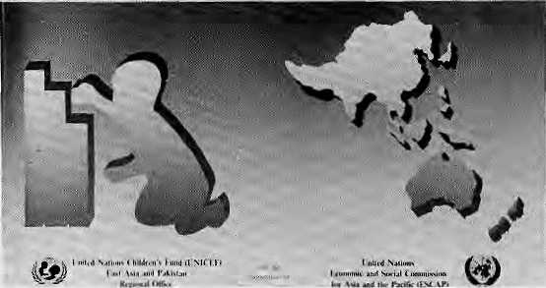
■
19SH Asian «it Pidfle ";
ATLAS OF CHILDREN in National Development
MOUNTAIN RESEARCH AND DEVELOPMENT Volume 9,Number 1, February 1989 Edited by Jack D. Ives International Mountain Society Boulder, Colorado
The latest issue of this quarterly magazine on mountain environments, resource development and human welfare, includes a study of landslides along a hill road in Nainital District; a discussion of the environmental and socioeconomic "stress factors" perceived by peasant farmers of the Andes; and an analysis of the impact of tourism in general, and glacier skiing in particular in the Austrian Alps. Mukul Sanwal, Director of the Administrative Training Institute in Nainital, argues in an article that mountain development strategies should deal not with questions of "technical production but of institutional issues of distribution and equal access". Sanwal's paper provides a framework for policy-focussed reform and a new perspective on common property, investment priorities and institutional arrangements. An article by Lauchlan T. Munro of McGill University, Montreal, argues that because of the highly unusual macro-economic and environmental features of Bhutan, the labour intensive technologies appropriate for most developing countries are, in fact, inappropriate for Bhutan. After a sectoral analysis of Bhutan's economy, Munro suggests that the country needs labour saving technologies which are economical in their use of capital and relatively intensive in their use of land, and which help generate government revenue. (Subscription information: PO Box 3128, Boulder CO 80307, USA)
RETHINKING VISUAL LITERACY HELPING PRE-LITERATES LEARN
UNJCEF-NEPAL 1989. price unlisted
This study explores how quickly villagers can improve their level of visual literacy, through exposure to illustrations or through instruction in how to interpret picture clues like emotion, motion, sequence and perspective. Due to the high illiteracy in Nepal, social change through the media can best be brought about through images and posters rather than the written word. Even then, villagers without access to regular "print media stimulation" have difficulty interpreting what to the urbanite would be a perfectly understandable poster or cartoon or photograph. This Unicef study, conducted by the Centre for Development Communication, is among the first attempts to try to make visual
literacy relevant to the "preliterate villagers" and thus help development communication become more effective.
WATER IN NEPAL by Dipak Gyawali
East-West Environment and Policy Institute, Hawaii 1989, price unlisted
This monograph is an inter-disciplinary study of the social and physical concerns that have a bearing on Nepal's use of its water resource. Casting a broad net, it analyses the whole process of development, "this new religion of our times", in a small nation rich in water resources but with limited capital and social infrastructure. The writer discusses the difficulties that arise when expatriate donor and technical assistance agencies dominate the development process. He calls for increasing the primary scientific databases on water and recommends that the administrative structure of the Ministry of Water Resources reflect a "basin-wise" approach. He says the Government must allow private power generation and supply companies. Rather than pursuing collossal all-or-nothing hydro schemes, Kathmandu's planners must set up smaller units and arrange one-on- one deals with individual states and companies in India.
LAND-LOCKED STATES AND INTERNATIONAL LAW by Almeen Ali
South Asia Publishers 1989, NRslSO
This book deals with the question of access to the sea for land-locked states, with special reference to the situation of Nepal. As such, the publication is especially timely in the present context of Indo Nepal relations. The author, from the Benaras Hindu University,
states that even as the number of land locked states increased after the Second World War as a result of the decolonisation process, particularly in Africa, the problems faced by these emerging nations increased in scale and complexity. The book contains a broad and critical study of relations between land-locked Stales and transit states, and about Nepal's policy regarding access to the Bay of Bengal and other facilities it requires from India. The author also describes Nepal's role and altitudes in international forums as regards trade and transit rights, especially in relation to the country's development process. The book is divided into seven chapters and contains references and a bibliography.
1988 ASIA AND PACIFIC
ATLAS OF CHILDREN
IN NATIONAL DEVELOPMENT
UNfCEF/ESCAP 1988, price unlisted
This joint effort of two United Nations agencies provides updated economic and social data that go to show the status of children within the context of overall national development of Asian states. The Atlas is one of the few available publications which stresses sub-regional data within countries. Showing the distribution of socioeconomic indicators on a geographic basis assists in understanding social development, which helps in targetting "interventions". The section for Pakistan, for example, contain data, maps and graphs on, among other things, the situation of children by administrative unit, population growth rate and density by district, birth rate, infant mortality rate, DPT immunization coverage, water supply figures, female iiterace rates and girls'enrollment in primary schools. There is also comparative data for the whole Asia-Pacific region.

34
HIMAL • Mar/Apr 1989




Macintosh

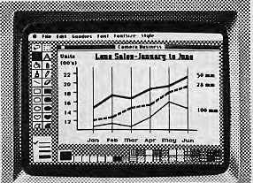
As these screens indicate, Macintosh™ can do all the things you'd expect a business computer to do. A lot of things you wouldn't expect a business computer to do. And some things no business computer has even done before.
If that strikes you as amazing, prove it to yourself. Come in for a screen test. Because only seeing is believing.
kz
gcipp
^P^Ks Authorized De:
Come in for a screen test
Authorized Dealer
Apple and Ihc Apple logo ire reKiskred trademarks d Apple Computer, Inr. Macintosh is a trademark licensed to Apple Computer. Inc.

Bugh Inn P.O. Bc« Z6OZ
: I-I2277 c«t>i(; micro
T.lm; NC2333THT
POTALA PUBLICATIONS
We stock the most comprehensive
selections of books, maps, periodicals
and audio tapes on Tibet:
Buddhism- History -Politics- Culture -
Medicine- Art-Lifestyles- Travel -Language - Women
Write for our catalogue.

POTALA PUBLICATIONS
IO7 EAST 31«rr STREET NEW YORK. N. Y. 1OO1B


CREATIVE BUILDERS COLLABORATIVE (P) LIMITED
PUWN&IS RND BUfLD€RS
Past Boi Ho. 926 Bokumtor. Kutfvnondu. topol.
BPGSW.

NEPAL PRESS INSTITUTE
Our job is to develop professionalism in Nepal's communication media. We offer Che following services:
TRAINING : A ten-month diploma in Journalism, workshops Tor managers of small newspapers, seminars on population and development reporting, special fellowships fur rural reporting, and training for mid-career professionals. CONSULTANCY : On all media-related issues.
PUBLICATIONS : A quarterly journal in Nepali reviewing developments in cotnmunications around the world, and an annual number in English tor those interested in communications development in Nepal. Several monographs on media-rdaicd topics.
Posl Box 4128
Kathmandu Tel: 215158

Mar/Apr 1989
H1MAL
35

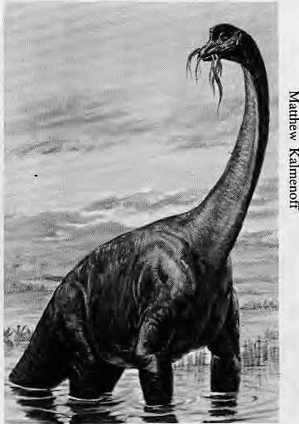
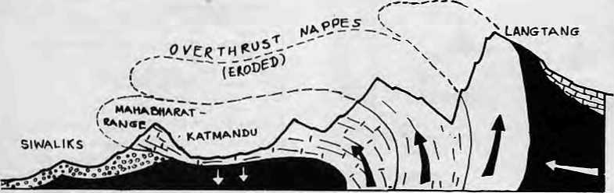
Abominably Yours,
It was soon after an earthquake jostled East Nepal and Bihar that Messrs. Trade and Transit decided to take a vacation. The tremor was an act of the Maker but the holiday plans were definitely drafted by the Policy Maker. All of which strengthens my thesis that geology and geo-politics have common origins. More research is obviously called for, and should be taken up jointly by the concerned departments of the Tribhuvan and Jawaharlal Nehru Universities as soon as they start talking to each other.
I myself have had some time to theorize on these matters on my Toshiba laptop these past few weeks here in my Upper Barun library. We're cut off from the outside world because there is no mail. Langur, the mail carrier, has not made a delivery in weeks because he's on a kerosene line that starts in Chainpur and ends on the far side of Sankhuasabha.
The recent upsurge in geological and political seismicity along the east-west fault lines seems to be the culmination of a process that began 230 million years ago. In those pre-Jurassic, pre-colonial times, the Indian landmass used to be attached to the part of Africa near what is today Zanzibar. Australia was also an appendage of this prehistoric dinosaur-ruled superpower, the Republic of Gondwanaland. Ayer's Rock, eroded and wrinkled today, was still an adolescent snow-capped massif then.
Responding to deep-seated discontent seething under the mantle (probably against the despotic Tyrannosaurus rule), independent minded India look off on its own and set sail across the ocean that now bears its name in memory of that epic voyage. Along the way, this renegade peninsula shed Madagascar and also off-loaded atolls like the Seychelles, Diego Garcia and the Maldives. Thar
she sailed, nor' by nor'east at the incredible speed of one centimeter per year. Spray whipped her prow, and suddenly, KABOOM (colloquially: DHISHUM), a head-on with the Asian landmass.
Africa's loss was Asia's gain. Before India bumped in there were only noodles and stir-fried broccoli and green peas. Now there was curry and tandoori. But I digress.
To return to the geological drama that was being played out on the windswept continental plates, dinosaurs lounging about on the Indian upper deck were thrown by the impact. Those not wearing seatbelts got left behind in Lanka, later Ceylon, and in the last micro second of geological time, Sri Lanka. A stately Brachiosaurus male was having breakfast in an outdoor beach cafe in what is now Darbhanga in Bihar. He looked up from his fern salad and noticed something strange. The Sub-Continent he was riding was disappearing under the Asian landmass. Propelled by discontented convection currents that stir the seething, shifting magma, India bulldozed right into the soft underbelly of the stationery Asian plate.
As India was moving in, yeti legend has it, my ancestors were sunbathing on palm fringed beaches of Tibet's Tethys Coast. The next thing they knew, though, they were hurtling skywards as the clash of continents squeezed out the first curls of overthrust nappes. And to this day, controversy reigns among geologists and geo-politicians as to the line where those beaches stood. A point can be made that the resolution of Aksai Chin deadlock can be reached through a stratigraphic analysis of the bedrock found there. Presence of Malawi Gneiss would prove the region is in the Gondwana sphere of influence.
Startled Barachiosaurs w/fern salad.
A legacy of the geological upheavals of eons past, tectonic pressure points are still evident along 13 of the 15 thrust axes on the Indo-Asian plate interface.
It is heartening to note that the Himalayan inhabitants, though raised heavenwards and left hundreds of miles from Howrah Bridge, have never forgotten their pre-historic links to the sea. After all, the yellow band below Everest's summit is made up of limestone containing Jurassic period marine organisms. And in Mussoorie, an alert Himal reader recently spotted a sign for the "Seamen's Institute for Marine Electronics", right on the Mall.

Even Lucknow, once capital of landlocked Avadh, seems to pine for the sea breeze. In February, the city hosted an exhibit called "Ocean -- Our Culture". The lazy currents of muddy old Gomti obviously cannot match the crashing of waves upon the shore. The Press Trust of India quoted Uttar Pradesh's N.D. Tiwari observing at the inauguration of the exhibit, "Since the Ganga descended to the plains of the country, 70 per cent of it has been flowing into the Indian Ocean. Therefore, it is essential to maintain its purity for our dependence on the Indian Ocean." Yeah, otherwise the monsoon showers will bring the muck right back A

36
HIMAL
Mar/ Apr 1989

The most fantastic range
pasat

this side of the Himalayas¹

naya pasal
Dh

Pasal - Kathmandu's top shop for high quality home products and fun fashions. Linen, crockery, dharis, lamps stationary, toys, bric-a-brac amd oodles more. Whatever you're looking for, Pasal has a nice surpsise in store for you. Drop in today for a great new shopping experience.
Sakya Arcade, Darhar Marg, Kalhmandti, Nepal

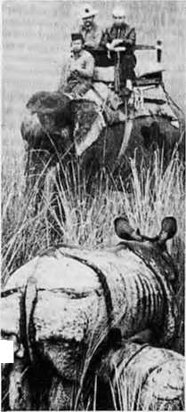
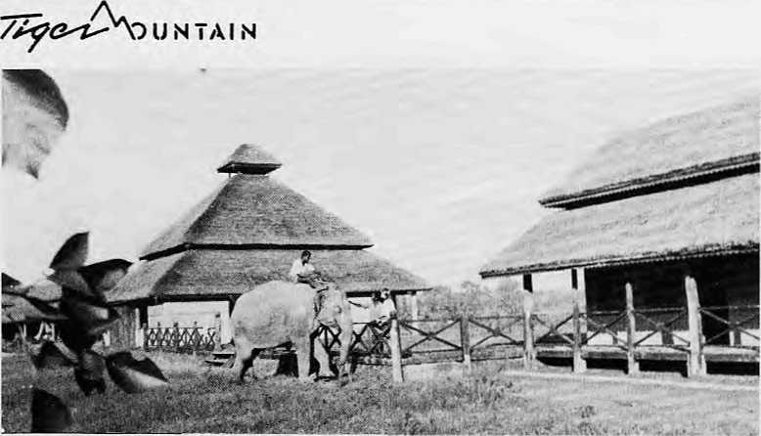
Tiger Tops Nepal has now pioneered adventure tourism in remote far West Nepal \'₄
with the opening of a deluxe and uniquely styled Lodge on the edge of the
Royal Bardia National Park. Together with the existing Tiger Tops Karnali Tented
Camp, the Lodge will form the base for a variety of exciting adventures in this
remote destination: wildlife viewing on elephant back, river running on the Karnali and Bheri
rivers, short treks, nature walks, bird watching excursions, leisurely strolls to nearby Tharu
Villages and slide shows.
FOR DETAILS PLEASE CONTACT: TIGER TOPS KARNALI LODGE AND TENTED CAMP
PO BOX 242, DURBAR MARG, KATHMANDU, NEPAL.
TEL: 222706, 226173, TLX: 2216 TIGTOP NP
FAX: {977)-1-221379

Regd. No. Lalitpur 65/045-46



Royal Nepal /Airlines
The way to Nepal
umrila

Experience the subtle difference

OF MOUNTAINS AND MEN...
OR, HOW TO TREK IN THE HIMALAYAS IN AN ECOLOGICALLY CONSCIOUS WAY
WE CARE FOR THE ENVIRONMENT

fANGRIMA
■Trekking a Mountaineer ing (PJ. Ltd
P.O. Box: 2951, Kathmandu, Nepal
Teh 225608
Telex: 2474 SUMTRA NP
Fax:977-1-414184

