NRs20 IRs12 U$6
ISSN 1012-9804
JUL/AUG 1989



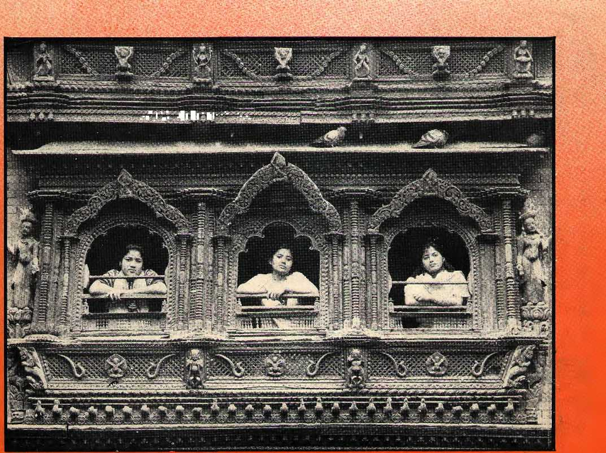
.-,-.:■,'. ■::::■:■■:::■■■■■ ■-.-.

FOR DEVELOPMENT AND ENVIRONMENT

session wi
DAM NEWS
ELEPHANT KNOWHOW REINHOLD MESSNER
ourism
PAKISTANI WOES LANGTANG AND KHUMBU MOUNTAIN MINING


INSIDE
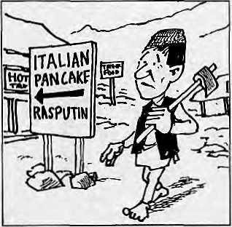

COVER
3 An Obsession with Tourism
- Crisis Management in Srinagar
- Off the Beaten Path
- Ladakh and Tourists
- Alternative Tourism
- Dolpo and Bhutan
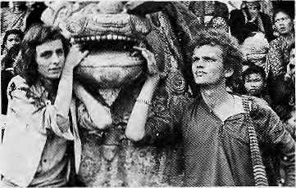
VIEWS
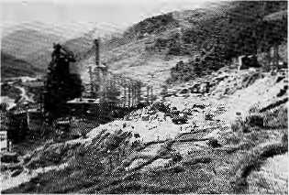
- Divine Support
- Controlling Tourism
- Not All Floods and Famine
- Kumaon and Garhwal
FEATURES
16 Mountain Mining
DEPARTMENTS
24 Reviews
The Himalayan Dilemma India's Forests Besser Reisen: Nepal
- On the Way Up
- Abstracts
36 Abominably Yours
Ganesh and Kharidhunga Destroying the Strata Reinventing the Wheel Godavari Marble in Court
- Pakistan's Environmental Woes
- Marsyangdi and Arun III
- Messner towards Antarctica
Climbing in India
- Profile: Visheshwar Saklani
- Breeding Asian Elephants
Cover picture by Kevin Bubriski shows Sita, Durga, and Ambika Shakya,
guardians of Kathmandu's Living Goddess, at "Kumari Ghar". They are looking
down at the tourists looking up for a darshan of the Kumari. Between them, says
Bubriski, Sita, Durga, and Ambika probably see more tourists than immigration
officials at Tribhuvan International Airport
Himal (ISSN 1012-9804) is published six times per year by Himal Associates, P.O. Box 42, Lalitpur, Nepal. Tel: 523845. ©Copyright 1988. Please turn to page 2 for subscription information.
HIMM,
W.,2 JSfo. 3 jal/Aug 1989
of the Gods, King, of Mountains, Himalaya You bound the oceans front east to west
A northern yardstick , To measure the Earth ■■■-. Kalidasa(Kumam Samphavatn),
. . . .. .. .... .V „ V .„:
Edited and Published by Kanak Mani Dixit
for Himal Associates
KesaMg Tseten
Associate Editor
MarijushreeThapa
Advisory Pane
Picture Editor
i M. Abdullah, University of Peshawar, Peshawar ■■■ ":: ■" ■■ AdiaiAjBior, Asian Fomm 'Journalists.
AuStn Ana Kid, Inter Press Servicej Itinl^y borje, Kuenset Weekly, Thimpu Hartot Bahadur Gurung, Kathmandu CflitieiHe Jest, Gentre National de !a Recherche Scientifique, Paris
:iPreni:Shen1tci;Jha, Commefce, New Delhi iharatD. Kolraia, Nepal Press Institute, Kafhmandu
Rnm Ciiandra Mathotra, Jhternationa! Fund f(>T Agrucrultiiral Deveiopment, Rome Hsmanta Mishra,Kihg Mahendra Trust for Nature Conservation, Kathmandu
: David iSassoon, ^arthpost, New York Kumar Kliad^a Ritkram Shish, Centre ■for Nepal and Asian Studies, Ka thmandu IJonald Shimor, Columbia University Softool of Journalism, New York Ainbica Shrestha, Nepal Business and
: Professional Women's Club, Kathmandu
; VidyaStok«_{r}Himachal Legislative Assembly, $himla
EiG. Verghese, Centre for Policy Research, New Delhi Brian Wcisti, The Ho!os Centre, London

MAIL

KHUMBU REJOINDER
Thank you for publishing a magazine which is interesting and informative regarding the great variety of issues that are of concern to the Himalaya. I have read with special interest your recent article on the electrification project at Tengpoche monastery in Solu .Khumbu District (Jan/Feb 1989).
I would like to respond to the letter entitled "Khumbu and Hillary" by Michael Rojik (Nov/Dec 1988). Considering that Mr, Rojik used to bring several trekking groups a year to Nepal, his apparent intent to lay blame for the problems of Khumbu on Edmund Hillary seems unfair. Individual Sherpas chose to capitalise on the flow of visitors to their valley and built hotels themselves. While the hotels contribute to the problems of sanitation and forest depletion (through use of firewood and construction timber), their existence isn't the problem, it is how they are managed.
Mr, Rojik also misses the point regarding tlie construction of new buildings at Tengpoche monastery. The Abbot has rebutted criticism that they "spoil the classic view" by replying that the offending building are there for the on-going vivacity of the Sherpa culture -as a school, museum and student hostel. The Abbot placed the buildings in these locations to show that Tengpoche is not merely a museum piece of picture postcard sites for the tourists to see, but rather, an active community devoted to spiritual endeavour,
Tengpoche gumba has been destroyed -- for the second time. The Abbot was truly composed when we discussed this tragic event. To a question, he reph'ed that the spirit of Tengpoche continued and that what would happen in our hearts and souls was more important than a building.
Certainly, this event has rallied the
Sherpa community to begin working
together to rebuild their gumba.
Frances Klatzel
Alberta, Canada
and
Sherpa Cultural Center
Tengpoche
MORE ON TENGPOCHE
Having read your photo-essay on Tengpoche's burning down and the "follow-up" item on the funds being gathered internationally to rebuild the monastery, I have a question which might also be relevant for development projects in the rest of Nepal, It seems that the Sherpas were perfectly capable of rebuilding their own gumba when it was destroyed by an earthquake in the 1930s. Why is there now a need for foreign aid to do the same thing? Surely the Sherpa community could tell the world, We will rebuild our own monastery and you are welcome to visit when we are done. I fail to see why now there is a worldwide campaign, a search for architects, and tenders. Amrit B. Pradhan Tangal Kathmandu
SUPPORT FOR GIRL CHILD
I am a regular reader of Himal, and I followed with interest your cover story on the girl child (Jan/Feb 1989). It made me aware of how even we, the Nepali women engaged in professional life, are content to take a back seat in our male-oriented society. Himal should continue to focus on such social issues so as to arouse the consciousness of the public. Your story must have made an impact on other female readers, many of whom require motivation and proper direction. In the end, I hope that understanding for the girl
child will continue to grow. Otherwise,
she will continue to remain neglected,
overworked and under appreciated.
Smita KJianal
Baluwatar
Kathmandu
ABOUT HIMAL
I would like to congratulate you on producing such a fresh new development magazine with articles on a wide variety of subject. So Himal would, it seems to me, interest both those who work in this sphere and those who know little or nothing of it. Taysir Mustafa Offtcer-In-Oiarge Infonnation and Communication IFAD, Rome
I read Himal with great pleasure. Because of its substantial articles on development and environmental questions, its focus on the Himalaya's threatened beauty, and its coverage of the predicament of a developing region, I feel the magazine is vital. At the same time, I also find it a great source of cultural delight. In fact, it is unquestionably written with literary care and devotion. Hans Janilschek Society of Writers United Nations, New York
By accident I picked up your magazine from a vacated, vacant house, and to my surprise I found it to be a gem. Now I have decided to collect every gem on my way. Terrific job; and how can I render my services? R. Krishna Maya Enclave New Delhi
I read with interest Mahesh Banskota's Viewpoint "What is missing hi Moun-

JuVAug 1989 • IITMAL 1

MAIL

tain Development" (Jan/Feb 19S9). We need to look at what is unique about mountain development. Why not start a regular series of papers on this concern, which would be more detailed than a Viewpoint column? Mukul Sanwal
U.P. Academy of Administration Nainital
The few issues of Himcd I have seen at the residence of a colleague leads me, if you will forgive me, to ask you how you will sustain the magazine because it is my view that there is not enough to report on in the Himalayas. This is because not enough is happening. Across what Himal prefers to call the "Himalayan crescent") there are too few industries, little activism, too little communication, transport is difficult, there is a tiny literate middle class, and so on, I fail to see where is the "masala" that a publication has to have? Harish Ram Yadav P. C. Colony Patna
By itself, Himal towers over the magazines published from Nepal. But its high standards may be a bit over the heads of most people it should address. Some of the articles are thoroughly technical and others are so full of development jargon that it appears that Himal is just another addition to the development culture.
The range of subjects covered and the way they are presented limits the magazine's appeal to the so-called development pundits and environmental gurus. Himal must not become another forum where idealistic tendencies on perennial development issues are exercised.
Himal talks more to the participants in the development culture and less to the emerging English reading, opinion orming readership that it claims to address. Regarding the geographical purview, the magazine is even more vague. Pieces like the merits and demerits of eucalyptus (Mar/Apr 1989) are best eschewed.
The magazine needs to address the English reading, opinion forming readership, not necessarily to appeal to their leadership potential, but more because of their responsibility in the natural, cultural and mental destruction in the community.
Development advocates cannot make up their minds between the extremes of western and eastern values. It is easy to condemn deforestation and the eroding cultural values, but it is difficult to give up the practice of seeing development in "western" terms.
Himal deals extensively with the natural environment, on a subject which is dear but distant. Talk about development and environment are only effective when people can relate to them. Issues that involve urban readers directly have
more chances of success in forming attitudes and generating concern which will in time extend farther afield. Kamal Tuladhar Asan Kathmandu
Himal Alert!
As of this Issue, Hlmat has shifted its operations from New York to Kathmandu. This move will allow Himal to provide fuller coverage of economic, social, environmental and cultural processes in the Himalayan region. We invite correspondence from readers to make this magazine more in-depth and relevant to their needs. Because of the move to Kathmandu, Himal did not publish its May/June (grey) issue. We wish to reassure subscribers that they wit) be receiving the full number of issues they are entitled to.
We ask readers to use the Mall column to comment, criticise or add to information appearing in this magazine. Letters should be short and to the point, and are subject to editing. Send all your mail to P.O. Box 42, Lalitpur, Nepal.

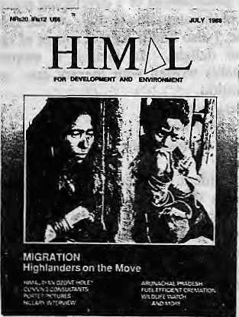
A limited number of back issues of Himal are available. Please write in for information.
JOIN HIM£sL !
Himai is current. It is readable. And it is serious. It is indispensable
if you want to keep in touch with the region. Join us.
ANNUAL SUBSCRIPTION RATES (SIX ISSUES)
Individual Institutional
South Asia Elsewhere
NRs 110/IRs 65 U$ 25
NRS 300/IRs 200 (or equivalent) U$ 45 (or equivalent)
Personal checks acceptable, bank drafts and money orders preferred. Address subscription orders and correspondence to;
In South Asia:
PO Box 42, Lalitpur, Nepal, or
Central News Agency, 23/90 Connaught Circus, New Delhi 110 001
In North America: 4 South Pinehurst Ave. #6A, New York, NY 10033
In Europe:
- B.Welsh, Holos Centre 139-A, Battersea High St. London SW1 (for UK)
- LDebuck,Donaustr,38, D-4100 Duisburg 29, W. Germany (FRG, NL, B)
- A.Odermatt, Winterthurerstr. 112, CH-8006, Zurich, Switz. (rest of Europe)
- C.Euler, Hagelerweg-7, CH-8055 Zurich, Switzerland (general info)

2 HIMAL • JuVAug 1989




"^^
m
HHH

An Obsession with Tourism
by Kanak Mani Dixit

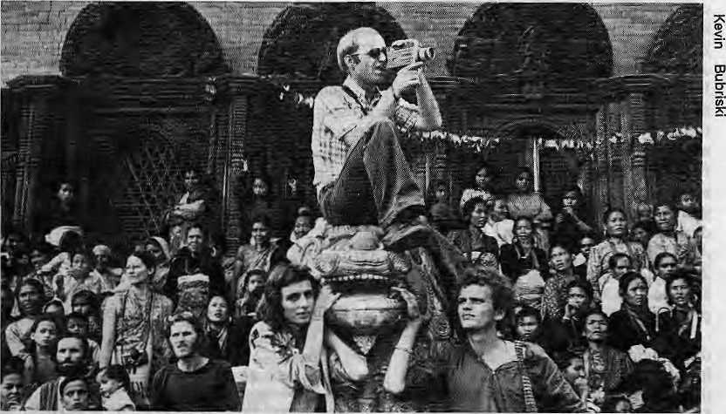
T
he Himalaya has taken to tourism in a big way. International visitors are swelling the high valleys from Chitral in Pakistan, eastward through Manali, Thak Khola, Khumbu, Sandakpu to Wangdiphodrang in Bhutan, They are all out to "do" Kashmir, Bhutan, Nepal or Tibet. For the foreigner, the South Asian rimland continues to attract visitors from the farthest reaches of the globe.
Newfound income is making its way into mountain households used to centuries of subsistence living. The economies of the region are being turned on their heads. Most would acknowledge tourism's benefits — foreign exchange, employment, to name two ~ but the industry has always been regarded with a certain amount of discomfort, as if there were some guilt attached to it. One simplistic explanation would be that tourism brings too much too soon to too few. Tourism is categorised as an industry, but it produces no wares. In the Himalaya, tourism is the tantalising lifting of a veil - and collecting "tax" from all those who get lured by the charm. Just as the charm is lost when a veil is lifted too often, mass tourism dilutes a society's identity.
Since tourism in the, Himalaya cannot be wished away even by those who regard it with distaste, the key is to learn to manage it as a long-term resource. It is a complex game to play and the industry is nothing if not vulnerable — to war, scarcity, internal strife and even, as in Nepal's ongoing case, trade disputes with neighbours. Vacationers run shy at the first whiff of instability, sending the arrival charts dipping like an aircraft that has lost power.
While tourism brings precious foreign exchange to the national coffers, it also causes inflation and distorts the local economy. Even the foreign exchange that is earned often takes flight in the form of "leakages" -- legal and illegal transactions that transfer hard currencies right back to where they come from.
Then, there is the question of pollution, both environmental and cultural. From non-biodegradable tourist refuse outside Tengpoche monastery, to the changing mores of Srinagar's youth, and drug addiction in Kathmandu, all are ascribed to some degree to the opening up to tourism and outside influence. The presence of affluent foreigners in the midst of materially poor Himalayan societies gives rise to unrealistic expectations that are typically unmet. This creates maladjustments, particularly among the impressionable young.
And yet, in a region with so little in natural resources, the scenery, the people and traditions have become most valuable assets. As American geographer Nigel J.R. Allan says,
speaking of the Himalaya, "Trading of some of the cultural peculiarities for basic needs is a worthwhile endeavour." So there is no alternative to tourism — indeed, it may well be a boon. Until the Himalaya gets eroded to little hillocks, or unless there is total global economic collapse, it seems, the tourists will keep coming, and in even larger numbers. The planners, and the people, can only learn to cope with tourism and maximise the particular "comparative advantage" that all mountain regions enjoy vis-a-vis the plains. And they must do so without losing grasp of what makes the Himalaya unique in the first place.
BOOM PERIOD AHEAD
In general, the region's hoteliers and travel agents need not worry that the tourist sport will dry up. The economic forecast is for sustained tourism growth globally as well as for the region. The World Tourism Organisation and the International Labour Organisation and most institutions and experts are bullish about prospects till century-end and

A tourist overdose during Indra Jaira In Kaihmandu
1989 • HIMAL 3


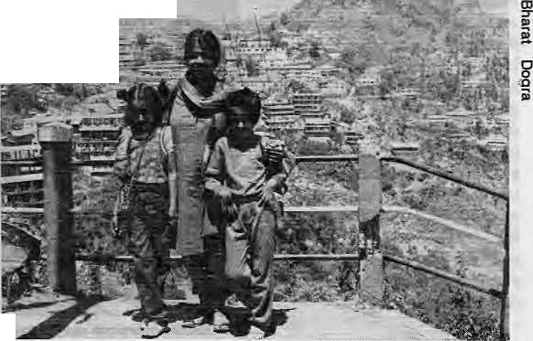
Bullish prospects for tourism
beyond. Last year, Nepal, which receives 200,000-plus tourists per year, set a target of one million tourists arrivals by the turn of century. That target may turn out to be- rash, not because the potential tourists are not there but because facilities to host a million visitors will hardly be in place a decade from now,
The United Nations estimates that tourism earned the Third World about U$55 bilh'on hi 1988, which makes it the developing countries' biggest export after oil (U$70 billion annually). Inter^ national tourism is expected to grow about five percent every year for the rest of the century.
There were a mere 25 million tourists traveling internationally hi 1950, but today there are about 400 million. The ILO's Hotel and Tourism Branch estimates that there could be up to 600 million tourists girdling the globe by 2000. Where will they go? A significant and growing number will head up the Himalayan valleys. Those traipsing about in these mountains will include the "baby boomers" of the United States and Western Europe, who will soon be reaching retirement age. In 1910, Japan is expected to send 10 million tourists a year to travel the world. The newly industrialised countries in South-East Asia, as well as Australia, New Zealand, and glasnost-bitten Eastern Europe and the Soviet Union, are all prospective markets.
In South Asia, the ever-growing Indian middle class forms a huge and lucrative tourist market all its own. In the hill stations from Mahabalipuram to Darjeeling, these nouveau riche
4 HIMAL • Jut/Aug 1989
travelers are swamping the hilly lanes. Except for this year's fiasco, Kathman-du is almost entirely reliant upon Indian tourists to fill up the hotel rooms in the summer.
EACH COUNTRY TO ITSELF
Local and national responses to tourism differ, says geographer Allan, who has written on the impact of tourism on South Asian mountain culture. The range, he says, "is from the active positive response in Nepal and Tibet, through favourable but less enthusiastic response in India, to silent acceptance in Pakistan, and aggressive reaction to foreign cultural intrusion in Afghanistan."
Indeed, Himalayan tourism is not
monolithic. Just as destinations differ
from the Tarai jungles to the Mahab-
harat valleys to alpine highlands and
trans-Himalayan drylands, each country
too has its own way of running the in
dustry. Policies change, and an element
of schizophrenia ^r
is inevitable in an
industry which j
requires inviting L
the outsider to |
the inner
sanctum of one's
society and cul-
tUTe. Last year,
Bhutan decided
to restrict
tourists to 2,400 a year. But in the next instant it bought an 80 seater jet that flies between
Travelers In Mussorie
Bangkok, Delhi and Kathmandu. Those seats have to be filled, and so to tourists they may turn.
Even the military rulers of xenophobic Burma (now "the Union of Myanmar") have decided they can no longer do without turodollars. Looking enviously across the border at Thailand, which last year hosted 4.2 million visitors compared to their own 10,000, the Burmese have decided to give tourism high priority. But they are far from then- goal of 150,000 tourists by 1993.
To some, Nepal's announced goal of one million visitors by 2000 is equally laughable. After all, lack of foresight and planning has marked Nepal's tourism policy. In fact, it is tourism that leads the Nepali economy by the nose-string rather than the other way around. As Abid Hussain, Member of India's National Planning Commission, stated in a lecture in New Delhi last February, "tourism-led growth rather than development-led tourism has characterised places like Jamaica, Kenya and Nepal." In the absence of governmental action, in Nepal, the industry is led almost entirely by the private sector. In fact while the Nepali tour operators might have a thing or two to learn about managing mass tourism, they are well ahead in trekking, mountaineering and river rafting — the Himalaya's quintessential attractions. It is these selling points that have made Nepal a primary destination for many tourists.
So far, Nepal has been fortunate in drawing the number of visitors it does without aggressive or deliberate marketing. A July 1989 report of the Tourism Study Project Office of the Nepal Rastra Bank welcomes tourism

VIEWPOINT

as "a major growth sector and stable sources of foreign exchange...with immense potential and virtually unlimited scope." Indeed the last 15 years has seen a three-fold increase in tourist arrivals and a 10-fold increase in gross foreign exchange receipts.
WHICH WAY TO SHANGRILA?
While Nepal's policy is to take in whoever knocks at its doors, rich tourists or poor, Bhutan, has decided to maintain its low volume, high yield tourism. Group tourists are taken on strict itineraries at about U$200 per person per day. With a relatively unspoiled environment, low population density, and a "manageable" polity, Bhutan has been able so far to maintain this excluvist approach. But then Bhutan's tourism is still in its infancy, having begun only 15 years ago, at the time of HM King Jigme Singhe Wangchuk's coronation.
In fact, the Dragon Kingdom is today where Nepal was in 1955, at the time of late HM King Mahendra's coronation. Nepal was then the "Shangrila" tour operators were searching for. Today it is Bhutan, and the mantle might have already passed on to Tibet but for the unrest that led to the imposition of martial law in February this year. Tibet is in every sense the new frontier, with the Chinese authorities having shown every inclination to promote tourism. The land is vast, with unlimited attractions for the traveler.
In South Asia, India's tourism is bigger than all the others combined, but except for Srinagar Valley, tourism in its Himalayan region is still relatively undeveloped. Even on a national scale, it comes as a surprise to learn that the whole country hosts no more than 1,5 million tourists a year. "An annual foreign exchange of IRs2,000 crore is nothing to feel proud about considering our potential," says Abid Husain.
While the potential might be untapped, Indian Himalayan tourism may be the most organised, with heavy government involvement. Also, international hotel chains, and "super-travel agencies" with headquarters in Delhi or Bombay have professional planning capabilities, promotional budgets and a worldwide reach. Large sums have been injected into tourism promotion and planning under the broad umbrella of
Crisis-Management in Srinagar
by Kishore Singh
T
here is no doubt that'tourism is vulnerable to a number of pressures that can seriously hamper efforts at promoting "traffic" to destinations. Should a situation arise in which the traveler's safety is in jeopardy, the crunch is immediately felt by all who depend upon the tourist. :
Consider what happened following the riots after the assassination of Prime Minister Indira Gandhi. Tourist traffic to Kashmir nosedived and it was several-years before the situation stabilised, Kashmir's economy took a beating. Hotels and houseboats lay vacant, taxis ran empty, the state's famous handicrafts sector sank into a stupor, prices fell, and restauranteurs,shikliara-watfas, shoprowners and sales staff all were in a slump.
When a somewhat similar situation arose again this fear, the state tourisni department swung effortlessly into action to ensure that the gains of tourism did not suffer from the disaster of 1984-85, There were communal riots and political protests in spme parts of Kashmir Valley, but these did not extend to most areas that tourists visit. Having experienced the devastating impact of a tourist-legs season, officials were determined not to let the situation reach that stage. They reached out to the media and spread the word that the Valley was largely peaceful and that a Kashmir vacation was still possible. To counteract skepticism, the : department took reporters on trips to Kashmir.
But the real coup was, in taking international travel agents to Srinagar. In April, India hosted the aSFA international conference, which brought to Delhi record numbers of participants. Providing personal assurances of safety, the tourism authorities saw a group of agents to Kashmir, where they enjoyed themselves thoroughly. Upon their return, the agents became Srinagar's ambassadors, spreading the-word that Kashmir was as viable a destination as ever.
The department also went to towii with its own advertisement campaign to directly reassure potential tourists. Enough was at stake that it spent large amounts to splash advertisements in all available media. The advertisement copy itself could have been more hard-hitting but it got the message across. Tourists began arriving by the plane-loads. Flights to Srinagar are now sold out and extra aircraft and trains are regularly pressed intoservice*
While the number of foreign tourists has remained steady more domestic
travelers have visited the Valley so far this year than during the same period m
1988. What had all the makings of a disastrous season was averted by tourism offi
cials who were able to deal creatively and quickly with the, crisis even as it
developed. K
..Singh is Executive Editonof DESTINATION INDIA.
™.. *.**, „

JuVAug 1989 • HIMAL 5

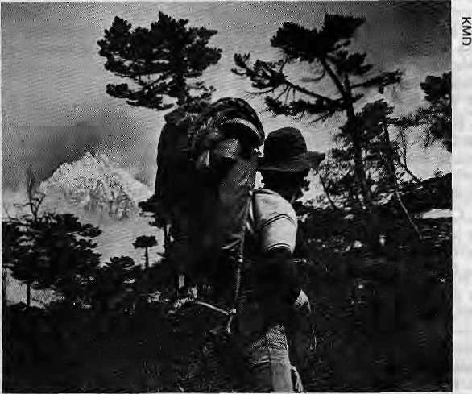
Clouds part for a view of Thamserku In Khumbu
The Path Not Taken
jy Stephen Bezruchka
'People from the United States and Canada have everything that money can buy and yet they still want something. That you can't buy with money."
— Chundak Tenzing of Walangchung Gola
O
ver the 20 years that I have been associated with Nepal, "poor" is a word that has crept into the Nepalis' vocabulary as they have become more aware of the great gulf that separates them from the "haves". But the self-respect of the hill and mountain peasant continues to hold, and that may be Nepal's greatest wealth.
What is there for a person who has trekked in one of the regular routes in Nepal and wants to return again and again?
First, I say, try the monsoon. For the moment, trekking during the rainy season has remained a closely guarded secret of a select few "Nepalophiles". But others should take up this eccentricity, especially because the timing corresponds with the summer holidays in the West.
Popular trails that are packed with foreigners are completely empty during the rains. The plant and animal life are at then-most spectacular and the clouds perform dramatically, periodically parting to reveal spectacular snow vistas. The high country is alive with activity as animals are taken to pastures on the upper slopes. Some precautions have to be taken, especially because of the slipperiness of the trail, but the monsoon is undeniably the most beautiful time of the year in Nepal.
Another idea is to take your family along. Nepal is an extended family society, in which family ties are the strongest bonds in the country. It stands to reason that bringing your family will make you more acceptable to the people along the way. This can include newborns who are breast feeding, toddlers who are carried by porters, and children from four years and up, who can walk much like grown-ups provided the days are short. There are plenty of diversions along the way. Consider taking children out of school for such a trek. They will probably learn much more than they would in a classroom.
Bring your parents, too. People well into their late 70's and even older have trekked happily and successfully in Nepal. There are obviously hazards associated with such travel, such as the relative lack of medical resources, but record shows that few people succumb while taking these risks.
Many travelers feel they must rely on the expert services of one of the many trekking agencies that line the Kathmandu streets. Not so. Once you have got the feel of the country, consider either heading out by yourself, or hiring your own porters. You will get to know Nepal much better that way.
Go to a less trekker-visited place. Many of the 50,000 who trek annually in Nepal head north of Pokhara. The number two destination is the Everest region. But places like Lake Rara National Park host less than 50 trekkers a year. When you get off the sahib-trodden trail, for starters you will immediately notice that people don't beg. There will be many other great joys to experience.
Trekking in Nepal used to be an activity for fit individuals with mountaineering experience. But people with chronic illnesses and great physical disabilities have found they too can experience the country. Amputees, blind people, and many with significant illnesses have trekked in the Nepali hills. This fall, a quadruplegic gentleman from Sweden is preparing to be carried back to the Everest region, where he once walked.
Besides just walking the trails, consider learning about aspects of Nepal, such as the plants and animals, or the village architecture as it varies from one ethnic group to another. Most of all, make an effort to know the people. Learn the language, or study some of their crafts. Go on a pilgrimage as the Nepalis do. Perhaps even more importantly, consider sharing yourself with them. If you play a musical instrument, bring it along. Bring simple games, or pictures of your family, your home, or your work.
As Chundak Tenzing said, what Nepal has to offer is not something that can be purchased with money. Countless trekkers have discovered this great wealth of Nepal. With care exercised on the part of the Nepalis and their visitors, this resources can be around for future generations. A
S. Bezruchka is writer of a popular trekking guide to Nepal.

(> HIMAL • Jul/Aug 19»9

the India Tourism Development Corporation (ITDC). In Uttar Pradesh, Himachal Pradesh and Jammu and Kashmir, state-run tourism development entities plan and implement, albeit sometimes poorly, tourism development programmes, from organised pilgrimages to ski runs, bus transports, lodges, hotels and golf courses.
MANAGING THE INDUSTRY
The Economist (March 1989)stated that Third World governments "do not use the information now plentifully available about how (tourism) works so as to make the most of it...they do not know how to grease the wheels of tourism." This is especially true for the Himalayan region. "Take a look at Nepal's one million target. There is no plan there. How can you declare a policy without stating how you are going to get there?" asks Veit Burger, an Austrian who in 1978 wrote an oft-quoted Ph.D. thesis on Nepali tourism. "You have to look at tourism as an export business, none of this stuff about it being an international passport to peace."
The Sri Lankan government perhaps best understood Burger's point. Its approach to tourism development was pragmatic and flexible, providing operators with incentives and tourists a hassle-free vacation. The government worked hand in hand with the private sector to bring in high volume tourist traffic, particularly from West Germany, But that was all before the ethnic turmoil and violence of the last few years. Arrivals plummeted to nearly half between 1982 and 1986. One fallout was the suspension of the Himalayan link to Sri Lanka, Royal Nepal Airlines' Kathmandu-Colombo flight.
THE STATE CORPORATIONS
None of the Himalayan nations and states have been able to emulate Sri Lanka's success at promoting mass tourism. Among the best run are the state tourism development corporations of Jammu and Kashmir and Himacha) Pradesh. They have a faster "reaction time" when crisis hit the industry, and do not shy from launching extensive media campaigns.
But HP. Tourism and J&K Tourism are all bluster and little substance, charges a Delhi travel analyst. Says the critic: "For all the slick ads and tourism

'.■■>*! '
VIEWPOINT
Ladakh and Tourists
by Martijri.van Beek
T adakh only opened to tourists in 1974, before which it was almost completely J-Visolated from outside influences. After the Sino-Indian war of 1962, large nura- * bers of Indian troops were stationed in the region and efforts to develop Ladakh began. But it was when large numbers of tourists began arriving that the changes became dramatic;— in the environmental, social and economic spheres.
Tourism certainly is not the only factor contributing to this process of change, but it is the most important. The "tourist industry has made some of the local inhabitants affluent, but the benefits have not been shared equally and a significant part of the revenue does not stay in Ladakh, Th& souvenir trade, for example, is almost completely naonopoh'sed by Kashmiris and Tibetan refugees.

Between 1974 and 1980, the number of visitors coming to Leh went up from about 500 to 14,000. During this ■initial period of expansion, many Ladakhis opened guesthouses and were able to earn well. However, the number has leveled off at the 1980 mark , but new restaurants and guest-houses continue to-be added. Conse* quently_{r} occupancy has gone down drastically and competition has increased. Since, the tourist season is limited to four months per year, with up to 70 percent travelers arriving during July and August* the possibilities of attracting more tourists ire limited.
Development in general and tourism in particular
have disrupted the traditional" subsistence economy
and made Ladakl more dependent upon imports
from other parts of India, The population of Leh, the
capital, has risen from 5,500 in 1971 to 15;000 today.
Leh can no longer provide for its own needs and the
Leh-Srinagar road has become a lifeline whose fre
quent closure leads to Severe shortages. Another side-
effect of tourism has been rocketing inflation — a
day's rental for a horse or donkey used to be IRs30,
today it is IRsl20-150, Leh now depends upon large
supplies of fossil fuels trucked in from Kashmir.
Tourists demand imported foodis and a constant
supply of hot water. UtiLady
The disruption of the economy, intensified competition, and unfulfilled expectations raised by modernisation and tourism have caused increasing tension within the Ladakbi community, and between Ladakhis and Kashmiris in particular. The* traditonal harmony between different sections of the population has gradually been replaced by open conflict, the latest outbreak of which in July led to the imposition of curfews in Leb.
Tourists in general exude a seductive image of life in the West, one marked by wealth and leisure. This leads the Ladakhi youth to imbibe a highly unrealistic image of life in the West. They take on "Western values" and reject then* own traditional societies as backward and inferior.
Having endured the shock-effect of "development" and tourism, many Ladakhis have felt the need for a different approach. One noteworthy effort was the establishment in 1987 of the Students' Educational and Cultural Movement of Ladakh (SBcmol), which works for the preservation and development of traditional culture, particularly among youngsters. Together with other groups, such as the Ladakh Ecological Development Group, SECMOL is working to manage the impact of tourism.
Judging from the response of Ladakhis and outsiders to these and other ihitia«
tiyes, there remains hope that, with the help of the state and Central governments,
the harmful effects of tourism can be countered. But equally important is the at
titude and behaviour of the tourists themselves. Without a greater awareness among
the visitors, these efforts are all in vain. t\
M. van Beek is a development sociologist,
Jul/Aug 1989 • HIMAL 7

seminars, they have done little to build up adequate facilities. For example they did a big sell on Sirmour lake in H.P., but the deluxe bungalows are all reserved for viPs."
In the Uttar Pradesh hills, poor cousins of H.P. and J&K Tourism, are two entities known as the Garhwal and Kumaon Mandal Vikas Nigams. Originally mandated to bring all-round development to then" economically depressed areas, these corporations have become largely tourism promotion projects. And they are not doing too well at that, either. Says the Delhi travel analyst, "GMVN became a tourism agency because it is easy money for little work. You do not have to invest in people and the community. Just put up
garish pink and blue bungalows, buy a few buses and hire drivers: you're in business."
Last year, a GMVN programme to develop the area around Gangotri was shot down by sants and sadhus. Lately, an effort to develop the village of Auli into a ski resort has come under fire of environmentalists and development experts (Nov/Dec 1988 Himaf). S. Chandrakala, who has done research on tourism's effect on the environment hi India's resort locations, says that tourism "has meant direct devastation" in Kumaon and Garhwal.
Sunil Roy, a former Director of ITDC, describes the activities of the state cooperations as "generally disastrous" because "they have a very nar-
row development focus and are concerned only with numbers of tourists. Whereas quality rather than quantity is important, because with lesser numbers you can earn more, with less infrastructure."
T.V. Singh, a scholar who has written extensively on tourism issues, has this to say about efforts of the corporations: "Ad hoc and impulsive planning, indifference to research, seems to characterise most of tourism development in the Indian Himalaya."
BASKET CASE TOURISM
Singh gives Nepal high marks. "Nepal has adopted corrective measures through appropriate research," he says. "Efforts have been made to understand

Marching to a Different Drummer
by Mana Man Singh
T
he bulk of tourists in the Himalaya do it the way the others do it. But there is a breed that marches to a different beat. They do "alternative tourism", variously also know as "discerning tourism", "gentle tourism" or "tourism with insight". The are a motley group of crusaders, made up born-again tourists as well as local "tourism activists", be it in Goa, Garhwal or Gangtok.
Paul Gonsalves, who runs the not-for-profit group Equitable Tourism Options (EQUATIONS) in Bangalore, says alternative tourism promotes "a just form of travel between members of different communities and seeks to achieve mutual understanding, solidarity and equality among the participants."
EQUATIONS believes that people are primary to any social process and, therefore, "Tourism development must consider the interests and rights of those living in tourist areas as at least as important as those of the visitors." Says Gonsalves, "Tourism must be developed in ways consistent with civil rights as well as promote justice and the distribution of wealth and resources."
EQUATIONS has published an operations manual on alternative tourism for groups in the Third World "interested hi working out new patterns of tourism."
In 1987, students in Leh launched a movement named Students' Educational and Cultural Movement of Ladakh
(SECMOL) in order to give direction to the younger generation of Ladakh, "which has been susceptible to outside influences indiscriminately", according to a SECMOL brochure.
Sonam Wangchuk, one of group's founders, says "SECMOL is not against economic growth or progress, or tourism, for that matter. All we want to do is to take carefully from the outside world the best of what it has without losing our own values." SECMOL fulfills its goals primarily through educational activities, counselling, and cultural programmes designed to instill pride in Ladakhi culture.
Aavishkar ("Discovery") is what one might call an alternative travel agency. Run by organisers who have worked in development, the Bangalore-based agency offers itineraries for tourists who want to "combine leisure and a meaningful experience of India." A typical group, says an Aavishkar pamphlet "will be exposed to the issues of the Indian rural dynamics, health and nutrition, environmental concerns, education, religion, women in Indian society, tourism, and traditional crafts, interspersed with sight-seeing and relaxation.
"The Working Group for Tourism with Insight comprises 28 groups from 11 countries, primarily from Western Europe. Many of the group's founders have themselves been thoughtful tourists in the Himalaya. The Working Group promotes "gentle tourism" and
considers itself part of the ecological movement. According to West German author Ludmilla Tuting, "the group does not believe that tourisms benefits should be denied to any of those invose involved, be they tourists, tour operators, local business-people or the local population. However, tourism should not be associated with social disadvantage, cultural destruction or with damage to the natural world. Gentle tourism is one that is environmentally compatible and socially responsible." The Working Group has produced a brochure that lists the responsibility of the host population, that of the tourist, and that of the travel business.
In Garhwal, there is another organisation headed by Shankar Kala, a professor, called Stop Exploitative Tourism (SET). Rather extravagantly, SET calls itself the "first global movement against modern tourism." The group stands for "a return of tourism to original principles and philosophy." ^
Addresses:
EQUATIONS, 96 H COLONY, INDIRANAGAR, STAGE I, BANGALORE -560 038
AAVISHKAR, 88 NARAYANAPPA BLOCK, R.T. NAGAR, BANGALORE - 560 032
SECMOL, KARZOO, LEH, LADAKri-194101, J&K
TOURISM WITH INSIGHT
C/O TUTING, MITTENWALDER STR.7,1000
BERLIN 61, FRG
SET,
C/O MAYA ZEROZ PHOTOSTAT BLDG.,
SRINAGAR (GARHWAL) - 246 174, U.P.

8 HIMAL • JuVAug 1989

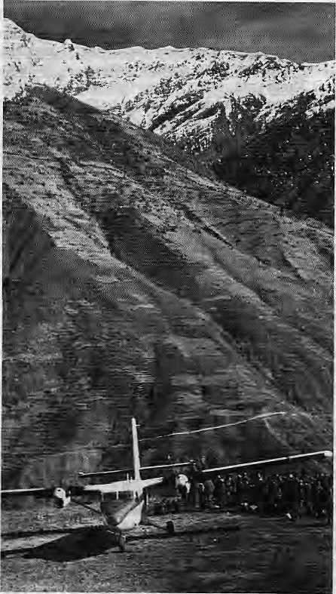
Jufaal airstrip, gateway to Shey-Phoksumdo
In opening up parts of Dolpo, the Nepali Government has decided to only let in organised groups carrying their own food and fuel. This is considered a necessary measure as Dolpo is poor in resources and sudden additional demands on its meager food supplies would cause dramatic inflation locally.
Given the ecological fragility of the
trans-Himalaya ecosystem when com
pared to the areas south of the
Himalaya, there is a need for additional
vigilance. As regards littering and other
forms of environmental degradation
said to be caused by tourists elsewhere
in Nepal, some have suggested that
trekking agents be made responsible for
any failure to keep campsites and trails
clean and for allowing indiscriminate
use of fuelwood. The local authorities
would monitor the effectiveness of
such a system, which should be in
stituted at the outset rather than when
it is too late. /^
D. Basnet has been a trek leader for many years and visited Dolpo in July.
the complex phenomenon and attempt an integrated development of tourism,"
Few experts share Singh's appreciation of Nepali efforts. In fact, they see Nepal as coming closest to the u. P. hills when it comes to tourism management ~ or the lack of it.
Tourism is already the mainstay of the Nepali economy and is central to all future calculations. Yet there is assiduous neglect of the industry. There is apathy in most areas, from tolerance of the filth in the major trekking trails to turning a bund eye to large-scale flight of foreign exchange earned from tourism.
Although Nepal has made strides toward becoming an independent travel destination, helped by alternate gateways where there was once only New Delhi, the country still depends largely on Indian agents' marketing and sales for a significant portion of its arrivals.
By and large, the country has been thriving on its natural appeal. The Nepali government's tourism promotion remains minuscule compared to the importance of the foreign exchange earnings from tourism, not to mention its contribution to employment. What promotion there is of Nepal abroad is done with the meagre resources of individual operators.Perhaps the case of Lumbini best highlights the apathy that pervades tourism management hi Nepal. After more than two decades following United Nations Secretary-General U Thant's tears when he found the Buddha's birthplace in a state of neglect, Lumbini remains an unshining example. Trees have finally begun to green the area, but facilities are virtually non-existent. Leave alone tourists, only the highly motivated pilgrim will go to Lumbini.
Contrast Lumbini's case with the well-packaged rail-cum-road tours organised by Indian operators to the other places associated with the Sakyamuni's life in UP. and Bihar, all of them remarkably well maintained. And further progress is promised - in a new master plan by the Indian Department of Tourism to improve existing facilities, helped by a IRslOO crores soft loan from Japan.Having learnt from their mistakes, Nepalis are ahead of others in some areas. In the Annapurna Sanctuary, for example, a unique park management programme is underway
Opening up Dolpo
by Devendra Basnet
T
he lower reaches of Dolpo district in the rainshadow of the Dhaulagiri massif was opened to tourists by the Nepali Government in May 1989. Trekkers can now explore the areas of Tarakot, Do (Tarap Valley) and Phok-sumdo Lake. They can cross the Kagmara pass or take a more southern route into Jumla in the west. And cumbers have 12 peaks of the Kanjiroba Himal range to choose from, A quick entry can be made from the STOL airstrip of Jufaal, which is perched over the Bheri river.
The northern villages of Vijer, Saldang, Tinje, Tsharka (Charka Bhot) and Mukot remain off-limits to foreigners, thus cutting off the Shey Valley, a place of great religious significance to the local Buddhist population. The high route from Phok-sumdo to Mustang is also similarly inaccessible.
Dolpo became better known to the outside world through two books by David L. Snellgrove, "Himalayan Pilgrimage" and "Four Lamas of Dotpo", which were based on Snellgrove extensive travels in the region in 1956. Through these books, a fascinated world learned of the pre-Buddhist shamanistic practices of Tibetan B'on, which is still followed in Dolpo. There are active B'on monasteries in Pungmo, Ringmo and Sanding.
Much of Dolpo today falls within Nepal's largest nature reserve, the 3,555 sq km Shey-Phoksumdo National Park, established hi 1984 to protect the unique trans-Himalayan ecosystem. Apart of protecting such endangered species as the snow leopard, wolf, Himalayan fox and musk deer, the park also hosts a significant population of bharam (blue sheep), Himalayan Tahr, goral and serow. It is thought that the Tibetan sheep known as the argali is extinct from the area.

Jul/Aug 1989 • HIMAL 9

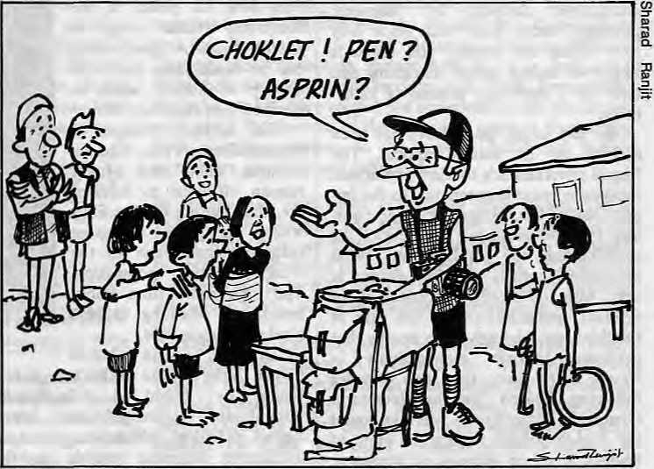
which is assisting the local people to take advantage of the presence of trek-kers, while at the same time preserving, if not upgrading, the natural environ-ment.There are other signs that the Nepali government is awakening to the need to support the tourist industry. A tentative plan exists to establitablish a Tourism Development Fund and start active promotion abroad. Finally heeding the demands of the trade, the Government has gone for a limited "open skies" policy and today passengers direct from Frankfurt, Karachi, Singapore and Hong Kong disembark in Kathmandu's newly inaugurated terminal building. Finally heeding the clamour for new trekking areas, the authorities opened the Kanchenjunga area in October 1988, and the lower reaches of the trans-Dhaulagjri region of Dolpo in May this year.
Perhaps the Government's change of heart is best illustrated by the fact that, even while the rest of Kathmandu reeled under fuel shortages during the ongoing Indo-Nepal fireworks, the tour operators were assured of gasoline and diesel for their excursion buses. "If one good thing has come out of this trade dispute, it is that the governmenthas come to realise the importance of tourism and seems willing to support us," says Yogendra Shakya of Marco Polo Travels.
A VULNERABLE PROPOSITION
Total reliance on tourism can be dangerous because international travelers are by and large a nervous lot. Little things deter tourists. An article in the New York Times Sunday Travel Supplement in 1988 February, detailing the medical hazards of trekking in Nepal - from diarrhea to meningitis -must have discouraged hundreds of trekkers. One isolated disappearance on the trail, and trekking will suddenly be termed "dangerous." As soon as the Kath-mandu-Delhi crisis began, many embassies in Kathmandu sent out travel advisories warning their nationals to scrap travel plans.
Tourism is thus inherently vulnerable to the vissictitudes of geopolitics. Kathmandu hotels had been looking forward to a summer that would bring tens of thousands Indian tourists attracted by the "Hong Kong" shops, and thousands more westerners stopping over on their way to or back
10 IHMAL * JuVAug 1989
from Lhasa. The Indian visitors, plus the Lhasa connection, was getting to be significant enough to rescue Nepal from its "seasonal" doldrums. The unrest and martial law in Tibet, and the problems with India, quickly ended that expectation, at least temporarily.
For the moment, Kathmandu tour operators are putting on a brave face and maintaining that the main tourist season, which starts in mid-September will be as strong as ever — if the Indo-Nepal dispute is resolved by then. If not, the ruined season of 1988-89 season will cast its shadow far into the future.
Though Kathmandu hoteliers and travel agents report healthy bookings for the fall, as one agent put it: "The real test is August-end, when the advance payments have to be made. That is when the cancellations begin."
Citing Nepal as the prime example, some experts say it is wrong for planners to develop tourism to a saturation point. Harka Gurung, a Nepali geographer and Minister of Tourism from 1976 to 1978, does not agree. He believes that no one can plan for wars and unrest, and significant income will be lost if a deliberate policy of pulling back on tourism is adopted. Tourism is not unique in being vulnerable to political turbulence, he says. A well-managed and flexible tourism policy
can today cope better today with potential disasters.
ENVIRONMENTAL HAZARDS
Much has been made of the dangers of letting tourists have the run of the land, especially if the land is as environmentally fragile as is the Himalaya. The mountain trails frequented by the 50,000 tourists who come to trek every year are invariably littered with garbage (Mar/Apr 1989 Himal). Trekking has led to deforestation of whole tracts of upland woodlands in the Khumbu and in central Nepal.
Tourist traffic in Nainital has grown
from 50,000 in 1979 to 1.5 lakh today, with over 80 new hotels in place. The resort's famous lake is silted over, and heavily contaminated. In Srinagar, Dal Lake is dying slowly due to sewage and grime in its water. The most important pollutants, says S. Chandrakala, are the 1,000 tourist houseboats which flush wastes directly into the water, raising bacteria and coliform to extreme levels. The central government recently approved the conversion of a city forest designated as a national park into a golf course, in order to attract more tourists.
T.V. Singh is unequivocal about the environmental hazards of tourism. According to him, "Tourism and environment are generally in disagreement.

Controlled Growth in Bhutan
Mass movement erodes massively. Mouatain environments are made up of vulnerable ecosystems. Losses are hard to repair."
Many people dispute this charge of environmental degradation brought about by the tourist. While some mountain trails are degraded and more firewood is chopped along the mountain trails, they say the problem is not the tourist, but management. Says a Nepali trek leader, "The deforestation is there, but most of it has been taking place without the tourists. You can go to remote valleys where no tourist ventures, and yet you see the telltale scars of landslides and hillsides wiped of whole vegetation."
Edmund Hillary, presently New Zealand's High Commissioner to New Delhi and Kathmandu, blames tourists for making the environment worse than it would otherwise have been. He expressed a strong indictment of the industry when he spoke before an adventure travel conference in Kathmandu earlier this year. He said, "It is 38 years now since I first visited Nepal and I have developed a deep affection for the country and its people. And yet in all honesty I have to admit that there are few places where tourism has been so gravely abused. Impelled by a relentless urge for financial gain, tourism has been encouraged far beyond the ability of the country to absorb it. Forests have been denuded, tracks have been covered with litter, mountains cluttered up with leftover junk.''
CULTURAL POLLUTION
Acculturation, or "apeing" the values of another society, is another perhaps unavoidable result of welcoming tourists, and parts of the Himalayan region have been reeling under it for many years now. Few will argue that exposure to foreign visitors is entirely negative. To join modern society, some might even say that such exposure is essential to enable the people of the Himalaya to join the 20th century. Such as in the town of Bhaktapur, where tourism has revived dying arts and crafts. But, ultimately, "bad culture drives out good". Already, people have said that Kathmandu is "a less friendly place" because of tourist overdose.
The worst case scenario of tourism's negative impact in the Himalaya-Hindu Kush was probably of Afghanistan,

Since it cautiously opened its borders to foreign visitors in 1974, following the coronation of HM King Jigme Sin-ghe Wangchuk, Bhutan has been earning about U$2 million a year from the tourist trade. Early in 1988, the Bhutanese Government virtually closed its borders and recalled its tourist promotion agents based abroad. Bhutan's Director of Tourism Jigme Tshultim told a group of North American travel agents then that restrictions against foreign visitors were adopted because tourism was undermining "the Buddhist faith".
That decision had been based on the recommendations of a special committee for cultural affairs which analysed the effects of tourism on the local society. The report, submitted to the Bhutanese Parliament, described how cultural values had been severely affected by tourism. "Tourism is harmful to the holy nature of our Buddhist monasteries, contributes to the desecration of the country's holy places and corrupts the population," it pointed out.
As an expert on Bhutanese tourism stated, "Bhutan presents a unique example of a country that has learnt from other's (read "Nepal") experience to take tourism wisely and cautiously," adding, "Bhutan is in no hurry to expand tourism." Mindful that tourists can overrun traditional festivals, the Thimphu authorities decided to limit the number of tourists attending Paro Tsechu, a spring festival in the capital.
The introduction of services by Druk Air in 1983 between Paro, Calcutta and Dhaka had been a major event
where geographer Allan says, there were "all the negative aspects of the interaction between hosts and alien cultural intrusion."
It has never been quite as drastic elsewhere in the Himalaya, but the symptoms are lurking. In Ladakh, according to Suneetha Dasappa of the Bangalore group Equitable Tourism Options, the Ladakhi chuba is being replaced by imported jeans and skirts. Tourists' demands for souvenirs has led to a thriving business in antiques and valuable artifacts. Monasteries, once serving as retreats for' meditation and
for Bhutanese tourism, and this year Paro was linked to Bangkok, Delhi and Kathmandu with a new 80-seater jet aircraft (Jan/Feb 1989 Himat). A function of the policy of limiting tourists, perhaps, was that a recent flight to Kathmandu carried only 9 passengers.
While the planes might be running empty, the fear of tour operators that Bhutan would be completely inaccessible did not materialise, however. In 1974, 287 tourists trickled into Bhutan. With controls still in place, that number rose to 2,524 in 1987, and dipped to 2,195 in 1988. In 1989, the figure is expected to reach 3,500.
The monetary attractions are clear, Bhutan earned Ngultrum 10.4 million from international visitors. Last year, it earned Nul2.5 million (Nul = IRsl).
The Bhutan Tourism Corporation, which runs tourism in the country with a staff of 307 is deliberately opening the country from west to east. Tours and treks began around Paro hi the West, and have now been extended eastwards to central Bhutan, including the town of BhumtangA Tourism Master Plan initiated in 1984 began with construction of basic infrastructure such as lodges and hotels and training personnel. In the "medium term phase", from 1991-1995, unless it is overtaken by events, the plan is to begin air services to central Bhutan and construct hotels in Bumthang, Mongar and Lhuntshi. The "long term phase", beyond 1995, will see the extension of tourism all the way to the east and the development of winter wildlife tourism in the south. ^ M.M.Singh
learning, are beseiged by groups after groups of tourists, says Dasappa.
Yet all blame cannot be laid at the tourist's door, for there are other ways in which the traditional communities are getting exposed to outside influence. In Ladakh, for example, Allan is of the view that "the presence of a large, equally alien, plains Indian population has already altered the local Ladakh Buddhist culture," In Nepal, says Veit Burger, the Austrian expert, tourism forms only one part of the external influence on the populace. "One should not confuse the impact of tourism from a larger process of west-
Jul/Aug 1989 • IIIMAL 11

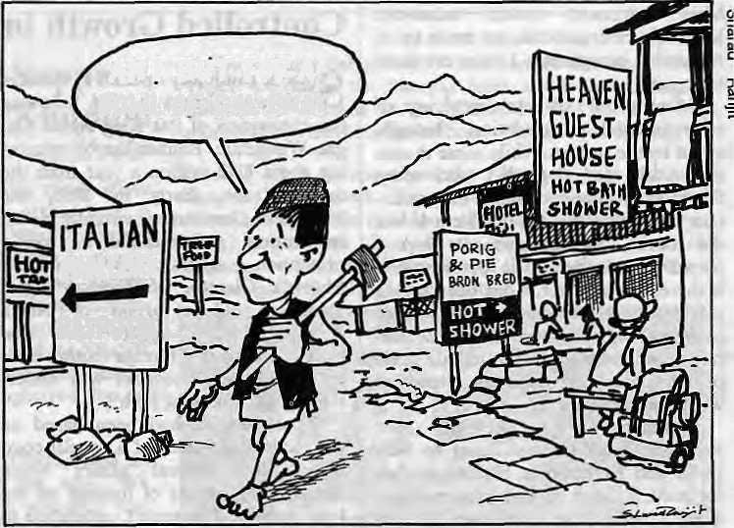
AH I BUT FOR A SQWLQFOAIBHAT
PANCftKE RhJPUTlNL
ernisation and modernisation." Besides the inflow of tourists, the process is also propelled along by international aid and its associated personnel, video movies from Bombay and overseas, the antics of the westernised local elites in the major towns, and a plethora of other agents and items of influence.
Geographer Gurung regards all the talk of cultural pollution without sen-timentalism. In his view, tourism — and the larger forces of Westernisation ~ are inevitable and there are no options available, especially for Nepal. "You cannot get something without giving something up, in this case culture," he says. "The strategy is to maximise contact so that you develop immunity to the outside culture." Gurung believes that since the country cannot do without the income from tourism, there is "no use beating one's chest about cultural dislocation."
IS THERE A THRESHOLD?
Should there be a threshold figure beyond which the gates to travelers must be shut? The majority of experts say yes. There is an environmental limit beyond which an alpine valley cannot take more tourists. The Mani Rimdu festival of the Sherpas would no longer be Mani Rimdu if there are more tourists than Sherpas attending. That point might well have been reached in Tengpoche, according to recent reports.
Bhutan appears to have embraced the concept of threshold tourism and put a cap on the numbers. Suneetha Dasappa reports that a section of the Leh's population also wanted to do the same and had forwarded to Srinagar a proposal for restricted tourism, but that it had been turned down by the state government.
Gurung believes that Nepal cannot and should not put a limit on the number of arrivals. A limit is useful for a country that has a choice, according to Tiinr "If you have other resources to tap, then why bother with tourism at all. From Bhutan's calculation, for example, tourism is not a high priority. The Chukha hydro project can now pay for anything the country desires. So it can afford to bring down the number of foreigners seeking entry,"
Gurung points out that the Swiss and Austrians have never felt the need to limit the number of tourists coming
12 I1IMAL • Jnl/Aug 1989
in. And Spain annually hosts 40 million visitors. "Tourism is an economic commodity. The more you have, the more the suppliers will be able to refine then-services and expand profits," he says.
OPTIONS AHEAD
The question of opening up restricted areas such as Larkya Bhot and Walangchung Gola in Nepal, presents the tourism planner with an unwelcome task. Some would advise that the closed off areas be maintained as such. On the other hand, if the Bhotiya people in Walangchung Gola want to reap the "decadent" benefits of tourism just the same as their neighbours in the Khum-bu, are policy-makers in Kathmandu right to deny them their wish?
Such are the complexities that face the public and the planner. Given a choice, and adequate information, people tend to make the best decisions for themselves. The government, for its part, must assist the population in reaping tourism's long term advantages while at the same time trying to ensure that the uniqueness of the Himalaya is not irrevocably despoiled.
First and foremost, the issue is one of equity. Tourism's largesse must not be disproportionately claimed by the city elites or siphoned off to outside interests. Tourism officials and travel operators from across the South Asian rimland must meet to exchange notes, ideas, and learn from each other. After
all, tourism activities in the regions of the Himalaya, from Hunza to Khumbu to Paro Valley, have more in common with each other than with Goa or the Sundarbans. Above all, tourism planners in the Himalaya must look to integrate tourism development with other aspects of development. For that is the whole idea.
Tomorrow more than today, tourism
will be a vital source of income for the
impoverished mountain peoples. How
to make tourism a profitable proposi
tion, benefiting the maximum number
of the Himalayan people without losing
the "soul" of each individual Himalayan
society is the big question. The answer
depends, ultimately, upon the sense of
responsibility of the travel trade, the
sobriety of the visitors themselves, the
cultural resilience of the Himalayan
peoples, and the level-headedness and
foresight of the governments that rule
over them. /\
Himal Alert!
Hlmal welcomes news reports, articles and opinion columns on any and all aspects of Himalayan society. Forthcoming Issues will cover, among other things, the monsoon, hill poverty, "development refugees", and the Tarai belt. While all submissions will be read and considered, the editors are not obliged to return unsolicited manuscripts. For a copy of "Writing for Hlmal", please writa to P.O. Box 42. Lalitpur, Nepal.

BRIEFS

Cactus Gains in U.P. Hills
Traditional forests of the Uttar Pradesh hills are losing ground to the cactus plant, the "harbingers of desertification," say noted geologist K.S. Valdiya of Kumaon University and his colleague S.K. Bartarya,
The two scientists based their observation on a study of the catchment area of Gaula River near Nainital. They traced the deteriorating environmental conditions to clear-felling for agriculture, road construction, forest fires and other largescale destruction of woodlands. The cactus is replacing traditional flora because evaporation of moisture {torn the treeless soil is nigh, according to Valdiya and Bartarya,
The flow in the streams during the monsoon was sometimes one thousand times greater than at other times. This "too little, too much water syndrome," say the scientists, is a common feature of desert country. The weather too is changing and it is now warmer and drier in the Himalayan belt
in summer, Average rainfall has declined by 30 percent. PANOS
A Circumpolar Conference
The Inuit Circumpolar Conference, which was held in the southwest Greenland town of Nuuk in late July, for the first time brought representatives of all the indigenous Arctic peoples (Inuit — Eskimo) together. Though international gatherings of Inuits from the high arctics have been held every year since 1977, this is the first time that the Soviet Union has sent a delegation.
Besides those from the Soviet Arctic, the Conference brought together Inuit delegates from Canada, Greenland (Denmark) and Alaska (United States), representing some 105,000 Inuk inhabitants of the high arctic regions.
The Soviet shift is said to reflect President Mikhail S. Gorbachev's call for the Arctic countries to devise a comprehensive plan for protecting the region's environment and indigenous peoples, as well as for a sub-
stantialreduction in. military forces stationed there, and the creation of art Arctic nuclear-free zone. The-new policy was signalled by Gor-bachevat an October 1987 speechjn Murmansk, the administrative capital of the Soviet Arctic region.

Glorious Bamboo
From Tanzania comes the news that the bamboo is better as a water pipe for rural communities, superior to the steel and plastic pipes, favoured almost everywhere ; in the Third World from the Himalaya to the Andes. Pioneered by a Tanzanian water engineer named Thabiti Lipangile, bamboo pipes now bring potable water to villages around the capital Dar es Salaam and the region around Mount Kilimanjaro. Today, there are more than 260 km of bamboo water pipes in the country. Aid for bamboo pipe proliferation is now flowing in from the Netherlands, Sweden and the European Economic Community.
The bamboo water schemes utilize materials which ate cheaper arid available to villagers, says Lipan-geti. They use less than five percent of imported material. Research,has

shown that wood and bamboo, when properly treated with chemicals, are superior to any other conventional pipe material. A preserved bamboo pipe lasts an average 50 years, compared with 40 years for plastic and 10 to 15 years for steel. Good news for Himalayan communities that have been waiting for the "porjet" to bring potable water to their homes. Third World Network

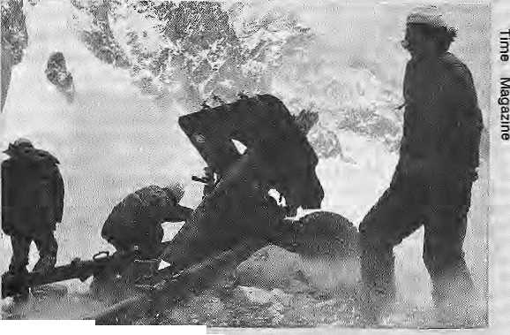
Siachen Thaw
If there are now warmer relations across the high arctic, the same might also be said to be true in the high Himalaya, The machine-guns,, rockets and howitzers are finally silent on Siachen Glacier, the loftiest battleground in the world, where hundreds of lives and crores have been lost in five years of high altitude warfare. One pitched battle last year was fought on a 21,300-foot peak. Both sides claim the sprawling desolate area, which has never been properly demarcated. Siachen is the longest
glacier in the Himalaya. Most of the deaths among the thousands of troops deployed on each; side have been due to combat, the acute cold, accidents and high altitude sickness.
Islamabad and New Delhi are moving to resolve then-dispute in this corner of Kashmir without the use of force. It is hoped that talks held in early July will lead first to the establishment of the exact positions of both armies in the area. This would be followed by further talks arid "redeployment of forces", meaning an eventual joint pullout from the
Pakistani artillery on Siachen glacier, leaving it a demilitarised zone.
As the Pakistani brigadier on Siachen told a Time

magazine correspondent, "This place is beautiful. It was not meant for fighting;¹

l$$!) • HIMAL 13

BRIEFS

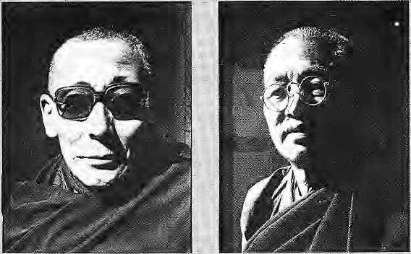
Sangey Yes ha
Passing on the Old Craft
Sangey Yeshe, 66, is one of the last surviving masters of the Tibetan art of creating thangkas, scroll paintings which are objects of worship. Pema Dorji, 58, is a metal image maker in the Tibetan tradition, possibly the only one outside Tibet. Ngawang Chonjor, 64, is one among a very few who carry on an ancient tradition of Tibetan wqodcarving.
All three masters are engaged in passing on their age-old expertise to apprentices in Dharamsala. Such teaching is not available in present-day Tibet because "there are no good teachers," says Yeshe. "If such traditions die, we'll cease to exist as a people," says an apprentice of Yeshe at the Thangka School of Painting in Dharamsala. funded by the London-based Oxfam relief agency.
Fortunately, thangkas are in great demand among Tibetan refugees all over the Sub-Continent for their altars, and also in the West. The waiting period for a reputed master can be up to two years or more. Thangkas depict Tibetan iconography - deities, rnan-dalas and other Buddhist themes - which conform to prescribed dimensions and colours. The paints are
14 HIMAL * Ju)/Aug 1989
Ngawang Chonjor
made from stones which are found in Tibet.
Peraa Dbrje, who works in metal, spent more than 2Q years learning his craft from masters in Tibet, He belongs to the Sakya sect v£ Tibetan Buddhism. Very few like hini remain. As a student of Dorji said, "Back in Tibet, there are two or three masters, but they are quite old. Once they are gone, this art will disappear."
An attempt is nevertheless being made to keep some of the craft alive. Eight of Dorji's students have coin-pleted 10 years of training and now draw, cast, engrave and mould statues. In two more years, they will become teachers themselves,
Ngawang Chonjor's best wood carvings were done in his hometown of Gyelthang in southeastern Tibet, sortie of which can still be found in Lhasa today. When he first came to India in 1959, it looked like he would never work at his craft again. But as Tibetans settled into their new communities* monasteries came up, and his talents were promptly engaged. One project in Kar-nataka took three years to complete, So far, Chonjor has trained seven students. "They are now able to earn a livelihood, and I am happy to have passed on my craft," he says. Gemini News Service.
And Now,
a Himalayan Commission
A paper before the Planning Commission has called for the establishmeiit of a "Himalayan Commisr slon", tinder the chairmanship ofthePrirne Minister, to promote regionwide: developrnent of the Indian Himalaya. Entitled "Ecological Development of the Himalaya," the paper was prepared by B.N. Dhoun-diyal, Secretary in the Parliamentary Affairs Ministry and formerly Advisor to the Planning Commission.
According to the PTI news agency, the paper also calls for strengthening and widening the scope of the North-Eastern Hill Council and the creation of a North-West Himalayan Authority that would look after the interests of Jarnmu and Kashmir,
Next, a
Mountain
Secretariat
A group of mountain scientists led by Jack D. Ives (University of Colorado), Lawrence Hamilton (East West Center_{r} Hawaii) and Bruno Messerli (University of Berne) has proposed the setting up of an international mountain secretariat
The journal Mountain Re^ search and Development reports that, among other things, the secretariat would help develop education, training and public awareness programmes concerning mountains and their relationships with human, survival, sustainable development and welfare. It would "conduct international integrative interdisciplinary research and
Himachal Pradesh and the Uttar Pradesh hill areas.
The paper estimates that the regionwide development effort would require IRs9,000 crore to implement. If total coverage is provided within the next two five-year plans, approximately IRs4,000 crore would be required during the Eighth Hve-.Year Plan (1990-1995). These requirements could be met from the funds to be transferred to special category states and hilt area development programme "by moderating the usual iri-creases in the sectoral plans." The World Bank and other aid agencies should play a significant role in funding these schemes, the paper recommends.
policy-oriented study concerned with mountain science in all its aspects."
If this sound a bit like the mandate of the Kathmandu-based Internationa! Centre for Integrated Mountain Development (ICIMOD), Ives maintains that it will be quite different* He writes in the journal that the secretariat has not been conceived of as a competitor to any existing institution but as a complement. It would "have an apolitical structure that can grapple with sensitive topics that may prove politically un* manageable for the more conventional institutions." The sponsors are hoping that the secretariat's initial funding will come from the Swiss.

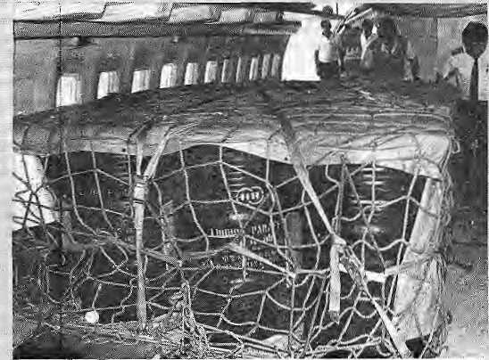
Royal Nepal Boeing jet hauls paraffin drums to Kathmandu
BRIEFS
An Economy At Standstill (Continued)
India and Nepal are still locked in the trade war that began last March. Some say it is likely to continue until India's elections next January, in which case the Nepali economy, already in shambles, -would be devastated.
The most greviously hit so far have been the tourism and energy sectors. Industries are at a standstill and agriculture has been seriously affected. If the crisis drags on, economists expect the financial and banking sectors to be weakened and the efficiency of government severely undermined. Very few development projects have moved forward. Inflation is at double digit and unemployment levels can only worsen.
Innovative ways were found to try and circumvent the fuel crisis. The "mountain bike" took Kathmandu by storm. With supplies of sturdy Indian and Chinese designs running out, atrociously priced Taiwanese
Bhutanese Learn to Conserve
Bhutan's Conservation Education Programme has continued to expand its (each in order to make the public aware of the country's natural heritage and the need ot preserve it. Thimphu's Department of Education has not only endorsed the project, but expanded it into a countrywide environmental education programme. All science and geography text materials are being re-drafted so that
bikes took over the market. Royal Nepal Airlines kept flying because its larger planes flew into Kathmandu with full tanks and siphoned off the fuel for use by smaller aircraft. For a while; drum-loads of petroleum, diesel and paraffin were flown in from Bangladesh. But by and large, the country continued to reel under the fuel crisis,"
In a major policy shift, Nepal decided to eridlhe free and unlimited convertibility of Indian currency visa-vis the Nepali Rupee, To diffuse speculation of impending devaluation, the Nepal Rashtra Bank announced that it had U$277 million in foreign currency reserves, only id percent of which it said was made up of Indian currency. The reserves, said the bank, were good for six months.
The restrictions on the Indian Rupee followed an earlier decision to conduct trade with India on the basis of the "most favoured na-
forestry, agriculture, ecology and environmental studies are not neglected/Teacher training workshops have also been organised, and conservation clubs have been started ra three schools. The dubs hold field trips for youngsters and maintain video and publication libraries on nature. The project, begun in 1988 with help from the World Wildlife Fund/USA, recently held a workshop for more than 300 teachers and government officials in the Manas National Park, which is also being established with wwf funds.
tiori" principle, meaning Indian commodities would no longer enjoy tariff concessions and would have to compete with third country goods. Nepal is also seeking early admission to the General Agreement on Trade and Tariff (gatt) to facilitate uniform tariff rates. The Nepali Government introduced a U$733 million budget for fiscal year 1989-90, saying that the main challenge now was to minimize further "economic contract tion'¹.
The Government's revenue is expected to fall from
The Director of the Conservation Education Project is Chadbr Wangdi. He spends half of his time working with schools throughout Bhutan, encouraging the participation of students and faculty in conservation efforts. Waisgdi travels in a vehicle that has been outfitted with audio-visual equipment so that his message is more effectively disseminated. Wangdi also supervises an OXFAM agroforestry project, "which complements the education activities since agroforestry has been intro-'. ijuced as a subject in ail of the Country's schools.
U$345 million last year to U$290 this year, and the impact on the economy is expected to be even more severe in 1990. The gross domestic product (gdp) growth rate for 1988-89 has plummetted to 1.5 percent for 1988-89, against an estimate of 5.3 percent. Jan Sharma
Flowers for Sikkim
Gangtok and the town of Yuksom in Sikkim, have the proud distinction of being designated the hosts of the 1990 International Flower Festival. This is the first time that the annual festival has been hosted in South Asia and thousands of flower enthusiasts from the world over are expected to descend on Gangtok.
Sikkim, with its diverse Himalayan terrain and traditional flower industry is a natural choice for the month-long Festival, which starts 28 April 1990. The state boasts more than 500 indigenous varieties of orchids; it is also rich in species such as rhododendron and gladioli,
JuJ/Aug 1989 • HIMAL IS

FEATURE

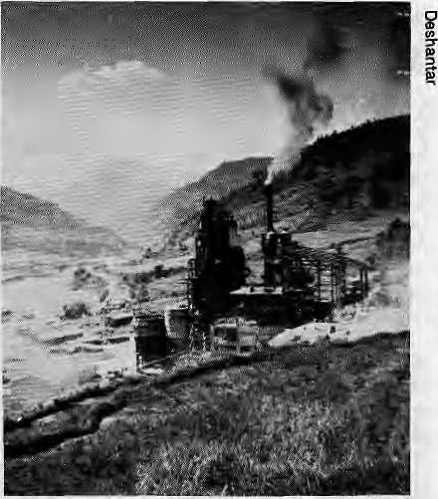
Fields next to Lamosangu magneslie plant
nels under a Ganesh Himal spur. This is one of the highest mines in the world - only a notch lower than the sulfur quarries atop Chile's Aucanquilcha volcano.
Visits by Nepal's Prime Minister and the Minister of Industries have won the project official sanction, but critics charge that the Ganesh Himal mine is environmentally unsound, brings little benefit to the local people and that the
Mining the Mountain
by Binod Bhattarai
M
ining in the Himalaya has never been easy. The staggering costs of digging underneath the world's loftiest mountains involve risks. And like mountaineers, only the most intrepid entrepreneurs have dared.
Despite persistent warnings against mining in the mountains, and lack of proper assessment of just who would benefit, mine shafts and open pits scar Himalayan flanks from Pakistan to Burma,
Unlike the Andes, the Himalaya's young and un-volcanic geology have deprived it of the gold seams and copper lodes that enrich parts of Peru, Chile and Bolivia. Noted Swiss geologist Toni Hagen, who traversed the Himalaya in the 1950s, didn't think our mountains had much of a mineral potential. Four decades later, he still has to be proved wrong. There is still no major mining industry in the Nepal Himalaya, though it is not for want of trying.
Mining deposits of iron ore have been tapped in the past to craft khuktis and forge cannons for the Anglo-Nepal wars. Nepal's mountain rivers bear names of metallic ores (Tama Kosi, Sun
Kosi). Deposits of iron on Phul-choki Hill southeast of Kathman-du, and the Those Mines in east-central Nepal have about 4.5 million tons of high-grade iron ore each, but they are not considered competitive enough for export to India because of the higher cost, particularly because of the need to import vast amounts of coal for the smelting process.
Mineral-based industries account for 2.34 percent of Nepal's gross domestic product, and according to the Director General of the Department of Mines and Geology the pressing need to attain growth through industrialisation makes the search for minerals vital. Oil prospecting has begun in the eastern Tarai, and Nepal has called for international bids for prospecting at other blocks along the Tarai.
UNDER GANESH
Inaccessibility does not seem to have deterred exploitation of the lead and zinc deposits at the lap of Ganesh Himal, north-west of Kathmandu, where workers have been burrowing into the strata at a height of 4,460m. They have already dug 1.8 km of tun-

VIEWPOINT

Destroying the Strata
by Shekhar Pathak
rrrhe chief components of lite environment - air, wafer and •m. soil - are being destroyed rapidly hi the mining regions of the Himalaya, particularly in Garhwal and Kumaoti. The local people, labourers, as well as small contractors are being simultaneously exploited. There are no specific mining or environmental laws for the mountains. Even the general laws are not followed up here.
Open blasting, providing mining contracts to petty contractors in order to avoid labour problems, inadequate pollution control measures, provoking local gangsters to suppress or dilute local protests - all this has become common practice, Under such alarming conditions, no mineral should be mined in the mountains of Uttarakhand unless it is essential hi the national Interest. The fact that a quarry or mine yields profit to an industrialist arid employment to a few people does not in itself make a national need.
Even if we overlook the long term devastation wrought by mining, we find that the immediate benefits are grasped by a tiny influential fringe and not by the local people. Those in
politics and administration; have stood firmly behind the mini-- eg contractors and factory owners. Understandably, theloqals _{s} will always hail and welwme mining projects because of the prospect of employment,' But in due course they will understand what they have lost, When their dwellings begin to show cracks, land becomes infertile, water and air pollution become commonplace, and village lands and forests get confiscated.
The mining problem, grave in itself, cannot be studied in isolation of other processes. Mining is part of a larger scenario in which the natural wealth of the Himalaya is exploited by big industry. This larger scenario also includes the construction of high dams, the over-exploitation of forests and medicinal herbs, the reach of alcohol to the remotest villages, and the establishment of rnagnesite, lime, cement and paper mills in the name of industrialising the backward hill region.
What is required to tackle these problems, including that
of mines, is stirring up consciousness and awakening society
through the cooperation of the judiciary, the media, and the
world of science, ^
S. Pathak teaches histpiy as Kumabn University in Nainital and edits the ah-

.& .a. * »;».

: . «»„,**.*■* „."«*■„

16 HIMAL • JuVAug 1989

FEATURE

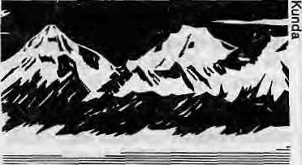
Ganesh, 7405m
104km approach road from Trisuli has bulldozed through fragile terrain with the same lack of concern for the local people, primarily Tamangs.
Environmental considerations are beginning to loom large. Damage to the ecology occurs even if the effects are not immediately noticable, according to a study on another high-altitude Himalayan mine conducted by Nepal's Environment Impact Study Project. That report today lies in slumber, buried deep from public eyes.
There are those who fear that Ganesh Himal may duplicate the effects of mining in the Andes and the Indian Himalaya. But in Nepal there is no grassroot movement and a handful of elite environmentalists in Kathmandu seem to be howling in the wilderness. The cardio-pulmonary and chronic high altitude sickness prevalent among the tin miners of the Andes could also be a major concern here.
The main disturbance to the environment occurs from the debris displaced by the mines, according to a paper on mountain environment management by Jayanta Bandyopad-hyay, an environmental scientist currently associated with ICIMOD. This damages farmlands, chokes river beds and disrupts the hydrological system. According to Bandyopadhyay, who studied the impact of mines in Doon Valley, dry-season discharges from spring sources in villages surveyed had decreased by half over 20 years and that explosives used in mining operations loosened shaky rock structures and triggered landslides.
The incredibly picturesque Chilime Khola region below Ganesh Himal is estimated to hold nearly two million tons of rich lead, zinc and silver ore. Ore samples indicate the presence of 15.7 percent zinc, 1.62 percent lead and 30 grammes of silver per ton. When production begins in 1992, 25,000 tons

is in full swing. So far, 125,000 tons of magnesite have been extracted from the site, which has an estimated deposit of ISO million tons.
Both the Ganesh Himal and Kharidunga mines ownerships hold 49 percent of shares, with Indian interests holding the other half. The management of both mines cite employment generation as one of the important benefits. At Kharidhunga, 275 persons are directly employed in the quarries, and the company says 1,000 more benefit indirectly. Most locals are hired as unskilled labourers at an average rate of NRs27 a day. Because of the low wages, parents bring along their children to the mining site in order to supplement family income. All in all, the mines seem to have injected a
of zinc and 1,500 tons of lead concentrate per year are expected to come off a processing plant to be located in Rasuwa.
Some experts are asking where the mineral, originally planned for export to India, will be marketed. The cold wave in relations with India and the shrinking international demand for lead and zinc in this age of fiberglass and other light metals will make marketing difficult, they say. Meanwhile, the owners cling to the hope that the trade dispute will be resolved by the time they are ready for commercial production in three years.
MAGNESITE MADNESS
At the magnesite mine in Kharidhunga,
100km northeast of Kathmandu, digging
Meteentus
r the Jjpiled Nations Development .Programing (UN®!*) set <out t© assess'
's iftinera'I wealtK and to biiild up its technical manpower ami infrastructure
|<f (%at jrjiuierai. e;xplor$tfort ^duM^jnjdppenderitly ^carrledLout by the Nepa)i_{s}ei> %
|ieTts.;.Xn§ MinerantxplQ.r&t§on |rpject was formulated and implemented jointly by-
UNDP and HMG. [, . , ::, .::.,, , . ■■■■ - ■ ■■ - " ■■>■. ..■■ , ■ *
During the Projeet^s some lO-yeartenure, UN0P provided expatriate expertise Md'tahoratPty'equjprrteiit and: tools to streagtljesj the capacity ofNepati>sden£sts to conduct exploration of copper, lead and zinc. Teams pf-"ffefialrtectniciafts'were |r|med to con<|uct;ge6-ch£mical field, and laboratory work, .geophysical fieldwork -aadphota-geologieal field-and laboratory work; The day;:a¥rivedwheri Nepali tecE icbuid ^arry%ut: mineral 'exploration: m;the fi$4 and in the labbratpl
* - Meanwhile,'a^wealth of information on the selected site had been
Md'fijed "in fcchniftal fep^"^.^Tjh| taxgeCarea ^showedi geo-chemical _{s}anonialie^.©/
.copper,-lea-d 3nd:.ziiiG. Samples hud jjeea stored {or. fiuture'reforence, ineluding for
f l
shorty the mmeral 'potential of the site had been systematically as^dssed * ascermmed/ A 'numb&rj ^:g^o-c^nKcat"inOfiia:lies'¹ Md; be|n: fpllqwed: up, .to ^h %i$go M.:fociiting jnineratdeposits. Some drilUng had been-made to> determine th extension- of Mn|er^li0de§ Sfliall ^erjositsiof copper, liati :and"zinc
* The exploration of minerals throughout Nepal was to continue - by the cot
cejried !fmq department us>riglhe;new method; transferred !by ti| Mnerat S... : plpration jProjeet. However* flits did not happea. The Nepali technicians who had
learnt -new; methodsM?4 ffit^^r^dre-adapt-tp thf gilder tecftnpl&gy and c^4venf] . al methods pCminerai exploration. The knowledge gained through the Project :: largely unutilised, including that of Hurwritief. Most iof the manpower trained und
ttidBrejecl feadfceen dispersed b^ !9&% whe(J k enHed;
:°T1ie lessoWfrbrii;thls(e>:p;ene%ce(is;that when fechiiology fa'transferred'through*a^ ■ ^Oject, th&rb .innsj jbe; foBo^up by. ih£, donor agency and redpSent country s.O:that
costly effort ^adi resource* are not wasted In the absence of such self-examinatioS ;f We will be en^gfed in f einVep|i%. the w^idel again jsnlA again:
*;.<, ,: i .:. , ,i s . ■ -■ . -: - " - - ■=! - * -^{i:} ?: ': ■: *
■ ■^aiT!TOngSi)^n?csand:..ecor!Ptni^:..j . .■ ;- _{s} „ ^ ^
Jul/Aug 1989 • HIMAL 17

FEATURE

limited cash income to the hill communities but by taking them away from the farms.
Kharidhunga's quarry workers wear makeshift face masks which are not enough to prevent inhalation of the fine silica dust. Villagers have reported unprecedented flash floods on the Charange rivulet downstream from Kharidhunga. Tests of water samples also showed a higher than normal ammonia content linked to acidic discharges from the mine. A study suggests contaminated water may have affected
productivity of the fields. Villagers at Jathul, near the magnesite quarry, live in perpetual fear of landslides triggered by mining activity.
"This year my harvest was only a tenth of my normal produce," complained a villager at Lamosangu, where the plant that processes the magnesite is situated. Fine magnesium dust carried by the wind settle on his terraced fields and, mixing with water, causes the soil to harden. "The crops just withered and died. And when we harvested the stalks there was only husk at the end,"
the farmer said. Soil scientists in Kath-mandu explain that magnesium is chemically basic and would render the soil more alkaline than normal, thus harming crops.
As monsoon rains broke over Kharidhunga last month, the magnesite mine continued to spew dust. There were no signs that five years of operation had benefited Kharidhunga's subsistence farmers. Instead, forests are dwindling and what little wildlife there was has been scared away by the dynamite blasts that rent the air. ^

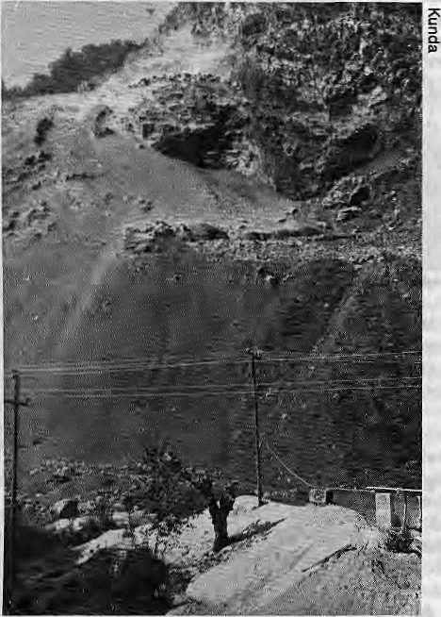
Godavari Marble Goes to Court
A
s Nepali officials went on a sapling-planting spree on 5 June, World Environment Day, a Kathmandu voluntary agency hit the headlines in its own way. The group, called Legal and Environmental Analysis for Development Research Services, Incorporated (with its rather wistful acronym, leaders), filed Nepal's first environmental public interest litigation against the Godavari Marble Industries Pvt. Ltd. The suit was filed with the Supreme Court, and on 10 August, the Court issued a "show-cause" notice against the defendants.
LEADERS' leader, advocate Surya Prasad Dhungel, says five ministries, three government departments, two district and village administrations, a school, and the national botanical garden wnl be also be called to defend the charges of environmental neglect.
The marble quarry is situated on the flanks of Phulchoki mountain, which contains one of the last surviving Himalayan cloud forests in central Nepal. It is located on the south-eastern run of Kathmandu Valley. (See Himal prototype issue, June 1987)
The quarrying at Godavari started in 1934 and provided marble for Kathmandu's Rana palaces. It had been chugging along with antiquated equipment and modest production until 10 years ago, when bigger business bought the quarry and turned it into a major source marble as well as "construction aggregates" to feed Kathmandu's building appetite. Godavari Marble Industries was set up to quarry marble,
18 HIMAL • Jul/Aug 1989
Godavari's blasting fields
but seems to have found the byproducts more profitable. Phulchowki's mountain flanks are said to have 625,000 cubic metres of high grade marble. The firm paid NRs203,846 in royalties in 1986, but critics claim that this is "peanuts" compared to what it earns from the sale of byproducts alone.
Says Dhungel, "We want quarrying to stop till the court appoints a commission to investigate the extent of environmental degradation on which it can base its decision."
But some critics of the litigation maintain that the whole approach is wrong. They say the lawyers have spent little time lobbying the local people to convince them to take the case to court themselves. Jayanta Bandyopadhyay, a researcher at ICIMOD in Kath-* mandu, draws lessons from public interest litigation hi India, where environmental cases, as in the Doon Valley, were spearheaded by grassroots groups. "The element of success in the Doon case was the continuation of the peoples' expression of protest from the beginning till end," says Bandyopadhyay, himself a former Doon activist.
Others are puzzled by the inclusion of the Jesuit school at Godavari and the Royal Botanical Garden in the list of defendants, leaders maintains that the school, which is on the quarry's frontline and under constant threat of falling rock from dynamite blasts, has been negligent by remaining silent, as have been the elected representatives of the villages.
Village officials are not exactly jumping with joy. "Are the lawyers doing this for their sake or ours?" asked one office- bearer in the village of Kitni, near Godavari,
What direction the suit will take in
the Supreme Court is unclear. Either
way, Dhungel is confident the litigation
"will open the victims' eyes and teach
them not to suffer in silence," f\
-B. Bhattarai

PEATURE


Pakistan's Environmental Woes
by Imlia/ Gul
T
he case of Pakistan is not different from ihc Oilier countries of the region when the subject is environment. Unsustainable over-exploitation of natural resources by a fast-increasing population (presently at 100 million) has led to poor living conditions in cities and villages. Rapid urbanisation and indiscriminate exploitation of natural resources by industry are greatly compromising human health, forests, crops and water quality.
DIRTY WATER
Recently, 16 percent of the 200 wells studied in the ex-capital of Rawalpindi and the present capital Islamabad were found to be contaminated with faecal coliforro organisms. About 57 percent of the piped water sampled in Rawalpindi was unfit for drinking due to chemical residues.
The city of Lahore, capital of Punjab province, produces 2,000 metric tonnes of solid wastes daily. Large quantities of liquid wastes heavily contaminated with toxic chemicals are discharged untreated into the Ravi river. What is true of Lahore is also true for cities like Karachi, Faisalabad, Hyderabad and Gujranwala. A fertiliser plant in Multan has been discharging highly dangerous pollutants directly into a nearby canal. Elsewhere, there is no monitoring of industrial discharge of lead, mercury, chromium, nickel, celenium, asbestos and vinyl chloride.
Water dirty with wastes, toxics and garbage surely contributes to Pakistan's high infant mortality rate of over 140 per thousand. After all, about 30 percent of all reported diseases are water-borne, including cholera, typhoid, diarrhea and hepatitis.
DEADLY CHEMICALS
With its agro-oriented economy, Pakistan has been emphasising the use of farm chemicals to boost productivity. While the yields have improved, farmers have tended towards the excessive use of pesticides, which can cause irreparable ecological imbalance. In 1984, 20 people died in a village 80 km
The Pak-Arab Fertiliser plant in Multan
west of Islamabad of mysterious causes. A subsequent study by the World Health Organisation revealed that they had died of poisoning by Eldrin, one of the "dirty dozen" pesticides which had been widely used at the time against sugarcane and cotton parasites.
At least four Asian nations - Philippines, India, Indonesia and Malaysia -have adopted a system of integrated pest management to protect the environment and secure a balance between the prey and the predators. Pakistan has yet to make a headway in this respect.
SAVING THE TREES
Another important area of environmental concern in Pakistan is its diminishing forest wealth. The suspended sediment load per kilometre of drainage basin hi Pakistan is the largest in the world. This is an adequate indicator of the intensity of soil erosion, which has affected as much as 1.2 million hectares of land so far.
Every year, the Department of Forests organises spring and autumn tree plantation campaigns. Theoretically, over 50,000 hectares are planted or regenerated every year by the Department. But most of the new plants and saplings die and vanish within a couple of weeks. Were the department officials and workers more serious about their duties, the Pakistani forests, particularly those in the northern areas, would not have vanished so quickly. The wood-based industry, too, has done severe

damage to the already meager forest resources.

It is clear why we have to save the woodlands, and it is not just to maintain environmental balance. Village carpentry is a source of livelihood for thousands of families. Half the annual heating and cooking requirement is met by 21 million cubic metres of fuelwood. Two million cubic metres of building timber is used annually, and 86 million heads of livestock depend upon the degraded rangelands and forest areas for grazing.

Millions of hectares of land have been cleared of all types of vegetation and diverted to agriculture, human settlement, roads and canals. Furthermore, inappropriate farming practices and indiscriminate use of pesticides have aggravated natural as well as manmade problems. The network of canals for irrigation has caused waterlogging, salinity and other allied problems.
It is estimated that Pakistan is losbg one percent of its forests annually. This is nothing less than disastrous for a country whose lands under forests is already a paltry five percent. The availability of timber is only 0.13 cubic metres per capita annually (it is 1.6cu.m. in the United States).
EMERGING POLICY
There has been some official response to the country's environmental woes. The Environment and Urban Affairs Division of the Ministry of Housing and Works, for example, has tried to integrate environmental considerations
JulMiig 1989 • HIMAt, LD

FEATURE

into the economic development process. It has made several recommendations to improve the quality of environment.
A national policy enunciated in 1980 contained several measures to improve the woodlands. In 1983, the Government promulgated the Paldstan Environmental Protection Ordinance, which was followed by the setting up of two authorities at the federal level, the Pakistan Environmental Protection Council and the Pakistan Environmental Protection Agency. The Pakistan Council for Scientific and Industrial Research, for its part, has taken initia-
tives to bring to light the seriousness and magnitude of the problem by establishing special sections in its laboratories in Lahore, Karachi and Peshawar.
The very emergence of these institutions promises a better and healthier environment because they can check, observe, evaluate environmental phenomena and recommend remedies. Yet, coordination has remained a problem. Scant regard is paid to the need for an "integrated approach." This is a potential barrier, and there remains a vast gap between the experts and academics on the one side and policy
makers and the bureaucrats on the other.
A lot more needs to be done, in
cluding the provision of adequate
funds, training and motivating person
nel, improving coordination, and, above
all, empowering offices to enable them
to carry out their programmes without
interference from higher authorities.
Environmental administration must not
be considered a secondary sector. En
vironmental thinking must every existing
sector of the economy and administra
tion. ^
I. Gul writes for The Frontier Post of Islamabad.

DAM NEWS

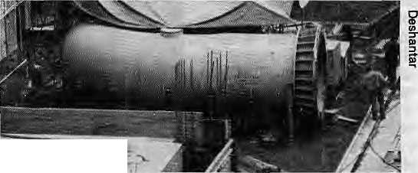
last August's earthquake, and a geological phenomenon called the "Barun fault" running thr-ough the area. One critic says Arun III will produce Marsyangdi under construction
Marsyangdi and Arun III
by Binod Bhattarai
W
ith the failure of Kulekhani to meet the expectation of Kathmandu's electricity demands (see Mar/Apr Hitnaf), all eyes are now on Marsyangdi and the hydel project in East Nepal known as "Arun III."
The monsoon rains filled Indra Sarovar, Kulekhani's reservoir, so power rationing in the the Valley was ended. With the inauguration of the Marsyangdi project expected towards the end of the year, Kathmandu residents could forget about load-shedding for at least another four years, it was said.
HIGH TAB
Marsyangdi, in central Nepal, will have an installed capacity of 69 megawatts. The tab will be U$4,000 per kilowatt of installed capacity, making Marsyangdi possibly the costliest project of its type in the world. Some compared the figure with Bhutan's Chukha hydel project's U$l,000 per kilowatt (Nov/Dec 1988 Himat) and sighed.
Even Marsyangdi will pale in comparison with Arun III, which would be located on the Arun Kosi river in the East Nepal, If and when completed, the project will produce 402MW. of power -four times the country's entire power consumption today.
Arun in, too, has come under fire. Firstly, it falls in the seismic zone hit by
too much power, which the country can never use. That kind of criticism did not deter an Aid Nepal group, which, meeting in Paris under World Bank auspices last May, pledged U$550 million for Arun m.
ARUN'S PROBLEMS
Actually, the World Bank itself reportedly will not fund the project unless India agrees to buy at least 200MW, or half of the projected installed capacity. In the present context of Indo-Nepal relations, at least, that seemed to be an unlikely prospect in the near term.
Before the first shovel is dug at the Arun III site, a 200km access road will have to be built from the lower hills. It is learnt that only two tenders were submitted for the construction of the road, at quotations twice the amount budgeted by Arun til's feasibility consultants.
It is said that there are a whole lot of projects which could "come on line" faster than Arun ill and would have better economies of scale, such as Sapta Gandaki (capacity about 240MW), Kali Gandaki (90mw) and WestSeti(105MW).
SAVING THE CLOUD FOREST
Yet another major consideration: Arun ni will be sited adjacent to the most pristine woodlands remaining in the country ~ the cloud forests of the Barun Valley and the adjacent hills, which are sparsely populated by Rais, Tamangs and Sherpas. The area hosts a profusion of unique flora and fauna, some of which have never even been catalogued. With the easy access provided by the road, Barun is bound to be overrun by low-landers and tourists.
Fortuitously, should Arun in ac
tually come through, possibly in the
late 1990s, the Makalu-Barun area
will likely be a managed wilderness.
Under directives from HM King
Birendra, a task force headed by
botanist T.B. Shrestha is half-way
through a two-year study for protect
ing the Makalu-Barun and possibly
linking it to the Sagarmatha National
Park. The study's recommendations
are to be implemented over a ten year
period, providing a structure for
preserving the region's natural
heritage. ^

20 HIMAL • Jul/Aug 1989

CLIMBING

Messner towards Antarctica
R
einhold Messner, a Himalayan climbing legend like perhaps no other, is turning his back to the Himalaya. He is starting out with a companion in late October on a traverse of Antarctica — without huskies, and pulling their own lightweight sleds.
Messner, 45,* who comes from the Tirol mountains in northern Italy, has done just about everything possible in the Himalaya: Everest alone, he has climbed alpine style and solo. His latest climb was Makalu, which he did via the South West Ridge in 1986. With that ascent, he became the only person to have climbed all of the world's 14 peaks that are over 8,000m (all of them, of course, in the Himalaya-Hindukush). The Tirolean climbed every peak without using supplementary oxygen.
The challenges now lie elsewhere, Messner told a New York audience in late June. He was glad to be free of the eight thousanders, "to which I had become a slave". The Himalayan region
was getting more and more crow-ded: " I am happy to be somehere else,"
It is not that challenges are lacking here. To Messner, the supreme traverse (which he would let others attempt) would be to climb the south wall of Lhotse, descend to the South Col on the
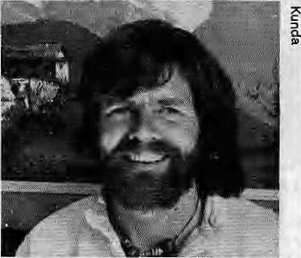
other side, climb Everest, and end up down on the Rongbuk glacier in Tibet. Also, there were enough peaks around that "one can find ones own mountains — but humans are like sheep, they all want to go to the same mountain."
He was critical of the tendency of climbers to shimmy up peaks in a race
with others, using a lot of fixed ropes. In terms of technique, climbers must use "fair means" against the mountain, he said. Mountaineers had no right to cut trees or to leave the peaks dirty. "The wild places must remain like thej were before the cumbers came. The white wilderness must remain."
"I like deserts, high places and holy places," said Messner, Recalling aparik-rama he did of Kailash along with pilgrims, he said, "The height of mountains means nothing if you do not understand the depth of human beings."
His reason for turning his sights on Antactica? "A desert is nothing more than a flat mountain and the mountain nothing more than a vertical desert. Antarctica is a cross between the two."
Messner and his companion, a West
German, expect to take 120 days for
their 4,200km traverse of the southern
continent. "It is a new kind of adven
ture, a new approach into my own soul.
It is so easy to die. It is much more dif
ficult to struggle so that one may come
back alive." - M.M.S ' [>

i
VIEWPOINT

z
Indian Mountaineering Comes of Age

H.C. SARIN retired as President ©f tiie Indian Mountaineering Foundation (IMF) cm 30 June after 2? years is (he post. ~elow, he discusses how climbing as a sport has developed in India during that period.
•rTl/#y .thoughts go natttrallyto the few ^M-servants who got J-VAtogetlier more than three decades ago. It Was this enthusiastic band that sponsored the very first of our climbing, ventures to Cho Oyu. That successful dirabwas a feat which jiad been termed impossible and absurd by seasoned mountaineers. :With Cho Oyu as a start,;within;eight years,;;oiif -youngsters had not only climbed a number of challenging and virgin peaks, some of which had defeated good climbers in
| the past, they also climbed and placed rime oh top of Everest. The Himalayan Club, based in Delhi, is more than-60 years old and has worldwide affiliations. It publishes a climb-,ing journal of high standard. The Indian Army, Navy, Ajf Force, the National Cadet Corps (N£e)> and the policeforces, all have made vital contributiofts to the development of ad-: "venture activity and rescue worfc.'They have been active iii rJie
: preservation and improvement of our environment arid
: wildlife neritage. i : - ,
The achievements of Indian c'hmbershave been: many. The
focus of activity has been ori a wide canvas of adventure. We
have chosen not to fritter our :energies, at .this- s|age, on dif-
ficolt approacles arid; newjrmites^Jtfeough a good number of* *■ these have been taken as Well. Indian, expeditions to the ' Himalaya now average 100 a year, whereas in the 1950Sj we * : used to have about one a year. Then, the Himalayan Club was" about: the only mountaineering and adventure <dub. Jiow;-
Jthere are more than 300. :
Indian women have been'trained in, mountaineering since* 1961 ,and have been increasingly active in expeditions. The' maximum interest in this respect comes from West Bengali Gojarat- and Maharashtra;: indiaA women haye- successfully climbed peaks like Kamet and Narida'Deyi, and the firstTn*« dianwornaii achieved Everest summit five years ago.
Mountaineering has been one area where there has been.
■■- no "politics," aijd we have always attempted to work on; the-basis of fairness and integrity. There, are some unfulfilled dreamsi One is the setting up of a Himalayan Museum. The* Indian Himalayan states were approached and a Museum' Committee/ was -cpnstitated, -but. nothing much came of it. The IMF haS;: i few exhibits, such as a diorama of the> KariChenjanga rriassif, but sot enough t© make up a museum. Yet another-goal is¹ the establishment of a mountaineering library for reference, research and fact-finding. We have to collect historical works as well as books of current interest. Indian mountaineering has matured enough that we should
:daih J ^

Jul/Aug 1989 • H1MAL 21

PROFILE

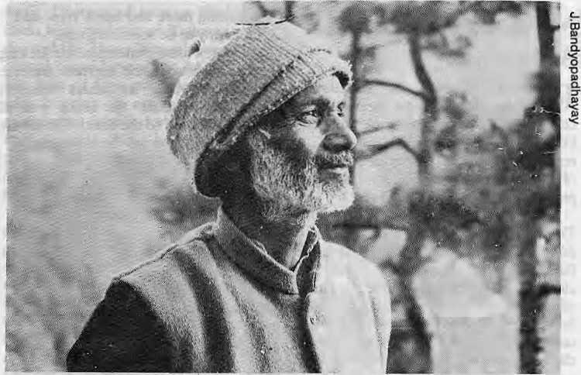
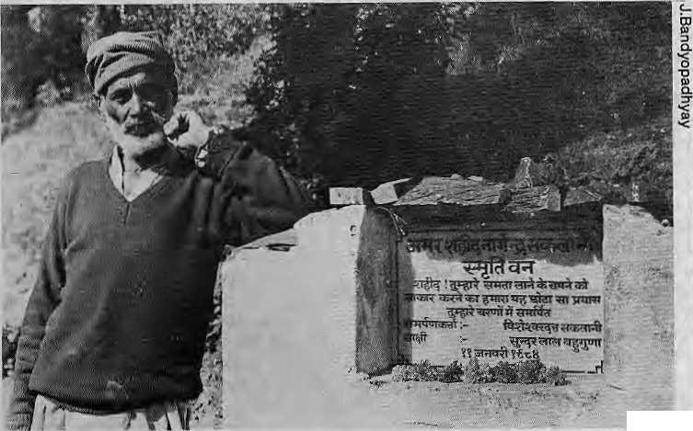
Thorns for a Protector of Trees
by Bharat Dogra
F
or over 35 years, Visheshwar Saklani has worked to bring greenery back to Pujar Village and its surroundings in Tehri Garhwal. With his own energy and meagre resources, Saklani has transformed devastated landscapes into dense forests of oak, rhododendron, chir pine and fruit trees. In recognition of his contribution to the nature conservation, Saklani was recently given the Briksh-Mitra ("Friend of the Trees") Award by India's Department of the Environment.
Yet last year, the Forest Department of Uttar Pradesh launched a case of illegal encroachment against this man, who has done more than most to protect the forest heritage of Garhwal.
Saklani's crusade is a story of a man fighting mountainous odds. First, he had to face the ridicule and wrath of his own fellow villagers for controlling grazing and fodder collection in the initial phase of Pujar Forest's revival.
Saktani by his brother's monument 22 UIMAL • Jul/Aug 1989
Among the villagers were those who wanted to take immediate advantage of the protected forest. Their hostility knew no bounds and once they even had Saklani severely beaten. "Had my daughter not saved me at just the right time, I would have died that day," recalls Saklani.
The Forest Department's ire is that Saklani did not distinguish between his own land, the village community land, and the land under the Department's control. To him, an eroded hillside was an eroded hillside in need of "rest" and rejuvenation. Saklani's attitude once earned him a fine from the Department.

The immediate cause of the suit against Saklani is a memorial that was placed in Pujar Forest, dedicated to the Indian freedom fighter and martyr Nagendra Saklani, Visheshwar Saklani's brother. The modest monument was inaugurated by Chipko leader Sunderlal Bahuguna in 1984
From the very start, the Forest Department took a very hostile attitude towards this small monument, alleging that it was built on its land. The Department asked Saklani to remove it. In doing so, the Department firstly did not consider the great service of Narendra Sakalani to the freedom movement. Secondly, it forgot the great service that his surviving brother was doing as a guardian of the forest, at not a paisa's cost to the Department. The Department officials have made this man, aged and in poor health, keep court dates and go through the whole gamut of legalistic runarounds.
Though old, weak and confronted
with these obstacles, Saklani is not
about to give up. His love of forests
have deep roots that cannot so easily be
stilled. He was born to a family which
greatly valued the protection of trees.
But the inspiration for his future work
came when his wife died of tuberculosis
and left him a shattered man. Saklani
used to wander about in the neighbour
hood forest, stopping at places where
his wife had rested. During one such
wandering, he fell asleep in the forest.
He awoke a changed man, with a deter
mination to devote his h'fe to the forest.
Speaking of that moment, Saklani says,
"Poetry was on my lips, the restlessness
and confusion had vanished." ^
B. Dogra is editor of the Delhi-based News from Fields and Slums (NFS), which provides news features from the grassroots in India.

PARKS AND WILDLIFE
How to Breed an Asian Elephant?

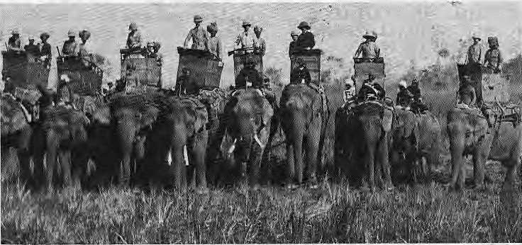
Days of plenty: elephants back up tiger kill by Prince George V,
Prince of Wales,fn the Nepal Taral. 14 Dec. 1921
by J. Michael Luhan
T
he decline of the Asian elephants (Elephas maximus), while not regarded as alarmingly as that of their consuls, the African elephants (Lodonta africana), has continued since the beginning of the centuiy. They do not face the same imminent danger as the Bengal tiger and the one-horned rhino, but nevertheless are endangered. In India, there is now a call for Operation Elephant to save the species.
The worldwide population of Elephas maximus was estimated in 1978 at 40,000, ranging across the continent from India through South-east Asia, China and Indonesia. But that number was speculative. No firm figures have been available for Burma and Laos for years. In most countries, the number of domesticated elephants has been rising as a percentage of the overall population. In Nepal and India, especially, demographic pressures have squeezed the wild elephants into ever smaller areas which cannot sustain them, and continued ivory poaching and their capture for logging and tourism has further diminished their numbers.
BREEDING METHODOLOGY
Meanwhile, a methodology has not been developed to breed elephants in domesticity. "The principles have been agreed upon, but nobody thus far has the knowhow," says Hemanta Mishra, Secretary of the King Mahendra Trust for Nature Conservation (kmtnc). "The breeding biology of the male and female are not yet fully understood."
A method employed in India has been to set domesticated females loose in areas roamed by wild bulls, to allow mating under natural conditions. There are still considerable numbers of wild elephants in pockets of south, central, north and north-east India, an estimated 16,000 to 21,000, according to D.K. Lahiri Choudhury, an authority, but as their herds diminish, so will the results of that breeding method.
In Nepal, prospects are even less promising. Traditionally, Nepalis have relied upon the north-eastern Indian
states for their supply of elephants. In recent years, however, their import has become extremely difficult due to political turmoil in Assam and Nagaland, two prominent suppliers, the Indian Government's ban on trapping elephants in the wild, and other factors. Because the number of wild elephants probably does not exceed 50 in Nepal, the Indian breeding technique is not feasible on any significant scale.
Several years ago, Kathmandu's Department of National Wildlife Parks and Wildlife Conservation traded four one-horned rhinos to India in exchange for 16 elephants, to be used in a breed-mg project at Tikoli forest in Chitwan, Some proved to be too old for mating and the others simply refused to perform. Some of the unproductive Indian bulls have since been replaced by new ones bought in from Thailand and Burma, and efforts are continuing in Tikoli to mate them with the project's stable of females.
GOOD OLD GANESH
With the lone exception of a baby elephant born at the Tiger Tops jungle lodge in Chitwan, the only domestic bull in Nepal which has proved up to the task of mating has been the famous "Ganesh" in Kosi Anchal of East Nepal. A semi-wild bull, Ganesh has thus far serviced two domestic females brought into Kosi from the Tikoli project, who were set free in the area roamed by the bull to mate under natural conditions.
Ganesh's willingness to cooperate provides only a limited option for
a.
3
TJ
TJ
C
Nepali wildlife experts. For if only his stock of offspring were to be produced in Nepal, it is bound to lead to genetic degradation due to inter-breeding among his descendants. Still another proposal by KMTNC is to recreate a natural habitat for breeding purposes by building a huge reinforced corral.
Even if a technology can be developed for domestic elephant breeding, the enterprise may prove uneconomical. Calves are only born singly, the gestation period is 19 to 21 months, and the interval between potential birthings is four years. A mother can, therefore, produce only one offspring every six years even under optimal conditions, and females usually do not produce their first calf until 14 or 15 years of age. Breeding is also expensive. A calf cannot be separated from its mother for three to five years after birth, during which time both are unproductive while consuming enormous amounts of grass, molasses and rice.
As the clock ticks away, several
major considerations hinge on finding a
successful breeding method. One is
tourism in the Tarai, for which the
elephant is a major attraction and vital
hub for many activities. But the most
urgent one is to preserve tusked males,
whose numbers are diminishing rapidly
because of ivory poaching. "If it goes on
at the current rate," says Mishra, "there
will be a natural selection in which the
tusked Asian will soon disappear
altogether from Nepal," [>
J.M, Lunar) is a writer based in Kathmandu.

Jul/Aog 1989 • HIMAL 23

REVIEWS
Towards a Quantum Theory of Environmental Degradation

THE HIMALAYAN DILEMMA: RECONCILING DEVELOPMENT AND CONSERVATION
Jack D. Ives and Bruno Messerli
The United Nations University Routledge, London and New York 1989 295 pages, price unlisted
Review by Indra Jung Thapa
O
ne of the major contributions of Kulin and Ritzer on the paradigm- theory is the proposition that the evolu- tion of knowledge is a dialectical process in which the juxtaposition of opposing viewpoints results in higher platforms of understanding. Therefore, the prevailing academic conventions are constantly in fear of being dislodged by emerging facts and novel styles of interpretation. Quite to the contrary, however, environmental theory has progressively sought to design a single interpretative matrix, a universal idiom as it were, applicable over time and space. One consequence of this has been that the onus for environmental degradation, particularly in the Himalaya, has fallen squarely on the shoulders of the poor. Through persistent reiteration, this position has acquired the status of religion, which has left virtually no breathing space for the dissenter.
In contrast, The Himalayan Dilemma by Ives and Messerli introduces a Heisenbergian perspective into environmental theory. Based on an extensive survey of the Himalayan region and the proceedings of the Mohonk Mountain Conference of 1986, the study sets out to expose the severe uncertainties upon which several ironclad conclusions have been founded. In contrast to the view that improved healthcare after 1950 has caused population precipitation which has led to deforestation and consequent soil erosion and floods downstream, Ives and Messerli propose that it might be reductionist to level the blame on the subsistence farmer who is at best a single instrument in a concerto in which tectonic forces determine major movements.
The authors' central argument is that the current crisis is consequent
24 IIIMAL • JuVAugl989
upon larger geological forces, and that the amelioration of the condition would rest substantially in treating the peasant as a part of the solution rather than as the source of the problem. Under the circumstances, it is questionable if the horizontal expansion of agriculture by the hill farmers is responsible for landslides in the hills and floods downstream.
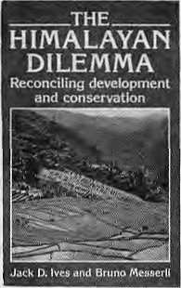
This position might have appeared
untenable except for the academic rec
titude with which the argument has
been substantiated by Ives and Messer
li. Without striving to promote a schism
between orthogenetic and anthropo-
genetic processes, the book merely sets
out to prove
that the con
clusions in the
"Theory of
Himalayan Degradation" have been based on extremely fragmentary evidence. Using a considerable width of information from geology to social anthropology from across regions, the authors remonstrate against the uncertain and often contradictory facts that have been marshalled to support foregone conclusions.
Contrary to popular belief, the writers prove, by employing time-series and photographic evidence, that the situation may in fact be improving and that human intervention in some instances may have led to a regeneration of degraded land. Ives and Messerli, however, reiterate that in identifying the uncertainties in the current theory, the problem units must nevertheless be considered as parts of a composite frame and treated as issues for redressing.
The book comes at a time when the environmental question is being viewed in terms of fixed sets of binary equations wherein perspicuity is being sacrificed in the pursuit of dogmatic ideological imperative. In the past two decades, the environmental debate has
witnessed the dominance of solidarity over scruple, and has been unable to extricate itself from the essentialist moorings. Comprehension has been repeatedly sacrificed on the altar of geo-political posturing. The "stop and recap" message in this book is made thoroughly readable by a prismatic narrative which shifts from one set of salient considerations to another.
The emergence of the hill peasant as a dynamic category at the forefront of any efficacious regeneration effort in the Himalaya is one of the significant achievements of this book. In concluding, the authors suggest vital issues that should enter the design of development projects in the hills, and the priority areas for research in economic development in general. The book is recommended to both academics and policy makers.
I. J. Thapa is a sociologist with an interest in rural issues.
Cutting
through the Maze
INDIA'S FORESTS: MYTH AND REALITY
J.B. Lai
Natraj Publishers, New Delhi 1988IRs225 304 pages
Review by C.P. Jayalakshmi
F
orest degradation is a topic of great interest to planners and economists concerned about the availability of resources. Floods, drought, loss of fertility, atmospheric pollution have all been blamed on deforestation. Is this a myth or reality? Who are the culprits?
As J.B. Lai says in this book, the conflict between natural functions of forests and those that man has imposed upon them has bred many myths. The shrinking of wooded areas has raised a host of pressing questions but the search for answers has led to a "blurring of realities." Lai's new book seeks to clarify the issue based on statistics and references of Indian forest studies

REVIEWS

made over the last century. The book is suitable not only for technical personnel but also for planners, administrators and generalists. Interesting anecdotes which complement the technical write-up makes this book an absorbing and easy read.
Data on forests are often contradictory and overlapping. Lai has attempted to reach a consensus on available figures. The historical perspective deals with quotes from the pre-Christian era, but lacks references to forests in the two great Indian epics, the Ramayana and Mahabharata. Lai talks of classification and forest management efforts during the period of Emperor Chanakya, but the concept is older than that.
He says that degradation of forests is a result of social indiscipline. Ironically, such indiscipline began with the defiance of forestry laws during the non-cooperation movement against the British. The British also contributed to the destruction by drawing ahnost then-entire timber needs for the two world wars from India's forests.
But the British also took preventive measures by marking out forest reserves, though these reserves have shrunk in recent years because unauthorised occupation was regularised and restrictions on grazing waived. It was only when the Indian Forest (Conservation) Act was passed in 1980 that the situation began to change.
Only one of the 10 chapters actually justifies the title. Lai's faith in good management is quite obvious owing to his affiliation with the premier institute on forests survey in India. Even the latest Forest (Conservation) Amendment BUI that was passed by the Indian Parliament in December, 198S is nothing but rhetoric. One can only wait and see how a beautifully worded document of that kind can actually see effective execution.
Lai believes the functional classification of forests and its good management are routes to effective conservation. Emphasis on preserving the biological/genetic diversity is also missing in the whole issue of management. This diversity has been evolving for over four billion years and is manifested in climate, geology, soils, animals and plants. It is using this in-
tegral definition that we must look at the conservation and economic role of forests.
Lai deals with controversies such as whether or not eucalyptus is actually water depleting and whether the intimate relationship between tribals and forests is eroding.
The book is a significant addition to the rather scanty literature on India's forests. And it is offered by an official who knows and cares for forests and their administration.
C.P. Jayalakshmi is a consultant with the Technology Information Forecasting and Assessment Council (TIFAC), Department of Science and Technology, New Delhi.
How Not to Do Nepal in a Daze
BESSER REISEN NEPAL
Ludmilla Tuting
Merian, Hamburg
1989 dm 9.80 98 pages
Review by Satis Shroff
T udmilla Tuting has done her Ajhomework well in this compact new booklet in German on Nepal. A strong advocate of tourism with a human face, Tuting's book is informative, current, and full of snippets of useful knowledge ~ like which doctor in Kathmandu speaks German.
She reminds tourists that they are "guests" in Nepal and exhorts them to behave as such. Ecology-consciousness permeates her writing as she talks about Nepal's architecture, economy and nature conservation efforts.
Tuting, however, is scathing towards westernised Nepah's who cross her path and consumer-oriented tourists who want to do Nepal in a daze. The booklet is aimed at German-speaking visitors from Germany, Switzerland, Austria, Alsace and South Tirol to whom Tuting explains Nepali etiquette and mentality. "When you go into a private house or Hindu temple, you have to take off your shoes," she says, then adds: "Don't worry, they won't be stolen."
Tuting also discusses Nepal's efforts at economic development and how this has not always been successful. She says many Nepalis have become vigilant through wrong development aid and the effects of tourism. Too many foreign advisers, tourists and western- -ised countrymen have said Nepal is backward, and too many Nepalis seem to believe it. "(Many) have lost their pride, self-respect and identity and have developed inferiority complexes."
When you speak with villagers, sirdars and porters, cautions Tuting, please help correct their wrong impressions about the "Golden West," full of unlimited wealth and eternal holidays. Paint a picture that is close to reality and help strengthen the Nepalis' pride in themselves.
Further tips from Tuting:
- Don't distribute medicines if you are
not a doctor and further treatment is
not guaranteed. Encourage local
people to visit health posts, and
stress hygiene and cleanliness.
- Don't wear loud colours in Chitwan
and take a pair of binoculars, insect
repellant, a hat and umbrella. And
don't forget your malaria
prophylaxis!
- If an adult female rhino approaches
you, do you: a) holler to Jimmy Ed
wards for help, b) take a picture of
her cubs, c) run in a zig-zag manner
and climb the nearest tree. The cor
rect answer: c.
- In the evenings it is advisable to have
a strong torchlight (even in Kath
mandu) because lighting is bad and
you can dazzle the street dogs."
- Nudism? Streng VerbotenJ
The Federal German government has sponsored a study on the demand potential of "soft tourism". Dr. von Wartenberg, the West German parliamentary state secretary summed it up in Bonn recently by saying the abnormal behaviour of some tourists was either due to lack of tact, ignorance, lack of ability to speak the local language or general insecurity.
A pity there is no English edition of
this book. The reader may ask, "Will I
really travel better after reading this
book?" The answer is, yes - it gives
tourism a human dimension that is not
seen in other travel guides. A
S. Scroff is a Nepali writer based in Freiburg.
Jul/Aug 1989 • H1MAL 25

VIEWPOINT

Divine Support in Langtang and Khumbu
by Tom Cox
X
t is a chilly autumn afternoon in a herding camp above Langtang, a Tibetan community which lies at 11,500 ft. in Rasua District north of Kathmandu. Yak, Tibetan cattle and chauri (yak-cow crossbreeds) graze while Tibetan herdsmen busy themselves with evening "chores. Two lowland Nepalis, who work for a mountaineering expedition camped nearby, come over to buy some sheep. Pasang, a Langtang Tibetan ("Bhotiya"), bargains with them and a ram is sold for NRs500. The two lowlanders grab the sheep by the horns and drag it back to their camp, where it will be slaughtered for the mountaineers' evening meal.
Back in the herding camp, many Langtang Tibetan men are furious. One man, Lakpa Tenzing, tells me why. "We, everyone in Langtang, are Buddhists. And yet year after year, some Tibetans sells sheep to be slaughtered in the shadow of our sacred mountains. As a result the gods are angry and curse us. This is why so many of our children die, why there is so much disease in the village and why the crops fail."
Langtang Tibetans, one of the poorer ethnic groups in central Nepal, have little arable land and can grow only one crop of barley, potatoes and buckwheat a year. These crops are not enough to meet the basic requirements of the Langtang Tibetan community. To make up the deficit, they trade wool, spices and herbs and sell h'vestock and dairy products, and work as porters and guides for mountaineering expeditions. Despite these other sources, many Langtang families do not have adequate food or clothing.
Most Langtang Tibetans claim to respect traditional Buddhist values, such as that forbidding the taking of life. However, abject poverty forces some of them to sell livestock for slaughter. Langtang Tibetans believe that if they forbade the slaughter of livestock they would alienate mountaineering expeditions which pump much-needed cash in to the local economy. However, almost all Langtang Tibetans (including those who sell the livestock) also believe that by allowing animal slaughter they are cursed by the gods whose support is necessary to get rid of the disease, poverty, child mortality and crop failure.
A perceived lack of divine support has caused widespread apathy in the Langtang community. Many Langtang Tibetans believe that unless they regain divine support by protecting sacred values and providing support to religious institutions such as gumbas, development projects in their community have little chance of success.
Compare the situation in Langtang with that in the Khumbu heartland of the Sherpas. It is Saturday, the weekly market day. Dozens of hill Nepalis have their goods displayed: cooking oil, biscuits, rice, flour, sugar, blankets, clothes and jewelry. Four men sell meat from large bamboo baskets. "Why are
26 HIMAL • Jul/Aug 1989
no live animals being sold?" I ask one of the meat sellers. "Don't you know the Sherpas have a rule forbidding the slaughter of animals in the Khumbu? This meat is from animals that were slaughtered below Namche yesterday,"
Later, I ask a Sherpa about the Khumbu's rule forbidding slaughter of livestock. "How could we call ourselves Buddhists and still allow the blood of animals to stain our sacred lands? Expeditions often offer to buy our goats, sheep and chickens for food. But if we allowed the slaughter, our monks and our gods would no longer protect us," he said.
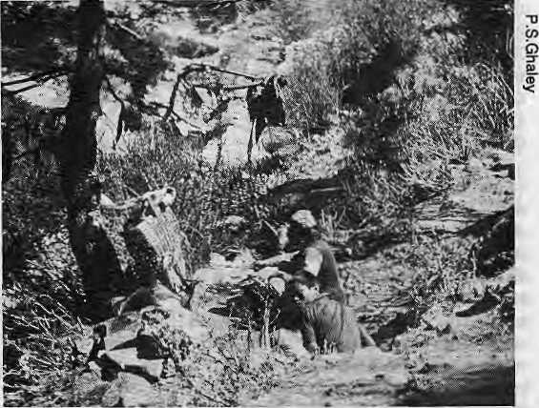
Butchers at work below Namche
The purchase and slaughter of sheep in Langtang, and the rule against the slaughter of livestock in the Khumbu, reflect important differences in the culture and socioeconomic life of Khumbu Sherpas and Langtang Tibetans. These differences have important implications for approaching development in the Himalaya.
Khumbu Sherpas are a wealthy ethnic group who have maintained their dominance by being active in the mountaineering and trekking trade. The community's wealth has given it much political clout in dealings with outsiders. The rule forbidding slaughter of livestock is just one example of this. While Langtang Tibetans fear economic repercussions from such measures, the Sherpas are able to force outsiders to abide by local rules.
Their economic and political clout has given the Sherpas more cultural autonomy than that possessed by Langtang Tibetans. The Sherpas are confident in their knowledge that the sacred landscape is secure and protected, and that they have the divine support so necessary to sustain their existence in the Khumbu. Faith in divine support has also given the Sherpas the confidence and motivation necessary to develop their communities.
There are important lessons to be learned from the experience of the two communities. First, that development, as an ideal in any Himalayan community, cannot be arbitrarily

VIEWPOINT

imposed by outside observers. Rather, the goals and meaning of development can only be understood from community members' point of view. Development, in their view, is not simply the access to health care, food, clothing and education.
Khumbu Sherpas and Langtang Tibetans will only consider
their communities developed when they have the political and
economic resources necessary to support their religious in
stitutions and protect sacred values. They also believe that
the maintenance of religious institutions and protection of
sacred values is essential to maintain the divine support on
which their h'ves depend. When these are missing, both com
munities have little faith in the potential success of any
development project. f\
T. Cox, an American anthropologist, ha* studied Langtang Tibetans.
Controlling the Forces of Tourism
by Sunil Roy
W
hen a country's tourism policy is geared to financial benefit based on numerical increases, there have been two distinct results. Tourism has brought considerable economic benefit to a local minority and enhanced foreign exchange earnings. At the same time) tourism has left the economically weak worse off and damaged the cultural and natural environment. Often, the benefits of employment have gone to those from outside, leaving only menial jobs for the unqualified locals. Meanwhile, established traders dominate marketing.
A conspicuous example of what can go wrong with tourism is the case of Acapulco, the Mexican resort. The growth of the holiday industry led to an influx of outsiders seeking financial gain. Local culture was undermined and all forms of vice including prostitution, drugs and gambling were introduced. Hotels and restaurants bought up the once plentiful local suppliesi increasing the economic burden of the local majority. The natural environment of Acapulco Bay was irreparably damaged, so much so that tourists are now moving away to nearby Cancun, where the process is now being repeated.
Closer to home, Sri Lanka also faced the problems of vice and cultural dislocation. However, it managed to preserve the coastal environment, which was under threat, by imposing and implementing building and zonal restrictions. In Thailand and the Philippines, sex and drug tourism dominate and are often run by criminal elements.
India and Nepal have also faced similar problems. Goa, Mus-sorie and Kathmandu were, and to a degree still are, centers for drug use, distribution and smuggling. The damage to the environment has also been considerable, with Sir Edmund Hillary going as far as to urge the closure of the Everest
route for five years. In Mussorie, expansion of holiday homes are endangering the stability of the hillsides. Similar stress exists in all former hill stations. The major cause is un-planned haphazard development, fueled by tourism. In a different dimension, tourism in Ladakh, mainly in Leh, has combined considerable economic benefit, most of which, however, goes to agencies out of the area. A few of the already better off Ladakhis have done very well but the majority of Leh's residents are having to cope with difficult times. Tourism in Ladakh has undermined the local culture, created demands the locals cannot meet, and bred resentments.
The answer does not lie in criticising tourism as an industry but in overall integrated planning. The key is to balance and manage human intervention so that "visitor satisfaction" is maximised while tourism's multiple negative aspects are minimised. Tourism must be planned so that it is part of broad-based development that considers economic, socio-cultural as well as environmental aspects. Certain guidelines can be set out.
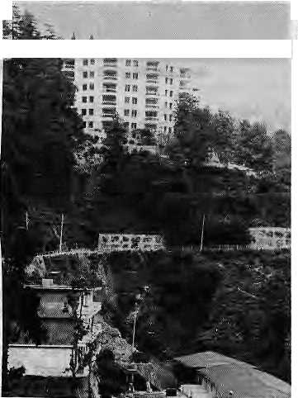
Tourism planning must be integrated with regional economic plans. Where expansion of the tourism sector is planned, a commensurate expansion of public services such as transport and energy is mandatory, A careful analysis must be made of how many visitors an area can absorb. The factors which determine this "carrying capacity" are related to social issues, the environment and management.
The social factor % :■■;.. :
includes impact on cultural life and behavior pattern of local people. Different types of visitors — package tourists, motorists or hikers ~ affect the environment in different ways. In natural areas, the environmental impact will also depend upon the fragility of the beaches or alpine areas.
Once a carrying HIghrlses In Mussorie capacity has been
determined, the volume of visitors can be regulated by measures such as increasing prices, limiting the number of hotel rooms, creating alternative destinations, select advertising, and controlling admission to vulnerable attractions.
Environmental impact assessments (EIAs), though used widely now in most development activity, is still not used enough in the tourism sector. Despite the perils of mass tourism, the

Jul/Aug 1989 • HDWAL 27

VIEWPOINT

industry is seldom required to produce EIAS. Changes wrought by tourism might be lamented retrospectively, but few attempts are made to anticipate them, eias are seen by developers as yet another bureaucratic impediment although a well-designed assessment will ultimately benefit both developer and the environment.
When preparing a tourism management plan, it is crucial to decide who should be the primary beneficiary: is it the local people, the investors, or tourist agencies? And to what extent should the area become dependent on tourism? The planners must realise that the supply of tourists is always uncertain and depends upon a wide range of factors over which the government has no control.
The Government has to decide what scale of tourism is to be promoted. Any tourism plan must explicitly state the cutoff point at which further growth of tourism would not be allowed. The planners cannot ignore the impact of mass tourism on the social fabric of local communities. Exposure to ideas and lifestyles of tourists are bound to affect the consumption and behavior pattern of local people. They should be protected from decisions made by outsiders who may have a short-term vested interest in rapid development of tourism.
S, Roy is Chairman of India's Committee for Management of National Parks and Sanctuaries and Tourism and has served as Director of the India Tourism Development Corporation (ITDC), as advisor to the Bhutan Government on tourism and environment, and as a consultant to the World Tourism Organisation.
It Is Not All Floods and Famine
by Donatus de Silva
TT7hen the North thinks of the South, the image is often W one of hopelessness: drought and destruction, floods and debt. Weeping fathers and mothers in disaster-ridden countries burying their children wrapped in old rags. Malnourished children with distended bellies and faces covered with flies. Once proud and dignified men, women and children begging for food with cupped hands — these are all common images in television and newspaper articles.
However, in the North and the South, the causes of poverty which make people vulnerable to disasters receive scant attention. Despite some decades of "development", most of the Southern nations are in desperate shape. Having pursued economic strategies largely modelled on Northern experience and inappropriate to local conditions, the countries find themselves deeply m debt and unable to extricate themselves from the quagmire of poverty.
The poor, who have been seldom more than mute actors in plays conjured up in the capital cities, becoming further alienated in their own societies.
It is easy to lament over the plight of the poor. But for the poor themselves, despair is a luxury which they can ill afford. And throughout the South, there are seeds of hope, sown by
citizens' groups. All over the world, and against all odds, tenacious people have started projects small and large. Out of bankruptcy and poverty of failed international and national development strategies, a new set of organisations has emerged among the poor.
Change and development are taking place at local levels. Individuals, families and communities are planning and organising to survive in difficult environments. Tens of thousands of such groups have been identified across Asia, Africa and Latin America. In scores of countries, women's groups, peasant groups, religious organisations, consumer campaigners and environment protection societies are acting as important engines of change.
In Bombay, for example, an estimated 100,000 people sleep) wash and raise their families on the roadside. But over the last five years, groups of "pavement dwellers" have come together to form a group with the ungainly title of the Society for the Promotion of Area Resource Centres (SPARC). Through the organisation, women have learnt to design and build their own shelters and to claim their rights. Anyone who visits the SPARC office cannot but be moved by the confidence with which the poorest of the poor now conduct themselves. It is a strong antidote to the popular belief that Indian women are spineless and submissive.
la Bangladesh, one small community organisation, called Proshika, has, by using the existing skills and labour of villagers, effectively and efficiently implemented over 600 small but crucially successful projects under 10 years. "The project has freed me from the chains of money lenders by enabling me to earn more," says Rabindranath, a small-scale farmer.
In Kenya, the Undugu Society is assisting "parking boys," Nairobi's street children. The term derives from one of their popular activities, which is directing motorists to available parking spaces. They eke out a living doing anything that is likely to bring in a few shillings, such as rummaging through garbage for items that could conceivably be saleable and going to the wholesale market, the "marikiti", where they pick up the odd tomato or potato left behind.
Undugu provides education and training for children.
"I gathered scattered potatoes at the marikiti and sold them, I
unscrewed the lamps on people's cars and sold them," says
Muhoro, a former destitute Kenyan boy. He is now a success
ful carpenter. ₍
These examples do not mean that things are getting better for
the South - far from it. But they do demonstrate that when
development programmes are designed and run with the par
ticipation of people, they work. If the tide is to be turned in
the South, then efforts are needed on a vast scale to support
the work of citizens' groups. There should be greater col
laboration between citizens' groups and the voluntary agen
cies of the North and the South, t\
D. de Silva is a Sri Lankan journalist who has been covering development issues for over 20 years. He is Director of Regional Programmes with the Panos Institute in London.

28 I-IIMAL • Jul/Aug 1989

VIEWPOINT

A Hill Development Council for Kumaon and Garhwal?
by Bharat Bhushan
rwihe demand for a separate state of Uttarakhand in the hills A of Uttar Pradesh has been voiced off and on since 1952. The proponents of Uttarakhand believe that all the developmental problems of the eight U.P. hill districts (Pithoragarh, Almora, Nainital, Tehri, Uttarkashi, Chamoli, Pauri and Deh-radun) would be solved if they were welded together into a separate state.
The people of the hiHs of Garhwal and Kumaon scarcely need to look beyond their own villages to see how little they have gained from the process of development. About 70 percent of the population lives below the official poverty line.
In their own lifetimes, people have seen the hills being denuded of tree cover and the forests of Kumaon and Garhwal converted into a hinterland for the plains' timber industry. The degradation of forests has also meant the destruction of the peasant economy, crucially dependent upon woodlands.
About 72 percent of the agricultural operational holdings are less than a hectare in area and agricultural land itself is quite limited. Terrace farming on these marginal holdings continues to be the primary source of livelihood for a majority of the population. Clearly, the income from agriculture is not sufficient and the household economy would collapse but for the male-migration to the plains and the consequent money-order economy.
Villages are thus conspicuously deprived of their able-bodied men, who have gone to join the army, work as dishwashers m small restaurants and to other forms of "fourth-class" employment (peons, chowkidars and the like). A common Garhwal saying is — If a Garhwali does not die of hunger at home, he dies in the army.
Things have changed somewhat over the years, though not significantly. Only those who cannot hope for any other job join the army. A fair number of industrial training institutes churn out diploma holders. The spread of education and increased tourism into the region has also led to an upsurge in people's expectations. But there is little economic activity that offers gainful employment to the educated youth.
The problem is lack of investment. Of late, there has been some investment in tourism-related activities, but not quite enough and it has tended to help only those living along the main motorable roads. With the official policy tilting towards five-star tourism and the plan for building two airports in the pilgrim routes, the economic benefits accruing even to these people are likely to be limited.
When the per capita plan expenditure on these hill districts is compared with that in the hill states of north-eastern India,
the extent of their neglect by the central and state governments becomes apparent. The average per capita expenditure in the various five year plans for the U.P. hills has been less than half that for the hill states of Mizoram, Meghalaya, Nagaland and Manipur. The total annual outlay for the Uttarakhand districts is less than one-third of what they contribute to the total income of U.P. In any case, a sizeable portion of the budget allocation in the hills is spent on transport which raises all costs and reduces the efficiency of what little investment is made.
Moreover, the nature of these investments has not been best suited to use of local resources. More than two-thirds of the U.P. forests lie in Garhwal and Kumaon, together accounting for 80 percent of the timber produced in the state Deodar and Chir, found exclusively in this region, alone contribute 60 percent of the state's total timber production. Besides timber, more than 60 percent of bamboo and cane (ringaaf) in u.P. is produced in this region. Yet, there is no timber processing industry in the hills. Similarly, though pine-resm from Chir worth about IRsl3 crores per year is produced here, the state government transports more than 90 percent of it down to Bareilly for processing.
There is no effective forum for the airing of specific grievances. Thus, disgruntlement has found expression in a number of agitations, including Chipko, which questions many aspects of development. But Chipko never pitched itself against the state, and is yet to become an effective pressure group for its demands.
Today, there are two organisations that profess to represent the region's true interests - the Uttarakhand Kranti Dal and the Uttarkhand Sangharsh Vahini. But neither group seems to have a development plan for the U.P. hills. Indeed, not even a critique of the excessive tourism-related development exists. It is easy to talk of not cutting any trees and saving the environment or to scream other slogans. What is needed, and is sorely lacking, are alternative development strategies that take into account social, political and environmenal concerns. Merely calling for development contributes nothing.
For a development strategy to be successful, it must be backed by local political will. A local leadership that can tackle complexities can only develop slowly. A good beginning would be to create the opportunity to address clearly and convincingly where the problems of these bills lie. Perhaps the degree of autonomous authority enjoyed by a hill development council, akin to the one for Darjeeung, Kur-seong and Kalimpong, is what it takes to sort out the true priorities for the development of Kumaon and Garhwal. Such a structure would have the potential to change the social, political and economic scenario of the hill districts of U.P. f\
B. Bhushan is Delhi-based editor for the Times of India
•'. "*" ■■■■ ■ ■ ■ • - ^{!i;} ■ ""■■ ■■■ ■ !*t8M
The Viewpoint section is a forum for debate and dialogue. Contributions are welcome. Opinions expressed here do not necessarily express the views of flimal or the insiitu- I fionswith which the writers iare affiliated.

JuVAug 1989 • HIMAL 29

EIEHER MITSUBISHI



EICHER IS RIGHT ON TOP. IN MORE WAYS THAN ONE.

The EICHER-MITSUBISHI CANTER. India's No.l LCV takes to the hills, with ease.

. . .' .■ .
The Eicher Mitsubishi Canter is the No. 1 light commercial vehicle in its class in India. And last making inroads into
markets in Nepal. Bangladesh. Sri Lanka and Mauritius. It is the LCV that sets new standards. In power. Fuel efficiency. And
versatility. *
The Canter's 92.5 HP engine can take on the most diverse terrains with ease. Whether it's the hot deserts in . Ra'jasthan or the steep mountains in the Himalayas, the Canter powers its way. All the way.

CHNTER
Tough. And built to stay that way.
EICHER GOODEARTH LIMITED
13. '■DEEPAK'. Nehru Plate. Now Delhi. 1 1001 9, INDIA

30 HIMAL • Jul/Aug 1989

On
The Way Up
Kanak Mani Dixit
I
t has been almost 15 years since Erik Eckholm's book Losing Ground hit the stands and made many aware of the perils of Himalayan ecological degradation. Since then, there have been many studies on the processes of erosion, "mass wasting", floods, forestry policy, stall feeding, topsoil runoff, and the perceived role of the hill peasant in all of this.
With more scientific study, there is today increasingly sophisticated understanding of the process of erosion in the hills. Some swear by Eckholm's thesis of havoc in the Himalaya. Others go to the opposite extreme and profess not to know what the fuss is all about, for, they say, the Himalaya is "dynamic" and erosion is as natural as snowmelt in the summer. A few would even have you believe that there is no cause for worry.
The outcome of this debate, and its followup, is crucial for the Himalayan people. The truth must lie somewhere between those who say we are all doomed and those who refuse to worry. Himal seeks to provide a forum for all who have opinions one way or the other. In its own reporting, Himal will try to be careful not to be carried away by dogma on either side. Too often, concern for the environment is a fad among unconcerned elites. Environmental reporters get roped in to this "fashionable" pursuit of predicting armageddon on the high slopes.
We have often read and believed stories based on selective facts supplied by experts. A reporter lands up in a researcher's home ground for a couple of hours or days, is willy-nilly fed a lot of information, which is then regurgitated into a convincing article. Such writing disregards the first rules of reporting by shunning background research, ignoring historical precedent, not questioning the researcher's credibility and motives, and not getting a second opinion. This kind of journalism gives environmental reporting a bad name and none of us has been blameless, including Himal.
CRYING WOLF
Here is a typical news report that came our way the other day. In the space of
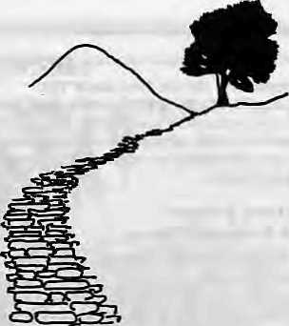
one page, and based on the say-so of one scientist doing research in one small catchment area, a journalist reports that mountain springs are drying up in the lower slopes of Himalaya, groundwater seepage has decreased 40 percent. Deforestation is rampant and desertification has begun. The report says that evaporation rate from the treeless soil is high, broad-leafed oaks and rhododendrons are being replaced by pines, pests threaten to eliminate different kinds of vegetation, and uncontrolled blasting is upsetting groundwater flow patterns. The weather, too, is changing; it is now warmer and drier in the Himalayan belt in summer, with average annual rainfall down by 30 percent, the report adds.
Doubtless, much of this breathless report reflects reality, but the sweep is too broad and unquestioning. The reporter's task is not only to take the scientist's word, but also to talk to the villager, to check the historical records, and to question other scientists who might disagree. If the facts require it, the reporter must write a less alarming, less "catchy" story. Cry wolf too many times, and the public will stop listening.
LOOKING TO THE WEST
A review of this magazine in the latest issue of the South Asia Journal, published in New Delhi, states: "Himal will do a great service it if eschews the fads and fancies of so-called environmentalists in the West in favour of initiating in-depth research and discussion of the ecology and ecological significance of the Himalayas, where ground-breaking work still remains to be done." This last is very true. But "fads and fancies" are not limited to environmentalists in the West, and South Asian scientists and policy-makers too would do well to keep an open mind. and do then-
homework. For it is not only journalists who are afflicted by intellectual laziness, nationalist blinders, and an inability to look at the others' point of view.
It is wrong to presume that all Western scientists are remote from Himalayan reality, while all South Asian foresters, geologists, sociologists and economists are well "plugged in". Can one forget the pioneering studies on Himalayan ecology, on the Nepal Himalaya in particular, that have been done by Westerners? Even today, quite a bit of the legwork is done by the expatriate scientist. An article in the most recent issue of the journal on the Himalayan environment includes a list of 61 names in reference, from "Baj-racharya" to "Zeimer". Only seven are from South Asia.
ABOUT HIMAL
On a brighter note, at least for those of us who put together this magazine, Himal expands its reach day by day. The other day a subscription arrived from Alice Springs, right at the heart of the Australian outback. We already have many readers in North America and Western Europe. Most important, we seem to be hitting stride in our own region, the Himalaya. Since we made it easier for our Indian subscribers to hook in through the Central News Agency in New Delhi, our Indian readership has been building up. Newsstand sales in Kathmandu continue to be brisk.
Himal does not have the resources of the mainstream media to market itself. It depends on you, our readers, to help spread the word so that it may be a more effective medium of dialogue among the people of the Himalaya. Please tell your local library and bookshop about Himal. Also, tell your friends and colleagues and, if married, get your spouse to read Himal as well.
Himal now coming to you straight
from Kathmandu. We have come home
after having printed our prototype
issue in Colombo and earlier issues in
New York and New Jersey. This move
meant that the May/June (grey) issue
had to be scrapped, but we will make
up for it by giving you better reading
from Kathmandu. t\
Jul/Aug 1989 • HIMAL 31

ABSTRACTS

Hugging The Trees:
The Story Of The Chipko Movement
by Tfiotnas Weber ViMng
1988 IRsl25
This book recounts the history of the Chipko movement starting with Mita Behn, the daughter of a British admiral who became a lifelong associate of Mahatma Gandhi and later moved to Tehri Garhwal. Mira Behn's belief that "year after year floods in the north of India seem to be getting worse...this means that there is something radically wrong with the Himalaya and that something is, without doubt, connected to forests..." may be disputed by recent research. But the book highlights the very real "deadly changeover*¹ from traditional Himalayan oak forests to pine and eucalyptus. Weber, an Australian Gandhian, laments the felling of hill forests by contractors from (he plains and discusses Chandi Prasad Bhatt and Sunderlal Bahugima's emphasis on food, fuel and fiber forvillagers. The book eon-tains an appendix by M, S. Swaminathan on the Study of Eco-Development in the Himalayan Region.
The Festivals Of Nepal
by Mary M. Anderson
Rupa Paperbacks, New Delhi
1988 !Rs75
This is a reprint of the comprehensive guide to festivals, not of all Nepal as the title suggests, but the major festivals of Katbmandu Valley. It was first published in 1971 and the reprint has not been updated so that information such as "...Tribhuvan's son, the present King Mahendra" is allowed to stand. But this lack does not matter much in a book such as this, which is about the "meaning of the ancient processions and rituals, the mythological, religious and historical backgrounds of the ceremonies, and the wealth of delightful legends and folktales surrounding them." Running chronologically at the start of the Nepali calendar in April/May, with the Bisket festival in Bhatgaon, the book describes 36 different festivals, ending with Sapana Tirtha Mela, which takes place on new years eve. Hundreds climb through the night to the northern slope of Shivapuri mountain at the headwaters of the Bag-mati river to bathe at the ponds of Sapana Tir-tha, "the holy place of dreams."
Nepal: Socio-economic Change And Rural Migration
by Poonam Thapa Vikas, New Delhi
1989 IRsl95
This book by a prominent Nepali scholar on development and women's issues deals with the relationship between socioeconomic factors and rural migration in Nepal. In particular, it studies the historical relations between landholders and the peasantry, and the role of caste. It examines the circumstances under which individuals or entire households select migration as an "adjustment strategy," and it investigates the consequences of out-migration and in-migration with respect to the economic well-being of the migrants. The author concludes that peasants make up for loss in access to land by seeking
32 HIMAL • Jul/Ang 1989
employment in the non-farm sector. The proliferation of low return non-farm work, however, "pauperises" the household, leading to permanent migration. Households with access to land are less likely to move and send individual migrants instead.
Cultural Patterns And Economic Change
by Rishikeshab Raj Regtni 1989 IRslOO
How do indigenous people adapt, change and survive the spreading tentacles of a modern global culture? Regmi takes the example of the Dhimal community in Nepal's eastern Jhapa district. The traditional Dhimal habitat has in the past decades been crisscrossed by roads, a telecommunications network and various development projects. The book is riddled by typos but its use of pictures to show traditional Dhimal society and how it has been modified by the change is commendable.
The Unquiet Woods: Ecological Change And Peasant Resistance In The Himalaya
by Ramachandra Gnha Oxford University Press, New Delhi University of California Press, Berkeley 1989 IRsl75
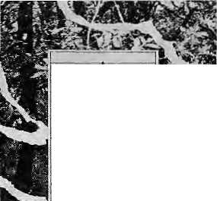
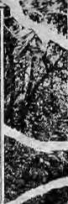
The Unquiet
Woods_
Ecological Change
and Peasant Resistance
ifi the Himalaya
Ramachandra Guha
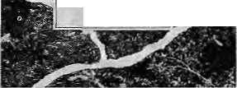
This book documents the social and environmental consequences of commercial forestry in the watershed of the Ganges, even as it focuses on wide-ranging peasant struggles in defence of forest rights in South Asia. It attempts to fill the gap between two scholarly traditions, the sociology of peasant protest and the ecologically oriented study of history. The book contains a historical and comparative analysis of forest-based protest in the nominally independent chief-dom of Tehri Garhwal and the colonial territory of Kumaon. In both regions, peasants invoke a moral economy of provision in opposition to the
political economy oE profit that characterises commercial forestry. Tte author challenges "Eurocentric theories" which hold that peasants and peasant movements will disappear in the modern world. His study of the Himalayan experience suggests that Western-style industrialisation is unlikely to be replicated in the developing world on account of ecological constraints.
Lahaul-Spiti:
A Forbidden Land In The Himaluyas
by S.C.Bajpai
Indus Publishing Co., New Delhi 1987 IRsl50
This book, from the authoT of "The Northern Frontier or India" (1970) and "KEnnaur in the Himalayas" (1981), describes the land and the people in the northernmost and largest district of Himachal Pradesh. It is a multidisciplinaiy study which deals with Lahaul-Spiti's history, language, religion, customs, rituals, "moral values," economic development and future prospects. Charting the collision of modern infrastructure with an ancient way of life, the book describes the advent of electricity, the impact of modern communications and the increasing reliance on education and allopathic medicine. The chapters are divided according to ecological setting, historical perspective, social setting, traditions, economic resources, political organisation and administration, and development and "attitudes" of the local population towards it.
Against All Odds: Breaking The Poverty Trap
Donatus De Silva, Editor Panos Publications, London 1989 4.95 Pounds
This is a collection of reports by journalists in selected developing countries on development efforts initiated by citizens groups. The books contain two reports each from Kenya and India and one each from Tanzania, Bangladesh, Sri Lanka, Zambia and Indonesia. Instead of lamenting over the plight of the poor in these countries, the journalists describe the work, "against all odds," of the organisations and individuals dedicated to people-oriented development effort. The reports take the reader from the pavement dwellings of Bombay to the parking lots of Nairobi and the small farmers of Bangladesh.
Fire Of Himal
Rajesh Raj Ktinwar Nirala Publications Jaipur 1989 IRs300
This is an anthropological study of the Snerpas of the Nepal Himalaya. Kunwar's doctoral thesis conjures the ritualistic life patterns of the Sher-pas. It provides an account of Kunwar's adventuresome journey to the heart of the Himalaya in search of "embers of faith that keep community intact amidst the winds of change" brought by modernisation and natural calamities. Considering the link between man, nature and spirit as central to the makeup of the Sherpa community, Kunwar attempts to capture the life-drama of faith that is being enacted on the heights. The book provides insight into the socio-ecological setup of the Sherpa community.
The Himalayan Plants
Hideaki Ohba and Samal B. Malla,
Editors
University of Tokyo Press
1988 U$225
This comprehensive guide to the plants of the
Himalaya is based on an extensive field research
carried out between 1983 to 19&5 by a University

ABSTRACTS

of Tokyo botanical research project team. Its topics include the nature and diversification of the Alpine flora of the Himalayas, descriptive and revisional studies of Himalayan plants, and enumeration of ferns and fern allies in Nepal and discussion of anatomical diversification of Himalayan trees and shrubs. Ultimately to be published in five volumes, The Himalayan Plants will be a comprehensive guide to the flora of a fascinating high-altitude region. Ohba is Associate Professor at the University Museum, University of Tokyo. Malla is Director of Department of Medicinal Plants in Kalhmandu.
The following abstracts are presented here by arrangement with the Environmental Services Group/WWF-India. Human Health And Trace Elements, Including Effects On High-altitude Populations fey G.lyengar, et al Ambio, 17 (1) 1988
According to this article, evidence is accumulating that population at high attitudes are prone to essential element deficiencies, e.g. iodine and selenium. These problems warrant skillfully conceived multidisciplinary approaches if future investigations are to elucidate the diverse interrelationships between the geochemical environ-
FOLLOWUP
ment, anthropogenic pollution, and metabolic factors. The future studies should include effects of high altitude physiology that are related to trace elements, and their profound impact on human and animal health. For public health reasons, it is necessary to ensure continuous monitoring of various geographical areas for several chemical elements.
Save The Sahyadris
Madhav Gadgil
Wastelands News, Feb/Apr 1988
The Western Ghats (Sahyadri) harbour rich timber, varied wildlife, and diverse species of wild fruits and spices. They also support plantation crops and paddy. Mining and industrial activity are flourishing. The Western Ghats are now being devastated, states the writer, due to increasing demands of a growing population, the over-exploitation of natural resources by industrial elites at highly subsidised rates, and a variety of other factors. To halt the devastation, ill-advised development projects need to be halted, strict pollution control measures be enforced and development refugees suitably rehabilitated. Local people must be organised to care for their resources base. To win their cooperation, it is necessary to allot high priority to the basic needs of the poor. Also, new technologies, adapted to the local situation, need to be developed.
The Effect Of Eurasian Snow Cover On Global Climate
T.P. Bamett, et al Science Jan 1988
Numerical simulations with a global atmospheric circulation model suggest that large-scale variations in the amount of snowfall over Eurasia in the springtime are linked to subsequent strengths of the Asian summer monsoon. Largescale changes in the Eurasian snow cover are coupled with larger scale changes in the global climate system. There is a strong "teleconnection" to the atmospheric field over North America and other climatic fields known to be intimately associated with the Bl Nino phenomenon off the South American coast.
grag
THE THIRD AND FOURTH EDITIONS (COMBINED) OF THE ANNUAL HINDI JOURNAL ON THE HIMALAYA, PAHAD, ARRIVED AS WE WERE GOING TO PRESS. IT WILL BE REVIEWED IN THE NEXT HIMAL FOR A COPY, SEND IRs275 (HARD COVER) OR IRsSO (PAPERBACK) TO PARIKRAMA, TALLA DANDA. NAINITAL-2, UTTAR PRADESH.

In this column, we report on significant developments and new ideas relating to articles which appeared in past issues of Himat.
CHARCOAL PLAN MUST BE PUT ON ICE (Nov/Dec 1988)
India's Central Water Commission, it seems, has yet to give up its idea of spreading charcoal dust over Himalayan snows in order to produce more water for the theoretically parched plains. A CWC official, who wished to remain anonymous, told the Asian Wall Street Journal that the plan merely called for the snow to be melted a little earlier in the year "It has to melt anyway by June/July." Responding to environmentalists' complaints that fiddling with natural hydrological cycles could lead to disastrous results, the same official observed, "We are tampering with nature, no doubt about it. But when you shave you tamper with nature. That doesn't mean you should stop shaving."
"LET THEM SMOKE CIGARETTES" (Mar/Apr 1989)
The World Health Organisation (WHO) reports that an estimated 630,000 deaths in India every year are attributable to smoking. Studies indicate that in Asia, cigarette companies arc aiming their advertisements at the younger populations and at women. WHO officials also report that bidis are more harmful than cigarettes because they contain more tar as well as nicotine. Smoking among women is dramatically on the rise in the Third World. The top ten countries with the highest percentage of female smokers are in the Third World. Papua New Guinea, with a population of
three million and with 80 percent of its women smoking, heads the list. Next comes Swaziland with 72 percent. Kiribati in the Pacific ranks third with 70 percent. The next seven countries are Bolivia (61 percent), Nauru (59 percent), Nepal (58 percent), Brazil (53 percent), Mexico and Fiji (44 percent) and Tonga (38 percent). There are 20 countries where more women smoke than do men. Meanwhile, the Bangladesh Government, in the middle of an anti-smoking campaign, has decided not to permit the setting up of new tobacco industries. The Government has prohibited cigarette and bidi-manu fa during firms from sponsoring sporting events in the country. President EM. Ershad, himself a non-smoker, has ordered that all health-related institutions such as hospitals and public dispensaries be declared nonsmoking areas. He has already declared "Bangab-havan", his official residence, a no-smoking zone.
THE VALLEY CHOKES
(Prototype issue/June 1987)
The premier issue of Himal reported on air and water pollution and solid wastes in Kathmandu Valley. Since then, the water quality of the Nepali capital, at least, seems to have deteriorated alarmingly. A report just released by the Family Planning Association of Nepal in association with DISVI, an Italian consulting firm, found that almost every water outlet studied in Kathmandu city had contamination levels far above the acceptable limits. The old part of the city showed the highest degree of contamination because of the old and decrepit distribution system of water pipes. In fact, old Kathmandu around Asan showed the highest degree of bacteria! contamination, having an average 275 coliforms per 100 ml. Of the samples, 79 percent had contamination

 | tIIMDL"i
Pit |  | 1
r -1|
THE VALLEY CHOKES TEMRt A TIBETAN TRAQEDY LADAKH DEVELOPMENT DHABWA n^AKTAPOH
levels that far exceed the safety threshold set by the WHO. Drinking water became polluted mostly in the pipelines through the "infiltration" of sewage and polluted water. The degree of contamination increases dramatically during the mon soon.
The FPAN/DISV1 team also found that water stored in Kathmandu's seven hospitals were more contaminated than those collected from public taps. Sometimes, the disinfection process in treatment plants were ineffective for the highly polluted water that is taken in. The Sundarighat treatment plant, for example, takes water from the Bagmati River at the point where it is most polluted with organic matter, ammonia and nitrites as it carries al! the untreated sewage of Patan and Kathmandu.

JulMug 1989 • IIIMAL 33

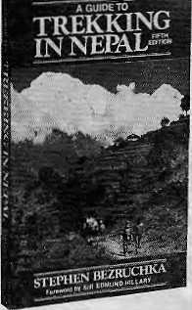
CLASSIC
A Guide to TREKKING IN NEPAL, 5th Edition, by Stephen Beiruchka. Completely revised, enlarged by 1/3; covers trip planning, trek details, Nepali culture. "What's crammed into this volume is not available elsewhere."— Co-Evolution Quarterly. "Best, most comprehensive guidebook of its kind." — American Alpine Journal. "The whole book is excellent." — Library Journal. 352 pp, paperbound. $10.95 retail.
Cat!/write for catalog of over 100 outdoor titles: travel, adventure, how-to, natural science and history.


Two 30 minute video (VHS) on environment and development in Hindi available at Energy and Environment Group, P.O. Bag No. 4, New Delhi - 110066. Priced at IRs250 to NGOs and concerned individuals. Handling and postage extra. Book your orders now.
Help Us Conserve Nature

Write for our Product Catalogue 1990
Contains listings for greeting cards depicting the
splendour of India's wildlife.
Also, wall calendar, desk calendar, nature desk
diary, table diary, telephone index, wildlife stickers,
WWF
India
badges, publications, ruck sack, cap, nature lovers'
notebook, playing cards and picture sets.
Write to:
World Wildlife Fund-India, Educational Products
Section, c/o Godrej, Lalbaug Parei
Bombay 400 012

The
MOUNTAINEERS BOOKS
306 2nd Aye, West, Seattle WA 98119
(206) 285-2665 1-800-5534453
ADVERTISE IN HIMM. ! WRITE FOR OUR RATE-CARD. P.O.BOX 42, LALITPUR, NEPAL

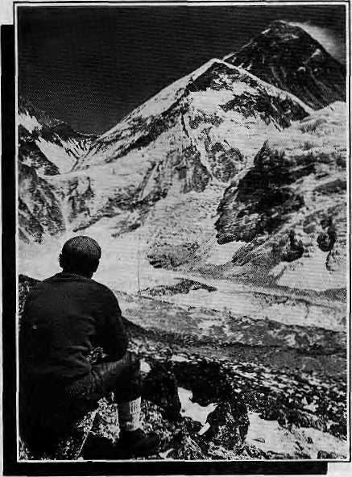
OF MOUNTAINS AND MEN...
OR, HOW TO TREK IN THE HIMALAYAS IN AN ECOLOGICALLY CONSCIOUS WAY

WE CARE FOB THE ENVIRONMENT
IANGRIMA
•Trekking & Mountaineering (P). Ltd
P.O. Box: 2951, Karrtipalh
Tel: 225608 Kathmandu Nepal
Telex: 2474 SUMTRA NP Fax: 977-1-414184

34 HIMAL • Jul/Aug 1989

ASIAN TREKKING INVITES
YOU TO AN EXPERIENCE WITH NATURE
We take you through natural trek trails to places unending beauty and into contact with the 1^ friendly mountain people and their gentle living.
An experience you will never forget with our professional team to attend to all your trekking
and tour arrangements with quiet efficiency.
IANiUfi[P]l».
P.O. Box: 3022, Keshar Mahal, Thamel
Kathmandu, Nepal.
Tel: 412821, Telex: NP 2276 HOSANG
DUN TAIN

TIGER TOPS THARU VILLAGE RESORT

Tiger Mountain announces the establishment of the TIGER TOPS THARU VILLAGE RESORT,
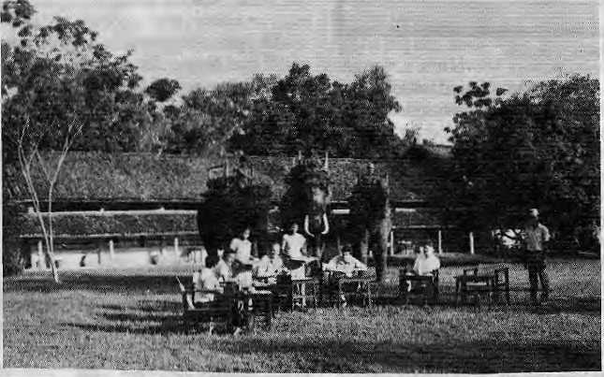
open all year round.
Situated on high ground overlooking the lush green forests of the Royal Chitwan National Park, the Resort's comfortable rooms have attached bathrooms with. solaT heated showers. It is styled along the lines of the traditional "longhouses" of the Tharus, in a tranquil jungle setting. Our inclusive price offers all meals and accomodation, as well as the following --
a) a full-sized swimming pool with attractive garden surroundings, b) a saddle club with eight horses for exploring the countryside. A riding master is available to teach beginners, both adult and children, c)horse drawn buggy ride, d) bullock cart rides, e) elephants from our own stables for viewing wildlife, f) boat rides down the beautiful Narayani River , and, g) jungle walks and treks. Open all year round. A stay of three nights and four days is ideal. Special introductory rates are being offered to local residents of Nepal and India.
FOR DETAILS CONTACT: P.O. BOX 242, DURBAR MARG, KATHMANDU, NEPAL TEL:222706,226173. TLX:2216 TIGTOP NP. FAX: (977)-1-221379. CBL: TIGERTOPS.
Jul/Aug 1989 • HIMAL 35

Abominably Yours,

G
oing to Delhi, had hoped to fly Royal Nepal Airline's Boeing 727 "Yeti", but got dumped on a river instead. "Karnali", the Boeing 757, which is so new the toilet lights still work when you pull the latch.
You didn't know I did inter-SAARC travel? Well, my column on the linkage between geological seis-micity and political turbulence in the Himalaya earned me some notoriety. So am now on the international seminar circuit. And I'm headed to right now to one in Pilibit entitled "Anthropoid Evolution, Basic Needs and Sustainable Development."
While I was mulling over the basic needs aspect of my lecture, a Royal Nepal mosquito trekked through the matted fur and bit me in the mid-to-lower section of my thigh. Which got me thinking.
"Basic needs," as defined by the Qiri-quinentielle Congress du Necessites Basique, held in Bamako in landlocked Mali, which I attended as a UNESCO consultant on loan to the Sahelian Emergency Office that was studying the possibility of importing blocks of ice from Himalayan glaciers to melt and bring the green revolution to the Sub-Sahara, was that of the right not to be forced to migrate. (It was in Africa that I learnt the proper use of commas, and to write long sentences.)
Anyway, "the right not to migrate" is a basic need, according to the Bamako Declaration. Yet, here was a mosquito, clearly en route to India. We will soon be touching down in Delhi. Passengers will disembark and those in transit will make a beeline for the duty-free. Those headed into the Indian heartland will hold their breath and run the "green line" gauntlet of Indian customs, into the arms of family, friends and welcoming hosts of seminars and symposia.
But what of the mosquito? Have you thought of Anopheles? The maintenance people will turn off "Karnali's" auxiliary power unit and forget to close the door when they leave. Unwittingly, our little Nepali friend will buzz off into the muggy Delhi skies, with a dust storm approaching from the Thar. What of cultural shock? What of environmental dislocation? And friends,
what about friends? Would Indian mosquitos be friendly, hospitable, neighbourly and SAARC-like to intrepid highland insect vectors? Or will they tell Anopheles to buzz off? All in all, Anopheles will feel pretty down, much as I did in Bamako.
To get back to the narration: Convinced that a kindred Himalayan soul was going to be yet another statistic in the money-order economy, I hit upon the idea of coaxing Anopheles into Royal Nepal's throw-up bag and smuggle him to the Pilibit seminar, then back with me to my Barun sanctuary. But it was too late. As the plane began Us descent to Indira Gandhi International Airport, the cabin pressure

Anophelese, dead.
changed. Anopheles, gorged with anthropoid blood, simply exploded, and made a splotch on the matted fur. I lost a friend in the airplane.
In the few minutes I had left for airborne musings, I thought about the third segment of my lecture, "sustainable development." Luckily, I had some light reading handy — a paper, "Globality and Change Sustainability," by Candido Mendes, President of the International Political Science Association. It was presented before the ipsa annual conference in Washington D.c. last autumn. Honest, honest, honest, I didn't make this up. Prof. Mendes wrote:
"The fiat of sustainability of the Brundtland Commission'asserts the necessary convergence of development and environmental policies in a defused
historical schedule. The engineerings of totality built this first basic inter-twining between development and environment in an at random set of the inner dynamisms of those eco-systems, with no assessment of their self-closing, or disruption, or dependable reading of their effective Interplay. Within this categorical framework, these exercises at globalisation suggest the analysis of the scientific adequacy of the assumption. Sustainability in fact exchanges trend redressing for a preemption on the encompassing view of change, and the over-institutionalisation needed to assure its becoming. As a limit forcing function, in the building of the logic of an eco-system, sustainability brings, by itself, a zero-sum game look at the en-dogeneity-exogeneity coupling of the variables of change. What is, at this level, system transformation or system adaptation?"
Uh-uh, what, sir? The plane is about to land. The mosquito is dead. Was that a question? Oh well, since you insist, I guess at that level, it most definitely was "system adaptation." Whereas, if you take in the exogenous coupling as it relates to system transformation, Mr. Mendes of the IPSA, the zero-sum game looks pretty stupid, doesn't it? On the other hand, i<p ipovp vafie la tcv^ap,^ov ftvoz fis fip. kottcc.
The plane comes to a complete halt, and Royal Nepal allows you to unharness. Glance out of the window - is this Delhi? What are those mountains doing here?! And why are these h'ttle Rais and Sherpas looking up at me and smiling? Hey, what are they doing with mygw/ita? Stop!

Then it dawns. This isn't Delhi by a long stretch. It is the airstrip of Tum-lingtar up in Nepal's eastern mountains. And the plane isn't a Boeing but a de Havilland Twin Otter. I am actually headed home to my Upper Barun cave and a not to a Pilibit conference, after all. So what was all that about basic needs and sustainable development? What about Anopheles the mosquito? Or is it mosquitoe?

36 HIMAL • JuVAug 1989


MIRROR MIRROR ON THE WALL WHY IS THE SHANGRI-LA THE BEST OF ALL ?

Is it because of our prize winning garden and the Shambala Garden Cafe - a coffee shop that serves everything from Continental crepes to Chinese delicacies with a gourmet stop in India in between ?
Is it because of Tien Shan our Chinese restaurant where the decor is as soothing as the food is authentically delicious and is derived from all over China. Which means dishes you've missed all your life ?
Or is it because of our Kokonor restaurant that serves up French cuisine conjured by chefs taught by the French ? Kokonor also serves Tandoori food that melts in your mouth and absolutely demands an encore.
Could it possibly be our Lost Horizon Bar and it's Beer Garden,
Both dispensing cheer, snacks and flowers ?
You tell us.

Because we crafted The Shangri-la to reflect you. Like a Mirror,
SHANGRI-LA
LAZIMPAT, G.P.O. BOX 655 KATHMANDU. NEPAL TELEX : 2276 HOSAIMG NP TEL : 412999/410108
CABLE : SHANGRI-LA FAX : 9771914181
DESLA

Regd. No. Lalitpur 65/045-46

 |  |  |  | , v /
ills | -■'■- :.'-■-■'■ ■ .': ': ■■,': y- |  |  | Jjj NORWAY j | SWEDEN
ills |  |  |  | ^3e>s|ar^ |  |  |  |  | >.S.R.
V; .!::V:;:;.!::V | ^ / r |  | wgreat lfc;>.::.:::;-:-::.:::  2 BRITAIN 7/X ; ,\ ^ |  |  | \ POLAND V |  | \
::V.V::O.-:-; |  |  |  | ]J_{M} CDEM. RE^jV |  | \
 |  |  |  | ^V^R AN KFU RTNCZEQ |  | ^^  HOSLOVA | <IA /
f-?.r =". ', .-^ |  |  | k: \ \ | /fed. rep. oF/^y |  | "aVy
 |  | r ■■'■'■ :: :: ^ | \> \FRANCE \ |  |  | T^ HUNGARY A |  | RUMANIA/
 |  |  |  |  |  |  |  | S/buLGARIA S. ;
 | SPAIN |  |  |  |  |  |  | N^ QJRKEY
 |  |  | ^^•^^^ |  |  |  |  | REEcK^ k
TO EUROPE VIA ROYAL NEPAL

Frankfurt is the focal point when your target is Western Europe. Fly direct to Frankfurt on Royal Nepal's week-end flight which saves you time for business or pleasure and also connects upon arrival to over 20 other cities in Europe and Americas.
Plus - you have time at Dubai for the world's best duty free shopping.
Relax in the exclusive Shangrila class or in the welcoming atmosphere of our quiet comfortable B757 jet, savouring during your journey choicest drinks and food served by our charming hostesses.
To Frankfurt via Royal Nepal, you will enjoy every moment of it.


Royal Nepal l
3

For further details, please contact your travel agent or the local Royal Nepal Office
Bangkok Calcutta Delhi Dubai Kathrfiandu Hong Kong Singapore Frankfurt
228308
3-699151
298534
3321-572
220757
233-3921
225-7575 (069) 289-971

