■■='=■■■..V\.\. :. ..:'■=.> ■■=.==>■'■:'■=. =■„■■■.':- :;:
al MlmW,
'■ SSj'c-X:¹-": ^{L} ■>■*>:



NRS20 1RsT2 u$6
FQR DEV|LOPiyiENX AND ENVIRONMENT
ISSN;: 1012-9804 NOV/DEG 1989


- ■"- -
\



t- ■-« ■
|}^...:..K.. ■"■:■■■
/ _{s}. ■ :... ■ -^ ■
1
r -::-:.
]. .■;:.:.■ ■"■::;::::::::c
 | ■'v . H.;v~T•■:;'■:..;
i. : '':.:;.:■ -r — r; ■ *,::%*,. - •
*;;l*.i *- t :TlZI. ■.
 | ■""■■■ ■-" "kz--⁵"— """ - __~_ __{s}: |::.
1  l ■ ■& ::: ■.,. | ■ -t;-^{:ME::}!? I. I_{s}.- ■-■■■■^{E}-?::: ^{ih::}
:■■■■■:■ -I:-- | ..""■■■■ -!!H= : ^{:I} -, --if!- '•*■ "^{V} ".?'■■;■■ '-^. 5$
,-.■# II- ==■■
■ ■ ■ '
t REFi

"MARLBORO" TIBET SMALL BUSINESS SUNGDARE
GOITRE PREVENTION RESTAURANT BOYS WHICH WITCH?


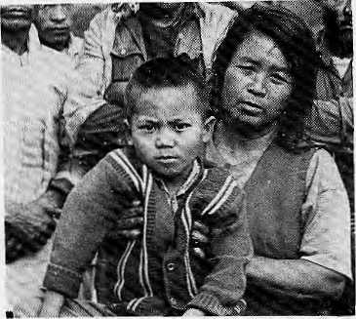
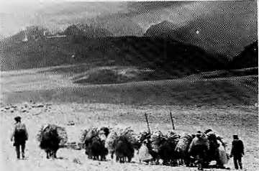
INSIDE
COVER
3 Development Refugees
5 "Voices From Baliapal"
- Kulekhani Diaspora
- Will They be Displaced?
11 Missing Tribals
FEATURES
- "Guns on Ice"
- Summits Are Lonely
- Chipko Poet
22 Goitre and Cretinism
24 Tibet's "Marlboro" Country
27 Small Business
Hiit
Vol. 2 .;■ ■■■■No, 5 Nov\Dee 1989
Mountains, Hinialaya Yob bound t&e oceans from
A northern yardstick ■■■■■ - ■■■■■■ ■■■■■
To measurt; the Earth _{;v} "
.'"■- Kalidasa {Kunidm3mtbk#vaiit)
Edited and Published by Kariak Marii Dixit
■:■■■■ for Hinial Associates
Kesaiig Tseten
:--- .J' ■■■ Associate Editor J" ■■:■:

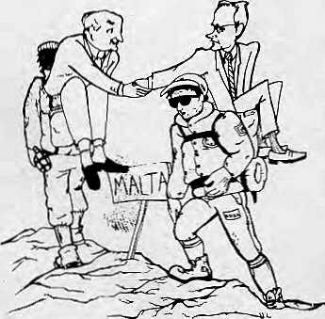
DEPARTMENTS
12 News in Brief
18 Photo Essay: Restaurant Boys
21 Interview: Toni Hagen
25 Parks and Wildlife: Spiny Bable
31 Reviews: Migration
33 Abstracts
36 Abominably Yours
VIEWS
- Goitre Prevention
- Eighth Five-Year Plan
Cover picture by Kevin Bubriski shows a woman from Rara.
HIMAL (ISSN 1012-9804) is published six times per year by Himal Associates, P.O. Box 42, Lalitpur, Nepal. Tel: 523845. Copyright 1988. Please turn to page 10 for subscription information.
Special acknowledgement to Pradyumna Kumar Kotta for technical assistance.
Thapa
Picture Editor
Advisory Panel
■M. Abdhullnhi Oniyemty of Peshawar, ' Peshawar - ■■:■."■.■. ■■■ .. " ■■ ' ,, Adlai Amor, Asian Fbrurii of En\ii'onmeo-..jal ■■■jottr-nalists
jVnila Animdj Inter Press, Seivice, Rome ...
Klnley Dorje. Kuensci Weekly, Thimpu
Ilarka Uahiidur Gurung. Kathmanijii ■*
Corneiiie Jest, Centre.National dela... ■■:■. *. Recherche-Scientifique, Paris .. . ,. * "Prcrii Shenk^r Jtia, Cwiwiieare*, New Delhi Bharat Diilt Koirala; Nepal Pri;ss Iristitjtc," KathmafiqEu ■.. ■■... ;- . ■■■ .." ■■ . " ■..... ,, Rfinv Chandra Malhotra, Intern atitjiial for Agriculture Development, Rome ■■« ri ..MishVn, King Mahendra Tmsf . for Nature Conservation, Katrimandu .." ^{s} David SassDOh; Hartiipost, Nqw Yprfc Ktimiir Klindga Btkram Shall, Centre tat" ⁵ Nepal and Asian Studies, Katliniandii . ■■■ Donald Slianor, Columbia University of Joariialism. New York ...
Shrcslha, . Nepal Business, and PmCessttjriai Women's Ghiti. Kaihinandu Vidyn Stokes, Hiniacha] Pradesh L«gtslaiivc... .Assembly, Shiriiia ■■■-..
B.G. Verghese, Cent re. for Foiicy Research, _{s} ^{vi}NewDelhi/
Wtlsii, 'me Hoios Centre, London. =

MAIL

AGAINST THE WEST
There is a tendency among the Indian intelligentsia to blame the West for anything and everything that turns out to be bad. Mr. Siddiq Wahid's article, "Riots in Ladakh and the Genesis of a Tragedy," is no exception.
The article conveniently blames agents of the British Raj and western scholars for the recent violence in Ladakh. The writer thereby gives a clean certificate to both the state and the central government on the matter. That more than 40 years have passed since the British left India seems to be of no significance to the writer.
Wahid may well be right in his interpretation (though he fails to substantiate it), but if the western scholars were so wrong in their interpretation, where were the presumably innocent Indian scholars hiding? Why did they not offer their correct interpretation?
It is dangerous to blame others for one's own mistakes and carelessness. In the long run, it does more harm than good. With his ill-concealed prejudice, the writer has shown that he is just another scholar with a deep-rooted prejudice against the west.
Mm] B. Shrestha Kathmandu
NEPAL-CENTRIC HIMAL
Himal, it appears, has not only shifted its base of operation from New York to Nepal but also its priorities in reporting. Recent issues have zeroed in on Nepal. This focus on Nepal has in turn resulted in thinning out other reportage of the Himalaya that should be within the scope of Himal. Sikkim, Bhutan, Pakistan, and Tibet are covered inadequately and irregularly. This is not what Himal promised its readers. Further proof that Himal is becoming more and more Nepal-oriented is its
liberal use of typical Nepali terms such as daalbhat, doko, khasi, chautari, chiura, khaja, matwali, dhindo, gundruk, and many more - and then, too, without explanation.
It should not be surprising if discerning and disappointed readers start calling your bimonthly Nepal Himal. Would you like that?
Basanta Vmpa Kathmandu
KATHMANDU ISNT ALL
It is heartening that Himal has moved from New York to Kathmandu. However, in doing so it seems to have developed a tendency to see Nepal with Kathmandu eyes. In particular the section Dam News (Mar/Apr and Jul/Aug 1989) caught my attention. The Mar/Apr issue had the headline "Kulek-hani lets Kathmandu Down," and in the article says, "...meet the expectations of Kathmandu's electricity demands...," "...rationing in the valley was ended...," and "...Kathmandu residents could forget about load shedding.,.." While Kathmandu did suffer, other towns and cities suffered much more. In fact, the NEA was switching off supply outside the valley in order to supply Kathmandu.
I think writers, especially writers for Himal, should constantly bear in mind that Kathmandu is not Nepal. Himal should do its bit to eradicate the "frog in the pond" syndrome which afflicts people living in Kathmandu.
In the past, this Kathmandu-centred thinking has meant that Kalhmandu received a disproportionate share of the country's resources. Although it is the capital, there is no reason for everything to be concentrated in Kathmandu. The sites, for examplp, of the Teaching
Hospital, the Foundry Project, the soon-to-be built conference centre, or even Tribhuvan University, in one of the regional towns would have decreased the strain on Kathmandu's infrastructure and, at the same time, helped in building up the economy of other regions. This trend should be reversed for the good of Kathmandu and Nepal.
This brings to mind something else. Apparently, consideration is being given to a project to bring the waters ol Melamchi to Kathmandu at a cost of 110 million US dollars. All well and good, but will Kathmandu residents pay for this? Again it will be the rest of the country paying directly or indirectly. 110 million dollars could go a long way, and it should not subsidise mismanagement in Kathmandu.
Himal has provided pleasurable reading. However, expressing views and being informed are not ends, only means. Decisions are being made that will have a large impact on the lives of people in this region, e.g. Karnali and Arun III to name but two. These decisions should not be left to a handful of bureaucrats and politicians. I am not suggesting Himal sponsor a crusade, buf it could encourage people to actively participate in influencing decisions and policies, perhaps by organising lectures, seminars, public meetings, even though these fall outside the normal purview oi a newsmagazine.
Girish KJiarel Butwal
We invite readers to comment, criticise or add fo information appearing in this magazine. Letters should be short and to the point, and are subject to editing. Send mail to:
PO Box 42, Lalitpur Nepal

Nov/Dec 1989 • HIMAL 1

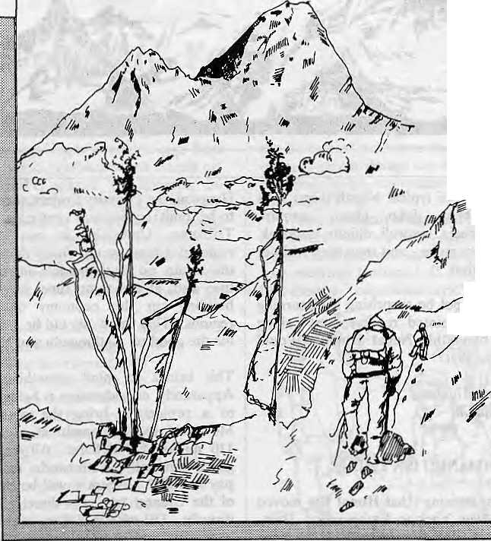
ASIAN TREKKING INVITES
YOU TO AN EXPERIENCE WITH NATURE
We take you through natural trek trails to places ^v of unending beauty and into contact with the }0, friendly mountain people and their gentle living.
An experience you will never forget with our professional team to attend to all your trekking ^ and tour arrangements with quiet efficiency.
TV An

IAHtaN8iHl».
P.O. Box: 3022, Keshar Mahal, Thamel
Kathmandu, Nepal.
Tel: 412821, Telex: NP 2276 HOSANG


"Simply, The best book store in Nepal, perhaps Asia."
- authentic customer statement
Featuring
• Quality Stationery • Classical Cassettes • Film Sales & 1-day
Developing • Fine Teas • Fine Teas • Handicrafts • Gemstones • Post
Cards • Posters • Worldwide Book Shipping • Mail & • Telegram Service
• Friendly and Helpful Staff where Browsing is Welcomedl
tiwahis PILGRIMS BOOK HOUSE
Next to Kathmandu Guest House, Thamel, Open Daily & a.m. -10 p.m.
For Children and Adults' Books Visit: Sales Counter at Blue Bird SupermarketTripureshwor (Open-8 am to 8 pm)


RESTAURANT- BAR
TIME O UT-IN KATHMAND U
the perfect water *hole; you will love it.
BHUGOL PARK. NEW ROAD, KATHMANDU

2 IIIMA.L • Nuv/Uec

COVER
Development Refugees
In their rush to make development happen, planners and developers sometimes forget, or push to the side, people who just happen to be in the way.

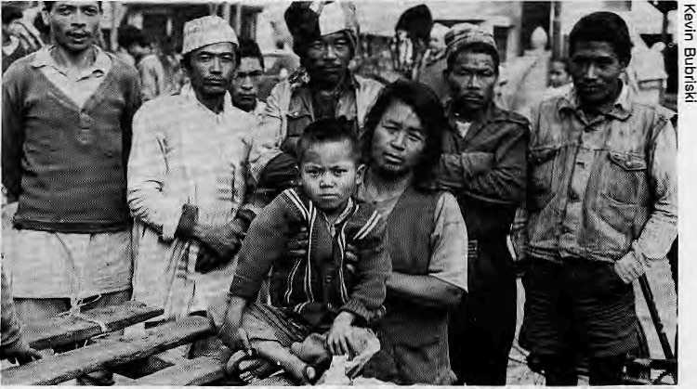
The need to save Shivapuri's forest cover has driven these Tamangs io push city thefaaa
jameswar Choudhary points to a rk where the Rapti washed away almost two ropanis of his land. Tourist brochures may call it Asia's best managed park, but to Mm, it poses a direct threat to his livelihood. So successful was the USAID-sponsored malaria eradication that Chitwan's population jumped from 36,000 in 1950 to about 100,000 in 1960. Today, Chit-wan has a population density of 117 persons per sq km.
In 1964, the Land Settlement Commission removed 22,000 people from the area to create what is today the Royal Chitwan National Park. They were resettled on the River Rapti's northern bank, which forms the park's natural boundary.
Older Meghauli residents remember the bitterness that was caused by the resettlement. Today, they are only allowed into their onetime home for 15 days a year to collect elephant grass, an indigenous building material. Since they otherwise have no access to fuelwood, villagers admit to entering the park illegally for deadwood and grass. For their extra energy needs, they catch the driftwood which float down the Rapti each monsoon.
Or take the case of Mansabdar Khan, He is a Muslim who was moved to Sagarhawa village 12 years ago because his house came under Lumbini Master Plan Area, a multimillion-rupee plan to develop the environs of Mayadevi's Temple. Mansabdar calls himself a "refugee" because he has never really settled in his new home, with its significantly lower yield, its fuel shortages and because the community is predominantly Hindu.
Meanwhile, closer to the capital at Chobar, Man Man Singh (see Himal prototype issue) and other members of his community were hopeful when they heard a cement plant was going to be set up near their home. Jobs - finally, he
thought. And his sons did find employment at the plant. Then, ever hungry for limestone, the plant bought a huge tract of land that included his farm and house. Man Man Singh had no choice but to move further uphill to begin a new life on Chobar Danda, but he had not escaped the painful reminder of his misfortune. Today, as he sleeps, he breathes cement dust.
According to HMG's Environment Impact Study Project, Himal Cement's emissions at the time - before the factory's subsequent expansion - were 450 mg per cubic metre. By comparison, the emission limits for similar factories in West Germany and India are about 120 mg and 250 mg per cubic metre. And rumours are about that the plant may further expand. So Man Man must look for a new place again.
Man Man Singh and the Meghauli villagers share some thing: their problems were caused by development projects aimed at "high social benefits," for the uplifting of someone or other but, apparently, not for them.
ryihese cases are all too familiar in-J. stances of developers aiming at the "larger good," but in the process, overlooking or undermining those often most directly affected. And there are many such development projects -
hydro-projects, roads and wild life parks
- that come with a mission to deliver
benefits and instead move the lives of
people a step or two back, creating
"refugees" — people who are physically
displaced or whose lives are severely
disrupted by the implementation of
these projects. Often no adequate com
pensation - the least that could be done
- is even made.
Most development projects need to acquire forest or farm land, villages, towns, rivers and lakes, on which many depend for their livelihood. Thus large numbers of people are displaced from their homes, or their use of resources is markedly curtailed.
If it were only change, it would be understandable. After all, development needs to go on; and there is often no other way but for some to be inconvenienced for the good of many. But what is reprehensible is when these "refugees" - (physical or metaphorical) -are inadequately compensated, if at all, or, when they find themselves in far worse straits than before "development" touched them. The result is that a few are made to bear the burden for a sometimes abstract notion of the "larger good." This then is one ugly facet of development.
As far as parks and "refugees" go, the "Rara experience" is a familiar one
Nov/Dec 1989 • HIMAL 3

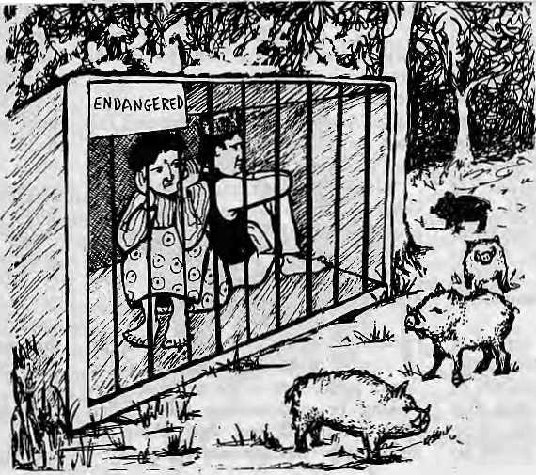
to most people in the development field. About 200 people were removed from Chapra and Rara villages up in the mountains to establish the proposed park. While that is in itself not bad, they were settled in the sweltering heat of the Nepalgunj plains. No one knows with certainty what happened to them. Some apparently went to work on the highway, others might have succumbed to the heat, malaria, or simply, the pains of such a drastic change. Others are said to have returned to the Rara area, and now continue their broken lives outside then* traditional milieus. Even in this day of mega- tragedies, the Rara experience serves to underscore the human distortions caused by well-intentioned attempts to change someone else's environment.
Jamling Tamang, 50, of Dhunche looks despondently at what was once a wheat field. "I thought we would have a sort of a zoo here with animals in cages with the coming of the Langtang Na tional Park. But it's we who have been put behind bars. In cages! Look at that wheat field! It's become a playground for wild boars!" He was referring to the Langtang National Park, an area of 1710 sq km, directly north of Kathmandu.
Dhunche's Pradhan Panch, Chewang Dhingdup, says everyone was a bit fuzzy when rumours started that a national park was going to be established right at their door-step. Nobody knew what one was. And then, three years later, people said, "The national park is set up." But just what was set up, and where, no one knew. Yet another year passed before the park boundary was drawn. And then the Langtang folk knew - because they were in it.
C
onceived in 1970, its boundaries demarcated six years later, the Langtang National Park was established to protect the habitat of birds and animals such as the snow leopard, musk deer, and boar, among others. It encloses 16 village panchayats of Rasuwa, Nuwakot, and Sindhupal-chowk districts, a population of some 30,000, who depend on the park for fodder and firewood.
"We thought the park would bring in development. Instead, it introduced a lot of new rules. 'Don't touch firewood, don't light medang (a torch made of the inner shavings of pine trees), don't use Pangling wood for roofing, don't kill boars.' Just don'ts and don'ts!"
Now, these people are being pestered by bears and boars. "Pestered" is hardly right: there are many "bhalukorey" people (people scarred by bears) in Rasuwa. Boars are regarded as the scourge of crops. And there are many bear-and-boar tales, like the one about the father of the Syabru Pradhan Panch, who was gored to death by a wild boar.
"We are a jungle people. We cannot survive without the jungle," says Gyal-sang Ghaley of Timmurey. "We need a lot of firewood to protect us from the cold, and we need Medang. But the officials put limits on our firewood, and we aren't allowed to cut 'green trees.' Can we get Pangling and Medang from dried wood, I ask you?"
Nima Tamang, another Timmurey resident, complains: "We're told to kill crop-marauding boars, but without guns! That is tike trying to kill a tiger by holding onto its tail!"
"When the park was being set up, they went around and destroyed all the baits and traps. Now no one is alive here who knows how to do these things," says Damey Tamang of Bridim.
Now the traps and baits are built by novices. "Instead of boars, buffalo and sheep are trapped," said the RP mem-
ber. "The traps even got some cows, but the matter had to be hushed up because of legal complications."
Gazing at this "playground of the boars," Jamling Tamang sighs, "This national park has done nothing but cause mischief since it was established."
When they expressed their dis-grunttement, the park warden suggested that people build stone walls to keep the boars out, and use GI sheets to replace Gobare Salla as building material. In response, officials visiting the area are often challenged with the question. "Janata pyaro ki janawar pyaro....(Do you care for people or for animals?)"
Director of National Parks and Wildlife Conservation Department, Vishwanath Upreti, sees the problem being rooted in the ignorance and low literacy of the people in the area, but he admits that there is not adequate funding or personnel to spread the conservation message.
Talking to these people, one senses resentment toward what is ostensibly a development effort but one from which they feel they derive no benefit. Many Langtang-bas go as far as wishing they could be relocated elsewhere. As Nima Tamang put it, "What good is this National Park that is green with trees one cannot cut and teeming with wild boai we cannot hunt?" While not technically so, these people are "refugees" in that they, too, are victims, to some extent, ol development.
A
s important as compensation is - since that is the only remedial measure for people so "touched" by projects- the traumatic experience of a person or community facing such an upheaval cannot be underestimated. More than just being in a new environment, more often than not, these displaced people find themselves significantly worse than before.
As ecologist Tirtha Bahadur Shrestha points out, "The functioning of rural societies and their farming systems have acquired an equilibrium through ages ol trial and error. To externalise decision to exert influence in

4 HIMAL * Nov/Dec 1989

their system one would need careful thought..."
Frequently, development refugees are directly the result of improper implementation. Often compensation is delayed, and peasants are trapped in no-man's land, waiting and unable to find a new livelihood. Complaints about delays as long as a decade have been registered, as in the cases of the Mahendra Rajmarg, Ring Road Plaza at Tinkune in Lalitpur, and housing projects at. Neither has compensation been made to some for land acquired for the Ring Road and the Taragaon Project. This acquisition occurred more than 10 years ago.
Although the Land Acquisition Act (2034-1977) requires that payment of reasonable compensation be made to displaced persons, the experience is
otherwise. For instance, the land at Sat-dobatc in Lalitpur district was acquired to develop the Ring Road piazza. Peasants were evicted from their land years ago, but have yet to receive compensation, and it looks doubtful now that the project will be implemented.
What is incredible is that those evicted were compensated Rs.16,000 per ropani (5476 sq feet) for land that would fetch Rs.600,000 or more in the market. Similarly, the evacuees of the Dallu housing project in Kathmandu district, whose land was acquired to build low-cost housing, were compensated Rs.8,000 per ropani against a market value of Rs.300,000. Equally unhappy are the displaced families of Chepawa (Pokhara-Baglung Road Project) and Lamachaur ( Irrigation Project), who feel their land and homes
have been snatched away "almost free of cost" - so nominal has been then* compensation.
Other complications have been triggered by slothful administration. For example, the Land Acquisition Act stipulates that the government must promptly transfer the land from the original owner to the organisation or project, but because it is seldom done promptly the original owner's name remains in the Land Registry. As a result, the displaced person must continue paying the land tax long after the government acquires his property.
Sometimes these lapses provide an easy avenue for fraud. For instance, unscrupulous land owners may succeed in selling their property again to innocent buyers because of delays in the property transfer. Thus, they get away with two

"Voices from Baliapal"
- Panos Features
T
he 70,000-strong community of Baliapal, south of Calcutta, has been mounting a sustained campaign against government plans to evict them from their fertile farmlands in order to build a missile testing range.
The community's efforts are also the subject of an award-winning documentary, Voices from Baliapal, by film-makers Vasudha Joshi and Ranjan Palit, which had its European premiere at the Ecovision '89 Festival in France earlier this year.
Ever since the proposals came to light in 1984, the local community has used a combination of blockades and direct action to deny officials access to the area and thwart attempts to carry out eviction plans.
As Joshi explains: "One of the most striking things about their campaign is that it's based on non-violent, Gandhian principles. And this is very embarrassing for the Congress-I Party because they revere Gandhi as their founding father.¹¹
Most observers believe that moving people to accommodate a project is not bad in itself and often necessary, but they are unanimous in saying that
the government has a poor record in rehabilitation.
In the film, villagers cluster around the camera to affirm their determination to hold on to their homes, "To us, this land is like gold!" exclaims an elderly farmer. "How can they expect us to give it up?"
Others deride the government's offer of compensation: "Would they give up their birthplace if someone offered them money?" demands a young man.
A group of women show steely resolve: "We're prepared to die if need be - they'll have to drive the bulldozers over, us."
And they seem ready to back their words. On several occasions, the villagers blocked incursions of military vehicles by forming human barricades -with women and children in the front ranks. When the first vehicle approached, lookouts blew conch shells and beat drums, and within minutes thousands of villagers were mobilised.
Repeated government efforts to convince people of the advantages of "relocation" have not swayed the local community. Last year, villagers unceremoniously destroyed the foundations of a "model village" built by the authorities.
Voices from Baliapal impresses the viewer with the courage of its subjects. Last year, it won India's National Award for the Best Film On Social Is-
sues. The Ministry of Information, which generally airs all such award-winning films on state television, failed to do so with Voices from Baliapal,
As Palit points out: "They simply will not show controversial subjects on state TV. Nevertheless, the film has been seen widely in India, at local film festivals and through screenings by other groups of activists. Joshi and Palit are particularly pleased. "Balapial has had a fair amount of press coverage," Joshi says, "but when people see a film, it just comes across much more clearly. What's going on in Balaipal can give a lot of strength and inspiration to other movements."
To fund the film the two used their savings, loans from friends, and they also managed to sell copies of the 51m to voluntary groups working on similar issues.
The glitzy Bombay film industry, which prefers to turn out escapist romantic epics, offers little help to India's 20 or so film-makers who take on social issues. "They take a very condescending attitude towards us," says Palit.
Undismayed, he and other like-
minded directors arc hoping to set up
an independent association that would
co-ordinate funding appeals and dis
tribution, "and generally give us the
chance to sort out our problems
together." *

Nov/Dec 1989
IIIMAL 5

VIEWPOINT
Speaking for Kulekhani's Diaspora

by Jagdish Pokharel
I
n Nepal, the public and the Government alike have had little experience with projects that involve considerable displacement of people. The Kulekhani Hydroelectric Project was one of the first. Before proceeding with much larger projects such as Karnali and Budhi Gandaki, it is urgent that we learn the lessons of Kulekhani.
When talk of a dam or reservoir began in the late 1960's Kulekhani was already reeling from the fallout of Rajpath, the highway into Kathraandu, which took away the jobs of porters and merchants alike. At first, these people ridiculed the notion that Kulekhani khola - dammed - could inundate their khet and bari. But they had understimated the technological strength and administrative capacity of the state machinery, and disbelief gave way to fear and uncertainty as bulldozers arrived and evacuation notices were posted.
In 1985, I studied the situation of Kulekhani valley's people - primarily Tamangs, and some Magars, Newars, Bahuns and Chettris. Today, those displaced by the project are, by and large, worse off than when they were in Kulekhani. Most have moved to poorer land around Hetauda, lost their previous societal standing, been separated from their relatives and communities, found no use for their traditional skills, and are dispirited and nostalgic for their old hillsides. In short, they are miserable, and they are convinced others have benefitted at their expense.
In all, the project displaced 3,500 people and acquired 4,015 ropanis of land, 450 houses and 50 ghattas — modest in comparision to projects in India, Indonesia, or Brazil, but sufficient to highlight the suffering caused by displacement.
When the land aquisition began, Tamang women of Markhu village stood up in militant opposition. To them, their land was everything, and the compensation money, they feared, would go only to men.
They reasoned rightly. The stories of damages caused by the false sense of security when men suddenly acquire a big sum of cash are many. One gullible young Tamang who received NRs. 65,000 lost all of it at the casino in Kathmandu within months, and then wound up as a dishwasher in the capital. Two individuals with entrepreneurial ambitions but little experience bought a truck and soon went bankrupt. Many succumbed to gambling and drinking.
The wisdom with which Kulekhani residents spent their compensation money depended on the extent of their exposure to the world outside and to market economies. The few who were used to handling money and had family contacts outside the valley were quickly able to parlay their lump sum amount into sound investments elsewhere. Those whose loss was the greatest were people with a deep attachment to the land, such as the Tamangs and Magars, the less educated and more community-oriented tillers of the soil.

D
eeply flawed was the whole plan for resettlement and compensation. The villagers were shown remote forest land in Bara, which they were to reject. But they were not given another option. With only rumours to guide them, and the approach of the planting season, most peasants panicked. They took the cash, and headed south for Makwanpur. Word reached Hetauda before them, and overnight land value shot up five to six times. Left to rehabilitate themselves, the villagers turned to rapacious middlemen, or they wasted large sums on travel. No effort had been made to train, counsel, or otherwise prepare these hill folk for the severe physical and psychological dislocation they would experience.
Worse off are those who settled in Chisapani, southeast of Hetauda. Their monetary compensation bought them inferior land which can only sustain one crop per year. These people are still finding out the best ways to farm this unfamiliar land they bought.
Who should have looked after the people of Kulekhani? The project agreement shows it was the Electricity Department which should have resettled the displaced households, but it lacks the administrative and technical expertise necessary for the task. Naturally, as the project coordinator, its primary goal was to complete the project on time, with the least extra expenditure. In the absence of special agreements, the Department could not count on Government agencies dealing with housing or forestry to help.
Clearly, the cash compensation policy implemented in Kulekhani was designed to incur the least financial burden on the Government. The policy implicitly, attended to the interest of the majority (national) population, white ignoring that of the local population of Kuleakhani, The question of equity in sharing benefits and costs was never addressed. The compensation was too small for the sacrifices made. The outcome is unjustifiable and immoral.
Privately, many officials showed keen concern for the displaced people, but they did not or were unable to help. This was perceived as negligence by the affected people, who became enraged. But unchannelled rage was of little use. The traditional village headmen were disregarded by project authorities, and the resettlement committee was composed of politicians and administrators, whom the peasants distrusted. An attempt to organize a sit-in returned from the capital dispirited.
There are lights in Kathmandu, but the people who paid for it are scattered hi dark, desolate settlements in Makwanpur. Perhaps when they switch on their lights at dusk, urban dwellers should spare a thought for those who were forced to give up their roots. It is still not too late to help them.
J.C. Pokharel is pursuing a doctoral degree in Environmental Planning and Resource Management at MIT in the United States.

Nov/Dec 1989 • HIMAL 7

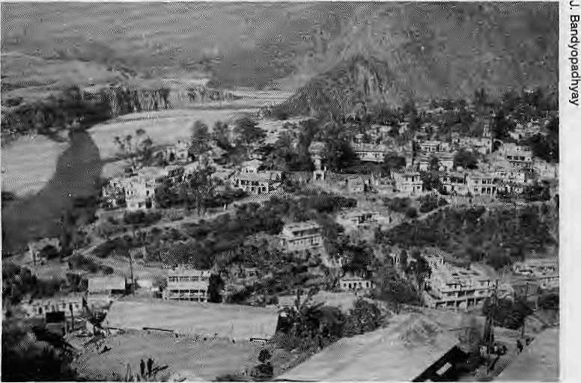
Will they all be displaced?
Damn the dam, says the opposition. If built, Tehrl Dam in Garhwal will submerge the homes of 86,000 people. The decision is the Supreme Court's.
by Kesang Tseten
W
ork on the controversial Tehrl Dam continues as opposition to it mounts. Meanwhile, thousands of would-be refugees, caught in mid- air as it were, await their fate, which lies in a Supreme Court verdict.
In the face of widespread support, the arguments of the dam authorities sound increasingly hollow. Though the Supreme Court's acceptance of the petition gave greater legitimacy to the opposition, at least five years have passed since then. Work on the dam has dragged on for a decade with little chance of meeting the 1997 dead-line. Most hurt are the 86,000 people, whose homes are to be buried under the reservoir. Caught in the middle, they have no choice but to endure these long disruptions and uncertainties until the Court decides, or something else gives.
Meanwhile, present-day Tehri town is a place with a death sentence. Ah¹ construction work and development projects have been stopped since 1969. All monies earmarked for the town have been diverted to the new Tehri town. Thus, the Tehri people find themselves split between two bad homes, one long neglected, the other remaining unfinished.
Even the windfall in jobs that the Tehri people had been hopeful for did not materialize. According to the Cultural Survival Journal, not a single engineer from Tehri has been employed, and cheap labour has streamed in from Bihar. Instead of a boost, more people have had to be accommodated, the town facuities shared among many more, and prices have shot up. The crumbling town now supports double the population it had in 1969.
New Tehri, near completion, is like a ghost town, with schools but no residents. The traditional hillside homes have been supplanted by box-like concrete structures hi identical pink and blue lines, a "brutal monument to the folly of modern Indian architecture." The town also lies above 4,000 feet above the old town, and is thus colder.
8 II1MAL ♦ Nov/Dec 1989
Residents are grumbling that Tehri - as the new district headquarter - will be filled with government buildings, courts and employees. These coutd not be relocated elsewhere as all the towns in the region sit on hill-tops, except for Tehri, which will be submerged.
A journalist who recently visited said, "People just don't want to move to Tehri,¹¹ According to him, the town can accommodate 20,000, but the remaining 66,000 rural "oustees" have nowhere to go. The government has reportedly been unsuccessful in acquiring land for the vast majority who will be displaced, namely the farm people. Another critic said that, at any rate, the town would be filled with only those who have the money.
T
he proposed dam lies in the Tehri valley in the Garhwal region of Uttar Pradesh. It entails the building of a 260.5 m-high rockfill dam across the Bhagirathi River just 1.5 km downstream of the ancient town of Tehri, at the confluence of the Bhagirathi and Bhilangana rivers.
Tehri town awaits its -fate.
According to its propopents, the power crisis and the huge requirement
for irrigation made the harnessing of the Ganga Valley urgent. The absence of a storage dam in the valley, they said, resulted in a loss of 6 million acre-feet of water. The Tehri Dam couldturn this "colossal waste" around to spur the state's industrialisation with the added hydropower as well as expand its irrigation system. Tehri had been selected for commissioning the first out of three storage schemes. Its reservoir, extending 45 km into the Bhagirathi valley and 35km into the Bhilangana (a water spread of 42.5 sq km), would impound 2,62 million acre-feet of water. The dam would have on completion an installed capacity of 2400 MW of hydropower.
The only disadvantage, according to dam authorities, is that the dam would submerge the town of Tehri, 25 villages, "partially submerge" another 72 villages, and 1600 ha of the region's richest farmland. But the project was considered economically viable despite the high cost of resettling 86,000 people.
The proposed dam, which would be the world's fifth largest if built, was anything but straightforward. It gave birth to a protracted battle between the developers and those who believed the behemoth project posed potential hazards to both human lives and the environment which far outweighed its purported benefits.
The ongoing project faces an increasingly formidable opposition, composed of passionate supporters with some compelling arguments. At the core of this opposition is the Tehri

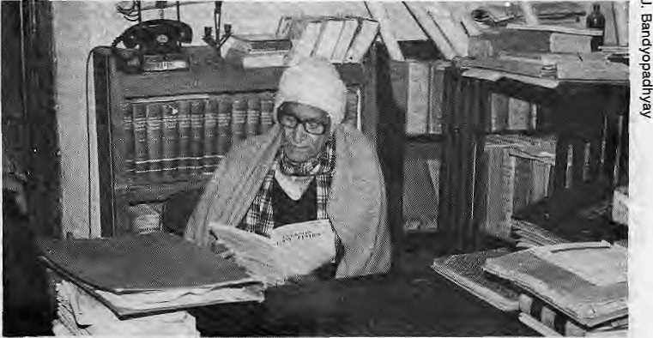
Bandh Virodh Sangarsh Samiti (the Anti-Tehri Dam Struggle Committee), made up of the people of Tehri, led by V.D. Saklani, and supported by well-known environmental activists, scientists and scholars of the region.
Opposition to the dam began in the late 70s mainly on the displacement issue. It was the hey-day of the Chipko movement, and the anti-dam resistance got its inspiration from it. For a while, the government responded by paying "very liberal" compensation to the would-be refugees. But the opposition gained impetus when the Wadia Institute of Himalayan Geology in Dehra Dun cautioned the project because of the seismicity of the dam site, and its potential hazards. Armed with a persuasive scientific critique, the opposition in 1983 took its protests from the streets to the Supreme Court of India.
Put simply, the anti-dam people argue that it is foolhardy, indeed criminal, to build a dam as high as the Tehri on a site that lies in an active seismic zone because of the potential hazards to communities up and downstream, and the possibility of a reservoir induced earthquake. They also argue that the silt-load of the dam would give it a useful life of less than half that officially estimated. Furthermore, the high cost of resettling 86,000 people, and the environmental impact wrought by landslides, flooding, and deforestation, dictated that the project be halted.
T
he Tehri Dam proposal, although conceived in 1949, was sanctioned only in 1972 by the planning commission. But lacking funding, all that was accomplished by the late 70's was a project report and some minor construction. The dam drew attention again during Gorbachev's 1986 visit to India when an atomic agreement fell through. As a substitute, the Soviets signed an agreement for the Tehri Dam.
In 1979, in response to growing outcry, the Department of Science and Technology was directed to form a Working Group to assess the environmental impact of the Tehri Dam, The team, headed by noted environmentalist Sunil Roy, "recognized the urgent need to harness the Himalayan waters for its potential energy." But their concern centred on the extensive deforestation, the location of the Tehri on a highly
Virendra Dutt Saklani - the Tshri crusader seismic zone, the known instability of the hillsides, "all of which could have grave consequences for Tehri and the upstream and downstream communities."
The issues raised by the Working Group's interim report elicited a directive from the prime minister's secretariat that "there were grounds for concern," and it recommended that "the project be examined." In the end, because of powerful pro-dam lobbying, the Working Group did not recommend that the project be halted. Roy described his experience as "harrowing and distressing," saying he had "never encountered such an unbendingly dogmatic approach,,,to ensure continued work on the Tehri Dam whatever the cost to the environment and public funds."
Stated Roy: "From the outset I held the view that work should be halted on the Tehri Dam but lacked an adequate data base. Now, I consider this is essential as it is clear that the extensive environment recommendations will be largely ignored.... " He added: "....there is enough national and international experience now to show that taking all factors into consideration, including the social and environmental costs, major water resource projects are no longer economically feasible."
Some similar concerns were expressed by the Soviet team that assessed the project. According to chief engineer Alexander Fink, the high seismicity of the Tehri Dam "fails to be adequately considered," and that the "design insufficiently ensures the reliability and safety of structures, especially considering the height of the dam
and the fact that a densely populated area lies behind it." His team's conclusion was that a new design would be necessary.
Although a new design might enable the dam to withstand a major earthquake, "the enhanced cost of the new structure may not be economically viable," says ecologist Jayanta Ban-dyopadhyay.
The siltation factor is another issue to contend with. Even the Soviets have not solved the problem of heavy sedimentation in their mountainous dams, and the sedimentation of Himalayan rivers is as high, said Ban-dyopadhyay. According to a study by Singha and Gupta, the siltation of the Bhagirathi River during 1978's heavy monsoon was 40 million tons per year. And according to the anti-dam petition, even if the siltation is 16.53 hectare metres per year per 100 sq km, the useful life of the dam is less than 50 years, and if it is higher - as claimed by the petition - the dam life could be less than 20 years.
I
ts final recommendation notwithstanding, the Working Group had been shocked by the intensity of the opposition to the Tehri Dam and the concerns raised by the local people. Its final recommendation, therefore, sowed dissent among Group members themselves, which was voiced by the group's chairman Sunil Rcy. Their opposition was understandable. Not only were their homes to be submerged under 260 m. of water but the ancient city of Tehri on the River Ganga (Bhagirathi becomes the Ganga), on the pilgrimage

Nov/Dec 1989 • HIMAL 9

routes to Gangotri and Yamnotri, would be lost forever.
By way of rehabilitation, the plan called for a new Tehri town to be built on a mountaintop south of the reservoir, and the acquisition of forest and private land for rural resettlement near Rishikesh and Haridwar in Dehra Dun and Sahanpur districts. The "oustees" -as they have been dubbed - could, on the other hand, also take cash compensation. According to the Cultural Suf-vival Journal, the government has already distributed money to one-sixth of Tehri town's population — who accepted because of alleged intimidation. But they now ask what the money will be worth when the dam is completed.
While it might have looked alright on paper, the government has a dismal record in rehabilitation. Dams in India are said to have produced a half-million "refugees" - left to fend for themselves. The Working Group had thus stressed that "even greater efforts be made to ensure that those being rehabilitated in distant sites receive all the facilities, and that immediate steps be taken to improve the condition of those already relocated."
Two rehabilitation sites visited by the working group ~ Bhaniwala and Johra -- showed them that "despite the best efforts of the project authorities,
the conditions were far from satisfactory,¹¹ There were none of the facilities such as a hospital, school, water supply, post office, temple, and approach roads that were supposed to have been provided. The local people - "already among the most neglected in the Himalayan region" - were deriving no benefit.
Little attention has been given to the break-up of village and family units. In the village of Khandal, for example, according to the report in the Journal, more than half of the village's 50 families who had accepted relocation were now unhappy in their new homes, the poor yield of the land, and water scarcity. Some had moved to cities or returned to their villages to face social ostracism by those who had stayed.
In his dissent, Roy wrote: "Apart from the dislocation of local lifestyles, the oustees are uprooted and, almost literally, scattered on a dust heap." He criticised the planners for not seeing the hill village as an "integrated entity," and that "village groups are broken up and the oustees thrust helter skelter into the cash economy."
In acquiring land for the new town, villages and farm land, the government has acquired some forest land, thereby violating its own conservation laws. Other villagers (who too need compensation), have also been removed by the
government, thus setting off a vicious cycle.
The 30-odd-km road linking present and future towns is a circuitous two-hour journey on a rugged mountain road. The Dam Authority did not succeed in buying land from villages (such as Baurori and Pipli) that had been included in the blueprint of new Tehri Town. Today, many Tehri school children have to travel a few hours daily to attend classes. And higher transportation costs have already increased the prices of milk, vegetables, and other items.
G
iven their situation, it is hardly surprising that the project has fueled so fierce an opposition. "What is being opposed," according to ecologist Bandyopadhyay, is "the wisdom of destroying the sustainable and perennial economy of the fertile valley agriculture and the displacement of thousands of villagers for a highly costly construction with a questionable life-span." All because of, in the words of Sunil Roy, "the undiminished drive for development without environmental consideration,"
Charges the opposition: "The dam is
an exercise in unconstitutional
economics," and adds that to display
"giganticism in the fragile eco-system of
the Himalaya is nothing but to invite
disaster," n

ANNUAL SUBSCRIPTION RATE {SIX ISSUES)
SOUTH ASIA ELSEWHERE

INDIVIDUAL | NRs 110/IRs 65 | U$ 25
INSTITUTIONAL | NRs 300/IRs 200 | 11$ 45
 | (or equivalent) | (or equivalent)

Personal checks are acceptable, bank drafts and money orders preferred. Send subscription orders and correspondence to:
In South Asia: P.O. Box 42, Lalitpur Nepal, or
Central News Agency, 23/90 Connaught Circus, New Delhi 110 001
In North America: M. Basnet, 4 So. Plnehufst Ave #6A, New York, NY 10033
In Europe: B. Welsh, Holos Centre 139-A, Battersea High Street, London SW1, UK L Debuck, Donaustr 38, D-4100 Ouisburg 29, W. Germany A. Odermatt, Winterthurerstr 112, CH-8006, Zurich, Switzerland
In Japan: Akio Horiuchi, Post Box 9, Klyose, Tokyo, 204 Japan In Australia: Indra Ban, 12 Norfolk Street, Paddington 2021, Sydney Australia
HIMAL is current. It is readable. And it is serious. It is indispensable if you want to keep in touch with the region.

10 HIMAL • Nov/Dec 1989

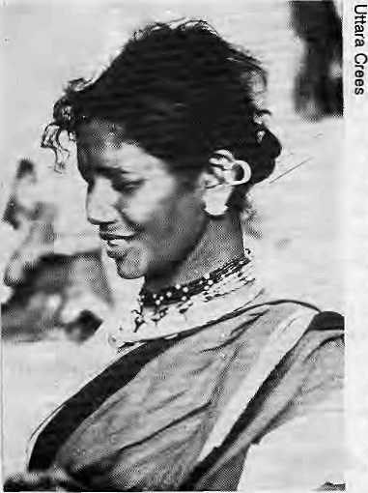
Missing the Tribals for the Trees
In their mission to save forests, conservationists overlook forest dwellers
by Rajiv Tiwari
I
n a cruel environmental paradox, there is provision in Indian forest laws for conserving tigers and trees, but little thought for the tribal people who have lived in the jungles for centuries. Successive laws passed since the late 19th century, ostensibly to protect forests, have stripped away tribal rights over forest resources, impoverishing more than 50 million tribals.
Tribal leaders have protested against provisions in the Forest Conservation Act of 1984 - amended in 1988 - which threaten the already precarious livelihood of the country's poorest and most exploited group.
At a recent workshop on the rights of tribals and forest policies, many experts voiced the opinion that forest conservation and tribal welfare were synonymous. A government agency was to have handed in a report in October on a forest conservation strategy that is charged with insufficiently considering tribals' views.
The proposals precede a massive show of force organised recently in central India by environmental action groups which protested against policies that promote "destructive development." The protests centred on the huge Nar-vada Valley dam project, which is expected to displace up to one million people.
An official in the National Commission for Scheduled Castes and Scheduled Tribes said that although there were an estimated 5,000 forest villages in India, the tribals living in them have no land rights. Because these villages have not been designated as "revenue villages," they are not eligible for government development funding. Basic social services such as schools and water have to be provided by the forest department, which views tribals as the chief source of environmental degradation and as a budgetary burden. And the department refuses to sanction any change in the tribals' status because, legally, forest land cannot be allotted for "non-forest" activities.
A Madhya Pradeshi tribal
Ironically, as Indian "greens" demand better conservation measures, forest authorities appear to be placing greater restrictions on tribals. Consequently, tribals find it difficult to graze their cattle or pick fodder and fuelwood around their settlements. Also, forests continue to be turned over to industrialists who extract raw materials such as pulp and timber, helped by authorities and their promotion of fast-growing exotic commercial species.
According to Walter Fernandes of the New Delhi-based Indian Social Institute, "Everything that the tribal needs - such as fruit and fodder - has been declared as a non-forest priority. The forest department sees forests as plantations and not as a life-support system for the people living in them."
Fernandes has studied the way the tribals traditionally use their community resources in the dense jungle tracts of central India and believes that, left to themselves, they maintain a sound environmental balance.
However, with more than 15 million tribals displaced in the name of development, and the steady ingress of commerce into their native lands, the tribals have tragically become wage-earning partners in the destruction of their own habitat. Thus many activists
in India are beginning to question the usefulness of western prescriptions for ecological regeneration. They say that most industrialised countries have no experience in tackling the human dimension of the problem, since their forests are not inhabited by aboriginal settlers.
Fernandes, among others, holds that India's forests are community resources that cannot be handed over to corporations nor turned into sources of profits for individuals who have been awarded rights. Many well known Indian conservationists say that humans must be completely kept out of biosphere reserves crucial for maintaining an ecological balance. Experts are said to agree that no more than six percent of Indian forests need to be left untouched. With an estimated 23 percent of India's land area under forest cover, there is more than enough to apportion to the tribals, who are likely to take better care of them than do forest officials, according to Fernandes.
At present, the same tribal who fells trees for a timber contractor could be employed by the government to plant them. Critics argue that this is not sustainable and say that the forest department should not be allowed to monopolise the forests and to sublease them to industry. And no one contests the fact that there is an area of partnership between the forests and forest people.
If the government restores to tribals the right to collect minor forest produce, fuelwood, fodder and fruits, it may not need to allocate vast sums for "poverty alleviation programmes" that, in any case, seldom reach the beneficiaries, say experts. It remains to be seen if these concerns and suggestions find their way into the strategy being drawn up by the government committee headed by Duleep Mathai, vice-chairman of the National Wasteland Development Board. Officials say former Indian Prime Minister Rajiv Gandhi intervened on behalf of the rights of tribals and asked the committee to include them in its plans.
But, as one official put it: "There is
still a danger that the strategy might be
hijacked by conservationists who can't
see tribals for the trees." A
Rajiiv Tiwari is a New Delhi-based journalist, and a regular contributor to Himal.

Nov/Dec 1989
HIMAL 11

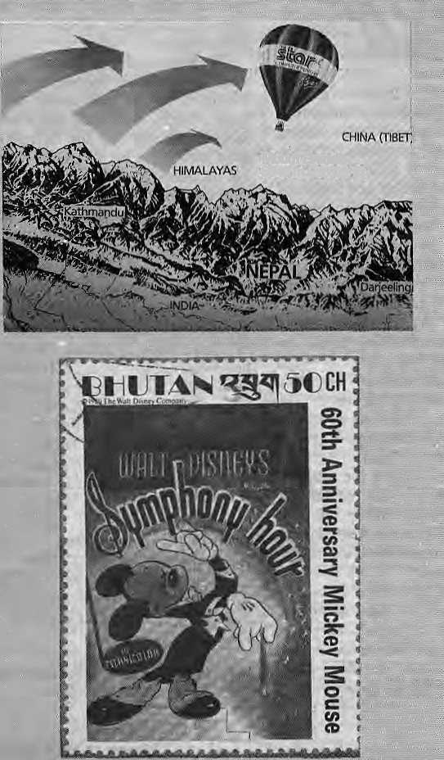
mm'

Protecting the Roof of the World
Trie plan to protect one of
the world's unique ecosystems seems to be- making progress,.
" In M at ch I ta i s- yea r,." tja e; 2.5,1)00 sq km Oomolangma Nature Preserve was officially established, and a task-force is due to submit its .■recommendations 10-HMG/Nepal for the proposed 3,000 sq km Maltalu-BahinGonserva-tion Project (his coming spring.
When that Happens, three parks south of the Himalaya *■ die Makalu-
Barun, Jhe 1400 sq km Sagarmatha National and the 1700 sq km 1 Langtang National Park - J will He contiguous to the Qomqiangma Preserve .,'.. 7 _{s}; across the-bordcr, the latter under: the:'overall■autlioriiy " pjf tlie Worlcing Coiiimission of the Tibet Autonomous ^Region. -Itsmanagement bureau park is in Shigatse, I iDra«Ch'office in -=■ ■■■: -g .
Mount Everest 8848 m (29,028 ft)
Bofh, tljd'Qomolangrna " Nature PTese>Ve and; the; ■■■■..-. Makahi- Barura Conscr\^- ;; Hion Project are supported ! by tJS-based Woocttands ■ Mountain Institute and various internatioiiaLdpnofs:
Nomads near the ^rdposech-Goniigudiis paifksj
By Balloon
Bythetime the; contiguous parks are a reality, hot-air balloonist Per Lindstrand might balloqn-fly over it -piid Everest j which is the point Mtheexercise. ...
If successful j
Ljndgtrand's balloon expedition will be the first to fly over Ihe highest mountain in the world* Uii'djtrand has already staked a name in ""The Guinness Book of JRecOfds" for hte record- ■■ breaking transatlantic crossing - 4,948 kms in 31 hours 41 miri u leg - a a d for a h pt-airbalfopiihighaltitiide ; record.
The "Ultiniate Ascent"-or "Himalayan Challenge* by ho t- al r b a 1 to on is be in g organised by writer/journalisi Peter Mason, whose The Acne/l Display Company
specializes in aviation-re-."" lated promotional, advertising and niarketing services' for some of Britain's leading business houses.
The brochure says nearly a quarter of a mOhon cubic feet of hot air will be required to rais^ the balloon, builtby Lindstrand's Thunder and Colt company,, and christened "The'Star Flyec." Instead'of the normal payloadvof U erew members, the vehicle will carry three- a pilot, a copilot, and a cameraman -for the foxir-to-six hour cruise at 33,000 feet.
Barring liitchds, the com-ingspringwillsejs sponsor StarMicronicsOKLtd. beaming its high-tech advertising message emblazoned en the 91-foot-tall balloon to the highest and, possibly, least populated landmass in the world.
What's Mickey doing in the Land of the Dragdh?'
Sticking a stamp....i;]'/..i
ing a pbce_{T} that's what. In Bhutau's stamp-d us try'

The Himalayan kingdom of 1 million-plus, thought of as llic most pastoraj of places, is also noted For its sticky sci-fi, rnostv...wcH...,iin-pastoral philately, in'cludbg three-dimensionals of men walking on the moon.
Mickey, Mouse-worship, in its 60ilr centenary, hasin-filiraled the Himalaya;
i ,,..

