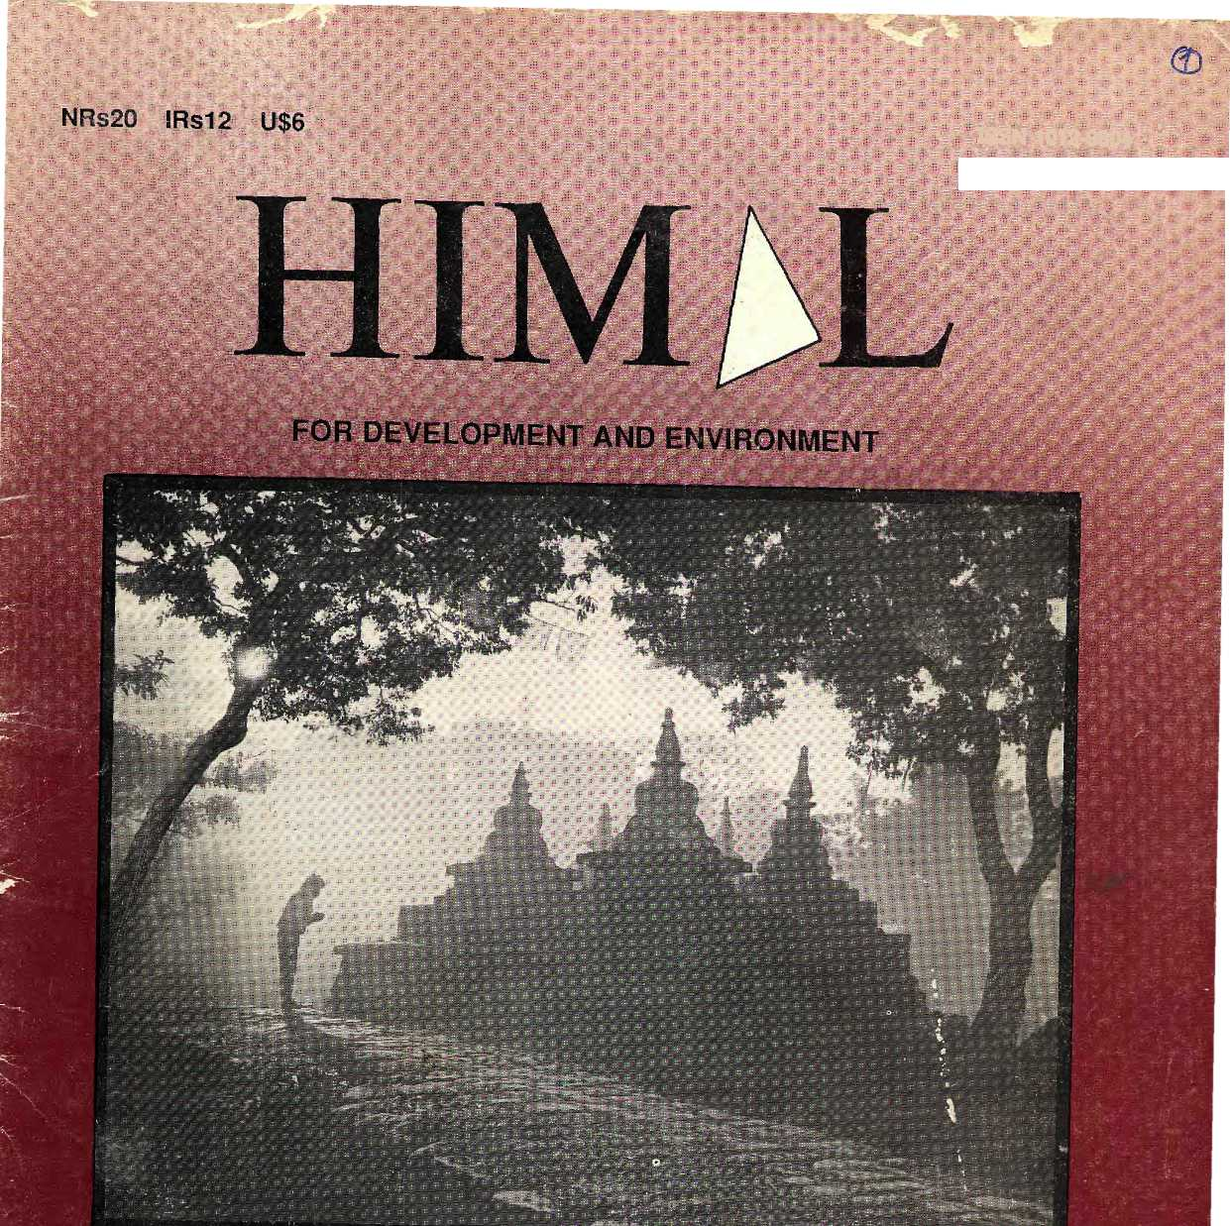
ISSN 1012*9804 -: '
JAN/ftEB i 990

e Shangri-La Myth

AYOGORKHALI ! STATE OF MIND? BHUTAN'S FORESTS
LUMB1NI DEVELOPMENT? GREEN ROADS VOICES

INSIDE


COVER
4 The Himalayan Image
- The Movie Behind the Myth
- Whose Shangri-La?
10 Ayo Gorkhali!

- Grotesque Lands
- Why Not Shangri-La?
- The Carpetbaggers
- East on East
- Roles Reversed
- State of Mind?
- On the Mountain
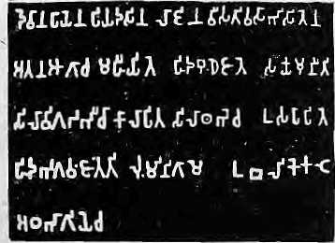

FEATURES
22 Green Roads
- Bhutan's Green Health
- Lumbini: Still Far to Go
- Lumbini's Failures
- Conservation and Adventure
The Abode of theClods, King of Mountains, liimdlaya &aaA the oceans-t'mm. %
east to west A northera yardstick
ii jida Sa'
iSdntbhavam)
Edited and- iM)tisb^t Jyt
'.: ,!i^o^k1W|anmrJ&ixits^{s} %
for Rimai Associates
! Tsete» - -
Editor^

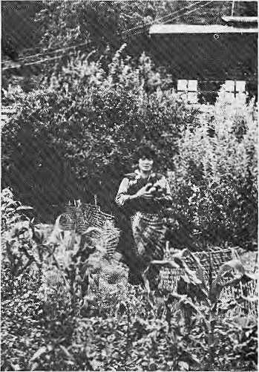
DEPARTMENTS
16 Voices
19 News in Brief
23 Jerzy Kukuczka
28 Book Reviews
30 Followup
32 Know Your Himal
36 Abominably Yours
VIEWS
31 Unrest in Ladakh: Rejoinder
Cover picture by Kevin Bubriski.
Himal (ISSN 1012-9SO4) is published six Limes per year by Himal Associates,
P.O. Box 42, Lalitpur, Nepal. Tel: 523845. ©Copyright 1988. Please turn to
page 34 for subscription information.
Advisory Panel
M. AhtlHOSIart, Wm-veraLy..t>£ Peshawar, ..i^{J}(5sliawaf ""■*"" "^{v} ■:■ ■■ = ■■ ■■ ?i™ Foritiii of Bntftronme
, iGier l*ress Service, Rdme : Dorje, liucnscl WeeKly; "Kiithphu
Jil dc la :■:■: ■-
e%s Institute;-
.. ... , ~ Rain Chandra Malhotra; tatematkni^.l fund....
MisBiraJ King
y
j Eaiihgosj, KJ)ad^ Eictaani
PonaI<JSfiaiiw,
, Niivsyorit-. .... ■/, .... .,... ,..
stba, j*fcpaj IJusjn^sss and
i j
;Vfiiiya Stokes, ;Himacljal;.P{a(ics| ^^y Assembly, SEhim!a ■?■ ■■ .-.■.■ ;■. .;■ ■> ... ,,. ., „ . B.G.^Vergh'cse, ecmre forPcrticy Resestch, New Delhi " ^{v} ■'■•■■ ■<■ r -s.Jljian \Velsh, itie HoloS Centre- tamrieti ■■:;■:■

MAIL

LADAKH RIOTS
In his article on "Riots in Ladakh" (Sept/Oct 1989), Siddiq Wahid makes two points. First, that it is the wicked foreigners who have planted the notion that Muslims are oppressing Buddhists in Ladakh; second, that the same foreigners have created the impression that to be Ladakhi is to be Buddliist, and that, therefore, there is no such tiling as a Muslim Ladakhi.
Wahid's citing of Franckc and Sncllgrovc, however, do not justify his somewhat excited conclusions.
Wahid ignores certain facts both in the valley and outside. In the valley, the ethnic protests by Buddhists were rooted in at least two grievances: in not being given representation in the Kashmir Cabinet; and in not being allowed to pray in Buddhist shrines in areas where Muslims are in the majority.
If ethnicity over-rides religion, the first poinl should have been taken up by non-Buddhist Ladakhis as well, and the second should simply not have arisen. Since Mr. Wahid works in Delhi, he cannot have missed the fact of the Partition in 1947 and the communal violence that took place in British India and continues to take place in the sub-continent. Does he mean to tell us that Hindus and Muslims in India and Shias and Sunnis in Pakistan are not of the same ethnic stock, or that wicked foreigners are responsible for it all?
Second, Wahid blames "intellectual colonisation," " development," even " compulsory education" - all of them good cliches, and therefore more emotive than factual. He is scathing about compulsory education which more often than not means, according to him, 'merely' ,(a word he emphasises) the ability to read and write, preferably in English. Thus he hits out at several concepts: compulsory education, skill of leading and writing, and, of course, English. One cannot but feel that Wahid himself has merely picked up the ability to read and write English.
We should not scoff at the modest skills that literacy imparts; the literate citizen is dangerous because he ot she will not remain dumb for long. The feudal kings realised this, and so always denied education to their slaves
and vassals. It would indeed be disastrous if the activist lobby were to lend them its unwitting support.
As a woman, I am very glad to have the education and the opportunities that my grandmother was denied. So are the large numbers of the lower castes, Hindu and Muslim. The burgeoning of Dalit literature in India is a testimony to that. It is their sole passport to a tolerable life. Vasudka Dhagamwar New Delhi
SPINY BABLER
"In search of the Spiny Babler" (Nov/Dec 1989) was most interesting. Congratulations to Dr. Tej Kumar Shrestha for his efforts.
This rare bird, or one seldom sighted, has never been seen by me or any of my friends during many years of bird watching in Kumaon. Hari Sharan Nepali, president of the Nepal Bird Watching Club, can retain his confidence that me Spiny Babler is endemic only to Nepal! Akshobh Singh, Kumaon
SUNGDARE
The article "Summits are lonely places" in llimal (Nov/Dec 1989) is inaccurate in some respects. The expedition that Sungdare "barely survived" and on which he was badly frostbitten was the occasion of his firsl Everest ascent in 1979 and not Ms third. The sardar was Pertemba, as is correctly stated.
Subsequently, allegations were made in the foreign mountaineering press that Sungdare had been badly treated - "sent down to Khuncic strapped to the back of a Yak" and the like. These allegations were hotly denied by some expedition members, but Sungdare undoubtably suffered a great deal. It is generally concluded that his drinking habits dated from this lime, when he took to drink as a pain killer. Jimmy Roberts Mountain Travel
RAMAYANA
AND ANTHROPOLOGY
It is clear from the article by Dor Bahadur Bista ("Ramayana, Ramayana, Ramayana," Jul/Aug 1989) that he is upset.with the version of Hinduism that is currently being propagated by the state-supported group of pundits. I sympathize with Prof. Bista on this point. In fact, I would like to add that the Brahmin gToup is increasingly alienating not only the numerous ethnic groups that Prof. Bista quotes but a whole lot of "high-caste" individuals who are educated and have a wider outlook on these issues.
Prof. Bista is identified at tlie end of the article as "an anthropologist and a Matwali Khas..." It is my opinion that in the process of writing the article he might have retained his identity as a Matwali Khas but he certainly damaged his anthropological standing.
An anthropologist needs to have an objective view of the people he/she is exploring. In the article, however, Prof. Bista shows himself to be subjectively entangled and lets his biases show. He has selectively chosen "facts" to fit his theory. From Ramayana, he has learned to be "cautious and watchful of every woman, for they clearly are wicked, vicious, cruel, unpredictable and altogether insensitive." He chooses Manthara and Kaikeyi as examples. Why has he left out Ram's mother, Kaushalya, or Sita herself, who arc portrayed in Ramayana as kind, predictable and sensitive. Prof. Bista makes sweeping generalisations about the Matwali and Brahmin groups: "...there are still a considerable number of ethnic Matwali people who are by tradition and temperament collectivists and not egotists, as are most 'civilized¹ high caste people." It is not possible with research tools currently available in psychological anthropology to explore such broad concepts like collectivism ot egotism. How are these terms defined and where does egotism end and collectivism begin for Brahmins and Matwalis?
In discussing the imperious pundits and the stubborn Matwalis "who refuse to mend their ways and insist on their ethnic identity," Prof. Bista has not dealt with two social processes that deserve study: sanskritisation

Jan/Feb 1990 • HIMAL 1

MAIL

and modernisation. The traditional process of sanskritisation is going on, however much we might like to disbelieve it in light of the new values we have acquired. At the same time, through the modernisation process, people of different ethnic and religious backgrounds are striving to climb the social and economic ladder through education and new occupations. Under the modernisation process, the value of converting to a higher caste no longer exists. Here, other value systems come to the fore. True, there are a number of pundits who not only favour the sanskritisation process but, as Prof. Bista rightly points out, go so far as to perform braiabandha among ethnic groups.
In the rage against the pundits who are propagating a very narrow form of Hinduism in the country, Prof. Bista seems to have lost ihe anthropologist's perspective. Instead of looking at the larger and "more whole" social processes, he seems to have been frozen in the perspective of a Matwali Khas. The questions raised but unanswered by Prof. Bista should lead Nepali anthropologists to mull over how they define their discipline, what should be their focus, and how and for what purpose they "do" anthropology. Arun Raj Joshi Harvard University, Boston
RAMAYANA AND VALUES
Reading Dor Bahadur Bista's "Ramayana, Ramayana, Ramayana" leads me to believe that Himal (Jul/Aug 1989) is a forum which encourages debates even in the rarely reflected on realm of values. It should, because value issues, though they are at the very core of development debates, are rarely discussed openly. This is why the public stage has been captured by fundamentalists the world over and the upholders of rational values quake in closed cloisters, D.B.Bista takes a brave potshot in ridiculing our own fundamentalism
riding the electronic waves, but takes liberty with reason that may be counter-productive.
First, a historical epic like the Ramayana is no more Indian than Einstein is German or American, and Nepalis (matwali or otherwise) have no reason to embargo it. Second, while one may find quaint some form of etiquette of honouring the learned by those wielding state power, it cannot per se be said to be bad, especially in Nepal where a clear dearth of this tradition is seen. And as regards brahmins being learned by birth, one can quote enough Sanskrit slokas that ordain that lcamedness does not come as a patrimony. Third, mistreatment of women is very wide-spread and does not spare any ethnic group as the article implies. Similarly, collectivism and individualism are traits seen in every group, and Hinduisation cannot be explained in such terms. It may be more rational to explain it in Toynbccan terms of cultural mimesis where the values and life-styles of a creative minority are emulated by the majority, D.B.Bista really has nothing to fear regarding further Hinduisation: The appearance of fundamentalism in currently practiced Hinduism in Nepal is not a sign of strength but a symptom of lost creativity. Nobody will emulate what a spent elite does, Dipak Gyawaii, Chabel, Kaihmandu.
KANGSHUNG CORRECTION
Hearty congratulations on your continuing success in bringing a new and worthy journal to bear on the issues of the Himalayan region. A correction, however, is needed to your "Abstracts" section (Scp/Oct 1989), concerning Steve Venabte's book, Everest: Kangshung Face. Venable's climb of the East Face of Everest, memorable though it may be, is not the first climb of the East Face as your review stated. Three Americans summitted
from the Kangshung Face on 8 October 1983, and three more the next day. As expedition leader of that second American attempt on Mallory's "impossible" face which he left to "other men, less wise," let me set your records straight.
Under a permit first secured by Dick Blum for a 1981 attempt, and using the photographs taken by Andrew Harvard in his 1980 solo reconnaissance up the Kangshung Glacier, and having learnt from the 1981 attempt, our expedition successfully climbed the 4,000-foot buttress of the East Face, including the formidable 800-foot overhanging section which we named Lowe Headwall for George Lowe, who had done most of the brilliant leading in 1981. Those who reached the summit were: Kim Momb, Louis Reichardt, Carlos Buhler, George Lowe, Dan Reid and Jay Casscll, James D. Morrissey, M.D. Stockton, California
FLOODS
In response to "Another solution to flooding?" {Himal Nov/Dee 1989). Increase in population and development of modern science have aided human beings to occupy the floodplains and interfere with the river systems. Learning to live with floods would be an ecologically compatible and economically viable solution to the flood problem. This would mean a change in the perception of flood management. Floodplain zoning, disaster preparedness, flood forecast and warning, cropping patterns suited to floods, instrumentation and study of river systems, preservation of natural retention basins, development of railroads and roadways based on drainage patterns are some of the ways and means which would aid people to live with floods. V. Arivudai Nambi Tamilnadu

YOU CAN EITHER LAZE AROUND OR YOU CAN READ HIM^L | I | 1
J | mm |  | 1
 | '4 | " K
/f you want to keep informed, see page 34 for subscription information.
Himal Alert!
The first annual issue of Himal in Nepali - in paperback book form - is being published in time for the Nepali new year, 15 April 1990. The issue will be available in retail outlets throughout Nepal and elsewhere. Due to the financial and human resources required to
fulfill this long-standing objective, Himal is not able to publish its regular
March/April 1990 issue. While we regret this inconvenience, Himal reassures its subscribers that they will receive the full number of issues they are entitled to. In future, we hope to be able to produce publications in other highland languages as well, without having to suspend publication of our regular English bimonthly.

2 HIMAL ♦ Jan/Feb 1990


BANGKOK FOUR TIMES A WEEK
Royal Orchid Connections to Major Cities in
ASIA
AUSTRALIA MIDDLE EAST EUROPE U.S.A. and CANADA
^{T} * ^^ ^^^^ Thai Airways International Ltd
For information, please contact Thai Airways International. Phone: 223565/224917
NEPAL INDUSTRIAL DEVELOPMENT CORPORATION


A developing country needs to industrialise, and it must do so thoughtfully, choosing appropriate sectors and the right strategy.
At NIDC, we are development bankers first and foremost. We promote appropriate and sustainable development.

We started nearly three decades ago in a country with virtually
no industrial history • Since then, we have helped nearly a thousand
industrial entrepreneurs successfully establish and run industries • We provide
technical and financial assistance to establish, expand or modernise private sector
enterprises • If you are an entrepreneur in need of advice or assistance, please contact us.
Nepal Industrial Development Corporation, Post Box no. 10, Kathmandu. Tel: 411-322, Tlx: 2369 NP.
Jan/Fcb 1990 • HIMAL 3

.

The Himalayan Image

by Mana Man Singh
A staple image carried home by travellers
voked rivers, clouds, dawn and the sun — and reserved its greatest paens for the Himalaya. Myths, legends, cults arid rituals came to be associated with the Himalaya, where Shiva, embodiment of love, hatred, fear and mysticism, probably made his home. More recently, the puranic literature assigned Himalayan tirthasthals for pilgrims and conferred on the hills and valleys of Uttarakhand in Garhwal a status superior to all the other sacred places of the Sub-Continent. Taking Himalayan veneration to new heights, the Skanda Purana went as far as to state that "he who merely thinks of Himachal is greater than who performs all worship in Kasi; and <all things that die in
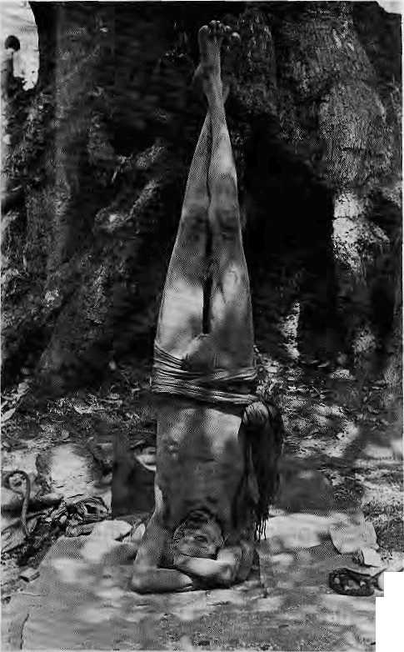

" rrihe wildest dreams of Kcw," wrote JL. Rudyard Kipling in one celebrated verse, "are the facts of Katmandu." But how could he have known? Certainly, Kipling never made it up to Nepal. He spent most of his time hobnobbing with the imperial sahebs and mem-sahebs in Calcutta, Lahore and Shimla. Like many before him and countless after him, Kipling was fantasizing. Remote and unseen, the Valley had to be a dreamlike and Utopian wilderness even though for Kathmandu's own citizens, daily life in As an market might have been as mundane as a stroll down London's Picadilly Circus ot the Mall in Shimla was for an Englishman, Since long before Kiplbg, those across the seven seas have derived pleasure from the perception of a romantic East. These mountains and valleys of the Himalayan region have provided mythological relief, and served as a gigantic psychological sponge to soak up global angst. The Himalaya carries the burden of Western fantasy by merely "being there," standing tall, while a large section of humanity looks up at it with soft- focus, rose-tinted lenses and sees — Shangri-La! Where the view is limitless, where rosy-cheeked children smile beautifully, grandmothers all live to 100, and reincarnation lets you come back for a second and more tries.
OLD SPORT
'The idea of a mysterious kingdom hidden behind distant snow mountains has an intrinsic appeal," according to Edwin Bernbaum, a former Peace Corps volunteer in Nepal who has written a celebrated book about the Tibetans' mythical kingdom of "Shambhala."
The seeds of the latter-day glorification of the Himalaya were not sown in the West but much closer to home — in the Indo-Gangetic heartland of the Sub-Continent. Since pre-Vedic times, the mountains have been a subject of veneration, and the Hindu scriptures themselves mythologized with abandon. Mem, mythical mountain, stood erect at the center of the universe ~ in the Himalaya.
Long before travel brochures started touting the "Roof of the World," the Rig Veda, in-
_{c} Himachal, and all beings that in dying
2 think of the snows are freed from
°- sin..." (emphasis added)
Sr The Indo-Gangetic plainsmen of;
§ prehistory were not the only ones to sing to the glory of the mountains. The ancient Chinese believed that their immortals went to live forever on a jade mountain to their west. And within the Himalaya itself, the pre-Buddhist Bon believed in "01-molungring," an invisible kingdom in the north-west surrounded by snow mountains. Writes Bembaum in The Way to Shambhala, "While many Westerners have regarded Tibet as the mysterious hidden sanctuary, Tibetans themselves have looked elsewhere for such a place -- their sacred texts point to Shambhala."

In Shambhala, which Tibetans believe lies north towards Turkestan, a line of enlightened kings are said to guard the most secret teachings of; Tibetan Buddhism - the Kaiachakra (Wheel of Time), In this Shambhalan Utopia, writes Bembaum, "The inhabitants of the kingdom live in peace and harmony, free from sickness and hunger. Their crops. never fail, and their food is wholesome and nourishing. They all have a healthy appearance, with beautiful features, and wear turbans and graceful robes of white cloth. They speak the sacred language Sanskrit. Each one has great wealth in the form of gold and jewels but never uses it. The laws of Shambhala are fair and gentle: physical punishment, whether by beating or imprisonment, does not exist,"
THE HIMALAYAN MARKERS
The Western image of Tibet as the ultimate mystical sanctuary gathered momentum with the Theosophists. The Theosophical Society was an occultist movement founded in the mid-1800s by a Russian, Helena P. Blavatsky, who claimed to be receiving secret telepathic teachings from spiritual masters "behind" the Himalaya.
While earlier Himalayan glorification like that of the Theosophists might have been limited to the mystically minded and the pilgrim, and then to the adventurer or the ad-

4 HIMAL • Jan/Fcb 1990

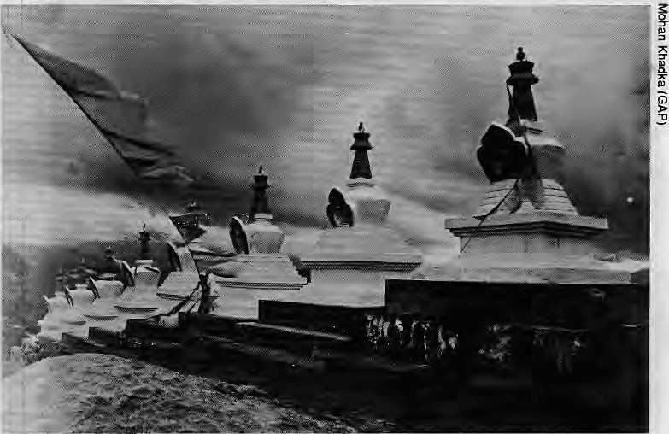
ministrator of the Raj, today, the revellers are the mountaineer, the development consultant, the aid official, the diplomat, members of the Westernized local high society, the political scientist, the social scientist, the tourist and the journalist — including one who wrote from Ladakh in the Los Angeles Times that "the word 'awesome' should possibly be limited to the Himalayas, a place that truly does it justice,"
Today's Himalayan romanticism includes not only the religious motifs carried over from the past, but additional "markers", both religious and secular, that conjure up exciting images and settings. A partial and random list of current subjects of Himalayan fascination, both old and new, mystic and otherwise, would include: tantric Buddhism, Bon, the Potala, Lhasa, Mustang, Dolpo, Hunza, Manali, the "Gurkha", the Sherpa, the Kham-pa, Ladakh, Lumbini, Mount Everest, Mount Everest Base Camp, Kailas, Ama Dablam, Machhapuchare, the lakes Manasarovar, Dal, Rara and Phoksumdo, the yeti (yet unseen), the prayer wheel, the tnani wall, Tengpoche, Rongbuk, Sekhar Dzong, Tongs a Dzong, honey hunters, the Karakoram Highway, the Kumari, the third eye, the Jewel in the Lotus, Swayambhu, temple erotica, Nyatapola and Machendranath.
MANTLE OF SHANGRI-LA
Being endowed with many of these Himalayan markers, Nepal represented the Himalaya to the world from the 1950s through the 1970s. With the well-reported coronation of His Late Majesty King Mahendra, it rose suddenly to Shangri La status: other supporting events were the Gorkhali soldiers emerging from their feats in World War II; the "discovery" of Nepal as birthplace of the Sakyamuni; the enticements of unconquercd eight-thousand meter summits and the charm of the Shcr-pas on the way up; the come-hither charms of Kathmandu Valley; the influx of Tibetan refugees; and the output of story-tellers such as the film-maker Lowell Thomas and writers Han Suyin (The Mountain is Young) and Dom Moraes (Gone A way).
For a western world coming out of the ravages of a world war, Nepal filled the yearning for that semi-mythical country where everything was different, yet "just right." In this difference was a kind of fairy tale perfection, Tibet and Bhutan were still firmly locked from the inside, and India required the inner-line permit for even its own citizens to go anywhere near sensitive northern border areas. In Nepal an element of psychedelic romance was provided by the unrestricted availability of hashish and marijuana. Adding to Nepal's sheer exoticism, apparently, was its charm as an open, as-yet-uncommercializcd
society where xenophobia was distinctly lacking.
"Nepal had everything a tourist might want of a destination," says Bill Fisher, a professor of anthropology who studied the Thakalis of Central Nepal and presently co-edits the prestigious journal Himalayan Research Bulletin in New York. "You tended to see Nepal in contradistinction to the places you had been to. It was a place to relax, to loosen up. In the 1970s, when you went trekking, the villagers welcomed you with open arms; there was no set fee for dinner. No one treated you with obvious resentment, and theTe was an absence of strict orthodoxy."
Continues Fisher, "Calling it Shangri-La would be an exaggeration, but definitely there were charms to Nepal not easily found elsewhere." But why Nepal? Why, in the 1970s, did the adjacent plains hold less charm for the westerner? Fisher says that because of some of the literature of the Raj, the Western audience had come to think of the plains in negative stereotypes — "the caste system, thuggie, Kali, suttee, sacrifice, whereas the culture of the hills seemed to be beyond these markers of the plains. In particular, Tibetan Buddhism of the hills seemed attractive for its perceived mixture of benevolence and mysticism."
By the 1980s, while the package tours came in ever-increasing numbers, Nepal's balloon was losing its larified air. The sale of cannabis had been illegalized under U.S. pressure, large parts of the country had been "tasted" by seekers of novelty, and it was time for the mantle of Shangri-La to pass on.
Bhutan was waiting in the wings, cautiously opening up to the development agencies and to the tourist. In 1990, Druk Yul, the "dragon kingdom" finds itself essentially where Nepal was in the mid-1960s in terms of
exposure to outside influence. With controlled access and rigid itineraries, Thimphu's planners have thus far managed to maintain Bhutan's "exclusive" character. The impecunious need not apply for a visa.
As a Scandinavian development expert reported effusively, Bhutan is "the forgotten land of happiness where time stands still," which had provided material for "exotic myths...of happiness, supernatural beings, and spiritual strength. Myths that tickle our fantasy as the Bhutanese chilli pepper our tongue." Linking the idea of Shangri-La to the development process, he continued, "serious woTks on development normally do not deal with such myths, but classify them (as) romantic stories... It is, however, our impression that the myths about Bhutan have a background of reality, and that discussion of Bhutan's social development cannot be separated from the cultural dimension."
TIBET, MYSTIC MECCA
When all is said and done, Nepal and Bhutan are but "Shangri-Las by default." The first and foremost claimant has always been Tibet. The country's inaccessibility, its unique form of Buddhism, its monasteries and reincarnate rin-poches, and its wide open landscapes and cloudscapes, all combined to make Tibet the mystic meoca of other-worldliness. "People have for centuries thought of Tibet as a land mysterious and remote, as a wilderness, perpetually covered with ice and snow, or else as a kind of a fairyland ~ a latter day Eden...There have been countless descriptions of Tibet, some genuine, some purely imaginary," says Ngapo Ngawang Jigmie, a Tibetan scholar, in the foreword of a Chinese-sanctioned book entitled, Tibet (1981, McGraw-Hill).

Ephemeral and sacred
Jan/Feb 1990 • HIMAL 5

REVIEW

\Lost Horizon:
the Movie Behind the Myth
j by Jeanne Marie Gilbert
S
pectacle, excitement, romance... Stirring, fantastic... Thrilling and compassionate... A grand ad venture... A drama of heart's desire come true."
Such were the plaudits of the critics at the movie opening of the U$2 million extravaganza of Lost Horizon in New York in 1937. Heralded by three years of record-breaking book sales, Lost Horizon was an instant and enduring success at the box office as well. What would make James Hilton's "brooding masterpiece" such a sensation in the Western world in the 1930s? What was it about the land of Tibet cum Shangri-La that has continued to so capture the imagination of the West?
Hilton's hero, Conway, is kidnapped on a flight from revolution-tom Baskul across bleak mountains to beyond the edges of the Frontier. On contemplating the reason for the flight, Conway muses whether it's "the will of God or the lunacy of man — it seemed to him you could take your choice...Or alternatively, the will of man and the lunacy of God..." Then Conway is transported to the lamasery at Shangri-La where the High Lama has built a sanctuary for civilization, preserving "the frail elegances of a dying age and seeking such wisdom as men will need when their passions are spent."
Conway was a veteran of World War I, as were, figuratively, Hilton and Hollywood in the 1930s. Still war-weary, they were among those whose perspective led them to fear that the world again was being pulled into war. The escapist dream otLost Horizon filled a barely subconscious need. Tibet, among the last lands unveiled to the West, became, in Shangri-La, the projected dream-
home of millions. In Tibet, among the mountains of the Himalaya whose scale and grandeur exceeded even Western superlatives, here the American hoped the best of man lay protected.
In Shangri-La, there was no fearful "ism," no modem nation-state, no economic-political organization of empire or kingdom, but that best of all governments: the benevolent dictatorship, infused with moderation, virtue and sweet serenity (and, incidentally, Western classical music and plumbing). Here was still, to quote Joseph Campbell, "an isolated society, dream-bounded within a mythically-charged horizon."
In Shangri-La, an individual lived long enough to outlive his greed and lust and destructive tendencies. In the aftermath of the War to End AH Wars, Hilton and Hollywood feared that man might not be so fortunate. From the current perspective of an age of nuclear proliferation and continuing ethnic and political strife worldwide, perhaps their fears were well-founded.
Interestingly enough, however, Hilton leaves us with the paradox of our hero Conway, having escaped from the escapist dream, struggling to return to the lost horizon of Shangri-La. Ever-clever, Hollywood filmed two endings and when the one of Conway successfully returning was deemed too happy, cut the more ambiguous one of Conway still struggling. That this would be the "real" ending to the fantasy of Shangri-La, more satisfactory to the subconscious, attests to the internal nature of the struggle, wherein the mind of man must wage the fight between gTeed and desire, and the freedom to choose a different order. Shangri- La is not to be found in Tibet, but in the heart of man.
Early in the century, a European scholar described Tibet as "the country qf the unknown, the fantastic, and the impossible... In that country, plants, animals and human beings seem to divert to their own purposes the best established laws of physics, chemistry, physiology and even plain common sense...Men compelled to abandon cherished ideals incompatible with their stem, prosaic surroundings, are eager to transplant them to a more favourable fairyland. As a last resource, they build a garden in the heaven and super-terrestrial paradises to shelter their daydreams, but how much more readily will they seize upon the opportunity of lodging them in an earthly country. Tibet offers that opportunity."
The French mystic and traveller, Alexandra David-Neel, perhaps set the tone for the rest of the century in a 1929 book which described Tibetan mystics who had the ability to live naked in zero temperature; who talked to each other over vast distances by telepathy; who could float in air and walk on water; who created animate objects by thinking them into existence; and who performed a secret ceremony that caused corpses to move. The outside world was only too eager to believe these visions.
In the end, Tibet and other Shangri-Las great and small have served as symbols for people in distant lands to find solace or escape from the cares of a modem world, or to express a need to believe because of a deep sense of their own loss. "Why is it that the fate of Tibet has found such a deep echo in the world?" asked German-born Lama Anagarika Govinda in his book The Way of the White Cloud, first published in 1966 (1988, Shambhala Publications), The lama answered his own question: "There can only be one answer: Tibet has become the symbol of all that present-day humanity is longing for, either because it has been lost or not yet been realized, or because it is in danger of disappearing from human sight."

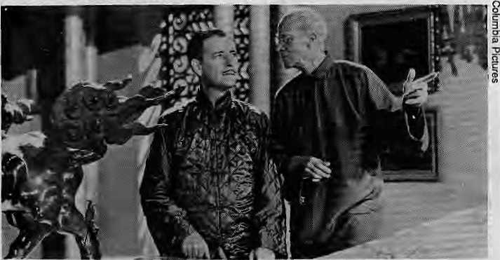
Conway. Hilton's war-weary hero, at the lama sanctuary
Himal Alert!
The cover feature of the next issue of Himal will focus on "Understanding Technology." Himal will carry wide-ranging discussion of related issues such as appropriate technology, low-tech versus high-tech, transfer of technology, technological blunders and successes, mountain-specific requirements, and philosophical issues regarding technology and equity. We welcome ideas, suggestions and contributions. Write to us for a copy of our guidelines "Writing for Himal" PO Box 42, Lalitpur, Nepal.

6 HIMAL • Jan/Fcb 1990


VIEWPOINT
Whose Shangri-La is It Anyway?
by Kanak Mani Dixit
restricted scientific knowledge be given credence and lived by i today's world?


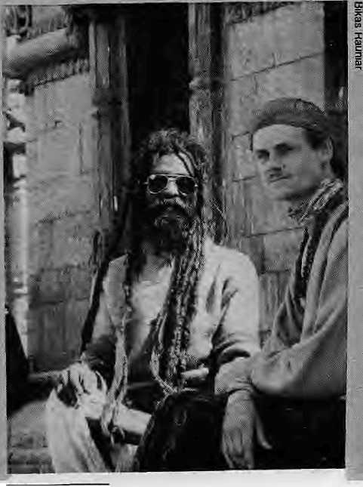

I
s life in the Himalaya oil a spiritually higher plane than it is in the rest of the world? Even, jf it is not, does it do any harm if people across the oceans think of our mountains and its people as somehow exalted? instead of pointing to the material poverty which forms a counterfoil to the Himalaya's perceived: romance, should we just turn up die hype if that will bring more foreign-exchange-laderL tourists? How can it hurt if others fantasize about the unremarkable and sometimes harsh living up in Tibet's beleaguered plains, SCathmandu's gullies, the deep gorges of Bhutan, or the extremes of climate in Ladakh's high desert?
■
These are questions that have yet to be considered seriously in a region where the focus has been either on willy-nilly maximising tourism income (as in Nepal) or protecting one's heritage while maximising tourist income (Bhutan), The impact of perceived exoticism on the host popuiadon is a murky area that has been neglected so far by sociologists and psychologists. Perhaps there is nothing intrinsically superior about this place.
Mostly, Himalayans like to bask in the world's overwhelming admiration of their region. If it doesn't bring tangible benefits, there would seem to be psychological rewards. And yet, it is bound to hurt somewhere, sometime* in some way, when people begin to believe an outsider's well-meaning fantasy. It has been said that members of the Third World intelligentsia are all sudkers for what the sdheb says and does: we follow his scholarship and also his myth-making. In the particular instance, do we tend to internalize what others perceive is our allure and glamour, just as discriminated minorities in developed countries internalize negative images of themselves? The saheb, of course, will go back to Kansas, Kensington or Kew, but We have to descend from the borrowed clouds and return to the squelch of out marketplaces.
HIGH ALTITUDE WOOLINESS
The ancient fascination with the Himalaya is understandable and obvious. The religious and spiritual myths of the Indo-Gangetic plains people and of the Tibetans thai were associated with these mountains emerged during eras when the mysteries of nature and geography were overwhelming — and a Shambhala, a Mem or an Olmolungt-ing was essential to an ordering of one's cosmos. The modem world, with its scientific faculties and inherited and developed logical methods, should be able to take a broader view.
Exotic and "cool"
Whereas Himalayan mountain tops used to be regarded as sacred, today these same summits have been trampled under mountaineers' boots and crampons, and "defiled" by expedition refuse, national flags, ropes, pitons and even an occasional bust of Chairman Mao. So what is one to make of Himalayan exoticism? Can the same mountain mysticism that developed in isolation and amidst
The response of some to such "positivjst" arguments tends to be an exasperated sigh, followed by the admonition: 'Teh, Teh, don't make die same mistakes we did. Do try to maintain your mystic beliefs: they are really so nice." Bursting a few bubble?, it might be in order to point out that socio-economic realities drive the hsrhan mind, even in the Himalaya. The Tibetan who craves a time-piece is as much a materialist as the tourist pondering whether to unstrap Jus wafch and hand it over in order to accrue some dbarma points, Himalayan materialism is m full display at Chungking Mansion, the Hong Kong marketplace where Nepalis flying in on Royal Nepal Airlines' "Porter Express" congregate to buy up the island".; A Sony Walkman is a Sony Walkman in Taip perhaps more so in Lhasa or Ladakh.
STANDING TALL
Perhaps the mountains inspire simply because they stand up while the plains lie down, and there is nothing more to it Eh an that. But surely it isnot this purely geophysical distinction that leads to the "higher thinking" among highlanders? Some do not doubt that it does. One commentator insisted that "Tibet is a land so close to the sky that the natural inclination of her people is to pray." A Buddhist scholar wrote in l£51 that: 'The physica! conditions of Tibet lend themselves to religious thinking, The great spaces, the height of the mountain ranges which surround them, the rarefied air...the silence where men are scarce wildlife is rarer still, all lend themselves to introverted thought..."
But if mysticism is a journey into the self, aren'trnountains just p Why shouldn't the blazing summer heat of Miizzarfarptti be just as i ducive to spiritual fulfillment as the numbing cold of Gangoiri?
it be that, there is nothing intrinsically
holy about the Himalaya and that they
are glorified only because they are "dif-
ferent:" unexplored, mysterious and
mostly under-populated? If Kipling
never made it to Kathmandu in spite of
singing its odes, is it possibie that
Kalidasa, too, was writing of the eternal
snows, sight unseen, when he wrote
about the "King of Mountains,
Himalaya" in his epic
Kumarasambhava7
Of course, not ail observers, Western or otherwise, accept the hyperbole and romantic simplification, glorification and distortion. There are those who try to understand the Himalaya for what it is, to empathize with its humanity, and to study its cultural institutions in their own terms without an overlay of expectations. And there are even a few "realists" who profess 10 know that life in the Himalaya is just as pedestrian as anywhere else in the world. Some of them are decidedly negative about the Himalaya, or parts thereof. One such is Eliot Weinburger, an American writer who took a particularly jaundiced view of Tibet in an article that appeared in the April 1980 issue, of the journal The
Jan/Peb 1990 • HIMAL 7


Nation. Under the title "Dhanria Demagogy," he wrote: "Because we don't know, because we like to imagine anot}ier civilization as wiser than this pale and plastic swamp, we have invented a spiritual paradise in the Himalaya: a Shangri-La of other-worldliness, of ciianang, meditation, telepathy, astral projection. But the true history of Tibet is as violent and depressing as anywhere else. The continual rise and fall of waiting, monasteries arid sects, each connected with anoble family; the forging and breaking o£ alliances; endless vendettas; holy squanderers supported by a miserable majority of landless sef£s■■>.-' and a Few great teachers struggling against the worldly excesses of their contemporaries." Which Westerner was closer to the truth: Weinburger or James Hilton?
ORIENTALISM & HIMALAYAN KITSCH
Himalayan mythologizing is but one branch of "the larger "discipline" of "Orientalism" — the study of or fascination with everything east of Europe. The Occident after all, has always romanticized the Orient. Edward Said, the Arab-American man of tetters, goes as far as to claim tot "The Orient was alinost a European invention, and had been since antiquity a place of romance,, exotic beings, haunting memories and landscapes, remarkable experiences." This "seductive degradation of knowledge continues to this day," says Said.
In 1975, the Asia Society in New York conducted a study ofhow Asia was depicted in American textbooks. The Society found that the textbooks were full of condescending tefrris such as "the friendly, fun-loving Filipinos" and "happy, gentle Thais." The suggestion was that Asians were childlike and "in need of guidance, if not domination."
The Asians themselves participate in stereotyping the Orient, and are often quite chauvinistic in their views of themselves, their mountains, or their continent. As Said has stated, "The modern Orient participates in its Orientalizing."
Among Himalayan scholars, there is an unscientific tendency to take the "inherent holiness" of the Himalaya for granted. Take Ecology, Economy and Religion of Himalayas (1986, Orient Publications), an otherwise serious book on the socio-economic pressures in today's Indian Himalaya, Many contributors get carried away in singing simplistic praise of Ihe Himalaya even when they are presenting social-scientific papers. How does one react when a Calcutta University anthropologist ; that, "From the long hoary past the towering majestic Himalayas
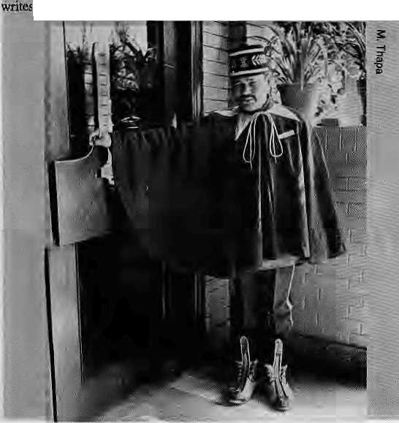
Offer ah awe-inspiring attractive and scenic beautyY that have drawn 1o-its bosoni millions and miHionE of people of varied interests and needs,, from age to age," A work on mountain-to-plains migration begins with,"Once an abode of £3ods, the eight hill districts of Uttar Pradesh are today a land of mass exodus." To begin a sociological study with the pretnlse that mountains" used to be inhabited by gods is perhaps s&etching the very oMet limits of social science.
WHERE DOES IT HURT?
While the pragmatic use Of Himalayan mythology and perceived exoticism might be a smart idea, especially for increasing tourism income, there- is a fine line between peddling romance and imbibing it as die rightful Himalayan state of being, lit the latter case, could there be pos_{r} sible social, psychological - and even political - dangers?
Upon finding that American textbooks characterized Asians as inscrutable and'exotic, the Asia Society concluded that "presenting Asia as exotic also fails to reflect the full humanity of its people by making them seem alien." However, it does nbt stop there. While Western perceptions of the East have been well studied, the East's reaction to such perception has hardly been delved into.
Some might consider it harmless that the whole world comes to regard die Himalaya as a romantic wonderland where the people maich to the beat of a mystical, drummer* But it becomes worrisome if the population of the Himalaya, educated or not, the rulers and the ruled alike, sfc internalizing the idea of their own other-worldliness.
The power of the West to define the Bast is even more evident at the non^acadernic leveL A once-every-mree-year cursory report in Tiftiz magazine will be ascribed rhore authenticity and wisdom than the work of alifelong writer in a local weekly. You snuggle up to the image thst has been created for you. A Sherpa gets stuck in his role as "high air tittide porter" while an equally adept Tamang might never aspire to be an expedition sardar — all because the sakeh has said it shall be so.
It is a mark of their own failing that third world elites often have their culture defined for them by western anthropologists or political scientists, they then pass this understanding, or its ramifications, to the rest of society. Indigenous scholarship in South Asia is probably at its weakest in die Himalayan region, so that Western definitions lend to be those accepted.
Siddiq Wahid; a Ladakhi divinity scholar, maintains that the claim by outside scholars that Ladakh is primarily a Buddhist society became so insistent that it brought rifts within Hjadakhi society (see Himal Sep/Oct '89). Animus was aroused as Ladakhis perceived themselves as Muslim and Buddhist, rather than as Ladakhis who evolved a culture in a shared environment. While Ladakh's Tibetan Buddhism was tanta-lizingly novel to scholars, Islam was - ho-hum - why? Because it extended all the way from Turkey eastward!
DEVELOPMENT OUT OF FOCUS
The fascination with Buddhist cultures is perhaps one reason \ forest dwelling communities of the Assam Himalaya are not regarded as romantiealty as, say, Ladakhis, Sherpas or Tibetans. The scholarly and popular focus on exotic pockets of the high-Himalaya might even have affected development emphasis and aid giving. Could this partly explain why some highland communities are coddled while others—such as the southern rim of Kathmandu Valley, the mountain monotony of farrWest Nepal, or parts of the Nepali Terai — today suffer in neglect?
The point is confirmed by American political scientist Linda Richter, who writes, "Aid tends to flow disproportionately to nations with high tourist arrivals as compared to other countries of similar size Mid political importance." Which leads to the question; Not considering for a

8 HIMAL ■ Jan/Feb 1990

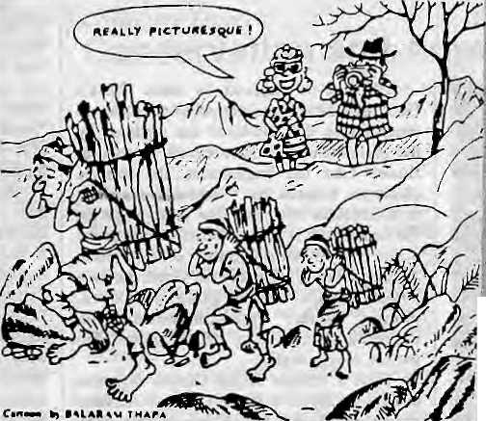
moment the geo-political factors that make Nepal the foreign aid recipient par excellence, would it receive the same amount of external assistance it does today if it werelocatedas an independent country, say bordering JEtfltar and Madhya Pradesh to the south?
Li¹ the early i9SOs, Bhutan suddenly became the darling of the mternation-..&$ development set. Thimphu, it seemed, could do no wrong: its .'■ development priorities were right, the people were enigmatic yet charming, the Government was firm yet benevolent Thimphu's policies'were-.. compared to Kaihmandu's and con^ sistently given higher grades. Bhutan was said to have "learned from Nepal's mislakfes."
While some of this is doubtless true, lias the craving for forbidden ex:-
oticism once again clouded judgement? The foreign analysts might have
overlooked that Bhutan was an easier country to "manage," with only
three major communities in contrast to Nepal's cacophony of voices. Li
extolling the present, they might have failed to peer into the future, and
the conflicts that inevitably he ahead as "modernity" seeps in, much as
they did in Nepal and elsewhere. As a DANIDA (Denmark's aid agency)
brochure cautions, modern development in Bhutan has ''given rise to a«.
certain tendency towards social polarization" and that "such unbalanced
development might lead to the growth of new, dissatisfied social
groups." ' ■ . .-■'-.. ■" -..■. \- ■■■.' -."".
Those who would put the Himalaya on a mystical pedestal believe that
the region is above the animosity and violerroe that mars other parts of
the world and South Asiai "Die Himalaya is different," we are
reminded; or we reassure ourselves "ft can never-happen in NepaL"
Belief in such utopianism may be one reason why, while we bask in a
false idyll, urgent tasks of socio- economic: develbpinent are left un^
'finished and why the pressing agenda for equity and integration is
neglected. Going hack over the tourist brochures and eveir the eth^
fiographic literature of the past, one finds that the same Poliyainaisb im
ages were attached to Kampuchea and Sri Lanka as- are today'toNepal
or Bhutan: gentle peoples, hospitable, in tune with.theirenvironment.
"CSi, it can't happen here", they said, until it did "
ANTHROPOLOGIST'S DELIGHT
Can misrepresentation of a culture -.- even by glorifying it — do violence
to its people? Why, foT example, are the Saraoahs angry at Margaret
.Mead? ' ' . ''..;" -.'. ±K.:l.
i 1926, as an anthropqlpgy student in her mid-tWenties_{f} J teSouthera Pacific island of Western Samoa. She studied a group of SO: adolescent girls for a few rrionths and emerged With the book Com-ing of Age in Samoa, which was immsdM^Iy canonized and has since idwioTied Samoa as idealized islands where every person was well ad^ justed, sex was free, and worries were lirniied to who would .roast the day's communal pig. The Samoans resisted this pigeon-hole they had been forced into hut no one seemed to listen. Such was the pO'wer of a young American anthropologist; what she wrote, true or false, defined a society for the rest of the world. Only in the last five years have serious questions been raised about the believabmty of M^d's findings.
■ ;:.a?riv«difl i0O.p-s^m"$anoes--a& heroic migration from Polynesia. They also believe; in a supreme being knpwri as lo. According to a 20 February "ar-
Jjcle-iii Jte New York tif^es, these Maori beliefs were ^{l}'rnore an inyerrttoji of Eiirapeah anthrppbtogisis than -..'aft authentic heritage." ironically,- the Maoris how accept this created "tradi^ tioti^ as historical fact and .angrily resist any revisionist assaults an it by anthropologists. Reporting what it calk this "scholarly echo" of colonisafen With a twist,"- the newspaper states*-
"The -Maoris argue \ d^t : OTithTopblogists ;may have created, and imposed this- culture but it is .their?
oiow. They are proud of it, and so,: them believe what they Want to."
Ball's exjierience prtesentS' anothCT-est-ample of" how outsiders' preconceji-aons -can ^Ene■■.:a land, Touristic Ior6 salutes tfris supposed ^{lf}tropi^d ShajigH:La>" but ui doing so merely "succeeds in ddiumaniang its society. The islaiid is Only "superficially" serene," says James A- BpQHj who "has tried tqde-" mytShblogizs uie island in his book The. AtuhrbpoidgiealBjorf^^PQfBali-^xioTi points outthat the foreigner's Irnfige does not deal with^ the reality that Bali is "over-populated, under-
Lilce the South Sea is-tes, Bali, or Papua New Guinea, the Himalaya also is an anthropologist's mecca, with people to "discover, ' practices to.study and to report". Because of restrictions tm Tesearch-! Tihev Bhutan and much of India, Westerit iuittjropologists have over* Nepal. Initial studies of Himalayan fcornmuriities tended to be quick i ciirsbry, while diere is today increasingfy serious study and aiet understanding of tile deeper realities of Himalayan living. And yet qu a few come for the; sheer novel^ of it; such as the anthropologist couple who "were: -capfivaoed, by the aiea of doing field Work in" an exotic society thousands of miles a,way from Los Artgeles..Jv(epa seeftjed-an ideal place for us to Eye out ourfantMi^"
?\Vhere even social scientists come to. live out their fantasies, who deny: the tourist his or her few days in $hangri-La?
THE ^OtTOM TIJRTLE
The need to perceive anothea¹ land, another peoplej as having attributi that are almost-exlra-|errestrial arid extra-^iuman is present in every society. The exoticism and Utopian myths surjoundmg the Himalayas only among fei most elaborate.
There ^nothing ihhwartly wrong iri fantasy, especially if it t p^e-o&rnihd-'and mejual weil-being- to the berkver, There is als° nothmg wrmg in file fantasy as long as the subject-people use it to: advantage without actually btiyirig into it. Th^ outsider might want Jo read romar^e, mystery, ertjgrria behind every rifuai, every gesture and every glance. For the native, it might be life as usuai
The perspective of Ae viewef and Eh^ viewed is captured to ail anecdote rela^dty anthropologist iQiffprd. Geertz in his book, The Inierpretafiim of Cultures i an Englishman, when told that the world rests on a plat-forrn on the iacK; of an elephant which rests in turn on the back of a turtle, asked the native what didtiie turtle rest on?

Like the Samoans, the Maoris of New: Zealand too have had- their Came thereply, "Ah. sahfb, after that it is tunles all the way down"
image manipulated by outsiders* The .Maorishelievei thatfheir ineestpi^ . * V .... ..... .....V .. ... .,-..-,::"
jan/Feb 1990 • HIMAL 9

AyoGorkhali!
The days when the Khukuri defended one's own soil have long been past for Nepalis. Since eaily 1800s, the Khukuri has served in the battlefield for others. In fact, the very notion of "being (rue to one's salt" ("noon ko sidha") has elements, not of glory, but of submissiveness. The near- mercenary status of fighting another's war (with official sanction) is also not necessarily edifying. But most people seem to readily agree with Prince Charles (Colonel-in-Chief of the 2 Gorkha Rifle, now a part of the British army) that "the very name 'Gurkha' is a byword for courage and steadfastness."
The connection between the Gurkha myth and the Himalayan "Shangri-La" myth comes full circle when Sandro Tucci, a weil-known international photographer, writes in the introduction to his glossy coffee-table book on the highland soldiers, "The Gurkhas are proud sons of a blessed land, where the mountains and the flowers, the rivers and the scents, all seem to talk an eternal language of beauty and peace."
All that is required to burst Tucci's Gorkhali bubble is to descend to the plains to observe how the "Gorkhas" are regarded by the plainsmen from Bombay to Baraelli to Buxar. Like the Englishman, the average plainsman believes that "Gorkha" is the name of a ferocious hill tribe. The myth might be the same, but it is put to a different use. In the plains, the mythical prowess of this proud martial Tace is pressed not into glorious military service, but into guarding godowns, escorting "saheb's" children to school, standing by the gate, or doing "raman" (rounds) in the hot, muggy night.
Such a critique of the Gurkha mystique does not suggest that all Gurkha battalions should be disbanded. It is merely part of an attempt to understand, through the murk of myth, the phenomenon in socio-economic terms - why young hillmen leave farm and family for years in "lahur" or, lately, find employment as darbans (home or office guards) in lowland cities.
The myth of Gurkha invincibility is belied by their graves in the battlefields of Gallipoli and Tobruk. The myth of fearlessness tends to deny the humanity of the Nepali soldier. How can one refuse him the same right to fear the bullet as every other soldier, and the right to "better judgement" when the moment comes to decide whether a suicidal assault on a well-fortified bunker is worth it?
Among the mass of Gurkha literature,
there are a few that attest to the humanness of
the Rai, Limbu, Gurung or Tamang. One is
Even the Brave Falter, by E.D. Smith, an
Englishman who commanded Gurkhas in Italy
during World War II. Smith agrees that the
"cheerful, gallant Gurkhas" have attracted
countless admirers. "Nevertheless," he writes
with some understatement, "the picture
presented to the world has been a trifle un
balanced, as if all the tough soldiers from
Nepal were supermen...while many lived up to
their motto, many others have faltered when
faced with death in battle." Which is as it
should be for a people who are as sane and as
human as any other. IN.
-KMD

Grotesque Lands:
What Earlier Visitors Saw
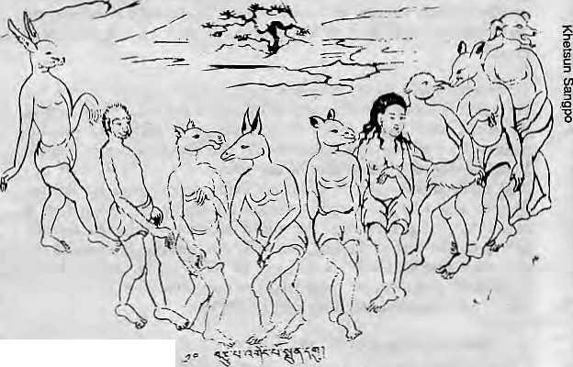
Before it became "Shangri-La" to the world, it seems, the Himalaya was the land of the grotesque. The earliest Western descriptions of the Himalayan region are, to say the least, unsatisfactory from an ethnographic point of view. Herodotus, the Greek historian of 5th Century B.C., thus described the goings-on in the Tibetan desert:
"Great ants in size somewhat less than dogs, but bigger than foxes throw up sand heaps full of gold as they burrow. A warlike tribe north of all other Indians tries to steal it by filling their bags with sand and riding away at their best speed. Then the ants rush forth in pursuit..if it were-not that the Indians get a start while the ants are mustering, not a single gold gatherer would escape."
Only a little less bizzare, the Chinese Buddhist monk Hsuan-Tsang in the mid 7th Century made the following "report" on Nepal:
"The climate is icy cold, the manners of the people are false and perfidious. Their temperament is hard and fierce, with little Tegard to truth or honor. They do not know the value of time and justice, and have not learning, but they are much skilled in the arts. Their body is awkward, and their appearance is ungainly and revolting."
Of the Kashmiris, Hiuen Tsang reported that "they are light and frivolous, and of a weak, pusillanimous disposition."

first account
The
European
of Nepal comes
from a Capuchin
monk, Father
Greuber. In 1661, he passed through Tibet and Nepal on his way back from China to Europe via India. More than a little disoriented, this is what the priest had to say:
"There is another custom in this country of monstrous cruelty. If a sick man is near to death and no further hope of his living is entertained, they take him outside away from his house into the fields, and there throw him into a ditch already full of dying men. He there remains exposed to the inclemencies of the weather, without consolations of religion nor pity they leave him to die; afterwards his corpse is given to birds of prey, wolves.dogs, and other similar beasts to eat. They are convinced that the only monument of a glorious death is to find a resting place in the belly of living animals."
Next, the itinerant Father sets his sights on the fairer sex:

"The women of this country are so ugly that they resemble rather devils than human beings. It is actually true that from a religious scruple they never wash themselves with water but with an oil of a very unpleasant smell. Let us add that they themselves are not pleasanter, and with the addition of this oil one would not say that they were human beings, but ghouls."
It must have been upon Teading "eth
nographic literature" such as this that Sylvain
Levi, one of the most famous observers to
visit Nepal in the 20th century, noted that
"science gained almost as little as religion"
from the 60 years presence of the Capuchin
monks in the Himalayas. They apparently suc
ceeded in converting no one. \

10 HIMAL • Jan/Feb 1990


VIEWPOINT
is This Shangri-La? Why Not.
by Kiniey Dorje
S
hangri-La...the perfect realm, shrouded in profound mysticism...
visions of sacred monasteries, fluttering prayer-flags, maroanrclad
rcfonks in meditative chants.,, up among lofty snow-clad peaks deep in
the Himalaya. :.
To a Bhutanese, the notion has been a source of much pride, disappointment, realisation and, perhaps, serious thought. While I have neither heard the subject discussed in Bhutan, nor "Shangri-La" mentioned, except by an occasional tourist, I have been bombarded by it elsewhere. "Wow, you're from Shangri-La?" "How is it in Shangri-La?" "Is it really Shangri-La?" The more academic ones want to compare Bhutan to James Hilton's Lost Horizon.
Well... Who knows?
About eight years ago, as an overseas student in Australia, I addressed a group of businessmen. I spoke in a general way about Bhutan- her geographical situation, and her people, a little history, some culture and religion. After my talk, one man questioned me: "How will you adjust at home after all these years of "luxury"?
I told him we had differing views about luxury. To him nice homes, cars, central heating, automated household appliances and physical conveniences were all that mattered. In my country, many people are not familiar with a lock and key, as they have no need to lock up, People venture out alone at night, they are generally content as very little importance is given to monetary matters. The air is free of pollution. That, to me, was true luxury.
Looking back, I am a little surprised, even today, by my spontaneous response that evening. Was it an indignant outburst of patriotism from a Bhutanese youth or a genuine emotional response that bespoke values that a Buddhist upbringing had nurtured in me? I do not know.
arrived with, new ideas ranging- 1 from Russia to establishing telephone arid facsimile links with New York through satellite, Shangri-La, seemed only surface deep. At first all our traditional ways seemed wiong, arid traditional values began to suf-fer; Twenty years of exposure brought drasticchanges: traditional robes gave; way lo faded denim, warm woolens to synthetic fabric, indigenous games to Kung Fu movies, and our language to Western slang.

Bhutan pulled her reins in 1987, She placed new emphasis on preserving traditions and: culture, Development became a more cautious-process with priorities to forg« a unique; national identity for die people...
But I have digressed.
On a recent visit to remote parts of eastern Bhutan, I met a Western couple who were about to leave the counoy as the husband had completed three years as a consultant in agricultural research. In the last days, the villagers had been coming in to bid farewell. On iheir last morning an old lady came to say goodbye. She had walked along way and had brought them all she could afford: two tomatoes. 'TTiese poor farmers," they said, visibly moved, "are the most wonderful people have ever met."
It is always fun to travel in the remote villages of Bhutan. It is also a learning experience. These villagers who have never been to school, and have travelled little, represent a civilization that is not taught in the classrooms. It makes yow happy to meet a person for the fust time ever who will take out a grimy piece of yak cheese and offer it in a gesture of friendship. Fortunately, jt is these "real people" that make up most of Bhutan.

In these desperately poor villages, the doors are always open. People will share everything they have. The last lump of cheese, the last bowl of rice, and the last strip of dried meat is offered first to the visitor or "guest," And everyone is a welcome guest. Perhaps this is religion in its purest form.
Could this, then, be the feal Shangri-La? Kiniey Dorje is a jotrrnaiist in Bhutan

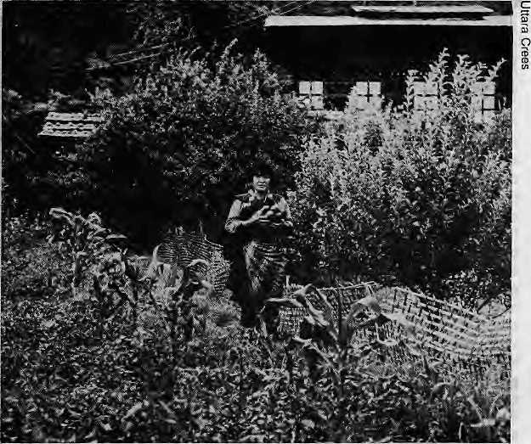
Until the early 1960's Bhutan may have indeed been the last Shangri-La. Before it emerged from its zealously gathered isolation, very few outsiders had seen the "forbidden kingdom." When the kingdom launched itself into the development process 25 years ago, it was one of the last countries to tread the path of modernisation.
Bhulanese, particularly the youth, who ventured out to be worldly wise found a world that seemed to be just beginning to value the traditional and the unchanged. The outside was looking for peace, which for us was still a natural way of'life;, My parents and my neighbours did not even know that two World Wars had been fought, so innocent were we of the outside.
Suddenly we were the lucky ones. For the young everywhere, it was trendy to be from Bhutan, for the elders, it was a geographical find, and for the development process which was taking over, it was a new baby. AH these despite the inconveniences facing the Bhutanese traveller. Many airport authorities did not recognize out passports, never having heard of Bhutan; post offices sent back our mail; our driving licenses were not accepted; and often people did not know quite how to react or what to talk about with us because they had no idea where we came from.
Then the confusion began. When the armies of "development ex-

Bhutan may have indeed been the last Shangri-La.
Jan/Feb 1990
H1MAL 11


The Carpetbaggers
H
imalayan exoticism has turned out to be an economic commodity, and not just for those who live here. All kinds of Western (the term including Japanese) professionals continue 10 make hay under Himalayan sunshine — tour-guides, filmmakers, photographers, novelists and political scientists.
Even spies have found employment by virtue of the mysteries — mystical or otherwise ~ of the Himalaya. After all, the venerable Indian pundits who infiltrated Tibet in service of the Raj were not following the footsteps of Padmasambhava, the Indian sage who brought Buddhism to Tibet. And doubtless, the shenanigans of the KGB, the CIA and other services continue to provide employment in the Himalaya. Kalimpong used to be the unchallenged hotbed of international sleuths right up to the 1950s. And remember the American " mountaineers "who set up a nuclear-powered observation unit on top of Nanda Devi to monitor Chinese activities in Lop Nor?
Speaking of using Himalayan mythology to advantage, there is also the story that around the turn of the century, at the heigh: of the "Great Game" to secure dominance over Central Asia, a Siberian lama tried to convince the thirteenth Dalai Lama to side with the Czar against the British, using the argument that Russia, being north of Tibet, was the true Shambhala of Tibetan myth.
It is undeniably true that many foreigners, particularly scholars, come to study and to empathize. Quite a few have a genuine regard for the Himalayan people and the challenges they face. In fact, some Western social scientists know more about Nepali communities and traditions than their colleagues in Tribhuvan University. But then there are always the "carpetbaggers."
Even among Western academics, there are those who use Nepal solely to get on the tenure track in universities, never to look back at the communities they studied. There are the photographers out to catch Himalayan exoticism before it goes out of fashion. These lensmen prowl the by lanes of Kathmandu and are engaged in cut-tliroat competition to get into glossy magazines like Geo and the National Geographic. They routinely disturb intricate rituals with strobe lights, or use telephotos on unwary women at Pashupati's bathing ghats. Or they steal each other's picture ideas in a mad rush to come out with the first coffee-table book, say, on Dolpo or Mustang or some place
so forbidden by the Government that it cannot even be named in the text. There are, certainly, scholars and photographers who have a feeling for the place and keep coming back Ui friends and community, but such individuals rarely gel published or tenure.
Pulp novelists have discovered Shangri-La. The number of spy thrillers that send their protagonists up the Himalaya is on the increase. Actually, the lieros and villains invariably seem to head up the Kali Gandaki gorge. The exoticism that attracts them there includes the natural wonder of the deepest gorge in the world. Mustang's walled township, and the possibility of infiltrating Tibet to the north. Two recent best-sellers use these motifs to the full. In Shelkagar^ by Harold King, a daring American heiress, a Russian aristocrat and a reckless Englishman arrive in search of a huge Tibetan diamond which many centuries before had jinxed Alexander the Great's Indian campaign. Another novel, All the Grey Cats, by Craig Thomas, is the unlikely story of a Russian plot "to seek to determine the future of Nepal," whose denouement is an attempted airborne invasion which ends in fiery disaster on the tarmac of the Tribhuvan international Airport, Both books take extensive detours through the upper Kali Gandaki Valley.
International do-gooders flock to the Nepal Himalaya as they do nowhere else - to
build cheese factories, organize environmental symposia, electrify monasteries and set up integrated hill development projects. Bhutan is also an increasing attraction. If they had full access, surely development agencies and "development persons" (for want of a better word) would overrun the Indian Himalaya and Tibet as well with theiT benevolence. It is a fair guess why those that rush to open schools and health clinics in the high valleys do not show the same "help thy neighbour" attitude for the Terai population.
One American, who helped bring hydroelectric power to a Sherpa monastery, was still distributing a self-glorify ing article about his role in the project months after the monastery itself had been reduced to ashes. In some instances, it is clear, aid to the Himalaya is a response to its exoticism and an.attempt 10 link one's name to that exoticism, often for profit - rather than a genuine regard for the place and the people.
The latest in the line of western experts to succumb to Himalayan charms may have been the environmentalists. If you believe that the Himalayan ecosystem is pristine and that there is total harmony between man and nature in these mountains, then it becomes so much easier to believe that the man-environment "balance" is about to collapse horrendously, wreaking starvation in the hills, floods in the plains and islands made up of Himalayan soil arising in the Indian Ocean. Carried away by this vision of absolute horror soon to be visited upon Shangri-La, some think that Nepali hills and dales will be transformed into a highland desert by the turn of the century, never mind the monsoon rains. While the ongoing environmental dislocation in the Himalaya is sadly all too true, exaggerations and unscientific claims that emerge from those who are expiating their own demons might do more harm than good in the long run.
Smitten by the same well-meaning regard for the Himalaya, some local experts also tend to get carried away by ecological simplicisms. Take this Indian environmentalist's prose: "The Highlanders and the 'Sons of the Himalaya' have now awakened to the reality that the Himalayas are the repositories of India's physical resources (plant, soil, water) and they must guard against the robber's economy rather zealously."
The imagery of the Himalaya as
the annadata (provider) of the Sub-
Continent occurs again and again in In
dian environmental writing. At times, it
seems that every natural resource of the
Indo-Gangetic basir. derives entirely
from the hills: the water, the topsoil,
the air, the weather... /\
-KMD

12 HIMAL • Jan/Fcb 1990

The East on the Exotic East
by Yeshi Wangdi
E
the Japanese are at all aware of the hangri-la image of the Himalayan countries, in all likelihood they got it from the West.
"We are also from the Orient, which the West sees as exotic. We don't have the same romantic idea of Nepal," said Takashi Miyahara, a Japanese who has lived in Nepal for 24 years. He first came to climb in 1962, then returned four years later to work as a consultant, and is presently chairman of a hotel in Kathmandu, the famous Bverestview Hotel up in Khumbu, and a trekking agency.
Yet what made Miyahara return after his climb of Mukti Hima], behind Dhaulagiri, was the discovery of "Tohgenkyo," a word of Chinese origin, which comes closest to the notion of Shangri-La. The difference is that Toh^ genkyo, which accolades a pristine scene of plum blossoms with mountains all around, really refers to a specific instance or site of beauty, whereas Shangri-la is a notion of a way of life imbued with an elevated sense of o ther- worldliness.
If stretched, Tohgenkyo can mean a "fairyland," said Miyahara, but clearly, the Japanese do not have a specific region in mind as qualifying. Thus Miyahara cites particular sites - Ghorapani, Lang tang, Syangboche (where his famous but presently inoperative hotel is located), and Hunza in the Gilgit -that, to him, are examples of Tohgenkyo.
To a question about Kathmandu and Shangri-la, Miyahara answers: "With jets and all that now, how can there be a Shangri-La?" Miyahara views his new home with soberness.
perhaps because it is home, though he adds that the Japanese are drawn to Nepal because of its mountains - "which are heights and holy places to us, too " - and the people - "very gentle and good people."
Japan, after all, was an intensely insulated society right till the pre-modern Meiji Period, when the Japanese first became aware of the Himalaya. Then in 1936 there was a Japanese expedition to Nandakot in India, It was only after World War II, however, with their new-won affluence, that they began to travel out.
Par from having romantic notions, the Japanese tend to view places like Tibet as cold and harsh, according to Miyahara. They are keenly conscious of the fact that the countries here are not economically developed even though there are many who are clearly not deterred by that. About 13,000 Japanese come to Nepal annually, many of them several times.
The word "exotic" may be as foreign to the Japanese as the particularly Western allure of the exotic rooted in a desire for fantasy, adventure or a projection that is more to do with personal yearning than what is out there. It may also be that the Japanese are by and large content with their own unique identity, a self-preoccupation, along with a fear of the unfamiliar, that often inhibits venturing into other worlds.
For example, a Nepali travel agency about to receive several charters of Japanese travellers was instructed by the Japanese operator to remember two things: comfort and security.
This absence of a romantic taint in their outlook perhaps leads Japanese to look on the less developed, mostly non-Western - that is,
the exotic - cultures in the light of dieir material backwardness - and to place them in awe of the robustness of Western affluence in spite of Japan's emergence as an economic power.
For instance, Yoshida Rucko, who travelled alone in India, was so taken aback by the unfamiliar and disturbing scenes of beggars, the smells, and her "delhi-belly" that she ended up not venturing beyond a 10-metre radius of her hotel. Mr. Narita, 78, of Nagoya, on the other hand, feels "fulfilled" because he was able to make a pilgrimage to the Himalaya on his first and only trip abroad. His photographs, however, reveal a disproportionate number of angles on poverty.
In contrast to Westerners, many of whom are nagged by their own presumed unexotic-ness, the Japanese seem to be deeply interested and preoccupied by how foreigners perceive them, and do not mind being reminded of how unique or exotic their compulsions appear to others.
This self-occupation is evident in a recent TV documentary series on a team of Japanese journalists' visit to rural Africa. Rather than depict cultural aspects of the host countries, they chose to highlight what sometimes seems to have become a Japanese mission of introducing baseball (a popular Japanese sport) in the backwoods. In doing so, are the Japanese trying to show that they are not exotic? Are they, in adopting this quintessential aspect of Americana, running away from their own sense of their exoticness?
When the Japanese come to the Himalaya,
they do not come to find any kind of a fairy
land but perhaps to get away from the conges
tion of their cities and to breathe some fresh
and rarified air, N
Yeshi Wangdi is a Tibetan studying Japanese in Nagoya,

Habit OfHatago Lodge
In the lodge, it is the habit of counting by yourself of your eating and drinking. In case of a party, please count and pay each bills, the leader of the party to the master ofHatago, after the dinner. As we regret deeply a few guests who ran away without paying their bills, unseen in the early dawn, in spite of advanced nations in Europe and America by birth, coming to this beauty scene with poor, difficult life-surrounding. After dinner we shut the door of the restaurant at 7:30 pm. because our labour must get up early in the morning. Pardon us.
From a sign in a lodge in the Khumbu run by a Japanese who has lived there for 15 years.
Jan/Feb 1990 • HIMAL 13

REVIEW

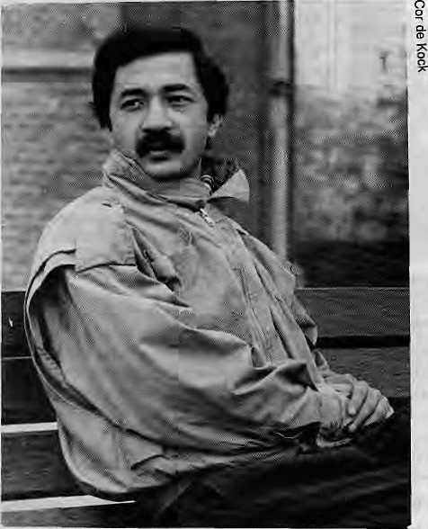
Nice Weather, Mr. Pradhan
Roles Reversed In Schoonerwoerd
Director: Hans Heijnen
Distributors: Coe Film Associates, New York
1988 (30 minutes)
Review by David Sassoon
C
lassic Hollywood jungle movies, in which white criminals and heroes match wits in an exotic setting, all have at least one scene in common. When the white man enters the jungle of darkest Africa, the drums start pounding in warning, and soon everyone in the jungle is aware of the trespass.
Rajendra Pradhan, an anthropologist from Nepal, in his real life had the experience of being such a trespasser. It happened not in Africa, but in Holland, as he set about studying the 1,500 elderly, conservative, Calvinist inhabitants of an orderly Dutch village named Schoonerwoerd.
Anthropologist Pradhan-. a "dark stranger." 14 HIMAL • Jan/Feb 1990
From the moment he arrived, the people of Schoonerwoerd were confronted for the first time with a true stranger in their midst. And they set about, in their own way, beating their drums. The first difficulty they faced was Pradhan's colour, and most concluded that he was not black but "dark." They were surprised at how nice a fellow he was, that he could so quickly grasp the difference between Presbyterians and Reformists, that they could talk with him intelligently, that he was clean and
well-behaved. And their collective respojiM; to him was ordered and polite.
For his part, Pradhan had a very lonely time. He was in a place where by his estimation "no one expressed their feelings" and so he never knew what they were thinking or feeling. He was in a place where everything was ordered — social relations, personal emotions, people's homes — vo the degTee that there was hardly any deviation in behaviour. Then one day the Dutch television company --having heard the drums - decided to make a short documentary about the people of Schoonerwoerd and their dark stranger.
What emerged is a curious and charming little film called Nice Weather, Mr. Pradhan, which, to begin with, is of interest because it documents a reversal of expected roles. Nepalis are customarily those who are studied by others, not those who do the studying! And even though the film is not very deep — it was after all made for television — it does manage to raise many issues about anthropology that are worth pondering.
To begin with, Pradhan found himself in a community in which he did not want to live, in a country he did not want to study. Perhaps his predicament was rather extreme, but the loneliness of being a stranger is a fact that all anthropologists will face in the field. In Pradhan's case, he ended up in Schoonerwoerd not out of choice but by default, because the funding granted him for research had certain restrictions. Yel all anthropologists must have at least one moment of wondering how in the world they have ended up where they arc, what they are doing there, and why they should stay. It was very giving and brave of Mr. Pradhan to speak so sincerely in the film about his own difficulties, for they are truthful and illuminating.
Another aspect of Pradhan's experience is similarly central to the anthropologist's experience: being a celebrity. The degree to which Pradhan has become one seems remarkable. His story was broadcast throughout Holland, was featured at the Margaret Mead Film Festival in New York, and is being distributed widely in the United States. But perhaps the attention is not as out of proportion as it appears if we consider some simple arithmetic. Multiply
the attention another anthropologist might receive in an out-of-the-way village by a factor commensurate with the power of available communication technology and you will arrive at the popularity of Nice Weather, Mr. Pradhan.
What is of such compelling interest in this little film? Why does the anthropologist almost invariably become a celebrity? It is that his or her presence forces us to ask who we are. We become more aware that we are being observed, we wonder what it is that is being seen, and we begin to see our own peculiarities. The closed universe we customarily inhabit is punctured by an annoying self-consciousness, and after the anthropologist departs, we are not quite the same people, wheuier we care to admit it or not.
Nice Weather, Mr, Pradhan will take its place in Western society as little more than charming entertainment, but for Western anthropologists, it illustrates how potentially powerful their presence in an alien land can be. If Pradhan was able to attract the attention of so many strangers, it is not farfetched to assume that another antliropologist, in a smaller, more isolated and innocent community, would have more impact on his surroundings.
Pradhan is reportedly at home now working on a book called Dark Stranger in a Dutch Village. It is interesting that he himself figures so largely in the title. Perhaps his present effort will have more to teach us. More important than many pages of finely detailed ethnography may be a description of what it is like to be a stranger. That is a very human concern, and it is because of a sensitivity to it that Nice Weather, Mr. Pradhan succeeds. A
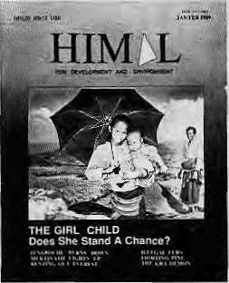
Limited back issues of Himal are available. Write for information to any of the addresses listed on Page 34. Please cite institutional affiliation, if any.
0. Sassoon has worked for UNICEF in Nepal and presently edits a educational tabloid in New York.

REFLECTIONS
Tibet: A State
or a State of Mind?
by Losang Gyatso
T
ibet probably ranks high in many people's list as a place for which they feel a close affinity but know next to nothing about.
For instance, I recently sent a book of old photographs on Tibet to a friend's mother, an American. She told me later that she enjoyed it very much but was disappointed to see one photo of a group of men proudly posing for the camera with swords and firearms at their side, with a picture caption that said, "Tibetan Bandits." She had hoped that Tibet would be the one place where something as mundane as crime didn't exist.
I'm sure dial pictures of European highwaymen or American robbers like Jesse James or Bonnie and Clyde would not have the effect of changing her perception of those countries. But somehow, the unethical and often violent behaviour involved in committing successful banditry was difficult for my friend's mother to assimilate into the niche that Tibet occupied in heT mind And in my experience as a Tibetan who has lived in the West for more than 25 years, the Tibetan niche in the minds of many Westerners is very similarly informed or, in my opinion, ill-informed.
This ubiquitous fantasy of Tibet as a realm where a "beautiful" people live in a transcendental state is more like the perceiver's personal inner yearning than an appreciation of a nation. What's not clear, however, is if tliis view of Tibet springs from a need to believe that somewhere on earth, a place exists where life continues in a blissful state of innocence or whether it is a desire to believe that,Tibetan people live in a perpetual nirvana induced by mental high technology.
The former reason would constitute naive condescension and the latter is for people who believe that all Americans are wealthy and that all Frenchmen are great lovers. In either case, this projection of a fantasy onto Tibet ought to be a private matter between an individual and his or her doctor and distinct from the realities of the country.
Sometime in the future, when the people of Tibet begin running their own affairs, they might adopt a policy of promoting tourism. We may then want to perpetuate the myth of Tibet as the "state of tranquility," much the way the Caribbean islands promote unceasing sunshine or the way the British will have the tourist believe that there's pageantry lurking around every street corner in England.
But in the present geo-political situation, continuing to believe in the myth of Tibet is like pulling the chair from under someone whose neck is already in a noose, because when someone continues to believe in the legend of Shangri La, he is denying the cultural devastation wrought on the land over the last 30 years. He is not believing the killings, the prison camps, nor the levelling of historical institutions.
It is ironic that those who are predisposed to Tibet and feel an affinity with it as a place of great serenity are actually the ones who, in effect, inadvertently deny the suffering of her people. When tourists in Tibet are asked by Tibetans for a photo of the Dalai Lama, please understand that they are not yearning foT a Tibet where everyone lived in a godlike state of bliss. They merely aspire to lead normal human lives in their own country. Even if that freedom includes having Tibetan bandits. At least they'd be robbing Tibetan banks, and if caught would be tried in Tibetan courts and sentenced to Tibetan prisons that served Tibetan food. LGyatso is an art director at a New York advertising agency.
A Mute Girl
On The Mountains
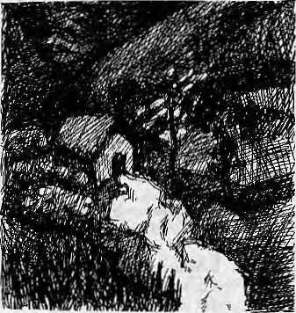
by Howard B. Goldstein
T
he more memorable experiences of life are rarely those we plan for. ^{v}
On a cold overcast day in October 1980, I and five other New Yorkers were trekking along a narrow wrinkle of stone which comprised the trail on the side of the mountain above Kavre, north of Pokhara. It was mid-afternoon. We were anxious to get beyond this exposed elevation as an electrical storm, might appear and endanger us. A cold, light rain began to fall. We stopped for a few minutes in the tight shelter of a projecting rock ledge. The rain began to soak us and we soon heard thunder. We decided to continue to descend as rapidly as the trail would allow, hoping to find refuge at the next village some miles ahead.
The first building we saw was just a few hundred yards ahead of us. It was quite small and had been built partially across a now full rushing stream. Ducking our heads as we passed through the low doorway, we entered a room dimly lit by a few holes left in the wall. There was a narrow wooden deck on the four sides and in the centre was a heavy millstone which we took care not to wet as we crowded into the space. An hour passed while we relaxed and hoped foT an easing of the storm outside. Through the floor we heard the low roar of the swollen stream as it rushed down the incline on which this little grain mill was situated.
Suddenly, a young girl entered pushing the door flap with her head. On her back was a seemingly heavy sack covered by a piece of cloth. Her face was towards the floor and she did not see us until she let the load slip from her back to the floor. In the instant before she looked up, I feared that she might be frightened to find the mill filled by six relatively large foreigners. However, her immediate reaction was a broad amused smile. We greeted with "namaste." She silently pressed her palms together while looking directly at us and continued to smile. Then she was busy. In a quick move, she was outside and under the building. The millstone began to turn and she Teappeared, smiled again, then began to grind her grain.
As she was almost finished with this task another child, a young boy, put his head in and touched her on the arm. His "namaste" to us was uttered with a glance that was filled with questioning and surprise. He made numerous hand gestures to her while speaking softly. She answered in sign language. It was then obvious that she was deaf and mute.
In the years which have passed, we all remember that girl and her spon
taneous warmth and trust. We have thought about the qualities of family
and community which could nurture a child bom with such a handicap
so that her immediate reaction in that situation would have been a calm
ness. Pervasive love and acceptance can be presumed to have been her
general experience. She remains in my mind a positive comment on her
culture. t\
H. B. Goldstein is physician practicing pathology in Nyack, New York.

Jan/Feb 1990 • HIMAL IS

VOICES

[Speech]
WHAT IS - AND ISN'T - A QUALITY TOURIST
From a speech by Toni Hagen at the PATA conference on Adventure Travel held from Jan 28 - Feb 2,1990
T
A he question arises what are "quality tourists," who bring as much money as possible doing the least possible harm to nature and people?
Certainly not all affluent tourists are quality tourists who have the necessary understanding for other cultures and behave properiy. Many (of them) know that one can buy anything with money. Many of them have already "made" and "bought" the whole world and people. And they are looking at their list for what they have not yet "made" or have still to "buy,"
Some countries promote just this kind of tourism by marketing the privacy of their people, religious rituals and sacred ceremonies and whatever else may be sensational for the foreigners with their reckless photographic behaviour. These same tourists generally prefer in their host countries the same food and same drink as at home, and the clever hosts readily comply with those wishes offering in tea shops and lodges Italian pizzas, German sausages, and French bread.
On the opposite side, there are the alternative "soft" tourists. They pretend to understand foreign cultures and try to adapt to local habits. They feel eating local foods, wearing local clothing and being dirty and filthy and showing "alternative" behaviour is adaptation. Nothing is more wrong than this assumption.
[Essay]
ON THE LIBERATION OF MEN
by Greta Rana, a writer, who lives in Kathmandu.
'ne December, descending from Muktinath before the early snows, I walked with a man and his two wives (they were sisters). Their children had accompanied the elders some days earlier. The man, whose name was Yangye, never spoke to me, nor did he speak to his wives in my presence. They carried everything while he strutted ahead like a jaunty turkey cock. Yet, at night, he was the first to Tetire, seemingly exhausted by the day's walk. It was then that his wives came to life, entertaining us with their wit and country wisdom. Just before reaching Pokhara, my destination, I asked, "Do you never speak to your husband the way you speak to us?" In broken Nepali, the youngest answered, "Never! He does not even know us!" From that day on, I have nurtured a compassion for men who do not
know women, who do not know what lives beneath the skin of those who walk life's pathway with them.
It is time to liberate men from the anachronistic ideas of their superiority in terms of gender. To liberate man, we must understand the fall of woman. Why is she dangerous enough to be subdued, relegated to second class?
In the caves of Lascaux, our common ancestors drew a picture of the spirit of a deceased ancestor entering the womb of a woman. They worshipped woman as the mother who mysteriously produced life by providing a home for the spirit of humanity. Ever since the realization dawned that this was not the way a new human comes about, women have been made the "second sex," enslaved, exchanged like cattle, deprived of education and, in the extreme, burned, either as devoitd widows in the Hindu tradition or as witches in the West,
Are women so fearfal? Perhaps. For it is the curse of man to fear that which he does not know and to placate his fears by retreating into myth and ritual.
A pragmatic look at culture reveals that it has throughout the ages provided us with a body of lore and ritual in response to crisis. Let us begin at the level of taboo and examine how far certain taboos (menstrual, natal, etc.) are unique. Splendid examples of taboos and myths that view women as stupid, duplicitous and unchaste (which many still adhere to today) can be found in Hindu lore and also in the Talmud and the Pentateuch, some of which date as far back as the early second millennium B.C.. They thrived and left an indelible impression on Judaeo/Christian thought that was barely cracked open by the destruction and internecine wars that transferred western women from the kitchen to the workplace.
Women have always been "objects" in the male ego-game of Te-righting injustice. This has not changed from Homer's Iliad {800 B.C.) to Valmild's Ramayana (300 B.C.). The only difference, of course, is that Valmiki's Sita is virtuous though equally subject to the machinations of supernatural beings as is poor Helen, whom the gods had decreed to be bad.
Given that these myths are not unique, does the argument for parity become stronger than it is today? Perhaps, but it does not reduce the rural woman's work load (although it might make it easier), noT does it develop remote areas.
We often hear the politicians' promise of "development without change," by which they mean that many of these "time honoured traditions" will be adhered to. Social anthropologists join "experts" in assuring us of the "uniqueness" of such traditions. In the mountains, where subsistence depends on women's labour and compliance, it is obvious that the traditional response to crises no Longer work. We cannot ever have development without change, for development needs the three P's: People, Participation and Parity.
Men will be liberated v'asn they relieve themselves from the oppressive burden of superiority. It is incumbent upon us to realise that the quality of superiority is not in-

16 HIMAL * Jan/Feb 1990

trinsic to any one human being as opposed to another; it is a culturally ascribed value bolstered by privilege in education, access to resources, and socioeconomic advantage.
Socrates {470 B.C.) held that if a man knew what was virtuous and just he could do no possible wrong. For him, virtue was rooted in knowledge, and only the virtuous and knowledgeable were capable of governing.
If men accept that women deserve parity, what does it mean in terms of their virtue and knowledge if that parity is upheld? The greatest knowledge, according to Socrates, is to know thyself, for only then can one be free. In this lies the secret of the liberation of men.
[Journal]
THE GUIDES SPEAK
From the journal of trek-guide Cyprien Luraghi and trek-sardar Mukti Gurung, to be published in a book, on their "expedition trek" from the tip of the Western Himalayas in India to the farthest eastern tip in Nepal. Having completed their Indian portion, they were recently in Kathman-du, ready to begin their walk in Nepal.
w.
e are the first "sardar-trekking guide" expedition -expedition in the sense of discovery. Mukti and I met in 1985 when guiding a French party around Annapurna. We became good friends. Both of us are trekking guides who feel that there are real problems with our agencies. So we have a few remarks about what's wrong with trekking agents operating in the Himalayas. Of course not everybody is in the same bag, but ....Being a group leader for French agencies and having guided 72 groups in the region since 1979,1 have a lot to say.
First, there is a huge gap between the office and the field staff. My suggestions to my company have always been thrown in the trash. For example, having done the notorious "Around Annapurna" trek 16 times since 1980,1 progressively became fed-up to utter disgust about the inhumane treatment to porters and other Nepali workers, and the poor equipment given to them by our agencies. (I was with Padam Singh Ghaley when we discovered a frozen dead porter on top of Thorung Pass: see Himal July 1988). I was horrified by the amount of wood used by ours and most other groups (I'm only a group leader, not a scientist, but it IS a big problem in the Annapurna region, compared to only ten years back....)
The Nepali sardars, cooks, "kitchen boys," and "sher-pas" are also totally bound to their agencies and nobody in the Kathmandu offices cares to listen to them. When a trek is successful, it is because there is good communication between all its members: foreign trekkers, Nepali staff, and guides. The weather could be rotten and the trails broken, everybody stil] enjoys the experience. Maybe we all really love this place. Maybe these valleys are really magical.
In our offices, however, they crave something else. They don't realize how involved we are with the Himalayas and its people. They only have mountain posters in their offices. And they have their own troubles; they have no time. How else is it possible that in 1990 we continue the obsolete "British Raj" style of trekking? A majority of clients dislike it and want something more simple and friendly. Of course, our agencies reply that all this luxury employs a lot more people. And I too see no reason to reduce the Nepali staff on the treks, but let's give
them decent jobs. Already, some trekking agencies have adopted a more humane management, but they are very few.
Look at how mad it is: our clients paid for a nature trip and they end up in a cheap replay of the "good old times." Consider the mad schedule of the kitchen staff: wake up before dawn to prepare "bed-tea," then breakfast. The group starts walking while they wash the dishes, pack, and run to catch up (while the group leader has a lot of trouble explaining to clients why they should go slowly,..), then run even faster to get ahead, find a place to cook that has water, firewood, shelter, or a good open spot; then cook a hot lunch for 15 people in one hour flat, re-pack the kitchen, move again for camp, set up camp, serve afternoon tea with popcorn, and so on until dinner, then after that, tea water, water for the water bottles, etc. etc. until they collapse dead to the night.
Last year, a woman in the group asked me for firewood. I refused and explained why: deforestation, this and that, blablabla and so on.
"And what about the wood we use for cooking?" she said. She had a point.
Of course, it has been seven years since I sent reports to my company about that...
A lot has to change, and it can only be done if the trekking companies begin to listen to their staff. I don't put the blame on any particular agency, as most are equally guilty. It's also not a question of which country: they are all the same.
The cost of many improvements is zero! For example, if we take more porters to carry kerosene instead of buying wood, it would be cheaper; porters* equipment is cheap, and changing old habits is gratis!
We have lo begin somewhere.
[Report]
REPORTING CRASHES
From a recent article in a Pakistani magazine, commenting on how the media covered the air crash in the digit mountains and a bus disaster in the district of Swat.
T
A. he PIA Fokker accident was treated as a major media event and questions were raised about aircraft maintenance, hazardous terrain, and PIA's safety record. Meanwhile, 35 people were killed when a bus skidded and fell into a deep ravine in Swat...most newspapers carried a brief single-column item about the accident. There were no calls for investigation, no follow-ups. This stood in sharp contrast to the Fokker tragedy.
Bus accidents are much more frequent and take a higher toll of lives than air accidents. They are so common, indeed, that we hardly take much notice of them, nor are any steps taken to minimise road travel fatalities. Perhaps class identification explains why aircraft accidents get so much attention. People traveling by air are more likely to have connections among the groups that produce and read newspapers, while bus travel remains a low-income group's mode of transport. Perhaps man has still not been able to get over the amazement of being able to fly, and views everything connected with flying, including accidents, with bewildered excitement.
Be that as it may, bus accidents should be of much greater concern to the authorities than they appear to be.

Jan/Feb 1990 ■ HIMAL 17

[Interview]
"CONSERVATION TO US" - A VILLAGE HEAD
Excerpts from an interview with Min Bahadur Gurung, Pradhan Pancha of Ghandruk -village, where the headquarters of the Annapurna Conservation Area Project is located.
^onseivation can be anything: it means to preserve the environment, nature, our cultural ways. Our elders didn't know about it, and it wasn't in our old ways. We didn't know what "conservation" was, so we didn't know it was needed, but we knew that landslides would occur if we felled the forests. So we practised it a little, not because we understood it, but because we felt that in the future, if we didn't conserve, we might suffeT, there might be landslides.
Before, people were mistrustful of the Project. They thought that sooner or later a national park would be established. And they thought, "We who live by the jungle won't be able to stay." Many feared this. But the officers from the Project explained it to us nicely, and people thought: "If a national park is going to be established, they wouldn't try to trick us like this. Their plan seems to be entirely different. If it's not going to be a national park, then we should help it." One or two of us understood this, and we began to talk to others about it.
Community projects like school repair, water taps, trails and health centres made us trust the Project. Had we just been told: don't cut the jungles, don't hunt, why would we obey them? Since there were programmes that helped us, we decided to help them.
Those who clear the forests by cutting all .their firewood at once, those who want to hunt and enjoy themselves and make money from it - for these people maybe things are not so bright these days. But 80, 90 percent of the people here believe in conservation.
Right now, when you roam through villages some panchayats have people who have never seen a white foreigner, who don't know anything beyond their village. Until there is good communication, they will retain their old thinking and their old ways. The.people here, unlike other villages, will be more educated. Ten more years, and the difference between this village and others will be one between a village and a city.
Conservation isn't something one person should be made responsible for: even the government, without changing people's thinking, won't be able to protect nature. Just the people alone won't get anything done. If the government wants one thing and the people another, things will be unsuccessful.
With today's people and their work, if anything is forced on them, things that take five or 10 years will not be completed in even 20 years. The project might be promoting sanitation and health, or one or two good people may be promoting it, but if people don't agree, what can be done? To put them in jail isn't feasible.
Village people who can think - those with some educa-. tion - are already in the cities. Here, there are only people Jike us. We have only gotten to know this by associating with important, educated people.
We do the work, and there's a lot of work. But when we try to think of how the work should be done, or what could be done instead, since we're uneducated, we can't
think through how the work should be - by we I mean myself.
For that reason, what I have said, please translate nicely. If you tell us to show you our work, we can do that, but to show it in words is a little difficult for us uneducated people. Educated people do little work, but they show it well.
[Musings]
DATES AND ALL
by Hetnang Mani Dixit
A,
l.s it is, the weekly day-off observed by Muslim Pakistan, Bangladesh and the Maldives is Friday. Secular India as per her colonial heritage continues with Sunday and part Saturday. Hindu Nepal settles for Saturday. Both Bhutan and Sri Lanka rest on Sunday. Thus, we have only four days in the week - Monday to Thursday - when communication can flow between the seven countries of the South Asia Association for Regional Cooperation.
Our neighbours seem to have accepted the Gregorian calendar, but being a tourist-oriented society, we find ourselves celebrating five New Years in a year. This underscores our commitment to providing a show for tourists.
Currently at 1110 is the Nepal S ambat-Vintuna celebration. This is not a problem, for it provides a show. Also a real bargain in terms of cost, as it piggy-backs on the Tihar festivities.
The Tibetan New Year poses a problem, as it has no date but a 60-year cycle, named after 12 animals and five elements in combination. This year belongs to the ton Horse. The event is celebrated in many of our northern areas and in Kathmandu, in accordance with the Tibetan calendar, providing the display and photo opportunities for tourists. It extends by a little the average three days that a tourist spends in Nepal.
Then we come to the celebration of the Birth, Enlightenment, and Nirvana of Lord Buddha. This year in May is the 2535th anniversary. Should we take this up as our national calendar considering that the Lord Buddha was, after all, a son of Nepal? A holiday will not be added as we already celebrate it. Though a Hindu Kingdom, Buddhism has a significant following and special meaning here. We could maintain B.S. for Buddha Sambat.
Finally to present times - 2046 of the Bikram Sambat. It smacks of neo-colonial ism and rankles at Nepali aspirations. Having refreshed my long-dormant religious knowledge from the present screening of Ramayan and Mahabharat, I would like to forget the fact that Vikramaditya's horse, even in its hour of glory, trampled up these Himalayan slopes before its end at the sacrificial altar. The use of Bikram Sambat in the Terai plains, the mid-hills and the slopes of the high mountains are a constant reminder of a subservience that is even more ignominious than the defeat of Sugauli in 1916.
We ask readers to comment, criticise or add to information appearing in this magazine. Send ait correspondence to P.O. Be. 42, Lalitpur, Nepal.

18 HIMAL • Jan/Feb 1990

BRIEFS

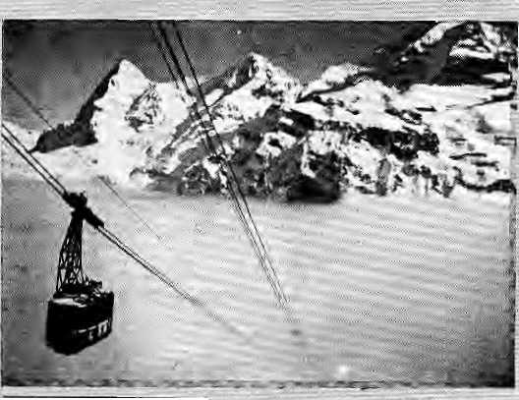

Ropeway to Salvation
Hindu pilgrims looking for salvation at the shrines in the Garhwal Himalaya Will soon be helped by an aerial ropeway linking the Bhagirathi and Mandakira Valleys,:
The four idlometre-long ride over the canopied gorges will whisk pilgrims from the scarce of the river Ganges at Gaiigotri to the Shivaite temple of Kedamath, a journey which presently takes two days of grinding up and downhill walking.
The ropeway will be constructed at about IRs. SO million arid connect the shrines in two phases:; first, from GarudaChatti on the Bhagiiathi valley toGaurl Kunda, which presently is the staging point for the arduous 14-fcm trek to Kedamath. In the next phase, the ropeway will be extended to Rambada, short of the 13,500 ft. -elevation temple under .: the Kedar Dome. Its "iinga" is shaped Like the rump of a bull whose head emerges at Pashupadnath in Kathmandu, according to local mythology.
According to a senior of ficial in the Uttar Pradesh government, theproject feasibility report is completed, and the construction of the aerial link will begin next year. The primary objective of the project is to enhance tourism without causing environmental degradation, he said.
The model Swiss ropeway.
A ski-lift is already operational at the newly-developed resort of Auli, in the Alakananda valley, which is billed as offering adven-
turous skiers som<£ of the world's largest slopes. According to
..'visitors, however,thfiinfrastrucr-fee at Aiih'iis: inferior: Eo that at Gulmarg inKashmir. Meanwhile, die Swiss Alps remain adistint dream which tourism deyelopers hold as the favoured modei for the promotion of tourism in the ln-
: diart Himalaya. :.::::
India's: feeder airline Vayudoot has also announced plans to begin services to Pithoragarh in the Kuniaonbelt: of the U*. hills as well as to :'.' ■Gaucliar in GaihwaL Thus: pilgrims headed for the back-breaking pilgrimage'to K^la^ Mansoiovar in Tibet will be able to fly to Pithoragarh. Instead of '. riding a Tattling bus for two days, the journey ftom New Delhi will Eakejust two hours;
While the ropeway seems 'ail appropriate option to the further widening and building of landsHde-prone toads in the Himalayan interior, the old folk living under the: shadow of the world's highest peate will pnibab-: ly shake their heads in mild disapproval at the sight iif pilgrims speeding past over their heads, .: If legends are to: be believed, in the good old days, die priest who conducted the morning "pooja" at Gaumukh reached Kedamath in time for ihe evening "aiirtV'afeat requiring the crossing of two glaciers and a trail treacherous for a superior mountaineer: The ropeway might breathe fresh life into that legend, this time more as a farce.
— R Tiwari
Electric Gar
The-Nepal Engineers* Associa-:. tion <NEA) has will hold the first-ever electric car race m • Kathmardumthecorning fail. The race consists of a complete run around the: 26 km. Ringroad ihat circles Kathmandu. The main goal of the face, say theor-gartisers, is; to channel indigertous technical cjteativi^ toward solving problems that are relevant to-Nepal. Participation by irhported commercial care is enoawagedi but they are not eligible to receive prizes.. ..
This race is not merely the idiosyncratic brasinpHld of technology :bu£fs; die stated objective of theNEA is to deinbnstrate that electiiciry can beused for public and private transpMt in Nepal. Battery-powered vehicles would require none of the additional in-frastnicrnre that expensive cable-cars or ropeways would, anii could catdi on if the technology is made affordable by the government Nepd' s tremendous poten:
Climbing WithoutSight
If you Were hiking in die Dzongri La aiea north of Darjeeling last fall, you might have met up with 21 men trekking, rock climbing ■ and fappeling down sheer cliff faces. Nothing out of the ordinary,except that these adventurers were all Mind. The cumbers formed ihe first batch,of sightless persons being trained by the: Himalayan! Mountaineering 3ii-stitute (HMI) in; techniques that had till then been th&exclusive realm of those with sight,
In die last few years, there has been a significant effort by handicapped persons to explore the Him,al^a, and prove that ;petffjie without sight can also appreciate nature and fiarticipate in adventure. The Nehru Institute of Mountaineeraig in Ulttirkashi has been conducting training for deaf andniutepersons. And blind persons; have in the past few years
■tia| for hydro-power makes it particularly suited to electric cais: "The us"e of electricity: for traiisporiation would save on foreign exchjmge, reduce dependence on imported fuel,: and-above all, decrease air.pollution," says NEA.
Moreover,Ste motors,controls, and baueries required for electric vehitdes are simpler to manufacture than the st^idard iii-Eemal combustion engines. IF papular with the Nepali car-riding public, this could mean the bird of an eleetric car industry in Nepal.:
So keep your schedule free in October. Take some company and apicnic. The locally produced battery-powered vehicles are required to zip trough the 26km. course-within two hours.
For enquiries: EVR Commit'-tee, Nepal Engineers* Associa-don, G.P.O. Box 604, KTM, Nepal, tefc (01)221426
been undertaking individual: treks at varying altitudes arid terrain in -India.
It was in 1-98S that the Calcutta:..,'.. based Society for the Visually Handicapped propped training -for blind people, and HMI was, ■ willing to take up the. challenge. -Widi the Indian Mountaineering -Foundation providing backing,:. - ■ the course was conducted from 24 October to 8 November 1959. The21 blind men ranged in age fromi9 to 34 and wftre accorh-panied by 11 sightedescorts.The" programme included an,expedi-tion to Tiger Hill .above Darjeel-tng, trekking up; to Dzohgri La {14^600*),climbing rocks andrap-peling down them ori belays.
The Sotietj¹ for the Visually Handicapped hopes Us trainees will soon have the opportunity to take part hi regular ejqpeditiif&jQr-. ganised by sighted rnouhtameersi which wbuld"helf> m "the integnt' ; tion of haikiicapped j*er*an£.»i ■ -. die mainstream of life." According io HenaBasu, Sctcfety's
Jan/Fcb 1990 • H1MAL B

■ ■■ ■ . ., ..

BRIEFS

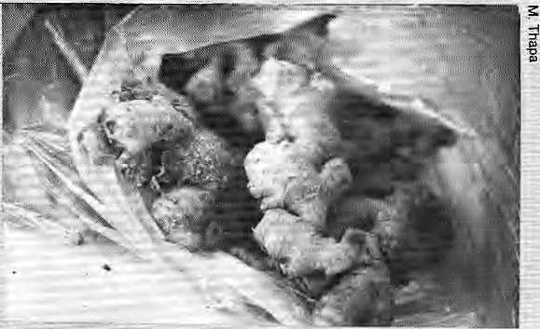
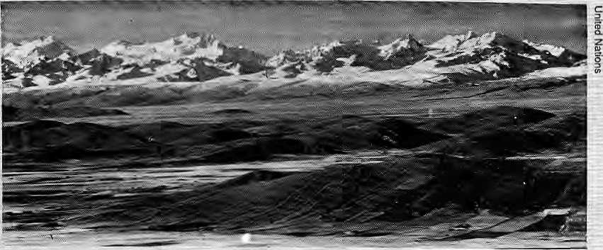
honorary secretary, preparations are being made for another mountaineering course, this time for sightless women.
Also in the works is a second course for sightless men in October 1990, and an advanced one for selected members. The Society also plans to extend mountaineering training internationally "by drawing participants from all the South Asian countries and beyond to form the first-ever international team of sightless trainees."
For enquiries: 34 Ritchie Road, Calcutta 700 019 (tel:75-8865).
Bolivian Competition
The latest challenge to Himalayan "adventure tourism," it seems, comes from land-locked Bolivia, nestled high in the Andes of South America. According to Reuters news agency, Bolivia is fast becoming a trekker's and mountaineer's haven, attracting adventurers away from other highland destinations in the Andes and the Himalaya.
Unspoilt Bolivia: Cordittera Rea! 20 HIMAL • i&nfFeb 1990
Just a few years ago, many North American tourists with a taste for outdoor travel used to roll their eyes when someone suggested a Bolivian vacation. The country was dismissed as "a backward, backwater dump of South America, a country of runaway inflation and revolving-do or dictators," says Reuters. No more. Bolivia has enjoyed a democratic presidency for more than four
years and now has one of the lowest inflation rates in Latin America. Besides, the country boasts countless square miles of untouched aipine terrain, cultural roots that predate the Iiicas, low-cost food and shelter, and ideal weather conditions for the travekr.
The mountains of Peru and Argentina were once the prime magnets in South America for serious trekkers and climbers. Today, Peru's highlands areout-o£r bounds becauseof extremist violence by the Shining Path, a Maoist guerrilla movement. Foreign debt and a ruined economy have also led to increased crime in Peru's tourist areas. Argentina has in the past few years become overrun by American and European tourists. Those returning from trips to Acongagua {23,000'), thehighest peak in the Western Hemisphere, complain that it is suffering from overuse — as are many Himalayan mountains. Bolivia, by contrast, is still pristine, "there's an incredible amount of territory down there that's untouched.There's no garbage in those Valleys, They're absolutely clean," said a climber.
'^{r}You fly to the capital La Paz and there are these magnificent 20,000- foot peaks sticking up everywhere," said Ed Boulton, an American climber who last year helped explore uncharted valleys in Bolivia's Cordillera Real region. He told Reuters: "Bolivia costs maybe one-fifth of what Nepal does for a great expedition, plus you have the pleasures of isolation,"
Marginalised crop
Ginger, Anybody?
Thousands of farmers in India's "apple state" are on the brink of starvation. A devastating disease has attacked the state's not-so-exotic crop - ginger. According to Frontline newsmagazine (Oct 28 -ISTov 10), the farmers of Sirmour district were hit hardest by the mysterious "ihizorhe rot" disease, A few years ago, Simour, Solan, Bilaspiir and Kangra districts together produced India's second largest ginger crop.
Production has slipped from 127,000 tonnes of dry ginger in 19S6-B7 to 850 tonnes. Rhizome rot has also spread to seeds. Farmers say the disease has been especially severe the past four years.
About 123 panchayats in Simour grow ginger, The annual loss for about 100 of them is estimated at IRs. 13,5 crores. The state's ginger fanners say they are
hurt by the government's partiality to apples. Neglect allows the traditional crop to rot. In Himachal, everybody is aware of the "apple lobby," which manages to win for itself the best subsidies and prices.
The government, it seems, has not yet acknowledged that the dis^ ease has reached endemic proportions. The state's Deputy Director of Agriculture is quoted as saying: "It is a fungal disease and the situation is not that alarming."
Scientists are offering different theories about the disease. Some say it is transmitted through fertilizers, while others put the blame on nematodes. The rhizome rot manifests in two forms, soft or wet rot and dry rot. In the case of the soft rot, the leaves turn yellow and the affected parts become soft. The rhizomes of the diseased plants discolour and rot. In the dry rot, the mycelial growth of the pathogenic fungi can be distinctly noticed on the rhizomes. This rot is transmitted by a different fungus.
The government has advocated "integrated" control measures to battle the disease, which has more than one reason for its spread. The Department of Agriculture introduced a system of seed certification for ginger to ensure quality seed. But the strong apple lobby always manages to push ginger to the sideline. Farmers who store the crop in pits are perhaps burying the crop.
-B. Bhattarai

BRIEFS

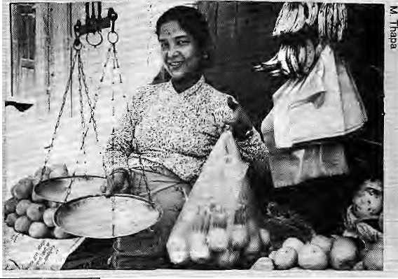
All the rage: plastic

Havoc in Fartdpur
Disaster
Management
Institute
(Bangladesh to Sponsor Studies on Environment and Disaster Management)
Every year, about 2.7 billion tons of top soil get deposited in the Bay of Bengal, creating new land. Based on this assumption, biogeochemical studies of Bangladesh's major rivers were launched in 1980 by Prof. Syed Safiullah. The Professor, who taught chemistry at the Jahangir Nagar University in Dhaka, is now the Secretary General of the International Institute for Environmental Study and Disaster Management (HESDM), based in Dhaka. Founded in 1989 under the patronage of the President of Bangladesh, ItESDM's primary mandate is to understand the causes of natural disaster, and help the South Asian nations cope with the seemingly incessant calamities that befall them.
"It is an unproven hunch that soil erosion and deforestation in ihc Himalayan region has anything to do with this," contends Prof. Safiullah. Floods, famines, cyclones, soil erosion and resulting desertification is common in Bangladesh. The country's geographical location and gtomoqjhology make it prey to natural calamities of one kind or another every year or so, destroying the fertile lands and rendering thousands homeless. The establishment of a high level 17-mem-ber international board of advisors gives new hope to find-

ing solutions fo these chronic problems.
The HESDM wili give priority to six research areas: (a) deforestation, erosion, and other factors leading to sedimentation with regard to floods in Bangladesh; (b) persistent xenobiotics (xeno: harmful foreign bodies) in the living organism, and its consequences; (c) the forecasting of floods and storm surges and the collection of green house data; (d) the adverse effect of flood on health and nutrition of the population; (e) the building of regional cooperation for flood prevention and control; (f) the legal and institutional aspects of drought in South Asia.
-P. Khafial
Mountain
Engineering
Meet

Geologists, engineers, decision makers, donor agencies and consultants from Bangladesh, Bhutan, China, India, Nepal, Pakistan and U.S.A. recently met at the International Centre for Integrated Mountain Development (1CIMOD) in Kathrtiandu to discuss the problems of developing infrastructure in mountain regions.
The field of Mountain Risk Engineering, (MRE) as it is called, is based on the interdisciplinary techniques of "transforming the constraints of mountain hazards into tolerable risks using cost-effective designs-"
Outlined as an independent discipline for the first time in a manual published by 1CXMOD, MRE combines aspects of the
established disciplines of geophysics, geotedinicai engineering, civil engineering and geology.
This approach is geared to studying the probability of damage due to natural processes on slopes (such as erosion and landslides) or human interference (such as cutting of hills for roads or blasting), and to calculate the threat posed to human interests by these probable damages. MRE focuses mostly on the construction of roads and canals, which, when built without a sound understanding of their site, can cause and incur extensive damages. At she meeting, a call was made to institutionalise risk engineering in those agencies involved in the development of infrastructure in the Hindu Kush Himalayan region.
Plastic Litter
In villages and urban centres, plastics have become a scourge of litter in the environment. Colourful litter of plastic bags, bottles, cupSi cans, buckets and saucers are strewn about everywhere. While they may be recyclable, these plastics are non-biodegradable andcontinue to accumulate.
Plastic wares are finding a niche in Nepali markets because they are cheap, light, unbreakable and come in attractive coSours,. Shoppers will notice a fleet of plastic wares decorating shops in Asan, and will most likely return with at least a few shopping bags.
'These are best for packing things becaose paper bags are costlier and not easily available," says Baidev, who has run a grocery store at Maiti Devi for more than three decades. And sure enough, even the smallest vendor wraps your purchases in plastic. Paper bags are now out because of the .soaring prices of paper and Ehe labour required to make them.
"I give plastic bags to anyone who bays anything that costs over NRs, 10," says Baidev, A few years ago, at least three persons came daily toBaldev's store to sell paper bags, but now only the plastic bag vendors come.
Maheswor Man Vaidya, proprietor of Ugratara. Plastics in Asan, sells on average NRs. 4,000 worth of shopping bags and packaging polyethylene bags daily; and sales continue to rise. Currently, out of more than 100 plastic industries registered with the Ministry of Industry, 44 are in production. Most plants manufacture plastic kitchen wares, and 13 manufacture shopping bags, plastic sheets and plastic bottles. According to the Industrial Statistics, 2971 metric tons of plastic products were manufactured in the 1988/1989 fiscal year.
The strength of plastics has attracted scientific research. But synthetic plastics do not disintegrate, and their long molecular chain is known to cause depletion of the ozone iayer. Cellulose-based bio-degrad able plastics have also been developed but are not yet in use in Kathmandu.
Jan/Feb W0 • HIMAL 21
- P. Khanat

FEATURE

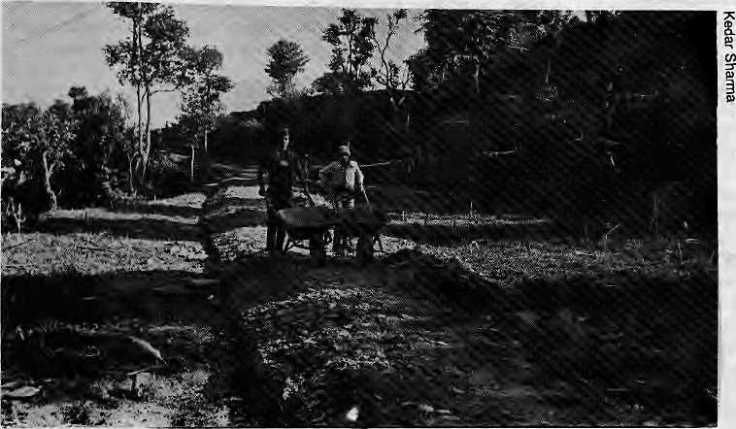
Green Roads for Rural Himalaya
Wheel Barrows, weeds and local labour build "gentler" and cheaper roads.
by Kedar Sharma and Binod Bkattarai
C
onstruction foreman Pashupati Dawadi had helped build many roads in his lifetime. But sowing millet on a newly dug surface? He had never seen that before.
Yet the instruction from engineer Hare Ram Shrestha had been to sow millet on the freshly completed six-kilometre stretch of the Dhading Besi - Salmetar road. Partly in jest, the foreman had asked: "Sir, did you study the same engineering as others?"
In response, Shrestha had merely said that he was "trying to demonstrate a 'way' to grow weeds." His intention was to give the road a "green top."
The Dhading road holds more surprises. Unlike the scene at most road construction sites in the Himalaya, there is not a single heavy machine nor a scar of any kind to be seen on the landscape of this 57-kilometre road. Says Shrestha, "The most sophisticated mechanical equipment used here is a wheelbarrow."
"At first, I was afraid when I heard a road was coming to the village", says Hari Bahadur Lamsal, a resident of Mukhiathok, a village on the road. "I lost some land and about 22 fodder trees, but it wasn't as bad as I had expected. Had the bulldozers come, the road would have caused more damage. And the blasting that comes with big projects would have created a lot of disturbance."
Hari Bahadur's sentiment is shared by otheT villagers who are thankful to have escaped the din and dust of big construction machinery and the invasion of an outside
work-force. Instead, the "green road," as engineer Shrestha called it, had given them work, and the villagers were pleased to discover that roads did not necessarily mean defaced hillsides.
NO DEBRIS
Most villagers have heard of construction sites where bulldozers rain debris into faimfields; or of roads being built so that the wayside drainage pours into them. But in Dhading, the debris had been arranged in terTaces so as to reduce erosion and soil run- off. Here the road builders had taken care not to scatter debris even where no damage was possible.
One reason, according to Chet Nath Lamsal of Murali Bhanjyang, is that the road labourers were not from elsewhere. "Since all of us are from here, we take special care to minimize the damage to our own fields."
Work on the road had also brought villagers added cash income. Wages of NRs, 24 per day are to be revised to NRs. 36 per day, of which 20 percent is deducted as a "participatory cut," and which some had contributed in land and labour. A government official called this practice "exploitation in the name of participation," but villagers have not groused. "There is now more money to spend," said Hari Bahadur, whose son too works as a labourer.
The brainchild of Swiss engineer Warner Paul Meyer, "green roads" were first promoted in Nepal by East Consult Pvt.'s director, P.C. Joshi. Work on the first Nepali "green load" started in Palpa district in 1986. The 59-
Idlometre road in Palpa began as a 23-kilometre rural track constructed through private initiative, and is now under the joint supervision of Helvetas-Nepal and East Consult.
The Palpa and Dhading roads both use simple building technology that is labour based. Designed for slow traffic, the road's alignment follows the terrain contour, thereby eliminating the need for sophisticated and expensive earthwork. Construction is cheap; a four-metre wide earth road with appropriate by-passes and a 20 km/hr speed design like the Palpa road, can be built at NRs 200,000 to 300,000 per kilometre, according to P.C. Joshi. A similar road built by the Department of Roads costs at least two to three times more.
Engineer Hare Ram Shrestha, engaged in the Dhading Besi - Salmetar road, says the approach is unique and unlikely to be found in engineering textbooks. Engineer Govinda Narayan Mallick, in the Bhim Dhunga section, explains: "We combine our knowledge of theoretical principles with practical solutions to problems."
TECHNIQUE
The main principle used is that of "balancing the mass," which mak^sj unnecessary voluminous cutting and dumping of land. Whatever soil is hewn from the slope is used on the road, and so there is no need to import mud. And since this method is directly and immediately implementable, the chances of "mass wasting," or failure of large chunks of land and other effects that normally lead to landslides are reduced, says Dipak Gyawali, an independent engineer-economist in Kath-mandu.
Another basic technique is known as "gradual widening," which means that all widening work is stopped until the initial cut has had a year to "heal." All work comes to a halt during the rainy season, the main "healing" period. In addition, the roads are built following the "half-filling, half-cutting" method.
No drainage canals are needed on these roads. In Palpa and Dhading, the surface of the road was built with a five percent outward slope, thus allowing the drainage to take place as it does in terraced fields. Where the road slopes gently, it is covered with grass, which reduces the velocity of the run-off water, which, in turn, reduces the pressure on the dry stone causeways.
At the "green roads," trees that were in the path of construction were not chopped down but laid horizontally at the side of the road, their trunks serving as support to the road. The stumps have since regenerated and carry green outgrowth. In some instances, trees

No need for state-of-the-art.
22 HIMAL ■ Jan/Keb 1990

FEATURE

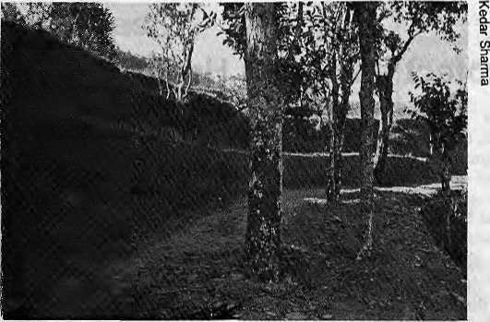
serving their purpose welLFor the villagers, the road has also meant the opportunity to learn building and maintenance technologies. Dhan Bahadur Khattri of Jyamere, for in-
were left to stand in the middle of the road and will be cut only if cars are ever to run there.
CHEAPER
Road engineers in love with conventional building methods and large projects will disbelieve the cost of structures used on the Dhading road. The builders claim that the causeways of dry-stone soiling are six times cheaper than rod-cement structures of the same specifications. The dry walls are about 4.5 times cheaper than gabion walls, and the gabion walls are nine times cheaper than stone masonry wails. Still
Minimal environmental disruption
cheaper are the retaining walls on the Bhim Dhunga road - used, earth-filled cement bags that replace the customary boulders. Besides being cheaper, the structures are reported to be
stance, is thrilled that learning to build retaining walls and causeways will have other applications in the village.
In Nepal, and the rest of the
Himalaya, where a motorable
road is generally regarded as the
harbinger of development, rural
roads become especially impor
tant as ihey bring basic consumer
goods to villagers and provide
local producers easy access to the
market. While "green engineer
ing" may not prove feasible in
major highway construction, the
concept applied in rural areas
may well be the answer for en
gineers, economists, environmentalists and vil
lagers. |\
K. Sharma is with Nepal Press Institute ^
and B, Bhattarai is a freelance journalist.

CLIMBING

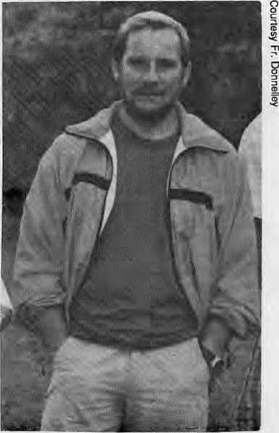
Jerzy Kukuczka:
He Climbed with Genius
high on the mountain sun is a river, and wind is old and deaf.
O
n the calm, clear morning of October 24, 1989, Jerzy Kukuczka was killed in a fall from the South Face of Lhotse, the 27,883' neighbour of Mount Everest. Although most of the world did not know of Kukuczka, to mountaineers he was well-known. He stood beside Reinhold Messner as the only other climber ever to have reached the summits of the world's fourteen highest mountains.
Not only did Kukuczka climb all of the 8,000 m. peaks, but he did so with genius. All of his ascents, except for Lhotse, were by new routes undertaken in winter; all, except for Everest, were climbed without oxygen. In 1981 he made the only true solo ascent of Makalu, which to him was his greatest achievement.
His accomplishments now pass into history and legend, and will remain an inspiration
long after words have ceased. Only those close to Kukuczka will know the sorrow his death brings, but for those who share his love of the mountains and his pursuits, he will command admiration and respect.
Unlike other better known mountaineers, Jerzy Kukuczka received little of the fame and fortune that were his due. He completed the manuscript for an autobiography, which is to be published this year. Other than that, there was little to be marketed. He was an electrician by trade, a father of two sons, a husband, an unassuming man in a presumptuous world.
For now we know little of Jerzy Kukuczka, about his life in Katowice, Poland, or about his family. What we do know is diat he attained in only nine years much more than the summits of the highest peaks on earth. Only one other man knows what sacrifice Jeizy Kukuczka made; only his family knows what was sacrificed
Michael Yaeger is a writer and a mountaineer.
Kukuczka summitted the 14 highest mountains, all except one w..riout oxygen.


RESTAURANT- BAR
Time Out in Kathmandu
the perfect watering hole; you will love it.
BHUGOL PARK. NEW ROAD. KATHMANDU

Jan/Fcb 1990 . HIMAL 23

FEATURE

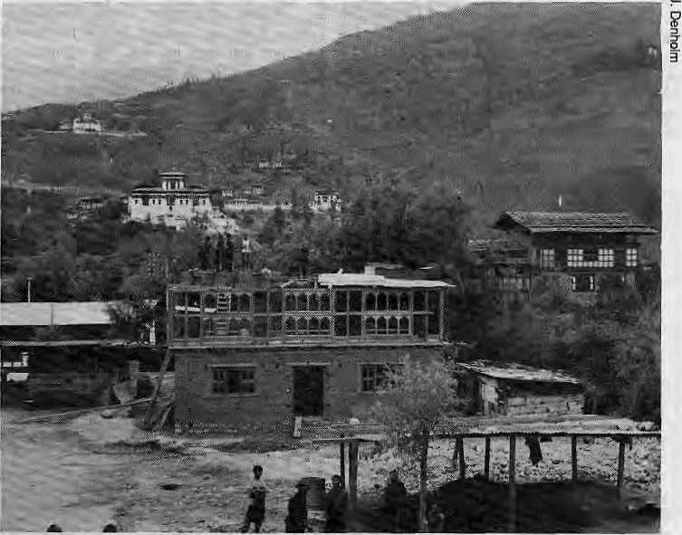
ready cultivated land rather than convert forested slopes to arable land. With a population estimated at 1.2 million in 1986, and a population density of 25 persons per square kilometer, which is half the average for the Himalayan region, one might assume Bhutan has adequate resources to be self-sufficient in food. The reality is, however, that every square kilometer of agricultural land must sustain 481 persons (this figure is 667 persons for Nepal). With an average farmland holding of one hectare per capita, and no option to open new land to crop production, it is obvious that the country will soon face growing problems as its population increases.
If the Bhutanese are poor in arable land, they are rich in forest wealth. Bhutan's per capita forest area is 3.52 hectares, many times more than that of the neighboring regions. Per capita forest area for the neighbors, in hectares, is as follows: Nepal 0.31, Kashmir 0.36, Himachal 0.51, Garhwal 0.5, and Sikkim 0.81. The Bhutanese, however, are also the largest consumers of wood, consuming 10 times more
The richest in per capita forest wealth, Bhutan also consumes the most wood per capita.
Bhutan Must Protect its Green Health
by Jeanette Denhotm
E
nvironmental degradation, deforestation, and "deteriorating quality of life" are terms increasingly used to describe the conditions in which the people of die Himalayan foothills live. A refreshing exception, it seems, is the small mountainous dragon kingdom, Bhutan. On seeing the pristine mountain streams and uninterrupted tracts of hemlock, spruce, fir, and juniper forests, one is likely to forget the "gloom and doom" prognosis of the Himalaya.
A closer look, however, reveals that Bhutan's resources are being subjected to pressures not entirely dissimilar to those in neighbouring Himalayan countries. Most venerable presently are its forest resources. Although almost one half of Bhutan's land area is under forest cover, forests jafe gradually declining in area and quality <iue to 1) uncontrolled grazing by cattle, yak, and sheep, 2) fires occurring both intentionally and accidentally, 3) land cleared for shifting cultivation, and 4) high consumption for both commercial and domestic uses.
Cattle, which are grazed in forests and shrubiands during summer months, are increasing at the rate of 8 percent yearly. Already fodder supplies in some areas are inadequate, resulting in low production of milk, which supplements the Bhutanese diet of rice, maize, millet, and chilies. Signs of erosion are already evident in many of the heavily overgrazed alpine pastures.
The Bhutanese use periodic fires to regenerate the forest grass and make fertilizer from the ash. But forest fires are spreading to coniferous areas as well, and villagers are unable to control them.
The practice of "shifting cultivation" accounts for 27 percent of the land under agricultural use, and is prevalent in eastern and southern Bhutan. Cultivators clear small plots of forested land, and cultivate them for a few years, then leave them fallow, thus using more and more forest cover. Although prohibited by law, this practice continues due to the acute shortage of arable land available to the growing population.
More than 90 percent of the population farm subsistence crops on just 5.5 percent of the country's total area. Due to the preponderance of steep slopes, fanners are more inclined to intensify production on al-
timber and three times more firewood than Nepalis. Hearths often bum all day for cooking and heating, and houses are constructed of timber. Timber is often viewed as a lucrative source of export earnings through sale to India's insatiable market. The government of Bhutan is proceeding cautiously with commercial extraction, but some areas accessible to roads are being heavily logged, and have created erosion hazards.
Bhutan's planners have evolved a unique development strategy so as to promote its cultural heritage and values while aiming for self-sufficiency. To date, a small population, limited land use, and few development efforts have exerted only slight pressures on the fragile ecological system. Now, with a population growth rate of two percent, and the impact of improved health care beginning to be felt, it is likely that the growing population will initiate changes in land use. This may include encroachment on marginal lands, land fragmentation, increased pressures on forests for livestock feed, fuel-wood, timber, or migration. An environmentally sustainable future for Bhutan requires wise land use policies and an informed, aware populace whose participation is sought to strengthen their cultural values, while addressing their basic needs. t\
J. Denholm, a specialist in community forestry, is presently with ICIMOD.

24 HIMAL • Jan.'Feh 1990

FEATURE

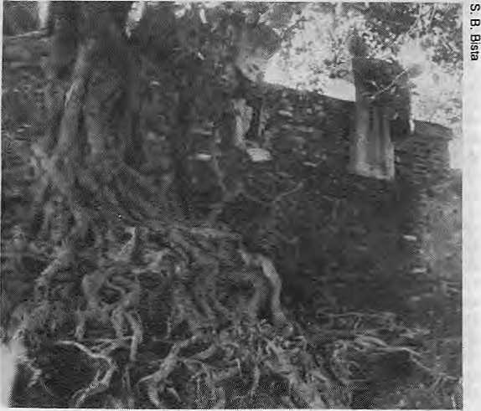
Lumbini Development: Still Far to Go
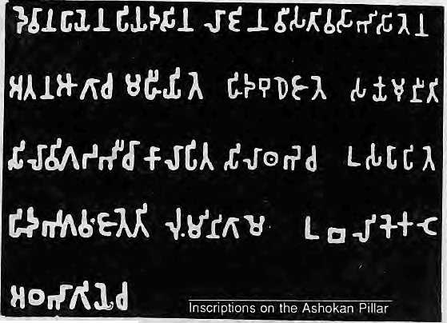
by Sichendra Bista
D
uring an. archaeological excavation in 1885, Dr. A. Furher unearthed the Ashokan pillar, the only evidence of Lord Buddha's birth in Lumbini. In 1899, the Archaeological Survey of India (ASI) assigned P.C. Mukherjee to study the archaeological findings in Lumbini. The ASI also deputed Mrs. Mitra in 1962 to analyse the nature and history of the bricks, lying to the west of the Ashokan pillar. Field Marshal Keshar Shum-sher unearthed antiques in Lumbini during extensive excavations in 1933 and in 1939. Unfortunately, his findings were not published. In 1970, the Archaeological Department of Nepal launched an excavation to delineate the area of Lumbini village during King Ashoka's rule (249 B.C.). The team unearthed a clay wall, a circular crematorium with a human skull, and an iron scythe from the sixth century B.C.
The 1967 visit to Lumbini by U Thant, then Secretary General of the United Nations, gave impetus to the idea of developing Lumbini which is now materializing. After U Thant's visit, the International Committee for Lumbini Development was formed under the chairmanship of Nepal's permanent representative to the UN. The Master Plan for Lumbini, followed by the Lumbini Development Trust, was developed by the well known Japanese architect Prof. Kenzo Tange.
RISKY EXCAVATION
Archaeologists argue that a number of places remain to be excavated near the Mayadevi temple because some antiquities have been observed on the surface. To garner support for more archaeological work, they cite the finding of a well some 500 metres west of the Ashokan pillar. The well was apparently constructed during Kushan rule in the first century A.D.. The bricks used for constructing the well are enormous: some up to two feet long, eight inches wide and ten inches high. Most important, each layer of bricks is engraved with different symbols: ^^If A further clue to the underground structures is the uneven growth of two mango trees planted on November 8, 1979, by the former president of Sri Lanka, J.R. Jayavardhane, and his wife. The trees were planted in the VIP afforestation area, about 50 meters north of the Mayadevi temple. Although of the same species and in identical conditions, one tree is growing more slowly than the other, leading archaeologists to speculate that the downward growth of the roots may be impeded by an underground structure.
KAPILAVASTU
The development of
Lumbini should
parallel the develop
ment of Tilaurakot at
Kapilavastu, 28 km
west of Lumbini,
where the remains of
the palace of King
Suddhodhana (Lord
Buddha's father)
were discovered. The
concerned IiMG
department, however, has not shown interest in studying the area in detail. Fortunately, the Lumbini Development Trust has deputed six local watchmen at Tilaurakot, although the trust has no linkage with Kapilavastu. At Tilaurakot, ruins of the eastern and western gates of King Suddhodhana's palace, a courtyard, a crematorium, and two stupa-like structures have been found. It is believed that Prince Siddhartha exited from the eastern gate {Mahabhinishkaram Dwar) when he started out in search of supreme enlightenment.
Similarly, appropriate measures need to be taken to preserve the damaged Ashokan pillars of Niglihawa and Kotihawa, 33 km north-west and west of Lumbini. The open border with India makes further excavation somewhat risky because of the case with which the findings could be smuggled out of the country. According to one archaeologist, it would be better to leave things underground to remain as hidden treasures.
A PIPAL PROBLEM
As seen in photographs, Lumbini lies in the shadow of a huge Pipal tree {Populus deltoides) to the east of the temple. The tree poses a problem because its roots have grown so extensive that it threatens the Mayadevi temple's destruction. As the roots have caused the near-collapse of the main eastern entrance, pilgrims have been compelled to use the northern entrance. Likewise, thick

roots at the west of the temple may soon harm. the Ashokan pillars.
The only solution remaining is to cut down the tree. This also poses problems. Local people would never let the tree be cut down since: a) People believe that the Mayadevi temple has always been under a Pipal tree, b) They believe that Mayadevi gave birth to Siddhartha Gautam while leaning against this particular tree, as seen in the nativity posture of Mayadevi in the temple,
- The Buddhist community worships it be
cause Lord Buddha attained enlightenment sit
ting under a Pipal tree in Bodhgaya in India,
- The Hindu community also warships the
Pipal-lree as a form of Vishnu. In addition, the
local community worships Mayadevi ' as
Rupadevi (Beautiful Goddess), and on a full-
moon in April (Chaicra Purnima), some 50,000
Hindu pilgrims gather here for a mela. The
district in which Lumbini lies is named after
M ay ade vi-Rup andehi.

Pipal roots strangling Mayadevi Temple
Jan/Fob 1990 ♦ HIMAL 25

FEATURE

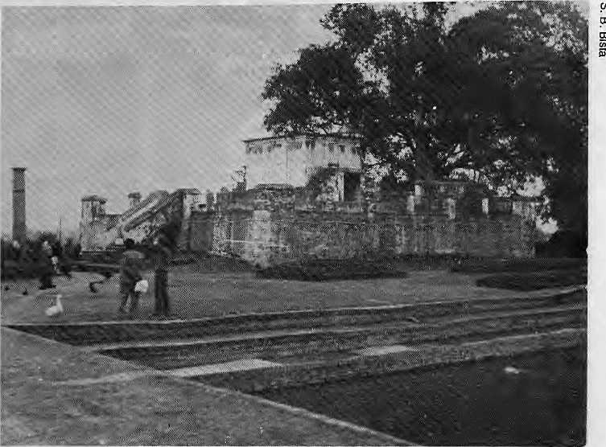
Despite adequate resources, sound planning and enthusiasm, development cannot be successfully carried out without public participation and awareness, understanding between the locals and development authorities, and long-term consistent policies of the government. This is what the Lumbini experience has demonstrated.
The Master Plan for the development of Lumbini, birthplace of Lord Buddha, who propagated the message of universal peace some 2,500 years ago, is gradually being implemented in three square miles of the Terai. Although the accommodation for pilgrims, a museum, and a library were completed three years after the Lumbini Development Trust was established in 1985, Project Manager Diwakar Pant is not happy. "We could have achieved more only if we had received support from the locals and His Majesty's Government llirough timely, consistent and enlightened policies," said Pant.
In a country like Nepal, wnere social norms are all-important, support must be sought before carrying out development plans. Because of a failure to solicit such support, locals had expressed their dissatisfaction through violence and sabotage, according to Pant. He said some unidentified, technically adept locals had stolen the copper coil inside a 500 kilowatt transformer by unscrewing more than
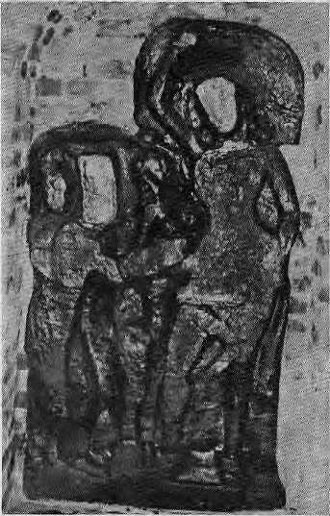
The Mayadevi Goddess
Ganga Prasad Pandey, 51, the Hindu priest who has served at the Mayadevi temple for the last 40 years, said that it would be wiser to protect the temple than the tree. The tree, he said, could always be replanted.
SACRED BUT POLLUTED
The sacred pond of Shakya Puskarini (Shakya pond) to the north of Mayadevi temple, in which Prince Siddhartha was bathed after his birth, hardly seems to be sacred anymore. It is murky and full of algae. Swans and ducks have full reign. Devotees who come from various parts of the world to collect the Jal (Sacred water) from the pond have second thoughts as the pollution stares at them.
The eternal Peace Flame that was brought from the United Nations Headquarters in 1986 in the International Peace Year went out during the recent fuel crisis resulting from the Lido-Nepal dispute on trade and transit. When gas became unavailable, an oil lamp was substituted, which bums about half a litre of mustard oil every four days.
The old monasteries, about 50 meters east of the Mayadevi temple, are to be removed because of the design of the sacred garden in the Master Plan for Lumbini. The Buddhists seem unwilling to demolish these existing monasteries. A Buddhist from Bhairahawa, Nidan Shakya, asked: "How can we -the Buddhists- ignore the gods in the monasteries to whom we have earlier paid our hearty homage and respect? Such destruction is against our tradition and social norms."
Lumbini: "Failure to Win Local Support"
by Sichendra Bista
200 nuts and bolts in one night. The transformer was set up at the power-house on behalf of the Hokke Club of Japan, which has plans for a four-star hotel in Lumbini. 'They do not dare to leave window frames, glass sheets or even bricks outside," Pant said. As evidence he pointed to the bare windows of the power house and a damaged portion of a culvert.
Why do the villagers resent a project that is globally applauded? "First, about 80 percent of the villagers here are Muslims and they are not concerned about any Buddhist development. Second, they claim that they are not employed by the development project, even though they do not actively seek jobs. Third, they resent being evicted from 13 kilometers of land for the Project," said Pant. "But they don't think about the numerous advantages that will eventually come from the development of Lumbdni," he said, with a sigh. "Tolerance is lacking here."
Hiralal Halawai, 60, who lives half a kilometre from the Mayadevi temple, was one person evicted from his inherited house just in front of the temple. Even though he was paid NRs. l6,000 for land that was worth NRs 100,000, Halawai said he harbored no anger towards the government. "It all belongs to the Government, so what if they take it? I am not angry. In fact I feel thai I have contributed my assets to the Rupandehi Mayadevi."

26 HIMAL • Jan/Feb 1990
How long before the Master Plan is implemented?

FEATURE

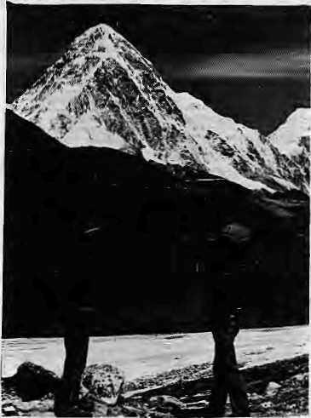
Conference Report
Conservation and Adventure Travel
Pant said that the Project would have been far better supported by the public if Lumbini had been in Eastern Nepal, "People there are more aware than those in the West."
Pant expressed fears that vandals may even destroy the Ashokan Pillar, the sole evidence of the birth of Shakyamuni in Lumbini. He felt that better security measvires had to be taken in Lumbini. At present, 18 unarmed security guards protect the entire project area. The Trust recently sought permission for two rifles and some khukuris to be provided to the guards on night-shift.
Asked why the Trust has failed to initiate programmes to create greater public awareness about the positive aspects of the Project, Pant said, "Periodically, we call them and explain the benefits of the Project, but the fundamentalist Muslims are not easily persuaded."
Li criticising the ever-changing policies of the Government of Nepal, Pant said that an agreement was signed between the Trust and the Hokke Club about two years ago for the construction of a four-star hotel that would be fully financed by the Club. But the hotel has not been built because the Industrial Policy Act of HMG did not permit foreign investment in such a project to exceed 80 percent.
According to Pant, the proposed hotel would bring more tourists, particularly Japanese, who would be interested in visiting the birthplace of the Buddha. The present lack of basic facilities deters many. The Project has one Japanese and three English speaking guides, but the information office reported that only 15 to 30 tourists (excluding Indian nationals) visit the temple each day. Explaining the technical details of the proposed hotel, an engineer at the Project site, Gopal Manandhar, said that the two-storey building would cover a total area of 160 square metres with 50 rooms, though only 25 will be constructed initially.
The Master Plan has allotted one square mile each to the Sacred Garden, the New Lumbini Village for accommodation of staff, and a Monastic Zone cum Cultural Centre around Mayadevi Temple. In the Monastic Zone, 41 countries would be allowed to build monastic enclaves in their national style. About 60 to 70 percent of the total land allotted will be reforested to enhance the natural environment of Lumbini. More than 600,000 plants have already been planted within the Project area. The Trust set up its own plant-nursery, under the supervision of Masayoshi Kawaguchi, a Japanese landscape engineer volunteering for the Japan International Cooperative Agency (JICA). Kawaguchi, who has been at Lumbini for a year, said that the nursery would be the foundation of the landscaping, and that it would be the best in Nepal.
Sichendra Bista is a reporter for UNI in Nepal.
fry Kesang Tseten
I
s there a hint of a new maturity among the travel trade these days? Whereas before tourism was either seen as she destroyer of culture and environment or the sole panacea of poor countries with nothing to sell but their exoticism, a middle-path attitude was recently being sounded about the industry's merits and its faults.
For one, at the PATA conference in Kath-mandu in February on adventure travel, the buzz-words were conservation, the environment's carrying capacity, and cultural sensitivity, even though what followed were three days of business among South Asian sellers and overseas buyers.
As usual, the subject of controls on the number of tourist arrivals as well as that of tourism's impact on the environment were touched. Key-note speaker, Toni Hagen, often credited with opening Nepal to the world, for example, criticised HMG/Nepal's target of hosting 1 million tourists by the year 2000 as "dangerous for Nepal." Instead, seek "quality tourists," Hagen urged; that is, trade numbers for better-paying tourists.
A call to close the Annapurna Sanctuary and the Everest regions in Nepal for a few years "to give them a chance to revive" was made by Capt, M.S. Kohli, president of the Indian Mountaineering Foundation. Kohli, an Everest summiter, is also chairman of the recently formed Himalayan Adventure Trust, which will work to protect the Himalaya, and has already drawn up a code of conduct and ethics for tour operators and visitors,
Hagen also posed the all-important question of tourism in Nepal: Would the deterioration of Nepal's ecology be saved or the Nepali economy collapse if tourism was abolished? The answer is no on both counts, according to Hagen. With regard to the environment, for instance, Hagen said that Nepal's 50,000 foreign trekkers used a negligible 6400 tons per year of fuel-wood against more than 8 million tons consumed by the country's 18 million natives.
Cultural erosion, particularly from mass tourism, however, is a much graver threat, Hagen said: "Ecological damages are theoretically reversible. The loss of cultural substance and identity is irreversible, which no money or technical measure can buy back." He also urged HMG/Nepal to look to alternative sout-ces, and cited the example of the highly successful carpet- manufacturing industry, which earns an estimated U$ 60 million in foreign
A bright decade ahead for adventure tourism.
exchange besides generating wide employment.
There was some good news for the travel industry. Leading publications are forecasting that the 1990's will be the green decade and outdoors will be in, said Ken Chamberlain, executive vice president of PATA. If so, the region's natural assets make it particularly amenable to cash in on the higher-yielding and less-innocuous form of tourism called "adventure travel."
"If you put together environment, outdoors, nature, fitness, and excitement, no form of travel fits the bill better than adventure travel," said Chamberlain. He characterised adventure travel as: out of the ordinary; distance from civilisation; outdoors; a limited degree of perceived risk; experiencing things that would otherwise be difficult to arrange; active participation. The spectrum included everything from mountaineering and cultural sightseeing to bird- watching.
In a recent survey among what are called Nature Oriented Tour Operators in the U.S., according to him, Nepal emerged as the top destination in their promotions, with India not far behind. Not surprising considering the tremendous diversity of South Asia: high mountains, rivers, desert and jungle, monks and mystics, palaces and fortresses, elephants and tigers, a unique mixture of natural grandeur and ancient culture.
In spite of South Asia's "image problems,"
said Chamberlain, the region often delivered
the unexpected, and is meant for the adven
turous, for the person who is something of a
romantic. N

Jan/Feb 1990 • HIMAL 27

REVIEWS

Charity that Strangles the Poor

CHORDS dj

LORDS OF POVERTY:
The Power, Prestige, and Corruption of
the International Aid Business
Graham Hancock
The Atlantic Monthly Press, New York,
234pp. $17.95
Review by Thurstnn Clarke
H
ere is how Graham Hancock describes the villains of Lords of Poverty: They belong to a "notorious club of parasites and hangers-on" that has set "record-breaking standards...in self-serving behaviour, arrogance, paternalism, moral cowardice and mendacity." They are "unsavoury, greedy, stupid, and dangerous," not to mention "maladjusted, inadequate (and) incompetent." They work for organizations that have "condoned - and in some cases facilitated - the most consistent and grievious abuses of human rights that have occurred anywhere in the world since the dark ages."
Hancock is not talking about Nazi war criminals, toxic waste dumpers or crooked investment bankers. He is talking about everyone, from top officials to field workers, employed by the multinational relief and development agencies - such as the World Bank, UNICEF, UNESCO, UNDP, FAO and the European Development Fund of the European Economic Community - and by the bilateral agencies of the United States, Britain, Japan, and just about any ijch country you care to name. In other words, he is talking about some of the century's most sacred cows, about organizations associated with words such as "sacrifice," "humanitarian," and "generosity," (although Hancock would say this is because these are precisely the words their public relations departments use in their self-congratulatory campaigns).
Can these accusations be true? Does Hancock really mean that the Halloween pennies school children collect for UNICEF, and those sacks of emergency American grain that spill from the bellies of Air Force transports onto the tarmac of third world countries like Jitters of kittens, that the mighty World Bank dams, the countless USAID financed village water pumps and, in fact, just about all foreign aid is evil, and should immediately be stopped? Yes, he means exactly that. "Aid is not bad, however, because it is sometimes misused, corrupt or crass," he says; "rather, it is inherently bad, bad to the bone, and utterly beyond reform. As welfare dole to buy the repulsive loyalty of whining, idle, and malevolent governments, or as a hidden, inefficient and inadequately regulated subsidy for western business, it is possibly the most formidable obstacle to productive endeavours of the poor."
Hancock believes foreign aid is "nothing more than a transaction between bureaucrats and autocrats," enriching only the international civil servants who administer it and the ruling classes of the third world countries - who steal and misuse it.
Tb^ "over-compensated" civil-servants, he insists, enjoy a higher standard of living than they could aspire to in their own countries, and in third world nations they fill jobs that would otherwise go to locals, while back at headquarters they hardly work' at all. Their achievements and performance are never subjected to the rigorous evaluation that is normal in private business, or even in other government agencies, and because their profession is "humanitarian," they are never required to demonstrate their worth in quantitative ways -despite the fact that the United Nations agencies and others disperse funds that have been forcibly extracted by taxation instead of donation.
He reinforces these charges with the kind of United Nations honor stories that have become familiar reading. We learn that personal and associated costs absorb 80 percent of the organization's total expenditures, that some time ago the president and executive board of UNESCO received reimbursements of U$ 1,759,548 for one year's travel and lodging costs, that there are 750 bureaucrats on the staff of the FAO in Rome whose pensionable enumeration ranges from U$ 70,000 to U$ 100,000 a year.
While Hancock provides considerable evidence that aid has enriched the bureaucrats who administer it and the companies who supply shoddy goods at inflated prices, along with prosperous third world traders and urban intermediaries, there is no evidence, he says, that the poor in the third world have benefited at all. For foreign aid's successes are lucky accidents, whereas its most grandiose projects either "wreck the lives of the poor," or leave them untouched. In this regard, he is right to point out that any foreign assistance - including emergency food aid - given to corrupt regimes can only have the unintended consequence of strengthening the regimes, enriching the ruling classes and increasing the suffering of their populations, in part by blunting the righteous anger that might otherwise over-tlirow such governments.
To support his assertions, Hancock has assembled a compendium, of foreign aid fiascos that he claims are the rule, not the exception. "There are small-scale bunglings: food donated to Africa by the European Economic Community during 1988 diat was found to be contaminated by radiation from the Chernobyl nuclear disaster, laxatives, anti-digestion remedies, frostbite medicine, low-calorie soup, chocolate-flavoured dietary drinks, and food

fifes'--¹ * ■:'" V.:'";
GRAHAM HANCOC
so bad that San Francisco zoo-keepers had stopped feeding it to the animals, all sent to alleviate starvation in tropical countries.
And there are large-scale disasters: the Aip fish-farming project in Mali that produced fish at an actual cost of almost U$ 2,000 a pound; the donor-financed dam in Guatemala that led to a 70 percent rise in residential electricity prices; the Sudanese sugar refinery turning out sugar that is sold in Sudan at a significantly higher price than imported sugar; and the World Bank resettlement schemes in Brazil and Indonesia that have destroyed rain forests, obliterated tribal peoples and some-tiifies left migrants poorer than when they left home.
I cannot agree with Hancock's extreme condemnation of the development industry. I have seen AID projects in Africa that were clearly successful and beneficial to the iocal people, and I have met many people in the industry who were not monsters of greed and careerism. Nevertheless, much of my experience in Africa and Asia confirms the essential truth of Ms charges.
Hancock has chosen to levy these accusa
tions in a prose style so shrill and venomous
that if books had hands, this one would be
reaching out to strangle the United Nations of
ficials who will no doubt be reading it at their
desks in brown paper wrappers. This style
sometimes distracts from his arguments, but it
does not disprove them. Beneath the jumped-
up language is a deadly serious book about a
desperately important subject, a book that,
despite its exaggerations, succeeds in standing
the myth of foreign aid on its head, and
demands a serious reply from the development
industry. \
Thurston Clarke is the author of Last Caravan about famine in Africa and the Equator, This review appears here courtesy the New York Times.

28 HIMAL ' Jan/Fcb 1990

REVIEWS

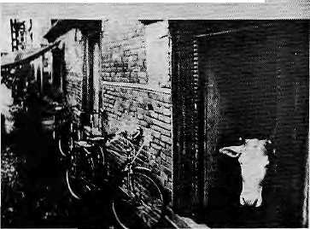
Letters from Nepal
MISTER RAJA'S NEIGHBOURHOOD LETTERS FROM NEPAL
by JeffGreenwald A JIM COOK EDITION John Daniel Publisher Santa Barbara, 1986
Reviewed by Michael Yaeger

R
ecently, readers had the pleasure of Ruth Higbie's A Classfui of Gods and Goddesses in Nepal, a sensitive and delightful account of the author's experience as a Peace Corps Volunteer teaching science to tenth graders in the Newari town of Banepa. Higbie, who was 58 when she did her stint with the Peace Corps, succeeded in opening a world beyond our door for readers just as she left a handful of children wiser about the world outside.
Around the same time, journalist Jeff Greenwald was traipsing around the Valley, intent to write a novel but instead composing Mister Raja's Neighbourhood: Letters From Nepal. Unfortunately, Letters misses much of what is interesting and moving in Nepal, and spends far too much time in pseudo-intcllec-tualisations and self-indulgent pronouncements. Some of the letters are incoherent, while others prod the reader through tangled, nonsensical metaphors, more confusing and irritating than a thistle patch.
What is more, Mr. Greenwald is insulting to and condescending about a culture of which he seems to know very little. If we have to give him the benefit of the doubt, the book not so much disrespects another culture as it lacks insight into that culture, and fails to reveal to
Jeff Greenwald
the reader things of importance, the culture's realities vis-a-vis its processes.
Moreover, the wisdom of Greenwald's narrative choice is to be questioned. Letters belong to a genre of writing that cart be fascinating, occasionally mystical, and often revealing. They can be the seed of a memoir or journal, the catalyst for a tale, a short story, or the building material for a novel, letters have a potential to directly engage the reader into the life and struggles of the writer. They form a narrative that encourages in the reader the sense that he or she is eavesdropping, privy to a story both intimate and confidential, and when used by an author who has a good sense of timing, and taste, and integrity to the form, the genre offers all the poignancy and
vigor often missing in historical and documentary writing.
Consider, for example, in Memories, Dreams, Reflections, the lyrical quality of C. G. Jung's letters to his daughter, written from America and Africa; or the moving intimacy of Alice Walker's The Color Purple; or the byzantine, efficacious tetralogy of Henry de Montherlant's The Girls. Each of these involves the reader.
The first-person point-of-view of Letters is a narrative stance that demands the same reader involvement, but fails to achieve it. Instead, we are toid about the author's sexual fantasies (visiting Freud); about creativity being a slimy something or other (Freud revisited); about how the narrator and other artists have to struggle to survive each day (inspired prophet's syndrome); about his drug-induced episodes (nostalgia over the next-to-lost generation?); about yet another quest for enlightenment, supposedly his own (an often-seen no-side-loans or balloon-payments acquisition of the spiritual).
Regardless of the genre and point of view, good writing moves the reader with details, not with generalisations. The sensible writer does not use the reader as the knife in a Buphonic ritual; that is, the reader does not force the writer to it, and thus does not deserve to be cast into the sea.
Humans are neither all bad nor all good,
and writers, too, are human. Though I believe
Letters is presumptuous and misinformed,
there is an energetic, youthful zeal contained
therein. Potential, too. And I hope that
Greenwald's forthcoming novel taps into more
of this potential. I hope that it tells us less
about the author, and shows us more about the
characters. \

WE ARE THE BIGGEST BOOKSELLERS IN TOWN
Drop in at our showroom in downtown Kathmandu or write to us for our detailed
catalogue. We carry a wide variety of publications on the Himalaya, including large
selections on Nepal, Tibet, Bhutan and Sikkim. We also carry guide books and maps in
addition to our regular selections on anthropology, commerce, management, language,
folklore, and politics. Through the Bibliotheca Himalayica, you have access to current
and classical works on Natural history and civilization of Central Asia and the Himalaya.
Ratna Book Distributors Pvt. Ltd.
Publishers and Distributors, Bagh Bazar, Kathmandu. Tel: 223026, 220501
Jan/Feb 1990 • HIMAL 29

FOLLOWUP

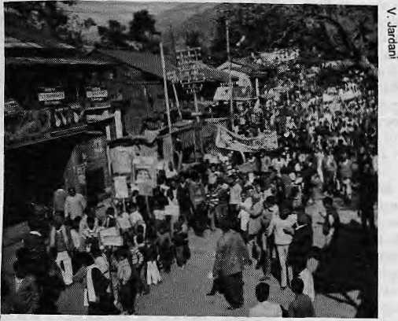
People demonstrating against the dam at Tehri.
APPLE TREES UP IN SMOKE
(Sept/Oct 1989)
The case of Helambu shows that development initiatives in moutitain areas that do not consider their specific attributes turn out to be fiascos from the beginning, or are unsustainable. These attributes are usually inaccessibility, fragility, marginality and diversity, with their physical, biological, social and economic dimensions.
Apples were introduced in Helambu only because of its physical and climatic likeness to Himachal Pradesh, which is famous for its apple crop. The Helambu case illustrates the result of such naive planning.
Compare Himachal and Helambu. The apple orchard economy is successful in Himachal not because of its climate alone. The state has been sensitive to what development experts call "mountain specificities." Apple farmers there received considerable support, political good-will and the necessary infrastructure such as roads, marketing facilities, and price subsidies. Helambu, in contrast, is a particularly marginal region, which was not provided with any special favours.
Helambu's inaccessibility, which should have been considered before embarking on the project, was the most important reason for the failure of its apple-farming scheme.
- Tej Partap.
WILL THEY ALL BE DISPLACED?
(Nov/Dec 1989)
Work on the controversial Tehri Dam was temporarily halted when Chipko leader Sunder Bahuguna drew wide attention with his dharna, a prayer-fast.
Until then, the construction had been in full swing even though, with mounting opposition, a Supreme Court verdict was to decide the fate of the dam and 86,000 would-be refugees.
Following the order by the Central Government, discussions were held in late January in the office of the State Minister for Environment, Mrs. Maneka Gandhi.
The decision that emerged was that until the ministry submits an evaluation report to the Cabinet for its decision, construction was to be halted, though river-bed cleaning, without explosives, is to be permitted.
The Cabinet has already received the evaluation report, it is believed, but no one is certain when it will decide.
"For the first time, the environmental debate in the country has been elevated from the confines of a single project to the arena of development policy," wrote ecologist Jayanta Bandy opad-hyay in the New Delhi Economic Times on Feb. 12, 1990.
"So when the Union Cabinet takes a final decision on the future of this hotly debated project within the next few weeks, it will also be setting down the parameters of the development debate," he wrote.
- K. Tseten

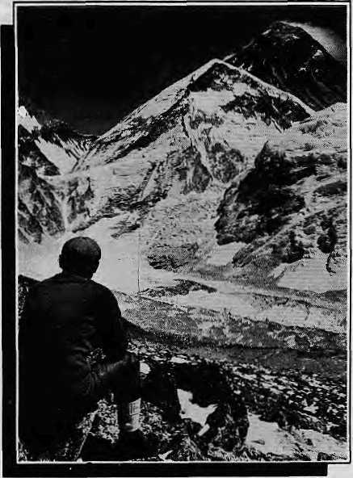
OF MOUNTAINS AND MEN...
trek ecologically with Yangrima
JWANGRIMA
^SlTV" Trekking & Mountaineering (P). Ltd
P.O. Box 2951, Kantipath Tel: 225608,227627 Telex: 2474 SUMTRA NP Fax: 977-1-227-628

30 HIMAL • Jan/Feb

VIEWPOINT

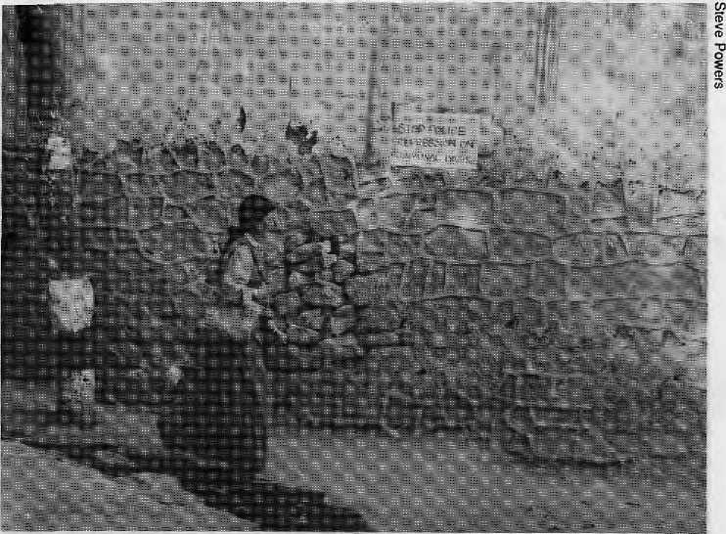
UNREST IN LADAKH:
Did the 'foreign hand' strike again?
A Rejoinder
by Martijn van Beek
I
n the September/October issue of Hitnal, Siddiq Wahid offered his views on the causes of the recent turmoil in Ladakh. According to this scholar, the cause of the unrest in this sensitive border area is neither economic nor political, as Ladakhi leaders themselves have suggested, but a phenomenon of 'intellectual colonialism' as Mr. Wahid termed it.
Wahid asserts that the Ladakhis, particularly the Buddhist community, have been "corrupted" by Western scholars and their books. He blames the "rupture of the fabric of Ladakhi society's health" exclusively on prejudiced Westerners, who he claims have not only mistaken Ladakhi culture as being part of Tibetan culture, but even succeeded in planting this idea into the heads of Ladakhis. An amazing case of indoctrination perpetrated by those unscrupulous Westerners, who have no other aim, but ... but what? Apparently, the author argues, the poor, misguided Ladakhis have been lured into believing that their culture is unique and exclusively Buddhist in nature. And, apparently, this is why Muslims and Buddhists no longer live in the perfect harmony that the author implies prevailed earner.
To a Westerner who has visited Ladakh several times, Wahid's allegation seems to be unfair. A simplification such as this not only strengthens the already strong xenophobia that is such a prominent feature of science and politics in the Himalaya, but more important, it completely ignores the real grievances of Ladakhis, both Muslim and Buddhist. As a foreigner and outsider, I feel it is not for me to pass judgement on the parties involved in the conflict in Ladakh, it being a matter to be settled by those same parties. But as a social scientist interested in the processes of social change with some knowledge of Ladakh, I feel I am able and that I should give my views on this matter.
Wahid quotes Francke, who supposedly claims that Islam is gaining ground in the Buddhist areas of Ladakh. Wahid takes issue with this statement as he does with Snellgrove's seemingly similar conclusion that there.is no demographic evidence to sustain them. I do not have such evidence either. But to say that these statements, which others have made, imply that the authors believe that "to be Ladakhi is to be Buddhist" has no basis. In fact neither Francke nor Snellgrove make this statement. They only report what they observed: that the number of Muslims in Ladakh is increasing. Demographic surveys could either prove or disprove such an observation, but it is not a value judgement, and certainly not enough reason for such a serious allegation as "intellectual colonialism." When Snellgrove writes that Ladakhi Buddhists are "driven into a small corner between Islam and Chinese Communism," Wahid accuses Snellgrove of having implied that communism and Islam are working together to destroy Buddhism. The two examples cited by the author
hardly substantiate the claim of "intellectual colonialism." If we analyze the two statements by Francke and Snellgrove, there is nothing in them to support the author's charges.
At the same time, I would not deny that there is a perception of Ladakhi Buddhism as a subject of curiosity on the part of Western scholars. Much of the scholarship on Ladakh centres on Buddhism and the Buddhist areas of Ladakh. The Muslims of Leh and Kargil districts deserve more attention from researchers, both Indian and foreign. The interest in Ladakhi culture and society stems not only from the fact that the Tibetan Buddhist culture is still alive here, but also in this culture's interaction with Islam and its transformation by the forces of "modernisation." But the interest of scholars in the Buddhist aspects of Ladakhi culture is perfectly understandable in light of Chinese policies in Tibet. Is this scholarly interest to be condemned? Is it exclusively the foreigners and their 'intellectual colonialism' that are to be blamed? One need only look at the brochures of the tourist offices in Delhi and Kashmir to see that here, too, it is the Buddhist aspects of Ladakhi culture that are highlighted.
Siddiq Wahid reduces the unrest in Ladakh to a clash between religious communities caused by some mysterious process of indoctrination of the Ladakhis by Western scholars. This explanation of the unrest in Ladakh is entirely at odds with what happened in Ladakh last summer.
Well before Muslim Ladakhis and Buddhist Ladakhis clashed, there were demonstrations in Leh, during which pro-Pakistan slogans were raised. Most of those involved in a demonstration I witnessed were not Ladakhi. Subsequently, a fight between Muslims and Buddhists led to agitation by the Ladakh Buddhist Association, However, considering their demands and my information about the agitation, it would be wrong to conclude that the agitation was directed at Ladakhi Muslims. Rather, the demands and the agitation itself were clearly directed at the state government for its perceived discrimination against Ladakh. Whether the demands of the agitators were justified or not is not for me to answer. To reduce the troubles to a purely communal conflict, however, is to ignore the real course of events and the grievances of the Ladakhis.

Jan/Feb 1990 • H1MAL 31

VIEWPOINT

To many the outbreak of trouble was surprising, though not its timing and intensity. Anyone who has visited Ladakh in recent years would have been aware of the growing dissatisfaction of the Ladakhi people. In the July/August issue of Himal, well before the first outbreak of violence in July, I described the disruptive effect of 'modernisation* on the economy and culture of Ladakh. I maintain that the causes of the glowing tension in Ladakh are due to the disruption of the local economy and society. In a sense, this disruption is the result of a form of "intellectual colonialism," but not in the way Siddiq Wahid suggests.
In Ladakh, the introduction of the money economy, of 'modem* education, health care, agricultural techniques, etc., has led to the collapse of the self-sufficient economy in the Indus Valley while increasing people's dependence on imports. At the same time, education, radio, TV and tourism have created unrealistically high expectations that cannot be met, and certainly not through the present model of development. All these factors have generated growing dissatisfaction and intensified competition among Ladakhis and between Ladakhis and others.
To bring peace back to Ladakh, the present model of development may need revision. The Government of India has done much to improve the standard of living in Ladakh. However, the present turmoil in Ladakh is directly Telated to the larger process of "modernisation." A different approach, aimed at a more sustainable development, would benefit not
only Ladakh, but the economic, political and strategic interests of India.
I cannot accept that the root cause of all of Ladafchs problems is the alleged "innocuous advances of the missionary, reinforced by the agents of British India and, now, by the scholar." I firmly believe that Ladakhis and the Government of India, making use of the insights of both Indian and Western scholars regarding development and planning, can arrive at a solution. The "foreign hand," rightly blamed for many things, is not culpable in this case.
M. van Beek is a development sociologist.
The Viewpoint section is a forum for debate and dialogue. Contributions are welcome. Opinions expressed here do not necessarily express the views of Himal or the institutions with which the writers are affiliated.

KNOW YOUR HIMAL

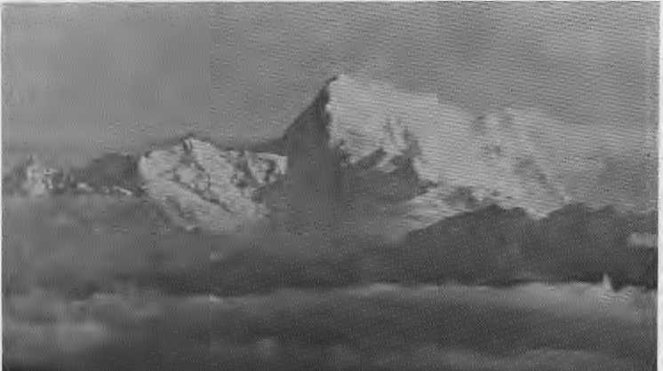
"prom Toma La and Mo Chu on the east, X^ the Chomolhari Range runs from northeast to southwest along the northern border of Bhutan to Tremo La. The Western edge of the range runs along the river known in Tibet as the Khangpu, in Bhutan as the Amo Chu and in India as the Torsa. Chomolhari, considered sacred by both Tibetans and Bhutanese, is generally listed as the third highest peak in Bhutan, after Kunla Kangri (7,554 m) and Kankarapunzum (7,451 m). It should be noted, however, that since most of the Bhutan Himalaya has not been precisely
Chomolhari (7,315 m)
surveyed, these three peaks joust for the title of highest within the 100 metre accuracy range.
Chomolhari, alternatively spelled Jomol-hari, means, "Mountain of the Goddess." A prominent snow-mantled pyramid on the ancient caravan route between India and Tibet, Chomolhari was among the first Himalayan peaks to be known to the West The Chumbi valley, lying on its western slopes with the Tang La, yielded Younghusband easy access to Gyantse and Lhasa in 1903. This pass was used extensively by Everest expeditions from
1920 to World War II.
Of the 18 or so peaks in the Bhutan Himalaya that are over 7,000 meters in height, Chomolhari was probably the first to be climbed by a Westerner. British explorer F.Spencer Chapman wrote of the peak in his account of the 1937 climb:
"Chomolhari gives a greater impression of sheer height and inaccessibility than any other mountain I have known; it drops in a series of almost vertical rock precipices to the foothills beneath. It is thought by many to be the most beautiful mountain in the whole length of the Himalaya."
With permission secured from Lhasa, as Chomolhari was then part of the Tibetan frontier, Spencer, two climbers and three Sherpas made up the first ascent party. Spencer reached the top with Pasang Dawa Lama, and their descent included a harrowing push by the goddess off the summit down the steep slopes for about 125 meters. They survived the epic with 4 nights on the mountain to tell . of the unspeakable beauty of the peak.
The mountain was climbed a second time by a joint Royal Bhutan Aimy and Indian Army expedition. It is possible there was a third climb before the sacred peaks were closed to climbing by the Bhutanese. On both the Bhutanese and the Tibetan sides of the peak, rhododendrons and azaleas abound, and the valleys are favourable for grazing yak and sheep.
-JMG

32 HIMAL • Jan/Feb 1990


SUMMIT HOTEL
GARDEN RESTAURANT
Kupondole Height, Lalitpur P G Box 1406, Kathrrtandu, Nepal Tel: 521894, 524694 'Fax: 977 1 523737 Tlx; 2342 SUMMIT NP
The Summit Hotel is famous for its warm and friendly atmosphere, efficient staff, excellent food, a delightful garden with swimming-pool and one of the best locations in town with a spectacular view

Sven white stuyppvng,
Srwironment is important

Ideally located in Lazimpal & Tripureshwar, so you bum less of fuel even/time
that you go shopping. Small contrtMJtion in reducing polluter, but every thing
matters.
Environment inside the shopping complex is skillfully designed to stimulate your
buying instinct. And an array of goods from all over the globe makes your task of
choosing even more exerting. We go to extremes in selection to oHer you goods
of consistent quality eveiytime.
You are welcome anytime between 8AM to 8PM
lihwhird
SUPER MARKETS DEPARTMENTAL STOKE Tripureswar, Tel: 212826 • Lazimpal, Tel: 415181
ADVERTISE IN HIM
Do you have a commercial message?
Do you need a credible medium to carry it?
Do you need to target a sophisticated audience ?
Then you need to advertise in Himal.
Himal is the only international magazine of the Himalaya. It has a select, committed and expanding readership -- in Nepal, India, Bhutan and Pakistan, as well as in Europe and in North America. Whether you are a travel executive promoting a new destination, a banker seeking high profile investors, a development professional looking for a social marketing outlet, or an industrialist unveiling a rugged new pick-up truck, Himal's pages are your best medium in the Himalaya.
So join us. Advertise in Himal and reach your market.
Write for our rate-card. P.O. Box 42, Lalitpur, Nepal

Contact us for books on Nepal, Tibet,
Bhutan, Ladakh, and other areas in the
Himalayan Region. You will find other
useful materials including Maps,
Guidebooks, International Magazines,
Newspapers, Post Cards etc.
Maharjan Book Centre, P.O.Box 3105, Ttiamcl, Kathmandu, Nepal
United Parcel Service
Nepal Air Courier Express (P.) Ltd. Putalisadak, G.P.O.Box: 4417 Kathmandu, Nepal Tel: 221588, 225854 Telex: 2318 NAXNP
For Maps of NEPAL
Please visit our showroom.
S.M.Trading Centre,
New Baneswor,
P.O.Box 4782,
Kathmandu.


MMIT NEPAL
Summit Nepal Trekking
Kopundole Height
P O Sox 1406, Kathmandu, Nepal
Tel: 525408, 521810
Fax: 977 1 523737
Tlx: 2342 SUMMIT NP
Specializing in:-
- Mountaineering/Expeditions
- Tailor-made Trekking
- Unique Cultural Tours
- Wild Life/Jungle Safaris
- White Water Ratting
- Personalised Services

Jan/Feb 1990 • HIMAL 33

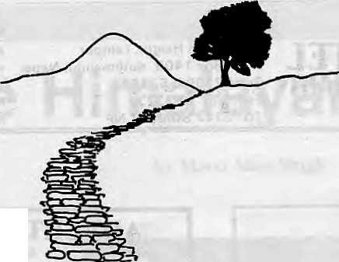
On the Way Up
by Kanak Mani Dixit
T
his is a call to all you people who have read and perhaps even liked Himal: why don't you consider writing for us? No, we have not run out of ideas or writers. There is enough happening in the Himalaya to report on, and we feel privileged to have a roster of committed and talented journalists and writers. But we know there are more of you out there who Himal would like to invite to its pages.
Enlarging our circle of contributors will make Himal's coverage more comprehensive and, we hope, relevant to the needs of our community. You do not have to be a journalist, you do not have to write good English, in fact you do not even have to write in English. What Himal asks is that you have an idea to share which will contribute to a dialogue on improving the quality of life in

the Himalaya. That might sound like a tall claim for a smati magazine, but we try.
THIS ISSUE'S COVER
Turning over the pages of Himal's "project document" prepared when this magazine was just an idea back in 1987, we came across the following under the section entitled "Editorial Policy": "About 25 percent of Himal's readers will be from outside the region. While this international (primarily Western) readership is welcome, the editors will be cautious not to adjust the magazine's emphasis so as to cater to that market."
That was in 1987. We hope that this issue's cover story on Himalayan "image and
reality" will contribute to the process of seeing the Himalaya for what it is. We were fortunate in being able to attract contributions on various aspects of the subject from writers with a love and commitment to the Himalayan region.
Having brought out this issue on the outsider's myths about the Himalayan region, we feel duty-bound to publish an issue on the "native's" visions and misconceptions about the West. In the minds of many Bhutanese, Garhwalis, Kashmiris, Kumaonis, Nepalis, Pathans, Sikldmese, Tibetans and other inhabitants of the Himalayan highlands, "Shangri-La" actually exists, and its name is America!
NO NEXT HIMAL
As the notice on page 2 makes clear, there
will be no March/April issue of Himal as all
our resources will be devoted to bringing out
an annual issue in Nepali. Subscribers should
not worry: they will receive the number of is
sues they are entitled to. In publishing the
Nepali annual, we are trying fulfill another of
our commitments: to serve a non-Engiish
speaking (mostly non-elite) readership as well.
In forthcoming years, we hope not to suspend
our regular English issue in order to publish a
vernacular number. We also hope in future to
publish occasionally in some of the other lan
guages of the Himalaya, Stay tuned. t\


ANNUAL SUBSCRIPTION RATE (SIX ISSUES)
SOUTH ASIA
INDIVIDUAL NRsllO/IRs65 INSTITUTIONAL NRs 300/IRs 200 (or equivalent)
ELSEWHERE
U$25 U$4S (or equivalent)

Persona! checks are acceptable, bank drafts and money orders preferred. Send subscription orders and correspondence to:
,_{n} South Asia: ^^^^^L^_{m} Circus, New Delhi 110 001 in North America: M. Basnet, 4 So. Pinehurst Ave #6A, New York, NY 10033
In Europe: B Welsh, Holos Centre 139-A. Battersea High Street, London SW1. UK in turope. a ^^ _{Donaustr} ^ ^^ _{Duisburg} _{29p} w. Germany
A. Odermatt, Winterthurerstr 112, CH-8006, Zurich, Switzerland
In Japan: Akio Horiuchi, Post Box 9, Kiyose, Tokyo, In Australia: tndra Ban, 12 Norfolk Street, Paddington 2021, Sydney Australia
HIMAL is current. It is readable. And it is serious. It is indispensable if you want to keep in touch with the region.

34 HIMAL • Jan/Feb 1990

legendary kingdom in the trans-himalayan region, namely
Bhutan, Nepal & Tibet.
We have polite, efficient and professional staff from each of these regions.

We offer the land & the people, You discover the rest ....
GSA druk-air CORPORATION
(A ROYAL GOVERNMENT OF BHUTAN UNDERTAKING)
f^5?%?yi Durbar Marg, Kathmandu \y$y\f ^{po}- ^{Bo}* 4794, Tel: 225166/227229 ^^£S Telex: 2627 RABSEL NP, FAX: 009771227229
NEPAL
INTERNATIONAL CLINIC

■Western medical setting serving
the entire community •Care by a U.S. Board Certified
Internist •Comparable services
at lesser rates
• Imported vaccines, Lab work •Knowledge about mountain sickness •Central location •9:30 am - 5 pm (Wednesday - 6:30 pm)
Saturday: Emergencies Only •Open Sunday •Prior appointment encouraged
419713, 412842 (answered 24 hours)
Royal Palace Main Gate
Lazimpat
_| I
Jai Nepal Cinema Hall
Naxal
Thamel
Kantipath
Baths
Durbar Marg
2nd "sate

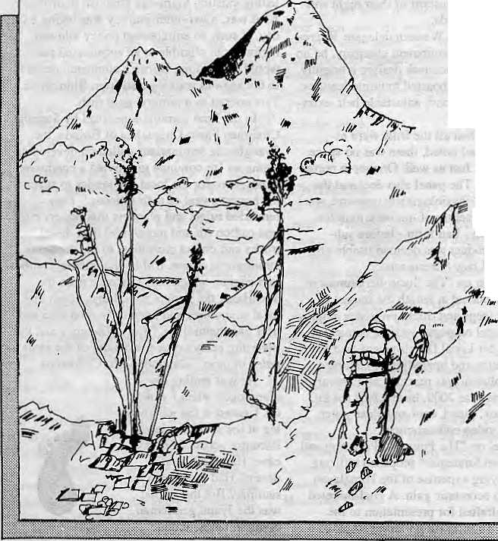
ASIAN TREKKING INVITES
YOU TO AN EXPERIENCE WITH NATURE
We take you through natural trek trails to places ^f unending beauty and into contact with the /a friendly mountain people and their gentle living.
An experience you will never forget with our professional team to attend to all your trekking and tour arrangements with quiet efficiency.

m taw [p] to.
P.O. Box: 3022, Keshar Mahal, Thamel
Kathmandu, Nepal.
Tel: 412821, Telex: NP 2276 HOSANG
. ■'■ ~ - ■ ■ .'..{

Jan/Fcb 1990 • HIMAL 35

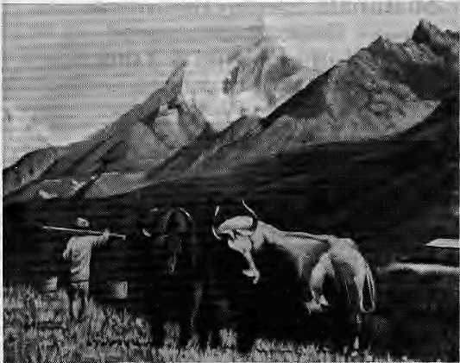
Abominably Yours,
What is a Kathmandu Jyapu with a Khar-pan doing under Ama Dablam's gaze in the Khumbu? Did the gentleman take a wrong turn on his way to the market to find himself 150 miles off to the east? Two perplexed yaks gaze in wonder. Have they reincarnated as holy bulls in Asan's vegetable market?
The only plausible explanation for the Kharpan-Khumbu mismatch is that the artist did not know nor particularly care that Sherpas live in Khumbu, Limbus in Limbuan, Dmkpas in Bhutan, and that Jyapus are indigenous to Kathmandu. Or perhaps weary of touristic renditions of Machhapuchare and Ama Dablam panoramas, the artist decided simply to spice up by transporting the Kharpan to the Khumbu. Who knows, he might next plant a yak grazing on the elephant grass in Chitwan ot a gharial sun-shivering itself at the glacial lake of Phoksumdu.
Sufficiently intrigued, I sought some jaach bujh. So I descended from my upper Barun hideout, traversed the Hongu basin, turned in at Kharta, and took a right at the Imja Khola fork, finally reaching Syangboche. To my utter astonishment, what did I see but a field of Kharpansl
The Jyapu gentleman had every reason to be where he was. Syangboche was the venue for a United Nations Technical Cooperation among Developing Countries (TCDC) meet. The red on white banner, flapping in the highland breeze, said: "Seminar on Loads, Load-bearing Techniques and Carrying Capacities." Load-carrying people - porters - from around the globe had gathered to consult and adopt "forward looking strategies."
A Quechha Indian from the Andes was demonstrating his technique, which intrigued the "locals" because that was exactly how the dhobi washermen and women carried their loads - a sheet with its ends tied in a knot at the chest. Next, the Himalayan delegation presented its technologically more advanced exhibit, the doko. Another workshop demonstrated to the-Andeans the use of the strap around the forehead, the role played by neck muscles, breathing techniques, and how to Test in mid-trail by placing the load on a T cane.
The versatility of the human head was next. Most people limit the head's cargo-bearing to parking pencils or cigarettes behind the ear. But the Tciai wallah showed that even logs could be balanced on the head, as could lunch pails, water jugs, or bundles of grass. The hightanders were impressed by this method which left the hands absolutely free. "Look, Ma. No hands!" cried out a Sherpa lad 10 his mother.
The subsequent panel discussion revealed deficiencies of the head-on method. A grizzled Gunmg from Lumle asked the Terai man if the skull was structurally strong enough to bear the normal 80 kg doko load. "The answer was no: it was advised that heads were better used for delicate tasks such as carrying eggs to the market. At this, the Bolivian representative declared the technique okay on flatlands, but could one walk erect with eggs on one's head while negotiating a sleep trail? There was a murmur of assent and participants moved to the next agendum.
The Kathmandu and Hunan delegations were both amazed to see the other presenting the kharpan. The Kathmandu representatives, demonstrating its versatility, balanced the baby on one basket, and a sack of rice on the other; rakshi and jaand on the port side and farming implements on starboard. The Han Chinese sat agog. They admitted sheepishly to using their kharpans only for transport of their night soil from outhouse to fields.
There was a lone Western delegate. Representing an outdoors equipment company, he unveiled the latest in backpack design; a brightly coloured sack which boasted multiple features: extra padding all around, adjustable belt, extra-wide padded straps.
Hang on! When all the frills were assembled, the panel noted, there was no space left foT the load. Just as well. One more porter would gel a job. The panel also declared the backpack to be "physiologically unsound, wasting the energy reserves of the back muscles, and putting form - bad form - before substance." The product was deemed usable only for tourists and lazy bureaucrats.
The seminar on "The Socio-Economics of Portering" discussed at length the impact of gas guzzling jeeps and trucks on porter employment. The panel on porter welfare demanded the Ministry for Local Development take over the maintenance and upgrading of chautara stops. A resolution was reached: all chautaras should, by the year 2000, have a first aid kit, suggestion box, piped, cool and clear water, and radio or video entertainment.
The panel on "The Future of Portering and Diversification Strategies" proposed utilizing the load carrying expertise of the Himalayan population to economic gain. A goal-oriented agenda was drafted for presentation to the government. To increase portering employ-
ment, all foreign trekkers would be banned from carrying their own rucksacks, backpacks, duffles, or daypacks. They could hold on to their trail nuts and Kleenex, for which a special permit would be required. Turn-of-the-cen-tury palanquins (ulinkaths) must be salvaged from moth and mildew. A Palanquin Express would operate for tourists. What adventure! Riding through Himalayan hill and dale in five-star comfort on four sturdy mountain men.
The farthest reaching resolution was sponsored by the Nepali delegation. It muscled in an act that would suspend all highway building activity, and commended the government for letting existing highways languish in disrepair. As it was, a two-hour journey was taking a full day. If such an enlightened policy allowed highways to crumble at an accelerated pace, it would not be long before Kathmandu reverted to the age-old walking trail from Bhimphedi. Tantamount to a porters' gold rush.
In the final communique, read by Steering Chairman Pablo Chihuahua of Bolivia, the Syangboche seminarians called on developing countries "to continue to provide a conducive atmosphere for the local economies to support the honest sweat of their citizens." They reminded rulers and planners that porters emit less carbon (di and monoxide) than diesel trucks and do not contribute to the depletion of atmospheric ozone. Unlike the internal combustion engine, which sucks income from the hinterland, the porters would inject cash into local economies and keep the nation lean and trim like themselves. "Self sufficiency and the portering economy are two sides of the same paisa or peso" concluded Mr. Chihuahua.

He was ending his monologue when I woke up. 1 gazed at the ice glistening at the sheer flanks of Bamntse across from my cave. Had it all been a dream? Had there been no seminar? But then, what was the Jyapu gentleman doing in the Khumbu?

36 H1MAL • Jan/Feb 1990

NEPAL
OFFERS UNFORGETTABLE NATURAL SIGHTS AND RICH CULTURES

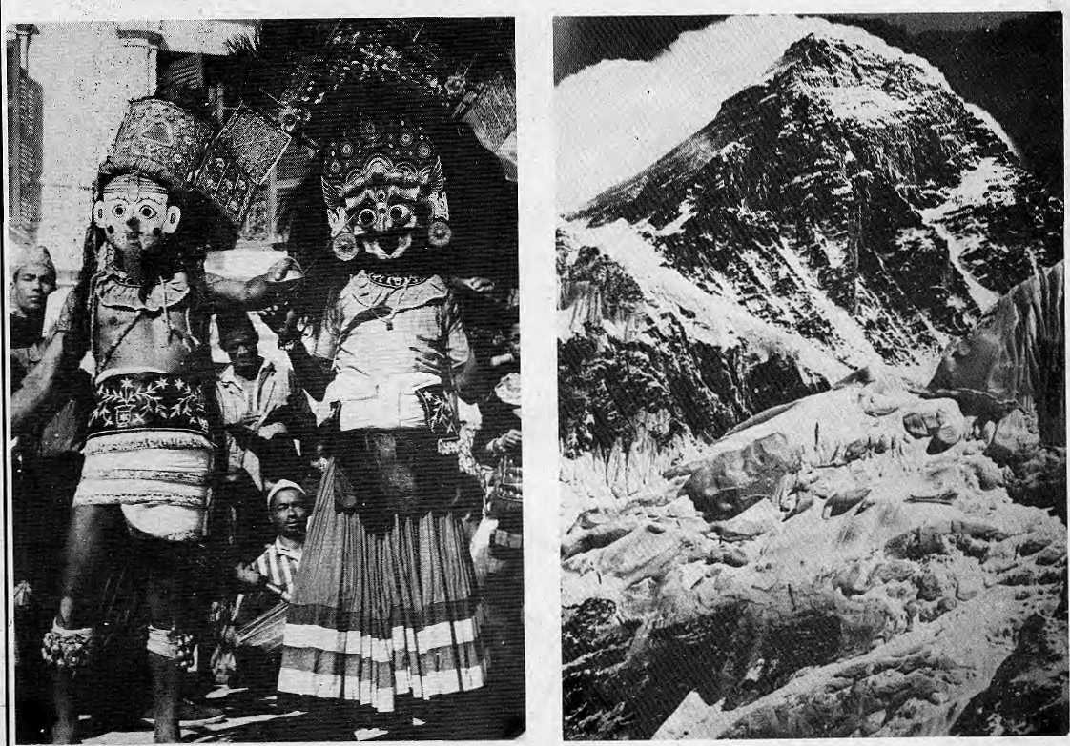

^
PLEASE HELP PRESERVE THEM: TREAD LIGHTLY!
Trekking • Safari* Mountaineering Cultural Exchange • Adventure

For information, please contact the Department of Tourism, Ministry of Tourism, HMG, Tripureswor, Kathmandu
telephone: 214519 cable: TOURIST

Regd. No. Lalitpur 65/045-46

.,:.,.:.■,..
;!.:;:::;:::|:::i-::::::.:\:J :.:: :::: ■::■:::.;:■:; ::.::■::':'.: : : ■'. ■ ■ ':'..■ v::-.'-\-\ :■':.■.: .V^y¹;:.

iiiHIBBiiiiilili

I ow the only direct flight toLondon is via Royal Nepal, departing ©very Thursday at 2120 hours ^arriving in Lon^
flight saves you timeon the ground, and: invites you to enjoy select drinks and choice delicacies served by our attentive^hostesses thtoiighout the journey:
Enjoy your way to London.

'- " "■■' ■■ - ■ - -:- - ■: '■-.'.
Airlines

Fos further details, pleasie contact yourtravel agent or the local Royal Nepal office /; ''':;:Wz0rt^^iim£??*^^:':t
:. Bangkok: . .Calcutta! Delhi :. Dubai Kathmandii Hong Kong Singapore:: :-: London::-..:::: Franifftirt :- :■:::..
233-3921-4 . : 298534 ■ )'■/, 3321-572 .228308' ■ ;/■ 220-757;..' .3-6991.5.1/2;... ; 225-7575. . ■ .. ,3834314.:.... ; (069) 250-106/7 '.

