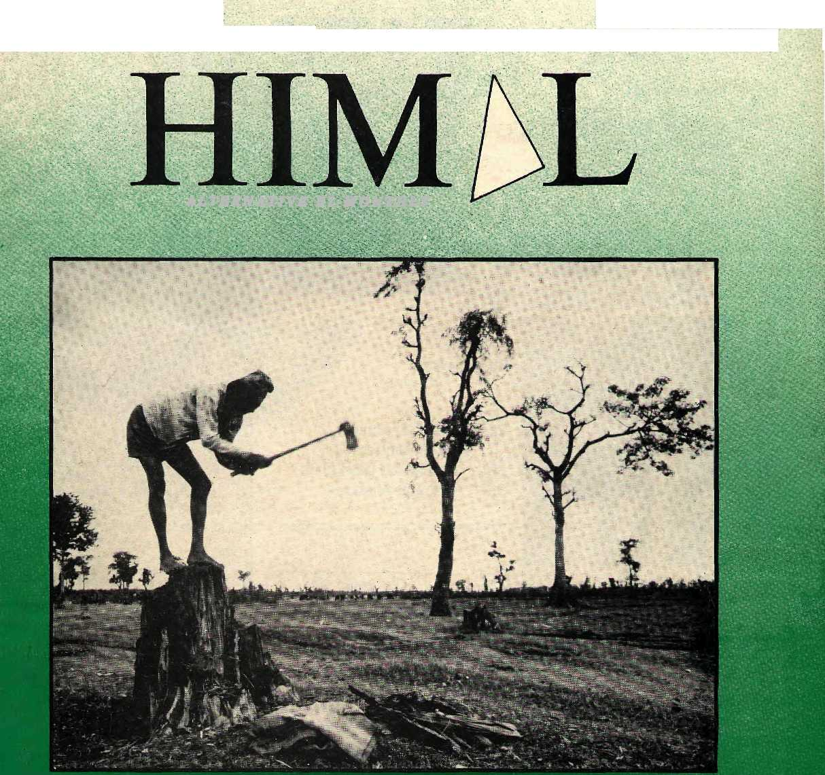
NRS20 IRS12 U$6
ISSN 1012-9804
SEPT/OCT 1990
ALTERNATIVE El-MONTHEY

arai:
Backwater or New Frontier

AIDS EXPOSURE KHUNJERAB EAST TO WEST
PEACE FLA
SICK OF HEIGHTS
ERA FOSTERS HERO

INSIDE

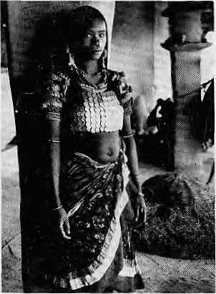
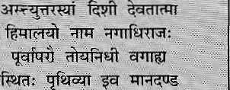
COVER
5 Nepal's Tarai
9 Making of a Dynamic Region
TO Plains People
11 East to West: A Highway
to the Future 14 A Wild World that is No More
- Where Mountain Meets Plain
- Tension and Conflict
in Western Tarai
- Deepening Crisis in Sagarhawa
HIMAL
Vol. 3
&: 3.:.'.;Sep.i/Oct, 1990


DEPARTMENTS
19 | Briefs
23 | Voices
31 | Abstracts
37 | Reflections
40 | Abominably Your's
FEATURES
Removing the AIDS Blinders Khunjerab Workshop Ignoring Altitude
26
33 35
Cover picture by Kevin Bubriskl: A hill migrant desperate for firewood in Kanehanpur, West Nepal.
Himal (ISSN 1012-9804) is published every two months by Himal Associates, PO Box 42, Lalitpur, Nepal. Tel: 523 845. Copyright 1988. Turn to page 4 for subscription information.

9Bu *■■■ jS^^H^teii; fc,
"/I « '^{v:} r;^:': ■: -w
IM:

TV Wy  trader sets fortW to discover | Kr*n.wtll...
TheAbode of Goefs,King of
You hound ike oceans jram :. .."" := ,, east to west ■■■ ■■■■■-,.:"Anorthern yardstick To measure the Earth
Edited and piiblisiied by KimakMaalDlxit
: Jpr Himal Associates
? Kcsang tseteri
^{v;:} ■=::. Associate Editor,
ArtUpRaj Josni :■;.■ ,
-Staff Writer C
,Mi Abflullah, Peshawar Adlai Amor, Manila Anita Anand, NewDelhi KlaleyDorje, Thimphu Harka Bahadur Gurung, Kathmand« Gorneille[Jest, Paris PremShankherJliB, Hew Delhi BliSrat JDiitt Koiraia; Kathmandu BamChandra Malhoira,JRome HwnantaMbhra, Kathrnandu David SassboHi New York Kumi ar K had ga Bk. Shah, Katlim andu Jt)oiisl(i ShantoF; New Yptk Ainbica Shrcstha,Kathmandu Vidya Stokes, Shimla. B.G. yergh^se; New Delhi Brian Welsh, Athens

MAIL

FRESH AIR OF FREEDOM
As a visitor who has been to South Asia, particularly Nepal, again and again over the past eight years, I applaud the title piece 'Tryst with Democracy" by Dipak Gyawali (May/June 1990). I feel the fresh air of freedom in Kathmandu (who could miss it?),
HIM^L
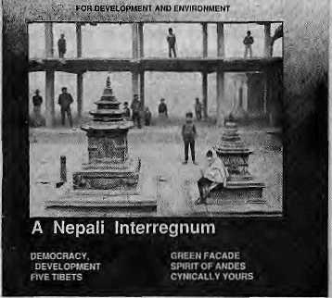
and Gyawali's unabashedly direct article was additionally invigorating. I have been buying extra copies and mailing/giving them to friends so that they can gain a proper perspective on the deeper currents of Nepal's politics. I must say, though, that Gyawali's listing of the wrong turns in economic development, the brewing discontent in society, the intellectual bankruptcy, and the "tense interregnum" of the present, in the end, make for depressing reading. Is there any hope?
Being a foreigner myself, I fail to understand Gyawali's point on the role of "the diplomatic and aid community" in propping up the Panchayat system. Their possible misinterpretation regarding the king's divine status can at best have had a tangential impact on the development of Nepali politics. People get the kind of political system that they deserve. If they are unwilling to stand up, they
get a feudocratic monarchy, and why not? Following the people's movement, the Nepalis finally and most happily became deserving of democracy. That is how I see it. Is Gyawali taking a pot-shot at the expatriate community just because they are an easy target? G. Campbell-Reynolds Kathmandu
BEWARE OF MANDAL
Kedar Mathema's article on Nepali education, "Cheating Our Children" (May/June 1990), was clear, precise and cogent. While concurring with most of what he has to say, I strongly disagree with the suggestion that one remedy for the present unequal access to education in Nepa] is "allocating certain percentage of seats in higher education for applicants from dis advantaged groups, particularly girls".
Although the author did not have the benefit of hindsight, the repercussions of the Mandal Commission Report in India must be noted. Nepal can well do without the troubles of New Delhi, especially during its presently heightened state of tension.
Instead of suggesting that colleges should take persons because of who they are rather than how good they are, I would like to see the government allocate a certain amount of its education budget to support students from dis-advantaged groups who have qualified for a particular institution against the same standard as everyone else. Devendra S. Rana Kathmandu
IN DEFENCE OF SEMINARS
With the May/June 1990 issue, you have joined other high-minded media of Nepal, into the area of uninhibited speech. For Hanoi, the "manual agricultural excavator" has turned into a spade (page 25). Congratulations!
But the problem is not over yeL The user of the spade is not ipso facto a fanner. He has to vise the spade consistently and conscientiously.
The same is true of free speech, democracy, multi-party sysLem, or the constitution-in-making. They are all excavators which must eventually turn into spades and be used widely and freely in order to have any meaning. Hence, the high-minded media has a critical role to play: it has to show the people that putting into practice this new-found freedom is what is important; not basking in its theory.
Yet, even Himal, in its latest "Briefs" section, appears to disgrace this freedom. In the column called "Seminar! Symposia! Dementia!" you discredit decent efforts by ridiculing the organisers, sponsors and participants of symposia, seminars, workshops, hearings, gos-tis and so on. By doing so, you are in a way depriving those people who want to use the new opportunity to put into practice their right to free speech, to act democratically, to meddle creatively with the gerontologists of constitution-writing and to venture beyond the multiparty arena.
I have been assigned the task of organising an international workshop on solid waste issues in Kathmandu - "Asia's busy seminar capital" as you call it — in late October. I will, with pride, speak up in defense of those involved in equally relevant programmes. Since April, there have an increasing number of these seminars and there will be more so. We are here to stay!
"Why swelter in the plains of Delhi, Dhaka and Bangkok?" you ask correctly. You forget to mention that the fresh climes of Kathmandu compromises not only of the perennial "monsoon green and autumn gold" but also of the unique crispness of the globe's youngest democracy. With equal accuracy you state that "most development activity (in Nepal, at present) is at a halt. To this I would like to add that such a halt may very well be Nepal's Sternstunde: a time to reflect, to reconsider, and to change. Christian von Hattfeldi Kathmandu

Sept/Oct 1990 • HIMAL 1

MAIL

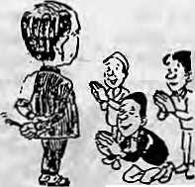
ACTING OUT "DURBARIA LEGACY"
Prabha Thacker's excellent and concisely written article, "The Durbaria Legacy" (May/June 1990), was a masterpiece of social analysis on some rather unpleasant characteristics of the Nepali society. %As a development worker in a remote rural area, I have frequently come across the "distorted traits" mentioned by Thacker, particularly in government offices. On some occasions I have myself been subject the hazoor, darshan or chakari culture.
Thacker rightly points out that these traits are part of a feudocratic legacy. They add to
the numerous obstacles Nepali people face in their efforts to build a democratic society based on human rights and social justice. The traits mentioned above and their counterparts ghamanda and ijjat — have been internalised to such a great degree as elements of male virtue that much time and educational effort will be needed to gradually overcome this burden of the past.
Just to illustrate Hitnal's practical impact on development, I would like to share a recent experience from our non-formal education work. As part of the monthly in-service training for our staff, we organised a role play based on Thacker's article, in which we acted out the
different traits in various scenes. The response among the 20 members, actors as well as the rapt spectators, was astonishing. Everyone was emotionally touched by the performance and there was much laughter. A social issue with which we had been familiar in one way or another had been addressed. As a result, somehow, unexpectedly, we found ourselves tapped in to the 'Generative Theme' (P. Freire). By so doing, we were able to set free and realise some of the tensions and negative feelings that are part of internalized oppressive structures. Actively and creatively, we had learned a lesson, not maaihi hata, but lala bata. Continue your good work! Thomas Doehne Non Formal Education United Mission, Okhaldhunga

Robin Hood Cannot Do It Alone
Kk.Panday's article "Waiting for Robin Hood" on Nepal's forestry contains factual errors and misleading implications. He claims that the recently prepared Master Plan for the Forestry Sector has not been "conscious of the villagers* needs". In fact, the Master Plan explicitly acknowledges the important relationship between Nepali farmers and their forests. One of the plan's key strategies is the "phased handing over of all the accessible hill forests to the communities, to the extent that they are able and willing to manage them".
The plan's major focus is not on the provision of leasehold forestry as claimed, but on a mix of strategies which, if implemented, would result in: forests being under villager's control; improvement in the condition of forests; development of industrial forestry (mainly in the tarai); and leasehold forestry, where there is a potential for economic activity and no community forestry requirement.
The Master Plan was not based on the Panchayat System and does not lie in limbo as claimed. It certainly acknowledges the Panchayat. That was the political and administrative reality in Nepal during the planning stage. Fortunately, the key- elements of the plan in relation to community forestry were based on interaction between the rural people and their forests. This is unchanged and will remain unchanged regardless of the political system.
The plan, which has been widely acclaimed within the country as well as internationally (it is in line with FAO's Tropical Forestry Action Plan), has been endorsed by Nepal's Interim Government and its implementation is proceeding accordingly. Several other countries, including India, have proposed similar master plans for their forestry sectors.
Panday refers to an "undemocratic forestry bill" which was drawn up to implement the Master Plan. In fact, this proposed bill is a radical piece of legislation and should be viewed in the context of what it was supposed to replace. The previous forestry legislation, the Forestry Act (1961) and Forestry Protection Act (1967) were repressive and designed to strengthen the role of the Forestry Department in enforcing protection. The proposed bill, on the other hand, recognises the right of villagers to have control over forests in their immediate vicinity.
Panday comments on the "disaster (that) hit the environment" when forests were nationalised in the 1950s. It is common these days to attribute most of the country's forestry ills as having emanated from the passing of that legislation. It is often overlooked that one of the intentions of the Private Forest Nationalisation Act (1957) was to remove remnants of feudal land tenure and restore public ownership over large tracts of forests which had passed into private hands during the Rana regime. By 1950, about one-third of forest and cultivated land was held under birta tenure, un-taxed, 75 percent of it owned by members of the Rana family. This discussion is not an attempt to justify the 1957 legislation, but rather to provide some perspective. The primary reason for forest destruction is the grinding poverty of the hills.
The claim that the nationalisation legislation led villagers to feel that the government has taken their forests away, is an overly simplistic view. It would have been almost impossible, more than 30 years ago, to have conveyed the intention of the government, expressed through legislation, to the villagers in rural Nepal. A more powerful influence has been the recent
activities of survey teams. Once villagers know that the government is going to fix boundaries of land holdings, they often scramble to claim as much area for themselves prior to the arrival of the survey teams. This often results in the clearing of trees and shrubs and commencement of cultivation on land that may have been previously used to harvest forest products.
As mentioned by Panday, in many places villagers have established their own management systems to protect and manage local patches of forests. Most of these local systems have evolved during the past 20 years, many during the past 10 years, responding to locally felt needs. This indicates that people were still able to take limited but effective action to protect local forest resources they considered to be theirs by traditional right.
As always, it is easier to be destructive than constructive. In that sense, Panday's article was disappointing. Many of his pleas, such as giving the Nepali woodlands back to the people, actually form explicit components of both the Master Plan and the proposed legislation. In fact, these are the underlying principles of community forestry practice in Nepal which the government has been attempting to implement for more than a decade.
As for Robin Hood, there is no need to wait for him -- he is here! But Robin Hood cannot achieve miracles alone. It is time thai the Sheriff of Nottingham and Robin Hood worked together for the betterment of Sherwood Forest and the villagers that depend on it. It does not matter who was who in the past - it is the future that is most important. Baban Prasad Kayastha Additional Secretary and Spokesperson Ministry for Forests and Soil Conservation Kathmandu

2 HIMAL ■ Sepi/Oct 1990

MAIL

Neither Can the Ministry
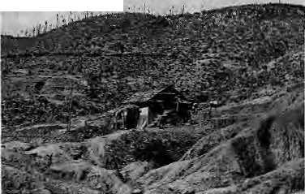
The letter by Mr. Kayastha is the first positive signal from the Ministry of Forests and Soil Conservation that it is willing to listen to constructive criticism of its policies. For too long those who are concerned about Nepali forests and Nepali soil have shouted without being, heard. This is a small opening that is long overdue. The Ministry must respond to new situations and ultimately respond to the people's demand that forests be transferred to community ownership, not just management.
To first respond generally to the Ministry's letter, it could not have been the hill peasants who have conspired to decimate as vital a resource as their mountain woodlands. They arc not likely to consume more than they need to survive. The problem has to do with greed (nothing less) of forest administrators who have allowed major and minor comipt commercial interests free play in the forests. Who can forget that the highest echelons of the Forest Ministry themselves, were manned by persons known openly to be indulging in corrupt practices. Therefore, however good the Master Plan might or might not be, it is in their implementation that much depends.
Regarding the Ministry's record, there must be some fire inside the forests because there is smoke on the hillsides of Nepal for all to see. The Ministry accepts for the first time that the Forest Act of 1962 and the Forest Protection Act of 1967, which follow'ed the 1956/57 Nationalisation Act, "were quite repressive and were designed to strengthen" enforcement. How was it then that no attempt was made to remedy such drastic problems during 29 long years of the Panchayat system? We are asked to believe that the Ministry is making an 180 degree turn overnight with the introduction of a Master Plan and a flawed forestry bill?
Turning to the Master Plan (prepared by Finn and Filipino consultants) and the proposed "Forestry Bill 1990" (prepared by an Australian), my contention is that the whole superstructure of the Master Plan's community forestry provisions are based on the Panchayat system, through the medium of "Panchayal Forests" and "Panchayat Protected Forests" (seepp 149, pp 179 of Dec 1988 Main Report). How does the Ministry propose to extricate itself from this mess?
Also, how is it that two legal documents which are meant to regulate a relationship as symbiotic as between the peasant and his/her forest, are prepared in original English? The semantic hurdles in doing so, themselves, are insurmountable. The spirit of any legislation which would presume to regulate Nepali life, particularly rural life, must be in original Nepali. Were there not individuals with decades of experience within the Ministry itself and its departments, who could have come up with documents that are much more understanding of the Nepali situation? Why do we get increasingly enamoured of foreign consultants, even in areas where they can only have hearsay knowledge?
Acknowledging the "important relationship that exists between Nepali fanners and their forests", as the letter does, is one thing and doing something about it is another. The Plan and the proposed legislation, it is true, are willing to hand over management of many forests to the villagers, but this is a half-way measure whose utility went with the Panchayat. What is required is to transfer ownership to the village community. Please note that the Forestry Bill 1990, Chapter 5 makes community forests part of "National Forests" and thus brings them under the ultimate control of the District Forest Officer (DFO). This is exactly where the problem lies. What we need is a "de-nationalisation" legislation which will allow community forestry, pure and simple. Certainly, it will be a courageous act, but if one has trust in peasants (rather than in technocrats) and their innate sense of logic and ecology, the planner will never go wrong.
Among the "undemocratic" aspects of the forestry bill are the features contained in Chapter 10, Article 28 on power of arrest for suspected encroachment of forests, using "whatever force is necessary", including "lethal force". Article 21 says thai when a person cuts trees on his private forest, he is forced to replant trees. If he does not, (he government can move in and plant trees and charge the landowner for the service. This is simplistic en-Vtronmentalism, devoid of any understanding of village economics — do I detect the foreign consultant's handwriting?
I have a major problem with the fact that the Master Plan allows leasehold forestry at all, because it will maintain the rule of village overlords over forests and allow powerful national elements to manipulate things to their benefit. In Article 19, the Minister of Forests and Soil Conservation has the power to hear and decide appeals relating to action which his own Minis-fry has undertaken. That hardly bespeaks a sense of justice.
In the end, I am alarmed to learn that implementation of the Master Plan is "proceeding accordingly". The Ministry has a responsibility to incorporate democratic values and human rights principles in all its forestry legislation, which must be in conformity with the new Constitution which Nepal is getting. This is why we have suggested that the Ministry pause and lake another look at the two documents in the light of the criticisms that have been made and the changed context.
What might seem nit-picking criticisms to urban sophisticates can be of vital importance to village people, which is why points I make above should not be brushed aside. There must be a built-in learning process in the Master Plan, for as things stand, heavy input of foreign consultants rob national-level Nepali experts the opportunity to put their experience into use; just as at the village level the heavy hand of forest administration robs the villagers of tenurial rights and ability to collectively own and manage forests.
Even if the Master Plan were to be "ac^ claimed" the world over and praised by everyone high and low, it would still have to pass muster With the Nepali hill peasant. As it stands, and if the peasant is allowed to have his say, it is my belief that the Master Plan would not. International applause might jusi mean that the general policies enunciated in the document are laudable. Implementation is another thing, because it needs proper understanding of hill conditions as well as the political will and ability to push through new and courageous ideas. Kk.Panday
We invite readers to com mem criticise or add to
information appearing in this magazine. Letters
should be short, to the point and are subject to
editing.
Send mall to; PO Box 42, Lalltpur, Nepal
TO OOS READERS:
We want you to note that because of the substantial amount of time spent in bringing oul the first issue of Nepali Himal, we were unable to bring out the July/August issue. However, you will still receive the six issues for which you paid. We apologise for skipping the issue.

Scpt/Oct 1990 • HIMAL 3

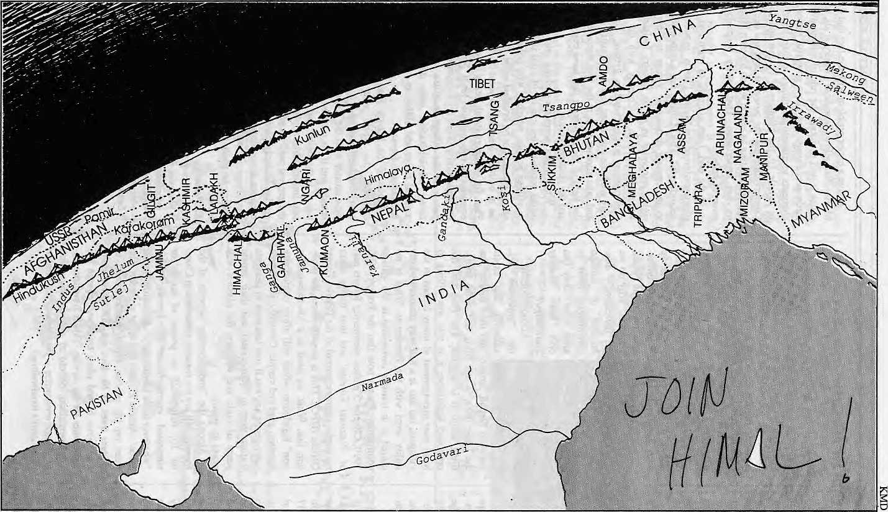
.u
g

ANNUAL SUBSCRIPTION RATE (SIX ISSUES)
SOUTH ASIA ELSEWHERE
INDIVIDUAL
NRsllO/IRs65 U$25
INSTITUTIONAL NRs 300/IRs 200 U$ 45
(or equivalent) \ot equivalent) Personal checks are acceptable. Bank drafts and money orders preferred.
Send subscription orders and correspondence to:
South Asia: P.O. Box 42, Lalitpur, Nepal (tel: 523 845), or
Central News Agency, 23/90 Connaught Circus, N. Delhi 110001 North America: M. Basnet, 4 S. Pinehurst Ave. #6A, New York, NY 10033, USA
Europe: L. Debuck, Donaustr 38, D-4100 Duisburg 29, Germany
Helene Dingg, Tannenweg 18, CH-3073, Guemligen, Switzerland
Rest of Europe:
Zahia Hafs, 23 Rue de L' Ecole de Medecine, 75006 Paris, France
Japan: Akio Horiuchi, P.O. Box 9, Kiyose,Tokyo, 204 Japan
Australia: Indra Ban, 12 Norfolk St., Paddington 2021, Sydney, Australia
HIMAL is current. It is readable. And it is serious. It is indispensable if you want to keep in touch with the region.

i ■■:•.••••..:

Nepal's Tarai
Backwater or New Frontier?

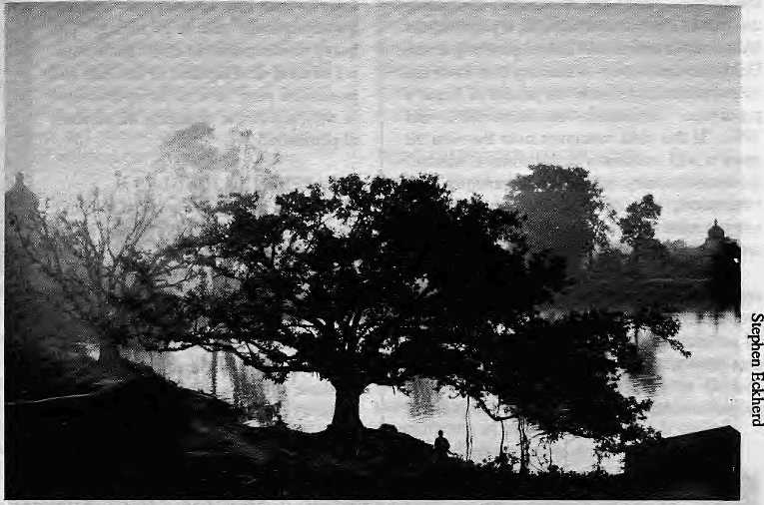
Enchantment: Morning mist by m talau in JanaKpur.
T
he tourist brochures about Nepal invariably look to the hills, and the rhetoric gf the national identity is derived from the mountainous regions of the country. Nepal's southern lowlands, the tarai, does not fit the image most people have of the country. Says a Himalayan anthropologist, "The Kingdom of Nepal is...an archetypal Hill and Mountain society."
Many Nepalis themselves think of the tarai merely as a strip of sub-tropical flatlands bordering India, inhabited by the gracious Tharus. Until recently, the tarai for some was nothing more than a place to go hunting. Still others were aware only of its unbearably high summer temperatures.
These attitudes are part ignorance and part geo-centric ity, rooted in the belief that the hills contain the soul of Nepal. But the tarai is neither small nor insignificant. It includes 20 of Nepal's 75 districts, slightly under half the country's total population of 18 million and 15 per cent of the total land.
The tarai people with their diverse background form an integral part of the national mosaic. The region has become the nation's bread-basket, its industrial heartland, and a pressure valve for the over-populated hills. The tarai is being increasingly described as Nepal's new economic frontier.
A RICH HERITAGE
While the hills are full of enchantment, the plains have a charm of their own. The beauty is there for all who care to stop and see: a misty sunrise at Chitwan's National Park, disturbed only by the ripple of water and the distant chatter of langur monkeys, or a village in autumn surrounded by bright yellow fields of mustard, overshadowed by towering cumulus that reflect the setting sun. The holy Hindu soil of Janakpur, the Sakyamuni Buddha's home ground of Lumbini, also are part of the tarai's heritage.
Actually, the tarai is like a counter-foil to the Himalaya. Without its green flatlands, would the white massifs seem so impressive? Surprisingly, the tarai is never too far from the Himalaya. On a clear autumn morning, looking
to the northern horizon from the border town of Birganj, the sun mesmerisingly cuts a 100-mile swath across the snow mountains from the Everest region in the east to Ganesh Himal, north-west of Kathmandu.
There is also beauty in the everyday lives of the tarai's inhabitants, from the briDianily woven wicker baskets of individual villages to the Picasso-esque figures daubed on the village wall marking happy occasions. Some religious ceremonies seem to bring the Vedic period back to life. In the forests, among the Tharus, one gets the feeling that this must have been how life was in the South Asia of old, before the Gangetic plain was entirely colonised. Like the Kathmandu Valley, the tarai is full of festivals, from the rollicking celebration of holi to the reenactment of episodes from the Ramayaria in Janakpur during Biha Panchami and Ramnawami.
Many visitors from the hills and from the Gangetic plains to the south are surprised by the agricultural luxuriance of the tarai and the resultant. diversity and richness of the diet available. The sweetshops at the market towns
are piled high with delicacies which act like magnets to the pahadiya just descended from the hills. The regular fare, even in middle-class households, consists of basmati rice, ghee, puris and pickles. The diet is enhanced by an abundance of tropical fruit mango, litchee, banana, papaya, jackfniit and breadfruit.
"MOUNTAIN-RURAL" TO "PLAINS-URBAN"
The opening up of the tarai to settlement is one of the most significant events in the history of the Nepali nation-state. Social scientist Frederick Gaige in his 1975 book Regionalism and National Unity in Nepal describes the tarai as a "population vacuum", drawing in people first from the Gangetic plain and more recently from the hills.
During the past two decades, the larai has accommodated the release of demographic, economic arid environmental pressures in the Nepali hills. The process of migration has turned much of the tarai into a melting pot for Nepali cultures, a place where the plains population mixes with hill migrants and settlers

Sept/Oct 1990 • HIMAL 5

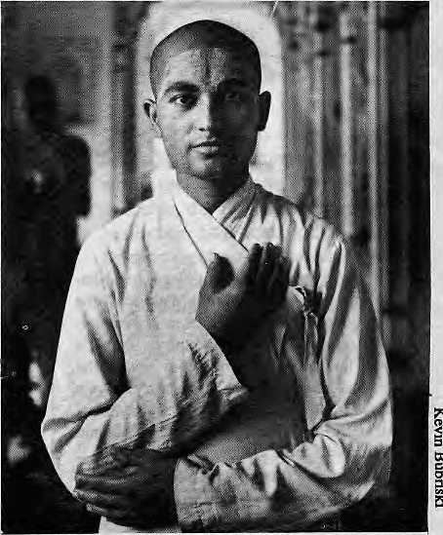
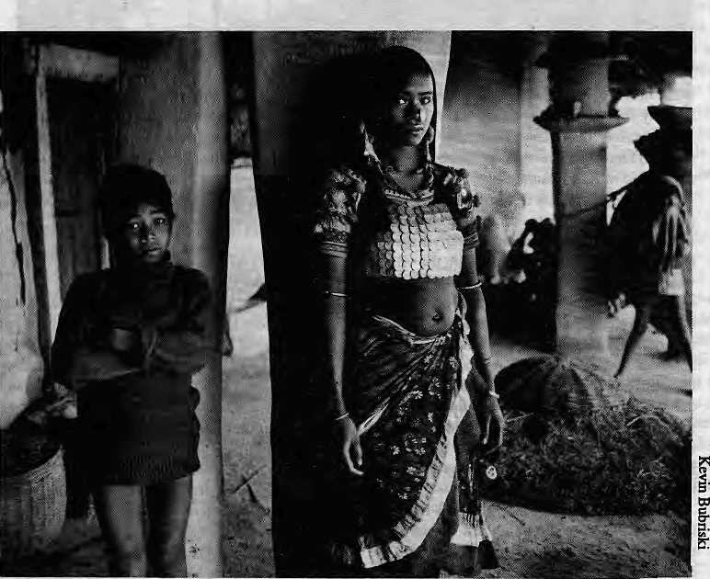
percent of Nepal's total population in 1991, 57 percent in 2001 and 62 per cent in 2011.
The decade of the 1970s saw the 'Terai-ization" of Nepal, says Goldstein. This dramatic rum of events "represents a serious challenge for the government of Nepal...(the country) is racing headlong into an uncertain future at a breakneck speed." The anthropologist says the country's economic planners must readjust their goals and assumptions to take into account the "massive metamorphosis" that is occurring. "The heavy concentration of effort and resources in rural development in the hills and mountains may have to be re-evaluated in the face of. the changing distribution of population."
DISAPPEARED JUNGLES
The tarai is mostly sub-tropical lowland, no more than a few hundred feet above sea level, with soil that supports strands of Sissoo at the foot of the Siwaliks and Sal and Simal hardwoods further south. The tarai can also be said to include, at a slightly higher elevation, the wide valleys of the bhitri madhesh, or "inner tarai". The region as a whole offers a habitat for wildlife that is probably the most lush in Asia, The sanctuaries
A Rana Tharu woman In Dakat Bhull village, Kanchanpur, far wasl Nepal.
from as far away as Burma. As a result, the taiai has become the most variedly populated region in the country. Says Gaige in the aforementioned book, which is one of the few to study the tarai in-depth, "Migration is...an essential factor in the economic and political integration of the hills and plains regions of Nepal, a prerequisite for the more complete cultural integration chat is likely to take place in the more distant future."
Anthropologist Melvyn C. Goldstein says that Nepal is being transformed from "a moun-tain-ruial to plains-urban society". Analysing the latest (1981) census data in a paper in the Mountain Research and Development journal, Goldstein and two co-writers say that there has been a substantial shift in the pattern of Nepal's population distribution between 1971 and 1981. "If this shift continues over the next 20 years it will transform Nepal from a 'classic' mountain country into a predominantly flat, subtropical, and UTban nation; and there is every reason to expect that these rates will increase."
In 1954, only 35 per cent of Nepal's total population lived in the tarai; 20 years later, the proportion had increased only three points to 38 per cent. Suddenly, in the 1970s, the census data shows, the proportion of tarai-dwellers shot up to 47 percent. At that growth rate, projections show that the tarai will comprise 51
Bindeswar! Jha, pujarl at Janakl Temple.
such as Chttwan and Suklaphania provide refuge to the world's dwindling populations of the South Asian one-homed rhino, the Royal Bengal Tiger, the nilgai and other species. Today's teeming sanctuaries stand testimony to a lost heritage, vast swaths of rich jungle that existed just decades ago, never to be restored.
After malaria was eradicated and roads were built, the tarai forests began to fall to massive logging operations. The timber was mostly exported to India as building material or to make railway sleepers. The clearings were immediately occupied by "sukumbasis", or migrants, but in addition there were both government resettlement schemes and the unplanned destruction of forests by people eager to carve their own homestead on the forest floor.
The tarai forests have thus been decimated by uncontrolled timber felling for export and the continuing need for agricultural land. The famous "char kosay jhaadi", miles upon miles of barely penetrable malarial jungle that protected Nepal from southern invaders, has all but disappeared. The tarai forest has been reduced to patches that can be spotted between agricultural clearings on both sides of the East-West Highway.
It is not clear that the levelled tarai lands -now fields -- will be able to live up to the expectations of agricultural productivity that the nation seems to be placing on them. It seems a misconception that the tarai is endlessly fertile. To being with, much of the fertile sections, mostly in the eastern parts of Nepal, have already been colonised since long. Forests that

6 HIMAL • Sept/Oct 1990

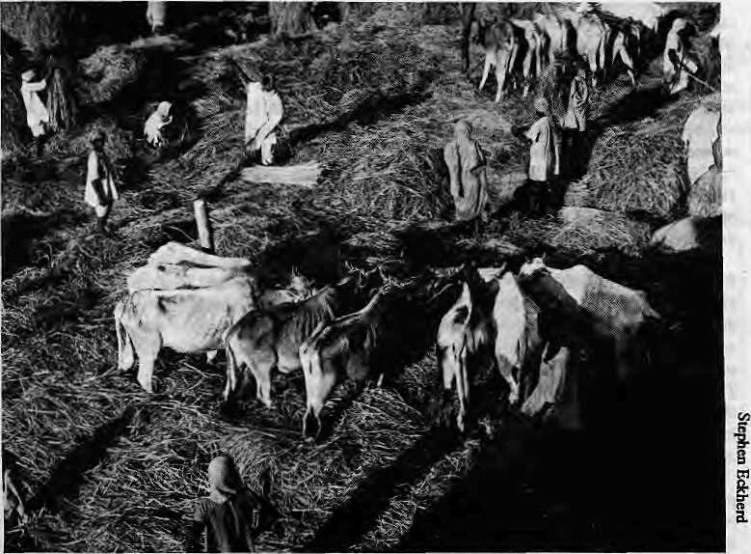
Harvest of plenty In Bara [Ilia.
still stand but are about to go in the far-westem tarai can ai best provide marginal, environmentally unstable land. Even if clearings are fertile to begin it, soil scientists fear that productivity of the fields are going to drop sharply over a decade unless there is a huge investment in fertilisers.
One legacy of the worldwide attention paid to Himalayan deforestation and floods in the plains farther down is that the ecology of the tarai has been ignored. Planners, social scientists and politicians, all have ignored the possibilities of soil degradation in the tarai, which is conceivably more critical to the country's economy than soil loss in the hills. Because of indiscriminate building of canals over the last two decades and the loss of root crops, there are increasing flash floods in the tarai ~ in rivers such as the Kamala, Biring Khola and Tinau. Even a normal rainstorm is liable to bring flooding.
Says Sandra Burton, who surveyed lands for resettlement in far west Nepal, "The tarai is often thought as a fertile alluvial plain with infinite and homogenous potential for resettling landless fanners...(But) the tarai is actually a mosaic of different land types. In Kailali District, for example, she found that only nine per cent of the "land available for resettlement" (meaning forests) was "good rice land", and 23 per cent was suited for "diversified cropping". Thus, 68 per cent of the available area was not suitable because of low fertility, flooding hazards, or other drainage problems.
A MATTER OF DISCONTENT
It is not surprising that the tarai has close and long-standing ties with the bordering states of West Bengal, Bihar and Uttar Pradesh, After all, most of Nepal's long and winding border with India lies in the tarai. The proximity, the relatively developed transportation and communication systems, and the free border crossing permitted to both Indians and -Nepalis have been significant in nurturing these ties. As a result, there is considerable movement of people in search of employment and those engaged in trade from both sides of the border. This is not to speak of the cultural and linguistic affinities among the people of the region, ties that are maintained through constant interaction and matrimonial links, akin to ties that exist between the hill people of Earn and Baitadi in the east and west of Nepal with communities across the border in India.
Educated tarai Nepalis point out that most Nepalis do not understand what Nepal is or who is a Nepali. They express frustration about perceptions reflected in the attitude of people in Kathmandu to labourers or street hawkers, many of whom actually come from the tarai and not from India. Tarai people sometimes find themselves in the vulnerable state of being seen as Indians in Nepal and as Nepalis in India, thereby facing double discrimination.
Many of the grievances are genuine. Some may be just inter-ethnic suspicion. Yet, the hill people use the term "madhesi" for the people of
the tarai, and even though not originally a negative term, it has come¹ to carry a derogatory connotation. The discrimination felt by the tarai people is not unique. Nepal, with its numerous population groups, soil suffers from ethnic and regional prejudices. These exist, for example, between the "parbatiya" and the Newars, hill and mountain groups, tarai and hills. Note, for example, the distinctively derogatory "bhotey", a term used for the Nepalis from the northern-most area.
Many in the tarai feel that their region is under-represented in mainstream of Nepali life as defined by Kathmandu's power centers. They cite their low numbers in the national legislature under the Panchayat and discrimination in government service. They have watched Nepal's constitution-making process with wariness and remain concerned that distribution of seats in the forthcoming national Parliament will maintain the under-represeniation.
Disgrontlement among the inhabitants of the tarai had been bottled up under the Panchayat system. "Feudal politics" kept the region normally quite and docile by "buying off key leaders and politicians. With the advent of democracy, the simmering demands of the tarai people, like those of other communities and minorities who feel discrimination across Nepal, have come to the fore. One of the results has been the formation of the Sadbhavana Party headed by tarai politician Gajendra Narayan Singh, which claims to speak for the people of the tarai.
It is unclear how broad a base either the Sadbhavana Party or others who would represent the whole Nepal tarai have. Given the divisions of class, caste, ethnicity and geography which divide the tarai, just as they do the hills, an attempt to form a tarai-wide political forum might not succeed, or might succeed only in the event of extreme insensitivity to tarai concerns in the part of the new power centers in Kathmandu. A better strategy, say some political scientists, would be for tarai activists to establish strong links with political parties which claim to be national, such as the Nepali Congress, and the various wings of the communist movement. The strategy would be to force these "hill-dominated" political parties to live up to their rhetoric about equity, share of resources, economic development, and reprsenttional politics. If democracy continues to sprout roots in the Nepali soil, including the tarai's fertile soil, it is certain that at least a good part of the regional discrimination that is said to exist will vanish. If the tarai has the votes, it will get its demands.

Scpt/Oct 1990 • HIMAL 7

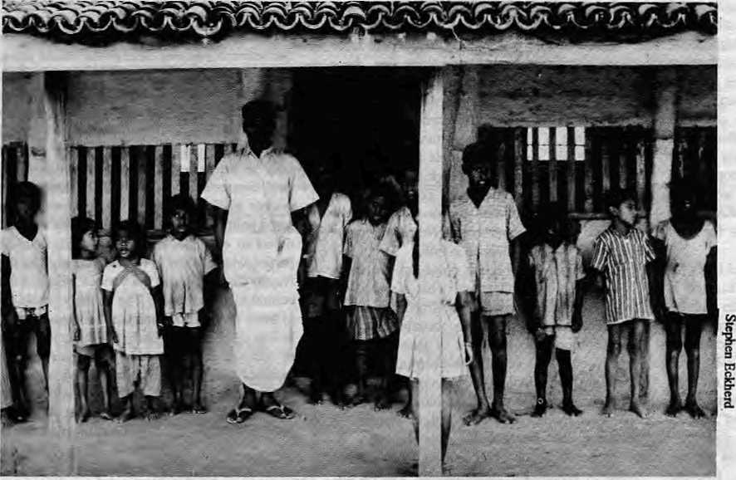
cated in the region, with investments totalling NRs3,143 million, and an output of NRs5,17O million, generating a total income of NRs2,226 million. The hill districts, apart from Kathman-du and Pokhara, are virtually without industry. According to 1985/86 figures, the total revenue contributed by the tarai was NRs793 million (compared to NRsl33 million in 1965/66). The duty collected from 15 districts of the tarai amounted to NRs555 million, and its tax revenue amounted to NRs8,667 million.
ECONOMIC NEGLECT?
Despite its important role in the country's development, say some economists, not enough attention has been paid to the tarai by policy makers and development agencies. There is a feeling among many in the tarai, including many who have migrated from the hills, that the country depends on the region but neglects many of its concerns.
Even though the tarai may be economically productive, the actual condition of many tarai Nepalis is not much better than that of the hill Nepalis. There is abundance in the tarai, for some, but scarcity for many others who are barely able to scratch out a living. Like the hill migrant, many plains people also travel to Bihar, Uttar Pradesh and further afield in
Singing th» mtktiwl inth«m In Aponl vfflag*, Pan* |
THE BREAD BASKET
By the early 1960s, the taraj had emerged as the mainstay of the economy and begun to attract the hard-pressed people of the hills, who were in search for land and a new life. According to estimates based on the Rastra Bank's figures, in 1964/65, 59 percent of the Nepal's gross domestic product (GDP) came from the tarai. In the 1960s, the tarsi's contribution made up 50 percent of the country's total agricultural produce. By the 1970s, the tarai's share of GDP had risen to 63 per cent.
Today, the tarai has a total of 1.4 million hectares, or 57 percent of Nepal's total arable land. In 1985/86, about 1.6 million metric tonnes of foodgTain came from the tarai, making up 60 percent of the country's total production, though only 1.2 percent metric tonnes were needed to feed the tarai population. A surplus of 34 percent was generated.
By contrast, in the same year, the food grain production of the 16 Himalayan districts was about 32 percent short of their requirements. Likewise, the remaining 39 districts in the hills had a 16 percent deficit. The surplus produce in the tarai made up for the deficit of Nepal's 55 hill and Himalayan districts, with an additional 0.2 million metric tonnes to spare.
Also remarkable is the tarai's contribution to industry. A total of 3,228 industries are lo-
pearch of cash income. Indeed, many are landless, even bonded, labourers.
A 1986 study by Tribhuvan University sociologists showed that "the percentage of households heads reporting worsened life conditions is higher in the tarai than in the hills...a higher percentage of hill households heads are positive and optimistic about the future than tarai household heads." Given that most economists forecast a heady economic future in the tarai, this despondence among tarai households is puzzling, and perhaps indicative of the distance that exists between the Kath-mandu-based planner and the tarai villager.
Another sociological study shows how even within the tarai there is plenty and scarcity in close proximity. The study, of a village named Bastipur, lists the caste/ethnic groups according to education, health, land holding, annual income and annual expenditure. The riches to poverty spectrum went from Brahman-Chhetri (average land holding: 3.7 hectares) to Tharus, Shaha, Yadav, Chamar, Mushashar, and ended with Muslims (average land holding: 0.19 ha.) Clearly, the tarai's contribution to the country's well-being is immense. And the expectations of its vibrant society and economy are greater still. The tarai may well turn out to be the new frontier, but there are crucial questions to answer. When will it reach its limit to absorb? Will the people who are currently living in the tarai also get to reap the advantages of the growing economy? Or will that economy buckle under a burden of growing too large too quickly? Can the fertility of the tarai's soil be sustained? Do we keep clearing forests until the last tree outside the national parks and sanctuaries are felled? What are the limits to the tarai's growth?
The perennial conflict between development and environment, the long-term need to conserve and the immediate need to make use of resources, too, has been brought into sharp focus in the tarai. How much more valuable forest cover can be converted into equally precious agricultural land to feed more people? There are no easy answers, but an understanding of the tarai, its people and its prospects, will help.

8 HIMAL • Sept/Oct 1990

Making of a Dynamic Region
Development indicators show that the tarai lowlands are doing better than most hill and mountain regions of Nepal.
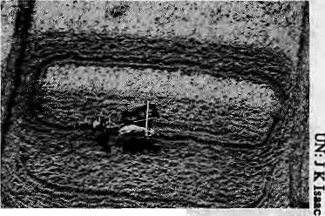
byHarkaGurung
rrihe traditional Nepali term for the Inner X Tarai and the Tarai lowlands is ma.dhe.sh — a geographical extension of the madhya-desha (heartland), referring to the Gangetic plain. Until the late 1950s, the prevalence of endemic malaria made the madhesh a peripheral region. In the last three decades, however, large-scale migrations and development activities have transformed it.
Over the last 30 years and earlier, a process of "spontaneous migration" has directed two-thirds of the interregional migrants and most immigrants to the lowlands, which experienced a Tapid population growth of 2,5 times in less than three decades. Population growth was high hoth in Tarai villages and towns. The average Tale of urban population growth in the lowlands was 7.8 percent compared to 3.5 percent in the highlands (Mountain and Hill). Overall, the lowlands (Tarai and Inner Tarai) had an average annual growth rate twice that of the highlands.
Levels of development, too, have been higher in the Tarai. In economic development (including agriculture, industry, transport, banking), the Tarai led all other elevation zones. Among geographic regions, Kathmandu ranked first and Central Inner Tarai second. Most lowlands regions except the Eastern Inner Tarai had a higher economic development level than the highland regions except Kathmandu Valley.
In soclo-cultural development (education, health, communication), the Tarai and Inner Tarai ranked higher than the hill and mountain zones of Nepal. Kathmandu Valley ranked highest in socio-cultura] development; The eastern and Central Inner Tarai and the Central Hill region came next; the Western Mountain and Hill regions had very low levels of sociocultural development.
Kathmandu Valley, the Central Inner Tarai and all three Tarai regions ranked high in regional development. Of the 18 Tarai districts, 17 had regions ranked high in regional development. In the Liner Tarai, three districts were above and three were below the national level. In the Hill region, 10 districts had higher and 23 had lower values. Of the 15 Mountain districts, only two had values higher than the national average. Thus, 20 of the 24 lowland
districts had levels of development higher than the national average.
(The conclusions regarding economic, socio-cultural and regional development are based on a 1980 study by Shrestha and Shar-ma. The National Planning Commission has also done some exercises on levels of regional development.)
The aggregate value of development for the Tarai and Inner Tarai was much higher than those of Mountain and Hill districts. Kathmandu Valley appeared as an island of high-level development in the generally backward highland area. In macro-regional terms, one could say that the higher the elevation of a geographic region, the lower the level of regional development.
Development Indicators of recent years show the comparative advantage of the Tarai region. In terms of the road length/area ratio, for example, the Tarai leads with 11,0 followed by the Hill Region with 22.9; the road length/area ratio for the Mountain region is 245.8. Three mountain regions (Midwest, West and East) have no road to speak of. All five Tarai regions Tank high in road length/area Tatio. An exception to this pattern of under-development in the hills is the Central Hill region (with Kathmandu Valley), which ranks second. (Data source: National Planning Commission, 1987)
The physical quality of life index (calculated on the basis of average life expectancy at birth, infant mortality, and literacy rate) also places three Tarai regions at the top followed by two Hill regions, the Central and the East. The Far Western and Midwestern regions in the Mountain and HiU zones rank very low in physical quality of life.
Of the total development expenditure of NRs 3,297 million during fiscal year 1985-86, the Hill region claimed 59.8 percent against 33.9 percent for the Tarai and 6.2 percent for the Mountain. Central Hill (including the capital region) ranked first in development expenditure followed by Central Tarai. But most Tarai regions were placed higher than other Hill and Mountain regions except Western Hill. The five Mountain regions ranked very low in development expenditure.
The total estimated GDP of Nepal was valued at NRs4,174 million at 1984-85 current
Looking down on the tarai.
prices. Of this amount, 56.5 was contributed by the Tarai regions. The share of Hill regions was 39.2 percent and thai of Mountain regions was only 4.3 percent. Central Tarai ranked first and Central Hill second; Eastern and Western Tarai ranked third and fourth in GDP contribution.
The level of development based on 25 variables placed Central Hill (including the capital region) in the first rank. The next four places were taken by Tarai regions. The last four in level of development were Mountain regions. As a general pattern, Tarai regions had a comparatively higher level of development except for Central Hill, with metropolitan Kathmandu.
The lowlands with their concentration of infra structural and production factors has emerged as a dominant region of demographic and economic transformation. Once it was a region associated with large estates of absentee landlords; today, however, increasing numbers of landless households encroaching and squatting on forest and common land have generated political tension. The problem of squatters, a new expression of increasing poverty and economic inequality, is basically the outcome of increasing migration from the resource-poor highlands. Therefore, interregional migrants are directed to the lowlands for agricultural settlement The lowlands, particularly the Tarai, is also the prime destination of immigrants. Unlike internal migrants, the immigrants are moving to lowland areas that were settled earlier and to urban areas. The dynamism of the lowland economy has attracted immigrants, many of whom intend to stay permanently. With a few exceptions, Tarai districts with a high percentage of foreign-bom and foreign citizens have a comparatively low percentage of internal migrants. Thus, interregional migrants and immigrants are moving into different ecological niches: the former into frontier lands and die latter to sealed areas and generally in secondary and tertiary occupations.
Harka Gurung is a Nepali geographer. This article forms part of his monograph Regional Patterns of Migration in Nepal, East-West Population Institute, Hawaii.

Sept/Oct 1990 * HIMAL »

PEOPLE

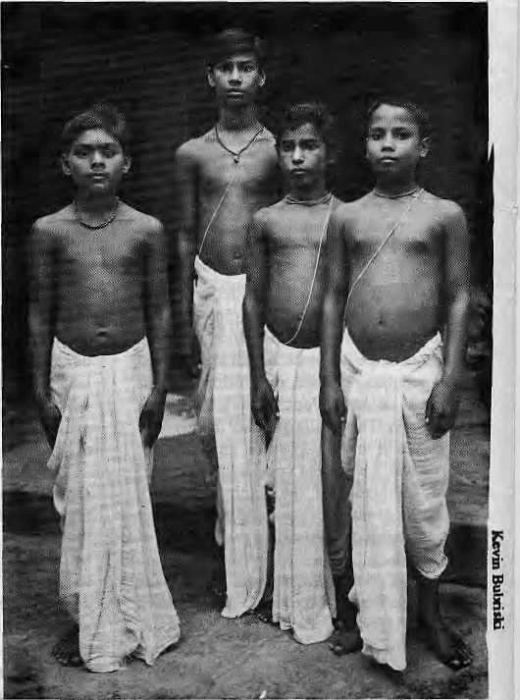
The Plains People
The tarai people are not one faceless group; they are diverse and differentiated.
by Ramashish Prasad
Much of the tarai society has today become a unique amalgam of hill people and plains people. As in the hills, so too in the plains, there is a great diversity of culture and heritage among the people.
The Maithili Brahmans, Bhumihar Brahmans, the Rajputs and the Kayasthas wear the janai (sacred thread). Their numbers are comparatively small, but they enjoy high status because of their ranking in the Hindu caste system, their education and their property.
The Maithili Brahmans are priests whose lives are filled with rites and rituals. They still engage in their occupation as priests. The Bhumihar Brahmans, in contrast, generally live off the land, though they do not actually till. The Rajputs of the tarai are "Kshetriyas" who wear the janai. The Kayasthas formerly looked after the financial aspects of principalities and estates, but are now found mostly in government service and in professions such as teaching.
The commercial class comes
next. In the tarai, they are,
among others, the Sum, Teli,
Kanoo, Kalwar, Rauniyar,
Sonar, Rastogi and Kathbahniya.
Though attitudes are changing,
many upper caste Brahmans still
will not eat with nor touch food
"contaminated" by these castes. Next in the caste hierarchy
are the Yadavs, Kurmis,
Amatyas, Dhanuks, Kewats,
Koeerees, and others, who were
traditionally farmers, though
many are landless labourers
now. {The Hindu caste hierarchy is being used purely for
descriptive purposes - editors.)
The Yadavs are the only group
found in all the districts, and
constitute the single largest
group in the region.
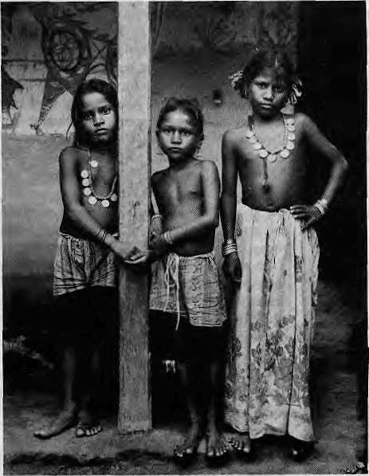
Apprentices Bihar Kund,
Mehtat Barahee
The other farmer castes tend to be poor, with many of their women and children working menial jobs. Below them are the skilled occupational castes, such as the Hajam (barber), Lohar (iron monger), Badhaee (carpenter), (scavenger), Tatama, (betel sellers), Mashar (farmer), Dhobi (washer folk), Mallaha (seller of fish), Doli (coolies), Chamar (tanner), Dom (cremators), and others.
Also found in the tarai are castes such as the Marwaris, Agarwals and Khatris — affluent commercial groups who migrated to Nepal from Rajasthan. They are often £ lumped together descriptively as §■ "Marwaris". They typically used to g* sell textile goods, but have recently K set up factories on a large scale and K own a sizeable share of industry in Nepal.
Girls of Suga village, Mahotari district.
There is also a significant Muslim population, belonging to
at Yufjal Vlnod Kurt] ashram,
Janakpur
groups such as Seikhas, Sunnis, Dhuniaas, Hajams, Dhobis, Pathan and Julahas. Although Islam has no castes, there are differentiations that resemble castes. Untouchability, however, is non-existent and ail Muslims worship at the mosque together. Most are poor, with little education, and eke out a living as tailors, masons or butchers.
The Tharus have been recognised as the original tribe of the tarai. There are also other indigenous peoples such as Rajbansi, Danuwar, Bantar and Sautaar, many of whom still live in the forest. Tharus speak dialects related to Maithili, Bhopuri and Aradhi. They are found in all 20 tarai districts. They are not influential or wealthy. They work in the fields, are usually not well-educated and often fall victims to exploitative landlords.
R. Prasad writes for several Indian publications, including the fortnightly newsmagazine Dinmaan.

10 HIMAL • Sept/Oct 1990

ECONOMY
East to West, A Highway to the Future
While the building of the East-West Highway led to the destruction of the country's lowland wilderness, the road artery along Nepal's tarai became the key toward a more "whole" Nepali economy. The Highway has wrought important democratic shifts in the Nepali landscape.
by Bijaya Lai Shrestha

In just a year from now, Nepalis will be able to drive from the eastern border town of Kakarbhitta all the way west to the opposite-frontier — without once having to make a detour through India. The 30-year-long ordeal of constructing Nepal's "spinal cord" isnearing an end Road contractors are working full swing to complete the one remaining segment in the far west.
The East-West Highway's completion symbolises the country's coming of age, coming as it does so soon after the economic catharsis of an Indian "blockade" and the jana-andolan that ushered in a measure of democracy. The fact that Nepali citizens can now traverse the country without exiting certainly enhances their sense of sovereignty. Gone are the days of just three decades ago when you had to cross over the southern border and take the North-Eastern Railway west or east before re-entering Nepal.
Mixing the good with the bad, the Purba Paschim Rajntarg (or Asian Highway Route A-2) has helped integrate the national economy. It has opened up the tarai lands for settlers descending from over-populated hills and brought a degree success in industrialisation and commercial agriculture. But the road has also been the one catalyst for forest destruction. It has brought unforseen turbulence into the lifestyles of the tribes of the tarai, arousing fear of cultural loss among many inhabitants.
In the way it was built, with piecemeal work by antagonistic governments the world over, pait of it during the height'of the cold war, the highway is a fine example of a three-decade-long experiment in international cooperation. But the East-West Highway presaged the foreign aid takeover of Nepal. The division of different sectors of the road among various donor countries predates the division of the country's hill sectors for "integrated hill development projects": the Kamali for the Canadians, the Rapti for the Americans, the Kosi for the British, and so on.
The East-West Highway, of course, is much more than a symbol. It is a very physical presence in today's Nepali landscape and is
capable of defining the country's development,
demography and direction well into the next millennium. Whether Nepajis will be able to take advantage of what the highway has to offer depends on how planners and politicians utilise it: as a lifeline to the future or merely as a safety valve to tide over present problems.
MAHENDRA'S RAJMARG
It was King Mahendra who first conceived of a tarai highway that would zip the country together. His was also a political and strategic decision, arising from a need to reduce Nepal's over-dependence on India. The king was also keen to promote an arousing nationalistic programme at a time when he was still consolidating his position after the royal coup of 1960.
On 1 Baisakh 2019 (13 April, 1962), invoking patriotic sentiments, the king traveled down to Gaidakot, a point in the central Nepal tarai district of Nawal-Parasi. He inaugurated the earthworks by heaving a silver pick-axe. The king said (Tather ingenuously, in hindsight), that the road would be built "by the Nepalis for the Nepalis".
However, the drumbeat of nationalism could not be sustained in the absence of funding, equipment and technical expertise. Like a jeep hitting a patch of monsoon mud. King Mahendra's project ground to a halt within two years. So he decided to seek foreign funding. The United States declined, stating that Nepal did not need a U$70 million highway. New Delhi, which had watched the campaign with a jaundiced eye right from the start, could not be convinced to support a project whose very
raison d'etre was to undermine Indian influence. The Russians proved reluctant even though earlier they had been willing to do a survey.
The Chinese jumped at the opportunity to woo Kathmandu. In 1964, they offered to build the 170-kilometre Biratnagar-Janakpur section of the highway. The Russians promptly came back and said, sure, they would love to build the 109km Pathlaiya-Dhalkebar section. New Delhi stood thoroughly displeased with the prospect of the Chinese snooping around just a few miles from the Bihar border. Indian Ambassador Sriman Narayan used feverish diplomacy and Kathmandu agreed to send the Chinese packing, but for a price. The Indian Aid Mission would not only take over the Chinese portion from Janakpur to Biratnagar but also build beyond to Kakarbhitta, on the Mechi River.
RUSSIANS ON THE LOOSE
Charting the shortest possible route from Path-laiya to Dhalkebar, the Russian engineers ploughed through what was among the best of tarai jungles — 75 percent of the cut was through pristine forest. Because of the large number of rivers on the route, 25 major bridges and over 140 smaller bridges were put up. Highly mechanised road construction technology was introduced. The Soviet-built segment is one of the most durable roads in the country. Rather than pack the road bed and embankment with earth, as is the normal practice, the Russians trucked in rocks and gravel from river banks. Besolov, Soviet Economic Counsellor, said when the road was completed in 1972 that it would last four generations.
Would that the same were true for the bridges that were built. Most were of unseasoned sisau timber, and had already begun to rot by the end of the 1970s. The Russians never revealed the cost of the highway, maintaining that "friendship mattered more than money". It is thought that the tab then was NRs200 million.
One Russian legacy was the indiscriminate and unnecessary hacking down of large tracts on both sides of the highway. As if they were on a hunting holiday, engineers and supervisors used to return from forays with jeep-loads of dead deer, wild boar and other tarai fauna. Fishing meant using dynamite on water, or passing a naked wire into the river and turning on the current. Nepali labourers watehed awe-struck as the fish came belly-up.
BRITISH AND INDIANS The British also used high mechanisation on their Butwal-Narayanghat segment. Always rather extravagant, they decided, against the

Sept/Oct 1990 • HIMAL 11

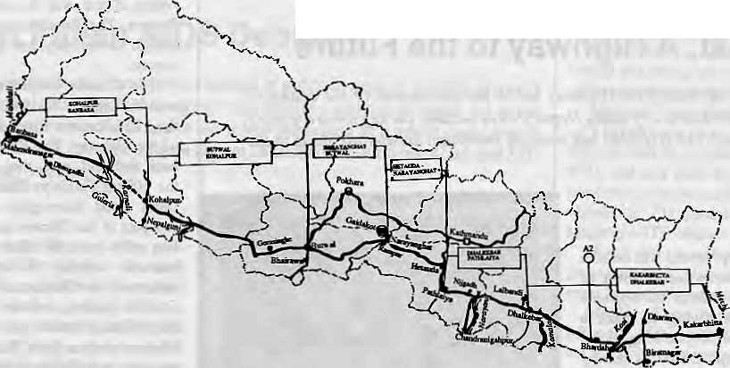
East West Highway

advice of the Nepali government, that their 113km segment deserved a service track along its entire length, much as you find on European autobahns. The project took six years to complete, and in the end less than 20 per cent of the service track ever saw use.
To their credit, the British introduced the use of gabion walls, packing stones into boxes of wire and using them as retaining structures. These walls have proved far stronger than concrete blocks in saving roads and bridges when rivers are in spate.
Unlike the Soviet and the British, the Indian projects used labour-intensive, cost-effective measures to build their 256km section from Dhalkebar to Kakarbhitta. Since much of this alignment runs through the alluvial plains of Nepal's eastern lowlands, there were no forests to be cleared. However, almost the entire length is pock-marked on both sides by huge depressions from which earth has been taken to build up the road. These ponds and ditches are eyesores and a breeding ground for mosquitoes. However, jute farmers have begun using them to soak their hemp crop. Going east, the highway begins to deteriorate beyond the town of Bhardah, mainly because of poor earthwork and low embankments. Maintaining the Indian section has proved a formidable task .because of short-cuts taken in design and construction.
Besides the donor countries mentioned above, agencies like the World Bank, the Asian Development Bank (ADB) and the Saudi Fund have also helped finance certain sections of the road. The ADB provided a NRs200 million loan to renew the 78km Narayanghal-Hetauda sector, originally built by the Americans through deep tarai forest to gain access to their agricultural project at Rampur.
After having completed construction in the east, India also helped build the 250km section from Butwal to Nepalganj. And now, New Delhi is funding the last section, from Kohal-pur to Banbasa on the Mahakali river, where the East-West Highway finally ends. The contract for this western-most section, 204km long, had originally been awarded to the Chinese against a global tender floated by the World Bank. But India, with its perceived security interests in mind, offered to "buy back" the entire project The Nepali Government paid the Chinese firm a sum of NRs40 million for breach of contract. The estimated cost of the Kohalpur-Banbasa section, slated for completion by December 1991, is NRs840 million.
HIGHWAY WATCHDOGS
The Kohalpur-Banbasa road is being built when there is increasing awareness of environmental impact of development works, of corruption and "comroission-agenting" in high places, of cost-benefit ratios, and of appropriate technology in the implementation of large projects. As a result, questions with demands of accountability have been raised regarding the building of this far-western segment of the highway.
A major controversy surrounds the building of a bridge across the Karriali River, to be built with World Bank funding. A 500 meter "single tower cable-stayed" siructure has been planned which will be the second longest of its kind. The Kawasaki company of Japan is doing the construction at a cost currently estimated at NRs250 million. Many Nepali road engineers have vehemently opposed this "hi-tech" bridge, maintaining that it is expensive and inappropriate for Nepal.
Disregarding appeals by environmentalists, a part of Kohalpur-Banbasa alignment was made to pass through the Bardia National Park, which is the largest sanctuary in west Nepal. There are claims that "petty interests" were involved in. deliberately lengthening the road and taking it through the park so that the route would make it imperative to build the expensive bridge over the Kamali. Even the World Bank is known to have pressed for the road to bypass the park and touch Guleria, the headquarters of Bardia District. But some officials say that the road through the park would provide access to the proposed high dam on the Kamali river, which would be just two kilometres upstream. Others say that the plan had always been for the East-West Highway to hug the southern slopes of the hills rather than the southern border.
The environmental concern regarding the Bardia sanctuary persists. But some experts feel that the highway is unlikely to endanger the integrity of the Park because, unlike other forests of the tarai which were ravaged, Bardia is already well-protected. The remaining wilderness west of the sanctuary all the way to the border, however, is sure to go.
EAST-WEST DEMOGRAPHY
The environmental impact wrought by the highway along most of its length is obvious to even the casual observer. But one has to look deeper to understand the powerful demographic forces that the highway has unleashed, migratory trends which are capable of changing the face of the country.
Because the traditional trails from the hills to the plains - like the rivers — run north to south, the Purba Paschim Rajmarg cuts through all of them. In a country which has been divided by geography into culturally dis-

12 HIMAL • Sept/Oct 1990

WILDLIFE
A Wild World That is No More
The tarai used to evoke the image of steaming jungles and tall grasslands teeming with South Asia's "mega fauna" - rhinoceros, tiger, barasingha, elephants. Today, the image is one of fields and flatlands as far as the eye can see, punctuated by lone trees that speak for what only a few decades ago was one of the richest areas in the world.
by Hemanta Mishra
My first train ride, at the age of 12, was on the narrow gauge track from Amelefchganj in the inner tarai to Birgunj at the border. The slow-moving train meandered through the rolling sal forests of the char kosey jhadi, the 10 to 12 mile belt of unbroken jungle south of the low hills. The train chugged past stately trees laden with vines and teeming with chattering langur monkeys, and in the dark of the forests, one knew, lay the domain of the tiger and the rhino. Little did I know then that the trigger of the tarai's destruction and fragmentation was about to be pulled down. Highways, canals and settlements would spell the end of a whole kind of wilderness.
PLAYGROUND OF MAHARAJAS
The tarai is the moist, alluvial sub-tropical belt just south of the Himalayan mid-hills. Untrammelled by human intervention, it once consisted of a continuous carpet of malaria-infested forests and grasslands extending from the Indus river in present-day Pakistan all the way east and south to the Brahmaputra and beyond, to touch the borders of present-day Myanmar. The tarai had amazingly abundant flora and fauna even during the Miocene era, 20 million years ago, and it is their evolution that led to the present forms of plants and animals.
The tarai's profusion of wildlife made it the hunting ground of emperors, rajas, maharajas and latter-day viceroys. Babar, the Mughal
emperor, is known to have hunted rhinos in the floodplain of the Indus in the 15th Century. Even as late as the 1850s, tens and thousands of deer and antelopes roamed the Punjab, and large herds of gaur and wild buffaloes were reported right along the tarai Bhabhar forests from Nepal through Bhutan and Assam.
Nepal's Rana prime ministers used to invite royalty from India and Great Britain for mammoth shikars which employed 350 elephants or more. A hunt arranged for King George V in 1911 ended with the killing of 39 tigers, 18 rhinos, 4 sloth bears and numerous deer. A 68-day Chitwan safari in 1938 by Lord Linlith-gow. Viceroy of British India, shot 120 tigers, 38 rhinos, 15 bears and 11 crocodiles. The Maharaja of Coach Bihar boasted of killing 207 rhinos. Zahir Shah, King of Afghanisthan and Queen Elizabeth II have also hunted in the tarai.
Despite the shocking figures, these hunting binges did not Teally endanger the tarai species. The reason is that the shikars were organised only occasionally; at the same lime, habitat destruction and poaching were strictly discouraged. A British naturalist wrote in 1880 that Nepal's rulers deliberately protected the malaria-infested forests and forbade human settlement in order to maintain the jungle barrier as a deterrent to British territorial designs.
It is nothing less than ironical that the destruction of the tarai forests began around mid-century - with the fall of the Rana Taj in
Nepal and the eclipse of the British Raj in India. The big hunts stopped, but giant clearing operations began.
DECADES OF DESTRUCTION
The 1950s and 1960s constitute the "Decades of Destruction" of the tarai's wild places. In Nepal, malaria was banished by the United States Operation Mission (predecessor to today's USAID) with a programme begun in 1954. What followed was legal and illegal human settlement, commercial logging, dams and canals, roads, and extension of agriculture and establishment of tea plantations. Destruction of forests accelerated.
Besides loss of habitat, rampant poaching and hunting (which no longer remained the prerogative of a privileged few) also played a part. By the end of the 1960s, the tarai population of tigers, rhinos and many species of ungulates such as the gaur, barasingha and the blackbuck were on the brink of extinction.
The plight of South Asia's large and small fauna drew international attention during the General Assembly of the International Union of Conservation of Nature and Natural Resources (IUCN), held in New Delhi in 1969. Politicians, planners and administrators were shocked to learn about the decline of South Asian — particularly tarai — wildlife. The IUCN meeting provided the impetus for Operation Tiger, which was launched by the World Wildlife Fund. The tiger was chosen because it sits at the apex of the food chain and needs lots of territory. Any effort to save the tiger would automatically require preservation of a large habitat A domino effect would benefit the general flora and fauna.
The 1970s brought in the era of protection. As a direct result of efforts to save the tiger, there emerged in the Nepali and Indian tarai green pockets — national parks, wildlife reserves and sanctuaries. Legislation converted the very areas where rajas and emperors once hunted into sanctuaries for threatened wildlife. International conventions were introduced to

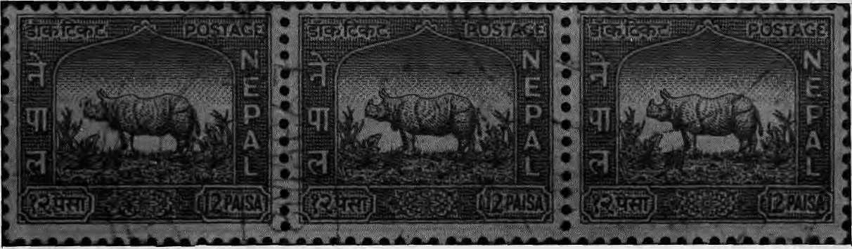
H1MAL ■ Sept/Oct 1990

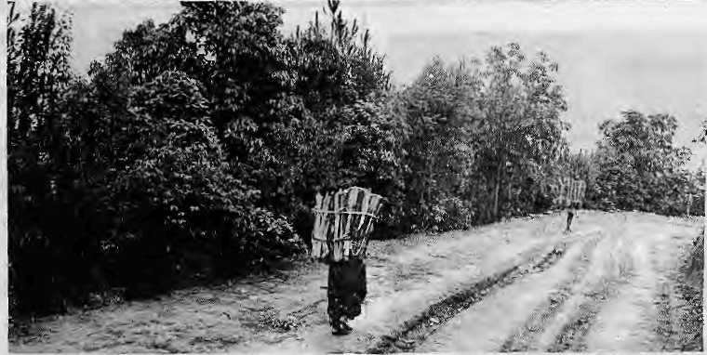
ban trade in endangered species. People were relocated to provide more room for wildlife. The successful introduction of national parks and reserves was backed by mechanisms to combat poaching and grazing, including the deployment of armed guards.
As a result of these strategies, the number of large mammals such as the tiger, rhinoceros and swamp deer rebounded within the sanctuaries. In Nepal, Gharial crocodiles were bred in captivity and released in the wild. Chitwan's national park was filled to capacity with rhinos so some had to be translocated westward to the Bardia National Park. Elsewhere, sightings of the Hispid Hare and Pigmy Hog, once identified by the IUCN as among the- ten most endangered of species, began to increase.
Success in the tarai, unfortunately, was not without its pitfalls. Attention lavished on parks and reserves short-changed wilderness outside such sanctuaries, which saw continued destruction. The trees of the tarai, which were a source of instant cash for the unscrupulous, fell victim to the axe and power saw, during times of political instability and lax enforcement.
ANIMALS AND PEOPLE
The other side of the coin was that the strict enforcement of exclusive park rules often affected the work and lifestyles of the local population, particularly indigenous people such as the Tharu. Indeed, while resources and manpower were lavished on large mammals, the needs of the local inhabitants for fuel, fodder and firewood was ignored.
The patches of forests that remain are the result of "negotiations" between politicians, developers and planners in the capital cities. Delineation of tarai wilderness into "protected forests", "reserve forests", "national parks" and "sanctuaries" was decided in the metropolis and engenders conflicts at the village level. People who have traditionally used forest lands
for grazing, firewood and shifting cultivation find their access to the forest barred.
The success in the protected areas has led to increase in the number of large carnivores, which tend to prey on livestocks. The most cattle are lost in the vicinity of the best wildlife sanctuaries. Similarly, the increase in ungulate population is directly proportional to the loss of crops in adjacent farmlands. Studies in Chit-wan showed that sometimes the loss to deer and rhinos can be as high as 90 percent of the harvest
The killing of humans by tigers, rhinos and elephants is regarded as an exceptional aspect of animal behaviour. But when such killings do occur, they becomes the ultimate expression of the conflict between man and nature — and arouse outbursts of,emotional reaction not only against the beasts but the forests that shelter them.
ALICE IN TARAI WONDERLAND
Today we find the national parks and protected areas as islands of green in a sea of ever-increasing humanity. Unfortunately, these forests of the Indian and Nepali tarai are not zones of coexistence where people and wildlife live symbiotically as did the indigenous peoples. Instead, these woodlands are areas of conflict between conservation needs and human needs.
Rules and regulations drawn up by the western-educated city planners are often based on intellectual or aesthetic values, and the goal is, of course, conservation. Such macro-level legislation is often meaningless for the villager struggling to subsist on the meagre produce of farm and forest.
Much of the legislation which exists for the protection of the tarai forests is either outdated or unworkable. In essence, the rules ignore the day-to-day requirements for food, fuel, foddei and other basic needs. Conservation laws are accepted under duress. The villagers* only recourse is to avoid being caught by forest
guards, or, if caught, to scheme to get away with minimum penalty or harassment.
Many international and national agencies in Kathmandu and Delhi have tried to "save the tarai" with missionary zeal. But these "tarai conservationists" have been like Alice in Wonderland - babes in the woods, truly. For, as Mark Twain put it: "The pleasant labour of populating the world goes on with prime efficiency." The tarai has become the proving ground of such efficiency. The ideals of the urban conservation theoretician are swamped by the separate and harsh reality of wood hunger and food hunger. What was perceived -as a nicely defined biological problem, it turned out, had complicated social, economic and political implications.
Tarai conservation must involve the human dimension in wildlife management and protection. There must be direct participation and involvement of the local people. In the long run, no park or sanctuary can survive as an island in the middle of a peopled landscape unless the surrounding humanity accepts it as art economic package for its own benefit. Today's harrowing tale of African wildlife is proof enough of this. Woodlands must be a source of monetary gain, jobs, markets, even prestige or other sentimental human values. Otherwise, the forests will not last.
How to strike the balance between the short-term needs of the villager and the long term needs of conservation? Between firewood demand and maintaining genetic diversity? By understanding, especially in today's context, that people, and not deer or bears, elect those who will decide. The people themselves will have to speak for tarai's wildlife, not the bureaucrat, forest guard, zoologist or environmentalist.
A LOST HERITAGE
The vast, continuous tracts of the tarai's wild lands are gone forever. The generation that is middle-aged today will remember what it was really like. For the young, a sense of what was lost will require a visit to a protected sanctuary such as Chitwan, and lots of imagination to multiply it a hundred times over. Our responsibility now is to save the green that exists, both inside and outside the official park boundaries. But to think that we can do this without taking account of reasonable human needs is a mistake.
Hemanta Mishra is the Executive Director of the Kathmandu-based King Mahendra Trust for Nature Conservation (KMTNC). His PhD in wildlife resource management focused on tigers and their prey species in Chitwan.

Sept/Oct 1990 - H1MAL 15

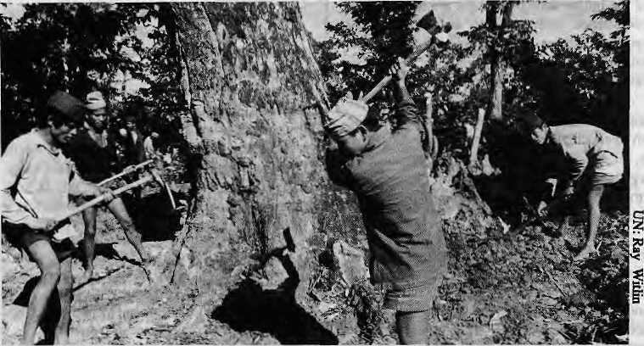
HISTORY
Where Mountain Meets Plain
The tarai is becoming indistinguishable from the plains as its environmental and cultural uniqueness is undermined. Traditionally, it was the place where transition from kill to plain took place.
Hillmen clearing up the Kumbher forest in Belgharl.
by Chetan Singh
O
bservers of the economic interaction between hill society and that of the plains tend to perceive the tarai as supporting forms of socio-economic organisation which are representative of the plains. Insofar as the tarai has today almost ceased to exist, such a perception is not inexact. With an almost relentless momentum, the "plains" (more importantly, the kind of society and economy they support) have in many areas and in a series of waves advanced right up to the northern foothills. This phenomenon, however, is recent.
Some early descriptions of the tarai make interesting Teading. Tavernier, a French merchant, who (ravelled through much of India in the mid-17th century describes the area lying to the north of Gorakhpur thus:
From Gorakhpur to the foot of the high mountains there are still eight or nine days' marching, during which the caravan suffers much, because the whole country is full of forests, where there are numerous wild elephants, and the merchants instead of sleeping at night must Temain on the watch, making large fires and firing their muskets to frighten these animals."
The later observations of Kirkpatrick (1793) and Hamilton (1820) in this respect are also quite similar.
Until very late, therefore, the greater part of the tarai consisted of undisturbed forests. It was a kind of no-man's-land for agriculturists both to its north and south; an area into which periodic forays of agricultural expansion could be made. Bishop Heber, who journeyed through the area to the north of Bareilly in the 1920s found "cowmen and woodmen" coming down to cultivate suitable patches of land from the north of the tarai. The dividing line between agricultural and forest areas was, nevertheless, an uncertain and fluctuating one and the advance of cultivation was not steady and irreversible. There were times and places where the forest rejuvenated itself. Remnants of old habitations are to be found in the midst of forested area even today. It was not till the coming of modem medicine, the increasing pressure of a growing population and the commercialisation of timber that the tarai lands underwent a qualitative change.
In short, the tarai has not been the place, as is the case today; where the mountain and the plains met. Instead, it was a strip which divided the two. However, any economic and cultural link between the mountains and the plains had to pass through the tarai. In the north you had the treasures of the Himalaya like the musk and herbs. South of the tarai were the urban bazaars of the Gangetic flatlands, where
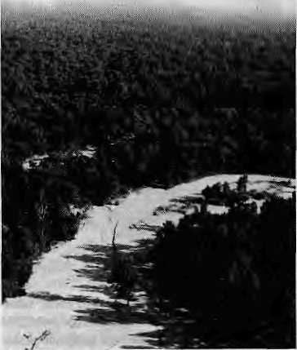
The way It was.
produce of the fans- and mid-Himalaya acquired monetary value. The barter system between the subsistence-oriented hill society and the commercialised plains was carried out through the tarai.
This trans-tarai trade used to be significant. Mirza Haidar Dughlat, a 16th Century noble of the Mughal court, tells us that Tibetan nomads exchanged Himalayan produce for "cloth, sweets, rice and grain". According to Dughlat, the Tibetan trader-nomads were known to carry as many as "10,000 sheep-loads". Himalayan produce was capable of being carried over considerable distance. According to records, in the 1620s, Kashmir walnuts were exported to Agra and musk from the hills of Himachal Pradesh to Lahore. Lac from Assam was exported in large quantities to China and Japan. Nor was the money involved insignificant. Tavemier, the Frenchman, in 1966 bought Rs 26,000 worth of musk in Patna!
While the tarai might not always have been the focal point in the mountain plains nexus, its inherent economic importance was growing steadily on account of its dense forests and rich pastures. In 1809, the rent of the pastures in Morang district gave the Nepal government revenue of Rs 24,000. This compares favourably with the "land rent" of the district, which was Rs 54,025. The duty on MoTang's timber was Katmandu's second largest source of revenue.
The tarai was an area that Kirkpabick in 1793 called "an almost inexhaustible source of riches". For the sake of the countries and states of the region, let us hope that Kirkpatrick was right.
C. Singh is a historian at Himachal University in Shim la.

16 HIMAL • Sept/Oct 1990

SOCIETY
Tension and Conflict in the Western Tarai
by Bharai Dogra
The tourist on the way to Mussoorie or Nainital, Uttar Pradesh's hill stations, passes the beautiful green, yellow and golden fields of the Himalayan foothills. But appearances are deceptive. In the Western U.P. tarai, violence has erupted again and again in recent years.
Uttar Pradesh's tarai is different from the old settled villages of the Gangetic plain further to the south. Most of the settlements here are of recent origin, results of colonisation of marshy lands and forests. Interestingly, the in-eqalities spawned by these newly settled lands of "socialist" India are no less acute than which exists in traditional Indian village society. In fact, the inequality is even more glaring because the mansions of big farmers of the tarai are adjacent to the humblest of shanty colonies.
The virgin lands were opened up at great public expense in the 1950s, with the primary aim of resettling the Partition refugees from Pakistan. The state also provided land to demobilised defence service personnel and "political sufferers". The pioneers flourished: irrigation was abundant and land was cheap. Soon, opportunity seekers arrived from all over, buying up hundreds or thousands of formerly forest lands at throwaway prices. Slowly, a breed of gentlemen fanners grew out of the western tarai, which is the closest you come in the Sub-Contincnt to large country ranches in the style of the American Wild West. A new kind of "secular zamindari" was created.
The U.P. tarai is one of the few areas in India that has combine harvesters: the American-funded Pantnagar university was only next door to show the way. It was
fashioned after American land-grant colleges, with mechanised farms attached to it. The university is a major supplier of high-yielding seeds, and therefore became the Mecca of so-called progressive farmers. The Sikh gentleman farmers settled here, particularly near Rishikesh were among the first, like the Punjab farmers, to incorporate green revolution technology in their fields. However, especially among the smaller farmers, there is today a drift back to traditional seeds.
Because the big landowners could not cultivate the vast tracts they had accumulated, they needed farm labourers, who arrived from eastern U.P. and Bihar. At the same time, "refugees" of population increase and environmental dislocation in the hills also came down to the tarai, hoping to improve their prospects. The Garhwalis descended to the Dehradun-Rishikcsh area while the Kumaonis settled around Haldwani, Pantnagar and Rudrapur in the Nainital tarai. But the best land has already been cornered by the relatively few landowners, and the stage was set for friction. Some families started encroaching on the Forest Department's land.
In all the coming and going of outsiders, the indigenous people of this portion of the tarai, the Buxa and the Tharu, were forgotten. Their property gradually passed to others and they were pushed into unproductive land or had to work as landless wage labourers. They have been victimised by the frontierman's tradition of coercion, violence and manipulation.
All of the U.P. tarai is not equally problem-ridden. For example, relatively the Nainital sector is marked by more inequality, conflict and violence. Other areas are relatively calm.
However, there are some features that hold common for most of the region.
Firstly, the indigenous inhabitants are increasingly marginalised. There have been occasional, ineffective campaigns to wrest out the original tribal lands from the landowners and return them to the Tharus or Buxas. In the Pauri Garhwal-Bijnore border under a movement started by Vinova Bhave, the effort to deprive Buxas of bhoodhan land given to them led to violence and incidents of torture.
Secondly, there is the question of land rights of those who have settled on Foresi Department land and remain there under uncertain conditions. Recently, there has been widespread incidents of repression in the Bin-dulkhatta area of the Nainital tarai. Even elephants were reportedly let loose on the huts of the poor settlers.
Thirdly, there are numerous land struggles as various organisations of the poor strive to get landlords with above-ceiling holdings to let go of their properly. After suffering through a prolonged campaign and for their rights the poor of Tehriwala in Dehradun district actually succeeded in wresting land from the rich.
Fourthly, there is the general demand of the farm workers for better working and living conditions. The most violent incident in this context occurred in 1978 at the Pantnagar university, when a massive police firing took the life of at least ten workers, possibly many more. Today, the demand for better working and living conditions is more muted, but it continues.
But as more awareness of the politics of socioeconomic and human rights permeates the bustis of tribals and the landless poor in the Uttar Pradesh tarai, the demand for a fair deal will become more strident
If the past is any indication, then more violence is in store for this region of the tarai.
B.Oogra is founder-editor of News from Reids and Slums, a news feature service based In New Delhi.

"Simply, the best book store in Nepal, perhaps Asia!" "A literary oasis in Kathmandu." - customer statements

FEATURING
Book Shipping to Any Country Rare & Antiquarian Books
"Search and Find" Book Service Publishing and Distribution
Grindlay's VISA
MASTER CARD
AMERICAN EXPRESS
Tiwari's PILGRIMS Book House
Thamel, P.O. Box 3872, Kathmandu, Nepal
Tel:416744 Telex:2662 TREKER NP Fax: 977-1-416870
OPEN DAILY 8 am to 10 pm

Sept/Oct 1990 • HIMAL 17

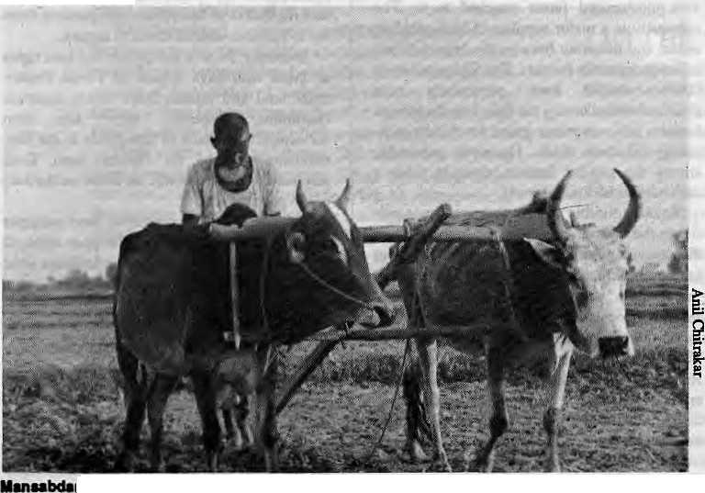
SOCIETY
Deepening Crisis in Sagarhawa
Mansabdar Khan moved to Sagarhawa as a "development refugee". Today, his village faces many crises, of population, fuelwood, irrigation, unemployment, et cetera.
by Anil Chitrakar
r Khan with his aim.
T^{r} one asks whether the village of Sagarhawa Alias a school, a health post, irrigation canals, a community forest, or an Agriculture Development Bank, the answer is, "Yes." But if the question is whether the villagers are educated, healthy, have clean drinking water, irrigation for the fields, fuelwood or gobar gas for the stoves, and collateral for bank loans, the answer is, "No."
Sagarhawa is a village of 70 households in Rupandehi District of Lurnbini Zone. One of the many villages of the Nepali tarai, it is coming face to face with the demographic, economic and environment problems common in the region.
Sagarhawa is Mansabdar Khan's village. "Demography" or "environmental crises" are terms that are alien to Mansabdar's ears, but he clearly understands the process that is overtaking his village. He is a Muslim family man who moved to Sagarhawa 12 years ago as a "development refugee", when his old property came under the Lumbini Master Plan Area, a multi-million nipee project designed to develop the environs of the Mayadevi Temple, the Sakyamuni Buddha's birthplace.
CRISIS OF FUEL
The growing concern among Sagarhawa's residents is one of fuel. The law and armed guards prevent Mansabdar and his village companions from entering the nearby forest and collecting firewood. Each morning, his wife now has the added chore of making bundles of kanda, which are foot-long cowdung fuel cakes used as firewood substitutes. She mixes the cow-dung from Mansabdar's pair of bail bullocks with rice husk and straw and pats it all into place around a stick of bikaya, a local shrub.
"This land is drying up; it is not as fertile as when I arrived," says Mansabdar. The decline in productivity is most probably related to the fact that the cowdung goes up in cooking smoke rather than into the fields as fertiliser.
Even the supply of cowdung is not unlimited. The heads of cattle are decreasing with the disappearance of grazing land. Bullocks need "habitat" just as do the rhino and the sam-bar deer. But Masabdar cannot imagine plains living without the trusty bails, the backbone of the tarai economy. With the supply of grass dwindling, and the cost of gram and animal feed high, Mansabdar is hoping for the day
when he will have to sell his oxen, which fetch between NRs3,000 and NRs5,000.
Mansabdar says he will soon shift to kerosene, even though this will further deplete his meagre savings. He takes a visitor to the outskirts of Sagarhawa and points out the fourteen different parcels which make up his three bighas of land, hi an adjacent plot, several men are digging what appears to be a hole in the dry ground. Upon closer inspection, it turns out that they are hacking at the roots of a tree that stood here as part of the jungle before the land was cleared decades ago. In their growing desperation, the villagers of Sagarhawa are even prepared to go underground.
MIGRANTS
One reason for the fuel crisis is that Sagarhawa and its surrounding villages are bursting at the seams with people. Migrants arrive constantly from the hill districts of Gulmi and Arghak-hanchi, from the Lumbini development area and from across the border in India. There is less and less in Rupandehi to attract the migrants and yet they come. At the same time, others are leaving. In the southern parts of the district, such as Asuraine and Semra, where irrigation canals have long since dried up, people are selling land and seeking menial jobs in urban centers like Bhairahawa and Butwal. There, they pull rickshaws, hawk fruit and work at construction sites.
It is conceivable that Sagarhawa residents can organise and try to belter their living standards, even if marginally. But this is easier said than done. In a region which is today riven by divisions of caste, class, property rights and religion, there is little opportuniry for the possibilities of common purpose. Sagarhawa, while not strife-ridden, lives on the edge of cultural disharmony. It has within its 70 households Muslims, Hindus, migrants from the hills, indigenous Tharus, migrants from India, the landlords, and officials from development agencies and government.
Asked why his people cannot pull together as they do sometimes elsewhere in Nepal, Mansabdar shrugs his shoulders: a gesture embodying at once wisdom, puzzlement and despair. The people of Sagarhawa try to concentrate on surviving from one day to the next and leave initiative and progressive thoughts to others. Propose a bold, new idea and they will immediately come up with 20 reasons why it cannot be done.
A. Chitrakar is an engineer interested in rural technology.

18 HIMAL « Sept/Oct 1990

BRIEFS

Tttet flame fn happier times,

PeaceFIaiUe
: ThLumbini, the birthplace of'
Sakyamuni Buddha, there burns to Eternal Peace Flame.
: But die fire has already died
'■■■ many times told cannot
, properly'1jS called "elernal" airy more. More to the point,: people havefbrgotten how this flame; landed up here in the first place, which makes its upkeep even more pointless: at a site as noble as Lumbini.
The bureaucrats and diplomats at the United Nations inNew York, for want of anything better to do, decided that 1986 would be celebrated as the International Year of Peace. Next they decidedthat there should be an ''Earth Run", which would, among other things, bring a peace flame to Lumbini, The then Nepali government, always looking a tpmasha to divert idle minds, jumped on the bandwagon. That is how the peace flame ended up in Lumbini, not to mark a watershed in history (as is the case with other peace flames from Hiroshima to New Delhi to Washington DC), but on the whim of an international bureaucracy and an unrepresentative government.
The watchman who looks after the flame for the Lambini DevelopmentTrust (which has been burdened with its "eter-nality") says ihe flame went out the first time when India and Nepal quarrelled in 1989 and the borders were ctosed, There was no gas in the market to feed the flame.
Since the flame was intended nevei to go oat,the LDP might have airlifted gas canisters from third countries. It would have been forgiven if it had resorted to smuggling even, in the name of. humankind. There does exist a well-trodden smugglers' route near Lumbini from Kakarhawa (Nepal) to Piparhawa (India), B«t no, the officials preferred to stick by the rules: no gas, ho eternal flame.
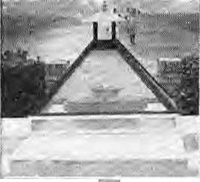
If "eternal¹¹ was-what: the ~ . flame w as to be_{r} wh at better -■ ■ ■■ sourceof ruellhaabiogas, churnedoutby thetanti'sabun-: dant (and patriotic) -cattle: But .:'; there wssnoapj*opnaie'te«hnoi- ■ ogybuff aroundinLmTibimand .'.-■■ Nepalmissed toopportunityto send a positive message to the : world about innovation in the face of adversity.
fei the end, the peace flame began to be run on mustard oil, "Jo^&v&r.Anoii wMona pd«atiibalanced atopthegas bowl. Amild^to-heayy gust of wind Hows the Eternal Peace Flame right out. So the watchman keeps a kerosene hurricane lantern (fattin) in ashed; ' nearby >o provide transfusion; A glass faoxhas also beert: built to ■ protect the flame on windy days. When it rains* and it rains hard in ■.■■.'■ Lumbini, the water level of the." : adjacent river rises and surrounds the peace fJanrae and its platform, which stand forlorn, a beacon in the middle: of a sea: of gpSen water.

There is a plaque; on the platform celebrating the International Year of Peace and.as abonus, the Silver Jubilee of the : ParichayatSystem. Today's^:
Sikkim's Tribes Seek
the Schedule
implement the Mandal Gdm-: mission report sets India aflame, :theMbes of Darjeelaig;fthd Sik-kim: are exercising their lobbying clout to get into India's list of .: :■:.: scheduled castes and tribes^ which woiild allow themeduca-tionaJ (piota? and prcferentiai ^ -treatment itijobTeseryalions : under the iidiari Cohstitoticai. {B.P,:Mahdars report submit^Sd : to Indira Gandhi in 1^2 and shelved by her proposes makmg firrtber reservatkms forOther : ; Backward;Plasses, OBC& who I do not make the list.)
The Tamangs of the Indian north-east, campaigning to thieve scheduled tribe St^us complain that -'sister tribes" like the Bhutia, Sherpa, Lepcha and' : Yblmos haveJohg smce been hw cluded-m the list; According to the Echoing Hills, a Sikkim ,^iblbid,;the Tamangs were pjeased to hear that the Indian Union Minis!3?r for Labour and Welfare, Ram Vllaa Paswjm • (also thepointperson for-the Mandal report implementation) had declared in Darjeeling on August 12 that the Tamangs
visitors will findthat the plaque has been chiselled out bythe LDP people and fitted back, inside-out. Meanwhile, the flame sput

fiiUlIledall thecriteria to be included: as ..a "5T'^{f}; He:said the Centre would move a bill daring "Parliament's winter session loin-clwde die group in the ST list .. .-Meanwhile^ fe Limbysof... Sikkim tod are gearing up for a ■ cartrpaign; Tile Sikkim Observer: reports that ihe Akhii Silddm Kirat LitnbM Ctitimhing is ex-; :pectedto press for "cottstitutkin-al and legal safeguards to protect (the Limbus*) distinct culture and history". The campaign gathered momentum when the-Limbu demand for reservation of seats in the Sikkim State Assembly wasnotmet.
Not tobe outdone, the Sher-pas are demandmg a better deal. Even though they figure in the STlist^ they feel discriminated : against vis-a-vis Sikidm's Bhutia-Lepcha population in matters
vadons and land purchase rights* according to; the Observer. For their part, iheBhutias; Lepchas and Limbus, who are known collectively as ^{J}'Lho-Mon-Tso:ngr Suhl" are d^tnanding coristitutioiial recognition of their languages. The Lhb-Mon-Tsong-. Sum are displeased that Chief Minister Nar Bahadur Bhandari isfighting forrecogrdtionbf onlj the Nepali language in. the Eighth Schedule of the Inthan Constitti' tion.
Gay Newsletter
hen South Asia's kings, presidents and prime ministers put their heads together to comeup;with die SAAKG idea-, primarily as a pulpit on which to .grandstand themsefves, they probably never realised what diverse forms SouJh Asian regional cooperation «oqid take; 6om summit meetings to en-
regional games and quiz contests. But they certainly never im-agihed that a regional newsletter catering to homosexuals in the Sub-continent was also in the cards.


Sept/Oet
HIMAL 1»

BRIEFS

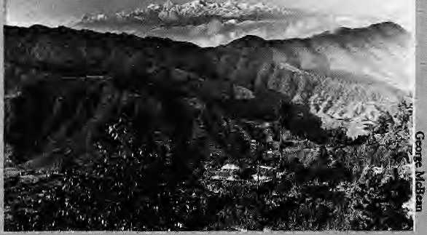

st issue of the news let-.: ler, Bombay Dost, came out in May 1990. It. is for private circulation only and ainis at providing "aplatform for people interested in alternate sexuality and all its implications", The newsletter deals with serious gay issues ranging from, networking among homosexuals to AIDS safety, and "seeks to encourage

Promising A Garden, Delivering Dust
^Apposition to big dam
projects, either planned or already long since built, brings to mind Tehri; Bhakra, Narmada and Kosi. Nepali activists, have only just begun to talk of Arun HI, Kulekhani and Kamali -- but whoever heard of Kaf abagh?

Nasir Gazdar, a Pakistani environmentalist, has just brought (Hit a critical book of the Kalabagh Dam Project, proposed to be built by the Pakistan Government on the Indus River. In the book, entitled Sabi Bagh: Promising a Rose Garden and Delivering Dust, Gazdar says the Kalabagh scenario is reminiscent of disastrous projects such as the Martgla Dam on the Jhelum and the Tarbela Dam on the Indus. The development of water resources in the entire Indus basin has beenflawed, he says, and planners Kalabagh havefailed to consider if their project is socially and economically justified.
20 HIMAL • Scpt/Oct 1990

and self-esteem" among: males and females "who feel isolated in the practice of alternate sexuality".
Started by Ashok Rao Kavi, a Bombay gay activist, thenewsiet-tea seeks to network with South Asian groups and individuals and to act as a cell for counselling, in-: formation and advice.

Gazdar ahoVhis Karachi-based: NGO, th« Enyironmental ■: ■ Management Society, are against "merely another round of dam building in: thelhdus Basm''.In the book, he tackles issues ranging from earthquake risk and '"•■..-flood hazard to the population of Peshawar Valley to population dislocation and she possible contamination of water supply to cities as far downstream as Hyderabad and Karachi. Gazdar specifically targets Pakistan's Water and Power Development Authority (WAPDA) for having promoted and;imposed watet and power projects in the .past without considering social, economic and environmental impacts. He claims mat since the: early 1980$ when the Kalabagh idea was floated, the KDP*& objectives and goals have been* shrouded in secrecy, "perhaps in order to move quickly and begin ■ pouring concrete inttr the Indus-River". (The book, ISBN 967-990-03*03, is available for U$J2 orPRs75fiomEMS,Sha<3ib Lodge Ground Floor. 371 Am-
Karachi74299_{i})

^{u}ECO^{f}92^{M}
- ¥t looks like the growing divide between the world's industrial north and developing southis ■ going to come tcr a head at the ■: Umted Nations Conference on Environment and; Development, scheduledfor;June 1992 in Rio de Jmplro,:BxMR.:The forecast is: for a deadlock over the respori-sibitisy for depletion of atmospheric ozone, halting climate change, and combating tropical deforestation. Some industrialised countries have been callingfoTjCorrectivemeasures that lay art overwhelming burden
;; on developing countries. ;
Other issues at the conference, :
transbbuniiary pollution, decer-taOcadon and drou^it, biological diversi^", and management of bio-technology. The conference Wffl also address pollution ofthe oceans and seas, protection Of; : fieshwater resources,and management of hazardous wastes andtoxic chemicals.
trie independent sector <rtew term for noh-goyearonerttal ar-ganisuiorjs) does not want to be left behind as governmierits: gather in E-io to mouth rhetoric and take expected positions. High-flying representatives of international NGOs, as well as their more tentative regional : counterparts, are gearing up for ECO '92 with position papers, workshops and brainstprming sessions. The Geneva-based Center for Our Common future is or-gasiising a series of public fefums, one of which washeldM New Delhi in early September.
The raliying cry of ECO *92is "environment and development'¹. According to the Canter's newsletter in preparation for Rio, an iiiterhationai conference 6tiin-digenpus peoples, environment and developmeni is being organised. Anew jgroap on "Religion and the Earth", is meeting in New York to higM^ht flise moral and ethical dimensions of the environment and development debate* into the ECO *92 process¹¹.
Not to be outdone* UNDPhas ; created a¹ Sustainable Develop-mentNetwork "to assist develop^ ing countries tomore furtly participate in ECO '92". Thelnr ternational Chamber of Commerce has created ten working committee^io preparefatthe Ria conference and has now a new Office of Enviroiunsnt and Enagy in Oslo, which is preparing an "industry platform" for ECO '92. A World Women's Congress on Environment and Development is planned in November 1991.
Some lightis bound to emerge frost tall he heat generatedby this independent sector activism, but wiil there be ; anyone speaking up for the Himalaya? Will anyone bother about how acid rain, ozone depletion, toxicity, climate change in the Himalaya-Gangetic regfcm or about its indigenous people? Will the Rio conferees alsoJimit themselyeS ttj mouthing siniplis-tic notions about Himalayan ecology? Perhaps it is not too late: June 1992is still ayearanda half away.

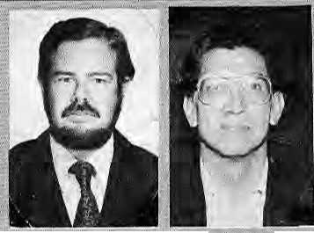
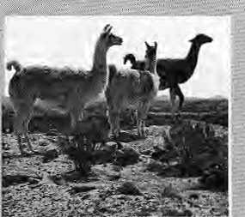
provide low:cosf moun--
(Both(hellamas, the' al paca, and their wild ; ■ ■ cousin the vicuna, are related to the camel). :
Tapia says that 25,000 years of humai: civilisation in the : Andes has left unique ■' techniques and tradi-.:. tions that can be useful inthe Himalaya as ^eM-^frorft animal husbandry £o food pceservation to weather forecasting. The Aymara arid (Juechisa; indigenous people of the South American altiplano (high plateau), practised surplus agricultural production and storage. They perfected the technique of freeze-drying potato^ ■ (see HSmal, July 1980},a storage procedure that might be
, userulontheHiinalaiya'sowna/-ifptatti}, whichis the Tibetan :
.plateau. -~,<"
Tapa says Peru's flora includes the "wild ancestors'' of a-wide variety of domesticated plante,wjtich carry genetic traits-that can be used to improve
: produt^iyi^ arid resistance of present day crops the world over Peru's peasantsiiave domesticated plants with shortmataring cycles. In earlier-times, crdfs were saved from highland frost by growing them in a unique sys tern of "ridged fields" kn^wn as hmru-hauru. These fields were flooded anclthe presence of water which absorbed heat-



BRIEFS
Mo Cairieis, Please
■. ^{r}Phe Germany abased watchdog
groups Tourism with Insight (TWI), has raised the alarm against a Himalayan auto rally planned by Camel Cigarettes aiid its parent company, the nuiltina-; tional Reynolds Tobacco Company, The Camel Trophy has been held every year since 1979, mostly in "exotic" Third World settings such as Sumatra, Amazonia and Madagascar.
According to TWI coor-^toator LudmiliaTuting, who is a longtime Himalayan ■whistle-blower, ursotor rallies are environment-unfriendly, promote false-bravado and cigarette-macho. She says: "The sole aim of the Camel Trophy is to promote Camel Cigarettes and male chauvinism ...we strongly oppose this rally and its Camel-heroes,"
Tutingis also critical of "aggressive" Indian tourism policy which only pays "lip service" to environmental concerns, TWI criticises New Delhi's tourism authorities for promoting motor rallies "along dusty roads, forest routes, mountain trails and through dry river beds". The German Alpine Club in 1986 demandedabanonauto rallies in die Alps, and TWI feels a similar ban should be applied in the Himalaya.
The date of the rally has not yet.been announced, but it is expected to be held sometime in .autumn 1991, TWI says ir wants to stop, what it calls "this colonialist Camel Trophy" dead on its tracks. Those wanting to assist (or even those who dunk that a Himalayan rally is one fine idea) can write to Equitable Tourism Options (EQUATIONS), 96 H-Colony, bi-dfranagar Stage I, Bangalore 560 038.

Yes To Llamas!
Tf two Peruvian social scientists ""recently in Kathmanduhad. : their way; Andean llamas would be browsing on hillsides in the upper KhUmbu while hardy : .. Himalayan yaks"would bei v transporting pot aloes for thfc cam-pasinos of the Andean altiplofio..
Mario Tspia, an agjonomist, and Alejandro Camino, an ■■: anthropologist, who were in : Nepal receiKly to attend a semi^ nar on "strategies for sustainable
mountain agriculture", are keen to explore areas of possible ex- ■■. changebelwecn the world's two : highest mpuhiain regions. They came With a basket-full of ideas. Upon learning that the Nepali-carpel industry uses sheep wool ■ imported ail the way from New Zealand, Caraino suggests Tearing the alpaca in the Himalaya; for it is a productive wool-producing animal whose fibre has been used by the people of the Andes for along time. The ama (pronc-uriced "yama") can
Dam News
T^amsBTe always in the news,
from Kalabagh to Arun II to : Subansm, This last one is amul tj-purpose 4800 megawatt project on the Ass am-Arunachal border, which would email a"257 -meter high rockfall dam on the Brahmaputra near the town of Gumkamukh. The Subansiri project tab is presently IRs3086 crores. Assam is pushing the Union Government to clear Sub^ ansiri, saying that it is vital for
Peruviansocial•ctainlsta Camino amdi Tapia.
during the day prevented formation of frost at night.
According to Camino, the terracing techniques used in the Andes could be of interest in the : Himalaya: 'Thelncas were superb soil builders. Their terraces not only prevented erosion, but helped create local microclimates which enhanced the potential of high altitudes to sustain a variety of crops." Hesays ancient Andean agriculture also flourished because the Incas had mastered weaih^r forecasting, based on astronomical observa-fibiis ar»d pateful mordtoring of natural indicators.
While the Andean past mig have been glorious, Represent, as in the Himalaya, is replete ■ with land overuse and;«hv^on^ mental degradation. Inotder'lti helpfevive agricultural production and the ecology in the Andes, Camino and Tapia are taking back word about invocation in the Himalaya--such as comnjiuiity forestry management in Nepal.
mergence¹ was: "thenattardconse quence of a dam project", only 13 villages and their 7,500 inhabitants would be affected, and that "no important species of frees and wild animals will be affected by the project",
Meanwhile, over and across in the Garhwal hills, environmen talists are reportedly "shocked and outraged" at the Environment Ministry's decision to clear the Soviet-aided IRs 3000 crore, 2400MW dam project atTehri. The activists claim that vital ts-
promoting nwiu^ry in Indian's north-eastem region as a whole.. Assam also cites the flood-control benefits, and that the electricity would be available at J5 paisa per unit con^ared to present fates of IRsl ,34 per unit.
The Government in New Deihi has to contend with the opposition of Aiunachal to Suban-siri, because 193sq.'kmof Arunachal land would be submerged and many villagers would be displaced. Assam claims that displacement and sub-

Sept/Oct 199«; • HIMAI, 21


BRIEFS

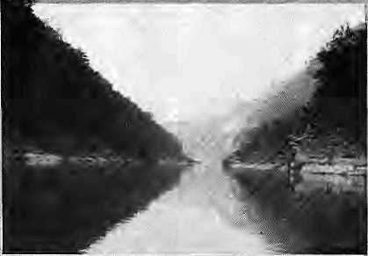
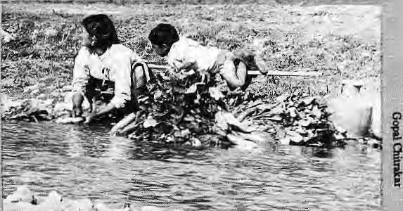
Washing radishes ot\ Bbhnumati river for Ksthmafidu market.
Need another dam? sues have not yet been fully assessed at Tehri, including questionsof seismicity, catchment area treatment, compensation, afforestation and human displacement. They say the Environment Ministry's own standing: committee's conclusions on the matter had been ignored in granting tjie: clearance, which now allows Soviet aid Worth about IRs900croreJo flow to theTehri Hydro Electric, Corporation. The Corporation has plans to cornmis-
Fighting for Water
Vlfith the arrival of a
"democratic dawn" in Nepal, activism is bound to increase-to redress so many iljs tha,t have festered in society. The first flush of democracy has, in fact, bolstered the fight for clean waterin Kathmandu Valley.
Water activism was helped by lhe factthat thesuCccssof the people's movement in April 1990 was folfowed immediately iy the onset of the monsoon, whichis when coiifohn in the Kathmandu fl^(«a reach record-breaking levels. Everyone -- journalists, lawyers, doctors ■, politicians—seemed on the side of dean water. Like motherhood, it was an issue with.-which you cannot go wrong.
The local tabloids were rife with water stories, Among Nepal TV'» first forays into inves'dga^ five journalism was a story on
sipntKe . ■;
project by
.. December. .;■■.
1995, ■
'. ;To its ; ■; credit* the bi^ dian: Environment ..
■ '■. Ministry has...; ; decided to a hydroelectric: projectelsewhere in Garhwal, at
Vishmiptayagi near the : Ba^ina&i temple. The project would, have been the first of its km<i in India's high Hiinaiaya, andproposed to generate 48OMWljy utilising; a 943 metre fall at Visfosuprayag and using the water of the AlaknanSa and Bbuindargaitga rivers, Chipkoactivist ChandiPrasadBhatt was ,-active in stalling theproject.
In Nepal, fe-Anih III project movesahead.if slowly, Constructionof a 190 km long access
raw sewage dischargejutb the Bishnumati River, and footage of meat being prepared for market by being washed on fet discharge. :
It. was easy to be a water activist because the ground work
hatlbeendane; hard data was ;... available¹ because of researdft by two groups; One is DISVI, an Italian NGO, thaihasbeen monitoring Kathniandu's drinking water since 10BS, and the
: road- js planfied in order to build ■;■ the4TOMWpowers^aJipndeep : . ^ in the gorge of theAruriKosr . river. What this will do ta die erc-vironmeruo^ the Arun Basin is ' anybody^ jguess. Tlie region con-tams one of the last remaining patches of Himalayan cloud : forest, with. rr*aay ertdangered ~ plants, anirrials,aswell a^hetbs endeiftic: to-Nepal, The bib-diyerr *i^ of the Aim Basin is said to be UttpaM]eled.;Alsp, what will happenwhen the road feiagsthe ■. ■. cash economy to th^Sereihofc hill flanks? And willthe local people; Rais, LimbuSi Magats and others, benefit from the raaii arid get a shareof the electricity? Much seenis: to ride On the reconi-.:'■ -mendaiioiis of the King
Maheridra-Trast for Nature Conservation, a non-profit organisa-.: tionin Kathmandu whichhas: : been entrusted with the task of carrying out a "Basin-wide Eri^ viipninental Study".
other-is aNepali group, the Naturtil Resources Studies: and Services. Unfortunately, both groups had to work under the infamous Social Service National Coordination Council (SSNCC, set up to monitor the independent
sector) and their work had remained under ^raps.
In the past two months, several groups have been formed ■to focus attention on Kafhmandu water. "Medics Against Polluted
Water⁰T-abbte-fousedatth? Mmistry of Health to protest wafer cbntamiriatioriiit(he Valley;,Soon thereafter, six : lawyers filed a writ petition vti the Supreme Court against (he
■ Nepal Drinking Water Corporation, adding a cptiple of miiustries and IheKathrriandu Municipality as co-defendants. On 14 August, the Court issued a show-cause-nofice u> the concerned autiiorities,
Meanwhile, two left-leaning groups, the Forum for Human
: Rights Protection and the-
^Democratic National Youth Association pyt out posters on water quality and appealed to the public to boil their water*..Qn
: Nepal-TV, "Meetthe Press" en.-counters grilled concerned mim-stcrs of Nepal's Interim Government about water.
; Unfortunately, if all Shis be "water activism" thealhepeople should taken to the sttee^; Instead, they continue to drink fr<jrn their taps. Also, those who fight fqr water seem to think that-ihey can do it aloiie: doctors talk to the Health Ministry, lawyers go to the supreme court, human rights workers bring out posters, but, they do riot speak to each other.
Tha lawyers who moved the Court never bothered to consult the Medies against PoJIutaj Water, who, for their part, seemed to have gone underwater lately. The! poster-writers who exhort the public to boil water seem to tbrgatthat most of the target audierice can.never afford fuel for such luxury. AJso, in all the tajk about water quality in privileged Kathmandu, no one is ..concerned with the people downstream from Kathmandu, all the way to the tarai, who suffer front ICathmandu's heavily paliutfed disdiarge, White the tap of freedom has been opened, activism remains ^{f!} top down" rather than "bottoms up". It neither erganises nor arouses. - Skhendra Bfsia>

22 HIMAL • Scpt/Ocf 199*>

VOICES

[Definition]
"OIKEOS" and "LOGOS"
Excerpt from paper presented by M. Vannucci, a Brazilian consultant working with UNDP on management of mangroves in Asia, at a conference on "Environment Protection in India," held in New Delhi in September.
-E/cology is a word used in many ways and with different meanings. Usually, it is misused in popular and newspaper parlance, therefore the need to start by defining terms to enable us to understand each other. In what follows, I use the term "Ecology" in its original scientific sense. Ecology means "science of the house", from two Greek words; oikos meaning house, and logos meaning science or logical deduction. Science of the house means "science of the living and non-living environment in which man and other living beings exist". The science of ecology is a quantified mathematical treatment of the exchanges of matter and energy amongst living beings and between them and their nonliving environment. It is the analysis of the basis of production and the rate at which production takes place is called productivity of the system. The study of productivity is the measure of prediction of the overall production potential of a geographical area or of an ecosystem in a defined interval of time, usually one year. What is that which is produced? From the human perspective, it may be a variety of things; food, grass for cattle, fuel wood, timber, or any produce of economical or survival importance to man. There is also production that has no immediate economic value and this is often wrongly overlooked. This could be production of energy or matter than enters into nature's food web; for instance marshlands do not at present produce much of direct value to man, but marshlands are very productive in terms of recycling energy in different manners, besides storing energy as fossil fuels.
It is the intensity of the recycling process, or the rate at which new matter is produced, as well as the rate at which energy is liberated or stored that is the de facto productivity. The bulk of the produce is production. Production is what is produced and productivity is the rate at which it is produced.
A degraded ecosystem is one that is at a level of productivity lower than the original ecosystem. Wastelands are areas with low productivity that either have an intrinsically low production potential (as permafrost areas, snowbound high mountain tops, arid semiarid areas, etc.) or that have come down to low productivity because of natural or man-induced degradation processes.
In the present context. Ecology is the Economics of Nature. Man has ever since, even before he became Man, interfered with the productivity of nature. Counties examples in the history and pre-history of mankind could be given where whole areas, whole ecosystems were changed by man's activities or by catastrophic natural episodic events or changes in the climate. Man sometimes put whole areas at a higher level of production and sometimes caused degradation, sometimes irreparable degradation.
[Prediction]
THE CATASTROPHE NEVER CAME
A news item appearing in the 4 September 1990 issue of the Los Angeles Times by staff writer Bob Drogin who says that even though many saw Nepal's woodcutters as formidable environmental foes and predicted dire consequences, in the Nepalis forest, the catastrophe never came.
Oajhang, Nepa!--As hundreds of millions of dollars and scores of Western experts flooded Nepal with elaborate forestry and dam projects, the World Bank warned in 1980 that Nepal would run out of trees by 1995. The so-called "eco-catastrophe" made headlines around the world.
There was only one problem. "The conventional wisdom was wrong," said Don Gilmore, Head of an Australian-assisted forestry project. "It was all a myth."
Indeed, satellite photos and ground surveys show Nepal's mountains may have more trees today than 30 years ago.
Buried in the story of Nepal's non-existent "ecocatastrophe" is a lesson that some say has parallels from Peru and Pakistan. It's the story of a profound waste of resources wthat could have been used to address the country's real human needs. It stems, critics charge, from the practice, prevalent among international banks and aid agencies, of measuring progress by how much money is spent rather than how efficiently their programs meet local needs.
[Confrontation]
AN OUTSIDER LOOKS IN
Excerpt on the tared from Travels in Nepal: The Sequestered Kingdom (1988) by British adventurer-author Charlie Pye-Smith. (For review of the book, see Mar/Apr 1989 Himal.)
1 erai too hot, Terai loo flat. Terai too much mosquito," in-canted the squat old Rai who sat next to me as the bus headed towards Biratnagar. I offered him a cigarette, which he took and passed on to the woman who sat beside him. "I no smoke," he explained, "but old woman smoking. Very bad for her. Very bad for you too."
Shortly before we reached Biratnagar the old woman got off and we passed her stuff - two dehydrated hens with gaping beaks, some aluminum pans tied in a dirty cotton shawl, and a small sack of rice - through the open window. A vermilion sun was melting rapidly into the horizon and welding the brown fields to the opaque blue sky. An ox and a cart rumbled by.
I asked him what he did. He replied that he'd been with the British Gurkhas. "Malaysia: put down rebellion, then Sumatra, then Hongkong. Hongkong no fighting: stopping Chinese. Seventeen years in Gurkha. My father fight in World War One."

Sept/Oct 1990 • HIMAL 23

The old man lived in Biratnagar, a place for which he seemed to have an intense dislike. "For you, no good. You leave tomorrow? Where you go?"
Hitherto I had met not one person with a good thing to say about the towns of the Terai, and indeed the guidebooks hardly mentioned them. This had struck me as perverse, not least because the Terai was home to nearly half the country's population. The Insight Guide, which is by far the best available, devoted 151 pages to the Kathmandu Valley and only four to the Terai, most of which was about Chitwan. The only mention of Biratnagar, the second largest town in Nepal, came in the form of an aside:
"Like Nepalganj in the west and Birgunj, Janakpur and Biratnagai to the east, Bhairawa's fortunes are built on the trade filtering between Nepal and India. Each of these towns consists of a collection of ramshackle concrete and wooden houses, a few factories, and a handful of rundown hotels. Their streets are left to fleets of often idle rickshaws."
There's little I can add to that. If I had to live in Birat-nager I suppose I would develop a liking for the place, however devoid of pleasures it may be. With its atmosphere of disconsolate tawdriness, Biratnagar reminded me of a Soho pinball parlour: garish, seedy and entirely without charm.
[Rumination]
"We Are Living The Changes In Climate
The Taste Of The Water
The Sad Songs OfThe Birds"
David Yanomami, the spiritual guide of the Yanomami tribe
of the Amazon in Brazil, writing a column with Marcos
Terena, leader of the Terena Tribe, for Inter Press Service,
news agency.
hen we come together in our villages, we often discuss the style of life of the white men. When they first came here, they promised a better world, a "civilised" world, and to convince us, they gave us gifts. We gave them our best spears, our best arrows and our best hammocks.
But when we got to know the world of the white man better, we realised that what they had told us were all lies, a big illusion. But when we tried to break away from them, they had already taken over our land and destroyed it, justifying themselves with the explanation that what they had done was done in the name of progress.
Having changed the green of the trees for the colour of money, betraying his villages in the face of Mother Nature, the white man decided he had to bring his progress to our villages in the middle of the forests.
We, all members of the indigenous family, believe that development is not merely material but also spiritual. We have always known how to walk the tightrope between the material, the natural and the spiritual. This is something the white man still has to learn. He has to find the right balance now, otherwise he runs the risk of finding it too late, when all he has left is the desert of his illusions.
The big industrialised powers speak of progress and development. Why do they not say that their richness has been achieved at the price of poverty of others?
Perhaps the white man is unable to understand our philosophy of life. Some think everything is pretty and poetic, others find it Utopian. But whatever we say is nothing less than the obvious, nothing less than the natural... For the
last four centuries, we have been acting as the guardians of nature in our villages. Today, with the forward march of ambition in the name of progress, we believe the time-has come to join together with friends, friends for the future, for the survival of the planet and of life itself.
Today, everyone is worried about the fate of Amazonia, but we so-called savages or "Indies" are here, living the call of nature through the changes in climate, the taste of the water, and the sad songs of the birds.
[Reflection]
LETTER TO GASTON
Excerpt from an article by climber Ken Hopper in the May/June 1990 issue of Mountain magazine, published in Sheffield. England, The article describes the writer's thoughts while attempting the East Face ofHagshu Peak in the Indian Himalaya.
, Gaston, you threw the furniture out of the window at the howling dogs of Kathmandu. So much passion and so many schemes, the lure of them all nearly sent us crazy. You studying your Tibetan and your Sanskrit and stealing away to Himalayan snows. With me picked up by your optimism and sweet insanity we went in search of a Himalayan dream under searing blue skies and crystal peaks in the cold, cold air of a Himalayan dawn. A bag of tsampa and some crazy gear nearly took us too far but a part of our own craziness broke clear and hurling itself at our own mad reasoning woke us from our wild dreams on winter ice, and shattering there wrote a Himalayan haiku in honour of our glorious failure. Ah Gaston, you never said we could fail. And rejoicing we came back happily, turning away from under those exquisite peaks, reeling under those searing blue skies, reeling with the exquisite pain of it all. I returned over different passes but you, being possessed, went on, on in search of your own wisdom. Your "crazy wisdom".
Where are you now, Gaston? Still out there somewhere, raving, bombarded by those insane messages transmitted from within your own skull? Or have you gone? Your spirit forever in that life between lives, in "Bardo", exiled to an endless existence in the infinite void between incarnations?
The last letters I wrote to Gaston remain unanswered, so maybe he has gone. Gaston did exist, although on assuming these heroic aliases in mock respect of our own aspirations, which became fictional characters in each others lives. But now it's been so long I'm not so sure, not sure who he is. Just a fiction. A satori of the Tibetan insight of "Crazy Wisdom", a blend of all those crazy angels that have somehow touched me - Tilman, Kerouac, Van Gogh, Hermann Buhl, Milarepa, Al Harris, the Dalai Lama, Mo Anthoine - polishing their own facets onto the prism of my imagination, overlaying their own reflections on the mirror of my mind. A blurring spectre of all these crazy angels projected back as splinters of light hazily focuses as a shimmering image of them all, an image of Gaston, my crazy saint. I have never stopped writing the letters to Gaston. I just stopped sending them. And now sometimes, in times of "exquisite pain"., I just make them up in my head, to myself. Thoughts at these times become confused, almost indistinguishable from a letter to Gaston. The "doing" ofHagshu is one of them.
On pilgrimage, in pursuit of that "exquisite pain".

24 HIMAL • Sept/Oct 1990

KNOW YOUR HIMAL

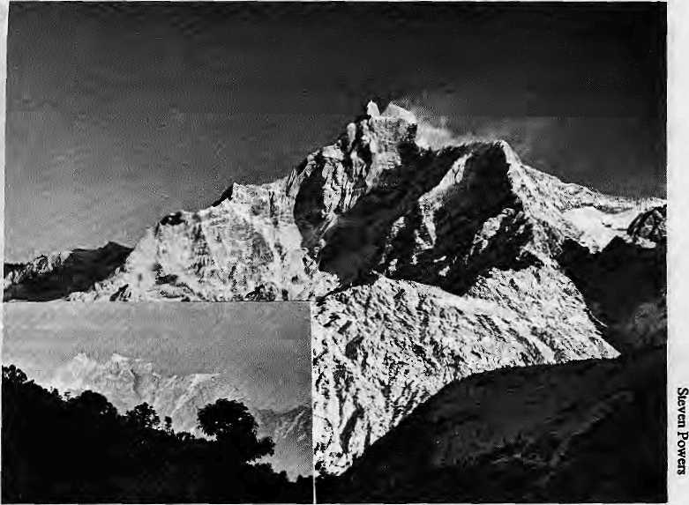
Gauri-Shankar
by Arnica Kumar Panday
g~^ auri-Shankar was once thought to be the VJhighest mountain in the world. This peak of 7134m, in what is known as the Rolwaling Hirnal chain, is actually 1714m lower than Everest/Chomolongma/ Sagarmatha. It lies on the border between Nepal's Dolakha District and Tibet at 27°57'57" North latitude, and 86° 20' 07" East longitude.
The mountain consists of two peaks, Gauri and Shankar, less than two kilometres apart. Shankar is the main peak, Gauri (7010m) the secondary peak. The ridge that connects them is above 6500m at its lowest. The two peaks resemble a sealed couple and have been given the names of the Hindu divinity Shiva, or Shankar, and his consort Parvati, or Gauri.
Gauri-Shankar is an interesting massif because even a slight variation in the viewer's position distinctly changes the mountain's shape. Flying west to east, travelers can watch Gauri-Shanker metamorphose from a broad massif to a knife-edge with striking cornices on the top. Even a four-hour walk from Tingsang La to the Bhagwati temple at Kalinchowk in Dolakha brings a significant change in perspective.
Steep cliffs and ice-faces drop down from all sides of the mountain. To the north-east, the Menlung Glacier slants toward's Tibet's Men-limgtse peak. To the south-east, there is a sharp and distinctive drop to the village of Beding, just seven kilometres away. To the south, the mountain drops down to the gorge of the Rolwaling Chu. To Gauri-Shankar's west and south-west lies the valley of the Bhdte Kosi, a major tributary of the Tama Kosi. This valley continues into Tibet, to the mountain's north and north-west side, where it is known as the Rongshar Valley. To the west lie other peaks of Rolwaling Himal, Tsoboje and Tengi, as well as the 5755m high Trashi Labtsa pass that leads into the Khumbu region.
The topographic map will show that Gauri is located on the watershed boundary between Tibet's Ronghsar Valley and Nepal's Rolwaling Valley, while Shanker lies entirely within the watershed of Ronghsar Valley. One would, therefore, assume that Gauri lies on the border and that Shanker lies entirely within Tibet, since most of the Sino-Nepali border runs along watershed boundaries. However, according to the 1979 border agreement between the two countries, the frontier runs like this: it toes the watershed boundary up to the peak of Gauri, where it makes a sharp turn north and
Gaurl Shanker from the South and East (inset).
runs along the ridge top to Shankar. From there it cuts diagonally southwest across a rock face to join the watershed boundary, at a spur called GhodChadi (6009m).
But Rolwaling's vegetation is not the kind one would expect to find in arid rain-shadow valleys elsewhere in the Himalaya. Except for clearings around villages, most of the valley is covered by dense forests of rhododendron, bamboo and conifers. Fogs frequently creep up all year round from the Bhote Kosi, keeping the area moist. Very litfle is know about the fauna of the Valley, which is regarded as "beyul", a holy valley, where no hunting is allowed. Along the Rolwaling Chu, which flows westward for 30 km, from the Trakarding Glacier to the Bhote Kosi, lie the villages of Nyamare, Ramding, Gyabrung, Beding and Na. They are inhabited by Sherpas, who it is thought migrated from Tibet later than the Sherpas of Solu.
The climbing history of Gauri-Shankar dates back to 1950s. Reconnaissance of the area was carried out by a British team in 1952, by the French and Swiss in 1954, and by another British group in 1955. In 1959, a Japanese expedition intended to be the first one to scale the mountain, but because their pieces of equipment were robbed by Tibetan Khamba rebels they had to give up their attempt.
It was not until the spring of 1979 that climbers actually reached the summit. The first men
on top were Dorji Sherpa and John Ruskelly, members of a Nepali-American expedition. Fourteen expeditions followed them, of which three succeeded in reaching the summit of Gauri. Two were able to continue on to Shankar.
There has been no known climbing attempt from the Tibetan side. Unlike some other peaks, Gauri-Shankar has been good to climbers: there has been only one recorded death on the mountain, during a Japanese expedition in 1985.
A Spanish group was the last one to attempt Gauri-Shanker in 1986 autumn. Even though they had climbing permits, the Spaniards were able to proceed to the mountain only after two weeks of having to deal with government authorities. Since then, the Ministry of Home Affairs has without explanation refused to grant permits to Gauri-Shank. The mountain, meanwhile, remains on the list of peaks open to climbing.
For now Gauri and Shankar have the peak once again just to themselves.

■ ■■ ■ " ■ ^. . ■■  HIMDL | Some back issues of
■ ■■ ■ " ■ ^. . ■■  HIMDL | Himal are available
 | in limited numbers.
r.:J*|MJfigW | Please write to
 | P.O£ox42,
 | Lalitpur, Nepal
BSr^y. ,'■ ■- %V'.i | for information.

Scpt/Oct 1990 • HIMAL 25

INVESTIGATION
Hear No AIDS, See No AIDS, Speak No AIDS
AIDS, until recently considered a problem of poor African and affluent Western societies, is very much a South Asian problem. As the epidemic engulfs the backwaters of Asia, health workers will be unable to cope with persons requiring specialised and complex care. In India, AIDS has brought not only fear of the disease, but also confusion and dissatisfaction about how the epidemic is being handled. Nepal does not have afoot in the right direction, either. Meanwhile a potential disaster is in the making as Nepali women carrying the AIDS virus return home from the brothels of Bombay.

systematically destroying the T4 lymphocytes, popularly called "helper T cells". The T4 lymphocytes act as "guards" against infectious agents, and stimulate the immune system to attack them. When enough of the T4 lymphocytes are destroyed, the immune system breaks down and AIDS symptoms appear. Patients then oscillate from one infection to another. With hardly enough time to recover from one episode they succumb to another attack. After several years of full-blown AIDS symptoms, the body is unable to sustain any more insults and literally gives up. A peculiarity of AIDS is that it afflicts people in their prime (20-45 years).
The incubation period (the time lag between HIV's initial entry into the body to the first signs of AIDS) is about 11 to 12 years. HIV is a "slow virus of an insidious onset".
Since time-bound data on AIDS patients is available mainly on patients in Europe and North America, one can speculate that the incubation period for victims of poor third world countries will be shorter. Especially due to the poor nutritional status, and an environment that is conducive to opportunistic infections.
AIDS and HIV in Asian Countries, (WHO July 1990)
AIDS cases
Number Tested
fflV Positive
Country
0
0
0
48
7
0
0
0
3
4
45
42266
2975
7580
486804
96963
2606
11399
20545
17141
121943
1700000
1
0
0
2575
19
0
0
324
6
24
19292
Bangladesh
Bhutan
DPR Korea
India*
Indonesia
Maldives
Mongolia
Myanmar
Nepal
Sri Lanka
Thailand
♦ 362 HIV positive cases in Manipur (mostly among intravenous drug abusers) not included.
by Shanta Basnet Dixit
S
ince the first cases of AIDS were reported in 1981, health professionals have been increasingly concerned about the unprecedented dangers this disease poses. But many people have tuned out, deluged by sensational coverage of the disease in the media. This is unfortunate, because AIDS still has the potential of overrunning all of the Third World,
In African countries the prevalence of AIDS is nothing less than tragic Other Third World countries would be living in a fool's paradise if they thought they could escape the grasp of AIDS. As rio cure is available and people lack the knowledge of how the disease is spread or how it can be prevented, AIDS will not bypass any region. It is therefore urgent to put public information campaigns into high gear and prepare public health institutions to tackle the most dreaded disease of modem times.
India, with its large and proficient medical profession and public health administration, has a mixed record in confronting AIDS. There have been glaring instances of AIDS patients being mistreated. But at least some treatment facilities exist in the Indian metropolitan centres.
By contrast, Nepal is totally unprepared to handle AIDS. Should the HIV virus, which causes she disease, find an easy way to enter Nepal in large volume, the country will head into a public health disaster. The fact that HIV has not inundated the country so far is the very reason to immediately start taking measures: through public information campaigns, medical research, epidemiological surveys, and long term planning of AIDS treatment.
Besides the public health disaster that would overtake Nepal and all other poverty-stricken hill and plain regions that "export" prostitutes, what about the psychological trauma that the patients face, the cost of treatment, the training of medical personnel, the gearing of medical facilities? Is it fair to ask the medical professionals to focus on AIDS, a disease that is not yet a crisis when there are so many other medical priorities to contend with, from high child mortality to diarrheal diseases, malnutrition, measles, malaria et cetera?
MESSAGE FROM AFRICA
It took many years for doctors and public health professionals in Europe and the United States to begin to comprehend the complexity and magnitude of the disease. Until recently, they considered the disease confined to certain groups of people, particularly the homosexual community in California and the intravenous drug abusers in inner cities, especially New York.
In the mid 1980's only, the AIDS pandemic was recognised. The disease could no longer be confined to groups of people with "high risk behaviour". It had begun to spread among the general population. The World Health Organisation (WHO) approved a Global AIDS Strategy in 1987, forcing many countries to take a more serious look at the disease. Still, it remained a disease of the developed countries and of Africa.
According to WHO, by May 1990 there were 650,000 AIDS patients worldwide, and half were from Africa. One out of every 50 persons in south Saharan Africa carries the virus. Unlike in the United States and Europe, AIDS has become a family disease, spreading largely through heterosexual transmission. Many children are being bom with this disease, Experts recognise that today, that all over the world, the disease is spreading much more rapidly in the heterosexual community than among the gay community or among intravenous drug abusers.
The message from Africa to South Asia is that it could happen here. Noth-i ing is saving us other than luck. Once AIDS begins to take hold there is no reason why its prevalence in India or Nepal should be any less than in Africa.
WHAT IS AIDS?
Acquired Immune Deficiency Syndrome (AIDS) is not a specific disease, but a collection of symptoms and conditions resulting from "opportunistic infections". The Human Immunodeficiency Virus (HTV) is the micro-organism that causes AIDS. It has a special affinity for the immune system,

26 HIMAL ■ Scpt/Oct 1990

HTV has been isolated from body fluids and tissues such as blood, saliva, tears, breast milk, bodily secretions and semen. However, the virus can be transmitted only in certain well-known ways, the main routes being sexual contact, infected blood (sharing of infected needles, and blood transfusion) and perinatal transmission from mother to the infant before or during birth. HIV is a fragile virus and, provided certain basic precautions are taken, it cannot be transmitted through casual day-to-day contact.
PREVENTION AND TREATMENT
Ordinarily, infectious disease can be prevented through vaccines, or treated. AIDS has no vaccine and no cure, and a breakthrough is unlikely in the near future. The therapeutic drugs prescribed to AIDS patients are meant to fight specific infections Tather than to inhibit the growth of the virus itself. The drug known as AZT (AZUDOVUDINE) has been shown to slow the progress of the diseases by preventing the virus from integrating into the host chromosome. However, AZT is expensive and it has many side effects including bone marrow destruction. In addition, AZT is not widely available. The patent of ihe company that produces it does not expire until 1992.
Responsible Individual behavior is a must in preventing this disease, but sensible behavior cannot be expected from uninformed individuals. People must be convinced of the need to protect themselves and others from being infected by HIV, and to act accordingly. Nepal and India would be more productive if they began intensive country-specific and culture-specific public information programmes, than to focus on screening with imported kits and aid money just because it is done elsewhere.
While it may be easy to convince and motivate individuals who have not yet been infected by HTV, it will take much time and effort to convince those infected to avoid infecting others, especially if their livelihood depends on continuing high risk behavior (prostitutes and professional blood donors). Infected women
I must be convinced that it is unfair to conceive children who are likely to be HIV positive.
Most countries focus on prevention, which involves screening. Firstly, "high risk" populations are screened for HIV positive cases. Secondly, blood and organ donors, as well as blood products, are screened. Pregnant women are also screened.
Before a country decides on any specific method to prevent AIDS, it has to make an intelligent assessment of the mode of HIV spread among its population. Taking the world as a model, 75% of the spread of AIDS is through sexual intercourse, 15% through blood products (transfusion, intravenous drug abuse), and another 10% through mother to child. Most of the spread is thus through unsafe sex.
"In India, the Gay population is not at special risk, like in the West", says Ashoke Rao Kavi, one of the very few Indian gays who is actively working for the gay cause. The spread of HIV in India was previously thought to be only in the promiscuous heterosexual community, and among professional blood donors. A recent report on the seropositive rates of intravenous drug abusers in Manipur, the hill state of Northern India, has changed this epidemiologi-cal profile. Thus, ablind focus on screening and testing without a well supported programme on public education will not contribute to the prevention of AIDS.
Unfortunately, India and Nepal, like many other developing countries, are already heading up the wrong path in AIDS prevention and treatment They have chosen to spend their money mostly on testing persons (those with high risk behavior) and screening of blood and blood products, two activities which are easily done provided that there are financial resources.
NEPAL AND AIDS
According to WHO*s 1990 data for Nepal, 17,141 people were screened for the virus. Nine tested HIV positive, of whom three had AIDS symptoms and one had ARC (Aids Related Complex, not yet full-blown AIDS). The limited data shows that HIV positives are either ex-
patriates (nationality unknown) or Nepali prostitutes who have found their way "home" from Bombay. No HIV carriers were identified among blood donors, pregnant women, or the "general population". So far there have been two AIDS related deaths. One Nepali girl died in Nuwakot in July 1990, and one westerner died in a Kathmandu hotel in 1988.
While the indication of HIV positives among those Tetumed from Bombay is significant, on the whole, WHO data is suspect. Normally, the ratio of AIDS patients to those infected with HIV is between 1:50 and 1:100, in Nepal, the ratio is 1:2. Thai the data shows no HIV positive person among the general population sample could also lead to a false sense of security. Firstly, the cursory sample survey might have missed existing cases. Secondly, the constant high-volume population movement over the open border with India means that an AIDS epidemic in North India could immedi ately envelope Nepal as well. It is therefore important for Nepal to coordinate its AIDS strategy with India's.
While the AIDS virus can enter the country in many ways, public health professionals should immediately look into the possibility of the virus penetrating Nepal's hinterland through prostitutes returning from the AIDS-ridden brothels of the major Indian cities. HIV positive prostitutes would be the major carriers of the AIDS virus into Nepal, it can be safely said. Because Nepali girls are more "popular" among clients, they also have a higher prevalence of sexually transmitted diseases (STDs). This would also translate into a higher prevalence of HIV positivity. It is estimated that Bombay alone may have about 45,000 Nepali prostitutes. Even if it is 30,000, and 10% (and not 30% as widely reported) of the prostitutes in Bombay are infected, 3000 Nepali girls in Bombay alone would be carriers of the HIV vims at this very moment
Most of the Bombay girls ultimately return to Nepali towns, if not to their villages. They thus become a source of infection whether they continue as prostitutes in Nepal, or many and


Young victims or HIV at GT Hospital, Bombay. Left to right: Mayurl (17) after neurosurgery related to AIDS; Meena (19) with luberculosls; Selvl (14) recovering from an acute Infection; Sundarl (17), wounded by brothel keeper; SunM (20), eager to marry his betrothed in 6 months.
1

Sept/Oct 1990 • HIMAL 27

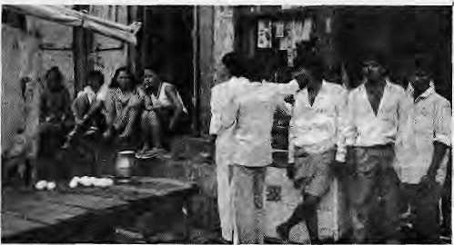
flip chart, a pamphlet targeted to Nepalis travelling abroad, some posters, badges and an AIDS summary book.
Most of the foreign visits by Gurubacharya and his staff have concerned diagnosis, nursing and management of gj AIDS patients. None of the O workshops attended related to
health education and AIDS. The overwhelming focus on treatment of AIDS is not proper, especially because Nepal does not yet have an epidemic and because such an epidemic can be prevented only through education. An educational programme aimed at villages on the prevention of the spread of HIV would be difficult, challenging, but absolutely necessary.
Surprisingly, not one non-governmental group in Nepal has shown sustained interest in understanding and combatting AIDS. Dr. Gurubacharya's Programme is the only (understaffed, under-funded and under-utilised) resource for AIDS in the country.
INDIA AND AIDS
Unlike Nepal, in India there are numerous organisations ~ manned by qualified doctors, social workers, counselors, and epidemiologists — ■working on the AIDS epidemic. However, much of the AIDS activity has been confined to the main cities, particularly Delhi and Bombay. Moreover, there is little coordination or trust among those involved in the AIDS field. Few have anything good to say about the other (see page 30).
Perhaps because the sheer size of its public health infrastructure and because of the fears of an African size epidemic on its lap, India is far ahead of many Third World countries in researching and responding to AIDS. Both the governmental and non-governmental sectors are active in implementing AIDS-related projects.
In late August, a massive "Health Education in AIDS" project was being planned by Bombay's DirectorateofHealthServices.lt hoped to pool expertise from among the city's municipal corporations, governmental bodies and non-governmental organisations. Lintas, a top advertising firm, is to package the health message and organise the mass media campaign. The Tata Institute of Social Sciences is to design a scientific survey an the knowledge and attitude towards AIDS among a representative sample of the city's population. There is no saying how successful the Directorate's project will be, but it provides a rare example of good sense and cooperation in tackling AIDS.
While the Directorate works on the social and psychological aspects of the AIDS
Nepali girls and clientele on Falkland Road, Bombay
settle down. It is known that several HIV-positive girls [from Bombay] have returned to villages across rural Nepal and are assuming a "normal" hie. One of them is reported to have a daughter who is also HIV positive. These cases have not yet made their way into the published "statistics".
Since air links were established between Nepal and Thailand in the 1970s, Nepalis who visit Bangkok have mixed business with pleasures of the flesh. Earlier, they used to return with sexually transmitted diseases (STDs). Today, with HIV in epidemic proportions among Thai prostitutes (over 40% in some areas), airliners from Bangkok could well be bringing back sexual adventurers with HIV.
Migrant labourers from Nepal and other Himalayan states who work in Indian cities are also likely transporters of HIV. Many male migrants, alone in the big cities, visit prostitutes for recreation. If they originally came back with STDs (see Hlmal. July 1988), now many must return with HIV as well. Long and short-term Nepali migrants inlndianumber in the millions.
Many AIDS cases might not even be recognised. Patients would be spared the despair of knowing they have AIDS. Dr. N. K. Shah, a Nepali who directs the Communicable Diseases Division of WHO in New Delhi says, "People in the villages will die without even a diagnosis. Everyone will think that they died of malnutrition. This may happen within the next 5 years, as the incubation period for our people will be much shorter."
Inspite of this, the AIDS Research and Control Programme in Nepal is a one-man show. Dr.B.L.Gurbacharyahas been designated by WHO and the Government as the Principal Investigator of the Programme. He is supposed to conduct his AIDS dudes in addition to his normal work as the Chief of Central Health Laboratory in Kathmandu. As a result, he says he devotes only about 25 per cent of his time to the AIDS Programme.
The epidemiological response of Gurubacharya's office to a possible AIDS flare-up in Nepal has been confined to the one-time testing of blood and screening of high risk groups (the WHO study already mentioned). The Programme has published two booklets, a
epidemic, the Indian Council of Medical Research (ICMR) carries out'sero-surveillance work; it evaluates testing kits, and follows the natural history of the disease within India. The ICMR publications ICMR BULLETIN and CARC Calling, are invaluable for understanding the AIDS epidemic in relation to India.
There are many critics who feel that Indian doctors and public health institutions have little to be proud of. While there is some good work being done, much of it is geared towards screening "high risk" captive population who do not even find out their results.
There are incredible divergences in opinion about the rate of HIV positivity in Bombay, the prevalence of STD among high risk populations, and the ideal system of treating patients. While one doctor sues the blood banks for infecting the blood donors with HIV, others maintain that the blood donor population itself has high risk behavior that makes itself prone to HIV infection. When onw doctor insists that there is low prevalence of STD and HIV positivity among prostitutes, others say only a very select and unrepresentative group frequents his clinic Nepali prostitutes in Bombay, some say, have a lower prevalence of HIV because of a better clientele. Others argue that more of them may carry the virus because these girls are more "popular".
An ICMR booklet for health professionals on "Standard Biosafety Guidelines" (June 1990) underscores that "with the application of universal precautions, no further routine isolation is necessary for FflV-infected patients". But that is absolutely not the case in reality, with the foremost hospitals in the country refusing crucial treatment on the basis of HIV positivity.
A HUMAN RIGHTS ISSUE In the panic of handling a growing AIDS epidemic, the human rights and personal dignity of HIV positive persons can easily be undermined. If the improper and inhumane treatment of AIDS patients and HIV positive individuals in India and Nepal is any indication, increasing number of victims can expect only hostility, misconception and cruelty.
The unwinding tragedy of Rohit and Vineet Oberoi (ages 24 and 28), and Kavita Maharjhan (22 years) shows the excruciating times South Asia's future AIDS sufferers have, in store for them.
Vineet and Rohit, both hemophiliacs, received infected blood product and are HIV positive. Since 1975, they had beenreceiving treatment for their haemophilia from the Army Medical College in Delhi, one of the few places where this genetic disorder is treated.
Rohit was admitted to All India Institute of Medical Sciences (AAIMS) in April 1989 to

28 HIMAL • Scpt/Oct 1990

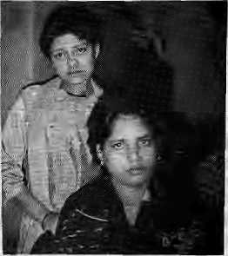
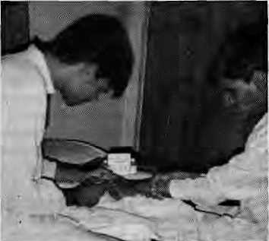
Rohlt gives Vliwet a transfusion.
treat a bleeding knee joint. When the hospital found him HIV positive, he was discharged immediately. Since then, every time he has visited ATMS, Rohit suffers abuse from doctors and nurses who refuse to treat him. He faces discrimination only because he cares to inform the medical staff that he is HIV positive.
Vineet also faced-discrimination when his blood was found to be HIV positive in June 1990. Immediately after, he had an attack of Pneumocystis Carinii Pneumonia (PCP), one of the most common opportunistic infections among AIDS patients. He was treated with Difulcan, an imported drug which costs US375.29 for a 30-tablet bottle. Vineet overcame the PCP attack, but because of lowered immunity has been advised to take the AZT, one year's supply of which costs U$8,000.
Meanwhile, the AMC has sent the Oberoi brothers registered letters telling them that they will not receive any hemophiliac treatment as they are HIV positive. The Oberois have had to establish a mini primary care centre in their own home. They treat each others' minor problems. Plastic bags, latex gloves, disposable syringes, and polar bleach have become household objects. But there is no knowing what will happen if their bleeding takes on emergency proportions, and they require specialised care.
Says Rohit, "I am not afraid of dying, but it hurts to see the way we are being treated. We arc victims of the time. In a generation AIDS will be regarded simply as another disease." Unfortunately, the case of Rohit and Vineet is likely just the beginning of a scenario that will be repeated thousands of times in coming years.
In Kathmandu, Kabita Maharjhan with exposure to Bombay, was kept at the District Superintendent of Police's (DSP) office for two years, because she was HIV positive. Numerous letters by Inspector Purna Chandra Adhikari to heads of health sector, zonal commissioner of Kathmandu, the Teaching Hospital, and social service organizations proved futile. Kabita was confined to a "cell" where policemen shared
their ration with her. She attempted suicide. After ihe April 1990 movement in Nepal, Kabita was freed and she has been working incognito in the AIDS research and prevention project through the offices of Ihe Minister of Health.
In another instance, an HIV positive man, a westerner, went to Patan Hospital in Lalitpur. When he disclosed his HIV positivity status, none of the staff would go close to him. He got no treatment till one of the dentist proved brave enough to attend to him.
LOOKING AHEAD ON AIDS
While the AIDS work in Nepal is a one-man-show, India has numerous professionals vying to contribute to work towards the further understanding of AIDS. Both countries, however, find themselves at the same point in time when AIDS has made its presence felt but has not spread uncontrollably.
Health professionals in both countries should concentrate on a response to the AIDS pandemic that fits South Asian conditions. The response should be based on the peculiarities of South Asian society, and the peculiarities of AIDS — the psychological trauma it brings, the expensive treatment, the "hostility" of medical personnel, the discrimination against patients. For example, an appropriate response might be to start home-based care for AIDS patients. Such care might prove more economical and perhaps safer because of the presence of fewer infectious agents at home. The family would get involved, and the patient, would get love and support up until the very end.
There is a need for a pooling of resources on AIDS, both in terms of clinical research and public information campaigns. The screening of blood and blood products should be continued to maintain a safe supply, and voluntary screening of high risk population should be en-
m Tepali girls often land up in Bombay unin-1 T( tentkmally, and get forced into prostitution. Once they are "bought" to become a slave of the brothel keepers {ghar-walis), escape becomes impossible. Savdhan is one organization that works to repatriate girls (especially minors) who are unwilling prostitutes. Vinod Gupta, the founder of Savdhan, has rescued 1631 girls since 1983. Two Nepali girls "Neelam" and^{lt}Kalpana"(16andl7) have sought Savdhan's help. Their story is socking. Tricked by two Tamang boys in the name of jobs in Kathman-
couraged for research purposes as well as to let interested individuals know their HIV status.
Given that for the moment, in absolute terms, a very small proportion of the population is affected, AIDS education linked with health education and family planning would be more cost-effective. Innovative ideas should be used. For example, the yet uninfected people have to realise that not only is HTV a slow killer, but HIV positive people are like international prisoners, as at least SO countries including the United States, West Germany, India, Pakistan and China have varying degrees of restrictions.
Discrimination against HTV positive persons is likely to encourage them to continue their high risk behaviour, such as prostitution, as a means of "getting even with society". A trusting, understanding environment must be created which will encourage people with high risk behavior to have their blood tested voluntarily. Because HIV earners outnumber the AIDS patients manyfold, and it is this group of "healthy carriers" that are the main source of infection who should be given priority in counseling and health education. AIDS patients should be given, in addition to medical care, counseling on how to manage the disease both physically and psychologically.
The AIDS epidemic has provided Asian countries with a lead time of at least 6 years. It is important not to lose this advantage. Most of the lessons should be learnt from the developed countries, but application has to be catered to our own special circumstances. Also, in the urge to protect public health, the right of infected individual to receive the best care available, and the right to human dignity should not be undermined.
S.B.Dixit is an epidemiologist. Himal's investigation of AIDS in Nepal and India is made possible with support from the Panos Institute, London.
du, they have been prisoners at the red-light district of Falkland Road, Bombay, for the past four months. They each entertained 15 to 16
costomers during the day, and were shuttled between two customers every night. Each earned, on an average, IRsSOCVday excluding tips, but received nothing. They were beaten by Gkarwalis for resisting clients and were given shots if they suffered from overwork. The Bombay experience is one from which girls do not usually recover. They lose face, do not go home, and are trapped for the benefit of the flesh Irade.

Sept/Oct 1990 • HIMAL 29

INTERVIEW

The Great Indian AIDS Debate
There are many individuals and institutions engaged in different aspects of AIDS research and treatment in India. Not surprisingly, there is not always a meeting of minds. To get to the bottom of AIDS research in India and to learn how the region as a whole could benefit from the work done to date in India, Shanta Basnet Dixit interviewed some AIDS and STD specialists in Bombay and Delhi.
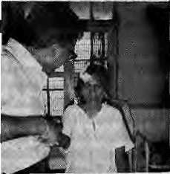
Dr. A.S. Paintal is the Director of the prestigious Indian Council for Medical Research (ICMR) in New Delhi, an apex body for medical and public health research in India. ICMR has pioneered procedures for screening and surveillance of high risk populations, and blood and blood products. However, ICMR has also been accused of coercively screening "captive populations" for the HIV virus and for not letting those screened know the results.
Dr. A. S. Paintal: I would have prevented the AIDS epidemic in India if they had let me stop foreigners entering this country in 1987. (12 of the 44 AIDS cases as of March 3990, and a higher proportion in 1987 were expatriates.)
Himai: What about the Indians that bring the virus from abroad?
Paintal: I would have tackled them in a second phase.
Himai: How can you go around alarming people by making unbelievable forecasts? You claim that by 1995 one third of all Bombay housewives will be infected by the HIV.
Paintal: Pardon me, the press misquoted me, I meant "one third of all pregnancies",
Himai: Even that, of course, you must be saying just for effect.
Paintal: You do not understand; there are 20 million people in the Bombay area and about 100,000 prostitutes, each having an average of 10 encounters daily, which gives a total of one million encounters every day. If 5 percent of all pregnancies are HIV positive now, don't you think by 1995 30 percent of the pregnancies will be HIV positive? I am not an alarmist. I am trying to save Bombay. The epidemic in Bombay will be worse than in New York, but I hope it does not get as bad as some of the African countries.
Dr. I.S. Gilada, treats sexually transmitted diseases (STD) and venereal diseases at JJ. Hospital in Bombay. He founded the Indian Health Organisation (IHO) in 1982, a non-profit organisation to work with groups that have been marginalised by society. A colourful character, Or. Gilada is the most quoted among Indian
doctors on AIDS. He goes to the red light districts, particularly Kamatipura, mike in hand, to educate prostitutes and their clients on the use of condoms for safe sex. Dr. Gilada is presently organising a world congress on "HIV, The Future of an Epidemic", to be held in Bombay 7-9 December 1990.
Himai: Do you agree with Dr. Paintal's figures?
Gilada: The call to save Bombay is appropriate, but the situation is not that alarming. They have a habit of making issues out of non-issues in Delhi.
Hanoi: What has IHO done against the AIDS epidemic in Bombay?
Gilada: We were the first to start working on AIDS, especially in relation to prostitutes. IHO started work in 1987 when the government thought that AIDS was not a problem.
Himai: What is the seropositivity rate among prostitutes in Bombay?
Gilada: 30 to 40 per cent are HTV positive. 80 per cent of the prostitutes have at least one STD and 50 per cent have at least two.
Himai: How many clients does an average prostitute see?
GiIada:The average four years ago was five clients per day, now it has dropped to three per day.
Dr. J.K. Maniar is a specialist in Skin and Venereal Diseases, Grant Medical College, Bombay. He also operates the Municipal STD Clinic, the largest of its kind in Bombay, that has existed since the 1940s in Bellasis Road adjacent to the red-light district of Falkland Road.
Himai: Where should health workers from India and Nepal j go to study AIDS?
Maniar: Ourj situation is similar to that in Africa, so we should learn from Africa, I do not understand why our government is sending people to Aus- Maniar with Pattont
tralia for training. The spectrum of diseases in Africa is closer to what is found in India.
Himai: Do you agree with the figure of Dr. Gilada and others who say that 30 to 40 percent of the prostitutes are HTV positive in Bombay?
Maniar: Those figures are obviously blown up. I have kept my own records and which show that less than 50 per cent of prostitutes have one STD, and less than 30 percent have two. HIV positivity rates are much lower ~ among the visitors to J.D. Hospital, Zion Hospital and Municipal STD clinic it is less than 10 percent.
Himai: You have kept AIDS patients in the general ward of your hospital, and you do not seem to mind close contact.
Maniar: There is nothing wrong with that. After all, AIDS is just another STD and I am not at risk if I treat my patients as any others.
Himai: Does your staff have special training to handle AIDS?
Maniar: No. Any hospital that maintains. proper sanitary conditions should be able to take care of AIDS patients. All doctors are expected to appreciate that one does not Just get AIDS.
Himai: But your programme will backfire if there is even one case of HIV positivity among your hospital staff. (There has been one job related sero conversion in a young Bombay doctor)
Maniar: It is not necessary to have a separate AIDS ward or to make a big deal of it. You keep your American ideas to yourself, we cannot deal with AIDS from an ivory tower. Ninety-six per cent of Bombay doctors don't want to deal with HIV. I think their licenses should be cancelled.
Mahendra Trivedl, who runs the Ayurvedic clinic at Falkland Road and caters primarily to Nepali prostitutes, is unhappy with whoever comes to work in his turf.
en voluntarily
O condoms.

Trivedi: Gilada, Vinod Gupta (Founder of
Savdkan, see box on page 29) and Geeta Bhave
(Head of AIDS surveillance center at KEM
Hospital, Bombay) are all opportunists. By
working on the prostitute, they gain 95 percent
of the time and the prostitutes only 5 percent of
the time. I introduced each one of them into the
red-light district. Gilada operates on the 10 per
cent work and 90 percent publicity principle.
What is the use of going from kothi to kothi dis
tributing con
doms? Th- ese
people know they
can get all the
contraceptives
they want from
us. There are 32*
brothels that
use

30 HIMAL • Sept/Oct 1990

ABSTRACTS

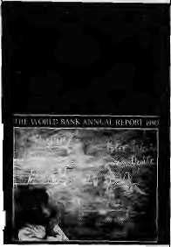
Hindu Kingdoms of South Asia* by R.K.Kanchan Cosmo Publications, New Delhi 1990,IRs225
Vedic and Classical Sanskrit scholars have examined with interest the Indo-lranian migration into Mohenjodaro and Harappa, to Kuru-Fancala, and to Kosala-Videha, but they have ignored migrations further East. Realising that this is the "untold chapter of ancient Indian migrations" and hoping to arouse interest on this matter among the lay reader of history. R.K. Kanchan looks into Sanskrit classics and inscriptions. Chinese chronicles and Arab travelogues to document the ancient journey of the Hindus into South-East Asia, up to the Pacific coast. The author is unhappy that so little study has been done on such a significant topic. He sees a richness in the multiplicity of factors that caused the migrations to take place, often under dangerous conditions. Kanchan examines political, economic, social and religious factors; he takes the readers to Myanmar (Burma), Java, Sumatra, Kampuchea, Sri Lanka and Vietnam; he allows them to experience some of the pain, hazard and mystery in the journeys of those who migrated. As Kanchan writes: "The history of the Hindu argonauts., .is a saga of heroic deeds of marvelous activity of fearless courage and immeasurable devotion to religion and duty. It reveals a long tale of unfathomed sagacity and an unimaginable deplhforesight."
The World Bank Annaal Report 1990
The World Bank Washington DC ISSBN 0-8213-1561-7 This annual report says I that 1990 was an "auspicious" year for the World Bank, which loaned out a total of US I 10179.9 million, out of I which Asian countries \ received a total of US 6397.1 million. Its standard loans were worth U$ 4174.8 million. Standard loans are made to governments, have a grace period of five years and are repayable over fifteen years. The soft-loan division of the World Bank, the International Development Association (IDA) loaned out US 2222,3 million. These credits are again made to countries with an annual per capita income of or less than S650. They have ten year grace periods, thirty-five or foury-five year maturities, and no interest. The growth rate for East Asian countries rose from 6.6 percent in (he 197O's to 8.5 percent in the late 1980's. The same level of economic progress was not apparent in the South Asia. But then, states the Report, the problems are more complex here and the development agenda is more complicated. The World Bank believes that there is still a need to address longer-term development issues. The report states, "fiscal consolidation and reform...remain at the forefront of the mactoeconnomic policy challenge in all of South Asia..."
Nepal: Dimensions of Development* by Harka Gurung Awarta Press, Kathmandii 1989, Price not listed
The book is a compilation of essays by Harka Gurung on diverse topics concerning Nepalese development, such as "Implications of Foreign Aid", "Tourism trends", "Ecological Change", and "Migration and Development". The essays vary in tone and style as well as coverage and depth, and are taken from Gurung's past writings. The reasons they are all brought together here in this book is to "...record one individual's perception of development process in Nepal". This perception should be interesting and valuable to all those concerned with development Gurung grew up in a tribal milieu and did not begin formal education until the age of ten. He went on to become extensively involved in national level planning and implementation. Gurung presents many incisive views on the development process, but one in particular: he says that unless a new perspective is developed to deal with and to improve the process and the pace of development, "the past will persist". He argues that Nepal needs a commitment of "deliberate urbanization", a responsibility to test and rigorously evaluate the processes operating within- the country, and an obligation to pull together resources from all sectors to find solutions to major problems.
The Indian Blackbuck*
byM.K.Ran.jitsinh
Natraj Publishers, Dehradun
1989, IRs250
ISBN91-85O19-18-5
The author is a recipient of the Order of the Golden Ark for service to conservation in the international field. He is concerned about the scant attention being paid to the rapidly declining numbers of the blackbuek, wild ungulates of the Sub-Continent. In Chapter One, Ranjitsinh presents a brief but interesting account of the importance of this species in the history of South Asia. He then proceeds to study the physiology, group structure, food and feeding habits, social behavior, and courtships and relationships with other species of the blackbuek. Habitat destruction has been the main cause of the decline in the blackbuek population. Stronger measures must, therefore, be taken to save the species from becoming extinct. The book is replete with information and pictures of the blackbuek. It also contains an extensive bibliography for the specialist reader.
Nepali: A National Language and Its Literature by M.J.Hatt
Rama Pus tak Bhandar, Kathmandu
1988,NRs275
The key word in the title for the first theme of the
book is "national". Hun. is interested not so much in
the emergence of Nepali as a language pp-se. but as
a national language. He asks how the Nepali language came to be a dominant force within die Nepali nation-state and how it was standarised, promoted and politicised. He looks for answers in governmental attitudes and policies over the last 200 yean. The second theme of the book is Nepali literature, particularly on how it has acquired much strength and prestige in Nepal and India. Hint devotes a chapter each to three recent Nepali writers who have contributed significantly to the Nepali literary tradition and helped give it both the shape and respect it has today. The three writers are Leknath Poudyal (1884-1965), Balakwna Sama 0902-198!) and Laksmi Prasad Devkota (1909-1959). The book contains, rather incongruously, a chapter about the printing and publishing industry in Nepal.
Trans-Himalayan Trade: A Retrospect (1774-1914)
by Phanindra N. Chflkrabarti Classics India Publications, New Delhi 1990, IRs210
This book is an historical investigation of the political identity of Tibet between 1774 and 1914. Chakrabarti is Director of the Indian Institute of Oriental Studies and Research in New Delhi There are three parts to his book. The first part, about the search for "Tibetan identity", surveys basic facts, especially having to do with tndo-Tibetan and Tibetan-Chinese trade and commerce. The second part is about the official and unofficial attempts made by the East India Company to establish a trade route to China through Tibet The third pan of the bode deals with how the Gurkha invasion of the last century led Tibet to seek help from the Chinese, the British having decided that they could not interfere in Tibet's internal affairs. At this point, Chakrabarti discusses the decline in commerce and the re-routing of the trade routes. The author is convinced that this is when the Chinese invasion of Tibet began and that 1959 was merely the culmination of China's earlier "imperialistic attitude".
Once a Hermit Kingdom: Ethnicity, Education and National Integration In Nepal byTodA.Ragsdale.
Rama Pus tak Bhandar, Kathmandu 1989, Price not listed
Todd Ragsdale looks at how the Nepali government tried to modernise the country, especially the rural areas, by radically changing its educational system. The New Education Plan of 1971 had two primary goals: economic development and nation-building. Instead of looking at the government statistics about the effectiveness of the New Education Plan, Ragsdale studies the peculiar ways in which the educational reforms affected the Gurungs in West Central Nepal. For instance, he examines the Third Grade Examination thai students from around the nation have to take in order to be promoted to the fourth grade. He concludes that the Gurung students have little knowledge of exam-taking techniques and find the questions themselves quite foreign. This is

May/June 1990 • HiMAL 31

ABSTRACTS

hardly surprising, says the author, given that the tests are designed by uiban-based Brahmans and Newars who are in control of the system, and make the exams with their own backgrounds in mind. Still, though critical of some of the aspects of the plan, Ragsdale believes: "There is no doubt that the New Educational Plan is an imaginative and forthright approach to very real problems existing in the Nepal education." He ends the book by making six recommendations on how the Nepali Government can improve its educational system. The author is a consultant for the World Bank.
Energy Digest*
Tata Energy Research Institute
New Delhi, 1990
Energy Digest is a slim but tight compendium of abstracts, summaries, digests and articles. Published four times a year by the Tata Energy Research Institute (TEW). Its main purpose is to provide information to those seeking knowledge about energy, the primary input in the production of goods and services. Over 300 primary journals and sources are regularly scanned to bring out the Digest. The latest issue of Energy Digest contains articles on Petroleum, Natural Gas, Hydrogen, Other Synthetic and Natural Fuels, Biomass, Hydro Energy, Solar Energy, Geothermal Energy, Tidal and Wave Power and Wind Energy. Other topics, such as Energy Planning and Policy, Energy Conservation, Consumption and Utilization and Energy and Environment are also reviewed. Contact: TERI, 7 Jor Bagh, New Delhi 110003
Mountain Research and Development*
Jack D. Ives, et al, editors University of California Press Vol. 10, Number 2,1990 Mountain Research and Development is published four times a year and contains papers on current research and practical programmes, short notes, news items, book reviews, report of meetings and professional announcements. The latest issue, May 1990, is a result of the proceedings of a conference held in Tsahkadzar, Armenian SSR, USSR. The issue is titled "Transformation of Mountain Environments". Of the seven papers compiled here, the first two are introductory. One is about the progress made in theoretical and applied mountain research between 1973 and 1989 and major future needs. The second is more specific: it is about "sustainable development" in the mountain regions of the Soviet Union. A series of papers are then devoted to examining the possible effects of climate change on mountain environments. A paper also discusses the "utility of models in mountain research and development". One such model, MICRO-GIS (Microcomputer-based Geographic Information Systems), was used in Nepal to evaluate mountain watersheds and is presented as a case study. Contact: MRD. University of California Press, 2120 Berkeley WAy, Berkeley, CA 94720, USA
The Politics of Tourism in Asia
by Linda K.Richter
University of Hawaii Press, Honolulu
1989, U$24
Tourism, states author Richter, is a "crude but reliable barometer of international relations". This book is based "on the premise that tourism is a highly political phenomenon, the implications of which have been only rarely perceived and almost nowhere fully understood". The book gives seldom-considered facts: tourism is the largest industry in the world; tourism has been used as a political weapon by the United States; tourism precedes the normalisation of relations between two countries. The book is significant because asks not only "why?" but also "so what?" The case studies of areas explored first-hand by the author concern China, the Philippines (under both Marcos and Aquino), Thailand, India, Pakistan, Bangladesh, Sri Lanka, Maldives, Nepal, and Bhutan. These case studies form the core of the book. Richter considers the reasons a government uses tourism to advance its policies and the political and economic problems within a country that can prevent tourism from functioning as expected. The book's seven chapters are framed by an introduction of the politics of tourism and a final chapter on alternative strategies for tourism development There is a 46-page bibliography, (from Third World Resources)
Directory of National Parks and Sanctuaries In Himalchal Pradesh A.Kothari, etal. editors Indian Institute of Public Administration, New Delhi
1990IRsl50
This comprehensive compilation of information of wildlife reserves in Himachal Pradesh is a field guide, a reference manual and a management status report, all at once. The first in a series of state-wise directories covering all the national parks and wildlife sanctuaries of India, the book is intended for government officials, wildlife enthusiasts and researchers. The directory, contains information on legal, biological, geographical, management and social aspects of Himachal's reserves. Annexures present flora and fauna listings, information on threatened species and recommendations on improving the status of protected areas within the State.
Foreign Aid, Poverty and Stagnation In Nepal by N. Khadka
Vikas, New Delhi
1990, IRs495
ISBN 0-7069-5321-5
This study focuses on the "relationship between aid and a number of structural and institutional variables which might be useful to examine whether aid does work or does not work in Nepal and other recipient countries". Among other things, the study examines the socio-cultural and political constraints to development, looks at "source-wise and sector-wise" allocation of aid over the past three decades, evaluates the macro-economic impact of aid on the
economy and analyses policy implications for aid and development in future.
Studies hi Himalayan Ecology Tej Vir Singh, Jagdish Kaur, editors Himalayan Books, New Delhi 1989,IRs495
This 314-page volume is intended to serve as research reference for formal courses on Himalayan studies in the fields of geology, geography, botany and zoology, as well as on regional development of the Himalayas. Among the contributors are H.C. Rieger, Otto Tautscher, Kesari Kishor, A.K. Sinha, Devender Pal, H.M. Patel, Duncan Poore, S.C. Tiwari. K.S. Rswat. R.L. Semwal, R.K. Gupta, M.S. Swaminathan, Franz Kollmannsperger, Michael J.B. Green, K.G. Tejwani, R.L. Singh, Rana P.B.Singh, A.D. Moddie, Tej Vir Singh, T.M. Vinod Kumar, Sunder Lai Bahuguna and A.B. Mukherjee.
Science for Villages*
Devendra Kumar, editor Center for Science for Villages Wardha, Maharashtra Subscription: IRs25 p.a.
Now in its twelfth year, this bi-monthly publication "seeks to be the voice of all such individuals and institutions which are striving to carry the benefits of science and technology to develop the village economy". The editor says hundreds of periodicals and publications are consulted in order to present village-level innovations for the benefit of rural India. A recent issue dealt with the imperatives of adult education, the case for sustainable agriculture, the greening of a section of Maharashtra, (he dangers of chemical fertilisers, avoiding problems in the structural design of pouery stoves, soil characteristics, appropriate technology, etc. Contact: Dattapur, Wardha 442 001, Maharashtra.
Rural Energy Planning hi Sikkim VOLUME I & II
by K. Stidhakar and P.P.S. Gusain
Vikas, New Delhi
1990, IRs250 (each)
ISBN 0-7069-4934-x & 4935-8
These two volumes present a systematic study of
integrated rural energy planning in the Sikkim
Himalaya. The authors assess the physical, social and
economic environment and how it affects the rural
energy situation. They also study demand and supply
trends and suggest strategies for further
dissemination of energy-efficient innovations.
(An asterisk indicates the publication is available for
reference at Himal's office).
ifda dossier 78
Current issues of the quarterly journal, ifda dossier, published from Geneva by the International Foundation for Development Alternatives, edited by alternative development guru Marc Nerfin, available for free in Himal's office at Lalitpur. Tel: 523 845.

32 HIMAL • May/June 1990

FEATURE
A Khunjerab Workshop Gone Awry
Why did the participants of a workshop discussing the future of the spectacular Khunjerab National Park (in Northern Pakistan) recommend that a rigid system be adopted which would ban the local villagers' traditional access to grazing lands within what is
today the Park area?
by Per Wegge

"■^"unjerab National Park in the Karakoram J\.mountains of Northern Pakistan was set up by the Pakistani Government in 1975. Adjacent to the Taxkorgan Wildlife Reserve in China, the 2,600 sq km park is one of the highest in the world. Scenic-ally attractive, it is a sanctuary for many high-altitude mammals in need of protection, the foremost among them being the Marco Polo sheep, the snow leopard and the Tibetan wild ass.
When it was established, the Park's main purpose was to provide protection for its dwindling wildlife populations. Illegal hunting was considered the main threat to these species, as well as habitat deterioration from excessive grazing and fuelwood collection. During the construction of the Karakoram Highway in the late 1960s, the local population of Marco Polo sheep was nearly exterminated by poaching, mainly by Pakistani road crews and security personnel. It is reported that non-resident government officials also participated in the decimation of the sheep population near the Pakistan-China pass. This was a sharp departure from earlier times when hunting control was exercised by the Mir of Hunza.
Despite its being declared a national park, however, nothing was done to actually develop Khunjerab. Following reports of environmental degradation from overgrazing, forest-cutting and poaching, the International Union for the Conservation of Nature (IUCN) was finally asked by the Government to study the Park's ecological status, including land-use practices, and make recommendations for a plan to manage the park. I surveyed Khunjerab in the autumn of 19S8 as part of the IUCN study. IUCN's report reached the conclusion that the human-nature conflict in the Park was not excessive. It recommended that the area be enlarged and developed into a multipurpose conservation area (or biosphere reserve) which would properly integrate environmental needs and the local people's use of the area.
Bearing in mind that Pakistan's National Parks regulations call for restrictions on traditional grazing rights, which are bound to arouse strong resentment locally, the IUCN proposal called for zoning-the expanded Park
into sections - areas where there would be full protection for wildlife, where there would be controlled grazing, and where professional hunting would be allowed. Both the goals of protecting important fauna and guaranteeing sustainable use of the natural resources by the indigenous people would have been achieved. hi fact, the proposal was similar to the successful pioneering approach to conservation launched in the Annapurna Conservation Area in central Nepal.
After the IUCN proposals were presented, a ten-day workshop was organised by Pakistan's newly established National Council for Conservation of Wildlife (NCCW) in June 1989. The participants -foreign professionals, conservation agency representatives and Pakistani officials — made a quick visit to Khunjerab with short excursions into the nullahs (side valleys) along the Karakoram Highway. They also met with some villages near the western boundary of the Park.
The workshop rejected the proposal to establish a biosphere reserve. Instead, it agreed to phase out all grazing in Khunjerab over a period of several years. It concluded ~ not u-nanimously -- that the only proper conservation model for Khunjerab was to develop it into a National Park, strictly construed. There would be total prohibition of human activity. In older to compensate the local people, the workshop proposed a number of rural development projects in the villages adjacent to the park, for which funding would come largely from foreign donors.
(Why did the workshop choose such a rigid approach to management of Khunjerab?)
A web of socio-political factors, are involved. To begin with, Pakistan lacks a well-trained staff in wildlife conservation. Wildlife and protected areas are managed by forestry personnel with little background on multiple use of natural resources and even less appreciation of local people's traditional rights. The existing political structure tends to enforce this aloofness from human concerns. The laws and management regulations for forests and mountain pastures have, of course, been developed by urban bureaucrats. District officers are more
concerned with implementing such centralised legislation than exploring the best solutions to resources management at the local level.
Another reason is that the NCCW, based in Islamabad as it is, occupies itself with designing and implementing conservation policies at a national level. This office tends to rely overly on conservation needs as articulated by international agencies. A National Park has the potential of generating far more tourism revenue than, say a biosphere reserve, and this is attractive to the central treasury.
Changing the park status and expanding it into a biosphere reserve would require new legislation because the present Northern Areas Wildlife Preservation Act (1975) does not allow for it The conversion would therefore require extensive bureaucratic procedures, hi the eye of the bureaucrat, issuing a national park directive is much simpler. Another reason for pushing for a national park might have been that the Government would receive more international funding, including money for compensatory programmes for the local communities.
Another possible reason: the participating expatriate "experts" clearly had only a superficial understanding of the ecological status of Khunjerab. None of them had been to the area before, and their only contact with the "locals" was an improvised interview with village representatives. More importantly, their terms of reference dealt with the formulation of management plans for a national park and did not allow for other options.
On the whole, all the workshop participants failed to take seriously the vehement opposition of the village representatives to the restrictive national parks idea. The plea of endangering traditional lifestyles through restrictions on grazing clearly fell on deaf years. The participants also failed to recognise that the ecological status of Khunjerab might actually be better than what they must have heard or read. Neither did they consider for a moment that livestock grazing can be compatible with conservation objectives.
The workshop's proposal to establish community projects was obviously well-intended. The aim was to compensate the area's in-

Sept/Oct 1990 • HIMAL 33

FEATURE

habitants for the loss of grazing rights and associated incomes, and also for improving the local standard of living. However, given past grievances and existing suspicion, it is uncertain that locals will participate in government-led programmes.
What will happen next? The Government of Pakistan will study the workshop's recommendations and decide on their implementation. It can be expected thai the villages adjoining the park will vigorously oppose the recommendations. The Government may try to reach an understanding with the vDIagers by asking the Aga Khan Rural Support Programme, a group located in Gilgit which works closely with the region's village organisations, to initiate
development projects outside the Park to compensate villagers for loss of grazing. However, the Programme could prove reluctant to push a project which takes direct aim the villagers* traditional lifestyles. Livestock, after all, represents far more than just capital in the culture of mountain people.
Conservation groups such as IUCN have publicly spoken up for a more people-oriented approach to conservation and for integrating land-use practices as integral parts of long term, sustainable use of natural resources. Many specialists have emphasised that conservation efforts in developing countries cannot, and should not, follow guidelines which were originally practised in the developed world.
The influence of villagers on the use of their own resources is a must for developing a harmonious relationship between public authorities and local communities.
In conclusion, one has to think twice before imposing new activities and means of subsistence on hill people, who have over centuries evolved lifestyles and traditions intimately linked to the land and livestock. What the Khunjerab workshop has done reflects a parental attitude towards minority ethnic groups. There are two requirements that should be met before initiating projects to replace traditional use of resources: proven need and local support. Neither condition seems to exist in Khunjerab.

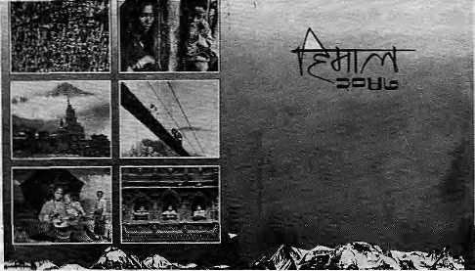
NEPAL
INTERNATIONAL CLINIC
•Western medical setting serving
NIC
the entire community •Care by a U.S. Board Certified
Internist •Comparable services
at lesser rates ' Imported vaccines. Lab work
-Knowledge about mountain sickness
-Central location
•9:30 am - 5 pm (Wednesday - 6:30 pm)
Saturday: Emergencies Only •Open Sunday •Prior appointment encouraged
419713,4J2K4I (utuwinil 24 hours)
Itoyal
\ r
I JI/kiiflltL
j l
p
rMwg
vnn
D
Himal's blend of "development journalism" and newsmagazine style writing is now available in Nepali as well. The first annual "Nepali Himal" (V.S. 2047) contains a selection of 60 articles carried by Himal over the past year, carefully translated into Nepali.
"Nepali Himal" details:
Paperaback:
(130 pages of text,
illustrated)
Indivicuals:NRs20
Institutions:NRs50
For information, write to Himal/Nepali Himal P.O. Box 42, Lalitpur, Nepal. Tel:523845

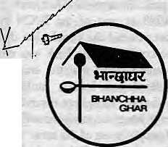
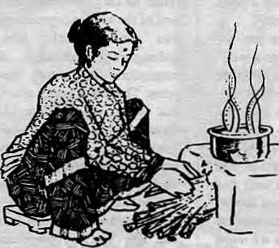

While in Nepal
Enjoy Nepalese Cuisine in
"BHANCHHA GHAR"
(The Nepali Kitchen.)
This place is something special
P.O. Box 3011
Kamaladi, Kathmandu, Nepal Tel: 225172

34 HIMAL • 1990 Sept/Oct

CLIMBING
Ignoring Altitude!
Even as the tourism industry expands and more mid-hill and lowland people take to the mountains, altitude sickness goes unnoticed. Or is being merely ignored?

by B tiddha Basnet
I
Altitude sickness used to be thought of as a "white man's disease" because it was the Western mountaineer/trekker that seemed to be most often afflicted. But it is more likely that altitude sickness among the Himalayan "support staff' ~ sirdars, porters, cooks -went ignored or unrecognised in the rush to look after the climber sahib.
It is time for the governments of the region, the tourism sector and the medical community to recognise the impact of altitude sickness on the local population of the Himalaya, including not only expedition porters but also civil servants, pilgrims and other mid-hill and lowland people who venture into the high valleys and passes.
THE TREKKING TRADE
As the trekking industry expands, not only the highland Sherpas, but also people from the lower mid-hills are joining up as guides, porters and cooks. Almost to the last man and woman, these mid-hill porters who head for the high trails have no inkling of what altitude-related illnesses lie in wait for them, including snow-blindness and frostbite. They are even less aware of the hidden dangers of mountain sickness. Moreover, many trek organisers and climbers seem to be unaware or uncaring of the possible impact of pushing their mid-hill people beyond physiological limits.
For every reported case of Nepali death due to altitude sickness, there must be many more who suffer or succumb in silence. In the spring of 1990, a 23-year-old Rai porter was treated for acute cerebral edema (an altitude sickness symptom) at the Himalayan Rescue Association (HRA) health post in Pheriche. After some improvement, he was sent down towards Lukla. However, his descent was not adequate and the man suffered even more serious complications. The last climbing season also saw the death by altitude sickness of a Sheipa on Island Peak, and of a mid-hill porter on Mera Peak, both in Khumbu.
More and more westerners with poor knowledge of Himalayan conditions and of altitude sickness are being pressed into service as trek leaders. Whereas a decade ago, an experienced climber or adventurer with time on
his hands lead a trek, these days it is not uncommon to find inexperienced individuals just doing a "Himalayan fling" on a free air ticket. Such individuals are bound to have a lackadaisical attitude towards altitude sickness. With the growingly important role of mid-hill people, the increase in the number of novice tour leaders, and trekkers on a rush with time constraints and planes to catch, the incidence of altitude sickness can be expected to grow.
PILGRIMS AND OFFICIALS
Another breed of mountain sickness victim is the government bureaucrat on assignment to durgan chhetras, "remote regions" which at times may be high of altitude. A Kathmandu civil servant "on kaaj" to, say Solu Khumbu, wants to get the job done and return to comforting warmth of his Valley as soon as possible.
Last autumn, an officer from the Department of Hydrology, after flying in to Lukla from Kathmandu walked as fast as he could up to Dingboche. His body could not cope with the altitude change and he was already in a stuporous state when a group of trekkers found him in a local lodge, he was already in a stuporous state. They hustled him down to HRA's Pheriche post, where he was treated first with oxygen and injectable medication, and then put in a hyperbaric bag that simulated a fast descent to lower altitude. Once he recovered slightly, he was carried down and achieved total recovery. Had the official not received immediate treatment from the health post doctor, the official would have died.
Pilgrims to high Himalayan shrines, lakes and caves have suffered from altitude sickness without knowing it since ancient times. Many of the reported visions of demons and deities on the pilgrimage routes, of poisonous herbs by the wayside that kill unrepentant pilgrim, et cetera, can be attributed to altitude. Pilgrims to Amamath in Kashmir, Kedamath in Garhwal, Kailas Parbat in Western Tibet, and Muktinath or Goisaknnda in Nepal, have always had to deal with altitude sickness.
Before roads made access easier, the long approach march to high-altitude shrines at least acclimatised most travelers to altitude change. These days, especially in the pilgrimage spots
of the Indian Himalaya, high^{w}ay access does not allow much time for the body to adjust to altitude. The only reason that there has not been an epidemic of altitude sickness related deaths is probably that today's bus-loads of easy-riding pilgrims descend as quickly as they come up. A quick darskan is all they have time for before heading down to the plains.
WHO DOES THE RESEARCH?
Sadly, it is not only the porters, civil servants or pilgrims, but the region's physicians themselves that have poor knowledge of altitude sickness and the dangers it spells to their compatriots. The lack of interest is in stark contrast to enthusiasm shown by foreign medical specialists. During a Hypoxia Symposium attended by this writer in Canada a few years ago, paper after paper were presented on mountain sickness in the Khumbu. The papers ranged in diversity, from the measurement of barometric pressure at the top of Mount Everest to the study of the carotid artery of a yak.
Altitude sickness research was pioneered by several western physicians based in Nepal over the years. Dr. Peter Hackett conducted extensive study of hypoxia (disease related to lack of oxygen) at altitude while doing work at the Pheriche post. Drs. John Dickinson and Walter Bond, both of whom worked at the Shanta Bhawan Hospital in Kathmandu, also enhanced understanding of the disease through treatment of patients and doing autopsies. The Indian military, which has thousands of troops constantly on duty on lofty Himalayan passes, has also done ground-breaking research on high-altitude medicine.
The Nepali medical profession by and large remains oblivious to these developments. Organisations like the Royal Nepal Academy of Science and Technology (RONAST) have barely lifted a finger when outside groups proposed holding high altitude medicine conferences in Kathmandu. The Royal Nepal Army, which conducts high altitude warfare exercises, has not promoted research in the field. The International Center for Integrated Mountain Development (IQMOD), the Nepal Medical Association, the Institute of Medicine, are other institutions which might have con-

Sept/Oct 1990 • HIMAL 35

CLIMBING

Symptoms of Altitude sickness
sidered the dangers altitude sickness pose to local populations,
UP AHEAD
While we wait for these and other organisations to take some interest, what can be done? As far as the trekking industry is concerned, it would be good if all sirdars and western trek leaders were required to train to recognise mountain sickness and administer first-aid. This would help them to better take care of themselves and of the tourists under their care. Equally important, however, they should be sensitised to the need to recognise even subtler cases of altitude sickness among the porters and cooks. Before dismissing a sluggish porter's attitude as deriving from old age or laziness, trek leaders might give. a thought to altitude sickness. Affected porters should be treated and escorted to lower altitudes just as would a foreign trekker.
Government departments which regularly send personnel from the mid-hills and plains to high altitude postings — such as cartographers, administrators, hydrologists and development workers ~ must impart at least basic knowledge about mountain sickness. Needless to say, the Royal Nepal Army and various medical and research organisations must promote clinical research in altitude sickness, especially as it relates to the Himalayan populations.
The route up to major pilgrimage centers must contain signboards warning travelers to watch out for altitude sickness symptoms. The Himalayan Rescue Association must be active
The Himalayan Rescue Association has made a great contribution in reducing altitude sickness deaths in the Himalaya over the last 15 years of its existence. The main objective of HRA has been to prevent mountain sickness through public information as well as treatment. It does not have the paraphernalia of rescue items such that might be found in the Alps or the Rockies. HRA has an office in downtown Kath-mandu where free literature is available in Japanese, French, German and English. During trekking seasons, HRA posts volunteer doctors at health posts in Manang and Pheriche in the Annapuma circuit and the Khumbu, respectively. Contact: PO Box 495, Kaihmandu.Tel:418755)
Altitude sickness has various symptoms, including headache, loss of appetite and lethargy. It usually hits people at or above 10,000 feet when they have been ascending too quickly without allowing the body ttmegto adjust to the higher altitude. The patient's worsening condition is marked by excessive coughing and shortness of breath even after adequate rest. This indicates pulmonary edema (water in the lungs). Confusion, drunken gait or other unusual behaviour indicates cerebral edema, a water-logged brain. Altitude sickness can be prevented by grading the ascent so that there is no more than 1000 feet of height gained each day once over 10,000 feet. Care should be exercised in ascending when there are the initial symptoms such as headaches, loss of appetite and excessive tiredness.
in this respect. It is encouraging to note that this voluntary organisation is putting out a brochure on altitude sickness in Nepali, in addition to the four western languages already available. An innovative programme might be to run a public information campaign during the next Krishna Astami mela (mid-August 1991) at Gosainkund, with leaflets available at the roadhead above Trisuli Bazaar and a temporary health post at the high-altitude lake itself.
A long-term goal would be to set up, in some accessible Himalayan township in Bhutan, India,-Nepal or Pakistan, a school or center for the study and treatment of altitude sickness. Such a center could be the regional focal point for high altitude medical research and for treatment of altitude sickness as well as other forms of hypoxia, as well as injuries related to avalanche, hypothermia, et cetra. A well-functioning high altitude medical research center would be a boon not only to the burgeoning trekking and mountaineering industry, but also to the safety and well-being of the Himalayan people themselves.
Dr. B. Basnet is a Visiting Professor at the Institute of Medicine in Kathmandu and also has a private practice.
The sure-fire way to tackle the disease is to descend immediately to lower altitude when the symptoms first manifest. If available, oxygen can help reduce severe headaches and some other symptoms. Diamox (acetazolamlde) is a proven drug for mountain sickness. It can also be used by the helicopter pilot who has to go up on short notice to high altitude regions for rescue missions. Oral steroids (dexamethasone) can also be life-saving in the case of cerebral edema, but its helpfulness is more to buy time while descent is instituted. Nifedipine, a blood pressure medication, appears useful for pulmonary edema. The Gamow Bag, a recent innovation, uses pumped air to simulate descent. It may well revolutionise altitude sickness treatment and act as a boon to Himalayan people and foreign visitors alike.


NEPAL PRESS INSTITUTE
Our job is to develop professionalism in Nepal's communication media. We offer the following services:
TRAINING : A ten-month diploma in Journalism, workshops for managers of small newspapers, seminars on population and development reporting, special fellowships for rural reporting, and training for mid-career professionals. CONSULTANCY : On all media-related issues.
PUBLICATIONS: A quarterly journal in Nepali reviewing developments in communications around the world, and an annual number in English for those interested in communications developmeni in Nepal. Several monographs on media-related topics.
Post Box 4128 Kathmandu Tel: 228 943

36 HIMAL • Sept/Oct 1990

REFFLECTIONS
Happy Tourist, Unhappy Traveller
Tourists and travellers are essentially the same. Yet, while the former acknowledge their otherness, the latter do not.. They deceive themselves by believing that they can be cultural insiders.
by Robert Shepherd

P
umpernickel Bakery in Thamel, downtown Kathmandu, is a favourite spot for foreigners. Even during off-season, the bakery's garden tables fill quickly each morning. The service is good; the bread, fresh; the croissants, delicious and the coffee, passable. The staff members are unobtrusive and polite and With their brown faces a rarity in the restaurant, where the rest of the people are foreign travellers.
They are travellers and not tourists. A young English woman, on her way home from a year abroad in Australia, tried to explain the difference to me. She said that 'travellers' live 'like the people'; they travel the way 'the people travel'; and they are 'in touch* with, and have *a feel' for, 'the people'. The tourists, on the other hand, travel in air-conditioned buses, live in five-starred hotels and eat at overpriced restaurants. And they never drink the water. There are no tourists at Pumpernickel; only travellers.
Touring extensively around the world, the long-term world travellers (WT), the majority of whom are North American, Western European, Japanese and Australian, share a common ideology. They view the Third World as their laboratory and look upon themselves as romantic, even intrepid, adventurers. They sneer at tourists and laugh at those who have remained back home in Peoria. They share a common language, English, and even a common dress code in Nepal: cheap cotton drawstring pants, rubber sandals, and printed t-shirts. The t-shirts are the public resumes: in one
glance one can discern who has come up from Kenya, BalVBangkok or Goa.
World travelers adorn themselves with the handicrafts of this week's locale. In Kathmandu, turquoise and silver rings, bracelets, earrings, sheep-skin shoulder bags, wool caps and vests. It is said the jewelry is actually mass-produced in Lhasa. The caps are Afghani, and the vests are multi-coloured combinations with tassels hanging from the edges. Who wears this stuff? Not the Nepalis. In Kathmandu, they are the ones trying to dress like us!
In their attempts to 'become native* the world travellers often corrupt indigenous systems.
At the bakery, several Germans, a Swede and an American couple are engaged in a heated discussion about exchange rates, which is a favourite topic among WTs, in addition to the black market They can quote the going rates for the dollar in Delhi, Kathmandu, Borneo or Burma, They also know where to sell whiskey and cigarettes, blue jeans and cameras.
An Australian advised me: "See, you buy your Indian rupees in Kathmandu, get an air ticket to the border, buy your Johnny Walkers and Marlboros at duty-free and sell them for twice over what you paid, once you land." He continued, "If you are going on to Burma, hold on to your stuff. The country is quite screwed up and the people will buy anything you've got, even the shirt off your back." I wondered where he was headed. "Oh, I'm off to an ashram near Bangalore for a month of meditation."
Ashram, shrines and mosques are the traditional destinations for WTs. Those who look for spiritual wisdom are all young, white, educated, affluent, radical, chic. They search for "meaning"; they overflow with good intentions.
One day, in Kathmandu's main bazaar area, I noticed a backpacker haggling with an Indian selling oranges from a basket strapped to his bicycle. "How much?" the backpacker asked. "One orange, three rupees", said the Indian. "One rupee", the westerner insisted, "here". He dropped the rupee into the basket and walked away pleased at his bargaining skills. After all, he had successfully acted just like the 'people.' He has just had an "experience". Some Nepali bystanders cluck with sympathy for the Indian, who swears in Hindi.
Beneath the WT's talk about cross-cultural sensitivity and "experience" is a sense of cultural imperialism that would have done the Victorians proud. Notwithstanding their beatific expressions, world travellers are cutthroat practitioners of the mundane living. In Nepal, as elsewhere, they compete at a game with the odds stacked heavily in their favoT. They use their economic clout to secure shamelessly that which the society can offer and that which it cannot and should not also offer.
The world traveller expects to find a unique culture in the "exotic" East, only to wait in line behind the same people whom they seemingly wanted to avoid. This is probably why many WTs openly shun their fellow travellers as they saunter through the streets of Thamel. They

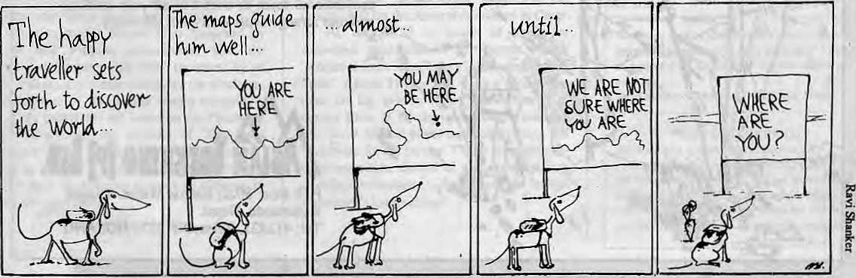
Sept/Oct 1990 • HIMAL 37

REFLECTIONS

throw hostile glances at other foreigners whose Only fault is to walk the same street.
Tony Wheeler's Lonely Planet guide books are one of the main reasons why the WTs end up in the same places. The difference between this guidebook and others is that it targets a different audience and never describes them as tourists. Tony Wheeler calls them travellers who "want to see the country at ground level, to breathe it, experience it and live it". He writes that tourists stay in Hiltons, travellers do not. Instead, travellers should go tramping through the back alleys of the Third World and absorb exoticism through osmosis. Wheeler has built a multi-national publishing business catering to the world travellers of this planet
What happens, of course, is that no world traveller is alone when he "does" Bali or Rangoon or Kathmandu. After all, they carry the same book. They check in at the same hotels. They eat in the same restaurants. They discover the same hideaways off the well-trodden paths.' The traveller longs to discover the particular place to which no tourist or traveller has been. Yet, he keeps running into many othetfs like himself.
Westernisation has consumed Japan, Hong Kong, Singapore and Bangkok. But it has yet
to hurdle the Himalayas. In Nepal samosas and mo-mos are in fashion: not Big Macs. Yes, Michael Jackson is popular among young people, but Kumar Basnet and Narayan Gopal still outsell him in the tape shops. The inauguration of the country's first escalator is frontpage news.
Into this other-world enters the world travellers. They speak English, are obsessed with money, and dress in odd peasant costumes. Off they go to the mountains in search of experience. The handful of Nepalis they come in contact with are guides and lodge-owners " whose burden it is to "represent" the society and culture.
The East is not the West. Religious, linguistic and philosophical differences separate the two. Yet, world travellers approach the East, including countries like Nepal, as if they were on a jaunt into the Parisian countryside. They do not realise that finding a bathroom, exchanging money, buying hasish and ordering dinner does not constitute "inter-cultural communication".
Frozen out of the cultures they travel through, WTs ultimately feel at home among their own kind. That is why they crowd the tourist ghettos. Subdividing into factions, they
share their cultural illusions and seek to alleviate their secret boredom. They trade tales and anecdotes over omelets and pizzas and they huddle together to watch American videos. Make-believe hippie and aspiring Buddhist, both will be watching a scratched copy oiRambo.
Truly, the "traveller" isno different from the "tourist". He carries the same shackles: an ignorance of the language, the culture, and the people and their idiosyncrasies. However, the tourist, by recognising and accepting the differences between themselves and others admit that they are outsiders or visitors. They implicitly accept the premise that travel is a privilege and not a right. The world travellers deny the possibility of such an acknowledgment. They blindly believe that living cheaply and dressing like a native can transform them into cultural insiders. V.S. Naipaul writes of them as those "who wish themselves on societies more fragile than their own. ..who in the end do no more than celebrate their own security".
R.Shepherd worked in rural Nepal for three years as a Peace Corps volunteer. He is now an instructor at the Beijing Second Foreign Language Institute in China.

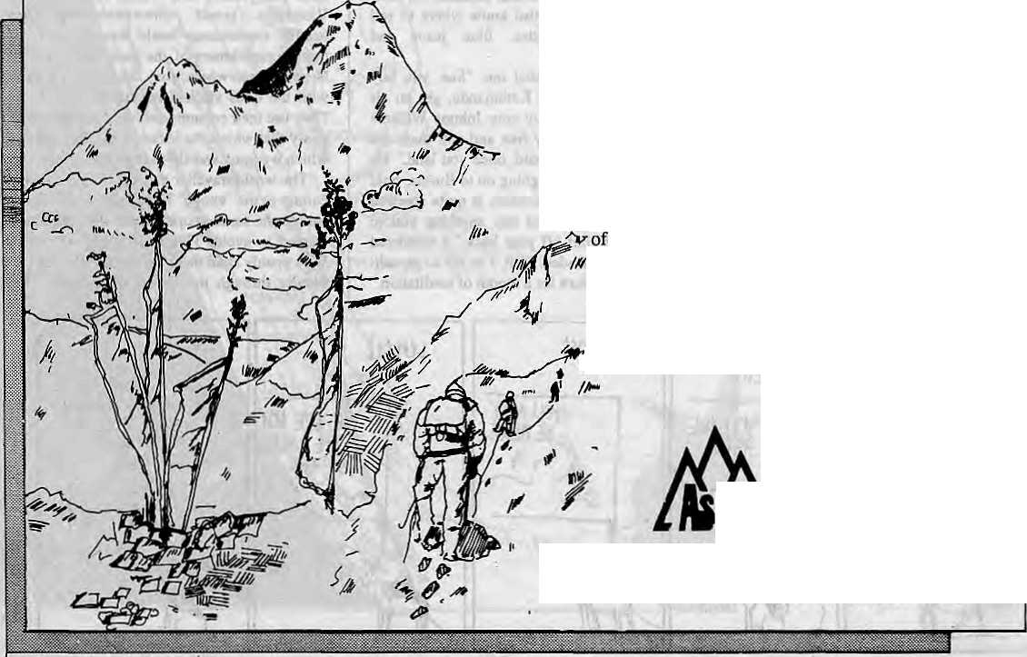
ASIAN TREKKING INVITES
YOU TO AN EXPERIENCE WITH NATURE
We take you through natural trek trails to places unending beauty and into contact with the friendly mountain people and their gentle living.
An experience you will never forget with our professional team to attend to all your trekking and tour arrangements with quiet efficiency.
'fm -
lANKIKKINifrlbft.
P.O. Box: 3022, Keshar Mahal, Thamel
Kathmandu, Nepal.
Tel: 412821, Telex: NP 2276 HOSANG

38 H1MAL • 1990 Sept/Oei


u n TA i

THE PIONEERS OF ENVIROHENTALLY SENSITIVE TOURISM IN THE HIMALAYA

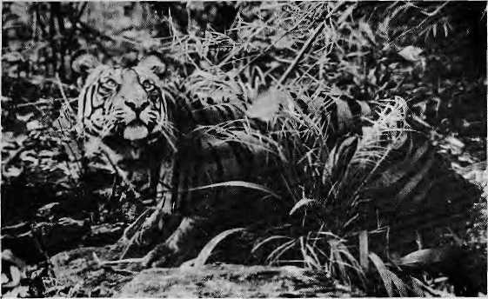
TIGER TOPS JUNGLE LODGE
AND TENTED CAMP
THARU VILLAGE RESORT
ROYAL CHITWAN NATIONAL PARK
TIGER TOPS KARNALI LODGE
AND TENTED CAMP ROYAL BARDIA NATIONAL PARK

CONTACT: TIGER TOPS (P) LTD.
P.O. BOX 242, DURBAR MARG KATHMANDU, NEPAL
TEL: 222706/226173 TELEX: 2216 TIGTOP NP FAX: (977)-1- 221379

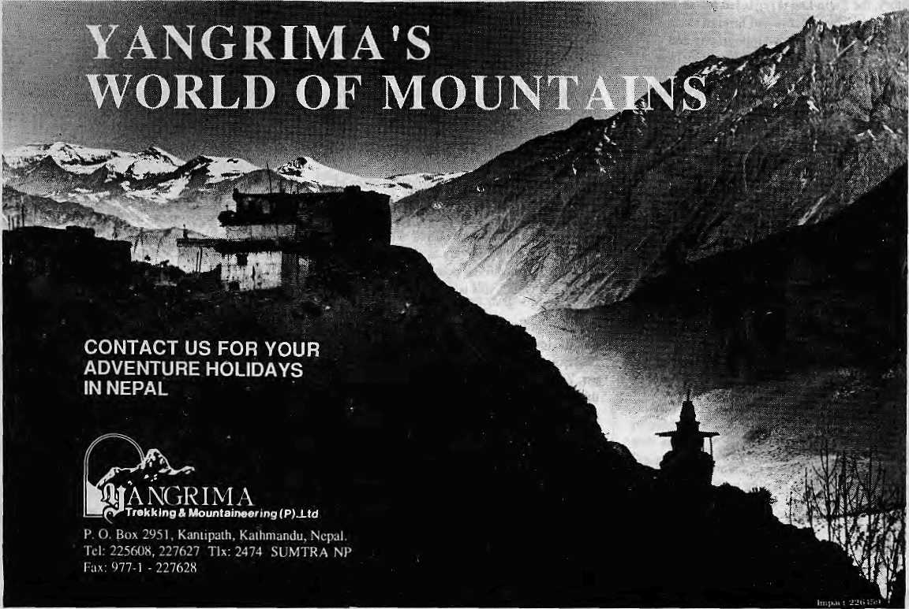

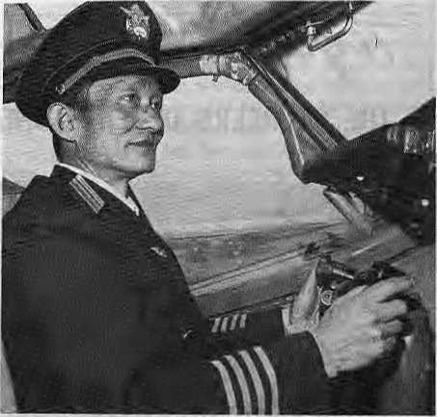
Abominably Yours_{y}
"Mr. Liang Luxin, His owner of civil aviation first grade flying safety medal"
Since China's Southwest Airlines re-starUd its flights connecting Lhasa to Kathmandu (last spring),! have made many trips over in the comfortable cabin of their Boeing 707. (Fumy to think of Tibet as part of anyone's "south-west", but that's geography and geopolitics for you. I was winging my way north last month to attend a Lhasa Academy of Sch-tied Sciences symposium on "Abominalism, E> vironment and Development" when the stewardess handed me a copy o/Southwes: Civil Airlines, Southwest Airlines' in-flight magazine.
For the benefit of those unable to put together the money or the visa to fly SWA to Tibet, I reproduce below, word for word, lucid excerpts from the article entitled "Cultivating in cloud sea thirty years" in the March 1990 issue.
ERA FOSTERS HERO
The advantage of air transportation is speed and safely, especially to transport valuable instruments, chicken, fish, vegetable, melon and fruit, and other fresh and live seasonable cargoes.
Flight from Chengdu to Lhasa is the highest one above sea level over the world. In history, the flight line is regarded as "air forbidden area" by Chinese and foreign aviator, because of its well known topography and changeful climate. However, since they flew in 1965 Southwest Airlines' flight personnel have kept the record of safe flying for twenty years, and received high appreciation from their same occupation. The well-experiences pilots of Boeing have to highly praise them after observed. Country's and people's interests are over everything. Whenever and whatever occurring, they are always ready to support with all strength.
Ninety percent personnel of the group are Communist Party member, they are devoted to motherland, love people. During Beijing counter-revolutionary riot in 1989, ninety comrades, who studied Boeing 737 simulated flying in Boeing Company of USA, refused extension of Visa or acceptance of entrance of American nationality. These comrades determinedly returned to motherland after finished their courses. It shows special quality of Chinese aviation.
Era fosters hero. All flying crew of the group is determined to perform new meritorious services once again under the policy of reform and opening to the outside world.
Mr. Liang Luxin, a ordinary aircraft commander of Chengdu flying group, flying saftly 10,645 hours in thirty years, is rewarded with first grade flying safety medal. Since the thirty years, he has strictly operated in every programmes so that he had headed off many disasters in flying.
As a flying teacher and inspector, Liang Luxin acquires masterly skill through intensive training, moreover, he is boundlessly loyal to our party and people. Liang Luxin has his heart set on flying cause. He has little time to look after his wife and children, because he has to fly more than three hundred days every year.
He has received commendation by higher authorities and good comments by comrades.
YOUTH, GLISTENING IN THE BLUE SKY
Most to them, beautiful and gentle, regard the blue sky and white cloud as their friend, and enjoy the beautiful nature. The others call them "angel" with envy. However, if you realise their job and life, the meaning of angel has another explanation. The stewardess of Southwest Airlines must go through four steps, such as hardship, tiredment, dirt, feeling. Besides the quality of general stewardess.
Hardship, is obviously observed on flight Chengdu-Lhasa line, plane often bring trouble to passengers with bump caused by airflow, because of dangerous topography and changeful climate. Stewardess, Ge Ling has had a scar on her head, because of sudden bump.
Tiredment, that the stewardess is often effected by. Flying thousand kilometers, they service passengers more than fifteen times in passenger cabin with only thirty meters long, they fly four times per day as usual. So, some people say "stewardess does fly over the world, but walk", this is a quite reasonable explanation.
Disregarding dirt, is a distinguishing feature of stewardess of Southwest Airlines. A passenger had incontinence of faeces, stewardess, Zhu Jiang Yin and Tan Gou Ping, helped this passenger without hesitation. The passenger was so moved full of tears.
The chief of stewardess group, QuiXiu Yin saw a message left by her husband "Son has a high fever, please Tetum soon", after she came out of duty flying Charter Chengdu-Hongkong. At the moment, she had another assignment flying Gue Lin-Beijing. As a mother,
who does not love dearly her child? Finally, she choose work. Such thing no longer new in this group. Some stewardess leave their children in grandmother's home. Several years late, the children unexpectedly call them "aunt".
"Company services country, plane is my home, greeting passengers with a smile, keeping reputation over China". This is spirit of Southwest Airlines.
LESSONS PAH) FOR IN BLOOD Before civil planes take off and land, the hostess always ask passengers fasten their safety belts, Why?
Civil planes, although flying in the air, must depend on the runways to take off and land. During this course the aircrew maybe restricted by some factors, then it's hard to avoid accidents, for example, obstacles on the runways and failure of planes, etc. For these reasons, the aircrew has to take emergency measures, and stop the flight. And then if you don't fasten your safety belts, you'll be injured by strong inertia and resistance of the planes, even though special accidents don't occur.

By the time we landed at Lhasa Airport, I had become acquainted with the dangerous flying conditions on the Tibetan plateau, the raison d'etre of seat belts, and, verily, the importance of flight itself. The partnership among, and the dedication, professionalism, nationalism and ideological purity of Airlines' pilots, stewardesses and other flight personnel must explain why flying SWA is as satisfying as it is. It is abominably recommended.

40 HIMAL ■ Sepl'Oct 1990

Enjoyable Treks • Relaxed Excursions • Fulfilling Expeditions • Well Arranged Travels •
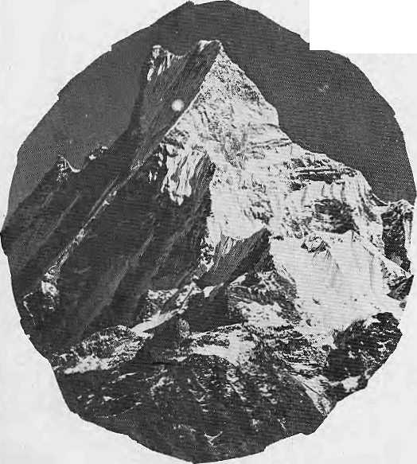
Allow us to take the load off your mind. We excel in arranging all your trips in style.
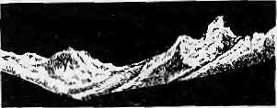
HIMALAYAN EXCURSIONS
Specialising in trekking and expeditions
P.O. Box: 1221, Keshar Mahal, Kathmandu, Nepal
Tel: 414842, Fax: 977-1*222026, Tlx: 2636 SHERPA NP
Res: 416112
I

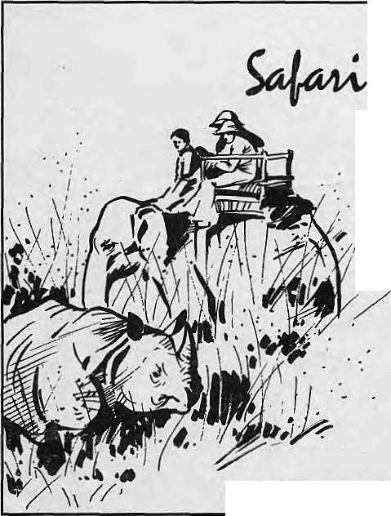




Resort and lodge offers you luxurious rooms as well as rustic style cottages.
Swim, play tennis or just laze in the garden. Ride an elephant, canoe or walk in the Royal Chitwan Park to encounter rare and unusual treasures of nature; Rhinoceros, Tigers, Leopards, Slothbear, Gharial Crocodile and
scores of different species of birds. Stroll along steeply farmlands and ethnic villages. Watch the elephants bathe and witness the famous Chitwan sunset from our elevated lodge site.
Chitwan, Nepal. Mailing Address: G.P.O. Box 1357 Kathmandu, Nepal Fax: (0977-1) 521291 Telex: 2262 NARANI NP

I



We Also Serve You Birds On Trees



French, Italian, Chinese, German,
Russian cuisine. Served on the
greenest green you 've ever seen.
Plenty of sun, fresh air and bird s^ng
' ' :-^:/r^\:M:&^ tOO. /^{V} -: -::-^::::': ' '




SHANGRI-LA
LAZtMPAT, KATHMANOU, TEl: 412999
We MakeftuftelGieat!;
4
I
5

