
: ^ ftflAY/JUNE f 991,;
ALTERNATIVE BI-MONTHLY

NRs20 IRs12 U$6
W

w
lilSltiSii

roubled Wate
WhyKarnali? ^jr Blay. icrovs Macro Vhe Middle Way
atan! KHiingRhinos
flying Varig ^{1-l} Abominably Yours

iill^S^, -: ■ ■.. B^^^^^^^ft^^^^(

INSIDE


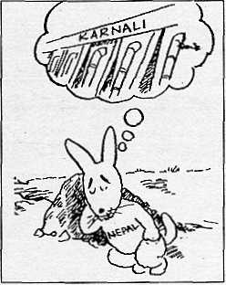
■ ALTER HA TIVE Bl-
COVER
5 Troubled Politics of Himalayan Waters
- Sarda and Tanakpur
- Little Bhutan, Big Power
- Sharif s Indus Accord
- Playing Water Politics
- Karnali (Chisapani)
16 Bad Business in Bajhang
- Village Hydros Abloom
- Review: Waters of Hope
Vol.4 NW2, May/June 1991
^ TheAbodeofGods, Kins: of
Mbuntains, Himalaya
Xouboundthe oceans from
' east to vest
A northern yardstick To measure the Earth
- Kaiidasn (Kumara Sambhava)

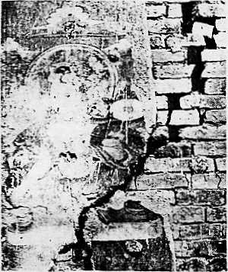
FEATURES
24 Patan:
A Tarnished Image 26 Where is the Pride?
Kanak Mani Dixit
Editor
KesangTseten
Associate Editor
Sasanta Thapa Marketing Director
Balram Sharma
Anak Thapa Vedpani
Administration

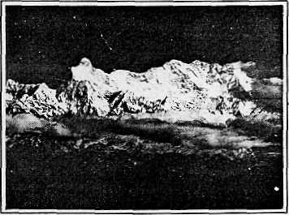
DEPARTMENTS
21 Briefs
29 Voices
31 Know Your Himal
33 On The Way Up
36 Abominably Yours
Cover piciure of the Ganga during the monsoon, Banaras, by Kevin Bubriski.
Himal ( ©Copyright 1988) is published every two months by Hima] Association,
PO Box 42, Lalitpur, Nepal. Tel: 977-1-523845. Fax: 977.1-521013.
ISSN 1012-9804, Library of Congress Card Catalogue No. 88-912882.
Please turn to page 2 for subscription information.
Printed at Jagadamba Offset, Lalitpur. Tel: 521 393
Advisory Panel
M. AbdhuHah, Peshawar AdlaiAmor, Geneva Anita Anand, New Delhi Kinlcy Dorje, Thimpu Harka Bahadur Gurung, Kaihmandu Corneitfc Jest, Paris : Prcm Shankcr .Jha, New Delhi BharatDuttKoirala, Kathmandu Rarn Chandra Malhotra, Rome HemanlaMishra, Kathmandu David Saissoon, New Yoik Kumar Khadga BK. Shah, Kaihrnanda Doiiaid Shanor, New York Ambica Shrcstha, Kathmandu Vidya Stokes, Shimla B.G. Vcrghesc, New Delhi Brian Welsh, Athens

MAIL

FEUDAL INSTINCTS
I could not afford not reading the March/April issue as a Tibetan. "Discovering Dharamsala" has incisively dealt with all the important issues afflicting the Dharamsala Administration. And Dawa Norbu's *Ximits of Tibetan Democracy" was a breath of fresh air, used as I am to the Tibetan press, which, excepting the periodical Dasar, often fights shy of throwing light on the murky areas of the Dharamsala Administration with the unwillingness of a man having to wash his dirty linen in public. Feudal instincts, it seems, is even now deeply ingrained in us. Choephel Tsering Central Tibetan Secretariat Dharamsala

 | m
 |  | i
 |  | m
 |  | 1
Tibetan Diaspora  Dharamsala Politics Opening Mustang Da lei Lama Indlgn Activism . CarpetStory Plains' Bias TneDharma Tinlin in Tibet : |  | 1
REFRESHER COURSE
It was in one of those chance-glances that I noticed the March/April 1991 Himal on the stand. The majestic Potala in black and white stopped me instantly. I pulled out one for a possible free-reading. My fingers impatiently ran through the pages, and I ended up buying two copies. Back at home, after a hearty reading, I "surprise calls" on my friends about the
"discovery". By late night, I had gone through the entire magazine two times and felt like I had justs uccessfully completedarefceshercourseon Tibetan diaspora problems. Thank you very much for a most exciting and exclusive issue. Dawa Dhargye Maharajganj, Kathmandu
TIBETAN BONANZA
Among the Tibetan exile communities, it has begun to seem as if the concept of freedom for Tibet is limited to "Chinese dogs quit Tibet" slogans chanted on March 10th every year by Tibetan refugees wearing Chinese shoes.
The Tibetans who arrived as refugees are today by and large economically well off. While they are hard-working and entrepreneurial, in India atleast, there are anumberof other reasons for their sudden upliftment. Their refugee status earned Tibetans sympathy. Many youngsters were sponsored by foreigners to attend elite hill schools. Many declared themselves overnight orphans in order to take advantage of Westerners' largesse.
The recognition of the Bhutia tribe as a Scheduled Tribe under the Indian Constitution proved ano ther bonanza for the refugees, for they could easily claim to fall under that bracket and take advantage of bonanzas like income exemption and quotas in education and employment. The educational facilities and job reservations policy meant there was a disproportionate increase in the number of Tibetans in the governmental bureaucracy and in banks. This created jealousy and frustration among Nepah's and other communities of the Darjeeling hills, which have a sizeable population of Tibetans. This is believed to be one of the reasons behind the Gork-haland movement.
Not being subject to income tax and on the whole facing lower legal hurdles as businessmen, the Tibetans* business activities became diverse. Their shops display an srray of foreign, particularly Chinese, goods „.«* second hand clothing smuggled across from Bangladesh.
Leading a life full of so many advantages in India, will these refugees be interested in going
back to the plateau? Will the sense of attachment really be there, especially among those who have never seen their ancestral land ? Rebuilding Tibet upon the "great return" will be a hard task, and will the Tibetans of India be up to it ? After three decades of Indian isation, who says there will not be problems with the "Sino-Tibetans" of Tibet? There are many questions ahead in the murk that is the future. Jeewartla Thera Calcutta
IN SUPPORT
We are greatly encouraged by Prof. DawaNorbuV "The Limits of Tibetan Democracy" for his political insight and courage. It is high time out scholars and younger generation face realities and spoke the truth. Prof. Norbu has our full sup port.
Power-sharing is never an easy task and th< Tibetan case is no exception. If Tibetans arc serious about democracy, they have to work even fight for it The present general apathy i: conducive for the power elite to have their way while we suffer the consequences.
Directly or indirectly, the Toi-pa Tibetan; put up most of the money to run the Administra lion at Dharamsala; thus, they should be beKei represented, and their voice duely respected The present Cholka-based election system is unfair and only breeds regionalism and sectari anism. The U-Ts ang people should exihibit som-political will that will challenge this system st that justice and equality will have some place in our society. We hope there are other politically conscious people who will support us. Sortam, Sangya Tenpa & friends Baitdha
IN BAD TASTE >
Why did Himal's in-depth coverage of the Ti betan diaspora problems ignore the very recen episode in which the Dalai Lama was "dis invited" to Kalhmandu? It was an unhappy affair. The Nepali Prime Minister and Horn* Minister had already given the okay to the Nepal group which was making the arrangements

Maj/June W91 • HMAL

MAIL

—annual subscription Crates
SOUTH ASIA
NRs.H0/rRs65
NRs 300/IRs 200
(or equivalent)
■=.T---
Send a gift subscription to a friend or colleague. There is no better way to keep in touch with the Himalayan region. Himal is current. It is serious. And it is readable^
Please do NOT send cash in mail. Bank drafts and money orders preferred.
South Asia, do not send cheques. pJend subscription orders and correspondence to: South Asia: P.O. Box 42, Lalitpur, Nepal (tel: 523845, fax 521013), or
Central News Agency, 23/90 Connaught Circus, N. Delhi 110001 North America: M. Basnet, 4 S. Pinehurst Ave. #6A, New York, NY 10033, USA
Europe : L. Debuck, Donaustr 38, EU100 Duisburg 29,,Germany £1.— '
Helene Dingg, Tannenweg 18, CH-3037, Guemligen, Switzerland £
•p Rest of Europe : /"-■■
Zahia Hafs, 25 Rue de L"Ecole de Medecine, 75006 Paris, France
Japan : Akio Horiuchi, P.O. Box 9, Kiyose, Tokyo, 204 Japan
Australia: Indra Ban, 12 Norfolk St., Paddington 2021, Sydney, Australia
During his trip, the Dalai Lama could have been i expected to be extra-sensitive to the Nepali situation in relation to China. Besides, he had already visitedLumbini once before so it cannot be said that there was no precedence to his visit to Nepal.
That it took just one intemperate outburst from the press officer of the Chinese Embassy in Kathmandu (doubtless trying to appease his own masters) to cancel a visit that would have been i; important for both Nepalis and Tibetan refugees ' in Nepal does not speak well of our self-confidence even under a democracy. The entire episode was in bad taste on Nepal's part C£. Kftadka Jawalakhel Lalitpur
BHUTAN REVISITED
I commend Anil Chitrakar for his perceptive and balanced treatment of the present situation in Bhutan ("The ChalIengeofDrukYul,"Nov/I>ec 1990). His observations agree largely with those I formed during six months while building a school in southern Bhutan. I worked closely with Drukpa students (as well as some- other ethnic groups) who were hired for the construction.
Among these teenagers, jeans, pop music, and the desire to "go to America" were common as they are anywhere. Inasmuch as young people become the next generation's adults, this does not bode well for those who would like to see Bhutan's culture preserved in a bell jar. As Chitrakarpointsout,it'stoo late to hold back the . floodgates of "modern desire".
Yet I saw a happier side to "Drik Lam Namzha", the notorious dress code cum cultural preserv aiion strategy. These same students would learn and perform traditional dances and ceremonies as part oftheirschool's Drik Lam Namzha requirement The vigour and enthusiasm displayed by these youth for the colourful "masked dancing" showed that cultural preservation is indeed taking place where it should - am young people.
Regarding the ethnic discontent, my impression was that the government was bending over backwards to be egalitarian and accommodate Nepali concerns, perhaps with the exception of "X the dress code. The government spending is heavy in predominantly-Nepali southern Bhu- £ tan.Nepalisarewellrepresentedingovernment, • which is die majoT employer in Bhutan. Nepali students tend to do better in school than their Drukpa counterparts, unlike minorities in many \y countries. Aside from the inappropriate dress code, the plight of Nepalis in Bhutan seems far milder than that of most minorities in the world, for example, inner-city Blacks in America.
Yet 1 also personally experienced the xenophobia and autocratic tendencies of some of
Thimphu'sofficials. Decisions affectingus were often made arbitrarily and without consultation; it was difficult to ever get a straight answer, and business was not conducted in an atmosphere of openness and trust. This may partly explain the recurring Nepali-Thimphu misunderstandings. But ratJier than a "repressive Dzonkha elite," I would attribute these characteristics more to simple inexperience: Bhutan's government service is very young and management skills are not abundantly a^{if}»'labjej[n fact, the recently established Rfjal Institute of Management was founded to address this concern.
Western environmentalists do tend to rhapsodise about Bhutan's commitment to environmental preservation, and I would agree with Chitrakar that this has yet to be proven. One study found that the average Bhutanese uses ten times as much firewood as the average citizen of Nepal. Cattle over-grazing has changed the na-tureofmuchofBhutan'sforestfloor,evenasthe trees have been left standing. Bhutan's environmental health ascribes more to a low population than to an environmental ethic per se.
One hopeful sign is the relatively high quality of the schools, meaning that the next generation stands a better chance of making literate and informed decisions about their country and their environment. Bhutan's future does look bright, if the groups in conflict can recognise the mutual advantage in focussing on their common interests.
JeffSeveringhatis PO Box 207, Kathmandu
FOR A FEW DOLLARS MORE
Manjushree Thapa, writer of "The Key to Mustang" (Mar/April 1991), has done a remarkable job in throwing light on an issue which has
INDIVIDUAL INSTITUTIONAL
seemingly received lukewarm attention from the Nepali Government, However, the article raise* as many questions as it answers. Upper Mustang might have to be opened to outsiders, for whatever reason it might have been "closed". But to open it just to attract a few more foreign currency notes might prove counter-productive in the long run.
We have already paid a heavy price for our ill-conceived tourism policy, which gives the profits to a wealthy few. Even if we were to consider the material benefit enjoyed by the people in the other "open" regions due to tourist influx (say, even Lower Mustang), this is meagre if we take into consideration the cultural, environmental and even "moral" price that was paid.
Furthermore, to expose the people of a region who have otherwise always remained in seclusion would be to ask too much from them. An opening might actually do more harm than help. Any decision should therefore take into account the complex and often difficult aspects of the people living there. Clearly, a better approach would be to open up the region to nationals of other countries and aid organisations (like Save the Children, Oxfam, etc.) without necessarily exposing them to a heavy inflow of tourists.
ELSEWHERE
US$25
US$45
(or equivalent)
By now, it has already become amply clear that the people in the lower strata do not get to enjoy the benefits of tourism. It is only those residing in the "durbars of Kathmandu" who use tourism as a useful lever for their personal gain. We simply cannot afford to make another of our "downtrodden regions" rum into another "toilet paper trail" (with all its consequences) for a few dollars more. Niraj B. Shresiha MJt£ngineering College, Jaipur

MAIL

Thoughts on the Tibetan Diaspora
by Tsering Wangyal
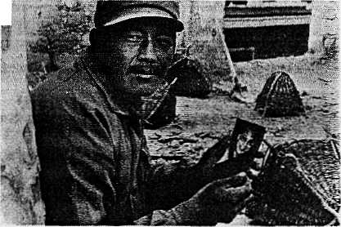
For the benefit of those who have only recently begun 'Tibet-watching", I wouldlike to mention a few points with reference to the last issue of Himal, on the 'Tibetan Diaspora".
The reported admission by the Dalai Lama [list he may be the last in the lineage always gets played high in the media. However, this is not a new stand taken by him. What the Dalai Lama had said in an interview some time in the early 70s was that he may be "the last Dalai Lama", if there is no further use for the institution.
Does Tibet, and the Tibetans in exile, still need him? Unquestionably. Leaving aside the matter of his divinity, there is no other single person, or even a recognised group of persons, in the Tibetan commun-nity in exile or un- B der occupation, who commands as much respect, love and loyalty.
Let us assume that the 13th Dalai Lama had chosen not to be reborn. What would have happened to Tibet? The Chinese would have marched in any case, but perhaps they would not even have felt the need to create the rubber-stamp government of the Tibet Autonomous Region. Many Tibetans might have found their way into exile. But it is doubtful if, in the absence of someone like the Dalai Lama, they would have been received with the same amount of sympathy and concern. The refugees would gradually have been assimilated into the host populations.
The Tibetans back home, lacking leadership among themselves or inspiration from outside, would have accepted the Chinese rule as a fait accompli The Chinese themselves would not have felt obliged to justify anything to anyone. There would have been no Tibet support-groups in the world, no sympathetic legislations from Western parliaments, no Nobel Prize to any Tibetan, nothing. So it will not be far-fetched to say that in the absenceof the 14th Dalai Lama, by now Tibet and Tibetans would have been virtually forgotten by the rest of mankind.
STRASBOURG PROPOSAL
As Peking remains unresponsive to the Strasbourg Proposal and even the Dalai Lama is feeling no longer bound by its terms, it may be
educative to look back on this controversial proposal, a variation of which may yet emerge as the next Tibetan initiative. We must understand that the Dalai Lama cannot just issue a statement like,"We want total independence and nothing else." Tibetans and most Tibet-support groups would, of course, be happy to hear something like that but it will not go down very well with the more influential parliamentarians and government officals, who believe that there has to be a basis for negotiation.
Even the most hardened critic of Strasbourg will have to admit that no one could have forced the proposal upon the Dalai Lam a. He picked the proposal from a number of available options and is now talking about not being bound by it, not because of criti-cim, but because of the Chinese failure to respond to the proposal. The Strasbourg proposal was just an idea that appealed to the Dalai Lama to provide the Chinese a face-saving device to come round to the negotiating table.
DHARMA CENTRES
It is wrong to think that the mushrooming of Tibetan dhanna centres in the West is indicative of the growing support for Tibet Right from the start, the majority of Western Buddhists have had very little sympathy for Tibetan political aspirations. For that matter, most of them have no interest in anything Tibetanexcept their chosen lama and whoever and whatever he favours. One up-and-coming guru I met in the United States was almost apologetic while admitting mat he does not talk about Tibetan politics to his disciples because "they don't like to hear such things." Most of the supporters of Tibet are non-Buddhists who, as Himal reported, "after their trip to Lhasa, returned home as self-appointed ambassadors of Tibet".
Whenever one talks about the decline of monks and monasteries in exile as compared to those in pe-1959 Tibet, one tends to overlook the difference between the sizes of the population involved. Look at the statistics cited in Himal itself. Before 1959, the combined population of Sera, Drepung and Ganden (SDG) monasteries was 20,000, while the rehabilitated SDG
in South India only contain 8,000 monks. However, the estimated population of Tibet was 6,000,000 while thai of exiles is 100,000. This means that while in Tibet there was one monk for every 300 laypeople, in exile the ratio is 1:24. That is why I feel that the number of monasteries and the size of the monk population in exile is too high. Our energy and resources need to be diverted to other fields^
THE QUESTION OF RETURN
An Indian journalist with a penchant for finding fault in Tibetans often says that the Tibetan younsters in exile are so Westernised in their upbringing and appearance that they are unlikely to return to s class-ridden medieval Tibet even if it becomes independent Such statements are classic cases of theories built around presumptions. The assumption is that Tibet was, and will revert to being once it regains independence, a thoroughly unpleasant place to live in, unless you happen to belong to the ruling class.
Tibetans settled in the West constitute a tiny minority but even among them, there are many who talk longingly of going home. If independence is restored, the majority of the exiles in India and Nepal are likely to return, though they need not totally abandon enterprises they have built over the years in exile.
However, it does not matter even if no Tibetan in exile wanted to go home. Most Tibetans happen to live within Tibet, and they want the Chinese' very presence removed. An end to the suffering of mis majority is the main issue and most Tibetans feel that this is not likely to happen as long as the Chinese are there.
Once independence is restored, Tibetans would undoubtedly face many large problems: there will in all probability be shades of post-partition India, of the unified Germany, and any number of other unforeseen challenges. But these need not have anything to do with the Chinese, and a new chapter in the history of Tibet will have begun.
T. WangyaJ is editor of 7iU,_,,.i&view, published monthly from New Delhi.
Readers, please note that opinion columns carried in Himaldo not necessarily reflect the viewpoint of the magazine or its editors. Readers are invited to comment, criticise or add to information and opinion appearing in Himai. Letters should be short and to the point, and may be edited.
Send to : PO Box 42, Lairtpur, Nepal.

May/June Wl-HTMAL 3


,-':-'vi^"--S-^ -■•■ ■--
■-■-.■>■;■■ -■■-'}■■:■■-,■'



French*/ Italian,
\ ':_{r} '. Russian cuisine. Se^K® f/iej ^ gfeenestf green you've ever


■LAZIMPAT, KATHMANDU. TEL:412399

:.■ ;;We Make You Feel Great

Troubled Politics of Himalayan Waters

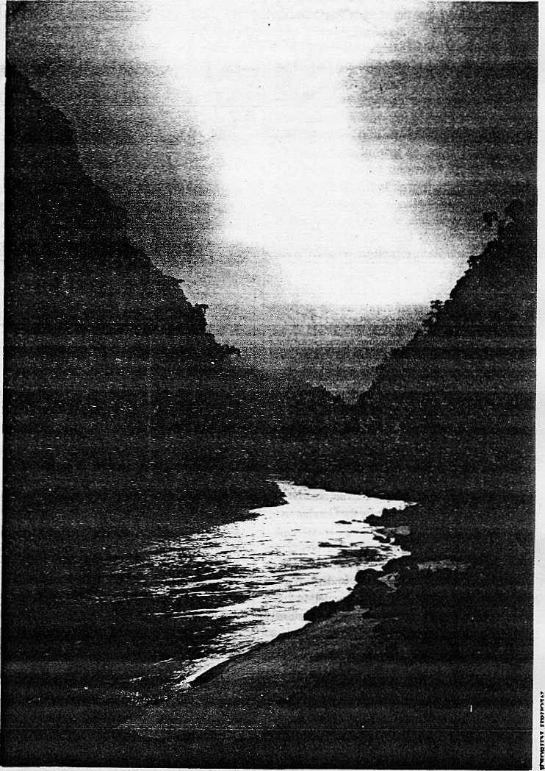
Indo-Nepal water negotiations are muddied by Nepalis who come without doing their homework, Indians who tend to have an overbearing attitude, anddonoragen-cies which have yet to be made accountable.
by Dipak Gyawali
S
ince the advent of modernisation in 1951, Nepalis have been fascinated by the possibility of generating hydro-electricity from their country's 6,000-odd streams and rivers. The international oil crisis in the early 1970s elevated this fascination to an obsession. Nepalis were mesmerised by the vision of becoming sheiks of Araby lolling in hydro-dollars from the sale of power to India.
Even following the recent political changes in Nepal, this vision of water-power continues and finds place in the manifestos and pronouncements of political parties. At a mass meeting in Kathmandu in October 1990, Prime Minister Krishna Prasad Bhattarai held forth that "the problems of trade deficit with India will be overcome with the Arun HI hydro-electric project and Nepal will be developed like Singapore iftheKarnaliandPancheshwar projects could be implemented."
At a workshop on rural development, Ganesh Man Singh, the Nepali Congress' "Supreme Leader" promised that after Arun 111 comes on line, every Nepali villager would be able to cook his daily datd-bhaai with electricity. As for the Nepali Left, their spiritual sustenance comes from Lenin's famous equation: "Kommunizm est sovetskaya vlast plyus etectrifikatsia vsei rossii" ("Communism is Soviet power plus electrification of all Russia.") It would hardly be f-:-to expect them, in the first flush of openpuuty, to stop and wonder about the complexity of the political economy of energy.
This "hydro-dollar naivete" assumes that the buyer (India) will not bargain, that the seller (Nepal) will be welcomed on a red carpet to occupy a share of the market. Such simplistic approaches to development, in vogue in Nepal, ignore one fact; that water development in general and energy marketing in particular are political questions involving resource control and bargaining strength rather than straight-forward economics and technology.
Trisuti gradient
Nepalis, pampered by donors in the decades past with easy money, have grown complacent and are not even today fully awakened to the harsh realities of hydro-politics. Perhaps the envisaged load-shedding this coming winter, and the realisation that there is no interim power project between now and the completion of Arun HI in the next century, will jolt them out of their cozy dream-state.
ONCE BITTEN TWICE SHY
Although electricity first came to Nepal in 1911 with the Pharping power plant, used exclusively to light up Rana palaces, the country 'sencounter withregjonaIhydro-politicswasonlyinl927.At that time, the British in India were constructing the Sarda barrage across the border river of MahakaK in the west. The Rana prime minister of the day chose to swap water rights on the

Msf/June 1991 • HIMAL 5

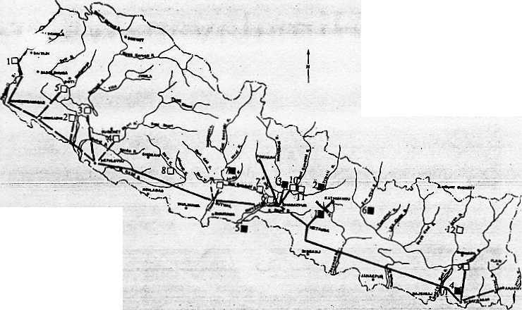
MAJOR POWER PROJECTS:
KULEKKAffl lill
TR15UU-DEVIGHAT
MARSYASOW
DUHABIMULT1FUEL STATION
OANDAK
SUNKOS
ANmHIKHOUl
WDEKCONStDERATIONj □
1. MMCHEIWOR
-L CKUAPAN1
3. &UUUUEEND
J, SEnWEJT
& SAPTAGANDlUKI CDEVOHAT)
7. ICAUOAHIWXI SCHEMES
! JHMRUK
9. MUU3KAT
11 MUGUNO
11.
h.

Major power projects : in operation and planned.
Mahakali for a tract of forest on the opposite bank and a sweetener of 50,000 rupees.
Two and a half decades later, the Rana dynasty came to an end in Nepal, and the British quit India. However, the British-established Indian water bureaucracy continued with its mission of harnessing water for power and irrigation; and one of their first crusades in modem India was to tame the Kosi, called Bihar's river of sorrow. It was at their insistence that the Kosi Barrage was built, on Nepali territory. A reservoir behind the dam inundated valuable Nepali agricultural land Subsequently the Gandak river, too, was similarly dammed.
The belief in Kathmandu that Nepal received a raw deal in these two projects has been the subject of much acrimony and skews the pitch in negotiations for new water relationships. King Birendra himself, in an interview shortly upon ascending die throne, stated that Nepal had been "cheated" in the Kosi and Gandak agreements.
In the 1950s, Indian water negotiators tended to look at Nepal patronisingly. This was perhaps due to the non-existent Nepali technical expertise in the field and the knowledge of how easily, backin 1927, the Rana durbar had swapped valuable water rights for a patch of sal. New Delhi's attitude was that as long as India made all the investments, it had a right to use Nepali sites for ■ flood control and irrigation projects which would benefit India. In the last three decades, however, Nepalis have begun to realise the value of their flowing water for their country's own development The West Rapti river serves as a case in point
India has long been advocating a dam on the WestRapti close to the Indian border at Jalkundi
in Nepal - which would flood much of the valuable agriculture land in Nepals' Deokhuri valley while benefiting 3 aharaich District south of the border. The Nepalis, on the other hand, would prefer a dam higher up at Naumuri, which would transform agriculture in Deokhuri and the west Kapilvastu plains, as well as generate electricity. The Naumuri project, however, would soak up the river, leaving very little dry season flow for India. For this reason, India has not spared any effort to prevent international agencies from participating in any development effort involving the West Rapti or the adjacent Babai river. A notable instance is the "killing" of the Sikta irrigation project north of Nepalganj, which was to have been funded by the World Bank.
While it is possible for these matters to be settled amicably to mutual benefit, Nepali water bureaucrats constantly harp on Indian "intransigence". Although international practice now accepts the conceptof'international water course systems" in which projects should try to optimise benefits for the whole basin, says a Nepali scholar who has followed bilateral talks, "the Indian position has remained frozen in the paradigm of the 195Os."Therehas been no evidence of breadth of vision, and the Indian water bureaucrats have done little to build confidence, say Nepali officials. As proof, they cite the ongoing imbroglio over the Tanakpur barrage on the Mahakali (see page 10).
Another matter raising doubts about the wisdom of "water resources development for export" is the Indian insistence on control of management. Such a provision is understandable for large projects like the proposed 10,800 MW Kamali high dam, which would export so
much electricity that any disruption would throw the northern Indian grid into disarray. However, India is said to be insisting on management control over even relatively small projects, such as the 402 MWArunDI, as long as export to India is involved.
"COST PLUS"
New Delhi's tough bargaining stance has also subdued what futuristic euphoria existed in the corridors of Nepal's Jalasrot Mantralaya (the water ministry) or its r¹ ' ^ wing, the Jalashakti Aayog. India has stuck to a "cost plus" position: before negotiating the terms of electricity purchase, it insists on knowing the cost of a project through detailed feasibility studies. This procedure would leave Nepal little room for manoeu-ver, while allowing India to bring the purchasing price as close to the costprice as possible. Nepal would prefer an initial agreement on "benefits in principle" before proceeding to spend on investigations, expensive expatriate fees and infrastructure improvements. The most recent Nepal-India negotiations and discussions on the Kar-nali project, it is learnt, showed no change in the Indian or Nepali position.
Atapressconferenceduringhisofficial visit to Nepal in March, Indian Prime Minister Chandra Shekhar, otherwise renowned for his extempore remarks, when asked about water resources agreements, meekly read out a prepared text handed to him in front of the TV cameras by the Indian foreign secretary. When asked "what benefit Nepal is to get" from the large water resource projects, the Prime Minister said engineers would work that one out, forgetting that that is not an engineer's task.
The most concrete political fa]lout from this shared history of distrust, as reflected in the national Nepali psyche, is the provision in die new Nepali constitution that any treaty on natural resources must be ratified by a two-third majority in the national legislature. Indian officialdom has complained that this would make it impossible to initiate any project with Nepal if the ruling party does not have a two-thirds majority.
New Delhi officials, however, forget that the ratification feature was put into the constitution precisely because of the shared Nepali perception of having been "cheated" in me past On the positive side, this provision will ensure a large enough societal consensus within Nepal for any project that is finally approved. And the final test of a "good" Indian proposition will be when Nepalis are seen falling over one another to muster a two-thirds majority. Indeed, this constitutional provision may usher in the practice of holding "public hearings" on major development project so that social, economic and environmental issues are brought out in the open.

May/June W91 -HIMAL 6

Hydro Facts
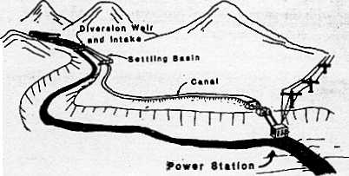
1000 watts make 1 kilowatt (kW)
1000 kW make 1 megawatt (MW)
When lkW of electricity is used for
1 bout, 1 electrical unit is consumed (1 kWh).
The average urban household's electricity
requirement is as follows (in watts):
100 w bulbs 500
Room heater 2000
Iron 1000
Cooker 1000
Others (TV, Videos, etc.) 500
Total 5000
The average rural household's use of electricity is as follows:
60 w bulb 240
Radio/Cassette 100
Total 340
Hydro-electric power is generated by a river water's energy. Water from a river section is diverted by canal or tunnel until there is head difference between the river below and the canal or tunnel above. Water is then led to the power house from the penstock. The falling water spins the turbine, which is connected by a shaft to a generator. The generator produces electricity which is then stepped up to higher voltage. It is then transmitted by high voltage power lines to consumer location, where it is stepped down and distributed.
Hydro-electric power plants are generally classified into two types as storage andrun-of-river systems. A storage system involves a dam which holds back water to form a reservoir having sufficient capacity. This allows to cany over storage from wet season to dry season to develop a flow greater than minimum natural flow of the river.
A run-of-river plant is built on a river which has a sustained dry season flow that can
LIVING IN A GLASS HOUSE
/ Delhi officials have their own list of complaints about Nepal and Nepali negotiators. Whatever their Nepali counterparts may say or feel, the Indian water bureaucrats cannot be faulted for not knowing what they want The Panch ay at-fostered Nepali bureaucrats who took part in water negotiations with India, on the other hand, have a decades-long record of not doing their homework, not having a transparent policy, and not distinguishing the personal benefits of highly placed individuals or cliques from the national interest.
Indians, who have followed a policy of self-reliance since independence and have developed •heir own planning, design and organisational

be divertedfor electricity generation. The plant has very limited storage capacity and uses water as it comes. Sometimes, a run-of-river plantis provided with storage, "pondage" which allows storing of water during off peak hours for use during peak hours of the same day. The sustained flow of Himalayan-rivers provides opportunity for many run-of-river schemes.
The flow of 1 cubic meter of water per 1 second falling from 1 m can theoretically generate 9,810 watts of electric power. The first estimate of Nepal's hydro-power potential was calculated in 1960 by Hari Man Shies tha while studying power engineering in the Soviet Union. Shrestha's study divided the country's rivers into different energy divisions and excluded rivers whose catchment was less than 300 sq km in area. Average flow of the rivers was considered.
The study put the value of 83,000 MW as Nepal's power potential, which comes to about 1,5 per cent of the world's total potential. Subsequent basin-wide assessments have estimated that the economically feasible potential which could be harnessed is 42,000 MW. The theoretical value of 83,000 MW is considered the yardstick and remains to be updated.
- A. Dixit

base for water resources, are uncomfortable with Nepalis who, rather than do their own work, hire outrageously expensive western consultants to do even simple things that their own idle engineering talent is fully capable of. A case in point is the Trisuli project, which India handed to Nepal in 1967 on a turn-key basis. Today, this project is being "rehabilitated" with World Bank aid and Canadian consultants even though Nepali technicians say they could have done the job cheaper and better.
A conversation this writer had with the Indian Ambassador Arvind Ramchandra Deo a few weeks before his departure from Nepal in Jan 1990 highlights the difficulty Indian mandarins have in dealing with Nepalis. India's central
government, said Deo, would always be the loser in a bilateral electricity agreement. Nepal would persistently harp on the poor deal it received, while the consumer states of Uttar Pradesh and Bihar would never stop complaining that the price negotiated by Delhi was too high- Why would Delhi want to get involved in such a no-win situation, he asked.
Deo said he asked a Nepali electricity baron, perhaps as adiplomatic feeler, why Nepal wanted to sell power to India at all? Why not, instead, invite Indian industrialists to come in and establish heavy industries such as aluminum or fertiliser plants and take advantage of Nepali power? The incredible answer he got, a day later, was that Nepal was not interested in industries but only in the export of power!
Such thoughtless "policy" have not enhanced Kathmandu's prestige and have instead convinced both "friend" and "foe" that the caretakers of Nepal's public affairs are not serious about the country's long-term interests. It is known that Nepali bureaucrats, at the behest of their Pan-chayati masters, similarly rejected a fertiliser plant that was oiieieA for free to make the Sapta Gandaki hydro-electric project more attractive than Arun HI.
The Panchayati dispensation shackled Nepal with very expensive power plants. While projects were being built in the Indian Himalaya and in similar terrain elsewhere ata cost of about U$ 1,000 per kW, Nepal went ahead and built the 6OMWKulekhaniatU$2,O0OperkWandthe69 MW Marsyangdi at a whopping U$ 3,500 per kW. Poor infrastructure could hardly have been the reason for high costs: Marsyangdi, for one, is located on a good highway with easy and direct access to the plains through NarayanghaL
DONOR, EXPLAIN THYSELF
A 26 MW petroleum- based power plant installed and about to be tested north of Biratnagar in the east proves the mockery that is power planning and management in Nepal. A disingenious gift of a Scandinavian donor agency, the plant will operate at a net loss of about one million rupees per day, the yearly loss to equal half the gross re venueo f the Nepal Electricity Authority. Donor agencies involved in Nepal's power sector will have a hard time explaining to future scholars of development how and why they promoted some of the world's most expensive power projects in one of the world's poorest countries with one of the richest hydro-power potentials on Earth.
The excuse proffered by many expatriate experts is that they don'tmake the rules inNepal; they only fouV¹¹' them. This may sound logical, but donors; biuiAS and agencies have played a significant role in weakening the institutional base of power sector management. The economic logic behind foreign aid and the procedures for selecting projects for development have

Miy/June 1991 • H1MAL 7

The Kosi Barrage : a sell-out ?
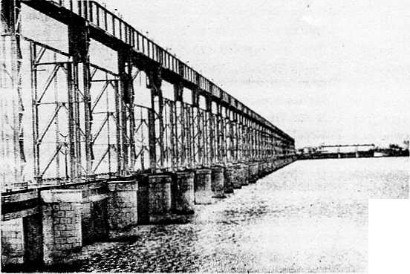
both been distorted, among other things, by an "iron triangle" nexus between highly-placed
Nepali bureaucrats, "development merchants" with monopoly access to those in power, and donor employees dangling titillating carrots in all guises and forms. There is also a revolving door between western consultancies and west-em-backed donor agencies which turns constantly with experts and consultants going in one direction or the other - a fact substantially feeding Ihdi an paranoia. This iron triangle encases an air-conditioned, insulated world in which many of the grave decisions regarding Nepal's power future are decided without accountability and, sometimes, for personal gain.
Many irresponsible acts of the Government in the power sector have been backed by donor agencies. Take for example, the disappearance of private power companies. In the late 1960s, there were three such companies in the Nepal Tarai: Morang Hydro in the east, Butwa] Hydro at the center, and Bageshwari Electrics in Nepal-ganjinthewest. Nationalisation destroyed these companies and left consumers worse off because state-supplied electricity was more expensive. Such irresponsible acts of nationalisation discouraged "feudal accumulation" from finding a productive avenue in nascent capitalism. Only Butwa] Hydro is being re-incamated today, with backing from Norwegian missionaries of the United Mission to Nepal.
The nationalisation of the power companies was an act of warped socialism which was, ironically, promoted by Western-backed donor agencies to make space for pet projects such as Kulekhani. Such large projects were justified on the grounds of "economy of scale," without the donors or the pliant Nepali bureaucrats realising that power generation and consumption is more than simply a mathematical model. In their macro-economic myopia, the planners and financiers failed to appreciate socio-cultural, legal and institutional problems related to the "inefficiency of size" that would undercut the benefits gained from the "economy of scale".
Donors displayed raw clout in remoulding Nepali institutions. Loans were offered for the Mars-yangdi Project on condition that the Government amalgamate Nepal's Department of Electricity and the Nepal Electricity Corporation into one Nepal Electricity . Authority (NEA). The donors* dictates were followed.
Today, the NEA employs over 9,000 persons, about 500 of whom are qualified engineers trained in some of the best universities in the world. The vast majority of the employees have no job description
and little is expected of them other than carrying outroutine maintenance on the national-grid and
w^ilecting salaries at the end of the month. The second worst over-staffed powerutility in Asia is Bangladesh's with 93 MWh of electricity sales per employee: Nepal's utility trails far behind with the same index of productivity at 43 MWh. Indians are no doubt watching all these shenanigans and drawing their own conclusion, which in turn influences their attitude towards Nepal, as well as their bargaining stance. An Indian delegate to a bilateral water session, a ,designerofdamsformorethan30years, was told over dinner that Kulekhani I cost U$ 2,000 per kW. He dropped his knife and fork, incredulous. When finally convinced, he muttered: "In India, we would no t even dare present such a project to the Planning Commission. Doesn't your Planning Commission look at such things?"
BAD PROJECTS
Much of the problems that linger in Nepal's water bureaucracy can be explained by the feu-docratic functioning of the late Panchayat system. But political changes have recently taken place in Nepal and the question is, what does it mean for mountain water?
Democracy, of course, means therightto ask uncomfortable questions and to expect honest answers. If in the "new Nepal" there can be enlightened public debate on matters of vital national interests, democracy will have already opened the door to a more wholesome and less expensive power development scenario. However, if democracy is seen merely as the right of political parties to be elected and to form governments, then a healthy dose of skepticism is in order regarding the future use of Nepal's precious water resource.
ActuaEy, the hydro-dollar hangover persist among leaders of almost all the political parties, old and new. No party has a cell examining policies in areas of water resources, or for that matter, studying any other productive sector
such as agriculture or industry. They don't seem to have had time to ask where they want to go,
and how. Serious questions of alternative water and power development scenarios and policies go unasked. Ideally,, "think tanks" should be busy studying, for example, water-sharing difficulties of Paraguay or Canada vis-a-vis their bigger neighbours.
The record of the one-year old Interim Government in Kathmandu shows that political parties have been unable to challenge, or direct, the Pane hay at bureaucracy which is stillin place. This is evident in the energy sector as well. At the very least, a review of large public projects should have been initiated but this has not been done because it is "business as usual."
One such mega-project that begs-examination is the 10,800 MW Kamali Chisapani project, for which no macro-economic impact analysis has been done despite all the feasibility studies that have gone into it We still do not know the risk a small country would face when mega-projects dominate its economy. Chisapani, for example, would cost U$ 5 billion to build, and that is about three times the country's GNP.
The other large project in need of review is the 402 MW Arun HI, which has been propagandised as cheap but whose estimated cos t is reaching the one billion dollar mark. The dam is to be put at the end of a 200 km road in the high Himal, construction of which is nowhere in sight. The assumptions that have gone into NEA's "Least Cost Generation Expansion Plan," which justified Arun ID, were shamelessly concocted,For example, it arbitrarily increased the cos t of alternative projects by 25 to 30 percent and also held that no hydro-electric project could be built in Nepal before Arun FJI. This was patently false, because there were attractive ready-to-go projects waiting to be picked: Seti West, Kan Gan-dakiA,SaptaGandaki,KarnaliBend,andsoon. But those were the days of the Panchayat, and if anyone spoke up in the national interest, he was not loud enough w be heard.
POWER AND DEMOCRACY
-■■.-..•.:
The history of Nepal-India water hamstrings every political party's ability to take fresh initiatives based on merit, and a healthy dose of scepticism would be in order regarding the ability of a newly elected Nepali government to set new definitions. Fear of oft-used slogan "Desk Bechua!" and of being branded anti-national and pro-Indian will shackle the parties even in a democratic Nepal. Only courageous and far-sighted statesmen or women can lead the parties

MaW.Iun* 1991 • HIMAL 8

mm

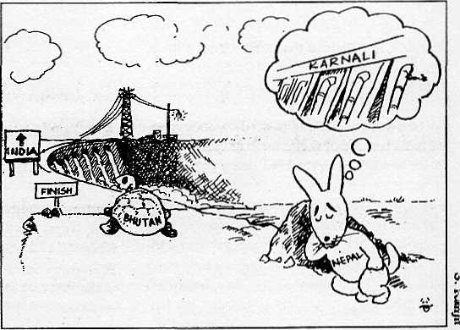
out of theif timidity and address genuine, long-term national interest.
The official meetings held in Kathmandu recently between old political pals K .P.Bhattarai, prime Minister of Nepal, and Chandra Shekhar, prime Minister of India, prove that even when Indo-Nepal friendship is at a pitch, the political equations so far as water is concerned tend to stay the same. Chandra Shekhar will read a prepared text handed him by a bureaucrat. And no matter how friendly a Kathmandu government is to India, when it comes to water, it will be staunchly nationalist.
Even the Tarai-based Sadbhabana Party, which many like to malign as "pro-Indian", and which supports the "common rivers" concept, can be uncompromisingly nationalistic on issues of water-sharing. In an interview, party stalwart Garni Shanker Mohpal, while accepting that his party would pursue a policy of friendship with India, stated categorically that water should be releasedfor India's irrigation only after all Nepali requirements are met Mohpal, who comes from the western Tarai town of Nepalganj, would be the first to know that every drop of Babai or West Rapti water released to India would mean so much less for the irrigation of Nepal's western Tarai.
The complexities of future party positions on Himalayan water should not come as a surprise to India, given the long and convoluted history of its own inter-state water conflicts. As for Nepal, the only thing its political parties are sure of is that the nation has wasted 40 yerjs shouting, till hoarse, how rich it is in water resources without doing anything about it
"COMMON RIVERS"
The Nepali Congress's position on water resources, as carried in its election manifesto and party pronouncements, expresses mostly wishful thinking. It emphasises the export of electricity, which is not necessarily beneficial in a "monopsony", where there is only one buyer (India). The party's thinkers also seem to believe hydro-electricity will be cheap,contrary to Nepali experience to date. The emphasis on small hydro for rural upliftment and the use of electricity for transportation are, however, positive elements of the Nepali Congress* manifesto.
But both the manifesto as well as other Nepali Congress publications are marked by a defensive tone, which might have something to do with the "common rivers" concept floated earlier by the party. This concept has been criticised by the Nepali Congress' opponents as a sell-out to India. In defence, the party maintains that it is merely trying to exploit the physical commonality of the Ganga river basin. This is a justifiable interpretation insofar as neither India nor Nepal can hope to do anything with the major
Himalayan tributaries of the G anga without realising that the hydro-ecological reg ime inextricably links the countries of the basin together.
The ex-Panchas arrayed behind the last Panchayat Prime Minister, Lokendra Bahadur Chafld, have tried to make the most of the controversy. They object to the "concept of common rivers because it muddies the perception of enlightened national interest and mutual benefit" Fishing in troubled waters, they hope to be back in power by riding a wave of narrowly defined nationalism based on anti-Indianism. Barring navigation, which they promote, neither their criticism regarding common rivers nor the rest of their manifesto enlightens the voters as to the concrete steps they would take to exploit Nepal's water resources. This is disappointing because several party stalwarts have served as Minister of Water Resources in the past. , The leftist parties, too, are riding the bandwagon of knee-jerk nationals m. Their campaign banners blame the Nepali Congress for selling out to India by tittering "common rivers". This is curious becauseLeftists formedpartof Bhattarai' s cabinet and participated in his talks with V P.Singh in New Delhi when the term first emerged in a joint communique.
Unlike their banners, however, the m anifestos of the left parties are more responsible and better informed. The dominant left faction of the United Marxist Leninists (UML) clearly perceives a link between Nepal's industrialisation, her water resources, and her transportation needs and possibilities offered by electric railways and ropeways. They forward navigation as a clear Nepali desire, possibly because that may be a subject of bargaining with India and Bangladesh in the future. In an interview, the party's Politburo member Madhav Nepal and left-leaning journali st Rag hu Pant sounded positive about the role of local self-government in power development as well as private initiative to generate power at the sub-national and village levels. Even the Maoist-leani ng party of Rohit of Bhakta-pur is quite perestroika-bitiea in its support of the traditionally non-Marxist notion of private sector involvement in developing the power sector.
BUILDING CONFIDENCE
Whatever their wish list al's political parties are constrained by the nature of the water resource and by external factors beyond their control. India has taken the position of not hold-
ing joint talks with Nepal and Bangladesh. This is because it has been pushing contradictory principles to suit its purpose: the doctrine of "natural flow" when dealing with upstream riparian Nepal, and that of "absolute sovereignty" with downstream riparian Bangladesh. Bangladesh, meanwhile, is keen to export floods to Nepal in exchange for benefits of navigation to the sea, if India can be made to go along. It would like to see storage dams built in the deep Nepali valleys to hold back the monsoon deluge.
In negotiations with Nepal, the Indians have been reluctant to share data on water resources, including actual irrigation requirements and potential. Indians negotiators want Nepalis to accept their word, which leads the latter to suspect that Indians want more water and more control than justified. "Confidence-building meas-ures,"thus it seems, are as necessary for regional talks on water-sharing as for global disarmament. In one bilateral session, an Indian bureaucrat reportedly lookedaskance at a Nepali counterpart, "Bhaisoab, between Nepal and India, what need is there for confidence-building?!" The truth of the matter is, there is.
There is impending food andenergy crises in the Ganga basin, which means that Himalayan waters will not be left in peace. It is difficult to imagine how the rapacious economic demands of South Asia will allow these rivers to remain scenic and wiid. With this in mind, it is necessary to ask questions that may seem impractical or idealistic at this stage.
How can a more optimal basin approach be taken to develop the Ganga and her tributaries? India could have shown innovative leadership in this sphere but hasn't. Neither have the smaller basin countries come up with anything imaginative. Meanwhile, Bangladeshis seem to have lost all hope in Nepal since the only joint Nepal-India-Bangladesh water talks were heldin 1986. At that session, Bangladeshis made some proposals and were disappointed by the pusillanimous position taken by the Nepali delegation,

May/June 1991 • HIMAL 9

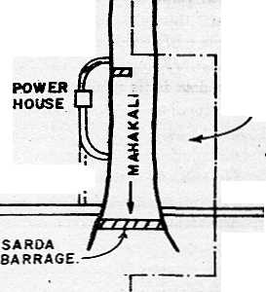
Righting A British Wrong
sionfromKathmandu to ex tend the weir ("afflux bund") all the way across the river into Nepal so that the Mahakali is better controlled and Tanakpur Power Plant properly supplied.
.PROPOSED 'PANCHESWOR
DAM.
INDIA
NEPAL
TANAKPUR BARRAGE .
LAND SWAPPED IN 1927
Original plan }'
460 CUSEC
SARDA
Canal
MAHAKALI
IRRIGATION
INTAKE
If there is a"common river" in the Himalaya, it is the Mahakali which flows between Nepal and India. Its water should, under the ideal conditions, be shared equally. Through a quirk of his tory {Ch andra S humshere' s deal with the British), the Indian side happens to own both sides of this common river at the point where the Sarda Barrage is built. As a result, both the power to be made as well as the land to be irrigated out of the Mahakali water from projects to date benefit India overwhelmingly.
In order to save Tanakpur, Nepal is now being asked to allow the construction of a weir across the Mahakali which would intrude into Nepali territory. What should Nepal do? Show magnanimity, obviously. What should Indiado? Perhaps right a British wrong and come up with a formula for more equitable sharing of the Mahakali waters. Perhaps half of Tanakpur's electricity output, or perhaps half of the river's flow, or perhaps something in between,
— D. Gyawali & A. Dixit
which was unable to say either yes or no. They seem to have decided that their interests lie in ignoring Nepal alto gether and hoping for the best with India.
Under the Panchayat system, Nepal could not take a self-confident, scientific stance vis-avis India because of skeletons in its closet- such as the heretofore secret 1965 treaty on defence which shackled its ability to tackle Indian negotiators. Hopefully, democratic Nepal will make some bold proposals that will be acceptable to all countries of the region. Such proposals could address inter-linkages .and complementarities on all aspects of Himalayan water, from navigation to flood control, electricity to groundwater lifting.
Turning to possible Nepal-India initiatives, large water resource projects need large capital investments - money that neither Nepal nor India nor even the World Bank has. What will be the role of the governments of financing capitalist countries? Will they demand a pound of flesh or will they be liberal? What would have to be done, by both Nepal and India, to make the terms generous?
As for Nepalis, they will gain or lose based on what policies they follow at home. A policy of self-sufficiency, promotion of the efforts of its own people, and internal economic growth will enhance its bargaining position. Aid addiction and day-dreaming will only weaken the national resolve. For the moment, Nepal does not seem to know where it is going. Neighbouring Bhutan, in contrast, seems quick to grab opportutiities on its path (see next page).
In India, theage of Gandhi an idealism ended with Lai Bahadur Shastri and the ageof pragmatism began with his successor, Indira Gandhi. The Nepal-India trade and transit impasse of 1989 showed that New Delhi is now capable of ruthless realpoliiik b&igaining, quite willing to push its own interests. As new leaders take the helm in India, its neighbours will have to rely not on benign Indian good-will, but on their own domestic strength.
If Nepal feels that her hands are weak and lacks the confidence to play the power game, it should concentrate on domestic development and let its neighbours know its position. In sum, what is required for smoother sailing on Himalayan waters is for NepaJ to put its house in order and for India to refrain from bulldozing. If India' s neighbours are not to forever suspect its motives-on a subject as vital as water, New Delhi must adopt policies and practices that are magnanimous and which help build confidence, K
0. Gyawali is an engineer/economist and author of Wate/-/oWepa/(East West Center. Hawaii). He took part in most India-Nepal waterre sources negotiations between 1979 and 1987 and was present at the only trilateral Nepal-India-Bangladesh talks held in 1986.

N
I
n 1929, the British reached an agreement with Rana Prime Minister Chandra Shumshere to an unequal swap. India would build the Saida B arrage on the border riverofMahakaliinNepal's west and receive some Nepali territory for the purpose. In return, Nepal would get 4,000 _~i es of sal forest in Allahabad Presidency District which lay to the east and fifty thousand rupees.
396m³/»
The sal forest is long gone, but under the agreement, the Saida Barrage continues to take away mostof the water of the Mahakali, The Mahakali has a mean annual flow between llOO to 1300 cubic meters per second (cumec), and the Sarda canal takes away about 400 cumec. When, in the 1970s, with World Bank help, Nepal initiated the Mahakali Irrigation Project just above the Sarda Barrage, it was allowed to withdraw about 460 cusec of water as per the old agreement.
In the early 1980s, when Nepal first heard of Indian plans for a power project upstream at Tanakpur and made enquiries, it is reliably learnt, New Delhi denied the existence any such design. Subsequently, when the earthworks couldnot be hidden, the Indian side came back and said that the Tanakpur power project (for that was what it was) would not affect Nepal in any way. Actually, this 125 MW Tanakpur hydro-electric project, completed in 1988, had serious physical implications for the Mahakali Irrigation Project. Initial plans were to divert mostof the Mahakali water to the power house and direct the exiting water through a tail-race channel into the Sarda Canal. Because, apparently, the canal cannot take so much water it has now been agreed that the outflow from Tanakpur will be released back into the Mahakali, above the Sarda Barrage and the Mahakali Irrigation intake.
In order to capture the Mahakali water for the Tanakpur power house, Indian engineers built a weir part way across the river. However, rivers do not always follow the engineer's dictates, and the Mahakali flowed away from the weir, in the process taking away 33 acres of Nepali land. The Indian side now wants permis-

-Maj/June_lWl.-HIMAL 10

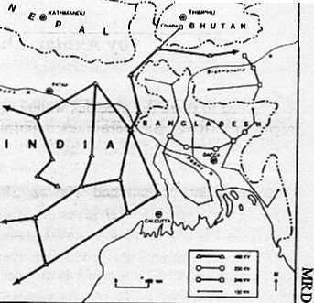
Little Bhutan's Big Power
Bhutan's domestic hydro-power needs are small. But there are large electricity markets in Bihar, Orissa and West Bengal, and a developing one in Bangladesh, which Bhutan can capture.
.'—'~i_..
by D.N.S. Dhakal
(Mountain Research and Development)
he four major rivers of Bhutan from west A to east, are the Torsa, Sunkosh, Wangchu and the Manas. The four rivers have a total energy generation potential of 40.4 billion kWh. In addition, micro and mini projects on the smaller rivers and minor tributaries could contribute as much as one billion kWh.
At present, the domestic market for electricity is underdeveloped; the quantity of electricity consumed in 1987 was 70 million kWh. It has not increased significantly even after the Chukha Hydel Project (which is on the Wangchu) lowered the electricity price from IRs 0.70 to 0.40 per kWh. Because the domestic electricity consumption is unlikely to grow substantially, Bhutan's prospects for development are not commensurate with its generation potential. Bhutan would do well, therefore, to consider the markets in India and Bangladesh when planning its hydro-power development.
POTENTIAL MARKETS
To export to Bangladesh, Bhutan's electricity would have to be routed through sub-stations in West Bengal and Meghalaya, unless India allows the construction of transmission over its territory, Assuming that this is not feasible in the near future, Bhutan will need India's assistance to route electricity to Bangladesh.
In 1985, Bangladesh had an installed capacity of 1,050 MW and generated 4.5 billion kWh of electricity. Eastern Bangladesh generates electricity primarily from gas turbines and hydro-electric plants, and Western part of the country fiom oil-fired plants. Demand far exceeds supply capacity. The World Bank estimates a system peak of 6,553 MW and an energy demand of 26 billion kWh annually by the year 2005. To meet this projected demand, Bangladesh is speeding development of its 12 billion cubic feet of natural gas reserves in the east.
Presently, Bangladesh has one of the lowest per capita electricity consumption rates in the world. However, the country has a priority programme for increasing food production by adopt-■"gwimcrirrigaUonwithdeep-aq¹ " pumping. Therefore, Bangladesh's consumption may exceed the projected development plans, Bhutan could capture a substantial share of this increased Dtiations permit it.
India, for its part, is experiencing phenomenal growth in demandfor electricity.On average, demand has grown 10 per cent per annum, a rate which is likely to be maintained throughout the 1990s. India seeks to achieve ageneration capacity of 17,700 MW by the year 2000. To add 11,000 MW within a decade is a formidable task, considering the difficulty experienced in adding 2,000 MW in the last five years.
India's diverse electricity markets are quickly integrating into one. Beginning in the twenty-first century, India will have a well-supervised 400 kV network to facilitate interregional electricity transfer. There will be power corridors from areas with a power surplus to deficit regions. "These corridors will consist of either HVDC (high voltage direct current) or 800 KV transmission lines capable of delivering large quantities of electricity with only asmall loss of power. The first will probably be set up in the northern plains, connecting the North-Eas t to the Eastern and Northern regions. Bhutan could take advantage of these facilities to transfer electricity, not only to the neighbouring states but also to the Northern and Southern regions of India.
In the long term, all of India is Bhutan's market. But for the next twenty years or so, the Eastern and North-Eastern regions are more important for Bhutan. Of course, the North-Eastem region is itself extremely rich in power resources and could contend with Bhutan for hydro-electricity markets in other parts of India. Arunachal Pradesh has the highest hydro-power potential of all Indian states.
The eastern region covers the states of West Bengal, Orissa, Bihar and Sikkim. In 1989, it generated 24 billion kWh, of which only 3 billion kWh were from hydro-electric plants. On average, demand exceeded supply by 10 per cent and the region has had to resort to regular load shedding. In the past, daily load shedding in Calcutta was more than 100 MW. (In 1988, the Federation of Chambers of Commerce estimated that India suffered a loss of IRs 75,000 million as a result of a 10 per cent cut throughout India.)
In the past, the Eastern Region has maintained a demand growth rate of about 9 per cent per annum, with industry's share over 70 per cent of the total consumption. At the moment, there is a move to provide power for irrigation
Proposed markets,
and rural electrification. Bihar, West Bengal and Orissa are expanding winter rice irrigation by deep-aquifer pumping, so the demand for electricity is bound to grow even more.
Given these prospects for development, energy demand in the region is likely to exceed the projections of India's Central Electricity Authority, which estimates 104 billion kWh of energy and 18,111MW of peak load capacity by the year 2000. Bhutan, which now supplies about 1.9 billion kWh annually from Chukha, can step up the supply to the Eastern region. As Bhutan has an untapped potential of about 40 billion kWh, the two countries have a unique opportunity to cooperate in hydro-power development.
TAPPING THE POWER
Bhutan needs to take bold decisions to tap its abundant hydro-electric potential. The hydro-power resources could be developed in phases over the next 50years. Phase I could develop the Torsa and the Wangchu basins. Phase II the Sunkosh, and Phase HI the Manas river system.
Rather than evaluate each project in isolation, the hydro development plan should adopt a holistic approach to economic development in each river basin. In addition, the plan must consider electricity demands of the export market and be flexible to adjust when market situations dictate change. It must also include long-term buyer-seller arrangements to avoid misunderstanding at a-1 ^e.
The first step, however, is to establish a reliable data base. Bhutan still lacks accurate data on rainfall, sediment load, and glacier hydrology. Bhutan couild mitigate these deficiencies by involving regional or international organisations in the planning before launching any massive hydro-power development programme,
D.N.S. Dhakalhasadoctratein Mineral Economics and is with the Department of Geology and Mines, Thimphu, this article is adapted from Mountain Research and Development (International Mountain Society) December 1990 issue.

Maj/June 1991-HIMAL II

A Shaky Indus Accord ?
A Dark Winter

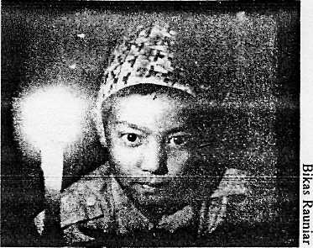
by Akhtar Khalid
P
akistan's feuding provinces have at last agreed to share the precious waters of the mighty Indus River. But there is new doubt about whether the plan is politically realistic.
The agreement, announced in early April by Prime Minister Mohammad Nawaz Sharif, marked a major breakthrough in resolving an old dispute that has costthe country an estimated U$ 20 billion in lost agricultural production over the past two decades.
■-'

The Indus has its origins in far-western Tibet (near Mount Kailas), and its tributaries traverse Jammu and Kashmir and Himachal Pradesh before entering Pakistan's arid plains. It flows for about 1,000 km across the fringes of the Thar
PrinwWntoUrShwH
desert to empty into the Arabian sea near the port city of Karachi,
The river was a cradle of the Indus Valley civilisation of 5,000 years ago. The ruins of the ancient cities of Harappa and Mohenjodaro attest to the level of political organisation and hydrological expertise that existed centuries ahead of their time.
After Pakistan's independence in 1947, its provinces immediately started squabbling over the Indus, which to Pakistan is what the Nile is to Egypt. Punjab, the richest and most-popu]ated province in the country, has taken full advantage of its upstream status to build dams and barrages ■ across the Indus and to use the river's bounty for irrigation. Downstream provinces — Sindh and Baluchistan—claim that they are being cheated of their share of the water. The North-West Frontier Province, which is upstream from the Punjab, complains that it is not allowed to build its own diversions.
PUNJAB AND THE REST
Under the agreement hammered out by Prime Minister Sharif, Punjab, Sindh, the NWFP and Baluchistan have agreed to share the Indus waters fairly. Punjab will get the largest volume of water, but will in return pull the plug on the controversial Kalabagh Dam it was to have built on the Indus (set .,..^i Sept/Oct 1990). The downstream provinces had contended that Ka]a-bagh would have diverted an unacceptable share of water for irrigation in upstream Punjab.
The agreement is seen as a victory of Sharif, where his successive predecessors had failed. Key to the dispute was Punjab, and Sharif is a Punjabi from Lahore. He also used his Party's political clout over the other provinces to drive through the agreement.
Announcing the accord, Sharif stated triumphantly that it would irrigate 20 million hectares of dry land in the four provinces, and the country would be able to produce an additional 2 million tonnes of wheat every year. In arid Baluchistan alone, 200,000 hectares of waste land would be irrigated, and about 300,000 ha would be made productive in the NWFP.
But there are nay-sayers to offset Sharif s optimism. Pakistani water experts say that converting the water-sharing accord into profitable projects will require about U$ 5 billion over ten years. Besides, it is an open question how strong the agreement really is. There are already voices I of dissent, both within Punjab and in the other j provinces. Groups sue h as the "Jiye S indh Tehrik'' have rejected the accord, saying that it still fails to guarantee equitable sharing of water. Local leaders in the NWFP want their share of the Indus water increased by 30 per cent.
Above all, the other provinces are not entirely convinced that Punjab has given up the Kalabagh dam plan. And former Prime Minister Benazir Bhutto, who is from Sindh, has roundly criticised the agreement. Afsalysts say that the position taken by her Pakistan People's Party (PPP) will have an important bearing on whether or not Sharif's accord can be implemented
A. KhaJid writes (or The Muslim in Islamabad,
Himal Alert!
The second annual fssue of Himal'm Nepali - in book form - will be in the market soon. This issue will carry a selection of relevant articles published in
Himal in the past year. Please reserve your copy in advance.

Kathmandu residents can remain secure in the knowledge that their country's massive hydropower potential will be tapped—in the next century. Till then, they will have to suffer loadshedding - starting this winter, say water experts.
Compared to some cities in neighbouring Bihar and Uttar Pradesh, Kathmandu has been pampered with relatively stable electricity supply, but this idyll will not last much longer. This is because the water bureaucrats of the Pan-chayat years and their masters greviously mismanaged energy planning. For reasons which have nothing to do with power demand and projections, all the eggs have been put in one basket, whose name is the Arun III project in east Nepal. As this project flounders (its 200 km mountain access road has not even been started) and its completion date at the most optimistic recedes to the year 2005 and beyond, there is no other project in the works to fill the gap. Hence load-shedding, should start as soon as household space heaters are switched on this coming autumn.
The peak load of the winter just past in the Integrated National Gridof Nepal was 203 MW. Even though the installed capacity of power projects in the country is about 250 MW, the "reliable capacity "is only 205 MW. Since power demand in Nepal is expanding at 10 per cent annually, it is clear the Nepal Electricity Authority will not be up to meeting the demand which is expected to reach at least 220 MW by winter.
As if that was not bad enough, the reservoir of the Kulekhani project has been overdrawn in the past two months. In late April, the water level stood at 1,485 meters (above sea level), down 45 metres from optimum capacity. The reservoir is expected to be drawn down to " de ad water level", the level of the intake tunnel, which means that the Central Nepal System will lose 60 MW at Kulekhani I and 30 MW at Kulekhani II. If the monsoon is delayed beyond June, therefore, Kathmandu*s residents will get a taste of winter load-shedding in the middle of the summer.

May/June 1991 • HIMAL 12

playing Politics with South Asian Water

The perception of insecurity in South Asia is today more marked than before, and water appears to be a key component of this new insecurity.
by Shaukat Hassan
In the 1990s, water may become the key issue in the security debates in the Sub-continent for a number of reasons. First, the dam age potential of water-related calamities is on the rise. The frequency and intensity of natural disasters like flooding and drought, as well as of disasters induced by human activity such as waterlogging, salinity, pollution, and those arising from the interference with watercourses, have had a most telling effect on the region's economies and the morale of its peoples. The material damage and loss of life is so prohibitive in social "<nd economic terms, that environmental insecurity is now a critical concern, acquiring a degree of political urgency the regional governments can no longer ignore.
Second, the drive for industrialisation will gain greater urgency throughout the Sub-continent, and it will require a relatively inexpensive and cleansourceof energy. The largely untapped hydroelectric potential of the Himalayan region could create the domestic energy substitute Nepal and Bhutan need so urgently to arrest deforestation, as well as provide export energy to the entire region; India's demand for electricity is estimated to grow more than 5,000 megawatt/w annum in the coming decades.
Third, water is a critical resource in the development of agriculture and food production, neither of which has kept pace with the rate of growth in population. The region's irrigation potential is yet to be fully realised, and food production must match demand if the governments of the region are to attain any degree of immunity from internal dislocations and external influence. And, fourth, the domestic requirement of water already exceeds domestic availability, and this will surely worsen if population continues to increase at present rates. For these and other reasons, water will assume increasing significance in the coming years.
DISTURBING TRENDS '
However, the politics of water utilisation jn the Sub-continent suggests a number of disturbing trends. At the regional level, water politics seems to be acquiring strategic significance. A case in point is Rajiv Gandhi's linking of Indian assistance to resolve Bangladesh's flood problem with the latter's commitment to resolve die tribal disturbances in the Chittagong Hill Tracts. Such
a willingness to employ water as a bargaining chip can only be disruptive to inter-State relations in the long run. Additionally,the inability to resolve contentious water issues bilaterally has paved the way for their internationalisation in various world forums. This is a sad commentary on the political wisdom and diplomacy of the regional governments.
USURPED BY BUREAUCRACY
There are disturbing trends at the national level as well. First, there is the tendency to deny the importance of multilateral cooperation on water usage, and to assert the primacy of bilateral cooperation. While bilateralism has its merits, it cannot supplant the need for a regional plan for the most effective and beneficial use of the Subcontinent's water resources. As long as the importance of multilateral cooperation is not reco g-nised, water utilisation will remain unilateral, inefficient, inequitable and conflictual.
Second, the issue of water utilisation appears to have been effectively usurped by the concerned bureaucracies. The "bureaucratisa-tion" of water usage has become a major hurdle. Rajiv Gandhi's willingness to explore various dimensions of the water problem immediately after coming into power, and his subsequent change of heart, prove that the political will remains hostage to the bureaucratic will.
Third, the issue of water utilisation appears to have important motivated political use. For example, any suggestion of willful interference with the water-flow by a neighbour who appears less than benign, or blame for the failure to reach bilateral agreements placed on the intransigence "^{c}- "l-intentioned neighbour, can have considerable political utility for the government in power.
HussainMohammad.Ershad's public stance that the damage potential of the flood waters of 1988 might have beenmitigated if there hadbeen the right mix of concern and commitment in the upper riparian region appeared to strengthen his government's credibility in the eyes of the non-secular forces within the co untry. The full impact of this manifested in the enhanced ability of Ershad's government to deal as it saw fit with the opposition democratic forces arrayed against it, in the salience of the religious forces in the country, and in the reordering of the domestic
balance of power. All these helped consolidate an administration that was suffering from a crisis of legitimacy. WTiile such internal consolidation may increase a country's negotiating strength, more significant is the extent to which water politics can influence domestic politics.
And, finally, the politics of water utilisation can also have a considerable political impact at the local level. Decisions on the selection of sites for major water-related investments, the quantum and procedure for the allocation of water and derived benefits, and so on, have in direct and indirect ways affected ethnic relations (for example, the Kaptai Dam and the Bengali-tribal relations in South-East Bangladesh), power relations (Bangladesh's tussle with West Bengal over the Ganga waters, or with Assam over the waters of the Brahmaputra), questions of economic equity (East Punjab's share of benefits from its own water resources), and questions of political priority (the trade-off between industrial and agricultural needs).
WINDOW OF OPPORTUNITY
The questions that face South Asian leaders are: how to resolve the existing water disputes? How to negotiate an agreement that maximises benefits to be derived from the region's water resources? And, how to achieve equitable distribution of benefits?
There is need for "new thinking" that transcends nationalistic constraints. Perceptions of security must be remoulded, with the focus shifting from the nation-state to the individual. "Security" should mean mote than purely military concerns. The notions of unilateral security must be replaced by one of "common security" encompassing the whole region. International relations cannot continue to be seen as a zero-sum game, where gain for one is loss for the other. In South Asia, security for one community, one people must create grounds for the security of others.
"Windows of opportunity" for progress in water resources sharing are few and far in between. Changes in governments, as is happening today in South Asia, appear to provide the best opportunity for constructive engagements. The political will must establish its primacy over bureaucratic and technical obstacles. South Asia has politicians in abundance; alas, we need statesmen.
S. Hassan, who is from Bangladesh, is presently a research fellow with the Canadian Institute for International Peace and Security, Toronto.

M»y/June 1991 • HiMAL 13

FEATURE

Karnali (Chisapani) in Retrospect
Is the Karnali Project feasible? Does Nepal need it ? The answer to the first question does not necessarily lead to the second.
by Paul D. Terrell, Jr.
More than a year has passed since the Feasibility Study of the Karnali (Chisapani) Multi-purpose Project was completed by Himalayan Power Consultants (HPC) for Nepal. HPC was ajoint ventureof Acres International, Shaw-inigan, and SNC (all of Canada), and EBASCO engineering company of the UnitedStates. Since the completion of the feasibility study, Nepal has been occupied with more weighty issues than confronting the advice of the study. However, the day will come when Nepal and India will approach the issues surrounding the development of the multi-purpose potential of the Karnali River. Now that good technical work has been completed, it is approriate that some thought be given to aspects of development that are not easily quantified in a feasibility study.
The decision to study the feasibility of harnessing the river in the Chisapani Gorge was made about thirty years ago. Once set in motion, feasibility studies tend to crank out numbers to prove the desirability of the project in question. Sometimes the cart comes before the horse, and from the outset we stop questioning whether the development is a correct line of investigation.
This is not to imply that the recently completed study is somehow flawed. It is technically correct and of high quality. However, that some U$ 11 million of study money have been spent does not necessarily mean that all the pertinent questions have been asked, or that the methodlogy of analysis covered all alternatives in comparable detail. Let us take a quick look at the situation obtaining in Nepal as it relates to the Karnali Project.
MACRO FACTS
The Karnali River has plenty of water. The monsoon, although variable in annual intensity, provides a reliable source of precipitation over the Jong term. The groundwater, snow pack and glaciers of the Himals provide storage which produces, even in the dry season, a substantial base flow. Thus, even at its lowest flow, the Karnali can irrigate the entire command area of the Tarai, from the Mohana River in the west to the West Rapti in the east.
The low and high flows of Nepali rivers are some of the most extreme in the world. This hydrologicextremeisanover-ridingfactbrinthe cost of spillways, necessary freeboard on dams, capacity factor of installed generating systems.
the basic concept of irrigation headworks, and the scope of flood control works.
Because the Himalaya is a young mountain range, stiit being uplifted and eroded, the sediment load of its rivers is also among the highest in the world. The Karnali is estimated to carry 260 million tonnes of sediment per year.
Except for short expanses of the Tarai, Himalayan river systems flow in deeply incised channels with steep gradients. This characteristic presents a conundrum to a would-be har-nesserofwater power. There are many good darn sites, in the sense of high dams with small structural volume, but few good reservoir sites, in the sense of large storage volumes with small dams.
The major concern in building hydro dams is tectonics. The Himals are seismically active and although this does not preclude building large dams, it certainly requires stringent design criteria, and the resulting structures may become relatively expensive. In case of the Chisapani Gorge, the structural geological problems do not limit developing an economical project design, even for a dam 270 meters high.
When you think of "land" as a "used by people" commodity, Nepal doesn't have too much of it. Snow-fields and glaciers are not habitable, and much of the country is too steep and mountainous for terracing by the hill farmer. The only resource guaranteed to increase is the human population. The land is increasingly crowded even as the country struggles for self-sufficiency in food.
DEVELOPMENT DILEMMA
These essential factors about land and people present a dilemma to the hydro developer. On the one hand, reservoir space is needed to harness the water; on the other, land covered by the most economic reservoirs, in terms of large storage volume for small volume of dam, is the same precious flat land needed for agriculture. In considering the trade-offs, the land used by the reservoir and taken away from agriculture must be offset by the increased productivity of land that the reservoir irrigates as well as protects from floods. While we cannot create land, wecan destroy or enhance its agricultural productivity. As conceived, the Kamali Project would serve several purposes: enhancing agricultural production, and providing power, flood control and environmental benefits. These, together with
the secondary benefits, are what give planners the incentive for embarking on large scale projects. Some benefits may fall beyond the pocket-book and are, therefore, difficult to weigh.
The market for agricultural production is first within Nepal, with surplus for export. Given that Nepal is struggling to be self-sufficient in agricultural production, serving this market is vital. The increased dry season flows released to generate power from the large storage reservoir would inc . jjioductivity in India, This capacity would be a marketable commodity.
The power market is^{r} in India, because the Karnali Project's output would be far beyond Nepal's ability to absorb. The Project is projected at 10,800 MW of peaking energy (operating four to five hours per day). This level of energy can only be absorbed by heavy industry with concentrated load requirements, conditions not existing in Nepal's industrial sector.
The economies of scale favours the large hydro project. For example, the economic cost of power at Kamali is estimated to be US 630 per KW and the cost of energy U$ .033 per KWh. At such costs, it should be possible to entice the potential buyer into negotiating a power purchase contract. For Karnali, the net economic benefits, including irrigation in India, is estimated to be US$ 10 billion.
As for flood control, both Nepal and India would benefit.Thecontrol of floods allows more intensive development of agriculture and the permanent reclamation of flood-prone agricultural lands. It also protects the investment in infrastructure (and encourages additional infrastructure development). Such benefits can make flood control a "marketable product" of the Karnali Project.
Environmental benefit might be considered another such marketable producL Generation of hydro-power at Karnali would eliminate the need to burn about 10 million tonnes of coal per annum, thus reducing the loadof carbon dioxide, sulfur, and particulates from the atmosphere and releasing coal reserves for higher petio- chemical uses. The enviromental benefit to India from not burning coal would be attributable to the Karnali Project - hence, its marketability.
DISINCENTIVES
A coin has two sides. In planning projects or in considering which projects to plan, we have to be careful that we don't forget to turn the coin over. We must do so with the Karnali Project as well, and the. points to ponder refer to relocation, the environment, natural and man-made hazards, the threat to sovereignty, and what Icall"the general fear of the unknown."
It is impossible to create a reservoir in Nepal without inundating people's homes and taking

May/June 1991 • HIMAL 14

FEATURE

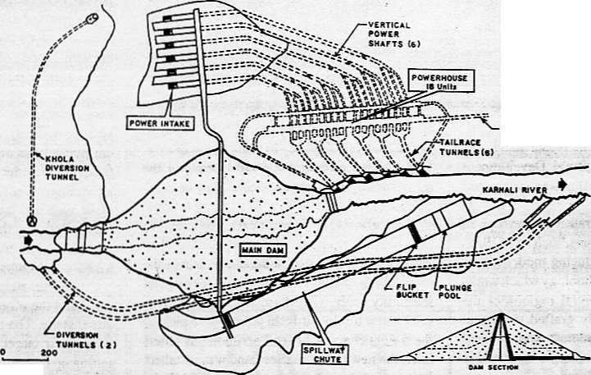
away their agricultural livelihood. The magnitude of the problem varies with the reservoir site but does not vary much with the dam height People farm the flatter land, which lies lowest in any river valley. Even a low dam, at any site, will flood most of the upstream agricultural land.
While we know something about the problems of relocating people, the data base in Nepal is very sparse on the distribution and enumeration of flora and fauna. Without question, a hydro dam changes the environment It is not possible to bring steeply rushing water into a flat lake without profoundly affecting the flora, fauna and the micro-climate of the area. The Kamali Project would inundate about 100 km of streambed and 340 sq km of land. Its dam would also constitute a 270 m high "fence" against migratory fish life.
The larger a project, the greater are its potential hazards. Firstly, there are the natural hazards deriving from earthquakes, floods and drought All of these hazards can be analysed and designs made to lessen their impact. However, we are not clever enough to make them go away.
METJtEI
Man-made hazards
derive from "mal-opera-
tion", lack of maintenace
and repair, lack of periodic
inspections, and lack of
continuing collection and
analysis of data. These''in
stitutional hazards"
threaten the health of a large
project but can be mini
mised by a healthy operat
ing organisation. Plan for Kamali rock
"Threat to sovereignty": On the one hand, there is the possible sale to India; on the ottier, the buyer will become somewhat dependent upon the product that is sold -energy, irrigation water, and flood control. This dependency may be perceived as a hazard to the buyer and certain guarantee. ,_{v} t>e needed for him to feel comfortable with that dependency. These guarantees may extend into the following areas, all of which may be perceived as threat to Nepal's sovereignty :
Territorial - the buyer may want to exercise some control over the storage and power facilities, in order to be assured that the flow of benefits is not interrupted by events beyond his control.
Institutional - the buyer may want to have control over or participation in the institution th operates and maintains the project facilities.
Operation and Maintenance - the buyer may want, in addition to some control at the institutional interface, actual "hands on" control over the operation and maintenance of the facilities.
As for the "general fear of the unknown," basic and fundamental decisions will have to be taken by people at levels of high visibility. No one wants to make a blunder which would imperil his career or the well-being of his country.
ON BALANCE
Given that the Kamali Project appears to be feasible and a potential money-maker for Nepal, "Why not do it?" But we should also ask, "Why do it?" Can Nepal attain self-sufficiency without the Kamali Project? I believe the answer is, "Yes."
Consider the Kamali Project from a provincial, rather than global point of view.
fill dam.
As noted, the Kamali River can irrigate the command area of the Tarai without I arge storage. Irrigation headworks can be designed to pass the annual floods and still divert what is needed for irrigation.
As noted, the power Nepal needs would not come from Karnali. Other, smaller, hydro-electric projects that rely less on large storage and more on the minimum flow found in the Himalayan rivers continue to appear to be the best choice for Nepal's own needs.
Where flood control is concerned, a combination of flood-plain zoning and levees could provide a relatively high degree of flood control to Nepal's agricultural zone in the Tarai. Also, rather than flooding the flat land upstream of the Chisapani Gorge, it could be developed to sustain a higher level of agricultural productivity than now exists.
IN CONCLUSION
The following statements about the future of development in Nepal may inspire some thought and debate. These are my personal views and are not representative of either the Kamali Project Staff or my former employer. Overseas Bechtel Incorporated.
Nepal can decide NOT to build the Karnali Project, but Nepal alone cannot decide TO BUILD the Project Not even the World Bank, which has been generous in loaning money to fund the feasibility study, can implement a decision to build the Project.
SOUTH ACCESS TUNNCl
Although it is the undeniable owner of the resource base, Nepal cannot develop large projects without the co-operation and encouragement of the buyer of the products and of the international financial community. Both buyer and financiers, in turn, will have to answer to world opinion on environmental and ecological matters as to the desirability of the project. Nepal will thus only have a veto voice in the final decision as to whether the project should be built or not. Nepal is not presently well-equipped for large project development, and will need to develop an institution to manage the development of a large export-oriented project Such an institution does not presently exist and the personnel to manage and staff one are only
beginning to gain the necessary experience and training,
Nepal should beware of unintentional "giveaways" in hydro development, and not rush to compromise the optimum development for the sake of a quick deal with the buyer. A less than optimum power dam on the Karnali River could preclude optimum development for all time. The present institutions should be wary of giving away Nepali children's rightful inheritance.
Nepal is equipped to perform most of the work required to implement the self-sufficient alternatives mentioned in "On Balance" above. The technical institutions and private consulting engineers are in place in Nepal to perform most of this work, with minimal ,ide guidance. f\
P,D. Terrell, Jr. was adviser to the Nepal; Government on Kamali from 1984 to 1990. He now lives near San Francisco.
.,■/ . . .-

Mar/June 1991 - HIMAL IS

Bad Business in Bajhang
Micro-hydro-power technology, when unthinkingly grafted to remote areas, can destroy the spirit and the savings of entrepreneurs.
by Joanna Pfaff-Czarnecka
T
here is a warning being whispered these days in the village of Byasi in Nepal's far western district of Bajhang: "Don't give your daughters in marriage to Mr. Joshi's sons."
The reason is that many people believe Dhana Raj Joshi is headed for bankruptcy. But how could it be? Joshi comes from a well-to-do priestly clan which served the rajas of Bajhang. Besides officiating as a well-regarded pundit, he is also a school teacher and has income from his land and a shop that sells calico. What changed his fortune? "Oh, the micro-hydro business," say the villagers of Byasi.
This may come as a surprise to many who have heard of the successful spread of micro-hydro projects elsewhere in Nepal under the sponsorship of the Agricultural Development Bank (ADB/N). But such projects seem doomed to failure in Bajhang.
Joshi's problems illustrate what can happen when state-backed institutions, such as ADB/N, take over the task of introducing modem technology to remote areas. Technology which works in the more developed central regions of the country, when unthinkingly grafted to remote areas lacking the proper economic environment, can devastate the spirit of entrepreneurs and is unfair to the population at large. . While today, ADB/N has the means to introduce modem micro-hydro technology to all - or nearly all - districts of Nepal, whether such introduction will succeed is a different question, especially in areas with difficult access. The experience of Joshi, and others like him in Bajhang, shows that rural entrepreneurs must wisen up to the forces at play or get enmeshed in a losing battle against complex institutions and processes.
PROMISES, PROMISES
It is natural for entrepreneurial-minded villagers to be drawn into the exciting new venture of generating electricity .from local streams and rivulets. Like many others, Joshi had reasons to be optimistic back in 1987, when the ADB/N branch manager of Chainpur, Bajhang' seat, came knocking. Ambitious Bajhangis had already installed two turbines elsewhere in the district. The manager was keen to distribute
loans and promised all kinds of assistance, "All of a sudden, the bank manager and the Sarkar were at our door with funds and service," recalls Joshi. With the government so keen to help, what could go wrong?
Equ ally reassuri ng were the technici ans who came todo the feasibility study. They said a grain and oil mill would have to be setup first; once the turbine was tested, the bank would step in with an additional loan for electrification. The unit would initially produce 10 kW of electricity and electrify households within a radius of 3 km without need for a transformer, they assured him.
Joshi's loan came through without any "push" and the turbine too arrived on schedule. The transportation cost, however, far exceeded his calculations. The freight charges from Kath-mandu to Dadeldura was NRs 10,000, as estimated, but the porter fees for hauling the turbine up to Bajhang came to a hefty NRs 50,000. Joshi's troubles had begun.
Technicians reached Byasi soon after the turbine arrived. However, they realised that some essential parts were lacking and they flew back to Kathmandu. They came a second time and set up the turbine, but after they had left, it was discovered that the turbine could not operate at the designated speed and hence could not be commissioned.
Joshi wrote numerous letters and sought the help of some friends in Kathmandu, but it was only a year later that a technician was sent by the manufacturer, who found fault with the original feasibility study. The company now agreed to send anew turbine, if Joshi promised to pick up the freight charges. Several acrimonious letters later, the new turbine arrived and was installed. It ran smoothly, but could produce only 7 kW. Its reach without a transformer was now a dismal radius of less than one kilometre, andthenearest consumer household was more than a kilometre away. Since a transformer would be expensive, Joshi turned to his supportive banker. To his surprise, the ADB/N representative said an additional loan was out of the question.
HELPLESS ENTREPRENEUR
Joshi's grain mill can process 300 kg of grains per hour but he has few customers. His earnings lastyear was NRs 12,000, after deducting maintenance costs. The annual payable interest on his loan is NRs 22,000. Labour costs are extra. I Unable to invest any more in his electrification venture, Joshi is now thinking of installing asaw-mill to utilise the generation capacity gone waste. Asked if he was not making another mistake, Joshi replies, "I have already spent more than alakh, so what's another ten thousand rupees?"
Problems and bottlenecks similar to Joshi's have beset the other eight Bajhangi entrepreneurs who invested in micro-hydro. To begin with, most had no managerial skills and were ill-prepared for the task of electricity-generation. They miscalculated the cost of haulage and overestimated the quantity of food-grains that would be brought for processing. Some did not even consider the seasonal fluctuations of water flow, which left their intake pipes dry for months on end.
Sometimes, the very novelty of the technology rendered the power entrepreneurs helpless. All they could do when the turbine did not work was to sit and stare at it and say, "Something has happened to the turbine." The manufacturers's stipulations kept the entrepreneurs dependent on faraway technicians and prevented them from learning about the system's workings.
On the whole, the entrepreneurs received poor advice, both from the ADB/N andmanufac-turer representatives. These would-be advisors failed to consider how modern technology, hauled up with great difficulty to Bajhang would fit conditions far different from the mainstream of Nepali development Bajhang lacked not only easy access, but had a low level of technical knowhow. When the bank insisted that the micro-hydro units also have milling capability- '* failed to consider that Bajhang does not have increasing rates of agricultural production which make such add-ons attractive elsewhere in Nepal. In Bajhang, the comparatively low demand for milling is being adequately met by the traditional ghaitas.
Unfortunately, the support promised to Joshi and the others did not extend beyond the initial stage. The officials* only interest was to fulfill their target, and that was done with the setting up of the turbines. Now, when Joshi and the others desperately need help, the institutions of the state are drifting away.
AN EXCEPTION
Rajendra Khatri of Chainpur is the one exception among the eightpower entrepreneurs of Bajhang. He has sufficient money, some technical skills, and good contacts with Kathmandu high-ups. When problems arise, he is able to mobilise his support system and overcome hurdles that would have left the others helpless.
Because Kharri's turbine was affected by seasonal fluctuation of water and sand damage, one day it stopped turning. Whereas Joshi might have waited for a technician to come from Kathmandu, Khatri went ahead and had the turbine opened. He found that a part was broken and took it to the local goldsmith. The turbine was repaired within ashort time and at little cost, Khatri succeeded essentially because he broke the manufacturer's rules, which Joshi and others would not dare do.

Mav/June 1991 ■ HIMAL 16

Micro-Hydro Facts
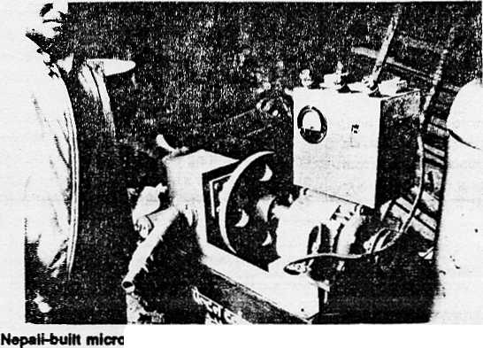
Due to his Kathmandu contacts, Khatri was also able to obtain a transport exemption from the Cottage Industry Office, which saved him the costs of hauling in his machinery, Joshi and the others, overwhelmed as they were by modem techno logy,-had not even been aware that such a facility was available.
Quite unprepared when they ventured into the micro-hydro business, Joshi and the others became completely dependent upon state institutions. Khatri, meanwhile, is likely to overcome most difficulties despite Bajhang's infrastructu-ral and economic conditions. He is still financially independent which makes him more self-confident and self-reliant and his ability to mobilise officials and institulions is, in fact, a powerful economic resource.
TERRA INCOGNITA
For micro-hydro units, Bajhang was terra incognita. Par the people ofBajhang, the units held out the promise of ushering in "development". The state, with its supra-local, hierarchical organisation and comparatively abundant funds at its disposal can plan, design, implement, andorgan-ise - even when basic infrastructure such as roads are lacking. But such lack is a formidable threat to enterprises that require outside assistance.
What makes the experience in Bajhang paradoxical is the fact that planning for decentralised energy supply and a higher degree of sustainability has in reality made entrepreneurs more vulnerable and dependent on central action.
A "take-off* of a specific kind is required. What is abstractly called "local capital formation" is in practice reflected in the emergence of local entrepreneurs who, besides possessing personal abilities, managerial skills, commitment and some technical knowledge, have sufficient capital of their own, participate in local and national social networks and are, above all, experienced in dealings with state institutions.
In Bajhang the micro-hydro-power station
owners ventured into the state-promoted pro
gramme expecting full assistance. They thought
so especially because the programme had come
looking for them and not vice versa. In fact, it
might even be said that the programme was, in a
way, imposed on them. Yet today, half of
Bajhang's power entrepreneurs are in danger of
losing the land they kept as collateral for their
loans. But even now, they continue to rely on the
Bank to take a sympathetic attitude. They are
hopeful that the ADB/N will not insist on repay
ment of the credit. K
J. Pfaff-Cazmecka, a social anthropologist teaching at the University of Zurich, spent four months in Bajhang last fall.

unit.
F
or centuries, the waters of the more than 6000 big and small rivers of Nepal have been harnessed to power traditional water mills, ihzghaitas. There are about 25,000 suchghaltas operating in the country, but attention is shifting to electrification.
Altogether 70 micro-hydro private sector turbines have been set up in 58 districts of Nepal. Eightof these areo wnedby small farmers groups, the rest by individual enfrepreneurs. Together, the turbines generate about 700 kW of electricity and light up about 3,000 households.
Since 1984, entrepreneurs in remote districts such as Kalikot, Mustang andSolu-Khumbu
HIMM.
DOES NOT ACCEPT LIQUOR
OR TOBACCO ADVERTISEMENTS.
Please write to us
for our
advertisement rate card.
P.O. Box 42, Lalitpur, Nepal Tel: 523945, Fax: 521013
have received installation subsidies of 75 percent for setting up micro-hydro units. Those in other districts receive a 50-percent subsidy. The total investment in the70 projects has amounted to NRs 13 million, of which NRs 5.9 million is in loans provided by the Agricultural Development Bank (ADB/N), NRs 4 million is government nibsidy, and NRs 3 million put up by the beneficiaries them-telves. According to ADB/N, another 44 projects producing 674 fcW are on the pipeline, IS of which will be operational within 1991.
The cost of electricity provided is variable. In a bazaar town with an active economy, the monthly
charge for a 40 watt bulb might be up to NRs 40
per month. Elsewhere, the price can dip to as low
as NRs 15 per month. The main problem in
lighting is the high mortality of Jight bulbs, and
this has to do with voltage fluctuation. Since
Indian govemers have proved unwieldy, voltage
regulators have to be imported from the United
Kingdom, which greatly increases the costof the
units. - Prakash Khanal
WATER
A publication which addresses all aspects of water development.
- Detailed research
- News reports and analyses
- Sharing of practical experience
- Important reprints
- Literature review
WATER NEPAL is a must for government ministries, international agencies, planners, natur I resource development professionals, a ademicians, educationists and rese reft institutions.
Write to: PO Box 2221, Kathmandu Tel: 228-741 Fax:418-342

May/June 1991 • HIMAL 17

Let a Thousand Village-Hydros Bloom

The Nepali government should relinquish its hold over small-scaie hydro-power and leave the arena free for more efficient consumer-run schemes.
by Bikash Pandey
In the upper reaches of the Kali Gandaki gorge, north of Annapurna Himal, there are micro-hydropower plants within an hour's walk of each other. They serve five villages in Jharkot, Muktinath and Jhong—together generating 60 kW of electricity. These plants are owned by the villagers and were constructed at their initiative — with door to door collection, voluntary labour, as well as subsidy from outside org anis ations and the government and loans from the Agricultural Development Bank (ADB/N). Micro-hydro (up to 100kW) and mini-hydro (up to 1000 kW) schemes were first put up by the Small Hydro Department of the NEA in the early 1980s to serve district headquarters and other major hill townships. In 1984, micro hydro-power was aclicensed, allowing villagers to build their own units and charge their own rates. The following year [ADB/N] came out with a programme to subsidise village-level hydro-electric schemes by up to 50 per cent (although the granting of the subsidy has been irregular). Today, there are about 20 operating small hydro schemes built by the NEA and over 70 smaller units built privately, such as at Jharkot, Muktinath and Jhong.
It is these smaller non-NEA electrified hamlets that show the way towards finally utilising Nepal's hydro-power potential for the benefit of its villagers. The experience of the past decade indicates that the government, NEA to be specific, should relinquish its hold over all sm all-scale (and not just micro-) hydro-power development and leave the arena free for cheaper, more efficient andbetter managed con sumer-run schemes. As the rural consumer's needs grow, the government must allow private sector entrepreneurs to build into the mini-hydro range (and beyond). More than 50 years ago, another mountainous country with a large rural population, Norway, was electrified through rural hydroelectric cooperatives. There is no reason why Nepalis should not follow the Norwegians.
POWER CLOUT
The problem with NEA-installed micro-hydro schemes is that they come as outright grants. As long as the government, with or without foreign aid, insists on gifting hydro-power schemes to villages, only the communities with political leverage can benefit. District headquarters, for example, have no incentive to work to get their
power. They will get it first, anyhow, as funds become available, at the cost of villages which lie in the political backwaters.
Centralised control does not allow local communities to demand or initiate projects. Instead, NEA-run projects are unable even to tap voluntary labour for work which is ostensibly for the villagers'own good. The costofKathmandu-led projects are alarmingly high. When the government is willing to foot the bill with foreign aid, it is in no one's interest to keep construction costs low or to use better designs and more appropriate technologies. Far from contributing labour and local materials, some villagers who benefit from NEA schemes have been known to demand compensation for allowing power lines to pass through their land. The NEA units are also characteristically over-staffed Salaries are not dependent upon the plant's income, and the Authority pays a subsidy of NRs 4,000 (U$ 133) per kW produced in its small hydro plants.
The cost of NEA's micro-hydro projects, at currentprices, averages aroundUS 8,000 per kW produced. Village-owned and ADB/N financed hydro schemes, on the other hand, have averaged about U$ 1,500 per kW. This has been possible because the village entrepreneurs and Nepali hydro-power companies use appropriate technologies and local energy for construction and components manufactured in Nepal.
RURAL INITIATIVE
Even in the most cost-efficient, villager-driven micro-hydro project, the connection cost is about U$ 160 per household for lighting and U$ 320 if there is enough power to cook. The government would never be able to electrify rural households at these rates. However, where there is a determined community that is willing to pay for, say, half of the amount, it reduces the necessary subsidy and also allows for self-selection of the most organised and determined villages.
Since power generation requires the use of water which is invariably already being used in the community for a number of purposes, the villagers need to be in agreement that a proposed scheme &. worthwhile. There are questions of displaced ghattas, fixing of irrigation schedules, compensation for land used by the power house, and so on. These are much better negotiated and sc tiled w: thin the community, rather than through the diktat of a central authority.
The ability of Nepali communities to order their own hydro cures a number of the ills that beset NEA's efforts. At the: village level, there is commitment and initiative; there is constant oversight over the contractor's work; there is voluntary labour. Questions of water rights and compensations are internally debated and resolved, in much the traditional fashion. Flexible tariff allows reasonable payback on the scheme and optimises the use of the hydro resource by improving the toad factor.
In the end, it is not realistic to expect NEA, which has to look after the national grid and hundreds of megawatts of power, to be able to sort out the many minor issues of waterrights and sharing of resources demanded by a small 25 kW scheme. NEA's tariff scheme is completely unrealistic when applied to village micro-hydro schemes. Innovations like the flat tariff (fixed price per month for a set number of watts) favoured by village-owned hydros are not available on NEA-run schemes. The flat tariff encourages customers to spreadout their load insteadof concentrating them at fixed times. Heat storage cooker technologies ("Bijuli Dekchi") coupled with flat tariffs can be effective in utilising small amounts of power over long durations.
LIGHT IN THE COW-SHED
In the past, the bright lights of the city attracted young villagers away from their farms and homesteads. Today, in Nepal, the bright lights can be brought to the villages, with indigenously produced micro-hydro technology.
Naturally, villagers are initially excited by a 25-watt light-bulb in the cow-shed, and the ability to do away with batteries for their radios and tape-recorders. But where it works, village hydro-electricity is also beginning to fulfill the more important roles expected of it, such as reducing fuelwood consumption and powering small industries.
With the advent of heat storage cookers and
the flexible tariff that is possible with "decentral
ised hydro", it is very likely that Nepal's hydro-
power potential will finally assist in improving
the rural quality .of life. This is not possible
through expensive power provided by connect
ing villages to the national grid. Neither is it
possible through village hydro financed, built
and controlled by NEA in Kathmandu. The only
way ahead is for NEA to leave development of
micro- to small-hydro up to the initiative of the
rural folk themselves. a
B. Pandey works for Ihe Intermediate Technology Development Group in popularising micro-hydro-power in Nepal.

May/june 1991 • HIMAL 18

Verghese's Middle Way

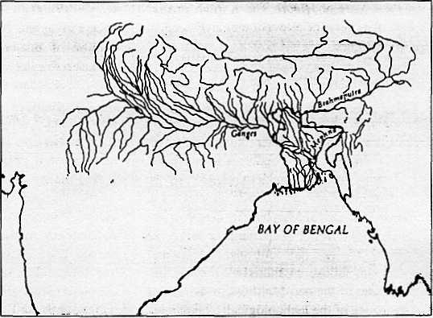
RATERS OF HOPE
B.G. Verghese
Oxford and IBH, New Delhi
1990, ISBN 81-204-0519-6
Review by Ajaya Dixit
he Gangetic plain, making up about 2 5 per X cent of the Earth's area, supports almost one-tenth of its population. Even then, according to M.S. Swaminathan, the eminent Indian scientist, the region has the potential of being the bread-basket of the world. Today, 43 years after India's independence, the region is still sunk in its hallmark destitution. Waters of Hope questions why this is so and seeks answers from the Brahmaputra and Ganga rivers.
Journalist George Verghese presents abroad and detailed canvas of the potential held by the waters of the Ganga-Brahmaputra-B arak basin: 214 hectare-meters of annual runoff, a staggering 250,000 mega watts of electricity, irrigation of 115 million hectares of land, and an array of associated benefits. Why not say "Open Sesame", and extract the benefit that is there for the taking, asks Verghese. The only thing lacking is "regional will'*, he contends.
The actors in this search for regional will, and the subjects of the book, are Bangladesh, Bhutan, India and Nepal. The book discusses, at the micro and macro levels, the policies and practices of these countries' water resource development.
Verghese starts by describing the natural setting and provides a perspective on the sociopolitical setting. He then discusses the issues of land reform, irrigation management, floods, watershed management, forests, public health, displacement, seismicity (as they relate to dams), legal compacts, inland navigation and regional cooperation.
FEEDING <25 MILLION
His thorough research enables Verghese to pack within these covers (412 pages) as many facts and figures of the region as it seems possible to collect. At the very least, he eliminates the need to scour the libraries for information on South Asian water. In fact, the book is sometimes daunting, so infested is it with facts and minutae. On the whole, however, Verghese succeeds in communicating his deeply felt belief that the countriesoftheregion/wv^toovercorr 'Jtual fear and suspicion, if the quality of life of their P»ples is to be improved.
The population of the Brahmaputra-Ganga region will surpass 625 million by 2000 A.D. To feed these many people, agricultural production has to increase by 2.5 per cent annually, and this will require irrigation water. But, as Verghese points out, irrigation is considered more a protection against famine than a means to increase productivity. Undertaken by rule-bound rather than result-oriented bureaucracies, projectsof-ten ignore farmer-participation and force them to adopt unacceptable chopping patterns. Many systems in India operate at low average irrigation-water efficiency because water management is neglected.
The region, with its perennial rivers and topography, is a storehouse of energy in the form of renewable hydro-power. In that sense it is one uponKuwaiteven.NapthaJhakri(Sutlej Basin), Chukha, Arun ID, Tehri, Karnali and Panches-wor are some of the projects which offer im-mensepotential. However, several problems have dogged hydro -power development in the region, including long gestation periods for projects, time and cost over-runs, environmental objections and other uncertainties.
Nepal's experience in hydro-power development, including the much-discussed Arun III project, is replete with problems that arise from the paucity of data, and also ad-hocism. A general failure to forsee the effect of natural processes and to understand sedimentation has been one of the banes of Indian dams and barrages. As Verghese points out, reservoirs in India heavily lose their storage capacity due to siltation. All new project designs in the region have to take account of the sedimentation rate of Himalayan watercourses by providing larger "dead storage" and effective flushing mechanisms. Watershed management remains important in reducing silt-load.
The existing uncertainty or lack of knowl
edge regarding physical processes peculiar to the
region has to be remedied, and Verghese is right
to point to the urgent need to improve the data
base. But this is easier said than done, given the
lethargy that afflicts the region's water bureauc
racy. :
VESTED INTERESTS
While lack of data is a major problem, perhaps a biggerproblem (at least in Nepal) is the penchant shown by those in power to team up with vested interests (read commission agents and contractors) to ram through projects that do not deserve priority. Kulekhani was one such project, built when the government should have prioritised other ready-to-go projects. As for Arun HI, Nepal's power development has been heavily mortgaged to this particular project at the cos t of other worthy ventures. Unfortunately, Verghese does not even mention the word "corruption" spawned by the lure of the mega-bucks of mega-projects. In ignoring the role of corruption in power and irrigation projects in the Sub-continent, the author provides an incomplete picture of the political-economy of development
Waters tfHope, rightly, addresses the problem of populations displaced by water projects. The insensitive uprooting of hapless villagers and indigenous people with inadequate compensation has been one of the failings of major water developmentprojects. Verghese merely describes the rehabilitation packages offered in the N armada, Tehri and Koel Karo projects. Packages always look good■■„.. _{r}-per; Verghese might have analysed their actual implementation. India's past experience with projects such as Pong in Himachal does not inspire much hope.
A discussion of the problems faced by "oustees" and the challenges of satisfactory rehabilitation would have been most instructive for planners in Nepal, which in coming years is certain to undertake projects that will entail population displacement The performance to date is no cause for "cheer. The Marsyangdi

M»y/June 1991 • RIMAL 19

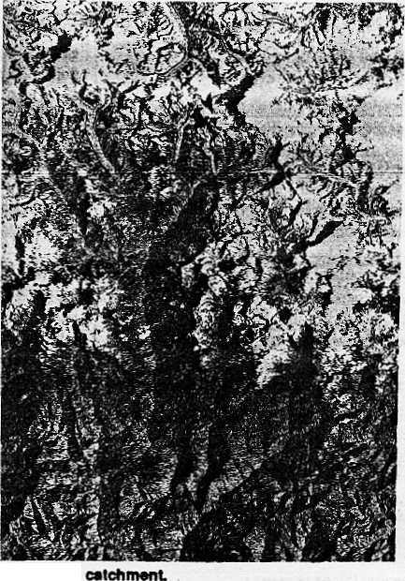
Project, commissioned in 1990, did not include any provision to rehabilitate the 222 displaced households. The fate of those displaced by the Kulekhani dam has been highlighted in the Nov/ Dec 1989 issue of Himai. The Karnali project alone will require the relocation of an estimated 70,000 villagers.
LOGIC REDUCED The author questions the passions aroused by the submergence of forest tracts by reservoirs by arguing thai there are other more significant causes for disappearing woodlands in the Hi: laya. That is true, as Nepal's exprience proves. Forthe second time in one decade, there is today an ongoing plunder of what little forests remains.
Verghese himself is passionate when he tackles the "big-vs-small controversy. His water development philosophy shuns both the eco-fun^ damentalism of the neo-Malthusians as well as the arrogance of the technologically-hep breed. He does not agree that large projects are necessarily all bad and small projects are good per se, but thai both have their proper place in development. Large storage projects on snow-fed rivers were, in fact, found to be more dependable for agriculture during the 1987 drought. "Logic pushed beyound a point is sometimes reduced to absurdity," the author writes and proceeds to ask, who can today think of an India without the Bhakra Dam? Verghese credits the dam and the Rajasthan Canal for enhancing ecology, going by the still uncounted trees planted along canal andcommandareas.Theneedisamiddlepathof wisdom and environmental prudence that may be achieved by a little planning and some foresight.
The message that Verghese wants to convey is that flowing water must be transformed into a productive resource. Nepal, India, Bhutan and Bangladesh, he says, must shed the mistrust which presently marks their dealings.
All this is well and good, but how are these countries going to shed their mistrust of each other to look beyondnational interest? Verghese asks each country to consider the other's point-of-view and also to not minimise the advantages re aped from such projects. Nepal' s apprehensions vis-a-vis India, for example, stems from its two earlier miscalculations regarding the Kosi and Gandak projects. Verghese attempts to point to the benefits that Indians believe Nepal derived: a bridge over the Kosi, flood control, irrigation,
10,000 kW of power from the Kosi (no longer functional due to excessive siltation), and another 15,000 kW from the Gandak. About Indian worries, Verghese does not specify except to say that New Delhi's perception of bilateralism in water resource sharing with Bangladesh and Nepal seems to go against its smaller neig hours' concept of internationalism.
For Nepalis, the next genera
tion of power projects to feed the
Indian market, after fulfilling do
mestic demand, seems attractive
indeed. Projects like Karnali and
Pancheswor (on the Mahakali) will
remain beyond Nepal's technical
and financial capability well into
the next century and Indian partici
pation is essential. Alas, both coun
tries are still mired in the distrust
Verghese decries. An unprejudiced
assessment of the modality of shar
ing costs and benefit has yet to take
shape. Who will manage.the mam
moth projects, during and after con
struction? What would be the dis
bursement mechanism? We are still
far from getting answers to these
questions. Himalayan
Would politicians and bureaucrats, in the continuing confusion that reigns in South Asia, risk committing their governments to projects likely to be completed in 25 years at the soonest? Who has the vision and who has the patience? While his heart is clearly in the right place, Verghese does not grapple adequately with these crucial questions. Oneis left waiting for the final analytical punch from the mass of descriptive in* formation presented in Waters of Hope.
Verghese, who is presently working on a non-governmental regional water sharing study involving Bangladesh, India and Nepal, does offer some possible scenarios. He has ventured to state, with simple clarity, what we have been too scared, proud or uncaring to admit. As the central and most powerful country of the region, says Verghese, India has a catalytic role to play in ushering in the transformation of South Asia through the use of water. India need not fear the oft-repeated bogey of "security threat" from its smaller neighbours. In the end, it would be crimi-
nal to allow the waters to flow, unproductively, just because the region's politicians cannot come together.
WaiersofHope, perhaps because of its focus on the northern basin, does not touch upon the sensitive issue of inter-state water use and sharing in India (Madhya Pradesh and Gujarat, and Tamil Nadu, Andhra Pradesh, Karnataka and Kerala), A discussion of this subject would have been illuminating and instructive.
Soon, for the first time in history, the new
government of India will be dealing with demo
cratically elected representatives of its two neigh
bours, Nepal and Bangladesh, Will each country's
representative be up to the task of tackling the
essentially political questions head-on? First,
they have to face up to the problems that confront
the region, of which water is one. WaiersofHope
is a good place for them to begin. f\
A. Dixit is a water engineer and editor of Water Nepal.


SUMMIT HOTEL
GARDEN RESTAURANT
Kupondole Height, Lalitpur
P 0 Box 1406, Kathmandu, Nepal
Tei: 521 894, 524694
Fax: 977 1 523737
Tlx: 2342 SUMMIT NP
The Summit Hotal is famous for its warm and friendly atmosphere, efficient staff, excellent food, a delightful garden with swimming-pool and one of the best locations in town with a spectacular view,

May/June 1991. HIMAL 20

BRIEFS

Calling Lhasa...
A
month before US President George Bush met the Dalai Lama at the White House, the -Voice of America, on 26 March, ,■ started broadcasting in Tibetan,; ■ under a mandate set by Congress, The broadcasts last for 15 minutes daily from 10:30 to 10:45 a.m.; "Chinese Standard Time", VOA is the first major non- . Chinese radio station to beam transmissions in Tibetan and is expected to provide relatively unbiased news, albeit with a touch of propaganda as is its
wont, (Its editorials do claim to be "reflecting the views of the United States Government.") The Tibetan transmission, 44th in VGA's international : language broadcasts, is relayed -frpmastarion.in'SriXankaand'.,. can be heard in the rest of the Sub-continent at 8:15 a.m. NST or [8 p.m; ISTl.lt is said mat the;"' broadcast to Tibet ("a remote " rural country" in VOA-speak) is being expanded within a few months.'
■ VOA's Tibetan broadcasts are prepared by a team of four translators/broadcasters all of
wljom, apparently, are Tibetans hired straight from the New York City borough of Brooklyn. A VOA manager was overheard saying on air that in order to provide better quality, more staff •\ypuld soon be tired frbm: Nepal and India. .
.. While the Tibetans are understandably pleased that VOA is looting their way, when will : the Americans start thinking about the Nepalis? There are seven million Tibetans, maximum; counting those within Tibet and thosein exile. Nepali-speakers in India and Nepal make
up many times that number. While its initiative for the Tibetans will be appreciated, Nepali-speakers await the day when another Congress mandate will move the VOA to follow the lead of the stations which today broadcast in Nepali: Radio Moscow, Radio Beijing, BBC, All India Radio, Sri Lanka Broadcasting Corporation, Radio Bangladesh, Bhutan Broadcasting Service, and the British Forces Broadcasting Service (in Hongkong, Brunei, United Kingdom and Belize). - Ohruba Adhikaiy

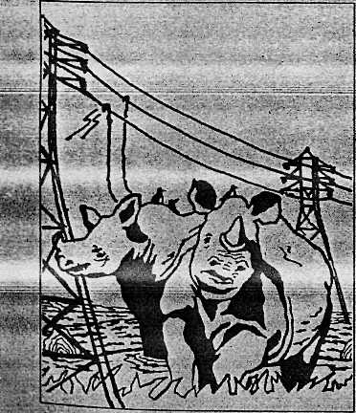
■■
They
Electrocute Rhinos, Don't They?
I
ngenuity knows no bounds, An item in the last issue of Himal highlighted the'use of pesticides to kill fish, Here is news from Assam that poachers are killing the endangered greater one-borned rhino with high-voltage ?:< electricity.
Nairobi-based ivory sleuth -.-,'-, Esmond Bradley Martin recently sent around a report on this "hor-V rifyingly effective way of killing rhinos." High tension lines run; through two of Assam's protected . areas: Kaziranga National Park,: . V.
home of about 1,250 rhinos, and the Pobitora Wildlife Sanctuary, where about 60 rhinos remain. Both sanctuaries are situated on the alluvial fkiodplain and terraces of the Brahmaputra.--.-.. :
sale/The middlemen offer .: poachers in Kaziranga and nPbbitonL about U$j6,250 a ■.;
kilo.
t v^VildUie enthusiasts' iri-V."="!:-;;;; Nepal can take cold ■ comfort from the feet that no high tension lines run
The poachers hook naked wires onto the power lines to draw current into them end then ; suspend the wires about three feet above paths used by the rhinos at night to reach grazing fields ... adjacent to the protected areas. The rhinos only need to brush the live wires to be electrocuted to ■ death. Bums on rhino carcasses indicate that they struggle for at -least five minutes before suct. : cumbing to the 11,000-voit. shock;;,-. ■....'.' -.:,, : The poachers then disconnect the wires and. hack out the horn, which finds its way to amiddle-man in a; nearby Village,-to-be smuggled out to East Asia. In Singapore and TaiwanVrhino horns fetch
Bardia .National Parks. For the moment, Nepali rhinos
: need not fear death by electrocution. Guns,
..maybe. .. ■.,..,■ ..;. .
TheDreckSack
hat is to be done when trekkers refuse to heed warnings against littering .. "^ . Himalayan trails? Slap them with ; a bright yellow sack to lug non-degradable personal waste back
;' to Germany, Switzerland or ;/ .;':j France.
The novel idea of the ■DreckSack ("trash pack" in :.,...-. German) has been developed by Giinter Strum, who runs the popularMunich-based moutntain-
i eering and trekking agency . .-■known as the DAV Summit Club. .The Club has started a."Target _-Programme Waste" to reduce the amount of trash produced in its
/ mountain tours, and to dispose of "unavoidable waste" through en-
"yironmentally acceptable means;?.' And the best thing to db> with
: compact non-degr adable trash, obviously, is to take it back to . where it came from. Why didn't"
vianyone think ofjt before?. ..:■: .:^—:
; clients to- pause awhile before boarding thai flight to Kath- :,■ mandu. Dp they really need the
. Walkman yith music cassettes ci;ti and replacement batteries? What
; about yiat big camera and all -those tolls of film and that over-sisjiffed washk^t full of rnedica-. ... tions? fvlotst towlettes individu-" ally sealed in foil? '
"Travellers should take heavy duty trash which will not decompose back home, to be
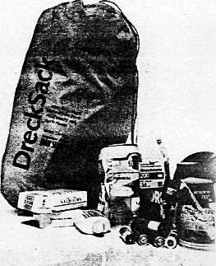
disposed of in an environmentally sound way," says Strum, who is a veteran mountaineer, "That is why we developed theDreck-Sack, to bring back garbage like batteries, aluminum foils, plastics and medications. They do net belong in the mountain landscape, not even bidden or buried."
The "return transportation bag lor trash," is made of thick, .iWashabje nylon fabric of about -iflrree litres volume/E>AV trekkers pay DM 5 (about NRs 100} for a Drecksack arid the privilege of carrying their garbage home in ^S^le/;-:¹;:^-:^-^;--^.:";-- .,.■-:> '
Strum hopes that mountaineering associations of the region and trek agencies will take to the idea. And who knowi), maybe entrepreneurs will begin to' produce DreckSacks locally: Whatever, says Strum, trekkers miist be~tbld that "who sows trash shall reap filth."

May/June 1991-HIMAL 21

BRIEFS

Eyeing Rio
■ •■■

Reaping Filth
A group of students from Saa:;;
Francisco State University arrived in Tumlingtar and headed tip north along the west bank of the Arun River; up towards the, v Makalu Base Camp. There were 13 students, chaperoned by two professors. The programme (for which the students paid dearly, we are told) was ofVJ">i|;edbVthe Woodlands Moui.....ji institute of West Virgini], which has worked in planning national parks north and south of Mount Everest. The purpose of the trek was apparently to catalogue plant species in the Upper Barun.
So far so good. But the garbage left behind by the group at the campsite of Gokane leads
The Mountahr Agenda
nbeknownst to many, a"core
group" met near Berne in ■-. Switzerland last Decembei arid started work on the "Mountain Ageoda-UNCED 1992^ The group consisted of individuals from ICIMOD, the United =. Nations University and the; International Mountain Society,' and had the objective of raising "public and political concern for the mountains and their inhabitants^ --■.-■./■ :-'^v%
The Mountain Agenda's central document will be a ;::: "Status Report" which will set out the condition of the world's mountains, trendsiri their environmental degradation, and theirprospects for sustainable development. The report will ■ focus on major mountain regions -of the world, including Hindu Kush-Himalaya, Alps,'Andes;-* ". African mountains; the Rockies? " antf the mountains of thfeSowfet^ ■ Union. . , ; ■.;--.;^;.-;-:,.j>l..
Besides production of the Status Report and other documents, the core group also " believes in a"widespread political campaign" to sensitise
Mav/June 1991 • HlMAL 22
one to wonder whether this group of botanists knew the first thing about biodegradability. Shouldn't. those wfio study plants also worry about clean campsites?
Or is it okay to blame the trekking agency staff for all the mess the sahibs leave behind, as is the usual cop-out? The sahibs and meems move on ahead, leaving it for the "staff to hurriedly break camp because they have to awive at the tea-halt before the sahibs and (he meems. The very people who would leave behind clean campsites in the Colorado Rockies or the Sierra Nevada seem to have no qualms about dirtying someone else's. mountains, including environmentalists-in-making who would come and catalogue Himalayan plants.
, "society at large" to mountain issues. However, there is no : suggestion as to how this political agenda is to be fulfilled other than to state that it requires "spontaneous support from ; interested individuals, institutions and NGOs." ■ ■
Core grouper Jack Ives of fhe IMS explains why the Mountain Agenda is necessary: "If,.:... : international and bilateral aid .agencies, governments, and eyea environmental movements, continue to neglect the mountain lands, or treat them as mere two- ■ .' dimensional adjuncts to the other ; rfiajor world Homes or problem .." areas, no balanced approach to world environment, resource , management, and development issues will ever emerge." ;
Ruedi Hdgger, Chairman of ICrMOCTs governing board, says the Mountain Agenda promoters seek''^eementsatU^CEDta v, put mountain environments in" their rightful, and urgently needed, position in: the world's:, enter of priorities." The organ- ;'*'•: is^rs invite contributions frorri up to one thousand "collaborators" in the Status Report. In the Himalayan region, contact: "Mountain Agenda - UNCED 1992" c/o ICIMOD, PO Box 3226, Kathmandu,.
. ...
O o-called activists and self-appointed protectors of the Himalayan environment are warily eyeing each other to see who gets to go to Rio in June 1992. The main idea is to get to Rio. Secondarily, it is to attend ECO'92 (also known as UNCED), the United Nations-sponsored environmental summit conference being organised 20 years after the landmark environment conference of Stockholm in 1972/
; . In Nepal, a government-, appointed "steering committee" assigned the task of preparing the national report for the.Conference. to New Era, a private consulting firm. The Nepal Forum of Envi-, ronmental Communicators has expressed apprehension thata ■ national report is being prepared by a consultancy group for a fee, reportedly, of three lakh (Nepali) rupees. The consultants respond: : would you rather that an "outside expert" be hired at three times matfee?
A new non-governmental group has been formed, known as '"Coalition Nepal", attempting to"
Bhutan
np he inhabitants of Druk YuL : nbmber 13 million, right?
No, more like 600,000. King Jigme Singye Wangchuk has admitted as much in recent interviews. UNDP and other aid agencies had already received hints earlier.,:
It appears that Bhutan's population was fixed atone million back in [1975] to make it"' easier for the country to gain membership in the United ":■ "■': Nations. From then on; it became ■ necessary to live the lie and . "natural growth" soon had the: population up to 1.3 million by ' t990.
The exact population figure" .■:} (no fibbing) will not be known until the first census of Bhutan,
consolidate the strengths of various NGOs active in the field of environment. Various; areplanried, siich as; a"green technology expo", and an "environmental photo album". The mast-head of the group's letter pad is more clear on the intent — perhaps. "On The Road To Earth Summit -'92" it reads.
There is also a "Who's going to Rio" fight brewing in the government. The "steering committee" mentioned above comes under the Planning Commission and has just about every government secretary and two token independents as members. One of its main tasks is to celebrate 5 June as World Environment Day. Nothing doing, said another committee that was formed under the Ministry of Forests and Soil Conservation. The issue has been settled for now. Today, there is only one committee.
In the end, one might be
forgiven for suspecting that this
sudden interest in 5 June 1991
has to do with who will get to go
to Rio in 1992. Rio is about the
furthest it is possible to get from
Kathmandu on a junket. And
every environmentalist wants to
: fly Vang, Brazil's national ,
airline^ . ' ■ ■■• - . -
which was started in 1988, is . complete. However, there is no saying when tfiat will be. Part of the present Drukpa-Nepali conflict is said to have its origin in the census inaugurated in the . southern district of Samchi, when the authorities claimed to have discovered 18,000 "illegal aliens'VThe census has been bogged down since then and it i seems the world will have to wait till die internal political problem .: is sorted out before it finds out the number and proportion of Ngalungs, Sharchokpas and Bhiitanese Nepalis in Bhutan.
■ Inciderrtally, does Bhutan's : mea culpa hold any lesson for Nepal, whose population has been rising improbably all these years and today is said to be within hailing distance of 19 million?

BRIEFS.

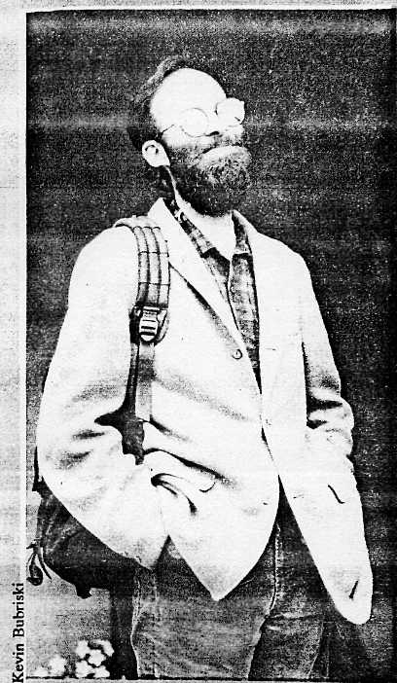
The Funky Trekker
tt ugh Swift, one of the great '■■-" Himalayan trekkers, author ■ of Trekking in Nepal, West Tibet and Bhutan and Trekking in Pakistan and India, and archivist par excellence, died suddenly in California ori 16 February. This : gentle, private man, who never owned anything bigger than a bicycle, spent 20 years travelling throughout the Himalaya,
.'..wearing a Pakistani sAc/hot*, ;, -equipped with lit*¹ *nore;than his ubiquitous tuu.—mo,and ah:'■"'''.''']V.."; abiding desire to experience (and
■#' record)every remote corner; of-;:
"^{:V} the mountains he loved. Ttekkiiig made him feel "liberated from the
. thrall of time and Western materialism," he wrote, and many of his
¹ journeys were pilgrimages, not in a specifically religious sense, but
vioumeyswithagoalandpiirpose. Always aware that the journey itself was as important as the ■ ttrival at the goal. - ..;■:.-,:,.
■ "■■'-;The destina-
: tioninjght. have, been
h'tlfe^i ; "'
power places of the region (he circumambulated Kailas three times on two * different trips), a.. ; newly opened route! (when the Khunjerab Pass opened to..-..,.'. outsider travel in t ;1986, he immedi-: ately made a circuit norm of the Hima- . laya), or simply a valley that was of interest because he had never been there. Not a bagger of '^firsts (although he always knew the history of exploration and who had been there before him), Hugh did the .. Annapuma circuit 13 or 14 times, and always found something new to pot in his meticulous ■ notes. Rather than complain about •rm area being ''spoiled" by mass, trekking, Hugh's perspective was, .i* .".These are the good <>Id days!" Hugh was a tireless sampler .of local products, and he would , ; "'. speak with great enthusiasm of
■ the particular rod in such and
■"■■ such a village. Although he led
"■ many trekking; "groups, his-
preferredstyle of travel was what :. he labeled "funky trekking",
which meant going out with one
-"■.■;porter;%nd^haring: t^e food and i.:
accommodatioh of local travell-
^{y}^-l<^\-v.ti'''--X!-:-;':;'.:--:. ;:'.,,;■■ ■■: ■■:': \.'■:::■■:.
"■■While; mourning his passing, •■ • his Mends in Asia and the United
■ States take opiiifort in the
knowledge that Hugh was an
■£ unusually self-realised person . ;
who clearly focused on what he
¹:: wanted to do and arranged his life i
- so mat he could concentrate fully
: on the things he cared about and
..■..- wanted to accomplish. , >
-Pam Fkjss
Hillary: Children's
t enough is being ■ done for«ur children," said Sir Edmund Hillary. He was speaking asllNICEF.'sncsyly...-.. appointed "Spepial liidpres^nta-' tiye of;the.Children of the Himalaya." He continued, '"Without childreny our future is ..nothing.".- ....;!..■ ■: > "At UNICEF's behest, Hillary was speaking to journalists in .Kaflimandii about his new .-. . ^honorary rote."."I'll do what they tell me to do," hesaid, adding with a laugh, "I'm not making :;;.~ money out of this."
In fact, Sir Ed is supposed to make money/pr jUNICER His role will be to raise UNICEP's profile among those in the donor countries Who might have a ; handle on funds for the Himalayan region. lie is also expected ; to lobby the region's governments to go beyond rhetoric to pay greater attention to their young. .
While he is known primarily . as co-summitteer with Tenzing, Norgay, Hillary has been involved with Himalayan (Sherpa) children for more than (wo decades. The schools and hospitals he has built in the Solu-. Khumbu have produced healthy, ■ educated young Sherpas who are' a step ahead, of many other hill : communities. The school Hillary buili in 1961 i'h. Uie Sherpa village
Up Ahead
Tp
he Indian Mountaineering
Foundation is organising a Himalayan Mountaineering ^rtd'.: Tourism Meet in New De!hi on 21-22 September^The purpose of tfie Meet is; "to bring j»^{r}gether: v:; decision milkers aid key - ■ ; operational agencies concerned .*V|th. the promotion of mountain- _.
the Himakya and preservation of, tibe mountain entvirpnment." , ..
Participants will represent a wide
of Khumjung started with 40 students. Today, there are 404,
;Said Hillary, "The main problem with children in the
. niountainsis health and education. In education, getting rrtotivated and well-qualified teachers remains the challenge." Turning from children to the state of mountaineering, Hillary said; "It has changed for the worse; there are more prima ■ donnas today. When I climbed all
s I wanted to do was to climb the mountain. As simple as that.". Hillary, who is 7V; admittedthat
, he had recently suffered symp-Jr toms of altitude sickness (pulmonary edema) at 13,500 ft.
.■■:*Tve been there, IVe seen it all and I've come away, and I'm not going back again."
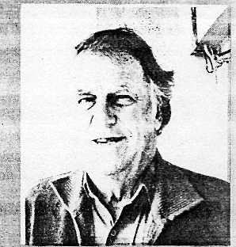
' .' Back to UNICEF and ■ children, in his fund-raising role, Hillary is joining such celebrities ].-i is Peter Ustinov and Liv Ullman. '-•- ■ In his case. Sir Ed's hands on
experience with children's issues ■;■ :>.id;Solu Khumbu should count;;:;'
■ cross -sei^ion of thetravel ffi3e"" and "environmentally conscious organisations" both from India and She main Alpine regions of the world. Among the' 'big ,^ i
Hillary, Maurice Herzbg, .; ■ Reinhold Messner, Chris Bonington, Junko "^ Nm, M.S.
Singh. ...: ;■
Contact: IMF, Benito Juarez Road,NewDelhi 110021.
Tel: 671.211 ■ '■■ F ■ V^' ■ .

May/June 1991*HIMAL 23

FEATURE
Patan: AGity No More Shining
The art, culture and ambience of old, medieval Patan has almost disappeared under the assault of historical neglect and runaway "modernisation".

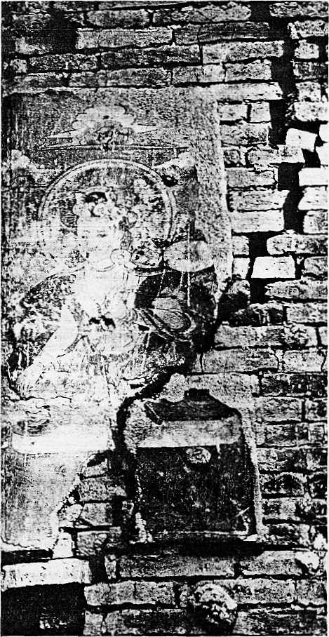
by Bijaya Lai Shrestha Photos by Stephen Eckherd
B
uddhi Man Shakya, a 77-year-old craftsman from Nag Baha, remembers the days when traditional Newar homes like his used to grace all the-narrow stone or brick-paved streets of Patan and its multitudeof courtyards.Even till the late 1960s, the market thoroughfare of Man-gal Bazaar, the Durbar Square, and the more than 175 residential courtyards had an ambience that was quintessentially medieval Patan. Lalitpur, the artisans' town, which is Patan's other name, looked and functioned like Florence, Milan or Rome might have at the height of their renaissance glory.
But no more. Over a span of just four decades, Patan has lost that luster it had preserved for centuries. Today the skyline of the "city of a thousand golden roofs" is being taken over by spindly concrete "skyscrapers" built on tiny plots of sub-divided land. The population has doubled many times, the townservicesareover-burdened and Patan today is a dirty relic of its old self.
Aged buildings with frescos, latticed windows and fired-brick fronts come down in a flurry of centuries-old dust and in their places shoot tip multi -story ed cement boxes with ubiquitous steelshutiers on the ground floor. Billboards of Pepsi and Coca Cola block views of stupas, political graffiti deface temple walls, and banners of assorted beers and lotteries festoon the narrow gullies. Patan gets to look more and more like India's provincial towns of Muzaffarpur or Gorakhpur.
In the courtyard of Nag Baha where Buddhi Man whiles away his afternoons, the deep foundations of the neighbouring high-rise have disrupted the conduits that bring water from faraway sources to the sunken dhunge dhara (water spout), and the flow is down to a trickle. Outside the courtyard, there is the din of care, three wheelers and motorcycles beeping and speeding on the gentle, winding lanes meant only for foot traffic.
Even today, it is possible to traverse the entire length of the Patan by going from one baha (monastery compound) to another, only once in a while stepping unto a public lane before entering yet another baha through tunnel-like passageways. Each courtyard used to have a distinct ambience, defined by who lived there and what trade was practiced by its resident
It is within these bahas that the extraordinary artistry of Patan's Newar artisans was born.
But where once craftsmen chipped away at stone, or hammered on brast or copper, today, shops offer cheap locally made curios, or souvenirs imported from Hong Kong, Thailand and India.
DYING BAHAS
The deterioration of Patan's indigenous cultural forms can be ascribed to a number of historical, political, economic and demographic factors. A slow decline actually began with the fall of the town's Malla rulers. In 1768, Prithvi Narayan Shah conquered the threeprincipalities of Kath-mandu Valley and established Katmandu town as the national capital. Bhaktapur and Patan were sidelined.
The political unification of the Valley ended 550 years of stability and prosperity under the Mallas, during which period Patan was able to preserve and build on its uniqueness. The chaos that followed Prithvi Narayan's death in 1774 also marked the beginning of the endless palace intrigues in the Valley, which kept the upper classes fully occupied. The Newar artisans had lost their Mallt patrons earlier, and in the confusion that ensued, there was less and less support for the arts.
During the last century, the lucrative India to Tibet tradeth at passed through the Valley began to dry up, especially after the British opened up the Chumbi Valley route from Ka-limpong. With the slide in trading activity, the income of the Newar towns plummeted. A major source of income under the Mallas had been the customs duties levied on goods in transit to Lhasa. Also, Patan and its sister towns had a monopoly on handloom exports to Tibet and the nearby mountain regions. Patan's brass-ware, bronze statues, religious paraphernalia, and silver and gold ornaments were in great demand in Lhasa.
Patan is said to have suffered more than its sister towns after the change in political fortunes. While Kathmandu enjoyed its status as the
country's capital, Patan's close proximity to Kathmandu meant that, after 1768, its political identity diminished even more than Bhaktapur's. Before the unification, Patan was governed by a council of six powerful ministers, known as the Pradhans, who wielded enormous power. They were king-makers who had humiliated and dethroned many a ruler. Dal Mardan Shah, younger brother of Prithvi Narayan Shah, invited by the

M»i/Jupe...1991. • fflMAL 24

FEATURE

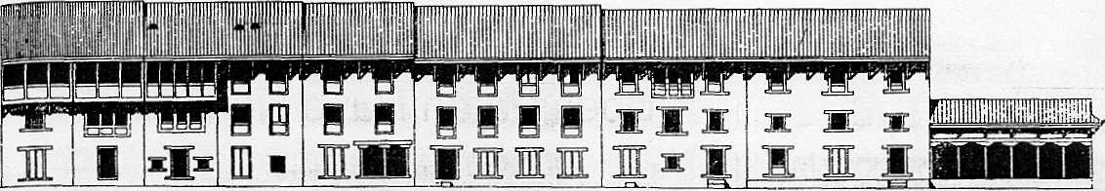

"The Traditional Architecture of Katbmandu Valley." W. Kom
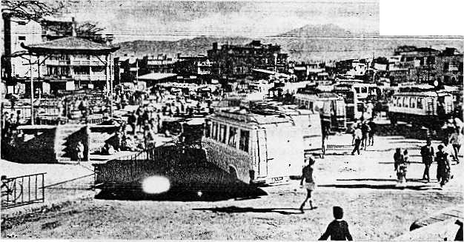
Lukhachhttn Tola, Patan. Pradhans from Nuwakot to rule Patan, was one of thosedeposed by the Pradhans. Soonafter the conquest of 1768, these ministers were killed, and Patan was spited.
Why else, ask local residents, was Patan Durbar left to rot while Hanuman Dhoka in Kathmandu and the Bhaktapur Durbar complex remained well preserved? Even today, no military guards stand at Patan's Durbar Square, as they do outside the Bhaktapur and Kathmandu durbars. This may also explain why so many idols have been lifted from the Patan's durbar complex.
ANARCHIC MODERNISATION
The,century-old Rana rule continued the Shah tradition of ignoring Patan. The annual "Bhoio JaSra" of Machindranath (Bungdeo), which required the king's presence, was the only day when Kathmandu's power elite looked Patan's way.
Other than build a few French Renaissance style palaces (about as far as you could get from the indigenous architecture of the Valley) in the fields outside the town, such as in Jawalakhel and Pulchowk, the Ranas left Patan to itself. While this translated into loss of political power and stagnation, the workings of the old town was not tampered with. Outside influence was kept at bay andPatan remained "medieval" well into the late 1950s.
It was with the passing of the Ranas and the opening of Nepal to the outside world that time suddenly caught up with Patan. It found Patan unprepared. At first,the change was slow, but with all manner of social and economic influence breezing into the town, the pace of changeacceleratedtoafrenzy.and anarchic modernisation emerged the victor.
The exponential increase in population and the continuous division and sub-division of property within Newar families have dealt death blows to old Patan. For a town that is said to have housed a population of a little over 15,000 under the Mallas, within the same living space today there are about 60,000 Patanites, and their numbers grow.
LagantdMt.
The infiltration of "western" values into the inner core of the town is evident in the collapse of Buddhi Man'sjointfamily.Five years ago.his four sons decided to break up, so Buddhi Man had to divide his house four ways. When a Newar house is divided (angsa banda), it is normally separated into vertical segments. When Buddhi Man's third son found hisliving space reduced to such a sliver, he sold his share to his brothers and moved out of the old town precincts to Kopun-dole, down the hill towards Kathmandu.
Today, Buddhi Man's old house has been cruelly transformed. Half of it remains untouched, with the traditional motifs, frescos and latticework intact. On the other half, from a narrow base, concrete pillars andcantilevers reach out at the second floor to make more space. The rooms are one on top of the other, connected by a narrow stairway that reaches up four stories.
Not even one new house is built to the old architecture. While there is function in the modem cement boxes, there is no beauty. And the series of cement boxes around &baha robs it of its soul, unlike in the preserved sections of the old cities of Europe. While the old houses had dank and dark landings used for stacking straw, the ground floors of today are buiJt with an eye on the market. Houses facing the street have cement plastered over handsome red brick to make them commercially more attractive.
One is not sure whom to blame for the architectural folly that has done Patan in. "But where can we get the wood to build what youcall a typical Newar house?" asks Ram Chandra Lai Joshi, a shopkeeper. He lives in his old house at Nag Baha though he has built a new brick-and-
concrete one just a block away. "Where are the artisans.wheredo you get theold/e/iaeef ("oued bricks"), and the old techniques? A cubic foot of wooden beam costs 500 rupees."
FREE-FOR-ALL
The real estate boom at Patan's outskirts, particularly the perimeter from Lagankhel around to Pulchowk and toward the Bagmati bridge and Kathmandu, has also changed the character of the town. New residential enclaves have come up, inhabited by many who have forsaken their compact, traditional inner-city settlement to live as suburbanites with lawns, gardens and garages. What they have lost in this shift is the life of the public spaces within all old towns: the courtyards, the neighbourhood shop, the potts (rest houses), the public stages, and the dhunge dhwas. Meanwhile, suburban Patan has claimed the very fertile agricultural land which had helped sustain medieval Patan. The Mallas had kept Patan residents from building outside its precincts so that there was no encroachment on the productive fields. Today, it is a free-for-all. The sky-rocketing price of land has made many traditional fanning families (Jyapus) rich in cash. Many Jyapus of Jawalakhel, Kumaripati, and Chakupat have given up farming altogether, their time-tested skills in farming lost forever. From PatanDhoka, only a decade ago, you could travel down through terraced rice fields all the way down to the Bagmati River. Today, this is the neighbourhood known as Chakupat, an unplanned mishmash of upper middle-class housing where concrete and tarmac is the rule andrice fields the exception.
Why has Patan changed more than Bhaktapur? In a way it was Bhaktapur's poverty that
helped preserve rhattowii.K
became much more commercialised and its land values rose dramatically because it was closer to Kathmandu. Eachpaisa Patan's wealthy have has gone into tearing down old buildings to replace them with new cement ones. One measure of Patan's wealth is the fact that weli:heeled Kathmandu families no longer hesitate in giving their

May/June 1991 • HIMAL 25

FEATURE

Does Patan Havo No Pride?
daughters to Patan families, while they would think twice before considering a match with a Bhaktapur boy.
LOST CRAFT
Though Patan remains a Newar town, the larger "Nepali culture" has intruded on its insularity, through education, radio, television and exposure of residents to the "modern world" outside. Two decades ago, a non-Newar who came to Patan to sell his wares would have to first learn Newari, says Maher"¹- ■ ^hoj-Joshi, a middle-aged retired shopkeeper. Today, the people of Patan use their video-film Hindi while buying vegetable from Indian vendors. Many Newar children do not speak their parent's tongue even at home because schooling is in Nepali.
Today, residents seem to have little pride in "belonging" to Patan. Whereas even two decades ago, famiEes were unwilling to live away in spite of better facilities outside, today's educated generation would readily pull up the stakes and shift to Kathmandu or to one of the suburban settlements.
Dev Ratna Shakya, 55, a jeweller of Naka Bahi is one who would never move. But does the same hold for his five sons? The two eldest have followed the family's calling and make silver and gold jewellery, The third has taken to writing for journals in Newari, the fourthis studyinglaw, and the youngest finishes high school this year.
"It is difficult to keep a balance between my sons' interests and this family art," says Dev Ratna. "If they go to college they will stop making jewellry, but I also want them to be educated."
To Patan*s young, it is more prestigious to own a general provisions shop, join government service or the university, or be a travel executive, than to follow the family's calling. And so they leave the trade, which is taken over by mass-production artists with an eye on tourist sales. The fact that Nepal's schools do notimpart any vocational training has hit the Newar towns hardest because, as the traditional father-to-son transfer of skills is interrupted, there is no other means to keep a craft alive.
Thus it is that the stone masons have all but disappeared from Patan. The town previously had many stone totes where Ion karmis worked on the thriving tradeof stone carving. Today they are confined to a few families in Bhinche Baha.
Patan also had a vigorous handJoom industry. Unlike Kirtipurand Bhaktapur, however, the business has all but disappeared in Patan. "Practically each house used to have a loom and you saw women with hand-held spindles dryingyarn for saris along every baha lane," says Ramchan-dra Lai Joshi, 77. Cotton and nylon saris imported from India have taken over. During the time of the Ranas, remembers loshi, weavers
by Stephen Eckherd
I
f you can withstand asphyxiation by the combined fumes of the local latrine and the Patan buses enter Patan through Patan Dhoka. If you can find your way through, the shanty town at Lag ankhe or avoid being hit on the freeway of Pulcbowk, visit Patan while there is still something left to see.
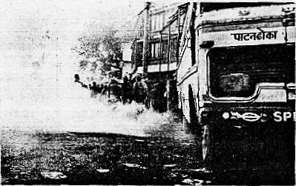
i
I first came to Patan 25 years ago. At that time, a few whimsical white stucco versions of Singha Durbar and a few ugly government buildings of cement on the edges of Mangal Bazaar were the only exception to the red brick, wood and stone of old Patan. Sheep grazed on the Ashoka stupa at Pulchowk and temple bells were the loudest sound on a windy day. To enter abaha was to step back in time, to immerse yourself in living history.
Returning to Patan in January this year was a painful experience. The charm is gone. In most countries, the houses which I saw and photographed a quarter of a century ago would have been on a national register of historic preservation. In Patan, they have been cemented over, or razed to the ground. The wealthy have used their power, paid their bribes, pulled down old classics, and thrown up new ones in concrete. Among the more unique travesties is the splitting of houses down the middle, one side recalling Patan's glorious past, the other side miming the worst of contemporary Sub-continental architecture.
What was unique about ancient Patan was that a common esthetic and love of craftmanship crossed all social andeconomic boundaries. Small shrines, private homes and tiny shops wereoften as elegantly decorated as the king's palace and the major temples. Many were of superior craftsman-ship.
Nor is any great, new shining city rising from the foundations of the old. From the dust of crushedred brick, dull grey cement buildings now cast long shadows over temples and bahas. Where richly carved "akhey jhyas" once stopped me in my tracks, today glass windows stare blankly out on the gullies. Where open passageways with painted parrots and frescoes of protective dieties led into exquisite courtyards of stupas and shrines, today, metal grates and sliding steel doors block the way.
Do the citizens of Patan really care? Woodcarvers may complain that they have no work, but their own homes areof cement. An artistmight feel regret at seeing a fresco done by his grandfather crumble with the demolished ho uses, but hefails to pass on the technique to hisown sons. TheNewar curio dealers of Patan are themselves willing to sell copies of traditional Newari images which are mass-produced in India.
And what of the tourists, from whom Patan hopes to earn its future income? Tourists come for postcard views: a reconstructed Wiftiamsburg or Warsaw, the meticulously restored town squares and cathedrals of Europe flanked by houses and shops of the same period. They expect to wander through blocks of old cities where even electric and telephone lines, and not just sewers, run underground. Patan, on the other hand, offers 17th Century stupas hemmed in by electric transformer poles and concrete buildings.
If Patan had civic pride, its citizens would try to save their town from self-destruction. They would ban the sale of curios which are not authentic, and bring down billboard and banners that hide temples and shrines. They would restrict vehicular traffic in the narrow lanes and find a way to keep Patan dirt-free. They would also lobby to eliminate property taxes on houses of artistic or historic significance, and increase fees and penalties for new construction. It isjyithin the power of the citizens of Patan, even now, to resuscitate their old town.
S. Eckherd is an anthropologist presently studying the Tharus of Nepal's Parsa District.

May/June 1991 • HIMAL 26

FEATURE



were paid 10 paisa for weaving a yard of cloth. "But now even for 12 rupees, no one is willing to take up the work."
THE GUTHIS
The Mallas, whose rule began at the end of the 12th Century, provided Patan with a water system andseweis. They built monasteries, temples and rest houses, and set the rules and regulations for running the town. One of the traditions they left behind was that of theg«/Ms, which are trusts run by neighbourhood elders Cguthiyars"). The heait of Palan beats in these guthis, which have the responsibility of maintaining the temples and monasteries, observing rituals and festivals, and sponsoring feasts. The guthiyars, in turn, re!ied on the income from their agricultural lands, brought in by the tiller who had a ten ant-landlord relationship with the guthi.
If there is onecause for the decline of Patan's h'vingculture.itisthepauperisationoftheguthis. Large tracts of guthiland were confiscated during the reign of Rana Bahadur Shah, grandson of Prithvi Narayan. The vast grounds of today's Singha Durbar Secretariat were once property of Patan's YampiMaha Bihar (Ibahi). TheRanas, too, confiscated the lands of many bahas to build palates, depriving many guthis of their primary income source.
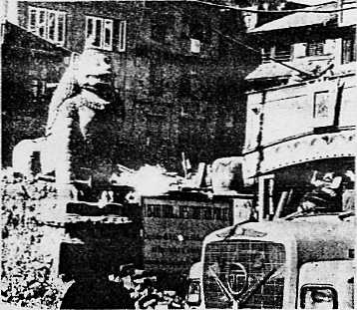
In
1964, King Mahendra introduced the Land Reform Act as part of a social programme to do away with exploitation ofthetillef.lt proposed to secure for the tenant ownership of a part ofthclandhe tilled and a substantial amount of the harvest. While most landowners managed in one way or the other to evade the programme's impact, theguthis caught the full brunt. Prior to land reform, the tenants used to bring in their dues without the community members having to supervise the harvest. But the land reform broke the bond of trust existing between the jyapu farmer and the guthi. A national government's well-intentioned and "modem" programme had the effect of weakening the core of Patan's old traditions.
In some cases, the farmers lookadvantageof the situation by having the guthiland registered in their own names. In others, members of the guthi themselves acquired legal ownershipof the land by deceit. Mostly, however, tenants simply stopped bringing asharctothc guthi. As transference o fg ut hi rea I estate into private hands reached scandalous proportions, the government set up the Guthi Sansthan in 1964 to undo what its policy had wrought. The Sansthan (corporation), to be run by tfie government bureaucracy, was to look after guthi properties and to channel the income back to the guthi community.
The Sansthan, in many instances, soldguthi-land to the tiller and deposited the amount in a bank. The interest was then given to guthi members to cover the usual guthi activities as well as to maintain the guthi buildings. In such cases, the guthi's traditional income of food grain was replaced by interest from the bank.
Unfortunately, theGuthi Sansthan, like most government offices, is poorly run. It has a hard time running the guthiland in 72 of the country's 75 districts. The inevitable official corruption has also had its toll on the guthis. Also, the Guthi Sansthan bureaucrat is liable to view the festivals, rituals smdpujas as simply administrative work. Ideally, the Sansthan should have kept the guthis afloa,t until they (the guthis) were given back to the people.
Since land reform, BuddhiRaj Bajracharya, 77, the guvaju priest of Cho Baha, has received only one muri (a sackful) of paddy for performing the annual rituals required of his position. Every year, in the bright half of the month of Chaitra, after Buddhi Raj performs rites at the shrine of Cho Baha, he is expected to give a feast to the community. Since the guthi income is not enough to feed even a quarter of the guests, he has to reach into his famUy coffers. Says Buddhi Raj, "I am doing it merely because I am Hearing my end and because it is my dharrna."
FOUR THAT SURVIVE
Together with the decline of the guthi system, one sees in Patan today the steady disappearance of traditional rites and rituals in many temples and shrines large and small. Without an income nor caretakers, many small vihars (Buddhist monasteries) are in ruin. Hem Raj Shakya, a specialist on inscriptions who is retired from the Departmentof Archaeology, says that most vihars are no longerplaces to learngranihas (old texts), ayurveda and traditional iconography. "As a result, today's community members are illiterate in traditional learning. They are no longer able to look at inscriptions and religious documents, and decipher history of the bahas in which they live," says Shaky a.
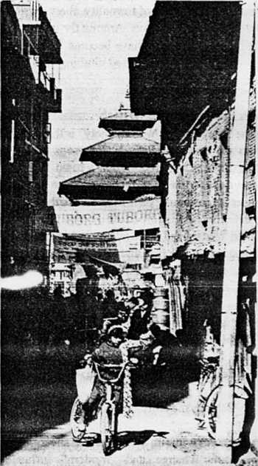

May/June 1991 • HIMAL 27

FEATURE

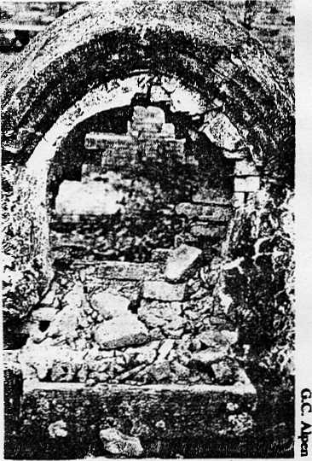
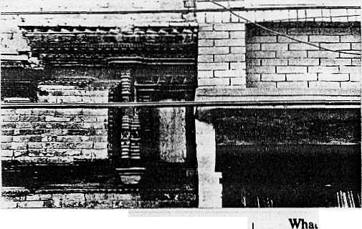
Only four of the 15 principal vihars in Patan continue the tradition of sounding the wooden gong known as the dkarmagrantki to summon lay people to worship. These are Kwa Baha, Ugu Baha, Bu Baha and Ha Baha. These vihars have survived because their incomes from guthilands have continued uninterrupted. They have managed to remain out of the Guthi Sansthan's administration and, most Importantly, they have-a loyal contingent of well-to-do community members.
Even the richer vihars today find it difficult to manage all the traditions due to the high cost of performing rituals, hosting feasts, and maintaining the spaces. Kwa Baha now conducts the Sambhyaya feast only once a year instead of four times. According to guvaju Hira Vajra Bajra-charya, who laments the loss of faith among his flock, those who attend the pujas and ritualsdo so more out of a sense of formality. Piety seems to be on the wane, he says. Among the well-to-do, religious ceremonies have become social occasions to show off imported clothing and lavish gold jewellery.
PATAN SURRENDERS
One falloutof the "waning piety" is that the care and protection of Patan's numerous places of worship has suffered. When a town as rich in traditional artifacts and icons as Patan suddenly loses the community spirit, and when the administration and police are made up of often disinterested "outsiders", idol-lifters and international smugglers move in. Idol theft has stripped Patan of many priceless treasures. Eighteen idols are missing from theTushaHiti, the royalbath in the Patan Duibar Square. Astonishingly, a police post is located in the very same courtyard as Tusha Hiti. A few years ago, the life-size idol of male/female Balbhadra was lifted from the Ta Baha courtyard (what you see in its place is a new, idol).
Perhaps the story of Patan is the story of all ancient communities subjected to political pressures from without, as well as the sheer pace of economic change and "modem" influence. Unable to withstand the changes, Patan has lost its old unity and ambience.
Today, as one takes the side gullies off Man gal Bazaar, a sense of old Patan still lingers under the eaves and mound the shrines. But within a few years, even this will be gone. The retouched Durbar Square or the main vihars will terve the tourists, but for the inhabitants that will not be enough.
is Patan waiting for? As the temples and the vihars fall into disrepair, perhaps its inhabitants are looking the way of a well-meaning western government, or UNESCO, to come along and give them back their city. Because the Germans restored parts of Bhaktapur, perhaps Patan is waiting for the French. This waiting game is costly, because every day another tradition bites the dust, another ancient dwelling crumbles, another exquisite door or window succumbs to rot, and another idol is stolen. The people of Patan have to wake up to the meaning of what is happening to their city.
Many attribute the drying up of numerous sunken dhunge dharas and wells to the construction of the Ring Road, which is said to have cut off the fla/Ku to aqueduct which brought in water from the south. If the people of Patan want it, the conduit can be reconstructed.
There was a pond at Kumaripati that had been handed over to aguvajubyGirv ana Yuddha Bikram, successor of Rana Bahadur. People purified themselves in the pond on the tenth day of mourning their deceased. Unable to sustain its
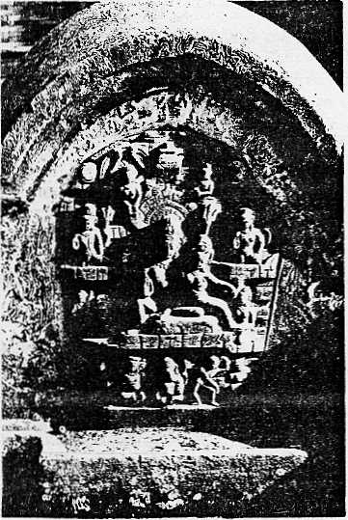
upkeep, the guvaju's grandchildren handed it over to the Town Panchayat, which simply divided the pond into smaller plots and sold them off as commercial property. One of the houseson thisplot is today the Lalitpur District office of u_{lv} Nepali Congress party.
What does the new democratic polity in Nepal have in store for Patan? If the old town could not be preserved even under directed authoritarian rule, is there some hope in a democracy? Taking advantage of "freedom", many clever Patanites have already added a storey or two to their new buildings, exceeding the limits set as a zoning measure by the now-defunct Panchayat government.
Unless these clever residents wake up, the economic pressures of modernisation will continue their onslaught on Patan. Local initiative and activism, discouraged in the decades past, are now allowed full play by Nepal's democracy. And if any community in Nepal can come to-gether with the activism and the funds required to preserve the heritage of the old Newar inner cities, it is the Newars themselves.
So, if Patan is to preserve its uniqueness and
not be subsumed into the identity of Kathmandu,
the townspeople have to take matters into their
own hands. Unfortunately, those who would be
activists in Patan are preoccupied speculating on
land or adding floors to their skyscrapers. Busy
as they are reaping economic profit from the
Valley's commercial and real estate boom, the
young careerists of Patan would rather join the
Jaycees or the Lions than take a concerned look
back at the old neighbourhood guthi. K
B.L Shrsstha is a reporter for Kathmandtfs Rising Nopal daily.

May/June 1991 • HIMAL U
iicforc ami aflcrr Uma-Mahcshwar image of Kumlthqshwar. Patan.

Voices

[Analysis]
NEITHER SELF-CONTAINED NOR SELF-SUSTAINING
From article entitled "From Autarky to Dependency: Society and Habitat Relations in the South Asian Mountain Rimland," by geographer Nigel 7Jf. Allan in February 1991 issue of Mountain Research and Development
I
t is widely assumed that mountain societies in South Asiacan now be self-sustainable. In almost all cases this idea is fallacious and is crippling some form of self-development that can be achieved, because it fosters the hope that, at some time in the future, mountain communities can be self-sustaining. Nowhere in the South Asian mountain rimland can one find any area that is self-contained and self-sustaining. From Afghanistan, where so much of the income has been derived from smuggling goods and illicit drugs to Pakistan, to Assam where the tribal population is struggling to make ends meet by working as road laborers, the indigenous population cannot be supported exclusively by their immediate habitat.
An examination of these mountain societies and habitats reveals a historic failure to maintain anything like what ecolo-gists are fond of calling "equilibrium." From one end of the mountains to the other the investigator finds a legacy of trans-montane trading, caravan and slave raiding, conquest, starva-tionandsubsequentdeath.andcontinualmigration to the plains. Mountain migrations is a prominent form of "maladaptation," common through the South Asian mountain rimland. Migration of impoverished mountain peoples is not at all new; one need only think of the regiments recruited from the Highlands of Scotland and the Swiss guards who guard the Vatican today as well as the Tibeto-Burman mercernaries from Nepal who recently won a reprive to enable them to continue to serve the British government. Simply stated, the resource base of the mountains is inadequate to support the population of the mountains.
Pisco very]
THE PANAX PSEUDO-GIN_-SENG AND THE REAL THING
From "Korean Ginseng Found in Nepal," unpublished manuscript ofKhagendra Pradhanang, who was once described as "the incredible hobbyist ofDhankuta" in East Nepal.
A,
.nybody interested in fauna science knows about Panax pseudo-ginseng, which belongs to the Ivy family (Araliaceae). It is a forest perennial closely related to the Korean ginseng with rhizome and 15 to 30 cm, topped by a whorl of digitate leaves. Leaflets 4 to 6 , lanceolate, long, pointed, saw-toothed with scattered bristles above. Flowers greenish yellow in globular, Usually solitary, terminal long stalked umbels 1.5 to3cmacross, Petals 5 ovate. Fruit globular, shining red and black.
Between 1,500 m and 2,000 m, I found a single plant topped by a whorl of digitate leaves in a very rugge and sunny place with red earth and many pieces ofquartzite all around, surrounded by a king of "Pirrhe" grass. I was thrilled. But when I brought out the plant from the earth, I was aghast! It was not like the rhizome of Panax pseudo-ginseng but instead looked ;ole a radish with a faint yellowish brown colour. I was struck to see that it was thesame as the rhizomeof the Korean ginseng. It was sub-cylindrical, spindle-like, about 12 cm long and 2 to 3 cm thick. Within the yellowish brown bark of the cambium layer was the same as the Korean cambium layer with slippery juice. The root has an aromatic odour. I thought it wise not to taste it until a laboratory test is carried out.
The plant stands less than 20 cm in height. Its stem is thin, with a whorl of figitate leaves, and leaflets 2,3,4, etc. Unlike the pseudo, the leaves are not saw-toothed and the bristles are absent. The rhizome, especially, is quite different. In compari-sonio the thin stem, the root is thick like a radish. I found three plants. One in a sunny and rugged place, another in very deep shadow, and the third one was in a place neither sunny nor shady.
The Nepali ginseng is very much like the Korean ginseng and is a very valuable plant. Nobuo Kase, Director of the Japanese Institute of Fauna Science, has seen the photograph and description and has telephoned me to confirm the identification. Anyway, the scientific proofing is in process. Let us see whether I am entitled to be called a discoverer or not and again I shall tiy to inform the readers.
[Editorial]
GORKHALESE VS. NEPALESE
An editorial in the Sikkim Observer weekly of 20 April 1991, published from Gangtok.
T
X he formation of associated bodies of Gorkhas in Sikkim voicing similar sentiments of the Gorkhas in the hills of Darjee-ling is an indication that politics in this region will gradually become more assimilated. The main issue which seems to be a uniting factor for avast majority of those living inSikkim and Darjeeling is the language issue - the Gorkha bhasa. More and more people inSikkim are looking towards theGNLF chief, Mr. Subash Gheising, on this issue. Similarly, many in Darjeeling, particularly those who oppose Mr. Gheising on the language issue, are looking towards Sikkim and identifying themselves with the StateChief Minister, Mr. N.B.Bhandari, who has been pressing for constitutional recognition of Nepali language.
Many believe that Mr. Bhandari's various activities on the language issue involving many organisations and individuals from outside the State have indirectly forced the Gorkhas to initiated their own plan of action in the State. Along with the "bhasa" issue, various other issues such as culture, religion and ethnicity may soon surface, adding to the already complex socio-political pattern of the hill people. And as the two Nepali

'

M.j/June 1991 -HIMAL 29

leaders fight for supremacy over the language issue, a time will come when they will be forced to demonstrate their numerical strength among the Nepalese living in the subcontinent The fight between the Gorkhalese and the Nepalese will eveuntally lead to a new political and social order here.
[In Memoriam]
SLICE OF TIME
Excerpt from book by Hugh Swift, Trekking in Nepal, West Tibet and Bhutan (Sierra Club Books, 1989).
W
hen you walk in Nepal, you will be in a country that has a human history going back hundreds of years, in a blending of cultures that trace their ethical and spiritual beliefs to events so ancient they disappear into prehistory and have been mytholo-gized. These traditional cultures have elaborate social and, in some areas, caste systems, all of which will be largely invisible to you. As a visitor you are seeing only a slice of time, and much mat will meet your eyes, your mind cannot interpret.
[Profile]
A KUMARTS LOSS
From "A Story of Kumari, the Living Goddess of Nepal" published in the March 1991 issue of Voice of Child Workers, the newsletter of Child Workers in Nepal Concerned Center (CWJN).
i nita Shakya, a stunningly beautiful girl of 15, had been a Kumari for six years (1979-1985). She speaks shyly of her life as a living Goddess and what it was like to return home and lead a normal life.
"I was enthroned Kumari when I was only four. The Kumari temple priests read horoscopes of a number of young Shakya girls without a single scar on their bodies. Maybe I was the most suitable among them, so I was chosen. My parents and family were happy about that Once enthroned as Kumari, I had to leave my own home and live in the temple. I have forogtten now how I felt when I had to leave my mother and live with the strange woman who was entrusted to look after me. "I was worshipped every morning, from 7 till 9.1 would be dressed in rich red and gold silk cloths and adorned with ornaments and then be seated on a high throne. The priests would perform their daily "pooja" (worship) and touch my feet with their heads. Nobody ebe was allowed in during that time. Yes, I really felt I had a divine power while being worshipped like that.
"During the day I would be free but I was not allowed to come downstairs and play in the courtyard. The children would come upstairs to my room to play with me. My play time would end when people came to see and worship me, "I would be publky exposed during special religious occasions such as India Jatra, Dashain, etc. I would be carried in an elaborate chariot through the city while thousands paid homage. Actually, it is the most fascinating part of being a Kumari. I very much enjoyed those rides.
"People offered clothes and money to me, and every year the King offered a gold coin, but I was never allowed to touch any of it All those riches weie taken by the family who attended me.
"My periodofbeing Kumari ended when I was 10 and my menstruation was drawing near. When they brought me home and I realised I was no longer a Goddess, my eyes filled with tears. I felt that loss for more than a month. "While being a Kumari, I was taught but a very little and that, too, with the children of my attendants. I could not possibly start from class one since I was a big girl for my age. My elder sister, who was a teacher, admitted me at her school in grade six. I had a very hard tinus, but adapted in time. I am in the 10th grade now.
"As a token of my being Kumari, I was given just an old, tattered piece <** '' embroided cloth ('tash') and nothing more. And yes, i get monthly allowance of Rs.300. They say it will continue till I reach the marriageable age of 22, and then I will be given Rs.10,000 in cash. I don't know how true it is. "Idon'tknow if I will ever get married. Most probably I won't. I would like to get a job in an office after my study. "I really enjoyed being a Kumari. It was more fun than being a normal girl. I am sorry that they treat ex-Kumaris like a nobody. They should show some respect or care. And it is not fair to keep all the offerings to the Kumari for themselves. "I feel sad when I see the new Kumari being carried in the chariot I feel a great loss."
[Feature]
RAVISHING RUKU
From the Saturday Entertainment Special
May 4,1991 of the Rising Nepal. !
_{L} s she sits in front of you, her scintillating eyes look at you with warmth, mixed with apprehension. Her guardedness takes time to open up. Only after a long and patient wait does she finally come up with her views on cinema, her ambitions and her future plans.
Her views on the whole appear too crude, too fresh. She is yet to go through - or if you prefer, yet to get defiled by - the emotional and mental grind. After all she is no veteran. In fact, she is a mere novice.
"I'm more or less new to Kathmandu. I've recently come from my hometownButwal,"Butwal...er...your mind wanders until you relate it to the fact that the most talented actress to come out of Nepalese cinema - Gauri Malla - comes from the same place.
"I've done a minor role in Yug Dekhi Yug Samma as a dancer or a byustander in a dance scene whatever you would like to say."
Moviegoers will, however, get a good glimpse of this beautiful actress only after the release of Manakamana, which will come out in few months.
"I don't have the role of a leading actress or that of a side heroine as Iwas told I would be given earlier." Ruku does have acting ambitions. "If I get good roles where I can give ample exposure to my potential. I'm not doing anything-that-comes-my-way kind of roles." It's still too early to say whether she actully possesses the kind of acting talent she claims she is capable of. But one thing is certain: if she can survive the early storms in the turbulent world of cinema, Nepalese film industry can surely boast of one pretty damsel, a rare commodity.

Maj/June 1991-HIMAL 30

KNOW YOUR HIMAL
Jannu

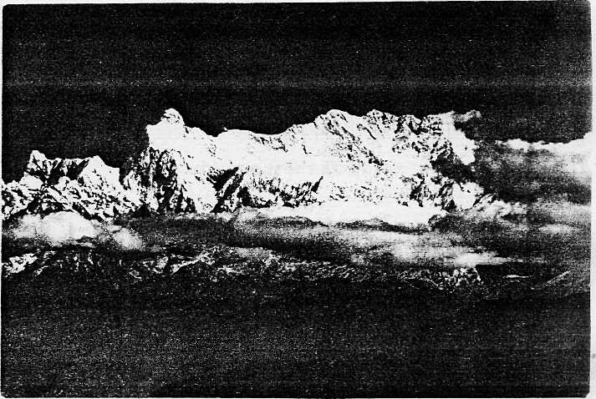
Height: 7,710 meters/ 25,289 ft Location: 27*40'58" N, 88"02'45"E
by Arnico K. Pahday
J
annu is considered by many to be the most impressive looking peak of the entire Kanch-enjunga Range. Its unique shape and inaccessible summit has roused much awe from viewers and climbers alike, even though it is not as tall as nearby Kanchenjunga (8,5 8 6m) and Kangbachen (7,903m).
The Tibetan and Bhotia inhabitants of the region named the mountain "Jannu", meaning "giant". The Survey of India called it "Kumbhakarna", after a Hindu mythical sleeping giant (not to be confused with the Kumbhakarna Himal Range, further west towards Makalu). From the southwest, Jannu looks much like a gigantic chair; its summit, flanked by the South-West and South ridges, rises from a lofty snow plateau of 7,000 meters and appropriately "named "Throne Plateau" by early expeditions.
Jannu is located some nine kilometers southwest of Kanchenjunga's main peak (8586m), on a subsidiary ridge which branches off from the north-south running Kanchenjunga range. Jarmu's unclimbedEast Face drops2,000meters down to the Yalung Glacier; on the other side of this southward flowing glacier rise the Kabru and Thalung peaks on the Nepal-Sikkim border.
Going clockwise, separated from the Yalung Glacier by Jannu's South Ridge, is the Yamatari Glacier, which empties out into the Ghunsa Khola. At the glacier bead, a huge icef all cascades down die rock walls from the Throne Plateau 1,250 meters above. North of the Yamatari Glacier and west of Jannu' s summit are some obscure 6,000m peaks bearing such names as Sobithongje and Phole. North of these is Jannu Glacier, also flowing west into the Ghunsa Khola (a major tributary of the" . jJiver). This glacier originates north of Jannu and passes underneath the mountain's famous NorthFace, described by Jill Neate in her book High Asia as "a continuous
succession of steep hanging glaciers and vertical walls overhung by snow cornices, falling for over 2,500 meters." North-east of Jannu, a ridge between Jannu and Yalung glaciers leads up to Jannu East Peak and beyond, towards Kanchenjunga. One and a half kilometre from Jannu, the Jannu East Peak is 7,463 meters high and yet unclimbed.
Jannu is located in the sparcely inhabited northeastern area of Nepal's northeastern-most district, Taplejung. The lower valleys around Jannu are inhabited by Limbus, probable de see n -dants of the Kirant dynasty that ruled the Kath-mandu Valley between 700 BC and 200 AD. Higher up and further north, villages such as Lhonak, Kangbachen and Ghunsa in the upper Ghunsa Valley are inhabited by yak-raising Bhotias of Tibetan origin.
The mountains of the Kanchenjunga Range were among the first in Nepal to be explored by foreigners. In 1848-49, the renowned British botanist Sir Joseph Hooker travelled through Sikkim studying the flora. He managed to enter Nepal when foreigners were not allowed in, and walked almost completely around the Kanchenjunga Range.
A 1957 French expedition led by Guido Magnone was the first to reconnoiter Jannu, exploring all three glaciers; they found apossible climbing route up from the Yamatari Glacier over the southwest spur. In spring 1959 another French expedition, led by Jean Franco, found this route swept by an avalanche; they attempted the longer south ridge and reached a height of 7425m.
Jannu was first summitted in April 1962, by a French expedition led by Lionel Terray, which went up the South Ridge, All nine French members and two Sherpas reached the top. Since then there have been twelve more successful and nine unsuccessful tries on Jannu. Four climbers have lost their lives on Jannu.
According to Elizabeth Hawley, the mountaineering record-keeper of Kathmandu, the last successful expedition made the most records. It was the only solo climb of Jannu, the fastest climb and the only one going straight up the North Face.TheYugoslav climber, Tomo Cesen, 29, climbed almost non-stop and reached the top in just under twenty-four hours, at 15:40on April 28,1989.


MMIT NEPAL
Summit Nepal Trekking
Kopundote Height
P O Box 1406, Kathmandu, Nepal
Tel: 525408.521810 -
Fax: 977 1 523737
Tlx: 2342 SUMMIT NP
Specializing in:-
- Mountaineering/Expeditions
- Tailor-made Trekkir-
- Unique Cultural Tours
- Wild Life/Jungle Safaris
- White Water Rafting
- Personalised Services

May/June 1991 • HIMAL 31



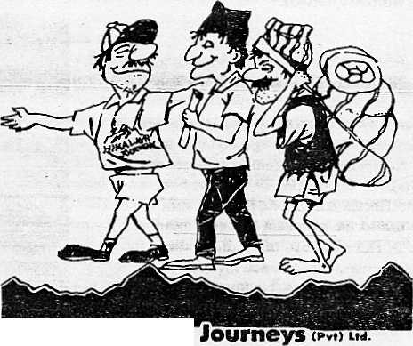
40,0001/ftBAFL...
-..Where
are as tall a§ the mountains
Succulent steaks and burgers
bountiful, with a vegetarian variety.
The friendliest bar around tlie most
convivial fireplace in town.
Rum doodlE
THAMEL, KATHMANDU-NEBVL
WE 7REKEVEREST
EVERY WEDNESDAY S
ANNAPUHNA EVERY FRIDAY
We telte care of ell vow arrangements.regulations,
the Hirlr.g of guides and porters food and equipment-at the eleventh hour, too
Hlmaiayan
Kanlipath, Kathmandu-Nepai Tel. 226138, 226139

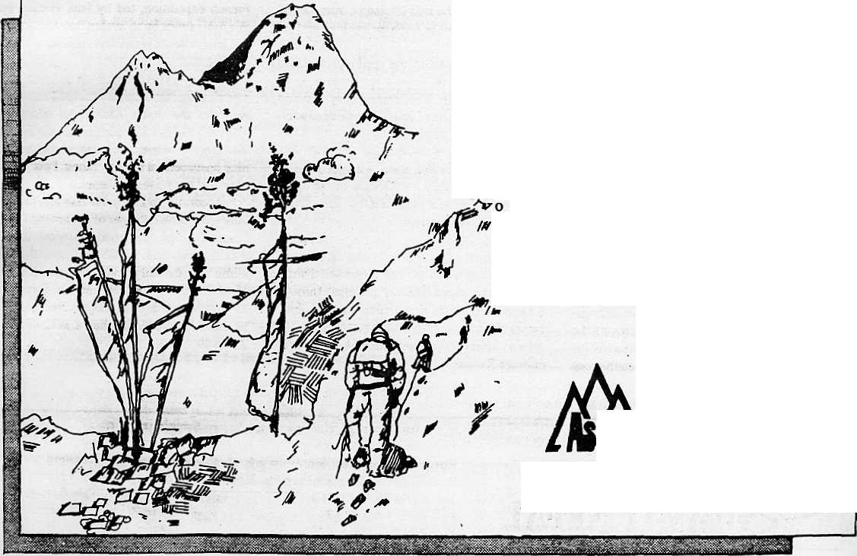
ASIAN TREKKING INVITES
YOU TO AN EXPERIENCE WITH NATURE
We take you through natural trek trails to places f unending beauty and into contact with the friendly mountain people and their gende living.
An experience you will never forget with our professional team to attend to all your trekking and tour arrangements with quiet efficiency.
IAN iBf KKHi {r| lift
P.O. Box: 3022, Keshar Mahal, Thamel
Kathmandu, Nepal.
Tel: 412821, Telex: NP 2276 HOSANG

Mtj/June 1991 • HIMAL 32

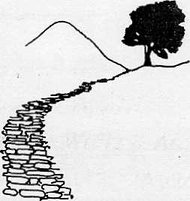

On the Way Up
by Kanak Mani Dixit
W
hat George Bush called "the vision thing" in a different context is what seems to be most urgent for the proper development of South Asia's water resource. "Statesmen" with vision is what we n^ed, say the writers in the current issue on water politics. In his lead article, Dipak Gyawali bemoans the demise of "Gandhian idealism". Shaukat Hassan calls for political will to overcome bureaucratic and technical obatacles. B.G.Verghese, whose book Waters of Hope is reviewed, looks for people with vision and patience.
Jagat Mehta, who was unable to write for this issue of Himal because we did not give him enough time, also echoes the theme in a note he sent us. Mehta, former Foreign Secretary of India who was involved in water negotiations with Nepal, Bangladesh and Pakistan at different times, writes, "Diplomacy to face the contemporary problems of socio-economic poverty of South Asia has to take a perspective beyond short-term politics: nor should it be spatially insulated around the confines of national sovereignties.,^we require) new guide posts for squaring national independence and international interdependence. We therefore have to raise our political sights - and this can only happen if enlightened opinion educates the people and the rulers to rise above narrow political considerations."
Statesmanship is what we need, everyone agrees. The statesman or woman, as defined by Paul Terrell in his Kamali article, would be one who can overcome the "general fear of the unknown" so that he/she can take fundamentaldecisionsofhighvisibilityandri.skbeing wrong. So who is the man/woman with the vision? Prime Minister Nawaz Sharif of Pakistan, who seems to have brokered a shaky agreement on sharing the Indus waters? Or King Jigme Singye Wangchuk of Bhutan, who has moved resolutely to exploit Druk Yul's power potential for export while Nepalis continue to debate, ponder and hire more foreign consultants?
Talkof Himalayan water does not end with large hydro-power projects and high-level bilateral diplomacy. As far as isolated "hill communities are concerned, micro rather than macro projects might be the way to go. The experience that Nepal has gained in this area and the indigenous manufacturing capability it has developed over the last decade should come useful for other hill regions of the Himalaya, The article by Bikash Pandey talks about the right way to go about spreading "micro-hydio" while Joanna Pfaf-Czarnecka discusses the problems encountered in getting there.
In trying to gel as many viewpoints as possible on the cover story, Himal's editors wrote to the newly free political parties of Nepal, requesting meetings with their thinkers to talk water. Only the Tarai-based Sadbhavana Party responded with a date and a time for discussion; the attitude of the other major parties seemed to be, "The rivers will still be flowing after the elections." In sharp contrast to the the disinterest of the Nepali party-folks, the Indian Embassy responded with alacrity when approached. The problem of mind-set which is identified by Gyawali as the major hurdle for Nepal, it seems, will not vanish just because the country holds an election exercise.
Hopefully, ihe series of elections that South Asia is seeing this pre-Monsoon season will throw up some leaders who do not carry bureaucratic baggage and understand the need for "regional pragmatism". New and elected governments are taking the helm in all three Ganga-basin countries, and if they are capable of vie wing the long term, which means long after the next elect ions, the waterissue will have to be grappled with. In order to keep the subject of Himalayan water alive, readers are invited to use liimal\ pages for continuing debate on the subject.
We canputyou intouch with Macintosh.
If you're one of the 18 million people in Nepal who don't know how to operate a computer, you haven't met Macintosh,™ the newest personal computer from Apple.

It's so powerful, it's incredibly simple to use.
Just put your hand on the palm-sized "mouse" controller. And click - you're Macintosh-liteTate.
Our professional sales staff will answer all your questions and, of course, provide service and support.
So if you're searching for the right computer, hurry in for a demonstration. And put your finger on it.
MIPS Pvt. Ltd.
P.O. Box : 2502, Bagh Bazar, Kathmandu, Nepal. Tel: 222-277, ■ Tlx : 2521 ATLINK Fax : 977-1-419250
Apple end the Apple logo are registered trademarks of Apple Computer Inc.
NEPAL
INTERNATIONAL CLINIC
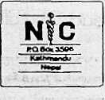
to Western medical setting serv
irfg the entire community •to Care by a U.S. Board
Certified Internist ■to Comparable services at lesser
rates
■fr Imported Vaccines, Lab work ■to Knowledge about Mountain Sickness. ■A Centra] location * ! 9:30 am-5 pm [Wednesday-6:30 pm)
Saturday: Emergencies Only ■ir Open Sunday <r Prior appointment encouraged
412842
Phone answered 24hrs.
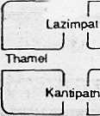
J«j Nepai Cinema Hat!
Naxal

Royal PaJace Main Gate
Durbat Marg
1 L_

May/June 1991-HIMAL 3.'

INTERNATIONAL TREKKERS
Leading house of treks and expeditions offers Unbeatable Adventure Holidays

INSTANT TREKS INTO EVEREST, ANNAPURNA 8c OTHER REGIONS
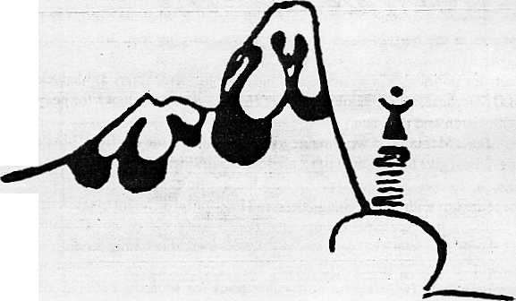
WHITEWATER RAFT TRIPS & WILDLIFE SAFARI TOURS
EXCURSIONS TO BHUTAN, SIKKIM& TIBET
Contact us for details
P.O. Box 1273, Naxal, Kathmandu, Nepal
Tel :418694,41856V, 414942
Fax:977-1-221151
Telex: 2353INTREKNP
Cable: INTREK




(Himalayan Height Resort Pvt. Ltd.) Haatiban, Pharping
Now OPENED, the Resort that you have been waiting for — Unbeatable panoramic view of
Kathmandu valley against the backdrop of majestic Himalayan peaks stretching from
Ganesh to Everest.
Fresh and clean air with ample opportunities for walks in lush green pine forest
and along the hill towards Champa-Devi Peak.

The Resort has a spacious restaurant with terraced garden and
17 twin cosy rooms in 4 separate cottages.
Situated on a pin© forested hilltop 1852 meters high,
only 13 km from Kathmandu city on the way to Dakshinkali,
Haatiban Resort is the place for you _{tf} " ^§ ^
and yourfriends to visit. HaOWMl
For further information, please contact:

M«v/.Ihm 1<»1 • HIMAL
G.P.O. Box : 1273, Tel: 221181, Telefax 977-1-221151 Kathmandu, Nepal.

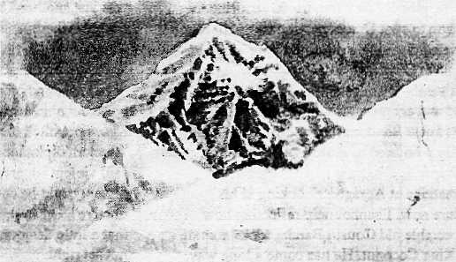
A NICE STORE FOR BOOK LOVERS!
TIBET BOOK STORE
Exclusive Distributor & Outlet
For Library Of Tibetan Works & Archives
ADDED ATTRACTIONS:

- Dharma Books From Local & International Publishers
- Books On Tibet, Nepal, India & The Himalayan Region
- Travel Books
- Maps
- Pictorials
- Magazines
■ Comics
- Stationaries
- Folk Music Tapes...
New releases added every week!
Book Mailings & Mail Orders are accepted
With Everest Trekking
top of the world is
■ ■ ■.
at your feet


Everest trekking
Centrally located (next to immigration office) with convenient parking.-
TIBET BOOK STORES
PO Box 1485, Thamel, Tridevi Marg. Keshar Mahal, Kathmandu, Nepal Tel: 225390 Ext-276, Fax:Chuteng:97701523972
P.O. Box 1676, Kamaladi, Kathmandu, Nepal Tel: 220558, Cable: ANSTREK Telex: 2286 SABHIN NP, Pax: 226358

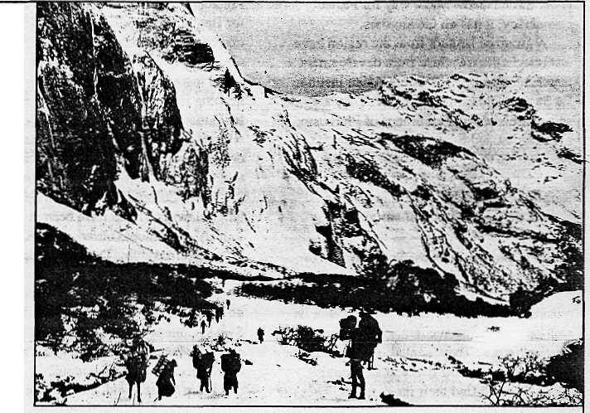

For
- Trekking
- Mountaineering
Expeditions
- Rafting and Exotic
Adventures in
the Himalaya
For details please contact:.
Sherpa Society (P.) Ltd.
Trekking & Mountaineering

P.O.Box 1556, Chabahil, Chuchepati, Kathmandu, Nepal Tel: 470361; Tlx: 2731 SSTREK NP; Fax:977-1-4-70153

Abominably Yours,

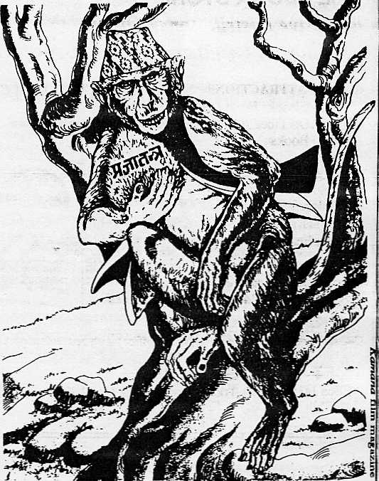
D
emocracy is like a coconut. Especially if it is in the hands of my good cousin. Bandar the rhesus. Bandar recently sent me a polaroid picture of himself in Bankali taken by an election observer from Vanuatu. There he sits, proudly on a bee trunk, scouring the horizon to spot Democracy on its uphill climb to Nepal. Striking a dignified pose in his immaculate Dhaka Topi and East-a-Coat, he tries vainly to conceal his well-endowed manhood and exercise his adult frp ...■ • -
I knew Bandar as a good-for-nothing rowdy who used to molest female pilgrims at Pashupati and harrass tourists shooting cremations at AryaghaL Looking at his picture now, I cannot help reflecting how respectable old Cousin Bandar looks nursing his King Coconut He has come a long way, indeed.
Theories on development have gone through several incarnations. At one time, they said peace equals democracy, hence zones of peace. According to the most recent Human Development Report that my ape friends in UNDP faxed me, the latest mantra is democracy. Move over, Trickle Down. Shame on you. Sustainable Development Be gone, Basic Needs. Make way for Project Democracy, it has all the answers.
A group of langurs from the region have just bought the franchise from development merchants to set up the South Asian Institute for Sustainable Democracy, Inc. They are sole distrubutois for all brands of Pluralism, Free Market and Empowerment, from Afghanistan to Burma. It is not yet clear whether the langurs will find buyers in Rangoon or Lhasa, but one thing seems certain: they are assured of sustainable funding.
Ever since it was discovered by the National Geographic and was opened up to civilisation, Nepal has been blessed by an outside world that has cared deeply about its well-being. Early travellers wrote about our pristine habitat. They wanted us to remain the way we were so their descendants could travel here and find their inner selves. Th6 children turned out to be of the floral bent who proceeded to discover themselves by setting fire to our grass. ffc The change from feudalism to democracy ; would be too jarring, they said. Nepal needed time to adjust Visit Nepal, gushed their tour operators, it is still medieval. We adjusted in uninterrupted hiberanation for 30 years. Ocassionally we caught glimpses of ourselves reflected in western mirrors: idyllic portraits
of Shangri la where Vishnu incarnates and living goddesses serenely ruled.
The mirror was shattered by last year's andolan. Nepal was just another Third World country where "mobs rampaged", "police fired tear gas and baton-charged students", "curfew-bound cities were tense but quiet as security forces patrolled the streets", "western diplomatic sources said violent suppression of dissent could be counterproductive". Oh well, nothing that a little democracy would not set right
We have just survived another onslaught of firemen journalists relieved to get away from cyclonic Chittag-ong. And we have also just got over an invasion by international election observers who came to see if we were following the instructions in Project Democracy's Manual for Beginners. Reporters observerd the observers observing the polls. In the end, the international inspectors gave Nepal the Good Housekeeping Free and Fair Certificate. But we team that there were doubts among some when it seemed that the Nepali masses were defying a world trend by using their freedoms to vote back bureaucratic centralism.
Now, Cousin Bandar writes he and his langur lawyer friends have been invited to join an international observer team to monitor a Swiss referendum. The delegation will pay particular attention to low voter turnout and electoral apathy. They will advise the federal government in Beme on how to sensitise the Swiss public to important national questions such as whether or not pet owners should pay a nuisance-tax to local cantons.
From Switzerland, our primate sleuths will fly on to Britain to investigate alleged human rights violations by Gatwick airport's immigration interrogators. A recent report by the Togo-based human rights group, EuropeWatch, has accused OECD gatekeepers of "inflicting indiscriminate mental torture and degrading physical examination of civilian."
In Leipzig, our Himalayan observers will examine samples of eggs lobbed at Helmut
Kohl to test their state of putrefaction. The same delegation is also monitoring the U.S. presidential elections next year to try and find an answer to the intriguing question: Why is the USA a two-party state?

The Foreign Ministry at Shitall Niwas has started issuing weekly travel advisories to Nepalis venturing overseas. This week's circular warns visitors to avoid the Washington DC area because of rampaging mobs, arson and looting by marginalised minorities. Third World embassies have sent all non-essential diplomatic staff home and advised personnel to venture out into the streets only if the dog needs to do wee-wee. Travel to Brussels by Nepalis has been banned till that city returns to normal after a week of violent rioting between rival white groups. Parts of France are also off-limits because of rampant tribalism.
Meanwhile, I fear, Cousin Bandar is going to have his coconut and eat it too.

M»j/Jime 1991 • HIMAL 36

discount
for residents.
ftfANGRIMA

Trekking & Mountaineering (P). Ltd.
PRESENTS

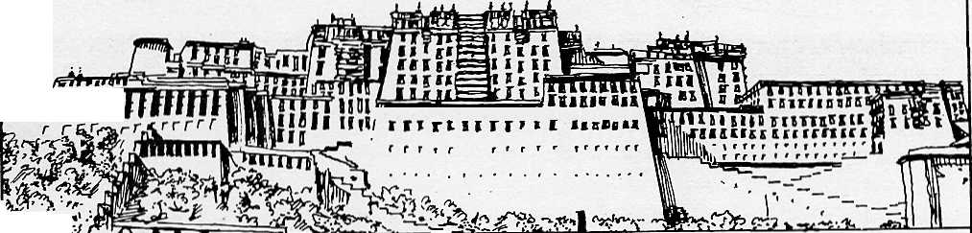
mini
. rTTTTTTmni VI1BI1I
■■' [trrrrrt'rrr r r t I r t i
■3.';.••;

scheduled trekking and tour departures inTIBETthis summer.
CONTACT:-
- Trokking & Mountaineering (P), Ltd
P.O.BOX 2951, KANTIPATH. KATHMANDU, NEPAL TEL227627.225608, TELEX: 2474 SUMTRA NP
JOIN OUR SHERPA LEAD TREKS TO
,MT. EVEREST BASE CAMP
OR
MT. KAILASH




For the best possible souvenir of the Himalaya, get a great book!
From Kathmandu'sfamous bookstores:
* KaiiashBookDistributors
At main entrance of Yak & Yeti, Durbar Marg. Kathmandu
* Pilgrims Book House
PO Box 3872, Thamcl, Kathmandu. Phone 416744
/yisA-MASTERCAFD ; H S MALAYA]
AMERICAN EXPRESS - J
Magniiicient Postcard Selection Worldwide Book MaifinS Service)
Books on Every Subj£ MAPS &GUIDES


■ ■ :■■'
Northwest makes it easy to go to America. With a choice of 8 gateways. And connection to 200 cities beyond.
Choose a connecring city that suits you best :i generous free flight plan there is.
p., rt.'iL.-.U Wnnn 'ifr^m^i **\f *\ fnn r< n^r^
Bangkok,. Hong Kong or Singapore.
j ; General Sales:Agent in Nepal :
Mdlla Treks, Malla Hotel Arcade, -Katmandu, Tel.4?8389
■.-., Sjf itv ■-'.:,■ ■■■■ . -i-
Ui ^{i}-*Norrliwesr^hQS daily 747 Flight via" Seoul straight to the U.S.A.
^ ^:^iure to" ask about WorldPerts, the njosi
; '.:'.:■■'

NORTHWEST AlRlINES
From .12■cfttis-fn Asia.vie make; i"

