NR$20 IRS12 U$6
ISSN 1012-9804
JULY/AUGUST 1991



ALTERNATIVE. BI-MONTHLY

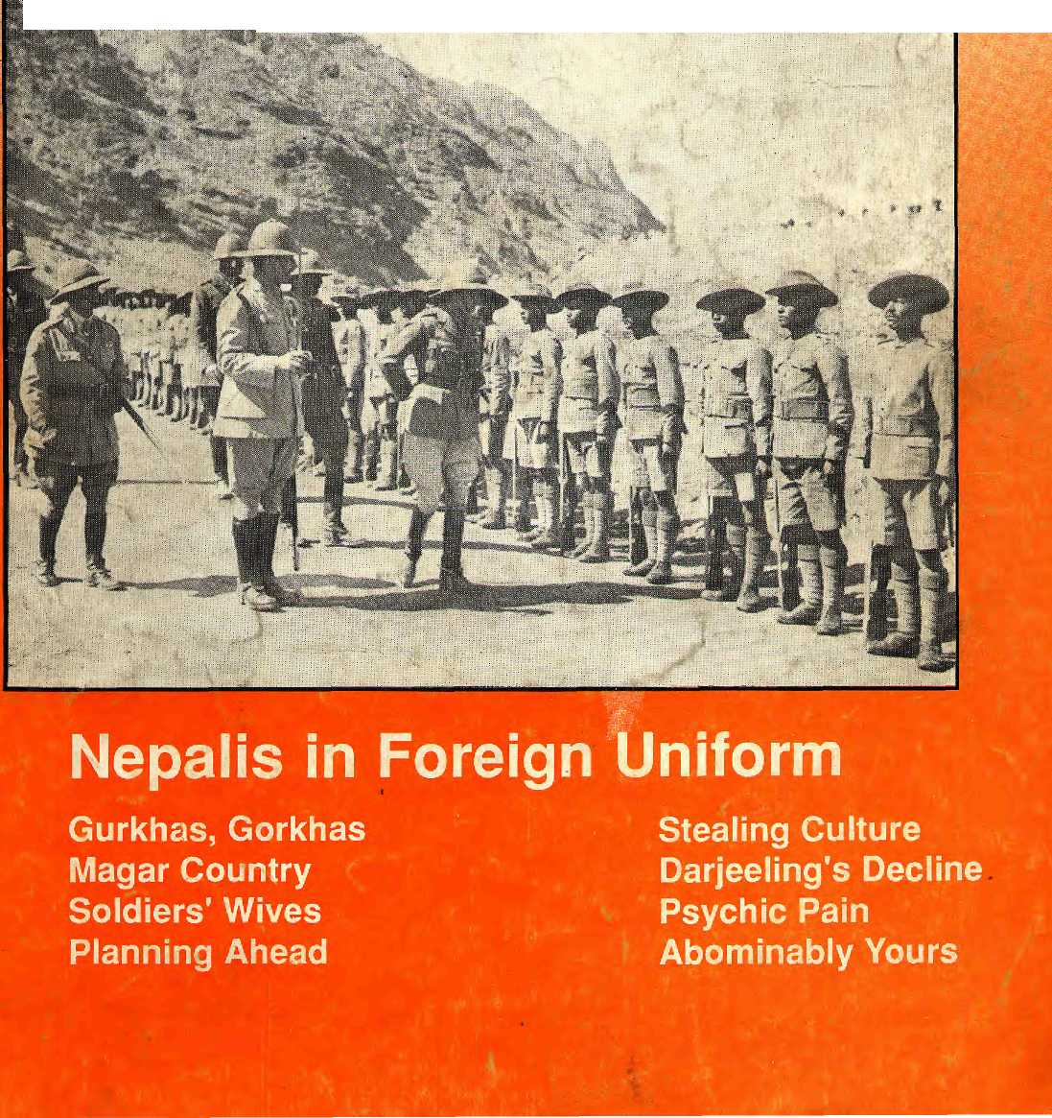

INSIDE


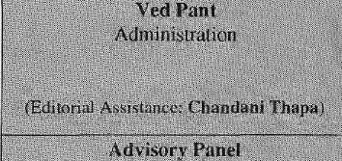
:: Y:.:i :■:■:. -
Vol.

COVER
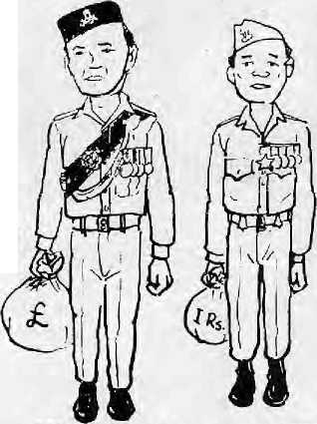
6 Ties That Bind: Gurkhas in History
- Pentax and Khukuri
- In Magar Country
- Future of the Brigade
- A British Commitment
- Three Myths
- Lahuray Women
BRITISH GURKHA INDIAN GOR.KHA

FEATURES
32 Housing Choice
'■■^:-:4M:-:: 32 Sikkim/Darjeeling
Stealing Art
'""■ :'-^T^f36 Psychic Pain of
Technology
- Gurkha Guide
- Himal Discussion
24 Planning Ahead

DEPARTMENTS
26 Briefs
29 Voices
35 Know Your Himal
37 Abstracts
36 Abominably Yours
Cover picture : Edward VIE, Prince of Wales, inspecting the 1st Gurkha Rifles at Landi Khotal in Khyber Pass (5 March 1922). (Courtesey : Madon Puraskar Pustakalaya)
Himal (© 1988) is published every two months by Himal Association,
PO Box 42, Lalitpur, Nepal. Tel: 977-1-523845 Fax : 977-1-521013.
ISSN 1012-9804, Library of Congress Card Catalogue No. 88-912882.
Please turn to page 2 for subscription information.
Printing and layout at Jagadamba Offset (Page Make-up: Kiran Shakya). Tel: 521393.
f

'/Vie A*o<iV of Gods, King of Mountains, Himalaya
You bound the oceans from
east to west A northern yardstick To measure the Earth
-
ilip
: ■■ .: .V :.:-■ .---.._,
Kanak Mani Divit
:■ ■■.■.■■■■■.:-.-:-::.■■:■:■:■
^illii^iilSI-liiiS
As»x⁻iaf« tditor Basanta Thap;i
Biilram Sbarma
M. ,4bdhiiIlah,Peshaw;ir
Adlai Amor, Gciu:va
Anita Auaitd. New Dcllii
Kinky Dorje, Ihirtipu
Harka Bahadur (iurung, Kalhm
Corneille Jest, Pitris
Prem Shanker.lha, New Delhi
Bliarat Dutta Knirala, Kailunan
Ram Chandra Malhotra, Koine
ilemanUi Mishra, K:ithm;irKiu
Bk. Sh:»h. Kallimantlu
::■■ •■■..■■■ .: '■ '■ •■• •■ ' .■■ - - -

'
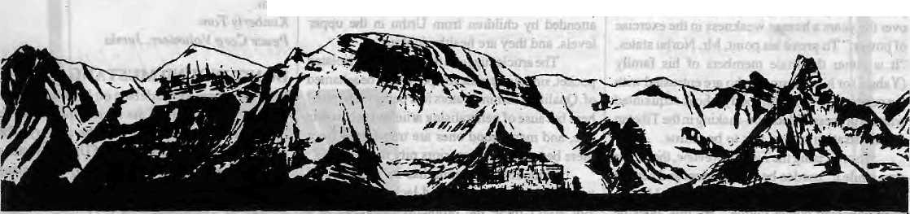
MAIL

WATER BLINDNESS
The article 'Troubled Politics of Himalayan Waters"(May/Junel991)dealsextensively with political factors, which are seen as the main reason for the failure thus far to harness Nepal's hydro-power potential. The article is written with the assumption that the power will be exported. In fact, after resolving the political issues laid down in the article, we shall have to face additional technical, economic and social problems which will be ever more difficult to solve. These will include uncertain dam life due to excessive siltation, high cost of transmission to low demand areas, transmission losses, high capital costs and long project gestation periods, as well as the low buying capacity of the majority of the Nepali people. Electricity by itself is not a very useful resource. In order to utilise it, people need to invest in electrical appliances. How many Nepalis can afford a rice cooker?
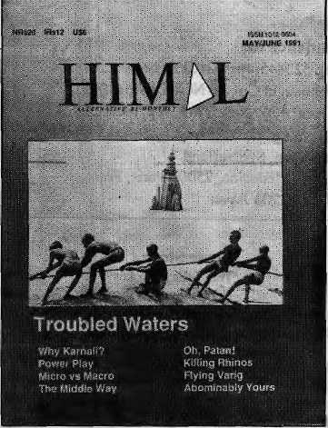
While "water people" are day-dreaming of "hydro dollars", Nepal needs to concentrate on ways to efficiently use presently available energy in the short run and switch to renewable energy resources in the long run. For example, forests have long been the source of most of our energy
■
needs. We need to invest in and promote the efficient useof this bio-energy, with better stoves, gasifiers, and even conversion into alcohol for fueling our vehicles .This needs to be further supplemented by other biomass energy sources such as biogas, saw dust, peat briquettes and agricultural residue.
Nepal must take small (mini and micro) hydro, solar (photovoltaic and thermal), wind and even geothermal energy more seriously to meetfuture energy needs (liftirrigation, powering rural television and telephones, domestic heating, drinking water supply, and lighting).
If and when our water merchants strike a deal and succeed in earning a lot of hydro dollars, we will still have to spend all of it importing kerosene, gas fossil fuels, and continue to deplete our forests. At that point, we will realise that we cannot cook, heat or power anything with dollars. Anil Chitrakar Kathmandit.
DEMAND-SIDE EFFICDZNCY
The articles about the potential for large and small hydro power from the Himalayan slopes (May/June 1991) address issues that should be considered carefully in coming decades. However, I would like to raise a voice about the potential of another energy source in the Himalaya: Efficiency, getting the same work done while consuming less energy.
When faced with energy shortages, decision-makers tend to focus on development of new power sources as the only solution. However, with advances in energy efficiency technologies, no wise planner can ignore the benefits of demand-side management. In many situations, saving energy is cheaper, faster, politically more feasible, and less damaging to the environment.
Demand-side management strategies include changing the electricity rate structure to encourage off-peak power use, and rebates for compact fluorescent lamps and more efficient refrigerators, water heaters and motors. In villages, stand-alone hydro systems can either provide power to more consumers, or be downsized* if the use of high efficiency technologies is
incorporated into the package. It would be wise to consider efficiency potentials in every case.
Energy efficient strategies, because they make sense, often develop at the grassroots level. In contrast, supply-side schemes are generally directed by centralised agencies at the top of the political-economic hierarchy. It is important to develop new energy resources, but every new hydro project, large or small, and every new grid extension, takes time and capital.
One of the inspiring forces behind BuckministerFuller'sdymaxion map of the world (that shows the seven continents as more or less one connected island amidst the oceans) was the notion that if the hydro potential of the Himalaya could be linked to an efficient high voltage transmission network, the whole world could be supplied with cheap electricity. I doubt that the waters of the Himalaya will one day drive the global network envisioned by Fuller, but I do not doubt that more and more of the energy potential in the region will be developed. In the process, both supply and demand-side technologies and options should be evaluated. David Hill Lahachowk, Kaski District
DEMOCRACY AND HIS HOLINESS
Though I respect Dawa Norbu's forthright opinions on the nature of Tibetan politics today ("The Limits of Tibetan Democracy," March/ April 1991), I would like to respond to some of the points he raises.
He writes, "Thanks to the favourable impact of movements for democracy in Nepal and Eastern Europe, the Dalai Lama was compelled to announce some democratic measures in Dharamsala..." As an informed person, Mr.Norbu shouldknow that this is simply not true. The new democracies in Nepal and EasternEurope, while welcomed by His Holiness, did not provide the impetus for the latest stage to full democracy for the Tibetan people. The fact is, His Holiness has been advocating democracy for decades. Democracy, like non-violence, is the personal credo of His Holiness. It is wrong to suggest that he has been "compelled" by outside events to promote democracy for the Tibetans. July /August 1991 • HIMAL 1

MAIL

the answers to such questions may help solve
them.
Kimberly Tom
Peace Corp Volunteer, Jumla
DON'T WOUND MUSTANG
With reference to the debate on Mustang (Mar/ April 1991), I believe the region should not be opened till at least the turn of the century. The argument that the inhabitants of Upper Mustang deserve the same prosperity as Lower Mustang may be right, but would tourism be of ultimate benefit to Upper Mustang people ? There are duties to be performed for the prosperity of Upper Mustang before inviting tourism in.
Upper Mustang must be provided basic facilities from the available natural resources, such as drinking water, health care, and the introduction of modern technology to improve the present state of pasture, animal husbandry, horticulture, and so on. But the priority is Education. For only through proper education will the inhabitants of upper Mustang be able to look after themselves, utilise their natural resources efficiently, and prepare themselves to shoulder the responsibilty of tourism, to achieve a proper balance between limited natural resources, tourism, and themselves.
The article also states, "For whatever the pontiff's religious piety might be, he has shown over the years a human weakness in the exercise of power ."To prove his point, Mr. Norbu states, "It is either the male members of his family (Y abshi) or his clansmen who are entrusted with top political power." Anybody who is acquainted wimtheprocessof decision-makingin the Tibetan Administration knows this to be untrue.
■ Incriticisingthe7'j£»e(an/tevi<?M',thewriter says while it "used to be independent and neutral at one time," it is "completely controlled by the semi-educated power clique." By this, does he mean that it was "independentandneutral" under his editorship, and is not under the present editor, Tsering Wangyal? When Mr. Wangyal took over from Mr. Norbu as editor of the Review, he insisted on, and was granted, a written guanrantee from the Kashag stating that it would not interfere in matters of editorial freedom. Today, the Review is as independent of the Tibetan Government as it was under Mr. Norbu. But I shall leave Mr. Wangyal to fight his own battles.
Nevertheless, Mr. Norbu's pointabout the need for a free press is a valid one, and one that has been raised over the past weeks by many members of the Chi-Thuis {Assembly of Tibetan Peoples' Deputies) and the public. But as a former editor of the monthly Review, Mr. Norbu surely knows how costly and difficult it is to run an independent newsmagazine. The obstacles to a free press for the Tibetan community are not so much political as financial. Sonam Topgyal General Secretary,
Office oflnformationand International Relations, Central Tibetan Secretariat, Pharamsala
1
DON'T PITY JUMLA
The article "Jumla Journal" (Nov/Dec 1990) by Kedar Sharma could be considered an insult to the Jumli and to those involved in development in Jumla district. The writer apparently spent four days in the district, three of them in Urthu, so the article might have been better titled, "Poor Children of Urthu." A whole year of research is being done for a.National Geographic article on Mid-Western Nepal; Jumla deserves at least two weeks from Himal.
While the article mentions government offices with sarcasm, no comments by govemmentofficers seemed to have been sought. There is scathing criticism of Jumla's hospital and doctor but their views are not given. Urthu has both poor and well-to-do Chetris, but no comments of the latter are given. And the photo, entitled "Living the Curse: Children of Urthu" is gratuitous, in my opinion.
Urthuisn'ttheonly village near the airport. Dillichaur, an easily village with a school, is only three hours* walk from the airport. Here, the Small Farmers' Development Bank and school 2 HIMAL • July/August
work together and are very active. Most Chetri girls in Dillichaur attend the school, which is also attended by children from Urthu in the upper levels, and they are healthy looking;
The article suggests that Jumla is an isolated pocket, singularly undeveloped and to be ashamed of. Qualified administrators fear being transferred here because of generalising articles such as this one, and many good ones are transferred from there because their superiors pity them.
Undoubtedly, Jumla has its problems of transportation, isolation and lack of schooling. But aren't these the problems of Nepal as a whole? What is the basis for the statement, "But the development programs are helping the Jumla people little, if at all"? As a development worker, I like to think I encourage competition and involvement in the community, but in the end, it is up to people themselves. Perhaps Jumla's people aren't motivated because they wallow in the self-pity encouragedby outsiders. Or, perhaps they are satisfied with life as it is. After all, Jumla's children sing, laugh, play and hassle foreigners just like otheT kids. It could be that they suffer from "dependency syndrome," but if that is the diagnosis, why not ask why Nepali development offices pay villagers to come to trainings? Instead of adding to Jumla's problems,
ANNUAL SUBSCRIPTION RATES
SOUTH ASIA ELSEWHERE
INDIVIDUAL : INSTITUTIONAL :
NRsll0/IRs65 U$25
NRs 300/IRs 200 U$45
(or equivalent) (or equivalent)
Send a gift subscription to a friend or colleague.
Please do NOT send cash in mail. Bank Drafts and Xloney Orders preferred.
In South Asia, do not send cheques.
Send subscription orders and correspondence to:
South Asia: P.O.Box 42, Lalitpur, Nepal (tel: 523845, fax 521013), or
Central News Agency, 23/90 Connaught Circus, New Delhi 110001 North America: M. Basnet, 4 S. Pinehurst Ave. #6A, New York, NY 10033, USA Europe: L. Debuck, Donaustr 38, D-4100 Duisburg 29, Germany Helene Dingg, Tannenweg 18, CH-3037, Guemligen, Switzerland Rest of Europe: Zahia Hafs, 25 Rue de L'Ecole de Medecine, 75006 Paris, France Japan: Akio Horiuchi, P.O.Box 9, Kiyose, Tokyo, 204 Japan
Back Issues of Himal:
Vol.
0
1
1
2 2 2
2
^ 3 3 3 3 4 4
No. Colour
- Green
- Green
- Blue

- Red
- Purple
- Orange
- Green
- Blue

- Red
- Grey
- Greeiv
- Blue

- Purple
- Grey
Date
May/1987 Jul/1988 Nov/Dec 1989 Jan/Feb 1989 Mar/Apr 1989 Jul/Aug 1989 Sep/Oct 1989 Nov/Dec 1989 Jan/Feb 1990 May/June 1990 Sep/Oct 1990 Nov/Dec 1990 Mar/Apr 1991 May/June 1991
Cover Story The Valley Chokes Highlanders on the Move Dharma's Changing Landscape World of the Girl Chfld Prosperous Himachal Pradesh An Obsession with Tourism Changing Food Habits Development Refugees The Shangri-La Myth A Nepali Interregnum The Tarsi, A Backwater? Hill Poverty Tibetan Diaspora Troubled Waters

MAIL

"Reaping Filth" Correction
In the item entitled "Reaping Filth" in our Briefs section (May/ June 1991), we mistakenly reported that garbage was left behind at the campsite of Gokane in the proposed Makalu-Barun National Park and Conservation area by a San Francisco research expedition of students.
The report also mistakenly named the Woodlands Mountain Institute of West Virginia as having organised the expedition.
Expedition leader Dr. Charles C. Carpenter, as well as two Nepali participants, Kiran Kumar Dangol and Udhav Khadka, of the Tribhuvan University Departmentof Botany, have written with justifiable displeasure, in protest.
We sincerely regret our erroneous report as well as any harm done to the reputation of the concerned university's study programme in Nepal, to the Woodlands Mountain Institute, as well as to the individuals concerned.
There is a lot to leam from past errors in the Everest and Annapuma regions. Even a limited influx of tourists is sure to raise the demands and requirements on the locals and their limited resources. The fact is that even rudimentary tourists are much greater than the luxury requirements of locals, and this will in the course of time compel! us to pay back in three-fold the expenditure of natural resources against the income from tourism.
It is time we started mending the damages caused by heavy tourist influx in other regions before creating a fresh site for new wounds. 5. Chhetri, Aanbu Kkaireni Tanahun District
RIGHT FOR WRONG REASONS
"Decorative Green Is Not the Answer" (Mar/ Apr 1991) performs a valuable service by exploding the widely-he Id (anddes tractive) myth that deforestation in Nepal causes flooding and sedimentation in India and Bangladesh. As B idur Upadhaya correctly points out, the best available scientific evidence shows that these are natural processes which Nepali activities have done little or nothing to augment. Perhaps more to the-point, reforesting vast areas of Nepal (were it possible or desirable) would prove a tragic disappointment as it would surely not decrease the flooding and suffering that India and Bangladesh experience. But some of the evidence Mr. Upadhaya cites in support of this view highly debatable.
The statement, "the impact of monsoon rains on geologically young mountains...is to ensure rapid runoff regardless of what the land cover may be" is difficult to accept. In fact, several studies in Nepal have shown that human land-use can lead to higher peak flows and flooding on alocalscale. Similarly, reforestation of small watershedscanprobably prove beneficial towards reducing local siltation. The key issue is one of scale. Local flooding is "diluted" by the time it reaches the major rivers, Sediment from a relatively few big natural landslides dominates the sediment "budgets" of the major rivers. To use the terms of Jack Ives and Bruno Messerli (The Himalayan Dilemma, 1989), the "micro" scale effects of human activities do not have an impact at the' 'macro" scale of Nepal-Bangladesh interactions. The importance of realising this fact is that human actions do impact on our own local environment; let us not wash our hands of our problem on the excuse that Nepal is "geologically young and unstable".
The statement, "most scientific evidence...fails to link deforestation to reduced dry flows" is potentially misleading. Indeed, "paired-catchment" experiments in which the trees are simply removed often show increase in dry season flows. But the loss of soil organic matter and the compaction of soil that usually
accompany a real-life
conversion of forest to
agricultural land have the
effect of reducing rainfall
infiltration and storage
opportunities. These are the
key processes that often
result in reduced dry season
flows. In fact, a study in Sri
Lanka of a real-life
deforestation event showed
reduced dry season flows,
and much anecdotal
evidence form the middle
hills of Nepal reports of
springs drying up after
forest conversion to
agricultural use. There is
probably quite a bit of truth to the folk tale that
"forest soils act like sponges," soaking up water
during the rains and releasing it slowly during the
dry season.
Finally, the statement that "no scientific rationale exists to suggest that forests are a major factor in preventing landslides" is probably only half true. The big, deep slided almost certainly are natural and occur in forests and non-forests alike. But shallow slides may be prevented by the mechanical action of tree roots holding the soil in place.
Samuel Wilkins Kathmandu
STEPS WITH A PURPOSE
The intent of the Bagmati Watershed Project is to fulfill the aims agreed by HMG and the European EconomicCommunity, and they include activities far more than the "white elephant steps" mentioned by Binod Bhattarai in his article (Nov/ Dec 1990). The article also states that the Project only constructs steps because it does not know how to spend 5 million ECU.
I would like to inform the writer that trail improvement is only one out of numerous activities mentioned in the work plan approved by HMG and EEC. They include nursery establishments, conservation plantation, improvement of trails and terraces, water source protection and water supply scheme, rural irrigation canal improvement, landslide control, among other schemes, with the primary focus being to control soil erosion, which has destroyed much land and is thus a root cause of poverty.
The reason why "white elephant trails and steps"are being constructed all over the region is that trails often cause soil erosion, creating deep gullies where trails once were. With improved trails, the runoff water during monsoon flows down in a controlled manner, and small drains' divert it to natural streams via the steps and reduce the water's velocity.
All our activities are undertaken in close
cooperation with villagers, with a "great amount of time spent in extention and education at grassroot level. Our project area tot|Is 1,000 sq km, with apopulationof 160,000inlive districts, though work has so far been carried out in three - Kathmandu, Lalitpur and Kavre.
The salary and travel allowances of our Project staff, under the Ministry of Forests and Soil Conservation, is at a minimum level, and most of the staff are employed only for the project period. In spite of this, our staff, in particular the engineers and technicians, do their best because they believe the project brings development to the region. They are often away at the project site for weeks. Gerald Mutter, Project Co-Manager Bagmati Watershed Project, Kathmandu
REGRETTABLE CHANGE
Once upon a time, there was a publication named Himdi: For Enviroment and Development. This publication dealt with issues and information of the Himalayan region and Himalayan people. Issues as they related to people, and had an impact on people.
Perhaps my mind has become less able to extrapolate, but it would appear that since the "Interregnum" issue (May/June 1990) and the "alternative" bent, the coverage has been politics, politics, politics. In reducing the arenatopolitics, it would perhaps be no small jump to making the same mistake that the politicians make. Politics has to do with people. With live flesh and blood people. Not yet deadened by being made objects of the incessant manipulations of leaders and wags, whatever their intentions.
However, it may be that as simply a "parachute" reader, these matters are above my comprehension. As a "feeling" person, I would, however, implore you to return to your original sentiment which is more laudable than the current bent, no matter how erudite. J.M.G. New York
July/August 1991 • HIMAL 3

SUMMIT HOTEL
GARDEN RESTAURANT
Kupondole Height, Lalitpur
P 0 Box 1406, Kathmandu, Nepal
Tel: 521894, 524694
Fax: 977 1 523737
Tlx: 2342 SUMMIT NP
The Summit Hotel is famous for its warm and friendly atmosphere, efficient staff, excellent food, a delightful garden with swimming-pool and one of the best locations in town with a spectacular view


The Only Place For Your Entire Range of Photographic Needs.


Be Sure of The Best!
^{KA}™^{MANDU}
PHOTO CONCERN P. LTD
PAKO NEW ROAD, KATHMANDU, NEPAL P.O. BOX 4012, TEL : 223275, £24092, 227028 FAX : 9771-227027. TLX : 2279 ETS NP
JANAKPURCOLORLABP.LTD
BHANU CHOWK, JANAKPUR DHAM DHANUSA, NEPAL TEL : 041 - 20601
JANAKICOLORLAB.P.LTD
SANCHAYAKOSK SHOPPING COMPLEX
SHOP NO, 213, TRIDEVI MARG, THAMEL, KATHMANDU
TEL : 225392 (7 LINES) EXTN : 335, DIRECT NO: 222349
MOONSTAR COLOR LAB P. LTD.
BIRENDRA CHOWK OHAMBOJHI, NEPALGUNJ TEL: 081-20541

(Discount
for residents.
JltANGRIMA

Trekking & Mountaineering (P). Ltd.
PRESENTS

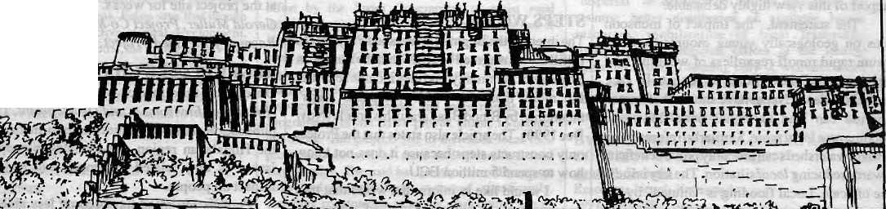
mm

SCHEDULED TREKKING AND TOUR DEPARTURES

INTIBET THIS SUMMER.
JOIN OUR SHERPA LEAD TREKS TO
iltANGRIMA

MT. EVEREST BASE CAMP contact.-
E-Lj-Y" Trekking & Mountaineering (P|. Ltd.
P.O.BOX 2951, KANTIPATH, KATHMANDU, NEPAL TEL:227627,225608, TELEX: 2474 SUMTRA NP
OR
MT. KAILASH .


Summit Nepal Trekking
Kopundole Height
P O Box 1406, KatMmandu, Nepal
Teb525408, 521810
Fax: 977 1 523737
Tlx: 2342 SUMMIT NP
Specializing in:-
- Mountaineering/Expeditions
- Tailor-made Trekking
- Unique Cultural Tours
- Wild Life/Jungle Safaris
- White Water Rafting
- Personalised Services

MAIL

DEFENDING ARUN III
M
any aspects covered by DipakGyawali in "Trouble Politics of Himalayan Waters" (May/June 1991) were informative, but his treatment of the analysis which underpinned the selection and subsequent reconfirmation of Arun III as the next hydroelectric generation project for Nepal was regrettably ill-informed. This is especially unfortunate in view of his close involvement and expertise in the sector. I do not wish to belabour the various assumptions which went into the "least cost generation expansion planning" analysis to which he referred, but I would make two important points.
First, to make a responsible choice among alternative projects, comparisons are necessary. Unfortun ately, the quality of information between known projects varies greatly. Moreover, as projects go through the sequence of investigation leading from pre-feasibility to feasibility to detailed engineering, surprises occur and, in Nepal, these have historically been in one direction—cost estimates have always increased as more information becomes available on a particular project. Thus when Arun III, for which detailed engineering has been completed (and about which more is known) is compared with
otherprojects s till at earlier stages o fi nv estigation (with major parameters still much more approximate), ways to correct the bias of early
! optimism must be introduced if realistic comparisons are to be made.
Houses which are already built have leaky faucets and bad wiring, while houses still at the blueprint stage never do; in the same way, many of the alternative projects Mr. Gyawali mentions appear to be free of the problems of Arun III only because less is known about them. Mr.Gyawali will remember that the cost estimate for Marsyangdi at feasibility stage was only about
j U$ 70 million compared to the more than U$ 200
I million it has cost upon completion. The correction factors which he alleges were part of a "shameful concoction" in the case of Arun III were introduced in the light of such experience and in order to improve decision-making.
Second, large and complex investments involve uncertainty. Thus, depending on the tilings considered important in the analyses and those relegated to lesser importance, there is
| ample room for error. When analysis is flawed, this should of course be pointed out. But flawed analysis does not automatically prove dishonesty. If this were the case, then Mr.Gyawali would be equally culpable for suggesting that Nepal should be undertaking smaller projects instead of Arun III. If electricity demand is to be servedcontinuatly without disruptive and costly interruptions, then
abandoning Arun III in favour of a smaller next project would mean dealing with overlapping construction schedules for two ormore generation projects during the next 10 to 15 years. There would be two consequences from this: it would be more costly to the country than starting with Arun III (something which was clearly shown in the Least Cost Generation Expansion Planning study); and it would place enormous additional burden on Nepal Electricity Authority's already-limited implementing capacity, an institutional weakness that Mr. Gyawali himself would acknowledge.
If Mr. Gyawali feels that Arun III is the wrong choice for the country, then it behooves someone of his expertise and analytical acumen to spell out a superior approach; failing this, he falls into the same trap of non-accountability he has accused others of. Considering the time, effort and resources that have been put into power planning in Nepal, it is unfair and irresponsible to dismiss genuine professional effort with unfounded allegations of wrong-doing. Eric D. Cruikshank Deputy Permanent Representative The World Bank, Kathmandu
(Mr. Cruikshank was Project Director of the Canadian-sponsored Water and Energy Ftesources Development Project in the late 1970s and early 1980s, which assisted H MG to establish power sector planning capabilities.)

Dipak Gyawali replies: The argument that other projects would also turn out expensive if more detailed studies were carried out does not explain why, ever since Arun III was identified in 1985, investigation of alternative projects were halted, with the World Bank going even so far as to prevent Nepal from investigating other projects without its prior approval as per its "Power Sector Efficiency Project" currently underway. Nepalis who resent Indian encroachment on the country's right to sovereign decision-making need to be told for what benefit such a right hasbeen"givenaway"totheBank.
An analysis by Water and Energy Resources Development Project in 1983, with which I was also involved, clearly showed that Marsyangdi was anextremely expensiveventure, that Sapta Gandaki was two-and-a-half times cheaper on average than Marsyangdi, and that the cost ofswitchingoverwas minimal in financial terms but high for "the personal reputations of some middle level IBRD and bilateral donor staff members." At a subsequent meeting of the Bank and WECS, a lady member of the Bank team almost wept with sorrow when told that "institutional momentum" would not justify a switchover to Sapta Gandaki. Arun III is history repeating itself.
The correction factors used to boost the rating of Arun III (by increasing the costof other
alternatives by 25 to 30 per cent) is guesswork and has no scientific justification. However, if a non-monopolistic, more competitive institutional setup were provided, the costs could readily go down by 25 to 30 per cent. The reconfirmation study of Arun III done by Electricite de France, in its first draft, stated "NEA and IDA imposed a number of conditions concerning the finalization of the study" including the untenable one that no other projects could be commissioned before Arun III, and that cost estimates for Arun III by prev ious consultants be used without modification or revision, and that the civil works estimate of a!l other projects be increased by 25 to 30 per cent. So much for responsible choice among alternative projects!
The- argument that two smaller projects would be more costly than one large Arun III ignores the fact that a smaller Kali Gandaki or Kankai can be absorbed by Nepal even if India refuses to buy at rates favourable to Nepal. The original plan of Arun III required India to buy 200 MW to make the project feasible, a fact that forced a wholly unprepared Nepal to agree to a tariff agreement with India on 27 December 1988 that may cripple the country's economy in the short term for a pie-in-the-sky future.
Is there a superior way? Yes, and one can only hope that the Nepali politicians are up to letting Nepali technicians show what they can
do, without the World Bank standing in the way. Private generation is presently limited to 1 OOkw. Raise the limit to lOOOkW. Nepali banks and local turbine manufacturers may be able to add 15 to 20 MW within the next five years. Follow this up with arevisionof the Electricity Authority Act, which favours monopolies, to one more conducive to competition. For the 1 MW to 30MW range, encourage bilateral donors and international NGOs to participate on generous terms along the way shown by the ButwalPower Company with its 5MW Andhi Khola and 10 MW Jhimruk. Spread from east to west, this approach could easily add 60 MW over the next six years. Beyond 30 MW capacity, let us consider sane and accessible alternatives like Kali Gandaki-A, West Seti, SaptaGandaki or Kankai, all of which can come on line within six to eight years. Arun III should also be built, but it should notbe allowed to hold other far better alternatives hostage.
b
Readers are invited to comment, criticise or add to information and opinions appearing in Himal. Letters should be short and to the point, and may be edited.
Send to : PO Box 42, Lalitpur, Nepal. Fax .-977-1 -521013

July/August 1991 ■ HIMAL 5






^' ■_ ■ ■ ■ '■■■' ■- :': ■ i :. ■ ■
: : ■ :X V^ _-
il: : -■ ■ : ■■■■ -:
CYPRUS, 1974

■ ■.:■ ■ ■ ■■_!
by Anup Pahari
S. M. NIVEN

Tyr e/?a/ /ifli¹ ffe dubious distinction of being a nation that has 1Y existed in peace for over a century, but whose citizens have girdled the globe fighting in the two Great Wars of the twentieth century, and in virtually every military confrontation to which either
India or Britain has been party.
Indeed, it is the Gurkhas' servicein foreign armies for more than 170 years on which the Gurkha legend was born. But what lie behind the "stuff of legend are men and women with lives and circumstances rooted in the Nepali hills. For hundreds and thousands of these hill people, the tenure in foreign armies was and remains the chief means to a livelihood and. often, a better life. Ithas provided generations of youth prestige in their own societies and exposure to the outside world.
Today, four decades after Nepal supposedly stepped into the modern age, the largest single employer of Nepalis (not counting His Majesty' s Government) remains, anomolously, the Indian military. Remittances by Nepalis serving in the Indian and British armed forces probably ranks among the fourth largest sources of the country' s foreign currency earnings, and definitely account for the biggest infusion of cash into the economy of the hinterland.
Who the Gurkhas are, and how they came to be, is a tale situated at a historical crossroad where the political economy of nations and Empire intersects with the lives of peasants, kings, nobles and colonisers. A Nepali saying, "Laliara tanda pahara garjine" (Tug a vine and start a landslide) might aptly describe any attempt to delve into the Gurkhas' story. But it is a vine worth pulling, for the quakin g hills ide will
reverberate with deep and unadorned truths about die people and society of Nepal. And out of an understanding of the past will come the confidence to tackle a future that is increasingly uncertain and could include the eclipse of the Gurkha as we know him today.
GORKHALIS TO GURKHAS
In 1743, Gorkha was a mini-state in the central hills of present-day Nepal. The people of Gorkha, subjects of Hindu Shah Kings were collectively known as "Gorkhali". Gorkha was composed of aracialandethnic make-up typicalof the medieval hill-states -Bahun, Chetri, Damai, Gurung, Kami, Khas, Magar, Sarki, Thakuri, among others. The Army of the King of Gorkha - with natives of the territory of Gorkha as the predominant recruits -became known as the Gorkhali Army within and outside of Gorkha.
From Kathmandu Valley, whichthey took over in 1769, the Gorkhalis launched a series of military campaigns to the east, north, south and wes t. In the process, the Gorkhali Army expanded both in numbers and in regional and ethnic coverage. By 1814, the Gorkhali Army (by then controlling territory from the T-ista to thc'Sutlej) was no longer a fighting force composed of men from Gorkha. Through the slow process" of conquest, and social and political osmosis, the Gorkha Army was eventually permeated by
disparate "non-Gorkhati" recruits. Any hillman who fought on the side of the Kathmandu-based Gorkhali regime automatically became a Gorkhali. Originally, political allegiance, not race, was the primary consideration in the making of a Gorkhali.
The transition from "Gorkhali" to "Gurkhas" — a designation destined lo evolvea life of its own — entailed more than a linguistic mishap, although, at the hands of the British, it was also surely that. In March 1816, after a series of fateful battles between Nepal and the East-India Company, Kathmandu signed the Treaty of Sugauli. For Nepal, what began in the late eighteenth century as a bid to annex the eastern and western portions of the lower Himalayas ended in lost territory and an enforced pact of "perpetual peace and friendship" with British India.
The Gorkhati State had been halted in its expansionist tracks, but there remained other impediments to British colonial expansion in the Sub-continent. In the east Nagas, Abors and Manipuris weTe a constant threat while in the rnorth and north-west Sikhs, Pathans, Mashuds and Afghans were fully capable of putting up a stiff resistance to the British. The Marathas in the west, too, were militarily ambitious. Poised as they were to dominate a greater part of the Subcontinent, the British felt an acute shortage of cheap and reliable military manpower with which to undertake the work of conquest.-
General David Ochterlony, as he prepared to engage the legendary Gorkha General Amar Singh Thapa, was already looking ahead to the future value of Gorkhalis in British uniform. Even before the Anglo-Nepal War ended, he

6 HIMAL
July/August 1991

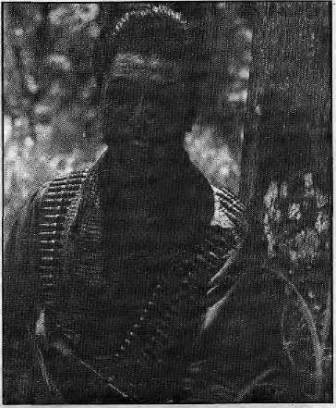
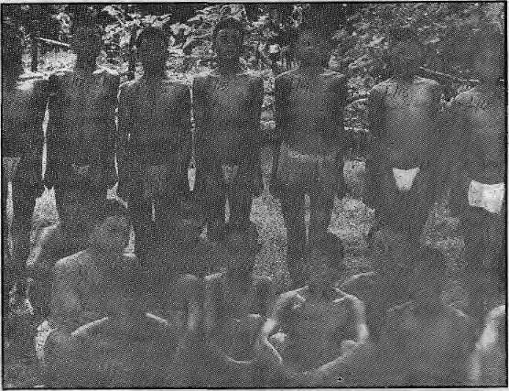
British, however, lahuray recruitment was to reach staggering proportions.
Why did the British place such tremendous value upon the fighting abilities of Nepal's hill peasants at a time when theplainsmenof all India were available within their Indian domain? Certainly, there was the first-hand experience with Gorkhali gallantry. But, other regional powers - Bihar, Oudh, Punjab, Kashmir - also had illustrious martial traditions.
The decision to opt for cheap and effective Nepali military manpower was governed by three relatedconsiderations. To begin with, the fighting ability andphysicalenduranceof Nepali peas ants were, for the British, a matter of demonstrated truth. Second, until"recently an enemy, Nepal had become a "friendly" nation with whom no future wars werelikely.Third, withmany regional native powers still intact, recruitment within India was fraught with strategic risks.
There were many things that the British wished to acquire in India. But from Nepal they
Jungle warrior (top) and hill boys up for selection
B. M. NIVEN
recommended to his superiors that Gorkhali soldiers be recruited to the British side. The "Capitulation Act of 1815" signed by Amar Singh Thapa after his defeat in Malaun included the following clause:
"All the troops in the service of Nepal, with theexception of those granted to the personal honour of the Kajees Ummer Sing and Ranjur Sing, will be at liberty to enter into the services of the British Government, if agreeable to themselves and the British Government choose to accept their services..."
In early 1815 the first three "Gurkha" regiments were constituted from among the defeated and disbanded Gorkhali Army of Amar Singh Thapa; 1st King George V Own Gurkha Rifles (the Nasiri and later Malaun Regiment), 2nd King Edward VII Own Goorkha Rifles (The Sirrnoor Rifles), and the 3rd Queen Alexandra's Own Gurkha Rifles. (Gurkha Rifles = "GR").
All three regiments consisted mainly of men from Kumaon and Garhwal — regions not only remote from Gorkha, but outside the present borders of Nepal. In the course of raising the "Gurkha" Regiments, it seemed to m atter little to the British where their soldiers came from just as long as they were from the Himalayan midhills and belonged to vaguely defined groups of "martial races".
The transition from "Gorkhali" to "Gurkhas" was, thus, irreversibly set into motion by Nepal's defeat in the Anglo-Nepali War (1814-1816). In its essence, the transition entailed the large-scale migration of peasant-soldiers from the patronage of the now greatly incapacitated Gorkhali military-machine to that of the regionally ascendant Imperial Indian Army. The Gorkhali expansion had ended, but the process of re-directing the momentum of Nepali peasant-warriors to the task of Empire-building was only beginning.
PLOWMEN TO RIFLEMEN
It was not only their soldiering skill, nor any mercenary zeal, that brought Nepali hillmen by the thousands to the recruiting centersof theEast India Company. Rather, it was the slow decline of the Nepali economy, which, by the end of the eighteenth century had rendered large sections of the population in the interior destitute.
In the early 1800s, Nepali society was strictly divided into two groups - the tagadhari (eg, Bahun, Chetri, Thakuri) and matwali (eg, Gurung, Limbu, Magar) castes. The ritually "pure" Hindus condemned alcohol-drinking and wore the "sacred thread". The latter were ranked low in the orthodox HinduWerarchy. The original Gorkhali Army was closed to Bahuns and the "untouchable" castes. Thus, Prithivi Narayan Shah's Army in 1745 consisted largely of Chetris, Thakuris, Magars and Gurungs.
A major source of employment and subsistence for the gradually expanding population of the hills had been the business of conquest undertaken by the Nepali State. That came to a halt in 1816 with the Treaty of Sugauli. With no scope for territorial expansion, and available resources distributed through highly unequal feudal arrangements, the ranks of those without subsistence swelled. The effect of this process was especially potent among the Tibeto-Burman population.
Meanwhile, the consequences of a Nepali military obliged to abandon its expansionist designs further marginalised the matwali community. An Army that had bred soldiers was gradually transformed into an Army that bred patrons and clients: tagadhari patrons began to prefer soldiers that were of their own kind. At all levels, Kathmandu's fighting force became the monopoly of nineteenth century Nepali elites. This was equally true of what little civil employment there was in the country, as well as of privileges associated with land-ownership.
The majority of people in the mid-hills were, and are, fanners and pastoralists. But land was largely subject control and monopoly, which left the average peasant's access to, year-round subsistence tenuous at best. Universally high rents, obligations to supply free labour and produce to the stale when called upon, and a variety of other demands — these were the origins of poverty and agricultural backwardness in the hinterland. These conditions ensured, over time, the need for peasants to pursue full-time soldiering as a means of attaining "subsistence".
"BEST ASIATIC SOLDIERS"
The British were not the first to cash in on the
supply of fighting men from Nepal. The term
Lahuray had an established meaning decades
before the British raised their first Gurkha
battalions.La/iurffy —one who goes to orreturns
from Lahore—was the
name assigned to any
hill-man who sought his
fortunes in the armies
of states to the west of
Nepal. One such Army
was that of Maharaja
Ranjit Singh of the
Punjab.Otherkings and
chiefs in the Western
Provinces also
employed Gorkhalis.
When the famous
Gorkhali commander
Balabhadra Kunwar
was defeated near
DehraDuninl815, he
andahandfulof soldiers
Sikh the
in the Under
enlisted Army.

July/August 1991 • HIMAL 7

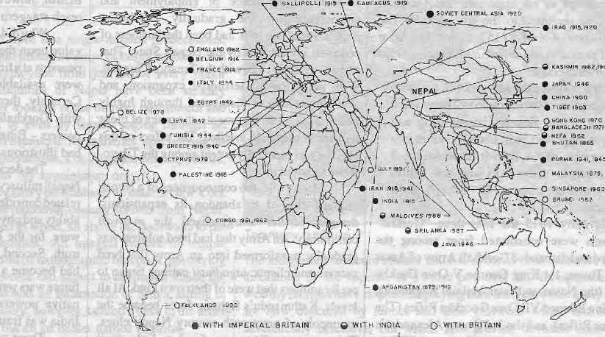
A. DIX1T/B. TYATA
present day, both in the British and Indian brigades.
The recruitment scenario changed in 1885 when Bir Shumsher became Prime Minister of Nepal. Partly to fortify his new regime, Bir Shumsher permitted recruitment into the Indian Army on an unprecedented scale. In return, Nepali rulers tacitly urged the British to lift restrictions on arms imports into Nepal. Till then, Nepal had relied on smuggled arms just as the British had on smuggled soldiers. What followed can only be described as an "arms for soldiers" deal. The first formal Gurkha recruitment depot was established in Gorakhpur in 1886, and a year later four new Gurkha battalions were raised and more were in the making. At about the same time, Nepali rulers began to receive official consignments of the newest European rifles at duty-free prices.
A tentative agreement was reached between Bir Shumsher and the British Viceroy in Calcutta in 1893 sanctioning the ongoing "exchange". On the strength of this de a!, Viceroy Landsdowne, referring to the Nepali Army's preference for Magars andGumngs, feltqualified to offer Bir Shumsher the following advice -"...avoid poaching on our preserves." Whether or not Nepal was a "soldier farm", British perception, evidently, had already made her out to be one.
Although there were many other forms of employment opening up in British India at the time (plantations, timber, construction, railways, and so on), Nepali rulers and the British collaborated formally and informally to close non-military employmentto the so called "martial races" of Nepal. To an extent, this explains why the Magars,Gurungs,Raisand Limbus remained predominant in the Indian and British forces.
However, the concept of "martial race" was a social rather than a racial category. For example, the Tamangs of Central Nepal, racially
;>;:WH::i;aI:;Jj::^
sought only "peace and friendship" — and a steady supply of Gurkha soldiers; more than likely, the former as a means to clinch the latter. This, was clear in the 1922 statement by British Under Secretary of State, Sir Arthur Hirtzel: "It is, after all, mainly because of the Gurkha element rn the Army that we value the friendship of Nepal."
Between 1815 and 1856, the British made no effort to raise new Gurkha regiments in addition to the three already in existence. These were deployed in many regional confrontations in the first half of the 1800s. The Sirmoor battalion (2GR) was the first Gurkha unit to fi ght under the British, in the Pindari War of 1817. The same battalion later served in the MarathaWarof 1817-1818. The Sirmoor and Nasiri (1GR) battalions took part in the battle for "Bhurtpore" in 1825-1826. The Sirmoor and Nasiri battalions also saw action in the First Anglo-Sikh War (1845-46), when Gurkhas in the Indian Army faced several battalions of Gurkhas fighting on the side of the Sikhs.
But if there was one single factor that tilted the scales in favour of retain ing the Gurkhas as an integral part of the Imperial Indian Army, it was their role in quelling the Indian Mutiny of 1857. In May of thatyear, the Sirmoor battalion marched south from Dehra Dun to take part in the "siege of Delhi". Still unsure of Gurkha loyalty, British officers had clandestinely instructed artillery units to fire upon the Sirmoor soldiers "at the slightest sign of mutiny". But the Sirmoor fought on the British side and in the course of battle lost 200 men, out of a starting force of 490. The fight the Gurkhas unleashed in Delhi between June and September 1857 made military history, and the message was not lost on the British.
During the Mutiny, the State of Nepal itself officially sided with the British. Fourteen thousand Nepali troops under the command of Prime Minister Jang BahadurRana retook for the British the besieged areas of Oudh, displaying a degree of mercenary fervor.
THE GLOBAL WARRIOR
The British needed no further proof that the poor, willing and hardy hill peasant of Nepal was without equal. Also* without parallel was the State of Nepal itself, whose observance of the Sugauli Treaty was fastidious. Between the Gurkha soldiers ("the best Asiatic infantrymen") and the State of Nepal, Britain had stumbled upon the most lucrative military.
When, in 1850, Viceroy Dalhousie had Tecommended expanding the Gurkha Brigades beyond the three regiments, his advice had been 8 HIMAL • July/August 1991.
GORKHALI WORLD MAP (1815 -1991)
rejected. In the heat of the 1857 Mutiny, however, two whole new regiments were raised - the 4th Gurkha Rifles (Pithoragarh) and the 5th Gurkha Rifles (Abbotabad, in present-day Pakistan). In the decades following the Mutiny, Gurkha soldiers were actively deployed in the North -East and North-West of British India, and their role in the two Afghan Wars (1878, 1919) was decisive. Between 1860 and 1900, different Gurkha battalions saw action in Waziris'fan (1860. 1900), Malaya (1875), Afghanistan (1878), Cyprus (1878), Burma (1885) and China (1900). All tills during an era when Hindu travel customs prohibited the crossing of kakipani ("black waters", oceans and open seas).
Because the Gurkhas were being recruited without formal authority from the Kathmandu rulers, it came in the way of systematic military planning. Five Gurkha Regiments, wasted in 1880, raised mostly by relying on recruits smuggled out of Nepal by serving or relired Gurkhas. The "British-friendly" Rana regime in Nepal continued to stall over British requests for official recruiting permission, mainly because the British competed with the Nepali Army for the service of Magar and Gurung soldiers.
The British, taking matters'into their own hands, setabout creating large Gurkha settlements in the hills and valleys outside Nepal. Gurkha soldiers were encouraged to settle with their families in these "hill stations" — Shillong, Darjeeling, Dehra Dun, Dharmasala, and so on. The hope was that in-migration and a steady population expansion would avert strategic dependence on Nepal. In praciice, these "soldier farms" did not meet the demographic expectations. Also, curiously, sons of Gurkha soldiers born in the Army settlements ("line boys") were never preferred over raw peasant-recruits from the hills, despite (or, as some argue, because of) their superior education. The bias in favour of the raw hill recruit continues to the

■_ „„„„___.

Gurkha service medals for First (left) and Second Sacond World Wars.
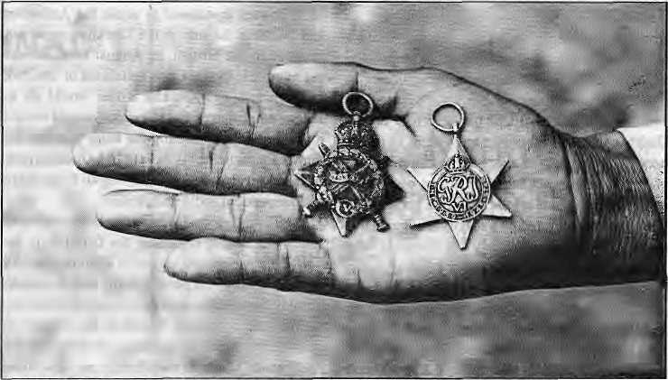
akin to the Gurungs in the West, living under identical natural and environmental conditions, cannot be any less "tough" than the Gurungs. Even though the Tamang population is higher than that of the Gurungs, however, their numbers in foreign Armies has always been disproportionately low.
The fact of the matter was that Nepali rulers preferred to retain their "monopoly" over Tamangs, wholivedclose to Kathmandu Valley. The Tarn angs were usedassemi-captive labourers for everything from portering to soldiering, mining, and construction. Their bondage to the state and Kathmandu elite was often formalised through an arrangement known at the time as rakam. To date, the proportion of Tamangs in the foreign Annies is small, while their relative strength in the Nepali police and army is significant
THE WORLD WARS
As the hills of Nepal rang out with word of ready employment and high pay in the army to the south, the number of Gurkha battalions increased tol6byl904.Themaximumpeace-timestrength of ten Gurkha Regiments (20 battalions) was reached in 1908. Between 1910 and 1917 there ' was another massive recruitment drive in preparation for World War I. Chandra Shumsher, Bir Shumshere's long-reigning successor, personally campaigned to convince hill peasants to enlist in the Imperial Indian Army. From 26,000 in 1914, the number went up to 200,000 within a couple of years.
In the course of the World War I, virtually any willing and minimally fit youth from Nepal wasenlistedviaoneoftheseven depots operatin g along the southern border. Gurkhas fought the bayonet and trench battles of World War I in France, Belgium, Gallipoli, Mesopotamia, Iran, Palestine, Greece and Soviet Central Asia (See ^nap, "The Gurkha's World"). When the War ended, two Nepalis had won the coveted Victoria Cross. On the other hand, 20,000 had lost their lives, and an unknown number were wounded or disabled. For his support, Chandra Shumshere was decorated by the British like no other Prime Minister of Nepal was or would be. For a country not even directly involved in the War, Nepal suffered per capita the highest casualties among thelroopsof all the countries fighting. In 1915, Nepal's population was no more than 5.5 million and the impact of the War was devastating in the hill villages. As Francis Tuker wrote:
"The War was over and Nepal...had bared herself to the bone to send her men to Britain's aid. In the fields were only the women, the children and the old men: her youth had flowed out along the mountain ways into depots in India and away over the wide seas."
In recognition of the service rendered by her people and her rulers, Nepal was granted an
annual "subsidy" of Rs. 1,000,000 in perpetuity. But for Nepal, the major political pay-off of the War was the signing of the 1923 Treaty of Friendship with Great Britain in which the British, for the first time, recognised Nepal's independent and sovereign status.
Nepal's sovereignty was, thus, no historical accident. Peas an t-warriors, under Prithivi Narayan, gave their lives to unify Nepal in the late eighteenth century. Nepal managed to escape being drawn into the political map of British India once again because of the Gorkhab soldiers. Since 1815 and till the early 1920s, enough hill-
JiSni, 24 October 1937: Bhltn
Bahadur Gurung is a Gurkha soldier from Nepal fighting for the Indian Army against Tamil Tiger guerillas In Sri Lanka. A group of journalists had flown up from Colombo on Sri Lankan helicopter gunshlps. Bhlm Bahadur was posing on the ramparts of the 19th Century Dutch Fort of Jaffna for Uie benefit of visiting press ph otographers.
Amidst bursts of automatic fire and loud explosions from the direction of the town center, Bhlm Bahadur agreed to a quick Interview. 'There arc other Gurkha units fighting In the town," he said. 'Two of my friends were killed by a Tiger landmine the day before yesterday."
The Indian commandant declined to disclose the number of Gurkhas deployed In Sri Lanka. There are altogether 20,000 Indian troops here to implement the peace pact signed between India and Sri Lanka on June 1987.
Bhtm Bahadur has a wife and
two children in the village of
Tatopanl on the foothills of the
Annapurna massif in central
Nepal. "They don't know 1 am here
In Lanka. I have not written to
them." i
BIKAS RAUNIVAR
peasants had laid down their lives in service of the British Empire that the rulers of Nepal could, with justification, demand from the British a fully independent status for their country.
Gurkhas spent most of the period between the two World Wars patrolling the frontiers of India, in particular the North-West Frontier Province (NWFP), where sporadic resistance to British occupation continued wellin to the 1930s. From the Third Afghan War, which began as soon as World War I ended, to the time India was partitioned, Gurkha battalions continuously manned the disputed borders of the NWFP,
World War U exacted an even heavier demographic toll from Nepal than World War I. The existing 20 battalions of Gurkhas were increased to 51. Every kind and quality of male labour that Nepal offered was absorbed into the War effort. When offered, the British did not refuse the services of Nepali convicts. They were used in the Bearer Corps during most of the War.
In all, 250,000 Gurkhas were engaged in World War II. Nepali hill-men fought in North Africa, Italy, Burma, Malaysia, Indonesia and the Indian North-EasL The Gurkhas almost singlehandedly checked the Japanese advance in Burma. Ten soldiers were conferred the Victoria Cross. Gurkhas suffered more than 10,000 dead, and 23,655 wounded or disabled. The annual subsidy to Nepal was raised to Rs. 2,000,000. Juddha Shumsher, Prime Minister during the War years, was also liberally decorated with British medals.
By late 1945, the war over,Gurkhas poured back into the subcontinent from war stations all over. Retired and discharged Gurkhas returned to Nepal in large numbers, causing an immediate glut of foreign money and unemployment. Two years later, India became independent. Rana rule in Nepal had withered away by 1951. The Gurkhas, however, were to survive not only the two World Wars, but also the perils of political change in South Asia.
July/August 1991 ■ HIMAL 9

TRANSITION
Between 1945 and 1947 Gurkhas witnessed a different kind of war raging closer to home - the Indian freedom movement andits aftermath. Bui this was not a military war and, unlike during the Mutiny, the British made scant effort to use Gurkhas against the freedom movement. Gurkhas became the keepers of peace as the violent throes of Partition gripped India. Millions of Hindus and Muslims were on the move to geographic destinations separated by a sea of carnage. In (his dark period of Indian history, the Gurkhas were among the handful of units in the Indian Army that carried out orders with impartiality.
Amidst the confusion of Independence and Partition, the future of the Gurkha Brigade was being secretly negotiated between Indian politicians and the departing British, who were keen on retaining as many Gurkhas as possible in their own British Army. The Indians were reluctant to allow this, and evidence suggests that Jawaharlal Nehru conceded only when Lord
Mountbatten threatened to retain the Andaman and Nicobar Islands if the Gurkhas were not released to the British. In August 1947, it was revealed that the first two battalions of the 2nd, 6th, 7th and 10th Gurkha Rifles would go to Britain while the rest (19 battalions) would remain tn India. Without altering the basic Regimental ¹ numberingscheme{lGR-10GR), Gurkhas now began to serve under two non-Nepa]i flags, those of Independent India and Britain.
The only formal agreement between Nepal, India and Britain regarding the Gurkhas is the Tripartite Agreement signed in Kathmanduon 9 November 1947. It permits India and Britain to employ Nepali citizens in the ir respective Armies; to maintain recruiting depots in the region; to reserve the right to increase or decrease the number of Gurkha battalions; to determine (between India and Britain) a mutually agreeable scale of remuneration.
Many details of the Agreement like the terms and limitations governing the use of
Taking Port Stanley
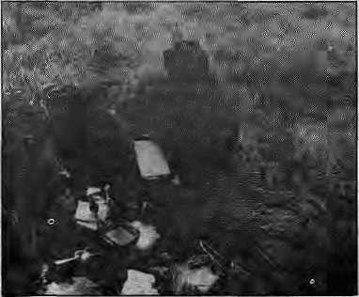

Wherever they have served, the Gurkhas have found that their reputation for fearlessness, toughness and discipline has preceded them. But even the Gurkhas were surprised at the stories which came out of the freezing shores of the Falklands (Malvinas) Islands, which the British retook from the Argentines in mid-1982. While it is not clear to what extent the fighting ability of the Gurkhas was employed, the British Army seems to have made full use of their potential for their psychological warfare.
COURTSEY: H. B KIRAT
A Falklands bivouac.
A commando of the 7th Gurkha Rifles on leave in Katmandu in June 1983 recalled that during the advance on Fort Stanley, military intelligence discreetly leaked information to Argentine captives that Gurkhas would be making a predawn attack on a crucial outpost. A few captives were equally discreetly allowed to escape, "and when we went there the next morning, the enemy had fled," recalled the soldier.
But the martial romance attending the Gurkha warrior took a beating from the Argentines. Buenos Aires' delegate to the United Nations, Eduardo A. Roca, expressed shock to observe "mercenary forces introduced into Latin America in order to bring about the restoration of a colonial situation." The Argentines also lodged a formal protest with the Nepali Permanent Representative at the United Nations, demanding an "immediate withdrawal of Nepali troops from the Malvinas."
In a magazine article, the Nobel Prize winning Colombian writer Gabriel Garcia Marquez, described the Gurkhas as "decapitators" who beheaded Argentine prisoners "with their scimitars attherateof one every seven seconds (and) they held the severed head by the hair and lopped off the ears." Garcia Marquez provided no evidence to support this claim, which was ascribed to an extreme case of war jitters in Latin America. Certainly, Marquez's report contradicted the account of Falklands veterans who spent a "bonus" leave in Nepal. Some said they had been used mostly for "mopping up" operations that did not require much fighting.
In Kathmandu, the Nepali government clarified that Gurkha troops were recruited under
"specific terms and conditions and are an integral part of the British and Indian armies." Meanwhile,
the Argentines cancelled a planned expedition to Mount Everest in, 1983, which mayor not have
been due to Falklands-phobia. - Kunda Dixjt
Gurkhas, (he status and amount of "subsidy" paid to Nepal since 1920, appear in annexes which are not available to the public. It is widely known, however, that the Annexes contain the following provisions: I) Nepal must be "informed" about the future use of the Gurkhas, 2) Gurkhas are not to be used against other Gurkhas, 3) Gurkhas are not to be used against "Hindus", unarmed civilians and against popular movements. The third clause has been violated by both Tndia and Britain.
Ontheinsistenceoflndia,thepay-scaleof Gurkha troops, Indian andBritish, was pegged to the prevailing Indian Army rates. Accordingly, the basic salary of a soldier was fixed for both Armies at Indian Rupees 350.00 ($40.00). The British, wishing to pay their Gurkhas higher rates, later devised a system, of "allowances" over and above the basic salary. Because of this arrangement, a British Gurkhaeams several times more than a Indian Gorkha of similar rank.
At the time, the Gurkhas selected to go with the British opted in the last minute to stay with the Indian Army. In order to accommodate the unexpected body of "unattached" Gurkha soldiers, the Indian Army raised the llthGurkha Rifles after Independence. No more Gurkha regiments have been established since. The last of the British Gurkhas had left India for Malaya by 1948.
In a space of little more than one hundred and thirty years, the Nepali peasanthad traversed the distance from common hill foot-soldier to a global warrior - from serving the kings of an isolated and impoverished Himalayan State to defending a latter-day economic and political colossus - the British Empire.
THE INDIAN BRIGADE
After Independence, the process of "Indianisation" of the Indian Gorkha Brigades, deferred since the 1920s, began in earnest. British officers had long held that Indians could not comrnand the Gurkhas because they would not get the respect of the soldiers. In reality the anti-desi air in Gurkha regiments was a social, racial and strategic distance carefully cultivated by the battalions, rather than a reflection of the Gurkha soldiers' "dislike" for plainsmen. The myth was dispelled after Independence, when Indian officers successfully took over command of Gurkha battalions from British officers.
Soon after Independence, the Indian Army adopted the name "Gorkha" in pliiee of "Gurkha". Many other symbolic and organizational ch anges followed. The underlying logic behind-Jhe "Gorkha connection", however, remained unchanged - the Gorkhas were a cheap, reliable and effective fighting force, as they had been under the Imperial Indian Army. India's army inherited and continued the Gurkha tradition.
The Gorkhas tasted battle in the Indo-Pakistan frontier immediately after Partition in

10 HIMAL - July/August 1991

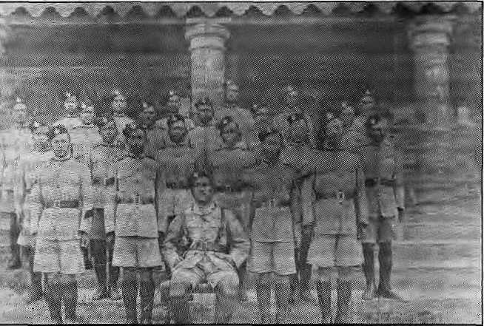
MADAN PURASKAH PUSTAKALAYA
the 'foreign" component in its Army. Finally, Nepal is content not to pursue details about the Indian "Gorkha connection", for all the political and economic implications involved,
In contrast to the British Army, in the Indian Army today, the term "Gorkha'* no longer carries the weigh t of nationality. It has become a "nation-neutral" term and refers to soldiers who display a diffuse racial and linguistic similarity. Indeed, Nepali soldiers have the option to settle in India upon retirement and, as in the past, many do. Still, the bulk of the Indian Gorkhas remain citizens of Nepal (though there is no saying what percentage), and Nepal will continue to be the chief source of Gorkha recruits in the future.
ON HER MAJESTY'S SERVICE
On 15 August 1947 theBritish Brigade of Gurkhas consisted of about 10,400 Nepali soldiers serving under four regiments. Among the'most strategic decisions made by the departing British was to

1947. They were used again in 1948 to subdue the princely State of Hyderabad. In 19614962a contingent of Gorkhas was sent to the Congo as part of a United Nations peace-keeping force.
India's war with Pakistan (1965, 1971) and China (1962) occasioned the heaviest use of the Goikhas. In 1962, soldiers of 9GR faced the very first wave of Chinese attack in Ladakh. The Indian Army's casualties in this war were heavy, and those of the Gorkha battalions are said to have been particularly high. Because they were deployed in the intense battles along the high frontiers.
The extent of Gorkha involvement in India's wars with its neighbours and the number of Gorkha war casualties are matters about which little is known, either to the people or the government of Nepal. India maintains characteristic silence. In the Nepali villages, people reconstruct their senseof Sub-continental wars on the basis o f accounts of returned v eterans, which spoke of high casualties in the Indo -China and Indo-Pak wars. These accounts of veretans have often found their way into the songs of gainays, the travelling minstrels of the hills.
Gorkha battalions continue to be among the preferred military units deployed in India's land frontiers. In the process, Gorkha battalions serve in some o f the highest theatres of opcr ations in the world, including the Siachen Glacier. Recent deployments of Indian Gorkhas include their use against the Tamil Tigers in Sri Lanka as part of the Indian Peace-Keeping Force (IPKF) as well as a brief interlude in the Maldives.
Today, the total number of Gorkhas of Nepali domicile in the Indian Armed Forces ranges anywhere from 90,000 to 150,000. Educated estimatesput the figure at over 100,000, making the Gorkha component of the Indian Army three times as large as the entire Royal Nepali Army. In addition to the seven regular GorkharegimentsOGR, 3GR, 4GR, 5GR, 8GR, 9GR, 11GR), Gorkhas areemployed in the Assam Rifles, Jammu and Kashmir Rifles, Garhwal Regiment, Kumaon Regiment, Naga Regiment, Border Security Force and the Territorial Army. TheCentralReservePolice and the Bihar Military Police also employ a sizeable number of Gorkhas, Military support units including the Engineer Corps, Signals, Military Transport, and Pioneer Corps, each has its share of Gorkhas.
In recent years, it has become increasingly difficult to distinguish between "Nepali Gorkhas'' and "Indian Gorkhas" in the Indian Army. First, millions of Nepali speakers are domiciled in India. A fair share of young men from this diaspora also joins the Indian Army. Second, Nepal's open borders with India makes it impossible to keep track of population movements. Third, India has no incentive to advertise the actual number of Nepali citizens employed in its military, indeed, from India's point of view, it would be strategic to downplay
;,,■■■"•■■:■"..■•,■ v
■1> »'•*■¥■■-■ ..... J i, ,...„ S *.&;?*• ',■....' j. * S: „ ■'■ ■ .

■ H * : :..: .■:• .:: 1 \ «

Nepali army soldiers wave goodbys at the Tudikhel grounds in Kathmandu before having for Waziristan (Afganisian) in 1918. Below, a British Gurkha platoon in Wazinstan, 1919 with Subedar Parsai Gurung seated.
HARKA GURUNG COLLECTION
negotiate the right to retain Gurkhas in their forces. Even in the post-war period, Britain's need for cheap and effective soldiers was acute. The Empire was collapsing, but for the British it was crucial that it collapse the "right" way. From 1948 to 1970, from Malaya and Borneo to Belize and Cyprus, Gurkhas became the agents through which Britain set out to preserve a post-colonial world from the remains of its Empire.
It was literally from the frying pan into the fire for the Gurkhas that landed in Malaya in early 1948. The countryside was "infested" with rebels and Gurkhas were given the task of counter-insurgency. For 11 years, Gurkhas laboured in the jungles of the Malayan peninsula, tracking and engaging what the British had labeled "communist bandits". In the end, Malaya did not "go communist".
With their proven ability in guerilla warfare, in 1962, Gurkhas were subduing Indonesian rebels in Brunei, the oil-rich Siihiin ate
July/August 1991 • HIMAL 11

in Borneo, In 1965, they were secretly engaged in fighting Indonesian troops in what was Indonesian territory. The last Gurkha to win the V.C,,RambahadurLimbu,didsoin this particular operation.
In the two decades leading up to 1968, the Gurkhas quietly achieved in Malaysia, Singapore, Brunei and Indonesia what proved to be an intractable venture for the United States military in Indochina. Certainly, with Gurkhas helping, Britain did not get bogged down in a potential "Vietnam" in Malaya- Indeed, at the time there were perhaps no better jungle warriors than the C-urJcnas. No unit in any western Army had operated in tropical jungles more intensively and extensively; the Gurkhas had seen action continuously since the late 1800s.
In 1970 the Brigade of Gurkhas moved its headquarters to Hong Kong, where it has remained since. The strength of the Brigade between 1948 and 1966 stabilised at 14,000. By 1971, however, there were only 7,000 in service. Many British officers complained publicly about the cut-back and Walter Walker, Major General of the Brigade of Gurkhas, was stripped of his rank for championing the Gurkha cause too enthusiastically. The present strength of the Brigade is about 8,000 Gurkhas. However, the British Government on 23 July announced plans to reduce the strength of the Brigade to 2,500 in the next few years (see page 15).
Presently, of the five Gurkha battalions, three are in Hong Kong, one in Brunei, and one in Britain. Hong Kong battalions are mainly employed to provide security and to patrol the borders with mainland China. In 1987 alone, 22,000 illegal immigrants were interdicted. For this service, the Government of Hong Kon g foo ts more than 70 per cent of the annual cost of maintaining the three Gurkha battalions.
One battalion is formally stationed in Brunei through an agreement it has with Britain. Brunei bears the entire running cost of the battalion, provides schools, hospitals and other facilities and in addition pays 1.5 millionPounds annually to the British Government. Brunei also employs roughly 1200 Gurkhas (mainly retired) as private State Guards in addition to the full battalion of British Gurkhas leased from the British. It is widely believed that in the mid-1980s, Nepalrefused Brunei permission to lease Gurkha battalions directly from Nepal's Army.
There are today more than five hundred Gurkhas in the Singapore Police and their recruitment andpension is handled by the B ri gade of Gurkhas. Since 1989, Singapore has wanted to lease a Gurkha battalion from the British, but has received no response. The battalion stationed in the United Kingdom participates in exercises in Belize, Falklands and, to some extent, in the NATOcountries. There were 300Gurkhasamong the Britishforces in the Gulf War, but, apparently, they saw no action. The Gurkha Transport
12 HIMAL • July/August 1991
Regiment provided drivers for an ambulance unit. The Falklands confrontation (1982) was the most recent war in which the British Gurkhas took active part. The 1st Battalion of the 7th Gurkha Rifles (then stationed in UK) was involved in the recapture of Port Stanley. A great deal of war propaganda accompanied the introduction of Gurkhas into the Falklands which, many claim, did more damage to the enemy morale than the actual fighting. As one British officer pointed out: "When all is said and done, if we can win by reputation, who wants to kill people?" No Gurkhas have been used in Ireland - a policy that Britain has carefully maintained.
In anticipation of the 1997 take-over of Hong Kong by China, Gurkha retention or retrenchment was an issue that recently warranted a series of discussions in the British Parliament. The House of Commons' Defence Committee seemed to be of the view that there was a need and role for the Gurkhas in the British Army well into the twenty-first century. The Government, however, has taken steps to reduce the strength of the Gurkhas.
Today, 176 years after the first Gurkha battalions were raised in India, the Brigade of Gurkhas is a mirror image of its long time employer, Great Britain — humbled by time, increasingly unable to reproduce itself after its own memory. The Indian Army employs more than ten times the number of Nepali soldiers employed by the British Army.
It seems all too likely that the British Brigade of Gurkhas will ultimately fadeaway. In fact, a fear among some ex-British Gurkhas in Kathmandu is that any debate about the status of the Gurkhas is likely to provide the British with the excuse not just to reduce, but to close recruitment altogether. That the low costs of maintaining the G urkhas vis-a-vis British soldiers is reason enough for a cash -strapped Great Britain to retain the Gurkhas seems to have been negated.
In whatever scale the British Gurkhas are maintained, it is the continued recruitment into the Indian Gorkha regiments that will be more significant, not only in terms of employment provided, but in terms of the impact on the hill economy of Nepal, and the geo-political considerations that con tinuing recruitment would raise.
Given that relations between Indiaand her twolargestneighboursarelifcelyto remain bumpy in the near future, and also because India may be Far from lasting internal peace, there is no reason to expect that the Indian military will voluntarily phase out its Gorkha recruitment. In fact, so entrenched and in tegralapartof the Indian Army are the Gorkhas, it does not seem likely that they will be disbanded in the foreseeable future.
As to the level of recruitment, barring an outbreak of long drawn-out war for which the Indian Army would require new soldiers, it seems unlikely that Nepali State can continue to look to
the Gurkhas as a safety valve for its expanding population.
Nepal, after the recent political changes, has yet to review the question of Gurkha recruitment. Until such a time as it does (and perhaps even after), it seems that the relationship forged in the early nineteenth century will remain on the tracks it was placed on in 1947 through the Tripartite Agreement, particularlywithlnida. In the meantime, the Gurkha issue has become openly politicisedinNepaLTheleftist parties are the strongest critic of recruitment and they raise the issue periodically. A recent musical play, "Simma", which played to packed houses in Kathmandu, evoked strong responses from the audience for its emotionally charged messages against recruitment into foreign Armies.
COST AND BENEFIT
Realistically, the future of the lahuray is not likely to be determined merely through the rhetoric of political parties in Nepal. There is no denying that until better alternatives to soldering become available on a large scale within Nepal, its young men will continue to seek to enlist in foreign forces, as long as the avenues remain open. At the moment, Gurkha recruitment offers the only lucrative and prestigious employment to Nepali hillmen, who would otherwise have to seek menial labour in Nepal, India and elsewhere.
At the same time, unlike other kinds of out-of-country employment, military service in foreign armies by citizens carries with it implications that a sovereign democratic country must weigh with great seriousness. For Nepal, the immediate cost of discontinuing recruitment will be economic hardship for communities throughout the hills. The long-term costs of continuing the recruitment are there, though often invisible and hard to calculate. These can range from a chronic shortage of labour in agriculture and industry in Nepal to the constantpotential for international embarrassment when either India or the United Kingdom goes to war.
One thing, however, remains certain. The long period of recruitment into foreign Armies has left indelible and contradictory impressions upon Nepalis. For over a century, the hills hummed with the bustle of lakurays coming and going. An entire economy, folklore and lifestyle evolved around the men in green uniform. For large sections, foreign army service was the primary means available to break a cycle of extreme poverty and indebtedness. It was a route to individual escape from conditions that oppressed individuals. The lingering irony is that the oppression of individuals, in new and old forms, is still the rule in the mid-hills even after hundredsof thousands havemade their individual "escapes".
A. Pahari is a sociologist doing research at the University of Wisconsin in the United States.

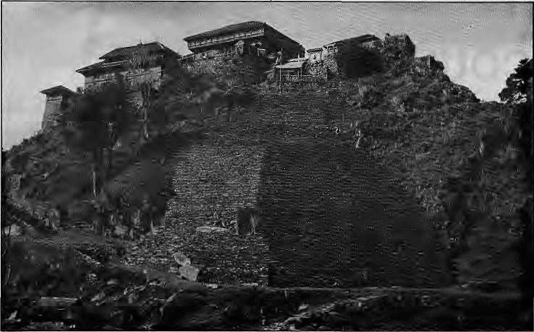
Gorkha Durbar
MUKUNDAB. SHRESTHA
Pentax Cameras and Khukuris
Impoverished hillmen have always had more to fight for, having less to lose.
by Bill Aitken
he small town of Gorkha sits in the middle of Nepal halfway between Pokhara and Kathmandu, near the important road junction of Mugling. The 23 km-long road up to Gorkha is one of the most pieasant drives in Nepal, passing through the handsome open paddies of the Daraundj river. The savage red of the hill soil is set off by the green of the forest. An attractive, arched bridge indicates that this road was built by Chinese engineers and the waltzing cuives have the grace of a Chinese work of art.
As the road reaches Gorkha bazaar, it bears up steeply and then stops dramatically at a deadend, with the old durbar and fort of Tallokot rearing on the skyline a thousand feet above the bus stand. There is no better psychological demonstration of the phrase "commanding heights".
The contrasts between the soft open valleys to the south and the steep gorges of the Great Himalaya must have convinced Prithvi Narayan Shah that he was king of all he surveyed. Could it be that the success of the Gorkhalis has been the tollman's unromanlic appraisal of battle? Only the fully professional survive to enjoy their hardwon earnings.
The first myth about the Gurkhas to fall under closer examination is that of the martial race theory. The Gorkha district, from where many of the men are recruited, has a mixture of tribal backgrounds, each with their own customs, dialect and dress. The famous Gurkha fighting spirit can have nothing to do with the place as
such, for the regiments comprise of too many heterogeneous elements. The face of Maharaja Prithvi Narayan Shah, founder of modern Nepal and creator of the Gorkhali fighting forces, as well as his name, is more Aryan than the typical Mongol features one associates with theGurungs, Rais and Magars who form the backbone of today's Gurkha units. In fact, his appearance could easily be mistaken for that other genius of waifare, Maharaja Ranjit Singh of Lahore.
Is it so remarkable that brave but peor Fighting men led by a military genius from Gorkha should have conquered the rich Newar kingdoms of Kathmandu Valley? The highlanders of Scotland could have altered English history if they hadhadalessornamentalleadcrlhan Bonnie Prince Charlie. Their guerrilla tactics which terrorized the English as far south as Derbyshire were foolishly abandoned for a pitched battle at Culloden where the clansmen with claymores were decimated by grapeshot. It is interesting that the initial British assessment of the Gorkhali infantry was conditioned by what seemed to be the enemy's extraordinary tenacity. History shows that other factors including the uselessness of the East [ndia Company strategy and the dismal leadership of some of its generals were responsible for the debacle. Having conquered Napoleon and India by the thin red line of formal advance, the Company failed to realise that the hill terrain demanded a change of t actics. Captain Young in Dehra Dun had demonstrated how one shrewd decision — to cut the Gorkhali water
supply — would have made unnecessary weeks of heroics and the loss of life of hundreds of the Company's soldiers, including that of General Gillespie.
S ome mig ht argue that hav ing been worsted in battle, the British were bound to boost the valour of their opponents, specially when the curious weapon of the khttkuri lay in hand as a kind of secret weapon which provided scope for unlimited legends. In fact, the Sikhs were poised to give the Company a much greater drubbing, but infighting cost them their chance.
The British capture of Kumaon is often portrayed as a fluctuating battleoutside thegates of Almora when it seems likely thai the over-stretchedGorkhalicommanderinfactsuccumbed to a British bribe. The old gazetteers are agreed that the Gorkhali rule was hated throughout the hills for its "cruelty" and hence the enlightened British administration was welcomed by the paharis. Il seems this so-called "cruelty" is precisely the attribute the British admired in their Gurkha recruits and which they gave the more dignified name of "fighting spirit".
The term "mercenary" has never been less popular than in the present era; yet it has a savoury history. The papal guard of Switzers are legendary for their loyalty and the francs and liras had obvious advantages over the nebulous concepts of patriotism andchivalry. Impoverished tollmen have always had more to fightfor, having less to lose. Whether it was McKays' highlanders fighting for the king of Sweden or the Gurkhas inspiring dread in the Falklands, the motivation is die sound'one of a man being paid for doing a dangerous job well.
It seems a pity that the down-to-earth acquisitiveness of the hillman, which gives him the edge in toughness over conscripts, has been romanticised and the lineof little Johnny Gurkhas are supposed to be guarding Buckingham Palace withthesamemotivationasthatoftheGu ards men in bearskins who tower over them.
Incidentally, in Gorkha I did not sec a single person carrying a khukuri. Instead, I saw evidence of much-traveled mercenaries, brave men willing logo anywhere for the king's shilling or the republic's rupee. In the shops of Gorkha bazaar were lartan bolls from Scotland, maroon velvet shawls from China and floral lungis from India. The latter, copied from Nepalis once resident in Burma, are now worn by all Gorkha women in preference to the hill skirt or saree.
One gets the feeling that the Gurkhas are in danger of swallowing their own myth and would like to believe that every man, woman and child in their founding village goes around toting a khukuri with which to pick teeth and toenail. The reality is thai Pentax cameras from Hongkong arc much more in Iheir thoughts.
B. Aitken is, among other things, a writer of Himalayan travalogues. He lives in New Delhi.
July/August 1991 • HIMAL 13

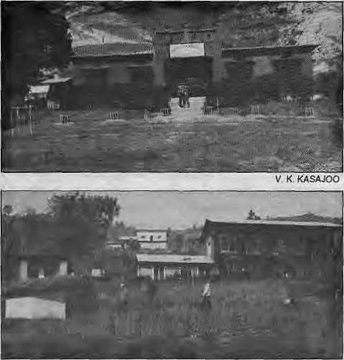
.--"
IN MAGAR COUNTRY
These hills of central Nepal run on Gurkha remittances, but is the money being used productively ?
by Vinaya Kumar Kasajoo
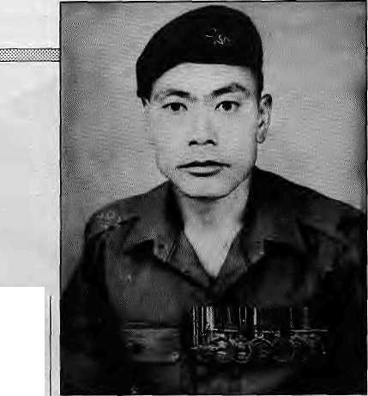

T
he rural hinterlandofPalpa.Gulmi, Syangja and Arghakhanchi in central Nepal is Magar country. To the bus traveler on the Butwal to Pokhara highway, this seems a desolate corridor reflecting little economic dynamism. Industry is nil, commerce is weak and while agriculture is the mainstay there is never a bumper harvest.
And yet, the peopleof this area manage to survive. Not only that, they keep radios and videos and buy expensive land in Pokhara to the north and Butwal and Bhairawa to the south. There is a lot of ready cash available in the Magar villages of Palpa, Gulmi, Syangja and Arghakhanchi.
The answer to the incongruous affluence in the region is to be found in two buildings of stone and cement, both near the regional hub of Tansen. One is the District Soldiers Board Building and Compound in Chilangdi village and the other is the Brigade of Gurkhas Welfare Centre in Khorbari village. The pension of the Indian, and British Gurkhas in the region is distributed from here.
Most adult males in Chilangdi village, where the Indian pensioncamp is located, served or are currently serving in the Indian Army. About 3,500 ex-servicemen draw their pension from here, but a number o fold pensioners continue to go to Gorakhpur (in India) or Pokhara, as they did in the past. Nevertheless, the total amount
distributed by theChilangdi camp comes close to about NRs 2.5 million. The minimum pension is NRs 400 per month, and the maximum is about NRs 2,900. (The recent devaluation of Indian currency has buffeted the economy of this area.)-The British'Welfare Centre at Khorbari, for its part, is located near villages with heavy recruitment in the Brigade of Gurkhas. About 400 men come here to draw their pension, which is distributed once a year. The total distributed is about NRs 1.5 million. The minimum pension received by an ex-British Gurkha is NR 1100 per month.
The pension camps maintain records of the pensioners and when one dies they decide on the beneficiary. They also provide assistance in education, health and income-generation. The Welfare Centre helps servicemen on duty to keep in touch with their families, acting as a conduit for letters and messages. The Centre also helps with loans of purchasing land or cattle, and provides education allowances to pensioners' children. Incaseof need, the Centre also provides allowances to those who left service before 1945 without becoming eligible for pensions.
There are various agencies and individuals around the world who provide assistance to the ex-servicemen of this region through the British Welfare Centre. One such person is Sir Horace Kadoorie, 81, a millionaire who lives in Hongkong. Sir Horace was never a soldier but it has been his crusade to help ex-British Gurkhas. Though disabled by paralysis, he occasionally helicopters in from Kathmandu to inspect the projects that he has assisted in — bridges, school buildings, latrines and a demonstration farm in the Welfare Centre which raises pigs and rabbits.
TARAN BAHADUR
Gurkha recruitment pervades life in Palpa and the adjacent districts. This has been so since soon after the Anglo Nepali War of 1814-
The Indian pension office at Chilangdi, top, and the Brigade of Gurktjas Welfare Centre at Khorbari.

Haveldar Khem Bahadur Thapa (NO.5032836A) is retired from the First Gorkha Rifles of the Indian Army, which he served for 23 years starting 1956. During this period, he collected seven medals, including the Sangram Medal for valour in the Kashmir front in the 1965 war.The 1 GB's origins go back to the 1815 Anglo-Nepali war, when the remnants of the Gorkhali force defending K/lataun Fort were organised by the British into the First Nasiri Gorkha Battalion.

1816, when the East Indian Company recruited mostly Gurungs and Magars. During the First World War, when 114,000 Gurkhas were called into service, approximately 35 per cent are said to have been Magars. Both the Gurkhas who were awarded the Victoria Cross for gallantry in that war were Magars, Kulbir Thapa {France, 1915) and Kama BahadurRana (Palestine, 1918).

Today, it is not so much the glory of battle as the pay-packet and pension remuneration that is the attraction. Among the first things a newly married bride does is to implore her groom to go join military service, preferably in the British Army or Indian Army. (The Royal Nepal Army is the third preference, and the Nepali Police is even further down.) A family without a son in a foreign army is pitied.
In that sense, a visit to the house of Taran Bahadur Thapa, 72, in Chilangdi village shows that hisextended family has done well. There are 14 females and 11 males. Two sons are in the Indian Army, each earning over NRs 2,000 a month. Another is with the British andearnsNRs 3,600 a month. One, Hie much-decorated Khem Bahadur Thapa, is retired from the Indian army and receives a monthly pension of NRs 800.

In addition to the non-military income of other members of the family and the sale of agricultural produce, the family earns a cash income of NRs 8,400 every month. But a visit to Taran Bahadur's house in Chilangdi would not show this relative affluence. The diet is poor, the living conditions unhygienic. Such is the condition of many families of ex-Gurkhas here.

14 HIMAL ■ July/August 1991

The Future of the Brigade of Gurkhas
Who Gets Royalty?
Is royalty being paid by the British or Indian governments, either to the Nepali Government or to someother entity, for the privilegeof recruiting Gurkhasoldiers'? It certainly began that way. According to researcher Vidya Bir Singh Kansakar, "In order to ensure the regular supply of the Nepalese in the Indian army, in 1919, theBritishgovemmentprovided the Nepal governmentwith a gift of one million rupees annually in perpetuity. This gift.. .(was) treated as the ruling Prime Minis ters'personal income, and they deposited the money in foreign banks, particularly in India," In August 1945, Viscount Wavell, the Viceroy, sanctioned a raise, and the annual "present" was hiked to two million rupees.
What has happened since? The British have been long gone from India and theRanas from
the seat of power in Kathmandu, It seems that the Indian government continued to transfer two
million rupees through the Stale Bank of India to the NepalRastra Bank till 1976-1977. That year,
officials in Kathmandu recall, the annual payment was unilaterally halted from the Indian side.
There was some discussion in the Nepali Government, which decided to quietly allow the matter
to lapse. Raising the issue for so paltry a sum would only lead to international embarrassment.
Officials in the British Embassy maintain that they have no knowledge of any continuing
payment of "royalty" for "use" of the Gurkhas. - B. L Shrestha
THE SILENT ECONOMY
For what it represents, recruitment in theGurkhas immediately raises the social stock of a family. When a Magar boy is selected, his family can suddenly get everything on credit. It can get loans from well-to-do neighbours or money lenders and shopkeepers in order to purchase land, cattle or commodities. They are paid back with interest when the recruit comes home on leave.
Till the late 1970s, the military men used to buy gold bullion, gold ornaments and valuable do th, particularly velvet. They also broughthuge consignments of persona] goods from abroad, in addition to cash. With their vaults bursting, bank managers in Pokhara and elsewhere advised the pensioners to invest in industry and business. A few took the advice, but many failed. One such enterprise which was the recently liquidated Palmi SiddharthaOil Company of Palpa, whose shareholders were from Palpa and Gulmi.
The majority of ex-servicemen, however, had little entrepreneurial skills and they were not adept at tackling the bureaucratic hurdles put in the way of enterprise. Gradually, therefore, the ex-servicemen have drifted towards safer investments, which means buying land, or throwing up buildings in urban centres. The price of land in Pokhara and Butwal has risen nearly ten times in the last 3-4 years. The price of farmlands, particularly kttet rice fields, has increased considerably in rural areas. In the villageofCherlung in Palpa, where the irrigation system is quite good and the land gives three crops a year, the cost for a ropani of land is NRs 80,000, which is what the khet fields of Kathmandu cost today.
It becomes obvious that thus far the government in Kathmandu has been relying on the economic "safety valve" provided by Gurkha recruitment while doing next to nothing to assist returned soldiers, including the Magar ex-servicemen of centra] Nepal, to join the economic mainstream. Not only should there be a willingness on the part of the Government to utilise the diverse skills that ex-soldiers bring back with them, there must also be a concerted programme to make productive useof the capital thatexists, and is presently being wasted through <x>nspicuous cons umptio n or on land whose v al ue is artificially high.
Gurkha recruitment will not continue forever, so it is time for the Government in Kathmandu to begin to pay attention to the needs of the hill economy, particularly in areas where recruitment is high. Rather than leave the Magar servicemen and pensioners of central Nepal to fend for themselves, the Government must begin to accept as its responsibility the problems presently attended to by the pension camps.
V.K.Kasajoo is editor of Tansen-based Satya weekly.
"Gurkhas to Go" - The Independent, Kathmandu, 10 July
"British Gurkhas to Stay" • British Embassy press release, 24 July
On 4 June, the Ministry of Defence in London announced that the strength of the British armed forces would be cut back by a third by the mid-1990s. This news was cause for immediate concern among the Nepali hill communities which have traditionally sent their boys to enlist in the Brigade of Gurkhas.
The detailed breakdown of the British armed forces, whose strength is to be reduced by 44,000 to 116,000 by mid-decade, was presented in a White Paper submitted to Parliament. The Brigade of Gurkhas is to be reduced from five infantry battalions to two, and the number of soldiers is to be reduced by two-thirds.
The Secretary of State for Defence Tom King stated before Parliament on 23 July : "We intend to retain the Gurkhas within the British Army after 1997; but we believe, subject again to any m ajor change in circumstances, that a smaller force of around 2,500, based oh two infantry battalions and support units, would be more appropriate. As a first step two Gurkha battalions will amalgamate in 1992."
In 1989, King's predecessor in office had committed his Government to a plan to retain some 4,000 Gurkhas even after the British withdrawal from Hong Kong in 1997. But according to King, that understanding had been contingent upon "changes in the circumstances, such as the size of the British Army as a whole." The new commitment to maintain a force level of 2,500 is similarly qualified by the phrase in the Minister's statement "subject again to any major change in circumstances."
"Detailed terms will be promulgated shortly and...arrangements will be made to assist former members of the Brigade to prepare for civilian life in Nepal," King said. It is learnt that the plan is to reduce the number of Gurkha soldiers by attrition to 4,000 by 1997, down from the present 8,000. Following the hand-over of Hong Kong, by 1998-1999, the force level will be further reduced to a constant of 2,500 in two infantry battalions.
In Nepal, some parliamentarians raised a voice against the "unilateral action" by London, w hich they felt should h ave consulted Kathmandu authorities on a matter of such importance to Nepal, Indeed, it seemed significant that London saw no need to consult Kathmandu given that the Gurkha connection is touted as the bond which strengthens the relationship between the two countries, and also because British Gurkha remittances have a significant impact on the Nepali economy. A courtesy note informing the Nepali Government of the reduction plans was sent to the Nepali Government 24 hours before the announcement, it is learnt.
Strictly speaking, however, there was no obligation to consult the Nepali Government Nepal did not have a say in the very treaty document on which continuing recruitment is based: the 1947 Tripartite Agreement was primarily hammered out bilaterally between between Great Britain and newly independent India; with Nepal asked to signon the dotted line.
The British Government seems.to have decided not to heed the advice of the House of Commons' Defence Committee which, speaking for the retention of the Gurkhas "in something like their present numbers"in 1988, stated, "If ain't broke, don't fix it."

July/Augim 1991 ■ HIMAL 15

VIEWPOINT
A Basic British Commitment

Neil Thome

Picture of Victoria Cross holders taken at the Kathmandu British Embassy premises on 20 February 1986 tvitfi Elizabeth II, Queen of England, and Prince Phillip. Standing (left to right) : Hon. Captain (GCO) Ram Bahadur Umbu,, VC 10GR; Havetdar Bhan Bhagta Gurung VC 2GR; Hon. Capt. Ganju Lama VC 7GR; Hon Lt. (OGO) Tul Bahadur Pun VC 6GR; and Subedar Agamstng Rai VC 5GR
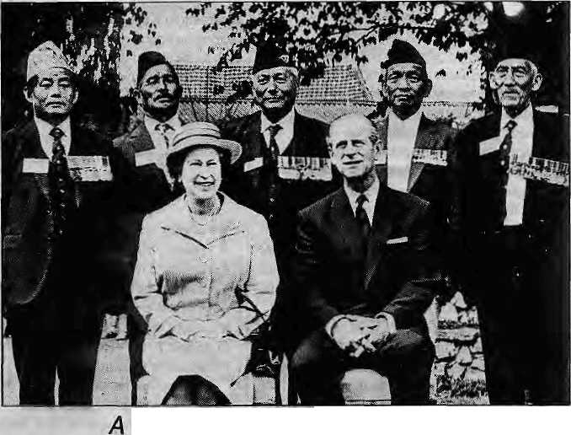

M
any people already know of the connection between the Gurkhas and the British Army. This relationship stretches back more than 175 years to 1815, when the Bntish East India Company was trying to push the northern frontier of India to the Himalaya.
From the British soldiers' first meeting with the hill soldiers of Nepal on the battle field, a bond of mutual respect grew It became obvious that the conquest of the foothills would not be possible, and therefore a pact was signed at Sugauli in 1816 in which the boundaries between India and Nepal were agreed and permission was given by the King of Nepal for the British Indian Army to recruit soldiers to serve in its forces.
Time does not stand still but in looking back, I believe the Gurkhas have been of major advantage to both countries over such a long period of co-operation. Until relatively recently, the Gurkhas' military remittances in pay and pensions were the largest source of foreign currency in Nepal and are still substantial; indeed the monetary value to Nepal of British Gurkhas alone is estimated at well over £30 million a year .The hillmen of Nepal have not only been able to acquire wealth but also a number of agricultural, building and medical skills to take back to their villages when they complete their service.
On the other hand, the British forces benefit from the fact that the average length of service for a Gurkha infantry soldier is 15 years, whereas the British soldier only serves an average of 5 years, which means that there are considerable economies in training Gurkha soldiers. At the moment British Gurkhas are trained, and many garrisoned, in Hong Kong. As this colony is to be vacated by Britain in 1997, aquestion quite naturally arose about the future of Gurkhas within the British Army, if there was to be a future where they were to be deployed. As a consequence of this, the House of Commons Defence Committee decided in 1988 to carry out an enquiry into the future need for Gurkhas in the British Army,
As a result of this enquiry, the Committee said that in terms of excellence, abundance of volunteers, discipline, cost-effectiveness - in that the annual total cost per man per year is about £13,000 for a Gurkha and £17,000 for his British counterpart and the return on training investment as a result of the length of service noted above, "the Gurkhas can provide cost-effective and adaptable soldiers of the highest quality and for these reasons it is expected that the British Army will be keen to employ them well into the twenty-first century."
Folio wing the repo it, in May o f 1989, George Younger, then Secretary of State for Defence, gave an undertaking that there was a continuing role for the Gurkhas in the British Army for not less than 4,000 men. This was initially a disappointment because it was felt that a reduction ofSOper cent was proposed, but of course, it is difftcultfor governments to commit themselves to actions to be taken someyears ahead and, in this case, nearly ten years hence. However, this is a basic commitment, and it certainly demonstrated a desire by Her Majesty's Government to continue the relationship into the foreseeable future. All of this depends, however, on the wishes of the Nepali Government and can only continue while it is a willing party to such an agreement.
Some people claim that it is wrong for one country to supply troops to another in the belief that they are mercenaries. This is, of course, quite erroneous in the case of Gurkha soldiers because a mercenary is a person recruited by a foreign power for a specific conflict at
16 H1MAL ■ July/August 1991
special rates of pay without the consent of the government of their country of origin.
Rules have been laid down by the Nepali Government as to where Gurkha soldiers can serve. They cannot, for example, be used in hostilities against a Hindu country without specific permission and, as a convention, nor are they likely to be used anywhere should this cause the Nepali Government embarrassment. However, they have been extremely successful in various parts of the world and one battalion is currently based in Brunei at the request and expense of the Brunei Government while remaining under British command. I like to think that if a similar arrangement had existed in Kuwait before August 1990, the Iraqi army would have given the matter a lot more thought before carrying out their invasion of that country.
Only one in 30 Nepali boys who volunteer are actually recruited into the British Army and as part of the same process, similar recruiting is carried out for the Singapore riot police where they are paid by the Singapore Government and have for many years provided exemplary service in that law-and-order role.
In all cases involving the U.K. Government, considerable care has been taken toensurethatloyaltytoNepalicustomsismaintained throughout the whole period of engagement. Diet, religion, accommodation, education, medical services andloyalty to Nepal and the royalfamily are punctiliously observed. It is only possible to expect the Nepali people to accept these very special arrangements for so long as it is mutually beneficial.
1, personally, hope that this relationship will prosper and flourish for
many years to come. [>
N. Thome is a Member oF the British Parliament and of the House of Commons' Defence Committee, which examines the expenditures, administration and policy of the UK's Ministry of Defence.
JSPRS (HK)
Gorkhali Ethnic Cross-Section
(This article was written for Himal before the cuts in the British Gurkhas were announced on 23 July.)

VIEWPOINT


s
Three Gorkhali
Chaitanya Mishra

T ike so many other political, economic and cultural processes, the JLj issue of Nepalis in foreign military and para-military forces is often obscured by multi-layered veils. These veils notonly cloud the perceptions of our men in foreign uniform, but also fog the personal and collective values of Nepalis generally. This leads to distorted interpretations of our past and present, and to wrong prescriptions for the future.
The Myth of "Isolationism"
One of the long-standing myths is summarised in the notion of "isolation". Politicians, political scientists,historians and journalists without exception have told us that prior to 1950, we were, as a people, isolated from other peoples. Correspondingly, that the Nepali state practiced isolationism visa-vis the rest of the world. The "modern peiiod" of Nepali history is said to begin from the 1950-51 watershed, when there was a "democratic revolution" which, in turn, opened Nepal to the world.
This interpretation of history is patently false. Lying in the zone of transition between the Indie and Sinic civilisations, two of the greatest cultures of world history, Nepal could not have remained isolated in any period of history. Trade, culture, migration, political influence and domination constantly buffetted what is present-day Nepal. The scale and the rate of flow varied temporarily at brief periods, but it always resumed.
During the latter part of the Colonial Era, primarily though not exclusively because of the Gurkhas, Nepal moved into the centre stage of the global military theatre. Demographically, Nepal remained one of the mostopen (i.e., mobile) populations". Such large-scale mobility necessarily had its corollaries in the political, economic and cultural lives of the Gurkhas and their communities back home. Surely, Nepal's level of global interaction were limited within the spheres of the British Empire. But that was the hallmark of the colonial order. It was a caryed-up and buffered world, and none but the colonial masters dared trespass geopolitical, economic and cultural divides.
Why, then, do we continue to propose the' 'isolationist" historiography which misrepresents the Gurkhas' — and Nepal's—history? It is the urge of the modern period to portray the Rana period as one of unmitigated evil, one which kept Nepal "in darkness". It is also the need to extol the political-diplomatic sagacity of the regime to come, under King Mahendra and the Panchayat system in particular, which supposedly introduced Nepal to the world. There are also those among us who believe that the "post-1950 openness" was really due to Jawaharlal Nehru, generous enough to let Nepalis breathe fresh air in the community of nations. Most importantly, the historiographical misrepresentation owes much to the upper caste, upper class, Hindu, Kathmandu-based worldview which, swallowing the English notion of "military castes", regarded the travails of such castes as unfit to enter the history books of Nepal. A historiography which broke away from "pre-1950 isolationism" would, at the very least, place the institution of recruitment at the heart of Nepal's interface with the colonial era and legitimately recognise the Gurkhas' role in Nepal's history.
The Myth of Gurkhas and the 1947 Treaty
The occasional debates in Kathmandu on the issue of the Gurkhas centre around the Tripartite Agreement of 1947, which legalised the "partition" of the Gurkhas between Britain and India. As the argument goes, were it not for the treaty, there would be no Nepalis in foreign uniform. This assumption may hold true as far as recruitment into the British Army is concerned. (Even this is not certain, however, as indicated by the recruitment of Nepalis for the Brunei Guards and Singapore police, both carried out under the aegis of the British Government.)
As far as the recruitment into the Indian military is concerned, the assumption cannot hold true. This is simply because the political foundations of Nepali recruitment into the Indian military is laid by the 1950 Treaty of Peace and Friendship. While the 1947 treaty provides the legal basis for recruitment, it would be inoperative in the absence of the 1950 Treaty, which assumes an open border between Nepal and India and goes on to enunciate the "rules of reciprocity" in matters of residence, job entry, property ownership and so on. Such provisions, as long as they hold valid, would substanlively nullity any attempt at breaking away from the 1947 treaty. The view that recruitment of Nepalis in the Indian security forces arises out of obligations to the 1947 agreement, thus, is another myth.
The Myth of Gurkhas, Ethnicity and Regionalism
That Gurkha recruitment has a decided ethnic and regional connection has been a subject of much discussion. What is less exhaustively discussed is the internal political implications of recruitment. This lack of debate and knowledge can largely be attributed to the myth that recruitment is, as far as internal Nepali politics is concerned, quite neutral.
The recent natio nal election results, ho wever, indicate that recruitment may not, after all, be politically neutral. It appears that one of the many causes underlying the east-west electoral divide may have been related to recruitment. As is well known, West Nepal has "historically been the heartland of recruitment. Can one, then, surmise that the decided electoral dominance of the Nepali Congress Parry (which is widely perceived to favour continuation of recruitment and which is also regarded as favouring a closer-than-friendly relation with the Indian state) may partially be linked to the institution of recruitment?
To the extent that such a link has been operative, the question as to whose interests the certain Pratinidhi Sabha representatives would be serving during their tenure would have to remain open. Would they be defending the recruiters? The recruits? Or the.larger in terestsof the Nepali State?
b
C. Mishra teaches sociology at Tribhuvan University, Kathmandu.
To All Whctn it Hay Concern
This is to certify that the Khukuri is the National as well as religious weapon of the Gurkhas. It is incumbent tm a Gurkha Co carry it while awake and place it under the pillow while retiring. As a religious weapon it is worshipped during the Dashera and at other times whenever any sacrifice is to be made. It is very much regretted that in India due to provincial legislations the Gurkhas there have been deprived of their Khukuries thus making it impossible for them to carry on their religious observances. The All India Gurkha League is taking up the matter with a view to have this disability removed. Any assistance rendered to .the League and steps taken to remove this disability will be very much appreciated by them as well as their ccinpatriots at home.
(Sd/-) Padma Sham Shere Jung_{F} Maharaja Prime Minister and Supreme Commander-in-Chief, Nepal
Testimonial issued by Prime Minister Padma Sumshere in 1948.
July/August 1991 HIMAL • 17

To Marry a Lahuray
Hundreds of thousands of lives have been touched by Gurkha soldiering.
Many toasts have been drunk to and books written about the Johnny
Gurkhas, but reference to their womenfolk has been scant.
by Manisha Aryal
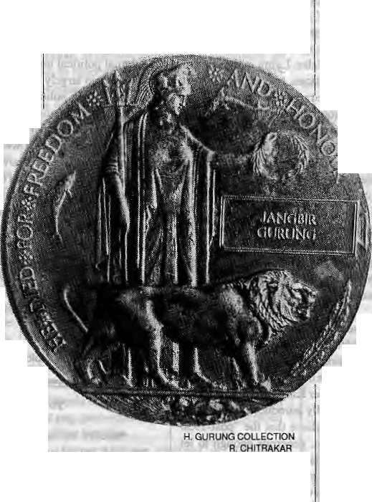
Bom and raised in Taplejung in Nepal's far-east;hill country, Sancha Maya Limbu was 16 yeirs old when she married Jit Man Limbu in 1948. Two weeks after their wedding, the 17-year-old groom went off to enlist in the British Gurkhas.
The community approved of the match. Sanchaya Maya had "done good" for herself and enhanced the family's status by marrying a potential lahuray. The new bride was the subject of teasing among her envious girlfriends: Would Jit Man return without a leg or an eye? Would lie return at all?
Even in Taplejung District, where going into "bhart'r (recruitment) has long "been a tradition, Sancha Maya's family had unusually strong ties with the Gurkhas. Her father had seen action in the First World War and had had some close brushes with death. While one of her three brothers stayed at home to farm, one was killed Eh. action in Burma fighting the Japanese only a few years previously. The other brother had gone down to India to be recruited but had never been heard from again. And now Sancha Maya's youthful husband was intent on following the same path. Of course, no one questioned Jit Man's decision, least of all Sancha Maya.
Jit Man returned to Taplejung a full four years later, and there was much rejoicing. Villagers crowded around, wanting to talk to him, to touch him. Although ihe Second World War had been over eight years before, the questions invariably weK/'KaliJarniariMaryo? Japan pani maryo? ". (How many Germans did you kill, and Japanese?)
As Sancha Maya tells it in her rented flal in Kathmandu today. Jit Man was astonished to leant that he was father ofa three-year-old son. In two months, however, his leave over, the soldier left home. He left without knowing how his child bride had coped in his absence because he never asked. To a 21 -year-old, all [he attention lavished upon him as a talmray must have been quite exciting and disorienting.
Sancha Maya was pregnant for the second time. This time, she found it harder to adjust. With the responsibility of looking after in-laws and two infants, and the constant fear of widowhood (she knew he was in combal, though she never learnt where he was stationed), she 18 HIMAL « July/August 1991
began to understand why her mother so often sacrificed goats and lambs lo the spirits and why her sister, whose husband was also a lahuray, cried in her sleep.
In time, Sancha Maya came to accept her life as a soldier's wife and a single parent. Her I husband came on leave and went a few more j times. Then the word came. Jit Man was dead. She docs not recall being told how her husband died.
Out of 18 years of marriage, Sancha Maya had spent only 21 months with her husband. "It seems as if all I have done is wait all my life," says Sancha Maya, now 57, tears welling up in her eyes. "When I was small we used to wait for my father to come on leave. When I got married, I waited for my husband. Now it is for my children that I wait." All three of Sancha Maya's sons have followed in the footsteps of a father they never knew. One is in the British Gurkhas and two in the Indian Gorkhas. One of her two daughters is married to an Indian Gorkha.
TODAY'S WIVES
Sancha Maya's experience, common lo many lahuray wives during tire two World Wars, is less frequent in these last decades of the twentieth
century. Widowhood is a less likely fate for most wives. Today, Gurkhas are entitled to have their families accompany them to their duty station for stipulated periods. In the case of Indian Gorkhas, even if they are nol assigned housing, families can move in close to the "lines". Because their menfolk arc assigned closer lo home and generally in a recognisable so cio-eultural milieu, the family problems of the Indian Gorkhas, who number far more than the British Gurkhas, are lesser. For the British Gurkhas, even though the pay packet is thicker (a married, unaccompanied rifleman stationed in the United Kingdom earns £6,790 per annum), the sense of dislocation felt by the family is far more acute.
On average, a Gurkha soldier is 18 when he is recruited and if single he usually returns for his First long leave in Nepal three years later. Most soldiers are married by the age of 21. Approximately 8Oper cent of the Nepalis serving in the Brigade of Gurkhas are married. Married Gurkhasmayserveaccompaniedbytheirfamilies inHong Kong andBrunei, with permission being granted on the basis of service and seniority. A soldier who puts in 15 years of service might have his family with him for 2.5 to 3 years.
NOT A SOCIAL SERVICE
Today, the Gurkha wives may not undergo the "waiting and worrying" that their mothers and grand-mothers did, but different worries have come to the fore. Among these, mainly social and psychological in nature, are one, the wives' roles in a male-dominated military hierarchy in which they are mere appendages and, two, the impact of military life upon the children.
Poonam Gurung, who married Charam Bahadur (real names witheld upon request) two months ago, will be accompanying her husband on his second lour of duty in Brunei.
However, Poonam will be able to find her feet in Brunei more easily than most other young wives straight out of the Nepali hinterland. Lt. Col. Guy Pearson, Chief of Staff of the British GurkhaTransilCampinKathmandu, says efforts are made to cushion culture shock. "Almost a mini Nepal has been created in Hong Kong and Brunei," he says. "While we try our best, the military, after all, is nol a social service."
To keep the women occupied, courses are available in dress making, cooking (Chinese and Western), swimming and badminton. If they are lucky, the "didi bahinis" are able to find work as sales persons in shops owned by Indians or in haircut ling salons. Other than gain a few "housewifely'¹' skills, few women venture into areas that would give them professional skills. Training in secretarial management is attractive to many, but it is loo expensive. After all, the

- ." \
::. ■" i
7~rEnr;. """" -

NamasaraThapini
She had never been more than a few miles from her mountain village when she was broughldown and taken to Nowshera to be given her husband's medal. The ceremony was held in the old polo grounds on the banks of the Kabul River, a rectangle of green turf surrounded by trees. The troops were formed up on the three sides of a hollow square, on the fourth side was a saluting based and an enclosure for spectators. Field Marshal Viscount Wavell, viceroy of India, had come to present the medal to Naik AgansingRai and to NamasaraThapini. The pipes and the band played. The viceroy inspected the troops and then presented the medals. Brigadier N. Eustrace, D.S.O, formerly of the 6th Gurkhas, stood beside the widow as her escort and translator. Then the troops marched past, vigorous young men from the hills such as her husband had commanded, and it was over.
Agansing Rai was beseiged by reporters. What had been his feelings during battle? What had been his thoughts? Rai shrugged and grinned, "I'm sorry, I forget," he said. No one asked Namasara what she felt as she stood in this alien place with her dead husband's medal in her hand.
The long trip to and from Nowshera must have been alarming, perhaps frightening. The grand personages whom she met must have meant little to her. And what did she make of the medal on its red ribbon? In photographs taken of her holding it, still in its little box, her face seems impassive. The medal itself is neither gold nor silver hut of bronze from Russian guns captured in Sevastopol in a warshe had never heard of. And what became of her? Noone ever thought it worthwhile to climb into the mountains northwest of Kathmandu, where the Magars live, to find out.
- from A History of the Finest Infantrymen in the World—The Gurkhas by Byron Farwell. Namasara Thapini was the wife of Subedar Netra Bahadur Thapa, of the 2/5th Gurkha Rifles, who received a posthumous Victoria Cross.
COURTESY: YOGI GHALEY
Ram Bahadur Limbu.
family's priority is to save as much as possible in order to builda house in an urban center in Nepal and to bring back household goods.
When the "family permission" period comes to an end, the wives and children return, but, increasingly, not to their own villages. And no one can blame the Gurkha wives for wanting the same city convenience as their urban sisters; tap water, electricity, video, schools and transport.
MIND THE CHILDREN
With their husbands in absentia, the main worry of returned didi bahinis is their childrens' education. Many children who make good on the exposure they received in the British Gurkha schools iti Hong Kong and Brunei now find themselves in Nepali schools with far lower standards. While there is no difference in curriculum (the Hong Kong and Brunei schools teach the Nepali SLCcuiricuIum), many returned boys and girls exhibit signs of maladjustment. This uprootedness, combined with societal disapproval, has linked many Gurkha children to the rise of gang robberies in Pokhara, alcohol problems in Dharan, drug abuse in Pokhara and Thamel, and alleged acts of hooliganism in Jawalakhel, Clearly, these Gurkha youth require more guidance and understanding than they presently receive, and it is unfair to expect the mothers to bear the entire burden.
Talk of wayward children annoys many Gurkha parents, who feel that their children are being unfairly targeted.Some,likeNanaGurung, an ex-Gurkha spouse who shifted to Kathmandu from Parbat District 16 years ago, acknowledge that there is a problem, but say that the blame lies with the fathers, who consider their duty done as long as they send money home for the childrens' education. They feel that the absence of a father's firm guidance, particularly in a urban setting where the family and village support is missing, spells trouble for the children of soldiers stationed abroad.
In the past, families bid farewell to their sons, husbands, fathers at the recruitment center and awaited their return from foreign wars. The main fear then was that of death of their loved ones in action, widowhood and orphanhood. Today, the problems and [he challenges are different. Even though they may not be obvious, these problems and challenges turn around "modern-day issues" such as urban dislocation, women rights, education, childrens' prospects and employment prospects. No more will the soldiers and their families remain content to return to their villages and not be heard from. The government in Kathmandu, as well as the nongovernmental sector, social activists and others will have to take note of Hie demands and expectations of Gurkha families and tackle them with care and understanding.
\> M. Aryal is a free-lance reporter in Kathmandu,
Soldier Heroes No More
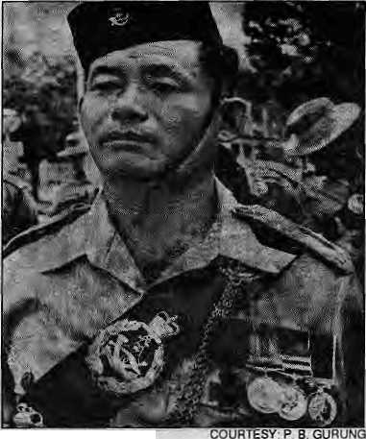
T
enzing Shcrpa the climber, Bhanu Bhakta the First Poet, andGajeyGhaleylhe soldier. These were the text-book heroes oCNepali school children in the 1950s and 1960s. Above all, the feats of Jamadar Gajey Ghaley, VC, captured their, The sketchy biography in Nepali Sahitya primer rcco u n ted h ow a bu Uet ridden G ajey at lackc d en e my tanks and immobilised them almost single-handedly. A hillman, a son of impoverished parents, he rose to receive the ultimate award a soldier could aspire for. Hie Victoria Cross. He hailed from the other side of
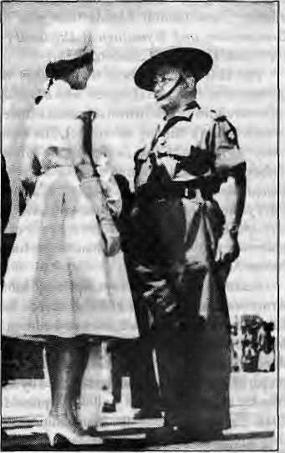
Gajey Ghaley with Queen Elizabeth It. the border, but that did not matter: he was a Nepali hero.
Today's children do not know the meaning of "VC", and their role models are different. Most Nepali children are not told and do not know who are the latter day Gurkha heroes, such asRam Bahadur Limbu, who received his VC for valour during the Brunei Confrontation (1962-66).
- Basanta Thapa
July/August 1991 H1MAL • 19

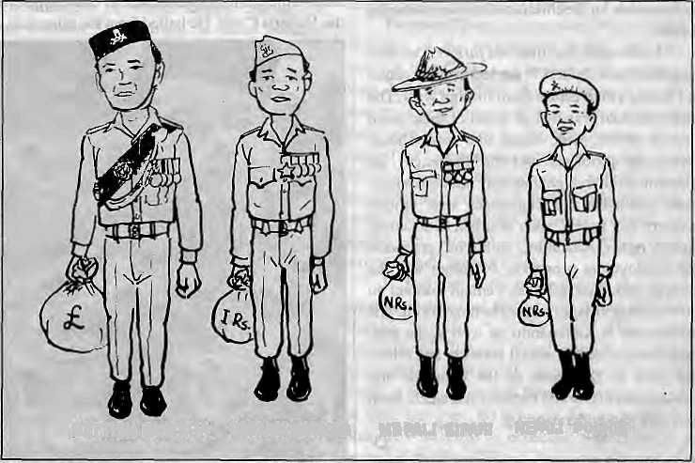
;.::::.. .:. ...
THE GURKHA GUIDE
byHarkaGurung
Rifles and British Brigade of Gurkhas: The
BIKAS RAUNIAR
Conway's The Alps From End to End (London, 1895), describing the exploits of HarkabiiThapa andKarbirBurathoki,whocrossed39passesand climbed 21 peaks in 86 days of Alpine traverse. Further accounts ofGurkh as as mountain climbers are to be found in Twenty Years in the Himalaya (London, 1910) and Himalayan Wanderer (London, 1934) by Charles G. Bruce and Abode of Snow (London, 1955) by Kenneth Mason.
Mountaineering was only a peace-time diversion.faee page 35), The Gurkhas were mostly in the thick of the war, be it imperial expansion on the frontiers of India or global conflict. The First World War involved 200,000 men fromNepal. AftertheGreat War, the Gurklia handbook went through three revised editions. There were also two other books: The Gurkhas, Their Manners Customs and Country by W. BrookNorthey&C.JohnMorris (London, 1928) and The Martial Races of India by Sir GeoTge MacMunn (London, 1932). One good descriptive account of the Gurkhas and their country is to be found in Gorkha: The Story of the Gurklias of Nepal by Sir Francis Tuker (London, 1957).
There have been numerous books on the Gurkhas after the Second WorldWar, particularly since the Malaysian campaign and the British confrontation with Indonesia. One was before the Gurkha regiments were split into IndiaGorkha
BRITISH GURKHA INDIAN GORKHA NEPALI S1PAH1 NEPALI POLICE
AGORKHALI LINE-UP

TheGurkha lore is a British creation. It was no invention but borne out of the respect for their bravery that was vouchsafed by no less a person than Gen. David Ochterlony in his dispatches from the front in 1814, The story of the Anglo-Nepal War 1814-16 is well-documented by John Pemble (The Invasion of Nepal: John Company at War, London, 1971). A hundred years later. Sir Lain Hamilton noted that "each littleGurkha might be worth his full weight in gold at Gallipoli" (Gallipoli Diary 1915, London, 1930). The best eulogy to the Gurkhas, however, is tobefoundnotinahistoricalaccount, but adictionary preface by SirRalphTurner,"As I write these last words, my thoughts return to you who were my comrades, the stubborn and indomitable peasants of Nepal... Bravest of the brave, most generous of the generous, never had country more faithful friends than you." (A Comparative and Etymological Dictionary of the Nepali Language, London, 1931.)
The first account about the Gurkhas was published by Brian H. Hodgson who advocated their recruitment in the Brit ish serv ice as a strategy to curb Nepal's military adventures. His 8-page essay "Origin and Classification of the Military Tribes of Nepal" appeared in Journal of the Bengal Asia Society, Vol. II 1833 (Calcutta). Fifty years later. Major E.R.Eltes wrote AReport onNepal (1883) that was to form the basis of the numerous editions of Gurkha handbooks for the Indian Army series.
Recruitment of Gurkhas in theBritish Indian Army was formalised in 1886. A decade later Elles' report was expanded into a new edition by Maj. Newhan-Davis and Eden Vansittart. The third incarnation of the Gurkha handbook prepared by Eden Vansittart and revised by B.U. Nicolay appeared in 1915, and was reprinted in 1918. The book includes the first administrative mapof Nepal showing tribal areas for recruitment. The Gurkha handbook was further revised by CJ. Morris in 1933 and 1936 with 7 appendices including details of recruitment from 1886 to 1934-35. The last incarnation of the Gurklia handbook was prepared by R.G. Leonard as Nepal and the Gorkhas (London, 1965). The book's bibliography on Nepal has only 27 items (the latest reference dated was 1956) although Hugh B. Wood's Nepal Bibliography (1959) already had a long list running to 103 pages.
One interesting reference to the Gurkhas in the last century is to be found in Lord Martin
20 HIMAL • July/August 1991
Most deal with the exploits of the Brigade of Gurkhas in the British Army. A.E.C. Bredin's The Happy Warriors (London, 1961) deals with the 1/6 GR during the Malayan emergency while Duncan Forbes in/oftwyG«r£/ia( London, 1964) attempts a wider coverage.
A comprehensive account with a historical sweep is provided in The Gurkhas by Harold James and Denis Sheil-Small (London, 1965). Other interesting books are Gurkhas: Pagent of Historyby DavidBolt (London, 1967), Britain's Brigade of Gurkhas by E.D. Smith (London, [973)imdBettertoDie;TheStoryoftheGurkha$ by Edward Bishop (London, 1976).
Some books provide more insight to the life of Gurkha soldiers. This is best represented by novelist John Masters in Bugles and Tigers and The Road to Mandalay. Hired to Kill: Some Chapters of Autobiography (London, 1960) by John Morris is_an interesting account including reference to homosexual relations between the Sahib and the Sipuhi: Ay o Gurkha by J.M.Marks (London, 1971) is an imaginative account of a Limbu soldier from boyhood to retirement. His Aitahang Limbu may be considered a modem version of Scottish and Irish mercenaries epitomised in Quentln Durward by Sir Walter Scott. One may aiso refer to a native effort in similar vein: Come Tomorrow by Mani Dixit (Kathmandu, 1980) is about three generations of soldiers. Finally, one should refer to TheMountain Kingdom: Portra its of Nepal andtheGurkhasby B.M. Niven (Singapore, 1987). It is a quarto volume with evocative photographs and lucid text about the Gurkha heartland.
b
SHARAD RANJIT
H. Gurung is a geographer.

sss: ■■ ■:■. ■■■-. mmrn&z,;:. :■::::,-:,,
viai ov: :
ssk?¹¹ ■"■ :■.:;:;::■::?■■■■■■ ^ksSks:-:- : ■. : ■ ■■,:■,:■■■:*:;

To Fight or Not to Fight
On 21 June, Himal organised a discussion in Kathmandii entitled "To Fight Or Not to Fight: Nepalisin Foreign Uniform." Below is a summary of the discussion in the five-hour session. All statements have been shortened for reason of space..
Panelists:
VIdya Bir Singh Kansakar, population geographer: During the transition to Indian independence. Jaw aharlal Nehru only reluctantly agreed to allow the British to retain Gurkha battalions. For iLs part, the Rana government wanted recruitment continued. The British, finding it very expensive to garrison the colonies, made use of the Gurkhas. Without exam in ing the documents of the Tripartite Agreement of 1947, it is pointless to discuss the future of the Gurkhas. The treaty papers, particularly the annexures, have to be made public. Perhaps it is time to have bilateral agreements with India and the United Kingdom to replace the Tripartite Agreement. The recruitment of Gurkhas into foreign armies has often put the country in an uncomfortable position, such as during the Indo-Pak wars. Also, neither Malays nor Yemenis have warm feelings towards the Gurkhas. Internally, Gurkha recruitment has contributed to the rising aspirations of the ethnic minorities.
As for the term "mercenary", it cannot apply to Gurkhas because they are bound by bilateral treaties between sovereign governments. If they are mercenaries, then so are Nepalis who work abroad for United Nations and other agencies. Rather lhan argue over such issues, it would be more useful to try to get maximum facilities for the Gurkhas and to try to seek equality in basic pays and pensions.
J.P. "Cross, ex-British Gurkha officer and linguist; By no stretch of imagination can the Gurkhas be termed mercenaries. Everything which the British Government did with itsBrigade of Gurkhas was based on the Tripartite Agreement of 1947. The deployment of Gurklias was strictly according to British Government policy. Since 1945, British Government policy, as it relates to the Armed Forces, has been maintenance of law and order, self-determination, respect for the sovereignty and territorial integrity of all nations, regardfor all treaties relating to the UK and other nations, and regard for international law. Over the past 44 years, the Gurkhas have taken part in all the campaigns of the British Army except in Korea and Northern Ireland.
Having walked about 10,000 mites over Nepal's 64 districts, I can say with confidence that it is those who could not enlist that arc most vociferous against recruitment. Also, the intellectuals of Kathmandii arc often against recruitment. From 1948 to the end of 1986, 37,000 Nepalis joined the British Army, which
was 0.04 per cent of the population. In 39 years of service to the British Crown, 247 were killed inaction, and 552 died of other causes, a total of 2.16 percent in fatalities out of 37,000.
The Gurkhas face great difficulty during their "re-absorption into civilian life", mainly because of the lack of infrastructure for those with trade qualifications. Ex-servicemen rarely find jobs which match their training and ability. As far as the pay scales of British Gurkhas are concerned, they were originally based on the 1947 agreement, but were modified from theatre to theatre. Certainly in Hong Kong, the pay scales are better than anything I saw when I was a soldier.
As to the argument that Gurkhas indiscriminately killed Malays in Malaya, having been personally involved all through that campaign, I know this lo be untrue and can say with conviction thai the Gurkhas have never been "heavy handed". The continued enlistment of Gurkhas is based on the superb reputation and skills they have as fighting men. However, no intrinsic need for Gurkhas to bolster numbers in the British Army exists. There are those within the British establishment who do not wish the Gurkhas to be retained. The extraordinarily vast reservoir of goodwill and trust that exists between Nepal and the United Kingdom transcends purely economic considerations. Both countries will suffer from a hasty and mis-judged severance of the Gurkha connection.
Sridhar Khatri, political scientist: It is important to study the question of recruitment in a historical perspective and to try and ascertain whether Nepal at any time could have emerged with a better deal from the recruitment policy. Even during the crucial moments when significant shifts occurred in Nepal's foreign policy, the recruitment question was considered above debate. In 1969, when India was asked to remove its military mission and check-posts, the recruitment issue was left untouched. Similarly, it was accepted that the "zone of peace" concept wouId have no effect on this question. TheGurkha factor has historically provided a national identity to Nepal, much like Everest. The economic incentive also has a self-propelling logic of its own.
Just because the political system has changed in Nepal, it is not necessary that everything else must follow suit. For the most part, recruitment will have a stabilising effect on
the country's overall policy because of the continuity it wou Id represent. Even though Chin a, Pakistan and even Argentina may find it difficult at times to completely accept Nepalis in foreign uniform, the strong historical tradition associated with the recruitment policy does not require any further justification on Nepal's part to the internationaicommunity.
Nepal's historical link with the United Kingdom will be severely weakened and, in the case of India, any attempt to discontinue the recruitment policy, which involves anywhere from 100,000 to 130,000 Nepalis. will put a wholly new dimension on relations between the two countries. The present government should first conduct a macro-lev eJ review of how Nepal should project its national interests. Only then should micro-level issues, such as the recruitment question, be evaluated. Meanwhile, the Gurkha recruitment policy has stood the test of time and we no longer need to be defensive about it.
Chaitanya Mishra, sociologist: It is an elite-centric view of history to say that Nepal "opened up" to the world only after 1950. Nepal's history is unique in that its people (including Gurkhas) migrated frequently and in vast numbers. History is being mis-interpreted in order to blame solely theRanaRegime for Nepal's backwardness, and to rationalise the subsequent regime.
The regional divide that became apparent in the recent general elections, the left's sweep in east Nepal countered by the Nepali Congress' good showing in west Nepal, may also be explained in part by the fact that recruitment is much more intense in the west. Perhaps the Nepali Congress' perceived tilt towards India helped it in the polls in the west.
It is possible that the people from the hills of Nepal might enlist regardless of the 1947 and 1952 treaties, particularly in view of the continuing bilateral migration, the open border, and the citizenship situation. The Nepali State might stop recruitment as a face-saving measure, but will that stop the people from joining?
Those who speak of the advantages of G urkh a rem j ttance s should remember thai G urkha recruits, had they remained back, would have also been contributing to the economy. The long yearsofGurkha recruitment have actually delayed political change s in Nepal. Political change m i ght have occurred earlier, which would have accelerated economic development. How can there be only benefits but no costs to recruitment? It is also wrong to assume that Gurkhas are being kept in foreign armies due to the sheer magnanimity of the United Kingdom or India.
Narendra Bahadur Singh, retired officer of the Indian Army: First of all, nobody forces any Nepali to join the Gurkhas. The recruits are all volunteers who are found qualified to join. In the Indian Gorkhas, there is no restriction on the
July/August 1991 HIMAL • 21

:
:

rise of the Nepali soldier. Based on merit, he can rise to commission rank, become senior officer, and move on up the seniority ladder. And what does the soldier and his country get in return? What Nepal gets in return is an educated, well-trained and disciplined citizen, a good asset in any developing country. Also, the pensionof the IndianGorkhas that is disbursed in Nepal amounts to about NRs 100 crore every year.
Individual soldiers serve in the foreign country for only 20 years and are still capable of contributing to society when they return. Unfortunately, the knowledge and experience of retired soldiers has been continuously wasted in Nepal. The ex-Gurkha is considered the odd man out. The country's dec is ion-makers must understa nd that a well -trai ncd re so urce b asc e xists in the community of ex-Gurkhas.
On the whole, the system of Gurkha recruitment is beneficial to the poor man in the village, and until such lime that the Nepali economy can make alternative arrangements for its entire work-force, the existing system of recruitment should not be tampered with. In the meantime, the larger problems of unemployment and population growth have to be tackled. If Gurkha recruitment is beneficial to the country, there is no reason to even raise the subject.
Participants
Dor Bahadur Bista, anthropologist: Many Kathmandu-based persons tend to discuss the issue of Gurkha recruitment without knowing the reality, and the discussion too often descends to an emotional and political level. Even during the Rana years, the lahuray was not respected within Kathmandu valley. So they traveled the world, butdid not come to Kathmandu, preferring instead to go directly back to their hill villages. Today's burning question is how te put the country's youth into productive work, and it is important not to start the analysis at" the wrong end. Ultimately, the only solution is for development to finally reach the hills where recruitment takes place.
Novel KishoreRai, linguist: Uis perfectly legitimate to openly discuss the sensitive issue of Gurkha recruitment. Bitter facts must be discussed sincerely. After all, Gurkha recruitment is a matter not of brain drain but of blood drain. On the whole, recruitment is not a good thing. How can you say that recruitment is voluntary when there are bilateral agreements and quotas on the number of Rai, Gurungs andMagars to be hired, and when there are age-old traditions which propel young hill boys into recruitment centres? The lahuray gives the most productive years of his life to foreign armies. When he returns home, he is adrift because he does noi have "contacts". The socio-psychological impact of recruitment on the children of soldiers is also serious. If recruitment comes to an end, we will survive somehow.
22 HJMAL - July/August 1991
Shy am B hurt el, historian: State-sponsored recruitment must ultimately be stopped, but first economic, ethnic and other possible problems must be understood and tackled. As far as the 1947 agreement is concerned, it must be understood that Nepal was given no option but to sign. There can be no denying that the recruiting armies have extracted more than the full price from the Gurkhas. Can the British, for example, have fought the insurgencies in Malaysia as cheaply as they did using the Gurkhas? Regarding pays and perks, there should be equality among British and Nepali soldiers — the right lo eat in the same mess, for example, "Mutually beneficial" arrangements have also to be compatible. There are many questions relating to Gurkha recruitment that have not been discussed openly, such as the role of the British Gurkhas in Brunei, and Gurkhas serving in the Singapore police force.
Bharat Upreti, lawyer: Gurkhas give their best years to the service of foreign armies, and that is a loss to the nation as a whole. As for the question of royalty, if it exists, how can it be justified? How can any entity receive royalty for the sweat of Gurkha soldiers? The person who toils should get the payment, and not any other en tity, otherwise how can recruiunentbe regarded as being different from prostitution?
Atlanta Poudel, political scientist A foreign policy approach should inform the study of Gurkha recruitment. The there must be a structural change in such a policy, incorporating humane values and fundameuntal rights under the newly democratic conditions prevailing. Gurkha recruitment was a legacy of colonialism and the Government should not be officially party to it. If recruitment is to end, let it end. As for the tendency lo identify certain groups as ascendant and other groups as downtrodden, it was no longer possible to make such generalisations in Nepali society. During the past decades, for example, in many parts of Nepal members of certain hill tribes could be described as ascendant.
Kishikesh Shaha, elder statesman: The recruitment question cannot he handled in isolation. If all the Gurkhas are to be brought back, can they be reseitled comfortably? Otherwise, what is the sense of any loud talk of closing recruitment? These arc important questions that have to be discussed in parliament, in party working committees and in polilburos. The Gurkhas, too, are Nepali citizens, and they have training with peacetime uses. Presently, the abilities of ex-servicemen are being wasted. Li negotiations with other countries relating to the Gurkhas, if there is a conflict, then of course Nepal's interests should prevail.
Navin K. Kai, ecological anthropologist: The popular thinking in Nepal focuses in on the economic benefits the hill ethnic groups are deriving from IheGurkha recruitment. What this
thinking totally missesjs the fact that the ethnic groups that send men in large numbers for the recruitment also are bearing disproportionate social and human costs for it. This fact is borne out clearly by the evidence that there is an inverse relationship between the number of recruits coming from ethnic groups and the numerical representation of these groups in national politics. It is urgent to begin thinking about the sociopolitical amelioration of the Gurkha returnees.
Chandra Gurung, geographer Gurkha recruitment has opened up possibilities of education and a better life for many hill people. For that reason alone, it will not be so easy to stop Gurkha recruitment. But the dislocation felt by Gurkhas returning to their home communities is real, and the economic condition of many steadily declines in the years after their return. It is the responsibility of the government and the former employers to assist in resettlement of former Gurkhas and their families. The School Leaving Certificate (SLC) must be considered a minim urn requirement so that young boys who do not get recruited can continue their studies. There is a big problem of uneducated youth who try again and again until it breaks their spirit, which leads to social disruption. In the case of many British Army retirees, the money does not go back to the home villages,
Dhruba Hari Adhikari, journalist: Recruitment is not an academic but a burning issue that deserves frank discussion. The recent elections witnessed some debate on the subject, and many leftists pressed for recalling the Gurkhas, while the Nepali Congress stood for continued recruitment. The skill of soldiering, which has been perfected over two centuries, should not be allowed to lapse. New roles to utilise these soldiering skills must be explored. If the United Nations is thinking of a permanent blue hel meted army, can anybody be better suited for the purpose than the Gurkhas?
PoonamThapa, geographer: Whatever the outcome of the recruitment debate, the fact remains that Gurkha ex-servicemen are there, with skills and abilities that can be used for the country's development. Foreign donor agencies have been impressed by Die development work cfirriedout by ex-servicemen's groups. It is time HMG's planners recognised the potential that ex-servicemen represent. While it is true that many British Gurkha officers remain in Katmandu, most retirees, perhaps 85 per cent, return to their home villages.
P. Rai, presently in the British Army: It must be emphasised that recruits do not join the Gurkha brigades "just for fun". There are Compulsions, Illogical Nepaii regulations must be abolished, such as one which requires British Gurkhas to bring back to Nepal only 40 per cent of their earnings. 60 per cent has to be spent outside. Why is this so, especially when UNIFIL troops of the Royal Nepal Army are allowed to

. : ■■■■. :jiM<
^____ ;••• •-.

bring in their full earnings after only six months in Lebanon?
Katnal Thapa, politician: The subject of recruitment no doubt arouses extreme emotions, but it is important to study it objectively. When discussing the pros and cons, the social and economic issues must be considered. It is a fact that recruitment brings enormous prestige to individual soldiers. At the same time, there are also questions of morality. Regarding the Indian Gurkhas, as long as friendship between Nepal and India is maintained, there will be no problem, but what impact will there be on Nepal's stability if at some point that friendship weakens? It is therefore important to study recruitment from a foreign policy perspective.
Kishor Uprety, lawyer: What conditional it ies are present in the text of the Tripartite Agreement is important to know. The question of recruitment was primarily related to economics. Even in France, where there was a well-paid volunteer army, the Foreign Legion continued to exists. If any questions about recruitment linger, perhaps a referendum should be carried out among the people who are recruited.
Jayanfa Bandyopadhyay, social analyst Is it proper for a sovereign, democratic state to have its citizens in foreign armies? This is a question of political morality and civil morality. Also, while everyone talks of the states* responsibility to the individual, can it be forgotten that the citizen of a sovereign state, too, has reverse responsibility towards the state? As for economicmorality, the mere fact thattheGurkhas bring in money cannot be seen as a positive end in itself. If there is no fiscal discipline and income is not put into productive use, then the outcome tan actually be negative and ruinous. A dollar misspent on unproductive imports, forexample, will actually leave Nepal more economically dependent than before.
Stephen Mtkesell, anthropologist: So far, no one has spoken about the role of high rent, usury and other kinds of exploitation which forced Nepali citizens to serve as mercenaries. It is perverse to send people due to a poor economy into any army. If historical precedence is to be used to justify recruitment, then one can also condone colonialism, American involvement in Central America, prostitution, and so on. Continued recruitment also raises questions about Nepal's national identity.
Khadga Bikram Shah, former director of CNAS: Recruitment should be studied from a "politico strategic dimension", from its genesis to future scenarios.The British originally started recruiting Gurkhas in order to neutralise the Nepali capacity to launch another military misadventure, as well as to maintain Gurkh as as a neutral force loyal to the British among India's heterogenous population. Both those dimensions hold today for the Indian Gorkhas. As for the British Gurkhas, if they participate in NATO
exercises, what are the implications for Nepal's non-aligned status? The question of Gurkha reeniitmentis,aboveall, anational issue. Among the first things that might be done is to have Indian and British Gurkha pensions distributed through Nepali banking channels.
Anantia Ad itya, political scientist: An irony of Anglo-Nepali history was the fact that in 1817, avowed foes became the best of friends. The question of continuing recruitment is not an economic but a psychological and political question. Asfaras Nepalis leaving the country to go abroad for work is concerned, there are two other issues that are even more pressing than Gurkha recruitment — prostitution and labour drain.
Pradeep Gir'i, political thinker: The material aspects of the question of recruitment are very visible, but it is also necessary to discuss the invisible moral, ethical and spiritual dimensions. Money, employment are secondary. It is the Government's responsibility to provide sustenance to its people. At the very least, it should stop taking royalty (tiro). In ethical, moral and spiritual terms, there is no question of supporting recruitment. At the very least, a long-term campaign must be started to ultimately do away with recruitment. Certainly, recruitment "is there", as others have said, but one must also visualise the situation "if it is not there." History does not develop only by accepting reality; there is also counter-reality.
Navraj Gurung., politician: Gurkha recruitment brings enormous prestige to recruits in village society. For instance, parents are willing to pass over well-educated men to wed their daughters to uneducated recruits. During the recent elections, I was a candidate for the Nepali Congress and would have won had the Leftists suddenly not changed strategy and spread word that far from opposing recruitment and pensions, they were very supportive.
Keshar Bahadur Gadtaula, re tired Royal Nepali Army officer: What is the proper forum for contemplating the question of recruitment? Questions relating to recruitment must be asked not in Kathmandu gatherings but amongst communities that send soldiers in to theGurkhas. I can vow that you would not dare discuss these issues under apipal tree in those communities. It is not true that childienof lahurays are invariably a spoilt lot. For example, at Budhanilkantha School, the offspring of Gurkhas often outshine their peers.
Vikram Subba, researcher: The discussion so far has only been a "brain exercise" and those with actual experience as Gurkhas have not been heard thus far. Concrete issues have yet to be raised. The Go vernmen tmustformulatepolicies which will make it possible for returned servicemen to become productive in the government as well as private sectors. Incentives and assistance must be made available.
La) Kazl Gurung, ex-Indian Gorkha
officer: I do not think we went as recruits to sell our blood. I had to go somewhere to work, so I joined the Indian Army, and I got paid according to my labour. How can anybody make a blanket statement that children of Gurkhas are wayward, when it all really depends upon the individual parents and how well they were able to control their offspring? We must remember that the number of Nepalis working in defence or security-related jobs in India is high: atIeast55,000 active servicemen; 80-90,000 in the para-military; 20-30,000 in industrial security; and 10,000 in the Port Commission. Gurkha recruitment must end only when the Nepali State can arrange for "gaos^ baas and kapaas". A 200 year old tradition cannot be halted just by wishing it, First, let us lay firm foundations (adhar) and start a phase-wise programme. As for those who liken recruitment to the sale of blood, what do they term the labour of those who go to the Arab countries?
Deepak Gurung, retired British Gurkha officer and former editor otParbale: All that had been said against recruitment sounds like "sour grapes". At the present juncture, even raising the issue of recruitment is foolhardy. After all, the Nepali soldiers are but employees, and India and the United Kingdom are the employers. The Gurkhas are not conscripts, but volunteers, and make up butO.Ol per cent of the population of the country. Those who shout loudest against recruitment are always the first in line at the recruitment camp. If the Leftists come to power, noone needs to worry about closing recruitment, it will happen automatically. What is important to discuss is not recruitment, but the facilities that the soldiers are entitled to. As for the future, the Tripartite Agreement should be extended for as long as possible.
Basanta Thapa, journalist If the Gurkhas were to be termed mercenaries, then any Nepali who goes into any kind of foreign service might be termed a mercenary. Under existing circumstances, Gurkha recruitment must continue.
Furna Bahadur Gurung, ex-British Gurkha officer: Returning ex-servicemen who want to start productive lives in Nepal face grave obstacles. One of the biggest problems of returning soldiers is tackling the local bureaucracy in order to get things done. Presently, the qualifications gained by Gurkhas on assignment are not recognised back in Nepal. The Government must take steps to ensure that such qualifications and trades are recognised. An employment exchange must also be started, which will help find proper employment for returning soldiers. This will aid greatly in their resettlement. What would happen to the Nepali State if all the benefit derived from Gurkha incomes are to
My/August 1991 HIMAL • 23

-■;.___ . _:.„... _-_£;;:
__:.,
: '- ':

Planning Ahead for the Gurkhas
Since the Gurkha-safety valve cannot operate indefinitely, it would be
wise to start planning for the day when it will close. The announced
reduction of British Gurkha down to two battalions is a warning.
by Bijaya Lai Shrestha
Gurkha recruitment has allowed successive Kathmandu regimes over the last two centuries to evade ihe challenges of developing the national economy. With the best and the brightest of the mountain people finding easy escape into Gurkha regiments and their high volume remittances helping maintain the economy of the hills, therehas been little incentive topushhardfordeveloping the Nepali heartland. The sun has long set on the British Empire, and it is waning on the British Brig ade of Gurkh as. Thankfully, the rumblings thus far have emanated fromLondonandnotNew Delhi, whose military and para-military forces employ more than ten times the number of Nepalis than the 8,000 presently with the British Gurkhas. But it is entirely possible that India might, for economic, strategic or internal political reasons, decide one day to reduce, or eliminate altogether, the enlistment of Nepalis from Nepal into its military and para-military forces.
THE MARKET
Opposition to Gurkha enlistment has come traditionally from either the members of the Kathmandu elite who consider it a cause of national shame, or leftists who perceive recruitment as a neocolonial arrangement, strange bedfellows though they make. Theii criticism is harsh and often unsympathetic to what has been a source of lucrative employment for ethnic groups of the mid-hills.
While it is easy to make resounding calls for closing the"Gorkka bhartikendra", it would be more responsible to make contingency plans for such an eventuality. A government which has been relying entirely on the welfare schemes and pension offices of the Indian and British armies must plan for the day when the soldiers come marching home - to unemployment.
The Gurkhas, long known for their integrity, courage, loyalty and diligence, can be expected to be eminently marketable. The government could begin by commissioning a study of global job prospects for future Gurkhas; Thepossibilities range from bilateral agreements to send Nepali soldiers as defence personnel, to an organised "market promotion" of new roles for Gurkha soldiers as personal bodyguards, industrial police, banking security, and so on.
Besides, since Nepal has in the past been willing to facedown international embarrassment when Gurkhas fought for India or Great Britain,
24 H1MAL ■ July/August 1991

why now hesitate to send soldiers to serve in the defence forces of, say Belize or the Bahamas, where the di plo matic fallout would be negligible? Examples of gainful employment for Gurkhas which also seems politically acceptable to the Nepali State are the service' of the 500 or so Nepalis in the Singapore Police, and the Gurkha Reserve Unit, an elite paramilitary unit of retired soldiers on the payroll of the Sultan of Brunei.
Earlier this year, Papua New Guinea expressed an interest in recruiting 1,000 former Gurkhas, to be increased to 5,000 eventually, to train its proposed National Guard. But the PNG Government seems stumped for funds to carry this out, and recently decided to abandon the plan. Several years ago, PNG was interested in recruiting Gurkhas for its police in order to curb the rampant 1 a wlessness and vio lence in i ts capital but that plan, too, failed to materialise.
Many Middle Eastern states are already hiring Nepali security personnel provided by private contractors. In recent years, ex-servicemen have found ready employment as industry workers and security guards in Yemen, Bahrain, Saudi Arabia and Kuwait. However, these jobs are relatively low-paying and without security. For the large number of Nepalis who work abroad informally, government-to-government contracts might ensure better terms.
According to Shy am Bhurtel, a historian whohasdoneextensiveresearchontheGurkhas, in whatever capacity Gurkhas serve in the future, the Nepali Government must take an interest in their pay, post-retirement employ in ent, pension and other benefits.
Some who are engaged in supplying manpower to the Arab slates say that the security-related market will be quickly saturated. If so, it is necessary for the Nepal to start training its manpower to target the higher-level labour market The "labour contractors" say that there is demand internationally for Nepalis trained in heavy equipment and machine tool operation, specialised construction, electrical assembly, and so on. There are possibilities for lucrative employment in the decades ahead not only in the Arab, countries, but in Japan, Taiwan and the newly industrialisedeconomies (NICs) of South-East Asia. If government-to-government agreements made Nepali manpower available with the guarantee of service and return, it is entirely likely the "Gurkhas" would figure high on the list of sought employees.
BLUE HELMETS
A less likely, though tar more attractive, role for future Gurkhas would be service in apermanent United Nations peace-keeping force. Having served in. various United Nations theatres, including the continuing role in UNlHL in Lebanon, the Royal Nepali Army has proven that the soldier of Nepal are the ideal for a "Blue-Helmet" army un^er the world body.
With the thaw in East-West relations and a shift in favour of collective security, the United Nations has emerged as a powerful body. As more and more military confrontations are placed before the United Nations for resolution, the Security Council and General Assembly might well decide to maintain a peace-keeping force permanently on stand-by. Mana Ranjan Josse, who recently served as a Nepali diplomat in the United Nations, says Nepal should join together with other like-minded nations and pursue the idea of a permanent peace-keeping force.
"Disbandment (of the British Gurkhas) would be a knock for Nepal's economy," wrote the Economist in an editorial two years ago, referring to a possible break-up of the British Brigade of Gurkhas. "It would be a shame in a wider way. The world still needs these fierce and loyal fighting men... The UN now has a better chance of being a proper peace-keeper.. .(It) could therefore use a small, permanent force of willing fighters. A force of 5,000 or so Gurkhas, professionals to the khukuris in their fingertips, would do just the job."
B. L. Shrestha is reporter for the Rising Nepal.
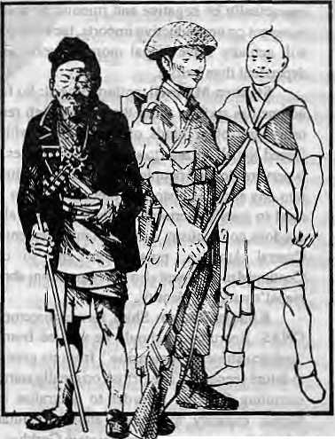
BHU-PUU tAHURE RANGRUT
"Bhu~Puu", the ex-servicafnan
"Lahure", the serving soldier
"RangruT, the recruit
—from an Indian Army ex-servicemen's newsletter

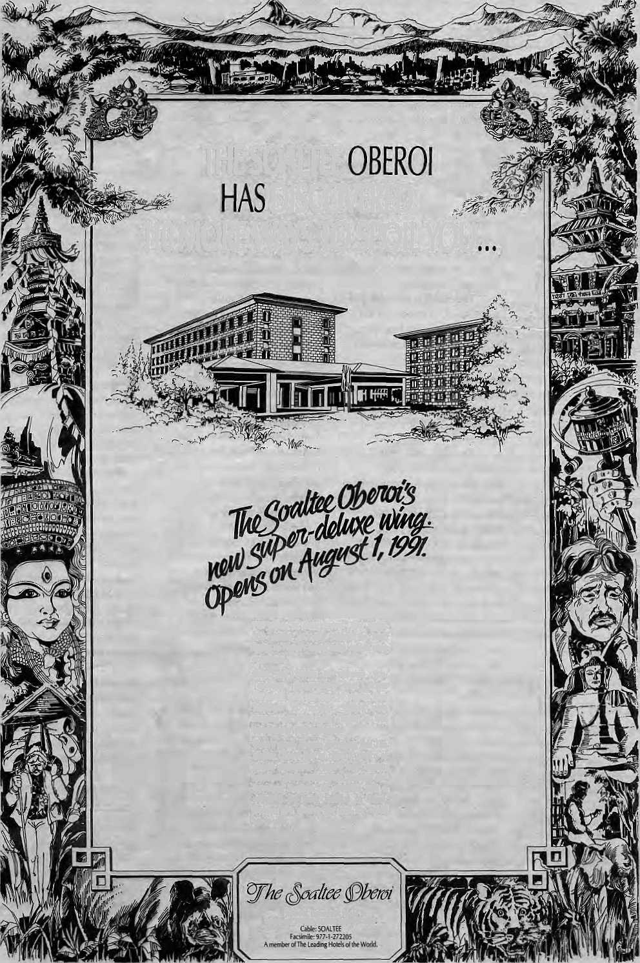
THE SOALTEE
DISCOVERED
110 MORE WAYS TO SPOIL YOU
110 rooms of sheer luwry. That makes 300 rooms in all. Which in turn, mates us Nepal's largest holel. And its most hospitable.
Fmils and flowers to welcome you. Television programmes from across the world. And you can call anyone from Turniingtar lo Toronto... without even stepping outoflhe balh! Thanks to that telephone in your bathroom.
There's more. There's everything (tat The Soaltee Oberoi has to offer, h choice of superb restaurants. Nepal's only casino. Luxuriant green surroundings. Business and Secretarial Services. Alt provided with a smile. In the buest tradition oi Nepal. Because you deserve Ihe best (he world has to offer.
Tthaciul. Mmandu, Nepil TeltpiimeiKlSSO.272555 Tel™: Ml* 3303

i sewage sludpe is not river silt, nor is


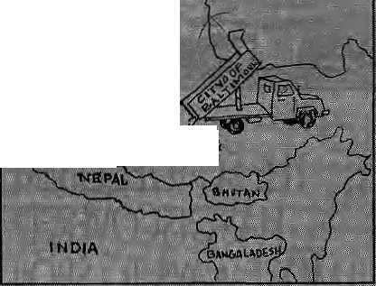


Tibet?
ccording to a Greenpeace
p£$ih
March, Ihe US cny of Baltimore
has secured C Ee
ysitfi a SiMaraj^
Jfirfn, daUfo|iiPajEsrteipn.seCto ship
:20,QDQ tdriScrf tii|
wjaste to Tjixji fh g
payment oT tJ$l 4 null ion I
tons -might .eventual ly fe ;'because &«* Chinese tiJEQ&ejsof
. jjsejjchefne,H^ryuv'SMfrtitiGroup,"

ship up to i.5 million foils of from
Tibetan Native
According to a Baltimore por! whether officials in China arc
'bjtif ial, the $ti*|Igf will bejjslider 7 swans of tMtoxie nature oj the
s^-because the .■'
By ponfuyion over whether Uitv ;" ™ : shidgeh&rjirSj'refers tS '*h^i#'.,v B^iJMig (3oy«rpmentha&.:appr6v«4 ...J' th'eJCIjirtese wwrd-foi* "river sail". ,tl,\c..slt|dge.:irBpori$. ft;is-anplgar; /■ ;; Wiiersas tfie'word fet-.
by houseliold and industrial toxic wastes. When sewage :;kidj:c lias %fti1f.UseS as Jei'tifiserTO-thie .. v '; United States, the results hav<:
presence of toxic polluuinis and
■ ■Any ^udgtjS hipped to is likely to teirnaiffltliierc-.fl&iS
.:. Sfinlill Group has; uSstfhjd .-., ...
ivCali'forp'iai^Etiterrifise.'iBiat "we wi take the- responsibility for all *
l
lirtishing the CtcstonieF procedutes afteK aiTiVirt of the goods jsvtiie .... ■ Qiifid'portey^aiiS we guarantee Slat wi'wift not ship {Ik goods Saelcid'-the USAT (erifii

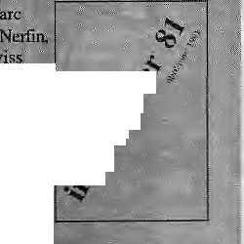
charripiotj Qf | - **jj^{<t}
' ■ ■"■■■ ^. j <!\,*
dfevgk^meEtt;,! ■ >jp.-
|s ^ibout (p . ' .,
pull .^o.wft <• I *^ the shutters on Ifdii
fijiesi'fflfieS¹.-" -:-"'::. .7 ':' ::- ■■;-■ ■>■■' ;:■■->.; contairuriatipiV of' stored"water;.
The ajieTitative plan lipwis-. SiliriisjitioB ol waterways Mid soil:
it. build several dams on in noilh-east Thailand has already
•tiibHiaries;ofife3^]^ktinj;]riv>er,iiv " l.^dto. yjoieiii pratests by rice- ,;, ...
jTheun-2 is a U$ 500 million Why is no one talking of
: eonsLruction flfrd^ins along the *
,:■ " lp^i;r-Mekong? Became, that ■■:■:■ .*.'
T
hailartd'^ ptKiiOoii ^'ts^vis Laos.-.-is, in sftmsi-Ay.ayis, ■■" ■"" ■■ ssini [ar'to"'India's if/i'ra^vjs Nopal t apd Bhutao, WKich is why...plaits
- provide ekctriciLy lo power- ...
•stareed^ Tttailaiid¹ fwhose ene i §y demand is expected 10 triple to 20,000 MW withinJWj mat few ight b^ ijiow t bau at
The iMigfec
altersativg power jS'QJcpt rrt.iLaos _{f}a Ker 'Th ar enyjrpnmijmaiis IS "pressed fot.a.niarateiidiiii on daai^-;
building'itiThailand- Tfeianji-.';
dam movement's major >mccc\s
-fte ■
Choaji project, wliich would have
Germany,.japan are^
i
fnfil^r%E)-fce:eteafadftoin|he mctreitrart amilfiorr feres, ot.. ■re|erv^iE-afia-:;vflfrpK:sH;aa"Hi be exported to Thailand.
EaaMficialsj ar-e not pvet- ' jiastie m. tiiere. is.evidence.of
of 4S vvell,■■.-.■
would feijuire.ithe "Vietnam-.and Ca
positipri i(Vparticipate''flrthe ... Meksiig Comrnisee, wijicii was ■■■ sei up jji ;1957- to cpopdifiate datn-_{s} biiBiing-in4ifi region. ■■■ , ; ;: ■■■
After, years of^{s}.p«b|i shiftg-out-c»f-..thi-W3y ■Tbirjj Wo'rid-ijrienied wii[ings_{p}?"the snagji^i'ive is dying, says JjerFin, because of fifiatttial. pr)§blemsiat>d because "today's world bears little resemblance so
pubii<ratiofl fr&s; launched. Siaci then,|, the Dossier has serv iced a

ones have _{Sh:}«fcen up the Himalaya "* ""^ "^ * *?**$ & V° * , ^T
ver tlie mst \W ears Which spread havow in the pkuw. Commission on Large Dttms.
'•■ * /-/I-'. . ^{li}™- ■-!' . '^{i}'- '■- f, „ '„ ""' ^WWkESfired iissaSve " " ° "Min• fales?e,...Si»jei.wfemolt
E
ight major cartli^uokes of
7.5 magnitude (Richer
scale) iind many less powerful
h hk Hi
r^ fo J
w;iter inipo.ujidcd by this proposed factor of placing .t dam at Tchn is darn would come crashing flown "extreme". On the hazard scale of
^aud citizens '.;.asscjcijilion" in J se^cli oi a'fcrriattve pathslo- -. social jihd etononik; progress, flat moVkV say* W erf in, Die Lhx'bigr's ■■ frolernust tj<*ni^esainifie'd srid.itii. tcuorfsdaptedjn.ihe ■. . £w- iai<ai iri s&Uic gsr.;,

ilownstriani imd wipe oui Uie holy


callons of wulet daily to
■■;,<• r":"# ■>
* a. .. -■ * J
eosi three billion doltes would kill millions ol people
P it *«**•#•■**:'* • * J
*ur;'eitt tnesxages to Ell lop Ifldtari :" goVrfiim3nt»ffic,i:ais tiorriiUje ^' -PresiJeu) on down, while THDC'a ^hau^rnim;has,y<^ved"ts

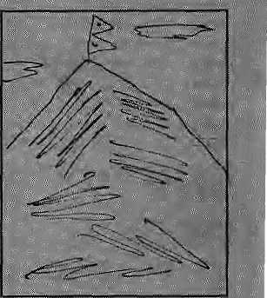
programme
The actual number ol oi
'thlsl' -' f " f^^ #⁾^^{tm}##^ª^^{C}I |^{fl}*^{s}*W¹| S#i fe .,: = ■::■
infected could be much higher. brothels.
Even from the limited daw Meanwhile, there is not
it can Ik seen that the face of the ^{muc!}» awareness regarding AIDS/
epidemic is changing. While HIV even among the high-risk
several months ago, those infected groups, let alone- the genet a!
were cither foreigners, or Nepali

BBIEFS
ADOS
T
wenty-foui HIV infected ...... ...cases feave iiciwjbeea ..■■'.' :"
identified in Pftei: IfJNepafi
foreigners. Two
wojheite
i'cpuTrtwJi 17-i fe feigners, ^ght-%id..:ttBfee-t!fepafi'
fl&e«ad. stage qf HIV infection;).-"
■ nil tH
.■woman. was: infected-wif.fi feleraf ^{s}
'■■■ donatedb# a male iffclfetivj'. Jhtee../
of :lte eight.jrj^rr> were ji.detitif|kf' :
' fiti abJw^ss ttiat did ijigit fteal^ Tpie our rften fta|J fjfftqvie,?)[ted .;
South East Asia; ■
s rising,'
Dolphin
T
she ijitfoductiontpf; itioforised.
roereaaed shotetfnc actlvtes . -. associated, with ihe pT«pGssd
control office in Kathmtindu, the is on average one Slew case reported every week. However, the figure of 24 HIV-iffflN
l
s- rr|lslead(hj -^ because most of them were discovered accidetitally f>r through voluntary testing of Wood rather
distribution of the Susu.
The Susu i"-: lisled as a ihreiMencd specie by IUCN. Its total population is estimaterl at no move than 5000, spread throughout the sub-eontioent. In the Kainali, t>csides the dam-related and other noisty activities., the habitat has been affected by the recently constructed darn downstream at Kailashpuri in

#»W
India, now many more men have been identified. (Fir more background on AIDS, see Uimal Sept/Oct 1990 ). The gender gap seems to be closing, with the virus panos invading the general population. Unsuspecting promiscuous men with HIV -infection art likely to sprer.d
branded as
much mttre rapidly than
« Singh, social-scientist from Tehri Garhwal, has just launched Friends of Eco-
network of people interested in
Sherpas on
hree more climbers successfully made st to the top of Criomolongrna/Sagarmalha/ Everest on 8 May 1991. states a picss re[e&«e dated 31 May. With 343 climbers having 'made it' to
eyebrows, except that this expedition was ali-Sherpa.
Lobsang Sherpa. Sona DemJu Apo .ii>S jjjjtajg [T'iVnteSjhearp»,,fil:T#; J , whom work fi^ mountain guides
SifivTravel Nepal; a- ...: n**e|:itiS agency.: ng-Sherpa, :fe|der of.""' itioji,:*'Before,.:w&


thefesn
sifriply by feeing too⁵ poisy, says Brian Smith, ajij
'Ganges $usu:<as the species,
ix gangeticd, is called f evolved in the turbid i ot' the Gariga urtd js, cfivtrly- blind, li d^peij^s tijion a sophisticated sonar system t»
sptUre prey. Nfti.se disttirbfffice cnticaDy impairs the ¹ 4'audjtoiy .vision'' of the cblphjns *arid thws their aJbi.iiiy to siirviw.,
After ilie Karinili River ik the mountasis at Chis^jarii 'giiirge,. il fails ottl in aiiuv \a\ brafded^chjiiihcjs, This veiui-tropical basiii provides tbe prime hiibitfti site I'of the uorfhorss-inost
... spiWiiiggrun of jyf& pulitoraX a tnajor Food fish foi Hie local people ;md the Susu
-Only miep dolpbfins weeej :
surveys by Sm3h ahovc tiie ln<rii:i(i' bx>fdt!T. TJ:! is' ii dp v^ii from thie 2ft ■Susu coiMiied/by Dr;,Tl'K;Shre_s6ta: ■ iri 1983_{r}If'tllfC jJliVntlcti 270 nl ■', high Chiijaparji Dam is tonstructed; the jrwltic^i wgter disdiatrge is expeet^d Yo titusp !. mstjor eftHn^ss iff ttie jiyarologicat ■ju Rl ;ge.o itiorp hologi^a l^onditio rjs that'c^mbirie i e forrn 'f§QlpBn habitats.
... .. Snviifi feels th«t fisrSMiPli-. * merit of aruriieriiatidiwi} dojphiri saiicHitffy at the Nopal/India bevnior fitl thcKriVrtali ivould be an iniporJant stu*p tfls.va.fds- p-es^fviftg this uniqiHi riv.<ir doiphifi.
organisation will woit; to "fostei
yearly copies'off tiie NeH\£rditi -:.\'aidesof Phik>s&pfiy: ■ „ ■' "Wrtfeto;Vjr.^irtgh, G. sity-, Klil Carapys,,.
NOT TRUE;
■ A* |ndiaft ne*s agescs< carried aft ilem stating tliait the Nepali Government had .announced a iii6r|itc|ri'im («i ciijnbing Everest Not iKie. said the. Miiitsiry of ■■ Towlsiii.^pirte one., come ail, but y«u jjave to ^f,ai| id line. The moHntaiii is booked titt the turn tif the' cent ury.
carrying joadis Uirough;ihe : ~ danjgeroius.jKiitHnbu Icefafl iirid
6s,tng roujes arid trigli camps for jh« saiiib$^ This time, we; Srie ■ bavfi dcme.it ait by pii
planned atid QrgSrtiKe
afittte expedition, food,
While' the 3fct«rpas cJjFtt Ihe rno.iintoii, stitus saijihUnendf *■ ■: were prov itl i ng- able s lippoirt from 4 deep baclcgrpund. Three friends ■ .from C<jlifor!>ia,_{J}aiid Colorado^ ' * lielp'ed the ex<pedijucm with, rno'ney _{f} and the Aiiiericap QUtfitletiS North* Face arfd Patagonia contributed * equipment,' :
Mow tiiat tlje Sherpas havt-done it,'perhaps It Is time tor a pan-ethnic :Nep&H atternpt on ^ie mountain' Sherpas, yes. bill why not also Th^us?
...,: ■■■■'■'■
Iyo 1 - ill\A A l «*T

■ It * * ■■■ ■ •

Himalaya"; ^
T
4uf Nepal Moantaineefing 'Association (NfylA) is .... ..... .
jaundiing a''Glean Himalaya ■:■■ Campaign" on J&tittary 1992 to rid She higfi Hirhals <md trails of ions &f garbage left behind by climbers and trefckers;
According to NMA's ; President Tek phandsa Pokhajel; ojieciunbing expedition on : average leaves more than 500 kg of garbage. "Theje ,fniist be more
.been $9 grawl^.-abused,'' ba .called-fo ft rftoratorinii! on: ■
to al&w themoiinfeui to . Meaj.n.wK.ile.,
points out tfiat '*Ufe oxygen cy}irjaers."lei't'.behind Isjf i 1953 are sltiSJ tltere ia tact;" :
■■; Amon^otiieT t h i n gs,. N M A is prpposing thai elimtjing parties ■'■■
" be asked to leave a sizable" deposit before ihcir asdjBnt, „ refundable pn|y if |ii?y bririg back : ail their rubbish.-It is also :; : proposing'off-seasontrekkitiigT
: and lllc opening up of virgin areas to rsdiicc pressure on..Annapuiisa..

K
North by
selling holiday packages to ; TibjBtareoomplamins.afeoutthe
■'■Besflis;# afflict CJh^ s, whiph.operates.iwjce.
Kathmaiidu antlLhasa, ■■■■ :; "■ Many: flights'iSfe-'': '"' pcr-.-rnplorily cancelled nl (lie l.iii
/chronic depart w& delays, fe
ifi t|sf(aviQpr.i. "■■.■ .■■■ .:
awaits many a ■
boarding call, clutching bottles of diampx fpr-vihe iljSOO ft laHdirig at Geungkffir Aii^ott: Instead of '
is spread ■'throiijefi rlmours iii the";;
; .. "Cpnironied wirti kam -■■ ... -.;. tr,av«fers weefcsServ weefcv'trse :: airiiji^f ^pieseiiitative tries ttard; to' sound serious when reciting the


. Ease Camp and
■ Saj*arriijtna. ■■ : ' ;.■ .". .. .. .. .
... ■.■:■ Garbage includes cans* ~ ■
■ box*sv toilet■■paper (used),pacte
[fiafenM,. tents and oxyg£(1 i
. ^liriders. $»; Bdrnund fililiary; :: whose vreiy ft. i| iJiat ^liiiqre.a^e.
:■■ portion
to cleaa i^p
-ranging ipom ''rioLcsiottgfe plaScS"¹ to "not enough passengers". ^.irfiotiaw*i a-bfcnkd- baa oft ■■■■■■ ■■■■ ■■ travel to TtbeL a biiii on individual (non-group) tourists, and so on
|rr|ve
lo show signs of estreme lethargy
; "adverse climatic ;
tei %eefcK ^T feai we
agents deeded to investigate. Sure enough, on days when the weairwi

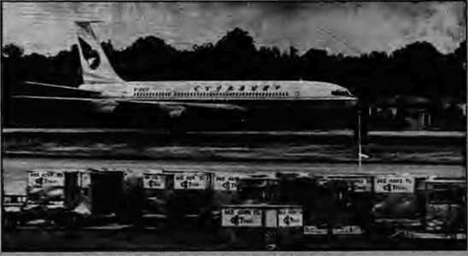
g.^{:i} The-sober" '■ ' : headline would read "t-eauing
sickness!'¹ If * sthere were Hollywmod or Bombay
snacenlt {some-wou3dsay «till~ ^ > " boifi) filiti induStrj, the fiieadliries wouldbe screastnng, "Ecicina
Ag^ini", "My Ilrush with, _{w}AMS''i "Matinee Idal Gasps for : iife'', or "Oh,. Sweef Gxygeni"* '
Acjually, ;the drajna was cli more muted*. The shooting ' Itstafion was in Miuiang. the fiigh^ ^altitude valley behind Annapuruaj
Bpi^iv voo could *-ay Tiiorung Z.<s, Uh" aclor Ivitl developed acuic v.siiodness of Jbieattj.*jfecoEdiiig -to^ smoiintaiB-sickness experts ;A-^^ ? cjn be marked by pulnionarj' edemasw'filer til the;Iiaigs)5tor ■ ^{v}" cerebral edema (wattrlogged
highly ■
UispaicJi^! to lower . ... ..
climes. and is now: reportedly: ■ breating hbririatlyj Meanwhile,"; Arjun $hrestlijs_{i};._{i}w|io.\y_{i}as..tq;havc . second fiddl-c, has a IpJ
Obviously maleof sturdier stuff, he giit to "play the leading Tok; opposite acliess¹Mo usltami Mafia.
hi
0 |
fliglit comes in from tte north at
p
. vintage Boeing: 7Q7:kfere8siiigIy tprtds lev: roosiijySf-night. ■ *
ailftwajictiof 0$";. if af:\^snaj Pazaar m.iti^wjitpwn ...

iijghtThefilm-M-sjiQoting , fh© HlllS
^abandon the fflrri. What v/as ttie ' ^mpsf cpnyinping,eJLcpse? Jureka!;.-isA«ute Moutitaii» Sickness, weti feknown for its immediate and tiniy e: descent froin higivaltifudej :

iff tiie
1991
®? ^ #
According to the irj)'orLTje<3 "^sources, leading.fipn Bhttvan st paid sctpr in the Nepali

Fa<^di¥iti internal;political, . pr^urearul some ■■; :;■ -.-.■ -international tyriticisnj, fh& ..: ... :■:■
#o|ild gr^ut'"[injited aLjtonQfny":: „ tp ^i^ people of )li« Ghtjtagdng ^{s}
y In order to break thebsckpf.
a; 1^-year oJd ipsyr^dacry by: :- ■'■ hili^wople, Dhaka :
⁴ ■*■ f. i 211.1 z 1 .* z i *; i * ♦
■decided JO"''haiid oyisralt i6c|l ^ Gk)Vierrunent power* Eo: the three "disrfict
;foj!ciwed; Ibe refease of a teporl fey*'
S'et
rights situation in!ibe : Qii ttagoiig Iiil I £". "Di s cb rriniis sio 11, headed by a Onadiari profi^sor. sar^j expert <*n;indigenous.people*, ^lfegisdl ahiprtg otte.tMiigs; that
the Eihd;^ Goy e(n sites t.had a poficy ef forcrbl j¹ reloCMilig tfibfli
pjedpte into "imli'tary con
w^cf the view thattpa; ■■■. ■ atitCTnamy-asd-poSjiicas *■:■ norittdlisation wciulcl nothe
Chihagang KilEs, wfitcin are ^{p} . pjre^entiy Keav^ p_a!ipl|ecl % the Bangladesh miiit
*■*»*«■■

VOICES

THE NIGHT PRAYER
Unpublished poem by Tsering Wangmo, who graduated recently from the Lady Shree Ram College for Women, New Delhi.
T
A he porch lights arc switched on.
Till the whole neighbourhood is bathed in a soft luminous glow. A golden shine against the darkening sky. Then with the deepening darkness:
ablankrtess invades, As the night swallows all life.
quiet solitude. But for restless dogs, dogs barking at the shrouded moon. Dogs barking at fear itself Dogs barking for a lover.
Dogs barking along with the chants from the old monastery. Sleepy monks at their evening communion with a thousand deities.
the drums, cymbals and the bells, the prayers. The barks.
The drowning human voices. The soft murmers from curtained windows, All interlaced. Voice upon voice, And the Eastern night is born.
SULTANA DAKU AND THE IRRIGATION DEPARTMENT
Copy of document dated 2 April 1991 that arrived in Himal's mail.entitted "AnExample ojinstitutionandCapability Building in the Department of Irrigation."
o,
' n one hand in Irrigation Department some 140 engineers are idle without works, on the other hand project preparation and feasibility studies are continued to be carried out using consultancy firms most of which are ill-mannedor with raw hands. Theresults of studies made by such firms are topo copying and useless and never match to the site situation. In case of Irrgation Sector Project (ADB-loan) in Central and Eastern Regions Districts, the appraisal and approval of projects has been made on reconnaissance level studies done by local consultants. Such reports areof no use and prepared in their offices in Kathmandu and not based on site surveys. Therefore district irrigation offices and regional directorates are unable to use these reports. They have to carry out other engineering studies and project estimates which surprisingly are much different than the consultant reports. Recent Asian Development Bank (ADB) mission on Irrigation Sector Project (ISP) review has remarked that the approval of projects be made on full feasibility reports and not on reconnaissance type of studies prepared by local consultants.
Thereis another fallacy; in the supplementary budget some 1.5 croreRs. is addition ally allocated for enhancing constructional
works. But the Project Director & Director General of DOI are bend upon to spent this money on payment of project preparation by local consultants thereby extract some 50 lakhs (33%) to fulfil their commitments. Also they want to make happy some friendly consulting firms with whom they have either share partnership or from whom greater percentage can be availed. These consulting firms are welloff people and their sons are studyinginUS A. They need not any support or obligation from DOI leadership.
The hard luck is with the poor engineers who are idle. Without any work they are in difficulty to feed their family and children. This 1.5 crores additional budget wilt serve as boon to fulfill the commitments of the main men of DOI. In original project document of ADB it is specified that the two Regional Directors wilj function as Project Managers for the two regions but now it is the project coordinator sitting in Kathmandu who is pay master. Will the authorities look to it in depth to avade the trecherous motives. Even Dakus (like Sultana Daku) work on certain ethics but not the DOI (Department of Irrigation).
THE THARUS' PLACE
From article in May 1991 issue of Mountain Research and Development, written by Ulrike Muller-Boker of the Justus Liebig University and entitled "Knowledge and Evaluation of the Environment in Traditional Societies of Nepal."
T
JL he evaluation and perception of the natural environment, however, is not only motivatedby purely economic considerations. The following story about sal forests that one Tharu told us as a characterization of his people may make this clear:
Long ago, God called all people to him in order to give them riches. All the castes, such as thePahariyas,the Newars and the Tharus started toward God in order to receive riches from him. After wandering a long way, they passed through a beautiful forest area (kathaban). Everyone continued their journey; only the Tharus remained in the forest, looking around for nice wood, thereby forgetting to con tin ue their journey to God. After some time the other people came back with riches, and the Tharus came back from the forest.
The Tharus say of themselves, in contrast to recent settlers (inChitawan valley), that they are a"people with a strong relation to the forest;" the forest represents a familiar environment to them, and they know how to utilize its rich assets. For them, "going into the woods" is something positive, something they like to do. My Tharu friends in Chitawan, for example were always highly enthusiastic about going out to collect plants. However, they attached great importance to going wtth a large number of people, particularly when they went into the more remote regions. This is quite rational in view of the dangerous rhinoceroses, tigers, and bears, but it was more the presence of the gods and spirits that made the Thares feel uneasy.
The pantheon of Thani gods exhibits a large number of deities that live in the forest, and they may feel disturbed by the inappropriate behaviour of intruding humans. Even more dangerous are the spirits (bayar), whoseDathsonemay accidentally cross. The Tharus avoid these "spirit ways" {bah); the shaman

July/August 1991 ■ H1MAL 29

knows where the spirits and gods abide (usually in damp places and puddles). Before going into the forest, one recalls the name of the Forest deities and asks them for their aid; in the forest one avoids doing "bad things".
For the Pahariyas, too, the forest is an important economic resource. (They frequently poke fun at the Tharus for their faintheartedness; in fact the Pahariya women go out all alone into the forest to cut fodder, but the Tharus never do!) But for the Tharus, forest is a part of their form of economy and way of life; it is part of their cultural identity. As the inhabitants of the high mountain regions of Nepal associate the snow mountains with the seatof the gods, so the Thar us highly revere the forest as the place where the gods and spirits live. For them it is that much harder to confront the ideas of Western ecologists who see the forest and the savannas only as a living space for animals, one in which the Tharus no longer have a place.
FOREIGN NGOS AND AFRICA
Excerptsfrom paper presented by Yash Tandon (as carried in the IFDA Dossier) on the role of non-governmental organisations (NGO) read out at a rouridtable organised in Nabuja, Nigeria in December 1990.
J_ here are two issues of concern about these (western) Ngos in Africa: Who are they and what are they doing in Africa. Public understanding on both these issues is both superficial and uncritical, for the fact of the matter is that we do not really know what the western Ngos amidst us are doing in Africa. Are they the missionaries of a new era and therefore forerunners of a new kind of imperialism, or are they indeed allies of the people of Africa in their continuing struggle against domination and exploitation by imperialism over the last hundred and more years?
Much of the criticism we have of foreign Ngos in Africa stems from the fact that they work with such secrecy and opaqueness that it is right for an African to be suspicious about them ab initio. After all, Africa has in the past been taken for a ride many times. The generally hospitable and welcoming culture of Africa is too easily prone to taking the foreigner at his face value, and in the process Africa has lost all its lands and all its resources to the the foreigners. This time Africa should be more vigilant.
"THE YEAR OF TIBET"
From introductory remarks about concerted Tibet-related activities being held around the world ("The International Year of Tibet" ) by Robert A.F Jhurman as carried in the first issue (Fall 1991) o/Tricycle, a US.-based quarterly Buddhist review. Thurman is a Professor of Indo-Tibetan Buddhist Studies and founder of Tibet House, New York,
hat is remarkable about the "Year of Tibet" is that no government and no U.N. agency and no foundation and no onyf/i/Hg official declared a "Year of Tibet."In fact, noneof those officials even recognize Tibet. They think, "What is Tibet? Maybe it's part of a province of China." Everyone knows thatthis
is a lie, but in spite of that people in 35 countries said, "In the middle of this decade of indigenous people and this decadeof the environment, let's celebrate Tibet!" The idea took hold in New Delhi because Tibetan refugees live there, then in New York because, by now, it's filled with old Tibet hands; and then in places like Prague, Brazil, and Mexico, where people know something about oppression. Particularly throughout Eastern Europe, people said, "Hey, let's do it!" In a way it's like having a cultural embassy. We wouldn't have to go through all this trouble if Tibetan culture were in fact Chinese culture. But the awkward, inconvenient fact is that Tibet is a totally separate place, with a totally separate culture. The Year of Tibet is a way of culturally recognizing the nation around the world which nobody is doing politically. It's a very heartening move and the Tibetans are very excited and happy about it. It's a lot of work but we hope to really turn out the people to celebrate and recognise Tibet. We can't wait for all the state departments of the world.
THE GURKHAS AND THE BAHUN
A description of the various designations in the Brigade of Gurkhas, taken from The Future of the British Gurkhas, House of Commons Defence Committee Report, 1989 {Her Majesty's Stationery Office, London, £14.20),
A
Gurkha may hold one of three types of commission. Sandhurst-Commissioned Officers have exactly the same terms and conditions of service as British Sandhurst-commissioned officers and are their equals, rank for rank. They are frequently sons of retired Gurkha officers, and much better educated than the average Gurkha. There are at present 14 Sandhurst-commissioned Gurkhas in the Brigade—8 per centof the British Officer strength; the most senior has been a lieutenant-colonel, GurkhaCommissionedOfficers(GCO)hitiren.$tai\]s equal to that of British officers, but different terms and conditions of service. There are 6 GCOs in the Brigade, of whom 4 are serving with infantry regiments. Queens' GurkhaOfficers(QG0)pTO\ide the majority of the officers in the Brigade of Gurkhas. All were originally recruited as Riflemen or equivalent and have risen through the ranks. They have a status between Gurkha NCOs and the British and Sandhurst-commissioned Gurkha officers, and may hold the rank of Lieutenant (QGO), Captain (QGO) or Major (QGO).
TheGwrMaMtfjforistheseniorQGOinabattalionand is selected from among the best of the senior QGOs. He is the Commanding Officer's principle adviser on all specifically Gurkha affairs, including cultural, religious and family matters. No Commanding Officer (and certainly no mere junior British bfficer) lightly ignores the views of the Gurkha Major.
The Bahun is a Hindu religious teacher roughly equivalent to a padre. However, unlike Army chaplains in British service, he is a civilian, employed by the MoD. As well as his spiritual teaching duties, he is responsible for the unit's Hindu Temple. In recent years, the influence of religion and its disciplines upon Gurkhas has lessened, -but the role of the bahun is still of great importance in maintaining the Gurkha soldier's cultural identity.

30 HIMAL • July/August 1991


NEPAL
INTERNATIONAL CLINIC

& Western medical setting serving the entire community
* Care by a U.S. Board Certified Internist
•i? Comparable services at lesser
rates ■ft- Imported Vaccines, Lab work
* Knowledge about Mountain Sickness.
■it Central location
■& 9:30 am-5 pm
* Open Sunday
it Prior appointment encouraged
412842 & 419713
Phone answered 24hrs. __
Jai Nepal Cinema Hal!
Royal Palace Main Gate
~i r
Lazimpat

Naxal
_J L_
Thafnel
i r
Durbar Marg '
I
Kantipam I !
We canputyou in touch with Macintosh.
If you're one of the 18 million people in Nepal who don't know how to operate a computer, you haven't met Macintosh,™ the newest personal computer from Apple.

It's so powerful, it's iuwedibly simple to use.
Just put your hand on the palm-sized "mouse" controller. And click -you're Macintosh-literate.
Our professional sales staff will answer all your questions and, of course, provide service and support.
So if you're searching for the right computer, hurry in for a demonstration. And put your finger on it.
MIPS Pvt. Ltd.
P.O. Box : 2502, Bagh Bazar, Kathmandu, Nepal. Tel: 222-277. Tlx : 3521 ATLINK Fax ; 977,1-419250
Apple and Lhe Apple logo are registered trademarks af Apple Computer Inc.


Get A Great Book '. THE KINGDOM'S FAMOUS BOOKSTORES:


SPECIALISATION
- Tibet
- Buddhism
- Rare & Antiquerian
- Nepal & Himalaya
- Dictionaries, Encyclopedia,
Phrase Books
- Books, in French, Italian,
Sanskrit, German &
other languages
- Art, Culture, Religion,
Philosophy
- Travelling, Adventure &
Mountaineering
- Natural Sciences

KAILASH BOOK DISTRIBUTORS
At main entrance of Hotel Yak & Yeti, Durbar Marg,
P.O. Box 3872 Kathmandu, Tel: 225159
Tlx: 2765 71WAR! NP Fax: 977-]-229983
TIWARI'S
PILGRIMS BOOK HOUSE
Thamel, P.O. Box 3872, Kathmandu, Nepal Tel: 416744, Tlx: 2765 TIWARl NP Fax: 977-1-229983
Worldwide Book Mailing Service
Amex - Visa - Mastercard
Magnificent Postcard Selection
Maps - Guides
Books on every subject for the whole world

VIEWPOINT

A Choice of Housing

Ambika P. Adhikari
' uring the very short history of urbamsatio n in modem Nepal, remarkable changes have taken place. There were less than 10 towns in the 1960s: today the number exceeds 30. About nine per cent of the country's population is now urban-based, up from about three per cent in 1960. The annual rate of urban growth now stands at eight per cent. Urbanisation has exposed Nepalis to the era of jets and global communications and dramatically increased their mobility, changed their attitudes and, also, led to shifts in the design and building of houses they live in. Unfortunately, not all the changes in Nepali urban housing havebeen for the better.
Most professionally designed houses in Nepal are so culturally unsuitable that the owners make changes almost as soon as construction is complete. Problems include lo w insulation of thin brick walls, infiltration of winter cold through large glass windows also shows abias for the modern and a mindless abandonment of the tested and the tried. Professionals, architects, engineers and others, must change their technical orientation and be more open to locally suitable technologies that are culturally valid and functionally efficient
Technology choice in the design and construction of housing in the Third World may be roughly divided into three categories: traditional, modern and "intermediate". Hasan Fathy of Egypt is the well-known prqmoter of vernacular design. In Nepal, architect Ramesh Manandhar has championed the cause of reviving traditional systems with an emphasis on building with mud and otheT indigenous materials. Inspired by the use of mud walls in Nepali housing, Manandhar has tirelessly experimented with the construction of workable mud domes. Certain prototypes were built in Gorkha and elsewhere, but there has been no widespread application as yet Mud domes, which are not traditional, could yet provide an excellent roof construction technique for Kathmandu builders.
Choice of modem construction technology is favoured by architects and planners in the mainstream of the profession. Examples can be seen in the representative works of architects Naxayan Bhattarai, Bijay Burathokt, Shankar Rimal and others, including previous works of this author. Rimal pioneered modern building design in Nepal, with works such as the Royal Nepal Academy hall in Kathmandu and the factory and housing for the Janakpur Cigarette Factory in Janakpur, as well as numerous other institutional and residential buildings. He initiated the extensive use of concrete, machine-made bricks, steel, glass and other modern materials. Pre-stressed concrete portal frames of more than 30 metres were used for the first time in the Academy building. In many residential buildings, Rimal has used bold new designs such as hyperbolic paraboloid roofs and large concrete cantilevered beams.
During the 1970s, appropriate technology was seen as the way to go, and numerous socially and culturally conscious architects have taken comfort in the idea of an "intermediate" space in housing design. Because the concept of intermediate technology assumes a unidimensionat and bi-32 HIMAL • July/August 1991
polar notion of technology, practitioners have been confused about hitting the middle point in the line that extends from traditional technology on one end to advanced technology on the other.
In Nepal, architect Ranjan Shah has popularised a form which combines modem technology and vernacular aesthetics. Since the early 1970s, Shah has completed numerous residences in Kathmandu valley which incorporate sloping roofs with brackets Jali windows, carved doors and exposed brick walls. His buildings utilised the vocabulary of traditional aesthetics to create nostalgia and were extremely popular. Numerous architects have followed Shah's intermediate path and the approach is still much in vogue, but critics complain of the superficiality of the building
forms and deceptive use of materials in these buildings.
The intermediate technology approach seeks to find a middle ground between the two extremes of the technological systems. But technology choices are not necessarily linear, and a person in a given situation, at a given time, may pick up two kinds of technologies and combine them for his purpose. For example, Kathmandu builders often use imported high strength steel bars to construct areinforced concrete roof to cap an otherwise traditionally built house with raw bricks and mortar.
STEPHEN eckherd Because certain
componentsof modem technology are functionally better and economically feasibleeven in poor co un tries, they are suitable in supplemen ting otherwise traditional construction. Hence, an approach that selectively integrates the modern and traditional approaches to design and construction is most suitable for Nepal.
Housing standards for Kathmandu should incorporate the best of both worlds, as both have their strengths and weaknesses. There are many inherent problems (construction, sanitation, accessibility) with the traditional systems, whilethe modem system has produced sprawl, climatic inefficiency and other problems. Appropriate housing in Kathmandu, therefore, would. seek an "optimal synthesis" of the traditional and modem systems. Obviously, this is easier said than done.
A.P. Adhikari is doctoral candidate in architecture and planning at Harvard University.
Sikkim Surges, Darjeeling Trails
S. Shakya
Oikkim, the Indian state of today, is unrecognizable from independent Sikkim of 16 years ago. During its latter years as a sovereign state, Sikkim served merely as the path for the lucrative trade between Kalimpong (in ■ Darjeeling District) and Lhasa, via the Chumbi valley route (then in Sikkim, now underChinese control). When the trade route closed, even the little benefit Sikkim was deriving from it disappeared. Being a country of limited means of subsistence, Sikkim under the latest Chogyal became increasingly dependent upon Indian aid.

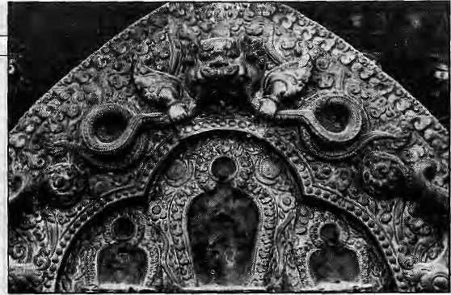
VIEWPOINT
have simply taken over the job from less, single-minded predecessors, others who have done the same job under the guise of being scholars, and embassy or foreign mission employees from just about every major Western country. That the antiquities of Nepal have been steadily disappearing is simply proven by looking at the number of museum and private collections of ihis loot, or even by simply paging through art magazines and noting the advertisements for galleries specializing in Nepali art. These galleries in Albuquerque, Los Angeles, Miami, Seattle, and New York like to do business "by appointment only."
Several years ago, I entered a gallery on Madison Avenue in New York and came face to face with a seventeenth century torana from Nepal. Toranas, beaten in metal or carved in wood, sit above the doorways to the inner sanctums of all major temples. An integral feature of temple architecture, they function as a kind of icunographic blueprint, portraying on their surfaces the deities a devotee can expect to encounter inside the temple. On this particular torana was an incarnation of Shiva, sitting in meditation. At the back nf the gallery, however, behindadesk in the inner sanctum as it were, sat not Siva but an art dealer named Krishna.
Seeing the torana on Madison Avenue struck me as wholly unnatural, if not sacrilegious, and I couldn't help inquring how this object had come to be where it was. I was promptly escorted out the door. Since then, I have become more adept at masking the intent of my curiosity, and in a subsequent conversation with a well-respected and venerable old dealer of Oriental Art, I was candidly informed that Nepali antiquities are really peripheral luxuries of American culture. If we possessed none of them, we would hardly be impoverished.
"There are collectors who are serious and genuine, but most are 'extroverts'. They want to show off. It's an ego trip. A collector will want Nepalese art because it is different. Not many people are collecting it. It's exotic," this dealer explained. "And anyway, Nepalese art is not really suitable for the modern mind. It has so many curlicues. It might look good with French furniture, but that's about it. Don't you agree?"
This dealer was a rather endearing fellow. I wish I could say the same about another dealer I happened to meet recently who had the demeanour of a smug parasite. He had just returned from Nepal with five exquisite (by his account) pieces and had already found his buyers. He was well aware
about what he was doing, and he made the claim that never has he "smuggled" anything out of Nepal. After some circufnlocuitous conversation, I established that every piece he has exported has had an appropriate stamp from the Department of Arch aelogy, easily acquired by paying a sum of money to the man in charge of the wax and the official government seal.
An tliropolo gists will testify to the breakdown of tradition that comesin the wake of disapp¹ earance of art works.
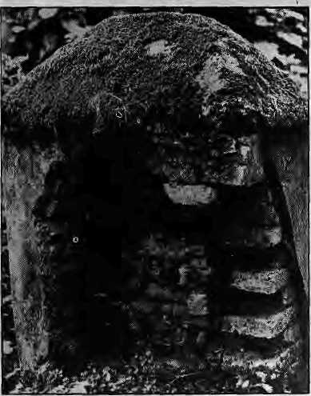
G. C. ALPEN
of what I thought Site of Shiva Kamdsva MrigasthaN Hill, Pashupatl. 23 October 1984

D. SASSOON
Too many curlicues ?
The indigenous museum system that has evolved over centuries is being threatened by the appetite of a more powerful and foreign one. Many wealthy families havestopped displaying their images, while many temples are now obscured by fences and iron grillwork which not only are aesthetically offensive, but which also prevent devotees from giving offerings and receiving blessings in a traditional manner.
After having seen the great artistic achievements of the Nepalis in situ, I cannot avoid the sensation of witnessing a great crime when 1 stand before those same antiquities wrenched from their living context and forever relegated as a curiosity in a well-humidified but hermetically sealed plexiglass cabinet. Museum exhibitions are instructive and entertaining, thus valuable, and the general public cannot be expected to travel halfway around the world to see the great works of other cultures. Yet Amercian museums probably possess enough artifacts in their basements to mount unique exhibitions continuously for another century, and they can easily offer newly studied or freshly discovered master-pieces to the public through the channel of international exchange rather than theft.
There are those who argue that collectors are saving much of humankind's heritage from certain doom by extricating it from inimical surroundings of decay, neglect, instability, and poverty. Senator Daniel Patrick Moynihan has been for more th an adecade the champion in theU.S. Congress of art dealers and collectors, and has used his influence to maintain the status quo in the country's laws. "Nothing has been more striking than the respect which Western countries have shown for the artifacts of other countries," he once argued in Congress. This attitude betrays a paternalism that may shdw a.res^ect for artifacts but a lack of consideration for the very countries jn question.
This is where a revived notion of patronage comes into play. Instead of removing antiquities from their place of origin, could we not contribute to preserving them in situ ? Could Americans not share their expertise and wealth to build museums large and small, and of still umimagined originality, all over the world? Could they not support the creation nf new works of art, could they not make sure that the age-old knowledge preserved by today's threatened craftsmen be kerrt inviolate into the future?
These efforts until now have been primarily advocated by organizations such as UNESCO. There doubt that such efforts could also be championed privately. It has been estimated that the trade in antiquities reaches nearly a billion dollars per annum. Surely people with vast riches could exercise a bit of common sense and make a more visionary effort.
There is another positive direction in which efforts can be made that would benefit the public, enhance internationaLunderslanding, and show respect for other cultures: we can refine our ideas of what is. worth collecting and include the creative products of contemporary culture. By limiting their interest to valuable antiquities, American collectors exhibit their avarice and declare to its victims that only their forebears ever produced anything of a standard of quality such as to merit our attentic
D. Sassoon lived and worked in Kathmandu in the early 1980s and presently edits Earthpost magazine in New York City.

34 HIMA.L • July/August 1991

CONWAY/ALPS FROM END TO END
INDEPENDENT
Beneath and Bcyor. News

For Subscription and information: GPO Box 3543, Kathmandu, Nepal. Ph. No. 223836, Fax: 977-1-226293
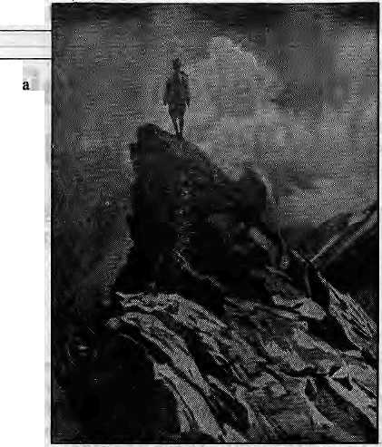


KNOW YOUR HIMAL
The
Pioneer
Mountaineers
Nepal is associated in the mind of many with Gurkha soldiers and Sherpa climbers. Not much is known about the earlier association of the Gurkhas with mountaineering.
by Harka Gurung
D
uring the latterhalfof the 19thCentury,the intractable tribes of the North-West Frontier Province of India could be con lained only thro ugh military mig ht. The Frontier Force included some Gurkha regiments. Then there was the Great Game revolving around the Pamir Knot, where impinged the imperial shadows of Russia and Britain. Baltistan, Chilas, Giigit, Hunza, Nagir and Karakoram were unknown frontiers. Clambingskillwasnecessaryto deal with hostile tribes and to explore the rugged borderlands.

Whether you are in Nepal or abroad keep in touch with the help of the
country's best English news-weekly.
During the 1880s, Charles Bruce was sub-altem with the l/5th Gurkha Rifles. Bruce trained some of his riflemen to be mountaineers. They were the first Nepali "climbers". The first occasion when Gurkhas were employed on mountain exploration was in 1889, when Francis Younghusband was investigating raids on caravans across the Karakoram pass (5,575m). During this mission, theGurkhas helped discover the Gasherbrun, Urdok and Braldu glaciers.
In 1892, Martin Conway led the first major expedition to explore and climb the Himalaya, In his party were Charles Bruce and four Gurkhas of his regiment were stationed at Abbotabad. Among other places, the expedition crossed Nushik La (5,273m) for the first time to reach Hispar, and climbed Pioneer Peak (6,888m) near Baltoro Kangri.
Conwaycon sidered the G urkh as admirable scramblers and good weight-carriers. In order to give them experience of snow and glacier, he organised a traverse of the Alps. In 1894, Conway traveled to Europe with Amar Singh Thapa- and Karbir Burathoki. Along with Alpine guides J.B.Aymond and Louis Canel, they started at Limone in the Maritime Alps and ended at Lend near Wildbad Gastein. The ranges covered west to east were Maritime Alps, Co ttian Alps, Western Graians, Bernese Oberland, Uri, Glarus, Oetz, Stubai, Zillerthal, Venediger and Glockner. During the 86 days of travel they crossed 39 passes and climbed 21 peaks, including Mont Blanc (27 June), Monta Roas (12th July), Piz Gurkha (25th July).
Back in the Himalaya, the first attempt on Nanga Parbat (8,125m) was made in 1895, led by A.F.Mummery and including Raghubir Tnapa and Gaman Singh. After trying various difficult alternative routes. Mummery and the two Gurkhas attempted to approach the peak by crossing a col north of Nanga Parbat II. That was on 23 August. The three never returned, probably buried in one of the avalanches that raked the route.
In 1898, Gurkha climbers were active in the Kashmir Himalaya. Bruce took a party of 16 Gurkhas, including
Amar Singh on Rock Tooth, Swiss Alps, 1834.
Karbir andHarkabir, north of Nun Kun (7,315m) for training in exploration and climbing. In 1907, Bruce, T.G-Longstaff and A.L.Mumm, three alpine guides and nine Gurkhas, including Karbir and Daman Singh, explored the Kumaon Himalaya west of Nanda Devi (7,816m). Longstaff, two alpine guides and Karbir reached the summit of Trisul (7,120m) on 12 June. This was the highest summit to be scaled at the time. Later Longstaff attempted to enter the upper Rishiganga gorge with Kul Bahadur Gurung and Pahal Singh, but the "inner sanctuary" of Nanda Devi remained inviolate.
During 1910-1913, a re-survey of Kashmir and the Russo-Chinese frontier was carried out by Kenneth Mason. The undertaking involved much exploration and climbing and the Gurkhas proved up to the task — Kulbir, Kul Bahadur Gurung, LokBahadur Gurung andHastabirRana. Then came the Great War (19144918) and, for ^{r}the Gurkhas, the new frontier was Givenchy, Ypres, Suez, Gallipoli, Palestine, Mesopotamia and Persia.
The Gurkhas were involved in successive expeditions to MountEverest during 1921-1938. In 1922, Tejbir was one of the four climbing members in the second assault, and he spent two nights at 7,772m. The 1933 expedition included Gagan Singh Pun, Lachman Singh Sahi and Bahadur Gurung of the 1/3 Gurkha Rifles. The 1936 expedition included Lachman Sahi, Lilambar Rana and Gopal Gurung.
The Gurkhas were complete soldiers. Exploration s and cl imbing for them were amateur diversions that ended with the passing of gentleman alpinists they emulated. On the other hand, their Sherpa compatriots had begun to mature into professional mountaineers. A mountain stands on a high pedestal, and the Gurkhas passed on the baton to the Sherpas who in turn delivered it to the summit.
k
Courtsey : Nepal Qjmat
July/Augusi 1991 HIMAL ■ 35

REFLECTION

The Psychic Pain of New Technology
Change is inevitable. New technology is helpful, but what does it take away ? One must anticipate and adjust.
George Everest Munro
^{r}W^{y} he effect on Nepal of roads, hydro-electric power, television
and other kinds of technology will come in two categories. The first one will better the lifestyles of the people. Refrigeration, for example, enhances food storage and guns facilitate hunting. The second category, whose workings are harder to gauge, will have the opposite effect Its practices will subtly eat away the fabric of the culture in the name of development. What I hope, therefore, is that Nepalis can somehow learn to anticipate the adverse effects of technology and, thereby, learn to avoid them. Perhaps technological intrusion cannot be stopped, nor would it be fair to many if it did stop, but it could be slowed or modified if it is understood thatit could cause harm.If they do nothing more than anticipate and understand these effects, Nepalis will be one of the first cultures to do so in history.
At one time, I was a dam builder. So I understand the power potential of rivers. Iremember seeing the roaring Dudh Kosi river in its deep canyon as I walked from the Phortse Bridge to Gokyo in the Khumbu. I visualised a gigantic electric power dam and roads constructed to wheel in supplies and equipment. But then I also thought about what effect the building of such a dam would have on the people - mostly the children.
Cheap, abundant electricity would illuminate, heat, and inform through radio and television. With roads, porters would no longer have to walk. It is easy to speculate what electricity and roads would bring to the Khumbu and other parts of Nepal. But what will be taken away?
The Canadian historian Harold Innis writes about the abrasive and destructive effects of the media on more traditional forms of culture, hi the book Empire and Communication he shows how the spread of literacy in Greece between 470 and 430 BC destroyed family unity and scathed religious beliefs. Even as individuals began to read and write, they became more independent and more willing to question traditional values.
Yet, noneof the Greek philosophers seem tohavebeenawareof how literacy was also destroying the bondof family life, the enisling culture and the belief in the gods. While they weTe aware that their tradition was slowly disappearing, they were either unaware that the problem was literacy or consciously avoiding blaming literacy. Even Plato saw only benefits in literacy.
Literacy has been handed down from those ancient times to the present nuclear age. There were also other continuities but many of them have been lost in a mere half decade. Television was still unknown in my childhood and youth. As a result, I spent a lot of my time outdoors, playing games, some of which have come down, like literacy, from Greek and Roman times. For instance, a piling-on game called "Buck Buck - How Many Fingers Up" had remained essentially unchanged since Roman children played it two millennia ago, until around the early 1950's, when not only "Buck" but also marbles and chestnut bonkers disappeared from the scene. Strangely, no one was aware of the loss.Those born before 1940 remember the games quite well, but those born after seern not to. In 1952, television, like a Pied Piper, enchanted the children and brought them indoors. For these children, what they saw on the screenfor hours andhours every week had little in common with the traditional culture and what they
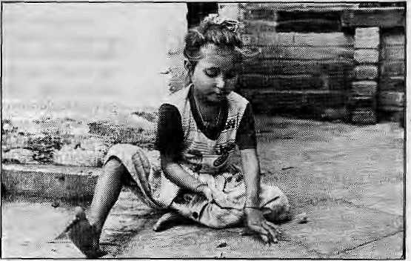
BIKAS RAUNIAR
were taught by parents, teachers and priests. They acquired new ideas and new wants, being often dissatisfied with their own lives and with their parents' insular views. While the parents put the blame on many causes, few, if any, pointed to the television screen.
Tim Chesterton, a friend, has the third most northerly church parish in the world, atHolman in the Canadian Artie. Seven years ago, his church installed a satellite dish. Story-telling practices began to disappear as soon as the TV sets were clicked on. Not only that, the youth began even to forsake their warm parkas and to go out into -40'centigrade weather in light leather jackets—because this was what their television heroes wore.
Instantaneous changes in culture have occurred everywhere and at all times. One more example: when Johann Gutenberg invented the printing press in 1454, anyone willing to read found books available within a few years. The result was that so many read, and read well, that they were soon able to challenge the small group of priests who had enjoyed a monopoly of knowledge until then. "The book," says Harold Innis, "was the battering ram that brought the cathedrals and castles of Europe crashing to the ground." The church blamed the devil for its collapse.
These very thoughts about rapid change and the disappearance of tradition occupied my mind while in Nepal recently. On one of my visits to Swayambhujwaswithmygrown-upson and daughter. Wecame across scores of children skipping and playing as we started to walk from Thamel. My children joined them and even gambled a couple of rupees. One day, these children having fun outside will also be enticed indoors to watch the "American dream" by the hour. They will get new ideas and discover that their parents are ignorant of what is happening in the larger world. Dissatisfied with their own culture, they will question its very foundations.
Surely, if bo th the parents and the children can anticipate the change, there will be enough time to adjust to the results of the new technology. Anticipation will, in fact, allow for control and for dealing with troubles that lie ahead. As Professor Marshal McLuhan says, "Anticipation gives the power to deflect and control force."
Television will be only one of the many technologies to influence Nepalis. There will be others. It took 18 porters eleven days to deliver a tonne of cement to the Everest View Hotel above Namche Bazaar. Someday, trucks will replace porters and, thus, end the "porter culture". One can hope that the porters will find a better life in other callings, but this cannot always be assured. When the airplane started taking supplies to the North of Canada, the Inuits had no more reason to hunt. So, many filled the void in their lives by taking to drink. Values judgments generally win over detached logic. If only this could be reversed...
My great uncle, Sir George Everest, charted your land. I hope that, in some small way, I can help in the making of a different chart - one that will be a guide for the mind rather than the feet. There is a great need to reduce the psychic pains of the coming technology in Nepal.
t> G.E. Wiunro lives in Ontario, Canada.

36 HIMAL
July /August 1991

ABSTRACTS

BLUE MOUNTAINS
Paul Hoc kings. Editor Oxford Univ. Press, Delhi 1998, SBN 0-19-5621778
Subtitled "The Ethnography and Biageography of a South Indian Region", this book covers the 982 square miles of the Nilgiri District and its much worn massif of gneiss and granite. The book provides detailed analysis of the environment and the distinctive ethnic groups of the Nitgiri. While there is some farming, much of the economy of the district revolves around the hill station of Ootcamund and its two satellite towns, Coonor and Wellington. A recent phenomenon is industrialisation and hydropower development. The editor remarks upon a paradox that while more than 3000 articles have been written on the Nilgiri {"three publications per square mile"), there has yet been no geographical or anthropological survey of the area.
HIMALAYAN CULTURE AND ENVIRONMENT
N.K, Rustomji. Charles Ramble. Editors Indus Publishing Company, New Delhi Indian Institute of Advanced Studies, Shimla 1990, ISBN 81-85183-32-9
In an attempt to "view the Himalayan reality from as many different perspectives as possible," in this book, "Linguists are represented side by side with architects, philosophers wilh historians, and anthropologists with monks." Among the contributions which try to tackle the complex interactions of "traditional society, the environment and modem society," we read, among others, N.K.Rusiomji on the Indian North-East, Sonam Wangmo on the Brokpas of Eastern Bhutan, Tashi Rabgias on the role of Buddhist monasteries in Ladakh, B.K.Bunker Roy on the historical ecology of the Himalaya, A.C. Sinha on Nepali immigrants in the North-East frontier, and D. Chakravorty on the architecture of the Western Himalaya.
THE HOLY HIMALAYA
Nitva Nand and Kamlesh Kumar Days Publishing House, Delhi
1990, ISBN 81-7035-055-7
This book, "A Geographical Interpretation of Garhwal", is a reference work prepared for the benefit of post-graduate students of geography in Garhwal University as well for those "keen to have an intimate knowledge of the land and people of Garhwal, the holiest part of the Himaiaya." Among other subjects, the authors describe the physical landscape (topography, river valley projects, floods, climate, soils), culture (pilgrimage, diets, dress, festivals, ethnography), economy (population, settlements), and provide suggestions for development and planning. "The people of Garhwa) look to Himachal Pradesh's progress with envy and believe its progress is due to its statehood," write the authors. "The seeds of discontent are sprouting due to backwardness and neglect...Continuous exploitation of the hills for the sake of industry and agricultural development of the plains will push the youth of the Kill region on the path of confrontation." Something tangible and concrete must be done in the region which can bring it on par with Himachal.
ECOLOGY OF MOUNTAIN WATERS
S.D. Bhatt and R.K.Pandev
Ashish Publishing House, New Delhi
1991, IRs 400
ISBN 81-7024-366-1
The authors state that while the study of still waters
and wetlands of the mountain regions of the world is
. already quite sophisticated, our "understanding of the
ecological behaviour uf running waters" is only jus! emerging from the "descriptive style". The study of the ecological aspects of rivers and streams still lag behind those of lakes and man-made reservoirs. The book looks at "the implication of environmenial degradation and our confused and often destructive treatment of the high altitude aquatic biota that arc known to display a measure of ecological solidarity..." The bopk contains 26 contributions, mostly on the fresh waters of the Sub-Continent. A few articles on the geo-ecosystem of the Alps are also included.
MOUNTAIN ENVIRONMENTS
John Gerrard Belhaven Press, London 1991. ISBN 1-85293-049-7
Subtitled "An Examination of the Physical Geography of Mountains," the book claims to be the first "to be devoted 1o a systematic analysis of the prooesses that shape the mountain environment." The emphasis is on mountain gcomorphology, with ecological, dim Biological, hydro! ogical and volcanic processes also dealt with. The author tries to show how, no matter what their location and origin, all mountain regions "share common characteristics and undergo similar processes." A general introduction of mountain types is followed by a discussion of geomorphological processes such as weathering, "slope processes", hydrology and glaciation. Volcanoes are examined as a special class of mountains. The book also deals with snow avalanches, lands! ides .floods and debris torrents, as well as specific highway engineering aspects. The author identifies "current problems with mountains" and identifies major gaps in knowledge.
HIMALAYA MAN AND NATURE
Krishna Murii Gupta. Editor Lancers Books, Delhi 1991, IRs 200 ISBN 91-7095-0198-8
K.M. Gupta is Secretary of the Himalayan SevaSangh and long-time editor of Himalaya: Man and Nature, thejoumal brought oui by theSangli, which is dedicated to the study of environmental and developmental processes in the Himalaya. The book contains selected contributions of 55 writers from the 600 articles published in the journal since 1977. According to the editor, the present publication seeks to "review current trends in the development process," the need to retli ink and (o evaluate, and to synthesize interdisciplinary research. Contributors include Madhava Ashish, T.B. Subba, M.S.Swaminathan. S.K.Roy, B.K.Roy Bumian, Ani! Agarwal and Nawang Tobden.
WHOSE TREES ?
Jan Sharma. el. at. PANOS Publications. London 1991,7.95 Pounds ISBN 1-870670-25-6
This book, subtitled "A People's View of Forestry Aid," is the result of a collective effort by writers in Tanzania, Sudan and Nepal who were given a FIN NID A-funded assignment to study three FINN IDA-sponsored forestry projects, including the HillPoresi Development Project in Nepal. (FINNIDA is Finland's development agency.) As the introduction states, forestry management conditions in Finland are "virtually opposite of those in the developing countries where FINNIDA operates." The book concludes that there must be a willingness and ability on the part of national governments and donor agencies to continuously scrutinise and question development projects. "More importanily, looal people also have to have the power to critically question the relevance of
foreign aid to their daily lives. No amount of consultancies can replace grassroots opinions.¹' Jan Sharma, writing the section on Nepal, concludes that a key problem is the absence of clearly thought-out, sustainable programmes which address development priorities. Forests are being destroyed by people "not out of apathy or stupidity, but because of the need for fuel, fodder and land, tliey are claiming the forest to grow food." The experience of the HFDP showed that it is not foreign aid Nepal needs, but effective management of forest resources and adequate reinvestment of the revenue earned.
HUMAN CONFLICT IN CONSERVATION
Him raj Dang Vikas Publishing House Development Alternatives, New Delhi 1991, IRs 295 ISBN 0-7069-5050-X
This is a study of the increasing pressures on India's wildlife resources and the resulting conflict between the priorities of development and conservation. The declining population of various wildlife species has led the Indian government to set aside protected areas. Today, in the 25 "biotic provinces" of India, 426 national paries and sanctuaries covet 3.3 percent of the country's land area. However, even the protected parks and sanctuaries are facing tremendous human and developmental pressures. Concludes Dang, "Today, the biggest challenge facing conservation in India is not animal management but management of human pressures on wildlife resources." The wildlife-resource conflict in India was an indicator of unsustainable development practices. The suggested solutions for this conflict; eco-development and park-people cooperation, were both essential features of a sustainable development policy. The book also provides a case study of the Dehra Dun Siwalik forests, an area that is soon destined to be upgraded into the Rajaji National Park.
MINING IN THE HIMALAYAS
Ratna M. Sudarshan (Project Coordinator) Institute of Social Studies Trust, New Delhi 1991
The acceleration of mining activity in the Kumaon over the past two decades has further aggravated the region's economic and environmental degradation. ITiis study investigates the experience of selected villages in the vicinity of mine sites in Almora and Pithoragarh districts where the correlation between environmental damage and economic loss was found to be high. One common feature was the role of women as leaders in agitations protesting damage to common property resources. Mining leases went mostly to entrepreneurs with trading and commercial background and without local connections. Profits were repatriated elsewhere. Labour laws and safety regulations were obeyed only cursorily. Dust pollution and land subsidence were significant in almost ail sites, and the rale of accidents was uncommonly high. Attempts towards land reclamation were feeble, employment generation minimal. The present methods of mining and processes by which leases were granted did not contribute to economic growth, sustainability or the observance of human rights. A coherent mining policy was required to adequately balance local and national needs. The leasing and operation of mining sites had lo be responsive to local needs.On the whole, development strategy must build upon traditional strengths of the people of Kumaon. Concludes the study, "decision-making-must be sensitive to protest." Contact: D. Jain, ISST, S.M.M. Theatre Crafts Museum. 5Deen Dayal Upadhay Marg, New Delhi 110 002.
July/August 1991 HIMAL ■ 37

ABSTRACTS

MOUNTAIN RESEARCH AND DEVELOPMENT
Volll,No.2(May 1991) Jack f3. Ives. Pauline Ives. editors. International Mountain Society This issue of MRD contains several articles on the Himalayan region, as well as contributions on Rwanda's mountain gorilla mortality, the climatic Factor in soil conservation strategics (an Ecuadorian case study), management of the Changbai Mountain Biosphere Reserve (astride the Chinese-Korean border), and rain-fed barley production in the Andes, On the Himalaya, one article concerns the water and sediment yields of the Sutlej river and concludes that extensive sediment control treatment will be necessary lo improve the safety and efficiency of the many hydropower projects that are planned on the river. Another piece is on "the knowledge and evaluation of the environment in traditional societies of Nepal" and focuses on the how the farmers of Gorfcha regard different kinds of soil (rato nutto. kalo mate) and the relationship of the Tharus of Chitwan and the forest. There is an article on 32 medicinal plants used by the people of the Tons Valley, Uttarkashi, and another on little-known "endemic wild alii urn species" in the Uttar Pradesh hills. Contact; PO Box 1978, Davis, CA 95617-1978, USA.
ELECTRICITY FOR RURAL PEOPLE
Gerald Folev
Panos Publications, London
1990, ISBN
ISBN 1-870670-21-3
This 195-page book is "an attempt to explain rural
electrification: what it is, what it does and what it
cannot do," writes the author. Though governments
tend lo see rural electrification as "the key to unlock
thedeveJopmentpotentiaiof rural areas, "it can also be
seen as a diversion of development funds from more
important and pressing areas. Foley says that though
in the longer term perspective of rural development,
rural electrification is essential, the timing and level of
resources committed to it at any one time or level of
economic development should be carefully taken into
account. The book has a brief section on small hydros,
with positive reference to developments in Nepal, but
none of the seven detailed case studies presented deals
with the Himalayan region.
THE GORKHA CONQUESTS
Kumar Pradhan
Oxford University Press, Calcutta, 1991, IRs 350 SBN19 562723 7
This book describes "the processes and consequences of the unification of Nepal ,with particular reference to Eastern Nepal." It is divided into three sections, dealing with the pre-unificalion situation, the process, and the consequences of unification. The author seeks the "real motives" behind the expansion of Gorkha. He examines whether Nepal could have been considered a nation before the Gorkhali expansion, and whether unification was, as is popularly viewed, prompted by a nationalistic desire to unify Nepal. Sn the author's view, the notion of Prilhvi Narayan's noble ambition of unifying the nation "does not stand to reason in the light of the character of his conquests." Considering his achievements, it is no wonder that scholars should praise Prithvi Narayan, says Pradhan, but "the traditional historians of Nepal..,tend to make too little of the'dull multitude'and too much of the cataclysmic personality of the rulers."The book goes on to explore the economic considerations that might have played a role in the unification. It also examines the point that the "multitudinous diversity" of Nepal couki not be sc
38 HIMAL • July/August 1991
easily resolved through mere territorial unification, and underlines the importance of the ethnic viewpoint in an understanding of Nepali history and sociology.
HIMALAYA TODAY
March-August 1991 Dil Kuman Bhandari. editor New Delhi
This quarterly publication, which resumes publication after a year's hiatus due to "certain operational difficulties and research activities," bills itself as "one of the first journals in India devoted exclusively lo the Himalayan problems and potentials." Revived, this comprehensive issue carries articles under headings ranging from tourism, society and culture lo politics and adventure. In her editorial, Bhandari, recently-elected MP from Sikkim to the Lok Sabha, writes that the Restricted Area Permit has been a strong deterrent to tourism development "Nepaiis in Nagaland" is a semi-autobiographical examination of the social, religious, historical and political status of Nepaiis in that far-eastern slate. Prem Poddar and Tanka B. Subba present challenges related to tourism in Sikkim; S .S. Negi examines the depletion of Himalayan forests; O.N.Dhar considers the insurgency in Kashmir ("The Pakistani Connection"); and Mahendra P. Lama (the magazine's Honorary Resident Editor) analyses "Foreign Aid in Nepal: Interdependence to Dependence." Contact: 125 South Avenue, New Delhi 110 011.
IMPACT STATUS REPORT NO2
Swiss Development Cooperation, Kathmandu, 1991
This report was prepared by INFRAS (Zucrich) and CEDA (Kathmandu) and is the second in a planned series of documents on the impact of the Lamosangu-Jiri Road Project and the Integrated Hill Development Project. The two projects form part of the 20-year effort by the Swiss Government lo assist rural development in the hills of Nepal lying directly east of Kathmandu. The report notes that the road has induced rapid growth of Charikot and Jiri doe mainly to intra-regional migration from nearby areas. The result is that income disparities within the region are increasing between the road corridor and more remote areas. Programmes of the [HDP proved unable to counter this trend, The projects led to increased local food production as well as more and diversified food consumption. The road das greatly reduced transport costs and imports have increased significantly, including construction materials, agricultural inputs, clothes and luxury goods. Pottering has shifted lo the north and south but has not decreased as a source of cash income. The most visible impact was in the form of roads, schools, health posts and drinking water schemes. Modernisation of thinking was undermining parts of the traditional social structure. "In aggregate, people are on the average slightly better off nowadays than 15 years ago though more than one-third of the people still five below the poverty line."
ASIA-PACIFIC UPLANDS
R.D.HJII. editor
Pacific Science Association, Hong Kong A flier sent out by the Pacific Science Association states that the planned publication will be a "A Newsletter for Scientists", which will seek to develop as a medium of information relating to the uplands areas of the Asia-Pacific region, "both along the rim and amongst the islands." The publication will seek to involve scientists in many disciplines and cover issues that re late to "each island, each region, each catchment, each village." Contact: Dept of Geography and Geology, University of Hong Kong, Hong Kong,
ECOLOGICAL IMPACT OF APPLE CULTIVATION IN THE HIMALAYA
Vir Singh
International Book Distributors, Dehra Dun 1991, ISBN 81-7089-114-0
According lo the author, the available publication on the apple are all confined lo production technology and economic issues. Ecological aspects of apple farming have been completely ignored. Apple cultivation is leading to the alteration or replacement of temperate forests at a rate that is arousing concern among social workers, ecologists and others. In 14 chapters, the author deals with issues such as biological productivity, soil, hydrological cycle, atmosphere, biodiversity and life-supporting base.
PLANNING, AGRICULTURE AND FARMERS STRATEGY FOR NEPAL
Prem Lai Chitrakar Mrs.G.D. Chilrakar, Publisher Kathmandu, 1990
This 332-page, heavily referenced book is meant for decision-makers, scholars and development professionals with an interest in Nepal's agricultural development efforts between 1851 and 1990. Whether ad hoc or planned, the author notes, development benefits have not been equitably shared by fanners living in the different agro-ecological regions of the country. As the author relies upon his 25 years of experience in HMG' s agriculture sector, his arguments and the strategy options he outlines bear some weight. Starting with background information on Nepal's agricultural and crop environment, the book goes on to study the genesis of agricultural development, the perfonnance of planned agricultural development (Third Plan through the Seventh Plan) and prospect) for Nepali agriculture. The measures suggested for improving agricultural performance include "dispersal" of development efforts throughout the country; better distribution of available human resources; mobilisation of local leadership; strengthening of regional offices of the sectoral ministries; external funding only of well-articulated plans and programmes; and the "complementary development of the diversified resources of the Terai, the hills and the mountain regions."
HYDROPOWER IN NEPAL: ISSUES AND CONCEPTS OF DEVELOPMENT
Arjun P. Shreslha Resources Nepal, Kathmandu 1991, NRs 250
While retracing the history of Nepal's hydropower development, this book is scathing in its criticism of vested interests and technocrats who for "personal advantages and petty benefits continue to undeimine theeconomicprospectsandhumanpotcnlialofNepal." According lo the author, the near-total dependence on overseas professionals and the infatuation with turnkey projects has shackled institution-building in Nepal's power sector. Many past mistakes continue lo be repeated. The author provides detailed background, charts and figures on die workings of the Nepal Electricity Authority and the Ministry of Water Resources, among others. He also discusses power forecasts and potential market sand suggests strategies for "bulk power export" to India. He presents alternative concepts for planning and development of hydropower, and provides a selection criteria for proposed projects. On the controversial Arun III Project, the author (who is presently chief of the Pancheswor Project) calls "fraudulent" the claim that the Arun HI Project was the mosleconomicaibargainofaQthehyd ropower proje cts studied.

tuS


We Also Serve You Birds On Trees

/Gaixtet)
■

French, Italian, Chinese, German,
Russian cuisine. Served on the
greenest green you've ever seen.
Plenty of sun, fresh air and bird song
too.
■ . ■

SHANGRI-LA
LAZ1MPAT, KATHMANDU. TEL: 412999
We Make You Feel Great!

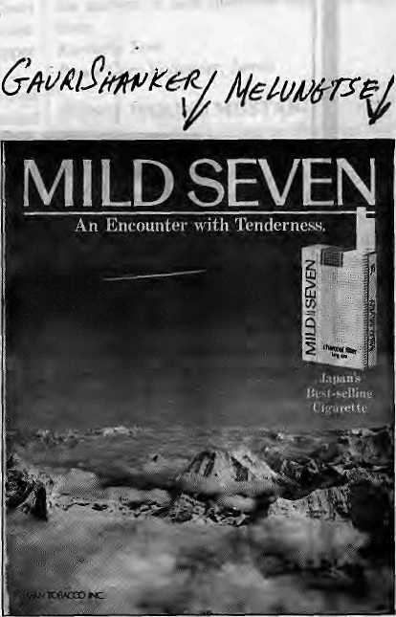
Abominably Yours_{y}
Humans think of me as a recluse. But being a curious snow-person I have recently subscribed to several mags and papers, and, yes, I have even set up a dish on top of Baninutse to keep up with goings-on on Lhasa Television and Nepal TV. Though I thought this might lead to a better understanding of the ways of humankind, I must confess that several items have made me more baffled than ever, for they fly in the face of what I thought humans meant by common sense. Mostly, I am perplexed by what are called "ads", (why they are called this I do not know, for they more often seem to subtract, but I digress).
For example, in one ad, flying above the Himalaya, in a view as clear as I ever remember having, is a giant packet of Mild Seven cigarettes. Surely if ever such a monstrous pack was to be smoked, we would never see the mountains quite so clearly again. Perhaps this particular brand contains a miraculous ingredient that allows the consumer to see such heights even through the dense air of Kathmandu Valley? Or is it that the Mild Seven people have finally invented the smokeless cigarette?
Does the Japan Tobacco Inc propose to place this giant pack of Mind Seven permanently in the site shown? If so, I fear for personal safety because the mountains below make up my summer stomping grounds and pasturage. An "Encounter with Tenderness" in this stretch of the Rolwaling Himal I do not want, with or without charcoal filters. Directly underneath the clouds gurgles the as-yet-unpolluted Rolwaling Khola, on the left is Garni Shanker and straight ahead is Melungtse, on whose ice fields Eric Shipton shot those famous paw marks of yours truly back in the 1950s.
Another image, this time on Nepal TV, that baffles: "Khukuri Chappals" in front of the Baudha stupa. Though I rarely have occasion to wear them myself, I definitely recall that shoes and other leg-wear are not usually items that one associates with the respect becoming a place as holy as Baudha.
R. CHITRAKAR

I
Is the shoe company making some disrespecful statement by placing their shoe in front of the stupa? Or, perhaps, are these shoes specially designed for circumabulating, tilting slightly to the right (or, for Bonpo, who like to go about it the other way around, to the left), easing the foot distress associated with constant circling? If this is so, it is not at all obvious from the television commercial, and the product is failing, I am sure, to reach the public for whom it . was intended. I personally suspect that it is the^good light on the high stupa platform that attracted the admen, and the stupa management proved only too willing to provide a commercial backdrop for hawking chappals made of plastic.
Why "Sherpa Sabun", may I ask? Is it specially formulated to do away with the kind of dirt that one is most likely to encounter in Solu or Khumbu, or the farther reaches of Walangchung Gola? What about those Shirpas who are busy running restaraunts, making rugs, and selling curios in the Valley? Will the soap work for them? Does the soap company intend to come out with an entire line of cleaning products, each appropriate to a particular ethnic group? Actually, "Bahun Sabun" has a better ring to it and would have had a captive market of all pundits enjoined to bathe every morning before dawn. If ethnicity is the key, can we now look forward to Limbu Bleach, Jyapu Towels, and Thakhali Toothpaste? Why pour it on only the Sherpas?
Turn a recent issue of any ASEAN newsweekly, and another Himalayan image leaps out of the pages. A gigantic Carlsberg Beer trailer truck (the sort you see on German autobahns) cruising amongst the sedate paddy fields of Pokhara Valley. Annapurna I, gleaming in the evening light, towers overhead, seemingly content in the presence of "Probably the best beer in the world."
I am privy to a certain lofty perspective on the roads of Nepal, and I am certain that no trailer truck of such size could ever have negotiated its way into Pokhara, either by way of Mugling or Butwal. We are thus left with two honest possibilities and, dare I suggest them, two dishonest ones.
The honest possibilities are that one, the truck was airlifted into place by gigantic helicopters; or two, that it was carried overland, piece by piece, like the first cars to come to Kathmandu. The two dishonest possibilities that I can fathom, are: one, that someone got busy with photos of mountains
and trucks and scissors and glue; or, two, that a life scale plywood model of the beer truck was fabricated by local artisans for the photo session.
For the sake of beer consumers, I would hope it was one of the latter (dishonest) possibilities, for any beer company so extravagant as to entertain either of the former would have to price their product far beyond the reach of today's average beer drinker.
And this just in. "Tibet Soap", straight from Karachi, Pakistan. The model on the wrapping is a blue-eyed blonde. Perhaps a descendant of Alexander's hordes who got lost on her way from Hunza to Chitral and ended up selling soap to tourists under the Potala, only to get offered a modeDing contract she could not refuge from a Sjndhi soap manufacturing tycoon/tourist who thought that she must be your typical Tibetan damsel.

From all Pve seen, it seems that advertisers go rather far out of their way to put something of the Himalaya into the selling of their products. As the Himals are the abode of the gods (not to mention myself), I must object. To make a mountain out of a molehill is bad enough, but to conjur the Himalaya from shoes, soap, beer, and cigarettes is more that these hills can bear.

40 HIMAL • July/August 1991

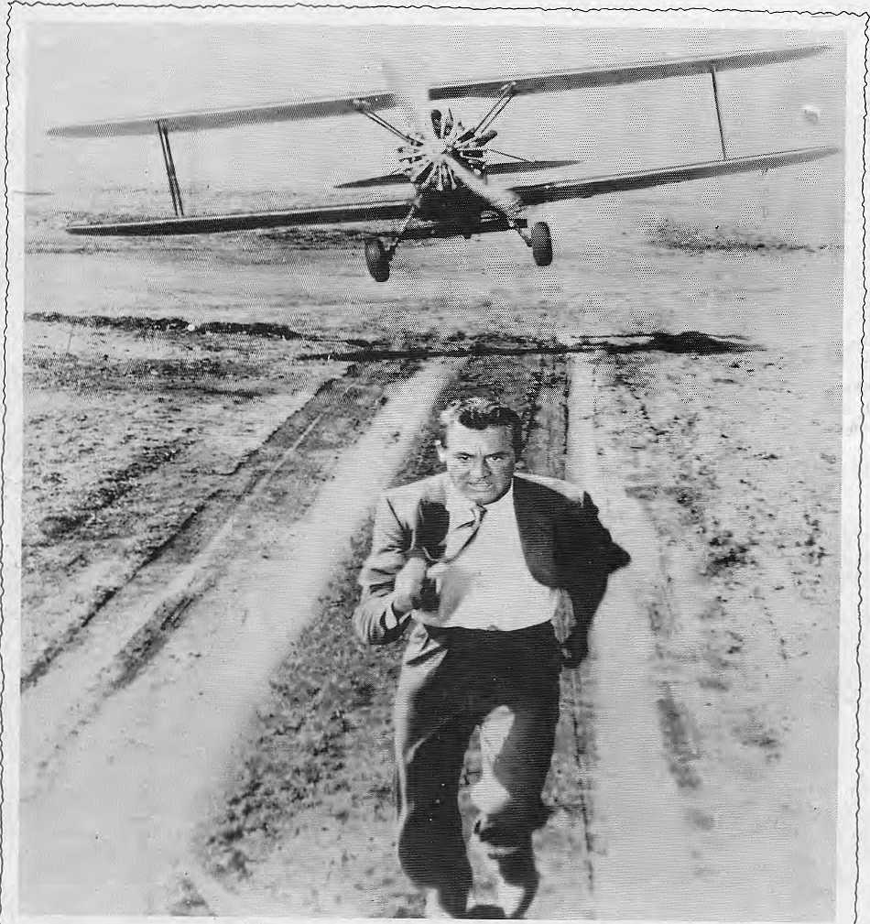

HEADING FOR HOLLYWOOD? NOW YOU CAN FLY THERE ON THAI.

'Commencing July 1st, Thai will fly from Bangkok, via Seoul, to Los Angeles three times a week. Arriving at 10.30 am, it allows ample time for connections across the United States (including Mount Ruslimore).
Thai people are famous for their hospi-
tality, so we're sure you'll enjoy our renowned Royal Orchid Service en route.
You can now fly to Los Angeles on every Monday, Thursday and Saturday in our brand new MD-II aircraft. And re- ?\ _{tm} turn via Seoul the same days. *''-'■'■ •■'■• ' ' ■ '■

details, please contact Thai Airways International Ltd., Durbar Mar_{Br} Kathmandu. Phones: 115WM/22 4917/22 3565 or your travel agent


■ ■■ ■■■■■-■■ ■■■■■■ ■■ ■■ ■ ■■■ ■{-■ ■■■ ■■■ ■ ■ ■ ■■■ ■■ .■;■,.■..■ ■;.* .■;■':«. t.■■..■ ■■„.::■..;..v,?.■..; '■■ .?........-j-;.:>.
'■■'■■' :■.:"'!-::::''.'::::':■:■:■ ■.■:■:-:■ :■■:': 2'■ :■■'■ ■■:::-:;' ■'■■ ''. '■' ■ ■ :■:■''.:■:■:::■■ :■■::.■ ■• ■■■ ■ ■;:■■:■;■ ■■:;:":

Northwest makes it easy to go to America. With a choice of 8 gateways. And connection to 200 cities beyond.
Choose a connecting city that suits you best: generous free flight plan there is.
Bangkok, Hong Kong or Singapore.
General Sales Agent in Nepal : Northwest has daily 747flight via Tokyo or Seoul straight to the U.S.A.
Ma! la Treks,
Malla Hotel Arcade,
Be sure to ask about WorldPerks, the most Kathmandu, Tel. 41 8 369

