HIMALAYAN MAGAZINE

NRs 20 IBs 15 U$ 6 Mu 20
■: •.: ■ tSSMi012'9S04:.;
May/June 1992

ETHNICITY
i)ta4^ Riches #1V4^
..::...::::.:..:.:..:;....:■.:■:;

INSIDE


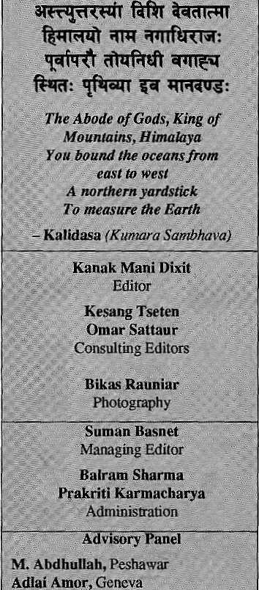
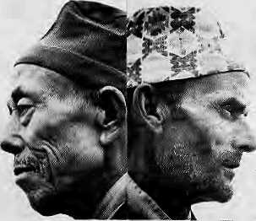
COVER
7 Tending This Garden prayag Raj snarma
10 A Pan-Tibetan Identity Dawa Nortu
- Pointed Noses, Stubby Noses
- The State of Jharkhand subhachan Dasgupta
14 Trap of Cultural Diversity
17 ATarai Divided dim Ram Dahai
19 Representation in Parliament
22 Bahunvada's Myth & Reality Kamai p.
24 Cauldron of Assam Bnupindersingh
25 The Tamangs¹ Burden parshuram
28 Bangladeshi Minorities Father T.
30 TO be "Nepali" TankaB.Subba
FEATURES
35 Wild Yaks of
Kunlun
37 Khaptad's Riches 39 Reviews:
DEPARTMENTS
- On the Way Up
- Voices
42 Briefs
46 Know Your Himal 48 Abominably Yours
State of India's Environment #3 Ethnicity, State and Development

j 1 | I | 2/ |  | ?4 C,
[9 ] | ^{f} 8  X, | ) 7 |  | )[ 5 )
 | I¹⁰ | >/ 11
(is | \{ | 14)! | 13)
HIM

Anita Anaad, New Delhi Kinky Dorje, Thimpu k Bahadur

Cover picture by Jan Salter shows, according to the key provided above, 1 Bahun, 2 Sherpa,
3 Lhomi, 4 Magar, 5 Limbu, 6 Newar, 7 Chhetri, 8 Gurung, 9 Tamang, 10 Newar Jyapu,
11 Tamang, 12 Chhetri, 13 Tharu, URaiand 15 Tatraa. (See Page 11.)
Himal {© 1988) is published every two months by Himal Association,
PO Box 42, Lalitpur, Nepal. Tel: 977-1-523845 Fax : 977-1-521013.
ISSN 1012-9804, Library of Congress Card Catalogue No. 88-912882.
Please turn to page 2 for subscription information.
Printing and layout at Jagadamba Offset (page make-up by Kiran Shakya). Tel: 521393.
ShahJ
, NewYork
B. G. V«^bcse,NewDeUii

MAIL

What's In It for You?
In "What's In It for Me?" (Mar/Apr 1992),
Manisha Aryal tried to analyse the activities of different non-governmental organisations (NGOs) involved in women's development. As a trainee who participated in the Center for Women and Development's Communication Education and Gender Training Programme, Aryal deserves congratulations for her bold venture. Unfortunately, her article lacks in-depth study and maturity. It makes interesting reading but lacks objectivity and is bias. An accusing finger is pointed at almost every
MAR/APR 19ft?-.
lil
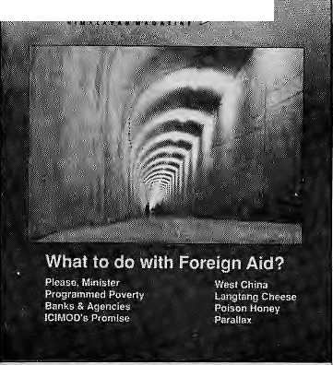
NGO working in the area of women and development. The findings, based as they are on sweeping and hurried interviews, do not do justice to organisations that have worked with commitment in this area for a long time. Also, does the question in the title of the article apply only to women-oriented NGOs?
It is not necessarily true that NGOs go "where the money is," as our Centre's work demonstrates. Our action programme grew out of our research findings. The decision to extend work into training and action was certainly not donors-inspired, as the writer implies. In fact, donors view the work we
started on a modest scale, with our own resources, as successful and worthy of support The Centre's research programmes are continuing and will continue; research, after all, forms the knowledge base for action.
The immature and hasty accusations made by Aryal that all women and development NGOs are donor-driven, or are patronised by donors, have no foundation. Regarding NGOs which tend to resemble family enterprises, no doubt this seems to be a lucrative trend. However, without a thorough investigation into the social service approach versus the commercial consultant approach of NGOs, it is premature to pass judgement.
The writer should also have been better informed about the Women, Water and Energy series, which is not a research study undertaken by one institution as she seems to think. It is the result of a training workshop in which writers from various institutions presented their own perspectives and analysis.
We would suggest that Himal, in its enthusiasm to present alternative views and generate innovative ideas, be aware of the social responsibilities of journalism. The borderline between analysis and bias may be thin, but the latter certainly shows in print, in your journal. Furthermore, is Himal exclusively free from the all-engulfing donor syndrome which overwhelms.the whole country today? Self-assessment-and introspection may be worthwhile. Board of Directors Centre for Women and Development Kamaladi, Kathmandu
Out of the Dark
I found the issue on foreign aid {Mar/Apr 1992) extremely informative. Your journal has played an important journalistic role by providing unbiased, well-investigated information. The issue has brought a vital subject out of hallowed seminar halls and discussion among "aid practitioners", into the public forum. In the spirit of democracy, it represents an important step towards forming public opinion on what we, the people of Nepal, need and what we do not. It is high
time we stopped paying for the mistakes of decisions-makers and the greed of "significant others" in the aid game. Arm Rana Lalitpur
ICIMOD's India Problem
It is sadly an occupational disease of so many journalists the world over to describe situations in terms of personalities as a substitute for serious thought and "analysis. As is clear from his article on ICIMOD₅ (Mar/Apr 1992), Bijaya Lai Shrestha too is arflicted by this malady. His personal attacks on me as the Centre's first Director are both grossly unfair and inaccurate.
There is no truth whatsoever in the scurrilous statement that India's alleged apprehensions at my appointment (at age 57 not 62) arose because I had "been asked to leave India in the 1960s while working in Calcutta as a Ford Foundation employee." Whatever its malicious origin, this is a complete fabrication. And ironic in that, just two years ago, I was honoured to be invited back to Calcutta to participate in the Tercentenary of this great city, and to receive an award from the Mayor for my "personal contribution to Calcutta's planning and development" Shrestha's absurd allegation could be ignored {though damaging to my reputation as it is) but he uses it in this article to justify a much greater fabrication: "that Rosser's role was greatly undermined by his 'Indian problem' which greatly hurt the organisation as a whole". This is superficial nonsense.
To the extent that ICIMOD (and therefore myself as Director - not the other way round) had an "Indian problem", it arose from much more serious issues than those linked to the personalities involved. Apparently Shrestha's analysis cannot rise to the level of geopolitics. Perhaps he should reflect a little on his own country's complex relations over the last few years with its giant neighbours to the north and south (doubtless he will recall the reasons for the recent 'trade boycott' of Nepal) and then transfer some of thii thinking to seek some minimal
May/June 1992 HIMAL • 1

MAIL

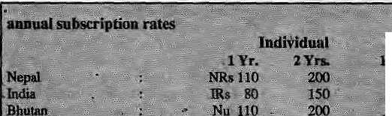
Bangladesh (over Farakka and the Brahmaputra), and Nepal and Bhutan re their relations with China — and clearly ICIMOD had emerged in the middle of a political minefield. In India's South Block view, its very existence was 'a mischief — one of the commonest nouns of Indian diplomacy! There is much more to be said (on another occasion)'about this, of course, and about its implications for the structure and functions (and frustrations) of the ICIMOD Board of Governors whilst I was the Director. But this one fact of the inclusion of China was the cause and essence pf "ICIMOD's India problem." The cast of players in this particular minor chukka of the Great Game was largely irrelevant; the basic problem was intractable. If Indian harassment focused on me
Sou^{v}t|t East Asia-

understanding of the politics of 1C1M0D in the framework of the whole region.
This letter is not the place for a discussion of ICIMOD's problems or indeed achievements whilst I was its Director. (I am currently preparing a lengthy memoir on ICIMOD's foundation as an instructive example of the inescapable conflicts between 'soft' environmental idealism and the 'hard' realities of international power politics.) But I must say it seems hardly possible that one obvious problem, the very basis of India's concerns about this new Centre, should have completely escaped Shrestha's attention. The inclusion of China.
Shiestha notes the early history of ICIMOD's foundation, but omits the absolute key fact that the Centre's validity as an international institution had its basis in a resolution at the General Assembly of UNESCO in Paris in 1981 (three years before I had even heard of ICTMOD). This resolution, passed unanimously, defined the "countries of the Hindu Rush-Himalaya" to including eight countries including the People's Republic of China. Given the Centre's fundamental non-political objectives, 'the inclusion of China made excellent sense in terms of the genuine, if naive, idealism of this new Centre's sponsors. The inclusion of China apparently passed unnoticed (at least without recorded objection) by the Indian delegation at the UNESCO General Assembly in 1981. It was several years, it seems, before the Ministry of External Affairs in Delhi woke up to the geopolitical implications of China's active participation in a regional institute to be based in Kathmandu with the whole of the Hindu Kush Himalaya within its mandate. As a senior Indian diplomat said to me in an unguarded moment, 'The Indian delegation at this UNESCO General Assembly must have been asleep to let ICIMOD include China."
Thereafter, it was South Block (Joint Secretary North) in Delhi that "controlled' ICIMOD affairs, not the Secretary, Department of Environment, Government of India. The Indian Foreign Service, that is, not the Indian Administrative Service. Clearly the inherent international structure of this new Centre conflicted (unwittingly for its European sponsors and staff) with a fundamental tenet of India's foreign policy with regard to its highly sensitive northen border along the whole of the Himalayan range. The inclusion of China, for 'whatever reason, in a regional Centre based in Kathrvrandu appeared, ip&o facto, to legitimise 'Chinese interests in the southern face of the Himalaya. And thus offer a challenge, however minor it might seem in ICIMOD's case, to Indian hegemony in this whole complex region. It was as if China had somehow been invited to join SAARC1 Add Pakistan (over Gilgit and Kashmir),
2 HIMAL • May/June 1992
personally, this was quite understandable; as Director I was a suitably visible, neutral and 'easy' target in essentially 'coded' political exchanges. The board and my senior colleagues understood only too well. Not difficult to understand, surely? Difficult to change, certainly.
lasiiftrtiorial "
wo V' 5%
i2oal;- ±."::$&fc
In making this single point, I do not intend any criticism of India. Every country must, of course, be the sole judge of its national interest. As director, I unexpectedly found myself in an impossible situation in political terms. And with much sadness, because a deep affection for India has been the center of my personal and professional life for almost five decades. Colin Rosser West Malvern, England
'Mm:
45
m
#;
Other South Asian Countries
Send *gp;«abJeripri6h*P:£ fnei>d or^collea^ue. ₄, _{v;}; - _{:r} J-- ,!; ^ -
Mease4o:.not.^ra^ash^{i}fom^{s}aa,,B.iir&
Please mj&eiwataUfwymentftev Assqcitttimt
Seed subscription or^srs;
Nepal (tet 977-1-523845i fax; 9f7-l:521pl3X or
^ ■■■"
iiiii, Singapori 2Q57--...
^; 204.Japan., ... .
Ban, 12 Norfolk S^ PaddungtotiSmi^f^, Australia..; .It Basne^S. #inehursif As®. #6A, New York, NY ,100J3.» USh
Back Issues of Himah
.: No. ;: ^
0 * " . "
Nov/Det 1989 Devdtpment Refugee
h

MAIL

Out of Sight, Not Out of Mind
I strongly disagree with Umesh Malta's statement in the item "Urban Voices" (Jan/ Feh 1992) that "polluting industries must be located outside the Valley, in Hetauda or Bharatpur". I am amazed that such a statement could have been uttered by an "urban planner". The problems created by polluting industries ore not solved by moving industries to places where they can continue to pollute out of sight.
Firstly, the products of these industries would still have to be brought to the main markets of KalMmandu, need more trucks and more fuel consumption, and creating more air pollution. Secondly, other towns and rivers of Nepal should not have to shoulder the pollution that Kathmandu is fed up with. The Panchayat era is dead; with the new democratic norms we fought for, the inhabitants of other towns cannot be made to accept what has been deemed unfit for Kathmandu. They too are Nepali and have the same rights as the people of Kathmandu.
Moreover, shifting polluting factories out of the Valley does not even guarantee an end to their harmful effects on Kathmandu. Wool-dying factories banned within the Ring Road periphery show us clearly that smoke does not remain within the boundaries that the factories are relegated to. The mighty Narayani river at Bharatpur, or its tributary at Hetauda, are "easy" dumping sites. But will all that we dump into these watercourses conveniently flow across the border — not to mention the effect on India? There is a dam across the Narayani at Tribenighat which diverts water to irrigate fields in Nepal's districts of Parsa and Bara. Since these districts provide food to Kathmandu, the pollution dumped on the Narayani ultimately travels back to the plates of Kathmandu citizens.
Environmental problems are not solved by moving them around. The solution is, simply, to force polluting industries to stop polluting.
Arnico Kumar Panday Lalilpur
American Shangri La We encountered Hittud shortly after arriving in Nepal. We are leaving with all the back issues we could find. Your journal contributed in a major way to whatever partial understanding of Himalayan issues we are carrying home with us.
As visitors to Nepal, we were particularly interested in the Jan/Feb 1990 issue on Himalayan mytho log i sing. Few honest western visitors can deny participating in this process in some way. We found the perspectives presented instructive and thought-provoking.
Now, though, we are wondering where the promised corollary issue on the "American Shangri La" is? We have encountered enough
Nepali mythologising of America and Americans to be convinced that this process can also use a healthy examination. Ultimately, unbalanced Nepali views of developed countries may prove to be as troublesome to the Himalayan region as the imposition of romanticised Western visions. Mark Shapiey, Lynda Saul Helena, Montana-, United States
Editors - We Intend to get around to it soon. Please keep your subscription current.
Take Heart from
the Doctrine of Odious Debts
One vital aspect, briefly touched upon by Bihati Krishna Shrestha but not dealt with in depth by HimaFs foreign aid issue (Mar/Apr 1992) was the ethical dimension of development financed through someone else's wallet (the taxed poor in the rich countries paying the rich Marcoses and Mobotus in poor countries). This is whatPatricia Adams deals with in her book Odious Debts.
Your abstract of her book, however, missed the main point. Its central theme is the doctrine by that name which, the author argues, must be considered in any serious attempt to solve the South's debt crisis and the related environmental degradation. In calling for the shut-down of the World Bank, one of the secondary conclusions of the book, which you did mark, Adams is not as motivated by the pathology of its projects or the plight of the South as was Devendra Raj Upadhyaya in his article. Her starting premise is the failure of the taxpayers of the rich countries to come to terms with the issue of lender accountability.
The doctrine of "odious debts" was first propounded by the United States in 1898, when it took over Cuba from Spain. The latter argued that, in taking over, the United States assumed formal responsibility for Cuba's debts.. The United States countered that the debts were incurred by an undemocratic regime and not the Cuban nation. It was a burden "imposed upon the people of Cuba without their consent and by force of arms, which was one of the principal wrongs for the termination of which the struggles for Cuban independence were undertaken."
The doctrine of odious debts was given its strong, legal shape 25 years later by Alexander Nahum Sack, a professor of law in Paris and a former cabinet minister in Czarist Russia. Sack held that if a'despotic power incurs a debt, not to further the interests of the state but to strengthen its despotic regime, to repress the population that fights against it, to aggrandise and enrich itself with vanity projects and their attendant corruption, then the debt is not an obligation for the nation but is a regime's personal debt which falls with the demise of the regime. Such debts are odious
for the population of the state (dettes odieuses).
In Sack's formulation, creditors should not expect protection for loans to foreign states if they are unable to prove that those loans have been properly used for the just needs and reasonable interests of the state. Adams applies this doctrine to current Southern aid maladies. According to her, besides loans financing the arming or enrichment of despotic rulers, odious loans also include those extended to an electric utility or for balance of payments support (structural adjustment). "When government officials, treat state investments as vehicles for political favours, graft, and capital flight, and are prepared to turn a blind eye to the technical and economic viability of such projects, foreign bank loans become grease in wheels that turn against state interests. Foreign bankers who fail to recognize or act upon pricing irregularities, slipshod plans, and suspect contracts soon become parties to hostile acts against a populace." In short, Adams argues that some debts can be immoral and the burden of such an immoral act must also be shouldered by those doing the lending.
This issue of lender-accountability is also examined by Cheryl Payer's just published Lent and Lost: Foreign Credit and South Development (Zed Books, 1991). Payer comes from the Monthly Review school of neo-Marxists who also gave us the groundbreaking book Nepal in Crisis. In her work. Payer makes mincemeat of the structural adjustment programme so religiously subscribed to by aid agencies in recent years. As the debt burden of developing countries rose with borrowings for unviable projects — reaching the point where these countries became net exporters of capital — it was imperative to prevent a repudiation of loans. According to Payer, the structural adjustment program, known as the "Baker Plan", was the bankers' response. It is Reaganomics exported to the South, an attempt to solve the debt crisis by forcing the borrower to assume yet more loans to pay its debt under the direction of a creditor's cartel. The situation is similar to the story of the extravagant prince and the moneylender: the former has no credit elsewhere and so needs the old creditor, and the latter is in danger of seeing his investments collapse and so keeps transfusing credit to keep the fiction of solvency alive.
Payer suggests a public registry of debt exposure to prevent over-borrowing by corrupt regimes and to penalise lenders responsible for such over-borrowing. Creditors whose loans are not publicly registered would have no legal claim on a country's foreign exchange earnings. No secret deals could then be made. pledging future public revenues, and new creditors would have an accurate picture of
May/June 1992 HIMAL • 3

MAIL




His expectations betrayed trie pilot.
Pulls up the nose of his jet
The lower he goes, Uw Lhicku it gcu.
Be te^te^ipping. aswitig mt& the murks
and flics his puzzled passengers back lo Calcutta.
, JM..c|ry_{s}g^es ^
The diminished Bagmati struggles through silt.
Art army of tempos roars staggering from Ratna Park,
But there are i>c airplanes. The inverted bawl of the sky v
teports; ^ * »■" 3F»ir throHghout live Kingdom,
StevenJervis -,■ ■■;. ,■ ■ ■<■■ ^ ■■. .■■■ Fttllbrigkt Scholar : : Visiting Professor of English *£ril>iwwn University:



other claims on a country's future earnings. Finally, when debt service due on registered debts exceeds the legal limits payable, the registry would establish automatic priorities for debt service.
Because of the donor/recipient nature of foreign aid, in the form of whether grants or soft loans, the high moral pedestal is usually assumed to be occupied by the one who gives. Not often has the analytical spotlight been focused on the more pervasive reality which is the other way around, especially when the debt-burdened South has been a net exporter of capital to the North. This occurs even in grant projects when subsequent imports of spare parts can bleed a poor country white as your abominable snowperson seemed to understand regarding the case of the steel trussed paddy terraces in the village of Kuh ("Abominably Yours"), and as the holy Father Grueber, SJ. warned about alpine water pipes in your "Mail" section.
What Adams and Payer are saying to taxpayers of the North (and theii governments which underwrite their bankers' loans) is that Southern nations are not morally obliged to carry the burden of odious debts incurred by undemocratic regimes even for public works projects — unless these have undergone a process of public hearing and the sovereign loans have been democratically accepted after a transparent debate (as is the case in the North where loans then do not become odious). Nepal's electricity consumers, infuriated by outrageous tariff hikes used to cover the costs of the poorly executed and overpriced Mar-syangdi and Kulekhani hydroelectric projects, should take heart that theirs is a just cause supported by the doctrine of odious debts.
Dipak Gyawali Chabel, Kathmandu
Camel Trophy
Unfortunately you never followed up — in genuine Nepali style — on our successful campaign against Reyonld Tobacco's Camel Trophy (Sept/Oct 1990). We did not succeed in stopping it for good, however. The rally was shifted from the Indian Himalaya to Tanzania in East Africa, and this year the rally will be held in Guyana, South America.
Be alert, they might try again to come to the Himalayan region! The Camel Trophy rally fits very well into the new Indian tourism policy, which is based on "adventures" of all sorts. Ludmilla Tut ing
Working Group "Tourism with Insight" Berlin
4 HIMAL • May/June 1992
Is Pahari Being Defensive?
Anup Pahari's review of Dor Bahadur Bista's book. Fatalism and Development (Jan/Feb 1992) misses the forest for the trees, and is a one-sided, negative statement. The "politics" of Pahari's language appear designed to devalue the author and the book. Although Pahari acknowledges, "the book is a remarkable collection of valuable insights, pointed and accurate criticism" every positive comment is subsequently retracted or devalued. What is most disturbing are the many unanalysable, unsubstantiated, highly evaluative comments which regularly attempt to reduce Bista and his work to an inferior position, Pahari even suggests that the book is dangerous. Bista's book, which is concerned with the problem of persistence and change, provides hope and a challenge to transform Nepali society for more positive development. Is Pahari's statement a living example of Bista's concern with the power of culture, and the difficulty some members of the dominant high caste group may have with his observations?
;; wiiaj it %
For example, Pahari says: "Bista
provides a highly simplistic, biased and untenable framework for the study of the relationship between society, culture and economic development in the Nepali context." The reviewer, however, does not tell the reader what is simplistic, or untenable about Bista's framework. How can one then assess Pahari's assertion? In related statements Pahari appears upset that Bista does not use what is commonly referred to as a "cause and effect," "logical-positivist" approach to the topic, but he never directly challenges Bista's use of "inductive and ethnographic" social science methodology. With this methodology Bista does not set out to test hypotheses (or alternative hypotheses), nor to examine cause and effect relationships. If this is not his goal, how can Pahari criticise him for not pursuing it? Rather, Bista sets out to present the Nepali perception of social processes, to critically analyse these perceptions, and to search for general laws. To realise these goals, an inductive-ethnographic- approach is the appropriate method. In this instance, the hypothesis testing method preferred by Pahari is inappropriate, equivalent to the value of measuring an elephant's ass with a micrometer.
Using the inductive-ethnographic approach, Bista's sociological imagination follows the tradition of other great scholars such as C. Wright Mills. Bista uses the most effective research instrument, his human intelligence, and ethnographic skill to sort out and to focus 30 years of observations he has made on Nepal's attempt to develop and respond to change. Nepali society is rewarded by meaningful ideas and insights which can be of help in its struggle with development, and with persistence and change.
In the introduction to Fatalism and Development, Bista advises die reader of the difference between universal and exceptional observations, and of his concern that the reader may disregard the valid "public issues" or "universal" concerns in Nepali society because they differ from their own experiences. This critical conceptual concern is widely acknowledged in research literature and has helped to focus many problem areas. (See, for example, William Ryan's book, Blaming the Victim.) And the definition and redefinition of social problems is critical to their solution. (See E. Seidman and J. Rappaport, Redifning Social Problems.)
Pahari twists and misrepresents Bista's warnings: "Bista is well aware of the charges he will face and has taken great pains to defend himself a priori. First, he urges that detailed counter examples not

MAIL

be used against his fatalistic model, as otherwise generalisations cannot ever be made." In fact, what Bista says (using Leach, 1966; andBurghard, 1983, as authoritative support) is: "Generalisation is inductive, it consists in perceiving possible general laws,,.an intracultural approach to the study of Hindu society permits valid levels of generalisation ... some readers may find fault with the generalisations as they will have had their own personal experience and will be aware of exceptions that do not conform to the picture I have presented here. But to insist on exceptions to prove the generalisations wrong would suggest that Nepali society is beyond the reach of a systematic study under any discipline in the social sciences; and by inference, beyond the possibility of guided correction, change, and development." Is Pahari being defensive?
Bista's thesis is that Nepal's main problems follow from the importation of caste principles from India with the ensuing hierarchisatkm of ethnic peoples. He argues that this alien culture devalues the concept of productivity, has a fatalistic orientation which inherently conflicts with development and retards and diminishes the many cultural groups and the positive social elements which can generate and sustain development. He asserts that, although a minority in a
"hetronomous" society with a complex ethnic mix, the values and institutions of the alien culture are ascending because this minority is well-educated and has political power — 76 per cent of all the members of the Rastriya Panchayat from 1963 to 1988 were from the high caste groups. The danger he points out is "the productive sector of the society is increasingly getting discouraged in the proportion that the fatalistic culture is being encouraged and propagated." Bista effectively supports and illustrates these assertions with many convincing examples and insights. The book presents hope and challenge to Nepali society. The hope emerges from the insights which help to identify and illuminate the social and cultural problems. The challenge is to transform the self-defeating structures and behaviours, particularly those which encourage Nepali society to internalise a . fatalistic worldview. The ideology of fatalism and and hierarchisation of Nepal's ethnic peoples, by definition, depreciate human life and the ability of society to control and to influence change and development. Because Bista's book sheds light on theseproblems.it would be foolish and unfortunate to ignore it, Pahari's statement is a living example of Bista's concern with the power of culture and the difficulty some members of the dominant high caste groups may have with his
observations. Pahari's pillorying of Bista and his book will not increase Nepal's understanding of the problems Bista struggled to identify, nor help in solving them. Edward M. Bennett Professor of Psychology Wilfrid Laurier University Ontario. Canada
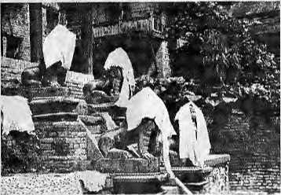
This picture in HitttaTs last issue should have been credited to Stella Snead - Editors
Readers are invited to comment,
criticise, or add to information and
opinions appearing in Himai. Letters
should be short and to the point, and
may be edited.
Mail to: Post Box 42, Lalitpur, Nepal Fax:977-1-521013

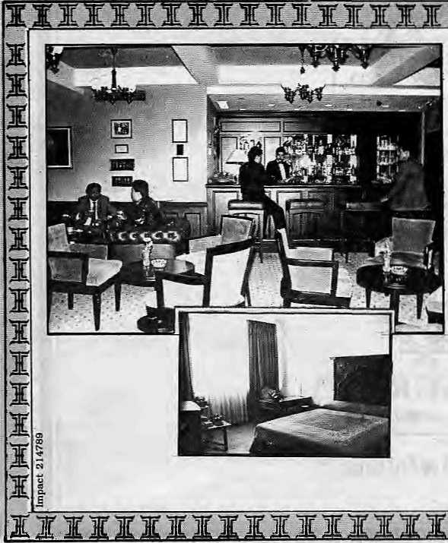
Come to the Everest Come to the Best
Everest. The onfy five star deluxe hotel that offers you your very own Nepal. The traditional hospitality¹ of its highly trained staff. Touches of Nepal's beauty in its enchanting ambience. The sheer luxury of the rooms with breathtaking Himalayan views.
Dine in the cosmopolitan atmosphere of the 'Cafe.' Enjoy the Chinese and Tibetan food in 'Sherpaland.' Or the delicately ' spicedTandoori and Mughlai dishes in the 'Far Pavilion,'
Live up Katmandu's velvet nights in the 'Himalayan Tavern. Or savour the-atmosphere at 'Bugles and Tigers.' Dance to the latest tunes in Galaxy — Nepal's only discotheque.
Everest has so much more to offer. And a reputation as loffy as Mt. Everest to live up to. Every day. All the time.
The Everest Hotel
Banetww. P.O. Boi 659, ICittimandu. Nepal Te< 220567 Fax: ITT-1-226088 Tin: 2K0H0TEVS NP
May/June 1992 HIMAL

r


We Also Serve You Birds On Trees


French, Italian, Chinese, German,
Russian cuisine. Served on the
greenest green you've ever seen.
Plenty of sun, fresh air and bird song
too.

SHANGRI-IA
LAZIMPAT. KATHMANDU. TEL: 412999
We Make You Feel Great!

COVER
How to Tend This Garden?
Prithvi Narayan bequeathed a "garden" of
"four caste division and thirty-six tribes " Why not
pull down the hedges and let a hundred wildflowers bloom?
by Prayag Raj Sharma

S
ome 200 years ago, the Gorkha king politically unified Nepal through conquest While the political entity called Nepal has existed all these years, however, the nation stateof Nepal has not yet stood the test of national integration. Having been propped up for two centuries by feudal and authoritarian rule, the country is now asked to hold together under a multi-party democracy.
Today, whether they fully realise it or not, those who would rule Nepal are weighed down by the responsibility of managing multi-ethnic, multi-linguistic and multi-tribal divisions. Like elsewhere in the young and emergent states of Asia and Africa, the search is on for a single cultural identity that would make Nepal a "nation-state" rather than merely a "state",
A "state" requires only a central government, people, territory and political sovereignty. In the slightly more abstract notion of "nation-state", a people see acommon destiny of remaining together, despite differences in language, culture, religion and political ideology.
Nepal's transformation from a feudal state to a democratic state, without an intervening period of tutelage under colonial rule, has been abrupt. The feudal authoritarian rule of the past two centuries sought to maintain and promulgate national integration in one way. Under the new dawn of multi-party democracy, national integration will be achieved in a different way.
A Notion of Nation-State
If the inter-ethnic relationships are still relatively stable in Nepal, the credit should go to the country's unique history. What kept Nepal "integrated" was the so-called harmonic model of feudal, pre-modem government The values within this model were decreed by the ruling
Prithvi Narayan Shah, and those after him, base d [he country' s unification on four key ideas: the unquestioning power and authority of the Hindu King of Gorkha; the supremacy of the
Hindu ethos in national life; social integration through the Hindu social system based on caste division; andrecogni tion of Nepali as the language of government, administration and, in more recent times, education.
Prithvi Narayan did recognise the cultural plurality of his conquered lands. His Dibya Upadesh, in which this remarkable conquerer and statesman described his policies of governance, likens Nepal to "a garden bedecked with four varnas and thirty-sixjats". Despite this recognition of diversity, however, the cultural rights of the different communities were not recognised by the old state. Neither did the communities themselves have opportunity to articulate their demands.
Historically, the Hindu ruling class dealt withotherethnic groups (the/a/is) not as "foreign" or "alien", but as part of the Hindu social and cultural older. The hill tribes were taken as equivalent of "castes" within the Hindu fourfold social division known as varna. And the traditional caste divisions cast people in rigid socio-economic and political roles, providing a minimum of social and economic security, but precluding competition and role changes.
TheoldMuMMm of 1854, promulgated by Jung Bahadur, specified and categorised the schedule of social offences punishable by law. Punishment for an offence was determined by taking into account the caste of the offender and .that of the victim. The new Muluki Ain, promulgated in 1963 by King Mahehdra, while it did not do away with the idea of caste altogether, did make it illegal to discriminate on the basis of caste in the courts, in education, and in employment.
Modem states arebasedon the newer values of democracy, human rights, minority rights, equality and social justice. These novel and external notions of governance entered Nepal during the 1951 anti-Rana revolution. Even the Panchayat system, which didevery thing to retard the political process from the 1960s to the 1980s,
was forced to pay lip service to these new values.
The new Nepali Constitution of November 1990 represents a final break from the historical model of national integration. In no uncertain terms, it acknowledges the cultural pluralism of Nepal and guarantees the right of every community "to conserve and promote its language, script and culture."
While the new Constitution rejects the earlier basis for national integration, it is now up to the government and the people to develop a new model. Are we up to it? The lukewarm attitude in official circles towards the minority languages indicates that, perhaps, we are not The Nepali language already has an unchallenged predominance in Nepal, and the need of the times is to accord other languages a meaningful place in national life.
From the administrative tardiness in; recognising the aspirations of Nepal's multiethnic groups, it seems that the outlook of many Nepali Hindus, even today, is dominated by an outdated view of caste distinctions. They would rather see ethnic aspirations subordinated by the more overriding concern of national integration. The legacy of the 1950s — that of ignoring a person's ethnic or caste membership in census-taking-—was continued even in the 1991 census. The census sheets recognise merely the existence of linguistic minorities and, even then, there are many flaws in the counting. Therather ingenuous assumption is that ethnic problems can be circumventedby simply not counting. It is perhaps not too much to hope that by the time the next census comes aroundin2001, the administrators will have doffed their cultural blinders.
We do not know the exact number of the languages spoken in Nepal and how many speak them. But linguists estimate that there are about 40principaI minority languages, most of them of theTibeto-Burman tongues. Some of the smaller languages have died over the past 50 years and their few remaining speakers absorbed into the closest majority language. Nonetheless, the more
May/June 1992 HIMAL • 7

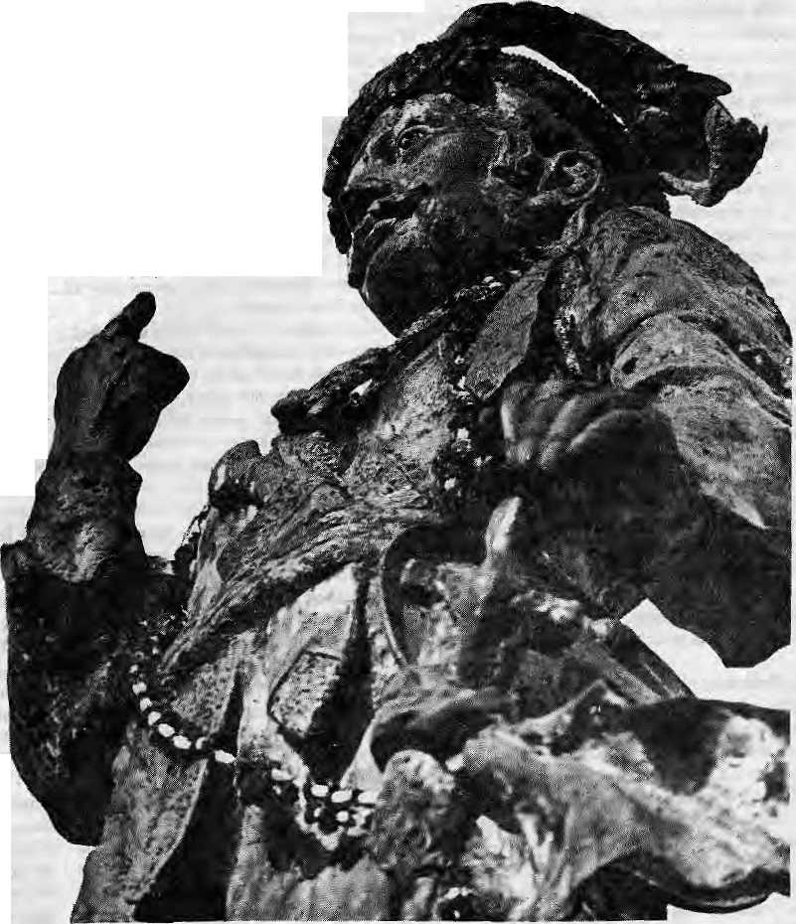
prominent linguistic groups have managed to survive and their ethnic awareness has today been revived in the fresh air of democracy. Some of the still-extant lingu is lie groups are the Gurung, Magar, Tamang, Rai, Limbu, Thakali, Sherpa, Tharu,Raji and Route. Even today, the ethnic awareness of these groups is largely of a cultural rather than political nature.
Nepal's minorities do not merely consist of the Tibeto-Burman linguistic groups, however. Hindus themselves are part of several regional and linguistic groups. First, there are the Nepali-speaking Hindus of the hills who have controlled Nepali politics for at least two centuries. Unlike the many ethnic groups mentioned above, they are not lied to a specific region but are settled everywhere*baning the High Himal. The Bahuns migrated from the hills of western Nepal in the 12th to 14th century.
Then there are the Newar Hindus, who make up about half the population of the Newars — the "heroes and builders of Nepal". Next, there arc the Hindus of the Tarai whose history in Nepal is more recent. They are further divisible into three groups according to language: Maithili, BhojpuriandAwadhi. Although the Tarai Hindus have been less in volved in the process that created the state of Nepal, they can hardly be excluded from the rights and privileges of being Nepali nationals.
The'modernisation and development of Nepal's economy have produced significant social changes: new economic classes have been formed; there are more middle class professionals and some new trading classes are emerging. However, these changes have made no dent on ethnic self-identification. If anything, ethnic consciousness is strengthening day by day. Take, for example, the Newars who, as inhabitants of Kathmandu, have benefitted the most from the development of the Valley over the past four decades. This has not diminished their ethnic consciousness — if anything, it has been reinforced, as is obvious from their demands for greater recognition of the Newari language.
Uahuti Ethnicity
An interesting current trend is that the
Hindu caste groups are also beginning to get "communalised", that is, gaining an ethnic identity all their own. Earlier, the Bahuns — the Brahmans of the Nepali hills — had formed part of the ruling class. Hence they had little reason to develop a communal psychology as did the under-privileged, discriminated groups. B ut in the anthropological works onNepal, written mostly by Westerners, the Bahuns are being depicted more and more as a class of exploiters in relation to other ethnic groups, and held responsible for imposing certain "fatalistic" ideologies.
Bahuns reaped advantage of their caste privilege in the past by acquiring land from
S HIMAL • May/June 1992
the rulers. Their social status and access to education and economic resources gave them an advantage of joining professional and government service. As a result, Bahuns presently make up the most politically articulate group in the country. Bahuns, now as well as in the past, have contributed most in nurturing the idea of a Nepali state.
The Bahun's predominance in national political life is being labelled batatnbad, or brahmanbad, by some and is increasingly a subject of attack. Since it is only the hillBrahmins that are being made the target of attack—and not the Brahmins in other Hindu ethnic groups—in the process the Bahuns could be slowly developing an "ethnic" consciousness all then-own.This consciousness is still incipient and can only grow if "Bahunbad" remains a rallying cry of those opposing them.
TheThakuri and Chhetri castes of the hills, too, are beginning to show a tendency to look upon themselves as distinct cultural groups with separate roots and origin. The untouchable castes of thepre-1963 MulukiAin, actually, have even more justification — as an exploited and still-exploited class — to forge a new identity of their own. The trend, thus, is that even the so-called culturally homogenous groups are beginning to seek to build the ir new political and economic security under the spell of "ethnicisation". The process of cultural atomi-sation seems to have begun.
B etter education, increa sed communication, transport networks and—the final ingredient— democracy, might be expected to nudge the ethnic groups, fuelled by distinctions of race, region, culture, language and so on, to a new level of political consciousness. Cultural and ethnic minorities, and erstwhile subject groups, are bound to demand a share of power and the recognition of their cultural and linguistic rights. Today, diverse cultural and regional groups are trying to come to terms with the political change and to find their niche in the new State.
Like many ideas which have come to influence Nepal from the outside, today the stress is on divisions rather than on similarities. Obviously, this is because the notion of a single "Nepaliness" has in the past been used as a tool for control by the dominant classes. The fear among some, however, is that this stress on divisions will ultimately undermine the very foundations of the Nepali state. Is this questioning of societal structure only part of an ongoing and more lively process or will it lead to the mole

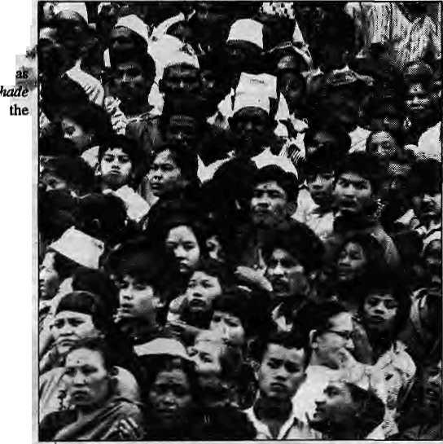
sinister development of national disintegration in the name of-ethnic differentiation and subnationalism?
Those with divisive tendencies have never been in abetter position to foment tension. Some highly ambitious spokesmen w striving lo bring Die minority groups together on racial rather than ethnic grounds. Distinctions are being made between the "indigenous" people of Nepal and all Hindus, who are dubbed "outsiders". The Mongol and the Janajati parties—banned from contesting in the June 1991 general election for raising communal slogans — are attempting to give a racial twist to their politics. Because individually the minority Tibeto-Burman-speaking groups have significantly reduced clout in a democracy, the attempt is to try to rally a political force based on the racial distinction of being' 'Mongoloid''. The o utsider-versus-insideT schism that is being propagated contains, in essence, the same elements as the bhumiputra agitations in some Southeast Asian states, directed against the Indian and Chinese population there.
Another distinct ethnic as well regional fault line lies between the Pa. and Madhesiya, the tollman and plainsman. "Regional ethnicity" is what seems to come into play. That these generic terms have even acquired some pejorative sense indicates the direction of this confrontation. Today, the relationship between the two groups is marked by deep suspicion. The Pahades regard the Madhesiyas as Indian in their cultural orientation and political loyalties. For the Pahade, the Tarai-based Sadbhavana Party's championing of Hindi is proof enough of this.
The Madhesiyas, for their part, regard the Pahades as colonisers and exploiters of the Tarai who treat them as second class citizens. The Madhesiyas protest their under-representation in the political decision-making process, in government employment, and resent the resettlement policies which favour the hill migrants. The unsettled question of citizenship rights rankles the political leaders of the Tarai.
The rig id attitudes which divide tire Pahades and Madhesiyas indicates an ethnic conflict of explosive potential which could well engulf Nepal in the future. And the fear lurks in the mind of many — could there be a Sri Lanka-in-making here, including the possibilities of Indian involvement in the aftermath?
Short-sighted Desperados
Why is national integration a desirable goal in the first place? Even in the aftermath of the disintegration of the .Soviet Union and Yugoslavia, the concept of national integration remains relevant Some short-sighted political desperados, in Nepal as elsewhere, will always try to stir up ethnic turmoil in complete disregard
to the advantages of national integration. But what, indeed, will happen in the wake of a disintegrated state? Are there to be separate political states along ethnic lines? Is there an ethnic group in Nepal which can claim to be a completely homogeneous group? There are all kinds of divisions—including hierarchical ones — within every group in Nepal, and there are economic inequalities to be found among them all. It would be short-sighted folly to try to achieve economic survival as atomised entities. The emergent ethnic states in Europe are alllooking to the European Economic Community as the saviour, and they are justified in pinning their hopes on the EEC, given the evolution of econom ic cooperation in the Continent. But what would be the price to pay for emergence of mini-states in Nepal's stead? Without a doubt, such disintegration would only spell further poverty for the population of the mini-states, which would

be that much more vulnerable to internal and external threats. There is little likelihood of a strong confederated organisation such as the EEC emerging in South Asia. There would come anarchy and instability first
One would hope that ethnic problems would never reach such a pitch as to threaten Nepal's prevailing social harmony, even though that harmony has been maintained largely through the social order laid down by the Hindus. Certainly, this historical legacy needs readjusting and re-appreciating in a more modern context
An ethnically and culturally diverse population is seeking to redefine its role and its place, and to make new adjustments within the State, like India, the State of Nepal needs to formulate policies relating to minority languages and culture, secure them their new rights in these respects, andlay down a democratic and equitable basis for political power-sharing by ethnic
minorities. All conflict-prone situations would be resolved by taking recourse to dialogue between the contending parties, without sacrificing the long-term interests of national integration.
The world in recent years has been witnessing an increasing violence in the management of group relationships between so-called "majorities"and"tninorities". The majority is seen by the minority to be the personification of brute domineering State, and the minority by the majority as harbouring secessionist tendencies. Only a restrained, tolerant and democratic approach on both s ides will see Nepal through the adjustment period that she is now experiencing. Rightly or wrongly, Nepal has had the good fortune of enjoying relative ethnic harmony thus far. If we can bring to bear a new outlookon group relationships, m aking necessary accomodation and adjustments in it, the future ethnic problems might be more manageable.
What are the interests of astate's majority and and those of its minorities? What are the obligations of Nepalis towards each other? What gives a State the right to protect its integrity? By the same token, what moral right has an ethnic minority to dem and secession and independence? In claiming this right for itself, does it recognise the rights of other, smaller minorities* within its borders to do the same in the future? For there is no accepted political theory, nor any provision in international law, on how large or small a state should be. Is the break-up of States sought on an enlightened basis of positive philosophy of anarchy, or the idea of the dissolution of the State? Indeed, the formation and breakup of States seem to depend on the sheer force of events, and rationalisations come later.
To Prithvi Narayan goes the credit of establishing the enlarged Nepali state and, and the same time, being the first to recognise the cultural plurality of the Nepal he had created. Sut his times were guided by a different feudal ethos, and hence the values he used in nation-buildin g and in laying down group-relationships. Today's is adifferent world. How would Prithvi Narayan have acted or reacted to the modem challenges of ethnic relationship? True visionary and statesman that he was, with the ability to be decisive when necessary but also with the ability to correct himself when proven wrong, tie might just have stood the test of the times and given Nepal a leadership that if so desperately needs now, in forging a new basis for group relationship, different from the one which he established two centuries earlier.
P.R.Sharma is professor of history and cultural studies at the Centre for Nepal and Asian Studies, Tribhuvan University
May/June 1992 HIMAL • 9

"Otherness" and the Modern Tibetan Identity

Tibetans were once content to identify themselves by region and sect. Post-1959, the Chinese presence has stimulated a pan-Tibetan identity.

Off-duty Chinese soldiers watch Khampa monks at the Jokhang Temple, Lhasa.
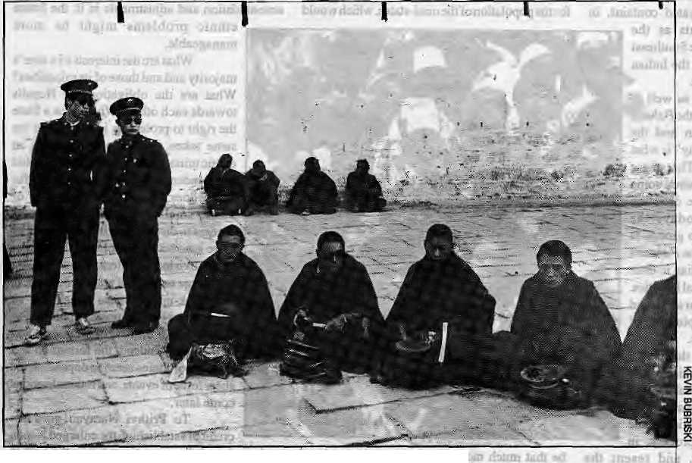
Thibetans have multiple identities. This is true M. of them as it is for the members of all other traditional, complex societies?" tJnder some conditions, however, a pan-Tibetan identity prevails and, under others, sub-national identities emerge among Tibetans.
Before*1950, sub-national identities based on sect or region prevailed. The former category included the Nyingma, Kargyu, Sakya, Gelukpa,
and Bonpo. Regionally, Tibetans identified themselves as Khampa, Topa, Tsangpa and Amdo-wa of Kham, Toi, Tsang (Shigatse) and Amdo regions. Sectarian identity is rooted in the different traditions of Tibetan Buddhism and is particularly powerful among the lamas. Regional identities and attachments to homelands (phayul) are more popular among the laity.
In practice, of course, sectarian and territorial identities may overlap and reinforce each other. In such cases, sub-national identities can be quite powerful. This combination of sectarian and territorial identity was the motive force of the Geluk and Sakya domination in Tibetan history.
But how do Tibetans differentiate themselves firom non-Tibetans? Do Tibetans have an encompassing pan-Tibetan identity?
10 HIMAL • May/June 1992
by Dawa Norbu
Before the politicisation of Tibetan ethnicity, "we" and "they", or Tibetan and non-Tibetan, was a Buddhist differentiation between believers, and non-believers,/?fcy(/Mtand«ang/7fi. However, since the Chinese takeover in 1959, there has been a growing consciousness, particularly among "urban" Tibetans, about a pan-Tibetan identity that sharply differentiates itself from rgya-rigs or rgya-mi — the Chinese/
Han. The "in-group" is increasingly identifteflas bodpa or bog-rigs.
Feeling 'Tibetan'
Perhaps because "ethnic" politics is, practically banned in-Tibet, this writer has seen no comprehensive description of the sectarian or regional identities being articulated within Tibet. But there seems to be considerable evidence of "we" and "they" differentiation vis-a-vis the Chinese/Han, at all levels of society, as- is immediately apparent to Western and Asian visitors. This is corroborated by the post-1959 ethnic tensions in Tibet that have cut across ethnic lines. It is not too difficult to construct the major sociological components of Tibetan identity, with a comparative knowledge of Chinese and Tibetan cultures.
Although hardly articulated or politicised before 1959, most of the ingredients of a pan-Tibetan identity are inherent in the structure of Tibetan civilisation. As we know, most ethnic identities in the non-Western world are nothing but politicised cultural identities.
Geography defined Tibet's boundaries and separated it from its neighbours, including China. Elite consciousness of Tibetan territoriality was evident as early as 8th Century AD, when aSino-Tibetan treaty declared, "Tibetans are happy in Tibet and Ch inese in Chin a; and neither should trespass the other's territory..."
Confucian and Lamaist social structures and civic cultures differ vastly, just as Chinese and Tibeto-Burman languages and literature are distinct from each othef. Traditional economic activities in China and Tibet are also very different. If the Chinese peasantry has essentially a rice-growing economy, the lifestyle of Tibetans is shaped by a nomadic and barley-growing economy. Two separate ways of life emergedover the centuries. But to the soul-searching sections of the,Tibetan populace, the defining characteristic and the core of Tibetan identity appears to be the lamaist culture which is so radically different from the culture of the "dominant generalised other" — the Chinese. This appears so as the Tibetans glance through the significant aspects of Tibetan historical achievement as a distinctrace. They are inevitably driven to the various Tibetan traditions of Buddhism as the ultimate source of their pan-Tibetan identity, reinforced by other shared commonalities such as written language, territoriality and lifestyle.
If the secular-minded reader thinks the lamaist dimension of Tibetan cultural identity is being exaggerated, let me explain. Tibetan as a classical language suitable today for serious academic study in major Western universities is largely a creation of lama-scholars going back to

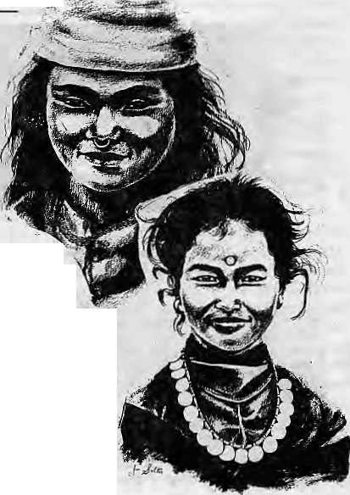
A Face for All Regions
it was in 1975 that I travelled up the Raj Path in the local bus from Birgunj. Duringastop at a teashop, I was struck by the beauty and variety of faces around me.
That same beauty had impressed me during abrief visit to Nepal in 1968, whenl worked at Boris Lissanevitch's famous Royal Hotel. A vague urge had pulled me back to Nepal to illustrate her beauty. At that teashop on the Raj Path into Kathmandu, I knew what I wanted to do — draw the faces of Nepal's people.
My materials were simple; plain paper and pencil. The fust portrait was of a small, cheeky, Newar boy. In the process of capturing him on paper, he captured my heart. I became involved in his life. Today he is my adult Nepali son.
Drawing the faces of the many ethnic groups of Nepal meant travelling north, south, east, west, all over the country. Being a woman has been a definite advantage. Villagers are more forthcoming, and there is much laughter and interest as they watch a picture emerge. In one Tharu village, in Dang, some Western friends who lived there cautioned me that the people would be shy. In two years, they had never succeeded in photographing even a single villager.
Sure enough, as I entered the village, everyone disappeared into their houses. So I sat and began to draw, A little girl, unable to resist her curiosity, cautiously peered over my shoulder. Then, one by one, the villagers crowded around me. I was able to draw many of their faces. It was great entertainment for us all.
I have drawn perhaps450 portraits. Recently, I taught myself the techniques of oil painting. These confine me to the studio when I do portraits, because I have not yet solved the problem of preventing curious children from fingering the irresistible gooey colours, or from squeezing tubes of precious paints. With these distractions, painting from life in a village has been difficult,
I do miss that personal contact with the villagers—hardy, friendly people who work in the fields and are
the backbone of this country. - Jan Salter
the 8th century AD. Similarly, classical Tibetan literature worthy of academic pursuit and world recognition was possible only through the serious and important contributions by lamas. Consequently, apart from some early Tibetan kings, most of the Tibetan culture-heroes are lama-scholars such as Milarepa, Sakya Pandita, Longchen Rabjampa, Tsongkhapa, and others. In short, the history of Tibetan civilisation is a history of lamas, before whom the other actors appear mundane and insignificant.
Such a cultural perception of Tibetan identity is borne out by the post-Mao developments in Tibet The Dalai Lama's fact-finding delegations to Tibet in the early 1980s brought out-film footage which show Tibetan youth, born after 1959, prostratinginatraditional religious manner before religious objects brought by theDharamsala party. Tourists have witnessed enthusiastic participation by Tibetan youth in the renovation of monasteries and temples across Tibet.
Because the post-1959 generation was totally deprived of religious upbringing and socialisation, its religious behaviour must be interpreted in terms of affirmation of identity. Tibetan youth exhibit religious behaviour not because they are pious, like their parents, but because they believe that is the authentic way of being 'Tibetan" and being different from the Chinese. In this regard, the leading role played by monks and nuns in the 1987 and 19S8 pro-independence demonstrations in Lhasa is also noteworthy.
Thereis truth in the psychological definition of identity. The assertion of identity is made possible by the presence of a "generalised other". That is, there can be no self-conscious projection
of ethnic or any other kind of identity without the generalised other. For Tibetans, the Chinese have assumed this function. Their "otherness" in Tibet provokes the assertion of Tibetan identity and the we/they differentiation.
Whatever may be the veracity of Chinese historical and legal claims over Tibet, it is a fact that any Chinese presence, before 1950, was confined to Lhasa. Ordinary Tibetans would never have seen the Han people. Their influx into Tibet since 1950, and especially after 1959, has been unprecedented.
The otherness of the Han in Tibet is accentuated by their domination of Tibet's political, economic and cultural life. The Han monopolise the state power structure behind the scene, have greater access to education and job opportunities within Tibet, control the country's natural resources, and so on. The new city of Lhasa is occupied by Chinese, while Tibetans are confined to the old quarter. A Western teacher at Tibet University recalls how in her classroom Tibetan students used to sit in one row and Chinese students in the "other" row. That there is ethnic polarisation is clear.
Beijing's policy of national integration and assimilation has engendered polarisation against the Chinese and the politicisation of Tibetan ethnicity. In particular, during radical phases such as the Cultural Revolution, Chinese policy sought not only to communise, but Han-ise Tibetans through force-feeding of Chinese language, education and culture. Even communism is propagated in Tibet via Maoist interpretation and Chinese idiom.
The Chinese or Han dimension of the exported Communist Revolution in Tibet cannot be denied. Chinese culture and language
are forced upon Tibetans under the.auspices of Marxism. This Han-isation belittles and questions Tibetan ethnic identity, thereby engendering an identity crisis among the Tibetans. They ask themselves: Are we Chinese as the Han cadres claim? Or are we different? If we are different, then how do we assert our identity?
The 1987 andl988 demonstrations in Lhasa may be seen as the early manifestations of this assertion of ethnic identity by politically conscious Tibetans. At thesame time, such events also reveal a legitimation crisis faced by the Chinese rulers in Tibet.
With the appearance of the generalised "other" since 1950, sectarian and regional identities have assumed a passive, secondary role in Tibet. In their place, a vaguely-felt pan-Tibetan identity has arisen, particularly in the main towns.
Ethnic identity must be understood functionally, and its primary function is to achieve the greatest degree of differentiation from the generalised "other". In this sense, ethnic identity is an aggregation of ethnic variables such as tradition, culture, language and race. Which of these variables may be emphasised more than the others depends on the nature of the group against whom the differentiation has to be drawn and ethnic boundaries erected. In Tibet, the accent so far has been on lamaist culture, language and race — and in that order.
y
D.Norbu is Associate Professor of Central Asian Studies at Jawaharlal Nehru University, New Delhi. His latest book is Culturs and the Politics of Third World Nationalism (Routledge, 1992).

May/June 1992 HIMAL • 11

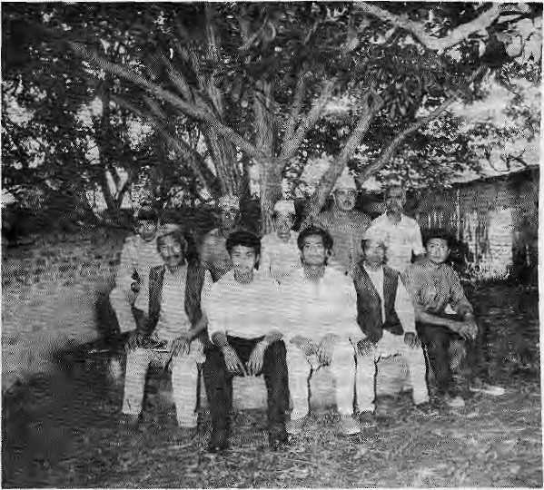
Pointed Noses, Stubby
Noses, and Local
Elections
At the chautari, clockwise from top left, Ganash Bikram Thapa, Man Bahadur Magar, Ganesh Shrestha, Gajendra Nath Regmi, Ramasish Sharma, Dambar Bahadur Limbu, jagat Bahadur Maharjan, Mahi Narayan Chaudhari, Man Bahadur Gurung and Jas Bahadur Tamang.
Ram Bahadur Tamang, Birman Maharjan, and tha Gorkhapatra.
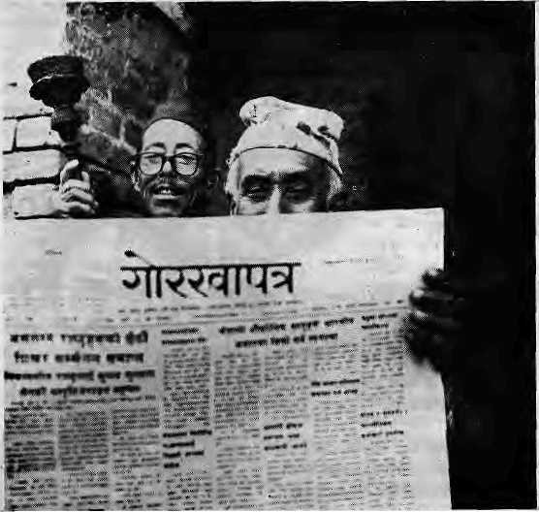
by Raghu Pant
It is not a crime nor is it a virtue to be born with a pointed nose. Likewise, it is neither a curse nor attraction to be born with a flat nose. When a Nepali hums a tune, he does not select only one that was put to music by one from his own caste or tribe. It might be a melody given to us by AmbarGurungorArunaLama.BhupiSerchanis no more, but his poetry is still alive in the minds of countless Nepalis. The Tarai has countless stalwart Nepalis. Just because Harka Gurung's nose is shaped differently from my Bahun's nose, why should I be prevented from taking pride as a Nepali in his erudition and learning? Nepal is not a country of Bahuns, nor of Chhetris or Thakuris. Nor can this Nepal be divided into a Mongol Nation, a Limbuan or a Magaraat. True, there once were a Liglig, a Gorkha, a Lamjung and a Tanahun. But that is history. The past. If yesterday's reality has not survived till-today, it cannotbe revived tomorrow. In the future lies an "improved Nepal", which should be the common property of all.
Today, there are all kinds ofpoliticalforces at play here. Gajendra Narayan Singh of the Sadhbhavana Party warns of domination of the Tarai-basis. Gopal Gurung of the Mongol National Organisation, M.S.Thapa and Goray , Bahadur Khapangi of the Jana Mukti Morcha, • and Bir Nembang of the Limbuan Mukti Morcha
rail against Bahun-Chhetri domination of the hill tribal. Certainly, these are not "mainstream" politicians, and much of the politics they espouse is nega-tive and ulti-matelyantU development. But you cannot ignore them. Rather than relegate them to a corner, we
must sift through their demands and search for positive elements. Otherwise, we go the way of the countries of South Asia which did not heed the danger signals in time.
If Goray B ahadur Khapangi has the abilities to serve as Prime Minister, I have no problem withthat.IfhewantstobealeaderoftheMagars, I have nothing to say. It is communalism of the meanest kind to think that Bir Nembang cannot be a leader ofBahunsjustbecausehisnoseisflat. Nepal was not created only by Prithvi Narayan's decree. Nepalis of all caste, creed and ethnicity have played a role. So if hill ethnics or Tar&i-waltas say they have too little say in governance or in administration, how can we ignore them? It will no longer .do to sing paeans to the glory of the Gorkhali conquest. We must strive to provide an all-encom-passing environment in which the Gurung, Magar, Rai, Limbu, Tharu, Bahun, Chhetri, Newar, Muslim and all the Tarai peoples will feel equally Nepali. And if the S tats hesitates, the people wiU.try to grab their rights for themselves.
Local Electrons
An occassion had presented itseli to address the dissatisfaction among the hill tribal and Tarai leadership —■ but the Government let it pass. If only the process leading up to the local elections (in late May) had been tackled properly, we might have been going somewhere. The Govemment should have been daring enough to give autonomy to the local elected bodies. Instead, it dragged its feet and wasted an opportunity.
District, town and village level organisations are the ones to ensure equity and decentralised development. With autonomy and control over resources, they would have developed as the foundations of democracy. Why, after all! does a tiny developing country like Nepal need a huge centralised structure of government? Why tend and feed this white elephant? Strong, autonomous, .elected bodies at the local level would actually make the center stronger. And in no other way can that old dictum, unity in diversity, come true for Nepal.
S o the opportu nity came and went without politicos and parliamentarians on both sides of the bench showing too much concern. The Government rushed the legislation on local government through Parliament towards the fag end of its session and prevented debate from taking place. What it has done, and the ostrich-like attitude of the intelligentsia, will only delay genuine social and economic progress in Nepal.
R. Pant is a columnist with the Bimarsha and Dr/st/weeklies of Katmandu. A longer version of this article appeared in Bimarsa.

12 HIMAL • May/June 1992

Jharkhand Will Have its State

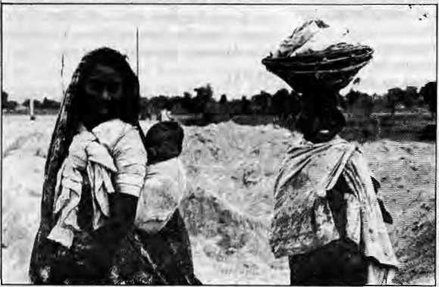
White Jharkhand will have its states,self-determination based on ethnicity may not be the answer to underlying class inequality.
by Subhachari Dasgupta
There are more than 400 communities designated as tribes in the Indian Subcontinent For every tribe so named, there are several others whose distinctive cultures have not been recognised. Their struggle has been hampered by their small numbers and their thin spread. In order to overcome this obstacle, a nationalistic tribal identity is sometimes forged fiom the many tribes to make a viable "demand group". The Jharkhand movement is one such demand group, which brings together different communities of the contiguous tribal areas of Bihar, WestBengal, Orissa andMadhyaPradesh.
The movement is not new — the demand for a separate tribal state known as Jharkhand ("forest areas") was mooted even before Indian Independence in 1947. Recent years have, however, seen increased activism and the state of "Jharkhand" is closer than ever.
But what lies ahead for the people in Jharkhand once they achieve statehood? Can "Jharkhand" be any different from every other state in the country? Will the "Jharkhand" state live up to expectations of the movement?
Elite Leaders
Santhal woman ofChotanagpur.
"Jharkhand" will be quite different from the predominantly tribal states of the Indian northeast This is because the Santhal. tribe, which today leads the political agitation for statehood, will be a minority in the future state. At the same time, some of the other tribes within the proposed stale area are also demanding separate statehood. The Kolhans, for example, want a state within the very heart of the proposed Jharkhand state. The Jharkhand movement is also presently weakened by f actionlism and party rivalries. Not
to mention the ideological division between Maoist groups based in forest areas who espouse armed struggle and a democratic movement relying on mass participation which is backed by the other parties.
The doyen of the movement was Sri Jaipal Singh, a highly educated tribal married to an aristocratic Bengali. Singh delivered the leadership o f the tribal struggles to the community elites. Theelitist bent of the Jharkhand leadership is strengthened with their English-medium, Church-run schools, which turn out young, tribal graduates who are alienated form their own families and communities. The Government's decades-long support for education of tribels has further encouraged the estrangement of the educated from their communities. In the name of "reforming" the tribals, their cultural practices have been denigrated as superstitious and harmful. Extremely valuable tribal knowledge has been belittled. A feeling of inferiority developed among tribal populations and even among their elites, who today go as far as discouraging the traditional community dances and ceremonies.
The tribal leadership of the Jharkhand movement has been dubbed as the most corrupt by its opponents, not without justification. As is well known, the leaders of the tribal communities enjoy luxurious lifestyles untouched by the poverty and deprivation of their people. Indeed, there is little difference between the tribal and non-tribal political leadership.
Apart from the problems with its leadership, iuter-etnic competition is bound to mark the state of "Jharkhand". As a result, the trump card will be played by the non-tribals. who are wielding power in the area even now, by dint of their economic power and trade and c o m m e r e'e acumen.
"Jharkhand" is
likely la become a
reality. This alone
will satisfy the
yearnings for tribal
identity, however
fallacious or m ade-
up that identity
oj may be. But this
g process of
z "forging" or ■b creating tribalism is likely to lead, ultimately, to an
identity crisis. The process of forging a tribal identity, as is happening in Jharkhand, is synthetic and will not satisfy the need for ethnic individuality.
Ethnic contradictions are likely to surface as a divisive force within "Jharkhand'', and they will be accentuated by the dominance of the educated tribals. Many of them are Christians and exist at the outer periphery of the tribes. Thus, the very force that has united the communities and shaped the state of Jharkhand may leave that new tribal identity splintered into ethnic sub-nationalism.
Because the issue of tribal identity fills the horizons of the proponents of the Jharkhand movement, and they have tended to ignore issues such as rights of the poor and equality of opportunity. They assume that the socialistic nature of the tribal communities will spontaneously be restored in a tribal state. But the experience of the tribal states of the Indian North-East does not bear this out. Those states, too, have turned out to be no different than non-bibal states. They are led by elitist forces who have suppressed minority ethnic groups with little hesitation.
A Misnomer
"Jharkhand" is already a misnomer.— it is no more a pristine habitat peopled by forest-dwellers. The woodlands have disappeared, and have been partially replaced by commercial plantations. Old occupations and traditions are dead or dying. Tribal worship of trees has became nominal and ritualistic. Gone also is the spirit of equality that pervaded the traditional tribal culture. ' 'Jharkhand" is set to be one of the more advanced mining and industrial states of India, one with a high concentration of industrial labour where the ethnic concept of equality will be a casualty.
In "Jharkhand", individual cultural identities will submerged in the course of modernisation. The relationship between the non-tribals and the various communities classified as tribes will be changed radically. The community organisation of the ethnic groups will lose significance, as indeed many already have under the different state governments that presently rule over them.
It is clear that the socialistic pattern of tribal ethnic groups will not be achieved without addressing questions of economic privilege and class. But it seems all too certain that the tribal state of Jharkhand will be achieved by playing the political game in the same manner that the non-tribals do. But in doing so, the most desirable characteristics of tribal societies will fall by the wayside on the way to "Jharkhand".
S. Dasgupla is with the organisation PIDIT, based in Delhi.

May/June 1992 HIMAL • 13

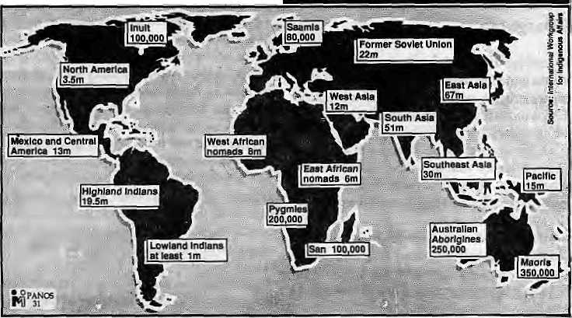
Cultural Diversity Biological Diversity
Indigenous peoples
Indigenous peoples everywhere aie under threat today. One indicator of the loss of human cultural diversity is the loss of language. Linguists predict that almost half the world's 6000 languages will die out in the next century. When they do, these cultures will also take with them traditional knowledge that is invaluable.
The world's 250 million indigenous peoples live in about 70 countries and are marginalised wherever they are. They are also known as First Peoples, Indians, Natives, Aborigines, Nomads, Tribal?, First Nations, Minority Nationalities (China) and Small Peoples (Russia). But they are not just the first-comers to a land. The term is usually used more broadly, to include other marginalised groups such as the nomadic peoples of Africa. British anthropologist Andrew Gray says that, compared with the number of national state cultures, indigenous peoples constitute 90 to 95 per cent of global cultural diversity and "therefore represent the diversity of human existence, even though they constitute a numerical minority".
Previously, the main threat to human cultural diversity was extermination, which led, for example, to afallin the Aboriginal population of Australia from 500 000 to 100 000 in the century after the arrival of Europeans. Since 1900, in Brazil alone, more than 90 indigenous groups have disappeared; 26 of those tribes were killed or scattered in the past decade. The rate of extinction has accelerated as a result of forest destruction. Today, assimilation is the main threat to cultural diversity.
Examples abound of the value of indigenous knowledge to modem agriculture and medicine. Forest dwellers in Papua New Guinea have for years cultiv ated the hardy and protein-rich winged bean (Psychocarpus tetragonohbus) which also
enriches the soil by its ability to fix nitrogen. Virtually unknown outside the region 20 years ago, the plant is now grown in more than 50 countries and is set to improve the diets of hundreds of millions of people in the countries of the South. Of the 121 plant-based drugs in the modem medicine chest, three-quarters were discovered through ethno-pharmacology, which draws on indigenous knowledge to help pinpoint useful plants.
"Native people have been stewards of 99 per cent of the world's genetic resources, and there is an inextricable link between cultural and biological diversity," stated the International Society of Ethnobiology (ISE) at its first congress in Brazil, in 1988. The Congress called sought ways of compensating native peoples for the use of their knowledge and their biological resources. "Recognition of the value of indigenous knowledge by our civilisation would permit Indians to be seen as major intellectual contributors to humanity rather than exotic footnotes to the pages of history books," says ISE president, Danell Posey.
Increasingly indigenous peoples are
devising their own strategies for conservation
and development, founded on their rights to
ancestral lands, control of their resources and
self determination. Brazil'sUnion of Indigenous
Nations (UNI) has set up a research and training
center to preserve traditional knowledge about
the rainforest and apply it to sustainable
development. It is compiling an inventory of
natural resources on Indian land to determine the
products available for sustainable use and to
identify areas in need of regeneration. A Forest
People's Charter is being drafted by
representatives of the 50 million forest dwellers
worldwide. — Panos Institute
Ethnicities, More Ethnicities
The following "Indicative List of Ethnic and Cultural Diversity in the Himalayan Region" is taken from the chapter "Himalaya Status Report", written by J, Bandyopadhyay and included in thB just-published book State of the World's Mountains: A Global Report (Peter Stone, ed.Zed Books, London, 1992 — see forthcoming issue of Himal for review.) Please note that the list is "indicative", not "exhaustive", and refers to the "Himalayan" areas of countries listed.
AFGANISTAN
Baluch, Brahui, Gujar, Hazara, Kirghiz, Kohistani, Moghol, Nuristani, Pariswan, Pushtun, Pamiri, Qizilbash, Tajik, Turkoman, Uzbek etc.
BANGLADESH
Chakma, Marma, Tripura, Mro, Bawn, Khumi, Khyang, Chaak, Thangxhangyas, Murung, Riang, Pemkhu, Lushai, Moghe, Kuki, Saka, Shandhu, Bonjugia, Pankhas etc.
BHUTAN
Ngalung, Sarchop, Nepali speakers etc.
CHINA
Yi Bai, Hani, Lisu, Lahu, Jiangpo, Achang, Nu,... Pumi, Derung, Miao, Dai, Naxi, Benglong, Tibetan (Zang), Sherpa,Loban,Hui, Han, Qiang, Wa, Menbaetc.
INDIA
Adi, Angami, Ao, Batti, Bhotia, Chang, Dimasa, Dogri, Garhwali, Garo,Gorkhali/Nepali speakers, Hmar, Himachali, Kabui, Kashmiri, Khasi, Khenzha, Khiemnungan, Konyak, Kumaori, Kuki, Ladakhi, Lahauli, Lushai, Lepcha, Bhotia, Tibetan, Vaiphei, Wanchoo, Yimchungre etc.
MYANMAB
•Mao, Shan, Kachin, Burmese, Wa, Lisu, Lakhu, han, Karen, Jingphaw, Atsi, Lashi, Mara, Kadu, Kanan, Naga, Pao, Palaung, Dhanu, Kaw, Lahu, Intha, Myaungi, Majngtha, Yinga etc.
NEPAL
Maithili, Bhojpuri, Tamang, Awadhi, Tharu, Ne war, Magar, Rai, Gurung, Limbu, Bhote, Hindi speakers, Rajbansi, Satar, Sunuwar, Sherpa, Danuwar, Chepang, Dhangar, Thanri, DhimaL Majhi, Thakali, JireL Urdu, DoTai, Bodo etc.
PAKISTAN
Afridi, Khattak, Orakzai, Wazir, Mashud, Turi, Sinwari, Daur, Yusufzai, Kohistani, Kalash, Baltistani, Pathan, Baluch, Makrani, Boorishki, Brahui etc.

14 HIMAL • May/June 1992

Escaping the trap of cultural diversity
Variety is the spice of all life and ethnicity its
human expression. But stripped of tolerance and
respect, ethnic feelings degenerate into communal
hatred and conflict. We must flee the prison we
have made of our cultural diversity.
by Rajnr Kothari
A,
l new threat hangs over the power elites of our time. It is the threat posed by ethnicity, variously expressed as the assertion of culture, the upsurge of communalism, the revival of religion and the voice and movements of marginalised peoples, regions and nationalities. It is O affirmation of diversity, of indigenous identity, of organic rather than televised or museumised cultures. But ethnicity has a rather sinister alter ego, too. In its defiance of the modem nation-state and Northern technology, ethnicity can assume s homogeneity. Militarised, it can tear down the walls that separate identities and preach revenge and martyrdom in its drive for victory. Alas, in so doing, it loses its finer qualities of the sacred and the mystical and emphasises fundamentalist notions of religiosity and culture.
Ethnicity is a response to the excesses of the modem project to shape the whofeof humanity around the three pivots of global capitalism, the State system and a global culture. That global culture is based on modem technology, pervasive communications and information systems and a universalising educational system. Most societies of the South, prior to political independence, were described as "ethnic patchworks". These, they were told, should be replaced by homogeneous and centralised nation-states that would "integrate" all diversities and cultures. Ethnicity is a powerfoI rebuttal to this drive for modernisation which, fashioned after the Northern idea of how the world should be, almost succeeded in subjugating the immense diversity and richness of human experience. It is an affirmation of all "the others" who might have been brought under, colonised and eventually dispensed with.
This rebuttal to the drive for modernisation directed from the North is perhaps the most potent source of ethnicity. But there is a second source, which is located within the South. This second source of ethnicity is a response to the homogenising forces of capitalism, the nation-state and technology imported from the North and promulgated by the Southern powers,
Pamnoisi chauvinism and insecurity
Among die many negative transfers from the North to post-colonial Soon ire the notions of "majority" and "minority" and the idea that both legality and legitimacy are based on majority rule. These notions have been particularly harmful for plural societies which have, for centuries, survived without thenj. They survived because they fostered respect for cultural diversity and coexistence. These notions were by no means easy to live with, however. Social tension and evei. violent outbreaks were not infrequent. There were structural inadequacies antf manyfonrtsofdomination and exploitation bythe powerful, clever and deceitful. But such groups were small and, in any case, there was no attempt to foist the will of the majority on the whole society. Nor did the poorer or oppressed¹ strata suffer from any minority "complex".
Even today, the "rights of a majority" are hardly ever upheld by large masses of people belonging to the so called majority community.
They are more often invoked by a few people who claim to cpaak for the masses, seeking their sanction from imported ideas of majority and mitwrity. The "fhreat" to the unity of the country, thai alltoo common bogey, is raised by a small section of upper class and upper caste peoples. They locate the source of the threat in minority communities which, they claim, have been given too much licence or have done better economically while their community, the majority, has suffered because of its remaining disunited and unmindful of its "natural" rights. This preoccupation with the rights of the majority has emerged as the creed of some paranoid individuals who try to poison the minds of entire communities, despite the fact that those communities are composed of different castes, occupational groups, linguistic groups, even groups having diverse religious symbols and community-based godheads. They are nonetheless asked to stand together and face the "threat" from the "minorities". Perhaps not surprisingly, most people do not want this.
The paranoia of the majority is matched by the paranoia of the minorities. They are pushed to the wall by the growing accent on numbers in a democracy. They feel betrayed by the S tate that began by promising them security in return for loyalty and ended by discriminating against them and pushing them around. They are eventually diagnosed as suffering from a "minority complex". This mental state is characterised by a sense of inferiority; fear and insecurity give rise to a deep sense of alienation from the "system"— the State and the nation. Fanatics and fundamentalists emerge, calling for the closing of ranks and sowing seeds of separatism; "we're not needed here, so let's get the hell out!" Hie small groups that continue to struggle against such tendencies, and "dare to belong", in Baljit Malik's ringing assertion after the November 1984 carnage of the Sikhs in India, are branded as timid and compromising the integrity and honour of the community.
Such minority paranoia begins a chain reaction, reinforcing the paranoia of the majority. The result is an insecure majority that somehow feels beleaguered by minorities which it views as economically more prosperous with access to arms, foreign support, constitutional guarantees and so on. This gives rise not only to the majority chauvinism that is everywhere in evidence but to a new kind of fundamentalism of the majority. It is fundamentalism that breeds on, and takes its cue from, the fundamentalism of the minorities. Communication channels choke, the parties become estranged from each other. Polarisation feeds the fundamentalist appeal and its call for "standing together" finds earnest listeners. It is in this context, of a growing sense of alienation from "the other", that all calls for "unity" in effect become calls for disunity with respect to the larger nation or the State.
Large communities are everywhere diffuse, plural and tolerant of ambiguity. But reversal is now sought Hindus, for instance, are called upon to close ranks, adopt a unified theology and a common doctrine, a clergy that is ordained and a common "book". A far cry indeed from thehighly plural and decentralised landscape of traditional Hinduism. There is a similar trend among Sinhala Buddhists and Islamic Malays and Indonesians. With all this, the regenerative and holistic dimensions of "ethnicity" or "community" are transformed into negative and exclusive ones, giving rise to the virus of lianj.
Communalism can have two meanings. In a positive sense it refers to the conscious identity shared by a group of people, based on their cultural heritage as expressed in language, religion, caste, homelandandsoon. In plural societies, ethnic identities were positively
experienced and expressed. Positive communalism has been associated, by andlarge, with mutualrespect for other identities in an environment where diversity is celebrated as the essential parts of a whole. This is what "unity" has meant in our mixed villages, mohallas and inner

Mayflune 1992 HIMAL • 15

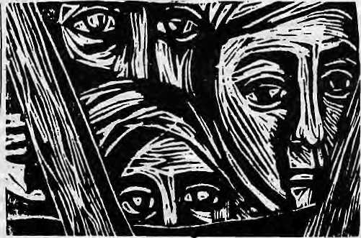
cities — the possibility of diversity in the context of a positively felt identity that offers stability and security.
In contrast, the negative sense of communalism is based on an exclusive identity that denies respect for other identities and views unify as something that is achieved by subjugating others. Secularism, too, has opposing meanings; a typically Asian one that we began with and a typically Northern one towards which we seem to be moving. The former entertains no rejection of religious or cultural identities but respects them equally .The more homogenising and pervading Northern ' concept pushes religion and culture out of the domain of the State and leaves society to find its unify by surrendering its diverse cultural heritage to the modem Stale and its modernising mission. The latter Version of secularism aims to remove diversify and what it perceives as undermining allegiances to religion, language or culture. It views its model of development as creating the conditions for modernising the minds oFthe people, moving them towards a post-ethnic consciousness.
But, paradoxically, instead of helping religious, linguistic and cultural identities to wither away, modernisation has hardened them and provoked ethnic conflict and communal violence. Worse still, it has transformed positively experienced identify into negative identity. Identities have not withered away - what have withered away are the conditions under which diverse identities can together share a social space. Cultural survival has been reduced to meaning the temoval of the other, the exclusion of the other, the death of the other.
Modernisation creates social and economic vulnerability and insecurity as it homogenises cultures, conditions whose management the State assumes responsibility for. When governments proclaim equality as a social ideal yet persist in development and modernisation programmes that result in inequality, each individual and group interprets its loss as someone else's gain, and interprets the other's gain as a result of its being well organised as a group—whether linguistic, religious, caste or regional. Ethnic groupings have helped people to bargain with the State.
Economic survival becomes the issue, as it was for the upper class doctors and lawyers in Gujarat fighting against the reservation system earmarking educational seats for the depressed castes and tribes, or for the Malays Tesenting the upward mobility of their fellow Chinese citizens. Because electoral politics and government intervention respond to ethnic groupings, economic issues become issues of cultural survival. If "they" get jobs "we" will be unemployed. If "they" prosper, "we" will be deprived. And the struggle for economic and cultural survival is experienced by all communities, not just the minorities or the marginalised. In India, Hindus see Muslims and backward classes being pampered for votes. Muslims see Hindus excluding them in new ways, and see the State encouraging such exclusion. The same is the case with the Sinhala and the Tamils in Sri Lanka. It is this disease, nourished by cultural decay, growing inequality and the employment of ethnicity as the exclusive basis for gain and protection, that turns communal feelings violent and destroys society. This is why communal violence is epidemic.
The increasing alienation of community from the State is, in some respects, a more far-reaching development than even the growth of violence and terrorism which, of course, thrive on alienation. Alienation is the slow but growing withdrawal of the citizen from the
constitutional apparatus called the State, as well as from the larger entity that envelops all smaller affiliations and identities, called the Nation. People increasingly feel indifference, apathy and alienation from the State. There is an equal if not greater withdrawal from "nationalist" commitments- While terrorist killings upset and disgust people, they fail to make them feel any closer to the government. The awe and respect for the army declines precipitously. What grows instead identitification with one's own caste or linguistic or religious community andoftenawithdrawal into still narrower shells of primary and secondary loyalties—of peer groups and family—and often into just one's own lonely and miserable self. Communalism thrives on this larger canvas of societal breakdown. It thrives on the destruction and decay of institutions andtheerosionoflegitimaieauthorify.lt flourishes as society declines and the democratic state collapses.
But, while the "poison" of communalism spreads under the pressure of insecurity and the power of chauvinist and fundamentalist doctrines, it is well to remember that it is spread by a minority in all communities. Thus, so-called majority communities, are bom of a minority's interpretation of a dominant or hegemonic culture that is proclaimed to be dominant or hegemonies!. That powerful minority demands that the State accept its culture as dominant and that the other "minorities" be forced to do likewise. The State is asked to confer special status on those belonging to the "majority" and inferior status on the others. Of course, such privileges are conferredon a small group who in any case are privileged and have access to resources and opportunities pro videdby a modernising S tate and a capitalisteconomy. Predictably, thereaction this produces in the minority communities also plays into the hands of small, privileged groups. Thus, in the state of Kerala, known for long for the amicable' coexistence of its Hindus, Muslims and Christians, the communal virus has begun to spread and now affects each of them, thanks largely to the political compulsion of narrowly conceived electoral calculations. The result is Hindu eemmunslism exploited by the privileged among the dominantcastes; Muslim communalism exploited by the rich and privileged strata known as the "timber mafia" that has benefitted from "Gulf money" (and against which the Hindu communalists direct their ire); and Christian communalism in which the Catholic clergy, with massive Church and other resources, plays a major role.
Where will it all end? In the recovery of the conditions of
diversity as the condition of survival for all, or in the annihilation of all?
Those Hindus and Muslims who think that religious uniformity is a
condition for peace need only remember the Karachi riots where, in
spite of a common religion and an Islamic State, the Mohajirs fight the
Pathans and Punjabis. If we do not divide ourselves up by religion, we
will do it by language, by caste, or by race. Divisiveness and
fragmentation is infinitely regressive. For every Hindu who thinks that
Indian Muslims should be sent to Pakistan, there is a Pakistani Punjabi
waiting for the Mohajirs to be sent back to India. And for every Indian
who thinks that the Tamil refugees from SriLanka should be sent back,
there is a Sinhala who believes that all the Tamils should go to India.
We seem to be trapped in our cultural diversity. t*
R. Kothari, eminent Indian social scientist, is with the Center for the Study of Developing Societies in Delhi. A longer version of this article appeared in Rethinking Development.

16 HIMAL • May/June 1992

Grasping the Tarai Identity
How can the Tarai unite against perceived highlander domination, with its peoples divided by ethnicity, caste, religion and region?

S
ome senior Nepali politicians, who should know better, like to claim that there is no "ethnic problem" in Nepal. Because of Nepal's ethnic and regional diversity, the potential for conflict and crisis is ever-present, just below the surface. All that is required for conflagration is a few power-thirsty individuals who think nothing of setting a match to the ethnic sensibility of communities. Nowhere in Nepal is this more true than in the Tarai, the strip of tropical flatlands that runs contiguous to the east-west foothills of die Himalaya. An attempt is on today to draw a sharp dividing line between the Tarai and the hills, based on regionalism and ethnicity.
The regionalism has to do with the distinct geographical position of the Tarai. The 34,019 square kilometres of the Tarai makes up 23 per centofthecountry's total area, and it is inhabited by 46 per cent of Nepal's population. The Tarai has seen a three-fold increase in population over the past four decades, from about 2.9 million in 1952 to about 8.6 million today.
Historically, the Tarai strip was thinly settled by malaria-immune "indigenous" groups such as the Tharu, Dhtmal, Rajbansi, as well as some caste groups from the south. At the turn of the century, the Rana regime in Kathmandu encouraged migration from India in an effort to develop the Tarai. This is why some of the Tarai districts today comprise a significant number of people who are of "Indian origin". It was impossible to entice hill groups to settle in an area considered fit only for exile or penal settlement, so-called KalaPani (black waters.)
After 1960, with the eradication of malaria, the wild lands of the Tarai became the destination of the dispossessed from the hills of Nepal and those known wprabasi—Nepali-speakers from Burma, Bhutan and the northeastern states of India. With the opening up of forests by highways, the spread of agriculture, and the establishment of a timber industry, the Tarai soon emerged as the economic backbone of the country.
If there is one area of the Himalaya that is simmering with ethnic discontent, it is the Tarai. All three main groups that reside within the region — the original inhabitants, the people of "Indian origin" and the Nepali Highlanders — nurse negative feelings towards the Kathmandu government And on (op of the everyday push and tug amongst these groups, there is the influence of politics from across the border, in Uttar Pradesh and Bihar.
The Tarai, divided by major rivers that
by Dill! Ram Dahal
flow out of die Himalaya, is also a demographic mosaic that hardly presents die uniformity that some would like to see in it A quick run from west to east proves the point (please refer to the map on page 19). The western districts of Kanchanpur, Kailali, Bardtya, BankeandDang-Deokhuri are 30 to 50 per cent Tharu; hill people make up the second largest group. Hill people account for a similar proportion in BahkeEKstrict, but here Muslims and Tarai caste Hindus make up 50 to 60 percent of the population.
Moving further east into Kupandehi, 70 to 80 per cent of the population are highlanders. Kapilbasiu has a high concentration of Tarai caste Hindus, while almost half the population of neighbouring Nawalparasi are highlanders. In Chit wan district, nearly 80 per cent of the population is of hill origin, and 15 to 20 per cent are Tharu. The Tarai caste Hindu groups dominate in -Dhanusa, Maliotah, Siraha, Saptari, Bara, Parsa, Sarlahi, Rauthat and Kapilbastu.
In the eastern-most Tarai district of Jhapa, the indigenous groups of Dhimal, Rajbansi and S atar comprise up to 20 per cent of the population, while highlanders make up the rest. In Morang District, we have a mixture of Tarai casteHindus, hill people and Tharus. Neighbouring Sunsari, on the other hand, is dominated by highlanders.
The influx of the hill population is a significant demographic event of the past few decades; ant¹ several to wns have developed where hill meets plain with hill-majorities. These include, west to east towns like Mahendranagar, Tribhuvan Nagar, Butwal, Bharatpur, Hetauda, Dharan and Damak.
Thus, there are three main ethnic divides in the Tarai deserving consideration. The first is between the Pahade, or hillman, and the Madhesiya, or plainsman. The second is the split between the Hindu caste groups and the "original" ethnic groups such as the Tharu, and the third is thedivide between Tarai high -caste Hindu groups and the Tarai low-caste Hindu group.
Hillman, Plainsman
Neglect of the plains people by the hill-dominated government in Kathmandu encourages the first divide. The hill people, for their part, tend to deride the affinity that many Tarai dwellers feel for their kinsfolk across the border in India.
Some Tarai leaders, particularly those representing the Hindu caste groups in-the SadhbhavanaParty,have started &PahadiaHasao campaign to physically remove the- hill peoples
from the plains — which might be considered a disturbing trend in national politics. These leaders also advocate the use of Hindi as a link language among Tarai groups, much as Nepali tends to link the hill groups. However, only nine of the 20 districts of Nepal's Tarai have predominantly Tarai Hindu caste groups, who are most likely to speak Hindi. These include Dhanusa, Mahotari, Siraha and Saptari districts—where the mother tongue is Maithili. Bhojpuri is spoken in Bara and Parsa districts, whereas Bajika (a mixture of Maithili and Bhojpuri) is spoken in Sarlahi and Rautahat districts. Thus, even in the "Hindi belt" of Nepal, Hindi is hard to come by other than at political rallies. West of the Narayani River, in Kapilbastu, Banks and B ardiy a districts, Awadhi is spoken by Tarai caste groups.
It is not that Hindi comes easier to the tongues of Bhojpuri and Maithili speakers than Nepali. Linguistically, both Nepali and Hindi are Indo-Aryan tongues. In fact, Hindi is just as foreign to speakers of Bhojpuri andMaithili as it is to the Nepali speakers of the hills, Hindi is not the mother tongue of the majority of even high caste Hindu groups of the Tarai, and it is certainly not the first language of the substantial tribal population nor of the now significant hill population of the Tarai. Why, then, do Tarai-based politicians tilt towards Hindi?
The Hindi preference is a reaction against perceived hill chauvinism. It is an attempt by Tarai elites to close ranks in a bid to strengthen bargaining power with "the north". The demands for Hindi are of strategic importance to those who presently feel outside the Nepali mainstream. The solution seems to lie with the Kathmandu government And the onus is on, Kathmandu's bipartite Batiun-Chbelri-Newar establishment heeding demands for ethnic representation and linguistic rights of all the communities of the country, whether Tarai or non-Tarai. With more recognition of the mother tongues of the Tarai in •education, in the media and in other culture-related and state-supported activities, the pro-Hindi agitation — which comes so unnaturally — might well be diffused.
The divisions bet weenhili people and plains people also seem linked to the uncontrolled flow of Indian migrants crossing the border to settle in Nepal. Because so many of the groups on either side of the border are culturally identical, it is difficult to differentiate the Nepali 'Tarain"from the Indian settler. Daily familial, cultural and commercial interactions which take place

May/June 1992 HIMAL • 17

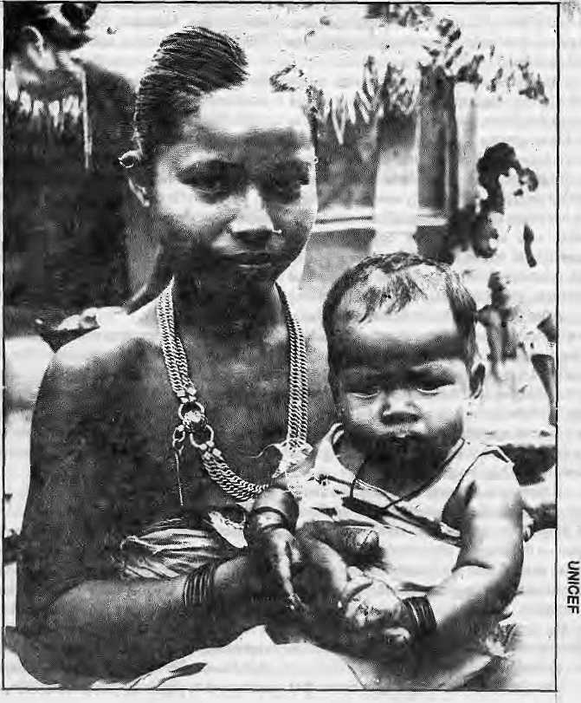
between these groups, as if the border does not exist, further complicates matters. That a problem of national identity should arise among the Tarai people, and that hill Nepalis should thus question their allegiance, seems natural.
One aspect of the Tarai-hill divide is resentment of the hill-dominated administration and the culture it represents. The other aspect is the conflict between the plains people and the Nepali-speaking settlers who have moved into the Tarai, homes leading on cleared forest lands with government blessing. From perhaps less than five per cent at the turn of the century, the highlandNepalistodaymakeup35to40percent of the population of the Tarai. ('Tarai' also refers to Bhitri Madhes, the Inner Tarai.)
While there are a few landlords of hill origin, who received their holdings from the Rana overlords, the majority of the hill migrants have little land and today make up part of the poorer segment of the Tarai population. With the advent of party politics, this group of poor high lander s h as tended to s upport the mainstream left (CPN/UML) or the far-left Ekata Kendra (United Center). At a recent rally of the Ekata Kendra in Janakpur, it was noteworthy that many poor Tarai low-caste groups also participated; Needless to say, very few Tarai-dwelling. highlanders who support the Sadhbhav an a Party.
High Caste, Low Caste, Tribal
Poverty and landlessness are the major problems of Tarai society. The landless and the exploited tend to be from the low-caste Hindu or the tribal groups. For example, in the villages of Laxminiy a, Belgachhi and Dharampur in Mahotari district, nearly 30 of 100 peasants interviewed were landless—low caste groups such as the Chamar, Batar, Mushahar and Dushad.
The exploitation in Ihe Tharu areas of Kanchanpur, Kailali, Bardiya, Banke, Dang-Deokhari and Surkhet districts in the western Tarai extends beyond landlessness to bonded labour-—known as the kamaiyasys tern. A Tharu man's debt passes on to his sons and, before long, generations are bonded to the landlord or moneylender's estate. In West Nepal, these landlords arenot only Bahuns and Chhetris, but also Tharus.
If the talk these days is of human rights, then the Tharus deserve special treatment among all the Tarai groups. So far, however, special treatment has meant tokenism, even though the Tharu is the largest single ethnic group in the Tarai. Tharu elites were wooed during the Pancha-yat system with representation in the Rastriya Panchayat and in national cabinets. Even today, political parties have sought to use Tharu frustration for their own ends. Their feeble cries of "Freedom from Bonded Labour" are being drowned out in the tumult of democracy where the mote vociferous communities get heard.
Preferring to identify their communities as distinct from Tarai caste groups, some Tharu and Dhimal leaders insist that they have more in common with the hill-ethnicities of Nepal. The
IS HIMAL • May/June 1992
Dhimal of the eastern Tarai, for example, regard themselves as kin of the Limbu of the hills.
While they might want to be regarded as closer to hill communities than to Hindu caste groups of the plains, the Tarai ethnic groups are frustrated that their integration into the political-economy of the country has been so slow. At the same time, they do not take kindly to state policy that encourages their integration into the Hindu caste model. A mild cultural backlash is thus taking place in which the Tharu and other ethnic groups such as the Dhimal, Gagain, Satar and Rajbansi are coalescing into one force, setting themselves apartfromboth the Tarai caste groups and the Pahades.
The complex pattern of Tarai politics does not end with the tussle between ethnic groups, hill communities andTaraicaste^roups, however. Conflicts within castes is emerging rapidly, in close coordination with caste politics of neighbouring Bihar and Uttar Pradesh. The most significant demands are being made by the Yadav community — with high concentration in the districts of Mahotari, Siraha, Saptari, Morang and Sarfahi.
Yadavs have developed considerable apolitical muscle in Uttar Pradesh and Biljar over the past decades. Relying upon their numerical' strength, they have challenged the holdofRajputs
andother groups over state politics. LallooPrasad Yadav 's controvers ial chief ministership in Bihar
is the best example of this newfound strength.
Since their numbers are quite significant in Nepal as well, the Yadavs are now able to use the democratic process to their advantage. A new acronymic political slogan has emerged in the central Tarai: "BHURA BAL halao," aimed against the (high caste) Bhumihar, Rajput, Brahmin and Lala (Kayastha). The main proponents of this campaign are not the low castes and ethnic groups, but the Yadavs.
Ethnic expediency
Ethnic politics in the Tarai — like politics anywhere, to be sure — is one of expediency. The elites use community-identification as a tool for their own ends. Moreover, as a strategy, they are trying to foist a pan-Tarai identity on a geographical region which is divided in more ways than one. But this strategy might giveout as the presurred sense of commonality does not exist among the people of the Tarai. Merely harbouring and promoting animosity against the hill people might not work.
D.R.Dahai is an anthropologist with the Centre for Nepal and Asian Studies, Tribhuvan University.

Representing An Ethnic Mosaic
The social composition of Nepal's House of Representatives is the outcome of the people's choice ...
by Harka Gurung

Zone | West(Kamali) | Central (Gandaki) | Central (Upper Bagmati) | East (Kosi)
Mountain | Khasa, Bhote | Thakali, Bhote | Tamang | Bhote, Snerpa
Hill | Khasa | Magar, Gurung, Chepang | Newar | Sunuwar, Rai, Limbu
Inner Tarai | Raji, Tharu | Danuwar, Tharu, Darai |  | Majht, Danuwar
Tarai | Tharu, Awadhi castes | Tharu,  Bhojpuri castes |  | Yadav, Rajbansi,  Maithil castes
N
epal has been aptly described as Asia's ethnic turn-table. It is the land of interface between the oriental Kirant (Mongoloid) and occidental Khas a (Caucasoid) people. The former migrated from the east and north while the latter came from the west. The Khasa were, in turn, supplemented by high-caste Hindus from the south — a fallout of the battle of Tarain (1192 AD) in which Muhamad of Ghur defeated the Rajputs. Once the plains of Hindustan were lost, the martial Rajputs and their Brahmin consultants headed for the hills. It is significant that Garhwal and Kumaon—source of the Khas a migration to Nepal—has49to59.6percentRajputand21.6 to 23.7 per cent Brahmin as the predominant population. Their migration eastward was to greatly transform the polity and society of the then Nepal. This was epitomised in Prithvi Narayan Shah's claim of Nepal a&"Yo asit Hindustanaho," (Thisis the genuine Hindustan)
and in the imposition of ib& Muhtki Ain (1854) Hindu caste code on a multi-ethnic society. Of the 212 signatories of the Am, over 70 per cent were tagadhari Brahmin, Thakuri and Chhetri. The Hindu kingdom of Nepal still considers discus sion on ethnicity as anathema and therefore no official data are available on ethnicity and caste. However, some broad cultural areas can be recognised, based on linguistic evidence. The simplified schema is as follows:
The Khasa, including the priestly upper and occupational lower strata, predominate in the West, or the old Baisi. The Central or old Chaubisi, is home to numerous tribal groups and Khasa migrants. (The terms Baisi and Chaubisi refer to the 22 and 24 principalities west of Goikha before the consolidation of Nepal in the late 18th century). Upper Bagmati, or proto-Nepal, has Newar at the core and Tamang on the periphery. The east, or early Kirant land, has

 | Bhote: EJ | MagarEJ
 | Gurung: Cl | Tamong;Il
 | Thtaotin | UmburlH
 | RakQ-
ETHNIC AND CASTE REPRESENTATION NEPAL'S HOUSE OF REPRESENTATIVES BY CONSTITUENCY
HILL GROUP
^^ Newar
SB Tribal
^y^l Occupational Casle Party™ a
TARAI GROUP
IMlBrahmh
I Landed Caste IS5I Trader Caste
$m Tribal
EHIIl Muslim
Them: IB] Vodtw: a Kuutii: JB
Rqjput:EI Ddnuwar: m Kfise. 19
Ko/QlthQ: (33 Ha/a:ai Rajbarai: Ql

Map by Harka Gurung; Drafting: Nabin Shrestha
May/June 1992 HIMAL
19

There were 1,345
candidates for 205
constituencies during the
1991 general election. Out
of the 20 political parties,
eight fielded 50 or moTe
candidates. These were the
Nepali Congress (204),
CPN/UML (177), NDP/
Thapa (163), NDP/Chand
(154), CPN/Democratic
(75). Nepal Sadhbhavana
Party (75), UnitedPeople's
Front (69) and Nepal
National Peopled
Liberation Front (50). The total number of candidates representing these parties was 967 or 71.9 per cent of all contenders (Table 2).
Of all the candidates
from the above eight
parties, a quarter was
Bahun. Chhetri candidates made up one-fifth of
the total, closely followed by hill ethnics. Among
the latter, a sizeable number of candidates were
from the Gurung (39), Tamang (35), Rai (34),
Magar (33) and Limbu (26). Among the
candidates of Tarai origin, landed castes made up
3.6 per cent, the highest representation being that
of Yadav (46), followed by Chaudhary (25) and
Rajput (15). Within the Tarai tribals, the Thani
led with 30 candidates (excluding those
designatedasChaudhary).There were 18 Muslim
candidates and all were from the Tarai. Of the .
967 candidates sampled from eight parties, 27.2
per cent were from the Tarai. \
Choice of the People
The social composition of the House of Representatives is the outcome of the people's
more tribal groups both in the hill and plain. A distinctive distribution pattern is the "horizontal" diversity of ethnic groups in the hills and the proliferation of "vertical" caste groups in the Tarai.
Since there are no
ethnicity data for the country,
land-ownership records
available for the Central
Development Region
provide a sample framework
for analyses. The total
population lecorded for the
above region "(comprising of
Bagmati, Narayani.
Janakpur zones) was 3,488,825 during the mid-1960s, as against 3,865,753 enumerated in the 1971 census (Table 1). Thus, ethnic groups slightly outnumber the caste groups, while the hill group is more than double of the Tarai group.
Political Participation
The ethnicity/caste of the party leaders may influence their cadre composition. The two largest parties, the Nepali Congress and the Communist Party of Nepal (United Marxist-Leninist), headed by Bahuns of hill origin had large numbers of hill candidates and Bahuns. Of the 204 Nepali Congress candidates, 79.9 per cent were of hill origin and36.8 per cent Bahuns. Similarly, out of 177 candidates fielded by the CPN/UML, 84.2 per cent were of hill origin and 47.5 per cent Bahuns.
The National Democratic Party (Thapa) had 38 Chhetri candidates (of whom seven were Thapa-Chhetri), 23 Bahun and 12 Thakuri. S inularty, the N ational Democratic Party (Chand) had more Thakuri (36) than Chhetri (26) and Brahmin (21) candidates. The Western hill region

Table 1: Ethnicity /Caste of Central Development Region
Social Group | Ethnic | Caste Population | Per cent
1. Mountain & Hill |  | 2,327,924 | 66.7
Ethnic | 17 | 1,292,361 | 37.0
Caste' |  | 13 1,035,563 | 29.'/
2. Inner Terai
Ethnic | 8 | 156,388 | 4.5
3. Tarai |  | 794,369 | 22.8
Ethnic | 3 | 261,922 | 7.5
Caste |  | 48 532,447 | 15.3
4. Religious Group |  | 130,994 | 3.8
Muslim |  | 128,226 | 3.7
Jain |  | 2,768 | 0.1
5. Others/Unstated |  | 79,150 | 2.3
Total | 28 | 61 3,488,825 | 100.0
Total Ethnic |  | 1,710,671 | 49.0
1 Total Caste |  | 1,568,010 | 44.9
Religious Group/Others/Unstated |  | 210,144 | 6.0
Source: District Land Reform Records
is supposed to be the stronghold of the Thakuris, butNDP (Chand) fielded Thakuris forthree seats in Kathmandu Valley, five in the Inner Tarai and nine in the Tarai, all of whom lost
Table 2: Candidates of Eight Sampled Parties
Ethnic/Caste | Sub-group | Number | Percent
Hill Group |  | 202 | 72.6
1. Bahun |  | 243 | 25.1
2. Chhetri |  | 211 | 21.8
3. Newar |  | 61 | 6.3
4. Tribal | 10 | 184 | 19.0
5. Occupational Caste 2 |  | 3 | 03
Tarai Group |  | 263 | 27.2
6. Brahmin | 9 | 30 | 3.1
7. Landed Caste | 10 | 83 | 8.6
8. trader Caste | 8 | 60 | 6.2
9. Tribal | 5 | 45 | 4.7
10. Muslim |  | 18 | 1.9
11. Others |  | 29 | 3.0
Total |  | 967 | 100.0
The Communist Party of Nepal (Democratic), led by a Newar, had eight Newar * candidates in eight districts. The far left United People's Front (Samyukta Jana Morcha) had nearly 90 per cent candidates of hill origin and one-third Bahun. The Tarai-based Nepal Sadhbhavana Party did not field any-[hill] Bahun and Chhetri candidate, and only five of its 75 candidates were of hill origin. On the other hand, mehill-ethnicproponentNepalNationalPeople's Liberation Front (Nepal Rastriya Janamukti Morcha) did not sponsor any candidate of Tarai origin, while 40 out of 50 of its candidates — none of whom succeeded — were from six hill ethnic tribes.

Table 3:1 | Ethnic/Caste Representation in the Legislature
Ethnic/Caste | 1959 | 1978 | 1981* | 1991 |  | 1991
 |  |  |  | Lo. House | Up. House | Both
A. Hill Group | 78.0 | 85.0 | 79.5 | 79.0 | 85.0 | 80.4
1. Bahun | 27.5 | 21.3 | 12.5 | 36.6 | 40.0 | 37.4
2.Chhelri | 31,2 | 36.2 | 36.6 | 183 | 15.0 | 17.7
3. Newar | 3.7 | 7.9 | 8.0 | 6.8 | 133 | 8.3
4. Tribal | 15.6 | 18.9 | 22.3 | 16.6 | 133 | 15.8
5. Occupational
Caste | - | 0.8 | - | 0.5 | 3.3 | 1.1
B. Tarai Group | 22.0 | 15.0 | 20.5 | 21.0 | 15.0 | 19.6
6. Brahmins | 3.7 | 2.3 | _ | 2,4 | 1.6 | 23
7. Landed Caste | 10.1 | 7.0 | 7.1 | 5.4 | 5.0 | 53
8. Trader Caste | 2.8 | ■ 1.6 | 1.8 | 2.0 | 33 | 23
9. Tribal | 3.7 | 3.2 | 9.8 | 8.8 | 33 | 7.5
10. Muslim | 1.8 | 0.8 | 1.8 | 2.4 | 1.7 | 2.3
All | 100.0 | 100.0 | 100.0 | 100.0 | 100.0 | 100.0
No. of Seats | 109 | 127 | 112 | ,205 | 60 | 265
* Excludes nominated members.
Source: Gurung. Asian Survey, Vol XXII, No. 3, March 1982, p. 313.

20 HIMAL • May/June 1992

H. Gurung is a writer and consultant.
May/June 1992 HIMAL
21
nominees. Two are of hill occupational castes. The combined strength of the lower and upper houses is 265 members. The share of the members of hill origin comes to 80.4 per cent. Hill Brahmins are predominant, with 37.4 per cent of all members (Table 3). Chhetris come next with 17.7 per cent, closely followed by hill tribals, 15.8 per cent. Tarai Brahmins and Tarai trader castes have a lower representation along with the Muslims.
Who Represents Whom ?
Some social groups have a higher propensity for political participation than others. This can be exemplified in the case of the Central Development Region. This region represents all varieties of ecological zones, including the metropolitan region of Kathmandu, and has 64 election constituencies, or 31.4 per cent of the total.
Of the 19 districts in the Central Region, seven have a Tamang majority (Table 4). The Tamang constitute the largest ethnic group with 15.4 per cent of the total regional population. However, the region has only three Tamangs elected members out of the 64 constituencies. The second largest group in the region is Newar with 13.9 per centof the totalregiopalpopulation. They h ave nine representatives from the region. Newar representatives come from threeTamang majority districts and one Yadav majority district, including three from Kathmandu Valley.
Chhetris constitute 12.1 per cent of the regional population. They are in majority in only two districts (Dolakha, Ramechhap). Chhetris have six members in the lower house from the region. They do not represent R amechhap, where they are the most numerous, but have seats in three Tamang-majority districts, and one Yadav-majority district.
Hill Brahmins constitute 11.7 per cent of the regional population but 41 per cent of the regional constituency, with 26 elected representatives. They are in majority only in Chitwan District, but represent 7 hill, 6 Kathmandu Valley, 6 inner Tarai and 6 Tarai constituencies in the region. This includes Rasuwa, which has 88.9 per cent Tamang population.
Among the Tarai social groups, the largest is Yadav, with 5.6 per cent of regional population with majority in five Tarai districts. However, there are only three Yadav representatives out of 27 Tarai constituencies. On the other hand, eight Tarai constituencies are held by representatives of hill origin.
Overall, the literate Brahmins and the bazaar-based Newars seem the mostconscious and cosmopolitan in political culture in Nepal. But the former also carry a burden of an Indian wisdom: "Before the Brahmin is in want, the kings's larder will be empty."
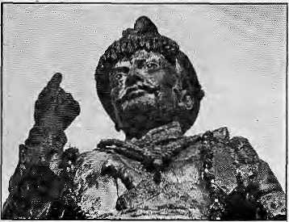
choice. The House represents eight ethnic and three caste groups from the hill, and three ethnic, eight caste, and one religious group from the Tarai. These can be regrouped into 10 broad categories (Table 3). Hill Brahmins constitute the largest group with 75 members out of 205. In other words, more than a third of the House members are Bahuns. The second mostnumerous areChhetris, with 18.5 percent. Hill taibals come next with 16.6 per cent. Tarai tribals rank fourth with 8.8 per cent members.
Choice of Party and Palace
The Upper House is composed of 60 members, of which 50 are nominated by prominent parties on a proportional basis, and 10 by the King. Compared to 36.6 per cent in the Lower House, the Upper House has 40 per cent Bahuns (Table 3), Out of 31 Congress nominees, 13areBahun. One-third of the CPN/UML nominees, both the nominees of the United People's Front and four out of the 10 royal nominees areBahuns. Chhetris are second in preference. Nominees of the Tarai social groups are nine, and those of Newar eight. Four hill tribal groups are represented with eight
Compared to the social composition of the 1959 general election, Bahuns have gained in 1991, while Chhetris lost their share considerably. Other social groups with a lower share than 32 years ago are caste groups of the Tarai, particularly the landed castes. On the other hand, the Tarai tribals have made considerable headway. The representation of the Tarai group has changed only slightly: 22 per cent in 1959 to 21 per cent in 1991. The Tarai representation was lowest (under the Panchayat election system) in 1978, but improved in 1981. Even during the 1991 election, more than half of the Tarai's 67 constituencies were won by candidates of hill origin. These include 25 hill Bahuns, five Chhettis,twoNewars,twoTamangs, onePariyar (Damai), and one Gurung.

Table 4: | Social Groups & Representation in Central Region
 | Most
District | Numerous | Population | Current Representatives
(No. of Constituency) | Group | Percent | (Their population percent in district)
A. Mountain (3)
l.Rasuwa(l) | Tamang | 88.9 | Bahun (3 5)
2.Dolakha(2) | Chhetri | 34.9 | Chhetri (34.9). Tamang (16.6)
B. Hill (15)
3. Dhading (3) | Tamang | 21.8 | Tarnang (21.8), Bahun (19.3), Newar (11.0)
4.Nuwakot(3) | Tamang | 39.2 i | 2 Bahun (21.7), Chhetri (14.0)
5.;SindhuPalchok(3) | Tamang | 365 | 2 Chhetri (15.7), Newar (10.5)
6. Kabhre Palanchok (4) Tamang |  | 331 | 2Bahun (24.3), laman£ (33.1), Chhetri (13.6)
7. Ramechhap (2) | Chhetri | 25.4 | 2 Bahun (8.3)
C. Kathmandu Valley | (10)
8. Kathmandu (5) | Newar | 46.7 | 3 Bahun (16.1), 2 Newar (46.7)
9.Lalitpur(3) | Newar | 50.7 | 2 Bahun (10.1), Newar (50.7).
10. Bhaktapur (2) | Newar | 55.2- | Newar (55.2), Bahun (10.0)
D. Inner Tarai (9)
ll.Chitwan(3) | Bahun | 28.7 | Bahun (28.7), Newar (6.4), Thakali (0.0)
12. Makwanpur (3) | Tamang | 37.6 | 2 Bahun (10.0), Newar (17.5)
13. Sindhuli (3) | Tamang | 19.4 | 3 Bahun (11.1)
E. Tarai (27)
14.Parsa(4) | Kurmi | 9.4 | 2 Bahun (3.6), Tharu (8.5), Koiri (3.8)
15.Bara(4) | Yadav | 15.0 | 2 Bahun (3.3), Tharu (12.1), Muslim (11.4)
16. Rautahat (4) | Yadav | 14.6 | Muslim (11.7), Tharu (4.5), Rajput (2.3),
 |  |  | Brahmin (0.3)
17.SarIahi(5) | Yadav | 20.6 | Tharu (7.1), Mahato (2.5), Chhetri (3.2),
 |  |  | Newar (0.9), Brahmin (0.4)
18. Mahotari (5) | Yadav | 214 | Yadav (21.4). Brahmin (93), 2 Rajput (1.2),
 |  |  | Gurung (0.0)
19. Dhanusa (5) | Yadav | 214 | 2 Yadav (21.4). 2 Bahun (2.5). Kavastha (0.6)
Note: Ethnic/Caste name of representatives underlined conform with the most numerous
in respective districts.

After 25 years of persevering belligerence, Prithvi Narayan Shah conquered the three cities of the Kathmandu Valley in 1769, One year later, on 23 March, he shifted his capital to newly occupied Kathmandu. With his court came his kinsmen, retinue, priests and soldiers — the new aristocracy of the hill region — to settle permanently in Kathmandu. They symbolised what Nepal's leading economic his torian Mahesh C, Regmi calls "ashift of political and economic power". Among them were the thar-ghar, the chosen and select families of hill brahmins such as Aryal, Khanal, Pandey and Panta who were rewarded with the best lands and houses in the Valley as their jagirs in return for their services to the Gorkhali court in war and peace. Thus begins the success story of thepdrbate Bahuns, the brahmins from the hills.
The Sanskrit word brahmana has more than one meaning and is therefore potentially ambiguous. Without the contextual clue it might mean any of these four: supernatural power or the absolute world-spirit; a Vedic text of the brahmanic class; the god Brahma; or a member of the priestly order in the Hindu society. Relatively speaking, the native term Bahun is decidedly preferable for it is starkly unambiguous
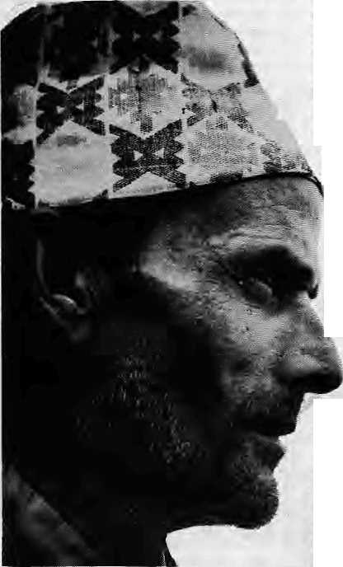
Bahunvada: Myth or Reality
by Kamal P. Malla
in its social and cultural reference. Manu, the Hindu law-giver, prescribed six main functions to a brahmin: study and make others study, sacrifice and make others sacrifice, give and receivegifts(Monj«wj7(X:75).However,Manu nearly forgot the central political or ideological function of the brahmana, that is to legitimise the political power, no matter who holds it, for which he receives the munificence of the powers that be. It may not be instantly possible to verify if all the known clans of parbate Bahuns, listed for example in Shikhamatha Subedi's Tharagotra Pravaravali, perform all these ritual functions. Perhaps, they don't. Nor is it possible to chronologise and substantiate the claim of these clans to have migrated from the heartland of Aryavarta into the laps of the rugged hills of Nepal. Perhaps, it is even silly to expect them to observe Manu's prescriptions in the cold Himalaya at the high noon of the Kali Yuga. But a number of these clans and lineages with gotras and pravaras allegedly drawn from eponymie Vedic and Upanishadic rishis claim nothing if not pristine purity of blood and Aryan descent. However, only a few families have published their authentic genealogies, going back eight to ten generations, and fewer have bare Us ts of dead manes. Those who migrated to the Kathmandu Valley came with their jajamw families such as the Chhetri families of the Thapas,Pande, Basnet, Bohara and Kunwars — who later on staked a claim to have descended from the Ranas of Chitor. Both ihepurohits as well as thejajamans speak khas kura {orNepali as it is known today) and are known as khasa — a people originally classified by Manu as vratya or "those who have abandoned sacred rites and lost their caste" (Manusmrti X: 22) Not only the Gorkhali army but also their civil administrationdid no t recruit the Newars — the inhabitants of the conquered Valley because of the deeply ingrained distrust and contempt for them in the Gorkhali psyche — graphically expressed in such sayings as Newar ista ra babu dusta kahilai hundaina: a Newar is never a friend just as a father is never an enemy. Only since October 1804 were someNewars admitted in therevenue administration, then only because the Gorkhali sardars didn't comprehend the the Valley's land administrationsystem.
After Jang Bahadur Kunwar came to power in September 1846, following the Kot Massacre, he reorganised the judicial, civil, and revenue administration along seemingly institutional models. His MulukiAin, or Civil Code of 1854, tried to codify Hindu caste orthodoxy as a State ideologywiththeBahunsandThakuris-Chhetris
topping the social hierarchy, and lumping a large segment of other Nepalis, including the Newars, as enslavable maiawalis. Although Jung Bahadur's Muluki Am, which gave the highest ritual status to Bahuns, was officially abolished llOyears later in 1964, ithad by then ensured the Bahun's secular status as well by putting them at the top of the social pyramid. The Newars were "upgraded" as "un-enslavable" in 1863, when Jung Bahadur was visibly pleased with their services in the 1854/55 war with Tibet and the 1857 Lucknow operation.
Among Jang Bahadur's client families staffing the Rana administration, most came from the Khas Thakuris, ■ Chhetri and Bahun famines. Of the 230 bhardars (council members) signing the 1854 Ain there were only seven Newars — three subbas from the family of SiddhiManRajbhandari,twoyt/iariJar.r,andone rf/H/w, and one other. Because of their knowledge of Persian-Urdu, Tibetan and English, the Jaishi Kotha and the Munshi Khana — which dealt with all foreign affairs — were staffed by a few select Newar families. Thus, the Newars seemed to have made a small dent into the early Rana administration. Their administrative skills and accomplishments must have been no small assets, enabling them to survive the conspiratorial court politics which lingered on till the rise of Chandra Shumsherein 1901.
A classic instance of the Rana court ethos is narrated by Sukra Raj Shastri, the martyr hanged in 1941, in a biography of his distinguished father Madhav Raj Joshi entitled, Sahidke Kalam Se ("From the Martyr's Pen," posthumously published in 1958). In July 1905, in the presence of Chandra Shumshere, Madhav Raj was brutally beaten by the pandits of his court for asserting that true Hinduism is enshrined in the Vedas and the Upanishads, not in worshipping the stone image of Pashupatinath. Madhav Raj was paraded through the streets of Kathmandu with ableeding head and a bloodstained body. In many ways, as BhuvanLal Joshi andLeoE. Rose put it, Madhav Raj Joshi was the first rebel in Nepal who revolted against brahmanic orthodoxy by inaugurating the social and political awakening which led to the movement for democracy in the 1940s and the overthrow of the Ranas in 1950.
Theextent and proportion of the Bahun and Newar inroad into the Rana administration can be judged from the list of bharedars who assembled on 7 November 1950 to depose King Tribhuvan after he sought asylum in the Indian Embassy. Among the 258 highest officials signing the document, there were 23 Newars in all—two kazis, four sardars, 16 mir subbas, and one engineer.FromtheBahun community there were 36, out of which 13 were from the families of Badaguruju, Rajaguruju and Gurupurohit, four pandits, nine Mir Subbas, five Sardars, four professors and one doc tor (see Grishm a Bahadur Devkota's Nepaiko Rajanaitik Darpan Part I, 2016 pp. 28-33 for the full list).
With the exception of the Bahuns, the

22 HIMAL • May/June 1992

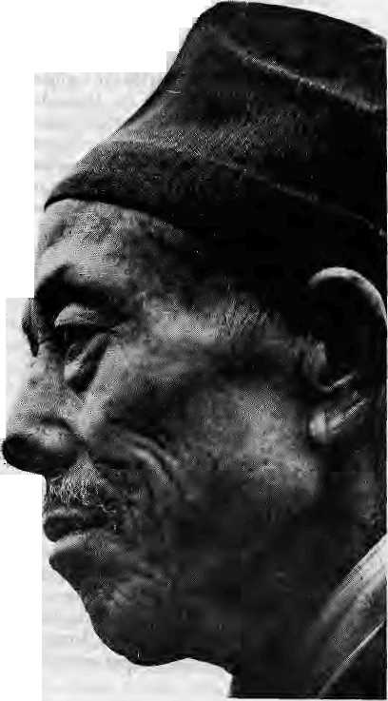
Newars were the earliest to realise the importance of modern education and training for the professions. They were among the first to make use of education, as soon as the Durbar School was made accessible to the public in the 1890s. They were also among the first to send their youth to attend Tri-Chandra College when it opened in 1890. During Rana times, Newars not only made use of these limited opportunities at home, but also sent their offspring to India and as far afield as Japan.
Rivalry and competition for patronage by the Ranas took the form of that typical Nepali institution 'called chakari, .or visible demonstration of personal or familial loyalty. Bitter rivalry was an invariable part of the social history of powerful and influential Bahun and Newar families during the Rana century. One notable rivalry between Bahun lineages, for example, was the feud between the Kumais and the Purbiyas, those with origins in Kumaon and those who had- settled further east, -This was reflected in the personal conficts between Badaguruju Hem Raj Pandey and Ram Mani Acharya Dixit during Chandra S humshere's reign.
The social and political competition between the Bahuns and the Newars has deep historical roots as these two communities were the first to enjoy the fruits of Rana patronage, access to civil service and opportunities for modem education and training abroad for learned professions. With their higher literacy rates, Bahuns, Chhetris and Newars, make up more than 70 toSOpercentof Nepal's trained manpower —excepting the army and police. Twenty-eight years after the overthrow of the Ranas, when a survey on the social and ethnic composition of higher education enrollment was conducted by Tribhuvan University it was found that out of its total enrollment in 1979, 45 per cent were Brahmins, 20 per cent Chhetris, and 19 per cent Newars.
Now that democracy has arrivedonce again in Nepal, this hold of the three communities on the strategic roles and elite functions in society is unlikely to stay where it was. And education as much as politics probably holds the harmless key io social change, particularly education for the socially and economically disadvantaged communities of Nepal, such as the Tharus, the Tamangs and other Tibeto-Burman-speaking communities.
The recent outbursts against brahmanism are not, therefore, too unexpected. When the Nepali Congress supreme leader Ganesh Man Singh voiced his discontent at the political appointments made by the elected government, which went mostly to Bahuns, he launched what some local papers called "a crusade against brahmanbad." Unfortunately, the term "brahmanbad" is a total misnomer here because historically speaking "brahmanbad" — brahtninism—is areligious outlook which gives acrucial place to sacrifice andrituals ch aracteristic oftheVedas and theUpanisads.lt has nothing to
do with Bahuns pushing Bahuns to the top of diplomatic service, for example.
Nor does "brahmanbad" have anything to do with fatalism, allegedly a typical outlook of Bahuns and inimical to Western-style development. Both Ganesh Man Singh and Dor Bahadur Bista, through ideas introduced in his recent book Fatalism and Development, have done a great disservice to the Brahmins' love for learning, their intellectualism and application— not to speak of their traditional role in Hindu society as ritual spec;al ists withrtear monopolistic knowledge of the scriptural texts.
The inborn instinct for s urvi v al, particularly political and economic survival, is too strong a propelling.force among the Bahun community. If survival is the surest testof fitness, the Bahuns have done remarkably well under every political regime — the Shah-Rana, and the partyless as well as multiparty ones. All the ruling monarchs, not to speak of the princelings of doubtful descent, roughly from Manadeva (464-505 AD) to King Birendra (1945-) may have been led to believe by their counsellors that Nepal is asil Hindustan^ and they — and they alone — are the true Defenders of the Faith, the true Hindupati. This illusory pedigree and cultural legitimacy is enshrined just as much in the modem democratic Nepali constitution with sovereignty vested on the people of Nepal as in Manadeva's inscription at Changu, installed in 464 AD.
The fatalistic outlook could not have been the propelling force behind the Brahmin success story. A propensity for fatalism does not explain the political successes of today's Marxists-Leninists-Maoists with their unending rival claims to political caste purity and the monopoly overrevolutionarywisdom;neitherdoesitexplain the political success of so many others who are notas enthusiastic about the classless millennium. They may recite the Gita in private or preach selfless action in public, but Bahuns are anything buffatalists" in social and political practice. If any section of Nepali society has perfectly internalised "the Protestant capitalist work ethic" and its accompanying cult of acquisitive success, it is the Bahuns. Without relentlessly pursuing success,-how could they have dominated every field of Nepali public life just in a matter of a few generations since the creation of the Nepali nation-state? You name it—rightist, centrist or leftist politics, the media, literature, diplomacy, civil service — you will invariably find Bahuns at the top, if not ^■dangerously close to it. Fatalism certainly didn't carry them so close to the peak.
.On his return from the seminar on democracy and ethnicity in England recently, Nepali Congress Party President and former Prime Minister Krishna Prasad Bhattarai once again broadcast his sanguinity when, in an interview given to Nepal Television he said, though not in so many words, that democracy is the ultimate solution to all ethnic problems. Just
look at the voter behaviour in the Tarai, he said. Sadbhavana couldhave swept the polls. And the Mongol candidates would have swept the east. Just see what happened. Both were rejected and swept aside by the well-behaved Nepali voters.
One so much wishes that "Kishunji's" optimism and his confidence in the healing capacity of democracy were a shared experience in South Asia, Forty-five years of democracy, punctuated once in a while by Pandit Nehru's Linguistic States solution or Mandal Commi-ssion's Report, have left ethnic nerves in Punjab, Assam and Kashmir as raW as ever before. .„
The aggrieved sentiments of the Tarai, the Janajatis. the Matawalis of the Hills, and the Newars of the Valley may be fake political gimmicks, but the two millennia of Brahmin domination in the social and cultural life of Nepal's recorded history is not. So far these aentiments-have been expres sed in psychologic al metaphors, often confined to Janajati get-togethers, newspaper columns, or Sadbhavana public meetings, and rarely if ever in organised political activities of any damaging value.
But if these sentiments, as expressed by Ganesh Man Singh, Gajendra Naxayan Singh, Gopal Gurung, .Sitaram Tamang, Suresh Ale, M.S. Thapa and Padma Ratna Tuladhar are translated into organised political movements, then into military action, Nepal will never remain the same. We will all be committing national haraldri, unwittingly converting Nepal into a Sri Lanka of the north.

May/June 1992 HIMAL • 23

Cauldron of Assam
The demographic transitions that the Indian Northeast has endured,
and the resulting rise of "political ethnicity", should be
instructive for other areas where such transitions
are more recent.
by Bhupinder Singh
The periodic outbursts of these leaders have, therefore, acatharticvalue because now and then they let the steam out of the ethnic pressure cooker or the melting pot, if you like. What might ultimately be damaging to the political prospects of the leading parties is the "Kishunji"-style over confidence in democracy as the Ultimate solution because such complacency is likely to sweep the brewing storm under cheerful carpets.
One shouldn't, for instance, be surprised if the Newars, one of these days, rally round a "sons-of-the-soil" style movement in sharp reaction against the swarming inroads by madhesiyaStParbates tmAbhotias (thanks to the construction, car-pet and garment industries) whose influx has dis-pla-ed Newars from their lands andreal estates. With his social and cultural fabricof life slowly being destroyed, the average middle-class Newar of Kathmandu today feels like a displaced Nawab of Lucknow after the Loot. He feels like an alien in his own home, pushed too hard against the wall by ever-stiffer social and economic competition with some 20,000 in-migrants every year.¹ The headlong rush is not only robbing Newars of their jobs, open space, and unpolluted civic life, but also destroying their culture and treating them as a dwindling specimen of aborigines deserving to be confined to the slum areas of Asan and the vegetable markets of Kathmandu.
Let me conclude with the latest so that I need not elaborate any. more. With a per capita income of U$ 170, the State in Nepal supports 16 years' free education for the Bahuns who cultivate the Sanskrit language. It spends NRs 32.1 million annually for 690 students at the Mahendra SanskritUniversity—at NRs 45,000 per student per year. Recently, 77 members of Parliament, representing all the five leading political parties, submitted a memorandum to the Education Minister for making Sanskrit "compulsory from Grade 1 through 10" in public schools.
Astonishingly, this appeal is signed by leading Marxist-Leninist leaders such as Jhalanath Khanal, Radha Krishna Mainali and Lilamani Pokharel. With all their commitment to the slogans of social justice and equality, do these leaders know that the State is already spending NRs 45,000 per Sanskrit student out of the taxpayer's pockets, whereas it has been refusing to spend anything on 25,000 students studying Science, Management, Medicine, Education and the Humanities in the so-called "private campuses" of Tribhuvan University?
When one delves deep into the recesses of the political manoeuvre for making Sanskrit compulsory to 3.4 million Nepali children at school, for many of whom 'not even Nepali is their first language, one unwittingly bumps into naked bahunvada and medieval feudalism running amok under the garbof New Democracy or. infant democracy. Viva Venfant terrible!
K.P.Malla reaches-English at Tribhuvan University, Kirtipur Campus.
24 HTMAL • May/Jnne 1992

If there is one"melting pot" in the Himalayan region, it is the north-eastern region of India, particularly the "mother state" of Assam. Here, six different demographic strands are identifiable. The indigenous tribes, whose origins are lost in time. The Ahom, who invaded the area from the southeast in 1228 and ruled for nearly 600 years. The caste Hindus who arrived two or three centuries later from today's Bengal, Bihar, Uttar Pradesh and Madhya Pradesh. The remnants of Muslim contingents of Mughal power. East Bengalis, whose influx began with the British occupation of 1826 and continues to this day. The tea-garden tribal labour with origins In Bihar, Bengal, Orissa and Madhya Pradesh. And lastly, migrant Nepalis and others from as far afield as Rajasthan, attracted by economic opportunities of the Indian Northeast.
About a million people inhabited the northeastern region as a whole when the British annexed Assam in 1826. At the turn of the century, the number was up to about 3.3 million and the region as a whole still sparsely populated. The last 90 years, however, has seen a phenomenal jump in population — to more than 31 million today.
Immigration has had a profound effect on the region—first and foremost on the psychology of the indigenous people and locals, as successive alien groups arrive to dispossess them of land and forests. The impact of immigration, is evident everywhere — in the culture, the economy, administration and politics of the region.
When long-miTsed grievances are not addressed by ruling majorities, these blossom into full-blown movements. The most potent fuels for such movements are the dispossession of land and forests, discrimination in education and employ ment, indifference and even contempt for cultural and linguistic aspirations, lack of respect for equality before law, and unfair administration. The right of indigenous people over common property resources—land, water, forests — based on the doctrine of historical prerogative have received scant respect. Unfair psycho-social treatment has caused anguish and deep discontent.
The clash of cultures led to the rise of political ethnicity in Assam. This powerful force sometimes manifests in movements for autonomy
or separate statehood. Thus it is that today the Bodo, the largest tribeof Assam's northern plain, is demanding a separate state of Bodoland. A smaller tribe of the eastern part of the northern plain, the Mishing, have also demanded an autonomous state under Article 244-A of the Indian Constitution. Similar demands are being made in Karbi Anglong and North Cachar, the two hill districts of Assam which already enjoy considerable self-management under the Sixth Schedule of the Indian Constitution. Scheduled tribes south of the river Brahmaputra, meanwhile, are demanding Sixth Schedule status for two proposed districts.
At the time of Indian Independence in 1947, with theexceptionof Manipur andTripura, the northeastern region wasone unit going by the name of Assam. Today, the Northeast comprises of seven states: a truncated Assam, Arunachal Pradesh, Nagaland, Meghalay a, Manipur, T'rip ura and Mizoram. The hive-off in the post-independence era is comparable to departure of children from parents upon attaining maturity. The children may enjoy their new-found independence, but the parents may not relish the separation.
Nagaland, Meghalaya, Mizoram and Arunachal Pradesh acquired statehood during the course of the past three decades. Statehood appears to have- benefited the people — they derive satisfaction from their identity, dignity and status, and as equal partners in the Indian Union. Further, because these states are small both geographically and population-wise, the inhabitants feel much closer to the political, legislative, administrative and development apparatus than do the people of large states such as Uttar Pradesh and Bihar. Though there are some negative features also, this is no mean democratic achievement.
It is this perspective on the break-up of the former "Assam" that should inform and illumine the process of dealing with ethnic issues in the rest of the Himalaya. A just and equitable social order, built on the rigorous profession and practice of the rule of law, is the best guarantee of peace and progress in die region.
B Singh is with the Council for Social Development in New Delhi.

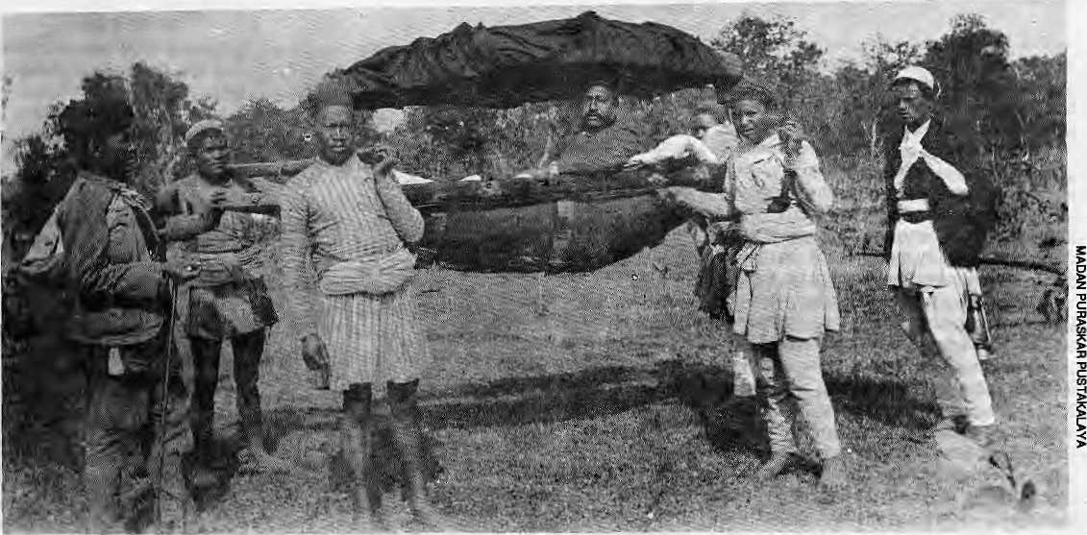

Turn-of-century picture sfioivs "pipae" carrying palanquin.
Tamangs Under the Shadow
Historically discriminated because of their proximity to Kathmandu Valley, Tamangs demand alternative development models and a political structure that provides hope.

W
hat do you say of a community that is everywhere, yet nowhere? Every one who arrives or leaves Kathmandu Valley by road or on foot has to pass through Tamang territory. This largest of ethnic groups among the Tibeto-Burman speaking peoples of the Himalayan region is especially concentrated around the Valley. The Bagtnati Zone, made up of Bhaktapur, Kathmandu and Lalitpur districts, has more than 51 per cent Tamang speakers.
More than half of the mountain areas of Nepal is covered by the Tamang nation, which has inhabited these hills for longer than any other group. Tamangs have their own language, their unique lifestyle and religious beliefs. Though Tamang history has been largely ignored and ttteidbre lose, it must have been significant According to one Tibetan inscription, the fort at Lo Manthang (Mustang) was built back in the 13th century AD as protection against the "Se Mon Tamang" of the south.
Yet, it was not until late in the present century that the world outside Nepal had even heard of the existence of the Tamang nation. Westemvisitors, guests of Rana Prime Ministers, who walked up the foot-trail from Bhimphedi had Tamangs cany their baggage without ever knowing it. To some, it would seem thatTamangs gained an identity only in 1932 after King Tribhuvan and Prime Minister Bhim Shumshere allowed them to write "Tamang" after their name in civil service and military rolls.
by Parshuram Tamang
The low profile of the Tamangs and the poverty that marks their villages are the result of concerted exploitation over the centuries. Two hundred years ago, Englishtraveller Francis B. Hamilton had occasion to remark that "Muimis" (Tamangs, as they were also known) were prohibited from entering the Valley. Because Tamangs ate carrion, they were known to the Newars of the Valley as Siyena Bhotya. Wrote Hamilton, "They never seem to have had any share in the government, nor to have been addicted to arms, but always followed the profession of agriculture, or carried bads for the Newars, being a people uncommonly robust." Portering was a function of vital economic importance to thethreeprincipalities of the Valley, whichrelied on the trade links through the rugged terrain of the north and south. The Tamangs, residing in the periphery, provided just the required brawn.
According to Hamilton, the Lama Buddhism of the Tamangs was not acceptable to the Gorkhali conquerers of the Valley. A list of groups that may not be recruited as soldiers, prepared in 1896 by another Englishman E.Varsittart, reads as follows: "Chyame,Domai, Drat, Gainey, Kamara, Kami (Lokar), Kasaii Kumal Majhi, Pipa, Poday and Sarki." Among these "Pipa", unlike the others, is not the name of a tribe or ethnic group. It was the term for "porter", which was the occupation reserved by the Ranas for Tamangs. The pipas were used to cany loads, pitch tents, and provideother menial
physical labour forthe military, but wereexcluded from the military hierarchy. They were administered through the depot known as the ' Tipa Gos wara", which still ex ists near the outside gate of the Singha Durbar Secretariat in Kathmandu. Tamangs were forbidden to join other occupations.
The attitude towards the Tamangs was quite in accordance with the upper-caste Hindu blueprint for governance rule according to the Manusmritt and Hindu texts. The main aim of the MuhtkiAinoi 1854 was, of course, to induct the hill ethnic people of Nepal under the four-tier Hindu hierarchy. The non-Hindu communities were pegged as "pant ckalney" Sudras, as differentiated from the "pani na-chalney" Sudras. TTiis di v ision was carried6ne step further. Based on loyalty and need for labour, particular groups were declared either masiney matwali (who couldbe enslaved) and na-masiney matwali (those who could not be enslaved). The more the masiney matwali accepted the Hindu ethos, the more easily they were assigned higher status.
While the Tamangs were thus not categorised as pani na-chalney Sudras, their position was lowest among the hill ethnics who were pani chalney. There was some attraction therefore to jettison one's traditions andreligion, and Tamangs who did so were declared Gurungs. In Gorkha District, even today, there are many BahraSaley Gurungs-Tamangs who became "Gurung" in the year 2012 (Vikram Era).
May/June 1992 HIMAL - 25

Thola-gada pushers of Kathmandu.
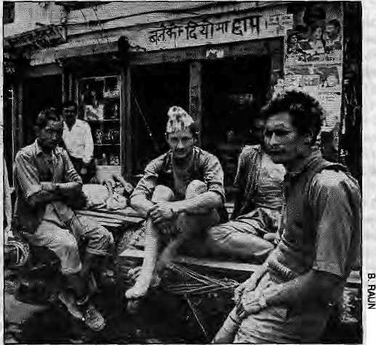
Following the Gorkhali conquest, the Kip at community land of the Tamangs was wrested and distributed among the Bahun and Chhetri courtier-class in the form of birta, jagir and guthi property. Tamangs were retained as bonded labour (kamaiya) and near-slaves to work these very lands. Even as bonded labourers, however, they had to pay jhara (a corvee like system).
During the Rana years, Tamangs were used as menial labour by the rulers and the courtier class — as construction labour for the durbars, for cutting trails, portering, carrying palanquins (doki bokneyji, running mail, delivering forest-based products such as duna and tapari (containers made from sal leaves), weaving doko baskets and nangh trays, keeping palaces clean (leep-pot garney), maintaining the indoors (baitkakey), doing gardening, providing agricultural labour, keeping herds, making lokta paper, holding umbrellas (chaiey), maintaining hookahs, canyirig.goods (dolay), and serving as dhai-ama, or surrogate mothers for high-born offspring. The system of keti basne (or nani susarey) imported women from the Tarn ang hills for all kinds of chores in Rana palaces. Thfc maintenance of scores of female retainers, some of whom served as concubines, is said to have started the trend towards prostitution among poverty-stricken Tamang communities.
Tamangs provided a ready labour reserve pool for the rulers of Kathmandu. And it was in order to maintain this pool, that they prohibited the Tamangs from joining the British regiments in India, even though the Gurung and Magar west of the Trisuli river and the Rai and Limbu east of the Dudh Kosi were permitted. Tamangs were prevented from joining even Nepal's own government administration and the military.
It was written in a handbook on Gurkha soldiers that "...the Tamang make an excellent soldier", but because he will eat beef, "the more orthodox Gurkha officer is prejudiced against the enlistment of Tamangs.'' However, the treatment of Tamangs was based oo something more than the mere eating of beef. More significant was that historically the Tarn ang nation came to occupy the strategically important region surrounding Kathmandu Valley. Feeling threatened by- this "encirclement", Kathmandu*s rulers thought best to bring them forcibly under central rule and exploit them enough that the community could never rise — as it has not been able to until this day.
The Mallas were overtaken by the Gorkhalis. The Ranas ousted the Shahs. Then democracy arrived, briefly. The Shah rule returned under the Panehayat. Andnow here is democracy again. But the Tamangs of Nepal have remained where they always were. According to a survey done east of the Valley in the Ramechhap/Sindhuli
26 HIMAL • May/June 1992
region, more than 50 per cent of the porters (bhariyas) are Tamang .Generations of Tamangs have worked as porters in Kathmandu town, in recent decades as thela gada cart-pushers. Practically all rickshaw pullers and the majority of three-wheeler tempo drivers today are Tamang.
The lowest rungs of the trekking trade are manned by Tamangs. They have proven themselves to be adept climbers, but mountaineering expeditions mrely allow Tamangs above base camp. Tamangs make up more than 90 per cent of thangka labourers, as contract artists hired by Tibetan and Newar businessmen, who reap the real profits. Above' 75 percent of the carpet weaving labour js Tamang — mostly women and children prized for their deft fingers. The restaurant kanchas of Kathmandu are overwhelmingly Tamang, and Tamangs more than any other hill community are engaged in (he flesh trade in Indian metropolis. and Nepali towns;-The women have their origin in the economically deprived areas in the northern neighbourhood Qf the Valley. The tragic distinction of being the first recorded Nepali to die of AIDS has fallen on a Tamang woman.
Late into the 1970s, many Tamangs of the Valley's periphery ensured economic survival by providing Firewood and charcoal to the urban dwellers. It was hard work, but provided cadi income for these subsistence farmers. These Tamang peasants have been targeted by some environmental experts-as responsible for the de-greening of the Valley rim, quite forgetting that it is the urban demand that drives the trade. As woodcutters, meanwhile, the peasants have to face corrupt forest guards and constrained access even for their own needs. The increasing demand ' has led to depleting woodlands and drastically reduced income for the peasants. Meanwhile, the closing off of large tracts of woodlands, in particular the Shivapuri watershed area, has hit the surrounding v illages very hard. The economic
deprivation has merely increased the influx of indigent peasants to the job markets of polluted, expensive, uncaring Kathmandu.
Tamangs also have the distinction of providing the⁾'foot.-soldiei!s for the "Hongkong trade", regularly riding Royal Nepal's Boeings as carriers of contraband. While the enormous profits of smuggling are made by others, it is the Tamang arid other "bhariyas" that are caught, and sometimes paraded in front of Nepal Television cameras. Prison surveys have shown, that a disproportionate number of Tamangs ace behind bars for criminal offenses. The psychological impact of economic depression is severe, although Nepali social scientists'have not had occasion to study this problem so far.
Poonam Thapa, a Nepali geographer, speaking at a 1990 SAARC symposium oil the girl child, informed participants of the large number of women and girls from.among the toiitwati groups who were in the flesh trade: "A family whose daughter is a prostitute in Bombay will have a corrugated" roof over its head. A family whose daughter is a madam will have a spacious bungalow." But Thapa chose not to delve into the historical reasons which force Tamang womei* to enter this most despised of professions in the remote cities ofclridia.
A young Tamang woman who weaves carpets in Kathmandu had this to say, "This country is ours, but we are only labourers. The Tibetan refugees have no country, but look at them..."
Perhaps. Tamangs are inherently witless and uncreative, and deserving of their lowly position in Nepali society?TW is most unlikely. Their position has nothing to do with heredity and everything to do with focused historical discrimination. One need only glance across the border to the achievements of Tamangs in India to see how they have flowered when presented with fairness and opportunity. In Darjeeling, for example, descendants of Tamang migrants are today at the forefront of culture, the arts, education, government and politics. The few Tamangs who have achieved fame and recognition in Nepal in these fields, too, mostly have their origins in the Darjeeling hills.
The founding fathers of the Indian Republic made arrangements to provide constitutional security for the development of "backward" tribes and castes. Many tribes and Harijans took advantage of the facilities extended to "Scheduled Tribes" and "Scheduled Castes", but the Tamangs of India did not. So self-confidentweretheyof their abilities — and this was as early as the 1950s—that they preferred not to take the offer. They did not consider themselves "backward" or weak in any Sway.
Today, a Gorkha Hill Council runs the affairs of the hills of Darjeeling,.

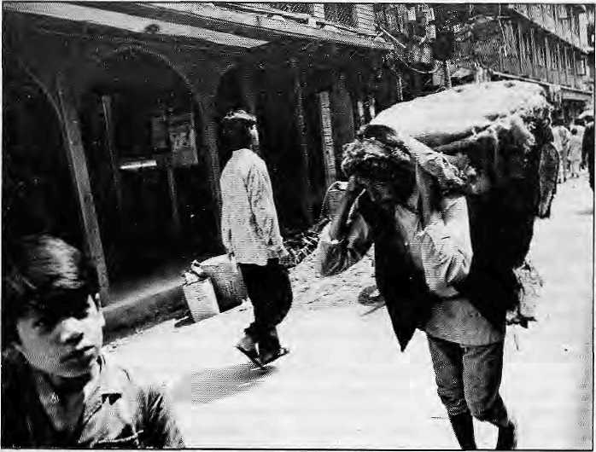
It is the only government agency in which there is adequate representation of Tamangs in policy-making roles. Subhas Ghisingh, the leader of the Gorkh a Nation at Liberation From is aTmnang.
The names Ghisingh, Yonzon, Waiba and Pakhrin are only some of the clan names that Tamangs use as their surnames in India, As there is adequate recognition of tribal and-caste rights in India, Tamangs there have felt free to use the clan surnames. In Nepal, however, Tamangs still feel a need to assert their group identity and solidarity by retaining "Tamang" as their surname.
Psychological subjugation is the worst form of defeat, and the Tamangs carry this load like perh aps no other Nepali community. Not content to merely ignore the Tamangs, the rulers of Kathmandu tried, consciously and unconsciously, to quash their self-image. While Tamangs were prevented from eating beef, for example, nothing Was done to discourage alcoholism among Tamangs — after all they're matwaiis.it. was said. And so today the Tamang community as a whole has been severely weakened by generations of liberal drinking. Many men and women of the deprived hinterland drown themselves in jaand and rakshi from dawn to dusk. Even children are not spared.
When a few sons and daughters of the Kathmandu elites take to drugs, there is hue and cry. It is declared a national problem and crash programmes are started to counter the "drug menace". But there is little concern for entire communities that are facing relentless decline through drugs and drink?
The psychology of the Tamang thus took a beating over centuries of economic deprivation, political discrimination, and social marginalisation. As a result, they have developed a culture of silence, accepting their lot as defined without challenge. So much so that many thought nothing of jettisoning their Tamang identity and joining foreign armies as Gurung, Ghalcy, Magars, Rai or Limbu. Even today, quite a few "Gurungs" in the British and Indian Gurkhas, and even in Nepal's own army, are actually Tamangs. These Tamangs and their families are having great difficulty m akin g citize n ship papers due to service and pension records which have them as Gurungs or some other ethnicity.
Today, the consumerism that has conquered the Valley towns is spreading its tentacles into the Taman g heartland. The draw of Kathmandu' s cash economy and the bright city lights has emptied the Tamang hamlets of all but the infants, the aged and the infirm. Strength, intelligence,
skill and initiative have seeped out of Tamang hillsides. The migrants arrive in Kathmandu to serve as the underclass, as domestics, and as carpet weavers living in dilapidated shanties, unhygienic rooming houses, and working rickshaws and push-carts.
In the Tamang areas of southern Lalitpur today, there are schools but no Tamang pupils. Little boys and girls who should be at school and at play are hunched over carpet laans in Patan 's inner city, in Jorpati and Baudha, concentrating on complicated "hand-made" knots so much in demand among European consumers.
There is no Tamang in the present cabinet. Why? In Parliament they make up a bare 1.8 per cent of the membership. Why? There is not a single Tamang in a leadership position in any political party. The proportion of Tamangs is minuscule in the Government and Tribhuvan University services, the court system, the professions, education, and in non-governmental organisations. In the military andpolice, Tamangs man the barricades but have little role in the upper hierarchy.
In other words, while they make up perhaps 18 to 20 per cent of Nepal's 19 million population^ Tamangs as a nation are practically unrepresented in the country's national affairs. The proportion of Tamang is the proportion _of the three elite communities — Bahun..Chheiri and Newar — combined. Yet these three groups make up the following percentages: 92.8 per cent of the civil service's Deputy Secretary posts and above, 93.9 per cent in the court system, 93.7 per cent in the national administration, 83.4 per cent in senior technical posts like doctors and engineers, 87per cent of all army officers, 62 per cent of the members of the Lower House of Parliament, and 70 per cent of the Upper House.
The process of development has been co-opted by the Kathmandu's elites, made up mostly
of Bahuns, Chhetris and Newars. The "development agencies" are investing huge amounts, but mopt of it is diverted to the elite classes and rarely get down to communities such as the Tamang. Because the development mechanism as determined by the state is quite inadequate, development funds do not get to the intended beneficiaries and instead benefit Kathmandu-based contractors, bureaucrats and professionals. If under the new-found democracy, political commitment remains lukewarm and the structures of delivery remain the same, there is going to be no development of the hill communities. The result will be no better than during the Panchay at years. A new model of "alternative development" is required, and the political system under the present constitution must be adjusted to reflect the country's reality.
Local political units must be structured according to communities. "Local development" would then mean the development and implementation of work programmes by autonomous comm unity-based institutions. There is, certainly, a need for central planning and programming which has to be overseen by a national-level unit. For this, the existing House of Representatives is appropriate, but the Upper House as it exists is superfluous.
Most members of the Upper House are chosen by political parties in proportion to their victory in the general elections. This merely duplicates the political representation which already exists in the Lower House and has no function. What should be done is this: the Upper House must be called the House of Nationalities, in which all nations that make up Nepal should be represented on the basis of equality, irrespective of numbers. Such a significant improvementof the existing political system can be done without changing its basic structure.
Only a system which allows representation "of all communities large and small, weak and powerful, will work in the Nepal of the future. Only then will there be genuine self-determination, which willbring all communities into the mainstream and ultimately strengthen the unity and sovereignty of Nepal as a multinational state. To be multi-national is not a danger, and ruliong elites must recognise this. The Tamangs, meanwhile, wait for the day.
£>
P.Tamang isa lecturerof economics atSaraswati Campus in Kathmandu.
May/Jutr*-,,9« HIMAL • 27

Bangladeshi Adivasi and Other Minorities
Because most Bengalis belong to one ethnic and linguistic group and share one religious faith, the large number of minorities of Bangladesh tend to be relegated to the shadows.

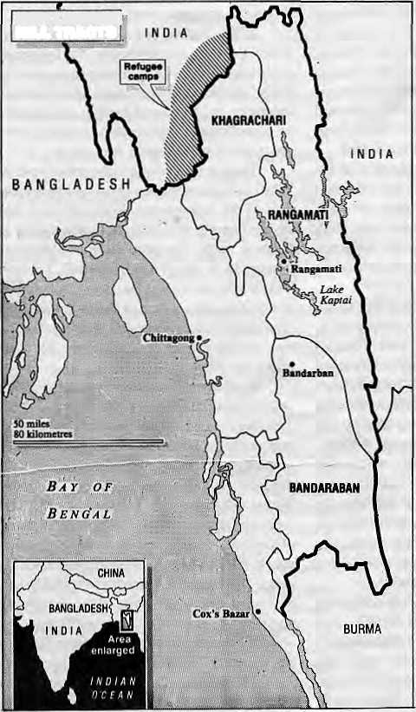
A
ccording to official figures, about 98 per cent of the 110 million people of Bangladesh are Bengalis — part of the larger Bengali population in the Indian states of West Bengal, Tripura, Assam and elsewhere. Most Bangladesh Bengalis areSunni Muslims (whereas in West Bengal the majority are Hindus). According to the 1981 census, Muslims comprise 86.6 per cent of the population, Hindus 12.1 per cent, and others 1.2 per cent. Many experts contest these figures, maintaining that the proportion of non-Muslims could be as high as 25 per cent. The "other" religious minorities comprise of Christians, Buddhists or animists; many are also ethnic tribal minorities.
Though Bangladesh began in 1971 as a secular state, Islam was made the state religion by constitutional amendment in 1988. Other religions are, however, recognised by provisions in the constitution. Despite the Constitution's acceptance of the principle of non-discrimination, many activists allege indirect discrimination as well as direct persecution of those outside the "Bangladeshi mainstream". The late 1980s saw increased fundamentalist agitation directed against Hindus and other religious minorities. Using the recent Babri-Masjid and Ram Mandir controversy in India, the communal repression and violence in Bangladesh has assumed a deadly new dimension. Feelings of anxiety and insecurity have increased.
Hindus and Bihar is
The Hindus are the largest religious minority. They used to make up a considerably larger proportion of the population, but many left during Partition in 1947, arid still more after Independence in 1971. Most Hindus are Bengalis by ethnic origin and language, although some tribal groups also follow beliefs and customs which have 50^; affinity io Hinduism.
During Partition, there was a mass migration between India and Pakistan. Of,the 1.3 million who moved from India into what was then East Pakistan, about one million were the Muslims from Bihar. These came to be known collectively as "Biharis" — Urdu speakers who are also Sunni Muslims like the Bengali population. Because they were seen to be favoured by the West Pakistani authorities in professional and administrative work, Biharis became increasingly unpopular among Bengalis and came to be seen 28 HIMAL • May/June 1992
by Father R.W.Timm
as symbols of West Pakistani domination.
In such a climate of hostility, the disturbances preceding and following independence in 1971 saw waves of retaliatory killings againstBiharis. Thousands were arrested as alleged collaborators. Most lost homes, shops and property. While Pakistani army and civilians were evacuated, the 839,000 Biharis were left behind, most in enclaves protected by the Indian Army. The majority of Biharis expressed the wish to be repatriated to Pakistan, and 163,000 had been transferred by 198.1. Political developments in Pakistan have made further mass repatriations unlikely.
CHITTAGONCI HILL TRACTS
The Dast allegiance of Biharis has not been
forgotten. Most are afraid of trying to integrate into the Bengali community, even though cultural and economic ties are closer here than in Pakistan. Without determination from the Biharis and goodwill on the part of the Bengalis, it will be a long time before Biharis join Bangladesh's mainstream.
The Adivasi
While in India, seven per cent of the population (51 million), are classified as members of "S cheduledTribes'', in Bangladesh the proportion of the adivasi ("original inhabitants") is much smaller, perhaps-one per cent. In this respect they are similar to the indigenous tribal peoples of North America and Australia.
The government deliberately has not attempted to take a census of the tribal people on the basis of language and religion—it is said, in order to emphasise their marginality. The adivasi were officially estimated 623,216 in 1981, although today they certainly number over a million. Of these, about 44 per cent are estimated to be Buddhist, 24percent Hindu and 13 per cent Christian, and 19 per cenf'other". The largest tribes in Bangladesh are the Santhal (200,000), Chakma (194,949), Marma (65,889) and Mandi (60,000).
The plains adivasi of Bangladesh have their origins in the Himalayan foothills. Some migrated centuries ago from Meghalaya at a time when the plains were lightly populated. gThese adivasi are now settled y agriculturists, having long since ^abandoned slash-and-burn Scuttivation.Theyhavelongbeen &cut off from their extensions in q India, and divisions imposed by 2 the great river systems of g Bangladeshi further divide the EBangladeshi plains adivasi 5 communities from each other. *The Mandi, also known as the

\
Garo, live in the north-central Bangladesh, east of the Ganges and the Brahmaputra. Other tribes, such as the Santhal, live in the north-west.
All tribals have in common their readily apparent differences from the majority Bengalis — ethnic, cultural, religions, linguistic. The communal spirit remains strong, and the tribal people live close to land and nature, and to the spirits they believe in. While the tribes of the south-east hills and the Mandi tend to be well-educated, literacy among the plains tribal people is very low.
Chittagong Hills
The main problem of the adivasi all over the country is land-grabbing by the Bengalis, and nowhere is this more true than in the Chittagong Hill Tracts (CHT), where an insurgency has been in progress for decades. These hill tracts, which cover fully lOpercentof Bangladesh's total land area, are the home to 13 different peoples, with the Chakma, Marma and Tripura (Tippera) making up the majority.
Most of the CHT peoples migrated into the area from what is today Myanmar between the 16th and 19th centuries. They retreated to the hillsstarting in the 17th century when theBengalis arrived to settle the coastal areas. However, the tribal hinterland remained largely undisturbed under British rule. After Partition, the Pakistani Government allowed Bengali Muslims to move
into the CHT, causing resentment among the hill people, many of whom sought refuge in India.
The huge Kaptai Dam, built in the 1960s, submerged 40 per cent of the cultivable land in the CHT and displaced one-sixth of the population. Perhaps 40,000 environmental refugees fled to Amnachal Pradesh, where they continue to live in limbo.
A delegation of hill people petitioned the new Governmentof Sheikh Mujibur Rahman for restoration of autonomy for the CHT (which had existed from 1958 to 1964). The Government considered this secessionist and launched raids . into the CHT. The tribals resisted through the United Peoples' Party and its military wing, the Shanti Bahini. The Shanti Bahini has conducted a guerrilla war against the Bengali settlers and Government troops throughout the 1970s and into the 1990s. Dhaka's counter-insurgency campaigns created fresh waves of refugees.
The Government continues to look on the CHT as an "empty" land on'which to resettle landless Bengali peasants. Between 1977 and 1987 about 300,000cthnieBengalis were moved into the area and today they constitute at least one-third if not half of the CHT population.
The CHT as well as the north-east of India are remote strategic areas which are normally closed to foreigners. Independeat information on the continuing war within the CHT is therefore hard to obtain. Even Bangladeshi investigators
have difficulty in penetrating the military net which engulfs the area. Nevertheless, over the past decade there have been well-attested accounts of human rights violations against the adivasi by both military and government personnel, as well as Bengali settlers, The most complete accounts come from the Chittagong Hill Tracts Commission, an international non-governmental body established to investigate human rights abuses. The Commission has collected many first-hand accounts of ill-treatment and torture, threats and killings, along with destruction of houses and temples.
Since 1988, many aSivasi have been moved into so-called "cluster-villages" (similar to those used by the^US in Vietnam and the Marcos regime in the Philippines), to isolate them from contacts with the Shanti Bahini. In education, there have been attempts to impose the Bengali language on the adivasi, in order, it is said, to bring them into "national mainstre am". Ironically,_ the tribal people of the CHT are more advanced in formal education than the Bengalis of the plains—60 per cent literacy compared to 23 per cent for the rest of Bangladesh.
Father R.W. Timm, who has lived and worked in Bangladesh for over 35 years, is athiiman rights activist. This article is excerpted from his report, the Adivasis -of Bangladesh, published by the Minority Rights Group, London (1991).

HOTEL GAURI SHANKER
(Under New ManagGment)
For economical stay in Kathmandu
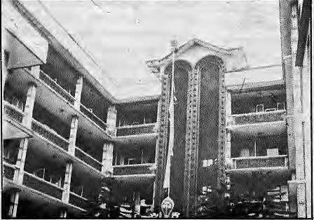
We have neat and clean rooms with attached baths running hot and cold water.
Our facilities include:
oBard Restaurant, o Roof Garden oTelephone and trunk call service o Money exchange o Mailing service o Transportation
Hotel Gauri Shanker (P) Ltd.
Thamel, Kathmandu, Nepal
P.O. Box 3022, Tel: 417181, 411605
Fax: 977-1-411878, Tlx: 2703 AflNIKO MP
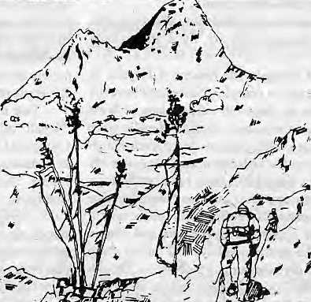
ASIAN ^TREKKING INVITES YOU TO AN EXPERIENCE WITH NATURE
We take you through natural trek trails to places of unending beauty and Into contact with the friendly mountain people and their gentle living

An experience you will never forget with our professional team to attend to all your trekking and tour {arrangements with quiet efficiency.
IAN fetKKHI Miff
P 0 Box 3022, Keshar Mahal, Thame!, Kathmandu, Nepal Tel: 412821, Telex: NP 2276 HOSANG

May/June 1992 HIMAL • 29

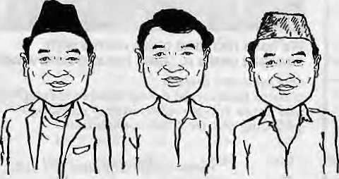
To Be or Not To Be "Nepali"
Blurry definitions needlessly target the Nepalis of India. Terminology must come to the rescue.
by Tanka Subba
"NEPALESE" "NEPALI" "GORKHA" |
A'nomenclative crisis* today confronts all Nepali speakers in India. What to call oneself?
Some would argue, "What's in a name?" But India being what it is, the name given to a language or people does matter. Morarji Desai, when he was Prime Minister, declared that Nepali was a "foreign language". The next step is to label all those who speak this "foreign language" foreigners, as does happen all over India, and especially in the Northeast.
It matters little to the people of Nepal, secure in their citizenship, whether they are called Gorkhali of Nepali. But for the Nepalis of India, the search for a term which indicates iheir Indian nationality and docs not confuse them with the Nepalese of Nepal has is urgent.
Besides Nepal, sizeable concentrations of Nepalis exist in Bhutan, West Bengal, Sikkim, Assam, Meghalaya, Mizoram and Manipur in the Northeast. Nepalis are also found in parts of Himachal Pradesh and Uttar Pradesh, and diffused throughout the Subcontinent.
Though the crisis of identity affects Nepalis of India wherever they are, there are regional nuances.
West Bengal: The history of Nepalis in West Bengal is in complex. Since they have the numbers in the three hill subdivisions of West Bengal's northern-most district, Nepalis were able to create a viable pressure-group, even though their voice tends to be feeble in the State Assembly in Calcutta. Since 1907, there have been efforts tocarveouta separate politic al and adminis fcrati ve unitforNepalis. These efforts were unsuccessful because of opposition by Lepcha and Bhutia tribes of the northern valleys and due to sharp ideological divisions among the Nepalis. Though the All India Gorkha League and the undivided Communist Party of India shared the same platform in the beginning, for example, they were soon to separate.
The recognition of the Nepali language in the Eighth Schedule of the Indian Constitution has been another major Nepali demand. After achieving the Darjeeling Gorkha Hill Council in August 1988, however, President of the Gorkha National Liberation Front Subhas Ghisingh has been harping on the 'Gorkha' identity, and condemning the term 'Nepali',
Ghisingh may be ignored, but we must address the issue, whether the Nepalis of India should forever cling to 'Nepali' and all that it connotes. Those in favour qf 'Nepali' point out
that the term is accepted by national institutions like the Sahitya Akademi. The Calcutta Doordarshan broadcasts in 'Nepali'. They mention resolutions which have been passed in the legisl ati ve assemblies of West Bengal, Sikkim, Tripuraand Himachal Pradesh for constitutional recognition of 'Nepali'. In themselves, such references are a weak basis to retain the term 'Nepali', although Ghisingh for his part has yet to explain how use of'Gorkha' or 'Gorkhali' will resolve the main problem, which is that Indian Nepalis continue to be regarded as foreigners. There is also the question whether a word, no matter how appropriate, can be imposed by an individual leader on people spread out over the length and breadth of India.
Sikkim: There were many supporters of the Gorkhaland movement in Sikkim, but there is no inclination here towards the word 'Gorkha'. Chief Minister Nar Bahadur Bhandari has, in fact, emerged as the champion and propagator of 'Nepali'. To him, 'Gorkha' merely refers to an occupational category, or those who are in the Gorkha regiments. This conflict between Bhandari and Ghisingh, this battle between the twoheavyweightsofDarjeelingandSikkim,has merely strengthened the position of the Union Government in Delhi vis-a-v is the language issue.
Due to historical reasons, one finds that 'Nepali' often is not extended to include the Chongs or Limbus of Sikkim. They are regarded as a distinct community like the Lepcha and Bhutia. There was reservation of seats for the Chongs in the Sikkim State Assembly up til! 1978. The Chong language and script is taught in school up to Class XII, and this language is recognised as one of S ikkim' s four state languages (the others being Lepcha, Bhutia and "Nepali).
North-East India: Nepalis are found all over the seven states of northeastern India and they all suffer from common social and political problems, primarily deriving from their identity. Nepali numbers are most significant in Assam, Meghalaya and Manipur. Most local tribes and communities, as well as the administration of the Northeast understand all 'Nepalis' to be the
'peopleof Nepal', that is, foreigners.The mockery of the 1950 Indo-Nepal Friendship Treaty is nowhere as glaring as it is here in the Northeast, where thousands of Nepalis have been evicted, most recently from Meghalaya.
Nepalis are discriminated and exploited in the Northeast even though they have shown an inclination to assimilate more than other groups. In fact, their assimilation into the local cultures is sometimes so successful that it is difficult to call them 'Nepali'. They have embraced the local languages and inter-married with local tribes. In some parts of Assam, Nepalis are reported to have rejected their surnames and adopted Assamese ones. In Meghalaya, the children of Nepali fathers and tribal mothers have taken the surnames of their mothers. Children cannot manage even a simple sentence in Nepali, and adults hesitate to divulge their Nepali identity.
Itiseasytopassj udgement from the distance of Darjeeling and Kathmandu. On the ground in the Northeast, Nepalis do what they have to do to survive in a hostile cultural milieu.
Conceptual Lag
The gradual shaping of a "common identity" as a strong binding force among Nepalis of India has been splintered by factionalism or recent years, which finds expression in the tilt towards 'Nepali', 'Gorkha' or 'Gorkhali'. The understanding of these terms has not changed with evolving reality. This conceptual lag has allowed primordial values to find nourishment. One major hurdle in any effort to rename a people is created by 'other' people whose interests may lie in perpetuating the old terminology. A new name might threaten the existing control of resources and privileges. But this does not mean that there should be no effort to change the boundaries of a concept — which a name is — along with changing times. Time has probably come to look for a multiplicity of mutually compatible symbols rather than a single symbol,
b-
T. Subba is Reader of Anthropology at the North-Eastern Hill University in Shillong. His book Ethnicity, State and Development is reviewed on page 44.

30 HIMA.L • May/Jone 1992

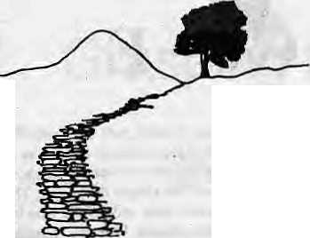
On The Way Up
In these times of
political flux all
over the Himalayan
region, it is essential
to be sensitive to assertions of identify. Such
sensitivity is especially important in Nepal, whose
people have only just gained the right to speak
out and to demand.
In the past, itwas enough to pay cursory tribute to Nepal's cultural diversity through inexpertly-produced 'phulbari' programmes on Nepal Television or Radio Nepal. This will no longer suffice. While the Nepali speakers of India have long struggled with dual identities and confusing cultural markers, their kin in Nepal are bnry now haying to confront issues that India tackled in the early 1950s.
Are the political chieftains of Kathmandu sufficiently sensitive to the new ethnic demands? Indications are they are not Otherwise, why should scores of Members of Parliament from across the political spectrum sign petitions seeking compulsory Sanskrit education in high school, as if the debate over inclusion of "Hindu rastra" in the Nepali Constitution had never taken place. Do they appreciate thatmany Nepalis are Tibeto-B urman, who might speak Nepali but perceive Sanskrit as the vehicle for a Hinduised State?
There is a tendency to regard the newfound self-assertion among the tribes as an irritant on the rough hide of the nation-state. But if B shuns and Chhetris have a pan - Nepali identity to fall back upon, aRai or aMagar, depending upon how distant he is from his roots, has an ethnic identity in addition to that 'Nepali¹ identity. Without doubt, more and more "hill ethnics" will be inevitably drawn into the pan-Nepali culture -- pushed and pulled by market forces, politics and self-desire.
As 'unifying' culture spreads through a country that is being linked by highways, radio and television, Nepali will take on added roles as (he language of discourse, of study, of media, of advertising, and of entertainment. Other than in pockets of the Tarai, the one medium to access an integrated national market by educators, entrepreneurs, media-persons and politicians alike will be, increasingly, Nepali.
As long as it has something to offer, Nepali will remain ascendant. At the same time, however, can we deny the urge of culturally
unique groups tony and preserve someoftheirowndistinctiveness when faced with the great leveler that is the modem centralised State? Those who hold the power and the purse-strings at the center must understand the concern that grips the person who sees his identity and ego, signified by language, about to disappear.
If one can decry the insensitivity of majority representatives, then one may also criticise the opportunism of minority leadership. For there are no simple answers.
True, ethnic diggruntlement needs an outlet, and Bahuns, as the theoreticians of the HinduisedNepali State, are available. Of the two other groups that make up the Nepali power elites, the Chhetri/Thakuri are perceived to have had their comeuppance with the demise of the Panchayat, andthe Newars are seen as minorities in their own right Whom, indeed, to blame other than the Bahuns? Such strategy might provide only temporary relief, though.
Tanka Prasad Acharya, lifelong political activistand former Prime Minister, died on 28 April 1992 of natural causes associated with old age. Had he not been a Bahun, Brahmin of the Nepali hills, he would in all likelihood have been martyred a half century earlier, on January 1941, under orders of Prime Minister Juddha Shumshere. But this rather extreme advantage of caste did not last long in a modernising Nepal. Barely a decade later, there was no such clemency for Sunder Raj Chalise, who escaped death row only because of the political upheaval of 1951. A caste barrier had fallen.
Harks Gurtmg's map on page 19 indicating caste and ethnic representation in the Lower House of the Nepali Parliament shows white (for Bahun) all over. This political edge is based not so much on overhwhelming feudal or economic power, nor on control over the army and police, but on access to education and learning. In all likelihood, as has happened in India, upper-caste representation will dip as democracy progresses, and there will be less white on the map in the decades ahead. Bahuns do not constitute a monolithic block of privilege ~ there are large numbers in poverty — and their political clout as a group can only wane from today's zenith.
While emphasising the rights of individual communities, one might also mull over the cultural attributes of being 'Nepali'. Along the southern sJopesof the centralHimalaya, certain geographic, economic, social and political factors created conditions for 'Nepaliness' to

break through the various distinctions; This phenomenon cannot be explained merely as a result of Gorkhali conquest and subjugation. For whateverreason, the Nepali topi found acceptance
within just the Nepali segment of the Himalaya. This 'feel' of Nepaliness is not strong enough to make a Nepali nation — which is why the dream of "Greater Nepal" is a mirage. But there is something there, elusive but real.
The one segment that did notparticipate in this evolving Nepaliness, which was the result of interaction among the hill groups, is the Madhesiya community. Culturally more apart of the systems of north Bihar and Uttar Pradesh, and traditionally regarded as alien by the hill elites, the Madhesiyas are now being requested to feel 'Nepali'. Such integration, however, can only come over a period of decades, at the very least
"'".-- The cultural mellowness highlighted in the tourists brochures of Nepal is not all make-believe. There are also some built-in safeguards against communal turmoil. The multiplicity of ethnicities in Nepal will not allow a two-community fight-to-the-death such as in Sri Lanka. Equally, an Assam-like situation of instability brought by in-migrating hordes is unlikely because, other than*a sprinkling of Bahuns and Chhetris, the heartland of the major hill communities remain exclusive.
Speaking of which, the so-called B ahun -Newar confrontation of the pastyearmight be mis-read as the startof the unravelling process. Indeed, if this divide were deep-rooted, Nepal would be in the midst of inter-ethnic conflagaration. But the rest of the country perceives this much-ballyhooed battle as a fight for the spoils by elite groups within the Newar and Bahun communities. So, despite the banner headlines, life goes on.
Ofice ethnic sensitivity is aroused, the next step is to do something about it So should Nepal go in for quotas and reservations? Or should a non-interventionist course be charted? Asks an exasperated Krishna Prasad B hat tarai, President of the Nepali Congress Party:"How can a Government with so little resources try to fulfil the demands of each of the country's 1200 communities?"
A way must be found, and as leader of a pan-Nepali party spanning ethnicities, B ha i tarai, among others, has the responsibility to weave the fabric respdecting all the strands. Smugness canonlyruinlhe Him alay an idyll. In thepresence of visionary statesmanship and in the absence of political brinkmanship or extreme insensitivity, Nepalis of Nepal will probably find a way.
- KartakMani Dixit

May/June 1992 HIMAL • 31

VOICES

BARBERS REMOVE SOCIAL EVILS, was the
general view of the special invitees at the two-day convention of the Nepal Barbers' Association, held in Kalhmandu on 28 April, as reported by the Rastriya Samachar Samiti {RSS) news service.
In his opening remarks, former Prime Minister Krishna Prasad Bhattarai said that barbers, whose serivce is essential for a man from birth to death, have an important role to play in society. Their role is equally important in keeping the society healthy, he said, and underlined the need for them to cooperate in the country's development.
MP Sindu Nath Pyakuryal spoke about the importance of professional organisations in establishing political and economic traditions of respecting each other's professions.
CPN (UML) representative, Chandra DeveJoshi, said that apart from helping people to remain neat and clean, barbers should also give attention to removing social evils.
General Secretary of the Nepal Labour Union, Ganesh Shaha, said that the barbers inspire all to move on the path of self-reliance, starting a profession with small capital.
On behalf of the CPN (15 September), Sharan Bikram Malla expressed the view that the problems relating to professional rights cannot be resolved unless and until democracy and civic rights are preserved.
MARTYDOM is discussed by Martin Gaenzle and Richard Burghart in an article in the The European Bulletin of Himalayan Research. The authors review five publications ("witness literature" ) which deal with the Spring 1990 political movement in Nepal.
...Sivakoti's brief, and all too conventional hagiography, is short on details, but stresses a major theme in the rhetoric of the movement: that the victims of police firings were martyrs who had sacrificed their souls for democracy. In fact, many of those who died seem not to have been "political activists" at all. They were people, who like everyone in Nepal, were caught up in the events but who unfortunately found themselves at the wrong place at the wrong time. (One martyr mentioned by Sivakoti is "Richard Henari Jon Wiliyam," an Englishman caught up in police Firing on Durbar Marg). The theme of sacrifice was critical, however, for the rhetorical construction of events. The Nepalese-authored texts under review stress the idea that their co un try men offered their blood in sacrifice to the motherland for which democracy was received in return. By extension, even those citizens who donated bloods so that doctors might save the lives of their fellow countrymen round their blood donation (rakta dan} transformed into sacrifice {bait dan). Sacrifice, of course, is a willed act. By making the victims of state oppression into martyrs, the movement appropriated not their deaths by the gesture of their dying which symbolised the truth of the life that they had led. Dying, however, has nothing to do with death. Death, for Janki Devi, was senseless, and it probably remains so for her relatives as well. Her dying, however, extended its power over the living...
In the rituals of Nepalese political culture the martyrs of 1990 joined those at Martyrs Gate, who two generations earlier had given up their lives in the overthrow of the Ranas. Despite their deaths, the martyrs continued to play a decisiv e rolein the negotiations concerning the new Constitution. The various proposals were never put to a popular test, neither by referendum nor by constituent assembly. It was understood, however, that the wishes of the martyrs had to be
respected in the new Constitution, and it was clear in the rhetorical construction of the people's movement that sovereignty had already been transfered from the king to the people. The king was no longer the mediator between deity and people who by sacrifice preserved the well-being of his subjects. Prom the Nepalese texts under review, it is clear that the martyrs had sacrificed their lives to the motherland for democracy which they, not the king, gave to the people. Power of legitimate agency had shifted within the kingdom. Sovereignty did not lie with the royal dynasty (thepanchayat model) and could not lie with Parliament (the British model). Ratheritlaywiththe people, who now have the burden of defending-the martyrs' sacrifice in the future.
THE ENVIRONMENTALIST IMAGE takes aut
of a beating in this excerpt carried from Vikalp (Alternatives), the quarterly journal of the Vikas Adhyayan Kendra, Bombay.
Environmentalists are variously seen as:
- A well-intentioned bunch ofbom-again do-gooders and romantic
idealists with mis conceived ideas, mistaken fears, misconstrued
priorities, misplaced efforts and misdirected methods barking
on the wrong trail.
- A bored brigade of comfortably-off middle-classers and rich
elite indulging in a temporary fad to pass their time and salve
their conscience,
- A selfish coterie of urban elite status-quoists who insidiously
continue to indulge in their wasteful conspicuous consumption,
rapacious lifestyles, while seeking to keep away the fruits of
development from the rural masses by preaching moderation,
austerity and self-sacrifice for others; even as they continue to
corner astill larger slice of the development cake for themselves
by depriving their already impoverished rural brother folks.,
- A psychotic breed of anachronistic obscurantists seeking to
impose on society their own fundamental brand of anti-
materialism and anti-development ideology as a throwback to
the earlier, backward past.
- A rabid band of conservation-minded recycled radicals on the
lunatic fringe who resort to eco-terrorism, militancy and social
disruption in order to achieve their aim of opposing all forms of
nature-resource utilisation projects for industrial or commercial
exploitation and development.
- A pathological faction of foaming fanatics seeking to force on
to society their own fundamentalist, anti-modernisation ethic by
advocating a retrogression to the medieval way of life.
- A manic mob of compulsive anti-technology, anti-development
protestors, dissenters and obstructionists irrationally opposed to
all forms of industrial progress, material growth and technological
development, just for the sake of blindly opposing it.
- A leftist clique of disillusioned, disaffected, discontented,
disgruntled intellectuals seeking to setback the industrial progress
and material development of the nation in the distorted belief
that therein lies salvation.
- A mercenary pack of status-seekers and cons artists out to make
a big name and a quick buck by attaching onto the environment
bandwagon to con the gullible masses.
- A part of an international hippte-type back-to-nature pacifist
movement rejecting the techno-materialistic way of life by
advocating a futile return to the simplicity and nature-values of
a feudal past.

32 HIMAL • May/June 1992

- A vested interest fifth-columnist conspiracy of a local group
funded and floated by foreign governments and/or MNCs with
the sole aim and explicit purpose of resisting, disrupting and
subverting the establishment, development and emergence of
a local industry and agriculture base that would effectively
threaten their economy/profits, undermine their entrenched
pos ition and loos en their stranglehold on the huge international
woild-markets, thus endangering their very survival.
- A pathetic group of pessimistic dooms-dayers projecting on to
society their own personal fears and failures by crying out that
the end is near.
- A cracked flock of freaks, cranks, weirdos and queers with
nothing better to do, wasting their time and society's meagre
resources by getting unduly worked-up over non-issues.
Alternatively, one could view "environmentalists" as:
A sensitive like-minded nucleus of mystical visionary pioneering individuals who, coalesced as the creative minority, are the conscience of society heralding the dawn of a New Era of Man. This nucleus of a creative minority on the cutting edge of social reform is destined to jolt mankind awake again and set civilisation on the moveonce more, to expand the frontiers of his/her spiritual, social and existential horizons, to encompass the emergence of a New Millennia of a more just New Social Order, a more equitable New Economic Order, and a more harmonious and sustainable New World Order.
SPONGE BATHS ARE BEST, according to Gary McCue, in the "Trekkers Environmental and Cultural Code for Tibet," printed inthe Spring 1992 issue ofEcotrek, the newsletter of Himalayan Guides for Responsible Tourism.
Dealing with beggars:
Please never give candy, food or gifts (balloons, pens etc) to begging children or adults. Donations of 20 fen to 1 yuan (US$ 0.05 - $1.00) to religious beggars on pilgrimage are appropriate. Appropriate Attire for Trekkers and Travellers:
Men - No shorts! Always wear shirts.
- Women - No shorts! Mid-calf length trekking skirts or
pants are appropriate.
- dress modestly; no revealing sleeveless tops. Bemodestwhile
bathing; no complete nudity. Sponge baths, are best.
Visiting/Staying in a Tibetan home (or tent):
- If a family invites you into their home for tea, it's typically an
act of hospitality.
- If staying with a family for the night, pay for meals and
lodgings.
■ Establish a price in the evening to avoid confusion in the
morning. Please never leave without paying. Visiting a Monastery:
No smoking in any temple. Dress appropriately. No shorts, hats off. Women - no revealing tops. ■ Shoes are usually OK.
• Walk clockwise inside Buddhist temples and around any
religious sites or objects (pilgrimage circuits, prayer walls, etc)
• Always ask before taking pictures. Photo fees can be expensive —US$ 1.00-$ 10.00 per photo and higher!!) or pictures may not be allowed at all.
Donations of 1 to lOyuan (US$ 0.20 00 $ 2.00 are appreciated and used for maintenance or filling butter lamps. Place on altar.
Has the time come to ABOLISH BIHAR? asksArvindN. Das in an op-ed article in The Times of India of 29 April.
...In any event, Jharkhand of one sort or another will come into existence sooner rather than later. And with that Bihar will die.
After Jharkhand goes, Bihar will be left with flood-prone plains, an antiquated agrarian structure, overgrown villages masquerading as urban trading and bureaucratic centres, no industrial culture, acute poverty and abysmal productivity.
In such a situation, Bihar will have no option but to turn itself painfully into an agrarian Haryana if it has to survive at all. Butthat is obviously difficult. Haryana had land reform through involuntary transfer of population following Partition. It has a relatively homogenous peasantry, hardy in both mind and body. It has had a set of dynamic, if not always incorruptible, chief ministers. It developed a public infrastructure of roads, electricity, irrigation, agricultural marketing yards and input supply depots. Above all, its proximity to Delhi and its political counterpoise to Punjab helped Haryana.
B ihar bereft of Jharkhand will havenone of these. Landreforms are a cruel joke there perpetrated from time to time with overblown rhetoric matched only by political impotence. The state's economic infrastructure is woeful. Its chief ministers have not been untainted by the charge or corruption even while they have been innocent of dynamism. Worst of all, its people have lost their self-identity as the proud inheritors of India's historic culture.
Under these conditions, the time may indeed have come for the abolition of Bihar altogether and thereby carry out another reorganization of Indian states. If that is not done speedily enough, the body politic of India itself may suffer the hardening of the arteries leading to Bihar, a state that John Houlton described as being "the heart of India." If Bihar dies unsung, can India live for long?
DAILY DEATHS OF TEN THOUSAND
CHILDREN is unconscionable, sdidJamesP. Grant, Executive Director of UNICEF, at inauguration of his agency's South Asia regional office in Kathmandu on 28 April.
There are .(challenges) to be met concurrently, from Sri Lanka to Nepal and across the vast Indo-Gangetic belt — challenges, for example, in basic nutrition and basic education for the physical and mental growth and developmentofthe450 million children under 15 years in this region. South Asia has the material, intellectual and moral resources to liberate the potential of each of these children for the common good. Yet some four to five million young children die before the age of five each year — a daily toll of well over ten thousand each day. To the human conscience, this is unacceptable. With the capabilitites at our command, this is unnecessary. The irony is that this human tragedy can be avoided. Undoubtedly, its causes are rooted in the material conditions of poverty of large segments of people in village and town. But the greater irony is that the life and future of our children can be protected now—without waiting for the

May/June 1992 HIMAL • 33

end of poverty. And, in that process, we would have loosened the grip of poverty and enhanced people's capacity to cope with it and then overcome it For it is the non-development of children which perpetuates poverty from one stage of life to another and from one generation to the next
Will South Asia make it? The answer has to come in die form of action. Together we can do what we may not be able to singly. The alliance for children has to be strengthened at the level where the children are, in their own community. It has to embrace the relevant professions and voluntary organisations and express itself as a viable partnership between the government and the community, between those in power and those in poverty.
FOLLOWING MR. KOIRALA'S COW,areporter
from The Times of India daily stumbles upon a story involving smuggled dogs. The item was daietined Darbhanga, 22 April, which is nowhere near April 1,
The sensational tracing of a cow belonging to the prime minister of Nepal, Mr GP.Koirala at Darbhanga, recently, has confirmed the rampant smuggling of cattle. As reported earlier, Mr Koirala's cow was stolen from his house at Biratnsgar, a month back. A few days later, the stolen cattle was recovered here with the active cooperation of Nepal police.
Despite vigil on the smuggling of animals, particularly dogs and cattle at the Indo-Nepali border, illegal cattle trade with Nepal is flourishing in different parts of the state. According to sources.
approximately 300 to 500 cattle are being illegally brought into India through Jaynagar, Madhawapur and Loukaha in Madhubani district, Nirmali and Birpur in Saharsa, Raxaol and different parts of Sitamaihi districts daily.
Besides, dogs are smuggled with the connivance of police officials and supplied to pet dealers at Darbhanga, Muzaffarpur, Patna, Ranchi, Jamshedpur and other parts of the country.
The animal trade is being operated with the help of poor villagers and selected groups of smugglers managing the entire business on the Indo-Nepai border.
Puppies and even Ml grown dogs are av bailable in the villages of Nepal, prices depending upon the breed. A Nepali citizen told the Times of India News Service mat the puppies are available in the interior areas for Rs 40 to 75 each which in Bihar are sold at five times the price. These dogs are normally brought in through fields on bullock carts and rickshaws, avoiding the regular routes, trains and buses.
As for cattle, farmers of villages on the Indian side prefer to purchase Nepali cattle due to their being more hardy, with higher resistance besides being relatively cheaper.
Smuggling of cattle has become so profitable that the traffickers have now begun supplying the Indian cattle markets. Sources said that the smuggled cattle are openly available at village "heats'* (markets) and of course in fairs throughout including the famous Sonepur mela.
Meanwhile, following the recovery of Mr. Koirala's cow from Darbhanga, the Centre has taken serious note of the smuggling and directed stricter vigil. But the district administration as well as customs officials on the Indo-Nepal border are yet to gear up and clamp down on the cattle smugglers' activities, sources alleged.

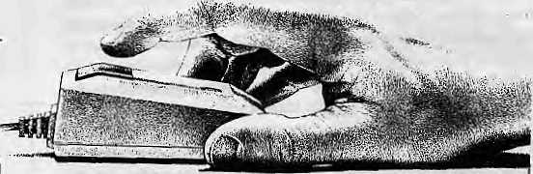
Naxal
34 HIMAL • May/June 1992

W can put 5«u in touch with Macintosh.
If you're one of the 18 million people in Nepal who don't know how to operate a computer, you haven't met Macintosh,™ the newest personal computer from Apple.

It's so powerful, it's incredibly simple to use.
Just put your hand on the palm-sized "mouse" controller. Auu Ciiek - you're Macmtcsh-Hterate.
Our professional sales staff will answer all your questions and, of course, provide service and support.
So if you're searching for the right computer, hurry in for a demonstration. And put your finger on it.
P.O. Box ; 2502, Bagh Bazar, Kathmandu, Nepal. Tel: 222-277, The: 3521 ATUNK Fax :977-l-419250
Apple and the Apple logo are registered trademarks of Apple Computer Inc.
NEPAL
INTERNATIONAL CLINIC

* Western medical setting serving the entire community
•ir Care by a U.S. Board Certified Internist
4 Comparable services at lesser rates
- Imported Vaccines, Lab work
- Knowledge about Mountain Sickness.
- Central location
6 Open Sunday
* Prior appointment encouraged
412842 & 419713
Phone answered 24hrs.
Jai Nepal Cinema Haft
Lazimpat
Royaf Palace Main Gala
"~* r
Kantipaoi
_J L
ThamtH
1 I |Baths|
Durbar Mara '
I 1

■
1 Mid. Y | ^ks of Kunlun
Hk*-^*s<|&;'; '■;■ . . ■■. ■.'■:. ,. .' , ■ ■-■ ■.. ■; : '. ; ■■. IB' ' ■ "■-,■•" '" ■'--■' ■■ .'■'. 1 'j ■ "■■'-. \ | ■HHIH ... .. ■ ■- ■ . ■ ■ ■■ ■••'/-.■•rot  a of ifafihei'an-'ti&teau la iatptissiw. hut ir ufider threat.
!j^^^^^ ■ - : ' ■ ■■■■■.'■ ■ ■'..■.■■' -' ffi»i£-!a?3
 | H ■ . ■ —~—
 | ||M MM WvmSE
, THwten wild ass, on the Changtang steppe.

A naturalist today would be hard pressed to Jl\. name a truly wild paradise, yet the rugged mountains, isolated valleys and steppes of the Kunlun Mountains, on the Tibetan plateau, are exactly thajtj The accounts of 19th-century travellers speakofthe fabulous wealth of wildlife on die plateau. On his first visit to Tibet in 1872, the Russian explorer Przewalski estimated that the southern slopes of the Kunlun Mountains may have supported millions of wild yak. After travelling across the Kunlun range in the 1880s, the American explorer Rockhill described the upper Yellow River as "the most wonderful hunting ground in Asia". Sadly, wildlife has since diminished drastically but for the most isolated areas on the plateau. Worse still, the survival of these few sanctuaries are threatened.
The Kunlun range, nearly as high and Ion ger than the Himalaya, defines the northern edge of the Tibetan plateau as does the Himalaya its southern border. Stretching almost 2000 km, from the Pamirs in the west to Mount Amnye Machin in the east, the Kunlun Mountains separate the Tibetan plateau from the desert expanses of the Tarim and Qaidam Basins. This immense mountain landscape is one of Asia's largest wilderness and one of the plateau's last refuges for wildlife; -^.
Today, the best refuges for the great herds of wild yak, wild ass, Tibetan antelope and argali are in the Kunlun Mountains, west of the Golmud-Lhasa highway. This is the highest, most remote and inaccessible part of the Tibetan plateau, the so-called Changtang, or "northern plains", of Tibet. The Changtang steppe is a cold, arid grassland with a backdrop of rugged mountain ranges. Most of the region is above 4000 metres. It is virtually impossible for the urban eye to
comprehend the magnitude and wildness of these grasslands. The Changtang covers some 600 000 sq. km, an area the size of France. There are no roads and habitation is limited to a few thousand herders living on the fringe of the wilderness.
There are Tibetan antelope, which can migrate hundreds of miles between their winter and summer ranges. There are lush meadows where herds of hundreds of wild yak graze and rolling grasslands that sustain large bands of wild ass, or kyang, and graceful Tibetan gazelle. Huge flocks of argali, the world's largest and rarest species of sheep, graze undisturbed in this pristine mountain landscape.
In Qinghai province, to the west of the Kunlun Pass and the Golmud-Lhasa highway, lies Wild Yak Valley, one of the most important refuges for wild yak on the plateau. The main valley is drained by the Kunlun River which flows northward for 150 km into the Qaidam Basin. Mountains to the south of the valley rise to 6000 m and are covered with glaciers whose melt-waters nourish extensive, lush, sedge meadows on the lower slopes. The valley floor, evenat elevations of 3500 to4200metres', contains areas of productive grassland. Wildlife thrive on the diverse vegetation of Wild Yak Valley,
As part of a cooperative wildlife research project between the University of Montana, in the US, and the Northwest Plateau Institute of Biology at Xining, in Qinghai Province, I worked on wildlife surveys of Wild Yak Valley in 1990 and 1991. Given that even a few years agopeople were unsure of whether wild yak still existed on the plateau, we were amazed to count more than 1000 wild yaks in an area of 500 sqkm. We saw herds of up to 400 wild yaks. The Valley is an exceptional sanctuary for other wildlife, too. In
addition to wild ass, Tibetan gazelle, Tibetan antelope, blue sheep, and argali, there are white-lippeddeer, lynx, wolves, marmots, pikas, Tibetan fox, red fox, snow leopard and browabear. The diversity of species in this little cbrner of the Tibetan Plateau is truly impressive. But this remarkable refuge is under increasing threat.
Although unregulated hunting is now illegal in Tibet, poachers still take significant numbers of antelope, gazelle, and blue sheep. But wild yak are also being killed. The main threat is from meat hunters who, armed with high-powered rifles, penetrate hundreds of kilometres into remote areas. They kill large numbers of animals to supply the meat markets of outlying towns.
Tibetan antelope, prized for their cashmere-like wool, are also prime targets for hunters. There is a large market for animal products, which form a significant part of the Chinese traditional pharmacopoeia. Such unregulated hunting-can destroy this precious resource and should be brought under strict control. Gold miners and petroleum geologists pose yet another threat to wildlife and habitat.
Nor is poaching the only problem in this unique landscape. Inappropriate management techniques have also damaged some rangelands. The steppes of northeast Tibet were long recognised as the best of Asia's grasslands, providing a livelihood from herding where the high elevation makes agriculture impossible. Nobody knows when pastoralism first established itself on the plateau butit was certainly widespread by the 6th century. Nomadic pastoralists have coexisted on these grasslands for thousands of years, moving their herds of yaks, horses and sheep across the landscape in a pre-sei pattern that carefully prevented overgrazing the pastures.
May/June 1992 HIMAL • 35

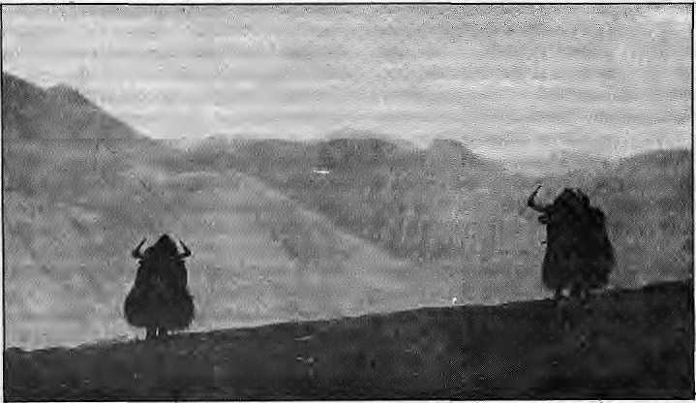
. TIBETAN AUTONOMOUS HEGION
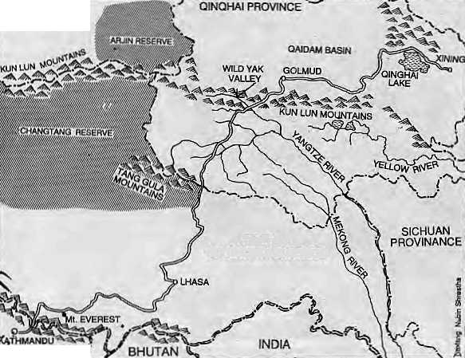

XINJIANG
Every three years the herders would take a livestock census, and reallocate grazing land to ensure that pastures could adequately recuperate. The fact that the rangelands of Tibet still support viable pastoral cultures and wildlife today bears witness to the remarkable diversity and resilience of these grasslands, as well as to the sus tainability of wise use.
NEPAL j^{v}
This important system of reallocating pasture ended when policies introduced in the early 1960s gave communes responsibility for rangeland management. By the early 1980s, China introduced a hew system of management which viewed the household, rather than the commune, as the basic unit of production. Although households resumed responsibility for the production and marketing of livestock — as in the pre-comm une era—the practice of pasture Tcallocation was not re instituted.
Population growth in the Qaidam basin, just north of the Kunlun Mountains, has been dramatic in the past 20 years. This, coupled with better communications and transport, has contributed to raising the demand for meat and livestock products. The introduction of consumer goods and services and an open market pricing structurehas been accompanied by rapid increases in prices of livestock products such as wool and cashmere, the nomad's main livestock products. Although most pastoralists now enjoy a better life than two decades ago, does the new system provide any incentive to conserve the rangelands and their extraordinary productivity?
Pastoral i sni in Tibet was a surviv al strategy for life in a harsh environment. The components of the ecosystem — the people, livestock and
vegetation — have been subjected to selective pressures over, perhaps, two thousand years. Consequently, the ecological characteristics of all the actors on these rangelands are the result of centuries of complex interactions. The processes that formed the unique ecosystems of the Changtang demand much more study.
In northern Tibet, an areaof 240 000 sq km was recently designated as the Changtang Reserve. This huge, largely uninhabited area is an important refuge for wildlife, especially for wild y ak ai id Tibc Uin an telope. Recommendations have also been made to extend the Changtang Reserve 50,000 sq km further west, to include critical antelope lambing and Wild Yak habitat. Along with the Arjin Reserve to the north, in Xinjiang Province, the proposed addition and the Changtang Reserve itself, an area of almost 335,000 sq km would be set aside for wildlife.
There is presently no wildlife reserve in western Qinghai province despite the fact that the Kunlun Mountains were historically sacred to the Chinese. The Changtang reserve could also be extended to include die area south of Che northern limit of the Kunluns and west of the
Golmud-Lhasa Highway,, in Qinghai Province. This area would include the Wild Yak Valley, which contains exceptional biological diversity, as well as the unexplored Kolcoshili Mountains and the headwaters of the YangtzeRiver. Inventories of the wildlife and surveys of habitats would identify areas demanding special protection. Although most wild animals are protected by law, wildlife protection officials have limited resources to combat poaching. Agencies responsible for managing wildlife need considerable assistance' and training to effectively conserve the range and wildlife resources of the plateau.
Eco-tourism offers potential jobs for local people and would help them to realize the economic value of wildlife. Trophy-hunting, if strictly controEed, helps to maintain desirable populations of large ungulates and could provide additionalincome for local herders as well. Local people co uld be recruited for jobs in conserv ation, management, and sustainable use of natural resources. Such ao environment would engender economic rationality, instil awareness', promote a sense of responsibility and encourage local participation in development.
The recent history of the plateau, particularly the negative impact of systems of management imposed from the outside, emphasize the folly of intervening without a clear understanding of the ecosystems. Modern systems of livestock production developed in the West for the Western prairies may be just as inappropriate for the Changtang as were the introduction of recent Chinese management systems. Detailed studies of the rangelands and investigations of pastoral production systems could identify those traditional practices that are useful and suggest which modern practices were most appropriate to complement them. It is certainly clear that conserving the biological diversity on the Tibetan Plateau depends on the cooperation and support of the local pastoralists. The social and economic needs of the herders must be reconciled with management of the rangetands and conservation of wildlife.
The grasslands of Tibet need not lose their wealth of flora and fauna nor their unique pastoral cultures. Their futures lie in the hands of conservationists and development planners willing and able to devise programmes that are sensitive to this unique ecosystem.
: &
I D. J. Miller is a range ecologist who conducted i investigations on rangelandsandwildyaks on the ¹ Tibetan Plateau from 1988 to 1991.

36 H1MAL • May/June 1992

What Price Khaptad's Riches ?
National parks and protected areas are meant to conserve biological wealth for all humanity.
But poorer countries end up paying. For now, Nepal's network of protected areas are
a burden rather than a benefit, including Khaptad.
by Devendra S. Rana

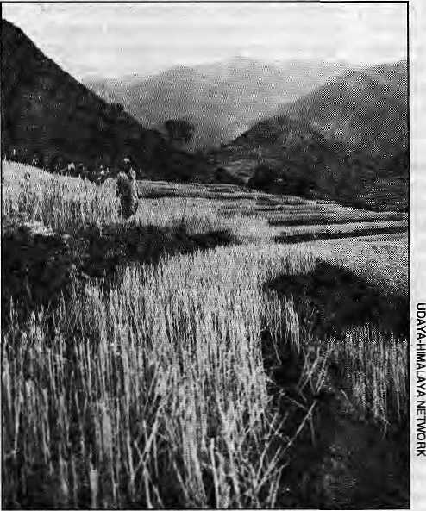
Looking towards Khaptad Plateau from the fields ofGabise
T
he villagers of Khaptad first saw the surveyors in 1980. The outsiders arrived and started drawing maps of the area. In reply to their friendly queries, the outsiders advi sed them "chintanagarnus" (don't worry). But it was bad advice. The surveyors were defining the boundaries of Khaptad National Park, which was officially in 1984.
People from about 300 surrounding villages have lived with, and from, Khaptad Lekh, in far-westem Nepal, for centuries. They have collected fuel wood, fodder, small timber, compost, and nigalo, a bamboo, from which they made baskets and containers. Those with insufficient agricultural land of their own have cleared small patches of forests for crops when times are hard.
Kathmandu's politicians and bureaucrats, in contrast, know Khaptad Lekh only as the place where a well-known ascetic, the Khaptad Baba, resides. So it was not difficult for them to order that the area, which they considered "wilderness" anyway, be demarcated as protected.
Overnight, the villagers' access to the resources of Khaptad Lekh was severely restricted. As elsewhere, the Royal Nepal Army were given the task of policing the area and keeping people out. The villagers are now allowed to collect products at fixed times during the year, buthave to apply for permits for everything from collecting fuelwood and fodder to the right to graze their animals.
Conflicts with Guards
In trying to conserve the biological wealth of the area, the Government abolished the traditional rights of local people to use the resources of KhaptadLekh. Not surprisingly, "poaching" and "encroachment" became common. This, in turn, led to sometimes heavy-handed behaviour from soldiers .Thevillagersstillbitterlyrecallconflicts with the guards, sipahis, and will point to spots where soldiers seized their baskets and sickles, the pond where villagers were dunked in midwinter and where the soldiers burned the fuelwood and fodder they had collected!
HisMajesty'sGovernmentofNepal (HMG) appears not to have benefitted significantly, either. Unlike the Annapurna Conservation Area and the national parks of Sagarmatha and Chitwan,
Khaptad is not a major tourist destination. In 1991, the Annapurna area saw over 36,000 visitors, but just over ten visited Khaptad.
The history of Khaplad Lekh's formation has important lessons andraises questions about future conservation practices in Nepal and, indeed, in other Southern countries in a similar position. First must be the question: whom is conservation for? Onee that is answered, it is easier to identify who should foot the bill.
Few, today, would question the appropriateness of conserving wilderness, particularly in Nepal, where the dramatic variations of altitude and climate have given rise to an enormous range of ecological niches that support a wealth of biological diversity. There are excellent reasons, of importance both locally and globally, for such efforts. Good conservation programmes can protect the watershed, maintain the microclimate, control soil erosion, conserve the flora and fauna and save for local people all the elements that make the area unique or distinctive. But there are even larger concerns. We have belatedly recognised the crucial importance of conserving genetic resources.
Though plant scientists have screened only a small fraction of the earth's plant species, genes discovered from this tiny fraction of the planet's biodiversity have yielded some of the most important commodities world — and about 40 per cent of the medicines normally found on the phmarcy shelves? But most important of all is our reliance on plants for food.
All our food comes directly or indirectly from plants. In order to breed more productive crops, scientists need different varieties of plants. Variety, for example, in a plant's productivity, tolerance to drought, resistance to pests and diseases is genetic. Each plant variety is recogms ably distinct because aparticularcombinationo^geneswork together to produce that plant variety. Yet this very base is threatened, Aswe put more and more wilderness under the plough, we lose more and more of the wild flora and fauna that once inhabited it. And with each extinction is lost a unique collection of genes and — nobody knows how many ~ unique single genes as well. What is true for our plant genetic resources is also true for our animal genetic resources. Everything that is bred for commerce is subject to the same dangers of genetic erosion.
As the science of biotechnology matures, it increases the scientist's and breeder's ability to manipulate specific genes, and therefore particular characteristics, in crop plants or livestock. The value of genetic resources is thereby increased.
His Majesty's Government of Nepal (HMG) has pursued conservation with a single-mindedness that has resulted in the protection of 10.8 per centof the country's landarea. Such zeal in establishing national parks, hunting reserves, wildlife reserves and conservation areas has earned Nepal the respect of international organisations such as the World Conservation Union and the United Nations Environment Programme (UNEP). On the whole, however, the current conservation practices of the Department of National Parks and Wildlife Conservation (DNPWC) are inappropriate to the needs of Nepal's people. The parks do not even pay for themselves. Tourism within the protected
May/June 1992 HIMAL ■ 37

areas, including fees charged for entry, mountaineering and trekking, raised only U$ 0.76 million in 1988 whi! j the operational cost of the DNFWC runs to about U$ 3 millions annually. Out of that, the Royal Nepal Army is paid U$ 2.1 million to guard parks all over Nepal.
To date, there has been no serious study to identify the pros and cons of protecting an area such as Khaptad. Who are the beneficiaries? If they are the local people, a cursory analysis suggests that costs far outweigh benefits. The environment may have benefitted from the protection of Khaptad: the watershed may be better protected, ground water recharge may have improved, soil may have been conserved and so forth. But what of the negative social and economic impacts of the conservation programme on the local population?
The Park Doesn't Pay
The current state of knowledge dictates that protected areas should be divided into zones for different levels of human interaction and utilisation. A "buffer zone" would allow surrounding communities access to forest products for their daily needs while providing full protection to the inner sanctuary. Thus, the recently established Makalu-Barun park does incorporate a conservation area as part and parcel of theoverallplan. Itis neither politically feasible, nor ethically justifiable, to exclude poor people fromParks and protected areas. The Government must decentralise and demo cratise its institutional framework. Decisions governing the use of resources must be made at the local level.
But, unfortunately for Khaptad, even such enlightened management policies are unlikely to adequately pay people to protect the area. The development of nature tourism around the unique habitat of Khaptad, even if successful, will not attract the numbers that the high Himalayan valleys do. The farming of medicinal plants holds some promise, but the experience so far has not been encouraging. Few other options present themselves in the immediate future. The infusion of development aid to indirectly compensate the villagers for their loss of access can only have limited success.
If tourism at Khaptad cannot pay for its protection, and if the forest products are insufficient to pay local people to protect the area, why is Khaptad worthy of protection? If whatisbeing protected at Khaptad is biodiversity, the shared heritage of all humankind, then a mechanism must be found by which humankind will pay the local inhabitants — who have lost access to resources that were traditionally their own — in order to save that biodiversity.
How could Khaptad's biological wealth be re alised as an economic asset?Nepalcouldfollow the lead of countries such as Costa Rica, which, has recently created a new quasi governmental "resources centre" to act as broker for the country's biological wealth. The founder of the
centre has capitalised on people's native interest in natural history and has offered volunteers free training in taxonomy. An "army" of new taxonomists identified and listed hundreds of thousands of entries of floral and faunal species in the first year alone. The database, kept at the headquarters of the centre, includes information not only on taxonomy but also on local medical, culinary and other uses. If, for example, a pharmaceutical company is interested in Costa Rican plants with particular properties, it must go through the new centre. The centre will have carried out chemical screening of the plants and will sell the information, or biological materials. Once active compounds are discovered Costa Rica will be in a strong position to negotiate royalties from foreign companies or be able to licence the material to national firms.
The issue of ownership and rights over resources is presently under heated debate in several international forums. Increasingly, it is seen to be opening old wounds of exploitation of rich countriesoverpoorones.Muchof the wealth of the diversity in food plants lies in the countries of the South. The world's most biologically diverse areas are in the South, in its tropical forests and its coral reefs, for example. During discussions in the Committee on Plant Genetic Resources, within the United Nations Food and Agriculture Organization (FAO), or in the UNEP's international convention on biological diversity, delegates from Northern countries alw ay s refer to bio logical weal th as the "common heritage of humankind". Yet plant varieties bred by Northern scientists from Southern materials are protected by legal frameworks such as "Plant Breeders' Rights" or other intellectual property rights. The advent of biotechnology heralds ever more stringent laws to protect innovation.
But is fair? The North has, for a long time, viewed the biological wealth of Southern countries as "raw materials" with which it can produce improved varieties that can then be sold on the world market But the most useful materials are not just lying on the ground in Southern countries, waiting to beplucked and exploited by enlightened Northerners. They are in or around farmers' fields. Landraces, varieties of plants that have adapted to, for example, the specific conditions of climate, moisture, aspect and so on in a particular mountain valley, exist because generations of farmers have selected seeds that, through experience, they know will survive, Landraces, needless to say, are of great interestto plant breeders. For example, in 1973, scientists at Purdue University in Indiana, United States began to hunt for varieties of sorghum containing genes for high protein content. They examined more than 9000 varieties from all over the world before they discovered, in the fields of Ethiopian peasants, two obscure strains with the qualities they sought. The patent for developing the high-protein sorghum lies with the scientists. How have the Southern farmers benefitted?
The existing legal systems protecting innovation are seen as unfair both by the North and the South. The North says its researchers and industries have spent billioris of dollars in the research and development of new varieties and they must be assured pro fits from such investment. The biotechnology industry argues that Plant Breeders' Rights and IntellectualProperty Rights are useless in protecting innovation, and that it is impossible to recoup its investment if farmers are allowed to use the engineered variety with fio obligation to return a royalty to the innovator. If new, and more stringent, laws are not introduced, companies will incre asingly question the benefits of developing new varieties of crops. The South says patents are unfair because they haveprolected only a tiny fraction ofgenetic resource innovation taking place in the world. The millions in the South who have developed and conserved landraces have been ignored.
Until now, the North has benefitted more from the resources of the South. The FAO has been pushing for a more equitable exchange of resources: the genes of the South for the expertise of the North. It has established an International Fund for Plant Genetic Resources, to which the North can contribute for the use of the South's biological resources. But that is as yet only voluntary and only concerns plant genetic resources. What of animal genetic resources? What of areas ofspecial scientific interest but of no commercial value?
The benefits of conservation accrue to all humanity, yet it is mostly the poorer. South that bears the costs. It is the Southerners who forego immediate economic returns, who cany the burden ofpolicing protected areas and who must provide alternative livelihoods for rural populations affected by such protection. Yet Southerners do not enjoy any of the benefits of preserving the planet's biodiversity. There are missing elements in our present cost-benefit equations. We need to identify them and to find ways of ensuring that those who benefit from conservation pay their fair share for it.
For Nepal, this could mean the introduction of a two-track policy. In the specific case of Khaptad, it could mean handing back control to the local inhabitants and the simultaneous es tablishment of national gene banks andresearch institutes. Even if such strategies were impossible at this time, HMG must attempt to ensure that collectors of Nepal's biological resources pay royalties for collection rights. While this may go to the local communities, the ownership of any genetic resource must belong to the country, Once local people see the potential economic and social benefits of conserving biodiversity they are more likely to participate in and cooperate with government efforts. Only then will conservation have any chance of succeeding.
D. S. Ranais currently undertaking action-re search in Bajhang District, adjacent to Khaptad, on behalf of the group, Udaya-Himalaya Network.

38 HIMAL • May/June 1992

REVIEW
One Flood Report and Some Muddy Reviews
by Jayanta Bandyopadhyay

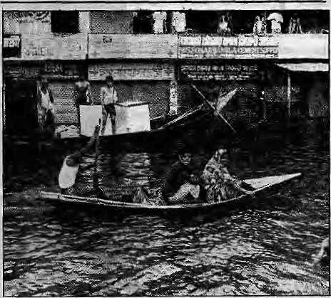
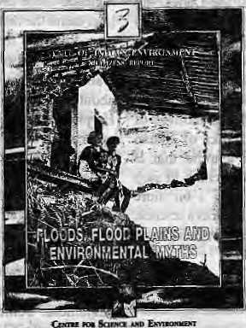
Floods, Flood Plains and Environ mental Myths State of India's Environment, A Citizens' Report (No 3)
by Anil Aganval, Neeraj Labh andVA.Nambi, 1991
Centre for Science and Environment (CSE)
New Delhi, 1991.
T
he Third Citizens' Report on the State of India's Environment, which looks into the causes and effect of the annual floods on the lower plains of the Ganga-Brahmaputra basin, has attracted some decidedly hos tile rev iews. B ut the criticisms therein are disturbing more for what they reveal about the health of the Indian environment movement than for the considered analysis provided by the authors of the report
The Third Citizens' Report represents a step ahead for CSE in many ways. Researchers concerned with upland-plains ecological linkages have long understood the correlation between various types of floods and deforestation in specific areas of the Himalaya. Unfortunately, the confused correlation put forward by Erik Eckholm, an American researcher and journalist, fired popular imagination and seriously set back public understanding of the ecological processes at work. Eckholm arrived two decades ago and in 1976 published a simplistic treatment of Himalayan soil loss which related all lowland floods with Himalayan deforestation.
What Eckholm had to say was of course a distortion of Himalayan ecological studies. It was a bad joke on the Himalayan population, yet his doomsday predictions in articles and in his book, Losing Ground (WorldWatch, 1976), encouraged the growth of know-all environmentalists in all the Himalayan countries. Truth and seriousness lost out to reductionist treatment and sensationalism. The report is a courageous attemptlo marsh all available research to fight sucli sensationalism. Is itany wonder thai the active champions of reductionist environmentalist!! in India are alarmed? There is need for holistic thinking about floods in the Ganga-Brahmaputra plains, and the CSE has producedauseful document which will encourage the earnest peruser to read further.
Were the authors, in preparing this report, awareofthefundamenalistthinVyngamonglndidii environmentalists? Perhaps they Avere not, or they might have introduced the reader to the types of floods in the Ganga-Brahmaputra basin anddescribed how changes in land-use in various parts of'the Himalaya affect them. Perhaps they should have known better, because for many plains-based lovers of the environment, floods are of one kind and are caused solely by the cutting of trees in upper catchment areas. Those who do not find it necessary to read, would not know any better.
The most notable critics of the report are
Bangladesh floods, 1988.
N.DJayal (India Today, 24 February 1992), B. Sahgal (IllustratedWeekly of India, 27 October) and V. Shiva (Sunday Observer, 8 March; National Herald, 20 January). Had these renowned Indian environmentalists-turned-critics paid attention to recent publications on the subject of Himalayan deforestation and floods, they might have been less surprised by what the CSE team had to say, and their self-frighteous anger might have been blunted somewhat. For theideas presentedin the report have had currency among serious students of Himalayan environment, witnessed in a number books including//i»w/cjyart£i/7e»wia(Routleclge, 1989) and in journals such as Mountain Research and Development, Himal, too, has carried several articles on the s ubject, including one by D. Gyawali and this writer in Sept/Oct 1989 which analysed the ecology of the Ganga-Brahmaputra floods with respect to upstream deforestation.
Jn a nutshell, deforestation on hill slopes that receive rain undoubtedly causes flash floods in the respective foothills. But the hydrological behaviour of the entire Himalayan region
— 3000 km in length, with diverse forest cover and fantastic clim atic differences— cannot be extrapolated from the performance of a single micro-watershed. To do so would be folly.
Floods can be- caused by several factors during the various stages of a Himalayan rivet's journejkio the sea: the outburst of glacial lake?; opKoingupoflandsIidedams; natural spreading of the rivers at the foothills due to sharp declines in slope, and so on. Towards the lower reaches, rivers flood mainly due to heavy local rainfall, high-tides, and the simultaneous peaking of tributaries. Human activities which are not ecologically informedrSiich as the construction of embankments, help pack up water, causing water-logging.
Shiva's claim that the 1978 Uttarkashi blockage of the Kanodiagad, a small tributary of the Bhagirathi, which is a tributary of the Ganga, led to "flooding of the Ganges basin all the way to Calcutta" — more than 1000 km downstream on a distributary known as the Hooghly —■ is laughable. This is only among the more egregious examples of the "evidence" brought to bear in criticisms of the CSE report.
Among the so-called experts of India, why is there so little self-control in making public display of ane'8ignorance?Anddo these persons who find it so easy to hold a heroic stance not realise that their fantastic rhetoric serves only to divert attention from the unscientific and pathetic record of water-management in the Ganga-Brahmaputra basin?
The main con bib ution of the report are the holistic insights it offers on the processes of flood creation, thereby aiding the search for ^solutions. The report also provides much data on flood damage and protection works. One major criticism is that, for all its data, the report does not provide a series of annual hydrographs of the various rivers. All superficial talk on deforestation in the Himalaya causing floods would have been dismissed right there.
Thereportalso pro v ides adetaileddescriptionofthe orogeny and geology of the Himalaya, which is useful general information. The reader is forced to consider HIMAL • 39
May/June 1992

REVIEW
FRONTIER TO BOUNDARY
by Harka Gurung
Ethnicity, State and Development A Case Study of the Gorkhaland Movement in Darjeeling
by Tonka B. Subba Vikas Publishing House, New Delhi, 1992.
: STATE MBS DEVELOPMEl
$£p*CASE STUDY OP'ftW
TANKA B.
the Himalaya as a source of mountainous volumes of sediments throughout geological time which helped to form much of what is today's Bangladesh. Thus, the new islands forming on the Bay of Bengal did not begin to do so after Independence. Just because satellites now give us pictures of some ecological processes, it does not mean that soil loss, siltation or flooding are new phenomena.
Undoubtedly, deforestation on slopes of the Himalaya increases soil loss, but this is insignificant compared to the debris created by the natural uplift of five to ten millimeter a year. This is why reforestation in the Himalaya is unlikely to reduce appreciably the heavy sediment load of Himalayan rivers. Certainly, rain-receiving slopes must be protected by full- canopy forest cover to reduce the power of flash floods. But only a fraction of the total Himalayan catchment, say between five to seven per cent, receive heavy and intense rainfall and need such protection. The forests in the Himalaya are vitally important to the agri-pastoral economies of the mountains. And this alone is reason enough for reforesting the Himalaya.
It is a pity that such well-known actors in India's environmentalism missed the main point of the report, that is, the need for a holistic understanding a floods in the plains. With their naive outburts, the reviewers have merely exposed their own ignorance about up-to-date scientific information and their proclivity for sensationalism. Two reviewers (Jayal andShiva) virtually condemn Agarwal and co-authors of being anti-national in referring to the work of an American scientist, Larry Hamilton, of the East-West Center in Hawaii. They little realise that Hamilton is among the best ecologists to have set eyes on the Himalaya.
As such, there is no serious challenge to the
CSE report from Sahgal, Jayal or Shiva. Sahgal
and Jayal, being ardent lovers of forests and
wildlife, have over-reacted to the reduced
importance of forests in the scheme of things
described by the researchers. Shiva goes a step
further. "Maybe it is time to investigate why so
much international money is coming the way of
CSE. The Dutch, the Swedes, the Danes, the
Norwegians, the Canadians are all (reportedly)
sending funds to CSE, an organisation which
seemsto exist only for the sole purpose of pleas ing
those in political power," Shiva wrote in Sunday
Observer, 8 March. This incredible charge,
Unking foreign donors and alleged motives of
CSE in trying to divide the ranks of Indian
environmentalism, represents a trend that is
slightly sickening. The time has come to stop
slinging mud and to start gelling a bit more
serious about treating their vocation as a science.
If not, environmental movements in India stand
to lose much of their credibility. [^
J. Bandyopadhyay is one of the authors of the newly released State of the World's Mountains (Zed Books, 1992)
40 HIMAL • May/June 1992

The book Ethnicity, State and Development by Tanka Subba, an anthropologist at the North Eastern Hill University in Shillong, is about political conflict in an Indian hill territory that has common borders with three (four until 1975) other countries.
Political geography defines boundary as a demarcated territorial limit which is more specific than fuzzy frontiers. In fact, boundaries evolve out of frontiers. Boundaries are also malleable, tending to shift with changes in power dynamics. For example, the Darjeeling area, with which this book is concerned, originally belonged to Sikkim, until annexed by Nepal in 1783. The latter was ejected by the East India Company in 1816 and the territory returned to Sikkim. In 1835, part of Darjeeling area was "granted" away by the Raja of Sikkim to the British. Adjoining divisions of Kalimpong and Dooars were annexed in 1865, from Bhutan and Sikkim, respectiv ely. All these territories became partof Bengal during the imperial heyday. Neither did Bengal's own boundaries remain sacrosanct. The most traumatic was the partition of 1905. Until then one provincial unit encompassed Bengal, Bihar and Qrissa.. Dacca, Chittagong andRajshahi divisions were transferredto Assam in order to reduce the Bengali majority. Bengal regained these divisions in 1912 but 35 years later came the historic partition of 1947.
Bounded territories, whether national or sub-national, also refer to the people that inhabit it and provide the substance. Subba's book is ail about a people's endeavors for political space. He presents a lucid account of the Gorkhaland movement It is the usual story of highland-lowland interaction, expressed in the political struggle of a martial people (Gorkhali) against a highly cultured host society (Bengali).
The Bengali people have been the pioneers of modernisation in India, be it in social reform, arts, literature or revolutionary politics. Of the last category, two Bengalis whose reference is pertinent are Subash Chandra Bose and Charu Majumdar. Some of Bose's host prominent followers were Gorkhali (see Subba, p. 59), and

lii
Majumdar's heritage is alive in the m ain opposition party in the Nepal's House of Representatives. In comparision to the Bengali, the Gorkhali of the Darjeeling area, as well as their n eighbo ms the Lepcha and Bhotia, are rustic highlanders. Thus, what transpired in the DarjeeUng hills during 1986-88 was a clash of divergent values of societies at different levels of development and sophistication. The confrontation was, in a way, predicted in the title of the book Baas Salki Rahe Cha ("The house is on the fire") by Bhagirath Rawat on the life and times of Ari Bahadur Gurung along with Gorkha League history (Kalimpong, 1981).
Subba's book commences with a survey of conceptual sources on ethnic politics (pp 17-22) and the author describes ethnicity, state and development as forming a vicious triangle from which it is difficult to isolate any one of the three. There is also a lengthy discussion of the so-called macro-theories and micro-theories on ethnic movements, with reference to Gorkhaland (Chapter5). Incidentally, there is a clear cleavage in the theories cited: the nine macro ones are all Western and the seven micro ones mostly Bengali. But what Subba describes is based on a thorough understanding of the ground realities. The political, ethnic and economic history of the DarjeeUng area provides an appropriate backdrop to his political analysis. Particularly well-researched is the chapter on the history of ethnic movement in the area, spanning over eight decades. Initially, these were polite initiatives for a separate administrative set-up: demands made by an informal hill group (1907), the Hillmen's Association (1917), and the All India Gorkha League (1943). When these pleas went unheeded, the demands became more strident caUsforGorkhastan(1947),Uttarakhand(1949), and separate statehood. The proponents of statehood were the Pranta Prishad (established April 1980), the Gorkha National Liberal Front (July 1980) and Swatantra Manch (May 1985). There was also a parallel movement for the recognition of the Nepali language in India since 1924.

Subba provides a vivid description of the days, months and years of confrontation, of violence which he calls a "nigh tniare". Similar to the author's evocation of three inter-linked themes (ethnicity, state and development), GNLF's confrontation was also triangular. One was directly against the State of West B engalthatwas represented by the police. The seco nd was ag ainst the Union government that deployed paramilitary and armed forces. The third was against the Communist Party of India (Marxist), the main political contender in the area.
The triangular negotiation is described as a process of three steps forward and two steps backwards. Finally, conciliation between GNLF, the West Bengal Government, and the Centre was agreed upon on 22 August 1988. The demand for a separate state of Gorkhaland was dropped and the Darjeeling Gorkha Hill Council was created instead, empowered with 19 schedules of local self-government contained in a "Memorandum of Settlement." (Annexl)
The author considers the agreement as political expediency on the part of all involved parties. The overall impact of the movement was mostly negative, particularly in the economic front, he states. A chapter is devoted to media coverage of the movement wherem it is revealed that journalistic objectivity was a myth as far as Gorkhaland was concerned: the closer to the scene, the higher the propensity for bias. Subba rightly ignores Nepal's press, which was conspicuously silent on the violence in neighbouring Darjeeling while covering at length diarrhoea deaths in Bihar.
Frontiers can be changed and boundaries redrawn. But the basic question is one of political —not ethnic—identity of the people within the borders. Subba has attempted to deal with this issue in the chapter on evolution of Gorkha identity. His diagnosis seems somehow incomplete. He is also in error, incidentally, while discussing the roots of the term Gorkha to link it with Gorakhnath, derived from 'go-raksha' (protector of cow). The more plausible explanation can be credited to Surya Bikram Gyawali, who suggested that Gorkha was a variation oftheKhasa word'garkha', that means revenue area. Subba subscribes to the distinction
between 'Nepalese' (of Nepal) and 'Nepali' (of India) for the people. On linguistic terminology, he is in favour of 'Nepali' (Bhandari version) as against 'Gorkha' (Ghising version). Therefore, he suggests 'Nepali'as the common designation for the people and their language in India. (See Subba's article on page 30 - editors)
An example of confusion due to such synonymous ascription is the terms 'ethnic Nepali'or 'Nepali ethnics' that have been widely misused. Take for example the sentence, "Many ethnic Nepalis were expelled from Meghalaya and Bhutan". As a matter offset, 'ethnic Nepali' (JVepali jati) does not exist, but rather different ethnic groups that live within political Nepal (as citizens) or are of "Nepalese" origin but live outside (aliens). The above statement in quotes actually refers to a language group that use Nepali as lingua franca, not necessarily as a mo ther tongue. Tribals, whether within oroutside Nepal, use Nepali to communicate with each other. Those outside Nepal may use the Nepali language but are not necessarily "Nepalese" in the political sense.
The nomenclature of the language we today call 'Nepali' has undergone numerous transformations, involving an extensive longitudinal traverse. It actually belongs to the family of 'Pahari' languages (Central Pahari in Kumaon and Eastern Pahari in west Nepal). Eastern Pahari in rum became 'Khas-kura' or the language of the Khasa. Its third incarnation was as 'Parbate', probably derived with reference to the powerful principality of Paibat or Malbum in today's central Nepal. When Parbate arrived in the Gandaki region, the powerful house of Gorkha usurped it as 'Gorkhali' and it spread eastwards along with the expansion of Gorkha territory. It was as late as 1932, after 163 years of Gorkha rule in Kathmandu Valley, that the term 'Gorkhali' was officially changed to 'Nepali'. This was a clear case of cultural annexation, since etymologicalty Nepali was the languageof the Newar, who in turn, now call their language 'Nepal Bhasa¹.
The fifth" incarnation of the eastern Pahari language that has been widely adopted as Nepali may, therefore, better suit the political unit in which it is predominant, that is Nepal. For the
sake of distinction and identification, there is no harm if those outside this territory co-opt 'Nepali's' synonym, 'Gorkhali', as their language. Following the same logic, some hairsplitting can be done to clarify other related terms. Thus, those people using Gorkhali language outside Nepal, and claiming origin in Nepal (butalien) could be called 'Gorkha'. Within political Nepal, the people would be' Nepalese' and their language 'Nepali'.
But the crux of the matter regarding the identity of the Gorkhas in India is regarding their political status. This refers to their citizenship. The con stitutions of both Nepal and India confuse 'nativism' with 'political identity'. The constitutional terms 'Nepali origin' and 'Indian origin' have connotation of cultural affinity (basically language) rather than political identity. Such a provision is contrary to the concept of a modern State, narrow in national context, discriminatory on geographic and ethnic basis, and ambigious in operation. This has been further confounded by Article VII of the Indo-Nepal Friendship Treaty of 1950, which makes the boundary between the two countries not only a 'porous border'but 'open' for human movement The main contributing factor to the problem of citizenship, indeed, is the unrestricted entry and exit between the two countries, rfetivistpolicies that are weak (non-existent in the case of Nepal and India) in immigration control but restrictive in naturalisation have all the making of a larger socio-political conflict. The implication of such anomaly is clear: that the political identity of the Gorkhas, or for that matter problems of political demography between India and Nepal, cannotbe resolved without the regulation of the boundary.
Tanka Subba enlightens readers with a comprehensive account of an important issue. He believes ethno-development contributes to national integration .Recent ethnic conflagrations in eastern Europe suggest that Marxists have failed in minority group management. The Darjeeling area is not a 'no man's land' as claimed by GNLF leader Subhash Ghising — it is very much Indian. The resolution of political problems that generate separatist movements such as Gorkhaland is through more regional autonomy.


SUMMIT HOTEL
GARDEN RESTAURANT
Kupondole Height, Lalitpur P 0 Box 1406, Kathmandu. Tel: 521894, 524694 Fax: 977 1 523737 T[x: 2342 SUMMIT NP
The Summir Hotel is famous for its warm and friendly atmosphere, efficient staff, Nepal excellent food, a delightful garden with swimming-pool and one of the best locations in town with a spectacular view


MMIT NEPAL
Summit Nepal Trekking
Kopundole Height
P 0 Box 1406, Kathmandu, Nepal
Tel: 525408, 521810
Fax: 977 1 523737
Tlx: 2342 SUMMIT NP
Specializing in:-
- Mountaineering/Expeditions
- Tailor-made Trekking
- Unique Cultural Tours
- Wild Life/Jungle Safaris
- White Water Rafting
- Personalised Services

May/June 1992 HIMAL • 41


kunlun:shan
District
; all of eight and:partof
ipqt^s of Indiat;
6j theiNorth¹ Western Frontier
Piovjitce o| Pk 4
Baluchistan; and thti Kachiu, Ghih bnfy Shan states of ;I4y^nmaf. Ajl;;
Bandyopadhyay, iii have:produced
unkjUfiviewojtbeHimala^ari ;' region_{t} snd also drtutiiv|nf$ 3, v rAaJQrst«rablin|^lppkot: i ' Himalayan cartpgraphy—^ i*hat : to dp Witiit Jammu¹ and Kas^rt)jr_{s} %y i^ing district ahd pointy ■■■■ " boundaries insjieklsfriatkniat boundaries, (he: m^> ftesfte?: out a region l(jn^ depicted try the sparing use of black: curves to denote the inqufitajtvj-anges. In so doing, the map also bvercpmes the need to draw dotted lines fof : the dikfiuted boundaries. This works only when the districts » ■■§
(#tripfed ar^a above). {Nfijt ip take :ahy: diatices.ithern^) also earries th? standani di&d&irnet m ^{h} :; •
"denominations; used and boundaries shoWn;"^
Gqjngbythetn^p,:the
, fallwithiri;.dieHinduKusK,; :: * Rafakpram, the; Greater iHitpafaya arjd lhe H«igdua^, whiclj dips
uahiinlo Myanrnar,; ,: : y-fjve; of Afghanistan's 30 ' prbvuicesrriaKe it ijptp ttiemajj,>s do the ChSttagong Hill Tracts -flf ■ Bangladesh; aH of Tir^et/^i^ang ^aiid pa)t^ of Ytinrtaa and Sichuan...
of area.The * ; : approxirriat^ populafioii is 118 thilliqji (1991); average density 3S per sq kiSfi, ;Ni NJs to Tibet is the ■■ ; largest dfistjdct of all, Xhpi smaller dfefiriicte atecoricefiiraiedinthe .; jopthi 11 regions of the Him al»y 4 and the Hengdaan.
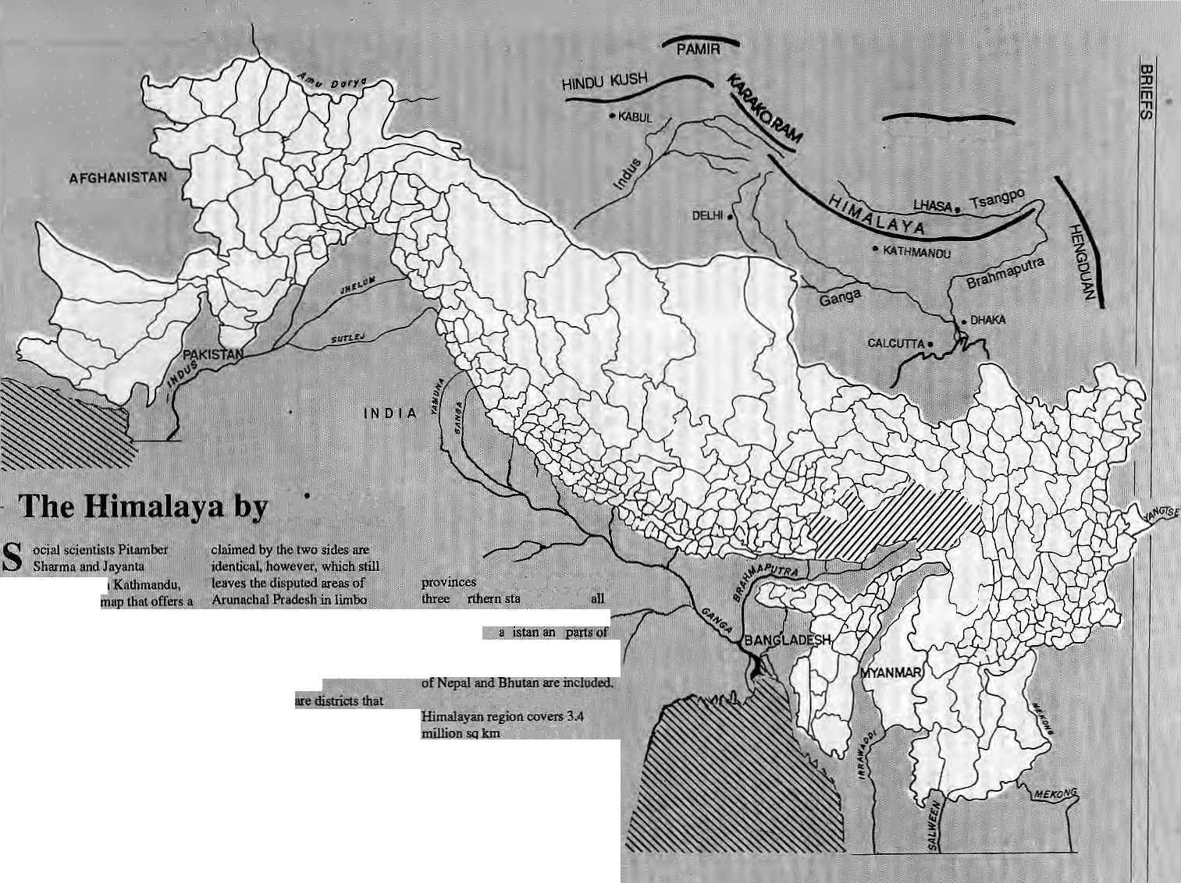
!
■**
_{f}* '

BRIEFS
Black Buck: OM Farmers: Nil
...classic popujaJiori v«sas - - hands, "but the Black Buck have
Hard Date*

Ki
athmaiidu environmentalism tends fa,
proceed ™ the basis of seminai grandstajsdjng, ..adopting eopycai concerns -—-and guesswork. In she" absence of hard data* soft ecology prevails, particularlywith regard-to air quality. ■ -: . ...... ... .; ." t..: *
: Surendra Raj Devkota, an
enviroiMneniai engineer 'at the
Asian Institute ofTechnology
(Bangkok); has now tabulated[
sojrne haifd figures on the yalley's
air. quality. An air poihuiwi
''inventory" Devkota undertook in
■August and September1991
: indicates the following, „
Thedaily exhaust of public transportation (bus, minibus, ' three-wheelers) contains about 6fJ kilograms of CO, 36 kg of NOx, 4 kgof Sp^ and; 7kg ofjparticulstes.; 5? percent.-o£ all fossil .fuel _{s} j emissions (diesei,kerosene, gasoline) in Nepal occurs intfte Valley. Annually, this amounts to 61UQQ tonnes of C0^ ftO2/andf 300 tof ^ have been Totmdedi)
Hsrisiddhi is estimated at 13 t of!
M
^{v;}if»"the ^iphery of Bardiya v,. _{v;}v -. Matilonait Par^ "in NejKil^s Western vXaraii'Notcontent with the protectionandforageoffered: ;_J within jaMyi saiictuaiy herds of Black Btif-k have taken a likingjb'" the"rtiftiu', apiilsei and?pepper = i available in the fields of Guleriya:: ...b^Qt^ ^ parjfc %i iuiday;¹ much tothe dismayof Jb&al..'fafmeiS who-tetid them. At the moo[w?nC 7 the exasperated faniiers.:chas.e -the, Bjiaok Bade South\6i the border, : iotci India, .whi^ they are freely htujted. Bute^aspecatiorjiis ti iniiiig into rager. Khadka Nan4a .J kanel, Sita Aanti Kusbanda, Khem Narayan Khanaland Gsrtgal I I I t
.petition to the.Dislrict Forest GffiiSei "Do something about the , hundreds of Blade Buck that. : invaMo^fi|ldXWwe w2l take ■ (he matter in|o pur gwn ftandl,'*
nrigbt start sfeooiing, ;' ■ ■;' * :. adiaife i
window. Outside, incredibly; 50 of more Black Buck are grazing ^sfithgoatsand :eatti«. A little .' .
are not impressed. They lead the way toa large field of rafiaf arid' stfifthobtbig¹andclapping, Maf.^.. Sian ft hundred Black Black ■ s
making a meal of suc^ule^t,:
■quickly disappearai into She next ■patch.^ ■■- ■■=■ ■?■ - "■ I ... ...
■Natioaal P&rks and Wildlife . moViag;thp wii
to fence the area. * »■■■*■■■■*: fc *■ = ■.;• ■■ !' JFehcuigj in any fejase,l«enis^{l;}
■■. to be-.of;iiq.. use .,"r^e; farmers''' ^{h} j erected-a five-foot high feiice to "\ protect one field but it served only
■p highlight Row agile the fcucfe
fence to their next ?n0al. '. f y 'Most of ttie; f«EjaesFs of,
' 5)

{(pad. The villagers are' both fioni ihe hills and from Jjndia, just a. Jew
kilometres south *■'♦•*■.«« « -
wil]) the villagers and they acra*
|fihcy*w^uid;):aJh|r'sl
:thaii: site Slack Buck.
* »

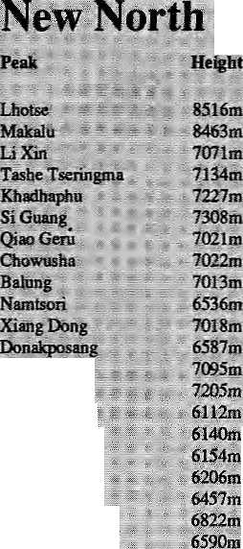
Haras
I Nobugangp
■■ Kiiattiiajopho ⁴ Shienti Luktse,
■■■ Lakuekaiigh ' Xiakangjian :" "1 s Saindinggangsar
! flUMineattd 2 kg ofjeaci. There j ire some 5000 traditional updrafi i ftilinS in th* Valley, each of which ■: produces about 31 of CO : I . ' Anntialfy, ^s well as 460 kg of
"porticulate. iitevkota estimates that the brick facitfrte and fcikis .:■ together consume at least 443,800
• tofKathmandusoil, ."'; '~ '; ; Devkou found that the < .*
,■ ^iipai C^inssnl Company V'amttal ; contribiitiofi was ?'680jt of 002, 401 of W>K, 201 ofSOx, 3720t ■■ I
cadmium, 49 kg of chrojnium, aid
"Hie^Tiriifer Corporation of Nepal alone supplies 25,2001 of juclw^od w Kitthmahdu. The total .ttHiSMal emissiojis Jtronj f;ueiwci5d boming is estimated at ISlQtpf, CO! 431 of NGx, 191 of SOx, 252
Cows, buffalos, :and other 6,9061 of

W
hite_{f}N^ial^isT)iis| llinging-open new |r«fcfc|tig ansW : thts a«th*onties'in^{i}'I5t^t ans going~
allTO.ut .opening TiiQiiiiialnif^aks '*
including
Some higii
the
Nepali side, and now may be attempted from the no&Eh* in
), Makaltt (M63m)
:Gasiri.:ShaEtkar>K
methane per year, while rice :w.
ptsddies pr6dfct& 102 ^g^xsr ye«r. After cows, can mrplari^ be far: • 'S^lyji^.; According feftevfcbtl, ~'~_ emisssion of air pollutants by. , i anoiLial landing and tafce-off al-thfe^ * airport in Safhm^ncfu produces''
hydrocarbon
s.Tstngri ^Tingrfc ^Tlngn! -Tingrii
-Tingii
■;Tingri::-Tingri Tingri⁸
Nimu
,t)jMnst Damshafig
^Jlsoqirt. .Nagqu
\\

s. ;»

M'.:. -%:-ftp\ \y--~- ^ jSf- -,..'■. *?iiS S^v- yiv... ™. :™... .„ '. ..... ...V..v

H1MAL -4?

BRIEFS
Pesticides Bury Badly and Burn Worse

;

I
n & godown belonging to Nepal's Agricultural Inputs Corporation (AIC), ntsar ■■: ■■ Amlekgiinj, sits a chemical rime bomb. Almost 24 tonnes of date-,. expired pesticides await their fate but Nepal has neither funds nor facilities so ensure their safe disposal. No one knows how irtanysimilar godowns are scatteredthroughout the ^Jimalays, prone to uhssfil. disposal, the ft, inappcopri«te reuse and all the attendantrisks of poisoning and pollution. Their Jitetory raises *eiious ethical questionsabout jthe sale,-use, distribution and disposal x>f higlity toxic chemicals from one. oouatty * to another, aftd'particularly from
The 1A jonnes.of: pesticide at ' the AIC warehouse are of the ' highly toxic arganocMorirre elm and can be safely destroyed only: by incineration at high temperatures. A plan, devised in 1991 by the AIC, Asian Development Bank (ADB). tJriited;Hations Development: ;.. Programme arid ANZDfcC ttdin New Zealand, sought so burn the pesticides in the kiln at the nem by Hetauda Cement Industries .; IiiiKited (HCI): It was aborted when environmentalist Shree Shah alerted ADB to the dangers of incineration.
itocmeration deiiianjds. :: special equqjment to feed the pesticides' — a little at a timer —£ into the hottest part of the kiln. 1. .1
of'effluent ■■■■■ ;- '■■■ M:*Jsu» that thereisnp 1 Mow-baskinto the factory and no Mrtbumt j^ticides released to the" atmosphere,, is essential. A stabile... temperature within the;k0rus .,, ,:..: rarucialif thepesttiad^ aie to...be : completely 'bupifc Partially burnt ;: pesticides can prodw^e subsiaiices nftbfe fosicthaa ttiestarting materiaL ■■■■■■ ■■■ - ■■■" " '. ^ ■ /i ■;■■ ...wjt^as vety-.aijiBiriiHg"; said
t andendrin are»r>ipe ffian DDT. They produce phosgene and hydrogen icWoride^ gases %hi# ■■ are highly toxic. Th^ would have : had to'(ilear an area of five : ; kilometres suitpundting the cement plant for art unspecified iimei- which would'ibe impossible iocarry Out".
■:- ■■■■ /Tolls'crea5tf.ADB's ■; * ■= ^ enVixoriJTient divisionresponded' jmaiadiateiy andditdied'the plan.
tonnes iwere
together and placed in a
store near Amlef^un|, fM sp the
remamiftg 96 tenpes of out-bf^
'datep|sMdes that the AIG f Z
discovered mite stores. Of this 96
tonnes,' 24 tonnes were ■.- ■■■■::. ■■■■■ ?■■ ^{v}
categorise4;as suitable for ; . "I
i %
ing" or burial. The first
fpjhe £ears?of such as Shah;
time from the US, tbIhfecfcthat--the 1991;:bMals; of the pesticides
poised liarsignificant..
ye£Hf the" dipiping sties were I i?iiwesr|gate4i'The:findm|Cn<»t... . .only.. JH^ify the#ars of labal rob-
reyea doable st^rlards between what!is:
L and the South. ' ! ". -,. ,:: ,: v: -:-Thb ^esbcides wfiice buried
Nepalgunj. The: Warninvestigated the burial at 5idaithauagar: artd? AirilekgunJ.TheSidiothaha^ir hutthe was apUbfig
health hazard. Ttfer| y/as. evidence of two" byiSils of which the Vifr October 1991 ,T 4
yere.unopened oontaiftefs 6f;; %uid organophosphates^int^t and ruptured: p^cjeejs o|f ungieide
treatments! Fifteen pife had feee% . i Was^;eyidence»of :
Smcetherii, the? ijjejias been-, unopened containers
but, again, the cleaii-dp appears tq havebeeh less |fnngeht p^y because i| was conducted in Llfopal, Aieportbylr^Americaii ■:■■
ctivesuitsand plastic *
disposable gloves" but ^protective footwearwas not OTpjafele,sQ '-labota-efsVeii?instructed tskeep : feet away from exposed prodvict aridrequired; to wash their i|ei _{m} af|er the "taslt was completed.'' It as difficult to irKa|roe.! American or HeV ^ajarid: pesticide disposal teams going barefbolr^eSause of
"footwear.^ :■■ ■■■■■ i-A» • ■■'■■ : ^ ... .. ,:. The mereury-c6:n£ain.i(ig> , i pesticides arid the ^ .tonnes of. ■ 'orgaiiochloriiie pesticides are now art in onestoie atAinlekgunjaiiid awaiting safe dispbSali. The American consultant is due to s retarrtix> Nepal befor^ tiie
the Nepalgunj site. Aa ADB ; reprfeseiitative gays'the Agency. '■■■ teas' [ftotaUy,qbliged lodealwith ^ iiie 24 tonnes of date-ejcpired ' " pesticiiJes Kiif is' stilT leisure Qf.... s
' When tte dust settles^' ^:' ₉
; may just Jt>e~ ". dumped*', he said. *' ".,

atteegivet
innovative, _{a}
Tiger i
A
pparently undeterred by: geographical isolation and the barrier imposed by the " Himalaya, Beijing is to create a special economic zone in Tibet. According to the China Daily, an economic zone could attract investment from inland provinces and foreign countries to Tibet.
But the visions of a Himalayan Guangdong — China's economic zone par excellence inland from Hong Kong — might be premature, and officials recognised that there was more than geography to overcome. Violent winter storms.
rudimefttaty transport, energy , shortages kad limited tn&fcets are significant barriers in themseMjs."; Tibet's regional government is ;.-. now adjusting land rents and taxation to lureinVest6rs_{Ts}the paper said.
! Several ne^jxirdsr trading-: : - postsaretobeopened,including: Buratig irv Ng^ci ,prefecftjre, India and China have ended 30 years ,o£ closure of the Siriorjndian border■* to Mlpw piSgrims and tourists to visit Burang-every year between f June and 30 September.
Meanwhile, Tibetans in exiles are viewing the whole affair"
:with;a jauridiiie^ eye> In their¹ yiew^ Beijing's is using ti&e economic zone idea just 3S a bring hi tuoreHan
Upcoming.,.
The annual South Asia Cbnfeiencf
at- the v University- of Wisconsin-Madison (Uiiiied States), whjich has always¹paid sjiecisfl attentioia to me Himalayanregion,isscfwduledthis; year for, 6-S Movember. The Conference provides a for^p^for Representation of abroad range of scholarly papers, which are chosen hy a programme committee from among alafge number of proposals submitted. According to a handout
Just receiyecl, thft committee givef "priof i^f- to new arid innovative research papers; , and new? ' participants in theGortference."This" year, it is- learnt, a paiiiel is beiiig organised *' to make research done in* the Tatai more visible in; the field of'; Kepal studies; the increasing ■ "i of the Tarai,ta "■ ■
l
on Nejpa^," "the panel organisers ate' seeking papets.ithat explore'the : nature of etbmcity, identity formation and conscious ness among the people of. the Tarai. ■ .Contact: Dept of Anthropology, University of Wisconsin-Madison, 5000 Lincoln Drive, Madison, Wisconsin 53706, United States. Fax:608-252-6123 '

44 H1MAL • May/Jane 1992

BRIERS

Oiiig and Svjjak;.iaKashmir; TaiAru and Tabm inLsdj&lj; t
|S,
nsost aliases In
Seabucfcthojn, a ^hrufe-tree tliat *; : cov|ldb| qf §noraiou^value *F M excitement of scientists who have studied^isjustified. ; ... ...... ...:. ...:
The uifemaiSonsi Centre for? iiiiBgf atwlMountain Bevelbpinenl ^ 1
C4nifmssiott of Ae'ihtefQ ■■ Union 6f Aj^inisf -^ssociadon
psychological drama being played fout between a tyrsuirjical jfathe*, a :
bf the iyaft.ef Sat^ajft Ray— >jh6 Vvqus'-a man of-ihe rriouri^ir)s mom than many of ys.^ ,.:: .. ... .
-Reita Raf GuriJng
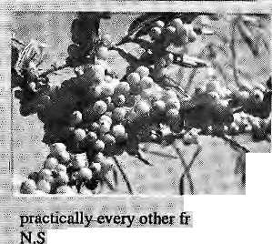

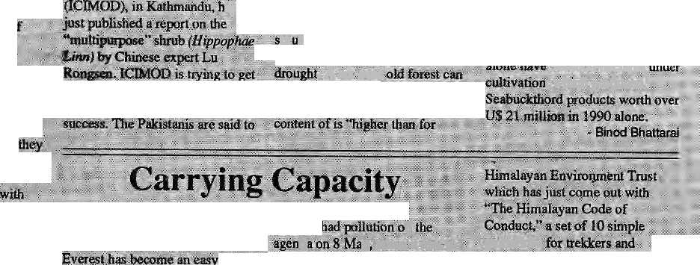

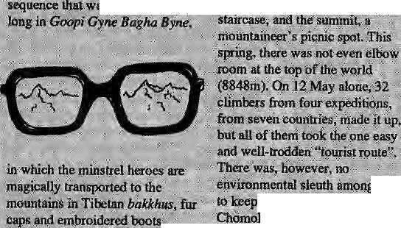
Ray of
B
qnib&y*s film producers and diiepiois have long : vulgarised'breath-takinglocales in Shimla, Mpssoorie, Xashmi^asd¹ g for melodisi iVi-.ic song-
^takers
; all oi r&Hi>'@,
Ray had & soft corner for; * tnouBtains. Tlxe }nis[inespows, wooded slopes, tagged;hiii-5( gushing sfer^uns^caseades/-all fed his aesthetic¹ appetite "aiiil :' he used.:thsnt well.
esploi|4ng the grandeur of -M^knang, ..Kakaw or Pokhara far escapist: absurdity *— desecratin nature'sf gift bf ifioUnijains. ,. -..-. ' ;: Satyajif Kay, who passed ■ away ,Ji). Calcutta .on-23 -April," i would have norte of-if: He'cpufel notbear ;t6';see jiature shorn
■i fhe:iri6uiitt|n|f tjiat moved him to ~ ..make jus bano«! film, Sikkinu. '":. i" shenot brijtoeation for a
s barely a lintaiite'

KanekenjuHgii, %$g% firs* o in colour, shot'

rnast^r*^ (^npo^hy for ■■ the-highraiids, Yet_{v}as always,-h£ '' vi^is caieful: not to use the teraiti'S' beauty Iojt its o#nisake; ^o^wptlring heman had to happen, and didiRay'iised the Iaiidsc4pe to

people-in tft tfiis case a Calcutta f amiiy out
» on 8 tenfe vadabion. The sokrriri: Or trees of Jtalpahar Road above
X)itrj(!eiing town,'the *Viow,sun,
all stand witness to the
"IVIu j|ipurp6s|Sliruh"
at theHimachalJ^radesh Science
t is |nown as^AjEHialito; Ashuk ^nd i"aH3riif Nepalf
afresdy aacted work ott the shrub.
I A-KcpalHorfiBter Wofkpig fdrT ......
IGMOT3 has started.
aK Ganrfaki.
s, Seafoackthloni
s to l;
a hectare can produce tip; . |.ts..
js Iiold soli, butaiscs fi initrogen at a mte ^I that of a ^yab^aapl^nt-the ■■<■ ■'■■ hijE) is ferdyiaiid can withstaad «sagm'i!leMipqjj:a|uips,an(d.! .:.:■...■.* .■ , A. sis-yeM 18 loses of fewbo'd pei V1^ip C ■."■
1LJ1AA) p
^y* when it met in ■ K^tpanda. Partiyjpants'agpfoye 4
■ ffloun|aips and trails;. aiietfo?etean ,.i^t areas {hat fea^e¹!^^!!^!^)^;^!!^ soiled. The "cam_,!uig capacity" of 'sm.regiorishould fe
|g|^
sajtctio&s tnusf be appjied against; tndividttais ancf prg^ika^oBs.«th^t*:: break existing environmental
Iheni
track. o|d^bris:;}eft on? ongma;-. ■■:■ ^ ' ■ ; ^ t was quite appropriate.
'■ r|gula^qns, the.Cominiission ' :: ./■decided. ~It -also Impressed concern
iprineipie *v«s b^| g ■:go^eMSiTisiQ44U131iiJ.es, *F?4cfees-ace.being ^ . sueh a maitnerfttat targei expeditions are now being

i ':: ■:';■ Indiairnio^titai^eer Mohan■■■■■: S.'Kihli, a CPiUHfii^sion¹ irtehsbier, ■

?, and Qther characters. *; henjunga, Sie rtiptijii|un app&a/anos only at the
time "cfeaai-up^xpeditions*' ... favoured by ftiffity f|6rthera.

. biconne a ftshioii to go clean up.. Everest. This Is r)oiiscr>se..Miieh better that the same money be used:by loedi cornritunitjes-tQ set lip permanent systems," « I Kohlii&Chairman 6f the.
uit,*: said . Jodha, anotherscientist at:':
WilJ''theSea|)uck];hprrilive,
ariodie^ muchrtouted miracle
3£©;OQ0 hectares ; which produced
will■:-wj]fcafietthe' spotlight is tiff? Titne "^ill^ teji, j)ui, ■i|t is frue that in RiKsia and Qhuta, the stjnib provides products ■■■■■ ^{v} ranging ftotii wifief to.
guidelines moantaiiieexsf to "hd
the tiniqtie lenyiroHment ajndl ancient culiu^

' Kbhliiic|jes |}<|nsure..,.. , .y/jjhilieCo^e'by a* we|l ts . approxiiiiateiy 500 a

«^s^) "We-'w31 'ge ^ of triy|l operatois.affd (hen iise different methbds to eoriipliaince'*(

that show & disregard ft^r yirotiriienE, wejwill ^suggest wsuance of wattiaig^

For copies of the Code,jmte to: The Hirnalayan Environment ' Trust-,at 82 Saihik F^rfinS, Mew Delhi ;ltp$62.

May/June I992.HIMA1, • 45-

KNOW YOUR HIMAL

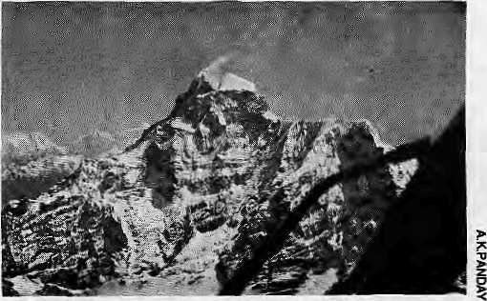
Flying High
by Arnico Kumar Panday
Pilot's viewofGauri Shankar during RAIOO's return lag.
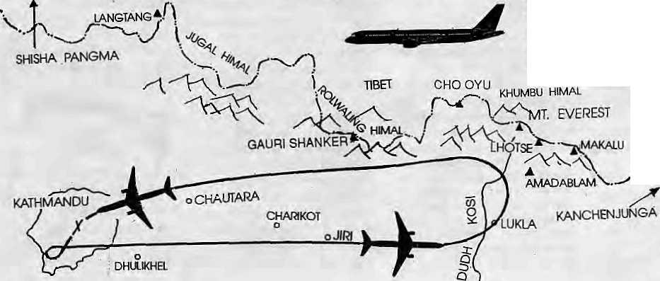
inceits inauguration in 1968, RA 100_{t} the ^{<I}daily"Mountain Flightof Royal Nepal Airlines, has been a major Himalayan tourist attraction. For U$ 99 you can fly along and above the eastern Nepal Himalaya for a bird's eye view of Chomolongma/Everest/Sagarmatha.
The typical flight departs from Tribhuvan International Airport at 7 am. It flies a right-turn climbing loop over Khumaltar, Chobar, Kalimati, Kupandol and Patan in the Kathmandu Valley, and heads eastwards over Dhulikhel towards Chahkot and Jiri. The Himalaya unfurl on the plane's left: from Langtang and Shishapangma (8016m) to JugalHimal,Lapchi Kang, Ru! waling Himal, and the Khumbu Himal. Passengers are invited to visit the cockpit, where the windows are cleanest and visibility is best. Everest can already been seen from over 100 km away, rising above all other peaks.
After exactly half the flight time, the plane reaches the Dudh Kosi Valley. It starts a wide leftU-tum flying northwards, bringing into close-up view the four 8000m peaks of Makalu, Lhotse, Everest and Cho Oyu. Around Namche Bazar it begins to head west, skirting closely past Karyolung (6511 m) and passing the prominent Solu peak of Numbur (6957m) at a distance of less than two kilometers. It then turns towards Gauri Shanker, flying past its twinpeak. By then the plane is already descending back towards Kalhmandu. Chaduk Bhir/Chhoba Bamare, the Tin gs ang Pass and the ridge-top town of Chautara pass by the window. ;
It makes a difference whether you get to sit on right or the left side of the plane. On the left, the mountains are visible during the out-bound trip. Excitement mounts as they draw nearer. Though Royal Nepal maintains that there is no difference, the right side, facing the mountains on the way back, ultimately offers the better
view. When visibility is good,
Kanchen-junga (8586m), on
the Sikkim border, can be
seen from the right side as the
plane banks north ward dm ing
the U-turn. Because the
aircraft flies 20 km further
north during the return trip,
those on the right get more
close-ups while flying over
Dudhkunda Glacier and the southern edge of the
Rolwaling Valley. Karyolung, Numbur,
Menlungtse and Gauri S hanker loom particularly
close. Khumbu Himal is a special attraction:
instead of a linear chain, the passenger is presented
with an intertwined mass of mountains, ridges
and valleys. Right side passengers also get a
glimpse of the glaciers and plains of Tibet
Though very impressive, the passenger's close-up experience with the individual peaks is brief, Numbur'swuth face fills the window for barely 30 seconds; me two peaks of Gauri Shankar switch places in very little time. The U-turn above theDudh Kosi takes less than three minutes. So much is seen during so little time.
Depending on the number of passengers, the Mountain Flight is carried out with either the 44-seater turbo-prop HS 748 "Avro", the larger Boeing 727 jet, or the even larger and more modern Boeing 757. The route is the same; the Avro takes one hour and climbs up to 19,500 ft (6000m), while thejets fly it within forty minutes at 25,000 ft (7600m). On the Avro, the bulbuous turbo-prop engines tend to obscure some of the view for seat-rows Two through Six.
Royal NepalhaskeptRAlOOonits schedule for nearly a quarter of acentury now. One winter afew years back, an Annapurna Mountain Flight was introduced out of Pokhara, but it did not attract enough passengers and was discontinued.
Plans for a one-and-a-half hour jet flight from Kathmandu, to take in the Himalaya from Annapuma to Everest, never got off the ground. Only Royal Nepal's "classic" flight to Everest has endured. Now since mid-May 1992, it has had private-sector competition. Nepal Air Charter, a new company, flies its German-made Dornier aircraft on a mountain-viewing flight up the Imja Valley over Tengboche to Dingboche. In India, too, a private airline is operating sightseeing flights in the Himalaya.
"The Himalayan should not become another Grand Canyon," cautioned an American in Kathmandu upon learning that mountain flights might proliferate. He was referring to the congestion of sight-seeing aircraft around the Canyon, in Arizona, which creates considerably noise and air pollution.
Royal Nepal's Mountain Flight provides a unique experience to see the snow peaks of Nepal. Except for the engine noise and occasional air-pockets, it resembles watching a short documentary movie of the high Himalaya: purely visual. It is flown by travellers in a hurry, mostly Europeans, Americans and East Asians. On one recent flight, half the passengers were Indians— incidentally they were all given boarding cards foT seats on the left side of the plane.
But no matter the swiftness with which it is all over, and no matter that one may have a big engine blocking the view, Royal Nepal's Mountain Flight does not fail to fulfill its one main objective: the passenger returns home able to say "I've seen Everest from a distance of less than 14 miles." In fact, the plane takes off only after confirmation that the mountain is visible. At the end of the flight each passenger is given a certificate stating: "This certifies that
is a friend
of Mount Everest
(Sagarmatha) by
virtue of participating
in the daily mountain
flight of Royal Nepal
Airlines." k

46 HIMAL • Msy/June 1992


Remember! Remember!! Remember!!!
MANDALA BOOK POINT
for
Scholarly Books on Nepal, Tibet, Bhutan etc. Latest Trekking Books & Trekking Maps
Mountaineering Books Guide Books of all Countries
- ™^^- Kantjpath, G.P.O. BoxS28, Kathmandu. Nepal, Tei: 227711
Tlx: 2685 NP MANDALA, Attn: MANDALA BOOK POINT, Fax: 977-1-227372 NP NATARAJ, Attn: BK PT.

WE ACCEPT
AMERICAN
EXPRESS
VISA
MASTER CREDIT CARDS

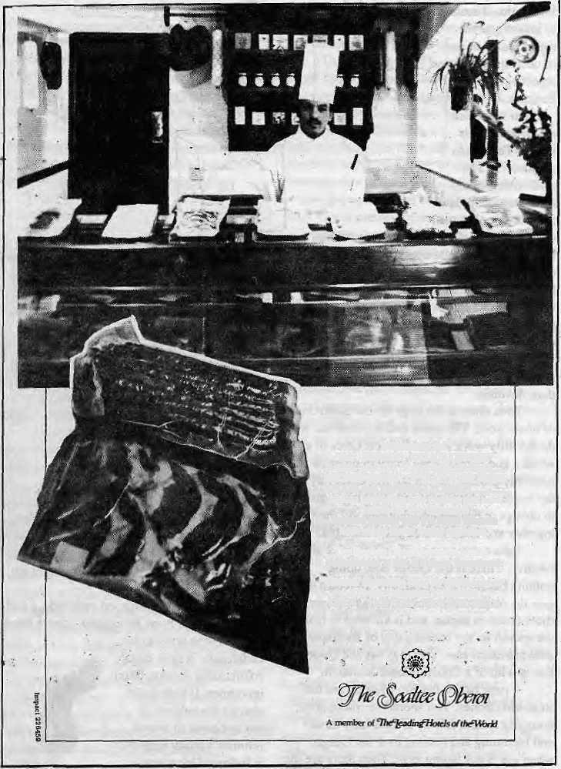
Introducing the "AL FRESCO DELICATESSEN"
a wide selection of speciality products
SMOKED BREAST OF DUCK, HAM, PRIME
BACON and PAPRIKA LYONNER
Makes Interesting cold platters and toll¹.
buffets for any occask>nl
Vacuum packed with the latest German
technology under Swiss expertise.
The Soaltes Obsroi presents quality Delicatessen at the Al Fresco Restaurant.
"Contact Executive Chef forassMance at
Z7J-55O Extension 613&6256 OPEN 1100HRSj, 230OHRS.DAILY
97, Tahaclml, Kathmandu,.
Aid in Nepal's Development How Necessary?
Proceedings of a panel debate.
Available at: UDAYA - HIMALAYA NETWORK
(Tel: 410216) or leading book s&res. Institutions NRs 40 Individual NRs 20
Show your support!
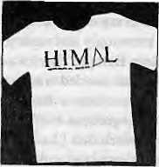
Get Yourself a Hlmal T-shirt.
Himal logo in front, Nepali Himal \ogo on back. Cotton. Assorted colours. NRs 120. Tel: 523845. Patan Dhoka, Lalitpur.
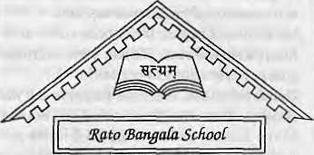
%fr? fycmgaUi School seeks qualified
graduates for teaching positions. There are vacancies for Classroom Teachers up to Class V, as well as
for a Nepali Teacher. Lack of
teaching experience is not a bar, but
applicants must have aptitude and
eagerness to learn.
Tel: 522-614 PO Box 42, Patan Dhoka, Lalitpur
A Center cf Excellence in Kathmandu.
May/June 1992 HIMAL - 47

Abominably Yours,
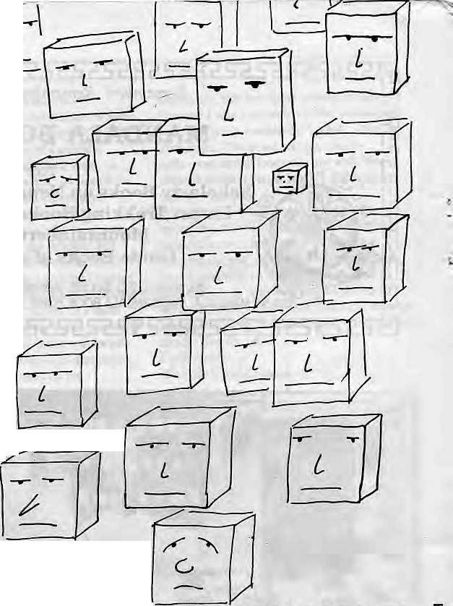
What would you do if Blockheads arrived at your gate bearing a petition? It happened to me. Disregard for a moment why they preferred to call on me rather than on the King, the Prime Minister, the Chief Justice, or the Chief Conservator of Forests. There they were at my cave entrance, shivering in the pre-monsoon gale. Ten thousand or more saw I at a glance. Blockheads, as far as the eye could see. Such a monotony of shapes and expression as you have never seen.
The petition contained a plea for action against a strange new pestilence called Affirmative Action that was spreading its tentacles across the "homogenous Nation-State of Blockland." Apparently, some of the lesser blocks had been carried away with visions of one block one vote. Crushed for too long under the weight of the heavier blocks, they wanted some wriggling space, and the freedom to take on attributes of spheres, coneheads, cylinders or just lumps. The Affirmative Action virus was responsible for these awful ideas, said the petitioners. How to maintain the plainness that is so prized in Blockland?
Clearly, the Blockheads were a bit disoriented, what with every expert they interviewed sighing knowingly and saying, "Ah, just like in Eastern Europe." Buckwash! All that my cuboid visitors needed was some political priming, so I gave mem a dose of my "Nature is Unfair and Inequitious and That's All There Is to That" speech that I had prepared for a seminar that never took place because the country of venue had disappeared due to ethnic strife.
Nature, science and the Brahmanda itself are in favour of pecking orders and hierarchies, I began. It has been survival of the fittest from the start. If there were affirmative action, reservations or quotas in Gondowanaland, someone forgot to tell me about it. When the Neanderthal lost out to the Homo Sapien, there was no civil rights panel to deliberate on the matter and demand special outreach programmes for the Neanderthal, which is how, following the Law of Nature, they extincted themselves.
Vegetable, mineral, animal, spiritual — all have hierarchies and all have discrimination. A big cauliflower will soak up so much water that the next one, of the same gotra, will be shrivled with thirst - too weak and intimidated even to tattle to the gardener. And yet the seasons come and go...
A millionth of a second after the Big Bang, sub-atomic particles were already arranging themselves into a hierarchy of energy levels. Some quarks were more equal than others. Favoured electrons got a choice of
nuclei to orbit around. There was a disgruntled proton here and some neurotic neutrons there who tried to fight for equal rights, but Brahma's goons took them away and turned them into microwave background radiation. And there was no Amnesty
International around to investigate the rights violation and issue a sharply critical report against Brahma.
Much later, man made gods in his image. The Hindu pantheon of 330 million deities did their best to emulate the anti-social human characteristics of the time. Some gods had high standing despite consistently showing a cruel, autocratic side to themselves. They even had hugely popular temples with char dham status dedicated to themselves. Other gods (and I do ribt want to name names here for fear of being denied entrance at the Pearly Gates when the time comes) have.become upwardly mobile, as mirrored in the economic status of their devotees.
Then there is the large divine underclass of lesser gods. The meek and acquiescent, who do the dirty work around heaven. Once in a while a god comes along to try to unionise the heavenly proletariat, but the Big Gods buy off the bosses and it fizzles out Nothing is going to change inheaven until humans get their act together and learn to set a good example.
Take a day or two off and observe any beehive. There is the Queen Bee, doing nothing but laying eggs all day. In return she gets the respect of her citizens, the choicest rhododendron nectar, and is allowed to make the speech on the opening day of Barliament. And not much else. You may say the Queen Bee is a bit of a Constitutional Monarch.
A rung below the Her Majesty are the Brahmin Drones. You should see these guys, lounging around all day in their holy thread and humming and fussing over the Queen when she is not laying eggs.. Then there are the Kshetriya Bees, forever sharpening their stings and keeping them aerodynamically trim. Hives
rarely go to war, and rumour has it that the soldiers are actually used for internal security and peacekeeping operations. The Vaisya is the Trader Bee who flies back and forth tirelessly between Hong Kong and Beehive, bringing back golden pollen.
Despite the deep caste divisions, the hive is a harmonious place. Nothing like the Los Angeles riots ever happens here. A Kshetriya might accidently sting a Sudra, but it gets hushed up before you can say honeybee twice. Once in a while, a bunch of politically frustrated citizen-bees may try to question the reigning order and set fire to the combs, but the guards soon take care of them. This sometimes forces dissident bees to swarm and flee to neighbouring hives and seek asylum. But by and large, the beehive has settled to a kind of social equilibrium from which Vedic designers of the Caste Society probably got their inspiration.

So Nature is firmly on your side, I told the delegation from Blockland. Ignore those upstarts who want to be coneheads. If they shout Affirmative Action, feign ignorance. If they insist, change the subject. If worse comes to worse, promise a study tour that is followed by action-research.

48 HIMAL
May/June 1992
r

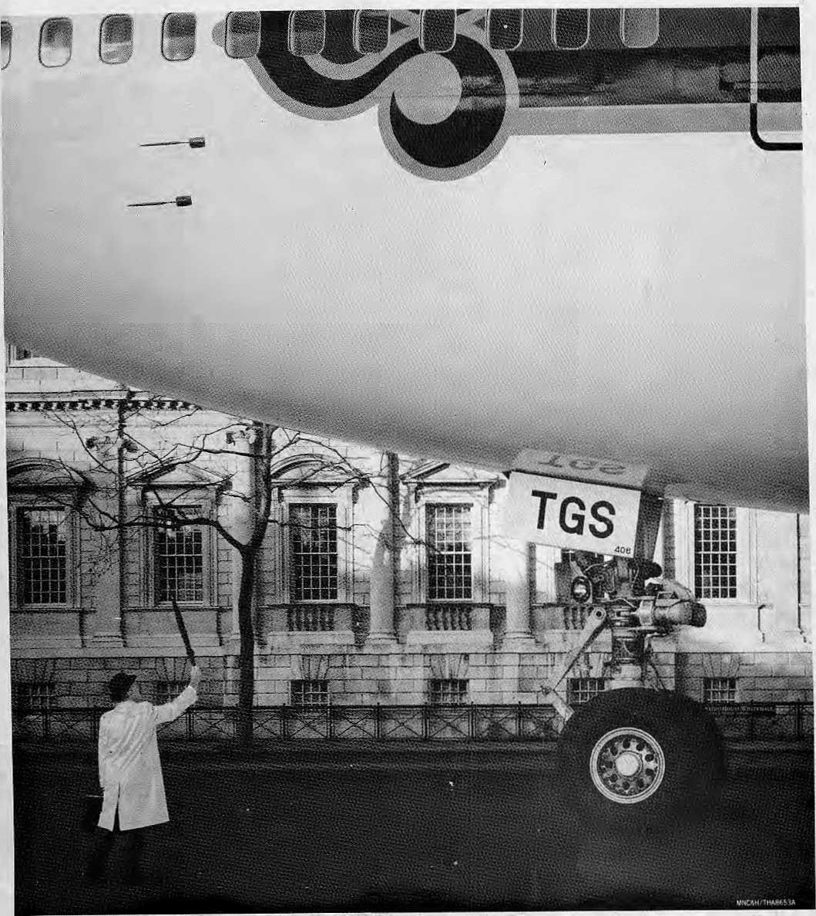

THAI NOW TAXIS INTO LONDON SEVEN DAYS A WEEK.

Flying to London? Hail one of our magnificent new 747-400's. Now Thai takes you there from Bangkok every day of the week with Royal Orchid Service all the way Via Delhi on Mondays, Wednesdays and Fridays. Via Amsterdam on Tuesdays, Thursdays and Sundays. And on Saturdays we fly non-stop _{c}JSjp|' to London. Thai. Centuries-old traditions. Innovative thinking. State-of-the-art technology.'!^)
For information please contanct Thai International, Kathmandu or your Travel Agent.

Regd. No. Lalitpur 65/045-46


\
Northwest makes it easy to go to America. With a choice of 8 gateways. And connection to 200 cities beyond.
Choose a connecting city that suits you best: generous free flight plan there is.
General Sales Agent in Nepal !
Ma I la Treks,
Ma Ha Hotel Arcade,
Kathmandu, Tel. 418 389
Bangkok, Hong Kong or Singapore,
Northwest has daily 747 flight via Tokyo or Seoul straight to the U.S.A.
Be sure to ask about WorldPerks, Ilie most

P

NORTHWEST MRMNES
From 12 cities In Asia we make it easy to fly to over 20& U.S. destinations,

