
HIMALAYA -N* MAG A Z I N E
NRs 20
IRs 15
Nu 20
U$ 6
DM 9
Sep/Oct1992

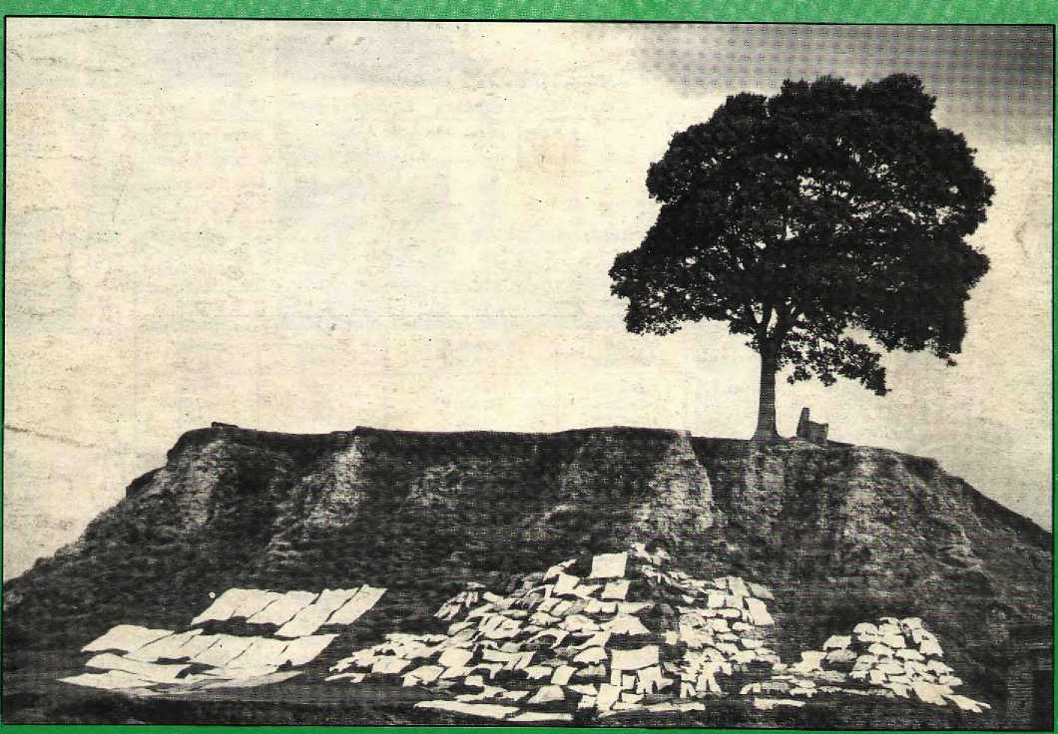
HE STRESS OF UHANGE
Ambivalent Anthropology • False Geography Led by Ladakh • Up-Country Bandipur • Himachali Riches



aircraft-
Our German Dornier -
•f has air conditioned cabin. + has more comfortable seats,
+■ has individual windows for better mountain viewing. + has weather radar and modern avionics.
+ Our flights are punctual & reliable.

■ AUTUMN SCHEDULE ■
EFFECTIVE FROM SEP 16 TO NOV 15, 1992
SECTORS |  | FLT NO. | DAYS OF OPD. | ETD | ETA
KTM KTM | MTN MTN | NS-3OO NS-4OO | DAILY  DAILY | 07:00 ,_ OS:2O | 08:00 O9:2O
KTM PKR | PKR KTM | NS-3O1  NS-3O2 | DAILY DAILY | OS; 45 1O:4O | .10:15 11:io
KTM BHR PKR BHR | BHR PKR BHR KTM | NS-303 NS-314 NS-313  NS-3O4 | DAILY DAILY DAILY DAILY | 11:35 12:25  13:15  14:O5 | 12:OO 12:5O 13:4O 14:3O
KTM BIR | BIR KTM | NS-31 6 NS-31 S | DAILY DAILY | 14:55  1B:1O | 15:45 17:00
KTM JMO PKR JMO | JMO PKR JMO  KTM | NS-3O5 NS-312 NS-311  NS-3O6 | 4, 5, 7 4, 5, 7 ■4, 5, 7 4, 5, 7 | 07:O5 O8:15 09:00 O9:45 | O7:5O  06:35 O9:2O 10:30
KTM MEV | MEV  KTM | N3-323 NS-324 | 4. 5, 7 4, S, 7 | 11:15 12:05 | 11:40 12:30
KTM  JUM KEP JUM | JUM KEP JUM KTM | NS-317 NS-319 NS-310 NS-318 | 5, 7 5, 7 3. 6 3,6 | 13:is  15:OO 14:15 15:15 | 14:35 15:35 14:5O 16:35


_J EVEREST AIR

3rd Floor, Singapore Aklines BIdg., ?. O. Box 482, Durbar Marg Kathmandu. Telephone : 22941 2, 222290, Fax : 226795

Kathmandu
Tel.: 228392 222290
Pokhara
Airport Tel.; 21883
Bharatpur
Prlthvi Chowk Tel.: 21093
Bfratnagar
Mahendra Chowk Tel.: 22227. 25345
NepalgunJ
Surkhet Road Tel.: 20035

INSIDE...

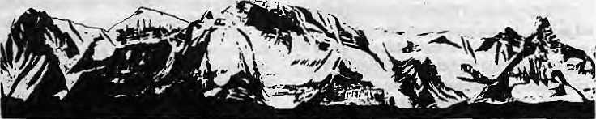
MAIL
Nepalayan Feelings
As a sporadic reader of Himal, I find that the magazine of facts and feelings has been straying more towards the latter. Whether it is immature authorship or editing, certainly it has been continuously losing its diversity and narrowing its horizons. Moreover, it has become a Nepalayan magazine, which I am sure no sensible reader likes, I think there is still time to save Himal from being another cuddly-bunny magazine. With reference to the Ethnicity issue (May/June 1992):
"Pulling down the hedges", used in the summary of the cover article by Prayag Raj Sharma, is bad analogy. Hedges are part of a garden and your usage is sure to hurt hedge lovers (at least in the West). Perhaps 'weeding' would have been better? I would not have given so much space to this formula article (statement of a general problem with no conclusion). Nor so much space for Jan Salter, though I am aware of the liking of your Western readers for this type of story.
I think the issue of ethnicity is more economic than political in nature. They have been politicalised for vested interests, as pointed out by the non-Nepali authors. The elites from among the politically less-represented ethnic groups of Nepal are the main promoters of this tendency. I happened to encounter one such elite member of a Mongoloid ethnic group. He hated Bahuns for having dominated them, etc. But he would not let his food be touched by a person from an occupational Hindu caste. He was also given to expressing his hatred for the poor and worse-off, while he never shirked from flattering the superior Bahuns.
The ethnicity issue concerns us all. If they have positive concerns, the neo-elites from the heretofore politically less-represented groups need to go to the people and help develop the economic base before they highlight their malfeelings. They must strive to retain their identity (if they would like to) without undermining social integrity. Others must realise that if the whole society cannot move together, they will lose the most.
Your issue, it seemed to me, missed
giving a voice to the real Bahunvadi. The Bahun authors do not seem Bahunvadi. In fact, you got anti-Bahunvadis in different scholastic disguise. For unaware readers, therefore, academia has been misrepresented.
The reason I am concerned is that there are some racial qualities that are not easily transferable. By "the time any ethnic group achieves what it wants —■ what the 'superiors' have been enjoying — it will not be what it was supposed to remain.
TeekaRamBhaitarai Cetere for Agro-Ecology and Devetopmem, Kathmandu
Mustang Treasures
I am a bit confused by the messages conveyed in two articles that appeared in the Jul/Aug 1992 issue of your magazine. "Long Haul Home for Stolen Nepali Idols" points out that Nepal does not yet have a comprehensive inventory of its antiquities, a fact which makes it difficult, if not impossible, to track down and retrieve the country's stolen cultural property. On the opposite page, in "Free-for-all in Lo Manthang", you criticise an unnamed Western journalist for his suggestion that the sacred art of Lo Manthang be photographed, although he points out that having such photographs would help Nepal trace and recover stolen cultural property.
While I have very mixed feelings about the opening of Mustang to tourists, I can't hejp but think that, as long as the area is open, the Government and others concerned about the theft of Nepal's cultural property should take advantage of the presence of journalists and photographers, local or foreign, to document these treasures. As the foreign presence in Mustang increases, so does the likelihood of theft. What is to be done?
The fact that Mustang will be under the jurisdiction of ACAP is commendable — as long as the area is to be open, there is no organisation better equipped to work with the people of the region as they try to deal with conservation, tourism, and other issues. However, the article does not mention what steps ACAP and the area's residents are
COVER
9 Stress, Strain and insults
by Dipak Gyawali
A more holistic view of the environment affords a
better appreciation of change in the Himalaya.
14 Road to Riches, Road to Doom
by Chetan Singh
Himachal has withstood the surge of tourism, but mineral exploitation poses a more serious threat to its survival
16 Up-Country Bazaar and Changing Forces
by Stephen L. Mikesell
Himalayan bazaar towns always stood for
change, but change was not always for the
better.
19 Darjeeling Beneath the Cosmetics
by Marcus Dam
A Darjeeling-born writer is saddened by the
changes he finds on returning to his roots.
20 Real and False Geographies of
the Himalaya
by Nigel J.R. Allan
Geographies have always been created
according to trie needs of the day.
23 is Lo Manthang Ready for Electricity?
by Bikash Pandey
The debilitating effects of development hype.
FEATURE

31 | Anthropology Still Finding
 | Its Feet
 | by Pratyoush Onta
 | Anthropology in Nepal struggles for a
 | unique identity.
DEPARTMENTS
26 | Briefs
30 | Himalaya Mediafite
34 | Voices
38 | Review
40 | Abstracts
44 | Abominably Yours
Cover: A hillock, pipal, shrine and drying laundry at the outskirts of Kathmandu town. The more things Changs, (he more they remain the same. Or do they? Picture by award-winning United Nations photographer John Issac.
Himal {© 1988) is published every two months by
Himal Association
PO Box 42, Lalitpur, Nepal.
Tel: 977-1-523845 Fax: 977-1-521013.
ISSN 1012-9804, Library of Congress Card
Catalogue No. 88-912882.
Subscription information overleaf.
Printing: Jagadamba Offset. Tel: 521393.
(Page make-up by Kiran Shakya)
Sep/Oct 1992 HIMAL • 1


yms No,5 : Scjt/oct 1992
The Abode efGc^s, Kingof Mountains, Himalaya
You bound the oceans from
east to west A- northern yardstick To measure foe Earth
Kalidasa (KumnfaSwnbkava)
Editor
Associate Editor Consulting Editor Managing Editor Staff Writer Photography Administration

Kanak Mani Disit • 'Omar Sattaur KesangTseten Sumac Basnet
Manisha-Aryal Bikas Kauniar Balram Sharma -P rakrit i K ar in ac h ar ya
Subscription Rates
Send agift subscription Id a friend of colleague. Do;f>IOT send/cash in mail.

Individuals | 1 | Year | 2 Years
Nepal | N&s< | 150 | ,200:
India | IRs | SO | 150
Bhutan | Nu | 110 | 200 ■
Oiher S. Asian Countries | US | 12: | 20"
Getmany | DM' | SO | 90 ;■
Elsewhere | m | 25 | 45
Institutional
Nepal |  | 360 | 550
India | ■IRs | 200 | 350,
Bhutan | No | 300 | 550,
OtherS. Asian Countries | m | 25 | 45
Germany | DM | 70 | uo
Elsewhere | \}% | 45
Send all subscription orders .and
correspondence to:
Soulh A-sia S P.O.Jiox 42, Lalitptir; Nepal"(iei
977-i-S23845JEsa977-[J2UH3X.or ! Central News Agency, 23/90 Conaaught '
a^s\ New Delhi 110001 .tapuii : Akio Horiuchi, P.O.Box?,Kiyosc,
folcyo, 204 Japan Australia > India Ban, 12 NMolk St.f Psddington'
2021, Sydney, Australia North America 1 AhupPahari, 134 East Walnut,:
^{f} Lancaster, PA S7602, USA Europe; Durga Press (HIMAL), Luitputdstn 2Q, W-8036. Hemching, Germany .
■
Helene Zjngg, Tanneriweg IS, Cl«037, Guemiigctij Switzerland
considering or taking to deal with the possible theft of cultural property. Is this matter any less important than environmental conservation and responsible tourism? I think not.
If the people of Mustang are made aware of the fact that the opening of the region increases the likelihood that cultural property will be stolen and then choose to continue the prohibition against photographing sacred artefacts, there's not much that anyone can do. On the other hand, if they decided that these artefacts should be documented, why not take advantage of the presence of photographers to undertake this work? Writers and photographers, both local and foreign, are going to benefit from Mustang one way or another, just because the region is now open. So why not use them? Their photographs can be part of the documentation process, one which could help save Mustang's sacred artefacts.
Even if the unnamed journalist is not altruistic, his suggestion shouldn't be rejected out of hand. Useful ideas can be found in all sorts of places, even in reports that might be regarded as "alarming" or "Machiavellian".
5. Limbu
PO Box 4365
Kathmandu
Floods and Forests
I am afraid the review in Himal (May/Jun 1992, by Jayanta Bandyopadhyay) of my review was not quite on the nail. My original review of the State of the Indian Environment Report No.3, as carried by Sanctuary magazine, noted that
., .after years out of the environmental limelight, CSE, in trying to grab quick attention, has slipped on a self-positioned banana peel... If (the editors) arc to be believed, deforesting the Himalayan might just be perfectly in order. ..if only no human s lived on its slopes...
I have gone through the 167 -page report twice, very carefully. And I can understand, but not condone, the editors' twisted logic which suggests that deforestation in the Himalaya does not cause serious flood problems in the plains. In the view ofthe authors, in receni years, toomuch focus has been paid to deforestation and its ill-effects.
Note to Subscribers
European subscribers please note new subscription information at (eft. Those who have been serviced by Ludwig DeBuck henceforth please contact Durga Press (himal) in Herrsching, Germany. North American subscribers please contact Anup Pahari in Lancaster, Pennsylvania. We have taken specific steps to enhance prompt and secure delivery ot Himal overseas. Do write to us if your copy continues to arrive late anoYor damaged.
Developers, planners and even environmentalists have paid inadequate heedto the issue of managing floodplains... It is, apparently, to draw focus on the floodplains that the editors expressed their extremely subjective opinion) which even flies in the face of their own data.
No one in his right mind would argue against the necessity to leam to live with floods and to improve the development patterns in the floodplains. But surely this does not mitigate againstoneofthemosteffective,most inexpens ive ways available to humans 10 control floods, i.e. through the protection of Himalayan forests? Besides, the idea of managing floodplains wisely, which is virtually all that CSE (quite correctly) asks for in its latest report, is nothing new. What Goldsmith and Hildyard staled seven years ago (in their epi c work 77ie Soc/a (<W Environmental Effect of Large Dams) vi rtually sums up what the Third Citizen's Report presents as a 'new' revelation.
In belittling the effect of deforestation on floods the authors ignore the one factor which can mean the difference between life and death in the event of a flood — time. It is a well-known fact that even an hour or two between a warning and the actual flood can save thousands of lives. What forests do is to staunch the rain, particularly the initial downpour. This slows the velocity of the runoff and can provide crucial extra time for people to climb to s af ety... The CSE report f orgels that forested slopes add to that edge.
(The) voluminous and meticulous data collected by (the editors') own researchers point out that over 44,000 km of road construction in the Himalayanhas resutlted in between 1,760and 5,520 million cubic metres of debris! Just this one effect of deforesting Himalayan slopes must surely result in a devastating amount of sillation and consequent flooding in the plains. Moreover, it defies logic to suggest that the combined effects of the timber industry, mines, dams, fuel and fodder extraction and terrace fa mi ing on unstable slopes constitutes no more than a 'minor' effect on siltation and floods downstream.
What tops all of the CSE's sloppy conclusions is the fad thai the report deals with the emergence ofthe Himalayan ranges on a geologic time span, while it judges the effect of deforestation on a relatively insignificant human time frame. Nowhere, for instance, was I able 10 detect any attempt to predict the consequences of deforestation on hill stability over a span of say, 50,100, or 10,000 years. Yet, plant communities have 'conspired' to control surface erosion in the Himalaya for millions of years.
The people of ihe Himalaya will probably never read ihe CSE report. They don't need to... All in all, the Report has been a great Himalayan Blunder on the pan of the CSE. In try ing toclarify what they perceived to be environmental myths, the editors merely succeeded in creating one for themselves.
Bittu Sahgal
Editor, Sanctuary magazine
Bombay
Editorial note: For lack of space, we have published only excerpts of original Sanclua/y review sent by Sahgal.

2 HIMAL • Sep/Oct 1992

MAIL

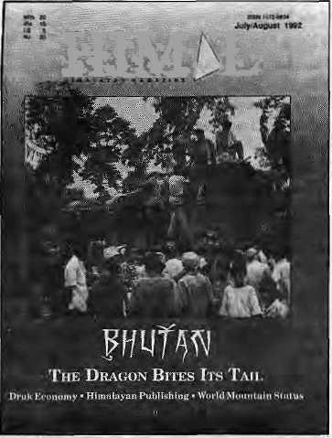
MML

Himal Prized
The two annual volumes of the Nepali Himal which you have brought out not only provide much-needed information but are also helping to catalyse public action through awareness of development and environment issues. Our organisation, which stages activities for school children and local youths in over 18 districts of Nepal, is also finding that the Nepali Himal is the most appropriate prize to give out in various competitions that we organise. The recipients cherish the volumes. As more and more schools, youth groups and colleges organise essay competitions, poetry meets, debates and oratory competitions on contemporary issues, we would suggest that the organisers similary think of using Nepali Himal as prizes.
Anil Chiirakar
ECCA,
Lalitpur
Selfish Sentiments
Kamal P. Malla's article "Bahunvada: Myth or Reality" (May/Jus 1992) is overflowing with dogmatic views, prejudiced arguments and, above all, deeply bitter sentiments. Throughout, he is concerned only with the so-called oppression of the Newars, implying that Newars have been the most affected victims of Bahunvada (if such a thing really exists). Malla completely (and perhaps conveniently) forgets the plight of the Tamangs, Gurungs, Tharus, and many such genuinely backward groups, thereby creating a feeling that the article is merely the voice of the Ncwari elite.
Imposition of Sanskrit, in my opinion, is not "naked Bahunvada" as Malla suggests. It is human selfishness. Changing times have caused certain Acharyas or Shastris to realise that they can well be forced into extinction if they do not come up with some bright idea. And what better way to raise the market value of a Pandit of Sanskrit than to open a separate {and no doubt wasteful or unnecessary) Sanskrit University and to cj-y "Sanskrit for All"? This is not Bahunvada. It is plain old selfishness not unlike, in a broader sense, the cries of a Bhindranwale in Punjab or a Milosevic in Serbia.
Malla also says that the Newarof Kalhmandu today feels like a "displaced Nawab of Lucknow after the loot" and "alien in his own home". What does Ma Ha mean by
"his own home"? An academic like Malla should know that the Newars (originally known as Naiyars) had first come to Kathmandu with Nanyadev of Simroungarh and that many other dynasties ruled the Valley before them. Kathmandu was not discovered by Newars,
Malla's claim that the headjong rush is "robbing Newars of their jobs and open space, confining them to the slum areas of Asan" is baseless. What Malla calls the slum areas of Asan are, in fact, among the most valuable urban property in the whole of Nepal, and the Newars residing in these areas are much better off than most of Nepal's population. Parbates do not own property in these areas simply because they cannot afford it!
As to the claim that the Newars are being robbed of their jobs, this sounds more like insecure whining due to increasing competition. Talking of robbing people of their jobs, what about the Madhesiyas who constantly face growing competition from hill people (including Newars) migrating south by the thousands each yeiic, robbing them of their jobs and living space? And what about the Sherpas who, until recently, monopolised the market for trekking guides but, of late, are threatened by the invasion of other ethnic groups into this lucrative profession?
Does the Jyapu whose vegetable fields are being usurped by concrete structures know what Bahunvada is? Does it matter to Hie Tharu servant girl whether her masters are Bahuns or Newars? Docs the caste of her customers make any difference to the Tamang girl who sells herself at Ratna Park in order to stay alive? The six-year-old boy in the neighbourhood tea shop washes dishes and serves tea to Chhetri, Newar, Bahun and
Thakuri alike — from six in the morning till ten at night. All these persons are the real victims, not of Bahunism but of selfishness.
This battle between the Bahuns and the Newars, both privileged groups, is overshadowing the plight of the real victims of a corrupt system. Leaders like Ganesh Man Singh and Krishna Prasad Bhattarai (and scholars like K.P. Malla) belong to Nepal — not an ethnic group, and it is indeed disheartening to see thai such people have fallen prey lo selfish sentiments. Hridaya Bdr, Limbu Jawalakhel, Lalilpur
Inflated Sales
Although we appreciated the article "Slippery Slopes of Himalayan Publishing" (Jul/Aug 1992), the statement that our yearly turnover is "NRs 35 million" is false. We do not know which figures were tossed around in the interview, but it seems unlikely for Rama Tiwari to publicly discuss sales figures, especially ones that do not truly reflect our sales volume. Perhaps that is a figure or goal that, in future, with the aid of publishing, we would like to achieve. The only true and accurate figures are those documented and reported by our book-keepers and accountants employed to audit our records and prepare our tax statements.
hi the concluding paragraph, you quote Mr. Tiwari as saying "once I die this (bookshop) will also die," We understand that most businesses revolve around a man (or woman) with vision or at least start off that way and lead to a certain direction. Certainly, if Mr. Tiwari dies, there will be changes in the business, but we do not believe there will necessarily be a deceleration or death of it Our partners, investors and financiers would hope not. Mr. Tiwari would also hope not, even though at times he is frustrated because others are not similarly motivated.
We appreciate the emphasis in your article about the new breed of publishers caring only for quick profits from publishing low- quality works. As true book-lovers, we are very much against this type of business. fiJV. Tiwari
Tiwari Pilgrims Book House Thamet, Kathmandu
Editorial note; Pilgrims¹ annual turnover, as reported, should have read NFIs 3.5 million in the article and not
NRe 35 million. We regret the proofing error.
Sep/Oct 1992 HIMAL • 3

MAIL


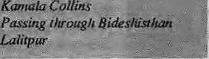
»(And
There are only Drukpas
I am a Drukpa born and brought up, like my father and mother before me, in Tashigang district in eastern Bhutan. I am also a son of Drukpa peasants who were subsistence farmers and never went to school. I was fortunate to be among the first group of students enrolled in the first school established in my home district of Tashigang. Today, 1 am the Director General of Education. I am also a member of ihe National Assembly and His Majesty has already made me dasho, a red scarf officer.
The efforts of Kanak Mani Dixit (Jul/ Aug 1992) to paint the picture of the Drukpas from eastern Bhutan as "a distinct community further east in ihe districts of Tashigang, Mongar, Pema Gatshel and Lhuntshe" have deeply hurt the sentiments of the Drukpas (like me) who have been bom and brought up in these districts. His statement "the Indo-Mongoloid Sarchops have distinct dialects, local customs, dress and food habit" is incorrect. People in eastern Bhutan do speak a dialect called Sharchkogpa but the religion, customs, food habits, dress and architecture are the same as in all the other northern districts. I am amazed to have read in this particular article terminologies like "Ngalungs" and "Sarchops" perhaps more than I have in my entire lifetime. What is even more regretful is Dixifs attempt to cast doubts on the love, loyalty and dedication of these people from the East, like myself, towards our Tsawasum (the King, the Country and the People and not "the King, the Kingdom and the Government" as the King represents the Government in the three elements).'
School history books of Bhutan tell us that the country, then known as Lho Mon, the Southern Country in Darkness, existed for over 1,300 years. It was in 746 AD that Guru Padmasambhava visited Lho Mon and not only enlightened it with Buddhism but also blessed the country as a paradise. In doing so, Guru Rimpoche visited Bumthang and Kheng areas in central Bhutan as well as Sengye Dzong in the east and Paro in the west. It is for this reason that even today Kuje Lhakhang (Bumthang), Sengye Dzong (Lhuntshe) and Taktsang (Paro) are the holiest religious places in Bhutan.
Dixit, while calling Shabdnmg Ngawang Namgyal, amongst others, "a unifier" falls short of completing that he and his followers had, by the time of his death, totally unified the entire country, including the eastern districts. The present Tashigang Dzong was built in 1656 AD (exactly 336 years ago) which marked the complete unification of Druk Yul. 336 years is, by any means, a very
The prices here are very hjgli, .Batmen fity tioisse is fallicr gr I%yfe:'fhe British. Primary just nearby,. And a modicum effort land. ' .-■
cpdddo with fewer lips;, ^ i
for despite the GenAans* yellow skips. It's still ugly Fro tfr³^ ,;^{vi} ■■■-.,/ ■■:- / : ,•■
Out house is triadeof c|eanred tjiieks, ^Witti abathroom #n every floor, .,' ^.-There's a "solar panel" on ferQof; ., »'. And .aGsmeshicarved on lie door; ;
esikl Buent English, ;. ;
.Hex iroiiisgIs suprcmei ,. ...■■., .. :: * My cepk knows ill the Western dishes,. ■And/His ciea(}Qns!,wbuJd. plesafc a quee n.
f 1 know-1 pay top" muclv for rruisto ooras,: .
And baked beanf and cheese -andcrisps^v ^{s} fhit. I'lRBttib.aTrr&ssied to say I can af f ore! ir,, r
isft the dogs would be less loud,. . ..^specially.atnights_{f}: ■■ ■■■ : ■■■ .' '■'■ -.- " i Werenty cbhwk&iarsa-irifieless^{:i}proud, ^y..sendtherfs out-to stop the fights.
,'fB.y keeping buses and juggerriapbclear, * Jhamsikhel might gain environmentally.
._{f}Q*ti's.aEarid"fMiver.jarii..M.aruti_{t} * r ■■
I'm sure that I shWld not; complain, ' «f tarm'acadam,
)W:'m«ch they're paid, * Those^p'oor chaps who calS.rntt '"Madam".
s And tf Fmhonesj: 1 nyist concede that, : With my jeep; my job ^nd aiy;!
^{r}s a wonderful Gkinan
Of coursi one can'
_{F}"Blt, qji the whole; we'rehar^y he Deep in theMart pf Bideshisihart,
long period in the history of not only political but also religious, cultural, social and economic unification and integration of a country. There had been over these 336 years so much inter-marriage and. inter-district migration amongst the communities of the different valleys in Bhutan that one can today confidently challenge anybody who can really identify a single Drukpa who is a direct descendant of either "the pastoral/peasant
Ngalung" or "the forest-dwelling Sarchops of the east" that Dixit refers to. In fact, apart from the Lhotshampas, there is today hardly any minority ethnic group in Bhutan.
Bhutan's monarchy has its roots in the east Jigme Namgyal, the father of King Ugyen Wangchuck, the first ruler in the dynasty and the great grandfather of the present King, was bom and, till the age of 18, brought up in Kurtey Dungkhar in Lhuntshe district. He was to become the Tongsa Penlop and the country's 50th desi (temporal ruler) and for many years the most powerful man in Bhutan. The remarkable and ever resourceful Jigme Namgyal is even today remembered all over the Kingdom as a folk hero. He successfully led the country through its most difficult times with the British in India and in 1865 led the Bhutanese to a famous victory over the British army which resulted in the recapture of Deothang (in Samdrupjonkhar district). By the time of his death in 1881 Jigme Namgyal had brought all the warring pentops and dzongpons under a central authority and thus paved the way for the rise of his son, Ugyen Wangchuck, ultimately unanimously elected as the country's first hereditary monarch on 17 December, 1907.
Both Jigme Namgyal and his son Gongsar Ugyen Wangchuck were hardly "the Ngalung Penlop of Tongsa", The people from Lhuntshe still take pride in claiming Jigme Namgyal and his son, Ugyen Wangchuck, and the hereditary monarchy they had established which, in turn, helped Bhutan on its path of political stability and social and economic prosperity, as the biggest contribution which Lhuntshe district had made towards the Bhutanese nationhood. Following the traditions established by these two great leaders the title of the "Tongsa Penlop" and thus the leader of the Sharchhog Khorlo Tshibgyed (the eight provinces of eastern Bhutan) is bestowed on the Crown Prince before he ascends the throne. The present King, His Majesty Jigme Singye Wangchuck was himself installed as the Tongsa Penlop in 1972.
Just as Jigme Namgyal and Gongsar Ugyen Wangchuck came from Lhuntshe district and were to administer over the rest of the Kingdom, many penlops, dzongpons and other senior officials from all parts of the Kingdom had administered different regions of the country. Even today one can find officials bom and brought up in the east appointed as Dzondags (District Commissioners) and in other senior posts in the west while officials bom in the west are similarly appointed in the east. Should regional representation in the government be measured only in terms of the

4 HIMAL ■ Sep/Oct 1992

MAIL

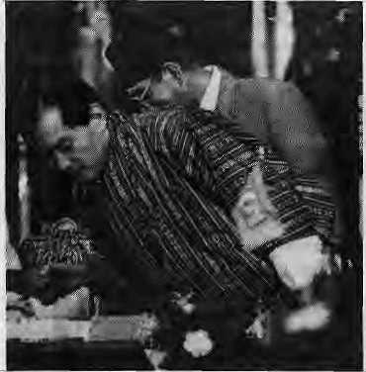
number of lyonpos (ministers) From that region? It must not be forgotten that only about 10 years ago most of the lyonpos in the Royal Government happened to be from the small eastern district of Bumthang. If one looks closely it will be seen that there are many senior officials (like myself) from Tashigang district alone holding key positions in the Government. Similarly, there are many businessmen from Tashigang and other eastern disliicts doing very well both in their home districts as well as in other parts of the Kingdom particularly in the capital city Thimphu.
The history of the modern education system in Bhutan is very short and dates back only up to the 1940s with the establishment of the first modern schools in Bumthang and Haa. Other districts were to follow suit only much later. Today's lyonpos are mostly the products of these two pioneering schools established in Bumthang and Haa, just as I am the product of the first school established in my own home district, Tashigang, in 1960. The secret of the Bhutanese administrative system is that its recruitment and promotion systems are based strictly on merit and seniority rather than on regional representation. That is what makes the Bhutanese bureaucracy one of the best amongst the developing countries, a fact which even Dixit acknowledges. There is at the same time all the opportunities for even a son of a peasant like myself to be die Director General of Education of the country,
A group of Utotshampas with vested interest, supported by illegal immigrants and encouraged by the proponents of Nepali chauvinism have been carrying out a campaign of malicious propaganda against the Drukpas and the Bhutanese government. To this end, they have been veiy successful in unabashedly mixing half truths with untruths. It is evident that the dissident group, acutely aware of the
hollowness of their claim that they represent a popular movement against the Government, is now making desperate efforts to dent the unity of the Drukpas. This, in itself, makes mockery of their claims of popular support for their movement inside Bhutan. I am certain that the dissidents deep down in their own hearts fully realise the futility of their exercise. After all, it must not be forgotten that Drukpas from the different districts unanimously condemned the ngolops during the 70th session of the National Assembly as well as during the various public meetings. In fact, the representatives of Tongsa, She'mgang, Bumthang, Samdrupjongkhar, PemaGatshel, Tashigang, Mongar and Lhuntshe (Skarchhog Khorlo Tshibgyed) were particularly adamant in proposing tougher measures in dealing with the ngolops.
In conclusion, no one should underestimate the unity and solidarity of the Drukpas especially when the security of their nation is threatened. The Drukpas have always preserved the security and integrity otDruk Yul against great odds in the past and will continue to do so today.
Thinley Gyamtsho Department of Education Thimphu
His Majesty King Jigme
His Majesty Jigme Singyc Wangchuk has been described by some sections of the Nepali press as a fascist, a Drukpa despot who manipulates a "rubber-stamp" National Assembly. If the Bhutan crisis is to be resolved, it must first be thoroughly considered, both by the Drukpa elite in Thimphu and by the people of Nepal. The role and position of the King in this crisis has been a matter of some speculation. I hope that the following account of my audience with His Majesty, held at Tashichho Dzong, Thimphu, on 10 September, will shed some light on this matter. I have resisted the temptation to add my own comments and interpretation.
His Majesty and I talked about the issue of southern Bhutan for one-and-a-half hours. I carried no tape-recorder and took no notes during the conversation, but I wrote down as much as I could remember about two hours later. This summary is accurate, except that some minor points may have been omitted:
On emigration from the southern districts:
The King is fully aware of the fact that many Lhotshampas (southerners), even those classed as full nationals in the 1988 census, have left Bhutan even after he has pleaded with them to stay. Now, when southerners apply to emigrate, the King says he tries to play for
time by delaying the processing of theii applications. "It is very difficult. If we delay the application for loo long, they simply abscond without receiving payment from the Government for the property they leave behind. I have toured the southern districts 25 times in the past two years. If what they say is going on down there was really going on, 1 would stay away. I would not implicate myself. We do not have the sovereign power to transport so-called refugees across Indian soil. If we evicted people across the border into India, they would be sent straight back. They are leaving as migrants. They tell the Indians that they arc emigrating to Nepal. When they arrive in Nepal, they claim refugee status."
On destruction hi the south: "So far, 84 civilians have been killed, 22 schools have been destroyed, and 34 policemen have died (26 men and eight officers). Several bridges have been blown up and basic health units and agricultural extension centres have been severely damaged." (The King did not reel off those statistics glibly, but in a tone of genuine anguish.) "The south has received a large portion of the development budget in recent years, but this has set us back years." The King and the National Assembty: "I have acted against the wishes of the National Assembly many times. So far, I have released nearly 1,600 detainees accused of anti-national activities. Soon I plan to release 43 more," (45 detainees were released the following day.) "I exempted the southern districts from taxes. When I ordered the Army not to fire on a crowd of demonstrators who were attacking a census office in Geylegphug, I came under a lot of pressure. But if a building is destroyed it does not matter. We can always rebuild it later. It is better for a building to be destroyed than for my men to shoot 20 or 30 people. Most northerners want sterner measures against the anti-nationals, and this view is reflected in the National Assembly, I have gone against them many times. So long as I succeed 1 am popular, but if I fail once I am finished," On the dress code: "At first, the ruling caused corruption. Police were fining people on the streets and pocketing the money. I called in the Chief of Police and said — what is this nonsense? The dress code applies only in dzongs, government offices, the courts and so on. I told the southerners they could wear what they liked, so long as their clothes distinguished them from the people of neighbouring countries. We are a small country between giant and powerful neighbours. We have no resources, we have only our culture and identity." ("Well, Your Majesty", I asked, "What could the

Sep/Od 1992 HIMAL ■ 5


We Also Serve You lirds On Trees


French, Motion, Chinese, German Russian cuisine. Served on the greenest green you've ever sees. Plenty of sun, fresh air and bird
too.

SHANGRI-LA.
LAZtMPAT, KATHMANDU, TEL:412899
We Make You Feel Great!


southerners wear, other than the gho and kira, to make them distinctively Bhutanese?") "Look," said the King, as if weary of the issue, "I've told them they can wear what they like so long as they don't go around naked." On democracy: "If Bhutan disintegrates and falls into ruins, there will be no need for a king. This problem is my responsibility and if I fail there will be no throne for me. It is a question of national survival. The boys in Nepal don't understand one thing. They say I am fighting tooth and nail foi my own survival. But, if I wanted something that would make my position more secure, the southern issue would be ideal. West, north and east are united behind me. I am not fighting for my position. I am fighting for the sovereignty and future prosperity of Bhutan. They say I am a dictator, and that our system is fossilised. They do not realise that we will do anything — anything — to preserve our nation's sovereignty. I believe that a system that depends on a single individual is extremely risky in the long term. We are adaptable people, we are open to ideas. They may be surprised by the extent of the changes we are prepared to make in the years to come. We will do anything to secure the future of Bhutan."
On the Nepali press: "I know what the Nepali newspapers arc saying. Disinformation, misinformation — I do not misunderstand. I do not take offence. These things are not important,"
On the Nepali Prime Minister: "G.P. Koirala is a good man, a sincere man, and I can see no one better able to lead Nepal at piesent. In an interview on the BBC he called me a despot. But Idon't mind, I have a thick skin (the King smiled). He is a little inexperienced, having spent so many difficult years in opposition. When we met in Colombo, we joked about it. But I like Girija: he is genuine, arid committed. The problem is that he says he is involved in quiet diplomacy, but he makes public all his tetters to me, and all my letters to him. In this situation, I am unable to state my views freely, to say what I truly think. The problem is complicated, very complicated, and if we are to solve it a genuine dialogue must begin in an atmosphere of mutual trust. For G.P. Koirala to lefuse sanctuary to so-called refugees would be bad politics, I realise that. But we must have a genuine dialogue."
On academics' attitude to Bhutan: "The problem in die south is the most crucial issue in Bhutan today. We do not need praise. Praise does not help us. We need criticism and advice. It is a question of national survival, and we must not be adverse to criticism. We are an adaptable people... Congratulations on your achievements in Nepali. It is a rich and beautiful language." ("I am sorry I know little Dzonkha, Your Majesty," I said) "In your next lifetime, perhaps," he replied. King Jigme Sigme Wangchuk and I laughed for the first time together, shook hands, and parted.
Michael Hutt
School of Oriental and African Studies
London
The Tail has Gangrene
No one so far has given an account of the current problem of Bhutan as comprehensively as you have in your cover story (Jul/Aug 1992). The information provided on such a variety of issues must have been an eye-opener for botli the Nepalis and non-Nepalis of Bhutan in particular and Bhutan lovers of the world in general. However, I feel that a few additional aspects that are of major importance need to be considered to provide a holistic understanding of the problems. And my plea is that let no Nepali be accomplice in the loss of another (and last) surviving fragment of a legendary Himalayan cultural empire.
One may conclude after reading your cover story that the Dragon's 'hard choice' to bite its own tail is wrong. But the Bhutanese refugee problem must not be seen in isolation. It needs to be related to its deeper roots lying beyond Bhutan.
Nepalis in general have had a major role to play in the Bhutan crisis. The period following the annexation of Sikkim (1974-1985) was a crucial period in the country's history, during which time Bhutan's future was being independently thought about by both politically ambitious Nepali-speakers and the non-Nepalis of Bhutan. Indeed, unprecedented steps were taken by both the camps to achieve their different goals. For the non-Nepalis, preserving their culture was the ultimate priority, and human rights and democracy the Nepali priority. Sikkim, in both cases was the primary sensitising factor.
Since Bhutan's very identity is based on its unique Drukpa culture and not on Nepali culture, non-Nepalis of Bhutan believe that if the former is undermined the whole country will fall apart. Ask the non-Nepalis of Bhutan, what has Bhutan to offer to the modern world other than its unique culture?
The Nepali-speakers' so-called movement for human rights and democracy,
MAIL
meanwhile, is aimed at systematically destroying the language, aesthetic canons of society, ethical priorities, and in fact the very political philosophy of Bhutan. Indeed, Nepali-speakers have emerged as nothing more than a parochial economic force which refuses to flow with the mainstream of Bhutanese culture as perceived by non-Nepalis. If this were not true, these human-rights lovers and champions of democracy should have raised their voice equally against the poor and marginalised northern population of Bhutan — irrespective of caste, creed and race. Are human rights the birthright of only Nepali-speakers?
Developments in Sikkim, Darjeeling and Nepal have been enough to convince the Bhutanese Government that Nepali-speakers are increasingly hungry for power, domination, corruption and opportunism in the region in genera! and Bhutan in particular.
These must be the reasons which forced Bhutan to plan its future based solely on non-Nepali culture. In fact, many non-Nepalis of Bhutan believe that their Government's action against the Nepali-speakers had been inordinately delayed. It should have started when tile 1975 coup in Sikkim was still fresh in the public mind, and would have been completed long ago — except for the the Government's compassionate attitude towards Nepalis then.
As far as the attitude within Nepal is Concerned, might I ask why Nepal does not feel ashamed of the continuing export of innocent young girls by the thousands to brothels in India? While there is a lot of breast-beating on the refugees from Bhutan, why are the authorities dead silent about the hundreds of thousands of economic refugees that flee Nepal every year — besides prostitutes, there are migrant labourers and young boys joining foreign armies? Does Nepal have any pride left at all?
Nepal has a long way to go and many more Bhutan-like situations ahead. Hence, do not blame the Dragon. The Dragon knows that the tail is gangrenous and it is trying to get rid of it before it infects its whole body, Suman Lepcha Gangtok Sikkim
Readers are invited to comment,
criticise or add to information and opinions appearing in Himal. Letters should be short and to the
point and may be edited.
Mail to : PO Box 42, Lalitpur, Nepal
Fax:977-1-521013

Sep/Oct 1992 HIMAL • 2

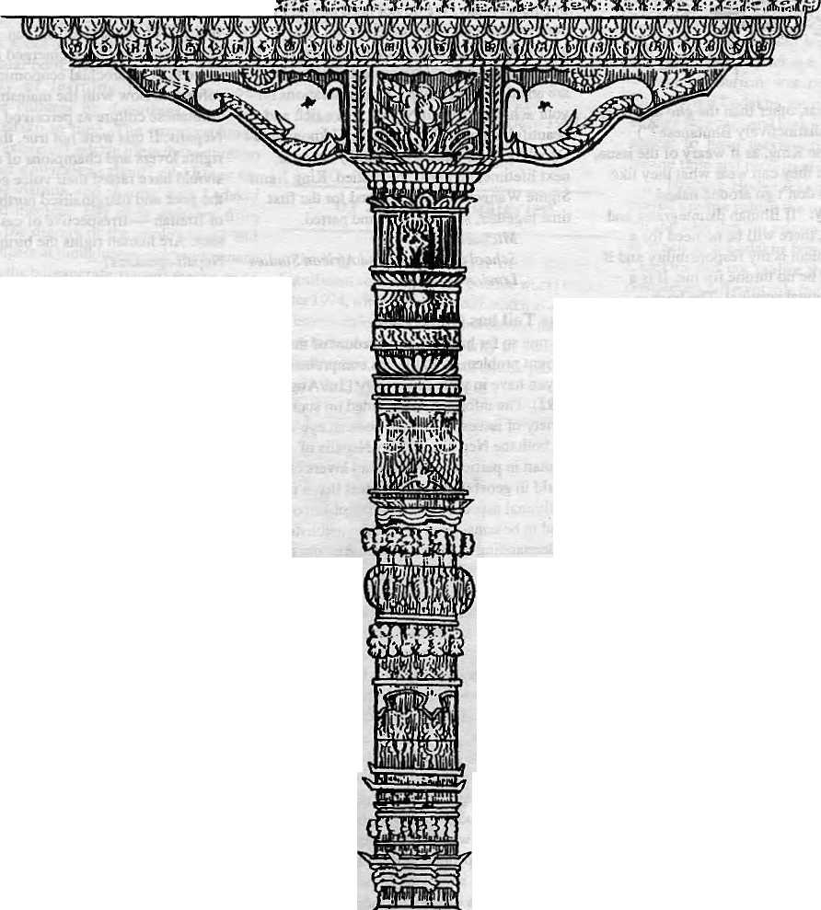


7%e exquisite Woodcarying ofKathmandu
It's more than an art
It's an Exuberant Demonstration of a Rich Tradition
It's an Eloquent Expression of a Living Culture
It's a Wondrous Display of a Timeless Heritage
It's a Priceless Ornament of two Religions in Perfect Harmony
TTte Summit Hotel in Kathmandu
It's more than a Hotel
It's a Tribute to Traditional Nepali Hospitality
It's a Homage to a Magnificent Nepali Architecture
It's a Commitment to Quality of Service and Care
It's a Guarantee for your Comfort and Pleasure

SUMMIT HOTEL
Something Special P.O. Box 1406, Kathmandu, Nepal Tel: 521894, 524694 Fax: 977 1 523737
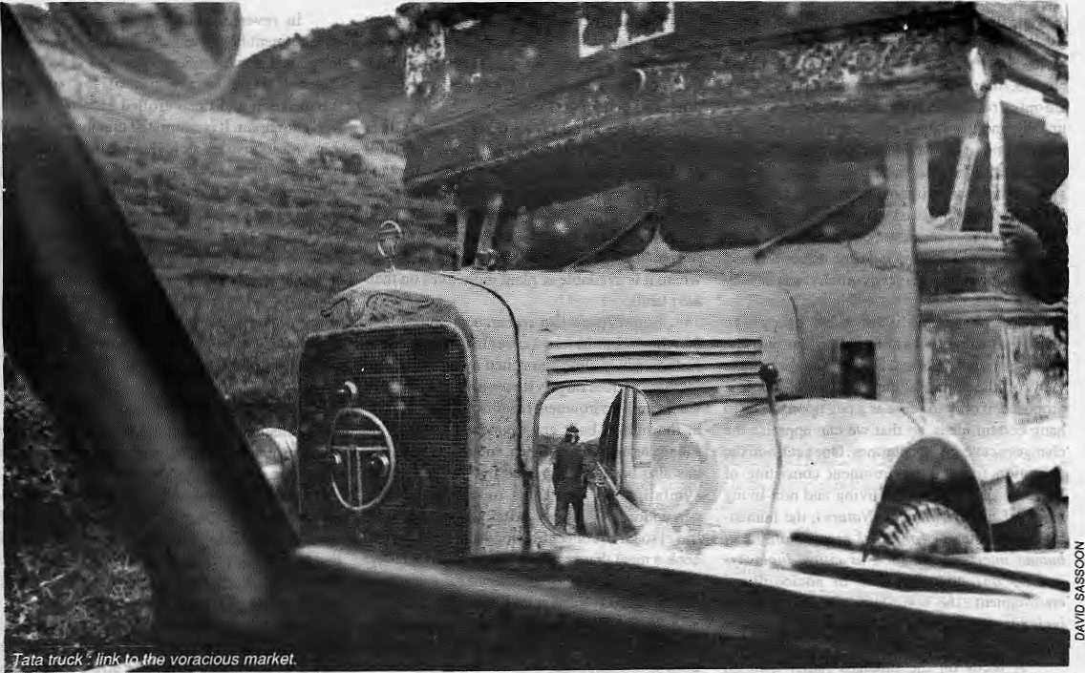

Stress, Strain and Insults

Philosophers say that change is inevitable and inexorable; that "old order changeth yielding place to new". The Himalaya and its people know well what they mean. The process that has created that whirlwind of change is the concern of both those who suffer its consequences as well as those who have conjured it by their practice of 'development'.
by Dipak Gyawali

"W" ti the same way in which an ancient Tibetan I (/iongfajisrestoied, if the process of change -™- is gentle enough, the result is a thing of beauty and a joy to behold. If the process is violent—ifaninexperiencedoroverenthusiastic artist applies new paint or, worse, puts the thangka in a washing machine to cleanse it of decades of soot — much of the harmony between dements of the fabric is lost, beauty is destroyed and degradation — a type of under development — results. Some of the processes of change occurring in the Himalaya, including some well-meant development efforts, may well beof the washing-machine variety.
Change, though inevitable, can be good or bad depending on how it occurs and where it leads. If the environment is transformed sensitively, affected parts are allowed to adapt slowly and thus escape permanent injury. Arural road constructed in the Himalaya using "green technology" neither destabilises tlie hill slopes nor does it dump debris on the terraced farms of subsistence farmers (see Himal Jan/Feh 1990). A 'cut and dump' bulldozer technology may be efficient if one considers only the road project's wellbeing; but it is an efficiency achieved by transferring muchof its costs to ahelpless Nature and the unsuspecting poor.
Change that is orchestrated in-distant
Kathmandu can hit the marginal farmer with the force of a knockout blow. His traditional world falls apart and he becomes an alien in his own home. While the metamorphosis brought about by projects focussing only on constructing a factory, a high dam, or a highway has been rightly criticised for tlie insensitivity to social dislocations accompanying it, even environ men till projects (which tend to be pursued with myopic certitude) can devastate the world of tlie rural poor.
When the Rara National Park was created in northwest Nepal, it was hailed as a good thing. Few, however, care even today to enquire into the fate of the highland shepherd families who were uprooted from their alpine homes and dumped as 'development refugees' in the middle of a hot Tarai forest, near Nepalganj. Unable to cope with the stress ri'f change, they are said to have, truly, disappeared — some succumbed to lowland pestilence,,'others just drifted away, unnoticed and unmdurned. When tlie level of stress is so high, as in this case of the Rara oustees, their suffering can only be termed an insujt and the ultimate in human degradation.
Linking Three Environments
In trying to get a feel for the forces of change at work in our midst, to appreciate even a little tlie
Sep/Oct 1992 HIMAL • <)

High priests of 'devofopment' at local puja.
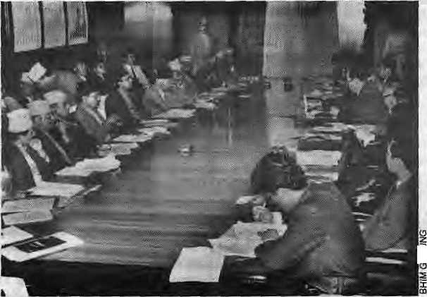
tectonic undercurrents transforming our age, it becomes necessary to step back, turn inward and review how we view ourselves and the world outside. After all, it is said that external institutions are only aieflection of internal ideas collectively upheld; and the values advocated by a group of people impart to its institutions its goals and objectives. This direction, this inertia! guiding system, moves institutions to respond to changing external stimuli and to take appropriate corrective measures.Theprocessesofchangeatworkinthe Himalaya today put the ideas of its people, and die world of values, under as much stress as they doits forests.
The word 'holistic'— meaning the consideration of the whole rather than just the part—is much misused. Nonetheless, a holistic view of the 'environment' needs to be first proposed, if only to serve as a peg upon which to hang certain ideas, so that we can appraise the changes occurring in our times. One such holistic definition sees the environment consisting of four key elements — the living and non-living biophysical environment (Nature), the human-built environment (physical manifestations of human interventions such as cities, highways and so on), the symbolic or sociocultural environment (the non-physical manifestations including beliefs, laws and institutions), and the linkages between the three,
A focus on the linkages rather than on individual elements is what distinguishes the holistic 'environmental¹ thinker from a reductionist — who concentrates on knowing more and more about less and less. An ornate temple is not just the sum total of the bricks, wooden struts and dies on the roof. It is the interrelations between these elements, their i division.of labour so to speak— the bricks with each other, the wooden beams with the bricks and the roof tiles, the arrangements that create open spaces within the structure and openings to the outside — that distinguish a temple from an equivalent pile of bricks and lumber in a construction yard.
It is through linkages that the views of priests, die wisdom of holy books and the thoughts of the architect are translated from die abstract into the tangible. A change in the symbolic environment (the views and values upheld by the priests, monks, architects and philosophers) would find its immediate expression in a changed physical environment. If Hindu priests with their world view were replaced by an equivalent number of Muslim mullahs or Christian padres, the interrelations between the bricks, beams and tiles would be quite different. A temple-infested
Durbar Square in Kathmandu is a different environment from a mosque-infested Lucknow or a cathedral-infested Vienna, although all three may be of the same order of magnitude, brick for brick and plank for plank.
In the Himalaya today, the natural biophysical environment, the human-built environment, and the symbolic environment are all undergoing transmutation; but more important, changes in any one of them induce change in all the others: Receding natural forests are forcing people to shift to kerosene, pilfer electricity where it is available or plant more trees on their bart lands.
Some Australian researchers have found that the decline in forest cover in districts east of Kathmandu is almost matched by an equivalent increase in trees on private terraces. A change in the natural environment has thus forced a change in the human-built environment — in private village terraces, the kitchen, and so on—but this has also been accompanied by a change in the symbolic environment, or the collective perception of villagers. After all, one can only travel so far to collect firewood and still return to cook a meal that provides the calories to collect tomorrow' s firewood or fodde randdoeverything elseTequired to sustain a village life.
While the decline in natural forest cover is worrisome and the increase in private ban land trees is encouraging, both scenarios should be studied if the enigmatic links between them are to be appreciated and worthwhile lessons learned for future development intervention. How was it that one behaviour pattern, the tragic over-exploitation of the commons, was replaced by another, the spontaneous enhancing of private property? Who took the initiative? How did the idea permeate villages? How much resistance was there? How did the landless react? Can this spontaneous event be replicated with premeditated plans applied with greater urgency in other degraded areas?
In reverse, changes in the human-built environment have similarly induced changes in the natural environment. The sad state of (he Bagmati river is a result of the runaway urbanisation and uncontrolled industrialisation of Kathnnandu.lt is estimated that the carpet and garment industries alone have added in the last decade a migrant labour force of a fifth of a million over and above the regular inhabitants of the Valley. The strain on freshwater resources and the stress on the waste-absorptive capacity of the Bagmati and its tributaries have exceeded the levels of normal tolerance. It is nothing more than anenvironmental insult. God forbid that the degree of insult be so high that it is irreversible and that Nature strikes back, making a healthy life in the Valley prohibitively expensive.
The Symbolic Juggernaut
While changes in Nature andin human habitation have been studied to some extent, the symbolic environment of the Himalaya, its metamorphosis and its impact on the other two, are still a poorly-charted territory. That such an important area of change should have escaped the attention of development planners and practitioners is surprising, given the excessive influence this environment has wrought on all the others.
Sociocultural and value influences are all the more important in Asian societies where the power of thought to initiate or arrest change has always been given great importance. In one of the sacred texts recited during the autumn Dasain festival, the Devi Mahatmyam — Saraswati — the Goddess of Learning, renders the armies of the demon Shumbha impotent simply by sprinkling them with sacred water. This symbolism is a powerful expression of the supremacy of thought over raw force. Even the strongest wrestler may be unable to fight if his opponent has managed to unsettle his mind by spreading rumours about his beloved. Colonisation of the collective minds of developing societies is the beginning of Third Worldisation; control of trade in necessities, dependencia and adverse balance of payments are natural consequences of this mental colonisation.
The primary change in the symbolic environment of the Himalaya comes from that great force of mimesis — the proselytising cause of modernisation demanding an imitaUonof the views and values of the aggressiveanddominant Western civilisation. The greatest attraction |S that development (taken often as synonymous with modernisation) has is the modern amenities it offers when Nature is used to do some of the chores that humans

10 HIMAL • Sep/Oct 1992

The world view of the marginal hill farmer...
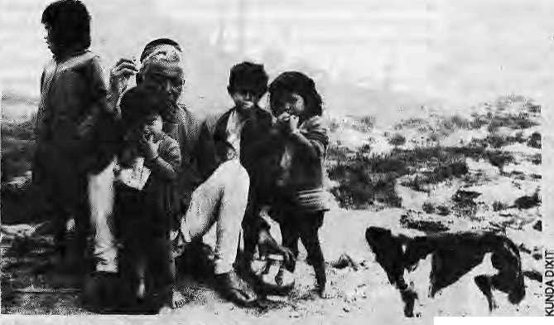
had to do. When harnessed water can flush away night soil Ihat previously required reluctant human hands to carry, when a diesel engine on a road can do away with the need for days of porteiing, when a small transistor radio can bring the whole world to one's isolated hamlet, modernisation becomes the juggernaut of the Third World's symbolic environment, unstoppable without the equivalent of a spiritual upheaval.
This symbolic juggernaut has its own crushing impact on ihe natural and human-built environment. Engineers, economists and modern managers are the high priests standing on its bow and exhorting the masses to heave. While Northern development could shift most of the social and environmental costs to the people and the environment of the South, the South cannot externalise these costs so easily. But the priests do not stop exhorting and the juggernaut rolls on, crushing everything in its path.
Perhaps, to acquire a degree of sensitivity to these hidden costs of blind mimesis, those professionals engaged in modern intervention exercises should be required to spend some time on retreat in a Buddhist or Hindu monastery. They may then gain something that is not given in an engineering college or a business school. This practice may also prevent foolish thoughts from finding berth in the minds of water-supply managers of Kathmandu, as when a few years back they proposed impounding the traditional dhttngey diiaras of Katliniandii and pumping the water to an overhead concrete tank to alleviate water shortage in the V alley *s piped water s y stem!
Roads bring Alien Values
A healthy change in the symbolic environment means that Ihe collective mind can respond to changes in natural and human-built surroundings, however stressful they may be, without itself degenerating into despair. Lack of confidence in facing the challenge of external change leads to unhealthy reactions such as a retreat into fundamentalism, ethno-opportunism, corruption and fatalism. Healthy social systems opt for painful change rather than voluntary suicide; but the sickly ones, with a paranoid fear of the future, are paralysed and unable to take initiatives in the future. The result is atrophy and decay.
When change occurs swiftly, it is often for the worse. Rapid development has its victims and its beneficiaries. The social carriers of change are the primary winners. At the other extreme are the larger mass of primary losers. The whole world targets them, wrongly and with the active
connivance of the major beneficiaries, as the culprits.
The hill farmer has been unjustly blamed for Himalayan deforestation. But new evidence indicates that the poor farmer is, at best, its secondary cause and the primary cause the ever-gluttonous market and State policies feeding their voracious appetites with policies born of a world view entirely different from that of the marginal farmer.
The forests of northern Tanahun District, for example, were degraded not by overbreeding hillmen (who have always overbred), but after the seasonal link road from thePokhara highway was completed. With this change in human-built environment which made a remote area more accessible to large-scale logging technology, and a failure of corresponding control measures to coevolve, it was inevitable that the forests would be mined today for quick profit rather than be harvestedsustainabry with tomorrow inmind.
The key link between a voracious market and denuded hillsides is that potent symbol of development — the motorablc hill road — and the mindset that introduced it. Similar to introducing disease vectors to a population that has no resistance to them, building aro ad allowed agents of change who had alien values, who brought trucking and other technologies with them, to interact with the natural environment. These agents saw greater benefit in logging the growing stock rather than harvesting it while preserving the integrity of the forest—livingoff the capital rather than the interest.
Nature and human societies in the Himalaya are undergoing transformation largely because ofthechangesincoUectivevalues and aspirations. In the high-altitude Everest region, Sherpa lodge-owners are anxious to install Western-style flush toilets. Their own traditional pit latrines tackled excreta with dried leaves and pine needles, and the compost was used in potato fields. This now is seen by the majority of Sherpas as a relic of their underdeveloped past. The flush toilet is what the rich tourists use in fancy hotels in
Kathmandu and abroad, and this is what everybody wants in the Khumbu. This seems economically a logical and sensible thing to do.
The widespread acceptance of this idea means that the Theso stream flowing into the Nangpa Dzangpo (BhoteKosi) will eventually be diverted to a reservoir above Namche Bazaar and water distributed by galvanised iron or polythene pipes to homes and lodges in the area. It does not seem to matter that night temperatures in winter in the Khumbu drop to minus 25" C and the temperatures inside the well-insulated Japanese hotel at Syangboche or the "Hillary hospital" came down to minus 15° C last winter. Pipes will burst when the water inside, freezes and indoor plumbing in poorly insulated Sherpa homes will be ajoke. Indeed, the Japanese hotel regularly finds its commodes frozen solid in winter. They are maintained for guests by flushing them with boiling water. But Khumbu's collective social aspiration outstrips social wisdom that can only come from unpleasant experience in the future.
One cannot deny the Sherpas the comfort of modern amenities and the freedom from demeaning drudgery any more than one can deny 'development' any where else in the Third World, including Kathmandu. But technology must be adapted to suit the local natural environment and adopted by the social system; and it must be understood that adaptive physical engineering is much simpler than adoptive value engineering. Unless muchmoreof the social and environmental costs are properly appreciated at the beginning, runaway aspirations for the fruits of modernisation invariably lead to unmanageable despair.
Strip Mining a Future
One indicator of the change for the worse in the symbolic environment of rural Nepal is the prevalent usury. Unofficial moneylender rates are as high as 24 to 36 per cent per annum while that of the State-sponsored rural bank — the Agricultural Development Bank of Nepal (ADB/N) — is officially between 15 to 19 per cent. When one adds high transaction costs, this rate can go up to 36 or even 40 per cent in real terms.
High interest rates on loans are a reflection on a society's inability to put any faith in the future. The higher the rates, the more clearly a society is saying that it values money now more than in the future. In the past, when weD-off Nepali villagers made charitable endowments to guthis of established temples, they were saying
Sep/Oct 1992 HIMAL - U

Doing it right.
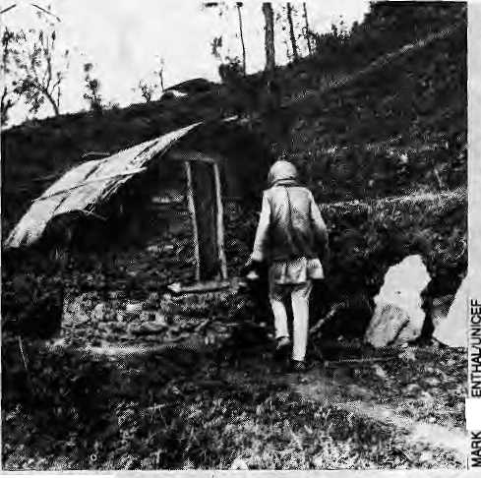
that the future, and future generations, wereimportantenoughtoinvestin today. When a State-sponsored bank promotes intcrestiates that double a loan burden in three or even two years, the social message is loud and clear — do not take the risk and invest in anything such as industry, which requires start-up time and does not give immediate returns.
Villagers across Nepal are getting wise to the fact that the ADB/N, set up to help the marginal fanners, has managed instead to shift all its risk burden onto the poor villagers who are being pauperised. In the process, the Bank has possession of enough land-holding certificates (held as collateral) to become the country's biggestlandowner.Itwasnotthefarmers who went to the Bank, but the Bank that came seeking them with loans and projects in the name of the State. The farmers trusted the ADB/N, and now they find themselves worse off than before because of the-crushing interest rates.
Tek Bahadur Ranamagar comes from an upcountry village in Gorkha and can be found today toiling over carpet looms in a Kathmandu factory, together with three of his brothers. How did this come to pass? Under coaxing of the development motivator in his village, his father took a smallloan from the ADB/N to start asmall cottage industry — basically a knitting device and woollen yarn. Unfortunately, neither the raw-material supply nor the sales projected euphorically by the molivator could keep pace with the 15 per cent interest on the loan. Before long, the Bank was threatening to auction off the family's meagre landholdings held as collateral.
Unable to salvage what they had, the family members have no w fanned out to do the best they can. Instead of tilling the fields and living in rhythm with their seasonal rituals, able-bodied sons have migrated to the urban slums, pauperised by a satanic mill which grinds men into masses who haveonly their labour to sell for subsistence wages. Tek Bahadur and his brothers have lost the saftey and comfort of their social net; and they have lost it for the next generation as well, for there is nothing left to bequeath.
The Bank's lift-irrigation scheme at KarmasingPhantontheroadtoGorkhaisanothei grim illustration. The farmers there were poor and had sufficient land to feed themselves only for about eight months a yeai with one or two crops.They used to migrate in search of seasonal work to make enough for the remaining four months. Theirs was hardly the most desirable of lifestyles but it was at least one in which the marginal farmers were independent of external obligations.
Then came the Bank, In order to test a lift-irrigation technology, it offered the villagers a pumping scheme, which has been installed and has now been operating for several years. On the
face of it, the scheme has achieved its objective ■— it now allows three crops a year on Karmasing Phant. On the dark side, however, the loan burden is crushing the community. Even with three grain crops, they find it impossible to clear their debts; and the three-crop pattern is leading to depletion of soil nutrients and declining yields. The fanners are now being presented with another project— a loan package to buy chemical fertiliser. These days, the farmers wistfully talk of the old times when they were marginal, poor villagers or migrants.
Rethinking Development
The lesson from these examples is that market expansion, so blithely mentioned in development seminars and which seems such a peaceful process, is socially most violent. The legitimacy of the market comes from a changed symbolic environment where it is accepted as proper to 'mine' a future instead of allowing one's future or that of a later generation to harvest it when the time is ripe. Capital not ieined in by social responsibility converts land and labour into grist for the market mill where the social and cultural assets of fanners are stripped away as bark from a tree. Only drudgery remains as saleable lumber. Development, as practiced today, is based on ideas of how the human-built environment of the future should look. It has both export and import components. Ideas of development and progress areexported from urban centres and the global metropolis of donors and they are imported by the recipient communities. The linking elements are credit and technology. Whiledonors have been the focus of much criticism for inappropriate concepts, and rightly so, it is worth while to direct attention to those who import concepts, the faceless and unaccountable national-lev el bureaucrats. Not to mention those who have such notions thrust upon them — the
countries and people who are the targets of development.
The people who have remained exploited and underdeveloped for centuries continue to perceive development as a form of liberation gifted by a Western knight in shining armour. This kind of impression may be termed "koseleebikas" ('gifteddevelopment'), a kind of a cargo cult de v elopm ent where wealth and wellbeing are seen as gifts from without and not the result of re w ard for self-slriving. This view is prevalent not only in the poor and backward villages,butpermeateseventhehighest echelons of State power. The inevitable result is a further shackling of the mind and attempts to change the human-built SS environment to suit. Development is hijacked from the poor in order to benefit sharper elites.
Only a few agencies or NGOs among those that are doing 'development' seriously attempt to bring out inherent creativity within social groups (who are waiting for gifts). Only reformist movements based on self-reliance, or political agitation based on anger at the unfairness of it all, may be able to change this state of affairs.
Worse is the symbolic environment of the developmentconsultantsthatconsideritvalidto shi ft the burden of risk onto the shoulders of the poor whom they have come to help. If high-interest development loans impoverish an already poor people, high-volume loans for large development projects are also bad because the element of risk involved is so much greater.
If a small dam or a village watermill is washed away, it can be restored by the villagers themselves. If a high dam or a large development project is destroyed by an unforseen disaster, it is beyond the recuperative powers of underdeveloped Himalayan societies to restore things to their previous condition widiout falling into an even greater debt trap. Developing countries and poor rural communitiescanthusbe described as having 'low-risk resilience' when it comes to large projects. They should not be forced to undertake very large projects in the name of the nirvana of development without assessing their risk-absorptive capacities.
Change with Confidence
The process of modernisation and interventions in its name, if it is understood and controlled, induces changes that can be called 'development'. Industrialisation is an expression of controlled changes within the natural environment and, done within the bounds of 'risk resilience' not only of society but also of Nature, it may be a good diing. It is a scientific control over natural processes. Similarly, democratsation controls the process of social aspirations through the use of cons ens us-building. Here, the ability to reason

12 HIMAL ■ Sep/Oct 1992

\

and convince others is more important than the use of force and threats. On another plane, scientific rationalisation can be seen as a way to streamline the processes of mental change. To generate consensus, to cope with the forces of Nature and to change long-he Id beliefs, an appeal must be made to reason in a peaceful and nonviolent way.
If changes are induced such that members of a society feel they are helpless when buffeted by external forces, if they do not understand what is going on around them and believe that they have little control over the processes of change, then they 'underdevelop' or, in extreme cases, plainly'degrade'. When the values of the internal world change, one should expect external institutions and external Nature to change; and the quality of the sum total of changes in the three environments, measured with the yardstick of risk resilience and sense of control, determine whether the changes can be called development or degradation.
Eastern religions, particularly Hinduism and Buddhism, have considered time and desire
together be the Great Destroyer as well as the Great Creator — the essence of power and change. While time destroys the old, the new is created by desire, only to be destroyed with the passage of time. This play of creation and destruction — dynamic and perpetual change — expresses itself in the symbol of Skakti the Mother Goddess and her maya the power of form. The power to change forms of reality — in essence change the environment—is expressed as a trinity of relationships. Raw physical power is symbolised by Maha Kali, the power arising from human relationships by Maha Lakshmi, and the power of thought by Maha SaraswatL This symbolism conveys the same image of three environments, their power and their interlinkages — that of Nature, that of human endeavours and finally that of thought. It is worlh approaching the composite problems of change in a complex environment through indigenous metaphors such as this which capture and convey the primacy of interlinkages in environmental thinking.
Perhaps Himalayan societies, if they wish
toTegain harmony in their developmentprocesses, which entail changes in all the three realms, need to go back to symbolisms within their social psyche, redefine them for a new age and Tegain some control over their lives and surroundings. This is a task for Himalayan philosophers mid development thinkers. Development gifted is change passively accepted; whereas development reconsidered and redefined is the first expression of attempts to control change in all its manifestations and of efforts to save oneself and one's society from helpless buffeting by fate. To the defenceless villagers suddenly visited with development disasters, a redefinition of change based on their own symbolic meanings may be more digestible than the charts, graphs, projections and promisesof change grafted from without.
b
D.Gyawali, an occasional contributor to Himal, is a member of the newly reconstituted Royal Nepal Academy of Science and Technology. He is also the Honorary Chairman of a grass-roots organisation, Swavalamban.

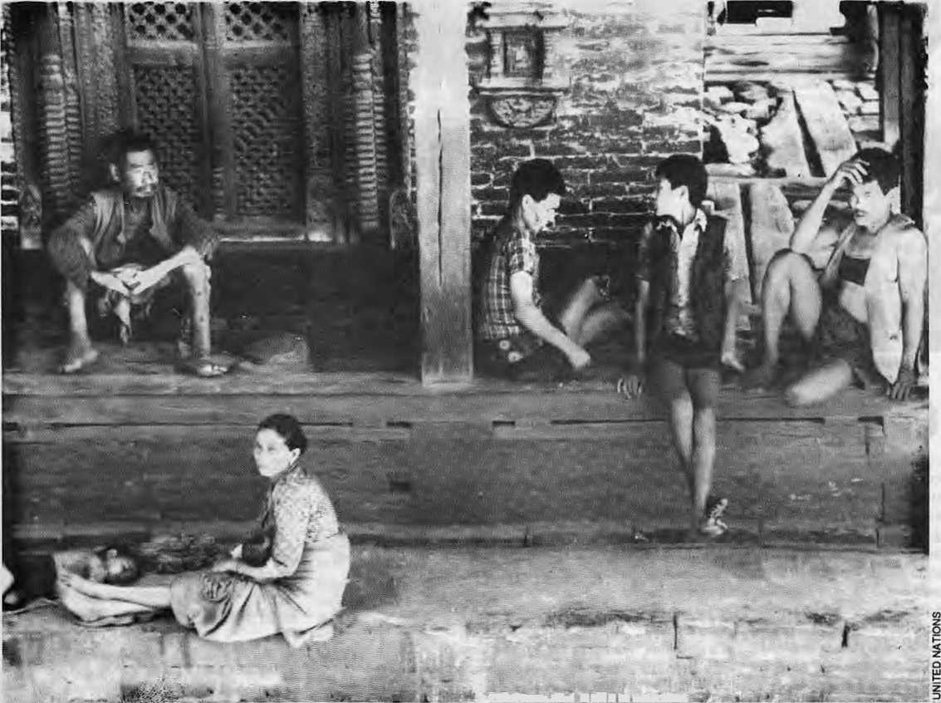
Grist to the 'satanic mill'.
sm^m*-.^-*: ■ m i m Pep«

Sep/Oct 1992 HIMAL • 13

Road to Riches, Road to Doom
While the influx of pilgrims and tourists may have changed some parts ofHimachal Pradesh, other parts
have resisted the destabilising influences of highways. Butwill this still hold true as the network
of roads expands to further exploit the state's natural wealth?
by Chetan Singh

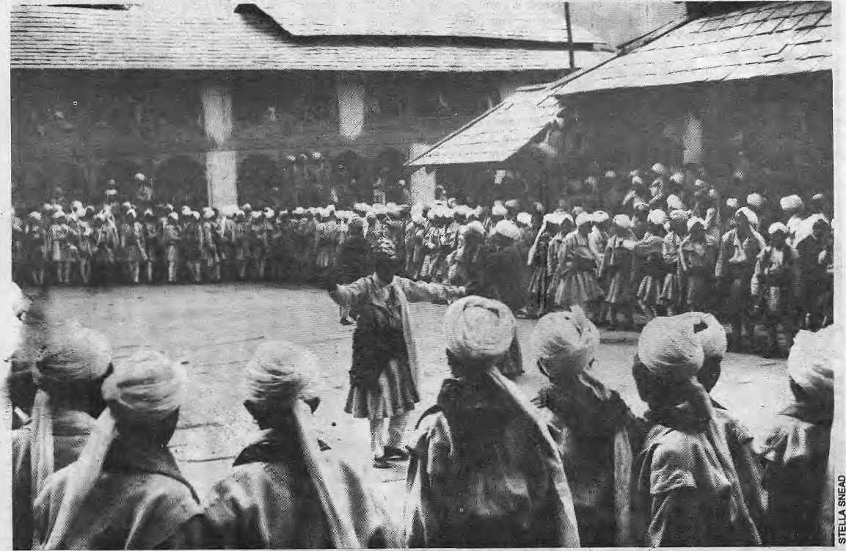

Autumn festival at Chaitrari in Ghamba, Himachal.

G
ods, sages and renegades apart, the hills were traditionally a forbidding place for plains folk. It was the British who, escaping from the hot, dusty, diseased 'India', began to dot the Himalayan landscape with hill stations. Sanaloriums, cantonments and exclusive retreats sprang up on the cooler slopes, amidst the fragrance of pine and cedar. The annual migration to the Himalaya of people who mattered, or were too ill to matter, assumed the nature of a ritual. To spend the summer in the hills was no ordinary privilege. Even the humble babu who followed the sahib with files revelled in the second-hand importance that it gave him. Shimla, the summer residence of the Viceroy, became particularly important as a centre of British social and political activity — not to mention the decisions of imperial significance
14 HIMAL • Sep/Ocl 1992
that were taken inside ils (in-roofed chalets.
So to Shimla was brought the cart road, all the way from Kalka, and upon it carts began to ply. The railroad followed. The British were, and could afford to be, snobbish. Civil and municipal laws were strictly enforced to keep the influence of the natives away from this little Scotland in India. With their departure the inevitable happened — up the cart road and Ihe railroad rushed the dusty plains of India.
This has been repeated in several other hill resorts ofHimachal such as Kasauli, Dalhousie and McLeodganj, where iheGoraSahibs resided in summer and to which broad roads were built at enormous public expense. Itistotheseold British townships that the Maruti-owning, middle-class families now rnsh during the summer closing of schools in the plains. Within a very short time, a
large number of buildings have been converted into hotels. In Shimla, some of the old structures thathavemanagedto escape the insatiable hunger of the bureaucracy for accomodation, or the ravages of fire, are now ill-maintained government hotels and guest-houses. Wild Rower Hall, at Mahsobra, (one-time residence of Lord Kitchener, then Commander-in-Chief of the Indian Army) is one such building. From the ashes of Peterhof (home to several viceroys), which was lost to a fire some years ago, has risen a monstrosity with pretensions to being a luxury resort.
Penthouses and Pilgrims
Post-independence India has witnessed innumerable rags-to-riches stories. Traditional social mores are increasingly under stress as the

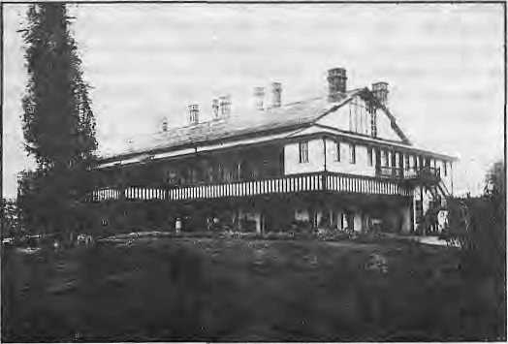
Peterbof (in 1904) before its transmutation to luxury hotel.
middle classes redefine the 'good life'. Not only is it respectable to accumulate enormous amounts of wealth, it is even more admirable to be seen to be spending it on expensive holidays.
The business community in the hills has been quick to mop up the extra money that has floated up from the plains. Luxury hotels of fering videos and cable television; fast-food comers and drive-in res taurantshave mushroomed aton g the highways and in the larger towns. You can now drive right up to the once-formidable RohtangPass (connecting Kulu to Lahaul-Spiti) and gulpdownachilled bottle of Pepsi which the vendor retrieves from a heap of snow beside his kiosk, stocked with packets of Uncle Chips. A rich Delhi businessman and his family, desiring a weekend with a difference, can fly to Dharamsala and find themselves lunching the same day at a hotel a wink away from the Dalai Lama's residence in McLeodganj.
The obsession with acquiring a luxurious lifestyle in this world has in no way discouraged people from attempting to make similar arrangements for a comfortable stay in the next. Important temples are now accessible by road, and the number of pilgrim-tourists has increased markedly. Hotels and restaurants in traditional religiouscentressuchasJw alamukhi, C hintpurni and Kangra enjoy flourishing business, while numerous other temples are attracting an increasing numbero freligious-minded tra ve Hers. Kangra valley resounds with the music of disco-bhajans played on car-stereos as pilgrims flit from one temple to another. The numberof taxis, too, is rapidly growing. From just 75 taxis registered in all ofHimachal in 1986, the number jumped more than tenfold to 1,020 during 1989.
Between 1989 and 1990, there were 1,503 state transport buses which plied 1,272 routes within Himachal and outside. Chartered private buses and conducted toursof the popular circuits preferred by economy-class tourists are also offered by just about every travel agency. And the number of takers for such holiday packages continues to increase by leaps and bounds. If a
recent estimate is to be believed, the increase in the number of tourists registered in hotels in the four main areas of Shimla, Kulu, Manali and Dharamsala has been nothing less than astonishing. While 150,000visitorscametothese areas in 1986, the number shot up to 940,000 in 1988 and further jumped to 1,100,000 in 1989.
The state's large road network, providing 14,889 km of motorable roads in 1990, has made possible Shimla's rapid transformation. Given the fact that the whole of Himachal Pradesh is hilly, the average road length of 40.3 km per square km is impressive compared to other hill slates (Jammu and Kashmir with 5.9; Sikkim with 22.0; and the national average of 56.1),
The pressures that such a tremendous expansion of tourism can put on an ecologically sensitiveHimalayan region can well be imagined. Most of the popular resorts have grown in a completely unplanned and hazardous manner. The collapse in July 1992 of a four-stoiey guesthouse in Shimla, which resulted in the loss of dozens of lives, exemplifies the gravity of the problem of illegal and disorganised co nstruction. The escalation of tourism has led to the mushrooming of scores of structurally unsafe buildings. The sewage and garbage disposal systems have virtually collapsed in most of these towns, while the supply of drinking water is grossly inadequate. With the network of roads spreading to the inner Himalayan regions of Kinnaur and Lahaul -S pi ti, some o f these formerly isolated tribal areas, too, are slowly being affected.
Village Life Persists
There is, nevertheless, another side to thispicture of enormous seasonal influx into HimachaL The pressure is felt most acutely only along the main highways or major link roads. At the peak of the summer rush, the main street of Manali town resembles Delhi's Karol Bagh market; but one need walk only two kilometres further north to reach the secluded Vranquility of the old Manali village and the neglected ruins of the mediaeval fort of Manaligarh. A short distance away from the crowded hotels and restaurants o f N afkanda (on the Hindustan-Tibet road), one c an still walk in splendid isolation amidst the thick alpine forests surrounding Hatu peak. Most tourist resorts in Himachal have been able to retain niches that lie beyond the reach of typical highway holiday-makers from the plains.
More generally, road-building and the accompanying growth of the transport sector has not led to increased urbanisation. Himachal remains the least urbanised state of India and
most of its people still live in tiny villages scattered across the hills. The average population of a Himachali village stands at 238 persons (in contrast to Jfammu and Kashmir with 726 and Sikkim with 682 persons per village). The co ntin ued exis tence of the smal 1 village, however, does not mean that the state has fallen behind in development. Not only are all villages electrified but, compared to the other hill areas of India, the per capita consumption of electricity in 1987-88 was much higher in Himachal. (In kWh: Himachal 145; Jammu and Kashimir 140; Assam 51; Sikkim 57; national average 191.)
Two other factors which have an important bearing on the future of Himachal are population growth and literacy. Here, once again, there is cause for optimism. Population growth between 1981 and 1991 was only 19.39 per cent against the national average of 23.50 per cent (Jammu and Kashmir stood at 28.92 per cent and Sikkim at 27.57 per cent). Literacy, on the other hand, stood at42.48 per cent in 1981 as compared to the national average of 36.23 (Jammu and Kashmir registered 26.67pcr cent and Sikkim 34.05-per cent).
In effect, the construction of roads has not, so far, led to any drastic internal demographic restructuring in Himachal. Nor has it, for that matter, led to large-scale flooding of the state by immigrant settlers. It needs to be added, however, that the enactment of certain state laws has discouraged permanent immigration. Moreover, the fairly high level of socioeconomic development in some parts of the state has equipped people to withstand many of the destabilising external influences to which simpler and lesser developed hill societies are more vulnerable.
The impact of tourism-generated stress has, thus, been mostly confined to the more popular resorts located along highways. Much of Himachal remains undisturbed in this respect But the influx from the plains is not the only consequence of more roads and motorised transport Equally, if not more significant, is the fact that modern transportation provides an efficient means of carrying away from the hills resources that were difficult, or almost impossible, to extract. While there is an increasing awareness of the need to preserve valuable timber, the same cannot be said about mineral resources. As the state wrestles with its growing financial problems and endeavours to modernise its economy through industrialisation, there is imminent danger that roads wil! gradually become an important instrument in the exploitation of its natural wealth. The environmental and social fallout of such a development, as compared to disorganised tourism, would be of a far more serious and irreversible nature.
C. Singh teaches history atthe Himachal Pradesh University, Summerhill, Shimla.

Sep/Oct 1992 HIMAL • 15

Up-Country Bazaar and Changing Forces
The Himalayan hinterland, for all its isolation, has never been far from the economic forces at play in the rest of the subcontinent and the world. Change in bazaar towns was not always for the better.
by Stephen L. Mikesell

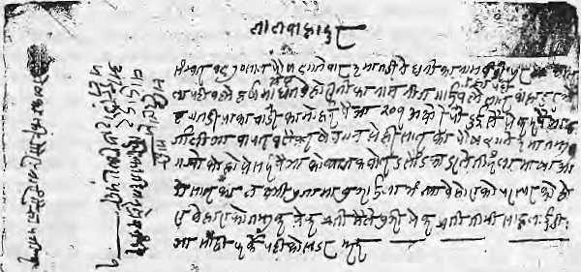
from the Tanahun king in the February of that year.
Following the complete conquestof the Kingdom of Tanahun, Bandipur became the military capital of the new district. Rana Bahadur Shah, Prithvi Narayan's grandson, awarded Jagadev Bhandari, of a prominent Lamjung family, with the post of sardar of Tanahun in 1792, providing him a large birta estate near Bandipur as Teward for his role in the war of conquest.
Old tamsuk, or debt vouchers, indicate that by the 1790s, Tekan Singh's family was trading in homespun cloth, ghee", and other goods produced by the surrounding Magar and Gurung villages. Business records and personal correspondence from the 1830s indicate that Tekan Singh's descendents also continued to maintain property interests in Bhaktapur, where they collected rents and engaged in usury.
Taking adv antage o f the pe asant hunger for credit — arising from the centuries-old inequalities in landholding and distribution of agricultural products which had culminated in and u nderwrote the Nepal i State—the merchants loaned a portion of their prof its to peasants in the surrounding countryside. The peasants mortgaged their accumulated wealth in jewellery, farm implements, animals, land, and even rights over the bodies and labour of their children. Formidably high rates of interest enabled the merchants to slowly alienate this peasant wealth and labour and increasingly assert more direct control over agricultural production, displacing olderclaims on the peasant labour. The surpluses alienated in this fashion were reinvested in trade. Strategically situated between the Indian plains and the Himalayan highlands, the Bandipur merchants also established themselves as middlemen in the flow of trade from India to the hills and mountains of Lamjung, Manang and Mustang. Thus, when machine-made textiles began to enter the subcontinent following the mechanisation of cloth production in Britain during the last one-third of the 18th Century, these bazaar merchants were already positioned to promote the penetration of foreign fabrics into the Nepali countryside and the great changes in rural society that this entailed.
The, establishment of textile factories in
Common interpretations frame change in terms of the same obvious political events which are accepted as cumulatively making up Nepal's history. Starting with unification in the 18th century, these events include the ministerial takeovers by theThapa and Rana families in the 19th, and, in the 20th, the revolution of 1950-51 which brought the fall of, the Rana regime, and the people's movementof 199Owhich ended the Panchayat system.
This reduction of history into a document of the careers of regimes allows the complicated lives of the people of Nepal's villages to fall away from the picture. Their lives are trivialised and formalised in theories that misrepresent them as overly traditional, stagnant and fatalist. Rather than the force and purposeof change, the villagers' fecundity and conservatism are seen as its roadblock, which must be subjected to the dynamism of "development."
The truth of the matter is that rural Nepal has always dynamically interacted with and shaped the flow of historical events. The Nepaii countryside of today was shaped by a long, gradual process of the entry of village society into wider spheres of interaction. It is the villager who produced and traded the products of the land, who filled the coffers of kings and fattened the moneylenders, who built the palaces and fought the wars and who bore, nursed andfed all, from pauper to king.
More significant as markers of change than the rise and fall of regimes is the development of relations among the various peoples which underlay them. Industrialisation, marked by the invention of the Spinning Jenny in 1764, merely confronted an existing dynamic which had been developing over many centuries, or even thousands of years, to sublimate and set it to its own purposes. Key steps in the process, for the transformation of industrial and commercial life in Nepal, were the global rise of the conglomerate joint stock corporations, in the latter part of the 19th century, and their succeeding expansion into the multinational corporation in the 1940s. These changes were accompanied in the Indian subcontinent by the appearance of indigenous industrialists, in the second half of the 19th Century, and their assertion of control over the
Tamsuk IOU between businessman Harshaman Shrestha and Lai Bahadur of Gairapati village for NRs 201, December 1913, Bandipur.
economy and polity from the 1920s onwards.
The sudden, successful pioselytisation in Nepal of "development", the ideology of capitalism in its multinational form, has been the culmination of a long series of developments in the villages of Nepal. While colonialist adventurers of the late 19th century created a picture of a "forbidden kingdom", still profitable for marketing exotica, the hilis of Nepal were being buffeted by economic and technological changes wilh origins far from the Himalayan heartland—in the industrial cities of Europe and commercial centres of India. How did these changes penetrate Nepal's remote valleys?
Perhaps the most important agents of change opening the hinterland for expansion and exploitation by outsiders were the Newar mercantile families who managed the rural commerce across Nepal from their trade marts such as Dhankuta, Chainpur, Doti, Tansen, Bhojpur,Kusma,Baglung,PokharaandDailekb. Scattered through the length of the middle hills of Nepal, these towns were settled mostly by families from Bhaktapur and Pat an in the wake of the Gorfcha conquests. Although these rural bazaars quietly and slowly grew amidst the swirl of political events, they have been major actors in shaping the countryside of today.
The Bandipur Tradition
An old family genealogy, written on bark paper in the 18lh century, records that, in 1769, a scion of a wealthy Bhaktapur family, Tekan Singh Piya, left his home following the overthrow of the Mallas. He travelled westward and settled in Bandipur, a trade mart on a ridge of the Mahabharat range above the Marsyangdi river. Bandipur, according to the letters of Prithvi Narayan Shah, had already been taken by Gorkha

16 H1MAL • Sep/Oct 1992

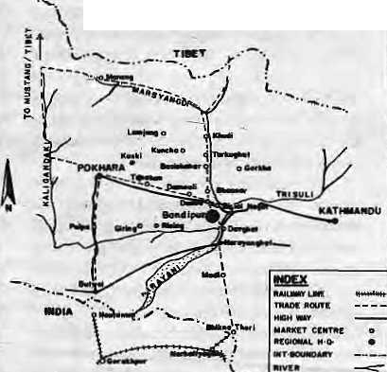
Indian cities such as Kanpur in Die latter part of the 18th Century pushed down prices and encouraged further expansion of textile markets.
Previously, traders had been mostly immersed in local commerce, economically exploiting village producers and buyers, but also providing the credit that underwrote and sustained agricultural production and community life. As thebazaarmerchants traded increas ing quant i ties of industrial commodities, however, their relationship to the countryside slowly changed. With the new liade, Ihe bazaar merchants of B andipur became incorporated into the circulation of industrial commodities, in which the sales of fabrics to villagers became the last step in realising the priceof the product necessary for sustaining and expanding factory production in India, Britain, the UnitedStates and, eventually, Japan. The merchants' orientation and commitment gradually shifted away from the community of the villages around Bandipur, with its moral imperatives and obligations, to the goal of expansion of markets for foreign industries.
The market underwent a qu alitative ch ange following the First World War, nine generations after Tekan Singh's arrival in Bandipur. Large numbers of Magar and Gurung veteran mercenaries returned from the War with their accumulated wages and new desires. At the same time, the up-country bazaar capitalists in India began forcing their way into the prev iou sly Europe an -controlled foreign trade, displacing the large European houses such as theRalliBrothersofLondon.Volkart Brothers ofSwitzerlandandDavidSasson&Company of Manchester, which could not survive the market crises of Ihe period.
As they grew and consolidated their position, the native Indian mill owners were beginning toshift their support from the British colonial government to the Indian Congress Party. Foremost among these were the Birla andlspahani families, closely connected with Gandhi andJinnah,respectively. This process culminated, following the Great Depression and the Second World War, in Indian native capital's final assertion over the colonial state apparatus, represented by the Indian Congress Party and Muslim League in India and Pakistan.
Although the Rana regime, along with the remaining Indian princes, was one of the casualties of this process that gave "independence" from the British to India, the impact was not limited to Kathmandu's rulers. As large Nepali merchant houses were "themselves already integrated within the up-country bazaar economy of North India, this process greatly benefitted iheir position.
Expansion
The merchants of Bandipur were set to take full advantage of political and economic changes represented in the shift of the administration of colonial stales from foreign to native rulers. By
the 1930s, the bazaar population totalled more than 10,000 people. Tekan Singh's descendents alone counted for more than 4,000 of them.
The eight largest merchant houses, each with large co-resident extended families and dependent retainers, expanded their operations into subsidiary bazaars across the southern slope of the Himalaya and along the Mahabharat east from Trisuli to Pokhara and south to Chitawan. These smaller bazaars with Bandipur's presence included Phale Sangu, Besisahar, Khudi, Tarkughat, Jarebar, Tunje, Changling, Maibal, Rising,Kabung,Sabung,Khoplang,Phalangkot, Thulo Dunga, Kunchha, Chisenku, Gorkha, Trisuli, Pokhara, Narayanghat,Butwal, the yearly haat bazaar at Devghat, as well as Bhikna Thori on the India border, where Bandipur merchants also had winter shops and large godowns.
TRAM ROUTES W WEST-CENTRAL MEP*L
While remaining under She ownership of the patriarchs of the trade groupings, in amanner characteristic of north Indian business houses, these subsidiary shops were managed by sons andpoorer,dependentsons-in-law. Other brothers and sons apportioned their lime between Kathmandu, Butwal, Bhikna Thori and India, arranging licences and quota rights, raising

finance and transferring moucy, buying and facilitating the movement not only of cloth, but of raw cotton, thread, cigarettes, kerosene, salt, bangles, shoes and other profitable goods.
The trading house headed by one of Tekan Singh's descendents was the largest and wealthiest in Bandipur. According to oral histories, by the 1930s, die eight major merchant houses were engaged in a total yearly purchase of approximately 1.5 million rupees of fabric and other goods from India, wholesaling to the other smaller Bandipur merchants and to traders walking down from Manang and Mustang, and retailing to the agricultural producers in far-flung villages. Members ofeach household made five or so trips to India every year. In these trips, 70 to a 100 merchants look along hundreds of porters and carried immenscquantities of coinage.
They went armed, as protection against thieves in the forests of Chitawan, where they often buried and slept upon the money at night. Avoiding colonial inspection points, the merchants surreptitiously exchanged their Nepali coins with Indian businessmen in Narkatiaganj or with return ing Lahuray mercenaries in Butwal, depending upon the rates — a constant topic of their letters.
In India, many of the merchant houses had established residences and warehouses, and close social relations (often as mil or blood brothers) with large Indian commission agents who provided them with purchasing, credit, money transfer, exchange, transport, insurance andother facilities. They also utilised close relations with important figures in the Ran a government to gain control of customs, licensing, marketing quotas, as well as obtaining various government contracts withinNepal.Someoflhciiownfamily members, positioned as judges, customs inspectors, talukdars and other officials, greatly facilitated access to the Rana government. During a period when a son of one of the families of Bandipur bazaar look the contract for the customs post at Bhikna Thori, the Bandipur merchants avoided paying customs duties entirely, causing Kathmandu businessmen to walk the two weeks roundtrip journey to Bandipur to buy wholesale fabrics at cheaper prices.
Erosion of Rural Life
TheBandipur merchants'espansionof outlets directly into the countryside meant that they were able to exeri further control over agriculturalproductionin villages throughout Nepal's region between Trisuli and Pokhara. It was in this period in the late 1920s and 30s, with a decrease in the prices of imported textiles and a transition by Indian mill owners to the production of inexpensive fabrics, that the indigenous fabric production in the villages of the central hills received its death blow.
The fields of cotton in the valleys and the looms in the households all but disappeared. Peas an t agri cu It ural pro d u ctio n and th e ro un d of village life were by now deeply drawn into the sphere of commodity exchange, and elements of village relations and culture had taken new content and meaning, or had been transformed entirely. As spinning and weaving had been the domain of women and this same household labour had to be somehow entered into the market within relations controlled by men to obtain the same commodities, this change particularly affected women's status and autonomy in the households and community.
As he iay dying of fever in 1775, Prithvi Narayan had warned of the threat posed by imported textiles. In the years 1939-44, Rana Prime Minister Juddha Shumshere vainly attempted to reindustrialise Nepal by establishing the Cottage Industry Department {"Gharelit"). Although initiated to encourage indigenous
Sep/Oct 1992 H1MAL • 17

village producers, the. Gharelu was co-opted by [he merchants, whose accumulated capital, controlofthe villages, and connections toofficials gave them an edge over village producers.
A group of major Bandipur merchants, facilitated by a well-placed family member, took advantage of government subsidies to establish the Saraswati Cloth Factory, which fell apart as soon as thesubsidised thread became unavailable. Individual merchant houses used a quota system, meant to encourage the producer by allotting distribution of cloth in each district, to establish amonopoly over materials and finished textiles, allowing sale to villagers at exploitative prices.
Soon after, the Indian Congress Party, itself linked to the large Indian business houses, took over the state apparatus in India, it forced the Rana gov ernm ent to dis continue the quota sys tern. The Bandipur merchants who, according to their letters, had already been anxiously anticipating this step, dismantled the Gharelu and shifted the capital accumulated under it back into commerce on a scale far larger than before.
As the rural community had been based on the unity of agriculture with household industry, the destruction of the domestic industry in the 1920s led directly to erosion of rural society and culture, and its "formal subsumption" to indusuia! production. Wider and wider spheresof the rural produclion were subsumed in the circulation of industrial commodities by the merchants. In part, all this meant the growing subordination, expropriation and displacement of the old class of landlords, as represented by Jagadcv Bhandari's descendents, who lost their original birta estate piece by piece over the several generations, by foreclosure to various large merchants; many of these, however, moved into new roles in administration.
Shifting Center of Gravity
Until the 1950s, the Bandipur merchant houses were satisfied in simply establishing themselves as rental landlords over existing smallhold agriculture through various sharecropping arrangements. But with the development of transport and greater accessibility to markets, the merchants and other landlords have been entering their capital in to cash crop production and industry using wage labour.
It was in 1952 that the gradual shift of Bandipur residents into the Chitawan valley to the south started. In Chitawan, facilitated by a USATD malarial suppression and "defoliation" campaign which inundated the area with DDT and constructed the then largest sawmill in Asia, the Bandipur merchants, especially those from the targe houses, used their stocks of capital, alcohol and Tharu hospitality to expropriate the Tharu villagers from their communally he Id lands, reduce them from hosts into house servants, and illegally clear great swathes of forest for grain, mustard, and vegetable production for sale to urban markets in Nepal and India.
18 H1MAL - Scp/Oci 1992
The emigration from Bandipur to Narayanghat, but also subsequently to roadside markets of the inner valleys, increased as roads were constructed linking the region to India, the new agricultural markets of the Chitawan and outer Tarai, and the urban centres of Kathmandu and Pokhara. This process has repeated itself in Tansen, Dhankuta and other hill bazaars.
In Bandipur's case, individuals of one "new-rich" family spirited the offices of the district headquarters to Damauli (on the newly constructed Kalhmandu-Pokhara Highway) in a night-time coup d'etat. The town of Bandipur, which meant so much to so many generations, remains today little more than a crumbling, though elegant, monument to its economic heyday. It had risen upon and sapped away its own rural hinterland, to itself disappear as roads that followed river valleys took away the raison d'etre of hilltop bazaars.
Recent Events
In the 1980s, the transformation to cash crop production extended from the Chitawan lowlands back towards Bandipur andother hill areas to the north. The remaining small merchants and others whocouldmobilisethenecessaryresourcesbegan citrusplantationandnut orchards. Where the hill farm ers had already lo ng s erved as s harecroppers on the paddy lands, these cash crop plantings, growing exponentially since thebeginningof the 1980s, have increasingly displaced these people, through foreclosure on long accumulated debts, from the dry lands which had been the remaining property base of the communities.
The rural labourers have had no choice but to enter directly into national, regional and international labour markets in order to satisfy needs and wants which they had previously supplied themselves (clothing, foodstuffs, energy, transport, entertainment) and to offset their decreasing access to products.
As the members of the bazaar classextended their activity and control into more and more sectors of national life, in their role as agents of regional and international forces, they and associated groups, like their Indian counterparts under the British Raj, began to bid for more direct control of the State political machinery than possible through Hie chakari and other personalisedmeansiofmakingdem ands on power.
Thus, in the closing days of the overstated "revolution" of 1950-51, it was the people of Bandipur bazaar, feeling that their widening spheres of activity and interests were increasingly restrained, who launched an attack on the local army garrison (albeit when shot upon they fled, leaving eight dead). They were nol the villagers who had lost their land and become dependent upon the bazaar merchants for commodities and finance, nor were they economic migrants.
The subsequent royal takeover and essentially one-party rule from 1962 lo 1989 were tolerated by the merchants and the
intern ational force s th at they represe n ted, because a variety of unpredictable interests continued to contest thetr control of Nepali Stale and society. Foreign governments and agencies underwrote the one-party State's advancement of the penetration and co-opting of the remaining local autonomy and control over resources and labour in the name of development, modernisation, rationalisation and other euphemisms (crowned most recently by the new local government law). This process was augmented by universal education and a certification system that set (and continues lo set) foimalistic, esoteric and inappropriate forms ofknowledge of the Western-oriented specialist over me generalise practical knowledge of the villager.
By 1989, many of the sons of theBandipur merchants had become national players in business, the profess ions and political leadership. Their power and breadth, along with that of their domestic counterparts and the international interests they associated with, had sufficiently neutralised the remaining indigenous social organisation and culture in the countryside, albeit with disastrous effect on the environment and rural community, leading the one-party government to itself become an obstacle for the full assertion of these groups.
Thus, the burgeoning new force represented by the bazaar merchants, nationally and internationally, gave its qualified support to a political upheaval ignited by the images of freedom and democracy. Labelled with the euphemistic term "People's Movement", it was safely halted once the representatives of the emergent dominant groups had set the terms to renegotiate their access to the State machinery without actually threatening it.
The drafting of the new Constitution and laws, such as of local government, which was one of the more visible aspects of this process of renegotiating the relationship between various interests within society, has removed many aspects of the process of industrial expansion and transformation from the domain of State control and political contest to the private one of business relations in the name of "privatisation". It has circumscribed the sphere of public decision and dialogue in the name of "democracy" and removed control over the country's resources and labour from the village producers in the name of "free markets" and "autonomy" of local governments that lack any effective mechanisms of accountability to their constituencies.
Thus, the cure proposed for the changes exemplified by the 200 -year history of hill towns in Nepal such as Bandipur bazaar is an even bigger dose of the old medicine, reflecting the worldwide consolidation of corporate industrial interests which increasingly provided the substance of this history.
S. MiKeseli currently researches at the Centre for Nepal and Asian Studies, Tribhuvan University.

Darjeeling Beneath the Cosmetics
Writer Marcus Dam left Darjeeling when he was 15 "and sick of the place". In Calcutta, however,
distance made the heart grow fonder. He returned recently and noted the changes.
This article is excerptedfrom the 'Miscellany' supplement of the Statesman.

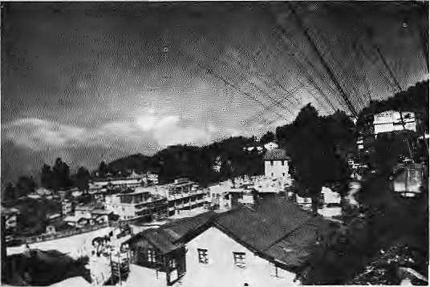

W
hen I went back this time, Lhe skies were not thesame. The city seemed to have changed over the years. It wore a smile that seemed to mock the native as he tried to return. The only thing that possibly kepi me going was a flood of memories thai, came eras hin g to my mind, tossing me into a cemetery with gravestones overgrown with weeds: Nature paying its respects to the sahibs and their memsahibs who came to an alien land, thousands of miles away, to rule -— and die.
Fresh terraces have been carved out of whatever hillsides that remain for tomorrow's gravestones. Once, the cemetery was my makeshift stage, lhe headstones my devout fans; I would strum a Beatles tune on a borrowed guitar. Today, the cemetery is bursting at the seams with the dead. Like everything else in Darjeeling. Leaving you no space to laugh at the discordant notes without being overheard. Or to cry out just for the heck of it...
Spilling into public life is a new xenophobia, so long brewing in theshadows of'baltadur-babu loyalties. Darjeeling, the place that long lay lost in the pages of photo albums and lourist brochures, is simmering with political passions and injured feelings that threaten to burst into violence any moment. The clerk at the reception of the hotel glares at me with barely concealed hostility. He refuses to ans wermy queries in his own language —the one I tookas my own when I grew up in the hills. I am not surprised — newspapers have forewarned me of such behaviour. Nonetheless, the forbidding look on his face jars my mind: I realise that I am no longer wanted in a place where I was born and whichl consider my home.
I check into my room and watch from my window the roads winding up the hills. How the soft fog carresses and smothers the roads in its embrace; how the mist creeps in through the window to hold me. All this may sound rather sentimental, but the hills are no longer as depicted in those slickly produced tourist guide-books.
Yes, the truth is that the inexorable march of politics has scarred Darjeeling beyond recognition. Till now forced to be content with being just anobliging masseur to tired bodies and fatigued minds, Darjeeling is now coming to terms with itself. And, as it does so, shaking off that image of ethereal beauty which spurred the fantasiesoftheseasoners.itseemsto say: "Accept

me the way I am. Wash away the cosmetics. Clear the cobwebs of myths that people have spun around me, people who never quite understood me." I listen.
I meet a "man on the street" — I need a quote for my story. He echoes what has become, 1 feel, the voice of Darjeeling. "Leave us alone if you don't understand us." The daisies on the hillside are not for plucking. Not because the daisies have shrivelled up, but because the hillsides have changed. To put it in terms more academic: a social metamorphosis has begun. Insulated from the mainstream for decades, its people are now putting down their demands in clear, unvarnished terms.
But there is hardly anyone to listen. There is the GNLF leader Subhas Ghising, flexing his muscles and painting himself in leader's colours. The West Bengal Government seems to have resigned itself to an unhappy coexistence. Meanwhile, the Centre, which had its hand thick in the political pie, now wails and watches as things seemingly go out of hand.
Caught in the crossfire of these opposing political forces are the people of Darjeeling. And every homecoming widens the gap between memories of the past and doubts about a future that is uncertain. People are groping for new social moorings; they're even willing to burrow into linguistic intricacies to find out what exactly their language is.
Even the Himalaya — in whose niches resided my childhood's imagined wonder, the S now Queen—ha s ch a nged. Th e Kanche nju nga is no longer visible from the many vantage points as I meander up from the lower Chowkbazar downtown. Jagged housing structures have sprung up breaking through ,the ground in a
frenzy matched only by the desire to own a house. Real-estate developers, with their men, machines and concrete, are not short of clients.
So all year round, new houses are built and old ones raised to newer heights, the hillsides get disfigured —andDarjeeling buckles under their weight....
He was a Lepcha. His ancestors, he claimed, were of the earliest inhabitants of the region. Then came the sahibs, lured by the pristine, cool beauty of the hills — and out of the S swelteringheatoftheplains.Theyset \a up a health resort, and a people's home became a ''hill-station". Then began an era of colonisation which continued well past Independence, forcing the Lepchas into a state of penury, snipping off their roots and robbing them of, perhaps, the only thing they had left — social identity.
And there he was, this Lepcha, lumbering up the hill, selling newspapers: his face weather-beaten and wrinkled, on his tired shoulders a haversack crammed with newspapers. As he emerged from around the bend, I would run down my staircase and snatch the paper from his outstretched hands. He wo ul d w ait for the change as 1 excitedly peered into the sports pages, the smell of fresh newsprint and the morning air gently rubbing against me as I tried to find out what had happened to Calcutta's Big Three. On one of my earlier homecomings, I was told that my Lepcha friend had given up his job and retreated to the "caman" down the hills, wherehe looked after his tiny orange orchard. Today, those who read newspapers go to stalls.
Even the names of the roads have changed. The highway that snakes upthe hills from Siliguri, known till recently as the Hill Cart Road, has been changed to Tenzing Norgay Highway. Predictably, such changes haven't gone down well with many old-timers. Fortunately, the "Pagia Jhora" (waterfall gone crazy) — whose turbulence during the monsoon triggers landslides — is still called "Pagla Jhora".
As the agitation picks up momentun anew, rumblings from the hills may once grab the headlines. Violence may reappear on the snaking streets, bombs may find their targets — unless the deafening voices of the people are heard. Meanwhile, Darjeeling waits for the healing touch — and the clerk at the hotel's reception to flash a smile and greet the native's return.
Sep/Oct 1992 HIMAL ■ 19

Real and False Geographies of the Himalaya
Trans-Himalayan travel, however it might have been portrayed, was not the exclusive pastime of Western adventurers. But geographies are created according to the needs of the day.
by Nigel J,R. Allan

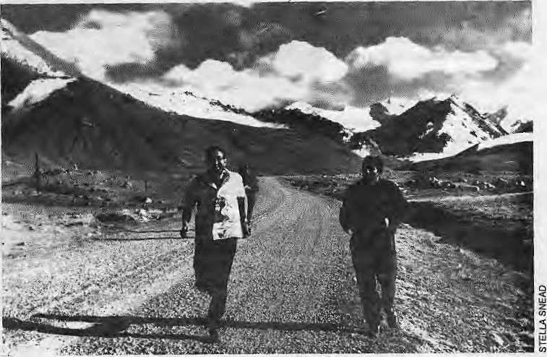
I
n arecent essay on exploration in the Greater Himalaya, travel writer Stephen Venables remodels the mountains to suit the tastes of Western consumers. Venables touts the Himalaya as the "greatest mountain barrier on Earth". Over it forged the Europeans, especially the British, exploring, surveying and documenting the mountains, not for the benefit of science but for political and commercial exploitation. What is missing is any mention of the indigenous people who have long travelled the mountains. In narrating the European exploration of the Himalaya, which occurred almost entirely during the past two centuries, Venables successfully reinforces the notions not only that Himalayan travel is recent but also all travel over this perceived barrier was European or European-inspired. Venables perpetuates the idea that knowledge about the Himalaya is Western-derived: that the problemsof accessibility, Lhough difficult, were solved by British imperialists from the Indian subcontinent and that the first descriptions of routes and places were recorded in the English language.
The barrier notion need not be taken very seriously for there is enough literature to successfully challenge it. Furthermore, that liter ature is far fro m Euro pe an - in spired and m uch of it was written centuries ago. Accessibility of the South Asian mountain rimland has always been of major concern. Although now ignoredby contemporary 'neo-colonialists' — adventure travellers and the like—the Royal Geographical Society (RGS) in the last century used old accounts of tians-Himalayan travel to further the aims of the British in their frontier tracts. It was the constant movement up and down and in and out of the Greater Himalaya that gave rise to its portrayal as a Highland-Lowland Interaction system. Perceptions such as Venables¹ mountain 'barrier', or claims of undiscovered 'refuge' populations, are concoctions of the contemporary mind. They are not rooted in history. There is a long record of travel tlirough the mountains by trans-Himalayan traders, pilgrims and seasonal migrants. Enhanced accessibility is the most important transformation of Himalayan habitat and society.
MostWestemershaveaconceplual problem in considering the South Asia mountain rimland because most are city folk used to relating everything to a core, the city, and a pcriphery. We would do well to re-re-ad Agehananda Bharati's essays. Actual and Ideal Himalaya:
Khunjerab Pass on the Karakoram Highway.
Hindu Views of the Mountains, and Mountain People and Monastics /nKwnaon, both of which help us to appreciate the huge gulf that exists between thepahari and the maidani admi. Despite claims of plains folk that they have always considered the Himalaya (the periphery) a place of adoration and sanctity, mountain people are socially and spatially far from the city. The phenomenon is not unique to the Indian subcontinent. In the West there is a similar gulf in perception between rural agricultural workers and city folk who prattle on about the ephemeral nature of 'wilderness'.
Geographical Absurdities
Instead of appreciating that mountain societies are not static and that they have floating populations, Westerners attempt to pin down these 'fuzzy' areas. Invariably, the resulting geopolitical boundaries are made to conform to natural features such as the crest of a mountain range or a watershed divide. The facts that ridge tops are often areas of social interchange in the summer and that the major rivers divide people are ignored. A Western example would be the Swiss who earned wealth by becoming brokers between the southern and northern Europeans in an area that could be described as culturally and ecologically fuzzy. Smuggling was prominent and, even today, the Swiss have globalised this
venerable mountain tradition by becoming clandestine bankers for the world's funny money.
Many such boundaries in the Greater Himalaya are products of the "Law of Geographical Absurdity", as George H.T. Kimble put it, under which boundaries that do not exist are drawn around places that do not matter. Nepal and Baluchistan were demarcated and set off by themselves. Afghanistan, now home to only 40,000 'real' Afghans (as they define the elhnonym), was a surreal concoction of the British. Two of the three principal 'cores' of the Greater Himal ay a—Pesh awar-Kabul andPunch-Srinagar —- were bifurcated seasonal capitals. Only the third, Kathmandu, was fairly static, but even it has lost its gateway status as Brratnagar emerges as the Denver of Nepal. Kabul and Sri nag ar owed much of their prominence to the fact that they were the points for access into Central and Inner Asia. Local control took the form of licencing access to trade routes rather than dominating territory.
Britain, an island nation, never had to delineate borders and so its efforts in defining territory in South Asia were forever clouded by ethnocentric bias. One example of the limited horizon of the imperialists can be seen the farfetched remark by Olaf Caroe that Central Asia lay beyond the Ambela Pass — a place well within the Indus watershed and with Indie

20 HIMAL • Sep/Oct 1992

languages that were known for hundreds of kilometres around it and as far west as Kabul. Because Caroe never gained access to Kabul, the western limit of South Asia, the Indian subcontinent stopped at the limits of his progress, which was in the low hills. Peter Bishop's excellent book, The Myth of Shangri-La (University of California Press, 1989) shows how curtailed access to Tibet resulted in Europeans concocting fanciful notions of the country. Another example isMary Louise Pratt's recent book., Imperial Eyes; Travel Writing and Transculturation (Routledge, 1992), about travel in the 19th Century, an amusing account of imperialists* letters from abroad. The struggle was not for Hie enjoyment of travel, but to create access for the imperialists.
In an excellent essay on the history of European scientific exploration in the high Himalaya, Ken Hewitt of Wilfrid Lauricr University in Ontario, Canada, highlights the different styles of European exploration of the Karakorum. Most 19th Century Europeans, such as the three von Schlagintweit brothers, were interested in scientific discoveries whereas the British were the surveyors who measured the heights of passes and the widths of river crossings in the hope of political, military or commercial penetration.
Who were the people who gained access through the Himalaya? They were traders, pilgrims, or local folk exploiting t!ie highly varied biophysical environment. Wliileihe popular idea of a 'refuge' population living in a valley is plausible, most of the claims about these people arise from the fact lhal many separate languages exist in the mountains. Karl Jettmar's remark about parts of the Himalaya being an "ethnic zoo''hasoftenbeenmisinterpreied. The languages exist in discrete populations, but many of these people were multilingual because the bazaar languages, such as Pashto, Farsi, Hiiidi, Pahari and Tibetan, ere ate a veneer over the many Indie Dardic languages in the west, or subsuming the profusion of Tibeto-Burman languages in the east.
Traris-Hinialayan trading is centuries old. In addition to trading in foodstuffs and condiments, such as salt and asafelida, and Eves lock, there was also an active trade in slaves, especially between Kashmir and Central Asia. Speciality trading in certain commodities such as 'Kashmir' wool from theKaghan goats of the Bakkanval typify the close relationship between an ethnic group and a traded commodity. By trading surplus commodities the mountain residents could overcome the disadvantages of their marginal environment. In traditional mountain economies, the operating niche was quite small. Therefore it was necessary to maximise output from the niche and Irade a product for another obtained elsewhere. These practices fit well with the notion of Highland-Lowland interaction wherein people and
commodities must move seasonally in order to survive in a marginal environment.
Unfortunately, the 20th Century introduced Asia to Uic idea of the nation-State which resulted in the creation of boundaries around those States. These boundaries completely disrupted traditional trading patterns in the South Asian mountain rimland. Access was denied. There were no really self-sustaining mountain communities because trade was necessary to susiain them. From one end of the Himalaya to another, mo u ntain comm un ides were transformed by the restriction of travel. A.C. Sinha lias documented how the swidden cultivators, Abors, Mishmi and Miri in the Sadiya Frontier Tract in Assam, traded forest products for tools obtained from Tibet. Bhutan, too, traded extensively with Tibet, not just for metal products but for horses and other livestock. The British al the end of the 19th Century realised that this trade was substantial and arranged to have an 'insider', David MacDonaJd (the offspring of a Scottish father, Sikkimese mother, and married to a Nepali), as their agent in Gyantse. By restricting trade on many trans-Himalayan routes while improving some key mule tracks that converged on British control led caravan serais, Imperial India sought to monopolise trans-border trade.
During Ihe last century, British India saw developing trade relations with Centra] and Inner Asia—essentially east and west Turkcslan-—as something more than an opportunity to make money. Their activities were suffused with a missionary zeal to convert local people to Christianity. This fervour was an integral part of Ihe 'Great" Game' that started with 'Bokhara' Burnes and, later, Conolly's ill-fated miss ions to Central Asia in 1842; Themuch -decorated Henry
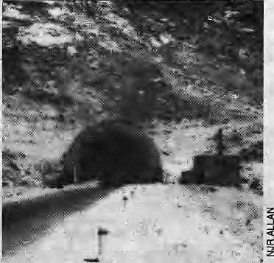
The north portal of the Sstang Tunnel through the Hindu Kush. This tunnel, and an all-weather road, links Central Asia with South Asia. The 30-year impact of this road and tunnel has fc_{t} i greater communication between the two halves of Afghanistan, thereby reducing spatial inequalities among the many ethnic groups of the country.
Rawlinson, in an address to the Royal Geographical Society in 1868, stated that the most valuable result of all the RGS-sponsorcd researches and exploration was the opening up of new routes for international commerce. Rawlinson believed international commerce to be the -'most important instrument in extending civilisation, in promoting peace and in raising the social condition of people who engage in it". Furthermore, when two countries stand in (he relationship of producer and consumer, their material interests become so identified that it is almost impossible for them to go to war. Pox Britannica was based on this notion. The travels of the 'pundits', the clandestine British-trained Indian and Bhotia surveyors arose from these beliefs.
lea for Turkestan
One widely discussed commodity was tea. Tea for Chinese east Turkestan travelled 4,800 km, via Shanghai and Canton to Bombay and Karachi, up the Indus into the Punjab and Kabul and over the Hindu Kush to be sold in the bazaars of Kokand, Yarkand and Kashgar. The British, suggested Rawlinson, could obtain tea in their newly developed estates in Assam and convey it through Tibet to Chinese Turkestan, a distance of only 800 km. The British estimated a profit margin of 50 per cent if they could identify a good route, negotiable by wheeled traffic. It was left to the RGS to find explorers who could create a geography that established such a route to Central Asia. But, as Rawlinson remarked in his 1868 address to the RGS, "there is a true and false geography of these countries." False geo graph ies, like the one invented by Venables, are constantly manufactured. With their zeal for trade, the British redoubled their efforts at finding a way into Turkestan.
Invaders to South Asia invariably came from die northwest because the route supported little vegetation to hamper passage. The researches of British-trained local scouts suggested that the prospects of substantial trade between South and Central Asia were dim. What did alarm Ihe British was the conquest of Central Asia by Tsarist forces. The turning point of the Great Game occurred in the Pamirs when Grombchevski faced down Younghusband—of 1904 Lhasa fame — and the British retreated back to the watershed of South Asia.
The model of Highland-Lowland interaction takes several forms. The Himalayan form focuses on exchange of goods from the Indo-Gangetic plain to tiie highlands of Tibet. Until the 1960s, Tibet had never been self-sufficient in grain; hence imports from the south were exchanged for salt and wool. Much trade went through princely states which exactedduty on the commodities. The Administrative Report of 1919 for Bashahr State (now part of Himachal Pradesh) gives trade statistics monitored by the trade posts at Shalkar Chang, Shipki, andMorang

Sep/Oct 1992 HIMAL • 21

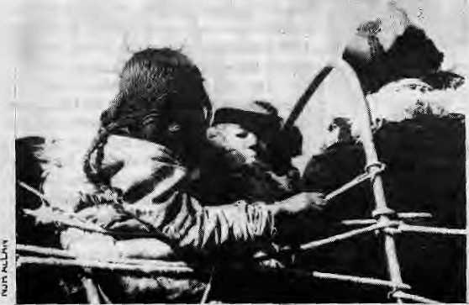
leading into Chinese Tibet ("Chinese Tibet" is the precise wording in the document). Bushahr State imported mainly Pasham (fine wool), raw wool, borax and horses. Imports were about four times that of exports, indicating that Bushahr State processed Tibetan goods and traded the finished goods in India. Altitude per se was not ahindrance in trading over the 5,500-metre passes. Rather it was the seasonal snow blocking the passes that hindered travel.
Too often is Nepal cited as the archetype , for Himalayan habitat and society. In fact, Nepal is entirely atypical of the general pattern of rural life in today's Greater Himalaya because access by vehicle from the Tarai to the hills and mountains is almost negligible. Only two all-weather roads penetrate the foothills. Compare this with the major transformation oftheHimalaya in the past 40 years due to the closure of trans-montane trading routes as nation-State boundaries closed, and theenhanced access from the lowlands into the mountains via motor-vehicle tracks. The 1962 imbroglio between China and India on their frontiers forced India to build an estimated 11,000 km of border roads. India, a nation with a transportation fixation on railways, built many bad roads during this period because it had not the technical experience and skill necessary to build good mountain toads and tracks.
Kachha Roads and Irrigation
When I first became involved with the Himalaya over 25 years ago, in a food-for-work programme, we always asked the cultivators what they would construct if we provided wheat in payment. The answer then was always kachha roads and small irrigation facilities. The answer today is the same. Tommy Carlstein of the University of Lund, Sweden, believes the transformation was from the pre-industrial eco-tech no logy to an adjunct of industrial economy. The success of the Aga Khan Rural Support Programme in northern Pakistanrests on its ability to satisfy the villagers' (albeit male) wants. Those desires are jeep/tractor tracks with bridges and improved irrigation. Once a village has approved the basic
organisation for a development project and that initial desire is satisfied, the project has the goodwill of the village which Ls a good basis for executing further projects.
In the 1960s, Will Owen, a one-time World Bank transportation economist, wrote several books relating to enhanced accessibility to villages.Distanceand Development enumerated the advantages of kachha roads which, translated for mountain areas, allowed jeeps and farm tractors with trailers to substitute the need for complementary eco-niches that were exploited at different altitudes. Rapid travel allowed surpluses to be marketed, specialisation to occur and spatial inequality in access to public services id be reduced. In a Muslim area, for example, it meant th at women couldseekhealthcare because rapid travel to and from a health facility made overnight stays unnecessary,
Increased accessibility also expanded the role of government. Anyone who has worked in the mountains knows of government officials who never ventured beyond the confines of their offices in the district headquarters. Rapid travel meant that they could hot only maintain social cohesion by visiting their families, invariably in some distant town or city, but also patrol their domain and work more efficiently.
Increased road transportation into mountains h as its detractors, however. Ideal routes do not always correspond to where villages are and some villages therefore remain remote. Researchers have criticised the routes of major roads in Nepal and Indian-built roads in mountains. The roads thatthosescholar&criticise are major roads for five- to seven-tonne trucks. Heavyvehicleroulesrequiremuchmoresidecut and when 1 talk about enhanced accessibility I do not have these roads in mind. That level of technology is simply inappropriate in Himalayan mountainous ten ain. Jeeps , the in famo us 'cargo' jeeps with one-tonne payloads, and farm tractors pulling a twb^ to three-tonne payload require a much narrower tiack than a seven-tonne truck.. Farm tractor and jeep tracks need about the same width as do many foot trails in the Himalaya, and
Road-building on tha Tibetan Plateau has enhanced religiousity. Tibetan pilgrims take advantage of the road to Lhasa.
the wire cable bridges use a design that has been around for 100 years. The environmental impact of this level of transport technology is minimal compared to that needed for large trucks.
Wilfrid Owen's ideas about rural vehicle access also have their detractors. One set of development experts sees the controllers of an outside technology, transport vehicles, creating a decreased demand for surplus products. But if the type of transport technology is kept at the level of jeeps and tractors and not of large trucks, the investment in a motor vehicle is modest and within the grasp of Himalayan expatriates working in the Gulf states or even in the Indo-Gangetic plains. Farm tractors perform other duties besides pulling trailers in mountains. Jeff Fox, a research associate at the Environment Policy Institute of the East-Wst Center, Hawai, made a 10-year retrospective study of his survey village in Nepal and found that a jeep road had enhanced the condition of the local forest resources. Tractors had dispensed with the need for draught animals, and the absence of animals, in turn, resulted in fewer trees being lopped for fodder leaves. There are, of course, questions about rais ing foreign exchange for imported fuel, but the casual visitor to a city like Kathmandu soon realises that foreign exchange for motor vehicle fuel does not seem to be an impediment to owning and driving a vehicle.
Geographies Continually Bora
Other criticisms are levelled by outsiders at the 'destruction' of the local culture. This school of thought believes in the preservation of 'human zoos'. The proponents of this school believe that culture is static and notdynamic.KenMcDonald, a researcher working with Ken Hewitt, while living in Askole, the last substantial village on the route to Concordia in the Karakorum, found that trekkers and climbers were dismayed that the jeep track would be extended to this village, thereby linking it with the rest of Pakistan, Invariably, they felt the track would have a negative effect on the village and the trip up to Concordia. Similar comments were expressed about the construct ion of a jeep road to Shims hall, the only village in north Pakistan not served by a jeep track. Modern conveniences such as molar vehicles and relatively benign conveyances such as mountain bikes often reinforce ethnicity because they expose rural people to a variety of outsiders. Geographies are created continually. A bus driver, switching the cassettes of his tape player as the bus groans up the mountain road into a different language are a, is bul one indicator that traditional cultures adapt lo modern conditions of which accessibility is a key component.
Nigel J.R. Allan coedited Human Impact on Mountains and his edited book Karakorum Conquered will be published next year by Oxford University Press

22 H1MAL • Sep/Oci 1992

Is Lo Manthang Ready for Electricity?
Government reluctance to admit its limitations urges villages to think big when it comes to
development. They are encouraged to ask for airports and highways rather than to initiate
projects that they are already able to maintain.

How about an airfield from here to there?
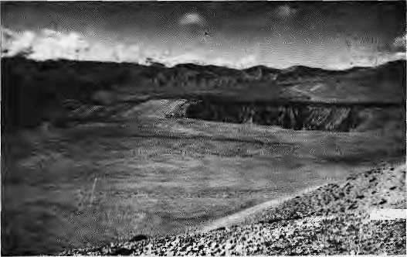

T T ro
alkingup to Lo Manthang, the 'capital' of Upper Mustang, the graffiti on the rocks are still full of the pledges made during the genera] elections of June 1991. The candidates of the three main political parties ambitiously promised to bring aroad in lOyears, and electricity in five.
AroadtoconneetLoManthangtoBaglung, in the mid-hills near Pokhara, would have to be about 150 kilometres long and would be difficult to align along the steep flanksof the KaliGandaki valley. The Karakoram Highway of Pakistan, which traverses similar terrain, is considered a marvel of modern engineering but would be prohibitively expensive to replicate. The high way to Lo Manthang would cost at least- NRs 1.5 billion (US 32 million), which would certainly require foreign aid, loans and international contractors.
The politicians' promise of electricity, though a bit moie modest, would nevertheless cost much more than the annual budget of the entire district. The politicians promised a hydropower plant at a village named Ghami, to cost an estimated NRs 100 million.
The Mustang leadership's vision of desirable projects and development are 'large-scale and implanted' rather than 'home-grown and evolved'. Development is seen to be something that will be delivered as a fully packaged gift from the outside, from the Government. The leadership assumes that the community can leap into development and that the support for this jump will come from karmacharis — bureaucrats and administrators — and the Government budget.
There is little room for evolution in any of this. The development of local capability plays no role.
Development Desires
The politicians' perception of what development is seems to be shared by the village folks of Upper Mustang, the Loba, as well. So it is not only the District Chairman, for example, but also the Loba on the mil'who feels that a road and electricity are high priorities. The villager walking up fro m Chuksang to Lo Manthang with grain on his back collected in exchange for labour will say:''You see life is difficult here, if we had roads and buses like
by Bikash Pandey
you have in Kathmandu, life would be so much easier." Another will complain: "There is no firewood here, and you cannot imagine how cold it gets in the winter; with electricity, we could cook on electricity, we could heat our houses..."
This is the level at which many development desires are being expressed. Since the opening of Upper Mustang to tourism in April of this year, the ward representatives of three out of the six main villages even submitted a joint application for an airport. S uch an airport wouldbring tourists directly to Lo Manthang rather than through the Jomosom airstrip and up the Kali Gandaki trail.
In addition to the question of what are the real needs of the people, therefore, we must also ask: who voices those real needs? And who does one ask to voice them if not the representatives?
Do the promised 'products' match a real need? Interestingly, during the electioneering, no promises were made to provide a health post, school or agricultural extension office. No matter how poor these services are, they are considered to be already supplied and, therefore, not worthy to be the objects of political activism. This even though the poor of Upper Mustang would probably benefit more from a properly functioning health post than from a highway or airport. Presently, those who can afford it head down to the District Headquarters of Jomosom, in Lower Mustang, or to Pokhara for medical care,.
A de velopme nt organ is ation that is starti ng work in Lo Manthang recently proposed building a health post that would have a reliable stock of medicine at reasonable prices and be staffed year round by a qualified health assistant. The costs
would be borne by the interest accruing from a revolving fund. The organisation proposed that the villagers might put up some of the money for the fund, from the payments they received for labour contributed to other development activities. The villagers thought about it and decided that, as there already was a Government health post in Lo Manlhang, they did not want to invest in another one.
The Lobas seemed unable to distinguish between the proposed project and what the Government was providing — an over-staffed health post which was closed all winter and whose drug supply rarely lasts more than a se ason. The fact that a Government health post existed seemed enough for the villagers. Meanwhile, their desires moved on to bigger things for which there is no budget.
Numbers Speak
As far as 'development' is concerned, the public' and its representatives both appear to be satisfied with numbers, and so the Government proceeds to provide them: so many kilometres of road, so many kilowatts of power, so many hectares of irrigated land, so many schools and so many health posts...
Indeed, rhetoric seems to be all that the villagers are fed. The Lobas are unsure of how the assurances are to be implemented. Of electricity forLo Manthang, some thought that it would be brought up from Jomosom, while others had heard that it would be generated from the river by Ghami village. The Lobas believed that there would be plenty of power for lighting, cooking Wd heating — all of it to be available at government rates.
The promise to bring electricity was of special interest to me. I was going up to Lo Manthang to try to
< persuade the inhabitants to move
1 aheadwiththeircommunity-owned
UJ 22 kW electrification scheme,
x Equipment had already been
3 delivered, but construction was
< stalled due to political rivalries.
> At a public meeting in Lo
2 Manthang, some inhabitants
gggggi % expressed their desire to proceed
^ with the installation but wanted d softer terms on the loan taken from the Agricultural Development Bank (ADB/N). They were confident that

Sep/Oct 1992 HIMAL * 23

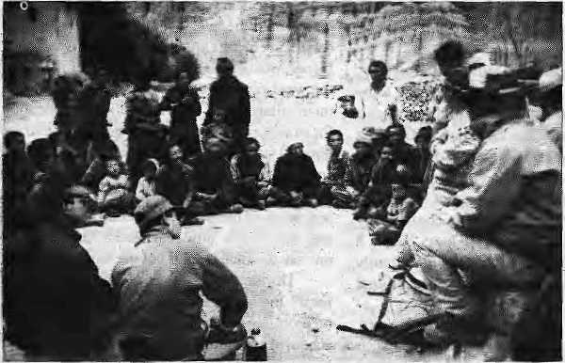
the scheme could pay for its operation and maintenance from a monthly tariff if it did not also have to service a loan.
A larger number at the meeting, however, were categorically opposed to involvement in the project. They wished no share of the re spon sibility. ^Why can' t the G overnmen t build the scheme?", they asked. "We will pay the monthly rates and, when things breakdown, the Government will lake the equipment to Kalhmandu in a helicopter and fix iL"
Alternative economist E.F. Schumacher talked of development starting not with goods, but with people. He claimed that, among the causes of poverty, the material factors—such as lack of natural wealth, capital or infrastructure — are entirely secondary. Schumacher believed that the primary causes of poverty are non-material, they lie in deficiencies in education, organisation and discipline.
Painless Development
Yet here they were, the people of Lo Manthang, very much asking for materials and implanted development. They wished to shun the slow and uncertain process of capability -building. "We do not want to take any of these risks," they were saying, and, "we certainly do not want the responsibility for thesechanges.Wehaveelected representatives that will go to the Government and demand the road and the electricity. We will pay our bus fares and we will pay for the units
recorded on the electricity meter every month." Were they asking, perhaps, for painless development?
One factor that contributed to Lo Manthang's reluctance to complete the small, community-owned and operated hydro scheme certainly was the recent experience of Ghyonhup, Qiarang and Marang, which had built iheir own hydro schemes in the past.two years :— with unhappy results.;The three villages had gone to the^{v}ADB/N, taken out loans, and hired a development agency from the southern-Nepal engineering town of Bulwal to build and install their hydro units. The District Chairman of the
time had motivated the villages to implement the schemes.
It would have seemed to Schumacher that Chyonhup, Charang and Marang had made all the right development-sensitive moves. Village people hajd taken matters into their own hands; they had made electricity their own -concern rather than leave it to the Government. Villages had cooperated in contributing labour and collectjng.pashtloor-to-door. Theequipment they had installed was made in Nepal and could be repaired in Nepal and, furthermore, the power plant operators were locals from the villages.
And yet, for all this, acouple of years down
Lobas in Lo Manthang sit with a team of outside motivators to discuss bikas.

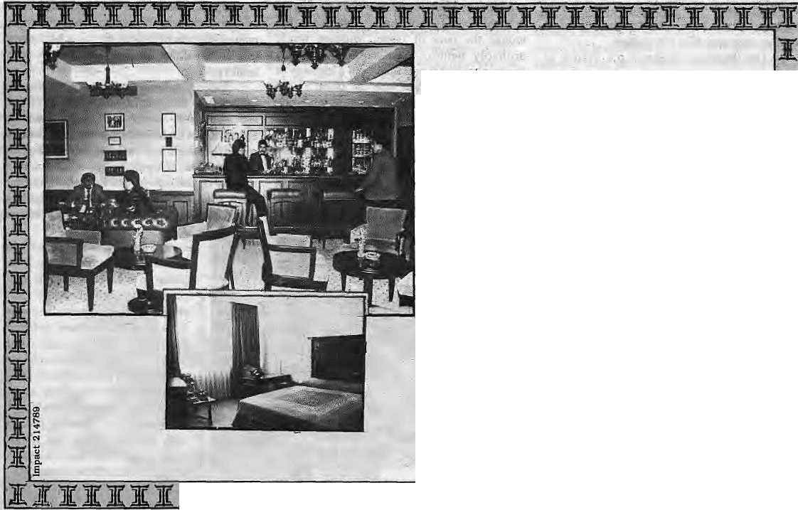
Come to the Everest Come to the Best
Everest: The only five star deluxe hotel that offefs you your very own Nepal. The traditional hospitality'of its highly trained staff. Touches of Nepal's beauty in its enchanting ambience. The sheer luxury of the rooms with breathtaking Himalayan views. _
Dine in the cosmopolitan atmosphere of the 'Cafe.' Enjoy the Chinese and Tibetan food in 'Sherpabnd,' Or the delicately spiced Tandoori and Mughlai dishes in the 'Far Pavilion,'
live up Katmandu's velvet nights in the 'Himalayan Tavern. Or savour the-otmosphere at 'Bugles and Tigers.' Dance to the latest tunes in Galaxy — Nepal's only discotheque.
Everest hqs so much more to offer. And a reputation as lofty as Mt, Everest to live up to. Every day. All the time.
The Everest Hotel
o, P.O Bo* £99, Katmandu, Nopri Tel: 330567 Fax: 977-1*226005 ."fix: Z&Q HOTEVS WP
IIIIIHHI

24 HIMAL • Sep/Oci 1992

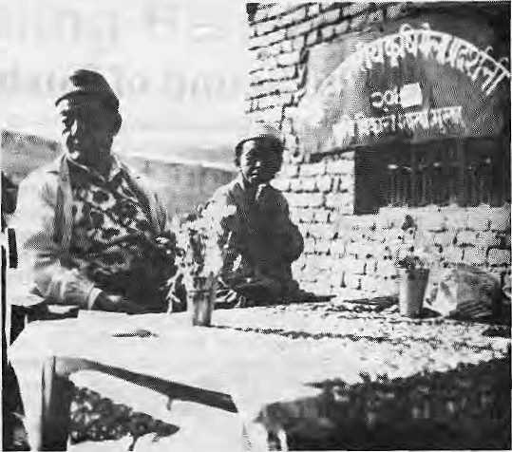
yam see fl ^better: and look better
OPTOMEtRlSr%SreaAUSTIN CORRECTIVE GLASSES & SUN-CLASSES
New Roejcj, Kathrhoridu.: I: Tel: 217856 ■ /
American Cultural.,
OFHC IiitemutibnaT _ NERVE Color Bab BAT A
Jigme Parbal Bista, Raja
of Mustang, at an
agriculture fair.
ihe line the throe schemes are barely surviving. No village has repaid its loan and the electricity supply is erratic. The experience of Chyonhup, Charang and Marang have convinced all the other villages of Upper Mustang that this is not the way to do tilings.

NERVE
Rainbow Photo
Nirula's
NEW ROAD
Mabaci
Right choice of technology, and the daring of villagers to take control, do not appear to guarantee results. What is required? The process is long and slow so organisations that are promoting development must be willing to stay around longer than they did in the case of the three villages of Upper Mustang. The help that the villagers required was not so much in the hydropower equipment but inlhe'software¹—in helping the community to organise, in the support of proper management, in the discipline required to make monthly collections. In other words, development organisations must assist in the process of making the villagers more confident of their capabilities.
The question is not whether the Ghami scheme would be better than the individual microhydro schemes in the three villages, but whether the capability to run the schemes is present. Given that the Ghami scheme is larger man the three smaller schemes, certainly, the necessary management and technical skills do not exist at present to operate and maintain it
While at their present capability level the Lobas cannot run the Ghami project (if it were built, the Government would have to run it), village committees and local operators could easily operate the smaller village-level schemes —- if they are properly supported. It is only with the confide nee til at comes from success in running smaller projects thatlhevillagers can tackle the challenge of larger schemes.
One more important question needs to be answered: Why should the people of Lo Manthang lake responsibility for their development when tlie people in Kathmandu do not? For purely practical political reasons, the Government will never invest the same amount of money on the person in Lo Mnnthang as in Kathmandu. Besides, the demands of villages has created such a bottomless pit that even
a Government that would want to go beyond development sloganeering cannot provide all the boons that the hinterland asks for.
Lo Manthang and Kathmandu
Today, even after the completion of the Seventh Five YearPlan,only 1 lpercentofthepopulation has access to electricity. The people of places such as Lo Manthang represent but a tiny proportion of this 11 per cent. Of the 7,000 km of motorable roads built in 30 years of planned development, none penetrates areas such as Lo Manthang.
The Government needs to think carefully and stateclearly what it can and cannot do for the villagersofNepal.lt is debilitating, for example, when Hie people of Lo Manlhang are led to believe that the Government can bring them electricity from Ghami. Rather than build up their capabilities from smaller schemes, it is easier for them to wail for the larger hand-out project.
TheGovemmentmustnow prod uce apo licy that clearly slates its limitations. This cannot be ai the vague level in which the minister says, "Our resources are limited and we need community participation in development activities." In small hydro, for example, the Government must state specifically that it can give only so much support and that rural communities must build the schemes themselves. Or that it will build highways up to a certain sue but it cannot build the link roads. The commitments maybe modest, butonce made theGovern-ment must be duty-bound lo fulfill them.
This kind of limit-setting will not only cut tlie Government's development burden but also stimulate people to go get things for themselves rather than wait for Kalhmandu to come through. Most importantly, it will make for vibrant communities that can take development into their own hands, with some clearly specified assistance from the Government or other institutions.
Meanwhile, development agencies and nongovernmental organisations need to work much more on the 'software' aspects of development. Everyone knows you need pipes for a drinking water scheme, for example, but few agencies bother with helping villagers create sustainable management systems. As things stand, NGOs are too busy "handing over" projects with management packages for the villagers to run.
After the equipment is delivered and the construction complete, they should stay around to provide management and maintenance until the villagers are able to take up running ihe services by themselves. After all, the real problems of management start after the contractors and consultants go home down the valley.
!>
B, Pandey works in Nepal with the Intermediate Technology Development Group.
Sep/Oci 1992 HIMAL ■ 25

BRIEFS
The Bills' re Alive with the Sound of Turbo-props

Reinhold and the Iceman
Turbo Panda' has landed.
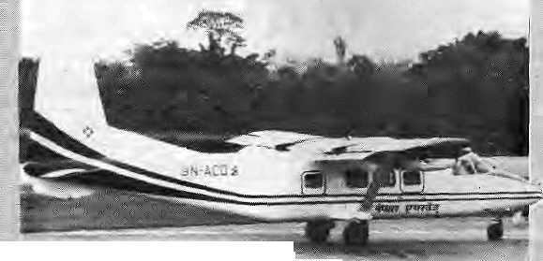



T
he Himalayan skies have never seen so many airlines. Three new airlines were launched in the summer in Nepal alprte, A helicopter service has also been registered though it is not yet flying,
In India, even while the Vayudoot feeder airline struggles to stay airborne, other airlines have taken to the air under a government-sponsored "Air Taxi" scheme. Jagson, a new Delhi-based airline owned by Jagdish P, Gupta, serves Dehra Dun, $himla and Kulu with its Dornier Do-228. jagson also runs ''Himalaya Darshan", mountain fh'ghls that Qy tlie Nanda' Devi Sanctuary.
The Indian Department of Civil Aviation, meanwhile, has dropped the idea of extending short landing and take off (STOL) services to the sparsely populated hill states of the northeast. Instead, it decided in June to go
the celebrated find of a 6,000 yeair-old, pre-Btonze Age corpse tin an Alpine glacier last September an elaborate hoax? if it was, what did mountaineeer Reinhojd Messnetjfcave to do with it? (See Hlmal Jbn/Felb 1992)
The Sunday Times of London reports that Austrian researchers are questioning the evidence asking awkward questions about the circumstances in which the iceman was found. Michael Heim, heading an investigative unit for a Bavarian television station, concedes that the coipsfc must be about 4,000 years old, "But we are not convinced that this man died tip there on the ice."
The sceptics find it extraordinary that the corpse (dubbed:Frozen Fritz) could have survived intact for thousands of years under tonnes o£ slow-moving glacier ice before surfacing on a well-trodden walker's trail.
26 HIMAL • Sep/Oct 1992
Vertical and begin helicopter flights as they are more cQ^t- i
airsixiiK for iow-voluine tfaffie. The State capilakofMizoram,
Manipur,Tripura and Arunaehal Pradesh are thus set to be linked with the plains: and each other through a hub which will be in Shillong, Meghalaya. It is . J reported that while the routes'will be set by the "Government, private operators may fly them.
Pawan Hans, the Indian helicopter operator, might have used its 18 British Westland helicopters in the northeast, had the craft been flight-worthy."New Dejhi made a t>illicm:)rupee blunder by acquiring the whirly-birds, which are apparently orily good enough to be sold as^unk, IncitJentally, the only other hill state capital to have been served by helicopter was Sikkim's Gangtok, which used to be
Heim contends tjfiaf fe iceman closely resembles. Egyptian mummies, implying that a museum mummy might have« been transported to the glacier for later "discovery". According to the Sunday Titnes, Heim "points a questioning fmger at the celebrated Italian mountaineer and self-publicist, Reinhold Messner, who just happened to be in the vicinity ySven Fritz was found:"
Sowhai wereyoti doing : there, Reinhold? Heim toH the paper, "Messnef, who has previously claimed to have seen a-Y«ti in the Himalayas, told journalists what kind of shoes Fritz was wearing before the body had been prised from the ice."
If the iceman was indeed a hoax,.and if Messner was involved, the Nepali Ministry of : Tourism would do well to invite him over to arrange Yeti sightings. The Yeti irail gets colder every day and the mystery needs some well-planned revival.
connectedby Westiand serviceto BagdograuHtil 1988:- ■■
It is; in Nepal, (hough, that the skies are buzzing louder than a beehive in distress. Nepal Airways began with its Chinese-built 17-seater Herbin Y42 "Turbo^Panda" aircrafton 17 •May, with flights to Pokhara, tufcla* Biiatnagar»aadjSf^paiganj. It presently fjies three Y42s and plans to introduce tap-of-the-line Swedish SAAB aircraft next year.
On 26 September; one Y-12 hit a rock on Lukla's airstrip and was totalled.
On 1 June, Everest Air (Nep'al Air Charter until a name change in mid-Sepf ember) began operation with two Dernier 228s {a la.Vayudoot and Dirak AirJ, one 18 and cine 14-seater. It currently-serves Pdkhara, Bharatpur, Biratriagar, Nepaiganj and Jqmsdhi, though it also runs mountain flights up along the Upper-Khmribu valley—Everest terrain; Anothermount ain fligli t, from Pokhara tikiiig in Dhaulagiri to Manasalu, is planned.
With retractable wheels, and fastbr cruising speed, the Dorniet is being sold as the luxtiry liner of dibrnestie NepaE travel: Tte company would like tb fly tot Indian cities npxt year, but it is not clear that official (Indian and Nepali) peifffiissioii will be foriheomitig: Bom Everest Air and Nepal Airways do cargo stints ire Nepal's Far-West.
Himalayan Helicopters took? delivery of its Bell 206L3 "Long." Ranger" "helicopter in mid-July, and hasoptions on another helicopter. The service,'is expected to mostly service wealtliy tourists wanting to make quick forays into the High FBrrial valleys, although motmtain rescue operations are aiso envisaged by the company. Some travel specialists expect .; private helicopter services to stimulate the estabSishment of high-cost Himalayan super-res&rts that are accessible ohly:from the ain the company is presently beinjl given the run-around by assorted Kathmandu bureaucracies, while its Long : Ranger remains grounded;
NECON Air is the latest company to. take to the air, on 14 September. With a Titsul for its insignia, the airline flies" an earlyr model Avro HS^748 and, besides mountain flights, does hops to Biratnagar, Pokhara, Bharatpur and Nepaiganj. The management says it is acquiring a DeHavillartd Twin-Otter (Royal Nepal's mainstay, for its domestic. STOL routes) in November. The plane will be based in Nepaiganj, which is the hob for the Far West.
Anaidst the fluay of activi^, Nepal's national airline, Royal Nepal, flies gamely on. With help from British Aerospace, it has resuscitated an HS-748 Avro that lifid long slouched on the old rutiway at Kathmandu, and is. §
a.

BRIEFS
A Music School in the Heart of Bhaktapur

Asian music, analysing structure an<t developin notation syst where necessary;
Students will also foe able to si tradition al dance in Special practice
FiautiktS:SUbstiiu(e for tailor Musicians {tftgpgi 6h&yvft filayersrWht for lack of funds) ifi ariinS^Srum fcand (nati baj6/ofBhaktapur,
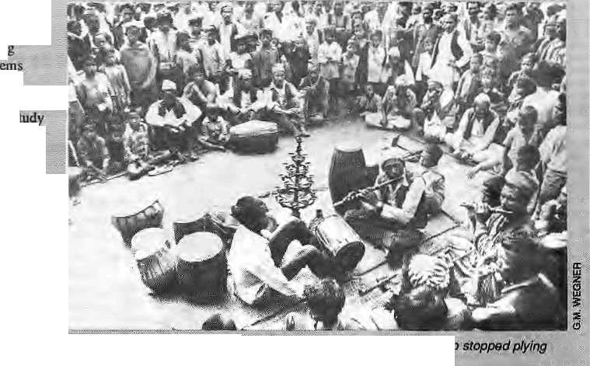

N
epal's Tribhuvan University is to open a new department of musicology next June in an effort to rev ive and conserve traditional Nepali music, Interestingly, the department will be housed in an ancient Newar' building that is pait of Bhaktapur's old Durbar. "TIik ajiia is to create an awareness of..the value of these traditions in Nepal.* People talk about the destruction of the Nepali culture, particularly by Western forces. The department of musicology js one way in which Western donors seem happy to make some srrtali amends," satdGert-Marthias Wegner, incumbent head of tha new department.
I the department will offer maste degrees to a maximum of 12 students during its first two years. Wegner hopes that oneor '■ fwo may stay ore as lecturers since Nepal has no trained musicologists at present Students will study Nepali as well as: South'
P pliuming to purchase a medium -range turbo-prop such as ;; the British Aerospace's ATP* the ATR-42 or the Pokker F-50 to Supplement its internal services. That would free the smaller Twin Otters to do lucrative cargo charters and tourist flights, says an airline official. Royal Nepal's concern is that it will be left with the trnproStable "social-service" flights to remote non-tourist airstrips while the new airlines. mate aff with the money-beariftg fogd-cargo flights and tourist routes to Lukla and Jbmsom.
Not everybody is>conviriced about the new airlines' bona fides. '*lt is hard to believe that this small country can sustain all these airlines," says one sceptic, a pilot with Royal Nepal. But the initial prognosis is positive. Even with 11 flights a day to Pokhara, the planes are all flying fulJ, including R«ya? Nepal's.
There is some speculation ihat at least some of the new airlines' shareholders, who double
mirrors.
The department is,to-beneiStfrom a... .:: ■■<■ : significant portion of a Japanese grant for sound and visual-recording equipment worm YenJ50 .. ...:. -i million. Wegner's salary and the running costs of the depaftrftent are to comefrom the;German jpvernmeihl via tiie^{v;}G^nnan_{v}, Academic Exchange Service;-- .::•
Student^ and members of the public jwj 11 be able to listen to music from the sound archives
as agents for the aircraft they ity_{v} ,arein the civil aviation more for the commissions: they hope to get from future sales to Royal^N^paL There is no doubt that flying.° airlines in Nepal with leased aircraft is one way to prove tfie ability of those makes -— particularly the Dornier 228,and: the:Y-12 — tdflyBvmalayan skies. "Aplaa&that can fly in Nepal can fly anywhere," says a Twin Otter pilot. Because ofDo-; 13285 failure with Vaytidoot and Y-12 being a new aircraft, both liiandfaciiirers need to show the ': woflddieirciipabilities.the • Dornicr and Herbin agents are bo t!i on jqueue to sell their birds to Roya] Nepal Airlines foi when its Twin Otters retire.. • Are Hirnalayan sfcies suddenly getting more dangerous? There have been two major civilian air disasters in Nepal .: since the last issue of Hiffud came out. On 31 July, a Thai International Airbus 310 overshot Katmandu and crashed into a
arid watc|t videos of'traditiphat dasnee. The^qiaititait isto generate softi#of its own funding by#airung foreign students of musicin traditional Nepali arts and selling recorded publications
cfag,north of the Valley, jailing all 113:6hboar4,On28 September, an Airbus 300 of Pakistan International Airfirips ploughed info ^ hillside Just south of Hbe Valley while on approach. ::
These were the first two jet crashes involving passenger deaths since jgt airliners started -flying into Nepal in December 1968. Moreover; tfiese were sophisticated"late-model jets, and noti-ths smaller tuibo-props that fly the more hazardous dornestic routes. No one will be sure until the flight data recorder analyses on the Thai and PI A crashes are published, byt the iikeliiitK)d in both cases is eitherpilot erroi-(anathemsto afil aiflines) or recimtcal problem (a word ii!a^ufacturers dejesi). It wou!d,; however, help if Kathrnatidu aiirpftrt had aradar tq track aircraft and a sophisticated instrument landing system to guide,planes in.
Ujjwal Raj Joshi
of books,-music and video. !
The department of vmusicology is an: attempt Eo fescue traditioftaS Nepali arts from a premaaareideath.'Weg'nermadeit, clear that this was not a case of ' artificial preservation of'a cuiture that is dying a natural death but thai certain ia9tprs.-were kiiling the culture. Not leasf-of'tflbsie factors:* tfieSlate' commandeering aiguthi land which h-aditianaHy produced enough income td pay for musfeians and otiier artists,:The: spread of Bombay popular film:: music in cinema and cassettes"is" also strangling Nepali rnasic.
Nepal's situation contrasts-sharply with India's, where classical music has been saved by
recognition of its valuable place' in the nation's cultural heritage. Some ftidiari mastersare now well-trayejled and welcome guests* die world oven Wegrier; atabfn student of 2Oyears and a longtime scholar of Newari musk, sees the department of Tnusicojogy as playing a ^ital role in contributing to the same trend in Nepal."My dream.is to have traditional rausic as part of the school cutricultim here," he say?. Omar Sattaof

Sep/Ow 1992' HIMA^ • 71

BRIEFS

Vishnu's i
p carrierjfm\& bird's ; eye view of the la&w «, jatra celebrations In ^{:i} Kathmandu, TO
SepietiifbeK A n& does.
Oaf uda, See pilot and
ygrj have d* ■ ■■-. *

Mustang Bhot, geographically and ethnically iiDeian, nas been sequestered from the rest of Nepal by the Himalayan range, and, till recently, from the rest of the world by the policy of restriction. Manjushree Thapa took the first of two trips there in 1990. Mustang Bhot in Fragments is die account of her trips, and the story of a Nepali woman confronting schisms in the community she visits, in her
country, and in her own identity.
^- NOW AVAILABLE !

HIMM_
P.O. Box 42,
al Books -1-52101
BOOKS
Interested dealers pic Lalitpur, Nepal, Tel :
3845. Fax: 97
The, <3est 'Bookstores m %athmandu Valley
Ratna Book Distributors (P) Ltd.
PO. Box 1Q80, Bsgbtrar, Karhnumdu, Nepal Tel: 223026 Dkill
Deak School & College Books, General Books, Fiction, Non-fiction
Books on Himalayas, Religion & Others.
Saraswati Book Centre
Putchowfc (near UN Bnildini), Lalifcur Tel: 521599
Dcab frith: Engineering Book!. Books on Hin^iaycn JCeginn £ Childems Books.
Books' Paradise
Tripwcswon: (oral to Blue Bird Departmental Store). KnthmamJu, Nepal Tel: 214314
Deahwith:
ChMiens Boots, Tmmit books. Paintings and Books of General Interest.
28 jHJMAl

F
orihe past five yesjis IGlIvIODi the Kal based institute For mountain development, lias b^n teaing its
(SIS), a
stores
h3 surface:
the stra£e|ie sig|Mficance: and mapping, finally gave the the gb^ahead to :*e(up.
became apparent to the
.toiiger.of.^mtlitary significance : ■■■■■■ atiid, even if they were, tbiat sticp diOaiiefiowreadily _{v}a;vailabfe to anyone vi^io warils to buy them "fifbni satellitecff^nisationS'in die:: United States, EMmpe and^ the , ... fotnief Soviet Unitiiv . *. „ ; ■■:■■■■ ... According to Surendia ■ . J
Mountain Envirppraeoi £indi ■ Natural Resources liifonnalian:
: countries afUtobeftiUy equipped and opet^ioiial by: 1995, die seconij phase, of the programme; Start-'upfunds from Use A*'^{an} / Development Bank^ yicre us<id to
Development
said, emphasised training people from member «o«rttries. in ■ how iojapply pK Jo planning; s. Sales of case studies
aiidtrainirjginGIS:tffgorj departments, Bilateral agencies and-piivate companies has provided ]£:iMQS)vvit!i a;resewe; ■ ofiJS300,0!»whichhesay): will :b^tSrme*iirainiflgarid:
hardwtfe tnaintainance. ■
■ Twocaseitudkscamedqut
■; and Bsed iri MENRIS's training pTpgumme tllustrale ttiepowetof GlsJlfi deeidfag the best location: for health posts (f schools in Nepal's Lditpur dis&ict, for example^ plaiiners need Vo know about corrent demaod for the service's and abouttheir kecessibUHy:, Tlie star iitig point is a map showing the health services laLalitpur. Using stored GIS dat^
:on i^pulation distribution wifhia thedisrxiet, itispossibleto, modify ilie first map te shew only those health centra serving 500/ or iriore people. Another set of data allows a third map to be
:: dr?twri,.lt|ts timataking.into ...,
' aK^bntttiefKtesU to which Sie:; ₄
popuiat^onshadestheheaHh .."\ sejfvices. The last map .shows l distance to the centres; ■•^
opinion <m 1
open skies poUcy of
f the Nepali " ;'
Atthe very least, he steins to be Unhappy
en his lap.
A French, tourist

. - .., -^ briefs:

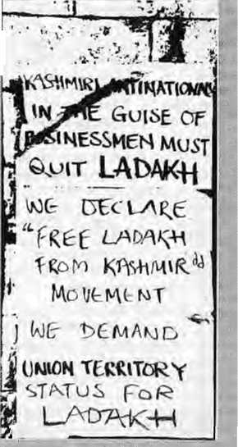
Rio Mountain
: Agenda: Who Follows Up?
In August, Russians aiid Yakuts attending an interriational : cofiferfeniie on shamanism in ■ Yakutsk, Siberia, were¹ fascinated to see filmed evidence .that shamanism is alive and^{r}well in Magar villages of Nepal. They were wstcliing excerpts from the-celebrated four-hour docurneniary Skamt&is of the Blind Country, by Michail Qppitz,.a German
United Nations *JL Conference on E sod Developriient of Jun« 1992 is already fading in me mory. Which is wfty It might be as well to reciili that Chapter 1? of "'Agenda 21", the action programme adopted by the ■CNCSS), was, after all, the Mountain Agenda.
A "final advanced version?' of Chapter 13 incluiles two programme areas: generating and strengthen iiig knpwtedge s about 1 he ecology aod susf a hi■ Sble development of tnoiintam ecosystems; and promoting
alternative livelihoods.
IT he annual cost of the first programme area lyili be about 11$ 50 million. The second progracHme area is estimated «j " cost %l% 13 biilien, including about U$ 1.9 ijfllion in aid.
is absolutely where such funding is to i>*:- mobilised and ■ : *i%o or tyhat will ?Mrtte charge of _{a} im piementatioB sfnd moniturmg the Mountain; Agenda*
tbeWay]
Solutionfo^eLadakhissaecoiitd " ; be hainmeredpnti Three reundi of tripartite talks have been heM so far, atid a foieih is expected to be place m October. The
indicated that (hi| J. Parliamentary and S^ate- Assembly elections, arid ppils for me proposed for Ladakh, would be held
'"Daqeeling_{r}type anfonmous hili, council#i0:Liadakh"rince the ...:... pioWcnSE within Lad^di are , sorted ost (see//«ito(_{s}Sep/Oct 1989 and J[a«i/|feb l!»8>:
Jacob said he was planning ta revive discussions among tbe Ladakhis, (he Jammu and Kashmir $tateiGovernmeiit and the Home: Minis try _{T} so that a
Sep/Qei 1992 IHMAt • 29
Planning
fc The blank areas on final map ifevtal graphically thai many seitiements in Lalifpur district do not have ready access to government services.
Information is stored in layers with in the computer's memory, Service centres such as schools and health posts are point locations on a map. Information on the routes of major roads or waterways stre (represented, as ; lilies.
Agricultural land can be categorised according to i ownership, crop cover* soil type awl so on, all represented by polygons; It sometimes; majces sense lo group, sets a£ data in the same layer, according to the way. '.. they are represented. Fpr example , all point Ideations, representing schools or hospitals may be stored ■in'the same layer.
Another example used by JCINJGD as an illustration for firaiiicos shows the district of Dftading, westof Kathmandu Valley, in wiiieh topographical information and the waterways ate correlated with data on population density and distribution to arrive at an appreciation of potential supply and demand for hydroelectiicity in the area.
: ■ GIS-uses, ay -information in anew way.''CUSifroiily atbol to help people to make decisions,'* saysSjhrestha. **The dataneeded taworkaGISi$ already JJiere in one government department or another. Il'^justtfiat such departments; raiely taikfWiih each other."
Cteariy, GIS can work only if it'sdatasejs.arecompatible. A prerequisite is th^efore the standardisation of data.
iClMOti's efforts with
QIS *aiso relies upo.n continued
goodwill of all its ree&nber :
coimtties. The iess nervotfs
govennneftl officials are about
GIS, clearfy, the beWer it wii]
be for the regional sharing :
of 4ftta.
Omar Sattaui-
Shamans hook W
anthropologist now working in Switzerland,. . ..
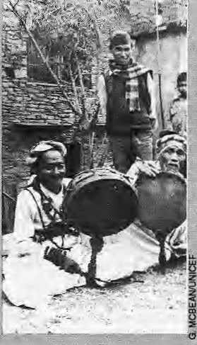
Traditional shaffia^s have
almost disappeared in. Siberia/ant!
the parti|ipants:to: the conference
were instead treated to folk artists
performing shaman dances_{r}=:
paintings inspiredbyshamanic
rnyths and New Ag«-styk "folk
healeK"^ Tliey were therefore
gripped by a'film of aMagar
village of 2000 people with,
according to OgpilZi 36 pract&ihg
shamans,..Similarities between
Magar sharaanisfm and Siberian . .-.:■■
shamaniatn WereTobvtous.i :
;: t; ^Farmer Soviet YakiitiE(is;. [ .,
sow theatitonomoiis Sakha
-R-epublie, |ari.QT..the Russian
Federation; The Sakha Republic
;,..is...the size of India, containing a
population of a million -^ad ■
itnach of |heformea; Soviet
itJnion^{T}s mineral'Weahh:The
conference flierefore had "\
politicatas wefl affi academic -
significance. The Yakut (SaJdia)
"people were rediscovering their
roots. : . ...■
Perhaps we cart look fpnvardt& Siberian visitois coining to Nepal to"learn from ■: meir Magar cofleagu^. :
Geoffrey Samuel
After all is said and do(ie_{T}'the model for disgpintled hili : communities of north India might
Development Council. Accoidisg to India's Minister of Shils for fifonne Affairs, M.M. 3acoj>, speaking to the press on 26 ■■ September while ok a visit to
is toying
■ In ; >j w seveie'agitaticm in whichLeh 7 :::-towri remained under carfew for nearly a moiitli. kozoidixigto the GW/iiews agesicyv me Buddhist Assobiittion deinandiifig; a "Qnson Territfiry" siatus for Ladakh, but later scaled
s the-demand to a Dwjeeling-
autoftoiinous disbict.

■HIMALAYA. MEDIAFiLE • HIMALAYA MEDlAFiLE"* HIMALAYA MEDiAEILE •"HIMALAYA, MED1AF1LE ■ HIMALAYA

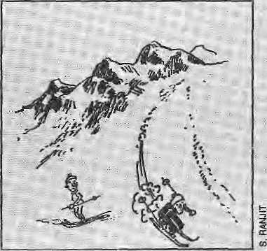

La! Kumar Mishra laments in the Times 0J India thai trade between India and Tibet through the Taklakol border posit isslow in pickingup. Give ti time, soine would say. for trading was formally opened only on 15 July this year.Mishra vvrjtos tliat Tibetan ("Chinese") anil Indian tradespeople a(s hampered by the absence of a currency-exchange agreement and (lie foimal listing of duty -fee goods. Resides, according to Vijay Kranti of India Tadcry/'neithej custorns officials ai the frontier nor the Finance Ministry officials in Delhi hado clue as 10 whether Indian "Rupees, Chinese Yuans or US dollars were to be used." For the moment, the traders are making tlt^u^ith barter. Kranti is uf the view thai resumption-of trade could put the economy ofthe whole Pithoiagarfi region back on the rails. The, urea's oottags industry once was to produce woolen rugs, which might resume aow thai import of Tijbetaft wool is alfowei Trade worth IRs46 crOrts a yearuSed to take place across theirarderuntil 1962* when >:vsr,--!.;■•!i;;g came to a halt withihe indo - j Chinese coofBcLtlus-y e«-'sbmdettrade; is not expected^o go to beyond IRs, 50 lakhs. Up to late August, 126 ttaders, some from as far afield.as Kalisnpunjj ami SikkLm, had receivwi travel permits to cross the border, Indian textiles, tea and vegetable oil has gone up to Tibet over the Upnlekh Pass, while the traders tmvp brought back products like salt, borax powder and sheepskin.
Speaking of Piifioragarh, apparently a "primitive trilic" which inhabits the district's outer reaches "is facing virtual extinction cwing to the pressings of modem civilisation," accordiiig to Ajay S. Rawat, who heads Kjumaou University's Department of History. United News of fridia reports him as Saying that the "Van Raji" tribe's population lias come d&wnto 372, among l62 families. The massive programme of io;id-building following the 1962 conflict with Chma apparently led lo deforestation which culminated in collapse of the tribal economy. The tribespeople were unable to adapt to the changes wrought in then lives by ths "external forces", reports Rawat, according to whom some families have migrated across the border to forestan:as of Nepal (where; certainly, there are no roads to disturb the tribal equilibrium).
In late Sepjenil>ttr, La (lakh held a five-day festival "to boost tourism in this cold region", according to the Statesman, Director of the jammu ;tn<i Kashmir Department of Tonrism G,J, Nehvi said that the wain aim was to attract more foreign and Indian tourists. There has been a "downturn in tourism after 1989, whan political unrest in, Kashmir
stemmed the flow of visitors. According to Nehvi, despite [he militancy in the Valley, 10,006 tourists:had-vis tied LadaJch since toe this year, when ihv SrinagarvLsdakh highway was cleared of snow. The main features of this festival m Leh, apparent! i^, were "rafting on the river Sindh, polo^matches, archery, dances, solo music performances; and muck marriages." Mock marriages?
While Lattakhiseems tobe lookingahead to better times, Sifckfm tourism is in "rapi d dech' ne^{T}' accord ing to a UN! repbri <>!" 8 September, Re|illations wete teJascd in late ISSOtoaUowmoie tourists in, and 1992 was supposed {o|se aboom yeur. Instead, polidcat instability in
—- Naii<si4i tlighway 31, Incline, -psissts- tilroogti DarjecJiig's Kahmportg iijb^Jivisim. Ov-er60,0Q[) tourists visited.Sifctim (knvngth« fct
arrivals dropj>;d srurply foBowing fee rDjiiiiJ
jgg
In 1990«SJkUin received SO.W inclndi(»g S_{S}646 overseas visitors. In 199i,the figure was (60,000, 10.000 were pyerseas visitors.
dale for the pnijet! ed GifcatR^mni to the High Pliil eatl. Fram "f ive^o-tcn years"; His intoMson how tells him that it wiE be no more titan "a coiipk of years" tefore Tibetan refugees are eating tsemfSa in Lhasa restawa(«s (not His. Holiness' expressioti, this last): Addressing a gathering of TibtStaas ineAile atj» newly inatiguralcdmonastery alKastwnpti (near Sliiinia), reports Tits Hindu, tlic Dalai Lama said thai "unthinkable changes" were occurring in the isuepiaiional sphere, and he anticipated changes in the Sino^Tibt'tan relations as wett. The doywasnoi&r off wheri Ti tietaiis li vin§ in exile andthosc residing inTibel wuW together in a ^free Tibet". ', the Dalai Latna has taken
Ue is 10 write occasionally in me op-ed column of the Tiutes of India., the first iiiBtaHmenl, on 2 September, delvyd into Gandhianthoughtft and seif-realisatlon.
llicre is'ai* e.ipert group in the Indian Planning Commission, which is formulating a "National P^litj on (he Himalayas" «^ and Htmachal Chid¹ Minister Shanla Kumar had a tiling or two to tell the experts recently; He •reminded them that while (here *as a need to develop a balance between hum an needs arid preservation of tbrest s, the hill stales should not be ieft underdeveloped arid¹ backward ijt tlic: name of ecology preservation. The Qucf ■ Miijsteraddedthatihe Centre jnust give liberaiaid t^tfie Ifimaiayian States, wjiich
had pome into existence for "special historical reasons". The Times of India report did not Srpe^cifj what these historical reasons were,
SSiapta Kumar would have been pletiset) to jcara that the intUan Union Minister of State for Planning, Stikh Ram, is pianaitig to revive the plan to create au ec(>-(ieve!opment aotharity for the Northwcstmt (In Jiah) Hbnalaya oil (hepatten of thsNortlu&stenThill states of Indiai. According to the U Times, the the proposed authority is to be headed by me Prime Minister, with thi diief rininisters of IJitar Pradesh, Jaihmu and Kashmi r ;md Hinudial. as. b
Taelaiesi¹ is Suwijm/, newsletter « Nepal S5ooiog]cai Society, . takes<m Nepali
w5\jch" was presented t« the TJfJQED confeiehce in R i o last June. "The rep^iEi presents mQjnect infdmv iition on faynst ravierrt-orres," states ihenewsletteli, The document says there areSttspecics-of moth in Nepal j whereas. 636 spepes were foiind in the mini-valley of Qodavari alorie. The estimate nationwide is of oyer5,000 speci es. The report qaotes 850 species of birds (tnchidinghirdspecieswhicharc heitiiei: reeorded iior imported in tlw last 160 years) while the authoritative figure seerristobe R38. "Inaccuracies stiggest weakness in ijuaiity research, ia^riw infofmatim source artdcomrAuhication gap."
Speaking t>f naiura!, history of lh« sort, not only is there is an
but aJso na Indiaji5ocicly for Sheep an d Goat Production and Uiilisafioii <ISSOf U), Both are run by goat4overs who would undoubtedly hate tfie Dasain season in Kathmandu. Both TGA and tSSGPU recently rushed to the defence of their fayouritt an iraaL imports the Times of India. ''Contrary io the earlier notion thai the goat is % major cause of dcforestaiicE, experts now feel 'that (his 'poor man's cow' isa propagator of vegemion." flow? Well, ''me much-maligned .animal actually helps promote greenery hy spreading plants throiigh, its droppings and facilitating vegetative propagation through broking." Bro«^JHg, accotui«g to IOA President R.M; Achatya, ooesnol destroy surface vegetation, whicitis«sset>lial to prevent sort .erosion, TWworid, ■weJcSni:isl'uJI _{T;}
s _{T}and700of(hemnscent1y gathered in New Delhi. "Like irt IwfMoes ,'mgatiU, too, Indi a is the world leader. It no! mty has the la rgest number c-f goat breeds, but also the best ones_{r} such as jainnapaci." So there.
l brings news that the Garhwal Maedsl Vifcas Nigam <GMVN) is to open a new ^ki: rts^rt in <thp Garhwal .Himalaya bjf December. An JRs 925 ■.c.rore' ropeway, which eopnects (ai 6000 ft) wit
pastures of Auli <10^(K> fl>. is almost complete. With typical press release-fed bltistef, the report daims that Auli is "al] sftt to become one of the.best ski resorts in tlie world," and its slopes are considered of "international sitandard" and ■"better dian those at Gulmatg in Jamrnu and Kashmir ,an<i Solan in Hirfiachai." Auli*'s ski area is spread over five sq km and was originally developed by the .Indian Army. (Fw a critique of downhill ikjieg in die Himalaya and support of cross country, seeWntal Sep/Oct 1*991.)
Indih Today reports of gtfiustic looting
going on in Himachal Pradesh, a "botanical disaster". Fallowing unbridled exploitation by drug manufacturers, many medicinal herbs are disappearing from the inoim tain flanks. Thirty-two species are endangered, including: Comas speciosus, a herbused : in stetMsiRauwolfiax^rpentina, which affects blood pressure; and Taxm baceala, a plant recently found to ccnlaiti 5 high-potency anti-cancer ingredient. While collection of medicinal ftots is a regulated trade in the UP hills and Jamrnu and Kashmir", says the report, in Himachal it is a f ffie-for-all. The v iUagers ^eU tbe heitis- at thfoWawaiy prices and the profits are made by the mtdillenien; Ilimachai is said to be the source of SO per cent of Indian ayiirvedic medicines, apart fronv 4^ percent tif unajii md 33 pe* oenjiof altopai&c dru^s.''.''-..-

V—lij
Anthropology Still Finding its Feet
Anthropological research in Nepal, by local scholars trained in the country, is just ten years old. Today, its relationship to development and to foreign academia is helping it define its identity.
by Pratyoush Onta

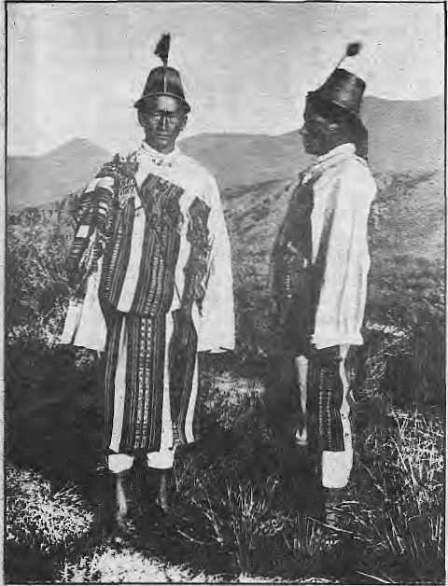
Lepchas ofSikkim pose at the htm of century tor L Austins Waddelt L.L.D., C.B., C.I.E., ELS., F.A.I.
"If this is anthropology, then I'm definitely not a social anthropologist." But, says Bruce Owens, presently at the University of Chicago, if anthropology in Nepal is to make sense to the larger community of scholars, then "there is need, at least academically, to get into the larger theoretical body of literature. That might be frustrating to our Nepali colleagues who do not share this need."
Prayag Raj Sharma, former dean of CNAS, feels that the Nepali-foreigner divide is not as wide as some people make out. "Resentment between Nepali and Western scholars has been played up", Sharmasaid. Diverse factors, such as institutional and national traditions of research, as well as personal preferences, may influence a foreign scholar's choice of research topic. Sharma adds that it is unreasonable for Nepalis to resent the Western scholar's abstract level of analysis. "They are ready for it", he says, "and it might be some time before we Nepalis can do the same." B ut if th ere really were a sch ism, S harm a belie ves, Nepali scholars should be encouraged to first identify national research needs and then to invite foreign scholars to collaborate. But. Sharma
I
n 1974, seven years before the forma! study of sociology and anthropology by Nepali scholars had even begun, Khem Bahadur Bista asked the "Ncpalese authorities to consider whether to remain indifferent and let., .(foreign) researchers do whatever they like or channelise them in a desirable way to meet the requirements of the Nepalese government, which is preoccupied with the socioeconomic development of the country. "Bista, a Nepali anthropologist trained in France and now working for the Centre for Economic and Development Administration at Tribhuvan University, had signalled (he startof a battle that still rages today over the merits of applied anthropology as against those of pure research.
The schism thai grew between some foreign and Nepali research camps was still apparent at the first national congress of the Sociological -Anthropological Society of Nepal <S ASON), held in Kalhmandu at the beginning of September and at the conference that immediately followed it, on Structure and Transition: Society, Poverty andPolitics in Nepal, also held in Kathmandu by Tribnu van University's Centre for Nepal and Asian Studies (CNAS) and the anthropology department of the University of Sydney.
Ram Chhetri, a Nepali anthropologist now working for the Nepal Australia Community Forestry Project, says foreign scholars have done research "with no relevance to Nepali society" for many years. The he art-search ing over relevantereaUy took off atTribhuvan University after 198 l.when it began to offer Nepali students Masters degrees in sociology and anthropology. People then asked why such obscure research was encouraged. Why should the university bother to grant affiliation to such researchers? Chhetri, if you had not already guessed, believes Nepalneedsappliedrcscarch that addresses local problems and which can guide policy makers. Both Nepali and foreign scholars, Chhetri says, should be encouraged in this type of study. "I've a friend doing research among the Jhonkris. But the abstract level at which he [works]...is of no importance even to the local community, forget about others", Chhetri complained.
While Declan Quigley, of Queen's College, Bel fast, drew comparisons bet ween the literature of the Newar caste system and that found in India, at the CNAS/Sydney conference, one Nepali scholar whispered to a foreign colleague:
regrets, "examples of collaborative research are rare. There is noneatCNAS right now."
Theargumentis clearly not black and white. Development has been a national priority for four decades, yet its meaning i s s till a subj ect of he atcd debate. If is no wonder that Nepali anthropologists participate more actively in discussions on anthropology's relationship with development. But, given that the concept is so nebulous, is it possible to sort research proposals into those that are relevant and those that are not? Who is to say that today's abstract research will not turn out to answer tomorrow's development goals? And is it wise for anthropologists to identify so closely with dev elopment goals o ffici ally stated by political parties? Doing so would make them as vulnerable and no more valuable than, say, historians who, in the service of state powers that be, invent ancient histories suitably steeped in glory.
Given the interest of donors in applied anthropology, it is perhaps easier to see why, at least for Nepali scholars, there may be less attraction for abstraction. Indeed, there were many papers at the two coreferences concerning anthropology and the management of resources such as forests, traditional irrigation systems, wetlands and agricultural land. More than half, though, concerned aspects of social forestry, such as the social consequences of deforestation, indigenous forest knowledge and management systemsandgenderdimensionsofthe' 'ecological crisis". This is perhaps not surprising given that "Nepali social forestry studies have led the world", according to Don Messerschmidt, an advisor atPokhara's Institute of Forestry,
Attraction for Abstraction
Messeischmidl says social forestry is a new field which Nepali scholars can pioneer. "Also, there are plenty of jobs since there are more than 50 social forestry projects in Nepal at the moment." Messerschmidt sees social forestry as an ideal field for collaboration between Nepali and foreign scholars. He says that although relatively better access to current literature has helped Nepali scholars to succeed in social forestry "it is the wide open field and the money that is there to support this type of research that matters more,"
Sep/Oct 1992 HIMAL ■ 31

|eir)au;ed; " Jfie
Qrlief-ShsngfeLfis of fojrbiddea, Schoiars j'-'
fetaled content; ^retojst' otMr^{p} to. :;nictft>poUfari centres of ■ar
len.rnjpg. .:■:.- ■; ';' ■■ ■;■ .... '■"■ ■■■■■=
: :.-pflratleast two decides
-.Vjpn ^urer-fMirfien^bif dld.his flrsj ^
field ivork ^n<ing tii&Slierpaspf KliuinbAiin ..the mki 1950s,, trieartthrbf»lQ^!of NepaJ ; rerrjftiriedl ein:lusi vely in the Jpjiriain pfWtestem ~ reseatchm j?|(ey arriyeS to«ondHctthS firsft-.
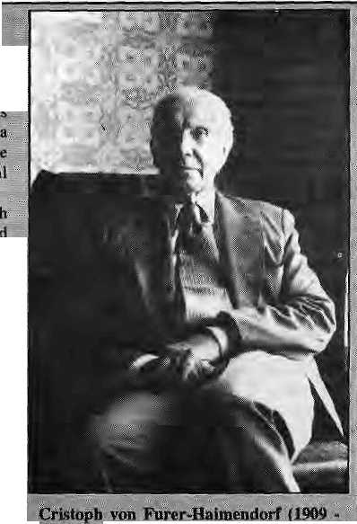
efo-revthe fiebi/wprlairs came the ;fqrejjgfi
wcie Briiibh aiimtnisir;ito)t<; and travellers Cum-writers, suctf as: William: Kijrkpatrick^ ..vFrancis Buchanan Hamilton, Brian Hodgson : Sfid' Edwin J-?Aiki.nspfi. Wtvile Kirkpaniek: fad Puch-aiiaii ^fafhtltonjiavg leftitnpt&ssive apcfliupts' of what they saw iM hear^ dating their brief sojourns in Nepal, Atkin"s>oa'sis an account of the
. ufeas.-i
of the?British Residency in
^siabliBhedin tfilfi, for nrore than |w0 decades, * starting from the early 18JCis. Besides being;
JentralJo the resurgfinceof Budttttist studies
iin the; subcdntirtent,* Hodgson- pionee.f«d » research cm the'lattguages; peoples; flora arid
foujia of the Hirrfafeya>T|is'worfc, apd'lhatpf
corttribulions to the jknowl^dge^m^ipVng of Ihe region. Then, in early part of thiscenrury,
rare opportunities b^v the jRana rulers 10 visit Kathrnaiidu to pen thejt important volumes. • l»eyi and Lahdbn np'twithstjjiiiing, ; boWever, jSlepal remained off limits xa .
;wi 1951: What Sir Kk sirU.88.1—": _{t}tif the Nepali dominion¹ Erom'the gaze of
: t|ie middle of this century. The hi control on Recess 1's lands and her peoples, Tn the decades following 1951, Nepal opened up to overseas research but She rest-o( • the Hir^afayan region of India, Tibet ^ud ! Bhutaii temained off-limits. Therefore', with sortie no table exceptions (Gerald Berjeirnan: -andRaraachandraGuria in the. Uttar Pradesh hills, Jonatlian Pairy iD Himachal Pradesh, T,N. Madaci in Kashmir and Ctiie Nakanein Svkkim), academic attention to the Himalaya focisssod overwhelmingly on the place's and peoples of N epal' s northern territories. A| the-
g g Rais,..trie ki
tSieTanaapgiandtlieN«w.arS,:A3n
sand fessefi
scholarship Jby, Hepalis.JcfRain.ed' rns until the ikspfit ark jniMicstiors in! %1: of Dof B.ahadttr Bisifa's Pgpfite of l^epai, .,Af- F»st ^^i tens-style ariihropofcgicM ftibhograph to ■ be written by a Nqpali. ^ !; f ' .^ .J ^{v}' ■■ ■■:■:■ ;. (Slvange. c;arne.:. in die e.arly 198C)s:: M
leyel-coursesirisopicilo^yaiid ;The; cl assen have been populiij afid a "' this ye:tf eitj.i^eti 400. jive past decade |hus... law a significant jttrop in: the;noirtber of trained PJepali anthropslogists,; Tjiis group has alre a^y published as izabte 6oi3y: o f anthropological literature» : : .-
&\ 1-feast three iriajor. iatetns^orial conferertces HnHjmiflayaninmrop^lggy bave been^.fganisej3 in the West anp conferences, in Earop<i ari&North Anieripa'routjrielyinclujd^ ; the antisrajpology of the Hinialayas and/ar Nepal. The difference in ;the two jr^cent galheriiij^s in Kathmiiniiii was that fpr the first time they a/Hawed Heps)i and* overseas anthropologists to partic|pat^simnltan?Q;tisiy: in large numbers; The participation of so many Nepali aivthropolcigjsts at the Kathtnahdu conferences could fee said ^d indicate thatNepal|antlir«pQlDgylias arrived,
1$95) passed away recenttj. Born ia Austrian
in l!M)9,.;he: stuciifed anthropolqgj;~at the
JUjiiyersaies .of Vienna and tofidon. pufer*
HaSrnertdorf first went id India in 1$?* to^
ctmdiict fiel^prk arnrnig t|f»e Konyak
Nagass, Irt 1944«i$, jHe'workea in tfee N^
JEfist Frontier Agency foptJie ^
tit tttdiik ErpmrMS ^t J945J, he was A-d v isoe to the Hyderabad State Government for ***tr ides ?ind hac k warrt classes'^- He *8sii (so ■ pir^fessor, of Aothrppotogy at Osteania, Uriiversitj^subsequenl tp whicj, fr«m.l9'49 to mi, pt heMfhe fcftairin Asian Anpiropdi(^;J° aft the School of Qrientai and African, Studies, in London; After almost two decades of research among the, tribal populations of India, t?ufer
Haimejndorf first came tt* Nejial in 19
firtd pioneered.aiuhropologicai studies on the Slrerpas. He also wrote early important
essays on the tamangs, Chhettfis* Newars, andThakatis.

Om Gurung, former head of sociology and anthropology alTribhuvan needs no convincing of the valuable contribution that applied anthropologists can make to development programmes. In 1990, he wrote of their role in providing information to donors and motivating communilies to accept the implementation of programmes. However, Gurung observed, "becauseNepali sociologists and anthropologists are working primarily to serve the interests of funding agencies, they have been unable to develop a particular Nepali theory of development." And therein lies a danger.
Social forestry is not the only area of research that has captured the imagination of
32 HIMAL • Sep/Oct 1992
donors. Applied anthropology in agriculture, irrigation and community medicine have proved equally appealing to donor agencies. It's very success — at least in terms of donor support —■ raises worries about whose interests such research is meant to serve. Michael Allen, organiser of the CN AS/Sydney conference, warns that "a distinct type of Nepali anthropology might develop on the back of donors." Such an anthropology might lose sight of its intellectual base.
Could an endless flow of donor money eventually tip the scales in,favour of applied anthropology? It seems not. Chhetri, for one, believes there should be "continuous cross-fertilisation between the two sub-disciplines of
anthropology." Academic anthropologists should also look into the "grey literature" of dev elopment projects, says Chhetri, because it too contains "new concepts, insights and methods useful for all scholars in the discipline." Messerschmidt feels that applied experts could benefit from occasional removal from the field to a place where they might be "allowed to think and write exclusively for the academic world."
Bikas Wizardry
Listening to Gurung, it seems that Nepali anthropologists have helped to extend the network of government and donor-sponsored program mes. B ut these programmes, replete with

the most up-to-date development rhetoric, have hardly empowered their stated beneficiaries. Nepal now has what anthropologist Padam La] Devkota at Tribhuvan calls "-silent listeners" — masses for whom participatory development means participating in a predetermined way in projects designed elsewhere and by others.
In a paper presented at theSASON Congress entitled "Anthropology and Development in Nepal: A Vision from Below", Devkota envisaged an anthropology of Nepal that would empower the poor and help to bring about socioeconomic transformations. He called on Nepali colleagues to accept the challenge of transforming anthropology into an art of human emancipation by being willing to leam from people who may be poor but know more about their needs and concerns than educated experts have ever acknowledged. Devkota wants to see the emergence of an anthropology that feeds directly into grassroots development activity.
But judging from the record of the role played by Nepali anthropologists in the country's development there seems little hope for such an emancipatory anthropology in the near future, Dilli Ram Dahal, a senior Nepali anthropologist at CNAS, says improving their living conditions — the "bread and butter" factor — has defined the participation of social scientists in Nepal's development. He says that the conlribution of Nepali anthropologists to Devkota's empowering development lias been "non-existent".
Anthropologists and social scientists, whether Nepali or foreign, have fed the top-down delivery of anti-people "development" projects. Nepali social scientists have been described as "bikas wizards" who wave magic wands to produce the instant feasibility, evaluation and impact studies. Working as development advisors, consultants, project researchers, programme officers, and soon, they profit financially from a knowledge of the "native's point of view" that is supposedly superior to that of their expatriate counterparts.
The Natives Strike Back
Twenty years ago, A nthr apology and tlie Colonial Encounter (edited by Talal Asad) opened discussion on anthropology's colonial links. It showed how ethnographies were written to meet imperial administrative needs. Anthropologist Arturo Escobar, of Smith College, Massachussetts, recently suggested in the pages of American Ethnologist that ii might be equally relevant now to discuss anthropology and the development encounter.
Escobar is referring to the development of an industry which profits by the study of "backwardness". The anthropologists it employs study the natives on behalf of their would-be saviours, powerful institutions such as the International Monetary Fund, the World Bank and its lookalikes, which pay highly for such studies. The prescriptions of such institutions are
then adopted by the Third World country. The anthropologists' roie in development in Nepal to date would provide rich material for analysing the Development Encounter.
The close questioning, in recent years, of the methods employed to lend authenticity to anthropological works is a measure of anthropology's search for purpose. Such reflection has primarily focussed on the anthropologists' claim that living among their subjects affords them unique insight into the native point of view. The scrutiny has brought into question the legitimacy that field work has traditionally lent anthropological research.
Anthropological authority is further shaken when the very subjects of anthropological research begin to appear in seminar rooms, asking questionsoftheintrepidstudents of their culture. The subjects talk back, and not always with the kind of politeness that is expected in seminar rooms, questioning the academic study of their livesinwaysthat sometime s m akes anthropology appear absurd. Their judgement wrests power from the anthropologists to being "experts" on their "local customs". Are they, then, any any more well-informed than the interested lay person who is familiar with an area and its people?
Objectivity has been the prime disciplinary goal of anthropology thus far, but with native scholars and native subjects around, objectivity, if indeed such a thing is possible, becomes only one among many goals of anthropological research. Breaking anthropology's encounter with development reduces the power it has so far enjoyed but also gives hope for the emergence of an empowering anthropology.
Anthropology 2000
Antliropology of the modern world, if it is to be meaningful, is forced to address the nation state. In the anthropology of Nepal it is the newest area of study. Since the politics of identity is the politics par excellence of any modern nation state — and the advent of democracy in Nepal permits more strident expression of politics and identity — alliances between national politics and ethnicity deserve more anthropological attention. Bill Fisher, currently in Nepal to study the emergence otjanajati politics at the national level is confident that the "relationship between national politics and politics of ethnicity will be the topicof the anthropology of Nepal during the 1990s." As Fisher notes, Nepal already has a wide range of ethnographic studies (except for the Terai region) which new researchers build on to tackle this relationship. Such research may present us with fewer boring debates on whether a particular people arc a tribe or a caste, bu t rather emphasise their place in history and reveal the factors and interaction between them that contribute to the complexity that is Nepal today.
P. Onta is a PhD candidate in history at the University of Pennsylvania, USA.

I
b ^hropologieal studi«s; cerfiim people¹ arid places become associated with pajriipUlai .thgjMs at. rjesearcji... Th§ best, example ,/oi such gatetajeping* concepts is perhaps thai of caste in India. S.uch concepts, ijnighi be useful at some Jevel ©f anthropological practice but ultimately they . siUMJlfp grswjth of bojth..:tt^ 4iscipline, anil aw understanding, ot t^.wpTjd^F^r,. foreign
conceal a people's culture as if their lives were nitre museum exhibits. For natives
of N^j)
prove ihe.ppi.BU ■'■-'■ ■' First; the Thakalis; who were'ieSe for almost two decades in the anthropoiogy of /Nepali as die best exaisipkrof*%ibe5** thaf have sanskrilisixL From Shigem Iijima to ;;FHrer-,H$irnei[KlQrf M> JDor Jja^adar B ista, the . theme: was; how 'the Ttvakatis¹ had- stopprf wearing Tibetan clothes.prohibited the eating oi yak. nieaUapd abandoned Asm Tibetan-
ali ^rthropologists"). It took'Andrew ,: iii |9?8, to point oiit unit, the, , wsre. expert public- *;ekstioiis< S. This sm^li afid^eaHfty ^effcp"~pf |he population were-■'skillful manipulators of-iniages ancf identities'¹ who 'h&d \i6 qualms' jibout |rie.d#i.yii}g. "culture" to^su endSi in this¹ case for their upward inability:¹ Sjnijiljrjy, it tyxjk Bjll: Fishci, jn L9$7t tq sayhow tlie Thakali identity involved an intricate convergence" of historical dynamics — of the Nepali staje ai\d the Tliafc lithpla. reg jop, -^- arid a consc jous politicks
I 0k--meat irita.Thak Kholatillage-, just %Vait uiitil yoh re^ch the; nex^t village_{v} ; .. ' . ; . The secondijuestiorcs $im v«si litcr-atore
- dnt|iEK|itl)rnafiiiu valley which, lintjlrecently^
, gavethe 4jTyjres5i0.11 dial only
- Aett;arid,mojeovet,
- ^ith their festivals an
•true even iotthe CNAS/Sydiiey?couCerefscts-[..where no |^^s:.Jhan six "papers £n\ i
■' fifeKl work arribrig the-Ncwarsj But, as irr
reseaftit on tfieThakdiis", ^tiiidsof change arc?
approachifligj Kecerit research by Nepali aiid *• fftreigl) isch»iafs oh ho^¹ ^KaUit^aiidi; putli-
cipatesirttho consumption aaclprodactiDn.of-: media, how lEie.tojrostiridusfcryvonnecis with,, • eUisiic ait, iti'td how its L:nkklte*class residenis-*
are hypocrites wlien itcomes to "democracy"' indications sof thg

Sep/Oct 1992 HIMAL ■ 33

V
o
I
c
E
s

ThereareNO MORE OASES TO DISCOVER,
says Boutros Boutros Ghali, Secretary-General of the United Nations, in his statement at the opening of the UNCED conference in Rio de Janeiro, 3 June 1992,
In the past, the individual was surrounded by Nature so abundant that its immensity was terrifying. This was still true at the beginning of this century. All victories havebeen victories over Nature, from the wild beasts menacing the cavemen to the distances separating communities. The wild beasts have been conquered, and so have the distances, and taking both these conquests into account, we can say that all of science has grown out of the conflict between man and Nature, with man moving forward by gradually taming an infinite Nature.
Yet, the time of the finite world has come, a world in which we are 'under house arrrest'. What this means is simply thatNature no longer exists in the classic sense of the term, and that henceforth Nature lies within the hands of man. It also means that man has triumphed over his environment, a triumph nevertheless fraught wtih danger. Finally, it means that there are no more oases to discover, no more 'new frontiers', and that every new triumph over Nature will in fact be a triumph over ourselves. Progress, then, is not necessarily compatible with life. We may no longer take the logic of the infinite for granted. It is this great epistemological break which the Earth Summit may ultimately symbolise for historians.
We can still waste the planet's resources, at our current pace, for a few decades more. We can still live, for a few years or a few decades more, with the acid rain that is only gradually destroying our forests, lakes, works of architecture and even ourselves; we can stand it if the climate heats up by a few degrees, if the biological diversity of our planet diminishes, if the pollution of our waters continues, if the desertification of the planet accelerates— we will always have enough forests, enough water, enough natural resources. But we must realise that oneday, when we as individuals have ceased to exist, it will no longer be possible to let things go on, or let things go, and that, ultimately, the storm will break on the heads of future generations. For them, it will be too late.
I do not know whether ideas make the world go round; in any event, nothing is possible without them. We must begin, then, by an act of collective reflection, which is also part of the work of the United Nations, and we must equip ourselves with courage, for reflection entails a risk: the risk that we will be forced to give up myths, comfortable ways of thinking, sacred economic principles. Our reflection has a common denominator, which is the central concept of our conference, and that is development. Development! The term has enjoyed unprecedented glory. Yet, it has been through the preparatory work for this conference that the term has taken on its full meaning. We now know that if we prove unable to expand the concept of development further, we will find ourselves confronted with a paradox that would make us smile if it did not mask so much suffering and danger: the Earth is simultaneously suffering from underdevelopment and from overde v elopment.
TWO POEMS by Cecil Rajendra, a Malaysian lawyer, poet and "non-partisan politician".
Now, Seriously—
Last year alone we held twenty-three seminars eleven conferences conducted forty-seven-point-two in-depth surveys apppointed sixty-eight-point-five research officers invited thirteen foreign experts set up eighteen special commissions published sixteen analytical reports and issued three hundred and forty-four
press statements
Now, who says we're not Serious about restructuring society Redressing the imbalance Between haves and have-nots And forthwith eradicating poverty?
Foreign Interference
His chain hotels are run by Swiss and Austrians; And his dairy project monitored by Australians.
His electronic industry is controlled by Japanese; And his canning-factory advisers are all Chinese.
His begging bowl is filled with aid from the States; And his cars are fuelled by the United Arab Emirates.
From the United Kingdom he imports his professors and a dour German coaches his footballers.
Yet, when one small voice questions his detentions with magisterial petulance he stomps his foot and rants against foreign interference!

34 HIMAL • Sep/Oct 1992

Painstakingly complied LIST OF DIGNITARIES, that Tenzin Gyalso, the 14th Dalai Lama, has met. The complete list, which contains 57 names, was distributed by the Office of Tibet on the occasslon of his 58lh birthday on 6 July.
Date
1954
Name of Persons
Mr. Mao Tse-tung, Chairman of the People's
Republic of China, and Chou Enlai, Prime
1956
- Nov 1967
- Nov 1967
29 Sep 1973 10 Oct 1973
10 Oct 1973
Oct 1980,1982 & 1986 & Jtin 1988 & 1990 1980
Aug 1982 Jul1982
13 May 1986 6 Nov 1986
1980 &
27 May 1986
27 Jim 1989 3Jul1989
6 Dec 1989 8 Dec 1989
- Dec 1989
- Dec 1989
2Febl990
10 Sep 1990
24 Apr 1990
Sep 1990 19 Mar 1991
- Mar 1991
- Mar 1991
Minister of the PRC
Dr. Rajendra Prasad, President of India and Pt.
Jawaharlal Nehru, Prime Minister of India
Field Marshal T. Kittikachorn, Prime Minister
of Thailand
His Royal Majesty King Bhumibol Adulyadej,
Thailand
His Holiness Pope Paul V
Mr. Erskine Childers, President of the Republic
of Ireland
Mr. Lien Casgrade, Prime Minister of the
Republic of Ireland
His Holiness Pope John Paul II
Mr. Suzuki Zenko, Prime Minister of Japan
Mr. Adam Malik, Vice President of Indonesia
Mr. A. Ratu Perwiranegasa, Minister of
Religious Affairs, Malaysia
Dr. Rudolf Kirchschlaeger, Federal President
of Austria
His Excellency J.R, Jayawardene, President of
Sri Lanka
Mr. Jacques Chirac, Mayor of Paris, and former
Prime Minister of France
Dr. Oscar Alias, President of Costa Rica
Mr. Carlos Salinas dc Gortari, President of
Mexico
Mr. Jurgen Wohirabe, President of West Berlin
Mrs. Rita Sussmuth, President of the West
Genii an Bundestag
His Majesty King Olav of Norway
Mr. Jan P. Syse, Prime Minister of Norway
Mr. Vaclav Havel,Prcsidcntof Czechoslovakia
Mr. J.Lizin, Minister of Foreign Affairs and of
Development Cooperation, France
Mr. Mark Kyskens, Minister of External Affairs,
Belgium
Mr. Gerry Weiner, Secretary of State, Canada
His Royal Highness, The Prince of Wales
Mr. Neil Kinnock, Leader of the British Labour
Party
Mrs. Mary Robinson, President of the Irish
Republic
16 Apr 1991 Mr. George Bush, President of the USA
29 Sep 1991 Mr VitautusLandsbergis, President of Lithuania
4 Oct 1991 Mr Olo Nugis of the Supreme Council of the-
' Estonian Republic.,
5 Oct .1991 Mr Zhelyu Zhelev, President of Bulgaria
3 Dec 1991 King Carl XVI Gustaf and Queen Silvia of
Sweden
8 Dec 1991 Mr. Son Sann, Prime Minister of Kampuchea 8 May 1992 Mr Paul Keating, Prime Minister of Australia 13Mayl992 MrJimBoiger.PrimeMinisterofNewZealand
PARADOXES OFSINHALA BUDDHISM
inSriLankaasdbcu$sedinaneditorialinPravadn,anew monthly journal published in Colombo.
Buddhism is a highly politicised and political religion in Sri Lanka. Buddhist interest lobbies havebeen tremendously active in politics since independence. Politicians seek the support of organised Buddhist groups as well as of the Buddhist clergy at elections and their presence at ceremonies which are-instruments of political mobilisation. The Buddhist "Church" too depends on the state. This symbiotic relationship between the state and the institution of Buddhism was given juridical recognition in 1972 when Buddhism received constitutional status as the foremost religion in the then Socialist-Democractic Republic. Amidst these political trappings, however, the all-pervasive problematique of contemporary Sinhalese Buddhism remains Sinhalese ethnicisation.
Symptomatic of a deep-seated crisis of Sinhalese Buddhism as a religion as well as a social-ethnic ideology is the recent warmongering of leading Budddhist intellectuals, monks and lay persons alike. In fact, whenever the idea of a negotiated settlement to the ethnic question has entered the political debate, the mainstream Buddhist intelligentsia has hot only opposed it, but has also openly advocated war. One leading spokesperson of this Buddhist war lobby recently stated in the Sinhalese press that the prohibition laid by the Buddha on killing applied only to the semgha and not to lay society. No Sinhalese-Buddhist intellectual has so far come forward to refute or contradict this doctrinal justification for a Sinhalese-Buddhist holy war. Similarly, when a group of Buddhist monks on a 'peace mission' visited Jaffna to meet with the LTTE leadership, Buddhist intellectual leaders, supported by the Sinhalapress, denounced it as an act of treachery.
The question that emerges in this context is the absence of a peace content in modem Sinhalese Buddhism, despite rhetorical claims about Buddhism's role in making the entire universe a peaceful Utopia. The Buddhism which is hegemonic among the Sinhalese community today is certainly not the same doctrine that is supposed to have been preached by the Buddha some two-atid-

Sep/Oct 1992 HIMAL . 35

^HANCHHA GHAR

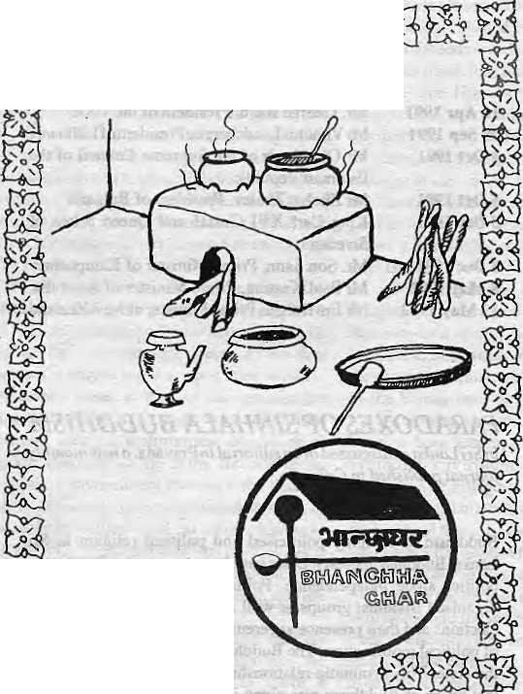


AT UVST, THE PLACE FOR EXCLUSIVE NEPALI CUISINE
Kamaladi, Kathmandu Taiephone: 225172
OPENDAILY12-10
Why
Macintosh ?
Why do people who use Apple Macintosh computers every day enjoy working with them so much/and find that they're much more productive in the process ?
Is it because Macintosh computers are so easy to set up, leam, and use? Or because Macintosh applications all work in the same consistent, intuitive way? Or because every Macintosh comes with built-in networking and file-sharing capabilities ?
Or is it simply because once people use a Macintosh, nothing else will do?
Every day, thousands of people discover the advantages of Macintosh for the first time. And catch a glimpse of its magic.
So if you want to know why contact us at MIPS.

MIPS Pvt. Ltd.
P.O. Box: 2502, Tel: 222277,
Telex: 2521 ATLINK Fax: 977-1-419250

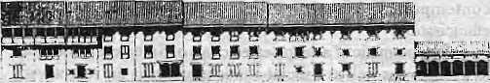
NOT BY WORDS
ALONE
PRESERVING NEPAL'S ENVIRONMENT AND CLEANING KATHMANDU'S
TOWNSCAPE NEEDS STUDY,
COMMITMENT, ORGANISATION,
DEDICATION.
LET US ALL WORK TOGETHER.
N A N G LO
DURBAR MARG
PO. BOX 4384, TEL : 223498, FAX : 527865
NEPAL
INTERNATIONAL CLINIC

* Western medical setting serving the entire community
■k Care by a U.S. Board Certified Internist
■ir Comparable services at lesser rates
- Imported Vaccines, Lab work
- Knowledge about Mountain Sickness.
- Central location
ir 9:30 am-5 pm
- Open Sunday
- Prior appointment encouraged
412842 & 419713
Phone answered 24hrs.
JaiNepaJ Cinema Hall
\ r
Royal Palace Main Gate
Lazimpat

Naxal
Kantjpam
_J L_

half millennia ago.
The task of coming to terms with...transformations is complicated by the unwillingness of the Buddhist intelligentsia to accept the need for reforms. Nevertheless, Buddhism, like all other religions, has never been static. Except for those bigots who claim doctrinal purity, there is no inflexibility towards innovation, incorporation and change in the population construction of Buddhism. Popular Buddhism is flexible, pluralistic, and non-exclusivist.
However, contemporary debate among leading Buddhist intellectuals in Sri lanka does not address these issues. Rather, it attempts to take Buddhism back into the past, to the antiquated world of pre-capitalist orthodoxies. Opposition to the ordination of women, antipathy to Mahayana Buddhism, and the militant opposition to any form of Buddhist interventions in seeking a peacefulresolutionoftheethnicquestionaresomereeentexamples of this fundamental lacunainthe contemporary Sinhalese Buddhist intellectual formation.
A SAMPLE LETTER, from Amnesty International's "Guide/or LetterWriters" (ISBN0-86210-199-9), tobeaddressed to repressive governments, "...a steady stream of letters from all corners of our globe can and does liave an effect on governments."
Your Excellency,
I am an engineer, and 1 worked on an irrigation project at
where the dam was construe ted with theexpert assistance
of technicians from your country. This was truly a memorable experience. The dedication of your engineers, both to the job in hand and to the achievements of your revolution, really openedour eyes and inspired us by their example. Many misconceptions about your country disse min ated by the foreign press were dispelled, and we became good friends too.
It was therefore with special concern that I came to hear of
the case of Mr I understand that he was arrested in for
publishing a book critical of some aspects of the government, and has been held since then without charge or trial in contravention of the UN Declaration of Human Rights. This matter has been the
subject of discussion among my colleagues. If the facts are incorrrect, please let me know, and I will see that the true version is explained. If, however, they are true, I appeal to you to look into
this case with a view to releasing Mr I am confident that your
system is sufficiently strong to permit that open debate without which no human society can be really rich. Yours faithfully,
WHATNEPALIS ARE UP TO. BS.Ratnam, of
New Delhi, professes to see through it all in a tetter in the 13 September issue of the Statesman daily.
The whole of North-East India is at last the domain of Nepalese, thanks to an understanding between the Governments of India and Nepal. Sikkim no longer belongs to Sikkhnese; stateless immigrants are the rulers now. Lepchas and Bhutias, the original inhabitants of Darjeeling, are no longer to be seen in the north Bengal hills because they have been outnumbered by the Nepalese. Bhutan is now in the last stage of its losing battle with the ethnic Nepalese. The Indian media are dutifully echoing the viewpoint of the Nepalese in Bhutan.
Gorkhaland has already been carved out, even if shortsighted leaders in Calcutta are unable to see it. This was done for only one reward — recognition of Hindi as the second national language in Nepal, so that the Hindi empire can extend to the mountains. With a common script, a large number of Hindi-speaking Indian settlers in south Nepal, and with an India-friendly Nepalese prime Minister at the helm of affairs, the dream of "Akhand Bharat" could come true. While much is being made of Bangladeshi infiltration, the Union Government is turning a blind eye to the continuing influx of the Nepalese through porous and unguarded mountain borders.
MrJyoti Basu throws up his hands and says: "What can we do?" He could at least start building barracks and refugee colonies, so that Bengalis thrown out from the north can be successfully converted to a compound-interest fixed deposit in the vote bank of the future.


uk-
Remember! Remember!! Remember!!!
MANDALA BOOK POINT
for
Scholarly Books on Nepal, Tibet, Bhutan etc. Latest Trekking Books & Trekking Maps
Mountaineering Books Guide Books of all Countries
Kantipath, G.P.O. Box:528_{r} Kathmandu, Nepal, Tel: 227711 Tix: 2685 NP MANDALA Attn: MANDALA BOOK POINT, Fax: 977-1-227372 NP NATARAJ, Attrt: BK PT.

WE ACCEPT
AMERICAN
EXPRESS
VISA
MASTER CREDIT CARDS

REVIEW
Between the Horns of a Development Dilemma

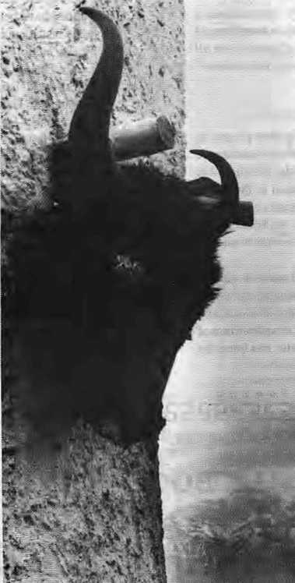
A
ncient Futures is an intriguing title for a book about development and, indeed, this is an unusual book. Norberg-Hodge raises the possibility of learning from indigenous sustainable cultures by describing a journey through Ladakh in time. The narrative jumps fTomdescriptionsofLadakhi life to the maturation of the author'sown views about Ladakh over her 16 years of visiting and sharing with Ladakhi friends and mentors. Her style switches from eulogising the dignity of the noble savage and pointing fingers at thoughtless maldevelopment wrought by the bureaucratic powers that be, to an attempt ai understanding the complexities of Ladakh's uneasy status at the periphery of the global economic network.
The bookhas three parts: Tradition, Change, and Learning from Ladakh. In the prologue, Norberg-Hodge denounces her Western heritage which she sees as rooted in an industrial culture that promulgates centralisation, technology, a money economy, and suffers the pressures and stresses that accompany it. In contrast, traditional Ladakh is depicted as "a society in which there is neither waste nor pollution, a society in which crime is virtually non-existent, communities are healthy and strong, and a teenage boy is never embarrased to be gentle and affectionate to his mother or grandmother."
The section begins with an account of Ladakh's unique landscape, high, remote and cold, where the pattern of life is dictated by seasons which alternate between scorching summer sun and winters in which rivers and land are frozen solid for eight months a year. The reader travels with Norberg-Hodge and her Ladakhi friends to field, village and monastery, 'catching glimpses of agricultural work and festivals. The key to survival in this harsh jnvirotiment is thrift, not in the sense of miserliness but in the frugality that comes from thecareful allocation of limited resources. Indeed, caring for the needs of others is an essential and integral part of traditional Ladakhi life.
Ladakhis come alive for the reader as a joyful people whose culture finds ample means of expressing well-being, vitality and high spirits. Men, women, the aged, andchildren live a stress-free existence, eg t wholesome, local, organically-grown food, rely on the Tibetan system of medicine (as practiced by local doctors, known as amcki) and believe that conflicts should be avoided at all costs. Above all, the Ladakhi life is fashioned by its Buddhist religious heritage — there is no better way to please the Buddha than to please all sentient beings.
The second section of the book, "Change",
Ancient Futures Learning From Ladakh
by Helena Norberg-Hodge
Sierra Club Books, San Francisco 1991,
U$25; 204 pages
ISBN 0 87156 559 5
by Sandhya Chaterjee
aptly begins with the arrival of Westerners. Significant con tact with the outside world began after 1974, when Indiaopcned Ladakh to tourism. Western-style development initialed by the Indian government consisted primarily of building up infrastructure, especially roads and the production
of energy. And tourism was an integral part of this development package. The most disturbing impact of totirism was on the Ladakhi self-image. To a Ladakhi, tourists not only speak a strange language and look even stranger but they appear to have inexhaustible wealth, infinite leisure time and no responsibilities.
Norberg-Hodge acknowledges that money played a minor role in the subsistence economy, but she adds that "in a day a tourist would spend as much as a Ladakhi family might in a year. Ladakhis did not realise that money played a completely different role for foreigners, that they needed it to survive. Compared to these strangers they suddenly felt poor. The tourists, for their part, think Ladakhis are backward; implicitly or explicitly..." While this is undoubtedly a biased view—not all tourists are so dumb, and certainly not allLadakhis so simple—there is truth in this perspective.
The opening of Ladakh to theoutside world
brought not only tourism but also Hindi/We stern
films and television. "For the young Ladakhi the
picture they present is irresistible and by contrast
their lives seem primitive, silly and inefficient."
The move away from traditional learning patterns
begins with the government schools which
provide Western-style education. This is
perceived as "synthetic and divorced from the
living context." Enamoured with the material
culture so viv idly portrayed by to urism, lelev is ion
and partly by development programmes, young
Ladakhis are rejecting their traditional way of
life. They willingly exchange a rich heritage for
an esoteric ideal, without really knowing, or
choosing to ignore, the reality of what
development has brought to other countries.
For Norberg-Hodge, commercialisation, the
provision of
infrastructure and
the alien tourist/
television intro-
: duccd culture arc
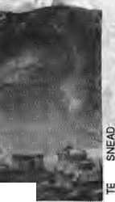
the cornerstones of a systematic transform alion of society. Ithas, for example, made it difficult ta remain a farmer, increased the gap between the rich and poor, slapped a monetary value on time, and 3 pushed people d
and
t^. a M*.
further

38 HIMAL ■ Sep/Ocl 1992

REVIEW

Norberg-Hodge and a LEDeG member receive the Right Livelihood Award, 1986.
existence for Ladakhis. Although development has its plus points — money and medicine have brought subs tantial benefits—there is a broader perspective to consider. "It becomes clear", Norberg-Hodge says,''thatthe traditional Nature-based society, with all its flaws and limitations, was more sustainable both socially and environmentally ... By comparison, the new iLadakh scores very poorly; the modem culture is producing an array of environmental problems :that, if unchecked, will lead to irreversible decline."
But does development inevitably destroy? Norberg-Hodge is optimistic. "I am convinced that the Ladakhis could raise their standard of living without sacrificing the sort of social and ecological balance that they have enjoyed for centuries. To do so, however, they would need to "build on their own ancient foundations rather than tearing them down, as is the way of conventional development." As one of the last subsistence economies to survive virtually intact 10 the present day, Ladakh has a unique vantage point from which to observe the whole process>of development.
This brings us to (the icemtral point of this section.To counteract raaidevelopment, Norberg-
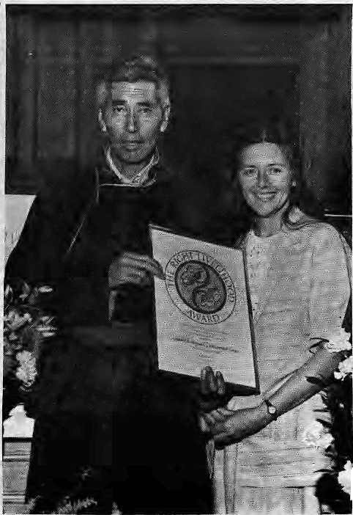
further apart. The pressures that lead to cultural breakdown are many and varied, but the most important elements spring from the fact that most individuals do not and cannot have an overview of the development process, while they are in the midst of it.
The problems and stresses of economic transformation are especially visible around Leh, the capital. Urban overcrowding and lack of amenities have begun to become serious. Pollution and waste are rampant, and the modern economy has begun to "play havoc with common sense." In Leh, building with mud — a traditional and freely available resource — is becoming prohibitively expensive whereas the imported style of building with its attendant negative aesthetic impact is mushrooming. "This is a good example of how Western-style development operates to undermine local systems." In lamenting the direction of change Norberg-Hodge writes thatperhaps the most tragic vicious circle she has witnessed is "the way in which individual insecurity contributes to a weakening of family and community ties which, in turn, further shakes individual sell esteem... A gap is developing between old and young, rich and poor, men and women, Buddhist and Muslim,"
Development scientists would be most interested in the third section of the book, "Learning from Ladakh", which tries to link change here with global processes. One gets the impres sion Jrom Norberg-Hodge"« dhange o f tone that this section was written in [the latter years of her relationship with Ladakh. She acknowledges -thai "my description might well seem exaggerated, as though I have seen the traditional Kfe through rose-tinted ;gjnsses and painted the modem much too black ... much of what I have described in the old Ladakh is positive and most of my description of !the mew looks ate^aiwe'dhangeK. This is because I tuwe primarily dealt wiitib [reftatatiaisMips M&d connections—to describe She shape and Keel of two contrastiag wayB^of EfeEathei than focussing
(lev-doped -world tioiAld ami help but look at Ladaldh -with different .eyes, "whatever hei or his intellectual viewpoint.
INorberg-Hodge admits iflaat many aspects of traditional lOuharewraejEarlfeteiBa ideal: there was a lack of basic com forts, such as heating durittg freezing ■winteis; &mi ted jcornmunic ation wiili ihe outside world:; high illiteracy and high inf antinortality., R^{i}ut,^{i}she^says,'WeiSi£irri yardsticks cao ibeivory misleading. MndhusC-wihatWesterners would consider hardships are part of daily
Hodge proposes what she calls "counter-development". Its primary goal would be to offer people the opportunity to make informed choices about their future. Counter-development would employ all forms of communication to spread the message that modern capital — and energy-intensive trends are simply not sustain able. Ultimately, the aim would be to promote self-respect and self-reliance, thereby protecting life-sustaining diversity and creating the conditions for locally based, truly sustainable development. The steps needed to stem the rush towards unsustainable development can and should be taken on a massive scale and should be implemented immediately. To combat the rapid spread of the monoculture, we need to meet it on its own terms: global, top down, fast-paced and capital-intensive. Such analysis prompted Norberg-Hodge to start the Ladakh Project in 1980, which seeks "to encourage a revisioning of progress towards more ecological and community-based forms of living." In 1983, the Ladakh Ecological Development Group, "LEDeG", was £2 formed. Its aims are to develop and Jft demonstrate a whole range of appropriate t technologies such as Trombe walls for space heating, solar cookers, and hydraulic ram pumps, apart from supporting cultural activities.
The book ends on a note of optimism, "new movements are springing up, committed to living on a human scale, and to more feminine and spiritual values. These trends are, as Ladakh has shown in an important sense, very old. They are in fact a rediscovery of values that have existed for thousands of years — values that recognise our place in the natural order, our indissoluble connection to one another and to the Earth."
Ancient Futures is worth reading. It is liberally sprinkled with nuggets of wisdom gleaned from the Ladakhi way of life, which is depicted as the epitome of simple living and high thinking. Norberg-Hodge's compassion and deep regard for the Ladakhi people shine through, despite unwitting overtones of arrogance. Though some of the analysis seems simplistic and more than a trifle naive, the book makes important observations and suggestions. But if only storytelling were kept in its place. Although perhaps intended as a means of emphasising important points, such tales interrupt the flow of the book and its arguments and would be better placed in glossy travelogues.
S. Chaterjee is a Delhi-based social scientist who has lived and worked in Ladakh.

Sep/Oci 1992 HIMAL ■ 39

ABSTRACTS

Rural and Agrarian Social Structure of Nepal
by Sohan R. Yadav Commonwealth Publishers New Delhi, 1992, IRs 300 ISBN 81-7169-174-9
This book makes use of a wealth of data to describe the people and culture of the Tarai against the backdrop of Nepal's geography, history and agrarian reforms. It includes study of "people of Indian origin" living in tlis Tarai and shows how they fare in Nepal. Chapters deal with the socio-political, linguistic, economical and hierarchical ranking of Indian ethnic groups and their contribution to economic development. The author includes a brief account of Asian diplomacy, and Nepal's involvement with the East India Company, prior to Indian independence.
Contribution to Nepalese Studies
Volume 17 No 2 D. P. Bhandari, Chief Editor CNAS, Tribhuvan University Kathmandu
This delayed issue, dated July 1990, has just been released and contains eight research papers and two book reviews. Lionel Caplan discuss the use of the 'tribe'and 'peasants' with reference tohul communities of Nepal and suggests that the key is to look at "traditional relationships to land, and how attitudes to this land shaped people's identities." Premalata Ghimire presents an analysis of the Sattar community in the eastern Tarai of Nepal, while Tej R. Kansakar studies the "lexical and syntactive causatives" in Newari. Does divinity protect the King? asks Bert van den Hoek in an article on the ritual and politics in Nepal. He ends with: "The king's divinity does no more protect him than it did Lord Visnu himself. ..and least of all, it must be concluded, does it protect him from hi s own people."
Sushila Manandhar presents research on the economic links existing historically between Nepal and Bhutan. In "Mass Movement 1990", Krishna Hachhethu presents a detailed wrap-up of the days which led to the overthrow of the Panchayat system, including analysis of the cooperation between the Left and the Nepali Congres s, the role of the Middle Class and international support.
Political Awakening in Nepal (The Search for a New Identity)
by Prem R. Uprety Commonwealth Publishers New Delhi, 1992, IRs 240 ISBN 81-7169-190-0
Uprety's book is a critical history of a modern Nepal that is trying to portray a democratic image. The work aims to place in its proper historical perspective end of the Rana oligarchy and the role of the revolutionary intelligentsia. The author throws light on the activities of the Nepali middle class and analyses the role of revolutionary social and political organisations, indicating an extraordinary development of indigenous ideas and aspirations of a people who had lived under a "Ranarchy fora century. Thebookhas six appendices concerning rare sources, such as the revolutionary leaflets issued by the "Bloodshed (Raktapat) Committee".
Development Through Non-Governmental Organizations in Nepal
by Diwaker Chand
Institute forNational Development Research and Social
Services 1991, Kathmandu, U$ 20
The author's book is a spin-off of his own involvement
b the non-governmental organisation (NGG) sector of
Nepal, The book describe the institutional isation of NGOs in the country and in doing so elucidates the formation of the Social Servi ce National Co-ordination Council (SSNCC), which was designed to co-ordinate and facilitate work of NGOs. One chapter deals with issues that arose daring the 1990 political movement. This section is of particular interest as it discusses the stepping down of Queen Aisii wary a as Chairperson of SSNCC and related issues.
High Religion - A Culture and Political History of Sherpa Buddhism
by Sherry'B, Ortner Motilal Banarsidass Publishers New Delhi, 1992, IRs 120 ISBN 81-208-0949-1
Antrhopologist Ortner narrates the story of the establi shment of the fi rst celibate Buddhi st monasteries among the Sherpas of Nepal in the early twentieth century. She discusses how the monasteries were founded, by whom and why. Ortner has also delved into the history of Sherpa society and discussed its internal dynamics, and of the external forces that affected them, from the time of the Sherpa settlement in Nepal in the early s ixteenth century to the time of the founding of the monasteries in the early twentieth century. The book is also an essay on the relationship between worldly dominance and spiritual striving, between power and merit, politics and religion.
The Unknown and Untold Reality About The Lepchas
byJfi". Tamsang Lyangscng Tamsang
Hong Kong, IRs 22
The Lepchas, indigenous to Sikkim and Darjeeling,
have lost a lot during the past century without the world
knowing. Author Tamsang says although different

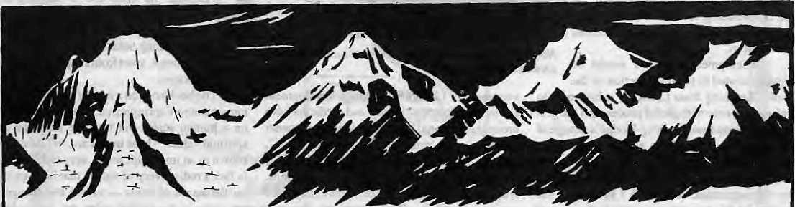

The sheer cliffs of Ganesh Himal. Shisha Pangma (Gosaithan), which is still pink after the lower peaks have succumbed to darkness, The rolling crest of Phurbi Ghyachu and the stark and lonely beauty of Choba Bhamare, leading the way eastward to Gauri Shanker and Chomolongma (Everest). All these Himalayan wonders are yours at the Haatiban Resort, With Kathmandu Valley spread out at your feet.

On a pine-crested ridgetop 13 km south of Kathmandu city. Fresh and clean air. Walks in the lush forests of Champa Devi. A spacious restaurant with terraced garden and 20 twin comfortable rooms in 4 separate cottages. This is the resort you have been waiting for.

G.P.O. Box: 1273, Kantipath, KTM, Nepal
City Tel: 221129,221181
Hotel Tel: 290623,290622
Telefax: 977-1- 221151

40 HIMAL • Sep/Oct 1992

ABSTRACTS

authors have attempted to write about the tribes' h j story, they have failed in 'diving deep into the real facts" and, consequently, have based their writings on the market gos sip of nan-Lepcha guides, inte mreters and informers
|«L m \m j*-r ms*. J _{B} _{n}^_{n} m^n. italh J A._* jM \m. 1 _ til ,iJ 1 _.^~ ^."L _^ u_ . _if _T
from the lips of aged and authoritative Lepchas. The author discusses Lepcha language, Lepcha script, its manuscripts, race, religion, culture, arts, handicrafts, architecture and culinary am.
Geographer's Point Voll.Nol
Centre for Nepalese Geography Kathmandu
NRs60/Ks50/U$4 per copy
This new journal seeks to "enrich Nepalese Geography" and enhance understanding of the science at all levels of education. Edit or Ram Kumar Pan day bemoans the "geography illiteracy" in the country. Nepal has poor maps to begin with and few people who can read them, he says. Officialdom cares litlle for geography. The issue has an article on geographical linguistics by Japanese scholar Sueyoshi Toba and another on the many uses of bamboo by Nepali scientist Punya P. Foudyal. The bamboo is socially, economically and ecologically-friendly and should not be marginalised by consume ribt, concretised culture, he says, and lists 34 sub-species of bamboo found in Nepal. According to the editor, the forthcoming issue (expected out in November) will contain a thematic bibliography of all the writings of Nepali geographer Harka Gurung, covering 14 subject areas from tourism to geology. Also featured: Bangladeshi geographer K Maudood Elahi and Japanese scholar S. Kobayashi. Contact: Department of Geography, Tribhuvan University, Kirtipur, Kathmandu.
Sikkim Since Independence
by Amal Datta Mittal Publications New Delhi, 1991, IRs 210 ISBN 81-220-0181-5
Sikkim, the 22nd state of the Indian Union, has modernised rapidly. All spheres of life — politics, social structure, economy, culture and li ft sty le—have changed considerably since 1975, when it was incorporated intolndia .The author attempts to illustrate the changes wrought by modem education on the people and society of Sikkim. Education has spawned what the author calls a new class in the state. The middle class has new ideas about caste, ethnicity, language and religion. The attitude towards religion and the sending of sons for monastic education is of particular interest.
The book also examines the major constraints to the development of education and consequently their influence on the new class. There is also a comparison of educational growth among various ethnic groups— Nepalis, Lepcha, Bhutia and four other ethnicities.
Bhutan Environment,
Culture and Development Strategy
byPf.Karan
Intellectual Publishing House
New Delhi. India 1990
IRs 175, U$ 30
ISBN 81-7076-027-5
The author tries to describe Bhutan's pattern of
development since 1960, including Indian assistance
which began then. After outlining Bhutan's cultural
and environmental development, Karan discusses
Bhutan's energy, mining and manufacturing sectors,
the impacts of transport, trade and tourism, forest use
and management, development of human resources,
land use and agriculture. Most o5 the material for the book were gathered by the author through field observation starting in 1960 when he was invited by the present King's father to undertake research in Bhutan.
Sherpa of Khumbu, People, Livestock, and Landscape
by Barbara Brower Oxford University Press New Delhi, 1991, IRs 290 ISBN 0 19 5626141
The Sherpa world has changed considerably since 1953, when Everest was first climbed. There are new pressures on the people and land, new expectations about what Sagarmatha National Park ought to look like, whom it is for, how and by whom it should be managed. These pressures and expectations profoundly affect the animal husbandry practi ces of cattle herders. Brower looks at animal management in the Park in the context of Sheipa subsistence, demonstrating the intricacy of the relationship between herders and the land, the adaptability of herders and considerations that must be taken into account in any attempt to modify traditional land -u sc practices. The book provides an account of a society in transition.
India And Nepal • A Changing Relationship
by SD. Muni
Konark Publishers
New Delhi, 1992, IRs 200
ISBN 81-220-0181-5
Muni analyses the linkages between the domestic
political imperatives of each country and their bilateral
relations. The study then details the erosion of the Lido -
Nepal Treaty of 1950 and, among other things, discusses
King Birendra's "Zone of Peace" proposal (enunciated
in 1975) in relation to India-Nepal relations. Trade and

"MOUNTAINEERING"

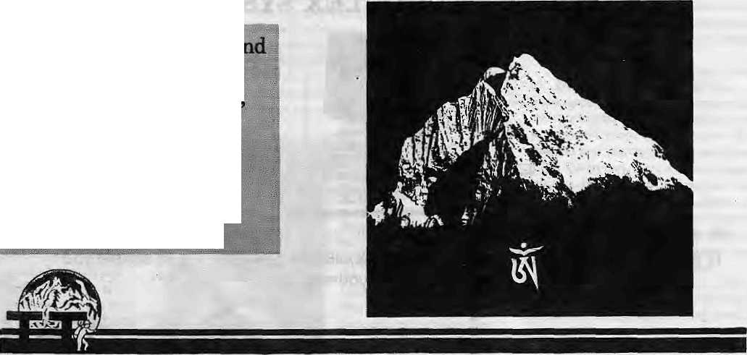
Fpr major expedition^
trekking all Over Nepal,
India,Xadakh, i&ansk Pakistan^ |fcimtaiiand
g BIST MOUNTAINEERING SERVICE

Thamserku Trekking (P) Ltd.
P. Box 3124, Narayan Chaur, Naxal, Kathmandu, Nepal, Tel: 411562, Telex: 2682 SERKU NP, Fax: 977-1-227042
Sep/Oct 1992 HIMAL * 41

ABSTRACTS

Indian aid to Nepal is also covered, and the study concludes with a survey of the most recent political transition in Nepal.
Snowlight on Everest
A History of the Sherpas of Nepal
by Sangs-rgyas bstan-'dzin 1992, Franz SteinerVerlag Wiesbaden GMBH Stuttgart, 1992 ISBN 3 515 06078 2
No. 18 in the Nepal Research Centre Publications and edited by Franz-Kail Ehrhard and Alexander W. Macdcnald, this book concerns the origins and customs of the Sherpas of East Nepal. It is written in Tibetan script by the celebrated Sheipa stiiolar Sangs-rgyas bstan-'dzin (Sangey Tensing), who died in July 1990 at the Solu monastery of Junbesi. The editors say that much of the information contained in the publication, particularity the details of marri age and funerary rituals, is little known outside the local context.
Political Parties and the Parliamentary
Process in Nepal:
A Study of the Transitional Phase
Sridhar Ktotri, Editor Political Science Association of Nepal Kathmandu, 1992, NRs 400
This 317-page study is the outcome of research undertaken between August 1991 and March 1992 with funding from Danish International Development Agency (DANIDA). It contains papers on issues such as the candidate selection process in major political parties, internal party affairs, factionalism, how political parties view monarchy, etc, A section on the legislative institutions contains papers on the composition of the Parliament, intra-party behaviour, legislator's attitude
on foreign policy, etc. Most interesting is the section whichprofUes political parties. The support baseof me Nepali Congress and the United Marxist Leninists aie found to be largely similar—both parties being strong among the younger generation, the more educated and affluent, professional and businessmen, and among Biahmans. With regard to the MF's attitude towards the monarchy, 95.5 percent of United Marxist Leninists are found to oppose it while only 3.4 per cent of the Nepali Congress MPs do so. Though die publication is about politics and is written by political scientists, it contains information that is useful to all scholars interested in Nepal's transition to democracy.
Self-Reliance in Small Communities
by Ramesk Manandhar Oxford and India Book House New Delhi, 1992, U$ 49 ISBN 81 204 0700 8
This 468 page book examines the question of sustainable development and the choice of technology. It que stions the appropriateness of the conventional notion of appropriate technology, on the has i s of field experiments with earth (roof) construction in two countries. If the application of appropriate technology of earth rooting was found to be a success in a small town in Australia, similar attempts in a Nepali village led to social, economic, technologies, cultural and psychologies problems. On the other hand, participatory action-research leading to "facilitation" of indigenous technology systems of handloom, mat-making and animal hu sbaqdcy was found to encourage community self-reliance in the very same village. According to the publi shers, the book recommends "an innovativemodel for community self-reliance in developing countries based on Gandhian deas." Author Manandhar died in the Thai International disaster of 31 July.
Contemporary South Asia
Volume 1 Number 1, 1992 Carfax Publishing Company Gowher Rizvi and Robert Cassen (editors) This is a new journalpublished by scholars at the University of Oxford. The journal aims to address the major issues facing South Asia from a regional and inter-disciplinary perspective. The premier issue contains nme papers and seven book reviews, all of high quality. The first piece is by Nepali scholar Sridhar Khatri, writing on South Asian regionalism, while others cover Indo-Pakistani relations, food crisis in India, conflicting visions of democracy in Pakistan, and others. Five of the contributers have South Asian names. Although the journal apparently aims at being inter-disciplinary, the first issue is dominated by international and political science perspectives. India and Pakistan figure prominently whereas other South Asian countries tend to be neglected. One of the book reviews is a critique of V. S.Naipaul's Z/uCaMMiWon Mutinies Now.
Monk, Householder, and Tan trie Priest Newar Buddhism and its Hierarchy of Ritual
by David N.Gellner
Cambridge University Press, Cambridge
1992,50 Pounds
ISSN 0521 38399 4
Anthropologist Gellner details "for the first lime" an
account of how Tantric Buddhism works in practice.
The book is a detailed ethnography of the Mahayana
and Vajrayana (Tantric) Buddhism of the Newars of
Kathamndu Valley. It describes a way of life and social
organisation of "Hindu-Buddhist Lalitpur", the
relati onshipof Buddhism to Hinduism, and the place of
religion and ritual in the life of Newar Buddhists. The
study of the Newars has wider implications, says the

TRUE UPGRADEABILITY MADE POSSIBLE WITH DATAMINI MULTIFLEX SYSTEMS


SKUlKV K*y4tt*
LED display panel incorporating system a - d lUtN awitthflJ.
1x3.5'FDD.1X5.25" FDD. 1 x 5.Z5* hand disk and on« tape back-up s/slam.

By simply changing the CPU card of your Muitifiex, you can upgrade your computer to a top-of-the-line 486DX from a 286, 386SX, 386DX or 486SX.It's so simple you
can even do it yourself.


Authorised Distributor:
Muktinath Trade Concern
P.O. Box 5073, New Road, Kathmandu, Nepal.
Tel: 2-26858, Fax No: 977-1-227068

42 HIMAL • Sep/Oct 1992

ABSTRACTS

author, "because it allows us to grasp how Buddhism works and worked in its original context of caste and Hindu kingship." The book has twelve chapters and references in 416 pages, plus 23 tables.
Anti-National Activities in Southern Bhutan An Update on the Terrorist Movement
Department of Information Government of Bhutan, Thimphu 1992
Dated 12 August 1992 as an update to a similar publication brought out in September 1991, this booklet is meant to counter news coverage of the events tn southern Bhutan which have been "sensational" and "one-sided". Staling that the anti-national activities continue to seriously threaten Bhutan's security and weUbeing, the report targets the Bhutan People's Party, the Bhutan National Democratic Party and the Human Rights Organisation of Bhutan for criticism. A novel strategy adopted by these organisations ("which are supported exclusively by ethnic Nepal is") to keep their movement alive was "to convince as many Southern Bhutanese as possible to leave Bhutan and register themselves as refugees" in Nepal. A section on human rights in Bhutan defends the Government's record, while other sections deal with the judicial system and the social and economic development in southern Bhutan. As in the previous publication, the present report provides a pictorial summaiy" of "continued acts of terrorism . Pictures of skeletons, decapitated bodies, wounds and exhumations are shown. Even though it is "not in good taste or in keeping with the Bhutanese character" to show the gory pictures, says the report, they ate printed to counter "the malicious propaganda and constant stream of false accusations" against Thimphu.
PaharSI6
Shekhar Pathak, Editor Naini Tal, 1992
Ks60 (Library edition IRs 350) Pahar is an annual magazine in Hindi on the society, culture, history and environment of the Himalayas. Pahar 1 came out in 19&3, Pahar 2 in 1986, Pahar 3! 4 as a joint issue in 1989. The present dual issue, Pahar 516 contains more than 40 arti cle s in 272 pages covering, among other things, the following topics: history, currency, agriculture, the Tharus, the tea industry, herbal medicine, the Tehri Dam, balanced development, the Shimlan monkeys, petroleum, woodfuel, ancient and historical culture and arts of Uttarakhand, the Chipko movement and Gaum Devi. Some travel memoirs and poems are also included. Two of the articles deal with Nepal's straggle for democracy. Perhaps the most important section is on the the 20 Ocl 1991 earthquake which hit GarhwaL presenting reports on relief works and indepth discuss ion of con sequences of the earthquake and in that context the need to change the present style of mountain development works. (Contact: Pahar, "Parikrama", Talla Danda, Nainital 2, Uttar Pradesh.)
Gorkhaland Agitation
Compiled by Rajendra Baid Janapath Samachar IRsffl, first published 1988
The first pail of this book is a compilation of articles carried on the Darjeeling agitation by the Siliguri-based newspaper, Janpath. Baid, its editor, credits reporters ManojRouth and B.B.Sing for having risked their lives while reporting from the hiUs of Darjeeling during the troubled period. The book contains a compilation of letters, correspondence and agreements
relating to the Darjeeling agitation, start ing with a 1917 memorandum of the Hillmen ' s Associ at ion antl ending with a 14 August statement by Subhash Ghising.
Trek to Mustang
by Stan Armington Mandala Book Point Kathmandu, 1992
This small booklet (37 pages) provides basic information for trekking in Upper Mustang (Lo), the area which was opened by the Home Ministry of Nepal in October 1991 fortrekking tourism. The author, who has written a popular trekking guide to the Nepal Himalaya, writes: Change and development will come to Lo regardles of the degree of protection that is exerted. Despite their isolation, the people of Lo are worldly, well-travelled and resourceful. They are essentially Tibetans and are skillful traders, travellers and merchants. One hopes that they can retain their traditions under an influx of tourists, but they are by no means a primitive tribe that must be protected from outside irifluence."
Mountain Research and Development
Vol 12, No.3, August 1992 Jack arid Pauline Ives, Editors University of California Press The articles in this issue of MRD are mi the following subjects; Land -use conflict ontwoHawaiian mountains; tree cultivation on private land in the Dolakha District of Nepal (by EJ.Carter); streamflow and sediment from mountain watershed of the Chao Phraya basin in Tha i land; a study of secondary evergreen broad-leaved forest in Yunnan; and natural revegetaion of coal mine spoils in the Rockies of Alberta, Canada.


THE ULTIMATE ADVENTURE DESTINATION
Let Tibet Travels & Tours- The pioneers in
Tibet adventure-unfold for you the inner
secrets and mysteries of this fascinating land, people
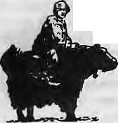
and culture-so different from anything you have ever imagined
Departures to Tibet Every Tuesday and Saturday By Air/Land
For details contact:
TIBET TRAVELS & TOURS (P) LTD.
Tri Devi Marg, Thamel, P.O. Box 1397 Kathmandu, Nepal. Tel:410303, 415126, Tlx: 2672 TIBTVLNP, Fax: 977-1-415126

Sep/Oct 1992 HIMAL • 43


Abominably Yours,
Tphe jet stream on the South Col just threw X up a New Zealand five-dollar note that sports a profile of Edmund Hillary, the beekeeper. I do not know if Sir Ed had any say in (he matter, but it seems to me he-was co-opted. If I know him well, Sir Ed is not one who would agree to stare for eternity out of a bank note while people with greasy fingers manhandle him in and out of overstuffed wallets. What a comedown for he who led the Queen and Commonwealth to glory in 1953.
Aside from all that, do I detect a speck slightly below and to the left of Sir Ed's nose .that bears a striking resemblance to Tenzing Norgay hacking away at the Hillary Step while his Mend takes a self portrait? It was only correct that the New Zealand monetary authorities also thought of Tenzing, and we thank them for their commitment to the one-world concept and internationalism.
Having a mugshot on the currency note of one's nation truly represents (if you will pardon the expression) the peak of a person's career, especially if still alive. It puts Sir Ed right up there with, and actually a step ahead of, Abe Lincoln, the Mahatma, King Bhumibol and the African Rhinoceros.
The arrival of the five-dollar bill got us thinking about currency in general and how it has changed our world. In the days when the Upper Barun was only populated by itinerant langurs, snow leopards, early yak herders and hippie ho mi no ids, things were simpler. Bartering was the order of the day. A dozen yak-dung patties for three cubes of ckhurpi rock-cheese was the official exchange rate determined by the Tingri Bureau of Monetary Affairs, and every thing else was calculated from that benchmark.
Bartering, of course, is still in vogue around me world. A Pacific island nation has just exchanged 20 ship-loads of shrimp for five Sia Marchhetti jet trainers from Italy. Meanwhile, since the rouble has fallen clean through the earth and come out on the other side, everyone in the land of Peak Lenin is . trying to make a fast buck. They will exchange anything far anything. Taiwan is salivating after a Ukrainian aircraft carrier from the Black Sea fleet and has put in a bid — two million fake Lacoste T-shirts. Malaysia is trying to bargain down the price of 35 secondhand Mig -29s from a year's supply of toothpaste to the Commonwealth of Independent States to a just a condom factory for Irkutsk.
Bartering served us well, but we in the Barun converted long ago to beads and lumps of salt as currency. There were times when the exchange rate mechanism would go haywire as
speculators in
Rongbuk and Num
started stocking up
on rock-salt. Beads,
too, often fell off the
edge. But the timely
arrival of a yak-load
of chhurpi bullion would soon stabilise the
currency market.
Today, even the tea shop below Tilman La is monetised with Nepali funny money. The tiny one-rupee note depicting Pashupatinath, for all its religious merit, has lost all monetary value. The lone roop does not even buy a quarter slice of yak pattie anymore. The musk deer on the flip side, shown adroitly darting from crag to crag below Ama Dablam, seem unhappy that the leopard on the two-rupee note is stalking them. The snow leopard, as per its reclusive nature, does not make an appearance in the currency notes. Despite the altitude and the terrain, however, the 100-rupee rhinos have started turning up. Perhaps something to do with deforestation and habitat loss in the Tarai, which will soon be driving the 10-rupee blackbucks and 20-mpee barasinghas northwards as well.
But it is Nepal's 1000-rupee note that takes the yak dung pancake for creativity. We do not know who the Rastra Bank's zoological consultant is or was, but we suggest that he be fed to the malnourished big cats of the Jawalakhel Zoo. Or could it be that the draftsmen at dc la Rue thought that the note was being designed for Botswana?
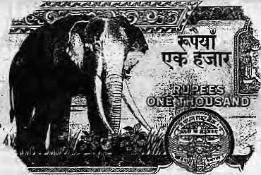
The 1000-rooper unmistakably shows an adult African bull elephant about to charge Robert Redford. I know that there is no such thing as ethnic purity, and we are all hybrids of one short or another, and (for example) anyone arguing that he is a pure Aryan, a pure male or pure female is probably a fascist — but the bull elephant in question has no Asiatic traits. It is an alien pachyderm. Tusker ain't one of us. He doth trumpt to a strange tongue. Asia for Asian Elephants! And a vigorous "no" to African expansionism and all other kinds of
Lost Continent Creeping Hegemonism through monetary units!
Of course, there is no rule, even in the new Nepali Constitution, which says that Nepal cannot have a currency note showing African wildlife. Especially if Bhutan can get away with hosannas when it churns out postage stamps of Mickey Mouse and Rembrandt paintings, and if the Seychelles can unblushingly issue stamps with polar bears.
In fact, if only we got over our chauvinism, a whole new world of currency design would open up for us. After Nepal's last one-homed rhino is sold and shipped to the Singapore Zoo, the 100-rupee note can simply switch to a two-homed species from Tanzania. And when the Barasingha or muskie become extinct, the Rastra Bank can call in the gnu, bison or okapi.
Central banks usually like to stick in icons of their nation's industry, natural resource or historical heritage on their bank notes. The higher the denomination, the more precious to the nation the symbol being flogged. Countries of the CMEA, the old East European block, liked to display gigantic steel mills with humungous chimneys spewing forth billowing clouds of sulphurous fumes. It was socialist realism that showed the seriousness of their pollution problem. Other countries like to show off their prime assets — nuclear power plants, waterfalls, or royal families in the throes of extinction.

The Bank of England could more truly reflect the new value of the pound by planting the Duchess of York's most recent revealations from the south of France on its five pounder. Currency notes should also reflect a country's main activity, and no whitewash or prudery allowed. Thailand could change its 100 baht note to show a panoramic view of Pat Pong; Burma's 100 kyat note could show Thai trucks carting away teak logs; and Bangladesh's 100 taka note should display an embankment made by corrupt contractors being washed away by flood.
And now back to New Zealand. Better you, Sir Ed, than sheep.

44 HIMAL • Sep/Oct 1992

 |  |  | HIMtL "
 | ''1 i^r'^nTM ' |  | Oj. V V¹' f * ■ ■ ^{p} ■ ":

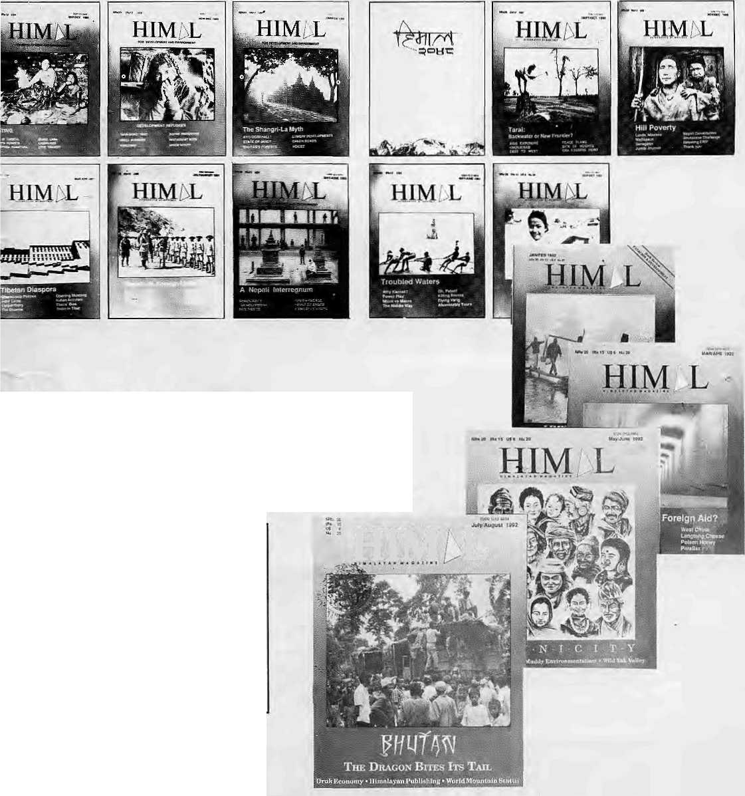
Advertising
In The Thinking Persons
Magazine Of The Himalaya
HIM L
Himal is the only international magazine of the Himalaya. It has a select, committed and expanding readership in South Asia as well as overseas. Every two months, our pages will carry your message effectively to a high-profile audience. Himal is a bimonthly, but its shelf life is counted in years. Advertise in Himal and reach your market. Write to the Managing Editor at POBox 42, Lalitpur, Nepal. Tel 523845 Fax 977 1 521013


Regd. No. Lalitpur 65/O45-4t

Northwest makes it easy to go to America. With a choice of 8 gateways. And connection to 200 cities beyond.
Choose a connecting city thai suits you best: Bangkok, Hong Kong or Singapore,
generous Iree High) plan there is. General Sales Agent in Nepal :
Northwest has daily 747 flight via Tokyo or
Seoul straight to the U.S.A. ' Ma la Treks,
Malla Hotel Arcade,
Be sure to ask about WorldPerks, the most Kathmandu, Tel. 41 8 389




-From i2!;citieis-!n*ASf

