
NRS 20 IRS 1$; Nu 20 U$ 6 DM 9
H 1 M A L A Y A N M A G A Z
Nov/Decl992

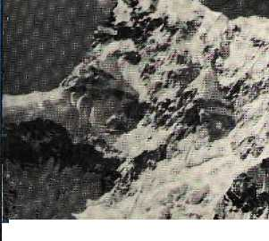
1

ff*
;V

^

LIMALA
Mountaineering
Unseemely Scramble for the Karmapa's Throne
There is No Smoke without Advertising
Reviews • Voices • Abominably Yours
■
■ j-Qss|

_{s} _,,_ ,.„„,_-,, -Jp'*- -j'

 |  |  | 5§|j |  |  |  | -
 |  |  | „..:.■:■,- ■■.■■■;■■■■.■■■:-.'-.■;■■ v\.
 |  |  | ■ .-■■■:V.^-V. ^.y-^m |  | ■^■■^■■■■- ■ ^ S
 |  | ,- • * ■
 | mm^mm | liSSiiii | »f||
 | mm^mm | liSSiiii | »f|| | ; i ;•■:, -i
 |  |  | WINTER |  | SCHEDULE*
 |  | _{L} EFFECTIVE FROM NOV. |  |  | 18, 1992 TO FEB. 15,1993.
 |  | SECTORS |  | FLT NO. | DAYS OF OPD. | ETD | ETA
 |  | KTM | MTN | NS-300 | DAILY | 08:00 | O9:oo
 |  | KTM | MTN | NS-400 | DAILY | 09:20 | 10:20
 |  | KTM | PKR | NS-301 | DAILY | 10:40 | 11:10
 |  | PKR | KTM | NS-302 | DAILY | 11:35 | 12:05
 |  | KTM | PKR | NS-401 | 2. 3. 4, 6, 7 | 16:00 | 16:30
Our German |  | PKR | JMO | NS-311 | 1,3,4,5,7 | 08:10 | 08:35
Dornier -226 aircraft : |  | JMO | PKP | NS-312 | 1,3,4,5.7 | 09:15 | 09:40
 |  | PKR | KTM | NS-402 | 1,3, 4, 5, 7 | 10:05 | 10:35
+ has air conditioned |  | PKR | MTN | NS-500 | 1,3,4,5,7 | 07:00 | 07:45
cabin. |  | KTM | JMO | NS-305 | 4,5,7 | 08:O0 | 08:50
 |  | JMO | KTM | NS-306 | 4,5,7 | 09:15 | 10:05
•f- has more comfortable |  | KTM | BIR | NS-316 | DAILY | 12:40 | 13:30
seats. |  | BIR | KTM | NS-315 | DAILY | 13:55 | 14:45
 |  | KTM | BWA | NS-307 | 1, 3, 5 | 15:10 | 15:55 I
+ has individual windows |  | BWA | KTM | NS-308 | 1,3,5 | 16:20 | 17:05
for better mountain |  | KTM | : BHR | NS-303 | DAILY | 11:20 | 11:45
viewing. |  | BHR | PKR | NS-314 | DAILY | 12:10 | 12:35
 |  | PKR | BHR | NS-313 | DAILY | 13:25 | 13:50
•f has weather radar |  | BHR | KTM | NS-304 | DAILY | 14:15 | 14:45
& modern avionics. |  | KTM | JUM | NS-317 | 5, 7 | 11:35 | 12:55
 |  | JUM | KEP | NS-319 | 5.7 | 13:20 | 13:55
■*- Our flights are |  | KEP | JUM | NS-310 | 6,3 | 14:00 | 14:35
punctual & reliable. |  | JUM | KTM | NS-318 | 6, 3 | 15:00 | 16:20 1
* subject to government approval.



— EVEREST AIR
3rd Floor, Singapore Airlines Bldg., P. 0. Box 482, Durbar Marg ■ Kathmandu. Telephone : 229412, 224188. Fax : 226795

Kathmandu
Tel.: 228392 222290
Pokhara
Airport Tel.: 21883
Bharatpur
Prithvi Chowk Tel.: 21093
Biratnagar
Mahendra Chowk Tel.: 22227, 25345
Nepalgunj
Surkhet Road Tel.: 20035, 21482

INSIDE...

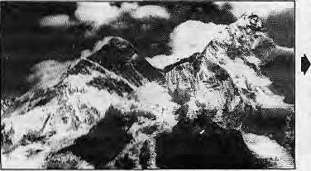
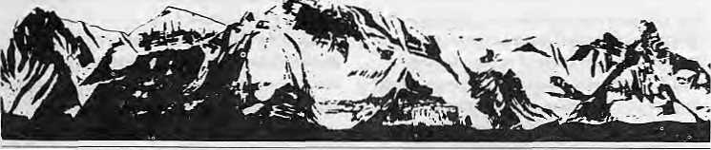
MAIL
Stench of Prejudice
I cannot refrain from expressing my disenchantment on reading your article "The Dragon Bites its Tail" (Jul/Aug 1992). Yon have tried to re-writu our history into your version, perhaps intending to give the world an illusory picture of Bhutan.
An ex-Drukpa official has supposedly told you that in the past the northern Bhutanese were "...afraid to spend even one night in the south. No Northerner would ever go down there...", except for a brief spell during winter. Well, in case this official and you did not know, this is for the record:
In 1774, there was a major encounter between the Bhutanese and the British in Caoch Bihar. In the J864-65 war between the British and the Bhutanese, the entire southern Duars were guarded by Bhutanese soldiers from Dewangiri (Deothang) in the east to Dalim Kot in the west.
Our forefathers sacrificed their lives and suffered in the hot, malaria-prone areas of the southern region to protect the foothills from foreign invasions and passed down to us a nation that is independent of any foreign influence. You should take note that places like Dungsum, Chirang, Pasakha and Dalckha were extended settlements from the north. So it is not true to say that southern Bhutan was ignored by northern Bhutanese.
You have also made an attempt to establish that Nepali immigrants began to move into Bhutan as early as 1700s. This is in sharp contradiction to your preceding paragraph that the Dorji family of Kalimpung (which existed only from late 19th century onwards) 'opened these southern foothills to Nepali immigration'. I do not think your readers deserve such grossly re-writlten history of another country.
You have also indicated that Sarchops arc ethnically separate from Ngaking making Bhutan a nation of three ethnic groups. This is absurd, Ngalungs and Sarchops practice the same religion, wear the same dress, build houses in the same architectural fashion, and are culturally the same people. Difference in

dialects alone cannot confirm ethnic identity, especially when the main vocabularies are common, and the people are so closely interlinked by marriage and ancestry.

The founder of the Wangchuk Dynasty came from the District of Kurtoc in the east. By direct lineage, this dynasty is descended from the 15th century saint Padma Lingpa from Bumthang in central Bhutan. From his mother's side, the present King is also an integral part of Western Bhutan. Above all, the monarch is a symbol of unity and harmony. The King, the people and Hie country are the three principal roots that hold together Bhutan as a Nation and Bhutanese as a People — whether they live in the south, east, north or west.
Tliioughout the length of the article, the stench of prejudice was evident and many points of unfair criticism were made. I hope that in future, for the sake of your readers, you will avoid such nonsense.
Jaj>ar Dorji
Deparlnwn! of Education
Thimphu
Royal Games

llimais issue on Bhutan was an eye-opener. It also made me immeasurably angry. To think [hat a community can be so heartlessly harassed without any hope of succour from human rights groups, nations or media is cause for shame for all those who profess to have humanitarian instincts. In the excellently researched articles, however, no one mentioned that the mountain peasants of most of Bhutan, especially from central and eastern parts, are also quite unhappy under the yoke of the dashos, dzongdas and ditngpas.
I had travelled across Bhutan in 1985,
COVER
11 Maineering's Himalayan Face
by Kanak Mani Dixit and Dipesh Risal Climbing must be treated more as an economic resource.
19 Heroism is Poor Counsel
by Hermann Warth
Needed: more "qualitative climbing".
20 Who Climbs Whom?
by Pitamber Sharma A question of equity.
22 Keep off the Mountain!
by Tashi Phuntso
Bhutan's exclusionary policy.
24 Death in the High Himal
by Dipesh Risal
Many do not live to tell the tale.
26 Messner the Myth Maker
by Gerald Lehner Image-maker in Europe.
28 Learning the Ropes
by Roddy Mackenzie All about taking advantage.
29 The Hign Profile Dump
by Lhakpha Norbu Sherpa
Trash is oversold.
31 Trouble with Indian Mountaineering
by Usha Prabha Page
Climbing with bad equipment.
FEATURES
42 No Smoke without Adverts
by Manisha Aryal
Nepal's government media should turn
allergic to cigarette smoke.

45 | Scramble for the Karmapa's Throne
 | by Omar Satiaur
 | Followers are turned off by bickering rinpoches.
DEPARTMENTS
32 | Briefs
35 | Himalaya Mediafile
36 | Voices
40 | Reviews
51 | Know Your Himal
52 | Abominably Yours
lHmat{© 1988) is published every two months by
Himal Association
PO Box 42, Lalitpur, Nepal.
Tel : 977 1 523845 Pax : 977 1 521013.
ISSN 1012-9804, Library of Congress Card
Catalogue No. 88 912882.
Subscription information overleaf.
Cover: Panorama of Chomolongma and Nuptse taken from Kalapathar (by Steve Powers) has been laterally inverted to a) indicate a different perspective on mountaineering, and h) to alert our Himalayan readers to begin to study their himals Correct visual is at left
Printing: Jagadamba Offset. Tel : 521393 (Page make-up by Kiran Shakya)
NoWDcc 1992 HIMAL • 1

BlMbL
Vol.5 No. 6 Nov/Dec 1992
7*Ae Abode of Gods, King of Mountains, Himalaya
You bound the oceans from
east to west A northern yardstick To measure the Earth
— Kalidasa (Kitmara Ssntbiiova)
Editoi
Associate Editor Consulting Editor Managing Editor Staff Writer Photography Administration

KanakMani Dixit Omar Sattaur Kesang Tseten Sum an Basnet Manislia Arya) Bikas Rauniar Balmm Sharma Prakrit i Karma chary a
Subscription Rates
Send a gift subscription to a friend or colleague. Do NOT send cash in mail.

I lid iv id u a is |  | 1 Year | 2 Years
Nepal | NRs | 1 10 | 200
India | IRs | 80 | 150
Bhulan | Nu | 110 | 200
Other S. Asian Countries | U$ | 12 | 20
Germany | DM | 50 | 90
Else where | US | 25 | 45
Institutional
Nepal | NRs. | 300 | 550
India | IRs | 200 | 350
Bhutan | Nu | 300 | 550
OthurS. Asian Countries | U$ | 25 | 45
Gem) any | DM | 70 | 120
Elsewhere | U$ | 45 | 80
Send all subscription orders and cnrres|>ondeuce to:
South Asia : P.O.llox 42, Lalitbur, Nepal (tel 977 1 523845, lax 977 I 521013), or Central News Agency, 23/90 Comiauglil Circus, New Delhi 110001
Japan : Akio Horiuchi, P.O.Uox 9, Kiyosc, Tokyo, 204 Japan
Australia : India Ban, 12 Norfolk St., Paddington 2021. Sydney, Australia
North America : Anup Pahari, 134 East Walnut, Lancaster, PA 17602, USA
l'!iir<>|)(:: Durga Press (HIMALi, I^iitpoldMr. 20. W-H036, Herrsching, Germany
Helene/jngg. IimtiL'inv^g IS* GH-3.037, GueHiHgen, Switzerland
1987 and 1988 by motorcycle, stopping only in villages along the way. From Wangdi Phodrang onwards 1 found that the dashos etc. were as feared by the Monpas as much as they arc by the LhoLsliampas today. The reason? The villagers had to pay for the visiting officials' substantial pocket ejipenses, comforts, and ail kinds of needs. Are they really "practically incorruptible" as you state? Avarice is a bottomless pit, and this so-called Shangri- La's "super elite" is no exception.
Regarding India's tolerance of Bhutan's misuse of extra territorial privileges, it is inexplicable and seems to be a hangover of the Rajiv years, when the 'royal families' of both countries weie close. This is the only way to explain a shocking incident I witnessed in the Manas sanctuary. This wildlife game reserve in Assam borders Bhutan and, every winter, the King used to stay on the Bhutan side, but would hunt in India where lone rhinoceroses could be found.
In January 1987, the King and his courtiers, equipped with night vision, spot lights and SLRs perforated a rhino, and returned to rest, with the horn, in their palace across the river Manas. This used to happen every year till Bodo militants spoilt the King's game plans.
As far as the success of India's policy of appeasement is concerned, one has only to be an Indian in Thimphu, to be insulted and reviled, and that loo only by the pampered jacies who are the main beneficiaries of this attitude on the part of the Indian authorities.
No one should be fooled by the King's conciliatory statements. He and his aristocracy have made a fine art of bleeding Bhutan for their profit. That is why they cannot tolerate dissent, or even learning. They view the Lhotshampas as a troublesome horde demanding equality and justice. Ideas that might become popular among their own people, and spell the end of their feudal lifestyles.
Romesh Rhaltuvhwji New Friends Colony New Delhi
Red Scarf Turncoat
The letter from Thinlcy Gyamlsho (Sep/Oct 1992) makes interesting reading. It would be fairer thai the Sarchops (eastern Bhutanese) decide if Gyamisho is correct in his assessment thai no distinct Sarchop identity exists. If they did, they would no doubt share his "deeply hurl sentiments" regarding 11 total's issue on Bhutan. However, since Gyamtsho, Bhutan's Director General of Education, has chosen school history textbooks approved by his oton department to
air his greivanccs over what he considers incorrect coverage of Bhutan's history, people and politics, I would like to make the following comments based on the same source.
The Government-commissioned textbook History of Bhutan — Land of the Peaceful Dragon, by Bikrama Jit Hasrat, contains only the following two passages in its 241 pages to describe a combined populalion of over 80 per cent and its impact on Bhutan's history:
"People of Indo-Aiyan origin flowed into southern Bhutan from Bengal and Assam; they form a small minority of people distinct in language, religion and ways of life. The Indo-Mongoloid people came into Bliuiiiii from the east and settled in the southeastern part of the Kingdom. Although of Mongoloid origin, language, and religious beliefs, they have distinct cultural patterns...The Indo-Aryan settlers in southwestern Bhutan are mostly Nepalese...They constitute 25 per cent of the population. 'Itielncio-- Mongoloid settlers in southeastern Bhutan, though of the same origin as the dominant Bhutanese of northern and central pail of the Kingdom, have a distinct cullural pattern akin to Tibcto-Burmans. They speak a language named Tshangla (Shachobi-Kha), practice the Tibetan form of Buddhism, and for livelihood live on sporadic type of fanning and trade."
Note: Bariy British records give an interesting description of the composition ol numerous tribes inhabiting the country...Minor tribes were the Brokpas.lheDakpas, and the Sherchokpas spread pytef the different parts of the Kingdom. The Nepalese predominated southern Bhutan and the Lcpchas were to be found in western Bhutan."
Gyamtsho is, therefore, quite correct in complaining "I am amazed to have read in this particular article terminologies tike Ngalungs and Sarcliops perhaps more than I have in my entile lifetime," but for obvious reasons he fails to delect the irony in his own statement. It is true that Gyamisho has not "read" such terminologies often because there is very little independent writing on Bhutan. Like the substitution with imaginary numbers of the closely guarded, true census figures, the policy of strict censorship has ensured that factual information and history have always been presented according to the dictates of the Government. Thus one generally finds only passing references to any subject lhat the Government considers not to be in its interest.
Whether Gyamtsho finds it palatable or
Readers are invited to comment,
criticise or add to information and opinions appearing in Himal. Letters should be short and to the
point and may be edited.
Mail to : PO Box 42, Lalitpur, Nepal
Fax: 977 1 521013

2 HIMAL
Nov/Dec 1992

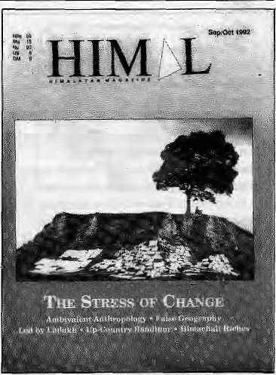
MAIL

not, the truth is that Sarchops, until the current efforts of the regime to woo them, were only marginally higher up than the Lhotshampas in its 'ist of taboo subjects.
Gyamtsho also attempted to highlight the east-west bond through the Sltarchhog Khorlo Tshibyged (the five eastern provinces and not eight as he maintains) by slating, "Following the traditions established by these two great leaders (Jigme Namgyal and Ugen Wangchuk) the title of the Tongsa Penlop and thus the leader of the Sharchhog Khorlo Tshibyged...is bestowed on the Crown Prince before he ascends the throne." Gyamtsho apparently needs to go through the above history textbook — the Late King, Jigme Dorji Wangchuk, became the Paro penlop but never the Tongsa Penlop! Gyamtsho may further wish to note that this important nomenclature merits just three mentions, without any elaboration, in the entire book.
Moreover, in downgrading his own language, Sarchopka, to a dialect, Gyamtsho has aiso failed to note a passage in the same textbook that states: "There are four major language groups and approximately 13 to 14 dialects which prevail in the country." That this should have escaped his notice is understandable since none of the four other languages is even named, let alone merit further discussion. The expansion that follows, a whole page, is devoted entirely to Dzonkha, the langauge spoken only by the Ngalungs in western Bhutan.
The unceasing efforts of the Government to conceal unpalatable truth is quite evident even in the brief, but complete quotes above. Even disregarding the Government's reduction of the southern Bhutan ese population from close to 50 per cent to 25 per cent, the group can hardly be described as a "a small minority".
Likewise, eastern Bhutan ese who constitute close to 40 per cent of the total population cannot by any manipulative effort be deemed a "minor tribe".
The Director General of Education, clearly keen to express his gratitude for the red scarf, membership in the National Assembly and his exalted post, has taken pains to disown his own community. In the process he has conveniently opted to disregard the truth as he knows it, the half-truths he has to come to terms with and the obvious fallacies in the Government's reconstruction of history and
social conditions prevailing in Bhutan.
In passing, I cannot but help taking up cudgels with Suman Lepcha writing from Gangtok {Mail, "The Tail has Gangrene"). Lepcha apparently is a regular reader of Kuensel, the official weekly Bhutanese newspaper, since his vitriolic tirade has ample plirases of incitement that could only have been lifted from the last two years' pages of the paper. Since Lepcha has chosen only to repeat the rhetoric of the Bhutanese regime, and Himal has already covered the issue in detail for those who wish to be educated on the subject, I can only advise that Lepcha study the history of his own people. He may then discover who was responsible for the murder of the last Lepcha king and how the Lepcha heritage was destroyed much before the advent of modem Sikkim, and realise that his anger has been totally misdirected. Putting the blame on the Nepalis of modern Sikkim, and carrying that resentment further to Nepalis in general, is both unfair and unfortunate.
Kamai Dkilal
(Presently in Kalhmandu)
Bad Quote
I found your issue on Bhutan most unfair and biased. When one looks at the history of the region, Bhutan is right to be worried about Nepali expansionism. The insurgence in Darjeeling area, the takeover of Sikkim, etc...
Page 11 of the article by Kanak Mani Dixit has this quote: "Once Chhogyal Raja of Sikkim ruled this country in a (brutal and uncivilised ) way..." Of course you know this is not true!! To refresh on your recollection, I enclose a copy of an article from the British Observer (29 August and 4 September 1977). Also, some of the exiles from Bhutan .such as Bliim Subba and R.B. Basnet are not the best informants of the situation in Bhutan. They absconded with several million Ngultrum and were involved in large-scale corruption.
Xenia Brim Ho lie. Denmark
K. M. Dixit suggests Ms. Brun reread the passages concerned to answer her real and perceived concerns.
Indignant on Bhutan
Never have I read a piece in Himal with more indignation and outrage than Suman Lepcha's supposedly "holistic view" on Bhulanese
refugee problem (Mail Sept/Oct 1992). It is difficult for me to understand how a forced migration of the people of Nepali origins can be justified. Lepcha suggests that the move was necessary to preserve Bhutan's "unique" culture and way of life. He suggests that Nepali speakers are always hungry for domination, corruption and opportunism. While the latter argument is outrageous at best and only proves the writer's jaundiced mind and his open anti-Nepali bias, the former point needs to be countered.
Bhutan, today, finds itself with a large Nepali-speaking population, whether or not it is to its liking. The correct thing to do would have been to try to integrate them into the Bhutanese mainstream. In an increasingly open world, where newer generations will question traditions and older values, the change in social outlook is inevitable. As Bhutan turns more towards the outside worla, it'll find its own traditions and values challenged. Should it then insulate itself from the rest of the world? The tremendous suffering that has been inflicted on the Nepaii-speaking people apart, the question is also how Bhutan will cope with fresh ideas and values.
The Bhulanese King's views on the same section also provided some insights into the current state of affairs. On Die one hand, he says that southern Bhutanese should wear dresses thai separate them from people of neighbouring countries (read Nepal ) and in the same breath he says that they can wear anything as long as they 're not naked. This is surely double-speak. At the same time, the king also objects to his being called a "despot' Now it is difficult to beleive if he is anything else as long as he enjoys absolute power and alienates a section of his own people ,

Nov/Dtt 1992 HIMAL • 3

MAIL

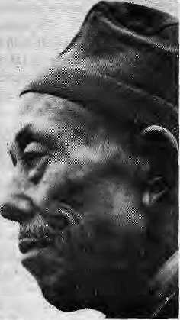
Coming back to Lepcha's piece, he has tried to link Nepal's own internal problems with the question of Bhutanese refugees, whose issue has nothing in common with economic migrants from Nepal. Joining the foreign armies or brothels in Bombay has its own socioeconomic and historical dimensions. The Bhutanese refugee problem, however, is the result of an official policy of an independent State which is dumping its own citizens of a certain background.
But much more ominous is Lepcha's statement thai Nepal should look forward to many Bhutan-like situations in the days to come. He must surely be referring to the large pocket of Nepali-speaking people living in the Indian Northeast and Sikkim. But he should bear in mint! that another Bhutan-like situation would be catastrophic not only to the Nepali-speakers in those areas but to the community at large. Let not the likes of Lepcha try to get rid of a part mistaking it to be gangrenous. The result would be suicidal for all concerned, Lepcha should resist the temptation to scapegoat Nepalis, who have little political voice both in and outside Nepal. NirajB.Shrestha M.R.Engg. College Jaipur
Not Caste but Class
With reference to Himal's issue on Ethnicity (May/June 1992), what has been lacking in the polemics on both sides of the debate on caste preference is a foundation in facts. An exception is anthropologist Dor Bahadur Bista's Fatalism and Development. Bista attempts to raise the level of debate by examining historically the role of "brahminism" in Nepal. But his use of the term "brahminism" differs from some other's in that it refers, not to a particular caste preference, but to a set of cultural values peculiar to high-caste Hindus.
Do Brahmins truly dominate the national economy and administration of Nepal? This is difficult to answer directly because the national census does not record numbers according to ethnicity but according to mother tongue. The next best source is the few anthropological case studies done in Nepal and which touch on ethnicity and caste. Among these are Lionel Caplan's Land and Social Change in East Nepal (1979), Bengt Eric Borgstrom's Patron and the Panca (1980) and Patricia Caplan's Priests and Cobblers (1979).
The latter do find links between high-caste status and economic and political power. The two Caplans find Brahmins dominating over non-Brahmins, over the Limbus in one case and the cobbler community in the other.
4 HIMAL ■ Nov/Dec 1992
But further scrutiny reveals that brahminism per se is not the problem. Instead, it is a problem of a high-caste, wealthier and larger community dominating others. In Borgstrom's work, it is the Silwal Chhetris that dominate. M.N. Srinivas, a leading Indian sociologist, refers to this as "control by dominant caste".
Such dominance is reflected not only at the village level but, as Harka Gurung recently pointed, also at the national level. In Nepal, it is not just higher castes versus lower castes but higher hill castes versus other hill ethnicities and the Tarai community, as Frederick Gaige shows in Regionalism and National Unity in Nepal (1977).
What these researchers point out, and what we knew all along, is that caste, class and political power are related. Why, after all, has Nepal always had a Prime Minister who is Brahmin, Chhetri or Thakuri? Why not a Tharu Prime Minister, a Sarki Chief Secretary or a Tamang Commander-in-Chief?
In other words, there is a tendency for a high-caste person to be politically or administratively powerful as well as economically well off. The issue centers, therefore, not on brahminism but on domination of poorer lower castes by high castes which are usually also high class. To say that caste, class and political power are related is not the same as saying that they are related causally. Were they so related, high-caste status would guarantee economic affluence and political prominence. The many poor Brahmins around us precludes that interpretation.
We must look to history to explain the congruence of caste, class and political power in today's Nepal. The origin can be traced to the creed of high-caste, Indo-Aryan migrants to Nepal, fleeing Muslim rule in northern India after the 13th Century, The religion of these migrants might be termed "defensive Hinduism". I prefer this term to "brahminism" {understood here to mean cultural values peculiar to high-caste Hinduism) because it does not lay blame on just one group of people. It was, after all, the ruling nobility as well as the Brahmins who sought to enforce this creed.
To explain further, there is no central church in Hinduism to enforce a particular interpretation of religious scriptures. Nor can
Hindus speak of the church being seperatc from the State. All we have as the corollary of the church and State is the caste-based distinction between the Brahmins who interpret religious scripture and the king who enforces it. Because Hinduism is not an organised religion there is no consensus among Brahmins as to what constitutes a valid i interpretation of the z dharmashastras. Thus, the J ruling monarch is free, at any 3 given time, to choose and m enforce a certain
interpretation. Monarchs, not suprisingly, tend to support interpretations that best serve their interests.
From the 13th Century onwards, high-caste immigrants to Nepal tried to forge a symbiosis between Sanatana Hinduism as religion and monarchy as government— a relationship that was severed in North India by the Muslim invasion. That fusion progressed over the centuries, with the dissolution of the Mahayana Buddhist empire of the Mallas in Far West Nepal culminating in the ideal Hindu Kingdom following Prithvi Narayan Shah's unification of Nepal.
The old Mulki Ain of 1854 reinforced that symbiosis by institutionalising caste into state polity. The state then became the instrument for upholding the dharma, the classical chaturv am ashram dharma, whereby each caste performs duties and obligations peculiar to it. It was only natural for officials in a Hindu state to be of high caste. Ironically the defensive Hinduism that Nepal's ruling class sponsored not only insulated it from foreign Muslim and Christian influences but also distanced it from reformist Hinduism.
Whether defensive Hinduism is as pervasive today as it was during the Rana regime is debatable. Similarly, to account for Nepal's underdevelopment solely in terms of that creed would be too narrow. But this ideology undeniably influenced societal formation and stratification: as we know, class and political power in Nepal follow caste lines.
Democracy is here again. Will domination by high castes now be redressed by democratic politics alone, or are other legislative measures essential? The present composition of Parliament and major political parties suggests that, for now, democracy does not automatically guarantee representation of disadvantaged castes. That is not to say that things may not change. In its formative years, the Indian National Congress was dominated

MAIL

by Brahmins. The composition of that party today is such that no single caste has a commanding position. Studies in India conducted by the likes of M.N. Srinivas, Rajni Kothari and Andre Beteille show how, in time, political power has become autonomous from caste hierarchy. Democratic politics has been given the credit for that.
One way of assisting disadvantaged castes, and one already adopted by India, is to institute a quota or reservation system. In this, a ceTtain percentage of government seats is sei aside for underprivileged castes. While critics claim that quotas encourage mediocrity, it is one of the few ways to ensure some measure of social justice in a caste society. Land reforni is another way of limiting high-caste dominance. In predominantly agricultural Nepal, land continues to be the main determinant of class.
Both land reform and affirmative action are thorny issues. Yet these twin reforms, along with the consolidation of democratic politics, could strike at the very roots of high-caste domination of Nepal's economy and politics.
Sudhindra Skarma
Ateneo de Manila University
Philippines
An Anthropologist's^!'
I am pleased to see that attention was given by Pratyoush Onta to the two anthropological conferences recently held in Kathmandu {Sep/ Oct 1992). The meetings provided both Nepali and foreign scholars with opportunities not only to present research but to receive critical feedback from colleagues in a supportive and enthusiastic environment. The participation of non-anthropologists (including development workers, sociologists, historians, journalists and non-specialists) was also appreciated, providing us with a depth of understanding and cross-disciplinary interaction not normally possible at conferences and seminars.
With regard to Onta's discussion of the "schism" between foreign anthropologists and Nepali anthropologists, he makes the basic assumption that Nepali anthropologists are focused on more applied research while foreign anthropologists are more interested in pure research, or what he calls an "attraction for abstraction." I believe he is oversimplifying the case.
Many foreign scholars, including Don Messersciimidt, whcOnta interviewed for his article, are extremely interested in applied research. Lynn Bennett, one of the more well-known foreign anthropologists who worked with Brahmin and Chhetri women in the Kathmandu Valley, has gone from research-
oriented anthropology lo applied work in her position at the World Bank. In addition, some Nepali scholars focus on more "pure research" than applied. Onta also makes an error when he states that "Objectivity has been the prime disciplinary goal of anthropology thus far..." Cultural anthropology has had a multitude of goals since its inception as a discipline —■ the main one being to bring about an understanding of cultures which are not one's own. Methods are what distinguishes cultural anthropology from other disciplines, such as sociology or history. The cornerstone of cultural anthropology is participant-observation, whereby the anthropologist attempts to participate actively in the culture under study in order to understand what it is to live another life. This includes living in the same households, working in the same fields, eating the same foods, tolerating the same weather, speaking the same language and participating in the same rituals as much as possible.
The observer part comes in when, at the very same time, the anthropologist tries to observe the culture from afar in order to try to gain objectivity on the situations. As a result, anthropology has been a combination of intimacy and distance, subjectivity and objectivity from the beginning. But, both objectivity and subjectivity are among our goals.
And this has not gone unquestioned as Onta seems to imply. Many works have taken up the issue of how objective anthropologists can really be; the implications and advantages of our humanness when we ourselves are our main research tool; what are the distinctions between self and other, issues of method, theory, authority, and even the anthropologist as author.
Julia J. Thompson
PO Box 380, Kathmandu
Anthropological Origins
In his history of anthropology in Nepal (Sep/ • Oct 1992), Pratyoush Onta has missed an 'ancestor agency¹ which was a benevolent grandparent to the formal study of the discipline in Nepal. Predating his 1981 origin of the formal study of the discipline was the Anthropology Unit of the Institute of Nepal and Asian Studies (INAS), the precursor of today's Centre for Nepal and Asian Studies (CNAS). As early as 1973, under the direction of its Dean Prayag Raj Sharma, and later Dor Bahadur Bista, INAS anthropologists combined rigorous and scholarly field studies with attention lo what later came lo be the basic issues of applied anthropology in a Nepali context.
More importantly to Onta's discussion, the department always involved a collaborative effort between Nepali scholars (Dilli Ram Dahal, Navin K. Rai and Drona Rajuria, for example) and foreign scholars {among whom were Linda Stone, Alexander MacDonald and myself). It is largely due to our experience in INAS that many of us are still working in the applied area, often attached to projects, with a long-term commitment of improvement and change.
As for the sidebar on "Galekeeping Concepts", I thank Onta for naming me an iconoclast and grouping me with Bill Fisher, an anthropologist I admire. In middle-age, however, my characterisation of the Thakalis as "master manipulators" seems to me to make Thakalis seem too sinister. While admitting that conscious manipulation is characteristic of some individuals of any group, nowadays, I would prefer to think of the Thakalis as having fluency in several symbol systems, transition ing between them as one might switch from Nepali to English or Newari. Calling this behaviour "multi-cultural fluency" rather than "manipulation" eliminates the sinister edge to the description.
Andrew E. Manzardo Baltimore, Maryland United States
Buddhas in the Box
It was good to learn from your Briefs section (May/Jun 1992) that a small bronze image of the Buddha had been returned to Phodong Monastery in Sikkim after an absence of 80 years.
While the returned statuette in your report was a gift to David-Neel, there have been numerous cases of rampant theft from the monasteries in Sikkim. The Labrang Monastery, also of Tumlong District, like Phodong, was once in proud possession of a pair of Nepali-made dung-chens, long prayer horns, used to accompany tantric ceremonies. These horns were much prized by the Monastery because they were specially made of pure silver and embellished with precious stones.
One of the horns was stolen in 1981. In fact, the early 1980s was a free-for-all period in Sikkim, the aftermath of Indian statehood. Needless to say, collusion took place at the highest^ almost Nepali scale, and many artefacts left Sikkim forever. Mafia, ministers and minister-makers were all involved.
There are numerous hosts and hostesses in Nepal, Sikkim, Bhutan, Thailand and elsewhere, who enrich their living spaces with artefacts whose rightful place is in temples, monasteries or museums. The little bronze

Nov/Dec 1992 HIMAL

MAIL

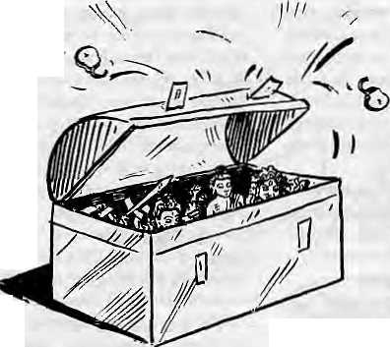

\
Buddha also must have served a similar purpose for David-Neel, who thought of returning it to Phodong only when she was about to give up her ghost. There are some foreigners in Kathmandu who consider themselves the culture-custodians of Nepal. If only these culture vultures were to die, leaving instructions that their possessions be returned to the bahals, temples and monasteries of their origin.
In the meantime, these foreigners and their Nepali counterparts are sitting on a Pandora's Box. Once this box is opened by some person of substance and courage, the whole nefarious trade will be blown wide open. And the repercussions will go deep enough for even the vandal culture-vultures of yesteryear to spin in their graves.
We all have reason to rejoice in the return of the little bronze Buddha native to Phodong Monastery. How it was brought about could well be described by one person at the Monastery. His name is Tobden Lama, the Chhumba-La (teacher) at Phodong. He is the most learned authority in all of Tumlong District on matters secular/temporal and religious. One may look forward in Himal to articles that shed further light on the Nepali/ Sikkimese perspectives on the theft and (hopefully) return of stolen heritage. Peter J. Karthak Lalitpur
Harmony in Bangladesh
The article by Father R.W. Timm (May/Jim 1992) is one-sided, baseless and a product of his imagination. The contention that the proportion of non-Muslims in Bangladesh "could be as high as 25 per cent" is incorrect. Before independence, the figure was never more than 15 per cent, and it has remained unchanged at 12 per cent over the last many years. The record of communal harmony in Bangladesh is exemplary in the Subcontinent.
Since 1971, no communal incident has occurred in the country. The Babri Masjid-related incidents in India did have some minor after-effects, but the Government and people of Bangladesh brought the situation under control and no untoward incident took place.
The reference to different treatment of Pakistani citizens (so-called Biharis), except during the 1971 war, is a figment of imagination.
(This letter was received before 6 December. - Editor)
Of the total population of one million Pakistanis (so-called Biharis) which opted to live in Bangladesh, half has been allowed to stay. Meanwhile, 127,000 Pakistanis have already been repatriated to Pakistan and efforts are continuing to repatriate those who are keen to emigrate.
People of all religions in Bangladesh enjoy religious freedom, which is enshrined in the Constitution. In 1947, during Partition, some Hindus {eft for India and some Muslims came into the then East Pakistan. Since Independence in 1971, there has not been any movement of Hindus from Bangladesh.
The use of the term "aborigines" in the article is incorrect. As Father Timm himself admits, the tribals of Bangladesh came here between the 16th and 19th century, from origins in Burma, the Himalayan foothills and the Deccan of India. They did not merge with Bangladeshis, unlike the other arrivals such as the Arabs, Turks, Afghans, Moghuls or Portuguese, who have by now been completely absorbed into the mainstream population. These tribals have maintained their separate identity and the local people have never posed a threat to them. Except in the Chittagong Hill Tracts (CHT), tribals of all areas are living peacefully and in complete harmony. In the CHT, however, insurgents of the so-called Shanti Bahini have terrorised both tribals and Bengalis. Despite this, the Government has repeatedly declared amnesty so that the insurgents may Teturn to normal life. In order to ensure greater autonomy, three hill district Local Government Councils have been formed at Rangamati, Khagraehari and Bandarban. As many as 22 'subjects' have been earmarked for the Council, out of which 20 have already been transferred. The tribals have been enjoying significant facilities in infrastructure, education, health and other welfare provisions. Educational seats and jobs in Government have been reserved for them. As a result, the literacy rate among tribals is 63 per cent, more than twice the rate for the country as a whole.
(Unsigned but stamped) Embassy of Bangladesh Kathmandu •
False Geographies
Nigel J. R.Allan forms the thesis of his article (SeptfOct 1992) around a travel writer's erroneous perception of the Himalya as forming a great barrier to communication. I have no arguments with this general thesis of a noted Himalayan scholar. However, I did note several items in his own essay that do not coincide with the facts as given by other authorities.
First, one is led to believe that the British only recognised the importance of cross border trade with Tibet and Central Asia in the late 19th Century. In fact, Governor-General Warren Hastings, in 1774, had sent George Bogle to Shigats with just that purpose in mind, followed by Samuel Turner in 1783, Second, we are told that the British stationed a man named MacDonald as their first agent in Gyantse. He may have served as an agent in Gyantse, but (according to Younghusband's India and Tibet) it would have had to be after the 1904 expedition. There was no British agent further north than Yatung, at the lower end of the Chumbi Valley until Captain Frederick O' Connor, an artillery officer and Tibetan scholar, was left behind by Younghusband to become the first Gyantse agent.
Of greater importance are Allan's remarks that Younghusband had been defeated by the Russians in the Pamirs and the chastised Brits scurried back to the warmth of the Indian lowlands, leaving the heights to their enemies. The events as recounted by Peter Hopkirk in his 1991 book, The Great Game, tell a somwhat different tale.
First, Younghusband and Gromchevsky had an amicable meeting in the Pamirs in 1889 and parted as friends. It was Colonel Yanov, in 1891, who with 400 Cossacks forced the lone Younghusband tn leave the Pamirs, having claimed them for St. Petersburg. London quickly challenged Russia's claim to the Pamirs and demanded an apology for forcing Younghusband from the area. In the end, Russia backed down, withdrew its troops, and blamed Colonel Yanov for exceeding his authority. After this incident, far from "retreating back to the watershed of South Asia", the British took, control of both Hunza and Chitral. established a consulate in Kashgar, and marched into Tibet to keep the Russians out.
Allan writes that "false geographies .... are constantly manufactured." I fully agree with him. As minor as they are, these points do illustrate that even the best of outsiders are prone to commit errors when faced with explicating the cultural and physical complexity of the Himalayan region. Paul Lundberg Kumaripati, Pat an

6 HIMAL ■ Nov/Dec 1992

Final Words on Fatalism
Himal takes leave of the debate on Dor Bahadur Bista's book Fatalism and Development (Orient Longman, New Delhi 1991) with two items. One is an excerptfrom a talk presented by Bista on 6 September at the National Congress on Sociology and Anthropology of Nepal. The other is an extended definition oi 'fatalism' as provided by Robert Nisbet, Albert Schweitzer Professor of the Humanities at Columbia University, New York, in his book: Prejudices: A Philosophical Dictionary (Harvard University Press 1982). We suggest that any reader contemplating further correspondence on fatalism and development consider writing a book instead.

Hawking the Anomalous
It is true that I have frequently shied away from the identity of an anthropologist. That is because I am not sure whether I fit in with the straitjacket definition of an orthodox anthropologist. I am, by nature, an unorthodox creature. 1 cannot help it. This is the only way 1 can be honest with my academic friends, colleagues and myself. But it doesnoibother me because it is not my problem...
I have been frequently criticised by some of my colleagues for not appearing with the appropriate behaviour and style of an anthropologist— whatever that may be or whatever they may have had in their own minds. My actions, particularly the publication of my latest book Fatalism and Development, has touched upon the sensitive nerves of many a traditional Nepali elite and has done a little bit of an unsettling job.
In some ways I feel that I have done a very good anthropological job by disturbing thepeaceofa certain type of mindset. As CliffordGeertz, one of the well-respected anthropologists of our time, has said, "We, with not little success, have sought to keep the world off-balance; pulling out tugs, upsetting tea tables, setting off firecrackers. It has been the office of others to reassure; ours to unsettle. We hawk the anomalous, peddle the strange."
Talking about hawking the anomalous and peddling the strange, I envy some of my Western colleagues and my Western gurus that they can and have been hawking and peddling the exotic from faraway and strange lands to audiences who can lake it at a theoretical level. It becomes an entertainment item rather than an unsettling, sensitive, nerve-touching pinch, the way some of our Nepali upper- class academicians have taken it.
Thus, my fate here lakes a very different turn. As you know, I am a Fatalist, albeit in a mythical sense. You know what I have been irying to do lately. I am trying to distracl the worried and insecure upper-class, upper-caste Nepalis and draw their attention before they go to bed towards a grisly ghost in their ownbackyard. This makes itdifficult for them to have asound s leep until they clear it al 1 aw ay fro imh e ir m in ds with c are ful r alio na lis alion.
I am not necessarily concerned about the future of anthropology, but I am concerned about the future of Nepal and its people. I cannot afford to worry too much about what happens to anthropology as a discipline. What I am interested in is how best anthropology can help Nepal.
I am aware that there are anthropologists who do not like to be involved in the process of change. There are others who do not even like to see the changes. To be involved in the process of change is a risky business with a very heavy moral responsibility. It is much safer and easier toremainanobjective,uninvolvedscientistpundit.Itisalsotheeasiestway to remain always right and never be wrong. You never commit yourself to do anything which could go wrong. We have quite an impressive share of such persons among us here in Nepal and, to a certain extent, abroad.
There is a Nepali adage, Pani maihiko obhwio (pretending to be dry while sitting on water—an impossibility). To claim that field anthropologists can remain uninvolved, objective scientists who do not want to interfere with the lives of the people they study is absurd. Whether they know it or not, and whether they like it or not, field anthropologists do mess up the lives of the people they study.
Living here in Kathmandu as a member of a society and producing a book that criticises the lifestyle which is at the heart of one's own background, is madness. It is like heating from below the rock that one sits
on. There is no way I can escape the criticism and its consequences. I was quite aware of this when I began writing and I am fully aware of the wave of reactions that is up in the air now. But that was my deliberate choice and there are as yet no surprises.
I am at the moment deeply involved in action research in Jumla, in northwest Nepal, with a community that has a very serious crisis of identity. This action researches Enaturalresult of the kindof rationalisation I have just made. To make the point more explicit, I would say that this project is a sequel to the publication of Fatalism, and Development. It will be the second volume of the book. I am trying to deliberately expunge the community of the evils of fatalism as reinforced by degenerated Baftunw/w, which most of the urban-based educated elites are not even aware of, and therefore do not want to admit, exists.
As far as I am personally concerned, I visualise my own role here like that of an untouchable low-caste or at best that of a Shudra, who performs all the menial jobs of fetching mud, stones, bamboos, flowers, pots, pans, lice, vermillion, firewood and so on; but who will have to step aside, stay away and apart to make room for the dhoti-wearing, clean -bathed- in- a-holy-river and prayer-mumbling cosmopolitan pundits. They will perform iheyagya, invoking the Gods while carefully staying away fromti^Shudra who has completed all the unclean but very important tasks.
We anthropologists cannot continue for too long mimicking thegreal
classical scholiirs who can only perform the incantation part. We need the
Shudra type of anthropologist who will try to be innovative and develop
new levels of methodology andjjlueprints. 3
Thanks to the clean-handed anthropologists who tell the people that they should stay and remain where they have always been, the people continue to live in misery and apathy. They should not try to change because their culture and lifestyle is idyllic and therefore enjoyed by the distraught visitor from the industrialised West. Study of Nepali society in its entirety is not a piece of cake. And until you know the society in its entirety, your arguments are going to be fragmentary. Then you would not be able to write in the type of language that my critics have been filling up the pages of Himal with.
But I have patience, I will wait, because I know I have to. If not me, personally, my thesis will.
Dor Bahadur Bista
Fatalism of the Multitude
Nearly a century ago, Bryce wrote of "the fatalism of the multitude". In his view, this fatalism had far more appositeness to American reality than did themore famous reference by Tocqueville to "thetyranny of the majority". Bryce, in his frequent visits to and extensive travels over the American continent, could find little evidence that rule over individuals, in the local community, state, or nation, was other than that of well-placed or zealous minorities. He sawnoevidenceofindividualscoweringbefoTe the majority. What Bryce was deeply struck by in America — and to some degree in all democracies — was the kindof mass community that was formed, not by any positive initiative, but by the submission of individuals to their perceptionsof amorphous but large anddetermining forces: "This tendency to acquiesce nee and submission, tli is sense of the insignificance of individual effort, this belief that the affairs of men are swayed by large forces whose
Nov/Dec 1992 HIMAL ■ 7


We Also Serve You
Birds On Trees


f'Garxfct)
French, Italian, Chinese, German,
Russian cuisine. Served on the
greenest green you've ever seen.
Plenty of sun, fresh air and bird song
too.

SHANGRI-LA
LAZ1MPAT, KATHMANDU. TEL:412999
We Make You Feel Great!

movement may be studied but cannot be turned, I have ventured to call the Fatalism of the Multitude."
Bryce was correct in distinguishing this fatalism from, and giving it greater appropriateness than, Tocqueville's tyranny of the majority. Tocqueville himself had declared that democratic peoples are both susceptible to faith in ineluctable forces of a massiveness that allows little individual interference and prone to falling into an undifferentiated social mass within which personal ambition and enterprise come to seem unavailing. Still, Bryce's phrase, his direct invocation of fatalism, is the more trenchant.
The question is whether Bryce described accurately the American peopleof 1880, or whether, as is true so often of Tocqueville's insights into American culture, he extracted a quality or attribute from an ideal type, a theoretical model of democracy in his mind, and declared it a visible characteristic of Americans. It is hard to say for sure. Certainly, few other visitors to this country or native prophets seem to have spied suchafatalism in the American people at that time. What is far more perceptible, through the medium of books, diaries, letters, and speeches of that day, is an ebullience of individual faith in self that borders on hubris.
But Bryce's fatalism does have a striking relevance to the America of a century later, just as so many of Tocqueville's descriptions of Americans in 1830 seem more near iy telesoopic previews of the future than accounts of what was around him. There is no mistaking the degree to which Americans today have become fatalistic. In a hundred immediately evident ways, Americans reveal an atrophy of faith in the industrious apprentice, in the Horatio Alger ethic of pluck and perseverance. They reveal too a strong faith in the power of chance, fortune, luck, the random, and the purely fortuitous to affect positively or negatively men's fortunes in life. Rarely in history has so large a proportion of a people become so preoccupied by the occult, the miraculous, and out-and-out gambling. Contrastthe savings propensities of Americans of every class a century ago with the virtual antipathy towards savings that is evident today. There is an enormous amount of money potentially savable or investable. The tens of billions of dollars spent monthly by Americans in either domestic or foreign casinos, race tracks, slot machine centers, bingo parlors, lotteries, and numbers games are tribute to that fact. And the whole of this vast orgy of chance bespeaks but one thing: the fatalism of the multitude. The time has passed when gambling was the avocation of the few who were rich, eccentric, or interested in brief recreation. It is the single greatest, though far from only, sign of the true and distinctive temper of this age. The wager is the constant companion in American society today of the occult belief in the stars or other impersonal, unreachable, but decisive forces. Gambling joins a multitude of analogous expressions of disdain for, cynicism about,
and superstitious avoidance of Poor Richard's Almanack. What alone matters, in the judgement of tens of millions of Americans young and old, is fate. One may work hard and be very successful; or one may take it easy, and be very successful. In neither case, though, is work or ease the crucial factor. Fate is.
Fatalism is the invariable refuge of the incoherent, distracted, and disenchanted multitude. It is a sign of a failure of nerve — failure of the collective nerve that exists in every true community, local or national, and the failure of individual nerve. There have been many ages of fatalism in world history. The spirit of fatalism waxes and wanes with the health of the social body. It was weak in the Greece of Heraclitus, Protagoras, and Pericles; but fatalism was strong and pervading in the Greece that followed the wars between Athens and Sparta and particularly in post-Alexandrian Greece where every conceivable form of occultism, superstition, and worship of chance could be seen. Fatalism was scarcely present in the Rome of the Republic, of Cato and Cincinnatus, but it was pandemic in the Romeof the Caesars.There was much belief in demonsin the Middle Ages, as well as saints, but little evidence of fatalism. That was reserved for the Renaissance, another age inundated by faith in fortune, chance and myriad forms of the occult.
Different explanations are necessary for the fatalisms of different epochs and places. Two explanations are apposite to the present age: the first, oldest, and most entrenched is egalitarian ism; the second is inflation. Egalitarianism represents the leveling of those "inns and resting places"of thehumanspiritwhich are found in social hierarchy, tradition, kinship, and institutionalised religion. When a society is leveled, this does not confer equality upon people, only a sense of individual isolation, a traumatic feeling of loss of the social bond, of introduction to the precipice or void. Egalitarianism, far from strengthening the sense of fraternity, greatly diminishes it, leaving what was once a culture a mere mass of disconnected atoms. When family, community, parish, socialclass, school, and jobcease to be evocative, to supply incentive and kindle confidence, nothing elsebut the irrational, the antisocial, and the occult are left to turn to. Fatalism feeds on the carrion of the social organism.
So does it feedon inflation. Few things are better calculated to induce a permanent social vertigo than the incessant erosion of the values people depend upon for their sense of place and time. When it becomes clear that no amount of energy expended in a job will yield a re ward sufficient even to stand still, much less advance, despair quickly becomes disillusionment with the rational andleads increasingly to dependence upon chance, to faith in the stars or in numbers—to, in short, a gigantic, all-consuming fatalism. Bryce's fatalism of the multitude is indeed a reality today.
Robert Ntsbet


This is a 1.5 inch by 2.5 foot plywood-mounted panorama of the Himalayan range as seen from Himal's rooftop office at Patan Dhoka. When we tried to sell this panorama to readers two years ago, this timed Product proved ahead of its time and sales were tardy, much worse than our Himal T-Shirts. Not enough people wanted to know of, far less identify, the Himalayan peaks. In the hope that this mountaineering issue has raised consciousness and the requisite political will, we are proud once again to offer our Himalayan Panorama for sale. The price is constant at NRs 150, even though inflation in this Himalayan Kingdom has galloped ahead and fallen off the Kangshung Face. But do not expect touristic gloss, four-colour, seige-style reproduction. Our's is a matter-of-fact, alpine-style, black-and-white panorama, with peak names, height and some commentary on the reverse side. If you come by, and the weather up at Khumbu Himal is clear, we'll even show you an edge of Chomolongma from our rooftop. Call: 977 1 523845
Nov/Dec 1992 HIMAL

exquisite Woodcarving ofKathmandu
It's more than an art



^;iS^^7ii'^^;iy>^T'^^^Xs^^,S>^^^A^X■i.^H^^;^sJ?^^i3;cZSlri
The Summit Hotel in Kathmandu
It '$ an Exuberant Demonstration of a Rich Tradition
It's an Eloquent Expression of a Living Culture
It's a Wondrous Display of a Timeless Heritage
It's a Priceless Ornament of two Religions in Perfect Harmony
It's more than a Hotel
It's a Tribute to Traditional Nepali Hospitality
It's a Homage to a Magnificent Nepali Architecture
It's a Commitment to Quality of Service and Care
It's a Guarantee for your Comfort and Pleasure



m
SUMMIT HOTEL
Something Special P.O. Box 1406. Kathmandu, Nepal Tel: 521894, 524694 Fax: 977 1 623737

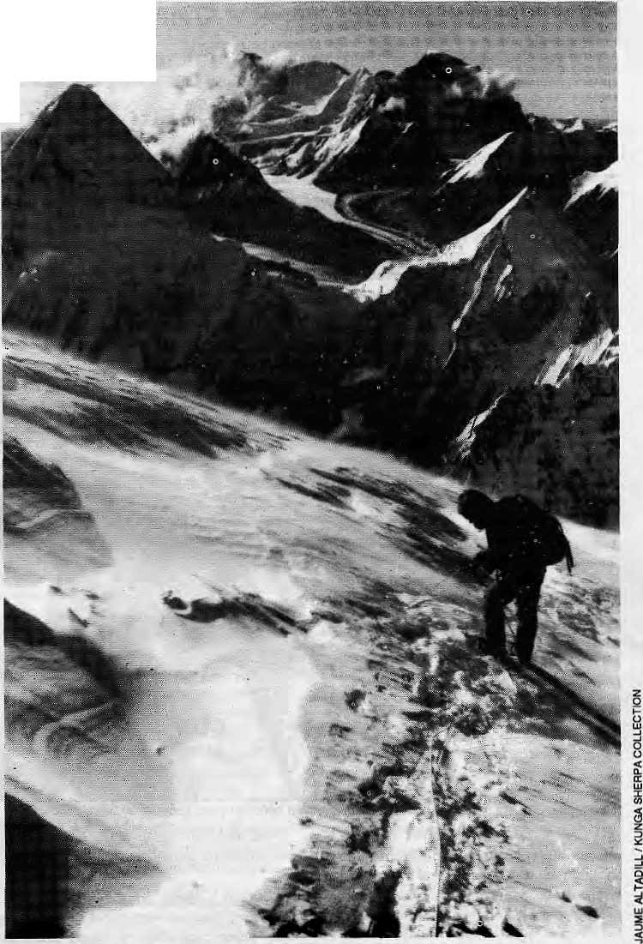
Mountaineering's Himalayan ^{M=aBi}
Climber descends Chomolongma's Wast Ridge. Pumvri on the lower left.
But if they remain blase¹ about the mountains, they cannot remain so about mountaineering. Developments in technology, information, geopolitics and economics together are changing the face of Himalayan mountaineering and the region's people and policy-makers can no longer afford to overlook its economic importance.
Going Himalayan Alpine
It has been 40 years since Himalayan mountaineering started in earnest. In 1950, Annapurna One (8091m) became the first mountain over 8000m whose summit was
Nov/Dec 1992 HIMAL • 11
But for most Nepalis, fed only on Radio Nepal's curt announcements of deaths, ascents and expedition failures, mountaineering has not yet come to life. It is a great divide that separates the native population and the climbing world — a chasm of history, culture, economy and socialisation between the local who is content to look up at Gauri Shanker (7134m) in reverence, and the mountaineer who would gladly set foot on (or near) that corniced summit if only the Ministry of Tourism would allow it. Spiritual distance, indeed, marks the'attitude of most of tlie Himalayan peoples towards the snow peaks.
Mountaineering has not even begun to live up to its economic promise in the Himalaya. Decades of publicity about difficult climbs by elite mountaineers has kept 'holiday climbers' away. Encouraging easier, more commercial climbing, could prove lucrative to Himalayan countries if their governments, tourism industry and native climbers took advantage.
by Kanak Mani Dixit,
with reporting by Dipesh Risal
Tn early October, as every year, the people of I Kathmandu Valley enjoyed lhe festival of _Mj>asain, largely unaware of the dramas being acted out high above them, on the snow, ice and rock of the Himalayan massifs. Autumn brought 750 mo untaineeis employing thousandsofnative support climbers and porters from among 76 officially registered expeditions. Some were climbing alpine style, others were doing it solo with or without oxygen. Yet more engaged in the classic seige-style assault. As in every season, there was triumph and heartbreaking tragedy in the High Himal.

CHOMOLONGMA = SAGARMATHA = EVEREST
Spiritual distanca: the holy, corniced summits of Gauri Shanker.
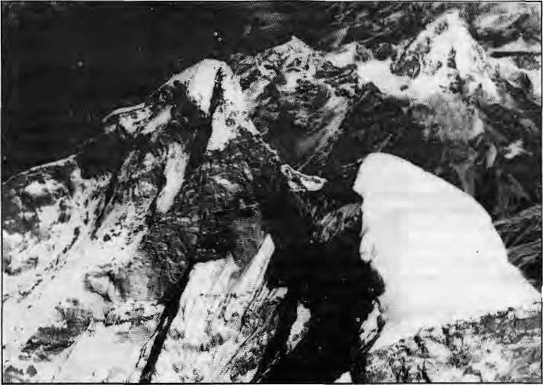
reached. Chomolongma was topped in 1953, and all 14 'eighnhousanders' had fallen to Reinhold Messner by 1986. As little as two decades ago, the seige-style attempts characterised by thepre-War expeditions of the 1920s on Chomolongma were the norm. These militaristic assaults, heavy on logistics, are, now largely passe and the vanguard climbers have developed alpine style techniques of varying degrees of difficulty. A pure 'Himalayan alpine style' attempt involves a fewer climbers than traditional expeditions, the minimum use of porters on the approach march, the least impact on the terrain, no Sherpas above base camp, no oxygen, and use of bivouacs where others rely on a line of fixed camps. This style — "bold, light and fast" as one writer described it — has been perfected by the likes of Reinhold Messner (who everyone knows), Voytek Kurtyka (who few do), Doug Scott, Tomo Cesen; and a long list of others who are deceased — for the Himalayan alpine style isadangerous technique.
Even while alpinists stretch the limits of what is possible, however, the "coffee table climbers" continue their seige on the peaks. An example was the much-hyped British Telecom-supported team on Makalu in spring 1992. This expedition— a "dinosaur of an earlier age" as one magazine called it — failed on the planned West Face and again when it shifted to an easier route. Ultimately, as consolation, it cleaned up the mountain's basecamp of garbage and helicoptered sackfulls to Kathmandu.
Alpine style assaults today account for about half of all expeditions to the Nepal Himalaya. Pertemba Sherpa, Chomolongma
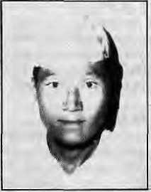
NATIVE CLIMBER
Mingma Sherpa,
Khumjung. Together with Ang Dorje, first Nepali to climb Chomolongma without bottled oxygen (1979).ln poor health, has given up climbing.
12 HIMAL ■ Nov/Dec 1992
summitteer and trekking executive, believes that peer pressure and high costs will make seige-style assaults rarer. "Soon, more than 75 percent of expeditions could be in alpine style. The growing popularity of lightweight expeditions will mean that the employment of Sherpas will fall drastically, but it has been my experience that assaults without Sherpas are seldom successful." The change of style has other repercussions too, pointed out Khadga Bickram Shah, the non-climbing founder-President of the Nepal Mountaineering Association {NMA). "The alpine system is ethically great for them, economically the worst for us," Shah said. The hottest topic to discuss, however, is not about
'alpine style' or 'seige-style', but about the pos sibil iaes of' guide- led aimmerci al climbin g'.
Packaged Climbs
Commercial mountaineering has already begun, with entrepreneur-climbers selling peaks like package destinations. Whether the purists like it or not, roost Himalayan climbing will go this way. The best that can be done is to ensure that local people benefit, that the mountain environment is preserved, and that the'climbers' sense of freedom does not suffer. In a commercial climb, the travel company (mostly Western, subcontracting to local agencies) arranges everything, including the permit, Sherpas, transport, equipment and route selection. The "clients" need only bring their personalgear. The difference from "private climbing", whetherseige or alpine, is that here clients are led by guides in much the same way as they are in the lesseT peaks of the Alps.
The word is spreading, and holiday makers who might otherwise have gone for a couple of weeks' climbing in Chamonix or Zermatt are beginning to consider a month in the Himalaya. The advertisements beckon from the climbing magazines. One company offers Changtse (7553m), the distinctive north peak of Chomotongma, for £3650London-to-London, in a 50-day trip billed as "A climb in the shadow of Everest." Muztag Ata(7546m), near Kashgar, is also on sale, "a very straightforward high altitude adventure above the Silk Road". An unclimbed 6247m peak in India goes for just £ 1980 door-to-door. In the Khumbu, Ama Dablam (6856m) could be the Matterhorn of the Himalaya, with Western climbers lining up to climb. Some New Zealander climbing guides are already selling the peak, as it can be climbed (weather permitting, after aboutlO days of acclimatisation in and around Pheriche village) in just three days from base camp.
Today, even Chomolongma is on sale, and Lhe premium is high. On 12 May.forUS 35,000 each, two American guides escorted a handful of clients to llie summit via the standard South Col route. Sisha Pangma (Gosaithan, 8013m), the Tibetan peak which lies north of Kathmandu, is lii) probably the most attractive eight thou-sander for commercial entrepreneurs. In late September, there was a bevy of inexpert Spaniards on the mountain trampling a virtual highway to die summit. According Kurtyka, the Polish alpinist, the South Face of the mountain "is the shortest and quickest existing line to an 8000m peak. ..for a busy man, it is a dream ground to flash an 8000m peak..."
Steve Bell, a proponent of commercialisation, has nodoubt that this variety of climbing is here to stay. As lie states in Mountain magazine, "These (commercial) trips are not for hard climbers out to make a name for themselves. They are designed for the vast body of mountaineers who want a personal challenge with a minimum of hassle."
The Nomenklatura
Himalayan mountaineering is manned by 'Sherpas' but devoid of native observers and analysts. In India, there are a few among the many amateur climbers who, at least, have lhe background and interest to discuss issues

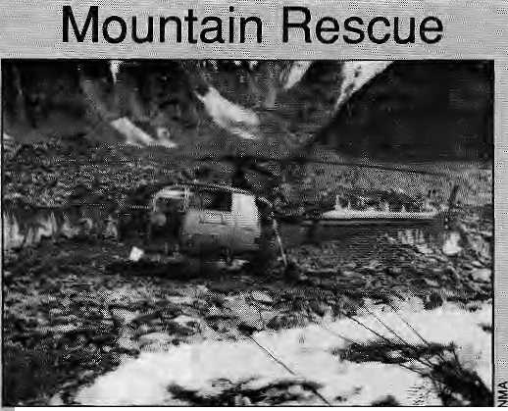
with a regional perspective. In a recent issue of Mountain, he scathingly criticised climber PeteT Hillary (Sir Edmund's son) for producing "one-sided mountaineering literature". Kapadia continued: "Lately it has become fashionable to criticise the bureaucracy in this part of the world for the proble mscreated by the climbers themselves..."
That is not to say that the Himalayan bureaucracy is above criticism. Whereas the IMF officials at least have experience of crampon on ice, Nepal's officialdom is about as far as one can get, mentally and spatiaEy, from the mountains. Yet these officers of the Mo untaineeringSection of the Ministry of Tourism control and administer over the grandest mountains on Earth.
A visit to the Ministry's dismal offices, behind the Kathmandu sports stadium, can be disheartening. Routes are assigned on the basis of a dog-eared and disembodied Japanese book, Mountaineering Maps of the World. Only current information on ascents, failures and deaths are available and there is no library, b ackground inform atio n or data. "The real problem is that we lack a computer," confides one official. Things are no better at the presently headless Nepal Mountaineering Association (NMA), whichhad over the year become aden of bickering among non-climbers and recently collapsed under its own weight. When someone comes along asking for information, the standard refrain at the Ministry, the NMA, and the trek agencies is: "Go ask Miss Hawley." They are referring to Elizabeth Hawley, who has lived in
disabled Alouette helicopter at Chcmphngms Base Catripi
Setting _{s}up mountain rescueinthe Hirtialya M. a little like the," chicken or jhe egg story. Do you set up expensive rescue fsgilities to attract clinlbers, or al)6w the industryto grow and justify the infra structural. The largerexpeditiiofis have been able to take tare of their own rescue operations, but lighter and "coniirtlsrqial" mountaineering will make more demands on independent rescue and evacuationl procedures. In "Nepal, ih§Me of tjieHimapyari HpsCus Association (HRA) for the first two-decades of its existence has primarily been limited to tackling acate mountain sickness |AMS),: with public inform ati.Dn.and through seasonal health posts inM^ntog
■ ■ aiijd the Khombu.... ' "■ ■■.-.■ ... . ■'■■ ■■ ; ./ - ... "' ■■■ . ....'
■I Unlike in the Alps, whei^helicoptersareabletoiiois.tclimbt&s'¹ off the mountain, the ihin atmosphere aboyeGOOPm means thai . primary rescue will always have to'be byfellowcUmbersaildpuid^s.' Airborne rescue above base camp ate mostly not possible, /
In. a dramatic rescue-on 26 June jthis year., an Indian Ajrny
helicopter ^picked British climber Stephen Venables from Panch:
Chuli V (<i>349m)ia the Komaon Himalaya.Pushing the limits :of the
helicopter's abilities^ the pilot balaneedone skid on a glacier slope
wh iie fello w-elimrjefs bundled' VenaMes aboard. Probably the mos t
;; dramatic 'sel^rescue' in recentyears was Doug Scott's, "who with
;■' bojthlegsbroken,dragged,abseiledandjiini^rdahiniselfdQwnlrqrn
: mear the summit of Ogre^ (7285m) in the Karakoram;and; finally
ciawled on all fours over three rri iles of glacier to base camp. "It was.;
a severe lesson which I was lucky to survive and am not anxious to
repeat," be sa'id¹ later: ■■..,." ..." _ ..." . ;
It wp«kl be; too much to expect the holiday Climber to be as-. iueky as Venables or as^tenacigus as Scptt; and the Himalaya will'Dot affractthelarg&numbers envisaged untiibetter^arjfarigeinents can be made for rescue. As thenwrnberofclimbersincreases, it ispossLble; that the HRA couldfind itpossibly to main taina£e!ieepterdedjc;ite<ji to rescue. EleVjSlopirig special stretchers that cai be b|lanced be the backQf yaks, the availability of Qamow Bags forrenMin Kathmandu shops, and training local guides on rescue and traiirna treaynrait, are the other activties lhat would promote confid^nc&of lay climbers.
important to climbing.-Harish Kapadia, who edits the Himalayan Journal from Bombay, is oneofafew who scrutinises the mountaineering scene independently of the officious old-boy network that manages climbing through the Indian Mountaineering Foundation (IMF), In a field dominated by Western observers, Kapadia writes
Kathmandu for 32 years as news correspondent, Executive Officer of Edmund Hillary's Himalayan Trust and chronicler of Nepali mountaineering.
It is not necessary that a mountaineering official him self/herself be a mountaineer, but some first-hand experience and empathy would help when it comes to defining policy. Lacking such sensitivity, officials are easier swayed by exaggerated claims or misrepresentations by climbers, tourism business interests, and so-called mountain environmentalists.
For all its other weaknesses, the Nepali Government has been at the forefront of setting up mountaineering regulations, the very word being anathema to Western climbers who suffer restrictions only under duress. The system of permits, royalties and liaison officers, for example, were perfected by Nepali bureaucrats and now are de rigueur all over the Himalaya. When China decided to open up Tibetan mountains in the late 1970s, it sent a delegation to Kathmandu, literally, to learn the ropes. Says NMA's former President Shah, "There is a great divide between the climbing nation and the Himalayan nation. They tend to view mountaineering from the European experience, where there are no royalties, no strict rules on porters, and no liaison officers. Ours is a professional mountaineering system, and theirs is a amateur system."
Nepali officials, too, are matter-of-fact abouttreating mountains as an economic resource. "For them it is a sport, for us it is a tourism product," maintains Prachanda Man Shresiha, who ran the Tourism Ministry's Mountaineering Section for six years till 1990 and is today with the Department of Tourism. "The Government views that mountaineering activities must be used to provide economic opportunity to remote areas. Mountains are an asset to the country's economy generally, and they also provide direct revenue to Government." At the annual meets of the international association of alpinists, UIAA, and elsewhere, the Himalayan representatives are smug in the knowledge that the mountains are in their command, which gives them unimaginable clout vis-a-vis the world of climbing heroes. As an Indian representative said to a Nepali member at a UIAA gathering a couple of years ago, "Baal chod yart Akhir yeh

NATIVE 1
CLIMBER
Ang Rita Sharps,
Pangboche. | i. ■R^**'' ■"*"■ ' 1
First Nepali
woman to scale
major peak
(Lam j Ling, | I! P\-/il i
6983m).

Nov/Dec 1992 HIMAL • 13

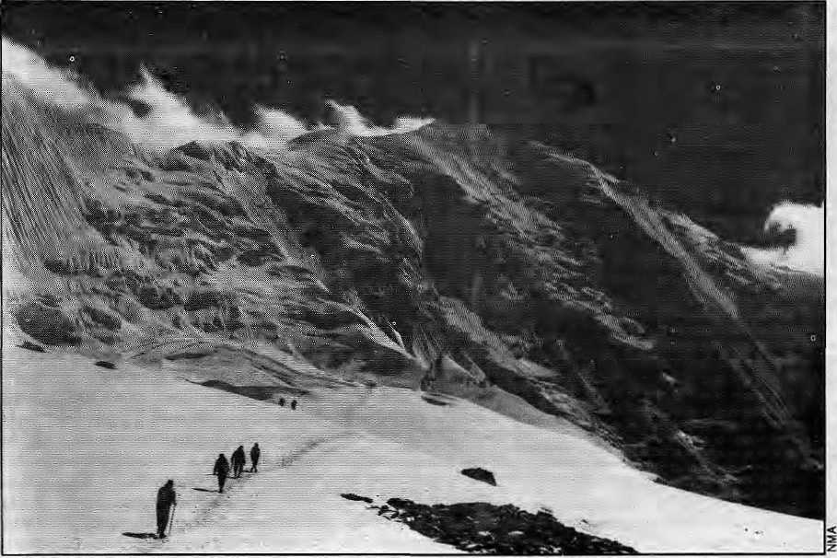
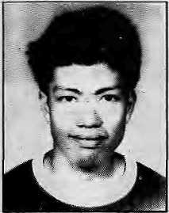
loghomorahitoadnahai!" (Letthemgoon! All said and done they have to come to us.)
Himalayan Economics
Commanding as it does the southern approaches to an entire section of the Central Himalaya, the Nepali Gov emmentis well placed to s et monopoly prices. Butit is doubtful that the Tourism Ministry can fine-tune its policy to maximise benefit from mountaineering. With commercial expeditions showing the road to the future, officials have to carry out a serious cost-benefit analysis, to arrive at the rates that will bring in climbers of the right spending category.
The sum the Government collects from royalties alone was a little under a million rupees in 1982,rose to NRs4.3 million by 1987, and was NRs 9 million in 1991. In Spring and Summer of 1992 alone (following the latest hike in royalties), it earned NRs 11.7 million from its mountains, thisfigureexcluding fees collected separately by the NMA for the so-called trekking peaks.
First Japanese expedition to the Himataya,1936, on Nanda Kot, a peak east of Nanda Devi.
NATIVE CLIMBER
Narayan
Sh rest ha, Kavre.
First Newar on
Chomolongma,
Summer 1985.
Deceased,
It may not be too late for the Nepali Government to mull over whether it is in its interests to be regarded as the Scrooge of the Himalaya, milking impecunious mountaineers whose only fault is that they want to climb here. It is now already Impossible for climbers of the former Soviet Union and Eastern Europe to set foot on Nepali mountains, and an ambitious Russian plan to do the 'Everest Horseshoe' (ridge-climbing from Nuptse to Lhotse to the Chomolongma summit) in 1993 seems to have been scrapped after royalties were raised. For now, Nepali peaks are much more costly than their Indian siblings. While Chomolongma goes for US 50,000 starting in Spring 1993, India's most expensive East Karakoram peaks cost U$ 5000 apiece, while the Nun and Kun peaks in Zanskar cost U$ 2250 each. All other peaks in IndiarangefromU$900toU$ 1800,whilepeaks below 4500m earths climbed for free. In contrast, Nepal's eight-thousanders are priced at US 8000, those between 7000m and 8000m cost U$ 3000, 6500-metre to 7000-metre peaks cost U$ 2000, those between 6000m and 6500m are set at U$ 1500, and peaks below 6000m costUS 1000. The market will either force Nepal to ultimately reduce royalties (other than Chomolonga, which is a 'product' apart), or India will follow suit and hike up its own prices. No one is yet talking of a "moutain cartel" that coordinates royalties and mountaineering regulations.
A Growth Sport
The greater availability of information and the confidence that comes with it, technological
advances in mountaineering equipment (see page 17) and the opening up of new climbing areas are leading to more arrivals in the Himalaya, but the pace could be quickened with better publ ic relations and marketing. Unlike in the 1950s and 1960s, mountaineers need no longer waste weeks on the approach march. In Tibet, they can truck it to the base camp of most peaks while, in Nepal, turbo-prop aircraft drop climbers off much closer than the road heads in the Tarai where erstwhile adventurers such as Eric Shipton and Maurice Herzog had to begin. Herzog's 1950 French expedition to Annapuma One found a mountain range blocking the way where the map showed "an easy cow path". Even though maps available today also leave a lot to be desired, mountaineers have access to aerial pictures, satellite images, andin the caseof Chomolongma, a detailed 20-metre-interval contour map.
With increased demand, the governments of the Himalaya willrespond by opening up new peaks (except, for themoment, the Indo-Pakistani mountain border, and Bhutan). As Indo-Chinese tensions ease, and with individual Indian states demanding their share of tourism income, Inner Line restrictions are being relaxed. With its announced economic reform policies for Tibet, the Chinesecan definitely be expected to open up more peaks.
There are so many mountains out there. Nepal alone has 1310 peaks above 6000m, of which 118 are open today. "Taking into consideration the mountaineers being concentrated in the Eastern region and to diversify the mountaineering activities," the Nepali Government announced in August that eight more peaks from 6500m to 7000m will be available in the west Nepal districts of Darchula, Humla, Bajhang and Dolpo, Whereas till now only three climbing seasonshad been recognised, the Government also decided that the summer season too would be open for mountaineering expeditions, which means that climbing can now be year-round. Winter climbing in the Himalaya used to be considered extreme, but today it is an established, albeit difficult, sport. Perhaps the new frontier will be climbing in the monsoon, with its special challenges such as danger of avalanche.

14 HIMAL ■ Nov/Dec 1992

writings emerged on the world of intermediate Himalayan climbing. A significant new book is Bill O'Connor's Trekking Peaks of Nepal (Crowood Press, 1989), which describes routes on peaks such as Pisang and the "Chulu sisters" in Manang, Mera in the Khumbu, and Yala and Naya Kanga in Langtang,
At a time when
the talk is only about
bagging eight-
thousanders, the world of the holiday alpinists (who number in the tens of thousands rather than the hundreds who today come to the Himalaya) must be told that there are faces here between 6000m and 7000m waiting to be climbed. Once you gel over the altitude factor, the Himalaya need not be all that different from other more popular lower ranges of the world. On 90 percent of the existing routes, says Roddy Mackenzie, a Chomolongma summitteer and heli-skiing entrepreneur, you do not expect to fall, although you do need protection. Writes author O'Connor, it is now possible for "an individual or group of friends to take part in or organise their own expedition within the context of a few weeks' annual holiday with the minimum red tape or expense."
The lack of standards in the local trekking and mountaineering vendors is a major hurdle to be overcome on the road to commercialisation. Competition among trekking agenciesis rife and undercutting is the rule. These conditions encourage many businesses to cut corners, providing inexperienced porters, bad equipment and little backup in case of accident. Every year, therefore, scores of climbing teams return home dissatisfied and spread the word of an industry that has yet to know what is in its long-term interest. The climbers themselves help little by shopping around for tlie cheapest agency, mostly
(purkhas as 'Sherpas'
A
s Gumngs, Tamangs^.Magars, Rais and Lirnbu^ become acliv c in Hi m a J ay ah mo un trj ine eri fig, th ey wi 11, j h a ra anner o I,, speaking, Be going back to their roots. For as Gurkhas, the rjon-, JSherpa hill people of Nepal have also beefi active mountaineers since the lime they helped British empire chart and control the Himalayan region. As geographer Harka Gurmig"wjites; it was jn the 1880s that soldiers of die; V5m; Gurkha Rifles were trained as moiiritsineers ^hik seiving in tiie North-West Frontier of India. These riflemen, according to Gurtmg, "became pioneers among Nepalcse climbt;r|," (see "Gurkhas and Mountaineering" in NMA's--1985 Nepal Himal and Himal JuJ/Aug WIJ.,
The Gurkhas were first engaged iti mountain¹ exploration in 1889, when they traversed several till-then unknown glaciers tn the Karakoram. The most interesting early Gurkha exploits were by-.-. Amiir Singh Thapa and Karbk Bufathpki, who together with.soHtt: alpine guides "crossed 39 passes and climbed 21 peaks in 86days ... of Alpirse traveise'": A.F.Mummery's 1895 attempt on Nariga Parbat (8125m) included t\y§Gurkhas". The tliree never returned, ahd were believed to have been perished iji an avalanche,
Gurkhas were als o m embers o f tile is.ucce s si ve exped i tion s o n Chomolongmabetween 1921 and L?l&Jn t922_{v}NaikTejbiiBuda: of the 3rd Gurkhas spent twonights at ■ 7772m on the mountain: In 1927, Ke received an Olympic medal from the Presidentof Frsirjce, ^ for his high altitude resilience.
All this was the distant past. These "amateur diversions''' ended for lha Gurkhas, writes Gurung, "with- tlie passing of tlie : gentleman dpinistsiheyemulabd.'⁷ As forthe future, niountainecring and trekkinghbld;o9ttKe possibility of absorbing at least some of' the sutphis labour released,by fine planned phaseout of the British Gurkhas and reduced recruitments into ihelhdianGorkharegiments^
White tlie nori-Sherpa hill people pf.Nepafhaye. concentrated iffprov iding* 'lowlandpoiter'' support to m duntai nee ring expeditions, some of th«ir bretheren in the armed forces have been actively ; engaged in mountain climbing. The British Army, for example;, has tieen training Gurkhas-in the Alps for decades. andGorJthas.of the ladiuh Army serve in high altitude outpost^ iiicSuHiag...th« killing snow-fields of the Skciien Glacier. ..
Li a unique mix of two of the motifs which define Nepal for
rflany — the Gurkhas and the Himalaya — one trekking agency "
recently put out an advertisement inviting cltmrxirs to ''Explore tlie
highest snow rnpuriiain with tlje'braye Gtirkhas of Nepal"— using :
Gurklias ratlier than:S'beipas Jossell 'rnp)jti(ai:hei:Tiiig services. There
seemed to be a bit of overkill, though. For when H'itrtal called the *
agency, ihe voice at the other end was apologetic: yes, they had one ;-,
Gurkha wjtji tfaetn-i ; :
Plan the Future
For all the awe that extreme Himalayan climbing garners, the bulk of mountain tourists do not come to the best mountain system in the world. There exists alarge clientele between the US 12-a-day trekkcr (who the Kathmandu agencies are scrambling over today) and the US 3 5,(XX)-guided climber on Chomolongma. The sales pitch has to counter decades of incessant coverage of the heroics of Himalayan climbing, which projects the severe conditions and convinces amateurs that they need not apply. The books, lectures, trade magazines and journals are all aboutextreme hardship climbing. Only recently have some
to be found in and around the Thamel tourist quarter. Once on the mountain they are apt to find that their 'guide¹ has never been above 12,000 feet and is sickiy to boot. He drops out, and the porters start agitating to leave for home. Three Australian women on their way to Yala peak in mid-October spoke of the difficulty they had in finding a proper mountain guide. More than one agency promised experienced guides, but failed to produce them for interviews. "The few we did meet were not the sort we would trust our lives with on tlie end of a rope. In the end, we put up signs in Thamel lodges and went by the advice of a returning climber we met."
Those who tend to lose out in a cheap and ill-organised climb are not even the sahebs, but the lowland porters. For it is they who take up the slack by having to carry more loads, sometimes even to high camps. While some trek agencies provide adequate clothing. Chinese basketball shoes, and even cheap dark glasses, the majority go up the mountain unprotected and innocentof the dangers. A big and unexpected storm over the Himalaya puts porters right across the chain in great jeopardy. While the Tourism Ministry keeps records of those killed on the mountain, there is no one maintaining figures on porter deaths along the trails of Nepal,
CERTIFICATION
In the world of commercial climbing, it will no longer suffice to glorify the Sherpas and to bank on their name and effort. The Sherpa ability is in mountain travel, through awkward moraines and steepslopes. Sherpas are, as one Western climber says,"greatplodders".Theyarcwell-acclimatised to Himalayanheights, usedtocarrying incredible loads, and wizards of seige-style logistics. For thefuture, however, Sherpas and other would-be native climbers need to be better at technical climbing, which comes not from portering on snow, but from climbing rocks and handling ropes. Unfortunately, an understanding of the 'science of climbing', from the optimal angle required for an ice anchor to recognising the symptoms of AMS, does not come easy with a Nepali village-school education.
A whole new world will open up to native climbers once their technical ability is enhanced and they receive an UIAGM certificate or equivalent (see page 28). Until that day arrives.

NATIVE
CLIMBER
Sung da re
Sherpa, | 9BL li
Pangboche.
Five-time
summitteer of
Chomolongma.
Deceased.

Nov/Dec 1992 HIMAL • 15

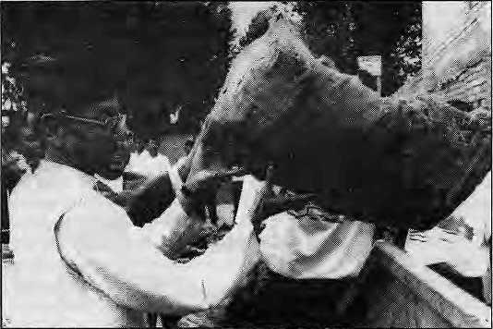
<5UIDE-A5£ISTEp
CLIMBING
Tourism Minister Ram Hari Joshi dumps Makaiu trash in Kathmandu.
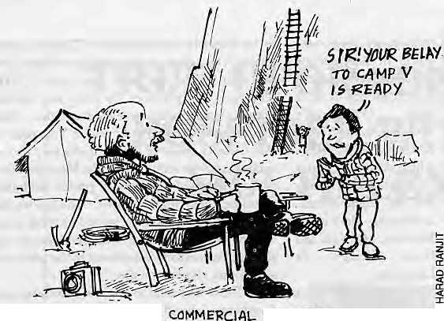
however, Western guides will continue to take clients op the peaks, Ama Dablam at US 200 a day orU$35,000*perpax'on Chomolongma. At present, a handful of Nepali climbers have taken some of the stringent UIAGM courses at Chamonix, but none have been certified as professional International Mountain Guides.
The few climbing schools in the Subcontinent, in Uttarkashi, Manali, Darjeeling and the NMA's own in Manang, are producing amateur climbers, not qualified guides. Says Tashi Jangbu Sherpa, who has taken some UIAGM courses, "Getting a certificate from Manang has become just like taking a computer course. But you do not get qualified just by getting acertificate, you have to climb mountains and gain experience." Another Nepali climber says he knows of "at least 15 certificate-holders who have not climbed a single peak."
If the mountaineering industry expands as envisaged in the coming decade, it will grow beyond the numerical capacity of the Sherpa community of Nepal to fill. And as is already happening with Tamangs mid Gurungs today, more hill communities are going to be joining the lucrative trade. There is a sense of uncase among some Sherpas that a trade they have nurtured for so long (since the British picked up their ancestors from Darjeeling tenements in the 1920s), might go out of their grasp, to be taken over by "rongba" lowlanders, both in terms of sardaring and operating treking agencies in Kath-mandu. Occasionally, non-Sherpas climbers, too, complain aboutSherpa dominance andreluctancc
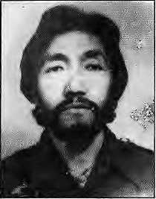
NATIVE CLIMBER
Chewang Rinzi
Sherpa, Namche. First Nepali to scale
Chomolongma from North face.
to allow others the
lucrative positions on expeditions. There is also exasperation with the Westerner, for whom every native with apackonhis back is a S herpa. "They want only Shcrpa, so we become Sherpa," said one Gurung sardar recently en route to the trekking peaks of Manang.
But resentments are not as deep as one might expect, probably because the market is expanding rather than shrinking. "It is good that non-Sherpas are getting involved," says Pertemba Sherpa. "So far, the number of non-Sherpas is quite high in trekking and not in climbing, where you need to be physically adapted to high-altitude." Adds Ang Tshering Sherpa, trekking executive, 'There is always a demand for people in this profession, so there is no friction between Sherpas and non-Sherpas."
Trickle Down
Does the benefit of climbing trickle down from
the mountain to the surrounding landscape and
population? Or does it just
tTeacle down to the
commission agents in
Kathmandu? If it is true
thatthefirsttobenefitfrom
climbing must be the
people around the
mountain itself, then
Himalayan climbing is
largely equitable as far as
the Sherpas of the upper
Khumbu are concerned.
But a look at the odier
regions of the Himalaya
indie ates that diose closest
to a mountain chain do not
necessarily benefit most.
Part of this may be due to
lack of interest and part of it may be not knowing how to take advantage. For both these reasons, and for the expertise they have developed in climbing and logistical support, Sherpas today help in climbs rights across the Nepal and Indian Himalaya, in Tibet, as well as in theKarakoram. And Sherpas will continue to provide the backbone of Himalayan mountaineering for the forseeable future.
While there is u need to ensure that there is vertical equity (by class) and horizontal equity (by community) in the mountaineering trade, no one expects the Government to play an activist role. And unionising will not work. Attempts by porters to organise right after the advent of
democracy in Nepal in 1990 were promptly short-circuited by political divisiveness and external pressure. The regional academia and media are both too far removed from mountaineering as a Irade, although the Tribhuv an University has just begun courses in tourism which might lead to some ongoing monitoring of the trade. The only players left, then, are the trekking industry executives, who come in an incredible variety, from Chomolongma veterans to Kathmandu Valley 'lowlanders' who have been above 3000m only on an airplane. The social commitment of trekking agency operators tend to vary widely, and the majority has little time for v icarious concerns in the rushtoundercut the competition.
One should not, of course, over-emphasise the exploitative ness of mountaineering and trekking agencies. After all. they bring cash income to a population that has few other alternatives. Nepali men and women are able to work in their own mountains and to earn an income as a direct quid quo pro for the energy they burn. However, equity has also to be seen in terms of the to ;al profits made by the trade and its distribution. And portering in the Himalaya is probably the most excruciating of labours in the world. Neither is anyone counting the. income earned in relation to the high cost of food and shelter on the trail, the opportunity costs, depreciation of clothing and footwear, and, most
importantly, the wear and tear of the body. With all these factored in, the income of portering is not as high as it is made out to be. Thus far, no one has come forward to help porters do a proper cost benefit of their labours.
Pseudo-Nationalism
The 'intellectual' non-climbing circles in Kathmandu often latch on to the theme that for all the trouble that the Sheipas take in assisting the sahebs and memsahebs to the top, they do not get their share of the income nor of the fame even as the foreigners go on to write books, do lecturers and buy castles in the Tyrolean Alps. Some of this concern is justified, some misplaced.

16 HIMAL • Nov/Dec 1992

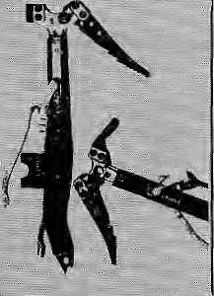

ju ring Ihe secbrid British expedition to Chomolorigma in. 1922. George Eirich and Geoffrey Bruce: used bottled oxygen for the very first time,.. The four sUsel. cylinders and the supporting frame of each piece weighed around 14 ... kilograrnr^es:and..th.e;apparatuswast>otiiawkward. and pjOrie ta clogging. That was 70 yeafs agp^ Today, J he ijiarket is patted with modem, alira-efficicntandinnovaLive equipment, some of which has undoubtedly contributed to: making mountaineering more accessible.
The ice axe, one of the indispensable taols of climbing, has seen remarkable: Changes since...it? early ...days. The ice axe of the early 20th.ce'ntury usedto be quite long,doubling upas a walking stick on level grotind. Nowadays, apart From being Shorter, It is also provided with t:wo or more holes for looping ropes. New alloys, resins anil fibres, gnd combinations of these, have replaced the Lraditiona! wo&daad wietal iii ihe-ajtel
A decade ago, the "reverse curve pick" axe — the '..pick ■■curving slightly upwards ^became available. It is liQwteoasidered to Have been a revolutionary step in the design of ice-climbing eqinpmenj. Some shafts nowadays are bent, the phis side of these being that they reduce fatigue and protect the knuckles While attacking ihe ice, arid the mirius point bein.g that they are less versatile because dF their, specialisation. Researchers at ScotlaRd'sStrathclyaeUiiiversityhavedey^loped safer roptss:for the Cairngorm Climbing Co mjpany, A chemical dressing applied to the yarn used in making the; rape changes colour whenthfe ror« reaches its UIAA designated number of falls. So, v^henthe rope has beenused forlong enough, it turns blackat theplaces where it Sia$ been weakened, wailing theagajnst an unprotected fall.
Gore-Texis.a syntljeiicrpefnbrane that lias been used widely iiV mountaineering gear. Sheets of llie membrane- are Used lojine outdoor clothing. The clothing keeps thebody surprisingly¹ warm and dry-while allowing noojslure to-escape Ihroagti pores in tlje m#rfbran<i. This material has also-'.been used for shoes, sleeping bags and tents* with
mixed results: Gore-Tex liners In boots help in frying up the? boots qukkjy while oh ice or nioistgroynd. Bul intents. It is less effective. Rucksack design is.^creasinglyergonpmic, geodesic domes:. profiiie more living space for a .given floor area, and their alloy poles' are .-lightand stj^fig^l^irnesses lor foll'-hpdy, waist arid ieg have been Improved although moiffltiineerscorripiaiH they are incbrivenient and restrictive anft many prefer to tieropes Erectly arojindthetr waists Uie
.. qId-fashioned way. ■■■ ■:■ " ■ ■■■ - ":- ■-: ., ' ":- ^ ..,. ' ': ■■■ .^2 '"' ■ ...
" ; A noteworthy dtfveleprnetitinthe 'Nepal Hrnalaya Kas bewjfthe -easy ayailability" of Ught, bigfj-pressore QXygenbottles, coming from' Moscow. After the Soviet disintegraticm, these cylinders, said tbnave been deyeiopad for tiic military, haye penetrated:the market and have become quite popular. Their selling point is that they are half as, heavy
^{v} as the-regular European models. "' , , : :- ■:■ ,,. :' ■■■ ...,; " ; -
Qn the life-saving Jfo'ntv perhaps: one of the most jnipprtant product of Himalayan ciimbihg: has been tjie Gamow Bag,: aseven kilogram nylon chmnber which resembles a pjiriiped-iip sleeping bag. It has been hiiiled as an effective Gfe-sayiijg, first-aid device forasttte
■ mountain Kickness (^iMS). The sufferer is platsd inside the bag, and air is fed p frani" an attached pump, simulating a descent of several thousand metres. AltiiougJi intended as a temporary first-aid device
: only, this Gam6w Bagj developed by a Colorado doctor, lias proveh ■ valuable: in many cases ;of AMS.; The price of the Gamow hovers around U$ 2000, wbcli orient[y : ...-restricts it tra. target expedituins. However| wo^cl: that" other
-mahufacfiffeis are wbrkmgpn clones to sell irithe teioW::U$ 50<S range: ... polds put the possibility that this innovative hypertiaricch amberw ill lead to ..greater...confidence amang mpufitaineers tt> come climb in the .

Among Sherpas, but almost never reported in the climbing press, there is the inside story of climbs that their clients would rather not have discussed. It is significant that practically all climbing reports in themagazines are first-person
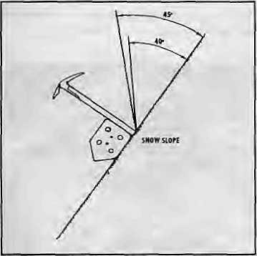
A snow anchor requires knowledge of physics.
accounts, and only the native climber knows what is ommitted. But blowing the whistle would be bad for the next season's employment, so the Sherpas keep silent on who had taken swigs of bottled oxygen on aa no-oxygen climb, who had Sherpa support most of the way on a solo climb, and the many who had to be dragged and cajoled to the top so that they could be heroes and heroiens back home.
MarcBatard'sfamoussoloclimbof Makal u (8463m) is a case in point. The most difficult parts were fixed with ropes a couple of days earlier by Batard and his partner Iman Singh Gurung. As the latter recalls the climb, on 24 April 1988, "We had just got to the top of the French Pillar at 8000m and only aneasy climb to the top remained. The weather was great and it was only noontime. Suddenly Batard said he was extremely tired, and we just had to descend. 1 was shocked, but there was nothing else to do. He insisted." Once down, Balard confided that it was important for him to go up solo. The weather held, and the next day ihe climber shinnied up the
fixed ropes to the lop, and to much adulation in his native France.
The Nepali mountaineering establishment has occassionally tried toglorify the achievement of Sherpas. In 1953, Tenzing Norgay was feted in Kathmandu, songs were written about his heroics (and how he supposedly 'pulled Hillary to the top', and so on), but in the end Norgay was unceremoniously dumped for having "defected" to India. Much later, ihe NMA tried to lionise
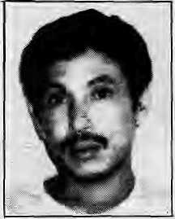
NATIVE CLIMBER
Sambhu Tamang,
Sindhupalchowk.
Youngest
Chomolungma
sumrnitteer
(1973) and also
first non-sherpa
Nepali on top.

Nov/Dec 1592 HIMAL ■ 17

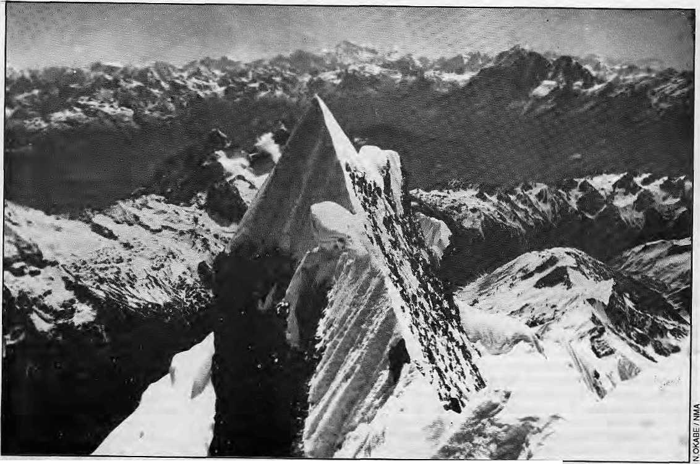
There are so many peaks out there... Looking out over the mountains of Tibet and Nepal from the summit of Ganesh Five.

Sungdare Sheipa, at one time putting him in display at a travel meet in the West Germany, recalls one German writer, "as if he were a specimen on display." AsfoimerNMA President Shah concedes, "We tried to promote Sungdare Sherpa, but we realised that we had burdened him with something for which he was not psychologically prepared."
The.Ncpali Government has done what is within its powers to recognise climbing achievement, says one official. "We made sure that they received the highest national awards— the TrishaktiPatta and the GorkhaDakshin Bahu, both First Class."But, says TashiJangbu Sherpa, "the medals are not very useful. You raise their spirits, give them high hopes, make them briefly
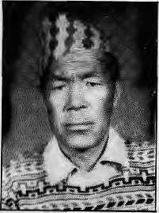
NATIVE CLIMBER
Ang Rita Sherpa,
Thame. Seven-time Chomolongma summitteer.
IE HIMAL • Nov/Dec 1992
part of Katmandu's cocktail circuit. But in the end, they have to return to reality and go back to toil on the mountains. So frustration builds, and drinking begins."
It is actually surprising how little Sherpas have been used by the commercial world for marketing and promotion. That, at least, might have brought so me ancillary income to the famous Sherpas such as Sungdare, Ang Rita and Ang Phu. Instead, a delivery van manufactured in England and a Nepali bathing soap have been christened "Sherpa", and no one is talking of royalty. A couple of years ago, a Nepali public relations man did try to "market" Ang Rita, seven-time Chomolongma summitteer. He wrote to famous corporate sponsors in the West, but the interest just was not there.
When native climbers are asked what the mountaineering establishment could do to assist them, they invariably speak of the need for a welfare scheme: old age pension and disability coverage. For the moment, old climbers and those whose health goes bad return to their home village and to work as subsistence fanners — to re-live old glories momentarily when the occassional Western climber comes looking for them to pay homage and to reminisce.
Climbers from the worldover will continue to come in increasing numbers to the Himalaya.
As for the locals, the porters do not know to do any better, and the native climbers and sardars will continue to serve as untrained, underpaid support staff. The trekking agencies are willing to undercut each other and scrabble around for leavings. The majority population, meanwhile, con tinuestoTegard the mountains from aspiritual distance, while the governments use the peaks to topup die national coffers and to promote pseudo-nationalistic pride of the Himalayan heritage.
It is time that the people of the Himalaya appreciated the mountains both for the challenge of climbing that they pose, as well as for the fair and distributive trade that it has the potential to offer, at ascalemuchlarger than the mosttrekking agents of today are able to visualise
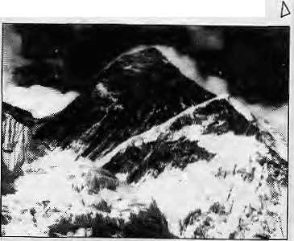

Heroism is Poor Counsel"
Climbing ethics presently limits itself to matters of sportsmanship and technique. But being a better
mountaineer demands somewhat more than this.
by Hermann Warth

You first! Sherpa negotiates the Khumbu Icefall.
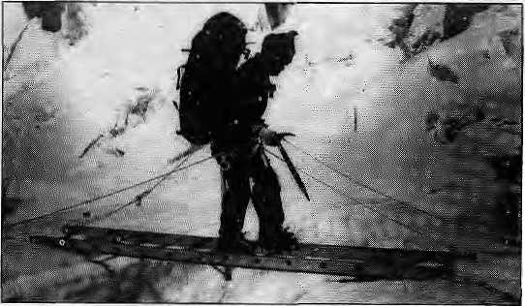

T
housands of mountaineers from all over the world come every year to the Himalaya to experience the fascination of the Himalayan climb. They write essays and books describing the joy of the ascent, the experiences under extra-natural conditions and their sense of personal enrichment. They prepare slide shows and present films to mesmerised audiences in the West.
The Himalaya has given richly of its gifts and continues to do so. But what do we, mountaineers, give in return?
The ethics of mountaineering aspresentlyunderstoodenvisageasport involving minimal useof technical aids. The concern is only with aspects of sportsmanship vis-a-vis the physical mountain. It is high time that climbers liberated themselves from these narrow confines.
The Himalaya is not just a chain of mountains but a complex tapestry of natural and cultural landscapes. Mountaineers therefore assume a responsibility for its ecology, economy and human culture, as well as for thenative comrades on therope, and for tliose climbers who will come after them.
In suggesting what follows, I have no intention of appearing as a moralist pointing an admonishingfinger,forlhaveto admit with regret that my own behaviour as a climber in the Himalaya has not always been in complete accordance with the desired code.
First, we must prepare for the mountain not only by ensuring physical fitness and logistics, but by informing ourselves about the surrounding cultural landscape, the sensitive ecology and economy. Such preparatory confrontation and involvement gives rise to a sense of humility and an awareness of responsibilities entailed by mountaineering practice. This, in turn, is a good way to reduce the danger of accidents and to contribute to proper adaptation of an expedition and the complex of prevailing sociocultural, economic and ecological conditions of the area.
We should strive to act in accordance with the laws of the country. These include obtaining a permit for climbing the desired peak, not trespassing inlo areas that remain 'restricted', and obtaining the obligatory coverage for climbing staff regarding insurance, equipment and remuneration.
We should disregard the temptation to utilise the existing laws of the country as a kind of subterfuge, just because they do not specifically stipulate that porters be provided with tents or canvas sheets for sleeping at night; or that a doctor or medical specialist be taken along to serve the expedition staff; or that artificial oxygen be carried for emergencies. How mountaineers deal with their own health and safety is their own concern, but since no expedition in the Himalaya can do without native personnel, climbers must bear the responsibility for them over and above what the law might require.
There is a tendency to treat the obligatory liaison officer as a kind of parasite, a burdensome appendix to the expedition, who is effectively excluded from the community over a period of many weeks. Appointed by
the authorities, the LO is doing his duty. Generally not a mountaineer, he comes from warmer, lower climes. For him, the expedition is generally a cold, monotonous but necessary intermezzo in his career and this should be appreciated.
We should not demand that the j Sherpas accept unreasonably risky g routes. Neither should we lure and g tempt them — against their better S judgement and physical condition 1 —todangerouslyextcndtheirefforts < with offers of better pay, valuable gifts and promises of trips to Europe, Japan or the United States. While on the climb, we should respect the native climbers' cultural sensitivities and religious reservations, taking into account that Sherpas generally climb for a livelihood and not for the thrill of it. Do we treat the Sherpas as hired underlings who are good enough to carry loads, make the route, set up the tents, cook the meals, and then wait dutifully at the highest camp for the sahebs to return? Or do we treat the Sherpas as partners and comrades in wild nature by sharing in the burden of carrying loads, contributing to making the route, setting up tents and cooking, and by giving them achance to make the summit as weE?
Given the poorly developed facilities of the rescue infrastructure in the Himalaya, it is the duty of Western climbers to ensure that the risks we take on the mountain are in reasonable proportion to our own abilities.
In our lecture tours and our publications, too often, we tend todiscuss success only in terms of whether the peak was reached. Rarely do we find climbers talking in terms of how well their expedition adapted itself to the economic, ecological and sociocultural ambience of the mountain region, and the extent to which it proved possible to realise "partnership on the rope" with the indigenous members of the team. If only out of a sense of responsibility towards future mountaineers of the Himalaya, as chroniclers we must resist the urge to portray the climb as a glorious race to the top with a stopwatch in hand. Heroic glorifications should be avoided. The mountaineering stars are also human — they train hard, prepare carefully, and experience weakness and fear, as well as exhilaration. To be properly informed is a necessary prerequisite for responsible climbing. Hero ism, on the other hand, is poor counsel.
"Integrated expedition style" and "partnership on the rope" — these are more difficult, but also represent qualitatively more valuable challenges than that of "mastering" the "meter giants", "by all means" or "by fair means". Have we, climbers from the West, lived up to this challenge? Most certainly not. But some of us have started to care for the Himalaya and its peoples. In films, articles, lectures and radio programmes, a small beginning is being made. Insight is increasing. May deeds and action follow.
6
H. Warth, who headed the German Volunteer Service in Nepal 1975-1978 and 1980-1984, is also a well-known Himalayan summitteer of Makalu, Lhotse and Chomotongma, among others. A version of this article first appeared in the Rising Nepal Friday Supplement of 2 March 1984.

Nov/Dec 1992 H1MAL

Who Climbs Whom?

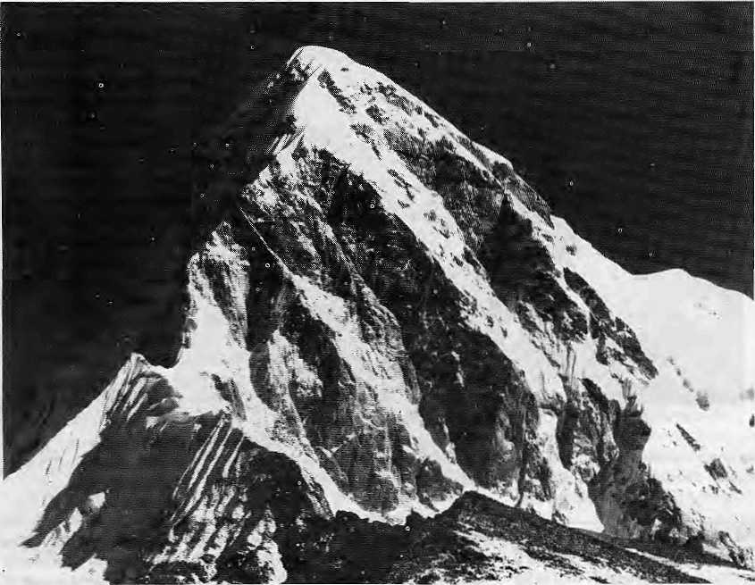
Pumori's pyramid: structure of the mountaineering trade.
Mountaineering as a sport is about fairness, honesty, and humility born of risk. It is not about taking advantage of helplessness and poverty.
by Pitamber Sharma

I
n the winter of 19 78,1 w as horn e in P halebas, Parbat District, after an absence of almost four years. My village is situated along the eastern terrace formed by the Kali Gandakj river and commands a grand view of Dhaulagiri (8167m)andtheArmapurnaranges.Oneevenmg when Dhaulagiri looked aflame in the setting sun, an elderly lady happened to find me staring at the view in fascination. She threw a quick glance at the mountain and saidmatter-of-iactly, "Yes it is truly beautiful, but it does not feed us." The point inherent in that statement has stayed with me ever since.
Department of Tourism statistics show that in 1990 Nepal earned U$ 63.7 million from 195,121 foreigners (other than Indians) who entered the country. In that year, the latest for which the breakdown is available, 62,092 trekking permits were issued to tourists. These included 972 climbers who were members of 120 mountaineering teams. These teams employed 863 high-altitude porters and guides and 13,316 local porters.
In 1990, the Nepali Government earned a mountaineering royalty ofNRs 7.3 million (about US 160,000). In addition, the mountaineering teams were levied fees in lieu of trekking permits and entry into national parks. With the exception of the Annapurna Conservation Area Project
20 HIMAL • Nov/Dec 1992
(ACAP), where entry fees are utilised by the Project for conservation work, these direct earnings from mountaineering (royalty and other fees) went to the central exchequer.
Money from Mountains?
The 1 ack of detai led inform ati on m ake s it di ffic u 11 to ascertain the real beneficiaries of mountaineering in Nepal. In all likelihood, the financial benefit flow resembles the pyramid of Pumori (7161m). The maximum benefit at the baseis derived by the(mostly Western) countries of climbers' origin, tapering off through travel agents and operators in the country of origin, travel agents and operators in die host country, the sordors, the high altitude guides and porters, the owners of 'hotels' along the major trails and, finally, the local porters and the vendors of tea and snacks at wayside inns.
This typical pyramidal structure is revealed in expenses reported lo [he Ministry of Tour ism's Mountaineering Section in October by an Autumn 1992 British expedition lo AmaDablam (6812m). The total cost of this expedition was reported to be U$ 23,000. The expedition had a total of 11 members and employed 25 porters for about two weeks. Although US 13,000 was declared spent in Nepal, the report to the Ministry accounts only for U$ 7,082 under different expenditure
categories. This means that 69 per cent of the total expenditure was made outside Nepal.
The declared expenses incurred in Nepal makes interesting reading. The climbing permit fee (royalty) accounted for 26.8 per cent of the expenses made in Nepal. Lodging expenses while in Kathmandu took up 14.1 per cent. Purchase of food and fuel (mostly in Kathmandu) accounted for 28.2 per cent. "Agency Service Charges" took up another 12.7 per cent and the insurance premium paid in Nepal (mandatory under the Mountaineering Expedition Regulations) accounted for 3.1 per cent of the total expenses incurred in Nepal.
Wages to "local" porters and lodging costs spent during the approach to and return from Ama Dablam, which might be considered the most important elements of theexpenses in terms of spreading the benefits of mountaineering, lookuponly 13.8 and 1.2 per cent of the total. On an average, a porter-day costs only NRs 128 to the expedition, or about U$ 2.8 at the current exchange rate.
Actually, the report submitted by the Ama Dablam expedition lo the Ministry tells only half the story. Candid conversation withpersons who have acted as liaison officers and others in the mountaineering trade reveal that the Agency Service Charge (a euphemism for the commission

Backtrash from the
Kfitirribu
aklrig into considexation the pressure on the environfnenf of upper.. Khurobu, the Nepali Ministry of Tourism announced in July that effective lfie: Autumn 1922 climbing .;. seasoils "each..mountaineering^ team to rile Khumbu region shall : have to take back the garbages to their home countries." Actually, the intiiner.jibje ;and .biodegradable, material was to be brought " down to base camp and disposed of in the presence of a village headman; recyclable material (such .as. gas canisters, (ins, jars, ■ p i ast ic barrel s) w ere to be 1 u gge d back to K athmandu: andhanded - iover to the Wtiste Disposal¹ and Management people; and "reexportable goods" such as used oxygen botioles, batteries and :■■■ climbing equipment were lobe flown back home. Only afttfr the receipt of airport custom clearance of the rcc^portable goods would an expedition get back, iIs security deposit. The liaison officeris responsible to enforce all procedures.
[niliaf reports indicate that the bring-back-trash regulations
are working effectively, with trash actually arriving back in
'Katli ma ivluaiid being flown.back. BuUhero are also some tee thing
problems and questions remain whether this will betisel'ul oilier
than as an interim measure. One expedition toPumori went up with
...200 metres pf rope and returned to KaLhmandu with 300 metres.
■ The bureaucrat is at ion of it all had some climbers exasperated,
While there were unconfirmed reports thai some liaison officers
..were m aking.tinreast>nabk^{v} demands before signitig.releas.elbrms.
Foreign
travel
agent
1 Local Trekking agent
High
altitude
porter
Lowland portar
OlM&tHG TOTEM
and overheads charged by trekking and mountaineering agencies) is almost invariably under-reported, for obvious reasons. Often, the entire expedition is managed by agencies on a lumpsum contract basis. In such instances, [he ruthless law of Ihc market prevails. Since Ihe supply of porters in most areas is large, inevitably they end up on the losing side of the bargain.
Surprisingly, the paltry average sum of US 2.8 per day a (considering Ihe exorbitant prices along the trekking routes) is quite high by the standards of the Ministry of Tourism. A complimentary booklelcniitledSome Provisions Relating to Mount a in Totnisn t in Nepal, published by the Ministry in 1992, provides all the necessary dos and don'ts, as well as the Mountaineering Expedition Regulations 2036 (1979) and its subsequent amendments. Under section 14(1) as amended in 1984 (and which is currently in force) a regulation states:
The mountaineering team shall provide daily allowances,at least,atthefollowing rale to the headman, mountain guide, high-altitude porter, local porter and worker of the base camp:
- Forty-five Rupees to Ihe headman.
- Forty Rupees to the mountain guide
and high altitude porter.
- Thirty-five Rupees to the worker of
the base camp.
(d) Twenty-sixRupeesto the local'porter.
One is forced to conclude that those drafting (and
amending) the Regu
lations, and the policy
makers and politicians
who approvedit in the first place and continue to regard it as justifiable and rational, must indeed have an extremely poor opinion of the worth of the Nepali lie adman, mountain guide, high-altitude porter and worker of the base camp.
Who Climbs Whom?
Porthe mountaineer lured by the challenge of the Himalaya, mountaineering as an activity needs no justification. George Leigh Mallory summed it up for all mountaineers for all time with his famous quip, "because it is there". Bui is mountaineering j'l.sl another activity? As a sport, mountaineering is also aboutt he testof spirit, or physical stamina, of fairness and honesty, and ofadeepsense of humility born of the risk associated with the unpredictable
forces of nature and the reverence that goes with it. Mountaineering is definitely not aboul taking advantage of helplessness and poverty and, symbolically, climbing on other people's backs.
In recent years it has dawned on us that, as far as the people of the Himalaya are concerned, mountaineering is nor just about climbing mountains.
To begin with, mountaineering is about climbing "clean" mountains, and keeping them that way. It is also aboul time that the Government and the agencies comfortably collecting their royalties and commissions, Ihe policy-makers who work far away from the treacherous snows, and the politicians who produce daily avalanches of slogans, realised that mountaineering in Nepal is fundamentally about development in a very poorcountry.lt is also about equity, about raising income levels, aboul providing gainful employment off the land and mountains, and about the opening of choices for the multitude that have never had any choices. It is about giving voices to Ihe mountain people and dealing with the machinations that stifle those voices. And, not least, it is about addressing the remark ofthatoldlady ofParbat—all because it (poverty) is there.
h

P.Sharma is a Reader in Geography at Tribhuvan Uni versity and is currently associated with ICIMOD.

Nov/Dec 1992 H1MAL
21

Keep off the Mountain!
Bhutan strictly controls access to its mountains, but that is because the people want it so. In the battle between sport and spiritual belief, the latter wins for the moment.

GANG CHHEN 7200m
 | TSENDA 7100m
\ | TERI KANG 7000m
\ | v JEJE KANGPHLJ 7300m
 | \ ZOGOPHU GANG 7000m
GANGCHEN TAG 7OO0m | _ A A * , JUMOLHARI GANG 7000m
MASANG GANG 7200m A/"""^ | ^^*
TSENDA GANG 70n0m _{Aj}P^{r}"^ | * d GANGKHAH PUENSUM 7541m
, • CHUMHARI GANG 7000mA 1 ^ELUNGHI GANOTOOOm v
^TSEJA GANG sa33m | — - ^—^{r} ^*-*^ ^\_ - O_{oa}L H OR OJ  ^{d}^ CHURA GANG TOOOnPV |
V KHANGBUM 6500m | NAMSHlLA^n «^PHU GANG 7200m Ap_{eah#27} |
• ft^JITCHU DRAKE 6793m | J 3,
f+tJ TSHEflIM GANG 6532m
\7 CHOMOLHARI TWO 6935m | I
^■CHOMOLHARI 7315m
 | & BLACK MOUNTAIN
/ | KULA GANGRI, status disputed.
 | Peak positions are approximate.
W
here lies the perfect balance between earning easy dollars and preserving one's traditions and culture? The dilemma which has confironledBhutan ever since it opened to tourists extends to mountaineering expeditions as well. Many travel agencies have beenestablishedsincethe Go vernmen t of Bhutan privatised tourism, and the Government has had to compromise on thenumberof tourists entering the country. Mountaineering regulations, however, have not been adjusted and remain extremely rigid in accordance with the spiritual sentiments of the population.
As Phub Thinlay, a gup, or village representative, fora Hie Chomolhari region in the northeast, told a National Geographic writer: "I always pray to the local deities for snow when you outsiders come to our valley, so you will go away. You use all our firewood and show little respect for out tradi tion." S uch emph atic outbursts havebeenechoedtimeandagain in the brief span of mountaineering in Bhutan.
Only three peaks are open to climbers — Masang Gang (7200m), Jitchu Drake (6793m) and Khangbum (6500m). The royalty paid for these peaks are U$ 25,000, US 20,000 and U$ 15,000, respectively. All expedition hopefuls are screened by die Tourism Authority of Bhutan, a regulating body that was formed last year by the Bhutan Government.
Yak Herders
Peaks of the Bhutan Himalaya.
From the top of Kanchenjungha (8586m), the Himalayan range descends eastward through Sikkim to rise again when it reaches the
by Tashi Phuntso
northeastern border of Bhutan. With 18 peaks higher than 7000m, the Bhutan segment of the Himalaya skirts the counrry'sen tire upper frontier all the way across to the east, where it enters Arunachal Pradesh.
Nestled in small settlements along the base of these mountains, above 4000m, live Bhutan's yak herders, hardy people whose way of life has changed little over centuries. They are the Lingships and Layaps in the west, the Lunaps and Tsephups in the central region, and the Brokpas of the east. While some of these communities live in permanent settlements, others are semi-nomadic, their movement dictated by the seasonal availability of pasture. The lives of these high altitude herders revolve around their livestock, and they find time for little else. These people have fell no need to seek more lucrative opportunities, leas I o f all th at offered by trekking and climbing. Many a trek has had to be aborted because the locals refused to porter, no matter what the incentive.
To these people, like for others across the Himalayan chain, the majestic mountains are the abodes of myriad deities that watch over the land. While all Buddhists of Bhutan believe that thegrealestgurusmeditatedinthesepeaks.Uithe yak herder the relationship is more pronounced, with both the good and the bad arising in the mountains. The gods must be propitiated if the herders are to have a good year, protected from natural calamities. While small offerings are made all the time, every community performs at least one major ceremony a year for the mountain deities.
Chomolhari (7315m), the country's second
highest peak, is believed to be the abode of Tsheringma, the goddess of wealth. (Chomo is a term of respect for the female.) Jitchu Drake (6793m), which is open for climbing, is believed tobetheabodeof Jho Drake, the protecting deity of Paro Valley, which is the rice bowl of the country. According to legend, Jho Drake provided Paro with the river responsible for the the Valley's famed fertility. Gangkhar Puensum, at 7541m the highest of Bhutan's peaks, means three siblings and refers to Tsheringma, Namgyem, the goddess of longevity, and Dema (Tara for Hindus), the goddess that fulfills all wishes.
Dasho Rigzin Dorji, secretary of a special commission mandated to study the question of cultural sanctity in the face of increasing tourism, spoke thus to the 65th Session of the Tshongdu, the National Assembly, in July 1987: "If firm and timely measures are not taken to protect the aura of sanctity that still pervades most of our sacred places of worship, not only will our own leverencc and faith be undermined but the belief and faith of our children in our religion and culture will be placed in jeopardy." Besides temples, meditation centres and centres of Buddhist studies, the dasho also proposed that climbing of sacred mountains be banned.
All members unanimously supported the proposal, and King Jigme Singhe Wangchuk commanded that a law be passed prohibiting the commercialisation of sacred places from 1988 onwards. While temples and other sacred places remain closed to tourists, the restrictions on mountaineering has been relaxed partially following a year's lull.
Virgin Peaks
It was not as if Bhutan had been open for mountaineering for an extended period before the access was restricted. Bhutan was partially opened to tourism only in 1974, and mountaineers were allowed in as late as 1983, For the climbers, the prospect of 'conquering' so many 'virgin peaks' seemed too good to pass over. In the maiden year itself, a Japanese team led by Chomolongma summitteer Junko Tabei and an Austrian team led by Kanchenjungha veteran, ZeppTayavi, arrived in Bhutan. Both expeditions were to climb Jitchu Drake, notwithstanding the steep royalty of U$ 5000 for the peak and an additional U$ 85 a day per member.
The yak herders were aghast when they learnt that the climbers meant to trample atop their revered peak. Defilement of the summit

22 HIMAL • Nov/Dec 1992

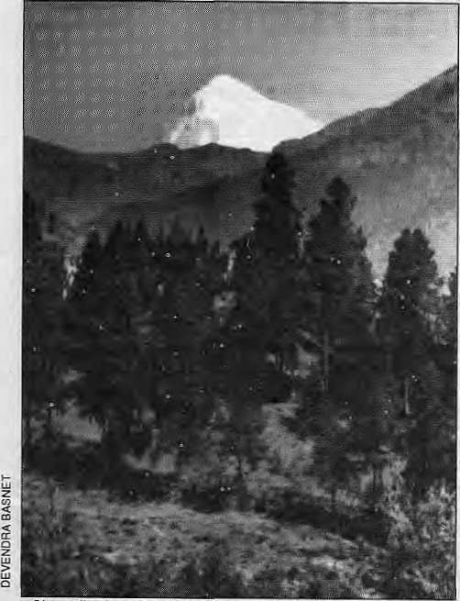
Chomolhari shies away in upper Paro Valley.
meant that the wrath ofgods would manifest itself in bad weather and the spread of diseases. Even as the two expeditions persisted on the mountain; it is said, the weather became unus u a 1 ly hostil e, w i th h ail and wind while the sun still shone. The people voiced their disapproval. One herder told a guide in charge of the acclimatisation camp that this happened every time tourists came near the mountains.
It was from this region, where Chomolhari, Tshering Gang (6532m) and Jirchu Drake stand sentinel over the Bhutan-China border that the first complaints reached authorities in Thimphu, "Chomolhari is the residence of Chomo, the deity who watches over our herds. It is a monastery where we offer our prayers," a representative of the Lingshi herders told Kuensel in 1984.
Historical records show that a British expedition led by Spencer Chapman and Pasang Dawa climbed Chomoihari in 1937.The mountain was climbed again by an Indo-Bhutanesc army team in
3. Colonel N. Kumar (then Captain) reported that his Bhulanese colleague who led the team all the way lo the top refused to slep on the summit, saying "Chomolhari is sacred."
The first mountain to be closed to climbers was Chomolhari, under orders of King Jigme, who did not want to see mountaineering introduced at the cost of the spiritual disappointment of his people.
In the last decade of mountaineering in Bhutan, an average of two groups have been allowed to enter the country every year. Expeditions have attempted Masnang Gang, Namshila (6595m), Kangbhum and Gangkhar Pucnsutn. Other expeditions come to climb the "trekking peaks" which are under 6000m. Prominent climbers who have braved Bhulanese mountainfi include Reinhold Mcssner, who was unsuccessful on Gangkhar Puensum, which did not yield to any climber and is now off limits. A team led by Doug Scott was the first on the top of Jitchu Drake in 1988. "It is one of the harder ice peaks I have climbed," he writes.
Today, with only three mountains open to climbers, the weather in most parts of the Bhutanese Himalaya reportedly holds good, even if momentarily.
h
T. Phuntso is Deputy Editor of the Kuensel weekly, Thimphu.

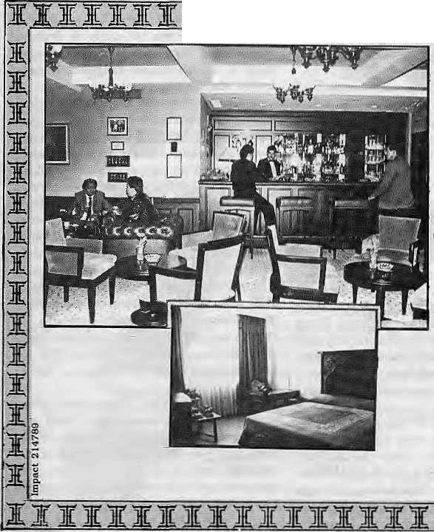
II111 3le % I B:HT:ft 11111II n JIT
Come to the Everest Come to the Best
Everest. The only five star deluxe hotel that offers you your very own Nepal. The traditional hospitality' of its highly trained staff. Touches of Nepal's beauty in its enchanting ambience. The sheer luxury of the rooms with breathtaking Himalayan views.
Dine in the cosmopolitan atmosphere of the 'Cafe.' Enjoy the Chinese and Tibetan food in 'Sherpaland.' Of the delicately spiced Tandoori and Mughlai dishes in the 'Far Pavilion.'
Live up Kathmandu's velvet nights in the 'Himalayan Tavern. Or savour the-atmosphere at 'Bugles and Tigers.' Dance to the latest tunes in Galaxy — Nepal's only discotheque.
Everest has so much more to offer. And a reputation as lofty as Ml. Everest to live up to. Every day. All the time.
The Everest Hotel
Baneswor. p o Bo« 659. Katmandu, Nepal Tel: 2205E7Fai: 977-1-226080 T7<: 22EO HOTEVS NP

Nov/Doc 1992 HIiWAL • 23

Death on the High Himal
The Himalaya has made heroes out of the men and women who have reached its summits and lived to tell the tale. Only climbers have seen the many who did not.

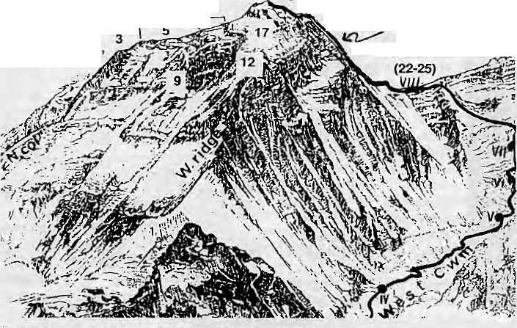
by Dipesh Risal
8848^16,18
"s.. summit (7,8,15,19,20,
(13,14) ^21,26-31)
(Hidden form vtew)
Sotilh Col
1.2
₈₃93steps
10,11
CLIMBER DEATHS ABOVE 8000m ON CHOMOLONGMA.
1 .George Leigh Mallory 2.Andrew Irvine 3.Shao Siching 4.Liu Lien-Maa 5.Wu Tsung-Yueh B.Mick Burke 7. Hannelore Schmatz S.Ray Genet Q.Marty Hoey 10-Peter Boardman n.Joe Tasker 12.Nima Dorji Sherpa 13.Yasuo Kato 14.Toshiaki Kobayashi 15.Pasang Temt/a Sherpa 16,Hironabu Kamuro 17.Hristo Ivanov ProdanoviS.HiroshiYoShino ig.Ang Dorji Sherpa20.YogendraThapa 21 .Kiran Kumar 22.Vijay Pal Sing Negi 23.Ranjeet Singh Bakshi 24.Jai Bahuguna25.M.V. Bhaskara Rao 26,Lhakpa Sonam Sherpa 27.Pasang Temba Sherpa 2B,0usan Bed k 29. Peter Bozik 30Jaroslav Jasko-31 Josef Just 32.Lhakpa Dorji Sherpa 33.Dimitar Ilijevski 34.Phu Dorjf Sharpa 35.Ham Sang Hun SBJunichi Futagami,
Pertemba Sherpa, the veteran Chomo-longma climber, remembers a tragic incident in theptherwise very successful Britishexpeditiontq^Chomolongma,ledby Chris Bormington in 1975. Pertemba and Peter Boardman were on their way down from the summit, when they met another climber, Mick Burke, on his way up. Burke asked to borrow Pertemba's camera and added that he'd catch up with them on his way back down. Pertemba agreed and gave him the camera after quickly finishing the roll of film on shots of Boardman and Burke. Pertemba and Boardman then waited for Burkeon the South Summit for two hours, but he did not return. In fact, the photographs lhat Pertemba took that day were the last to be taken of Burke while he was alive. They eventually found their way into Bonnington's book on the expedition, EvereshThe Hard Way (Hodder & Stoughton, 1976).
The brilliant climbing careers of Peter Boardman and Joe Tasker ended in 1982 while attempting the world's highest peak. There are remarkable similarities between their deaths and those of George Leigh Mallory and Andrew
24 HIMAL ■ Nov/Dec 1992
Irvine, who disappeared together on Chomolongma in 1924 near die Second Step (8600m), Both teams had been climbing in the pre-monsoon season, both from the northeast ridge and both parties disappeared while above 8000m. For the next decade, one more similarity was grimly noted: in neither case was any of the corpses found. But last spring, members of a Japanese-Kazakh joint expedition to Chomolongma found a corpse on Ihe northeast shoulder of the peak. Although the face was unrecognisable, its location suggested that it was the body of either Boardman or Tasker. It was more likely to have been Boardman's body since the its long, straight hair resembled his rather than Tasker's short, curly hair.
Cases like these have been recorded since the turn of the century, when mountaineering in the Himalaya began in earnest, and more frequently since 1949, when Nepal opened its borders to foreigners. Over the decades, equipment and climbing techniques have improved and climbers have narrowed the odds they face by experience and training. Butfataliiies have been the one persistent factor in
mountaineering. At the time of writing, 18 deaths had been reported for 1992. Eleven climbers lost their lives in the spring alone. Eight of those 11 disappeared, including four Korean climbers who had reached the summit of Pumori (7145m). In Autumn, three mountaineers fell to their deaths. Among them was Pierre Beghin, of a French expedition to Annapurn One. Nun Thapa of Kaski District is the only Nepali to have died this year. He succumbed to AMS after having been brought down to Pheriche from Chomlongma Base Camp.
Dangerous Places
Nepal's major peaks have all claimed the lives of climbers but Annapurna One seems to have had more than its share. Before Autumn 1992, 74 people had reached the summit but another 44 had died in Ihe attempt. Frequent avalanches of huge ice-slabs, seracs (towers of ice), and rocks are responsible for the high tol! on the mountain. Perhaps not surprisingly, more climbers have died on Chomolongma than on any other Himalayan mountain. The pfficial toll up to the end of May 1989 was 103 deaths at, or above, Base Camp. Many deaths on Chomolongma occur in the notoriously dangerous Khumbu Icefall, where falling seracs are common.
The main killers in the Himalaya, indeed, in any mountain range, are avalanches, crevasses and huge, steep, mountain faces from which falls usually prove fatal. Other major factors include exhaustion and subsequent exposure, and altitude sickness. Avalanches, obviously not common near the summits, account tor many deaths lower down in the mountains because they can strike groups of climbers. Fifteen people died in an avalanche in Manaslu (8156m) in 1972, and six Sherpas were killed in a glacier avalanche during a Japanese ski expedition to Chomolongma, in 1970. Falls from steep faces and sharp ridges have killed many mountaineers, such as Dr. Jiri Pelikan who fell 2500m on Annapurna One in 1988, K. Kogure on Dhaulagiri in 1978, and Jerzy Kukuczka who succumbed on Lhotse (8516m )in 1989.
Dr. Buddha Basnet, who has made special study of altitude sickness, says: "AMS isn't found in very high altitudes only. In fact, cases of AMS start from about 3,000m." Higher up, the body somehow has to survive the decrease of barometric pressure which not only means that less oxygen is available but that it can lead to the accumulation of fluid in between the cells in the

body. This fluid collects in the lungs and the brain, sometimes together. When fluids accumulate in the lungs, pulmorary oedema, the vicitim literally drowns. Accumulation in the brain, cerebral oedema, leads [o headache, appetite loss, nausea and vomit ing. Severe AMS results in loss of balance and dizziness which increase the risk of falls and other accidents.
The list of disappearances in the Himalaya includes many famous names besides Mallory and Irvine, Boardman and Tasker. Elizabeth Hawley, a chronicler of Himalayan climbing, recalls the disappearance in Kanchenjunga (R586m) of Wanda Rutkiewitz, the 49-ycar-old Pole who had already climbed nine of the 14 peaks above 8000m, In spring this year, she was attempting Kanchenjunga from the North Face when she was forced to bivouac alone at 8300m for the night. For three days, other members of the expedition waited, but she did not return.
Like Rutkiewitz's, every fatality is poignant. Jerzy Kukuczka, the only person apart from Reinhold Messner to have climbed all 14 SOOOer peaks, was to dieon Lhotseon in October 1989. Having left a high-altitude bivouac for the summit, Kukuczka is believed to have fallen from well above 8300m. His body was found the next day at 5400m.
On Manaslu, in May last year, Hans Kamnerlander and Karl Grossrubatscher ran into a thick cloud charged with electricity. They were waiting for visibility to improve when Kamnerlander heard a "sharp popping sound". He was unhurt, but Grossrubatscher was dead with three burn marks on his head. This was the firstreportedclimber death by lightning in Nepal.
During a South Korean expedition to Manaslu in 1971, Ki Sup Kim, the brother of the expedition leader. Ho S up Kim, fell into a crevasse and was killed. Next year. Ho Sup Kim returned to Manaslu, only to be killed himself in a nighttime avalanche. Ten Sherpas and four other expedition members died with him in what was perhaps the worst accident of its kind in Nepal.
The worst accident on record in the Himalaya claimed 16 lives during a German expedition to Nanga Parbat (8125m) in 1937. Seven Germans and nine Sherpas succumbed to a night-time avalanche at Camp Four (6220m). On the day before the tragedy, the party had moved the campsomc50m higher up afterjudging the previous site as unsafe.
S'ow Death
Deathslalkstheclim bers of treac herou s mo u ntain slopes: a slip, an avalanche a lightening bolt can claim a life. Usually, such deaths are swift. But dying can be painful, and injured climbers can linger for days before they finally succumb.
J. Kounicky was above Camp Five, at around 8000m, as part of a Czech expedition to Makalu (8463m) in 1973 when hisoxygen failed. As he removed his mask, Kouuicky fell 100m and broke his back. Companions kept assuring
him that ahelieopler would come to hisrescue.He died a few days later while still hoping for helicopter rescue, after his partner had descended, leaving him with some sleeping pills.
On 3 June 1954, the leader of an Argentinean expedition to Dhaulagiri,Lt.F.G.Ibanez, lost his crampons. Four days later, when help arrived, his feet were already frozen and he had to be lowered by rope down the steep mountain face. His toes were amputated at a village cailed Beni and, when he reached Pokhara on 28 June, part of his left foot had to be amputated. Two days later, he died in a Kathmandu hospital. K. Kogure, who in 1978 led a Japanese expedition to Dhaulagiri, was between Camps Four andFive when he fell. He died still suspended from his rope.
Heroic deaths of mountaineers are usually remembered long after the accidents, with details of how the afflicted tried to survive and get help. Whereas the deaths of expatriate expedition members arc usually publicised and the details made generally available, the many Sherpas who perish in the mountains are often remembered only in one-line statements. Most fatalities among Sherpas and porters occur below the summit approaches — Sherpas while stocking and maintaining camps, and porters while ferrying loads further down. But while these deaths might be frequent, theii details are scarce. The Khumbu Icefall is notorious for taking Sherpa lives.
Bodily Reminders
Those who die at fixed camps, or at lower altitudes, are usually brought below tlie snow line and cremated or buried. AngTshering Sherpa, who now runs Asian Treks, says there is no discrimination between expedition members and Sherpas: "If the bodies are accessible, if ihc physical condition of the remaining members is good and there is no risk of loss of another life, then all corpses, regardless of nationality, are brought down Lo a lower altitude". But a number of factors hinder recovery.
When an avalanche carries away climbers, the search for bodies is made virtually impossible after just four or five hours because the snow sets into ice. The bodies of climbers who have fallen and died in glacial crevasses are recovered only when the corpses arc accessible. Attempts are rarely made to recover bodies lost in accidents above 8000m. The harsh conditions and risk to other team members must also be taken into account. Thus, apart from recovery of bodies al lower altitudes and a few in the 7000m to 8000m range, most bodies left in the mountains.
A striking example is thecase ofHannclore Schmatz, the fourth woman to climb Chomolongma. Schinatzperishodou her descent, in 1979, below the South Summit. Her body could be seen on the southeast ridge above tlie South Col till six years later, the clothes a bit faded but otherwise undamaged. There was no skin in tlie face but the hair wa"s also intact. "'It feels strange to see the corpse of somebody you
know who has been dead for many years," says Pertemba Sherpa, who was sardar of the 1979 expedition. Somewhere in the mid-1980s, the body disappeared, but some parts were later found at the bottom of the South-West Face,
Iman Singh Gurung had a weird encounter while scaling Makalu with Marc Batard. While leading a pitch on the French Pillar at about 8000m, he saw what he thought was a blue sleeping bag, hanging above him. As he came up to the spot, he was suddenly confronted with a corpse, dressed in a blue down suit and hanging upside down from a fixed rope. He recalls thai tlie face was hollow and the hair was a wild mass on the head. Very frightened, Gurung shouted to Batard below, on whose advice he cut tlie rope. Unthelhered, the corpse, stiff and light from exposure, went down the mountainside.
The refrigerating action of snow and ice preservescorpsessuch thai they can remain, with little or no decomposition even years after death. The bodies of climbers who died at high altitudes can disconcertingly reappear many years later at the base of mountains, pushed down and disgorged by the continual deposition of fresh snow. Shifting ice masses have routinely throw up corpses that, for years, were lodged in crevasses. Like many who have been on the Khumbu Glacier, trekking executive Tashi Jangbu Sherpa recalls seeing the remains of those who did not make past the Icefall en route to C horn o Ion gin a's upper regions.
Maurice Wilson was the first to attempt a so loclimbof Chomolongma. Against tremendous odds, he reached the Rongbuk Glacier in April 1934. Over the next six weeks he repeatedly attempted the mountain but died on 31 May, in his tent at the foot of the North Col. The next year, two climbers on their way to the Norih Col found Wilson's wind-desiccated body and buried him in the ice. Then in 1960, his body was rediscovered on the Glacier by Chinese climbers. Wilson's body reportedly crumbled to the touch.
No one knows how long corpses can remain undecomposed in the ice-slopes, although exposure to sun and wind causes more rapid disintegration. The undecomposed corpse of the 'Iceman', discovered last year in a glacier in tlie Alps, is believed to be about 5300 years old.
Given that so many havedied attempting to climb the Himalaya and tlie many that will doubtless succumb on these mountains in the years to come, is it right that bodies be left on the mountains? Are there alternatives? Only climbers really know tlie unrelentingly harsh conditions at the high altitudes. Searching for and recovering corpses is not without risk, so the safety of surviving members is a clear priorily. Climbers arc perhaps resigned to the notion that death and an eternal stay on ihe high snows may be the price they pay for daring to challenge one of Nature's mosl formidable creations.
D. Bisal is a Kathmandu-basGd writer.

Nov/Dcc 1992 HIMAL • 25

Messner the Myth Maker
ReinholdMessner has marketed the concept of the Himalaya as a "dream factory" only too well.
He is better-known throughout Europe than any Asian politician. Whether or not he is a good
ambassador of the people of the Himalaya is for the people of the Himalaya to decide.

I
f you ask school children in Austiia or Germany about the Himalayan region, the first world that they will eagerly mention is "Messner", and follow it up with a cliche from the late 1980s: "He's there looking for the Yeti." On the subject of Nepal, they know that it is "the country of Everest", the highest mountain in the world, and that there is a lot of garbage lying around there. With regard to the people of Nepal, India, Pakistan, Bhutan and Tibet, they have very little idea. Ask any adult, and you do not get much more satisfaction.
How did discovering the Yeti and the rubbish dumps on Chomolongma Base Camp come to be regarded by Europeans as among South Asia's most urgent problems? Part of the answer, perhaps a major part of it, is Reinhold Messner, a story teller with a mass audience.
The Himalaya had existed for 120 million years ...then along came Reinhold Messner. He did manage to be the first person to make it to the top of all the world's 14 peaks that are above 8000m. But, even more significantly, he has managed to implant his ideas of theHimalayaon the minds of hundreds of thousands of people in a way that few other adventurers have. His books were read like the Holy Scriptures. Many Europeans gain their secondhand knowledge of the Himalaya through them.
Reinhold's Ascent
Messner is now 48. He was born in the South Tyrol mountains of northern Italy bordering Austria in 1944, when the star of the Axis powers was on the wane and this region, like the rest of Europe, was about to undergo massive reorganisation.
Messnci grew into adulthood in the 1960s, when university students were rising up in revolt against militarism, and against those of the older generation who had tlirived under the National Socialists and had yet to come to terms with the present. The youth of the 1960s, Messner included, had had enough of the rigid and inflexible ways of the older generation of politicians. In one interview Messner even conceded that had tilings turned out differently, he might well have become a terrorist. But in die end, he chose the gentler path —- rock climbing in his native Dolomites.
Since the beginningof the 19th century, the military and the nationalists had dominated
26 HIMAL • Nov/Dcc 1992
by Gerald Lehner
mountaineering in Europe and climbers spoke their language. Like the adventurersofthc British Raj, German climbers in the 1930s littered their language with words such as fight, conquest, battle, victory and defeat as they thrust their ice-axes into the heart of Asia in the name of Adolf Hitler. Even after World War II, the expedition reports in Germany, England, Italy, France and Switzerland continued to read like battle campaigns. National flags were among Hie most important icons to be carried on expeditions.
Only in the United Stales, it seemed, was climbing regarded as a non-military sport and as a symbol of free and liberal thinking. A product of the 1960s university culture, Messner similarly rejected the regimen tedideology of theEuropean expeditions. As he gained experience in the Dolomites, he discarded the traditional method of rock-climbing 'by force', where the climbers of the day used as many technical aids as possible to reach the top. In the new thinking that was taking hold, one's own body.one'sown thoughts, strength andperserverance were more important.
These days, Messner likes to call himself the "inventor" of that new thinking. He certainly was one of the pioneering world-class climbers who succeeded ill communicating the new idea of the climb to the masses. He is also among those who later started a revolution in the Himalaya with their top performance — which made large seige-style expeditions, rivalry in equipment and nationalism all passe. Sadly, every revolution consumes its leaders, and Messner proved no exception.
Most of Messner's earlier mountaineering colleagues are no longer friends of his. Many claim to have suffered under his egoistic behaviour and lack of consideration. Messner defends himself by maintaining that these are but individuals envious of his achievements. Hans Kammerlander and Friedl Mutschlechner (who died two years ago), both from South Tyrol, were the only ones to have maintained a longterm friendship with Messner.
In 1989, Messner and the German explorer ArvedFuchs crossed Antarctica on foot, but their great achievement was soon forgotten in a flurry of accusations and recrimination. Messner had given a German magazine the exclusive rights to his diaries in which his partner, Fuchs, clearly came across as a weakling. The reporter never bothered lo check wilh Fuchs. The words of
Waller Bonatti, the Italian who was one of the world's bestclimbers of the 1950s, sums up what many erstwhile colleagues feel of Messner: "All the success could have been more enjoyable and of greater significance and could have been more convincing, were it not for the publicity surrounding Messner."
The ace climber still sports long hair, and sometimes he wears colourful 1960s clothing. But he has long been a willing part of the establishment of Western consumer society. He advises businessmen on surviving under hard conditions and sells him self as well as the products of multinational companies by appearing in their advertisements. It is fashionable in the West to compare hard business with survival in the wilderness — Darwinism in marketing, whose best proponent is Messner.
Tyrolian Yak-Herder
On television, this world traveller and image-builder describes himself as a semi-nomad or, somclimes, as a mountain-farmer. You could take it as a joke, but he is dead serious. On closer examination, the only Ihing that would justify' this master of a castle in the Tyrol calling himself a mountain-farmer is the fact that he keeps a few yaks (imported from Nepal) on his estate.
Among scholars of contemporary European culture, Messner is considered one of the founders of an industry which has mouldedpopular images of Asia since the 1970s. IfEuropeans regard the mountains of Asia as mystical adventure playgrounds in which they can act out their ego-trips, it is because of the en tire tourism industry's message and its use of Messner as prophet. Contemporary writers present a rather idealistic view of the Himalaya to their Western readers.
Messner, despite his self-appointed role as the region's ambassador to the West, has done nolliin'g to counter the stereotypical image of Himalayan peoples as sturdy primitives who are always religious and/or friendly, making a meagre living in harmony with their surroundings. Even in today's Himalayan climbing literature, there is glorification of the 'good Sherpa' — a concept which in the view of Viennese anthropologist, Christian Schicklgruber, contains elements of "positive racism".
In describing the Sherpas as the content denizens of Shangri La, Messner omits any description of social conflicts—the mechanisms

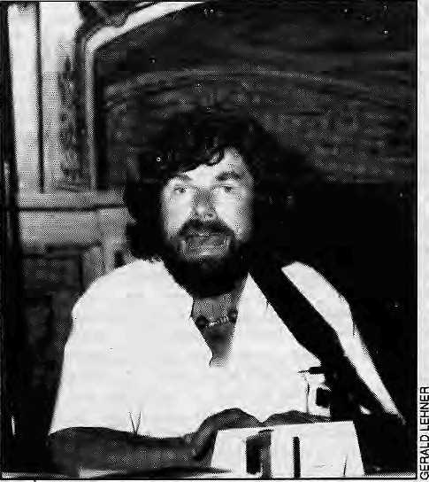
Reinhold speaks for (he Himalaya- Or does he ?
of exploitation, poverty and oppression thai pervade Himalayan society. The impression derived from Messner's books is that the Sherpa world is still intact. Like other mountaineering writers, he has failed to describe the severe cultural strain from the very expeditions and climbers that have brought the rest of the world into the lives of the inhabitants of the high Khumbu.
The real internal turmoil in the Khumbu docs not fit with Mess ner's vision of a seemingly intact Sherpa world. Numerous young Sherpas today think only of making quick money from tourism and fail to pursue studies. Quite a few are fleeing the country and immigrating to the United Stales, Canada or Japan. One young university graduate confessed that the social climate in the Khumbu was becoming unbearable. "Many of us no longer understand the world we live in. We have forgotten our traditions, customs and crafts,"
None of this, of course, makes its way into the climbing magazines, even though it is mountaineering (with trekking riding its coat-tails) that wrought the dislocation of Sherpa life in the Khumbu. Even while they ignore the complicated issues of cultural inundation and conflict, however, it is fashionable for contemporary climbers and authors to draw attention to environmental problems in the Himalaya, And in this Messner has been no laggard. While continuing to paint beatific pictures of Himalayan culture and society, he has been peddling the old wine of environmental degradation on the lecture circuits of Europe and North America. But he talks not of the deforestation and top-soil loss of the lower, populated hillsides, where you would perforce have to taJkabout/)ec>/)/e. Instead, for the past few years, Messner has been selling the idea of'White Wilderness" (his term), the snowy ranges of the world which needs preservation.
In his multivision shows, Messner often speaks of the need to protect nature. His photographs are always great, but his narration is simplistic. In addition, Messner always tends to project his own personality and has no activist words — unlike the 65-year-old mountain man Karl Partsch, who works in forestry projects, fights for the Alps at ground level, and is in contact with international movements and Native Americans in various crusades. Messner only talks in banalities about the White Wilderness.
Messner the Myth Maker
Messner illustrates one of his books with drawings by the Sherpa painter,. Kapa Gyalzen, from Khumjung village. "However, the artist is not even mentioned on the cover of the book. In this very place, Khumjung, and its sister-village, Khunde, one hears of polite dissatisfaction when the subject turns to Messner. Some men who worked in his earlier expeditions make no secret
of the fact that they are greatly disappointed by him. There was some talk in the beginning that Messner would be involved in development projects, much as Edmund Hillary is. "Messner makes promises which he does not keep...No good man," says one Sherpa elder.
Messner, however, gives the impression to his European reader that the Sherpas consider him one of their best friends. "Many thought of Messner as one of them," we learn from his wonderfully illustrated 1987 book The Way to Cho Oyu, The Sherpas are thus dragged in to be part of the cult following of the mountaineer. Incidentally, he opens the book with the rather immodest use of a quote taken from Tibetan Buddhism: "Lhagyelo — the Gods have won victory." Only two pages of the 240-page book deal with the natives of Nepal and Pakistan, on whose 8000m mountains much of Messner's fame rests.
It speaks volumes about Messner's public relations acumen that he continues to be regarded as a world champion when other, younger climbers, have set standards that have far bettered Messner's own. None of younger European
mountaineers, such as the Slovene Tomo Cesen, on the Lhotse South Face, have been able to snatch even a small portion of aura that continues to surround Messner. In fact. Messner's decades-long publicity blitz has so saturated the sponsorship market that newcomers are facing great difficulty finding companies to support expeditions to the Himalaya.
Last summer, in a castle called Goldegg in the province of Salzburg, Messner took it upon himself topublicly criticise the increasingly rapid destruction of the Alps. To some, this smacked of
hypocrisy, coming from a person who had done the most with his commercial endorsements and publicity of his dramatic exploits to drive the masses to the mountains. Harald Krcmser, manager of Austria's national nature reserve Hohe Tauern, pointed out from the audience thai Messner was actually both a beneficiary and proponent of mass tourism in ecologically sensitive areas such as the Alps and the Himalaya. He wondered if it was possible for Messner to take a back seat and do without all the publicity. Messner's answer to Kremser was telling of the man and his ego. "You want me to commit suicide? I am not responsible for those who imitate me. If I did what you ask of me to, it would mean my death. I can't help it. I have to fight my own way through the wilderness."
Messner is not even shy of providing impromptu political analysis of the Himalayan region when required. In early 1990, with Nepal in the midst of the JanaAndolon, the newsroom producers at Austrian television could think of no other than Messner to provide a review of the Pane hay at politics. By character, Messner is not one to t>3ck out when the TV cameras beckon. "You are thought of as a friend of the King of Nepal. Please tell us about what has happened in Kathmandu," said the newsman. Messner, who would hardly deny imputation of friendship in high places, made a valiant effort but in the end, understandably, his commentary lacked depth and understanding of Nepali politics.
G, Lehner, from Austria, is a mechanical engineer and journalist. He is studying Communications Theory at the Univeristy of Salzburg.
Jerzy Kukuczka was no friend of the King's. For a long time, this dedicated mountaineer from Poland was given the run-around by officialdom — in Nepal and in his own country. Kukuczka worked in factories and tortuously saved precious hard currency in order to finance his expeditions to the Himalaya. He had no rich sponsors, no outreach to the Western media, and no friends to call on in Nepal, where he came and went with little fanfare. But lack of publicity did not stop this best of the new breed ofclimbersfromclimbingalltlieSOOOm peaks the year after Messner completed the feat. And many of Kukuczka's climbs were winter climbs, unlike Messner's, and most of the routes more daring. His modest first and only book, My Vertical World, had not yet been published when Kukuczka fell to his death on the South Face of Lhotse on 24 October 1989. Messner honoured him by writing, "You are not second. You are great."

Nov/Dcc 1992 HIMAL • 27

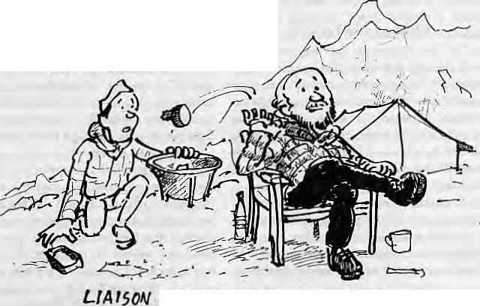
The High Profile Dump
How big is the problem of littering on Chomolongma? by Lhakpa Norbu Sherpa
AHEM, &*£....THE TRASH---£R... HEKF —
OFFICER COUfROUTS* 5AH£B
How big is the problem of littering on Chomolongma? Il depends on one's viewpoint. To a mountaineer, litter on Chomolongma is a big problem because no climber likes to reach the Fourth Pole only to stumble over discarded junk mat originated in Europe and Japan. But then, who is to blame but the mountaineers?
To local residents, the question of litter on the High Himal is not a big issue because they have no business to go up there unless paid to do so by a foreign expedition. It is an oui-of-sight, out-of-mind matter for most. For the decision-maker in Kathmandu, littering is an evil if it threatens the tourism industry. Otherwise, it is not a big deal compared to escalating pollution within Kathmandu itself. For unscrupulous climbers, mountain clean-ups provide an excuse for fund-raising at a time when sponsorships for climbing expeditions seem to be drying up. And then there arc the well-meaning, who devote their own time and money to fly halfway around the world to pick up someone else's trash. The only problem is that so much money is spent on a token gesture.
Cleanup Crews
The problem is not in perspective. There have been more than adozen national and international cleaning teams on Chomolongma. They range from school and scout groups to full-fledged mountaineering expeditions. Each team reports on the tonnage of garbage removed and papers are presented at seminars and conferences. Prominent mountaineering figures such as Edmund Hillary have suggested a moratorium
28 HIMAL • Nov/Dec 1992
on climbing Chomolongma. Although each clean-up campaign must have had some positive impact, none have shown the promise of a long-range solution. We must realise that littering on Chprnolongma is neither a problem of finance nor of labour shortage. It is an ethical and an organisational problem. So long as climbers continue to dump litter, the erratic and uncoordinated cleaning campaigns will only contribute to painting a negative image of the area. The Nepali authorities must come up with a sustainable and practical control programme.
Such a programme must include educational, regulatory and institutional measures. The commitment of die Government, businesses, mountaineers and local people is vital. There will be no commitment, however, unless the problem is recognised and its consequences clearly understood by all concerned. Perceptions of pollution vary. A lama from alocalmonastcry.forexample, once pointed out to a Western climber tliat pollution at base camps are of little consequence when there was spiritual pollution to consider.
From the perspective of tlielocal inhabitants of the Khumbu, the declining agricultural and pastoral productivity, inflation, shrinking forest reserves and rapid cultural erosion are of equal concern, if not greater. These problems may not be as visible as the toilet paper strewn around camp sites but are far more insidious and lasting in terms of potential human and environmental consequences. The environmental and cultural problems of the Khumbu region must be addressed in an integrated manner and attempts to deal with only aponionof it by riding the wave
of publicity will not only prove ineffective but will have negative consequences.
Over-exposure of the litter issue must not be allowed to obscure other environmental and socioeconomic concerns. For example, the influence of outside cultures is rapidly eroding the attributes of Sherpa society. Cultural features such as dialect, folk songs, dances and rituals are in decline. While human society must and always does evolve, unique cultural attributes should not disappear without trace. The monasteries mat once sustained themselves with popular support are now rife with internal conflict as they try to adjust to changes brought by forces external to Sherpa society. The ill effects of rapid social change are becoming apparent to those who are prepared to recognise them.
The highland forest and grassland ecosystems are increasingly stressed by human demands. The need for improved planning and management of natural resources is ever greater as the resource base shrinks and demands continue to grow. Littering can be prevented or removed but biological andcukurai values are much more difficult to recover. The natural ecosystems and human cultures are, after all, living components of the mountain landscape. If their survival is not ensured, even the cleanest of mountains are, as George Schaller's says, merely "stones of silence".
Over-stressing a single issue can force authorities into taking rash legislative and financial decisions. Recently, for example, the GovernmentofNeral decided to raise the royally for climbing Chomolongma five-fold. This was a strong measure, but not necessarily the most suitable measure. It is all very well for the Government to trade five small expeditions for one high-paying expedition with the hope of reducing pollution, but what impact will this decision have on the citizens who rely on climbing-rela ted employment? For lackof be tier alternatives, a sizeable portion of the mountain population is today dependent on climbing jobs.
Mountains are more than rental assets. And did the Ministry of Tourism exhaust all management alternatives to deal with thepollution before it decided to raise fees, cut climbing opportunities and reduce jobs? Are the recent measures supported by detailed impact assessment, or was tue Ministry simply yielding to media pressure?
Trashing Chomolongma The slopes of Chomolongma are obviously not thenormal human environment. Climbers require special equipment and supplies (oxygen, ropes, pegs, special clothing, tents, packaged and canned food) for survival in this 'hostile' arena. While the need for survival equipment grows with higher elevation, the extreme conditions greatly impair normal physical and mental performances. Concerns for safety, egocentricity, sorrows, joys, tension and longing for home and family often dro w n o u t th e concern a cl imbe r m ig ht o th erwis e

Learning the Ropes
Guides' associations would ensure that native climbers make more money and make high-mountain tourism safer and more popular.
by Roddy Mackenzie

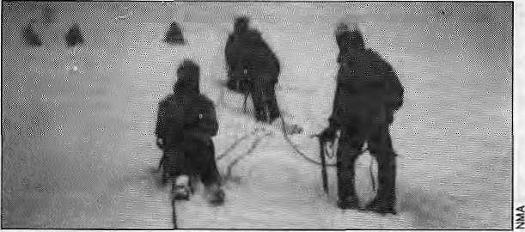
Trainees of the NMA's Manang mountaineering school take a breather.
I
n the past. Western tour operators took a large share of the profits from organised treks. The advent of the fax machine and the growing profession alismoflocal agencies have, however, helped local operators to bite inlo the market. Western businesses have had to find new pastures and have moved to areas which presently lie beyond the expertise of local operators. These include the packaging and sale of alpine pass crossings and the smaller 'trekking peaks'. Bui, as the number of Western tourists travelling lo ihc Himalaya continues to grow, in line with the increasing leisure time available in the West, local agencies may increase their share of this market, loo.
In many cases, foreign operators have been running these trips with a margin of safely that would not be considered prudent (in terms of litigation as well as actual safety) elsewhere. But to give specific details might be considered libellous. In general, most countries that have major mountain ranges also have a local guides association that is responsible for Iraining and assessment of guides. The pre-eminent body in this field is the Union Internationale des Associations des Guides de Montague. The UIAGM has the highest standards of guide training in the world and winning its recognition ensures high pay for guides and high standards for clients. This highly increases the benefits of high-mountain tourism. UIAGM guides are paid between U$ 130 to 200 per day, whether they are Peruvian guides or French guides, hi the Himalaya, I have never heard of a guide being paid more than about U$20 per day (and that, too, in rare cases).
The further development of mountain tourism in the Himalaya is likely to follow the trends set overseas. These are of increasing professionalism at all levels.
Trekking guides wili increasingly have to learn about botany, history and the social sciences. Locals will have an edge on these matters if the job is approached professionally. High-mo mi tain activities will expzmd as the Western public begin to recognise that high standards of safety are also on offer in the world's greatest mountain range.
Guides' Association
The formation of a guides' association in the Himalaya would raise these safety standards and increase wages. Currently, the professional guides in the Himalaya are excellent and unsurpassed in their fields but lack formalised training incertain technical areas (parts of climbing and first aid and medicine) and various modern guiding techniques. They are also frequently unable to project authority to foreign clients in a confident manner as they are frequently socially unsureof themselves with Westerners. Formalised training and assessment could fill these holes and produce top quality guides who would outshine the imported Westerners. I have often seen Western guides hopelessly out of their depth in the Himalaya where local knowledge and contacts count perhaps more than in any other range. If a professional mountain-guiding service existed as in the other major ranges of the world, a number of bureaucratic changes would be
30 HIMAL • Nov/Dec 1992
needed. The current system of Liaison Officer allocation for expedition is flawed. The LOs are frequently from low-country communities and feel out of place in the high country. They generally become good friends with their foreign wards and frequently feel hesitant to enforce punitive measures to ensure expedition compliance with environmental protection laws. The LOs arc often inexperienced in the mountains and can inadvertently put either themselvesor the expedition at risk.They arealmost never professional mountain guides and know little about rescue procedures (which is supposed to be part of their role). Paying and equipping LOs creates a significant financial burden for smaller expeditions, for example one which is engaged in a guided ascent of a 6500m peak.
Roving Patrols
Far better would be a roving patrol of mountain professionals, who would be permanently based at a high-altitude post. Such patrols could act as a clearing-house of information and would have no qualms about enforcing laws. The members would become storehouses of local information. Moving from base camp lo base camp, they would be able to advise on previous avalanche occurrences with reference to siting of base camps and
other camps (this would have saved several lives in October 1987 at the Island Peak base camp). A radio at their base of operations could provide a rescue back-up service.
The other change required for high-altitude guiding to succeed would be a relaxation in the procedures for issuing permits. By this, I do not mean scrapping of the peak fees but that permits for peaks without
ice-fall problems, and other factors that restrict numbers, should beissuedon the spot on a first-come-first-served basis, as is the case in every other range in the world.
A professional guides service would also increase winter ski touring potential. At present, the avalanche danger precludes amateur ski touring in much of the Himalaya, although there are many excellent venues for superb ski tours. Proper guiding with suitable back-up could provide winter income for much of the western Himalaya.
A guide's association can only come about through the efforts of the guides themselves. Training overseas is desperately expensive (about US 12,000 in fees alone) and would take about three lo five years to complete. The only realistic option is the formation of local associations in the Himalaya that are stable and have high enough standards to gain UIAGM recognition. In general, government assistance is a backward step as political interference is never very far behind governmental involvement in this part of the world. Nothing could be less conducive to client confidence than a scandal about political interference in guide assessment programmes.
R.Mackenzie is a Chomolongma summitteer and partner in a firm that has pioneered heli-skiing in Himachai Pradesh.

Learning the Ropes
Guides' associations would ensure that native climbers make more money and make high-mountain tourism safer and more popular.
by Roddy Mackenzie

Trainees of the NMA 's Manang mountaineering school take a breather
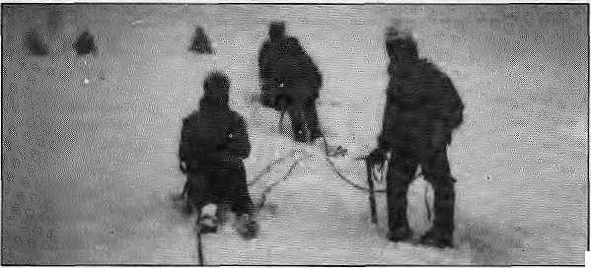

I
n the past Western tour operators took a large share of the profits from organised treks. The advent of the fax machine and the growing profes si on alism of local agencies have, ho we ver, helped local opera tors to bite inlo Lhe market. Western businesses have had to find new pastures and have moved to areas which presently lie beyond the expertise of local operators. These include the packaging and sale of alpine pass crossings and the smaller 'trekking peaks'. But, as the number of Western tourists travelling to the Himalaya continues to grow, in line with the increasing leisure lime available in the West, local agencies may increase their share of this market, too.
In many cases, foreign operators have been running these trips with a margin of safely that would noi be considered prudent (in terms of litigation as well as actual safety) elsewhere. But to give specific details might be considered libellous. In general, most countries that have major mountain ranges also have a local guides association that is responsible for training and assessment ofguides. The pre-eminent body in this field is the Union Internationale des Associations des Guides de Montagne. The UIAGM has the highest standards of guide training in the world and winning its recognition ensures high pay for guides and high standards for clients. This highly increases the benefits of high-mountain tourism. UIAGM guides are paid between U$ 130 to 200 per day, whether they are Peruvian guides or French guides. In the Himalaya, I have never heard of a guide beingpaid more than about U$20 per day (and that, too, in rare cases).
The further development of mountain tourismin the Himalaya is likely to follow the trends set overseas. These are of increasing professionalism at all levels.
Trekking guides will increasingly have to learn about botany, history and the social sciences. Locals will have an edge on these mailers if the job is approached professionally. High-mountain activities will expand as the Western public begin to recognise that high standards of safety are also on offer in the world's greatest mountain range.
Guides' Association
The formation of a guides' association in the Himalaya would raise these safely standards and increase wages. Currently, the professional guides in the Himalaya are excellent and unsurpassed in their fields but lack formalised training in certain technical areas (parts of climbing and first aid and medicine) and various modern guiding techniques. They are also frequently unable to project authority to foreign clients in a confident manner as they are frequently socially unsureof themselves with Westerners. Formalised training and assessment could fill these holes and produce top quality guides who would outshine the imported Westerners. I have often seen Western guides hopelessly out of their depth in the Himalaya where local knowledge and contacts couni perhaps more than in any other range. If a professional mountain-guiding service existed as in the other major ranges of the world, a number of bureaucratic changes would be
30 HIMAL • Nov/Dec 1992
needed. The current system ofLiaison Officer allocation for expedition is flawed. The LOs are frequently from low-couniry communities and feel out of place in the high country. They generally become good friends with their foreign wards and frequently feel hesitant to enforce punitive measures to ensure expedition compliance with environ menial protection laws. The LOs are often inexperienced in the mountains and can inadvertently put either themselves or the expedition atrisk. They are almost never professional mountain guides and know little about rescue procedures (which is supposed to be part of their role). Paying and equipping LOs creates a significant financial burden for smaller expeditions, for example one which is engaged in a guided ascent of a 6500m peak.
Roving Patrols
Far better would be a roving patrol of mountain professionals, who would be permanently based at a high-altitude post. Such patrols could act as a clearing-house of information and would have no qualms about enforcing laws. The members would become storehouses of local information. Moving from base camp lo base camp, they would be able to advise on previous avalanche occurrences withreference to siting of base camps and
other camps (this would have saved several lives in October 1987 at the Island Peak base camp). A radio at their base of operations could provide a rescue back-up service.
The other change required for high-altitude guiding to succeed would be arelaxation in lhe procedures for issuing permits. By this, I do not mean < scrapping of the peak fees but ^ that permits for peaks without ice-fall problems, and other factors that restrict numbers,
should be issuedon the spot on a firs I-come-first-served basis, as is the case in every other range in the world.
A professional guides service would also increase winter ski louring potential. At present, the avalanche danger precludes amateur ski touring in much of the Himalaya, although there are many excellent venues for superb ski tours. Proper guiding with suitable back-up could provide winter income for much of the western Himalaya.
A guide's association can only come about through the efforts of the guides themselves. Training overseas is desperately expensive (about US 12,000 in fees alone) and would take about three to five years to complete. The only realistic option is the formation of local associations in the Himalaya that are stable and have high enough standards to gain UIAGM recognition. In general, government assistance is a backward step as political interference is never very far behind governmental involvement in this part of the world. Nothing could be less conducive to client confidence than a scandal about political interference in guide assessment programmes.
R.Mackenzie is a Chomolongma summitteer and partner in a firm that has pioneered heli-skiing in Himachat Pradesh.

The Trouble with Indian Mountaineering
Indian climbers are good enough to climb with the best in the world, if only they had equipment to match their abilities.

I
t all started 20 years ago with a small announcement in the a Pune daily newspaper that a club was conducting a thiee-day rock climbing camp at Sinhagad, a nearby fort. I signed up, and climbing promptly became an obsession for me, as it was then becoming with thousands of individuals all over India. 1 completed a basic mountaineering course in 1971 at Manali, and an advanced course at Uttarkashi, in 1973. Already, a few other women from Maharashtra and Gujarat were into mountaineering, andwejoinedforcestoform the first women's climbing club in India.
Over two decades of climbing in the Indian Himalaya,I have come to the conclusion that this is a sport for rich people, or for those who have the time and capacity to raise funds. For the average Indian climber, thequestion of equipment and funds are great hurdles to mountaineering, far more than physical fitness and climbing acumen. Every time we have planned an expedition, the first worry has always been equipment. We used to hire one pair of boots from one climbers' club, and another from the Maharashtra Mountaineering Club. The equipment that we were able to gather was often of very poor quality. Over the last few years, we have been able to purchase some secondhand equipment from Kathmandu. Now, climbers of the next generation have started landing at oui door, desperately shortof equipment and asking for help. And so it goes on.
The number of Indian climbers lias grown dramatically, but the equipment manufacturers have not been able to keep up. Up to three decades back, the Indian Ordinance factories used to manufacture equipment for use by climbers, but that sourse seems to have dried up. Today, a few private companies as well as Himalayan Mountaineering Institute in Darjeeling have started producing tents, sleeping bags, down jackets, windproof suits, mittens and soon, butthe quality is nothing like what we have seen coming from abroad. For example, Indian manufacturers use chicken andduck feathers for sleeping bags and jackets, which is no match for eiderdown. Indian mountaineering gear is adequate for expeditions to below 7000m peaks but will not do beyond that.
With regard to hardware such as pitons, karabiners, ice-axes and crampons, the private sector has been unable to develop the required equipment, even though there is a large and growing market among the mountaineering institutes and the many small and medium-sized
by Usha Prabha Page
expeditions to the Himalaya every year. The equipment stores of the the climbing institutes and the Indian Mou ntaineering Fo undation (IMF) have been unable to meet the growing demand. Just getting a pair of snow goggles can bean all-consuming. We do read and hear of modern equipment available in the West, but if independent Indian climbers have one thing in common, it is that they are always short of cash. Afewyearsback,climbersofourclub,Giripremi, were on Shree Kailash with just enough equipment, they hoped, to see them through. However, the weather turned bad, and the old tent got torn up, with the result that one of the climbers had to have her toes amputated.
It might sound simplistic, but the future of Indian mountaineering depends upon more, and better, gear made available to the average climber. Indian mountaineers are good enough to climb with the best in the world, if only the equipment could match their abilities. Often, the spirit, urge and ambition dies at the planning stage itself, right at the equipment store.
How have trends worldwide affected the cloistered world of Indian mountaineering? To begin with, the light-weight alpine style is also catching on here. As far as my observation goes, the lack of extreme individualism among most Indian climbers means that, even though they are gaining in technical skills, they will, by and large, continue with the expedition-style and the team spirit that is inherent in it.
There lias been ahealthy change in attitude towards the mountains. Though the fascination with the highest mounlain lingers, more and more climbers arc opting for technical variety in their climbs, and the height of the massif is getting to be less of a consideration.
A point for consideration: the IMF is a body formed for the cause of mountaineering. But it is dominated by military personnel. It is responsible for coordinating the flow of Himalayan expeditions, both national and international. The Foundation arranges for Indian expeditions to receive the Inner Line permit and has actually acquired the status of a 'parent body'. Foreign expeditions la India all submit their climbing reports, including maps and pictures, to the IMF, but these are never made available to Indian climbers, nor are they published in the IMF's Indian Mourilaineer or elsewhere. Publication would greatly help Indian expeditions to make their climbing plans. The IMF could also help by having a project to make available good maps of the mountain regions.

;"^{S}S'-f' ■'■ ^ /*■"■■■■■?
■n
Shivling, one of the harder peaks. A private Indian expedition's canvas mess tent is seen at bottom left.
Over the years, I have noticed that due publicity is not given to climbing activity. Those expeditions that get coverage are of climbers with contacts in the press corps, while most climbers are too busy to find the time to garner publicity as a means of fundraising. Whatever the case, the press must be sensitised so that it is properly able to report on a sport thai is attracting an increasing number of Indians.
Despite this litany of problems, every year Indian climbers continue their dramatic advance on the Himalaya. Indian climbers have followed Chomolongma and Kanchenjungha with Shivling (6574m), Annapurna III- (7555m), Mrigthuni (6855m), Changbang (6844m), Mamostong Kangri (7518m), Vasuki Parbat (6792m) and Satopanth. Chomolongma has been climbed twice by Indian women, among whom the leading climbers are NandiniPandhya, Meena Agarwal, Bacchandri Pal, Chandra Aitwal, San tosh Yadav, Jurity Birdi andRekhaSharma. There was a time when women from Gujarat were in the forefront of Himalayan adventures, but now West Bengal is leading, followed by Maharashtran women from Bombay and Pune.
UP.Page is Station Director of All India Radio in Pune and member of tha climbing club Gmpremi.
Nov/Dec 1992 HIMAL • 31


■

BRIEFS

Little Lama_{r}Big Bother
Aloilrist in hisown city:: a Bhaktapur ih^
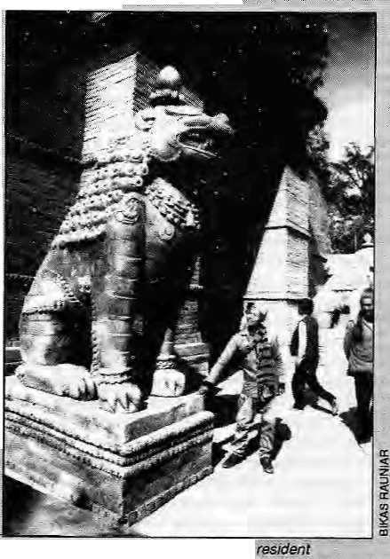
For a while there, Kathmandu was in the midst of Bertolucci-feyer. The IWlian4i*ector of extravaganzas was shooting a fSm based on' the' " life-and-times of a Western incarnation of a local riripoehe who, in turn, is taught in flashbacks about the Sakyarauni's bad to Buddhahood.
A good enough story line to cash in on the global craze far Himalayan Buddhism, one would have thought. But even before the plaster-of-Paris props at (lie ' Btiaktapur Durbar Square had dried, there was trouble for the U$ 20 million^pjus project.
Kathmandu -based Buddhist activists, who have been finding a voice since Democracy was reincarnated in the Land of the Buddha, took strong exception to the film's tttle,£j»/e Buddha.
Oxford Brownbags
"Politics, Identity and Cultural Change In the Himalayan K-egfon." Weekly seminars organised by ftm Institute pf Social and Cultural Anthropology, Oxford University,
If you happen tn be in London on a.Thursday, then consider hopping over to SI Banbury Road, Oxford to make It in time for the 4:30 p.m. seminars focus) ng on difTe ren t aspects of Himalayan life. Recent topics have included Hjndulsation and tfe-Hinduisaticn in the contextof Nepali politics, the social organisation of now ads in eastern Tibet, minority politigs of the Kaiasha of the Hindu Kush. Tamang identity and the cow as a symbol of national Integration in Nepal, Call (0865) 274687 or fax 274630.
Himalaya Ganga
Cooperative Development of Himalayan Water Resources 27-28 February 199? Scholars, politicians and scientists of Swill Asia and elsewhere are to come together for two-days of problem-solving In Kathmando. The Kathmandu meeting win study the tapping of the enormous economic potential of the Himalayan tributaries
Hewingvclose to literal i '■"■"they derii anded to know how the Bi.uddh a cauld ever be considered "Httie'\ They also seein<3 upset over theportrayal of the young
:Siddhartha as a rom^ritic4ly ... inclined prince. Even some nationalist sentiments were whipped up over the film script's reference to ''ancient India" 3s the birthplace of tlie Saiyarauai.: NVhy_{T} that has to fee Nepal!: ■■■■■
Shooting began oh"20
September, "but Buddhist groups
. demanded that it be suspended at
once. So a delegation of 39 '"
Buddhist: organisations and
representatives qf Bertpllu^ci's
Sahara Company met for :
iiegotiatioRS Under the good : offices of Nepal's Tnfoftnation ". and Corhmunications Minister, Bijaya kumar'Gachhsdap;
The scene at the Minister's
of the Ganga, which the organisers calt coHcctfvely the "Himalaya
Contact: Ajaya Dixit, Nepal Water ■ Conservation Foundation GPO Box 222J,Kathmandu
"Bhutan; A Traditional Order and the Forces of Change*
Organis«d bj the School of Oriental aJiA African Studies (SOAS) This .'frill -probably be the first conference on Bhutan organised in Europe, According to the organisers If will, among other things, look atthc institution of- monarch)¹, impact of Western Ideas of tourism and conservation, tradifioiial Bhulanesc historiography, language policy, Bhutanese diplomacy, and "an attempt al an objective assessment, of the ^Southern Problem'". Among the confirmed participants wilt be LeoK. Rose of the University of California, Nick Nugent of the BBC, Michael Arts of Harvard University, Cornell le Jest of CNRS in Paris and Brian C, Shaw of Hong Kong.
Contact: Mithae!J.Hutt,SOAS.Te!; 71 637 2388 Fax 71436 3S44
''"high-ccilihjged SinghaDiicbar "chambers could weU have provide the directc* mthfflatetia| fpryet 1 another blockbuster, Buddhist sfalwarts Surya Bahadur Shakya, Asha R am Shaky a, Eok Dju-sifian '"'. Bajracfiarya ind Ieftwi MPJit Bir Lama, representing ft cross-'' section of
Nepali...
Buddhistv
soeietyi :
confronted
Producer
Jeremy
screenp|ay writer Mark Pepltme (Beftelucci was absent even though h& :is:cred:ited with the story line.)
I .. At first,-: "^
the filmmakers : stood their grourti. Tpie story is based or Buddha CUdrittahy... ....
AsWa Ghosh, they said,. The. script had been "extensively researched" > arid scholars and lamas had
been consulted since the inception to ensure authenticity, Outside the chambers^ the mood of the flag-carrying Buddhist supporters was ■ turning ti^sty:
Thomas and Eeplone looked at each Otiier resignedly and seempd-to tactically decide fe give in completely. Okay, tltey said, we will change the title lo The Little Lama; mention Nepal as the birthplace; and delete aE -"objectionable scenes". They apologised for hurting the saitjuwnts of Nepali Buddhists and solicited suggestions to make the film' more correct.
The formal agreement was signed the next day. A jubilant Asha Ram Shakya said, "We got everything we-wanted. We are happy." Minister Gaehliadar sought to assure Nepali doubting
Thomases that "we have to trust them...after all, they will have to submit the film to as before : releasing the same;"
But on meeting the press that evening the Producer and the Scriptwriter repeated their'old arguments all over-again and
added plaintively that even the Dalai Lama had blessed the film project. Said Thomas, "In the West, tlie word 'little' is not construed derogatory or belittling. We did not mention Nepal because at tlnS tipie of the Buddha, Nepal ,-had not emerged as a state arid the whole region used to be identified as Indian land." Would thfe film have to be submitted to the Nepali Government for clearance bufure release? "No."
At a later date, the film company invited some Nepali journalists to a sumptuous party at a five-star hotel, obviously hoping for an end to Uncomfortable questions, at icast until the shooting ended. After that, will it be back to the "LUtfe Buddha" and then a littfe Oscar?
Susiiil Sharma

32 H1MAL • Hav/Dec 1992

BRIEFS

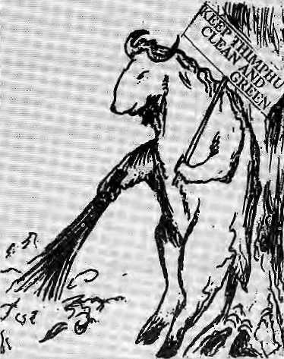
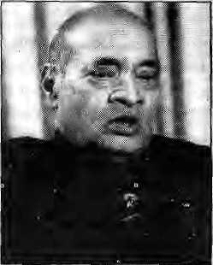
Rao Holds Key to Nepal-Bhiitaii Deadlock
Rao and (above right) Tshtiring in Kathmandu.
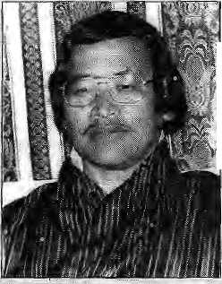
rp he fete of over 70,000 X Bhutanese refugees now in southeastNepalhangs on the long-awaited meeting of Nepali Prime Minister, Girija Prasad Koirala and Bhutan's King Jigme Siitghe Wangchuk, who are to meet at the deferred SAARC summit in Dhaka in mid-January. Nobody pretends, however, that the two leaders can solve their differences without the nod from India's Prime Minister, P.V. Narasimha Rao:
Article 2 of the 1949 Treaty of Friendship between Bhutan and India states that while the "Government of India undertakes to exercise no interference in the internal administration of Bhutan" Bhutan "agrees to be guided by the advice of the Government of India in regard to its external relations." Rao was asked at a press conference at Kathmandu airport, on 21 October, how and when India proposes to offer such advice, given the deteriorating "relations between Bhutan and Nepal. "We undertake to give guidance when it is asked for," Rao replied, suggesting a wholly new interpretation of InriV Bhutanese relations which must have given qtiiet comfort to officialdom in Thimphu.
First, India had .allowed Foreign Minister Dawa Tshering to negotiate independently with China on the' long -standing dispute over Bhutan's border with Tibet, and now here was India propagating a liberal interpretation of the "guidance" clause of the 1949 Treaty.
Under
normal circumstances, this development would secretly tisve been welcomed in Kathmandu as well, as the flexibility allowed Bhutan would also
have had positive repercussions for Nepal', instead, Rao's lemarks were received with sorne dismay [ because ihey revealed India's continuing unwillingness to urge Bhutan into negotiating a ;: satisfactory futare for the growing number of Lhotsh am pa refugees in Nepal. (UNHCR, the refugee- .."" agency, says there were 70,272 in the camps alone as of 25 October.)
"What it would take for India to address the refugee problem has long been a matter of speculation inKathmandu diplomatic circles. The number of refugees alone, as certified by UN .... agencies_{v}does not seerri to be doing the trick, and the Indiari media s til? have their see-nofevil-in-Thimphu blinders on.
If international recognition of the problem woukMead to a change bf heart in the South: Block, then things certainly seem to be;looking up for the refugees. On 5 November, Japan announced assistance to refugees totalling U$ ... 885,D(X), which was soon " followedby Australia's pledge of
More significant, however, was the United States GQy^rn-ment press note of 20 November, pointedly released the day::after , Foreign? Minister Tshering arrived., pn a long^deUyed first visit to Kathmandu for.consultations on the "southern poblerri". : Washington annpimded an aid package of US 1.42 million; Most significant was the note's last 1 paragraph which, forsaking normal diplomatic hyper-Jbole, statedihat the United-States "appreciates efforts of^ UNHCR, WFP and the private voluntary organisations that are caring for the Rhutanese refugees".Tt;also
expressed gratitude to Nepal for
haying provided -'first asylum".
This last was clearly a considered
jab at New IMhi,
Tor India as the]
neighbouring
country is the
logical country of
first asylum.
instead* refugees
have, to travel a
considerable
distance through
Indian territory to
gain refuge in :
NepaL ■
Kathmandu, Tshering raked iip the is$ui'of two ex»Thimphu officials, now refugees, who have been accused by it of embezzlement-and bttier misdeeds. Even some Efcukpa officials are known tQ l^ave in private conceded that the accusations hol<i no water. Tshering's request for their extradition appeared merely diversionary.
But the Foreign Minister was not altogether unconcerned ^{s} |bontdie .refugees;itseemed. "Geitauily we.reco"gtiise this ; tiumanitarian problem," he said op
P.L Singh, who has$&en talking-about the need to k&eftihecityl ' :
vbfiaraa, "dean
sndgreen".
Sorry, Mr. Mayor,
butagoatin
Thimphu
to,
first Jhe-oniy
question for the
artist ol'Kunsei
weekly, from
Which this image
■was. picked up,.
is, why a goat?
Or is it a yak?
22 November as he departed for Thimphu. Bhutan was "very concerned" about the "burden" that Nepal was being made to shoulder, and, j "burking is veTy I keen to resolve | this problem." 1 Koirala, meanwhile; hasiefused I to link theexira-dition question with me larger refugee
repatriation issue. On a one-on-one meeting, Koirala fold the Bhutanese Foreign Minister that, for the moment^ he enjoyed an all-party mandate to sort out Nepal's problem with Bhutan. If that consensus disappeared due to Bhutanese waffling, anything could happen iri the left-dominated districts of southeast Nepal.
Significantly, the King is to arrive at Dhaka after having first touched base in New Delhi. Wilt vhe finally ask.for some advice* and will Rao then "undertake to gjve guidance"?
Dhruha Adhikary

Nov/Dec 1992 HIMAL, • 33

BRIEFS
Speaking flip for the Nyimha

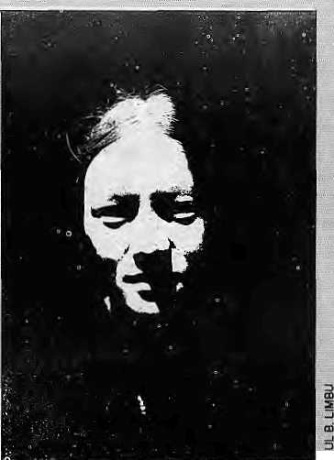

C
ultural Survival, the Boston-based group tljat agitates for the rights of indigenous peoples has launched a 10-part television,series to Educate;: millions in the West on 12 tribes from around th> world and the
;: threats they face : from industrial
jiociety. Among the tribes Chosen are the Mohawk of Canada, theHuicholof Mexico; the Gabira of Kenya, and the Nyimba of Humla district in
' northwestern Nepal.
Lady frorn Jabiang vilteg^Hitrrtid
Economic; woeshead the list of problems faeed by the Nyirabtti states Cultural ■Survival. With the ■ Chinese takeover of Tibet, the centuries-old salt and wool trade ■ between Tibet and India has dwindled, arid easier access io ■■■■ traders from the plains has also eroded the Nyimba's market: To maintain their ancestors' ^alth, some Nyimba resort to illicit trading in stpiea religious articles and tiger bouej which Chinese-jegarf as an Aphrodisiac, says :: Cultural Suryivai. .... ........ The organisation's...repOFt:
continues, "For the first time! ª Nyimba represents Humla in PaTliament, butto gain'politiciil power, Nyimbas must denyitheir ■■■■■:■ ethnicity ^^ tr>tSe point ot: adopting a Nepali name and' ^hanging their eating habits; :
"Nepalis oOrisidei; the ^Fyimba dirty aiid polluted and scorn their
incompatible with traditional values ^— from trading, working, _{v} or studying elsewhere ~ poses an additional threat to Nyimba culture, Western notions oflpve ■.■:■■ are becoming' more prevalent, and * msmyyb^nger brothers choose partition, the breaking up of the ; family andi[spropisrty,iaorderto have a rtio|i6gajtnoas marriage.'*
■(Gultural Survival states that some 1200 Nyimba live io Rumla butdoes plariry whether there are Nyimjbajn Tibet, for the tribefolk are said to Irace thei^ 6ri^ins to western Tibet TbN!Tl
1 Member of Pafn'ranierit Telerred to above is Ohfiaka Efehadur Lama; ;who goes jocalty by the name of Tsevyapg, Editors.)

Golden Opportunity for IBM PC Users
Bring your IBM Data Disk and
have them laser printed at dot matrix cost We also provide report binding services.
Please contact:
Telephones: 419148,417874
Vacancy Anouncement
Helvetas Nepal Invites applications for the post of Assistant to the Programme Director. The candidate should be a Nepali national of 35-50 years of age, and fluent in English. He/she should possess at least 10 years of experience in an executive postinHMG/NGO/INGOora private enterprise working in the field of development. A broad spectrum of experience and knowhow in general development issues is important and an acquaintance with the latest strategies and theories in development and development cooperation is essential. The candidate should have knowledge of business and office administration. The Assistant to the Programme Director will be responsible for advising and assisting the Programme Director in all matters of developmental issues.
Salary will be commensurate with qualification and national standards.
Apply to : Programme Director
Helvetas, P.O. Box 688 Kathmandu.

34 HIMAL • Nov/Dec 1992

LAVA MED1AFILE -HIMALAYA MED1AFILE * HIMALAYA MEDIAEILE * HIMALAYA MEDIAFiLE* HIMALAYA * HiM


Eat your he a,rV o a t
Prasar ■ ■ "'
"Khafati! ^ _{m},
Bhutan's" 'I "'
nationally
owned media has .. ..
beaten you to it. As
of 1 October, as
announced by the
Minister of Commuicau" on s, -nwwnwdilnitehiiuii'*
T. Tobgyel, and with the "^{r}"^{K}"¹""'""'
blessings of King Jigme_{f} the national newspaper Kuenset and the Bhutan Broadcasting Service ^i a ve become autonomous The establishment of an independent and effective media, said the Minister, was "a significant
A Renters report an a recent IFAD announcement regarding the rural poor in the developing countries once again rakes up the question of what to believe and what riot to believe about our own Jrufc Yul. Even though eye-witness accounts say thaf the Bhutariese peasants (those that'still remain behind, that is) are doing well enough thank you, (and Thimphu's unilateral reduction of the home population down to 700,000 has raised thepercapitaGNPthe country to from US 190 to U$ 425 per annum), international agencies continue to chum out horrendous statistics for Bhutan. There is a good PhD thesis here for someon e who wants to study the creation of economic myths ami realities. 3FAD, the Rome-based International Fund tor Agricultural Development, says that according to an index relating food production, consumption, income distribution, access to education and health services, the worst off rural poor are in Bhutan* Burkina Paso, Somalia, Mauritani a and theSudan, Or does IF A D know something we don't?
Former Indian Prime Minister, Chandra Shekhar, eanle out of oblivion to speak up for Poorvanchat, a region encompassing Bihar and eastern Utiar Pradesh which, he maintained, has suffered from backwardness due tothe Centre's neglect. Speaking before an audience in Delhi on 24 November, reports The Times of India, Shekhar called for restoring the self-respect of the people, of the regiorj, adding that the : Biharis,and Utiar Ptadeshis were also being dieated of adequate wages in the capital. He regretted that the word Poorbta was used to ridicule thepeople of the region. It should not be lost op Katmandu's leaders ofmen that Nepal borders on what Shekhar defines as. Ptsorvanchal. Any increase in self respect among the Poorvanchali s should without doubt help the economy of the region which, in iurn, should help the Nepali economy. Maybe even some of the newfound self-respect will rub off north wards.
Still oil Aruoaehal, it appears that the IUnagar government and Centre are intent on "doing a Mustang" on the state — opening up to "high-budget Indian and International tourists". The words were those of Suman Swamp, Aiunachal's Resident Commissioner art New Delhi, In another piece of writing, Amulya Ganguli, Th& Times of India analyst is not so sure. "The lull implications ...of opening up the state after its long isolation do not seem to have been adequately considered. It will be futile to deny thai rhe current trartquility is partly the result of the fact that the people of Arunachal have been
(eftto, them selves, with the army acting as a benevolent guardian. The result has been that the affluent el as ses comp rising politicians, officials and feudal chiefs have managed io do well for themselves in the absence of sufficient Competition, wbilethe poor, like the poorevery where, have been left 16 endure their fate in silence." This leaves one "confused; II there is a link between isolation under a benevolent stewardship and poverty, ■wouldopentng up help spread the-mooia around?
The'Indian military has taken a major decision to phase out over She next two decades units based on religion, caste or class. Only the Indian Gorkhas, apparently, have escaped the ax,e, India Today reports that the big shift in policy was made in an effort to give a "national character" to the aimed forces. The sections most affected, will be the armoured corps and the artillery, where most units have been nurtured on the concept of martial races: The days of the ail-Sikh, Rajput, Jat or Dogra regime ills are therefore 1 imitedi"Only theGorkhas will be exempt as torching them¹ coyld affectrektions with Nepal"Tiie^nuill advantages of fighting in another country's army.!.
Here-'sa reppn an the establishment of the So.uth -Asian Human Rights. Documentation" Centre by jjivil libertarian; Ravj N.air. Among other things, tlieCeritre publishes a montjily summary report forits subscribers about "human fights abuses in Ir\diaand Bhutan. "What about the rest ol us, MrNair? :
A man-eating leopard stalks the hills . of Hiniacha! villages between the Raria and Sukhud rivers. The Times of India report of 25 November cam es some rather specific irifopnation- over .14. victims have been claimed over the past six months; ehildrenbetweeit the ages of five and 14 are more-liable tq: be picked off; and the leopard strikes once every 20 to 25 Jays-; from the.pug marks the animal appears to be 14 years old, has a deformed front paw and has a canine missingfroriithe lower jaiy. Eight -sharp. shooters of thcpolice force and eight hunters hired by the Wildlife !>epart-menf, in add ition to anumSerof volunteer shikaris, have not been ajbie to nab* the roan-eater. The Government of HimachaS has annourice.d a cash reward of Nils 20,000 for whoever gets the animal. So far, the resulting shootjug spree has.left six leopards dead but the rriari-eater U still at large: Meanwhile^ a Congress, tylLA from the region had this: to say ajmut compen*a!iofi being given to the nextof kin: "If a man kills a kbparcEhe is fined Rs 50,000, hut .when a Jeopard ki^sahunranbcing:the compensation is only Rs 15:o6o."
Bhutan's National Newspajjer
Nil. 2
Autonomy for national media
The EittbJUtyrrmtt of an int ml ind efftcuyt' mtdii, ttid the
friendship." Like the Chukhha Project, triehew project is also on the Wang Chu, "but seven kilometres upstream. The project is expected to require a 140-metre dam across the Wangchu and two power houses producing 60 megawatts
achievement of His Majesty the King's each. The total estimated cost is Nu-
noblcpolicyof decentralisation". Cynics (IRs) 1,200 miiiion.
abound, however. Said a former editor
Apparently, Chinese restaurants in Delhi have decided to retain desi cooks; and make up for the lost flavour by having "M6ngoloid waiters" from Nepal. Since the authentic chef, whetherfromSechwan or jlurian is rather difficult to import, and since a Punjabi dhaba cook can wliip up a mean chopsucy any way, this indepen dent and have to ea rn your own proved the ea siest way topro vide make-keep. It cannot extend to editorial believe ethnic chic, which secrns to be
the" rage in the Indian capital theseilays. The Times of India reports,: ;"Most»f these Chinamen are actually Nepales,e hauled over from across the border." Or could itbe that s.ome of them are Naga of Manipuri? There-is great resentment
ofthe Nepal's Gorkltapatra daily, "The
Gorkhiipatra, too, is autonomous in
name but it makes little difference, as
long as the society is feudal, if you ijjire....
government-owned or autorsomijus.i"
And a Lhbtshampa refugee leader had
jthis to say, "In Bhutan, autonomous
p
free^orn." Still, one can hope, and any
media anywhere, autonohiy in name is
always better tltart no autonomy eve a n\
liarne.. ■.„■ ■■■ " ... ■■■ "
■merejy means that you are financially'
APTIsgsncyrepbrtfromBeijmgtjuotes a "top Tibetan official" as announcing
amongst the Northeast population that
Jhathairwas growing on the preserved ' ■,,. -.. ■ ■ . ,■ . _{c}
to tliem generically as-Nipalis_{;l}
If the introof.Manisha Jain's article in The'Statesman is lo be believed :Arunachs|l .Pradesh is "the land of numerous tribes and, dialects, darks brooding mountains and lush green valleys (which) is rich irj mineral resources, forests, arts and crafts yet 'plagued by backwardness.'¹ The piece tums.outto be about yaks and, when she gets around to it,«Jain provides some useful jnforniatiiin. Tlie Nalional Research Centre on Yaks set up in Dirang, is presently conducting asntdy pf yak' genetics and examining the, characteristics of the ariimafs "undercoat". Kifty-6nc varieties of grass species have been obtained from different countries for fodder tests. Five; or six yariette s a rethought to liave passed the taste test of the Centre's finicky yaks. Sadly, the Centre is, understaffed. It has only one scientist in residence, reportSj Jsin, Yaks dcKcrye better trealraem.
- Chhetria Patrakar
Nov/Dec 1992 HIMAL -35
, .. '■„'. t ■■ i ,. ». Hmdustanisinthelndian«nainlandrefer bodyof the Panchtn Lam a, who died j n
January 19g^{n}. While Otis Mr. Raidi seemed to ascribe the pheiiornenqri to "special effects" of Tibetan medicine, "experienced foreign hands" say it-is quite normal to find hafr and naHs growing :frorb preserved |>odies. Mr. Raidi, wlio was attending the Communist Parly Congress of rnid-Qt^obef as a delegate, sai(i tlje Chinese Government had spent a large amount in huildnig a stupafofthePanchenLanjafduetoopen , attheendof 19^{Q}3)andfiadalsodecided to lorjk-for his reincarnation. But since the Panchen Lama was'% good patriot", said a confident "Me, Raidi, the reincarnaton would also be Onb. Astu.:.
Chuklia seerns to have left agood Mste in the mouth — good income for Bhutan and dieap electricity for Indiaf. King Jigme Singhe Wangchuk said as much while pmsiding over the signing of a menwranduiii of understand ing io study tlie feasibilityof the Ounakhn Reservalr Scheme in Thimphu on 6 November, reports Kueitsel. fCing Jigme pointed to the Chukha Hydro Power Corpora lion" as "a shining testimony of jjido-Bhutan

V
o
I
c
E
s

SHERPAS WOULDN'T THANK YOU for
limiting tourism, said veteran British climber, Chris Bonnington, when asked by Mountain magazine about the impact of climbing on host cultures.
I think on the whole it is a beneficial impact. Progress, Westernisation, industrialisation, is part of the dynamic of the society mwhich we live.Climbers and tourists going to Himalayan areas are just a small part of that dynamic, and I think one of the traps that some environmentalists fall into is saying, "there are these wonderful little quaint Sherpa people living in their little villages and, gee, I don't want to see all of this change: all that horrible electricity, sewage, roads." I think that the development that's happening, a) needs to happen, b) is going to happen anyway. What is important is how the individual people manage to handle it. I think the Sherpas and most of the Himalayan people are very sophisticated. Remember this is a very old civilisation, slightly older than our own. The tourists going into Sola Khumbu or into Nepal are bringing in money. Materially, the people are much better off; you could say that maybe some of them are confused, as in fact an awfullot of young Westerners are confused, but it's allpart of progress. I think that to say we shouldn't have big expeditions is a load of baloney because the major impact is trekkers and not expeditions. But to say we should actually reduce the numbers of people going in, the Sherpas wouldn't thank you for that because they havebuiltupan economy around tourists and, significantly, they have built up the economy themselves. It's the Sherpas who are actually exploiting the tourists. I think the much greater worries should be for the aboriginal inhabitants of areas who basically cannot cope with the invasion of Western society. Damage has been done to them, an immense damage — whether it's the North American Indians, the Exkimos, the Indians in the Amazon Basin and so on. But that is not a climbing problem.
HIMACHAL TRAVELOGUE by observer Bill Aitken in The Statesman of Calcutta, in which he considers the transformation wrought in a region only recently released from the grips of Inner Line restrictions.
Tapri announced the transition from the red velvet flash of the lower valley to the green blaze of Kinnaur. This refers to the status symbol of the Himachal regional topi. Kinnaur represents the "A" team, highest in the pecking list. Its topi is twice the price of the Rampur model because the velvet is'lmported from Kathmandu", an euphemism for smuggled from China.
These cultural bonds with Tibet that can be detected in the folk music of Kinnaur scared the life out of plains administrators and the area has undergone a massive and unsubtle process of "mainstream" indoctrination. Formerly the presiding religion of Kinnaur was Buddhism but heavy official patronage has tilted the scales towards Hinduism. Almost every surname youcome across is "Negi" which signifies in theory ayogic forebear but in practice reveals cultural proselytisation mainly by the blandishment of
employment opportunities. The locals often answer to two names — their Buddhist family names plus a Hindu name for availing of sarkari benefits. Schoolgirls we spoke to said they would be punished by their plains teacher if they turned up in their Kinnaur topis.
So sad is the depletion of Kinnaur's vital culture by New Delhi's devouring ideal of progress through mindless uniformity that the only souvenir you can find in the shops is the area's distinctive topi. To get the genuine article you have to have one made by the local tailor who fashions them on a sawn off tree trunk, slim at oneend (for ladies) and thickat the other (for gents). It lakes about an hour to stitch the lining and apply the piping. Then the velvet is dampened and ironed with great love. It alone costs the price of a Rampur or Kulu full topi and the total outlay for your parrot-green headgear comes to Rs 100.
The food along the way followed the nature of the terrain, and grew bleaker the further one got from Shimla. Boiled eggs in batter were available at the latter's bus stand but by the time we came to Narkhanda,c/iAote was being passed off as vegetable. To indicate how plains culture quickly penetrates the interior we noicd at the Narkhanda dhaba that the battered steel water jugs, once revelling under the label of "stainless", were now manacled to rusty dog chains lest the driver with a leaking radiator took a fancy to these buckled objects. The chapattis likewise suffered the bruising of the way and, from the confident circular stamp of Shimla's alu paratha, by the time we reached Tapri their shape resembled some weird cartographic exercise to illustrate the theory of continental drift.
BANGLADESHI MINORITIES make _{up} less
than 14 per cent of the country's population. C.R. Chowdhury, writing in the Winter 1992 issue of Cultural Survival quarterly, says that minorities (Hindus, Buddhists, Christians and tribals) have "paid a heavy price for Bangladesh's independence" Below is his list entitled, Minority Hiring in Bangladesh.

Administration (officers) | 5%
Administration (lower rank) | 3-5%
Administration (secretaries) | 0%
Customs and excise | 0%
Income-tax officials | 1.5%
Military officers | 1.5%
Military soldiers | 0%
Border security | 0%
Police, officers | 6%
Police, rank and file | 2.5%
Major bank managers | 0%
Embassy & consulate staff | 0%
Foreign assignments | 0%
Home Ministry | 0%
Judiciary | 0%
Ministry of Defence | 0%
Industry managers | \%
Industrial labourers | Z4%
Recent bank loans | <1%

36 HIMAL • Nov/Dec 1992

PREDICTION LETTER which led to the discovery
of the 17th Karmapa reincarnation, Ugen Thirtley. The letter, said to have been discovered by Tai Situ Rinpoche in his "protection pouch" a decade after the 16th Karmapa placed it there, was translated by Michele Martin, andisreproducedfromthe Karmapa Papers (seepage 47).
Emaho. Self-awereness is always bliss; The dharmadhatu has no center nor edge.
From here to the north (in) the east of (the land) of snow Is a country where divine thunder spontaneously blazes. [In] a beautiful nomad's place with the sign of a cow, The method is Dondrup and the wisdom is Lolaga. [Born in] the year of the one used for the earth [With] the miraculous, far-reaching sound of the white one: [This] is the one known as Karmapa.
He is sustained by Lord Amoghasiddhi;
Being non-sectarian, he pervades all directions;
Not staying close to some and distant from others,
he is the protector of all beings:
The sun of the Buddha's Dharma that benefits others always
blazes.
PROLETARIAN POLITICS was
mountaineering was all about at Chairman Mao's behest, states a 1975 booklet meant to mark the ascent of "Qomolangma" from the north side. A travel back in time.
New Chinapromotes mountaineering as a sport to serve proletarian politics, the interests of socialist economic construction and the building of national defence, to help improve the people's health, and to foster such fine qualities in them as wholehearted devotion to the people and the collective, and fearing neither hardship nor death. In the recent expedition to Qomolangma, the climbers, united as one, helped each other and gave full play to their collective strength...
At 14:30 hours (Peking time) on May 27, 1975, Phanthog, deputy leader of the Chinese Mountaineering Expedition, triumphantly reached the top of Qomolangma together with eight men climbers and thus became the first woman alpinist in the world to scale the highest peak of the globe from its north slope. Her feat clearly demonstrated the new outlook of Chinese women steeled in the Great Proletarian Cultural Revolution and the movement to criticize Lin Piao and Confucius, and showed that with then-revolutionary courage they can scale the greatest heights and storm the most formidable fortresses.
One may well recall the wretched life of the working women of China, particularly those in Tibet, who were at the bottom rung of the social ladder before liberation. Phanthog, daughter of a serf, had been subjected to brutal oppression by the serf-owners since childhood, when she had to go begging with her mother. Afteraew China was born in 1949, an event of earthshaking significance, the Communist Party delivered China's working women from the
abyss of misery. When she grew up Phanthog got a job at the "July First" S tate Farm inLhasaandbecameoneofthe firs twomenfarm workers among the Tibetans. In 1959, she was one of the first Tibetan women selected to train as mountaineers.
The Great Proletarian Cultural Revolutionandthemovement to criticize Lin Piao and Confucius swept away the reactionary and decadent doctrines of Confucius and Mencius, and-all the old traditional ideas of contempt for women were repudiated, thus further freeing the minds of the masses of Chinese women. ''Times have changed, and today men and women are equal. Whatever men comrades can accomplish, women comrades can too." Living up to this teaching of Chairman Mao's the women members of the Chinese Mountaineering Expedition plunged into the oattle for the conquest of the world's highest peak, displaying peerless courage worthy of the proletariat.
IfstheSIDES OF THE MOUNTAIN that sustain
life and not the top, wrote Robert M. Pirsig in the now cult book, Zen and the Art of Motorcycle Maintenance.
Mountains should be climbed with as little effort as possible and without desire. The reality of your own nature should determine the speed. If you become restless, speed up. If you become winded, slow down. You climb the mountain in an equilibrium between restlessness and exhaustion. Then, when you're no longer thinking ahead, each footstep isn't just a means to an end but a unique event in itself. This leaf has jagged edges. This rock looks loose. From this place ihe snow is less visible, even though closer. These are tilings you should notice anyway. To live only for some future goal is shallow. It's the sides of the mountain which sustain life, not the top. Here's where things grow. But of course, without the top you can't have sides.
RETAIN PALI ,saysBhiskhuSatyapala,GeneralSecretary oj'theBuddhaTriratnaMission, Delhi, i« a/eHerto The Statesman of Calcutta,
Thedecision of the Union Public Service Commission to remove Pali from the Civil Services Examination has hurt the sentiments of the entire Buddhist community and also those of hundreds of students and scholars all over India who are deeply involved in the study of the language. Injustice has been done to the community and the subject,
Pali has a vast and rich heritage preserving the Buddha's eternal teachings. It has a wealth of information on the culture, religion, philosophy, psychology, history, politics, grammar, language, science, arts and crafts and ^archaeology of ancient Indian societies, particularly during the Buddha's time.
On behalf of the entire Buddhist community of the country, we request the UPSC and the Government to retain Pali as one of the optional subjects, not only in the interest of the Pali scholars, ¹ but also to strengthen the nation.
Nov/Dec 1992 HIMAL ♦ 37

TRUE UPGRADEABILITY MADE
POSSIBLE WITH DATAMINI
MULTIFLEX SYSTEMS


Security Keylock
LED display panel incorporating system reset and turbo switches.
Bay for 4 storage devices: 1 x 3.5" FDD, 1 X 5.25" FDD, 1 x 5.25" hard disk and one tape bach-up system.

By simply changing the CPU card of your Multiflex, you can upgrade your computer
to a top-of-the-line 486DX from a 286,
386SX, 386DX or 486SX.It's so simple you

can even do it yourself.
Authorised Distributor:
Muktinath Trade Concern
P.O. Box 5073, New Road, Kathmandu, Nepal. Tel- 226858, Fax: 977 1 227068

WE WELCOME YOCI TO THE HIMALAYAS!
Contact us for detailed information
HIMALAYAN EXCURSIONS
G.P.O Box 1221. Keshar Mahal Thamet, Kathmandu, Tfcpal Te!: (O) 418407. (H) 416112 Fax -.{0)00-977-1-418119 : (H) 00-977-1-418913 Tlx : 2636 SHERPA MP
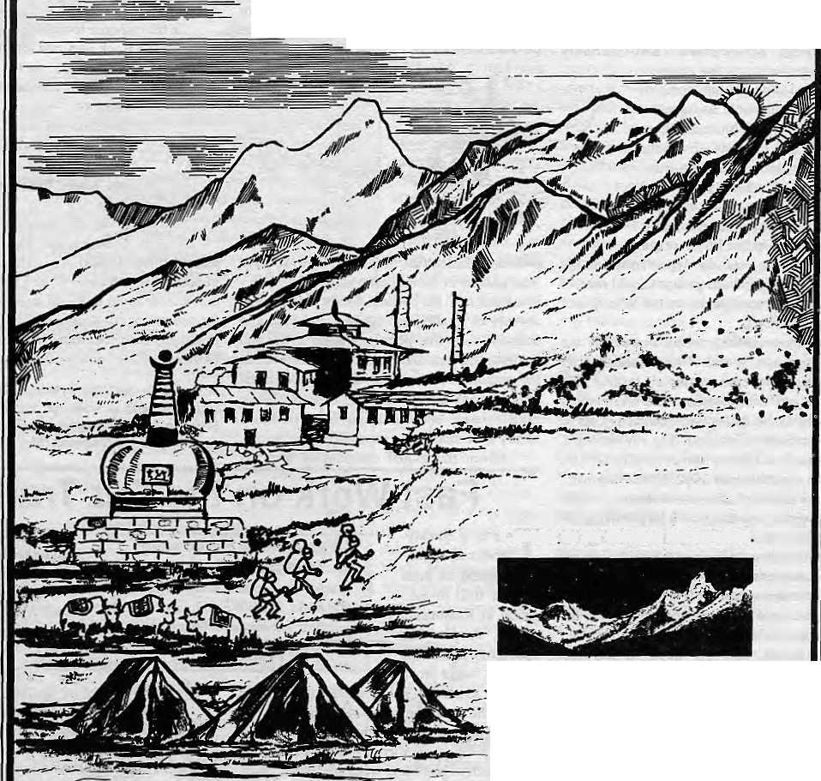
WE ORGANIZE: TREKKING AND MOUNTAINEERING EXPEDITIONS IN NEPAL, TIBET AND LADAKH PLUS WHITE WATER RAFTING, WILDIFE SAFARIS AND SIGHT-SEEING TOURS IN THE KINGDOM OF NEPAL

Wo accept all major credit cards.

REVIEW
Executive Directors Do Not Heed Independent Review

Fast Work on the Fur Trade
This is a quickly-c
Fur Trade in Kathmandu Implications for India
by Joanna Van Gruisen and Toby Sinclair
Traffic India and WWF India, New Delhi
November 1992
by Pralad Yoozon
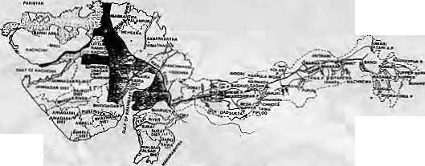

T
he damming of the N armada River in western India has proven to be a highly controversial undertaking. The ongoing construction of Sardar Sarovar, the first dam of what will be one of the largest irrigation and hydropower projects in the world, has engendered heated debate between supporters and opponents. The N arm ada situation effectively highlights significant contemporary controversies about development policy and implementation, including the problems of reconciling large infrastructural plans with participatory development, and equitably addressing the competing resource and cultural concerns and needs of disparate populations. At issue are the criteria by which one balances the needs and interests of various populations within a nation-state, £he means by which social and environmental costs are weighed against the projected economic advantages of large-scale development projects, the degree to which the interests of marginalised groups should receive special consideration, and even the definition of development itself.
In response to the growing controversy, the President of the World Bank established an unprecedented independent review team in June 1991 charged with assessing the resettlement and rehabilitation and environmental aspects of the Sardar Sarovar projects. The review team, led by Bradford Morse, former head of UNDP, issued its report in June 1992. Sardar Sarovar: The Report of the Independent Review, which brings together and analyses a large amount of information, should be required reading for development planners desiring toheedthelessons of this controversy.
The independent review responds to two issues: the need for measures to protect the human population displaced by dam construction and operation, and the need to develop environmental impact assessment procedures to anticipate and prevent adverse outcomes. The major focus of the Report's commentary is the negative consequences of (he poor management of compensation programmes by government agencies, and the passive acquiescence to this by Bank staff.
Seven years after World Bank funding was approved, there is> still no accurate count or analysis of the population to be resettled, and widely divergent resettlement policies have been proposed by the three Indian states of Gujarat, Maharashtra and Madhya Pradesh. The Report resists making direct recommendations about the implementation of the SSP and instead
Sardar Sarovar: The Report of the Independent Review
Bradford Morse, Chairman Resources Futures International
1992, Ottawa
ISBN 0 969 6325 09
by William F. Fisher
declares that "...the wisest course would be for the Bank to step back from the Projects and consider them afresh."f he report argues that the

profound difficulties of Sardar Sarovar have their genesis in the earliest phase of the Bank's involvement in the projects, for they turn on the absence of an adequate database and failure to consult with the people whose lives and environment were and continue to be affected. In the authors' view, social and environmental arrangements are fundamental aspects of dam project design and should not be treated as a luxury to be included as local conditions permit. Given the global controversy that has
produced monograph based on three days of field investigation in Kathmandu which, despite the shortcomings this imposed, could prove useful in sensitising policy-makers in India and Nepal. The book is also part of a welcome trend in which organisations in South Asia are looking beyond political frontiers in their treatment of issues such as pollution, water resources, trade, ethnicity and illegal trafficking.
This investigation, by Traffic India/World Wildlife Fund (India), is the third study made over the past four years of the fur trade in Kathmandu. Starting with Larry Barnes in 1988 (see//(/no/Jan/Feb 1989), all have concentrated on making a surreptitious inventory by visiting fur shops by posing as interested buyers. Apparently, Van Gruisen and Sinclair's present
erupted overhow to balance the benefits promised by large dams with the interests of affected people and the environment, it is perhaps not surprising that the publication of the Report has fueled the debate rather than end the controversy. Local, national and international opponents of the project touted the report as an indictment of projects which proceed without a completely worked-out plan for resettlement and rehabilitation.
N
In his response to the Report, the President of the WorldBank admitted that deficiencies of the Bank were particularly noteworthy in its failing to insist that the national and state governments consult with affected parties, develop socioeconomic data on project-affected persons, and assess their implementation capacity for resettlement. However, despite the Report's conclusions, the World Bank management argued that adequate steps to improve the resettlement and rehabilitation of the oustees could be taken simultaneously with the continuing construction of the dam. Heeding this assessment, theExecufive Directors voted in October 1992 to continue funding of the project.
W.F. Fisher teaches Anthropology at Harvard University and is 9ditor of a forthcoming book Working Towards Sustainable Development: The Damming of the Narmada (M.E. Sharps).
investigation was conducted in parallel with another one by Blaire Leisure and Joel Heinen (see "WhoCares for Dead Fur?" Himai Mar/Apr 1992), who it is conceded here "covered a greater number of shops and put in more time".
With so much duplication (given that other wild flora and fauna issues are so little covered), it might have been useful to take even a cursory look at the many other centres of wildlife trade in India, especially in the Kashmir Valley, the other celebrated centre of the Himalayan fur trade. But Traffic India was interested more in Nepal, perhaps because of the preparedness of two Western volunteers whose employment "precluded the possibility of co nducting the s tudy in Srinagar at this time". At the very least, an Indian investigator might have been asked to do a quick report for this publication.

40 HIMAL • Nov/Dec 1992

INVESTIGATION
No Smoke Without Adverts
Nepal's cigarette producers, supported by a Government media hungry for advertising revenue, are allowed to encourage the young and old to consume deadly smoke. The entry in 1987 of Surya Tobacco Company into the previously protected market was significant. Its advertising hardsell and superior marketing has left the public defenseless while propelling the company to be the country's premier cigarette producer, far outstripping the former Government monopoly of Janakpur Cigarette Factory. While it is Surya's and Janakpur's business mandate to make money off the lungs of Nepal's population, what does one make of the sellout by the Government's radio, print and television media? A look at the data reveals the surprising information that public media can survive without cigarette (and liquor) advertising. Somebody just has to insist. Following is an investigation by Maaisha Aryal.

"Nepal fascinates me.
While studying in Europe, I saw the Alps,
...but nothing to beat my Nepal, my pride.
I remember the day father and 1 visited the Palace of Nuwakot,
I went there again!
The drive was still as enjoyable, the mountains as mysterious,
andthepalace, ...breathtaking!
Suddenly I heard a flute,.
..the same tune I had heard long ago.
1 remembered the flute seller who 'd sit in a corner, playing.
I followed the sound and found him.
Do you remember me?
I picked one up
and played the same tune he had taught me years ago,
...and then he smiled!
... a beautiful mountain panorama, a Nepali village ...the soft, educated tones of the voice-over conjures up an image of an unlikely Kathmandu aristocrat who shops at Harrods and vacations in Monte Carlo.
This expertly shot commercial is not meant to lure Western tourists to Nepal. It is the Surya Tobacco Company's up-market television commercial to sell its deluxe filter brand, Surya.
At a time when governments all over the world are enacting stringent measures against tobacco advertising, public debate about the issue has barely begun in Nepal. Cigarette manufacturers are allowed free rein to peddle their drugs on Government television, radio and print media. Sponsorship deals have never been better and the Ministry of Communications does not seem to have been reminded by the Ministry of Health about the Government's "Health for All by 2000" commitment.
Death Dealers
Shikhar, the next in Surya Tobacco's lineup, aimed at the upper middle-income bracket, and is marketed as "the symbol of success" . Another brand, Khukuri, seems to target cash-in-hand Hue-collars and is sold as sahasi ko ek. maatra chaahana — "the on!y craving of the corageous" Unfiltered Bijuli, produced to satisfy rural smokers, is sold less by advertising than through a finely-toned Nepalwide marketing network.
Until Surya Tobacco entered the field in 1987 with marketing expertise of the Indian Tobacco Company (fTC), the industry was a near-monopoly of Janatpur Cigarette Factoiy, gifted to the Nepali Government by the Soviet Union in thel960s. In a desperate attempt to recapture a market lostto an upstart Surya Tobacco, Janakpur has resorted to nationalism, pushing its'Yak'brand as the conn try's oldest filter and the"most Nepali" of cigarettes. Going down the ladder, Janakpur's brands are Lali Gmans, Yak, Gaida. Koseli, and the recently introduced Sagun. A third Nepali producer, the Nepal Tobacco Company (Gorkha Filter, Action and Nepal Gold Flake), keeps a low advertising profile to match its low capacity.
42 HIMA.L • Nov/Dec 1992
The World Health Organization (WHO) estimates that 2.5 million deaths annually worldwide are smoking related; and that an additional 1000 non-smokers (passive smokers) die each week because of the accumulated effects of inhaling other people's tobacco smoke. While there is no specific data, Nepal has more than its population-wise share of these mortalities.
Each puff of tobacco smoke releases a hit of between 50 and 150 microgrammes of nicotine which reaches the brain within 30 seconds. Nicotine slows blood circulation and increases the risk of cardiovascular diseases. With nicotine, a smoker inhales a deadly cocktail of chemicals including mutagens, carcinogens, and co-carcinogens which wreak havoc throughout the body. Carbon monoxide combines with haemoglobin much more readily than oxygen does; the combination cuts the amount of oxgen reaching the tissues, particularly of mouth, throat and lung. Smokers fall prey to lung cancer much more often than do non-smokers.
Nepal has the worst figures in the world for female smoking. Medical research has already shown that women who smoke are more susceptible to diseases of the reproductive tract. Smoking during pregnancy can also cause premature delivery, low-birth weight babies, pre-natal deaths and miscarriages.
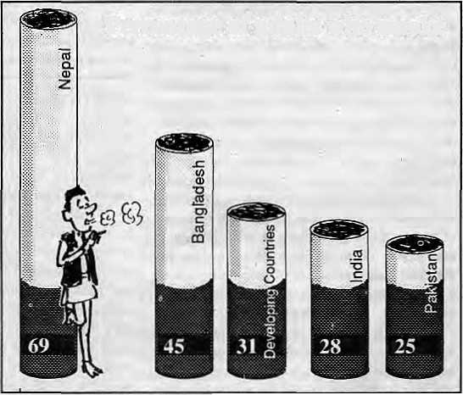
Percentage of adults who smoke
Source: Human Development Report, 1992
Do not expect Surya Tobacco to market that bit of information, though, or that children born of smoking mothers have an increased risk of acute respiratory infection, including pneumonia. Or that they will likely suffer chronic bronchial infection at age one, asthma at two.

INVESTIGATION
No Smoke Without Adverts
Nepal's cigarette producers, supported by a Government media hungry for advertising revenue, are allowed to encourage the young and old to consume deadly smoke. The entry in 1987 of Surya Tobacco Company into the previously protected market was significant. Its advertising hardsell and superior marketing has left the public defenseless while propelling the company to be the country's premier cigarette producer, far outstripping the former Government monopoly of Janakpur Cigarette Factory. While it is Surya's and Janakpur's business mandate to make money off the lungs of Nepal's population, what does one make of the sellout by the Government's radio, print and television media? A look at the data reveals the surprising information that public media can survive without cigarette (and liquor) advertising. Somebody just has to insist. Following is an investigation by Manisha Aryal.

"Nepal fascinates me.
While studying in Europe, I saw the Alps,
...but nothing to beat my Nepal, my pride.
1 remember the day father and I visited the Palace ofNuwakot.
I went there again!
The drive was still as enjoyable, the mountains as mysterious,
and the palace, ...breathtaking!
Suddenly I heard a flute,,
..the same tune I had heard long ago.
I remembered the flute seller who 'd sit in a corner, playing.
I followed the sound and found him.
Do you remember me?
I picked one up
and played the same tune he had taught me years ago,
...and then he smiled!
... a beautiful mountain panorama, a Nepali village ...the soft, educated tones of the voice-over conjures up an image of an unlikely Kathmandu aristocrat who shops at Hanods and vacations in Monte Carlo.
This expertly shot commercial is not meant to lure Western tourists to Nepal. It is the Surya Tobacco Company's up-market television commercial to sell its deluxe filter brand, Surya.
At a time when governments all over the world are enacting stringent measures against tobacco advertising, public debate about the issue has barely begun in Nepal. Cigarette manufacturers are allowed free rein to peddle their drugs on Government television, radio and print media. Sponsorship deals have never been better and the Ministry of Communications does not seem to have been reminded by the Ministry of Health about the Government's "Health for All by 2-000" commitment.
Death Dealers
Shikhar, the next in Surya Tobacco's lineup, aimed at the upper middle-income bracket, and is marketed as "the symbol of success" . Another brand, Khukuri, seems to target cash-in-hand blue-collars and is sold as sahasi ko ek maatra chaahana — "the only craving of the corageous" Unfiltered Bijuli, produced to satisfy rural smokers, is sold less by advertising than through a finely-tuned Nepalwide marketing network.
Until Surya Tobacco entered the field in 1987 with marketing expertise of the Indian Tobacco Company (JTC), the industry was a near-monopoly of Janakpur Cigarette Factory, gifted to the Nepali Government by the Soviet Union in the!960s. In a desperate attempt to recapture a market lost to an upstart Surya Tobacco, Janakpur has resorted to nationalism, pushing its'Yak'brand as the country's oldest filter and the "most Nepali" of cigarettes. Going down the ladder, Janakpur's brands are Lali Guians, Yak Gaida, Koseli, and the recently introduced Sagun. A third Nepali producer, the Nepal Tobacco Company (Gorkha Filter, Action and Nepal Gold Flake), keeps a low advertising profile to match its low capaciiy.
42 HIMAL ■ Nov/Det 1992
The World Health Organization (WHO) estimates that 2.5 million deaths annually worldwide are smoking related; and that an additional 1000 non-smokers (passive smokers) die each week because of the accumulated effects of inhaling other people's tobacco smoke. While there is no specific data, Nepal has more than its population-wise share of these mortalities.
Each puff of tobacco smoke releases a hit of between 50 and 150 microgrammes of nicotine which reaches the brain within 30 seconds. Nicotine slows blood circulation and increases the risk of cardiovascular diseases. With nicotine, a smoker inhales a deadly cocktail of chemicals including mutagens, carcinogens, and co-carcinogens which wreak havoc throughout the body. Carbon monoxide combines with haemoglobin much more readily than oxygen does; the combination cuts the amount of oxgen reaching the tissues, particularly of mouth, throat and lung. Smokers fall prey to lung cancer much more often than do non-smokers.
Nepal has the worst figures in the world for female smoking. Medical research has already shown that women who smoke are more susceptible to diseases of the reproductive tract. Smoking during pregnancy can also cause premature delivery, low-birthweight babies, pre-natal deaths and miscarriages.
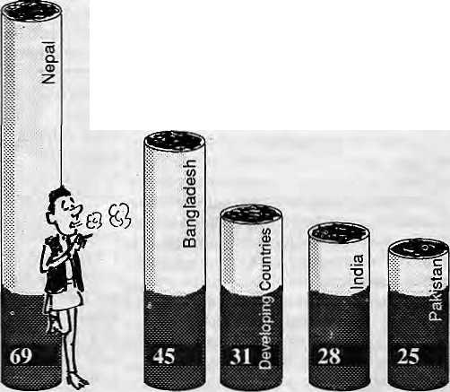
Percentage of adults who smoke
Source: Human Development Report, 1992
Do not expect Surya Tobacco to market that bit of information, though, or that children born of smoking mothers have an increased risk of acute respiratory infection, including pneumonia. Or that they will likely suffer chronic bronchial infection at age one, asthma at two.

INVESTIGATION

Mr, Macho sells Khukuri cigarettes. He uses a khukuri, and jabs stakes into bard ground, until asked to come rescue a weakling who bas fallen through the floorboards of a suspension bridge. In the evening the commoners dance around the fire while he watches benevolently.
Respectable Smokescreen
Smoking is becoming less and less popular in the West as more and more people understand how tobacco kills and maims, but cigarette peddlers in the developing world are hardly going to let on this fact.
Cigarette producers Iheworldoverbecomedefensive when confronted with the powerful ethical reasons supporting a ban on advertising. A high-level Surya Tobacco marketing man (who asked not to be named), when questioned why they insist on selling what medical research has already proved as being harmful to the health of the people, said, "Well there is research and there is research. It is just a question of choosing and believing." He maintained that all the studies being quoted were West-based and since there was no Nepal-specific data available, there was nothing to suggest that it was harmful to Nepalis,
Meanwhile, making a unique demand of Nepal's newfound democracy, a Nepal Tobacco Company representative argued that a ban on advertising would be unconstitutional and would threaten freedom of speech itself. However, he would notrespond to whether it is'constitutional'to broadcast harmful messages. The common defence is that through advertising the producers are merely providing information to allow a viewer to make "informed choice". But a glance at the promotional schemes suggests that neither information nor informed choice is really on offer.
Surya Tobacco has a large budget from which to commission advertisements that link smoking to material and social success. Its sponsorship ranges from sporting events to ari. exhibitions and even to surgical eye camps. In 1990, Surya Tobacco sponsored the televising of the World Cup at acostofNRs 1.3 million.This year, itpaidoverNRs2 million to sponsor the Barcelona Olympic Games on NTV. The drive for respectability even led the company to team up with 24-hour Television, alapanese charity, and the Netra Jyoti Sangh to provide eye camps "which treated 4000patients and performed 1400operationsforcataract."Wasthe relationship between cigarette smoke and cataract — as suggested by research atIndia'sCentreforCellularandMolecularBiology—lostonthe company's marketeers, 24-hour Television, and the eye hospital?
In September, Surya Tobacco wooed Kathmandu's elite, who they view as the target buyers of their Surya brand, with a sponsored art exhibition. Journalists were invited to a press briefing and presented with alarm clocks. When a photo-journalist asked for a glass of water, he was taken aside and offered a glass of straight whisky. Not only had Surya Tobacco been "contributing large sumsof money to Government coffers," wrote the company Chairman, Prabhakar S. J. B. Rana, in a letter to a Kathmandu English weekly, but it had also "as a matter of considered policy decision decided to partake in tho social and conservation field."
Would that Rana's company did less of such 'socially responsible' activities. For sponsorship of public events reinforces social acceptability of smoking and wins producers — in this instance Surya Tobacco — the false image of being responsible public benefactors.
Western television serials and sports programmes, popular among young viewers, are aired on Nepal Television mostly under sponsorship of cigarette and beer companies. Said an NTV official, "Other companies either don't have the money, or do not understand what promotioncan do."
Cigarette manufacturers world over claim that they advertise to convince people to switch brands and not to lure non-smokers into smoking. But the blatant message of cigarette ads and the subliminal messages imparted by sponsorship hardly support this claim. In common with other Third World companies, Surya Tobacco in its advertisements suggests absurdly that smoking is an integral part of Western lifestyle. It ties smoking with sophistication, success, sex and fun
Forging a link between inhaling smoke and social, professional, aihieiic and sexual success is an organised attempt to iccruit more nonsmoking youngsters to addiction. The seductive imagery of advertisements strangle the possibility of creating a non-smoking generation. As an

" -..:^{y}-f „'■■■■■■ ..;■-.
'■■■.-..' ■ |  | :
:
 |  | ^ ^ iy
American activist once said, "When the tobacco companies decide they want to sell to a certain segment of the population, what they are deciding is that they want that segment tu die at a higher rate."
Elusive company representatives, when this writer was able to get appointments,defensively pointed to the statutory warnings on the packets. But in Nepal these warnings are invariably tucked in comers and printed in difficult-to-re ad type. Warnings on television and radio tend to be deliberatedlydrownedOutbybackgroundmusic.Whileelsewhere, rotating statutory warnings are required, not so in Nepal.
David and Goliath
Opposing the huge promotion machine of the cigarette industry, andSurya Tobbacco as the single most powerful player, are the advocates of a tobacco-free media—ahandful of doctors and some volunteers, unorganised and unpaid. Their tentative efforts, such as collecting 30,000 signatures and presenting them to the Prime Minister Girija Prasad Koirala (a smoker himself) and organising cycle rallies, have not made even a dent on the industry's powerful fortress. Neitherhas the Government's recent executive order declaring public places as smoke free zones. The occassional health message in the media is poorly made, and presented without creativity.
Neither is the Ministry of Health's budget allocation any match for Surya Tobaccos deep pockets. Last fiscal year, the Government's Department of Public Health spent less than NRs 90,000 on anti-tobacco messages on television, radio and print media combined. Compare this against the NKs 7 million that NTV alone expects this fiscal year from Surya Tobacco commercials and sponsorships {figure includes NRs 2.6 million for the Olympic sponsorship). Nepal Television's income from promoting cigarettes rose by a stunning 183 per cent in the period ending Junel992over the previous fiscal year. Surya Tobacco's television budget increased by 116 percent for this period, while to counter this rivals Nepal Tobacco and Janakpur increased their own television advertising budgets from near-zero to NRs 313,225.
The time seems ripe for a ban on cigarette advertising. But, according toDr.MrigendraRajPandey, who heads the quasi-governmental National Anti-Tobacco Committee, "...the Government is hesitating to introduce a ban because it is fearful of choking the medis" This is the standard refrain of the media managers as well. For example, NTV Business Director Bishwo Prakash Maskey is fearful that thestation would "crumble and die" without the support of cigarette and liquor industries.
Letters against cigarette and liquor commercials sent to the Ministry of Communications (which 'censors' advertisements) by irate television
Nov/Dcc 1992 HIMAL • 43

INVESTIGATION

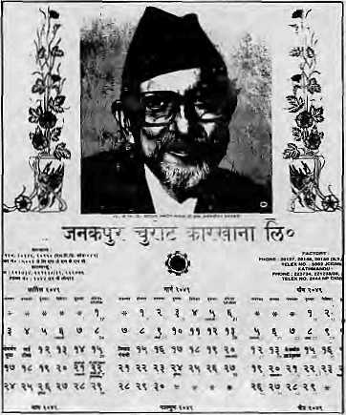
Time to get serious: The Nepali Congress Government should note that Janakpur Cigarette Factory uses B.P.Koirala, who died of throat and lung related illness, on its
promotional calendar.
viewers are dutifully forwarded to NTV "to do the needful". The station writes back to the Ministry that without such commercials it would have to close shop, and pointedly asks for Government subsidies. This blackmail is enough to silence the Ministry officials. NTV officials claim that the Government has cut them loose to earn their own keep, and that they would support a ban if the station could afford it,
Nepal Television, in the figures it provides to the Ministry, claims that 30 to 40 per cent of its advertising income is from beer and tobacco. This, however.does not tally withadetailedstudy of NTV's "Advertisement Register", which was made available to this writer. Analysis of the figures in the Register showed that cigarette promotion, including commercials and sponsorships, contributed a mere 5.1 per cent of NTV' s total revenue from advertising for the year ending June 1992, and 2.6 the year before. (Beer contributed 2.8 per cent of advertising revenue for the period ending June 1992. NTV defines beer as halka peya padartha, or soft drink.)
Would a ban on cigarette and liquor advertising deal a death blow to NTV? Deputy General Manager Durga Nalh Shanna concedes that a ban might set the station's development back a bit, but suggests, "There is also the whole market of Indian consumer goods that could be tapped." There is presently a boom in television advertising, with the market expanding beyond the standard line of tobacco, beer, soap, detergent and soft drinks.
The dangers to NTV from a ban on cigarette and liquor advertising thus are clearly oversold. Threats of closure seem to be used by media
managers to keep this tap of easy money flowing. In fact, Radio Nepal and the Government print media too could survive in the absence of cigarette and liquor advertising.
An official at the Government-run Gorkhapatra Sansthan, which puts out the Gorkhapatra daily, says no one has calculated how much cigarette advertising contributes to the corporation's total-revenue from advertising. However, he was of the view that the figure should not be more than 5percent.General ManagerUttam LaiPradhan, in fact, says thataban on cigarette and liquor advertising would not affect the paper at all. Is Gorkhapaira then contemplating a self-imposed ban? "There is no hurry," said Pradhan, "It's not a matter of pressing importance."
Radio Nepal, whose signal reaches over 75 per cent of the country, would probably suffer the most from a ban. It does not recieve the little financial backup fror.i the Government that NTV does. Tobacco and beer commercials account for 12 per cent of Radio Nepal's total earnings from advertising. Bhairab Bahadur Adhikari, who heads the station's commercial section, says it could survive without cigarette and beer ads if theGovemment subsidised it for the difference, or allowed it tax allowances.
Willithelp to chargeapremiumoncarry ing cigarette advertisements? In fact, acting together, Radio Nepal, Gorkhapatra and NTV have just slapped a 50 per cent surcharge on cigarette and beer advertisements. This could be considered a major step towards discouraging harmful advertisements. However, the managers underestimate the budget at the advertisers' command, and the hike in rates will only increase the Government media's income without protecting the public in any way. In any case, these are merely cosmetic gestures which will not work, and cigarette advertising should be banned as a policy measure.
The Government, which has a responsibilty for the health of all citizens of Nepal, must start somewhere in trying to curb smoking in a developing country with some of the worst smoking statistics in the world. The easiest first step would be to ban cigarette advertising in the public media, which the Government controls. Such action would be ethically sound and, as we have seen, relatively painless, except for the cigarette producers themselves.
But an advertising ban would only be the first step to undo a present travesty and to tackle Nepal's high smoking figures among men and, especially, women. Other measures would have to follow, including the Government's relinquishing its unheardofowncrship of a cigarette factory, and a concerted effort to counter the efficient countrywide marketing by the cigarette companies. For, even while banning cigarette advertising, politicians, administrators and activists must remember that a majority of Nepal's population does not watch television, listen to radio, or read the Gorkhapatra — but smokes.


"Pr-
Remember! Remember!! Remember!!!
MANDALA BOOK POINT
Scholarly Books on Nepal, Tibet, Bhutan etc. v Latest Trekking Books & Trekking Maps
Mountaineering Books Guide Books of all Countries
Kantipath, G.P.O. Box:S28, Kathma.ndu, Nepal, Tel: 227711 Tlx: 2685 NP MANDALA Attn: UANOALA BOOK POINT, Fax: 977-1-227372 NP NATARAJ. Attn: BK PT,

WE ACCEPT AMERICAN EXPRESS ' VISA
&
MASTER CREUJT CARDS

44 HIMAL ■ Nov/Dec 1992

Unseemly Scramble for the Karmapa's Throne
Tibetan Buddhism is enjoying growing popularity in the West and in Southeast Asia. But as the religious empire grows, followers are asking more difficult questions of the dharma as well as demanding greater
transparency of the administration.

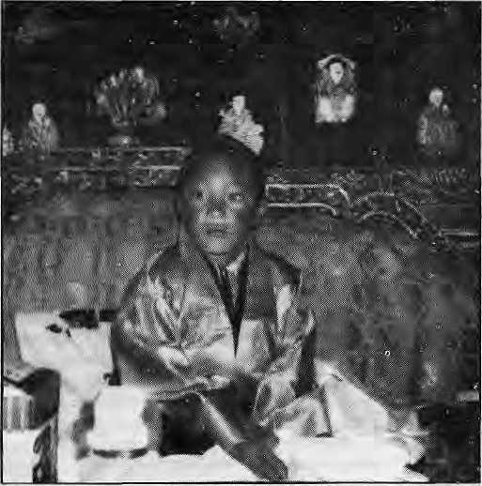
Thai 7th Gyalwa Karmapa: controversial choice.
O
n 27 September 1992, eight-year-old Ugen Thinley was enthroned at Tsnrphu monastery, near Lhasa, as the 17th Gyalwa Karmapa, an incarnation second only to the Dalai Lama in his importance to Mahay ana B uddhists. The ceremony should have occasioned universal joy among followers of the Karma Kagyu sect of Tibetan Buddhism, who have waited more than a decade for the reincarnation of the 16th Gyalwa Karmapa to be found. But doubts about the authenticity of this "reincarnation" have struck at the very roots of the Karma Kagyu lineage and have split the faithful into two camps.
The first believes that Thinley is the rightful occupant of the Karmapa's throne, and are accused of being seduced by political manipulators in league with China; the second believes he is the wrong boy and so arediscounted as troublemakers.The silent majority of followers see both camps as forsaking the dharma (the spiritual path) for samsara (the cycle of rebirth caused by attachment to worldly affairs).
At stake is the purity of the Buddhist teachings, handed down by the first Gyalwa Karmapa, Dusum Khyenpa, to followers in an unbroken line since he founded the Karma Kagyu school in the early 12th century. But even the unworldly cannot turn a blind eye to the fate of the priceless and fabulous treasures that have accumulated over nearly nine centuries at the core of what is today areligious empire that governs some 500 centres worldwide.
Like the other three major schools of Tibetan Buddhism—theNyingma, Sakya and Gelug — the Kagyu sect reorganised itself outside Tibet following the Chinese invasion. On leaving Tsurphu, monastery the 16th Karmapa, Rangjung Rigpe Dorje, choseRumtek monastery, in Sikkim, as his seat in exile. Rumtek was the second Karma Kagyu monastery to be built, in .1740. From there the Karmapa administered and personally held the affairs of the sect together, despite travelling widely to promote the dharma. His death from stom ach cancer, in the United States in 1981, left the faithful with a spiritual hunger that could be sated only by the Karmapa's reincarnation. It left others with a more worldly hunger — for a position of religious influence, political power and personal financial gain.
Sacred letters, magic, political intrigues, fabulous treasure and big
by Omar Sattaur
business; the events leading up to Ugen Thinley's enthronement read more like a modern-day thriller than religious custom. The roots of the controversy lie in the relationships between four men — themselves incarnations of important Kagyu spiritual masters — who, traditionally, were prominent in regional administration as well as in upholding the dharma. They are rinpoches; incarnations of spiritually enlightened beings who have chosen to forego nirvana for continual rebirth in order to lead others to enlightenment.
Regents of Rumtek
When a Karmapa dies, he leaves behind the total Kagyu teachings in chosen disciples who can later transmit them to his reincarnation. Tai Situ Rinpoche, Kunzig Sharnar Rinpoehe, Jamgon Kongtrul Rinpoche and Goshir Gyaltsab Rinpoche were thus groomed by [he 16th Gyalwa Karmapa and, on his death, appointed as regents by the Karmap.i Charitable Trust until the 17th Karmapa was identified and came of age. On 5 November 1981, when the 16th Karmapa died, they held in their hands the future of the lineage. Since then a number of candidates had been put forward as possible reincarnations of the I6th Karmapa. Unlike other rinpoches, most Karmapas leave letters predicting their reincarnations. The letters usually detail the name
of the parents, time and placeof birth and thedate on which the instruction letter is to be opened. After a meeting atRumtek, on 23 February 1986, the regents issued a statement in which they claimed that a thorough search of the 16th Karmapa's belongings revealed an "inner" and an "outer" letter. The outer letter contained instructions to remove obstacles to a speedy rebirth. The inner letter would not be opened until the future date marked outside. But followers were to hear no other news until 1992.
Wicked World
The Tibetan Buddhist tradition is rich enough to attract Western followers who, in secular life, would be considered poles apart. Its neat logic appeals to would-be ascetics and mystics as well as to those who see self-development through meditation as the most worthwhile goal of life. But there are others irresistibly attracted by the colourful rituals, magic and miracles of rinpoches who offer, literally, the wisdom of the ancients. That politics has interfered with the smooth running of religious affairs is certainly nothing new either to the Kagyu sect or to any other religious organisation. What is perhaps new is a greater demand for transparency from followers, particularly newly inducted Westerners, of the sect's internal affairs. Again, like any religious sect, the Kagyu is only partly open to the scrutiny of followers, who themselves are reluctant to disclose unsavoury aspects they may stumble upon.
Since the 16th Karmapa died there have followed years of mudslingingandpoliticking between supporters of Sh am ar Rinpoche, who doubt the authenticity of the most recent reincarnation, and supporters of Situ Rinpoche, who put Ugen Thinley on the throne. During the past decade, Shamar Rinpoche has been accused, because of his relationship to the Bhutanese royal family, of Hying to put a Bhutanese boy on the Karmapa's throne; Jamgon Kongtrul Rinpoche hasdied; and Situ Rinpoche, backed by Gyaltsab Rinpoche, has been accused of trading a Chinese-approved Karmapa for the promise of greater influence in the Kagyu sect and political power in a future, autonomous Tibet.
Nov/Dec 1992 HIMAL • 45

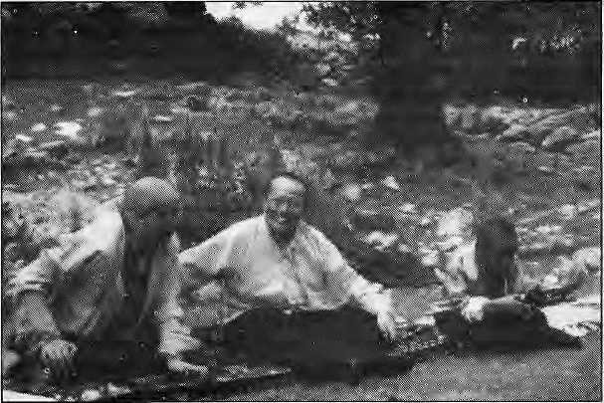
Gyaltsab and Situ Rinpoches with the new incarnation in Tibet
At the centre of the controversy is the authenticity of another letter, purportedly written by the 16th Gyalwa Karmapa, giving details of where and when to find his reincarnation. Situ produced this letter at a meeting of the four regents, held in Rumtek on 19 March 1992 — more than six years after the four had publicly announced the existence of the "inner" and "outer" letters. According to Shamar, he and Jamgon Kongtrul doubted the authenticity of Situ's letter, but Gyaltsab immediately accepted it without even reading it. Why had it taken Situ more than a decade to offer it? Why was half of the letter blurred and the signature unclear?
Situ's defence was that he was unaware that he had the prediction letter. In January 1981, he said, at the Oberoi Hotel in Calcutta, the 16th Karmapa had given him a protection chakra wrapped in yellow brocade. The Karmapa told him that it would prove useful in the future. Situ then wore it around his neck for a few years. Months of travelling in the heat of India and Southeast Asia persuaded him to transfer the brocade-covered chakra from around his neck to &phurba, worn around the waist Some time in 1989, he removed the chakra and found that it was a testament, upon which the Karmapa had written that it should be opened in the Iron Horse Year, which began on 26 February 1990.
But Situ's explanations failed to convince S hamar and Jamgort Kongtrul Rinpoches. S ham ar called for a forensic test of the letter which Situ rejected as improper. This dis agreement probably marked the rift that still exists today between Silu and Shamar Rinpoches. The four decided that, since Jamgon Kongtrul was already preparing to visit Tibet, he should look for the reincarnation as per Situ's letter and report back. They agreed to secrecy until an official announcement concerning the reincarnation to be made on 11 October 1992. As it turnedout,JamgonKongtrul was not to reach Tibet.
Race for the Throne
At about 6.30 am on 26 April, through the drizzle on the national highway south to Siliguri, Jamgon Kongtrul Rinpoche was trying out a new BMW, a gift from his brother. Accompanying the rinpoche and his driver were TenzinDorjee, his secretary, and one attendant. The car was reported to have been travelling at about 180 km per hour when the driver swerved to avoid hitting some birds on the road. The car skidded, fish-tailed for 30 to 40 metres and hit a tree so hard that all four passengers were thrown out of the vehicle.
The Kagyu sect lost one of its most important teachers, a man whom associates describe as sincere and selfless in his commitment to preparing the way for the 17th Karmapa. Shamar Rinpoche had also lost a colleague who shared his doubts about the authenticity of Situ's letter.
The vacuum createdby Jamgon Kongtrul's death served only to emphasise the rift between Situ and Shamar Rinpoches and the two factions
began to work independently. At Rumtek, on 17 May, Situ said that the death of Jamgon Kongtrul had altered the regents' plans. He said that he and Gyaltsab were unable to meet Shamar because he was on retreat when they arrived at Rumtek and, before they knew it, had left for the United States. He and Gyaltsab had therefore decided to forge ahead with the plans made at the 19 March meeting. Situ made no mention, however, of the doubts that Shamar and Jamgon Kongtrul had rai sed about the prediction letter he had produced at that March meeting.
On 7 June 1992, Situ and Gyaltsab Rinpoches arrived in Dharamsala to seek, as is customary, the Dalai Lama's approval for the reincarnation. But the Dalai Lama had left for the Rio Earth Summit and so the regents had to make their request by telephone and fax. On 9 June the Dalai Lama's Private Office faxed back. "The birthplace of the reincarnation, the names of the mother and father, and so forth, are in agreement with the sacred letter. It is very good that inside and outside Tibet, Tulkus, lamas, and the monasteries belonging to the lineage, are all one-pointed in their devotion and aspiration. It is appropriate to recognise and confirm what was stated above." If he knew of the dissent among the regents, the Dalai Lama made no reference to it.
The 7th of June found Shamar Rinpoche back at Rumtek only to learn that the other two regents had left foiDharamsala, without consulting him. Events now began to move rapidly and are detailed in The Karmapa Papers, which Kagyu followers believe was produced by supporters of Shamar Rinpoche.
The Karmapa Papers is a collection of a decadeof selected letters among thefour regents, eyewitness accounts of the installing of the 17th Karmapa, translations of important Tibetan documents pertaining to the search for the reincarnation, and interviews with the main players in the story. It was printed in Hong Kong and appears to have been compiled by a group of Western followers of the 16th Karmapa who sign themselves only as The Editors, They come across as disillusioned by the events leading to the recent enthronement and claim that the document is an attempt to clarity matters.
According to transcripts in the document, Shamar talked to followers at Rumtek on 9 June.
He referred to the letter produced by Situ Rinpoche in March 1992 which "appeared containing the n ame of the father, the n ame of the child's mother, the place... Everything is clear. This is quite problematic". He expressed surprise that Situ and Gyaltsab had gone ahead and that a search party had already left for the boy.
Thenextdaythe other two regents returned to Rumlek. By then, the atmosphere at the monastery had grown tense. Situdecidedtogive his version of events and informed followers that the Dalai Lama had confirmed the reincarnation and that the boy would soon be enthroned at Rumtek. In the same speech he dropped a bombshell. According to him, the "inner" and "outer" letters announced in February 1986 had never existed!
White Lie
Situ said that pressure from followers to find the 17th Karmapa, a fj the abt. ^ce of a true instruction letter, haa persuaded l -rinpoches to tell a white lie. They decided to place a poem of the 16th Karmapa in a g£H, or relic box, but they could not find a poem. Gyaltsab remembered a four-line meditation prayer taught him by the
16th Karmapa and Jamgon Kongtrul recorded it and placed it in the gau. At this stage all four were still convinced that either a true letter would eventually turn up or that the 17th Karmapa would reveal himself.
By revealing this 'white lie', many disillus ioned followers believe that Situ Rinpoche achieved what he had set into motion as soon as the 16th Karmapa died—to gradually marginalise the other regents in their roles as administrators and protectors of the lineage. The two leaders of the Karma Kagyu sect were now in open conflict.
Sharmar Rinpoche, in Ju ne suddenly hinted that a close disciple of the 16th Karmapa may have trustworthy information on the reincarnation.
Rumtek was to see more drama on 12 June, when Situ and Gyaltsab returned called a meeting

46 HIMAL • Nov/Dec 1992

to report on the Dalai Lama's confirmation. SharnarRinpoche arrived, but with some soldiers in tow, and pandemonium ensued. According to Shamar, an Indian Army general had informed him on 11 June that a bodyguard unit was being sent to protect him. It arrivedduring the night and the next day followed him to the monastery.
The mess seemed to be cleared up on 16 June whenUrgyen Tulku, senior to andrespected by both Shamar and Situ, arrived at Rumtek to mediate. Drgyen Tulku said news of Shamar's dissension would cause neg ativity and bloodshed in Tibet. There was also Dharamsala's confirmation to consider "Who am I to say that the Dalai Lama's approval is in error?" Shamar Rinpoche asked. He withdrew his request for forensic analysis of Situ Rinpoche's letter.
On 22 June, Situ and Gyaltsab Rinpoches sent an official announcement to followers declaring that the 17th Karmapa had been found, approved by the Dalai Lama and that all disagreements had been resolved. Beijing, on 29 June, gave its approval of the "living Buddha". On 27 September, he was enthroned at Tsurphu.
However, according to Beru Khyentse, a high Kagyu rinpoche, Shamar Rinpoche is still waiting for the 17th Karmapa.
Chinese Choice
If the supporters of Shamar Rinpoche and the editors o f the Karmapa Papers are to be believed, it would appear that Situ Rinpoche, backed by Gyaltsab Rinpoche, the Derge Tibetan Buddhist Cultural Association, and Chinese officials, manipulated events in order to enthrone Ugen Thinley. A number of factors suggest this interpretation.
First, is the Chinese reaction to the whole affair. Ugen Thinley is the first incarnate lama to have been officially recognised by Beijing since the abortive Tibetan uprising of 1959. A Tibetan newspaper dating from the summer quoted the letter of authorisation from the Chinese Department of Religion, of the General Home Ministry, which claimed that: "the son of Urgyen Thrinle, of the nomads Dondrub and Loka, born in Lhatog Shang, in the district of Chapdo of the Autonomous Region of Tibet can be considered as the reincarnation of the¹16th Karmapa and will later be enthroned as such. The Tsurphu monastery did an excellent job in protecting the reincarnation and choosing his teacher and attendants..." The letter also expressed the hope that the 17th Karmapa, "after having studied well philosophy and all the other sciences and possessing all the qualities turned towards the dharma, will become an individual loyal to his socialist motherland."
Secondly, the regents had decided on 19 March 1992 to wait for JamgonKongtrurs report from Tibet before making any public statements. But, according to the documents presented in the Karmapa Papers, Situ wrote a letter one week later stating that the search for the 17th Karmapa
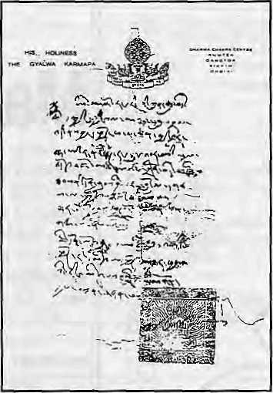
Pediction letter produced by Situ Rinpoche.
was underway. It also seems that, regardless of the agreements made at the 19 March meeting, the process for installing Ugen Thinley was already ongoing. Drubpon Dechen Rinpoche, the head lama of Tsurphu, said that a search party bound foreast Tibet h ad left Tsurphu on 8 April. He also said that the search patty had received instructions from Situ's representative, Akong Rinpoche. But the dates do not tie up; by other accounts Akong Rinpoche did not arrive at Tsurphu until late April.
In his Rumtek talk of 9 June 1992, Shamar referred first to a Nepal-based "Tibetan committee" that had been spreading rumours that Shamar wanted to install a Bhutanese Karmapa and that, in Kagyu tradition, the Situ Rinpoche usually recognises the Karmapa's reincarnation. Then he referred to a group of Khampas from Nepal who arrived at Rumtek in March 1992 with Akong Rinpoche "acting as a chief of them". Shamar said that, at the 19 March meeting, this group was pushing the regents for an instant decision about the Karmapa's reincarnation.
Thirdly, there is some suspicion about the relative ease with which Akong and Situ, compared to other Rinpoches and lamas, may travel in Tibet. According to the Samye-Ling newsletter of Spring 1985, Akong Rinpoche said: "I am very happy about the flexibility of the policy of the Chinese Government because they have asked us (myself and H.E. the Tai Situpa) to come whenever we like to Tibet, either foTashort term or a long-term visit."
All this suggests that Ugen Thinley was found, accepted by the Chinese and plans set in motion for his instalment in Tsurphu before Jamgon Kongtrul' s propo sed reconnaissance trip. Reproduced and translated documents in the Karmapa Papers imply that, for whatever
reasons, the Chinese considered Ugen Thinley a suitable 17th Karmapa and that Situ allowed them to have their way.
Beneath the Maroon
Underlying the concern and confusion overUgen Thinley's enthronement is an acceptance which perhaps non-Buddhists find difficult to understand. What if Ugen Thinley really is the wrong boy?
The doctrine of reincarnation is complex. It is difficult to understand for Buddhist followers, letalonenon-Buddhists. Questioning the doctrine from a scientific perspective is even more perplexing as there must first be consensus on the meaning of words such as mind, spirit and so on. Having s aid that, rinpoches talk of emanations of the same mind. Thus one mind may be reborn as different emanations in different bodies. To the cynical, emanations would seem to be a neat way of explaining away mistakes made in the identification of rinpoches and reincarnations were it not for the fact that even rinpoches admit that the "spirituality" of emanations can vary considerably.
Beru Khyentse Rinpoche tells a story that is perhaps instructive. There are fiveKhyentses, believed to be "emanatiuns" of the same being. The Beru Khyentse referred to in this article is Tibetan but tells of a Bhutanese man, also recognised as the reincarnation of the previous Beru Khyentse. Unlike the Tibetan Beru Khyentse, his Bhutanese emanation was not acknowledged by the 16th Karmapa and today he is no longer interested in the dharma. Could Ugen Thinley be merely one emanation of the Karmapa?
Beru Khyentse accepts Ugen Thinley as the 17th Karmapa because he believes that the boy could not have survived the enthronement if he were not the true Karmapa, such is the power of the great "wishfulfilling jewel". Western folio were are still doubtful but, for reasons simi lar to Beru Khyentse's, even they agree that if Ugen Thinley is not the Karmapa he is definitely ahigh rinpoche.
So does it matter if Ugen Thinley is the wrong boy? The unquestioning among the Kagyu faithful would not admit such a possibility. Increasingly, however, more difficult questions are being asked of the dharma, particularly by Westerners who come from a different cultural background in which he or she feels more secure in certainty. They perhaps are more willing to question ancient traditional methods of identification, are more willing to put Situ Rinpoche's letter through forensic tests, more willing to question Shamar Rinpoche's right to withhold information from followers; And all this in the growing recognition that rinpoches are not necessarily all that enlightened and that the man is more important than the maroon.

Nov/Dec 1992 HENUL • 47

3HANCHHA GHAR

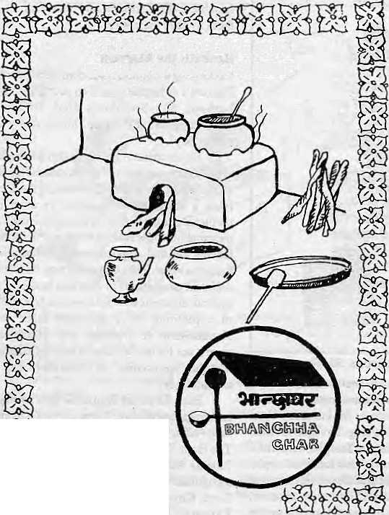

AT LAST, THE PLACE FOR EXCLUSIVE NEPALI CUISINE
Kamaladi, Kathmandu Telephone:225172
OPENDAILY12-10
Why
Macintosh ?
Why do people who use Apple Macintosh computers every day enjoy working with them so much/and find that they're much more productive in the process ?
Is it because Macintosh computers are so easy to set up, learn, and use? Or because Macintosh applications all work in the same consistent, intuitive way? Or because every Macintosh comes with built-in networking and file-sharing capabilities ?
Or is it simply because once people use a Macintosh, nothing else will do?
Every day, thousands of people discover the advantages of Macintosh for the first time. And catch a glimpse of its magic.
So if you want to know why contact us at MIPS.
MIPS Pvt. Ltd.
P.O. Box: 2502, Tel: 222277,
Telex: 2521 ATLINK Fax: 977-1-419250

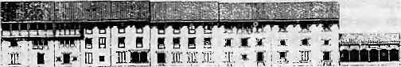
NOT BY WORDS
ALONE—
PRESERVING NEPAL'S ENVIRONMENT AND CLEANING KATHMANDU'S
TOWNSCAPE NEEDS STUDY,
COMMITMENT, ORGANISATION,
DEDICATION.
LET US ALL WORK TOGETHER.
NEPAL
INTERNATIONAL CLINIC

* Western medical setting serving the entire community it Care by a U.S. Board
Certified Internist ■it Comparable services at lesser
rates
•fc Imported Vaccines, Lab work it Knowledge about Mountain Sickness. it Central location it 9:30 am-5 pm
it Open Sunday
it Prior appointment encouraged
412842 & 419713
Phone answered 24hrs,


Naxa!
NANGLO
DURBAR MARG
PO. BOX 4384, TEL : 223498, FAX : 527865
i r
Lazimpat
Thamel
i r
Kantipatn J l_
Royal Palace Main Gate
Durbar Marg '
Jai Nepal Cinema Hall

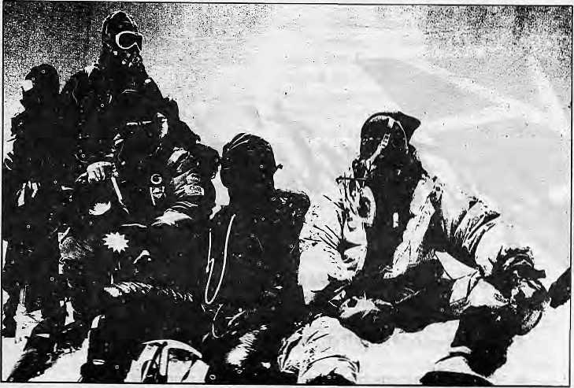

IN
WILDERNESS TREKKING (P) LTD.

LOOK! A BUNCH OF PEOPLE ARE ON TOP OF MT. SAGABMAJHA.
WHY ARE THEY THERE?

BOTANY, ZOOLOGY, METEOROLOGY,.GEOGRAPHY ARE ALL PART OF EVERY
PERSON'S DAILY LIFE. THE MOUNTAINS; DESERTS, OCEANS AND SKIES ARE
ALWAYS!iERE WITH A SMILING CHALLENGE FOR US. NATURE DOES
PRESERVE A BALANCE. BUT DOESMAN?:

Indeed, AngMitaSherpa^he legend, {^ ,m,,_{U}u,,A_{/iJB},,_{iia}i,u
many, marly other adventurers! explorers; and mountaineerstiave su^ce1ed:ih^conqueririg the ^ challenges and adversitiesof burIf If net. Of Course, all pioneers, explorers and adyehfurers deserve the highest respect and salutations; But one day all thesi Expressions df ad miration may becdhie curses for us.
Time is methodically:pressing on, and will?nbt waitfoj us to; prevent this beauti|ul;ahd challenging Earth of ours from falling intb aistate bi desdlation^ Dear fri$nds: let us survive; let us explore; let us rinak^ adyenture; let us trek,:but letustakie a-step to preservsatid protect what we hayeand to plarrt for the future.
With this cGnspiousness, yes, we support your holiday and
advinture tn



GPO BOX 3043. ^^Sf
: :: kmhmandu m^pal
TEL: 470760 (Res), 473700 (Off) ;■■ ::: -Fax; 9771 474685 ;: "


- The ancient art of Ayurved Medicine Is being revived again
by NATURAL MEDICINE INDUSTRY (N. I. M.) which is In
Swayambhunath.
- Shouldyoucometo our Pharmacy you wiliseesuch wonders
as:
- CORAL being made into a potion that stops the process of
aging,
- SILAJIT (Natural Bitumen) being transformed into a health
giving elixir.
- KARL being used for eye and memory reviving medicine,
- You will get the medicines you need for your common
diseases, (influenza, rheumatism, gastritis, indigestion,
flatulence, dysentery, diarrhoea, liver tonic, cough),
- So why not step in to the wonderful world of Ayurved which
has more benefits and few side effects. You will also be
rounding-eff the Swayambhunath trip with a healthy
experience I
FOR ANY INFORMATION OR ANY QUERIES YOU HAVE PLEASE CONTACT:
Mr. Jacques Lecup .

Mr. Sanjay Banskota A
N
Mr. Yam Bahadur Kulung Tel:412I93,271280.
ATURAL-f
MEDICINE INDUSTRY (PVT.) LTD.
finder French Colinhnrationi
♦ Geeta Mandir, Near Ananda Kuti School.

P.O. Box 1569, Kothmandu. Nepal,
KNOW YOUR HIMAL

Teaching Children to Know Their Himals
Geographic knowledge of places
distant or proximate is not born
spontaneously in children...
by Sam Brian
A
sllookcdfromtheplanewindow,watching the red-brown seal lopsof the Saudi Arabian Desert fading in the late afternoon light, I fell anxiety. An American teacher trainer — a geography educator — I was about to teach a class of fourth-graders at a newly st;irted school in Katlimandu for a few short weeks in August. While doing so, I would be observed by a dozen Nepali teachers-in-train ing.
Half a world away in New York, for the sake of the training course, I had fashioned a three-dimensional model to show the terrain of the Himalayan range. The 5-kilo grain me model, made of plasticine clay, was designed to give the students a feel of the mountainous region in which they lived and the great river systems arising from the Ganga-Brahinaputra watershed. Now that I was approaching South Asia, flying over the blackness of the Persian Gulf, I wondered whether bringing mountains to Nepal was really a redundancy of Himalayan proportions, like bringing coal to Newcastle.
Perhaps the mountain-savvy Nepali teachers and students would roll their eyes in exasperutio n at my n ai ve pre sum ptio n. Or perhaps they would simply smile politely and suffer through my lessons. After all, it was their region. All my knowledge was second-hand, gleaned from back issues of the National Qfioetaphic magazine.
Days later in Katlimandu, my anxiety was stilled as, ringed by a class of eager ninc-ycar-olds, I poured my blue-dyed water down the front range of the model that I had brought with me. The water pooled in a depression in the lap of the mountains before continuing on to the miniature sea at the base. In the centre of the pool, a little clay island remained, not quite in undated by the blue water. Thechildren became excited, identifying the clay island with a real hill in Kalhmandu thai was, according to legend, once an island in •<£ shallow Like — today's Swayambhu hill.
"Cuthere, sir! "thestudents urged gleefully. They wanted me to notch the edge of (he kike so that the water would exit and continue running downhill to the sea. As I raised my pocket-knife to perform the terrestrial surgery, the students
cried, "Manjushri, sir, Manjushri!" It was he, the legends say, who, with his flaming sword of wisdom, cut the gorge in the southern end of the Katlimandu Valley to drain the great lake. As I cut away a bit of plasticine, the coloured water drained outof the depression in the lap of the clay mountains, and the little island was transformed, as in the myths, into a hill that rises from the floor of the Valley. It appeared that, with some calculation and some dumb luck, my pedagogical plans had connected with the geography and myths of Kathmandu.
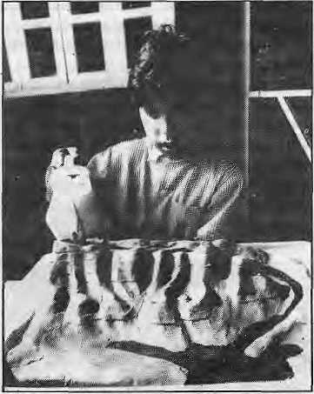
Student with plasiicinQ Himalaya model
As our work continued, I saw students discovering many things about their home region, tilings which, without a physical terrain model, would have been difficult to comprehend. They saw that islands are part of a continuous land surface despite their being surrounded by water. They saw how the arrangement and contours of the mountains orient the course of rivers that run down their slopes. They observed the places where the rivers plunged from greater elevations U) lower ones. They saw that the rivers ignored compass directions and obeyed only the laws of gravity. They saw the pattern formed by the many tributaries that converged from the mountains and flowed towards the delta and the sea. As an extra surge of water coursed down the rivers, submerging the delta, they correctly observed that extra rain in the valleys of the north had caused flooding in the delta of the south. In short, they saw themselves as located in a region where events in the mountains, valleys and lowlands were connected.
Because mapmaking plays a central role in the child's integration of geographic experiences, I had the children stand over the Himalayan model and draw maps of the peaks, ridges and rivers from this bird's-eye view. Mapmaking allows the child to associate objects in a three-dimensional world with graphic symbols on flat paper. This association of objects and symbols is a major stepping stone on the way toward reasoning with symbols and thus an important bridge to maprcading. The progression from concrete experiences with a geographic model, to mapmaking, and finally to mapreading is best told in the words of a nine-year-old student:
The part I liked was when Sir poured some colour-mixed waterandletit pourdownfromlhe lop of the hill to see where the water would come down {is a take.-,
It was powerful to see the children broaden their understanding of the magnificent environment in which they live. Nor was it superfluous for them to investigate the relations hip of mountains atidrivers on the model, whose use as a teaching tool I had momentarily doubted. What I had forgotten, in my anxiety not to appear the presumptuous foreign expert, was that geographic knowledge of places distant or proximate is not born spontaneously in children or adults. On the contrary, it has been my experience that the small slice of the Hudson River which any New Yorker experiences in daily life gives little hint of the hundreds of mountain lakes and tributaries that constitute the sourcesoftheriver,nordoesitrevcaliliedynamics of the estuary at the Hudson's mouth, or the complex relationship of humans, animals and plants to the river system.
Likewise, Nepali children cannot spontaneously understand the regional geography that conditions their lives as children and as future adults. They must explore the relationships of monsoon rains in the Himalaya and the. floods in Bangladesh on physical models. They must experience and map rivers to understand [heir role in the creation of hydroelectric power or the spread of water-borne diseases. And eventually, they must learn to read and reason with the iibs tract data of maps! hat show the incidence of malaria, AIDS, pollution, and deforestation.
If ignorance of our environment is a peril that holds future generations at risk, as-1 believe it does in New York as well as Katlimandu, then it is my hope that the teachers and elementary schools across the Himalayan region will consider making and mapping models of mountains and use their atlases as tools to develop themselves and their respective countries.
S.Brian, from the BankStreetColiegeof Education, New York City, was a teacher-consultant at the Rato Bangala School, Patan, in August 1992.
Nuv/IX-l \992 HIMAL • 51

Abominably Yours,

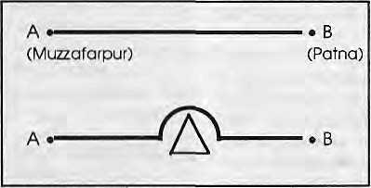
T
he breath does not come easily. Not because there's too little air, but because there is too much. Every time I open my mouth, more oxygen than I require enters my lungs. 1 can feel the sacs resisting this intrusion, but the air pressure is too much. In the end, unable to withstand the effects of Low Altitude Sickness (LAS), I am bundled into a portable de-pressure sat ion chamber, the Pokhrel Bag, It is named after the Nepalganj doctor who invented it as an emergency measure to save highlanders from this lowland specific syndrome.
Inside the Pokhrel Bag, as the air was evacuated to simulate the Himalayan heights, I had time to meditate over how it is that I find myself
here smack in the middle of the Grcal Plain of Bihar. I was in town to inaugurate and deliver die keynote address at a UNESCO-funded workshop entitled, "Stranded; How lo Take Advantage of Being in the Middle of Nowhere".
As I said, the town is Muzaffarpur, and if you stand on your toes you can see Patna. That's how flat it is. And it was this horizontality that first began to affect my health and wellbeing as soon as I got off the narrow gauge train from Jayanagar at die Nepalo-India frontier.
Without mountainous markers I was completely at sea, cr, plain. I kept searching for geographical signposts and there were none. Up where I live, that's Makalu in the north and dint's the Barun river jostling its way south. How do I orient myself here? There's this mango tree coming up as 1 take the rickshaw to the conference venue, but its hardly any use as reference point. Mountains do not shift, but mango trees seem to.
The Great Plain is not only flat, it is also low. Here, we are barely four hundred feet above mean sea level. It is a wonder how ihe Ganga even knows to flow towards the sea in an incline so subtle. That must be why il is revered as a great river. Mountain rivers like Barun and its elder brodier Arun never needed any divining power to know which way lo go, so diey are treated rather matler-of-factly. Besides, compared to the Ganga's serene flow, they make too much noise.
The symptoms of LAS had started to hit me as t began my keynote address. Its a little like how you feel when you blow loo many
baloons in quick succession and begin to feel light-headed. I started feeling light-headed and began to make light-hearted comments about all sorts of things, flatness being one of diem. Apparantly I had even begun to make merry, for I noticed my Bihari colleagues in the audience beginning to scowl, and the organisers in the podium to squirm.
The next thing I remember was being escorted from the podium with a doctor muttering something about diese overconfident highlanders that "come down too low too fast". Apparently, a Great Plains Rescue Association (GPRA) had been formed to help individuals such as myself who over-confidently make fast descents to the flats without realising that diere is so much more
pressure down here than up there. It has to do with the atmosphere, which presses down more heavily on Hindustan. Rapid descent by Himalayans is discouraged for it can lead to cerebral or pulmonary problems caused by the evacuation "of serous fluids from the intercellular spaces of tissue". In simple language, the lungs and brains lose water and shrivel up.
My brain, certainly, was at that very moment beginning to shrivel up like a chuno freeze-dried potato'of the Andes. Otherwise, why was I thinking of all the unsavoury cousins of the word 'flat"? Horizontal, lowland, level are all value free, but that was not what came to mind. My mental thesaurus kept veering towards prejudicial synonyms: prostrate, dull, listless, bland, supine, passive, insipid.
But before long, though, 1 seem to have stabilised. The LAS seemed to have eased off, for my musings entered a gentler phase. There were advantages lo flatness, I decided. The foremost advantage seemed, to me, that in the plain you could walk in a straight line without a mountain or hill coming in the way. What fun! Take point A and point B on the diagrams that I have drawn for your benefit. Now, if this diagram were lo be superimposed on a satellite imagery of the Great Bihar Plain, your average traveler could do die journey like a crow would rather than a hill porter. Whereas, if diere weTe a mountain on the way (as denoted by the triangle), the same average traveler would have to circumnavigate the obstruction. In fact, it seems that in the plain you can go straight lo wherever you wani to. You will also
notice that there is no need to traverse vertically in the plain.
So, in conclusion, there is no lateral or vertical deviation when you travel in Bihar. Whereas in the Upper Barun, there are many diversions before you make your destination.
In a bag in Muzzafarpur, I had discovered the reason why the Himalayan region is under-developed. And going right to the source, the problem was tectonic. If only the Indian plate had not collided with the Asian plate, everything would have been, as they say over in the Great American Plain, hunky dory. Without geological deities, there would have been no Himalaya where you today have Himalaya — only flatness as far as the eye could see, with whole populations living in the middle of nowhere and perfectly content with that. Instead, successive Geology avatars had to create these mountains, and now everyone comes by wanting to get to the lop.
If you asked ine why I want to climb Makalu or Chamlang, I wouldn't say "Because it is there!" I would climb it only to get to the other side. And if there were a way to get to there without puffing all the way to the summit, I would lake that route. But Reinhold Messner just would not listen, although he did promise to keep our meeting secret.
Back to our discourse on Development. Dear reader, do not pity the lowlanders for having to stand up on their toes. Instead, envy them, for whom the Raj built the Great Indian Railway system only because the landscape was a flatscape. You have noticed — as the Empire Builders got closer to the hills, the broad guage became meter gauge, and then narrow gauge, until only toy trains were employed to carry parasoled ladies to hill stations.
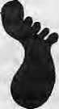
Breathing lightly inside a Pokhrel Bag in Muzaffarpur, I am beginning to formulate a Plan of Action. The only thing to do in these Democratic Moments, is to Organise. As soon I gel back to my terrain, I'm going to make myself an NGO thai will agitate and let the world know that the Himalayan indigenes have finally realised, albeit a few million years late, that Geology is at fault. Now, they want Lhe Inalienable Right lo Live in the Flats returned to them. So let us have the entire process reversed.
...ah, Doctor Pokhrel, wherever you are, this low altitude affliction does seem to be getting to my head. Could I be evacuated to higher altitude?

52 HIMAL • Nov/Dec 1992


HIM L
Advertising
In The Thinking Persons
Magazine Of The Himalaya
HIM6L
Himal is the only international magazine of the Himalaya. Ithasaselect,committed and expanding readership in South Asia as well as overseas. Every two months, our pages will carry your message effectively to a high-profile audience. Himal is a bimonthly, but its shelf life is counted in years. Advertise in Himal and reach your market. Write to the Managing Editor at POBox 42, Lalitpur, Nepal, Tel 523845 Fax 977 1521013

Regd. No. Lalitpur



Northwest makes it easy to go to America. With a choice of 8 gateways. And connection to 200 cities beyond.
Choose a connecting city that suits you best: Bangkok, Hong Kong or Singapore.
generous free flight plan there is. General Sales Agent in Nepal :
Malla Treks,
Malla Hotel Arcade,
Kathmandu, Tel. 418 389
Northwest has daily 747 flight via Tokyo or Seoul straight to-the U.S.A.
Be sure to ask about WorldPerks, the most


