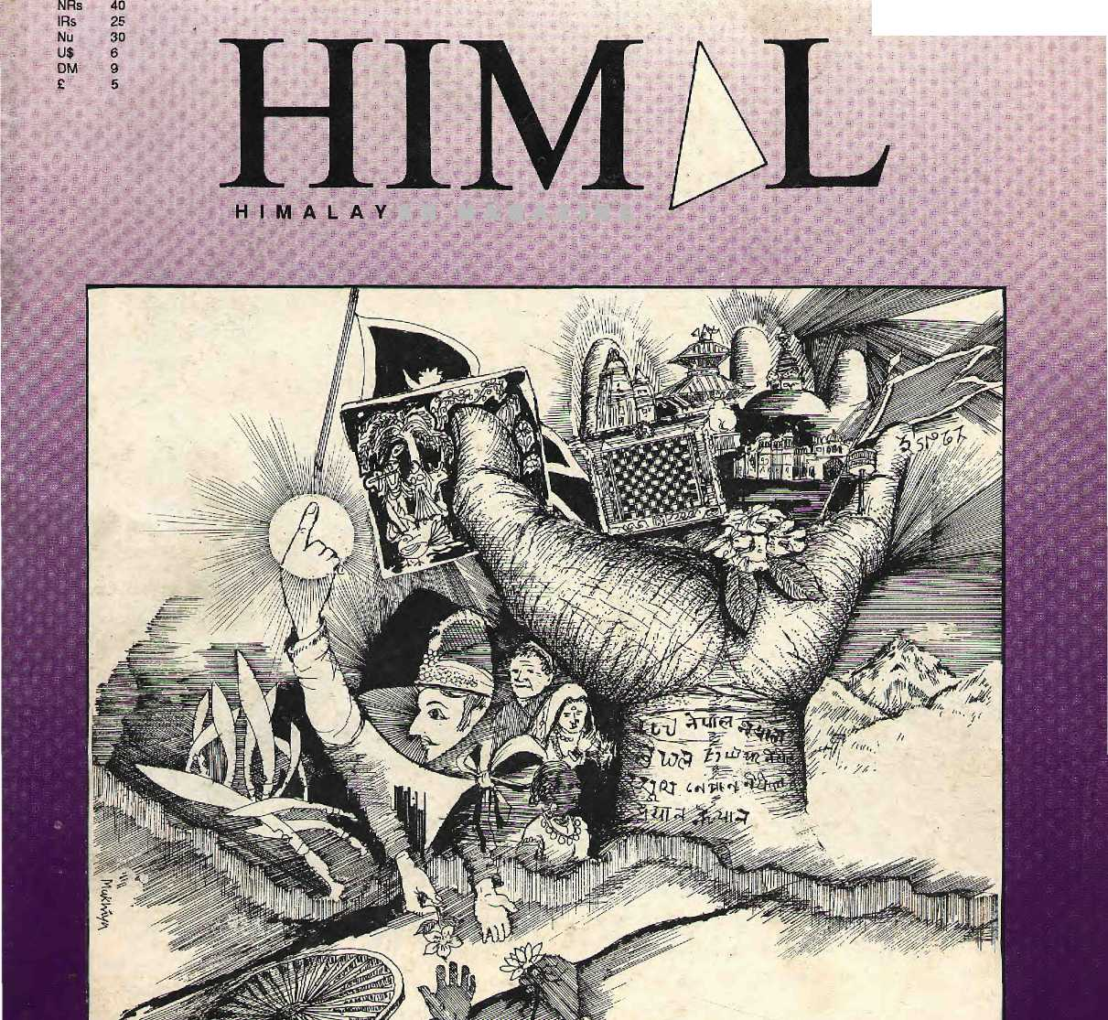
Mar/Apr 1993
a n m a: g a z i n e

GREATER NEPAL LESSER NEPAL
Comrade Gonzalo • The Support of Dharma Bhutan Conference • Arun Three

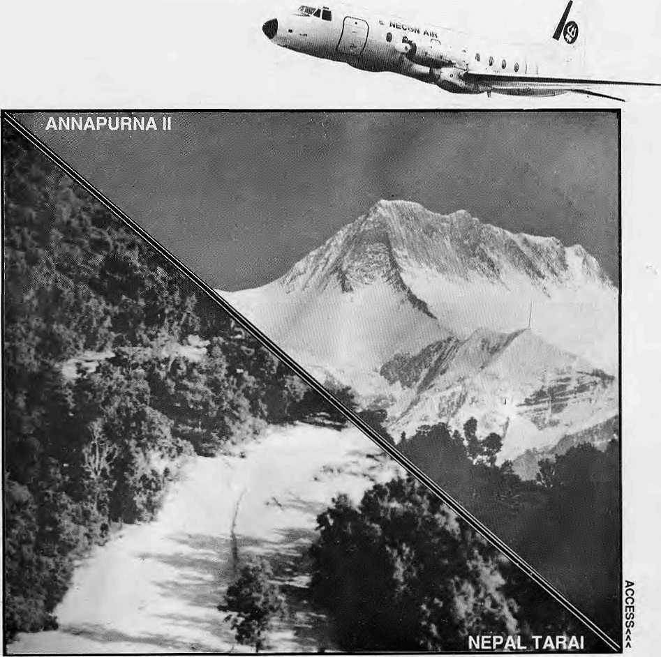

NEPAL UNDER OUR WINGSPAN

You want comfort.
NECON AIR's HS 748 Avro aircrafts are the most spacious, and our staff
You want punctuality.
NECON AIR links Kathmandu, Pokhara, Simra, Nepalgunj and Bairahawa with an efficiency that has become the talk of these towns.
You want pleasure.
We take mountain flights from Kathmandu for the Eastern Himalaya, and from Pokhara for Annapurna and Dhaulagiri.
Try us. Fly us.
NECQN AIR

Sales: 414367, 412260 Re sei vat ions: 418608, 418809 Fa*: 977-1-412645 Telex: 2739 NECOA NP PO Box 4047, Kathmandu.

INSIDE...

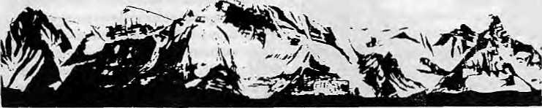
MAIL
His Father's Woes
Manisha Aryal's article on Himalayan herbs belittles Nepali professionals and perpetuates the inferiority complex that we Nepalis have. Aryal has covered many aspects of the Nepali herbal trade and goes into great pains to collect opinions from many Indian business people and one Indian scientist. I appreciate this effort. But there is very little of Nepal in the article. Talking to token businessmen, customs people and Government administrators does not provide the complete picture.
This phenomenon of treating high quality professionals with little respect is pervasive of our society; we would much rather take advice from a foreigner and trust his technical knowledge. Wake-up folks! There are Nepali professionals who are just as eompetent and well trained as many
An Apology
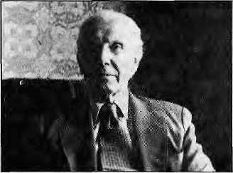
in its Sept/Oet 1992 issue, Himalcarried an obituary of Cristpph von Furer-Haimendort, doyen of Himalayan anthropology. Much to our relief, we were informed recently that Prof. Furer-Haimendorf has in fact not passed away, and probably had a good laugh. Our report was based on an announcement made by the organisers of the Nepal anthropology conference heldinSep-tember 1992 at Hotel Vajra, Kathmandu. A minute'ssilencewasobservedinProf.Furer-Haimendorfs "memory" at the inauguration ceremony on 6 September.
foreign professionals. And there are many Nepali botanists and field scientists who know the Nepali herbal arena well.
One such world-class professional who should have been consulted but was not (even though Himal was alerted twice upon its own request) is Dr. Narayan P. Manandhar, who has worked as an ethno-botanist for almost 30 years for the Nepali Government. He happens to be my father and a very competent fellow scientist.
As a lone researcher and field scientist. Dr. Manandhar persevered even when his own superiors were against his scientific work. Time after time, he would be transferred to outlying areas, much to the distress of a family in which both parents were professionals and had three sons to look after. After Dr. Manandhar published some of his work in the GorkhapaSra and The Rising Nepal dailies, his superiors threatened to sack him. Succumbing to this threat, Dr. Manandhar stopped all publication, but continued to provide vital field information to novice foreign scientists upon his superiors' commands. The department looked on while these novice botanists published glossy booKs that were scientifically third-rate.
As the love for his field grew, he travelled extensively around Nepal to collect botanical data, directly from the villagers. His method was not with the tape-recorder, or by dangling a five or ten rupee note in front of the villagers as many foreign scientists do. It was by befriending the villagers, living with them for days or weeks on end, solving their problems, and only then asking them about their herbal medicine practices. When Dr. Manandhar defiantly started publishing papers and books, botanists all around the world started realising the wealth of infoitnation provided by his work. In 1980, he took the initiative to start the ethnobotanic study division in his department. By 1983. he had travelled to
COVER
7 Throes of a Fledgling Nation
by Saubhagya Shah
If Nepal isa nation, it requires addiiional rational motifs.
11 Nationalism and the Janajati
by William F Fisher
Diversity in ethnic identity strengthens Nepali
nationalism.
15 Looking for Greater Nepal.
by Kanak Mani Dixit
Some see an irrendeniisUnreal. Others jus! a "bogey"
FEATURES
21 Bhutan Conference; Staying Afloat
by Robbie Barneit
Debate, rioi rhetoric to resolve the Southern Problem,
29 Exile Politics and the 'Third Spread"
by Kesang Tseten
The Dharma has lifted support for Tibet's cause to a
higher plans.
31 The Paradoxical Support of Nepal's Left for Comrade Gonzalo
by Stephen L Mikesell
Why would Himalayan communists lionise an Andean
militant?
37 Nepal's Narmada
by Binod Bhattarai
By the same standards, Arun Three might have been
scrapped.
OPINION
38 Look before You Leap
by Bikas Pandey & Janet Bell
How hydropower should really be developed.

DEPARTMENTS
22 | Voices
24 | Briefs
27 | Himalaya Mediaiile
34 | Review
39 | Abstracts
42 | Know Your Himal
44 | Abominably Yours
Cover: Tekbir Mukhiya
Himul © 1388 rs published every two months by
Hima] Association
1³O Box 42, Lnlilpur. Nepal.
Tell 977 1 523845, Fax: 977 1 521013.
ISSN 10129804, Library of Congress Card
Catalogue No. 88 912882.
Subscript ion information overleaf.
Printing: Jagadamba Offset. T3i: 977 1 521393. (Page makeup by Chandra Khatiwada)
MIMM/S CGtVER- PRICE AND SUB- RATES TOR SOUTH ASIA HAVE fBE£NBEV(SED⁸UPWARDS WITH THIS ISSUi.

Mar/Apr !W3 HIMAL

!■ »M


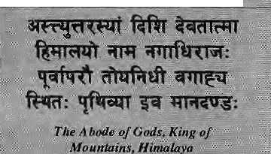
!VoLft ■■■ 'N<C2_{S} JVIar/A£r! 1993
)'»« bound the aceans from
M'-f S|
4 nortitem yardstick To measure the Earth
"Consulting Suitor £s Managing Editor
i.f.iH;as:..Rwirilar ■?' "^. ..:.■ ■;. Italian*™ Sh|rni| I ■ Prakrit! Karmacharya
NRs 220 400 ERs 140 260 Nu
DM ^{:i} ;;-5ft
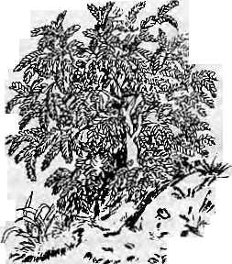

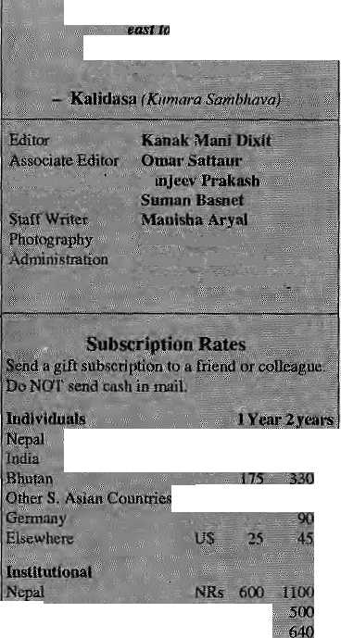
1*
Pttntaii ■ : ; ^ ,; ... :■: .- f^ ; 33Q ©tfcerS. Asia*€miritrid ■■" 0$; < 25 45" DM 70 120
correspondence to:
Son Hi Asia: P,Dv Brf?; ^{IV}4^, a J; ; 4f(;.97-7.;.l-523^44 &».

Australia: !ndra B;in. )? Koifolk St.. Paddington 21, Sydney, Australia.

Lancasler. PA 17602, USA Europe: Durga Press (HIMALl. Luitpoldsir 20.
all 75 districts on foot.
I have great respect for Dr. Manandhar not only as my father but also as a scientist. Although I am not a botanist, I'm convinced about his
many botanists
around the world
write to me to get his
books, papers or
address. I have also
spoken with editors
of reputable journals*
such as Economic
Botany (New York'
Botanical Garden)
that have published his articles. For those of
you who are degree-conscious, Dr.
Manandhar is a PhD from the University of
Science and Medicine in Grenbole, France.
At a time when scientists in Nepal do not
get any recognition by other Nepalis,
magazines like Hirnal ought to reverse the
trend, not perpetuate it.
Sanjay Manandhar Boston, United States
Generalised Thinking Unjustified
The box item "The Government Cannot Promote Herbs" by Manisha Aryal in Himal's herbal issue was interesting and thought-provoking. But I wonder how Aryal came to the conclusion that "the ethnobotanic studies conducted at the herbarium are limited to collecting plants and sticking them in paper".
I am unable to comment on the other divisions of the Ministry of Forests and Soil Conservation, but her statement on National Herbarium and Plant Laboratories is baseless and sensational. Had Aryal visited or called anyone at the Herbarium, she would have found that it was established in 1960 for taxonomical studies, whereas the ethnobotanic study started in 1980, at the initiative of a botanist working there.
Ethnobotany does not have a long history even in other developing countries, and in Nepal it is still at its initial stages. Yet contributions that have been made should not be undermined by ignorant generalisations. More than 50 books, articles and reports have already been published from the ethnobotanic section, and many interested Nepali and foreign individuals have received free information service concerning various aspects of
economic plants of the country. There is no other branch of botany that has made such a contribution in Nepal.
Although the collection of plants, preparation of herbarium, and sticking them in paper appears to be an unimportant task to Aryal, it happens to be a vital part of ethnobotany. Once the plant, is stuck on paper, it acts as a reference book in a library ■—with 'live' examples of plants for scientists to refer to.
'*3&£r:
our system, where scientists are required to operate under an )tf's *%4 amazing maze of bureau-
"V * \i'// cracy, sometimes it is
1^# ~f/" •*** difficult for a scientist to
*^ do much with his or her
research. The findings of ethnobotanic studies and their utilisation depend upon the higher authorities and the planning personnel.
More rigorous, mature and painstaking effort is anticipated in the future from Himal, especially the confirmation of facts gathered through second and third party sources. Command of the English language is not the only criterion to print such generalisations.
Narayan P Manandhar National Herbarium and Plant Laboratories Godavari, Kathmandu
Manisha Aryal responds:
Both father and son Manandhars seem to have missed the forest for the trees. My article was neitherabout foreigner-dominated Nepali scientists, nor about the ethnobotany section of the National Herbarium and Plant Laboratories. It was an attempt to bring to light a neglected Himalayan (and not just Nepali) resource that is delivering vast earnings — for everyone else (including eth no botanists) but the villagers of remote mountain hamlets.
Narayan P. Manandhar's education andethnobotanical expertise were neverindoubt, which was why I feft three telephone messages at his office, which were never returned. (Why does Sanjay Manandhar feel the need to have foreign journals vouch for his father's qualifications?) While researching the article in Kathmandu, Lucknow and New Delhi, I contacted qualified ecologists, economists, activists, politician sand eth no botanists, most of whom have not been named or quoted in the article.
As for the relevance of ethnobotany to the real-life conditions in the rural Himalaya, I believe that local scientists have the obligation to help ensure that villagers get their rightful share of profits which are presently being kept by middlemen and merchants. Because scientists, like Dr. Manandhar, know more than others, including journalists.

2 . HIMAL Mar/Apr 1993

MAIL


"As theplains faced: woman in her stationwagon a
'■■■ :•saileddowriExpbitionRoacI, an insectije proboscis masking-ltps andnose, was thenndiscrsiriijiate"air,'cleansedfor her alone,:, ;s ..;.;...; y.made^bf her presence, by her car ■passing, any easier to breathe; for'the campus students,; 2 " : for the women sweeping the sidewalk; for the girl beneath the rbad scrubbing clothes where the soo&lack river barely flows and tpeiipn-faced buddhas [ refteci nothing? Al ljie conference s orj the;Environment and Family Pjapninj : beneath the lectern where she; stands, : tnsfcskjike:lines on the lips arid "hoisef-*- insectile and plainly speaking, set in motion* by a voice strident in tone, the participants— masks distributed* donned theirs; and considering this question giaglahglagraglagla droned on and on,
Wayne Amtzis, Kathmahdii
Nepali Plants, Foreign Medicines
We have been working for the last twelve years in the field of plants and ayurvedic medicine and were delighted to read the article "Diverted Wealth: The Trade in Himalayan Herbs"' (Jan/Feb 1993).
Plants and ayurveda together constitute a gold mine for Nepal's economy, and international pharmaceutical industries have already started to show interest in. Nepali herbs and the pharmacology of ayurveda. The country has both the raw material and the market for ayurvedic medicines.
Yet, every year, Indian ayurvedic drugs worth crores are imported into the country. Why can't they be produced in Nepal? Why have the international pharmaceutical industries been slow in exploring investment possibilities? Why are expensive allopathic medicines imported while priceless Himalayan herbs arc allowed to be smuggled out?
The answer is actually very simple — it is impossible to invest in Nepal. The business incentives for potential investors in traditional medicine are quite inadequate. To add to this, these days there is no electricity, no water, no diesel and no petrol. On average, it takes more than a year to register a company, not to mention the numerous other battles in trying to get a drug registered and out in the market. Also, the law is such that it is easier for a foreign company to sell in Nepal than for a Nepali (or a joint venture) company. No investor would be stupid enough to throw a crore rupees (NRs 10 million, the minimum limit for a joint venture) just for the pleasure of facing these harassments.
Access to media advertising is important for any company. Indian companies can advertise their products without the approval of Department of Drug Administration, whereas a Nepali company has to get permission to do so. Today, a small advertising campaign costs over NRs 400,000, the kind of money small industries and private entrepreneurs do not have. If the Government redly wants to promote small industries and Nepali products (and not just tobacco and alcohol), it must help by providing special rates in newspapers, Tadio and television.
All these factors make it far more economical for a Nepali business-
man to invest in India or even to smuggle plants and plant materials across the border, and for a foreign company to buy the contraband Nepali herbs in India.
A few years ago, Elhnodex, a French company, placed an order for amala (Emblica officinalis), which is among the more common Himalayan fruits found in Nepal. It took more than two months to despatch the consignment officially from KfUhmandu, whereas the company's shipment of the same fruit from India reached France within two weeks. Companies do not have that kind of time to waste.
During our 12-year stay in Nepal, we helped establish two ayurvedic factories and trained hundreds of villagers in collection and cultivation of medicinal and aromatic plants. We were trying to establish manpower capable of competing against the herbal and ayurvedic monopolies. In doing so, however, we had to face numerous difficulties; including police harassment.
We aiso worked with the Department of Ayurveda and helped set up an ayurvedic rural pharmacy in Pharping, south of Katlimandu, with support from the World Health Organisation. We trained Government workers to acquire technical and managerial skills, and on collection, processing and cultivation of medicinal plants. Today, the trained workers have all been transferred. There is no budget either
6ri the Distfibuti0H;
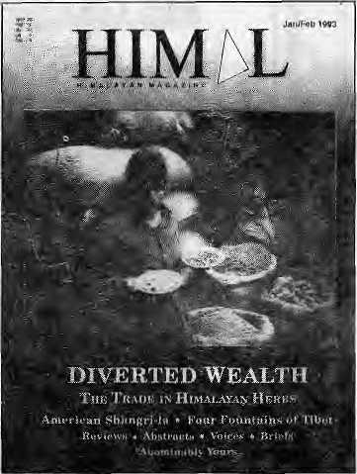
to buy, process or cultivate medicinal plants or to pay staff salary. Three sets of machinery lie gathering dust at Pharping.
Singha Durbar Vaidhyakhana (the Nepali Government's ayurvedic drug producing unit, inherited from the Rana times) is in nearly the same state of desolation. Despite the availability of machinery, processing is still done manually. There is always a shortage of ayurvedic medicines in the ayurvedic dispensaries operated by the Government, whereas the dispensary administrators stock and sell Indian medicines in Lheir own shops right next to the Government dispensaries. Which gives rise to the question, do Indian companies pay government officials to sell their medicines in Nepal?
Since time immemorial, Nepal's villagers have relied on dhami-jhakris (shamans), sundenis (birth attendants) and vaidyas (ayurvedic doctors) for health care. These practitioners of traditional medicine have always relied on herbs that are locally available. Bui the health programme of the Government of Nepal is propagating only modem medicines. The community health programmes for villages are designed by doctors trained in modem allopatliic treatment; even excellent allopathic doctors find themselves completely at loss when they have to work on ayurveda or other traditional medicines.
Although both ayurvedic and allopathic medicines are sciences of healing, (hey do not follow the same principles. Traditional medicine is conceptually different from modem medicine and should

Mar/Apr
HIMAL . 3


We Also Serve You
Birds On Trees

tpbaicr
/Garden

French, Italian, Chinese, German,
Russian cuisine. Served on the
greenest green you've ever seen.
Plenty of sun, fresh air and bird song
too.

SHANGRI-LA.
LA21MPAT, KATHMANDU. TH: 412399
We Make You Feel Great!

MAIL

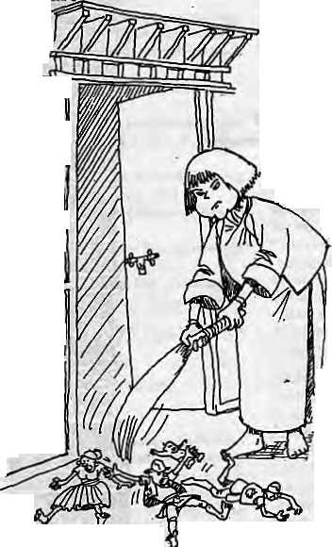
not be viewed within one framework. Development organisations working in rural health care have started training dhami-jhakris and the sundenis on basic allopathic medicines. This move takes traditional medicine into the arena of modern health care, but cannot be sustainable. It would be far more beneficial to train them in ayurveda or naturopathy — which uses local raw material for curing patients. This would also inspire confidence among the traditional healers, who would be encouraged to Tefer complicated cases to Government hospitals.
Today the ratio of an allopathic doctor to population is 1:30,000. It will take a long time to train enough modern doctors for the country's needs, and even then we know well that they will not go and work in remote villages. And where will the foreign currency to buy all that equipment and medicine come from? Besides, will the villagers of Nepal be able to afford allopathic medical care when it is finally brought to them?
Isabelle & Jacques Lecup Arras, France
Liaison Officer
With regard to the debate on liasion officers (mountaineering issue, Nov/Dec 1992), we recently received permission to cross over from Mustang into Upper Dolpo via the Sangda La. The LO assigned to us was a keen young policeman from the Tarai.
As we began the first day's easy walk up to Ghandrung, it became clear there was trouble ahead. After an hour's climbing, in between gasps, the LO told us that the limits of his daily exercise had been a 15-minute walk to office. We got to Ghan-drung at 6 p.m., and our porters a half hour later. The LO and our Thakati friend, who was cajoling him along, arrived at 10 pm.
On Day Two, we had expected to make it to Ghasa, but had to stop two hours before the village as it was getting dark and there was no sign of our LO. The following day, trying to find an excuse to cancel our programme and terminate his own suffering, the LO consulted with some locals and was only too pleased to inform us thai Sangda La was snowed in. We knew better than to believe this, for the Thakalis of this area do not know this route well.
We decided to find a way to send him home as it would be irresponsible to make him cross the high pass on steep and
dangerous trails. Our medical doctor gave him a thorough health check-up at Tukuche, but added in the health report that the LO had altitude sickness and must descend to lower climes. He willingly accepted this way out of his predicament, but not without asking his full pay of an expected NRs 20,000. We gave him a "down payment" of NRs 5000 and sent our LO packing.
We crossed Hidden Valley, Mulug Pass, and Upper Dolpo with a lot of enjoyment. We could not communicate with the locals, but the Nepali-speaking Tarai-based policeman would not have been of help. His presence would have ruined a trip on which we had invested a lot of time, money and expectations.'
We have not understood what criteria the respective government departments use when selecting staff for such assignments.
Tomas Mutter Munchen
Bhutan Torn
I write as a
Western individual,
in the relatively
rare position of ~°
having visited both
Bhutan and the Jhapa
Tefugee camps where
Bhutan refugees are
located. Michael
Hutt of the School of
Oriental and African
Studies should, I
believe, be ~
congratulated for
having convened the
recent London
conference on
Bhutan. At the very
least, this was the
first step to an
international
dialogue.
Even a year
ago, the meTe idea that the Home
Secretary Dasho Jigme Thinley and the
editors of Himal and Kuensel agreeing to
speak at the same venue might have seemed
absurd; how ironic, then, that the real fire
works should begin not between them but
between some of the Westerners present.
Journalistic bias in reporting Bhutan is one thing, but the'presentation of supposedly objective academic papers based
almost solely on Bhutanese government statistics is quite another. '"A free and trank discussion" was one of the purported purposes of the conference, but the problem was that too many Western academics whose livelihood depends on the next visa to Thimphu did not feel free to be Frank. I detected in more than one speaker in the "establishment camp", however, the same unease beneath the rhetoric that I had sensed in a young Drukpa in Thimphu last year who knew deep down that all was far from well in his country; indeed, he gave the impression that he would prefer to know the complexity of the truth rather than the simplicity of the official government line.
I plead guilty to remaining anonymous; we all have our own reasons for doing so. But I should like to believe that there are many Drukpas who do not choose to see theiT beautiful country torn apart in this way. I should also like to assure sceptics — as far as I am capable of exercising rational human judgement — that the overwhelming majority of refugees have gone to the camps neither on a paid holiday, nor for the heck of it, nor to gain an education in terrorism. The longer they remain, however, the more precarious the situation is likely to become. Given India's apparent indifference towards the refugee issue, I fully endorse Michael Aris's suggestion at the conference that independent mediation between Bhutan, Nepal and even India is the only way forward,
(Name witheld upon request)
London
Mea Culpa, too
I would like to correct an error id my own letter (Nov/Dec 1992) referring to Nigel J.R.Allan's article "False Geographies" (Sep/Oct 1992). All the significant activities of the British subsequent to Younghusband's expulsion by Yanov in 1891 did take place within the geographical bounds of the South Asian watershed. It is the upper margins, not the lowlands, which define a watershed. Hunza, Chitral and Lhasa all definitely He within this area. The consulate at Kashgar had, in fact, been established prior to that point in time. Apologies from a chagrined geographer. Paul Lundberg Lalitpur.

Mar/Apr 1993 HIMAL . 5


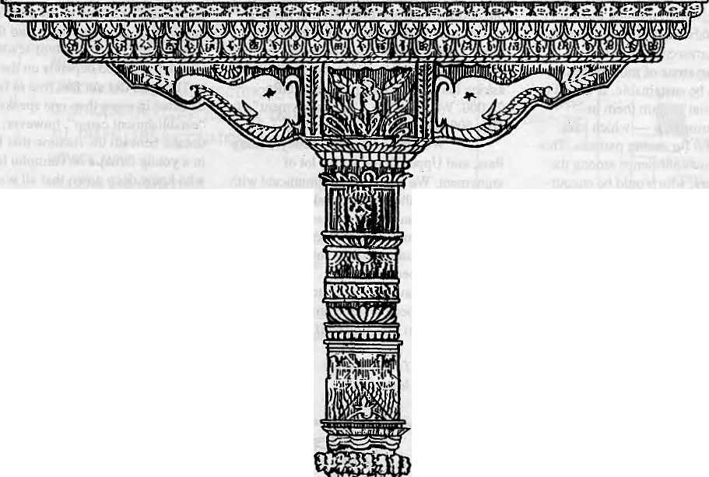
The exquisite Woodcarring
ofKathmamlu
It's more than an art

It's an Exuberant Demonstration of a Rich Tradition

It's an Eloquent Expression of a Living Culture

It's a Wondrous Display of a Timeless Heritage

It '$ a Priceless Ornament of two Religions in Perfect Harmony
The Summit Hotel in Katkmandu
It's more than a Hotel

It's a Tribute to Traditional Nepali Hospitality

It's a Homage to a Magnificent Nepali Architecture

It's a Commitment to Quality of Service and Care

It's a Guarantee for your Comfort and Pleasure



SUMMIT HOTEL
Something Special P.O. Box 1406, Kathmandu, Nepal Tel: 521894. 524694 Fax; 977 1 523737

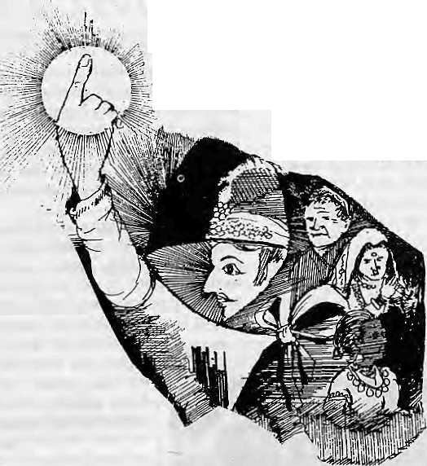
Hill Hinduism, monarchy and the Nepali language — the conventional symbols of a historically weak Nepali nationalism — are all presently under attack. A crisis of identity prevails among Nepal's educated.
by Saubhagya Shah
Throes of a Fledgling
Nation

H
idden among the advance sample tables from the 1991 Nepal Census is data that is politically significant. There has been a net decline of 5.14 percent among Nepalis who say that Nepali is their mother tongue —from 58.36 percent inl981 to 53.22 percent today. Although preliminary findings for population distribution by religion have not been published so far, there are strong indications that the percentageof population reporting Hinduism as its religion will also decline significantly. If these findings are confirmed, they would constitute majorrever-sals of national trends. Population percentages in both these categories had been on the rise in all previous counts.
Tc a large degree, nationalism is a matter of loyalties and emotions, which are charged with religion, language and other cultural elements. When a significant portion of the population shifts position on who they are or who they should be, the corporate 'self of the nation will be affected accordingly.
In the case of Nepal, Hinduism, the Nepali language and monarchy have been considered the three pillars of nationalism. What does Hmean, then, that all three are seen to be in decline? One cannot, of course, exaggerate the trends. There were those who had warned that the nation state of Nepal would collapse with democracy, but this did not happen. Probably the Nepali language and Hinduism are no weaker than they were, only the perception of how strong they are has
changed. And after the initial phases of rejection, the position of monarchy too is probably heading towards equilibrium, albeit at a less exalted level.
Nevertheless, given the obvious trends, there is a need to analyse Nepali nationalism and whether there is a need to tinker with the super-structure.
Newar, Tarain and Janajati
The wider freedoms available to the Nepali public since the political change of Spring 1990 has brought sentiments long suppressed to the surface. An array of organisations have been stridently challenging the established notions of nationalism, including numerous ethnic, linguistic and regional forums, as well as far-left ideologues, ultra liberals, and champions of extra-indigenous religions.
Hridayesh Tripathi, -stalwart of the Sadhbhavana Party, which champions the cause for an autonomous Tarai, says that there is not much in the Nepali State with which the madhesiya can identify with. "Unless the madhesiya people get due representation in thepolitical process and decision-making, and their regional aspirations are satisfied on an institutional basis, there can be no common nationalism," says the MP from Rupendehi District. "The Tarain can never be integrated with the hill mainstream on cultural and linguistic terms."
Among the Kathmandu Valley Newar, considered one of the three privileged
groups of Nepal, there simmers a resentment against the other two, the Bahun and Chhetri, which are considered the 'hill mainstream'. "The Newars carry a psychology of the van-; quished at a subconscious level and view the Khasas as the victors," says Malla K. Sundar; journalist and Vice ■President of the Nepal Bhasa Manka Khala, a 'mass organisation' which seeks to promote Newari culture and language.
On the hill ethnic front, the Limbuwan Mukti Morcha, Khambuwan National Front, Mongol Liberation Organization, Rastriya Janamukti Party, and a host of smaller organisations have, in varying degrees, asserted political, cultural, linguistic and religious separateness from the hill (parbatey) mainstream. In Kirat lands of eastern Nepal, the last and the leas t subjugated, by the Gorkha state, some Rai and Limbu groups last year boycotted Dasain and Tihar festivals to emphasise their rejection.
Nepal's Far West, which had been free of political mobilisation thus far for geographic and economic reasons, too, seems to have become agitated. A recent meeting in Kathmandu tentatively put forward a demand for autonomy for the Karnali region, apresent-day backwater which is actually the place of origin of the Khasas, who can be said to have provided the defining stamp of Nepali nationalism. A sense of having received a raw deal fromKathmandu pervades the Kamali's intelligentsia.
Mar/Apr 1993 HIMAL . 7

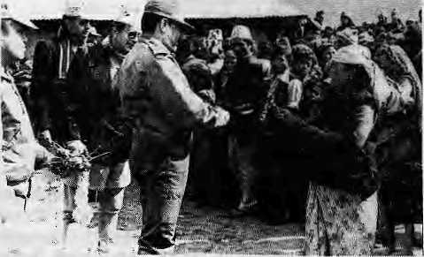
The demands,then, are for recognition of group identity and federalism on ethnic, linguistic or regional lines. Are the country's political and intellectual elites, who havebeensodishearteningly preoccupied with party politics of the lowest order, even capable of searching for new definitions?
At the same time, it is important to underscore that uncritical academic distinctions by social science practioners in thestudy of Nepali society might have further aggravated the tendency of retrenchment from the mainstream. Non-existent schisms have perhaps been dug up and mere difference of forms have sometimes been juxtaposed as mutually antagonistic categories, such as Aryan vs. Mongoloid, Hindu vs. Buddhist, and Sanskritic vs. Tibeto-Burman. When the
The raja and the praja.
focus is exclusively on highlighting conflict at the cost of linkages and similarities, the situation becomes reactive as people adopt the analytical labels for self-identification.
Raja, Bhcsh, Bhasa
Going by the conventional yardsticks, Nepal never had prerequisites for a strong nationhood or nationalism.The physical geography itself was too hostile to development of integration or homogeneity in population. The harsh landscape, intersected by north-south river systems, isolated communities from each other and prevented the easy flow of people, goods and ideas —- so necessary in evolving a broader, inclusive national identity. Says Mangal Siddhi Manandhar, a geographer at Tribhuvan University," Inadequacy of agood 'circulatory system' was Nepal's greatest handicap in welding the country into one nation."
Though the Gorkhali unification campaign in latter half of the 1700screatedthe territorial unit of Nepal, it failed to provide economic integration for the nascent nation. The subsistence economies of the hills were
instead progressively wedded Io the plains markets, thanks to the East India Company. Mercenary recruitment; plains employment, mercantile links, all relied on the vertical north-south link, which matured and reduced the chances of lateral integration of economy and production within Nepal. As sociology professor Chaitanya Mishra notes, "The national economy remained disarticulated; there was little Tarai to Tarai or Hill-Tarai exchange, either in terms of commodities or labour."
If the objective foundations of the nation are weak, the subjective ones are not very vigorous either. There is no belief of common ancestry or race or even common territorial loyalties among Nepalis. In the face of such heavy odds, after the conquest and subjugation by the force of khukuri was over, the Nepali language, 'popular' hill Hinduism and the institution of monarchy took over as the bind-j= ing forces that have sustained | theNepalinationstate thus far. 2 From the ancient period, _{z} kingship has been a central p pivot of political as well as g socio-culrural life. In the ab-z sence of a tangible state appa-8 ratus, the crown became the £ primary foci of loyalty for all communities as well as the personification of the state. "It is the empirical representation of national unity," says sociology professor Gopal Singh Nepali. The old adage raja sabaika saja (king is common to all) made everyone's relation with the monarch an individual affair. Il was for this reason that in the past, when political power was seized by ambitious families, the usurpers could not actually do away with the king himself. The crown was the legitimizing force in the eyes of the people.
ThenewNepaliConstitutionofl990 converted Nepal's 'active' kingship into a constitutional monarchy. But the transformation went further, and was marked by a significant dissipation of faith and veneration in the once vaunted institution. The rumblings of republicanism and the occasional snub from mainline political parties has greatly weakened the halo of this once seemingly invincible institution.
Religion has been the second bedrock for Nepali nationalism. Despite its constitutional label as a 'Hindu Kingdom', Nepal was never a puritanical Hindu State. Religion in the hills in fact evolved as a blending of indigenous shaministic worship practices with
classical Hinduism and Buddhism. What emerged therefore was a sui generis entity — a 'hill Hinduism' that is distinctly Central Himalayan — Nepali — in character. As anthropologist Dipak Raj Pant says, "The larger Hindu identity, and in some areas Buddhist identity, is not the exclusive prerogative of a certain group or a majority. The Hindu identity, especially, is that broad frame of reference which links all the indigenous cults and insulates the whole, but it does neither completely unite nor create a unique type."
Nepal's popular Hinduism, based on organic spirituality reflected through localised symbols such as particular hillocks, trees and spirits, offers one of the rarest examples of ethno-religiouspluralism,Pant adds. This hill Hinduism is quite distinct from the orthodox Vedic-Puranic traditions of the plains. Whereas theplains saw conflict between Hinduism and Buddhism, the hills were witness to exemplary coexistence and overlapping of the two, with added inputs from the local Bon Po and shaministic traditions. Even the rigid strictures of caste were loosened to incorporate the non-caste tribal groups. The Mulki Ain (civil code) of 1854, although much maligned, in seeking to organise the multitudes into a uniform frame of caste hierarchy did give considerable leeway to customary norms and practices.
The assimilitative tendencies of religion in the hills is not specific to Hinduism, and can also be seen in the shamanistic and Buddhist traditions on the southern Himalayan flanks. This point seems to receive support from Pahal Man Singh Moktan in a paper presented at the Third National Convention of the Nepal Tamang Ghedung (association), which concluded in Kathmandu in early April. Said Moktan, "...the original Bon Po traditions were first diluted by Buddhism, and the whole is now moving towards Lamaism."
It is this flexibility, overlapping and blending of magico-religious practices and beliefs which makes religion such a shared experience for the Nepalis. Islam, Christianity, and tosome extent the Buddhist Theravada sect, have not undergone this Nepali sing process due to their late arrival on the scene and their origins in qualitatively different environs.
Even before the unification process got underway, Khas Kura , the progenitor of the Nepali language, had established itself as the link language of the hills. In a sense, the spread of Khas Kura cast the die for the eventual military unification. It traversed eastward as the Khasa people migrated out of the Kamali region. Today, Nepali remains the

8 . HIMAL Mar/Apr 1993

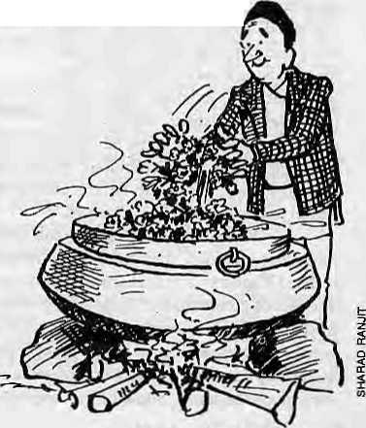
strongest asset of Nepali nationhood and the vehicle for preserving and articulating the national spirit and the historical experience. Balakrishna Saraa, the poet-dramatist, oncecoined a slogan"HamroRaja,Hamro Desh; Hamro Bhasha, Hamro Bhesh" (our king, our country; our language, our customs). This slogan was first politically articulated by a representative from Lalitpur District in the FirstBuddhijibiSammelan (Intellectual's Conference) called by King Mahendra in 1962. This slogan, modified by the Panchayat pundits to "Ek Bhasa, Ek Bhesh, Ek Desh" {one language, one custom, one country), was pushed for all it was worth during the 30 years of paTtyless rule. The slogan which was a logical extension of the system's monolithic ideology.
Panchayat Years
The Panchayat years, particularly the Mahendra reign, saw the State implementing an aggressive nationalising policy. Strong efforts were made to link the ideal of nationalism with the institution of monarchy. The king, in fact, ascended to ever higher pedestals and the Jai Desh, Jal Naresh (hail country, hail monarch) slogan superseded all others.
The Nepali Rupee replaced Indian currency in circulation, and use of the latter was made illegal for internal transactions. The building-up of a modem administrative structure, investments in transportation, and communication links contributed to the emergence of a national consciousness to some degree. But it was the introduction of a standard national education system in the early 1960s that laid the foundation for 'modern' Nepali nationalism. As a medium of instruction, Nepali foisted educational uniformity from Mechi to the Mahakali, Even more telling in its impact was the designing of national school syllabus and textbooks. Nepali history, geography, culture and economics began to be taught for the first time, enabling the new generation to be socialised into a particular image of the nation.
The de rigueur recitation of the national anthem and the stories of such mythical/ historical figures as Amshu Burma, ATaniko, Jayasthiti Malla, Prithivi Narayan, Kalu Pandey, Amar Singh Thapa, Bhakti Thapa, Bala Bhadra and Bhanu Bhakta sought to implant a vigorous and forceful patriotism among the youth. Earlier, in the absence of a national education system and syllabus, the kwSsnskril pathsfialas taught Indian books, and Kathmandu's well-to-do people travelled to India for higher education. Excluding the ruling circles, there had not been among the
general populace a concept of Nepal as a politico-territorial unit.
"The modern concept of nationalism is the product of the modern education system," agrees Prof. Mishra. Perhaps as a result of a nationwide peer pressure, the population which claimed Nepali as mother tongue rose from 48 percent in 1952/54 to 58.36 percent in 1981.
Anti-Indianism was a well nurtured undertone of Panchayati nationalism. It was politically expedient for the regime to point its finger at a "external threat" and allay internal discontent. Secondly, policymakers of the Panchayat astutely recognised the hillman's 'primeval' fear of the plains, and the more 'modern' fear of being sucked into the great Hindustani cultural cauldron.
The two nationalist motifs of monarchy and Hinduism came together in the Panchayat's assiduous championing of the cause of the "Hindu kingdom", and trying to contrast it to India's secular status. But the handlers of, the Panchayat over-reached when they chose to promote an orthodox Hindu order. This elitist 'Sanatan' dharma of the plains had little affinity witfi the cultic traditions of the hills. This propagation of an official version of religion alienated many communities who were less Sanskritie and could not identify with the Hinduism of Beneras and Ayodhya.
The fall of die Ranas in mid-century had left die country ripe for accelerated nationalistic evolution, and it was the definition provided by the Panchayat that the population had to accept or contend with — nationalism right or wrong. Perhaps a less autocratic Government would have provided a different stamp, but there is no doubt that the dominant nationalistic themes propounded by the Panchayat were palatable to the dominant communities of Bahun and Chhetris, as well as to the elites among the Newars and other communities.
A Pluralistic Mosaic
Even though the traditional symbols of nationalism have been tired out, there is still some strength left in them. And while it might not be fashionable to say so in certain parochial circles, there is something to be said for nationalism that is Nepali. It might be weak, but it exists and it is unique.
Since the first test of nation-state — survival —has been passed and a democratic politiy now exists within Nepali borders, social scientists agree that it is time for a new nationalism to be cast, borrowing from the old motifs and adding new attributes.
Nepal's distinct identity lies not in trying to trace its roots to the Gangetic plains in toto, but in learning to take pride in its own remarkable history and in the process of Nepalisation through which a cultural and religious syncretism has emerged. Indian, Tibetan, Hindu, Buddhist and animistic influences have undergone an accommodative and assimilative process in the Central Himalaya.
According to Prof. Nepali," Nepal must build its owncognitive foundations if its claims of a separate nation-state are to be sustainable. This means generating awareness and creating pride in indigenous traditions, heritage and personalities. We seem to make much fanfare about foreign events and dignitaries, but we fail to recognise the contribution of our own Khas, Kirat and other local heroes". The scholar suggests that celebrating the memory of Yelambar, an ancient Kirat king would be agood start in tracing authentic Nepali roots. Among others, the Magars' military prowess, Sherpas' mountaineering feats and the Tharus'quintessential cultural uniqueness could be propagated as national heritage. The national pantheon must therefore include personalities and events, historic as well as mythical, from all communities.
Mar/Apr 1993 HIMAL . 9
While me Panchayat decades were characterised by loud rhetoric that was long on nationalism and short on democracy, the situation has been reversed today. And as far as nationalism goes, those in power continue to flog the motifs of the past (althoughless so the monarchy), little realising that the time is now for innovative measures to strengthen Nepali nationalism by harking back to other traditions that can serve to bring al! Nepalis together. Initiatives are required on the cultural and ethnic fronts, but the Establishment seems ambivalent. It seems undecided between letting "a hundred flowers bloom" and retaining the overused melting pot ideal.

organisations and leadership are perceived to be just as distant From the common life and culture they claim to champion as are the central business and ruling elites. This was amply demonstrated in the last general and local elections, when the many candidates espousing ethnic or regional agendas made a poor showing, barring Sadhbhavana's achievements in the Tarai.
On the other hand, the calm should notlull the politicians or the intelligentsia into complacency. For the legacy of harmony cannot forever be a substitute for equitable economic development. The regional and communal tinderbox is on a short fuse, and viable
economic opportunities and social justice must be provided, irrespective of caste, class, religion orrace, and with affirmative action where necessary. Only such socioeconomic dynamism will promote the ideals of liberal democracy and equal cituenship. Otherwise, the slide towards parochial and tribal democracy may accelerate beyond the point of no return. The traditional foundations of the Nepali nation-state will have to be judiciously worked at until the society can come up with alternative values.and institutions that can
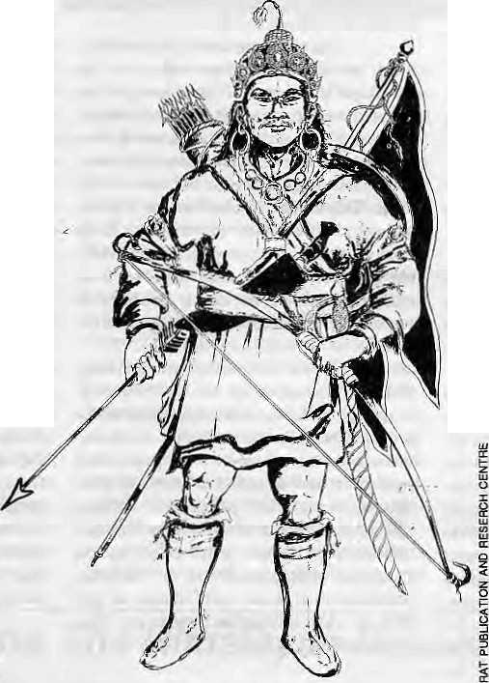
As in any multicultural country, the question of identity must be handled delicately. Specifically in Nepal's context, is there a golden mean between pursuing the policy of the melting pot or going for the pluralistic mosaic? In the lack of any shared sociocul-tural values and historical experience, Sadhbhavana's Tripathi feels that only a federal constitution granting extensive autonomy to regional aspirations will work in the long run. "If regional grievances are not resolved in time, a Sri Lanka-like situation cannot be ruled out and die eventual outcome witt be determined by the relative strength of conflicting forces," he warns.
But even autonomous arrangements such as what Tripathi suggests is bound to be a short-term expedient. For, in the lack of any common rationale or loyalties at a higher level, what would be the rationale for the continued existence of a central federated structure after regional autonomy is available? Once autonomous or federal status is granted on ethnic and regional lines, wouldn't it be logical for the Tarai to coalesce with north India and the Bhot region with Tibet on the same perceived ethnic and regional affinity?
There is another solution on offer." While local variations enrich the total cultural milieu, the effort should be to create a strong macro-Nepali culture at the national level," says Prof. Nepali. This pan-Nepali identity can bind together the local manifestations in a dynamic mainstream. Yalung Kirant, Editor of Himalaya magazine, which seeks to highlight die ethnic heritage qf the Nepali hills, is also of the view that the best way lies ingradually developing an all-Nepali culture in which every one can pride while at the same time allowing local variations to flour-ish. "But first, existing discrimina- _{Repre$entatjon} _{of} _{KiratKing} _{Yeiambar}
tions and inequalities across caste, ethnic and class lines must be removed," he adds, otherwise " unscrupulous politicians and parties will get fuel to fan the politics of hatred to create exclusive enclaves."
While the ethnic and subnational rumblings continue, they have by no means reached Yugoslavia or Sri Lanka proportions. The bile of communalism besieging much of South Asia is also absent among the general populace, irrespective of ethnic categories. Intergioup harmony and cooperation remains very much the norm. Some of the 'extreme'
sustain the national ideal. Constitutionalism, democracy and amultiparty system havebeen ushered in as the new ethos for the countiy. But these are highly intellectual and subjective institutions, and largely out of the grasp of the illiterate masses for the immediate present. If it can be of any illumination, the socialist ideals could not hold the Soviet Union together even after 70 years of ardent indoctrination. Nearer home, secularism, republicanism and federalism in India hasn't fared too well. It is solely the feat of Indian arms that keeps its troubled outposts within grasp.
These examples carry a deeper lesson for fledgling nations like Nepal. One iron rule of history is that a political entity exists only as long as its coercive powers remain greater than the sum total of centrifugal forces (existing in any system). Once the f issiparous tendencies upset the equilibrium, the entity crumbles, be it an empire or a republic, unitary or federal. In this equation, a heterogeneous federal structure requires greater ultima ratio regum for existence than a unitary one because it not only has to deal with the external threats, but also with the contending units within its own boundaries. The Nepali State, hard-pressed as it is to hold itself togetherin a unitary model, would find it well nigh impossible to command a federal structure, given die country's unenviable geopolitical situation.
Before even moving towards new definitions of Nepali nationalism, the society has to determine if nationalism is sucha desirable thing to have at all. There are perhaps equally convincing arguments for and against, but ilis undeniable that Nepali nationalism provides die people who populate the CentralHimalayawithan identity which would probably be lost if each of the individual communities were to decide to try to make it on its own. On balance, it would seem that a Gurung, Rai, orTharu should be able to maintain his distinct local identity while at the same time donning the garb oi Nepali nationalism. Once again, nationalism is only the glue that sticks a people together emotionally. It is the national economy which must seek to bind the people in self-interest. Mutual advantage is the best guarantee for the development and sustainability of nationalism.
S, Shah is a sociologist at Tribhuvan University and reports for Kathmandus Rising Nopal.

10 . H1MAL Mar/Apr 1993

Nationalism and the Janajati

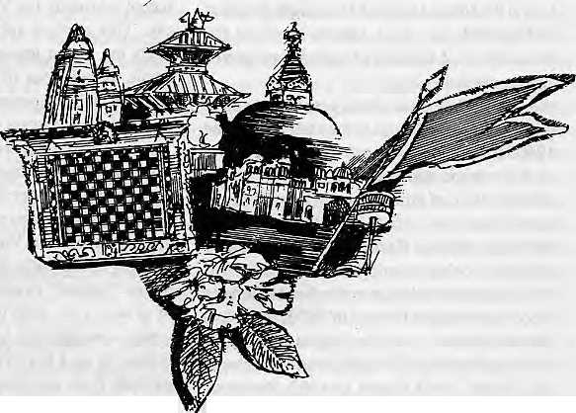
w
National unity will come from embracing diversity, rather than by imposing uniformity.
by William F. Fisher

s
" *^™^i omepoliticianscallusdogs.Butwe Janajatis are not dogs, we are as much Nepali as anyone else, and we deserve to be treated as full citizens of this country." With these w ords, Suresh Ale Mag ar, the General Secretary of the Nepal Janajati Mahasangh (the Nepal Federation of Nationalities), began his address to the national conference of the Newar association, the Nepal Bhasha Manka Khala, held in Kathmandu in October 1992.
Some politicians dismiss words like these as the rhetoric' of a few disgruntled or power-seeking individuals, insisting that there is no "ethnic problem" in Nepal. However, an increasing number of Nepalis recognise the spread in rhetoric like this as a signal of Nepal's growing "ethnic problem", one that will soon require but a single match to set off a conflagration. As Padma Ratna Tuladhar, a Left member of theHouse of Representatives, argues, "the problems of the Janajatis are one
of the most serious problems faced by Nepal a t the moment."
Whether it is a new problem that emerged in the wake of democracy or the latest expression of a tension that has been simmering just beneath the surface for a long time, many Nepalis fear that this recent growth in the expression of ethnic interests represents a form of ethnic separatism that could split Nepal apart in a fashion so recently demonstrated in Eastern Europe and the Soviet Union. Man Mohan Adhikari, leader of the Opposition in Parliament, expressed a widely held view in a recent interview when he suggested that "the expression of ethnic and communal interests might weaken us all." He went on to observe, "Of course, it is a democratic right to form associations and parties. But we must realise and understand that we are one nationality despite our ethnic and religious diversity."
The Janajati leader^ and others chal-
lenge assertions like this that seem to oppose their national and ethnic interests. In their view, the assertion of ethnic interests, far from weakening the nation, can only strengthen it. They insist that there is no "ethnic problem" that stands apart from and threatens the nation. Rather, the expression of the interests of the multiple "nationalities" is essential to the formation of a nation.
Parshu Ram Tamang, General Secretary of the Nepal Tamang Ghedung, argues that "therestoration of democracy opened up the opportunity for the creation of a wider collective identity." In his view, Nepal can only emerge as anation-state by fully embracing, rather than suppressing, its religious, linguistic, ethnic, and cultural diversity. K.B.Singh, Acting Director of the Administrative Staff Coilegein Kathmandu, succinctly articulated the problem facing Nepal, "We are
* Preface from Laxmi Prasact Devkota's Muna Madan. See end of article

Mar/Apr 1993 HIMAL . II




not a nation," he observed, "we are a nation in the making." The failure to recognise and confront this may pose the greatest threat to Nepal's quest for national unity.
One Nation, or Many Nationalities The October 1992 Nepal Bhasha Manka Kala conference was one of many similar conventions held recently throughout the country, the most receni being the national conference of the Nepal Tamang Ghedung in early April. Twenty of these national associations are members o f the Nepal Janajati Mahasangh, founded in July 1990 (see box). Others represent the perspectives of a variety of regional,religious, and oppressed groups.
While these ethnic associations have
come into the public eye in the aftermath of the
1990 Jana Andolan, the growth in the number
of these associations is but the most recent
manifestation of a long process. Formal ethnic
associations have existed at least since 1950:
the Tharu Kalyan Karini Sabha, which now
supports local associations in 22 districts, was
first registered in that year; the Nepal Tamang
Ghedung was first formed in 1956; the Nepal
Bhasha Manka Kala was organised in June
1979; and the Nepal MagarLangaliSangh and
the Thakali Sewa Samiti in 1982. Predeces
sors to the Mahasangh include the Nepal
Sarvajatiya Adhikar Manch (Forum for the
Rights of All Nationalities), organised in 1986,
and the Bibidh Dharcna. Bhasha, Jati lalha
Janaj ati S angharsha S amiti (V ariou s Religions,
Languages, arid Nationalities Action Com
mittee), which was active in 1990 during the
Jana Andolan. ^
The term "janajati" as interpreted Wk and applied by the Nepal Janajati jl Mahasangh, has both inclusive and exclu- I ' sive aspects. A significant indication of J," I, the Janajatis' conception of themselves f and of the nation is their insistence on ■I translating the term as "nationalities" rather j* than the previously more-frequently used H "tribals". This change indicates a shift to H self-defini tion from external ly-basediden- H tification, and draws attention to their con- I viction that Nepal consists of a number of | equal nationalities which collectively constitute the nation rather than a set of tribals who stand in opposition to the nation. The gloss "nationalities" may also be preferred for the ambiguity suggested by its two dictionary definitions. It can refer simply to "groups of people, each of which has a common and distinguishing linguistic and cultural background and form one constituent element of a larger group (as a nation)," though it also suggests that each
of these aggregations of people may be "potentially capable of forming a nation-state."
In an attempt to incorporate the wid-esL possible number of "nationalities" and to avoid discriminating against any linguistic or cultural group, the Mahasangh avoids defining "janajati" in terms of some Kirat/Mongol-oid/Khas/Indo-Aryan divide, and,instead defines it in opposition to the Hindu Vama system and Hindu caste groups. Janajatis are described as "fundamentally non-Hindu", where Hindu is understood to mean those who accept a place in the Vama system of hierarchy. This explicit anti-Hindu definition reflects the recent tendency of many of these ethnic associations to actively agitate for a return to their indigenous cultures and to reject the influence of years of Hindu isa tion.
While the Janajati leaders openly acknowledge that many individuals among these groups practise Hindu rituals, they categorically dismiss any classification of Janajati groups that uses the Varna categories of Sudra or Vaisya. Ironically, then, while they broadly define "janajati" so as to include a wide range of groups with differing ways bf life, world views, customs and territory, they base this definition on a negative characteristic which exclude from membership any group which has or accepts a place in the Varna system. In practice, any tribal and ethnic group in Nepal seeking membership in the Mahasangh has been accepted. Hindu caste groups including untouchable communities, and Christian or Muslim-based groups, have not been considered eligible.
Klrat Yaktung Chumiung KCfal: ]|al ¥ayekiha * -, ■* Chant yal Pariwar Sangh
Tamu Boudhs Sewa Samltl Nepal Bhasha Manka Khala Tharu Kalyan Karlnl Sabha Thakail Sewa Samiti
Chi Chhog Slwpu
Nepal Hyolmo Samaj Sewa Samlfl
Nepal Tamang Ghedung
Dhimal Jatlya Utlban Kendra Rajbansf Bhasha Prachar Samltl Jirel Samudaya Utthan Sangh

The foundersof the Mahasangh also mean for the term to have a positive definition, indicating the "aborigines" of Nepal, who, in theb view, share common interests because of the treatment their cultures have received since the formation of the Nepali State. This assertion that Janajatis are the aborigines of Nepal is intended to support the view expressed by Suresh AleMagar that "we Janajati deserve to be treated as full citizens of this country," but is sometimes unfortunately interpreted by Parbatiya Hindus to imply that, in the opinion of the Janajatis, Hindu caste groups are not as entitled as the Janajatis to their citizenship.
The barely submerged hint of exclusion or separatism occasionally bubbles to the surface when the emphatic flair with which Janajatis express their point that "we, too, are Nepali'¹ is often misinterpreted by Parbatiya Hindus, who hear them saying "we are the only Nepali". This misunderstanding lends a high emotional content to the rhetoric on all sides of this issue which threatens to obscure the substance of the debate and the possibilities for understanding and solving the problem. "We have never saidthat Bahuns are not part of the nation," argues Tamang. "We have only insisted that Janajatis be equally acknowledged. "He adds that "as long as Hindus continue to insist that Nepal is a nation and not a nation in the making, it is clear that they mean that this is their nation, a Hindu nation." Nevertheless, Tamang acknowledges that within the Janajati communities there are some individuals who take more extreme positions, arguing that political parties should form along ethnic lines and H should insist on full territorial autonomy. But while talk of separatism may reflect the consideration of hypothetical action, most Janajati leaders agree with the calmer and more practical view expressed by Tamang. Subash Nembang, an attorney and member of the Upper House of Parliament, argues that "we need to be practical about demands for autonomy since the ethnic groups are so intertwined and dispersed." This preference for a single nation composed of numerous nationalities is reflected in the stated goals of the Mahasangh, which are "to respect the freedom, equality, and fraternity of other Janajati organisations; to encourage different cultures to flower since diversity, not unity, is a global fact; and to make a single sovereign state of nations."
Numerous other ethnic, linguistic, religious and regional groups not belonging to the Mahasangh also object to the reigning definition of the nation, the nar-

12 . HIMAL Mar/Apr 1993

rowness of representation, or the limited and precarious provision for the rights of minority communities in Nepal. Among these, the Utpidit Jaliya Utthan Manch (Uplifting Forum for the Oppressed Castes), with organisations in 50 districts, was organised in 1987 to focus on the interests and rights of the untouchable castes of the Tarai and the hills.
Like the Mahasangh, the Manch wants a secular state and opposes Hinduism as a system because it endorses discrimination against untouchables. However, as Pradam Lai Bishwakarma, the General Secretary of the Manch, argues, "Untouchables are oppressed by a!l other groups in Nepal. We do not want to reform Hinduism, we want a nation where we are free to be Nepalis in any way we choose. We want equality and human rights for all, and to make ourselves citizens. While the law provides for equality, this does not extend in practice." As long as the laws allow for "traditional discrimination" and provide insufficient means for legal recourse, says Bishwakarma, the untouchable community will continue to face serious disadvantages.
The lack of accurate census data and the uncertain level of local support presents serious difficulties in analysing the strength of each of these associations. "The biggest problem in analysing the question of ethnicity is data," says Anand Aditya, lecturer in political science at Tribhuvan University. In the absence of reliable data, each grouping or federation can, and indeed, does claim to represent a majority of Nepal's citizens. The Government Figures have it that more than 80 percent of its citLZens are Hindu; the Mahasangh believes that Janajatisrepresent approximately 70 percent of the population of Nepal; the Manch maintains that untouchables account for 60 percent of the total population; and the Sadbhavana Party estimates that the Tarai contains halftbe Nepali population. In Aditya's opinion, "these figures are based more on sentiment than data,"
Behind the cacophony of rising demands is a need for a framework that allows for more equal and open competition.
Making Nepal
Nations are, in the words of Benedict Anderson, "imagined political communities". Ernest Gellner {Nations and Nationalities) observes that nations are not "inscribed into the nature of things", though they may be built upon the existing flotsam and jetsam of culture: they are not discovered, or awakened, but made. Nationalism is "the striving to make culture and polity congruent."
One of the most surprising and perplexing problems, of late twentieth century politics has been the difficulty of reconciling the ideals of cultural, linguistic, and ethnic homogeneity in the nation-state with the realities of ethnic and cultural pluralism. Politicians have usually concluded that national unity depends upon the creation or- maintenance of a notion of cultural homogeneity.
Dor Bahadur Bista, inFatalism and Development, has noted that in Nepal "(o)ne of the main arguments put forward for the elimination of the various ethnic cultures is the need to develop a strong national identity. Some pundits are arguing that this can only be possible with cultural homogeneity — with the complete institution of caste values." But as Gellner notes, "(states) can only become ethnically homogenous if they kill, expel, or assimilate" those who do not fit the national mould.
All too frequently, theobsession with homogenisation emerges from the desire for national unity. This pathological drive for an exclusive and homogenising nationalism is what led Albert Einstein to declare nationalism "an infantile disease, the measles of mankind"
Is there an alternative path to the 19th century idea! of a culturally homogenous nation-state? If, asGopal Singh Nepali claims, "Parbatiya culture will no longer work as a model for nationhood," then "the search is on," as Prayag Raj Sharmanotes (HimalMay/ Juii 1992), "for a single cultural identity that would make Nepal a nation-state rather than merely a state," Can this search uncover or create an identity that is equally cognisant and respectful of all the multiple cultures of Nepal? Is Bista correct in his claim that "pluralism is notnecessarily a problem for the development of...a nation"?
The recent changes in Nepal —specifically the overthrow of the partyless Panchayat system, the writing of anew democratic constitution, and the political dialogues of the past three years—have underscored the fluid and malleable character of the discourse underlying the artifice of the Nepali nation, and drawn attention to the always ongoing process of forming and transforming societies.
In the years following Prithvi Narayan Shah's conquests, the Gorkhali aspiration to make their Kingdom a true "Hindustan" faced external threats from the British and the Mughals, and internal threats posed by geography and religious, ethnic and political differences among their subjects. In addition to the creation of an institutional
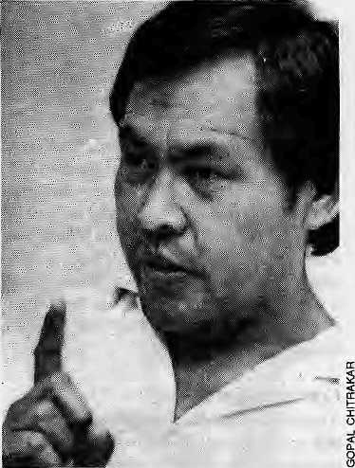
Suresh Ale Magar: angry man.
administration, state-building required the formation of a national ideology. With the fall of other Hindu principalities in South Asia to the British, Gorkha saw itself as the only remaining independent Hindurealm and acted to preserve the purity of that realm.
In the ensuing years, finding common ideological ground was even more difficult. As Andras Hefer has noted, within the possessions of the Gorkha kingdom were a wide array of social groups speaking more than 40 distinct languages; three historically and regionally distinct caste hierarchies, a number of loosely defined groups in the middle hills, and culturally distinct Tibeto-Burman speaking populations along the northern frontier. Ovci the years, strategies employed to create a Hindu nation out of disparate populations included persuading these populations to adopt some Hindu practices, broadening the definition of 'Hindu', and outlawing the conversion of Hindus to other religions. Since the late 18th century, the language and culture promoted by the State has been that of the Hindu population of the hill regions.
One significant step in this process was taken in 1854, with the codification of a 'national hierarchy that ascribed a status to each of the categories of social groups named in the MuLuki Am. This civil code served a dual puipose by distinguishing Nepal's society from foreign societies and cultures, and by justifying the placement of the rulers at the top of the hierarchy. This new social universe ranked high Hindu castes at the top, followed by an array of non-Hindu hill groups, Bhotcs, and, at the bottom, untouchables.

Mar/Apr 1903 HIMAL . 13

The legal code put forth the country's laws on diverse social, religious, economic and administrative matters in 163 categories in order to ensure that all subjects were treated according to their offense and their status. Its inclusion of legislation on commensality and physical contact, and provision of different sorts ofland tenure and tradingrights to different groups, imbued ethnic labels with a significance they did not formerly have. The incorporative model set up by the Muluki Ain whereby a group's legislated difference from other groups was the very principle by which it was integrated into society has had lasting effects in Nepal that have outlived the legal hierarchy.
Contested Futures
It is a testimony to the years of state formation that underneath all the current conflict about the national culture, there is an almost unquestioned acceptance that there is aNepali nation. The disagreement that rages, rages over the nature and character of the nation. The attempts of the Parbaliya elites to establish a Hindu nation succeeded in the establishment of a State and, to some degree, an abstract notion of nationhood, but the removal of the last institutional support for the old regime has allowed the power of the elite and the definition of the nation to be brought into question. The emerging dissonant voices heard inNepa], for the most part, are not embryonic nationalisms that threaten to compete with Nepali nationalism — there is no Tamang nationalism, Gurung nationalism, or Janajati nationalism, for instance. What they represent is differing visions of Nepali nationalism.
As in Eastern Europe, the authoritarian system in Nepal managed to submerge rather than resolve the regional and ethnic animosities in an ethnically diverse population. Not surprisingly, these differences re-emerged as the suppression was lifted. And in as much as the Parbatiya Bahun-Chhetri culture is identified with the State, it is not surprising that the Janajatis and others try to distance themselves from this culture.
The Janajati associations have perhaps been most forceful in their criticism of, and opposition to, the notiorrof Nepal represented by the 1990 Constitution and current Government .policies.
Most Parbatiya Hindus point to the new Constitution torefute the Janajatis'claim that Nepal has yet to provide them respect and equality. In fact, the Constitution does make a complete break with the historical model of national integration and acknowledges the cultural, linguistic and ethnic diversity of the
Nepali population. However, while the rights provided by Article 12 are the cornerstone on which ethnic, regional, linguistic and religious dissent can be built, many Nepalis argue that therights provided by the Constitution for these communities arc severely limited and precarious. Most particularly, they argue that thereligious freedoms menti oned in Articles 2 and 11, and spelled out in Article 19, are undercut by the assertion in Article 4, thai Nepal is a Hindu Kingdom. How can this be, they ask, if the nation is constituted by "the Nepali people irrespective of religion" (Article 2)?
Furthermore, they argue, the right of each community to preserve and promote its own langauge, script, and culture, and to oper-
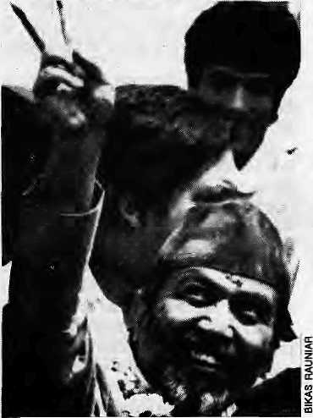
Padma Ratna Tuiadhar. "a communal Government".
ate schools up to the primary level in its own motheT tongue, is impotent without the provision of Governmental financial support. Meanwhile, the declaration of Nepal as a Hindu Kingdom and Nepali as the national language allows the Government to spend its financial resources for the support of Hindu temples, a Sanskrit university, and Nepali, even as it ignores the cultures and languages of the other communities. "This is why," explains Padma Ratna Tuiadhar, "whenever I am branded a communal politician, I respond that it is the Government which is communal."
Despite the tribute in Article 2 to the multiethnic and multilingual character of Nepal, many Nepalis see the. 1990 Constitution as another attempt to impose a national identity based on the cultural and linguistic heritage of one minority. ,
The perception that Nepal's Hindu
elite are determined to impose a national identity based on their own culture has been reinforced by the controversial drive last year to make Sanskrit a compulsory subject in schools. Such actions fuel the belief that high-caste Hindus are interested in making Nepal "their country" and ignoring the cultures of others.
While most Nepalis feel that there is a need to maintain Nepali as a national language, many feel that it is time to move away from the process ofsanskritisation that has characterised the development of the langauge. Some, likeBal Krishna Pokharel in 1964 and Rishikesh Shaha in 1982, have suggested that muctiof the vocabulary needed to enrich Nepali could be adopted from existing Nepali dialects or from other Nepali languages like Newari. As Shaha observes, "words borrowed from Sanskrit do not always have lire same natural vigour, simplicity and raciness as the expressions borrowed from the dialects."
Since contested futures are the hallmark of democracies, might Nepal avoid ethnic strife and find national unity by embracing diversity rather than by imposing uniformity? In a garden whose diversity now exceeds the four caste divisions and 36 tribes of PrilhviNarayan, there seems to be noconsen-sus on what is a weed and what is a flower, which plants are to be watered, and who is to be the gardener.
Mahttkabi Laxmi Prasad Devkoia may have set an appropriate example when he incorporated words from Tamang, Newari and other languages into his writings, and also embraced jhyaure, a formerly disparaged folksong meter. If national unity depends on the acceptance of a framework in which multiple cultures or flowers are allowed to compete without one dominating the whote system or garden, then it may require the resurrection and embracing of indigenous "sprouts" ...planted unseen in our fields May in bloom and wither, as God wills, but grant me this, brother! don't trample it underfoot —
let it flower and bear fruit! Invite the spring, and scorn not thejhyaure, dear sir... Nepali seed and Nepali grain, lite sweet juicy song
watered with the flavour of Nepal
What Nepali would close his eyes to it ?
if the fountain springs from the spirit
what heart will it not touch? k
W.F. Fisher teaches anthropology at Harvard University. Fluid Boundaries, his book on ethnicity and nationalism in Nepal, with particular reference to the Thakalis, is due out soon.

14 . HIMAL Mar/Apr 1993

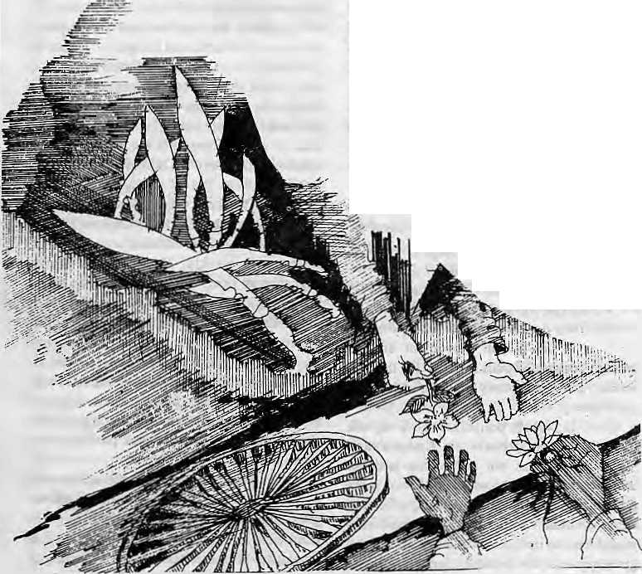
Looking for
Greater Nepal
Is there today in
South Asia
a movement
to establish
a "Greater Nepal" ?
If not, is such a
movement likely
to arise
anytime soon?
by Kanak Mani Dixit

M
ostconnosieurs of South Asian news and politics claim not to believe that there is a movement afoot to create a "Greater Nepal" along the Himalayan rim-land of South Asia. Like Jyoti Basu, the Chief Minister of West Bengal, they maintain that the concept is a "bogey" pushed opportunistically by a handful of regional actors.
But there are some diplomatic and media circles in the Indian capital of New Delhi, who profess to lake seriously the idea of a Greater Nepal "conspiracy" or "gameplan". Whether anyone believes it or not, therefore, "Greater Nepal" becomes an issue of geopolitical significance.
Those who have g iven Greater Nepal a high media profile over the last two years, apparently acting independently of each other, are Dawa Tshering, Foreign Minister of Bhutan, and Subhas Ghising, Chairman of the Darjeeling Gorkha Hill Council.
Ghising has had ongoing spats with West Bengal's Left Front government and Sikkim's Chief Minister Nar Bahadur Bhandari. His method of confronting these challenges has been to raise a scare with issues relating to territory, language and nationalism. Over the last coupleof years, Ghisinghas claimed that: Darjeeling is a no-man's-land due to lacunae in the 1950 Indo-Nepal Friendship Treaty; that Kalimpong is leased territory actually belonging to Bhutan; that 'Gorkhali' rather than Nepali should have been the officially recognised language in India; and that there exists a conspiracy for Greater Nepal.
Ina26JuLy 1991 letter to the Prime Minister of India, Ghising asserted that the recognition of'Nepali' rather than'Gorkhali' helped stabilise the GreaterNepal movement, which was a communist plot clandestinely supported by Indian leftists and
Bhandari. The Communist Party of Nepal (United Marxist Leninist), Nepal'spowerfuloppositionin Parli amen t, G hising w amed, was demanding (he return of Nepali territo-
ries ceded to the British.
"That is why I am spending sleepless nights," Ghising confessed to The Statesman of Calcutta. "My sixth sense and political acumen have repeatedly alerted me of the grave danger that the manifestations of the Greater Nepal movement .pose to the Indian Union. Surprisingly, this danger iscompletely unknown to the rulers in Delhi and Calcutta..."
TheForeign Minister of Bhutan finds common cause with Ghising. In January 1992, Dawa Tshering told a visiting Amnesty International delegation that Nepali-speaking south-em Bhutanese rebels were "supported by groups and individuals in India andNepal who support the concept of a greater Nepal, which is based on the premise that the Himalayas are die natural home of the Nepalese, a myth which is not supported by historical fact."
The concept had attracted Nepati politicians in India and Nepal because "the green hills of Bhutan have become a paradise for the land-hungry and job-hungry poor, illiterate Nepali peasants from across the border."
In Autumn 1992, as reported by the Kuensel weekly of Thimphu, theForeign Minister informed the Tshongdu (National As* sembly) that thepolitical parties and people of Nepal were supporting the "anti-nationals" of soudiern Bhutan not merely because of ethnic affinity, "but more out of their deep-seated desire to promote the concept of a Greater Nepal". The plan envisaged "Nepalese domination over the entire Himalayas by bringing Bhutan, parts of the Duars in West Bengal and Assam and the states of Arunachal Pradesh, Meghalaya, Mizoram and Nagaland under Nepalese control just as in the case of Sikkim and Darjeeling."
A Historical Yearning
Of course, there was once a Greater Nepal — an historical Greater Nepal — but it did not last for long.
Until the mid-1700s, the principalities of the Central Himalayan region had been content at fighting each other for strategic advantage. But then, emerging from the mini-state of Gorkha, Prithvi Narayan Shah dev ised a method of mountain warfare, conquest and consolidation which extended his domain far beyond what earlier rajas had ever contemplated.
Within four decades, Prithvi Narayan and his immediate successors had incorporated the prize of Kathmandu Valley and pushed the Gorkhali frontiers from the Kirat regions eastwards to beyond the Karnali principalities of the west. The Gorkhali empire-builders then lunged westwards across the
Mar/Apr 1993 HIMAL . IS

Mahakaliriverinto Kumaon, taking it in 1790. Garhwal was conquered in 1804, and other cis-Sutlej principalities were taken until the Gorkhali forces were laying seige to the fort of Kangra. Beyond, and probably within reach, lay Kashmir.
In 1813, this historical Greater Nepal extended from the Sutlej to the Teesta, spanning 1500 kilometres. Rule over this expanse was brief, however, and the 1814-1815 war with the East India Company saw theGorkhali realm whittled down considerably. The realtime Gorkhali presence in Garhwal was for a little over adecade; Kumaon for 25 years; and Sikkim for 33 years. The Treaty of Sugauli, between a chastened Gorkhali state and the Company, was ratified in 1816. It stripped Kathmandu'srulersofaboul 105,000 sq km of territory and left Nepal as she is today: a country of 142,000 sq km that has not shown extra-territorial ambitions since.
Even as the historical Greater Nepal went into eclipse, there began a process of migration out of the Central Himalaya which would lead to demographic conflicts more than acentury later. During what one historian has characterised as the "silent years" of 19th century Nepal, the pressuresof the State on the ethnic and other hill communities increased dramatically. Political repression, economic exploitation and, possibly, over-population, pushed peasants eastwards along hill and Duar towards the Indian Northeast, where the British needed Nepali brawn to harvest timber and to open up territories for settlement and tea gardens. Over the decades and well into the 1900s, Nepalis became heavily concentrated in the lower hills of Sikkim, Bhutan and in the Duars.Inlessernumbers, they extended themselves right across the Northeast and as far as today's Myanmar.
Would this scattered community of Nepali labour/peasantry ever come together to form a Greater Nepal?
The Likely Conspirators
Under presentcircumstances,aGreaterNepal could emerge from one of three directions: the Nepali State, the Sikkimese state, or the Lhotshampa Nepali-speakers of southern Bhutan.
The Nepali State. After historical Qjeater Nepal was truncated by the Treaty of Sugauli, Nepal entered an insular era which lasted till 1951. Much of this period was under the Rana oligarchs, who understood well that they were not to eye the neighbouring territories of the Raj.
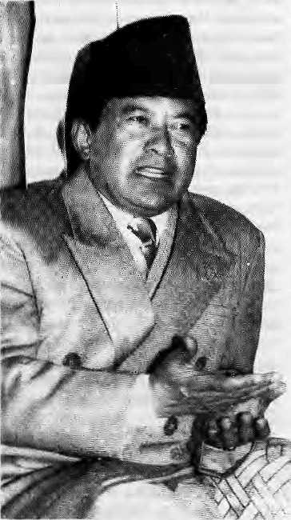
Nar Bahadur Bhandari; a Greater Sikkim ?
With the overthrow of the Ranas, Kathmandu's middle class shook off its century-old political shackles and was swept away by an upwelling of dated Gorkhali sentimentality. Childhood textbooks harked back to the halycondays of expansion, andpatriotic songs extolled the Gorkhali prowess. However, while there was a yearning for a glorious past, there was no militancy.
One folk lyric, collected in the early 1950s by Dharma Raj Thapa, went like this:
What has happened to usNepalis?
Our own songs have alt been lost.
We did twice best the Germans in battle.
We did take the Sutlej and Kangra.
But today out own voice is heard no more. A pan-Nepali movement did not emerge because Nepalis realised that the new Indian rulers had merely supplanted the British Viceroy.
If Nepali politicians gave up the thought of incorporating Ka/igra"^ and Darjeelirig, it w^s not necessarily because they did not relish the prospect. It'Was more the impracticability of establishing a Greater Nepal on India's front lawn. A Greater Nepal would have to include the takeover of Sikkim (now a state of the Indian Union) and Bhutan
(which falls squarely under New Delhi's security umbrella). Which government of Nepal, whether Nepali Congress or any Left combine, would be willing to take such a dare!? As one diplomat in Kallunandu asked rhetorically, "Would not any Greater Nepal move by Katlunandu bring it up against a certain institution called the Indian Amiy?"
The three decades of the autocratic Panchayat system might have provided leisurely occasions to push for a "Brihat Nepal", to be spearheaded by the King, a direct descendant of "Badamaharaj" PrilhviNarayan. Ho w ev er, the defining foreign p o I icy demarche during King Birendra's years as unfettered monarch was actually the Zone of Peace proposal which, far from being pan-Nepali in nature, was seen by some as an attempt by Nepal lo protect itself from a "Greater India".
With the second coming of democracy in the spring of 1990, the freedom to speak out has once again provided a fillip to those few who continue to be obsessed with re-establishing the Gorkhali state's lost land and glory.
A group calling itself the Greater Nepal Committee was formed in Katlunandu in July 1991. It senl a letter to some Kathmandu embassies, stating, "Since the Nepali people are now sovereign, it is but natural that they worry about their nation and the perpetual security of its territorial integrity." Under the 1950 Indo-Nepal Treaty of Peace and Friendship, India should restore unconditionally to Nepal the territories east of the Mechi river and west of Mahakali. The Committee's objective was "to create a world-wide public opinion in favour of the 'Greater Nepal' and to achieve it."
The letter was signed by Surendra
Dhakal as member of the Committee. Dhakal,
till recently, was the editor of a two-year-old
Kalhmandu weekly, Rangamanch. Dhaka!
says that by campaigning for Greater Nepal,
he was fulfilling his moral and nationalistic
duty. But why is it that he seems to be crying
in the wilderness? He replies, "Right across
the political spectrum, Nepali leaders are
cowed down by fear of India, which is why
they were unwilling to speak out In support."
Dhakal said he did not know of any organisation
/"b'therthan his own that was pushing for a
. Greater Nepal. <>..
Whatever might be the seriousness with which some individuals and groups regard Greater Nepal, their enthusiasm might be dampened somewhat when they look within the nation-state of Nepal. Since the spring of

16 . HIMAL Mar/Apr 1993

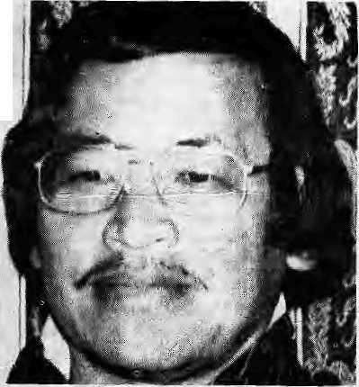
1990, there has been a surge of ethnic and regional assertion within Nepali boundaries. At a time when the Nepali State is looking inwards to resolve these challenges, it would hardly seek external adventures that would directly challenge the Indian State.
While Prime Minister Girija Prasad Koirala told Sikkimese journalists in Jiiapa that the Greater Nepal idea is "a product of unstable minds", Nepal's mainstream Left seems to be just a bit ambivalent towards Greater Nepal — they like the concept but are unwilling to do anything about it.
As much is clear from the Rangamanch's interview with Madan Bhandari, General Secretary of the CPN (UML). He said, "I do not want to make any political comment on Greater Nepal. But as far as it is a question of feeling, as a Nepali I can express the emotion that Nepali-speakers who are linked through their ancestry should be able to come together as one united family. If the Greater Nepal issue progresses ahead, then in a peaceful manner, taking into account the sentiments of alt people, this thing can be decided."
Asked about current CPN (UML) policy on the matter, however, Ishwor Pokhare!, Central Committee member of the CPN (UML), was unequivocal: "We have made no fonnal statements on the question of Greater Nepal and no leader of the party has endorsed this concept. We have decried un-
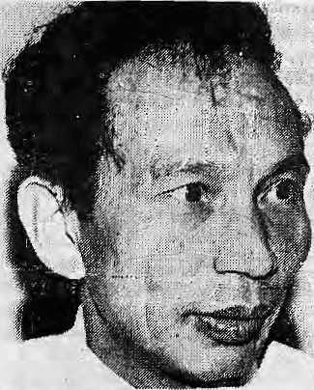
Ever-petulant Subhas Ghising.
equal treaties between Nepal and India, but that is in the context of the 1947 Tripartite Agreement and subsequent treaties. We have not gone back to question the Sugauli Treaty of 1816, nor asked (or cession of land to Nepal. The party regards the Greater Nepal
proposals as neither relevant nor timely and we have not taken them seriously."
The Sikkimese state. Today's Sikkim is dominated by Nepali-speakers and the Bhutia/Lepchas who were here first have been marginalised. Chief Minister Bhandari has ruled Sikkim for 12 years and emerged as the most powerful voice of Indians of Nepali-origin. A charismatic and ambitious man, Bhandari must seek successes beyond his small state. Could a move for Greater Nepal come from him?
_ Under.presenL circumstances,
it is not realistic for Bhandari or any
other Nepali leader in India to have vi
sions of becoming a leader of Nepali-
speakers of South Asia as a whole.
"Greater Sikkim", however, seems a
more likely possibility. In a July 1991
press conference, as reported by the
Sikkim Observer, Bhandari himself did
indicate a preference for a Sikkim with
Darjeeling incorporated into it; ~
Sikkim's historical claims over the Darjeeling hills would not make untenable the demand for a united state. (The Darjeeling hills were gifted by the Chogyal to the British as late as 1835,) But the establishment of such a Nepali-speaking enlarged state within India would be complicated as ii would impinge upon the turf of Ghising and West Bengal.
B.S. Das, a former Indian envoy to Thimphu, is of the view that if Bhandari's emergence as a spokesman for all the Nepalis settled in India remains within bounds, it does not become a problem. However, he writes, "if these forces are allowed to become stronger by Indian neglect or Bhutanese mistakes, the concept of Maha Nepal will emerge under the garb of the so-called Greater Sikkim."
The Lhotshampa. The third category of possible conspirators would be the Lhotshampa of Bhutan, in particular the 85,000-plus refugees who today populate the camps of southeast Nepal.. However, it appears that the Lhotshampa^s most logical agenda would be to strive for greater power-sharing within Bhutan.
Says R.B. Basnet, President of the Bhutan National Democratic Party (BNDP), "There has been no document and no speech by any refugee leader which has spoken of Greater Nepal as our goal. This is something we have heard of only since we have come outside. It is a concept that is neither feasible nor desirable for Bhutan. It might have been brought up to create misunderstandings be-
tween Nepal and India and to undercut any Nepali support for the refugees."
Since the Thimphu Government seems firm on not wanting the refugees back,

'Greater Nepal' Tshering. there is only one party that can ensure the refugees' repatriation to their homesteads — the Government in New Delhi. And the one move that would guarantee immediate antagonism from that quarter is for the refugees to agitate for a Greater Nepal. The refugee leaders perhaps realise this better than others.
Until the Lhotshampas emerged as refugees, there seems to have been very little political links between them and the Nepalis of Nepal. If there is any place where there is a feeling for being 'Nepali' today, however, itis in the refugee camps of Jhapa. Said one camp resident, "This feeling arises because the very reason we have been made refugees is because we speak Nepali. I used to feel Bhutanese first and Nepali second. Now it is the other way around."
Their refugee status, thus, seems 10 have forced the Lhotshampas to feel more 'Nepali' than before. By creating the conditions that have made Nepali-speakers into refugees on a mass scale, therefore, the Bhutanese Government might have unleashed a process of setf-identification that could become uncontrollable. For the moment, however, this seems unlikely, and the refugee leadership seems little inclined to initiate or join a movement for a Greater Nepal.
Eyes on New Delhi

It is clear that "Greater Nepal" is used by both Thimphu and Darjeeling as a weapon in their separate battles. It is a means to make the

Mar/Apr 1993 HIMAL . 17

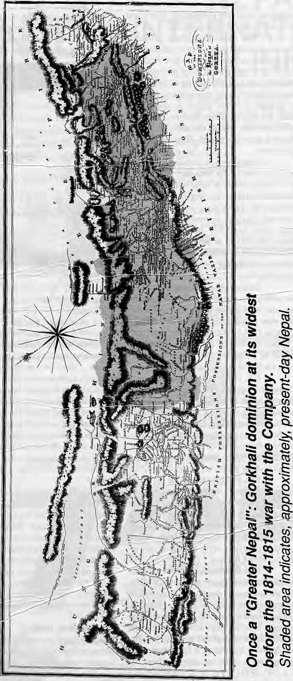
powerful politicians and bureaucrats in New Delhi si t up and lake notice. But why is "Greater Nepal" such a convenient issue to catch New Delhi's attention?
Both Ghising arid Tshering know well the sensitivity of India's strategists towards the "northern frontier". They understand that New Delhi would not take kindly to the emergence of a Nepali-speaking superstate in such a strategic region, most particularly the Northeast.
Greater Nepal, at its geographical widest, would command the Himalayan rimland, controlling water resources, irrigation,, hydropower, tourism, and trade with Tibet. Added if such a state were to be foreign, under Kathmandu's rule, this would give rise to attendant geopolitical complications that New Delhi could well do without.
. .^Among New Delhi strategists, therefore, a Greater Nepal state would be something to avoid. At the same time, astute diplomacy could make effective use of the Greater Nepal scenario, even if it were not entirely believable, as a means to keep the Nepali Government forever on the defensive. Stoking the Greater Nepal embers every now and then could serve a purpose.
What genuine concern there is in the plains about Greater Nepal probably refers back to the lurking fear that the martial Gorkhalis will one day arise and take over chunks of the Indian territory. This fear of the khukuri as a regional threat is quite dated to those who keep up with Nepali society. But many, some plains academics among them, continue to regard the "Gorkhas" as comprising of one unified race with the ability to articulate a political agenda and achieve complicated geopolitical designs.
Journalist Sunanda K. Datta-Ray wrote recently in The International Herald Tribune that the Indian Government "has long been wary of the Nepalis". The claim for official recognition of the Nepali language is seen "as the thin end of a wedge of political demands by a martial race entrenched in pockets along India's 1,500 mile Himalayan border..."
Tanka Subba, a sociologist and researcher at the North Eastern Hill University in Shillong, says that there is also fear of Nepali expansion from the tens of thousands of demobilised and retired Gurkha soldiers. "With so much military experience, so the argument goes, it may be possible for Nepalis to take over areas where they dominate."
With the layers of worries and suspi-

1S . HIMAL Mar/Apr 1993

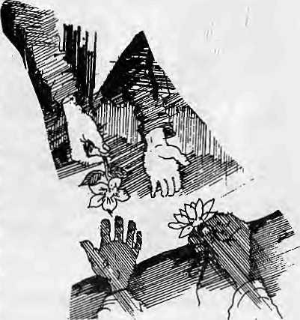
cion about the Nepali-speaking hills (sensitive northern frontier, a possible super-state, a supposedly homogeneous population, the martial legacy), a suggestion that the Nepal's Left parties are planning a Greater Nepal putsch, or that Nar Bahadur Bhandari's popularity among Nepali-speakers of India shows the way to Greater Nepal, or a suggestion that Lhotshampas of Bhutan are the vanguards of a Greater Nepal campaign — all serve Ghising's and Tshering's purpose to get New Delhi to see things their way.
When Jyoti Basu was dismissive of the Greater Nepal issue, one Sunday Mail reporter responded in a column, "...there is more to the 'Greater Nepal' issue than meets the eye... Jyoti Basu may dismiss the allegation of a 'Greater Nepal' movement as a 'bogey'forpolitical reasons, but the responsibility of the Union government goes deeper than that."
The Nepali Psyche
Anirudha Gupta, political scientist at the Jawaharlal Nehru University in New Delhi, speaking on Greater Nepal, says, "There is no conspiracy, but there is an aspiration. Today, there is revival everywhere, and the Nepali-speaking middle class perhaps is no exception. Historical revivalism always brings up irredentist eruptions. In theNepali case, people may start looking back to Sugauli and the ceded territories. The middleclass intellectual aspirations have always been an easy ground to revive a feeling of past perceived wrongs. When 'we' and 'they' comes to the fore of discourse, history comes alive, to influence me future."
Under what conditions would a pan-Nepali 'ethnogenesis' come about, which could then be expected to lead to a potent Greater Nepal movement?
There has been no wrenching incident in Nepali history, no trial by fire, that has led to the evolution of a collective national psyche. What has served to loosely bring the population together has been the force of Gorkhali expansion, the Kathmandu-based monarchy, a sense of being separate from the plains, and,'most significantly, the spread of the Nepali language.
While a sense of identity is there, nationalismnever settled deep. Prithvi Narayan Shah, unifier ofNepal, is nottheiconof choice among the Nepali-speakers outside Nepal. Even Nepalis of Nepal do not make pilgrimages to spots of erstwhile military martydom, suchasthebattlefieldsofNalapaniandMalaun.
Instead, except in Ghising's present-day Darjee ling, the accepted symbol of pan-Nepali cultural identity is Bhanu Bhakta Acharya, the adi kabi of Nepali literature.
And the Nepali language Ls travelling along the hills. The economics of modern mass communications demands a dominant language, and along the central Himalayan rimland, Nepali has slipped into that role. Nepali is ascendant even as there is an unfortunate loss of ethnic languages and cultures right across the Himalaya. In order to reach the largest audience, politicians, journalists, advertisers, filmmakers; entertainers, educators, tradespeople and others are making increasing use of Nepali.
While it is language that binds the Nepali-speakers of South Asia, it is a weak thread. The feeling of 'Nepaliness' in the Nepali 'diaspora' is culturally charged, but not politically so.
One explanation for this weak politicisation might be that, barring Sikkim, Darjeeling and the Duars, theconcentrationof Nepalis in India is relatively low. Another could be that Nepalis do not form an ethnicity or race. For a Bengali or Marathi, it is a quick step from language to cultural identification. For good percentage of Nepalis, however, the Nepali language is a second language. There is so much that sets apart even Nepali-speakers from one another — tribe, caste, class, language, region, and so oa Political mass articulation is therefore harder to achieve among Nepali-speakers than it would be for a more homogeneous population.
A serious move towards Greater Nepal would have to have its origins in the targeting and humiliation of Nepali-speakers from all over, in an extreme scale, for being Nepali-speakers. Even then, the threshold of tolerance seems to be notched high for Nepali-speakers, bo thin and outside the mother country. Severe suffering inflicted upon Nepali-speakers over the last decades did not lead to a circling of wagons and die subsequent rise of region wide nationalism.
Ne ither the ev i ction of Nep al i -speak -ers from Burma in the 1960s, nor the expulsion of Nepali-speakers from Meghalaya in 1985-1986 resulted in organised pan-Nepali reaction. When border points were closed during the height of the Nepal-India trade and transit crisis of 1989-1990, sentiments were affected among Nepali-speakers of India, but there was no political surge. And today, even with the volume of media attention that has finally focused on the Lhotshampa refugees,
there is no political coming together of the larger Nepali-speaking world.
An Indian national daily recently presented with alarm the geographical extent of the Greater Nepal that is planned — it is to include large parts of Himachal Pradesh, Kumaon andGarhwal, Dehradun, all ofNepal, Sikkim, Bhutan, and the Duars. The map presented by Dhakal of the Greater Nepal Committee covers more or less the same ground.
But a look at the rimland, from east to west, shows: a we 11-entrenched state of Himachal; the Uttarakhandregion which does want autonomy, but only from Lucknow; a Nepal whose political leaders remain preoccupied withmyopic politics of the short-term; a Darjeeling dial wants emancipation, but only from Calcutta; a Sikkim that wants Darjeeling, if it could have it; and a Bhutan that is every day shedding more of its Nepali identity.
The vested interests, the administration and the politics of the region are all well-entrenched, and only a Subcontinental wrenching that goes far beyond the Himalayan region would dislocate them and lead to, among other things, a Greater Nepal. While a large portion of the population of the region is able to appreciate the cultural attributes of the Nepaliness, the feel does not go deep enough to emerge as a movement for Greater Nepal anytime soon.
This article is adapted from a paper presented at a conference on Bhutan organised by the School of Oriental and African Studies, University of London. 22-23 March 1993.

Mar/Apr 1993 HIMAL . 19

ADVERTISEMENT
Iodised Salt for the Nation's Health

Goitre and cretinism have always been a curse on the Himalayan region, but only recently have we been able to do anything
tt is a curse that came guaranteed with geography. Normally, humans get their supply of iodine, which is an essential 'micronutrient', from foodcrops. In the Himalayan belt, however, natural iodine in the soil gets washed away easily. As a result, loodcrops are low on iodine and the population does note receive the required dose.
It is iodine deficiency that causes goitre. If the deficiency is severe, cretinism results, characterised by mental retardation, deaf-mutism, and lack of muscular coordination. About 40 percent of the Nepali population is said to be afflicted with some degree of goitre. And it is estimated that four out of every thousand citizen shows symptoms of cretinism. Controlling the Iodine Deficiency Disorders (IDD) is therefore one of the Nepal's gravest public health challenges.
Since 1973, a unique collaboration of private business and government has been actively engaged in battling the ageold endemic. His Majesty's Government, the Government of India, and the Salt Trading Corporation have been involved in iodisising and distributing salt throughout Nepal's high himar, hill and tarai districts.
Salt is one condiment that everyone uses. And salt that is iodised is considered to be the most efficient way to get the iodine micronutrient into the diets of the country's far-flung communities. It has been Salt Trading's responsibility to ensure that all the salt distributed in Nepal is iodised.
And it has been working. Studies have shown that the incidence of goitre in Nepal has gone down considerably. Whereas 55 percent of the population
was afflicted in the 1960s, one study showed that the incidence was down to about 40 percent by 1985-86.
Because iodine tends to evaporate from salt that is in storage for too long, with the help of the Indian Government, Salt Trading has set up three rodisation plants, in Bhairawa, Birgunj and Biratnagar, so as to reduce the time gap between iodisation and consumption. These plants presently iodise up to a quarter of the salt that is distributed in the country, while the rest of the salt comes iodised from India.
Since the last three years, polythene packaging has been used, which eliminates the evaporation of iodine. The Ayo Nun is powdered iodised salt. Since the communities of the high himal prefer to use salt crystals rather than powder, Salt Trading recently introduced Bhanu Nun. This new brand uses iodised crystals of granular size.
We at Salt Trading are committed to ensuring even better delivery of iodised _salt to Nepal's population and the introduction of Bhanu Nun is just one demonstration of this commitment. We are presently engaged in adding three more iodisation plants in the Western Tarai, and by 1994 Salt Trading expects to be iodising all the salt in Nepal itself.
In so doing, we will also proudly continue to be .part of this unique experiment in bilateral cooperation between Nepal and India, whose goal is to eliminate IDD in Nepal by the year 2000. This is a programme which is directly helping to raise the standards of public health in Nepal, and saving hundreds of thousands from the curse of goitre and cretinism.
Together with the nation, we look forward to the day when goitre is virtually eliminated from these hills and plains.

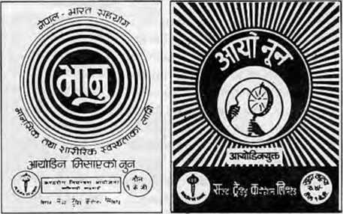
Iodised salt is distributed by the Salt Trading Corporation Ltd. both in loose form and in one kg packets. Packet salt is available under the brand names Ayo Nun and Bhanu Nun. An Ayo Nun packet costs four and a half rupees. Bhanu Nun is distributed only in the remote areas at subsidised prices.
GOITRE CONTROL PROJECT
MINISTRY OF HEALTH
(HMG/NEPAL AND GOVERNMENT OF INDIA
COOPERATION)

Programme Implementing Agency: Salt Trading Corporation Ltd. Kalimati, Kathmandu. Tel: 271593,271014 Fax: 271704

Bhutan Conference:
Staying Afloat
Traditional virtues were abandoned by many scholars of Bhutan, when confronted with the Southern Problem.
by Robbie Barnett
I
am a journalist and know my place at academic conferences: keep quiet, take notes, and let the experts do the talking. Compared to us hacks, the academics have longer views, deeper knowledge, and are more committed to impartiality. Or so (he theory goes.
It didn't quite work like lhai at the London conference on Bhutan, organised by the School for Oriental and Asian Studies of the University of London, 22-23 March. There were solid papers on non-political subjects, but in the political arena, where everyone's focus seemed centered, the traditional virtues were abandoned by many scholars, and it was left mainly to three journalists who presented papers — a British, a Bhutanese and a Nepali — to demonstrate the ait of rational debate.
This was inpartasignofgoodhealth: at least controversy was aired. The Bhutan scholars were not ostriches, and walked bctoss the sandrather than stick their heads in it. And a good third of them, more like ducks than ostriches, plunged straight into the turbulent waters of what is politely called "the Southern Problem".
The ducks, steered towards the maelstrom by the conference convenor, who thrust controversy forward at every opportunity, are to be admired for entering the debate. But not all of them knew how to swim, it seemed. In theexcitement of the controversy, or perhaps eager to show affection to friends in 'high' places, some of them forgot the basic skills of the trade: check your data and cite sources.
ExpertsoflhestatureofOxford'sMichaelAris, or Berkeley's Leo E.Rose knew how to hover above ihesurface of anissue, providing balanced overviews based on evidence thai is not in dispute. Lesser mortals tended to immerse themselves in one current or another; without the benefit of documented evidence they had trouble staying afloat. One researcher from Hong Kong accused the Bhutan People's Party of "a clear attempt to sow disease in the mind of the reader/ viewer", but gave no evidence. A Dutch ethno-linguist had four references in his paper, all of which were to studies he had written himself. An otherwise exemplary Frenchman sank to the level of assassination by innuendo: that "so-called democracy movement," he said en passant of the Southern Bhutanese campaign.
There was a deeper problem: none of the scholars who dealt with politics had surveyed the refugee camps or done field work in Southern Bhutan. They thus could not assess allcgatioas either of violence by Nepali-speakers or of oppression by the Bhutanese Stale. To describe, as one scholar did, Bhutan's implementation of the single language policy as "characteristically Bhutanese and in keeping with a benevolent Buddhist view of life" was not only, strictly speaking, meaningless, but, unless the perceptions of Nepali speakers had been assessed, invalid even as banality.
The journalists who spoke at the conference were canny rather than angelic, but they did nol make those kinds of elementary errors: where they stated facts they backed them up as well as they
could. Otherwise, they trod water and stayed out of trouble. They had another lesson to offer the academics: do not take sides. A learned professor from Shillongsank under the weight of his own rhetoric about the *'anli-feudal" efforts of the '^{L}ancLent, material and substantive Nepali commonwealth" to bring civilisation to the "relatively thin, simple and recent Drukpa fold". The researcher from Hong Kong appeared to have the trays mixed up onhis desk: we got the paper from the tray marked "Advice from Thimphu on Damage Control". He must have sent his "Objective Research" files to Thimphu by mistake — probably more useful to them in fact.
The journalists paddled in circles around calmer patches of the pond. Kanak Dixit shmgged off his apparently assigned role as token Nepali, demolishing others* theories without revealing his own partialities. Nick Nugent, a hierarch in the BBC World Service, used Thimphu's own reluctance to admit journalists as an excuse For not revealing which side or sides he thinks are lying on the Southern Bhutan issue. And Kinley Dorje, whose newspaper Kueissel frequently prints unattributed stories, knew nol to do that when speaking under his own name: his comments were always prefaced by "the Bhutanese Government claims", or "the Ministers' view is that", and were all the more useful for that. These are simpleprecautions,LessonOne for hacks, and vital for survival if you are going to enter into contemporary debates.
It was not just academics who got into difficulties at the conference. A bigwig from the United Nations High Commissioner for Refugees used the platform to describe another speaker as "mischievous and idle"; it did not help that his victim was not allowed the opportunity to reply. UNHCR has a diminishing reputation for dealing with criticism—see for evidence Iherecent correspondence from their special envoy in Cambodia on the Yim Sakun affair — and their representatives need to builddialogue rather than exchange abuse. The UNHCR must realise that if they do nol have a process of individual status determination (and this February they told me they don't), then uncertaintiesaboutrefugeeclaimsareineviLableand deserve acivilised response.
As for Bhutan's Secretary for Home Affairs, no one expected him to be impartial. But, having agreed to come to an academic conference, he could have played by the rules. He began nobly enough with an academic discourse on the central issue, which is the history of Nepali migration, but soon descended to unsubstantiated allegations against the absent Bhim Subba. a senior civil servant now a refugee living in Katnmandu. This was ungracious, not least since his Ministry had refused to attend if either Subba or any other Southern Bhutanese were invited to the hearing. Neither was his monody about ihe imminent swamping of the Drukpas of Bhutan convincing: it smacked of emotional blackmail andsounded too much like inciting other Bhutanese to xenophobia and revenge.
The Secretaiy's real failures were not unlike the academics: he too had not been to the refugee camps. Ho could not bring himself to acknowledge, still less to answer, the refugee's allegations of abuse by the Bhutanese military, reported impromptu to the conference by a young woman who had worked in Jhapa. Her emotions were unaca-demic but eloquent. His silence was damning: il was a failure of morality as well as intellect.
The tragedy is, of course, that the Minister and his ideologues are right: Bhutan faces acute danger from demographic pressures from the plains, and at ihe same time incidents of horrific violence are continuing. But they need to encourage debate not rhetoric to solve this, and the greater number of dispassionate scholars whom they can get involved the better. 1 salute anyone who takes the plunge.
R. Barnett is editor of the Tibet Information Network, based in London.

Mar/Apr I'J'B HIMAL . 21

V
o
I

DARJEELING CONNOISSEURS.reactinginsepa-
rate interviews to questions by The Independent of Kathmandu on how they found Nepal. Madan Tamang is President of the Gorkha Democratic Front, and Chhatre Subba is Chief of the Gorkha Liberation Organisation.They apparently cannotstandeachother, but seem to agree on other things.
Q: What differences have you found between pre-Jana Andolan Nepal and post-Jana Andolan Nepal?
Tamang: I've found dirt, ail over. Democracy has, of course, come to Nepal. But people don't seem to understand what that means. To urinate on the streets is not democracy. I've also found considerable indiscipline in the people.
Q: What don't you like about Nepal or Nepali politics the most?
Subba: The politics here is dirty. It is the politics of begging for aid. Self-respect seems lacking. Countries, even poor ones, must stand firm in their position,
Q: Was there anything that you liked in or about Nepal?
Subba: Let's see. I didn't really sec anything like that (laughs). I saw that a lot of trees had been felled. The hills were naked, forests all cleared. Also corruption is there in a big scale.
HUMAN RIGHTS SANS HAIR RIGHTS is
hardly cool, a reporter for the recently launched Kathmandu Post daily discovered. A fundamental freedom of Nepal's MTV generation is threatened by a suddenly puritanical Nepal Police, (For more about barbers, see May/June 1992 Voices.)
It has become a time of terror for those wandering youths who have long hair. This is the outcome of get-rid-of-long-hair campaign launched by the police.
In the past three days the police have shaved the hair of 400 such youths.
The 'punishment' for these long haired youngsters varies. Boys with only long hair are merely shaved and released, but if they are also found intoxicated they may have to pass more than 24hours in police custody.¹ If they are found rambling around annoying girls then the punishment gets even more severe. They could be taken to court for public offence. So far cases have been filed against ten such youths.
Two days ago in Dillibazar alone 200 youths with long hair were shaved by the police.
"We have had tobemostactiveinThamel and Man arajgunj in this regard," a police source informed this Post reporter.
The recent procession of youths at Thamel chanting slogans on hair right, however ridiculous it may sound to majority of people, has reflected the torments of the youth with long hair.
^{L}'In a country where there is no hair right why talk about human rights?" says Sanjeeb Nar Sing, a sufferer and an active participant in the procession.
"How about the long hair of Lekhnath Poudel? What would police do to such a person?" Sanjeeb questioned throwing light on the objectives of the campaign.
S.P. Rewati Bahadur Thapa of Kathmandu district police says "It has been launched 10 check growing social aberration."
However, a guardian at Hanuman Dhoka calls it a fools campaign. "Smugglers and hooligans escape from prison with police help. Who cares about that?" asks another guardian.
These days police are said to be bothering even youths walking in the streets. Bikiam Rana, a computer trainee says that he was harassed by the police on his way back home.
Some people have taken this police action very positively. Fathers who have been highly annoyed by their sons' long hair have expressed their satisfaction. And girls have also started walking in the streets without any apprehensions of being harassed.
On the other hand the youths with long hair are raising their voice against this police action. They say, "We won't keep quiet."
ALL ENGLISHMEN CANNOT BE GENTLE-
M.EN, said Nepal's Prime Minister Chandra Shumshere to Lord Morley, the Secretary of State for India, at the India Office,London, on 9 May 1908 at 12 noon. But he was not being rude, as will be clear from these minutes, reproduced in Asad Husain's British India's Relations with the Kingdom of Nepal (George Allen and Unwin Ltd., London).
Secretary: Are you quite comfortable?
Maharaja: Perfectly at home. Your Lordship knows that we Gurkhas are true and loyal and devoted friends of the British Government. I assure you that we wish to prove by deed should occasion arise the sincerity of our devotion to the British Throne. Secretary: Oh, I have no doubt of that and we will not forget what the Gurkhas did during the dark days of the Mutiny. Maharaja: Your Lordship, I hope the kindness and goodwill which we were so fortunate to enjoy at the hands of your Government will be continued.
Secretary: No doubt it will, whether it will be this Government, or another Government. I am so sorry that there is no good book on Nepal. I was reading the other day a book on Nepal by Ballentine. In it he spoke very badly of Nepal as well as our administration in India. Who was he?
Maharaja: He was an American and the book was written some eighteen or twenty years ago.
Secretary: Oh, I see, he was an American and the Americans are aiways against our administration in India.
♦ * *

22 HIMAL . Mar/Apr 1993

c
E
S

Secretary: Last year a very important society, the Geographical Society, demanded a pass from me to explore Everest. 1 refused it. Is it not as you wish me to do?
Maharaja: It was so good of Your Lordship. My object in keeping my country isolated is so that the Gurkhas may continue to respect the British as they have been doing so far. I think I am right when I say that their respect of the British official in their cantonment equals, if it is not greater than, their respect for their sovereign. But if we agree to let a party into our country others will gradually follow and alt Englishmen, Your Lordship, cannot be expected to be gentlemen. If unfortunately there may be a quarrel between the British subjects and Nepalese subjects and if there be frequent association between them in the hearth and home of the Gurkhas, it may breed contempt and they may not respect the British in the same manner as they do now, which would be a dangerous thing for the interest of Nepal.
Secretary: Iquite understand. Iquite understand. I agree with you. Was not an exploration party sent to Everest? Maharaja: Yes, it was, under a native overseer. I have no mind to keep anything secret from the British Government in my country and, if the British Government want, I have no objection to allow native overseers to go through my country to get any information they wish and so it was sent at the instigation of Major Manner-Smith. It has been found out that it is in Nepal.
WHAT IS A VILLA GE ? And why are villagers a marked categorywhen Nepal is acowtry of'villages? Excerpt from a paper by Stacy Leigh Pigg in Comparative Studies in Society and History V34 n 3:491-ST3, July 1992,
Nepal is a predominantly rural nation: Most people live in villages and make their living as subsistence farmers. The Nepalese government, assisted by international donor agencies, administers projects directed at improving the conditions of life for these rural people. Images of villages and village life accompany the promotion of development ideals. Radio NepaJ has actors playing the part of villagers in didactic skits aimed at convincing rural people dial they should consult doctors for their health problems or should feed oral rehydration solution to children suffering from diarrhea. School-books contain illustrations of village scenes and talk about village life as they inform children about development .programs. When development policy makers plan programs, they discuss what villagers do, how they react, and what they think. Together, these images coalesde into a typical, generic village, turning all the villages of rural Nepal into the village. Commonplace as these representations of the village and villages are, they mold the way in which people in contemporary Nepal conceptualize national society and the differences within it.
The village crystallizes into a distinct social category in the context of this national project of development. Further, the conceptual joining of village, development, and nation reworks an
abstract, internationalized development, rendering it Nepalese. This Nepalization of development accounts for why the village becomes a marked category in a society in which the vast majority of people are villagers.
KASHAG CONFOUNDS, unless you happen to be clued-in to Dharamsala-style elections. This item is from the Tibetan Bulletin, the official journal of the Dalai Lama's Tibetan Administration. (For an explanation of what is really going on,see Briefs, page 25. Kashag is the Cabinet, kalon, a minister.)
In light of the amendment to the Charter relating to the elections of the kalons (see report of ATPD session), the five members of the Kashag, Kalon Gyalo Thodup {Chairman), Kalon Kalsang Yeshi, Kalon Tenzin N. Tethong, Kalon Tashi Wangdi and Kalon Jetsun Pemasubmitted their resignation toHisHoliness the Dalai Lama on January 25,1992. The resignations were to enable the elections of fresh members under a uniform system. (Prior to dieir resignations, the kalons had met on January 17, 1993 in Dharamsala to elect a new Chairman. Kalon Gyalo Thondup was re-elected to the one-year post).
His Holiness the Dalai Lama accepted the resignations of the kalons and the process for fresh elections started. As per the amended Charter, His Holiness provided the Assembly of Tibetan People's Deputies with a set of 14 candidates. They were, in addition to the names of the outgoing Kashag, Rinchen Dharlo (presently Representative of the Office of Tibet in New York), Rinchen Khando (presently president of the Tibetan Women's Association), Kelsang Gyaltsen (Special Assistant to His Holiness the Dalai Lama), G. Nyesang (head of the Reception Centre for Newcomers), Dongag Tenzin (Auditor General), Dawa Tsering (Chairman of the Public Service Commission), Kesang Y. Takla (Representative of the Office of Tibet in London), Pema Dechen (member of the ATPD) and Rigzin Zalul (former Chairman of the Tibetan Community in Switzerland).
Under the supervision of the Election Commission, voting took place on January 20, 1993. There were 38 members of the ATPD who participated. Six candidates, who included all the members of the outgoing Kashag and Mrs. Rinchen Khando, were declared elected in the first round. Two c;indidales, Mr. Rinchen Dharlo and Mr. Kelsang Gyaltscn, secured equal votes for the seventh position. In a subsequent re-election, Mr. Rinchen Dharlo was declared elected.,
Mr. Rinchen Dharlo had submitted his resignation. However, at the time of going to the press, no decision has been taken on the matter.
The following arc the new members of the Kashag (with the numbers secured by them in brackets).
- Jetsun Pema (27) 5. Gyalo Thondup (18)
- Tenzin R Tethong i21) 6. Kulsang Ytshi (18)
- Tashi Wangdi (20) 7, Rinchen Dhurlo (15)
4!Rinchen Khando (20)
Mar/Apr 1993 HIMAL . 23

BRIEFS

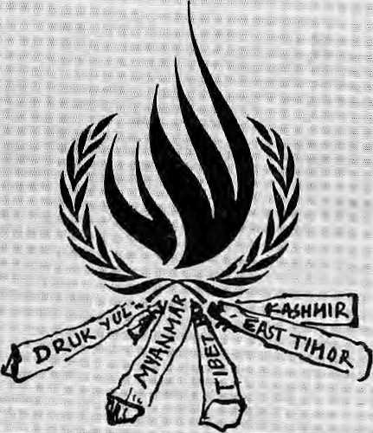
QOCtlMENf ARY REVIEW
fiarhwal onFHm
Themostbeautiftl areas of the Garhwal Hifnalaya'are practically inaccessible to the average tre kker arid t jurist. ;
... Victor Banerjee;'gw iherci I .,
Banerjee Rap scripted; directed ind filmed a 28-mirfuie documentary film, The Splendour of Garhwal and-Roop Kiinll, which is 10 premiere next" month.. He captivates the viewer with vibrant colours amd autumnal hues of the route from Dewa) to Roop JKund, and ; beyond Uttarkashi to Sahastra
■Tat The cinematography is excelleM, and the panorama is enhanced because Barierjee fil-
: me4.during the monsoon, when
'■ Ifte mountain^ are at'their best As fur as I kiiow, no one has ever made a similar film on these parts. Anyone who wishes to rush Up to Roop Kund
'fora "summer weekend" will of course be disappointed. Sorry.
- itctlive-star acconiodation up here! The people are poor and have little to offer the visitor. Nevertheless; their kindness and hpspitability ever-present, in a way that is Unique to the mountain people of Garhwal.
'When "I lived in Dehradim in the 1950s,! remember the sensation diatwas created by the discovery of a large number of skeletal remains in the frozen lake of Roop Kunci. There was much speculation at the time as to how they got there. Were th?y the remains of General Zorawar Singh's army, or a band of pilgrims trapped in the defile? Or were they Tibetan traders crushed by an avalanche? Presertt-day theory favours the idea of a royal pilgrimage, or the Raj Jaat Yatra, of a king of Garhwal. But who knows?
Banerjee does not enter into any controversy on this point. lie merely presents the place as it is — picturesque and eerie™ and captures the magic of the mountains in a way that
view, documentary film-makers ■■■• do; B anerjee, does Mt mtrU'dS 0it'"' the frame himself, but uses. a. ., ....
'■ trekker inmost flUhjswidocir ■ He H successful in -.-.. •..
6ttly Roop Kund itself, but the cnMre trek, from valley to: « l .... ;,. treelinejo sntMlin^ Stime of ■■ the highlights: of the fjlmM^ the tretrare the magrrificent ■■■■ ■■ ■■ -meadows at Kusfi Kalykrii anti pedrii Bagyal, the haunting temple" at tata, and the: images of Kali in tlie forests of K-Cji;" Kandhara. ;
For one who lov^s the HimaJaya^ELS Fdii, it is^goodlo) -..: see item being presented ^artistically by a professional ± ......
filra-maker. Wh4 ^ Aiore, seldom do Government ageiigies have the courage and enterprise to"sponsor such i project; ^ : : A country \\%<i l^gpfil gets, thpusatids of trekkersievery year. Why not (Sarhwal? Tlw answer, of Coiirsei, is that basic facilities need to bebroitght up tointemationalsiaiidaids; The Trelddng Division of Uje": '": SarhwaLMahdaiyikasNigam ... is cleaily doing its best. ;
The rianative is heJd tdgether by an interesting arid; effective musical score, working in thenies from Garhwaii iolk music, imerspersedbythe whirl of a bagpipe. Incidentally,ine bagpipe is veiy much a pai't of Gai;hwali folk musie, -having ■ been introduced here by Gaihwali soldiers who had: sef ved'in British regiments during World AVar I. The lnashak; as tliey catl it, is also placed at mamageSvan<i festive occasions. An other derivative from the Scots is the word dram* popularly used to describe a peg of the Garhwaii local brew.
Who Soiows, given a bagpipe and a few dram$,l rhighl get there n>yself someday!
in Bond. Musst)orte
Hiiiiiait ffi
A
CaregilDrial meeting ifi
Bangkokin early April;
Asia's affluent autocracies got
away with a rigid stance oa
hutnan rights. Cbuntries
speaking up weakly for 4ivjl;
Siberties and political pluralism
were the continent's economic
laggards: Bangladesh, the
Philippines, India and Nepal.
" The meeting had been, called to put together Si Asian agenda tor the U.N. World Conference on Human Rights, which is to beiield this June m Vienna. The ^t9 counti:ies of the^ Asia-Pacific region adopted a-watered-down 'Bangikok Declaration:* on human-rights,
; China, Iran and southeast Asia's newly-affluent nations'vociferously pushed for a recognition of economic, social'arid cultural rights, arguing that a iuO stomach was more important than the right £o' vote. China sliuck off a-1! mention of tovture in the- final resolution, and together with Southeast Asian nations, staunchly defended the "sover-■sign'ty issue" — an. euphemism . for their call to the West to mind its own business. Paradoxically. Asian human rights activists found themselves on llie same
Fiasco
side as' We.sterrt gdvesmntents. ori many issues... ,
For four days precede nig official meeting; some 2§0 human riglits activists from the region Had met at Bangkok's Cbuldongkpm University to hainrper out then own resoliK, ■ tiotL They succeeded in drawing tlie? attention to-Asia's human rights hot-spots like East Timor, Bui-ma, Palestine and-— jlnew entry — Bhuian. Indian, Nepali iuid Biiutanese human rights groups told their ASian cpilegiiues of tiie plight of fihuianene refugees in eastern Nepal and called for a tri-pailite dialogue between NepaJ, India and Bhutan to resolve: the;crisis.
Bhutan's Foreign Minister Dawa Tshcring was presenVto iouriter all this NGO rabble-" rousing. As member of the Conference Stcering!Gommittee, he Stayed in Bangkok for the duration of the intcrrggvemmen-tal meeting.
Glanng by their absence among the NGO aciivistit were any of the Tibetan exile groups, or Kashmiri or -Qiinesc dissidents. Perhaps they find it more productive to lobby eispwheie — directly where it masters.

24 HIMAL .
1993

J3HIEFS
l)em^

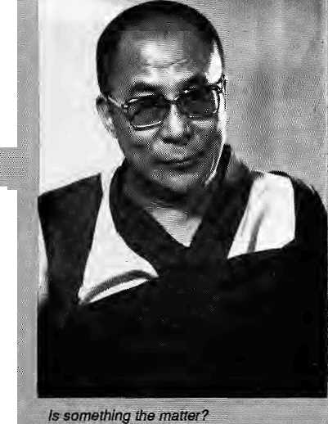

T
hewhoSe world jfiCiw wants ..idfflotracy. And the. Dalai Lama;wants democracy, Like:a mother. His Holiness lias been : coaxing &Assembly ef ■ ■■■"
,Ti|>etan People's Deputies to: take the first step; but withj>6 I little success'thaf he is:getfcing^ '■&% asperated. The Pal a | Lama
^wo^rd tike to reign, but (he ; Tibetaiss jji exile seem uornrrnV ted 16 seeing himjfule; :■:
The followingreport is taken frOjti the Tibetan Review of Match 1992,
..', .... ".. " : Residingc^ar (he ; ;. " swearing-in cereniprty of the ,new Kasliag; (cabinet) in. . ;. "
iFsamary,: the; Dalai Lairsastressed
'■tBeiieed for distaric|n| Mis name from the administrative, prbbessl
?HftwaS;%l up With? hearing that..
■■ any decision was carfi&ioat "in ici ordartce with the wishes of
Chines

way o/do]ng piijti|sjwhere ^ ■■:■ everything usedi% be ■ascribed-
Tse^timg, My a.Si o -" ;feng and row Deng :;}fiaoping.....This sort of ■ihirig had'nts place in :■ a democracy. ^{i;} ^{v} ■■ ■■■■
■ ■■■■ ■■■ ■■■■ When die ..." "'
present; Assernbiy was elected.nearly two years ago, :tfe Dsla! X^ma had asked the..... ,, jnemr^r^ t;b;elecC ■■■■■ ■:■■ ,-■■ ^ministets .thenjs^lye|, abolishing fee old : sysjteini ;in which he made nominations. This democratic move backfired, hp.weyer. Trie rfiinisteriat candidates, were ftr; recerro a naiuinsurn 70. percent of the ■■> : .. .., ' Assembjly,..v pteSj btit: °eveRafteKloweri^{n}E ■■■■■■■
Fe elected Sihc^ .
^FiteCtia Charter calls Tor at least seven ministers, ihe Dalai Latha was.jfort^d: to appoint ministers hiroself "to gel the work stsrtdd", says ih&Jt-evfe
'■' ' Afraid, of a "repeat embajprSSsrnent,:ihe Assembly ai its iariaiary. |993 session: . . .. amended rhe Charter pertaining t0 elections; It asked the dafai " Laina tp jipminate at least14 candidates, out of which flie Assembly wouldelect
seywiiii a straightforward V ote withou t any ...percejhtile
reqijirenients.
The Daki Larna based .his choice of H candidates on « poll he conducted will the" -employees of the Centra] Tjbetan Admmt strati on; In ^>e. elections ihat.foJlovieii, >l| five ' of theokLcabinet were wfelfas two ' . , Sg tni^rj; tor" deiiiticraey. for Eh

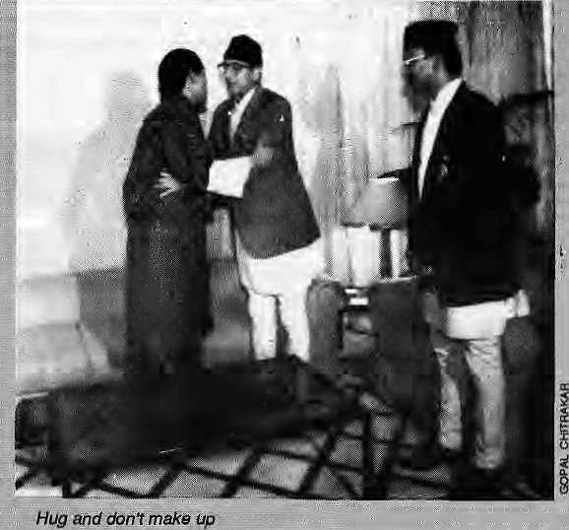
^bira ministerial,: commission to identify flie- ■ .-..■■ ■ refugees w^s easily sciirtled by-
stickmg r|omfc, reported Koirala I at his press.xonfejencji back: in Katrur^ridu, was the Bhutanese insistence lhat 111; the residents pf thecamp5^{t}in^{i}Jhapa,and; " Moring:(82,328 W»f 31 March te.called -"displace*!
s!!. They- Wete nettling of the sort, said Koirala:, wafnuig: '; that the preseniee of te.refifgees. ; was creatiing a'Ehreefold problem in Nepal: ;an e^onorriic burden¹; : ehvironmentai degradation; an<J "^oci^l polluttbtt".::; :
■ In the end, Nepal's Prime Mmister was kft muuer-,
forced to-international ise tfie,

^ Irog!
T
here ^fu|ie_{f}piayeti with fingers:. ., * called machhq mafliha bhyaguto ¹ ffishyfish,jtrog.--ihbther : ■ ! words, a damp squib.)
As expected, the long-awaited Bhutan-Nepal ^umiriit ;iaeeting;af the'E>hak» SAARC Was a dud* The Bhutaiiese made the most of it. "Die Nepalis w.ete, leftfoundering.
King Jigms, who knows th^ value of television : fofbtag&r-grabbed a visibjy uflcomtortftble Girija Koiiala j:and gave him ain im-South ^Asian.hug, His'Majesty then : made himself available to the, medift ahd insisted that the-talks had been positive and [ ih&e woBld: be & joint press statement
•Nothin^of the jsort
Whaj aboutjRV: " bimha Rao^ alsapjesetit in Dhaka? Koirala said he had
"•informally" raised the questioti with Rao, "He listened m me very attentively..."

Mar/Apr

BRIEFS
Humble Cummerbund receives Scientific Applause

Nepal . ■■■■ ■■■ = .1 / ■"■■ '■■ ■■■ | r ^{v}" ■" ... :.■■ spinal ■' ■■■■....
; : ;■■ ■■■ ., TKeteamdisco | ver§d. / movements, -
that theje was '*sprrte Jsek | snrific ; .■■:■.-.,allowsspin id
of:
it
the teafli;found '"aj incidence of backspairi in the patjika wearingpeople de|pfie : doing heavy physiq at works ift the field: or "carrying loads or '.
W
, ohder what Mtjyapu lady toiling away m her; ■ Kathm^du- Valley vegetable J patch of the Ftai elder cliriibirig op a trail towards Tapjejiing : would say if they learnt that research done on jhfe patukq they w£af bad jyst been awa+ded a ■ gold niedai fot the; Most OrigWlResearch by the;.......
fdifficmlt mpuwtato ttn
rs,..Was carped out ■ in ..central S^afiWf aLsoIexperimcriteid on
tirj the*Uiyied
University bfliiveipoof! : :..:■ .. The paflika is a wide gjeeeof cjotfi; abpuji five meters long/that is tightly wrapped •■; d the yaist by the men and i Of Nepal's Mil and .':' : valleys. This ciimtnerbund iis a? ;. Nepali aS thetopt, and evolved , . as' |means (0 pruusci thebody!
.e. Joshi :: :: -...conducE^d a pilot ^iudyendtled
g loaded and stessel3'^. ifrffilpedraise tttsintra* ,,. '. ';■'■■ < abd(uninalv pressure, which is... ;the Nepati Patuka' oil LumNJsto.: \ .'responsible for su
t". Accordrng tb pi i the.te?irrt studiMthe.. advantages of wearing
High RiM ft} Tibet
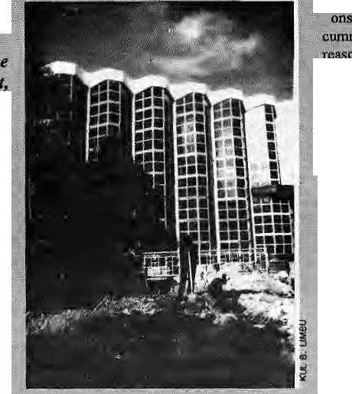
I Fouid^smUknor^wardfronxpte
ojfsimikoi in NepaVsHttinty
smack in the middle of the Tibetan plateau,
rises a BongKojrig-styie edifke/Thk place M
Burning, which serves as. ttie administrative
centre far the regianl &nd the high-tech
' building, it is said, willserve asabantLThe
old trade route from Tibet up thetipulekh
PUhomgarh was reopened fast July,nn4 the
Chinese apparently expect the trade to pick
up—*- imports of tea, textiles and vegetable
oil, and exports of mi£ borax pQwdei and
sheepskin. Enough to make Tibetan
bankers in this glass and concrete
structure yakkish, er.« buMsh.
ip tjalaJidnJcr^'baKkpain of heavy .,; resete suggest ih^t the pap^a warkersf attd Efippiitain porters at
26

UYA
^^

Tibet Review, the v^nerabiefrfoiithiy from Delhi, ■
if that means thai indcpefidericeyautoijomy/self-
detcrrninatic-n is at hand. 'Ssraausly ihougK, the
Review repom that || Dbarams^
in-exile has decided that "it is: lime
relations with {Bhutan) artd^tpp/taJkirjg abaut old
disputes"; The old disputes reJate to hard linnet.
given toTtbelan refugees in Bhutan following King
figime Dorps death in the oiid-1970s; He had a ■
Tibetan mistress Vhh;:_{a};s₉n elder loiCjng ligme ■■■
Singye, and apparently there wereTiears of.^a Ti-
betan-jed coup d' etat. Thimphu haslang reserved
the Tibetans' reluctance to take Bhutanese citizen
ship: In rapproachment mrxJe^Dharamsala how
says that the lOMor so Tibetans couMeither te
brought over to India, or they may''even take up
Bhutanesecitizenshtp-since the/Fi beta n Charter has \
so.objeclkirt to Tibetans holding dual cilizenship
provided they>ay the voluntary TifetanJax and ■■■■
remain; loyJJ to Tibet," Wonder what Thimphu will
say to thai last proviso. : ' ;
to those who thought Kathmandu; wa& row the :: center of ttit DJtarmd, hete comes compefiiionj : from BodhGaya. Reports Farzand Ahmed M India -Today,some Bodh Gaya-ifesars going pverboard ■—one teacher of meditation said that-fe town "has jdj fhe;riotentfdoi-timing into a worid spiritual center." Big money has come gram Buddhist lands tosei up splendid-monasteries *M!n tanka, Bunpa. -J, Thailand,; Japan¹, Bhutan,; Vietnam, Nepal,. ;tdhd^ithX?. And whatwf ail fhe! disparate architecture? Not to Worry, says Rav|ndra Singh Venha, an arcrutetf pko has studied the "Morphological Development of BodhGaya" apd; who believes that because all rhe'styles arebasedon; ' Buddhist pijnciples, they all haveintcgri^ in fheir architectural styles But if thaliapanese templeaud the Tibetan monastery are supposed to fooksimiiar Jiist because they are Buddhist, we'd better-get omselves anolher morphplcgist.
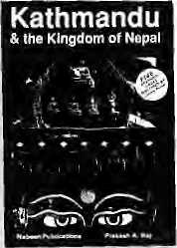
Nothing's sacred. With the current spate of bomb
ings in India, even Dharma buffs are in danger of
being labelled ternirisU. As reported by TtieStates-
mmi of Calcutta, one Astrid Veddai, aDufchtourist
sent a parcel to a friend back home. .Unbeknownst
to her, the Calcutta Police Department to keep its
honour intact, was on the lookout for a suitable
pared bomb todiscovcr. Soofficer^woopedinoft
theCalcuttaGPOandpickedoneMsVeddaf's.Tlie
Army's Bomb Dis^
posal Squad slit
ojien fhe parcel and
found the following
paraphernalia for
brijiging down this
Hooghly Bodge: a
wooden bust of Sri
Ganesh, several
boots on Buddhism
and meditation, a
tourist guidebook.
Subversive titerstuw? Kathmandu atid tlte
fictets; a tr^kfcuig permit .issued by the i^^ d
.di© cassette jhat tarries % man Vmesiagei "! miss ■■ y°V- T9M areifi: India and I am iiri IMjiarld. We are : ^he wasgoodefiougfi for.the Galc«tta

^ p
, thata parcrfwith; %cigji lusts had been fouhd;andl destroyed- Which, tomc.ru think ©lit. Was irut-.
ing todosoine faitcy foo^orfcTtdmaintain his grip on SifckimvDivisionsaiixingthe.dorninani Nepali^ speakers alung ethnic, lines has led him to wob Ihe
^f^^a-tepeba tribai cotVununity, who have re -cendy beeaslengthened by a Sopitenie'cpufl deci-sioa confirming theifrighftci B seats in jhe State
'Assembly. There had earlier been a move: to do:
..the Nepali community is diiftmg away from Bharidiri: arid towards Pawan Kamar Chamlmg, President of thfcSikkim democratic FW?t,^ays the wporteE Ever the tacdeian; Bhandari quickly dei-clared a pubSc Miday to celebrate,thevyictoryori ^{v} the seat reservation issge... ... . . .
Bhutan has won accbladtis jforVantirig restriclingi tourists i dp its wondrous ipalp, iSit the sceptics have always said, "Wait andiSee, wait and se&"5o what h Thimphu up to printing glossy four-tolour come-Jittiier agency-produced ^d^ in the\NepaC. traveller toutist iriagaKine? One is by ihe Govcm-
meiilandanotherbySrukAitTt-coHldeiiHerbeihat" the "high (io$t low volume" tpurism is not: quite-working out and some hardsell is nowdee tried accessary. Or it could be that Druk Air,' which""' ^^{c}?^{n}!b'^{w}^^{n}t info;a second BAe 146 four-engine ■ jet, now has seals to fill up. But it willnol help to bring in mpretoiirisu if they are going to be kept out of theDawlgsajidhave !o be satisfied with watching -regurgitating yaks. It,is old^styl^capitalism, versus medievaJ rornance-, the latter touted with abandon in the two ad inserts,
AjwwecX-',fweekly:"NewsMap"f6r3rMarchcon- * tains an intriguing bubble ppinte<i at the Nepa|-Titretborder, staling, "AGreen Light: China says it will construct a second road linking Lhasa and Kathmand u. The; Sjno-Nep^j esejroad w i (I ease grb w-ing (raffle on the existing road built in 1967_{T}" Sounds plausible, perhaps; buth^w corns nooiie has heard of it before? And w)to-saj.s there is gridlock on the: Kodari highway? It js not clear where anew alignment would enter Nepal, C6nne!tto
dhf
p
JC^thsn^ndu ijorth-west toTrisuIi; Which connects¹ with the-Arrny-buihroad up towards¹DJiuncheflt is known that th&Chinese have started a bus service .down to the head of the Trisuli rivervalleyiat; Kyarung. Only a few lalbmeters of read-building-up from flic Nepali'rcjadiiead at Syabrubesi, it is said; wouldeasiiy connect Nepal yet again with
But wfty, for Mahakala's,sake, a wholeneiw , second load at!: the way
"The beauty ofthisregion is proverbial and taiiis Mhe visitor fipni the plains ;by surprise. Tt is well-wadded, ijnllyjatiitg^nd intersected with sircars, T|e.riiec.s^ad:.shrBbs have..:frt!shncssi..!whi!st thet ipouptaisson the norfh,;th°e hilts v?n the sou tli;give' a charniihg vapation^ta theviaftdscape.¹* Is this a Harkihg back to-a iong-lost Kiilhmandu Valley? Sfope-. An;excerptfrbmabookoritteOoon V^ley, irepom UNl^lie"new«ditk)n--of Memoir ofDehm :DO(i>i; writtefl tale in the last century by G.R.C: riyij servatit, was relfeasetf afa funciitm ^n5April. Ail of which; h&s one ^linking ■ffii i! woujdiieit be a Sad idea; for the city lathers and mothers of Dchra aiid^Ka thmandu to get together t« compare flbtesabout I ^irrespective,.,rapidly degrading;, yd) leys.
'*AU arc equal before the tew and are entitled any discrimirjarioxi to equal,protection of i
Declavatim ofjluman Rights!'Fhe Chinese Gbv-eoirnent* heri* not-merely defending but bragging about human rights available in Tibet 4 brochure titled "Reecad of Human Righ^ in^Tibe! <B)"r which starts witbi the UDHR^uote, was distributee) auhe.Conference on Human Rights in Bangkok in" end-Marcb; Beijing is responding to sophisticated Dhararasala piibiic'reiations with its own volley. , 'Ehe paper is glossy, but the message is worp. pne
* pictuiesofmutilatediirnbsi.gotiged-outeyes,slaves, poverty, and s)i|heads like 'Three Classes and Nine . Grades", "Discrimination against" Women-', and "Barbarbtis and Brutal Puru'shmerit" The' flip side :
; i S cream- coio u redi, and waxes lyrical a bou l democracy, Equality, Cuaranlee of Personal ffreedom.lt. drools over the Living Buddha who' is now Wee- * chainiian of iheRegibnal People's Congress, cad- " res visiting, the Lhasa Welfare Institution, and, a fanner wurnari serf svhois now a women's leader. Everyone in the modern Tibet smiles and claps. Tibet'under the Cshineseis in lovely four-colour, whereas theBad Old Days was all blackand white.
Thc.Tjbetaij refugees teught NepaSis tQ make carpets, and now<ihe tables are turned, with the Ncpaiis teaching Tibetans how to make mmtey on carpets. Xitiluta newsagertcy reports thara"Si no-Nepal esc j oift [ caipe t manufaeturi ng co mpaay" has j ust bee n setupinljvasa. And just in case you did not know where lhqt_{l:} was, it is the "capital of Southwest China'sTibetautCHi onwus regi on. "The worldly wi se Kath man d ^company has appatenilyjitarteda joinl ■ Venture? to tall ing~25 milrioniyuan (nearly U$4,G iniilion) with the Li»asa Administration Bureau of Natioiriai Handtcrafts. The company will design, produce and sell 'carpets and also market Tibetan wool, By,1997,,tbeic will be \% factories producing 72,000 sq meters of rugs, A giut, obviously, in matiing, brie that will lasl awhile, because the "two sides h<»ve agreed fp Cooperate "for 50 years."
- Chketfia f*dtrakar

Mar/Apr
H1MAL . 37

NEPAL
INTERNATIONAL
CLINIC
Hours: 9:30 am - 5.00 pm (Sunday through Friday). Vaccination/medical advice available even on Saturdays.
Please feel free to call us at
4-12842
Phone/Fax: 977-1-419713
Nepal's Leading Institution in Travel Medicine
US Board Certified MDs
Staff has over 15 Ifears of Work Experience in
South Asian Diseases
Highest Standard of Clinical Care and
Efficiency
No Hassles
Free Advice on Altitude Sickness.
Convenient Location (off Durbar Marg,
opposite the South Gate of the Royal Palace -
see map below)
In Operation for 5 years

LAZIMPAT ROYAL PALACE - MAIN GATE
I i ( I
SOUTH GATE
I I

NAXAL

KANTIPATH
DURBAR MARG
2nd gate J_{ai} _{Nepa}l

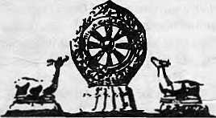

DISCOVER

THE ULTIMATE ADVENTURE DESTINATION
Let Tibet Travels & Tours- The pioneers in
Tibet adventure-unfold for you the inner
secrets and mysteries of this fascinating land, people
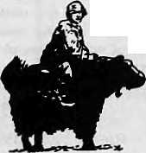
and culture-so different from anything you have ever imagined
Departures to Tibet Every Tuesday and Saturday By Air/Land
For details contact:
TIBET TRAVELS & TOURS (P) LTD.
Tri Devi Marg, Thamel, P.O. Box 13$7, Kathmandu, Nepal. Tel: 410303, 415126, Tlx: 2672 TIBTVL NP, Fax: 977-1-415126

Exile Politics and the 'Third Spread"

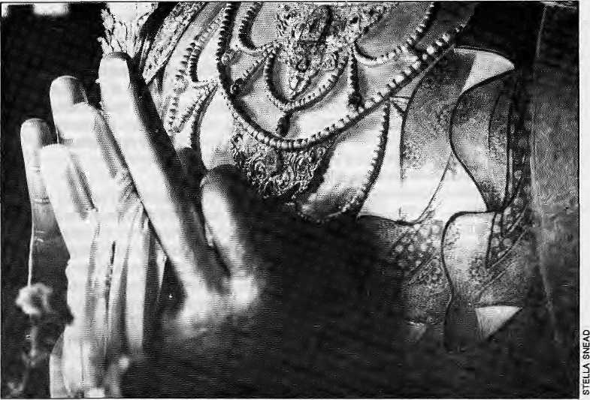
When future historians look
back, they may
find that it is
the dharma's universalism,
rather than
Tibet's victimisation,
that explains the
extraordinary
worldwide public
support for the
Tibetan cause.
by Kesang Tseten

I
nthe play Fantastics.itis asked—"What in the world happened to X?" — of a character who left his village to escape its suffocating enclosure. Someone answers: "The world."
What happened to the Tibetans in exile was precisely trie world.
Starting three decades ago as labourers breaking boulders on road-building sites in Nepal and India, Tibetans in exile today enjoy a decent, even enviable, standard of living, compared to any group in South Asia. In Nepal, they own a sizable share of the carpet manufacturing business, one of the country's two highest sources of foreign exchange earning.
In India, thousands of farmer-cum-traders thrive six months of the year from selling mass-produced sweaters from Bombay to Nagaland, passing them off as Nepali or Tibetan. The remainder of the year, on land once thought unpromising (given by the Indian government), they produce enough to affect the price of cor% in the southern states where their settlements are located And from Kathmandu to Gangtok to Manali to Delhi, they run bustling restaurants and "Hong Kong " bazaars".
"This entrepreneurial achievement of individual Tibetans is not all. The exile government's success in ensuring the preser-
vation of Tibetan culture, too, is remarkable: monasteries, secular schools for Tibetans, institutes of Buddhist dialectics, Tibetan medicine and drama. All these slowly brought about the awareness of Tibetans, their plight and, most importantly, respect, to fuel the extraordinary public support that is, today, the Tibetans' greatest gain.
The Dharma
The Tibetan identity is rooted in culture in its broadest sense. As a nation, Tibet is defined by a common language, religion, and history, notwithstanding its bias to religious events and interpretation. This 'cultural nationalism' is what glues the Amdo-wa of the northeast to the Khampa of the east, and the Toi-pa of the West, some 2,000 miles separating them. It is why they call themselves bod rigs ("Tibetan kind").
In spite of its one-people cohesion, however, Tibet was essentially a pre-political society until gorged by its giant neighbour; that is, politics had a minor significance in Tibetan daily life as cbmpare.fi. to its role in modern societies.
As ironic as it is that aTibetanpoliti-cal culture emerged'in exile, it is understandable. Exile, after all, is a fundamentally political condition. Exiledom, in the politicised arena of the modern world, coalesced the
100,000 or so Tibetans into a state, albeit without a territory. This identity, with its accent on the political, was propagated through various institutions' (schools, newspapers, political groups), which were embraced, then bolstered, by the outside world.
Above all, it is the spread of Tibetan Buddhist tradition that has been the single most potent force in theencounter between the notion of Tibet and the World. Propagated by the greatest masters as well as a younger generation of teachers, the appeal of Tibetan Buddhism has been phenomenal, and its contribution to contemporary Western culture, to the disciplines of philosophy, psychology, and the arts, Is widely acknowledged.
At the heart of this public and moral support for the Tibetan cause, therefore, is what might be called the "third spread" of the dharma. And I do not refer to the support of actual Buddhist practitioners as much as the respect for Tibetans as socio/cultural expression of humanism, or universalism, or the dharma. For all its flaws, Tibet was an example of a society shaped by Buddhist principles.
Third Spread
Public sympathy for-the Tibetans, if theirs' were not a Buddhist culture, might have been drawn from romance (the Shangri La myth, et

Mar/Apr 1993 HIMAL 29

al): the sympathy might have remained on the level of mere sentiment for the victim — and we know how far that goes. Besides, if it were a matter of measuring the degree of victimisation, can the claim be made that the Tibetan's suffering is more tragic than the Africans' from perpetual starvation, disease and mter-tribal rampage; or the killing fields of Bosnia/Herzogovnia; or Kampuchea at the hands of Pol Pot; or the Bangladeshis siraved by natural disasters? One calamity in Ganga-Brahmaputra delta last year claimed 100,000 lives, which is the entire population of Tibetans iri exile.
Though Tibetans were central in this spread of the dharma, the world's (mainly the West's) receptivity was equally significant. In full circle, as it were, the dharma had been revitalised, spreading to the land of the "red man" — in fulfillment of a ninth century prophecy — as well as to the otherwise "marginal" Tibeto cultures of the Himalaya.
Future Tibetan historians mightwell view this period of exile, which began in mid-twentieth century, as epochal, as it spawned the "third spread." Their unabashedly "Buddhologised" history mentions two "spreads". The "first spread" occurred from the fifth to the seventh century, in aheightened way during the reign of the great Songtsen Gampo, and took hold with the building of Tibet's first monastery at Samye, south of Lhasa, in Yarlung.
According to historians, a period of "darkness" followed when the Black BonKing Langdarma set out to destroy every Buddhist edifice in the land, persecuting its followers in the farthest reaches. This paved the way for the arrival of Pandita Atisha from the south and the "second spread". A king's life and the saint's weight in gold were offered to Atisha to make good the invitation. Moved by the Tibetans'faith, and perhaps as a result of the plainman's instinctive reverence for the land beyond the sacred Himalaya, Atisha accepted and stayed on to almost single-handedly restore the dharma to its former grandeur.
It was because of the dharaia element that this sympathy for the Tibetan cause went beyond sentiment. It changed the relationship between the sympathiser and victim to one in which.they stood at par. From respect for the dharma came respect for Tibetans, and the sympathy for the Tibetans that grew out of it became an expression of the supporters' own convictions as much as a response to what was out there.
An analogy that is illustrative: While trekking in the Khumbu, Western travelers are invariably impressed by the Sherpas' hardiness, their cheerfulness and forthrightness.
30 . HIMAL Mar/Apr 1993
But what also makes an impression on trek-kers are the Sherpas' bizzare deities, and numerous other items of exotica. The admiration risks turning into a fetish, to becoming one more thing in their make-up: "I think the Sherpas are cool, and boy, those guys don't need oxygen like we do." Whereas, if they had to contend with the philosophy that underpins the Sherpas' worldview, the same travelers might see the Sherpas in a way that transcends the economic relationship of client and employee, saheb and porter. That is, instead of voyeuring, they would have to experience — encounter — the culture intellectually.
Sudden Fame
Turning to recent history, by the mid-1980s Tibet had escalated into an international concern as never before. With'swelling public support, more and more public figures and politicians took note. Unthinkable a decade ago, state leaders met with the Dalai Lama; some backed resolutions that expressed concern for human rights in Tibet or for Tibetan self-determination; others wrote and spokeon behalf of the Tibet-support groups that had mushroomed. The firmament of supporters included personalities like actor Richard Gere, who helped launch the International Year of Tibet campaign.
These developments coincided with the dramatic change within China in the form of Deng Xiaoping's more liberal policies. For Tibetans, the reforms triggered momentous events: reunion between relatives in and outside Tibet, who after 35 years had given up on each other, and the opening up of Tibet to tourists. Overtime, the achievements of exiles and their politicisation rubbed off on their compatriots within, who until then had been suffocating in the enclosure of Chinese rule. Also, of the thousands of tourists who trav-elledto Tibet, anoverwhelming majority came away sympathetic to Tibetans. Some dollars dropped into Chinese coffers, but the gain for Tibetans was increased political awareness in Tibet and increased people-support outside.
In 1987, headlines splashed with reports of the bold, if reckless, demonstrations by monks in Lhasa. An outcTy for independence in such a tightly sealed, policed state? With the massive public support in place, the tarutality of the crackdowns that followed only nudged the Tibetan issue deeper into the international consciousness.
For the first time, Western politicians were calling for linking human rights abuses in Tibet to therr governments' economic and diplomatic relations with China. Beijing was visibly rattled by the outcry of Tibetans and their supporters. It had always
chosen to depict exile activities as either a mere irritant or the "spliitist" activities of a maverick feudal god-king.
In 1989, the Dalai Lama was awarded the Nobel Peace Prize, an event greeted with greater elation in the West than in South Asia.
Meanwhile, to Tibetan-exiles, history has been hurtling, and they are the subjects who cannot keep up with it, not unlike an obscure artist forced to make enormous adjustments to sudden fame. Just as their cause and their life in exile was slowly slipping into a routine, Tibetans were jolted into renewed hope.
Clearly, the strides made by the Tibetan cause is largely due to the phenomenal moral support it has received. What is astonishing is the role played by the "third spread" of the dharma in this support, and the fact that so little of realpolitik motivated it.
It is, I believe, the universalism of the dharma's appeal in a world spiritually vacuous and politicised to its teeth—as much as explicit activism —- from which accrued respect that makes the Tibetan cause more compelling than the fact of the Tibetans' victimisation.
K. Tseten is a Kathmandu-based writer and was an editor of Himal.

f3OXlV1)@$tt)dLt) Hotel
Ganabahal, Pipaibot, P.O Box 4249 Kathmandu, Nepal Phone;225338
Run and managed by- . <
Point8^{f} f&eofete

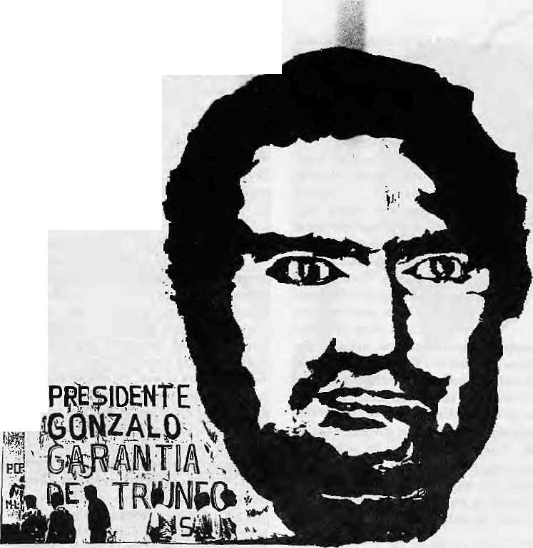
The Paradoxical Support of Nepal's Left for Comrade Gonzalo
...or perhaps not so paradoxical. For the conditions exist in the hills of Nepal for a Shining Path-like movement,
equally sectarian and equally violent.
n

by Stephen L. Mikesell
T
he London staff of the International Emergency Committee to Defend the Life of Abimael Guzman, the imprisoned leader of the Shining Path guerrillas of Peru, has been astounded by the volume of mail received from Nepal in support of him. From nowhere in the world has such a large number of letters been sent by so many mem-bersof a national legislature, to say nothing of common citizens.
Why should a country on the far end of the globe from Peru, known through the international press, travel brochures and anthropological monographs more for its medieval romance and mysticism than for militant political movements, suddenly gain notoriety through support for Comrade Gonzalo? He is a man who some in his own country have painted as a ruthless terrorist. Others, particularly the coalition of small Maoist parties known as the Revolutionary International Movement, Tegard Comrade Gonzalo as the new center of world revolutionary struggle, of Mao's "people's war".
Perhaps this support from a world away springs from ignorance of the less than
complementary picture portrayed by the international press and western analysts of the Sendero Luminoso (theparty's name in Spanish). Or does it derive from a naive romance of Nepal's intellectuals with the revolutionary tradition? Or could the affinity for Comrade Gonzalo's ideology have deeper underpinnings, based on similarity of certain underlying characteristics of Himalayan society with those of the Andean hinterland of Peru? If this were the case, could we then expect tendencies similarly violent to emerge in Nepal?
Masked Violence
Appealing geo-cultural analogies can be drawn between Peru and Nepal. Both countries straddle major mountain ranges of their respective continents, in which isolated valleys and high ridges have given rise to a wide variety of cultural traditions. While neither country hasahistory of recent foreign military conquest and occupation, as was the case of China in the 1930s, both have large rural indigenous populations subordinated to small ruling elites from whom they are divided by racism or caste-ism and regionalism.
Mural of "Chairman Gonzalo", Huancayo, 1990.
Both Pern and Nepal have experienced the sharp and growing divisions between the city and the countryside, as well as the rise of new mercantile and bureaucratic classes over the countryside. The development of these classes in both countries has been influenced and underwritten by outside industrial and financial interests and ideologies. Direct multinational investment andown-ership has been long entrenched inPeru, while Indian interests are consolidating their position in Nepal, particularly with the liberalisation process that is underway inSouth Asia.
Finally, both countries have strong communist movements that have experienced a history of divisions along similar ideological lines: Soviet and Chinese communist parties, parliamentary roaders vs. cultural revolutionaries, democrats/revisionists vs. extremists/ pure line Maoists, and so oa
In Peru, these cultural, historical, urban-rural and inter-communist party divisions have led to inter-community strife, manifest genocidal violence and peasant struggle, which the Shining Path took up and used as a

Mar/Apr 1993 HIMAL . 31

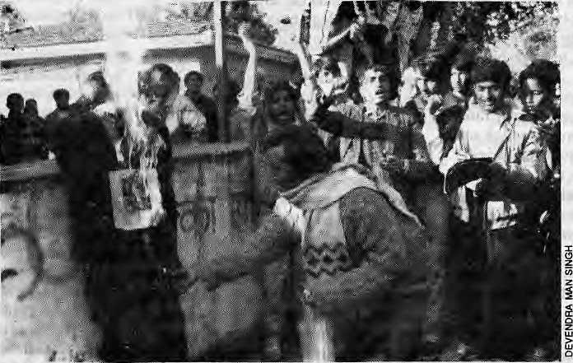
Far-left activists burn effigy of Peru's President Fujimori outside U.S. in Kathmandu
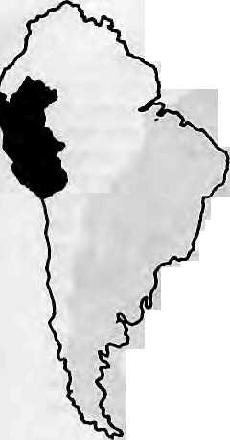
basis for its own programme. In Nepal, however, these various divisions have yet to surface with the same intensity and ferocity.
There are, however, ample forms of masked violence present in Nepali society, and perhaps the type of sectarian violence espoused by Comrade Gonzalo is but a short step away. These masked forms of violence include expropriation of lands, rural debt, rent servitude, liigh child mortality, misappropriation of resources, inflation, cor-niption in favour of a few, labour migration, and trade of women for prostitution. Besides the communist movement, these factors are also giving rise to new forms of janajati consciousness and nationalist movements in the hills. If respected as a cry for recognition, autonomous development and substantial change, theycould evolve intoapositive force; if ignored or suppressed, they could lead to sectarianism and violence.
Recruiting the Foresaken
The Shining Path has drawn its cadres from among the millions of Peru's young who sought to raise themselves out of their poverty through education but found that opportunities were limited to the informal sector, the drug trade, or the bottom of the state and military bureaucracies controlled by the Spanish speaking upper class. Consisting of 50 percent women, the Shining Path is also the one significant women's movement in the strongly male-dominated Peruvian society. The Shining Path offered these youths recognition and a sense of achievement in directly confronting a society which blocked their aspirations. In Nepal, young people and their families front all over are desperately seeking education as a means to better their economic and social conditions. Those who pass school and college are increasingly faced wi th the same prob -
31 . HIMAL Mar/Apr 1993
lenis of unemployment and unsatisfactory subordinate jobs in government, military, industry and commerce. The Government bureaucracy is saturated and actually casting off civil servants; Gurkha recruitment shows a downward trend; and industry's sluggish growth and ability to take in die labour surplus has been badly hit by recent power outages (which are expected to iast the rest of the decade). The submission of more than 50,000 applications for 55 openings in the Nepal Telecommunications Corporation exemplifies the desparate situation faced by Nepal's educated young.
The School Leaving Certificate examinations are designed so that an extremely low proportion of the population outside of the Kathmandu Valley succeeds. Nepali education simultaneously prepares the students for bureaucratic and managerial jobs and disqualifies most of them from these jobs. As is the case in Peru as well, the educational curriculum has not been built according to the situation and conditions of the rural population. It is instead an imposition onto the village communities of an alien system of knowledge, priorities, values and methods evolved from Western colleges of education. Classroom discipline, examinations and certification authoritatively determine what is "true knowledge", and devalue the know ledge, prac-tices and languages of the villagers. The process of failing examinations serves to convince rural youth of the need to submit themselves to the patronising and presumptive authority of 'certified' individuals — extension workers, health professionals, foresters, engineers, doctors, contractors, political leaders, foreign advisors and so forth.
An immense class of people is pres-
ently being schooled in Nepal to despise their own rural background. The situation is ripe and ready for the rise of movements such as the Shining Path, which provide the population widi an alternative and convincing-sounding "true knowledge". One form of absolutism and negation of social being thus can easily give rise to new ones as people become disillusioned with the old unfulfilled promises of jobs, development, land reform, health for all, basic needs, etc.
Filling a Political Void
The goal of the Shining Path has been to destroy the old society and replace it with its own paramountcy. The problem has been that the society which the Shining Path sought to replace was already filled by people and their independent organisations and initiatives: grassroots village and slum dweller organisations, labour unions, and political parties. Certainly they were imperfect and filled widi contradictions, but they too were trying to positively change the society in favour of the oppressed.
It is enticing to interpret, as did Comrade Gonzalo and theNaxalites of South Asia, Marx's concept of "negation" in terms of Mao's adage: "Power comes from the barrel of a gun." Marx's concept, developed from Hegel, was a much more complex one of an up-and-coming class creating a new society and culture which increasingly displaces and transforms the old one (Hegel's "sublimation"). This process has been going on in Latin America over the last five decades, with the vibrant growdi of thousands upon thousands of grassroots organisations in barrio, village, and factory. These in turn have given rise to larger solidarities—popular committees and councils, and even entirely new kinds of parties which are controlled through forms of direc t democracy internally by the grassroots organisations rather dian by party bureaucrac ie s, offi c i als and sponsors, as so-far characterises parties in Nepal.
Embassy
Elsewhere in Latin America, the Sandinisla Front of Nicaragua, the Workers Party of Brazil, and the 1.5 million strong Slum Dwellers Committee of Chile, were quite successful in building broad alliances among a variety of groups and interests,

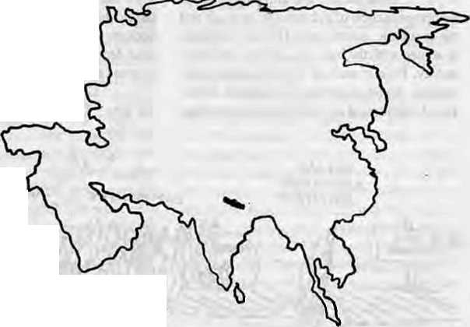
without destroying their autonomy and initiative. Rather than advancing the independent initiatives of the peasant, worker and slum-dweller organisations, the Shining Path interpreted their goals as "revisionist" or "reformist" and thereby "complicit" with the regimes. It sought to infiltrate and compromise them in the eyes of the Peruvian Government so as to force them to its side. Lacking the military organisation and secrecy of the Shining Path columns, the groups were left exposed to violence by undisceming authorities, who saw any popular initiative as subversive. Indigenous organisations were put in an uncomfortable position between two armed camps, suffering violent retribution from both.
Though these organisations initially supported the Shining Path to the extent that it advanced their own goals, when it demanded that they serve its particular military and political purposes, they organised themselves against it as well. Consequently, the Shining Path has been least successful in areas where these organisations were already strong, And it is these organisations that have proven effective against the ruling elites and powerful corporate sponsors of the Peruvian regime, on the one hand, and as bulwarks against all kinds of sectarianism, on the other.
In Nepal, the Panchayat regime's repression of political activity denied the growth of the independent grassroots organisations and movements that might have provided a bul w ark here against both military-bureaucratic over-extension and sectarian tendencies. Today, consequently, Nepali society Finds itself vulnerable to political extremism and violence.
For the purpose of catering to the most recent international funding priorities, the present local government \aw has been crafted to appear as if it encourages grassroots initiatives. Actually, all the machinery of the local government is manipulated back into the control of the center. True NGO activism is discouraged by bureaucratic ally determined constraints of registration. And some anthropologists have demonstrated that the recently passed labour laws are even more restrictive and anti-union than those of, the Panchayat period. Thus, the dominating tendencies of old continue to exert themselves in the present, albeit in the guise of a new "democratic" legitimacy.
The international development agencies in their latest slogan-Taising and report-writing have exhibited support for grassroots activism through non-go vemmental initiatives. But the tendency of these agencies to work through the educationally certified English-speaking group co-opts this potential class of
organisers with high salaries and perks. It removes them from sharing the difficult conditions and working alongside of the oppressed. Consequently, most of the funding for grassroots initiatives goes to developing this class into yet anew burden on the countryside, further subverting the position of the people it is to help.
All this leaves just the kindof void conducive to the development of a highly sectarian movement such as the Shining Path, whose disciplined and ideologically committed cadres are willing to spend years or decades among the villagers, intimately researching their situation and helping them to organise themselves. Lacking their own independent organisation to advance their goals or protect them from ruling class and governmental excesses, the rural and urban poor have few alternatives besides ethnic, nationalist or religious sectarian movements which build their base on real social divisions and exploitation by playing on illusory ideological antagonisms.
The militarisation of various nationalist movements within the country, spillover of violent repression of farm labour in adjacent Bihar, or a military response by the Nepali Government against indigenous social movements, all could lead to the growth of violence and sectarianism.
Alternatives to Sectarianism
One of Comrade Gonzalo's mistakes has been to try and transfer Mao's categories of revolution, which really only referred to the China of the 1930s, to a Peru of the 1980s. Neither do those categories apply to the 1990s Nepal. Although there are many patronistic feudal-like aspects in Peruvian and Nepali society, using Mao's characterisation of them as "semi-feudal" and "semi-colonial", tossing about epitaphs such as "revisionist" and "reformist", and designating one national group of capitalists as "national bourgeois" and another as "imperialist", seems a mechanistic exercise aimed atjustifyingapeople'swar programme to the exclusion of other initiatives.
Perhaps
the central paradox of the path taken by Shining Path is that it has not succeeded in transcending the same authoritarianism, violence and nihilistic denial of people's own alternatives which characterises and sus-
tains the present oppressive order. Strategy must begin with humans in the given conditions of a world intimately interconnected politically, economically, culturally and environmentally. The old leader-oriented bureaucratic national parties and national struggles seem to be obsolete, as people buy things, sell their labor, share ideas, interact and submit to or struggle with conditions determined far beyond their local communities and national boundaries.
What is required is careful analysis, self-eduction and organisation according to this analysis — not by outsiders, political leaders, intellectuals, experts and elite NGOs, who interpret the situation according to their own relatively privileged situations — but by the poor and oppressed themselves and others who choose to live and work alongside them and share their conditions. The problems and powers overshadowing the world today are so vast that confronting them requires coordinating a wide variety of strategies and initiatives, particularly those which cannot be anticipated according to old bygone theories transformed to present-day dogmas, whether Jhey be "Mao Thought," "Gonzalo Thought," or a recently exhumed and rehabilitated Adam Smith. They must be developed through practical effort and engagement
The future, if humans are to have a place in it, will require immense tolerance, willingness to work together, and also sacrifice, especially of a powerful few for the demands and needs of the weak and of the earth.
S. L Mikesell is a research scholar and editor at the CentreforNepaland Asian Studies, Tribhuvan University.

Mar/Apr 1993 HIMAL . 33

REVIEW
Indigenous good, Appropriate bad

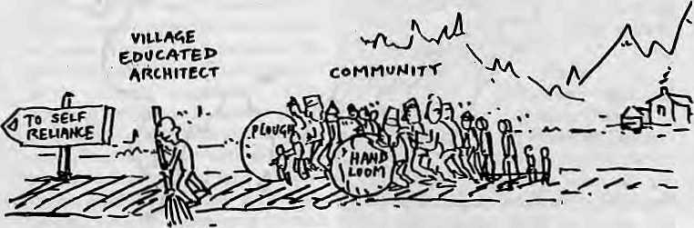
S
elf-Reliance in Small Communities examines the choice of technologies with which to help villages achieve self-reliance. The author argues for a revival of indigenous technology through a community-nurtured approach. He conducted action research on the possibility of using "appropriate technology" for earth roofing in two small communities, spaced apart by geography and stages of economic development; Maryborough, Australia andGorbung in Deurali Village Development Committee, Nepal. He concludes that appropriate technology per se will not work, and forwards what he calls the PARFTTS model (Participatory Action Research in the Facilitation of an Indigenous Technological System) as a strategy for community development
The book is divided into 13chapters and comes with an extensive bibliography running into 27 pages and 26 appendixed units. The first chapter sets up the rationale for action research: the Nepali villagers* traditional reliance on timber roofing juxtaposed with the dwindling timber resources. Manandhar therefore decides to borrow the indigenous technology of Egypt as appropriate technology for Nopal. The seed of failure for this experiment is sown early—by choosing indigenous mud-dome architecture of a dry and arid Egypt foT possible appropriation in a wet and moisturous Nepal. By the author's own definition of technology appropriation (page 8), theexperiments at both Maryborough and Deurali are failures and he bravely comes around to the finding that the "appropriateness of an appropriate technology is place and culture specific" (p. 241).
In the second and third chapters, the inappropriateness of industrial technology and the economic growth model for development is argued with the help of a profuse literature survey. Pitfalls such as technological deter niinism, depiction of natural resources, unbalanced distribution of wealth, waste and pollu-
Self-Reliance in Small Communities
by Ramesh Manandhar Oxford and IBM Publishing
New Delhi 1992 Nrs900
by Sudarshan R. Tiwari
tion, are all tackled Whereas one would agree that one of thecauses of hunger is "increasing inequality in the control over productive resources" and inequitable distribution, the author's argument that overpopulation is not an important aspect of underdevelopment is unrealistic.
Local self-reliance movements, such as the Chinese communes, the Ujamaa of Tanzania, and the Kibbutz of Israel, among others, are discussed and variously termed "failures" or "perFect failures". Eyen though the author is not explicit, Mahatma Gandhi's path seems to be his preference, and the Gandian model reinforced with Freire's approach finds place further down in the suggested PARFTTS model (Chapter 12).
Chapter 4 picks up the debates on appropriate technology and raises questions about its efficacy. It proposes to investigate socio-economic and political dimension of AT through the experiment on earth roofing technology. The author presents adobe technology as a panacea for mass housing, but his arguments tend to be simplistic. To suggest that mud bricks are stronger and last longer than concrete by citing archaeological finds from the second millennium B.C is rather farfetched. These are available today mainly because ofthe protection offered by the desert sand deposited over the structures thousands of years ago.
Chapter 5 is a weak deliberation un the title, "Decision Making is 'Top-Town'
and Based on Caste". Rana rule is blamed for introducing the top-down process of formal decision-making in Nepal. That the power continued to rest in the hands of a few, writes the author, was the major cause of the popular revolt of March 1990. Was it ail that simple?
The following three chapters offer a detailed account of the earth roofing experiment at Maryborough and Deurali. While at Maryborough, a sense of local participation is evident; at Deurali, it was not forthcoming. A fire incident at Salyangiri in Deurali comes as an eye-opener to the author, which is when he decides to move away from' appropriate technology' and starts the journey into 'indigenous technology'.
Chapter 9 takes up some of these indigenous technologies and finds them virtuous in many aspects. A revival of handloom for making cloth and mat weaving is tried and meets with Temarkable success in generating income as well as self-reliance. The findings of these experiments show that facilitating peoples' indigenous skills and technological systems can nurture self-reliance. This, then, is the PARFTTS model for community self-reliance.
That the villagers of particular villages were not too keen on mud roofing does not however mean all ATs are inappropriate. Nor would it be wise to conclude that all indigenous technologies would lead to self-reliance. Indigenous technologies work in as much as they are results of local materials and socio-cultural practices. To expect them to be able to survive, compete and lead to a self-sufficient society without innovations, is farfetched. It will hardly do toreplace 'industrial technology determinism' with 'indigenous technology determinism'. Why are some indigenous technologies dying away? Are indigenous technologies not in crisis? How come the villager ignores this saviour indigenous technology even as he becomes impoverished day by day? The book does not answer these questions. But these must be answered, and answered in positive, before the PARFTTS model may be a tool for self-reliance.
The book has a strong undercurrent, which is likely to find new takers. A fitting tribute to the late author would be further research in the area he has treaded on
S.R. Tiwari is an architect. He is Reader at the Institute of Engineering, Tribhuvan University.

34 HIMAL . Mar/Apr 1993

REVIEW
A Sweeping Review of the People's Movement

T
he partyless Panchayat system, established by King Mahendra after he toppled parliamentary democracy in I960, acquired 'legitimacy' through the plebiscite of 1980. But such legitimacy could not be translated into performance. A decade later, the political opposition (the Nepali Congress and theUnited Left Front) declared war on the Panchayat, and the people responded with alacrity to its call for a multi-party system.
Spring Awakening, a posthumous publication, gives an account of critical transitional phases in recent Nepali politics — the People's Movement (February-April 1990), the promulgation of the new Constitution (November 1990), and the parliamentary elections (May 1991). The main focus, however, is on the People's Movement
Analysing the underlying reasons behind the Movement's success, authors Raeper and Hoftun discuss changes brought by the modernisation process. Advances in some service sectors — growth in literacy rate, development of commun ications and mass media, and improved transportation eastward from the Karnali river — opened up new horizons. The book, however, does not deal adequately with Nepal's stagnant economy and the gap between the public's expectations and governmental performance.
The political mischief following the 1980 referendum, write the authors, was also conducive to the success of the uprising a decade later- While the Third Amendment to the then Constitution introduced some reforms, such as direct elections to the national legislature, there was the ominous emergence of conservative institutions such as the Panchayat Policy and Ev aluation Committee, the Sports Council, the Bhumigat Giroha (a murky underground network), and other organisations headed or patronised by the members of the royal family.
Unity between the Nepali Congress and the communists is seen as another factor, and the Left's acceptance of multi-party democracy is seen as crucial. But they overlook another turnaround, that of the Nepali Congress, which moved from attempts at reconciliation with the King to confrontation.
With the country so heavily dependent on foreign aid, the Panchayat government was not able to resist Western pressure
Spring Awakening:
An Account of the 1990
Revolution in Nepal
by Wiiiiam Raeper and Martin Hoftun,
Viking, Penguin Books India Pvt. Lid, 1992
IRs 200, NRs 320
by Krishna Hachhethu
for human rights. The book touches on this, but barely. And while Nepal's relations with India is extensively discussed, a perspective on the changing global scenario is lackmg.
During the Cold War era, when relations between India and China were also far from cordial, all sides granted protective support to the Panchayat regime in its attempts to contain the oppositioa But by the dawn of the 1990s, the world had changed. The West's heightened concern for human rights/democracy and the thaw between India and China substantially reduced the Panchayat's maneuvering ability. Last ditch attempts to divert attention from theMovement by stoking anti-India feelings backfired completely.
Raeper and Hoftun divide the runup to democracy in three stages: the first, Feb/ March 1990, was when people chanted for democracy in streets hoping for a royal proc-lamationannouncing political reform. Instead, King Birendra remained aloof, as presented by the official radio, television and press. This prepared the ground for the second "revolutionary" stage, at the beginningof April. Whole households mobilised themselves, and the women and children of Patan and Kirtipur took to the streets with kitchen utensils and agricultural tools. On 6 April, lakhs demonstrated around the country.
The King's belated response of lifting the ban on political parties was too little, too late, and die Movement entered its third stage. It was clear that the public wanted sweeping change, and this emboldened the opposition leaders to demand the total dismantling of the Panchayat.
The Movement thus ended successfully, with theparty chiefs quite incredulous at how quickly democracy was achieved. The tussle between the King and the parties on the nature and content of the new constitution began. The royal palace made every effort to
retain the King's sovereignty, but the popular force prevailed, and a new Constitution based on popular sovereignty was promulgated on 9 November 1990. Elections followed, with the Nepali Congress obtaining a comfortable majority in May 1991.
One of the book's shortcomings is that it leans too far towards the Left and gives short shrift to the Nepali CongTess. This tilt is obvious from the persons die authors chose to interview, and the text goes as far as to connect the goals of Nepali communists with the tradition of Nepali society (p. 88-94).
The book views the 1990 "revolution" as having openedNepal to the possibility of another revolt, "this time of a religious and ethnic nature". Many Nepalis may share the authors' concern about the rise of regional politics between the Tarai and Hills, and also communal politics between the Tibeto-Bur-man groups and Bahun, Chettri and Newar, But such fears could be exaggerated, and it is clear that the authors get their own impressions from three sources. Firstly, they witnessed the ugly ventilation of grievances during the highly charged moments of constitution-making and elections. The pitch of regional and communal politics has been considerably subdued subsequently, in the actual practice of parliamentary democracy.
Secondly, rather than speak to the people at large, the au thorsrelied on the claims of different communal and regional leaders, who naturally tend to exaggerate the problem to their advantage. Thirdly, they have spoken to the former Panchas, who have long contended, most erroneously, that democracy would lead towards national disintegration. As one of them is quoted, "Every thing can now happen, Nepal can become another Kampuchea, Afghanistan and Sri Lanka."
In this otherwise well-written and painstakingly researched text, Raeper and Hoftun have tended Lo forget that political parties are integrative forces, andit is to Nepali society's advantage that the two main political parties wield strong influence throughout the country. In highlighting the problems of contemporary Nepali politics, perhaps they failed to appreciate all (hat is positive,
K. Hachhethu teaches at the Center for Nepal and Asian Studies, Tribhiwan University.

The Ihree authors reviewed in these pages, Wiiiiam Raepar, Martin Hoftun and Ramesh Ma.nandhai, died in an air crash near Kathmandu, Juiy 1992.
Mar/Apr 1993 HIMAL . 35

REVIEW

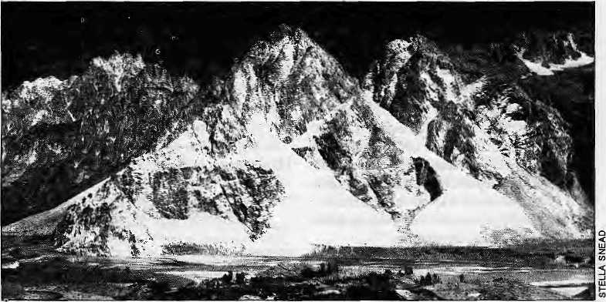
Unstartling Reportage
"Startling Discoveries"
Magazine article by Raj Chengappa
India Today 16 March 1993
by Amod M. Dixit
T
his investigative special by a well-known reporter of the Indian environment presents the different geological phenomena and processes active in the Himalayan region in easy-to-understandprose. The complex theory of plate tectonics isexplained withoutresort to jargon. Interesting findings such as the discovery of a hippopotamus skull in Ladakh, which proves that there was warm climate here in the recent geological past, will help awaken the public's interest in this most interesting of mountain ranges.
But the article, unfortunately,Teaches for scientific sensationalism when it makes claims of new and startling discoveries by the Indian scientists quoted and pictured herein. Chengappa seems not to have gone for second opinions. The knowledge of the geology of the Himalaya has accumulated steadily, bit by bit, through the efforts of hundreds of Western andTegional scientists, over the last 150 years. It is foolhardy to suggest that a few years of work by the handful of scientists quoted here has led to an unprecedented spurt in the under-
standing of Himalayan geology.
For example, it is reported that the recent geological findings in the Himalayahas substantiated the theory of plate tectonics. But the theory has been firmly established since the 1970s, and one can hardly claim now that the "major findings by Indian geologists radically alter old theories of mountains,' origins." And it is unfair to present the recent rise of the Himalaya as a "startling discovery by Indian geologists" when A. Gansser in his important monograph on Himalayan geology had already concluded as much in 1964. It was Gansser in fact who proposed that for primitive man the Himalaya was probably a collection of low hills rather than today's insurmountable barriers.
Perhaps the most troublesome aspect of the article is its loose talk on the impending earthquakes of enormous magnitude. It is known that several models for earthquake forecast are being developed in different countries, but to date none of their findings have been accepted even by their authors as
being conclusive and foolproof. It is therefore premature for Chengappa to present unqualified the alarmist prediction that anearthquake of unimaginable magnitude is likely to strike soon in the Himalaya. Such statements should be made only with the utmost care because of their ability to influence decisions on major infrastructure development projects such as high dams.
Many accepted geological findings have been presented by Chengappa as breakthroughs, albeit he has made the effort to fill in the details. While not disregarding the possibility of major seismic events in the Himalaya, the alarm raised about a truly 'ground breaking' earthquake should be regarded as speculation. Big earthquakes have been taking place in the region and there will be more in the future. But "soon", in geological terms, could be from now to the next 500 years, or more.
Chengappa's article is good reading as a primer on Himalayan geology.
A.M.Dixit is a geologist and consultant

Kailash and The Himalayan Research Bulletin

B
ecause there are less than a handful of academic journals on the Himalayan region, it lias been worrisome that Kailash and the Himalayan Research Bulletin have not been sighted for more than a year. Kailash is published in Kathmandu by Ratna Pustak Bhandar, while HUB has been handed around US universities rather like a waif.
Fortunately, the news of the demise of both journals was found to be a bit exaggerated. The editorial team at the South Asian Institute of Columbia University in New York has handed the HRB over to the West Coast. It is now with the South Asian Studies Center at the University of Washington. Himal has learnt that Volume 11, No. 1-3 1991 (a triple issue, 166 pp) is available, and Volume 12, 1992 will be available in June 1993.
Kailash is edited alone and valiantly by the scholar John K. Locke in Kathmandu. According to Locke, Volume 16, No. 1 should be out of press by June, to be followed quickly by No.2. Difficulties with the printers has been a major problem, says Locke, "but we are also not getting enough quality papers to choose from." Even as a "Himal ay an journal", Locke says Kailash tends to receive contributions that focus on Nepal and Tibet, and very little on the Indian Himalaya and Bhutan. Contact:
HimalayanResearchBulletin, South Asian Studies Center, Jackson Sciiool of International Studies DR-05,303 Thomson Hall, Univer-'sity of Washington, Seattle, WA 98195, USA. Fax: 206-685^787 Kailash, Father John K. Locke. GPO. Box 50, Kathmandu.

36 HIMAL . Mar/Apr 1993

Arun III, Nepal's Reluctant Narmada
by Binod Bhattarai

T
he Indian Government's decision not to use World Bank money to build the Sardar Sarovar (Narmada) Project was a victory for Indian environmentalists and human righters. The Bank heaved a sigh of relief, as questions on the environment, equity and resettlement of "oustees" had made the project an albatross that promised endless public embarrassment. Better to bail out from this one and continue with projects elsewhere in the Bank's realm.
It is business as usual for the Bank elsewhere in South Asia, though, particularly where there are no groups with the single-mindedness, media savvy and grassroots reach of the Narmada activists. Nepal's Arun III Project, for one, has no Medha Patkar. And Bradford Morse will not come out of retirement to do another evaluation (as he did for Narmada) on a project which all but a handful hope will slip through while no one is watching.
The World Bank has pushed the Arun III under the fig leaf of its "Least Cost Generation Expansion Plan", which in 1987 passedjudgementtbat this was theonly project in Nepal that was ready for implementation. A "no option trap" was set, and despite Prime MinisterGirijaPrasadKoirala's allergy tothe Bank when he took office, the NepaJi Congress Government has walked straight into it. The communist opposition, which has maintained such a barrage over the Tanakpur case, has been strangely silent, possibly because the eastern hills of Nepal, which includes the Arun river basin, is aLeft stronghold. Aboon-doggle is a boondoggle. A Left parliamentarian who questions the project confessed, "Our voter strength is in the east, so we cannot openly oppose Arun. Sadly, we do not have enough representatives from the West of Nepal."
Then there are the commission merchants as not-so-silent partners. A 10 percent kickback is accepted even by officials as the minimumfor aprojectlike Arun. Whichmeans that iheBaby Arun agentscouldmakeoff with U$ 70 million, the sort of money that rarely makes an appearance in bulk in Nepal. This was what got fJepal into the no-option trap in the first place.
The possibility of generating power in the upper Arun basin was first identified by the Japanese in 1985. The project's detailed design and even its tender documents were prepared by aconsortium of Western consult-
ing companies, the Joint Venture Arun III. Since the mid-1980s, Bank, Government and Royal Palace officials, as well as the commission-wallahs, stalled all progress on alternative projects. For thisreason alone today there is heavy load shedding in Nepal, expected to stay in place well into the 2000s.
The original plan was for a 268 megawatt project. When there were no takers, it was upgraded to 402 MW, costing U$ 1.2 billion, with die idea thai prospects of sale of power to India would make the project more attractive. But when everyone balked at the price, rather than look to other projects, the Bank pulled "Baby Arun" out of its bag. So now the project will generate only 201 MW, and the 'quoted figure' is down to U$ 764 million. To put things in perspective, Nepal's total annual revenue comes to about U$ 300 million.
Where will the money come from? U$ 355 million andDM235milli on have been committed, according to official information, by donors who include the Bank, the Asian Development Bank, the Kredittanstalt fuer Wiederaufbau, and the Overseas Economic Cooperation Fund, The Japanese would also like to construct the powerhouse and provide electrical equipment. The Finns have agTeed to provide deisel-generators for the power required during construction.
One reason the bureaucrats are so bent on Arun JH is that, as one official claimed, "89percent of the financing is through grants." This, however, is not proven, especially because high-profile donors include the OECD, the ADB and the World Bank, all of which provide loans, albeit some of them soft.
The project will use helicopters to ferry construction material including cement and equipment. Hiley and Tumlingtar will be transformed into "air support" bases and helipads will also be constructed at the damsite, powerhouse and the permanent and temporary camps of contractors. The cost of the helicopter services is expected to be about U$ 50 million. (For comparison, the United Nations Transitional Authority in Cambodia (UNTAC) will reportedly spend U$ 47 million for an armada of helicopters, including heavylift Russian MI-7s, for two years of continuous support.)
The Nepali Government is commits ted to proceeding with Arun III and the National Planning Commission'is staunchly behind the project. Neither Government offi-
cials nor NPC members found it worth their while to attend a public hearing on Arun III organised by some Kathmandu NGOs on 12 February. Ironically, when it was learnt subsequently that the Bank requires a public hearing for "Category A" projects such as the Arun.somc officials were quick to claim that that requirement had already been fulfilled.
Hundreds of thousands of dollars were spent on an environmental impact study of rneroad up to the project site, but this report is now waste paper. Because, to make Baby Aruncheaper ancimorepala table, theplanners decided to take the low road, a route along the steep valley bottom. Meanwhile, no environmental impact study has been carried out for the project as a whole.
The projected per-kilowatl cost of power generation for Arun III is U$ 3800, which experts say is more than twice the cost of power from projects of up to the 60 MW range (about $ 1,500 per kW). Arun's power would cost four times the cost per kW expected from the First Phase (1000 MW) of the controversial Tehri Dam in Garhwal, claims RajendraDahal, ajournalist who has followed Arun III for more than four years.
Load-shedding, which averages 10 hours every alternate day, is not likely to improveregardlessof Arun III. Overtime, this will blow the fuse of tolerance of the middle and lower-middle classes, and when that happens, Arun III will be of no help to the Government.
Are Nepali officials and the Bank free to blunder into projects that will mire the country in economic quicksand, just because activism is weak in Nepal? The day when Nepali activists are able to organise villagers to challenge faraway bureaucratic decisions is still remote.
Says Dahal, "The Bank and the bureaucracy love to keep the information close to their chest. We will ultimately bring out all the information on Arun III, and the alternatives that are being neglected."
Like journalists, Kathmandu's engineers and economists too have begun to speak out. A group calling itself the Alliance for Energy (see overleaf) has begun to ask questions about Arun III, and promises to be insistent.
B.Bhattarai reports lor The Independent of Kathmandu.

Mar/Apr 1993 H1MAL . 37

OPINION
Look before you leap..
by Bikas Pandcy and Janet Bell

A
World Bank mission arrives inNepal in mid-May to appraise the feasibility of the modified Arun III scheme, affectionately known as "Baby Arun". Thisrather oversized baby is still small fry in the eyes oftheWorldBank, but Baby Arun has serious implications for Nepal's future development path.
If the World Bank is truly committed to the development of Nepal, swely it should be looking at ways of helping to build up local capability rather than perpetuating the cycle of dependence on foreign aid and offering a convenient channel for the marketing of Western goods and services. The objective of gigantic power projects shouldnot be measured merely in terrnsof the numberof megawatts produced, but on the establishment of greater capability to produce power, in order to continue the cycle of development.
Neither the Nepal Electricity Authority (NEA) nor the country itself has the capability to take on a project as large as Baby Arun. Consequently, all the technologies, expertise and funding will be shipped in from abroad. The aid package is almost entirely tied to the provision of goods and services from the donor countries.
There is another way. There is a far more practical, cost-effective and environmentally sound approach to hydropower than the current obsession with large-scale projects that are driven by the donor. By investingin smaller schemes usinglocal capability, more power can be generated more quickly from theU$ 764 million budgeted for Baby Arun. Through this approach, load shedding could be overcome in five to six years instead of the ten to twelve anticipated with Baby Arun.
We need to move steadily forward in manageable steps, rather than leaping uncontrollably ahead. This would give the local hydro industry a chance to grow and mature, developing a solid base from which Nepal can eventually achieve self-sufficiency in hydro-power. Baby Arun may well be appropriate in 10 years time when local industry can take it on confidently, but Nepal simply is not ready for it now. Evolution, not revolution, is what is needed.
Other countries which rely heavily on hydropower, such as Norway and China, have successfully adopted this evolutionary approach to power generation, and still gain significant percentages of their total power from smallscale schemes. In Switzerland early this century, more than 99 percent of its power plants generated less than 750 kW each. The success of these hydro programmes is largely attributed to policies of decentralisation and local management in these countries. China was able to achieve a 3000 fold increase in its small-hydro capacity in 27 years.
The potential for Nepal's hydro industry to follow a similar path is already apparent. Over the last 25 years, local capability has been steadily growing and maturing. It took the Butwal Power Company (BPC) 12 years to buildup its capacity to produce equipment and expertise for the 1MW Tinau scheme. Over the next dozen years, that capacity has grown to more than 50 MW, BPC recently signed an agreement to build the 60 MW scheme at Khimti, which it will build at almost a third the cost per kW as that projected for Baby Arun. Nepal should be looking to consolidate its expertise with schemes of this size before moving on to more ambitious projects.
Engineers at the Nepal Electricity Authority (NEA) themselves have never had a chance to design and build their own schemes.
As the Authority takes on larger and larger turnkey schemes, these engineers, many of them trained at the world's best universities, are reduced to serving as 'counterparts' to contractors.
It is well within our capability to meet the country's ever-increasing energy needs without looking to outside support. Using Nepali engineering expertise at NEA and in private power companies like the BPC, 25 to 30MW of hydropower can be added to the grid every year. With sustained growth, in ten years' time, figure could reach 100 MW a year.
Not only does this new approach offer the chance to eliminate load shedding within a few years and increase the amount of energy available on the national grid, but far more Nepal is will be able to enjoy the benefits of electricity. A strengthened hydro industry will not only be able to provide larger schemes (such as Khimti) to fuel the urban centres, but will also enable micro- (up to 100 kW) and mini-hydro (up to 1 MW) schemes to flourish in the rural areas with no grid attachment, giving a boost to local economies.
Hydropower is not a simplecommodity like oil or coal—you cannot just dig it up and sell it; the actual process of harnessing the power is critical. ItIsn' t an easy route, but we are already well on the way to understanding and developing that process in Nepal. If we miss this opportunity to develop hydropower through local industry, we will condemn urban Nepalis to escalating electricity prices and periodic power shortages, and will deny many rural Nepalis access to electricity.
Baby Arun's malignancy lies no! in the'dam itself, but in the context of its conception and realisation. You cannot leapfrog your way through the development maze. Amn'sro tten core perpetuates thecycle of donor dependency and the stifling of indigenous capacity and creativity. There is a cure,, but its strength is finite and will fail to work if the malignancy is allowed to spread any further.
B. Pan day is member of the Alliance for energy, a Kathmandu group that seeks to educate on hydropower issues. J. Bell is with the Intermediate Technology Development Group, London.
Himal
is looking for a
Managing Editor.
His\her responsibilities will include international and regional marketing, administration, and public relations. Lack of experience Is no bar. but we seek a person who can adapt to Himal's unique demands. Starting salary NRs 5000.
Mall a hand-written application with curriculum vitae to PO Box 42, Lalitpur, Nepal. Applications post-marked later than 30 May 1993 will not be considered.

38 HIMAL . Mar/Apr 1993

ABSTRACTS

POLITICS IN NEPAL 1980-1991: REFEREN-DUM, STALEMATE AND TRIUMPH OF PEOPLE POWER
by Rishikesh Shah Third Revised Edition Manohar Publishers. New Delhi 1992 [SBN817304 0206 Ks320
The first edition oflhis book was published a&Essays in the Practice ofGovernment in Nepal in 1982 and was confiscated by the then Panchayal government. The 1990 revised edition did not contain the essays dealing with pro Pancliayat political history contained in the first edition. This third edition contains the 11 well-known essaysof the 1990 volume and three new ones —"Performance of the Interim Coalition Government {19 April, 1990 - 26 May, 1991)"; "Formation of the Post-Election Government"; "Visit of Prime Minister of Nepal to India and After"; and a brief epilogue. Text of the Nepalo-India Treaty of Transit, Treaty of Trade, and Agreement of Cooperation to Control Unauthorised Trade — the three separate documents signed by the Nepali Government and the Government of India on 6 December, 1991 — are provided as appendices.
100 HIMALAYAN FLOWERS
by Ashvin Meiha Text by Prof PV Bole Mapin Publishing Pvt Ltd, Ahmedabad IRs 695
Photographer Mehta captures the beauty of wild Himalayan flowers. The book contains 150 colour plates of different species, including Himalayan poppies, anemones, primroses, peonies, monkshood, buttercups, black pea, spurges, mentha, thyme, balsam, gentian,campanula and chrysanthemum have been captured in full bloom. With its serious text, this more than another coffee table glossy. Mehta's earlier works include Himalaya: Encounter with Eternity and Coasts of India.
ANNAPURNA
Satellite Image Trekking Map
Compiled by R. Kostka CartoconsuH, Austria 1992
This new trekking map, scale 1:250,000, is based on LANDSAT satellite imagery and hence contains correct information on rivers, routes, ridgelines and snow-cover on the trekking region around AnnapumaHimal. This is perhaps the first trekking map with professionally laid out three-dimensional shaded information tricolour. To serve as a hands-on map for trekkers, however, it requires more mute details.
THE FUTURE OF LARGE PROJECTS IN THE HIMALAYA
by Chandi Prasad Bhatt
People's Association for Himalaya Area Research
CPAHAR)
Nainital 1992 DCs 30
"The Himalaya is a vast store of natural resources," writes Chandi Prasad Bbatt. "We need hydro power and the rivers of the Himalaya are waiting for their use." Al the same time, "...the mountains ore the water towers of modem civilisation and thi s resource should not be the cause of the mountain tragedy''. The fear of tragedy looms large in Bhatt's reckoning, which is why he presents this small book (50 pages) as an attempt in "overcoming incomplete knowledge and unsound beliefs". Bhatt, who back in 1983 wrote to Indira Gandhi questioning the need for big dams ' in the Himalaya, here chronicles the history of floods in Aiaknanda, the earthquakes and landslides that wrought havoc to the region, and traces the emergence of Chipko movement. There are no two opinions about the 'sensible'
use of the Himalayan resources, and there is a need for "small", "good" dams, and run of the river projects. "But not.,,projects like Tehri or Vishnu Piayag."
NEPAL UNDER THE RANAS
by Adrian Sever Oxford and India Book House New Delhi, 1993 ISBN 81204 07709 Price not listed
This book g ive s an sec ounl of the more than a century long Rana rule in Nepal and concludes with an analysis and assessment of the same. The book starts with Prithvi Narayan S hah's conqu est of Kathmandu Val lev, and delves i ntn Jang Bahad ur' s rise, and allocates separate chapters to the reign of each Rana Prime Minister. Sever, an Australian diplomat much enthralled by Nepal, also includes brief descriptions of the people and cullurc of Nepal, as well as the contemporary state of trade, mining, slavery, education and so on. The book includes many old photographs from Rana albums, most of which are said not to have been published before. It concludes with an analysis and assessment of Rana rule. On Jang Bahadur, Sever writes, "By any standard, he ranges along with Prince Bahadur Shah and (Prime-Minister) Bhimsen Thapa as one of the great political leaders of unified Nepal." There is an exhaustive appendix which covers, among other things, the genealogy of the Rana family and the rolls of succession as drawn up by various Prime Ministers.
NATIONAL ENV1RONMENTCOMMISSION OF BHUTAN
This series of small monographs on the natural resources
of Bhutan is available from the National Environment
Commission of Bhutan, PO Box 466, Thimphu, Bhutan
CTel 23384, fax 23385):
Common Trees in the Temperate Forest ef Bhutan,
(no author). 1992
Hydropmw Development in Bhutan. BTaniang, 1993
Environment, Shelter and Energy, Ananda P Sharma,
1993
A Comparison of Traditional and Modern Farming
Systems in Bhutan, Mahesh Ghintiray, 1993
Erosion Due to Roads and Canals in Bhutan, Chenclw
Narbu and Yadunath Sharma, 1993
Micro Hydro Power Development for Remote Areas in
Bhutan, Chewang Rixin, 1993
A Preliminary Annotated List of Fish Expected to
Occur in Bhulanesc River Systems, P Tamang, 1993.
CHRONICLES OF THE DOON VALLEY: AN ENVIRONMENTAL EXPOSE by Prem K. Thadlmni
Indus Publishing Company, New Delhi 1993 ISBN 81 85182 841 DU500
TheDoon Valley nestles behind theShivalik and is bounded by the rivers Oanga and Jamuna. The history of Doom's decline, says author Thadani, began as outsiders came in to plundered its forest wealth. The Gorkha invasion of the late 1800s, followed by colonial policies of the Raj, and the introduction of modem-day hydel projects, have all affected the carrying capacity of the valley negatively. The author has analysed this impact in terms of floods, deforestation, earthquakes, landslide, soil erosion and poverty. This book documents how the Ooon's population pined hands to save their valley from ecological disaster.
CONTRIBUTIONS TO NEPALESE STUDIES
Vol 18, No 1
CNAS, Tribhuvan University
Kathmandu
Six research papers and a review of the book, Boles: The
Ferrymen of Tanahun, are contained in this recently re-
leased January 1991 issue. Anthropologist Prayag Raj Sharma reviews Suraj Subba's book on the Bates and describes it as "an ethnological manual on a people adversely caught up in the development and modernisation process in Nepal," Stephen Mikcsell and Jamuna Shrestha argue that "caste" and "class" are not necessarily two ends of a pole, but that caste is just one of the fonns taken in the development of class society; Prem R. Uprety writes that in South Asia, small polities like Nepal have no choice but to adjust according to security perceptions of India. Alex Kondos studies Nepal's manufacturing industry and concludes that unavailability of data relating to caste and ethnic identity does not allow researchers to explore class relations in different enterprises. Annnta Raj Poudyal looks at the issues of "Nation, Nationalism and National Consensus" from a political science perspective. John N, Gray explores "how marriage implicates gender relations and how these in turn mediate and constitutes a particular configurational relation between hierarchy and equality"; and Bhtm Subedi's paper examines two international migratory flows in Nepal, from the hills, and tolheTarai.
FUTURE
Issue 28, Autumn 1992 Thomas P Mathoi, editor Unicef (South Asia Regional Office), Kathmandu This quarterly on "development perspective on children" has resumed publication after two year's of silence. Published by the South Asia Regional Office of Unicef, it seems to have received a new lease following that office's recent move to Kathmandu. The present issue carries articles on community action, global monitoring of child rights, China's approach to basic education, as well as a 'Document' section carrying declarations such as "The Statement after the South Asian Consultation of Parliamentarians in Kathmandu, 18-19 May, 1992"and "Report of the South Asian Consultation of Social Statisticians in Islamabad, 8-lOJone, 1992."
THE ASIAN JOURNAL OF ENVIRONMENTAL MANAGEMENT
University of Hong Kong
This new biannual journal, expected to start publication this Spring, will be an inter-disciplinary periodical focusing on environmental management problems of Asia. "The goal is to facilitate information-sharing among environmental managers, businesses, research institutions and environmental groups. All articles are to be refereed by an international team of experts." Confaa. Managing Editor A/EM, Centre of Urban Planning and Environmental Management, Knowles Building, The University of Hong Kong, Pokfalam Road, Hong Kong. Fax: (852) 5590468.
NEPAL-INDIA OPEN BORDER: A BOND OF SHARED ASPIRATIONS
by Ram Prasad Rajttahak Lancer Publishers New Delhi 1992 ISBN8172I20060 IRs 200
In contrast to previous studies on Nepal-India relationship which have treated the open border between the two countries as a constraint, this refers to "the importance and effectiveness of Nepal-India open border as an instrument which facilitates the establishment of durable relationship through developing interdependence in vital aspects of national life ofthe two countries," Amidst piatitudes of the age-old "people-Uvpeople" relationship between the two countries, some aspects of trade, transit and friendship treaties signed between India and Nepal since 1816, King Birendra's efforts to replace the "special relationship" between the two countries with a "normal" one, implications of the 1989-90 trade impasse and specific policy issues, are discussed.

Mar/Apr 1993 HIMAL . 39




HIMALAYAN INTERNATIONAL
P.O. Box 5133
Jyatha-Thamel. Kathmandu, Nepal
Phone: 2-25455, 228998
Fax: 977-1-220143, Telex: 2669 GLOCOM NP
- MEDICAL CARE IN A WESTERN SETTING
- CARE BY MD, GENERAL PRACTITIONER, CARDIOLOGIST &
GASTROENTEROLOGIST (CANADA, UNITED KINGDOM.USA)
- ALL TRAVELLERS VACCINATIONS AND FREE VACCINATIONS
ADVICE AVAILABLE
- MODERN LAB FACILITIES
- X-RAY FACILITIES
- EN.DOSCOPY AND ULTRASONOGRAPHY FACILITIES
- INFORMATION ABOUT ALTITUDE PROBLEMS
- ARRANGEMENT FOR SPECIALIST REFERAL
- STANDARD SERVICES AT ECONOMICAL RATES
- CENTRALLY LOCATED AT JYATHA-THAMEL (IN FRONT OF
HOTEL BLUE DIAMOND) IN KATHMANDU
- OPEN ALL DAYS, 9 AM TO 5 PM
- PRIOR APPOINTMENT ALWAYS WELCOME
THAMEL
HOTEL BLUE DIAMOND
□
HOTEL
NEW,-,
GAJGR I I
IMMIGRATION OFFICE r—1
SAMCHAYA KOSH
HIMALAYAN
INTERNATIONAL
CLINIC
'ARK1NG
—[HOTEL _j tlTSE


Back Issues of HIMM.
Vol. | No | Colour Issue Cover Story |  | 3" 4 Blue Nov/Dec 1990 | Hill Poverty
0 | 0 | Green May/1987 The Valley Chokes |  | 4 1 Purple Mar/Apr 199! | Tibetan Diaspora
1 | 1 | Green Jul/1988 Highlanders on the Move |  | 4 2 Grey May/Jun 1991 | Troubled Waters
I 1 | 2 | Blue Nov/Dec 1988 Dharma's Changing Landscape |  | 4 3 Orange Jul/Aug 1991 | Nepalis in Foreign Uniform j
2 | 1 | Red Jan/Feb 1989 World of the Girl Child |  | 4 4 Green Sep/Oct 1991 | Keeping Women Down
2 | 2 | Purple Mar/Apr 1989 Prosperous Himachal Pradesh |  | 5 1 Red Jan/Feb 1992 | Weakening Spirit of Kalhmandu
2 | 3 | Orange Jul/Aug 1989 An Obsession with Tourism |  | 5 2 Purple Mar/Apr 1992 | What to do with Foreign Aid?
2 | 4 | Green Sep/Oct 1989 Changing Food Habits |  | 5 3 Grey May/Jun 1992 | Ethnicity
2 | 5 | Blue Nov/Dec 1989 Development Refugees |  | 5 4 Orange Jul/Aug 1992 | The Dragon Bites Us Tail
3 | 1 | Red Jan/Feb 1990 Trie Shangri-La Myth |  | 5 5 Green Sep/Oct 1992 | The Stress of Change
3 | .2 | Grey May/Jun 1990 A Nepali Interregnum |  | 5 6 Blue Nov/Dec 1992 | Himalayan Face of Mountaineering
3 | 3 | Green Sep/Oct 1990 The Tarai, A Backwater? |  | 6 1 Red Jan/Feb 1992 | The Trade in Himalayan Herbs
 | Some back issues are still available at Kathmandu bookshops and at Himal's office. |  |  |  | Bound back issues
 |  | (some photocopied) in three volumes are available from Himal for NRs |  |  | .2000.
T | s | V | HTMM_ | Himal Index no* allows readers and researchers access to live years of Himal Magazine's output — articles in 23 issues till Nov/Oec 1992. The fully computerised Index .s available in diskette or printed form (WordPerfect 5.1). and has ail tools tor access and sorting, including: serial number, title, author, synopsis, keywords, dateand / volume number, fhe index uses UNESCO's CDS/ISIS library package. For further information or purchase of the Himal Index dataffle, please write to or fax the
a | PC |  | INDEX | Managing Editor, Himal. HIMAL PO Box 42, Lalltpur, Nepal. Tel: | 977 1 523845 Fax: 977 1 521013

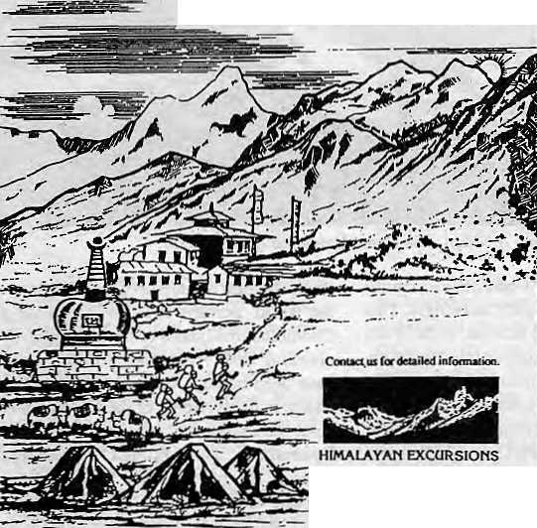
WE WELCOME YOG TO THE HIMALAYAS!
CP.OBm 1221. Keihir Kjhsl ThamcL lUUurnndu, Ntpar Tel: (O)41M07,<H) 416112
Fm ■ ;OjOO-97?-l-4H5l!9 9r»
x : 2636 SHEHPA
WE ORGANIZE: TREKKING AND MOUNTAINEERING EXPEDITIONS IN NEPAL TIBET AND LADAKH PLUS WHITE WATER RAFTING, WILDLIFE SAFARIS AND SIGHTSEEING TOURS IN THE KINGDOM OF NEPAI

Why
Macintosh ?
Why do people who use Apple Macintosh computers every day enjoy working with them so much/and find that they're much more productive in the process ?
Is it because Macintosh computers are so easy to set up, learn, and use? Or because Macintosh applications all workinthe same consistent, intuitive way? Or because every Macintosh comes with built-in networking and file-sharing capabilities ?
Or is it simply because once people use a Macintosh, nothing else will do?
Every day, thousands of people discover the advantages of Macintosh for the first time. And catch a glimpse of its magic.
So if you want to know why contact us at MIPS.

MIPS Pvt. Ltd.
P.O. Box: 2502, Tel: 222277,
Telex: 2521 ATLINK Fax: 977-1-419250

we accept all major credit cards.

&HANCHHA GHAR

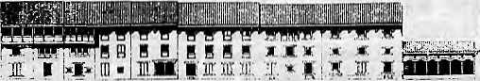
Kamaladi, Kathmandu Telephone: 225172


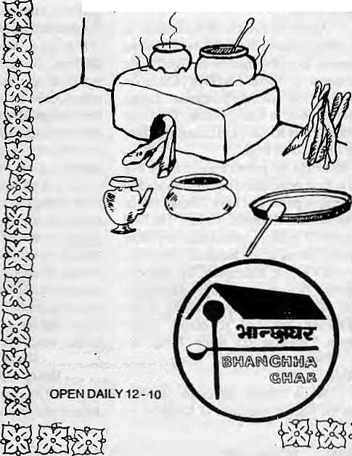
NOT BY WORDS
ALONE
PRESERVING NEPAL'S ENVIRONMENT AND CLEANING KATHMANDU'S
TOWNSCAPE NEEDS STUDY,
COMMITMENT, ORGANISATION,
DEDICATION.
LET US ALL WORK TOGETHER.
N A N G LO
DURBAR MARG
PO. BOX 4384, TEL : 223498, FAX : 527865
AT LAST, THE PLACE FOR EXCLUSIVE NEPALI CUISINE

KNOW YOUR HIMAL

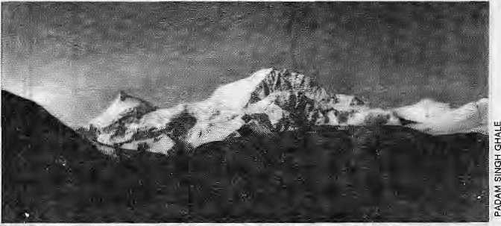
The Name Game
Shisha Pangma (8046m), The Crest Above the Grassy Knoll
by Dipesh Risal
L
ong before the first sightings of the Central Himalaya by intrepid colonial adventurers, the Newars of Kathmandu woke up everydaytothesightofthefonnidableGanesh, Langtang, Jugal and Rolwaling himals to the north of their Valley. Surprisingly, the Newars never Found it necessary to name these ranges, let alone the individual peaks. They generi-cally called the whole panorama Chwaphu Ghu (snow-hill). Similarly, except for isolated Kirat peak-names in eastern Nepal, and other than a few that cany thenames of deities, the mountain people elsewhere in Nepal do not seem to have christened the mountains that form the backdrop to their country.
It is thus clear that, for all diat is made of the Himalaya in the ancient Sanskrit scriptures (see, for example, Himal's masthead sloka). the Newars and other mid-hill-people were spiritually andculturally detached from the snow mountains. The same, of course, is not trueof the Tibetan-speaking communities such as the Sherpas, perhaps because they live amidst the mountains rather than astride them. These groups do have individualised names for peaks.
About 70 percent of mountains in Nepal today are known by their Tibetan/Sherpa local names, including three of die eight "Eight Thousanders" of Nepal. ChoOyu (8201m) is Tibetanfor "Goddess of the Turquoise", Shisha Pangma (8046m, in Tibet) means 'The Crest above the Grassy Knoll", and Lhotse (8516m) is, literally, "South Peak".
It is not height but prominence in shape that seems to have determined the importance and christening of peaks that have Tibetan labels. Sherpas consider Khumbui Yu La ("The God of Khumbu") as more sacred than any other mountain. The mountain stands tall above the villages of Khunde, Khumjung, Thangboche and Phortse, like a guardian angel. Among the Tibetan suffixes that keep recurring in the nomenclature, 'tse' and 'ri' denote "peak" (Baruntse, Langtang Ri), while 'Kang' denotes "Snow" (Gyachung Kang, Kang Rimpoche).
While Tibetan names are common around the Sherpa heartland of Khumbu, as
onemoves west, Sanskrit-based names tend to take over for the taller peaks and ranges. This may partly be due to the fact that, in the West, the Himalaya spreads deeper into the south, where Sanskrit-based cultures dominate. The Hindus who migrated eastwards, as well as pilgrims, must have had arole in the naming of Kailas (Kang Rimpoche), Gauri Shankar and Gosainthan {Shisha Pangma). This religious association is even more evident in the mountains further west, in Garhwal, home to the pilgrimage sites of Kedamath and Badrinalh, and to holy massifs such as Rishi Pahar, Hanuman, Shivling, Devthali and Devisthan.
In the early 1900s, the Survey of India provided four of the Himalayan "Eight Thousanders" with non-traditional Sanskrit names: Dhaulagiri 8167m, from dhavala (white) plus girl (mountain); Manaslu (S163m),from/na«aj(intellect or soul), means "Mountain of the Soul"; Nanga Parbat (8125m), theNakedMountain; and Annapurna (8091m), Goddess Rich in Sustenance. It is not clear whether the Survey's pundits/explorers coined these names or researched for local usage. That the name Dhaulagiri occurs togetherwidiNilgiri ("Blue Mountain"), lesser peak of the Annapurnas across the Kali Gandaki, suggests the latter.
Certainly, there is enough disagreement about the meaning and origin of peak names, including that of Makalu (8463m). In 1884, the Survey explorer named the mountain "Kama Lung", deriving it from the adjoining Tibetan district of Kham It is possible that the name Makalu came from a transposition of the original Tibetan words. Makalu might also have been a corruption of Maha-Kala, which in Sanskrit means "Great Weather", characterising the fierce qualities of the Hindu deity Shiva, who controls the weather. Geographer Harka Gurung refers to apilgrim site below the peak named Mahankal.
As the highest mountain of the Himalaya and the world, perhaps it is not surprising that Chomplongma boasts of the greatest number of callingcards. Altogether 24 different names have been noted, although most are obscure and/or unlikely. Some of die improbable and colourful names accorded to Chomolongma: Byamalung, Devadhunga, Jomolangma-higansri, MitJiik Dguthik Byaphur Longna and Lho Chadzimalungpa, the last one meaning "The Southern District where theBirds are kept". Most of these names were reported by early explorers who said the names were provided by monks in Lhasa.
Historian Baburam Acharya, as early as 1938,debated the issue of "Sagarmatha or Chomolongma" in a well-re searched article in Sarada magazine. He claimed to have come up with substansive evidence that Sagarmatha was, in fact,along-standing name among the Kirati-speaking people of east Nepal.
Name Calling
Whenever mountaineers in the Himalaya found that peaks in the vicinity of their expedition had no name (more likely they failed to ask), they went on a christening spree. Most of the names bestowed by Western climbers are descriptive in nature — Wedge Peak near Kangchenjungha, Roc Noir in Annapuma Himal, and so on. When he climbed up to the Lho La while attempting Chomolongma in 1921, George Mallory saw a 7161m peak to his right. He decided to name it "Clara Peak" after his daughter. But the Sherpas, finding the name alien, preferred "Pumori", literally, the Daughter Peak.
By 1983, the Nepali Government had decided to put a stop to this international name calling. That year, a Committee toNanie Mountains and Tourist Spots was formed, with Harka Gurung as chairman. The Com-

42 HIMAL . Mar/Apr 1993

KNOW YOUR HIMAL

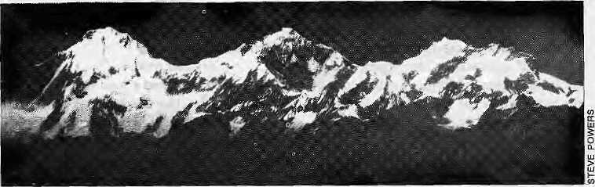
mittce came up with names for 31 peaks around the country. "Our first criteria was that as far as possible, existing indigenous names be used Failing that, we created names which were descriptive of the mountain in some way, or else gave names with local significance," says Prachanda Man Shrestha, a Tourism Ministry official who was in the Committee.
The Twins (7350m & 7005m), to the north of Kangchenjungha, were assigned the popularKirati name of GimmigelaChuli. Glacier Dome (7193m), near Annapurna One, was rendered Tarke Kang (White Peak), and Cross Peak (6431m) in East Nepal, was renamed Taple Shikhar after Taple, the popular historic King of the area. Altogether seven peaks weregiven the names of nearby glaciers or rivers, seven of adjoining regions, seven original names were restored, and ten new names were created.
The Committee's work has been lauded by those who know mountains and mountaineering, but it was involved with only certain prominent massifs in popular mountaineering regions. Many lesser-known peaks of Nepal still retain their 'foreign' names. For example, a cluster of 5000-60O0m peaks around Saipal (7031m) in West Nepal still bear the names Fimkopf, Grateck, Schiefer
Ganesh Himal, with Pabil (7102m) at left.
Spitze and Schwarze Wand Saitze — tongue twisters all.
Dothemountains,thusrechristened, retain their newly acquired names? The Ministry of Tourism has not carried out a follow-up on the work of the Committee. So, apart from Ministry of Tourism publications, and a few foreign purists, the climbing journals and mountaineers continue to use many of the original names. For example, the Committee Tenamed Jannu (7710m), the famous satellite peak of Kangchenjungha, Kumbhakarna. But the old name continues in use by mountaineering journals.
Atpresent, about 2 percent of moun-tainnamesinNepal are of'foreign' origin. Of the 439 peaks above 6500m in Nepal, almost
half have no names at all. They are referred to by numbers such as P.7739 or P.7514 to indicate their height. Similarly, many peaks of individual peaks are denoted by Roman numerals, as in Annapurna 1-V, Ganesh I-VI, and so on. If there are local names for any of these peaks, they have not been popularised, except for Pabil (Ganesh IV, 7102m). Ganesh III, in fact, is Salasungo and in Dhaulagiri Himal, many local names like Mula Kang, Sherbong and Jeyre Meyre have been noted. Hopefully, each of these 'nameless' peaks will acquire their popular and/or indigenous names, ones that are easy on the tongue and that local inhabitants can relate to.
b
D. Risal hlUmal's Know YourHimalcolumnist.

MANDALA BOOK POINT
;accept

Ce
Scholarly Books on Nepal, Tibet, Bhutan etc. Latest Trekking Books & Trekking Maps
Mountaineering Books Guide Books of all Countries
lii
iillillilliilllll



MANDALA BOOK POINT
Kantipath, G.P.O. Box:528, Kathmandu, Nepal
Tel: 227711, Tlx: 2685 NP MANDALA, Attn: MANDALA BOOK POINT
Fax: 977-1-227372 NP NATARAJ, Attn: BK PT.

lliK
™!lli
Wa;S|| llplsSpB

i dial
a

Mar/Apr 1993 HIMAL , 43

Abominably Yours,
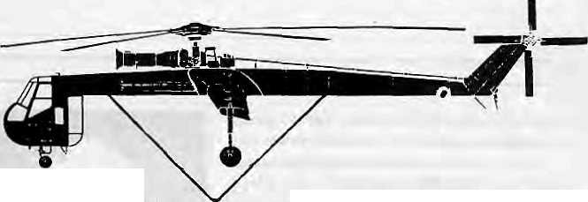

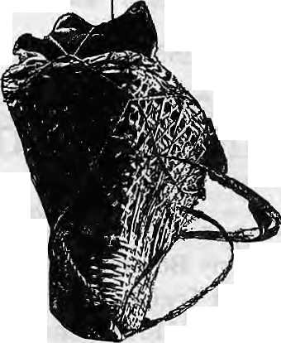
Standing on a high ridge and cocking an ear against the wind, I can hear the distant thunder of approaching Development. A short way down the frothing wild rapids of the gorge where the Bamn meets the Arun, they are going to build a hydropower plant.
The Infant Arun is a scaled-down version of" the monstrosity originally planned at Num, but from what I can gather from my activist friends In Kathmandu, El Nino here has a terminal case of gigantitis. So if I speak with more passion about this subject; excuse moi. This project is right up my river.
The Fat Cats of Kathmandu have always believed Big is Beautiful and Profitable. High dams equal Big Bucks, while mini and microhydros aTe for the birds. Egged on by co-conspirators out West, it looks like the Fat Cats will get their way once more. Only this time, the blunder is going to cost many times beyond Kuiekhani, that overpriced beaver dam on a brook near Kathmandu.
This area is not going to be same again. The langur tells me land sharks from the lower hills are buying up the forests from Hiley through Tumlingtar to Khandbari. On the Khandbari ridge, the cloud forests ablaze with rhododendron are now on fire — torched by foolish villagers staking claims. Do not take any chances if the Arun Highway alignment is not yet clear. Burn down the whole mountain.
Even baby langurs know that Baby Arun is bad economics. But not the Prime Mover in Kathmandu. Even.if the boys from the Bank ladle out nice soft loans and smiling ambassadors offer condition-loaded grants, El Nino is still going to be the most expensive project in its class ever conceived.
So I let off a blood-curdling Tarzan yell and swung from vine to vine down to Num to ambush an advance team of Arun pediatricians from the Bank of Megalomania. And there they were, already at the scene of the crime, showing around development merchants composed of turbine manufacturers, tunnel vision specialists, helicopter charterers, and suppliers of cement. Did I detect drool glinting in the late afternoon sunlight as they eye the innocent white water?
It looked like everything has been decided without Homo sapiens nepalensis having been consulted. Me Tarzan. You
Jane. This Democracy.
Another time, I
watched from behind a soon-to-be-submerged boulder as a road engineer arrived in a flurry of helicopter rotors; Sovereignty of the valley seemed to have been transfened over to his consultancy firm. While upstream, he mapped the far side. He then crossed across and surveyed the near side. He barely had time to grab a couple of pebble samples before the evacuation helicopter arrived.
Further south, the megalomaniacs from the Bank had established a beach-head at the Tumlingtar airstrip. As they picnicked over beer and five-star lunch packs, I sneaked up behind a banmara bush to listen in on the logistics of die project. It sounded like an apocalyptic version of the Vietnam experience. Giant Chinook helicopters capable of lifting 25 tons at a time are to ferry construction material to seven "forward bases" near Num.
All in all, this airborne assault will cost fifty million dollars. Ah-hah. So Arun Three, die Big Swindle, is being preceded by a heliborne Baby Swindle. I look up at the circle of villagers that had gathered around to observe. Their eyes are wide open but they cannot see die looting that has begun, nor will anyone guide them on how to partake in it.
After doing some basic arithmetic, and even after wildly inflating the tonnage to be lifted, I calculated that the job of getting the stuff to Num could be done for about half of the cost budgeted for the helicopters, by relying on the ageold Himalayan heavylift cargo methodology - portering.
Using hardy Arun Valley porters, you would do the job cheaper. What's more: the money would be pumped right into the village economy rather than be siphoned off by some Singaporean helicopter charier. The only cheaper and more environmental-friendly alternative would be to air-drop the cement and turbines from C-l 30 Hercules aircraft over Num, Bosnia-style.
Carrying cement bags or even dismantled turbines will be a piece of cake for the Himalayans, who have a glorious
tradition of being able to carry anything over any hump. Three-ton lorries were once lifted by porters over the Chitlang Pass and into Kathmandu Valley. Nepal's first hydropower plant at Pharping, in the Valley's south, had its turbines, tail-races and dynamos lugged over by an army of porters. But I guess that was a time when money came out of the wallets of nasty oligarchs, with no multinational development bahks to dangle juicy megawatts before weakling politicians.
Donning a golf cap, I hastened undercover to Dhankuta and established contact with bhariya thekedars, contractors who arrange for porteTs to carry anything from kerosene tins to hyper-ventilating trekkers. Negotiations began in earnest, once they knew me multi-crores I was offering. A bag of cement weighs fifty kilos, and the well-built Arunian hillman carries double mat and charges by die kilo —two hundred rupees a day to carry to Num. From where the trail bifurcates from the road at Sedua, it would take the porter five days up to Num and three days back.

There is a porter surplus in Pallo Kirat, and severe undercutting among the bhariya syndicates. The thekedars assure me that they are up to the job, and they will import from as far as the Far West if there is any porter deficit.

Two hundred and fifty crorcs, just for the whirly birds! For a fraction, die Dhankuta thekedars are willing to mobilise. This would be Lhc largest development windfall ever, and the best way for Kathmandu Valley to pay back village Nepal for the decades of bralnnaloot. And just watch the Fat Cats and meir cohort of international accessories starve, while the villages light up.
Either that, or sing a lullabye and put Baby Arun to sleep.

44 HIMAL , Mar/Apr 1993

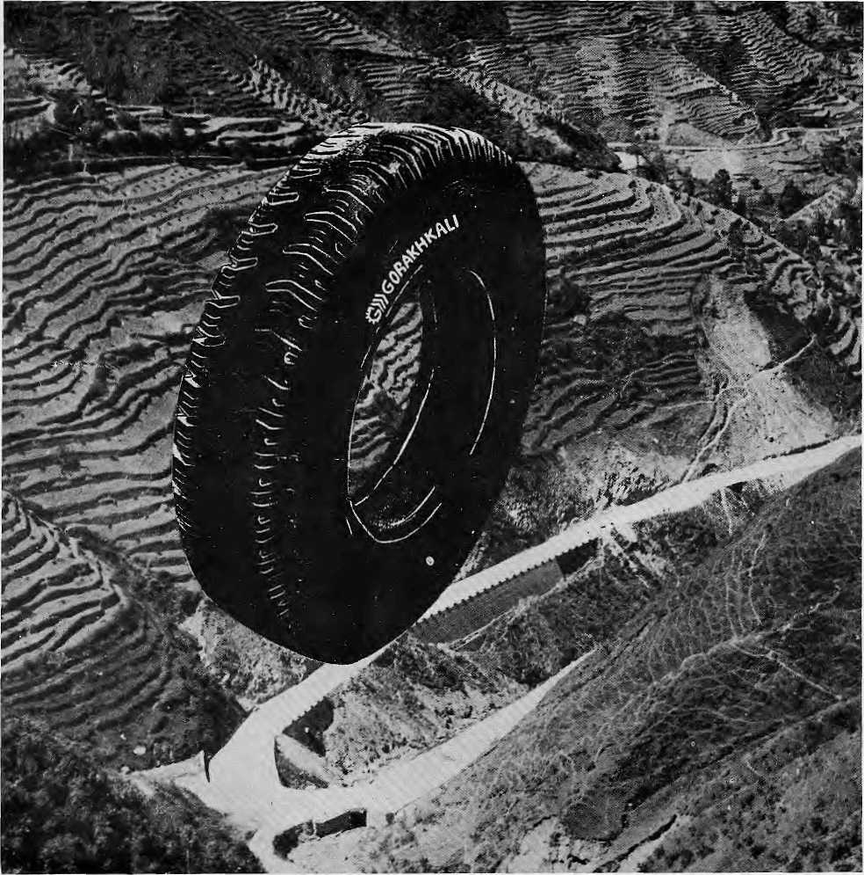

The Gorakhkali tyre is specifically designed for tough Himalayan roads and extreme Himalayan climate. It is the only tyre manufactured in the Himalayan region. The Gorakhkali tyre uses nylon backing and a special dual tread compound for added strength. Rigorous tests on Nepali highways have shown that the Gorakhkali tyre has excellent abrasion resistance. It is unmatched for steering, acceleration, braking and road grip. Overall, it has the lowest cost per kilometre of running.


>» GORAKHKALI

GORAKHKALI RUBBER UD YOG
Registered Office: Marketing office:
Majua Deurali PO Box 1700, Kalimati
Gorkha, Nepal Kathmandu, Nepal
Phone (065) 20179 Phone 270367, Telex 2788 GRUL NP Fax 271704
v
V V

Regd. No. Lalitpur 65/045-46

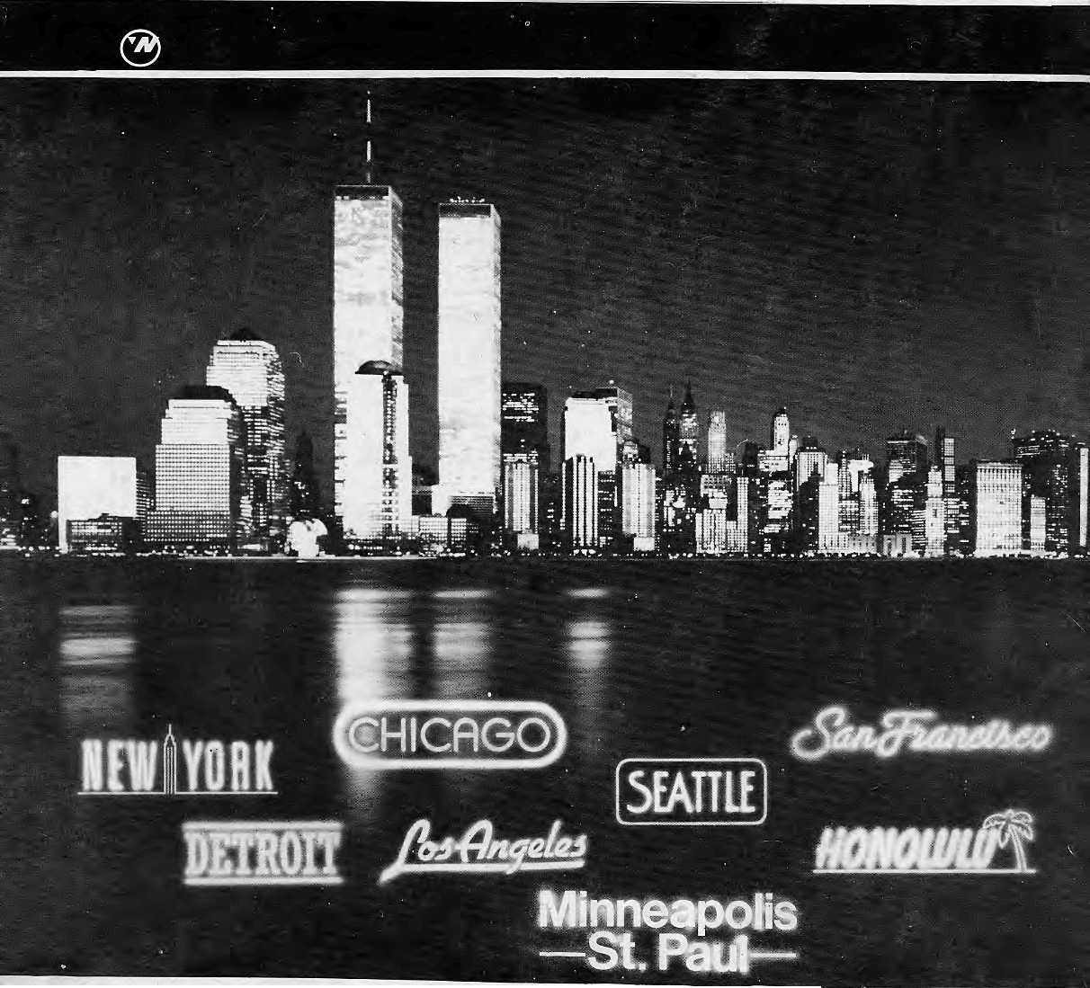
Northwest makes it easy to go to America. With a choice of 8 gateways. And connection to 200 cities beyond.
Choose a connecting city that suits you best: Bangkok, Hong Kong or Singapore.
Northwest has daily 747 flight via Tokyo or Seoul straight to the U.S.A. !
Be sure to*ask about WorldPerb, the most
generous free flight plan there is. General Sales Agent in Nepal :
Malla Treks,
Matla Hotel Arcade,
Kathmandu, Tel. 4J8 389




