HIM
H I'M A L A YAN MAGAZINE
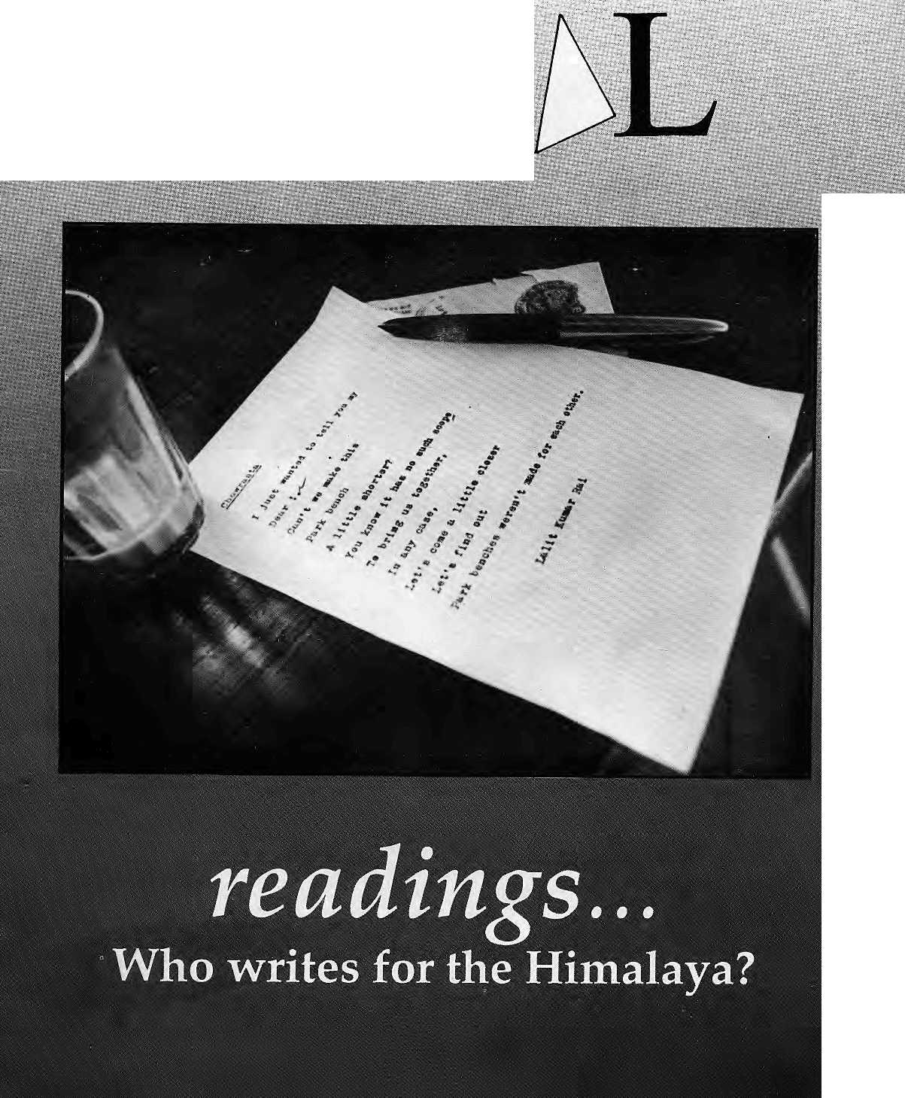
NRs ' 40
IRs 25
■NU '.■■ 30
U$ 6
DM ■ 9 ..' £ .4
May/Jun 1993

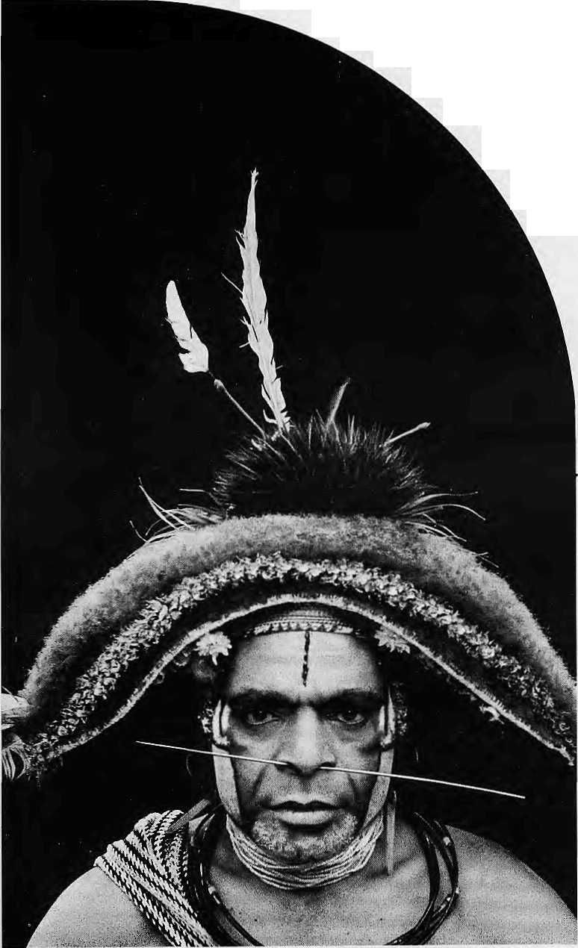
It's not quite so odd if you know how deforestation affects the weather.
Up to 75% of the rainfall in the Amazon rainforest is recycled from tree to tree. Water circulates up from the roots,
into the
atmosphere through leaves, and back down to another tree's roots as rain. In this way, one area of forest passes on
moisture to the next as though it were part of a huge conveyor belt.
By the time air masses reach the Andes in the west, they still contain as much water as when they first crossed the Atlantic coast over fifteen hundred miles away. Unless man breaks the chain.
Thousands of trees are removed from this
natural irrigation system eve-ry minute.
Yet even small changes in the timing Or severity of rainfall can have a disproportionate impact on the environment.
Trees fail to bear fruit, animals starve, and the people who live in the rainforests go hungry.
The deforested areas that cause the problem fare no better.
Without a canopy of leaves to protect the rainforest floor, what rain there is washes away the precious topsoil.
A study in the Cote d'lvoire showed that the soil loss on a hectare of forested slope was 30kg a year. On a similar deforested slope, the loss was 13.8 tonnes. And with no sponge-like blanket of fallen leaves to release water in dry spells, or tree roots to help absorb sudden deluges, the effects of the weather become more extreme.
In December 1988, four hundred and fifty people died during floods in Thailand. There would have been no floods had the local rainforest remained intact.
But it's not realistic to simply tell everyone to stop chopping down trees; so what can we do about it?
At Governmental level, WWF - World Wide Fund For Nature, negotiates to change the way we exploit the rainforests.
On the ground, WWF funds the training of rubber tappers in the north-eastern Brazilian Amazon so that their rubber extraction does no harm to the rainforest.
In Panama, we fund the wort of the Kuna Yala Indians who manage their rainforest territory as a nature reserve.
In Costa Rica, we are researching ways of felling and removing trees for timber without damaging tlie other trees growing around them.
These are just some of over 100 WWF tropical forest projects in 45 countries.
It's not enough. A lot more needs to be done. If you can help us with a donation or a legacy, please do.

WWF World Wide Fund For Nature
(formerly World Wildlife Fund) International Secretariat, 1196 Gland, Switzerland.
It could be the answer to someone's prayers.

THIS MAN IS PRAYING FOR RAIN.
THE STRANGE THING IS, HE LIVES IN A RAINFOREST.

INSIDE...

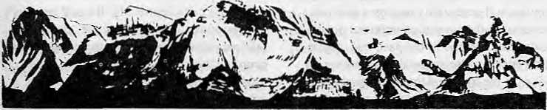
MAIL
Wrong on Kalidasa
Knowing some Sanskrit and having recently begun to lead Himal, I would like to comment on the translation from Kumara Sambhava which you have on your masthead. I believe it should go thus: To the North is the abode of gods: The Himalaya, king of mountains; Bounding the oceans from east to west, An immutable yardstick to measure
the Earth.
Good magazine, but terrible translation!
Sanjay Pratap Greater Kailash I New Delhi
Diminishing Value of Propaganda
The Bhutan conference held in London will probably be looked back at as the first healthy step towards finding a lasting solution to the current crisis. It seems from Robbie Barnett's report (Mar/Apr 1993) that even though 'diplomatic sensitivities' did not allow dissident participation, the conference managed to go beyond mere presentation and acceptance of the Thimphu Government's rhetoric. For Bhutanese refugees, therefore, London has sent a message of inspiration and hope.
For the first time, before a collective panel of eminent scholars, journalists and well-informed individuals, the details of the "Southern problem" was exposed. If the royal Government had believed that it could impress its views upon the international gathering, apparently it did not quite succeed. This was only to be expected in view of the regime's actions to date against a section of its people and the level of international awareness about the blatant violation of human rights in the country.
Now that the issues in question have
been aired by the Government at a forum beyond which there is no other, in terms of influencing decision-makers in governments and international agencies, and the regime has decidedly lost, it is imperative that Thimphu pragmatically decide its future course of action. The time for introspection by the policy-makers has arrived. The policies followed to date have been based on the belief that the regime would weather the storm of international opinion, and that it would, with dogged perseverance, be able to justify its repressive measures on the grounds of protecting the nation from a horde of "power hungry, illegal immigrants". The jury at the London conference, even as it began numerically in favour of the regime, has clearly ruled that this ploy will not wash with the world, and Thimphu must, therefore, make a conscious effort to deal with reality. As a first consequence, the regime's position, that in order to protect the right of indigenous people who happen to wield power and authority any act however abhorrent and cruel, including violation of the fundamental right to nationality of other citizens, is justifiable and morally acceptable, must obviously undergo major transformation.
It is fitting that the conference, Which exposed the weaknesses of the Government's arguments, also delivered wise counsel towards resolution of the problem in the form of a paper by Michael Aris who chose lo address the "Southern problem" from the point of view of finding a solution. He cited Bhutanese history to point out that the advantages of availing of traditional methods of conciliation to bring about an honourable settlement should not be considered superfluous by Thimphu. Rather, the regime would do well to heed Dr. Ails' advice about use of alternative
COVER
5 Who Speaks for the Himalaya?
by Michael Hutt
Outsiders do rot boilier and the locals do rioi talk.
10 Anmole Prasad
- Mana Man Singh
Moti Prasad Sharma
HarkabahadurCheltri
- Marlin Spike Werner
14 Krishna Bam Malla
It? S. Ram Kumar
- John Michael Chiramal
- Bhupi Sherchan
- Anmole Prasad
- Tsering Wangmo Dhompa
- Anadi Pawan Chettri
- Dorjee Tshering Lepcha
26 One Man's Himalayan Bookshelf by Bill Aiiksn There are some good books or the Himalaya.

FEATURE
29 | Himal at 25
 | by Anirudha Gupta
 | Looking back at 24 issues
DEPARTMENTS
22 | Voices
32 | Briefs
38 | Himalaya Mediafils
39 | Review
42 | Know Your Himal
44 | Abominably Yours
Cover: Poem "Chowrasta" by Lalit Kumar Rai, a scientist working with the G, B. Pant Institute in Gangtok. Pictureby Bikas Rauniar.
Hinial © 1988 is published every two months by
1! in sal Association
PO Box 42, Latitpur, Nepal.
Tel: 977 1 523845, Fax: 977 1 521013.
ISSN 1012 9804, Library of Congress Card
Catalogue No. 88 912882.
Subscription information overleaf.
Printing: Jagadamba Offset. Tel: 977 1 521393.

May/Jun 1993 HIMAL . 1

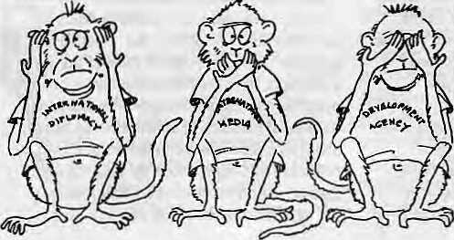
HIM&
Vol.6 No.3 May/Jim 1993
.-.■.■.■. Mountains, Himalaya: =■■ Yatu bound (he oceans from
east id ti^ejyif /I northern yardstick To measure the Earth ■■■:■
Associate Editor: Consulting Editor Managing -Editor :SWff Writer; "

Kanak Mani Dixit OmarSattaitr ■ v* Sanjeev Pi akash ■■;■■■ SimianBdsrbet
Administration
Bikiis Rauniar Uaiaram ShatiEiy -^ Prakrit! Karmacharya
iS end a gift subscription to a friend or colleague, i>0 NOT send cash in mail:

Individuals: | 1 | Ymr 3 | Yeari
;Nepal | NRs. | 220 | 400
Stadia | IRs | 140 | 260
Bhutan | Nii | ■ 175- '■ | 330
Other SI Asian Countries | Os; | ■ -12 " | : 20
;Germany' | DM | .50 | 90-
'Elsewhere | U$ | -25 ■: | 45
Institutional |  |  | _
iNepal | NRs | 600 | no;b:
Irtdia | IRs , | 260.:- | 30P ::■
Bhutan | No | 330 | 640
Other S. Asian Countries | y$; | "25 | 45
Germany | DM | 730..' | 120,^
Klsewhere | m ■" | -45- | ■■■■ 80-
Semi all subscriptioH tiititrs and " ■ ' ■ ■'
correspondence 10; -: '., - I ^
Wd: Eox 42,1.ali(pur_{T} Nepal - ^{s}.
(Mffrt 1 S23«45, fax 977 1 5?W>13), or :
Central f^ews; Agency, 23/90 Connau^it
Circus, New Delhi 11000J I Japan: Akio^Horiuchi.RQ.Box9,Kiyose, # : : Tokyo,-204 Japan, Australia: Imira Ban, 12 Norfolk St., Paddinglon
2021, Sydney, Australia. Ndrth A^iierici! AnupPahari, 134 East Walnut;
LancasterJPA 17602, USA Europe; DWTg^Press (1IIMAL), Luilpoldstr. 20. ; : W-8036, Herrsching, Gem^riy.
HeleneZingg, Tannenweg 18,
CH-3073, Guetpligen, Switzerland
methods that depended on coercive force since this brought about only interim solutions and provoked a cycle of further conflict.
The willingness to consider the soft option will necessarily require a dramatic reversal in the current government position. Given the rhetoric of the past, this may at first appear to be impossible. However, in view of the truth and the surprisingly large degree of real awareness among the Bhutanese people, it would be surprising if the very same northern public that the government fears would ridicule it for 'loss of face' did not actually applaud the regime form being brave enough to face up to realities. The value of propaganda is shortlived and people eventually find out the truth; the average Bhutanese has had enough and will welcome any step that will end the crisis.
Kesar Man Rai
Jhapa
Check Your Data
"Staying Afloat", Robbie Bamett's report on the conference on Bhutan in London last March was entertaining but contrary to facts (Mar/Apr 1993). The "single language policy" of Bhutan that Bamett talks about, does not exist.
Bamett writes that "a Dutch ethno-linguist had four references in his paper, all of which were to studies he had written himself." I am the only Dutch ethno-linguist to have attended the conference, and my paper described Bhutan's language policy and the country's 19 linguistic minorities. It contained 21 references, seven of which were to publications written by myself. Contrary to what Barnett maintains, a number of researchers present in the conference, including myself, have conducted field work in southern Bhutan. Most papers presented at the conference did not deal with the conflict in southern Bhutan.
The conflict in southern Bhutan is fundamentally ethnic. It is not religious or linguistic, although an escalation of the conflict could potentially cause it to become so. The situation is complex, and should be dealt with conscientiously. Barnett rightly praises journalists who practice "the art of rational debate", but a sensitive issue where people's lives are at stake deserves to be treated by dispassionate attempts to ascertain the facts, not by rhetoric larded with misrepresentations and value judgements. Before Barnett takes to impugning the integrity of scholars, he would be well advised to "check your data and cite sources."
George van Driem
Leiden University,
The Netherlands,
An Impossible Scenario
In Stephen L. Mikesell's article "Paradoxical Support of Nepal's Left for Comrade Gonzalo" (Mar/Apr 1993), I find some things which I agree with and some additional points that I wish the writer had taken account of. His article is a warning to IStepal's comfortable ruling classes, both rural and urban, that sectarian violence of the most extreme sort can overtake the society. But I have my doubts that there is anyone to heed this warning.
However, does not Mr. Mikesell believe that the existence of many ethnic groups in Nepal complicates his theory, or even undercuts it? I do not believe that ideology is strong enough to get even the most disadvantaged groups in Nepal to organise into a potent rural fighting force against the Establishment.
Also, do not forget the regional scenario. Peru does not have a neighbouring country that would be willing to suppress armed revolutionaiies in its hills, so the Shining Path movement has remained essentially Peru's problem alone. But how would India react if there was to be, as Mr. Mikesell suggests, "militarisation of various nationalist movements within the country, spillover of violent repression of farm labour in adjacent Bihar, or a military response by the Nepali Government against indigenous social movements"?
Sriram Poudel Dharan Bazaar

2 . HIMAL May/Jim 1993

MAIL

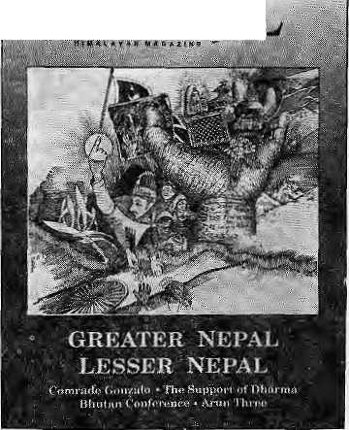
HIMM
Defensive and Detracting
In her response to my letter (Mar/Apr 1993). Manisha Aryal not only refused to take responsibility for what she wrote but also tried to wash her hands off the issue. She has tried to detract the readers' attention from the important issue about the need for Nepalis to treat experts by the quality of theiT work, and not by their nationality.
Aryal claims that Dr. NarayanP. Manandhar and I missed the forest for the trees; every tree is important in making the forest. Dr. Manandhar has been observing the trees as well as the forest of elhnobotany and the entire herbal situation of Nepal for almost three decades. Let me ask how long (for how many days or how many weeks) Aryal conducted her research? And are the readers not to respond for fear of angry journalists lashing out?
Aiyal's insinuation that ethnobotanists, like Dr. Manandhar, have accumulated "vast earnings" is reprehensible. If Aryal tries to find out how much Government researchers make, she might be surprised to discover that she is earning more than a seasoned ethnobotanist.
It seems that in preparing her article Aryal talked to some staff at the National Herbarium, non of them ethnobotanists, yet her comments were about elhnobotany. Her reference to the "real-life conditions of the rural Himalaya" is a total red-herring in this context. Do you suppose field scientists that spend a quarter of each year living with the villagers know more about these conditions or urban journalists that take a two day jaunt up the trail from the nearest bus-stop? Sanjay Manandhar Boston, United States:
Manisha Aryal responds:
Sanjay Manandhar continues to leap to conclusions and read insinuations wherethere are none. Once again, the original article, "Diverted Wealth: The Trade In Himalayan Herbs" was not about Dr. Narayan P. Manandhar.
Herbal Khaptad
Thank you for the stimulating article "Diverted Wealth: The Trade in Himalayan Herbs" (Jan/Feb 1993). The "activist agenda" envisaged by the article is especially relevant for the Khaptad Plateau and the Khaptad National Park in Far West Nepal.
The biological riches of Khaptad are well-known — enough for the Government
to once have established a. jadibuti (herbs) office, where for a number of years various medicinal plants were farmed. With the gazetting of a national park in Khaptad in 1984, the herbal farm was dismantled.
Upon reading the article,! was reminded of a well-known vaidya I once met in Khaptad. As I had been surprised by the diversity of plants in the region, 1 was amazed by the vaidya's wealth of knowledge about Khaptad's plants and their uses. Before Khaptad became a park, the vaidya said, he used to collect medicinal plants from the plateau, but now, with soldiers stationed in and around the park, he is fearful of even stepping into the area. Ironically, die very soldiers who will not allow him to collect medicinal herbs come to him for treating their various illnesses.
As things stand, the army battalion and the Park administration in Khaptad'are nothing but a drain on the country's limited resources. On the other hand, both the inhabitants of the surrounding area and the Government in Kathmandu would benefit from the revenues generated if there were herbal farming and sustainable exploitation of the medicinal herbs of Khaptad.
Having worked with the people of Khaptad for some time, I am convinced that cultivation of jadibuti can be revived here. NGOs could help by mobilising resources, providing the knowledge required for primary processing, and helping deal with the middlemen. This would have an extremely positive impact on the livelihood of the people and their income would increase significantly. This would in turn promote the protection of Khaptad National Park by the villagers themselves, and the Park would be converted from a liability to an asset. Jadibuti cultivation and harvesting is the key to the future sustainability of both the Park and the people.
Devendra S. Rana Udaya Himalaya Network Bajhang, West Nepal
Preaching and Practising
This concerns the article "Is the Grass Greener In America?" (Jan/Feb 1993). Although the writer raises some serious points, there seems to be more than a touch of hypocrisy in his article. Despite the grim situation of Nepalis in the United States portrayed by the writer, 1 would be very surprised if he himself regrets the decision he made of studying in America. And I am
sure he was not as worldlywise while still a freshman at MIT. My suggestion is, why not let each one of us who choose to go to America experience for himself/herself the harsh realities the writer describes. After all, those who make the important decision to go study in a foreign country obviously do so after a good deal of thought, and although Nepal is not so much a "land of the free" as America, individuals here do have a freedom of choice.
Sachendra Gurung Maharajgunj, Kathmandu,
•a. Kg
B

■ ■
A
H
B i
Html JhfiriR's* RarSfe, the literary Journal from , \Kalim pong, and its: ed tor Anrrjol e Prasadfor assistance Jft preparing the present issue. Readers who wish to' sontiriu 6 tftairiaoquai ntancis with Hirn alayai literature
in £rigifsrrmay get in touchwith Fjaffj/e.'cfc A. ft _{i} Chettrt, Ffsrii Road, Ninth'Mile; Kalirjippng 734301, .

May/Jun 1993 HIMAL . 3

exquisite Woodcarnng
ofKathmanda
It's more than an art
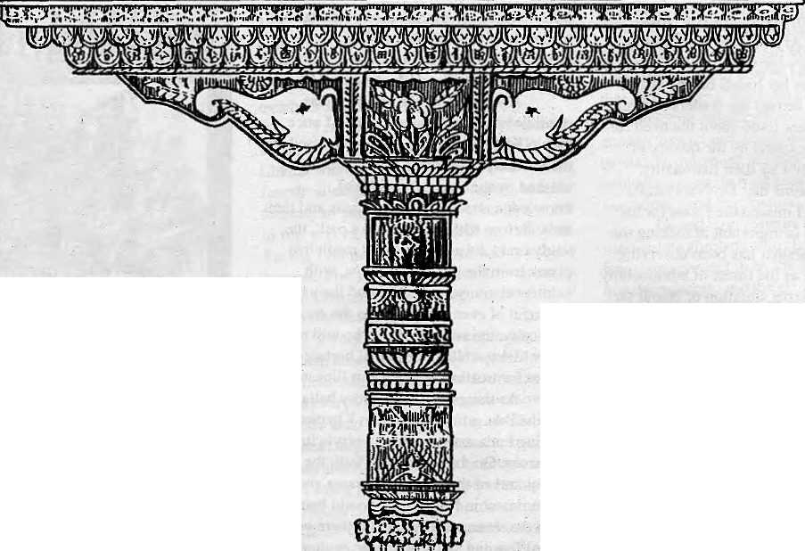
It's an Exuberant Demonstration of a Rich Tradition

It's an Eloquent Expression of a Living Culture

It's a Wondrous Display of a Timeless Heritage

It's a Priceless Ornament of two Religions in Perfect Harmony

mmlM

The Summit Hotel in Katkmandu
It's more than a Hotel

It's a Tribute to Traditional Nepali Hospitality

It's a Homage to a Magnificent Nepali Architecture

It's a Commitment to Quality of Service and Care

It '$ a Guaranteefor your Comfort and Pleasure


SUMMIT HOTEL
Something Special P.O. Box 1406, Kathmandu, Nepal Tel: 521894, 524694 Fax: 977 1 523737

Who Speaks for the Himalaya?

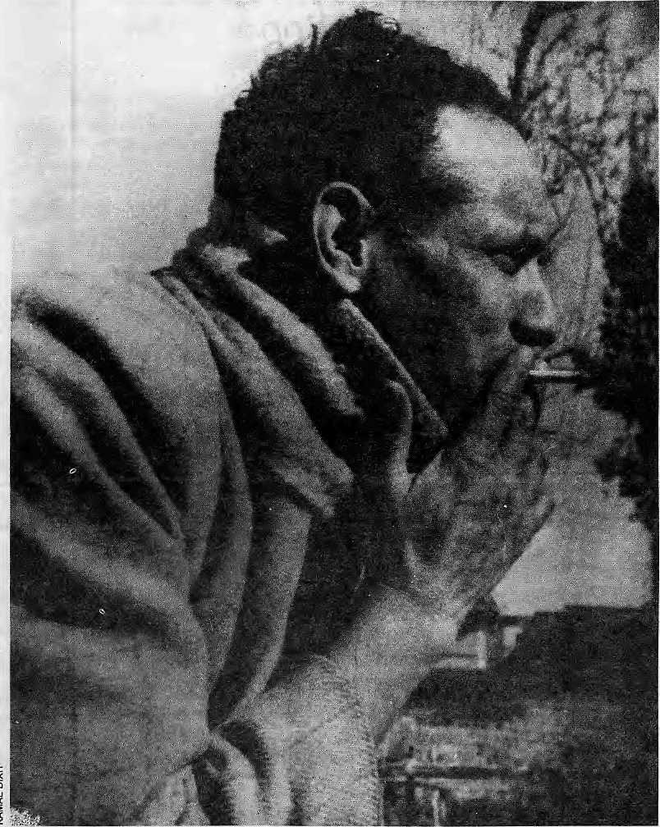
Laxmi Prasad Devkota (1909 — 1959)
B
efore 1950, becauseNepal was virtually inaccessible to foreigners, almost every visitor who passed through published an account of his or her experiences. The earliest book-length treatment (Col. William Kirkpatrick's.A« Account of the Kingdom of Nepcttif) appeared in 1811, and was followed by several others by visitors such as Hector Oldfield, Perceval Landon and Sylvain Levi. None of these were works of creative literature as such, though they aTe still referred to by
students and researchers.
Because Nepal remained independent during the period of British rule in India, it merited very few mentions in the works of popular Anglo-Indian authors like John Masters, Paul Scott or Rudyard Kipling. Though Kipling wrote about "the little yellow idol to the north of Khatmandu" and described the "facts of Khatmandu" as the "wildest dreams of Kew", he never set fdot in Nepal. For Kipling, "Khatmandu" was useful in
The region is presented
to the world by writers
and researchers who have
not been exposed to
the local literature.
As far as creative
literature is concerned,
the Himalayans
still speak largely for,
and to, themselves.
by Michael Hutt
tortuous rhyme-schemes. It also represented something lemote, unknown and exotic: "to the north of Khatmandu" probably sounded to readers of Kipling's day like somewhere near the edge ofthekncwn universe. In most British colonial fiction, the Himalaya meant hill stations like Shimla or Darjeeling, or occasionally Kashmir.
The early British travelers to Nepal usually presented its people and culture in a positive light. This may have been because
May/Jun 1993 HIMAL . 5



ptmiate

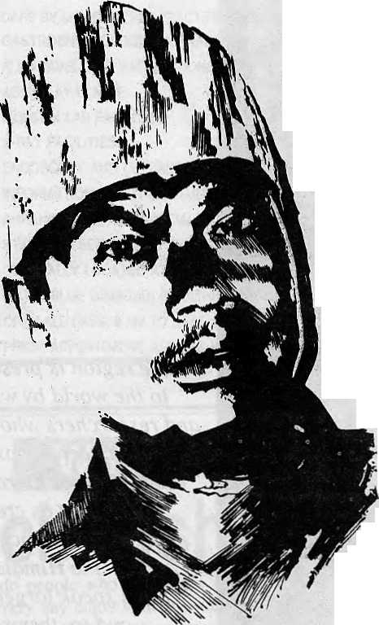
This mon doesn't have a Hotel Management Degree. Neitherhashe masleredthearioflandsajping.Andyet tohim-weoweourPrivate Paradise. V)
He is our gardener, the creator of our prize-winotng garden SHAMBAIA. A true reflection of our commitment "to a greener and healthier environment. Because within our hotel, fp^ we chose to build a Shangri-la-a true haven, to show the world what they came to see ■ nature's resplendent beauty. <ffl[ Perhaps,it is the splendours of our garden that enchants our guests into coming to stay with us, again and again. Or perhaps, because of our gardener, our people...who core for the environment.



4
SHANGRI-LA
KATHMANDU NEPAL
G.P.0 BOX: 655, LAZIMPAT, KATHMANDU,. NEPAL. TEL: 412999, TELEX: 2276 HOSANG NP, FACSIMILE: 977-U14! 84


Writers of the Literature* issue
BiMitkenwfft^prQlificaliyqntheHimafeyaaridisacoltimnist for fh? Statesman and the Piprieelr. He livesirt Deihf and:
Anadi PawanCh^ttri is am accountant wfth:tHe;Kalijiipbh0
■Municipality;;- ■■.. ' ^{v} ^ ;; ::- ": ■ ■■ '■■■ ■■■■ ■:-- ■ ■ ■ ■-■ ■■■■■■ ■■■ ■<■ ■
JoHn:Michaei:Chirarna;i%rbt6 the poem in page17 wfiiie m; in
Michael Huttls;lecturer in ffepaji Studies at the School for Oriental and African Studies, Grwersity of Lpridpn; and⁵ translated: apd edji&d'Himalayan Voices (University; of
California Press, T991). " ^{r} - ■■■■■ ' ■■■■ ~ ■■■■■■. ■■■ ■.- ■ ._{r},
S. Ram Kunjar is Working in the Centre for Environmental Education, thaltej,; Ahmedabad;
Dorjee Tshsring t,epcha, Harkababadur Cftettri anH 'Moti; Prasad Sftarma^reMteacKers liyihg in Kalimpong,
: Krishna Bam -Mails f19f2P -1985) was a senior civil servant • who hailed fromf-Western Nepal and studied in Benaras,
Anmole Pr#sad: practises \m in Kafimpong.
Laltt Kumar Bar is a scientist working with the G.B. Pant tnstitote rnGaogtok.
Bfeupi Sherpnart {1936 -1989) is co/i sidled one of themest popular modern poets of Nopal-
ManaMan Singh lives In Cftobar, Kathmatidtt.
: "THe Ploughman" ;{page 14) and the two poems by: Bhupi Sherchan.(page 18) were translated by Michael Hutt.: BharM Marti Pradrjah translated "Budget" {page i 2).
most of them visited the kingdom as representatives of the British Government in some shape or form, and because their relations with the Nepali rulers were generally cordial. This was particularly obvious during the latter half of the Rana period British travelers had few good things tosay about the culture of less pliant kingdoms. Ashley Eden's book (Political Missions toBootan) is still notorious in Thimphu for its withering attacks on Bhutanese officials, whom Eden found "boorish" and "insolent" when he visited in 1863.
Nepal in the West
Therecent exponential growthof international tourism has inspired an avalanche flood of guidebooks and picturebooks, accounts of adventure and mountaineering, and a body of anthropological literature that has now assumed epic proportions. There are, for instance, at least a dozen book-length studies of Sherpa society and culture. But the scene is still one of poverty if you are looking for Western-authored fiction set in the Himalaya, or for travelogues or mountaineering books that possess literary merit.
In the first category, we seem to ha\<zon\yHanSuyin'sTheMountain is Young (1958), J.R.Marks' Ayo Gurkha (1971), and a handful of novels by Greta Rana and a more recent clutch of fictionalised travelogues such as Pico Iyer's Video Nights in Kathmandu. Suyin'snovel is set against the backdrop of KingMahendra's coronation, which she herself attended. The heroine, Anne, is a shy English woman with a priggish English husband. Anne discovers her sexuality in sensuous "Khatmandu" through a liaison with an Indo-Nepali engineer. Suyin painted a iurid, exotic pic tureof Nepal, but hernovel probably introduced the kingdom to a huge number of readers who had never heard of it before:
Frederic Maliby knew the bendofthe road where he would suddenly see, and always with the same shock of happiness, the snow peaks, rosy in the early light, emerging above the near hills .Altho ughfrom his bedroom window he could see them just as well,yet itwas pleasure redoubledto meet them just at that corner, to see the lords of the snows towering incandescent pink in the early sky. I shall see them here again tomorrow, he thought, and felt himself fulfilled.
He had been five years in the Valley, He would never leave it. Never would he go back to the plains. He would remain here until he died, lifting his eyes to the mountains in the morning and many times during the day. 'For the chief things of the ancient mountains, and for the precious things of the lasting hills...
J.R. Marks' novel stands out from a mass of hackneyed Gurkha-inspired literature. It describes the life of Aitahang, aLimbu who joins the Brigade of Gurkhas and fights in Malaya. This is how Marks describes Aitahang's preparations for departure from his home (Bhalu is his dog):
Aitahang did not sleep a wink before he left. Every half-hour after midnight he peered out at the moon, full and clear in the cloudless night sky, the monsoon just past. At last, when he reckoned it was two hours before dawn, he slippeddown from the hayloft, still wrapped in his fur, whispered to Bhalu and entered the farmhouse. He opened the family chest,
took out his new kukri and closed the lid carefully. Thenhefolded the fur, laid iton top of the box and laid his working kukri on top of that. This was the only way he could leave word that he had gone of his own free will. He could not have told his parents earlier; they wouldhaveforbidden him to go, and would have extracted his promise that he would not.
For a moment he stood in the darkness of the lower room, the familiar scent of'pine-wood in his nostrils, hearing from outside the sounds of cattle shifting in the byre, and the clinkoj'Bhalu's chain-Through a crack in the window boards he saw moonlight flitter on the snows of Topke, and impulsively he stretched out his hand to the lid of the chest again, tempted to replace his new kukri and steal back to the hayloft beside his brother. No one would ever know...
The second category — mountaineering books and travelogues — is much more extensive. H. W.Tilman was the finest of mountaineering writers: Nepal Himalaya recounts his exploration of Jugal, Ganesh and Khumbu Himal during the late 1940s. The book is a masterpiece, full of laconic wit and offbeat allusions. Compare the following to the bald diary-like style of many other mountaineering books:
Our recent access of confidence was further undermined by the appalling prospect of the nextstage, from our camp on the rice stubbles ofCudel across an appallingly deep valley toBung, and thence to another pass on the ridge beyond. Bung looked to bewithin spitting distance, yet the map confirmed and the eye agreed that we should have to descend some 3,000 ft, and climb a like amount to reach it. Profound emotion may find some vent in verse as well as in oaths; despair as well as joy may rouse latent, unsuspected poetical powers. Thus at Gudel, uninspired by liquor, for there was none, some memorable lines were spoken:
For dreadfulness nought can excel
The prospect of Bung from Gudel; And words die away on the tongue
Whenwe look back at Gudel from Bung.

May/Jun 1993 HIMAL . 7

The village of Bung, a name which appeals to a music-hall mind, provoked another outburst on the return journal because its abundant well of good raksi, on which we were relying, had dried up:
Hope thirstily rested on Bung So richly redolent of rum; But when we got there The cupboard was bare Sapristi, No raksi. No chang.
To disarm the hypercritical I might saythatthe 'a' in chang, aTibetan wordfor beer, is pronounced like a short 'u',)
The neat houses and terraced fields of Bung, apparently rich in promise, covered several thousand feet of hillside. In Nether Bung they grew bananas and rice, in Upper Bung oranges and wheat. A sepoy had gone on to collect rice but on arrival the whole party scattered in search of provender like hounds drawing a cover. For ourselves we acquired nothing but a goat, worth about RsJ,forRs.l2, having been askedRs.2Q. In order to secure the rice we had to curtail the march and make a late start. Next morning the jemadar, with bloodshot eyes and husky voice, as became one who had attended an overnight harvest thanksgiving, led the rice procession up to our camp in swaying triumph.
The Facts of "Khatmandu"
So, as far as creative literature (fiction, poetry, drama) is concerned, theHimalayans still speak largely for themselves. The problem here, though, is that they also speak mainly to themselves, and the percentage of outsiders who take an active interest in the 1 oca] 1 i terature remains small, hi my more cynical moments, I sometimes wonder whether a Nepali poet in Kathmandu actually reaches an audience that extends beyond the other Nepali poets of Kathmandu .Then I remind myself that nearly every educated Nepali I know appears to have written poetry at one time or another.
Other problems persist: very little 20th century Himalayan literature has been translated into English or any other language, and most of what has been translated is not available outside the region. It took me about eight years tocomplete an anthology ofNepali literature in translation (Himalayan Voices) and more than two years to find a publisher who would takeit on. Most publishers seemed to assume that there would be no market for such a book because Nepali literature was unknown in the West. Authors of colourfully-illustrated travelogues probably do not face
such problems.
There is also the problem of Western expectations. People can feel profoundly uncomfortable when you question then-preconceptions. Some years back, I read some of my translations from Nepali at a poetry evening attended by respectable ladies and gentlemen from the English Home Counties. The poems I read included Bhupi Sherchan's "Monkeys of the Cold War":
, A monkey with shit on his hands Is eternally bothered by their smell; In an orange grove it makes him breathless; If he sees a rose, he blocks his nose; Raising polluted hands, he tries to keep his
body
From their hateful touch, Then runs from wood to wood With a scream of failure, Wiping his hands on rocks and trees, Dipping them into streams and springs, Trying to befree of their stench.
At each attempt, he sniffs at his hand, But finds that it smells even worse; As if mad, he shakes down fruits and flowers, Destroying sweet scents and sweet tastes. Despairing at last, he sits on a rough rock, Scrapes his hand hard there, then sniffs. He scrapes and sniffs, and sniffs and scrapes, And continues to scrape Till his hand is useless.
When a nervous monkey's paws start to
stink,
Me lays waste to the garden And maims his own hands.
It was mischievous to read such a poem to such an audience, perhaps.* [*AU translations are the writer's own.] But I felt that LekhnathPoudyal's "Last Poem" would probably make up for it:
God Himself endures this pain.
This body where He dwells.
By its fall He is surely saddened,
He quietly picks up His things, and goes.
And if not, I imagined that Devkota's lyricism in Pagal would win them over:
Surely, my friend, I am mad, that's exactly what 1 ami
J see sounds,
hear sights,
taste smells,
I touch things thinner than air,
things whose existence the world does not
know.
Stones I see as flowers, pebbles have soft shapes, watersmoothed at the water's edge in the moonlight;
as heaven's sorceress smiles at me, they putout leaves,they soften,they glimmer and pulse, rising up like mute maniacs, like flowers — a kind of moonbird flower. I speak to them just as they speak to me, in a language, my friend, unwritten, unprinted, unspoken, uncomprehended, unheard. Their speech comes in ripples, my friend, to the moonlit Ganga's shore. Surely, my friend, I am mad, that's exactly what I am!
You are clever, and wordy,
your calculations exact and correct forever,
but take one from one in my arithmetic,
andyou are still left with one.
You use five senses, but I have six,
you have a brain, my friend,
but I have a heart.
To you a rose is a rose, and nothing more,
but I see Helen and Padmini,
you are forceful prose,
I am liquid poetry;
you freeze as 1 am melting,
you clear as I cloud over,
and then it's the other way around;
you world is solid, mine vapour,
your world is gross, mine subtle,
you consider a stone an object,
material hardness your reality,
but I try to grasp hold of dreams,
just as you try to catch the rounded truths
of cold sweet graven coins.
My passion is that of a thorn, my friend,
yours is for gold and diamonds,
you say that the hills are deaf and dumb,
I say that they are eloquent.
But the response was one of polite incomprehension. This was not what they had expected to hear at all. These expressions of moral doubt, of political sophistication, of self-styled lunacy, surely could not come from the land of the Gurkhas andSherpas!
Diverse Himalayan Realities
The lack of quality translations from Nepali is less serious now that it was ten years ago. However, what is available is still only the tip of what is there. And what of the modern literatures of other Himalayan languages? Scores of Tibetan Buddhist texts have been translated and published, but where are the

8 . HIMAL May/Jun 1993

Tibetan novelists and short-story writers? Literature has been written in Kashmiri since in the middle ages, but hardly any has been translated. Is Bhutan still a land of medieval minstrels andBuddhist bards, or does it contain writers of Dzongkha and Nepali who deserve to be heard?
The days when anthropologists conducted fieldwork with the help of an interpreter are long gone, and works in languages other than English are beginning to creep into their bibliographies. The Himalaya welcomesmore than its fair share ofresearchers and advisors, but its diverse realities are still often presented to the outside world by people who have not been exposed to the local literature. So, although it may no longer be a case of the "wildest dreams of Kew", it may not be a case of all the "facts of Khatmandu" either. In 1945, Devkota published an essay, PafcadiViVd/i ("MountainLife"), which began like this:
On my journey to Gosainthan I saw mountains, but I did not see mountain life. What I saw on the way did not reflect it: apart from a few huts and a couple of bazaars I saw nothing but the forests, the hills and the path I was walking on.
Men spend their lives high up here like birds, sometimes in the terraced fie Ids. In the winter there will only be the smooth realm of snow where sheepfolds and cattlepens now stand... Here, Mankind is
blinded and numbed by the great frosty regime. Life springs up from the dust: smeared with a little of the dust of Spring time, it blooms, and then in the end it mingles once more with the dust. There are no greater problems here than eating and scratching a living. Here, 'home' means four posts and a roof of straw that lasts only a couple of months, and social life rarely exceeds the coming together of four people. Man lives a shifting, wandering life in such a place, travelling in search of warm air and sunshine. The world is stingy, and Nature is tightfisted: if he is lucky the earth might yield a little maize and a few nettles.
Why did Man come up here? What pleasure, what happinesswas heseeking? Did he come here just to eat thorns and to stand, rattling in the teethofthewind, like a few frost-ravaged leaves? Was it to display his alienation? The children are illiterate, and their legs are bare. They dance and play like jungle creatures, and life is just subsistence, and the water that moulds the red clay.
Compare the tone of this withTilman' s jovial account of life in the high mountains. Again, compare Peter Matthiessen's account of arrival inPokhara (from The SnowLeopard) with Bhupi Sherchan's satirical account of actually living there:
After midday, the rain eased, and the
Land-Rover rode into Pokhara on a shaft of storm light. Next day there was humid sun and shifting southern skies, but to the north a deep tumult of swirling greys was all that could be seen of the Himalaya. At dusk, white egrets flapped across the sunken clouds, now black with rain; on earth, the dark had come. Then, four mites above these mud streets of the lowlands, at a point so high as to seem overhead, a luminous whiteness shone— the light of snows. Glaciers loomed and vanished in the greys, and the sky parted, and the snow cone of Machhapuchare glistened like a spire of a higher kingdom. (Matthiessen)
Planes are coming, planes are going. Coming with honeymoon couples, Going carrying soldiers Summoned to Kutch next morning.
Planes come, carrying tourists To see the Fishtail mountain, Planes go carrying baskets and trunks, Ploughs and the Fishtail's children, Off to seek land in the plains.
Planes are coming, planes are going: From a bench by the airfield a blind man drones,
"No milk comes from a bird, For a sad man there's no home."
(Sherchan) t>

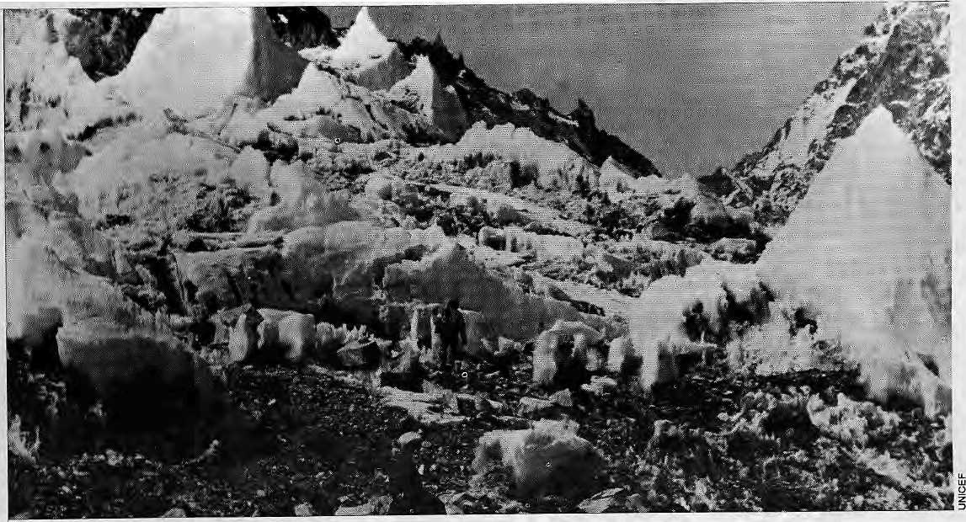
May/Jun 1993 HIMAL . 9

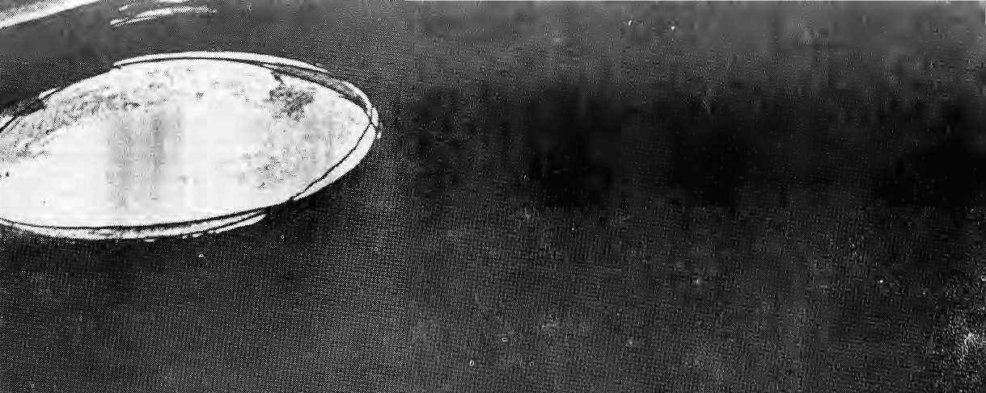

iv-"

m&m

|ji^ ■■■■■■■;

,



Main Road Revisit
by Anmole Prasad

There is a sodium moon at Thana Dora crossing that lights up every evening at six.
Under its corrosive glow, two men passed each other in the night.
One stops and in that terrible pause, asks himself: where have I seen that face before.
Wheeling abruptly he hurries after the receding figure, plucks at a sleeve. Excuse me, do you have a light.
There is some urgency in the question.
The other man turns, smiles a slow chemical smile. His bones jut under a black coat of seedy elegance. His is the angular grace of the stalker.
You already know who I am. Here, a light. For your cigarette and for you to to see me more clearly by.
Recognition scuttles across your face like a crab.
It does not matter anymore, for we are travellers and I have followed you down the centuries to this, the beginning of the end.
In the flare of the Ronson, your yellow smile twists uneasily in rememberance.
Do you remember the Iron King.
Do you remember the frown of the Damsang Fort over Pedong.
Do you remember Chel.
I was much bigger then: I could eat a whole bullock in a morning. It was foretold that because of this my body would slowly turn into iron. Afterwards, I would rule the world.
The ferrous dusk crept up from my feet.
Your masters trembled. Even as they sat in secret council, my scrotum, belly, my sternum, my ribs, arms, all hardened into steel, armouring me like a black rhinocerous.
They sent in vassalage, as a peace offering, the Three Assasins bearing white scarfs and fermented wine. To serve me; to stop me.
You carried a byanphok then, doctor, you were seldom without it. You were renowned for your deadly surgery then as you are known for your compassion now.
With your two friends you served me faithfully for a year. A year almost loo late. Only my neck and head still remained of flesh and bone.
Like the gods, I was almost invincible.
As you stand here on Main Road linked to me by flame, the fateful night comes back to you like a surge.
One of you held the basin.
One of you poured the water.
You lifted the black blade behind the curtain, your mouth bloody with paan. My hair, long, wet, straight.
The byanphok is a swift soughing arc.
My headless body leaps of its own violition about the
room. Great crimson patches on the ceiling.
You had a good memory then, doctor. You do not forget the monks' warning — let not the head join the trunk. Gibbering the ancient mantras, you snatch it up in a bag.
Do you remember:
i the flight through the avenue of pines; ii the clank of my decapitated body in hot pursuit:
Hi hurling my head in the grinning whirlpools; iv the white-fanged waters of Chel; v a metal carcass scrambling down the banks in
silent despair.
The other Assasins intercept me, I am drawn and quartered and drawn and quartered again into a thousand trembling pieces until the very stones above the ford are bubbling with blood.
My eyes watchedyou through the waters. They watch you now through flame.
For years after, travellers coming from your country learned to dread the crossing at Chel. Some of them survived.
Then the monks came, red robed, smelling of rancid butter, carved magic runes into the rocks around the ford. The wayfarers chanted the spells before crossing — / was thwarted.
I bided my time, doctor, I did. Watched and waited down the years that became decades that became centuries.
Three years ago I caught up with the two Assassins — hosted their heads in the park one gray morning.
They called it political killings. I prefer that.
But for you old friend, I have something more... special.
Come let us walk you and I down Main Road.
Where I break upon you like the flood filling this moment with everyone of your memories. Until it comes to you with unbereable clarity that one does not love, one only remembers.
And next I am gone, receding bit by bit from your head bleeding you of all recollection while you stand helplessly like a lake emptying in the sea.
For you can do nothing about it. Except savour the slow and exquisite agony that you are losing all of your mind.
As for the pain, it will stay long after I've gone, for no one forgets pain.
Andl cannot bring myself to bid you farewell.
The next day I lunched with a friend, a learned professor, who assures me that there is no legend of the Iron King of the Lepchas. He adds that the Bhutanese built the Damsang Fort only in the last century.
Perhaps he is right. ^

May/Jun 1993 HIMAL . 11

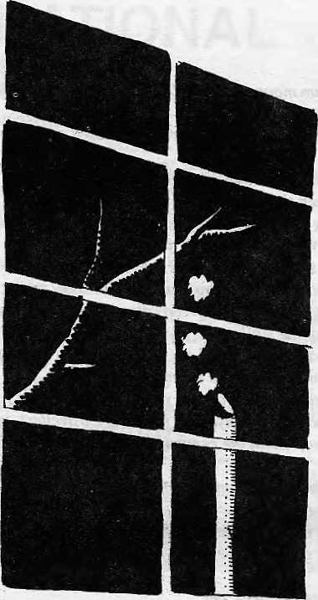

Shut up Cuckoo!
Kathmandu night, rain has jus! stopped. Unreasonably early pre-monsoon, making things wet when they should be dry. Which makes the local koelfeel like bursting forth into song. Bird, do you realise it is two in the morning? And the hard-working people ofPatan would like a bit of a respite from yburkoho koho questioning? You have all morning, midday and evening to practise, so why do you disturb the whole tole at this hour of deep slumber? Your call has sent poets of all cultures into rhapsodies, but tonight all you succeed at is preventing sleep. As you keep at it from the eucalyptus bough just outside my window, I am unable to recollect gurgling brooks, daffodils, secluded grottos, or wide open skies. The only association I can draw to your koho koho is the poop poop poop of rice mills in the hills. They attach whistles in the exhaust to alert surrounding villages that husking is in progress. I have no rice to husk today, cuckoo. Don't sing into my window. At least, turn the other way.
Matia Man Si ngh

Budget
Clenching the week's wages — all ninety rupees of it —-in a fist, Maitey recites the wife's shopping list in one breath to his grocer:
"Twelvekilosrice, twokilosflour, quarterofoil, halfquarteroftea, abottleofkerosene, sallhalf, tworuledexercisebooksno2, tabletsforcoughandcoldtwo, tha'salt."
"One hundred and twenty three and seventy Five paise."
"Same amount of rice, even that won't suffice. Leave out the floor. I'll do without lunch. Add up the oil, tea and salt. Skip the kerosene, we'll manage; give me the resL And.yes, better throw in four toffees, four balloons."
Like a criminal poised for the verdict, Maitey waits expectandy.
Moti l'rasad Shanna
Silverfish
Covers a great distance a hundred thousand miles stone dead under its feet the unveiled knowledge lies
Strange this relation unlike root to the soil this silver creature
amid wisdom toils
Upon a coarse surface a heart spreads open absorbed and tost before coming into'motion
Like a surprised branch at the onset of spring strange is the feeling the unknown brings.
Harkabahadur Chettri

12 . HIMAL May/Jun 1993

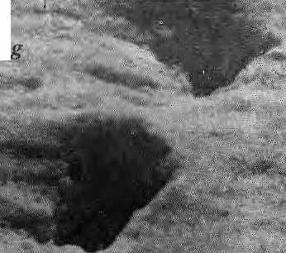

YEti Son
' river
¹ ■ ■ ■ -. rstatlf (msSi£ ?psi!<<i'aiiiBeauty-:: s's the fairer of them all


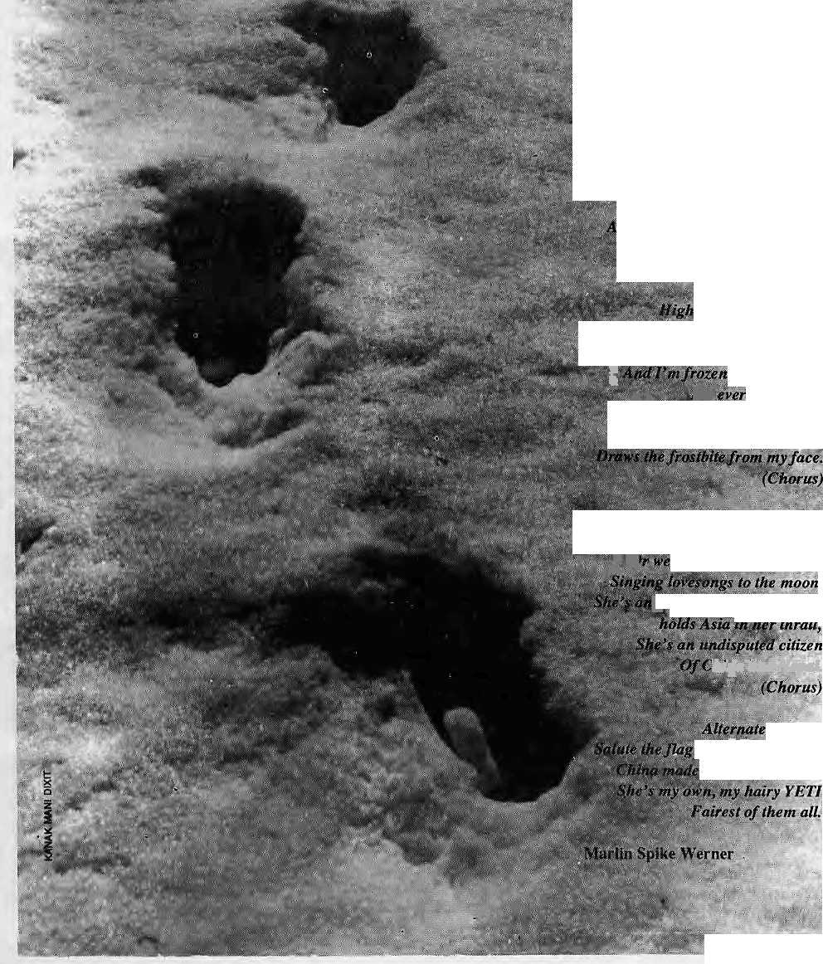
Full my Heat i and gone my reason. We fuiWfave f&r-every season; She's my own, my 'hairy YETI,
fo angora / cbld nip offall
'■'•■ ■:■-'• ■': :, .■•-^■z.sfw's moulting J -;^ *V-f *i*J $■* ft'oiliiifg on at alt. H•■? ■ .. ^-, h/atix. hairiness,:,:
;
I can't set' her eyes at air .W-s■ /.:.'^{v}- ■■■"■ ■■■ ;' (Chorus)■
ttg v/tStrgarmalha
When the cold is hard and blue
And the wind is icy n&ntes
| thrupn4thru.,
^£$fyving Yeti ' jjf Pali;** p# iip'ifrher: embrace: /'%■ -§$rtntk opherfo ur bosoms
•?//<■ H'n/p.t we h'iVA Acr cosiness Against the'chill monsoon, J ^ S| 5* summer twilight
jnU'rnalional heroine -—
iu^efa nd Nepa I.
chorus:
&nd .ftifow confetti tkefifsf spaghetti
May/Jun 1W3 HIMAL . 13
i.;'.,* fvs>iif i ftaire'stofthem all.

The Ploughman
Krishna Bam Malla

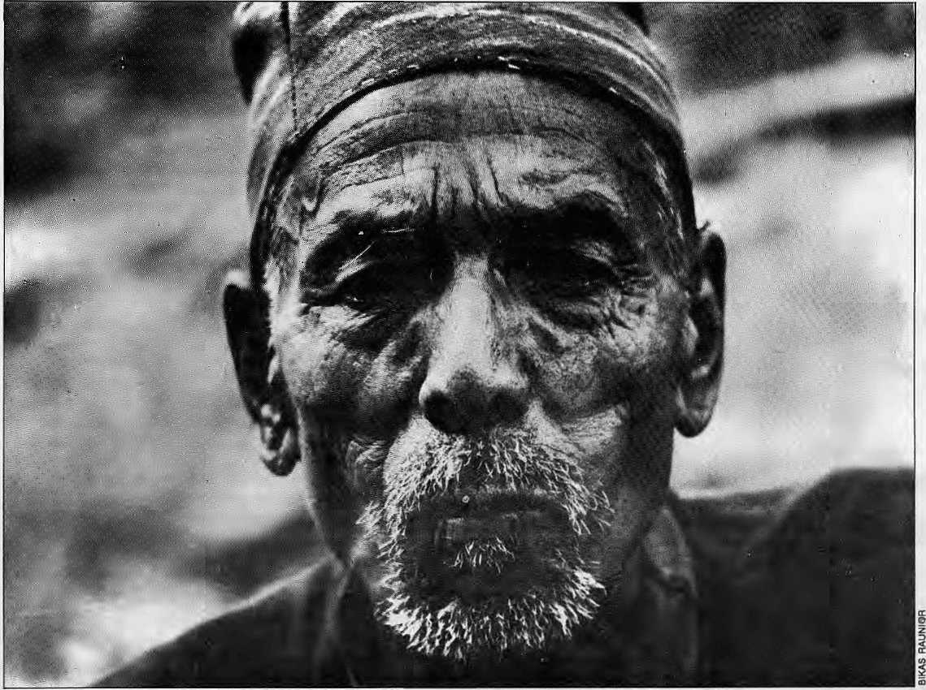

Before the beginning of August last year, Manidhar bista had come running ten times if he'd come once, to employ Pudke damai as a ploughman. So Pudke had ploughed his fields and done various odd jobs in his house, and this had earned him a full nine measures of corn. The grain had been allotted to him the day the bista's barn was filled that November. It was Pudke's profession to plough for others; this was how he made his Jiving.
Pudke damai was exactly thirty. Sometime ago, his wife had died. She had not left any children, and so he lived alone. But now he was able to marry again. Six miles from his village there lived a twenty two year old damai girl named Ujeli. She was just as stout and hardworking as he was. We will love one another, for sure, thought Pudke. And afteT the last crop was sown that year and he had some free time, he put on his best coat and went to visit her. She gave him chiura and green pickle, kept back from the midday snack in fields, and asked him,
"When will we eat the chiura of your wedding day?"
"In November, perhaps?" said Pudke and smiled.
"Is that just a hope?" asked Ujeli
"No it will certainly happen!"
Back home, he told Manidhar that die wedding was fixed for November.
A few days later, Pudke tethered the old ox in its stall after a long day of ploughing the mustard field. It seemed perfectly healthy that evening, but the very next day it died. This caused a tremendous fuss, and Pudke was blamed for ploughing badly. Manidhar claimed that he could no longer afford to give Pudke his share of the crop for the year. After all, how couid Manidhar bear such a toss as the death of his great old ox? On the day that the crop came in in November, Pudke wept and begged for forgiveness, but Manidhar would not soften.
How couldhe go to see Ujelinowwidi any kind of cheer? Would she still agree to marry him? No, he didn't think she would dishonour him — she would marry him, alright. But how would he feed and support her? And all he had was a tiny field producing only half a measure of corn. And there was barely a sackful left now.
Manidhar bista has refused him his share — what reward did he hope for in heaven after causing misery to the poor? There were not

14 . HIMAL May/Jun 1993

many days left in the month — the month within which he had promised to marry. What could he tell Ujeli? How were they to meet? He could think of no solution. But even as he sat there thinking, Ujeli appeared before him.
"Men are alt sinners!" she said "They string up other men's daughters in nooses of hope!"
Pudke understood full well what she meant, but what answer could he give her? His eyes filled with tears. Could Ujeli bear to watch her man cry?
"He didn't give you your share, and now you sit here crying! You won't have to keep me, you know. I have my own skills too: lean sew and earn money. If you have to, just move back the date a little."
Pudke got busy, and the wedding was set for December. But weddings don't happen just like that. He needed an outfit for himself. And the bride should be given a skirt and a blouse, a shawl and a waistband at the very least. There would have to be beer, and spirit too. Nor could they omit to slaughter a pig. He reckoned he'd need at least one hundred rupees. How could he borrow that now?
He went to Manidhar's house: who else would trust him? A loan of 120 was agreed. 10 was deducted as commission, his house and his fields were pledged as security, he was bound to plough for a year for no payment... In the end, he came home with 90 rupees, at ten percent interest for a term of one year. At the end of the month, he brought Ujeli home with trumpets sounding. The very next day, Pudke began ploughing Manidhar's fields, and Ujeli began sewing vests and blouses.
Every evening when Pudke came back from a long day's ploughing, Ujeli would greet him cheerily with a great wide smile, and fill pipe with tobacco. As soon as he saw her, he would forget his exhaustion.
January, February... the months went by. But as soon as March began, Pudke became very ill. The fever stayed with him for a whole fortnight. Even when it had abated, he could not leave his bed. As soon as he heard that Pudke's fever was better, Manidhar sent his man around to the house to ask when he was coming back to work. But Pudke could hardly get up. What he really needed was good food and rest, but there wasn't a grain of food in the house. Ujeti's three rupees had already been paid up to the shaman for sacrificing a black chicken at the crossroads. Ujeli had had no time to sew while tending her husband, so her income ceased too.
In the morning, Ujeli went round the whole village, trying to borrow a little rice and corn, but no one would lend her anything. Manindher even scolded her because Pudke wasn't at work. She was in despair. She would willingly live on water alone, but her sick husband had to have something to eat. What could she do now? Even if she did manage to provide a meal the next morning, she would have to go home to her parents' in the evening for a few pounds of grain. But she hadn't yet solved the problem. She was on her way home tired and disconsolate, when she met Chaure's mother fetching water from the spring. She had promised Ujeli a small measure of rice for the blouse Ujeli hadsewn for her. Sonow at least, she could give poor Pudke some rice, although she herself would have to eat a thin cornflour soup.
Next day, Ujeli fed the sick man in the morning and then set off to her mother's home without eating anything herself. That evening she came home, bearing rice for him and com for herself.
Thanks to Ujeli's attentions, Pudke was fit for work much sooner than expected. She begged him to rest for a few more days, but he just went off to plough the rest of Manidhar's fields. So she took up
her sewing again. In September, Ujeli gavebirth to a son, and Pudke was overjoyed.
Then November came around again, and Manidhar's man demanded payment at once. Pudke and Ujeli went to his house and begged for mercy. But Manidhar would not listen. He ordered that Pudke be locked in his cellar. Ujeli could not bear iL
"First pay us what you owe us for a whole years ploughing, then we'll pay you back. How can you lend 90 rupees, then demand 132 back? You should be ashamed!"
When she shouted at him, Manidhar read the agreement again. It was quite firm in its terms. Sohe said, "If you want to get your husband out, go and fetch the money. There is no point gabbling at me!"
"Where can I go? How can I bring you money? If we had money to pay off our debts, we'd never have begged you for charity. And it's not charity, either, it's payment for ploughing your fields!"
"Thisdamai woman just says what she likes! She should better ather age. If you love your husband, go and work. Earn some money and set him free!"
"Hey,bista, watch your tongue! "roared Ujeli. Foramoment she was blinded by rage. She was even deaf to the cries of the child in her lap.
Unable to bear any more of this, Pudke interrupted them. "You have the right to my house. But you have no right to destroy our honour. I hereby give up my house and my land. You just take it over. WeVe leaving."
Pudke relinquished ownership of the house and land of his forefathers, picked up his son and led Ujeli away. Ujeli clung to her husband.
"What are we going?" sh e asked
Pudke walked on a little further, then he tookhis son by the hand.
"To Assam. We'll keep cows."
(Original title Hali. From the Sajha Katha anthology, 196S.)
FILM HIMALAYA
1 994
FESTIVAL
HIMAL IS ORGANISING A HIMALAYAN FILM FESTIVAL IN KATHMANDU,18-19FEBRUARY1994.WESEEKTO PROVIDE AFORUMFORSCREENINGHITHERTOSCATTERED AND/OR UNKNOWN FILMS ON THE HIMALAYAN REGION. THERE IS GREATDEPTH AND DiVERSlTYIN HIMALAYAN FILM-MAKING, BUT THE "SUBJECT PEOPLE" OF THE HIMALAYA DO NOT KNOW THIS. THE FILM HIMALAYA FESTIVAL SEEKS TO FILL THAT GAP. FROM THE ENTRIES RECEIVED, THE FESTIVAL PANEL WILL SELECT FfLMS AND DOCUMENTARIES TO BE SCREENED BACK-TO-BACK FOR TWO DAYS. HIMAL HOPES THAT THE FESTIVAL WILL BRING FILM-MAKERS AND CONNOS1EURS TOGETHER IN COMMON INTEREST.
Details are being finalised and will be announced in the MAug 1993 issue of Himal. Queries may be directed to Suman Basnet, Festival Director, at P.O. Box 42, Lalitpur, Nepal. Fax 9771 521013.

May/Jun 1993 HIMAL . IS

OBITUARY OF THE BLACK TULIP QUEST
S. Ram Kumar

This paper uses modified Ahalpara Matrices to generate Hartree-Fock (yes, HARTREE-FOCK) approximations to account for Eigenvalues of upper f-p-g shell nuclei. Ground state occupancies in suchcases can be calculated..."
The rod jerked inmy hands. The line went oul screaming. I struckhard hoping that I had made him hooked firmly. Adjusted the drag, and by the pull he was exerting. I figured hemust be a couple of Kilos. In about tenminutes, he was flopping about on the beach. Later, around the camp fire as I bit into my roti and pickle, 1 couid almost predict the conversation; dull, stale conversation mocked by the sparkle and glow of the fire. I wandered off down the shore — I missed her. The contest was unequal — the sand kept diving under the water to seek refuge and the sea kept lifting it up and battering it on the shore. Another lot of sand dived in — do those bastards never learn?
Phosphorescent algae washed ashore, if you do not locate it fast enough to put it back into water, it stopped glowing. Flopped down on the sand, face down, if you dug yourself in a little deeper it was a lot warmer. Made a pillow of sand under my chin. Still missed her. Played out a demonstration of Green's theorem. I'd punch the sand as if hitting a button and sure enough somewhere on the shore at the very exact moment my finger hit the sand, a phosphorescent glow wouldlight up. A couple of times it didn't happen and the grave danger in store for the universe if Green's theorem refused experimental verification weighed on my mind. Going mad, stark raving mad. How long do I miss her? Wire her name on the shore, the waves flog her.
The trouble was that I had never met her. That's why I call heT Swapnika. Of my dreams, by my dreams and God forbid —■ for my dreams. Born of longing, desire and a desire for companionship — a composite creature, part Aphrodite, part Minerva, friend, lover, guise, mentor, personal philosopher, soothsayer—my Swapnika. Maybe I'd meetherin the next second, maybe never. Green's theorem failed again. I'll bait my largest sea hook with my harmonica and cast as far as I can. Maybe I canhook a mermaid — yes definitely goingmad. I jumped up; the keen wind at Okha can really chill you. Tripping over a dozen mermaids, decrepit Green's theorems and faded signboards that said
"Swapnika >" I stumbled back to camp. Radhan was just finishing
an eyewitness account of Suleiman killing a dory owner for fouling his nets. "Navlakhi is a bad place," he warns. Clavell springs to my mind. "Dew ne loh moh" on nets, Suleiman and Navlakhi. In that order—in any fornicating order. Hamari galli bhi phoren hai dekho!
Sleep is impossible. Swapnika, Swapnika, where are you? Long for you. What hook, what bait whatrod, what line —just what do 1 do now? Back on the beach it is too cold. Inside the lent it is too claustrophobic. Smoke a couple of cigarettes, count stars, sheep, sleep.
"Remember, in funds flow calculations, the rate of the flow is as important, sometimes more, than the volume of the flows. Japanese managers are adept at increasing flow rales to levels where the operating cycle becomes fifteen or twenty days giving them twenty rotations per year. Compare this with the two or three rotations possible in India...," 'rr- thirty minutes to go for lunch. Exams are from the day afleT. Long for the great, wide, open spaces.
The climb is lung wrenching. One step forward, heave, another step forward. Wish I had given up smoking. 12,000 feet and still climbing. But the great-big ice-cream cones are reward enough. Bhagirathi 1 & 2, Shivling -— the sky seems to lick their tops with gossamer cloud tongues. Simla baba makes us coffee with Swiss milk powder and offers to deliver instant bliss — smoke it, sniff it or inject it — we claim that the coffee is strong enough. Halfway to Bhojwasa, the snow starts falling. Too cold to even eat. Gulp down some soup and snuggle in under some dozen sheets. No one told me about cold seeping in through the floor, so I am now faced with a frustrating decision problem: from a total of 14 blankets, how many should I have on the ground and how many over me? No one at management school can help. Would love to have Swapnika inside, but she is not here at Gangotri either. Where is she then? Write her name, mine andNaganath's on a discarded cigarette packet; he wanted to bathe in the Ganga at Gaumukh to seek blessing for his investment banking company and slip it into the rushing torrent.
See the pines and miss her, see the rhododendron and miss her, see the lazy river in the far away valley and ache for her. Hate to see the beauty of nature so alone.
"Sahib, stockists ke paas se abhi bhi pandrah lakh baki hai to main kaise advance payment bharoon?" Market shares, price fluctuations, infiltration across state tax lines, territory poaching, sales meetings — the same litany every time. This month it is not loo bad. Next month, oh god. The new budget will come in, more excise duties, more taxes and till the stock in the channel gets sold right down to the consumer — no sales. Sick and tired of convincing, pleading, cajoling, and threatening people to buy. To keep that stupid sales graph pointing its obscene finger al the sky. Wish I was off somewhere far away.
We find that salt is good bui snuff's better. Leeches, bloody leeches. Sophisticated scientific bloodsuckers. They first make an incision and inject anaesthetic, Ihen an anticoagulant and for good measure a vasodilator to expand your blood vessels so they can gorge themselves. Doesn't impress me. Salt the little buggers away. But the jungle is worth it. They tell me that it is one of the last remnants of the primeval rain forests in the Western Ghats. There is an incipient fear of meeting an elephant on the trail. Jump off the trail, the game warden said. Into the leeches? No way. Rather take adiance with theelephants. Santosh says that elephant's trunks took like huge leeches. If leeches were that big, what would they suck? Whales? And how would whales move in the jungles? Very slowly, Isuppose. Sick jokes, horrid leeches, lovely jungle. Someone is catching butterflies for research. We flip through his day's collection. All "lepidoptera" and "etisis" and "ata". We nod dumbly. This criminal has just killed a fragment of a rainbow and has reduced it to a "lepidopiera somethingensis". Drop dead stranger, you don't slot nature into "ensis" boxes. Burying his body would be a tedious chore so we spare him.
Off lo the valley for lunch sitting on the rocks in the middle of die stream. Then for a light snooze. Warm sun on my eyelids battling to darken my vision hand in the water, leeches creeping up on my forearm — paradise in the here and now, leeches and all. A familiar ache begins lo develop in thepit of my stomach. Iknowwhat'scoming.

16 . HIMAL May/Jun 1993

May/I™ 1993 HIMAL . 17

But hark the river is saying something!. "Gurgleburblemessage, Gurgleburblemessage." And an extraordinary understanding bursts inside me, deep inside where I have never been, I know who I'm missing. I KNOW WHO SWAPNIKA IS. I KNOW HER! What a chump I have been not to know all along. I jump up and slosh along the river to tell someone, anyone who'll listen. Santosh, I'll tell Santosh. I interrupt the idiot who is explaining the dangers of drinking unfiltered river water to Prcmanand. Doesn't he know that there are better things than schistosomiasis, cholera, typhoid, or even a nuclear war? I shake him rudely and tell him all. He tries to calm me down as if he had the wisdom of a million years and tell me to check with this, what's her name, Swapnika, first. "Does she feel thesame way foryou? Wouldshe splash around the river and scare all the animals for miles around in Silent Valley if she thought of you? Ls unfittered water really safe?" I wearily go back to my Bodhi tree-rock equivalent. Polar ice smothering molten lava. Snatch at the nearest leaf and write a message to Swapnika. Santosh is right, but so what if he is? There are hundreds of treks, thousands of miles of coastline to angle on and many, many unspoiledjunglestodrown oneself in. Wish an elephant-trunk leech on Santosh.
Post Script:
I have recently angled at Okha, have been to Goa, trekked in Silent Valley again. In fact the last week I was in the little Rann of Kutch admiring the wild asses. Next week, I shall perhaps go to Gir. Lots more places to go. And by the way Santosh was wrong. Hopelessly wrong.
Monsoon Sunset, Shemgang
Sol's gone down, run aground,
Wan glow wanes in westwake;
The duskin' air is moisty.
Soundlessly,
Dip, slide east,
'tis twilight, throat's thirsty.
Jetstream steam, ill at ease,
Ponders precipitations.
The rain drops by without so much
As an 'if you please,'
Or a 'by your leave,';
No notice of intentions, as such.
Shadows deepen, darkness creeps in,
Domesticity hums.
The Wild Ones range the Great Outdoors.
Mother Earth rolls over,
Disdains companion Moon.lover,
Spurns Venus and Mars, etc. & stars.
Insect natter, clawfoot chatter,
Vie for supremacy.
Kingdoms catcall vocally
In mutually impersonal malice
And yet, their silence's twin solace
And their bedlam, harmony.
Yawn! Unwind. Pubcrawl a mile:
Buildup for self prescribed beer.
Shedwards the cattle are bound,
Mudcaked, sunbaked,
Fly scaled, dung trailed,
Black and white and dappled brown.
Now curtains are drawn and children kept warm
With motherlove and familial affection.
The beer's in my belly,
I'll home dead for bed.
It's ev'dent unsaid;
Nightlife don't live 'ere, I tell ye!
John Michael Chiramal

Evening on New Road: A festival of Light
To the Children of Quail, Partridges and Sacrificed Oxen


New Road has been swept and is outwardly clean;
Girls come and go in the dusk,
Khichapokhari gasps for breath
Amid the smoky sidestreet houses,
Dark and malodorous.
Like armpit hairs in a sleeveless blouse.
In the shops' display windows, Suzy Wong smiles, a Hong Kong beauty, Madam Nylon, Miss Terylene, Innocent virgins, virgins with loops, Arms bearing prints of penicillin's advance, Stride toward the dark alleyways.
A flower-baby hippy walks down New Road In the arms of her prince, engrossed in a trip Half-naked in a saffron-blouse, Her brassiere's baskets lift the stale fruits of youth. Every eye in New Road is fixed on her navel; Adopted sons around the pipal tree Stand seceretly thinking lewd thoughts; They sprout up from behind benches.
The filth thrown up by P.S.K. Drainage
Regards the day with jaundiced eyes,
Opening a newspaper's pages.
A beggar woman stands by the News Centre;
She X-rays a hard-up Nepali's pocket,
And begs for five paisa.
Then the poor man puts up a ballon of abuse.
Up into the Kathmandu sky.
He turns to the lottery stall,
Whence his fortune might come,
And finally spits on himself.
I see no point in loitering Tound here
So, to give meaning to the word "home"
(home by day, bar by night),
I make the labour of a new verse into some beer,
And I drink.
Then I pace out New Road, Plotting a poem.
Bhupi Sherchan
Whether it was in a German Assault,
Or in the seige of Burma,
Whether it was amid Malay rubber trees
Or in a strangers' wars in NEFA, Ladakh
Selflessly they died,
Deaths without meaning or aim
Partridges, quail, oxen to slaughter
Adding their "yes" to strangers' agreements,
Awakening to strangers' handclaps and slogans,
Drunk on the dregs of other mens' beer,
Crying "ayo Gorkhali", but merely oxen,
Tumbling headfirst into war.
Unfortunate women, weaning your sons
On pensions from husbands who are no more!
Old ones who worship the eighty four sages,
With income from the fall of your sons!
Young men who woo in the gathering-house,
Donning the jerseys of friends passed away!
Young brides in your palanquins,
Wearing bangles given by lovers now dead!
Beautifully it adorns your breast,
This medal of honour, Victoria Cross
But does it not give off sometimes
Arising stench from the corpse of your kind?
Bhupi Sherchan
a:
2
o a:
I

18 . HIMAL May/Iun 1993

Malli
He stretched my patience across
the long wet pull
on a bin and said it'll take time, sir
my hands are full
Why don't you have a glass of tea
while I seal
the puncture inside your flaccid wheel
Motor and compressor
sweating kerosene
a disembowelled Ceat tube
converted by a keen
blue knife, aplomb and a grin
into a giant rubber foreskin
vanishes inside
the thick truck tyre
Tista flexes muscle through the iron dusk truckers talk in low tones manly, brusque Along the black valley a myopic jeep carefully skirts a Tata grunting in its sleep.
By the tottering tyre-shop
loafers hang around
jaundiced by the petromax
spellbound
in secret admiration
at the prestidigitation
by Kumar
of Kumar Tyres
On the scourged hill,
above the far bank
the mud closes fingers
liquid, lank
over skull-coloured boulders
fallen from the shoulders .
of the road₍.to Danny's brewery
Insects creep creep creep as three lights vie: neon, the petromax and the crepuscular sky by the river a mournful fox concedes
the moon has risen behind what's left of the trees.
Tista at Malli —
not a pleasant sight
even when muted
by the seeping night
I can sit and watch the ballet, though
of rubber and the steel
and the man who resuscitates
my motorcycle wheel.
Anmole Prasad

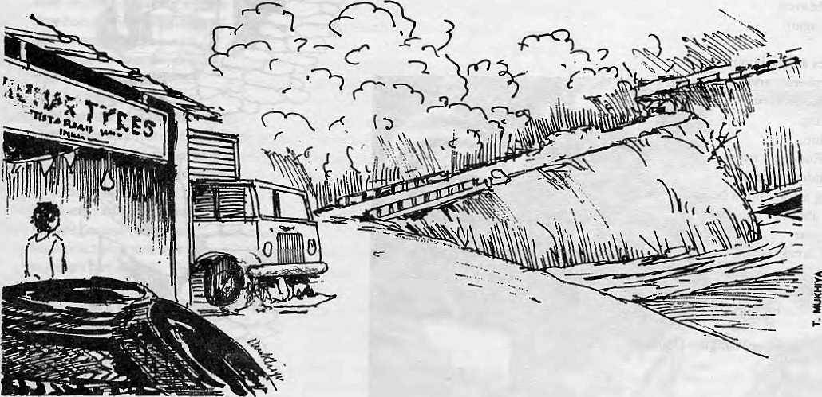
May/Jun 1993 HIMAL . 19

Counting Beads
Recurrences

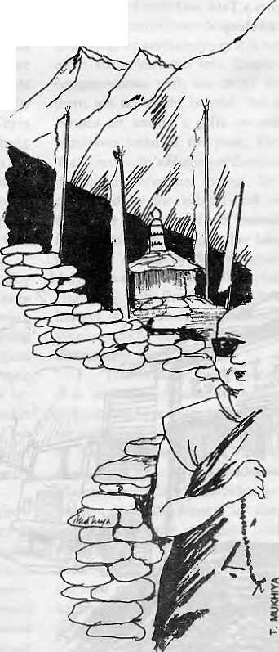
Sunlight flickers
Escaping around tall prayer flag
surfeited with prayers.
The morning wind blows,
not too gently.
with promises of an uncomfortable afternoon
Old Dawa walks with his prayer wheel
and Ray ban glasses.
Sending prayers upto heaven,
to descry his death.
Whose weight sits heavily on him,
along with remembrances of sins,
now recollected with the wisdom of age.
His faltering feet,
adhere to the rules of rheumatism
while he mumbles a prayer for compassion.
Propelled by some need to live forever.
At the feet of a prayer chant, sleeps another day.
Agnes in her borrowed dress,
fingers her Tosary with the shyness
and trepidation of a new lover.
The beads slip between fingers.
So that she falters between her chants
and loses sight
of the smiling Buddha in her mind.
She saw her life gape greedily at her
full of emptiness
and fled.
Only to be taught that die aim of life
was "emptiness".
The eyes of heaven, quietly wink again
Sonam smiles at neighbours,
sliding over queries and prayers
She would like to have
a turquoise ring.
LaTge and blue.
The golden Buddha's eyes,
burn her wandering heart,
and dropping a coin into a beggar's bowl.
She worries about a "chubba"
for the new year
and milk for breakfast.
The dust spawns majestically, uninlerpreted illusions and dreams.
Tsering Wangmo Dhompa
All day long she moves in silence.
Betrayed only by musical glass bangles,
I could almost believe in her non-existence
But at night,
she presents herself in giggles,
and the rustling of silk.
Sometimes,
she wears the night out in sobs,
and screams in between loud meeting of angry fist on flesh.
Her husband,
likes to think she is a goddess incarnate
and either adorns her in silk embraces
and worships her sensuality
or inflicts her malaise and anger.
In stages of brutality.
Her remons (rations.
His expletives.
And the night tries itself out.
Then silence, as intangible as death.
Her sobs.
His pleas
Canying die deadi of the fumbling dregs of his misery
The morning comes.
Carrying in its mouth,
promises of a recurrence.
Tsering Wangmo Dhompa

20 . HIMAL May/Jun 1993

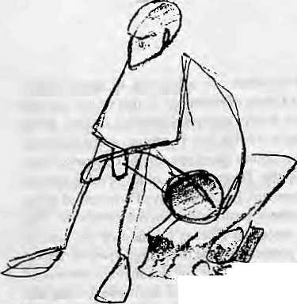
Monograph of a Murder
Anadi Pawan Chhetri
■^jrf--'
I no longer fear death. I no longer value life. Its remnants lie curled up cold and clammy inside me, waiting to be snuffed out.
It began with envy: the envy of a friend. What ended it was a poem. The sequence of events, as they unfolded are recorded here.
I attribute my present condition to Ajaya's death, For a week or two after that, memories of my life are at best hazy. I probably went through the motions of living.
My wife doubtless suspects that my behaviour is related to my friend's death. Her anxiety became obvious when she referred to my odd behaviour later. If only she knew.
Ajaya was the only person who meant something to me, who listened to what I had to say and understood me. I admired him very much. Everybody admired him. His first book of poems had attracted much attention. Some critics even regarded him as the most promising poet of the nineties. This was not his only talent. He could gather friends and aquaintances—even those who scarcely knew him -— and hold them in thrall for hours in a web of words, telling stories, reciting, or arguing with precision and wit.
Adulation and artistic recognition did not however, turn his head. He welcomed the company of his friends with the same easy warmth. He did not suspect the envy that lurked in me, eating away my soul. My bitternesss stemmed from the knowledge that I could neither captivate audiences nor write fine poems. My envy was a recurring interference in my passion for his company. I almost showed it the day the reviews of his book came in. So, secretly, I nursed my — yes — jealousy.
Matters finally came to a head one summer evening. Searching through haunts, I finally located him at a comer table with his girl. I hesitated because she did not like me. But I approached them anyway. She looked up at me, turned to him and complained audibly, "Here comes that bore!" My blood surged. Angrily Iretorted. Words flew, it looked like the beginnings of a war. Ajaya tried to calm us down. He didnotreproachher. Insteadheaskedmetocalm down. The implications sank in. I walked out, brushing aside his protests.
Bore!
The word rang in my brain. I strode down the street unmindful of my course. Only when Ireached there did I realise that my feet had carried me to my usual refuge near the Teesta river.
Wearily I sat on a fiat rock that served as a bench, From here the town's lights shimmered across the curve of the water. Tonight the moon seemed remote and the night failed to move me. My mind was
a mass of colliding thoughts. When at last I could think more coolly, I went home.
For the next few days I did not go to work, although that would have helped to forget. Instead I stayed home and brooded. Reading was difficult. I skimmed through several books, but nothing caught my interest until I picked up a collection of poems by a South American poet. One of them drew my attention. It was titled MAY 20,1928 (ON THE DEATH OF FRANSISCO LOPEZ MERINO). On a second reading, I grew exited. And the more I read it, the better I liked it. The poet had imbued the poem with uncanny insight. Or perhaps he had generously attributed to the protagnist his own sensibility and delicate nuances of feeling.
My immediate impulse was to go to Ajaya's house and show him the poem. In the excitement, my hurt was forgotton. With his perception and passion, the poem could scarcely fail to move him. But there ran in him a morbid streak which unnerved me at times. Sometimes he grew melancholy forno reason and talked gloomily of ameaningless life. I thought this to be an affectation but later realised it was genuine. And dangerous. The sane afld the insane are seperated by a thin line after all. But even as I hesitated about showing him the poem, an idea, fantastic in scope, logical in its implausibility, took shape.
Shoving aside my compunctions, I visited him early the next morning. Awake, he sat in bed, sipping tea. He smiled as he saw me. I felt guilty, and ashamed over having avoided him over the past few days. Soon we were arguing as furiously as before. Irealised how much Ihad missed him.
I took out the book and showed him the poem-He ran his eyes down the page. A second time. More slowly. Then.
"A good poem."
I returned home, my enthusiasm cooled by his lukewarm response.
He surprised me, however, by joining me for a stroll early next morning. Seeing thequestion inmy eyes, helaunched into an explanation. He had read the poem again, and liked it more. With each subsequent reading, new meanings sprang up. From insignificant little actions, a sensuous portrait emerged. What a romantic! Imagine being able to die such an artistic death.
Was I amazed, then? Maybe.
Ipulkdhimupforsuchrash thoughts butlhe devil in me shouted in glee. I pretended to caution him, yet Ikept stoking the fire. I did not allow him to forget. When his enmusiasm burned too brightly, I pretended to douse it.
It was a strange situation.
The whole affair might not have taken such a turn but for two (for him) unfortunate incidents. First, his brother, his only family, died. That shook him. Then on top of that, his girlfriend became schizophrenic and was put away.
Just when he needed my stabilising presence, I left for Calcutta. It was an official trip. I could have delayed it. I did not
I returned two weeks later.
He was dead.
Though I had worked to undermine him, the news came as a blow. Without him life became lusterless. Like so many others, I was now a vegetable. I could bear it no longer.
So here I am, once again on my rocky bench over the river. Watching for the last time the lights of the town and the shimmering water. There is no moon.
Soon 1 will press this weapon to my head. And end it in the way,
I suppose, Francisco Lopez Merino did. A

May/Jun 1993 HIMAL . 21

V
o
I

END OFTHE ROAD, headlined Asiweek, its decidedly rationalist cover story on the RoyalBengalTiger, written by Delhi-based RaviVelloor. "Let'sAcceptThatTherehNoWayBackFor Asia's Big Cats..."
Worldwide, there are perhaps 7,000 tigers in the wild. Poachers have suddenly taken to killing them. Why? For their bones, a valuable ingredient in Chinesepotions.SaysPeter Jackson, chairman of the World Conservation Union's Cat Specialist Group: "It's my belief that the end of the tiger is in sight, possibly within ten years."
But does it really matter? Species come and go. Some, like the dinosaurs, have been outstandingly successful, reigning for nearly 200 million years. But in time the evolutionary bell tolled for them too. The average life of a species is no more than a million years, so Pantheratigris, stalking about since theearly Pleistocene, has certainly had its run. Survival of the fittest is the golden rule of this planet — ask the ghosts of the mammoth, the mastodon, the ground sloth, the sabre-toothed tiger, the woolly rhinoceros. The tiger will leave the stage anyway: poachers' bullets are simply hastening its exit.
If species didn't die out, the world would be in real trouble. So it is encouraging to be told by the emotion-fuelled zealots of Greenpeace, as well as by numerous less-militant activists, that a new species becomes extinct every half hour.
Now it is the tiger's turn to face its karma. We mourn its passing the way we do a grandparent who has lived a long and good life. For the last half-dozen millennia the planet has been dominated by a species so young as to be still in the earliest stages of evolving. We are the Tyrannosaurus rex of the Holocene. Enjoying our ascendancy are slave species: cattle, sheep, pigs, dogs, cats. The brownrat does amazingly well in our sewers andrestaurant kitchens. When homo sapiens passes from the scene, others will have their turn.
If the tiger is useful enough, humans will intervene to save it. The camel, the llama, the ferret and the guinea pig were extinct in the wild before anyone recorded their presence in it. The horse, the dog, the yak and the water-buffalo have all but disappeared in their natural habitats.
...nature has written the tiger off. Let it go.
THE B UDDHIST POPE'S travails at the hands of the Celestial Empire is described in a Times of India editorial of 20 April 1910, titled "Tibetan Affairs" , and recently reprinted in the paper's "Archives" section.
The Dalai Lama has returned to Darjeeling. He has announced that he has no present intention of making his way to Peking in order to lay his memorial at the footsteps of the Throne. Therein he is wise. A correspondent has furnished The Times with the decree of deposition pronounced against the Dalai Lama and this betrays
sentiments towards him which are calculated to make Peking decidedly unhealthy as a place of residence. In this we are told that the Buddhist Pope had always enjoyed bountiful favours at the hands of the Throne, and it was his duty rigorously and devoutly to confine his attention to religious questions. On the contrary, "since he assumed charge of the Treasury and other secular matters pertaining to the Government, he has displayed unbounded pride, extravagance, licentiousness, insubordination andunruliness."The despatch of Szechuen troops to Tibet is justified by the need of maintaining order and protecting trade marts, and upon the arrival of these troops to Dalai Lama "left for destination unknown." Thereupon orders were given to the Imperial Residents to bring him back, andmakedueprovisionfor his "security andgoodbehaviour." Not appreciating these kindly offices on his behalf, the Dalai Lama continued his flight to India. The decree proceeds to inquire how, being the titular head of religious affairs, dare he thus once again leave his post without authority.
The Chinese Government is, dierefore, forced to the conclusion that "the Dalai Lama is crafty, full of deceit, unstable in his allegience, ungrateful for the favours he has received at our hands and unfaithful to the public trust confined in him."
We shall never know the whole truth of the causes which led to the Dalai Lama's reinstatement by China, and to his almost immediate revolt and flight. But a correspondent, signing himself "Uszdzang", writing in The Fortnightly Review, gives an account of the extremely orientalintrigueswhichmakesinstructivereading.
A TYPOLOGY OF EXPATRIATES (living in
equatorial latitudes} was presented in the April 1993 issue of Mirror, the newsletter of United Nations Women's Organisation.
In Hyderabad or Timbuktu,
Or Mandalay or Kathmandu
There is a certain similarity
— A vulgar, rhythmic regularity —
A kind of dreadful deathly sprue
Of misty myth and deja vu...
Such masters of deception That we meet at each reception: "Old hands" talk of yesterdays; "Anthros" hype the native ways. In no time flat I've heard their gripes And classified the ex-pat types!
The women talk about their cooks And give each other knowing looks As if to say: "I understand Why locals eat with their right hand." While husbands smugly sip their booze And wager on the coming coups

22 HIMAL . May/Juti 1993

c
E
S

Some have it on their mind
That life is just a petrol line
In which they wait their turn at pump
While contemplating native rump.
They talk a lot of ration cards
And stocks of gas in their back yards.
Others sing a song of dread: "The power grid will soon go dead." How will they live without AC And Ice cubes in their luncheon tea? They need a gennie to be cool, (And a thousand gallon tank of fuel).
A common type I've met of late Is quick to quote the exchange rate. This special monumental bore Knows the rate at every store. He even knows what silver bars Are worth in terms of SDRs.
Now when it comes to social rank
It's pride of place to the Fund and Bank
These Janizaries of Development,
Always humble and so eloquent;
They know what's good for goose and gander
When to punt and when to pander.
Some ex-pats are simply dull
— A perfect vacuum in theiT skull
No thoughts of higher things there are
While they watch their VCR.
They reject the intellectual
And Count instead post differential.
priorities. When mountaineers or trekkers hire helicopters to remove litter, as was done recently from Makalu basecamp, resource-poor villagers in need of assistance feel bypassed by what they see as-bizarre insanity of wealth—not a very ethical consequence of eco-trekking.
Aneco-tourist purchasing one Tibetan carpet in Kathmandu contributes significantly more environmental damage than what they mitigate by carrying litter — from surface water pollution caused by thedyeing and washing process, and frommany hundreds ofgallonsofwaterconsumed ^manufacturing a smglecarpet. The yak cheese market in Kathmandu (largely dependent upon foreigners) has been directly linked to overgrazing and deforestation in the Langtang Valley.
I also pick up litter, bul I try to keep the rhetoric, issues, and priorities straight
GARMENT QUOTAS AND SHIPMENTS of
readymade garments to the United States from Nepal, as listed in ECONews, a limited circulation economic review published by USA1D in Kathmandu. The listing forms part of an exhaustive review of Nepal's readymade garment industry.
Item Description
1991 1993
quota shipments (in dozens)
229,801 766,002
537,149 141,852 109.111 250,470
226,881 348,722
534,228
8,956
106.944
238,270
340malc cotton non-knit shirts
341 female cotton non-knit blouses
347/8 male/female cotton non-knit
trousers, breeches and shorts
342 female cotton non-knit skirts
- male artificial fiber non-knit shirts
- female artificial fiber non-knit blouses

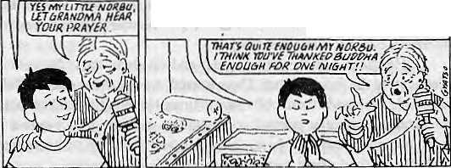
UTTER IS A STATUS SYMBOL argues Broughton Coburn in a letter to Summit magazine of Fall 1992. He questions the popular notions of "eco-tourism" as they appeared in articles carried by the magazine,
Ifeel thalrecent international focus ongarbage along trekking trails is an unfortunate distraction from the fundamental environmental issues.
Litter is not an ecological problem, itis anaesthetic problem, and then only in the eyes of foreign visitors. It is difficult to find substantial examples of trail litter having caused air or surface water pollution or habitat destruction. Indeed most residents of developing countries do not regard litter as a problem of any kind. Among poorer people. litter is a status symbol which labels them as consumers of expensive packaged products. Along trekking trails in Nepal, the status of nutrition, drinking water, as well as deteriorating forests and pastureland are the real problems and
"TIBETAN REARVIEW." A sampling from a regular cartoon column by Gyatso .which appears in the Tibetan Review of April 1993.
GMA ,00 YOU WANT 10 HIAH AflCW PKAYifl 1 MAOt UP TODAY %

Thank you soppha fm making tub Tibetan
ffSPte 5TX0A/6 AW IMTtLllGEHT THANK Yffl FCR61VW6 ViAKtAUYNICB PALAl 1/tMA. ThiAVK W0 FOfZMAKI*!6 U£f/6 XIAO P£JVS 5>H0£T AMD O&LY AND FD/Z MAKW& U PBNQ iDOK UK£APt6AMp-mflNK

May/Jon 1993 HIMAL . 23

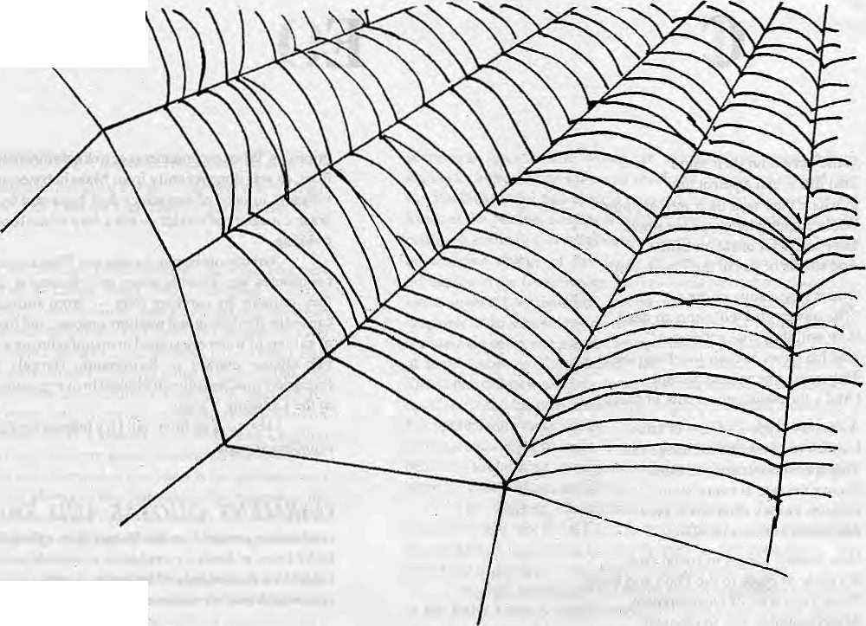
Spider/Man
Dorjee Tshering Lepcha

A certain recluse took his seclusion to its utmost to absolutely shun fellow beings. However, he could not kill his inherent compulsion to talk. He desperately wished there was someone or something to talk to.
He used to be, during his gregarious days, a teacher, and that was what he was good for. He thought that he would teach something to something to speak—maybe an animal, or bird or even an insect. He knew how difficult an endeavour it would be. Nevertheless, his search began for a possible candidate.
Parrots and mynahs he found rather stale and dull and bereft of reason who inevitably ended up in a cage, after all the cleverness in imitating human sounds. (He had an uneasy suspicion of kinship with these birds). He ruled out dogs and cats also because die one he knew to be too servile and the other overly self-willed. Besides, his resources were too slender to feed these ravenous beasts.
Finally he noticed that his house, due to lack of cleanliness, offered him with a wide variety of spiders. He had a great respect for them and they reminded him of glorious things such as how Robert Bruce regained his confidence to win the war; and how these creatures concealed the mouth of a cave by spinning a thick web to save the Prophet from his pursuers. There is talk dial he was later betrayed by the lizard, but that's another story.
He chose a fairly young spider and set about the arduous task of educating die web-spinner. Days passed, weeks and months. Their incredible zeal made them oblivious to time. He thought that he would not indulge in regular normal conversation with the insect unless it really became worthy of being talked to and stood up to its benign myth. So till then, there were lessons, lessons and lessons.
At last the spider appeared for the examinations and got through with flying colours. The teacher just couldnot believe his own
powers to teach. And now, since the spider had graduated and was fluent in human speech, the teacher thought that it was time for their first conversation.
"Hello, Spider! How old are you?"
"Hello, sir. My name is not spider. And we don't count our age."
"Now that you can talk to humans, do you find yourself emancipated?"
"It was amusing learning your language. I am quite pleased today that I can communicate with you."
"That's fine. Well, tell me something about your past."
"We were born sixty five brodiers and sisters. It was under your bed that we saw the light of the day. Then we ate our mother..."
"Wait ...wait, wait. What are you talking about? You don't eat your mother."
"Of course we do," die spider looked at him incredulously and then continued, "There were altogether thirty three sisters. I was the luckiest to have managed to copulate with seven of them. All of them have been eaten by my sons and daughters. Odier sisters too, got eaten. For that matter my brothers are also dead. You trampled two of them. Twenty were flushed down the toilet after they were brushed off the walls along wididieir dwellings. By the way, you ate one with yoursoup last night."
The man suppressed something in his tirroat.
"Weil. That's it. I don't know about die others. About myself, you know everything now. Oh! Please wait a second, sir. My webs are shaking. Yes, there! A fly. My favourite, good. Sir, may I go for my dinner? I have to know more aboutyou also. Sir!... Sir!... Where areyou going? Are you angry with me?"
A

24 . HIMAL May/Jun 1993

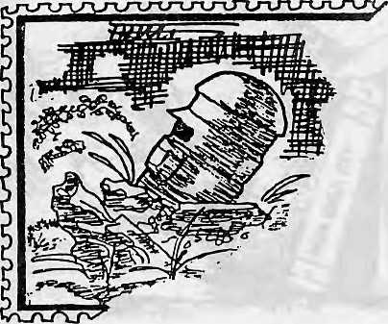
Dead letters
As a schoolboy, he had decided he was an introvert: later in the course of his maturing, he revised this analysis to "mildly schizophrenic." This had an immensely adverse effect upon his literary ambition: they never took off. As a result, a morbid sense of insignificance grew in him. To mitigate his predicament, he started a game. He would write long, florid, tasteful (to him) letters and send them to far away imaginary addresses, with the sender's name and address, too. Obviously, they returned. But that was the purpose of the whole exercise: he achieved some sort of sense of importance when the postman came to his doorstep to deliver letters. But while, initially the letters returned, after sometime, they mysteriously stopped coming back. When several letters were thus lost, his sense of abandonment was complete. One afternoon, with no one around to romanticize the tragic act, he took a strange poison and without any fuss, died.
Only one man, also with a smothered literary bent,
rued his death — the postman. Every night, by the pale
light of a kerosene lamp, he would take out the dead man's
letters and pour over them for hours. At the slightest
indication of any interruption, he would tuck those
exquisite (to him) pieces away. But sadly he will never get
to share the experience with others, for he is torn between
two fatal choices: to publish them in the writer's name or
his own. Dorjee Tshering Lepcha

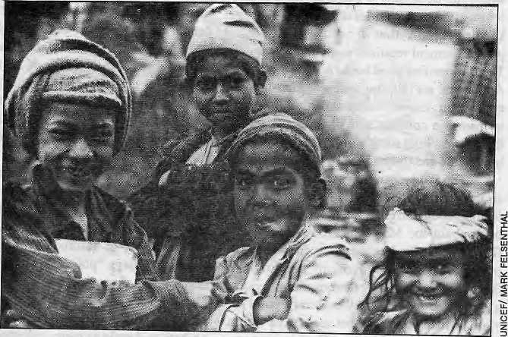
The Queen Ant
Two kids, a boy and a girl, were excitedly playing a game they had just invented. One of them would make a small mound of dust on the ground, wait for a while, hurriedly bare his/her buttocks, fart right into the dust mound to blow it flat and score points. The time one took in waiting for the fart was also computed by orally counting one, two, three, etc., and deducted from the final score. (They had been practising at home to summon fart at will). Then the other would take his/her turn. Just a couple of yards away, a queen ant in dishevelled regalia, with an anxious retinue, watched the game from the rim of the anthill with dread.
Dorjee Tshering Lepcha

May/Jun 1993 HIMAL . 25

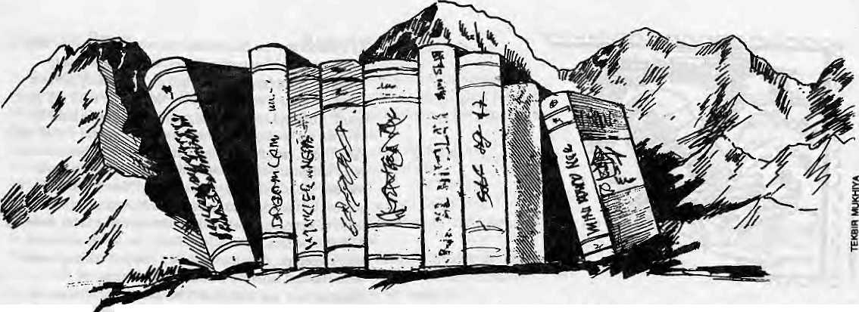

One Man's Himalayan Bookshelf
There are too many books. But there are too few that are worth reading.

R
ecently, the author Ruskin Bond v oiced his dismay at the lack of Himalayan literature. After we discussed this void in Mussoorie, I walked home and moodily viewed my own collection of titles.
What is probably the very first book I bought — from a pavement book stall in Calcutta in I960 — has been the most cherished, Swami Pranavananda's gun-toting guide to the Mansarov ar pilgrimage overcomes all the quaint desi usage to spellbind by its authentic capturing of the glory of the abode of Shiva. By contrast, Sven Hedin's more professional and ponderous findings lacks Che vital dimension of winged inspiration.
It was only when I returned to Delhi, where my bookshelf is more expansive, and hrowsedthrough my titles of eminently worth-keeping books that I realised Ruskin's pronouncement required some modification. There are too few good books on the Himalaya. And there are all too many leaden-footed expedition leaders' accounts that fulfil a sponsorship contract and fit in an appendix that lists the high street stores which provided long Johns and tinned tuna to the expedition.
S o can we narrow do w n the problem to an absence in Himalayan literature of authentic feelings about the greatrange? (Ruskin's own book about the Mussoorie foothills A Tree Grows in Dehra has just won India's most prestigious literary prize, in the English language section.) This categorisation provides a clue as to why, from the literary point of view, so many books do not seem to be worth the paper they are printed on. The foreign egos
byBillAitken
breezing through mountains that are sacred to millions of Asians are blind to anything but their route to the summit. They are here not for darshan of the Mother Goddess, but to achieve apointplotted onacareer graph. Asan example of this tendency to append literature to the main job of topping out, when Chris Bonnington and Friends climbed Changabang in Garhwal, this most beautiful peak in the world hardly merited a write-up. The peak-w eary B onington had included an amanuensis in the party to crank out the obligatory post-expedition blurb, padded with interviews with the climbers' wives.
Changabang's dignity was restored by the ensuing Boardman-Tasker Shining Mountain, which went on deservedly to win a literary prize. Even so, the technical climbing details and the urge to bandy psychological jargon as the climbers lay strapped in their hammocks is hardly designed to make lay readers fork out rupees for what mountaineers consider a classic. And here is the crux of our literary ascent. Who decides when great mountaineering skill translates in long literary shelf-life?
In the Himalayan Club library (now housed in the India International Centre in Lodhi Estate, New Delhi) the policy in the face of a barrage of expeditionary titles is only to keep those of assured literary pedigree. (When one says "policy" one really means finance for the price of niftily produced glossies. Any librarian will think twice about acquiring what seems to the layman a treatise on how to dangle as many coloured ropes as
possible on a rock face.)
For a minimum definiti on of mountain literature, we can safely say it is not more and more about less and less. Soaring thoughts commensurate with the range that inspires them are no doubt helpful, but the classic echoes an author's gifts as much as the numinous loom of the peak. For example, Walt Uns w orth' s History of Everest ismagical despite its reference format. He has been consumed by the subject and managed to make the ugliest of faces beautiful by his furious research. On the other hand Kenneth Mason's Abode of Show, considered the definitive spread of objective wisdom on the Himalaya, lacks fire. You refer to it when you have to, but are never tempted to dip in to give your mood a lift and stimulate that ache for the distant mountains.
TheHimalaya being an emotive entity, it is probably outside the scope of polite Englishmen to produce literature about it, and for real flavour perhaps we must turn to Bengali or Nepali accounts. But Harka Gurung's Vignettes of Nepal marches alongside Kenneth Mason in providing immaculate geographical information delivered in the cautious professorial prose designed not to arouse passions. It's a bit like wading through Elizabeth Haw ley's expedition debriefings that list how many Spaniards or South Koreans achieved the summit of Sagarmatha without falling off.
When I survey the shelves of the Himalayan Club collection, I am convinced that Ruskin's despair is unfounded It is true

26 . HIMAL May/Jun 1993

that almost all the works smack of the colonial "first white foot" syndrome. But to balance the imperial posturing of Fanny Bullock Workman -—rich, lugubrious and indefatigable — who recorded the mysteries of Nun-Kun and the Karakoram but added to them with her voluble pen as she went along, there is Lady Canning, who crossed the Rupin Pass from Kinnaur to Ultarakhand as wife of India's first viceroy. One senses Canning's sheer enjoyment of the mountains and her sketches catch the high magnificence of the Sutlej gorge. Canning sent her letters to Queen Victoria and recently Charles Allen has edited them. Incidentally, the latter, like John Keay, has written rattling good accounts of the eccentric Himalayan explorers. Modern British authors, it turns out, do not exercise the patronising tone inherent in pre-war accounts.
I would agree with Ruskin on one point. Garhwal, perhaps the loveliest of mountain areas, has had very little homage paid to her by way of literary tribute. Inevitably the mountaineer passes through and what seemed a classic like Frank Smythe's Valley of Flowers has settled into the lesser slot of erstwhile best-seller.
Feminine Literature
ShiptonandTilmanneatly illustrate thedivide between the feminine and masculine way of looking at the Himalaya.The first was content to enjoy and explore in foreplay while Bill, I fear, was not just the confirmed misogynist all his square Alpine Club buddies make him out to be. I detect a pent-up macho maniac of the sort I used to read about in the News of the World, thirsting to become intimate with the object of his desiTe. Shipton's accounts of NandaDevi are full ofTelish, whereas Tilman's more clinically accurate recollections forever give off the hint of a poker rammed up his rucksack.
Nanda Devi, the goddess of bliss, has been poorly served by her suitors. John Roskelley waited for ten years before he w aded into a justification for his spat with Willi Unsoeld and Adams Carter, a somewhat futile effort since the world is hopelessly hooked to the romantic version of how Nanda Devi Unsoeld became one with her goal. The latest book on Nanda Devi is William Sax's sociological study on the cult that climaxes its cycle with the Rupkund passage. Sadly, this glorious opportunity is dismally sacrificed to the exigencies of a lumbering PhD demand.
Other areas are not so badly served. Kulu has had, in quick succession, the gifted pens of Penelope Chetwode and Christina Noble, while Ladakh drew poetic fire from Andrew Harvey and Helena Norberg-Hodge. Nepal has attracted international exposure and my favourites are those enthusiastic Japanese cartographers like Tomoya Iozawa, whose Trekking in the Himalayas ranks in my opinion as the sort of guidebook Leonardo would have written had his flying machineever worked to get him here.
Possibly, the answer to Ruskin's prayer
is even now being contemplated by more than
one writer across the Himalaya. A selection of
articles from the Himalayan Club Journal has
been under consideration for a long time and,
hopefully, this will depict the range according
to the Club's brief "to extend knowledge of
the Himalaya through science, art, literature
and sport." A supplement to include lower and
morecolowful contributors to Himalayan lore
like the "Great Beast" Aleister Crowley — an
accomplished climber as well as poet (whose
works are included tin the Oxford Book of
Mystical Verse) - could be edited by the
inscrutable Yeti who lurks with literary gusto
in the hind parts of Himal. ^


MANDALA BOOK POINT
h
Scholarly Books on Nepal, Tibet, Bhutan etc. Latest Trekking Books & Trekking Maps
Mountaineering Books Guide Books of all Countries

MANDALA BOOK POINT
Kantipath, G.P.O. Box:528, Kathmandu, Nepal
Tel: 227711, Tlx: 2685 NP MANDALA, Atln: MANDALA BOOK POINT
Fax: 977-1-227372 NP NATARAJ, Attn: BK PT

- Mescosm: Hinduism and the Organisation of a Traditional Newar City in Nepal Robert Levy Rs. 720/-
- Monk, Householder and Tantric Priest: Newar Buddhism and Its Hierarchy of Ritual David N. Geltner Rs, 312/-
- A History of Modern Tibet 1913-1951: The demise of the lamaist state Meivyn C. Goldstein Rs, 880/-
- Eserttial of Modern Literary of Tibetan: A reading course & reference grammer Melvyn C. Goldstein Rs, 560/-
- Nepal Under the Ranas: • Adrian Sever Rs.960/-
May/Jun 1993 HIMAL 27

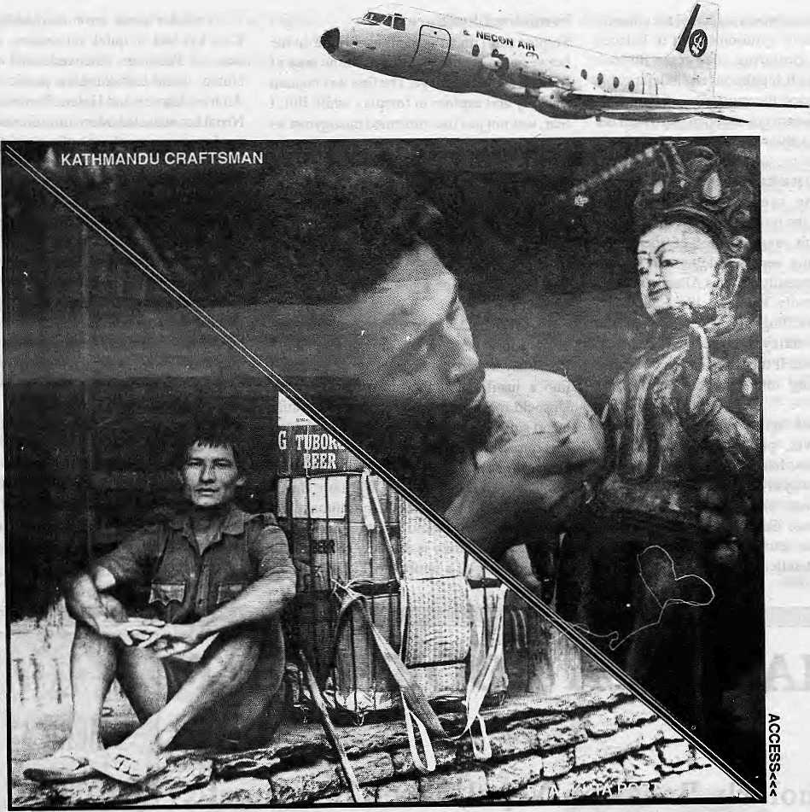

NEPAL UNDER OUR WINGSPAN

You want comfort.
NECON AIR's HS 748 Avro aircrafts are the most spacious, and our staff the most solicitous.
You want punctuality.
NECON AIR links Kathmandu, Pokhara, Simra, Nepalgunj and Bairahawa with an efficiency that has become the talk of these towns.
You want pleasure.
We take mountain flights from Kathmandu for the Eastern Himalaya, and from Pokhara for Annapurna and Dhaulagiri.
Try us. Fly us.
NEC®N AIR

Sales: 414367,412260Reseivations:41860S,418809 Fax: 977-1-412645 Telex: 2739 NECOA NF PQ Box 4047, Kathmandu,

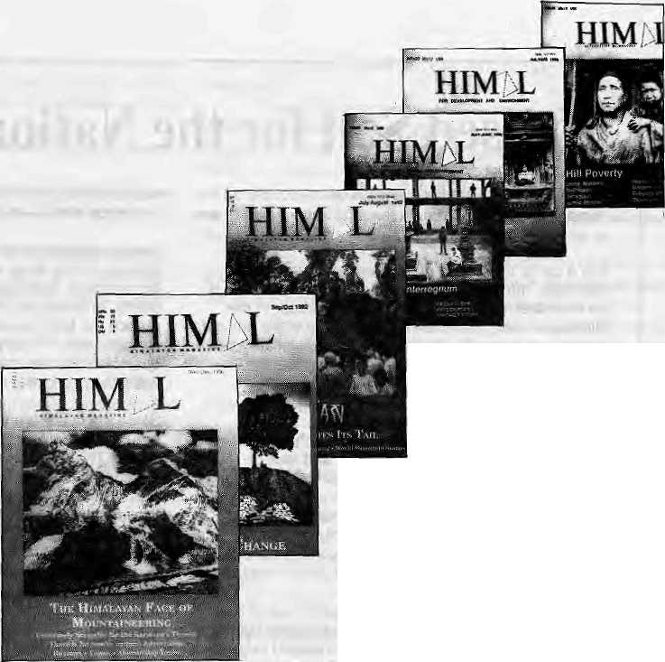
at 25
Himal's prototype (Vol 0 No 0) was published in May 1987. This present issue is the magazine's 25th. A political scientist from the Jawaharlal Nehru University looks back and reviews the effort.
by Anirudha Gupta
H
ow should one go about climbing a mountain? I found this useftil tip in Voices, Himal Nov/Dec 1992, excerpted from Zen and the Art of Motorcycle Maintenance'.
"...Youclimbthe mountain inan equilibrium between restlessness and exhaustion. Then, whenyou're no longer thinking ahead,each footstep isn't just a means to an end but a unique event in itself. This leaf has jagged edges. This rock looks loose. From this place the snow is less visible, even though closer. These are things you should notice anyway .To live only for some future goat is shallow. It's the sides of the mountain which sustain life, not the top. Here's where things grow. But of course, without the top you can't have sides."
And as Himal started from the base camp in 1987, did the ascent look exciting?
The fiTStfew issues of Himalcsny the doubts of a toddler- Not only does the editor appear unsure about what he proposes to be "developmentjournalism", there ate also those equally doubting Thomases who raise the cacophony: What earthly good could another journal in English do? Would//ima/gradually gain circulation or would it just fold up and fizzle out? A writer from Washington DC: "Will you provide an aloof and objective perspective or will you aggressively help define

that elusive blend of 'environment and development' as your cover proclaims?"

What does the cover really proclaim? The editor was tinkering with it, and the caption "For Environment and Development" now read "For Development and Environment" with this explanation: "Has the E-word lost out to the D-word? Not really. We reversed placement only because 'development' is generic and covers the entire social, economic and environmental universe. However we continue to keep 'environment' because in these fragile, overpopulated mountains, the environment development nexus is more important than anywhere else" (July 1988). Did this make sense even to the editor himself?
So, with the Tourism Issue (Jul/Aug 1989), Himal strives for a new perspective; It shows its resentment at being advised in a patronising tone by the Delhi-based South Asia Journal that Himal should avoid "...the fads and fancies of the so-called environmentalists of the West,"The rejoinder was telling:"...'fads andfancies'arenot limited to environmentalists in the West, and South Asian scientists and policy-makers too would do well to keep an open mind and do their home work. For it is not only journalists who are afflicted by intellectual laziness, nationalist blinders and an inability to .look at others' points of view."
Does this also meanOaaXHimal has begun to notice the mountain sides "where things grow" ? It did take pride in the fact that its operation had shifted from New York to Kathmandu: "We have come home." The Sept/Oct 1990 issue quietly drops both D and E words altogether. Instead, we find a new c apti on: ,A tternative bi-monthly. Practical, perhaps, but dull. But by Jan/Feb 1992, Himal has discovered what it always wanted to be: ^Himalayan Magazine covering the entire region from Khyber to Nathu La, from the Indus to the Brahmaputra.
Nepalcentric?
hi view of its limited reach, Himal gives more space to Nepali affairs. But this has not made it a 'Nepalcentric' journal. The Jan/Feb 1990 and Mar/Apr 1991 issues provide wide coverage of Tibet, the mystic mecca. July/ Aug 1992 devotes three quarters of its pages to developments in Bhutan, while also focusing on the plight of the Nepali-speaking Southern Bhutanese. The articles Taised a storm in the magazine'sMail section in the issues to come. "You have tried to rewrite our history into your version, perhaps intending to give the world an illusory picture of Bhutan," fumes an official from Thimpu. A Dane accuses the editor of "being most unfair and biased."
The sides taken by the letter writers tend to reveal ethnocentric affiliations. A pity! For, observes Rajni Kothari in the Ethnicity issue (May/Tun 1992), "...the paranoia of the majority is matched by the paranoia of the minorities. They are pushed to the wall by the growing accent on numbers in a democracy." The problem of ethnicity obviously disturbs Prayag Raj Sharma. He warns of "an ethnic conflict of explosive potential, which could well engulf Nepal in future." This issue also ■ carries an excellent essay on the ethnic mosaic of Nepal's Pratinidhi Sabhaty HarkaGurung.
Wending my way through the pages of successive issues of Himal, I begin to wonder

May/Jun 1993 HIMAL t 29

ADVERTISEMENT
Iodised Salt for the Nation's Health

Goitre and cretinism have always been a curse on the Himalayan region, but only recently have we been able to do anything about it.
It is a curse that came guaranteed with geography. Normally, humans get their supply of iodine, which is an essential 'micronutrrent', from foodcrops. In the Himalayan belt, however, natural iodine in the soil gets washed away easily. As a result, foodcrops are low on iodine and the population does note receive the required dose.
It is iodine deficiency that causes goitre. If the deficiency is severe, cretinism results, characterised by mental retardation, deaf-mutism, and lack of muscular coordination. About 40 percent of the Nepali population is said to be afflicted with some degree of goitre. And it is estimated that four out of every thousand citizen shows symptoms of cretinism. Controlling the Iodine Deficiency Disorders (IDD) is therefore one of the Nepal's gravest public health challenges.
Since 1973, a unique collaboration of private business and government has been actively engaged in battling the ageold endemic. His Majesty's Government, the Government of India, and the Salt Trading Corporation have been involved in iodisising and distributing salt throughout Nepal's high himai, hill and tarai districts.
Salt is one condiment that everyone uses. And salt that is iodised Js considered to be the most efficient way to get the iodine micronutrient into the diets of the country's far-flung communities. It has been Salt Trading's responsibility to ensure that all the salt distributed in Nepal is iodised.
And it has been working. Studies have shown that the incidence of goitre in Nepal has gone down considerably. Whereas 55 percent of the population
was afflicted in the 1960s, one study showed that the incidence was down to about 40 percent by 1985-86.
Because iodine tends to evaporate from salt that is in storage for too long, with the help of the Indian Government, Salt Trading has set up three iodisation plants, in Bhairawa, Birgunj and Biratnagar, so as to reduce the time gap between iodisation and consumption. These plants presently iodise up to a quarter of the salt that is distributed in the country, while the rest of the salt comes iodised from India.
Since the last three years, polythene packaging has been used, which eliminates the evaporation of iodine. The Ayo Nun is powdered iodised salt. Since the communities of the high himal prefer to use salt crystals rather than powder, Salt Trading recently introduced Bhanu Nun. This new brand uses iodised crystals of granular size.
We at Salt Trading are committed to ensuring even better delivery of iodised salt to Nepal's population and the introduction of Bhanu Nun is just one demonstration of this commitment. We are presently engaged in adding three more iodisation plants in the Western Tarai, and by 1994 Salt Trading expects to be iodising all the salt in Nepal itself.
In so doing, we will also proudly continue to be part of this unique experiment in bilateral cooperation between Nepal and India, whose goal is to eliminate IDD in Nepal by the year 2000. This is a programme which is directly helping to raise the standards of public health in Nepal, and saving hundreds of thousands from the curse of goitre and cretinism.
Together with the nation, we look forward to the day when goitre is virtually eliminated from these hills and plains.

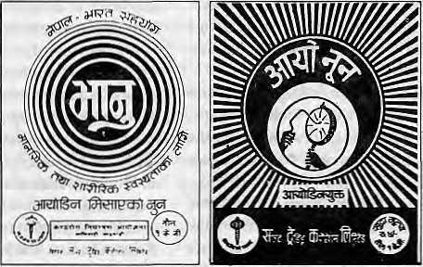
Iodised salt is distributed by the Salt Trading Corporation Ltd. both in loose form and in one kg packets. Packet salt is available under the brand names Ayo Nun and Bhanu Nun. An Ayo Nun packet costs four and a half rupees. Bhanu Nun is distributed only in the remote areas at subsidised prices.
GOITRE CONTROL PROJECT
MINISTRY OF HEALTH
(HMG/NEPAL AND GOVERNMENT OF INDIA
COOPERATION)

Programme Implementing Agency: Salt Trading Corporation Ltd. Kalimati, Kathmandu. Tel: 271593 , 271014 Fax: 271704

if Himat has a counterpart in South Asia. Probably not; for, leaving aside the glossies, most magazines produced in India are either owned by industrial houses or newspaper chains, faceno marketing hardships (asHimal apparently does) and having aready readership for the kind of fare they present. Some exist purely to provide entertainment, others are politically overloaded.
India Today certainly occupies a unique place in Indian journalism, but it caters to too many impulses under a single cover to be able to develop a definite character. Comparatively,Himal comes close to Seminar, a monthly started by Romesh Thapar, whose "issues carry acollectionofessaysona particul ar theme.
Perhaps the closest comparison I can think of is Transition, a bi-monthly that Rajat Neogy used to publish from Kampala. In its carefully etched black-and-white presentation, Transition was a remarkable journal, addressing itself mainly to issues of the African continent. Neogy was ever-ready to explore new ideas and use them. But the axe fell in 1970; the magazine was banned and around that time Neogy too fell seriously ill. With Transition's demise, Africa quietly buried its Homeric age.
It was in Transition's Mail that great debates raged, and in Ifimal's Mail, loo, I get a feel of the same. Some letters provoke
controversies, others lend greater depth to a certain theme. For example, a review of Dor Bahadur Bista's book Fatalism and Development (Jan/Feb 1992) whipped up a mighty debate. The gem to come out of this debate was in Bista's own defence of his book: "You know what 1 have been trying to do lately. I am trying to distract the worried and insecure upper-caste, upper-class Nepalis and draw their attention before they go to bed towards a grisly ghost in their own backyard."
Index Breakdown
What helps Himal to spread out a rich fare are its regular departments—Mail, Briefs, Voices and Reviews. One gets to know so many things; important, amusing or plain facts. The Jan/Feb 1993 issue provides an index of all the articles that have appeared in Himal to date. But a classified list of the topics covered would have been useful.
Subjectwise, Himal seems to have provided widest coverage to environment-related issues, in terms of articles and items in its regular departments. Next come, in the following order, 1) migration, demography and refugees; 2) economy, foreign aid and water resources; 3) mountaineering and tourism; 4) sociology and religion; and 5) women. Apart from country studies of Bhutan and Tibet, it carries articles on Doon Valley, Bangladesh floods, Himachal Pradesh, Tehii
Dam, Narmada Valley,and so on. The following issues are devoted fully to a single theme, not directly related to any of the above: Eating, Tarai, Hill Poverty, Democracy and Himalayan Herbs.
The subjects best treated — and this is purely subjective — are tourism, Gurkha recruitment, foreign aid, hill poverty, Bhutan and mountaineering. From the point of view of overall production and technological excellence, I rate... But no, this will not do. Who am I to judge, unasked and uninvited?
Instead, I should end with an excerpt from the editor's note in March/Apr 1992: "A few issues older, we arrived at the conclusion th&tHimal is actually a mainstream publication after all, as far as the Himalayan region was concerned, because there is little else. So today, we aTe a 'Himalayan Magazine' of Himalayan society."
Someday, as Himal traverses the summit and looks down the sides, it may perhaps discover that the outer edges of this society reach the sea to the south and roll across the Pamir, the Changtang, and Mongolia
to the north... ^
A. Gupta is Professor of Political Science at JNU specialising in Africaandlhe Himalayan region. His book Politics of Nepal 1950-60 has just been reprinled in paperback by Kalinga Publications (Delhi).

Back Issues of Himal
Vol. | No | Colour Issue |  | Cover Story
0 | 0 | Green May/1987 |  | The Valley Chokes |  | 4 1 | Purple | Mar/Apr 1991 | Tibetan Diaspora
1 | 1 | Green Jul/198S |  | Highlanders on the Move |  | 4 2 | Grey | May/Jun 1991 | Troubled Waters
1 | 2 | Blue Nov/Dec 1988 |  | Dharma's Changing Landscape |  | 4 3 | Orange | Jul/Aug 1991 | Nepalis in Foreign Uniform
2 | 1 | Red Jan/Feb 1989 |  | World of the Girl ChQd |  | 4 4 | Green | Sep/Oct 1991 | Keeping Women Down
2 | 2 | Purple Mar/Apr 1989 |  | Prosperous Himachal Pradesh |  | 5 1 | Red | Jan/Feb 1992 | Weakening Spirit of Kathmandu
2 | 3 | Orange Jul/Aug 1989 |  | An Obsession with Tourism |  | 5 2 | Purple | Mar/Apr 1992 | What to do with Foreign Aid?
2 | 4 | Green Sep/Oct 1989 |  | Changing Food Habits |  | 5 3 | Grey | May/Jun 1992 | Ethnicity
2 | 5 | Blue Nov/Dec 1989 |  | Development Refugees |  | 5 4 | Orange | Jul/Aug 1992 | The Dragon Bites Its Tail
3 | 1 | Red Jan/Feb 1990 |  | The Shangri-La Myth |  | 5 5 | Green | Sep/Oct 1992 | The Stress of Change
3 | 2 | Grey Mayflunl99O |  | A Nepali Interregnum |  | 5 6 | Blue | Nov/Dec 1992 | Himalayan Face of Mountaineering
3 | 3 | Green Sep/Oct 1990 |  | The Tarai, A Backwater? |  | 6 1 | Red | Jan/Feb 1993 | The Ttade in Himalayan Herbs
3 | 4 | Blue Nov/Dec IS90 |  | Hill Poverty |  | 6 2 | Purple | Mar/Apr 1993 | Greater Nepal, Lesser Nepal
a ; :- |  | Some fc&ck issuesarestill av|il|bte atKatJ |  |  | imahclu books r(6f&sarw |  | 1 at Himal' | a 6ftice,:^uhdbadcissueB *
f.:- ■ ,' | ffP | up to fiov/Deici^Z^sbme pfctocoriieci |  |  | in ihr^i volumes'arasa  ■■'■'■■ ~* ■' ■■■■■ ■ |  | vaiiable fr< |  | 3s,*000.;; , :' +. _*♦ , ■
"Tl |  |  | HI | Mb | f» Himal Index now allows readers and researchers access to five years of Himal »". Magazine's output — ariides in 23 issues till Nov/Oec 1992. The fully computerised <4\ Index Is available in diskette or printed form (WordPerfect 6.1), and has all tools tot {*[ access and sortir.g. including: serial number, title, author, synopsis, keywords, date and > 1 J volume number. The indux 'uses UNESCO's CD&ISIS library package. For further
LJ |  |  | HI | Mb
 | \ |  | HI | Mb
/ | \ | v | HI | Mb
I |  | > |  |  | ^^^^ information or purchase |  |  | oi mo Himai inaex aaiame. piease wrue id or iax uie
a |  |  | 1 N D | EX | Managing Editor, Himal. HIMAL PO Box. 42, Lalitpur. Nepal. Tel |  |  |  | 9T7 1 523845 Fax: 977 1 521013
May/Jun 1993 HIMAL . 31

BRIEFS
f

Something Gives in Tibet
*


W
hat do Levis Strauss & Co. and the Pa Lai; Lama have in common* which sets: ;them apart frorn ChrisPatten^ Weil, tfaemanuf-acturer of blue d^njpfn and the monk in saffron are both against China receiving most-favoured-nation status frorri the United States, while the Governor of HongKong was in Washington DC lobbying for retention of MFN. *. -.-
\ In May, as'President Bill: Clinton¹ was about to decide on the MpN; states, L^vi Stfaii^s-unilaterally announced that it would suspend business in! China to protest human rights abuses there. Some cypics saw this as-an attempt by the , cornpany to boost its itnage atnbng '^politically liberal jean wearers":, many; of whom might actually be-sympathetic: to the cause of Tibet.
The Dalai Lama has, in the meantime, emerged from his Bharamsala eyfieio; go on a publicity blitz, and he.seems to
Upcoming^
Consultation on Environment
and Ecology in the Himalayan
Region
28-30 August, Calcutta
This. Is. an informal regional meeting of grassroot activists, organisations and concerned NGOs to discuss environment and ecology of the Himalayan areas of Nepal and India, k> discuss Implications for Bangladesh, to identify ccmiiniin issues, to work out practical action plan, and to mobilise resources.
Contact: Mupendra Kishore, Service Civil International, K-5 GreenPark,New Delhi 11001& Tel: 664605
32 HIMAL • May/Jim 1993
be gaining grointd oivBtijirig. Tjbeth^s alwaysreceived sympathetic play in the: Western-media, but now the'coverage is more brpijdbasedt, rnqre: :.. ; ,:, politicised, and less quaint. ::
spin-artisEs have never had it so good.:"Optirrusm^ Spreads , .... ....
among Tibetan Exiles," was the headline used by the"..Asian Wall Street'Journal'as thepressure; built on China;;? :« ... I ;; ' :;.,
Tljere was a littlebit of every thing ^i the mRdia to ; ...;. enliveniTibet^overage; from; demdnstratitins in'Lhasa (With the?BBC South AsiaRejjort ; managing a live? interview with a tourist::stayihg at ttie' ..' '.:. Lhaga Holiday fcin)f toactor
night audience to -sendout energy, in support of Tibfet; American Vice \Piesident A1- ;Gore met wi& the Dalai Laxaa; : in his White House'office* atid the President hkd five minutes fr£e and "jiisi droppedi by ,, to say hi". Meanwhile, the Canadian House of Commons debated Tibet,.Chinese dissidents were coming around, arid Taiwan was beginning to make cooing noises.
A European Comniissipn
deiegatiohof ..ambassadors.or|a.. '... fact-finding tour to Lhasa, cut short its ■ trip pretesting the: arrest ofsome Tibetans. Over the lastcoupfeof ' jmonths, many major Western newspapers. hiyecarried editorials, an| 1 I I numerous articles > ~
the "Envoy; of I. ,,. ,:, feacer-Faithofthe ■■■■■ Dalai Lama"*'. I ;T .■■■ Meanwhile, the Austrian ■■:■■■■ ■■■ Government set precedent and invited the DalatLaraa to attend the UN Human Rights ¥ " ■' ■■■■■ Conference in Vienna, uhtief tfic: oldcover of -being ft "religious".;. rather thafi "political" leader. : The fact thai he was not allowed b^peakftomVthe jiodiurtijust made for better press; ■■ ■■■■■ ■■■■■■ i- ' 1. Z J "Besideii die Dalai ;■ '" ■ Lama's power of persuasion, the
available wea|»oti in their :
lj from dhatma academics
to'kalachafcra ceremonies'-— the latest of which was in Gangtok
la the end* Bill Clinton
tp anotHer year's" extension of MFN staussfpr ax but_{f}w|th c&rtditions'ori a yearhence (having to : do wi^i hmnan rights, arms transfers to third countries and, " 6verall s tgraffcant progress in protecting Tibet's tnstir^tive religious and cultural heritage'*). Dharan^ala seems to-have taken^ the.renewal in stride, Secure in the'kriowledge thatits friends in the US Congress had helped draft the iegislatioa witih . brigterfn strategy in mind.
I as it seeks to firm up its ties with consumer nations Of ths West, someibjng will have to give -=- and it can be «dier riumah rights wifhin China generally, or Tibet* Beijing might find that compromising witfi tlie Dalai , Lama is aless bitter pill than loosening the reigns on all of Chihese. society. -= : inKathmandum^{i}early' * June, Tndiaii legislator arid stauneh-Dharamsala backer* * George Fernancfes made a J. .1, ,.. ... _{h} controversial foray across the? Gprder |tKBasa. He agreedlwitri ; areporter-that a "decisive" moment was at hand as Far as Tibet was; concerned. Fernandes bad arrived straight from
, where there had'
;ever
on Tibet ef Indian academics, pp|s ffld|piimalists.'Onhartd' ware the likes of MPs Digvijay
*
forrner Himachal CM Shanta Kumar; former Foreign $ecre-taryMuchloind Dttbey; journalist N^hjl Chakravarty; and'so; on. :
'. Meanwhile, Nepal's headless Ministryfor Foreign Affairs continues to ;qiiake urider Beijing's glare, while jlie „ , . Kjtthni'aridu intelligentsia does not seem to care to relate the Worldwide surge orl Tibet to Nepal's own'situation and interests. The Government has bewme stricter with Tibetan; in "transit 0n: 8 Jun$, the Foreign Ministry issued a press reWse reiterating that "Tibet is an autonomous region of the Peoples Republic of China."
* If it is true (hat Beijing is feeling |he fieat on Tibet, and something does give,- then Leyi Strauss, at least.can remain confident in the knowledge that Tibetaris will always go for Levis.
f **«

J8R(EFS;

,. '..-. vOnharsdin thcKhumbu inlate March
-&.<& provided footage for:aBB€
*£'■ ?<: . i '.■■... . .... th .v
Lord Hunt Sir Ed,. Tengbocfr&s Abbot tailed by BBG soiipcf man in the Ktiufnbu.
is the average man's working :■ life and serves as a caret*" ",.."". '.. milestone. Besides, the 4©tih . ■■■:■■ anniversary "of the ascent of Everest is also closely associated⁵ with 40thanniversary of the Queen's coronation. And •the British have a prpiec^ve attitttde towards ."Peak X¥", It was our ntoEiritaih, we : "- ■■■ discovered it.^{if}
, Obviously,ithers was .........
alstfcOncemthaf njeftbets of the .1953: expeditions¹ mig&tjnQt . be atourid jfor the fiftieth, in
As far as anniversaries-go; one13 used to the tehtli, twenty-fifth and fiftieth. But it was the fortieth-anniversary of the ffof topping of ^he Big-fjrpw of the Sky that was celebrated dmingall of Mayi with a surfeit of television soundbites.
AsMaj.Gert Patrick Fagajij -Chairman of the Mount Everest Foundation; told a Hitnal' representative in London, "Forty years is a significant ybie;frarpe in thei British psychology md te#itioa; because 40 years
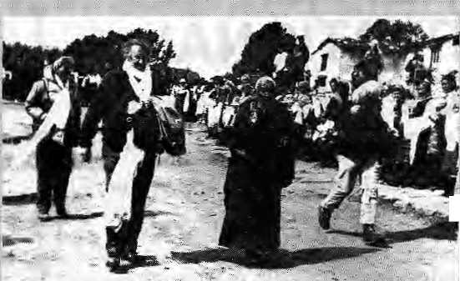


gtelevbioiipfogranMeforthe ^{m} a'nriiVefsaryWeeTc) were .' ^ surviving.member of .1953. ■■■■■. = .-g expeditjo% incjuding Bord Hunt. i SirEd, George- Baiide, Mich;ier : We^tmaccitte., Ctiaties Vylfc C . .. ....aniGe.orgeLowe. ■■•■•■,-.. ■;:■ ■ ■■■■■■
:_■■■■ After parties ^nii "
ftathmanduv the a three day
f eioriion ?ainp al 3C.ukia.iQji 2 ■■■
:April,Hillary and Huntwerc : feted by the Attoot of TengbbcheGumbat where ftiey : pased for TV against tiie LJiotse* Nuplsebackdrop. ^{i;} :- _ ^{;i}
■ By 11 April,the ;""; [' "'[ septSgei^amns ii^ departed _{;i} "Nepal, to;lumup in late May in :: Eijgiand fojr therealtamasha. "Pie Royal Geographic Society; flje Alp^in6Cluband"fiMi -Everest.
What?
to otjganise a week-long series of sli^e shows, luncheons and conferences, one of which
^ in 1953, she had described ; thenews::of theisiiccess-ion ■ ^3horn616h^cria,: sc ooped: by:: Times man (later wonian —he . changed se^)_{f},"aslhe..:bes£,. . _{s} coronation presenfi .■■.,, In their commenldralive
organisers of the 40th attnivbrsaiy celebrations prclcrred not to bring up tlie live issues of contemporary \ Hiinakyan climbing^ Rajter, Oian vague denundatiorrs of pbltutibri and commercialisatioll * of the Himalaya,, which * everyone Saiowsf-of by now, it Would have been more appropriate to use the occasion to ^debate the strategies of eleanup, mountaineering equity, and use of new equipment and techniques: Instead; all we got "was a mushy reErospeqdve.
Dtpesii Risai

A Spiti Iconoclast
... : ■ ....' . WL. ■,..,-.■•'": : ■' :' ' '"-" ■■■■■ ■■■■ ' ~r ■■■
t we would g&f&r front the madding ctowit,
Tfiougtu'so ifye^{l} madding crowd'too, Tkougfa Zansharwma'new
discovered* land',■
fhdugitt so the mtidding crowd, too,
Z
anskar down: La3afch down. Mustang Down, Manaslu down. Notf* it is Spiti*s turn tpsubmit itself to the ; voracious Tmirisni Beast Deihi-based activist Shubesidu Kausik. who penned the verseon Zanskar,isdetermmedtoraise a stink oti= Spiti;
As die formerly 'closed* valleys of the Himalaya are ftuiig open 'to tourist?, it seems that we are condemned to repeat mistakes endlessly. And how
could it be ortterwise, when 6frlci|jSLls froirt Tibet, ftepai, - ^£.have never.
, :. .. Spitiis&valley ■ , ^. . . btadiietedbetween Kimiajr on : diifc entl and. the Kiiiiieajii La arid Lahatil on the oiher. Tib wad fromShimb andCinnaiir . . (he-vaiieyand trav-ejs
. Man^li.arjd beyon^.jTfeB! Valley : has a population of aboutten ■. thousandand
Utilike Lada^h ;
' Spiti had reniained irelatively isolatol because;iLfe^l;within the Inner Line. However^ the area was opened in the Summer of -: 1992, andthe^{kL}madrush''began;
_{t} a- y cm TJiird.:World. ...; ■■, ^ -
tourisnx from iBattipilore.iKausik <■ ksaysi.:**ThSpeople ofSpiri ought
to prefjire" themselves fpr touri-, sni 4dfore,things-:g€t out of hand,:
Tiiey inusf linage sure that if tou-^risni is irteyiiablo.as it seems to
be, itsili effects Should be
nidniniisetL aM its gopct effects
(moh^y, that is) should not be
Mphpnedoffbyojuteide
ageacjes," -. ■■ ; :. :
uppri Sjjrase;lf to study tourism's 1. impact on Eesoarcesi lifes^lesv : eccKKimy trtd ecology of the valley. But.he wants to do: things differently: "I mtend to collaborate extensively with individuals and organisations that have th€ ■ ihFonTiatrort, itripwl^dgeor expertise that I might need as 1
go along, but t want *to work : esse&tiaHyalone arad in my own : way,, which is di«racterissed: by dowrt-to-eatth informality, by fre^doru |rom strict schedules and, quite importantly, a f^'edpmfrprn accountability to aay organisation or individual."
Kausliikr "thelunairig source or sources will have to rely on my integrity, for I do not irttend to have anything lo do with accounts. All this might "sound quile strangen.even unreasonable, but that js how itis,'!, : Grant-making agencies -arefarelyCdhfrOniea with stich audacity. But then, perhaps . atypical proposails are what we need. To test his ease, wite io; S: Katishffk, G-4CM Somvthar Apartments, R.KlPiirarrt, New Delhi 110022.
May/Jim 1993 H1MAL . 3.1

NEPAL
INTERNATIONAL
CLINIC

Hours: 9:30 am - 5.00 pm (Sunday through Friday). Vaccination/medical advice available even on Saturdays.
Please feel free to call us at
4-12842
Phone/Fax: 977-1-419713
-*- Nepal's Leading Institution in Travel Medicine
-&- US Board Certified MDs
-M Staff has over 15 Ifears of Work Experience in
South Asian Diseases *- Highest Standard of Clinical Care and
Efficiency -*- No Hassles
* Free Advice on Altitude Sickness, -& Convenient Location (off Durbar Marg,
opposite the South Gate of the Royal Palace -
see map below) -#- In Operation for 5 years

LAZIMPAT
I L
o
ROYAL PALACE - MAIN GATE
I L
SOUTH GATE
NAXAL

I r~
KANTIPATH I I
DURBAR MARG
I I
BATHS
CINEMA
HALL -
2nd gate _{Jai} _{Nepa}l

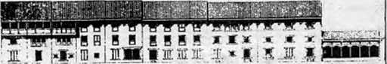
we accept alt major credit cards.

WE WELCOME YOU TO THE HIMALAYAS!
HIMALAYAN EXCURSIONS
CP.OBoi 122I.Kc(h«Mih.l
p T«l: (O(41MI>7. (H) 410112
Fax : (O^CQ-977-1 ftifll la :(H)0O-9TT-H 11913 Th: 2G JS SHEAPA HO
WE ORGANIZE: TREKKING AND MOUNTAINEERING EXPEDITIONS IN NEPAL. TIBET AND LADAKH PLUS WHITE WATER RAFTING, WILDLIFE SAFARIS AND SIGHTSEEING TOURS IN THE KINGDOM OF NEPAL
NOT BY WORDS
ALONE
PRESERVING NEPAL'S ENVIRONMENT AND CLEANING KATHMANDU'S
TOWNSCAPE NEEDS STUDY,
COMMITMENT, ORGANISATION,
DEDICATION.
LET US ALL WORK TOGETHER.
N A N G LO
DURBAR MARG
Pa BOX 4384, ITEL : 223498, FAX : 527865

BRIEFS


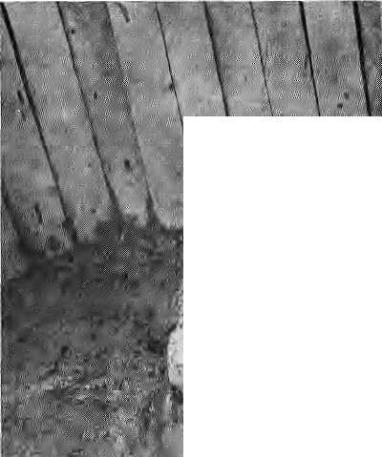

Selliag Gift Rhinos
Baby rhino from Chitwan being mailed to Frankfurt Zoo in March 1990,
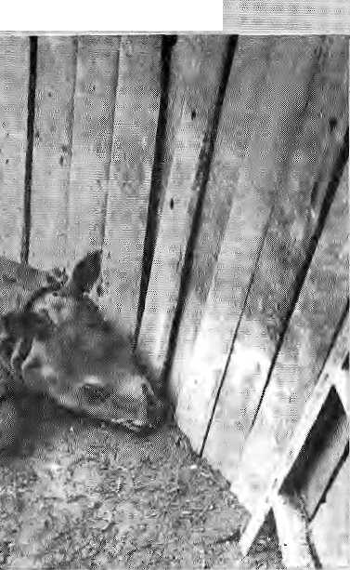
TiityCptfimanrfu Pox! daily .. broke the siory, but nobody k\& picked it up; more rhinoceros have been gifted and ■sold by fhe Nepali Government than have beeri poached between the years 1980 and i9<32. So it turns ouL that while one hand of the Government goes about organising conservation and ami-poaching programmes, the other merrily goes about distributing Thirios.
Wildlife specialist Prajad Yonz.oh, who blew the whistle on the.rhirio scam, Calculates that two rhinos a yeat Have been exported during the two ;'' years of parliamentary democracy, "whereas the earlier average was 1.-8", Asks Ypr)zoii, who was recently inducted by Prime Minister Girija Prasack Koir&la into Nepal's National Environment Council* "Why should Nepal take-the contract to stock wild rhinos in
zoos around the world¹, ^{v;} ^ *■
especially when theChitwati ■■■■
rhino population is only35Q and
the eaixying capacity is 500
...animals'?" ■ ■■■■ ■ ■■.■ ..,-. ......
The most recent deai-in- . making is between. the Nepali .Government and theStu.t.tgar| Zoo,.-which js said to have: 'ordered' a female rhino calf of 18 to 30 months age from the RoyalChitwart National Park. A-ccording to sources in Germany, some Nepali and . German collaborators have, designed this export to appear as the theme exhibit for the r-omiiig Nepal Festival :be.iqg prganised = |h'Stu[tgartin&ly,,ater wlncfi ::-the calf will |>e moved to the
If anyone was expecting : ClfES.tostop^{v}Nepal's;lavkh" f : gift-giving, past experience has
shown that. this, lrjteffiatiofial .:. .....
treaty prohibiting trade irC
endangered specjteghas not ... ...

re s trained¹ the Government. Arid
gift-giving either — ... .., "... '.' K ath m andV V. v etnsicu 1 ar weeklies have.repGrted... ,th.aUh.e gojng rate for-Nepali ... female rhinos in the past has
JbeenU$ 150,fKK» each. ".. 1 " 7;
... .:.. ........ ..... So the question arises .. ..
whether Nepalis exporting rhinos to spread the gene poo] of an endangered species internationally, as is sometimes elsmed, or whether it is simply the money involyetjr
: .;. GerrrtAn xoos already .
have two Eemale things / from-Nepal^apd: tKerfe seems to be little need for Chitwan. to Jose one more. -As-fai" as:: ,,. ,„' genclit; enharicemeniis ■ coiieemed,.."Nepal's rlpnb do noi need iaiy he!p," says
.....Y.pnzqn, The genetic vigour jot.
%he Chitwan rhinos " (measured in terms of
, "Jiejero?ygosity") is high... .. .
compared to pjiherild^i he maihtahis.

Some 26 Asian and .international activist groups were gathered in IVlaniia during .......the. first week of May to exexl
pressure on the Asian Develop* nient Bank, concei-ned about¹ projects which they say bear heavy social and environmental costs. The occasion was the annual meeting of the ADB's governing body.
As expected, there was some name-calling. Said Jim Barnes of the Friends of the : Earth (USA), "The ADB, me , World Bank arid the IMF are [ batiks; they just pretdidto be ■«■ * development institutions. Tliere is a basic flaw m'their structure. The ADB has some honest and Well -meaning people, but we need to stiffens their spines." : ...:.. So was theAUB put on
the defensive? Hardly: The ] reason was that the groups that
were gathered at the Bank's I swank new premises to protest
its policies have themselves got ■ soft around tlie middle. Each*
Jias a pet project, does little : homework on the many countries of Am whose NGOs ,do riot have international reach.
And so the Asian and international NGOs present in Manila stuck mostly to protest thermal power plants in the Philippines, deforestation in Indonesia, and commercial forestry in Bangladesh. One non^Nepali NGO representative did tentatively raise the question of Nepal's Arun III hydropower project, which has reached a critical stage in decision-making. Bui when a senior ADB official, a Pakistani, claimed grandiosely that "The Arun IJI is a project that will 5 take Nepal into the 21st !| century.'⁷ there people who F could throw him a follow-up quetjon were four thousand miles away in Kathmandu.

May/Jun
m H.IMAL . 35

Refugee Children

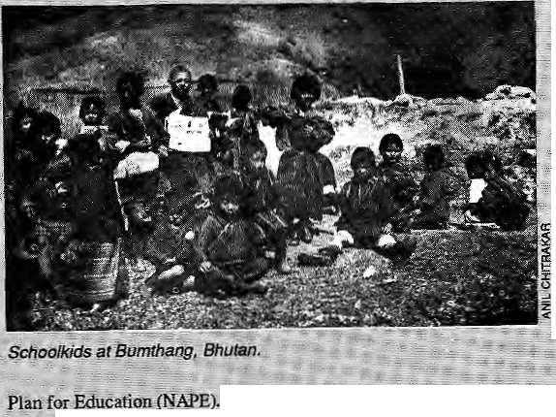

T
he most forward-looking ; education, in Nepal is being carried ouUoday, not In theeltie ediicajional institutions of Ka£hmandu;bat: intHe ovev-- " crowded and resource^ : : ,:■ schools of Bhutanese refugees, = ■= 1 X Some background; . jAriiidst the lethargy ihatafflicts pnrnary education all over^{s}South ^{s:} Asia, Bhutan has emerged as an jeXiieption, While more thto a hundrdd million cjiildren all; over the Siibc-otttinent gib about mew regimen of prescribed unimaginative rote learning, the ; cliildren ofDiiik Yular.e / ■■■■ i
- benefitting from "child-centered
Education". Innovative;teaching
- and curricula that moves with
the;times might have been I'
introduced in a handful of well-:
entlbwed schpols in,the other
countries of South Asia, but iri!
BKutan'they are being applied
countrywide, under a
programme tjegun in 1986
known.as me National Action :
Dirty Alps
j vy.orld's dirtiest mountains are not in Nepal's himals, in case you thought so after reading endless wirecopy out of fCathmandu. The Alps have that dubious distinction, particularly due to toe filthy surroundings Of Alpine refuges^ which are huts used by jcumbers and hikers to bed down for the night. The piles of excreta and trash that are to be found next to these refuges are said to vje with legitimate mountains for height.
A conference on "Alpine Refuges in the Year Two Thousand", held recently in Trieste (Italy), provided occasion for handwringing. Said one participant* "The refuges
3* ilirvlAL . May/Jun
... The programme wa? ■ started asa joint initiative:of,fiig pepai1inen_{v}t of Education!and ..; yol^fiteer organisations troift ■■:■■ Engiatid,irelandandNew.; ;; -Zealand. Begun as a pilot- ..... i7 project ill a limitsdtiumber of schoolsv and involvm^intettsive;' teacher training,; HA^E sppgHt to prornote;"Iearmng t
today dot the valleys and j
and' even some peaks in the Alps
risk losing their original ::

participants ftomtli^ Alpine Clubs of Italy, Austria, , Switzerland, France, Germany : and'Slovenia ^aid they were eommitted to>preventmg "alpine -tourism from; bfecomingthe / ' tourism*of waste''. They signed : a document pfoposinga new ~, basis for running lite refuges, ;= promoting alteranative enerpy" sburees, less use of iim and ..7 packets, and carry-out policies I for trash. On the whole,tbe refuges are to be more "spartan⁷'.
There were 16 thousand trckkers in the Khumbu in 1992, And 40 million tourists visited the European Alps the Who produced moretrash?
providing rei soutcevnjateriafe in, i
pl
"among children. With the- ■.,. „ . pregramrne's oiitial success^ it ; ,Jib^ now been;e|teruJed _{v} " :"^{v} ::- ■ ■■ countrywide. '/ y " ■.■; .,.. I T
Refugee schooling was initially begun in Ihapa by J ; ^untrained teachers, mostly '= ■■. ■:■:. members of the §hfdenis Ctiioh: of fihuLani y/ho picked up the* .,.. ; curriculum and textbooksofthe local Kaiilcai Boarding School. .;.;. But as quaiitied educators and '■ school ^dsniui s tjatbrs fled Bhuiari and amyeid hi the camps, mey were appalled by the| level of primary education in Nepal and worried about the step-down invplved for refugee .:.. children, particularly those ivh'o ;had 6een e|posedjto>f APR ■■■ .. 'The situation in. the .1 local schools aredire_{A}Tliere is no-comparison between education in Bhutan.and the educatiGfn^t have seeniriNepali sclibois;" says a British Volupteefwho has worked both-in Bhutan arid the Jliapa camps '^{L}We were' shocked with what we Saw in Nepal," concedes Bala Shaiina, Ihe ooly woman among the 18 District Education Officers of Bhutan before she came out in January 1991. "We have found a
dramatis; difference between ric^rfl arrivals who hadv_{v} Z ;; imdergOrjie the new education and traldrenCwho;had arr|ved;■■■■
) of the i , *
: relief agencies UNHCR aintt CARITAS.Sharma and .... [ / coilea|ues have set about trying SfAPEtotherefegee, ■.," ; - under exGrutiating ■■• _{t}, ds. NAPE pres|pj»oses.4ie' availability erf teaching; aids, T * ^{j}; appropriate educatioiial material, ° 7 snrallclass^izei none of which: :
abk; jh t!ie camps, ■'■■ vhose: educational programme "lacks even a photocopy ;niachine.v .,' ^{v} :- :,. ,. ', ' ■■■ ■
... . Says Sharjma,^We are trying pur best to adaptto the. ■circanistances; and it requires superhiHnan effort of out teachers." The maximum ■, allowable class size in Bhutan is' 35,:she.'says-, whereas in die. * "camps teachers hayetotake ■ ; classes of uptolOO; and then * "too teach in shifts. * '
There are sixss^ipols in* the*Tefiigee'camps, aiid 23,000" students^ wltli a three shift system in the largest three ■ schpols. Of the 300 teachers, 70, ate "N APE-qualified" from .Bhutan.
In January, Shanna and pltshCummings — a volunteer trainer who has worked In Bhutan —organised a training programme come up with strategies adapt NAPE toxefugee conditions. They discussed teaching' ever-crowded ckssrooms, adapting" local ihatetials as teaching aic tttilising,the inadequate textbooks available in the Nepali bookshops for innovative teaching. Shanna and other refugee educators are presently engaged in developing a syllabus and curriculum that follow Bhutan's NAPE philosophy - as far as possible.

BRfEFS
Goopy and B#ghta by the Bishnumati

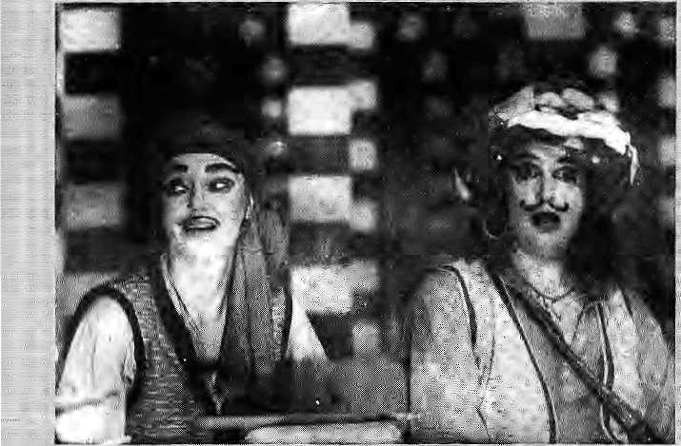
Nach:
<rhar,;with productions by
an
for relief; reaches for Sariity With^StudiHS '. "'.. Seven. Most...... .. ;■.. -.-. ..-..■■
remarkable is the development of young fewar actors whose ability to cha^ge^geai^ between^, classic dance and :
If the Himalayan region, has: : anything on offer that can be called innovative modern '",. ; theatre, it is to be- found at the Vajra Hotel, .the retreat by the Bishnumati River. A couple of times every year, the Vajra troupe known as Studio Seven
Ludmllla Hungerhuber as Bagha and Sabine Lehmann as Goopy,-
puts yp perFoitriarices that are ah unsejfconsciousinixof Western : d/ama; classical Sanskrit, |n& : :. Mewar modernism. The shows¹ arc directed by Sijbine I^ehjnaijn,;
Kathmandts's stage, ■ which ha$ long siilfprgd from over-asted Nepali melodramas
impressive.■■ ;;; -:- * Particularly...' ,, ..... ..........
noteworthy is the Versafile ftajeiisdra Shrestha,who^eeps the audience riveted
,. ..' .... : In Aitmmri J992,1 Seven presented a rendition of a?
about the mythical origins of ■JCailmanda yd%rFolfpwfe£ ; Nepal'Makaltnya:i the troupe was casting ar«uncl ffjr its next production. It so happened that Lehmann's husband Mid fellow
player Sangpo Lama fell aslfecp while: taping a Satyajit Ray .<■.■ T^Wspective on India ^{T}s Dorardarshari. The next marning, the family discovered dial it had on v ideotape a failslength (jOopyGyneBaghq Syne, the :; fovabie story afeout a bad singer and a ■vyorsp drummer in ancietit ^Bengal, who r-eceive three bbdjis
from tlffi King Qf Ghosts. ... ,;....
Studio Seven anglicised andnepalisedtheBengali story, adapts Ray's lyrics, and wrote
performances were put up during three weeks in Aptil, all :£oo few for the effort that went into the production, And therein Hes the rub. Very few get to watch what is. jr6bably the test of lEmatayari ^leatre over at ^& Yajra. Katiimandy folks by and large do not evert kticSw of StucSo Seven, and there is- as yet no means to bring productions like Nepal Makatmyata alargep Valley aiidience. And hove ^rand; it would be to stage the Nepali , story of Goopy and Bagha in ' Calcutta!

Nuke of theMorth
Now we know: Tibet has been used by Beijing for nuclear weapons research, uranium mining, dumping of radioactive wastes, and the placement of nuclear weapons. The confirmation comes in Nuclear Tibet: Nuclear Weapons and Nuclear Waste on the Tibetan Plateau, a 64-page report prepared by John Ackerly, Director of the US-based International Campaign for Tibet. Ackerly presents details of what till now has largely been heresay on China's nuclear programme and how it
concerns Tibet.
of
China's early nuclear bombs: were built in the''Ninth Academy¹', a top'securtty research and design facility based in the Haibet Tibetan Autonomous Prefecture in Qinghai (Amdoj,
On me whole, Ackerly writes, "There is little doubt that China's nuclear program has had aninordinate impact on the Tibetans, the Uygurs arid the Mongolians. JProm land appropriations, to.nudear fallout, to toxic and radioactive pollution
jn riyers,; lakes and pastures, the
•story aboui the ugly side-effects
;■; of Chma' s nuclei* programme is
just beginning Jo-emerge." " *
I Accprdbg to Ackerly,' "Geological bad juck.put the ;; largest cbmmercialiyiviable: uranium deposits in the Tibetan , plateau." Uranium continues to •■ be mined miwo main sites,; ; : which arcin the Gannan Tibetan : Autonomous Prefecture in Gansu Province and Hie Ngaba : Tibetan Autortprhpus Prefecture i:n Sichuan. The largest uranium ■ deposits are actually said to be aioundLhasa^but so far these have not been commercially mined.
Therepoit says that the
: stationing ofhucleal' weapons in iht Tibofaii region began in 19-71, when a-DF4; China's first intercontinentali ballistic rijissilp, arrived in the Qaidam Basin*. Nuclear missiles are presently said-to be deployed at a >
' mminiuni of three sites'tn Qinghai. Ackerly was unable confirm the siting of land-'btised missiles in the Tibetaji Autonomous Region proper,, (When Beijing claims that Tibet is "nuclear-free", it is not
: refeiTing to Qinghai, whieh falls outside'the TAR,)
There have been no reported nuclear tests in the Tibetan region. These are done in Lop Nor, in Easi Turkestan.

May/Jim 1993 H1MAL . 37

L4YA MEDIARLE , HIMALAYA ME DAI FILE ■■.. HiMAilAYA MEDAJFllE a HIMALAYA MEDIARILJE I MMALAYA-. .-HIMALAYA MI.PI&FJL1 . H!MA

What docs the U.S_{v}Federat Bureau;of Information think is the ideal weapon for flushing outcultleadersfrorri their
;; hideout's? If you gtiessed theM 16 rifle, stun guns or tear gas, you're, no Dick" Tracy. The FBI beamed Tibetan rdigi'jits chants in. high volume over the public address system, at thi
■ complex^ Where David Koresh and his , followers were holed up in Waco, Texas. The droning of mantras: contihuedall day long and till 3 in die morning/but Koresh seemed to be tujiedoffdharrra and the experiment failed. Ho* that its secret weapon js oui of the bagi the PBI inust^{s}come clean and publish the research which njude it Conclude that chants which have served Tibetans well over a thousand years an; good for .flushing out kooky eultists. Tibetan Review reports thatiheG -men initial ly thong ht of serenading Koresh witha popular American' country folk tune^ but decided lo go for the chanting, as it would be more annoying. Aire we to iaujjh w to sry?
Bicycling ladies are pati of a social movement, writes P. Sainath in Tim 77mero//ndw.The bicycle has brought freedom"and mobility to thousands of women ofTamlNado'sPudtikkottai district. The good women of Pudokkottai did not even care when once there was a shortage of ladies cycles; they hopped unto the cross* barredgerits'withequalease. "Cycling offered a way around male-imposed barriers " writes Sainath. Which leads one to the conclusion that the women ofChitwanDistrictmust be among the most liberated in all Nepal. This Inner Tarai, or doon, valley has a generation-old population of highly politicised and progressive homes leaders, And the women of C hitwan c ycl e as if there were no tomorrow. Pudukkottai and Chitwan should exchange notes^
More on the neglected Indian
.. Northeast r*?Tim«Q/7«d&j reports that Surendra Nalh Dwivedy, Chairman of the Northeastern Coiind] (the "high-powered nodal planning agency" for the region) has slammed the Union Home Ministry for stifling development activity through lack of attention. Dwivedy, who is also Governor of Arunachal Pradesh, said many projects had been held up due to the Centre's inaction, and the people of the Northeast were feeling frustrated. At a recent meeting of the
Cou ncil, rspresen tati ves of the smaller states of the region - wanted the 20* year-old Council to be given more -poi^ret'td allocatefund| and to takeup ■ schemes \yiihin the outlays fixed; by thePianning Commission-
The mountaineering media had a
busy Spring climbing' season, ■ wJiaf with the fortieth anniversary o£ ■ y^u-. knQw-what; :: the deaths on j Ghomqjongmi andthe endless stories ... about tjash anjrt overcrowding on the :■:■. mountain* Editors from Vietnam to: : the upper reaches of the Aitiazon Reyer .tire of mountaineering news, so if ' you're a Katmandu stringer low: on ■ riews, all you have todo is^ ctiuinout more; copy on trash and ov«rerow&ng on the, niouiitain. Only two articles ; keptmycyes from completdy glazing¹ over, one a t^iprt quoting Bofnbay alpinist Sharavati ("Sh^ru") Prabhu (who climbs with Doug Scott), who wondered why the Indian Goy ernmeint wasT wasting one crore rupees per expedition oil Chorpojongrnajusi to tabs the"yycroute" and easy dfudgetp the summit. "Only in India do people still think it is a feat to climb Everest by the South Col," she said. Iri die other piece; Sir, Ed Hillary got a mouthful from two Down Under sumifatteers, who felt that he was being :: awfully patrorusing as he went about herrioaning tVie loss of ehjvalry in fliei dirnbing ofChomoiongma.
Kthnic cleansing is toeterm the 1993
the treatment of -'ethnic Nepalis" ia B hu tani according to a.PTI ieport from Washington DC. First it was the IrilcrnationaV fleraid Tribune that slapped the term on Bhutan in a' headline, then the BBC WoridService magarinei, an^| how this, jt must tse enough to make the Thimphu Gov eminent, or its watchdog embassy in New Delhi, see red. With journalists resorting too quickly, to the term to describe complex phe nomena ail over, the term is already losing some of its power to hold-the reaifer*
And so to clarify matters,let us refcrto the delinisiqn provided by columnist A.M.Rosaithal in a The New York Timei;articleenmle(i"AModd: Ethnic Cleansing, in Tibet". According to Roschthal,^ Ethnic Cleansing comprises (in synopsis): lemoyalofas much of the indigenous population as possible without destroying the native
i nfras Criictureu ntil i t can be completely replaced; destrticSon of native civic and rcjigipus officials; destTUCtipri of most pUces " 0f mass -reJigious obacrvatipn;. bamiyng. of teaching of., jocaj jajigusige-to naximum practical extent; strict regime of pciiitical repression, with usna!" methods oi imprisj)n|nentand pa!jtlpaj persuasion; longrjangjs introduction from cleansing nation of-its own citizens until they-can tsks dismograplpc. or ■^qjnpmicxpntroL
"We want onl-y :a few but high-spending twiirists: Wearc defirtitely aiming for upmarket clientele." That havey been the Director of n's bepaitment: of Tourism^ or the Raja of Mustang.: It was actually the Commissioner ofTourism for Aninachal Pradesh, S... Rag h u nathan. AcCordmg: to peba-shishv (jlunshi"oF J'O/,thestatBrOTdenrigBunria,Tibet and Bhutan -'abounds ifi show -white
'rivers, tf|tr hills; lake^, ridges and , valiey«"i,1%. m$it be hard jo attract tourists ito ArunacHal: selling ^loSe attributes, which do apply to every other spot in the, Himalaya as :well. Any way, Ragh urtathan hasset a targe t of 500 fojrcign tourists for the current year, With an expected tariff of U$: 200 pcrpax, AtidmarkmRe for Environment friendliness, Arunachaj willnotpermif tQiirists to lug in plastic — "only
• bamboo baskets will be'alfowetl to be carried. The toiiriste are expdited to coiiie in groups arid stick to the main
A team of experts from Luckpow is ia ^adakh rcstu/lnggumbas, says PTI, but only after they convinced the AU •Gumba^ Association that they were not out toriib Ladakh of its artefaets. Afrparentlyi a nurnbei'of agencies had in the past carted out valuable thankas and manuscripts^ while others had de stroy ed muralsthrooghham-handed restoration: The lamas of l^adakh took some time to jie convinced of the hona fide of the LuclqipW-based National Research l,aboratory Tor the Conservation ofiCultural Properties, and its experts have now surveyed all the 40 odd gumbas of Ladakh and "convinced thelamas thatnot a single object would be taken away," according to the agency's Director.
Tibetologi st Robert Thurman rece ntl y challenged a large audience of scholars of'South Asia to reconsider the
significance p? Tibetaii studies for
South Asian studjesiis a whole, reports a newsletter ftom. Columbia University, fleyvYoxfc India's support for Tibetans in exile was ''fitting", he sa|d,"Vhen we recall thatTibetans, vpreserycid and fostered Buddhism _{t} 'during th^ jichtaries' when it had-virtually disappear^ fromlndi?." A,
■:•■ treasiirc trove of Mahayanti Buddhist tilerahro in Sanskrit, jn*ticuloiisly preserv«d in Chinese and Tibetan translations, awailied recovery. Such testoration shodd be a priority for Indian studies, argued this professor,
; because it ts "the key to unlock the HI. splendour oflndian studies. *'Thurman warned that East Asian studies were outpacing South Asian studi'b in the L!S, ^arid: urged sch61ars to try and undersiaiid whyi
MoreqiiTibet asl turned oh fheBBC Worid Television. :Not politics, hot dhanna; but high fashion^ Wendell Rodericks, a dress designer, was busy unveiling his Tibetan Collection. Claiming to haV& received some sojt
; of blesang ftorh the Dalai Lama, Mr. Rodericks, as designers, are wont to do;^{Y}described your basic larna colours as "active ycllgws, maroons and browns...just the colours for the 1990s;" There was -even a; "nuptial-motif" on display on lissome;bodies, and the narrator intoried oniho¹^ fascinatingly the crepe timics had succiesded in interpreting the Tibetan -ambience. While appropriately carried
"awayby thecrepe tunics, fashion critic Aiiseeta Bajaj granted, that "I don't, think most of this fashion will trickle? down to the market"
Tpdeiy reports that the major conduit for wildlife contraband departing from South Asia are Partt and Katntnandu airports. Illegal fiir traders, of course, have long found safe haven in Kathrnandu, where they can blatantly exhibit their wares right on Durbar Marg. Bhutan, apparently, is catching up fast as a favoured transhipment point, This has to do, apparently, with little controls, and the ease wi th which coa rraband can be smuggled info Bhutan from the Duars arid Assam. Paro's direct airlink with Bangkok makes the iuroort especially attractive to traders who are emptying the Indian Northeast of wildlife.
- Chhetria Patrvkar

38 HIMAL . May/Iun 1993

REVIEW


How To Develop the Himalaya in
Four Easy Steps
The book proposes a technocrat's model for eco-development. It does not touch base with the villager.
ACTION PLAN
FOR HIMALAYA
The third is the often times admitted lacks and uncertainties of Himalayan data. In Uncertainty on a Himalayan Scale, M. Thompson, M. Warburton and T. Hatley suggest that the latter two are related — that the differences in data are caused by differing perceptions, notions, cultures, etc. of the constituencies involved. They argue that, under these conditions, two models suggest themselves: the Tinkering approach and the Grand Design. The first builds on what there is — facilitating and empowering people through new technologies, processes and institutions and if it goes wrong (as it sometimes will), it cannot cause much damage. The second seeks to supplant whatexists with what "should be". If it goes wrong (as all things sometimes will), it can cause major problems, even disasters. And since perceptions of what "should be" vary, it will cause major problems for at least some people most of the time.
Thinking about Thinking
The 1980s was a crucial decade for thinking about thinking on the Himalaya. Part of this brain activity was transmuted into two key institutions. The International Centre for Integrated Mountain Development(ICIMOD) was initiated in Kathmandu, and India began
Even the bada sahebs of development community would acknowledge that development of mountain areas proceeds along a somewhat different course than that of the plains. What these differences are precisely is a matter on which there is less agreement. After plethora of reports around the "Rio process", including the State of the World's Mountains document and different country and subject-wise reports, those differences persist.
Part of this is because of differing perceptions of development itself: is development "human dev elopment" as defined by UNDP, is it weighed in terms of productivity and income, or is it calculated by substitution or supplementation of mountain subsistence by the market? Do these differences imply different goals or are they different ways of measuring the same thing?
The second reason is the differing perception, of the various actors involved in the development of the Himalaya: scientists, planners, engineers, foreign donors and their consultants, the independent sector, local communities, etc. None of these, on their own, can define development for the Himalaya, yet all of them are involved init in some way or the other.
Action Plan for Himalaya
Himavikas Occasional Publication # 2
Govinda Ballav Pant Institute for
Himalayan Environment and Development,
1992;Kosi,Almora
by Sanjeev Prakash
an indigenous clone, the G.B. Pant Institute forHimalayanEnvironment and Development, m Almora.
Two alternate conceptions competed while the G.B. Pant Institute was being set up. The first involved a decentralised structure in each region of the Indian Himalaya, with networking facilities for planning and communication. The second wanted a hierarchical institution with a central office ,and branches in the other states. The first was the engaged scientist's approach, while the second, the interested bureaucrat's. It was the second model that won, shaping, in a sense, the rutureof die Indian Government's thinking on Himalayan development.
Now hang on to youT Himalayan topis¹. ForherecdmestheG.B.Pantlnstitute's/lcrion Plan for Himalaya. It proposes cleaT links between research, demonstration and what it calls "extension/execution", and includes a matrix of actions, "existing" and "desired", for different constituencies.
As a contribution to the Himalayan development debate, thisplan serves a purpose; as a basis for the eco-development of the Himalaya, it is somediing else. Nevertheless, it is useful if only because it offers an insight into the state of official thinking about the

May/Jun 1993 HIMAL . 39




HIMALAYAN INTERNATIONAL
P.O. Box 5133
Jyatha-Thamel, Kathmandu, Nepal
Phone:2-25455, 228998
Fax: 977-1-220143. Tetex: 2669 GLOCOM NP
I. MEDICAL CARE IN A WESTERN SETTING
2- CARE BY MD.. GENERAL PRACTITIONER, CARDIOLOGIST & GASTROENTEROLOGIST (CANADA, UNITED KINGDOM.USA)
- ALL TRAVELLERS VACCINATIONS AND FREE VACCINATIONS
ADVICE AVAILABLE
- MODERN LAB FACILITIES
- X-RAY FACILITIES
- ENDOSCOPY AND ULTRASONOGRAPHY FACILITIES
- INFORMATION ABOUT ALTITUDE PROBLEMS
- ARRANGEMENT FOR SPECIALIST REFERAL
- STANDARD SERVICES AT ECONOMICAL RATES
- CENTRALLY LOCATED AT JYATHA-THAMEL (IN FRONT OF
HOTEL BLUE DIAMOND) IN KATHMANDU
II. OPEN ALL DAYS, 9 AM TO 5 PM
12. PRIOR APPOINTMENT ALWAYS WELCOME
THAMEL
HOTEL BLUE DiAMOND
□
HOTEL
NEW,-. GAJUR LJ
IMMIGRATION
OFFICE | 1
SANCHAYA KOSH
HIMALAYAN
INTERNATIONAL
CLINfC
'ARKiNG
n
HOTEL UTSE
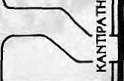

3HANCHHA GHAR

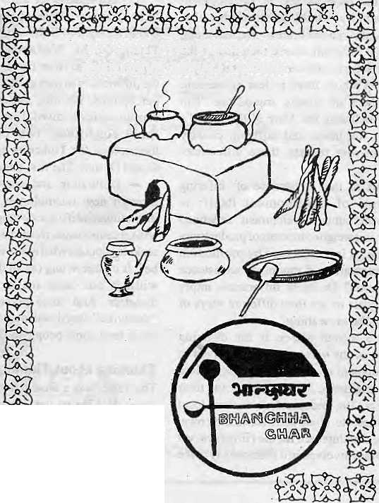

AT LAST, THE PLACE FOR EXCLUSIVE NEPALI CUISINE
Kamaladi, Kathcnandu Telephone: 225172
OPEN DAILY 12-10
Why
Macintosh ?
Why do people who use Apple Macintosh computers every day enjoy working with them so much/and find that they're much more productive in the process ?
Is it because Macintosh computers are so easy to set up, leam, and use? Or because Macintosh applications all work in the same consistent, intuitive way? Or because every Macintosh comes with built-in networking and file-sharing capabilities ?
Or is it simply because once people use a Macintosh, nothing else will do?
Every day, thousands of people discover the advantages of Macintosh for the first time. And catch a glimpse of its magic.
So if you want to know why contact us at MIPS.

MIPS Pvt. Ltd.
P.O. Box: 2502, Tel: 222277,
Telex: 2521 ATLINK Fax: 977-1-419250

REVIEW

If youliiave readafld#njoy©d Himal,here is. the.opp^H$uiiItyJ».erisure '■. that your colleagues to l&efleld andi cpunSeipart&alsa h^vs aecpss to the:. l:*-Jthrc^gh *^
to the* workersoi your organisationall ©v^Nepalpmdaise to your
cblteagL&rarid.counterparts; At2ffrupees a:c6py,;ihe digest is packed with diverge reaiSt^gi Ejhat j>rt>\Me a Breadth of relevant information , and insight not^^iia^leeisewherelntlie ivc-rld of Nepali jouijrtajis'm or ..a!cadernia..J¹tie:;Nepali Himal-provides the perspecyve.deveJiopment, workers :n«ed to understand their woirk'-and; their eown jtry> Previous digests,NepirtiHimal 2047 and2$4S arealso&vailabte.
For further details, contact the Mariagingpditpr;jfiimal; a:f 52"3&*5.
Himalaya in India, today. A typical excerpt:
One of the dilemmas being faced is the inevitable fact of the administrators {managerial staff} and the scientists {academic staff} working differently. It is, however, vital that they work as a team. At present this concept of partnership between the two types of institutions is completely lacking and this has further been aggravated by the prolific rise of the third Institution of a recent origin, the non-government organizations, which should have been the 'customers' of new technologies rather than becoming the 'creators' of technology and 'critics' of the government infrastructure. Their deviation from the main role of spreading the technology is creating and independency instead ofinter-depe ndency." On the prospect for people, the plan is equally dim. A section on roads: Road alignments should be worked out on the basis ofgeo-technicalfeasibility instead of the desire of the people, which is more often put forward and emphasized to serve political motives.
A Technocrat's Model
Despite its sincere approach to problems of scale, and its delineation of potential income generation scheme, such as eco-tourism, horticulture, bee-keeping (which many a Himalayan village has waited so long for), the Institute's document is a technocrat's model for eco-development. Its failure is that even where its proponents see the Televance of the efficiency-equity axis, they do not realise that it is different cultures and perceptions that are the issues.
And efficiency for whom? What is efficient for the fanner may not be efficient for the government; both may be inefficient from the perspective of the businessman. This involves scale, but also ends and paradigms. To give a very bad example, a bulldozer is of no use to a hill woman who wants to chop an onion. An axe might be. Both can be used to fell trees, in different paradigms.
But the main problem with plans like this one by the GBP, and the Grand Design approach in general, is that it fails to recognise the wonderful creativity of the Himalayan people in nurturing their harsh environment, in husbanding their forests and terraced fields sustainably, in raising democratic institutions. True, this is not invariably the case, butreasons for this state of affairs is one of the critical areas institutes such as the GBP should be
examining. The well-known failure of many people's institutions cannot be used to justify the technocrat's approach, for isn't the Himalaya littered with the debris of failed technocratic projects?
The Action Plan would like to see people as passive recipients of its largesse, not as thinking interactors shaping their own destiny. The fact that "the people" become "critics", notbecause of genetic predisposition but because of actions such as the GBP proposes, is an idea that never seems to have entered the calculations of its designers. As such, the Action Plan is illiterate about the possibilities of the very people it presumes to plan for.
The third thing that the authors fail to realise is that it is the task of institutions as the GBP to interpret the will of the people, not of some abstract, supposedly "efficient" Western managerial model—specially now, when the pure techno-managerial model is in disrepute across wide parts of the world, and is held as the prime cause for the environmental crisis. If, when they are unleased on the Supposedly "innocent" people of the Himalaya, the results of such plans are criticism, counter-pressure and lawlessness, (what the authors term "political considerations"), it can hardly be surprising. For politics mediates the process of development as much as its discourse and the preparation of this plan is proof of that.
Nowhere is there a mention of transnational linkages, so vital in a region as important as the Himalaya. The assumption is that the Indian parts of the Himalaya function in isolation from Nepal, Bhutan or Tibet. Nor is there any sustained analysis of upstream/ downstream linkages between mountain and plain, or within the mountain themselves. This, then, is apian that basically sees the Himalayan environment in terms of abstract policies and seamless national boundaries, rather than in terms of forest and field, mountain and slope.
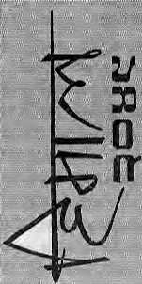
upstream and downstream, peasant and animal, all integral to theprocesses by which it survives.
More Litter
This is a document replete with current buzzterms such as "paradigm", "conflicts over natural resources", "sustainability ", but in way s that escape theiressentialmeaning.lt also lists an impressive line of advisors, suchasMadhav Ashish, M. S. Swaminathan, T.N. Khoshoo and K.S, Valdiya. One is forced to conclude that good advice might have been offered, but was notcompletely understood. And the merits of any document does depend on its authors, not on the quality of advice they might have been offered. This Action Plan fails to achieve what might have been its most basic goal: to articulate the Government's position on Himalayan development intelligently and purposefully.
This Action Plan will never be implemented on the ground. It is too simplistic for that. But it will mediate government thinking about the Himalaya, and may even fool a foreign donor or two. The mind-set it represents will simply exacerbate local resistance, causing more of the "problems" it ostensibly seeks to solve. Finally, it will add to the litter of information on the Himalaya: neither respected and credible, and completely non-biodegradable.
Which is a pity. For whether
administrator or scientist, planner or activist,
the Himalaya deserves better from us all. Just
as the processes of subduction and uplift as
well as of weathering and erosion have shaped
the mountains, so top-down planning must be
in alignment with bottom-up strategies in order
to work. It is time that India's high planners
incorp orated the shocks and tremors of ground
truth within their vision, uncomfortable though
these will be. ^
S. Prakash is Himal's Consulting Editor.

May/Jun 1993 HIMAL . 41

KNOW YOUR HIMAL

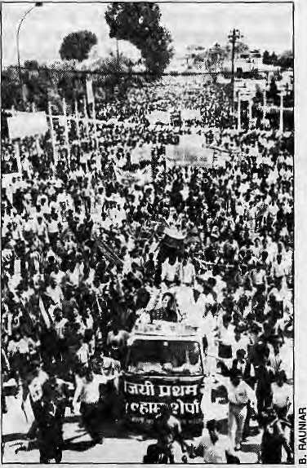
Pasang Lhamu
The celebrated death of a Sherpa woman climber on Chomolongma seems to have served the purpose of politicians and journalists far removed from mountaineering.
by Dipesh Risal
Overwhelming farewell.
O
n 10 May 1993,18 days after she had disappeared on Chomolongma, the body of Pasang Lhamu Sherpa was found near the South Summit. She had perished while on descent, along with her companion Sonam Tshering Sherpa.
There was public outpouring of grief, mostnotablyinKathmandu,forthefirstNepali and Sherpa woman on top of Chomolongma. In the face of growing criticism of the neglect of native Himalayan climbers (see NovVDec
1992 Himal, Mountaineering issue), the commemoration of Pasang Lhamu's achievement was significant. Atthe same time, however, it seemed that Kathmandu went overboard.
Tragic asher death was, there is general consensus among Nepali climbers thatPasang Lhamu was not a good climber. This was her fourth attempt on Chomolongma and the tenacity of purpose which eventually got her to top was to be admired. But as a climber, Pasang Lhamu's achievement was relatively modest. She was the seventeenth woman to climb Chomolongma, using ihe traditional South Col route.
Overkill of mountaineering achievement is notaparticularlyNepalifailing.lt is an international pastime of the mainstream media everywhere, which the mountaineering journals keep a stiff-upper lip about. When RebeccaLucy Stephens became the first British woman atop Chomolongma (a couple of slots after Pasang Lhamu), the hype which greeted her return to England bordered on the ridiculous. Only a little less grandiose was the glorification heaped on the Indian Women's Expedition on Chomolongma by the Indian press, even though the ladies seemed to have been helped to the top by a male "technical advisor". In this connection, the reported comments of Indian alpinist SharavatiPrabhu is worth considering. (See "Himalaya Mediafile",page38).
But if the British and Indian achievements were merely momentarily overplayed, Pasang Lhamu 'sdeathwasacause celebre that preoccupied Nepal's national consciousness for more than a month, and in fact was not eclipsed even by the subsequent deaths of Leftist leaders Madan Bhandari and Jeev Raj Ashrit.
High Profile
Why did Pasang Lhamu's case get extraordinary play, against the background of Sherpa deaths generally being treated as footnotes even by the Kathmandu press? A string of sociological factors seem to be involved, and this writer concludes that it has had to do with, among other things: Pasang Lhamu's high, public profile prior to theclimb; the vernacular media's limited understanding of what makes mountaineering achievement; the need of the political establishment to nurture a national Nepali icon at a time when nationalism is at a low ebb; and both the Nepali Congress and Left opportunistically seeking political mileage by displaying
sensitivity to ajanajati, hill ethnic, subject.
Theextendedandexhaustivecoverage of Pasang Lhamu's death and her funeral at Swayambhu could also be read as indication that the Sherpa community has become economically significant and politically strong enough to exact suchreco gni tion in the nation's capital. To the extent, therefore, that an "ethnic" subject was getting wide play nationally, there was some good to come out of the tragedy.
By and large, Sherpa heroes have been inarticulate climbers who climb as ajob. They have been content to let the Western climbers hog the publicity and the glamour of climbing. Past efforts by Nepali bureaucrats to peddle native climbers as personalities worthy of world media attention, such as in the case of the late lamented Sungdare Sherpa, have generally failed.
Pasang Lhamu represented a breed of "modern Sherpa" who had the ability to seek sponsorship (from San Miguel Beer/Nepalfor her last two attempts), conduct media briefings, make appointments with Kathmandu dignitaries, and go public with news and controversy that w ould c atch the public' s fancy. She was probably the first Sherpa to use the press in the way that many Western climbers have long done, some of them with the help of media consultants.
By the time she had gained the summit, therefore, the Nepali press and television were closely following Pasang Lhamu's moves. And when she died on Chomolongma's cold upperreacb.es, and when her body could not be located for days afterwards, the heroics and the pathos were readymade for the press. Forever having had to write about Western climbers on Himalayan mountains, a newly reportage-oriented vernacular media of Nepal played the Pasang Lhamu story to the hilt.
Originally,PasangLhamuhadplanned to climb with the Indian Women's Expedition as the Assistant Leader, but when that post was not given to her, she decided to form her own expedition — the Nepali Women's San Miguel Everest Expedition. There were two other womenin her team, LhakpaPhuti Sherpa and Nanda Rai, and several Sherpa men. As her's was an all-Nepali team, she petitioned the Minister for Tourism and Civil Aviation for a rebate on the climbing royalty, which currently stands at U$ 10,000, but when only a 10 percent discount was offered, she decided to pay in full.
Her husband, trekking executive Lhakpa Sonam Sherpa, who accompanied Pasang Lhamu to Camp HI (7300m), says the

42 HIMAL . May/Jun 1993

KNOW YOUR HIMAL

learn was not even allowed to take a walkie talkie set, because such sets are "controlled items" in Nepal. He says that the lack of such a set later hindered the rescue attempts.
First on Top
According to an interview given by Lhakpa Phut! to Rajdhani, a Kathmandu weekly, the original assault plan called for the women to try the summit together. But Lhakpa Phuti says Pasang Lhamu told her at Camp III (7300m) that she was in competition with the Indian Women's Expedition, which included a possible Nepali summitteer, Nimmi Sherpa. Hence, Pasang Lhamu would push for the summit on 22 April with the help of five male Sherpas, while Lhakpa Phuti could make her try on 26 April. It seems that Pasang Lhamu was determined to Teach the top at any cost, and as the only woman on the team. This was her fourth time oh Chomolongma, and the need to succeed this last time could have played a role in the later tragedy.
On 22 April, Pasang Lhamu did succeed in reaching the summit of Chomolongma, along with Pemba Norbu Sherpa and Sonarn Tshering Sherpa. Three other men of the expedition also reached the top separately that day. As they began then-descent, it is said to have taken PasangLhamu and her two friends five hours to make the South Summit, whereas for climbers in good form, that is a passage of about an hour. Since the team had left their night lamps at a cache lower down, they could not continue.
As night fell, Pasang Lhamu and her two partners were forced to bivouac on the South Summit The next day, Pemba Norbu descended to Camp II to get oxygen supplies for Pasang. But the weather deteriorated and he couldn't make it back to the bivouac. Over the next few days, in worsening weather conditions, there were repeated attempts to reach the two stranded Sherpas, but to no avail. Finally, on 26 April, Lhakpa Sonam Sherpa returned to Kathmandu, giving up all hope of finding his spouse alive.
The rest of the summitteers, meanwhile, went back to Base Camp to recuperate. A Russian team approached them and offered to bring down the bodies partway if they were allowed to use the route prepared by the Sherpas. With approval of the Tourism Ministry in Kathmandu, the Russians found the body of Pasang Lhamu and brought it down to 8,000m. From there, a Southwest Face Korean expedition provided members and Sherpas to carry the body to Base Camp.
Setting Precedent
Never before had a body of a climber been evacuated from that high on Chomolongma (8750m). That the climber's body was brought back to the capital for national mourning and funeral rites at Swayambhu attended by thousands of Kathmandu citizens marked another first.
After this episode, other expeditions too are said to be feeling the pressure to bring down bodies of dead members which earlier would have been left at site. The body of Tenzing Norgay's nephew Lobsang Sherpa, who died subsequent to Pasang Lhamu on Chomolongma, has similarly been retrieved from 8,200m, and a Korean who died below the South Col was returned to Base Camp and cremated. A precedent of Himalayan mountaineering seems to have been set.
The Pasang Lhamu case has also hi ghl ighted the issue of whether Nepalis should be made to pay royalty for climbing their own mountains. Although the Kathmandu press made too much of the fact that the Tourism Ministry had refused to waive the royalty required on Chomolongma (it was, after all, a sponsored expedition), the issue is bound to come upin future as truly amateur attempts are made by Nepali climbers.
A suggestion to the Tourism Ministry Mountaineering Section as it starts thinking about making policy would be that Nepali expeditions, as long as they are fully funded by indigenous money (itis impossible to mount full-sized expeditions without sponsorship), be waived royalty. However, Nepali climbers too must stand in line with foreign expeditions, and the first-come-first served rule must continue to apply. Foreign funders and "technical advisors" should not sneak into such "Nepali expeditions" for a quick hitch to the top.
If the newspaper men and women of Nepal look back over their coverage of the Pasang Lhamu "event", they will find that their concentration was on a rousing nationalistic story rather than on a mountaineering drama. For all the hundreds of column inches devoted to Pasang Lhamu, there w as no article which adequately presented historical, technical and psychological aspects of mountaineering.
And no one reported on Pasang Lhamu's climbing abilities. ANepali mountain guide who was with Pasang Lhamu on her 1991 attempt recalls that she "used to walk five minutes and rest for fifteen minutes" while up on Chomolongma. He says she had
neither the technical skills nor the stamina for mountaineering. It is also stated that Pasang Lhamu was not good at going downhill on crampons. The row between Pasang Lhamu and French soloist Marc Batard in 1990 was said to have to do with the latter's belief that Pasang Lhamu was too slow and engaged too many Sherpas to help her along, which was why he refused to allow her to go beyond the South Col. Back in Kathmandu, Pasang Lhamu went public accusing Balandfor discrimination against a woman and a native climber.
'Tenzing Sherpa"
hi many ways, the posthumous popularity of Pasang Lhamu harks back to the feeding frenzy that accompanied the first ascent of Chomolongma by Tenzing Norgay and Edmund Hillary in 1953. As Tenzing (then thought to be a Sherpa — he turned out to be from north of the border) arri v ed in Kathmandu Valley after a long trek from the Khumbu, he was swept off his feet, awarded the Nepal Tara medal, and hailed as a true Nepali hero, right up there on the pedestal with Amar Singh Thapa and Amiko the architect. But the moment Tenzing "defected" to India to join the Himalayan Mountaineering Institute in Darjeeling, he was dropped like a pariah.
The Nepali establishment had gone overboard with Tenzing, and felt let down by him. The song "Hamro Tenzing Sherpalay chadyohimalchuchura" (OurTenzing Sherpa has made it to the summit) quickly fell into disuse on Radio Nepal airwaves.
Pasang Lhamu also received a posthumous Nepal Tara. Her spirited sieges on Chomolongma have served to make the Nepali population generally more aware of mountaineering in the high himals. A sport that is so important to the national economy and which is the defining factor in the livelihood of the Sherpa community, has now received some recognition nationally as a result of her tragic effort.
It was probably bee ause o f the publici ty generated by Pasang Lhamu that Nepal Television was present at Kathmandu's airport when Ang Rita Sherpa arrived from the Khumbu, having climbed Chomolongma for the eighth time. Certainly, something worthy of national celebration and recognition.
D. Risal is Himal's Know Your Himal columnist.

May/Jon 1993 HIMAL . 43

Abominably Yours,
The Third World is sinking fast and we must act quickly to rescue it from the fate of other Southern alliances such as the Non Aligned (which had nowhere to go after the whole world became unaligned), the Group of 77 (which actually has 124), and the Group of 15 (an exclusive club of snobbish poor nations with 17 members).
But the traditional means of propagating Third World ideals are ff\tf({ now in deep disrepute. We could, for example, open an NGO to revive and propagate the grand designs of Nkrumah, Nasser and Sukarno, but NGOs have become un-chic

ever since the BINGOs (Big NGOs) opened corporate headquarters to rival Xerox or IBM. And grassroots activism nowadays is meant only for Third World cows.
So a few of us down-but-not-out Souihies have decided to keep the Third World flag flying by going commercial. We have incorporated "3-W", the new shopping destination for Third World knicknacks. Having tried and failed at imitating statism, bureaucratic centralism and the welfare state, we have adopted demand-side mercenary mercantilism. After all, liberalisation is the credo of the month in South Asia, according to Messrs Manmohan Singh, Mahesh Acharya and Om Bahadur Pradhan. The need of the hour is to cash in on the Third World before it loses all market recognition, or, alternatively, before someone else gets the idea.
So the next time you are in Kathmandu, ask the tempo to take you to Bhotahity, The third galli on the left, second doorway to the right, through the dank passageway and up the narrow wooden stairs. Welcome to 3-W, Store of Third World Trivia, registered, trade marked, and
The.

with a license to operate from Balochistan to Nagaland.
Excuse me, kindly take off your shoes by the threshold to leave behind Kathmandu-specific detritus. But walking barefoot will expose you to dangerous Thumbtack Roaches that inhabit these inner gallis, so you'll have to buy these authentic Walangchung straw clogs in order to browse around our two floors of Third World Hardsell. Of course we accept major credit cards, what do you take us for, a tea stall on the trail?
Can I interest you in this sawed-off &*oti5f half-globe? The Northern Hemisphere / has been thhrunnged out and sanded off to a fine finish. By simply ^{elimmat}i^{n}il^{tne} Northern Hemisphere, we have done away with the need to worry about the Most Favoured Nation status, import quotas, nasty multinationals, tourists who carry expensive cameras but ask stupid questions, trade imbalances, and modern values making inroads into serene Third World hamlets with high child mortality rates. Look at it another way. You will no longer have to fret about being refused a German visa, because Germany will not be there to give you a visa.
Henceforth, East, West and South are the three cardinal directions, and what used to be North is now empty space, a void. Our radical No North Concept (NNC) will be easier for you to explain by supplementing the half-globe with 3-W's New Third World Map, based on the Sembakuttiarachhi Projection. True, Australia and New Zealand remain with us in the South, but that is due to the vagaries of continental drift, and besides they can always serve as hostages. (Sembakuttiarachhi was the Sinhalese Middle East labour contractor who expostulated that the Earth was flat on one side. It turned out he was right.)
And here's a four-colour New Third World Atlas, yet another offering from the 3-W stable of products. We took the standard National
m JJq^ Geographic Atlas and ripped
out all areas north of the 37th parallel. As no one has complained, we are convinced
that NNC is basically sound A protest note and crude letter bomb did arrive from Ulanbattaar, whose citizens understandably feel left out way up there in the north, but we were saved when the postman decided to take a peek.
This way please, to our T-shirt section, where assorted designs on soft cotton highlight the heritage and militancy of the southern latitudes. Third World First, says this one. Third World: We are Second to None, says that one over there. It will go well with this fashionable pair of Power To The People spectacles, which come with blinders at no extra cost. Power To The People serves the dual purpose of providing visual assistance to myopic Third World leaders, and keeping them from learning from their own and other people's mistakes, either on the right or left.
Over in this little room with computers and scanners, we make
strategies for market expansion and product diversion, Mario here is a subversive economist from Huancayo and is looking into possibilities of marketing quinoa grain in northern Laos. U New, over there by the drawing board, is planning to miniaturise leak logs
so they can be exported without pesky groups like Greenpeace blockading Mandalay, The egghead with dark glasses is Sotdmatomo, an Indonesian electronic engineer who is designing autopilot navigation for. civilian airliners so that they never fly north of the 37th parallel.

And this is Lohsang Rumpus, our lama-in-residence who is developing the "3-W Peace and Harmony Facial Cream". With proper marketing, our cream will soon be used by the Maori and the Yanomami, the Zulu and the Limbu. It will succeed in spreading nirvana all over, like Pinatubo's dust, and will usher in disarmament in conventional weapons in the Southern Latitudes before the momos arrive.

14 HIMAL . May/Jun 1993

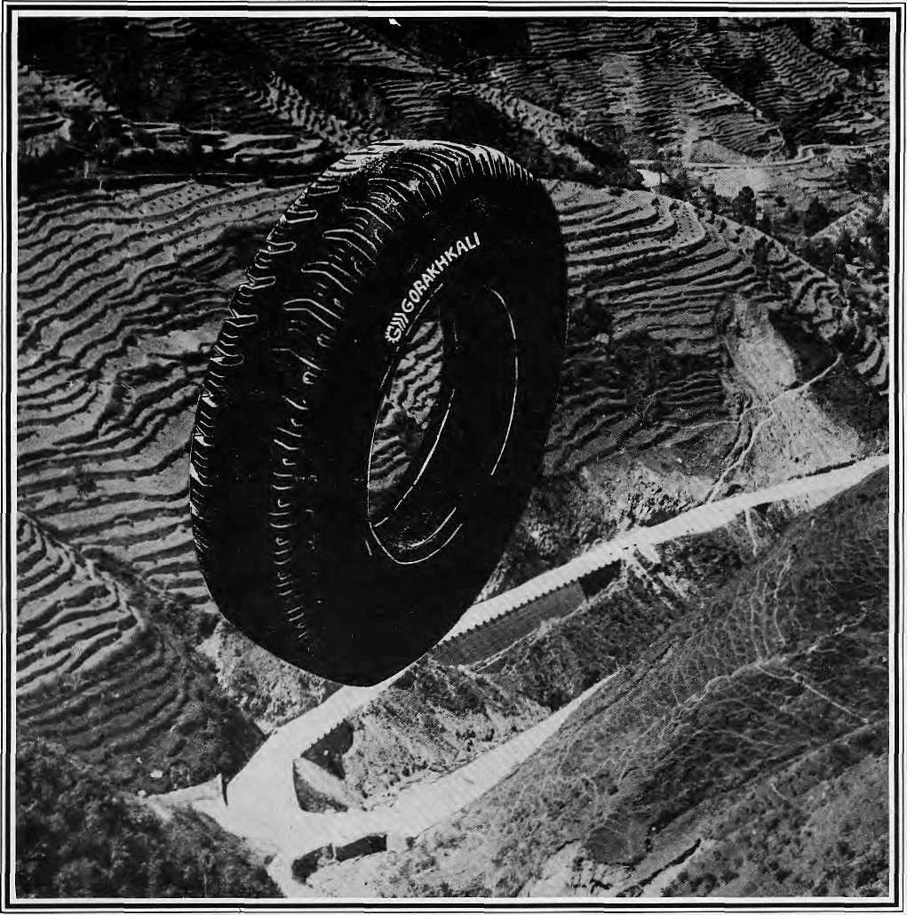

The Gorakhkali tyre is specifically designed for tough Himalayan roads and extreme Himalayan climate. It is the only tyre manufactured in the Himalayan region. The Gorakhkali tyre uses nylon backing and a special dual tread compound for added strength. Rigorous tests on Nepali highways have shown that the Gorakhkali tyre has excellent abrasion resistance. It is unmatched for steering, acceleration, braking and road grip. Overall, it has the lowest cost per kilometre of running.



GORAKHKALI

GORAKHKALI RUBBER UD YOG
Registered Office: Marketing office:
Majua Deurali PO Box 1700, Kalimati
Gorkha, Nepal Kathmandu, Nepal
Phone (065) 20179 Phone 270367, Telex 2788 GRUL NP Fax 271704
V
V V
U
o
<

Rsgd. No, Lalitpur 65/045-46

Be ,ure _{to} _{O}sk abou, WorldPerb, *,,
_{mosl}
Malla Treks
389


NORTHWEST AIRLINES
SOME PEOPLE JUST KNOW HOW TO FLY.⁵"

