NRs 40 DM 9
<Hs' 26 E 4
Nu 30 US 6
U$ 4.75 in North America
Jul/Aug 1993

HIMALAYAN MAGAZINE
. .i!
* ,.■':■ ",..!!. ■ ,
» : jt¹ ,„■ * '". ,. * ' . u ■ ■ ... ■
i : j,-'¹ ■


U*£
■':■ ;f

5!,:..: i:;(S,Frii,v -■;■;; ;■::.-■■



..,!"■".:
affi
. ^ ^
Ill
LOOK BACK AT HISTORY
Refracted Images • Rana Regime • Unquiet Uttarakhand Tanakpur on Thames • Refugees Unwelcome

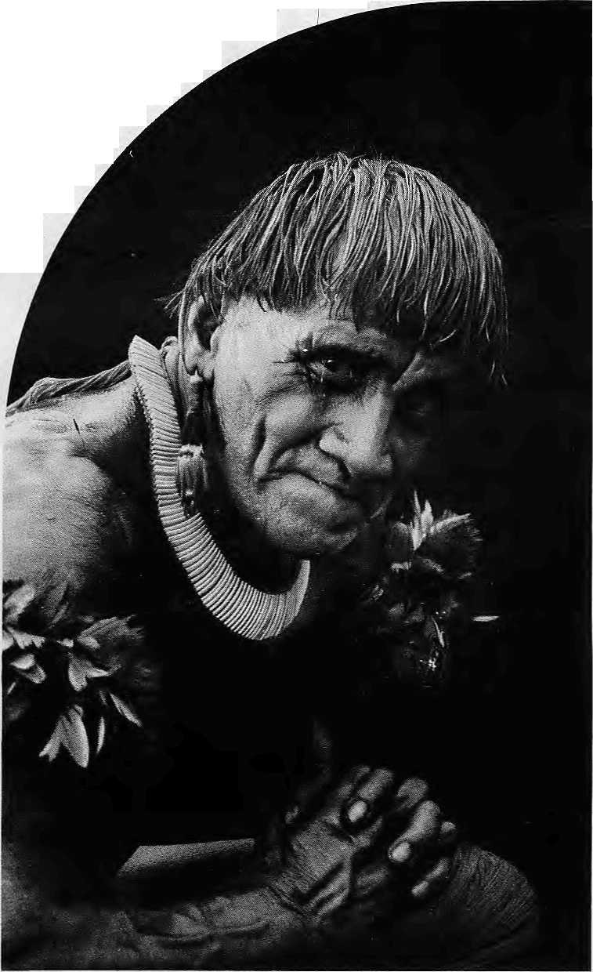

WWF World Wide Fund For Nature
(formerly World Wildlife Fund} International Secretariat, 1196 Gland, Switzerland.
Outside the industrialised west, no-one has to be told to respect their elders. It's simply the way society is organised.
Which is why WWF - World Wide Fund for Nature tries to work with older people in the villages of the rainforests. With WWF's help, they learn to teach the younger members of their communities about conservation.
In Kafue Flats, Zambia, it's Chief Hamusonde (93),
Chief Bakary (78), is our man in Anjavi-mihavanana, northern Madagascar.
In Ban Klong Sai, Thailand, we invoke the Venerable Papasro Bhikkhu, seventy-three year old chief Buddhist monk.
This isn't just expediency, it's how WWF believes conservation projects should be run.
Before you teach someone, we believe you have to learn from them.
We spend years visiting village after village, talking to the people, listening to them, living with them, understanding how they live their lives.
Only then are we able to gain th? confidence of the village elders.
Once they realise we're on their side, our elderly converts promote conservation with a zeal that belies their years.
"Uncle" Prom (68), another of our Thai community leaders, tells us that he frequently gets scolded when he starts telling people in the market that they should leave the forests alone. But he gets results.
Uncle Prom and his fellow villagers recently managed to prevent a new logging concession, and set up a community forest where tree felling is now forbidden.
Ninety-three year old Chief Hamusonde also makes things happen.
Income from the Kafue Rats game reserve in Zambia is funding a school, a clinic and new water boreholes for the local villages.
In Madagascar, seventy-eight year old Chief Bakary's village makes a profit by selling fruit grown in their new tree nursery.
More importantly, Chief Bakary's village now takes fewer trees from the rainforest because the nursery can provide firewood and poles for construction.
Not that we don't believe in catching them while they're young, WWF also organises special training courses to help teachers incorporate conservation into the curriculum.
20,000 primary teachers in Madagascar have already taken part.

And WWF produce teaching aids as wcl! as teachers.

We commission educational factsheets, booklets, posters and videos in over twenty different languages. These are distributed to schools and colleges all over the world, if you can
help our work with a donation or a legacy please write to the membership officer at the address opposite.
You only have to look around you to see that the world still has an awful lot to learn about conservation.

HE'S JUST ABOUT OLD ENOUGH
FOR OUR TEACHER TRAINING PROGRAMME.

INSIDE...

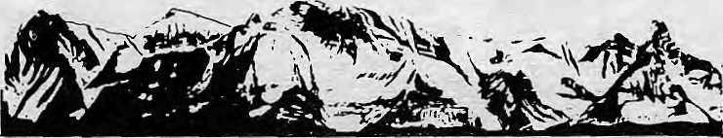
MAIL
Not Representative
Despite the pointedness of Michael Hutt's introductory essay "Who Speaks for the Himalaya?" (May/Jun, 1993) and his translations, the poems chosen by Himal prove only the unimportance and marginality of Himalayan Literature. Hutt asks if those who write about the Himalayas are informed by indigenous writing. Had the posse from Kalimpong read Bhupi Sherchan? Was there any poem other than "Budget" by Moli Prasad Sharma and translations of Bhupi Sherchan's poems that could have, by the issues raised, appeared on the editorial page of a newspaper?
s Compare AnmolePrasadVMalli", Admittedly a poem I enjoyed reading, with Sherchan's "Bhairawa". "Malli" attempts a sympathetic and observant account of a truckstop in Darjeeling, but the poet by his phrasing and his diction draws attention to the writer as writer. Applauding the poet, we forget the poem. Sherchan's bitter account is in effect one of exile, and yet the locality in its harshness and simplicity is speaking to us — Bhairawa coming out of a muddy pond with its "Bhai" of a Bhaisi (buffalo), "ra" of a burnt roti left in a pan, and its "hawa" of air scalding us.
Himal and its readers would have been better served by translations of contemporary Himalayan poetry — poems with social relevance or poems with a distinct Himalayan voice. As it stands, the photograph of Devkota says more than all the poems and sketches supposedly speaking for the Himalaya. Wayne Atntzis . Kathmandu
Inter-relatedness
Having read your issue on "Readings... Who writes for the Himalaya?", I must say it was an excellent idea. Glad to know that Himal
also cares about literature from the Himalaya and not only ethno-, sodo-, geo-, tectonic-, politico- problems and issues. After all, every thing is inter-related, including culture and language. Thanks to Flat/He of Kalimpong and Michal Hutt of London. It is so wonderful to read poems and short-stories written by Nepalis, Indians and foreigners who care about the development of Himalayan folks. Satish Shroff Freiburg, Germany
Despondent Readings
Michael Hutt did an admirable job of packing the essence of Himalayan literature into four informative pages. However, a couple of questions arise after one reads his cover article.
By his own admission, there is A general lack of quality translations of Nepali literature in English — but could it be that Nepali literature (and especially poetry) completely loses its subtlety in translation? I remember the feeling of pathos that pervaded
Laxmi Prasad Devkota's Pctgat, and it was not quite there in Hint's otherwise brilliant translation.
Further, all the Nepali poems that Hutt presents have a harsh realism to them, and although he might have selected these as a counterpoint to the nostalgic romanttcisation of Nepal by foreign writers, it could lead a stranger to wonder whether there is any optimism or light poetry in Nepali at all.
Even in the wide selection of Himalayan literature presented elsewhere in the issue, there is only one poem ("Yeti Song") which carries a jovial note. All the other stories and poems have a dark undercurrent to them, with Doirjee Tshering Lepcha ("The Queen Ant") as a Himalayan Kurt Vonnegut.
COVER
9 Refracted Images of the World Beyond by Chetan Singh Himalayan history cannot be seen in isolation,
11 Ranas Good, Ranas Bad... by John Whelptoh It is time to re-evaluate the Rana regime.
15 Tanakpur on the Thames by Dipak Gyawati
Nepal's water negotiations with India suffers from institutional amnesia.
17 Unquiet Uttarakhand
by Ramschandra Guha
Social activism is a historical heritage of the Uttar
Pradesh hills.
19 Why I Write Economic History
by Mahesh C. Regmi
Economic history makes the challenges faced by our ancestors comprehensible to the present generation.
20 Faceless in History,
by Tej Narayan Panjiar
Historical interest in the Tharus might shed lijjht on the past of the Himalaya.
24 Sleuth, Monk and Consultant
by Deepak Thapa i
A Japanese ascetic, on his way to Lhasa, steps to advise Chandra Samsher.
27 Long Road to Gandaki
by Bhovar P. Tamu and Yarjung K. Tamil Did the Gurungs of Nepal come from western Mongolia?
27 Whatever Happened to the "Golden Age"?
by Pratyoush Onta :
Modern day historians of Nepal have a lot ip
answer for. ;.
FEATURE i
40 Living Out a Refugee Welcome
by Gopal Guragain
The situation in Southeast Nepal, if the Bhutanese refugees stay on. will become explosive.
DEPARTMENTS
5
22 32 36 37 39 43 44
On the way Up
Voices
Briefs
Himalaya Mediafile
Review
Abstracts
Know Your Himal
Abominably Yours
Cover: Maharaja Ranaudip Singh looks back at the Kathmandu General Post Office. Picture by Kanak Marti Dixit.
Himal © 1988 is published every two months by
Hiniii'. Association
PO Box 42, Lalitpur, Nepal.
Tel: 977 1 523845, Fax: 977 1 S210T5,
ISSN 1012 9804, Library of Congress Card
Catalogue No. 88912882.
Subscription information overleaf. Priming: Jagadamba Offset. Tat: 977 1 521393.

Jul/Aug 1993 HIMAL . 1

HIMBL
Vofcfr No. 4 Jul/Aug Ip3
, The Abode nfCipts, King'afV.

Mountains, Himalaya
' Yptt bound the oceans from :
■". . ■ ■■■ east to west ' .... ■■■ ■■■ "
A northern yardstick
To measure the Earth: ■
'■"— Ka I id asa (kumaraSqmbhava}:
jawil 111:
■Asspqate Editor
Marjjsha.Arjal 1 1
? Managing Editor' 'pictography
Pcnia Waugchnfc D6r|ee:
JSalaramSharnia ^{v};: Z PraktitiKarmacharya
Rates
Individuals "... ■■ 1 Ye^rl 2years
J " . .. NRs".22Ci ■■" 40}
India
IRs: ., W : |&d
; ■■■ Nil',. 475-: :£?0;
Gther:S, Asian Countries V& ■'. -12 " ifflt
)■ DM 50
■Btsewbeie ' Institutional.
V$ ■■■ ■■ 251 '\ 45
" .■ :- ^{v;} '" ■,, Ms : 600. '
No 330
45
#
, Asian Countries
n
feeimsny tjnftwfK "Etsewhere
U$ 25
US 40^{V;} :;;#
DM : :7ft X20
Ireland '] £ - 30 ;; ^O
U$ 45 80
Seed all subscription orders and correspondence to:
$outh Aafa:»P.O. Boi 42, Lfjitpur, Nepal
;
Ceptirai; News Agency, 23/90 Co'nnaught fc*
Japan- Akjq HoriUChl, P,D,Bw 9, Kiyose,
Tofcyoi 204 japan. Aitstratia: Indra Ran, 12 Norfolk St., PandingtoQ 2021,
Sytlnuj¹, .-Misiralia. North Ainaica: Barbara Bella & Associates, 500
Sahsomts Street, Suite 300 A
UnUe4 Kingdrnn* Ireland: JoUGiii, "221 Ashly, * Gardens, Emery Hilt Street, London SWJP 1PA
1 "he N.-therlands: C. F. de Stpppcjaars Foundation Himalaya, Keizersgrrct W³* lOUDKArnstefdittn
Eiirtjjft: Diwga Press flllMAL), Luitpojdstx. 20.
L
W-&036, Merrschitig, Germany. H«knc Ziiigg, Tanncnweg IS, C
2 , HIMAL Jul/Aug 1993
Nepali and other South Asian writers may be loathe to romanticise their land and cultures excessively, hut surely there are countless pieces of good Himalayan literature that are light-hearted, if not optimistic.
D.Risal
Lalitpur
Addressing Ethnicity
Saubhagya Shah and William F. Fisher (Mar/Apr 1993) examine the issues of. "ethnic" identity and national unity as social and cultural phenomena. Similar themes concerning the relationships between tagadharis and other groups have been explored before, but because Shah and Fisher write in a changed political context, it permits them to make explicit their formulations at a level that was not possible earlier.
Yet, while an analysis of the interplay of the identities, loyalties, emotions, nationalism, etc. is very stimulating as an academic exercise, it fails to provide meaningful "cultural" policies for the State. In the discussion of broader issues, policy and implementation domains cannot be considered at a level that might be of interest and use only to politicians and policy makers.
Given the grave consequences that might ensue if the "ethnic" situation remains unaddressed (Fisher thinks that it "soon will require but a match to set off a conflagration", and Shah claims that "the regional and communal tinderbox is on a short fuse"), it is important to start immediately a discussion of alternate policies. The two conceptual issues that I list below might be helpful initial steps in developing workable cultural policies.
The need to distinguish between "rights" and "means": In addressing 'ethnic' inequality, it is important to start with a consideration of the concept of 'rights' and 'means¹, or what Amartya Sen calls "entitlements". "Ethnic" and other disadvantaged groups could have their rights carefully delineated in constitutions and other documents, but could lack the necessary "means" (including adequate
^ Afrt6ric>r| subscribers \n\\\.■■ , now be serviced by .Barbara Betta & Associates from Sarift and sco .Sub scribere ihEjeigium, U.K. and Irefand am request^ tooqrresporidwtth our r^ptpstentati veS.thprg,
income, access to good quality schools for their children, proper health care benefits, and the ability to politicise their plight in the media) to belter their standards of living. As a result, many of them are relegated to living and dying in deplorable enclaves and slums.
In Nepal, the 'ethnic' issue is regarded generally as an issue of 'rights'. The Nepali Constitution and the various ains (from 1851 to 1990) are invoked constantly in an effort to assess the status of various 'ethnic' groups with respect to the tagadharis. Even now, the vocal janajati associations seem to base their protests on the notion of 'rights'. Consider the statement of Suresh Ale Magar, whom Fisher quotes: "Some politicians call us dogs... we deserve to be treated as full citizens of this country." The Nepali Constitution, based on individual rights (but not group rights), treats every Nepali, including Suresh Ale Magar and his people as "full citizens". What Ale was trying to convey might have been a resentment concerning 'entitlements' that his people currently lack.
A clarification of the concepts of 'rights' and 'means' is a necessary condition for meaningful dialogue among the 'ethnic' groups, the government and other concerned people. Diverse cultures then can express their grievances concerning lack of specific 'entitlements' without disrupting the framework of 'individual rights' already secured by the Constitution.
The need to understand the context in which the "ethnic" problem interacts with other forms of inequalities: Before the "ethnic" issue becomes politicised and hastily generalised into flawed schisms, it is necessary to place it in proper perspective. Otherwise, remedies will be offered from a rather exclusive preoccupation with one domain of inequality to the neglect of others. In other words, mere is a need to understand the ethnic issue in relation to other forms of inequalities (such as 'class', 'urban-rural' and gender differentials) before useful policies for it can be devised.
For example, consider the interactions of the ethnic issue with urban-rural and class divisions. In rural Nepal, many studies have found little association between landholding, access to resources, and ethnicity. The higher castes, in this context, then, are as poverty stricken as 'ethnic' people. However, the higher castes have been shown to possess greater cultural

MAIL

capita], their 'superiority' being communicated at routine social encounters. Given this, in the rural context, it is social rather than economic discrimination that needs redressing. The ethnic issue becomes different in the urban context where ^cultural' capital of the higher castes determines access to resources and opportunities. This is evidenced in some urban surveys that have shown a larger degree of participation by the 'ethnic' people in educational and other urban institutions. In the unban context, then, the 'ethnic' solution may lie in attempting to realise adequate means for baHn-economic wellbeing as well us social dignity.
A full consideration of this topic vwuM involve an examination of 'ethnicity¹ in interaction with other relevant variables, such as gender. Such an investigation would not only shed lighten the true magnitude of the ethnic issue, but would also help design policies that may redress multiple inequalities simultaneously. Arun RajJoshi Massachusetts, United States
Greater India
The article "Looking for Greater Nepal" by Kanak Mani Dixit (Mar/Apr 1993) was remarkable for its fancifulness. The Indians must be trembling in fear of the brave Gurkhas!
Self-styled Nepali nationalists — driven by hatred of the native languages and cultures of Nepal — are doing a fine job of suppressing the very elements that can give Nepaliness a chance from being inundated under the ocean of Indian culture.
Dixit should watch Nepal Television once in a while — if he can find it under all the Doordarshan, that is. Or he should take a walk down New Road, and count the Nepalis on his fingers.
BhupiSherchan'spoem "Evening on New Road: A Festival of Light", translated by Mictel Hutt, was printed incomplete on page 18 of the May/ Jun 1993 Himat. The following portion was missing:
Then I pace out New Road, Plotting a poem And find myself besides TundikhBL
I toss a smile like Biwirawa Sugar Mill's
To the crowds a'I around al the Martyr's Gate,
I light my last-cigarette, put Katmandu's
ho II own ess
Into the packet and throw it away.
Glancing up, I fling a silent question at th(? Gate,
It replies with the weakest of smiles
And disappears into the mist.
In the present situation, "Greater Nepal" reminds me of two squirrels who, after being swallowed by a lion, continue arguing about who owned the jungle as they slid down its gullet.
Ram Sunder Maskey Mam Pyaphat, Kathmandu
Ravi, not Sutlej
In various-is sues of Himal, including those an ethnicity, the Gurkhas, and "Greater Nepal", I have found the extent of the GorkBrnli domain (before the Sugauli Treaty) referred to as being "from the Teefta to the Sutlej".
As a matter of academic discourse asd his.orical accuracy. 1 think it should be cirrified that the widest historical expanse of Nepal ivas actsrally from She Tecsta*o the Ravi, which is rrtich further west than'the Sutlej.
The Gorktatli conqnifct of Kuasaon was over by 1794, arai by 1$!&, Garhw^l and Dehradun had l>e en takam, as well m the territory betweer i Westterti Himadhdl (Jamuna) and th e Sulky.' The king^f Sirmour or Nah an, wSjjsfcent to Garhwal, was a friend of the C jorktadis and so (the latter had difficulty r eaching>out further west. Thus, they ove rtookmany small principalities, such as ' Kyunilhal, Baghat, Kuthur, Kaniya, Bhan _ni, Dhratii and so <en. The raja of Bisher (Rs anpur)[resisted, batihad to flee.
The hil' i region as a w.holeihad 12 kingdoms ai .id many^small principalities. Ttrc; hill raj¹ as wereEeaTfuI of Iheplains-baj sed Punjabi and Sikh rulers. Ferhaps due to cultural preference, they decided that if the ^y had to be conquered, betterithat it be by the ■ Gorkhalis. The Raja Mahachand of Bil aspur was sent as 'tlwir emissaiyito meet the Nepali commandei\Aniar Smg&'Thapa, and to accecte to Gorfciaslli authority.
If outlooks at the Hist of the rajfcs who thus acquiesced to the Garkhali authority, they include J&aja Jit Singli of Chamba,, whwse seat was in Chamba town, on the western bank stf the Ravi. IVom here, the borders of Jamnsu and Kashmir is barely 40 miles away.
The Sutlej we speak of has presently been dammed by file Bhakra Nartgal, and the original capital of Bilaspur is now underwater. Beyond Sutlej, the Gorkhalis had to go through Suket, Mandi, Baijnath and Palampur before they reached Kangra fort. Much beyond Kangra you reach Nurpur, then Pathankot, and further on you
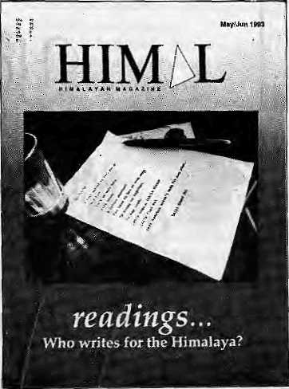
■come to BakJoha, beyond which lies SDalhousie, and about 30 miles further still is Chamba town.
The people of Chamba have not forgotten the Gorkhali conquest and even today a local song highlights the areas that the Gorkhalis look, such as Tisa, Baira, Bhandai, The lyric also speaks of the loot engaged in by the Gorkhali soldiers.
Inithe Bhuri Singh Museum at Chamba, there are two letters from Amar Singh Thi).pa to the raja of Chamba, in which the;iatter is referred to as the Vazir of the GorMhali state, which proves that 'jChamba was completely under the control cf Kathmandu. It is only correct history to state that before Sugauli, Nepal extended ftpm the Teesta to the Ravi.
Janaklat Sharma Panipokhari, Kathmandu
Don't Belittle Pasang Lhamu
Dipexh Risal's narrative of Pasang Lhamu tragedy (Know Your Himal May/Jun 1993) made me unhappy, to say the least.
Risal questions Pasang Lhamu's mountaineering skills at a time when her mourners haven't even had time to wipe away their tears, Risal faiis to appreciate the indomitable spirit of Pasang Lhamu which goaded her to pursue her aim even in face of natural and artificial hurdles. She succeeded but for the quirk of fate that acted so cruelly.
Risal says she was ambitious; but which mountaineer is not? Perhaps she was spurred by the urge of gelling on top first;

Jul/Aug 1993 HIMAL . 3



pimioke

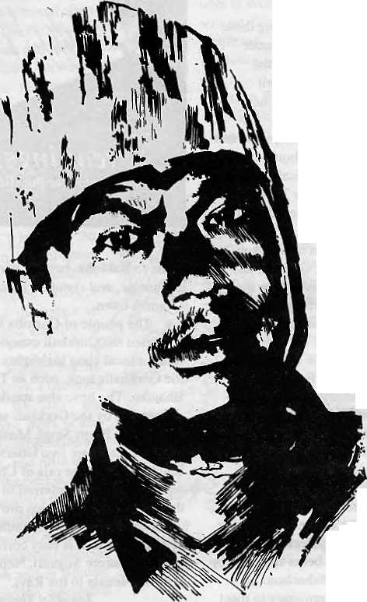
This man doesn'thavea Hotel Management Degree. Neifherhashe mastered the arfof landscaping. And yet tohim-weoweourPrivate Paradise. 'V)
He is our gardener, the creator of our prize-winning garden SHAMBAIA. A true reflection of our commitment to a greener and healthier environment. Because within our hofel, (jn*. we chose fo build o Shangri-la-a true haven, to show liie world what they came to see -nature's resplendent beauty. *nj PerhapsJMslfie splendours of ourgarden motencbants our guests into coming to stay with us, again and again. Or perhaps, because of our gardener, our people...who care for the environment.



i
SHANGRI-LA
KATHMANDU
NEPAL
G.P.O BOX: 655, LAZIMPAT, KATHMANDU,- NEPAL TEl: 412999, TELEX: 2276 HOSANG NP, FACSIMfcE: 977-14141U

but that too is the nature of the game. Pasang Lhamu was by no means a novice climber. This last attempt was her fourth bid. And haven't more skilled mountaineers met with similar climbing tragedies before her?
A country which cannot boast of a few heros and heroines with the tales of toils, tears and sacrifices — however foolhardy they might appear to some people — can not have its history illuminated. She worked a lot to plan, organise and execute her expedition. And if the country went 'overboard' to honour her after her deatii, it is not as if she had demanded or designed it a priori. In fact, the Government made the fuss over her to recompense for their shabby treatment of her earlieT.
Pasang Lhamu should not be derided by pointed references to her human failings or by comparing her achievements to British or Indian women's achievements. As a nation we are late starters, and in many regards, we are just learning to get out acts together. If Pasang Lhamu's death has helped the presently ethnically torn Nepal by binding her people together emotionally, isn't the achievement worthy in itself? Prayag Raj Sharma Kathmandu
A True Heroine
I found Dipesh Risal's treatment of Pasang Lhamu "event", as he calls it, sexist. Not only does he dismiss Nepal Tara Pasang Lhamu's mountaineering achievement by underestimating her victory, he also does not seem too impressed with her capabilities as a mountaineer.
In order to back up his finding that Pasang Lhamu was a poor climber, the writer reports on the row that took place between her and the French 'soloist' Marc Batard, and Batard's claim that Pasang Lhamu was too slow and engaged too many Sherpas to help her along.
Which made me flip back to the Mountaineering Issue oi Himal (Nov/Dec 1992) and the article co-authored by Risal, in which Batard is depicted as an egotist who would do anything to get his 'solo' ascent, including lying to his own climbing partner. How can the word of such a person be used to prove or disprove Lhamu's climbing skills?
The likes of Batard should not have been invoked to denigrate someone's genuine achievements. Pasang Lhamu is a
birangana, a heroine in thetrue sense of the word, and thus she will be known in the history of Nepali mountaineering, and it will not do for a non-climbing male reporter in Kathmandu to try and deprive her of credit. Would the inside stories of the climb have been as important if Pasang Lhamu was the first Nepali male to have climbed Chomolongma?
Mamta Acharya
Naya Baneshwor, Kathmandu
Culture over Political Ideology
Looking at the problem in Bhutan from an international perspective, it becomes evident that the rulers of Thimphu are absolutely ignorant of global happenings. Neither have they read their social sciences properly.
The ideologically divided Germany broke its wail and came together under the banner of shared culture. The eight decades of lessons in ideology failed to wipe out culture of the once communist Russia. Momentarily, China has got away with the ideology by adopting the most brutal and savage measures. Khoemeni's Iran kicked out the West by arousing religious sentiments of the people. The Croatian Serbs are out for ethnic cleansing. The cultural aggression ou one people by another gave birth to a Subhas Ghising and his likes.
The entry of religious and cultural elements in politics creates a new equation in the political landscape. The political theorists and scientists would dismiss it as a mere transitory phase, based on sentimentality and unreason, but they cannot deny the fact that these elements create strong social forces that can wipe out an ideology as firmly established as Communism in Eastern Europe.
When culture appears in the political arena, ideology has to take a back seat. For culture is the life-force of the society. While the battle throughout the world is fought for-cultural reason, Thimphu expects to wash out culture from the blood of a people.
A country like Bhutan, which neither has an ideology of its own to follow, nor enough human and natural resources to mobilise for its rapid progress, cannot afford to commit such a blunder. Imposing one's own culture on another is like invading privacy. Bhutan should learn its lessons by looking at the world and lake corrective steps, otherwise history will repeat itself. Harka Bahadur Chhetri Pedong, Kdlimpong.

Kanak Mani Dixit
Q
uite a lew readers were taken aback when we brought out our Literature Issue (May/Jun 1993).We think it was a pleasant surprise to most, and now feel that it is a good idea to be occasionally unpredictable.
When we tirst planned the present issue, we had not expected to touch the range of topics that we have, nor receive contributions from wrttersof such different backgrounds. Himal thanks Pratyoush Onta for helping prepare this History issue.
This issue brings with it some significant changes in Himal 's masthead.
Omar Sattaur, whose editorial expertise has been invaluable for Himal over the past year, will now be freelancing. Among other things, he is Guest Editor for our Music issue, Nov/Dec1993.
Suman Basnet, who has carried Himat as its Managing Editor for two years, will still be around as Director of Film Himalaya, the Documentary/ Film Festival we have planned for February 1994. Meanwhile, Pema Wangchuk Dorjee, whocomesfrom Kinnaur by way oi Kalimpong, takes over as Managing Editor.
Manisha Aryal is now Associate Editor of Himat.
Special thanks to Anup Pahari, our volunteer representative in the U.S. for being with us this past year. His enthusiasm and his patience went a long way in making Himal more widely read in North America.
We welcome Barbara Bella & Associates, C. F. Stoppelaar and Joti Giri who assume responsibility for North America, the Netherlands, the U.K. and Ireland respectively.
It is time lor Himat's "Know Your Himal" columnist, Dipesh Risal, to leave for study in the United States. We hope his knowledge of the Himalayan peaks serves him well in Lancaster, Pennsylvania, which, we gather, is flat.
Jul/Aug 1993 HJMAL . 5

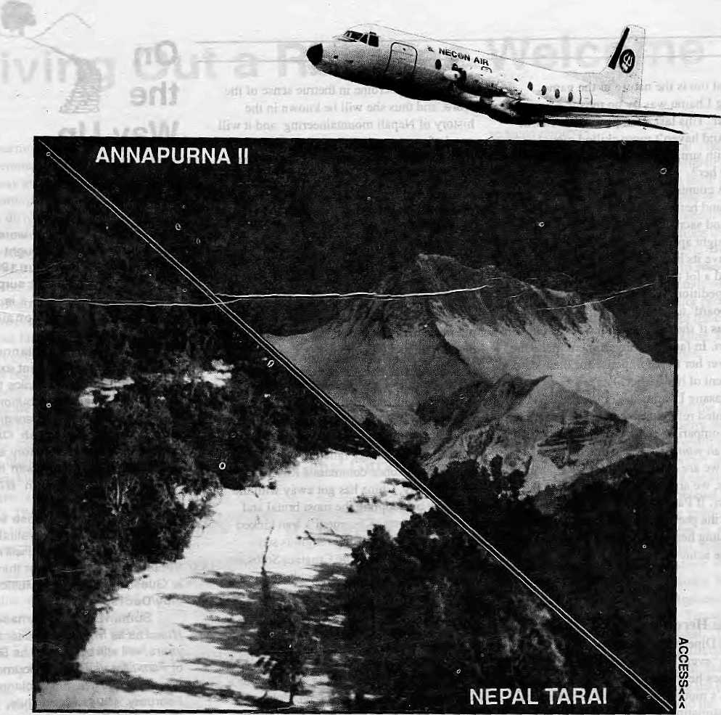

NEPAL UNDER OUR WINGSPAN

You want comfort.
NECON AIR's HS 748 Avro aircrafts are the most spacious^ and our staff the most solicitous.
You want punctuality.
NECON AIR links Kathmandu, Pokhara, Simra, Nepalgunj and Bairahawa with an efficiency that has become the talk of these towns.
You want pleasure.
Wefake mountain flights from Kathmandu for the Eastern Himalaya, and from Pokhara for Annapurna and Dhaulagiri.
Try us. Fly us.
NEC®N AIR

Sales; 4J4367,412260Reservations: 418608,418809 Fax: 977-1-412645 Telex: 2739 NECOA NPPO Box 4047.

Scott, Amundsen and Pasang Lhamu
by Marcia Lieberman
Pasang Lhamu Sherpa has been enshrined in Nepal's national consciousness as an authentic heroine, her legend established: need anything more be said?
Decidedly, yes. The article in Himal of May/June 1993 suggests that Pasang Lhamu was hot a strong climber and her achievement relatively modest. There is more to the story. Nepal may need a national heroine, but not at the expense of its soul. ThaNs the price of this concocted story: a freshly-minted myth, hastily packaged, that js a perversion of the truth.
I am a writer who has travelled several times to Nepal. I was at Chomolongma Base Camp this spring with my husband who was a scientific member of the American Sagarmatha expedition. Pasang Lhamu's story unfolded while we were there.
It has been presented as a drama of courage and determination: how a Nepali woman pursued her dream, and how through sheer grit she reached the summit, but then tragically perished with one of her "companions". The story bears an uncanny resemblance to the apotheosis of Robert Falcon Scott, the British explorer who ted an expedition to the South Pole in 1911-12. Arrogant, stubborn and intolerant of dissenting opinion, Scott's blunders led his men to their death. (They were beaten" to the Pole by the Norwegian Roaid Amundsen, who returned safely with his whole team.) Scott's widow doctored the records and suppressed the evidence; Scott was painted a hero and was revered as sucli by generations of British schoolchildren. Only recently has the myth of the noble Scott been debunked.
In Nepal this year, a similar icon has been created Yet, when the facts are reviewed, the Pasang Lhamu legend appears in a very different light. Instead of pluck and determination, we see greed, selfishness, incompetence and reckless disregard for the lives of others. The myth depends upon the suppression of evidence and the distortion of reality and is not healthy for Nepal.
Pasang Lhamu had made three previous attempts on the mountain. Non-Nepali expeditions are charged a "royalty" for climbing. The full royalty was waived (or greatly reduced) for Pasang Lharnu's earlier climbs. Her expeditions, however, included European climbers. On her second expedition, in the fall of 1991, six European climbers participated, including the French woman climber Chantal Mauduil, who paid Pasang Lhamu U$ 5000. Maduit believes that the other Europeans paid at the same rate. On her
final, fatal expedition, a Lithuanian named VJados Vitkauskas appeared on the membership list as a photographer, yet he reportedly paid Pasang Lhamu US 7000, and also had to bring his own oxygen suplies.
There were many signals that Pasang Lhamu was not interested in a team effort that would put a Nepali woman on the summit of Chomolangma. -The glory — and the rewards — had to be herV A group of Indian women had invited her to join them and form an Indo-Nepali women's team, but she turned it down to form her own team — one that she would lead and thus control. She created this team by taking along two Nepali women, Lhakphuti Sherpa and Nanda Rai.
But even within her own team, Pasang Lhamu tried to minimise competition. She told Lhakphuti that Nanda Rai was not strong enough to summit. And so Pasang Lhamu's only competitors for the victor's laurels were Lhakphuti and Nimmi Sherpa, a strong and experienced climber from Pangboche, who was on the Indo-Nepali team.
Pasang Lhamu's premature (in terms of weather) and somewhat clandestine rush to the summit, denying equipment and Sherpa support to Lhakphuti, betray her determination to summit alone at all cost. Why was the laurel wreath of such vital persona) importance? A mountaineering team normally represents a group effort to place at least one climber on a summit. But self-promotion rather than teamwork evidently marked the expedition from the start. The trekking company run by Pasang Lhamu and her husband would have gained much publicity advantage from her being the first Nepali woman on the top.
Lhakphuti had been assured that the expedition would provide all equipment required on the mountain, which is normal. But, Pasang Lhamu informed her that they did not have enough oxygen masks for everyone, and so Lhakphuti would have to be on the second climbing team. She justified this by saying that Lhakphuti did not have to compete with anyone, whereas she had to beat Nimmi Sherpa and the Indian team to the summit.
Of the six male Sherpas in the team, Pasang Lhamu announced that she would take four, leaving two for Lhakphuti and Nanda Rai. When Lhakphuti protested, she was told that she did not need more Sherpas — Nanda Rai could not make it to the summit anyway. As soon as the team began to ascend the mountain, reports came down about the Sher-pani who was being helped and almost lifted up the mountain by a small crowd of Sherpas^
Pasang Lhamu, her husband and Lhakhphuti climbed up tc* Camp Three for the purpose of acclimatisation. As they returned to Camp Two, Lhakphuti observed that Pasang Lhamu was extremely slow. Lhakphuti descended alone; Pasang Lhamu was helped
down by two Sherpas and her husband.
When Nanda Rai showed signs of altitude sickness in Camp Two, Pasang Lhamu asked Lhakphuti to take her clown to Base Camp. Pasang Lhamu then climbed up to Camp Three, taking five Sheraps with her. Using a radio belonging to my husband's expedition, Pasang Lhamu called down to tell Lhakphuti that if she wanted to buy oxygen,' the Sherpas had "found" two oxygen bottles — this was Lhakphuti's first notice that she would have to buy her own oxygen!
Meanwhile, Pasang Lhamu, began her summit bid with the five Sherpas. It was 22 April. The Spring had been stormy and there was still a great deal of fresh snow on the mountain. No other team would summit until 10 May. And Pasang Lhamu would not be seen again until her frozen body was dug out of the snow.
Lacking good technique, Pasang Lhamu took five hours to gel down to the South Summit instead of the normal 45-50 minutes. She refused to go, or was unable to go any lower. The fourth, Pern a Norbu, descended some hours later. Sonam Tsering stayed with Pasang Lhamu, giving her his remaining oxygen during their final bivouac.
There was heroism on the mountain in those few days, and grit and determination, among those Sherpas who tried to come to the rescue of Pasang Lhamu. These true heroes have not been named or recognised.
Sherpas who located Pasang Lhamu's body have reported that Sonam Tsering's pack was found wrapped around her legs. Her Sardar had apparently made her use it as a sort of a bivouac sack, as there was no other shelter or protection. The storm had been so ferocious that her body was found under one meter of snow. Sonam Tsering's body was never found: it'is thought that after she died he tried to descend and fell.
What has been seen as Pasang Lhamu's pluck and determination was in fact obstinacy, driven by ego and self-serving ambition. Tragically, this led to the death of another person, Sonam Tsering. He has been referred to in the press as her companion or comrade, but he was in fact her employee. As an experienced mountaineer who had already climbed Chomolongma four times, he was distressed when she insisted on pushing on to the summit so early. He had sensibly suggested a team of two women climbers and two sherpas, keeping two Sherpas in reserve at the South Col in case of emergency. Pasang Lhamu had vetoed this.
The true tragedy in all this is the fate of Sonam Tsering. Like Pasang Lhamu, Sonam Tsering also left three children behind, and his widow is pregnant with their fourth child.
M. Lei be man writes travel articles for The Wei* York Times.

Jul/Aug 1993 HIMAL . 7

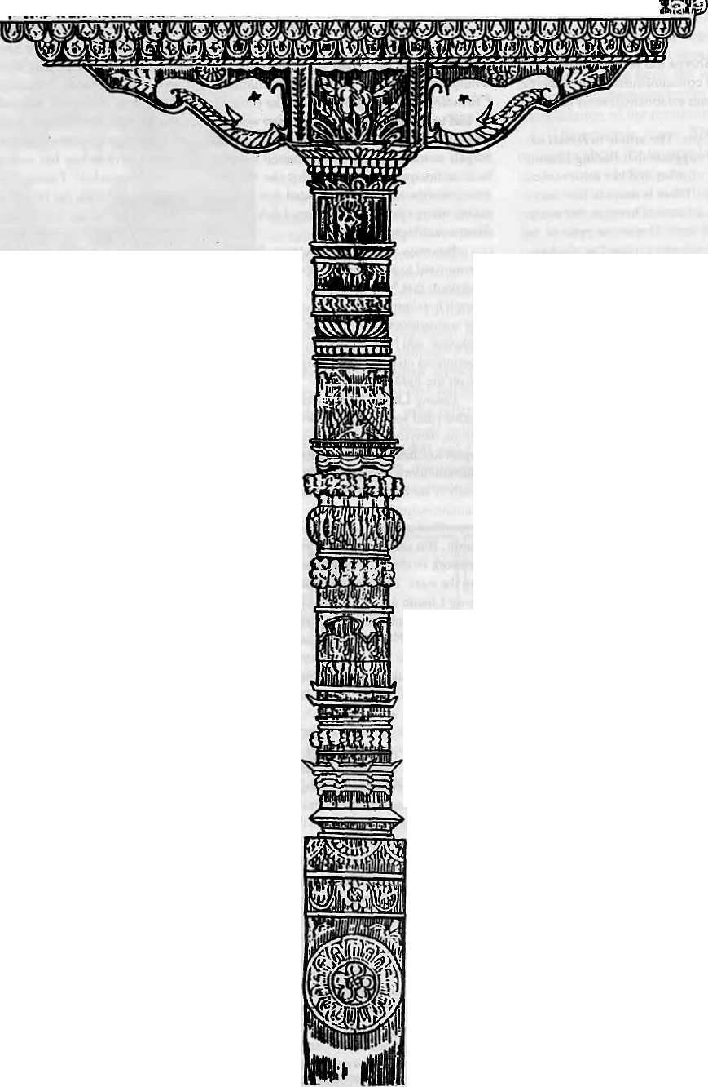
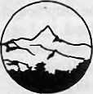

The exquisite Woodcarring of Kathmandu
The Summit Hotel in Kathmandu
It's more than an art
It's an Exuberant Demonstration of a Rich Tradition
It's an Eloquent Expression of a Living Culture
It's a Wondrous Display of a Timeless Heritage
It's a Priceless Ornament of two Religions in Perfect Harmony
It's more than a Hotel
It's a Tribute to Traditional Nepali Hospitality
It's a Homage to a Magnificent Nepali Architecture
It's a Commitment to Quality of Service and Care
It's a Guaranteefor your Comfort and Pleasure
SUMMIT HOTEL
Something Special P.O. Box 1406, Kathmandu, Nepal Tel: 521894, 524694 Fax: 977 1 523737

Refracted Images of the World Beyond

Himalayan history cannot be seen in isolation of the developments elsewhere in South Asia.
by Chetan Singh

H
istory is often accepted as an account of how good kings won battles, established empires and kept their subjects happy; and conversely, of how the bad ones oppressed the poor and ultimately lost both their wars and their kingdoms.
The greater part of Himalayan historiography has done little to dispel such simplistic notions. It tends to concentrate on elaborate, extended descriptions of petty boundary disputes between tiny mountain principalities. The chronological re-ordering of the reigns of kings and intricate etymological rationalisations for concocted royal lineages are, for many scholars, the goals of their research.
Significantly, the historiography of South Asia as a whole has seen considerable change in recent years. More rigorous methods and sophisticated scholarship are uncovering intricate historical processes of the past. Scholars aTe re-examining the nature of the state, economic organisation and social systems.
Research on Himalayanhistory, ho we v er, has not kept apace with the rest of the Subcontinent. Historians remain absorbed in unravelling political intrigues and court scandals. Art historians are content to follow the lofty achievements of Himalayan art and reluctant to soil their hands with earthy socio-economic realities.
Replaying a Past
Among researchers in the other social sciences, and particularly among Western scholars, the Himalayan region is taken as a social laboratory that enables them to observe once again the re-enactment of along forgottenpast. Irrespective of field of specialisation or research method, a constant undercurrent is the presumed isolation of the Himalaya. While the more sympathetic view is that this leads to the cultural diversity
of the region, others regard it as the cause of the 'primitiveness' of hill society.
Both groups of scholars, however, believe that Himalayan society has existed independently of the rest of South Asia, until the modem age forcedittoconform. According to this mindset, as far as the present is concerned, reticent hill societies need to be prodded into interacting with a rapidly changing world.
Many Himalayan historians unwittingly carry contradictory assumptions in their theoretical baggage. While the impact of subcontinental trends on Himalayan history is implicitly accepted, it is not given due importance. The historical inseparability of hill and plain emerges only when the scholar is unable to explain certain turning points through purely 'local' material.
For example, the emergence of centralised monarchial states in the region is often attributed to the arrival of military adventurers, whose 'royallineage' andTeasons for coming to the hills both originate outside the Himalaya. Here is Fraser's account of the Himachal principalities of 1821:
...alt the chiefs of the larger hill states are originally of low country extraction; probably soldiers of fortune, more able and politic than the mass of hill chieftains, who have hadpowerto gain afooting, and art to maintain it when gained; and to consolidate into one powerful government a portion of the vast number of ever-changing petty states...
The Muslim invasion of India is commonly believed (rightly or wrongly) to have encouraged the migration of a large number of Hindu families to the hills. Similarly, the spread of religious orthodoxy (the import of gods,caste and scriptures) indifferent parts of the Himalaya is generally considered
a part of the larger 'civilising mission' of Brahminism.
Simultaneously, however, Himalayan historiography has created an insular world for itself; one that overemphasises its separateness. In their seminal work, History of the Punjab Hill States, Hutchison and Vogel wrote:
In the hills social conditions have been prevalent from remote times, ...Till comparatively recent years the hills were almost entirely isolated from the plains. The rugged character of the country made invasion difficult and conquest practically impossible...
The influence of the developments in the adjoining plains has been underplayed in order to establish a distinct identity. The stress is on presenting an unbroken, romanticised and somewhat segregated continuity in Himalayan history. To quote Hutchison and Vogel again on the Punjab hill chiefs:
Good reason then have they to beproudof their ancient lineage. The ancestors of many of them were ruling over settled states when ours were little better than savages, and the youngest of them can point to a pedigree dating back for a thousand years. In comparison with them most of the royal houses of the plains are but of yesterday, and the oldest must yield the palm to some of the noble families of the Panjab Hills.
Such is the contradiction. While many complicated developments are seen as products of short-term influences of the plains, over the longer duration the Himalaya are depicted as an isolated region. Historic socioeconomic transformations in the rest of South Asia are disregarded until they become too large to be ignored. Objective history of the Himalaya

Jui/Aug 1993 HIMAL . 9

can only be written if such contradictions are resolved, and the traditional obsession with insularity explained and overcome.
Linkages
Innumerable factors have always bound Himalayan society to people and places beyond the mountains-The most commonly discussed links are oflanguage.sodo-rcligious practices, art forms, large-scale migration, and so on. While these links are indeed significant, we need to find out what kind of economy was able to sustain the cultural and political achievements that the scholars have attributed the Himalayan kingdoms.
Obviously, the large number of craftsmen engaged for temple-building and producing artwork were not paid out of wealth that was locally generated. Neither the non-productive cultural and artistic activities, nor the heightened military activity across the Himalaya during the late-18th to early-19th century, wouldhave been possible withoutthe income from trade and other commercial activities. However, the dramatic rise in the volume of commerce, must not distract us from the fact that the exchange networks had a long history and were an integral part of Himalayan economy and society.
The links with the larger world beyond
the mountains thus were very much a permanent characteristic of Himalayan history skice the early times. These characteristics were not created by any single factor, such as the adventurer's conquest, the Brahman's missionary zeal, the merchant's trading activities, or the craftsman's skill. Rather. Himalayan history was shaped by a blend of all these and a lot more, a convergence of which brought into being and nurtured a corresponding worldview.
There emergeda well-knit, yet extensive, network of socio-economic, political and cultural relationships that gradually came to be taken for granted. The existing image of this larger historical dimension is yet only a refracted one. So diverse were the ways in which Himalayan societies reached out to distant regions that it will take considerable and persistent efforts to p u t the c omplete pic ture together.
Not surprisingly, therefore, the answer to many intricate questions of the region's history may be found in areas lying beyond the Himalaya. In economic terms, it could mean that the region had established a relationship of mutual dependence with the adjoining plains. When translated into politics, it could imply that the exchange of salt, wool, gold, textiles, timber and other forest produce
between the Himalaya and areas far beyond enabled the accumulation of an extra bit of wealth which in turn made possible the emergence of hill kingdoms and polities of fairly complex nature.
And it is not only in the economic sphere that this wider aspect of Himalayan history is applicable. In social terms, for example, the upper echelons of the ruling elites of the Himalayan kingdoms have time and again emphasised their affinity in caste and status with the dominant classes of the Indian heartland.
History-writing is a method of recording and explaining change over time. Political upheavalsareatonceacauseandconsequence of the rise of new social classes in society. Having ascended to political power, it was necessary for them to acquire a corresponding social legitimacy amongst the peer groups. Matrimonial alliances have always been a highly effective weapon in the arsenal of rulers. To use a fairytale analogy: on many ahistorical occasion, it was the kiss of a Rajput princess that broke the spell of social peripheralisation and transformed the frog into a prince m his own right.
C.Singh is with the Department oi History. Himachal PradBsh University. Shimla.

MANDALA BOOK POINT
fa
Scholarly Books on Nepal, Tibet, Bhutan etc. Latest Trekking Books & Trekking Maps
Mountaineering Books Guide Books of all Countries

MANDALA BOOK POINT
Kantipath, G.P.O. Box:528, Kathmandu, Nepal
Tel: 227711, Tlx: 2685 NP MANDALA, Attn: MANDALA BOOK POINT
Fax: 977-1-227372 NP NATARAJ, Attn: BK PT.
VISACARDS
Mi
i v T m ■
iiji;!;;
Wl
CREDIT CARDS



* Nepal Past 4 Present: Proceedings of France - German Conference Arc-et - Senans, June 1990 Gerald Toffm
i Spring Awakening: An account of 1990 Revolution in Nepal (New Stock) W. Raeper & M. Hoftun
- Fatalism and Development: Nepal's Struggle for Modernization (New Stock) Dor Bahadur Bista
- A Course in Nepali-Revised & updated Second Edition David Matthews
EVEREST: The best writing and pictures from seventy years oi human endevour: Foreword by Sir E, Hillary. Edited by P. Giilman

10 . H1MAL M/Aug 1993

Ranas Good, Ranas Bad

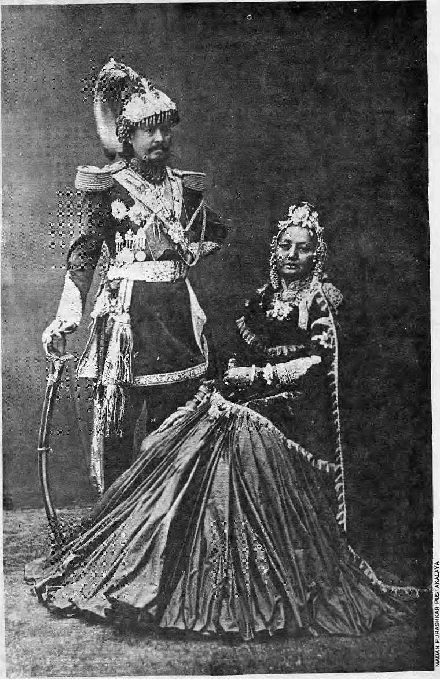
Three decades of
Panchayat rule
have been between
present day (democratic)
Nepal and
the period of the
Ranas.
it is time to
re-evaluate
their regime.
by John Whelpton
T
he past is usually interpreted to serve present purposes. The 1857 revolt against British rule in India, for example, has been analysed very differently by older British historians and by Indian nationalists, as even the names given to the episode — 'Indian Mutiny' or 'First National War of Independence' — make clear.
InNepal, after the end of a century of rule by the Rana maharajas in 1951, it was similarly inevitable that perceptions of the period reflected the concerns of the Nepali royal family and of the political parties who had together ousted the Ranas from power. Both the monarchy and the party politicians naturally stressed the failings of the Ranas when measured against ideal democratic standards, but the monarchy's interests demanded that the Rana period also be seen to contrast unfavourably with the situation before 1846, when the Shah dynasty held real political power. "The result has been that important continuities, especially between pre- and post-1846 Nepal, have been obscured.
Fabric of Intrigue
The Rana era began on the night of 14 September 1846, when Jang Bahadur Kunwar massacred his fellow ministers and their supporters at the Kot Arsenal. We shall never
Maharaja Jang Bahadur With his maharani-

Jul/Aug 1993 HIMAL . II

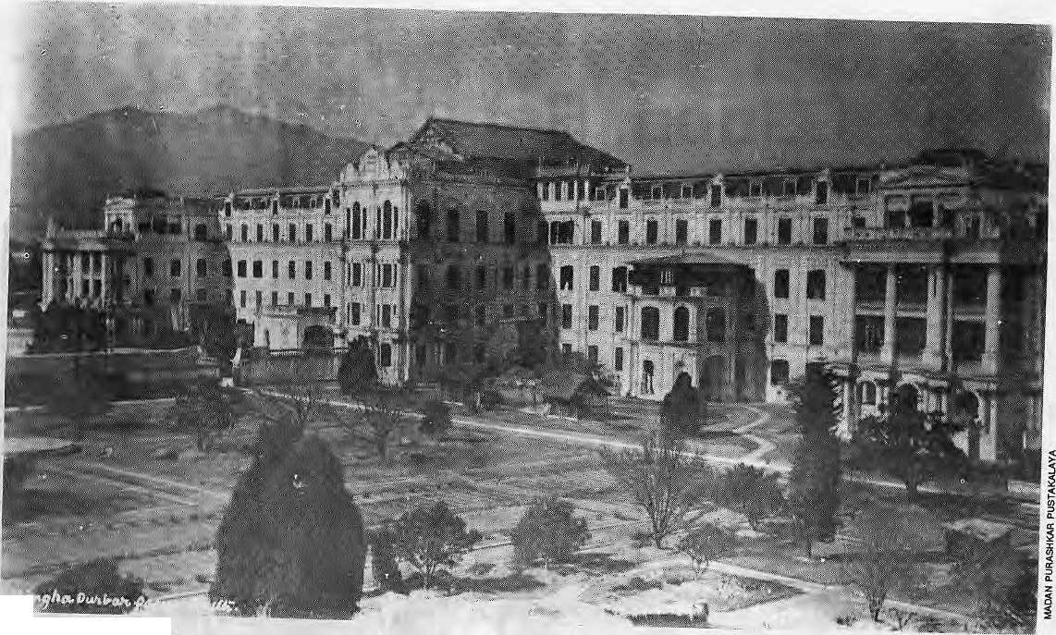
*■
From stucco palaces...

know if the bloodshed was pre-planned, or whether he acted to pre-empt a threat against himself and his brothers. It is likely, however, that Jang Bahadur and other ministers had been involved in the assassination earlier that evening of Queen Laxmi Devi's confidante GaganSingh, whichhadled her tocall together all leading political figures. Jang Bahadur was nevertheless skillful enough to retain the queen's confidence and was appointed Prime Minister by her. They worked together to expel the families of the slain leaders, but then Jang Bahadur deftly shifted his support to the Crown Prince and engineered the Queen's exile. King Rajendra, probably fearful for his life, announced he would accompany her to Banaras.
A web of intrigue and treachery indeed, but nothing thus far led contemporaries to believe that a new era in Nepali history had opened. Intrigue and assassination had been part of the fabric of Nepal's political life since the death of Priihvi Narayan Shah. Thecontro] of the government by a powerful minister rather than the king himself had also been common. Bhimsen Thapahad played that role for 30 years from 1806 and after his fall, as King Rajendra had proved incapable either of ruling directly himself or of trusting anyone else to do so, a succession of individuals had
12 . HIMAL Jul/Aug 1993
made short-lived attempts to take Bhirasen's place. Many, including British officials observing events from the Residency, believed that Jang Bahadur, too, would not last long.
In fact, Jang Bahadur did manage to break the old pattern in some ways. In the summer of 1847, he got the State Council to purge his opponents, to depose Rajendra and putCrownPrinceSurendraonthethroneinhis place. The Kunwars took the name 'Ranas' to show that they, like the Shah dynasty, claimed descent from the famous Rajput rulers of Mewar. This opened the way for the Rana-S hah marriages which became a crucial feature of Rana strategy.
In 1856, Jang Bahadur attempted a division of authority within his family: he resigned the premiership in favour of hiseldest brother, providing for the younger ones to succeed to the post in turn. He himself retained general supervisory power with the new title of Maharaja, which he intended to go to his own direct descendants. He was thus one ritual step below Rajendra, who, as Maharajadhiraj ('Great King of Kings'), remained the ultimate source of legitimacy, especially in its religious aspect.
The arrangement broke down within a year, largely because tiie British refused lo recognise any separate authority other than
king and prime minister, and Jang Bahadur resumed premiership. On his death in 1877, his eldest son, Jagat Jang claimed the right to maharajaship but Jang's surviving brothers ensured both posts went to the eldest of them, Ranaudip Singh(seecoverpicture).Agrowing reconciliation between Ranaudip and Jagat alarmed the sons of Dhir Shamsher, youngest of Jang Bahadur's brothers. In 1885, they seized power, killing Ranaudip and Jagat. From then on the combined post of prime minister and maharaja was handed down by agnate succession within the Shamsher Rana family: five of Dhir Shamshcr's sons (Bir, Dev, Chandra, Bhim and Juddha) mledin turn between 1885 and 1945, and two grandsons (Padma and Mohan) till 1951.
The constitutional relationship between the Rana rulers and the Shah kings resembled the Japanese shogunate, which similarly put political power in one family's hands whilst another retained a symbolic, religious predominance. Closer to Nepal, the Maratha peshwas had also acted as hereditary Prime Ministers whilst King Shivaji's descendants continued to occupy a powerless throne. In devising such arrangements in the 1850s, however, Jang Bahadur almost certainly regarded them as transitional, hoping that he would eventually be able to supplant King

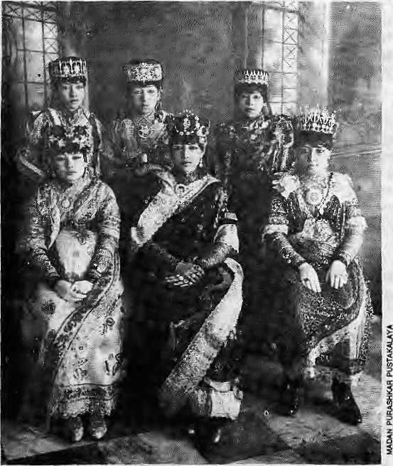
century. Caste barriers in the hills were certainly once less rigid than they later became, and Priihvi Narayan himself may actually have been of Magar descent, as one informant told a British visitor in 1803.
Still, the Shah dynasty's relationship with their Brahman gurus and their claim to Rajput ancestry, already put forward in the 17th century, suggest that the 'Brahmanical values' which Bista decries, had got a hold on diem well before Prithvi Narayan Shah's time. Although the rigour of the caste system probably increased in the 19th century, the watershed was the end of Nepali expansion in 1816, rather than the coming of the Rana rule. In caste matters, Jang Bahadur's 1854 Ain was just thai: a codification of existing practice, not the imposition of a new orthodoxy. The innovation lay in Jang Bahadur's wish for a uniform system of law throughout Nepali territory.
In foreign policy, too, the key to Rana attitudes lay in previous history.Nepal'sdefeat by the East India Company in 1816, together with a China initially unwilling and later also too weak to act as a counter-balance, led to an acute dilemma for whoever was ruling in Kathmandu: how to adjust to the reality of British power without inflaming nationalist feeling inside Nepal? The ideal solution was
Surcndra completely. The British Resident in Kathmandu at the time believed that Jang Bahadur would only risk the last step if the British would move to support. Such support was never forthcoming and the dual arrangement came to be taken for granted.
The system of agnate succession was similarly dictated by political necessity. Jang Bahadur had reiied heavily on his brother at the Kotin 1846, and he also knew thatBhimsen Thapa, Nepal's previous strongman, had fallen partly becauscof family dissension. Adivision of the political spoils with his brothers presented itself as anaturalsolution.lt was not a perfect one, as subsequent struggles over inclusion on the 'roll' {of succession) showed. In the end, the so-called 'C-Class Ranas' ■— out-of-wedlock sons who were removed from the roll in 1934 — played an important role in the movement that finally brought down the Rana regime.
Rana Brahminism
TheRanas were an elite living in luxury on the surplus extracted from an agrarian population without making the dedicated effort for 'development' which is now demanded of governments. They were thus 'exploitative', but the same could be said of the rulers of almost any traditional agrarian society and certainly of the Nepali state in the years before 1846,
Jang Bahadur's family came to power only at the expense of other members of the political elite {the bhardari), and ended a period of acute instability which might even have led to the loss of Nepal's independence. Ordinary Nepalis perhaps gained a little initially because of restrictions Jang Bahadur imposedonlandholders' powers over their tenants, A slow strengthening of the central administration continued under later premiers, especially Chandra Shamsher, and a] thou gh the pe asants were exploited, the Ranas did at least leave their successors in a better position to remedy this situation.
In his well-known book Fatalism and Development, anthropologist Dor Bahadur Bista contrasts the Ranas' enforcement of arigid caste hierarchy, set out in Jang Bahadur's Muluki Ain (National Code) of 1854, with the supposedly egalitarian attitude towards Nepal's different peoples displayed by King Prithvi Narayan Shah in the 18th ...toRanaladins
to play both ends against the middle: present yourself to the British as the man who could keep the Nepali army in check, while posing at home as a bulwark against British expansionism.
Bhimsen Thapa had done just this in the 1820s and 1830s, but, as his domestic position came under threat, both he and his opponents manoeuvred for British support. The British Residency did finally become deeply involved in internal politics in 1840, and although in 1842 the British decided to abandon such intervention, most Nepalis believed it could occut again. It was thus natural for Mathbar Singh Thapa, Bhimsen's nephew and Jang Bahadur's uncle, to seek close relations with the Residency in 1843-45, andfor Jang Bahadur to follow the same policy.
British Too)?
Jang Bahadur had aproblem because initially, far from being depicted the British tool he is still depicted as in some popular Nepali histories, he had to overcome their view of him as a desperado who might soon fall. He achieved this by consolidating his hold on power and then becoming the First Hindu ruler to cross the kaio patu to visit Britain in 1850. He proved the sensation of the seasonfor high society in London and Paris.
Jn 1857, Jang Bahadur led Nepali forces tosupport the British against the uprising in Awadh. Nepali governments had offered military assistance to the East India Company before 1848, but this was the First time an offer had been accepted. Nepal was rewarded by the return of the Tarai districts of BankeandBardiyawhichhadbeen taken from her in the 1816 peace settlement. Jang Bahadur himself received a knighthood, but not the backing for making himself king of Nepal which he had probably wanted.
It was under Maharaja Chandra, a product of Calcutta University, who came to p?wer in 1901, that are ally close relationship wasestablishedbetween the Bri tish and the Ranas. Since 1857, the British had turned to conciliation rather than supplanting the remaining Indian princes, and by the early years of the 20th century the colonial regime and the traditional autocracies found themsel v es allied against new -style Indian nationalism. There was thus

JulMug 1993 HIMAL . 13

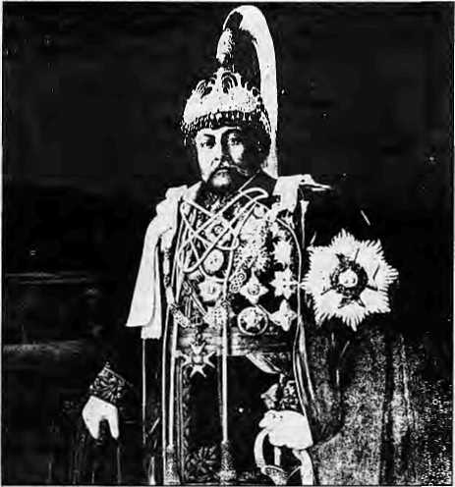
Aishwarya are, of course, both greatgrandchildren of Maharaja Juddha.
Nepalko nimiita sabbhanda thulo kura
usko swatantrata ra sanvabhoumikta kayam
rakhnu ho ("The important thing for Nepal is
to m aintain its independenc e and sovereignty"),
runs a quotation from King Birendra suspended
above Kathmandu'sRatna Park. If that is the
ultimate criterion, then Rana rule was
reasonably successful, for Jang Bahadur and
Chandra Shamsher, even if principally
pursuing their personal ambitions, dtf much
to ensure that Nepal survived the colonial and
post-colonial era as an independent state. If
we look at their record in social and economic
development, the judgement has to be harsher,
but probably no other regime which emerged
from the instability of the 1840s would have
served Nepal better. ^
J, Whelpton is author of Jang Bahadur in Europe and Kings, Soldiers and Priests and lives in HongKong.
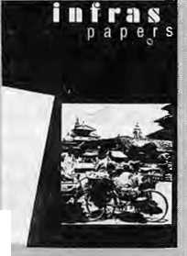
a natural convergence of interest: the Ranas continued to allow Gorkha recruitment, and also sent Nepal's own forces to fight in both World Wars, whilst the British paid for the soldiers and also kept an eye on the growing ami-Ran a movement amongst Nepalis in India.
The 1923 agreement acknowledging Nepal's full independence made sense in the same context: the more separate India and Nepal were politically, the less likely Gorkha troops in India would be to feel solidarity with the Indian nationalists.
Like policy towards British India, Rana isolationism had its roots in the past. From Prithvi Narayan's time onwards, restricting access to the country had been seen as vital for Nepal's national security. During the latter halfofthe Rana period, however, the maharajas required not security from a possible British attack but from political 'contamination'. In their final years, with British withdrawal from India imminent, the Ranas realised that diplomatic relations with as many countries as possible would strengthen their position in negotiations with independent India and began, belatedly, to change tack.
The Damage Done
Another area in which change came too late was in the whole pattern of personal excess which both repels and fascinates us today. The elaborate stucco palaces built in imitation of Versailles and Buckingham Palace, the jewelled head-dresses, the richly-caparisoned elephants, the scaleof the hunting expeditions, were all part of this and so, for many of the maharajas, was the pursuit of sex.
Jang Bahadur's amorous interests attracted interest even before he came to,po wer. His nephew, Maharaja Juddha, kept up the tradition. The accusationindissidents' leaflets are confirmed by a 1939 diplomatic despatch noting his tendency "to pick up any damsel that takes his wayward fancy and then to return her, with a few rupees clutched in her hand, to her parents or husband."
Such behaviour could be paralleled elsewhere in South Asia and beyond, but, as the same diplomat added, times had changed. Juddha's retirement in 1945 and the more subdued style of PadmaandMohanShamshei' were insufficient to repair the damage.
Whatever their personal conduct, Rana rulers in this century were aware of Nepal's backwardness and did take positive steps. Chandra Shamsher built suspension bridges, which are still in use today. He also founded the Tri Chandra College. And under Juddha Shamsher, factories weie opened in the Tarai. However, fear that rapid change might
undermine their own position was always paramount. In a report for Juddha on industrial development, Singha Shamsher, one of Chandra Shamshcr's sons, wrote that it was in the Rana's interests to raise the people's living standards but added, "we cannot possibly take steps that may in any way be subversive to our autocratic authority." Of the two maharajas who seemed ready to take a bolder and more generous view, Dev Shamsher (1901) was quickly deposed by his more conservative brothers and Padma Shamsher (1945-48) intimidated into resignation.
Great grandfather Juddha
In 1951. Mohan Shamsher, ■Padma Shamsher's hardline successor, had to accept the 1951 "Delhi Compromise". Rana rule was thus formally ended, but as in 1846, the break with the past was not complete. The many marriages between Shahs and Ranas meant that individual members of the Rana family remained members of the inner circle even when power was restored to the monarchy. In November 1951, King Tribhuvan reportedly compelled the Nepali Congress to accept his own choice of Prime Minister by threatening to impose direct rule with the help of Kaiser Shamsher, Mohan Shamsher's brother.
The Panchayat system of "guided democracy " which K ing Mahendra introduced ten years later was similar in spirit to the constitution proposed by MahaTaja Padma in 1948, only with Shri Panch Maharajadhiraj rather than Sri Teen Maharaj providing the guidance.
The final 'subversion of autocratic authority' came in 1990, but many Ranas still occupy senior positions in the Royal Nepal Army. And King Birendra and Queen
iniittkf Copies available sale &tMimal
NRs200
Rural Urban Interlinkages: A Study Based on Nepaiese - Swiss Development Experiences
^ ersy 18 R^itgrsiiV 80Q2Zurich. -iSee[abstracts on page 39)

14 , HIMAL Jul/Aug 1993

Tanakpur on the Thames
by Dipak Gyawali

A
nondescript building by the Blackfriars Bridge, over the Thames in London, houses the Oriental and IndiaOffice Collections of the British Library. Despite its unassuming looks, it is the repository of the institutional memory of England's colonial past, a .gold mine of preserved records, official memos and astute observations of her civil servants from far-flung outposts of the Empire. _
For the last two years, Nepal's state apparatus has been bogged down with the controversy over Tanakpur barrage on the Mahakali (Sarda) river on the western border with India. This area of Nepal has a history intermeshed with the British Raj going back to the late 18th century. At Blackfriars, one can take a walk through the history of Tanakpur— seeing how these lands "between Kali and Rapti" were ceded to the "Honourable East India Company" by the Sugauli Treaty of 1815, how they were gifted by the British back to Nepal following Jang Bahadur's help in suppressing the Sepoy Mutiny of 1857, and how Chandra Shamshere actually negotiated the details of the 1920 Sarda Treaty.
Nepal's water negotiations with India has suffered from the loss of institutional memory following the overthrow of the Ranas in 195 l.eightyears of interregnum, ISmonths of abortive democracy, and 30 years of Panchayat rule. India, on the other hand, saw white masters depart and brown masters take the helm without abyteof memory loss within its institutions.
Of all the resources spent on tours abroad by Nepali MPs during the last two years, if only a fraction had been devoted to Tribhuban University researchers spending some time at BlackfriaTs (orif the NepaliMission in London had been instructed to investigate), much of the historical facts of those times would have come to liglil.. Instead, what wehaveseenis an emotional heat wave engulfing thePaTliament and the nation.
One can now only speculate how the debate in the Nepali Parliament might have proceeded had, for example, the minutes of the meeting between Nepal's Superintending Engineer Kumar Nar Singh Rana and British India's Executive Engineer S. Athim, held at Tanakpur on 26th February 1918, been known in December 1991, before the Tanakpuv heartburn began.
The extract below, from British Library records, shows how the figures for Nepal's share of water from the 1920 Sarda Treaty currently in force (150 cusecs in dry season, 460 cusecs in the wet season with an upper limit of 1000 cusecs if water is available) were arrived at:
...The Superintending-Engineer admitted ' th~at'taking a canal across the Mohan(a) river was not contemplated and consequently the Kailali district may be left out of consideration. The Superintending Engineer stated thai judging from reports received from local officials, the total culturable area, including what was inspectedbyMr.A thim in 1917 may be accepted as 48,000 acres.
The Executive Engineer pointed out that if the gross area is as above, then the annual area to be irrigated at 66 w per cent will be = 2/3 X 48,000 = 32,000 acres; and that if the 48,000 acres represent the annual irrigated area, the rabi area will be 1/3 X 48,000 = 16.000 acres and the kharif area will be 213 K 48,000 = 32,000 acres.
The SuperintendingEngineerstated that in Nepal the whole of the kharif area was resown in rabi and that he considered that no difference should be made. The following calculations were made by the Superintending Engineer:-
Kharif Area = rabi area
= 32,000 acres
Kharif supply with duty of 70 acres
= 32,000/70 - 457 w cusecs.
Rabi supply with duty of 200 acres
= 32,000/200 = 160 cusec
[duty: araa lhat can bs irrigated wilh givsn water flow -»d».)
Executive Engineer pointed out that the proper kharif duty at the head of a canal is 100 acres', andlhat 70 acres is adopted for distributaries that run in alternate weeks; also that in a properly designed scheme the aggregate discharge of all distributaries is nearly double the discharge athead of main canal. Executive Engineer suggested a compromise as follows >
Rabi irrigation may be taken as 24,000 acres with a duty of 200 acres - the discharge would be 24,000/200 = 120 cusecs. It is, however, clear that in the Tarai the duty should hi more than 200
acres. If 250 acres were taken, the discharge required would be 24,000/250 = 96 cusecs.
It was also pointed out by the Executive Engineer that in the absenceofmaps itwas extremely difficult to arrive at definite conclusions.The Superintending Engineer ~~~agreed and said that he was acting on reports received from local officials and had no personal knowledge of the tract.
The SuperintendingEngineerstated that Nepal had a right to the Sarda water, and only so much was asked for as was considered necessary for the irrigation of a tract which at present suffered from lack of irrigation fac Hi ties.
The Executive Engineer pointed out that, as far as he understood the matter, the contention was correct, but this was not a question for present discussion; and furthermore, that if the water level was raised so as to make irrigation possible by the expenditure of lakhs of rupees on headworks, no claim could arise without participation in original cost and maintenance.The questionas towhat share may be given is one for the-.two Governments to decide. The purpose of this meeting is to determine what volume is--required for irrigation in Nepal.
The Superintending Engineer expressed the opinion that kharif supply should not be less than 460 cusecs, and rabi supply not less than 160 cusecs, or 150 cusecs as a minimum; also that up to 1,000 cusecs may be required for kharif.
These minutes are followed by Mt. Athim's "explanatory note" to his superiors listing his complaints on the process of negotiations:
—I found the whole position had changed owing to the Superintending Engineer holding that Iwas not shown all the country in 1917. The opinion of Lieutenant Jagat Bahadur, who showed me aroundin 1917, was entirely set aside. ...
The Koriali and Mohan(a) rivers are said to be fairly targe ones. TheDarbar is not utilizing to the full its resources of water in these channels, and it has done nothing as regards Sarda. Now that the British Government proposes to build headworks for a canal from the Sarda the Darbar asks for some water, it appears to

Jul/Aug 1993 H1MAL . 15

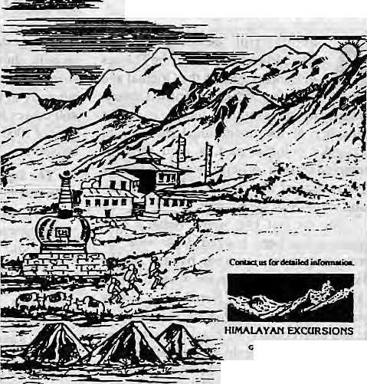
me that unless the Darbar shares the expenses involved in raising water level of the river, it cannot claim any share. It may be expedient to allow some share, and I consider that 100 cusecs in rabi is ample.
Resistance by British bureaucrats to giving Nepal concessions was not limited to ihelmgationDepartment alone. A letter of 16 August 1916 by the Special Forest Officer, the Tarai and Bhabar Government Estates, to the Deputy Commissioner, Naini Tal, states (after political decisions had been made to try and swap4000 acres of Nepali left bankneeded for headwork construction wiih equivalent iaftu in India):
... The old boundary between Nepal and Naini Tal district was, when it was laid down, the then mid-stream of the Sarda riverwith reference pillars on either side. Owing to the river continually changing its course, this boundary was found to be very unsatisfactory.
A realignment of the boundary was ordered by Government in 1909 and after a good deal of correspondence and meetings between local officials on both sides a boundary commission met in February 1912 and settled certain preliminary details which were accepted by both the Government of India and the Nepal Darbar,
The boundary as it stands isas near perfectionas possible and it wo aid be most regrettable if it had tobe altered.Moreover any alteration-^- the bsundary io-give . Nepal 4000 acres of British territory will mean having to go over the whole works again which has already taken up enough time of the locaioffirials and has also been very costly to the Government, 1 a'n of the opinion thatNepal shouldbe compensated with 4000 acres from some other district or, if possible, in money.
These and many other documents at Blackfriars show that Indian .ovo/vy and Nepali prajatantra notw ithstandiug, I ittle has changed
governments have alw ay s asserted the principle that a land-scarce hill statecan claim only that amount of water that it can actually use. In actual negotiations, the technically less-prepared party always loses. Broad political understandings can still be scuttled by vested bureaucratic interests. And, while institutional amnesia feeds the controversy, the slate is not blank. The writ of history is all over it.
D.Gyawali spent this spring at Blackfriars as an Oxford visiting scholar researching for his book on water diplomacy.
16 . HIMAL Jul/Aug 1993

offilms Miidean
iSuBjtct criteria ■"■■ :; - '.. ■ "Zritries wiff Wave: to Be. Tilafti to su6jict$ and-> issues of thi iHtntalaya w: have. specific riievunti to the 2fifaaidy$n-.T$pii((*ti$!i;: 'the 'fifm couii 6e mMt tj By "anybody ahd
'vf
ifj...... from ptopti,
and ftislorij p0 , development; poli Z iifino-
tics,
Type, of film
films (factual & fiction) hat is, ti> c Based'■■m ffoedecisions of-ike festival-selection
Length ■■ ■ -■ ■ ■■■' ■" ;.: ' Ike dufaiioh of the; 'fiCin', will not Be considered a 6m ' Snort spots as well as full kn'gifi 'Jiiriur will Be accepted.
Latiguage
■film ttfitf Have: to ht 'inl 'English prfuwe'Bru]lishsu^-_{i} Miles:. -- . . ., .. ,,
^Format
sfiouldB^sent in !0{$
for Miciion.
is-
J? selection walling siRtduled for 9{fjyern§ey tSZ 1393. Jfynti ail entries must? reach the ^Festival-office oy
1entry forms and other* p&ase conidcl
Symart
i: Festival Director, . Ntepal,
WE WELCOME YOU TO THE HIMALAYAS!
1221. Kcilur M»h*l t, KllhlMAdd, Tfcpvl Td ; {0)414407. (M) 415112 F«< T<O)W-37T-l-4iaiT9 :{H) 00-977-1-419911
WE OHGANiZE: TREKKING AND MQUMTAINEERMG EXPEQfTKWS IN NEPAL, TIBET AND LADAKHPLUS WHITE WA TER RAFTiNG, WlLDUFE SAFARIS AND SIGHT-SEEING TOURS fN THE KINGDOM OF NEPAL
We accept all major credit cards.
Why
Macintosh ?
Why do people who use Apple Macintosh computers every day enjoy working with them so much/and find that they're much more productive in the process ?
Is it because Macintosh computers are so easy to set up, learn, and use? Or because Macintosh applications all work in the same consistent, intuitive n'Sy? Or because every Macintosh comes with built-in networking and file-sharing capabilities ?
Or is it simply because once people use a Macintosh, nothing else will do?
Every day, thousands of people discover the advantages of Macintosh for the first time. And catch a glimpse of its magic.
So if you want to know why contact us at MIPS.
MIPS Pvt. Ltd.
P.O. Box: 2502, Tel: 222277,
Telex: 2521 ATLINK Fax: 977-1-419250

quiet Uttarakhand
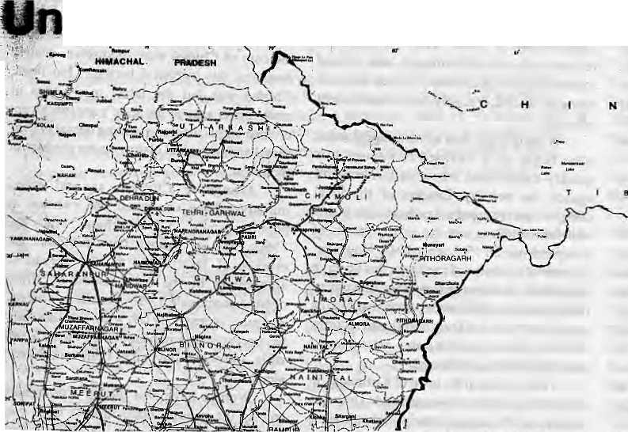
Over the past two decades, a wave of social movements has swept the hill region of Uttar Pradesh. These include movements againsi alcoholism and sale ofillicit liquor, againstunregulated mining, against the siting of large hydroelectric projects, and for the establishment of aseparate province of Uttarakhand within the Indian Union. Most celebrated of all is the Chipko Andolan, the 'Hug the Trees' movement that is arguably the best known environmental initiative in the world.

These contemporary social movements have heiped place Uttarakhand firmly on the social and environment at atlas of independent India. Yet these movements have also inspired scholars to recover, from the margins of history asitwere,theheritageofearliermovcmentsin the region. Where colonial officials liked to write of the 'simple and law abiding htllman', the fact is that the hill peasantry have been as politically active and alert to injustice as their counterparts elsewhere in India.
Mountains, Forests and Governance

The analysis of social movements in Uttarakhand must reckon with three distincti ve features of life in the hills. First, the ecological characteristics of mountain society — the close integration of agriculture and animal
{husbandry with the forest, the limited availability of cultivable land, and possibilities of agricultural intensification —■ have meant that in Uttarakhand, as in the Alps and the Andes, rural society has amore or less uniform class structure, composed largely of peasant proprietors with a relatively small proportion

of big landlords or agricultura! labourers. Hence the absence of the classic agrarian conflict between landlords and landless labourers. Rural discontent has beenexpressed in different ways, however. This I will deal with presently.
Second, the forests of the region are among (he most valuable in the Subcontinent, a source of hardy coniferous timber and lucrativepine resin. Fromthe late 19th century, the forests ofUttarakhand have been intensely exploited under government auspices, but for the outside market. Commercial forestry entailed strict curbs on the peasant's access to the woodlands, which adversely affected the local economy and sparked widespread resentment.
Third, throughout the period of colonial rule (1815 to 1848), Uttarakhand was divided into two distinct political units: the princely state of Tehri Garhwal, and Kumaun Division, which was controlled directly by the British. Thus, while theregion was quite homogeneous in terms of economy and culture, the structure of the state, and especially the style of rule, differed greatly in the two territories.
The monarch of Tehri Garhwal, representative of a 1200 year old dynasty, enjoyed enormous legitimacy among his subjects, who accorded him a quasi-divine status. Garhwal's personalised and flexible system of authority contrasted with the more rule-bound and bureaucratic style of the British in Kumaun, where the colonial state was further separated from its subjects by the chasms of Tace, class and language.
Where the first two factors might explain
Social activismmthe
Uttar PradesJt hills
has its origins back
in the days when the
British still ruled.
Back then, too, the
inhabitants of
Kumaun and
Garhwal were
politically alert and
active.
by Ramachandra Guha
the originsof socialpro test across Uttar akhand, it was political division of Kumaun and Garhwal which lay behind the different ways in which protest articulated itself.
Kumaun: The first century of British rule in Kumaun is notable for the absence of peasant movements. In view of its strategic location (bordering both Nepal and Tibet), land Tevenue was pitchedataratesubstantially lower than the adjoining plains districts. The system of providing unpaid labour {begar) and services {bardaish) for touring officials were, till the advent of commercial forestry, the main source of peasant discontent. The sporadic opposition to forced labour gathered momentum following the state's takeover of the forests of Kumaun between 1911 and 1917, because forest officials extracted begar at will even as their actions deprived the peasantry of a key economic resource.
Matters came to a head in January 1921, when a general strike against begar paralysed the administration. The strike was called by a massive demonstration at the great Uttaraini fair in the town of Bageshwar. This was followed several months later by a movement against the forest department, with villagers deliberately torching State-con trolled forest areas which were being exploited for timber and pine resin.
Both the begar and forest movements were quite successful: the former leading to the abolition of the forced labour system, the latter forcing the state to make major concessions in its forest policy (although it retained tight control over the more valuable forests). In later years, the peasant rebels

Jul/Aug 1993 HIMAL . 17

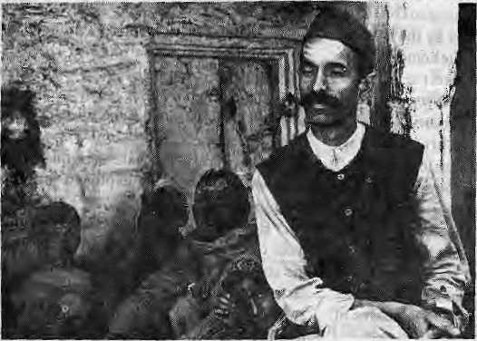
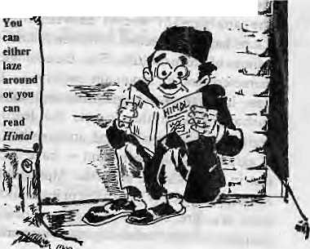
continued lo set fire to commercially-worked forests to express iheir dissatisfaction with government policies. Meanwhile, in 1930 and 1942, there was considerable local support, led by the Congress Parly, to the nationwide campaigns against British rule. This included attempts to hoist the national tricolour at public places, and general strikes in response lo the arrest of local leaders.
Garhwal: InTehri Garhwal, commercial forest operations had started even earlier — towards the latter decades of the 19th century. Peasant movements in the chiefdom were" often connected with restrictions on access to the forests. Social movements against state forestry, which erupted in 1904, 1906 and 1930, followed a classic pattern. While breaching forest laws and attacking state officials, peasants did not question the legitimacy of the monarch, himself above wrongdoing in their eyes (by contrast, popular movements in Kumaun were aimed directly at the British). Rather, the peasants asked him to intervene by withdrawing unjust laws and punishing tyrannical officials.
While earlier movements had tended to subside after the monarch's intervention, events took a different turn in 1930. In the absence of the king, away onholiday in Europe, the Dewan (chief minister) advocated punitive action against those who opposed forest settlement operations in Rawain, a county in the northwestern corner of the chiefdom. The movement spread rapidly when village leaders were arres ted. When negotiations broke down, theDewanmarchedonRawainwithanarmed force. Coming upon a meeting of villagers on the banks of the river Jamuna, this force fired on the crowd and caused many deaths.
Long before Chipko: Almora taacbar in 1958
Whereas theRawain affair and theearlier social movements had arisen in response to the state's takeover of forests, the last and most widespread movement in Tehri Garhwal
focused on the heavy burden of land revenue on the peasantry. Land settlement operations, commenced in 1944, were immediately resisted by the affected villagers, who refused to submit to the preliminary survey that was beingconducted.orsupplyfcegar to settlement officials.
Whenofficials took an intransigent stand, what began as a localised movement was quickly transformed into a statewide revolt against the nobility. Leaders of the local Congress party played a significant role in this transformation, as did the proclamation of Independence on 15 August 1947. However, in terms of its aims and methods, this upsurge resembled an archetypal peasant movement rather than a carefully orchestrated nationalist campaign. Thus, villagers burnt court records, attacked state officials, and set up azad pancftayats (liberated areas).
Police firing in the town of Kirtinagar, in early 1948, gave the movement added impetus —c arry ing the corpses of their de ad comrades, peasants marched in their thousands to the capital, Tehri, ultimately taking over the town. The legitimacy of his rule at last questioned, the monarch signed the instrument of Tehri Garhwal's accession lo Independent India.
Contemporary Movements
When die Chipko movement broke out in March 1973, it was quickly assimilated into the global environmental debate, then gathering force in the wake of the Stockholm Conference, whichhad been held the previous year. Others saw its non-violent tactics as an exemplificati on o f Gandhism (' 'G andhi' s ghost saves Himalayan trees," wrote a journalist breathlessly in one of the first published accounts of the movement.) In later years, Chipko has also been acclaimed by feminists as an inspiring example of the special bond that exists between women and natae.
It is true that there is a strong (if implicit) environmental message in Chipko, that its most important leadeis come out of the Gandhian movement, and that wo men hav e p articipated in large numbers (though not, as is sometimes presented, in opposition to men). But in their | eagerness to lay claim to 2 Chipko, environmen-t; talists, G andhi an s and feminists have all underplayed, and often
ignored altogether, the long history of social protest in Uttarakhand that set the stage.
Interestingly, the peasants who formed the core of Chipko were themselves acutely aware of this historical heritage. For them, Chipko was but the latest in a series of movements against the state's encroachment on their rights, its longstanding denial of their moral and historical claims on the produce of the forest.
Alongside Chipko, several other initiatives have continued the tradition of popular protest in Uttarakhand. Since the 1960s, peasant women have protested the erosion of family life by the spread of alcoholism in the hills, aided by illicit distillation and sale. Led by Gandhi anworkers, and more recently by left wing activists, they haveorg anised demonstrations, sit-ins at liquor stills, and social boycott of both vendors and alcoholics.
Women have also played a prominent role in the peasant opposition to open 'cast mining in different parts of Uttarakfeand, Meanwhile, the most celebrated leaders of Chipko have been coordinating resistance to large dams being planned or built in their home terri tory—Sunderial Bahuguna inTehri, and Chandi Prasad Bhatt in Vishnuprayag.
Scholarly research on the social movements of Uttarakhand is proceeding apace, but much work remains to be done. For the colonial period, research might focus on regional variations in the scale and intensity of protest, and on the role of ideology and organisation. The more recent movements against alcoholism, mining and dam-building also await detailed and sociologically informed analysts.
Above all, we lack an authoritative history of the Chipko Andolan, the most famous and yet in some ways the most misunderstood of social movements of 20th century UttaTakhand.
i
Ft. Guha Is presently Fellow of (he Nehru Memorial
Library and author oi The Unquiet Woods: Ecological
Change and Peasant Resistance in the Himalaya
(1:990) and co-author oi the more recent This Fissured
Land: An Ecological History ol India. ,

18 . HIMAL Jid/Aug 1993

Why I write Economic History
by Mahesh C. Regmi

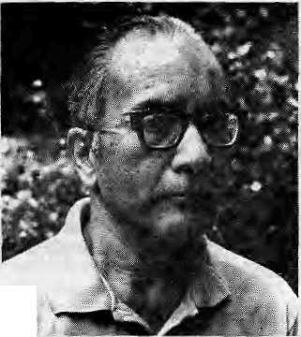

T
he editors of flimaf have asked me to write abriefnoteonwhy I write economic history. Having engaged in research and writing on the economic history of Nepal for over one-third of a century now, j could not honestly say no. Besides, I fell that the exercise would provide a good opportunity to review the reasons I have given at different times, and to clarify my thoughts and ideas as to why I have chosen economic history as my field of research.
The question why I write economic history may be countered with the question: Why not? Why climb Sagarmatha? There are people with an inquisitive or adventurous mind who try to do something ihai no one elsu has done. 1 suppose I iljjj belong to the inquisitive category. Before my studies on Nepal's economic history, the subject was virtually unexplored. In 1971, in the preface to A Study in Nepali Economic History, I wrote, "There has been a spurt in historical writing in Nepal inrecent years. The patience and perseverance ofa number of individuals in discovering and bringing to light documents, inscriptions and other source materials belonging to different historical periods have been commendable. Their diligence in the etymological interpretation of these source materials, and the meticulous care with which they pinpoint errors and inaccuracies in dates, names, places and personal relationships, are an essential process in our understanding of Nepal's past. One wonders, however, to what extent these efforts have made the problems and challenges faced by our ancestors comprehensible and meaningful to the present generation. From the viewpoint of substance too, thepersistent disregard for economic aspects of Nepal's historical problems is inexplicable and indeed inexcusable. The choice of dynastic political relationships or the esoteric aspects of human life as subjects for historical research may be explained by the personal predilections of the researcher or his incapacity to assimilate available historical data, but the contributions made by such efforts to the better understanding of the life and problems of the Nepali people in the past is of dubious value."
My interest in economic history is also due to the realisation that it is a key aspect of the nation's life. This is why, in my 1971 book, I sought to describe "...how the people of Nepal earned their living and what factors affected their economic life during the period from the mid-18th century to the mid-19th. It deals with the economic aspects of the people's life in the belief that this is the aspect thalconcernstheir very survival, and, as such, governs the nature of their life in other aspects too. It is concerned with such general phenomena as affect the life of the people from the economic viewpoint and not with particular incidents or personalities as subjects of intrinsic interest. Rather, it concentrates on the facts of economic life with the objective of determining the stage.nature and pace of economic development, and of identify ing specific factors inducing or retarding economic progress." Another aim was to explore the roots of the Nepali slate and society, by describing "...the economic policies and programs followed by the Gorkhali rulers to mobilize human and material resources for territorial expansion." I sought insights into the basic features and
objectives of Gorkhali rule without which the political history of this period could not be studied meaningfully. My study sought to shed light on the impact of those policies and programs on thelifeof the people. And it was in that respect that it left the "narrow and traditional confines of previous historical studies on Nepal" and sought to cover the entire country on a broad, regional basis, analysing the influencesat work among thepeople. In not confining my attention to wars, dynastic chronologies and political intrigues in Kathmandu as the subject-matter of historical study, I believe that I had set a precedent in Nepali historiography. As I look back today, I also detect a utilitarian streak in my writings. For instance. I wrote my Land-ownership in Nepal (1976) in the belief that "if the men of future are ever to break the chains of the present, they will have to understand the forces that forged them. "Economic development policies can only be formulated and implemented effectively if there is an adequateunderstanding of existing institutions, particularly agrarian institutions in countries such as Nepal. As I wrote in me 1978 reprint of Land Tenure and Taxation in Nepal: "Economic development in societies which seek to follow the path of evolutionary reconstruction necessitates an adequate understanding of existing social and economic institutions. This is so particularly in the fields of land and agriculture, where powerful vested interests often stand in the way of policies and programs aimed at improving the peasant's lot."
A similar motivation marked my volume Thatched Huts and Stucco Palaces: Peasants andLandlords in 19th Century Nepal (1978), which I undertook in the belief that: "...history consists essentially in seeing the past through the eyes of the present and in the light of its problems, and that the main work of the historian is not to record, but to evaluate." I believed that my work marked "a departure from the general tradition of Nepali historiography, in which greater emphasis is laid on the auxiliary sciences of history — archaeology, epigraphy, numismatics — than on the history itself as a dialogue between living present and past which the historian makes live again by establishing its continuity with the present." Inasmuch as economic development has¹ become the leading national slogan in present-day Nepal, I sought to explore some of the historical and institutional constraints facing such development. In other words, Thatched Huts and Stucco Palaces sought to answer the question: "Why is Nepal Poor?"
Having said this, I do not feel that there is any need forme to make
an attempt to justify my research and writings on the economic history
of Nepal in terms of their relevance to the mundane issues of economic
development and political evolution. For me, far more inspiring and
ennobling has been tlie feeling of participation, at whatsoever elementary
level it may be, in the eternal quest for knowledge. In the course of
exploring and recording a previously unknown and uncharted aspect of
the history of the Nepali people and, therefore, of mankind as a whole,
I have the feeling of having left my footprints on the sands of time. It
is this spiritual satisfaction from my work, rather than its material
rewards, that has sustained me during the long years of silent and lonely
study, research, contemplation, and writing. ^

Jut/Aug 1993 H1MAL . 19

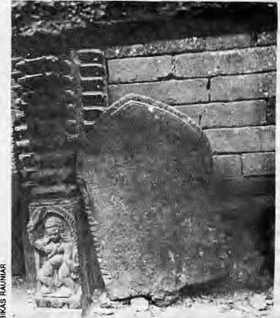
in
History
Fish charter in Tharu Chapagaoun
The Tharus could not have hid out in the jungle for aeons waiting to be discovered during the malaria eradication campaign of the 1950s. They must have a history of their own.
by Tej Narayan Panjiar
H
enry Ambrose Oldfield, in his book Sketches from Nepal, describes the Tharu of the Nepal Tarai as "a puny, badly developed and miserable-looking race, and probably belonging to the same original stock as the natives of the adjacent Plains of India."
Apart from the extreme cultural bias of this description, the belittling terminology was not borne out even in Old field's day, when the robust forest-dwelling Tharus were described by another contemporary book as being
"chiefly employed in the difficult and dangerous task of catching wild elephants". And a population group that had defied mighty malaria itself could hardly have been "badly developed".
As for Tharu origins, rather than his perfunctory hypothesis, Oldfield might have delved into the possibility that the Tharu have Mongolian blood, but he probably was not interested.
Unfortunately, things have hardly changed since Oldfieki's days, and successive British writers and historians, as well as the subsequent South Asian scholars have, by and large, shown similar weaknesses with regard to the Tharu society and its history. As one of themost disenfranchised groups of the Ganga basin, it is perhaps natural that this should happen to the Tharus
Sympathetic Mention
What were the Tharus doing in the malarial jungles and how did they get there? No social scientist has yet felt a need to study history of the Tharusin depth. They make up an invisible community which makes an appearance only when it suits the interests of the mainstream historians. In the case of Nepal, such a time arrived when malaria eradication finally cleared the jungles and it was imperative to say something about the resilient population of this region,
Evenso,theinterestofmodernhistorians of Nepal and India seems limited to brief sympathetic mention of Tharus as an exploited popujationgroup,andhowtheyhaveresiliejice against malaria. Some bizarre theories are also propounded as to the Tharu's origin. When they finally find the time to delve into the Tharus' past, researchers will find that they have not been faceless in history, and have in fact been active participants in the happenings of the Himalayan region and adjacent plains.
For example, there exist many lalmohars (land grant documents) awarded by the kings of Palpa, Makwanpur and Nepal Valley to Tharus for their bravery, "extraordinary sense of duty", or other reasons. Such documents can be found from Morang district all the way westtoKanchanpur.Thercare lalmohars from the kings of Kathmandu and Palpa which grant full enjoyment of Tharus to Tarai lands (except the tithe) if they are able to control the wild animals and the spirits of the jungles.
Mahesh Chandra Rcgmi, the economic historian, in his bookLandownership in Nepal during the Nineteenth Century seeks to prove that the Tarai lands belonged to the Thakuris, Ranas and Bahuns. While this is doubtless partly true, it must be remembered that, at
best, the hill people came down for three months in mid-winter, and were gone by the end of February. They did not know what the Tharus produced in their lands, and were content to let the Tharus be the det'acto landowners.
Thus, the Tharus were the masters of much of the Tarai lands, but there are numerous lalmohars to prove that they also had dejure title over vast tracts. For instance, one such lalmohar sanctions land in today 'sParsa district southof Kathmandu in Favour of the family of Darpnaiayan Garwar Tharu, for "gallantry" shown in a was' between Makwanpur and southern marauders. There arc many such lalmohars available for otherparts of theTarai as well.
The very fact of the linear habitation of Nepal through the length of Nepal's Tarai tends to prove that they spread out and inhabited this expanse over a long historical period. Unf ortunslely, we know h"tdc about this peniod. The priesis and nobles of IndiaandNepaLhave al w ay s worked we 11 together \Mhen the question at issue does not touch upon their rival claims upon one another. Whenit comes to the Tharus, therefore, these groups have&und it mutually convenient to relegate the Tharus to a historical corner, the implication being that these are barbarians with no history.
Rajasthan, Rajasthan
An attempt to write the social history of the Tharus is problematic, and credit goes to anthropologist Dor Bahadur Bista for at least having made a start in People of Nepal (HMG Nepal, 1967). But other historians are satisfied withfanciful notions about Tharu origins that do injustice to the community.
With no evidence to support the contention, some have claimed that the Tharus are descended from those that ifled from the Thar Desert in RajasLhan during the attack of Allauddin Khilji in the 12th century and Emperor Akbar in the 16th century. Baburam AchaTya, a Nepali historian of stature, has accepted this thesis and staled dial many Rajput soldiers were killed by Akbar's forces and that the women of those soldiers fled to the jungles of Nepal with their servants. The Tharus are supposed to be the progeny of these mistresses and their servants.
Some innocent/crafty modern-day Tharus have taken satisfaction in this explanation, possibly because it links the community to" the glorious Rajputs of Rajasthan. The reason the Tharus lost the sacred thread, it is reasoned, is because they gaveup warfare and adopted agriculture. (That perhaps they were not originally Hindus is

20 . HIMAL Jul/Aug 1993

indicated from an order that was issued to enforce the Muluki Ain (1854) among Tharus who lived between Morang and Dang-Deokhuri. Among other things, the order decrees that Tharus are not to eat pork ot drink liquor, and that males are not to marry maternal cousin sislers).
Rajasthan lies to the south and west of Delhi, which was the seat of the Muslim kings and emperors. Why would the bevy of doubtlessly brave Rajput ladies insist on travelling through Mughal territory to end up in the jungles of the lower Himalaya when they could have fled easily southwards to the hills of the Satpura and Vindhya ranges?
A theory propounded by Iswor Baral, presently the Vice Chancellor of the Royal Nepal Academy, seems more plausible than the 'flight from Rajasthan' myth. Baral, who grew up among the Tharus and knows the community well, is of the view that the Tharus are descended from a community that was persecuted and banished northwards during theexpaiisionoftheVajjii Republic. According to the Buddhist scholar Ashwagosa, this was a flourishingstateduringtheSakyamuni'slime. From geographical history, we know that the Vajjii territory incorporated Champaran, Muzaffarpur and Darbhanga districts in present-day Bihar.
This would explain why, as Baral theorises, the Tharus call all non-Tharu population to the south by die name"Vajiya". This term has now even entered the Nepali language, "bajiya" meaning "uncouth". This theory must, of course, stand the rigours of academic reasoning, which will probably happen when more scholars take an interest in Tharu history.
Sakya of Lumbini
The Tharus certainly were not a community that hid out in the forest for eons wailing to be discovered during the malaria eradication campaign of the 1960s. Serious work on their antiquity would probably reveal interesting linkages with the main stream of South Asian history. Could it be, for example, that the Sakyamuni Buddha was a Tharu?
The first and foremost principle laid down by the Buddha has been named Theravada. But according to its Pali rendition, it is Theragalha, that is, the story of the Tharu. It is though t by some that the S aky amuni modelled theorganisationofhisra/ig/iaonacommunity such as his own. It is significant that the Sakya seem not to have the Varna system, and they were isolated to the extent that they were self-governing and their polity was of a form not envisaged in Brahminical theory.
The fact that the Sakyamuni's birthplace in Lumbini is still in the midst of a Tharu settled area might be one indication that they are the original inhabitants of this area. A. Fuhrer, who discovered the Lumbini site, was himself of the view that Tharus are the descendants of the Sakyas, though he was unable to prove his case.
Excavations done at Tilaurakot, the site of the palace of the Sakyamuni's father King Suddhodhana, have brought up some 3rd century artifacts (contemporary to the Vajjii) that deserve further study. Some of the bricks are stamped with the octoradii circle, which is the mark of the "turning of the wheel of the law" throughout the Buddhist world of Southeast Asia, Japan, China, and also in ihe Ashokan inscriptions. Another stamp bears the mark of the trisul. On the wails of the thatched huts of the Tharus today, one finds frescos that carry identical marks of the octoradii circle and trisul.
As followers of the Buddha, were the Tharus persecuted by the Brahminical forces, and is this why they were forced into the forests, where the 20th century finally found them? As one scholar wrote in 1896, 'The clan and the disciples of Buddha were so ruthlessly persecuted dial all were either slain, exiled or made to change their faith. There is scarcely a case on record where a religious persecution was so successfully carried out as that by which Buddhism was drivenout of its place of birth."
Taking this lincof thought a step further, it is probable that as Ihe Tharus fled persecution they not only entered the Tarai jungle but that some also fled further north to the Valley of Kathmandu. There are several unanswered questions in the history of the Valley that could perhaps beexplained if the Tharuelemcnt were to be introduced.
Fish Lovers
Of Manadeva, said to be the founder of the Licchhavi dynasty (464 AD), there is no suggestion that he was a Licchhavi. It was only 126 years later that his descendant Sivadeva I laid claim to Licchhavi lineage. And it is Sivadeva who had a charter inscribed in stone to the people of Tharu Drang (Tharu Village), which is the present-day village of
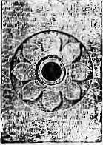
Octoradii
from
Lumbini
ChapagaoninLalitpur District.The inscription, which is to be found in Chapagaon today, reduces the tax to the people of Tharu Drang on different kinds of fish. Tharus, it need hardly be stated, are fish lovers to this day.
Historians Dilli Raman Regmi andDhana Bajra Bajracharya went to great lengths to try and identify the different kinds of fish that are named in the inscription, such as Kastika, Mukta, Bhukundika and Rajagraba, Despite complicated semantic analysis, they failed to identify these alien names. A Tharu would have told them that Kastika is a fish that can be boughteven today in the IndraChowkmarket. The standard name of this fish is Gainchi, but in colloquial usage it is sometimes known as Kastika, a term which indicates that the fish does not spoil as easily as other fish.
They were unable to identify a fishnamed Bhukundika, because, again a Tharu would have told them, Bhukundika is not a fish. It is instead a clam-type slug which is found abundantly in Kathmandu Valley but shunned by the local population. Today, the Thams who live in Kathmandu savour the slugs as a delicacy, although today they know it asDoka.
And what does the similarities of the Jyapu caste of Kathmandu Valley and the Tharu say of the origins of either group? The Jyapus use the kharpan, balancing two loads on a bamboo pole, as do the Tharu, who call their implement the baihinga. No other Valley community uses it but the Jyapu. Both Tharus and Jyapus relish beaten rice (chiura lo the Valley dwellers, also to Tharus). Jyapu and Tharu women use the okiial and musalo to beat rice, but this is not the case with the neighbouring communities of the Valley or Tarai. Jyapu women tattoo their upper heels, exactly as the Tharu women do.
Who are the Tharus, where do they come
from, and what light can their history shed on
the past of the Himalaya and Soudi Asia as a
whole? Some historical interest in the Tharus
by scholars of today will shed some light on
numerous nooks and crannies of the past. We
will then gain better understanding aboul so
many issues, from the days of the Sakyamuni,
to the spread of populations along the Ganga
and Tarai belt of today's India and Nepal, the
populating of the Kadimandu Valley, and the
reasons behind the backwardness of Tharus
today. And with such understanding, hopefully,
there will develop a greater appreciation of
Tharu culture, which in turn will finally work
to eliminate the social and political
discrimination that this community faces in
Nepal today. ^
¹ .N Panjiar works in the National Planning Commission of Nepal.
. Jul/Aug 1993 HIMAL , 21

V
0
I

USELESS CONQUISTADORSarethosevhoperform
most aesthetically on the mountain,as opposed to the couch potato climbers, saysMichaelThompsonxultural theorist, ex-mountaineer andco-authorqfUncertainty ona Himalayan Scale, while presenting a paper at the International Environment Academy, Geneva.
The essential point is that mountaineering would not exist if it did not have a direction, and it would not have a direction if it did not somehow generate a definition of achievement that united personal skill with personal risk-taking. To focus on skill without risk-taking would by-pass the whole business of risk compensation which, as every mountaineer knows, is what makes it all exciting enough but not too terrifying. Conversely, focussing on risk-taking without skill would lead the activity into a death-or-glory cul-de-sac, in which the direction of change is defined as the one in which everyone who moves in that direction is killed, hi other words, the relaxing of one or other criterion results in the demise of the activity of mountaineering: from boredom in one direction and from death in the other. Only when both criteria are applied is it possible for the activity to continue in existence. That is how mountaineering self-organises itself, and why the aesthetic of "doing more with less" is its essence: without it mountaineering would cease to be mountaineering.
Thisessence, ofcotfrse,isalways under threat. It is threatened, from outside, by commercial interest and by bureaucracy and, from inside, by those mountaineers who want to be up there with theelite without quite accepting the risks that entitle them to be up there. So the essence has all the time to be defended, and nowhere is this defence more needed than the Himalayas. "Giving the mountain a chance"jsnotasentimentthatcomes easily to commercial sponsors, and the whole business of selling places on expeditions guarantees that their members will do much less with much more than did Reinhold Messner before them. If the tide is running this strongly in the wrong direction what can turn it? My answer is: the environment. The argument is wonderfully simple. Those who consistently aim at doing more with less will be doing two things: they will be defending the essence of mountaineering and they will be having less impact on the environment than any of the backsliders.
THE DELICACY OF HIMALAYAN TEAS is so
exclusive that the market must not be sullied by the lowly tea from the Doons, writes the London correspondent in The Pioneer of 16 June 1865.
We have said enough to convince all disinterested parties that avery high order of Teas is nowbeing produced in the Himalayas, and that the planters have it entirely in their own hands to make the most of
their opportunities. It is to be hoped that no more inferior Teas from Government Gardens or elsewhere will be allowed to find their way into the home market or destroy the favourable impression created by the introduction of the samples of which we have been writing; and there is another point which we think the Hill planters should watch with some jealousy. Teas grown at a comparatively low elevation, and certainly not on the Himalayas, are being vended as Himalayan Teas. They are not bad Teas, but they are notHimalayan, and they are wanting in the delicacy of flavour which is the chief attribute of the article when grown at a high altitude. It is a worldwide principle that aspade should always be called a spade, and we therefore think the Hill planters, in Iheir own interests, should see that the Teas of the Dhoon and elsewhere are not retailed to the public as Himalayan Teas. With this remark we conclude our present series of of articles on Tea planting in Kumaon.
THE PAST IS ABSENT laments Arvind JV. Das in The
Times of India, 11 July 1993, the South Asian's neglect of history.
The method Indians appear to have found to deal with their past is to mythologise it. Fact is at a discount; fiction is at a premium among a people for whom time itself is not linear but a bewildering set of interlocking circles. Thus, while myths move millions, the actual and complex historical reality is often ignored
... Take Hospet, take Mahabalipuram, take Bhojpur, take Khandagiri, take Vishnupur, lake Vikramshila, take even Ayodhya. It isalt a long tale of apathy about the neglect of thepast.lt is a saga of the structures of history being enveloped under the vegetation of the creepers of myth and the trees of ritual.
The problem, as Ayodhya has demonstrated, is that poisonous weeds of hatred grow unless the ground of history is cleared consciously and conscientiously.
In fact, it is the space within the boundaries of history that enables people to fashion their collective identities and to so order their present that the future becomes at all possible. It is this process that is stifled when myth and superstition, hate and bigotry, social fragmentation and unenlightened selfishness are allowed to flourish unchecked and are indeed fertilised by vested interests that feed on ignorance.
Indian civilisation has already paid a heavy price in terms of internal strife, leading even to fragmentation of its polity, not only several times through the long course of its past but even in more recent times. Indeed, the wounds of such fragmentation are still festering.
In that context, if not also in the interest of scientific inquiry, it is imperative for Indians to be aware of their past so that their future does not get blighted. It is well-known that people who foTget their history are condemned to repeat it.

22 HIMAL . Jul/Aug 1993

C
E
ln
S

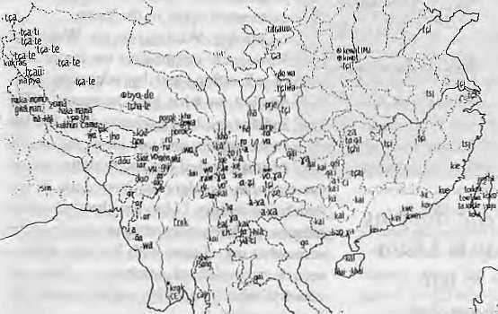
WORD DISTRIBUTION MAP drawnupby Japanese
researcher Tetsuo Suwa in a 1989publication on The Formation of the East Asian Ethnic World, analyses the distribution of 140 basic words which are considered to be important in the research of the formation and migration of ethnic groups in East Asia. The map below contains the distribution of words for "chicken".
ihe Dharma in accordance with the times and circumstances. Therefore, I appeal to all those concerned and those who have the responsibility (okeep this inmind.Itis also important that every body should pray that this might be realised as such.
The activities of a lama are determined by his followers, by the bond of samaya that exists between the guru and his disciples, and by many other factors which I do not have to mention here. Therefore, whatever has already happened is over. Now that the situation hasbecome clear to you, Imakean appeal to all concerned: it is of the utmost importance that one take great care not to create a barrier obstructing this interdependence.
If we look at this controversy from another angle, the subject of the contention is the Gyalwa Karmapa, one of the highest lamas ofTibet. And either side involvesahigh lama. So weare accumulating heavy negative karma in connection with a high lama if we get involved and let this controversy continue. I, therefore, earnestly appeal to all that everyone concerned should make a concerted effort to put an end to this controversy so that we will avoid all this negative karma.

O/V£ REINCARNATION AT A TIME, is about ail
Tibetan Buddhism can take, according to a statement by Karma Gelek, Secretary of the Religious Department of the Tibetan government-in-extie, while seeking to put an end to the controversy surrounding the recognition of the 17th Gyalwa Karmapa. (See Htma\,Nov!Decl992.)
Now, the matter of the reincarnation of Gyalwa Karmapa, who will be the seat holdeT of Karmapa, is settled. Generally speaking, it is possible to have Mind, Body and Speech emanations of a lama. According to Buddhism, it is even both possible and proper to have hundreds and thousands of incarnations of one lama. However, according to the unique tradition of Tibet, when it comes to identifying reincarnations, and especially in the case of high lamas like the Gyalwa Karmapa, it is not possible to have more than one incarnation at a time. This is a traditional set system—you may call it "the way of the society."
Therefore, there will be only one seat holder of Karmapa. And the recognition of that incarnation has already been finalised as stated above.
Now, the irnportant thing is that it is nolenough to just identify and enthrone theKarmapaJtiscrucial to provide aproper education for him, proper practice andmeditation, to offer him empowerments, textual transmissions and pith instructions so as to enable him to carry out activities of the same scope as that of the previous Karmapas. It is essential to enable him to benefit beings and spread
HIMALAYAN SOS, transmitted in a recent editorial by Yalung Kirat, editor of the bilingual journal Himalaya, published ' from Kalhmandu, which emphasises the cultural diversity of the Nepal Himalaya.
Whatever might be the goals and specialisation of Himalaya, looking at the present one feels, "O Lord! The country is waking up, but it is hard to walk on coals. Please drive home good sense in the minds of men, and sprinkle water on the path." The southern lap of the Himalaya is the meeting place and living place of numerous Asian cultures. It is a repository of the language, religion and culture of so many groups. But historically andup to even today, the government and administration continue to push for the development of one group, one language and one; religion/culture. The new age is the age of the entire human race, and no door should be locked to those who want to live and promote their interests peacefully. There should be mutual respect and understanding. This, after all, is the essence of "vasudaiva kutumbakam".
Though they might have suffered under the weight of poverty, till today, Nepalis have always looked at each other with goodwill. But today, opportunism and political pollution is raising its profile in the society, both in and out of the country. Let this not, tomorrow, lead to a breakup of the country, and let not the United Nations have to be invited to conduct elections, and let not the sovereignty of Nepal fall from the grasp of Nepalis.
Let the many numerous mother tongues flower and prosper together with the national language Nepali.

Jul/Aug 1993 HIMAL . 23

Sleuth, Monk and Consultant

IPSPSW
-0'V 4- '■■■ ■■■ ■■■■■■ ■■■■ ■;■ ■= -5
i
y
■' ■■■' 'if "■
A
glance back into the past of any nation reveals certain moments when a turn other than the one eventually taken could have altered its fate dramatically. Nepal is no exception to this, and a document that has recently come to light offers evidence of one such moment in its history.
The document in question is a 57-page letter written by one Ekai Ka waguchi to Chandra Shamsher, the then Prime Minister of Nepal, Entitled Memorial, this booklet was salvaged from among other 'useless' papers thrown out from Patan's Shree Durbar and is now reposed in the Madan Purashkar Pustakalaya.
Ekai Kawaguchi was a Japanese Buddhist monk who visited Nepal three times in the course of his two trips to Tibet in the early years of this century. Remarkable for the fact that he succeeded in getting to Lhasa and living there for more than a year during Tibet's strictest years of seclusion, Kawaguchi's trip was also one that made him, by his own claim, the first Japanese to enter Nepal.
Nepal, too, wasrigidly observing its own closed-door policy at the time. Under such circumstances, Kawaguchi's repeated incursions into the country led to speculations that he was an agent for his government. In fact, during his second visit in 1902, Chandra Shamsher directly asked Kawaguchi if it was the Japanese Foreign Minister or the Chief Marshal who had sent him. Kawaguchi somehow managed to impress upon the Prime Minister of his being no more than a humble monk in search of Sanskrit scriptures on Buddhism. Whether Chandra Shamsher actuallybelievedhimornotisanopenquestion but, interestingly, the two later had a confidential talk for about two hours. The substance of this conversation is still a secret,
he would not mention it even in his diary,
Kawaguchi arrived in Kathmandu once more in 1905 to make good his promise to bring a Japanese edition of Buddhist texts in return for the Sanskrit ones he had received previously. It wasduring this sojourn inNepal that he authored the Memorial to Chandra Shamsher which he says was "inconsequence of out last conversation." Since the letter is dated 22 October, 1905, and he arrived in Kathmandu in early March of the same year.
A Japanese ascetic stopping
over on the way to Lhasa
finds time to tell
Chandra Shamsher
like it is.
by Deepak Thapa
the conversation alluded to could not have been of three years before.
Full of courtly phrases embellished further by flattery, the Memorial at times reads like a Machiavellian treatise on governance, and alternately sounds like a composition by a diplomat tendering counsel to therulerofaninferiorcountry. Throughout, Kawaguchi is tactful enough to refrain from mentioning British India by name even once, although it is quite clear that the letter's basic purpose was to wean Nepal away from British influence.
The Memorial
In a text that is occasionally marred by misspe Hi ngs, Ka w aguchi beg ins with the u sual Temarks of praise that characterise such correspondence. He calls Chandra Shamsher "the father of life and liberty" who "saved them (the Nepalis) from foreign yoke" and whose "memory will be engraved on their heart." His intention, he says, is that "the land thatsentus light and moderation shouldreceive back from us science and'wisdom so that it
1 may retain its pristine glory."
But thai is not all. His other motive is * to ''see the great pan-Asiatic feeling '. fostered everywhere" and "see the day when the Asiatic will be combined and ; actasabodyinconcertandbeaguarantee ; to the independence of Asia." How he ; proposes that be achieved is spelt out in quite some detail in the letter.
Quoting Wellington on Waterloo, Kawaguchi emphasizes the importance of education, and by education he is explicit on what kind he means, "The Indians are being educated for the last two centuries and you know the quality of stuff, turned out and with the perfect system what wonders we have done in less than half a century." His view that "education must be worked under national principles" is somewhat out of tune with his later offer to secure "experienced teachers ... from my country" who " would be... glad to serve you in any capacity."
The services Kawaguchi offers of his countrymen are not limited toeducation alone. The following extract, one which leads to the suspicion that perhaps the simple monk was morethanwhatheclaimedtobe,isparticularly enlightening of that.
... you could establish a great arsenal in the interior of the country where your neighbour may notbe able to find outwhat you are doing. With Electricity and Japanese Engineers (if you are afraid of the friction with your neighbour you may bring them through China with your mission) you may do wonders. A factory justto turnout rifles and gunswithcardite amtnunitionfor it shouldbe amplefor your present need. My countrymen will do for you anything. Once they have put on Nepalese dress and picked up Nepalese language it is hard to find out who they are so closely they resemble your people. Your men are~ctevir immiiators so I think a smalt number of staff will be sufficient, I think the whole cost of the scheme will not be much. I thinkyou cannot do this witliout out-side help, as for the army instructors, these could be trained in Japan. Your men after they their college education may be sent to Japan where they could learn the art thoroughly. This is a slow method but a Wise one. I could understand your

24 . HIMAL Jul/Aug 1993

.'■-(

peculiar position and the careful and cautious way, you are managing things hold out a lot of hope to me.
In the ambiguity of the last sentence, Kawaguchi may have been referring to either Chandra Shamsher's domestic concerns {having survived an assassination attempt in 1903) orhisbalancing act vis-a-vis the British. His further comments, however, dispel any notion of doubts that the pragmatic monk may have had of Chandra Shamsher's options for dealing with them.
He advocates modernising the army, for he believes that "is & fighting machine (the Nepali army's) value is nil." And in an ostentatious display of national pride, hepoints out the results of the Russo-Japanese War (.0 give credence to his view that "old tradition "and valour" alone do not suffice in "these days of modern anus and their scientific application," Kawaguchi does not believe that is enough, ifnr he advises having "resorveswell-trained that could be called oitt at times 'of war" which he says "will .be cheaperito the state" and at the same time lead to the fortuitous result that "your neighbour migfat 'think that you are politically ;not ambitious."
On the home front, Kawaguchi-derides the "chakary" system as "the relic df feudalism". He attributes allsaurt intrigues to
be the cause of this system which, he says, gives rise to the situation where the ruler's every move is known to everyone and hence emboldening hopefuls to conspire against the ruler. Kawaguchi's suggestion to Chandra Shamsher on this score is to keep his distance and yet to utilise his spy system to monitor the movements of his kinsmen who, according to Kawaguchi, are most likely to move against him. As for the other nobles, Kawaguchi feels that getting them involved in profitable occupations such as agriculture should keep their attention diverted away from the centre of power.
Kawaguchi also mentions the disadvantages of having a centralised army, for in times of domestic disputes sach a body can easily be swayed to <one side or the other. He siys that an army distributed aboul the country would not tenable to be used try his opponents ind had (he added advantage of keying secret "the nature composition and number" of troops.
Kawaguchi seems not to have appreciated the Ranas' hereditary system of bK>ther-to-brother sflaccession.TThis imposes a burden on the country, he says. He stales thaUmder this system-every new ruler means a re-filling of the ruler's coffers which would notfbe the case if the successor were the son. Later events of instability arising out of internecine rivalries
between Rana families were to vindicate him to an extent.
Kawaguchi's observations on various other aspects of national life are uncannily relevant even in contemporary times. He is appalled at the lack of any forest management principles and is not above stating the obvious — "... your mountains are almost bare and treeless and no step is taken to reforest them. It pays just as well to do so and cut by rotation and sell off as the ordinary rice-field."
On commerce and industry, Kawaguchi underlines government initiative as being essential to growth. He calls for Chandra Shamsher's "goodwill and moral support" in the beginning to encourage people to invest within the county and urges looking beyond immediate profit. His outlook is that this activity will "support so much of the people and the people's money is your own." The good monk probably did not realise how literally the Prime Minister mighthave agreed
with the latter sentiment.
While taking leave, Kawaguchi tactfully reminds Chandra Shamsher that any fault in his missive is due to his being "a stranger" to Nepal, and with a plethora of "banzais", he signs (Biff "Your Buddhist monk."
D.Thapa'is a teacher in Latitpur.

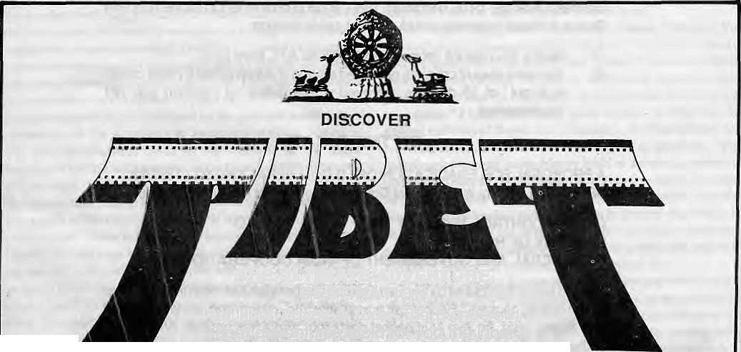
THE ULTIMATE ADVENTURE DESTINATION
Let Tibet Travels & Tours- The pioneers in
Tibet adventure-unfold for you the inner
secrets and mysteries of this fascinating land, people
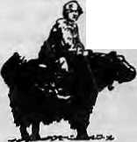
and cultufe-so different from anything you have ever imagined
Departures to Tibet Every Tuesday and Saturday By Air/Land
For details contact:
TIBET TRAVELS & TOURS (P) LTD.
Tri Devi Marg, Thamel, P.O. Box 1397 Kathmandu, Nepal Tel: 410303, 415126, Tlx: 2672 TIBTVL NP, Fax: 977-1-415126

Jul/Aug 1993 HIMAL . 25

THE JINX
Geogaphicaliy Nepal is placed in the Himalayan region which is naturally deficient in Iodine. Maximum cases of Iodine Deficiency Disorder in the world are recorded in Nepal.

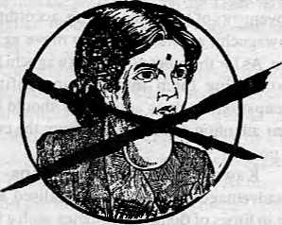

THE SOLUTION
THE GOITRE CONTROL PROGRAMMME:
Established in 1973; a major step to curb this curse on the Nepali Nation.
OBJECTIVES
(i) To educate people on the benefits of iodised salt.
(ii) To make cheap iodised salt available in even the remote parts of Nepal.
(iii) To construct warehouses for storage of iodised salt.
(iv) To install and operate salt iodination plants in Nepal.
RESULTS
(after a period of18 years)
Studies {Defange-1976, Bergman -1980) show improvement in Iodine Nutrition Status in Nepal following introduction of salt iodisation:
(i) Goitre Prevalence dropped from 50% to 40% from 55%.
(ii) No new cases of critinism observed arnong children under 5 years of age
in 8 out of 15 districts surveyed where Iodine oil injection was not
implemented.
ON THE FLOOR
A PROPOSAL FOR ERADICATION OF I.D.D. IN NEPAL.1992/93 - 1997/98 OBJECTIVE- to carry through what Goitre Control Project has already started.
GOITRE CONTROL PROJECT
MINISTRY OF HEALTH
(HMG/NEPAL AND GOVERNMENT OF INDIA COOPERATION)
Iodised satt is distributed by the Salt Trading Corporation Ltd. both in loose form and in one kg packets. Packet salt is available under the brand names Ayo Nun and Bhanu Nun. An Ayo Nun packet costs four and a half rupees. Bhanu Nun is distributed only in the remote areas at subsidised prices.


HOTS: ' : - ':/'": ' ;/;
A fjeld;:kttto test Iodine cpnteRtc^n be procyrred frorrif theSTCforfr^e, NGO'sand ptfrer interested individuals' site invited to : cblfeet bulk for further distribution^

Salt Trading Corporation Ltd. Kalimti, Kathmandu. tel: 271593, 271014 Fax: 271704

Long Road To Gandaki
The English edition of the classic French work by Bernard Pignede, The Gurungs (1966), has recently been brought out by Ratna Pustak Bhandar (see Abstracts, page 39). As an appendix to the English edition, the book's editors have included an original piece of work on the origin of the Gurungs and their encounter with Hinduism. Written by Bhovar Palje Tamu and Yarjung Kromchhe Tamu, the paper is excerpted and adapted here with permission of the publishers.
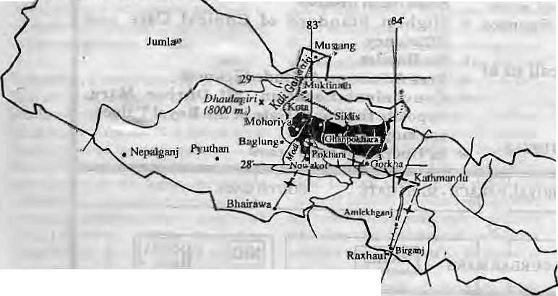
The history of the Tamu (Ihc Gurungs of Nepal) is preserved in the myths and legends of Tamu Pye (Bonism), which are recited by the Bon priests in a mixture of Tibclo-Burman dialects. Tamu Pye tells of how the first people lived in Cho(Tso) Nasa, which is thought to tie in today' s western Mongolia. From here they dispersed southward, towfards today's Qinghai, Kansu, Sichuan and Yunnan regions of China.
Some of tthe Tamu settled in the northern Bagmaliregion, having gone through theKcrun and Kuti passes. Acconfeg to Tamu legend, they must have settled in Mustang around the firstcentury AD, just after (he Tamangs settled in Bagmati. These two groups have been separate for no more thantthree thousand years. The Tamu used to hunt long distances following wild animals. They would move their settlements if they found abctterplace to live. While they inhabited the banks of the Mha-ri-syo (Marsyangdi river) in Manang, they adopted a new Klye (master) as their chief or king. His descendents are called Klye (Ghale).
Village of Kohla
Nepal and Gumng country
Some Tamus crossed the Annapurna range in the course of hunting around 500 AD. They liked the high land and sowed some grain there. When they returned on a second visit, they had. a good harvest. On the^ third visit
peoples from three clans came and settled there in their three groups, calling it Kohla Swomae Toh. This was the first historical village of the Tamus on the southern slopes of the Himalaya and it became the last united village too. Other Tamus migrated later from Manang and Mustang. Those remaining in Mustang became the Thakali when other Tibetan groups, and probably some Tamangs, arrived.
After some centuries of peace, politics began to affect development! An increase in population caused great problems at Kohla. Groups of people moved on, to the southeast, south and southwest, to start new settlements. It would appear that there wereno other tribes in ^he Gandaki zone except forsome neolithic Kusundas (now extinct). The Tamu ate Beef before their contact with the Hindu castes.
A legend tells how some of the Kwonma clan went from Siklis to Nar in Manang to learn Lamaism from recently-arrived Tibetan Lamas. On their return those who had learned well were called Lam, those who had not, Lem. Then the Kwonma divided inio three sub-clans, Kw.on, Lam and Lem, according to the closeness of their kinship connections with each suib-clan. Lamas introduced the word Guru, indicating high prestige, and it became die familiar term (distinguishing the tribe from other tribes or castes, eclipsing the word Ttamu.
Contact with Hinduism
In the 13th century, some Rajputs and meir Brahman priests fled to Khasan (western hills of Nepal) from Muslim rule in India. There they converted the Lamaist Khas peoples to Hinduism. During the 14lh and the 15th centuries, they extended their influence to the Magars of Magarat (mid-western hills). In the 16th century, they moved into Tamuwan or Tamu territory (Gandaki zone), bringing with them Magars and Thakalis.
TheTamu were most resistant to the new faith, having a deep belief in the efficacy of their own priests and rituals. However, the Hinduised Khan Thakuris founded small kingdoms inSyangja and gradually their people took over the lowlands in the Gandaki region, which were notsettled by the hilltop-dwelling Tamu. The literate Hindu Aryans were experts in exploitation and domination, introducing the idea of caste, making slaves, and pursuing a policy of divide and rule. They studied the Tamu andnoted the weaknesses in their system of government. They introduced and applied the law of dominant castes and attempted to erase the original elements of social structure, trying to make Tamus touchable Sudras under Hinduism.
Until the 16lh century, theTamu peoples
knew nothing of the Hindus, having their own Ghale kings in tlie Lasarga, Nuwakot, Kaskikot, Arghou, Kohla, Pojo, Liglig, Gorkha, Warpak, Syartan, Atharasaya, and other regions. There were no kings in certain areas due to the bad impression given by the dissolute Samri Klye of Siklis.
Legend tells how Jain Khan came to the banks of the Kali Gandaki fromSringa.Gulmi. There he married the daughter of a Kaski king, and with his help, crossed then ver. He defeated King Bhyag-sya Klye and founded the first Hindu Thakur i kingdom in Lasarga (southwest Syangja) with the help of the Ranas and Thakuris. His son, Surya Khan, became king of Khiiung, and his grandson, Mincha Khan, of Nuwakot, Syangja. Mincha's son, Jagati Khan(Kulamandan SaM) had seven sons and, in time, became king of the whole of Kaski,
Pseudo Genealogy
Four members of the Dura clan and one Ghimirc met on the banks of the Madi river ■(Karputar) and made plans to adopt a Sahi prince to become their king in Lower Lamjung, in opposition to the Thansi Ghale (Rag-sya) king of Pojo (Ghanpokhara). So Ihe five men went to Nuwakot in Syangja and asked Jagati -Khan for one of his sons. They look the second 'son, Kalu Sahi, together with officials of various clans, and made him king of Purankot

Jul/Aug 1993 HIMAL . 27

Win Lamjung. After three months, the Ghaie ' f&ng invited l£al«Sahi to Sulikol on the ipretence of maiasg a treaty with htm. Together they went to the forest of Sisidhunga to hunt, and there Kalu Sahi andhis companion, Naran Dura, were murdered.
Six other Hindu and Hinduised clans went to Nuwakot to take princes for their kings. King Jagati Khan was much troubled by his lack of success in defeating the Ghaley king of Lamjung. And so, political policies were adopted to encourage domination and exploits tion by theHindus, and the obliteration of the existing social system.
A royal priest, Bhoj Raj Purohit, composed the first pseudo-genealogy of the Gurung (Tamu) on 9 Falgun 1594 (around 1537 AD). In that false genealogy, the ancestors of the Gurungs were said to be Aryan, not Mongol, the migration said to be from the south instead of the north, historical Tamu characters weTe made Hindu. By means of the false genealogy, the king intended that his third son, Jsabam (Yasobrama) Sahi, would take the kingdom of Lamjung.
A successful attempt was made to elevate the smaller number of the Swogi clan and add them to the royal clan, Klye, which resulted in longlasting conflict between them and the Kugi. Meanwhile, four Swogi chieftains were called secretly and the genealogy and its implications were described to them. With the
promise of more land and power, they agreed to the murder of their uncle, Thansi Klye.
The four went to Pojo and told the Klye that the second Sahi king was very brave and clever, could not be killed by deception, and therefore it was better to make a treaty with him concerning the boundary than be defeated in battle. The Ghale king believed them and wenttoBaluwaBesi(nearBesiSahar) without weapons as invited. The Sahi's men then drew their weapons from their hiding place and killed the Ghale king and his Kugi officials. His body was tossed into the Marsyangdi river. Even today, some men of the Ghale clan refuse to drink water from that river.
Jasbam Sahi and his elder brother's pregnant wife, Jasatawati, were hidden in a cave near the junction of the Midim (Gaumati) and Ramunche (Ram) rivers. After the death of Thansi Klye, they were brought to Sindure Dhunga and married there, then they were taken to the capital, Purankot. The four Swogi chieftains were made "descendants" of Chanda Rajput of Chittaur like the Khans (rather than Nha-tsan, the ancestor of Song-tsan Gam-po of Tibet) for their part in the deception.
The chieftains used to introduce themselves as Maha Guru (borrowed from Lamaism), but the word Guru was used solely for Brahman priests, and they were given a new title, "Gurung" (Guru + Ange: part of a Guru). The Kwon changed their clan name to
the Hinduised Ghotane (Gotame or Gautam), and the^ Lem, to Lamichhane. The four chieftains got the power they had been promised, sincewhen the Kwonmaof Lamjung have dominated the other clans on the basis of the false genealogy. The Lem also increased in power so that they became known as Plon (boiled).
Through the use of the false genealogy, King Jagadi went on to capture the whole of Kaski. That genealogy was stronger than hundreds of arrows and swords. Pratap (Pasramu) Sahi, son of Jasatawati (or Kalu Sahi), was sent across the Dordi river to be king there, as previously promised. The elder son of Jasbam, Narahari Sahi became king of Lamjung and the younger, Drabya Sahi, became king of Gorkha. Their motheT, Jasatawati, ordered that neither of her quarrelling sons cross the Chepe river which formed the border between them. The six clans, Adhikari, Dura, Khanal, Bhandary, SuyalandGhimire, formed the royal assembly of Lamjung.and another six clans, Pande, Pantha, Arual, Khanal, Rana and Bohara, formed the royal assembly of Gorkha. There was no Gurung in either. Ram Saha, the grandson of Drabya Sahi, changed the title of Sahi to Saha. His descendant, Prithvi Narayan Shah, conquered Nepal.


NEPAL
INTERNATIONAL CLINIC
Nepal's Leading Institution in Travel Medicine
Hours: 9:30 am - 5.00 pm (Sunday through Friday). Vaocirtatibn/medical advice available even on Saturdays, ifc
US Board Certified MDs
Staff has over 15Tfears of Work Experience in
South Asian Diseases
Highest Standard of Clinical Care and
Efficiency
S.
Please feel free to call as at
4-12842
Phone/Fax: 977-1-419713
No Hassles
Free Advice on Altitude Sickness.
Convenient Location (off Durbar Marg,
opposite the South Gate of the Royal Palace -
see map below)
In Operation for 5 years

LAZIMPAT
ROYAL PALACE - MAIN GATE
SOUTH GATE

CINEMA
-I
HALL
o
~l r
KANTIPATH I I
I I
DURBAR MARG I I
BATHS
NIC
H 2nd gate _{Jai}
NAXAL

28 , HIMAL Jul/Aug 1993

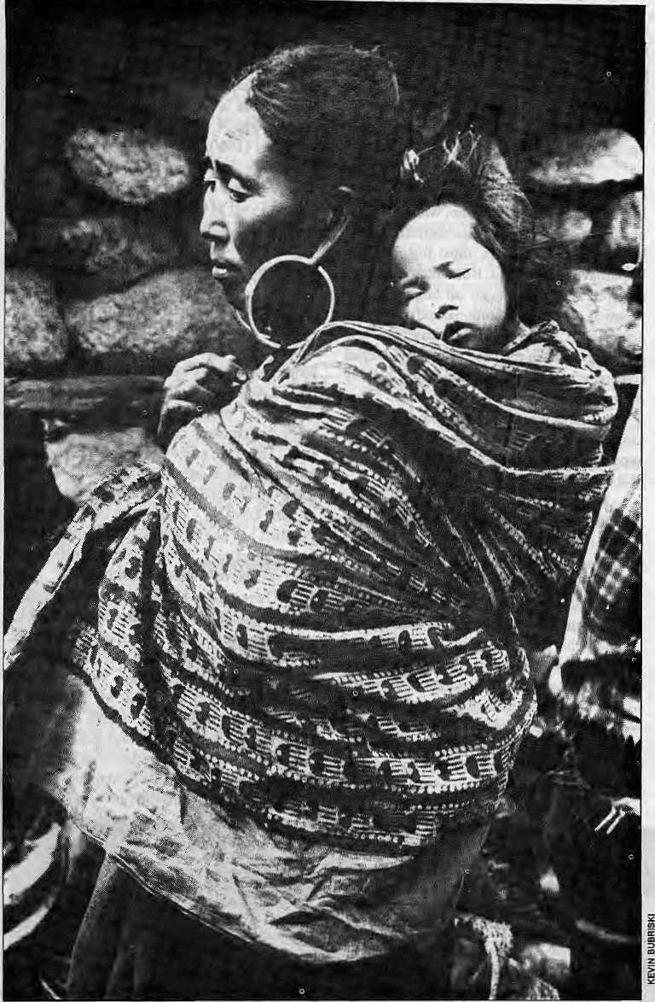
Whatever Happened to the "Golden Age"?
Nepali and non-Nepali modern-day historians
of Nepal have a lot to answer for.
by Pratyoush Onta

T
wo decades ago, addressing a gathering of social scientists in Kathmandu. historian Ludwig R Stiller declared that they were living in the "golden age" of Nepali history. "Rarely have historians of any nation had access to so much untouched material for their use," he said.
Stiller was confident that "the Nepali people have a sense of history," and the field of history was itself wide openfor researchers, both in terms of historical periods and topics to choose from.
Sense of Past
It is true, as Stiller said then, that Nepalis liked history: "They like to discuss it. They like to hear stories from their history. It has meaning for them." But it is important-to draw a distinction between a people's sense of history and the scholars' sense of history, and the conditions under which the latter has been produced in Nepal.
Two types of historical writings represent two different senses of history among the educated and powerful of Nepal. From the past, we have the vamsavali, and then we have the "disciplinary history writing" by modern-day scholars,
Vamsavalis are, in the main, narratives of the different ruling dynasties with their genealogies and include references to important events that occured in their respective regnal years such as the founding of a temple or an invasion by an enemy. Whi le some o f the cl aims made in v ams av al is can be independently verified, they tend to incorporate mythological and legendary stories.
Vamsavalis were in wide circulation in 19th century Nepal, commissi oned by those in power who had a need for cultural legitimisation and to fashion a past. As linguist Kamal P. Malla writes, vamsavalis were instruments for providing ksatriya-status to kings whose lineage was in doubt. Thus, these tended lo be political documents to ensure one's continued enjoyment of power.
Oneof the early "disciplinary histories" of Nepal wasDilli Raman Regmi's A/oder/i Nepal (1961). Although concerned like the v amsav al is w ith politic al hi s tory of the ru ling dynasty—the Shahs—Regmi'sworkdi ffers from the former. There is a self-conscious attempt to organise the past with references to a wide variety of sources — vamsavalis, travellers' accounts, archival materials, and other published works. This organisation of the past—historicalconsciou sness—di ffers from that fashioned by the vamsavalis. By

Jul/Aug 1993 HIMAL . 29

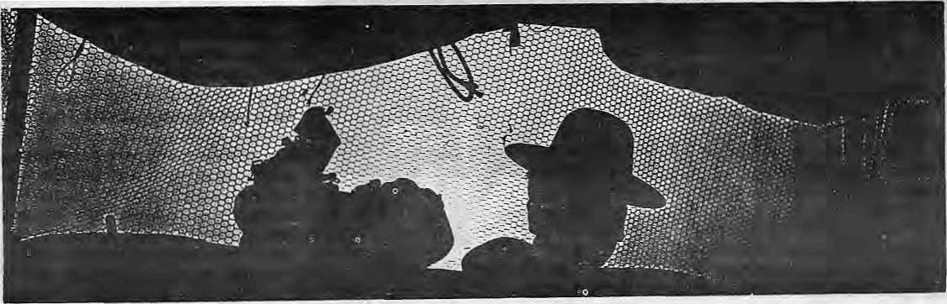
from thai fashioned by the vamsavalis. By excluding myths and legends that cannot be 'proved', this sense of history breaks away from mythological time and emphasizes the secular.
Scientific History
What were the conditions under which the disciplinary sense of thepast was first produced in Nepal? While discussing how history can be utilised in the development of Nepal, Stiller writes that it is only when historians have "laid bare the institution that form our national strength and unravelled the political problems that stand in the way of progress that we can with safety decide what aspects of Nepalese society wecan modify and what characteristics we can root out as a part of our development process."
The job of historians, then, was toexpose for the planning experts, the "inner spirit of Nepal."
Scientific history monumentalises certain contemporaneous objects as evidence of history. This ability to bifurcate objects into historical evidence and contemporaneous things is central to the idea of progress. It is in essence the task involved when, in Stiiler's words, "we decide what aspects of Nepalese society wecanmodify" in the name of progress, development, and the modem and "what characteristics we can root out" in the name of underdevelopmentandthe traditional.
30 . HIMAL Jul/Aug 1993
This idea of progress provides the energy for official nationalism, and progress and development were central to the rhetoric of Panchayat democracy under kings Mahendra and Birendra. As anthropologist Richard Burghart laid out a number of years ago, Mahendra-inspiredPanchayatinationalismin the 1960s emphasised, on the one hand, des vikas, and on the other, the uniqueness of Nepal. While students of all ages were spoonfed mega-doses of Nepal's non-colonial past as a testimony of her uniqueness and her people's desire for freedom, calls for des seva
reminded students of their responsibilities as citizens of a 'unique' nation.
The language of progress and nationalism, which was also the language of freedom and citizenship, existed in Nepal, as elsewhere, in a symbiotic relationship with the disciplinary sense of thepast. Without this sense, Panchayat nationalism's rhetoric of progress and uniqueness would not have been possible. This nationalism, in turn, made Nepali historians choose the nation-state with all its claims to unity, freedom and progress and its ultimate representation embodied in the king, the subject of all history.
Location and History
In a curious division of labour, while the field of anthropology of Nepal has been dominated by Western researchers, most historians of Nepal hav e been Nepalis. If the anthropological research agenda has been set largely by the personal, national, institutional and theoretical dispositions of the foreign researchers, one could say that, in the case of history, Nepali researchers have focussed almost exclusively on the life of the Nepali nation-state. These scholars have written political biographies of kings, prime ministers and other elites, as well as narrow political and administrative histories of the state.
For the period after mid-18th century, the few non-Nepalis who worked in Nepali history have not done anything to displace this obsession with narrow political history. This is clear from recent works by John Whelpton (Kings,Soldiers and Priests, 1991) and Adrian Sever (Nepal Under the Ranas, 1993). Sever claims in his preface that his is a "history of peasants as well as prime ministers" and that it provides "some small insight into die world of the unnamed, unsung peasantry of rural Nepal."Thesearelaudablesentiments,butthe excellently produced book with its Tare photos oftheRanaelites is,emphatically, not ahistory of Nepali peasants.
Western researchers who have gone
beyond the narrow confines of political history include anthropologists Richard Burghart and Veronique Bouillier, on the cultural history of the Nepali state, and Stephen Mikesell, on the extension of mercantile capitalism in central Nepal. Unfortunately their work has not received the attention of Nepali historians.
As for Indian researchers, Nepal does not figure much in their work (particularly post-18th century) because it was never part of British India. Among those that have looked at Nepal, there is an obsession with diplomatic history — K. N. Ch&wftmti's Anglo-Nepalese Relations (1960), B. D. Sanwal's Nepal and the East India Company (1965), Ramakant's Indo-Nepalese Relations 18I6to 7577(1968), SusiulaTyiLgi'slndo-NepaleseRelationsl858-1914 (1974), Kanchamoy Mojumdar's/Awg/o-Nepalese Relations in the Nineteenth Century and Political Relations between India and Nepal, 1877-1923 (both 1973).
So Anglo-Nepali diplomatic history is well covered, especially when one also considers the well-known works by non-Indian writers such as Asad Husain, John Pemble, Leo E. Rose, and Prem R. Uprety. Even with diplomatic history, however, the primary subject of research continues to be the nation-state. There are some exceptions, such as the writings of M.S. Jain andSatish Kumar on the Ranas and Jaher Sen's on trade. More recently, in The Gorkha Conquests (1991), Kumar Pradhan has begun a serious reconsideration of the glorified history of Nepali unification, with special reference to east Nepal.
There exists akind of involution inNepali historical scholarship. Aglanceatrecentworks by scholars such as one on Bahadur Shah by B. R. Bajracharya (1992) and another on Prithvi Narayan Shah by Tulsiram Vaidya (1993) (both senior historians at Tribhuvan University) shows that Nepali historians continue to churn out isolationist, narrowjy nationalist history. There is no serious effort to situate their analysis within a larger South Asian context, informed by the many

reconsiderations of 18th and 19lh century histories of India (hat have been proffered in the last two decades. In fact, there is no indication of any familiarity with this by-now large body of work. Imagination, both in the subject of research and presentation, seems stunted.
Thus, whi le considering the implications of the 'location and history', one finds the horizons of Nepali historians usually stopping at the border or, at best, extending occasionally down to India and up to Tibet. They almost never publish their works outside of Nepal.
Nationalism-Induced Amnesia
So what is wrong with this obsession with political history? It has, after all, produced many good volumes, such as Stiller's77ie/?ise of the House ofGorkha (1973) and The Silent
Jung Bahadur (Vol I, 1984), Triratna Manandhar's Nepal: The Years of Trouble (\9$6),RajeshG?nitam'sNepalkoPrajatantric Andolanma Nepal PrajaParishadkoBhumika (1989), Whelpton's above-mentioned work, and Prem Uprety's Political Awakening in Nepal (1992). And wedohave, in the works of MaheshC. Rcgmi, a detailed economic history of the Nepali state. Does not the history of the Nepali people come through in these works? Regmi'sandStiller's writings have elaborated the land-miiitaTy nexus (distribution of conquered territories to his military-men in the form of jagirs and birtas) that Prithvi Narayan Shah developed as the central feature of his conquest schemes. Stilier's, Adhikari's and Manandhar's writings have elaborated the political history of 19th century rulers, die history of intrigues and assassinations until the rise of Shamsher Ranas in 1885. Regmi's multi-volumes have clarified the process in which "thatched huts" and "stucco palaces" came to co-exist in the same Nepali space.
All said and done, however, even these respected Nepali historians suffer from national ism-induced amnesia.
Nationalism-induced amnesia can be studied in the context of various topics of research. Take just one example — the history of the Gurkhas. Many scholars think that Gurkha history has been c o vered s o thoro ughly that ihere is nothing more left to say. Nothing could be further from the truth, and true Gurkha history has barely begun to be written.
Apart from glossy accounts of the Gurkhas (for example, B. M. Niven's The Mountain Kingdom: Portraits of Nepal and ' the Gurkhas, 1987), we see what British academic MichaelHutt calls "quasi-histories" in the form of works such as Byron Farwell's
TheGurkhas{ 1984). Incidentally, thesequasi-histories are not devoid of the racist assumptions that inform many of the works on the Gurkhas.
Then there are the handbooks of the British Indian Army, written by and forGurkha recruiting officers, as well as regimental histories and memoirs of Gurkha officers. But when it comes to disciplinary historical work on the Gurkhas, the obsession of nationalist and diplomatic history converge in an interestingway.WorksbyAsadHusian(1970), KanchamoyMajumdar(1973), SushilaTyagi (1984), Prem Uprety's Nepal: A Small Nation in the VorlexofJnternationalConflicts (1984), Kamal Raj Singh Rathaur's The British and the Brave (1987), Madan Bhattarai's Diplomatic History of Nepal 1901 - 1929 (1990), treat Gurkha history as a history of recruitment and include it in the larger narrative of diplomatic history.
It is as if the use of Gurkhas, to borrow a phrase from the impressive 1991 Stanford dissertation done by anthropologistMaryDes Chene, as "a currency of diplomacy in Anglo-Nepalese relations" exhausts the subject of all Gurkha history.
And how does nationalist history treat the subject of Gurkha history? A sense can be had from a passage by Pursottam Banskota in NepalkoSainikItihas(The.Miht&ry History of Nepal, published by the Royal Nepal Army Headquarters, Kathmandu, 1992). The following is a free translation, with emphasis added:
Hundreds of thousand of Nepalis have been recruited in foreign military service. In the course of their service, these Nepalis have participated in many important wars and exhibited their unparalleled courage and bravery. Thousands have sacrificed their lives to safeguard or expand the borders of the countries in whose armies they served. Therefore it is difficult to neglect their contribution and sacrifice in spreading the glory of Nepal and increasing the respect with which foreigners hold Nepal. Even though they serve in foreign armies, they have contributed directly and indirectly to the country's economic,social, and political development by bringing in tens of million of rupees in the form of pension, and other ways.
So for nationalist history, the bravery of the Nepalis who have served in foreign armies, increases 'the respect with which foreigners hold Nepal' and the money they bring in contributes to its 'economic, social,.' and political development.'
But the great narratives of diplomatic
history and the nationalist glorification do not exhaust the subject of Gurkha history. As Des Chenehasshowninherremarkablcdisscrtalion on the cultural history of the Gurkhas, for Gurung Gurkhas of the village she studied, soldiering is not about diplomacy or bravery but more about wage labour in foreign places. The years spent as soldiers do not constitute the "centerpiece of their lives" but remain "a hiatus in them,"
Des Chene's work shows how when historians and anthropologists step out of the official archives to include oral historical sources, the studious works by diplomatic and nationalist historians begin to sound hollow, picking up as they do but the fragments of history.
Gurkha history worth its name must attend to other 'fragments': the pain of separation, the Song list of deserters who opted out due to the rigours of military life, the psychology of the Gurkha in a "theatre of war", and so on. Who is writing about the despair which leads soldiers to run amok in the battlefield or commit suicide in a bunker far from home, or about frostbite, shellshock, and those "missing in action".
Unless we begin to represent the pain and the emotions that are part of the history of the Gurkhas, they will continue to be subsumed under sanitised diplomatic and nationalist history, which plays up only the nationalist machismo and is ultimately unfaithful.
Victims of History
It becomes obvious that the golden age of Nepali history has not become a reality. That might not matter so much, but disciplinary history must become faithful to the life-experiences of the many'subaltern classes'of Nepal's peoples: ethnic minorities, children, women and the 'untouchables'. Those who presume to write history must come alive to the fact that there arc victims of history.
This writer would even suggest that historians abandon the disciplinary virtues as 'objectivity' along with the state-centric view of Nepali history. We should produce passionate poly-centric histories, using oral and other sources based on life-experiences, and resist the totalising claims of official histories. We must redefine the 'major problems of general interest' so that history of Nepal stops to be elite prosopography. Until that happens, there is no room for historians to feel complacent about their vocation or their commitment.
P. Omais a Ph.D candidate in History a! [he University of Pennsylvania, USA.

JuVAug 1993 HIMAL . 31

'. BRfEFS

How to Tackle an Act of God?
•PBrtstacksitKulekhani ^ ■■.■■■ - :■■■ leading up to Kittimaqdu. 1 ......' I
;Thoughthe whole legion* 4 eastern ;Nepal*wisaffected,* the mohsbOn system appeared to be particularly active over tjje ... ...
headwaters region of Rapti^ Kulekhani and Malefchu rivers
Tibet In the Himalaya; Ecology, Development Trends and Transnational Impacts on the High Plateau
Organised by the Royal Swedish Academy pf Sciences, SIDA and EcoTibet-Sweden Stockholm, 10 November 1993 Subjects; Environmental history and" transbjoiindary impacts; Development trends and prospects for Tibet today. Introduction by King CarlXVI Gustaf of Sweden. Contact: EjCpTibetrSweden, PO Box 2032,10311 Stockholm, Sweden.
The Third Pole: Mountains;
People and: Eriy^rQnjrntiiit jojf
Tibet
Paris, 30 Sen -IOtt.1993
Cdntact: EcoTlbet-France, 2,
Rue d'Agnou, 75850 Maule,
France. '
:;

A spry of misery unfolds jn Nepa! cvery-yeaf during: Iherainy season. Generally, these misfortunes do not affect the' IiV<js of the people of Kathpiandu. The devastating nauinil;fufy thai hit * ;■ Okhaldhfmga in- the east on 6 July was ignored, as the capital'," was engrossed by the unfolding political drama between the Prihi<j Minister and ihe " Opposition^ ,
Incessant monsoon rains- ott ; the 19, 20 and 21 July^ however, hit much closer to home. They' wreaked havoc over hili's and. . Taraiof Central -Nepal, md, claimed-above20OO^{i}!ives (as:of 26 My}. Significantly, tKe; extended cloudbjirst was centered in thq v^ry area where -the nation's .prim ary infrastructure is located — the Kuje&h^ni reservoir and dam, and the main road arteries
Upcoming...
Tea and Tourism Festival Darjeeling, 21-23Octoberl993.
Commission on Mountain Geoecology and Sustainable Development Symposium, 13-22 August 1*94, Freiburg, Germany.
Topics: questions of sustainable use of resources; watershed management and environmental problems In highly industrialised com a tries; discussion of "Convention of the Alps"; environmental issues Facing less developed countries and formerly centralised economies.
Contact: J. Stadelbauer, Institute of Human Geography, University of Freiburg, Werderring 4, D-790&5, Freiburg*
32 HJWtAt. .» Jd/Augi 1993
So
■Meflse;
beiweefl Uie mornings of 1*9 and ■■21; Mly;ab^ut;4O ^iii^ti^rf cubic meter of water was r«pjenished in the Kiilekhant reservoir; ::
73 million cubic : of live storage. For the . first time in several years water ; spiiled over :f«)ni bidra: SaTovar,
.. _{v};; The floods that were ;; unleashed smashed piers,
off decks of more man eight g bridges along the two highways
to the capital. Large sect-ions-of f -thehighways subsided, andit
:■ for nrarroalcy to return. -.-.■ ■.■ -4 ■■■■ :: Heavy rainS and Hood aisd:
; severed A 100 rti|ecti<)rti of tfj^ pen^icick pipe leading frorp the Kaiekhani reservoir. This meant that both the 66 megawatt JfplekhaMJ I power plant and the-32 MW Kulekhani H were dead, The shutdown of the two planfe was a grievousblow to the national grid, as it toot away 92 MW from a system whose operating Output used to be about 20CIMW,
dloud hursts and extended mcnsoonal showers have been occurring in the past. What is different now js that there are more and more large ihfra"strtictural projects being built in the mountains. However, the understanding of the temporal and spatial variations of the natural processes within the-monsoon regjnicis still at a rudimentary stage. At the simplest level, there is ho'proper" gauging network, which has flowed such hydroiogical extremes lo go un-monitored, robbing "scientists of vital clues that cpuld have filled gaps in existing knowledge and ther
. abjlity to fpracast, ;
THere havebeen similar;
episodes with cloudbursts ,in the." Kathmandu vicinity in the recent past. In 1984^ a sirriii air Bu t frio re
v copcemrated storm h^dwash&l
: away the^Maleldm bridge in the .1 Prithyi Highway;. This same
v bridge is once again gene. A^ i p>^mo^opn storm iri t?fl'l ;...j
... brotight down>.emire..sides of. 4 heiehillssouth ef Kathmafldu ■Mid created havoc all the way
Id0*n ihe,Bagmati river.; : : This July's phenomenon, : however, appears £0 have been more intense. Tlie two days of jdpvaioourbrought6|2naii of rains over the Kulekhani valley, which is half ojfiis average annual rainfall of about 1200 mm, While details will be ■ known as more information stari to filter in, this iiitensity of downpour is,prpba|bly not the . worst that can occur in-the
a. In 1965, the upper valley in Darjeeiing recorded 3000 rnm of rain, in 72 ; hours (Uhrtal Jan/Feb 1993).
The event highlights the extent of uncertainty and the critical situation, that a heavy rainfall occurring within very few hoiirs can create. The only way to deal witii these calamities is to try and understand them in the long tun, with scientific approach and investments in data collection, research and management.
Can anything then be done to save roads, bridges, hydropower stations, irrigation sysferns against such fury of nature in the mountains? At the very least, the efficacy of the current methods of planning, engineering, and operating major infrastructure projects should be studied. We must also assess the level of rifk we shouldbe ready take, and the country's capacity to absorb the risks of a large scale, The larger the project, the larger the risk, it seems, when an act of god decides to hit.
- AjayDixit
Watei Resource Engineer


ti-l-fl*tSifig

BRIEFS'

Tibet, the Air Cooler
of the Tibetan la
lead to cooling? What follows is -a paraphrasing of Pafersorrs ■■■
p f . _{e}
Tibet's plateau, which lies ■■■ ...between tpe. Himalaya «the southand theKuriiunto the ^ north, covers 2.2 million sq km,T: or 0.4 percent of the Earlh's sufrace, with an average height 6f about 5 km above sea level. It is "like a large;, boulder thrust : ihtothe atmosphere, so large that-it profoundly disturbs the atmospheric circulation patterns iathe'whole of the northern -hemisphere." ';
The next sicp is to understand how Tibet's rise icould have brought abpirt a ■ redrieUttn of the carbon dioxide "content in the atmosphere.
the Tibetan ThemiOiStat hypothesis was pill forward by MaureenRayjnp pf the
When in Calcutta, Eat Mamas
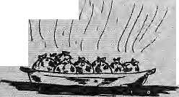
Give Tibet some credit, il is responsible for the climate ; which make life as we know it p tjssib 1 e cm p 1 a ne t E art Iv. Thi s is as reported in a cover feature of the 3 July issue c>J the
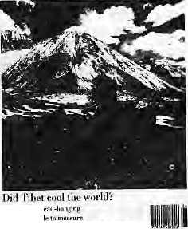
] l,»-in -mil!
Tr'flJii'lin Brn uinlaihlS¹; ]T*nrn'A frH-H-Jur-^11

NewScientist
*Nfew Scientist, "Did Tibet cool (he world?",
"If the proposed hypothesis is true," writes journalist David Paterson in his article, "w&may have the Tibetan plateau to thank for the Gobi and the" Sahara, for the evolution of the grasses that were domistieated into wheat 9000 years ago, and for the ice ages that accompanied the evolution of mankind,"
For 250 million years, the-planet was warm and wet. Then il began to cool about 40 million years ago and the cooling accelerated 15 million years ago. The theory Is that the uplift of the Tibetan plateau might have <aeted as the switch to the global thermostat which began the cooling.
The pr«cess"of geological - uplift, of course, is weli-known. The Indian plate (in geological time) slammed into the Asian plate, buckling .underneath arid raising the vast plateau of Tibet, making it "one of the world's i Imost prominent topograhical ¹ ^features," But how do^s (he
Massachusetts Irisli.t.ti.t^; oj "" Z Technology (MIT). Rayrno, a .geochcmist,' suggests thai the- ;■ raising of the TilMtan plateau . ...
iro.ni the. ^aflotir altered "■■■ climatic conditions and reduced ... the concen.tr at ion., of carbon dioxide in'the atmosphere^so..... ...
that;ihe Earth radiated more
...energy toanjxtfore, setting; off
■ ■global cooling. (The.gas traps.
;: heat radiated form 1ht> lai'uYs
surface, so as the level of carbon
dioxide, dropped, the.Earth
radialed more of the energy absorbed t ram the Sun "and" began to cool.) ;.. ..... Raymo; suggests that the
uplift of the plateau,.ereated,{he. ...
patterns of air circulation that : bring water-ladco air off the "
hidian Ocean in sumirier. and
deliver rji oil so tin iains to flic .Subcontinent, indtiding;.the: Himalayan ramparts. Dissolved id the torrential rain was carbon dioxide, forming weak cairboriie

"Trie higher the uplift, the
May she receive a Bharat
Raina--
Next door to Mukhia^{n}s is Hamro Momo, withils "distinctly shabby portals"' and* as -the name implies, catering.lo al'' th? Nepali babus stranded it\ C ale utta due to m ons o on nooding, jDown the road from Hamro Momo is the upscale Momo Pla/.a; which sports a Belgian;
chandelier and a \ wooden fail.
iThe :, establbhnient
■:.. was opened : by the. sophistica|ie3 S.N. Sen,.
" who hired a Tibetan eoupktq churn out the cuisiiie; Sen says he tried out kothas<: buk apparaptliy pajcutians do not like kolhaw ' .. ... : .:

We ftke momos. And we also like this description of moinos; "meat-filled sainosa look alikes that go with floricf. pungent sauce". Diti Sen, writing in a recent weekender S tales ma n, lets u s it j on the secret: Calcutia iswhereyou go to eat the steamy little rascals. For tlte best atmosphef ics, Sen directs us to Uday Mukhia's Valerie, the Tibetan Peli,ght, iti-a (; narrow, ill-Ik alley althecoiner of Chqwringhee Road and Suburban ttospital Road. There yoa shovel in momos "in a smallish room with rough arid ready tables and stools,; wildly swinging bulbs nestling in striw^ hats suspended cSverthern-."; Mukhia's mother-in-law is Said f to have introduced; momos to ' south CaSeuita.
greater is the volume of .water-lsden air drawn oil the ocean by the stack of rising warni; air. and the. greater the rainfall. And the . greater the rainfall, the More darbon;dioxide isyemoved froni the atmosphere. A corjibin'aton of chemical weathering by the acid rain and fast physical erosion dt the plateau'srock delivers carbon dioxide, in the form o| bicarbonate ions, to me oceans.-'
In essensc, Raymo sees the plateau as a giaMearbondioxide extractor, pumping the gas out of the atmosphere through rainfall and then dumping Jie by-produet in the oceans.
There is one Haw in Raymo's theory: it does not explain why there is any carbon dioxide left in the atmosphere— her extractor pump would have emptied tite atmosphere of the gas in less than lOft.OOO years.
Here is one subject for Himalayan gcochernists to start study oil — before Tibet suffocates the earth.
■3M *■♦
mm
Tlien there is Kunga Restaurant, (""owned by me Dalai Lama") in Tiretti Bazar. We are told that the restaurant is t mostly eoipty, which allows the waiter to snooze peacefully in a corner. Now we could have told His Holiness that this is the way of all public enterprises, and the exile government in Dharamsala, if it truly owns
* •
momos, Sen ends with, "In momos, we just might have the , alternative to the dreary dosa. It
mercifully, still handled Only Tibetan?! mid Chinese..;"
Kunga, should think o: privatisation. Who knows, the World Bank might come in ' handy someday. . Bactto

BRIE PS:

Sorters die on Larkya La
In the first-weekbiApjHl four porters wJiq were with an . Austrian trekking group 3ifed Up on Larkya La. -,:;.. J^arkya La is & p^si o'f above 17.000 X at the headwaters of -the Buri Gandak), Which foHns, exposure,'altitade sickliessj aind
Dalai Laina's Brother in Beijing
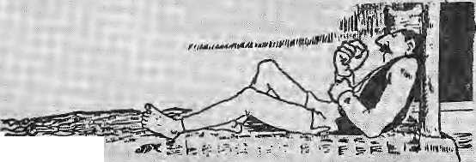
; newly opened "Around Mail as !u" trek, Unlikcihe Thorong La pass of-the Xnnspuma region ftiither to the. west, Lajkyais not-well- ,, travelled and can be more "treacherous.
On the days previous to the mishap, the Australian group • had apparently spent a riightat _{s}
5amagaqn;fal about 1J ,000 ft) ',. aridjiurrisdon.tothefoot of the. pass, 3t 14,000 ft, jt -wou|d have been advisable for them to.have spent ail interim night at !Samdo, ': which-is a| about 1 J,000 ft, as this,would have allow'ed Forrest . and acclimatisation.;
The treki;ers didtiol want t<> resi |t Samdo because they ;" thought the weatlser w.ould deteriorate, making it impossible to cross, But by skipping'
* Samd^o, 'the group was more _{M}
predisposed to altitude, sickness
¹ oecause of the potentially
• -dangerous gain in'sleeping
■altitude'; arid'the extra exertion
> involved, particularly forthe pojia-s with heavy loads.
TffuwiK, _{iM}
As ilie group approached- the pass; at least brie of the Western ■ members liad altitude problems and blizzard conditions were setting in. Attempts were made to keep fee porterS toget)ier and ."' to move ahead to clear tlie--path, but in the ftnd four porters lost ;

because t>£ a cpnibmali&ri of
.. Usejr Jives; [although only/two wefctcportedto the'' attthotities.}-. ... Evbry- s^spni porters.frain .' fjM: ki*cr hili ana
'viltagers w^tKliftfc Or nd : . ; , experience of high mountairi travel moonlight asparters when the folds have been planted'and there is Me time in the farm. 1 Ijiey irately'know whattitey are up against, pajrticrjjafly when the waa^ict takes a turn for the worse. The safety of their* , poirtfrs is primarily the ■responsibility of the b^kkJELg! agency,-and sorniarft belter than
•oiii^ri. The Western trekkerscjffi also help keep portering:safe,by a ski Rg some pcynied questions befoTf.;selectirig an agency, prie of tile most iniportiht is, does, the ageacy provides porters wii|i propra" gear for crossing high passes? TWs can he|& prevent
The go.vcrnmerrt can brief : the police eheckposts afopgthe
Jpotentiaily dangerorfs trails 1 (such as iiiNami^inGorkha: District for the Manaslu trek) to keep a cheefcotr how porters are equipped So!faTvthes^ !: <■ eheckposts oniy hgvef ^te duty to check trekking permits, an<l it would be appropriate to give; the I policemen this newii^k. Mote; awareness of the altitude sieioiess arhftrig the U'ekking
,staff would ^
,- Dr. Buddha Basnet
^Medfcal Director,. Himalaya Rescue Association
"New Head
I
s ICI^i©© about to >ya"ke; up from'its ye^rjnFsleep?The .: intei|ia;tiond center..ihSt.was' : supposed to rkeak ground in. ...
-development; is 3lm0sU.cn, ^{v}and a grand party i| planned. Over tire last iieeade, its has lumbered along like a United Nations bureaucracy, tjreiast few , :... years with Mr. E-F-TTacke at -the helm,- I
Jeii years old, ten rniElidh n, but none :
wiser,
iievertheless has the potential to yet e^nei-ge as a respecjeci msti&i^on fft.jhS mountains,. ... . The possibility of a new
"delegation frorn the
goverarnent consisting of Gyalo Thondup, senior member of trie
Cabinet) who is the Dalai Z Z. Lama's elder brothefc Wid Sbiiam Top^yal, Secretary Xti. tlie Kashag, fiew to Bey irig on 12 Jttly. prife Indian news agency quoted Professor Samdhong * Rirjipoche, Cliairmari at me Tibetan Assembly o| Deputies, as saying that the :delegaiion represented dieTjalai Lama. This would piake it the first official initiative between; -Beij ing and'Dharainsala for oy^-ien years;' ■■■
The delegation carried a note froni the Dalai L|ma 10 the ^eijiiig Goveronient, apparently denying that he was "putting iiuf'dles" in the way of a meaatrigful dialogue. Meanwhile acctrrding to news reports, spokesmen for Beijing ate said tci have (ienied.that the Visit even took plafe,
Gyalq^Thondup, a
■^{v;} beginning comeCwitH Sie¹ :.■■ .selectiori last month ol'ihe Director, rie...is Robert an antliropoiogist who conies to thejob with a r^earehback- I , ground; whsJeTaekeahiVcid ■> froman adqrini|traior's desk in , Z the Asiari Development Bank.
■ ■ Rjipades has done reseaicri
inthe Intern at ipnal Potato^
Center" ifl Peru?and has'
knowledge ri'fthe Andes as w$H
■ as tiie forest communities of
Sputri'East Asia. He is presently
"■ Headof the Qepartmcrit of I AnTthropology at the,"University; of Georgia in AtheriSi'Georgia id
■ -the OS,;. -
The benefit of doubt goes to; Rhoades, but he wilihotbe : joining til! March 1994. Tacke,; jrieanwhiSe, has been extended ':.. titMhen.
conjioversial figure among Tibetan exile?, feas several times visited Beijing in his private capacity^ He has btigbecn advocating talks with Beijing, believing total independence to be ah unrealisticgoaL Such; ^statements have made hini the butt of criticism from pra-independenee hardliners including his two other brothers, Thubten Jigme Norbu; and Tcn?,in Choegyal. Last year, Norbu resigned from his position as the Dalai Lama*s ernissary to Tokyo, in protest against Thondup's initiatives.
: Sources in the exile government-claimed thatthe delegation was part of a ^{L}'!o!ftgstsmdjng" dialcfgue between Dharamsala and Beijing, which goes back to the 1970s, and Ehat (he visit did noi imply the acceptance of any preconditions. The latter is in reference to Beijing's^ obsession that Bharamsala give up demanding independence so thai "constructive discussions

is* -.: •• » ♦■>»

BRIEFS
Tburism? Lfel Them See Rice

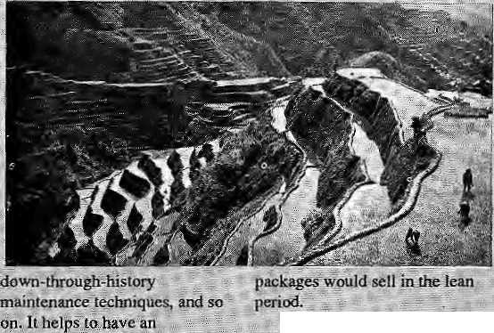

T
his picture of nee terraces "[. tSoesnarlcome Fronithe ; outskirts of KatliiTiando V alloy; Ilisfrom Banaiie, a region apeountryfrom the Filipino _{s} s. oapitaj of ManiJSi
i Bad ayehas been milking tourist fordecadiesby showing "; ■ therri ride growing on ledges and:: calling theiri the "eighth WQndet .; of the worid'VTptirists will look at everything, of course, aS long theyare told itisarnusl-see.: ' Filipino tour operators kripiv that the trick is tp package the product properly,; ' ,And the way tp package rice: terraces is; to sdl.lhe^emcrald- :; green, the age-old, banded-
.can take place. ... . : ; ....
"China-Watchers¹ believe that the delegation'niight hav'e been' "accepted ty Beijing iii response to the haidenmg Westefn"stance on -Tibet, which includes for the first time theumpositjon of ^conditions to China's iribst- fayoured-nalipn statqs fay the United States. sTheseexperts also believe that the real focus jpf the delegation was to try and influence Deng Xiao Peng. After the.death of the ailing. s«prerno_{v} Ghina,wilib6 plunged into, political-tutrnail arid all prospect ef Tibet parleys will recede into the heavenly realms, Until -China SWis outs its own problems. f here is a faction among "Free Tibet"advisors, however, who believe that such turmoil within .China w6uld actually be ^obd_{1;}skce anarchy offer? Tibet; its best chance of freedom: While hardi-heafled Tibet watchers "scoff at the possibility ,ot either prospect being realised intfe near future, Dharamsala is apparently foHowing a middle path by keeping all its options open. Hence, Gyalo Thondup's sojourn \o Beijing*
eyoiv|ng :: testaurant at a lookout point, of

Jn: Nepal, at a tiriie when ^{i;} " tourists are; beginning, to bypass ; Kathrnandu--Vail% shriaes; L because of all ;thediistarii4irt, ^avelageacies are beginning to feel the rieed for more _{J;} :-"destinalii^ns'^ Theyhave ^{v} " I missed theterracescompletely.
has-iprov.en that ft Is works/ ..
Not only in Sepai, toun^ra :■■■■ Officials and pperaKJrs a|| across : the Basierti pipialaya, including-(hose in Sijkkim, Bhiiiart and Arunachal, shoiiia join to develop "Paddy Packa|d!$"_{T} The added attraction is that these "

T
he world's diitiesr Bioiihtairis are riot Nepal's himals, iq.case yoii, rfiojighfr so aftef fjjading ehdless wtreeopy '., out of Kathmaiidiii The Alps .liave the dubious distinction, particularly due to the filthy' , surro\ihdings of Alpine refuges, which are lints used by dimbers and hikers-to bed down for the night. The pileof excreta and ;; trash that are to be found next to these refuges do vie with
If properly piarketed, ttie; :' : s an^hitheatres pf ' ⁼ ^atijdy terra^siofl the'TQad frorrt to DtiulStoeL or the ■

ij will soon be'coh.sidered tourist heayep. O^tsidp of ?; ...
^alleys Oiktcould ev%ii>e
of Bardibas Phant.a^pyeithe
p t, The wide :
t^rr^oe contputs eoirie closet itogeiribf'mwsrds the; he ad-of .the, yaUey;Tarbitte %i^//s lead to the ■'■:■ Newar clusterbf Syamgha. ;: ■: Crops change from rice |p wMat and kodS, andl:the hardets 'become,: Gufurtg, but it is ■ ■
fegltimate-rrioiintains¹ for height;
• A repent conference on :'. **A|pine Refuges in the Year Two ThousaticrV held receritly in Trieste (Italy), provided occasion for handwringirig^ Said one participant, "Theteiuges today dot flic valleys and passes, and ^yen some peaks in ttiv Alps risk losing tneir original appearance forever."
: Participants from the Alpine Clifbs of Italy, Austria, Switzerland, France, Germany and Slovenia said they were corhmiUed to prevent "Alpine
. terrag.es al! the way, Arid from ;: thc.xidgetop, you set; the. wide
expanse of Lamjutig. •
Touristicaliy; Banaue's o/"pc^{r}shot 'Woinder is left far behind.
: " But orie can learn froin , Banau'e nevertheless, tourism \
opetatbrs and envirpmnentalists
are voiGing concern over trie ■> charnis of Banaue.:
-shift away fr6nv,paddy apiculture have left die
/:: landscape blighted-;The ""..'."., ■.;:■< mountain sides of terraces are:nd Irkept, and, ... i GI^: she'st roofing « reflect back the sun at this various viewing spots.
.., Takirig ^iat asacue*one irdght:surmise that paddy tourisrii is allset |o die in Kathmaiidu,Valley before it has even begun. Brick and concrete: matchboxes that are sprouting*iff¹ :alj ectrneis, not only covering previous agriciil turaJland .but kiih'rig tourism-potential,
/The spec tactrlary alley belo^ Sankhij jsat its prettiest at this time, with its n^wly traiftsplante^¹ rice. But already, at the head: of the valley where the road corhes
, Up fromGqkama, anew briclc and concrete ■"shutter'" blocks -the view.
; tourism from besoming ihe tourisni of waste". They signed adociiment proposing a new basis for running the refuges, promoting alternative energy sources, less use of tins and packets, and cany-out policies for trash. On the whole, the refuges are to be more "spartan".
There were 16 thousand trekkers in the Khumbu in 1992. And 40 mil!ion tourists visited the European Alps. Understanding scale helps in developing strategy.

Jful/Aug
H1MAL . 35

WIEDlAFfLE
..M£BIASjL| ; ;RCMALAYA^{V}
HIMALAYA MEDiAFitE . HIMAL

scheme on : the bend Qyei py
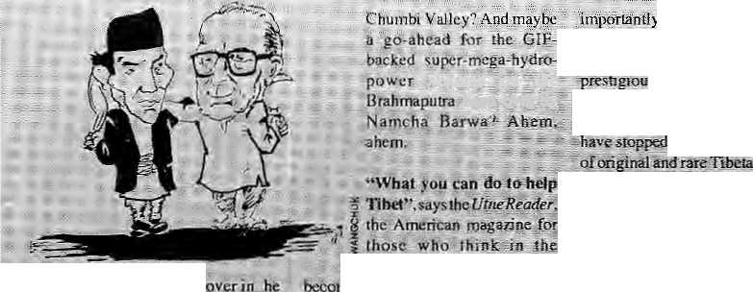
'Wonders will never.-c^as.p }
t&sta€ari£fdiDnThe}> fightandfigbt "
ths/t, suddenly make up, "needlessly ::
■■■■confysijfig. cyc^tyorre. 'SuWb-s'-Qhisiitg ■
yami"jyo# Basil ^suddenly,love each*
.'■ other. Just read the headlines*irv Ac,
two national Jr^ianpapfers (hat do
justice to Northeastern cOYe^age^
"MelloWed jbrfisihg awaits Basu's-
visit' ■ (7'te*Telegraph}, and/'Basu 'aif
PriisS for<jhisifig"{7^e?Sfeir^Fma>[)-
Safor whose bfeneflt WERE all-Uiese
yearsof acrimony? ../Htr|e vary least.
'Bastf at)d Ghising owe it io* tfjeir
coi(isjtit{tencies_{i}to go slow Dt5-all this
hugging and kissing, for if has taken ■■
out of politics. Wh'ich "
would get excited pvpr'a *
j like this from Basu:
**Aaionoray. dae| ? riot mean* ^agmeritaSofr, instead it-steengthesis unity»*' And do the Darjeeltng Oorkiias fcelfe^e that te is now '^wiiiing,u>give fhem more autonomy'", a largest share 6ftoarism proceeds, and crtoffi sayii; gaveysmeiit recniitm^nt Not to^be outdone, Ghising has decided he is not in¹" an agitating rnoad; Instead, he's busy overseeing construction of a34-.< acre golf course up oh Ttger Hill £ild • preparing fq^alei^ and tourism festival. I'am Sceptic no rfiqfe... ^{r}J£eljs rjrie trie , jCenkr^/iii.Nepal wanlGirija Koirala:, i to conlimse as Prime Minister and: 1 Will belicvfe it,
Speakirsg of renewed friencisftip. the "Hindi Ghini Bhai Bhal dap are here <aga£n.■".. Come September, : Snd PiV.Narasimha Rao will visit iteming, calrh prevails oti the border, and the yarioqs hi^h passes with' Tibet are-_{B} bcingppened for trade. 6n£ hears that thetroopshayet)eendisengagedright* : along the frontier, Yeh ky^ ho jatia hd'f Acawdihg IS se Times of India" cc&umrrist, this isihd "coriimon gense-optioo'Vand should lead to turning the present liae of ctmteol in Ladakh and " the Northeastinloa permanent border. ! What else will this Himalayan iHa* ' bring forth? Tourist to Lhasa vi.a
i6 HIMAL . Jui/Aug 1993
■. ■■-. aitiirifeir.ivt, if tlie--fofjowing." jid'informed, suclh &/:ky rcacEiiig¹' TihefofirB&dk ojUvmgstihdDying §'pgyaj Rihpacfic|-viiianleer ^pur iia'i by helping hoi>se"Kbetan .: onef, sucti ■
ii; (frge- 'jour-Gbngm- ■:■;

; educate yoiuesdf on..' or issues aT iKe"TlJ«et srruggle; nal outreaoh'.UoJiij:nds'

fertile ans*ijjg.fe|ugees dT South fihe Tainils/Chakraa,^ Lhatsharngas, etc.) .and we Will believe? justice is ■bi'ing-doup La iificiaSci of thffi fees rigtil "frtittn sea

a, "hare Krishna would surely have ^jproyt^. Mile poKriciatiSi use ■■ . rdigipti to:"srt)ke awntnitfiai (lies of.. Iftdia,iheWorldVfiiaiifeFund]Tndia)

press ifelease,itis Using .
thehelpof Hind u s watm&.to rrijike the'
^ bP Vrirtdavanp fwna,
arid swacklta.^'Presently; Tiii.*¹
esartd valkways.of Vrindavan,.
of Shyatn,¹"Staiid: amidst
fil Mi aindscuiri, ^eari ng hei tandipime.":
Kaeed wit.h.ihe syer-incre
of devotees and: intense
density(3,OT per sq km}j Nandafala
hiiiisdf i.woujd...haye iiioted to ;1he
s.'WWF is optiinisuc about ijs '
ptoject.'alter which ^icsy
must?makc ^o appoiiijtmen^ with---
I^aftirpanrfu 'sMayor P;L.Singn t^ see
Whatman jie_{n}clone lo theVVaifey that
Ma'rijasbreebuilL ... ■

A wnleupj aTlk fefeghph 6fCalcutti eoiidemns the oteclai neglect 6f the Namgya'l InstitMte of Tibetologj in
Gangtfk; The Institute rec«ved^ht support of tfie Chhbgyai and was maturated j^i I957: % Jawaiiarlai Mchru. It soon gained a :narne world wide'fof its scholarly wpFjssand ; its library and museum coSleclions. Today, "Namgyal" has bpeii dropped irom the Institute's tide, bat more
d -.its-.-.acadCjni..c.
..ambili.orii. ""Ifiete "'is" a- leadership ■• -.-vaciiaijj, ..sta.ie.s .the'. Srtfple, "and "the ■ Btillef iihpJ'X'b^i<>Uijjjy..has ' 'beew discoittifiuffd-iv-feseajscbcis whp.. ,uijedt.19.coilte TrorriaBo^er- the"W"0rtd si si i iiig...Tli £ "tran si ation "■'■ Q work&has...
beeiiafl bu Suspended.Whilcihesfucfj¹ of Tibetofogy .:is...:..:3mqng ffie.. iftost¹ vibrant feaficheijotSottlh and Central Asian studies in the West thesG^Rgtok.:. tostitjit.c. shows wfiaT Irappetri! #0 scholiarship: wbeo -politicians"arid' tJur£.gu<sa:'fs'-:-'-:a(e....:put .in....change. A depressing scBnaiiS; which inakes. .Chcitpii! i
ng, of:. a: Hwnalay an insti Sation lhat has done well by iSself Jlw Wadiai iBstiiule of IIL'tti'alay$n Ecology., housed since 3.975 in..Defira Duifi.has ccirriplSted ■■'IB' fttxse af ...exJst.cRce. . During tffis period,it'has te^3Hfie*t(ie ... < major So#£b7feiauir!Stilru^i6n studying earthquakes,* tectoniQS and ;;other geoioey :-reta ted' sii bjf c is .■.■■A.... seniina r cjn Hiniajayan geolb^ arid geopliysics was. ojgaiuf eel in IVfarcfi as piart of tlie i

Jitdepefidetit "'of
;iljtsBiitd-'a report'lhat six:feitmle
p(taf Pradesh are fiactng a •because they have only ione consort, by sthe Baffle of Eyeti while the park warden *y as -WDrryiag . ab.oui infirBeding; hctcfroXygosity atidaU-that^asotuttoii seems to haye presented itsdif jn. the fpnp of "kiien" rjjiinosfrom acrossthe tader. m Nepal. App?i.retitly, -rhirib : fnills from ths RoyaVsBai^ia Npiprrsl Pafjc aiE^{s}swaggKriiig.south across the... border and are-ajl-s^J to paintitig Dodhwa red; As .the ye port-says;' ..$ijggos5veIy;"6cSsdHidiiigs;at«in the. Mii as rhifjos froiti Bardia are disregardiing intcrnalional bucders,..''
SBipkfLia,¹ which connects Kmuauf in HEma^hal Pradesh with western Tibi?t,,is all.3&1 to b^ opened, with the liidiart; Qoyertirnent having already approache«tthe Chinese on the mattcj-, reports flit Times of Jttdia. In th^e me<sntiiije, Nepal is makiing its own advances qo JhK frotjtiejr. Mmister&r Tourisni Sam Hari Joshi traveled !o; Lhasa to sigh in agreement allowing tourists to access Kailash Parbal via the Si ijiikot route in north- west Nepal, The only problem, it is said, was that
w hen ifte First proup applied 6a go,jflit; phinesecguldnbtlocafetheagreernenl noFtfiepwsijsn with whom theMihistei
had
South Asia
in;coufrtry ac&visl groups Just have t& ||: with them;; It.will..jfig| dp to fere.atfi deeply, spread «■ i and bJairK*.t^e,.C|A*or^trie * ...JC.O13 /arjyimoTeV Any..gpy.crnrnet(t \ which does that wifljusHiaeffiorrtii ;crediWiity_{v}.It is impbrfarit, tei it..-. SantarSarovarinlfidjaortheArunH? ' in Nepal; K> debate projects on thdr! merits. Which brings rrsc to Ih^ Flood ■. Action KJa& 6$fjaiigliidesh. The sta^s* tjudisSi in Efchia rmislbje yntA with tfc» ^f(^>-grjoups¹which »werc bjeh)h3 the' Interaadicina!"FI6cia Actioii Campaign. Committee, which is seefcng fiielOMpn dolkf-World BankC coordinated FAFscutflfed In the wake iifihe 'fed' pwblieit^, thj "artiounr pledgedh^s tumbitd down to !ess than a billiim,.fepc^sInter* Prefss iS^vkei Now hear this:....a...Woild Bank * ?re|)reserttative claimed; tjjial the * oppo.sition pii being fiitlled by "left g -wing i^wsps wary of the more maito- §: ^{ii}ofjcnted Bangladesh go^{v}ernir0it;"
Keshav Prsidhah of The Telegraph : wjitts trjat the IMe tooristtoMi 6f * MirikiritfieNeJjal-Ihdia'borderjdear Oaqeelm^ is all set tp 1a)ie^{;i}fttl] advantage of foiinsm; now that the ^ violent days of the' porkhaland* iiioyetinejntare behind them. This town,'
^ari ch cflj unga visla, a nd Sprawling tea- * gardens as attractions, Seventeen¹ Jjotels 4hdT0dges hav« Comt: up jiisi" recently, and the town is already* teceivingsix toscven thousand visi tors, a day."
1^ ihcre a hill stale in the Hirtialayart rirr^and that dares to lay daim to 3 town, even a (iarl th^r&bfi that lies ; smcick in the middle of the plains? Yup, and it goes by: the- name of IC machal .Tnearly Ju !y» Chief Miiiisfer Shatnta^umar reiterated his demand ' fora..7.19 perccnj.sftafe for Himach,al" in Chandigarh, this is a '"right" as incofpotated in the Punjab Reorganisation A«l, he said, andTlirriachal was not "fegging forany :fayour"-Next, = we -will hear of Darjcetsng demanding a 14.fi pereeiit store in Calcutta.
- Chheina Patmkar

■ ■■
■r f

REVIEW
Lichhavi Kal through Panchayat Kal with Rishikesh Shaha

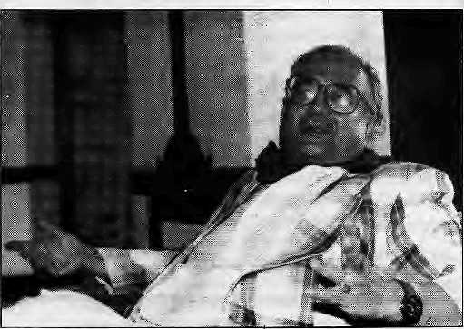
Rishikesh Shaha
I
t is not very often thai someone who has contributed to the making of his country's history also finds the time torecord for posterity his own interpretation of the contemporary events; what is even more rare is that he finds the time lo analyse the development of his own country's ethos over the centuries and brings to bear on his own work a profound stamp of his own humanist concerns. The two latest books by Rishikesh Shaha, Nepal's eminent statesman-historian, bear eloquent testimony as much to his scholarship as to his affection and deep concern for the people and institutions of Nepal.
His work, Ancient and Medieval Nepal, is a storehouse of information in 155 pages. It delineates in a few bold strokes the historical processes and forces which over the centuries contributed to the moulding of the kingdom in its present shape. It is not merely a narrative of the battles amongst kings or of intrigues amongst nobles. It describes vividly how the hill peoples in Central Himalaya coalesced into cogent political units, later shaped into a strong fortress-state of Nepal in the late 17th century by the political-military genius of Prithvi Narayan Shah. The contribution of the Lichhavi as well as of the Malla rulers is put in perspective in Ihe chapters on social conditions, religion and art and architecture.
The first draft of this work was prepared during the author's imprisonment in 1969-70. Thereafter, the worklay unpublished foralmost 20 years. The book's appearance on the bookstands after the recent revolutionary transformation in Nepal heightens its relevance to the reawakened conscience of the Nepali people. This is important because, as John K. Locke says in the foreword, failure to root the new order in the culture and tradition of the nation will produce "a bewildered society".
Shaha's other book, Politics in Nepal, which covers the turbulent developments between 1980 and 1991, is acollection of essays which serves to bring the reader up-to-date with modem Nepal (344 pages). However, while revising the work, Shaha has.sacrificed some useful essays appearing in the first edition, which was titled Essays in the Practice of Government in Nepal.
This book, too, had its share of misfortune. After barely a hundred
Ancient and Medieval Nepal
by Rishikesh Shaha Ratna Pustak Bhandar. Kathmandu,
1992, NRs 275
ISBN 81 85 425 698
Politics in Nepal: Referendum,
Stalemate and Triumph of
People Power
by Rishikesh Shaha Manohar, New Delhi,
1993, NRs 475
ISBN 81 7304 020 6
by Arvind Ramchandra Deo
copies had been sold, it mysteriously disappeared from the bookstores. Now that it is again available, scholars have a valuable reference for the study of political transformation in develop ing societies, taking Nepal as a case study. If there is one regret, it is that the book is somewhat silent on the political developments in the Mahendra era. This reviewer feels that the Nepali political bookshelf still lacks an in-depth work on what King Mahendra sought to achieve during his stewardship of Nepal from 1955-56, up to his untimely death in January 1972. The late king, not merely a monarch, was perhaps the shrewdest among the galaxy of South Asian leaders of his time. He captured every opportunity he possibly could to gather real power in his own hands, and he never allowed the tools he chose to become stronger than his own royal will.
The decade between 1979 and 1988 was, to put it mildly unexpectedly turbulent. The protest movement of students demonstrating against Zulfikar Ali Bhutto's execution in Pakistan gathered such momentum that King Birendra fell it necessary to proclaim "a national referendum...in order to explicitly u nderstand the kind ofchangeourc ountrymen desire..."
Shaha's recapitulation of those tumultuous days is probably the most faithful account on record. He also makes no secret of his scepticism about the reasons for the royal offer of referendum, which was but "a device for defusing the crisis created by the students' agitation."
The set of six chapters dealing with the referendum, its aftermath, the Third Amendment to the Constitution, the two general elections —1981 and 1986—and the condition of Nepali politics 1985-1990 deserves to be studied integrally. This is important if the reader is to try and fathom the reasons which led to the formulation of policies leading thePanchayati system of government to its own liquidation.
The self-destructive mechanism became inherent in the monarchy that evolved after Mahendra's royal coup of I960 and the subsequent evolution of the partyless Panchayat system. A parliamentary facade was created for an effectively presidential form of government in which the palace bureaucracy began lo wield effective power withoutbeing accountable to any elected body. Unlike the presidential system, however, the Nepali monarchy had lifelong tenure and was not renewable through periodic reaffirmation of the public's confidence. If the palace bureaucracy, too, was going to have lifelong tenure not renewable through periodic reaffirmation of confidence, all possibilities of change were automaticallyruled out. There was, of course, a Panchayat government for all to see and to take the blame, but its promises could g not always be matched in | performance. Commitments made « by members of the Cabinet, for s example, could be blocked at the Palace Secretariat for weeks, months and sometimes years.

Jul/Aug 1993 HIMAL . 37

REVIEW

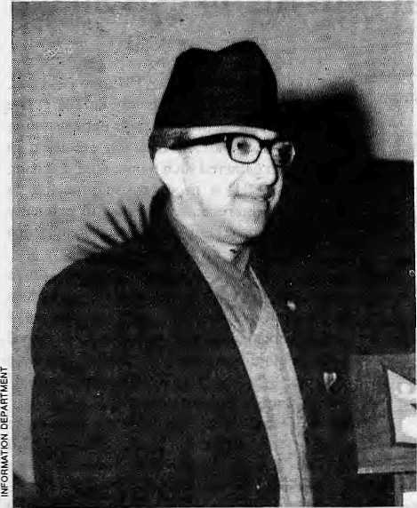
King Mahendra: Real power in his hands
Shaha's riveting chapters on Monarchy inNepal and Patrimonial Elites in Nepal serve the valuable function of explaining not only why 'the events of 1989 and 1990 took place, but also why they were inevitable. In addition, the chapter on Nepal's Zone of Peace proposal reveals how a proposal was floated without adequate preparation and pursued in a manner which finally defeated the very purpose for which it might originally have been conceived. This reviewer might add from his personal knowledge that even several politic] personalities associated with the Panchayal Government had expressed their strong reservations (although always in private) about Indian support to the proposal because they felt that it could vitiate any possibility of peaceful change in Nepali politics.
The events of 1990 and 1991 are generally well documented, although nowhere as coherently as
in the present work. The last chapter dealing with the visit of Prime Minister of Nepal to India and after and the epilogue read together with the three important appendices do not in fact conclude the book but only leave some tantalising suggestions on the future course of consolidation of the revolution in Nepal.
The reviewer shares Rishikesh Shaha's optimism about the prospects of stabilisation of the restored democracy. King Birendra, who is well-educated in the formal sense of the term and has travelled widely, seems to have die ability to help consolidate the revived structure of multiparty democracy in his Kingdom. He enjoys immense goodwill, not only in his own Kingdom, but also in India, and there is every prospect thai he could, if he so wished, provide leadership as a constitutional monarch to his people to facilitate their progress into the 21st century. He would well provide the answer to the question, ''Where are the people of Nepal going?" Meanwhile, Rishikesh Shaha's two books provide valuable guidelines. ^
A.R.Deo was India's Ambassador to Nepal from 1986 to 1989.


HIMALAYAN INTERNATIONAL.
P.O. Box 5133
Jyatha - Thamel, Kathmandu, Nepal
Phone:2-25455. 228998
Fax: 977-1-220143. Telex: 2669 GLOCOM NP
- MEDICAL CARE IN A WESTERN SETTING
- CARE BY MD., GENERAL PRACTITIONER, CARDIOLOGIST &
GASTR0ENTER0L0G1ST (CANADA, UNITED KINGDOM.USA)
- ALL TRAVELLERS VACCINATIONS AND FREE VACCINATIONS
ADVICE AVAILABLE
- MODERN LAB FACILITIES
- X-RAY FACILITIES
- ENDOSCOPY AND ULTRASONOGRAPHY FACILITIES
- INFORMATION ABOUT ALTITUDE PROBLEMS
- ARRANGEMENT FOR SPECIALIST REFERAL
- STANDARD SERVICES AT ECONOMICAL RATES
- CENTRALLY LOCATED AT JYATHA-THAMEL (IN FRONT OF
HOTEL BLUE DIAMOND) IN KATHMANDU
11 OPEN ALL DAYS, 9 AM TO 5 PM
\2. PRIOR APPOINTMENT ALWAYS WELCOME

THAMEL
HOTEL DIAMOND
□
HOTEL
NEW.-,
QAJUR I I

i
□
IMMIGRATION OFFICE
ii czn
< SANCHAYA KOSH
^HIMALAYAN INTERNATIONAL
CLINIC

PARKING
—I HOTEL | GTSE


38 HIMAL . Jul/Aug 1993

ABSTRACTS

Rural Urban Inlerl Ink ages: A Study Based on Nepalese Swiss Development Experiences INFRAS Papers. 1993, NRs 200
Decades of intervention in rural development has failed to banish rural impoverishment, and niral-lo-urban migration Continues unchecked in South Asia. This book, based on a 6tudy by 1NFRAS Zurich and IDA Kathmandu. investigates the transformation process of rural-urban inter! ink ages as the precondition to development. This has been studied at household decision-making level, using vegetable and fruits, metal trade and m a g rat i on a s the f acto rs. The case stud y a reas a re Dolalc h a -Kalhmandu, Palpa-Bulwal, and Bajhang-Bangalore ( South India). The study concludes that categories of 'niral'and 'urban' must be seen as part of a continuum rather than be strictly compa rtmcntaliscd.
The Camphor Flame; Popular Hinduism and Society in
Indl*
byCJfuller
Viking Penguin Books India, New Delhi, 1992
IRs 195 ISBN067084723 2
This is a synthesised account of popular Hinduism in India.
The spec ialisl anfh ropological li teralure on this topi c i s presented
in a broader and more accessible framework for the general
reader. Fuller also hopes that his work on popular Hinduism
counterbalances "the philosophical bias apparent in other
general books about Hinduism." Chapter headings include:
gods and goddesses, rituals of kingship, devotional movements,
and pilgrimages. The book concludes with some commentary
on Hindu fundamentalism in India as of mid-1991.
Simla: The Summer Capital of British India by Raja Bhasin
Viking Penguin Books India, New Delhi 1992, IRs 250 ISBN 0 670 5472S 3
Based nn published accounts and oral sources, this book attempts to recapture "the vitality and excess of the giddy theatre and dub life enjoyed by the British in India" [cover jacket). Bhasin narrates how Simla developed from a "nondescript hill town" into the glamorous summer capital of British India, Some of Kipli n g 'b writings on Simla are included, and the importance imperial Simla accorded its monkeys is described in a chapter enti tied, "Atop the Ped estal: Govemmen t. Monkeys and People." The concluding chapter is a brief note on the decline of Simla after the Raj: its merger into Himachal Pradesh in 1966. and the seasonal tourist onslaught, which has led to "incompatible land, and property use, ecological degradation and a large scale breakdown of civic; amenities."
Beyond the Trees, Tigers and Tribes: Historical Sociology or the Eastern Himalayan Forests by A.CJinha
Har-Anand Publications, New Delhi, 1993, IRs 195 ISBN 81 241 0009 8
Afterexamining the histo rical anteced ents of the British fo rest policies, Sinha analyses a variety of subjects including tea plantation and tea chest timber, forest reserves, shifting cultivation, timber trade and the supply of railway sleepers. Significantly, the book also deals with Bhutanese forests, providing a case study "away from the urban-industrial market economy." Overall, Sinha concludes that community control over the forests as it exists is not enough to guarantee a balanced regional ecology. "Something more positive and drastic has to be done," he writes, because in spile of the depleting forests, there is little awareness and grassroots movement to safe guard the forest resources.
Claiming High Ground: Sherpas, Subsistence and Environmental Change In the Highest Himalaya
by Stanley F. Stevens
University of California Press, Berkeley, 1993
ISBN 0 520 07699 0
This 537-page book, ten years in the research, holistically
explores the organisation cf Sherpfi society of Khumbu, and
how it has coped wilh the influx of mountaineeis and tourists.
In the author's words, the book is about "in d igeno us kno wledge.
adaptability, and cultural persistence". He discusses the local
resou rce management institutions of the S herpas a nd ma in lain s
that deforestation in th e region has " a greater h istorical context
than has been realised and the Sherpas themselves have a greater noli; in it than has been appreciated." He adds, "Loo king at Khumbu through Sherpa perspectives.,,means soling aside some of the romanticism of earlier outsiders' accounts and acknowledging (he environmental shortcomings of historical Sherpa land use and management." Sherpas^{h} relationship with [heir environment "were neither as harmonious in the pre-tuurism past nor as destructive in recent years as had been believed." Stevens fin (is that major changes in the subsistence economy have occurred in the lourism era alone and that despite recent economic transformation Sherpas also continue to maintain old adaptive strategics,
MOUNTAIN RESEARCH AND DEVELOPMENT
Vol 13, No. 2, May 1993 Jack and Pauline Ives, Editors International Mountain Society, Boulder This issuu of MRD pff-sems papers on the geo-ecology of the Andes, on subjects such as: climate change on the Atacama Altiplano, glactation in the Central Andes; cultural change over the last 12,000 yea rs;agco-ecological view of environment and human development: soil erosion and reservoir sedimentation: preservation of indigenous foods; and (see above on the Shetpas) whether traditional pasloralism is the cause of erosion of the mountain environment.
South Asia; Democracy and the Road Ahead
Lok Raj Baral, Editor
Political Science Association of Nepal, Kathmandu,
1992,NRs250
This book is the "byproduct" ofthe First South Asian Political
Science Conference, organised in Kathmandu in June 1992.
Sixteen South Asian political scientists delve into issues of
consolidating newfound democracy in much of the region, the
role of the military in each of the countries, democracy within
political parties, ethnic assertion, regional cooperation, and so
on. The editor ends his overview with the conviction that
"weak and uncommitted leaders and their blind followers
cannot help stabilise the process (of democracy)".
Hill Cities or Eastern Himalaya: Ethnicity, Land Relations, and Urbanisation A.CSinha, PM.Ckacko, IL.Aier, Editors Indus Publishing Company, New Delhi, 1993, IRs 750 ISBN 81 85182 80 9
This book is a compilation of papers by eleven academics of the social science faculty (hi sloiy, political science, geography and sociology) of the North Eastern Hill University (NEHU) in Shillong. There is a geneifl] dearth of academic work on the North, and against this background the editors hope that the volume will contribute to the undeislanding of the ongoing regional economic transformations. The contributors have come to the conclusion that the urt?an centers of the Northeast are suffocating because of missing institutional support and "utter contusion in the management of urban affaire." With all the attention diverted to the metropolitan centers of Calcutta or Bombay, "the genuine problems of the hill cities rarely gets attention." In the absence of participatory civic bodies in the hill towns, the academics see strife and turmoil in the Northeastern horizon. The book deals wilh th e problems of the following towns in detail: Sohra (Chcrrapunji), Shillong, Tura, laintia, Aizawat, Dimapur, Kohima, Mokokchung and Itanagar.
]endlessness and Migration in Nepal 6y NttndaF. Shrestha Westview Press, Boulder, 1990 ISBN B 8133 7677 7
This book is dedicated, among others, "to all the peasant* and workers who form the foundations of human history and human civilizations," The authorseeks to "describe, und erstand and explain the various facets of fiontier migration, focusing on landlessncss, near-landless ness, and spontaneous settlement among hill migrants in the Tarai of Nepal." The special focus on the politics of land is justified because land forms "the axis of the political and economic system in Nepal." Despite landlessness and near-landlessness, states the author, it would be naive to underestimate peasants' revolutionary potential and their resilience. At the same time. He asks, "how long will migrant peasants remain in a state of depolilicizat ion?" In the
end, "the future remains uncertain ..only time will tell what course these peasants decide to take in their attempt to improve their survival chances."
Politics in Nepal: 1950-tO
by Anirndha Gupta
Kalinga Publications, Delhi, 1993
When it was first published in 1964, this book created a furor
in Nepal because of its criticism of King Mahendra's coup of
December 1960 oustinglhe elec!edgovernment of B.P.Koirala.
In a preface to the second (1993)editi on, which is in paperback,
the author writes, "Still...the question remains — will the
second cuperimcnt (with democracy) succeed where the first
one fpiled?Thc question can only be studied and no! answered.
particularly in the context of the manifold changes that have
come about in the Nepali society over the last thirty years."
India and Nepal: Some Aspects of Culture Contact ivy Johar Sen
Indian Institute of Advanced Studies CShimb) and Indus Publishing Company, New Delhi 1992 ISBNS1 S5182 698 IRs 120
In &7 pages of ma i n tex I, th is book attempts to sketch art outline of cultural eontact between India and Nepal from pre-historic times to present. Although there is a section on Nepalo-India trade in Chapter 1 — a subject covered more fully in the author's two previous monographs — most of this volume is devotedtolinguisticandljlciary aspects of th e cultu ral contact. A chapter on Indian Nepali literature and an appendix listing more than 2 SO journals and collections of essays in the Nepali language published from India between 1901 and 1980 are also included.
Nepal: Human Sights in the Himalayas
Gopat Krishna Siwakoti, Coordinator INHURED International, Kathmandu, June 1993 This booklet, which deals with "the human rights situation in Nepal and.the non-compliance of Nepal with domestic and international human rights obligations", was prepared forme UN Human Rights Conference, held in June in Vienna. After reviewing the various obligations and their implementation, the booklet makes specific rccommenda lions to the Government ofNepal, with special referenceto areas relating to indigene us peoples and ethnic groups, children, women, and Bhutaneae refugees in Nepal.
The Gurungs: A Himalayan Population of Nepal by Bernard Pignede
English edition by Sarah Harrison and Alan Macfarlane RatnaPustakBhandar, Kathmandu, 1993 First published in 1966 in French, this classic work on the 'Tamu-mae ("Gurungs" in Nepali) is now available in English. RatherUian just p rov ide a strai ghtfonvard translation, Harrison and Macfadane have provided supplementary information through footnotes and appendices. The ejetia information p rovi ded, wh ich makes thisanuniqueactof posthumous act of collaboration wilh a dead author, is based on Harrison and Macf arlane' s o wn wo rk among the Guiung's o r as provid ed by Gunings who have read the lent. The translators hope that the book "will show some of the distortions which have been imposed on Guning culture and history by outsideis." They write, 'In periods of dramatic economic and political change, such as the present, ethnic similarities and differences become particularly important and legends of origin are closely scmtini sed. The Gu rungs, like many other groups, are engaged in this process." (Note: Simultaneously with this book, Rauia Pustak has also brought out the second editon of the booklet, Gurungs of Nepal: A Guide to iJie Gurun£s, written by Macfarlane and Indrabahadur Guning, NRs 75.)
NOTE: Acornptete setol nos. 1-23of the series Monumenla Serlndlca, has been received by the Himal Library tram tha Institute for the Study of Languages and Cultures of Asia and Africa In Tokyo. Also. Himalayan chronicler ElIzabeth Hawiey, in the process of emptying her shelves has provided the Library with valuable books on the Himalaya, We thank both the 1LCAA end Miss Hawiey.
Editor*.
Mar/Apr 1993 HIMAL . 39

Living Out a Refugee Welcome

DISTRICT OF ORIGIN | /Households
•Sarhhang | 4806
Chirang | 3259
Dagana | 2399
Samchi | 1296
Samdrup Joitkhar | 1069
Chhukha | 59,
Others | ; 349
Total | 13,237
DOCUMENTS ON HAND | Households
Citizenship cards | 8757
Land documents | 1627
School certificates | 33
Health certificates | 240
Others | 2248
Without any documents | ■332..
Total | 13,237
OCCUPATION | Population
Farmer | 30210
Government service | 961
Artisan | 14
Trade and business | 218
Soldier | 361
Professional | 80
Housewife (lierid of hh) | 3602
Student | 3428
total | ' 38..S74
The situation in
Southeast Nepal
will become explosive
if the Bhutanese refugees stay there
much longer.
Meanwhile, their
leaders concentrate
on running each other down.
by Gopal Guragain
gee
what was their oecispsti tin back iri-Drtik Yul, and,/above all, what documents dp they have on hand to prove their claimed status? These are questions of crucial importance as the,Nepali and Bbptanese governments beg iii talks on identifying and repatriating refugees.
Percent
36.31 24.62
T
he screening camp set up by the Nepali Government at Kakarbhitta. Nepal's gateway in the eastern Tarai, is hot and tense. Dhanamaya Chauhan, a middle-aged woman in a dirty dhoti, is pleading with an official and pointing to hercousin Bishnumaya, sitting in a corner with an infant in her arms.
She asks the official, "How can you sayourevidcnceisnotgoodenough?Wehave come from Bhutan, we are refugees."
Dhanamaya's family are among the hundred or so families that have so far been denied refugee status since the Nepali Government began screening the arrivals from Bhutan in early 1993. "Bayan milena" . they are told: you are not a refugee.
The flood of Nepali-speaking Lhotshampa from southern Bhutan, which reached its highest mark a year ago, is now down to a trickle. On average, 1992 saw 300-400 refugee arriving daily by truck at Kakarbhitta. The 1993 average thus far is down to about 90 a day, and the rate is much lower for May and June.
There are different views as to why this downwards trend. Pashupati Karmacharya-, who heads the Nepali Home Ministry's Operation Management and lmplementary Unit (OMIU), which has the task of monitoring refugee affairs in Jhapa, believes that the word about tightened procedures in Kakarbhitta has spread to southern Bhutan. Says Karmacharya, "We conduct detailed interviews and do not register those that cannot prove that they have been persecuted."
While the screening seems lo have had an impact in the short term by affecting the 'pull factor', the overall trend seems to have been influenced by a scaling down of repress ion wi thin Bhu tan, wh ich has been the 'push factor'.
Says an official with the UnitedNations High Commissioner for Refugees (UNHCR), "When persecution has increased in one or the other districts of Bhutan, we have seen an immediate rise in number o f arri v als. The intema ti onal pressure on Bhutan has intensified, and we see the direct result of that in
reduced numbers."
While the reduced arrival rate is a matter for relief for the Home Ministry and UNHCR, it leaves unresolved the issue of the 84,100 refugees in the seven camps of Jhapa and Morang, and of their repatriation. Quite apart from the complicated questions that the recently announced joint Nepal-Bhutan bilateral commission will have to resolve in order lo identify Bhutanese nationals who are 'eligible' to return, there are major problems with regard to the management of the camps, therelations with the local population, and the vexing question of refugee politics.
Jhapa Cocktail
: 8,07 0.45
100.00
Percent
66.15
12.29
0.25
1.81
S6.99
2,51
100.00
Percent
77.71 2.47 0.03 0.56 0.93 0.21 9.27 8.82 100.00
The most immediate problem for the Nepali authorities is the social instability that the refugee influx is bringing to the south-eastern corner of Nepal. Says one district official, "Jhapa District has in its hands a cocktail mix of a thousand problems." Even after three years, life in the refugee camps is not yet 'normal' for the residents. P.R.Dahal, a planner with the Agriculture Ministry back in Bhutan, leftGelegphug in 1991 and is now a Timat camp resident. SaysDahal, "The first year, it was very difficult topass the day. We spent hours and hours just walking the banks of the Mai Khola and the Timai." Maybe four percent of the camp population h a s some thing to do: the few are engaged with the relief agencies, in camp management, or in politics. For the rest, the Jhapa days drag on and on, which is why one sees camp residents washing hands more often than they need to, sweeping their huts even when there is no dirt, walking the river banks, or engaging in idle talk in the bazaars along the East-West Highway. Says Rudra Prasad Khatiwada of Goldhap camp, "One just gets tired by not having anything to do.¹' Because of the inactivity, tension is always just below the surface. A strongly worded 15-point notice pasted all over the

40 . HIMAL Jul/Aug 1993

refugee camps indicates that UNHCR and the Government's Chief District Officer do not mean to let things get out of hand. The rules restrict the inmates from leavingcamp without permission, keeping livestock, playing caTds, or drinking liquor. Outsiders are not allowed in. However, a Visitor finds that every patch of dry grass is occupied by card-players, while the road to the Beldangi camps is lined with raksi shops. "We have destroyed 2500 litres of raksi, but it is impossible to control," says a supervisor in Beldangi II.
Envy the Refugee
In 1991, when Nepal was still high on adrenalin after its successful Peoples Movement, the first refugees were welcomed by the local population of Jhapa. As the refugee numbers swelled, however, a chill developed in the relationship and there is today undeclared enmity between the refugees and the Jhapalis.
Interestingly, because Jhapa is also populated by recent migrants from the Nepali hills, the demographic cross-section of the refugees in the camps and the Jhapali population outside is nearly identical. This might partially explain why the resentment about the support being received by the refugees is as intense as it is. A UNHCR field officer concedes that the tension between the locals and refugees exists in all the camps, and that it is more pronounced in Pathari camp because of its proximity to the bazaars.
Says a trader inDamak bazaar, "There are more residents in Beldangi than the entire population of our town. Anything can happen anytime." Gopal Prasad Bhandari, Deputy Superintendent of Police of Morang, says, "The refugees have not understood that it is in their interests to remain within the camps. The local inhabitants ask why they should be penah'sedforhavmgbeenkindtotherefugees."
It is the poorest of Jhapa's and Morang's population who are most affected, because the refugees have pulled the bottom out of the labour market, Daily wage rates have crashed because refugees are willing to work very cheap. "They eat in the camps and come here to break rocks, andgobackfor their evening meals. We have to survive on this wark,"saysLokBahadurChhetri,afather-of-three who lives in a shack by the Dans Khola.
Refugees from Pathari camp travel 25 km by local bus to Bahuni village to engage in farm labour. They work as sand shovclers on the Jirikhimti Khola or break rock (gittf) on the Dans Khola, supplying Biratnagar town's demand of building materials. The daily wages are down from NRs 40 a year ago to NRs 25 today. While the landlords, contractors and
sahus of Nepal's southeast are taking full advantage of the basement price for labour, the local poor are reeling.
The presence of refugees has caused havoc with bazaar prices as well. From the relief agencies, the each camp resident, regardless of age, receives rationed quantities of rice, vegetable, sugar, oil and kerosene. Whilesmall refugee families manage to scrape by, larger families withmany children generate quite a surplus.
Because of the glut in the market, prices have come crashing. In the bazaars, rice that is NRs 12 per kilo elsewhere is available for NRs 7 or 8, and sugar of NRs 18 per kilo can be had for NRs 12. At the same time, the cash liquidity in the camps has raised the price of other commodities in the bazaars.
Many hill migrants of Nepal who live in the vicinity of the camps eye the refugee 'lifestyle* with envy and some have infiltrated. During a recent refugee count, 1222 camp families suddenly disappeared.
UNHCR's Field Officer in Damak, William Bell says that the agency has realised die need to provide services to the population surrounding the camps. It has initiated discussions to connect the outlying communities by road, provide them with healthcare, wateT supply, and promote reforestation.
But the locals wilt not be receiving the rice, cooking oil and greens, the bamboos,clean drinking water, the sanitation facilities, or the tarpaulin sheets, which means that the resentment will stilJ be there.
Cats and Dogs
The Lhotshampas are guests in Jhapa and Morang. How long these refugees will remain depends upon factors far from the teeming camps, in the meeting rooms of Kathmandu, Thimphu and New Delhi. There is a Tole in all this for the refugee leadership, but study reveals that refugee leaders are easily diverted by inter-personal feuds. It remains to be seen whether the decision by Nepal and Bhutan to finally set up a joint commission to study repatriation will have the effect of uniting, or further dividing, the leaders.
At this time, there are three parties in 'opposition' to the Government in Thimphu. These are the Bhutan Peoples Party (BPP), the Bhutan National Democratic Party (BNDP) and the Bhutan Congress Party (BCP). They do not talk to each other. The inter-party animus also affects the other 'non-political' refugee organisations such as the Peoples Forum for Human Rights (PFHR) - tilted towards the BPP, the Human R ights Organisation
of Bhutan (HUROB) - inclined towards BNDP, the Association of Human Rights Activists (AHURA)andStudentsUnionofBhutan(SUB) - relatively independent
R.K.Budathoki, President of the BPP since its establishment in June 1990, dismisses BCP with a wave of the hand, "We do not recognise those who turn to politics because it is a fashion." He is willing to concede the BNDP's existence, but considers it a "bureaucrats* party", and adds, "They are all opportunists, well-to-do from Bhutan who hope always to direct affairs from above."
The BPP says it espouses democratic-socialism, but it is apparent that Marxists dominate the party. The party has its vehement critics, who say it espouses militancy and that it has a leadership vacuum — other than Budathoki, the party post have high turnover.
BNDP was inaugurated in February 1992, in New Delhi, by bureaucrat refugees who understood India's importance in resolving the Lhotshampas' problem. However, the party's lobbying in New Delhi has not met with much success. Its manifesto speaks of "mutually-beneficial capitalism" as its credo, which places it opposite the table from the BPP.
BNDP has few workers in the camps. ItsPresident R.B.Basnet, who says, "We tried very hard to adjust into the BPP, but the BPP Wt3warenotverythoughtful."AsfortneBCP: "It is anew party anddoes not have a manifesto or constitution yet."
Established in April 1993, the BCP seems to be agathering of individuals who just outgrew the BPP and its lack of coherent programmes, "The other parties have no moral standing," maintains President D.B. Sangpang, who lives in a Beldangi.
Is there any hope for a reconciliation among the parties? "Yes,"saysBCP'sGeneral Secretary R.P.Subba, "We will play a mediator's role in bringing the parties together." But the party's Vice-President Rakesh Chhetri says the BPP's "militancy" and "lawless ways" are the main obstacle to inter-party unity.
The General Secretary of the BPP is Tenzing Zangpo (Pasang) — he is a Sarchop from eastern Bhutan, an exception among the refugees, who are overwhelmingly Lhotshampas. He becomes suddenly animated when asked why BPP does not unite with the others: "Of course, we want unity, but you go and ask those who say we have to wait 50 years for unity!"
Pasang is referring to BNDP's General SecretaryD.N.S.Dhakal whose view BPP with deep suspicion. "When BPP calls for unity, it

JuVAug 1993 HIMAL . 41

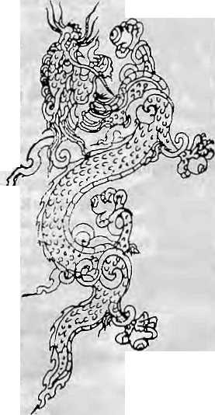
is to enhance its power. When we call for unity, it is for the movement. Perhaps we will be forced lo unite if in the course of Nepal-Bhutan talks we are asked to present a joint view of the refugee demands."
"The parties quarrel with each other and use us when it serves Iheir purpose," says a refugee who has started a business in Birtamod, the Jhapa town that acts as a hub for the surrounding refugee camps. "BPP is badly organised and lawless, and often terrorises the camps residents. TheBNDPsupports thestatus quo back in Bhutan and lacks credibility."
The animus between the various political factions has occasionally led to bloodshed in the camps. Last year, a melee between BNDP and BPP workers in Beldangi took the life of a BNDP member, while in April a BPP worker Jost his life.
Lift a Finger
Echoing the words of Nepal's B.P.Koirala, BCP hopes to "to promote return of refugees through national reconciliation with King Jigme Singye Wangchuk and thereafter to work for political stability iri Bhutan",
Grand words, but rio party has at present a coherent programme. Besides the obvious disunity, there is also paucity of political direction and staying power, and little or no organising in the camps. Other than fuming against each other, the leaders actually do very little. For obvious reasons, it has been impossible topoliticise the population within Bhutan, or to tap possible discontent among Drukpas and Sarchopas.
It was a year ago that the BPP announced a pro gramme for satyagraha within Bhutan. It still calls press conferences in Kathmandu and in order to announce the imminent start the peaceful protest. The otheT parties do not evengo the distance of the BPP, however, prefer to remain as far removed from activism and slippery political terrain as possible.
The reluctance to soil hands also has a bearing on the question of militancy against Bhutan, While some have warned that frustration among the youths in thecamps will lead to infiltration and eruption of militant violence against the Bhutanesc regime, the lack of politicisation in the camps indicates that this is not about to happen.
BPP is the one party in which some factions encourage militancy. However, the sporadic infiltrations have not succeeded in alarming the Thimphu government and only handeditapropaganda advantage. Since much of the violence within Bhutan seems to be the work of apolitical vandals, there is negative public relations impact for the refugee organisations.
SaysBhimSubba,aseniorcivil servant who is affiliated with HUROB, "Only those who totally misread the reality of therefugees' situation would go around espousing militancy,"
Human Rights, Democracy Rtidrabahadur Khatjwada, a headman {mandat) in Khorsane in Bhutan's ChiTang district, says, "We do hope to return, but god knows when that will be."
Actually, with Nepal-Bhutan talks in the offing, there is heightened expectations in the camps about prospects for repatriation. The standard demand of the refugee organisations has been for human rights and democracy, but it is clear that, at best, this issue can be raised by the refugees once they are back in Bhutan. The Kathmandu Government can only seek to ensure that a maximum number of refugees are taken back.
The refugee leadership is extremely anxious about the forthcoming negotiations, both in termsof who will be allowed to leturn and what will be the conditions inBhu tan after they return. On the one hand is a Bhutan which will make every effort to keep the repatriated numbers to a minimum. On the other hand is a Nepal which feels morally bound to keep the refugees but is tiring of acting as host, and also worried of political problems in its sensitive southeast.
Some refugees express worry about Kathmandu's position and intentions. Says SUB's Biswa Nath Chhetri, "The Nepali Government seems to have forgotten about the 'return with dignity' clause," referring to the Kathmandu's official stand on therefugecs' return. Says another leader, "When Nepal speaks of the return 'with dignity', we read that as recognition of our demands for democratic reforms."
BCP's Rakesh Chhetri: "We have
patience to wait for democracy in Bhutaa But it seems that in some quarters the patience to host us refugees is running out,"
Settling Down
Actually, the patience seems to be in short supply among a segment of the refugee population as well. They have decided that if they cannot return home, or have to wait interminably long for that, they might as well strike roots in Nepal.
Many believe that Home Ministry Dago Tshering has no intention to allow back more than a trickle. Despite their attachment to their Bhutanese homesteads, orange orchards, and other properties, a number of refugees have begun to prepare for a "post-Bhutan life" outside of the camps. Says P. R. Dahal, "I have teft behind lakhs worth of property, and even my school certificates. How can one forget such things? Tarn kay game?"
The longer the Lhotshampas stay on in Nepal, the more 'Nepali' they become. Each camp has already seen dozens of marriages with 'outsiders'. While the refugee educators are trying their best to follow the Bhutanese system, the fact that they teach Nepali (which has been banned in Bhutan since 1985) using textbooks from the Nepal's curricula means that the children are becoming 'Nepalised'.
But perhaps the most significant indicatorof the developing refugee mindset is seen in the citizenship rolls kept by Home Ministry. According to ahigh ranking Ministry official, about five thousand refugees now havedual citizenship. Since theaverage family size is six, it is likely, therefore, that 30,000 refugees have the possibility of becoming Nepaii citizens. Says the Home Ministry official, "Wecannot distinguish between who is a Nepali and who is a Bhutanese Nepali, They look alike," Refugees have bought land, and even built houses, in Jhapa's Charpane, BirLamod and Budhabare, and in Biratnagar town.
While it is true that 66 percent of the refugees have Bhutanese citizenship certificates, and about 97 percent have some kind of documentary evidence to indicate Bhutanese citizenship, how long will they hold on to the vision of return? Says Keshav Acharya, a poet and journalist of Jhapa, "If the Tefugee problem is not resolved before the nextNepali general elections, twoyearshence, it will change the entire political, economic and social scenario of Morang and Jhapa."
G. Guragain is a freelance jouralist based in Kathmandu

42 , HIMAL Jul/Aug 1993

KNOW YOUR HIMAL

Gurkapo Ri Dorje Lakpa 1  q | Dorje Lakpa 11 | Lonpo Gang (behind Dorje Lakpa II)  - 0 " I
 |  | >

Giving Jugal its Due
Between the Trisuli and the Sun Kosi, north of Kathmandu, lies a cluster of peaks whichhas been divided into two himals, Lang tang and Jugal. These tworanges actually share a common ridge: unlike other himals of Nepal, which are character!sticaliy separated by rivers, no river cuts through these two ranges. So it seems quite difficult to justify their division into two separate ranges, and yet they have always been presented as such.
Even with the division, some authorities like to include Shisha Pangma and Phola Gangchen, whi^hjut out north into Tibet from the main ridge of Langtang Himal, in the Jugal. Others maintain that Juga] is the half-arc that starts in the west from Tilman's Pass, and culminates in the easterly peak of Phurbi Chyachu (6637m). Perhaps this last grouping is more correct. AH the glaciers descending from the southern spurs of this half-arc empty into one river, the Balcphi Khola, and this certainly adds weight to the suggestion.
Jugal Himal is die range that is closest to Kathmandu Valley, and its peaks are seen clearly and conspicuously from Patan, and even more so from Bhaktapur. But nobody, Nepali or expatiate, feels attached to this impressive collection of assorted mountains. While climbers are probably disinterested because Jugal provides no sponsorship-grabbing 'eight thousanders', the reason for the apathy of Nepalis — and especially the Valley dwellers— to Jugal is unclear. Since ancient times, theNewar traders of Kathmandu have been travelling astride this range on their way to Lhasa and back, but they do not even have a name for Jugal, let alone for the individual peaks in this range.
Jugal derives its name, meaning "The Twins" in Nepali, from the prominent twin
peaks of Dorje Lakpa. Dorje Lakpal (6989m), the higher of the twins, is an almost perfect pyramid, and Dorje Lakpa II (6517m), which stands south of the main ridge of Jugal, is a fierce ice-hung tooth. From Dorje Lakpa's southwest side descends theLingshing Glacier, and from its eastern side, the Dorje Lakpa Glacier. Both are about seven kilometres long.
Interesting parallax can be observed in the position of the two peaks of Dorje Lakpa. From Kathmandu, the higher of the two peaks appears to the left of the smaller peak. But flying east of Kathmandu at low altitude, the twopeaks arc seen to switch their positions, so that the smaller peak is now seen on the left of its larger twin.
Although the twins of Dorje Lakpa are the most prominent peaks in Jugal, the highest mountain in this range is Loengpo Gang (7083m), also called the Big White Peak. This is one peak that deserves its English name. It has a long saddle-ridge that culminates in two end-summits as seen from the Dorje Lakpa Glacier, but from Kathmandu much of this peak is perfectly blocked from view by Dorje Lakpa. This mass of white mountain emerges dramatically from behind Dorje Lakpa when Kathmandu mountain watchers go up to, say, the Kakani lookout.
The other peaks in Jugal Himal are Bhairab Takura (Madiya Peak, 6799m), Gyaltzen Peak (6151m) and Gumba Chuli (Ladies Peak, 6256m). Although these and the mainpeaks of Jugal are relatively smaller than the others himals of Nepal, mountaineers who have attempted the peaks know that there are sheer rock faces and much steep ice-climbing in these peaks.
Although the other ranges near Jugal were extensively explored by the veteran
by Dipesh Risal
Himalayan climber Bill Tillman in 1949, the firstexpeditiontoJugalitselfwasbyaScottish women's expedition in 1955. This was also the fiTst women's expedition in Nepal. The team of Monica Jackson, Betty Stark and others expiored the southern flanks of Jugal and also made the first ascent of Gyaltzen Peak.
LoengpoGang claimed the lives of three members of a 1957 British expedition before it was bagged by a Japanese team in the Spring of 1962. The most recent expedition was mounted by a joint South Korean-Nepali team in the autumn of 1987, and they made the fifth successful ascent of the peak.
Dorje Lakpa was first climbed as late as 1981 by a Japanese-Nepali expedition. The reason for the long gap between the first attempt (in 1964) and the first successful ascent is that the peak was closed to foreigners in 1966 and only reopened in 1979. A joint American-British team made the most recent ascent of Dorje Lakpa in the Spring of 1992.
Phurbi Chyachu, with its rolling crest, was first climbed by a Japanese-Nepali expedition inSpring, 1982. This mountain has not been attempted since.
All the peaks in Jugal, except Gumba
Chuli, are open to Nepali expeditions, or
foreign expeditions with Nepali members.
Experts reckon that there have been many
unauthorised expeditions in the mountains of
Jugal, as the range is close to Kathmandu, and
relatively easy to get to. k
This wiIf be my last contribution to H/ms/. The past one year o( writing "Know Your Himal" has been tremendously fulfilling, and I wish to thank Miss Elizabeth Hawley for her assisiancs. Interested individuals are inviied lo contribute mountain-relaied articles to this page, so as to spread the excitement for the mountains among the people of the Himalaya.

Jul/Aug 1993 HIMAL . 43

Abominably Yours,

 | :*"„•*■■■■*;■■ - ■ - |  | ■■*'*■■'-■■V'%.,- ■. :--- -f
 |  |  | ^..^^^ ^
 |  |  | * ■ '■" *"■""" ^*^&3ra
 | M | ^%? 3- ■ ' '■ ** ■ ■*  ■ r •■ -^
 | 1*^3! | N * • *W
 | ^^- ?■■■ -.
 | r
O
ne hears thai the Indonesians are getting worried about the dog problem in their paradise island of Bali. Apparently, Balincse dogs how] all night long, just like the dogs of Panclikhal. The tourists are being driven away, even though tour operators have begun to speak softly and carry big sticks.
Like the good citizens of Panchkhal, the Balinese are used to the yowls and yelps that accompany the musty summer nights. Also, a certain fatalism pervades life in Bali as it does in Panchkhal —■ misdeeds in this life are said to be rewarded with reincarnation as an Indonesian dog. Which means that this ioud mutt could well be Uncle Sutomato, who fell into the roasting spit last March. Uncanny resemblance, when you come to think of it.
Unfortunately, and most untraditionally, sleeping dogs are not being allowed to lie in Bali, much less to truth. Tlie Government is being ^{Do}9^{s} ^{ofBalL} pressured into the attack-dog mode by a joint IMF and World Bank appraisal team presently ensconced at the Bali Bilton. The Team Leader, Clifford Bark (Jr), argues that while left to themselves the Balinese can sleep all day long without affecting their human development index, the package tourists have sight-seeing to do, which requires daylight.
Bark barks, "You see, Mr, Environmental Journalist, if the dogs howl all night, the tourists cannot sleep, which means they cannot sight-see, which means that they will stop coming, which means that Bali will be dogfull and touristiess by next fall. Do you want that, huh, do you want that?" The Tourism Ministry, manned as it is by Balinese, would much rather not have raised a finger, but was defenceless against the appraisal team's doggedness.
So now militant conservationists have united under the banner of the Association for Mongrel Emancipation and Nurture (AMEN), and are targeting insomniac tourists, international civil servants and government dog squads.
Personally, I think AMEN is barking
up the wrong alley. Rio has a lot to answer for. Let's face it, which of these dog genes are so valuable? Would we worry if the genes of the Indian House Crow or the Thumbtack Cockroach were suddenly to become all tangled up? But woe betide anyone trying to make Balinese nights more peaceful, ohoho.
AMEN's argument is that the mongrels play an important role in the Balinese food chain by recycling nutrients. Years of adaptation have produced front paws perfectly evolved for raking over
discarded household wastes. Without its dogs, Bali would be overrun by rubbish like base camp. And just look at what happened to Lalitpur once the scavenger xungurs all got eaten up.
AMEN also tried to convince using inductive reasoning: every city other than Singapore has a canine problem. Singapore has no culture. Hence, cities without dogs have no culture. Gorakhpur has dogs. So Gorakhpur has culture.
Luckily, Kathmandu Valley does not need tourists, so the residents can continue with their cordial relationship with all bhusyaha breeds. Elsewhere, Goan mastiffs hold choir practice every evening, and Dhaka Apsos wail tremulously into the night. When in flood, they do it from the rooftops.
With a view to restoring Bali's place in the sun as Dog Heaven, I suggest a remedy that would, in one fell swoop, cut unemployment in Western countries, boost tourism revenue, and reinstate nocturnal peace and harmony.
Project Proposal: To set up a collaborative venture between Southern
governments and unemployed youths of the West. The project will equip each volunteer youth with a yard-long stick tipped with rubber, with which they will prod sleeping dogs between the hours of 6 am and 10 pm (in two shifts). Being forced to remain awake and sort rubbish all day, the canines will be so exhausted by nightfall that there will be no howling at night. Both tourists and dogs will sleep like logs.
While they are at it, the young volunteers could also plan their postgraduate education in fields such as bio-environmental engineering, dog zoology, or North-Smith Understanding in a Polluted Post-Modernist World.
The frontiers of knowledge on dog behaviour would be extended. It is true, is it not, that there are too many specialists studying the rhinoceros even though it has only one horn? Whereas ignored have been the life and times of canines, who are partners to all us anthropoids in our common march to destiny. The rainforests may be gone, sir, but the dogs are right here under our roofs and over by the yellow containers.

There is so much we need to know about Fido, Kaley and Tiger. How plausible, for example, is the thesis that Panchkhal dogs are listless due to lives spent chasing passenger buses along the Arnico Highway, and the sudden realisation that this leads one nowhere but up the highway, whence one has to return? Is it true that Doti dogs are great rock climbers, that Bengal hosts the most maimed dogs in the Subcontinent, and that Californian New Age dogs are vegetai-ian? Do British dogs bark only when they're spoken to, and do they always look both ways before crossing the road. Are Gilgit dogs descended from Alexander's pels? Do Chipko dogs have a problem with trees? And Humla dogs carry loads of salt in from Tibet, don't they?

44 HIMAL . Jul/Aug 1993

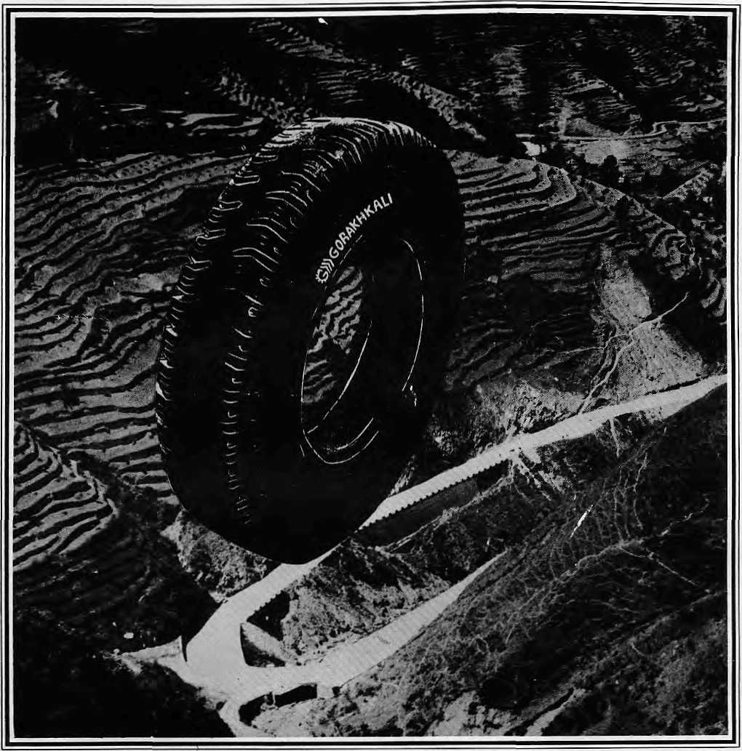

The Gorakhkali tyre is specifically designed for tough Himalayan roads and extreme Himalayan climate. It is the only tyre manufactured in the Himalayan region. The Gorakhkali tyre uses nylon backing and a special dual tread compound for added strength. Rigorous tests on Nepali highways have shown that the Gorakhkali tyre has excellent abrasion resistance. It is unmatched for steering, acceleration, braking and road grip. Overall, it has the lowest cost per kilometre of running.


GORAKHKALI
GORAKHKALI RUBBER UD YOG
Registered Office: Marketing office:
Majua Deurali PO Box 1700, Kalimati
Gorkha, Nepal Kathmandu, Nepal
Phone (065) 20179 Phone 270367, Telex 2788 GRUL NP Fax 271704

Regd. No. Lalitpur 65/045-46

ft. f. ^

Northwest makes it easy to go to America. With a choice of 8 gateways. And connection to 200 cities beyond.
Choose a connecting city that suits you best; Bangkok, Hong Kong or Singapore.
generous free flight plan there is. General Safes Agent in Nepal :
Northwest has daily 7A7 flight via, Tokyo or
Seoul straight to fhe U.S.A. Malla Treks,
Malla Hotel Arcade,
Be sure to ask about WorldPerks, the most Kathmandu, Tel. 41 8 389


NORTHWEST AIRLINES
SOME PEOPLE JUST KNOW HOW TO FLY.^{S}'

