
HIMALAYAN MAGAZINE

NFte 40 PM 9
IRs 25 . £ V 4
Nu. 30 ,US . 5
U* 4.75 in North America
Vol 6 No 5



^£-i^

..-■;•'
.4 ,<


■ ''■■:>"-.'■■;':::' ■:'•"/."] ■ ■■.•■•
liillllli
^tHis^-s^S

WE&SBSSmUXB^

Confused Identities in the Tibetan Borderlands
Sermon on the Mountain: The Gospel Comes to the Hindu Kingdom

Royal Nepal Airlines
AnnouriGes
FLIGHT TO

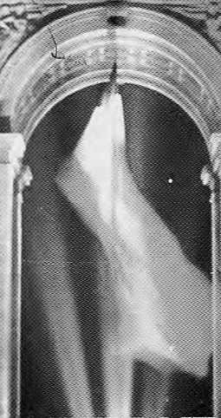


':.':■■ ■

rorri (S
CAtClirTA K/iTHMftHQU PARIS LOHOON FRftHKFURr S1NGAPOHE BANGKOK HONG KONG OUBAI

INSIDE...

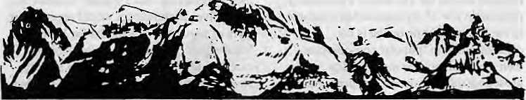
MAIL
Gloom Over at Shipki La
Having read in Himalaya Mediafile (Jul/ Aug 1993) that trade with Tibet was to be permitted through Shipki La in Kinnaur, Himachal Pradesh, let me share a recent experience that I had while trekking from the adjoining district of Spiti to Rapsu in Ladakh, along the Indo-Tibet border.
Upon meeting some people from Nako village in Kinnaur, which is near the Tibet border, I excitedly passed on the information, thinking that they would be delighted with the prospect of trade resumptions with Tibet. Far from being elated, they became dejected.
For many years now, it seems, the people from Nako and other border viljages of Chango and Yangthang have been unofficially trading with places in Tibet as far away as Tashigong and Gartok. Using chor rastas or even the Shipki and Kaurik passes at night, they would enter Tibet, where they would be met by Chinese or Tibetan soldiers who would assign them villages to sell their wares in. The Tibetans looked forward to the arrival of caravans from Kinnaur, as they brought cereals, vegetables, hair oil, scissors and horses, etc.
Reluctantly, the villagers confessed that with each trip they made a profit of 300 percent on their investment. With trade-legalisation, their profits would come tumbling down. And more importantly, they would be edged out by the money bags from the plains. Apparently, the Tibetans had warned them of as much!
Romesh Bhattacharji
New Friends Colony, New Delhi
After ihis letter was received, India and China decided to open Shipki La. Editors.
What about Myths and Legends?
Michael Hutt's definition of "creative literature" (May/Jun 1993) was too limiting
for proper appreciation of Himalayan literature. If only the usual "fiction, poetry and drama" were to be regarded as literature, where would one place folk-tales and religious stories, legends and myths, reviews and criticisms, (auto)biographies and memoirs, oral histories and travelogues, pieces of humour and even political cartoons? Surely, they are not uncreative and unliterary pastiches of Himalayan thoughts.
Also inherent in Hutt's definition is an annoying and false assumption that "literature" is sustained only by novelists and poets, and not essayists, critics and others who debate ideas on paper. I would argue that crafting influential essays is no less a creative and original task than writing a critic ally-ace] aimed novel. Any discussion of literature must encompass both kinds of works, in addition to others.
To fully answer the question "Who writes for the Himalaya?", both Hutt and Mimal should have considered other genre of writings that show the diversity of literary traditions.
AshutoshTiwari Massachusetts, United States
Victims of Historiography
In his survey of recent historical writing on Nepal (Jul/Aug 1993), Pratyoush Onta has rightly pointed out that Nepali historiography has not kept abreast with trends in South Asia and highlighted the advantages of combining anthropological and historical methods. 'Mainstream historians' do need to take more notice of, for example, Richard Burghart's work on the history of Janakpur and its ascetics, and on the evolution of a sense of national identity in Nepal. Mary Des Chene's dissertation on the Gurkhas, blending archival and library research, with fieldwork
COVER
8 Whither the Tsampa Eaters by Tsering Shakya Ethnic awakenings in the Tibetan borderlands.
12 Building Blocks of Bait! Ethnicity
by Nigel J.R.Allan
Baltis now communicate directly with the West.
15 Ladakh at Crossroads
by Timothy Malyon
Right conference at the right tima.
16 Who Cares for Humia...
by Tshewang Lama
Disinterest and ignorance aflect the Tibetan-speakers.
20 Tourism's Predicament
by Manjushree Thapa
Some win while others lose in Lo Manthsng.
21 Whither, Indeed, the Tsampa Eaters
by Charles Ramble
Looking at the Tibetan identity-who's in there?
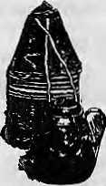
Bag to hold tsampa {pronounced "chamba'-bartey flour), and copper pot.
FEATURE
35 The Gospel Comes to the Hindu Kingdom by Saubhagya Shah
The missionaries should lay their cards on the table. Proselytising should be legalised.
DEPARTMENTS
23 On the Way Up
26 Voices
29 Briefs
44 Reviews
- Know Your Himal
- Abominably Yours
Cover: Yak traders from Mugu, north of
Shay Gumba, Oolpo (1979). Picture by Kevin Bubrlskl.
Hima] © 1993 is published every two months by
Himal Association PO Box 42, Sridarbar Marg, Lalitpur, Nepal.
Tel: 977 1523845, Fax: 977 i 521013.
ISSN 1012 9804, Library of Congress Card
Catalogue No. 88 912882.
Subscription information overleaf. Printing: Jagadamba Offset. Tel: 977 1 521393.

Sep/Ocl 1993 HIMAL . 1

HIM L
Vol. 6 No; 5, Sep/Qct 1993

The Abode of Goifs, King of. Mountains, Himalaya
Y&U bound the bctamfrom ■■■ iaxttowest ' .... A northern yardstick Towepsu^elhe Earth
— Ka \ i d asa 7 Kumar a: Sam bkaya
Associate Editor 'Consulting-Editor Managing Editor Photography Administration

KanskMatti Dixit MamshaAryaJ. ■ "..... -■ Sanjcev Prakastj Pcma Waitgcnulc Dprjee
liikus Rauriiar \ .. \
Balaram Sharttia
Pra(i riti Karmacharja......
Subscription
EtoNQT send cash in mail;
■ Individuals
Nepal India Bhutan
'OtherS. Asian Countries North America:
I Vear .2 years
NRs 220 ' 400
IRs 140 260
Nu . 175. 330
U$. 12 ■■.. 20
U$ ... ^.22.50 40.
DM 50 W
United kingdom* Ireland ■■£' 2ft : -35
■EJstwhere " UJ.. - 25 ";..45;-
Institutional
.Nepal NRs 600 1100
In^a, ; IRs 260^ SX)
DtherS. Asian Countries U$ 25:; 45:
North America \}.$: 40 70
Gefmany DM 70 120
United Kingdom & Ireland £_ ,30 50
Elsewhere U$ 45 ; '80,
Send all subscription orders and
correspondence t*>:
South Asia: P.O. Bos 42, Lalitpiir, Nep?il . i'ilj
Ceatrti News AgencjV23/9() ConJiaught
Circus,New DeltiiUi)001
AKio)lni'iuct!i.
P:0.B(tt % Kiyose, Tokyo, 204 Japan Australia: Indra Btui, 12 Norfolk St.,
P^ddirigton 202J, Sydney, Ausfraiia, -Jfiirth Americai;Barbara.Bella & Associates,500
Sansomestreet, Suite 101, PQBo* 470758
San Ertinciscti, CA5W111 United Kingdom & Ireland: Jotl Giri (Kef: H},
321 Ashij Garden?,Eriiery HillSiieet, "...
Lwidqn SW1P 1PA ^{s}
the Netherlands: CF; de Stoppelaar,
Foundation Himalaya. Kcixcrsgract 465,
1017 DKAmsterdain Swit«rlah(l; Helaie Zinggi Tannenweg 18,
Ruropn Outga Press (fflMAL), Liiiipoidsif.
amongst ey.-lahurays and their families in a Gurung village, also deserves praise.
This said, I feel Onta's concluding remarks were too sweeping, and in conflict with some of the evidence he himself presents earlier on. He adopts a needlessly polarised view of the approaches available to the historian: if he or she is not concentrating on 'popular consciousness', then the result will be merely 'elite prosopography' or nationalist propaganda. In fact, whilst the bulk of historical writings on Nepal has taken the state and its activities as its starting point, the two scholars whose work has had greatest impact are very much concerned with the ordinary people of Nepal as 'victims of history': virtually everything Mahesn Chandra Regmi has written is aimed at describing the impact of the state's extraction of revenue on the Nepali cultivator. This is also the centra! theme of Ludwig Stiller's The Silent Cry (1976).
Other writers whom Onta cites have indeed concentrated on conventional political and diplomatic history, but not quite as exclusively as he suggests. In my own Kings, Soldiers and Priests, I devoted a lot of space to 'who plotted against who' (and weren't the members of the political elite who perished in such incidents also 'victims of history*?), but I also examined how far the army in Kathmandu in the 1840s acted as client of the elite patrons and how far it was autonomous.
I am surprised at Onta's injunction to eschew 'objectivity' in favour of 'passionate' history. To my mind, one of the many merits of Des Chene's work is precisely that, while her own convictions come clearly enough, she tries to remain objective. In criticising the image of British soldiers presented in British sources, she tries to explain (ratheT than denounce) what she sees as misrepresentation. She is also scrupulous not to over-generalise from her own results, particularly with regard to differences between Gurung communities themselves and also the difficulty of demonstrating conclusively whether hill communities have gained or lost overall from the Gurkha connection.
Contrast this attitude with much more 'passionate' one adopted by Chaitanya Mishra, Stephen Mikesell and Jamuna Shrestha, and John Cross in the exchange of views on Gurkha recruitment published in Strategic Studies (CNAS,,Nos. 6-7 1985-6):
the pages almost glow with righteous indignation — of the left-wing variety in the first two cases and right-wing in the third. These authors all deserve respect, both for the sincerity of their convictions and for their scholarship, but I wonder whether they themselves in retrospect would regard their style of argument as a model for historians. Vehemence can raise the writer's own morale and encourage those who already agree with him or her to keep the faith, but in readers with different convictions, it is likely to provoke a knee-jerk hostile reaction.
While we do need more 'history from below', there is still plenty of work to be done elsewhere. Those working on Nepali history should feel free to select what interests them or what they feel they are the best at, while keeping abreast with what people with different approaches are doing, John Whelp ton Kowloon, Hong Kong
Authorial Location
In my article "Whatever Happened to the 'Golden Age'?" (Jul/Aug 1993), I tried to show the connection that exists between history writing and the 'location' of the author. It is my belief that 'true history' does not exist to be discovered by a historian. It was therefore with Tegret that I found that a sentence in my submission had been editorially altered so that it reads, "...Nothing could be further from the truth, and true Gurkha history has barely begun to be written..." Like all other history, "true Gurkha history" can never be written. Pratyoush R. Onta Thamel, Kathmandu We regret the nuance that was added in editing. Eds.
Paddy Museum
With regard to your Briefs column on Paddy Tourism (Jul/Aug 1993). the advantages of diversification in Nepal's vital tourism sector, both in terms of destination and season, hardly need enumerating. The beautiful and still relatively agricultural valley of Sankhu, as you suggest, would add a valuable extra dimension to a tourist's stay in Kathmandu.
Visitors from Europe are particularly fascinated by rice cultivation and all that goes with it. In Northern Europe, we eat rice but do not see it gTown, nor do we see terraces or the crops transplanted into wet fields.

2 . HIMAL Sep/Oct 1993

MAIL

However, it is not easy to charge tourists to see fields, other than indirectly along bus routes or from the window of a restaurant! A relatively low cost addition to make the package viable would be a Paddy Museum. It might be possible to rescue and adapt a traditional building, perhaps even one pleasantly sited in the middle of rice fields but easily accessible from Kathmandu and Patan.
The museum would house tools and equipment, costumes and ritual items, which would not be expensive or difficult to acquire as they would mostly be in contemporary use. These objects as well as well-prepared photographs, graphics and multi-lingual explanatory texts would tell the story of rice cultivation in Nepal, of the farming communities and their festivals. If older ot archival material were available, a historical section could be included. The exhibit would have to be prepared with the understanding that tourists do not have the time to get to understand and interpret what they see in the field and villages.
If such a museum also had well-managed toilet facilities, a clean and modest snack bar serving soft drinks, an attractive gift shop, and were well advertised, it would become a popular stop for the sight-seeing tours. Tourists as well as foreign residents would be happy to pay a reasonable sum to visit such a museum. Special arrangements could be made for parties of Nepali school children to be taken al little or no costs, to study paddy as a part of their studies. This will become ever more important as urban children increasingly lose their links with

g
Excellence in Learning
Rato Bangala, an institution dedicated to child-centered and innovative education, seeks primary level teachers. Applicants with a strong commitment to teaching and who have fluency in English are requested to collect application forms from the School office at Patan Dhoka, Lalitpur. Tel: 522614.
and appreciation of the land.
While there is no reason why this type of museum should not cover other aspects of rural life, one-topic museums, such as the Tea Museum in Hong Kong, have a certain appeal and impact. What is needed is a coherent display that tells a specific story in a lively way, in attractive surroundings with good facilities.
I do hope that one day a tourism entrepreneur will pick this idea up and run with it.
Mrs.RM. George Lainchaur, Kathmandu
Yellow Idol
It was pointed out to me recently that Rudyard Kipling did not write about the "little yellow idol to the North of Kathmandu", as I wrote in "Who writes for the Himalaya?"(May/Jun 1993)
The poem was a music hall monologue by J.Milton Hays. I cannot say if he visited Nepal, but my apologies for the error.
Michael Hutt
London, United Kingdom
Janajati are not Indigenous
Many people, including writers in HimaU seem to be confused about the meaning of the word Janajatis, and use it incorrectly to refer to the indigenous Mongol population of Nepal.
The word originated in India, and like many other Hindi (or Hindu) words, came to Nepal with Hindu refugees, i.e. Bahun, Chhetris and Janajatis. The Bahuns mostly came from Kumaun, Garhwal and Banaras, the Chhetris from Rajasthan, and the Janajatis from Chitor.
The ancestors of today's Janajatis were soldiers and porters of King Rana Pratap. After the Mughal invasion of Chitor, these people had no place to live and became Janajatis, or nomads. They fled to the Himalayan foothills together with Rana Pratap when Chitor was attacked by the Mughals. These Janajatis came to be called Kusunda in the hills of Nepal, and their present population is barely six thousand.
Similar to the way the Gurungs, Magars, Rais, Limbus, Tamangs, Newars and other Nepalis forgot their mother language and adopted the Kkas language as their mother tongue, the Janajatis too, over time, forgot everything that was their own. They lost their language, culture and
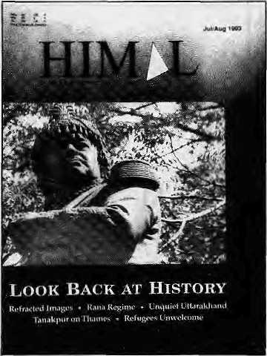
religion — and adopted the other indigenous peoples' ways, except for the word Janajati.
Besides the four Hindu Jats (castes), there are more than seven Jatis (sub-castes) — Kami (blacksmith), Damai (tailor), Sarki (cobbler), Gainey (street singer), and Kusundas (nomads) ot Janajatis.
In the real sense, Janajatis do not have a country. Almost all Janajatis in Nepal are pro-palace communists but are against the supreme caste of their Hindu religion — the Bahuns. It seems like the servant's envy of his master. Both B-ciass Hindus (the Chhetris) as well as the Janajatis are loyal to the King.
There are upper and lower classes even within the Bahun and the Chhetri castes. But whatever then- class, all Bahuns and Chhetris are jointly united against the welfare and the progress of the indigenous Mongol people of Nepal. This is because these indigenous Mongol people are non-Hindus and their race, religion, language, script, temperament, way of living, as well as their way of thinking, are completely different.
Mongols constitute 80 percent of the total population in Nepal; but the 20 percent Hindus who occupy senior positions in civil, police, military, foreign missions and projects, and monopolise and misrepresent the data that is to go to foreigners and to the people of Nepal.
There is only one political organisation in Nepal which looks after the welfare and fights for the rights of the 80 percent

Sep/Oct 1993 HIMAL . 3


Qjou/i
panad&e

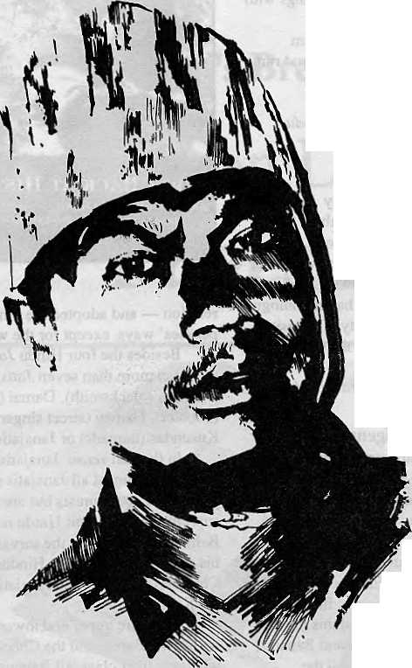
Thismandoesn'thaveaHolelManagementDegree. Neither has he mastered the artof londscoping. And yet tohim-weoweourPrivate Paradise. V)
He is our gardener, the creator of our prize-winning garden SHAMBALA. A frue reflection of our commitment to a greener and healthier environment. Because within our hotel, //+ we chose to build a Shangri-la -a true haven, to show the world whar they come ro see -nature's resplendent beauty. *3) Perhaps,it is the splendours of our gorden thatenchantsour guests into coming to stay with us, again and again. Or perhaps, because of our gardener, our people...who care for the environment.


SHANGRI-LA
KATHMANDU NEPAL
G.P.O BOX: 655, LAZIMPAT, KATHMANDU, NEPAL. TEL: 412999, TELEX: 2276 HOSANG NP, FACSIMIE: 977-1-414184

MAIL

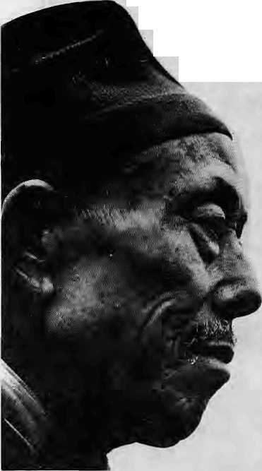
indigenous population, and that is the Mongol National Organisation. The
Election Commission has not yet recognised it, and a case is pending
in the Supreme Court
The present Constitution of Nepal has
been drafted by conservative Bahuns and Chhetris and is communal because it protects only the rights and interests of the ■ 20 percent Hindus. Nepal remains a "Hindu Kingdom" and the new Constitution is little different than the ones produced by the oppressive Ranas and the despotic Panachayat system. Thus, not only the rulers of Nepal but also the Constitution is against the aboriginal Mongol people of Nepal. The Mongol National Organisation wants real democracy, provincial government, secular country and human rights, not only in a constitution but in practice. There wiJl be a blood bath in this Himalayan Kingdom if the minority but powerful Hindus neglect the majority of the indigenous Mongol people.
Gopal Gurung, President Mongol National Organisation, Kathmandu
Trouble with Guesstimates
While appreciating the discussions on the issue of Bhutanese refugees and the impact
created by their presence on the local population, I disagree with Gopal Guragain's statement ("Living Out a Refugee Welcome" Jul/Aug 1993), that a iarge number of Nepalis are availing themselves of UNHCR facilities and that an even larger number of Bhutanese have taken Nepali citizenship.
With a combined total of 15,000 odd families in all the camps, Guragain's assertion that "1222 families suddenly disappeared" because they were Nepali infiltrators afraid of being detected during a refugee count, should have seemed improbable even to him. Admittedly, due to transfers between camps and absence of camp residents, there have been problems of proper tallies, but with a few hundreds, not with over 7000 as his article implies.
The 1222 figure (which counts individuals and not families) probably refers to double-counting when part of the refugee population was transferred to Khundanbari from Beldangi, as also to administrative lapses currently being investigated by UNHCR.
As regards the Nepali citizenship obtained by the 5000 refugees, the reporter should have grilled the "high ranking (Home) Ministry official" as to why no actions were initiated against his staff and the fake citizens. The official's statement seems to suggest that obtaining Nepali citizenship is as easy as buying a box of matches.
Five thousand foreigners cannot just walk in and be registered as citizens. The trouble with diis kind of guesstimate is that it is usually thrown casually by a respondent. Guragain could have tested this convenient number against his own knowledge of the type of people in the camps: how many of them could have afforded the 'special costs' of acquiring Nepali citizenship under false pretences, still have money left over to make use of such an acquisition, and benefit from the investment?
While there may be some such individuals, lo suggest that there are 5000 of them is a slur not so much on the refugee community but, unfortunately, on Nepali Government officials. Guragain should have realised that, if true, with 5000 fake citizens, he had a much bigger story than that of the refugees on his hands.
B. Ranapaheli Beldangi, Jhapa
Devastating Words
"Tis held that sorrow makes us wfse Whatever wisdom sleep with thee."
Tennyson
Thanks to Mamta Acharya and Prayag Raj Sharma (Mail Jul/Aug 1993), whose ethical understanding went to produce two positive letters supporting Nepal's own heroine — Pasang Lhamu Sherpa. Marcia Lieberman though, while accepting the hospitality of another country, attempted to publicly denigrate Pasting Lhamu's character and bring her family's trekking company into disrepute.
What would Lieberman's reaction be if a Nepali journalist were to travel to the West and sling mud at America's great heroes? I believe in the freedom of the press, but feel that a code of professional ethics and morality should keep good journalism out of gutter.
An arrogant Western woman sees fit to denigrate a national heroine of Nepal. A travel writer sets heTself up as judge and jury to condemn on hearsay evidence. How cold and calculating to pen these devastating words which are perversions of the truth, without any consideration for the massive hurt, humiliation and sorrow of families still in mourning. All this makes me ashamed to be Western but thankful that I am British and not American.
Lieberman contributed to, sat in, and moved amongst the rubbish and the debris left by foreign nations at Chomolongma Base Camp. She did this with her fellow Americans, whose expedition deemed fit to refuse assistance to Pasang Lhamu's rescuers, saying that theiT mission was to climb mountains and not to recover or rescue people or dead bodies!
Did Lieberman personally interview Pasang Lhamu prior to the expedition to discover the soul, truth and compassion of this Sherpa heroine? I fear not, for her writing reveals only circumstantial evidence, in negative terms, that were apparently presented to her by frustrated and envious individuals. Only Pasang Lhamu and Sonam Tshering would be able to relate the truth of those desperate hours on the mountain. How cowardly it is then to denounce a heroine who is no longer present to face the charges of such an adversary.
As a woman, I feel sorrow that Lieberman could tolerate and record such words against another woman, one who showed such courage and perseverance.

Sep/Oct 1993 HIMAL . 5

If you think you cannot walk in the mountains of Nepal ...
We could find another way !

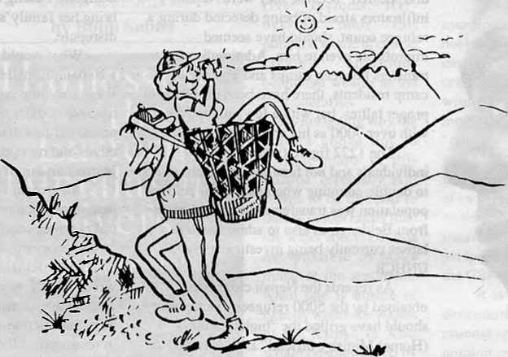

You can do it ! and enjoy it too 1 with the help of Summit Nepal Trekking !
Carrying the aged and the infirm in a doka ( bamboo basket ; is still traditional in the hills of Nepal .


MMIT NEPAL TREKKING
Write or call us at:

P.O.Box 1406, Kopundol Height
Kathmandu, Nepal
Tel: 525408,521810
Fax: 977 1 523 737

MAIL

Pasang's philosophy and aims were humane, and she was moved with a genuine mountaineering spirit.
Action and deeds speak louder than words. So a positive suggestion: let Marcia Liebennan put her implied skills to good use by helping the Pasang Lhamu Mountaineering Foundation, whose aims and objectives for women's and Sherpa welfare are clearly stated.
There are no unsung heroes among Sherpas, for the community knows and remembers each and every one, both past and present, who have been successful, or those who have given their lives for the sake of others on the mountain. The story of these heroes have and will always be told; they will continue to unfold through generations yet to be born, as their spirits do not die in this land of the Himalaya.
I do have a vested interest in producing this letter. I am proud to be married into a Sherpa family and have a wonderful husband who is related to the directors of Pasang Lhamu's trekking company, who form a loyal family group.
Madam Lieberman needs to learn how to digest and absorb only the truth so she may grow in compassion and become arhant and follow the Eightfold Path: The Fourth Noble Truth of Buddha's teaching.
Linda M. Sherpa-Padgeit Wales, United Kingdom
A National Heroine
Having been a close friend of Pasang Lhamu Sherpa and a lawyer lo her four expeditions to Everest, including the last one which established her as a true heroine who made such a name for the women of Nepal, I was distressed to read Marcia Lieberman's rejoinder. It seems to have been inspired by animosity harboured for a long time against Pasang Lhamu and her husband.
Why should Lieberman, a foreigner, be so concerned about what the Nepalis did or did not do to Pasang Lhamu? Nepalis themselves bestowed on her the status of an authentic heroine. The Nepali people, if not their Government, know how to respect and honour their heroes. The mass assembled around the airport, in Pasang's house, in the streets, and in the funeral site was nol an insane crowd.
That Chanlal Maudit, the French woman member of the 1991 expedition, paid U$ 5000 to Pasang Lhamu is a falsity
to discredit Pasang Lhamu. Thamserku Trekking — a private company registered under the Company Act of Nepal — was paid the U$ 5000, as the fee of the local agent for the expedition. Batard not only blocked Pasang Lhamu from ascending the peak because he wanted to see the French woman reach the peak but Pasang Lhamu also had to spend a night without oxygen at 8,478 meters. When Pasang complained to the Ministry of Tourism about the treatment she received from Batard, he was found guilty and was made lo apologise to Pasang Lhamu and the Ministry.
Pasang Lhamu told me that she turned down the Indo-Nepal Women's Expedition offeT to join the team because heT proposal that she be made the co-leader was not accepted. She felt that since the joint venture was envisioned at a national level and patronised by the Prime Ministers of the two countries, the question of co-leadership was very important. Since she had the bitter experience of being prevented to reach the top with Batard, she was not ready to let someone in a joint expedition to take the absolute leadership.
Before the expedition left Kathmandu, Pasang Lhamu, Lhakphuti and Nanda Rai held a meeting. Lhakphuti was to be in charge of the equipment and Nanda Rai, the food section. They also decided that Pasang Lhamu would go up in the first phase, Lhakphuti in the second phase, and Nanda Rai in the third phase. The agreement among the three concerning the division of responsibilities and the sequence for climbing is with Sonam Sherpa, Pasang Lhamu's husband.
According to plans, Pasang started her summit-bid on the night of 22 April. She fulfilled the promise made to her countrymen, but fell in the cruel hands of fate while descending. This can hardly be called "a clandestine rush to the summit". Lhakphuti was not a competitor, she was an associate, and the propaganda about equipment and Sherpa support are Leiberman's fabrication.
Pasang Lhamu was a citizen of Nepal, from a disadvantaged community and a woman, trying to buy pride for the country at the cost of her life. Her death shocked the nation. While with her narrative Lieberman has tried to fling mud, at least the nationalists recognise Pasang Lhamu as an authentic heroine.
Yubaraj Sangroula Advocate, Kathmandu
Marcia Lieberman Responds:
is a journalist's role only to tell people what they want to hear — only to bolster the official myth? I agree with Ms. Sherpa-Padgett that we must all "learn how to digest and absorb only the truth"; indeed, that is the question. Truth comes first, and to seek or accept it one must remove the blinders. I would welcome any Nepali journalists to my country, to write critically about anything. I respect Nepal too much to let a distortion of the facts pass without comment. If history never spoke criticalfy of the dead, it would be a fantasy, not history. Only small children need a diet of fantasy — and in my experience, the Nepali people are mature and intelligent. Pasang Lhamu's deficiencies are well known to the climbing community. I grieve for Sonam Tshering, whose death was caused by Pasang Lhamu's reckless rush to the summit, to beat out her sister Sherpani climbers. As for the statement that our Expedition refused to assist Hie rescue, that is false. Dan Aguilar, a member of the Sagarmatha American Expedition, gave up his summit attempt to help recover Pasang Lhamu's body, carrying it through the most dangerous part of the icefafl. Photographs document this.
As for Mr. Sangroula's letter, "Animosity harboured for a long time against Pasang Lhamu and her husband"? I never met them, had never heard of them before last spring. Nor did I call the mourning crowd "insane"; their response was moving and understandable. Why does Mr. Sangroufa bring in Marc Batard? I neither spoke to him nor mentioned him.
Pasang Lhamu from a "disadvantaged community"? Wife of a trekking agency director, she was better off than any of my Sherpa friends. And Lakhphuti says there was no prior agreement that they would climb first, herself second; Pasang Lhamu told her they would climb together. I fabricated nothing; the allocation of Sherpa climbing support -— five for Pasang Lhamu, none for Lhakphuti — is a fact and speaks for itself.
Nepal is full of heroic women — millions of them — whose lives are unsung. Their gifts to the nation is their lab'ur, in the fields, at the stream-side and village water tap, and at the hearth — and the honest, brave children they raise. The struggle of a village widow to feed and clothe her children can be tougher than climbing Sagarmatha. I honour them all.
The debate concerning Pasang Lhamu Sherpa is now closed. Editors.
information and opinions appearing in HimaL Letters
should beta the pcirvtandrrsay be edited. Letters which are unsigned and/or Without addresses Will not be entertained. Please include daytime con tec t telephone number, jf available.

Sep/Oct 1993 HIMAL . 7

Whither
the
Tsampa



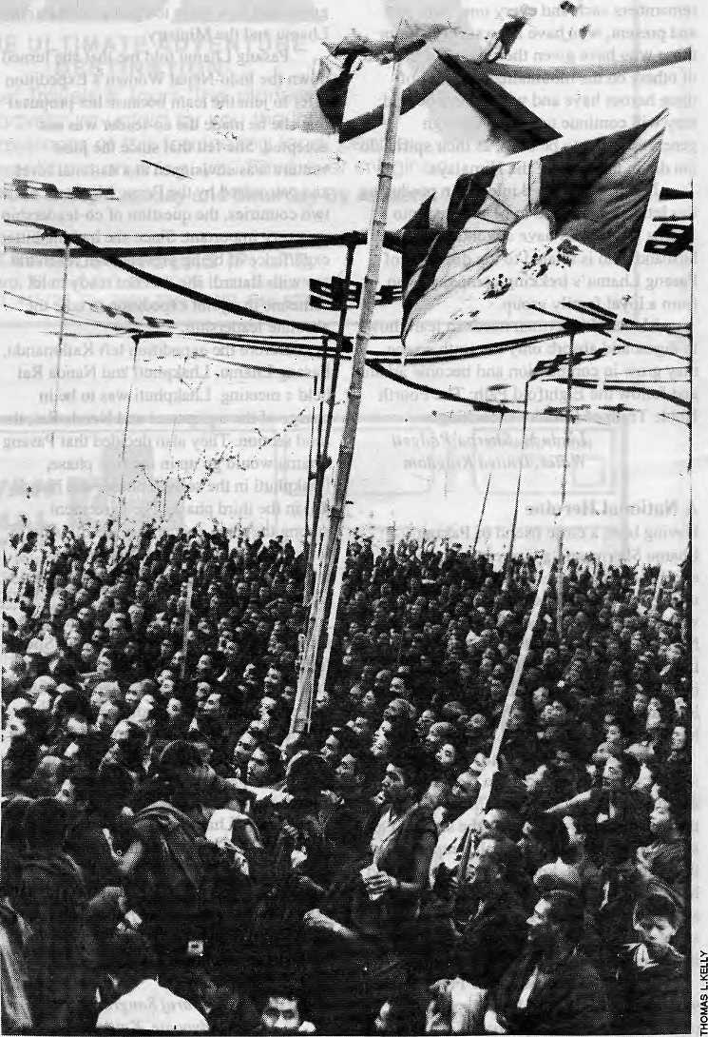
With the collapse of Lhasa as the centre of its cultural world, the Tibetan periphery has had to devise new means of survival in order to preserve its identity. Among Tibetans of Tibet, there is a shift from defending the faith to defending the flag.
by Tsering Shakya
A common identity is manifested: Kalachakra gathering, Tibetan national flag at Bodhgaya.
8 . HIMAL Sep/Oci 1993



T
he late 1980s saw the start of unprecedented political developments in the Tibetan-speaking regions of the Himalaya. In 1985, agitations began in Ladakh for greater autonomy from Srinagar. In Tibet proper, over SOmajor demonstrations resulted in the imposition of martial law in 1988, which lasted more than a year, and protests flared up once again earlier this year. Bhutan saw a sudden conflict erupt between the Tibetan-speaking Drukpas and the Nepali Lhotshampas.
Theseevenls, which have their origins in the assertion of the Tibetan ethnic identity, can also be ascribed to the concomitant resurgence of ethnic identity among other groups in the Himalayan region. Fot example, the Gorkhaland movement in neighbouring DarjeelingdistrictcontributedtotheDrufcpas' fears, and the emergence of Islamic fundamentalism in Kashmir helped deliver the Ladakhi agitation for separate status.
The revival of identity and the resulting political action is led by the most influential sections of thesocietiesconcerned. InLadakh, the leadership of the movement is in the hands of the Ladakh Buddhist Association, which has become ade facto political party. In Lhasa, all the demonstrations are led by monks and nunSjWhileinBhutanittstheThimphunobility which is defining policy and action.
While these conflicts have risen in di fferent countrieswhichhavedistinctpolilical systems and ideologies, there is a connection between the diverse political happenings. This is not to say that there is a central organisation withacooimon objective which is engineering a simultaneous evolution of attitudes among the Tibetanfold. Each development isof course independent, and those engaged in political activities a)l over do not perceive themselves as involved in a greater movement beyond their boundaries. The connection is essentially historical and sociological — the recent political developments are part of the Tibelan-speakeTs' growing sense of ethnic identity, which is perceived as being under threat from the outsider.
Who's a Bodpa?
During the height of the Tibetan resistance to the Chinese in 1959, a letter appeared in The Tibetan Mirror, symbolically addressed to "all ts amp a eaters". The writer had gonedown to the staple, barley, as the most basic element which united the Tibetan-speaking world. If Buddhism provided the atom of Tibetanness, then tsampa provided the sub-particles of Tibetanness. The use of tsampa transcended dialect, sect, gender and regionalism.
The term Tibetan, as used by Western academics, may be employed to denote populations which have common history and tradition, and share the worldviews and myths about their origins. Tibetan Buddhism and the shared myths provide the bases for social relationships and ideology. Although there is obvious diversity from region to region, there is a strong family resemblance in language, lifestyle and culture.
There is no indigenous term which encompasses the population denoted by the Western usage. A local term such as Bodpa can be used only res trie lively, even today. The nomads ofChangthang use it for the people of the Lhasa valley, while for the peopleofKham and Amdo it means exclusively the inhabitants of Central Tibet, Significantly, the person using the term Bodpa never identifies himself as part of the group.
Among the Tibetan refugee community, Bodpa is now generally accepted to mean the people from Kham, Amdo and U-Tsang. Even here, the term is used specifically to denote the people under Chinese rule and not the refugees themselves, who might have their origins in those regions. Meanwhile, the people of Ladakh, Bhutan and Sikkim, even though they have consanguinous and cultural affinity with the rest of the Tibetan world, are excluded from this definition.
This peculiar use of Bodpa merely explains the internal diversity as seen by the Tibetan-speakers. The emphasisisonplurality of identity, whichof course isnot unique to the Tibetan world. The singular marker of identity emerges only in opposition to "the other".
Despite the diversity, the element which defines the Tibetan-speakers is their shared belief that Buddhism unifies them. They see themselves asJV«n,gpa,whichmeans"insider". The sense of being Nangpa is shaved almost universally by Tibetan-speakers, for whom the very sense of being Tibetan is fused with the Buddhist identity.
The non-Tibetan is called Chyipa, the "outsider", providing the marker for "us" and "them". Thecollective identity of the Tibetan-speakers, as opposed to the rest, can be witnessed best during the Dalai Lama's Kalachakra teachings, when people from all parts of the Tibetan world converge to take part in shared group rituals. Regional differences are smoothed out and a common identity is manifested.
Besides the common faith, the other threads which hold thediverse groups together is the written language and the corpus of literature produced over the centuries. The written language, which is often referred to as
Choskhed (language of Dhaima), and to some extent the Lhasa dialect, formed the lingua franca. Monks from all parts of the Tibetan cultural world came to study in the great monasteries in and around Lhasa, and lay people flocked there on pilgrimage. The ruling classes of Bhutan, Sikkim and Tibet were all linked by matrimony, and the Lhasa dialect was the court language everywhere.
Based on the strengths of its faith and language, the Tibetan cultural world spread from the shores of Lake Baikal to the rainforests of Yunnan, and from the Siberian wilderness to the southern foothills of the Himalaya. When the Mongols adopted Tibetan Buddhism inlheearly 14thcentury,itmarkedadeparture in the development of Tibetan civilisation, for atthatpoint it crossed the ethnic and linguistic boundaries of Tibet. Tibetan became the language of the elites and of diplomacy in Central Asia.
This unity of faith, culture and language, however, never transcended into the idea among Tibetan-speakers that they constitute a single people, nor to a sense of political unity. The individual regional identities were so strong that they never allowed the emergence of charismatic leaders who would seek the unification of the diverse group into a single nation. Since the lOthcentury, after thepassing of the "Dharma kings" such as Song Tsen Gampo,Khri Song Detsenand others, political power never got centralised. The locus of authority remained diffuse. TheDalai Lama's own political authority never extended beyond Central Tibet, and even this was challenged by the Tashilhunpo, which regarded the Tsang area as the Panchen Rimpoche's fiefdom.
Rightup until 1959. the Tibetans had very little sense of being one group. When the Chinese first crossed the Yangtse, then marking the border between Tibet and China, it was the Khampa militia Tecruited by the Chinese which attacked and ransacked Chamdo. There was no sense among the militia that their brefhren were being invaded by the Chinese. Similarly, when the Khampas had to endure the most horrendous oppression during the Great Leap campaigns, people of Centra] Tibet showed little or no inclination to support the Khampas. Many Khampas rode hundreds of miles to

Scp/Oct 1993 HIMAL

BALTl.STAN
Skardii
'■.*■ . ■:■ 'i-
KHUMBU OLANGCHUNG GOLA
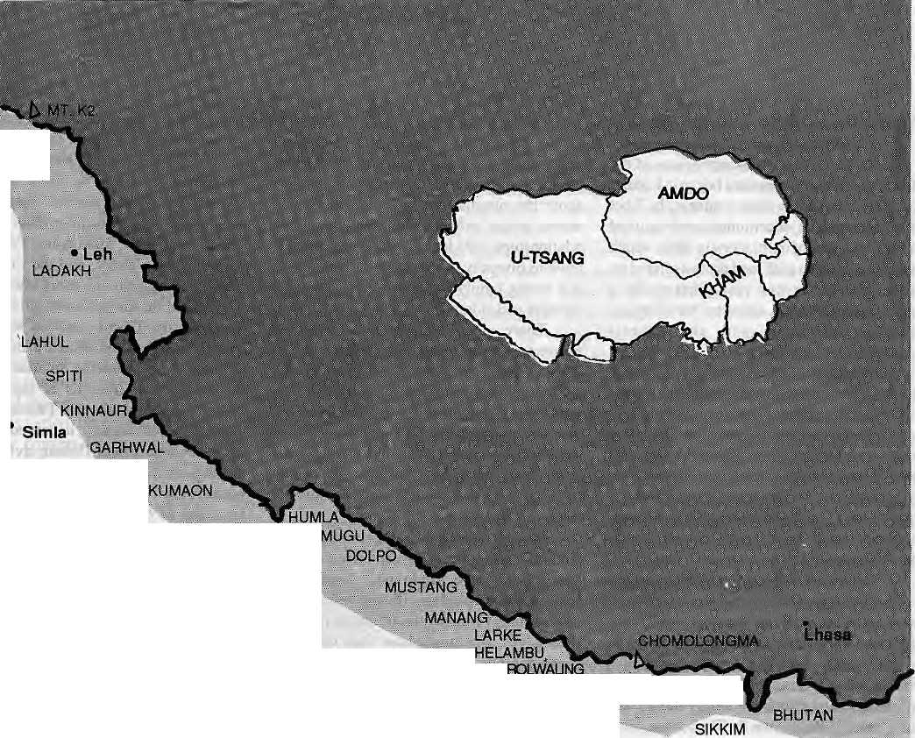
appeal to the Dalai Lama and the Tibetan Government, but no help was forthcoming.
The newfound unity inexile has not supplanted the traditional sectarian and regional loyalties. Among Tibetans, the primary loyalty had always been to the regional leaders and, more importantly, to the TsawayLama(Root Guru). The Tibetans never achieved a sense of loyalty to a country or a nation. It is evident that the people did not think in terms of their country being attacked, but their way of life and religion being under threat.
Fall of Lhasa
Until 1950, all Tibetan-speak ing people regarded Lhasa as the centre of their universe. Until the Chinese restricted cross-border interaction, all the Tibetan-speakers of Nepal looked towards Central Tibet as the source of theirculture. Monks from Ladakh.Lahaul and Spiti journeyed eastward to study, some travelling as far as Labrang, in present-day Gansu Province. Besides language and religion, there was also extensive trade and commerce between the periphery and the centre.
The people from the periphery were not merely passive spectators, however, and they played a significant role in the formation of Tibetan culture. Some of the most controversial figures of the 20th century had their origins in the periphery. For example, the prominent scholar Geshe Chodrak was a Mongol, and Tharchin Babu, editor of the only Tibetan language newspaper,77ie 776efan Mirror, was from Kinnaur in Himachal Pradesh.
When Lhasa was finally ransacked by the Red Guards, it marked the demise of the centreof Tibetan civilisation. Thefall of Lhasa

Kathmahdu
iscomparabletothe fall of Constantinople, and the collapse ofthe Byzantine Empire. The breakao wn of the centre meant that the regions had to devise a means of survival, and preserve their own identity and culture.
The collapse of Lhasaalso left Bhutan as the last Tibetan kingdom. Only in the Druk Yul is the ultimate state power in the hands of. Tibetan-speakers. Elsewhere, the Sherpas, Manangbas, Lobas and Dolpowa of Nepal are ijiled by the Bahun- and Chhetri-dominated political culture of Kathmandu. The Ladakhis perceive themselves as disadvantaged by the Kashmiri-dominated state politics of Srinagar. Today, the boundaries that separate the Tibetan-speakers are firmly set between the territorial nation states of Nepal, India and China.
The marginalisationoftheTibetanpeople is most clearly seen in the use of language. Even in Bhutan, the language of education and administration is not wholly in Dzongkha, while in Tibet proper Chinese is in use. In other areas inhabited by Tibetan-speakers, the primary languages of instruction are Urdu, Nepali, Chinese and English.
The gap between the language of the elites and that ofthe local people has naturally excluded the Tibetans from fully participating in the respective systems. This refers particularly to the poorest sections, who cannot

afford the luxury of modern education, which provides the only means of integration and social mobility. This perceived disadvantage vis-a-vis the elite groups is the main cause of the resurgence of ethnic identity among the Tibetan people all over.
Fear of Eclipse
The situation of Bhutan is unique in the Tibetan cultural world, and quite different from that of Tibet or Ladakh. Although it has managed to survive into the 20th century as the last remaining Tibetan kingdom and shares affinity with neighbouring Tibetan societies, the Druk Yul has since its very inception maintained a strong and separate identity.
The kingdom came into existence because of the persecution of the Drukpa school of Tibetan Buddhism in Central Tibet. It was founded in opposition to the dominant Gelugpa sect of Tibet. This opposition was so strong that as late as the 1950s, Gelugpa lamas who came to Thimphu on invitation were asked to d ismount when they entered Bhutan. Ho wever high a Gelugpa Lama might be, he may not enter the land of the Drukpas on a horse, Gelugpa monasteries have never flourished in Bhutan.

10 , HIMAL Sep/Qct 1993

Bhutan has always kept a vigilant watch on her Drukpa heritage. While Ladakh never Ladakhiniscd Tibetan Buddhism. Bhutan was ableto evolve its ownbrand of Drukpareligion and culture and develop its own cultural and religious heroes. The Bhutanese heroes Pcma Lingpa, Drugpa Ku nley, Shabdrung Ngaw ang Namgyal and others remain quintessential^ Bhutanese figures. The genesis of the country is linked with these great lamas, and their leachings and writings are dominant only in Bhutan.
By the beginning of the 20th century, Bhutan was unified under a strong monarch, providing centralised leadership. Today, Bhutan sees itself as not only defending its unique identity but also fightingfor its survival. Such fear has been dismissed by the Lhotshampas as paranoia and unfounded, but nevertheless is perceived as the truth by many Bhutanese.
The Drukpa feaT that the Tibetan-speaking population is on the verge of being reduced to an insignificant minority is also shared in the other areas. The Tibetan-speakers, after all, inhabit a region which is sandwiched between the two most populated regions on Earth, China in the east and the fndian Subcontinent to the south.
TheDalaiLama warns that the migration of the Han Chinese into traditionally Tibetan areas, if allowed to continue unchecked, presents the greatest danger to the survival of Tibetans as an ethnic group. The introduction of new economic policies in Tibet in the 1980s saw the influx of Chinese migrants and traders into the region, who began to dominate the economy. As thousands of Chinese traders moved in, among Tibetans the feeling of being disadv anlaged was become heightened. Perceived (socio-economic disadvantage leads to growing awareness of ethnic identity.
If the Nepali Tibetan population has been relatively passive, this is partly because the gro v» fr of t ourism has brou ght direct economic benefit to some Tibetan-speakers. The Sherpas maintain £ strong grip on the trekking industry, and have subsequently moved out into other tourism-related areas such as rafting, boleliering, trave] and transport. The population of Manang, too, has been economically productive due to a
special dispensation on foreign travel and trade granted during the time of King Mahendra.
All is not calm under the surface even in Nepal, however. Large Tibetan-speaking areas such as Humla, Dolpo and Mustang have been kept outside the general development, and there are signs that these people are beginning to feel the exclusion from the national power structure.
Invention of Tradition
hi the past, the commonality of faith has proved to be the strongest element in unifying ethnic Tibetans. Attheheightof the opposition to Chinese nile, the Tibetans were mobilised not in the name of their nation but in the defence of their faith. The "other" was identified asTendra, "enemy of the faith", and the resistance fighters were Tenzhung tnang mi, "defenders of the faith".
Today, if the Tibetan emigre community in the Subcontinent has achieved some measure oFuniform identity, it has been founded more on anti-Chinese ideology than on faith. The unity has also been fostered in exile though the manipulation of symbols and the deliberate invention of tradition. The prerequisite paraphernalia of nationalism, such as the flag and the national anthem, have been introduced. Most Tibetans in exile are now socialised into thinking of themselves as a homogeneous group through schooling and group rituals such as the celebration of the 10th March Uprising, or the Dalai Lama's birthday in July. Both rituals are recent devices, primarily designed to Taise political consciousness. The 10th of March helps separate "us" Tibetans and the Chinese. The birthday celebrations provide opportunity to focus on a single leader.
There is strong evidence that the symbols invented in exile are being adopted by the people inside Tibet as well, and that they have the power to move people into action. The demonstrations in Lhasa are marked ceremoniously by the unveiling of the Tibetan national flag. If in the past the Tibetan masses were called to defend their faith from the faithless Red Chinese, today a very different message is expounded and the masses are called to defend the flag.
This shift of focus from the faith to the flag is meaningful, as it shows the changing nature of the core of Tibetan identity. The move from the purely religious-based identification to a more secular notion of Tibetartness is clear.
The resurgence of ethnic identity is also marked by a shift in the nature of political participation. Under the traditional feudal

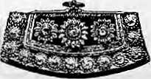
system, political
affairs were the
monopoly of the
elite. Moreover.
'politics' essentially meant coterie
intrigue and rivalry for power among the rulers.
The appeal to shared identity has meant, for
the first time, that apopulist political movement
has begun.
In Tibet, the political agenda is beginning to be set by the masses and the debate is taken to the streets of Lhasa. Elsewhere, too, there is an attempt to mobilise the masses in defence of a common interest and identity. InLadakh, villagers from remote areas came to Leh to demonstrate andshowsolidarity.lt is reported that in Bhutan, many Drukpa peasants are volunteering to serve in the militia to defend the Tsa wa sum (king and country) against " an ti-nationals ".
At the core of the modern identity among the refugees in the diaspora is the concept of Tibet as the trinity of Kham, Amdo and U-Tsang, commonly known as Bo Cho Ka Sum. This idea is at the centre of the political aspiration of the Tcfugee community.lt is evident that the notion of "Greater Tibet" is applied only to regions under Chinese control and, at least for the present, no one is articulating the idea of "Greater Tibet" based on unity of all Tibetan-speaking peoples.
Despite the increasing ethnic confrontation, it is unlikely that a process of Bafkanisation will begin in the Himalaya. In Nepal or India, the Tibetan-speaking population constitute a tiny minority and they coul d never hope to challenge the ethnic groups inpower. The situationin Bhutan is,of course, different. While her status as an independent nation state is indisputable, the question remains how long the indigenous Drukpa population can maintain their hegemony over power.
The situation inside Tibet proper is complex. Beijing isconfr on ted with economic and political problems which do not have easy solutions. If the economic underdevelopment and thedisparity between the success of China and the stagnation in Tibet are to remain unchanged, there will be further and more strident demands far independence.
Whether the Tibetan-speaking people are
in search of independence, greater autonomy,
or maintaining hold over a power they already
have, they are also collectively enmeshed in a
political and cultural crisis of confidence,
which has primarily to do with the question of
identity. ^
T.Shakya is a historian ai the School tor Oriental and African Studies, London.

Sep/Oct 1993 HIMAL . 11

Building Blocks of Balti Ethnicity

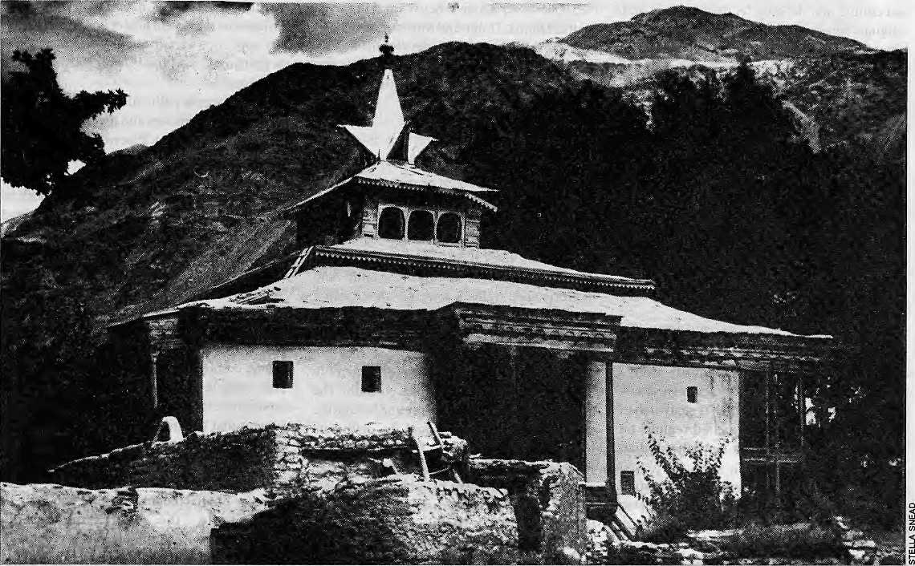

Oldest and largest mosque at Shigar, Baitistan.
The Baltis now have a global clientele on whose reflection they are beginning to fashion a new identity for themselves.
by Nigel J.R.Allan

T
he summer'window of opportunity' for the ubiquitous foreign tourists who want to see 'wilderness' has now opened for Baitistan, that cul-de-sac district in Northern Pakistan noted perhaps only for being a linguistic curiosity in Pakistan, because the inhabitants maintain a dialect of Tibetan.
For Tibet-i-Khurd (Little Tibet), as the Mughals called it, the window is open for economic entry into a cash economy. However, it is firmly closed and locked for political entry into Pakistani society. The national elections in Pakistan are set for 8 October, but the rules firmty prohibit participation by Baltis, as it is prohibited for their Northern Areas neighbours in Gilgit District.
This contemporary paradox (i.e., participation in society at one level but not at others) extends to the current cultural identity of the region, which is being moulded by foreigners through the popular books on mountains. Baitistan is in the midst of being manufactured by the Western media. For the Baltis themselves, their grasp of Tibetan Buddhist culture is limited to the petroglyphs of the surrounding culture and an English language text on the history of the "Northern areas" that foreigners keep writing about.
The reason why the Westerner is so interested in Baitistan is to be found in the circumstances elsewhere in the Himalaya. Travel in Tibet is sanitised because it is limited to supervised tour groups; Nepal's summer deluge seems to be getting greater even while its rambunctious citizens seek more political participation; India is still paranoid about its frontiers and prohibits ramblers on its boundaries; Kashmir, with its

12 . HIMAL Sep/Oci 1993

access to Ladakh. is a continuous bloodbath; Afghanistan is firmly in the grip of the 19th century; and the Pamirs in Tajikistan are now home lo malconients ambushing Western trekkers.
Despite the India-Pakistan dispute on Siachen glacier, BalUstan and the Karakorum mountains are seen as relatively tranquil places for the summer foreign tourists demanding a piece of the Himalaya. The slick brochures and glossy coffee table books beckon with panting prose and vapid photographs, and the tourist obliges.
Billed as a primitive place, unchanged, isolated, remote, with the greatest concentration of high mountain peaks in the world and the longest glaciers outside the polar areas, Baltistan actually has for centuries been the crossroads for trade and for Asian religions: Zoroastrianism, Buddhism, Hinduism and Islam. Despite their illustrious past, the Baltis today remain at the periphery of the Pakistani nation-state, smothered out by the cries of the plains' Pakistanis. With a population estimated at 200,000, Baltistan would amount to no more than a neighbourhood in Karachi, Ballistan is indeed a long way from the hubbub of imperious Punjab and Karachi.
Hand-Eating Culture
Baltistan is more easily recognised in the West than it is in Pakistan itself.The adventurous Pakistani tourist whomakesitup the Karakorum Highway to Gilgit in his 800cc diminutive Su2uki car and then along the Rondu gorge to Skardu is more impressed by the number of Westerners roaming around in Baltistan than with the mountains. They delight in having their photographs taken with foreigners.
Gradually, the plains culture is enveloping the mountains. Over the past five years, the foothill and midhill areas of northern Pakistan have developed as destinations for the plains' middle class in their Suzukis, much as Indian middle class is doing with their Marutis. The hill resort of Murree is swamped with summer tourists, as are the other smaller resorts along the ridge, while the Kaghan Valley towns and villages have seen a big building boom in hotels. Even in the isolated Kohestani community of Kalam in northern Swat District, the number of hotel beds has gone up from 26 in 1982 to over 600 today.
This process of popular integration has not yet reached the trans-Himalayan places. Distance is the limiting factor as far as Baltistan is

It £

'
illithe Tibetan refugees return id their homeland tomorrow, when the Dalai .decides to return to Lhasa? It-might
■ ■ * . .. "■■ ■■
seem obvious that they will. A- closer look, however, and the situation appears more ambigucu.5.
What many refugees thought was a _{a} temporary sojourn" when they came "out % ,
iriexile. Today, the refugee populationof over 100,000 is scattered around the world, but is concentrated in India, where there are about I 80,000. Approximately 15,000 live in Nepal J — in Kathmandu, Pokhara, Solu KhumM,! Walung, Rasuwa, -Chili,. Dhorpatan, lumla_{t} Mustang and Dolpo.
Pokhara has a refugee population of 1500 or so. Among them, about 40 percerit were born in Tibet, while the remaining 60 percent i ^constitute second generation refugees 'born in
- exile. As elsewhere in Nepal, the: refugee :
comittunity here-also is better off than the
Nepali cross-section. Many have acquired
- citizenship, art'd-learnt the language and the
ways of the Nepal is. While they have become
nearly one with Nepali society, the Tibetans
have also built a vigorous Cultural,wprld for
themselves, establishing monasteries,
promoting iheDhaona, arid drawing on links
with the numerous mythical Buddhist sites in ,
Nepal. While this might not be true for Tibetan
refugees all over, those in Nepa! ha¹?e adapted:
socially and settled down fairly conifort<tbly_{v}
The adaptive process is best illustrated I by the-case ofienzuvnow in his::50Sj who irecallshow shocked he was back in 1961 to see-Niepatis eat "grffss" with their daal-rjhat.
Folfham refugee atopa truck tpBaglttng.
"Do you think I will eatiriis green stuff f&r lunch?¹- he remembers asking the inn-keeper.Today, Teri^iii not only eats the "grass''(tori fcosaag, mustard)wilh relish, but ev*pn grows it in his garden plot.
Neither the'coujitriesptffvkJiiigthern
.asylum, nor the UNHCRf seen* overly
concerned abauj quibk repatriation.As for
cherished dreamy but hdw many would-return when Rarigzeii is finally attained? Would pipy'want to go back; ami what land
When :&ske|i
by Ram Ctihetri
'■■■■ whether they; would like to return to Tihet^* 7 fully 97 percent of the respondents this writer : Interviewed in Pokhara had no hesitation ta responding 'Yes'. However, When tjiejj "diseussiprituniedEo actual details, liie~aftswerKj .... became mofe ambivalent. It seemed cleat that-much would depend upon what kind of agreement the Dalai Lama accepted for his return, the economic opportunities available :. back in Tihet (compared to Oieir situation in* Nepal),thepolkieal stability within Tibet, and * ^so'on.
■» ..-. The return will probably begin witha, trickle, but it will never become a flood The first batch of returnees will probably include;' the political elites of theGovcmm^iit-in^exile arid those without an economic base. Thft ■g: batch might a)so include the recent arrivals, | who donot feel comfortable among earlier^ g refugees whohave been South Asiahised. The, ª fetem to ShigatseorLhasa will also be difficult for young Tibetans who have grown up in Kathmandu or New Delhi, For a refugee* population £hat fs noi in dire straits, too many;'* conditions will have to be fulfilled beforethey ? will move back en masse. - , ; Ifthe-Tibetansweretocemairiiriexilefor anothergeneratiOniliierJtiiC'questionofretUfn* wilt become moot. Eighty nine percent of those interviewedstated that they woiiia want : to make Pokhara.^ their permanent horrte if thes-'. awaited refum did not come*abou^ Phunjpk, a refugee official, said: "We will then be just another efhriie group of Nepal."
R Chhfitri, an anthropologist, siydjed sm
Tibet?n reiugee community irt 1988-89. He is novt, TVGrtJng in commfjnhy fosy

Sep/Oct 1993 H1MAL . 13

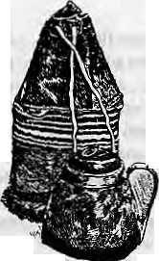
concerned, for it is a two-day trip to reach Skardu and few city-bred Suzuki owners will risk their cars on the weather-plagued roads. When planes do fly during patches of good weather, foreign lour groups manage to command priority as they spend hard currency.
Distance, however, doesnol proven tall the desirable consumer goods from making it to the Skardu bazaar. Imported soft drinks. Pakistani soft drinks, confectionery and chocolate biscuits are all available at premium prices. Like Namche in the Khumbu, Skardu's shops stock a variety of imported tinned foodstuffs and clothing sold to local merchants by departing climbing expeditions.
Tsampa eating is out! Barley and bitter buckwheat, the few crops grown at high altitude, have now been supplanted by higher yielding wheat, either locally grown or imported from the plains at subsidised rates. But the shift in the local Balti dietary staple has yet to produce the impact that it had in Tibet, where the substitution of low producing barley by high production wheat (from a hand-eating tsampa culture to a chops tick-eating wheat noodle culture) dramatically reduced the incidence of gasiro-intestinal disorders.
But cash-cropping steadily creeps northwards, as turnips and cabbages are grown in rotation with thenow widespread potatoes. Was George Orwell correct when he said in The Road to Wigan Pier that a change in diet was more important than a change in dynasty? Trie demise of barley coincided witii both the importation of subsidised wheat and the assumption of central control over the petty rajas of the region.
Goals and sheep, once kept for their TOle as dung machines to replenish soil fertility, are now sold for meat in the bazaars. While yaks roam the high altitude pastures well above 3000 metres, the demand for meat is such that old oxen — some even obtained illicitly from India — are now trucked up from Punjab and slaughtered in Skardu.
Thenet result of the conversion to the cash economy has been that the local Baltis are much more at the mercy of outside middlemen. These traders, mostly Chilasis from further down the Indus or Push tuns from elsewhere in northern Pakistan, often clash over commercial territory, or the monopoly over brokering certain products. Periodic clashes between the outsiders and the locals are also common. Shops of opposing groups are set ablaze as the Kalashnikov culture, so widespread elsewhere in Pakistan, takes over.
These altercations take on a more sinister tone because the intrusive traders aTe Sunni Muslims and the Baltis are Ithna Ashariya Shias. In neighbouring Ladakh, of which Baltistan was oncea part prior to the partition of 1947, Shia Muslims and Buddhist Tibetans used to live together in Leh, one of the junctures of the caravan trade between India and Turkestan. This coexistence was shattered in August 1988 after Sunni Muslims from the Vale of Kashmir intruded into the old trading arrangements and strife broke out. The foreigners marooned at that time in Ladakh were extracted and within a week T-shirts proclaiming "Free Ladakh from Kashmir" were being sported around

Limited copies available for sale at Himal ■  NRs2O0 | infra ft  p a p e r si
aura! Urban Interilnkagos:
A Study Based on .Nepalese - Swiss Development Experience (INFFRAS Papers X ; Cas$ studies of Dolaktia-Kathmanda, ■ PalpiarBulwal and Ba|hang-Bangalore,.
the Indira Gandhi International Airport in New Delhi. Perhaps the same process of the foreign 'invention' of ethnicity and the creation of 'place' — seen ai the most flagrant level in the invention of a single Tibetan "ethnicity", or even worse, national territory including Qinghai and western Sichuan — is being produced in North Pakistan. The most extreme example is the Kalash Kafir community in southern Chilral, which has two NGOs, a self-appointed English headmistress, and, of course, the obligatory resident anthropologist — all this for 3000 people. While the Kalash were in rapid decline two decades ago, with outside recognition their numbers nowremain stable and their rights are being 'invented'. Somuch so that they even requested parliamentary recognition by a special representative.
But the Baltis are changing their stripes too, as the foreign goodwill that is accorded to the people of Hunza is now granted to them.
Global Aspirations
The Canadian cultural geographer Ken MacDonald has documented how Baltis were perceived by the Europeans at the turn of the century. Their image then was of a people hardly belonging to the human race. That model has now been changed.
From being colonial dependents of the British a hundred years ago, in addition to being the subjects of local petty despots who forced them into corvee labour and tithing. Macdonald sees the Baltis now becoming the subjects of the 'neo-colonialists' — the foreign tourists, trekking groups, and climbing expeditions, as well as world travellers checking off another place in those endless Lonely Planet guides.
The exposure to foreigners on the ground is now multiplied by exposure to foreign culture on satellite television. Portable generators, bought with Gulf labour cash earned by somebody's cousin brother, power the glowing television sets. In addition to the prudish censored fare of Pakistan's CAW, Baltis can zero in via their bazaar-made antennae on to the concoctions of Doordarshan from India, and the five channels of Star TV from Hong Kong.
The direct exposure to foreigners whose goal is the Karakorum mountains, along with increasing direct links to extra-territorial culture, means that Baltis can leapfrog over the efforts of Islamabad to make them obedient servants of the state. Foreign attention means they now have a global clientele to lobby for their interests, and access to global culture raises aspirations for a consumer lifestyle far beyond their current capabilities. Both the local elites, many of whom are remnants ofthepetty states, and the military-administrative officials (in substantial numbers because of the continued carnage in Kashmir), now have to' deal with sophisticated Baltis who can get by in English, French, German and a smattering of Japanese.
The Baltis, almost singularly identified because of their Tibetan language connection, now find it possible to promote their ethnicity by the territory they occupy. Once seen to belong to the locational periphery, the frontier, by the British (and one might add, by their 'primitiveness'), and on the political periphery by the dominant Punjabi culture of Pakistan, the Baltis are capturing attention of the outer world by accessibility from roads, airwaves, and the skies,
h
N.J.Fl,Allan leacties Geography at the University oi California, Davis. His edited book. Karakorum Conquered: North Pakistan in'Transilion. will be published next year by Si. Martin's Press,

14 . HIMAL Sep/Ocl 1993

Conference Report
Ladakh at Crossroads
For the majority of the Buddhist population of Ladakh, the coming year will be a crucial one. Talks are entering a critical phase on the granting of Hill Council Status to Ladakh, along the lines of the Darjeeling Gorkha Hill Council and Ladakh wouldremain apartof Jammu& Kashmir State, but have its own General and Executive Council. These would Control district planning and development budgets, with state government approval, but would have no say over law and order or the judiciary. The Ladakhi side perceives the Council as a 'state within a state,' whereas the state continues to regard it as a 'planning and development board.'
Ladakh's bargaining position at these talks has been considerably strengthened by these ttlingof differences between the Ladakhi Muslim and Buddhist populations. Relations between the Buddhists and the indigenous Ladakhi Muslims, who used to run much of the trade between Leh, Kashmir and Central Asia, had historically been a model of inter-communal tolerance. But when serious street disturbances erupted in Leh in the late 1980s, Buddhist resentment against the Muslim-controlled government inSrinagar spilled over into anger at iheir fellow Ladakhi Muslims. The Buddhists also feared that their political majority within the district would be eroded because of a higher population growth rate among Muslims. The Ladakh Buddhist Association instituted a ban on all inter-communal associations, a decision which was much resented by both moderates on both sides. The ban was only lifted when the talks concerning Hill Council status began to bear fruit.
Although the recent political developments were not on its agenda, they provided a positive backdrop to the recently concluded Sixth Colloquium of the International Association for Ladakh Studies (IALS), held in Leh in late August. The possibility of Ladakhis gaining more say on their own affairs lent an immediacy which might not otherwise have been present in the di scussion o f a d i v erse range of so ci a], cul tural and development-related subjects.
Arun Kumar, the Srinagar-based Secretary to the Ladakh Affairs Department, set the tone to the Colloquium when he announced at the outset that major new areas were to be opened up for tourism, specifically the Nubia Valley, Pangong Lake and Dahanu.

He further predicted that following the Indian Prime Minister's visit to China in early September, the border crossing to Tibet at Demchok would be opened for trade, and to Indian nationals on pilgrimage to Ml Kailash, Kumar faced a barrage of criticism concerning the J&K fiscal policy towards Ladakh from P.Namgyal, former Minister of Transport at the Centre and Tsering Samphel, former Ladakh member in the J&K Legislative Assembly. Both were waved off by Kumar as "out of work politicians."
This was the first time, the IALS had held a conference in Ladakh, and was aremarkable meeting-ground for those with an interest in Ladakhi affairs, including many local Ladakhis, other speakers from India, as well as participants from Europe and North America. Indicating the newly-established concord between Ladakhi Buddhists and Muslims, there were speakers from both communities, as well as from the small Moravian Christian community in Leh.
Inall,43paperswerepresented,cov ering history, culture, religion, philosophy, health, education, anthropology, environment and development. The only omission seemed to be a paper on the traditional Amchi medical system of Ladakh (see Briefs^)
There was passionate debate on the question of education and the status of the Ladakhi, which is a dialect of Tibetan written in the Bodi script. As Sonam Wangchuk, Secretary of SECMOL, a cultural and educational organisation, said, "We hardly find the name of Ladakh mentioned in any of our textbooks." Bothhe and Rev. E.S. Gergan, principal of the Moravian Mission School in Leh, agreed that the local language should be used as the initial medium of instruction in primary schools with a gradual change-over to English medium in the senior classes.
Arun Kumar'sTesponse to these concerns was, 'if tomorrow you want to start a school with Ladakhi as the medium of instruction, nobody's going to stop you. You just need the textbooks and the teachers." This led straight into discussion of yet another Ladakhi complaint, that the entire district does nothost even onecoUege-level institution-AULadakhis have to go out for further education, including for teacher-training.
Other topics included the need to preserve traditional arts, crafts and architecture, particularly Ladakh's temples, many of which
by Timothy Malyon
date from the 11th century. The participants stressed the need for conservators to consult local people and work through local organisations such as the Ladakh Gumba Association.
Environmental degradation was a concern that was repeatedly raised. Leh town, bounded on three sides by high mountains, is suffering from a build-up of petrol and diesel emissions. There is also a serious water shortageand the level ofpollution is escalating day by day.
Anthropologist and poet James Crowden, the first Westerner in recent times to spend a whole winter in Zanskar, gave a paper on the effects of thenewroad to the village of Padam. Before the road, an equilibrium had existed between lowland and highland villages. Now, the road had bought a disproportionate concentration of wealth to Padam and the lowlands, especially through tourism. This had resulted in depopulation of the higher villages.
Aba Rigzin Jora and Henry Osmaston, spoke on the marginal]sation of traditional Ladakhi agriculture, and of changing diets. Because of misplaced subsidies, there has been a shift in eating habits, especially in Leh town, away from traditional barley and wheat to rice and dal. Ladakh used to supply foodgrains to parts of western Tibet and the Indus valley, but today is an importer of food.
The scholar Harjit Singh opened his paper by quoting the Dalai Lama: "No matter how attractive a traditional society may seem, its peopie cannot be denied the advantages of development." He added, "Culture is always dynamic, never static. Our main job is to minimise the negative aspects of development and maximise its positive aspects." Helena Norberg-Hodge agreed, answering one criticism of her recent book on Ladakh, Ancient Futures, with the comment, "I don't believe Ladakh was a perfect, ideal Utopia, nor do I believe it should stay unchanged." However, she stressed the importance of a critical analysis of western-style development.
Areport of thecolloquium was presented to the Development CommissioMer, the most powerful man in Leh. Another colloquium is planned, possibly in Hungary, in two years.
T. Malyon isafree lance wrrter and photographer who has been visiting Ladakh for 15 years.

Sep/Oci 1993 HIMAL . IS

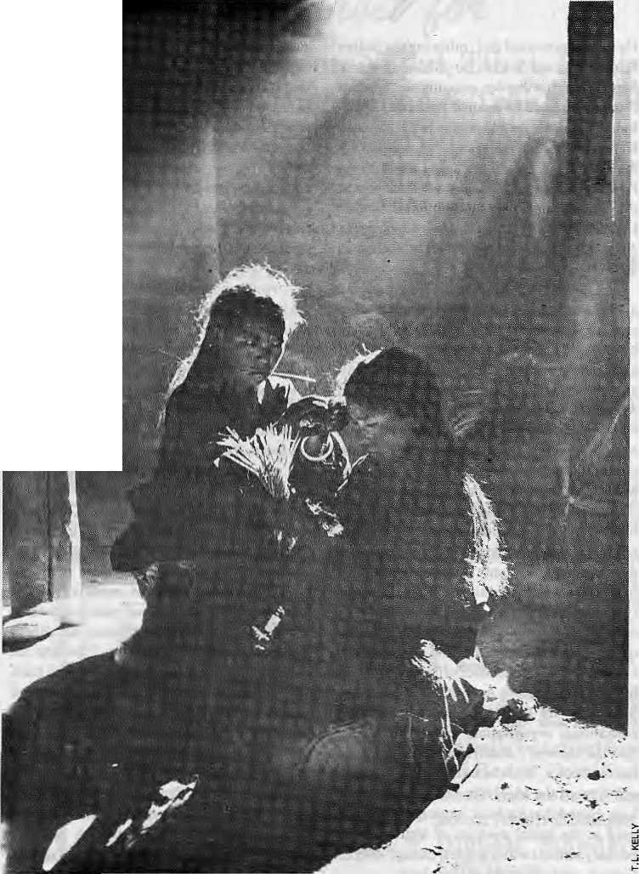

Who Cares for Humla...
Wedding preparation in Humla.
For too long, the lowlanders of Nepal have
neglected and denigrated them as
unkempt "Bhoteys".
The cultural and economic
distress ofHumla's Tibetan-speakers
is fed by the ignorance and
disinterest in Kathmandu.
by Tshewang Lama

O
ther than the Drukpas of Bhutan, the Tibetan-speaking inhabitants of the High Himalaya comprise ethnic minorities which are invariably persecuted within their respective countries. In Nepal, ihere is overt prejudice against the "Bhotey", inhabitants of the Himalayan rimland. They have always been treated as second-class citizens by the Rongba (or Monba)_{t} the low hill people who arc closer to the epicentre of power.
Fleeing political and religious persecution in Tibet during different periods of history, the ancestors of the Nepali Tibetan-speakers found refuge in Himalayan sanctuaries. These historical mi grants brought their 1 amas, ret igi on and customs with them. Isolated from South Asian cultural influence by rugged geography, from Olangchung Gola in eastern Nepal to Dolpo, Mugu and Humla in the west, they tenaciously held on to traditions and lifestyles, which have remained practically intact to the present day.
This cultural resilience of Nepal's Tibetan-speakers, however, is now being affected by economic and geo-political forces beyond their grasp. They are now more exposed to the push and pull of external interests than before. Over me last couple of years, due to the opening up of remote areas, their valleys have suddenly gained a high touristic profile. But Kathmandu'spolicy-makersscemnottoknow that most of the northern peoples have historically survived on trade and transhumance. On both counts, this ignorance has hit the Nepali Tibetan-speakers hard.
Tibetan Categories
The Tibetan-speakers' low profile may be explained by the confusion regarding their identity vis-a-vis the other hill ethnic groups of Nepal. Besides, there is enormous diversity among the Tibetan-speakers themselves, even though they might share the same root language, religious beliefs and cultural traditions.
In order to do away with the prevailing confusion and to clarify the status of the Tibetan-speakers withinNepal, it is important to categorise the population groups of the High Himalaya. One clear distinction that can be made isbetween those who arrived after the advent in Tibet of the sage Padmasambhava {who led the movement away from Bon and towards Lamaism), and those that migrated prior to him (see chart on page 18).
The pre-Padmasambhav a migrants make up today's Tibeto-Burman groups such as die Rai, Limbti, Magar, Byanspa (Byansi), and so on. Each of these groups have distinct cultural

16 . HIMAL Sep/Ocl 1993

which were exposed to southern influence slowly gave up their mother tongue, considered the language of the cow-eater. Many Tibetan-speakers that inhabited the lower hills gave up their cultural heritage and took up the Hindu way of life.
In Humla District, the people from the villages of Barain, Buwa, Kallasa, Kuti, Puma andNepkahavegiven up their Tibetan culture. Other than theNepka, who write their ethnicity as Tamapg, all the others assert that they are Budha, or Matwali Chhetris {alcohol drinking Chhetris). Up to three or four generations ago, these people spoke Tibetan. Like the original Matwali Chhetris, they now practise a faith which is an amalgam of shamanistic beliefs and Hinduism.
While the Rana period brought them
heritage and rituals, which are based more on the indigenous Bon and shamanistic beliefs rarely found within Tibet proper today. The Gurung and Tamang may also be brought under this category although they practise Bonism as well as Lamaism.
Those who arrived post-Padmasambhava may be divided into one category which uses Tibetan dialects and follows Lamaism and reformed Bon, and another category of 'full Ti be tan-speakers', which practices 'pure' Tibetan Buddhism. Both these categories may be referred to as 'Tibetan-speakers'.
As is the case with the Tibelo-Burman groups, there developed a great diversity among the Tibetan-speakers due to the extremes of geography. The tiny population of Manang alone has three groups, the Nishyang Tshosum, GyalSum Tag, and Narphu. Humla has five distinct communities of Tibetan-speakers: die Nyinba, Tsangba, Tukchualungpa, Vultshodunpa and Limya. There are also the Mugumpa and Karmapa of Mugu District, the Dolpowa and Tishirongpa of Dolpa, the Loba of Mustang, the Chumba and Nubri of Gorkha, the Sherpa of Khumbu and Rolwaling, the Holungpa from Olang-chung Gola, and so on.
There are numerous cultural and ritualistic distinctions between the various groups, and more pronounced differences between the dialect-speakers and Tibetan language-speakers. Even within one area, there may be many identities based on geography and culture. The phuru is a wooden tea-bowl whose use often indicates kinship and status. The Tibetan dialect-speakers tend to be stricter than the Tibetan language-speakers when it conies to sharing the phuru with diose who are not part of a kinship group. The saying Bhod kha chig, Mon luichig f "The Tibetan does not mind sharing a cup, whereas the Khasa do not mind sharing clothes") emanates from the northern-most regions of Nepal, where the Tibetan language-speakers dominate.
"Tshewang" to "Chhakka"
In ordeT to distinguish between the Tibetans of Tibet and the Tibetan-speaking people of Nepal, Jang Bahadur Rana conferred the caste of 'Tamang' to all Nepali Tibetan-speakers, even though they had little in common with the Tamang ethnic group that inhabits Central Nepal. This was how the Tibetan-speakers were brought under Hindu definitions — and became members of the 'Lama caste'.
The Tibetan-speakers were prohibited from eating buff or beef, under pain of being declared untouchable. While the isolated hamlets were left untouched, many groups

, = s <s m ■■■■■■
--V* - :;.
y
The Name Bhotey
E
tymologicaily, me name M|tev is innocuous enough. Literally:, it designates someone who fives-in BhoC Theterm fifiaf comes from the late Sanskrit B hot ah, which, derives* d; the Tibetan name for Tibet. A:Rhotey Is therefore, quite simply, a Tibetan. Bift
ipe \ : .... [ ;; , ....
ly, 'Bhotey Vhasgainec!pejorativeovertorie|, since it evokescertjiri cultural- traits, ebriox|otjsJo orthodox^
pe^plejn question, ar^.triaUhtey washiriff^uently^eatbeef/arid^inkakohol. To this extent*^ ¹ Sliptey 'is cofnparabk to the Newar word Saw; which has;beGome a derogatory expression _{s}
4oTethnicTibetans. \. .. , ,,. - . .. ..-. ■ :■ . .. . .. **
;Bhotcsy' has cdrn^ ^^
of.ihe kingdorrsleft the conquerors with a chaotic an-ayofpcoplesto organise into a natioa" ,Tomake legaliense«f:te
= allowance for the perceived deference in statusiof me cbmjpqaenl groups. The mo«t 9 :^iihg^tanb-qf-ftfee-c^ra;.w^;-&e-Mnlii^j/!AinvBt 1854; *hitjiproposed ahiejarchy-of Svfe *
caste gfoifps, three "pure-'and twp "impure". The Bfiofeys w«re ptacedin the.Jowest of the^ ,
i pmregroups,designatedErplay^ble^eoholDrinkers- ... :. ; ...
! ! .....: Jlniike' the Indian caste system, in which tribes lie altogether beyond ihe pale, the ^ i Nepali scheme-accord s central plaee to its ethnic;groups, who form thebackbotie ofthe*
"' middie:and lowefpurs categories/ ' :; ., _{v} ■■ ;- -:- '" " . . •■■ ■■ ■■ '".'.' ■'■ ". ^^
;Perhags becausethe Bhoteys lived a long y/Myfy&m Katrimaridp, they received mores; i
cursory attentidi. A number of Tibe!ah-$p«?aking enclaves have their own cas.te system^ *
■(sometimes Very efatbrate affairs), and allhave at letfet the cojicejSt of rahke^ social gr&ugs^ * • But ih^seiocM differences weie ignored _{t}. andisobi) i)y; were indi scrirnihateiy p lac^d together* :■ wttiiarjtisaii&iimder the 'Bhotey' rubric [
Firom the fsoint of view of the peogje who were designated by the terrn., Bhotey was ah
unsatisfactory Iabei largely because it did'nof refer to a single ethnic-;groap. 'Morij ,
ptoblematicaliy, itwasnotatjistinclively Nepali ethnoaym. In acontextwheremembershipi 1
of th^e'riatipn was based to somedegree on having a clear ethnic, identity, there Wjerecertairf
disadvantages iri; belonging to^a category as vagtie, ai the Bhotey.
"'Besides, Bhoteys were by definition from: Bhot, and the nation of Bhot was one with ;which Nepal was ty no means on^the bestofteiThs; Worst of all. legal <iocjimentssometirrjes
iused^termirffitanynucatiytodesignatethet^
"■'mernbers of theNon-lEnslavabie Alcohol DrinkwscategOrycouEd, as punishment for certain^ #
■ offences, be; turned into Bhdteys. A number of ethnic: groups raised objeetiorji to then* ' : inclussoriinUiecategoi-y, andreeor^tirate^ethnicgroBpsc^stallisedai-oundnamesthathad;:
peviousiy¹ applied; ta small enclaves. The adoption of new liames did-not neeessai'iLy ^improve flie legal status of their bearers.but (his at least had the rnentofbeinguriambiguouisly ■'
Nepali. .- Chyaffes Ramble
within the caste slratification, the bulk of the Tibetan-speaking population remained aloof from the South and in closer contact with cultural centres in Tibet. It was during the Panchayat reign that, hi the name of national integration,KingMahendra pushed Hinduism deep into the northern belt. One mediod was by opening up primary schools, called the "Mahendra Jana Jagriti Palhshaia". The aim was more political than educational, which was why these schools were placed directly under the Zonal Commissioner and die Central District Officer rather than in the hands of die District Education Officer.
These schools were specifically meant for the Tibetan-speaking Nepalis, and in contrast to the Tibetan educational system, they taught the Khasa Hindu way of life.

Sep/Oct 1993 HIMAL . 17

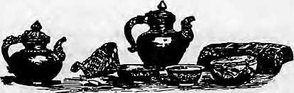

Tibetans and Tibeto-Burmans of Nepal
Highlander-
s Full: Tibetan
m; i Speaker-"
a '
k Tibetan TOalect o - Speaker (or old ¹¹ ..I Tibetan)
Tibetan T ..' Buddhism
Lamaism ⁵ - ^{S:} : Reformed Bon"
m a
SJjiajnanisfn Lamaism ' Hinduism
Shamanism Hinduism
Invariably, the Monba teachers re-christened their pupils, discarding their Tibetan names and giving them Nepali ones. I was one of the boys who went to the Mahendra Jana Jagriti Pathsala in my village of Todpa. In the year 1965, my teacher Sita Ram Paudyal changed my own name from the original "Tshewang", given by the village lama, to "Chhakka Bahadur".
(Place names of Humla got gradually changed as well: Todpa is now Torpa, Tangshod is Burangse, Bharkhang is Baragaon, and the Nyinba are the Barthapale.)
While national integration is essential and teaching Nepalicrucial as a link language, King Mahendra and subsequent rulers have failed to consider the culture and values of the northern ethn ic p opulati ons. The Hindu-based nationalism that still permeates the mainstream consciousness has been difficult for the ethnic Tibetan peoples to embrace. How is it possible for Tibetan-speakers of the Buddhist and Bon faiths to maintain their sense of identity within the perimeters of a nationalism, which, as one writer in Himal described recently, comprises "the Nepali language, popular hill Hinduism, and the institution of monarchy"?
Himalayan Traders
Semi-Hignlander
Low Hill People
Tibeto-Burnian
Low Hill People
The Sino-Indian conflict of 1962 proved to be a bonanza foT some businessmen of Humla and Darchula, whose trade volume increased dramatically. Following the 1962conflict, the Chinese closed the trading bazaars on the Indian border, one of the biggest of which was Gyanima Mandi, north of Kumaon. Instead, a
few centralised marts were developed adjacent to the Nepali border, including one in Taklakot adjacent to Humla.
With the changing world situation, China and India have normalised relations and decided to resume trade from several points in the Western Himalaya. After these highpasses are fully opened, it is likely that trade across the Humla border will dwindle down to the carriage of a few foreign readymade goods.
While some traders of Humla might have benefited economically from the Sino-Indian conflict, however, in other spheres the population of Htimla as a whole was coming under severe pressure, having to do with changes in legal regimes, environmental stress, and shifting relationships with the low hill population.
During the Rana regime, Himalayan caravans had the right to graze their sheep and goats in the forest of the various areas that they passed through in the course of transhumance. This right was afforded them by sanad. However, the growth of population in the lower hills and the changed forest policies have disrupted this all-important facility that has been historically available to the people of Humla. In iecent years, the low hill villages are forcing the caravans to pay grazing tax, something unheard of earlier.
LirnyV
Loba (Manthang),:
Nubfiwa;ete.;
Nyinba, Tsangpa, TukcliMuftgpa; : Mugumpa, Karmapa,
(Baragaon); Sherpa,::
Holungpa, et4
Taniarrg,TTtagpaf Gurung ■ "

Rai; Limbii, Magar,: Byanspa"(ByaiisiJ Z
Centralised decision-making in Kaihmandu has hurt the Tibetan-speakers in more ways than one. Due to customs policy, which regards Tibet as a third country, the local Tibetan-speakers have lost the benefit of free trade. The Government has imported
Indian salt for distribution in the hilly regions, which has deprived the Himalayan traders of a large segment of their trade. There exists a fund foT pasture development in the northern belt, but it has been eaten away by corrupt officials and there is little to show for years of work.
The Government has not been able to negotiate a fair deal with the Chinese with regard to traditional pasture lands which fall within Tibet, China argues that Nepal's borderland peoples can no longer rely on a resource that doesnot lie within theircoun try's boundaries. The Kathmandu authorities have agreed that the people of Limi, for example, must reduce their livestock by 1000 head per year, until they have no stock left to graze in Tibet after a five-year period.
This has been done in disregard of centuries of traditional use. The Chinese authorities insist that Nepal is must find another form of livelihood for the people in these areas. But this is expecting too much from the authorities of Nepal, who do not have a long term policy with regard to the inhabitants of the northern Himalayan belt. They might be buffeted by economic and social forces, but due to ignorance and lack of sensitivity little is done to provide support.
In India, there are reservations in education and civil service to try and uplift culturally threatened communities. Nothing like this is contemplated in Nepal, which means that the lifestyles and cultureof Nepal's Tibetan speakers are threatened and could ultimately be extinguished.
Some Kathmandu scholars seem to believe that it is important for Nepal's diverse ethnic groups to maintain their local customs while donning the garb of nationalism. They argue that nothing less than full integration with the national economy will ultimately bind them to the country.
Like their ancestors who arrived seeking
Tefuge in the hidden valleys of the Himalaya,
the Tibetan-speakers of Nepal now seek the
assistance of the Nepali Government to
compassionately act on the problems faced by
citizens of the highland districts, throw away
outdated concepts of caste and ethnicity, and
to embrace the Tibetan-speaking citizens of
Nepal as true members of Nepal's diverse
ethnic family. ..
T .Lama f s a social researcher who is present ly member (under the name Chhakka Bahadur Lama) of the Nepali Parliament representing Humla.

18 . HIMAL Sep/Oct 1993

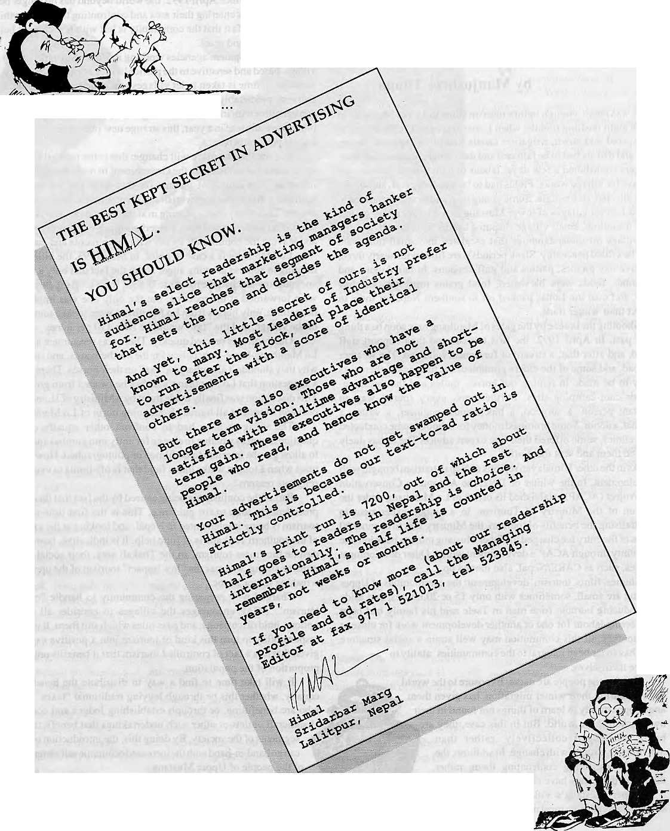
You can either laze around
.or you can read HIMAL

Tourism's Predicament
So far, Upper Mustang tourism has meant the individual's gain and the community's loss,
by Manjushree Thapa
L
ife was hectic enough before tourism came to Upper Mustang. In the eight bustling months when Lobas stayed in Lo, fields had to be prepared and sown, irrigation canals had to be repaired, sheep, goats, and dzo-pa had lo be fattened and their wool collected and spun. Villagers contributed a few days¹ labour lo their gumba and another few days for village works. Fields had to be weeded, grass, shrub, and dung collected, rice bought. Some young men and women migrated to the two-harvest villages of lower Mustang to work for cash or grains. In the meantime, small village disputes had to be resolved, and the inter-village misunderstandings that escalated into small-time wars had to be settled peaceably. Slackpcriods were filled with hearty three, four, five-day picnics, parties and guff-sessions. In late August and September, fields were harvested, food grains processed and hay stored, and then the Lobas packed off to southern Nepal or India to conduct their winter trade.
Shooting the breeze by the gates of Manthang may soon be alhing of the past. In April 1992, the first tourists and their support staff arrived, and after that, a stream of foreigners followed. The weather went bad, and some of the elders grumbled, but then again, there was money to be made in renting out horses, mules and the threshing-grounds-cum-camping-sites. Furthermore, every tourist was an important person: a surgeon, a biochemical engineer, a writer, a diplomat, adonor. Some promisedmoney for schools, someconduc ted dental clinics, some offered their free expert advice. The Lobas duely khata~ed them and sent them off.
Asinfhe other Himalayan regions of Nepal, tourism brought with it development. In the winter of 1992, the Annapuma Conservation Area Project (ACAP) established its office in Lo Manthang under the direction of the Ministry of Tourism. In a unique experiment in decentralising the benefits of tourism, the Ministry was to channel 60 percent of the entry fee charged to Upper Mustang tourists back into the community through AC AP's development works. Other development agencies, such as CARE/Nepal, also moved up.
Studies, films, tourism, development: the communities of Upper Mustang are smail, sometimes with only 15 or 20 houses, and aside from inducing burnout (one man in Tsele said his family had been volunteering labour for one or another development work for close to four months), all this commotion may well strain a social structure which has so far been integral tp the communities' ability to manage themselves.
Not that the people are naivfe. Exposure to the world
beyond, during their winter migration, has given them
ample opportunity to learn of things not found in their
own comer of the world. But in this case, they a
being challenged collectively, rather than
individually, to cope with change. In addition, the
change is something confronting them, rather
than something they have chosen. •=»==■
Upper Mustang's villages have had very _; strong rules regarding most mattersof significance
to the community — water and pasture rights, agricultural schedules, religious festivals. These rules have helped them survive in a very hostile terrain. Since April 1992, the world beyond has no longer been at a distance: it is entering their area and confronting them. Everything is happening so fast that the community is left with few choices but to react and react and react.
The development agencies working in Upper Mustang tend to be vil!age-based and sensitive to the particular! lies of each community. In most cases, time is taken to let villages reach their own decision. It is lounsm, predictably enough, which threatens the Upper Mustang communities with irreversible damage. Despite the fact that only 1000 tourists are allowed in a year, this strange new phenomenon is creating a great predicament.
It is not that the place will change: this is the inevitable outcome of a considered decision by the Government to make tourism the most important new source of income for this area. The predicament of tourism is that it can impoverish the community while enriching the person. The money that is pouring in at the individual level is widening the gulf betweenrichand poor, exacerbating pre-existing class tensions, and leaving the community awash with resentments and confusion.
Lo Manthang is a case in point. In May 1993, the village held a meeting to address growing anger about the fact that only a few horse and mule owners had the means to benefit from tourism. Several ideas were forwarded at the meeting, but the only one was implemented: henceforth, only horses from Lo Manthang were to take tourists north of the village, and the "tax" would be NRs 110 per horse.
Other villages reacted quickly. There was resentment against the Lo Manthang-horse-on] y policy for the northern area, and some asked why they shouldn't also charge a "lax" on their horses. There was even a suggestion that LoManthang's horses be banned from going south. This discussion was finally made moot by a Ministry of Home Affairs' decision to restrict all tourists from going north of Lo Manthang.
The villagers have had to confront other equally confusing questions, such as whether to charge for entry into gumbas and whether to allow gumba interiors to be filmed or photographed How does one react when a tourist walks into a field that is off-limits to everyone for religious reasons?
Part of the confusion is being caused by the fact that there are few precedents to look to for guidance. This is the first time controlled tourism is being implemented in Nepal, and looking at the experience of the southern Thakalis is of little help. It is indicative, however, that despite the "mass-tourism" in the Thakali area, their social structure remains strong, whereas the "low impact" tourism of the upper area is wreaking minor havoc.
Charged with preparing the community to. handle "controlled tourism", ACAP encourages the villages lo consider all available options, hold discussions, and passrules which suit them. It is ACAP's responsibility to turn this kind of tourism into a positive experience, given that it is a fact of controlled tourism that it benefits only a small proportion of the population.
It will take time to find a way to distribute the benefits more
equally, whether this be through levying traditional "taxes" on those
who are benefitting, or through establishing .lodges and cooperative
handicraft outlets or other such undertakings that benefit the poorer
segments of the society. By doing this, the introduction of tourism
can go hand-in-hand with the increased economic self-determination
of the people of Upper Mustang. i
M. Thapa is the Project Manager of ACAP's Upper Mustang Conservation and £ Development Projecf, The views expressed here are her own, and do not necessarily represent ACAP's position.

20 . HIMAL Sep/Oci 1993

Whither, Indeed, the Tsampa Eaters
Becoming good Buddhists may well be a matter of people becoming something they look as though they might have been but never actually were.
by Charles Ramble

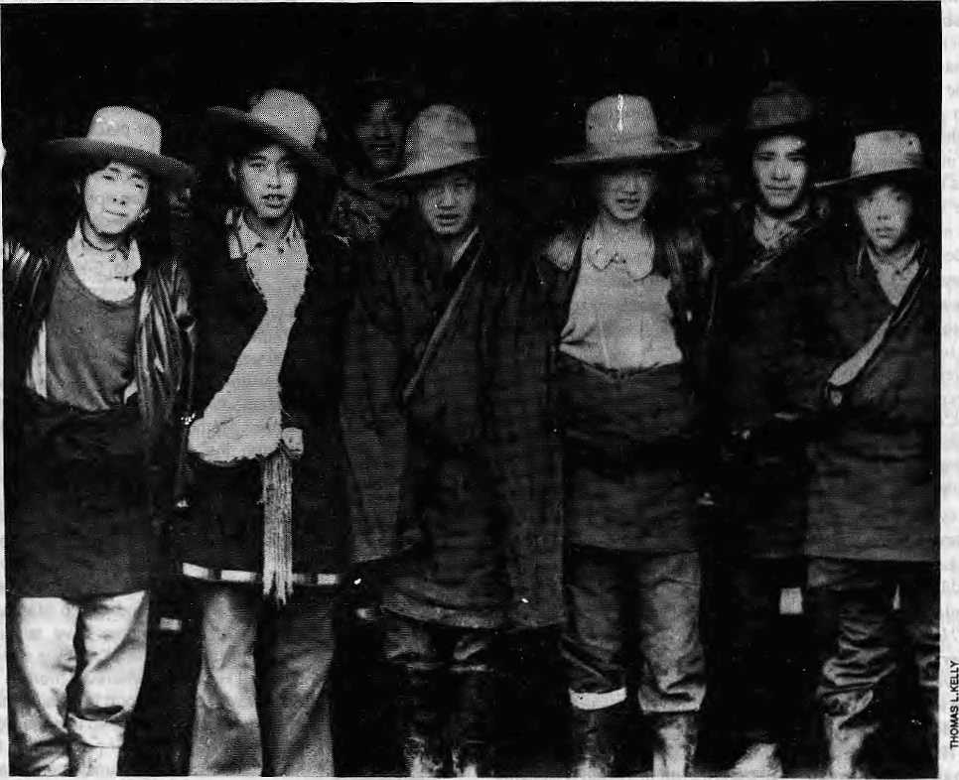

Khampa mughriders: Will they do Central Tibet's bidding?
C
hogyamTrungpa, the renowned guru, once suggested adefinition of Tibetan 'insiders', whichincluded the features that: they should speak some variant of the Tibetan language, follow the Buddhist faith, and eat tsampa. 'Tsampa-eaters' is an evocative designation for ethnic Tibetans, but it has certain limits; not all Tibetans eat tsampa (and many s«/w-eaters are, of course, not Tibetan). By the same token, not all Tibetans are Buddhist, and so, resorting to linguistic categories, the ratheTclumsyterm'Tibetan-speakers'isprobably the least unsatisfactory term English has to designate the totality of ethnic Tibetans within and outside the frontiers of the modern Tibet Autonomous Region (TAR).
Grossly, there are three main populations of Tibetan-speaking peoples. First, those in the TAR and neighbouring provinces under Communist rule. Second, the inhabitants of the High Himalaya, extending from Pakistan to Bhutan in a long band that blurs at the edges into less distinctly Tibetan cultures. And, lastly, the refugees, living primarily in South Asia.
The cultural variations within each of these groups is almost
legendary, but this triple division does represent three more-or-less distinct political climates and sets of cultural possibilities. While it would be a hopelessly rash undertaking to predict the future of the Tibetan-speaking peoples, it is worth at least considering some of the cultural possibilities by examining a few past and present trends.
Indigenous Bon
First, Tibet itself. Mourners for the culture of the old country sometimes speak as if Tibet were murdered in 1959 and the corpse burned in 1967. go a pretty severe battering. The relatively lenient 1980s saw the reconstrucion o f monasteries and their re-popu lation wi th small numbers of monks; prayer-flags were once more seen above village dwellings, and wheels began again to turn. Implacably embittered observers maintain that the resurgence is a rolang, a corpse rising in a vacuous show of life.
.Amore accurate analogy might be the opposite of this; the revival is less a zombie than a ghost, a strong spirit without much body to speak

Sep/Oci 1993 HIMAL . 21

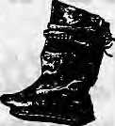

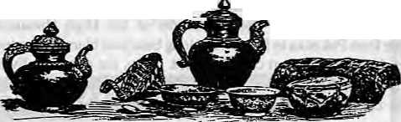
of. Unsophisticated devotion to Buddhism is as fierce as ever it was. Interestingly, italso seems to he widespread among theyouth. Adherence to Buddhism (or Bon) is generally regarded as being an integral element of Tibetan identity, although an exception is made for the Muslim minority. (The rather touching cliche that is commonly cited, apparently as a formula of acceptance, is that the Muslims "speak the best Tibetan", as if this linguistic excellence were satisfactory compensation for a religious deficiency.)
The situation may be rephrased in the form of a hypothesis. Where the need to be Tibetan is greatest, adherence to Buddhism is strongest. Imagine for a moment the impossible, or at least highly unlikely: China decides it has had enough of its Western Barbarians and gives up Tibet — that is the Tibet Autonomous Region and the Tibetan-speaking areas or Sichuan and Yunnan. Apart from the Balkanisation that would fragment the region within a year or two, what would happen to Buddhism in a modern world where, unlike now, Tibetan ethnicity did not have its back to the wall?
There would, of course, be no return to the massive clerical machinery of the past. Present apologists for the theocracy would no doubt suddenly remember that life was not all beer and skittles in the good old days, as many Westerners seem to have persuaded themselves it was. For a start, monasteries — several thousand big ones — are expensive to maintain, and the government would be hard put to find volunteers to reconstitute a serfdom.
{A brief word on the term serf, the use of which raises hackles as few other expressions manage to. The only entities entitled to receiving Tevenue in Central Tibet were the church, the nobility and the state. The ordinary peasantry in Centra] Tibet did not own the landholdings on which they worked, and they were not free to leave them. There, they were serfs. The use of the term implies neither a moral judgement on a political system, nor a justification for the brutal destruction of an extraordinary civilisation.)
State Lamaism apart, what about Buddhism among the people? Would Buddhism, as one of the components of Tibetanness, find such a wide popul ar base in an environment where Tibetan ethnicity were not threatened? Ethnic identity is simitar to the Buddhist notion of the self, that is, rather like the hole in the doughnut that needs something around it in order even to pretend to exist at all. The remarkable conformity to this Tibetan identity that one encounters may just be proportional to the colossal scale of the encircling context, viz. several million Han. But what if the Han went away? (A rhetorical question, for the Han are not about to go away.) It is reported that Catholicism in Poland is showing signs of declining, especially among the younger generation, in the short time that has elapsed since the collapse of Communism...
It is a possibility worth considering that the Buddhist component of the Tibetan identity may not be as indispensable as it is usually taken to be. There is some suggestion, in today's TAR, of a distinctly Tibetan culture that is neither Chinese nor the immediate heir to Lamaist civilisation. A trend is emerging among an educated minority in search of a nationalism independent of the theocratic heritage, and their hero is none of me usual eminent sages such as Padmasambhava, Atisa or Milarepa. Instead, it is Gesar of Ling, and the Tibetan epic is thecanon.
The Buddhist overtones of the Gesai story are regarded as a tarnish that has accruedaroundatrulyindigenousmyth, while Buddhism itself is seen as an unwelcome import from a foreign land. The trend further involves shepherding together all religious and cultural manifestations not of an obviously Buddhist character andlabelling the collection "Bon".
Properly, old Bon was not a shamanic religion, and did not include many of the pagan {in the true sense of the term, meaning 'village')



(fhoh top to bottom): trade leather boot and mongol garte r, tea churn and w0o0eu better box; copper praver wheb; coffer kettle; stve r chatela«e, knife, seal
AW EEALK3 WAX, SIWR AUD COftL MOWTEOSTtEL AW>TH*RBOX, (B&OW, FflOU l±FT T0R6HT). Bft»5$TEA*>T5; TEA STUM**; WJODEU (KWv; OHKA BCWL; CMS, A W?C« W TiA. SKETCHES T*KEN FROM TW UW Of

As remote control switches from Islamabad, New Delhi and Kathmandu open up restricted areas for tourism, Baltis, Sherpas, Ladakhis and Lobas are suddenly spollghted. The high valleys are playing host to tourists, climbers, journalists, film-makers and scholars, many of them in desperate search of places more Tibetan than Tibet itself.
While there is some scholarly information available onthe Tibetan-speakers, however.there is little discussion of their contemporary concerns, which is what made us do this issue.
From Baltistan to Sikkim, and excepting Bhutan.lheTibetan-speakers are resilient people-in-waiting. They await recognition, but recognition requires a clear identity, which is why each writer has wrestled with the question, "Who is a 'Tibetan'?" Tshewang Lama, Member of Parliament, resorts to a continuum chart, while Charles Ramble, anthropologist, decides to cut through the maze with the simple definition: 'Bhoteys'are really whatever they happento beat any given time! The multiple-identities and cross-bordercultural affiliations that makes 'Nepaliness' so ambiguous, seem also to apply to 'Tibetanness'.
As articles in this issue will testify, there are remarkable overlaps in issues and trends across the Himalayan rimhnd. In Lo Manthang, as in Skardu, instant noodles have supplanted the barley diet and thukpa. STAR TV is switched on all over the Himalaya, wherever there is electricity. Roadways now transport the plains middle class of Pakistan and India deep into the high valleys. The demographic buffer provided by the middle hi!) cultures is no longer functional in many places. In Nepal, where road networks are still undeveloped, STOLaircraftlandin Si mikot, Jufaal, Jomoson and Lukla, bringing cigarettes, Indian salt and Western tourists.
The patronising attitudeof educated Rongba notwithstanding, the Tibetan-speakers will probably do well by themselves. "The skill of moving with poise and assurance in unfamiliar environments", which Cristoph von Furer-Haimendorf identified in Himalayan Traders as the specific aptitude of the people of Humla, will probably help the Tibetan-speakers all over to adjust to cultural, political and economic challenges up ahead.__
- Kanak Mani Dixil

22 . HIMAL Sep/Oct 1993

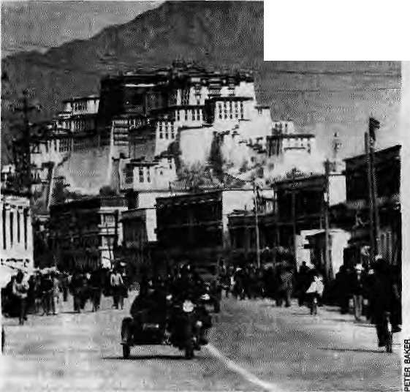

Joyride.in Lhasa: People's Liberation Army and the Potala.
beliefs and practices often attributed to it. But the word Bon, which may be cognate with the name Bod, meaning Tibet, is a convenient catch-all to designate the entirety of Tibetan religious beliefs not of Buddhist provenance.
Tibetan scholars of a nationalistic bent take pains to point out that in the earliest recorded versions of the famous procreation myth (which is also respectably Darwinian, as it happens), the protagonist monkey and ogress are not associated with Avalokitesvara and Tara. They also emphasise that the oldest sources concerning the Yarlung dynasty do notidentify the firstking,NyatriTsenpo, as aSouthAsi^i refugee from the wars between the Kauravas and Pandavas, but as someone who came out of the Tibetan nam (sky); and they also mention that nam happens to be the name of a valley in Central Tibet that they would dearly love to excavate.
How important this trend will be in shaping the identity of the next generation of Tibetans remains to be seen. Buddhism will undoubtedly survive, but, if the Lhasa intelligentsia is sufficiently persuasive, perhaps only as the little tradition of a culture dominated by a quasi-secular nationalist ideology,
Tibetan Borderlands
One of the ide'es recues about the High Himalaya outside the TAR concerns the inevitable fate of the region's Tibetan culture. It runs roughly as follows. For centuries, the people had depended on Tibet as the fountainhead of the dutsi, the nectar of Buddhist teaching. The Liberation of Tibet in 1959 effectively cut the borderlands off from that source. The destruction of the hives would soon begin, and, above all, the Queen Bee had flown to India. Severed from Iheir traditional centre ofgravity, foe Himalayan tsanipa-eaters would be flunginto a widening gyreofHinduismandmodemitythatwouldabsorb them and extinguish their culture.
The significance of the 1959 landmark is something we will come back to in a moment. What is certain is that cultural changes in the cis-Tibetan borderlands have at least as much to do with political and demographic changes south of the Himalaya, both before and after this period, as they do with the Chinese annexation of Tibet.
The people of Baltistan, for example, speakers of the most archaic form of Tibetan, have been followers of Islam for nearly five centuries. A particularly striking instance of democraphic change is Sikkim. A century ago, the population of that country consisted almost entirely of Tibetan-speaking Bhutias (or Lhori), Lepchas and some long-established Limbus. From about 1875 onward there came the first waves of Nepali immigrants, largely with British encouragement, and by 1S90 these already outnumbered the indigenous people. By 1980, the proportion of the latter had been Teduced to less than quarter of the overall population.
British land reforms, and later, the end of the Sikkimese monarchy, effectively put an end to the privileged position occupied by the 12 dominant Bhutia clans. Marriages between the latter and the Nepali majority are still relatively uncommon; but the advantages to being a Tibetan-speaking Buddhist no longer liein the traditional enjoyment of social ascendancy, but in the backhanded privilege of entitlement to benefits as a scheduled tribe — quite a different matter.
The integration of Sikkim into the Indian Unionin 1975 deprived the Sikkimese Bhutias of their sovereignty and thereby of the more drastic possibilities (still available to Bhutan) of shoring up an old eminence. The much-discussed Greater Nepal may be a political non-starter, but it is a strong cultural possibility, and the future of Sikkim's Bhutias depends to a great extent on whether the younger generalionis persuaded that its scheduled identity is something to be proud of, or if prosperous Nepali role-models are a better bet.
Being a second-class (or, more accurately, third-class) citizen is nothing new to the tsampa-eaters of Nepal. The unification of the kingdom brought around 15 enclaves of Tibetan-speakers under the rule of Kathmandu. In th&Muluki Ain national code of 1854, Bhoteys were pigeonholed in the third of five vertically arranged slots, as Enslavable Alcohol Drinkers, together with Chepangs, Tharus and Kirantis, just above more disreputable groups such as Europeans.
In a polity constructed" along these lines, the elite are a restricted club, and admission for the lowly is contingent on a reinvented past. Under the circumstances, a number of Bhotey groups did Hinduise with varying degrees of success, depending on whether the people who mattered were willing to be convinced by their conspicuous abandonment of giveaway Bhotey traits of beef, booze and Buddhism. Other groups managed to wring certain grudging concessions out of the lawgivers, suchas the right to be called Gurung(non-enslavable)Tather thanBhhotey—somewhatto the bewilderment of the present generation of Tibetan-speakers, who know they are not Gurungs and wonder why their forefadiers ever bothered to confuse matters.
The odd thing is dial these ethnic mutants quite often change back into being Bhoteys, and may even switch to and fro several times in the course of a walk from the plains to the plateau.
Anthropologists tend to fall into two camps on the matter of Hinduisation: those who lament the loss of the Bhotey's Tibetan identity and those who maintain that there is, under the Hindu cap, a secret self that is what the people really are. In point of fact, in most cases the groups in question are probably realty whatever they happen to be at the time; deftness in this kind of ethnic legerdemain is a feature of the protean character of people who live on borders.
The religious conversion of groups is often less to do with collective divine inspiration than with having an eye on the main chance. In more recent times, the main chance has increasingly come to lie not among theelite rulers of Nepal but in the international sphere. Real wealth no longer consists of gifts of land and customs contracts but in carpets, tourism and other murkier adventures in East and Southeast Asia. The international traders themselves return to their

Sep/Ocl 1993 HIMAL . 23

homes with more than mere profits.
Much has been said about the potentially deletrious effects of tourism on the culture of the High Himalaya, but many of these claims aie surely exaggerated. Tourism may certainly influence the economy of an area, but does it really make a significant impression on the culture? By and large, the host societies of the Himalaya take a benevolent view of tourists. They like the things they bring. But nobody seriously wants to be like the tourists. As the North English musician Jake Thackeray once sang about the droves of southern tourists who annually visited his native Yorkshire:
We don't mind (rippers and scouts and ramblers.
They can come and stand in the rain all day;
They give us money and beer and a right good belly-laugh.
Then they go away.
The traders who spendlong periods abroad in developed countries, where they find sleekeT foreign models than the peel-nosed, parsimonious romantics in clumsy trekking boots, do not go away. After all, wherever they are, they are the people. The adults speak among themselves in their Tibetan dialects, but to their children, to whom they give Nepali names, inNepali. The children are educated at boarding schools in Kathmandu or, better, in India, and one frequently hears parents proudly announcing that their offspring cannot speak their native tongue, or that English is their first language.
The inescapable conclusion to be drawn is that the successful traders are not especially attached to their identity as Bhoteys of the Tibetan hinterland; and that if they do possess a "real" identity that endures beneath their changes or travellers' guises, there is little indication that they want to pass it on to their children. And if these polished, English-speaking children return to live in their parental villages at the close of their years of systematic depaysement, it is they who willbe the cosmopolitan paradigms for the succeeding generation.
Traditional caste-climbing may no longer exercise sections of
Nepal's Bhotey population in the way it once did, but the trend may have been replaced by an aspiration to Nepaliness free of regional stigmata or, better yet, to a nondescript internationalism. However, in those areas of the borderlands where economic conditions permit, the future of Tibetan ethnicity may lie beyond the options of annihilation by acculturation to the neighbouring (Indian or Nepali) civilisation, or absorption intoaconceptualWesL The Tibetan-speakers of the Himalaya might become Tibetanised.
A particularly vivid instance of the process of Tibetanisation is Bhutan, the only place in the world where the politically dominant community comprises adherents of Lamaist Buddhism and speaks the Tibetan language. (Tibetanisaton must of course be understood in a very loose sense, since the process has a distinctively Bhutanese flavour.)
The policy originated in an effort to offset the consolidation of Nepali ethnicity in the south, but gained considerable impetus from the ascendancy of the Central Monk Body. The pursuit of the policy was resisted by the Nepalis who did not want to have their distmctiveness, or, more pertinently, their political agenda, snuffed out. A northern backlash precipitated a horrible slide into a Clausewitzian pursuit of policy by Other Means.
What about the Tibetanisation in other areas? Aren't the Tibetan-speakers of the borderlands already Tibetan? As it happens, rather less than is often thought. Conventionally, there were two phases of Buddhist diffusion in Tibet. The first from around the seventh to the ninth centuries, and the second beginning a hundred years or so later and enduring until the Liberation.
Subtle Barbarism
The Liberation of Tibet; die Integration of Sikkim; the Unification of Nepal. Liberation, Integration, Unification—these words all belong to the special vocabulary that the language of diplomacy reserves for gross political euphemisms, and no one who is not a propagandist for

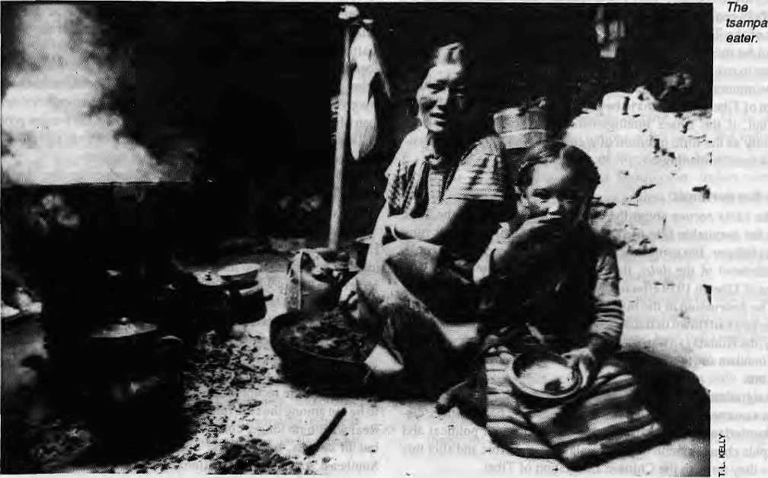
24 . HIMAL Sep/Oct 1993

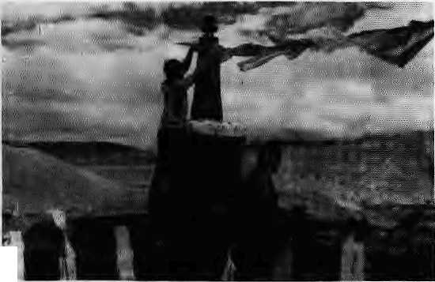
k
Loba "Gurungs"make repairs on Manthang gumba.
their perpetration can seriously utter them outside imaginary inverted commas.
There is another word that might safely be listed in this special vocabulary. Diffusion. How is a religion diffused? Not like perfume through a room. It does so through conversion, and, unpretentiously, the literal meaning of the verb 'to convert' in Tibetan is 'to conquer' or 'subdue'.
The history of Buddhist sectarianism in Tibet is very largely a history of conflict for patronage, the key expression being mchod-yon. Priest and Benefactor, a notion that designates equally the relationship between a wealthy householder and his private chaplain, as it does the alliance between the Sakyapas and the Mongols in the 13th century, or the Gelugpas and the Mongols in the 17th. Himalayan folklore abounds in stories of individual lamas who fought one another with magical bombs and spells over the matter of patronage from one village or another.
Buddhism is a missionary religion, like Christianity or Islam but unlike, say, Judaism ormostHindureligions.Theunderhand destruction of the shamanic tradition in Mongolia by the Lamaist vanguard is a particularly well-documented instance of the way diffusion has occured. Much the same thing seems to have happened within Tibet itself. Buddhism did not enter a religious vacuum when it reached Tibet. There was already a well-established religion, although we do not know what it looked like. (It is not even certain what it was called, except that one group of its priests were known as the bon.)
There was certainly a spirited resistance to the spread of Buddhism in Tibet. The First Diffusion was brought to an end by a king called Langdarma, who apparently decided that he'd had enough of the an-ogance of a privileged sangha, and in particular of the absurd excesses of his own late elder brother, Repachen. Langdarma was murdered for his deeds, and still gets a bad press about the whole business.
And now there is the Third Diffusion, originating in the exile community. As Kesang Tseten has convincingly suggested in his recent article on the subject (Himal Mar/Apr 1993), the burgeoning international interest in the Tibetan cause has less to do with a sporting sympathy for the underdog than with a real appreciation of the universal relevance of Tibetan Buddhism. But the Third Spread is not limited to the first-world public undergoing a spiritual crisis. It is also reaching the Tibetan-speaking people of the Himalayan rimland. How?
The common enough scenario is that a businessman from, say, Japan, United States or Taiwan becomes impassioned by the Tibetan
cause and goes trekking in the Himalaya. Because he has Tibet on his mind, what he sees is a Tibetan culture apparently fallen into decline: a struggling language, illiterate monks, dilapidated temples, and a degenerate Lamaist tradition. With the blessing of his lama (who probably has never been to the place), he elects to help the area by building a local school emphasising traditional Tibetan studies, ot perhaps even a monastery. No objection, naturally, from the locals, who have not to examine the gift horse too closely. To the outsider, at least, the generous act looks like the commendable resuscitation of a failing Buddhist heritage.
The truth is, the border regions may never have been all that Lamaist in the first place. The conversion of Tibet was a half-done job at the edges, andevennow there is abundant evidence of religious cults that were eliminated in Tibet centuries ago.
In an environment where village ceremonies can be strangely syncretic affairs, with a priest eviscerating a sheep beside a lama intoning formulae about benefits to all sentient beings, the identity of Himalayan Tibetan-speakers is understandably indistinct. In terms of national sentiment, the people in question may unequivocally be, say, Nepalis; but no one in Nepal is merely Nepali; and if the tsampa-eaters are to be ethnically Bhotey, they might as well aspire to the perceived apotheosis of this designation, the sophisticated Buddhist who speaks the elegant dialect of Central Tibet. Especially if someone is paying them to do it.
The conversion of the hinterland has been going on sporadically for a long time. In Sikkim, for example, the Lepchas have to a great extent gone over to Buddhism and the Limbu Tsong have abandoned their Mundhum in favour of the new faith. As for 1959, far from crippling Lamaism in the Himalaya, the Chinese annexation of Tibet may have fortified it. The passage of Tibetan refugees—some of them influential lamas apparently shocked by the paganism of the frontiers they passed in flight — gave Buddhism an additional boost, and the cults of autochthonous gods suffered as a consequence. Becoming good Buddhists is not necessarily a question of reversion to a glorious past state; it may equally be a matter of people becoming something they look as though they might have been but never actually were.
The need for a clear identity sometimes leads people to resurrect symbols from the very archaic past, or from someone else's past, or even from a past that never was.
Many of the rituals now being performed at the Pemayangtse monastery in West Sikkim have been hauled out of obscurity in recent years; others are entirely new inventions that merely look old. In Bhutan, the gho were never traditionally worn even by many of the Tibetan-speaking groups, and Dzongkha was spoken only in the west of the country. A great deal might also be said about the studied consolidation of folk culture in Ladakh. And so on.
Ironically, the border Tibetans may prevent the annihilation of their identity by turning it into something else. Their real tradition has too much in it of subtle barbarism to be reducible to a few bold, preservable strokes. But that is what happens when people, anywhere, begin to think about who they are and where their collective future lies.
The phenomenon has been remarked on by many commentators on traditionalism and the invention of traditions, but perhaps never so succinctly as by the 1 lth century Arab philosopher Abu Hamid Al-Ghazali;
"For those who fiave abandoned their traditional faith there is no hope of any return; because the perpetuation of tradition
requires above all that one should be unaware of it."
b>
C. Ramble is an anthropobgisl who has done research in Mustang.

Sep/Oct 1993 HIMAL . 25

V
o
I

KATHMANDU IS PURE KAFKA, writes-a.m."
in the Economic and Political Weekly of I7 March 1973, referring toNepal''s geo-political situation ami KathmanduNepalis' attitude towards India.
...whichever way they turn, the people here cannot get away from India. Ninety per cent or more of the country's recorded exports go to India; more than four-fifths of recorded imports come from there. More than one-fifth of the government's budget is contributed by aid funds from India. The vast uninterrupted stretch of the lower terai, all five hundred and odd miles of it, beckons to India, shades off into India, is enticed by India, is repelled by India, It is a smugglers' bonanza. Nonetheless, you talk with politicians and government officials, they cannot quite make up their mind whether to hate or to hug the smugglers: rice is spirited away to India, which is bad, since scarcities develop on this side of the border, but which is also good, since there is an accretion of India rupee balances. Smugglers also bring in quantities of raw jute from India, which again leave the country dressed up as exports, and provide one major source of non-Indian rupee foreign exchangeeamings.TheTc is of course also the well knowncase of smuggled synthetic yam— and of Chinese pens and textiles.Nepal thus survives, quite substantially, on the wit and resourcefulness of seedy smugglers. Andgoing by the articulations of the ruling elite, Nepal hates it; she hates her state of helplessness. At any given moment—was it Cyril Connolly who once made a smart comment of this sort? — one hates oneself; the sum of these moments is in one's life, Scratch the heart of Nepal: the chances are you will find more or less the same inscription etched all over.
WHAT'S STABBING YOUR BELLY?
Ram Paudel, FRCS, health columnist in The Rising Nepal, highlighting the importance of the pancreas in our lives.
A fat, 40 year-old lady felt terrible stabbing pain in abdomen and vomited several times. She collapsed and the family took her to hospital casualty. After few hours the surgeon confirmed that she has massive swelling of pancreas probably due to pre-existing stones in the biliary tree (bile flowing pipes). Resuscitation followed by intensive medical treatment improved her medical condition. After 2 weeks her stones were removed and she returned home safe. It sound a mixture of many odd events in acutely swollen pancreas (Acute Pancreatitis). Toputit bluntly, many complicated biological reaction may happen, dangerous complications (e.g. Pancreatic abscess, Mulliorgan failure) may ensure, heroic operation (e.g. near total removal of pancreas) may be undertaken. Often the final result
is painfully repulsive (progressively fatal). However some lucky people never feel more than slight discomfort in abdomen for few hours and few return home from hospital after one or two days of tolerable pain (self-1 uniting). Perhaps we will agree, it is very common problem requiring emergency surgical service. Although the incidence may be different in different countries, we do not know the exact figure in our homeland.
Pancreas is a cream coloured wedge shaped gland plastered in front of both kidneys and behind a potential space (lesser sac) formed by freely hanging stomach etc...
LAND FOR PEACE was the formula urged by Arvind Kala in the Calcutta Telegraph before P.V. Narashimha Rao travelled to Beijing in early September. The Prime Minister seems to have heeded the advice, at least in part.
Only 1,383 Indian soldiers died in the skirmish between Indian and China in 1962. All of the 3,968 Indian soldiers were returned by the Chinese, I deliberately use the work skirmish and not war because the word "war" produces an image of two nations bent upon each other's destruction. That has not been true of India and China. India fought for 21 days and has not fought since. The question is whether India and China should view each other as enemies, especially now 30 years after the skirmish.
India claims that China has illegally grabbed 38,000 sq km of Indian territory in Ladakh. China accuses India of occupying 90,000 sqkm of Chinese territory in Arunachal Pradesh, formerly the Northeast Frontier Agency. Thankfully the two do not air their views openly.
The Sino-Indian border dispute is one of the scores of border disputes among thenationsof the world. But India tends to exaggerate the significance of this dispute because it views the defeat of 1962 as a national humiliation. Indian rulers decry Pakistan too. But the resentment against China is more because its troops gave Indian soldiers a beating.
The resentment has to be dropped because in international relations, as the cliche goes, a sensible country has no permanent friends and enemies. It has permanent interests.
Essentially, the border dispute came up and remains alive because the 3,500 mile border has never been surveyed or delimited on the ground. As this was never done, both India and China accuse each other of occupying one another's territory.
The conflict actually boiled down to only one piece of territory. The Aksai Chin plateau in northeastern Ladakh is a desolate land which is of little use for India. There is no vegetation there, not even fodder. There is no shelter from killing, ice cold

26 HIMAL . Sep/Oct 1993

c
E

winds, and it is snowbound for 11 months in a year.
This barren region was so cut off from India that when China built a road over it in the middle of the Fifties India was not even aware of it till two years later. Aksai Chin was useless to India but vital to China as it lay between the two Chinese provinces of Tibet and Zinjiang. A road was the only way to link the two provinces.
Tlits is the territory India claims China has grabbed
About the MaeMahon Line between Bhutan and Burma, China repudiates its legality but is willing to accept it on one condition -— that India accept China's ownership of Aksai Chin. India refuses to do this...
Any senior politician would dismiss the Sino-Indian dispute as inconsequential. Yet the dispute exists and no political party dares to resolve it fearing a hand of friendship extended towards China may be exploited by its political rivals as a surrender to China.
That is the difference between politics and statesmanship. In politics, the political party's immediate future is of concern. In statesmanship it is the country'slong temigais that matter. India awaits a politician who is also a statesman and end this unnecessary source of contention.
THE MOMENT OF DEATH is not necessarily when breathing stops. Tantrically speaking, writes Ian Baker, in Tibet: Reflections horn the Wheel of Life, a book-in-print that he coauthors with Carroll Dunham, with photographs by Thomas Kelly. The book, by Abbeville Press, New York, is due out in early November.
At the time of death, the body's constituent elements dissolve into each other—eaTth into water, water into fire, fire into wind. As the wind element dissolves, external breathing stops, and from a Western point of view the person is clinically dead. From the Tantric perspective, however, the moment of death is linked not to inhalation and exhalation, but to the appearance of the innate Mind of Clear Light. With the dissolution of the coarse levels of consciousness and their supporting winds the white drop inherited at conception from one's father descends from the crown of the head while die red element inherited from one's mother ascends from the navel. Entering the central channel the male and female essences meet at the heart chakra, causing the appearance of the Clear Light of Death. Through thedawning of theClear Light, those who have achieved stability in meditation recognize the intrinsic nature of their minds and, "like a child jumping into its mother's lap," are liberated into the luminous expanse of Primordial Reality.
For most beings, however, unaware of the subtler levels of consciousness, this crucial stage simply passes unnoticed and one enters bardo — a hallucinatory, transitional realm between death and rebirth.
FOR GOD'S SAKE GET SERIOUS is the pieaof
Thomas E. Gafney SJ, long time Kathmandu-based drug rehabilitation crusader, responding to a report in The Kathmandu Post on discussions in the Lower House of Parliament on drug trafficking.
A member of parliament complained that representatives of an NGO which had worked with drug addicts for eight years had been "deprived of opportunities for foreign trips". I cannot perceive any essential relationship between service to addicted persons and foreign perks, nor why it should merit time in such a forum. But I do understand and deplore this prevailing attitude, which vitiates the quality of many public services. Priorities are hopelessly out of order. The moral discord between unsparing fulfilment of social assistance to the needy, and selfish pursuit of personal benefits might be worthy of parliamentary consideration.
It was further alleged in the article that "experts" from the drug control section had been unnecessarily transferred. The drug control section HAS no drug experts, or any personnel experienced in the problem or the nature of addiction. It has administrators. Controversial personnel have been transferred from that section during die tenure of the current minister, mostly to assuage offended foreign drug experts. It is unknown, however, that any member of the drug control office has ever visited any drug treatment centre except to preside at functions. This makes the Minister's assurance that NGOs "willing to work in coordination with the HomeMinistry are welcome"more ominous, if the "coordinators" are unenlightened and inexperienced. A Sarkari asar-kari!
Phensedyl (Indian) and Phencodin (Nepali) are codeine-based cough syrups which are among the most abused drugs in Nepal today. We read with amazement the Minister's assertion that there is "no other way of preventing the use of Phensedyl than by social awakening" for which he hopes to obtain the cooperation of the educated segment of society. I consider myself educated, but am totally impotent to prevent the hundreds of cartons of this substance which cross into Nepal, notably at Jogbani, but which have also (though never reported publicly) more than once been apprehended at Thankot. One needs more than education to collar those who ordered and paid for these shipments.
Atas, when will bureaucracy come to deal effectively with the drug situation in a manner not related to perks, money or post?

Sep/Gct 1993 HIMAL . 27

WE WELCOME YOG TO THE HIMALAYAS!
WE ORGANIZE: TREKKING AND MOUNTAINEERING EXPEDITIONS IN NEPAL, TIBET BHUTAN AND LADAKH PLUS WHITE WATER RAFTING, WILDLIFE SAFARIS AND SIGHT-SEEING TOURS IN THE KINGDOM OF NEPAL.



'* S
V"

*-.*
Contact us for detailed infonnation.

W

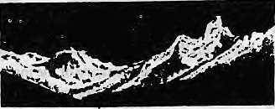

HIMALAYAN EXCURSIONS
G.P.O. Box 1221, Keshar Mahal Thaiael, Kathmandu, Nepal Tel: 418407, 418119 Fax: (O) 00-977-1-418913 00-977-l-22202€ Tlx: 2636 SHERPA NP

accept all major credit cards.



BRIEFS

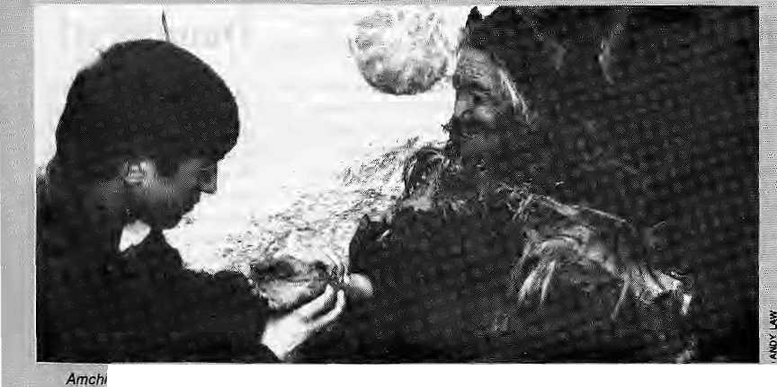
TseyifengStfiainfa reading<§paiienf'spUfseinR^pk/.. ._ ' .
Barefoot Aixiehis of fcadakh
As Ladakh develops and opens up, young Ladakhis see their future as tourist glides, soldiers and businessmen, Traditional professions are falling out of favqur,and one field ttiat has seen a decline is that ofAmctii medicine, the traditionalheatjng system prcvaleftt iji much of the Tibetan world.
The amchis of Ladakh, lite : local vaidyas and hakims ■elsewhere, have been■■'facing increasing difficulties in practising indigenous nsedldne. The herbs, roots, fruits and' Ordinal products necessary for medicinal preparations have
ibecprfie scarce. Their role jnv sooiety is being viewed'with Scepticism by modern jailopathia doctors. Beseayse the treatment
«has been traditionally free, there is little financial benefit in learning ip become urt'Amchi, a process which iakfes up to six years.
It is against such a discouraging backdrop that amchi medicine has suddenly . seen the beginnings of a revival ' in Ladakh; In the winter of 1992, AmchiTsewangSmanla
■ from the Ldi Nutrition Project, a local NGO, started a progfaft) to
tain young Ladakhisfrom .. .. remote villages as Amchi Health Workers (AMWs); The foojeci ;T haS: governmental support and receives assistance from the, ,,. ■:■ Health Department mprbviding a small monthly wage and raw medicinal ingredients.
.. The coiEfse designed by Anichi Tsewang consists of two : month training ■scssidns spread ou t o v ei; three corisecu Li v e ye ars.: Every year, he^ takes three %e<#: students. The liufriculum tackles ■ theeonimpn beaidi problems found in LaelaMi, sudi-as respiratory?tract infections and' stc-madi ailmenls. Besides traditiplltai knowledge; the course alsp promotes the : appreciation of westerts ; ' ;. rnedicine, ihc|udin g the rc>Je: of immunisation, hospital referrals, hy |iene,. prevep tiy c medicine and wound idressiiig, Allopatliic infcfi-njation'oh the- role of , ,, bacteria -artd viruses in causing diseases is also shared. ... .Villages thatlack easy: access t6 medical faeilifies are : giver] prefcience by the ftojeet 'when selecting eandidtates: The irairieil amchis afe expected! to return to their villages tip provide basic traditional¹ health care. However.they will also act as
health educators and motivators, ti alsing <y it}] heailft centre s and
: visiting doctors. They will charge a stiiail fee; for ; consullationagd. treatmesti
Skarma Targyas, from this year's new batch of tnnnees, is from Rupsuj a community of over300riomads;livingin Ghaogthang, eastern Ladakh. The nearest dispensary is a day's horse-ride away from Rupshu, and is often inaccessible it ■winter. ■■■ "''.... ■- ■ ''.
" Prior to 1959; Ladakhi monks use4 to tTavel t,o Lhasa to
~'Jeani ih§ traditional systerii 6f ■Tibetan medicine. This systern b.ased on faur Buddh^t fnedipal
■■■t&ikis,.-Gyiid-bz?bij according' to which disease resuiiB from -the unbalance inthe ihree bodily humours rbting iwind), jnKhrlspa £bil&) arid Jhttt/can (phlegm). Th^; amchi's role is to %.=and:restore this natural balance through dietary and ■ bchaviourial ■■cfi'atiges, : With the revival; of trkdilionat.iRedieirte iriXadakh^ : it is expected the nuraber of arrichi s w* 11 %q Ep from leday' s " 3QQ; Together witli it, so will the ■temtory '* health status: - Stephen Hoihewood/ '■'. Andy X.aw. -■ ;:;; .
Gurkha
What do Gurkhas and mosquitoes have in; common? WelL tiil ri&w we never had reasot) to consider the
: questioni Bifl; JSIepaPs highland so Idlers get targeted by the ■anopheles like everyone else.
Ml dial has ijaw changed,.. with ilie iniredticiion of the ''Gurklia Insect Repel-leaf' in the British market. Certified by the London School of Hygiene and Tropical Medicine, the new bfarid is all set to dorriiriatfi the . anti-mftsquito siielyes iirthe UK's,pijannactes> : ■ ■■ Therrtanufaeturer.claims thai
; "Gurkha¹" is an alternative to the standard Dieihyl Toluamide-bascd repellents available in the market, which are known to cause reactions on users. Not ^o the n&w; product, "which offers not just the usual protection against mosquitoes* midges, Eeochcs aridthe: like, (but) abo has skjrs conditiojiing properties.*" Ate an all purpose ₄ insect repellent, useful for beach : bums in need of protection ;■ against \h6 oSEone, salt watter'^. leeches and mosquitoes!


We insist that aW preset afa^
past British Gurkhas be lyi&dk *
dijigible for a 25 percent disc^upt:
on theif namesake, MeanwMie,*
if a competitor ever gets aho!4
of the formula faj "Gurkha",
they wouldtie better advised to
name their product
''The Tharu", for
their renowned
immunity to
malaria. Whqn- _^
'■will British " . i^>^{r}y^f^5! ■:
learn to consult ethnographers? The last,time they messed tt& : was wheri tr|ey named a delivery van. "Sherpa".

199? HIMAL , '29

BRIEFS ■■■:- :: .I "

iii
;the Valley...feKjtte tendency jpf.L ." .trap.pollutants: especially during
JBamburstl

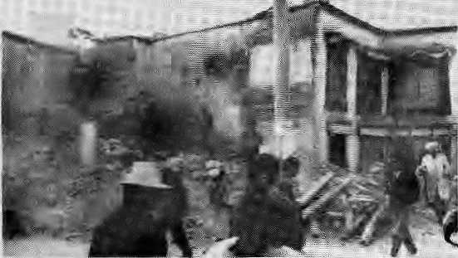
B arfchor Down
A Barkhor section being demolished inearly September. 30 HIMAL i Sap/Oct 1993
T
wo A nMf ic an e xpe r.ts a|rty cd in Kathmandu in late August to Lake sample measurements of vehicle emi*i6ns, using infra^ red scanners and impressive computer gadgetry. Donald H. Stedraan andGerie Ellis, the Mo Denver. University researchers., found that Kathrnandu has' the: worst emission levels among the five Asian cities they studied.
That was all there was to iu But before you could say chJoroflurocarbpn, this local and international media were out spreading the word that Kathmaridu had the worst air-quality in Asfa— this a I the very moment that western tourists weTe deciding where to go for the autumn season, which is peak time in Nepal.
"Kathraandu Air Pollution. Worst in Asia^" screamed the Commoner daily in its headline quite unmindful of what the researchers actually stated, The Kathmandu Post backed in with. "Asia's highest vehicle pollution

A
ccording to the Gerrtfari weekly Der Spiegel, the entire old town section surrounding the Potala Palace; is to be pulled down by the year 2000. Why? to make way for at
in Kat]jmandu", whigh; Was not .... what they.;sa1d;^{v}eithcE. The.iBBC■"■ followed through,7and news agency copy found play all over the world. A local vernacular daily decided tb add: a further twist: it
Asia's first an|l the world's... .5ec0rip most polluted cityv :■:■: .... ,.
The fGurothcr Asian cities :. . the two Anieficans had visited , w^rc Hong Koiig, TaipeL Seoul and Bangkok ~ harply jthe control sample to tar Katlimaridu wi&,.They had not.taken readings in Calputta, Dellti. Dhaka or iiahore. Besides,ilhe . ... study was hot of "air pollution", biit''vehicle e.jn?ssioas'\ and it takes a scientific je|p lo be able to equate one with the olhet-
(An Indian survey repojt released in 13 Septembej; ^ / ;; indicated thatihe dally vehicular pollution is about 550 tons in Bombay, 245 tons m Calcutta' ; and 253|onsiriBangalore. KSthman<iu!s would be rnacli less, although the bawl-shape of
multistorey shopping centre^ ... flats, souvenir gift ^ri^ps,-and a 100 bed hotel. There is obvious resentment ampng the residents of BaEkliof, and even Chinese architects -ai:e against the project,
Sledman and EIHs conducted" drive; through tests of nearly 6,000 vehicles out of the 70,0001
■■.registered in Kathmandu; ■■■■ ■■■■■■■ -:--
Carbon monoxide (C0) and
.. hydrocarbon eniissions were fouiid to be ttehighest among ihefive Asiari eities....Ayei;age CO emissions in exhaust was
in Kathniandu (it is■A-.Sfo *m. Mexico Giiy). The 'opacity' of. Nepali vehicles was at.least five tirhes higher than in Hong Kong.
Kathrrtaftdu^s vehicle emissions^ thus, are high enough tote of c«ncera wifliout the > medi a nbbai ng cry w o 1 f % a) equating vehicle emissions with ,oyera|l air pollution, ajidb) condenihirig Kathmandu before all Asia w'hen only fourp|her liiirepresentatiye cities have been studied. A lesson for the next time Western researchers come by with impressive credentials.
-firjaya L. Shrestha I
which is said to go against ... ...
existing laws protecting ancient buildings.^{A}'Soon; Lhasa will look like some Chinese small town,*' 3 Pi'ofessor Gap Zhieyang told the weekly.
While it has always been focus of Tibetan pilgrims to Lhasa, the Barkhor had also become the centre of resistance to Chinese rule. Despite , surveillance cameras and steel _{a} barricades around the whole 4irea, the Chinese-authorities have not been able to control its narrow alleys, and above all the tight-kriit comihunity which lives there.:
There is good reason to •believe that this is Why Barkhor is corning down.
*■«■»

A
dam eoilapse in Qinghai Should give pause to all Himalayan high dam and!
■■. jeseryoir-wallahs. pn 27- ■:, Aagus,t,jthe dam holdingTijSck , the waters of the Goahou ,. reservoir suddenly gave -way, -sweeping awayimore fharr400 „ people to their deaths, The alea* is inhabited by arnixedpogu-
: ialioriof Chinese ^jnd Tibetans.
., The damburst led to irnmediate concerns about'jhf Three Gfirges project bri the Yangtse, which Was given.lhe go_{r}ahead by Beijing a year ago. If the Gouhou reservoir's capacity was 3.3 riiillion cubic metres of water, the Three • Gorges reservoir will holdback TO billion cubic metcrsi The consequences of a structural failure at Three Gorges woulci be ''jiistpTy's Worst manrnade disa ster", c 1 aims hydrologis t Phil Williams of the International Rivers Network. Some experts suspect that the Gouhou dam might have been weakened by an earthquake which hit the area in 1990.
Over across qri the South Sideof the Himalaya, it was the time of Ooods, which is vyhen plains politicians wake up to propose high dani$ in the hills. This year, as Punjab* U.P., Bihar and Assam went underwater, it was P.V. Narashimha Rao's turn
"' to r^ieal the call. But the Pr.une Minister of India is not a geologist. K.S.VaIdiya of Kumaun University, who is a geologist, holds that that, "The majority of high dams constructed, being built and planned in the Himalyan region a« located in the proximity of
— or not far from — active
faults or tlirusts."
If nothing else, Gouhou : serves to alert everyone —both north and south of the Himalaya
— of the destructive power of
stored water unleashed.
♦*•

BRtEFS
Formalised Peace on the Frontier

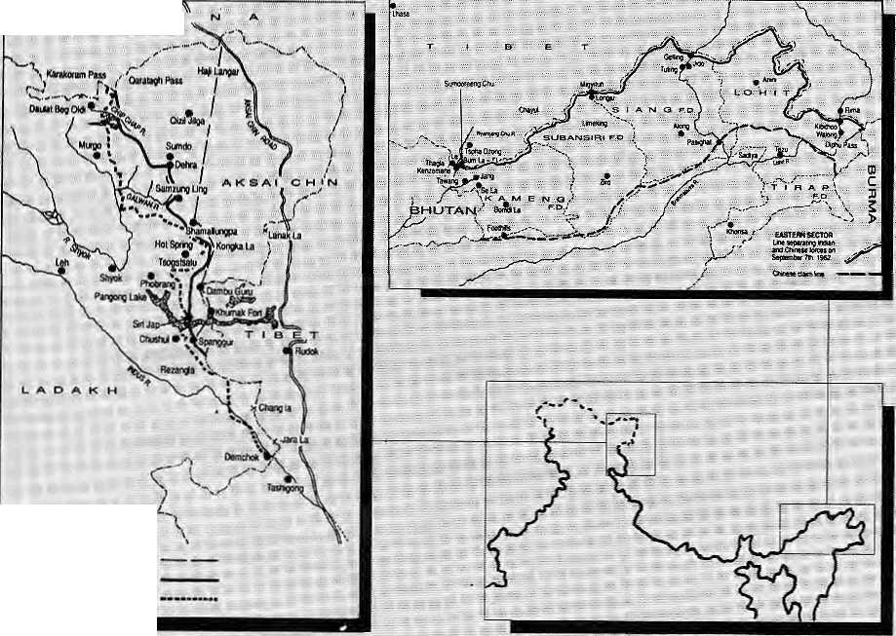
^{C} ■" '
wFsiEONsectoa
TiwIM Dt 1UI ctfflnjl tn'Oaitto¹''' ' Bros in w.cmbnr iSss
LintBeiaMinij mm and Chins ■
IWBas gn SepMnitlEf ni.19B2. . •
Ul

Delay on the Chiimbi Front
Distance as the crow flies from Lhasa to the sea
■2310 km
tTTistorjc' might be too Jleuphoric a term, but the |aet th^t China and India have agieed to respect the status quo along the disputed frontiers in Arunachai and Ladafch, was landmark enough as far as the Himalayan region is concerned.
Back in 1962, India was defeated in a briej conflict during which the People's Liberation Army swarmed south arid captured all the territory Cfcinahad claimed. Subsequently, the PLA Withdrew completely from Arunachai in the East, but stayed on in Ladakh's Aksai Chin; The Line of Control (LAC), which separates the positions of the two sides, has remained in place since 20 November 1962.
The agreement; reached on 7 Se^ternber.during the Indian ., . Prime Minister's visit to Beijing
basically foimalises the siatus quo whichhas held for 31 yeajs, Boih sides have: agreed to ' respect die LAC, but because it remains an imaginary line for the present, work is to begin to map it.
While the Sirto^Indiao accord, explicitly states that it has been signed "without prejudice to the respective positions of the two countries on the boundary question", this is Considered no more than a <5Q|> ■ to domestic politics. Barring :: iinfortiioatehappenings:sucna-s;: anothei- conflict, die formalised ; LAC is bound to evolve as the; Mtemational boiinijaj-y between the two Asian ^countries, :
por the* moment, the t-AC understanding, plus agreements or* nfiJitary .reductions and troop'; pullbacks along trie frontier, leave the Himalaya a more¹ potentially peacefiil place. -

Besides the LACagredment, ; tjbe..Rao- visit to Beijing also :. scotchedthe deil otiShipkiLa in Himacria|, opening it vtp for ^U;ade as:.well as Thcti^n"pilgrims' passage to/Kailash-and' Manasarovar; No agrfeemenf was fortheoiriing. however, on the two passes ov«r inSikkihi. According to g report in The-Times of India, die Chinese are insisting on the oldrpulelor Chumbi Valley via Kalimpong and the Jelep La, whereasilhe : - fedian side is insistingon Nathu ^La, above Gangtok.
tHASA:
LHASA-
The Statesman quotes :
HimaFaya-watcher John Lall as saying that, a re-opening of the Chiimbi valley route would be "the key to the prosperity; for Galcdtta and its vast hinterland which inclades landlocked ; Nepal and Bhiitaiii"
GUANGZHOU . (CANTON)
CALCUTTA
The Chinese are apparently keen to use Calcutta portfor easj¹ transport of goods'into Lhasa. The rise of commereial traffic between Tibet and Calcutta would probably be a boon to Nepal as well, for its Kuti and Kyerung passes are the only ones, which are snOw-free in the wjnter.

Sep/Oci !993 HIMAL . 31

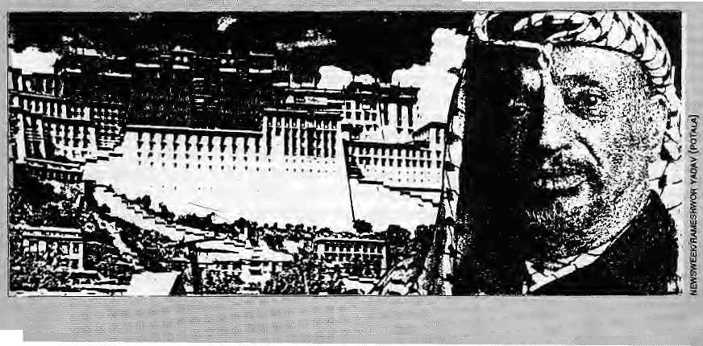
■ BRIBES.
Good News on
■ in the Tai;aii jimgles-.- "Sal is ■ generating vig<ffously in the
...plains andiid fjiajoT..difficulty c an be i^eeri in the maaagemerit pfSftl forests on a sustainable basis."; While the forests are
.. practically gone in the eastern districts bfphantishai Straha and Saptari; the good : " ..
I* H
»■
.«.*
Tibet and Palestine
in the United Slates and rhiicli of the, West;but look what they ...went aitdlgave him! Which : makes 9T¹? wonder whether the ^goodwill tt^g Dalai Lama is atscumuiattng all over ihe-wosrid wH] serve its purpose. His Holinessoffersonly theoiiye_{h} branch; whereas Mr, Arafat gave yoij a choice ofthe submachine gun or the oiive'btanch.vand still ^catfie-ovt on top. ;
In the karrnic wheel qf geopolitics, po- probipni is allowed to last more than a ieyt decades, and half a century at most; Without ^ proper turnover of world hqt sjjpts^ the attention will start Jo wander. That is how Namibia gol its independence, and now one fias to beremirtded: that it even exists. The"Middle
., «
» m m

Bemoaning the loss of Nepal's forests has been a ^national pastime for about three decades. R arely doe, s any one-have anything positive to report on trends in the green covet, So please let's have ground of applause for the Finns and their report on Tarai- forests which restores faith ift god and consakants. .....
"In contrast with the "genera! belief, die natural'f6rests&f the Tarai are not degraded but are abundant," states the study, entitled Forests .Resources t?/2Q Te?ai Districts, which has been funded by FINNIC^ and prepared by Finn experts. "On the' whole, the basic resource is substantial, and, given the favourable growing conditions of the Teiai, could produce a large volume of timber, fuelwood and bibmass under sustainable management.''
The study's claims are backed up by a satellite image forestry inventory, based on 1991/1992 data. ''The previous statistics far the wholeregiofi date back to 1964," say the researchers, who also found that theforesi areas of the far- ajid mid-western districts had been considerably under-estimated'by ^previous stiidies.
Besides the news on abundant woodlands, llie study also co^mes out heavily in favour of commercial"forestry.The total' "stem volurne," .of eommerdally viable piai$is forests is 70 million cubic meters.
"The present growing stock :: in the plains represents a remarkable renewable natural-'resource." Properly managed, : this resource eoald satisfy the wood demands of the country (including Kathinandu Valley which never seems to have enough), and provide raw-material for the'*re-
$2
Scfi/Oct 1993^
estabTishrheiif* b f the wood: p r 6c e ss i ng. i nd ustpy; The g wmment revertuQ. would incre.as&.dtamatieally, up to |j| 33 million by the;.end of the first year throiigh royalties and snirripage. ThexeA'enaes would ..in faet add tip to U| Z$5 million a year at the end. of two -decades:

":. The report which;seerhs" '' incapable -dpimparting any. teid news, also maintains that the Sal {Sttorea ^wi«sf«Xisdoing well

Y
asser■Ai-afat:hasdecided!© :
throjw ..in the towel": The:
Palestine Liberation ...

Organisation has, agreed to make astartwjjQilimited ■■■■-■■ :/:" autonomy m the occupied territiaries; of the Gaza Sftrip and -part of-the Wqst Rank, After £ years of celebrated enmity, the I PLO and the¹ tsrae|j&ha\f« <--decided to begin to patch lip,
This'breakthrough in the
Middle East doubtless holds
some, lessoas For the Tibetan .-.;..
plateau arid the other-'ocGiipied
territory'. . ■■ ■ ' '■■ ■-■
One lesson is that if you keep it it ionjg enough, . , r^gaidiess of how much they dislike you, they'll give you back your land, Yasser Arafat was the most disliked statesman
Woodlands of Kailaii arid ffenttianpur by satsltfte':
"forests are in the far-westi •Kaschanpur. Kailali and BaTdiya,
After such an Overdose of?, unexpectedly positive; diagnosis orrthe health of. Nepali woodlands_{f} one w-ould be Jorgiven for asking for asecond,
jiast problem got quickfy,. resolved because it had becoitne tiresome, especially after Bosnia emerged to provide the required <■■ grist for rnedia.preocGiipatiort
Going by tin's
predetermiiiistic hypothesis, : whether or hot the Tibetan gpvetnrrient-in-exile lifts a fioger, they will come to die table, some day. The Tibetans just have to be there when the Chinese come looking, Doggedness is more useful than international Kalachakras.
When thenewly legitimised Arafal meeEs Tenziri Gyatso.^as :they stirely must to exchange notefe, what adv ice, will'the-elderly Arab guerilla have for the- younger Tib,etan monk?

ADVERTISEMENT
Iodised Salt for the Nation's Health

Goitre and cretinism have always been a curse on the Himalayan region, but only recently have we been able to do anything about it
It is a curse that came guaranteed with geography. Normally, humans get their supply of iodine, which is an essential 'micronutrierrt', from foodcrops. In the Himalayan belt, however, natural iodine in the soil gets washed away easily. As a result, foodcrops are low on iodine and the population does note receive the required dose.
It is iodine deficiency that causes goitre. If the deficiency is severe, cretinism results, characterised by mental retardation, deaf-mutism, and lack of muscular coordination. About 40 percent of the Nepali population is said to be afflicted with some degree of goitre. And it is estimated that tour out of every thousand citizen shows symptoms of cretinism. Controlling the Iodine Deficiency Disorders (IDD) is therefore one of the Nepal's gravest public health challenges.
Since 1973, a unique collaboration of private business and government has been actively engaged in battling the ageold endemic. His Majesty's Government, the Government of India, and the Satt Trading Corporation have been involved in iodisising and distributing salt throughout Nepal's high himal, hill and tarai districts.
Salt is one condiment that everyone uses. And salt that is iodised Js considered to be the most efficient way to get the iodine micronutrient into the diets of the country's far-flung communities. It has been Salt Trading's responsibility to ensure that all the salt distributed in Nepal is iodised.
And it has been working. Studies have shown that the incidence of goitre in Nepal has gone down considerably. Whereas 55 percent of the population
was afflicted in the 1960s, one study showed that the incidence was down to about 40 percent by 1985-86.
Because iodine tends to evaporate from salt that is in storage for too long, with the help of the Indian Government, Salt Trading has set up three iodisation plants, in Bhairawa, Birgunj and Biratnagar, so as to reduce the time gap between iodisation and consumption. These plants presently iodise up to a quarter of the salt that is distributed in the country, while the rest of the salt comes iodised from India.
Since the last three years, polythene packaging has been used, which eliminates the evaporation of iodine. The Ayo Nun is powdered iodised salt. Since the communities of the high himal prefer to use salt crystals rather than powder, Salt Trading recently introduced Bhanu Nun. This new brand uses iodised crystals of granular size.
We at Salt Trading are committed to ensuring even better delivery of iodised salt to Nepal's population and the introduction of Bhanu Nun is just one demonstration of this commitment. We are presently engaged in adding three more iodisation plants in the Western Tarai, and by 1994 Salt Trading expects to be iodising all the salt in Nepal itself.
In so doing, we will also proudly continue to be part of this unique experiment in bilateral cooperation between Nepal and India, whose goal is to eliminate IDD in Nepal by the year 2000. This is a programme which is directly helping to raise the standards of public health in Nepal, and saving hundreds of thousands from the curse of goitre and cretinism.
Together with the nation, we look forward to the day when goitre is virtually eliminated from these hilts and plains.

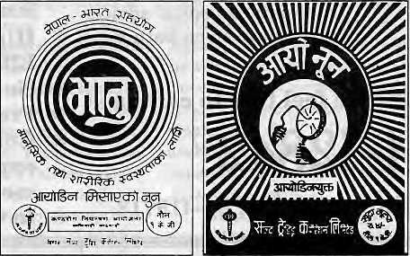
Iodised salt is distributed by the Salt Trading Corporation Ltd. both in loose form and in one kg packets. Packet salt is available under the brand names Ayo Nun and Bhanu Nun, An Ayo Nun packet costs four and a half rupees. Bhanu Nun is distributed only in the remote areas at subsidised prices.
GOITRE CONTROL PROJECT
MINISTRY OF HEALTH
(HMG/NEPAL AND GOVERNMENT OF INDIA
COOPERATION)

Programme Implementing Agency:
Salt Trading Corporation Ltd. Kalimati, Kathmandu. Tel: 271593 , 271014 Fax: 271704




■T-::
Ill
mm

Scholarly Books on Nepal, Tibet, Bhutan etc. Latest Trekking Books & Trekking Maps
Mountaineering Books Guide Books of all Countries
MANDALA BOOK POINT
Kantipath, G.P.O. Box:528, Kathmandu, Nepal, Tel: 227711
^{Tlx:} ²⁶⁸⁵ N^{p} MANDALA, Attn: BK PT., Fax: 977-1-227372 NP NATARAJ Atto: BK PI
1111 ISA CARDS
—y'<-\-:-yy.-yy-.'■■>'■■' .:::--::::::-:- ■:■:■'■■.'■'

MASTER CREDIT CARDS



- TALES OF THE TURQU1SE : A Pilgrimage in Dotpo (Forth Camming) Cornneille Jest
- TREK TO MUSTANG Stan Armington
- FOUR LAMAS OF DOLPO : Tibetan Biographies (Reprint) David L.Snellgrove
- EVEREST: The best writing and pictures from seventy years of
human endevour: Foreword by Sir £ Hillary P. Gillman


NEPAL
INTERNATIONAL CLINIC
Nepal's Leading Institution in Travel Medicine
Hours: 9:30 am-5.00 pm (Sunday through Friday). Vaccination/medical advice
US Board Certified MDs
Staff has over 15 Ifears of Work Experience in
South Asian Diseases available even on Saturdays. -#- Highest Standard of Clinical Care and
Please feel free to call us at
4-12842
Phone/Fax: 977-1-419713
Efficiency * No Hassles
-&■ Free Advice on Altitude Sickness. -&- Convenient Location (off Durbar Marg,
opposite the South Gate of the Royal Palace -
see map below) -& In Operation for 5 years

LAZIMPAT ROYAL PALACE - MAIN GATE
i i i i
SOUTH GATE
I I

O
I i
KANTIPATH I I
O
\ r
DURBAR MARG
I I
BATHS

NIC
CINEMA HALL
2nd gate _{Jai} Nepal
NAXAL

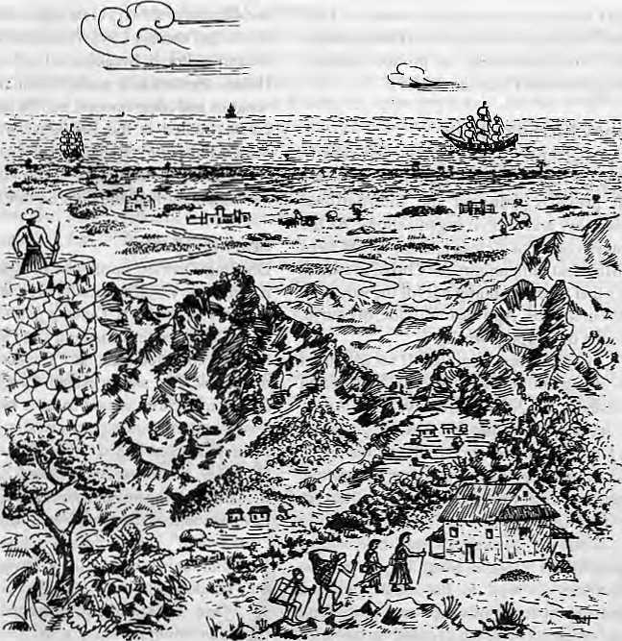
The Gospel Comes to the Hindu Kingdom
The political liberalisation
in Nepal came about
at a time when
Christian organisations
were looking for
new multitudes to convert.
The country provides
fertile ground for
the development-missionary
as well as
the proselytiser.
I

Vis the people of Gorkha-Nepal looked from their mountains to the plains of Hindustan, they saw coming towards them .... European colonialism and Christian Missions."
by Saubhagya Shah
And Jesus came and said to them, "All Authority in heaven and on earth has been given to me. Go therefore and make disciples of ail nations, baptizing them in the name of the Father and of the Son and of the Holy Spirit, teaching them to observe all that I have commanded you..." Matthew
T
his single most powerful ideological injunction of the Bible is what gives Christianity its essential missionary character, and whose fulfilment has made possible the transformation of the faith of a little-known and persecuted Jewish sect of 2000 years ago into a major world religion .
The spectacular success of the Church can be attributed to the high spiritual and moral ground offered to the role of the missionary. Not only has he been commissioned to win over heathen souls for the Christian harvest, the missionary is also the saviourofthe sinners and a civilising agent for the pagans. This theological righteousness has been wel!-complemented over the centuries by the dedication, endurance, sacrifice and sense of adventure of the missionaries for the cause of Christ.
It must come as an irony that despite its
constitutional label of Hindu Kingdom, Nepal is a country where the Christians are the most organised and vigorously expanding group. Even though missionaries have been making intermittent appearances since the early 1600s, it was only after the overthrow of the Rana regime in 1950 that they made significant gains in the hills of the Central Himalaya that Nepal occupies. Christiandom has done even better since Spring 1990 and the end of the Panchayat era, during which the State had sought to limit missionary work even as it welcomed mission-funded development.
At the time of the Panchayat's demise in 3990, there were 30 persons serving jail sentences for conversion related-charges, and another 200 who had cases pending indifferent courts. All were granted amnesty when the Interim Government took over from the Panchayat. No arrest has been reported for proselytising or conversion since.
The surest proof of the Christian gains is in the numbers. While in 1950 there seem to have been less than 50 professed Christians in all of Nepal, according to unoffical estimates, by 1990 there were between 25,000-35,000. {Precise figures are not available because the Nepali Census does not enumerate Christians as a separate category.) In the last three years,
the number of baptised Christians is reported to have surpassed the 100,000 mark.
Peter Thapa, a Christian worker who converted during the dangerous days of the Panchayat and was jailed for it, estimates that there arc an equal number of "secret believers". Even though the fear of legal persecution is now absent, social pressures keep them from going public, he says.
Today's proselytising vigour has been made possible by the liberal character of the new Constitution, whose provision on fundamental rights guarantee free practice of one's religion while prohibiting a person from effecting another's conversion. Under the old Constitution both the one who converts and the proseltyser were culpable.
According to Christian sources, there is now at least one church in each of the 75 districts of Nepal. Kathmandu Valley alone is said to have over 100 different churches and congregations.
Ambitious programmes are in the offing. One evangelist group, the Nepal Every Home Concern, has the target of reaching every home in Nepal with the Good News over the next five years, and to set up a church in every village and town by the year 2000. To meet these goals for Nepal, the organisation trained

Sep/Oci 1993 HIMAL . 3S

i 1,200 students in evangelical work in 1992 alone. Theological colleges and Bible ashrams have teen established to produce priests, evangelists and Christian leaders.
Happy Birthday Jesus
This heightened pace of missionary work in Nepal is in part the result of a sense of urgency that prevails amongst the international missionary and church organisations. As the century comes lo a close and the world steps into the next millennium, the Christian church feels that time is running out for the salvation of the multitude. And the multitude, of course, is in the developing world.
In 1987, Pope John Paul II set the target of winning abillion new converts "as aprescnt to Jesus on his 2000th birthday." In Matthew 24, Jesus has commanded that the gospel of his kingdom be preached to the whole world prior to his second coming. Poverty-stricken, populous Nepal was ripe with possibilities for the missionary.
Today's proselytising missionary organisations use the latest in information technology as well as the most advanced management techniques to reach out. With deep pockets and dedicated armies of professionals, they are spreading around the globe with the Good News. Just one American missionary group, the Southern Baptist Convention has an annual income of U$ 180 million, according to the book Missionaries , TheConvention has 4000 missionaries in 113 countries and operates with the precision and efficiency of a multinational corporation.
Bill Bright, the founder of Campus Crusade for Christ, is working overtime for the2000thbirthday.CCC,whichaIso operates in Nepal, has an annual income of U$ 80 million and works through 16,000 full time members in 151 countries. Bright has plans to reach five billion people (almost the entire world population) by the year 2000 through 271 languages and 1000 dialects.
Besides the dollar-laden missionary effort and amore liberal Constitution, the proddings of some Western Governments have influenced the growth of Christianity inNepal by tempering official attitudes. A resolution passed by US Congress in June 1991 asked the Interim Government toensure that the freedom of religion includes the freedom "to change one's religion or belief and the freedom, in public or private, to manifest one's religious belief in teaching, practice, worship and observance." Subtle hints were dropped about a dTop in the aid flow if the Nepal continued its anti-church posture.
The line of separation between the State
and Church is not very clear even in the United States. In February 1993. President Bill sat for theannua) Prayer Breakfast at the Washington Hilton, together with world Christian leaders, senators and congressmen, and the diplomatic corps. Invited at the Breakfast was Pastor Simon Peter, ne' Ram Saran Nepal, for his "outstanding contribution in the Pentecostal movement through the Four Square Church".
Matwali Flock
Dhading District, northwest of Kathmandu, has done very well by missionary standards. A majority of the local Tamang population has been converted to Christianity and today they formavoting block thatcaninflucnceelectoral outcomes. The sitting Nepal Congress MP, Dhaman Pakhrin, is said to have won due to their support. Similarly Butwal's Christian community contributed to the victory of Nepali Congress candidate Bal Krishna Khand. At thesametime, however, some Christian papers have denounced the same Nepali Congress as "Bahuttbadr and professed solidarity with the Communists, especially on the question of the "Hindu Kingdom".
One outstanding element of the Christianisation in Nepal is that a majority of the converts seem to come from the Tibclo-Burman groups — the maiwalis who traditionally practice a blend of spirit worship. Tibetan Lamaism and Hinduism. People from the Chepang, Tamang, Magar, Rai, Limbu, and Gurung groups form the majority of the Christian converts, while the higher castes are said to make up only about 10 percent of the flock.
The apparent success among the ma fu^ fa might be explained by the fact that their hierarchy-less syncretism of spirit-worship is the 'weakest' link on the Hindu-Buddhist continuum. As these relatively loose and easygoing belief systems succumb to the sociological forces of modernisation, they provide ready ground for the propagation of a vigorous, monotheistic and highly-structured religion. In fact, many matwali converts report thatthclackofastiong and structured religious tradition of their own prompts them to take up the new religion.
Interestingly, few among the northern communities suchas the SherpasorManangbas have been converted to Christianity. While partly this might be explained by their geographical remoteness, the fact that these Tibetan-speakers are backed by strong Tibetan Buddhist traditions doubtless keeps them from drifting. The same is the case in the southern belt of Nepal, where populations are secure (perhaps too secure) in their distinct Hindu or
Muslim identities. The midhills of Nepal, where the Hindu and Buddhist traditions meet, is where Christianity thrives. Over thedecades, as the gill population migrated to the southern belt, Christianity has followed the Parbates in to the Tcrai aswell.
The new converts face psychological stress when at first they are asked to abandon the worship of their deities, images and rituals in favour of exclusive loyalty to a single lord. The Christian god is a very jealous god, with none of the live-and-let-live attitude of the Hindu-Buddhist pantheon. Many converts admit to feeling left out and emotionally distressed during festivals like Da sain and Tihar. There is nostalgia mixed with guilt.
"It requires a lot of faith and will power to resist the temptation to participate," says Peter Thapa. Some Christian groups, especially among the Protestants, deal with these withdrawal pangs by organising retreats and recreation which coincide with the festivals. They have found that a few years of such diversions will wean the converts away.
The Catholics inNepal, who lay the least emphasis on evangelism and conversion, are perceived to be most tolerant of the local religious elements and practices. It is not uncommon, for example, to observe theuseof diyo and katash, incense, flowers and other local forms in their services. Their's is an attempt to "inculturate" and "indegenise" the church. "Each religion is a revelation of god given in the context of aparticular culture and historical situation, and we have to learn to discuss the truth behind Lhenames and forms," wrote one Roman Catholic scholar.
This view is not very welcome among Protestant groups, which believe in complete sanitatisation to prepare converts for the "new life". Speaking of which, not a few, it seems, are being prepared for it with non-spiritual enticements. Salvation or identity aside, the success of the proselytisers might also be a simple case of people responding to need and poverty. Case to case, free medical treatment, scholarships, employment, or even a change of clothes and a meal might work as adequate incentive for adopting another religion.
Not only are the destitute givenmonetary incentives to convert, the relatively well-off also convert for aprice, says Chiranjibi Nepal, a lecturer of economics at Tribhuvan University. He recalls the case of a senior bureaucrat's son who'converted'toget himself to the US but 'reconverted' when his purpose was served.
The standard view is expressed by Minister of Housing and Physical Planning Bal Bahadur Rai, who told a public gathering

36 . HIMAL Sep/Oct 1993

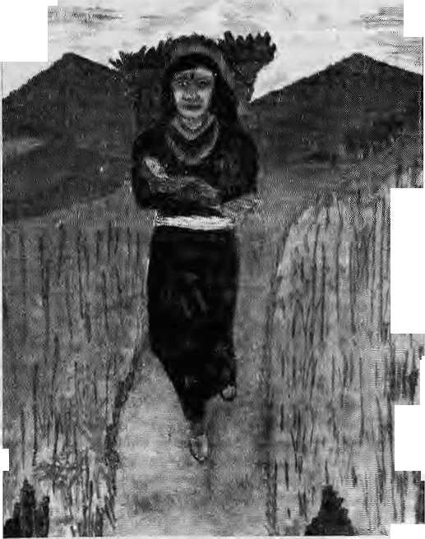
recently that the al lurement of money provided by the missionaries "could transform the spiritual heritage of the country."
Sila Gurung. Senior Liaison Officer at the International Nepal Fellowship (INF), one of the large missionary group in Nepal, presents a different view on the incentive question. "What we are doing is trying to help those needy who come to us. Succor to the poor is a basic tenet of Christianity and cannot be equated with the act bribery." Adds Peter Thapa. ^{lu}In a society where all try to lake away from the poor, what's wrong if one religion gives to the needy?"
The Bahun and the Christian
Notwithstanding all the promises of a new life, Nepali Proselylisers have not achieved complete emancipation for their converts. Thus, although the ■•**-,, outwardsigns of untouchabilily might be erased when Deepak becomes David, and Sanumaya becomes Samantha, it is clear that underlying biases of Nepali society are right there. Even though the original Hindu calling names might have been discarded, caste values have not disappeared. Admits Pastor Simon Pandey, General Secretary of Nepal ChrisiianFeHowshipofNepal(NCF), an umbrella organisation of 150 Protestant churches."There is still tremendous pressure to marry from one's own caste."
For all the disapproval of caste values, theliterature put out by certain Christian organisations appear to take inordinate pleasure when they report on "high caste conversions". This might be due to the credibility and respectability which comes from such victories. Even though Bahun J Christians comprise less than ten percent of the believers, a disproportionate number seem to be occupying the upper echelons of the casteless Christian hierarchy. Their higher literacy rate, if not their understanding of rituals and religious texts and natural propensity for "leadership roles", according to one cleric, "invariably pushes the Bahuns to thefore". The present head of the Nepal Jesuits, Anthony Sharma, whose origins are in Gorkha.
"Bahuns do not convert frequently, but when they do, they make'hardune' Christians." says Rajendra Rongong, a prominent figure among Kathmandu's Christian community.
Although various ethnic forums have been vocally decrying the Hinduisation or
Sanskritisation of hill ethnic groups, surprisingly no champion has yet raised a voice against the Christianisalion of their people. Padam Sunder Lawati, ex-minister and Rastrya Prajatantra Party stalwart, does raise a cautious note when he says that the gradual erosion in Kirati culture is being supplanted by evangelism, often induced by enticements.
One explanation why Christian conversions havenot been opposed too loudly might be, as Chairman of the Kathmandu-based Buddhist Youth Group Harsha Mani Shakya says, that "like Buddhism, it (Christianity) also does not believe in caste."
The reason why the janajati groups have not yet focused on proselytising could also be that they perceive the here-and-now threat to

With the divinest Word, the Virgin Made pregnant, down the road Comes walking, if you'll grant her A room in your abode.
St. John of the Cross

be that o f Ba/i w/i&ad, promoted by the dominant communities. Whereas, because theChrislians are still on the 'outside*, thereissomecommon cause, even through the church supplants traditional beliefs and rituals much more efficiently thanNepal'shillHinduism.For the moment, Hinduisation is perhaps seen to be the greater of two 'evils*.
The Door is Opened
When Nepal ended its isolation in 1950 and opened up to worldly influence, the missionaries were prepared, having planned for the day for decades. From their forward bases inDarjeeling and along the Nepali border, the were ready to move in.
Darjeeling was acquired by the British from Sikkim in 1835 to develop as a hill station; and migrants arrived from eastern Nepal to work as labourers. As missionary historian Cindy Perry has written, there was general receptiveness to the faith among this transplanted people. The Church of Scotland established a strong base among the Nepalis andLepchas. Over the next century, Darjeeling would play a vital role in transplanting the church into Nepal, Bhutan and Assam. However, Darjeeling was onty themost s prominent staging ground. Right along \ Nepal's southern and western frontier, various missionary groups had established beachheads at strategic transit points. As the gateway to Kathmandu, Raxaul railhead was considered vital, and the missionaries' influence in Nepal was enhanced when the Duncan Hospital opened in 1929. Other Indian towns with missions 2 included Jogbani.Nautanwa.Rupaidiha, '$. Tanakpur, Pithoragarh and Dharchula. ■M Enthusiastic evangelists made forays m into Nepal to create 'secret believers'. B After the end of the Ranas, the 1 Christians in these outposts set up I churches and congrega tions in the Nep ali heartland. David Mukhia, working for the Nepal Evangelist Band (NEB, later j to be rechristened the International Nepal Fellowship, INF) in Nautanwa, became '■. j the first missionary to set up church ] inside Nepal after 1950, in Pokhara. 1 NEB had been formed back in 1936 by i two missionary ladies, primarily to train and prepare "... those, who, in God's name, will go up to possess in his name * the land of Nepal".
Barnabas Rai, a evangelist operating from the border point of Rupaidiha, where he had been employed by the Assemblies of God since 1930, moved to establish a church in Nepalgunj. Tir Bahadur Dewan, who was working for the Regions Beyond Medical Union in Jogbani, became Kathmandu's first Nepali pastor in 1951.
The relatively free atmosphere during 1950-60, before the advent of the Panchayat, was conducive for the propagation of the faith. Many secre t bel ie vers began topubliclyprofess their Christianity, and churches emerged in

Sep/Oct 1993 HIMAL . 37



;. 1 astek( foray of. Ciiri s(ii.ui miss i oRarie$ in 10 S6nth Asia ... 4m beg a it w i th In e airi va To i" V as c o de Garpa. on the. I ndi-an eg ast
'".. some'SQQ year^ago: As the C&! hplieriiissionan.es worked their way northward, ihey.Jteard that there wcresojne lost Christian . eomm ftn j t ie s i h t_{s}i be f. C oji si dcri iig the tr av el eO pdi ti on£ of the irrrie.-they riiade daring probes into the high.BlateattilB.y 1626,... the Iesuits,hadeslabl(shed the first Christ)ancliarcli in Tsapaog,
. on'ttie banks of Sutlejiiithe western Tibetan'kingdorirqf Gage.
-fti 1628; another church appeared in Sighaste^ eastern Tibet, Jesuit priest Jolin Carattal was the first non- Asian to setfoot in-
■;. Nepal tjia.t year, on his way frorn Sighiste to Bengal.¹
After Ihe suppression of the Jesuits by Rdme^ the
.: lesponsibility for Tibet was assigned to the papaehiri;. missionaries in 1703. At first, their attention was focused on Tibet, and it was only when strong Lajniiisuc opposition daunted the missionaries' will that they turned their attention to Nepal, Incidentally, the first >!epalis to be converted to :: Christianity were some Kathmasidu merchants in Lhasa.
During the Mai la period, the position of 'the Capiichin : missionaries hung between strong stijspprtand^patronage of the niters to open hostility apd suspicion irpm the society In...
general and, tn pail i.cu ] ;tr:lhe. FJahuins. ,-^-thc b? te nriire. of die missions! lies
... .-■■■ ■■■■ Op. lhc: whole, Ihe CapucJiih gains w.cre^{v}i"iipdesn^{v} By llie time their . , friissj.on wp closed m..l76^...ihey l;iid been able ho convert about SO... .; adults,apjrtfrom the numerous dy|rjgeHildrenmey\y«reabieU)-ba;p|i3se ^{B}' ^Hhe^niaof deaihi Tn'T|7j6O. tlic dwrclfpt Our Lady's Assumption was ". : built...somewhere;; in tlie pfes.eatTljamel area,.arid,a.second one in *
; Bhaktapur. ■.■■■ ::- ::: .,. ■■■■::::- ::: \- ,■ ■■■■■ " ... ■■ £ :" - "" .. ■■ ^{v} . ■, ■■ ■ ' ^
■■■■■ ■■■■■ ' niiriatly, Piithiyj NarayJiOvSlitthvihc-upifier-df Nepali-was.-well-, ... ■ disposed .10. the Capuehiris. This amkable"rclaiionship ended abruptly ^
, whenthe GorRhaJis suspected the Italian nionksof havingpiayed arole * tn iiiyiiing the English to iriteryene in favour pf the Malla kings. ',.: .-. : ".. .After ho; took the ¥a|ley, inJt69, Piitlvi Narayan expelled the '* papuehips aiofig with 57 converts, who settled in Beltiaft, Bihar. The: expiijsipn of itiissioriaiies frorn^ Nepalseemsthusto have beenc^casjoned ' .4
:bypoh'tico-mh;taiycpnsi€kr& '•
in Prithvi Narayati's durb.ar..liked:trie idea. The imprest of the politjcal,.: and religioas elites ebriver;ged 1.6 cxeltide missionaries from Nepalfor
■ (My in the last deca%eoi: thcI20th ceijturj' would the missionaries and proselytisers hayeit as good as they did under the Malias. No less ,
during^ live BBC ph^ne-iniastFebru^ry with the words. "If fwant to'
is to s.toprne?'' . ■■ ■■■

hill towns like Tansen, Butwal, Gorkha and Okhaldhunga. Not only could Nepali Christians now live in Nepal, after a hiatus of two centuries, foreign missionaries Loo could now actively work to build the church within the Forbidden Kingdom.
Himalayan Bible Belt
The decision to publish Christian literature in the Nepali language was probabJy one of the most important steps taken by the early missionaries in Darjeeling. The missionaries were actually ahead of even the Nepali educationists, publishers and administrators in recognising the possibilities offered by the language inreaching the maximum number of ethnic groups.
Decades before Nepal's adikabi (first poet) Bhanubhakta started his work of translating the Ramayana from Sanskrit to Nepali, Baptist missionary William Carey, using the help of pandits for translation, produced the Nepali New Testament in 1821. This was the first book in the Nepali language to come off the printing press. The proper translation of the Bible into Nepali was completed in 1915 through thecffortsofPadre Ganga Prasad Pradhan, among others. The New Testament was further revised in 1957 and the Old Testament in 1977. A new revision effort is said to be underway to make the Nepali translations read better.
The last few years has seen an upsurge in
the number of Christian publications, which now include the large-circulation monthly newsletters Kanchan and Udghoshana. Two other half-yearly magazines, Mahan and Bodharlha, carry Bible portions, parables, religious essays, church news, and opinions on social and political issues. There are now four church bookstores — two in the Valley, one in East Nepal and a new one just opened in Nepalganj, western Nepal.
In 1992, the Nepal Bible Society (NBS) atone distributed 5,896 copies of the Bible, 14,126 New Testament portions, 183,450 other booklets and557,300pamphlets.SeveralBible correspondence programmes distribute Christian literature through the mail and audio scripts and mobile film screenings are available. Every morning, a radio station from Russia now beams Gospel for Asia in Nepali.
Besides Nepali, the New Testament is now available in 15 dialects, including Guning, Newari, Tamang, Rai, Chcpang, Kham and Magar. Most of these are jointly produced by NBS and International Bible Society,
Development Dharma
The notions of 'development* and 'modernisation' came into vogue in the aftermath of theSecond World War. In keeping with the times, the Nepali Government too desired modern education, industry, health services, communication, transportation and other good things for its people. Help was
welcome from any quarter, and the missionary represented a source of money, know-how and organisation. Moreover they were willing to help, albeit at a price,
Apart from the considerable resources at their disposal, the missions had already established links with a part of the population through their work in public health. As for the Nepali aristocrats, many were beholden for the education provided to their children in the numerous mission schools from Darjeeling to Mussoorie.
This link between the Kath-mandu elite and the missionary educationist was strengthened when Ft. Marshall Moran, an American Jesuit, arrived in 1947 to supervise theB.A. examinations at Tri Chandra College, then affiliated with the Patna University. Responding to the entreaties of Kathmandu's rich and famous, the priest set up the St. Xavier's School for boys in Kathmandu. A school for girls run by Catholic nuns, St. Mary's School, was established in 1954. There are today CatholicschoolsinPokhara, Gorkha and Damak, and a St. Xaviers College in Kathmandu. The Jesuits also run a drug rehabilitation service, a social service centre, a research centre, and a training seminary.
Apart from the Jesuits, eight different orders of Catholic nuns, Maryknoil missionaries and Holy Cross brothers are working in Nepal.
While the Catholics have made their

38 . HIMAL Sep/Oct 1993

mark in elite education, and made the Kathmandu rulers more willing to countenance missionary work, inother areas it is the various Protestant groups which have excelled. Back in 1952, with the intercession of the British ambasador, the Nepal Evangelist Band (now INF) became the first group to setup a mission hospital in Pokhara, which has now evolved into the 206-bed Western Regional Hospital. Besides a leprosy hospital, also in Pokhara, the INF has extensive community health programmes, TB and leprosy services in many districts of western Nepal. At present, the organisation employs about 60 foreign missionaries and 400 Nepali staff in its operations.
Likewise, the Mission to Lepers (UK) was allowed in 1956 to open a hospital at Anandaban. The Seventh Day Adventists started another hospital in Banepa in 1957. In the far West, Dr. Kate Young started a dispensary for lepers in Dadeldhura in 1960. It was later taken over and developed into a hospital by The Evangelical Alliance Mission in 1968. The Lutherans, the Assemblies of God and a few other Protestant groups arc also active in fields other than in public heaEth.
However, missionary-led development began in a big way with the UnitedMission to Nepal (UMN), representing the joint effort of several Protestant groups. Robert Fleming, the noted Himalayan orinihologist, and his wi fe Bethel were the mov ing force in th UMN' s establishment in 1954. Since then, UMN has grown, both organisationally and operationally and it now represents 39 Christian groups from 18 countries, and employs around 200 foreign missionary volunteers and over 2000 Nepali staff.
With an annual budget ofUS lOmillon, UMN today has more than 35 projects all over Nepal, focusing onhealth, industry, education, Vocational training and rural development. The agency is best known for its medical services—itrunsthel38-bedgeneralhospital in Patan, 125-bed hospital in Tansen, 50-bed hospital in Amp Pipai, GoTkha, and 25-bed hospital in Okhaldunga. The organisation has also played a pioneering role in the industrial and hydropower development through its three affiliate companies that do consultancy, construction and turbine manufacturing. Presently , the UMN is working on the 12 megawatt Jhimruk Project in Pyuthan, the 5 MWAndiKholaprojectinSyanjha,andthe60 MW Khimti project in Ramechhap. At a time when Nepal is facing a severe energy crisis, UMN's work in building indigenous capacity for power generation represents a down-to-earth contribution rarely made by missionary
organisations. UMN is engaged in technical education, non-formal education and adult literacy. It has a NRs 13,470,000 educational scholarship fund.
Government in Dilemma
Even as the Nepali establishment welcomed the development that the missionaries bring, it knew that overtly or covertly preaching and proselytising was bound to take place. As the missionary academician Herbert Kane wrote, "The Bible is a missionary book, the gospel is a missionary message, the church is a missionary institution, and when the church ceases to be missionary, it has denied its faith."
Given such a missionary mindset, the Government has tried to balance the benefits of the missionary development work with the hazards of conversion as best as it could. In one instance, it sought to do so by inserting a preventive clause (no.4.6) in the General Agreement between the HMG and UMN {similar clauses hold true for other missionary agencies as well):
UMN and its expatriate personnel shall confine their activities to the achievement of the objectives of the Project which they are assigned, and shall not engage in proselytizing or any political activity.
Notwithstanding these somewhat stem wordings, however, the actual situation is rather malleable. After the 1990 democratisation, UMN felt bold enough to write to the Foreign Ministry with a narrow interpretation of 'proselytizing':
"... Farther, in keeping with clause 4.6, we will not engage in proselytizing, that is, in attempting conversion through coercionor offer ofmaterial inducement."
So defined, 'proselytizing' is restricted to only the act of conversion throughforce and bribery, and the UMN is otherwise free to engage in conversion activities through other means. That the Constitution sets a total prohibition on conversion becomes moot under this interpretation. While UMN might be accused for fancy semantics, however, one may also question the Constitution framers' assumption that freedom to 'practice' religion can be divorced from 'conversion'particularly for those religions whose central tenet is evangelism.
In Nepal, the conditions for conversion are now so free that the challenges of missionary-hood might have begun to pale for some. Indeed, so easy has il all become that a few Christian leaders are even doubting the commitment of new converts. Whereas during the Panchayat era only the dedicated would
dare embrace the new faith, "the openness now may invitemany who are shallow in their failh and others who may be only after monetary gains," concedes Rangong. UMN's Director, Edward Metzler, expresses similar apprehensions.
The State's more permissive attitude has encouraged the entry of all kinds of denominations and sects into Nepal over the last three years. These range from Jehovah's Witness and Mormons to the cult group Children of God. The arrival of some of these new groups to Nepal once the going got easy has the potential of damaging an innocuous image carefully nurtured by the missionaries over the decades. Pastor Pandey worries, "These trends have the potential of dividing the Nepali church. Some of the questionable cult practices may also give Christians in general a bad name."
Aware of the denominational squabbles and infighting that have marred inter-church relations in other countries, the NCFrepresents an effort by Nepali church leaders to give a non-denominational unified character to the church in Nepal.
Apart from the 1990 Constitution's designation of Nepal as a Hindu Kingdom, the other matter that rankles Christians groups is the issue of organisation registration. Using a somewhat lame excuse that Christianity is not an indigenous religion, for example, the Chief District Office of Kathmandu has refused to register the NCF. Meanwhile, a Catholic society and two Protestant organisations have managed to get registered simply because they have secular sounding names. For example, the terms 'Christian', 'Jesus' ot 'mission' did not appear in the registration form submitted by tiieWitnessfor Nepal group.
Meanwhile,the NCF's case has gone up to the Home Minister, but Pastor Pandey is adamant about retaining "Christian" in the name. "We have waited long enough and we can wait a little longer," he says, adding, "It isn't preventing our work either."
Spiritual Food
While some missionary agencies may be ambivalent about whether they want to 'do development' or use it merely as a means to proselytise, most are committed to the latter and lose no sleep over the matter. Although theexamplesetbytheoftheGoodSamaritian, and the values of charily, are deeply ingrained in Christianity, and Jesus himself entreats people to "love thy neighbour as thy self" (Luke 10:27), the proselytising compulsion seems to take the higher priority for almost every organisation.

Sep/Oct 1993 H1MAL . 39


How could it be otherwise? With emphasis on saving souls rather than trie body, development works and social service are only the means to an end, a means to win heathen souls for Christ now, or if that is not feasible immediately, to prepare the ground for future conversions. This exclusive focus on conversions as an end in itself is especially true of Protestants groups and is admitted by many clerics themselves.
During its 2000-year history, Christianity has employed different means to enhance the flock ranging from preaching and evangelism to inquisitions and the use of military force. While the methods varied, the central goal of winning as many converts as possible has remained unchanged. So when after the second half of the 19th century the missionaries in South Asia adopted education, medicine and social service to get to the people, it signalled but a change in strategy. Forced conversion was no longer a possibility and you could never have the required number solely on the basis of the Good News. For the Christian soldiers, the spiritual end would always justify the temporal means.
Both the government and the missionaries appeartohavetheirowncalculations regard i ng church-sponsored development programmes and the proselytising agenda. But what about theniullitude,"...the people from a little known country in the remote Himalayas for whom Christ died," as Cindy Perry prefers to calls them? What's in it for them?
In a wqrld where all religions and beliefs tell of happy tidings in the here-to-after, here was one that guaranteed salvation in the afterlife and still managed to provide manna for this one. There are always many takers for the sou!, but very few for ihe belly.
If it is possible to get a decent education, healthcare, jobs and development projects in return for letting others save your sinful soul «n the side, it would be sacrilege not to go for such a win-win situation. After all, spirituality or non-spirituality, depending upon one's pious perceptions, is apersonal asset that one should be allowed to dispose of in the most advantageous terms. The prolonging of the salvation process might even prove to be in the recipient society's interest — the missions will look for heathens elsewhere once all have been saved here.
More seriously, it is for Katmandu's Hindu gentry to sincerely contemplate the questionsofreligion, ethnicity and national i sm in the context of a region that is increasingly exposed to outside influence. The automatic reaction against Christian proselytising, after all, is quite incongruous in this day and age,
particularly when the nay-sayers are the first to try to take advantage of missionary education and development. At the same time, it is both ironic and hypocritical that the conscience-keepers of Hinduism, a faith and philosophy that emphasises the non-duality of matter and spirit, should clamour for continued suzerainty over the soul of the masses when they are pitiably reluctant to do anything for the body.
Apart from the tangible developmental benefits like schools and hospitals, the intangible yet positive aspects of Christianity have been in the social and cultural spheres. The non-caste character of Christianity has helped generate some degree of awareness against some of the obvious discriminations of commensality rules and untoucliability. If nothing else, ilhasgivenaguiltcomplex to the upper castes for their complacent altitude towards their backward Nepali brethren. Many social reformers in Indiahave been influenced by Christian teachings that emphasise the dignity and inherent equality of all human beings, and this might yet happen in Nepal.
The liberalised political atmosphere in Ihe country has seen to it that missionary work is not the dangerous adventure it used to be and it is unlikely that dieTepression of the past will be repeated again. The last thing remaining to do, therefore, would be to eliminate the existing anomaly from the Constitution and allow freedom of religion not only in practice but in paper. Makingproselytising legal would not only end a lot of misunderstandings and acrominy but would also be in line with the political and social ethos Nepal is trying to embrace. Besides, is Hinduism so weak that it has to be protected from de facto secularism with a Hindu Kingdom armour?
At a different plane, though, the suspision of the section of the population that is automatically arrayed against Christianity would remain. This wariness can be disarmed only if the missionary organisations lay all their cards on the table and let public opinion make the decision. In conversion as well as in development, the people must be given the full picture that enable conscious choices. Ambiguities, half-truths and hush-hush operations ultimately disempower the masses and serve the elites.
Why, it may be asked, is it necessai;y to dismantle the religion and rituals of Nepal's multicultural population and erect a new monolithic model in their place if the goal is limited to bettering the living conditions of the masses?
In the past, and into the present, even missionary organisations whose sole interest is to convert have had to embellish their work
programme with a lot of development talk. One of the worst examples may be that of the Summer Institute of Linguistics (SIL), whose escapades in the early 1970s did some damage to the reputation of all missionary work.
SIL was affiliated to the Tribhuvan University during 1966-76, engaged in conducting joint research on the lesser known dialects of the Himalaya. It turned out that translation of the Bible into the regional dialects and distribution was all part of the 'research programme'. When information of the proselytising activities, plus possible involvement with the CIA in supplying arms to Tibetan Khampa guerrillas came to light, SIL had to pack up and depart in haste. According to a Kathmandu weekly, the organi sation is p 1 aiming a comeback into Nepal to resume unfinished business.
Even those institutions which might want to be more up front with their missionary agenda have been forced into secrecy by official and social strictures. Otherwise, there is no reason why the INF newsletter Today inNepal, published from London, should have been marked: "CONFIDENTIAL, not to be reproduced or sent to India or Nepal." Similarly, why should UMN feel constrained to deny that it has links with the local churches when it clearly does? The need not to roil the waters of Nepali society is so great thatUMN's annual report for public circulation makes no mention of its local Church Relations Unit, noT the expenditure thereof.
But these could be mere trifles in the
larger scheme of things. "Nepal will undergo
a metamorphosis within ten years if
Christianity is welcomed in this country,"
promises an editorial hi Kanchan. In the next
breath, however, the paper vehemently makes
demands for a seculaT state. A heathen soul is
left wondering whether salvation, when it
does come, will be through the holy Gospel or
the development mantra.. *
S. Shah leaches Sociology at Trtohuvan University, and reports lor Katmandu's Rising Nepal dally.

40 . HIMAL Sep/Oct 1993


Four reasons why you should fly our
HELICOPTERS

For™r₈in_{fa}r_{m3}«₀np,_{e}as_{e}contact DYNASTY AVIATION PVT. LTD.
- Reliable and safe because of
fail-safe design.
- Flown by pilots who have long flying
experience in the Nepali Himalaya.
OPERATIONS BASE Tribhuvan Intsrnationat Airport Gaudiar, Kathmand Nepal


- The network has 18 years of experience in helicopter
service and more than 300,000 flying hours.
- Operated by experienced technical
experts and reliable administrative staff.
HEAD OFFICE
KA-3-78, Naya Baneshwor,
Kathmandu, Nepal
Tel: 977-1-225602, Fax: 977-1-52295B

Lwwty Planet FuWieaSixia Pty Lid
A.C.N. OK 607 SS3
PO Bai 817. Hawthorn. Victoria 3122. Australia
Olfks: 192 eunvood Road. Hawthorn. VIOprii.3122
T»l«phoo»: (03) B»9 1677. F«; (03) 619 MSB
Why
Macintosh ?
Why do people who use Apple Macintosh computers every day enjoy working with them so much/and find that they're much more productive in the process ?
Is it because Macintosh computers are so easy to set up, leam, and use? Or because Macintosh applications all work in the same consistent, intuitive way? Or because every Macintosh comes with built-in networking and file-sharing capabilities ?
Or is it simply because once people use a Macintosh, nothing else will do?
Every day, thousands of people discover the advantages of Macintosh for the first time. And catch a glimpse of its magic.
So if you want to know why contact us at MIPS.

MIPS Pvt. Ltd.
P.O. Box: 2502, Tel: 222277,
Telex: 2521 ATLINK Fax: 977-1-419250
Nepal is a Land of spectacular mountain scenery, incredible flora & fauna, and great ethnic diversity -rich in natural beauty and cultural traditions.
From Himalayan treks, elephant-back safaris and wild river running, to peaceful temple visits and late-afternoon coffee in a Kathmandu cafe, Nepal's appeal is universal.
Nepal -travel survival kit Includes:
- 56 maps
- comprehensive information on flora, fauna & ecology
- Information on festivals & other cultural events
- guidelines for responsible tourism
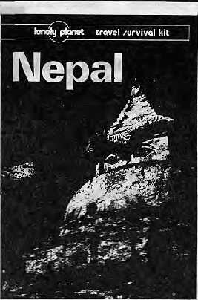

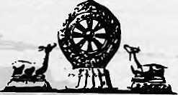

DISCOVER


THE ULTIMATE ADVENTURE DESTINATION
Let Tibet Travels & Tours- The pioneers in
Tibet adventure-unfold for you the inner
secrets and mysteries of this fascinating land, people
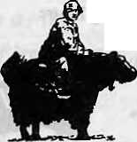
and culture-so different from anything you have ever imagined
Departures to Tibet Every Tuesday and Saturday By Air/Land
For details contact:
TIBET TRAVELS & TOURS (P) LTD.
Tri Devi Marg, Thamel, P.O. Box 1397 Kathmandu, Nepal Tel: 410303, 415126, Tlx: 2672 TIBTVL NP, Fax: 977-1-415126

 | II Jl |  | IMMIGRATION
 |  |  | OFFICE r~*1
HIMALAYAN |ji|H |  |  | L LJ
INTERNATIONAL MSfipi | THAMEL
'. P.O. Box 5133 Q I |  | M I—II  £ SAMCHAYA KOSH —i I
Jyatha- Thamel, Katmandu, Nepal ^^^ Phone: 2-25455, 228998
Fax: 977-1-220143. Telex: 2669 GLOCOM NP |  | HIMALAYAN
1. MEDICAL CARE IN A WESTERN SETTING |  | INTERNATIONAL
2. CARE BY MD., GENERAL PRACTITIONER. CARDIOLOGIST & | HOTEL | 1 CLINIC
I GASTROENTEROLOGIST (CANADA, UNITED KINGDOM,USA) | BLUE DIAMOND □
3. ALL TRAVELLERS VACCINATIONS AND FREE VACCINATIONS | BLUE DIAMOND □ |  | -_ , irnriMiiu —1 HOTFI
ADVICE AVAILABLE |  |  | OTSE
4. MODERN LAB FACILITIES
5. X-RAY FACILITIES
 | HOTEL
6. EN.DOSCOPY AND ULTRASONOGRAPHY FACILITIES
7. INFORMATION ABOUT ALTITUDE PROBLEMS | QAJOR CH
8, ARRANGEMENT FOR SPECIALIST REFERAL
9. STANDARD SERVICES AT ECONOMICAL RATES
10. CENTRALLY LOCATED AT JYATHA-THAMEL (IN FRONT OF |  |  | ¹ F
10. CENTRALLY LOCATED AT JYATHA-THAMEL (IN FRONT OF |  |  | \ F
HOTEL BLUE DIAMOND) IN KATHMANDU
¹ 1 ^-* ■ ■—' ■— W m *^ ^h b^ 10 11 T 1 \^ 1 1 '—■ 1 II 1 1 lj _ 1 1 IITll tl 1 Lj ^J
11. OPEN ALL DAYS, 9 AM TO 5 PM
12. PRIOR APPOINTMENT ALWAYS WELCOME | I |  | '1

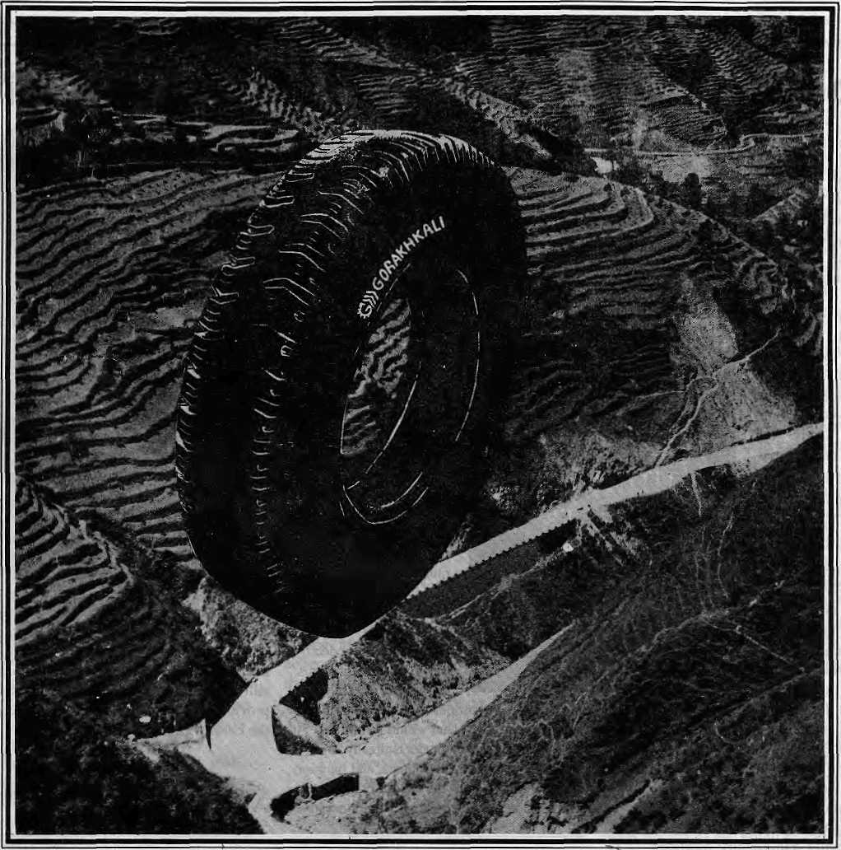

The Gorakhkali tyre is specifically designed for tough Himalayan roads and extreme Himalayan climate. It is the only tyre manufactured in the Himalayan region. The Gorakhkali tyre uses nylon backing and a special dual tread compound for added strength. Rigorous tests on Nepali highways have shown that the Gorakhkali tyre has excellent abrasion resistance. It is unmatched for steering, acceleration, braking and road grip. Overall, it has the lowest cost per kilometre of running.



GORAKHKALI
GORAKHKALI RUBBER UDYOG
Registered Office: Marketing office:
Majua Deurali PO Box 1700, Kalimati
Gorkha, Nepal Kathmandu, Nepal
Phone (065) 20179 Phone 270367, Telex 2788 GRUL NP Fax 271704
v v
V

REVIEW
Good on Description, Short on Analysis

Harnessing tbe Eastern Himalayan Rivers Regional Cooperation in South Asia
Edited by B,GVerghese and Ramaswamy RJyer
Konark Publishers, Delhi, 1993
ISBN: 81-220-0313-3
by Bhim Subba
Harnessing
i ZD
the
Eastern
Himalayan
Rivers
Regional Cooperation in South Asia
Run of the River Scheme
rn their quest to be regarded as factual or rivers as well as the frothing but tranquil
White Water Nepal
A Rivers Guidebook for Rafting
and Kayaking
by Peter Kncwles and Dave AHardice
Rivers Publishing, United Kingdom, 1992
ISBN 0-09519413-0-5
by Steve Van Beek
W
hile this book will prove'a welcome addition to some libraries because oFthe volume of information it contains, editors Verghese and Iyer deliver much less than what they promise in the title. Because negotiations on the Eastern Himalayan rivers have seen extremely limited progress "for a variety of reasons", they write, tile time seemed right for an "objective, non-official study by scholars uninhibited by political compulsions and able to examine and propose a range of possible options".
Unfortunately, this publication contains no definite proposals or development options. Instead, till past the halfway mark, the book belabours the background and describes the vast untapped potential of the Brahmaputra, Ganga and Meghna rivers —; of which there has been no doubt. When the book eventually takes up the core issues related to regional cooperation and development strategies, the discourses are mostly restricted to records of past dialogues and country positions — as seen from an Indian perspective. There are no startling revelations or fresh insights in this 286-page work, which contains 22 papers by distinguished Indian experts on a range of topics.
It is of course true: "it is not that the tremendou s, c ataly si ng po Lential o f the G anga -Brahmaputra-Meghna (GBM) system is unknownor technologically unreal isable", but opportunities have "not been creatively seized", because "a number of social, political and historical inhibitors are at work". The goals the editors set for themselves were to address these inhibitors and to define "a common approach to the nptimal development" of the Eastern Himalayan rivers.
What the book does best is provide the reader with background information on the
GBM Basin, which supports 535 million people
andcovers over 174 million hectares (including
in Tibet). The three rivers together drain a
third of India and almost
all of Bangladesh, Nepal
and Bhutan, and
represent one of the
world's most expansive
river systems. Har
nessing their full
potenti al w ou Id of c on rse
create enormous
economic wealth in the four countries.
It is intriguing why the editors chose not to include maps in this volume, especially as it seems to be directed to the lay readerrather than the water specialist. It is not possible to make much of the arguments when one is unsure of exactly where the waters of the Kamali or Kosi would be impounded by the proposed high dams, or where in India or Bangladesh the proposed alignments of the Brahmaputra link canal would terminate.
Pro v ided that the reader is already familiar with the territory, riveT courses, and location of important projects, thebookcontains useful information on the history of cooperative
Aeven definitive, guide books often Tead as flat as roadmaps; they get you to and around the destination, but provide no feel for the topography. It is refreshing, then, to find a book which sacrifices nothing in terms of accuracy, yet in conversational tone manages to make a floa t down the white page through the fonted obstacles a pleasure. White Water Nepal caters both to rafters and hard-driving kayakers. It covers maneater
efforts between India and her three basin neighbours. However, theabsence of achapter onthevariousprojectsthathavebeen proposed for future implementation is missed. Both in terms or past differences and possible future cooperation, discussion of schemes and development scenarios would have been justified.
The editors take pains to emphasize that meaningful cooperation within the region has notbeenpossibleintheareaofwaterresources development due to differing perceptions coupled with "mistrust and a sense of historical wrongs, real or exaggerated". Perhaps the most telling comment on the possibilities of "regional cooperation in South Asia" (one half the book's title) is contained in the foreword, where it is indicated that perceptions ofeachofthethreeparticipatingcountrieswill be compiled in separate volumes, and that this particular book represents the Indian perspective for the optimal development of the GBM Basin.
It is obvious that despite the earnest desire on the part of the contributors to "present rational options on the basis of which public opinion can be educated to recognise where true self-interest lies," inherent inhibitions are still at work. The book falls far short of providing any definite blueprint for harnessing die Eastern Himalayan rivers.
3.Subba. formerly head of Bhutan's Department of Power, presently lives in Kathmandu.
streams of the type normally run by the Kathmandu rafting companies for walk-in clients. AfteT providing a tourist's introduction to Nepal in factual but humorousfashion, the book embarks on ariver-by-river treatment of 23 runable Nepalirivers. Each chapter begins with a box of data on length, starting and finishing points, how to reach, difficulty, gradient, volume and best season. There followsa summary of theriver's

44 HIMAL . Sep/Ocl 1993


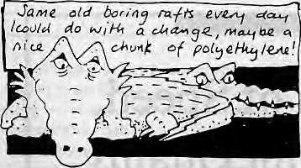
Key features and a description of its route and scenery, with separate information provided for rafters and kayakers.
Then comes the nitty gritty of running the rivers. The text includes a day-by-day description of possible obstacles and how to negotiate them, and the logistics of overnight camping. These are augmented by detailed maps, drawings, cartoons, horizontal sketch profiles of the rivers, and pictures of portions of the river or the Nepalis living along it.
What makes this guide really different is the authors' writing style. It is common to find martyr-authors who struggle to impress the reader with macho tales of hair-raising threats to life and limb while conquering remote rivers. These types of aficionados are skewered inhumorousfashionbyKnowlesandAllardice, who use a gonzo-joumalist approach and substitute nonchalance for terror.
Not that river-running is without its dangers. Launching a kayak into a river that is cranking at 150,000 cubic feet per second in mid-August is something like leaping into a gargantuan washing machine on the spin cycle. The book does not mince words in this regard, paying tribute to several kayaking colleagues who have perished under keepers or rocks.
The in-jokes of kayakers is liable to strike some as a bit grim, but there are also humorous asides for the general readership: "One group spottedarhinoceros; unfortunately the Thino also spotted them and flattened their tents." There is also a hilarious account of a drink-inspired float down the Bagmati, which has become the sewage conduit for Kathmandu's human and animal wastes. A warning on the inside cover comes as a volley across the bows of would-be counterfeiters: "WARNING; Printed using laser-phobic ink —this may degrade if scanned by photocopiers or similar devices,"
Sensitivity to the surroundings is perhaps
the book's biggest plus. Throughout, it
demonstrates an environmental consciousness
that goes beyond urging campers to carry their
trash home. Where many books on rough
sports concentrate on the technical aspects,
this one looks up from the river from time to
time, to enjoy the scenery, savour the air, and
drink in the peace, ^
S. Van Beek is a travel writer who lives in Bangkok,
REVIEW
INTERNATIONAL H^TIVAX OF HLMS/ DOCUMENT,Aklf S)&J$ THE MALAYA AND ITS
PEOPLES
Therange and diversity of Himalayan film-making will bfc on view at Film Himalaya 1994. This international festival of Himalayan films and documentaries willbrmgtogefc^ ^ndpverseasiQrtlitreed^ys ofscreenings anddi^ussions. Foffilmrmaker§
;and ftlm-watchers alike, Kathmaridu is the place to be from t8-2tfFebruary-
Entry Procedures: Films that are entered for screening in Film Himalaya 1994 must dealwith the Hirmlayadregiontwhiehenconipasseis the region from Afghanistan to the Indian Northeast, including Nepal, Bhutan and-: Tibet), or have specific relevance to the J^rnajayanpopulation.The subject area'carv range frorncultufeand history,-to adventure, tourism, ecology, development, jpolitics, ethnology, archaeology,etc.' \
Film Himalaya will accept entries ranging frofrLshort television spots to * full-length documentaries or features^ Entries 'Which are not in English; should be subtitled, although some, exceptions may be made. Entries in good qualify VHS (BAL,SECAM, NTS0are preferred, but provision¹ will also be made fpr-.celluloid pteseit;tations«Allentriesmust:reacri me Festival offleein Kathmandu bytl 2 December 1993i

FILM HIM
For United Kingdom: Audrey Salkeld Six way $ Lodge,? Linden Road Clevdon, Avon B5217SL Tel: 275 875 631
Entry; forms (forsending iff entries) arid registration forms (fpr attending the Festival) Can'be ordered from: the Festival office in Nepal or irom the international contact persons* Please note that entry as well aspartictpatioi) % free of cO'sUand the Festival, is not competition-oriented.

 | 1994 iFfe=3 !
A1J queries should be directed tor
Su man Basnet
Festival Director
Fiim'Htmalaya 1994 | For North America:
POBox42: | Jeanne-Marie Giibert
.Lalitpij!' :: '.. | PO Box 178
Mfepal ■ ■■ | KSljiWY 83011
Fax; 9771 521013 | Fax;'3O7 733 0883
Tel: 9T71K3845 | ' Tel: 307 733 5055:

Sep/Oci 1993 HIMAL . 45

An Unbeatable Combination of Speed, Paper-Handling & Superb Print Quality
Epson's Breakthrough Printer
EpsonLQ-1170ESC/P2
Pages ahead....



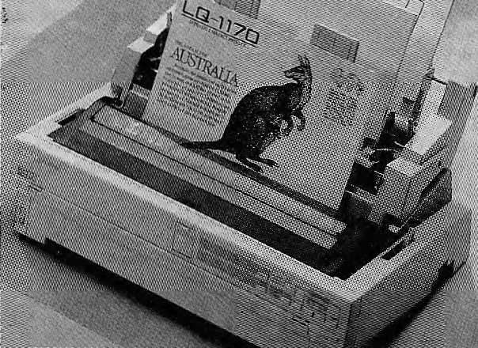
Authorised Distributor:
/MERONTILE
OFFICE SYSTEMS
P.O. BOX : 876 Durbar Marg, Kathmandu, Nepal.
Tel: 220773/223499 Fax ; 977-1-225407 Tix : 2263 METRA NP
EPSON
Special features ;
- 24 pins Dot Matrix Printer
- 330cps
- Multipath paper feed
- Multiple Character Fonts &
Enhancements
- Multi-position Tractor
- Enhanced Document Control
with Epson ESC/P2 Codes
- 1 year warranty

I
.a

KNOW YOUR HIMAL

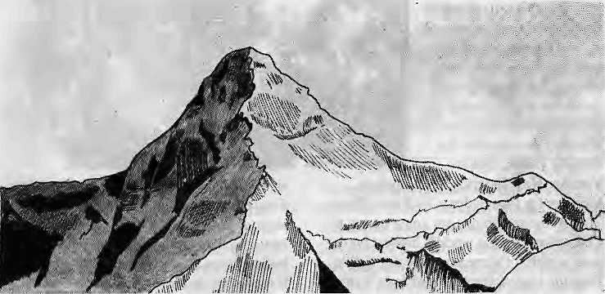
...Fairest of Them All
Which is the world's most beautiful mountain? The winner must be decided on the score of sheer aesthetic appeal and the ability to inspire wonder. Beauty does not depend on height, and the contender can, of course, come from any country.
The Alps, and even more so the Andes, would yield many contenders for the first round of a mountain beauty context. In the final round, however, it would be surprising if all the competing peaks did not originate in the world's youngest and highest range, our own Himalaya.
It is significant that so few of the 14 octausender big league peaks feature in the beauty stakes. Merely being 8000 metres high does not make a mountain attractive and at the outset we may dump the claims of Everest, which is positively plain from its souther approaches, though as "Mother Goddess"from the Tibetan sid, e the peak does assume a more regal air. Kanchenjunga, with its several summits clustered in one massif, is attractive but lacks the distinctiveness so necessary for the Top Ten list.
Of the 14 Himalayan giants, only K2 fulfils the dream of beauty that floats. Too isolated to possess a name, the passage to the feet of this mountain is unbelievably grand. TheK stands for the Karakoram Range, which outdoes the Himalaya for its hugeness of surroundings. However, the density of the high peaks in the Karakoram tends to cancel out their individual impact.
by Bill Aitken
Kashmir's Nanga Parbat, which marks the western end of the Himalayan chain, is in the 8000 club. The peak wins the medal for heroic rather than beautiful outlines. Nun and Kun are distinctly appealing in their clean sweeps and would certainly make it to the "reserve" bench. The same goes for Himachal'smany snow mansions, including lovely peaks such asMulkilaandDharmsura.
As we approach Garhwal, a run of beautiful peaks strung out on necklace of delight immediately claim a spot on the Top Ten. Srikant is a lonely, lovely peak that rides as an overture to the chorus that is to follow. I wouldplumpS/Hv/ingoverM7tottffc because of its perfect positioning above the source of the Ganga, which gives it the edge of harmonious association.
If K2 and Shivling are on my short list, I need to move east to Nepal and Bhutan to find other entires because the top two places I would also award to Garhwal (we will have to come back to conclude with their virtues). On the way to Nepal, I would include the superb Nanda Kot, shaped like an icy axe blade, which is the Kumaoni contribution to my list. Known to local hill]menas£««to(rya, this scintillating peak as seen from the dak bungalow at Dhakuri is one of the most memorable sights in the entire range.
The Nepal peaks that immediately leap to mind are Menlungtse and its neighbour Gauri Shanker. The former's lovely curtain of snow constrasts with the delightful pinnacles
that cap Gauri Shankar, which gives the impression of Shiva with his consort on his lap. Another lovely peak which lies north of Kathmandu, my wild-card entry to the list, is Langtang Lirung — no great shakes as a first prize winner but wearing the most feminine of lines with elegant fluted ridges to give the appearance of a draped mantle of ermine.
If by now you are screaming "What about Machhapuchare!", be assured that the fishtail peak resides where she belongs, among the top three most beautiful peaks. Its base, Pokhara,isthemoststunningofallHimalayan towns for the largesses of a lake, in which the superlative lines of Machhapuchare are reflected. No purer mountain vision for the unathletic could be devised.
Eastward from Nepal, according to many mountaineers, Sikkim is the home of the world's most beautiful mountain, Siniolchu. Further east in Bhutan lies Chomothari, a ravishing sentinel on the border with Tibet Then there is the newly-discovered sweep of the breathtaking sheerness, Jitchu Drakke..
It looks like I will have to sacrifice one of the two Bhutan peaks to leave room for the top two* both of which happen to be from the same neighbourhood — Changabang and Nanda Devi. Whether Changabang is more beautiful than Nanda Devi or vice versa is immaterial to anyone who has been blessed by their v is ion in the prosimity of the Sanctuary of the latter goddess.
Mountaineers who reach the base camp of the soaring grey polished shark's tooth of Changabang (the shining mountain) just sit there and gape at the unlikely wonder of this naked sheath so perfect in its poise. On Nanda Devi's ultimate beauty, little need to be said for she sails in open view from all points in Kumaon. The mostromantic aspect (frontally with the twin peaks) is seen from above ■ Pilhoragarh, especially at sunset. The most dramatic angle is from the Rishi Valley gorge, with the main peak side-on to the gaze of the approaching devotee. The mountain shoots up like an arrow bearing the message that true beauty lies in the ability of nature to lift our thoughts "unto the hills" whence cometh our inspiration.
Or, as the Rigveda would have us
pronounce, "Let us worship that wonder by
whose greatness these snowclad mountains
exist." k
B. Aitken is a traveler and columnist who writes on mountains and railways. A longer version oi this
article appeared in the Sunday Mail in January 1991.

SeplOci 1993 HIMAL . 47

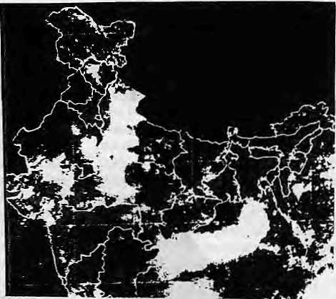
Abominably Yours,
Just this morning, while squatting on the ridge taking care of morning business and watching Peak Six turn pink with the rise of a new dawn, ] noticed Surendra the Snow Leopard foolishly taking a leak on a rock (an outcrop of flarun gneiss with feldspar encrustations, to be exact). Because my bowels were moving with rare smoothness, I was in a contemplative mood and this got me thinking about the territorial imperative.
What primordial instinct made Surendra, a 20lh century cat with a thoroughly modern outlook, do a thing as primitive as watering the perimeter of his domain first thing in the morning? There is enough wasteland up here amidst the soracs of the Barun Glacier for all of us, still here was the silly leopard fencing off his territory. "No entry," Surendra seemed to be saying as he zipped his fur and skipped across the moraine to the next point on his agenda.
Having myself unloaded some biodegradable orbs, and feeling clearheaded again, I clutched the lota and ambled back to my cave to write these lines before the editor of Himal sent me another poisonous missive on the e-mail.
Legend goes, the only manmade object visible from the moon is the Great Wall of China. (This is not true, but so many people, including most recently Harrison E. Salisbury and Mr. Chen Bao have repeated it, that the truth is irrelevant.) What is more important is that a lot of people believe that besides the blue oceans, curling clouds and tanned continents, the only human creation on Earth discernable from outer space is a border wall.
And in an age when space shuttles allow us to go up and peer down at pleasure it is painfully abominable that human beings cannot look at their planet without drawing dotted lines all across its surface.
It was while watching a khaki-clad immigration officer at Bhairahawa relieving himself on a Indo-Nepal border column that it all came to me in a flash: despite millions of years of evolution, the part of the human cerebellum that is responsible for territorial integrity is still right there next to the lobe that regulates the frequency of urination. And this correlation is most pronounced in males of the species, whom nature in its infinite wisdom seems to have selected for
territorial defence roles. The male sabre-toothed tiger and the Bosnian Serb soldier share the same genes.
The aromatic toilets at the Tribhuvan International Airport are the Nepali equivalent of a moist baobab trunk in the Masai Mara, sprinkled with a cheetah's urinary marker. The olfactory message for the arriving visitor: Beware, You Are Now Entering My Kingdom. Message for the resident: Welcome Home.
At the rate things are going on top of Chomolongma (the world's highest border post, which for some reason is not visible from the moon), there is need for a visitor's book and a toilet. All mountaineers, when asked by the Kathmandu-based Reuters correspondent what they did when they got to the top, say they took pictures, ate chocolate bars, admired the view, and called home. From my records, no one has ever said that he attended to the call of nature. And yet, that is what all mountaineers do. They can't help it. It is programmed into their hard disks: when you get to the border, take a leak.
Just like the male macaws on the slopes of Kota Kinabalu, some modern human tribes are very possessive about territory. Dominant male macaws get mighty pissed off, in a manner of speaking, when a belligerent member of a sub-clan from Sarawak is caught trying to unbutton his fly within his territory
This, in fact, is why there is a whole department in the Indian Ministry of Information tasked with looking through every newspaper, periodical, magazine and Tintin comic book entering the Indian landmass, for maps that award large chunks of Bharatiya territory to neighbouring nations. BEWARE, says the rubber stamp that the department affixes on every offending map: "The external boundary of India as depicted in this map are neither authentic nor correct." Oh.
The National Geographic magazine goes to the other extreme in political correctness, so concerned it is not to displease. In a recent article on tigers of India, it presents a map depicting tiger habitats, from Corbelt and Dudhwa across to Kanha. But, lo and behold, not a tiger in
sight in Chitwan, and nary a tigeT in the Sundarban, because this is an article only about Indian tigers. The super-sensitive cartographers at the Geographic know that Indian tigers are fully law-abiding citizens. If they stray in the night to the Nepal border, they say: "Oops, this is a national frontier, I must respect Nepal's territorial integrity, and not cross it without proper documents."
Another article about the Serengeti National Park shows the sanctuary extending only up to the Kenyan border and no further.
Wildebeest One: Why we running? Why
we running?
Wildebeest Two: (hyper-ventilating)
Don'tyousee that lion behindyou. Make
haste, you jackass!
Wildebeest One: (panting) Hey-ho
brother,!see the Kenyanfrontier looming
up yonder to the right. Why don' t we just
slip across the border?
Wildebeest Two: Shoot, left my passport
in the other trouser again.
Lion: (later that evening) Finish your
steak, Lisa, I almost had to run into
Kenya to get it.

Some satellite weather maps in Indian newspapers show portions of the Subcontinent which are completely cloudless all-year-round. Strangely enough, these cloudless areas fit exactly the outlines of Bangladesh, Nepal and Bhutan. The advance of the monsoon blows steadily northwestwards, but when they reach the Duars, the clouds swerve south and side-step Nepal and Bhutan completely. But this is Lo be expected. It is the Indian monsoon and it is an Indian satellite.

48 HIMAL . Sep/Oct 1993

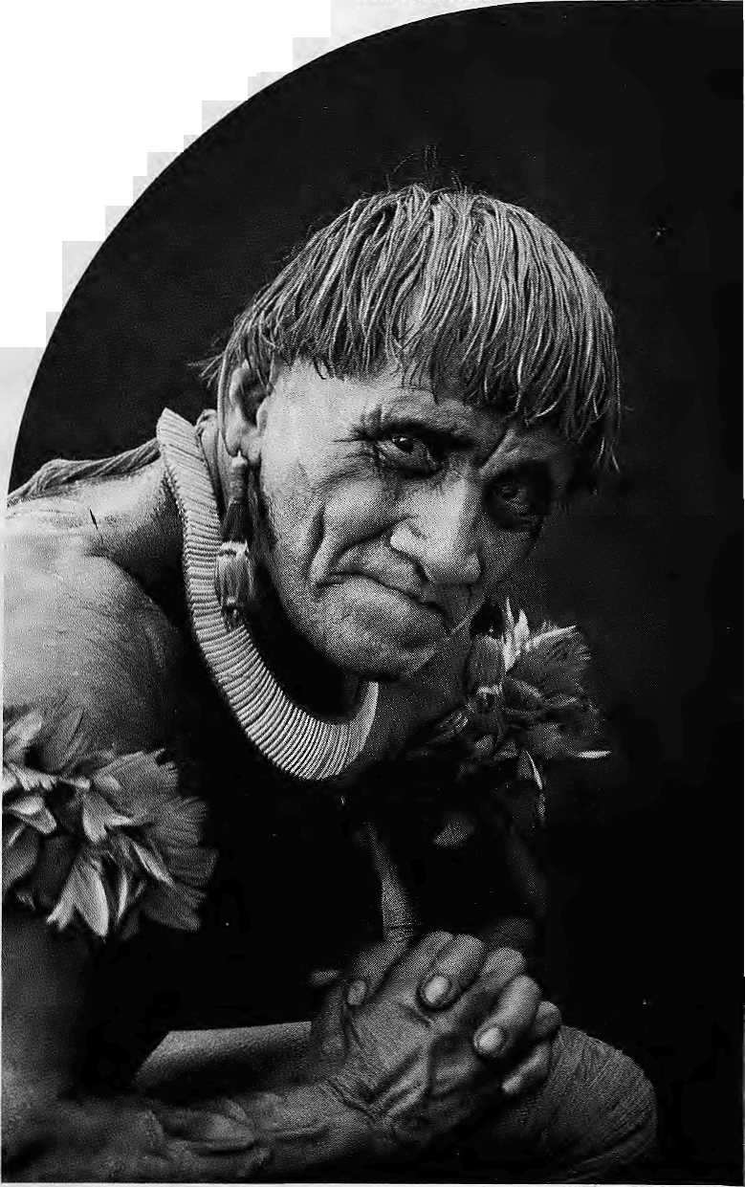

WWF World Wide Fund For Nature
(formerly World 'Wildlife Fund) International Secretariat, 1196 Gland, Switzerland.
Outside the industrialised west, no-one has to be told to respect their elders. It's simply the way society is organised.
Which is why WWF - World Wide Fund for Nature tries to work with older people in the villages of the rainforests. With WWF's help, they learn to teach the younger members of their communities about conservation.
In Kafue Flats, Zambia, it's Chief Hamusonde (93).
Chief Bakary (78), is our man in Anjavi-mihavanana, northern Madagascar.
In Ban Klong Sai, Thailand, we invoke the Venerable Papasro Bhikkhu, seventy-three year old chief Buddhist monk.
This isn't just expediency, it's how WWF believes conservation projects should be run.
Before you teach someone, we believe you have to learn from them.
We spend years visiting village after village, talking to the people, listening to them, living with them, understanding how they live their lives.
Only then are we able to gain the confidence of the village elders.
Oncc they realise we're, on their side, our elderly converts promote conservation with a zeal that belies their ye.irs.
"Uncle" Prom (68), another of our Thai community leaders, tells us that he frequently gets scolded when he starts telling people in the market that they should leave the forests alone. But he gets results.
Uncle Prom and his fellow villagers recently nianTgtrd-toprevent a new logging concession, and scr up a community forest where tree felling is now fotbidden.
Ninety-three year old Chief Hamusonde also makes things happen.
Income from the Kafue Flats game reserve in Zambia is funding a school, a clinic and new water boreholes for the local villages.
In Madagascar, seventy-eight year old Chief Bakary's village makes a profit by selling fruit grown in their new tree nursery.
More importantly. Chief Bakary's village now takes fewer trees from the rainforest because the nursery can provide firewood and poles for construction.
Not that we don't believe in catching them while they're young. WWF also organises special training courses to help teachets incorporate conservation into the curriculum.
20,000 primary teachers in Madagascar have already taken part.

And WWF produce teaching aids as well as teachers.

We commission educational factshcets, booklets, posters and videos in over twenty different languages. These are distributed to schools and colleges all over the world. If you can
help our work with a donation or a legacy please write to the membership officer at the address opposite.
You only have to look around you to see that the world still has an awful lot to learn about conservation.

HE'S JUST ABOUT OLD ENOUGH
FOR OUR TEACHER TRAINING PROGRAMME.

Regd. No. Lalitpur 65/045-46



Northwest makes it easy to go to America. With a choice of 8 gateways. And connection to 200 cities beyond.
Choose a connecting city that suits you best: Bangkok, Hong Kong or Singapore.
generous free flight plan there is. General Sales Agent in Nepal :
Malla Treks,
Malla Hotel Arcade,
Kathmandu, Tel. 418 389
Northwest has daily 747 flight via Tokyo or Seoul straight to the U.S.A.
Be sure to ask about WorldPerks, the most


NORTHWEST AIRLINES
SOME PEOPLE JUST KNOW HOW TO FLY"

