NRs 40 DM 9
IHs . 25 £ .4
Nu 30 US 5
US 4.75 In North America
Vol6 No 6


HIMALAYA N M A G A 2 I N E



lii


-fe . "■ %

I

; m


Mm-. ;■.

an ear jor music
Market God in Karakoram • Sikkim and Sukhim

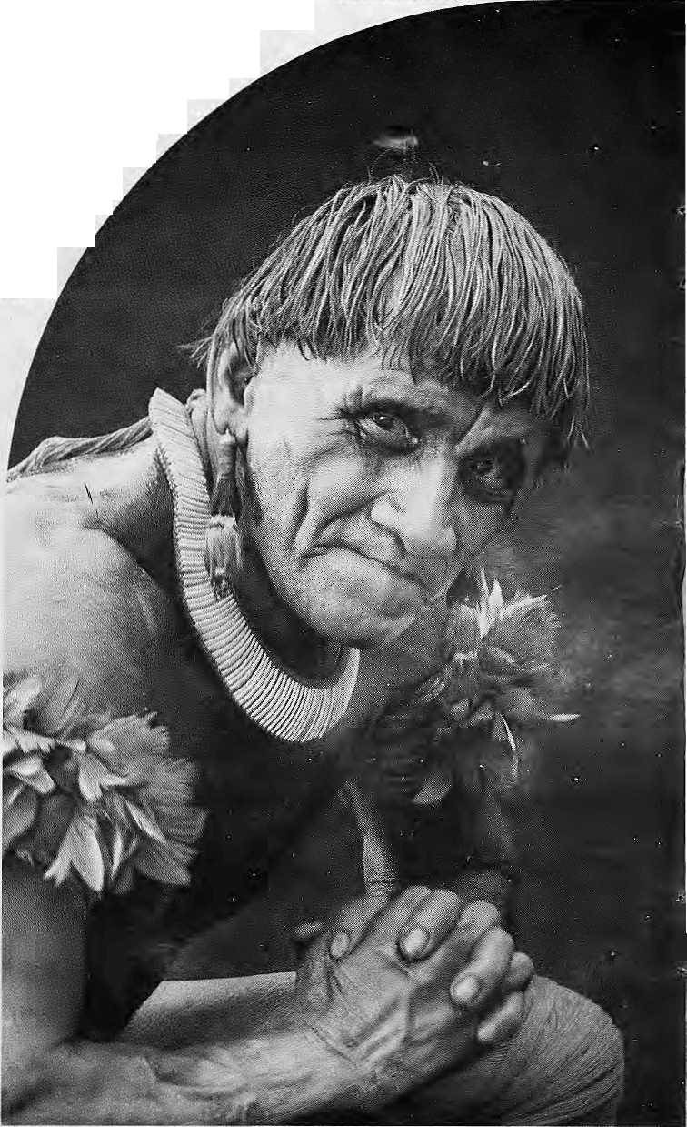
m
WWF World Wide Fund For Nature
(formerly World Wildlife- Fund) International Secretariat, 11% Gland, Switzerland.
Outside the industrialised west; no-one has to be told to respect their ciders. It's simply the way society is organised.
Which is why WWF - World Wide Fund for Nature tries to work with older people in the villages of the rainforests. With WWF's help, they learn to teach the younger members of their communities about conservation.
In Kafuc Flats, Zambia, it's Chief Hamusonde (93).
Chief Bakary (7S), is our man in Anjavi-mihavan.ina, northern Madagascar:
In Ban Klong Sai, Thailand, we invoke the Venerable Papjism "Bbikkhu, sevetity-three year old chief Buddhist monk.
This isn't just expediency, it's how WWF believes conservation projects should be tun.
Before you teach someone, we believe you have to learn froni them.
We spend years visiting village, after village, talking to the people, listening to them, living with them, understanding how they live their lives.
Only then are we able to gain_thc confidence of the village elders.
Once they realise we're on their side.our elderly converts promote conservation with a zeal that belies their years.
"Uncle" Prom (68), another of our Thai roiumunity leaders, tells us that he frequently gets scolded when he starts telling people in the market that they should leave the forests alone. But he gets results.
Uncle Prom and his fellow villagers recently managed to prevent a new logging concession, and set up a community forest where tree felling is now forbidden.
Ninc-ty-rhrcc year old Chief Hamusonde also makes things happen.
income from the Kafue Fl.its game reserve in Zambia is funding a school, a clinic and new water boreholes for the local villages.
In Madagascar, seventy-eight year old Chief Bakary's village makes a profit by-selling fruit grown in their new tree nursery.
More importantly, Chief Bakary's village now takes fewer trees from the rainforest because the nursery can provide firewood and poles for construction.
Not rhat we don't believe in catching them while they're young. WWF also organises special training courses to help teachers incorporate conservation into the curriculum.
20,000 primary teachers in Madagascar have already taker part.

And WWF produce reaching aitts as well as teachers.

We commission educational factsheets, booklers, posters and videos in over twenty-different languages. These are distributed to schools and colleges all over the world. If you can
help our work with a donation or a legacy please write to the membership officer at the address opposite.
You only have to took around you to see that the world still has an awful lot to learn about conservation.

HE'S JUST ABOUT OLD ENOUGH
FOR OUR TEACHER TRAINING PROGRAMME.

INSIDE...

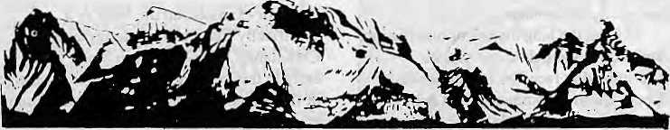
MAIL
Christian Qualification
In his brief mention of our newly registered organization ("The Gospel Comes to the Hindu Kingdom", Sep/Oct 1993), Saubhagya Shah writes that "...the terms 'Christian', 'Jesus' or 'mission' did not appear' in the registration form submitted by the Witness for Nepal group." We are writing to inform you thai Shah has been misled by some mischievous source. By twisting obvious facts, some pathetic elements in the church are always attempting to denigrate service organisations like Witness for Nepal by spreading malicious lies. In future, you should be wary of the particular sources which filled you up on the Witness news.
Since Shah has felt that mention of these terms are prerequisite qualifications for Christian organisations, may we mention that the name 'Jesus Christ' appears two times on the preamble of the bylaws submitted to and approved by the Lalitpur District Office. Similarly, the word 'Christian Isaee' twice and 'Ekklesia Church' once.
Lokmani Dhakal and
Lobiath Manaen
Wi tness fo r Nep at
Sanepa, Kalhmandu
A Bankrupt Faith and Cultural Imperialism
Saubhagya Shah's piece on Christian conversions in Nepal was informative, thoughtful and well-balanced, considering the sensitive and acrimonious nature of the whole subject. But in order to retain that sensitivity and balance, Shah perhaps had to refrain from probing deeper into some of the issues surrounding religion and missionary work in Nepal. The agenda of both the missionaries and their Nepali opponents are
steeped in contradictions which transgress 'religion' narrowly defined. As these issues must sooner or later come out into the open, I volunteer to unlock the pandora's box with the following thoughts.
A religion that segregates whole sections of its own followers as unclean and untouchable, and on this basis puts severe restriction on their use of religious texts, temples, and in so many other ways socially, economically and culturally discriminates against them, is, by this fact alone, a bankrupt faith. The greatest blight upon the Indie cultures is that of caste. It individually negates every positive spiritual and philosophical virtue that Hinduism as a religion and cultural system can lay claim to.
In India, at least, the modern battle against caste discrimination has a history going back to the early 19th century, when Hindu reform movements formed in pockets in northern India. In Nepal, by contrast, no serious and sustained effort has been made from within the Hindu community to attack and challenge the caste system. No religion can maintain its moral ground and continue to impress newer generations with its spiritual message if it does not address certain contradictions within itself as exposed by the passage of time. Instead of reform, however, Hinduism in Nepal has opted to adopt orthodoxy as the preferred method to deal with challenges.
A nation whose 'official' religion prohibits 15 to 20 percent of citizens of the same faith from openly entering and worshipping in public temples has lost the moral ground to question the intention of non-Hindu preachers, be they Christian, Muslim or Buddhist, hi light of the historically multi-faith and multi-ethnic structure of Nepali society, nothing in Nepal is in greater need of purging than the antiquated and dehumanising way in which
COVER
10 What is Nepali Music by KishorGurung
All genres in music am affected by change. Yet, they remain identifiable as Nepali.
12 The Goat and the Music God by Gert-Matthias Wegner
How is divine energy tapped in Shaktapur?
15 Where is Srtastriya Sangeet
by Omar Sattaur and Gen-Matthias Wegner
Is Classical Music and its players on their last legs?
23 Kathmandu, a Valley Fertile for Music by Ingamar Grandin
Does charge have negative implications for music or does it help it evolve?
28 Sound of One Mind Working by David Rothenberg
Tibetan Ritual Music wakes us up to the vibrancy of the world.
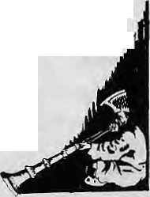
32 Ancient Rhythms and Modern Messages by Timothy Maiyon
Ladhakhi folk music is still embellishing old music j with new ideas.
PROFILES
18 Krishna Naryan Shrestha 30 Ram Sharan Darnal
FEATURES
44 From Sikkim to Sukhim byA.C. Sinha
Sukhim, a Nepali dominated State, would respond to the frustrations of Nepalis in India.
49 Market God Introduced to the Northern areas by Thomas Hoffmann
Questening succes to see what makes for success and the prospects of reproducing success.
DEPARTMENTS
20 Voices
35 Abstracts
37 Briefs
43 Himalaya Mediafile
52 Abominably Yours
Cover: A Gains boy singing to his Sarangi
in Patan Darbar Square. United Nations Piciure, April 1967.
Himal © 1993 is published every two months by
Hi ratal Association PO Bos 42, Sridiirbar Marg, Lalilpur, Nepal.
Tel: 977 I 523845, Fax: 977 ] 521013. ISSN 1012 9804, Library of Congress Card
Catalogue No. 88 912882.
Subscription information overleaf. Printing: Jagadamba Offset. Tel: 977 1 521393.

Nov/Dec 1993 HIMAL . 1

HIM&L
Vi)U 6 No. i! Npv/Dec 1993
45(4 -ft
The Abode nJGod$,JKthg of: Mourtimna. Himalaya
You hound iht' oceans.from
easttowest A riortkefn yardstick To measureihe Earth
Sditof
Associate Editor Gon suiting Gdi for ■ vfanaging E<iitor> holography Administration

Kaiiak ManlDixit
I'cina Wangchuk Btkas Saiijtiar
BalaramjSfiatnw " : Prakriti Karniatharya
Subscription Kates
3qt NOT-send cash in mail.
Nepal . NRs 220 ,..400,
India IK* 140 : 260
Jgbutan N11 .]75... . 330..
QthtrS. AsianCountries •.US 12 20::
North America U$ : 22.50 40
raiaiiy . DM 5^ , ^0:
United Kingdom & Ireland £ 20 35
Netherlands Dfl 45 80,
:ewhere US '".. 25 45
i
NRs 600: 1106
IRs 260 5001
Nh :33O ; 640
U$ 25 45
U$ 40, 70
DM 70 .120:.
£ 30 50-
Dfl 100 18<>
US 45 : .80
Nepal
India
BWan
plher S.Asian Countries
North America
Gcmjany
CTiiited Kingdom & Ireland
Nelhsrianrfs
Slsewlieru,
Send a)) subscription orders and
South ^{As}la: PO. f3ox42,LalIq>ur,Nepal
(tel 977 1 523345, fax 977 1 52ltfi3), 'of:,.
Central News Agency, 23/90 ConnaugM
Circus, New Dellii HODM [apnn: Aiio HoriuchJ,
MBos 9, Kiyo&e, Tokyo, 2O4Xipan: Australia: Itidra Ban, L2 Norfolk St.,.
Paddiogton S021, Syiincy, Australia. Vortli America: BarUiira BeiSa & Associates, 500
Saiisome Street, Suilu 10 ], PD feus. 470358
San Francisco, CA t>4i47 JntlcU Kingdom & Ireland: Joti Oiri (ReC H),
221 Ashly Gardefts, iiinery Hill Street;
London SW1P1PA fhtMethertands: C. F. (fe Sloppelaar,
Foundatioi) liiinalaya, Kcacrsgmcth 463_{T}::
1017 PK Amsterdam Switxeflitnd; HclemvZingg, Janntuweg IB,
CH-3073, Guemligen, Swiserland Eurojus OurgaPress (HHylAL), Luttpoldstr; 20. :
Hinduism is publicly and privately practised. In every corner of rural Nepal today, for example, untouchability is knowingly and openly imposed by the high castes upon the low castes, with the complicity of the state.
Given the long history of humiliation, denigration and public and private discrimination faced by low castes and Tibeto-Burman communities, it is little wonder that the Nepal hills are proving to be ihe new Bible Belt of South Asia. Humans have an innate sense of justice and equality, and they wil] use any method or message,
Guest Editor for this Music Issue isOmarSatteur.
be it Communism, Christianity, or Development-ism, to bring them about. In Nepal, millions of under-privileged Hindus and Hindu-Buddhists are in need of social and economic liberation. If Hinduism, as usual, fails to champion the cause of the depressed some other faith will; and when that happens on a large enough scale, those Hindus that have sat complacently by as their fellow religionists suffered under caste-based and socioeconomic discrimination will have lost the right to point fingers at others.
Yet, this story of the growth of Christianity in Nepa] is not without its deep irony, one arising out of Ihe nature and history of the Christian message itself. A religion that is founded upon the belief that all those who do not accept its particularistic Gospel, are by definition deprived of God, salvation and heaven, is no less arrogant and bankrupt than blinkered Hinduism. By last count, those not embracing the Gospe] included three quarters of humanity! It also should not be forgotten that at one time Christian churches and clergy, with some notable exceptions, openly supported and justified slavery, the pillage and genocide of non-European peoples, and colonialism — the exploitation of the entire globe by a handful of white. European nations. Today, Christianity proposes to save the Nepali millions, and the millions in nations that Europe once economically and politically colonised.
Missionaries have always been interested in the spread of a consciously Western Christianity. Far from spreading the Middle Eastern liberation ethic that Christianity was originally about, the missionaries are in the business of teaching non-Westerners how to structure their
spiritual and cultural selves along Western lines. Not only are they saying, "believe in Christ", they are also prescribing the narrow limits within which Christ ought to be believed.
For example, on the basis of a specifically Eurocentric interpretation of Christianity, missionaries in South India early in this century prohibited the exchange of flower garlands by bride and bridegroom at weddings, and proscribed such 'heathen' practices as the wearing of red by the bride, and die playing of Indian instruments at church ceremonies. Thus practised, evangelism became no more and no less than the ideological corollary of" the colonial Western mentality that the natives needed the civilising touch.
From every indication, in Nepal too, missionaries are requiring that converts renounce their cultural/ritual and tribal/caste identities, their customs, codes and festivals. But countering the caste system should not require individuals and communities to jettison major aspects of their self-created social and cultural identities. What the missionaries propagate is not Christianity, but an attempt at cultural imperialism. It is not the spread of Christ's teachings, but the imposition of narrow Western spirituality and cultural identity on a people whose mode of existence is radically different from that which confronted, or presently confronts, Western humanity.
But all this is not liable to deter the missionary, whose chief purpose in life is to see the global proliferation of the cross mounted on high ground. Hinduism, when and where it matters most, is blind and inhuman. Christianity, offered as an alternative in Nepal (with huge, global financial backing), is as blind and operates under equally dehumanising assumptions.
The real losers are the converts who will invariably find that discrimination does not end with conversion; if anything, it will assume an even more pernicious form. They will have lost their cultural, communal/ ethnic identity, and their special spiritual practices in exchange for the sanitised and de-contextualiscd religio-cultural world of Western Christianity. Caste discrimination will be gradually absorbed into the Nepali church, as it has in India. Denomi-national rivalries will become the surrogates for caste tensions.
Additionally, the converts will have tost any hope of finally breaking into the

Z . HIMAL Nov/Dcc 1993

MAIL


Nepali 'mainstream', a socioculmral milieu to whose creation they and their ancestors have contributed heavily, and in which they ought to have a rightful place and stake. This, unfortunately, is the irony of conversion to Christianity, a process which, incidentally, this writer does not oppose. What I do feel qualified to do is to call upon Nepal's native spiritual community — Bons, Shamans, Buddhists, reformed Hindus — and secular agents such as political parties, to carry high and far the flag of social reform and revival as well as values of justice and freedom. Without resorting to the remote and alienating world of Western Christianity, and without privileging a class of people who have no longterm stake in the land (global missionaries), the historically depressed castes and classes in Nepal must empower themselves permanently!
Anup Pahari
Lancaster, Pennsylvania
Religious Double Standards
Saubhagya Shah's in-depth piece on the activities of Christian missions in Nepal needs to be appreciated The increase in the number of converts over the last three years alone indicates that the missionaries are doing what they are legally forbidden to do and the Nepali Government is not doing what it is constitutionally required to do.
I have, in my possession, a booklet published by the United Mission to Nepal in 1972 which says, "There are perhaps 500 active Christians in the whole of the country, with about one-fourth of that number being converted, baptized Nepalis."
Qnly twenty years later, Shah reports, the number has risen to-more dian 100,000. Would this increase be possible if missions like the UMN were not involved in illegal proselytising?
But the issue here is not just of it being illegal; it goes further than that. It entails a very fundamental moral question that the missionaries need to ask themselves. Each one of them knows that in / the process of luring illiterate Tamangs and greedy Bahuns into the Christian fold, they find themselves condemning Buddhist and Hindu faiths.
Should this be tolerated by the Nepalis?
The West maintains a double standard when it comes to human rights and religious freedom. In the United Kingdom, for example, the Queen is an important religious leader. To the West, this is natural and unquestionable. But when Nepal wants to maintain its age-old Hindu character, diey object to it directly. (They are convinced that cultural identity needs to be preserved in Bhutan and Tibet, but the same reasoning does not seem to apply in case of countries like Nepal and Burma.)
Deepak Basnet Kathmandu
Further the Dialogue
I appreciated Saubhagya Shah's well-researched and thought-provoking article and would like to further the dialogue on this by offering some comments.
The article's underlying assumption, that the increase in the number of Christians in Nepal is due to foreign activity, falls short of the truth. Shah presumes that because in other parts of South Asia the Christian Church was started and expanded by Westerners, the same is also true of Nepal, It has to be noted, however, that it was the ethnic Nepalis from Darjeeling who first began Church work in Nepal in the 1950s. HMG/Nepal does not grant visas for foreigners to work with the church and expatriate Christians may not take leadership positions working in development projects, although they can worship with local Christians.
Contrary to what Shah suggests, the church, in Nepal, has grown strong because of its independence from foreign personnel and control and expands due to the enthusiasm of Nepali Christians in today's democratic context. I believe that their numbers would have increased even if every expatriate Christian had been expelled in the Spring of 1990.
Another troubling
presumption in the article that Nepalis turn to Christianity because of "non-spiritual enticement" or, as Minister Rai
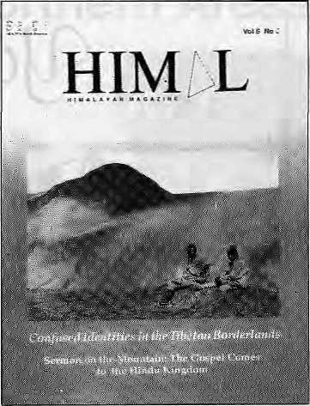
calls it, "allurement of money provided by missionaries" is condescending towards fellow Nepalis who choose another religion. And where is the proof of such accusations? I often ask for reasons when such suspicions are voiced; they have never been forthcoming!
In fact, the Christian organizations working in Nepal oppose conversion through "non-spiritual means." A UMN expatriate if proved to have offered a bribe to someone to become a Christian would be sent home.
The Nepali constitution guarantees freedom of speech, press and assembly and allows anyone to share the meaning of personal faith ■— provided it is done without maligning another's beliefs.
The term "proselytising" was clarified in a letter requested by the government in 1990 to mean "attempting conversion through coercion or offer of material inducement," No Christian would approve such activities and I doubt if Shah meant to condone them by suggesting that proselytisation be legalised.
The confusion about "conversion" is more to do with conceptual gap in understanding at two levels, than with their linguistic implications in Nepali and English. First there is the relationship between culture and religious beliefs. For many of my Nepali Hindu friends, culture and religion are almost synonymous; being a Hindu seems an important part of being a Nepali and changing one's religion amounts to abandoning one's culture.
Nov/Dec 1993 HIMAL . 3



pKl\iate

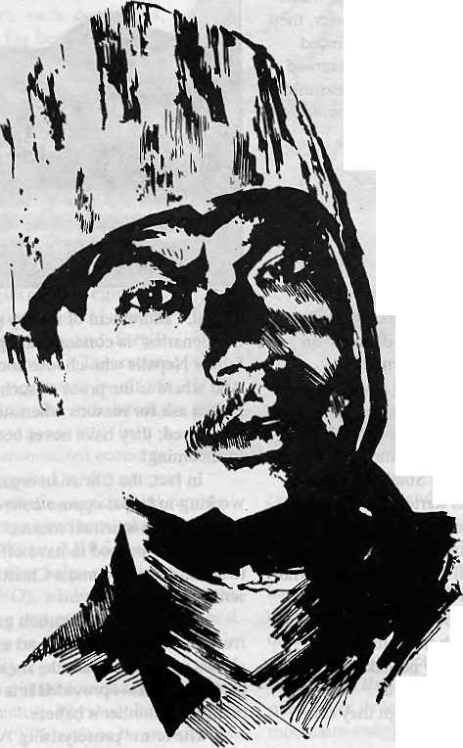
This man doesn'thavea Hotel Management Degree. Neithernas he mastered the artof landscaping. And yet tohim-weoweourPrivate Paradise. V\)
He is our gardener, the creator of our prize-winning garden SHAMBALA. A true reflection of our commitment to a greener and healthier environment. Because within our hotel, fr+ we chose to build a Shangri-la-a true haven, to show the world what they came to see -nature's resplendent beauty. *fl)
Perhaps,it is the splendours of our garden lhatenchants our guests into coming to stay with us, again and again. Or perhaps, because of our gardener, our people...who care for the environment.



I
SHANGRI-LA
KATHMANDU
NEPAL
G.P.O BOX; 655, IAZIMPAT, KATHMANDU, NEPAL TEL: 412999, TELEX: 2276 HOSANG NP, FACSIMILE: 977-1-4] 4184

MAIL

(Although, of course, my Nepali Buddhist friends have a different perception!). Worldwide, Christians express their Faith in many cultural forms and contribute fully to nation building. (More Christians now live in Asia, Africa, and Latin America than in the traditional Christian North.)
The other conceptual gap deals with the agent of conversion. In Christian understanding, no one can '*c on vert" another. One can explain personal convictions and even pTeach persuasively of the love of God, but the decision to follow Jesus can only be voluntary.
Christian acts of compassion express the love of God. A true follower of Jesus, thus, shares with those in need and works with them for their own development. This is done not out of sense of duty, but out of gratitude for the love and grace received from God. Thus, to suggest that social ser/ice is only a means to convert, is a distortion of the example of Jesus and the teaching of the Bible.
One of the burdens of identifying with religion is its association with those who have beliefs and practices quite contrary to the central ethics of that religion. I have Hindu friends who abhor what is being done -- in the name of religion — to Muslims in India and Buddhist friends who totally disagree with the actions of Buddhist clergy against the Tamils in Sri Lanka. Likewise, there have been many violent actions throughout history in the name of the church — the Crusades for one — that I would utterly condemn.
Shah's capsule history of 19th century mission efforts in South Asia, too, is quite distorted. Those missionaries disagreed with the earlier Western invasions of the Subcontinent, which sometimes used weapons to force conversions. The pioneering efforts of the last century to establish hospitals and schools were expressions of the love of God, not a mere shift in strategy, as Shah seems to think.
I suggest that Shah study the remarkable growth of the Christian church during the last few decades in places where the government was intolerant and there was no outside support {such as in China and in Eastern Europe) or in other places where there are very few or no Western missionaries.
I agree with Shah that there should be transparency and openness. In UMN, we now include non-Christian Nepali staff at
the highest levels, including the UMN Board of Directors. We do have informal links with Nepali churches, as is to be expected of an organization sponsored by 39 church bodies from 18 different countries; one chief characteristic of the Christian church is that it is a universal community transcending human divisions such as race, nation, caste and ethnicity.
Shah's call to "sincerely contemplate the questions of religion, ethnicity and nationalism¹" is urgent. Worldwide, newly formed nations, as well as the societies which thought they had settled this problem, arc struggling to keep the melting pot from boiling over. Can Nepal, then, provide a model for the world by developing a productive balance between human rights for individuals and organizations and the need for some kind of national unity? I hope people of all religion and communities will join in to search for the answer.
Edgar Metiler Executive Director, United Mission to Nepal, Kathmandu
Alliance for Identity
Gopal Gurung's letter {Mail Sep/Oct 1993) reflected his desire to sec the identity of Mongols secured in today's Nepal. However, Gurung should have realised that tracing the origins of the word "Mongol" takes us further than Kumaon, Garhwal, or even Raj as than.
All of us — Bahuns, Chhetris, Newars, Gurungs, Rais, Tharus and other ethnic groups, who have been living in this country for hundreds of years — should come together and try to cultivate the feeling of oneness to work for the development of the Nation. And Mr. Gurung, who seems concerned about protecting democracy, should rather try to mobilise the Nepali nation against outsiders — against the threat to Nepali culture, tradition and identity.
A "blood bath" would have dire consequences. It would leave no Mongols, no Bahuns, no Chhetris and will serve only the purposes of outsiders — for them it would be a scented bath. As Nepalis, we should come together and form a strong alliance to Tesist the threats to our identity*
P, Timilsina • Gyaneshwor, Kathmandu.
In Bad Taste
1 recently chanced upon your Sep/Oct 1993 issue. The cover enticed me enough to go through the magazine. I thought, now here is a magazine concerned about the people in the Himalaya-Excited, I read on.
When I got to page 6 though, I was appalled. There was a trekking agency ad which had the sketch of a young pahadi porter smilingly carrying an extremely pleased, camera-clicking foreigner up a mountain trail.
Was the porter as happy as his smile seemed to suggest? Or was the smile etched on to his countenance later by the trekking agency which, for a neat sum, would like to allure pseudo mountain lovers with offers of human rides?
In your copy, you talk of development in the mountains, your concern for progress of the people who live here. But where do your resolutions stand when you accept such lurid ads? Doesn't it go on to demonstrate that we still view ourselves as load-carrying -primates?
There is no dearth of magazines that unthinkingly cany advertisements as blase as this but it was disheartening to see it printed in a magazine like liimal. Sandeep Bhatt Alpine Adventure Club, Gopeshwar, Chamoli, U.P.
Wrong!
Bill Aitken, in his otherwise elegant piece "Fairest of Them All" {Know Your liimal, Sep/Oct 1993), states that Melungtse is a "Nepal peak". He is wrong. The massif is entirely in Tibet.
On the next page, the Yeti's knowledge of non-Himalayan mountains seems to leave much to be desired. Kota Kinabalu is a city. The mountain is simply Mt. Kinabalu.
Lalbahadur Lirnbu Sinamangal, Kathmandu
are invited to comment, criticise or add to information and opinions appearing in Himat. Letters should be to She point and may be edited. Letters which are unsigned and/or without addresses will not be entertained. Please include daytime contact telephone number, if available.

Nuv/Dec 1993 HIMAL , 5

Walking in the mountains of Nepal is not as difficult as you probably imagine ...

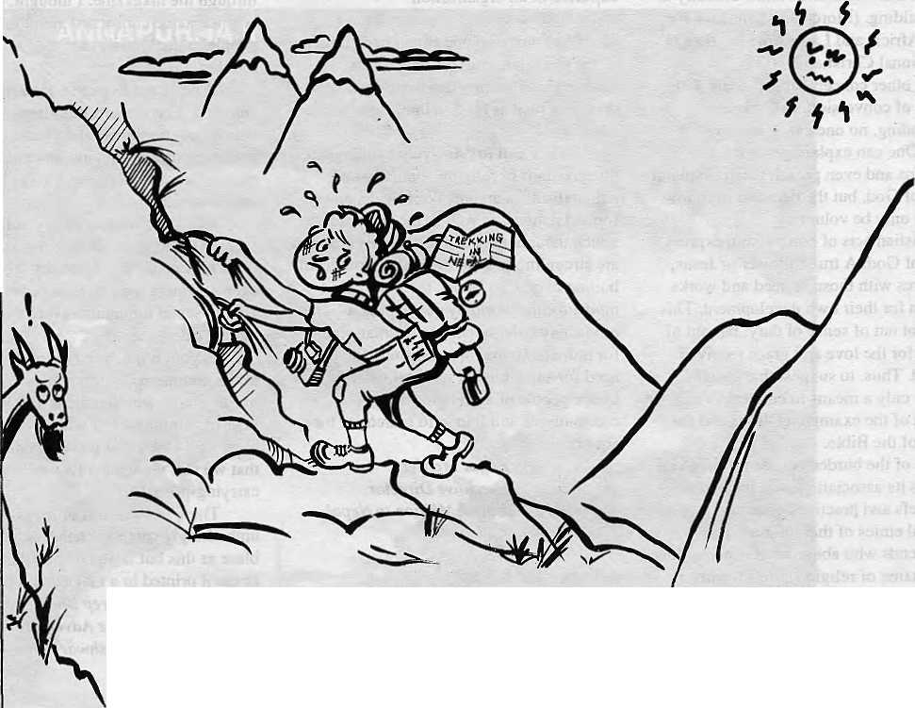
Summit Nepal Trekking makes it easy ! and tremendously enjoyable too !

Walking for several days to go from one village to another, or to the nearest market, is a part of everyday life for people in the hills of Nepal.


MMIT NEPAL TREKKING
Write or call us at:

P.O.Box 1406, Kopundoi Height
Kathmandu, Nepal
Tel: 525408, 521810
Fax: 977 I 523 737

Follow-up
The Last Newar of Chuhadi
The Sep/Oct 1993 of Himalhad an articleon missionaries, which refer red to Capuchin priests and Kathmandu Christians who wereforced to migrate to Bettiah after Prithvi Narayan Shah's conquest of the Valley. Theodora Riccardi, Jr. of Columbia University provides an account of that relocation in an essay written a few years back in honour of Luciano Petech, the respected historian of Nepal, Tibet and China. The photograph is byTodd Lewis.
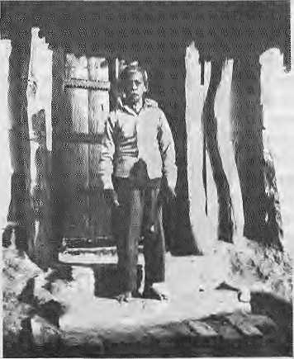
Eleazar of Chuhadi
IN 1769, theCapuchin priest, Padre Giuseppe da Rovato, leda small band of Nepali Christians to their new home in the plains of India. Most of them were Newars from Kathmandu Valley who remained loyal to theiT new religion and to the small group of priests who had tried, in vain as it turned out, to bring Christianity to inhospitable territory. The priests and their converts had beencaught in the web of intrigue and warfare that had beset the Nepal Valley for more than a decade. Prithvi Narayan Shah, King of Gorkha, had taken Kathmandu and Patan, and Bhadgaon was soon to fall. It was only with the greatest difficulty that he had been convinced that the Christians be allowed to go. The mission, which had begun in 1707, had come to an end. It was a failure, partly because of Rome's inability to see the difficulties of conversion in Kathmandu and Lhasa andpartly due to the political upheaval and military conquest that made it impossible for the missionaries to function.
Led through the mountains by the Italian priest, the Newar converts settled in a small village in Bihar called Chuhadi, near Bettiah, a town that had become, in the eighteenth century, acenterof Roman Catholic missionary activity. Little is known of the Newar community over the next two centuries. It is
said that they remained apart from the Indian population well into the nineteenth century, that they continued to speak Newari, and diat they did not intermarry with other groups until much later.
Therefore, much of the community supposedly remained intact well into this century, when it finally began to blend in more and more with the local population.
ti December 1978, Todd Lewis and I visited Chuhadi to see if any trace of the original NewaT community remained. Unfortunately, we arrived just before the very end. We reached Bettiah by car one afternoon a few days after Christmas. The main church, the Church of St. Rita, so dominates the town that we found it widiout difficulty, and it was there that we made our First inquiries. A priest directed us to the road to Chuhadi, which he said was about four miles away. The road was unpaved but in good condition and we arrived there at about four o'clock.
At first glance, Chuhadi differed little from the other villages of northern Bihar. It was thick with thatch-roof huts that sat amid plantain trees and mango groves. Its one distinguishing feature was the small chapel that stood near its centre. The head of the mission, Father Pollard, a Canadian Jesuit from Windsor, Ontario, was outside when we arrived, and he greeted us and offered us tea.
He responded Teadily to our questions, but he said that he knew little of the history of the Christian Newars. He confirmed that they had remained apart from the local Indian population for a long time, but that they ine v i Lably had begun to intermarry with Indian Christians. Only two members of the community were left — an old man by the name of Eleazar, and his wife, Susannah. We could meet and talk with Eleazar, he said, but Susannah was sick and probably would not want to see anyone, particularly two strange Westerners.
After tea, towards dusk, outside the old man's house, we met Eleazar. He was small and frail, in his late sixties, short even by Nepali standards, his appearance almost archaic, like some portrait of a Newar come to life after two hundred years. I'spoke to him in
Hindi, since he knew no Nepali or Newari, He spoke softly, but with great dignity. He said that he had been born in 1911.1 asked him about his ancestors, and he said that they had come from Nepal. As he spoke he pointed north to the greenhills that were visible in the horizon. I asked him about his family, his father and other members of his family, but he volunteered very little. The family had come from Nepal, but they had always lived in Chuhadi. Fourteen families in all had come, but none had ever returned. I asked him questions about the Newar culture and about modem Nepal, but it seemed that he had no clear idea of how Newars and their language could be distinguished from other Nepalis, and he had no knowledge of modem Nepal. His wife, Susannah, was only partly NewaT, he said, and she knew less than he did about their origins.
We spoke for a few minutes about the composition of the village — very mixed, he said, Hindus, Muslims, and Christians. He seemed diffident, even fearful, embarrassed by my questions, and I decided not to disturb him any further. I stopped and thanked him. I asked if we could take his picture, and he agreed without hesitation. We thanked him again andreturned to thechurch. Father Pollard then permitted me to look at the baptismal records, but those that were available began only in the 1840s. They contained only Christian names and general occupational designations in Latin such as agricola, auriga, etc. Any original caste or ethnic status was obliterated by the name given during conversion.
Father Pollard said that we had missed meeting Mary Anna, an old Newar woman who had died just six months before our arrival. She spoke Newariandknew more than anyone about the history of the community.
We thanked the priest for his help and took our leave. The winter sun was about to set, and it was almost dark as we left. We reached Raxaul, cold and hungry, at about eleven thatnight, and shortly thereafter crossed the border happily into Nepal.
Had some historian or linguist visited this village during the previous two centuries, we might have learned something about the Newars of Chuhadi, their memories of the valley they had left behind, and their language. We know only that after their arrival, da Rovato and the priests who followed later tried to help them adjust to their new home. They even composed dictionaries for them in Hindi, Bhojpuri, Newari, and Italian. These and the letters back to Rome are all that remain, however. The human record is gone forever.

Nov/Dec 1993 HIMAL . 7

What is Nepali Music?

Does music lose its identity when traditional
instruments are replaced by modern ones? Or are
musical ideas more important?
by Kishor Gurung
W
hile music lovers and musicians may find no difficulty in recognising Nepali music when they hear it, asking diem to define it more often than not results in a confused reply. This is not surprising, since a satisfactory definition of Nepali music would have to consider the many sources of musical ideas that aie, and have been, available to Nepali composers.
No account of Nepal's art can failto acknowledge the debt it owes to the diversity among its 19 million people of some 32 ethnic groups, who speak variants of 56 languages and dialects of Indo-Aryan, Austro-Asiatic, Tibeto-Burman and Dravidian origin. In addition, the threeprimaryreligions that underlie Nepali thoughtand ways of life— Hinduism, Buddhism and Animism— are intrinsic to the development of Nepali art forms. The assimilation of themes they have inspired is apparent in stone and wood carvings, metal sculptures, tftanfajpaintings, mandata drawings and architectural designs. Music, dance and drama are Tooted in these religions conceptually, metaphysically and in theft theoretical development. Hinduism's conceptualisation of sangeet (music) is elaborate, hi its fundamental form, sangeet denotes vocal music, instrumental music and dance. But, conceptually, it further pertains to paintings and sculpture. A passage from theNatya Shasktra, written around the Third Century BC, highJights this interrelationship between the art forms:
A king, wishing to learn how lo sculpt likenesses of the gods, consulted a sage for instruction. "You will have lo learn the laws of painting before you can understand the laws of sculpture", the sage advised. "Then", said the king, "teach me the laws of painting". "It is not possible to understand the laws ofpainting", replied the sage, "without learning the art of dance". "So teach me the art of dance", the king requested. "That wilt be difficult" said the sage, "asyoudo not know the principles of instrumental music" .The king, by now,was growing impatient. "Then why don't you teach me instrumental music?", he demanded hastily. "But you cannot understand instrumental music", answered the sage, "without a thorough study of vocal music, for vocal music is the source of all Art.
Hindus relate the creation of the very firs t sound, Nad, to Brahma, the creator of the Universe. Vishnu and Shiva are the two other members of the Hindu holy trinity, personifying the preservative and destructive forces, respectively. Spiritual contemplation of this trinity guides the creativity of artisans and musicians. Swaras (tones) and shrutis (microtones), manifestations of Nad, aTe described synesthetically as being "pure" or "true", and musicians hold that their proper execution brings one closer to Brahma.
At the other extreme, Shiva's frightening dance, Tandavnritya, is associated with the destruction of the universe while Vishnu, the preservative force of the Universe and all art forms. Iconography and
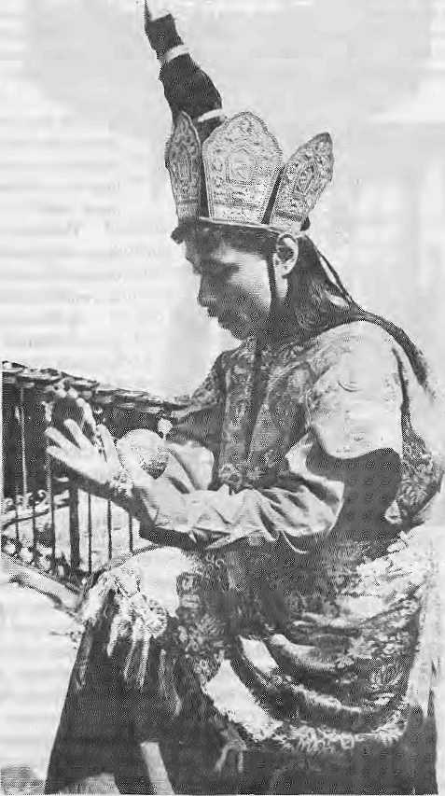
A Charya dancer performs before the Pancha Buddha at Swayambhu on Buddha Jayanti
illustrations associate certain Teligious figures with specific musical instruments: the sitar (plucked lute), for example, is associated with Saraswati, the bansuri (transverse flute) with Krishna and the ektara (one-string plucked lute) with Naradmuni. Furthermore, the classification ofmusical instruments into tata (literally "stretched" or chordophones), susira ("tubular" or aerophones), avanaddha ("covered" or membranophones) and ghana ("solid" or idiophones) is based on principles found in Vedic literature.
Theoretically, all Hindu shashtras (doctrines) trace the origin of raagas to thechantings of the Vedic scriptures, in particular to iheSaam Veda. The Vedic chantings are characterised by three tonal divisions called udatta, annudatta and swarita, collectively known as the samaganas. It is believed that samaganas were the basis upon which all swaras, shrutis and, later, Taagas were developed. The genre of music that incorporates raagas is dierefore, called shashtriya sangeet, a term virtually unknown in the West.

8 . HIMAI. Nov/Dec 1993

Baki Wanegu
Although the Buddha himself is thought to have considered music as detracting from the religious life, in many Buddhist Asian nations and communities "Buddhist music" continues to influence culture, and Nepal is no exception.
The Mani Rimdu, a 13-act dance drama performed by Buddhist-lamas of Tibetan ancestry, at Tengboche monastery in Khumbu, is but one example. In this play, the "erroneous teacher of Buddhism" is represented by an eighth-Century Chinese philosopher, named Me-Tshring, a comical character who is ridiculed. By ridiculing Me-Tshring, the masked dancers not only reinforce the idea of superiority of good over evil but also strengthen the common faith that binds people of a displaced culture.
As in Hinduism, some religious teachings can be explained only through music. For example the idea of infinity is expressed by the playing of two cymbals with increasing rapidity; at its fastest, the two cymbals are rubbed together.
The Baki Wanegu, (blowing of horns), is an example of a ritual that has survived from the earlier, indigenous form of Buddhism practised by the Newar communities of the Kalhmandu Valley, The performance, which takes place during the holy month of gunla, July-August, lasts for eight days and ends with the Mataya festival. It is believed that blowing of horns around the monasteries and chortens willbringpeace and salvation to the souls of dec eased family members. AlthonghBakiWanegu is a Buddhist ritual, the statues mounted ondha and damkhin (two-headed drums) are those of the Hindu deities, Mahataxmi andMahakali, indicating a synthesis of Hindu and Buddhist cultural elements.
Jung's Music
Between 1715 and 1768, there were Christian missions in Kathmandu Valley but no influence of Western liturgicai music has been observed from that period. The promulgation of Western music in Nepal seems to have followed neither in the footsteps of missionaries nor in those of the European colonisers and traders who had so much influence in other parts of Asia. Instead, Western music saw its initial institutional is ation in the military bands of the Nepali Army, during the second half of the 19th century.
While they continued the policy of isolation, the Ranas imported certain Western ideas that had profound influence on music. The Ranas' political strategy halted colonial aggression and formalised the recruitment of Gorkhas into the Colonial army. This, in part, led to Jang Bahadur's much publicised tour of Europe in 1850, which was the most important encounter between the cultures of Europe and Nepal until that time.
During his stay in England and France, between 25 May to 12 October 1850, Jang Bahadur attended more than a dozen operas, ballets, plays and recitals. The Nepali strongman's visit to England was commemorated by various compositions written in his hondur such as Kunwar Ranaji Polka, Long Live Jang Bahadur, The Nepalese Prince and The Highland Chief. There is an apocryphal story about Jang Bahadur's appreciation of Western music. It is said that during an enthusiastic curtaincall,Queen Victoria inquired(through an interpreter) whether the Maharajah had understood the opera, to which he replied that one need not know the language of the bird to enjoy its singing.
Among the prized objects owned by Jang Bahadur in his residence was a piano. The Ranas who followed, and emulated, Jang Bahadur not only owned pianos but learned to play them as well. That the imported pianos were carried by hand, some 200 kilometres between the plains at the Indian border over the hills into Kathmandu, gives some idea of
the fascination with which these instruments were once held. The published piano music and books on Western Music imported during the Rana period are still to be found in the collection of the Keshar Library in Kathmandu,
One direct result of Jang Bahadur's exposure to European grandeur and protocol washisborrowingofthe British an them God Save the King (at that time "Queen") as the official antfiem of Nepal. But, upon complaint by the British Resident, the Ranas decided to replace it with the present anthem of Nepal, Shreeman Gambhira Nepali, which was originally an instrumental piece. It was only in 1925 mat a text was set to it by Chakrapani Chalise. The anthem presents itself in a Western musical idiom of four-part harmony (a polyphonic texture of four simultaneous voiceparts).Thisnins contrary to Nepali music, which is characteristically monophonic.
Many questions related to the birth of the anthem remain unanswered. Thecomposer and the date of the composition are unknown. By the time the score was sent to be printed in England, some years had elapsed and the name of the composer was missing from the manuscript. Today, the printed score bears only the name of Chakrapani Chalise. Oral accounts credit A. M. Pathan, Director of Music in the RoyalNepal Army around the turn of the century, as composer. Other names that appear are Ketty and Geye, but much more scholarly scrutiny, devoid of sentimental or political bias, is needed. Based merely on the musical notation alone (voice movements,harmony, cadences and other melodic elements), and not on historical accounts, one can speculate that the anthem was most likely composed by an outsider and not by a Nepali.
In the absence of schools that teach Westernmusic, the demandfor musicians who can play Western instruments is partially fulfilled by army musicians. The primary demand for such musicians is in modem songs, or aadhunik sangeet.
Modern Songs
The term aadhunik sangeet refers to a genre of secular vocal music developed in the 20th century. It is primarily performed in a isthayi-antara (verse-chorus) form with text in Nepali. Although embedded in romanticism, aadhunik sangeet also expresses the sentiments of patriotism and national unity as rastriya geet. Another significant development in aadhunik sangeet has been the adaptation of narrative poems into musical productions called geeti natya.
Typically, vocal melodies are accompanied on the Western harmonium, introduced to South Asia by Christian missionaries. The harmonium imitates the vocal melody but the sustained notes are harmonised by either a major or a minor triad. The rhythmic accompaniment is provided by tabla (drum). The taalas, mnemonic rhythmic cycles, are of equal measure and, generally, in duple or triple meter. The melodic inspirations are particular to each composer, although melodies occasionally arise from lok sangeet, folk songs, or raagas. One popular source has been Raaga Yemen, a heptatonic scale (for example, a seven-note scale using the white keys on the piano keyboard) in which the fourth note is raised a semitone in pitch.
Although the harmonium and tabla function as the primary instruments for both the composers and the singers, in a recorded version the instrumentation is expanded by including such traditional instruments as sitar, bansuri, modal (drum), dholak (another type of drum) and Western instruments such as the violin, piano-accordion, guitar, mandolin, bass guitar and saxophone. The assimilation of traditional and non-traditional instruments gives aadhunik sangeet a unique timbre that now characterises the genre.
The development of aadhunik sangeet changed course after the revolution of 1951. The Rana government had enforced strict control

IWDec 1993 HIMAL . 9

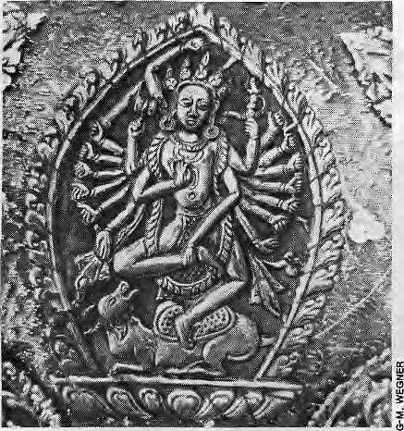
and censorship on all publications, including
newspapers and even literary works.
Immediately following the Revolution,
Radio Nepal was established, promising
freedom of, at least, artistic expression. As
Radio Nepal's broadcasting capacity
increased with the installation of more
powerful transmitters in 1954, its reach
encompassed not only most of Nepal but
also Darjeeling and parts of Sikkim and
Bhutan, where the major linguistic groups
are ethnic Nepalis. This was a significant
development. At the hands of the finest
composers, singers and poets aadhunik
sangeet manifests contemporary Nepali
thought and experience, transcending
ethnic, linguistic and political barriers.
Unlike lok sangeel, the genre is free of
specific ethnic and regional ties thus
enabling it to be adapted for the expression ^{A} ^{dtia} (^{dnm}) ^{shieki} ^{trom} ^{th&} ^{Patan} gunlabaja ensemble
ofpatrioticsentimentsinthefonnofrastriya depicts the Newar Music God, Uasadbyo, as Nrityanath
geet, GivenNepal's poly-ethnic character and the fundamentally Teligious
orientation of its folk andclassical music, only aadhunik sangeet is able
to rapidly absorb changes and adapt itseif accordingly. Today, the
horizons of aadhunik sangeet has stretched even further to include "rock
songs" and 'Yap", of Afro-European origins.
Roots in the Soil
Nepal's wide-ranging ethnic diversity is reflected in its folk music, making it impossible to describe lok sangeet as a homogeneous entity. Judging by the stock on the music-shop shelves alone, it would seem that lok sangeet is most commonly linked with song-forms such as chutke geet or jhyaure geet, generally sung by Gaines, a minstrel caste group, and Tamang selo sung in Nepali. This association not only falsely suggests that lok sangeet is culturally narrow but also obscures the social, ritual and even agroeconomic ties of lok sangeet with its people. An example, among the Gurung and Magar communities, would be the congregation of male and/or female groups at night to sing and dance in the institution known as the Rodighar. This is an integral part of huripurma, a system of reciprocal exchange of agricultural labour.
Although the ethnomusicological research of Nepali music has already begun, there still remains a large corpus of music unstudied, which makes it difficult to discuss musical characteristics in detail. Generally, northern music uses anhemitonic pentatonic scales (five-note scales whose intervals aTe the same as, for example, the black notes on a piano keyboard) and circular breathing or overlapping of voices without breaking the continuity of melodies. In addition, texts are set melismatically, such that the pitch may vary within the same syllable. Although the use of pentatonic scales are also found in Taagas, it is the performance practice that differentiates the two. Generally, southern melodies are based on heptatonic, rather than pentatonic, scales. A few songs with shamanic chant-like melodies have been released but, in general, no shamanic influence is observed in Nepali music. A glimpse at the repertoire of lok sangeet suggests its vastness.
Chutke geet and jhyaure geet are generally associated with the mendicant Gaines, who travel extensively, reaching as far as Assam in India, Darjeeling, Bhutan and Sikkim. In rural areas, cut off by lack of modern communication technology, Gaines function as "living newspapers." A jhyaure geet can include political satires or crime
stories.Amajordi fference between a chutke geet and jhyaure geet seems to be in the expression of happiness in the former and sadness in the latter. A unique musical characteristic of Gaine performances is the imitation of taala by the sarangi, which otherwise accompanies the singer's melody. The effect is achieved by plucking the strings with the left-hand little finger while bouncing the bow on the strings. The ghunghur (tiny bells), hung at theend of the bow, complement the taala.
Asarey geetandchaitey geet msseasona] songs, sung during the months of June-July and March-April. Sorathi, performed by the Gurungs, is an epic song form. The Rateuli is sung by women during a wedding. The text in a Rateuli performance can include obscene and sexual allusions. Another form of performance, also exclusive to women is Teej geet, sung
during the primarily Brahmin festival of Teej, A form of song, which has enjoyed a national appeal in recent years through recordings and live performances isDoharigeet in which texts are improved to a fixed folk melody called Bhaka. Dohari geet is a sort of musical contest between a man and a woman (with or without groups). The loser has to acquiesce to the winner, and demands can include even marriage. Therepertoire mentioned here is the tip of the iceberg; the vast majority of lok sangeet, especially those sung in the vernacular languages, remain unknown outside of their communities.
The instruments used in lok sangeet include the murchunga (Jaw's harp) of metal body and bamboo, damphu (frame drum), bansuri (flute), tungna (plucked lutes), chyabrung, dholak (two-headed drums, madal), and sarangi, to name but a few. Those of particular interest include madal and sarangi which have assumed a nationalistic character and are commonly held to be of Nepali origin. Nothing could be further from the truth, however. The madal is found throughout central India and in Bangladesh, where it is called modal or mondal, and the sarangi is of pan-Islamic origin and exists in many other countries. The concept of Nepaliness in lok sangeet should be determined by the inner performance details or musical characteristics and not merely by the musical instruments used.
Crisis of Identity
Nepal began to uplift the performing arts after the political watershed of the 1950s. The patronage of King Mahendra, who reigned from 1955 to 1972, was particularly important. The establishment of RadioNepal in 1951 was followed by that of the Royal Nepal Academy in 1957, the Rastriya Nachghar (now called Sanskritik Sansthan, the cultural institute) in 1961, the Ratna Recording Corporation in 1962, the Royal Nepal Film Corporation in 1971, and Nepal TV in 1984. Tribhuvan University has since added a degree course in shastriya sangeet. All these institutions are funded by the Government but, as Nepal strives for its place in the modern world after nearly two centuries of self-imposed isolation, her musical development faces several challenges. While there has been official promotion of the arts, however, the country strives to find a balance between its diversity and the need for a "nationalist" unified identity. It is said that it is this fear of inciting ethnic divisions which led to the ban on the broadcasting of ethnic i songs with texts in languages other than the lingua franca, Nepali

10 . H1MAL Nov/Dec 1993


Bhasha. Although there has been some relaxation, in that Radio Nepal has introduced some regional songs in a program called Phulbari (garden), the systematic inclusion of songs representing all ethnic groups is yet to be accomplished. Nepal Television, too, has introduced a similar program (also called Phulbari) but the production lacks authenticity, scholarly scrutiny and technical layout. In fact, the programme shows a lack of sensibility and even respect to cultural diversity which is made the worse by the directness and power of the visual medium.
The official broadcasting policy, which seeks to establish cultural homogeneity (and, through it, national unity) prevents acknowledgement of Nepal's own cultural products. Paradoxically, while theTe is a restraint in the broadcasting of vernacular ethnic songs, Radio Nepal regularly broadcasts Hindi film songs and Indian and Pakistani ghazats, sung in Urdu. The political view that came into force during the Panchayat era (1951-1990) of avoiding the incitement of ethnic tensions by banning vernacular music, seems to persist.
Aadhunik sangeet, on the other hand, faces a different challenge with its penchant for incorporating Western elements to the jeopardy of ils further development. Although aadhunik sangeet, incorporates aspects of Western music in ils use of polyphony (harmony), theory and instrumentation, there are no institutions where one may systematically learn Western music. There is a genera] resistance to institutionalising Western systems, which is best summed up by the scholar and diplomat, Rishikesh Shah, in his observance of modernisation in Nepal:
On the one hand, there is an intellectual acceptance...of the technological, scientific and intellectual aspects oj'Westernculture.... On the other hand, there is an emotional resistance against the slavish imitation of the West because the Nepalis are conscious of their own ancient heritage of civilisation and values, and also because the West is very much associated in Nepali consciousness with colonial war and exploitation.
The same traditionalism, which in the 18th century resisted Christianity and through it prevented the influence of Western music, is today slowing down the further development of Nepali music by ignoring the scientific and intellectual approach. The view shared by most composers is to adapt aspectsof the Western system to localneeds. The dilemma faced by aadhunik sangeet in this regard is best illustrated by the challenges faced by the Nepali film industry.
Bombay Mix
Films are a major source of entertainment throughout the Subcontinent and Nepali films, too, on average include five or six songs. But, despite the existence of various musical institutions, Kathmandu lacks technological facility for soundtrack recording, and also the type of orchestra desired. Thus, the recording of Nepali films takes place in Bombay, utilising the orchestras there. This is not without its own implications. First, the orchestral timbre results in what is recognised as "Bombay type", similar to diat heard in Hindi films. Secondly, all financial benefits of production accrue to the Indian industry. Finally, such a trend not only hinders the aspiration of Nepali artistes but also prevents the possible innovation in the use of native instruments in orchestral settings.
While thenew Government's policy of discouraging acculturation in film music is welcome — totally domestic productions enjoy a certain percent tax break — there are simply not enough trained musicians to supply the industry. This is not to mention the shortsightedness of some directors and producers who would probably still favour recordings in Bombay even if they were not forced to. So, the trend of recording film music in Bombay continues, denying self-
reliance in music.
Most composers believe that native instruments are incapable of meeting the demands of polyphonic orchestral composition. Some feel that native instruments are inadequate in compass andsonority compared to Western instruments. Others argue that ihsNepalipana (Nepaliness) rests in the compositional tools and not in the instrumentation alone. But recent trends in aadhunik sangeet contradict the latter view. There is a growing influence, or even emulation, of Hindi film songs which has not gone unnoticed. In describing the rmisic of Nepal Graves Dictionary of Music and Musicians (1980) notes that"... a continuing Indianization of Himalayan popular and folk music may be assumed". The conscientious effort to TCtain Nepalipana, which prevailed in the post-Revolution era in aadhunik sangeet, is today overwhelmed by outside influences.
Nor has shastriya sangeel escaped the pressure to change, as the adaptation of Western violin and harmonium illustrates. The violin originated from the eastern rabab and the harmonium was invented in France in the mid-18th Century. The violin, called bela in shashtriya sangeet, is played sitting down such that the tuning pegs rest on the player's feet, allowing easier execution of gamak (glissando or slide) and shrutis. However, the harmonium, being a mechanical reed instrument that uses a tempered scale, lacks the pitch variants characteristic of shashtriya sangeet and tok sangeet. The point is this: the tempered scale and the limitations of pitch that it imposes, force inner musical characters to adjust. However, this complication is not faced by aadhunik sangeet in its adaptation of the harmonium, because aadhunik sangeet incorporates Western elements in its theory and instrumentation.
Shashtriya sangeet, which shares common roots with the North Indian musical tradition, also faces a musical "identity crisis". In the West, this genre of music is generally known as "Indian Music" or Hindustani Music. Although the use of these terms is justifiable on a geographical basis, as in describing the music within India or in differentiating stylistic approaches, problems arise when defining music within Nepal. The Nepali view is that these terms evidently exclude the Nepali tradition. The term Hindustani Music, for example, will mean the tradition prevalent in North India. And even if one stretches the term to the "Hinduston/ Music of Nepal" (as distinct from that of Pakistan and Bangladesh) some conceptual complications persist. The word Hindustan originally denoted the earlier formational stage of the country of India, which included Pakistan and Bangladesh, but of which Nepal was never a part. Perhaps the term that more appropriately describes the musical format, without being regionally or religiously biased, is Raaga Music.
Nepali music, thus, is identifiable in its musical structure and the
ethnic, philosophical and religious ideas it draws upon. All genres aTe
subject to some change yet they remain identifiable as Nepali music;
The crucial issue for musical development in Nepal is the
infrastructure of music education. The inclusion of
shashtriya sangeet by TribhuvanUniversity is a welcome
gesture, but it needs further expansion because
shashtriya sangeet is essentially performance oriented.
A musical education should include both performance
training and intellectual study. This will better equip
people to understand and conserve Nepali music as
as to cope with that change. Without a well-conceived j
long-term plan for musical education, efforts to uplift
music will be fruitless. t
K. Gurung Is an eihn[musicologist. He is presently involved in setting up a recording studio, House of Mush.

Nov/Dec 1993 HIMAL . 11

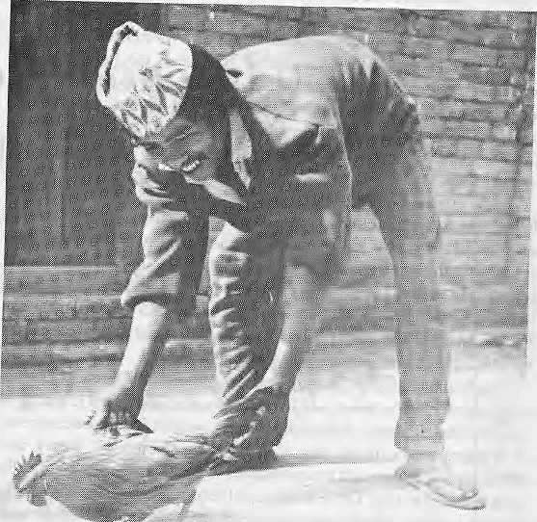
The Goat and the Music God
Each of Bhaktapur town's
200 or so music groups
has Us own rituals and functions.
This is an account of
how the members of
one such music group tap
the divine energy of
the music deity
Nasadyo.

text and photographs by Gert-Matthias Wegner
I
t is almost midnight. The goat has been locked in the potting shed and we are waiting for our drumming students to sneak into the garden and steal the animal for the music God Nasadyo. Ganesh B ahadur and I have been training die six students for the past four months. They are young farmers from our neighbourhood who have almost passed their apprenticeships in dhimay drumming. As with all other forms of traditional Newari music and dance, musical apprenticeship requires die students to be initiated into the cult of Nasadyo, the source of musical knowledge and inspiration. In Bhaktapur, Nasadyo has a destructive counterpart called Haimadyo which is responsible for the mistakes inmusic. Haimadyo needs to be pacified with regular blood sacrifices lest the music degenerates into cacophony. During the learning period, both Gods reside in a niche in the practising room where they receive daily worship and offerings. Ideally, sacrificial animals are supposed to be stolen by the music students. Nasadyo has aweakness for thieves, itappcars. Thus, agood drummer needs to be not only naughty but courageous as well.
It is a peaceful night, everybody is asleep. From the verandah overlooking the quiet garden, Ganesh Bahadur and I pass die time, sipping rice beer from clay bowls. Our dhimay students were too scared to really steal an animal, so we decided to stage it. The goat was purchased in the morning and carefully tied to one of the trees in the garden below our lookout. The students plan 10 use a small tractor parked by the garden wall as their staircase. It all seems too easy. After our third cup of rice beer, Ganesh Bahadur and I climb down, untie the goat and lock it in the pottingshed.Justtomakeitalittlemore real. While refilling our bowls for the sixth —-or was it ihe eighth? — time, things begin to stir below. The tractor emits acreak and shadows seem to flow over die garden wall. Then, a stunned silence. Eager
U . HIMAL Nov/Dec 1993
Nasadyo likes chickens loo. So Sujaman, a dhimay player from Bhaktapur.,.
whispers indicate a crisis conference. Where is the goat? Scouts swarm out to investigate the darker nooks of the garden. Then me bleating of the goat from inside the potting shed. Conspiring with the thieves, silly beast! The door is broken and muffled cries of triumph follow.
Here we interfere. I shout, "Kune su?'\ Who's down there? and Ganesh Bahadur, at the top of his voice, "Khun valaa!", There's a thief! Hectic activity in the garden. The goat scales the wall rather rapidly and lands on someone's head. Neighbours open their windows and join us with stentorian cries. The goat has gone. A final giggle accompanies disappearing footsteps. It will take another two hours before discussions among the neighbours die down and Bhaktapur resumes its slumber.
Flight Paths of Energy
Early next morning, we gather in the practice room. A colourful procession is under preparation. There is to be a band of drummers to announce the event, teachers and students carrying puja plates with various offerings and last, but certainly notleast, the goatled by arope to its final destination, the shrine of Nasadyo.
Every shrine of the music God has at least one hole as the centre of worship, through which divine energy passes invisibly and freely, like music. Strangely enough, there are similar holes in the buildings behind and in front of die shrine, such that flight paths are maintained through several buildings, in some cases even beyond Bhaktapur's boundaries. It is considered most inauspicious to block one of these Nasa holes.
But today, while decorating the shrine with offerings in the prescribed order, Ganesh Bahadur and I block the divine passage with

a sticky mixture of yoghurt and beaten rice. Then I paint the face of Nasadyo on it with red powder and insert three tiny silver eyes. Now Nasadyo is ready to receive his sacrifice. A large knife is placed on the altar and 1 perform abrief puja. sprinkling water and red powder on the blade. Meanwhile, the goat receives rice grains, powder and water on its head. Everybody is waiting for it to signal its consent to being sacrificed. It has to shake its head and hair in a particular manner before we can touch it. But it doesn't! Ganesh Bahadur sprinkles some more water. There! It worked.
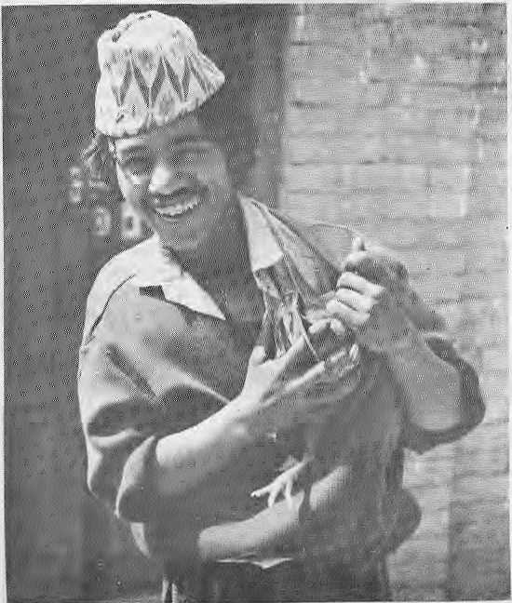
...domonstratas bsw to.,.
Immediately, the beast is grabbed, lifted and cut. The blood splashes all over the shrine and our feet. The students carry the body around the shrine, leaving a bloody trail behind them. Finally, the goat is decapitated and the head placed on the altar, a burning wick on its forehead.
The time has come for the musical offering and the students squat in a row, facing the covered drums. Ganesh Bahadur and 1 offer them each their instrument, while they pay theirrespects to us and do asmall pujafor the drums resting ontheir laps. Some ofthestudentshave kept a raw egg ready for this moment. In order to overcome their stage fright, they throw the eggs against the Nasa hole, where its contents cover the offering, upsetting armies of flies whichhad made themselves comfortable.
The music starts with an invocation, called dyolhoygu, of the music God. Played correctly, the dyolhaygu works like a telephone number, connecting the musicians with their source of inspiration, focusing their energies on its divine flow and uniting them in ecstasy and delight.
The students play the complete repertoire without a mistake while their relatives andneighbours watch and listen with pride. When
the music is finished, we are all decorated with great white turbans, red powder and flowers. We begin to resemble happy apparitions.
Meanwhile, plenty of divine power has accumulated in the yoghurt paste which blocks the Nasa hole. It is plucked off and distributed among all as prasad an edible blessing). Everybody feels hungry and thirsty and a preliminary picnic is consumed on the spot before proceeding home in triumph, where araz/Newari feast awaits us.
It is the students' tum to lead the procession. They play — still a bit tense, as everything is new to them — but with increasing joy. Their "coming out" is observed with keen eyes from the upper windows, wherever we pass. The girls of Bhaktapur have a weakness for drummers, and this will no doubt ensure a continuation of this tradition.
The formal apprenticeship ends here, although much remains to be learned, from experience rather than verbal instruction. How to convey joy to a vast crowd during festivals? How to make them all dance? How to untie a bunch of half-drunken drummers and make them play like fire? How to recognise when it is time to pass on your own drum to one of the extras walking with Lhe group and waiting their turn? How to remain in tune with the spirit of the occasion, and how to tap the divine flow of energy that, permeates all creative activity?
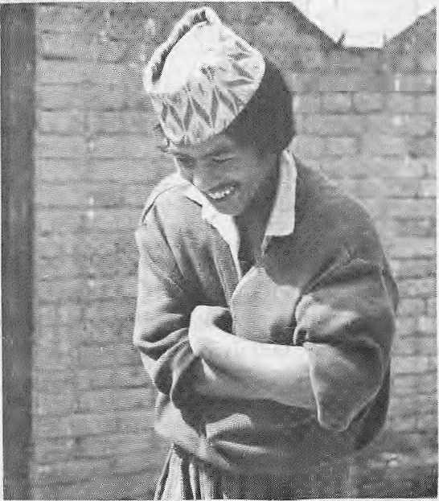
...staalahQ
Of course, there is much more to tell about Bhaktapur and its various music traditions. What joy, what a blessing to participate in all this! Let us hope these marvellous traditions continue to inspire coming generations. It needs understanding, work and love on everybody's part, but the rewards are unlimited.
G-M. Wegner is a German etfi no-musicologist, presemly helping establish a music department for Tribhuvan University in Bhaktapur.

Nov/Dec 1993 HIMAL . 13



Four reasons why you should fly our
HELICOPTERS
- Reliable and safe because of fail-safe design.
- Flown by pilots who have long flying experience in the Nepali Himalaya.
- The network has 18 years of experience in helicopter service and more than
300,000 flying hours.
- Operated by experienced technical experts and reliable administrative staff.


For more information please contact:
DYNASTY AVIATION PVT. LTD
OPERATIONS BASE
Tnbhuvan International Airport Gauchar, Kathmanau
Nepal
HEAD OFFICE
KA-3-78, Naya Baneshwor,
Kaihmandu, Nepal
Tel: 977-1-225602, Fax: 977-1-522958

Where is Shastriya Sangeet?

Classical music managed to escape the court boundaries of the ruling Nawabs and
Maharajas in India to delight mass audiences of concerts, television and radio.
But in Nepal, both classical music and its players are on their last legs.
by Omar Sattaur and Gert-Matthias Wegner

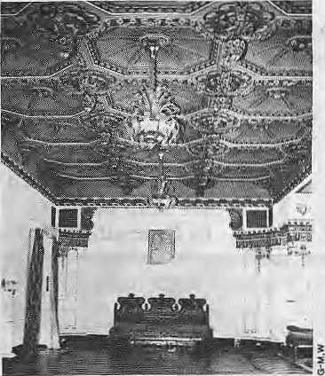
L
eading musicians from India's centres of excellence had for centuries been coveted guests at the darbars of the Nepali kings. MahindrasimhaMalla is known to have invited Muslim ustaads in the early 18th Century to play forhim at his palace, and his successors followed his example. By the Rana period, Kathmandu was recognised as an important centre for shastriya sangeet, the classical Hindustani music that is the main subject of this article, and there were frequent exchanges with other centres in the Subcontinent including those at Banares, Darbhanga, Lucknow, Rampur and Calcutta. Ekraj Shamsher, for example, was an accomplished dhrupad singer who, in later years when his voice began to fail, went on to master the rudra vina. Bir Shamsher, a great lover of music and patron to the great Taj Khan and Dunnee Khan, invited India's best musicians to play at a huge music conference atBagadi,infheTarai, in 1900. The conference is said to have helped in iheTevival of classical music then sweeping the Subcontinent.
The latter half of the 20th Century, though, has been less kind to music and its artistes in Nepal. Indian masters who had settled here returned tp India during the last years of the Ranas and during the Panchayat system, shastriya sangeet was pushed into the doldrums. Good classical musicians, today, have either left the country or are scraping a living together by accompanying and doing other jobs as well as making music. The standard of teaching is low and Nepal's most promising students are once more forced to bead south for likely gurus. Meanwhile, potential students of shastriya sangeet are being discouraged from studying the genre through anti-Indian feeling and the notion that Nepal has less claim to shastriya sangeet than does India. Yet while shastriya sangeet is declining in Nepal, it. continues to flourish in India, and Indian musicians travel the world to play to audiences that are increasingly knowledgeable about the Hindustani classical music tradition. While musicians themselves are partly to blame for the demise of shastriya
sangeet in Nepal — through seeking only patronage as a means of survival — its roots lie in the enormous political and economic changes die Subcontinent has undergone since the end of the 19th Century.
Nawabs and Maharajahs
Music Room at Durga Bhavan, Tangat
Classical musicians regard the last century as the "golden age" of music. They played at the courts of the Indian Nawabs and Maharajahs who not only enjoyed shastriya sangeel for its own sake, some of them becoming accomplished singers and players, but also benefited by the refinement and status that such music lent their courts. Each court might employ hundreds of musicians, who enjoyed a pampered life, being both highly respected and highly paid. To reach this zenith of the musical career, amusicianhad to learn from a master, and finding one was never easy. AllauddinKhan, one of the greatest musicians of recent times and the teacher of Ali Akbar Khan and Ravi Shankar, appeared to have leamedmostly by steadfast determination. He ran away from home to study music, first in Dhaka and then in Calcutta. His first important teacher, Gopal Chandra Bhattacharji, died long before AllauddinKhan could complete his 12-
year apprenticeship. He then decided todevote himself to studying sarod, after being greatly impressed by Ustaad Ahmed Ali Khan. Ahmed Ali Khan accepted him as a student but taught only a little. However, Aliauddin Khan learned much simply by listening to the ustaad's concerts and practising what he heard. His reward for having learned more than he was directly taught was to be turned out by his teacher.
After much travelling, he arrived in Rampur and sought to become a pupil of. Wazir Khan who was, in his time, unequalled hi playing the veena. But Aliauddin Khan found it impossible even to meet the ustaad. Only by throwing himself before the Nawab of Rampur's caniage did Aliauddin Khan obtain the opportunity to play for the Nawab and impress him enough to gain his recommendation and introduction to Wazir Khan. At last he was formally accepted as Wazir Khan's pupil only to serve him for the next two years without receiving any lessons at all! He stayed with, and eventually learned from, Wazir Khan for the next 20 years before settling downinMaihar in 1918, at the age of 56, to teach the local ruler.
The reluctance o f masters to take students, and then to reveal all they know to them, is a reflection of the fact that musical knowledge was treated as a commodity which could be traded and therefore had to be jealously guarded. This way of looking at music was particularly strong at the turn of the century when the gharana system of teaching was growing in influence. Gharanas have been characterised as closed groups, largely within families, in which apprentices belonged to a sort of musical guild that offered support and arecognisable (and saleable) style of playing. Gharanas were highly competitive and sometimes used by local rulers as prestige objects. For an aspiring young musician, apprenticeship in a gharana could mean years of servitude andleaming simply by absorption — listening to what the players said and how they played and copying it all later — before ever being dhectly taught music. The system

Nov/Dec
HIMAL . IS

began to fall apart as India moved into the modern world. Today, artistes would rarely claim to have been the product of a single gharana. The gharana system did not exist in Nepal.
Breaking out of Court
The disappearance of the gharana system is not the only change to have affected the passing on of musical knowledge. As already implied, the "golden age" ended with the demise of the princely courts. In his book,Mindustani Music in the 20th Century (Allied Publishers Pvt Ltd), Wim van der Meer outlines the major factors influencing the renaissance of Indian classical music in the early part of thiscentury. After the Indian mutiny of 1857, the British changed their attitude towards local rulers and encouraged them to Westernise and become allies in British rule of India. Some did, giving up their interest in things Indian, including shastriya sangeet but others, notably Maharaj ah Scindia of Gwalior, Maharajah Sayaji Rao of . Baroda, Nawab Hamid Ali Khan and his son Raza Ali Khan o f Rampur, continuedtosupport and encourage mu sic and musicians ev en when they had very little power and influence left. As the princes lost poweT, they concentrated on the pursuit of the trivial. And as they sank
into debauched lifestyles, music sank with them. Musicians found their places of work shifting from princely courts to entertainment houses in the cities and before long they, and their music, suffered the stigma of that decadence.
The end of the 19th Century saw the simultaneous rise of the newly rich, the merchant princes who had made money in trade, andthezamindars, or tax collectors who had settled in as hereditary landlords. Imitating the princes, they became the new patrons of music. TheiT decadent lifestyles were little different from their aristocratic models and, if anything, music sank further in status. India was changing on other fronts, too, all of which affected society and therefore music. As the British clutched at straws to maintain power, the nationalist movement was on the rise; the IndianNational Congress held its first meeting in 1885. By 1900, themain network of railways had been established. Radio was increasingly popular, the film industry was growing and gramophone records were becomi ng avail able. Musicians increasingly realised that they could no longer find the same kind of positions as they once held at the courts. Greater mobility from improved transport, presses and broadcasts brought music to a vast public and
changed the make-up, aspirations and lifestyle of the modern musician. The film industry in the 1930s was one of the largest employers of the best classical musicians. Although this has changed, All India Radio is still a very large employer of Indian musicians.
For the emerging middle class, who had a European education, music was something to look down upon. The nationalist movement stimulated patriotic feeling and it was only the movement's recognition of the important role that music could play in fostering Indian pride and unity that helped musicians to regain respect. Meetings of the National Congress included classical songs and Gandhi led the Dandi March of 1930 to the strains of certain classical pieces written by Vishnu Digambar Paluskar. Paluskar and another Maharashtran called Vishnu NaTayan Bhatkhande, led the musical renaissance which was to reach its peak after 1900.
Musical Missionaries
Paluskar was a musical missionary, popularising and stimulating interest of music among the middle classes. He played devotional music at temples and personally visited middle class homes to announce his programmes. In 1901, he opened his first

NEPAL
INTERNATIONAL CLINIC

Hours: 9:30 am - 5.00 pm (Sunday through Friday). Vaccination/medical advice available even on Saturdays.
Please feel free to call us at
4-12842
Phone/Fax: 977-1-419713
Nepal's Leading Institutionin Travel Medicine
US Board Certified MDs
Staff has over 15 Ifears of Work Experience in
South Asian Diseases
Highest Standard of Clinical Care and
Efficiency
No Hassles
Free Advice on Altitude Sickness .
Convenient Location (off Durbar Marg,
opposite the South Gate of the Royal Palace -
see map below)
In Operation for 5 years

LAZIMPAT
o
KANTTPATH I I
16 . HIMAL Nov/Dec 1993
ROYAL PALACE - MAIN GATE
I I
O
BATHS
I I
DURBAR MARG
I I
SOUTH GATE
I I
cinema;
HALL
NIC
2nd gate J_{ai} _{Nepa}]
NAXAL

Dhimay drummers play at the final puja marking the end of their apprenticeship
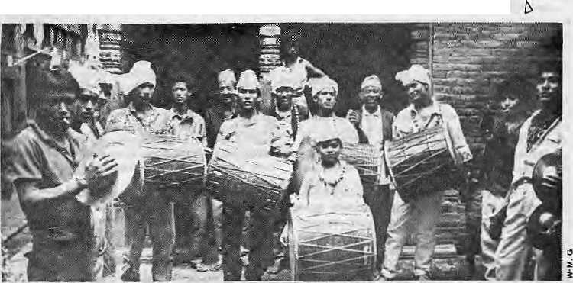
music school in Lahore, followed by another in Bombay a decade later, to spread musical knowledge and understanding. Bhatkhande travelledextensivelyandcollectedavastbody of musical literature and manuscripts from whichhe published a number of books. Some of these ate still source material for music students today. He organised the first All India Music Conference in 1916 in Baroda and followedit with others inLucknow, Delhi and BanaTea. With the support of Maharajah Say aji Rao of Baroda he reorganised the music school and later went on to open music schools in Gwalior and Lucknow, These schools became models for others to open the doors to mass musical education.
Music had at last escaped the domination of the ruling class and the financially privileged to reach a much wider audience. In 1936, the first tickets foT a concert of shastriya sangeet were sold in Calcutta. Later, music clubs became popular all across northern India. The members were enthusiasts who understood the intricacies and subtleties of classical music. They paid an annual fee for the privilege of hearing the best musicians. Non-members were charged an entrance fee. Although the pay was low, musicians were keen to play for such audiences because they were so well understood and appreciated—something rare after the lossof the small, specialised audiences of the princely courts. Today music clubs are still popular and there are music schools and colleges in almost every neighbourhood of the large cities. Music continues to flourish.
Tattered Raagas
In contrast, classical musicians in Nepal earn a living by playing watered down versions of the raagas to tourists who listen between mouthfuls .of food in the restaurants of expensive hotels. During the past decade, the ghazal, a musical vehicle for Urdu poetry, has become very popular and groups are to be found at many restaurants in Kathmandu. Those who cannot or would not play at such venues survive by teaching or accompanying. Many of the older musicians barely manage to survive, despite their talent and gifts. A sad exampleis the former court musician, Shambhu Prasad Mishra, now 76 years of age and the finest tabla player in the country, who can be seen hauling his bicycle uphill the five kilometres or so from his home in order to gain a few rupees accompanying. There is no support for musicians and they find it impossible eo survive by music alone.
Shastriya sangeet may have been inaccessible to the common people during the Rana regime, but it flourished in their courts.
Since the return of monarchy, however, even this court music-making almost disappeared. There is still token appointment of court musicians, but they rarely play and have few other responsibilities. Music continues to be neglected and so continues to wither. The Ministry of Culture and Education today provides almost no support for classical music. The Royal Nepal Academy has been likened to a tomb — there is so little that is of interest to the living going on within its walls. There are a few cultural scholarships to be won but none specially earmarked for students of music and people in positions of influence hi the relevant ministries do not seem to have any interest in music.
Nepal can offer its students two colleges at which to study up to Bachelor level: Padma Kanya Campus and LaiitKa)a Campus. There, students can pick up the rudiments of classical music and take examinations set to the standardsof Indian colleges. Teachers inNepal need a Masters from an Indian music college to begin teaching. Yet there are not enough teachers, they are paid very little, and the average standard is very low compared with India. In any case, a college-based musical education is still regarded as just a first step on the road to good musicianship. It has to be followed up by 10 to 20 years of dedicated study and practicewith the best masters. Nepali teachers would benefit enormously had they the opportunity to study with ustaads, but unfortunately there is no such scholarship scheme here to encourage such aspirations. And musical ambition in children is discouraged. Music is a dead end job.
The musical education of the public has also suffered. Radio Nepal allocates just 90 minutes per week to shastriya sangeet. Lok sangeet, folk music, gets 8.5 hours per week. In contrast, aadhunik sangeet is allocated 11 hours per week. Nepal Television, last summer, virtually stopped broadcasting shastriya
sangeet because, it was said, they could find no one willing to attend and record. Homnath Upadhyaya, a tabla player called their bluff and has been invited to record some programmes. There is little live music to be enjoyed even by those in thecapital and major towns but for the majority of the population, who rely on radio, shastriya sangeet is sighing its last notes.
The result is acircle of neglect spiralling towards the eventual death of shastriya sangeet in Nepal. Music, like all art, is organic. The more concerts that are staged, me moTe music that is broadcast, the more people will want to hear it and the more young people will want to study music. Without a critical number of music lovers, students, teachers, performers and artistes or music will simply die.
Fighting against this ignoble end are a few musicians who are usingtheir own money, time and talent to pump life back into Nepali shastriya sangeet. Among them are participants of the Kirateswar concerts on full moon evenings at Pashupatinath, where young musicians come and play for free. The atmosphere is good and the event looks promising, with the musicians sharing the costs of transport and refreshment. Some musicians open their homes to music groups with the aim of establishing music circles where music can be enjoyed.
If Nepali music is to survive and, more than that, find its rightful place among the many other musical traditions with which it has to compete today, itmust first find pride of place in thepublic consciousness. This means more concerts, more broadcasts and more emphasis in the curricula of primary and secondary schools and a notation method and systematicteachingofshastriyasangeet.Many more scholarships, to enable study with the best masters for at least five years, are also needed for those of whom shastriya sangeet has touched.

Nov/Dec 1993 HIMAL . 17

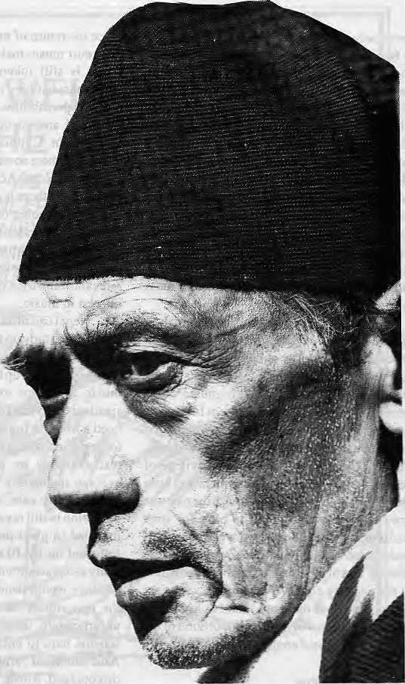
A Life of Music
Krishna Narayan Shrestha is
one of the finest living musicians in the Nepali Hindustani classical music tradition. Since in his early twenties, the 67-year-old maestro has won prizes in different Radio Nepal competitions and has been awarded the Gorkha Dakshin Bahu IV. In 1950, he joined the newly established Radio Nepal and rose to the post of musical director before his retirement at the age of 60, in 1987.
Among the more well known of his former students are the harmonium player Govinda Kipu, the dilruba player Uttam K.C., and the singers Bhakta Raj Acharya and Sunita Subba. He took some time off teaching to talk to Himal in his small room, crowded with instruments, at his family home in Patan Sundhara.

I
t was my father's wish that I learn music. He was inspired after hearing an Indian ustaad who could play many different instruments, like jaltarang and tablatarang. He came to Nepal to play at Chandra Shamsher's palace. My father went with my Guru-to-be, Shri Ganesh Lai, to hear him. He was so taken with the ustaad's playing that he told Guruji that my mother was expecting and that, if she gave birth to a boy, the boy would be totally under his instruction.
When I was old enough, my father took me to Guruji — not to learn music for my living, but purely because of his interest in music. I stayed with Guruji until he died, at the age of 72. Even though music was my father's interest, it eventually became my profession, because I spent so Jong at it and had so little chance to study anything else.
If I say that Guruji was my greatest influence, people assume I mention him simply because he was my teacher. But he was actually the only person to influence me in Nepal. The reason I say this is because there was no one in Nepal like him. There was no one who could play jaltarang and tablatarang. (Jaltarang is a range of china bowls tuned by filling them with different amounts of water. When hit, they produce a pure-sounding chime. Tablatarang is a
semicircular range of tablas tuned to different pitches such that it is possible to play melodies on them). But whatever instrument you gave him, even if he had never seen it before, he could play it well after an hour of experimenting with it.
I began when I was very young, about nine or so. Guruji always made me sing with him, usually in the morning for half-an-hour to two hours. That continued for two years. After that he introduced the jaltarang, perhaps once or twice a week. Guruji used to say that, whatever instrument you play, whether it is tabla, sitar, sarod, anything, without a background in vocal music there will be no mithaas (sweetness). It seems he was right. If you look at our sitar players today, they have no vocal training and so their playing sounds a little crude. There was none of that crudity in the late Asha Gopal's playing, though. He was Narayan Gopal's father and he played sitar and sang beautifully. Others here don't even know how to play thumri (a light classical vocal style). But it is wrong to criticise an artist. When you criticise an artist it is like kicking yourself.
At that time I was often accompanied by Guruji's brother, Digamber dai, on harmonium. Sometimes Guruji would play tablatarang, and I would sing. Digamber dai used to practise constantly, four to five hours at a stretch, to the extent that he did

18 . HIMAL Nov/Dec 1993

not eat enough. In the end he died of TB because he did not eat proper food. In those days, musicians strove to be better players than others around them. Today, shastriya sangeet (Hindustani classical music) is vanishing.
Changing Seasons
Everything has its time. Different eras bring different custom and different tastes. I believe it would be difficult for a person who has not learned shastriya sangeet to understand it. I don't know if there is shastriya sangeet in the hills but, in die valley, the Newars practise their own kind of shastriya sangeet. Here it relates to the changing seasons and festivals. Indian shastriya sangeet now heard in Nepal sounds as if it were composed whereas I feel that our traditional shastriya sangeetr has been influenced by our folk music. This gives it its Nepali flavour.
Tunes are developed from words and sounds. So, according to the environment, sounds and words are chosen to match and the Tesult is music that is proper for different times of day and for the changing seasons. This music is named accordingly. It seems to me that our branch of shastriya sangeet was composed giving more emphasis to matching words to the environment whereas Indian shastriya sangeet gave more emphasis to matching sounds. But despite these differences, some of the Indian and Nepali raags fall into the same category.
Shastriya sangeet is on a much higher level than aadhunik sangeet (modern songs). To enjoy it, listeners have to make more effort to go into it and investigate iL Once people do that, they will sink into its depths and cease to care for aadhunik sangeet. Aadhunik sangeet is outwardly exciting, whereas shastriya sangeet is tranquil at its centre. Since aadhunik sangeet does not have the same depth, listeners can enjoy it quickly and easily. What my soul says, if you ask someone listening to light music what they think about it, without thinking they can say "good" or "bad", because it doesn't have substance. But they cannot make the same judgement on first listening to shaslriya sangeet, because shastriya sangeet has substance.
It has substance because it comprises the efforts of generations and generations of master musicians. Of the four Vedas, music came from the Saam Veda. From Saam Veda, the old masters developed shastriya sangeet. But it is different with lok sangeet (folk musicj. I believe that lok sangeet, developed naturally. It is the original music of the people which gave the Basis to develop shastriya sangeet. But aadhunik sangeet is all mixed up. It is sometimes sweet and sometimes sour, ...it is all mixed up. It doesn't stand the test of time, whereas lok sangeet and shastriya sangeet were with us from the very beginning and will continue for all time.
Good things need a long time to develop. If there is not enough time, then I believe that good things will not be produced. Today, nobody has time to learn. Time and fashion are always changing; sometimes dhrupad is very popular, sometimes khayal is more popular. Nowadays, ghazal is the most popular. These styles weTe developed by people over lifetimes. Today there are some who continue to sing in these styles but most people believe that life is too short, so they cannot afford to devote 20 to 25 years to developing themselves as artists.
Five Harmoniums!
I had been studying with Guruji for about four years when we started travelling in India to give concerts. He took me to many places, wherever he went. I admired the Indian santur player, Omprakash
Chaurasia, whom I met and played with. I was also influenced by the vocalist Omkarnath Thakur, and the tabla player, Anokhi Lai, after hearing and meeting them. But, to this day, I have never heard anyone play like Guruji did, even in India. His special feat was to play five harmoniums at once. We students used to pump the harmoniums while he had a hand and elbow on each of four harmoniums. The fifth, in the middle, he played with his nose! Have you ever heard of such a thing? Five harmoniums? He demonstrated this feat only once, at Singha Shamsher's palace at Thapathali, where the Rastra Bank is now.
Once, in Jhaansi, a friend of Guruji'sletus stay with him for one week before asking him to play. Our host would play a piece and then Guruji would reply. But when it was Guruji's rum, he played a string of off-beat pieces. Pieces with rhythms of 27 beats or 81 beats. It was very difficult, so our host had to stop playing! We travelled to most of the major cities of India. Indians would greet foreign musicians with disregard at first. They would scrutinise the playing for mistakes. The smallest error would lose you any standing. If you made none, and showed that you had something they didn't have, then they would come, touch your feet and beg to become your students.
But my most memorable concert was in Russia, in Tashkent. A group of us was sent there by the Nepali government. I was the only one versed in shastriya sangeet among them. None of the group knew that I had taken my jaltarang in my baggage. One day, while 1 was practising jaltarang alone in my room, the manager heard me and came up. He saw me surrounded by bowls which, at first, looked just like soup bowls to him. He liked my playing and asked whether I would give a public performance. I agreed and he managed to get me on TV! In that performance I played jaltarang and Nepali sarangi. I think that was my happiest moment. After that TV appearance I was invited to play in many other places. I went to fourteen different states playing my jaltarang. Unfortunately there was no tabla accompanying.
Revive the Classics
We should champion the cause of reviving shastriya sangeet in its many different forms. People are different and have different tastes, so they should be exposed to different forms. To like shastriya sangeet you have to understand it, so there should be education also. Students have to be taught well, and in detail. Then each student must teach others. TV and radio people should know about music and try to find good music to broadcast. They should follow die musicians. But, in Nepal, it is not like that. Musicians follow the broadcasters!
Campuses are good but cannot teach to the full extent, unless you have some kind of system like guru and shishya. Campus students will know about music but they won't be able to make it. In the campus, students cannot practice enough. In order to practice properly you have to be with the teacher. Many students from the campus come to me to leam because they say they do not get enough time from the campus teachers.
I would really like to teach my children music. I have my books and my instruments here. If I could teach one of my children, I hope they could look after them. I have taught my daughter, Lochana, a little. She likes to sing, and that is good.
t>
This article is from a free translation ol K.N, Shrestha's interview by Mohan Gopal Nyachhyom

Ncv/Dec 1993 HIMAL . 19

V
o
I

FEAR IDENTIFIES SOUTH ASIANS much more
than does their use of masala in food, their common culture or shared history. So writes Amitav Ghosh in his 1989 Sahitya Akademi Award winning novel. The Shadow Lines, where he describes a schoolchitd's reaction to a race riot in Calcutta.
Tublu began to cry. One by one the rest of us gathered aroundhim. At any other time we would have laughed, but now, we listened to him in silence, appalled. He was really crying; we could tell, not for attention, nor because he was hurt. There was an ocean of desolation in his sobs. He cried like that all the way home, for all of us.
It would not be enough to say that we were afraid: we were stupefied with fear. That particular fear has a texture you can neither forget nor describe. It is like the fear of the victims of an earthquake, of people who have lost faith in the stillness of the earth. And yet, it is not the same. It is widiout analogy, for it is not comparable to the fear of nature, which is the most universal of human fears, nor to the fear of the violence of the state, which is the commonest of modern fears. It is a fear that comes of the knowledge that normalcy isutterly contingent, that the spaces that surround one, the streets that one inhabits, can become, suddenly and without wanning, as hostile as adeseninaflashflood.lt is this that sets apart the, thousand million people who inhabit the subcontinent from the rest of the world — not language, not food, not music — it is the special quality of loneliness that grows out of the fear of the war between oneself and one's image in the mirror.
Nothing is what it seems in EVASIVE VOCABULARY of a conservatism that seeks to conserve nothing, that only estranges us from our own experience and persuades us to abdicate the evidence of our senses,writes Jeremy Seabrookinhis book, Pioneers of Change, concerning the work of recipients of the Right Livelihood Award during the past decade.
Once the big words stand revealed as hollow, so many of the others also melt away. "Resources" no longer indicates the treasures of the earth, but has become a synonym for the money which cannot measure them. "Independence" is what people enjoy as they become more and more dependent on money, which undermines their autonomy by making them forget how to do and to make and to create things outside the encroaching cash economy.
"Sustainability" means maintaining the ideological fictions of industrial society, sparing it harmful contact with ecological reality. It also means sustaining the privileges of the rich and powerful. "Survival" suggest not safeguarding the rights of threatened peoples in forests and jungles but the already-rich getting enough money to keep pace with the monetising of more and more areas of human activity, "Defence" is the piling up of weapons of destruction, the manufacture of which actually undermines the most effective defence we have — the body's immune system, impaired by radioactivity and invisible contaminants. When we hear of our "complex society", we should not be too intimidated: opacity is not the same thing as complexity. What is meant here is the social fog generated by a division of labour so extreme that we scarcely recognise our own function in it, let alone that of our neighbour. "Efficiency" means the ever more effective meltdown of natural resources into commodities. "Development" means reducing the breath-taking variety of forms of natural wealth in the world into money. "Quality of life" is a genteel semaphore for the maintenance of privilege. "Community" is a neighbourhood of strangers, while "individualism" means the isolated pursuit of the collective illusion of mass markets.
HOUSE BINDING JAP is set out by Gregory C. Maskarinec in an article, "The World As Sound: An Introduction toJhakriMantars" j/j r/ieHimalayanResearch Bulletin(VolX.No I), in which he discusses the secret formulas (mantars or japs) used by the Kamishamans of West Nepal, Following the jap are Maskarinec''s remarks on how the japs are delivered.
Killing Jama Raj, killing Jama Rani,
killing those who died at the right time,
killing those who died at the wrong time,
killing those hung on a pole,
killing those hung in a noose,
killing those swept off in streams,
killing those fallen from cliffs,
striking the eastern direction,
killing Bhasam Ghost of the Eighty maund iron rod,
striking the southern direction
killing Kamsa Sur,
striking the western direction,
killing Maiya Sur Demon,
striking the northern direction,

20 HIMAL . Nov/Dec 1993

c
E
S

killing Long-ear Demon
take away, driving east, driving east
take away, driving south, driving south
take away, driving west, driving west,
May there be no tricks, may there be no deceits,
may there be no major witches,
may there be no minor witches
the main oaths of the Nine Naths, the Twelve Bhairam
will strike the treachery of ghosts, ghouls,
will kill them, thrust them into hell.
will bind this house...
...These texts are muttered in undertones, but not recalled in complete silence. The client and human audience know when one is being applied. The shaman shows signs of intense concentration, having paused in his drumming and dancing, if they had already been started. The muttering sounds rather impressive, actually, with a lot of breath snorts and puffs and, of course, they often end withaspectacular possession. Thedistorted syllables of the words disintegrate, the phonemes stretched to the breaking point, almost achieving a point at which their soundings might overtake their meanings. The shaman pounds on the words like he pounds on a drum, as if to shatter them, testing the elasticity of language, pulling it apart to reveal within it the vulnerable points of the world, where it may be most susceptible to manipulation. But enough meaning has to be preserved to demonstrate to the audience that the jhakri remains in control, that he hasn't succumbed to the disorder that constantly threatens the world. Just as the possession by spirits is rapidly brought under control, so too is the delivery of japs. I am convinced diat onlookers commonly overhear much of their content, though no one was willing to confirm this.
SUPPLY AND DEMAND seem firmly in place for trade in Tibetan artefacts in the transbordertowns of Nepal, India and Bhutan, writes Sandra Garson of Maine, in a letter printed in The New York Times of 1 November 1993. The reference to "Nepalization" is unclear.
Under the counter over the Tibetan borders and beyond China's reach, behind drawn curtains and locked doors in two-story towns dwarfed by the peaks of the snowy Himalayas, you can find Tibet's sacred treasures. They are all for sale.
You simply ask to see old things, and in Pokhara, Nepal, a young Tibetan mother produces an old lamabone horn and ivory dorje.In Thimphu, Bhutan, outcomes the gold-threadedceremonial robeofthel5thKarmapa.InGangtok, Sikkrm, a merchant unfurls an ancient sutra entirely printed in gold leaf and silver, now complete with worms eating the handmade parchment. In Darjeeling, India, an entire bone Vajrakailaya outfit suddenly appears, along with an ancient tantric thangkha and a large phurba made of crystal, gold, silver, lapis and other jewels.
The agony of Tibetans has apparently mounted to the point where they are selling their soul to survive. Some of the goods were traded by people still inside for necessities trundled over the mountains by interpid exiles, Sikkimese, Bhutanese and Nepalis. Others come with those who still manage to escape. The extraordinary sutra, I was told, was offered for sale by a lama. He was asking for $10,000.
The law of supply and demand seems firmly in place. During the single week most of the above goods were offered to me — a week that presaged the beginning of the tourist season, I was prevented from visiting two of the region's most important Tibetan Buddhist collections because, in each case, a major theft had taken place the night before.
Officials at the wonderful National Museum in Paro, Bhutan, suspected their own police, while three days later those at the most important Institute of Tibetology in Gangtok, Sikkim, had no idea who had robbed three ground-floor display cases of sacred statues. None of these treasures were by Western standards well guarded. Not to steal is a major Buddhist precept; not taking what is not offered a basic tenet of daily life.
The Nepalization of these still tender Buddhist areas seem the inevitable cost of letting us outsiders in. We come, we see, we want. Ironically, the day I came down from these mountains to the monotonous flatlands of Bengal, the Dalai Lama was in Calcutta proclaiming to the press and anyone else who would listen that he was no longer interested in the politics of the Chinese inTibet,but concerned, desperately, with preservingfrom extinction thecultural heritage and spiritual sanctity of the Tibetan people.
Certainly, this was news. But just as certainly, the news from my own two weeks' experience is that his problems with the continuing Chinese cultural revolution are going to be dwarfed by the revolution of goods arid money in the mercilessly greedy marketplace — unless those who want to save Tibet start by spreading and practising its Buddhist gospel of not wanting.

Nov/Dec 1993 HIMAL . 21

When the Going Gets Rough the ARMADA Gets Going



a vehicle that stands up to the rigours of difficult mountain terrain...
... and is equally comfortable on smooth tracks

1GNI
/INCORPORATED PVT. LTD.,

P. O. BOX: 3545, PANIPOKHARI, KATHMANDU, NEPAL
TEL: 410373, TELEX: 2325 COMEX NP FAX: 977-1-419611,
Sole Distributers of this miracle on four wheels
o o
<

Kathmandu, a Valley Fertile for Music

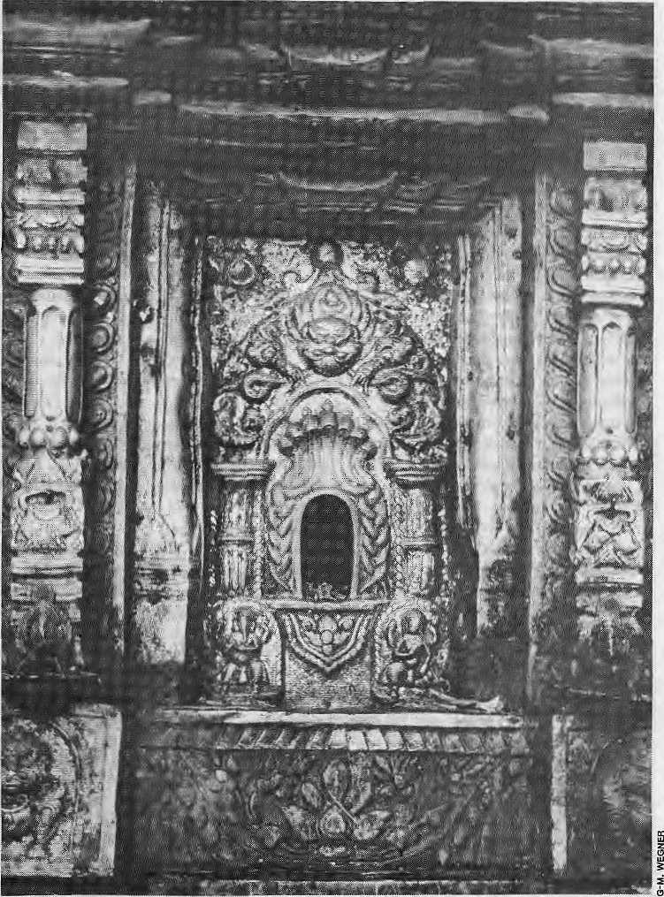
T
he Kathmandu Valley seems to be no less fertile for music than for rice. _ From the musical performances witnessed by the 7th-Century envoys of the Chinese Tang empire to the ubiquitous radio and film songs of today, the Valley has vibrated with music. Indeed, it may be as the poet Chittadhar "Hriday" claimed, the raagas arrived in the Valley as soon as they had been created by Mahadev.
Certainly, Inayat Hussein Khan and Haider Khan, the famous kliyal singers of the Rampur gharana, imported by the Ranas were notlhefirstlosingraagasinNepal. The earlier Malla kings are believed to have been keen supporters of the fine arts and were sometimes poets and playwrights themselves. Songs sung to various raagas and talas were an important part of dramas that were staged in Malla times. The musical ensemble used for these dramas employed a number of instruments — khi, komcakhi, and dhimay drums, bay flutes and, prob ably, pvamga trumpets—now recognised as part of the rich musical heritage of the Newars. This heritage also includes numerous songs of various kinds: devotional, narrative, seasonal, love songs, as well as the percussion ensembles thatno one can avoid hearing during festivals and the devotional ensembles which need a little more effort to find.
The quality of the Valley's soil is far from unrelated to its musical artistry. Musical artistes can not live from music alone; they need food, clothes and a place to live, and these have to be provided for them in some way. A culture close to bare subsistence cannot spare the large number of working hours needed tp support a large-scale communal involvement in music such as that of the Newar culture. Neither can it support musical specialists, suchas the classicalmusicMStatfds or the modern radio composers. Music needs a surplus of wealth to live from. In various ways, including agriculture, trade and taxes, the inhabitants of the Valley generated such a surplus, part of which was allocated tomusical activities.
The guthi system of land endowments has been one method of supporting music. The farmer working the land paid p art of hi s produce to the guthi, which could then be spent on, among other things, employing musicians for its community events. The Ranas could maintain their ustaads by means of their very comprehensive taxation system, implying that villagers inremote areas of Nepal paid for the fine arts of the Kathmandu darbars.
Divine energy emanates from the hole in the shrine of Nasadyo, the music god, at Yetachen, Bhaktapur
Cultural erosion, the dying traditional arts and the adulteration of music by outside influences are often regarded as the
inevitable maladies of a modern Nepal. But is change always negative or is music merely evolving?
by Ingemar Grandin

Nov/Dec 1993 HIMAL . 23

Music as Message
in iUeMrid. That is why, perham, governments t
■ ^ ■"*■ s-
- .i: M
Si however. For instance, the¹ songs of the Gaine " ; minstrels could be overtly pbljtical -corBn^atlng upon< political *'-events in a way that makes one suspect that the wards Mi. been -provided;-by sonie"po!itical actor father' than by the minstrel
'himself. ■;;■ ] '' " ': ": ,,: I I , .. .. I \ ' '.
But the political use of music goes beyond propagandist ■■songs. The love songs making up thebuik of Radio Nepal broadcasts ■ "d^|P^^yati^eswerehar^
.exactly t% poinL Artistes with poUtical inelinaEiorts either had to * ■: keep them out of their songs, orsing thein'outside the goveniment-sypported: institutions. This was a hard decision, for most of the musical opportunities in Panchayai Nepal were tied to such-institutions.
ftheMallakiftgdorESwas one way of mating clear to their subjects; what a glorious society
■ -fliey; were; living iklii thesj; Jkingoirns — extrapolating hom today's organisation otNewar musical activities—musical tasks were distributed ateeording to caste and locality, arid festival^ showed mat, despite ah" M diffejentiation, society was still an. 'nfc^ied whole. This was one way of telling the subjects how to
: interpret their society,andto showthemtheir own particular place¹ in it. Similarly, the Rana import of famous classical musicians frorn^
'"'^{bld}?^{ari}T^{aS}:ª ^{w}^^^moTistratip^ t6 both their subjects and visitors*
from abroad that they were indeed maharajahs, part of the*"
subcontinental btotherhpod of illustrious princes, and that national-
borders merely delineated the boundaries of taxation and not of "
culture : ; ■■
T^eRanLs chose a music weU suited to their ends; Classical music isequally pan-Subcontinental and has very little to say about ethnic-or natioiial;cultural; differences. With: the downfall of .the K#nMj objjeeiiyes were reversed entirely, and cultural differences came to the fore. PostRana Nepal has established and supported a large number or' institutions tliat prbmote" music. The policies governing these insiiiutioris; such as 'he National Commuiiicatioa Service Plan of 1971 overtly stress national unity, prestige and dignity. AH together^ these institutions, which together may be P*F$$r ?^{f} ª^ ! national stage for music, have .promoted Nepali musipal artistes and created new musical genres, above all the (modernised) Folk-sdng artd the modern, song, while classical music has becorrte relegatedUp obscui:ily. Ingemar Gran din

A good tune echo^sln ihernirM: Tkdtis why,:perkaps_{r}g^ernmefitsthe wprldmer try W reinforce their WologWW^dMgthe bright''-words for the tune:
O
ne day in -August last year, tourists sipping pbc;a;pol| and" eating curd at Bhaktapur's NyatapolaCafe found a new target
for their telephoto lenses. At the base ofthef^noHNypipola
temple, singers ariddancers were taking partin a suitaralprogramme.
But this was not just another performance of the Peacock Dance:
The tourists were incidental spectators of a show targeted at |ji|
Bhaktapur titizen. The songs were about poverty,^ inequality and
development and the show — which was performed-in several
other places — was presented by RastriyaJariasanskrttik Manch
Nepal (National People's Cultural Forum Nifpaly which i? tte
cultural wing of the UML, the main opposition party-in Nepal.. Music with political messages has long been a tradition in
Nepal. The various leftist parties have cultural units qf their own,-
Which began operating during Panchayat times. Many cofnposers,
song writers, singers and musicians have supported one or the" other!
ideology by putting their artistic capabilities to-political use.
Among renowned musical artistes of this brand, we fmd Dharnia
Raj Thapa, whose early songs; were said to be overtly political; the '.'.'.
late comrade GokulJoshi who travelled widely in Nepal's villages;
the group Ratpka and the many groups subsequently setup by its ioundmg members— B edema Parvwar, SanktitpaPafntiar, A as thah Pariwarjndreni Sanskritik Samaj.
Like the banners carried at political procession, somepolitiea] songs are simple and propagandistic, and are guhg to sirnple tnelodies that are easy to remember. Apparenflyi such songs were produced on the direct request of party leaders, who ;probaoly thought music an effective tool for prppagandai Other artistes preferred to elaborate their songs. Though they carry a politieal message, some couched it in metuplior. Allusions'to. ahigh-altitUde landscape, tormented by landslides etc, for example_{v}presented no problem for those used to reading between the lines.
These political, or progressive, songs were,'of course, not broadcast by Radio Nepal during Panchiiyat times, nor have they been taken up after the 1990 movement. Nepal TV, on the other hand, seems bent on'more-independent programming and has featured progressive songs in \Vs musical ;plojrfirirnes. Radio Nepal has now relegated many patriotic songs, and even some folk-songSf to its store rooms; they are not 'broadcast anymore; as they were too-explicit in praise of the Panchayat system! !
Musical political propaganda eertainly did not begin inthe

CalloftheVaUey
This surplus wealth of the Valley created an array of resources and opportunities that musical artistes drewupon. But the supporters of present-day radio singers include not only the Nepali tax-payers who, through governmental budgets, fund various music-related institutions such as the Royal Nepal Academy, die Sanskritik Sansthan, Radio Nepal and others, but also the Japanese taxpayers who provided development aid for the
24 . HIMAL Nav/Dct 1993
construction of one of Radio Nepal's recording studios. Thus, the modem-day darbars and guthis and the musical patrons are the Radio Nepal, the Royal Nepal Academy, Sanskritik Sansthan, cultural groups, schools and colleges and recording studios.
Many musical artistes earn additional income from these institutions, and some artistes even land full-tune jobs in them. In addition, an artist can earn income from his musical abilities by creating jingles for
advertisements (common on Radio Nepal), performing ghazals at restaurants, giving classical musicrecitalsathotels, appearing on stage, giving private tuitions, or walkingdown die streets in Thamel selling sarangi fiddles to tourists. For a prospective musical artist, then, it makes economic sense to set up shop in Kathmandu,
But musical opportunities do not end with earning money. Kathmandu is where artistes can earn their reputation, get their


music disseminated, tie themselves into networks of artistes and others, etc. This is where an artist can find good musicians to perform with, where the composer finds a good songwriter, the singer a composer, and all of them a musical studio in which to record.
However good the material conditions for musical creativity, the musical artist also needs musical material to work from. There are classical artistes from whom they may learn the basics of raaga and tala, instrumental and vocal skills. Other teachers, whether at "light music institutes" or in their homes, offer tuitions in guitar, harmony and even drumming. The influx of people from Nepal's villages may also try their talent for a voice-test at Radio Nepal and take part in the Chautari programme — or in a folk song competition. Besides all this, Kathmandu-based collectors of folk songs visit villages, and musical artistes of the Valley sometimes give programmes in various regions of Nepal, often returning with some new songs. Through migration, networking, the media, institutions and excursions back to the villages, Kathmandu has indeed become a national stage for music, a switchboard connecting different geographical and cultural areas and diverse musical traditions including north Indian classical music, Western music, Indian popular and light classical music, various Nepali regional traditions and, of course, the traditions of the Valley itself. No wonder then that so many musical artistes born outside the Valley gravitate towards Kathmandu and, in doing so, give further momentum totheartisticw ares of the Valley.
While the detail s naturally ha ve changed, this picture of Kathmandu Valley as a hub of musical networks and a switchboard For the Flow of musical ideas was probably equally true as far b&ck, at least, as the Malla kings. Many of the forms of music cultivated by the Newars hark back to Malla times, and they can hardly have evolved from nothing. The well-calculated almost architectural drum compositions and the delicate melodies of the old songs testify to the artistic creativity of their originators. Throughout, there seems to have been intense musica! contact with the south. During Malla times, Indian musical treatises were copied and translated and commentaries were written. King Jagatjyotir Malla himself wrote a voluminous work called
classic Natya Shastra. The Mallas were deligthted to entertain Indian musicians, singers and scholars in their courts, and the Hanuman Dhofca reportedly was widely known as a musical centre by the 17th century.
Music in more concrete form may have also been importedfrom the south. TheNewar scholar Thakurlal Manandhar has, for example, suggested that the dapha was borrowed from Mithila in the north Indian kingdom of Tirhut, with which the early Mai las had regular contact. The Nepal-India musical connections came to a temporary end in the early Shah period with Prithvi Narayan's decree that no Indian musician be encouraged in his country, under the Ranas, prominent Indian classical musicians were again invited to the palaces.
The more recent modern s ongs bro adcas t by Radio Nepal during the past few decades have obvious Indian connections. There are songs based on raagas but, more importantly, the whole genre draws upon its Indian counterparts — film songs, light-classical ghazah, and the like. Though there has been a steady influx of musical ideas from India over the centuries, these have mostly become "Nepalised" when utilised by the musical artistes of the Kathmandu Valley. In the case of modern songs, the Indian influences have been combined with musical ideas from Nepal's own regional folk traditi ons to produce a genre distinct from its Indian counterpart. Although the boundaries are by no means precise, the voices, manner of singing, orchestration, the melodies, the way different instruments are played and, of course, the fact that the singers, composers and songwriters are Nepalis (disregarding the most obvious sign, the language of the lyrics) all contribute to our recognition of Nepali music. Indeed, this distinctness is part of the modern songs' ideological reason for being. It is almost as if the whole genre is there to say: "this is not India, this is Nepal!".
Musical Independence
In contrast to this classical music resisted "Nepalisation". This may account for the somewhat ambigous treatment of classical music in post-Rana Nepal. At Radio Nepal in the mid-1980s, classical musicians had better status, commanded higher pay and had fewer
BOOKS
all, NRs 2X5.

workinghours than their colleagues in the folk song department, but still, the actual broadcast time was restricted to 1 hour 45 minutes per week for classical music — as compared to a totaj of ajmost 26 hours per week for Nepali folk and modern songs! Too much classical music on Radio Nepal and the message may be interpreted: "this is (part of) India".
Undoubtedly, classical music has high status and is seen as serious music and a source of musical knowledge and competence. But, outside a small circle of performers and connoisseurs, it is not taken seriously as a genre. Composers, singers and instrumentalists learn from ustaads and turn to the raagas and talas as bases for musical composition, to develop their practical artistic capabilities and for a better knowledge of music. In this way, classical music takes on a significance that goes far beyond the admittedly restricted popularity of elaborate raaga recitals. And, after all, this is expected given that shasir'rya tf<wige£f,thoughitis translated here asclassical music, actually means "music based on knowledge".
The musical artistry of the Kathmandu Valley is not confined to palaces, big stage events or recording studios. Inpalls, at temples, in the streets and on local stages not only in Kathmandu, Patan and Bhaktapur, but also in the small towns throughout the Valley, local musical artistes go on with their art. For instance, in Kirtipur, with its 10,000 inhabitants, there were in the mid 1980s, 10 dapha groups, six groups singing bhajan hymns to the accompaniment of harmonium and tabla, seven dhimaybaja percussion ensembles, and three wedding orchestras of the modem brass band variety. In one of Kirtipur's neighbourhoods, more thanhalf the men had learned to perform in one or other of these musical traditions. This is a sign of the pervasiveness of Newar communal music-making which has ensured that no part of the Valley would be without its own local musicians. In addition, the town has seen a more recent upsurge in a more specialised
Mustang bhot in
Fragments is an
account of a
Nepali woman
confronting
schisms in the
community she
visits, in her
country, and her
:<t own identity.
Available at at! leading bookstores

Nov/Dec 1993 HIMAL , 25

musical activity. Musicians who have gained their musical competence in traditional Newari genreshavegoneonto make stage programmes of their own, where modern songs composed by themselves or borrowed from more renowned Kathmandu colleagues and traditional Newari songs (which have been given new texts) are presented along with dances and short dramas. Along with this, new local patrons of music — such as libraries and cultural organisations funded by local householders—have c ontribu ted to prov iding new resources and opportunities for musical artistes.
However, as musical artistes-and maybe especially the most dedicated ones - devote more and more of their time to these slage programmes, the signs are clear that the communal involvement inmusic has lessened. Musical groups have closed down, people have given up performing and many young men never lurrt up when it is time to leam the traditional genres. As people shift from agriculture to modem occupations, it becomes increasingly difficult to take part in, for instance, regular morning singing in a dapfui group. And the young man who spends his morning hours in a college may find it impossible to take part in the tuition session organised by a traditional ensemble.
Progress versus Regress
Will the Katliraandu Valley continue to be a centre for musical art and creativity? The two common ways of interpreting historical processes, the optimistic and the pessimistic, predict radically different futures. The optimist sees history as progress i n wh ich society moves from a bad past to a decent present, towards a golden future, hi contrast, the pessimist sees history as aregression from a golden past to a deplorable present, where we move towards a future in which things will be still worse. The optimistic view is often encountered among people working in development while the pessimists are found among, for instance, environmentalists (who see the number of species ever declining and pollution ever increasing) or those who worry about problems with young people ("the youth of today is w orse th an ever before, more prone toviolence, drinking, and loose sexual morals").
The optimist would say that the Tough and rustic traditional music of the Kathmandu Valley, as well as the over-complicated classical music, is increasingly giving place to carefully worked-out modem foims of music that combine the best of East and West and correspond to the needs of time. Primitive instruments such as the sarangi, the modal or
the bansuri will be replaced by better ones, Western ones, oreven sophisticated synthesiser keyboardsanddrumrnachines.Thepessimists, of course, disagree. According to them, the valuable traditions of the past are dying out and, in the future, the music of the Kathmandu Valley will just be local versions of Michael Jackson and Madonna. But is there, perhaps, a better way of looking at change?
It was the great German musicologist, Curt Sachs, who said that musical development is never really a development in terms of aesthetic value—itis just change. And, to put the argument in terms of European classical music, no sensible person could possibly argue that the music of Beethoven is better than that of Bach (as the optimist would have it), nor that Beethoven should be better than Bartok (as the pessimist might mistakenly think). Sachs's view captures the truth aboutmusical development better than either the pessimist or the optimist The optimists are often found among people attracted by novelty for its own sake, and among those who instinctively feel that change is always development for the better. Pessimists, on the other hand, seem to base their views on objective facts: this or that tradition is vanishing, the level of artistic quality in a particular tradition has clearly deteriorated. The pessimist, though, convinces by comparing past and present on unequal terms.
Tohiscontemporaries,for example, Bach was just one of many composers. To us, he is one of the greatest of all times while his contemporary colleagues, perhaps seen by his time as greater than he, are long forgotten. Along the way, from then to now, the river of time has cleared away all the mud to reveal the pearls. The music of the present, howeveT, is a confusing and ambiguous mixture of mud and mud-covered pearls. No sifting has yet been done.
Muddy Present?
Comparing the shining pearls of the past with the muddy present, one may have the impression that we are sliding downwards towards a gloomy future. The sum total of music produced today appears not quite inspiring and this is as true for the music of Kathmandu Valley. The anistic music produced by contemporary artistes easily disappear in the massive output of new music. Themediaare often seen aschief culprits behind the vulgar commercialism and cheap popularity which, according to the pessimistic view, is the most salient feature of the music of today. (This way of describing things, of course, is by no means confined to the
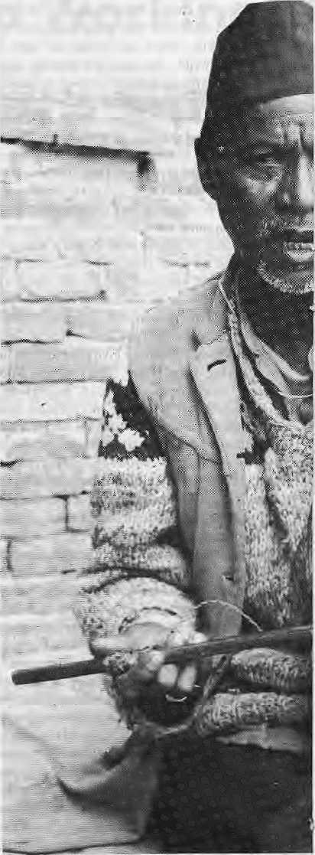
Krishna Gopal Gandharva, a gains, lives in Bbaktap
Kathmandu Valley but has been heaTd everywhere.) But it is precisely this national stage, created by the media, that has enabled artistic music, such as songs by Amber Gurung and sung by Aruna Lama "Sabaile bhanthe layalu phul bhai", Rameesh and Manjuls' "Mero sano Muralima" etc. (not to mention the many other fine songs by other musical artistes). Through their musical woTk, radio recordings, discs, cassettes and stage shows

26 . H1MAL Nov/Dcc 1993

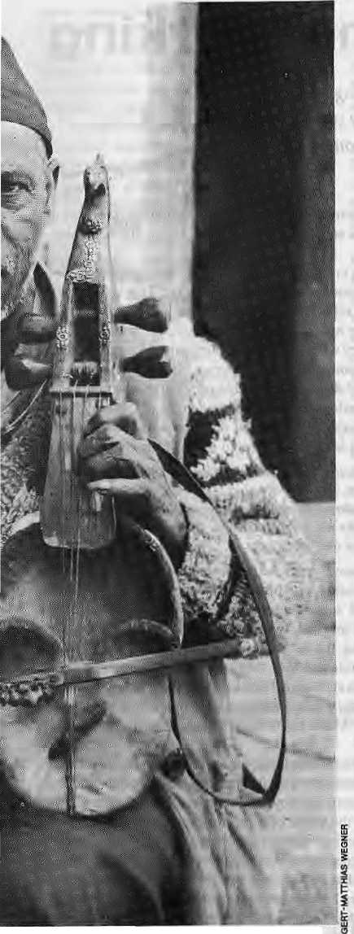
and sings Newari as well as traditional Nepali Songs
both artistes, neither of whom is a Kathmanduite by birth, were attracted by the musical opportunities the city could provide for them and have themselves joined this national stage for music.
The musical creativity promoted by the national stage affects also the local musical artistes of the Kathmandu Valley. Inspired by their Kathmandu counterparts, and drawing upon the musical ideas current in th&national
scene, talented musical artistes inKirtipur and other small towns compose their own songs. While there may seem to be a risk of musical impoverishment considering that the Newari traditional music of the Valley is not maintained, the Valley's musical arts have simultaneously become enriched by what the national stage has brought about. This enrichment does not end with the modem songs.
As a musical switchboard, the Kathmandu Valley has access to various local folk traditions. Consider a folk song such as "Simle mathi ban". We do not need to go ali the way to the villages ourselves to hear such songs. People go there for us to collect the songs, ot people come from the villages to Kathmandu to sing for us. Once here, these songs may take on a new life in Kathmandu circles, outside their place of origin: they are circulated among Kathmandu musical artistes, performed on stage as well as in gatherings of friends, maybe also brought out on a cassette. In the process, Simle mathi ban which has its origins in the Pokhara region and was a part of the local musical heritage, becomes part of the musical heritage of the Kathmandu Valley.
It is indeed true that many traditional formsof music in the Kathmandu Valley show signs of vanishing. The Valley may continue to nurture musical artistry and creativity without the Newari musical traditions, but, just as the loss of any species represents an irreplaceable loss to the world's genetic pool, the loss of a musical tradition is a loss to the world's cultural pool. But it may be too early for despair for it is a tradition's stock of musical ideas, its distinctive contribution to the musical pool, rather than the way it is maintained that matters. Music will just as surely die if preserved in a museum.
While traditional Newari music such as dapha and dhimay are no longer performed in each neighbourhood, this music may live on, entertained by dedicated musicians who keep the traditions alive. This has many paraileis in other parts of the world. In Sweden, the folk traditions that a few decades ago seemed bound for extinction have been revitalised by enthu-, siastic young musicians who have made folk music the most dynamic and creative of all Swedish musical scenes today. Very actively, they seek out melodies and tradition-bearers, but they also contribute to theTeper-toire with new compositions, try new instruments, new ways of group performances, and so on. This revitalisation inevitably brings about change.
There are signs that something similar is happening in the Kathmandu Valley. Several musical artistes work dedjcatedly with their own traditions, publishing collectionsof drum
compositions, working with performances in hotels, or travelling over the Valley to enrich their repertoire of Newari songs, to be used in their own performances. Also here, artistes may continue the tradition by composing new songs. Among these artistes, Ram Krishna Duwal has written a large number of new songs in which the music is based on traditional Newari melodies and retain a distinctly Newari musical flavour, and whose lyrics draw upon Newar culture. And the repertoires of traditional Newari genres have a life outside the traditional ensembles. You can hear the melodies of Newari folk and seasonal songs from the stage in the setting of a modern, mixed cultural program or, of course, when there is a classica! music recital.
In one classical music sammelan in Kirtipur, the sarod master, Mohan Sundar Shrestha, concluded his raaga recital with an enthusiastic rendering of one of the Newari fiostfttfa melodies, and where Krishna Narayan Shrestha playfully presented a jaltarang version of the Newari folk-song "■Rajamati". Incidentally, the si taristTarabir Singh Tuladhar has given a 10-minutc interpretation of "Rajamatt" on an LP disc brought out by a Western label.
Alive and Kicking
To give ahopeful interpretation, itmay be that the Newar traditions are not so much on the way to extinction as changing in the way they are maintained. The tradidonofmusical artistry in the Kathmandu Valley has been around for a long time and, as yet, it seems alive and well. Throughout the distinct phases of musical development, musical artistes have drawn up on the opportunities open to them and worked creatively and artistically upon the musical ideas provided to diem by tradition and borrowing. After all, the most important thing about Beethoven is not whether he composed better music than Bach or Bartok, but that he was given the opportunity to be a composer, rather than to be, say, a chartered accountant. The conditions that made Beethoven possible are the same that have created the musical artistry of the Kathmandu Valley: scope for musical artistes, musical traditions to build upon, an influx of new musical ideas, a gadiering of musical personalities, and that part of the surplus of wealth is allocated to intensive music-making. The future of the Kathmandu Valley as a centre for musical creativity depends upon the maintenance of
these conditions. k
I. Grandin is the author ol Music and media in local fife; Music practice in a Newar neighbourhood in Nepal (1969) and is looking al thss Nepali music scene since the 1960s lor his second book.

Nov/Dec 1993 HIMAL . 27

The Sound of One Mind Working
Tibetan ritual music is not a pastiche of gentle good feeling about the Universe.
It is an alarm to the system, waking us up to the vibrancy of the world we are placed in and
the prevalence of sound as a means to form our home.
by David Rothenberg

W
hatever one's relation to Buddhism, whether from within or without, the religion appears at once to be admirable. There have been few wars fought in its name; indeed, its teachings seem to aim for a kind of composed peace in the Universe. Though, at times, apparently indifferent to the upheavals of our present world, its visions lie beyond politics. Its aesthetic of calm can prevail behind all lhat seems to be changing far too often, far too fast.
All this composure can be shattered on first hearing the ritual music of the Tibetan monastic traditions. In the Himalaya, it can still be heard in the gompas hidden away in the mountains. Approach the heavy wooden monastery door, tiptoe so as not to disturb the silence, gently push open the portal and pass through a heavy, muffling cloth. Inside, lit by torches burning on either side of a podium, sits the leader of an assembly, deeply engrossedinareligious text. Hear the faint, low rumbling from two rows of monks on either side suddenly surge to an uproar as they pick up their instruments. Huge, thirty-foot metal horns anchor the sound with a groan- as if from the bowels of the Earth, cymbals clang from a crash to a wash, like a wave receding from the shore and preparing to strike, small trumpets made of human bone scream shrilly and large drums beat in rhythmic acceleration, from boom, to bum bum bm bm bm bbbb booom, each instrument with its own rhythm, falling like the leaves of trees that are then blown up into the air as if by suddengusts of wind, a cacophony of crispness defining the spirit of autumn, the harbinger of winter and the time when snow willdrape the valley in ahallowedstillness. At first itis noise, but adin that still understands the rise and the fall, far from the whirring of machines or the honking of traffic. Rather, it is something welling up from the slopes of the mountain, carried down into the winds of the world. Theswirls and voices of the spiritual jam session go on long into the night, allowing the sound to overwhelm the players as the candles wear down into darkness.
Crazy Wisdom
Once you too have heaTd that sound, you will know that it never leaves you, even when all other sounds are shut out. It is the sound of the body
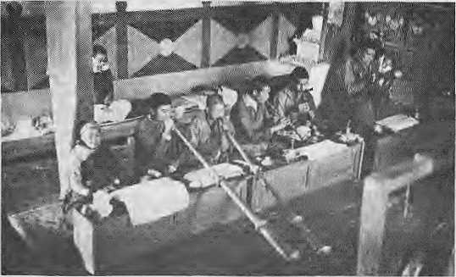
working, sensing the world. The sound of the mountain. The path of pure music, before the song, before the chord, before the beginning, middle or end.
The thing is, it's crazy. It's a roaring din. Western students of Buddhism are sometimes embarrassed by the racket. This is because it does not immediately reflect the peace they seek. Tibetan Buddhism suddenly seems to be not as contained as outsiders would like. It embraces akindof crazy wisdom, rich with pungent co Unit and swirling detail, mandalas of demons and terrors, all to take the individual through violent journeys of self-discovery. Yet that very roughness is all to be found inside us, projecting around us the dynamics of a purely inner struggle. Look what happens when you die; you will have to travel through madness. This is what the Tibetan Book of the Dead advises:
Be not afraid of the brilliant radiances of the five colours, know the wisdom to be your own. The natural sound of the truthwill reverberate like a thousand thunders. The sound will come with a rolling echo. Fear not. Flee not. Be not terrified. Know these sounds to be the manifestations of your own inner light.
It is said that the sounds produced by-Tibetan chants and instruments are the exaggerated counterparts of the sounds your own body would produce if all external sounds were shut out. "This sound", Sonam Chojor Geshe, a lama, told me, "will come to you when it is time. Do not waste time looking for it." Others are less optimistic. The late Gyalwa Karmapa maintained that "only incarnate lamas hear these sounds. They hear them all the time, and see the deities from which they emanate." Sakya Tichen, who has written a book on Tibetan music, was even more restrictive: "Music has nothing to do with man at all. It is for the Gods alone."
So, which is it to be? Will we ever understand the meaning of such distant and foreign sounds, or will we only hear them as shadows of their total purpose? Music remains beyond words and thus might just be better able to express the states'of mind that meditation is meant to produce. .Hear the repeating, fading sounds of the cymbals, perishable butneverconstant. It is perceived but may notbe kept. Listen to the deep reverberation of the chant of ancient sutras. Each individual voice produces achord, a deep bass far beneath the normal human voice, rich with overtones to produce an astounding presence. The text is not so much presented as evoked and camouflaged, penetrating far beyond the words themselves.
A Musical Window
Eleven years ago, I went to Nepal to attempt to learn part of this booming, crashing tradition from within. I studied an instrument called tbeGyaling, ahand-held conical horn similar to the Indianshehnai, with seven finger holes and played with a double reed. In the midst of all the gigantic, droning horns and crashing cacophony, this oboe-like instrument plays precise, flowing melodies that seem to both begin and end ix\ the middle. There is some improvisation, but only to the extent of deciding when to change to trie next prescribed pattern. Each piece,

28 . HIMAL Nov/Dec 1993

said my teachers, could last a few minutes or a few hundred years, depending on how far I wished to get into it.
Yet they laughed at my interest in the first place. "Why," said Lama Sangye Tcnzing, of Serlo Gompa above the village of Junbesi in Solu-Khumbu, "would you come all the way to this country to learn this one, insignificant part of our culture? Can you not see it makes no sense without the whole? I play this piece and can hear the cycles of birth and rebirth and the thirteen phases in the education of a lama. But to you, it is just sound,"
"Think of a window,"! toldhim. "lam outside, and looking at your world. I can see only one piece of it. And this is the beginning. As a musician, I know something of music. Through music, I can look in, listen in on your world. Then I can hear the world through what music can reveal of ii. It will be different to what others will read of it, others photograph of it, but it will be another window in."
The gyaling is usually heard in the midst of the crashing and roaring ensemble, so alone that it sounds surprisingly naked and calm. At first, all the pieces sounded alike to me. The differences between them are so subtle as to heighten the attention of the student who is trying to learn to play them. My teachers, usually, could not speak Nepali or English, so they would demonstrate and I would follow. The gyaling is usually played in pairs. One tends to follow the other. The blend must never be exact, to remind us that the musician is always following the music, an art never for humans alone. They would smile and point at my head, imploring me to remember. They would despair at my furtive efforts to write it all down. Music is not for pen or forpaper. It must be inside us to mirror the sounds of the naked mind.
After a while, I realised that it works. Today, more than a decade later, when all is calm, in those rare moments when I have sought out and found natural silence, in the background inside I hear the warbling melodies of the gyaling, without interruption, as if they would continue for years on end. It is the sound of the mind at work, only audible in places asquiet as the high Tibetan plateau used to be, before it began to be developed like the rest of the world. Those lamas were right. This is the sound of one mind working.

Aimless Peace fulness
I have returned to the United States to teach this musk to others, to try to make them understand. It works best when I break from the traditions, when I adapt the rhythms to the world I am now in. I've learned to play the gyaling pieces on my native clarinet, recorded them on digital compact disk, played them all over the world in different contexts.
But this has taken the sound away from its home. Is it sad that elements of tradition change, and are not always preserved? Since I embarked on this study years ago, some Tibetan music has crossed the globe to become all the rage. The monks of the Gyuto Tantric College in Bomdilla, Assam and other groups, have toured the "West chanting deep chants and presenting very clearly the grace and gravity of the endangered Tibetan tradition. These concerts are powerful, and have sold out. I suspect that many listeners^ do not want
to understand much more about the sound, except to take it in as another instant spiritual kick. Western composers have not been much more sympathetic; they tend either to appropriate the effect, to try to aim for a deep bass presence of their own or, worse still, to increase their own reputations by mere affiliation. There is, for example, a CD recording of chanting monks with apiece by the American avant-garde composer Philip Glass appended at the end that has nothing at all to do with the Tibetan music.
Last year, a benefit concert for Tibet House washeldinNew York city. The performers: poet Alan GinsbeTg, avant-pop star Laurie Anderson, Philip Glass, and a Tibetan New-Age flautist whose name, I must admit, I forget. It was an all-star cast, assembled to draw crowds and cash. Numerous film staTS and other celebrities populated the audience. The performers had never played together, and they did not share enough common ground to improvise successfully, as jazz musicians might well have done in the same situation. Musically, it was a grave embarrassment, though it is always hard to fault something done for agoodcause. Even the sole Tibetan participant, seemed curiously unauthentic. His music was aimlessly peaceful in a New-Age sort of way, rather than penetrating the depths like the tradition he was supposed to represent. The audience, then, got what they wanted to hear and felt what they wanted to feel. That they had seen some famous people and supported an issue without being challenged by a cultural tradition that is meant to shock us into the exactness of our being. Tibetan music, as a part of the Tibetan world, is not a pastiche of gentle good feeling about the Universe. It is an alarm to the system, waking us up to the vibrancy of the world we are placed in and the prevalence of sound as a means to form our home.
Way of Pure Sound
You have to look way back before Buddhism to find an eloquence that describes what is meant to be heard. In the Nine Ways of Bon, the early religion of Tibet, we find among them the Way of Pure Sound—not music, not noise, but a way of listening to the inside and outside as one.
Water rises from water. There is no
way to avoid it.
Wood sprouts from wood. It
never really dies.
Add wood to fire and where does
that get you?
You only avoid if you keep to yourself.
The way of Pure Sound is the way of change.
Without avoiding, it seeks to accept.
Taking all into friendship, everything
is its friend.
With all as your friend, nothing stands alone.
Sky and space, method and wisdom;
losing duality, reaching perfection -
Perform a realm of perfect enjoy<ment.
Music is always said to reach beyond language, so that we may
appreciate what we do not understand. Some say that it is the best way
to assess distant cultures. But music demands attention. It should be
serious, not the background soundtrack to the emotional surge of our
lives. Beyond the precision of words, it reveals the precise tones of the
soul in the world, Tibetan Buddhist music sets this up religiously as its
purpose. No wonder it is hard to listen to. But to live within its world
is worth it, k
David Rothenberg is a writer and musician. His adaptations of Tibetan music are available on his recording nobody could explain it. He Is a proiessor in the humanities department of the New Jersey Institute of Technology.
Nov/Dec 1993 HIMAL . 29

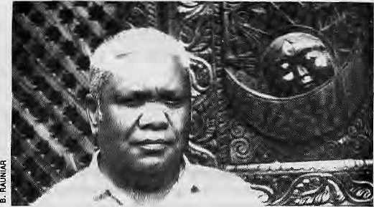
A Conspiracy Against Music
by Ramsharan Darnal (as told to Kedar Sharma)
Aj Ramsharan Darnal, am a member of the Damai caste, whose tradition and identity is in music. The caste system itself has a long history in our country, and is a legacy of a division of labour that was carried out during the Vedic age. This categorisation in time came to be linked with religion, and the system was refined with the introduction of customs and laws. Notions such as pure/impure, upper/ lower and touchable/untouchable took hold of Nepali society. According to tradition, therefore, I am an untouchable.
In this nation of "four varnas and thirty-six jatis" there are many communities whose identityismusic.Kulu,Sarld,Chanaro,Damai, Hudke, Kusule and Kasai are all groups which play variousmusical instruments, while Kamis make them. The Gaine and Badi are proficient at both ...they make and play instruments.
With so many communities traditionally engaged in music-making, one can surmise that this was once a profession respected and patronised. But the fact that all communities engaged inmusic were relegated to "lowcaste" status says, to me at least, that at some stage in Nepali history there was a conspiracy against music. The slow demise of Nepali music seems to have begun at the beginning of the 14th century, when King Jayasthiti Malla of Kathmandu regularised the caste system.
Even though there were so many Nepali castes and groups involved in music, the profession slowly lost its ability to provide for economic survival. Each group, therefore, had to adopt a line of work, which is how Damais began to sew cloth as a profession. Today, Damais all over the country are known first as tailors, and they play music almost as a side specialisation. Having a background so steeped in musical tradition, many Damais couldhave helped in the development of indigenous
A proponent and scholar of traditional music takes pride in Nepal's rich traditions and laments its decline.
Nepah'music, but the imperatives of livelihood have kept them tied to their sewing machines.
Band Baja
Us artist castes were relegated to the bottom in economic rung, but the society was never able to forget its musical past. Thus, auspicious occasions have always demanded thepanche baja or the naumati baja. Even the most conservative "upper-castes" cannot do without the Damais or Kusules. Howsoever much the politics of the day tried to wish themaway, the musical castes were never really abandoned by the society itself.
My ancestors came from Pokharithok village in the Gorkha principality of the great King Prithvinarayan Shah. My greatgrandfather Santabir arrived in Kathmandu around 1806, as the nagarchi (band leader) in the Bayu Guthi, the religious trust which was established after King Ranabahadur Shah's assasination to provide solace to his soul.
Of Santabir's four sons, two joined the army as musicians. One of them was my grandfather, whose son (my father) Satyakumar also served in the army as a musician. When he Tetired, Satyakumar ordered a set of bachhe baja, western band instruments from a firm in Paris known as Cousinon dfc Co.
That was the time of Maharaj Juddha Shamsher, and commoners were not allowed to play band music. As a result, the expensive instruments had to be put in storage. My father went to Sri Teen Juddha and made the plea: "Either the Government should buy my instruments, or allow the public to hear them." The Maharaj considered the matter and allowed Satyakumar to play the band baja before the merchant class, but only during marriages and other such ceremonies. I feel'that this decision
had significance for both Nepali music and Nepali politics.
Luckily, my own family has had better luck than most others in the musical castes. Since the time of my great-grandfather, we haveremained immersed in the world of music. My father's maternal grandfather, Bakhatbir Budhapirthi,gavethemusictoNepaFsnational anthem. His sons and grandsons, while in Calcutta, changed their surname from Budhaprrthi to "Banks". Bakhatbir's son Pushkal Budhapirthi became renowned in the Calcutta music world as a hotel bandmaster, performing under the name George Banks. The famous contemporary j azz musici anLouis Banks ishis son, whoseNepali name isDambar Bahadur Budhapirthi. By relation, he is my father's uncle's grandson, which makes him my bhai.
Not unnaturally, I have been interested in music since childhood. After a few years at Kathmandu's Durbar High School, I was enroled in St. Roberts in Darjeeling. But while still at school, I was called over to Calcutta to workwith Uncle Pushkal, under whomllearnt to play and perform with the guitar, mandolin and trumpet.
It was in 1957, Icame toKathmandu and began to study traditional Nepali music and instruments. I also became engaged in the recording of songs to which the lyrics were by M.B.B.Shah (late King Mahendra). In 1959, the first anniversary of the Royal Nepal Academy was celebrated with much fanfare, for three days, within the Royal Palace itself. That was when I joined the Academy.
A Country's Wealth
The Academy allowedme to devote myself to my discipline. I researched music, wrote six books (and have six more yet to be published) and wrote hundreds of articles in the papers. From what I have gathered during my studies, I have come to the conclusion that Nepal has been second to none in its musical traditions.
If one looks at the instrumentation, we have in Nepal instruments to represent all the main groups: chordophones such as the sarangi, pibacha, and tungna; aerophones mcliasbansuri,sefmaiandmufiati;percussion instruments such as jhyali, bhusya, mujura, ghantaandmurchunga; andmembranophones such as chyabrung, madal, dhimay, dhyangro. Even though Nepalis might not be advanced in the use of modern instruments like the xylophone and electronic keyboard, we do have music-makers as ancient as the binayo, which is made from bamboo.
The High Himalayan communities, influenced by Tibetan culture, have their own

30 . HIMAL Nov/Dec 1993

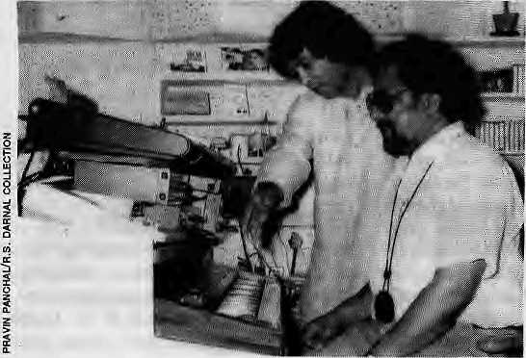
variety of musical instruments for social and religious occasions. These include the ngaha (a drum that is hung), Kangting (sehnai), lawabaja (6 to 12 foot long trumpet), buksyal (cymbal), chyot (drum), damphu, tungna, dongchhen, and so on. TheKangling is a wind instrument made from the human thigh bone, and damarus can be made from the human skull.
The instrument known in Newari as the kwatais one ins tmment that is today indigenous to Nepal. The kwata is referred to in Indian dance literature as the Tripuskar — it is a madal with three faces. While in the Ellora caves of Maharashtra, there is a statue seen playing three madals together, the kwata is found not even there. In Kathmandu Valley, Shakya monks rever the kwata, and bring it out only during the Gaijatra and Janai Pumima festivals to call the protective deities. When Lord Buddha was born, according to the holy book Lalit Bistar, this was one of the instruments in the orchestra which played from heaven.
A country so rich in instruments will be rich in music as well. We have raagas and tunes for every temple, every deity, every occasion, and celebration. During the Rana years, renowned Indian ustaads such as Taj Khan and Dunde Khan were resident in the palaces of Kathmandu. In 1900, during the reign of Bir Shamsher, a seven-day music festival held in Bagedi in the Tarai achieved musical fame for Nepal. The Bagedi Sammelan, as it came to be known, had established ten modes of music which was much more complex than the ten modes prevalent in tne (Bhatkhande) classical Indian music (sangeet) of theday. Unfortunately, this Nepali innovation was lost in the ensuing years. Had the tradition of Hindu classical music remained strong here, there is no saying what height Nepal would have scaled in the South Asian music world by now.
Made in Nepal
Music is a part of culture. Today, like Nepali culture, Nepali music too has succumbed to limitations and exigencies. All our traditions loqk weak when made to stand up against the razzle dazzle of the "modern". It used to be said that one never changes one's humi (the Bahun who does the horn) and dumi (the musician Damai). But today, at a time when the very traditions of humi and dumi are fast disappearing, the question of changing one does not even arise. Even Xhspanche baja, the five instruments ensemble which represents the five elements, which is mentioned in the Vedas, is in swift decline. How can we expect our traditional musicians—poor, uneducated and not respected—tocompete against today's electronic ins truments and commercialisation ?
The lack of a market for good music in contemporary Nepal is such that even the makers of traditional instruments have had to give up their trade. Thus, the descendants of Patan'sKrishnabilas, who gainedfameduring the Rana times manufacturing three sitars, today prefer to work in the more lucrative trade of carpentry. Of the three sitars that Krishnabilas made, one is in the Royal Palace, another is with the family of the late Bhupalsingh Pr adhan, and the thirdhas not yet been traced
Nepali artists and craftsmen have even developed new instruments, but lacking a market they were stillborn. One such instrument is the Chaturang Baja, which was a combination of three different instruments — the harmonium, tungna and swarpetika. It was developed by Patan's Mohanlal Bahari. Another instrument, developed by Ramchandra Bharati, was the Manarangi, which joins the sarangi and the piwacha. This instrument can be found only as part of the Royal Nepal Academy's orchestra. Another instrument which did not receive just appreciation was the brick xylophone
Dambar Bahadur
Sudhapirihi, with tebala maestro Zakir Hussain
developed by Music Laurate Yagyaraj Sharma Aryal.ThesamewasthefateoftheDhirjBaja, a sort of a congo drum developed by Dhirjlal Kulu. Mohanlal Barahi and Ramchandra Bharati continue to work on their trade. They are also master tuners of instruments. But when they depart, there will be no one to take their place.
Babulal Darshandhari, who played tht muhali in the Nawabaja orchestra in Patan died acouple of years ago, and now there is no one to play the instrument like he used to. Even though his sons have tried to follow in Babulaf's footsteps, they have not been able to attain their father's sublime artistry. This might be because they are not into music fulltime.
Actually, the problem with classical music inNepal is not only a matter of lack of market and patronage. The Kulus, drum-makers of Bhaktapur, are in a quandary because they cannot even find the right wood that their instruments demand. They are forced to make dhimey bajas of recycled tin, but then the drums do not have the same resonance of wood. The kulus have now taken to repairing old drums rather than make new ones. Meanwhile, the Shakyas, who excel in making metal instruments, are turning to the more lucrative business of making silver and gold ornaments.
To develop music, we need a national effot, an institutional effort and the effort of families and individuals. Unfortunately, there is little in the form of governmental or institutional involvement, and even the traditions that exist among musician families arc today fast eroding. Even what is there is hidden away — for example the musical collection of the Academy is in storage in the NAFA building. There is, finally, an effort to set up a Department of Musicology under Tribhuvan University which is to be located in Bhaktapur. If this succeeds, we will, at last have an institution dedicated to the promotion and study of Nepali music.
But how canl complain about the state of
Nepali music when even my own legacy is
questionable? Despite my family's traditions,
my own children are not in the musical line.
When I see one son an engineer, another an
archaeologist, and my college-going son,
daughter and daughter-in-law, sometimes I
think that perhaps I have done right. But when
they complain to me that I have kept them
awayfrommusic,Ifeel bad. Perhaps everyone
is in a quandary like me. Perhaps the whole
nation is in quandary. ^
Ft. Damal Is presently in charge of the Nepali Musical Instrument in Ihe Royal Nepal Academy. K. Sharma edits the annual Nepali Himai. This article was translated from ihe original in Nepali.

Nov/Dec 1993 HIMAL , 31

Ancient Rhythms and Modern Messages

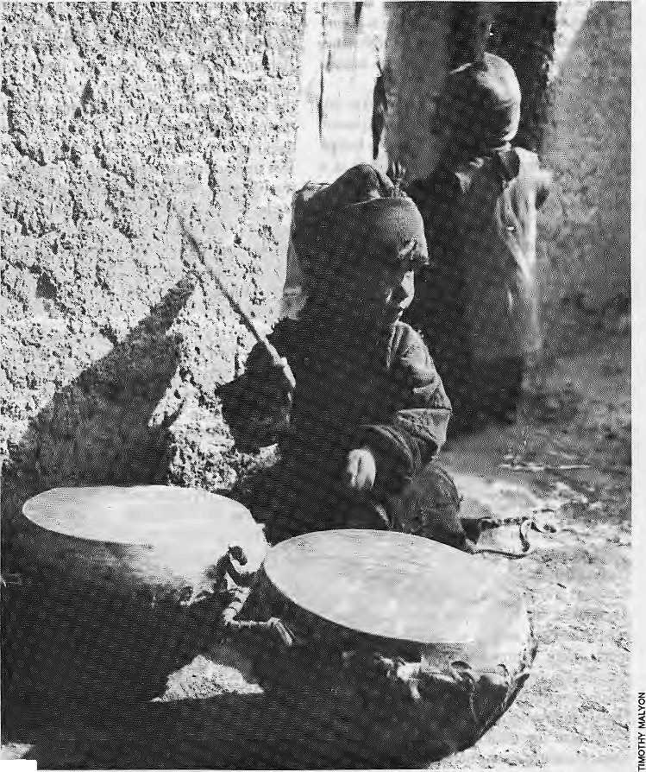
M l
stops. The timing is perfect. He leaps onto the pair of daman, kettle drums, used by the musicians. The Thythms may be Dardic, but these drums date from a later musical phase in Ladakh's history. They were most likely introduced into Ladakh from Baltistan in the 17 th Century when Laciakh was an independent kingdom. According to the Ladakhi chronicles, King Jamyang Namgyal of Ladakh launched a surprise winter attack on Skardu, the Muslim
L
adakh's Matho monastery stands on a rocky outcrop above the place where the Matho River meets the Indus. It's winter, and the monastery is packed. People squeeze together in the courtyard and on the flat rooftops, leaning over parapets to catch a glimpse. Suddenly a great roar goes up from the crowd, Ki ki so so lhage to, "may the Gods be victorious". Two figures emerge from the main temple, brandishing swords, leopard skins around their waists, running, running. And as they nin, drums beat out an insistent rhythm iike the pounding of sea surf, rising and falling. Sometimes the figures pause for a moment, screaming a prophecy for the coming year, or slashing arms and tongues with their naked blades. Flecks of blood cover the white scarves, katak, which people have offered them. These are the Gods of Matho, the/?OHgfs«« or "spirits of the gorge". They were brought here, so the story goes, from Eastern Tibet by the founder of Matho monastery, sworn to protect Matho and Buddhism. They belong to apre-Buddhist age of Ladakhi and Tibetan history when die Gods ruled all; Gods of the gorge, the pass, the village, the hearth.
Dardic Roots
The musicians who drum for the Gods are not monks, butvillage musicians. And therhythms are ancient. Mark Tre win, amusicologist from the City University, London, has beenstudying Ladakhi music since 1985. "The idea that we still findinLadakh, of playing music to invoke deities and spirits, I think this has much older roots, dating back to an age before the arrival of Buddhism. It was probably regularly used at village level for actually inducing trance, inviting deities to thevillage."Trewin believes that the rhythms used in the Madio ceremony to accompany theGods are similar to rhydims used by the Brogpa, the Dards, probably the original inhabitants of Ladakh, before the arrival of the Tibetans. To beat out thisrhy dim, Dards still use one of the oldest of drum forms, the barrel drum, a hollowed piece of wood with skin stretched over the ends. The drum is also still used for the New Year ceremony, Losar, inLeh, Ladakh's capital. It's also to be found among the Kafirs of northern Pakistan, Nurestan and Afghanistan, believed to be related to the Dards, of pre-Islamic, Iranian heritage.
One of the Matho Gods is sprinting ever faster around the cental flag pole in the monastery courtyard. Suddenly the drumming
Ladakhi folk music may have its wots in West Central Asia but was
later influenced by South Asian traditions. Today it is still
embellishing old music with new ideas.
by Timothy Malyon
Balti capital of Ali Mir Sherkhan (circa 1595-1616). The attack failed and die King was captured. As part of the peace settlement, Jamyang Namgyal married Ali Mir Sherkhan's daughter, whose dowry included a troop of Balti musicians. They became the Toyal musicians of Ladakh, ihs.Kannon. Along with daman, they brought with diem a kind of oboe, also to be seen and heard in the Matho courtyard, alongside the drums. In fact, there

32 . HIMAL Nov/Dec 1993

are two kinds of oboe here in the courtyard. One, the .sH77ifl,isplayed by village musicians, the otheT, the gyaling, now silent while the gods aTe present, is a purely monastic instrument. Ladakhi monastic musk and folk music are separate and have very different origins. The monastic music came largely from Tibet. So, although the folk and monastic ■oboes look alike, their tuning and tones are very different. The gyaling has a much softer sound, whereas the surna sounds strident, more appropriate for outdoor playing. Both instruments probably originated from Arabia in the 9th-Century, but reached Ladakh by differentroutes-ThesurnacametoLadakhvia Ali Mir SheTkhan's Baltistan, whereas it is generally assumed that the gyaling came from India via Tibet, along with Buddhism.
Blacksmiths and Kettle Drums
The God stands one foot on each kettle drum, screaming out his blessing to the musicians. Then his naked sword falls hard and flat with aresounding thwack onto the drummer's back. These village musicians are known as Mon, a Tibetan word for people from the southern slopes of the Himalaya, often from Himachal Pradesh. In many Ladakhi villages, especially those in the Indus valley around Leh, there are one or two Mon families who supply music to the village, for festivals, offerings to local Gods and for visiting dignitaries and parties. They may originally have been wandering musicians who came up from the south, hence their name, and were of fered land in return for their musical services. Although Buddhism is not supposed to entertain caste differences and despite the Dalai Lama's strong condemnation of such discrimination, the Ladakhi Mon are considered, along with the Gara, the blacksmiths, to be lower caste. The Mon still, worship a Hindu protective deity, their caste God, Akhten Narayan. In neighbouring Zanskar, according to anthropologist James Crowden, the village blacksmith family is often also the village musician family, underlining the craft origins of the Indian caste system, and the fact that musicians andrelated craft skills often migrated together - you need a blacksmith to make a kettle drum.
The Indian origins of the Mon have left their musical mark. There's one characteristic of Ladakhi folk songs which differentiates them from the Tibetan folk tradition and was very likely brought to Ladakh by the Mon. MarkTrewin explains: "If you lookatLadakhi folk song melodies, the way the melody goes up is very much s tepwise, from one note to the next, whereas coming down they move in
much more elaborate ways, using interlocking patterns. It's a sort of tumbling on the way down, in Western terms, within fourths, rather than a simple stepwise motion. You don't find that in Tibetan music".
There's another group of Ladakhi musicians who, in caste or class terms, are often considered inferior to the Mon. They are the BAet/ameaning "difference" in Sanskrit. Bheda is also a Garhwali caste word for a family of itinerant musicians and dancers who go from village to village singing andcollecting money - exactly what theBedas do in Ladakh. They almost certainly came to Ladakh later than the Mon, most likely from the Kashmir side, since they are mainly Muslims. Until recently, they were not settled in villages but kept on the move, probably because the Mon had already filled the niche of specialised v iliage musici ans. There are still Bheda groups living this itinerant lifestyle in Ladakh. For many, their existence is little better than that of beggars. In recent years, however, especially around Leh, Mon families have sought to escape their lower-caste status by abandoning music as a craft skill. Bheda groups have then moved in to fill the gap and have taken on the role traditionally associated with Mon.
While it is possible to recognise influences that have coalesced to create contemporary Ladakhi music, audibly distinct from the music of its nearest neighbours, the sometimes contradictory intermingling of all these different traditions can create some surprising paradoxes. Mark Trewin came across one example recently.
Every year, Phyang monastery, near Leh, holds a festival at which local Mon as well as monastic musicians play. The lead daman player at this sacred Buddhist festival, who also plays the surna, is in fact a Muslim. Trewin traced this man's ancestors back through several generations. He was probably a descendant of the troop of musicians who accompan j ed Jamyang NamgyaL' s queen from Baltistan in the 17th Century, These court musicians, Karmon, were given Tights to own land in Phyang, andeventualiy became village Mon after the fall of the Ladakhi monarchy. It's also not historically uncommon for intermarriage to occur between Buddhist and Muslim musician families, a practice that has virtually disappeared since the communalism of the late 1980s.
Between Bombay and Leh
The Phyang daman player and his son, one of Ladakh's finest surna players, have both been employed by All India Radio in Leh. Radio and television, both Indian and satellite, are
adding the latest ingredients to the pot pourri whichisLadakhimusic.LehRadiohas adopted an enlightened music policy. & plays traditional Ladakhi folk music as well as music with more Tibetan folk origins employing the limbu (flute) and thedamyan (lute); and some music influenced by Hindi films and Western rock. The best-known modern Ladakhi exponent of this mixed genre, who has received considerable air time on Leh Radio as well as Indian TV is Phonsok Ladakhi, a graduate of the Film and TV Institute of India. He's a successful actor and singer who divides his time between Bombay and Leh. A cassette he produced some years back of the Buddhist mantra, Om Mane Padme Hum, set to his own Hindi-film influenced melody was played incessantly in shops, taxis, buses, hotels, restaurants and guest houses throughout Ladakh. His most recent work, a song of praise to the Dalai Lama, is in Hindi. Phonsok has been able to achieve that hardest of musical goals, to produce songs with messages that also achieve widepopulari ty. He'sjust finished recording a series of songs for the Ladakh-based Leh Nutrition Project, promoting the importance of breast feeding babies, of vaccinating children, valuing girl children, not smoking and valuing local food as against exotic, imported food. Last summer, he gave an impromptu performance in Leh. Outside the tent where he sang was a children's playground. Children squeezed together on top of a slide to catch a glimpse inside the tent. They knew every word:
Oh my little brothers and sisters of Ladakh,
Please listen to the words of your wandering
big brother,
LearnyourABC, but don'tforget your kha,ga,
If you give up your kha, ga, you will lose the
heart of your knowledge,
Dance the rock and roll but don't forget your
folk dances.
Ifyou forget yourfolkdances, you will lose the
essence of your grace.
That is characteristic of Ladakh's musical tradition, to integrate the new into the old. Children are still learning the old dance steps and songs, especially in the villages, despite serious neglect of the Ladakhi language, the kha.ga, in schools. There are some fine Ladakhi musicians, those assembled around Leh Radio for instance, aware of the value of both old and new. All traditions need cherishing and constant renewal if they are not to ossify and die. The children on the picture would suggest this one is still alive and dancing. ^
T.Mai yon is a Ireelance writer and photographer. This article was written by him with information inputs from Ladakhi scholar Tashi Rabgyas and musicologist Mark Trewin.

Nov/Dec 1993 HIMAL , 33

I5UE



Scholarly Books on Nepal, Tibet, Bhutan etc. Latest Trekking Books & Trekking Maps

Mountaineering Books Guide Books of all Countries
MANDALA BOOK POINT
Kantipath, G.RO. Box:528, Kathmandu, Nepal, Tel: 227711, Res: 216100
Tlx: 2783 NP, MANDALA, Ann: BK PT., Fax: 977-1-227372 NP NATARAJ, Attn: 8K PT.
WE ACCEPT
AMERICAN
EXPRESS
VISA CARDS
1 &: \
iAiiii


* MUSIC & MEDIA IN LOCAL LIFE :
Ingemar Grandin
S. Armington & S. Upadhyay
Cornneille Jest
David LSnellgrove
Music practice in a Newar neighbourhood in Nepal (Forth Comming)
- HUMLA TO MT. KAILASH : A trek from Nepal into Tibet
- TALES OF THE TURQUISE : A Pilgrimage in Dolpo
- FOUR LAMAS OF DOLPO : Tibetan Biographies (Reprint)
EVEREST: The best writing and pictures from seventy years of human endevour P. Giliman

IMMIGRATION OFFICE

HIMALAYAN
INTI
LR NATION AL
P.O. Box 5133
Jyatha - Thamel, Kathmandu, Nepal
Phone:2-25455, 228998
Fax: 977-1-220143, Tetex: 2669 GLOCOM NP
- MEDICAL CARE IN A WESTERN SETTING
- CARE BY MD., GENERAL PRACTITIONER, CARDIOLOGIST 5
GASTROENTEROLOGiST (CANADA, UNITED KINGDOM.USA)
- ALL TRAVELLERS VACCINATIONS AND FREE VACCINATIONS
ADVICE AVAILABLE
- MODERN LAB FACILITIES
- X-RAY FACILITIES
- EN/DOSCOPY AND ULTRASONOGRAPHY FACILITIES
- INFORMATION ABOUT ALTITUDE PROBLEMS
- ARRANGEMENT FOR SPECIALIST REFERAL
- STANDARD SERVICES AT ECONOMICAL RATES
- CENTRALLY LOCATED AT JYATHA-THAMEL (IN FRONT OF
HOTEL BLUE DIAMOND) IN KATHMANDU
- OPEN ALL DAYS, 9 AM TO 5 PM
- PRIOR APPOINTMENT ALWAYS WELCOME
HOTEL BLUE DIAMOND
HOTEL
□
MEW
GAJGR
□
ifI—I
£ SAMCHAYAKOSH ^HIMALAYAN INTERNATIONAL I CLINIC
^^^PARKING
(HOTEL
| UTSE


ABSTRACTS

Contributions to Ntpalist Studies CNAS, Tribhuvan University Katbmandu
Vol 18 No 2 (July 1991) of Contributions to Nepalese Studies containstwo book reviews—JayarajAcharya's^Dcscri/Jfi've Grammar of Nepali and an Analyzed Corpus and David N. Gellncr's Monk, Householder and Tantrik Pries'; Newar B uddhism and tts ftj'ruab an d scv gn papers. Prayag Ra j Sha rma, reviewing Gellner argues that Newar Buddhism survived and preserved its distinct sectarian identity even amidst an overwhelming Hindu influence. *'It has to sustain itself in isolation^{|T} he argues, ^{L1}shom of all intellectual and ideological contacts with the centres of medieval Buddhism in Nalanda, Vikramasila and Odantapuri in North India, after their destruction by the invasion of the Miislims there in the 13th century."
Sunil Kumar Jh a classifies and analyses the vowels and diphthongs of Maithili and Ramavater Yadav investigates the process of cliticilation in Maithili. Iswarananda Shresthacharya looks at the graphic and classifier verbbases in the Newari language and Madhav P. Pokhrel the compound verbs in Nepali language. Ale*Kondos, VivienneKondos and India Ban conclude that untouchable {and to a lesser extent, women) do not figure amongst the giants of Nepal's industrial class and Gunanidhi Sharnia warns that unless Nepalis "strike a plausible balance between the interests of politicians, administrators and the busin ess finances, the productive sector will find themsclv es further und erdeveloped, for wh ich external over dependence may continue in future years^{TP}.
Vnll9 Nol (Jan 1992) contains Scssays: "Modem Nepalese poems and paintings: Canons and Contexts" by Abhi Siibedi; Gancsh Gurung 's "S ocioeconomi c Network of a Tarai Village-. An Account of Rana Tharus ofTJrma Urmi"; "Concepts of Mental "Illness; An Ethnopsychiatric Study of the Mental Hospital's In- and Out-Palients in the Kathmandu Valley" by Heinz B oker, "The Bad i: Prostitution asaSocial Norm Among an Untouchable Caste of West Nepal" by Thomas Coi; "The lndra Jatra of Kathmandu as a Royal Festival: Past and Present" by Gerald Toffin; "An Approach to Human Resource Planning in Nepal, The Case of Nepal Civ ilServ ice" by Dhami P, Sinha. It also has Khadga Basnct's "Sagarmatha (Mt. Everest) National Park; Conservation for Sustainable Development"; Sushila Manandhar's "Unsuccessful Cases in Woman Development Programme"; a review article by Kamai P. Malla "Nepaln Mahatmya: A IX- Century Teil or a Pious Fraud?", and review of Manjushree Thapa's book, Mustang Bltol in Fragments by Saubhagya Shah.
Nepali Journal of Constitutional and Parliamentary
Exercises _{f}
VollNol, 1993
LokRaj Baral andSurya Dhwigel. editors
This is the first issue of an annual journal published by the
Society for Constitutional and Parliamentary Exercises
(SCOPE). This issues contains: "Parliamentary Practice in
Nepal" by ArjunNareingh K.C.; "Legislative Committee" by
Frank P, Grad; "Parties in Parliament" byLok Raj Band; "The
Role of the Opposition in Nepal's Nascent Parliament" by
Pashupali SJB Rana; "Parliamentary Monarchy in Nepal" by
Rishikesh Stiaha and "Parliament of Indja" by Subash C.
Kashyap.
Forest or Farm? The Politics of Poverty and Land Hunger
In Nepal
by Krishna Ghimere
Oxford University Press, Delhi, 1992
ISBN0L956289OX
TRs 290
Using a broad political economic perspective, Ghimere analyzes
the phenomenon of sukumbasi in Nawalparasi district in
central Tarai. Defined as a "landless settler seeking to secure
the legal right to cultivate the parcel of land which he and his
family occupy," the sukumbasi has long been the victim of
state-regulated land use policies. The author traces the origins
of landlessness in Nepal to the historical development of
highly skewed pattern of land ownership that evolved as a
central feature of its unification process.
Continued immiscrizationof the peasantry, widescale failure of post-1951 land reform measures, and mismanaged resettlement programs of the Panchayat regime are held responsible for the deprivation of the sukumbasis. Ghimcre argues that the sukumbasis desire to own land in the Tarai because the security prov ided by stab) s crops and sh clter gives them greater freedom in the wage-labour market dominated by buyers. The Nepah state, on the other hand, declares them "illegal squatters" representing various interests and tries to evict them through physical violence and other means. Calling the present forest conservation policies which bypass the subsistence needs of the sukumbasis a luxury, Gh imere argues that enough land exists in the Tarai lo be distributed to the snkumbasis in small-holdings. Therefore, he Bays, Nepal with its increasing population of sukumbasis should distribute the productive land of the Tarai in small-holder settlements and grow trees for conservation in the relatively less productive lands in the hills.
Nepal, a Bibliography
Safari Mukltopadhyaya, editor
compiled by Dina jV. Wadhwa
Shatada Publishing House, Delhi, 1991
ISBN 81 B561GO0 0
IRs350
Organized under 34 subject headings, this is an annotated
bibliography of works published on Nepal mostly between
1951 and 1989.1301 entries, including monographs, periodicals
and articles mainly published in english are given, A 38-page
index makes it very useabtc.
Occasional Papers in Sociology and Anthropobgy Vol 3
Gopal Singh Nepali el ai, editors
Cent ralDepartmcntofSociologyand Anthropology,Tribhuvan University, Kathmandu, 1993 NRs Ti US S
This is a collection of nine essays. Earlier vereions of some were presented in the first national congress of SASON in September 1992 in Kathmandu. lite essays are "Forestry and Fanning System in the Mid-Hills of Nepal" by Kiran D. Upadhyay;"Soeio-Economic and Cultural Aspects of Ageing in Nepal" by R. R. Regmi; "Religion, Society and State in Nepal" by Dipak R. Pant; "Community Development as Strategy to Rural Development" by Kailash Pyakuryal: "National Integration in Nepal" by Ganesh M Gurung and B ishnu Bhandari;' The Failure of Confidence Mechanism " by Tulsi Ram Pandey; "Building a new American Academic Anthropology" by Thomas Con; "Afro- American Sociologist and Nepali Ethnography" by Stephen Mikcsell and "Case Studies on Domestic Servants: Reflections on Rural Poverty" by Saubhagya Shah
A Himalayan Enclave in Transition; A Study of Change in the Western Mountains nfNepal by Biiiari K. Shrestha ICIMOD Kathmandu, 1993 ISBN 929115 1130
The author was part of a Royal Nepal Academy team that conducted multidisciplinary research in Diyargaon, a village located at the head of (heSinja River Valley in north west Jumla in 1970. Based on fieldwork done two decades later, this study seeks to provide details regarding "the nature and direction of changes" in Diyargaon since the first study and documents "how different forces interact with one another at the micro-level" lo produce those changes. The author hopes that his attempt to develop "an understanding of the dynamic of the mountain environment and its communities" will be helpful in "achieving the desired development goals in mountain areas" of Nepal.
Separate chapters devoted to ch anges in the economy, forest resources, patterns of long distance trade and migration, and village politics constitute the main body of this work. An additional chapter discusses "development interventions." Shrestha concludes that population growth in Diyargaon has worsened the "already acute problems of shelterand sustenance for most of the village inhabitants." Steps described as essential "to enhance the quality of lifeand of the environment
in the region" include "local-level planning", "participatory approach to development interventions", "retargeting the poverty alleviation programme" so that the poorest of the community gain exclusive access to credit facilities, "capital loans fortiadbg", "women's development" with aims for their "empowerment and enabiemcnt"' "population control" "road artery", "enhancement of "non-farm income and employment opportunities outside the region."
Shrestha concludes: "Given the direness of the present situation, possibilities should be explored for attracting and engaging one or more multinational firms to invest in the development of the Karnali zone as a business venture under conditions that they might find sufficiently lucrative."
Water Nepal
Vol 3 No 2-3, Oct 1993
Ajay Dixil. editor
Water Nepal Conservation Foundation
NRs 100
This issue of Water Nepal, in a new book formal looks at [he
conflicts in development of water resources between India and
Bangladesh, Nepal,India and Bangladesh, Israel and Palestine,
and the sharing of Cauvery waters between Kamataka and
Tamil Nadu in India. It includes articles on seismic safety
assessment of concrete dams, management of a largescale
farmers managed irrigation scheme in Nepal Tarai and
maintenance and management of community water supply
schemes.
Falling OFT the Map: Some Lonely Places of the World
by Pico Iyer
Viking Penguin Books, India, 1993
IRsl95
"But lonely places are not just isolated places, fo rloneliness is
a state of mind. "...(A)ll lonely places have something in
common, if only the fact that all are marching to the beat of a
different satellite drummer. And many are so far from the
music of the world that they do not realise how distant they are.
"More than in space, than it is in time that lonely places are often exiled, and it is their very remoteness from the present tense that gives them their air of haunted glamour. The door slams shut behind them and they are alone with colourless and yellowed snapshots, scraps of old bread and framed photographs of themselves when young."
Thus prefaced, this book is an account of Iyer^{h}s travels to North Korea, Argentina, Cuba, Ireland, Bhutan, Vietnam, Paraguay and Australia. Iyer went to Bhutan in 1989 and he writes about flying into Bhutan in the first ever comm ereial j et-fli ght, v isiting dzongs ("the huge whi tcwashed sev enteenth - century fo rtres s monasteries cum administrative centres"!, visiting Torkstang ("The greatest of all Bhutanese monuments") of living in Thimphu and Pare, of reading Kuensel ("a paper rich in surprises"), of browsing in the Thimphu public library where, "the shelves were labelled not with the categories of books but with the names of the donors," and of makingunsucccssful trunk calls. Iyer writes ".. yet what was most surprising about Bhutan was how little really want wrong, how efficiently everything worked. Like the other countries of the High Himalaya, Bh utan had an ai r of gentleness and calm that left no room forchaos. The Bhutan csel met were unfailingly punctual and unreasonably honest."
"...and what impressed me most, the longer I stayed, was nol so much that the peopledid not know foreign goods as they did not seem to want to know them. Theirs seemed a genuine innocence, the resiillof cho ice as much as ci rcumstauce, in a p ro [ ected land where schoolbo ys told tne that thei r favou ri tc parties were ones that featured 'monk dances.' Bhutan struck me as a strangely seeularplace, ...a near inversion of Tibet. In many respects Bhutan is still in a state of benevolent despotism." When Drukpaisation began, which Lhotshampas there pretested, Iyer writes lie "could sense the first stirrings of a modernising impulse".
B: This instalment of Abstracts is devoted excljsively
to recent publications an Nepal, other than for the bock by
Pico Iyer. Thanks to Pratyoush OnlB. -Editors

Nov/Det 1993 HIMAL . 35

WE WELCOME YOG TO THE HIMALAYAS!
Contact us for detailed information

WE ORGANIZE: TREKKING AND MOUNTAINEERING EXPEDITIONS IN NEPAL, TIBET BHUTAN AND LADAKH PLUS WHITE WATER RAFTING, WILDLIFE SAFARIS AND SIGHT-SEEING TOURS IN THE KINGDOM OF NEPAL
HIMALAYAN EXCURSIONS

G.P.O. Box 1221, Keshar Mahal hKathmandu, Nepal Tel: 418407, 418119 Fax: (O) 00-977-1-418913 00-977-1-222026 2636 SHERPA HP

We accept ail major credit cards.

BRIEFS

''marshes,■aria'-spraying of:'" .chemicals'..to. combat riialapa, in --the lysfe, togetfief,"have ■ ■■■■■■ '
. devastated iHe living cofiditigns .
..ofthese Sirds.-- ■■■ ■'■■'■
The.Interhallonal..Crane" • '' Found<ilio.ru. based in ills United States^ estimates that perhaps Z there are 251)00 Saras stjlf -.- "■■■ living in. India although their numbersare diminishing dramatically every where due to... pesticides, industrialisation .artd o ther human i n c iirs i qns. 11 has reportedly disappeared frorn
Tie fungus-thai caused the infamousIrish potato'blight... of then'18^0.s...ts,once again... .,-. ■■■ "spreading-throughout, the world
. and threatening a crop that has become a staple in developirig countries. s|y experts. With
..-potato fjrrply entrenched as . ^ staple in th&HJmafayan region as well, spread of the....infestatiori to South Aiiia could be devastating to the region's diet
■"■"a'ridtput»lie hestlth.".. ,, ., i- ■■■■
\.....;.. TheNew'XprkTimesrrepoits..,
■ ndI&en..foTthcotniiig...Xhe;big"" mammals hav;e overshadowed biids in! wildltfe piarining. says Beiifuss, "They really haven't.... focused on birds in Nepal. Tourism is so fantastic for the -elephants and rhinos that parks have been set up based on /rnammais." ,-.
The people of the Tarai: look at the aiTival of the Sarus as a go6d:brnfcri. Perhaps its ... .. disappearance altogether bodes ".. ill for tile entire ecology,.
■~
and is all butgone from
as'wcli.... ■■ ■■■ ■■■ Rich"'Seilfussi, a wetlanBs ecdlogist...with the Foundation, has been trying to raise money from Bliddhist orgarjisatio|is and others tq create a wetlands : habitat for entries in qonjunction. \yith theLtirnbini development project, whieh is building up the three squaie mites ai;diind the Salcyamunrs bkthplace with monasteries, stupas i^nd , parkland. So far. the money has
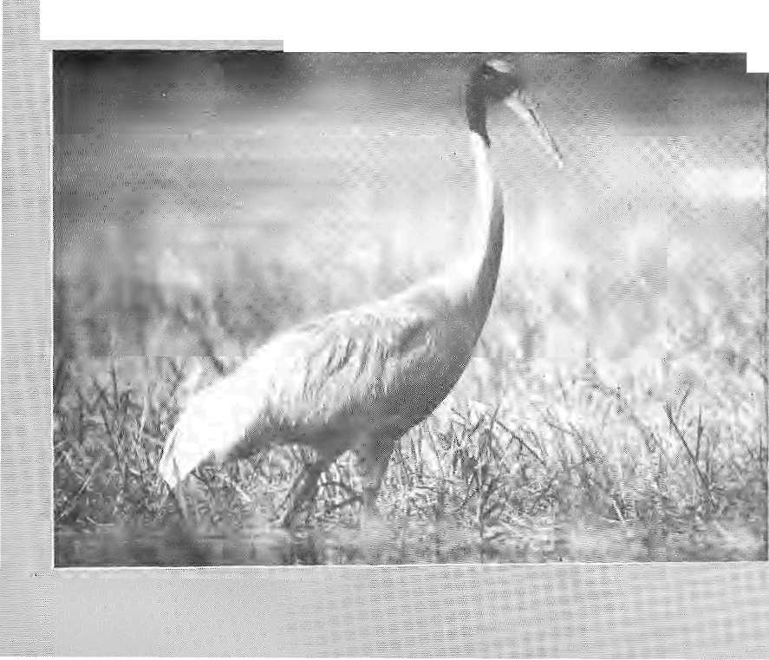

C
ranes are the oldest bird ■.spLt'ics on Earth, dating' . '.. Back 60 million years, and the ■; .rcdrcro wheel stiii-Jegged Saru's... ...
»er&tiel <i subspeoics/is tije largest pf all flying birds. Its days in the Nepal Tarai,. however, now sseetfl numbered.
The Sarus is one of theJ5 subspecies of crane left today in the world* arid is related to the endangered crane species such as the whopping crane of North America and the Siberian crane o.[ Asia. While it is not an
Loss of the Sarus
endangered species, there are individual populations at risk, including those that inhabit the Nepal Tarai, reports■■ lilts! National Geographic.
Rajendra Suwal. a Saras specialist, says the bird has already disappeared from Nepal's eastern Tarai and only 200 to 250 remain in the western parts. Even though the subspecies is highly adaptable to changing habitats, the clearing £>f Tarai wiIdlitads, draining of
Out! Out! Potato Blight!
" thaLthc-fUngai disease^ known'' asihe Late Potato Blight, has already spread throughput Europe, Russia and Latin Anierica.. and infestations are also reported in potato-growing regions of North America,, Africa,. Japan and Korea...
"All indications are that this new fofrii of late blight Is spreacting,around tlie world,;and" is m.ore aggressive and harder to
, control thiui its predecessors^' _{m} says Hubert Zandstra, chief of : the International PotatoCentet "_{M} in Peru. ... ;
I . Says Zandstra,. the greatest^. ■risk:is"to agriculture ~iri developing countries, where potato production is growing fastef thain any other staple crop > except wheat. {China is aow'the jajgest potato producer in the world.) Wliile modem fangi-eides could theoretically prevent the new disease, these chemical remedies are too expensive for the poorer countries. Besides, their use could set-back efforts
* £o reduce the use of toxic chemicals wr agriculture. "Just when people were starting to use fewer chemicals to grow potatoes, this blight will force them to use more^" says one researcher.
Potato late blight is caused-by the fungusPhytophthora jiifestans, which thrives incool_{v} nroist. conditioas and is spread by contact or wind-blown spores! "The disease is remarkably explosive, it can destroy a field in daysi'^{v}says a. plant pathologist at Cornell University. "An affected field looks like it has been burned." Scientists from around the world are scheduled to meet in Mexico in February to set up an international programme to address the problem, and one ,can only hope lhat there will be ■someone [here representing the
I Himalayan potato-farmers as
! well.
HIMAI. ..


,«
What's Doing in Hew York? IL
BRIEFS

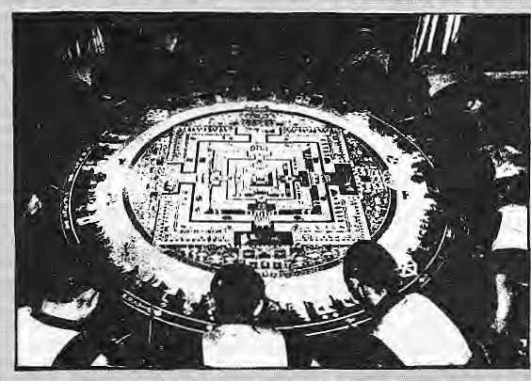
Croating the Sand Mandala -at the World Trade Center
T
he Lower Hudson Valley is on the other side of the globe from the mountains of South Central Asia. But then New York City, at the mouth of ■the. Hudson Rivera is the cultural capital of Ihe world, where no region goes unrepresented.
A quick review of the different cultural activities in the Big Apple during the month of October showed enough of the Himalaya on offer—from film showings to talkathons to photographic exhibitions. At the same time, it was clear once again that, as is true elsewhere in the West, here too 'Himalaya' means mostly the Tibetan civiii-satioii. The rest of the regtoo and its peoples, are absent;
Over at the Jacques Marchais Museum of Tibetan Art in Staten Island (ahorough which just decided through a referetldum to secede from New Yoi-k City),,photograph$ of Mustang are on display. They-were taken a year ago by four ladies who had trekked up to Lo Manthang.
In an apartment on the Upper West Side of Manhattan, the paintings of Lodoy Sangpo Gangshar {"Hymalian folk painter", says his visiting card) are on dispiay. Gangshar is a
Tibetan refugee; —just barely, for he comes from a village a day's walk north of Syabrubesi on the Trisuli Rivet-- who was among those picked up in the "immigration lottery'* run by the United States:Government for Tibetans in Nepal and India. &6: lives in Oakland, ;Califorrji4
Gangshar's: appealing watercoiours make a statement, not of Tibet but of a modernising Nepal, showing paTallax-bereft views of Syabrtibesi (the refugeecamp:vjllage!\vh.6re"hje grew up), carpet washing in Kathmandu, ^ie Trisuli pQiver I house, airplanes, and a submarine in Rani PokHari.
in downtown Manhattan, a Wheel of Time Sand Mandala wasbeingprepared m the lobby oi World Tr^ejCeritsr. The" I 1 TibetanritualarS was being painstakingly created ov«r a four-week, period by monks from the Namgyal Monastery, After U is completed, the mandala will be sweptup and the sand consecrated in the Hudson River, 9A.3Q November, accordingto: the: Saraaya Foundation, which raises funds for the Tibetan cause. The monks' performance also formed part of a well-orchestrated public relations effort by the Port
"Authority of I^ew York arid New Jersey, which runs the World Trade Centre-; to attract business after a tenant'.flight due to the massive terrorist bombing oiMaythis year. ... ... ... .... .
in the East Villagei a-corrimercial theatre was rtinning ibi film Bar|ka, '"adoSa&iehi:afy: about ..die Earth and the people'', which takes in panoramic sweeps of the nature and human civilisation. The very first frame,: before even the credits, yi'ii*s|the>iew of the extreme upper Khumbu, from Chomo-loftglriii 16 Amapablam, as seen from Tengbochfc This is followed by languid shots of devotees in Bhalctapur, walking among mists and temples. The film, shot With specially made wide-format jmax camera? pi Ttourtjhasno narration, only music (including Sufi, Balinesc Gamelari; and chanting moriks from Pharamsala),
At the other extreme, there was too orach narration at a preview of a brie-man show cai.led "psyeliodcssy!" in Canal Street, near Chinatown. The flier promised that the showrriafi, a
, yoang American magician who had trekked with milhonaire: Dick BasS to Chomolongma Base Camp a few years previously, would have a sort of mixed-media presentation built afo^id/his Khumbu trip. What he had on offer, instead, was an amateurish slide show that mighlwcfl have been entitled: "My heroic trek to Mount Everest Base Camp", replete with reversed transparencies, exaggerated claims, embroidered memory, and foolish talk (including one of "this 133 year old woman who tame down from her home at 25,000 feet just to meet me and see me perform.") The misinformation was riear-iofal, with an image of Shiva
identified as the Buddha, and every hulk of a mountain along the Imja Khola trail being pointed out as Everest
For relief, therefore, one turned into a bookshop, to find that Kevin Bubri ski's picture book "Portrait of Nepal" has jusl been released. It contains black and white pictures of Htimla, Gorkha, Ksthmandu and Jan&kpur. Right of f the bat, in mid-month, it recteived the first place in documentary photography category of the Golden Light Photography Book Awards; ahead of niany famous names in the New York photography world. (Some of the pictures can be seen in a photo essay in HimaVs next, Jan/Fcb 1994, issue).
There were a few other Tibrf-Tibetan happenings, to be sure. The United Nations General Assembly, for example, heard Nepaii Prime Minister Girija Prasad Koirala (who also spoke before the Asia Society, unveiled a B,P,Koirala bust, planted a B.P.Koirala sapling in Ccntial Park, and met with (he editors of The New York Times) and Bhutan's Foreign Minister Dawa Tshering. And the Kashmir issue surfaced again and again at the United Nations, as India and Pakistan raised the pitch of the quane].
The Asia Society's logo, incidentally is a Kathmandu-crafted bronze lion. Even though the logo is Nepali, however, the Society itself does not 'do' Nepal well. Kalhmandu, as aft important cultural hub of the Himalayan region, rarely figures in the Society's programmes. A look at the programme for 1993 showed nothing on Nepal (other than the Koirala dinner). A meet-the-authors programme was scheduled for 16November for the newly released book Tibet: Reflections from the


HiMAI,
1993
.

"* SS
BRIEFS

Save the Himalaya Frppv
Those jWfio Would Sayethe Himalaya!
by Thomas Kelly; Carrol! Dunham and Iari Baker, all Kathmandu-based.
There arc iriahy shops selling Himalayan bric-a-brac in Manhattan, bat Timing andPema: Presents of theMind js of a different genre.: A Stone's throw away froifn the Asia Society on 75lh Street and Madison Avenue, partly owned by Sikkimese,this shop sells Americana, and has not a whiff of Himalaya about it despite the quiiitessentiaily Hliftalayan fiasie. It seemed to be doing 6riskbtisiness with TManrMtan's affluent Upper Eastsidfers one recent Sunday* It was a shop for "diildren of allages", the.shop assistant saidj
While Tibetan R4ftigfces have a very high profile here, hardly anyone lias heardof refugees from Bhutan. Beyond Tibet, and beyond a IlitUp bit of Nepal,Bhutakaiuf Ladakh, the rest of the Himalaya is largely-absent in - New York, Large chunks-of \ Himachal Pr&deah^UttiKELfchahaY ParjeeMg, Sifckinr, and the Northeastern states. New York does riot know theniv Perhaps it is bette
- Kanak Mam Dixit

India for Meet to Save Himalayas," bannered aNew Delhi headline. "A meetingof ■■■ environment ministers of ,the..:.. seveq HirhalSyiti nations t* initiate measures to preserve the ecology and environment of pie uniqueipouritain rangeislikely tobe organised portly at India's initiative.? ■ ■,■ ■,,. ^ ...... 7.7- .7
We have, of ^course, heard all this before. ..Every so often, members of Jheold boy network —retired climbers .those manning mountaineering ' bureaucracies, krid politicians in search of fashionable plaiiks ^-;-have aniccup and remember to chimeMwit|itiie over-used 7 slogan: Save thi; Hiirialayat
Thefeisno ag;&enjent7 among these proponents what ■ they mean by'Himalaya'.Some, arethinking 'mpuntainwring'; otters'iiiass tourism', whale others mean oniyjheir part of the Himalaya (Knrnaoo, Garhw-aU $jScu4)i wliileistill : others think of floods or 7 7 deforestatibn, erosion or cultural loss. Unfortunately, thbsb Who" fashiohably pose by, the ; 7 7 ,Himalaya7d6 not have the time to be serious. ;Quite::a few New ■
Delhi babus ^r$ involved in &|eze-frambtig tlie,ufidei;7 popuiated_{v} backward ■■■-.■=■.■■■; jregions so that they seryg as a research subject and a ready-rto-:go holiday destinations
If ;only for the,duration of a talk fest where SifBdniand ::-Hillary will be theclnsf guest, it ■■■is attractive,tp don the^ garb of Saviouf of the greatest " mountain chain on Earth. The • latest to seek such reflected shine w^js fCanial''Nath« Indian I Minister ■ of Enyiroprient;
warnings ofTJCmalayan ■■■■ = ,, ,.
ecological collapse, pip minister 7 ni^eTthisfimpl-timpai call for S 7 : meeting of the seven Himalayan :: countries; Theywer6 ailata
Jamboree is Delhi, prgajiisal by
: tli# Himalayan Envu-onrneni 7
I' I 7 "
There is no reason to igjipre a meedng sucrl as ^f^Mtflister proposes ^bringing tpgej|ier Nepal, Bhutan; Bangladesh, ,, India,-Pakistan, Afghanistan and 7 Bu#m together to adckesa the ; issues of jnoiuitain enVironmenL But past experience shows that Himalayan breast-beaters tend to ccpperitratecm te-inventing ,th;e;;
'wheel. Ajid the experience of ICIMOD, riotwithstajftding the institution's non-performance, shows that India has been the-foot-dragger-when it comes to regional Himalayan development. This new Solieitousness, at least, is to be
On his riiost recent annoujn^ment, itjustdoesnet da for; the>Indian Minister to recall that lie "spent his 7childriood in the Doon Valley and was quite attached to the ; Himalaya," According to the news report, "He was amazed by th& negative development activity taking place in the Himalayas today. During his recent yisil to Mussorie, he was shocked to see bus services available by the hour to places wJiiclJ Wra-e earlier destinations for'trefckersl"
Yes, Minister, just let the locals walk to the next valley, j^ndhereis a gem attributed ib 7 Dr. itaran Siftgli: "India would riaye been a different eotity without the Hiinalayasi" Uh-uh.
Let us save ihe Himalaya from those who would save the Himalaya.

Failure, Forests
^{r} ■ 7¹tie tape of Himalayan X forests in, Nepal,' Uttarakhand and Himachal Pradesh can be.slowed immediately if a crucial bit of current information can be vswiftty shared'wi'tti'tliose who are actually (raffickiiig; herbal contraband. The news is that Taxoj, the much-touted eancer drug, is Koithe miracle cure for ovarian cancer itwas^thought to be just a year ago.
What this has to do with
Himalayan woodlands is that die needles of Taxu| tjapckta ("Talis .Pabra" in Nepali) is an important I source of the prtig extract. The -Taxol fever that gripped the Western phatmaceuttcal rnarketl raised|he priceoCtlieextractto unimaginable heights; and the plant rapidly disappeared from Himalayan slopes.:
As the aura fades frotn the cancer drag; the price of Taxol ,is bbiind to come down, and the pressure on this particular lofcst
product will diminish. To speed ]u^ this process and to savc^the; j^ees iha! ,are still standing, Indian and Nepali policymakers^ bureauoratSi NGOs, attivists and journalists piust work to get tfiis information out to the merchants and traffickers asfetasApossible.
: The news of Taxql's poor showingWas broken by The NewYork Times on 7 Novertiber, quoting researchers at the: National Cancer Institute of EheUniled States. "It is hot a 7cure, it*s not a panacea, it's not the¹ penjcijlin we're looking for,"
said one. Studies over thepast year showed that many women with ovarian; cancer did not respoi^ to Taxoj, and for those who7didrespond to the<teug, their tumours grew back to their original size within a few months_{v} In addition, it was found that T,axoi does not work with Colon, prostrate, kidney and storMch cancer or melanoma.
What is disheartening news for cancer patient, it turns out, Gpuld be good news for Himalayan forests. Speculators must be told immediately that the prices are about to crash!
N<Sv/Dec 1993 HIMAL . 39

is-.
::: ::::. §■ = :=..

ADVERTISEMENT
Iodised Saltfer tie Nation's Health

Goitre and cretinism have always been a curse' oh trrte Himalayan region, but only recently haye we been abie to do anything about it
It is a curse that came guaranteed with geography. Normally, humans get their supply of iodine, which is an essential 'mict'onutrient'.fromfoodcrops: In the Himatayan belt, however, natural iodine in the soil "gets washed away easily. As a result, foodcrops: are lew on iodine and the population ooes note receive the required dose.
tt is iodine deficiency that causes goitre. If the ■ deficiency is severe* cretinism results, characterised by mental retardation, deaf-mutism, and lackof - : muscuter coordination/About 40 percent of the Nepait population is said to be afflicted with somedegree of goitre, And it is estimated that four out of every thousand citizen shows symptoms" of cretinism. Controlling the Iodine Deficiency Disorders (IDD) is therefore one of the Nepal's gravest public health challenges.
Since 1973, a unique collaboration of private business and government has been actively engaged in battling the ageoid endemic. His Majesty's Government, the Government of India, and the Salt Trading Corporation have been involved in iodisfsing and distributing salt throughout Nepal's high himal, hill and tarai districts.
Salt is one condiment that everyone uses. And salt that is iodised -is considered to be the most efficient way to get the iodine micronutrientinto the diets of the country's far-flung communities. It has been Salt Trading's responsibility to ensure that all the salt' distributed in Nepal is iodised.
And it has been working. Studies have shownthat the incidence of goitre in Nepal has gone down considerably, Whereas 55-percent of the popuiation
wgs affircted in the 1S60s, one istudy showed that the incidencfe was dbwn 10 about 40 percent by" 1985-86,
Because ipeiine tends to; evaporate fro;m salt that is in storage for too tong, with the help of the Indian GoveiTirnertt, palt Trading has set upthree iodtsatjon plants,, in Bhairawa, ESirgunj and S|ratnagar_{v} so as to reduce^thetirnegapbetwe'eniodisationand : consLimptiori! These plants presently jodise up to a quarter of the saft that is distributed in the country, while the rest of the saH corrtes iodised from India:
Since the last three years, polythene packaging Mas 'been used; which eliminates the evaporation of iodine;, the AyoNuo is powdered iodised salt. Since the communities of the high hirrial prefer to use salt crystals rattier than powder, Salt Trading recently introduced Bhanu Nun. This new brand uses iodised erystais of granular size!
We at Sari Trading are committed to ensuring even better de.livery of iodised salt to Nepal's population and the introduction of Bhanu Nun is just .one dernonstratidn of this commitment, We are presently engaged in adding three more iodisatibn plants in the Western Tarat, and by 1994 Salt Trading expects to be iddising all the salt in Nepa! itself.
In so doing, we will aiso proudly continue to be part of this unique experiment in bitaterai cooperation between Nepal and Indja, whose goaj is to eliminate IDD in Nepal by thie year 2000. This is a programme which is'directty helping to r$ise the standards oi public health io Nepali and saving hundreds of thousands from the scurse of goitre and cretinism,
Together with the nation, we look forward to the day when goitre is virtually eliminated;from these hills and

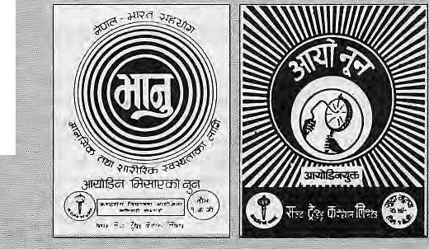
Iodised satt is distributed by the; Salt Trading Corporation Ltd. both in loose form and in one kg packets. Packet salt is ayaiiable under the brand names Ayo Nun and Bhanu Nun. Ah Ayo Nun packet costs four and a half rupees. Bhanu Nun is distributed only in the remote areas at subsidised prices.
GOITRE CONTROL PROJECT
MINISTRY OF HEALTH
(HMG/NEPAL AND GOVERNMENT OF ihfDIA
COOPERATION)

Prograramc Implememing Agency:
Salt Trading Corporation,!4d_{v}i^;inaHjitaum^dji,.i^:.27i:593,271014Fax: 271704

BRIEFS
"Mountains Should Come Firstv Hcrt Last
ICIMOD, the Kathmandu-btised organization of {lie Jlimdlay a, issuing isvfof its 10th anniversary'celebrations("30
Ngvepiber to 6 December). Overtf by the ICJMOPBoard tope'its■ ne% Director but hedecliwdihe offer diw to " careerjiming and personal finance".
The Board subsequently chdseMgberLPelinckyhahad "..'.....
and Development cooperation in Asia and Africa. The accowpaiiyin&arliclefdnned a partof"A Vision for iClMOp":, a prescMiatian Rfwades' niade to the ICIMOD Board prior to his:se .--■'".- - and'-is printed here.withhispectnissiqri, - - ■■-:" "... ■ ■■■

World perceptions: mountains get little press
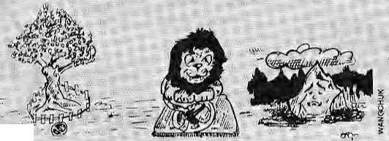

T
he Brundtland Commission Report was eloquent iri the v?ay it described a visiori of planet Earth, a lifigi.le.biiH of blue-greenish hues floating in space. It made httmans realise the fragility of the planet and the clear limitations that exist to how far we can exploit the diverse biomes which grace the Earth's outer tier.
Unfortunately, the Report did not deal evenly with the Earth's ecosystems. Rather, it highlighted the tropical rainforest, oceans,~wetlandsi 'grasslands, deserts, coastal margins, mangroves-only once, and that tod in passing, dJdHhc Report mention what 1 consider to be the most" crucial "add' most neglected of the worlds biomes, the mountains.
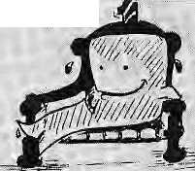
This unfortunate oniissiori was not accidental. Defenders of mountains have not been aggressive, persuasive or as articulate as have spokesmen for other caus«Si Rainforest' proponents will not tet. tic world foi'get tliat theif ecosystem protects literally tens of thousands of plants and animajs useful to everyone (cfiQcolsUe |or food, quinule for malaria, periwinkle to cure cancel', diogeninof for oral
); By contrast, ... even individual species (snow : leopards, pandas, grizzly bears, mountain gorillas, wjlei = ; ' ........ ■■■
potatoes) which depend qji the ;; mouritain habitat get better world press trian die supporting ; highland eposysterhs, ... ■;■■■ ..... ...
v ■■■ :It is time^ociiangc thM: ...; :»- '■■ neglect of \h<i moBiiiairis and to launcrl an^ggresslvi| campaign : to alert the: world's eitKeiify and politicians of t$e,stakes [| : mountains are not ^;6tectedi arid protectetl now. If ^lis/ Briindtjand's t<;am had done : ? ,some homework; it would have: discovered Sonie verj' impwrtaiit teasoiis why rftdirttains should: cofne first, nor last, in the global^ dgvetopnient agenda..'. ...
,■ :;- T$k& the iSSU&of headt: :.:. ?■■ walerSi The jAmazonriver ■■-... ...
originates in liny riyuleis high in the Andes which,;;as they rush ■ downwards; combine ::&ri& ■■■■ ■■■ recombine intalarger channels; '■ to form the mightiest of i^v%-s. fjcfcnders qf the South ± ■■' "t ", Ainericanrainforcstvafgue; : ■■ eonyinciogly that, without the oxygen-prfjiducmg "greeni ungs «f itie-earth'*,'life as-wfe Vnow xt would not be rwssibfe. could forget aboui all rainforest species ifthe ,, mountitins were not providing a
continuous supply of water. Without the Andes, there would teno'Amazon. Wlthoatithel^ ■■■ Himalaya, tli^r.e would'b^no ■ .....productive.Ganga plain where..... over 500 mijHon peoplejive; v^ ■■■■ Biodivcrsity^{v};alpnevshbtijfci be argurnent■ enough to allocate ■ more: stip| o xt ..to mountain: .defences. The great.Russiari set enlist Nikbl^i Vaviloc was thefirst to point out thjat, due to.. . l^ ecologies aiitf adjacent
mountains provide th^ seieetive :: pressiireSifor the genetic "diversity (wild specigs and landfa^es) of the major ::
: originated in and tjear.moiintaiiri. TtCjheSi-Without the mcnintain ' context, the future Of the world's ■ fodd^upply is c^idangefed, ■Wheat Goines from theZagms-; JauniK Arc, maiKe from the Mexican highland s, and p otaloes from the Andes, Many valuable ^medicinal plants: and uriderutiiised crops are also : found in the mountains. ^ : ...... v Other compe) Iipg reason^
pii't mountains up ffoht.li'you . aT« a ftatianrfeT,TEJoiintaiiiS cpme. as a bargain, a supplier (if 1 owe o st "(comp ared t o 16 wl and}) . ■precious' resources: energy, . water_{y} minerals, forests, and
beauty. The aesthetics of jiiouiitains are like magnets attracting tourists, hikers, climbers and nature lovers fine w or Id over:Archaeol ogy _{f}. art and ciiltyre of the gTeat mountain civilisatioris from the : Andes to Ceritrai China coritinuet to aw^ travellers from afar.
But if the positive aspects arc nbt enough, the citizens of the world need to ask th? question the other way^arourfd: What ai'e the social costs of neglecting mountains; <3f not haying a voice for the : mountains?
The costs to national and international bodigs are already enormous: poverty, ciyiLunrest, loss Oi biodiversity, bad downstream effects, illicit trade, pollution, erosion. A few years back, &e Food and Agriculture Organisation (FAD) issued a map of critical zones based on a careful study of the world areas which cannot support existing human populations even-with high inputs. A quick glarice at £hi§ map sho^s that, with the exception of the Atrican^Sahel, where few people live^ail of Lhe critical zones are motmtaihoiis. Poverty in turn drivfes mpuntain people to acts of deforestation, which sets in motion further devastation downstream. Mountains directly affect poor people morethan any other ^ ecosystem *— except the urban ecosystem — and this alone is an-argument¹ to elevate movntains to a piiority role on the glo6al developnienl agenda.

H1MAL . 41

An Unbeatable Combination of Speed, Paper-Handling & Superb Print Quality
Epson's Breakthrough Printer
EpsonLQ-1170ESC/P2
Pages ahead....

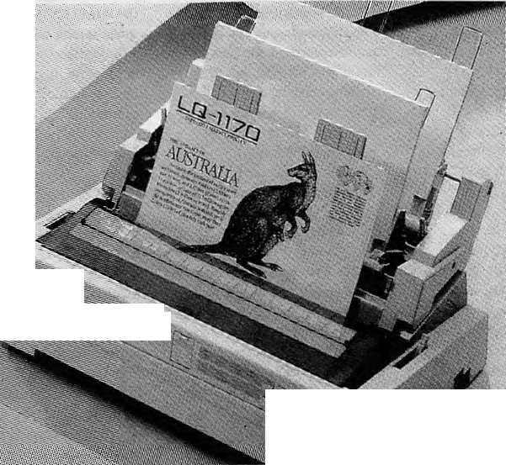

■ m'
MBBkl V -■■- '
Authorised Distributor:
•MERCkNTILE
OFFICE SYSTEMS
P.O. BOX : 876 Durbar Marg, Kathmandu, Nepal.
Tel : 220773/223499 Fax : 977-1-225407 Tlx : 2263 METRA NP
EPSON
Special features ;
- 24 pins Dot Matrix Printer
- 33Ocps
- Multi path paper feed
- Multiple Character Fonts &
Enhancements
- Multi-position Tractor
- Enhanced Document Control
with Epson ESC/P2 Codes
- 1 year warranty

a. I

IJJEplAWtie

MEDIA


By the time Nepal developsa "national •consensus" on tiow to develop its "hydropowei tesoiirce, andby ihe lime saner people pry the Arun FH Project beyond the grasp of kickback merchants* and ti m wo u sfpoliti cians, there; will probably be overproduction fif ■ hydrwicctrtcity In theGanga basin and no one will need Nepal's. Bhutan has already cut deals With New Delhi on many of its rivers, and now UNI reports that Hintachaj Pradesh Iras signed a memoranda of under&a'tuSmK. with six private sector films to produce a: total of 1500 MW of electricity, incJudinga90OMW project inKionaur district and a 231 MW unit iii Chamfer district ("Baby Aruri" in Nepal h io provide a 201 MW). Hirirachal's Governor Gulsher Ahmed gushed at the signing that HHn\aOhaJi. had a potential to generate 20,000 MW, of which: only 17.5 percent had ^een: harnessed. "Mark this: he said power shortages¹ iij Indians- northern region would be removed with the addition" of thel500MWtothejnid.
How the mighty; ideals have come «clashing. Once a centre 6t Maoist cal I toarms, Naxajbaritoday is_{r}ttieiisven ofsmuggle rsfeedi ng the lndianrnarkel with contraband consu-meiablcs carried over from Nepal, reports the Statesman. Customs officials:say that more than» 80 percent of the" Naxalbarians are today engaged jii the *trade',: mostly as couriers Who-lug electronic keyboards, Chinese calico and Japanese fice cqoke-rs' from Dhu5abari in Nepal across the Methi rivcrintoPanitankiin.India. A Customs ojjfiei appoints out to an unending line of women, all of whotn -s<si;rn to be abnormally, well, fat. ^'AIl of them have goods strapped around their waists and that's why they look double theii size," he says. Thecourie*sreport-edjy gel ten percent of the value qf the .contraband', which is quite neat, and reason eno ugh to dump Mao and Marx.
The state government of Mizorara has sent an SOS to (he central Govemm ent and the Utfited Nations Drugtontrol Program me to tackl? thedou ble-headed menace'of dr.ug addiction and trafficking. Although; more effective pat-rolling has led toreduced supply of heroin from theGoldcn Triangle area of northern Burma, young Mizo addicts are now switcMng ov erto a Am g detox-.ifier, Proxyvpn, whose tablets they dissolve in water and inject into the bloodstream. There are 911 hardcore addicts in the Male; capital of Aizawl alone; Meanwhile, to step, up jnter-
djctio h efforts, the state authorities have aijksd thtsUnifed NaiiQnsfiwvefiicies, computers andritght vi sioil eflujp pen h
Still on Minyjam', January marks a-hundreia years of Ghristianltjln the
land, of the Mizos; EBid a weekiong" .Gospel Ceittefiary- CelebTatipri is planned, reports The Tefegr.Qpfi. The New^{v}Peihl Govertiriiet)) has grimed more than 70 church elders irdrn overseas permission to visit Mffloraifn for the festivities. January 11th is regaled as the day of the adveni of Ghristtsifflty iqMieoram,Tdr thaiwas whenacentury iigotwo British rnission-¹ aties arrived in AiiawLAuiong otter' things, they ttansfafed portions of thir 'BjLbleiotoMizoiisingtheRoman script, ami published tSe first gramnigr^ book anfl dirtiojnary of theMizo lan
of the Himalaya continues apace, and the pjains folk? aie nowas Welcome to the pafyajart prabantthaks ^{r}3& the.:,Western J ourist, Uader the aegVofthe MKTounsm_{f} and to li^e coBStcmatioi) of some Ladakhltocaisi the inbr^hs;oJ August aiidt September saw the ^eleiffijlmii of tiieXadakb Ftsiiivril.X;was wJdely^ advertised m the hatiprial papers, fn the rrtena; an artists' camp; Inree ^ays of dance and music in which industani arel Carnaiic (!!!) ajtisles ^erfoqaed at Leh*s Polo ■Ground; and archery; polo, mask-dance, devotional music and "indigenous culliirt;"./tteter title for theiestival might have been''Ladakh : Gariealiireid ^especially aRefonehears that a^triockparrfage ce^rnony" was one o"J the exhibits". How about
Ah, lh(;/"Thc F'ireign Hand'' strikes : yet again. It-was ihefctreigo hand that crying o^sturbaheasinihil idyllic n state;Siji isim Chief Miniver
in Aagiisfio Prime Miiister Naras ini h a" Rao.' Foreigners yvej^: deSiberateiy creating i n s tabilit y i n Jh e "iiircrnajtional border state" on the controversy surrounding the reiiicamatiorf of the Gyajwa Karnapa of Ruflitek Monastery. Apparently, afaximessageftom New York was (he cause of eoncera, afid constituted ,"uReailed foe interfereiice irt the internal affairs of the State; by itweign elements in the; name of teligton". Not only was this aimed at creating misundersiiaridings betweerithe State and the CenSre, <aud the Ghief Minister, it wasafeodama^ng the improved relationship betwceil« tndia and China..
Here is soiiieone whodoes riot read Himal, arid hence missed the article in the History issiae; which ridiculed the proposition that the Tharti arc
".. de. see nded: from"Rajasthaniprincesses fleeing Moslem marauders (Juj/A ug '■19?%-Its is Shree Joginder Chawia, writing in Hindi in India Perspectives,
::. theinfl^ht hiagof ibrdian Airlines. In dhaste Hindi, but urfng not-sOflKtt sociology, ;si£HEe Ghawla writes tiiat Tharri pmen maintain 'tpUri adhipatya" (totai contipl) over their riusbands-JIisquiii goes otttt maintain t bat- siyaehhahd sarn bhogprachalit hai
,eve(jtodayamoh|gtheThani:butiliridi failsrne to frgurctlmt oiie out but it does riot sound goot!. Shree Chawia bdjeYcs that the yojing Rajput Ranis -
\:. -yitbaraniye-y/fo) fled to wards Jtep^l made a contact with thfeir ser-varfls that they would coriabit: but thai the wameiv would alyvays W«uperi6i "Yeh.
paaa.: Please pass the paan:
/A public toilet at the Bhaiiu:Cfeowk bazaai in the--tmvri of Dhania begati overflowing, and there was suspicion offbiiljjlaybythecity fathers. Not so, theyclairnilayiirigtricb|anieinsteaijQn triePharanba's sqiiearoishness! Alt we know is that herp, in Dharari, was one toilet that was well aheaciof its tifflc. 'jV. plans ealleEl for productioii of biogas iroin human wastes, to be sold 'to neighbouring hotels andhouseis as cooking fueL But the prudfsh Dharanbas refusedsto be caiighl in the act, so the unused gas now presises down on; the septic tank's -oiher^ occupant, spilling it but into the mean streets o ft hi,s eastern-Nepal metropolis. Some Nepali Vifs need to^{v}go on leievisLontoprove tjiat yodrio not lose your jaat by using human goEiar gas in : place of daum or inattilel
Sjpeatang of CortliptigLn ,;Sabi na S ehgal '.'"Wl,.SIft* Tithes of India writes fronv Ladakh that the Hetnis Monastery ■^{f}despile being the!wealthiest, best-known and biggest gompa in Ladakh^ is languisKing, largely due to "gross *roismanagement by its monks and the ealious indifference pf the¹ state adrtunistralion;-' She reports that the : pT/yer rooms ifre^'musiy" and in thfe main lempfc the gold and silver statue "pi the Buddha is covered with "thi^k layers of grime and gnjase" (on: the other ha/id, isn't this how all Tibitarj monastery sculpt ures.are?). Ms: Sehgal believcsthe absence of fhehcad monk, Slagsaiig Rimpoche, explains the" mismanagement. The'Rjmpoche has
spent the last three-and:a-half decades in China, being allowed to return to India only for ajaonth's stay, five years ago, she writes; "Hemis is headless for all practical purposes."
While the opening ujpgf the remoter parts of Ladakh siich as Nubia Valley \ andPanjgoTigLakeissaidtobeinihe cards, heie is a news item claiming that the Indian Home Ministry is even considering allowing tounsU iato the Siachen Gladcr area. The Times df India reports that ihe Secretary of J&K Tourism Parvfez Dewanias been work-, ing over the past few months to see the "Forbidden Ladakh" project through, and it includes the opening up of trie Siathen Glaciw as wcjl as linking ladakh with Kailash ManSaroVar by xoadv"The army has already certified' that the accessibiiitj'to touri sts of these a^eas poses'no real security threat." Himalayan wonders will never cease. In fact, wonders seerii to bd becoming more frequent, which is greats
The blokes si IlimachaT f ouriam» not to be o utdone by thdseTR types ov er at J&K, are ^planning an international festiyaHomarkfhelOOOthannlvtsyNary o/Tabo monasteiy in Spiti. Moie"bajKS bajia, more marketing of the Himalaya, "Situated at a- height of 12,000 feet from sea-level, the monastery is fams ous for its Wall paintings and knowoas theAjanta of the Himalayas," the H:P. Governor's Adviser, P.P. Stivastay, foiii UNI. Spare us; the analogies,please, Shree: Srivastav, or ne*t you will be extollifig the virtues of Nubra Valley, the Anrinioans t>f the Himalaya.
The Dalai L^na constitutes, a new *^pdwer cerifxeV in the world, according to a report just released hy World Media Coordination', aPari s -based commum-eations network. The report looks beyohd.the estabhshed ways to judge power, rating it according to political aiid financial elout. and searches instead for movers and-shakers ihat have ^{M}a more direct influence on day to day tife'VTenSan Gyatso, Who the report says "has become the symbol oFari endangered religion in this.century's last colonised Country",.shares the limelight ^ilh a motley group of new '^power centres". The list includes; Kaxakhastan; Aung SanSu« Kyi, Coca Coladieipmduct's-lheFrankfurtBook Fair, Nature magazine, the Nike-sports shoecompanyandtheMcDonaldfas't food chain. I do not.know if 1 like the idea anynibTe,
- Chhetria J'a/rttkar MoVpec 1.993- MIMAll i 43

From Sikkim to Sukhim

ofl864-65.) Meanwhile, theGorkhali generals JaharSingh and KajiDamodarPandey sacked the Sikkimese capital Rabdantse and took over die right bank of the Teesta, leaving King Tenzing Namgyal a refugee within his own country.
The rise of the British Indian Empire in Muglan to the south complicated matterseven more. The British wanted to open up the shortest route between Calcutta and Lhasa, and Sikkim fell strategically in the way. George Bogle, Warren Hasting's envoy to Tibet, was well-received by the Panchen Lama at Tashilhunpo, and the British were keen to remove all the intermediary hurdles between them and the trans-Himalayan trade.
After the Anglo-Goi kha war of 1814-16, keeping in mind the future utility of Sikkim
T
he hill area cast of the Kosi river was known as Denzong (valley of rice) to Tibetans. Earlier settlers, the Lepchas, called it Neliang (the country of caverns).
When a Lepcha chief brought his newly wed Limbu wife to his newly constructed bamboo house, she is said to have exclaimed, "Sukhim!" — the new house. This is how the name Sikkim came to be applied to this foT-estcd, hilly territory which lies east of Nepal's Limbuan and west of Lho'mon (Bhutan).
Three Bhotia lamas came down to Denzong in search of new land and converts. As they could not resolve their separate claims, in 1641 AD, they invited Phuntso Thondup Namgyal, a local patriarch, to be the chogyal (the one who rules according to the chho, or religion).
The kingship thus acquired was lost by PhunLso Thondup's 12th descendant Palden Thondup Namgyal in 1975, when Sikkim was incorporated into India.
The eclipse of the Namgyal rule was the culmination of conflict between a distinct but inflated identity of the Chogyal on one hand, and the desire of his subjects (by now overwhelmingly Nepali) to have a more meaningful say in their destiny. Thus, Sifckim lost forever its identity as a Bhotia principality tucked away in the mists of the Himalaya. And what has emerged is a Nepali-controlled Sikkimese state of India, an entity which has now become the focus of a new series of expectations in the region.
Losing Game
The picturesque contours o f S ikk i mese hi story of the last two hundred years reveals a Namgyal dynasty, itself Bhotia, that was exclusively oriented towards Tibet. The limited affairs of state were run with the help of MagaiSjLimbus and Lepchas. Butthe mid 1700s saw the rise of the House of Gorkha to the west and the demanding Deb Rajas in Bhutan, in the East. These developments proved disastrous for Denzong, which suffered intrusions and raids from both west and east and lost large chunks of territory. On more than one occasion, the Namgyal ruling family fled to Ti betas political refugees.
By the last quarter of the 18th century, Sikkim had lost to Bhutan its territories east of the Teesta. (This territory included the Kalimpong area, which was attached to Darjceling district after the Anglo-Bhutan War
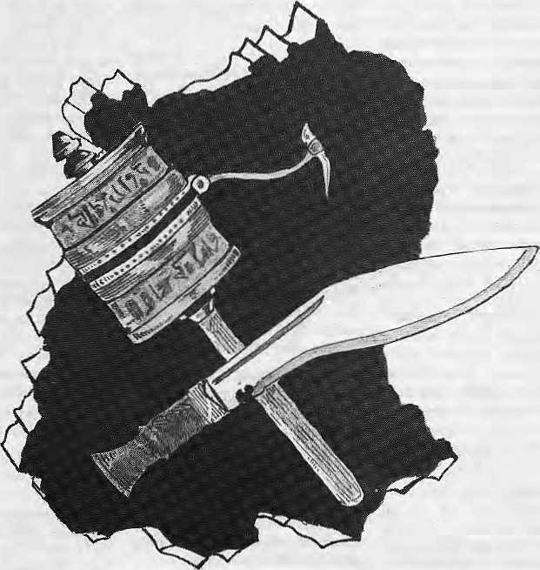
Giving Darjeeiing back to Sikkim would restore the historical unity
of this region. Old Sikkim was the land ofthe Bhutias and Lepchas;
the future Sukhim would be a Nepali-dominated state of
the Indian Union, which would respond to the frustrations
oftheNepalis of India and defuse today's tensions.
by A.C. .Sinha
for trade with Tibet, the British restored to the Chogyal the territories vacated by theNepalis eastoftheMechi. By this act,however, Sikkim lost its claims on Limbuan, and its western boundaries were set in stone.
In 1835, the British managed to secure a lease from the Chogyal for about 138 square miles around the village of Dorji Liang, which surveyors had recommended as an ideal site for a sanatorium for convalescent Europeans. The lease for Darjeeiing was set at Rs 3000 per annum-- this was laterraised to Rs 6000- but was soon discontinued after Sikkim briefly took captive a team including J.D.Hooker, the famous botanist. As a consequence. Sikkim also lost her territories from the Rummah and Rungeet rivers in the north and east to the Tarai in the south.

44 . HIMAL Nov/Dcc 19<J3

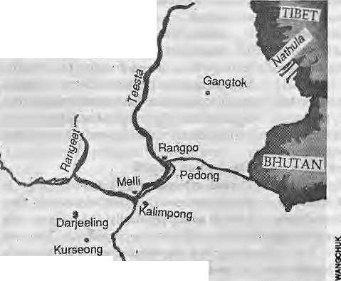
Nepali Inroads
Thus, in the historical shedding of its territory, Sikkim lost the Darjeeling enclave as well. In Darjeeling, the British went out of their way to induce colonials, traders, labourers and craftsmen to move in. And so there were immigrants from Nepal, Sikkim and Bhutan, as well as a large number of arrivals who were fleeing feudal situations in those countries.
The Sikkim Durbar did not appreciate the prosperity and phenomenal growth of Darjeeling, This was particularly true of the Kazi courtiers, because the Darjeeling area had originally come under them. When disgruntled Kazis kidnapped someDarjeeling residents, the British despatched a force of 1200 to Tamlong, the capitol, and were later able to extract a 23-article treaty which tamed theChogy al into a British-dependent Maharaja.
Within a few years, the Nepali-speakers of Darjeeling began to move across and settle in Sikklm's hills. Two Newar brothers were even granted a lease of land in 1867 by Sidkeong Namgyal, the then ruler of Sikkim. Nepalis found the Khansarpa Kazis, the Phodang Lama, and the Khansarpa Dewans (the two influential councillors of die royal court and ancestors of Lhendup Dorji Kazi, the first Chief Minister of Sikkim) as reliable advocates of immigration.
John Claude White, who was appointed Political Officer in June 1889, virtually took over as ruler of Sikkim. The Chogyal was provided with a monthly allowance of Rs 500 and kept in confinement with a small retinue in Darjeeling and Kurseong. Under White, the administration, economy and infrastructure wererestructured,andlarge numbers of Nepali immigrants were welcomed in.
- M ^ .,
The Nepalis' loyalty, perseverance and mercenary character endeared them to the British, who had become exasperated by the Tibetan punctiliousness of the Sikkimese elite. This bias against the Sikkim Durbar shows through in the Sikkim Gazetteer, whose celebrated author, Herbert Risly, predicted in 1894 that the khukuri would replace the prayer wheel in the Himalayan region.
Five decades of British control saw the Nepali trickle turn to a flood and the Lepcha-Bhutia community reduced to half the size of the Nepali-speakers. Their numerical superiority did not, of course, mean that the Nepalis were also politically powerful. As the
British developed Gangtok, Darjeeling, Kalimpong and Kurseong, the Nepalis served as the underdog and the beast of burden.
The deliberate British policy of encouraging Nepali migrationalso had another motive. Because of the uncertainties of recruiting soldiers from within Nepal, the colonisers set about creating "soldier farms" — large Gorkha settlements in Dehradun, Darjeeling, Kurseong, Shillong and elsewhere. The less fortunate among Nepalis became herdsmen, while others found work with the coming of tea plantation and an organised forest department.
By 1872, Nepalis constituted 34 percent of the district of Darjeeling population, which totalled 94,712. A century later, in the 1980s, Nepali-speakers made up 90 percent of a population of a million.
Dorje Liang
The Darjeeling enclave was enlarged in 1854 by annexing territories so that it extended from Mechi to the Teesta and south to the Tarai, with theKalimpongsub-division added after the Anglo-Bhutan war. From 1868 to 1905, DaTjeeling was one of the districts of the RajshahiDivisionoftheBengalPresidency.lt was later tagged to the Bhagalpur Commi-ssionary, untii a separate province of Bihar and Orissa were created Jn 1912 and then again to the Rajshahi Division, continuing to bewithitupto 1947 when it was made into a district of Jalpaiguri Division of West Bengal in the Indian Union.
Sikkim
Siiigtiri West Bengal
After Indian independence, Darjeeling remained with Bengal as a 'Hindu-majority' district. The All India Gorkha League demanded its separation from Bengal and at one point even suggested its integration with Nepal. Somnath Lahiry, the only communist representative in the Indian Constituent
Assembly, was agreeable to the formation of a separate "Gorkhasthan" foT the hill people, and the two communist parties of India raised the issue of autonomy on the plea that the Nepali language was separate from Bengali. In 1946, the Sikkim Durbar hired Indian advocate D.M.Sen to draft a memorandum for the return of Darjeeling — a demand which was ignored by the British Government. A feeble voice was also raised in 1966 by the royal consort Hope Cook Namgyal, for the revocation of the Darjeeling grant.
The demand for Darjeeling's restoration was rejected by both Calcutta and Delhi, but the loudestprotests were heard from Darjeeling itself, where the Nepali settlers claimed that the prosperity and development of Darjeeling were the result of their sweat and toil.
After the partition of the British Indian Empire, West Bengal was confronted with a massive human migration from East Pakistan. The Bengali refugee settlement became the first priority of the state Government. Thus it could do very little for investment in industrial and power sectors and Jost its primacy as an industrial state of India. Extreme Marxist adventures launched in Naxalbari worsened the UTban industrial unrest of the 1960's and the India-Pakistan war of 1971 which resulted in the emergence of Bangladesh, brought even more Bengalis to West Bengal. The predominantly Nepali Darjeeling was, thus, nowhere in the scheme of priori tiesand became subject to neglect, exploitation and internal colonisation.
The situation in the Darjeeling hills, therefore, became gradually depressing/The locals faced a continuous crisis of identity, in language alone—having to deal with Nepali, Bengali, Hindi and English — because they were Nepali speaking residents of a Bengali medium state, in the nation-state of India. As - Indian Provinces are organised on linguistic principles, the relatively small number of Nepalis inBengali speaking West Bengal invariably found themselves ignored for a meaningful public role.
It was out of desperation, therefore, that the Nepalis turned to the northeastern states, where the situation was favourable enough for them to find sustenance. Of late, however,-even this safety valve is unavailable. There has been a rise in ethnic assertion in the Northeast, leading to a movement against the so-called foreign nationals.

Nov/Dec 1993 HIMAL . 45

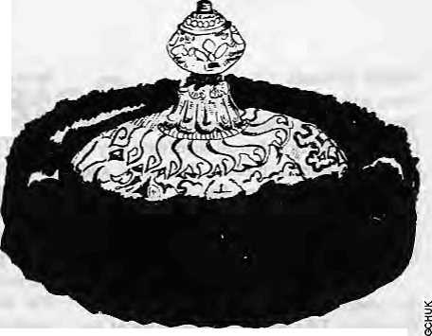
State Criteria
The Indian National Congress had committed itself toreorganise the Britishlndian provinces on the principle of linguistic affiliation. Thus, the All India Gorkha League demanded the separation of Darjeeling and the Duars from West Bengal into a separate GoTkha state. In 1956, the State Reorganisation Commission did not consider Lhe Gorkha League demand as territorially viable.
The Indian states were carved outmainly according to the linguistic principle, but historical antecedents and geographical contiguity were also kept in mind. Thus, the United Provinces and Rajputana were turned into Uttar Pradesh and Rajas than respectively, and Koch Bihar was attached to West Bengal, while Tripura remained distinct. However, within less than a decade ethnicity came to be recognised as acriterion—with the formation of Nagaland, followed by Meghalaya and Mizoram.
Meanwhile, in adjoining Sikkim, the Namgya) dynasty continued to rule over its increasingly Teslive majority Nepali subjects. As early as 1948, the Sikkim State Congress had started a movement on a three-point programme that demanded merger with India, establishment of a popular government, and abolition of zamindari. The merger with the Indian Union finally came about in 1975, and since then the state has been effectively under the control of the dominant Nepali-speakers,
Nepali Homeland
While the Ncpalis of Sikkim had been able to usurp power in Sikkim, throughout the 1980s Nepali-speakers in the rest of India, and most particularly in the Indian Northeast, began to feel increasingly threatened. A number of Nepalis from Nepal and Indian Nepalis were evicted from Assam and Meghalaya, where there was a rise in ethnic assertion and movement against "foreign nationals". The refugees turned westwards along the Duars, to arc as which had a Nepal i c oncentration, where they expected a sympathetic response and support.
Many of the Northeast returnees had snapped all ties with the "mother country", and so Nepal held no attraction. Sikkim was already saturated with the Nepalis. Bhutan had a strict policy of restricted entry to immigrants. In such a situation, the three districts ofnorthemWcst Bengal (KochBehar, JalpaiguriandDarjeeling),whichwere already reeling under the influx of Bangladeshi refugees, had to act as hosts.
It was natural for the Indian Nepalis to feel uncared for, and the belief began to take
hold that they must have their own homeland within the Indian Union. What emerged was the Gorkha National Liberation Front (GNLF), a movement to carve out a distinct Nepali-speaking slate within India, led by Subhas Ghising, an ex-soldier. The movement turned violent within no time, and the normal life in North Bengal, particularly Darjeeling, was completely derailed.
A tripartite agreement between the Delhi Government, WestBenga! andGNLF led to the establishment of the Darjeeling Hill District Council in 1988 but it was hardly the Nepali homeland that had been sought. What has happened is that Ncpalis have been divided into a number of factions working at cross purposes. Ghising's insistence that "Gorkhali" is a language of ethnic Indians distinct from Nepali — a philologically untenable concept — served further to confuse and divide Indian Nepalis. This division and confusion is clear from the fact that the Nepali opinion leaders in India have not found it convenient to protest the eviction of Lhotshampa refugees from Bhutan that took place over the last two years.
A decades-old demand of Indian Nepalis has now been met with the constitutional recognition of Nepali as an Indian language, but this hardly means that the lot of ethnic Nepalis has changed, or that they feel more secure in the Indian Union. The GNLF was supposed to herald anew beginning,but today the situation of the Darjeeling hills is quite dismal. No centre of higher learning orresearch and no significant industrial venture have been built in the last four decades. Meanwhile, the profits from the tea industry are not reinvested here, but continue to be siphoned out of the hills. The rate of unemployment in this most densely populated of hill districts is at an alltime high.
Meanwhile, the spectre oPMahaNepal" has been raised by motivated individuals, it seems, with a view to diverting the attention from the natural aspirations of Nepali-speakers in India to assert an identity and develop a base aspartofthelndiannation-state.Is there away outforlndianNepaliinthisconfusingscenario?
The Indian Nepali
The IndianNepalis are at times confused with Nepali foreigners and, not infrequently, they have to suffer physically and economically because of this overlapping identity. Time and again, they ask themselves, "Are we really Indian citizens?"
One can of course sympathise with the
Wu-Sha Norbu Tok-Chen,
the Jewelled crown of the Chogyai
handlers of the Indian Union, who fear that allowing the creation of a small state of Gorkhaland on an ethnic basis would be akin to opening a pandora's box. Meanwhile, there are also the West Bengal authorities playing on Bengali emotions by pointing out that GNLF plans would lead to the secession of Darjeeling.
While the Bengalis fear that Darjeeling would spin off their state, Nar Bahadur Bhandari would not like to see a merger of Darjeeling into his state, Sikkim. Where do we go from these divergent stands?
It is a fact that, for the sake of peace and security in the Indian Union if nothing else, the extremely vulnerable position of Indian Nepalisbe rectified. The recognitionof Nepali in the Constitution was a step in that direction, but does not go far enough. Precious time has been lost trying to shift blame from one to another, and the hour has come for serious people to take bold decisions.
Possibly, history provides the answer. If Darjeeling and Sikkim were to be united, as they were in the past, it would create a Nepali-majority state that has economic clout, with culture to match. The historical partitioning was hardly strategic and had to do with the British need for a sanatorium in the hills. On the other hand, Darjeeling and Sikkim share the same history and geography, and today they also share the same language and ethnicities.
A good-sized state of "Sukhim" would save New Delhi the embarrassment of creating a liny new state (Darjeeling) on ethnic and linguistic principles. Secondly, West Bengal will not be divided for creating a new state within West Bengal — it got Purulia from Bihar in 1956andshouldhaveno objection to parting with a non-Bengal district. Thirdly, the Indian Nepalis will have a strong and viable state as the champion of their language, culture and overall identity. Fourthly, a stable, dedic ated and s at isfied S ukhi mbetweenNcpal, Bhutan, Tibet and Bangladesh would be

46 . H1MAL Nov/Dec 1993

Bhutan, Tibet and Bangladesh would be strategically advantageous to the Indian Union.
Present-day Sikkim, which has been receiving a lot of economic assistance from the Centre, would have to share some of its economic resources and infrastructure with the less-privileged population of Darjeeting. However, this small initial sacrifice would be more than compensated by the revenue earned from the tea plantations, tourism, timber, hydroelectricity, industrial enterprises, etc., of the Darjeeling region.
Sikkim*s heavily dependent economy would then find its own strength. And if Darjeeling were to merge along with the Siliguri sub-division (which should be the case), Sukhim would have its own railhead and also be on the airways map of the country.
In Sukhim, a rotational system of office of Chief Minister, Deputy Chief Minister, Home Minister and Finance Minister could easily be worked out between Sikkim and Darjeeling. Similarly, summer and winter
capitals could be divided between Gangtok and Darjeeling. 'North Sukhim' and 'South Sukhim' could draw lots on where the high court, the university, or thestatepublic service commission are to be housed.
Darjeeling, would provide the economic and cultural backbone of the new state to a degree that is out of the reach of present-day Sikkim. Once they are assured of an honourable home in the Indian Union, the Indian Nepalis, who are culturally sophisticated, will immediately undergo a cultural resurgence.
The old Sikkim state of the Bhotias and Lepchas has long ceased to exist, and the new enlarged state would not be taking anything more away from them than has not already been wrested Of course, the new state would have to strongly protect the scheduled tribe status and constitutional guarantees of the Bhotias, Lepchas and Limbus. That would be only faiT, given the historical legacy of demographic usurpation.
From the Indian national perspective,
there is no doubt that state of Sukhim would integrate wel 1 into the Indian social and political milieu, as happened in the case of the erstwhile princely state of Hyderabad.
From a political point of view, Sukhim would be able to play a bigger role in the Indian Union, and the presence of the Nepali Indians would finally he felt at the national level. At the same time, Sukhim provides the best insurance against any possible future contingency arising out of a divided frontier community in a sensitive region. It will also finally kill the frequently raised bogey of Maha Nepal — for all time.
Undoubtedly, there will be reservations
in Sikkim, hostility in West Bengal, and
reluctance on the part of the Centre. But what
other choice is there? ^
A.C. Sin ha leaches Sociology an he Nortti Eastern Hi II University in Shillong and is a specialist on population movements of the Indian Northeast. His latest book is Beyond the Trees, Tigers and Tribes: Historical Sociology of the Eastern Himalayan Forests (Har-Anand, New Delhi, 1993.)


Fear Of ffig Sittkim
'he perceived dangers of a ''Greater Sikkim!' ftre discussk^ByMohan Rainin a recent article in the New-Delhi Pioneer, excerpted here, whose starting pointisthecanstitittionai recognition^gfyerito the Nepali language in India. .

i£S ikkim'snew status, as a linguistic state of Nepalis; gives a new edge to the hitherto nebulous demand for a "Greater Stkkim" encompassing the adjacentNepali-speakirig tracts ofthe formerkingdom which becameapanof India under controversial circumstances.
Eyebrows were raised at the Foreign Correspondents CJu& 6t South Asia in New Delhi late in May iVhen Bhutan's Foreign Minister, Lynpo DaWa Tshermg, said in answer to a question that the "Greater Nepal" demandof a Nepal extending to theNepalhspeaking tracts in India (Sikkim, Doo&rs, Kalimpong and Darjeelihg),was: a fnyth with no basis in history. But he hastened to concede thai a denrandfor "Greater Sikkim" wouldbea greater threat to Bhutan than t ■, the "Greater Nepal" idea.
Lynpo Tshering, during his talks with the Indian Government r last May, passed on a four-page pamphlet, "The Voice of the ■Oppressed People of Bhutan", which amounts to an open call for a GieaterSikkini.
It says: "The Gorkha people of southern Bhutan must unite'and fight for our rights. We,theGorIchasofsoi;thernBhutan,M'e,nOtonly the majority trat we also have 17 milHonbrotber&andsistetsinNepal and over 10 million living in India. Unless the minority Dnikpas, native Bhutanese, come to their rescue and immediately undo the damage and great harm they have done to themselves, there is every possibility that the borders nf the Gorkha State of Sikkim and. the adjoining districts of Kalimpotig and Darjeeling caneasity]be*extended across the whole of southern Bhutan. Then* instead of Bhutanisation of southern Bhutan, we may see the day whert the minority is Nepalitsed by the Gorkhas of southern Bhutan."
India and Bhutan seem to share the concern over theimplications of aGreater Sikkim demand. The implications of sucha demand was
discussed at a high-level conference called by the (Jflion Home ."Ministry in 1992, because a Greater Sikkim, ihougtfno challenge to India's sovereignty like the Greater Nepal demand, liad implications for the security, of tHe Northeast.
On the surface, the Greater Sikkim demand amounts |o.&_{s}" rational reorganisation of the states to conffarm to the linguistic principle. If Sikkiiriis accepted as a Nepali-majority, Nepalirspeak^ig state withNepali as its official language, (here is no logic in denying fherging the adjacent Nepali areas (immediately, Kalirapong and , Darjeeling: apd the Dooars) iitfo a single Nepali entity,
Thu&;far, the political competition between the Sikkinj Chief Minister Narbahadurfeharidari and the Gurkha National Front leader SubhashGheising, who beganademandfor statehood for Darjeeling region and settled for mtich less within the confines, of West Bengal, has relegated the GreaterSikkim demand to the background."
But if the demand picks up in Bhutan and £ains momentum in India, and in mea&likfiiyevent of theriVals,BhandariandGheising, findihgaccmnm^n;Wave-length,boi^NewDeaiiandThimphuwould •■ have to respond with sdme seriousness to the challenge.
Bhiitan'scpneemismcwfimdamental. A Greater Sikkjmis-a* more immediate possibility than aGreater Nepal Both mean a threat * of Nepali pressure on Bhutan's southern border in the- form of a renewed influx and a Nepali bid for political power in Bhutan onlhe tines of the unobstructed takeover in Sikkim.
; faNewDelni*sthirikmg,BhandariandGheising'h^vetobekept apart at all costs because something mon? than an-enlarged Nepali-iariguage state is implied-by the Greater Sikkim state. The real threat is the vital Siliguri corridor close to the China border which is the vital link be|wpen the fodo-C^rij^fc plains and the Npr^ieast k

Nov/Dcc 1993 HIMAL . 47

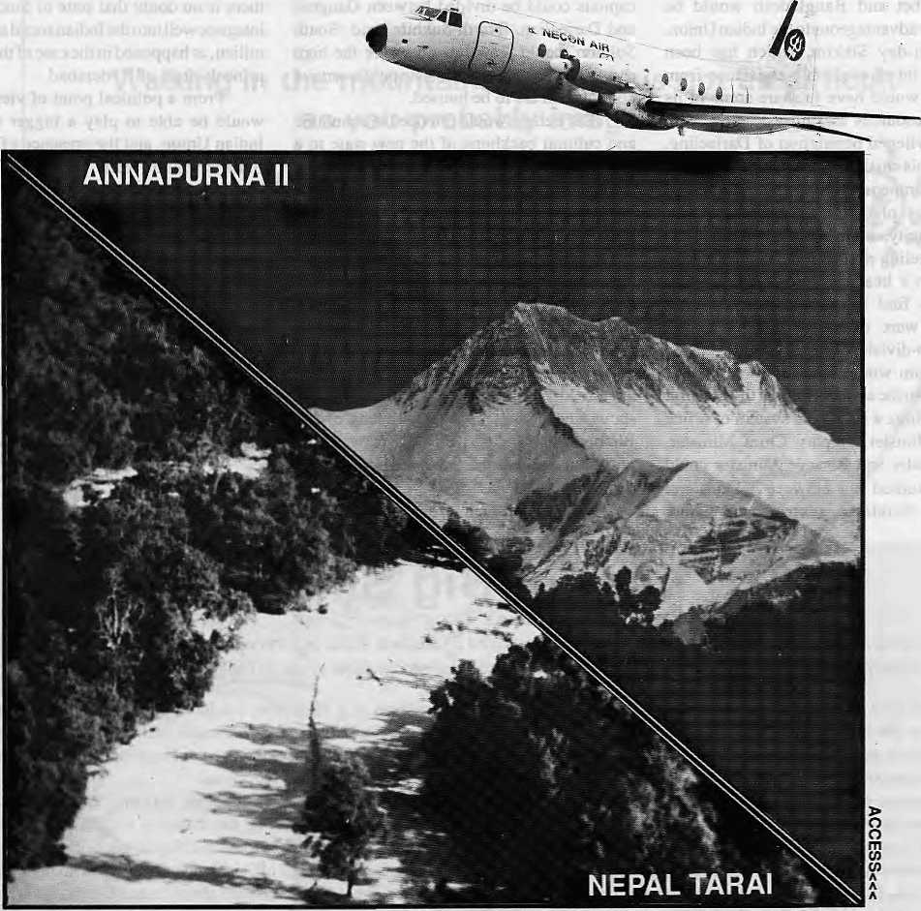

NEPAL UNDER OUR WINGSPAN

You want comfort.
NECON AIR's HS 748 Avro aircrafts are the most spacious, and our staff the most solicitous.
You want punctuality. NECON AIR links Kathmandu, Pokhara, Simra, Nepalgunj and Bairahawa with an efficiency that has become the talk of these towns.
You want pleasure.
We take mountain flights from Kathmandu for the Eastern Himalaya, and from Pokhara for Annapurna and Dhaulagiri.
Try us. Fly us.
NEC®N AIR

Sales: 414367, 412260 Reservations: 418608, 418809 Fiix: 977-1-412645 Telex: 2739 NECOA NP PO Box 4047, KaihmanduJ

Questioning Success
Market God Introduced to Northern Areas

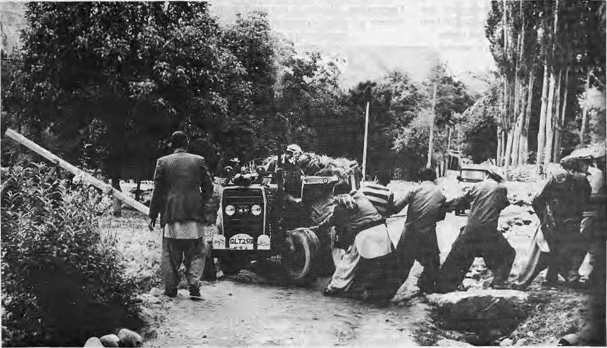

Struggling with market forces
During the four decades of international assistance and development programmes in the Himalaya and
adjacent mountain regions, amidst failures all around, some projects have received high praise. With this look at the AKRSP in Chitral and Gilgit, Himal begins an occasional series, "Questioning
Success", to see what makes for success, and the prospects for reproducing success.

C
elebrating his 75th birthday in 1940, AgaKhan III weighed himself against a load of gold and jewellery and donated the treasure to start an educational programme. That act of philanthropy marked the beginning of the Aga Khan welfare activities in a corner of the Central Asian highlands — today's Northern Areas of Pakistan, which has a large population of his followers, the Ismailis.
With its focus on education, the Switzerland-based Aga Khan Foundation established more than 150 schools in the Northern Areas. Most were for girls, as existing governmental schools served only boys, according to prevailing Islamic tradition. In 1960, the Foundation began public health-
by Thpmas Hoffmann
related activities in Chitral, extending it to Gilgit a decade later. The health programme, like the Foundation's work in education, tried to complement government activities, filling in the gaps in delivery. Again, the health programme targeted to serving women' sneeds.
In 1980, the Aga Khan Education Service was joined by the Aga Khan Housing Board, which concentrated on construction work and training local people in the crafts. The Foundation's work came full circle in the December of 1982, with the establishment of the Agha Khan Rural Support Programme (AKRSP), whose mandate was to generally provide rural development services as a non-governmental and non-denominational undertaking.
"The proclaimed task of this newcomer
organisation was to help improve the quality of life of the villagers of Northern Pakistan," says Shoaib Sultan Khan, who served as General Manager of AKRSP for many years and has.now been asked by the Islamabad Government to take the AKRSP concept "to scale" nationally (see Himal, Jan/Feb 1993). From its base in Gilgit, the capital of the Northern Areas, AKRSP directs, supervises and coordinates an ever-larger network of projects, covering nearly the entire high desert which forms the Pakistani part of the former Jammu andKashmir. These are the old districts of Gilgit, Chitral andBaltistan.withacombincd population of about 800,000 in nearly a thousand villages. The economy is almost entirely subsistence farming, and 90 percent

Nov/Dec 1993 HIMAL . 49


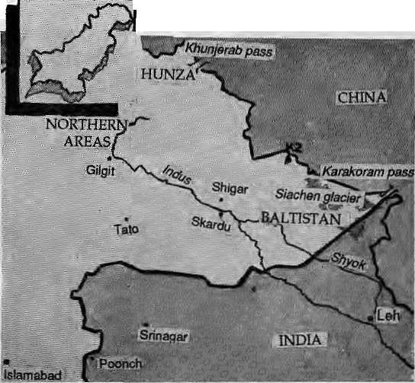
of the inhabitants are smallholders with less than two acres of irrigated land per family.
The Northern Areas suffer an acute lack of irrigation water, firewood, and fodder in wintertime. As a consequence, diere is poverty all over, characterised by extremely low literacy and educational standards. Off-farm work is not available and the per capita income is far below Pakistan's national average.
Faced with such conditions, AKRSP's goal has been to increase cash income as well as integrate the Northern Areas' market with the rest of the country in order to relieve the sociocconomic burden on the population. Says Khan: "The three principle objectives are the raising of income and quality of life, the development of institutional and technical models for an equitable development, and evolving sustainable, longterm strategies for productive management of natural resources in the dry and fragile mountain environment." This means that AKRSP concentrates its efforts on transforming the subsistence agriculture-based society into a market- and cash-oriented economy, one that is integrated to the national economy by marketing agricultural surplus.
Several steps have been taken to realise these goals. When AKRSP arrives in a community, it first helps establish a village organisation (VO), whose task is to fill the institutional gap that emerged after the local chieftainships were abolished in 1972. It is in these community organisations that the crucial local decisions are taken, such as the choice of the first Productive Physical Infrastructure (PPI) project. A PPI tends to be an irrigation channel, a link road, or a bridge, and the first one generally comes as a gift from the AKRSP to the community, and villagers who contribute labour are paid. Further infrastructure projects are subsidised by AKRSP, butmainly financed through c ommuni ty savings collected in v i llage meetings. The expectation is that the village organisations will develop as viable social institutions, through which villagers can determine theirown destiny far into the future.
AKRSP's activities go far beyond the infrastructure development which should, of course, be the job of the Government. Besides building roads, canals and bridges, the Project is also involved in agriculture, livestock, forestry, commercial and industrial development, women, credit and general finance, as well as human resource development.
Great Game
In all its work, [he AKRSP tends to be "remarkably successful", as attested by evaluation reports of the World Bank as well as of the German Ministry of Economic Cooperation. Success is measured in the number of village organisation and their membership size, rise in |community savings and per

capita income, and the rate of project completion, which is exceptionally high in the Northern Areas. It is clear that AKRSP's focus on filling in the gaps in development delivery has avoided duplication and done away with needless acrimony that might have arisen with other agencies.
What is the secret of AKRSP's success? What does the Project do differently from most other development programmes in the mountains and plains of South Asia? Siegfried SchoneT, an expert with the German Institute of Economic Research, points to the unprecedented religious legitimacy that the Project has in the Ismaili community, which is quick to accept it. Thus allowed to function as a successful demonstrator, the Project's activities tend to be easily accepted by the Shias and Sunnis as well.
This process is also made smooth by the Project'snon-denominalional approach, which allows all Islamic communities to take part, and because of the participatory decision-making that is encouraged. Finally, the multiethnic composition and reliability of the AKRSP staff contributes to positive results. The final proof of acceptability was provided recently when even the Sunnis of Astor valley at the foot of Nanga Parbat, who had till
recently been wavy of AKRSP, demanded the project's help.
hi evaluating AKRSP's work, it helps to remember that its financing is independent of the Pakistani Government exchequer. Besides fheAgaKhanFoundation,theProjectreceives generous support from donors such as the Canadian International Development Agency (CIDA), the British Overseas Development Administration (ODA), the Dutch Government and the German Adenauer Foundation. CIDA alone transfered about Pakistani Rs 20 million to AKRSP, and the Dutch Government and ODA each give about PRs 16 million annually. Add to this other sources as well as the Foundation's sizeable contribution, AKRSP's yearly collections total more than PRs 100 million, or almost U$ 5 million
Financial solvency seems to havealottodowiththe continuing success of AKRSP even as numerous equally well-meaning projects elsewhere in the mountains are moribund or have collapsed. Availability of cash has made an important difference for AKRSP. Among other tilings, it also allows the Project to run its own helicopter service, connecting the Gilgit headquarters with the project area as well as Islamabad, bypassing landslide prone highways and notoriously unreliable PIA flights.
Integration or Entanglement
The Project's principle strategy of economic integration has generally gone unquestioned. Whether to call a development project 'successful' depends first upon one's understanding of 'development'. If the villagers'cashliquidity and growth-orientation arc to be the tests, then AKRSP is taking huge strides towards fulfilment. In fact,the transition of the Northern Areas into a cash economy is progressing, with Gilgit, Chitral and Baltistan rapidly becoming part of the larger Pakistani and international marketplace. The question, then, is whether this is economic integration or an entanglement that only creates new dependencies for the local inhabitants.
A AKRSP social organiser, talking to a community group, might sound like ihi s: "Why grow wheat and maize? You should use your land instead to grow marketable produce such as potato seedlings, vegetables and dried apricots. Grow cashcrops, sell them at the

50 . H1MAL Nov/Dec 1993

ITS
The range ahd diversity oftpmalayan film-making will be on view at Film
Himalaya 1^94. This international festival of Himalayan filfjrte at»d
documentaries^
and overseas for three days of screenings and discus
andfiim-watehfrsalil^
■i9|C- ■ V- ."" !:.;;^{v}- " ;/; " _ ;/,""■ ;/„'" -.;".
Enfty Prpcedures: films that are entered for screening in Film Himalaya 1?94 must deal w|th the^Himalayan region (vyhich encompasses the region JfronlAfghanistan to the mdia^
Tibet); or have specific.relevance to..the Himalayan pojpuiatibn- The subject "area can range fern culture¹ and history, to adventure:;: tourism, ecology, t> politics^ etltnoiogyy archaeology, etc.
Filrn Hirijalayl will;accept entriesrangingfrom short television spots to
full-length documentaries Or features- Entries which are not in English
shdul#he subjtiHed,although sorne..exceptions rriay be made. Entries in
good quality VHS (PAl/SEGAM^NTSC);arepie.ferred, but provision will
als^bVrnade for:^ must reach the Festival
-officeVKathiirtafrdtfb^ 12 December 1993L "-■ '\, ,■■ ",
Entry forms (for-sending in entries) arid registration fdrms (for attending the Festival), can be'cfrdefedlrpm the Festival office in Nepal or from the international con|actperson$. Please note that entry as well asparticipafion is free of cost, and the Festival is not competition-ortehted.
Fl LM HIMMAVA
AU queries skbuld he directed td:

bazaar at Gilgit, and use the money to buy the grains that you used to grow before. You should produce what you can produce best according to ihe natural and social conditions of your area. You will find there is still money left after you have bought the amount of grain you formerly harvested from the Fields. The remaining money can now be used to buy clothes, school materials for your children.;."
The invitation is to participate in the new Great Game known as the World Market, to act upon the principle of Comparative Advantage. Forget about subsistence farming and welcome to the cash economy — this is AKRSP's economic message.
In making its strategy, the Project was obviously influenced by the completion of the Karokaram Highway in ihe late 1970s, connecting down-country Pakistan with the highlands of the riOTth. Following through on its message, AKRSP encourages communities to save part of their cash income, organises bulk purchase of fertiliser and other essential goods, and propagates market strategies.
There are hazards to such a plan of action which have not been properly analysed. The security of the family's nutrition from its own fields is being given up for the benefit of Ihe marketplace. A double-dependency is being created. On the one hand, the Northern Areas farmers must be sure that they will in fact find a sustained demand for their products and a guaranteed minimum income level. Tt is not clear that such guarantees are feasible.
On the other hand, the supply of Government-supplied subsidised food from down-countTy must be reliable, as food shortages could quickly lead to famine conditions. Given the Toad situation on the Rarakoram Highway, this dependence on down-country begins to look risky. In a way that was never true before, the health and well-being of the population of the Northern Areas will begin to depend on drought and flood conditions on the Punjab plain.
AJCRSP is hardly a failure, especially
when compared to so many other attempts at
integrated hill development At the same time,
the jury is still out on the Project and awaits a
better definition of how one measures
'development', and hence a 'development
project'. Does one deal with reality, or simply
the ideal. Perhapsit is, as Voltaire hadCandide
say, "...the best of all possible worlds" — the
best of all possible development strategies.
Measured to that ideal, AKRSP - the Aga
Khan Rural Support Prgramme — loses some
of its glamour. \
T. Hoffmann worked In the Northern Areas in 1991 and is presently studying migration in eastern Nepal.
Festival ESrector ... Film Himalaya 1994 POBox42
N^pal _ .. v: ■■ %; 977.1521013 Tel: W? 1523845

OH THB PEOPLES
FESTIVAL
For North America: ari'ie Gilbert
vhm ^355055
For United Kingdom; Audrey Salfceld SixW.aysLo.dge;? Linden Roati C!eydoh, Avon BS21 fSl Tel: 275 875 631

Nov/Dec 1993 HIMAL . SI

Abominably Yours,

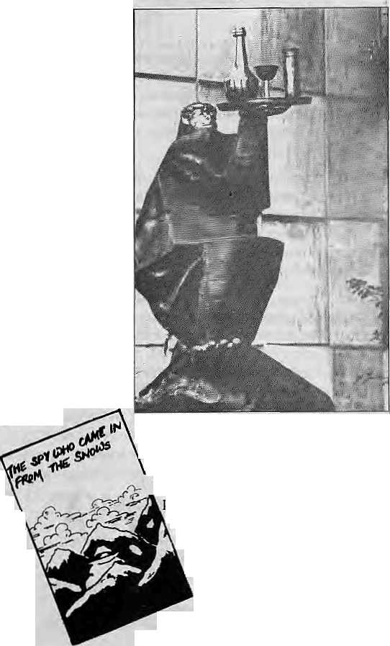

T
he fluted ridges of the Hongu peaks are as aloof and spectacular as ever, and the translucent seracs on Baruntse glow blue in the sunlight. But this scenery masks a deep turmoil caused by the new environmentalism that is sweeping the mountains like a westerly jet stream. Yes, recession has hit the Barun. Joblessness among high Himalayan primates and lesser mammals is at a all-time high as the Government's new anti-garbage regulations begin to bite.
Expeditions have become politically correct. They are leaner and don't leave any valuable litter behind. Many have started retrieving even cola cans and ketchup bottles back to Kathmandu, depriving the region of a major source of aluminium and components for kerosene lamps. Oxygen bottles, the preferred gong for school bells across the eastern hills, are getting harder to come by and no more climbing ropes for Seduwa's yak pens.
Proliferation of trekker latrines have deprived vegetation on either side of the trails of vital nutrients, stunting the undergrowth and setting off an ecological chain reaction that is affecting biodiversity — particularly some rare species of Himalayan dung beetles. Marmots that collected expedition crumbs are burrowing deeper this winter and choughs are going hungry.
More mountaineers and trefckers are getting lost because the green-conscious among them have taken down vital toilet paper streamers that marked trails through dense jungle. Today, trekking guides tell hikers to keep the mountain villages in the\ same shape they found it ■— mired in poverty. Leave nothing but footprints, take nothing but fotos, they say. That is exactly what we did all over Shipton La and look where it got us.
With unemployment among elusive primates rising, many have been leaving for the bright lights of faraway Kathmandu. Some take the high and wild passes of the Khumbu, into the Rolwaling
scattering footprints all across Tashi Lapcha Pass, across into Langtang to approach the city from the north. The more desperate ones lie at the end of the grass strip in Tumlingtar and hitch a ride on the landing gear of Twin Otters on takeoff.
In the city, they hang out with relatives at the Yeti Travel Agency or the Yeti and Yak Hotel. For the familiar whiffs of home, they dine on Yeti Loaf or suck on a beer at the Rum Poodle while flipping through recent issues of Yeti Flight Tails,
One of our sisters is immortalised in bronze in a rather accurate reproduction of a Royal Nepal Airlines stewardess \ outside company headquarters. She ;, with a tray of chianti bottles and long tall glasses, upset at an imaginary passenger who dared ask: "Can I please have some more?"
Other Barun refugees who migrated to Kainmandu and survived the first few days of breathing all that diesel have gone on to do well for themselves.
Take my albino cousin from Olangchunggola, Gori, who is now an entertainer at Himalchuli Restaurant. Gori was always a good girl, she was, and
would never expose her paws to just anyone — particularly not to gambling misanthropes with wallets stuffed with black cash accompanied by their squaws and hordes of rowdy offspring.
Last time I saw her was after a bash thrown by the men from the ministry from resources made available through a grant from the Global Environment Facility (always wondered about that one. Why facility? "Excuse me, sir, would you be kind enough to direct me to your Facility?")- Later, at Himalchuli we saw Gori dancing daintily to the tune of 'Jaun Jaun Railayma'. In economic hard times, hominoids will do almost anything including croon easy to digest doses of culture to Development Tourists.
Finally, it can be revealed: Gori is actually a SPY. She is the Matahari of Sustainable Development. Even while she dances for inebriated development merchants who have just signed rich irrigation contracts, she is carefully collecting data on who got the pay off and how much. With tiny microphones hidden under her arm-pit, Gori pirouettes past diplomats planning ways to sabotage 767 lease agreements as they gnaw their Naram Chara and Sande ko Sukuti.
During intervals, Gori is in the corridor jotting down what she overheard the Arunscam Appraisal Team tell co-conspirators on ways to muzzle the media and minimise fallout from soft social issues. She digs through the noise of Teutonic turbine manufacturers loudly slurping soup to discover who got the grease. She tunes in her remote-sensing antennae at wired consultants for geographical information systems as they dip into plates of Palak Jhinga.

One day, Gori says, she will write a book about how she fled recession to go undercover in Kathmandu — about the lords of poverty who spend on one dinner what a Khotang farmer would take more than a lifetime to earn. The book will be called 'The Spy Who Came In From the Snows'.

52 HIMA.L . Nov/Dec 1993

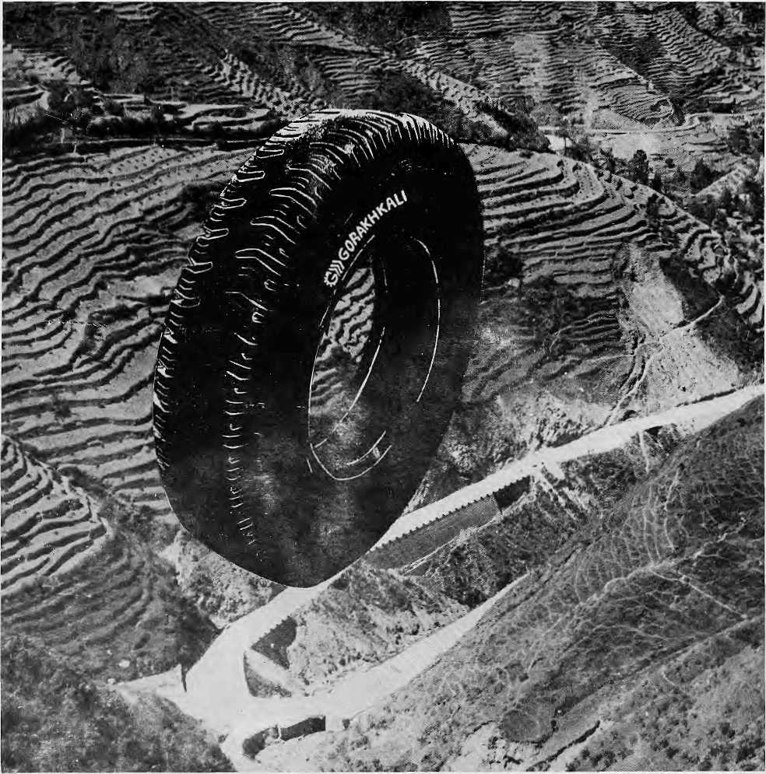

The Gorakhkali tyre is specifically designed for tough Himalayan roads and extreme Himalayan climate. It is the only tyre manufactured in the Himalayan region. The Gorakhkali tyre uses nylon backing and a special dual tread compound for added strength. Rigorous tests on Nepali highways have shown that the Gorakhkali tyre has excellent abrasion resistance. It is unmatched for steering, acceleration, braking and road grip. Overall, it has the lowest cost per kilometre of running.


GORAKHKALI
GORAKHKALI RUBBER UD YOG
Registered Office: Marketing office:
Majua Deurali PO Box 1700, Knlimati
Gorkha, Nepal Kathmandu, Nepal
Phone (065) 20179 Phone 270367, Telex 2788 GRUL NP Fax 271704


Regd. No. Lalitpur 65/045-46

Northwest makes it easy to go to America. With a choice of 8 gateways. And connection to 200 cities beyond.
Choose a connecting city that suits you best: Bangkok, Hong Kong or Singapore.
generous free flight plan there is. General Sales Agent in Nepal :
Northwest has daily 747 flight via Tokyo or
Seoul sfroight to the U.S.A. Malla Treks,
Malla Hotel Arcade,
Be sure to ask about WorldPerks, the most Kathmandu, Tel. 418 389


NORTHWEST AIRLINES
SOME PEOPLE JUST KNOW HOW TO FLY.™

