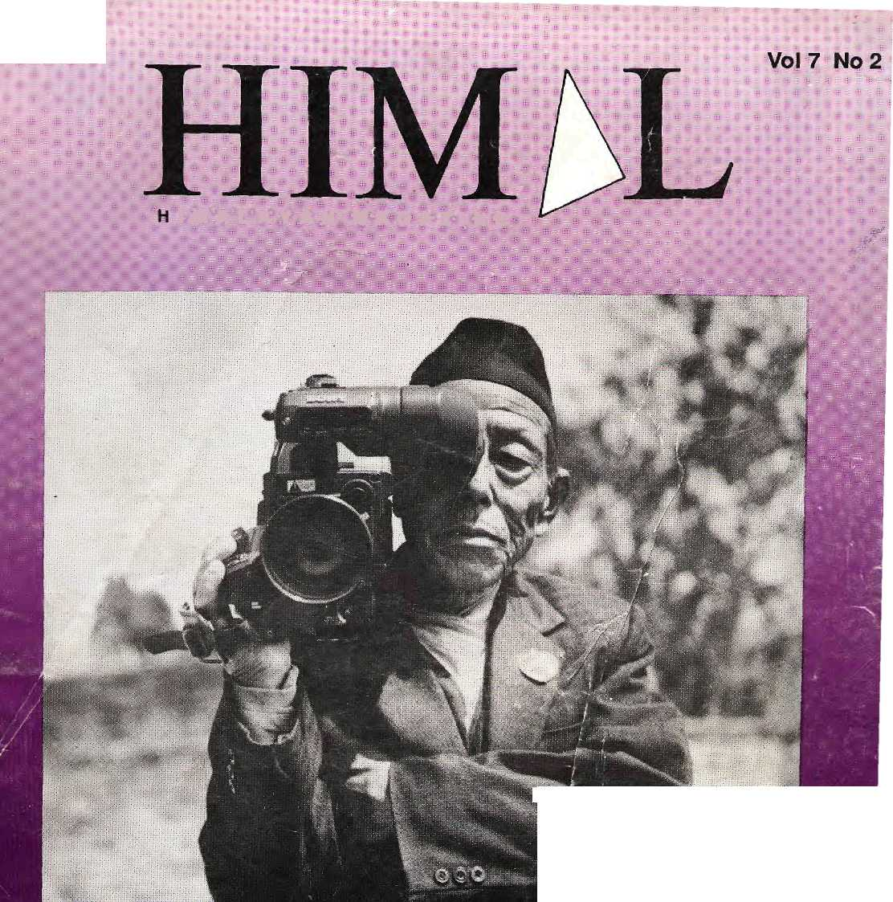
Nfis 40 DM 9
IRs 25 E -4
Nu 30 U$ " 5
U$ 4.75 In North America
f u' a : l : a: y a h • m - a g a: z: i: :n >e
0m:

mm-
Hill
MIRROR, MIRROR
A Revievsr of Himalayanf F|lininaking^

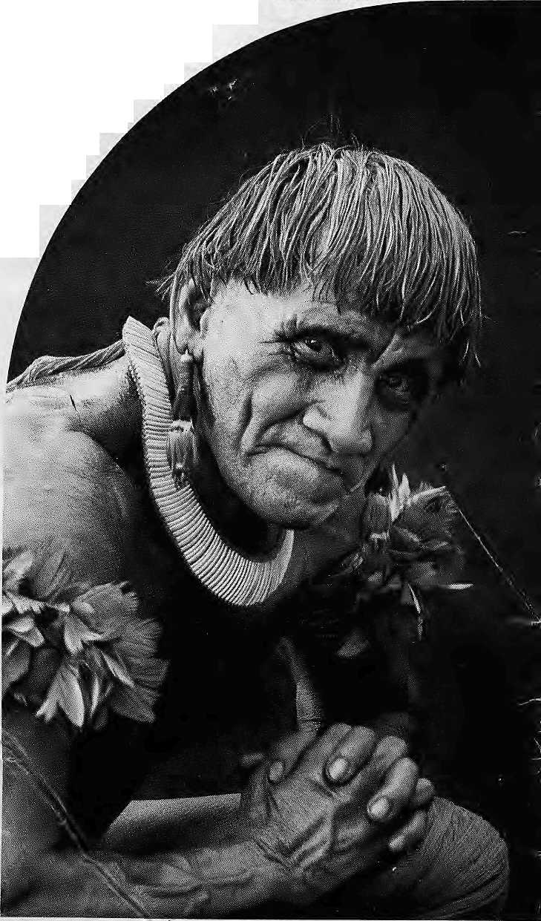
«

WWF World Wide Fund For Nature
(formerly World Wildlife Fund) International Secretariat, 1196 Gland, Switzerland!
Outside the industrialised west, no-one has to be told to respect their elders. It's simply the way society is organised.
Which is why WWF - World Wide Fund for Nature tries to work with older people in the villages of the rainforests. Wirh WWF's help, they learn to teach t!ie younger members of their communities about conservation
In Kafuc Flats, Zambia, it's Chief Hamusonde (93).
Chief Bakary (78), is our man in Anjavi-mihavanana, northern Madagascar.
ln Ban Ktong Sai, Thailand, we invoke the Venerable fapasro Bhikkhu, seventy-three year old chief Buddhist monk.
This isn't just expediency, it's how WWF believes conservation projects should be run.
Before you teach someone, we believe you have to learn from them.
We spend years visiting village after village, talking to the people, listening to them, living with them, understanding how they live their lives.
Only then are we able to gain the confidence of the village elder*.
Once they realise we're on their siie, our elderly converts promote conscrvatioi with a zeal that belies their years.
"Uncle" Prom (68), another of ourThai community leaders, tells us that he Frequently gets scolded when he starts telling peope in the market that they should leave the fosses alone. But he gets results.
Uncle Prom and his fellow villajeri recently managed to prevent a new losing concession, and set up a community fcrest where tree felling is now forbidden.
Ninety-three year old Chief Hamusonle also makes things happen.
Income from the Kafuc Flats game reserve in Zambia is funding a school, a clinicand new water boreholes for the local vilSges.
In Madagascar, seventy-eight yef old Chief Bakary's village makes a pufit by selling fruit grown in their new tree ifirsery.
More importantly, Chief Bakary Village now takes fewer trees from the rahforest because the nursery can provide frewood and poles for construction.
Not that we don't believe in catching them while they're young. WWF also organises special training courses to help teachers incorporate conservation into the curriculum.
20,000 primary teachers in Madagascar have already taken part

And WWF produce teaching aids as well as teachers.

We commission educational factsheets, booklets, posters and videos in over twenty different languages. These arc distributed to school? and colleges all over the world. If you can
help our work with a donation or a legacy please write ro the membership officer at the address opposite.
You only have to look around you to see that the World still has art awful lot to learn about conservation.

HE'S JUST ABOUT OLD ENOUGH
FOR OUR TEACHER TRAINING PROGRAMME.


mmmmM COVER
UIMbL
Vol 7 No 2 Mar/Apr 1994
INSIDE..


Editor
Associate Editor Consulting Editors
Managing Editor
Photography
Administration

TJie ylfcoiie of Gods, King of Mountains, Himalaya
You bound the oceans from
.
east to west A northern yardstick To measure the Earth
Kalidasa (Kumara Sambhava)
Kanak Mani DMt Manisha Aryal Sanjeev Prakash An mole Prasad Pema Wangchuk Dorjee Bikas Rau nia r Balaram Sharma Prakriti Karmacharya Rama Singh Suwal
8
notes frbm tfte festival \
by Anmoie Prasad ■ '■■;■■.■ ..■;■■.■■,■'■ ■;■'.' ^{v}-.. -^.■ ■ ..
"Hovy njany prayers. are.;ijiferfe;in thSt wheel of yours?" asks LowellThorneis to hlama'in Return to Shangri La.
there
13
...because they
by Sanjeev-Verma .^:-.:.'y:■;.'■■ ':'^V';?y■:":'■ j"
Films good, baH'and ijglywere soreented at Film Himalaya T994;%hich sthight to... \... demythify;i-timalayat! life arid
15
Delinquentpbctiniehtary
by Kan$kMarti Djxjf:.;
Films will become sincere only when the subject peoples get to critique them.

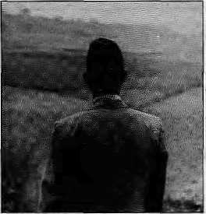
46 48

FEATURES
31 Hostage in Thimphu
by Bhakti Prasad Bhandari
Teknath Rizal is kept in jail only to maintain the fiction of a conspiracy, writes a former political prisoner.
35 Mistaken Antiquity
by Don Messerschmidt
A long-dead sadhu's stone image just has time to sow confusion before it is stolen.
41 Bahuns in
the Nepali State
by Prayag Raj Sharma
Hill Brahmans form an intrinsic part of Nepal's heritage. It is preposterous to call them "colonisers", writes the professor.

DEPARTMENTS
3 | Mail
19 | Briefs
■ | Tibetdevastates Nepali forests
 | Tourism is a genetic resource!
 | E-mail comes to Nepalis, Tibetans
 | Tharu brother to another planet
 | Wrangle at Rumtek Gumba
28 | Voices
36 | Abstracts
38 | Review
Is it distance that prevents Washington DCs environmental pandits from understanding Himalayan socioecological issues?
Himalaya Mediafile Abominably Yours

24 KATHA "The Storm Raged All Night Long" by Indra Bahadur Rai
Cover: Ram Bahadur Tamang, of Ward No. 3 Bebhar Village, Kabhrey Palanchowk District, wields a Sony U-Matic. Picture by Corey R. Davis, of Washington DC, who wields a Rolleiflex.
Himal © 1994 is published every two months by Himal Association, PO Box '42, Sridarbar Marg, Laiitpur, Nepal. Tel: 9771 523845, Fax: 521013. ISSN 1012 9804, Library of Congress Card, Catalogue No. 88 912882. Subscription information on page 5. Printing: Jagadamba Offset. Tel: 521393.
Mar/Apr 1994 HIMAL . 1

This mountain* is not going to come to you ... You have to go to it !

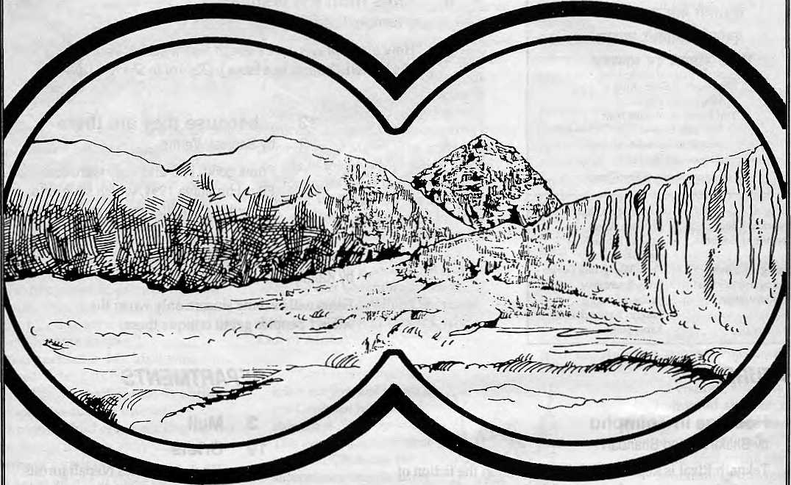

So, we will take you there. And make it a thoroughly enjoyable experience too !
* Sagarmatha (Mt.Everest), the world's most famous and highest mountain altitude 8S48 m. Treks can go up to the base camp. Fly to the nearest airstrip in Lukla. Trek 15 days. Other famous peaks in the neighbourhood — Lhotse (8516m.). Makalu (8463m.), Cho oyu (8201m.), Gyachunkang (7952m.), Nuptse (7855m.), Pumori (7161m.), Amadablam (6812m.)


MMIT NEPAL TREKKING
Write or call us at:

P.O.Box 1406, Kopundol Height
Kathmandu, Nepal
Tel: 525408, 521810
Fax: 977 I 523 737

MAIL

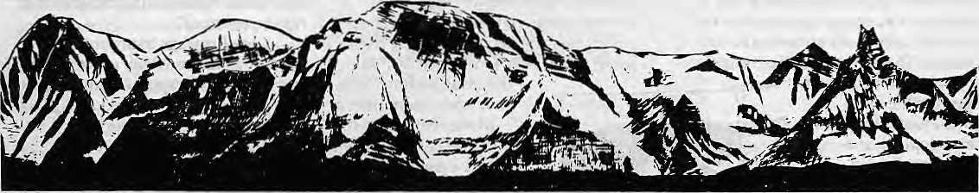

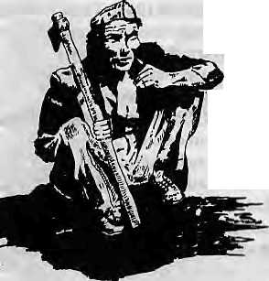
Need Activism
Missing from Manisha Aryal's article on Chipko's aftermath, "Axing Chipko" (Jan/Feb 1994), was analysis of why the movement did not spread to Nepal -one place where grassroots public movements concerning environment, health and literacy are crying needs.
The only movement that has happened in Nepal in the name of grassroots participation seems to have been the political movement of 1990 ~ the apotheosis and the epitaph of Nepali activism. It has been four years since democracy arrived in Nepal. And people's political energies have been sapped by leaders who do nothing more than play out intrigues upon one another in Kathmandu, at the expense of the larger citizenry. The goals of true participatory democracy appears to be receding rather than coming any nearer. Today's democracy does not provide a voice nor energise people from villages and towns.
Why is it that any sustained activism, away from ploitics, has failed to take root and achieve results in Nepal? Why this reluctance to have any public debate and participation on matters of national or local significance? Himal should have looked into these questions as well and tried to draw lessons from the movements that have long blazed a trail across the hills of India. Aryal's dissection of Chipko, while illuminating, would have been more useful with such a discussioa
It is high time for Nepal's so-called activists to emerge from the seminar rooms and workshops and dirty their feet in the rough and tumble world of activism.
Gyan Kumar Chhetri Lazimpat, Kathmandu
Chauvinist from Barun
While I read each issue of Himal from masthead to footprint, I am extremely concerned about the growing chauvinistic sentiments evident in the Abominably Yours column. Your fast-talking hairy friend from the Barun Valley, despite his enviable knowledge of mountain e-mail, is showing rapid signs of intellectual collapse, as evident in his diatribes against Homo sapiens, Indian meteorologists, the entire Third World and Socialism.
Certainly, the rights of free expression should be extended to wildlife, but only up to a limit. This should not become a form of license as it will undermine the whole notion of rights. If the writer of this regrettable column does not take back his unacceptable views, we will send the Bajrang Dal after him.
Down with all forms of chauvinistic bipedalism! Sanjay Pratap East ofKatlash, New Delhi
Trekking, Servitude, Inflation
Doug Scott, veteran Himalayan summiteer and recent devotee of green climbing, has called attention to the inequities in the trekking tourism business (Jan/Feb 1994). He is particularly concerned with the plight of the porters who are paid what he terms slave wages. While it is useful to call attention to this problem, it is tourism itself — the largest industry in the world — that is exploitative. Trekkers are just a small part of Third
World tourism, which in a global scale represents neo-colonial imperialism. I wish to comment on Scotf s suggestions for a solution.
There are two groups of players in the new colonies that he refers to, trekkers and climbers. Climbers accept a risk of death of two to three percent per escapade, and face a high rate of illness and disability. That is the price they pay to reach for the top. Their high altitude servants pay the same human price, and stand to gain very little in contrast to their charges. Climbing alpine style extracts a higher price of the aspirants, but fewer worker bees are exposed to the risks.
The trekkers are an entirely different lot, mere mortals who pay to be shepherded through the Himalaya, and who desire some of the comforts of home on the trails. They are willing to pay, and some want to be rescued if they stub their toes. However, few trekkers think of the health of their servants.
There is a new focus on green trekking, which Doug Scott mentions. Savvy Nepali trekking lodge owners now put trash cans along the trail, but the contents are dumped over the side of the hill every other day when the trekker, who is drinking mineral water from a plastic bottle that he discards into the container, isn't looking. But what about the porter?
Porters make about U$ 2 a day today in eastern Nepal, if working for trekkers, and less if working for shopkeepers or farmers, carrying supplies or produce. When I first came to Nepal, 25 years ago to trek, they were making U$ 1.50 to U$ 2 a day. A cup of coffee is now at least a dollar back home, and it was half that back then. But a meal of dal-bhat on the trail away from the trekkers' footprints, all you can eat, in the East costs 40 cents today. This
Mar/Apr 1994 HIMAL . 3

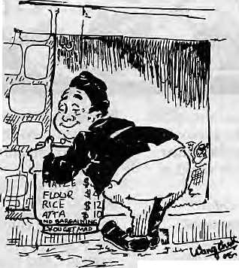
is not much different than 25 years ago.
So the trekker's dollar goes much further in Nepal today than it did a quarter of a century ago, making the country even more attractive for the tourist. That is the nature of tourist havens today, they are great value for money, and they also depend on a concept of servitude among the natives, an aspect of culture that is
indigenous to many ethnic groups in Nepal. Doug Scott proposes porters be paid a minimum of £ 2, or double what they are paid today. He would have this be uniform throughout the country.
If porter wages for trekking were regulated and doubled, the effect on the tourist would only be slight. Prices for vacations through trekking agencies would certainly increase, something Scott desires, and there would be a move to limit services. Perhaps fewer supplies would be carried, only one toilet tent instead of two, and less kerosene, which would lead to burning of more wood. Certainly, no sirdar would spend porter wages to carry out garbage. More local food would be consumed by trekkers in an effort to limit porter-rfotos, which now contain imported delicacies, to maintain profit margins. This could have a devastating impact on the local food resources.
Trekking parties already pay twice or more than what locals do for food staples. This has created significant inflation in the hills. No local will feed his children eggs when he can sell them to trekkers at twice the village market price. So, high protein items and fresh produce would be a smaller fraction of the local diet. The fine art of bargaining is lost on today's sirdars when the needs of their clients and the rushed pace for Instant Everest is more important than the time required to determine and pay the local price.
The major effect, however, would be to increase the price of portering all over the country for non-trekking
associated commerce, still the major arena where porters are used. Trekker portering is but a small part of the remote transportation economy. The inflationary impact of a dramatic rise in porter rates is very real. Scott dismisses this issue perfunctorily, " not even committing a
whole sentence to it.
Porters would flock
to the trekker trails, there would be no one to carry food to
the deficit areas, and the cost for mule carriage would
also increase. In the mid-1980s,
Nepal ceased being self-sufficient in
food production. In most areas now, the land does not grow enough to sustain its subsistence farmer inhabitants. They must supplement by wage labour. Famines, still rare in Nepal's marginal food balance situation, would become more common. Mass movement of the young men involved in portering would further compromise the precarious social balance in the hills and mountains, where women head the households most of the time. Prices for commodi-ties in most remote hill areas would rise substantially, since transportation is a major factor in the cost.
The impact would be much worse than that already created by trekking parties paying more for food. Having a uniform price throughout the country would be unfair as well, as costs are generally higher in the West, and this area would not receive the differential it does now, further compromising the marginal economy there.
Yes, the porters are maltreated, cheated and misused. Their wages are a pittance for the trekkers. Because of that, they are treated no better than pack animals, and too often left to die on snowy passes during storms by uncaring sirdars. How could a human being work that hard carrying a load all day that many trekkers cannot lift, for only two dollars a day?
Instead of a blanket recommendation, as Scott does, one might begin by modelling the effect of an increased fixed price on porter wages. Nepal has
plenty of economists who could do this. Does thfe model predict the results I anticipate? Realistically, could such a rule be enforced?
Look for ways to improve the conditions under which porters work. Have police checkposts do more than inspect the permits of trekkers. Let them decide if the porters have the proper equipment to undertake high altitude trek that is being asked of them. Develop a standard of human resource care for porters working for trekking agencies. All this is harder to do than simplistically saying, "Just pay the porter more."
Nepal, away from the popular trekking trails and the deadly pollution of Kathmandu, continues to be a paradise for trekkers. When venturing off the beaten path, one can share the people's hospi-tality in ways that are impossible anywhere else in the world. By paying the going rate for food and porterage in such a situation, the trekker contributes to the hill and mountain economy in a meaningful way that is not inflationary. By spending time with people, and sharing their home culture, the outsider can become a friend, and not a visitor to the colonies set up to do the master's bidding. It is still this way in 75 percent of the country. Such independent trekking by cross-culturally conscious individuals is the experience that Nepal should be promoting, one that the Nepali people want It is the agency trek, with the insulated bideshi coming through with his retinue, that is the problem.
Stephen Bezruchka Seattle, USA
Insist on Indigenous
I had mixed feelings upon reading Rajendra Pradhan's "A Native by Any Other Name..." (Jan/Feb 1994). The question of indigenousness is not an outcome of an overnight discussion. I strongly feel strongly, that the majority of Nepalis are indigenous people. Even by the definition of the International Labour Organisation quoted by Pradhan, we seem to have fulfilled the required criteria. Aren't we the first-comers to this land? If you go through the history of Nepal, you will find that Gorkha was a Gurung kingdom, the

4 . HIMAL Mar/Apr 1994

Subscription Rates |  |  |  | Send subscriptions i related correspondence to:
Only Bank -drafts acceptable for subscription orders |  |  |  | South Asia: P.O. Box 42, Lailtpur, Nepal
made to Himal inNcpal.DoNOT send cash in maiL |  |  |  | (tel 9771523845, fax 9771 521013), or
Individuals |  | : Year | Iyr» | Central News Agency, 23/90 Connaught
Nepal | NRs | 220 | 400 | Circus, New Delhi 110001
India | IRs | 140 | 260 | Japan: Akio Horiuchi,
Bhutan | Nu | 175 | 330 | P.O,B6x 9, Kayose, Tokyo, 204 Japan.
Other S. Asian Countries | U$ | 12 | 20 | Australia; Indra Ban, 12 Norfolk St.,
North America | U$ | 2250 40 |  | Faddirigton 2021, Sydney, Australia;
Germany United Kingdom & Ireland Netherlands | DM £ Of! | 50 20 45 | 35 80 | North America:BarbaraBeliai Associates,500 . Sansome Street, Suite 101, TO Box 470758
Elsewhere | U$ | 25 | 4S | San Francisco, CA 94147
 |  |  |  | United Kingdom & Ireland: JotiGiri (Ref: H),
Institution!] |  |  |  | 221 AshlyGardens,;EmeryHill Street,
Nepal | NRs | 600 | lioo | London SW1P1PA
India | IRs  KT.. | 260 | 500 | The Netherlands: C. F. de Stoppelaar,
Bhutan Other 5. Asian Countries | Nu US | 25 | 640 45 | Foundation Himalaya, Keizersgracth 463, 1017 DK Amsterdam
North America | U$ | 40 | 70
Germany | DM | 70 | 120 | Switzerland; Heiene Zingg, TannerAveg 18,
United Kingdom & Ireland | £ | 30 | 50 | CH-3073, Guemligen, Switzerland  Rtstuf ■'•■■
Netherlands ' | Dfl | 100 | 180 | Europe Durga Press (HIMAU, Luitpoldstr. 20.
Elsewhere | US | 45 | SO | D-82211, Herrgching, Germany

eastern hills were ruled by the Rais and Limbus, and so on. These people are differentiated by terms like 'matwali', 'janajati', etc., in much the same way as terms such as 'aborigine', 'tribal' and 'savages' were used in the West. In ignorance, some people even started calling them 'bhotey'. In the present context, they all have claimed to be indigenous in search of their identity. These people, who are willing to call themselves indigenous even when it is a derogatory term as Pradhan writes, surely represent the marginalised section of the society.
Today, people have become more conscious of their ancestry. It is quite appropriate for them to demand the land which their forefathers once used to til. Secessionist tendencies are cropping up everywhere. If certain groups had not dominated others and had instead remained on their own lands, the idea of Balkanisation would never have arisen, in this region or elsewhere.
If only the Naga, Mizo and Monpa are to be called indigenous people in the long stretch of the Himalaya, then do we need to rebel against the government with all pos-sible strategies? Incidentally, the movements to promote the self-identity of Nagas was severely weakened and factionalised with the death of Phizo, and similarly the movement of the Mizos was dissipated after Laldenga submitted to the Indian government. These experiences show how even
strong movements by 'indigenous people' do not seem to stand a chance when confronted by State power of mainstream South Asia.
Tika Gurung
MukH-5
Solu Khumbu
Unique Jesus
I found Huta Ram Baidya's comparison of Hinduism and Christainity {Mail, Jan/Feb 1994) quite interesting. However, he has failed to mention any guru who being God-incarnate, offered himself as a sacrifice for the sins of the world, and rose from the dead on the third day. Till such a figure emerges, Jesus remains unique for me. Ramesh Khatry Nepal Bible Ashram Kathmandu
Wealth of Music
With reference to Himal's Music issue (Nov/Dec 1993), it might interest your readers to know that in the Archives of Traditional Music of Indiana University is located the Terence R. Bech Nepal Music Research Collection. According to its catalog, the Bech Collection has 400 reel-to-reel tapes, 2000 black and white negatives, 1500 colour transparencies, and 120 musical instruments, 41 life history ethnographies, 7500 song texts, 200 musical transcriptions in manuscript form. Copies of 1212 commercially recorded songs are also available.
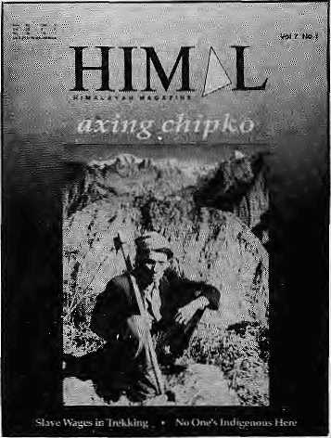
In an introduction to his collection dated 31 May 1978, Bech writes that "the materials in the various media and the data contained in them provide a foundation and stimulus for Nepalese ethnomusicology to build upon and expand in becoming an important discipline and field for research in the larger area of. South Asian studies."
After receiving a Master of Music degree at Indiana University, Bech came to Nepal in 1964 as a Peace Corps volunteer and began collecting Nepali music. After his Peace Corps stint, between 1967 and 1973, he conducted ethnomusicological survey research, carried out life history studies of Nepali musicians, and took photographs in addition to intensively recording Nepali folk music in eastern and central Nepal.
The catalog, produced in 1978, is a useful but not complete guide to the collection. It consists of six indices categorised by culture group, geographical area, language, musical instrument, song title, and subject/context For each song in the collection, the catalog provides the date and place of recording, the singer's name, the context in which the song was performed, the date of composition, and the instrument used. The text of quite a few of the songs are also available in Nepal, and in some cases in English as well.
The 41 life histories provide

Mar/Apr 1994 HIMAL . 5

information on musicians whose works have been recorded in this collection. One of these that I was able to see ran into more than 600 written pages in Nepali (with English translation).A quick reading suggested that these texts will not only be useful for musicologists but also for otherscholars of Nepali history, culture and society.
Information on this collection can be obtained from Archives of Traditional Music, Morrison 120, Indiana University, Bloomington, IN 47401, USA.
Pratyoush Onta Thamel, Kathmandu
Drukpas All
I am a Bhutanese citizen and I belong to the 'Ngalong' community. I have been living in exile for the last three years (and in Nepal since July 1993} and have been a silent political observer of the unfolding political crisis. These past few years, I have observed that the media, including Himal, and other organisations have only looked at the 'Lhotshampa' angle; the rest of Bhutan has been completely ignored. While I am inclined to sympathise with my Lhotshampa brethren, I would also like to point out the following observations and feelings — these views are personal and in no way connected to the machinery of any political or non-political organisation.
That the present political crisis in Bhutan which has led to an exodus of refugees and asylum-seekers to Nepal is the making of the Royal Government of Bhutan is a fact beyond doubt. The main factors leading to this crisis can be directly attributed to the lack of understanding of the people's sentiment and misinterpretation of the concept of 'nationalism' on the part of the Royal Government. Nationalism is not 'Driglam Namza'; it must come from the core of an individual's mind.
Himal on E-Mail
: With the help of Mercantile Office
Systems of Kathmandu, Himal is now
reachable by e-mail. Please use the
i address only lor correspondence with
f the editors. Do not unload digests,
letters to family, or cooking recipes.
himal@rnosrtepalernet.in
si ■
I am a Ngalong, but I am against the drastic implementation of the social customs and traditions of my community on other communities who have their own customs and traditions. These customs and traditions get in the way of living even in our own community but people have not been able to voice their misgivings due to fear of incarceration and the wellbeing of dear and loved ones. This rule, the Driglam Namza, is now being disregarded by the members and younger generation of the elite ruling class, while the ordinary citizen must bear the brunt of the men in blue, should they try to follow the way of the elites. The wool the Royal Government has pulled over the eyes of the ordinary citizens is not going to last long.
The movement started by the dissidents in exile began on an earnest note, but it is disappointing and frustrating that the proper goals and aims have been lost somewhere along the road. New political parties are mushrooming amongst the refugee community even with most of the existing parties lacking proper aims and goals. Forming a new party and talking to the media will not get us anywhere.
We cannot bring about changes in Bhutan while living in exile, and that too in a third country. If the leadership of the political parties in exile have the larger interest of their country and people in their mind and heart, they should work jointly and concentrate their efforts on taking back all the refugees with dignity and respect.
The question of democracy in Bhutan is a matter to be settled within the boundaries of Bhutan and not from a third country. I do not support that there should be preconditions for return, either on the part of the Royal Government or on the part of the dissident groups in exile. Rather, as a citizen, I demand that the Royal Government take back all the refugees and respect their individual rights. The dissident groups must put their efforts into this rather than setting pre-conditions.
The term 'Drukpa' has been used time and again to refer to citizens of Bhutan from the Western districts. It is important to know that the word "Druk" means Bhutan and "pa" the inhabitants of the country. Hence, any citizen must consider himself/hers elf a
'Drukpa', regardless of which community he/she is from.
I condemn the categorisation process demanded by the Royal Government with regard to the population in the refugee camps. Their concern should be with two categories only, viz. national and non-national. The Royal Government must realise that this process is an internal matter and not the concern of any other government.
The propaganda of ethnicity as propagated by the Royal Government carries no merit. The oppression meted out on the Lhotshampas is the only aspect that has come to the knowledge of the world as they have been forced to flee Bhutan. But what of the oppression of the other communities? The ordinary citizens of Bhutan have never had any say in the affairs of the government, their minds haying been enslaved by the ruling oligarchy. The Lhotshampas in exile have faced hardship and turmoil, but they, at least, are able to express themselves freely. But the communities that remain within the country, too, are suffering under the heavy yoke of the present regime; they too want reforms in the country.
The reforms and changes in Bhutan should be based on the aspirations and betterment of Bhutanese citizens without compromising the sovereignty and national integrity of the country. To this effect, the Royal Government, on its part, must show goodwill by respecting the articles of the Universal Declaration of Human Rights, to which it is a signatory.
We must create a situation in which the people of Bhutan can once again live in peace and tranquillity as they did before 1988. Like-minded people must work towards an achievable goal that is appropriate for Druk-Yul and its citizens. Chencho Jigme Dorji presently in Jorpati, Kathnutndu,
i Readers are invited to comment, criticise or add to information and opinions appearing in HimaL Letters should be to the point and may be edited. Letters which are unsigned andor without addresses will not be entertained, Please include daytim e contact telephone number, if available.

6 . HIMAL Mar/Apr 1994

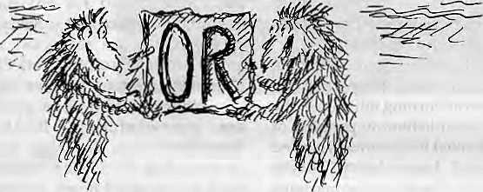
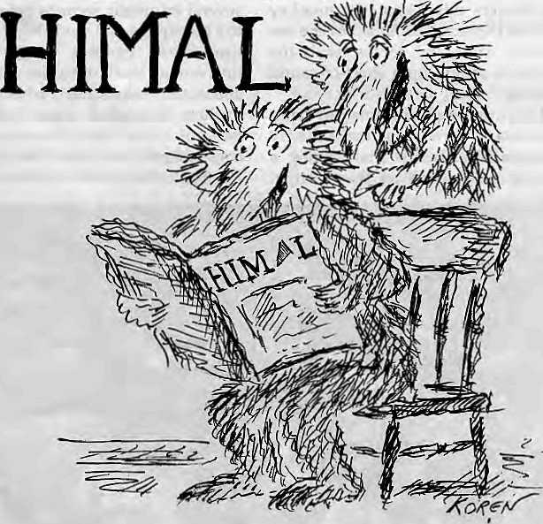
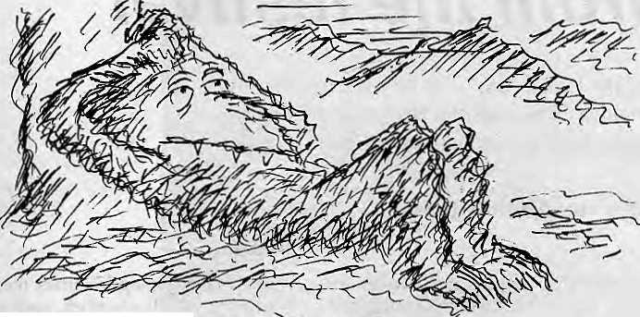
YOU CAN
...YOU CAN R8AD

way up
A
t Himal magazine, we ran a film festival for three days and rejoiced for weeks afterwards. The audience's warm embrace of a festival of documentary films was so meaningful that we are energised even in the editing of this magazine. The cover features of this issue are all spinoffs from Film Himalaya 1994.
Himal welcomes Anmole Prasad, lawyer and poet of Kalimpong, into Himal's masthead as Consulting Editor. While Anmole was earlier a stay wire to Himal's superstructure, he now becomes part of the foundation. He joins ourbabu from Delhi, Sanjeev Prakash. And we thank friend Ed Koren of The New Yorker for the fuzzy creatures he has gifted Himal (see adjacent).
Another paatra of our appreciation is Calfornian John Baccaglini of Barbara Bella & Associates, who believes that the North American readers must have access to Himal. If you have noticed improvements in the punctuality of this magazine and its print quality, you have to thank John's nudgings-by-facsimile.
When Himal began publishing seven years ago, we knew that this was one magazine that would not be an immediate best-seller. Our forte is in presenting issues rather than news of the day, the greys rather than the blacks and whites. Our gain in readership has therefore been tortuously slow.
In trying to reach the South Asian market without an advertising budget, nor any viable network to bank upon, Pema Wangchuk Dorjee has a task that is the marketing equivalent of doing the Kangshung Face, solo. But all of us here have understood well Himal's First Law of Market Penetration, which runs: "Survival is the best marketing strategy."
We could still use more advertisers, though, as long as you do not brew beer, peddle cigarettes, or operate casinos.
- Kanak Marti Dixit

Mar/Apr 1994 HIMAL . 7

notes from the festival
A review of the Himalayan films brought together by
Film Himalaya 1994 indicates that there are many
to applaud and enough to criticise.
by Anmole Prasad

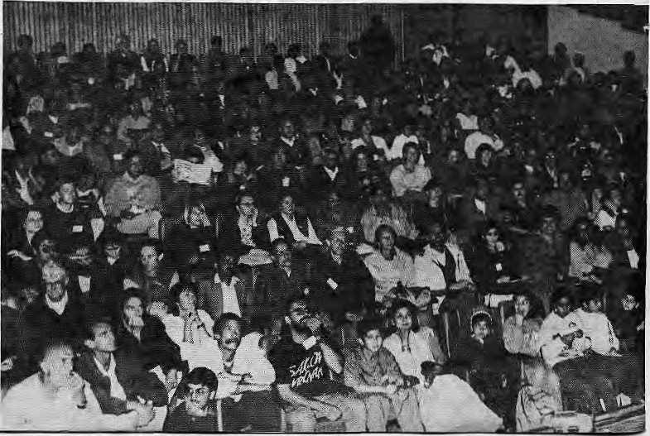
I
n 18 February, Sri Mustangi Rajasaheb Jigme Parbal Bista flagged off Film Himalaya 1994, a three-day-festival of documentaries and films at a refreshingly brief and dignified inauguration, followed by the screening of the film Baraka.
This was Baraka's Asia premiere — and there were other firsts as well. This was decidedly the first festival of films on the Himalaya and its peoples; probably the first in the region to focus almost exclusively on documentaries; and certainly, the first that showed more than token respect for the inhabitants of the Himalayan region.
The fare was as large as it was varied. Chosen by a Kathmandu-based selection panel of locals and expatriates, the films and documentaries ranged over subjects as diverse as development, anthropology, ethnography, religion, ecology and environment, tourism, wildlife, spiritualism, culture, architecture, medicine and history. There were fikns-on-the-making-of-films, others that were tainted with Hollywood hype,and others that were plain downhome entertainment.
Cobbled together with a shoestring budget of U$ 8000, a pittance as festivals go,and screened back-to-back in two small theatres at the Russian Cultural Centre in Kahtmandu, Film Himalaya 1994 was carried off with elan and precision, leaving little post-festival acrimony in its wake.
Pyrotechnic Cinema
Baraka, producer MargMagid son's larger-than-life panorama of the human condition, began appropriately enough with images of the Himalaya—theMount Everest panorama, the 'eyes' of Swayambhu, and shrouded shapes swaying in and out of a foggy Bhaktapur morning. The film is segmented in three parts, the first consisting of spiritual
8 . HIMAL Mar/Apr 1993
iconography, temples, monasteries and holymen(Baraka,inSufi,meansthebreath of life). The second segment lays on a guided tour, of the wretched plight of modern man, military and industrial horrors, and the evils of modernity. The third segmentagain finds relief in images of natural beauty and celestial grandeur, showcasing cinematographer RonFricke's prestidigtal skill with the camera.
Technically, the film is breathtaking, often carrying the viewer a way with Dali-esque portraits of burning oilfields in the Persian Gulf, or a heliborne panning of hundreds of junked B-52bombers parked in the Arizona desert (with Tibetan monastery horns droning an incongruous threnody on the soundtrack). One memorable sequence, showing a part of the Ramayana performed in Borobodur with dancers mimicking the monkey hordes of Hanuman, is filmed over a sea of brown arms and torsos, with the soundtrack setting up a slieet-of-sound gibbering.
Despite the absence of any commentary, Baraka is unabashedly propagandistic. Whilst maintaining a romantic perspective on the spiritual
wealth of developing countries, the film remains ethnically stratified, ending up as an indictment of the southern hemispherefor its squalorand ignorance, apportioning the blame for mindless modernity and consumerism on the Chinese and Japanese, and on the rest of the Third World for environmental degradation, strife and poverty. Images of the North are restricted to a few anonymous shots of New York City traffic blurred by computerised time-lapse effect. While its audio-visual pyrotechnics are overwhelming, Baraka is a disappointment. The New York Times reviewer described it as a "visual poem", but it is a troubled poem, not without its own crude symbolism: towards the end of the film the audience is treated to a close-up of a burning Varanasi corpse for several traumatic seconds before the cut to a breezy sky and scudding clouds. The time-lapse camera which creates interesting visuals of accelerated sunrises and storm clouds is overused on cityscapes inaham-fistedeffortto portray thefrantic pace of urban life. The sound-track, consisting of ethnic music beefed up with electronic effects, was often intrusiveand

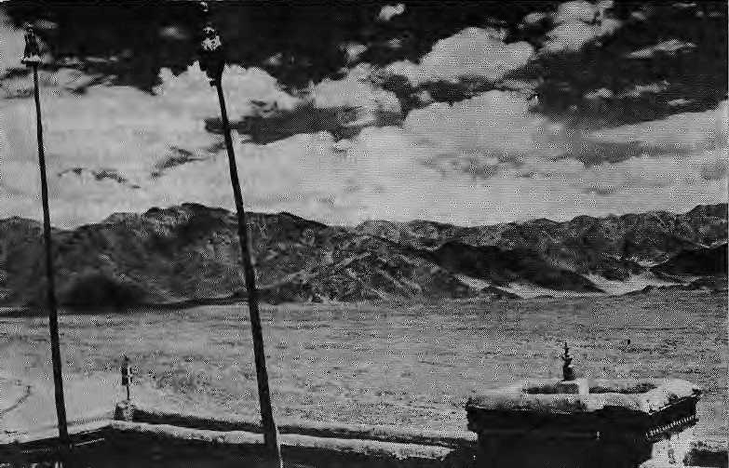
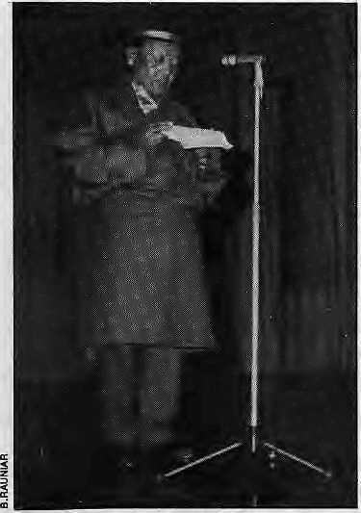
Jigme Parbat Bista, Raja of Mustang, inaugurates Flim Himalaya 1994. The Himalaya has been the subject of many documentaries over the decades, he said, and it was proper that the local inhabitants also get to view them. This was the first time the Raja had opened a public function in Kathmandu.
boorish. The film closes with whirling dervishes and a recapitulation of the earlier spiritual themes.
Licking Honey
With theexceptionperhaps of theChinese entry Dao Mao Zei, none of the other films of the festival attempted a canvas as large as Baraka, but many did make their point just as effectively. The first array of the festival was taken up with several small films. Catherine Marchiak's Himalayan
Vision played to a packed 50-seater auditorium (most of the tickets had been taken by Kathmandu's Nepal Eye Hospital). Marchiak follows the story of Khamsiyar Tamang, a woman blinded by cataract who is carried to Kathmandu from far-flung Gurmu in a doko to undergoeyesurgery.Thefilmisdelivered from becoming another sterile documentary onhealth and development by the presence of Dr. Sanduk Ruit, who performs the successful operation at the Nepal Eye Hospital, and who virtually requisitions the narration of the film, imbuing it with a loquacious warmth and spirit.
Interestingly, Himalayan Vision was one of the few festival films that also examined the after-effects of filmmaking on its subjects. Having regained her eyesight, Khamsiyar Tamang returns to her village, only to find herself alienated and maladjusted. She attempts to follow the film crew back to the city and it is only with some convincing that she finally settles back into her community.
Chugging up with Granny profiles the moribund railroad from Siliguri to Darjeeling. Produced by Ashok Raina, the film is presented with uninspired cinematography and and wooden commentary by Darjeeling historian Kumar Pradhan.However,Kathmandu's audience seemed to take to Pradhan's recitation of Darjeeling children's ditties. Director Gautam Sonti's Plastic Plastic records the efforts of the Mussoorie schools to raise local awareness and combat shop ping bag debris on the slopes. The gum-chewing students are themselves blissfully unaware that the film is funded by Colgate Palmolive (India) Ltd., a megacorp that contributes
generously to widespread use of plastic products and packaging.
The Splendour of Carhwal and Roopkund, filmed and directed astutely by Victor Banerjee during the monsoon, provides images of unsurpassing beauty of the lush bugyals (meadows) of Kusli Kalyani softened by half-light and the rush of rain clouds. Viewers were also treated to some quaint vignettes of the bagpipe tradition in the western Himalaya. This lyrical portrait of Uttarakhand, however, is marred by a narrative and commentary as windy as the high meadows of Garhwal.
The second day opened with the festival' spiecede resistance,Honey Hunters of Nepal, a fine ethrir graphically-sensitive work that riv is viewer interest. Filmmakers Eric valliandDianeSummers take us on a journey "somewhere" in Central Nepal, whore aquintetof intrepid Gurungs led by the 60-year-old Manilal risk life and limb by dangling over sheer cliffs to smoke out swarms of black bees from their hives. Their reward is a golden harvest of wild honey.
Honey Hunters, edited and produced seamlessly, with a rich if inappropriate soundtrack, celebrates the skill and daring of th e gen erations of G urung who, ha vi ng shunned the drudgery of agriculture, run the gauntlet of the giant black swarms. The film was followed by The Making of Honey Hunters, which in rum celebrates the skill and daring of the crew that shot the film, offering self-conscious glimpses of the Westerners encumbered by hi-tech mountaineering impedimenta, dangling alongside the nimble-footed honey-hunters.
Co-director Summers, who introduced the film and answered questions after the screening, said the .location of Honey Hunters has been a closely-held secret,al though Manilal was recently in Kathmandu for a cataract operation. Himalayan Vision for a honey hunter!
While Honey Hunters remains an expert and sympathetic ethnographic record, it tends to take an excessively fond look at the Gurung clan, reducing its members at times to quaint hobbits of Himalayan Middle-Earth. But patriarch Manilal is allowed the last word: holding out a gnarled palm dripping with honey, he repeats the old adage, "Jasle maha kardcha, usle hath chaatcha!" (He who draw honey, gets to lick the hand.)
Mar/Apr 1994 HIMAL . 9

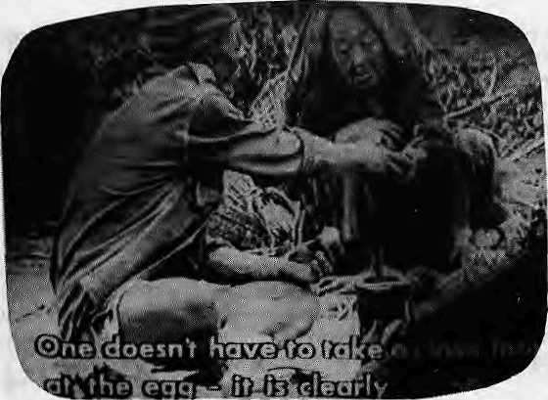
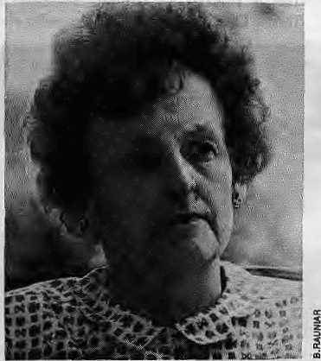
Nyinbas and Ladakhis
Polyandry among Nyinba in thearid hills of Humla was the theme of the BBC/ National Geographic production, The Dragon Bride, Thefilm charts the 'travails' of 15-year-old Tsering Kangzun, who is bom in the Year of the Dragon and is fated to marry four brothers in accordance with the customs of the community.
Constructed out of a series of interviews with the family and relatives of both Tsering Kangzum and her prospective husbands, the Nyinba community comes across as being perfectly at ease with polyandry, and this despite a subtext of disapproval from behind the lens. Articulate Nyinba cheerfully discuss everything about themselves, from matrimonial customs and rituals to — with many a lewd aside — the syndicated conjugal relations. Despite the obligatory plaints, perhaps more for the benefit of the Western filmmakers, Nyinba women seem not unaware of the advantages of having several breadwinners in the house.
Ever inquisitive, director Joanna Head'scamera renders adetailed account of the preparations for and the marriage of Tsering Kangzum. At one point, the crew is shooed out of a room by an irate nanny who screams "Why can't you wait until I've finished?" as she paints the wal Is with clay. Elaborate costumes transform Nyinba from scrubby farmers into strutting mythical figures, and the groom's company engages the bride's household in a battle of riddles and song in order to win the bride. The documentary dwells overtly long on Tsering Kangzum's tearful departure for her home — a normal enough Jea ve-takingandperhapsderigewr for any traditional bride — imbuing it
Deva and Chlnta: stark ethnography.
with an exaggerated sense of tragedy at her polyandrous plight and imposing upon her a 'civilising' monogamous sensibility.
MajanGarlinski, Martin Gaenzle and Albin Bieri put together Deva and Cinta, 127 minutes of stark footage on shamanic rites of Kulunge and Mehawang Rai of East Nepal. Opening on the night of the full moon of Baisakh, the film is laid out in two parts. In the first part {deva, divinity), libations are poured and blood sacrifices made. Thesecond part,rinte (meditation), recordsanall-night seance wheredemons anddein'espossessthebodyoftheshaman and pronounce oracles through him.
Liz Hawley says it like it is.
Filmed in searing floodlight, with little commentary and no score, the documentary is almostminimalist,a style entirely suited to the objective of documentation. The virtually immobile cameraandthelivesoundtrack of chanting and incessant drumming imparts to the documentary a dreamlike quality. The
oracles are cryptic and the interlocutor from among the gathered villagers finds his own meanings within them.
Thecinta ends with the symbolic despatch of a live lizard to the nether world across a bridge of stretched twine and exorcism of the spirits from thebodies of two afflicted villagers, a mother and daughter.
Another ethnographic film, but in an entirely different vein, was Jyapu: Industrious Productivity as a Lifestyle, which takes a 28-minute look at the indigenous farmers of Kathmandu Valley. Unlike other ethnographic portraits at Film Himalaya 1994, this 1981 documentary chooses to getdown on its knees and look at the community through children. Kathmandu farmyards seem to have enough well-adjusted, snot-faced toddlers, going by Jyapu. Like Baraka, here too, there is no narration.
Ancient Futures: LearningfromLadakh, based on the Norwegian Helena Norberg-Hodge's book by the same name, makes for a chilling before/ after story on Ladakh. The Indian Government's presumably well-intentioned construction of a highway into Ladakh has brought with it consumerism and the destruction of an entire, ancient way of life. The images of New Ladakh are frightening: trucks spewing smoke into the crisp mountain air, scrawny teenagers lounging about video parlours, exodus from the farms, and unemployment on the streets. But despite Norberg-Hodge's injunction — she has been a longtime observer and 'visitngactivisf in Ladakh—onthepitfalls of idealising traditional Ladakh, the film ends up doing just that. The Ladakh of yore, according to Ancient Futures, was a charmed place that knew no lack of medication or schools, no high death rates...
Two archival films deserve mention: one, Lowell Thomas' garrulous Return to Shangri La, which somehow manages to encompass all of early 1970sNepal within just an hour of footage; and the other a silent film, First American Mission to Nepal, April 1947, taken before any motor road led to Kathmandu. The journey up the tortuous trail from Bhimphedi leads to a Kathmandu that is mired in the Rana times. It was appropriate that the film was introduced by Huta Ram Baidya, an old-timer agricultural engineer and Valley environmentalist who has seen Kathmandudevelopandthendisintigrate

10 . HIMAL Mar/Apr 1993

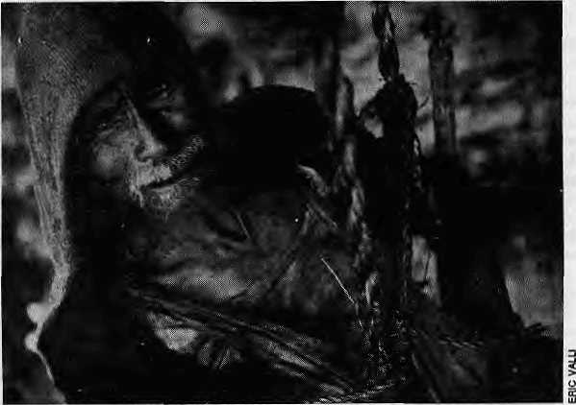
in front of his eyes.
Baidya provided commentary through the auditorium's PA system as American Mission was being screened. His eerie voice-over boomed and echoed around the hall, lending an air of melancholy and nostalgia to the proceedings.
Then, there were the lot of mountaineering films, without which perhaps no Himalayan film festival can be complete. For its part, Film Himalaya 1994 chose to screen old classics like The Conquest of Everest, of the successful John L. Hunt team which put Tenzing and Hillary on top, as well as some recent films which tended to be more brash.
Spiritual Horizons
If themes of developent, culture, environment, mountaineering and anthropology were on the festival's
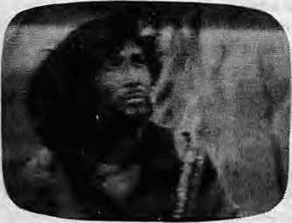
The horse thief of Dao Ma Zei
agenda, Himalayan spiritualism was certainly its leit motif. Anwar Jamal's hardhitting documentary on the Tehri Dam imbroglio in India, Call of the Bhagirathi, featuring the Ganga as the desecrated mother; On the Wings of Prayer, Siok Sian
Manila! Gurung looks for honey.
Pek-Dorji's compassionate rendering of the endangered Black Necked Cranes of Bhutan, which ritually circle over a monastery roof before setting off to their summer home in Tibet; and the search of thereincamarionofLamaTundu,theHigh Lama of Thame monastery, in Norman G. Dhyrenfurth's Samsara — a Tibetan Tradition, set against the backdrop of the achingly beautiful mountains around the Khumbu and the Tasi Lapcha pass.
The search for spin tual peace was on as far back as 1937: the festival organisers even exhumed {with the help of USIS) a copy of (the first) Lost Horizon. Tourism in the Himalaya owes an old and deep debt to James Hilton'sbookand Frank Capra's filmforthecommodificationoftheregion as an escapist paradise. Perceptions of the Tibetan plateau and its people were still foggy in the American mind when this film was made. "He looks like a Chinese, or aMongolian, or something!" screamsa character describing the pilot who hijacks the aircraft to Shangri La. In 1937, they did not recognise Himalayans,
Disappointingly, and perhaps predictably enough, Hollywood's earliest representation of a Buddhist Utopia merely resonates contemporaneous colonial and Christian missionary ideals — the High Lama of Shangri La is a European abbot and his concrete domain a paradigm of civilised living where the commode is indispensable for contemplating one's navel.
Bringing us squarely down to earth after this foray into mythical Shangri La was Compassion in Exile, Mickey Lemle's hard-hitting documentary on the Dalai Lama, Tibet, and the Chinese. Before there
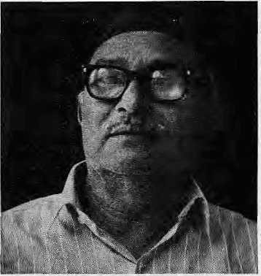
Huta Ram Baidya remembers Kathmandu.
was time to catch ur breath, however, we were yanked back to Shangri La by In Search of Buddha, Paolo Brunato's film on the filming of The Little Buddha. Brunato seeks to get spiritual mileage out of Bernardo Bertolucci's musings of Buddhism. The film played to a packed house and nearly sparked off a riot for want of seats. It seemed to attract a starry-eyed audience that was thankfully absent during the rest of the festival.
The camera follows Bertolucci on his cinematic peregrinations as he confers with lamas and holds forth on dharma. Bolstering the documentary further are Tussaudean extras and members of the crew who play converted Westerners practising Buddhism in Nepal, Bhutan and the USA. Given the rumours that The Little Buddha is financially adrift, perhaps this d ocumentary was produced to market a more user-friendly brand of Buddhism before the real thing hits the theatres.
If onediscounts Lost Horizon asbeing only of archaeological interest, then Dao Ma Zei (The Horse Thief) was the only feature film of the festival. Directed by Tien Zhuangzhuang, a "fifth generation filmmaker" of China, the movie follows the trials and tribulations of a Tibetan horse thief cast out by his community, and of the misfortunes that are subsequently visited upon his tribe and upon him. It is unlikely that there is another feature film on the Himalaya with similar power, depth and mastery of technique.
In more than one way, Dao Ma Zei stood apart from other films of the festival, and challenged the central theses of many. While Ancient Futures extolls the virtues

Mar/Apr 1994 HIMAL . 11

of a Tibetan community's traditions, Dao Ma Zei looks at theharshness of ostracism. The Tibet of Lost Horizon, a utopia of longevity and peace, is inverted into a bleak landscape of stark violence and immediate death. Barakn's optimism that religion and spiritualism contain the answers to the problems raised by the degeneration of mod em society isnegated by the denouement of Dao Ma Zei, where the penitent exile, having futilely attempted to comeback to the fold, reverts and dies an outcaste in the wild and unforgiving land.
The vast stretches of the Tibetan plateau are filmed with skill and care, showing an intensely surreal landscape. Tien Zhuangzhuang also utilises circular motifs — prayer wheels, water wheels, circuits of the monastery, and Mani Rimdu dances — to good effect, although the religious iconography is over-exploited in creating images of horror.
From another perspective, however, Dao Ma Zei was not without its politics. Its acceptance must be tempered by the understanding that it is a discourse generated by thedirector as representative of a dominant race making a film about a subjugated race. This distance between thedirectorandhissubject(s) is evident in One sequence in the film, where the tribe of Tibetans stands on a hillock releasing little slips of white paper inscribed with prayers into the wind. As the swarm of paper rises in the air, cries of "La Gyalo!" (Victory to the Gods!) are heard. But there are other voices, too, in the soundtrack, crying "Bod Gyalo!" (Victory to Tibet!)
Film Himalaya 1994 was not only a
festival of films. It was, at the same time,
afestival of awareness. Theexhiliration of
the festival was overlaid by a deep
pessimism and foreboding, a sense of
denudation and degradation of the
mountains and of the people living here.
The last image which comes to mind, and
which refuses to go away, is this: the
American Lowell Thomas in Return to
Shangri La, taking a lama affably by the
arm, asking, "How many prayers are there
in that wheel of yours?" .
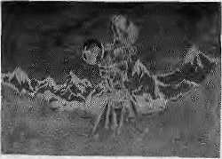
& *"*X?
tfbKlKr ^imHHIn

KiAIJfiBlpfjH'
to
iffllWtf

FILM HIMALAYA 1994 FILM HIMALAYA ARCHIVES TRAVELLING FILM HIMALAYA FILM HIM^AYA 1996
The successful holding of the first-ever international festival of Himalayan films and documentaries in Kathmandu on 18, 19 and 20 February has spawned a whole new set of activities. We now seek the support of filmmakers, sponsors and scholars to make these activities successful.
The Archives is a Kathmandu-based repository of films and documentaries on the Himalayan region. Its initial holdings include 71 films from among those entered in the February festival, whose producers have given us permission for non-commercial exhibition. The Archives will be fully functional once Himal magazine is able to put together the required equipment. The Archives will be available for a nominal fee to filmmakers, researchers, students and connoisseurs.
In order to give maximum exposure to the films shown in Film Himalaya 1994, ten selected films from the Festival are being sent around the Himalayan region as a travelling exhibition. And film connoisseurs who could not make it to Kathmandu for the festival will be able to savour a sampling of what all the Festival had on offer in their part of the Himalaya. Initially, the films will travel to Pokhara, Palpa, Narayanghat, Nainital and Kalimpong. The organisers must be assured of proper screening facilities and security of the films {no copying allowed) before arrangements can be finalised for other venues.
In early March 1996, Himal magazine will organise the second international film festival on the Himalaya — Film Himalaya 1996. While the February festival was organised solely by Himal magazine, the 1996 event will have the participation of government agencies, academia, development organisations and the private sector. Representative feature films from all over the region in addition to a broader selection of documentaries and a larger proportion of work by regional filmmakers will be screened.
We seek your enthusiastic participation in all these activities.
Suman Basnet Director, Film Himalaya

12 . HIMAL Mar/Apr 1993

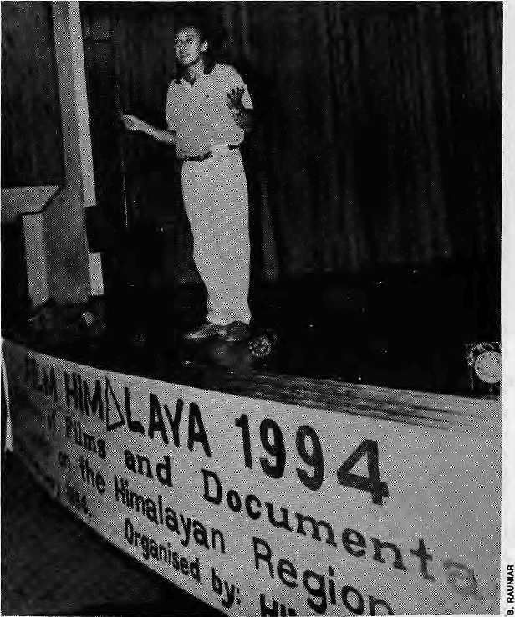
Victor Banerj&a on the dock.
Nepali documentarists. If it does, Film Himalaya '94 will have been worth the time and the effort.
The seminal contribution of the festival may be that it adds to the process of demythifying the Himalayan life and landscape. The poetic vision of a people living in perfect harmony with nature has endured long enough;itis time to examine the whys and wherefores of how Himalayan lifestyles are being deeply affected by marauding modernity. There were few films on show that actually proffered that alternative vision, but enough to hold out hope for the future. Films like The Dragon Bride, The Honey Hunter$ofNepalandShigatse:OneInjection Asks for More had the artistic integrity required to visually reflect Himalayan traditions and lifestyles.
All three films were made by expatriate filmmakers, which went on to prove that not all Western films which focus on Oriental themes have a skewed, superficial perspective on Oriental themes, as is generally believed.
What was interesting was the divergent, almost adversarial, approach to documentary filmmaking witnessed at the festival—at the impromptu question-
...because they are there
by Sanjeev Venna
T
he organisersof most film festivals come in for considerable flak on their choice of films to screen. Film festivals, after all, are meant to showcase the best cinematic fare available; there is no place there for mediocre, much less bad, films. If one were to apply those measures in estimating the worth of Film Himalaya 1994, the verdict would have to be entirely unfavourable. Most of the fare was bad or indifferent.
But, then, seeking only the best of Himalayan film-making seems never to have been the objective of the Film Himalaya organisers. The key term, instead, was "representative filmmaking". Hence, all manner of films — the good, the bad and the ugly — were deliberately screened, as one organiser said, "...because they are there. We wanted to present specimens of filmmaking on the Himalaya, a random samplingof what is out there."
It is difficult to quarrel with that line of reasoning. Screening of somedownright bad films can have a cathartic effect on the sensitivities of committed filmmakers. For instance, when the great film archivist Henri Langlois, of the celebrated Cinematheque Paris, used to randomly screen films for cineastes, showing a Fred Astaire picture right after a Bunuel or a Renoir masterpiece. It was in reaction to films that were largely pitched in the realms of fantasy that Truffaut, Godard, Chabrol and Ri vette set out to make a new kind of cinema, which came to be known as the nouvelle vague or new wave.
Given that Nepal has hardly anything like a filmmaking, mu chlessdocumentary filmmaking, tradition to speak of, Kathmartdu was an odd venue for the festival. But, conversely, there couldn'tbe a more apt one considering that the Kathmandu audience would be the most aware of the people, lifestyles and issues being depicted on the films. Also, there is the hope that the festival will inspire and provoke the latent filmmaking talents of
and-answer sessions with filmmakers after screenings, or at the brief talk forum on the final day of Film Himalaya. On one hand, you had the brigade of anthropologists and ethnographers who pooh-poohed the insatiable capacity of filmmakers to romanticise the life and traditions of the Himalayan people. And on the other, there were filmmakers who wondered whether it was right to strip bare the lives of the hill people on celluloid.
For instance, Diane Summers, who directed Honey Hunters with her husband Eric Valli, said that her approach is to see peopleaspeople,ratherthananalyzethem to the core. "Too much anthropology in a film becomes boring," she said. Besides, isn't the argument that cinematic aesthetics have no relevance in anthropological films indefensible?
The social scientists present pitched themselves in favour of straightforward ethnographic films which didn't go walkabout insundry directions. Films like Victor Banerjee's The Splendour of Garhwal and Roop Kund earned a severe reaction from this lot. Gerald Berreman, now a Professor of Anthropology with the University of California at Berkeley, and who incidentally did his original research

Mar/Apr 1994 HIMAL . 13

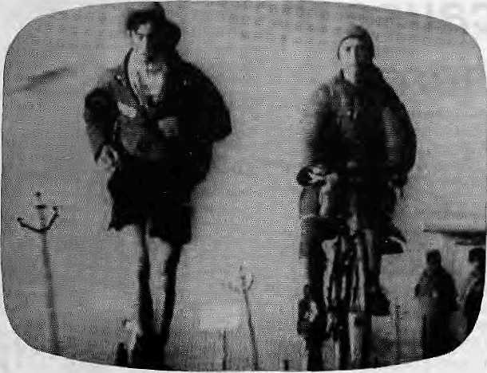
in Garhwal back in the 1960s could barely contain his anger. "Ifs a bad film — contrived, dishonest and appallingly silly," was his clear-cut verdict. Up on the stage, Banerjee was harangued by others as well for his transparent and saccharine-sweet attempt to romanticise the lives of Garhwali folks. His lame defence was that the documentary, meant to promote tourism, was funded by the Garhwal Mandal Vikas Nigam.
Banerjee's verbose and wayward documentary, as also several other films on view, dearly proved that the dialogic tradition has not reached documentary films. Rather than let the hill people speak about themselves, their customs and traditions, these filmschose to tell us their story through the stentorian tones of a narrator. It is also clear that, for the moment at least, most documentary films on the Himalaya are made for viewing by Western audiences.
If Film Himalaya were to inspire documentary filmmakers of the region to present life in the Himalaya as they see it, perhaps in future we will not have to suffer films like Galahad of Everest or In Search of Buddha. Or even Return toShangri La, which finds a bemused Lowell TTiomas, the American raconteur, travelling through Nepal remarking on curiosities large and small. Thomas is obviously tickled by the royal wedding of King Birendra and Queen Aishwarya, but of what value are his farcical observations?
Easily the worst film on view was In Search of Buddha, a scatter-brained project on the making of Bernardo Bertolucci's Little Buddha. The documentary tarries for much too long on the pseudo experiences of Americans drawn to Kathmandu by the tenets of Buddhist philosophy. Producer Paulo Brunato attempts todel ve into the meaning of the Dharma through the skewed perspective of Bertolucri and his crew members.
The audience reacted strongly to the filmsthatitdidnotcarefor.Inkeepingthe
singular nature of the festival, the organisers let loose Elizabeth Hawley, a long-time Kathmandu-based chronicler of the Himalaya, on the British entry Galahacf. of Everest. A supposed recreation of George Leigh Mallory's 1924 expedition with actor Brian Blessed in the lead role, the film was drawn and quartered by Hawley even though her role supposedly was to introduce it. Mallory (who said "Because it is there" with reference to his desire to climb Everest) was a hero all right, she said, but this was hardly the film to celebrate that fact.
Incidentally, Galahad has proved popular in the international mountain film circuit. A reviewer at the Banff Festival of Mountain Films wrote that it is "one of the grandest and most multi-layered films ever screened at Banff... It has been awarded major honours at mountain festivals around the world." It is most appropriate, then, that Galahad was panned at Film Himalaya 1994.
The Kathmandu audience found it easier to relate with the more activist-oriented films like Anwar Jamal's hard-
Starting the climb at MSLin Everest: Sea to Summit.
hitting Call of the Bhagirathi, about the
strugglebetweenthegovernmentandthe
people of Garhwal over the construction
of the dam atTehri. Everest: Sea to Summit,
an Australian entry on the extraordinary
conquering of Mount Everest by Tim
McCartney-Snape, who started his climb
at sea level from the Bay of Bengal, drew
a mixed response. There were those who
complained that it was an egoistical piece
of film and that it typically underplayed,
even ignored, the vital role played by
Nepali Sherpas in the extraordinary
endeavour. Others, including this writer,
reacted to it as a film which was executed
superbly — it had narrative drive and
packed a considerable dramatic wallop.
To put it succinctly, the Australian
film was watchable. And watchability,
surely, is a quality that every filmmaker
must attempt to invest his film with. For
regardless of what subject a film may
concern itself with, Himalayan or non-
Himalayan, it must interest rather inhibit
the viewer. ^
S, Verma is Delhi-based film critic tor the business India magazine.

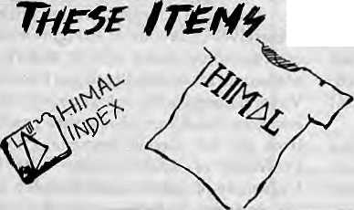
AVAiUKplE AT HIMAL

AY CM Cau

14 . HIMAL Mar/Apr 1993

Delinquent Documentary
The camera cheats on the Himalaya because the filmmaker gets away with it. Documentaries will become more truthful as the locals get to critique them.

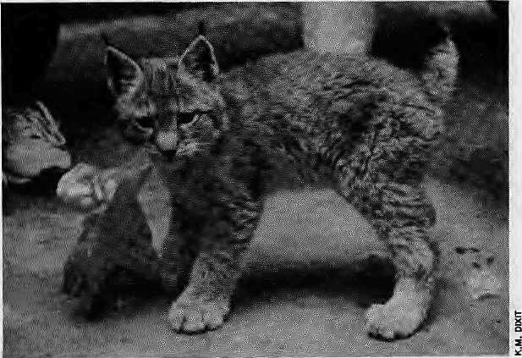
O
n 22 July 1993, in the village of Ghemi in Upper Mustang, crew members of a company named Intrepid Films was shooting a documentary for the US-based Discovery Channel. Thefilm was tobe on theculturat and natural wonders of Mustang, the principality that was opened to tourists in early 1992. Tony Miller, the director, — who also held the camera — was on the lookout for anything that would make his film stand out.
To provide a storyline for his narrative, Miller had brought along Rinpoche Khamtrul, a lama from Dharamsala whom he had met in Kathmandu. The camera would follow the Rinpoche's travel together with two assistant monks up to the walled enclave of Lo Manthang, the capital of Upper Mustang.
It was late evening. At the house-cum-hotel of Raju Bista, Ghemi's aristocrat, Miller was filming one of the monks brushing his teeth. From behind the camera, Miller was asking questions relating to local hygiene and the omnipresence of lice in Mustang. The young lama was providing earnest answers to the questions.
It so happened that a baby lynx {Lynx lynx) had been found by the residents of Lo Manthang and was being transported down to the national zoo in Kathmandu. The animal, too, was spending the night under Bista's roof, together with its handler.
Not one to miss the chance of incorporating this elusive, endangered animal into his film, Miller swung into action. He got permission from the handler, a worker from the Annapurna Conservation Area Project (ACAP), to expose some footage. A yarn was concocted within minutes and incorporated into the script.
As the evening enfolded, the lynx sequence was acted out under the arc lights and reflectors. An assistant lama goes up to Rinpoche Khamtrul, produces the animal, and announces that it has just
This autumn
on the
Discovery
Channel,
when you
watch a
documentary
on Mustang
that features
this lynx, be
forewarned
that you are
being taken
for a ride.
by Kanak Mani Dixit
been found in the hillsides of Ghemi. With Miller prompting him from behind the camera, the Rinpoche takes the lynx ("Ikh" to Loba) into his arms and sighs, approximately in these words, "Ah, these animals used to be abundant around these parts. Now they are no more."
The baby lynx is willing to play its part, and as if on cue begins to frolic with the lama's rosary, making snatches at it with its padded paws. No director could wish for better footage, and Miller is ecstatic.
Faking It
Unless it is a docudrama or carries an appropriate disclaimer, a documentary is not supposed to fictionalise. Additionally, even when he is not presenting fiction, there is a burden on the documentarist that his camera be as candid as possible-Due to the moving picture's power of manipulation — much more than still pictures or print media — the cinematographer has a larger responsibility to respect authenticity. Theaudience accepts documentary films on faith.
That, of course, is the theory of it. All film enthusiasts know that cent-percent candid ness, whileit might be within reach
in still photography, is practically impossible in cinematography except when you have a hidden camera, which has its own problem with ethics. Because of the nature of the visual medium and due to demands of equipment and large crews, documentary filmmakers invariably find it necessary to stage sequences — one cannot just point-and-shoot a documentary. Besides camerawork, in the process of scripting and editing as well, there are numerous opportunities for sleight of hand.
For the very reason that it is so necessary to set up scenes, it is important for the documentarist to know and respect the limits and not to play too fast and loose with the facts he claims to present. Under normal circumstances, these limits are defined by the critics' and the audience's knowledge of the subject and of filmmaking. If he is not careful, the filmmaker loses credibility.
Thus, the vi e wer' s po tential rej ecti on is the built-in safeguard which keeps the filmmaker on line. But when the subject of thefilm is a remote pocket in the Himalaya, both the target audience (in the West) and critics are at the mercy of the director or producer.
Mar/Apr 1994 HIMAL . 15

The temptation to takeshort cutsand to stage sequences beyond the bounds of propriety are in place for film companies that arrive in the Himalayan region. The Western audience is taken on a celluloid ride — often willingly, it seems.
Lynx Sequence
There were several problems evident in Tony Miller's approach to filmmaking, at least at Ghemi. If his film were to be certified a genuine 'documentary', Rinpoche Khamtrul should already have been on a trip to Lo Manthang when the film crew stumbles upon him. If not, then at the very least the lama should have made an earlier trip to Lo Manthang, in which case at worst the director could be accused of re-enactment. Instead, Miller has simply gone and chartered himself a rinpoche.
Now, when Miller completes editing the film, the only ethical way out for him istoindudeanoticestatingthattheRinpo-che's trip was staged, but that the rest of Mustang—thegumbas,thepotato fields, the Kali Candaki canyons — are for real.
Not only does Miller bring along Rinpoche Khamtrul to Mustang, he has the venerable lama mouth untruths. Apparently, Rinpoche Khamtrul had not visited Mustang before this. A refugee from Kham living in Dharamsala, he could not be an expert on the status of Upper Mustang's wildlife. Neither theRinpoche nor his prompter, Miller, are in a position to know whether the lynx as a species is abundant or scarce in the vicinity of Ghemi. The valley upriver is a high sanctuary which could well support a substantial population of lynx. The first wildlife inventory of Upper Mustang was being conducted by an ACAP team injuly even as Miller was filming.
Sky Burial
Mustang seems to attract documentarists who exel at faking it, even though this is one region that does not need to be made to look more romantic than it already is. The Jast two years has seen Mustang attracting more than its fair share of filmmakers. In fact, Rajasaheb Jigme ParbalBistahashadhishandsfuIldealing with emerging class conflict, much of it sowed by free-spending, insensitive film crews, including Intrepid's.
A team from the Japanese television station NHK managed to be the first to film Mustang when it was opened. Their production, while containing some good camerawork, generates snorts of disbeli ef among Loba who have seen video copies. It is a subject of much derision among the patrons who gather for chhang and tea at the popular bhatti of the "Hema Malini" of Lo Manthang.
The NHK director's interest is to heighten the sense of drama. He is out to out-Piessel the adventurer-author Michel Piessel (the writer of the original mass-market book on Mustang). The film begins by implying that th e crew is driving almost all the way up to roadless Mustang in two properly Japanese four-wheel-drives. It then hypes up a helicopter rescue of a team member who gets altitude sickness at an embarassingly low altitude.
As the camera progresses northward, the routine police check of trekking permits is presented with ominous music and tense dose-ups. A palpable sense of relief is conveyed when thehawaldar flips through the permit and sternly waves the team along. The impression is that the Japanese film crew might otherwise have been thrown into a dungeon holding a hungry Tibetan mastiff, or given sky burial.
Lo Manthang, when theNHK camera finally arrives, is dolled up to look like a garrison town under seige by Khampa marauders. For a settlement where the Rongba (midhill) police know to keep a low profile, there are policemen standing guard on every rooftop, bolt-action rifles on the ready. Sleepy and docile Lo Manthang is presented as a Dangerous Place, one from which the NHK team emerged alive to tell the tala
Cinematic Quacks
More than one documentary shown at Film Himalaya 1994 engaged in sleight of hand, secure in the knowledge that the Western audience for whom these films are made would not notice. Otherwise, why should good old Samaritan Dr. Ebehard Brunier, a dentist from the German town of Mainz, come to Mustang to pull out teeth? The answer is simple: he did it for the television camera. Dr. Brunier's narration in The Dentist from Mainz is child-like, and the public health aspects of his exercise questionable. For someone out to do good, Herr Doktor seems to travel without a dentist's drill, which reduces him to pulling out more teeth than he probably should have.
The problem of candidness, again, is what looms large in a film like Dentist, which utilises the Himalayan backdrop merely as a prop for a self-aggrandizing exercise. Every time we see Dr. Brunier walking alone through the hills of Nepal, tousling children's hair and distributing plastic mouth-rinse cups, we know that behind the camera are arrayed the cameraman, producer,director (Hermann Feicht), soundman, gofer, sirdar, porters, yaks and donkeys. The viewer, however, is likely to believe that this is the story of a lone dentist and his trusty donkey

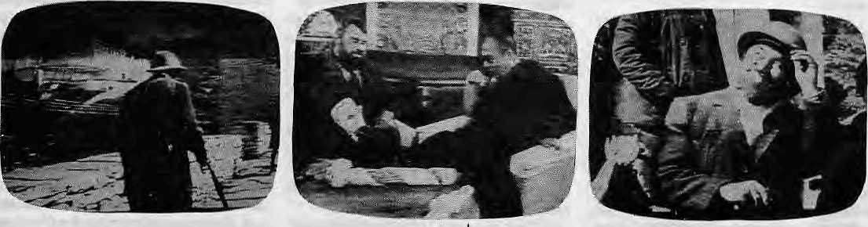
In Galahad, Brian Blessed enters Paro Dzong. meets the Dalai Lama, and emerges in Thimphu. 1* . HIMAL Mar/Apr 1993

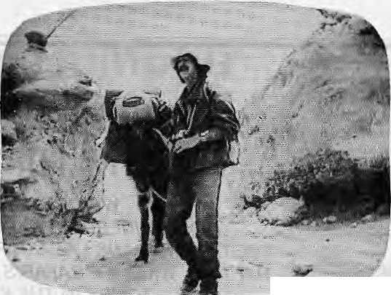
heading up to Mustang to do good. Another pitfall of ego-driven films: you stage more scenes to create proper atmosphere, almost as if you were shooting a feature film.
At the end of Dentist, the German public television company ZDF announces that it is providing U$ 10,000 for a clinic which Dr. Brunier is going to establish in Lo Manthang, as promised to the Rajasaheb. That was more than a year ago. Apparently, no Loba has heard from Dr. Brunier in the interim. In addition, Nepal's Minister for Tourism and Civil Aviation Ram Hari Joshy is said to have waived Mustang's hefty entry fee for Dr. Brunier on the promise that he would pay NRs 50,000 towards a school building in Lo Manthang. The money has yet to be collected.
Meanwhile, there is much hilarity in Hema Malini'sbhatti as the patrons recall the dentist who set up a stool by the town gates and pulled out the wrong tooth of so-and-so. Butit is the dentist fromMainz who had the last laugh.
False Galahad
Galahad of Everest, a film that has garnered much praise in mountain film festivals elsewhere, must be seen for its misplaced hubris and cinematic arrogance. British actor Brian Blessed tries to recreate George Leigh Mallory's 1924 trip to Chomolongma's North Face. In addition to numerous staged sequences, the film has several faked ones as well.
As Mallory, Blessed is supposed to be heading north into Tibet from Darjeeling. Instead, he pops up in the vicinity of Bhutan's Takstang Monastery. Next, Blessed crosses over the photogenic bridge at Paro Dzong, and — as the film editor would have it — drops in on the Dalai Lama. Once his meeting with Dalai Lama is over (most likely 600 miles over to the west in Dharamsala), Blessed is again out on a Thimphu street, bantering with a provision store owner.
The chutzpa with which Blessed carries out this deception would be comical, if the sequence did not make clear how little he cares for facts and sensibilities. The scene of the Dalai Lama comfortably ensconced in Paro Dzortg, for all the unease that exists between the Tibetan government-in-exile and the Thimphu regime, has implications which Blessed is bothered with. For him, the Dalai Lama is a prop, whose amenable

presence on the screen, incidentally, is also used by other opportunistic makers of documentaries.
In Search of the Buddha, by director Paulo Brunato, is insufferable enough for the Buddhist discourse by Hollywood actors. There are reports that this film, which speaks of the loftiest of principles, was not above deceit. At one point, the camera visits a Western ascetic meditating outside his flood-lit cave entrance somewhere in the hills of Kathmandu Valley. Word has it that the 'cave' was actually a hole dug for the purpose of filming. There are said to be other made-up sequences as well in Buddha.
Hit-and-Run
Numerous documentaries in different genres screened at the festival stayed within the ethical limits while presenting fine stories and visuals. It is the filmmakers who are careful of the ethnological perspective that tended to produce the most sensitive and illuminating films. Conversely, the most dishonest documentaries were by producers and directors affiliated to television channels, whether public or private. These hit-and-run documentarists have little emotional attachment for their subject, and their treatment suffers. There is no embarrassment to taking short cuts if you know that after Mustang your next assignment is the Shetland Islands.
So, why does the filmmaker cheat? The answer mightbe that they donot care enough for the locals and their sensitivities; the target audience is in the West (or in Japan) and does not know enough to catch the filmmaker out; the subject community does not get a chance to see the film and Teact 'effectively.
The temptation to fake increases
Does the doktor from Mainz travel alone in Mustang?
proportionally with thedistancebetween the audience and the subject peoples.
Meanwhile, if it is the responsibility ofthefilmcritictokeepcinematographers on the straight and narrow, i t fails to work when it comes to Himalayan films, which are aired primarily on Western networks and public television. Since the critics do not have the background to comment on the content of films on complicated Third World topics and locales, their critiques rarely go beyond the superficial. Like the general audience, the film reviewers, too, tend to get carried away by the grandeur of mountain vistas and the romance of Himalayan communities as presented by directors.
Even the most respected specialised forum of the Margaret Mead Film Festival, whose focusis on anthropological works, often showcases poorly made films on the Himalaya, to much applause. The discerning local audience would hoot down many of the films that receive wide-eyed appreciation at Western film festivals.
The camera cheats on the Himalaya because, thus far, the filmmaker has been able to get away with it. One way to promote documentaries that stay closer to actuality is to ensure that more subject audiences get to view them — in films festivals, national television, and via cable and satellite—and to react. Next, it is for the locals to develop the capability to produce documentary films for the Himalayan audience. The third step is for local filmmakers to acquire the sophi-stication necessary to present their region on film to the Western mass audience.
But at that point, might we find that local filmmakersarejustasproneto taking short cuts?

Mar/Apr !994 HIMAL . 17

WE WELCOME YOG TO THE HIMALAYAS!
Contact us for detailed information.

WE ORGANIZE: TREKKING AND MOUNTAINEERING EXPEDITIONS IN NEPAL, TIBET BHUTAN AND LADAKH PLUS WHITE WATER RAFTING, WILDLIFE SAFARIS AND SIGHTSEEING TOURS IN THE KINGDOM OF NEPAL.
HIMALAYAN EXCURSIONS

G.F.O. Box 1221, Xeshar Mahal Tbamel, Kathmandu, Nepal Tel: 418407, 418119 Fax: (O) 00-977-1-418913 00-977-1-222026 Tlx: 2636 SHEKPA HP

We accept all major credit cards.

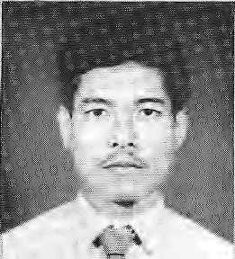

criticised :for its hype questionable science by some
BRIEFS
Tibetan Renaissance
Ibiirtsm a Genetic Resource j
Brother to Another Flanet
Onevt the anomalies of Tibetan culture-in-exile is that while hundreds of Tibetan works have been translated into foreign languages, only the Bible has been translated into Tibetan.
To salvage the situation and enliven Tibetan
intellectual life, fourscholar/ activists have begun the
•Amnye Machen Institute — also known as the Tibetan Centre for Advanced Studies — to begin systematic study of the Tibetan history; culture, society and politics. : The organisers of this Dharamsala-based Institute say that it will promote-"iiberal and humanist" values in seeking to raise the Cultural self^awareness of the Tibetans, "especially those .inside Tibet".
The initiator of Amnye Machen is Jamyang Norbu, playwright and novelist well "known for his critiques of intellectual life in exile. Norbu/ the controversial former director of the Tibetan Institute of Performing Arts, is joined by Lhasang Tsering,
Tilak Mahato is a Tharu from Chitwan. He is now, essentially, in another planet. On 6 March, the 31-year-old Nepali naturalist and five others were sealed inside Biosphere 2, the controversial structure in the Arizona desert which simulates a self-contained space colony supposed to be a precursor to one. The
educationist and one-time president of Tibetan- Youth .; Congress Tashi Tserirtgya scholarat the Library of " Tibetan Works and Archives; and PeiriaBhum, formerly ■■:■■ * associate professor 6fT.ib^tSn: literature at the ^forth-West I Institute for
Lanchau, China-According to: the organisers, 1 the very, success of exiled Tibetans in ■ preserving their culture and religion, coupled with theit traditional conservatism; has resulted in "a dosiftg-in of thenational mind from 1 .., I further investigatior*> : - j -discussion or rftdvement ° towardsculturataiid intellectual changes necessary to making"lit institutions andldeasviable in a rapidly changing:" I world." TheTnstitute wjllvtry;: to manitain contact with the literary and .. .. ... .;..
intellectual developments; : within Tibet.
The Dalai Lama*, who is supportive of Atnnye: i--i ^tachen, says h^ hdpes-its efforts will help bring about a 'Tibetan renaissance".
international team scientists will live ihside;their enclosed, self-sustaining-"' ecosystem for a year."
The outcome of the* imagination of Richard¹ Bass (of the old Texas^ojl money, who also has a stake in the out^of-the-way: Hote} Vajra of Kathmandu), Biosphere 2 is a glass, and concrete struchire which has been severely

If Nepal's tourism authorities-ever are given to worrying feat the ■■:■ ■. country's tourism industry may downslide, they can relax. HirMlayan tour: operators and hoteliers cari malte longtenn investrhehts saffe in;tHe knowledge that..... .
the tourism iap will heft furi
ldfc%anyftrfiesoon, ^{;v} ^{v}
Accoiding to recgrit „ research; love for nature is : encoded into the genes of humans. And as we all know,
: ipvejOf nature translates¹ into;: love^of" theHimalayan mountains, which;is what pulls in hundreds of thousands of itoijriste here
every year. ■ .-
A fte\y: bpokj The Bioyhilia Hypothesis (Island Press, . 1993) present?; convincing papers which speak of the "special link between the ■ human brain arid* tKejiatufal; wprld: As' co^editorEdward O> Wilson, an evolutionary ; biologistjtoldiTTieNepj Yprlc Times recently, "the brain evolved in a biocentric world, not a machine-reguiated World", and knowledge, mental skills, inspiration, the exploratory urge, verbal expression arid appreciation of beauty and harmony, 3U, , owe something to the human
scientists, but has received "'.grudging-praise from some others,, The firist group to spend time in Biosphere 2 emerged from a 2 year Stay last autumn^ thinner but [ wiser. While scientific : advances were made,''the getf-sustalning nature of the hermetically sealed station w|ls compromised -when the air recycling system failed to cope. Oxygen had to be pytnped inafter the carbon dioxide levels reached dangerous levels.
^connection with nature. Studies of aesthetic-
suggest that people i
different cultures prefer
enclosed, pnes,: writes Rog^r S; Ulrich> an environmental psychologist. "Studies-also suggest that people in many parts of the wprld^ clearly favournatural landscapes over urban vi.§tafs that lack natural content."
' Adds Uirich, "Perhaps modem humans, as^ a partly I
' genetic remnant of evolution,*, tend to have more positive -emotional states arid accordingly are 'smarted in creative-thinking when exposed to most unthreatening natural settings." So here's another' ■ plug for tine Ministry of Tourism's new ad campaign: ^{yj}Greativiry enhanced in : Himalayan setting. Cpriie ■ write a novel or programme software in Jomoson."
Is there a chance that love¹ for nature will dissipate sometime soon as humans genes adapt to urban conditions? No fear, says Wilson. "Even under controlled laboratory conditions it would take more than a million years tp *
Mar/Apr 1934 H1MAL * 19

■

Himalayan Cyberspace
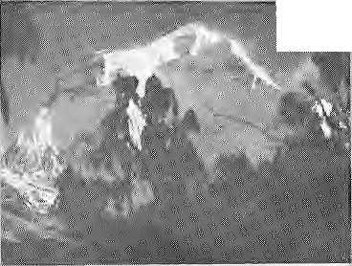
get an adaptation that favou- red attachment to the artificial over the nature. So, we're stuck with what we've got."
So the longterm prognosis is clear: the tourists will keep corning, as long as the Himalaya is maintained irt a dean enough state that it still reflects the attributes of nature. If tourism profits come encoded in human genes, (he only worry should be how to ensure maxitrtum equity and sustainable yield of this generic resource.
Upcoming...
South Asia Bulletin
Vol. 13 (1993)
Special Issue on Nepal
Guest Editor, Nan da R. Shrestha
Stacy Leigh Fvgg:
The Ideological Impact of
Development in Nepal
Jeffrey Riedingen Pros pects for
Land Reform in Nepal
Mary des Chens: Gurkhas as
Diplomatic Currency
Barbara Parker and Douglas
Peterson: The Sexual Division
and Labor and Habitus among
Nepal's Marpha Thakali
Naomi H. Bishop: Circular
Migration and Families: A
Yolmo Sherpa Example
RR, Shrestha: A Self-Reflective
Perspective on Nepalese Elites
and Development
David N. Zurick: Spatial
Development Frameworks and
Rural Transformation in Nepal
Himalayan Environment: Scenario and Awareness National Seminar at the

Theinformatfph highway rib w runs through th^' Himalaya.
In Kathmandu recently, the Royal Nepal Acadeiriy ol Science and-Technology {RONAST) arid ivtercMile ■ Office Systems, a private firm, each obtained a riodfe 6f Ernet from New pelrCs Department pf ;Eiecrronies; What this-means is that any Nepali with a computer,:
telephone line and ■M2W modern can how .. '. J\^, interact .■ ■■ ■ :
electronically >vith the world.
ForNepali .... . students overseas, who have been ] enjoying the... . benefits of wallowing in 'cyberspace', this new opening came
Department of History, Ku(n-
9-10 April 1994. Topics:;
The State of the Himalayan resources: forests, agriculture, water and wildlife The Natural Wealth of the Himalaya: history, colonial era and the present The Environment and Political and Economic Institutions The Environment and People's Movements
Local and International Awareness: From Chipkb to Himalaya Bachao,f rom Stock-holm to Rio.
There will be a Tibet TrmleTiiif in Kathmandu 24-30 April 1994, jointly organised by Nepal's Trade Prdmoli oh Cen tre and the Trade Promotion Commission of Tibet The plan is to promote traditional and new Nepali products tot the Tibet market and for Nepal to impart essential goods from Tibet.
asa joy. And they communicated with such ■■■ gusto that R0NAST% computers were .overwhelmed. Says Suresh Man Singh, who ] oversee^ theagency'se*mail lines, "Since December, we haye: been ihtmdated with e-mail messages and requiests fromstudents all-over."
Among tlied^ta RONAST^scomputers- : disgorged were miiltiple copies of The Nepal Digest: CTND'I, an e-mail newsletter thatisused by Nepali users; ^ twoyearSagoiri
free by some 400 Nepali students and scholars m: theWest, T^fP hasserved '£&"$ platform for debatei on political; development and social issues with the wires carrying hot debates on the state of Nepali democracy, ethnic assertion, and ^^-most recently— the ArUn ill hydf opoWet project. Now, this and many other services are available to acadetnicssm Nepal as well. (To access TND> send e-niaii to: : nepal@ips j) iuvedut)
For those interested exclusively in Nepal, there is also another Internet newsgroup, with e>mail address soeiety.culture.nepal (SCN), U(hicn functions as a computer bulletin board where anyoht; can post anything. SCN served an importaht'furiction fest summer when it carried, ttie up^to-date inforcnatUjn of the floods that ravaged central Nepal.:
India, Pakistan and £hma> too, have their own Internet newsgroups. While India's" SCI is usuatty'domihated by JIT graduates studying or working in the UmtSd States, who, never seem to tire of telling others how brillaint
they-are, Pakistan's SCP's-bulletin, bo^rd,periodically reaches for meltdown with debate on Kashmir, The * members of the Chinese newsgroup'; however, s.eenr-the most'undemocratic. They* engage in persecuting those who want to start SGT— society, cultu-tatibet — and s erase arty message on Tibet that makes ite way ihtb the network.

The Tibetan e-irtailers, however, need not feel i negl'ected"mvich longer, Sihee last November, despite unreliable phone connections, the exile Government in Dliaranisata has been hooked upon e-mail, At4heimtiarive of Tibet support groups In North ^{l} Arrierica, Dharamsala has let up the Tibetan Computer -Resource Centre (TCRC) to oversee-the e-mail project. (Dharamsala's e-mail address: tcrc®urtv,erneWn^{i})
Meanwhile, Mercantile* Office Systems of Kathmaridu, which is presently the only private sector group that provides Himalayan -e-mailing, has tested its system and is hapdirig out user account^ Says the firm's Director, Sanjeev Rajtoandari^ "For the moment^we are providing the e-mail service free so that people can get introduced to this whole new concept of communications. We have not yet decided how we are going to charge for usage." -,
If, as Rajbhandari hopes, e-mail catches on here, what would such ease of

20 HIMAf. . Mar/Apr 1994

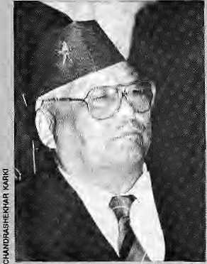
Gajey Gh^iey and 108-year old DhaneyTbapaMagar(vpperright).


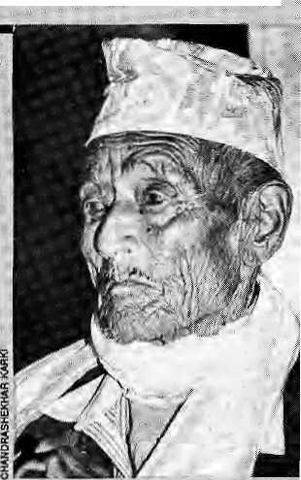
communications arid transfer of ideas mean for developments in the region? Since e-mail renders the barriers of time arid space obsolete, would it lead to greater awareness of diversity among Himalayan . peoples and better understanding °fme myriad challenges they face? Or will Himalayan e-mail, like is happening in the West, peg individuals into narrowly-based newsgroups which makes them more parochial and blinkered.
- Ashuiosh Tiwari
Gorkhali Honours
N
epaliswell past their middle age still remember what their childhood primer told them^{l} of Gajey Ghaley the brave.' Paras Mani Pradhan's; writings took; them to the Burma front, where this village boy from Barpak; Gorkha, single-handedly overcame a Japanese bunker. For his feat/Ghaleyof the 5th Gurkha Rif leS'Teceiyed the I Victoria Cross, and vicarious glory which Nepalis have long'cherished.

A
lmost without anyone notidng;it, the Nepali '"■ Governffietit and a private ■;■' Tsector concernin early March signed a landmark agreement; that heralds the way-ahead for Himalayan power sector' development . " .... ......
Indeed;., if it had-not-been 1 fof thecontroversy raging : i
hydrOpowerproje^; anyone
would have sat up arid taken
notice as the project I .■■■.■
.'.. document; was signed for the:
■ construction of a 60;; ;.. .... - ■■
megawatt "pp#er station on; ; the Khimti Khola,^tributary oi? the Tafria Kosi river in ^ait Nepal. At U$120 million, the : Khimti Project isessity the largest investment inNepal's private sectortod&y, jfts : significance also lies in the ;,.. fact that this is the largest., joint venture project between mternarional companies and a Nepali firm. - - -■^{v};; " 7 :; Z
Gajey Ghaley is therefore: firmly part of theMepaH ; !.'!. pant$eon. Imagine ^ie shock to most, therefore, to find that this man of myt^i is,. ■ alive, a swarthy 78;year-old who visited Kathmaridii; from his, home in AtiriOjra and laid claim to his; ; , - : love for his motherland* :
Together with a Param Vir Ghakra; holder and 6 mother Victoria Cress headers,
Ghaley had cOrtje to .«. o
Kathmajndu for the firsWyer ; arlzen'& reception given to GorkMli heroes on Nepali ; soil. Prime Minister Cirija Prasad Koiralahimself chose to-be present anditohono'ulr '] Ghaleyand th&otherVCs -i '... and jPVCs; Others who joined¹ the ceremony in-cliiided Ggnju Laixia, Tul Bahadur Pun : ,Magar, Agarpsjingh iiai, Bhanubhakta Gurung and; Lachhuman Gurung. Also
The Nepali firms are the Butwal Power Cdrnpany and its affiliate Himal Power ;; ;.. Limited,and they^afe;; .. ■■:■ .■■■■ ■■ collaborating with the Norwegian national power company, Statferaft, whichis; being allowed for the first time by'Oslo to invest outside Norway;
;;At pnemomerit, ., ■,-,=■ ■■■■ accoitling to $ources> the deal almo|t;fell through when Statkraft officials^ exasperated by the slow pace' of; riegb;tiat4oTiS:> eonsidered "1 „■■ ;■ investing in Laos and Vietnarninsteadi Arid Nepali^
^engineers and firms came;;;; very Hose to losing¹ access to TSfprwegian; technology in hydropower, considered of the best in the world and
, suitablefor Moptionin the
' Himalayan region;
Suddenly, in the weeks of February *J
::Nepali;side,brushed upite
present at thecer^rrtohy was : 108-year^pld: Dhaney Tliapa
: Magar of the 1/8 Gurkha Kfles, who fought-in the First; Wo]rlp Warjn Southern '..
"France.-. - ■ ■; " \ '.. .
: Atah oc^asignwhich was pregnant with meaning for so m^ny |ihnic:groups:of Nepal, the sociopolitical aspects of Gurkhajrecruitment —-of;;.;;: fighHng other countrys! wars^ the origbing^retrenchment qf Bntisn Gurkhas* of possible ■:■■■ closure of Indian Gorkha
:: recruitment in Nepal; — were not addressed.:T|teiocus: was ort celebrating the fact that: ^epai's Gorkhaii legacy had •■■ offidal recognition and was' nolbhger'beingtreated like an unsavoury secret; Rather
Vthan discourses an geopolitics and'sociology, tHerefore/one heard of ■patience, fortitude, loyalty,
■ courage,and, of course, the-
act. The Ministry of Water* Resources pulled out:ail the stops and bureaucrats worked late into thenightttJ agree' on the terms of the * ... agreement The National ' Planning Commission arid the higher echelons;of the Ministry pushed hard to overcome resistance to the : deal from some in the Water arid finergy Comlrtisslpn " Secretariat, the Electricity Developm.ent Gettter,and tlie Nepal-Electricity Authority,
With its go-ahead from the'Government thii Himal Ppwer Limited will rjow be * able to conclude financing agreements with the Asian Development Bank and the; International Finance Corpa- : ration.This is also the first * :hydropower! scheme to, be financed in the private^sector by thes^ multilateral banks'^ "
; So, after a long htetiis,,
is agreement on^a major* p project in Nepal, : ;whether anyoaehasheardf, of it or not.

spldier's duty of being true to qne'ssalt.
Among other things, the "" organisers announced the setting up_{s} of a Gprkha Memorj^i Thrust "in order Jtp keep alive the gloripus history of the brave Gorkha"¹*,

Mar/Apr 1994 HIMAL „ 21

Northern Forests on the Way Out
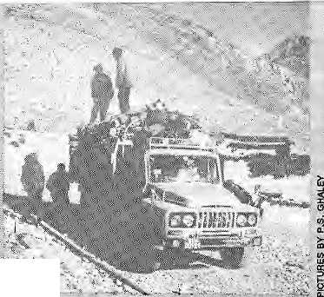

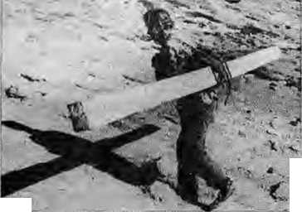
In (he 1960s and 1970s, Nepal's Tarai jungles were decimated when timber was carted south of the border to maintain the Indian nation's-demand for railway ties. In the 1990s, it is the turn of the thin northern woodlands to make an exit, to feed Tibet's economic boom.
The last couple of years has seen devastation among the precious, slow-growing high Himalayan forests of Hiraila^: Gorkha, Sarikhuasabha and other districts. It is an ecological Crisis that falls squarely in the blind spot of the national authorities, district officials and 'environmental' activists and journalists.
&.
This sudden rise in the
Wealth of Study
W
e can soon expect a mass of scholarly work on the Indian Northeast because of the initiative taken by the Rajiv Gandhi Foundation in awarding 18 fellowships on study of development issues in the region. Here is a list of the "Rajiv Gandhi Scholars" and the research they will be doing: Kanta Chakravarty: Study of nutrition, fertility and mortality among the Ahom, Karabi Duara: Fertility and infant mortality among the Mishing of Majuli, Prasanta K. Das: Public distribution system arid role
trans-Himalayan demand in timber is explained by the rise in economic activity in Tibet, related to economic ,.-. liberaUsatipjvd;emands^{v}fdr
tourism and pilgrim infrastructure, and the opening of high passes for trade with India.
Burang,,f or example/has become a boomtown. Situated fust north of where Tibet, IndKand Nepal's; northwest meet, the town is a staging point for tourists and pilgrims bound for Ka|las and Martasarovar. It is also " an important pointoh the: 1 Lhasa to Aksai Chin ■highway./and serves,as arv increasingly vital economic center for this part of Tibet. ■ Burang^s economic
Humla villager carries planks upto>!the * border to a waiting
-«| Tibetan truck
3 (upper right).
of gaon panchayat level samitis, a case study of Sonitpur district. Pranab K, Bhattacharya: Performance of self-employment for educated unemployed in Assam, with reference to Kamrup district. Atrima Bhagabati: Occupational mobility among the plains Garo of Maniknagar village of Kamrup.
Kakali Bora: Impact of television in rural Assam, case study of Kamrup: DebendraK. Bezbaruah: Socioeconomic change among scheduled castes in Nalbari district since
importance has also received a boost from theliidian trade pffthe Shipki La, above Pithpragarh.
What this means is that there is frenetic building in ..'■':■■ Burang, which is being supplied by tirnber from as far as three days' walk down in Huinla
The sound of axe on pipe; nevefleaves the trekker walking up from Sirriikot, with the Hiiriite villagers' hacking wood, sizing planks,
and yak-back up to Burang.
TDne firewood depnartd north
of the borderis supplied: in
the trees-and bushes are yanked out of the ground,
Most of th&clearTfelling jn Hiimla is concentrated in : 1^ ermi, Much u and Yari village samitis. And the district officials who are supposed to be preventing this ecological abuse are all down at Sitrukot.
Unfortunately, this ,,'. outflow of Himalayan wood is continuing across most of Nepal's fron tier passes. As in
Independence.
4t
agro-based industries in the
rural economy-
Arup Bharali^ Changed la nd-
usepartern'irt Borbhagaf ea
of Nalbari.
Mahaskanta Bora: Impact of
T.V on school-gding females.
Gopal C Bpro: Industrial
development and its impact
in the southern periphery of
Guwahati. .; :
Swapan Chandra Pal: Victims
of development — tlte
buistees of the Maharahi
BhushapC. Das: Occupational mobility and the growth of business in

Hurnla, there is open and unrestricted haulage wherever there are forests oat Nepal's side — in Mugu, Larkye^ Sankhuasabha.and : Walaiigchung.
The slow regrowth of once-fine Himalayan woodlands-is obvious when on^ studies the excruciatingly tardyrecovery of the Mustangiorests that vyere" deciiiiated by the Khampa-rebel camps in the, mid-1970s. Even today, all that is there to see in the hill flanks of Samar, for example, are acres of tree stumps. That pathetic view alone should be " warni ng, for poli tipans and civil servants to take yp the challenge of halting the present crisis.
It is imperative to save : Nepal's w<jodland, even where nature preserves -have-KQt been s,et up and where no tourists visit.
« Padam
Khowai block of West
Tripura.
N, GokurChandra:
Incidence of aids andi its
.social implications in
-Manipur.
Tbrigkholum Haokip:
.Development of .poliycal
consciousness among the
Kukis of Manipur.
Imti Temsu: Problems of
linguistic di versity in
Nagaland.
Srbari Das Gupta: Khasi
women in the petty trade of
Shillpng.
Manosh Kumar P.R;
Changes in the grassroots
level among the Nislu of
Arunachal.

22 HIMAL . Mar/Apr 1994



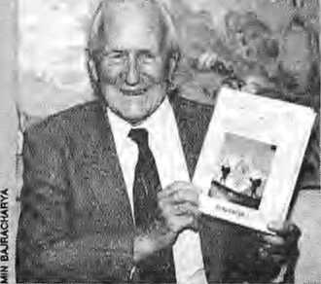
I
impoche Wrangle alt Runitek
The Original Irekker
and the In-fligjit Connoisseur
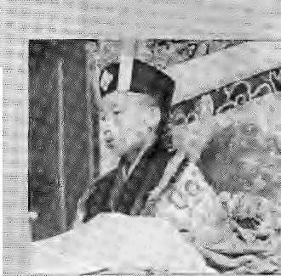


IfJKathmandu's cognoscenti thinks that the feud of tfie Nepali Congress Party's Big Three is the mother of all; fights, they should observe ... the all-out mter-rimpoche slanging match in progress over at Rumtek in Sikkjm. If you have missed the latest instalment of this progressively confusing monastic tangle, here is a synopsis of an intrigue that is worthy of old Lhasa,
The 16th Karmapa died in the United States in 1981, leaving four rimpoches at Rumtek Monastery to handle affairs and more than 500 enormously successful: Dharmachakra Centres worldwide. In time, one Rimpoche, Tai Situ, reported the discovery, of a boy from
Books on Himalayan topics emerge with such frequency that it is getting difficult to keep tab; Within one week in early March,-Kathmaffdu saw the release of two toines, by .authors Toni Hagen.and Dubby Bhagafc
Hagen is the Qriginal ■: Trekker who walked tens of thousands of kilometres in
Kham-aSthereineamatM Z^{vv} ; Karmapa 1Z, His arch-rival, ., lKairiarRimpoche would ; have norse pf ft; whieh led tO: .several incidentsatRumtek including one in which an; Z I; Indian Army contingent actuaUy entered the ....... .,,. _{v;}; ;
; monastery. Z '■ ■■■■■■ ' .,. "
Moping to defuse the situation with his -.-.,., ZZ ;; imprimatur, the Dalai.-LaroaZ Z "announced: his backing for ,Tai.Sitii's find/lJgen^T^inley, ■■■ and. .thebpywasritually . Z enthroned at the Kagyu sect's original seat in Tsurpu, near Lhasa. So understand the shock when Shamar (for ; ";. "whom there hgd generally been sympathy at th'e butsei: of thecaniroversy) . ■■.■■ ,, 7 announeed ihSthS had . located the real incarnate
Nepaljback in^{J}the 1950s; and mtrbdu,ced the: ::: ■■■■ country to the world arid to NepaliS tiiemselves. The78 year old Swiss geologistis noWiOiit with his memoir, Building Bridges to the ThM World, j^btished by Pilgrirrtsof - ■.■ 1 ,. .; Kathmandu and priced M an unfa thomable fi^s 2400, Hageh brings the '■ readerfrom 194$tp ih§ ; present, prodding-comnciehtary on Sepal's SifeS; process over four decades.:;:. '■' Forthecover of his-book;* Hagen-has insisted^ on the ■■■■■ ■:■ photograph whichhas '. become his signature—two : porters walking gingerly up the planks of a damaged ■:. suspensionibrid^eat- : T^toparii (Kali Gandaki valley), withNiigiriHimal as backdrop.
Kanpapa 17, the: 10-yeat o\d Ranjung Regbai Eferjee. A rival ehthrjonejnerlt ;was subsequently held in Delhi, where stones .fl§w and glass shattered.
■■ ReincarnatibTJ is an .■ Z
exercise in faith — one that goes to the c6r^ of being a7 Z Himalayan Buddhsst. TTie Rumtek wrangle severely .. tests" the faith pitne^believers, not the least because it ptits faction against faction. ■ .. : Questions to be answered: what does the episode say of thelSalai Lama's hold over the Urger TiBe| flock? Has its . Success among Western; adherents actually weakened tHfeKagyu onhome gtourtd? Will reincarrt^tioit polities ± Z ^fgvbur more within-Tibet : incarnah'tjris in future, br can one expect more blprtd e-h ai red_{r} bl u e-ey ed rancantiates? Who among
ZWhile Hagen looks up at the mountains, Dubby Bhagat's Peak Hour: A Handbook of the Everest flightpeers out of the window of pressurised aircraft Etes^rched and photographed by Rik.A.Di ' Sierpa, thi$ is the first book on :the Mbiintain Flighty a Hitn&layan fixture that has for two decades taken off and landed m Kathmandu after " takihg dollar^payirig tourists' sm a aerial four of the eastern Nepal Himalaya." All''of Nepal's newairlineSj in addition to venerable Royail Nepal, today do motintain flights. :■■■ : : Bhagat is a sedentary
-prefers to watch the changing hues of: the jugalHimal from
: KathmaTtda.- Rattier lhari a mountain-by-m dun tain -di$cussiontrf mountain technics! ities, hepresents delightful details of > ineliyidual peaks, their provenance^ Sherpa lore, role
Jfm Delhi Karmapa,
the foil owing i s, in vol ved and-shares blame for this deviasr-tating intrigue at Rumtek? ...Bfeij&sgj the Chief Minister* of Sijckim, South Block, the •'■ Drukpa,Diirbar, Taipei.. .. * ' shpg'uns, the Daiai Lama, the Western adherents. And do ihelay Tibetans, those within and: withput Tibet, have any' say in allthis?
in the Hindu pantheoh, as
the sea of Tethys., Bhagat also'" recalls the Himal^yans; he has krtown, particularly his friend Desmond Doig, lover and writer of the Himalaya, who died in Kathmandu in 1983:
the publishers Rtfpfl Publications announce^ that, together wiith'Harper ColliESipf London,-they will be coming put with Doig's My Kindvf Kathmandu, whose sketches and manuscript have been recovered from storage in England.
If you-think Bhagat's book a delight,you will find Doig's a celebration.
Mar/Apr 1994 HIMAL^ % ^

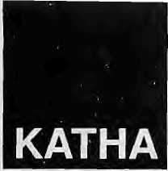
A
gain the wind began rattling the tin roof remorselessly. 'Clang, clang, dang/ it went. They feared the whole roof was going to blow away. Inside, in the dim light of a lamp flame, wavering in the draught, Kaley's mother and father looked up at the ceiling. The tin was blackened by wood smoke and in many places they could see some drips like perspiration. Someboughs, as black as the ceiling, prevented those eighty or ninety sheets of tin from blowing off in the wind.
"How strong the wind is up on this hill! How hard it blows!" said Kaley'smother,duringalull when thebangingof the roof paused briefly, then she set about lighting a fire in the hearth.
"It's never going to stop!" said Kaley's father, "It's been a whole week now!" He had barely finished speaking when the rain began to hammer down again.
"When it rains like this I'm afraid of landslides. We were fools to comeand live here!" The rain grewheavier, its noise on the tin roof became deafening as a flame began to dance in the fireplace. They could no longer hear the sound of singledrops: a continuous roar filled the room. Now it would wash everything away, they would be pulled down by a landslide, sweeping down from above to bury them all.,..
It seemed as if the house was- sliding away and pulling them down with it.
"Lord Mahakal! You are our SaviouT and Protector!"
The wind was making the flat wooden shelves bang against the wall. All the cupboards were saturated, inside and out. The bed which always stood against the wall had been moved away toaspotwherenorainleaked down on to it. Kaley was asleep, holding onto his little sister.
"It was you who insisted that I should build the house here!" The husband was suddenly angry. "Otherwise, we were enjoying living in a proper building in the middle of town, working for the police. We didn't have to worry about storms or landslides there."
The wife said nothing.
He snapped, "A big landowner you've become! You'll pay for it, you know!"
"Go away, sleep secure," said Kaley's mother, "The rains
are always like this in July, what can we do? If s been like this for years. If we're killed by a landslide, we're killed by a landslide. What can you do if your time has come?"
"You were asking for death when you came here, and now you're going to get it." The rain eased a little. The wife made some tea in a mug. As the deluge lessened, they could hear rainwater pouring down from the eaves. As he drank his tea, he asked, "What time do you think it is now?"
"Oh, who knows? Eleven or twelve o' clock, perhaps." Kaley's mother sighed.
"Will it be alright now, do you think?"
"It'll have to be."
He finished his tea and stood up. On his way to the door, he kicked against a pot which was catching the drips from the roof, and water splashed out everywhere.
"Why don't you watch where you're going?" said his wife, and spread out a sack. Saying nothing, he opened the door and listened out into the darkness. The Rungdung river was thundering fearsomely, making the hillsides tremble. From time to time, he thought he heard another kind of noise, and he imagined the river washing up whole trees, and the river waters becoming yellow with mud from the landslides.
It was so dark, he could not see his own hand. He turned and called to his wife from outside in the dark. "A torch, bring a torch!" Kaley's mother pulled an old black torchlight out from under a pillow and brought it to him.
"It's blown all the sheeting off the cowshed." Kaley's father switched on the torch and went down below the house. The eye-shaped light of the torch appeared on the soaked ground and the grass.
Kaley's father collected the pieces of sheeting that had blown off, and climbed up onto the roof. He straightened the tinsheetsand weighed them down withrocks. It wasdrizzling now.
Kaley's mother dug a sharp mossy rock out of the ground and passed it to her husband on the roof. He set it down on the Toof and told her, "You go now, it's coming on heavy again. I'll just feed the cow before I come in."
"Let's both go now," said his wife and waited for him.
"You feed it some grass, then, I'll just finish off here... Oh — who'll hold the torch for me if you do —■ wait, wait, I've nearly finished now."
Kaley's mother's face was streaming with water, and her

afeadur
^ Michael Hutt

Original title Ratbhari Huri Chalyo. From Rai's first collection, Bipana Katipaya, 1960. 24 . HIMAL Mar/Apr 1994

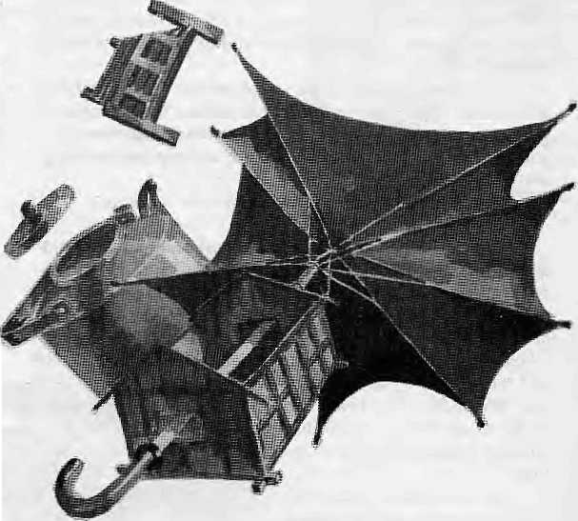
headscarf was drenched as she waited. Kaley's father finished and came down from the roof at last. They hurriedly fed the cow and went back into the house. The rain grew louder again. After they had changed their clothes, they looked ready to act as beggars in a play. They blew up the fire and dried themselves by it.
"Any tea?" he asked.
"Aren't you going to sleep now?" she asked in reply.
"You go and sleep. Just make some tea for me first." Kaley's mother got out the black kettle and scooped a mugfull of water into it.
"Fill it right up/' he told her, and she did.
Kaley's father was looking up at the roof. He got up, got out a rope that had been bought to make a tether, and tied it to a rafter. Then he looked around on the floor for somewhere to fasten the other end, and saw the millstone.
"Bring me that."
"Why?"
"The wind is so strong!"
Kaley's mother could say nothing. She staggered across with the mil Is toneuntil it was by his feet. Once he had tightened the rope around the millstone, Kaley's father was rather more at ease. Kaley's mother sprinkled some tea dust into the kettle, then climbed into the loft to sleep.
Kaley's father was alone, and deep in his own thoughts. Only when thetea boiled outof the spout to fall frothily intothe fire was he startled out of his meditations. He was making his tea when the wind came howling and something fell onto the roof with a clang. Was it merely the top of the alder tree, or was it something else? He was filled with alarm.
When it seemed more peaceful, and as if the storm was abating, he too went to his bed, without even blowing out the lamp. The Tadish seeds he had sown will all have washed away, he thought— thebanks of the terraces will have collapsed, a lot of sayapatri trees would have fallen down. His first job in the morning would be to dig a drainage channel down from the bhimsenpati grove above the house...
Had he been asleep for a while? He woke up: the wind and the rain continued. It seemed as if the house was going to blow away, so hard was it shuddering. The storm roared in the nearby trees.
He woke his wife. "If s a real storm now. What shall we do?"
Before she had had time to answer, there was a terrible noise, and the ground shook.
"Whaf s happened? Get up, get up!"
He took the torch and went to open the door. Kaley's mother came too, and stood behind him. When they looked properly with the aid of the torch, they saw that the whole slope had slid away like water. Just then, a mulberry tree slowly toppled over and fell down into the landslip.
"Now what will you do?" she cried in terror.
"Go and get the children up," he replied, raising his voice above the noise of the storm. When she had gone, he switched off the torch, stood in the doorway, and looked...
Then it seemed to him that he could see a dim light of hope. Dawn was beginning to break somewhere amid the

mists and the storm. Safe from fear under a basket inside the house, the big rooster flapped its wings and crowed/'Kukhuri—kaH"
"Kukhuri-i-i-i ka-a-a-a-a-a-a!!!

In the morning, Kaley's father was draining the flood from theyard with his hoe, his head sheltered by a pieceof sack cloth. He shouted to Kaley's mother as she set off to town with a churn of milk on her shoulder, "Some nails, some long nails. Don't forget to buy some, will you! I'll have to spend the whole day hammering."
"If it rains a lot, let Kaley stay home from school today," she called back as she went up the hill. In one place, a bank of earth had collapsed and blocked the path. Today she met none of the people she would normally meet on that path at this time in the morning.
After about an hour and a half, she arrived at Moktan Babu's door near the courthouse. Here they took half a seer. As she poured out the milk, the pretty girl who was the mistress of the house showed her some kindness.
"Come in and sit down for a minute. Have a cup of hot tea before you go." She shuther umbrella, stood itinthedoorway, and went inside.
"What a storm that was," said Kaley's mother, "We didn't sleep a wink all night!" "Us too!" said the mistress, "The wind was rattling the windows all night. I didn't sleep at all. Whata wind that was!"
"Oh, was that all?" joked Kaley's mother. Her face was dark,her body was strong, she was nearly forty. "linearly blew our house away! You're alrighthere, there's nofear of landslides. It took our whole yard away, and now the house is going too! , I don't even have time to say 'it's raining⁷ - the cow can't be left to go hungry, I have to run out and cut grass for it. If I don't sleep at night, I don't get a chance to sleep in the day.

Mar/Apr 1994 HIMAL . 25

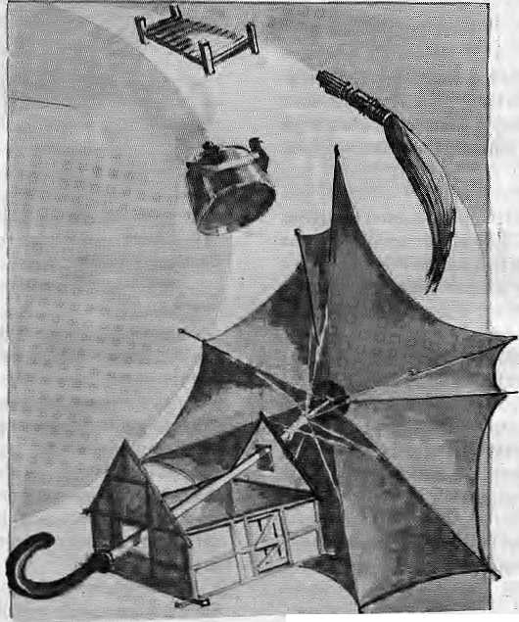
"Yes, it's true, we have it easy here," said the mistress, with genuine sympathy, "Our roof did leak, though, and it ruined out clothes, books and everything. Now the power's shut off."
"But when you look at our situation, you'll see that that's no calamity. While I'm here, I get really distracted as soon as it starts raining again, worrying about what's happening at home. Yesterday that wind broke all my maize plants, nothing was spared.... "
Kaley's mother went off to deliver milk elsewhere.
Now that they had suffered this disaster, she felt they had gained nothing from working the land. They had been comfortable in the town. At the end of each month they received a salary and wanted for little. The children didn't have to go far to their school, she didn't have to get soaked when she went to draw water, the streets were easy to walk on, and there was no fear of storms and landslides. Her head had never ached before - since they took up fanning, it ached all the time.
She had had no spare time at all since they took on thatland. She was ashamed of her hands, cracked by dust and cowdung, and of her fingers, scarred from working with the scythe. Her whole body was ragged. They couldn't goaway from the house even for a day: to travel anywhere far away was an impossible dream. She'd just have to go on working hard like this until the day she died...
Was she killing herself with all this work just so that she could eatandclotheherself? And what did they eat, after all? What kind ofclothesdidtheywear?Shehad to conceal her food in case someone saw what mad e u p their meals. Dressed like this, she felt ashamed of herseif in front of other people.
A storm of angry thoughts raged through her mind.
She arrived at the house of the half-caste man who worked at the police station. She knocked on the window of the locked door and called, "Milk!" A girl wearing grubby pyjamas came out to collect it. As she poured out a bucketful, the woman shouted to her from inside.
"Bring an extra three seers tomorrow, sister, to make creamed rice. Bring good milk, won't you!"
"Tell her I can't. It's hard to deliver right now. After that storm... I might not come tomorrow. Tell her to try somewhere else."
The woman had overheard: she came out of the door and looked at Kaley's mother.
"You bring the milk. How can I go out looking for milk in
this-weather? You bring it. If s little Dipak's birthday."
"I can't." Her voice was weary. She looked at the half-caste woman: her clothes were so clean, her face so fair; how fine her hands were! Her husbands's alright, thought Kaley's mother; the house is full of sofas and beds, her cupboards are full of saris. She doesn't have to touch mud and soil or sweep up cowdung; she doesn't have to be afraid of the weather.
"There's not enough milk. And if the weather's like this tomorrow 1 won't be coming."
"And you expect us to drink our tea without milk all day? What are you talking about? Bring us the milk, whatever the weather!"
Kaley's mother went down the steps and out towards the bazaar without saying another word. As she walked along the road she muttered to herself,
"Oh if s killing my family, living like this. Frightened of storms and landslides day and night, making our living by
turning over the soil twice a year on two acres of land. I'mgoing to sell both the co ws, and the heifers, I'll sell the whole lot oncel'vegot a good price. I'm going to sell the land too. And the tin and wood from the houseand the cowshed. I'm going to take a little room in the town, for five or six rupees. I'll sell greens in the market, like Thuley'smotherdoes.Heknows masonry and carpentry, or else he could easily get work as watchman. I'll be able to bring up those two children faT more easily. I'm not going to live in that desolate place any more..."
She felt much better once she had decided this. Theachein her legs disappeared, she no longer cared about getting soaked in the rain. In this cheerful mood, she approached the foodstore in the middle alleyway. There she bought two annas of peas and chickpeas, and put them in her
bag. The tailor's wife was shopping there too, so Kaley's
mother asked her, "Are there any rooms available near you,
sister?"
"No, there aren't Why, sister,have you had a landslide?" "No, I'm just looking for somewhere to live neareT the
bazaar. For 10 or 15 rupees, not too far from a water supply and
a lavatory."
"There is one room," said the tailor's wife, a thin woman,
"With two rupees for power, it's twelve rupees in all. There
was a plainsman renting it, but he's left. I'll let you know
tomorrow, sister."
"I'll come and see you myself. Tomorrow, at about this
time." She opened her umbrella and headed for Malgodam.
She had two more deliveries to make before she went home.
She aVrived on B.B. Gurung's verandah. The house had been
full of people since nearly morning. A few stood outside,

26 . HIMAL Mar/Apr 1994

talking under umbrellas. Kaley's mother went around to the back to deliver the milk. She could not discover what was going on. Something must have happened - cither to the husband or to the wife; there were no children. The fat wife used to come and go all day, her wooden sandals clacking. She went all over town carrying her white cat, Nini. The husband owned a dry-cleaning shop up on Laden-la Road.
"What's happened? Why are all these people here?" she asked the woman who came from next door to collect the milk.
"Nini's mother had a fall last night. She's unconscious."
"Where did she fall?"
She heard that the cat had been outside in the rain when the door was locked in the night. It must have mewed and mewed, but nobody heard it above the din of the storm. When the rain eased a little, there had been a search for the cat. They had looked outside, and called and called, but the cat had not come. Nini's mother's sandal had slipped as she was going down the hill to look for the cat, and she had fallen down on the road. A doctor had been called urgently, but he hadn't comeat once. The woman was still unconscious.
"If s all the result of that stupid cat!" said Kaley's mother quietly. "That's¹ it there, isn't it?"
A white cat sat warming itself and licking its fur by the fireplace. Kaley's mother couldn't just walk away. She sat down on the doorstep, and soon the husband cameoutin tears. The woman had died.
"HowastonishinglWhata shame!" Kaley's mother picked
up her bag and the churn.
When she had delivered to the watchman's wife, and poured some out for the littlest daughter who brought out a small bowl, Kaley's mother sat down on a sack on the ground.
The watchman's wife poured her a cup of tea with milk, then he asked, "How are things out your way? The storm must have caused lots of damage. Itmusthave wrecked everything."
Kaley's mother did not speak her thoughts, and the watchman's wife went on, "There's nothing for us to be afraid of here in the town, but I knowhow hard it is out in the villages and tea gardens. That's what made my father move to the town..."
Kaley's mother replied rather forcefully, "Oh, disasters happen everywhere. It's true, the storm did do some damage. But we'll put it right now. It's not an impossible task, I have my house, my cowshed,my cows in theshed. And there's the land, with thirty or forty bamboo trees, and fig trees and fruit trees too. The rows of cucumbers stretch up to the sky... How much damage can a storm really do, after all? I must go now and get started.
She gulped down the tongue-scalding tea and hurried off to the bazaar to buy the nails.
"It's getting very late," she said to herself, "Kaley's father
will be furious!" »
Indra Bahadur Rai is the renowned literateur of Darjeeting, who in the 1960s initiated the TesroAayam(Third Dimension) movementof Nepali literature, together with Iswor Ballav and Bairagi Kainla. Michael Hutt teaches Nepali at Die School of Oriental and African Studies, London.






IS
Scholarly Books on Nepal, Tibet, Bhutan etc. Latest Trekking Books & Trekking Maps
Mountaineering Books Guide Books of all Countries
MANDALA BOOK POINT
Kantipath, G.P.O. Box:528, Kathmandu, Nepal, Tel: 227711, Res: 216100
Tix: 2783 NP, MANDALA, Attn: BK PI, Fax: 977-1-227372 NP NATARAJ, Attn: BK PT.
VISA CARDS


* MUSIC & MEDIA IN LOCAL LIFE :
Music practice in a Newar neighbourhood in Nepal (Forth Comming)
- ANTHROPOLOGY OF TIBET AND HIMALAYAS
- ORDER IN PARADOX; Myth, Ritual and Exchange among Nepal's Tamang
- HUMLA TO MT. KAILASH : A trek from Nepal into Tibet
- TALES OF THE TURQUISE : A Pilgrimage inDolpo
Ingemar Grandin
Charles Ramble & Martin Brauen
David H. Hoimberg
S. Armingion & S. Upadhyay
Cornneille Jest

Mar/Apr 1994 HIMAL . 27

V
o
I

RELATING TO NATURE is done in nine ways by humans, according to Stephen R. Kellert, Professor of Social Ecology at Yale University, writ ing in The Biophilia Hypothesis (Island Press, 1993; see also pagelS. The utilitarian would go and build a high dam, obviously.

Term | Definition
Utilitarian | Practical and material exploitation
 | of nature.
Naturalistic | Satisfaction from direct experience/
 | contact with nature
Ecologistic -
Scientific | Systematic study of structure,
 | function, and relationship
Aesthetic | Physical appeal and beauty of nature
Symbolic | Use of nature for metaphorical
 | expression, language, expressive thought Strong affection, emotional attachment,
Humanistic
 | "love" for nature
Moralistic | Strong affinity, spiritual reverence,
 | ethical concern for nature
Dominionistic | Mastery, physical control, dominance
 | of nature
Negativistic | Fear, aversion, alienation from nature
A BASIC DISAGREEMENT explains theappalling lack of knowledge about Tibet and Tibetans, even among those who report on Tibet in the news media, writes A. Tom Grunfeld in Vol 24, No 2 of the Bulletin of Concerned Asian Scholars.
One group—by far the largest—argues thatthe policies and actions of the Chinese since 1950 have been so horrendous that these policies are the only appropriate subject for discussion and research, even to the point of lying if it is politically expedient. Any research that does not expose Chinese misdeeds, these people will argue, only aids and abets the Chinese government and is, therefore, a "betrayal" of the Tibetan people. For example, the first edition of the Dalai Lama's autobiography omits any mention of the Central Intelligence Agency (CIA)'s role in the 1959 uprising and his subsequent flight into exile, a position he reiterated foT over a quarter of a century. He repeatedly claimed, including in an interview with me about a decade ago, that theCIA had no hand inthis episode. Yet his recently published second edition now admits to a CIA role, although I believe itstill drastically underplays the full extentof all CIA activities. The second group maintains that historical research will lead to better understanding. Better knowledge of the
Tibetan situation will lead people to their own conclusions; one has to have an inherent trust that readers will be able to make rational decisions. This group would argue that exposing CIA activities in Tibet, for example, does not invariablymean that one supports Chinese attempts to destroy Tibetan culture,apositionthe first group would take. Attacks on the few people representing this second group are, when read carefully, not so much because they support Chinese actions—because they in variably don't—but rather because they don't support the Tibetan exile cause unquestioningly. Indeed in the past fifteen years the only publications I have read that exculpate Chinese actions come from Beijing.
The extreme political polarization cannot be overstated. As far as the two extremes are concerned, there are only two "acceptable" positions: entirely in the camp of the Dalai Lama (the Tibet lobby) or siding with the Chinese government Both sides seem to act on the principle that all historical understanding, nuance, murkiness, and analysis must be subverted for the immediate cause, and only the championing of that cause is acceptable in these difficult times.
They part company, of course, on the nature of this cause. So intractable is this division that they cannot even agree on such basics as how many Tibetans there are in the world — China says about 3-4 million, the Tibet lobby says 6-7 million —■ and what area Tibet constitutes. China means the Tibet Autonomous Region when it refers to Tibet, and the Tibet lobby means the entire area of ethnic Tibetan habi tation, an area twice the size of the autonomous region.
BROADSIDE AT A MINDLESS MEDIA,
fired by Indu Acharya Prasai and printed in the Letters column of the Rising Nepal ("TRN") of 4 Marchl994,on thegleefut naming of rape victims in the newspaper's copy.
One of the worst traumas that a woman can face is being brutally raped,andyouTRN staff coolly, casuallyand calmly write the name, age and the area that the victim hails from, without thinking of the impact the few words flowing from your pen will have on the child. Now what is left to be done is for Nepal Television to additionally highlight the matter by exposing the child's face on the idiot box. Those working in the media are considered superior to us mere mortals... So here'skudostoyourhigh id eals, values, foresight, sensitivity and perception in exposing a tender child of fifteen to the cruel, opportunist world, well ahead of her time.
The shame, anguish, despair and helplessness that the parents undergo are magnified a thousand times by your blowing the trumpet and encouraging gossip of the vilest kind. This is grief that cannot be shared, but would be

28 HIMAL . Mar/Apr 1993

c
E
S

preferable to endure in solitude, anonymity and within the privacy of the four walls of their homes. Keeping all this in mind, are any of you young men at TRN magnanimous and plucky enough to willinglyacceptherasyourlegally wedded wife, "to do or die, till death do you part, for better or for worse, for richer or poorer, in health and vitality or crippled or disabled"?
...It is high time that women formed a mobile team for swift reprisal, instead of sighing and hoping to be saved by a gallant knight in shining armour come charging on a white steed. Women from all strata should cut a swatheacross their leanings and form a vigilante group or organization to give due punishment to the rapists and women assaulters. The aggressors should be toured from town to town and their photographs splashed across all the leading newspapers, and on the roadside too. Details of their identity should be revealed, so that everyone from their locality becomes acquainted with their exploits. They could also be castrated at a public square. The money collected from the public viewing gala at Tundikhel could be utilized by the Kath-manduMimidpalitytokeepthecityclean,greenandhealthy...
You at TRN, how would you feel one fine sunny morning, on opening your favourite daily to read, horrified, that a particular woman member of your family had been molested and raped. So think and let your grey cells do the work and delete the ill-fated woman's name and particulars that can be traceable. For this could happen to anybody, anywhere and at anytime, whether rich or poor, old or young, ugly or beautiful — for a debased man's abhorrent lust knows no bounds, it transgresses all rationality, colour, caste or creed.
THE CENTRALITY OF CENTRAL ASIA
has been ignored by historians, writes Andre Gunder Frank, a development economist attheUniversit\/afAmsterdam_{f}m5tadies in History, Vol 8 Not (]an-]un 1992).
Central Asia appears as a sort of a black hole in the middle of the world. Littleis known or said about it by those who focus on the geographically outlying civilizations of China, India, Persia, Islam, and Europe — including Russia. Even world historians see only some migrants or invaders who periodically emerge from Central Asia to impinge on these civilisations and the world history they make. Historians of art and religion view Central Asia as a sort of dark space through which cultural achievements moved from one civilization to another. At best, they see Central Asia itself as a dark tabula rasa on which itinerant monks, mullahs, and artists from these allegedly civilized areas left their marks. Now their remains can be admired in a thousand Buddha
caves and mosques spread through Central Asia. Or they have been deposited inmuseums spread through the cultural capitals of the West and Japan after their "discoverers" unearthed them, crated them, and carted them away.
Yet Central Asia is also a black hole in the astronomical sense: it is hugely dark or darkly huge. Central Asia is also central to the civilizations of the outlying peoples, whose life space is sucked into theblack hole in the center. It is not clear where "civilized" peoples and their civilizations connected and interacted with one another. Indeed, for millennia the pulse of Asia, as Huntirtgton called it in 1907, probably came from its Central Asian heartbeat. Central Asia is truly the missing link in Eurasian and world history.
Central Asia is also central to any attempt at systematic or systemic analysis of the history of the world system. Central Asia is a black hole that mustattract the attention and even the enthusiasm of any analyst of the world-system history. Yet Central Asia is perhaps both the most important and the most neglected part of the world and its history. Among thereasons for this neglect are the following; History is mostly written by the victors for their own purposes, especially to legitimize their victory. While Central Asia was home to many victors for a long time, they either wrote or left few histories of their accomplishments. Then, since the fifteenth century. Central Asian peoples have been mostly losers in two ways. They have lost out to others on their home ground, and their Central Asian homelands ceased to be so central to world history. Moreover, these two losses were intimately related to each other: The world historical center of gravity shifted outward, seaward, and westward.
DONATION FOR BROOMS is what the indolent Nepali Government wants, says "A Choking Tourist" in a tetter-to-editor in the Rising Nepal of 26 Nov 1993.
The people of Kathmandu walk down the main streets like Putali Sadak and Kalimati and they get almost lost in the clouds of dust These main streets, which carry most of the traffic, are mostly good asphalt, with decent kerbs and the city should be proud of them. But why the clouds of dust? Because there is half an inch of soil lying atop the asphalt by the kerbs. The cars kick the dry soil into the air. Why is the soil there? Thaf s what I want to know!!
I'm sick of choking on Kathmandu's main streets. It is miserable to ride a bicycle. Why can't the sweepers just completely remove the dirt from the streets, just as sweepers do with brooms in a hundred other cities like Colombo, Chiang Mai and Varanasi? What does this indolent government want, a million dollar donation to buy new brooms? Stop making excuses and just SWEEP IT UP!!

Mar/Apr 1994 HIMAL . 29


NEPAL
INTERNATIONAL CLINIC
Hours: 9:30 am - 5.00 pm (Sunday through Friday). Vaccination/medical advice
Nepal's Leading Institution in Travel Medicine US Board Certified MDs
Staff has over 15 Ifears of Work Experience in South Asian Diseases available even on Saturdays. -#- Highest Standard of Clinical Care and
Please feel free to call us at
4-12842
Phone/Fax: 977-1-419713
Efficiency No Hassles
-*-
Free Advice on Altitude Sickness. Convenient Location {off Durbar Marg, opposite the South Gate of the Royal Palace -see map below) In Operation for 5 years

LAZIMPAT ROYAL PALACE - MAIN GATE
1 I i I
SOUTH GATE
I I

o
NAXAL

\ r
KANTIPATH I I
\ r
DURBAR MARG I I
BATHS
NIC
2nd gate
CINEMA
HALL ^{J}
Jai Nepal

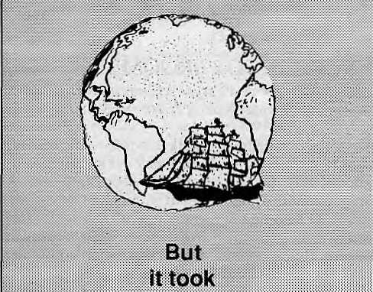
We Know The Earth is Round
i
::: .
Foresight, Courage, spirit to Discover &
Determination
of Christopher Columbus anfr his sailors t

at
INTEGRATED FORUM
v
We have the People of the same Spirit & Discipline
to Help you Research, Discover and Rediscover
newer horizons in the fields of:
Population
Publication
Public Health
Rural Development
Research
Seminar/Workshops organization
Training
Art, Culture & Archealogy
Audio visual material Production
Business Administration
Communication
Consultancy
Engineering
Environment
Info-management
^=1SS^ Integrated Forum (P) Ltd.
:=JEiHfc=; P.O. Box ; 5907, Thapaihali. Kathmandu, Nepal. "t^- Tel:212342,Fax:977-1-224586.

Open the Sails of your rYiind. and we'll take you beyond

Ad visory Council in 1984 as representative (councillor) of the people of Samchi and Chirang districts, southern Bhutan. Rizal did not have formal education, and in 1980 the Royal Government sent him for ten months to Australia to study English. In his public career, Rizal was vocal in the interest of his constituents. In
■
Thimphu, he was instrumental in raising issues of national concern such as border demarcation in the north, identity cards for all citizens, enhancement of foreign relations and opening new embassies abroad.
King Jigme personally liked Rizal. As even one Government document which denigrates Rizal says, "His Majesty the King always had the highest hopes and
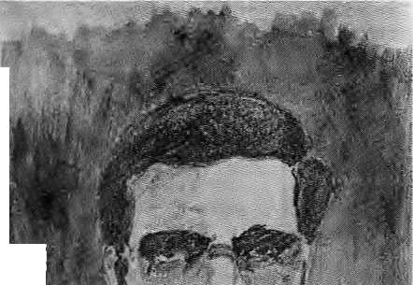
Hostage in Thimphu
The most significant national-level political prisoner of
South Asia is kept in prison to maintain the fiction of a
conspiracy against the Bhutanese State.
by Bhakti Prasad Bhandari
A
fter three years in prison without charge or trial, shackled most of the time and often in solitary confinement, Teknath Rizal was produced before Bhutan's High Court late last year. Four years to the day since he was abducted by agents of the Royal Government of Bhutan from his exile in Nepal, in a 250-page "reasoned judgement" — the words of the official paper Kuensel — the High Court sentenced '~|j Rizal to life imprisonment.
Whether the wider -■
world knows of i t or not, Rizal ' '::S.
is South Asia's most signi- :
ficant political prisoner. ;*
While there obviously are ; ;-;
political detainees serving :|j§ ^?
time from Kashmir to ^;Y?
Colombo, Rizal's case is 1;^;'^;-^
uniquebecauseitis a national
Government that has put him aH-'V<; ""'fit*
behind bars. >■■'■■ t^Z^A
A fuil bench of "hon- |H::^X""'"\"\3 ourablejudgesconductedthe ( ;-; ■ "': trial, which took place over a : full year, with 33 hearings in ■■■.>""" which 15 witnesses testified pB against Rizal. The judges handed down thesentence of life imprisonment under the National Security Act of Bhutan of 1992, legislated three years after Rizal's imprisonment.
Three days after the verdict, on 19 November, King Jigme Singye Wangchuck was pleased to grant him "conditional clemency", which would be activated upon resolution of the southern problem.
Teknath Rizal became a member of Bhutan's National Assembly in 1975, and was subsequently elected to the Royal
expectations from him as an official who could be trusted to play a constructive role in promoting the long term interest of the people and the nation."
When he was elected councillor, King Jigme appointed him head of an audit team to look into the finances of all development projects initiated after 1981. Rizal took his responsibilities seriously, and sought to bring to book those who had misappropriated government funds. High ranking and influential officials, including those with links within the palace, were directly and indirectly affected.
Among others, those who were troubled by Rizal's zeal were Prince Namgyal Wangchuk (the King's step-paternal uncle) and Princess Dechen Choden Wangmo Wangchuk (the King's sister), who faced questions on misuse of foreign exchange earnings from the Penden Cement Authority (PCA). The then Managing Director of the PCA, Rinchen Dorji, also related to the royal family, was also involved. K.D. Tshering, a former Dzongdag (district officer) and broth er of the d epu ty Horn e Minister Dago Tshering and Tshewang Penjore, another Dzongdag and a brother-in-law of the King's Chief Secretary Zimpen Dorji Gyaltshen, too were investigated for misuse of funds.
Much of the Royal Government's initial harsh treatment of Rizal can be linked to the resentment against him for the investigations and findings of the audit. A conspiracy was framed to indict and take personal revenge under the cover of Cabinet authority. Later, Rizal became the convenient scapegoat for, as well as focus of, dissident political activity.
Tsa-wa-sum
While the audit was nearing completion, the Royal Government initiated a census enumeration in early 1988, under the 1985 Citizenship Act. The instrument prescribed a new set of criteria that contained near-impossible requirements as far as the Nepali-speaking citizens of southern Bhutan, the Lhotshampa,wereconcerned. The Act was designed and adopted covertly by the authorities with the goal of depopulating southern Bhutan through the means of depriving ethnic Nepalis of their citizenship.
As cases of official high-handedness to implement this Act increased, there was panic among the Lhotshampa.

Mar/Apr 1994 HIMAL . 31

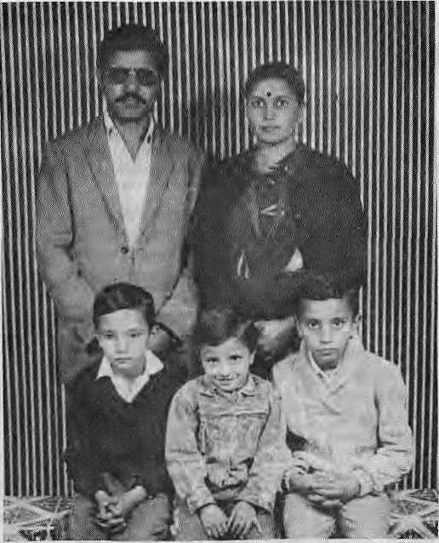
Reports of harassment reached theNepali-speaking civil servants, including Teknath Rizal, in Thimphu. At the same time, the powers in Thimphu were proposing a one kilometre wide "green belt" in southern Bhutan, part of the Royal Government's environmental rhetoric which, incid en tally, threatened todisplace at least 30 percent of the ethnic Nepali settlements in South Bhutan. When this policy was rejected by the public as well as donor agencies, the authorities came up with a magical figure to ciaim that there were a hundred thousand non-Bhutanese in southern Bhutan.
As Mitsher-Kutchhap, people's representative, in the Royal Advisory Council and as a Cabinet member, Rizal sought audience with King Jigme and apprised him of the problems the Lhotshampa werefacing from thepolicies adopted and from over-zealous functionaries. He spoke of serious ramifications of such ill-conceived policies and pleaded for immediate review of the situation. Rizal was commanded by the monarch to submit a report in writing. After consulting Lhotshampa bureaucrats in Thimphu, Rizal submitted apetition on 9 April 1988. King Jigme forwarded it to the Cabinet, which met on 1 June. Rizal was informed by the all-powerful Gup Wangchen, a
royal attendant, that the King did not wish him to attend the Cabinet meeting.
To begin with, Rizal had made many enemies during the course of the audit and investigations. The Royal Government perceived that the absolute monarchy and theobjectives of the vested interestgroupsandtheirprivileges would be threatened in the event of a change in the system of government. The fears were compounded by the move towards pluralism the world over, and the agitations of the Gorkha National Liberation Front which had reached fever-pitch in neighbouring Darjeeling. It was therefore convenient for theCabinet to be vindictive towards Rizal. The very act of presenting the petition was seditious, the Cabinet pronounced. It recommended capital punishment for violation of the Tsa-wa-sum — King, Government and Country.
Rizal was stripped of his public post. He was subsequently arrested, detained and tortured. After spending three days behind bars,hewas released conditionally after being forced to sign a 'confession-agreement'. The constant surveillance he was under and the fear of being re-arrested with possibly fatal consequences convinced the 41-year-old Rizal to leave the country.
Teknath Rizal
with his wife Kaushalya
and children in Jhapa.
Prisoner of Conscience
At first, Rizal attempted to take shelter in India, particularly in Assam and Sikkim, However, friends and some prominent individuals, who were worried for his security, urged him to move to Nepal, which was how he came to take refuge across the border in the south-eastern Nepali town of Birtamod.
Meanwhile, within Bhutan the situation deteriorated as the regime introduced increasingly discriminatory programmes against the southern population. People were constantly emerging from Bhutan and apprising Rizal of the unfolding situation, which included the imposition of the dress code forthegk>and/rim,droppingoftheNepali language from the school curriculum, arrests, and harassment of the rural population. In exile, with the help of six other Bhutaneseinexile,Rizal established the People's Forum for Human Rights (PFHR). (Rizal's naivete is reflected in the fact that he started a human rights forum in Nepal, a country where monarchy was then battling the forces of multi-party democracy.)
Rizal was abducted before his the PFHR could begin any serious activity. The Royal Government's claim is that Rizal was extradited by Nepal, but there is no extradition treaty between the two countries. He was abducted along with Sushil Pokhrel and Jogen Gazmere on 16 November 1989 from Birtamod, Jhapa, by the Nepali police. In Kathmandu, the trio's request for an audience with Prime Minister Marich Man Singh Shrestha was denied. Policemen in civilian outfits handed the three over to Bhutanese agents, led by King Jigme's aide de camp, Col V. Namgyal, who were waiting on the Tribhuvan International Airport tarmac with a chartered Druk Air jet.
In Rizal's absence, those in exile rallied behind PFHR, which was later renamed theHuman Rights Organisation of Bhutan (HUROB) in 1991, withRizal as its chairman in absentia. In May 1990, Amnesty International adopted Rizal as its "Prisoner of Conscience".
Since his first arrest in 1988,Rizal has continuously requested an audience with the King, without success. While Rizal hasbeen held practically incommunicado for over four years now, some information is available from those who have been incarcerated with him in Rabuna prison, Wangdiphodrang District. According to

32 . HIMAL Mar/Apr 1994


The House of Funi


T
he structure and ethos of Bhutan's judiciary are based on 17th century codes laid down by the ^country's unifierjSbabdrungNgawangNamgyaijandthetoditiona], practices of serfdom that existed in the country until 1967. Even though the codes were revised during .1953-57 by the National Assembly, they are not in the spiritof the Universal Declaration of Human Rights, the international covenants on civil and political rights, nor any of other international juridical standards essential for the protection ofcitizensirt a contemporary nation-state.
A court in Bhutan is cailedl'Thrimkhang''> literally, 'house of punishments'. As the travails of Tek Math Rizal indicate/the court does indeed dispense'only punishment^ not justice. As there is no written constitution to guide the judiciary, there is mi nitnal protection for those accusedlof political offenses,
The judiciary was supposedly separated fjQnv the
executive in 1968. Functionally* this has not happened. The
judges, appointed by and accountable only to the King, are
themselve$ responsible for allaspects of thfe case, indudiiig
investigations, filing of charges, prosecution, and judgement
There is no provision for jury trial or the right to a eburt-¹
appointed defence attorriey/Nfof does the system provide
for lawyers or solicitors. Thereare only legalrepresentatives,
known as/»lOTi,wh0t1nditextremelydiiffieulttodefend the
accused under the reStrictiye laws, ., ....... .......
.^.. ... ■
Bhutan Government's education sehip discourages students from taking up studies in law,anci as a result there is not a single Bhutanese today who is professionally qualified to practice it. The only law graduate in Bhutan,, Subama Lama, is now a Deputy Secretary in the Ministry of Trade and Industry.

None of the sitting judges in the High Court who handed d°wti the life imprisonment on Tek Narh Rizal can be sai d to ha ve any hold over the prin cipl es of juri spxud fence. Not only are thest? judges'tfagi caf ly ittcorfipetent on matters of law, they also lack thesense of service and commitment so necessary among those dispensing- justice to provide effectiveremedy for acts that violate therightsof Bhutanese dtizens> When someone is accused,of■apolitical offeitse, the learned judges take it for granted-that he-is
[&>$%■■: ■'.. " " . ■ .." ' ' , _"_
A-glance at fee background o.f the seven of ihe sitting
judgesiri the High Court in Thimphu/may throw light on
hoWlhecards^arelsteekMupaga'instapolitical prisoner
like Rizal.-- . : :
Sonant Tobgye, Chief Justice — high school graduate
D.NJsatwal — an eighth grader* Conner Director of
Posts and Telegraphs '■■
Karma Efaf ji Sherpa - a rjiedical dropout and
former Dzondag (District Officer).
K.B.Ghaley * aneighth grader, a teacher,
a former Gup (Village Headman)
Dr. T. Yonten i. a physidan
Chagay-an eighth grader
Napigay - a fpriftej nps Commissioned officer
in the Royal Bhutan Army
trythat seeks to join Hie community of nations as an in the nacore of'the Tsa-wa-"sum, sentenced Tek Nath Rizal to life imprisonment for treason, on 16 November 1993.
- B.P.Bhandarl

prison-mates who werereleased recently, Rizal is in good health and, while hedoes not know much about the details of the movement by Lhotshampa in exile, his thinking is as clear as ever on the need for human rights and respect of fundamental freedom in Bhutan.
Rizal is presently kept at Chemgang Centra] Prison, where most of Bhutanese political prisoners are presently housed. This prison is located near Simtokha Dzong in Thimphu.
Show Trial
After three years of keeping Rizal in solitary confinement, and probably concerned over its international image, the Royal Government finally produced Rizal before a court in 1992. The prosecution framed its case primarily on circumstances and incidents that occurred during Rizal's long detention. The very
fact that the conviction was under an act that was adopted by the Tshongdu (National Assembly) three years after Rizal's arrest proves the shows the bonafide of the entire exercise,
Amnesty International's request for permission to witness the trial was turned down by Foreign Minister Dawa Tsering. The 15 witnesses who took the stand against Rizal included: K.D. Chettri, a former Dungpa, sub district officer, who had absconded after havingbeen charged with misusing substantial government funds and whose charges were dropped on his willingness to testify against Rizal; Doenarayan Katwal, a High Court judge and member of the Bhutanese team for bilateral talks with Nepal on the issue of Bhutanese refugees; Gagan Pradhan, a student who had left the country for fear of persecution in 1989 and later wentback to Bhutan and is now absorbed in
government service; and Narayan Giri, a former Gup of Sibsoo District who had left Bhutan fearing arrest in 1989. He was one of the main confidantes of the dissidents at the Garganda refugee camp in West Bengal before they moved to Nepal. Giri also re-entered Bhutan and is now a contractor.
The large number of charges put forward by the Government were not madesubject to cross examination during the trial. The charges were that he had incited rebellion against the Tsa-wa-sum; sought to overthrow the legitimate and established government; tried to instigate the friendly people of India and Nepal against the Royal Government and create misunderstanding between donor countries and the Government; directed subversive activities; sowed communal discord between northern and southern Bhutanese; and written seditious booklets.

Mat/Apr 1994 H1MAL . 33

Rizal's activities, his personality and the chronology of even tsduring the crucial years 1987 to 1990 clearly show that the Royal-Government's charges—of inciting rebellion, subversion and communal discord,tryingtobringdowntheThimphu government, and attempting to create misunderstanding with neighbouring countries and donor countries — are without merit. To put things in perspective, Rizal was abducted and detained prior to the mass uprisings that took place in Bhutan in September-October 1990. He had little or no role in the major information activities that have been taken up against the Bhutanese Government machine. Certainly,, he is innocent of any accusations of inciting anyone to violence,given thathehasbeen behind bars since November 1989.
On the last charge, Rizal did help translate two booklets while in Birtamod, including Bhutan:HamroAdhikarKhoi. This was a translation of Bhutan: We Want justice, which was written by Ratan and Jogen Gazmere, the politically active brothers from Samchi, with the help of two British volunteers working at the National Institute of Education. Both brothers were imprisoned with Rizal, but have been released and areinjhapa. The High Court justices seem not to have considered the legal implications of releasing the authors and convicting the translator.
The Government weekly Kuensei reported that "Teknath Rizal chose to defend the case himself rather than call a jabmi." This does not come as a surprise as it is not possible to get a jabmi (representative) to defend the accused under Bhutan's restrictive laws, par ticularlyina case as sensitiveas Rizal's. Also, the legal system does not provide for cross-examination of government witnesses. Rizal was hostage and victim of a show trial
Conditional Clemency
On 19 November 1993, just three days after the High Court's handing down its judgement, King Jigme announced a conditional clemency for Rizal. The King proposes to release Rizal as soon as the southern problem is resolved. It is not clear what would constitute a resolution of the southern problem. Given the track record of the Royal Government thus far, Thimphu's interpretation would probably mean allowing a trickle of the refugees to
return, while hoping that delaying tactics will lead to the bulk of refugees assimilating among the larger Nepali-speaking population of South Asia.
Rizal, of course, is not available for comment regarding the High Court's judgement and the King's supposed magnanimity.
It seems that the Royal Government and King Jigme want to project Rizal as the pivotal personality in the drama that is being played out in the desperate hills of southern Bhutan, already emptied of a large chunk of their Lhotshampa population. As late as 20 November 1993, for instance, Kuensel was reporting that "Teknath Rizal is a central figure in the
Rizal's ongoing detention is a
fig leaf to try and hide the
trumpei-up charges against
the Lhotshampa.
anti-government propaganda which surfaced after Bhutan began its first nationwide census in 1988." In its various publications, the Government has implicated Rizal in many more 'conspiracies' than what the dissidents are capable of.
The fear must be that without a ringleader to point to, the Government's propaganda about a Lhotshampa plan to bring down the G overnm entmightsound hollow. For this reason, even though Teknath Rizal might not be any of the things the Royal Government charges him with, it is important to keep him behind bars in order to maintain the fiction of an insurgency and a concerted plan of subversion. For the King and his Government, therefore, Rizal's ongoing detention is a fig-leaf to try and hide the trumped-up charges against the Lhotshampa as a whole.
Rizal's image as the central figure in the Bhutanese upheaval was projected more by the Royal Government than by the dissidents. By no stretch of imagination could anyone believe that as National Assembly member and Councillor Rizal was capable of plotting an overthrow of the Government. If there was a reason for the sudden crisis in southern Bhutan and the subsequent political fallout and creation of a refugee populationof 100,000,
it was due entirely to erroneous government policies and their implementation.
The sentence given to Rizal is also meant to show the Royal Government's resolve to those living in exile in the refugee camps that resolution of their predicament is not in sight. The hope is that the Nepali-speakers will ultimately lose heart and give up on their hope of return to their villages. Meanwhile, in parallel with the life sentence, the conditional clemency comes handy to deflect international criticism.
Thimphu also obviously fears that Rizal's presence in exile might help consolidate the hopelessly fragmented political groups in exile undeT one umbrella, to pose a serious threat to the regime. However, given thetime required to build a political culture among people (viz, the refugees) that have been kept under such tight control, it is unlikely that Rizal's presence in exile would consolidate the divergent forces into a single monolithic forum.
Some have wondered whether Rizal has the calibre to remain the symbol for Bhutanese in search of human rights and fundamental freedoms in their homeland. While he was not "politically ambitious" in the manner characterised by the Royal Government, the initiative Rizal took in starting a human rights organisation certainly shows his commitment. Rizal's work in Bhutan was either supported or guided by people around him. Hispolitical personality has been moulded by circumstances and conviction. It is an open question whether, were he to be released by the Royal Government as per the royal clemency proviso, Rizal will continue to champion thecause of political reforms in Bhutan. His future actions would be guided by his conviction and commitment with regard to the democratic movement in Bhutan.
For the moment, through his tortured stay in prison, and the Royal Government's claims on his guilt, Teknath Rizal has become the central figure in the four-year long, Bhutanese crisis.
B.P, Bhandari is a former civil servant who served time in Bhutanese jaits without charge for 27 months, until his release on 17 December 1992. He was Amnesty International's Prisoner of Conscience, and spent his entire jail term In Rabuna prison, where T.N.Rizal had also been housed. Bhandari is presently member of the Bhutan National Democratic Party and stays in Jhapa

34 . H1MAL Mar/Apr 1994

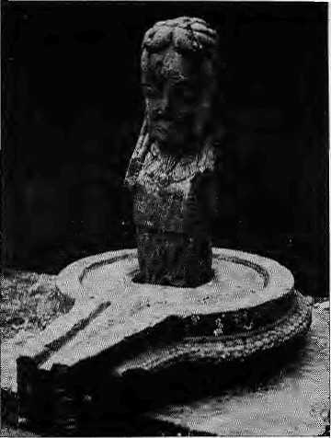
Mistaken Antiquity
by Don Messerschmidt
In the early 1970s, when the renowned art historian Pratapaditya Pal came to Kathmandutoresearchhisbook,TheArtsotNepa\(1974),heaskedNepaliarti$t and art historian Lain Singh Bangdel to help him identify and date a mysterious sculpture found outside Bankali. What resulted was an academic argument and the unfolding of a most unusual story.

The Bankali temple, where Pal found the stone image isin Mrigasthali, a wooded knoll on the east bank of the Bagmati river, where Lord Shiva is believed to have been seen wandering, disguised asa mriga (deer).
Pal, nowacuratorat the Los Angeles County Museum of Art, thought it to bea linga, but one so strange that he wrote, "...there is nothing else in Nepal or in India with which it is comparable."
The upper portion of the shaft, Pal observed, had a human head carved on it and looked as if it was emerging from a lotus flower. It rested onajalahari, which, ■ for a more conventional linga, serves as a base. It had a short chin, a tuft of pointed beard, tightly pursed lips, a flat nose and vacant eyes set off beneath arched eyebrows giving it a sinister expression — and from a distance, an effeminate look. His hair, curling on top and falling in long strands down the back and sides, showed him to be an ascetic.
It must be of some Shaivite teacher, surmised historian Pal concluding "(it) must remain one of those peculiar iconographical enigmas of Nepal and very likely perpetuates an image-type that had a local origin and significance."
Given its crude style, Pal assumed the image to be very old. He considered its location in association with other ancient sculptures, like the nearby figure of Virupaksha. Ultimately, he called the mysteriousimagean "unidentified figure" and dated it "4th century or earlier(?)"
Artist Lain Bangdel, however, came todifferentconclusionsabouttheimage's origin,ageand style. In his Early Sculptures of Nepal (1982), Bangdel points to its "crudely delineated necklace designed as lotus petals... clearly visible below the
chin (which) Pal has mistakenly assumed... to be a 'human head emerging from the lotus'."
While he agrees with Pal that it did not have any affinities with any icons found either in India or Nepal, he says "crudeness" is not a sure sign of antiquity. "A glance will at once reveal," he says "that this image is not an early icon, for there are no early features whatsoever to beseeninit. Infact,itisaworkofthe2Oth century..."
Twoeminentscholarsdrewdifferent conclusions, seeing the same sculpture. When this discussion was taking place, Bangdel, then the Vice Chancellor of the Royal Nepal Academy in Kathmandu, not quite sure what the mysterious image represented, nor when it was carved, sent a member of Pashupati's elite Brahmins, to do some research. He came back with a very strange story indeed.
During mid 1800s, there lived in Bankali, a renowned yogi, who attracted attention as an auguer and magician. It was said that he could predict the future, make fresh fruit appear out of ashes, light fire simply by incantation, etc. People visited the Aghori Baba each day to hear his stories, jokes, soothsaying etc., and marvel at his undeanliness.
One of his devotees was Dambar Bahadur Adhikari, a Chettri who came frequently to Bankali to visit the Baba, to pay his respects, get his blessings, admire his jadus (magic) and listen attentively to his prognostications of future.
Oneday, the Aghori said to Adhikari, "You must want a son." Yes,said Adhikari, he did want a son.
"In due course, it shall be," said the Aghori. And true to his predictions, a son was born to Adhikari!
When Adhikari went to visit again, the Aghori asked him if he had a son.
"No" said Adhikari teasing him, "I have a three-day-old daughter."
The Aghori looked at him sharply and declared, "You are lying, and for that yourinfantson will die before hisnaming ceremony on the sixth day!" Sure indeed, Adhikari's first-born died the next day.
Remorseful, Adhikari returned to the Baba and beseeched him to help, promising not to tease or lie again. The Baba predicted a second son for him. "This son, he said, "will live to grow old and bear sons of his own."
Not long after, the Aghori Baba died and he was buried near the Bankali temple. Adhikari, too, died. Adhikari's son grew up, married and had a son of his own.
Some years later, Adhikari's great grandson, in memory of the events, "decided to honour the Aghori Baba by erecting a memorial stele at Bankali, in the likeness of the Aghori's head. He told the sculptor to create an image which "at a distanceappearsasawoman,butupdose looks like a man." A novice stone cutter was comissioned, a crude likeness sculpted and reverently placed atthe site where the Aghori Baba had lived.
The strange Bankali image that had
so baffled Pal is no longer a mystery. But
it retains a peculiar place in the history of
Nepali art and sculpture. Unfortunately,
the story does not end here. In November
1982, the Aghori Baba image was stolen,
presumably for its value as a piece of
great antiquity. The theft is recorded in
Bangdel's recent book, Stolen Images of
Nepal. k
D. Messerschmidt, anthropologist, was till recently Research Advisor at the Institute of Forestry, Pokhara.

Mar/Apr 1994 HIMAL . 35

ABSTRACTS

Inside Sikkim: Against the Tide
by]igmeN. Kazi Hill Media Publications, Sikkim December 1993, IRs 150
Editor of the Sikkim Observer weekly and correspondent of The Telegraph, Kazi says this book is an attempt todescribe "how things were and how some of us have been living all these years — all atone and against the tide." He proposes to expose "the rot and hollowness" of the 'democratic' system which was thrust at the time of the 'merger' in 1975. The struggle of the Sikkimese people to preserve the distinct identity within the union and the fight for free movement and expression ... which has come out at a time when the people in the former Himalayan Kingdom are, once again, marching for freedom and democracy and demanding a better deal from New Delhi." In his preface, Kazi writes, "Even if the Centre is unwilling to go against (Chief Minister N ar Bahadur) Bhandari, the views of the Court and present anti-Bhandari wave in Sikkim, spearheaded by (Pawan Kumar) Qiamkng's 5DF, is likely to dampen Bhandari's prospects of a fourth consecutive victory in the Assembly elections slated for 1994-end."
Mountain Research and Development
Voll4,Nol
February 1994
jack & Pauline Ives, editors
University of California, Davis
This issue of MRD will be useful to South Asian
scholars for the Himalayan papers it presents.
The lead article by Jayanta Bandyopadhyay and
Dipak Gy a wall, on ecological and political aspects
of Himalayan water resources, calls for major
institutional changes, attention to smaller projects,
and for sharing and publicising ecological and
TIBET
HANDBOOK
NEPAL
HANDBOOK
guides for independent travelers
Tibet Handbook - 1,100 pages US$35.50 postpaid
Nepal Handbook — 378 pages US$16.45 postpaid
MOON PUBLICATIONS, INC.
P.O.Box 3040
Chico.CA 95927-3040
tel. (916) 345-5473
fax (916) 345-6751
—free newsletter available --
hydrological data among the regional states. Without substantial rethinking, the possibility of sustainable utilisation of Himalayan water is remote, they write. Joel T. Heinen and Pralad B. Yonzon present a review of conservation issues and programmes in Nepal and call for a comprehensive biological inventory and monitoring system. Some important natural areas are recommended for protection and the shift in focus from conservation of single species to broader aspects of biodiversity is welcomed. Joseph L. Fox, Chering Nurbu, Seema Bhatt and Alok Chandola discuss wildlife conservation and land-use changes in Ladakh, with relation to introduction of new livestock breeds, irrigation projects, farming practices, foreign tourists and the large military presence. J.S. Rawat and M.S.Rawat write on "accelerated erosion" in the Nana Kosi watershed of Kumaon: their preliminary results suggest that deforestation and agricultural activities increase the rate of denudation by a factor of five to ten. Himalayanists will also be interested in the paper on "erosional impact of hikers, horses, motorcycles and off-road bicycles on mountain trails in Montana."
Focus on Ja ribuli Occasional Paper No 2/93 David M. Edwards and M. Roderick Bmven, editors Forest Research and Survey Centre, 1993 Nepal-UK Forestry Research Project,, 1993 These are the proceedings of a seminar on non-timber forest products, containing seven papers. D.M. Edwards suggests a potential for "increased quality control if processing facilities within Nepal are improved", Pralad Yonzon recommends cultivating fhemain herb to "minimise the negative impact of over-use". Several writers suggest that more a tten tion needs tobepaidtotheexisting trade, while J.Y. Campbell suggests that up-to-date information on product prices and market demand, if made available to collectors and village traders, will help raise prices in the hill region.
Child Labour in Nepal
No 13, Anti slavery International's Child Labour Series by Omar Sattaur
ASI-London and CWIN-Kathmandu, 1993 ISBN 0900918 314 £5, NRs 200
Child labour to many, writes Sattaur, is "unremarkable and therefore invisible." Seven chapters Include "The Roots of Child Labour", "Kathmandu, The Schooling of the Streets", "Children in Urban Industries", "Working on the Land" and "Girl Child in a Man's World". The appendix lists the United Nations Convention on the Rights of the Child, SAARC's Colombo Resolution on Children, and the names of a number of organisations working on children's rights. The report forwards a number of recommendations on what the Nepali Government, the media and voluntary agencies can do to address the problems of urban migration of children and implementation pf existing child labour laws.
Contributions to Nepatese Studies Voll9No2,Jull992 D.P. Bhandari, Chief Editor Centre for Nepal and Asian Studies, Kathmandu NRs 100
This volume of Contributions contains eight articles. In his "In Quest of Mahakiranti", George van Driem proposes that the Kirant kings who once ruled the Kathmandu Valley might be the andent Ne war. Since "Kiran ti andNe war together form the hypothetical genetic unit within Tibeto Burman", he suggests that unit be known as "Mahakiranti". PremUprety writes on "Medieval Buddhist Art in Nepal: Penetration of Pal Influences in the Himalayas". Ramawatar Yadav in "The Use of Mother Tongue in Primary Education: The Nepalese Context" writes that Nepalis use languages they are familiar with as per their convenience. He recommends a central institute for the development of languages be established. Bert van den Hoek and Balgopal Shrestha discuss Daitya and Kumar as the protectors of the Taleju Bhavani of Kathmandu. In discussing infrastructures for agricultural growth in Nepal, Y.B. Thapa refers to the needs of "backward districts and backward sub-sectors." Kathleen M. Gallagher writes that squatting in Kathmandu Valley should be looked at with a historical perspective, and Sudhirendra Sharma that under.-development cannot be solved by dependent development. The issue also contains 4 book reviews. Pra tyoush On ta reviews Rishikesh Shah's two books, Three Decades and Two Kings (l960-1990)ar\dPoliticsinNepal(198Q-1989);Anne M. Rademacher reviews Diwakar Chand's Development through Non-governmental Organ isalions in Nepal and Ananda P. Shrestha reviews Gopal Chitrakar's photo book People Power.
A Bibliography at Himalayan Ethnography
Nepal Research Centre Publication No 15 by Beatrix Pfkiderer and Elisabeth Bergner under collaboration ofReinhard Greve F. Steiner, Stuttgart, 1990
This bibliography is the product of a seminar on Himalayan ethnography at the University of HamburgintheSummerofl987.Itcontainsl881 entries, arranged alph abetically by author, subject and ethnic groups. Works include ethnography, historical and geographical accounts, and travelogues of the region between Karakoram and Nagaland but excluding Tibet.
Nepak Growth of a Nation
by Ludwig F. Stiller Human Resources Development Centre, Kathmandu, 1993 NRs 100
Historian Stiller prefaces his book by saying that this is a survey history emphasizing the themes that "are significant to understanding the development of Nepal" written, in the main, for foreigners "who work in Nepal and are sincerely concerned with root causes of problems they encounter." Fourteen chapters and an epilogue cover topics thatindude the relationship between the land and the people, the vision and leadership of PrithviNaryan Shah, Rana politics, the growth

36 HIMAL . Mar/Apr 1994

of centralised bureaucracy under the Ranas, and "the awakening" that led to 1951 political watershed.
Hindus of the Himalayas
Ethnography and Change by Gerald D. Berreman HB, Oxford University Press, Delhi 1993 ISBN 019 563373 3 NRs680
Hindus of the Himalaya is based on anthropologist Berreman's research in 19S9 in Sirkanda, a hill village bordering Dehradun and Tehri Garhwal. The first edition of this classic was published in 1963 by University of California Press and in the 1974 second edition were added a prologue, "Behind Many Masks: Ethnography and Impression Management" and an epilogue, "Sirkanda Ten Years Later". Attempting "analysis of social organisation in a uniquely organised caste society; and analysis of reactions to planned and unplanned change in a remote and unsophistica ted village", Berreman concludes tha t Paharis, the hill people, have "much to offer as well as much to leam if India is to realise the potential inherent in them and in the land they occupy," The Oxford University Press is now out with a "revised and enlarged" edition.
Mountain Delight
by Bill Aitken English Book Depot, Dehradun, 1994 ISBN 81 85567166
This is a collecti on of colum nist Aitken's 24 pieces in various Indian papers. From the source of the Ganga, the writer travels eastward to the realms of Nanda Devi. In an essay titled "The Importance of Yeti", Aitken writes, "The Yeti may suggest a benign cosmic force (a hidden master) trying to scare us in to a realisation of our men tal conceit in assuming that, because we can climb the Everest, we have proved ourselves masters of wisdom." In the concluding essay, "Ghosts on the Mountains" he says, "Is any mountain worth your life? The older you get, the easier it is to answer, no. Indian mountaineering is luckily in having the early example of Jack Gibson before it. He succeeded on Bander Poonch after many attempts, and every attempt was enjoyable because he was an all-rounder, interested in the total mountain environment. If this attitude can be cultivated instead of'assaults'and'conquests' of peaks, maybe nature will be a little kinder to the next generation of mountaineers, and haunt us less."
People in High Places: Mustang, Everest and Other Approaches to Tibet
by Audrey Salkeld
PB, Jonathan Cape, London, 1993
ISBN 0224 03755 2
£9.99
Illustrated with beautiful colour photographs (of
Mustang, Ghorepani, Kali Gandaki and Tibet),
the book by the well-known writer of Himalayan
climbing recommends, "...if you desire to gain
morethanasuperfidalunderstandingofaiegion
and its people, you should journey, if not alone, with the smallest possiblegroup,soasnot to insulate yourself with shared experience. ..the traveller could wander from village to village, in the manner of the locals, living simply, making friends, learning secrets..." The book also contains a sketch map of Mount Everest and Rongbuk Glaciers.
Kumaun, The Land and the People
ISBN 81 85182 89 2
Garhwal, The Land and the People
ISBN 81 85182 914
Himachal Pradesh, The Land and the People
ISBN 81 85182 90 6 by S.S. Negi
Indus Publishing Company, New Delhi, 1993 IRS 250, U$ 25
These three books by Negi, part of Indus' "land and people" series, will be useful for those looking for start-up information on Kumaon, Garhwal and Himachal. fresented in identical style and format, each book is divided into 12 chapters ■— geography, history, economy, culture, environmental degradation, places of interest, etc.— and contains bibliography and appendices.
Nepal: The Rough Guide
by David Reed Penguin Books, India, 1993 ISBN 1 85828 046 £5.99
Presented with humour, Reed's guide presents a realistic account of what all you might expect while travelling in Nepal, "...flights in the spring and (especially) autumn high seasons get booked up to months ahead, while during slack times carriers sometimes refuse to confirm reservations until they've decided it is worth their while to fly". With the help of sketches. Reed takes the traveler through Kathmandu Valley, the Mils, the Tarai, and the Himalaya. There is no shame to hiring a porter, for "porters are an important part of the Himalayan economy". Many things donot happen in Nepal on time, and "getting angry or impatient will only confuse Nepalis and won't resolve the problem."
Nepal: Economic Policies for Sustainable Development
Asian Development Bank, Manila Internationa] Centre for Integrated Mountain Development, Kathmandu, 1992 ISBN 971 561 014 5
This report is one of seven country case studies prepared by the ADB in order to implement the 1987 reco mrrienda tions of the World Commission on Environment and Development, which called for development which meets the needs of the present generation without compromising the needs of future generations. The Nepal study, conducted by 1CIMOD, was completed in May .1990, and examines economic and environmental conditions in Nepal and most likely future trends, focusing on environmentally important sectors and their linkages and on development. It also identifies major opportunities for long-term balanced development of the economy and the environment. In transitioning fowards a "green
economy", the report recommends that "changes should be initiated while more Nepalese people still depend relatively little on fossil fuel, chemical fertilizers, pesticides, and plastics." Contributors to this volume are social scientists Mahesh Banskota, PitamberSharma, KamalBanskota,Bal Ram Bhatta, Suresh Sharma and Tashi Tenzing.
The Himalayan Journal
Vol49,199M992 Harish Kapadia, Editor
Himalayan dub, Oxford University Press, 1993 ISBN 019 5633660
This volume contains 17 articles, notes on 23 climbing expeditions, 24 hook reviews, and hie histories of 3 mountaineers — D.F.O. Dangar (1902-1992), G.C.F. Ramsden (1893-1991) and Katsumasa Itakura (1915-1992). Illustrated with black and white photographs, the volume also carries a rev iew of the first Himalyan Journal (1929) published in the second Himalayan Journal (1930).
Struggle for Existence: Park-People Conflict in the Royal Chihvan National Park
Human Settlements Development Monograph by Sanjay Kumar Nepal and Karl E. Weber Asian Institute of Technology, Bangkok, 1993 ISBN 974 8209 601
This is a monograph on the much-discussed issue of park-people friction lists the five main conflicts in the vicinity of the Chitwan sanctuary. The primary culprit is the "divergence between the priorities and objectives of the park authority and the local people". The authors recommend that a management planning process, involving both the park establishment and the villagers, be initiated and that the locals be involved not only in the planning but also in the implementation and evaluation phases. They call for regulation of resource utilisation, delienation of impact zones, and further scientific research.
Political Opinion Survey of Kathmandu Valley, 1993
Nepal Opinion Survey Centre Kathmandu, May 1993
The Nepal Opinion Survey Centre interviewed 522 people in its pilot test of proposed methods and procedures for conducting a national opinion poll in 1994. The study lists the responses on issues such as political views, price rise, attitude towards democracy, satisfaction with progress made after democracy. The most interesting segment deals with how the respondents rate the King, the Cabinet and Parliament.
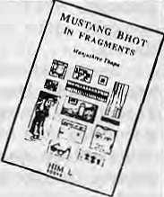

Available for sale at Himal
U$12NRs285

Mar/Apr 1994 HIMAL . 37

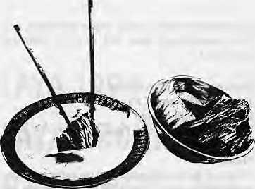
REVIEW
A False Harmonising of Himalayan Experience
Social vulnerability, rather than ecological vulnerability, has been the primary driver of environmental change in the Himalaya.

F
ollowing in the footsteps of Erik Eckholm, the well-known promul-gator of the Himalayan environmental crisis back in 1976, here we have another WorldWatch Institute babu drawing our attention once again to the urgency of attending to the troubled Himalayan ecology. This time around, Derek Denniston aims to undo the pervasive invisibility of the mountain problem in the international arena.
By vividly portraying environmental degradation's challenge to mountain livelihoods, Denniston encourages readers to envelop the ecologically vulnerable Himalaya within the "protective embrace of their consciousness." He starts off by deflating the old Western canon which portrays the Himalaya as a solid, rugged and impenetrable barrier, the mythical abode of deities which could only be reached through the arduous efforts of mountaineers and pilgrims. Instead, the writer stresses the geological youth and instability of the Himalaya, as well as its extraordinary ecological fecundity and cultural diversity.
Denniston's central mission, however, is to plot the dangerous trajectory currently beingfollowed whereby the "ancient balance" between nature and people has been broken through the encounter with modernisation, which is inevitably 1 eading to degradation. In doing so, he takes up the more recent and fashionable canon, popularised by Eckholm, whose storyline has been, ironically, rather simple for a region so diverse.
The ingredients of what came to be known as the Himalayan Degradation Theory story are well-known: a growing population on a fragile ecological base will inevitably slide down the slope of poverty. Overlay this with the entry of roads and the colonial intrusion of commercial influences, and the pressure on the ecosystem is accentuated. While
Saving the Himalaya
by Derek Denniston World Watch magazine
Washington DC November/December 1993
by Nayna J. Jhaveri
Eckholm's reports focused largely on India and Nepal, Denniston's distant gaze has been moulded by thebroader ambit of the work of the International Centre for Integrated Mountain Development (ICIMOD), which was set up in 1983. Denniston tries to show us the similarity of survival strategies across the full panorama of Himalayan terrain, from the Afghanistan Hindu Kush to the Chinese Hengduan mountains.
A Distant Gaze
The researcher's grasp of regional environmental change has been mainly compiled from his encounters with various researchers and non-governmental spokespersons familiar with the Himalayan predicament. While the 'indigenous' flavour ofmost of his sources would therefore appear to lend greater credibility to the scenario he builds, it is evident that Denniston lacks a more detailed familiarity with the landscape's character. This has largely prevented him from putting together a more rooted and nuanced presentation of the collected pieces of regional experience.
For a start, Denniston's analysis is quite brittle because he rests his case for a Himalayan problem on the ecological vulnerability which is said to exist throughout the Himalayan bloc. Yet nowhere does he explain what he means by this "ecological vulnerability". Is it simply correlated with the mountains' geological instability and youth? How is it that such a biologically diverse place becomes so fragile?
Certainly, it is quite clear that the sheer incline of the slopes in some parts themountainspose considerabl e d ifficulty for farmers. But the tendency to see all Himalayan zones as singularly fragile is misplaced. The challenge of deforested hillstotheagro-pastoralistsintheMiddle Hills around Kathmandu is quitedif f erent from therelative ease with which nomads are able to pursue their pastoral lifestyles in the rolling grasslands of western Tibet.
With his eyes placed squarely on the ecological basis of mountain livelihoods, the writer ends up neglecting the combination of socio-political conditions which make social vulnerability, and not ecological vulnerability, the primary driver of environmental change. An understanding of how subsistence farmers are designing new livelihood strategies for dealing with such two-edged swords as improved accessibility and commercial opportunities can be better reached through amore substantial grappling with national and regional political themes.
This political dimension, largely absent in Denniston's account, is already present in the literature. It has been popularised by political ecologists such as Piers Blaikie and Harold Brookfield, who in their study of the Himalayan condition have pointed to the importance of identifying the "chains of explanation" which nest the farmer's decision within the broader political economic context. Also, Denniston bypasses the important work of key researchers such as Deepak Bajracharya, T.B.S.Mahat, D.M.Griffin, K.R-Shepherd and Narayan Khadka, all of whom have highlighted how government policies on land, forests and food supply have played a major role in moulding the politics of natural resource use patterns.
Generalisations
If social vulnerability is going to take on a larger part of theHimalayan Degradation

38 HIMAL . Mar/Apr 1994

Theory, then Denniston will also need to amend his portrayal of "Himalayans" as a singular species of subsistence farmers carved out of hardy and indigenous agrarian material. Somehow, for him, the changing state of livelihood strategiesand responses of these mountain villagers, a culturally diverse lot, can be predicted in a unilinear response graph.
Such a position stands in contradiction to Denniston taking at face value the romantic beliefs of environmentalists like Anil AgarwaloftheNew Delhi-based Centre forSrienceand Environment, who is quoted as saying that the region's "cultural diversity is not a historical accident", but rather "the direct outcome of the local people learning to live in harmony with the region's extraordinary biological diversity". The naivete of environmental determinism which binds nature and society together in such a tight causal manner went out in the social sciences quite some time ago. The lesson to be gained for those who study the Himalayaanditspeopleisthatweneedto recognise how the region's complex sociopolitical history has contributed to its rich cultural constitution.
The evidence Denniston uses in demonstrating how subsistence farmers are battling with the nature of ecological fragility allows him to make some elementary mistakes. For example, the difficulties of firewood collection, a key facet of the Middle Hills experience, is mistakenly translocated to thearid Tibetan plateau. Denniston is misinformed when he states that nomads in this region "travel with a small herd of yaks for seven to eight days to collect several weeks' worth affirewood."Dung,rtotwood,isthemain source of fuel there.
Part of the same thinking method permits the writer to prolong the myth that population growth invariably con tributes to accelerating environmental degradation throughout the Himalayan range. Thisstatementcannolongerremain unquestioned, especially after a whole series of research has contradicted such simplelogicFortheMiddleHillsofNepal, certainly, we find that the relationship needs careful examination. Jefferson Fox's study of Nepal's Bhogtenivillageover the period 1980 to 1990, for one, shows that the forests were in a better condition ten years later despite an annual population growth rate of 2.5 percent.
Overall, Denniston lets himself get
caught up with events which although of central importance to parts of the Himalaya most affected byroads or urban markets, are not key si gnifiersof all village experience. The bald declaration that "mountain villagers developed dependence on mass-produced goods from the south",or that "appleorchards... now cling to marginal hillsides from the Thimphu district of Bhutan to the Northwest Frontier Province of Pakistan" give a false impression of the extent to which modernisation bears upon village life.
In those areas which have come under the 'development' umbrella's closer care, such sectors as tourism, education and health have probably been more keenly impressive in guiding the direction of ~progress'. Quite simply, the region's experience are somewhat more diverse than is made out, very often due to the very different role government plays in the various Himalayan countries. There has not been the same "downhill migration" everywhere: farmers in the Hengduan mountains of Yunnan and Sichuan have largely stayed put while those in parts of Nepal and Uttarakhand have descended to the plains.
The driving forces behind deforestation also vary, as Denniston does point out. Commercial logging is the central culprit in China, Himachal Pradesh or the Tarai, whereas it is household use which has played a larger role in much of the Nepali hills. For that matter, we have also not witnessedtheemergenceof social movements such as the Indian Chipko in other parts of the Himalaya.
Bioregionalism
What type of Himalayan panacea, then, is required to "Save the Himalaya", that overused activist slogan which theeditors of Worldwatch have also fallen for? Denniston recommends "a Himalayan-wide initiative to return local forests to the collective ownership of villagers would give them thedirect incentive they need to sustain this natural wealth." While there is no doubt that the recent decentralisation of forest management in Nepal has provided village communities with greater incentives to improve their forest quality, the enhanced zest with which Denniston can claim "now that villagers again have common ownership of their forests, degradation through excessive grazing, clearing of farmlands, and harvesting fuelwood has virtually
ceased" weakens the credenceof his policy suggestions. If Denniston had carried out a more politically contextualised analysis, it would have been less easy for him to so assertively put forward the straightforward populist plea for "a bioregional strategy for the entire range". His prescription lacks a recognition of the enabling role thattheStatecan potentially play. How will farmers in the plains be able to communicate their concerns to communities upstream. How can a bioregional strategy emerge without coordination at a higher level beyond the villager or valley? And other than the fact that the plea for a "bioregional strategy" seems rather naive, it is unclear what he really means by the word "bioregional". Does this involve a regional approach? Or, is it one which sees the bioregion as one within which one type of ecosystem exists? If the latter is the case, then clearly we are left with this deep-rooted problem of how we define the ecological character of the entire Himalayan range? Is it one bioregion, or need we become more sensitive to the differing nature of ecologies from locality to locality?
In sum, one wonders if distance
prevents these Washington babus from
really discriminating between the types
of signals being emitted from the
Himalaya? Is there a political economy of
knowledge whose rippling structure only
manages to transmit the stable image of
the Himalayan fragility, and not the
fluctuating vagaries of political lives in
the region? Denniston might take a lead
from the incongruous illustration accom
panying the article, where the mountains
are being dunked with chopsticks into
some sort of Chinese dip, and attempt to
submerge himself more fully in
Himalayan histories, in all their diversity.
The sculpting of the Himalayan
image and the portrayal of its woes could
have been donemoreartfully.Denniston's
cover feature — which one expects will
also appear as a Worldwatch monograph
before long — is only the latest in a long
line of research works that have over
simplified and over-generalised the
Himalaya. What has been said here will
apply to numerous others who have
writtensimilarlyinthepast,and doubtless
will in the future as well. *
N.J.Jhaveri is a doctoral student in geography at Clark University, Massaerujsetts_{r}and is specialising ort the common property resource management systems In the Hengduan mountains.

Mar/Apr 1994 HIMAL . 39

Qjou/i ptmiate patiadise

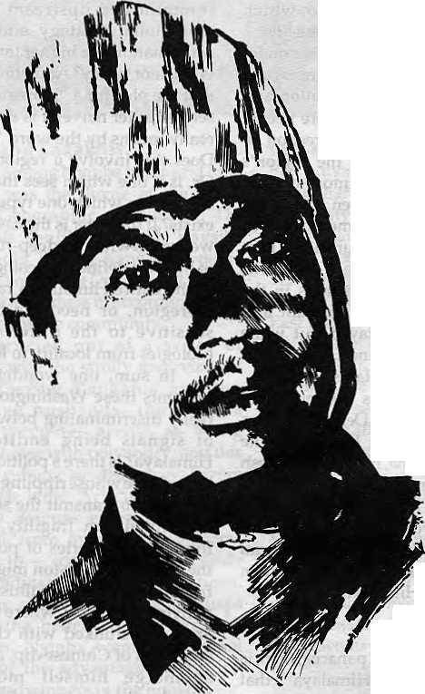
This mon doesn't have a Hotel Management Degree. Neimer has he masfered the art of landscaping. And yet lohim-weoweourPrivate Paradise, V)
He is our gardener, the creator of our prize-winning garden SHAM8ALA. A true reflection of our commitment to a greener and healthier environment. Because within our hotel, f/+ we chose to build a Shangri-la -a true haven, to show me world what they came to see -nature's resplendent beauty. »S] Perhapsjit is me splendours of our garden lhatenchanfs our guests into coming to stay with us, again and again. Or perhaps, because of our gardener, our people...who care for the environment,



SHANGRI-LA
KATHMANDU
NEPAL
G.P.O BOX: 655, LAZIMPAT, KATHMANDU,- NEPAL TEL: 412999, TELEX: 2276 HOSANG NP, FACSIMILE; 977-1-414184

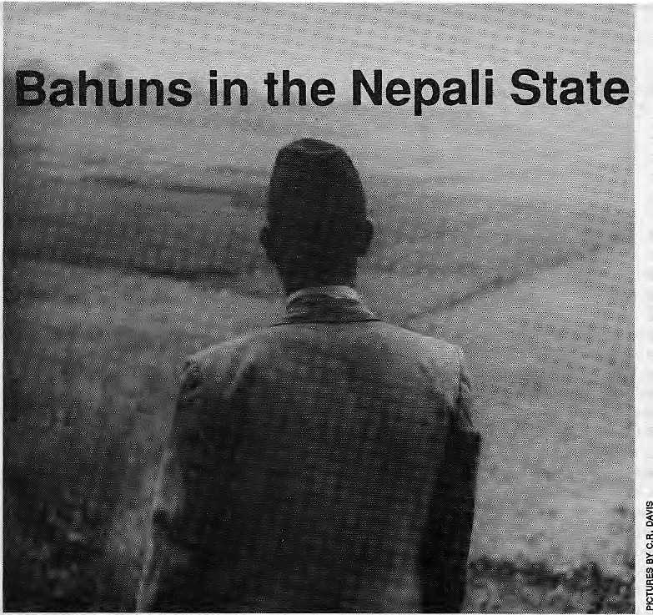

Bahuns, Nepal's hill Brahmans, have become the whipping boys
of the present-day ethnic leadership. Grab one by the collar though, and
you will find that he has forsaken most of Ms supposed traits.
by Prayag Raj Sharma

B
rahmanism is under d eep scrutiny. In Nepal, the era of multiparty d emocracy hasbroughtforthmany scholars,andlargernumbers of politicians and activists of ethnicity, who are critical of what they maintain is the continuing hold of Brahmanism over Nepali life and polity. However, it is not immediately clear how much of this criticism of Brahmanism arises out of a deep-seated dislike for Bahuns as individuals and as a group, and how much arises from disavowal of the country's political and administrative heritage.
Certainly, the Bahuns of Nepal have no monopoly on saintliness, despite their claims to religiosity and higher learning. Likemembers of any other group,Bahuns have their share of ills and shortcomings along the lines of which they have been stereotyped. While this stereotyping, too, initselfisnotu nexpec-ted ,theincreasingly shrill anti-Bahun pronouncements by
some in the ethnic leadership can have far-reaching implications, including the undermining of the very concept of the Nepali State, its unity and integrity. If this process of uncritical lambasting continues toits natural denouement, today's Bahun-bashing—for what it means to the notion of Nepal — will harm all population groups of the country, regardless of class, place of origin, religion or ethnicity.
Nomenclature and Ancestry
Ethnic disgruntlement has always been a facet of Nepali history, and it could not have been otherwise in a country of such demographic diversity. Under successive autocratic regimes right up to 1990, however, the sensitivities of the people remained largely bottled up. Ethnic politics surfaced dramatically and unambiguously with the dawn of democracy in Spring 1990, and gathered momentum during the drafting of the
democratic Constitution later that year.
One significant development during this period was the coming together of activists from among different ethnic groups to form the Janajati Federation. Anti-Brahmanism has been one of the main planks of the Federation's programme. This lobby tends to heap blame and all real and perceived national ills — from the idea of the Hindu state to upper-caste Hindu domination in national politics, and the existing social and economic realities — on unfortunate Brahmanism. According to this view, the exploitative tendencies of Bahuns is still very much there and continues even in today's democracy. The point is backed with reference to the stillborn move to impose Sanskrit in the school curriculum andthenationallanguagestatusaccorded to Nepali in the new Constitution. Both are seen as sign s o f Brahmani c domi na ti on.
The more sweeping den-unciations

Mar/Apr 1994 HIMAL . 41

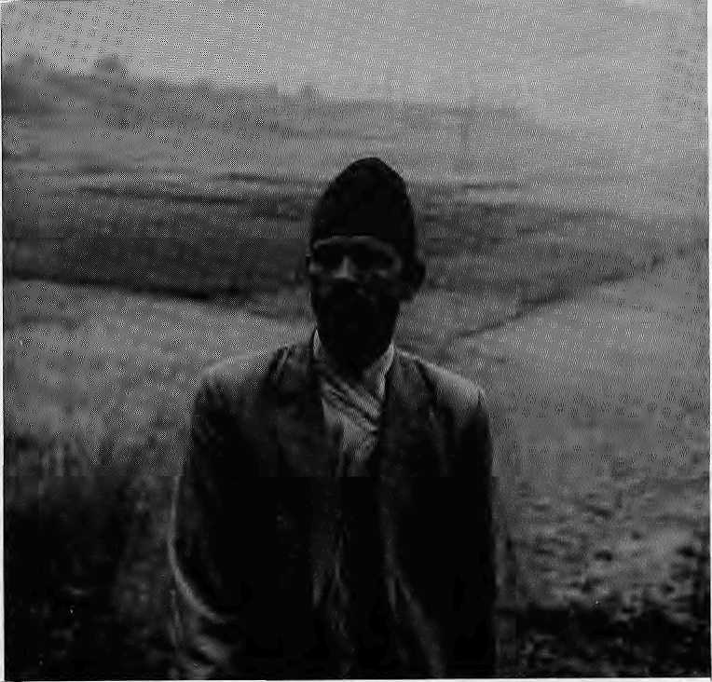
It is not as though nudging the country
towards ethnic brinkmanship is the only sign
of civilised living in the late 20th century.
castigate Brahman ism as representative of foreign culture, and liken Bahuns to aliens and outsiders. Bahuns are called 'Aryans', not to flatter them, but to depict them as a class apart and without rights to domicile in the hills of what is today Nepal. The non-Aryans are said to comprise all the ethnic groups. A more popular form of designating the diff-eren ce b etween the two groups is by referring to the shape of the proboscis: the pointed -nose Bahun and snub-nose hill ethnic. The contest over who are the indigenous and who are the non-indigenous people of Nepal is also part and parcel of this very politicised tussle over nomenclature and ancestry.
To put things in perspective,
itmustbenotedthatthejanajati onslaught
against Brahmanism derives from concern
for what the leaders feel is a historical
wrong that leaves ethnic communities
under severe disadvantage in present-
iay Nepal. To rectify the imbalance, the
Federation has been adding to its list of
iemandsfromtheGovernment,toreceive
vhat it calls full justice. These demands
nclude job reservations and a quota
ystem in appointments, political
epresentation on a proportional basis,
nd teaching in the mother-tongue in all
ne multiplicity of languages spoken in
le country. Then there is the proposal by
le Nepali Janajati Party to divide Nepal
\to 12 provinces, along ethnic and
nguistic lines.
Th e go vemm ent authori ti es, political irties and the informed and responsible lblic need to study these demands riously. A time has come to formulate a gent, rational and comprehensive policy ■eping the long-term social health of the untry and all its people in view. If the deration is right in what it is pressing
for, these demandsmustbe acknowledged and included in the political agenda. And this must be done announcing a timebound planand targetdates. Equally, where the demands are unreasonableand politically unwise, a force of opinion must be generated and a firm 'no' be said without delay. It is in this context that the Federation's attacks on Brahmanism needs to be analysed.
Colonial Bahun
Bahuns ha ve been inextricably linked with the process of formation of the Nepali State — such as in the setting up of the monarchical polity, and in the integration of disparate communities with a common link language. In contemporary times while all other groups have played the role, it is the Bahun community which has provided the bulk of the leadership in the struggle for democracy and social tr ansf ormati on.
It is a truism that should, hardly need repeating, but Bahuns have been part of Nepal's past and ongoing heritage. When
opportunistic scholars and the ethnic leaders repeatedly raise the anti-Bra-hmanism bogey, they must understand that they are also questioning some of the fundamental tenets of the Nepali national characteristic. The bogey seems to negate all of Nepal's historical legacies and its political heritage.
The string of Baisi and Chaubisi states in West and Central Nepal, as well as some other contemporary principalities of the mid-17th century, all had Bahuns in them, many of them enjoy-ingpositions of privilege. Throughout much of Nepal's recorded history, Bahuns have served as ideologues, priests, and even soldiers. Butmostly they havebeen ordinary farmers, managing livelihoods on the hillsides, like everyone else. They too were subjects of the state, not a class born to rule. When the multiplicity of states was unified by Prithvi Narayan Shah of Gorkha, Bahuns replicated their earlier role, this time on a Nepal-wide scale. Bahuns need not be accused of all kinds of evil just because career and growth in Nepal has been coterminous with the growth of the State.
Unification helped engender a common outlook and aspiration for statehood, order and organisation under the prevailing ideology of that time, i.e. Hinduism. Bahunsbecame an instrument through whom this ideology spread and got legitimised throughout the land. In fact, this ideological and aspirational bottomline was identical in all the states of the time, both the weak and the powerful. This was true in the history of the Baisi and Chaubisi states of present-day central and western Nepal, in that of theNewarstatesofKathmanduValley,as well as in the Makwanpur, Chaudandi and Bijayapur states of the central and eastern Tarai and hills.

. HIMAL Mar/Apr 1994

Ethnicity in Himal |  |  |  | y\\ NDEX
Himal hasbeen presenting many viewpoints on the sensitive and important questions of ethnicity |  |  | flflHHHHIHH
and group identity. For readers' reference, here is a listing of all |  | the entries in the computerised | , Himal Index, available to users  ... m- t 1 tt 1V% r a "1 ■" "" 11- ■ .■£■■*■■■
Himal Index under the following keywords: Anthropology, Brahmanism, Communal Tensions, |  |  | m WordPerfect, has all.articles
Community Relations, Culture, Ethnicity, Ethnic Politics, Gurkhas, Identity, Indigenous Peoples, |  |  | J that have appeared in Himal by
Janajati, Magar, Nationalism, Tamang, Tarai, Tharu. |  |  | -chronology, by author; aiid by Ikey word/subject. Topurchase,
Tamang, I'arshuram | Dahal, DilliUdin | University, Kirtipur Campus] | /contact Managing Editor:
[Lecturer 0/ economics. | [Anthropologist, Centre for Nepal and | Bahunvada: Myth or Reality? | t ■:■■■■ ■
Saraswati Campus, Kathmandu] | Asian Studies, Tribhuvan University] | Dept: Cover, | Conference Report
Tamangs Under the Shadow | Grasping the Tarai Identity | May/Jun 1992 Vol 5 No 3; (Grey) | KWS: Ladakh/Communal Tensions/
Dept: Cover | Dept: Cover | KWS: Ethnic politics/ Brahminism; (557) | Opinion; (712)
May/Jun 1992 Vol 5 No 3; (Grey) | May/Jun 1992 Vol5No3; (Grey)
SYN: Historically discriminated because | SYN: How can the Tarai unite against | Singh, Bhufinder | Wahid, Siddlq
of their proximity to Kathmandu Valley, | perceived highlander domination, with | [Council for Social Development, | [Ladakhi, who lives and works
Tamangs demand alternative develop- | its peoples divided by ethnicity, caste, | New Delhi] | in New Delhi]
ment models and a political structure | religion and region? | Cauldron of Assam | Riots in Ladakh and the
that provides hope. | KWS: Tarai / Ethnicity /Regionalism; ©55} | Dept: Cover | Genesis of a Tragedy
KWS:Tamangs/Ethnidty/Histoiy;(559) |  | May/Jun 1992 Vol 5 No 3; (Grey) | Dept: Views
 | Srinivas, Smriti | SYN: The demographic transitions that | Sep/Oct 1989 Vol 2No 4; (Green)
CurungrHaika | [Sociologist, Delhi University! | the Indian Northeast has endured, and | SYN: Recent ethnicunrest in this "remote"
[Geographer] | Ladakh on the Schedule | the resulting rise of "political ethnicity", | region have todo with the Ladahkis' own
Frontier to Boundary | Dept: Briefs | should be instructive for other areas where | victimisation to the phenomenon of
Dept: Review | Jan/Feb Vol 7 No 1; (Red) | such transitions are more recent. | "intellectual colonialism" that began with
May/Jun 1992 Vol 5 No 3; (Grey) | KWS: Ladakh/ Ethnicity; (757) | KWS: Ethnic Politics/ Assam; (558) | the Western missionary.
KWS: Ethnicity/ State; (566) |  |  | KWS: Community relations/
 | I'radhan, Rajendta | Gurung, Harka | Ladakh; (239)
Shah, Saubhagya | [Freelance consulting anthropologist | [Writer and consultant]
[Sociologist, Reporter, Rising Nepal] | based in Kathmandu] | Representing An Ethnic Mosaic | Sinha, A. C
Throes of a Fledgling Nation | A Native by Any Other Name... | Dept: Cover | [Head, Department of Sociology, North-
Dept: Cover | Dept: Feature | May/Jun 1992 Vol 5 No 3; (Grey) | Eas tern Hill University,
Mar/ Apr 1993 Vol 6 No 2; (Purple) | Jan/ Feb 1994 Vol 7 No 1; (Red) | SYN: The social composition of Nepal's | Shillong]
SYN: Hill Hinduism, monarchy, Nepali | Bxl: The Government vs. the Indigenous | House of Representatives is the outcome | A Policy Bom of Apprehensions
language-the conventional symbols of a | Peopled); | of the people's choice... | Dept: Cover
historically weak Nepali nationalism-are | SYN: Are 'indigenous people' those who | KWS: Ethnic Representation; (556) | Jul/Aug 1992 Vol 5 No4; (Orange)
presently under attack. A crisis of identity | were previously known as 'tribals'. |  | SYN: History, Culture and politics set the
prevails among Nepal's educated. | 'natives', 'aborigines' or 'ethnic minori- | Prasad, Ramashish | Lhotshampa and the Drukpa apart. The
KWS: Identity/Nationalism/ | ties'? What is the use of yet another term. | [Writer, who writes for several Indian | Drukpa has decided to act, but can he
■ Ethnicity; (638) | and is it applicable to most or Nepal's | publications, including the fortnightly | prevail in the long term?
 | communities? | newsmagazine "Dinmaan'] | KWS: Bhutan/ History/Culture; (579)
Fisher, William F. | KWS: Ethnicity/ Indigenous People; (761) | The Plains People
[Anthropologist, Harvard UniversityJ |  | Dept: Cover | Kasajoe, Vinaya Kumar
Nationalism and the Janajati | Ethnicities, More Ethnicities | Sep/Oct 1990 Vol 3 No 3; (Green) | [Editor, "Satya' weekly]
Dept: Cover | Dept: Cover | SYN: The tarai people are not one faceless | In Magar Country
Mar/Apr 1993 Vol 6 No 2; (Purple) | May/June 1992 Vol 5 No 3; (Grey) | group; they are diverse anddifferentiated. | Dept: Cover
SYN: National unity will come from | KWS: Ethnic Groups; (553) | KWS: Anthropology/ Tarai; (331) | Jul/Aug 1991 Vol 4 No3; (Orange)
embracing diversity, rather than by |  |  | SYN: These hills of central Nepal run on
imposing uniformity. | Kothaii, Rajni | Pahari, Ami p | Gurkha remittances, but is the money
KWS: Ethnicity /Janajati/ | [Indian social scientist, Center for the | Fatal Myth: A Critique of Fatalism | being used productively?
Nationalism; (639) | Study of Developing Societies, Delhi] | and Development | KWS: Magars/Gurkhas; (404)
 | Escaping the trap of cultural diversity | Dept: Review
Sharnia, Prayag Raj | Dept: Cover | Jan/Feb 1992 Vol 5 No 1; (Red) | Bista, Dor Bahadur
[Professorof History and Cultural studies | May/Jun 1992 Vol 5 No 3; (Grey) | KWS: Development Theory/ | [ Au thor. The People of Nepal & Professor
at the CNAS, Tribhuvan University] | SYN; Variety is the spice of all life and | Anthropology; (515) | of Anthrop ology.
How to Tend This Garden? | ethnicity its human expression. But |  | Tribhuvan University]
Dept: Cover | stripped of tolerance and respect, ethnic | Ramble, Charles | Tamangs:The Ethos of Balanced Exchange
May/Jun 1992 Vol S No 3; CGrey) | feelings degeneratein to oc.mm un.nl hatred | [Anthropologist, Who has done | Dept: Review
SYN: Prithvi Narayan bequeathed a | and conflict. | research in Mustang] | May/Jun 1990 Vol 3 No 2; (Grey)
"garden" of "4 caste division and 36 | KWS; Ethnic Identity; (554) | Whither, Indeed, the Tsampa Eaters | KWS: Tamangs; (316)
tribes." Why not pull down the hedges |  | Dept: Cover
and let a hundred wildflowers bloom? | Subba, Tanka | Sep/Oct 1993 Vol 6 No 5; (Green) | Fanjiar, Tej Narayan
KWS: Ethnicity/ Nepali Nation; (547) | [Reader of An thropology, North-Eas tern | SYN: Becoming good Buddhists may well | [Officer, National Planning
_ | Hill University, Shjllong] | be a mat terof people becoming something | Commission of Nepal]
Pant, Kagini | To Be or Not To Be "Nepali" | they look as though they might have been | Faceless in History
[Columnist, Bimarsha and Dristi weeklies. | Dept; Cover | but never actually were | Dept: Cover
Kathmandu] | May/Jun 1992 Vol 5 No 3; (Grey) | KWS: Buddhism/Indigenous Bon/ | Jul/Aug 1993 Vol 6 No4; (Orange)
Pointed Noses, Stubby Noses, | SYN: Blurry definitions needlessly target | Identity; (715) | SYN: The Tharus could not have hid out
and Local Elections | the Nepalis of India. Terminology must |  | in the jungle for aeons waiting to be
Dept; Cover | come to the rescue. | Malyon, Timothy | discovered during themalaria eradication
May/Jun 1992 Vol 5 No 3; (Grey) | KWS: Ethnic Identity; (561) | [Freelance writer and photographer] | campaign of the 1950s. They must havea
A longer version of this article appeared |  | Ladakh at Crossroads | history of their own.
in 'Bimarsha'. | Malla, Kama] F. | Dept: Cover | KWS: Tharus /Buddhism /Origin/
KWS: Ethnicity/ Politics; (550) | [Teacher of English, Tribhuvan | Sep/Oct 1993 Vol 6 No5; (Green) | Ignored; (695)
Mar/Apr 1994 HIMAL . 43

The ancestors of today's Bahuns have
known of no other home, no other country,
other than Nepal.
What are today regarded as the tools of Brahmanism — Sanskrit and Nepali — have helped in founding the state and in the integration of a diverse land. They have assisted in evolving a respectable, civilised polity in an area where fragmented tribalism alone would have otherwise prevailed.
Prithvi Narayan founded a strong Hindu state in the Himalaya, through conquest of arms. This is a fact of history, and similar facts of history — some of which are bound to be unsavoury — will pertain to every state on earth. Weaker groups and weaker powers have always been overrun by stronger groups and powers. In the kind of political vacuum thathad prevailed in thecentralHimalaya, someeven ts were bound toovertake other events, and that is just what happened. Nepal's political unification in the 18th century effectively filled a vacuum in the region and created a viable political entity in its place. If Prithvi Narayan had not done it, some other person, we do not know with what consequence, would have done it.
It is true that Nepal's earlier land tenure system was exploitative. But the hallmark of feudal orders have always been that any group which can exploit another, does. This basic human trait of selfishness so exists in all groups and cannot be imputed to any one religion or philosophy. One might also say that the groups that were known as the Matwali were downgraded ritually.
Otherwise, life in the hills was not marked by great isolation among Bahuns and membersof other ethnicgroups. There was a lot of sharing, and a lot in common. Brahmanical orthodoxy of the plains adapted and softened itself to fit into the hill lifestyle. Social relationships were formed at various levels between Bahuns and other communities. The way Bahuns dressed and attended to work was not markedly different from that of the rest.
Indeed, nothingis more preposterous than to call the Bahun 'coloniser', as some have. Bahuns have had neither the bearing, nor the skin colour, nor the superior-minded mentality or behaviour of a colonial. Hence, there can be no guilt on thiscount.Theancestorsoftoday'sBahuns have known of no other home, no other country, other than Nepal.
Neither can Bahuns become outsiders
just because they are said to bedescended from Aryans. If weare to believe these old notions, we must also believe that the land of Aryavarta did not exclude the hills of what is today Nepal. The Aryans aresaidtohavestretchedallthewayfrom the Himalaya to the Vindhya hills.
Language, Religion, Caste
Rightly or wrongly, it is the practice to equate not only Sanskrit, but also the Nepali language,with Brahmanism. With respect to Nepali,this view isabitskewed. Bahuns' role in the development and enrichment of Nepali is not more substantial than thatof many other groups. In its original form, Nepali was the tongue of the Khasa of western Nepal. Over time, Bahuns embraced this language as their
own, forgetting their attachment to Sanskrit They made Nepali the chosen mode of literary expression.
In recent history, the Bahun protagonists of Sanskrit have always lost their case against the Bahun proponents of Nepali. This only goes to prove that Bahuns can make do without Sanskrit, likeanyothergroupinNepal.Atthesame time, though, no one in his senses would disagree that Sanskrit's legacy in Nepal is significant. This fact can and should be acknowledged without minimising Nepal's non-Sanskritic heritage. Sanskrit also has a functional role to play in explaining and enunciating Nepali.
One reason why many Bahuns do not find the anti-Brahmanic sentiments too credible is that for many of them, in the late 20th century, Brahmanism is a dead concept. It survives purely in its ascription. And if it survives anywhere else, it does so in the imagination of a few motivated leaders in the ethnic leadership.
Where else does Brahmanism survive? In the constitutional denomination of Nepal as a Hindu state? But we all know how dilute this form of Hinduism was even duringits peak period in the Panchayat system. Under the Panchayat, the Hindu state served no other purpose than give political legitimacy to
the rule by the absolute Hindu monarch. Now that Nepal is a constitutional monarchy and sovereignty has been restored to the people, the "Hindu State" is no more than a label and Hinduism a weak basis for the state's identity. Whileit is unfortunate that the framers of the Constitution felt it necessary to define Nepal asa"HinduState",itisnevertheless true that this term can now never be functional in providing the State with a basis to discriminate against non-Hindu ethnic groups.
It is also important to bear in mind that opposition to the "Hindu State" itself does not appear to have secular and humanist credentials, and extreme parochial attitudes seem to prevail among opponents of the concept.
If not in the language and religion, where else is Brahmanism hale and hearty? Certainly not in the caste system. This system was officially ended in the early 1963 with the promulgation of the new Muluki Ain. As far as one can tell, no Bahun in any position of influence wants this form of social division to be restored. Cosmopolitan Bahuns themselves look happier to make the best use of their newly found freedom from caste rules. Many have forsaken all their traditional norms and mores regarding dress, food and drink. Throughout Nepal these days, Bahuns do not have any qualms about eating buffalo meat and pork, and neither do they seem to mind eating more exotic kinds of red meat.
Today, Bahuns are a most diversified caste, if one can still call them that. They have made an entry into every possible profession, turning possibilities that are available to everyone to full advantage, particularly by emphasising the education of the young. Their professional training, rather than the prerogatives of former caste, is what places Bahuns at the higher echelons of today's society.
And the caste system, while it exists in rituals like elsewhere in South Asia, does not provide the Bahun with any political or economic clout through group identity in a manner that is available to other communities.
A Politicised Community
Bahuns' interest in politics has been old and abiding. Along with the members of a few other social groups, in the modem era, they have been at the forefront of the

44 . HIMAL Mar/Apr 1994

The 12 federal provinces proposed for
Nepal by the Nepal Janajati Party areas follows:
: Khasan | Jadan
Magrat | Tamuwan
".,■;■■■;■■■ Tambasailing | Nepal
Khambuwan | Limbuwan
Cochilla | Maithil
Bhojpuri | Abadhi
The Federal Republic of Nepal
struggle to end despotic ruleand usher in democracy. It is also true to say that Bahuns as a caste enjoyed less favour in the exercise of real political power in the Panchayat system because of their greater proclivity for social change and democratic polity by and large.
Today, one can find Bahuns in every part of the political and ideological spectrum. Within their ranks, there are conservatives, liberals, monarchists, republicans, socialists, Marxists, Maoists, extremists and anarchists. Neither is there indication that Bahuns are concentrated more towards the conservative end of this ideological spectrum. They are represented in substantial proportions in all segments. This is quite a radical transformation. Traditional Brahmanism has been turned on its head.
For some ethnic leaders, however, Brahmanism is not dead. They do not look at a Bahun for what he is or what he stands for, as long as he carries a Brahmanic name and ancestry. When scanning the hierarchies of national political parties, they see Bahuns dominating everywhere. But it should be understood, firstly, that this very ubiquitousness is proof that Bahuns as a group have forsaken all rigidities of caste and religion. In fact, with their versatility, Bahuns provide the Nepali polity with the possibilities of transitioning into a more broad-based democracy.
But the political good fortune of Bahuns cannot last forever. They might be over-represented in the political parties for the moment, but the high point of the community as a whole is already past. As politics evolves and progresses, and as education spreads to all groups, making them more aware and participatory, the proportion of Bahuns in politics, bureaucracy and academia can only shrink to reflect their true proportion of the population. For this New Nepal to come about, ethnic groups must participate whole-heartedly in the political process defined by the new democratic constitution. There might not be instant gratification, but the road ahead is more certain.
Most Bahuns do not see the problem of the Nepali State in terms of Brahmanism. In fact, they are more in competition with each other than with others. This has made them the most
divided and bitterly feuding lot in Nepal. For thisreason, if not forany other, Bahun intellectuals can never produce a united communal front, or inculcate a minority syndrome among their lot. Bahuns have a far greater stake in looking outward and away from Brahmanism than turning inwards.
In all matters of national life, the logical conclusion of linking every evil of the day with Brahmanism with Bahuns were the dismantling of Brahmanism, it would also come part and parcel with the dismantling of the Nepali State. Such an eventuality would notbe of benefit to the ethnicgroups of Nepal, regardless of how much they may have been disad vantaged by Brahmanism in the past?
It would not do any one any good to threaten to revert to animism and tribalism only to spite Bahuns. If these cultural traits as national heritage have intrinsic merit, there is no reason why they should not be reinvigorated. But in the march towards progress, our steps should lead us not towards parochial cultural regression but towards greater modernisationofour values andlifestyles. Only in this way can economic prosperity, social justice and the fulfilling of political urges be realised.
Making Sense
Is only a Bahun expected to respond to this restrictive interpretation of Brahmanism, or should itbea matter of concern to others as well? A balanced view on questions of national unity and inter-ethnic amity is of utmost importance. It is not as though nudging the country towards bitterness and chaos by playing the game of ethnic brinkmanship is the only sign of civilised living in the late'20th century.
The Bahun intelligentsia seems somewhat nonplussed by developments.
For itkno ws tha t Bahuns are no longer the 'sacred cows' they once were. Most Bahuns are caught in the daily web of living and have no time even to consider the charges of exploitation and discrimination being laid against them. Others — the scholar, politician, journalist and bureaucrat — respond to this orchestrated din by talking defensively or sounding needlessly reconciliatory. The interest of all thinking people, among the Janajati and otherwise, should be towards greater demo-cratisation, leading towards speedier availability of social justice. They should seek the elimination of past economic and social disadvantages suffered by the weaker and poorer social groups. An acceptable political strategy will have to be devised for achieving a satisfactory solution, one which remains within the democratic process and does not do violence to the concept of the Nepali State. Certainly, those in the leadership who do notunderstandtheneedforsuchastrategy must be doomed to failure.
Politiciansandleadersof the political parties, Bahun or otherwise, mustsquarely face this agenda. At the same time, there should notbe any short-term appeasement of strident and opportunistic leadership. There is the ever-present danger in electoral politics that parties will indulge in treating minority and regional groups as mere vote banks rather than as parts of the national mainstream.
Cultural pluralism is a fact of life in Nepal today and preservation of cultural identity comes partand parcel with human rights. It would be hazardous for the continued viability of the Nepali State, if some leaders were to seek political identity outside of political parties, and in terms of cultural identity. It is not in the interest of anyone to change Nepal from a unitary state to a federal structure, which would go against all the grains of national identity. Such a structure is not in the historical experience of the country, would lay the seed of centrifugal tendencies, and would be economically devastating for all communities. Neither our political reality nor our historical and political conditions warrants such a devastating departure.
P.R. Stiarma is a professor at the Centre for Nepal and Asia Studies, Tribhuvan University and is a longtime observer of Nepali society and culture.

Mar/Apr 1994 HIMAL . 45



Patrakar,if you want fighringmen,you get the Gorkhali lads. But for a country that does not have much fight left in it after the last hurrah at Falklands/
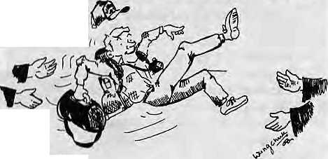
Karma Gyatso, commisioner and secretary of Sikkim, believes that Nepal and Sikkim can both benefit from what he calls "bilateral tourism". Speaking to the Kathnumdu Post recently, Gyatso referred to the need for joint tour packages as well as a Kathmandu-Bagdogra airlink, particularly during peak season. According to the report, the ease of obtaining Innerline permits has led to a 125 percent increase in foreign tourist arrivals in Sikkim over the past year. Gangtok now has 50 travel agencies and 200 hotels. Echoing sentiments of the administrators in neighbouring Bhutan, Gyatso says his government is aware of the problems Nepal is facing with mass tourism and that it plans to enforce safety measures such as campsite identification, kerosene depots, and back-trash regulations, Sikkim hopes to base its tourism on adventure packages, fiora and fauna, and its over 300 monasteries.
If Sikkim is gearing up to meet the tourist onrush, Darjeeling district is dusting off its old attractions and adding new elements of adventure tourism. The Darjeeling Gorkha Hill Council is waking up to the travel trade, if one is to go by the full page ad taken in the Calcutta Telegraph of 10 March by the DGHC's Department of Tourism. While Sikkim plans to reap dollars from the foreign tourist, Darjeeling seems quite content with desi greens.
The year of the Great Handover, 1997, looms large not only for Hong Kong residents, but also for the British Gurkhas, whose numbers are supposed to bottom out at 2500 that year. While the Nepali lads are laid off, this apparently does not mean that the proportion of Asians in the British Army is going down. The new South Asian daily Asian Age reports that the British Army and the Department of Employment have decided to tackle high unemployment among Asians in Lancashire by conducting a recruitment drive. The drive will focus on the town of Oldham, which has a large Bengali community. Which led a leading Asian academic at Hull University to point out that Bengalis do not have a military tradition. The way it looks to Chhetria

Malvinas, perhaps it is appropriate to convert the Army into an employment bureau, and hire Oldham Bengalis.

The Nagaland government has just earmarked IRs 6 million to be spent this year under an Integrated Watershed Management Programme. The main goal of the scheme, reports PTI, is "to lure away farmers from the existing practice of ala sh and bu m and to replace it by more scientific terrace cultivation." The Programme is to promote orchard s lower down, and do "social forestry" in the higher reaches of the hill state. Somehow, it seems, we have heard all this before, elsewhere in the Himalaya, further west. Integrated hill development, plans to make populations give up traditional agriculture, cash cropping, monoculture, and a self-confidence among bureaucrats and planners that they are on the right track... Well, as someone said recently, one has just got to do what one has got to do, even Nagaland.

The Chakmas are the only refugees in South Asia who are presently in the process of being repatriated, and they seem none too happy about it. The first batch of 450 tribals crossed over to the Chittagong Hill Tracts over the Feni river bridge one morning in mid-February. There were coloured shamianas, and ministers in them, to giye the event a festive air, and enough Hindi-Bangla bhai-bhai bonhomie. However, wrote Satyabrata Chakra-borty in The Statesman, "The signs of confusion are writ large on the faces of most of the camp inmates." Few returnees believe the Dhaka Government's "categorical promise" to provide security and restore tribal lands, he said. Upendralal Chakma, President of the Tribal Refugee Welfare Association,
told The Telegraph he had agreed to repatriation after a lapse of eight years because he wanted "to test the ground realities in the Chittagong Hill Tracts". The KhalidaZiagovernmenthad begun taking steps to evict illegal settlers from Chakma lands, he said. Another refugee leader, however, was of the view that the repatriation wasonly experimental. "The Bangladeshis have cheated us on many previous occasions. Mere economic rehabilitation will not do and the Bangladesh government will have to concedeourpolitical rights." Despite the fanfare and Hindi-Bangla bhai-bhai bonhommie at the Feni river crossing, therefore, it is clear that solution to the Chakma refugee question is fraught with uncertainty.
On 22 February, Bhutan celebrated the 400th birth anniversary of Shabdrung Ngawang Naragyal, the great unifier of the Bhutanese state. While the Bhutanese media would not see fit to mention it, do let us give a moment's thought to the Shabdrung's present reincarnation as he counts beads, with a full complement of Indian security, somewhere in Himachal Pradesh. Meanwhile, are we to believe reports of some restlessness among the Sarchopa of eastern Bhutan, who, incidentally, are said to revere the Shabdrung more than the Ngalung of the west?
The frequency with which Nar Bahadur Bhandariis having to putout brushfires within his much-pampered state is worthy of note. The latest was when the Army had to be called out in Gangtok after a revolt by some State policemen who were protesting ruling party (Sikkim Sangram Parishad)'s interference in police administration. Pawan Kumar Chamling, who has emerged as the most serious challenger to Bhandari yet, is clamouring for President's Rule. In an interview with The Telegraph's Keshav Pradhan, Bhandari was not about to give even an inch. The opposition, he said, "is nothing but a pack of corrupt and rejected people" that relies on Delhi, Jyoti Basu or RAW (the Research and Analysis Wing). On the merger of Sikkim with India:"! regard themerger as a fait accompli... I raise objections only about the injustices meted out to us by the Indian government, not by India asa country." Question one: why did he reject the lagadamba Shree prize

46 HIMAL . Mar/Apr 1993

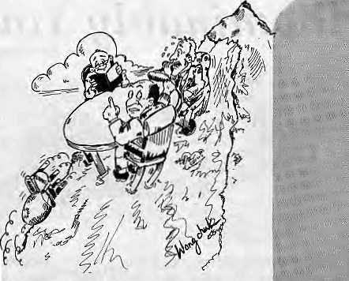
awarded him by a Kathmandu-based trust a year ago for "lifelong service to the Nepali language"? Question two: why did he this year decide that he would accept the prize, after all? Perhaps a need to pump up popularity at home base.
All Hindus know of the special properties of the waters of the Ganga, which supposedly putrefy only with the greatest difficulty. A recent head lire in theCSE-Down to Earth Feature Service indicated that the mystery had been solved. Instead, the article has only reconfirmed the kimbadanti without adding any substance. A Roorkee University scientist told CSE that the miracle of the Ganga waters must be ascribed to "yet-to-be described microbes" which has "phenomenal capacity to treat large amounts of organic wastes dumped into it". Better luck next time. Till then, we will continue to use the filter.
The Nepal-Bhutan Joint Committee
on resolving refugee issue met in Thimphu and once again made "steady progress". Pregnant silence on the details. Not hard at all to guess who stalled. The continuing marvel is how the Nepali side has been completely unable to utilise the possibilities of one word — 'diplomacy¹. Does the world know that there are as many' Lhotshampa refugees as there are Tibetan refugees? The endangered black-necked crane, which winters in Druk Yul, probably has higher name-recognition than the Lhotshampa refugees in the Jhapa plains.
If the Nepali Government does not seem to know the 'k' of kutniti-shastra, the Tibetan Exile Government perhaps knows too much of it. That might be what led it to place all its cards on the table back in May 1988 when in Strasbourg the Dalai Lama announced that complete independence was not a necessity. Unfortunately, Dharamsala has not made much headway with the only place where it matters — Beijing. Faced with continuous Chinese stonewalling of his overtures, in early March, the Dalai Lama'issued a statement admitting "complete failure" of his years of effort at moderation. So what card does he have to play, other than continuing reliance on the West?
Will someone call a halt on autonomous hill councils? The Indians have taken after it as a fashion. With the Ladakh Hill Development Council and the DarjeelingGorkhaHillCouncilalready in the bag, more autonomous entities are popping up, this time in the Indian Northeast. Didyouknowthatthereis a Khasi Hills Autonomous District Council, which held peaceful polls in earlyMarch?TheMizoram government is expected to negotiate an agreement with the underground Hmar People's Convention for setting up of the Singlung Autonomous Hill Development Council, covering the northern part of that state. At the center of the subcontinent, Madhya Pradesh too is setting up autonomous councils with full financial powers for its tribal areas. Chief Minister Digvijay Singh apparently believes that giving tribals greater independence in managing their own affairs will help "dilute demands" for complete statehood. Aha.
In a Tegion that seems to attract mostly anthropologists and development consultants, it is good to see the rise of scholars interested in Himalayan archaeology. "Ruins of an Early Gurung Settlement" by Mark Temple in the European Bulletin of Himalayan Research is a report on an ancient Gurung village at Khola Songbre, north of the present-day Gurung heartland in central Nepal. Temple concludes that the ruins at Khola Songbre supports current views about the origins of the Gurungs — which is that their ancestors moved down from the high mountains of western China tosettleinasinglevillage beyond the Himalayan divide before dispersing into different sett lementsin the south, (see Himal, Jul/Aug 1993).
Here is an organisation that all interested in the business of topsoil loss, runoff, mudslips, landslides, CLOFs and bishyaris should join. As noted in the journal Asia-Pacific Uplands, it is the International Erosion Control Association, whose growing membership includes more than 700 professionals, representing 15 fields of expertise, from professors and consultants to manufactures, suppliers, technocrats and civil engineers. Himalayan professionals, should they join, could easily make up the quorum and control the organisation! Contact: Box4904, Steamboat Springs, CO80477.

Nepalis havealways been proud about the role played by Princess Bhrikuti in taking Buddhism up to Tibet. Well, what will Nepali nationalists (who so oftep double as Beijing apologists when it comes to Tibetan autonomy) have to say about the following? The scholar \ Jamyaifg Norbu reports in the Tibetan Review of December 1993 that, in rewriting traditional Tibetan works to conform to the Chinese interpretation of history, the Tibetan opera The Chinese Princess and the Nepali Princess (of King Songtsen Gampo), the inconvenient Nepali princess (Bhrikuti) has been completely excised from the story. The opera is now called Princess Wen Cheng, after the Chinese princess. Wen Cheng was married off to the conquering Tibetan King as a peace offering, butthe Chinese cadres in Tibet firmly believe that Tibet became "enlightened" because of Wen Cheng. Let the Nepali hearts bleed a bit for their lost princess.

This one must have seemed awfully proximate to Thimphu: a South Asian conferenceon hutna n ri gh ts organised much too close for comfort in Siliguri, gateway to Bhutan and the Indian northeast. Organised in mid-March by the South Asian People's Commission for Human Rights, the Conference included leading civil rights activists V.M. Tarkunde, Nandita Haksar, N. Pacholi, and parliamentarian George Fernandes. Human rights violations in the kingdom next door emerged as the dominant theme at the meet, which also did not neglect other burning issues such as continuing President's Rule in Maldives, human rights in Kashmir, and the military's power in Pakistan,
- Chhetria Patrakar

Mar/Apr 1994 HIMAL . 47

Abominably Yours,

* We have had to cut the column off because the writer did not keep to the assigned word-length. If the columnist is nice to us, we might carry the remaining portion in the next issue. — Editors.
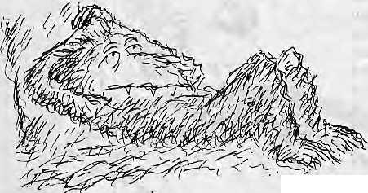

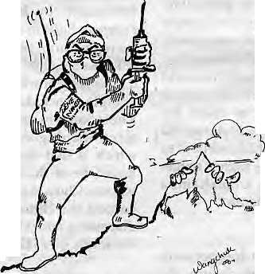
Late yesterday afternoon, I was relaxing on the large boulder by the lateral moraine below Camp II, enjoying the freezing late-spring foehn that was whipping up from the valley. It was a quiet and introspective moment, the kind in which one does not want, for example, to read a magazine that insists on making you think deep thoughts about issues. As I lay there on the rock, if you had happened to ask me, I would have said, "No, sir, at this time I do not feel like meeting gene mappers from the Human Genome Project."
You guessed it. My idyll was destroyed. Scientists from the Human Genome Project, part of that five billion dollar exercise to map human chromosomes, had come sniffing up the Upper Barun looking, they said, for the lost tribe of hominoids.
I knew all about these Gene Ninjas. They have been touring the world pretending to be primary health care providers, drawing blood and saliva samples from untainted natives. They have already done the Hottentots and the Ifugao, who willingly laid down their veins for the future of humankind.
Since I really, have nothing against humankind, except when it acts prissy, I too donated my blood (and with it my unique genetic heritage) to the Jurassic Park attendants. These gnomes from Genome knew that locked within my nail dippings and dandruff is the elusive genetic bridge that links Neanderthal Man and Michael Jackson.
It is the very desire to piece together the precise genetic code of humans, after all, that sets humans apart — a consciousness and curiosity about their own species which is absent in cockroaches and rhododendrons. So I was not unexcited to be part of a project that would finally help unravel the secret molecular arrangement that made
48 HIMAL . Mar/Apr 1994
organisms like
Slobodan Milosevic and
Saloth Sar represent
the pinnacles of
creation on this planet.
Early primates
are suddenlyJJig News.
After my last column
on the little known
sub-species of Homo obfuscatus, Time magazine featured Cousin Erectus squinting from its cover of 14 March. The article related the tale of the Java Man being actually a million years older than previously thought. Well, had the reporter bothered to check with me, I would have opened up our genealogical records.
Following is an excerpt from an entry by our venerable ancestor, Lumbasumba, datelined Shores of Tethys, 15 SCOA (15 Solar Cycles Out of Africa):
"Earthquakes rumbled below our feet, and shards of pre-Cambrian rock pushed themselves out of the sand. This was, serious upliftment going on. Obviously, the subcontinent was thrusting deeper into the Asian bodypolitk. The Chheparo-saurus, equipped with seismic sensors, was emitting warning chirps. Sutomato's clan, which had accompanied us for 15 years in the Great Trek from the Rift Valley, panicked and. wanted to set off right away in the catamarans despite the fear of a tidal surge. I told Sutomato not to be a toad, his boats would be crushed by the tsunami. He wouldn't listen, the hard-headed dork. We waved out as the outriggers paddled off in the direction of the Andamans, and that is the last we ever saw of them..."
Lumbasumba would have been glad to know (or maybe on this my venerable ancestor would have preferred to remain neutral — I have no way of verifying) that Sutomato survived the journey across the Bay of Bengal. He landed in Borneo and
migrated across land-bridges to settle down in Central Java. Just as well Sutomato was thick-headed, otherwise his skull would never have survived two million years of fossilhood to have the good fortune of being carbon-dated. Our genealogical charts show numerous other more deserving ancestors who were never done the honours.
As for the Lumbasumba branch of African migrants, it remained on terra firma although the terra was never again very firma on Mainland Asia, what with construction already begun on the Himalaya. Our ancestors were uplifted together with the mountains, which were being carefully modelled as the Great Northern Yardstick to Measure the Earth.
And to cut a very, very long story
short, we are still up here, being
uplifted another couple of inches every
year, writing columns, receiving hate in
the e-hulak, and entertaining ninjas
from the Human Genome Project.
<* According to my
visitors, after the hominoid and human
genes are all mapped, there will be
no limit to the permutation of transgenic organisms that can be
prefabricated through recombinant DNA techniques. Friends, this is the Second Genesis. Already,
scientists have grafted, don't ask me why, the genes of fireflies to the tobacco plant so that the leaves glow at night. Laboratory rats that were spliced with the genes of human males promptly began research on weapons of mass destruction, indulged in hostile takeovers, and showed a propensity for sexual harassment in the workplace.
I am not

making any of this up. What I am making up is the following. If junkiris can have lung cancer and *

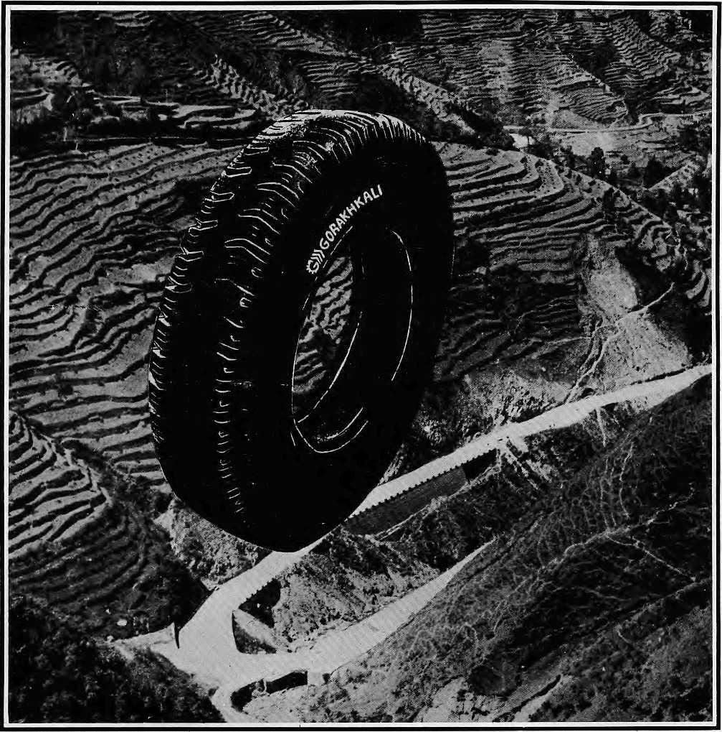

The Gorakhkali tyre is specifically designed for tough Himalayan roads and extreme Himalayan climate. It is the only tyre manufactured in the Himalayan region. The Gorakhkali tyre uses nylon backing and a special dual tread compound for added strength. Rigorous tests on Nepali highways have shown that the Gorakhkali tyre has excellent abrasion resistance. It is unmatched for steering, acceleration, braking and road grip. Overall, it has the lowest cost per kilometre of running.


3 GORAKHKALI

GORAKHKALI RUBBER UD YOG
Registered Office: Marketing office;
Majua Deurali PO Box 1700, Kalimati
Gorkha, Nepal Kathmandu, Nepal
Phone (065) 20179 Phone 270367, Telex 2788 GRUL NP Fax 271704
v v
V
s


Regd, No, Lalitpur 65/045-46

Northwest makes it easy to go to America. With a choice of 8 gateways. And connection to 200 cities beyond.
Choose a connecting city that suits you best: Bangkok, Hong Kong or Singapore.
generous free flight plan there is. General Sales Agent in Nepal :
Malla Treks,
Malla Hotel Arcade,
Kathmondu, Tel, 41 8 389
Northwest has daily 747 flight via Tokyo or Seoul straight to the U.S.A.
Be sure to ask abouf WorldPerks, the most


NORTHWEST AIRLINES
SOME PEOPLE JUST KtyOW HOW TO FLY."

