NHs 40 DM 9
IRs 25 C 4
Nu 30 U$ 5
US$4:75 Canada $5.75
Vol 7 No 5 Sep/Oct 1994


HIM
H I M A LA Y AN MAGAZINE



111111

Kashmir for Kashmiri



Northwest makes it easy to go to America. With a choice of 8 gateways. And connection to 200 cities beyond.
Choose a connecting city that suits you best: Bangkok, Hong Kong or Singapore.
generous free flight plan there is. General Sales Agent in Nepal :
Malla Treks,
Malla Hotel Arcade,
Kathmandu, Tel. 418 389
Northwest has daily 747 flight via Tokyo or Seoul straight to the U.S.A.
Be sure to ask about WorldPerks, the most


NORTHWEST AIRLINES
SOME PEOPLE JUST KNOW HOW TO FLY."


INSIDE.


Vol 7 No5
f<tftT
The Abode of Gods, King of
Mountains, Himalaya You bound the oceans from
east to tvest
A northern yardstick
To measure the Eart]i
- kalidasa (Kumara Sambhava)
COVER
11 Buddhljibl
Intelligentsia Has No Clothes
by Dipak Gyawali
16 Speak Truth to Power
by Rishikesh Shaha
18 A Generation Lost
by Ashutosh Tiwari
20 Contemporary Concerns
by Pitamber Sharma
21 "The Road to Nowhere"
by Kamal Prakash Malla
LKJ
Nepal's educated elites have no clarity ofvision,nor fixity of purpose. They are disturbed, schizophrenic, perhaps even autistic.

Editor
Associate Editor Photography Administration
Kanak Mani Dixit
Manisha Aryal
Bikas Rauniar
Balaram Sharma
Pmkriti Karmacharya
'";" " I ■■—_

FEATURE
40
Save the Nepali Tiger
by Charles McDougal
There must be 500 or more tigers in a
reserve for the population to be
considered 'effective' by scimtists. There
area maximum of 250 tigers in all of
Nepal.
45
DEPARTMENTS
Killing Fields of Kashmir
by Praful Bidwai
The Kashmiri people must be brought into the discussion of their own
fate. It is morally and politically imperative that they are recognised as
a legitimate party to the dispute and
that their will prevail.
3 Mail
Annihilating Bhutan A History of Marginalisation Earthquakes Creat and Small Chipko! More Chipko! Serfdom in Tibet Indigenous Identity
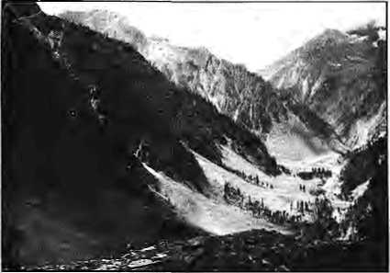
- Abstracts
- Voices
29 Briefs
The Magar Hunt No More Is Khumbu Garbage Tamed? Rupshu Opens to Its Fate Go Blame It on the Mountain Eight Languages On Air The KTM-LHX Bus Ride An Uttarakhand of One's Own Sikkim's Ethnic Lineup
38 Himalaya Mediafile 50 Know Your Himai 52 Abominably Yours
37 KATHA
"Kali with Crows" by JMorton Isaacson

Cover: Kathmandu cow and V.I.P. Picture by David Sassoon.
Himal © 1994 is published every two months by Himal Association, PO Box 42, Pafcm Dhoka, Lalitpur, Nepal. Tel: ^771 523845, Fax: 521013.
ISSN 1012 9804, Ubrary of Congress Card, Catalogue No. 88 912882. Subscription information on page 5. Printing: Jagadamba QffeeJ Pvt. Ltd. Tel: 521393.
Sep/Oct 1W4 HIMAL . 1


pa/iac(tsG

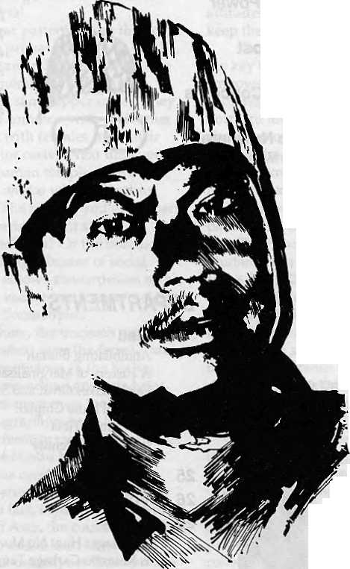
This man doesn't have a Hotel ManagementDegree. Neither has he mastered the art of landscaping. And yet tohim-weoweourPrivate Paradise. *\)
He is our gardener, the creator of our prize-winning garden SHAMBALA. A true reflection of our commitment to a greener and healthier environment. Because within our hotel, ffo. we chose to build a Shangrnla-a true hoven, to show the world what they came to see -nature's resplendent beauty. v)
Perhaps,it is the splendours of our garden that enchants our guests into coming to stay with us, again and again. Or perhaps, because of our gardener, our people...who care for the environment.


SHANGRI-LA
KATHMANDU NEPAL
G.P.0 BOX: 655, IAZIMPAT, KATHWANOU,- NEPAL TEL: 412999, TELEX; 2276 HOSANG NP, FACSIMILE: 977-14141U

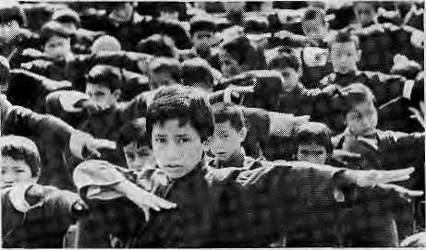
Threatening Annihilation
In his column "On the Way Up", Kanak Mani Dixit writes that it is hard for a midhill Nepali to understand Bhutan. Dixit proved himself right through his thoroughly biased and misunderstood 'analysis' of Bhutanese Society in "House of Cards: Fearing for Bhutan" (Jul/Aug 1994). The article ran like a premeditated list of threats.
From suggesting that the refugees can be instigated (by Himal?) to pick up arms and attack Bhutan, to the fickleness of Indian loyalty, Dixit, it seems, was threatening Bhutan with annihilation. It is exactly such rhetoric that turns even moderates on the Southern Problem into hardliners.
Factual errors and propaganda abound in Dixit's article. For instance, Dixit's claim that "Thimphu strategists" sat down to chart the present course is ridiculous. The present situation is a result of the synchronised demonstrations in several towns in South Bhutan. The synchronisation reveals that the uprising was planned strategically in advance and Thimphu's actions are nothing more than reaction to the reign or terror and violence unleashed by the anti-national terrorists.
Dixit also uses the "divide and
conquer" approach. He hopes to turn Sharchop against Ngalop, Nyingma against Kargyu, and Lhotshampa against Ngalop. Unfortunately, this will be difficult, since, firstly there is a high degree of integration between the Sharchop and Ngalop through marriage and sharing of a similar culture. Also, there are more similarities between Nyingma and Kargyu than differences. For instance, both sects follow the teachings of Guru Rimpoche who is highly revered in Vajrayana Buddhism.
It also seems like Rongthong Kunley is being used as a pawn in an attempt to cleave Bhutanese society. It must, however, be remembered that Rongthong Kunley left Bhutan because he was unable to clear off his gambling debts and government loans. He hardly has the decency to clear his bills, leave alone being a champion of the oppressed.
Rather than delivering threats, Dixit should be looking for solutions. Tharchen Dupihab Thimphu
Midhill Nepali's Misunderstanding
In spite of Kanak Mani Dixif s disclaimer that there is difficulty for a midhill Nepali "to understand the spiritual underpinnings and urges that drive the polity of a country like Bhutan", his cover article contained several contentious observations. I wish to comment on a couple of them.
The claim that there is a deep division between the people of western and eastern Bhutan is far from the truth and is a serious misconception. It is this misconception which impels
Dixit to conclude that the country is threatened by internal dissent. He has clearly overestimated the significance of regional and linguistic identification in order to project a regional division. I will only mention two factors which reduce the significance of such a purported division.
Firstly, there are too many cleavages within both western and eastern Bhutan for either of them to constitute a homogeneous regional unit. Secondly, such regional divisions, as there may be, are getting rapidly cut across by social and economic ties struck by working together in the civil service, the armed forces, banking and business world, and so on. Modern communication facilities and mass education has further promoted spontaneous assimilation.
The article contains derisive remarks about the immediate royal family, such as "marriages of convenience", "royal multi-marriage", and "avaricious economic exploiters" . Such remarks are deeply offensive to most of the Bhutanese for whom the members of the immediate royal family are inviolate, and they are also totally irrelevant to the discussion of the Southern Problem. Any criticism of the immediate members of the royal family is absolutely counter-productive. For, however mistaken the outsider may be, the monarchy is considered the only effective bulwark against any instability and it is totally supported by all Bhutanese.
There is undoubtedly an air of paradox in the article. On the one hand, Dixit recognises fully that Bhutan has a strong development momentum with the best socio-economic indicators in South Asia, an efficient and competent

Sep/Oct 1994 HIMAL . 3

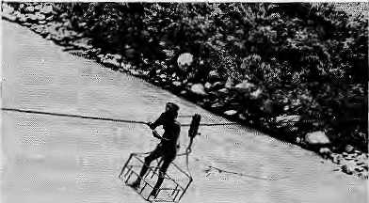
administration, dependable relationship with Bhutan's most important friend, India, and according to most of the reporters and scholars quoted in the article, a liberal King. All these positive factors point towards a greater stability in the country.
On the other hand, in his assessment of the'political situation that would be affected by the southern problem, Dixit is quite convinced that it could bring the political structure of Bhutan down like a house of cards. It is quite impossible to reconcile the strengths of the country which he admits with the image of a house of cards which will collapse with "a slight breeze or nudge". To reconcile the two, one has to believe, with violence to logic, that the strengths a country possesses can be fatal to itself.
Karma Ura
Thimphu
K.M.DIxit replies:
One of the masons Thimphu has been able to carry out its exercise ol depopulation is lhal it has "an efficient and competent administration*. The forces that have been unleashed by ihe Southern Problem, as well as the inevitable dislocations brought about by modernisation and shirts in geopolitical perception, however, are likely to impact negatively on Bhutan's brittle state structure.
Relevance of History
Many points raised by Dipak Gyawali ("A Fate Other than Marginalisation" May/Jun 1994) could not be argued better. Who would, for example, deny that one of the distinguishing features of today's Nepali economic thinking is that it is "biased towards the market and the plains". He underlines the significance of subsistence economy as well as the consequences of the theory of comparative advantage for the "latecomers to modernisation". He also draws an accurate picture of the traditional role of social sciences, especially of economics, and of their relevance to modern Nepal—that not only are the social scientists unable to provide an independent analysis, they are also unable to take into consideration the situation of the vast majority of the people.
However, haven't all these questions already been raised, albeit somewhat less precisely, some ten years ago? Perhaps scientific analysis has stagnated in Nepal owing to the intensified struggle for economic
survival and political power. But as conditions for greater political and economic independence improve, the ^stagnation becomes even more rioticeable. In this context, Gyawali's article can also be read as an appeal to follow up on democratisation in Nepal by increasing the independence of scientific thought.
While Gyawali's attempt to initiate such a research agenda is valuable, it is just as important to achieve an organised, scientific evaluation based on hard facts and data to answer questions such as; Whatdoes self-reliance mean in the context of the political economy of contemporary Nepal? How are such divergent concerns as equity and urgently required economic growth to be reconciled? We need a realistic assessment of present structures—the performance and efficiency of various economic sectors, demand for commodities, macro-economic restrictions, etc
While solutions to daily problems need to be found quickly, there is an equally pressing need to develop long-term perspectives. Also, if in-depth studies and a concept for 'another development¹ are to yield practical results, the arguments put forward must convince not only public opinion and media, but, perhaps even more importantly, find approval among experts.
It would be a challenging task to question some of the fundamental assumptions of expert knowledge— variously presented by international organisations, donor states, social scientists and national institutions involved in development planning. There is also a very real risk of simply supplanting traditional concepts based on theories of economy by development
concepts based on more or less wishy-washy historical arguments which may be handy in the political debate but are ultimately inadequate to describe and shape the Nepali reali ty.
In fact, Nepali development planners, who believe in the validity of the theory of comparative advantage and seek to follow in the footsteps of successful examples, such as Switzerland's, should realise that history is not necessarily a reliable counsellor. As a team of American scientists put it as early as 1965, "...when used carelessly, historical analogy can be a misleading guide. Worse, by establishing a facile resemblance, it may serve to prevent a more critical and analytical approach."
Do lessons of history exist at all for a country like Nepal? No doubt, a wider perspective presupposes an historical analysis—an analysis, however, which would not only have to be based much more on currently pertinent issues but which would also have to perceive history as an opportunity for the study of concrete development processes rather than as a justification of abstract economic theories.
Historical experiences of the First World concerning the nature of the hills-plain interaction in the context of expanding capitalism would have to be made available based on comparative methodology and solid empirical data and viewed from a perspective of current development conditions. In this way, the less spectacular, all but forgotten segments of European history might soon prove to be of far greater interest and relevance than the perhaps more familiar success stories. Such historical experiences could contribute significantly to our understanding of the destructive potential of market forces, the performance of a subsistence economy half-way to a market economy, or the role of traditional institutions and attitudes. Werner Thui Bern, Switzerland
Playing God
Dipak Gyawali's piece on marginalised farmers provides a refreshing discussion on the fate of the Highlander. But he provides a broad panorama rather than the details. Reading the piece was like riding a roller coaster

4 . HIMAL Sep/Ort 1994

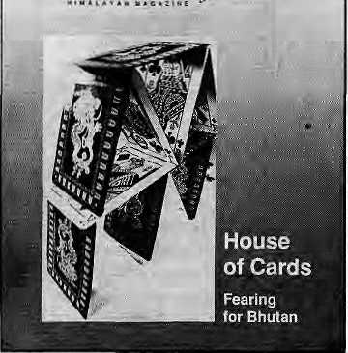
EJJLI
HIM5L
when what you really need is a slow-moving tourist coach with guide.
Gyawali writes: "Unless economists and philosophers brave these questions and seek answers specific to the hill condition, the road to marginality is wide and welcoming at the economic periphery where highlanders reside." And then again, 'It is the role of the economists and planners to ensure that the hills begin to enjoy more than the vapid remittance economy of today."
Implicit throughout the article is the notion that the current and future fate of the highlanders is largely determined by the gaze (bias) of intellectuals. Is this notion not the "traditional" planning perspective in disguise? Does planning by well-fed intellectuals at the centre work for the people in the periphery? Or does development progress, in its "organic-chaotic" form, with the micro-efforts of community leaders, entrepreneurs, activists, and citizens who find themselves entering, interacting, and renewing themselves in progressively larger domains of life, be it material, social, or spiritual?
While it is important for those of us who call ourselves "development specialists" to keep on contributing, intellectually and through programmes, for the benefit of the poorest, should we not shed some of our arrogance and stop playing god?
Another of Gyawali's concerns is the ascendency of capitalism and its
Subscription Rates Only Bank -drafts acceptable forsubscriptton orders

Individuals |  | 1 Year | 2yn
Nepal | NRs | 220 | 400
India | IRs | 140 | 260
Bhutan | Nu. | 175 | 330
Other S. Asian Countries | US | 12 | 20
Nprth America | US | 22.5Q | 40
Germany | DM | 50 | 90
United Kingdom & Ireland | £ | 20 | 35
Netherlands | Dfl | 45 | 30
Elsewhere | US | 25 | 45
Institutional
Nepal NRs 600 1100
India IRs 260 500
Bhutan Nu 330 640
Other S. Asian Countries U$ 25 45
North America U$ 35 60
Germany DM 70 120
United Kingdom & Ireland £ 30 50
Netherlands Dfl 100 IBtt
Elsewhere U$ 45 80;

adverse impacts. While agreeing with his claim concerning "pujari economists" and the use of "many splendoured humans" as mere statistics, I cannot understand how or why capitalism should hit highlanders (Gorkhalis, Marathas, and the Hapsburgs) alone. How about the slavery-styled capitalism of the East India Company? Has not the impact of capitalism (with its technology) on social values and organisation been pretty much the same the world over, including Europe and North America? If so, is it justifiable to discuss the repercussions of capitalism on the highlands while ignoring its impact on the plains?
This brings me to Gyawali's foundational claim: "Today, the plains and coastal zones are thriving economies while the hills of the hinterland stagnate, serving merely as reservoirs of migrant labour and natural resources." Aren't these communities supposed to be resilient and self-reliant, as Gyawali claims in another section of the same article?
Economic and social indicators (which, granted, may not capture the resilience of subsistence agriculture) show that all of South Asia, be it valley, hill, mountain or plain, is performing poorly. Meanwhile, the urban centres are doing well. If lower infant mortality is a reasonable goal for Gyawali, then consider this: in the early 1980s {and continuing now), the infant mortality was 105 in rural areas and 67 in urban
Sen d su bscrip lion s * related corre s pon de n <: e to:
South Asia; Pp. Box 42, taiitpur, Nepal
(tel 9771523S45, fax 9771 521013), or Central News Agency, 23/90 Cartrtaught Circus; New Delhi 110001
Japan: Akio Horiuehi,
P'O.Bbx 9, Kiyose,Tokyo, 204 Japan,
Australia:lndra Ban,...12 Norfolk St.,.[
Paddirigton 2021, Sydney,Australia!
North America: Barbara Belia & Associates, 500
Sansoroe Street, Suite 101, PO Box 47075S-
San Francisco, CA 94147 United Kingdom &. Ireland; ]oti Giri (Ref: H);
221 AsMy Gardens, Errtery Hill Street,
LondonSWlPlPA
the Netherlands; G; F. de Stoppelaar,
Foundation Himalaya, Ketzersgracth 463, 1017,DKMsterdahi -
Switzerland: Helene Zingg, Tannenvveg IS, CH-=3073>Gue«siEgen> Switzerland
Europe: Durga Press (Hiiiiai), Luitpoldstr^ 20. .;; D~82211^ Henreching,;Cerfnany
areas. New Delhi is performing better than Jomosom, and Kathmandu better than Uttarakand. Has not Mr. Gyawali confused "plains bias" for "urban bias"?
I salute Gyawali for bringing the issues of self-reliance, the importance of long-term resilience, and self-respect, to the forefront of development debate. At the same time, the ride was too fast! Arun R. Joshi Washington DC
Earthquakes Great and Small
We cannot agree with Roger Bilham ("The Next Great Earthquake" May/Jun 1994) that "an army of historians, language experts and geologists should be mobilised to attack" the problems of the seismic record; or that there is "tremendous reluctance amongst those in public office... to believe that the continued recurrence of nightmare earthquakes is inevitable", and that these public officials are doing nothing about it.
Contrary to the impression Bilham creates, the geology, tectonic setting and earthquake history of the Himalaya in general, and Nepal in particular, are now well understood to characterise the origin, nature and mechanism of damaging earthquakes. We know that the collision/subduction of India beneath Eurasia results in great magnitude earthquakes (M=8+) along the subduction zone; we know the location and geometry of the subduction zone; and, as noted by the writer, we know that these great

Sep/Oct 1994 HIMAL

For once, Think twice !

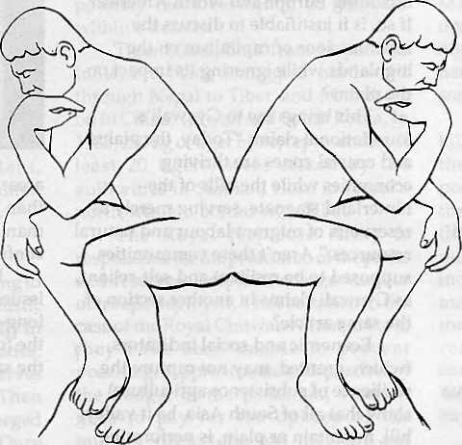

Are you looking for the cheapest rates ? Or, do you want value for your money ?
At Summit Nepal Trekking we design our programmes that ensure you get full value for your money.


MMIT NEPAL TREKKING
Write or call us at:

P.O.Box 1406,Kupondol,Kathmandu_{J}Nepal Tel:525408,521810
Fax:977 1 523737

earthquakes can be damaging and must be addressed in any seismic hazard assessment.
Bilham, however, fails to mention that there are active faults within the Eurasian crust in Nepal which are the source of moderate to large earthquakes (M=6 to 7.5) and that these earthquakes occur more frequently than the great subduction events. Although more local in extent, they nonetheless have an immense impact on the community in terms of risk to life and loss to economy, as shown by the 1988 earthquake in East Nepal. The overall picture of seismic hazards, thus, must be seen in the context of infrequent events of great magnitude with epicentres often far removed from the main population centres, and events of lesser magnitude which occur more frequently but with potentially very significant impact.
The most constructive approach in dealing with threats of earthquake in Nepal is the commitment to preventive measures. This commitment has formed the basis of the Building Code Project recently funded by UNDP and undertaken by firms from New Zealand, Canada, and the US, in association with engineering and architectural firms in Kathmandu.
There are many simple and effective methods that can be used to minimise structural damage and loss of life from primary effects (seismic shaking) of an earthquake. A full understanding of accepted methods of a seismic building design, good construction practice, better construction materials and better maintenance can improve safety against the poorly predictable seismic events. The areas most susceptible to secondary earthquake effects (soil liquefaction and landslide activity) can be avoided by land use planning. Householders can be encouraged to minimise damage from poorly located objects within or outside their houses.
A video produced by the project, and currently being shown in Nepal, demonstrates all these features for the average home owner or owner-builder to apply. However, even with the implementation of these preventive measures, two problems remain. Firstly, the numerous buildings situated in bad locations or built with poor materials — which cannot be improved. Many of
these will fail in the next major event because resources are not available to "retrofit" or improve these buildings. Secondly, it would be totally uneconomic in any society to undertake measures which would endeavour to protect against all earthquakes, especially the severe large magnitude events.
It is a fact that people living in the mountains, especially in regions of high seismicity, are subject to higher levels of risk than those living on the more stable parts of the earth's crust. Only by improving the awareness of risks and how they can be reduced, can the loss of life and economic destruction during the next major earthquake be minimised. Education is the key to this.
Gmiiam Rowlings, Vancouver
Don West, Seattle
Rain of Bricks
Roger Bilham's piece must have made people living downstream of huge dams in the Himalaya question why design engineers opt for low "g" figures which cannot stand earthquakes. The
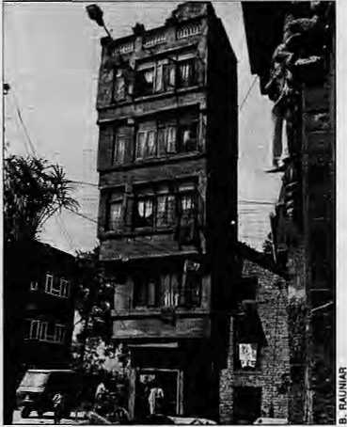
The first one to fall in Kathmandu.
reference to flying bricks defying gravity must have sounded unbelievable.
If a major quake were to hit Kathmandu, the resulting devastation would be due to not only the magnitude of the quake, but faulty construction techniques, dubious building materials, compounded by wanton lacks of quality control.
Contrary to what Bilham says about seismic considerations limiting the height of Kathmandu buildings to 15 metres, the relevant bylaws were adopted (17 years ago) merely to protect the Kathmandu skyline! Unfortunately, this too has changed beyond recognition and repair. Cheap construction and high rentals encouraged illegal construction.
An addiction grew for concrete as the demand rose for more and larger rooms. Timber, mud and unburnt bricks were replaced by cement concrete slabs made of reinforced concrete. This was followed by construction techniques based on reinforced frame structures— locally known as the 'pillar system'. The discovery of the cantilever jutting out of the building with one edge hanging free—known as 'top' locally—offered welcome space to the city's core dwellers accustomed to cramped living quarters.
This, and the opportunity provided by concrete, legitimised the cantilever's intrusion. Because cantilevers cannot be much wider than three feet, the owners tend to construct half-brick walls (4.5 inches) towards the free end. With the walls so thin, the bricks can be easily dislodged even by smallest horizontal thrust. The first things to fall in a quake will be the bricks followed by window frames.
Most modern houses running parallel to Kathmandu streets, have cantilever projections—big and small. As people run out of their houses to escape the quake, they will be greeted by a rain of bricks.
Hemant Arjyal Jhamsikliel, Lalitpur
Appalled at Himal
I would like to draw attention to the advertisement in Himal's May/June 1994 issue by a hotel sponsoring the education of five Nepali children. While congratulations are due, didn't they overiook a major detail? All five children selected are boys.
What happened to the slogans and commercials on Nepal Television about educating girls? Surely such a modern hotel is aware of issues of equality of sexes. If even they are not, how can we expect people in villages to be aware of gender issues? Two, if not three, of the five children should have been girls.

Sep/Oct 1994 HIMAL . 7


An Appeal to Readers
Asttieexchange of ideas on Himalayan issues i&'vitar, it has been Hirnaf's policy to set aside the maximum available space for the mail column. However, the letters we receiveare getting longer and longer. Before thef situation gets unmanageable, Himal appeals correspondents to please include all their ideas but in tetters that are shorter and less jargon-ridden.
(As an exampSe of what we mean, the above paragraph could be shortened with littte loss of detail to the note below. Editors)
shorter letters; i L ~
I am appalled that a reputed magazine like Himal sees fit to print such advertisement, projecting a so-called "great deed". Since it does not carry cigarette and liquor advertisements, 1 had believed that this was a magazine which was conscious of its social responsibilities.
I am disappointed with Himal. If you are short of money, I am willing to volunteer a fund raiser for the magazine at my school.
Rutna Rajbhandari
Class X, Little Angels' School
Jawalakhel, Kathmandu
We have received other letters in a simitar vein. The atfvetiiser assures us that it is considering supporting girl students. Editors
'Indigenous' is Indigenous
Rajendra Pradhan ("A Native by Any Other Name" Jan/Feb 1994) misunderstands what goes on within Nepal's ethnic Janajati movement. He seems to think of it as separatist and with tendencies to break up the country. However, the janajati leaders, in their program, state clearly that they want national unity—but a national unity that "will come from embracing diversity". One should note that not every social ethnic movement is asking for separate states; many would seek a redrafting of rights within the state, as for instance in the claims presently made in the world indigenous movement
Today, Nepai's Janajati movement definitely has a consciousness and identity linked to the world indigenous movement and the World Council of Indigenous People. The movement's members clearly consider themselves as groups which the UN defines as indigenous.
Having followed the events within the United Nations and outside for a long time, I find it difficult to agree with Pradhan when he calls the world indigenous movement a product of "western educated classes". There seem two generally held definitions of 'indigenous': one is that of being the first inhabitants of an area, while the second stresses that indigenous peoples are generally outside the realm of the state decision-making, and thus open to economic, political, social, racial and religious discrimination.
The present trend seems to be
away from the first category and towards the latter, which focuses on relative situational factors. The question of being indigenous is one of degree, depending on a group's relation with the state and whether there is any avenue for participation in national democratic institutions.
The matter of indigenous self-ascription is crucial, as also is whether or not one's self-ascription or identification is given recognition by others, both within and outside the group. In some societies, as in Nepal, the state and some intellectuals like PTadhan reject such recognition. This was amply demonstrated by the fact that Nepal sent two delegations to the UN Conference on Human Rights in Vienna in June 1993. The official delegation had no indigenous representation, while the unofficial one had. Later, the Nepali State seemed reluctant to implement activities during the international indigenous year and would not recognize basic human rights problems within Nepal.
Nepal's indigenous issues are not too different from those elsewhere in South Asia. A report to the Independent Commission on International Humanitarian Issues (Aga Khan and Hassan bin Talal 1987, emphasis mine) concludes:
InthelndianSub-continentJhecontimtal migration of peoples into the area during the past thousand years Iws made the question of antecedence too complex to resolve. There, as in other parts of Asia, indigenousreferstotribalandsemi-tribal communities.
Julian Burger (1987) also brings out the tribal distinction when he says: Ma ny indigenous peoples of the Americas find tiie term tribal derogatory because they claim they are nations, while many peoples in Asia make no objection.
This concurrence on the word 'tribal' is associated with the British
administrative term "scheduled tribes" which gave recognition to and certain rights for special groups due to their cultural separateness and marginalised status. In general, there seems to be a drift today in India to classify any groups not Hindu as tribal.
In Nepal, the word adivasi (tribes-people) is used synonymously with the English word 'indigenous' by the intellectuals. So one can now ask if the negative connotations (backwardness, etc.) attached to the term 'adivasi' are not rather a problem linked with the Nepali term and not the English one.
The English 'indigenous' was accepted by the UN only after a long period of test and trial. The assimilation aspect (i.e. making people accept dominant foreign values) was prevalent in earlier UN conventions like the ILO Convention 107. This convention was later revised as Convention 169 and is also quoted by Pradhan. However, in 1982, the UN Sub-Commission on the Prevention of Discrimination and Protection of Minorities created a Working Group on Indigenous Peoples (WCIP), with a mandate to create a "Universal Declaration of Indigenous Rights". In 1993 a draft declaration was formulated, and this will be put forward to the General Assembly this autumn.
Pradhan writes that "...indigenous peoples are a creation, an invention, of Westerners in search of a new term to replace the outmoded and derogatory terms 'native', 'tribal' or 'aborigine'." The WGIP worked for more than ten years hearing testimonies by indigenous peoples asking questions about how they perceived of their situation. As a result of such hearings, the indigenous peoples movement was much strengthened and the World Council of Indigenous Peoples (WCIP), founded in 1974, regained its strength.
The WCIP today is an organisation created by the indigenous group

8 . HIMAL Sep/Oct 1994

themselves, and they do not allow "western" members. It was recognised by the UN Economic and Social Council and from the very beginning urged to speak at hearings, which it has done time and again. Thus I can say safely, with knowledge of the debates that went on at that time, that it was the indigenous peoples themselves who forced the term to be accepted, and who through participation year after year saw to it that the UN draft declaration on indigenous issues was formulated. In no way can we consider this issue one of "Western invention".
The trouble, then, is not with a Western element threatening Nepali life, as Pradhan would have us believe. Rather, the situation is one of Nepali ethnic groups, feeling themselves to be in similar position in relation to state authority, cross-culturally identifying with each other and also with groups in similar positions elsewhere. As outsiders to these questions, both Pradhan and I should probably leave this issue to those who feel oppressed and accept the international conventions' right to apply the criteria of self-definition for indigenous groups. HaraU O.Shir Norwegian Institute of International Affairs, Oslo
For a 'self-definition' of Indigenous', see the Voices section, Edftora
Bhatt, the True Leader
While various explanations of the Chipko movement have emerged ("Axing Chipko" Jan/Feb 1994), they lack comprehensive treatment. I would like to share with Himal's readers the summary of a study I did on the movement for Ahmedabad's Indian Institute of Management.
Chipko was essentially an outer manifestation of the awareness of changing cultural and material endowments of Garhwal. My study establishes that some wrong choices were made by a vocal minority, and that resource users were never allowed to participate in Chipko.
The cultural roots of Chipko explain why it was unique in terms of its non-violent and non-political nature. The movement originated with the objective of reviving local forest management through participatory mode of action, but the ongoing events
turned it around. Chipko then became a story of the tug of war between two philosophies—economic development vs. environment conservation.
Chipko did not fail because of its noble objectives. It failed mainly because of wrong social choices by its leaders and an over-awed media that glorified the ban on tree-felling. Charismatic Sundarlal Bahuguna was an astute politician who could influence the Indian Government, But his choice was fraught with flaws, for it gave birth to Urtarakhand Sangharsh Vahini.
The participatory model of forest management, spearheaded by Chandi Prasad Bhatt, could have been the right kind of social action. Bhatt was the true leader of the masses. He had the welfare of the common man in his heart. The experiences gathered from the current programme of participatory forest management in India's 12 states confirm the credibility of Bhatf s model. His cry, however, went unheard in the midst of the cacophony created by the environmental activists, the mass media and charismatic leaders. D.D, Tiwari
Indian Institute of Management Vastrapur, Ahmedabad
So-Called Leadeis
Aryal's article on Chipko was incomplete because it did not speak of how the rights of the hill people to their
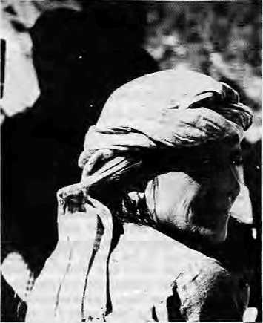
own forest land was wrested from them. Aryal's analysis should have been of what Chipko has achieved for the hill people and how shallow their so-called
leaders have been. While these so-caJled leaders amassed fame, the Pahari and Bhutia women were pushed to the extreme rear.
Virendra Painuly
Aragarh, Deliradun
Expression of Derision
Manisha Aryal's comparison of Sunder Lai Bahuguna and Chandi Prasad Bhatt is vivid and accurate: both are politicians first, social reformers second. Today, in the Garhwal hills 'Chipko' has become an expression of derision, Anand Singh Bisht, himself a participant of the Chipko Movement, today says, "Chipko might have gathered international fame but it could not give us angoo (ash) trees." Ghanashyam Sailani, the Chipko poet says, "Chipko is an illegitimate child. Everyone claims himself its father."
However, in her lengthy analysis, Aryat forgot to mention Govind Singh Rawat, a Communist Party worker from Joshimath who initiated the movement in Raini, and Bachan Lai of Gopeshwor, who was the first person to suggest the Garhwali term angwal (embrace). This is what later came to be known in Hindi as chipko.
For some reason, all hill movements tend to end with negative results. There is more liquor in the hills after the anti-alcohol movement; after Chipko there came the Van Adhiniyam (regulations) which violates the peoples' right to the forest. My late father Chiranjibilal was a real activist. He used to say, "Dil walaa kiam karta hai, aurdimag walaa, rajya" (he with the heart does work, he with the brains, rules).
These days, the Mukti Duttas of Almora and Vandana Shivas of Dehradun declare themselves the leaders of Chipko. Isn't it an irony on us hill people that we cannot even claim leadership for our own movements? Kranti Btuitt Gopeshwor, Cltamoli
Wrong on 'Bhotey*
In "Whither, Indeed, the Tsampa Eaters?" (Sep/Oct 1993), Charles Ramble does an admirable job of identifying social, religious and economic forces that shape ethnicity in the Bhotey communities of northern Nepal. The article, however, contains some serious misrepresentations of both

Sep/Oct 1994 HIMAL . 9

Tibetans in Tibet and Bhoteys in Nepal.
Ramble refers to Tibet in the pre-Chinese invasion era as serfdom. To support this he asserts, "The only entities entitled to receive revenue in Central Tibet were the church, the nobility and the state." And further, "The ordinary peasantry in Central Tibet did not own the landholdings on which they worked and they were not free to leave them."
To begin with, the pre-Chinese invasion Tibet State (i.e. the country ruled by the Dalai Lamas) consisted of far more than just central Tibet. Tibet had western districts (including Sakya) and eastern districts (including Amdo and Kham) as well. To arrive at a general conclusion on the basis of data from the central district alone is unjustified.
The fact is that Tibetan peasantry in Sakya and Kham were free to own, buy and sell as much land as they wished (they were also free to leave the land whenever they wanted). And while Tibetan peasants were obligated to pay a tax to the monasteries, this usually constituted of a bare fraction of their total agricultural produce and/or revenue from business. For example, the tax paid by Changtang nomads rarely exceeded one percent of their total produce (butter, cheese, wool, meat, etc.).
The pre-Chinese invasion Tibetan peasantry's private ownership of land, their freedom to buy and sell goods as they wished, and the significant degree of autonomy they brought to their relationship with the Tibetan aristocracy, are all very well documented in literature, such as by Jamyang Norbu and Dawa Norbu. The truth is that the majority (not all) of Tibetans in the pre-Chinese invasion were not serfs. (A serf is defined as an "agricultural labourer who is bound to the land to such an extent that he may be transferred with the land to another owner" — Seymour Smith, 1986).
Ramble also gives the erroneous impression that most present-day Bhotey are jet-setting entrepreneurs who spend much of their time flying all over South and Southeast Asia on
business trips. He asserts further that while these Bhotey adults speak among themselves in their own Tibetan dialect, they talk to their children in Nepali, educate them in boarding schools in Kathmandu and India, and further, are even proud if they cannot speak their native Bhotey language, but talk in Nepali and English instead. Indeed, Ramble concludes that Bhotey encourage their children to cast off their Bhotey identity and replace it with what he refers to as a "nondescript internationalism."
The Bhotey that Ramble refers to are a very elite group, a tiny minority who are not representative of the Bhotey majority. The majority of the Bhotey are villagers all across northern Nepal who have a diversified economy that includes subsistence agriculture, livestock husbandry and trade (that carries them to Kathmandu and often to India and Tibet as well). These Bhotey encourage their children to learn Nepali (and Hindi) as well as their own dialect. Many are barely able to send their children to local Government schools, much less to schools in Kathmandu and India.
What really needs to be emphasised is that while these Bhotey are often adept at moving between cultures, they do not just nonchalantly cast off their language and religious traditions. In most cases, Bhotey continue to follow some, if not most, of their local religious traditions, but reject others and end up with a very individual, consciously designed mode of cultural/religious practice that is anything but nondescript. Thomas E. Cox Kathmandu
Charles Ramble responds:
Thomas E. Cox's latter gives me the unsettling feeling of having stumbled into a crossfire of a well-entrenched dispute and being forced to take shelter in a hostile camp. His remarks are indeed reminiscent of a protracted and interesting e xch an gs of i ette rs wh ich n o a nd a cc rr es pond ent once sustained in the pages of a scholarly journal—1 forget which one. What I do recall, however, is that it discussed the question of serfdom in Greater Tibet, and the part of Greater Tibetcontrolledbytrie Dalai Lamas. The criticisms raised in the present letter would unquestionably be relevant if, in my offending article, I had said anything at all on this matter. I did not.
Cox quotes the passage in which I refer to serfdom in Central Tibet, concedes that there's nothing contentious about it, but criticises me
anyway, apparently just in case I might have said something else. He further accuses me of implying that economic system of Central Tibet was generalisable to the rest of the country. I do not.
The second main objection in his letter is the'erroneous impression" my article gave that "most present-day Bhotey are jet-setting entrepreneurs". I have re-read the article several times and am still unable to see how I could have given this impression. The relevant portion of the article talks very specifically about "traders who spend long periods abroad in developed countries", who, as Cox rightly observes, are an elite group, a tiny minority. I did not impfy that they were representative of Bhotey population. What I did propose was that the offspring of these international traders might, if they returned to their parents' villages, become "the cosmopolitan paradigms for the succeeding generation". The difference is the crucial one between astatusquo and an unlovely possibility.
But the important issue here is not the defence of opposed positions, since I have no argument with Cox's remarks. What may be more important are the troubling implications of the fact that what I say provoked Cox to mount an attack against something that I did not. Re-reading my passage about serfdom, I can just about seehow it could be taken to refer to Tibet as a whole, although such a reading would require forcing what's actually on the page. It intrigues me that Cox woutd findit worthwhile to apply die necessary force.
t can only speculate on this. Perhaps his reasoning is analogous to one of the more dangerous axioms that paralyse constructive discussion of Tibetan politics by forcing a polarisation oi stances: namely, that someone who mentions the existence of serfdom in Central Tibet, or appears to be critical of the pre-Communist regime, must ipso facto be hostile to Tibet and the cause of Tibetan independence. If I do not subscribe to the myth of Shangrila, must it follow that I believe in the insidious Utopias of China Reconstructs? On the contrary, there is a vast middle ground.
The version of the art cle which I submitted tor publication contained following passage: "The use of the term [serf] implies neither a moral judgement on thepolitical system nor a justification for the brutal destruction of an extraordinary civilisation. It's simply a matter of dictionary definitions." The passage was cut by the editors, and I have no objection to that: it pleases me to think that someone might have regarded it as superfluous.
Concerning my supposed denigration of the rich ne ss and disti nctivenes s of B hotey cul ture, a closer look at the latter stages of the article should set the records straight. And as for the culture being nondescript, it would be rather ironic if I had really said this, since a worryingly targe part of my adult life has been exercised precisely by the effort to describe it.
Readers era invited to comment, critii or add to information and opinions appearing in HimaLLettarsshouldba brief, lo the point and may be edited. Letters which are unsigned arid/or without address^ will not be entertained. Include daytime telephone number, it possible,:
email; himat@rfrosnepal.ef net. in

10 . HIMAL Sep/Oct 1994

Buddhijibi

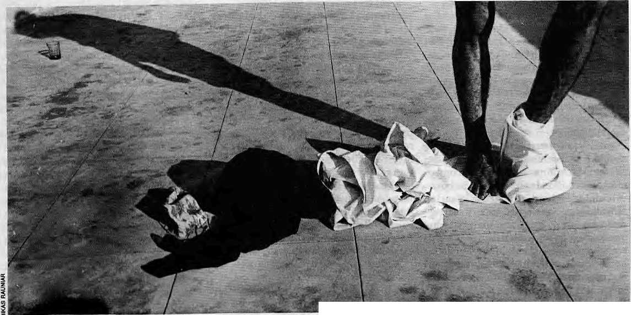

Intelligentsia Has No Clothes
by Dipak Gyawali

A
fter a long history of isolated stagnation, Nepali society is entering 'times of trouble'. The stress of change is everywhere—the economy, the environment, religious practices, relations among ethnic and linguistic groups, managing political affairs, educating the new generation, caring for the sick and needy, and building and operating modern infrastructure. The list is long, and traditional institutions of feudalism—such as organised Hinduism at the state level trusted to interpret national values, or kinship guthis at the local level responsible for organising Kathmandu's urban space—which should have been managing this stress, are sadly helpless to influence change. They may seethe in fundamentalist or obscur-
antist rage but the seductive charm of modernisationisrelentlessly undercutting tradition.
For such a body social, where is its head, if ithasone,andwhatis it thinking? Has it got some fixity of purpose, if not clarity of vision, or is it disturbed, schizophrenic, perhaps autistic?
In the past, to pose these questions would have been merely to indulge in intellectual tifiliation. Rana rule required only scholastic priests who were keepers of an old and moribund tradition, not seekers of new truths requiring, besides analytical acumen, a boldness that could warn of impending dangers to the social fabric and speak truth to power.
The brief flicker of democracy in the 1950s saw a small measure of intellectual
awakening, but one which was concentrated in literature and not so much in other spheres of national life. Society's hopes, kindled by flights of poetic imagery such as those of Laxmi Prasad Devkota's, could not be met in the absence of Nepali bankers, lawyers, industrial managers or modern administrators armed with the intellectual tools to remake the management of social affairs.
The Panchayat rule, imposed in December 1960, was but a reassertion of the old feudal order alarmed by the pace of modernisation. The system needed intellectuals, mostly keepers of tradition, but also some managers of new truths that emerged discomfittingly with the entry of modern technology. Engineers and doctors therefore had a field day in

Sep/Qct 1994 HIMAL . 11

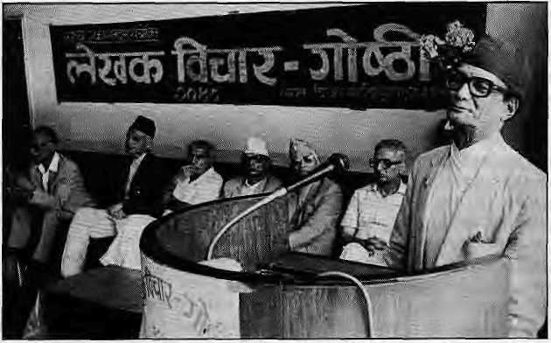
the Panchayat years, but those seeking newtruthsin social, political and economic affairs were either discouraged, went into exileinexpatriatedonor agencies, or were co-opted and shackled with privileges so as to rein in free-wheeling questioning.
Today, with democracy, a long-slumbering society has already given notice thatitin tends toleap into thefuture, riding the waves of mass culture and popular will. It is a future where everything will be mercilessly questioned, especially by those prevented from doing so in the past. Under assault from pent up fury of ages, only such aspects of tradition and culture will remain standing which can be rationalised to suit a new day and age.
What will that future be like, or what should it be like? Is that leap going to be performed in a state of groggy muddleheadedness? Or will it be a calculated effort towards clearly articulated goals? Nepal is today a society searching for its head, and about to run amok in fear and desperation as its searching hands find nothing but vacuous hot air where something more substantive and reassuring shouid be.
BuddhijibiBarga
A buddhijibi—the Nepali term for intellectuals which literally means "one who makes a living by exercising his brains"—is someone other than a sramajibi, one who lives by his brawn. But by its very reference to physical sustenance, 'buddhijibi' is more befitting of a compliant keeper of tradition than a bold seeker of the unknown. To encompass the latter category, a species that is admittedly rareintheNepaHsocialfirmament,several adjectives are attached to buddhijibi, such assaMtanfra(independentornotemployed by government), mspafofa/a (non-partisan or, at times, bold enough to go against established views), and sometimes even the English word 'frank'.
This linguistic anomaly is symptomatic of a social undercurrent: the intellectual as understood by the European Renaissance does not exist because Nepal has not had the historical experience of a reawakening. It has its share of ossified Oriental literati of the type that were to be found in the vast state bureaucracies of Mesopotamia, but very few capable of looking ahead and warning society in time about the impending dangers.
To hold up the intellectual as the
very subject of inquiry is no easy task,and certainly one in which little unanimity can be expected. Fortunately, the intellectual as a social category has been insightfully examined by many thinkers. The state of the nation's intellectuals can be fruitfully analysed against the backdrop of what these thinkers have written.
Arnold Toynbee, the British historian, feels that the intelligentsia is a class that appears in a society that is facing the threat of external intrusion by an alien civilisation which is powerful, more creative and dominant. This class functions as a middleman, not only interpreting and applying the tricks and tools of the dominant power, but also putting up a vigorous civilisational response. In India, at the mundane level, they were the Bengali 'babus' who held the quills of the Raj. At the more sublime level, they were thereformers of Hinduism who felt the need to adapt and adjust if they were not to be swamped by alien values—Ram Mohan Roy (anti-suttee), Kesab Chandra Sen (anti-child marriage), and Ramakrishna, Vivekananda,Tagore...
Mere collection of learned people does not make for an intelligentsia unless the historical threat and a parallel collective move to adapt and survive is there, according to Toynbee. Brahmin pundits placating the gods and maintaining purity would not form a class of intelligentsia, but Brahmin Marxists negating the caste system and calling for a new proletarian order would. So would Nepali thinkers who felt a need to preserve the Nepaliness of society even while analysing, adapting or countering alien values.
Unfortunately, Kathmandu society has not been given to intellectually
vigorous confrontation. Retreat and isolati on have prevented reformation and renewal- Attempts to introduce Hindu reform movements, for example the Arya Samaj, were crushed. Madhav Raj Joshi, an early Arya Samajist, was exiled tolndia by the Ranas. His son, Vedanta scholar Sukra Raj Shastri was hanged in January 1941 on sedition charges. Similarly, Newari Buddhist reformers were exiled to Darjeeling; and even today, Nepal is one of the few countries without a reformist Ramakrishna Mission.
Intellectual Spectrum
From Toynbee's grand historical panorama, one can move to Paul Baran, an American neo-Marxist professor able to hold his own even at the height of the McCarthy era witch hunts, who makes a sharp distinction between intellectuals and intellect workers. By his reckonings buddhijibi would not qualify as an intellectual unless he is able to systematically relate the significance of his work to the entire framework of social acti vity and thehistoricalprocessat work.
Nepal today abounds in 'intellect workers' safely ensconced in ministries, state corporations and even private consultancy services, awash in privileges compared to their less for tun ate brethren, but intellectually pusillanimous and politically irrelevant except as a reactionary force out to protect their fiefdoms. Intellect workers cannot function as a much needed social conscience in times of trouble.
Closer to today's scholarly concerns is Ahmed Sadri, a sociologist steeped in both Iranian and Western intellectual traditions. It was he who categorised intellectuals into "seekers of truth" and
Ad nauseum:
anothor
literary
bichar
gosthi in
Kathmandu.

U . HIMAL Sep/Oct 1994

"keepersoftradition".Sadridifferentiates between exemplary prophets and emissary prophets, those committed to ideas (pure rationalisers) and those committed to themasses (practical agents of ideas). Such a categorisation helps us to tease out the finer nuances between buddhijibis of various hues.
A priest, a librarian, a bureaucrat, a run-of-the-mill doctor, engineer or lawyer, would be practical agents of ideas, committed to the masses and keeping aliveahanded-down tradition. A monk,a critic, an expert researcher or consultant would be a systematiser, that is, intellectuals re-interpreting and routinising ideas but without commitment to the masses.
Mystics, top theorists, and men of letters and arts, those propelled by the search of pure truth and having little reverence for tradition or the masses, become the exemplary prophets of their ages. When those engaged in high intellectual pursuit simultaneously show a strong commitment to the masses, they become emissary prophets, leading reformers, philosopher kings, liberators and revolutionaries. Going by Sadri's classification, the former would be a Buddha, a Jesus, an Einstein, an Adam Smith oraMarx, while thelatter would be a Padmasambhava,a St. Paul, art Edward Teller, a Margaret Thatcher or a Mao. It might be asking too much for contemporary Nepal to produce another such, but then it tsinmuddy waters, the times of troubles, that the lotus blooms.
In this scheme of categories, Nepal's intellectual world today is weighted heavily in favour of the keepers of tradition: there are too few dedicated to discovering new truths and ideas. To borrow from Baran, the situation is weighted in favour of intellect workers; and to see things from a Toynbeean perspective, modern Nepali society has been so enticed and absorbed into the process of Westernisation, that it has hardly noticed the slow obliteration of its soul, nor been able to produce a vigorous counter response through an intelligentsia. What exist are not the reformers such as Vivekananda but merely the clerical 'babus of the Raj' variety, who facilitate mass modernisation but are ineffective at adaptation and reinterpretation.
If the search for the real Nepali intellectual is not to be as elusive as that

for the abominable snowman or as banal as that for the marketed Shangri La, the defining features of such a search must be the intellectual's ability to squarely face the impending change instead of hiding in comfortable bureaucratic niches, to think one intellectual step further than one's fellow coun hymen, to explain today using the past, and to see the consequences of today's actions a couple of decades further into the future.
Creativity Fatigue
What smallintelligentsia Nepal does have, has been produced in the process of modernisationoverthelastSO years. They haveei ther been themodern professionals, such as doctors, engineers and lawyers educated abroad and with exposure to English and the West, or Sanskrit-educated (mostly) village Bahun forced into confrontation with the English language and the ways of the West.
The latter classicists have nowhere to escape, and have therefore adapted themselves to the stress arising from the encounter of civilisationsby plan ting their feet firmly in their own soil. They aie found as school masters in schools all over village Nepal, in the Nepali civil service, in political parties, and they even formed a substantial block in the now dissolved Lower House of Parliament. By onecount,52ChiefDistrictOfficersoutof the country's 75 were Sanskritists.
The Sanskrit-educated thus form the true intelligentsia in the Toynbeean or
Baranian sense of the word, even though in Nepal they seem to suffer from some diffidence. Much of the world of science would be outside their reach unless they master English. (The only cheaply and widely available reading matter in Nepali in the villages is often either Christian missionary literature or Comrade Kim II Sung's Juche ideas together with China Reconstructs.)
On the other hand, the commitment of the former group (of the Western sophisticate and professional) to the society of birth has been diluted by job opportunitiesabroadorindonoragencies that may geographically be in Nepal but culturally in Europe or North America. The products of some of the best "boarding schools" man thelobbies of five-star hotels as highly paid social misfits of thetourism industry. Rarely are they found in the corridors of power, or debating the gut social issues. It is the failure of this set of modern intellectuals to effectively contribute to defining the larger national life and its debates that makes the Nepali intelligentsia naked in the eyes of the people and the world.
This professional intelligentsia was born out of the need to develop and maintain modem infrastructure such as roads, hospitals, banks, electrical system, etc. Many of these items were introduced by foreigners; and it remained quite an irony—and a telling commentary on Nepal's intelligentsia—thatin the world's only "Hindu kingdom" for much of the post-Rana period from the 1950s to the 1980s the best schools and hospitals were runbyChristian missionaries. Even in the much vaunted water resources sector, the only Nepali organisation capable of actually building medium-sized hydroelectric power plants today is one initially set up by missionaries in the private sector.
In contrast, the engineering profession backed by the Nepali state practically stopped doing engineering since the mid-1970's, choosing instead to bemanagers of global contracts. Linguistic hierarchy in the Nepal Electricity Authority is a good example. It runs thus: managing director, directors in chief, directors, deputy directors, managers, deputy managers, and so on. It does not go as: chief engineer, superintending engineer, divisional engineer... What this reveals is that there is no position of an engineer in the country's premier technical

Sep/Oct 1994 HIMAL . 13

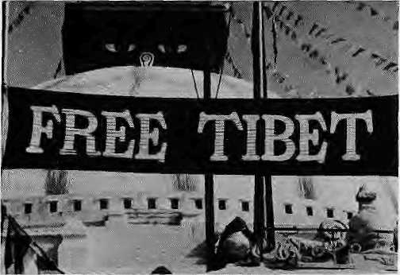
institution. The agency mostly manages contracts since it adopted the expensive, large-scale Kulekhani path of power development in t974, leaving down-to-earth engineering to expatriate consultants and contractors. The situation repeats itself in the road, irrigation, telecommunications, and water supply sectors.
The professionals have also inhabited sectoral organisations in health, education, finance,socialwelfare,etc.,buthavefailed to lead the national debate or to project a vision in any one of them. Part of the reason must go to foreign aid, which has so thoroughly come to dominate the modern sector that the professional intellectuals, whether as civil servants or as private consultants, are cravenly beholden to the real paymasters of the country's political masters.
Stable of Docility
Many of today's ills, from education to engineering, diplomacy to social service, can be traced to the early 1970s when decisions on a large-scale, foreign contractor-led pattern of development— whether it be Kulekhani, the infamous World Bank-funded urban water supply projects or the New Education System Plan—were taken up by a Panchayat system that had lost creativity.
In fact, the creativi ty of the Panchayat system (implying theuse of the intellect to reign and rule) was already a spent force by the time King Birendra inherited it. Theintelligentsiawhichshould have been challenging this decline into inevitable stagnation, in every sector, chose to play it safe.
In the country'sonly university till of late, the intellectuals mandated to produce new thinkers for the future have been a Toynbeean internal proletariat of modernisation, a stable of docility that has not goaded the nation with new vision or ideas. A few who had some vision used the university as a stepping stone to higher bureaucratic assignments, never to return to enrich its intellectual milieu.
One of the implicit purposes of Tribhuvan University under the Panchayat was to sequester free thinkers and rein in their propensity to challenge the existing order. Its mater was the Trichandra College, whose foundation stone was laid in 1918by a reluctant Rana Prime Minister fearful that he had just dug the regime's grave. The legacy lived
on after the feudal restoration of 1960 and the University could not rise above being a certificate-churning unit producing 'babus' for the Panchayati Raj.
Allthisisnow his tory;whatis galling is that the University has not been able to galvaniseits cerebral crucible even in this, the fifth year into democracy. The soul of a university—its lively post-graduate colloquiums and cutting-edge faculty research—is lost in the banality of form over substance.
Economists and sociologists are the tribe of intellectuals whose profession should have made a dent in defining a neworder,buthasnot.Despitedemocracy and a change in the political system, the 1985 Structural Adjustment Programme of the World Bank or the macro-economically damaging Arun III project (conceived around the same time) have been swallowed whole without questioningorpublicdebatebyamajority of the professionals, secure in their bureaucratic cocoons. Sociologists have been enmeshed in kinship and gender analysis of exotic tribes rather than facing the problems of civil society in the burgeoning cities and other potential hotspots. Many who are sustained by the donor-backed consultancy business have chosen the easy route of simplistic "baseline studies", leaving the rarefied heights of policy distillation to expatriate greenhorns.
A rugged mountain economy could be run in central planning style only at great cost to its efficiency, especially in harnessing local creativity; but decentralisation of economic pow er remain s a matter of lip-service by the new political masters. Despite democracy, devolution of power to alternative chains of command, to local government or outside-of-government bodies is not proceeding by an effort of will but only through the obvious, but sporadic, reality of electoral politics: thevotesaremostlyoutside Kathmandu and the need to move money there is an inbuilt pressure of democracy—not an enlightened management choice of Kathmandu's rulers. Intellectuals advising these rulers areunable to coalesce into effective think tanks, mulling over
matters of good governance.
Civilisational Failure
When Nepal gave up survival through conquest in 1816 in the aftermath of the Anglo-Nepal wars,it had no choice but to develop diplomatic skills and intellectual firepower. Although Rana rule was a retreat into isolation, it had in Chandra Sumshere one of the mo st astute d i plomat-rulers in Nepali history. In the modern era. King Mahendra was another such figure, despite his anti-democratic predilections. Bisweswor Prasad Koirala was one commoner who matched and surpassed Mahendra, and it was ill luck that the enlightened autocrat and the intellectual democrat appeared at the same juncture, eclipsing each other, Nepal is still suffering from this tragedy of historical spacing.
The collapse of the Second World in Eastern Europe means for the Third World that the Age of Foreign Aid is coming to a close. Where are the Nepali diplomats skilled in international economics who can lure investments this way? In the entire Himalayan belt from Afghanistan and Kashmir through Uttarakhand, Darjeeling, Bhutan and Nagaland, populations are seething with pent-up dissatisfactions of epic proportions. In this cauldron, where are the statesmen who can negotiate an elbow-room "zone of peace" for this country? And how well has Nepal's truly historical ties with Tibet been forgotten by an intelligentsia which should be free of the geopolitical concerns that shackle
the ruler and bureaucrat.
Intellectuals manning thebarricades of political and legal studies have been quite ineffective in defining and interpreting the new political order, A

14 . HIMAL Sep/Oct 1994

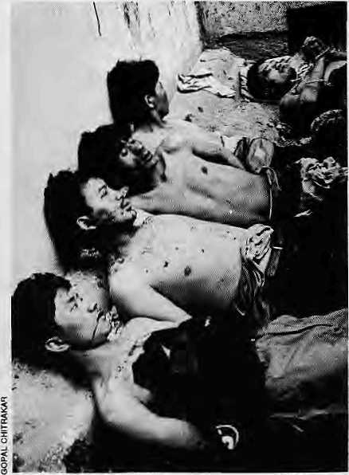
Dead and dying police of 1990.
new constitution was drafted, amidst domestic euphoria and hosannas from abroad, imitating Westminster and idealistically envisaging over-riding judicial supremacy. Today political and ideological forces find the constitution so restrictive, or unreflective of historical ground realities in Nepal, that protest has to be heard outside of the Parliament, and a party with a majority cannot run a government.
Nowhereisthederelicti on of intellect more evident than in the recent political wranglings in Kathmandu, to which "constitutional crisis" would be too genteel a term to apply. Mundane matters of parliamentary democracy—the right of a prime minister to call for midterm polls—is challenged in court; and when the court decides in favour of the prime minister, national leaders such as Ganesh Man Singh of the Nepali Congress and Man Mohan Adhikary of the United Marxist-Leninists, opine that "the Supreme Court should have given its verdict as per the popular feelings".
Granted thatyoumightnotlikeGirija PrasadKoirala,butthatisnoreasontoask that a civilised seat of justice behave as a kangaroo court. The Supreme Court, on its part, inexplicably wentahead deputing judges as election officers even while the case challenging the legality of the
dissolution of the House and the elections was sub judice before it.
Where are the political intellectuals and human rights activists who should have spoken truth topower,boththeGovernment and Opposition, these past four years? Underlying the political bankruptcy of both the Nepali Congress and the Left is the intellectual bankruptcy of its adherents who choose loyalty to personalties over fidelity to reason. After performing such a "sacrifice of the intellect", it is impossible for them not to be afraid of diving deep below the surface of issues toaddress the structural anomalies oftherecent crisis in democracy and the Constitution which upholds it.
A Communist leader dies when a jeep plunges into a river along a highway where busloads of people have died similarly earlier. Before investigations had even begun, supposedly responsible leaders of the Left were already using the word "assassination", and subsequently took the nation to the brink. Meanwhile, nobody dares speak for the driver of the jeep—by all accountsa loyal party hand— languishing in jail. Other than the exception of Rishikesh Shaha, "human rightsactivists" of all hues scurry forcover rather than defend the most hallowed of all principles—"not guilty until proven". Earlier, in 1990, as King Birendra conceded sovereignty to the people, rampaging mobs outnumbered ahandful of menial policemen and conducted an excruciatingly cruel eight-hour lynching in broad daylight along Kathmandu bylanes. No one came to the rescue, and who remembers them now? No academic felt the need to study the sociological and psychological implications of an incredible event. A year later, when demonstrators once again took to the streets, nervous and ill-trained policemen with good memories are unwilling to go in for hand-to-hand crowd control. They shoot into the crowd and several civilians die. All the public hears thereafter from human rights watch groups and opposition politicians is of conspiracy theories and police brutality. But where were the scholars whose job it is to put such incidentsincontext,and to try and explain and leam from wrenching events? The social scientists twiddle their fingers and
look skywards when confronted with tough, unpopular conclusions, while human rights intellectuals huddle in their safe escapist havens.
Today's new rulers of the Right and the Left, despite being mandated by a popular democracy, are showing as little creativity as the Panchayat in its dying throes. They are still culturally bound to the time-honoured system of chakari, rent-seeking and feudocratic entitlement to power, without renewing their mandate either through popular or party elections. The new pandits who whisper in their ears have not managed, worse, do not seem to want, to create new and effective fora where reasoned debates are conducted and conclusions heard. Not yet for Nepal the famous salons and parlours of an intellectually vibrant Europe where a Voltaire or a Carlyle could be heard.
Is therehope? Despite the pessimism and cynicism, the answer is a resounding Yes! Those who would light a candleratheT than curse the darkness can, under democracy's umbrella, act and organise. All we require is a handful of motivated professionals in each sphere of national life,and you have the stagef or a medium-sized renaissance. There will be self-confident women and men, exposed to the wider world of modern ideas, but with their" feet firmly on Nepali soil.
Such a long-term view may not be of much solace to those suffering the yoke of everyday inflation and service breakdowns,butrenaissance is not instant coffee. It must be preceded by hard and grinding rationalisation. One inter-generational hope is that the fight for a better order begun by the homegrown "vernacular intelligentsia" will be joined by at least a few of the younger set in the Nepali diaspora abroad who, armed with the intellectual tools of the West, will return to strive in their country, and, if Nepal is too small, as South Asian intellectuals grappling with the titanic problems of the region. They will find more satisfaction becoming socially relevant in the region than as materially well-off internal proletarians abroad. Essential is demonstrable commitment to a troubled society.
D.Gyawali is an engineer and economist, and Chairman of Swabalamban, a grassroots organisation working with marginalised communities in rural Nepal.

Sep/Oci 1994 HIMAL . IS

Speak Truth to Power

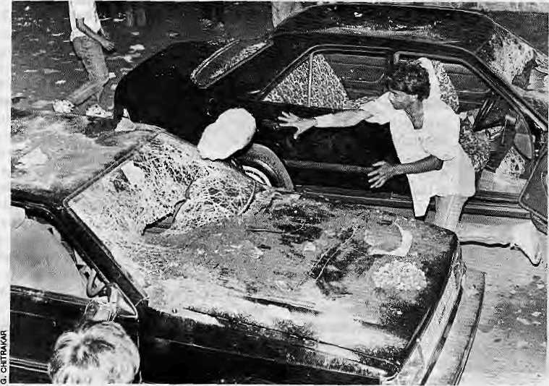
The main threat to Nepal's political stability is likely to come from the failure of the educated elites to cope with internal social forces.

OD
by Rishikesh Shaha

T
oborrow the words of Edward Said, the intellectual is he who possesses a faculty for "representing, embodying, articulating a message, a view, an attitude, philosophy or opinion to, as well as for a public in public." Such a role has something special about it, a special responsibility to raise embarrassing questions and challenge orthodoxy and dogma. The intellectual cannot be easily co-opted or hired by governments or corporations. Hismissi on in life is to represent all those people who are routinely ignored orthoseissues which tend to be swept under the carpet. Intellectuals are on their own and at their best when they attack corruption, and stand up for the weak.
According to the mid-century man of letters Julien Benda, intellectuals are a minuscule group of highly talented and morally equipped philosopher-kings who represent the conscience of mankind. Benda's treatise, LaTrahisondesclercs (the betrayal of the intellectuals) is a scathing attack on those who abandon their roles and compromise their principles. Benda mentions a few names and delineates characteristic features of those regarded by him as intellectuals — Socrates and Jesus, as well as more recent names like Spinoza, Voltaire and Ernest Renon. The image of the intellectual as
conceived by Benda is an attractive and compelling one. The intellectual stands out as someone capable of speaking the truth to the powers-that-be without mincing words, an extremely articulate, courageous and angry individual for whom no worldly power, however big and imposing, is above reproach.
Benda was spiritually influenced by the Dreyfus affair, which had compelled intellectuals either to stand up against an act of anti-semitic military injustice and blind national fervour, or slavishly go along with the sheepishhorde refusing to defend the unjustly treated Jewish officer Alfred Dreyfus.
The intellectuals have, as a rule, to choose between a despondent sense of powerlessnessattheirbeing marginalised, and joining the ranks of institutions, corporations and governments as a member of a relatively smaller group of insiders who take important decisions on their own and without responsibility. There is another alternative open in the modem age, toact as the "hired" agents of an information industry, but that is also no solution to the intellectual's basic problem, that is, to achieve a relationship with an audience like Tom Paine's. "The means of effectivecommunication" which is the intellectual's true domain, is now being expropriated by the media.
As the American sociologist C. Wright Mills points out in his bookPower, Politics and People: "The independent artists and intellectuals are among the few remaining personalities equipped to resist and to fight the stereotyping and consequent death of genuinely living things. Fresh perception now involves thecapacity to continually unmask and to smash the stereotypes of vision and intellect with which modern communications (that is, modern system of representation) swamp us. These words of mass-art and mass-thought are increasingly geared to the demands of politics. That is why it is in politics that intellectual solidarity and effort must be centred.Ifthethinkerdoesnotrelatehim$elfto the truth in political struggle, he cannot responsibly cope with the whole of live experience," (Emphasis mine.)
Th e ab o ve quo tation d eserves careful attention. Politics is omnipresent; one cannot escape into pure art and thought, or for that matter into the sphere of disinterested objectivity, or transcendental theory. Intellectuals havean uphill task of resisting some of the pernicious influences of the information and media industry by disputing and refuting theimages, official narratives, justifications of use of power circulated by an increasingly omnipresent media. The intellectuals must be on their

16 . HIMAL Sep/Oct 1994

guard against being herded by the mass politics of representatives, which the information and media industry services. Sticking by the truth is no easy task.
The real intellectual mustbe prepared to stand above rather than go along with the crowd. However, ivory tower intellectualism coupled with wishful longing or bitter criticism is of little use. Modern insights together with actual involvement in ameliorating the conditions of national life are needed in young leaders who, despite their dissatisfaction with the present state of culture and politics, will be able to adapt it purposefully to new circumstances and avoid the risk of blind and reckless modernisation.
In recent years, the gap between the masses and the modernising intellectual and bureaucratic and political elites has grown more rapidly and become much wider than that which existed between the traditional or feudal elites and the masses.
In Nepal, the educated class or intelligentsiabelongs to a tiny upper crust of the privileged section of society called
the middle class (which is also not expanding as fast as it should have been), as distinct from the majority of the people who live in poverty and are subject to the strains of a subsistence level existence. But a large portion of the middle class is itself vulnerable to innumerable pressures because of its comparative poverty.
However, the degradations of poverty can and should be resisted with the help of a basic sense of integrity. Unfortunately for Nepal, the educated middle class on the whole hasbeen found wanting in this respect. Meanwhile, the relative prosperity of some members of the more fortunate elites has created in theman utter indifference to the principles of social morality or the interests of the society as a whole.
Thesorialtiesbetweentheindividual and family, the tribe or the clan are disappearing under the impact of time and social change, but the elites have not been able to forge new social ties in the shape of increased awareness of their responsibility towards the nation and society. Unable to withstand either the strains of poverty or that of prosperity,
they have developed a split mentality which is the worst enemy of national character. The elites have neglected traditional values without being able to adopt or adapt western values in actual practice.
I believe that the main threat to
Nepal's political stability is likely to come
from the failure of the educated elites to
cope with the internal social forces whose
momentum and pressures are likely to
increase as popular discontent mounts.
Countries forced to meet the challenge of
internal social forces cannot always count
on outside help in withstanding this
pressure. If the mass base of discontent—
students, workers and peasants—should
stir, theirprotest movements will seriously
undermine stability in the country. Let us
learn from the experiences of other
coun tries far and nearand act wisely while
there is still time. Will the Nepali
intelligentsia, which forms a substantial
part of our governing and non-governing
elites, rise to the occasion? ^
R. Shaha, diplomat, human rights advocate, man ofletters.isoontestingtheNovemberPariramenlary ©lections from Kathmandu.

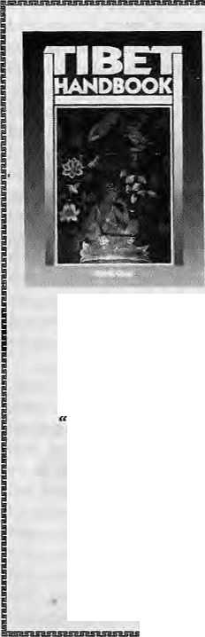
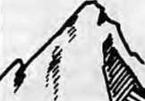
"This is by far the most detailed and
comprehensive guide to Tibet ever to appear
in a Western language.. ."
—Dr. Michael Aris, Oxford University . invaluable for those going on pilgrimage or extended treks."
—Melvyn Goldstein, Center for Research on Tibet
MOON PUBLICATIONS
P.O. BOX 3040 CHICO, CA 95927-3040 USA
(916)345-5473
TIBET
FIRST EDITION
1100 pages • 250 maps US$34.50 postpaid ISBN 0-918373-90-5

HIMALAYA
EVEREST.K2
ANNAPURNA
MUSTANG
MANASLU
LADAKH
KAILAS
RUPSHU
ZANSKAR
SPIT!
TIBET
BHUTAN
Walk in small groups to
unaffected places hidden in
the world's highest mountains.
Live in pure culture.
Walk back.
801-355-6555
FOR A FREE CATALOG
fSNOWLlON

Sep/Oct 1994 H1MAL . 17

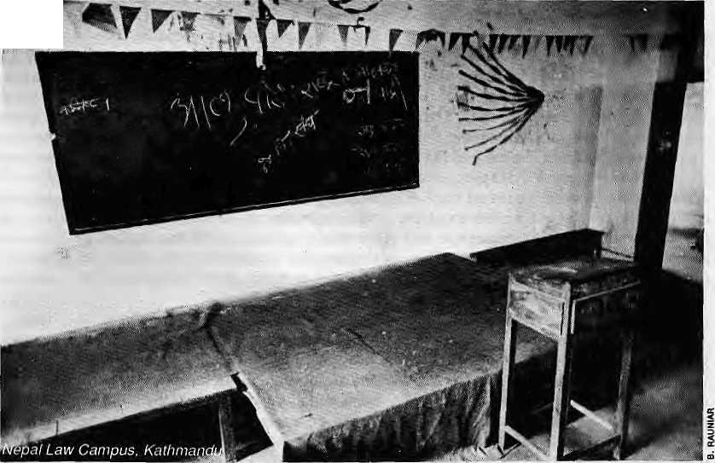
A Generation
Lost f x
Nepal's education
system has
delivered
a generation of
mediocre graduates
now in their
30^{f}sand40's.
by Ashutosh Tiwari

I
f Nepal today faces a severe shortage of qualified and able intellectual leadership—in just about every front from industrial managementto university professorships, from civil service to journalism, from political activism to social service, theblame must be placed squarely on the education system of the Panchayat years.
The legacy of that wasted era can be found in the generation that is today in its thirties and forties, whose intellect was never aroused by challenging education, and whose creative potential was therefore laid waste. A new lost generation is presently in making—five years into democratic rule, Nepali higher education has not changed course, and those attending class today have not been nurtured any better than were their fathers and mothers.
Rather than be shocked at the abysmal level of public discourse, the politicians' unbridled opportunism, the professionals' lack of commitment, or the irreconcilable greed of the so many nongovernmental organisation 'activists', it is necessary to understand why, when we are confronted with nation-building, Nepal is left with loud-talking non-performers as society leaders. These people were just not taught right, and
whatever ability they might have had to emerge as society's guides, was never promoted. The country lost a generation.
The feudal Rana era ended in 1951 with Nepal boasting all of two colleges with 250 students. The Tribhuvan University was set up in 1959, and within two years it had 33 colleges and 5143 students. Today, Nepal has 209 private and public colleges with an enrolment of over a hundred thousand.
The boom in the numbers was not accompanied with an awareness of the need for quality. Educational egali-tarianism had come to stay, summed up in the idea that higher education at state subsidy should be made available and accessible to all secondary school graduates, irrespective of their aptitude or even interest. College education was no longer seen as a selected passage for a gifted few (the defining element of the Rana years), but an open field to which everyone enjoyed virtually unrestricted access.
Nepali higher education up to 1970 at least had the saving grace that it was based on the old rote system of learning— dull but functional. It did not propose to carry out an experiment, on the lives of tens of thousands of Nepal's young and back it up with so little commitment. That
credit goes to the National Education System Plan, launched midstream in the Panchayat years by Crown Prince (and soon therafter king-) Birendra, as his defining contribution. The country is still reeling from the impact of the failed Plan.
As crown prince, King Birendra had attended Eton College, Harvard and Tokyo Universities. Narayan Prasad Shrestha, the most powerful presence in King Birendra's Palace Secretariat, recalls that the King had been very impressed with the Japanese educational system, "which combined modern education with ancient heritage. Upon his return, His Majesty felt that Nepal needed a similar system of education which emphasised change as well as continuity to meet the challenge of development."
It did not quite work out that way. With the full backing of the Royal Palace, the educational planners did bring about sweeping (but cosmetic, it turned out) changes. All colleges (henceforth to be called 'campuses') were nationalised and thrust under the central authority of Tribhuvan. A new system of grading and evaluation was introduced, requiring teachers of quality and confidence, and the academic year was divided into semesters. The National Development Service (NDS) was launched, a programme

18 . HIMAL Sep/Oct 1994


through which Master's level students spent a year in social service at assigned villages.
OtherthantheNDS (which wasdoing well until scrapped in 1980 by a king worried about the outcome of the plebiscite on the Panchayat System which took place that year), the National Educational System Plan was a wasted, unrealistic effort that only flaunted an attractive, modernistic outer shell. It was a fiasco at all levels—conceptual, practical, financial, bureaucratic and political.
The misperception among Nepal's educated is that going to college is everyone'sright,andnot,as should be the case, the privilege of a gifted few. With royal patronage and the monopoly of the media, the planners had a chance to clarify this societal confusion and to put
intellectual elitism into the academy. For all its much vaunted forward-thinking, the Plan failed to do so. It also failed to lure the academic non-performers-—the bulk of the entrants thrown up by an equally unsatisfactory secondary school system—to sign upfor vocational courses. The educated middle-class dismissed the Plan as a conspiracy to push their not-so-gifted children off the 'doctor-engineer track' to that of carpentry, farming and masonry.
The England-, US- and India-trained planners overhauled the educational system of Nepal, but they did not provide the vision, and King Birendra was found lacking in commitment. He did not provide sustained leadership to his brainchild,as was evidentintheease with which the NDS was set adrift.
The Plan ended up nothing more than a vivid example of egalitarianism running roughshod over quality. While this might have been good to assuage pseudo-socialist pangs of conscience, it did not help produce the leaders and thinkers in society, which is why in the mid-1990s we look around to find a barren landscape.
Unfortunately, the failure of the Plan did not pave the way to philosophical clarity of higher education. Jumbled egalitarianism continues to be the rule in Tribhuvan University, which remains the principal institution for higher education. Admission is automatic for anyone with the the most minimum acad emic abilities. "Once they register, most students do not show up until the exams at the end of the year," says a professor of English. For many, the admissions card becomes merely a ticket to enjoy hostel facilities, discounts at business establishment, to vote in the student union elections, and qualification to work in primary schools as teachers.
Lack of facilities, unmotivated
teachers, and automated students—all in
all, is unlikely that today's colleges wiil
deliver an intellectual "creamy layer" on
whom Nepal can rely in the decade
just ahead. In social welfare, foreign
policy, governance, and education, we
can expect no better than what we
have today- \
A. Tiwari spent six months as staff writer for the Spotlight weekly in Kathmandu. Bikash Thapatiya assisted in preparing this article.


The Namaste Nepal series is a foray into the panoramic beauty of the Valley Kingdom of Nepal.
HANDICRAFTS
3

The veil on the Valley is lifted by the first in the series — Handicrafts. The talented craftsmen earn their livelihood by engaging in a number of creative occupations, related to the traditional arts and crafts.
'Edited By: Caroline Sf.ngu.fta Thotografhs By; Marina Sixrestha
Available at All Leading Bookshops of Nepal

Othet Forthcoming Titles of Namaste Nepal Series:
Temples, Temples Erotica, Terracotta, Textiles, Festivals
Published by
7/16, Makhanlal Sdeet, Ansarl Road,
Daryagnnj. New Delhi- ! 10 002. Tel: 32B5665, 3270260 Fax: (011) 3277294

<Karakoram
EXPERIENCE
 |  | Pakistan
 | Join us on a Trekking,
 | Climbing or Mountain | Nepal
 | Biking Adventure*** | India
 | ,, .to the world's most exotic
 | mountain ranges. | Bhutan
 | Specializing in the unusual | China
 | and unique, as well as the
 | Himalayan classics. | Tibet
 | FOR A FREE, COLOR 1 | Russia
 | "GUIDE TO ADVENTURE" CONTACT:
 | ⁽Karakgram ^Experience | South
 | P.O. BOX 10535 ■ ASPEN, CO 61612 1 | America
 | (500) 497-9675 ■ (303) 925-B36S
 | FAX (303) 925-6704
 |  | Alaska

Sep/Dct 1994 HIMAL . 19

Contemporary Concerns
by Pitamber Sharma
T
he presumption is that as a category intellectuals, ceteris paribus, define their own agenda of issues that deserve study, reflection or speculation at a given historical juncture. Such an agenda is expected to articulate contemporary social, economic, and political concerns of a society discussed in research work, debates within universities and academia, in journals and periodicals and in the popular press. The purpose of thtsnoteis to propose what some of these intellectual concerns should be, and why.
Nepali Identity and Nepali Nationalism. While dwelling on a lot of peripheral issues, Nepal's educated have tended to ignore matterrelated to the national identity. Whatisa Nepali identity? What makes it distinct? Has the evolution and manifestation of Nepali nationalism reflected the totality of our personality as a nation? Are we on the move towards a modern notion of nationalism; in a multi-ethnic context how can a polycentricpan-. Nepali nationalism be nurtured; how do we pro vide a democratic and developmental relevance to Nepali nationalism?
Events nearer home have amply demonstrated that the emotive content of nationalism alone isnot enough to safeguard the existenceand sustainability of a small nation state. The better we define the contours of our identity and broaden and consolidateNepali nationalism, thebetter we will be recognized, as a confident member of our geo-political environment. Democracy has a way of bringing up, in the most unlikely ways, the issues that those in power would love to forget: the issues of real or potential conflicts; of unequal relationships both within and outside; of regional, ethnic and religious recognition or strife,and soon. A nation unprepared to recognise and deal with these problems is a nation doomed.
Neighbours. We cannot of course choose our neighbours. We can,however, choose the modes of our behaviour, determine the levels of our relationships and interactions withtheseneighbours, and indicate what we expect of them. The response of contemporary political pandits ranges from being intimidated and feeling subjugated and helpless, to outright rejection and paranoia. In a geo-political context as unenviable as Nepal's, political brinkmanship is a luxury we can hardly afford. For a prosperous Nepal to emerge from its land-locked predicament it is sine qua non that we maintain a long-term, predictable, transparent and mutually beneficial relationship with our neighbours. Known political and economic irritants in relationships need to beironed out. Matters of convenience and expediency in the past (the Indo-Nepali treaty of 1950, to wit) must be put under the microscope today, now that the people have become sovereign. A new relationship has to bedefined. Potential irritants abound, particularlywithlndia,butthetendervcyhasbeen not to confront them. These issues relate to the unregulated open border, migration and citizenship, forced repatriation of migrants from specific areas, work permit, trade and transit, smuggling and terrorism, and so on. It is the intellectual's burden to shift through the nuances, educate the publicand
the politicians, and lay the foundations for development of a national consensus.
Resources for Development: Wateris Nepal's primary resource. This is the received wisdom, and an established part of the harangue by the vendors of development these past decades. Here is a theme in which there is so much popular trust, and so little informed social, economic and political debate. This is an area in which both the politicians and professionals have done the greatest disservice to the nation. In spite of the Tanakpur barrage imbroglio, in spite of the lengthy wrangling on the Arun III hydropower project, a people-oriented and environment-friendly strategy for water and hydropower development is still not in sight. The intellectuals who could help shape a consensus on hydropower development have not been able to rise above petty political squabbles.
Liberalisation: After the land reform of the mid-1960s, regional planning of the early 1970s, integrated rural development, basic needs and decentralisation of the late 1970s-1980s, liberalisation is the new marching order. Like its predecessors, this too is an import item much coveted as theguarantor of agenerous foreign aid. It is the mantra on which our politicians and planners are pinning all their hopes for the salvation of the nation and the poor. With these newly tinted glasses, our decision-makers see privatisation as the only road to prosperity. Their collective memory is lost on the fact that Nepal is largely a country of the marginal and smallprivate landholder, the private businessman and petty trader, the unemployed and the under-employed, the seasonal migrant, and the mercenary soldier. How will liberalisation and privatisation affect at this level? What are the rolesand obligation of the state, the supposed defender of public good? How will it ensure thatgrowth and efficiency, thededared virtues of liberalisation, also relate to equity; that a situation is avoided where the benefits are privatised and thecosts socialised? Is privatisation always the substitute for an inept bureaucracy?
There are a number of other contemporary concerns which I feel deserve attention from our intelligentsia, not least of which is the system of education. Nepali schooling and higher education have suffered from unregulated privatisation. Quality education is increasingly a mirage as far as the poor are concerned. We continue to pay lip service to issues of gender but steadfastly refuse to analyse the linkages to development and build a legal and social commitment for action. Thegravity of theLhotshampa refugee situation seems to be all but lost on the Nepali intelligentsia even as the potential of similar crises from otheT quarters looms ever larger in the horizon. There are also broader global issues which have a bearing on our society and economy. TheimplicationsofGATTonNeparsbiologicalresourceshasby and large remained ignored. Neither has theissue of intellectual property rights excited our intellectuals.
Why have our intellectuals been so nonchalant to these
contemporary concerns? Isitbecausethesethemesdonotattract
the resources as do client-oriented, donor-funded projects? Is it
because the condition of ceteris paribus does not hold in the
Nepali context, and that our intellectuals have been thoroughly
co-opted? ^
P. Sharma isProfessor of Geography at Tribhuvan University andisassocia^ with ICiMOD.

20 . HIMAL Sep/Oct 1994

The Road to Nowhere

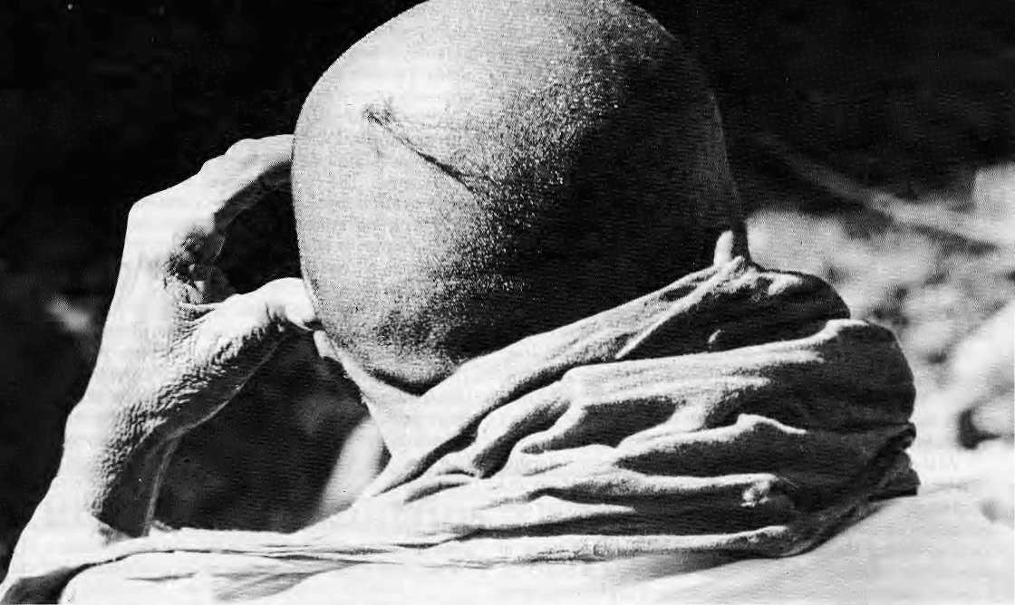

by Kamal Prakash Malla
(The following is adapted from Professor Kamal Prakash Maila's article "The Intellectual in Nepalese Society", originally carried by Vasudha magazine in March 1970, and subsequently included in Maila's collection The Road to Nowhere (Sajha Prakashan 1979). The essay is included here, with permission, both for its continuing relevance to the Nepali society, and to remind that the best Nepali writings in English appeared in the journals and magazines of the 1960s and early 1970s. Editors.)

T
his is an essay on the poverty of intellect in Nepal. Such an enquiry has become somewhat urgent, because 'intellectual' is one of the most over-worked words in recent Nepali writing. Before putting the vogue word under the microscope, I, however, feel tempted to make a few commonplace observations about the Nepali society of which contemporary intelligentsia are art offspring and in which they were brought up.
For the emergence ofintelligentsiaasa class nothing ismore important than the growth of cities and a pre-existing literate population sharing a culture of accessible language. It is only in the Valley of Kathmandu, with its unbroken historical continuity, where one can see a microcosm of the culture-formula, though already in a fossilised state. It is only the Valley which seems to have a cultural continuity with the present, consistently based on a broader literate population than elsewhere in the kingdom. In the culture of the Valley, more important than either the settlement pattern or the linguistic diversity is the stranglehold of religions and of their priesthood. Under thecaste structure the Sanskritised Hindu or Buddhist priesthood constituted a class of
intelligentsia in their own right. This class has been in existence around the Nepali courts at least as early as the Licchavis.
Though understandably and consistently tolerant towards the co-religions of Buddhism, Bonpo or Shamanism, the power-elite in Nepal has been zealously Hinduist. No wonder that in Nepal only those sections of the population who have assimilated the Sanskrit language (eg. the Nepali-speaking Brahmins, the Newari-speaking Brahmins, the Joshis, Maithili or Bhojpuri-speaking Brahmins—so powerful as court-ideologues in the Malla courts) constituted the traditional intelligentsia.
Traditional Nepali scholarship was mainly the output of Sanskritised priesthood in Nepal, and it had left its imprint in India, Tibet and China. In the lOth-llth century Magadha (North India) Nepali scholars like Ratnakirti, Virochana, Kanakshree were said to be great names in Vikramshila Mahavihara (University). In 11th century Nepal the scholarly achievements must have been high to entertain someone like Bageswarkirti, who later became a Dwarapundit (Head of Department) at Vikramshila. His disciples there included scholars like Niropali Sen (Bengal) and Marpa (founder of Kagyu sect in Tibet).

Sep/Ocl 1994 HIMAL . 21


At any rate, in the cities of Kathmandu Valley (mostly Kathmandu and Patan) there still exist several bahals (vernacular for vihara) or civic settlement which were, once upon a time, centres—not only of traditional learning of Buddhism, Philosophy, Rhetoric, Grammar, Medicine, Occult, Sanskrit language and Literature—but also centres of apprenticeship in painting, casting, jewellery, and other ancestral arts and crafts. In the wake of the Muslim invasion of North India, Pundit Buddshashree, an outstanding Nepali Dean of Mahasanghik Sangha at Vikramshila, cameback to Nepal witha great many of hisbooksand disciples. It was a momentin Nepali history which naturally reminds us of the Renaissance in Europe.
While in these bahais the Vajracharyas and Shakyas (the Newar Buddhist priests) were themain tutors, in the Vamashram system of Hindu education the tutors were mainly Brahmins— Newar Brahmins, theJoshisandAcharyas, then the Mai thil sand Parbaitya Brahmins. Morally and intellectually, the rest of the Sanskritised Nepali society had been, more or less, in their grip, which for a long time to come was the grip of tradition.
For, prior to the advent of modern education of Western inspiration, the most influential and articulate section of the society had been either the direct heirs to the traditional priesthood or the sections who had felt their presence and had accepted it as a part of the eternal scheme of creation.
At the bottom, the nature of traditional Nepali scholarship is derivative. The aesthetics of the manuscript, illustrations and scripts apart, much of it is exegesis, gloss, commentary and annotation on the authoritative texts. The tradition here is the tradition of transmission of the sacred text, the tradition of conservation of ritualistic continuity rather than of creativity, non-conformism, questioning and criticism. The preponderance of the textual over the critical, of the spiritual over the material, of theabstract over the concrete, of themagical over theempirical, of the didactic over the creative—more than anything else, characterises the traditional scholarship.
In a sense, a living contact with even this tradition had broken after the rise of Gorkhali power. What continued was more a routine contact with the past Tather than a creative renewal of the tradition to suit the altered contents of Nepali life after 1769, when Prithvi Narayan Shah defeated the warring Malla kings of the Valley and annexed itto his extended kingdom.
Culturally, the 190-year British presence in the Indian subcontinent did not affect Nepal very much. In fact, Nepal has nothing for which she should be grateful to the British. In India, the British left an infra-structure for the modernisation of culture—-both material and non-material. They left India with the Indian Civil Service, the universities of Calcutta, Bombay and Madras, with a framework of modem academic pursuits and aspirations; they left India with the largest literate population of Asia and Africa outside of Japan; they left India with the longest journalistic experience of any country outside the West. The British left India after awakeningher into literary,social and cultural consciousness of her own greatness (the Bengal Renaissance, for instance). English has been an agent of the cultural and psychological metamorphosis of many an Indian mind.
Nepal has remained almost totally unaffected by, and deprived of,all these cultural impacts of the British in India. The actual reason was not merely the British unconcern, but the deliberate and unenlightened policy of Jang Bahadur and his
successors. Under the stewardship of the British, he pursued a policy of absolute concentration of power in the family and of total abstinence from political-cultural contacts with the rest of the world. The most ineradicable single blot on the cultural history of Nepal is this dark night of the Nepali soul, a century of family rule when the common man was denied even civic rights. The above account is, of course, about the past which is oppressively presentasabackdrop of the history justbehind the post-1950 decades. Itis an account at once revealing and relevant to understanding the contemporary intellectual situation and the claims, at times absurd and megalomaniac, of the Nepali intelligentsia. The commonplaces of our geography, ecology, history, culture, evolution of power and the inhibited growth of other institutionslikemodern education and streamlined public administration are the burden of the past—a truly burdensome inheritance to which the Nepali intelligentsia today are an inescapable heir.
The story is sad because, among other things, the Nepali intelligentsia are not only an inhibited phenomenon—whose growth is as late and fresh as the growth of an overnight fungus. They are also a displaced stratum of society, because by their training and education (as against their upbringing and origins) they have suddenlybeen compelled to liveinthelatter half of the twentieth century without due ceremony. They woke up one fine morning from the sleep of the Middle Ages and found themselves exposed to the neon lights of an electronic age.
The post-1950 decade in Nepal is characterised, in the first place, by a sense of release and emancipation of theintellect from a century-old politicaland priestly yoke,and in the second place, by an unprecedented expansion of intellectual and cultural
Snow
.Forsy Yems:.of;;Ecstatic Skiing; Avalanches, and'Earth Wisdom
'J i -liaChapelle

"Oeep Peivder J$n&ur. is a personal; celebration - • ■ ani historical cc«j-rtti).f (lie Site-'ofow of the- ristjon's-most radical thirik«s\..a bobVatoiit wharit means to be alive." —Teiluride Times-Jounial.
> 4.25" x 6" ■ 112 pp
*■«-, a* I^P^{er:} 56.95
Xook ToITbe
l^n Ecology of Indigenous Education lljfegory Cajetc ^{s} --
Ri-4
"., .the first major worfcby Indian scholar to system awtaDy work through the tangent points that exkt between Indian aniaon-lndiafs undfr; landings of education; '■• ■ —Vjnf Deloria, Jr., Author, 'God Is
58S East 31st Street Duraago, CO 81301 USA Canada/Overseas

;7.25"i 8*S"_{S} * 248;.pp." „;

22 . HIMAL Sep/Oct 1994

opportunities. It was a decade of explosion of all manner of ideas, activities and organised efforts. It was a decade when the pre-existing narrow stratum of the intelligentsia was frantically active and vocal—socially, culturally and, most important of all, politically.
The decade also thoroughly exposed the social attitudes and the political immaturity of the Nepali intelligentsia, and the fluctuation—till the end of the decade—seemed to be more and more to the left. By and large, they were critical of the existing order, institutions, traditions and value systems. In fact, the up-and-coming among them professed Marxism, Frogressivism, Humanism or Liberal Democratic ideals in broad daylight. In these multifarious activities, they brandished their particular shade of ideology with very little inhibition. Numerous social, literary and cultural organisations like the student unions and federations, the youth organisations, the peace committees, study circles, debating societies, literary associations,art societies, journalist unions, writers unions, cultural associations, etc. came rapidly into being one after the other (or one against the other).
The picture of the 1950s will remain incomplete if no mention is made of the rapid swelling of the rank and file of the Nepali intelligentsia. Prior to 1950, Nepal had only one college, six high schools, and about 200 primary schools. But with the opening of the decade., the schools and colleges began to multiply, so that by the end of the decade there was already a sizeable literate population in Nepal. Although not all of them were members of the intelligentsia they certainly formed a broad base and reliable audience for potential intellectuals. For one great prerequisite for the emergence of the intellectuals as a class is the broad base of a literate audience—a sort of consuming intelligentsia, as it were.
These nascent beginnings made in the fifties show that, not only higher education and training in the modem academic milieux, but also academic pursuits on the modern lines of research and scholarship, are very recent phenomena in Nepal with hardly any precedence in our history. It may be worth
___.
Chessler Books
Send for our free Mail Order catalog of the world's largest selection of Mountaineering Books.
New, out-of-print, and rare. Also Tibet, Nepal, Polar, Exploration.
^ Guidebooks, trekking maps, videos and more!
I Please write or call for your free catalog today. \
| Chessler Books
S
P.O. Box 399-112
Kittredge, Colorado 80457 USA
, (303) 670-0093 FAX (303) 670-9727
r
i

remembering that Tribhuvan University was incorporated by law only as recently as 1959. By that time India's modern universities had already celebrated their first centenary. The 'modernised' academics of Nepal have hardly any history, except of non-achievement.
In the growth of the institutional complex which helped the recent numerical flowering of Nepali intelligentsia it is not just thegrowth of theeducationalinstitutions which deserve mention. Nepal's literary and journalistic elite, her administrators, lawyers, diploma ts,artists,unaffiliatedscholars,archaeologists, historians also saw a slow and steady growth in their numbers and institutional affiliations.
Outside the free-floating literary profession, outside teaching, journalism and management, it is government service that absorbs many of Nepal's highly gifted and educated Nepalis. This huge establishment swallows a great assortment of Nepal's literate output. Some of Nepal's most brilliant men belonging to two or three different generations-all enmeshed in the daily rounds of the Singha Durbar bureaucracy, are attracted by the magnetism of power into its field of operation. Yet by and large, in relation to the rest of society (as against the State), the huge institution of public administration in Nepal is nearly inarticulate. Thedecision-makers in Nepal may be creative; they may generate ideas, and once they are generated the decision-makers may translate them into reality. Yet institutionally a civil servant qua civil servant is less intellectually independent than a non-civil servant as citizen. When he has to choose between the security oftenureandarticulateconsdence,a civil servantis likely to find his conscience an expensive thing,and presumably would prefer not to have it at all.
The primary prerequisite for the emergence of a truly independentintellectual class is not just thegrowth of cities with university, colleges, libraries, journals, theatres, cinemas, radios etc., but also a sufficient degree of economic independence, so that the intellectuals can live up to their ideals and convictions without fearing social and economic persecution. One plain, but primary, reason for the poverty of intellect in Nepal is the poverty of the intellectual. The intellectual, as well as the non-intellectual, has to scrape a living. The intellectual may not live by bread alone, buthe has to live, like others, supporting a family with a host of dependents and economic liabilities. Except for a few self-supporting intellectuals like Mahesh Chandra Regmi or erstwhile politicians like D,R.Regmi or 'affluent aristocrats' like Surya Prasad Upadhyaya or Rishikesh Shaha, nearly every one of the established names in the creative and influential fieldsare in the full-time service of the Establishment, which normally settles their attitude towards society in general.
Thus, themost conspicuous single feature of the intellectual life inNepal in the 1960s is its neutralisation, its introversion and identification with an in-built nationalist ideology and aggressively pro-Establishment attitude. After 1960, not only did the writing of an articulate sectionoftheNepaliintelligentsia become visibly uncritical of the Government but also a large number of them were recruited to popularise the Panchayat system. ItisherethatinNepal one seesa situation almost parallel to what Julien Bendain France has called la trahisondes clerics, the betrayal of the intellectuals. Here I see the need to be explicit aboutthebasicroleand function of the intellectuals in a traditional society like ours.
. The primary function of the intellectual class is to serve as

Sep/Oci 1994 HIMAL . 23

a kind of permanent opposition in society by its radical criticism of actual institutions, values, behaviour and a tti hides, including outworn traditions. The intellectuals, unlike the rest of their society, are qualified to withdraw themselves and meditate and evaluate theactual in terms of the ideal. The role of the intellectuals isprimarily to evaluate the realities of their society. In Nepal this is where, because of the economic poverty and bondage of intellectuals, they seem to have failed society and betrayed their 'class obligations'—if they feel they have any.
An intellectual is not just a latter-day variation of the ancient Brahmin priest: his function in society is not ritualistic. Though a great many of his species do occupy high posts as experts, technicians, planners, advisers, ideologues and functionaries in the service of the Establishment, modern intellectuals, unlike theproverbial philosophers whohavemerely interpreted the world in several ways, must help society to change, not to stagnate. What we have in Nepal, however, is not an articulate class of intellectuals who are willing to fill in the critical-evaluative role; what we have is only a class of white-collared proletariat who work, not for wages, but for salaries of different scales.
Thebasisofall intellectual cultureishonesty or theintegrity of effort. The tenor of Nepali civic life, however, is such that it is extremely unlikely to promote either of these ethical bases of all intellectual culture. In the post-industrial societies of the West, intellectuals are said to\>e freischwebendemtetligenz, to be socially 'unattached' or 'free-floating'—free in the sense that they are not guided by any class or caste prejudice; free in the sense that they are guided, not by sentimental slogans or demagoguery, but by clear reasoning. The main prerogatives of the intellectual class are said to be 1. objectivity of outlook, and 2. freedom from allegiance, except to reason and truth, and to the intellect.
In the foreseeable future, intellectuals in Nepal are quite unlikely to fulfil this second role. Intellectuals as well as the broad stratum of the intelligentsia come almost entirely from the upper castes— the Brahmins, Kshtriyas and the upper caste Newars. They constitute more than 80 percent of Nepal's intellectual and power-elite, and in a profession like teaching there are more than 40 percent Brahmins and Kshtriyas, some33 percent upper caste Newars.
In a society where, however modern the culture of most intellectuals maybe, most of them live their daily lives in "a vital domestic culture of kinship, tribe and religious outlook", it is impossible to view them as "a class above all classes, a caste above all castes, a community above all communities"—with no prejudices. Few try to overcome the culture of kinship and possibly none succeeds completely.
Finally, by definition the intellectuals should be primarily (but not exclusively) preoccupied with the culture of ideas. He lives by some ideals and convictions. In Nepal, however, the literate section of the population shows, not only a great dearth of idealism, or a universal paucity of effort, application and dedication, but also an endemic infection with the virus of plain materialistic success. Success—measurable material success by hook or by crook—this is the law.
Hemmed inonallsidesby the nauveau richeof a developing society, the Nepali intelligentsia is becoming increasingly materialistic in its value-system, and like mercenaries who fight for money they measure success—just as other members of their society do—in termsof cash income, reinforced concrete edifices,
cars, foreign liquor, pieces of furniture, ad van tag eous marriages, overseas travel, and so on.
While this is the milieu of contemporary Nepali intelligentsia, paradoxically enough, Nepal is oneof the few countries in Asia where literate members of the population are greatly flattered when someone calls them 'intellectual'. They see their own shadows almost invariably larger than lifesize. Compared with their attainments, qualitative or quantitative, the claims of the literate Nepalis to intellectuality sound megalomaniac. Contemporary Nepali intellectual culture is a little too meagre, in fact so meagre that even the few genuine scholars have no special reasons to be self-congratulatory.
Take, for instance, any field of intellectual application. How many readable books and papers have been written by Nepalis in the last 20 years on, say, the economic problems of Nepal? How many books and learned papers are there on such vital, fertile and unexplored fields of Nepali life as Art, Architecture, Religion,Culture, History, Sociology, Anthropology, Geography, Political Evolution, Languages and Literature? Where there are a few, as on History, they are more a monument to personal perseverance than to the originality of approach or an abiding scholarly passion for minutiae, for accuracy of language and exactitude of details. A serious and unsparing self-examination should have leftnoroom for the curious senseof self-importance which nine out of every ten intellectuals in Nepal unfailingly betray.
Whatever be the social origins, the antecedents, the culture,
education and profession of contemporary Nepali intelligentsia,
they are likely to remain a shadowy and insubstantial
phenomenon—merely a band of economically castrated and
socially limping angels beating the drums of their respective
fads. In the recent past even the few stray intellectuals with us
have tended tobeless radical critics of their societies than earlier.
They have tended to be more concerned with solving thekind of
short-term, specific problems which arise out of their complete
identification with the Establishment. Of the rest, who are not-
too-understandably impatient tobeadmitted into thepantheon,
most lack character and distinction, integrity and effort, and
their numerical presence, like thepresen ce of monksin medieval
monasteries, is merely ritualistic. i
K.P. Malla teaches English at the graduate department of Tribhuvan University,
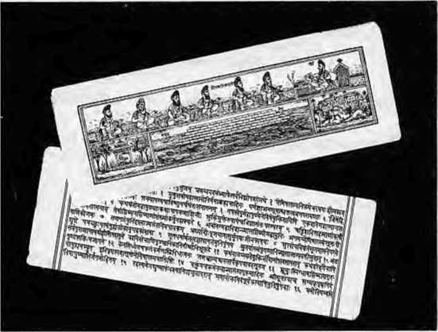

24 . HIMAL Sep/Oct 1994



Around Annapumas
One of the Famous Walks of the World
by Prakash A. Raj
Nabin Publications, Kathmandu, 1994
NRs250U$10
Around Annapurruis, written by a prolific and a
long-established travel writer, is on the Annapurna
Circuit, known as "one of the ten best walks in the
world". After the Khumbu trail to Chomolongma,
this is the second most popular trekking route in
the Nepal Himalaya. Raj's take-along guide
provides details of the villages encountered in the
trail, the people who live there and their festivals.
Illustrated with black and white pictures, the book
also contains some maps.
Winning the Future
From Bhakra to Narmada, Tehri
Raj as than Canal
by B.C. Verghese Konark Publishers, Delhi, 1994 ISBN 81 220 0357 5 IRs35O
India's water resources have to be harnessed for economic development, social harmony and political stability, argues B.GVerghese. Four major water resources projects, Tehri, Narmada, the Indira Gandhi Nahar and the Bhakra-Pong are looked at in detail. "No great endeavour is without its challenges, trials and tribulations. Prudence and care are always necessary. A generation hence, properly managed, the blessing of these great new projects... be seen as vital life-support systems for a resurgent India and millenary gifts to the nation. The future beckons."
Environmental Protection of the Himalaya A Mountaineer's View
AamirMi, editor A Himalaya Club publication Indus Publishing Company, 1994 ISBN 81 7387 012 8 IRs 150
This book was published to commemorate the 50th issue of the Himalaya n/owrnol. A symposium on the protection of the Himalaya was.organised to mark the occasion and the 22 contribution are included in this volume. To solve problems of rubbish and fuelwood use by trekkers and climbers, Chris Bonnington recommends an international conference. Mingma Norbu Sherpa writes about the Sagarmatha Pollution Control Project, Sushil Gupta about the Gangotri Conservation Project, Isobel Shaw generally about the impact of tourism, and George Brand about his expedition with Peter Mould to the Basingthang peaks in Bhutan in 1991. Also in this volume are extracts of Doug Scott's Himal article (Jan/Teb 1994) "Slave Wages on the Trails" where he recommends more, not less intervention by governments in the trekking marketplace.
The Butterflies of the Sikkim Himalaya
and their Natural History
by tAeena Haribal
Sikkim Nature Conservation Foundation,
Sikkim, 1992
Illus trated with more than 650 colour photographs
and sketches, Butterflies of the Sikkim Himalaya is a
pictorial guideon the winged crea hires thatabound in the Eastern Himalaya, especially Sikkim. The book also con tains a chapter for those who wan I to learn butterfly appreciation.
High Altitude Wildlife of India
by B.D. Sharma
Oxford and IBH Publishing Company, Delhi, 1994 ISBN 81 204 0813 6 IRs 54 (subsidised edition)
The first chapter introduces the Himalayan region and its environmen t; the second chapter focuses on high altitude adaptation of Himalayan wildlife and its biotic zonation; the third chapter lists a number of high altitude mammals and birds and the fourth chapter concentrates on the interaction between man, wildlife and environment; finally, the fifth chapter concentrates on conservation and management issues. The foreword is by George B. Schaller, who recommends building local constituencies for conservation. Every country within the Himala yan realm, writes Schaller, should have to have its own corps of trained conservationists who are sensitive to local objectives and the value of the local culture.
High Dams in the Himalaya Environmental and Socio-cultural Implications
by K.S. Valdiya
People's Association for Himalaya Area Research, Nainital, 1993 IRs 30
This PAHAR booklet is a collection of 14 articles by K.S Valdiya, eminent geologist of Kumaon University. The articles study the construction of big dams in the Himalaya and focuses in on the seismic risk involved. Valdiya suggests alternatives to big dams — each 10 to 30 meters in height, with a capacity of 50,000 to 100,000 cubic meters of waters in the reservoirs and capable of producing 5000 kilowatts of electricity.
Flowers of the Western Himalayas
by Rupin Dang
Indus, Harper Collins India, Delhi, 1993
ISBN 81 7223 060 5
Liberally illustrated with colour photographs, this
is a handy amateur's field guide to the mountain
flora of Kumaun, Garhwal, Himachal and Jammu
and Kashmir. Spring and late summer are the best
seasons to go flower hunting in the upper reaches,
writes Dang.
The Future of World Forests; Their Use and Conservation
Kitaparti Ramakrishna and
GM, Woodwell, editors
Natraj Publishers, Dehradun, 1994
ISBN 81 85019 42 6
IRs 295
This volume is the result of. a workshop on
conservation and use of world fores Is held in Woods
Hole, Massachusetts, in 1991, It contains seven
papers that stress the importance of forests and
discuss issues such as indigenous forest
management knowledge, government policies,
forest usage, forest protection, and so on. !n his
concluding paper, Kilaparti Ramakrishna
recommends that for the world's forests to be saved an independent international commission needs to be created. Such a commission would then, "weigh the environmental, economic and technological implications or various policy options on the conservation and development of forests and pursue appropriate action".
Mountain Research and Development
Jack D Ives ami Paulbw Lues, editors Vol 14 No.3, August 1994. University of Califoumia Press, USA ISSN 0276 4741
This issue of Mountain iteaserch and Development Con tains 6 articles and 2 book reviews. The articles are on the vegetation in the Bolivian Andes, women and mountain ecosystem, land degradation amongst shifting cui tiva tors in Nor them Thailand, a study of high yielding and traditional wheat varirjes in Siloti Village in Kumaon Himalalya, human in pact on stream run off in the Nana Koshi Watershed in Kumaon Himalaya, etc.
Tourism in Garhwal Himalaya by Uarshwanti Bisht Indus Publishing Company, Delhi, 1994 ISBN 81 7387006 3 !Rs350
The book claims to be the first systematic study of the economics of Himalayan tourism and its impact on the region's ecology. In seven chapters, Bisht investigates the tourism potentials of Gaihwal's Uttarkashi and Chamoli districts and provides detailed maps of the region along wilh useful data on tourist arrival, income and expenditure of the Garhwal Mandal Vikas Nigam's mountaineering wing; religion and the age group of the tourists (domestic and foreign) arriving in Gangotri; sites for tourism in Uttarkashi and Chamoli, and so on. The book studies the history oftourism, explores the elements of adventure tourism, examines existing infrastructure, economies, impact and problems of mountaineering and trekking, and recommends that only scientific and friendly tourism beundertakenforsustainable development of Uttarkaslii and Chamoli.
Water Nepal Ajaya Dixit, editor Vol 4 No.l Sept 1994 Nepal Water Conservation Foundation, Kathmandu
This 340 page special edition of the journal Water Nepal contains the edited proceedings of "The Ka thma nd u Meeting on Coopera ti ve Development of Himalayan Water Resources", organised in February 1993. Thirty six papers are categorised under 4 themes: Social and Economic Challenges, Technology and South Asia, Institutional Articulation, and Conflict and Cooperation. The papers present perspectives on challenges and opportu niliesofwaterreso urces development and management in the Himalaya-Ganga region. The views come from Nepali, Indian, Bangladeshi, Bhutanese, American, Swiss and British scholars. The volume concludes with questions that have been posed as research agenda for the future for broadening the understanding of the "interactive-complexity" that is the Himalaya-Ganga.

Sep/Oct 1994 HIMAL . 25

V
o
I

The demand for TIGER BONES is in China, and the best sources are India and Nepal, with Tibet in between. It is hardly surprising that Tibetans have become involved in the contraband trade, states an editorial (abridged here) in Cat News, April 1994, by Peter Jackson, Chairman of the Cat Specialist Group.
It is sad that Tibetans have been found involved in the devastating trade in tiger bones for Chinese traditional medicine. They have deservedly enjoyed the world's sympathy in their struggle to maintain their identity and culture in the face of the massive power of Han China...
Althoughsacks of bones have been foundnear Nepal's border with Tibet hard evidence of the Tibetan connection only came wheri aTibetan was arrested with nearly 300 kg of tiger bones in Delhi last August. The discovery a day or two later of a dump of bones near the Tibetan colony indicated that others must be implicated. Meanwhile, there have been reports from Beijing and Chongqing of Tibetans offering tiger bones in the streets. That somebones (and even some of the "Tibetans") are thought to be fakes does not invalidate the argument.
Itisheartening thatthe Dalai Lama has reacted strongly in his response toa letter from theDukeofEdinburg, President of the WWF. The Dalai Lama was right to stress the basic Buddhist concept of reverence of life, for it is this that is largely responsible for the respect that the world has for the Tibetan people. It is to be hoped that the Dalai Lama's powerful influence on his community will ensure that his appeal will be effective and that Tibetans will even become active in the efforts to eliminate the trade.
SELF-IDENTIFICATION is an important aspect of being an indigenous people, according to the booklet Indigenous Peoples of Nepal: Towards Self-Identification and Re-Establishment, containing proceedings of a national consultation that was held 23-26 March 1994.
'Indigenous Peoples' refer to those communities,
i) which possess their own distinct and original lingual and
cultural traditions and whose religious faith is based on
ancient animism (worshipper of ancestors, land, season,
nature), or who do not claim "The Hinduism" enforced
by the state, as their traditional and original religion.
ii) those existing descendants of the peoples whoseancestors
had established themselves as thefirst settlers or principal
inhabitants in any part of the land falling within the
territory of modern state (Nepal), or and who inhabit the
present territory of Nepal at the time when persons of different culture or ethnic origin arrived there and who have their own history (written or oral) and historical continuity.
iii) which communities have been displaced from their own land for the last four centuries, particularly during the expansion and establishment of themodern Hindunation State and have been deprived of their traditional rights to own the natural resources-(Kipat communal land, cultivable land, water, minerals, trading points, etc.)
iv) who have been subjugated in the State's political power set-up (decision-making process), whose ancient culture, languageandreligionarenon-dominantand social values neglected and humiliated.
v) whose society is traditionally erected on the principle of egalitarianism—rather than the hierarchy of the Indo-Aryan caste system and gender equality (or rather women enjoying more advantageous positions)—rather than social, economic and religious subordination of woman, but whose social norms and values have been slighted by the state;
vi) which formally or informally admit or claim to be "the indigenous peoples of Nepal" on the basis of aforementioned characteristics.
Though "indigenous peoples" and "Nationalities"
are restively not synonyms, all the 'nationalities' seem to be
the 'indigenous peoples' in the context of Nepal.
MUSSOORIE MASSACRE, in which six beak
were killed by the Provincial Armed Constabulary at ptholaghar Park, brings forth outrage from the pen of actor Victor Banerjee, who makes his home in the hill town, in The Telegraph of 6 September 1994.
Sikkim, Meghalaya, Assam, Nagaland, Mizoram and Arunachal have been raped or disembowelled. Their people havebeen left confused over their id entity and thedefacement of their ties with the nation as a whole. Jammu and Kashmir andPunjabarenowbarrenwherePartheneumhassuffocated the lives and the intellect of the common man.
Uttarakhand must happen, but never is our society permitted to evolve and grow naturally and face the truth of changing circumstances and changing social needs. It is now obvious that Uttar Pradesh is obese from having stuffed its coffers at the expense of people who can no longer tell rainbows from the stripes of our tricolour, from the lotus that churns up the muck it grows out of, or the sickle that has

26 HIMAL . Sep/Oct 1994

c
E
S

dissected their social fabric and religious sentiments.
To the animals who rule by the gun and use power to further their own partisan sentiments, the need to continue controllingParliamentwitha majority of votes makes splitting up this inharmonious family an anathema. The voice of dissent must never be heard, grievances must not matter till elections force appeasement and people mustbe killed if they do not understand. "Action Taken" reports are as fudged as the rabri from a dubious confectioner. But here the blotting papers soak human blood...
Corpses shall be planted in the garden of love. They shall sprout with an aspiration that their home might be cleansed of sin, and perhaps they shall blossom into an Uttarakhand that will give them a sense of belonging to their own—to those who care. Also let us keep the mongrels of political parties out of reach,lest they dig up the corpses with their dirty fingernails to arouse hatred. This emotion has no place in our Himalayan foothills.
If there were hatred in every handful of dust it surely was raked up in the plains of Uttar Pradesh. For almost half a century now, the entire nation has buckled under the pressures from this largely illiterate, grossly superstitious, socially oppressed and politically backward state. Its fertile earthis soaked with thebloods of Hindus, Muslims, scheduled castes, and Thakurs—and now the innocent souls of Garhwalis and Kumaonis. How sick that its fields should grow the very sugar that sweetens our palates.
MISSHAPEN STRIP OF LAND ishowSanjoy
Hazarika describes the region of the Naga, Mizo, Meitei, Tripuri and Assamese, in his newly released book Strangers of the Mist: Tales of War and Peace from India's Northeast (Viking, Penguin India, 1994).
The shape of the Northeast—or rather its shape on the maps of the world—has been altered with new lines drawn to recognize new political and administrative realities. The names of these units have changed: the Naga Hills became Nagaland, the Lushai Hills changed to Mizoram and the North Eastern Frontier Agency, still known to many simply as NEFA, was converted to Arunachal Pradesh, the Land of the Rising Sun. I am sure that those who coined the last title meant no offence to Japan.
And if these frontiers have changed, so have attitudes among its people; so have the skylines of its citiesand towns. So has the way people talk to each other, the things they talk aboutand in which they involvethemselvesandoneanother.
The forests ofpine, teak, sal and mangrove swamps are being maimed by plunderers. Yet, thick bamboo, coconut and banana groves, rubber and tea plantations, cluster of frangipane and bougainvillaea still dot the countryside. The hills are terraced with rice fields. So are its steamy plains.
One image that endures is of wiry farmers with Mongolian features, balancing bamboo poles across their soldiers with carte baskets filled with vegetables, chickens or eggs at either end, walking jerkily to market. Another image is of naked, cheerful children on water buffaloes, prodding the animals along narrow village tracks.
These images could be true of any part of this belt, which comprises a single geographical entity. Yet under this postcard-like facade of calm and exotic locale, smiling faces and lushness lie the deeper emotions: grief, terror, war and all the torments, tragedies and gore that accompany them. For decades, this jungle has seethed with unrest, rebellion and violence.
The jungles of Southeast Asia sweep down from Bhutan and Arunachal Pradesh across seven other nations— Bangladesh, Myanmar, Thailand. Laos, Kampuchea, Malaysia, and Vietnam—spanning political boundaries, irreverential even of physical frontiers. Ethnic coalitions, oral traditions, and lifestyles based on respect for nature have mattered more in these regions than frontiers. Here men and women, with common origins but different nationalities, share a racial, historic, anthropological and linguistic kinship with each other that ismore vital than their links with the mainstream political centres, especially at Delhi, Dhaka and Rangoon.
Itis this affinity that has played a role in theunrest and insurgencies that have long troubled the Northeast of India. The embattled communities have been bonded by suffering and opposition to the brutality of the government crackd owns against the militancy and revolts.
Affinity and identity. These, more than any other factors, represented the principal compulsions that triggered the Naga, Mizo,Meitei, Tripuri and Assamese affirmation of separateness from the non-Mongolian communities that dominate the Indian subcontinent.
India's Northeast is a misshapen strip of land, linked to the rest of the country by a narrow corridor just twenty kilometres wide at its slimmest which is referred to as Chi-cken'sNeck.Theregion has been the battleground forgenera-tions of subnational identities, confronting insensitive nation states and their bureaucracies as well as of internecine strife. It is a battle that continues, of ideas and arms, new concepts and old traditions, of power bitterness and compassion.

Sep/Oct 1994 HIMAL . 27

Be prepared for tales and visions of the extraordinary and endless enchantment
MY KIND OF KATHMANDU

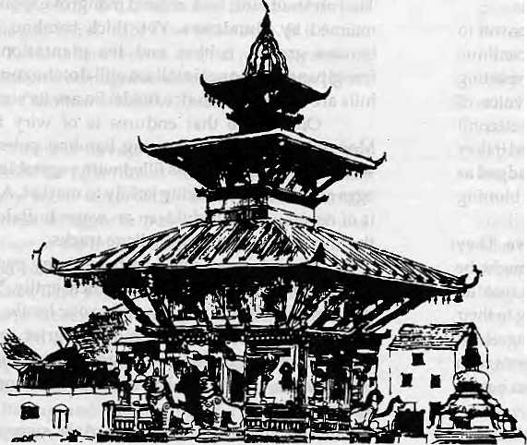
AN ARTIST'S IMPRESSION OF THE EMERALD VALLEY

Available at Alt Leading Bookshop a
55 Published by
HarperCollins Publishers India
Distributed by
're-publication Price Us. 1295 (I.C.) (Clothbound)
*\J4fLCL
7/16. Makhanlal Street, Anssri Road,
Daryaganj, New Delhi-110 002. Tel: 3265665. 3270260 Fax: (011) 3277294

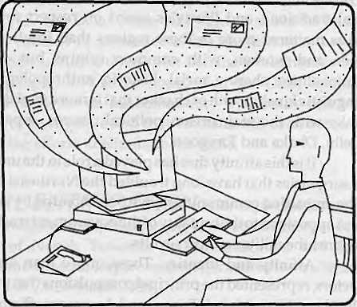
Get Connected to the
Information Highway!

Now you have a local access into the Internet in Kathmandu. *
Call Mr. Kiran Gautam or Mr. Deependra Basnyat at Mercantile Office Systems (9:30-17: OOHRS); Tel: 220773
, Fax: 225407 or e-mail: Postmaster@MosNepal.emet. in * Currently E-Mail Services available.

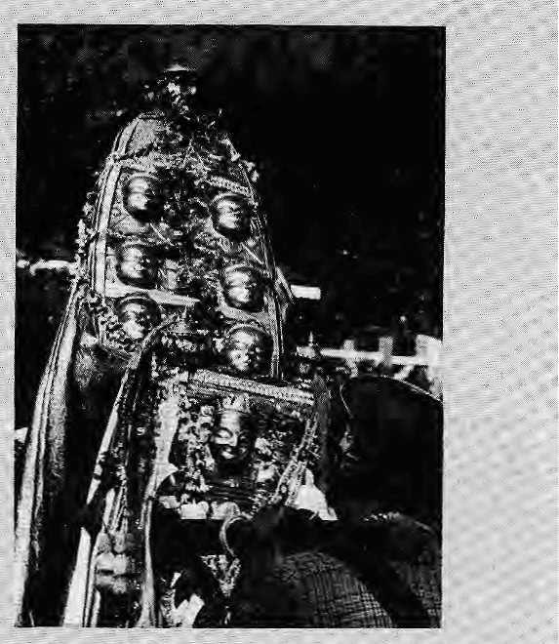

BRIEFS
Hunter and the
// ff is mid-autumn. It must be time once again for evil to be yanquisheo'by good. LJ^a-Dasain in parts of Nepal, In KuiluVaiiey of Hirrtachat, the occasion is celebrated as Pusshera. Deities arrive from all over, riding ovefrthe-shoulder palanquins and accompanied by raucous followers. The entire VaKey reverberates with music and dance:i.QrtfRaghuhath is the. festival's presiding<0eity,-but pride of place'is also resBtyed'for Hidima Devi, patrongoddess of the royal house of Kullu, Meanwhile, Jamlu", the maverick god of Malana, never crosses[the river[Beas and prefers\to observe thefestivities from th&: far shore. The ninth(day is the Devta Durbar, arid on the tenth an , effigy of Ravaha is torched, and the carnival ends.
Text and photograph by Chinmay Basu, New Delhi
by Ranaprasad Gharti Magar

TheMagar population living in the forested interior of central N^pal have ■traditionally been hunters with a meat diet. They hunted with bows (getoh} and poison-tipped arrows (mui), helped by hunting dogs (ansule pansuJe), and their myths reveal their deep-rooted links to the forests and to the hunting tradition.
Till recently, the Magar inhabitants of the remote areas of Rukum and Dhorpatan had continued to hunt as part of their lifestyle. All this changed drastically when a government team arrived from -Kathmandu in the spring of 1983 and announced the setting up of the Dhorpatan Hunting Reserve. The locals were advised that they were henceforth not to hunt wildlife of any kind inside the reserve. ("Forget animals, you cannot even touch a butterfly," one of them said.) The punishment would
include a fine as Well as a jail term, which woold have to be served in faraway.... ... .
Baglung.
This came as a rude shock to the people of, ■=■ the area, in parti cular thevillages of Takasera (880 houses) and Maikot 0400 houses). -For some reason, all of Takasefca's fieldswere... in eluded within the boundaries of the park. Earlier, the Magar^s meatdiet had included gal (wild boar),, ratqwa (barking deer), reya-(ghoral),bang (jharai) fl?wr (blue sheep), With the demarcation of the park, there is today an abundance of these animals: Barking, deer, jharaland wild boar eorne downto raidthe' terraces of barley, maiz^e, and potato; When this happens, or when their livestock are killed, the villagers are unable to react, Theyhave given up hunting.
All this hardship ani ignominy the Magar of Rukum and Dhorpatan have been suffering in silence. In fact, they have been positively docile in the face of such major changes. Earlier this year, when a dog killed a ghoral in the fields, the villagers were so scared of repercussions that they depositedthe carcass with the guard post at Takasera. Once, when a tourist group passing through the Svliseldhor village in Dhorpaten saw a local with a muzzle-loader and tciok away the spring mechanism so he could not use it, the villagers could only watch. If the villagers are thus
hurting, the bertefit of the Dhorpatan Hunting Reserve has gone only to outsiders. Many groups of huiyftng tourists arrive every year, often by helicopter, to shoot the famed blue sheep. The porters walk up from Baglung. They pay 0$1500 d o 11 ar royalty to the govern -ment for eacft blue sheep they get to kill. The porters are Sherpa and Tainang, hired in Kathmandu.
So, the tourist gets his trophy, the Government gets its fee, the Kathmandu travel agency gets its profits, and the Kathmandu porter gets his/salary^but theMagar receives nothing out of this
organised, goyemment-Sarsetjoned trophy Sport. Instead, he is kept out of his traditional hunting lands.
Tj\e Nepali Government has,started the practice of ensuring that some income from tourism gets back to .the region which actually attracts th6 tourists. This has happened in Upper Mustang and in Khumbu. This Magar hinterland of Nepal should also benefit from the hunting tourists, and there should be some laxity in the local useof the Dhorpatan Hunting Reserve.
H.Ghatti Magar (pictured af the top of the article) lives in Takasera, Bukum.
'#1
t
♦

Sep/Oct 1994 H1MAL ., 2?

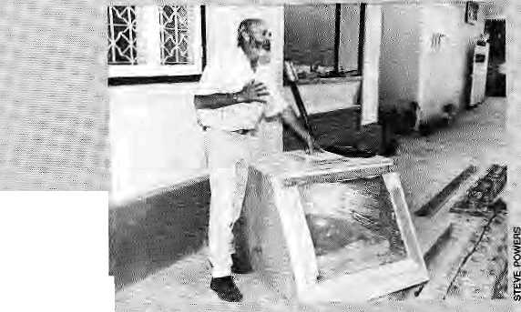
Garbage scientist demonstrates solar
toilet In j Kathm$ndu. '
problerri of animal waste in upper Khumbu; Some 2G0 to 300,yaks are at the Base <Tamp each day in peak seasop. "There's no t>n,e at the Base Camp tg collect the animal dung/'says Adhikarji-The Base Garrtpis completely cleared of rutibish, .saiys : Henry todd, a British climber. "The only thing remaining/is yak waste. You can't tell themnbtto shit"
IsKhiitiibu
a.j are free of .. controversy. Firstly, there" is the tussle between (southern) Sola and (northern) Khumbu, and then there istherivalry between Vowcr Khumbu and : upper Kh-upibu Sherpa. The Tone member of Solu Khumbu District in the dissolved Lowe^ House of Pariiament/ Bal Bahadur KG, saw fit tq divert NksJ^OOO of trieNRs3miliiprr goyernment grant to SPCC for constructing: an airstrip at Kangel, a village irvSolu. Khumbu's Sherpa leaders regard this asian act of treachery, no less, as the MP seems to be ighoriji.g sparsely populated Khumbu in favour of Solu's larger numbers,
A Ministry officiaiis firm in his view that SPCC is /supposed to work for the develapment of th& whole of Sagarmathajegion. "If the 7.5


R
ealising that trekking refuse on their trails affected the pocket book, a couple of years ago, the Shcrpa of Khumbu decided to act. They set up the Sagarmatha Pollution Control Committee (SPCC), a, community-based answer to dirt on the mountain. With infusion of funding, the project has suddenly achieved a high profile.
The local Sherpa decided to act when tod many well-meaning foreigners, came byte help out, frpm high, altitude garbage hobbyists suggesting unsuitable solar; toilets, to climbing teams masquerading as "cleanup expeditions",
There was alarm as the" overseas media had afield day writing about how dirty the Khumbu had become. "The time had come for us to -deari up the place, and to do it ourselves," recalls Ngwang Tenzin Jangpo, the Head Lama of Tengboche Monastery! "If tourist'numbers declined because of the of garbage, Khumhu's economy would be devastated,"
The presence of SPCG, which was set up on July 1991, is clearly visible in its three village units of Khumbu (Chaurikriarka, Namcheand Khumjurig).. Locals and travelers alike can be seen using the rubbish pits prepared by SPCC, and the well-publicised eyesores along the main camping sites are gone. The organisation also provides information to tourists, trains lodge owners, and helps improve local" hygiene. SPCC plans to rid the Khumbu region of soft drink and beer bottles, tin ■, cans, plastic bags, etc.
The recent spurt in SPCC's Work is because it has come into some good money. It received a N& 3-rnillian
30 H1MAL , Sep/Oct 1994
grant from the Ministry of Tourism this year. The Worldwide Fund for Nature (WWF) has provided expert advice and financial backing of. byer.NRs- 25 million thus far,.(Some .say the Tourism ... Ministry largesse: is a sopto jkeep the Khumbu Sherpa from demanding a share of the mountaineering - . ..."
royalties.),/
The Ministry has made it • mandatory for all climbing teamsreturfiing from:lhev Khumbu to get litter clearance from SPCC at ■:■■ Namche, Their garbage is fjrstweighed at.the Base Garhp by a Si^cc supervisor aiid later again at the group's head office atHamche.: Ineinerabls items are burnt irt a French-donated incinerator in Namche and at the :. : japanes^-donated incinerator at Lukfe. The rest is brought over to: Kathmandu,'courtesy Asian Airlines'Russian
helicopters^ which have ferried 8Q0O kg worth of Khumbu garbage so far. " : Nobody seem to know what happens to the stuff afteritis-unloaded in the gafbage-
expedtitions come under¹ the; / SPCG control, trekkingleams and free-wheeling trekkers ../ donot have toaccount for their trash. According to Kut Bahadur Adhikarj, a SPCC supervisor who is also on the staff of the Sagarmatha National Park/the biggest pollution threat are porters accompanying trek/king and climbing groups. "Qn /average,an expedition employs up to 90 porters,, and Vecause they are not: allowed to,us&hotjeltoUets' theproblem of human Waste becorn'es enormous."
Similarly, there
lakh hasbeen jraitsferired to the south, thaf s because the/" government desires all-round development x>f the district and not of the north alone. ■ With its,activities concentrated mainly on the Upper Khumbu, SJPCC would be furinellingresources to the most prosperous villages of the country/'
the Khumbu population, too, is divided into several groups, each vociferously defending its own set-
⁽T¹'S*y* orl? ^{Oi} interests. Thus, tlW
X dXiltrd • southern community «
of Chaurikharkha (With Lukla as its centre) feels that the richer villages of : upper Khumbu make unfair use of,their contacts among Kathmandu's leaders^ Lukla's business leaders are wary of the government's support for thc'Upper Khumb.ii Sherpa elite. Like the decision tg allow Kathmandu-based Sherpas to operate helicopter service to Namche (bypass--ing Lukla, see Himai;Jul/Atig 1994), they believe that the gbvernment support'for the SPCC is a political decision w appease Upper KhUmbu high fliers, who also dominate SPCCs governing body.
However, not everyone travelling' to the Khumbu would see these inevitable undercurrents as they trek along paths and nearly spotless campsites". Perhaps ¹ tha,t is air that matters.
- Akhilesh Upadhyay

Blame the Mountains No More
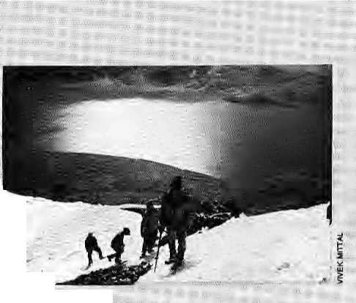
Rupshu Opens to Its Fate
R
upshu is one of those uhviolatedcrannies of the Himalaya that we fondly call 'virgin'. It is now about lose its maidenhead. Ihrierline restrictions have just been lifted in thisloncly high altitude desert-valley of southeast Ladakh, and the stage is set for unbridled commercialisation.
Tliis is good news for tourism, the travel agents, and even the impoverished Changpa—-nomadic inhabitants of Rupshu. But
B
runo Messerli, the well-known mountain ecologist, has in collaboration with some experts come out with a book which should be the last word on the Himalayan Degradation Theory. If the media, politicians and administratorsin Patria, Lucknow, Dhaka and New Delhi Still refuse to listen tot arguments against HDT, ^heu we might as well conclude that god-given floods will never be understood by the plainsman.
Himalayan Environment: Pressure - Problems - Process, the new publication edited by Messerli, Thomas Hofer and Suzanne Wymann, is the result of 12 years of research contained in 14 papers. In his own piece, Messerli enumerates the assumptions that were accepted as fact in the early 1980s, which affected decision-making and development project design. These assumptions were: that
how long the honeymoon before there is another ecological mess s fa' the ftarfda Etevj/Sancfuary? 2 Of 15,000 sqvkm;area, Rupshu stretches from Nabru Sumdo in the south to the Karzpk settlement in the north, a distance of about 5CL . km. The flat valley floor averages 15,000 feet above sea level.
Tso-Mbrari (Chomariri) is the jewel of Rupshu, a simmering aquamarine lake that is 25 km long and 6 kin at its widest. A nun (chqmo)r ;"' crossing the frozen lake on a yak is said to have drowned here despite her calls for help; ;: (ri! ri!), hence t|\e name. Strangely, this seems to be the only myth related to the lake, which is saline- The bird
population growth in the Himalaya generates^ deforestation, which leads to soil erosion and landslides, which leads/to si 1 ta K on, disas tr ous floods and lower water levels in the dry season. Erosion then leads to another round of deforestation/
"This so-called vicious circle is an intellectually satisfying concept,"states' Messerji. "As a working ": hypothesis it seems so reasonable that it is not surprising that it is accepted asafactand thatmany consequences far development flow frprti that acceptance... As we gained experience from research in the Middle Hills and High Mountains, we had : increasing doubts about the truth of the so-called vicious circle with all its assumptions."
Messerli ccmtinUesi'The message is dear: Although
island of Letse is a
distance from the north
Made ; famous by
brothersin
documentary
pf Rupshu,
this island is a haven for the
Tare Bra!htnmi duek and
barheaded geese,which
migrate south from Siberia in
winter; '
For the, hardy Tibetan-speaking nomads^ trie high security of the' Indo-Tibetan b6rder means little as they traverse the lineon themap.;;
currently available data are : ■insufficient, we can assume that most of the catastrophic floods in the plains are the result of heavy monsoonal precipitation in the plains or in the sub-Himalayan zone. Catastrophes are inevitable, particularly when the press-ureof growing population subjects previously aVoided hazardous zones to intensive-use. Forest removal in the * mountains plays a relatively modest role in Etiajof nion-soonal floods in the plains of the Ganges and Brahmaputra,"
He concludes with the proposition that "highland-lowland interactive processes are fundamental. Without the Himalaya we would have very low precipitation, no permanent rivers and only low-potential land in the plains. Land use changes in the highlands are not responsible for flooding in the lowlands/' So, there.

The richness and antiquity of their religious heritage is amply vlsiblemthe ancient monasteries. Karzok, one of the three perrhanent settlements in Rupshu, which lies "at, the northern snore"of Tso-Morari, containsa beautiful 470-year-old gtimba Which is presently under restoration.
With the opening of a.ditt road from Leh fo Karzok, completed three years ago, the Changpa nomads are gradually taking to the comforts of a sedentary lifestyle. Karzok is changing fast.and today boasts of a primary school, Kashmiri teachers, a modern dispensary (albeit without a doctor), and a comfortable government rest house. Kerosene stoves and pressure cookers are now the norm.
Already the changing lifestyle and swelling numbers of Ghangpaare adding stress to the environment. Adding Rup-slm to the tourist map can hardly help in the long run. The northwest shoreline of the lake, which the road follows, is showing signs of pollution. On another fronts the increasing premium on pashmina wool has jacked up* # demand, which has swelled the flocks and increased pressure on the sparse pasture land.
- Ranu Gupta, New Delhi

Sep/Oct 1994 'HIMAL . 31

-reader prepares to go on air:
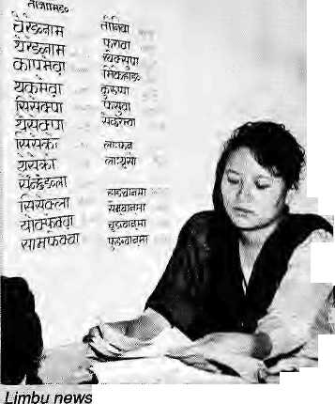
In fitsand starts, the 'integration' of Nepal continues. Radio Nepal has embarked on the Welcome yet sensitive task of recognising Nepal as multi* ethnic and multi-lingual. In raid-August it began broadcasting news in eight 'national languages'. -
In 1990,Radio Nepal had revived news broadcasts in Hindi and Newari which, started in1958, had .been, stopped a couple of years later by King Mahendra. Broadcasts in Maithili, the country's second mosfr-widely spoken language, began in 1993.
In August, acting oil the recommendations of a nirie-member committee, the station went on air with five-minute bulletins in Rai-Bantawa, Limbu, Tharu, Bhojpuri, Tamang, Magar, Gurungand Abadhi. These are languages spoken by more than one percent of the population going by the 1991
32 HIMA1 . Sep/Oct 1994
! census figures. A balance was also
; sought between Tibeto-Burman .,
■ languages arid lndo-
i'. Aryan ones,
'.'' according to
■ members of the
: committee.
As can only be ^expected with a task i as; complicated as- ; responding to disparate ethnic : sensitivities, the
choice of eight can (be challenged, Urdu, j the only other 1 language registered as mother tongue of I more than one "., j percent^
reasons given: Urdu • is considered mother tongue'by Muslims only bn religious grounds/ arid that in reality they mostly speak the language of the region which they inhabit.";
Reliance on me 1991 census report also mftkes a problemf or Tibeto phones, Trieire are apparently rib Tibetan-$peakfcts in Nepal/ only Sherpa-speakers, who ' make up less man the requisite one percent.
: In that case, Hindi is : reported *o be mother tongue of-Jess than one percent. So why news iri:H.indi?.."Tci; disseminateinforrnation about Nepal in India." Does: tliatmean we will hear: Chinese in Radio Nepal? "Why riot? provided resources are available/'says litterateur;Tilbikrarn Nemwang (Bairagi Kaila), member of the committee.
It has been recommended to Radio Nepal that it adcS to the current list of 11 national languages-eeonomic^ human, and■■■linguistic resources permitting.
Twister
Theoretically^ 70 or so languages Spoken in Nepal are national languages. But given the"4ifficultiesiwith iroadcastingnewsln even these eight, it will be wary before doing that.
Shailendra Raj Sharma, Director of Radio Nepal, says the new language policy is a challenge for the station. -'There is no comprehensive bilingual dictionary In these cightlanguagesv" he said. Indeed,only Limbu;BliGJpuri and Abadhi have Written traditions. This explains why many Nepalrand Sanskrit words sneak into the broadcasts^ Says Narhari Acharya, a Nepali Gongress Party ... leadfer arid chairman¹ of the recomntendation committee, "The main responsibility of developirig a language devolves^upcri",the:-commu-
caa only do so muchv":
Findirigthe: standard among ianguages which differ so iriuch from place to place has also been a ■ problem.'Eyen'Gururtgj concen fra ted only ■ i n th e central midhills of the country, lacks' uniformity. According to Sharrna, Tharu broadcast to east Nepal is : : different from Tharu bearnd' to ^vest Nepal: Gr take this:
: there are 34 varieties of Rai. Rai-Bantawa, which is -■ "',■ :
- accepted as the lingua franca" withih Rai community, w^>^{s} chosen-¹ in consulsatidn with and after a written support from Kirat Rai Yoyokha :(welfare,group), :
The cornmittee's work also threw up sOrrie^other¹ interesting moments, A Tibetan scholar saw.no reasbn,for the station to ' promote TibetorBurrrian languages; Earthly affairs can be conducted in Nepali/he saidy and spiritual ones in
Tibetan. In another instance, Magar leaders protested because one_{v} of the three recruits selected for their language wasaChhetri.
\yhile most ethnic'group's have welcomed the national language broadcasts as a positive gesture, some : Kathmandu scholars fear that Radio Nepal might be encouraging communalism. Not at all> says Nemwang. "This has in fact, for the time beirig, stopped comrnunal groupB from charging; that their aspirations are not being addressed."
: A-precarious balandrig. act lies ah«ad for those in Government as they take further stepsinthe direction of granting further recognition and support to the country's over 70 lah^uagei and diafettSi The problerns relate tb lack of funding, expertise and a corpus of iiterature/not id mention political backlash from perceived slights from different communities.
In April this year, the National Languages Policy Reco mmendati on Cornmission presented, its reportto the Government. Aniohg ...its recommendations: research in this field; , ihtroduction of,mbther tgnguey if a national language; in the primary school curriculum; replacement olSartsknt at middle school by rnother tongue; setting.up of ■■ linguistic departrhent in Tribhuvan University to preparenecessary manpower' in Vernacular languages; afld-. inclusion of linguists in the * census programme because the available dataon languages is not relaiblerS^ys Nemwang, also Coordinator of the CorrtmissiiDn, '''How mucli the government will : feel obliged to do is a different matter."
—-Manesh Shrestha

■■■;■. .;. :


Busiiig it to Lhasa
j Sonant; Wangyel
Bhu.tari (bffb-ffiti, ins'). Afao&ho-.intiiiioJ. A kingdom
Himalaya';
Rarely
- and tH^i;cfprc..JargGly=iniknbwiS,lsltne.:.earjisst; nCeM^wtarimade^
*Rtch.'Iri.l§£3,he wrote, 'There is acountry foar days journey from: Cuch or Quichtie [referring to the■-preSierftflayrCc^jchhefcaf, a district iii NorthBengal]=,„which is called Bhptaiiterandtife city of Bhbfea..," Theterm -Bhotarifa' oV'BbiariiafeiivftndEits psf *p|jli;rig;
" ari3.meamng.mTfeHi'sMMB»s'J-ftsto
: anjta^ that is, the ejftreri) ity.pl the land ■.of-BhflforBTiQt.'f .(Sanskrit-
* B/iof'::= Tibet; -Qriia '^ end./extremity.^ Tricr^ is. general, accord'-
sarrioiigst historians add lii^iusts^gMdyig this isnterpietatiori 6f"
'Bhbfarita', including:luminaries Ii|c4 Waddel/;C©eiho;: Aris Md.'.
Sunity Kumar Ghattefju . ...; " ^{;v} '" "" ... 1 .
... However, 'end air extremity ofTibet■ fe rather imprecise Jar it
-does riptdeftnfe Whether it means:theWater|fied between Tibet and Bhutan or the sou there-bjof tier pjBhiitan, Understandably a good. spany Bftuta liese a r$ peeved with-fchiswreiuri "■AK&X^GQWMUSieht brc«:rturefrpni..theiatel^Osispoliteiy:npii-cprnBiittal/ ■■-■'Pefluip? it cpiriesirQm the Sanskrit *BBoj-aiiii;a'jnearang 'end-of flSfec"'
, following decade, the Pfeutanese scfeplaf Loppn Peina.Ia
i
g
w^as derived from the Indian terni [Bihojtanta imeanifig "end "■JTibet'", (AU emphasis stij^pKedj'.Wn. the 19@0s^ The latest I .textbook for Schpol-leaYingi. ^udontsi rather than be traits Stiecelebrated 'Bhotanta' ^ersioii alfcgctherl ...
; The Bhutane^e are irritated With the linguistic p whic|i bring thei country within th|; arnbit of Tibet; One suggesfigh ^ is that Bhutan comes frpfn 'BhQt^stan' <SanSkrif Bhof = Tibet; si istan ■= placet Even a person of Briari'H, Hodgsp " knowledge erred monstrously When .he wrote that she y consider themselvesiapd their country¹ as an agpendage efBltot-o* t Tibet (see Jdupml pf (fie Asiatic Society qf 'fi^tgpi^. ]u\y 1849; pp703); ' P^F.Rennie, a soldier, 'surgegii.and chronider-bf tne- Bhtijtaii-r British war, steps On ftiany a tender toe when fie statesi-bhmtly; -'./.Bhutan simply meaningthc*:cemntry of i%e Bhot&ipr "Eibetans..?'": Jennie should have kfipwri better. Tibet was called 'Bhoidfcs^' irtd,

TJie Chinese, it has been said, have been trying to open up the Lhasa-Kathirtsndu road for regular traffic smee: 1984. But only in May this year was agreement was signed between the two governments. As a fbllow-up, delegations frcm the two countries met in August for a joint on-the-spot inspection of the 862 km trans-Hirnalayan highway, But : Vefore tourist agencies and traders can.benefit from the agreemerLt, it seems, there are snags aplenty to overcome;
To begin with, the Chinese offered night halts in three towns—Khasa/Jambu, Shigatse-a'ndLhasa—whereas Nepal insists on one rrtore, preferably in the 477 km, 14-hour streteh between Krtasa and: Shigatse, whieh: also has a4500 mpass. Beijing which seerns to be eyeing the cargo-potential rather than passenger potential of the rotitCj wants bus iravelers to .pay in hard currency, whil&Nepal desires a more convenient "currency.
Points agreed upon:". special oxygen-equipped buses are needed (which the
Chinese already have in Lhasa) for the high altitude travel; road signs in Ertglish, Chinese and Nepali; training for drivers to negotiate Nepal's left-hand drive and right-hand drive in Tibet; ant) bus services once a week, to be run by the public Sectors of the two sides.
Forsuch an important breakthrough^ the "arrangement will initially run for six months, after which it would be reviewed. Beijing is treading slowly, lest the experiment go awry.
Meanwhile, Kathmandu seems set to relive some of its old glory as a Himalayan entrepot Thetrade could "run into billions", according to a businessman with familial links to tlie pre^J959 Nepali traders of Lhasa. For him/ the agreement could not have come sooner and the implementation should begin right away* "The race over the Himalaya to Lhasa is on, ,The Indians are eyeing the Churribi Valley route from Gangtok and Kalimportg, and ■the quicker we establish the Kathmandu sector route the better," he says,
-^Manesh Shrestha

ttie name denotes aseparateregion/countrywith simtlaf people. A llktotywf: Bhutan' 099$), a Royal Government pi4|licatk>n> ;, maintains that t|ie Bhutanese: were caOed BHgi at IBhotey and
- therefore the country came to be ^nbwrt as Bhotstan; Adniittedjly
% tJKe.BJtiiitanese were arid jane called--.B^{rfejrbt5lthatisla,generkternt
- referrfrig to all the people of th& Tibetan plateau, and encompa'sses
^people akirj to the Tibetens in ihe soy them:Himalayanrdgipns...
¹ extending from Ladakh |o-Siinach»J. * ;: ::: :::: :/: ' t 1 '2 ,,. ,.
■■ An in^e^esiting,deGORstruction-proppses'Mutauttatijmeaning
%igh lands' in Sanskrit, Bhtitan beiaga mountain ebutttfy and the
Sanskrit root Bhu-uitan phpnetkaily having; a.n extraordinarily:
dose resemblance tp the name handed dpvvPj the sjiggestioft mijst
beigiven Us due place of honour¹. Sadly, historians 'have tended to'
igrsofe this interpretationi : :: ;
Traditipnal names of Bhutan arp,; of eotirs^ many, an^J the _{k} ^ndentMahayanascripturesrefertothecbuntryasitowwrjof-MoM t yul(khff= south;mon = non-Tibetaiisof Tibetan/StoGk;yiir= Iar(di,
Tried!drie'',^{i}rh©.c.ourttry-Has also t>een.called- Mw mah !lsRend®i/:am
t$fieitt}ei}}\ ■■■■■■■ •= ■■■■" ^{v} " t .. j, .,. ■ ■ ' ■'■■ ■■ ;■ * *■ ... t ■ ■:■ Of all the naineswitth thei.fo pfeftx^ljio.nwnkiia sfef e*f 1431 "AP *
antiquity. (ief: idpciimentsIfxpm vGye-Te-gtimpa,, availaWe« is * i,miCiTofilirrat Toyo^Byni«, Japan)¹ stems' the most appropriate, fdj
iHrarislates as thle /'southern ccfantry'p| four approacrtes", whlcK
describes thefeur sncienf p^SSea to Bhutan from" trie four.carclinai⁵
.dlreetions:* -; ? : "... \. ... ■
©espitesb many colourful and diescripti rename*, the'Brjutanese 4
prefer Jot call their country Druk or Dnikyul, aftei the 'thumler * d6ftK
|gg
Dragon',, one has to traVel baci> to the period betweei\: 1161-1211 Ap? whea Lama Tsanjgpa Gyarey Yeshay Dotji waa_{f} consecrating .a...monastery for his splintered faction pf Tibetan* Buddhism. During; the' cbnseciation cerembriy, a thunder was * heard and "tliaf beings aceordmg to local belief, the voice Ofjtftg* ^/j}. the:monastery; was called Druk and the religion olE

\called: Lhapo (people of the south").: The % worlds tho has been used in many' de^enptive combinatipns, ^including Iha'i menjong, which means '"the* sbtitHern land of-
eyeniually colonised became known asDrukyul.
tl,'frdjrn &jrjeslfrsg; runs arnedical pr^ofjee in Jaigaort,

S^/Oct Xm HIMAL . 33

BLs, RLs, BCs and Sikkim's OohiinunaJ
Bariy Bishop, bom 13January 1932, died in a car accident late September in Idaho, He was on his way to attend a gathering
Sikkim Observer > the ...'"nationalhill'weekly'' euiof Gangtak,is breathing fresh Mr in the aftermath of Nar Bahadur Bhandari's ouster as Chief Minister.Tha never-say-die editor of'the paper, jtgttte N, Kazt (author of the recmtly-released InsideSjkkim-Against the Tide), over a series of six articles in August and September provided an exhaustive analysis of the ethnic alignments that are likely to have a bearing on the State Assembly elections this November. Below is an exceiyted summary ofKazi'$ reports, which are based on 1993 electoral rolls.
P
olarisation of political forces along communal lines, which actually began in 1990 after the rejection of the Mandal Commission's report tin 'Other Backward Classes' (OBC) by the Nar Bahadur Bhandari Government; is likely to play a significant role in the upcoming elections.
The total voters in the state as per the 1993 electoral rolls is 195,492. Of this, the total number of voters from the OBC community is 76,302, the highest in comparison to the two other major groupings, the Bhutia-Lepcha and the Bahun-Chhetri. The Rai and Limbu (RL) alone have a total of 45,054 voters among the OBC.
the Bhutia-Lepcha (BLsj is the second largest grouping. With the Sherpa included in the BL fold, the total number of voters from the Scheduled Tribes community would be 50,814. The third largest grouping is of the Bahun-Chettri (BCs), who number 41,502. If the Newar, which is the only other Nepali group not included as OBC, are placed together with the Bahun-Chhetri, then
the NBGUNewar-, Bahun, . Chhetri) would have a total of 49,98$ voters.
.... ft is useful to analyse likely voting patterns of the threemam■■■■electorate categories—RLs, BLs and BCs. Of the total 31 territorial constituencies, the Bahun-Chettri, who belong to the upper :caste Nepali community, dominate in five. This is to say that if theBCs are united under one political party, they would win five seats in the Assembly.
The strength of the ■Bhutia-Lepcha tribals,_{s}though they make up the smallest of the three groupings, Was seen in the collapse of ^{r}rh^# powerful 15-yearTold, Bhandari regime on 4 May this year. The dramatic end was due to the revolt of all the13 tribal MLAs/backedby J me tribal youth force.
Though the BLs constitute about 25 percent of the State's population, they have a vital position in electoral politics. Of the 32 seats in the Assembly, t3 seats, including; the lone Sangha scat, are reserved for them. Besides, the BLs have all along, and particularly after SikkimV merger, stayed together and maintained-their unity.
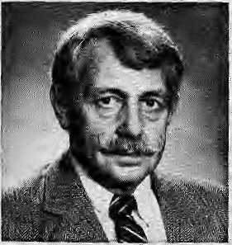
. Politicians realise thai the ..
■■■ jxiin.6rityBLs are a force to reckon with,.,particularly if ... they are united andstrong.
The rise of the Rai and Limbu in state politics,, and their heightened consciousness about political and economic affairs/have added a new dimension to J Sikkimese politics."The RaF Limbu are numerically dominant in the OBC group, making up 45,054 voters our of a total of 76,302 in the category.
■■'■ AH of South arid, West Sikkim, which haVe a total of 16 seats inthe32-meinber Assembly, are dominated by theOBCs, with Limbu dominating in the west and Ifei in the south. Of the nine Assembly constituencies in the west, Limbu are dominant in seven, Rai are dominant in six,of seven cbrtstituehcies in South : Sikkirh: If the SLs are able to garner, support from the 31,248 who make up the other OBC voters—-Tamang, Gurun&and Mangar (Maga^—this would ensure that the next government would be formed with an QBC chief minister.
Besides the BCs, BLs and RLs, which make up three-
ivt: San Francisco comme-mpratirig the 1963' American climb of Everest, inwhich he too had achieved the summit. (His son. Brent Bishop/madejt to the top in 1994 Summer)
Barry Bishop was a man of many personal achievements. He was a geographer, who in the latel960sdid detailed field work in, Nepal's far-western Karnalj region, "His 1990 Irook, Kanictli UniferSf ress, isalandmark work, remarkable for Us empathy for thesubject as well as its scientific thoroughness. As Cliairrrian of the Committee for Research and Exploration of the National
fourths 6f th e Sikkin\ : electorate, the minor ethnic : groups could aiso play an important role as to Which ;; groXip or party fprm$ the'ne)it government Amovt% the minority OBC groups. Guru ng make up 12,678, Tarnang 11^19, and Mangar 5118. Among BLs, the Sherpa have 8305 voters. The Newar, who have a total of 8487 , voters, have some influence inatleast 12 constituencies. The plainsmen community has a significant presence in the state capital, Gangtok, where it has 2320 voters, second only to the Bhutia^ Lepcha, who have 2212. To sumup, the minorities hold the key to at least five of the 32 seats in the Sikkim Assembly.
: Perhaps in this Year of the Dog, the underdogs might be,
able to influence the outcome of the Assembly elections. During the Chogyal's rule, it was the Bhutia-Lepcha who had an tipper hand, and since the merger in 1975, it has been the Newar, Bahun and Chettri. Now, perhaps the time has come for the most backward group in the state, the OBCs, to have their share of the cake.
{To subscribe: Sikkim Observer, Hill Media Publication, Zero Point, National Highway, Garigtok, SiKkim;}
Geographic Society, he was involved in many exploratory and academic activities in the Himalaya and elsewhere. One of the most recent was his teaming up with Bradford Washburh to produce the detailed map of the Everest massif in 1988.
Barry Bishop was kind and generous, and with his passing! myself have lost a longtime fri-| end and advisor at the Karnali Institute. May Lila Bishop and the children have strength enough to endure the bereavement.
- Dor Bahadur Bista

34 HIMAL . Sep/Oct 1994

llttarakhand out of Uttar Pradesfo

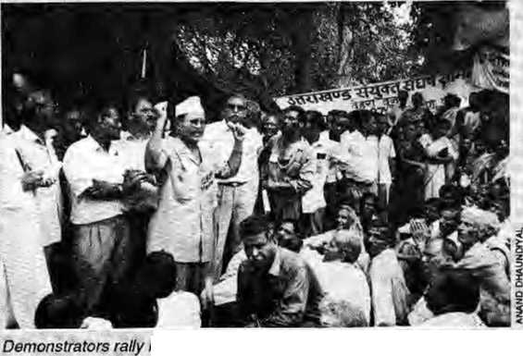
n Dehradun in early September.
Aaj do iibhido_{r}llttctrakhand raaj do! jari rahega chhuwachhut!
U
ttarakhand today reverberates with at least a dozen slogans. Demonstrations are the order of the day, and violent reprisals have become commonplace.
It all started in early August as swift reaction mounted against a derision by Chief Minister of Uttar Pradesh State Mulayam Singh Yadav to implement a
Upcoming!
10th HinValayan-KaraJkoram-Tibet Workshop (including a Special Session on "Geological processes related to uplift exhumation and elevation of the Himalaya, Karakoram and Tibet")
Venue: Centro Stefano Fran-scini, Monte Verita, Ascona, Tessin or, Institute of Geology, Swiss Federal Institute of Technology, Zurich 4-8 April 1995
Contact: David A. Spencer, Room H36,GeoIogische Insti-tut, ETH-Zentrum, CH-8092, Z«rich,Switzcrland. Tel+411 632 3698; Fax +411 252 0819; E-rrtail j DASp encer@erd w, ethz. ch
Local Heritage in the Chart ging Tropics
Innovative Stratergies for Natural Resource Management and Control 10-12 February 1995 Contact: Audi Eicher, ISTE Conference Committee, Yale School of Forestry and Environmental Studies, 205 Pros* pect Street, New Haven, CT 06511, Fax +1 203 432 5942; E-mail: civoodwar@nunervacis.yale.edu
Centre-mandated policy of reservations for dtsadvantaged Othef ^Backward Classes (OBCs). Within a feiv days, the protests had burgeoned and i converged into a fuMeged movement in demand of a separate hill state.
To be sure. Chief Minister Mulayam Singh was only following Supreme Court directives upholding the Mandal Commission report, which called for 50 percent " reservation for Scheduled Castes {SCs), Schedule Tribes (STs) and Other Backward Castes (OBCs)—a measured for affirmative action. The court ruled that SCs were to receive 23 percent quotas in education institutions, in the government and in-bureaucracy, while the OBCs' share was to be 27 percent and that of the the STs' two percent.
The hill activists' objection to caste-based reservation is based on the widely held claim that OBCs make up only two percent of the hill population. If the 27 percent rule is applied to the hills as well, claim ■■■ the activists, the
25 percent shortfall would be filled by the OSCs from the plains. .2
The Chief Minister, who -heads a Samajvadi Party-Bahujan Samaj Party coalition in Lueknow, has mprc to gain by standing tall agairtst the demands of the eight hill districts of Kumaon and Garhwal. This is because his support base is among the : SC/ST/OBC constituents ■■■. amorig-the remaining 56 districts in the,plains. (The eight hill districts'of U.P. are Nainital, PithpfagaTh and Almora-r—collecfively known as Kumaon—and Pauri,
Chamoli, Tehri, Uttarkashi: and Dehradunr—which rriake up Garhw<ii.}
Uttarakhand is not politically impQrtartt to the -Chief Minister. Of the 19 , ML As from the eight hillJ districts, only one is from Mulayam Singh's Samajvadi Party. The remaining include 15 from the Bharatiya Janata Party CBjP)> One each from the Congress and the Uttarakhand Kranti Dal, a regional party, and an independent. AH four MPs in the Parliament at the Centre belong to the BJP-
The decision- to implement the Mandal directives therefore drew deep resentment in;thehill$. The most agitated were the students, as the reservatiori ■ policy wouldjmmedfately ■ affect admission^ to higher education. Almost daily throughout August and September, iri one part of Uttarakhand or another; thousands took to the streets in protesf. In additron io students, tfiey were; housewives, lawyers, school. teachers,;ex-servicemen and journalists. The banners; slogans and-graffitti demsndedxancellation
of the reservations announcement, the Chief "Minister's resignation, a quota system for all of Uttarakhand, or a reservation policy, that would cover the entire hill population.
Mulayam Singh seemed Willing to let the crescendo rise, for he was playing to his own plains gallery. Meanwhile, his . opponents decided that their best strategy would be fo side with the hill people. Each tries to outshout the other in support of the separate hill
state demand*
The Chief Minister was reported to have retorted at a news conference in end- , Augu'st that if the Uttarakhand population" acted too unreasonable, the_{s} plains people would drive out the hill, people from the plains. (Hundreds of Kumaoni and Garhwali, like Nepalis migrate to: theplains every year to work as porters, restaurant boys, naukars and darbans in Lucknpw, Delhi and ,else where.)
Mulayam Singh's reported remarks, resulted jn a" spurt of violence, which reached a, leveUhat the

S^/Oct 1994 HIMAL .'■ 35

region had not seen before. Students torched government vehicles and buses. Bazaars"... "were closed, and traffic on the busy pilgrim highways of G^rhwaJ was disrupted. In;a show of defiance, state government signboards were painted-over to read "Uttarakhand Rajya Sarkar" (Uttarakhand State Government).
On 8 August, a fire brigade worker died in a confrontation between students and the police. On 1 September in Khatima, Nainital District, three died when police opened fire on armed ex-servicemen. In Mussoprie a day later, police opened fire on demonstrators who had come to snatch their Weapons; seven civilian and a police Superintendent died.
Talk of a separate state began back in 1952, when PC. Joshi, the Communist
Party of India firebrand, decided thatthe■■Kill p'eopie,
• deserved orie."However; the :± demand lay largely dormant
"because the rnariytojp- '.. ..... ,-.■■ ■■■■■
ranking leaders that Uttarakhand exported tq/the
state and Centre ■■
subsequently believed that bringing ug the subject would affect their national aspirations, ■■■■ ■■■■■
The hill poHtidans who have stfutteti on the national stage as'Ottar Pradesh' rather than 'Uttarakh^rjd' leaders includ e Qbvind Ballav Pant himself, Harsh Nandan Bahtiguna, and NarayaivDutt Tiwari, who hails from these HiMbut even today will not: penly support the separate state detrtand because he has Prime' Ministerial ambitions (for; 1 which he will requirie backing¹ from the whole of Uttar
Pradesh).
: While the separate state demandi-has thus retriairied on the hill people's agenda since irie;i950s,i* gathered '■ some mainstream " pslitical recognitioR only as
the BJP supportjjid it (cafilhig Sie. proposed ;: state 'Uttaranchal') during the la§t j\ssennbly ■;elections.l.... .. ■.-.,.■ ■■■■■ ■■■■■■■■
There is danger that a continued impasse between Luckriow |nd the hills will lead to increased violence, Indeed> Uttara|;Hanci can be likened; to a tinderbox, With its mixof thousands of uncttiployed youth; &c*; ; servicemen with access to arms and arrimunition; -and political parties onlytoo willing to exploifthe Kurnaoru/ : Gafhwali ire against plains-based neglect In
addition, Uttarakhand; ■ has in the two daily papers, Aniar lljaty and Dairtik Jcigaran, an overly zealous fourth estate ff)at is all too willirjg to sensationalise niinor events in the - name of righting for : Uttarakhand.
With the recent granting of limited autonomy to " Jharkhand in the south of Bihar^ it remains tq he seen what national and UP politicians will deem ;; adequate for the turmoil-.-..;.■ ridden Uttarakhand hills. Iri thf rheantime, it-is the responsibility of the political leaders, student activists, journalists and 'independent thinkers of Naini Tal, Almjora^Uehradun and elsewhere to ensure that the movement does not get out of hand.
-Nayin Nautiyalj. Dehrai'dun





Hours: 9:00 am - 5.00 pm (Sunday ;*
through Friday). : &
Vacciiiation/mediea] advice;; available even on- Saturdays.: -%
Please feel free to call us at t!"
4-12842 ?
Phone/Fax: 977-1-419713 ,_{it}
Nepal'l Leading Institution in Trav^lT\Jedicine VS. Board eertified MDs
Sta,ff hoover 15 Tfears ^fWoi^EsqperieiiGe in South Asian Diseases
Highest Standard of Cllinipal Care and Efficiency No Hassles
Free Advice oh ^titude Sickness. Convenient Location (off Durbar Marg, opposite the South Gate of the Royal Palace -■'See-map below) In Operation for 5 years

LAZIMPAT
j i
o
ROYAL PALACE • i . \
o
SOUTH GATE
'. ' -I : \ - -■ -
.NAXAL

KANTIPATH I I
DURBAR MM&: ■ ■ i ^ I :
MATHS
NIC
2nd gate
CINEMA
HALL -
Jai Nepal

36 HIMAL,. Sep/Oct 1994



withCrozus

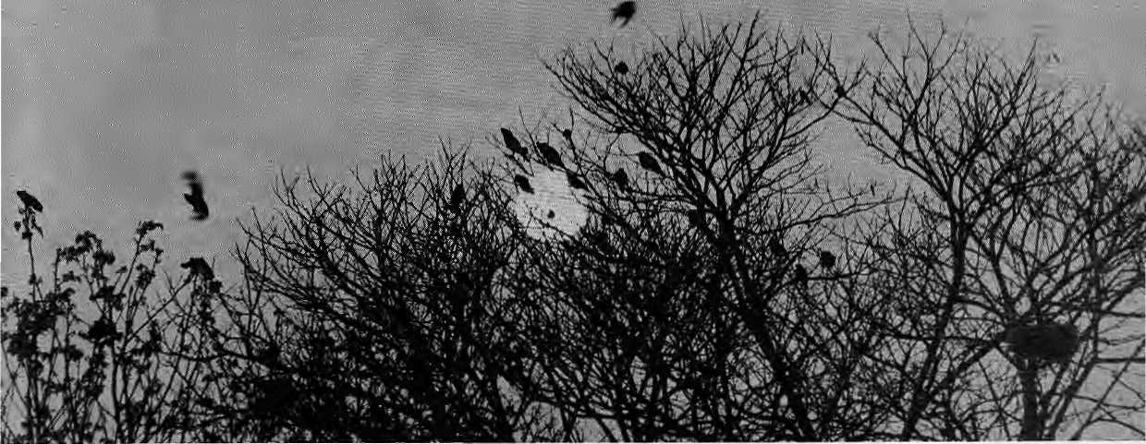

The frenzied crows broke cover from the forest above the bazaar, where the trail continues north along the ridge going up toward Debribas. The flock skimmed the red tile rooftops of the bazaar and dove under the power line, shrieking bloody murder. All but one of them banked right and rose again through the drizzling mist, pursuing a marauding cuckoo into a stand of pines, down on the flank of the slope. The big male crow that hit the wire bounced back in a small violent explosion of black feathers and fell convulsing to the ground. It lay on its back, one wing beating the wet grey stone, the other lying limp beside the kicking black body. The broken crow flapped in circles on the main street of the bazaar, in front of the old Durga temple.
The street was deserted in the chill evening drizzle. From the old brick water tank down to the Durga temple, all along the high wall of the district jail, the worn stone street was littered with wet leaves blown from the two great trees opposite the jail. In the compound behind the wall, all but the guard at the gate squatted under shelter around small fires; he looked in at them in envy.
The old rag lady came around the tank with her broom. She had been sweeping leaves behind the tank when the crows' hysteria gripped her heart like talons. Now her mad eyes focus on the fallen crow, smashing his one good wing against the stones, while her ears scan through the mist for the source of the hoarse demoniac crying of the angry flock. She advances down the wet stone street of the bazaar toward the terrified broken crow.
The hag holds her broom in her left hand. In her right hand she holds a buffalo clavicle. Arms spread like a black carrion bird, she herds the broken crow onto the low porch of the Durga mandir. The porch is immaculate and red with
by J. Morton Isaacson
fresh mud and cowdung. This is where the old woman sleeps and she cleans it for hours on end, with seasonal brooms of long grass. Her own black rags reflect no change of season. Rags too torn to wear, she sleeps on, stuffing them, each morning, into the filthy hessian sack which she leaves in the care of the black goddess on the porch of the temple, for the day.
Beside her bag of rags on the porch the tortured crow cowers, screaming. The flock breaks cover and their panicked calling rends the mist. They have heard his pain, and they quarter the ridge searching for their fallen member. The fat cuckoo flees silently into the rain, a hatching crow dying in her claw. A cock's crow from somewhere down the valley is drowned by the violent screaming of the flock. The crows rail and wheel and dive at the roof of the Durga mandir. They are mad with rage. They fly menacingly at the black rag advancing on the broken crow but turn just short of her; there is a margin that they do not dare cross.
The rag lady mounts the three stone steps to the temple porch. The broken crow falls silent and lies trembling softly, black on the red mud floor, beside the filthy sack, beside the door with the black image of the goddess (red with offerings) inside. And the old woman tenderly places the still black form at the statue's feet. And in the jail, the wet pathetic guard at the gate turns to see where the moan came from, but now only a cock's crow floats up through the mist, from somewhere in the valley. And he sees behind him rain on the stones and crows in silhouette against the cold gray evening sky, black and strangely silent on the wall.
J.M,Isaacson is an architect and writer; he livas in Kathmandu.

Sep/Oct 1994 HIMAL . 37

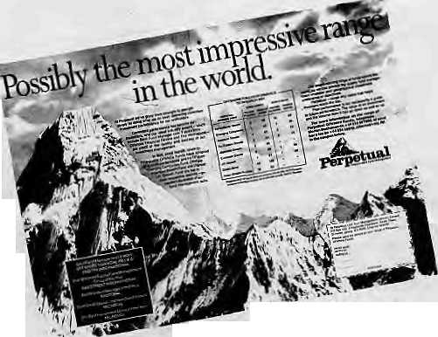
o
i - 2 is
"Mountains of the world unite, you
have nothing to lose but your height," was the message a Nepali highlander recently left on one of those visitors hooks that are found on the summit of Alpine 3000ers. Really, mountain massifs must organise and get a lawyer to defend their rights against the advertising onslaught of multinationals. One international hank relies completely upon the image of stability and virility provided by The Rock of Gibraltar, others use every shapely peak available on their mastheads, logos, packaging and promotional brochures. The latest indignity is an all out campaign by the company named Perpetual Independent Fund Management (Jersey, Channel Islands—definitely something fishy), which has long since hijacked the virginal Ama Dablam for its logo and now has blown up the mountain for double page advertising spreads. Of course, no one thinks of royalty or IPRs because they all think mountains are inanimate. We know better.
"I don't like Arabs. They have nothing to do on out land." Spoken like a fanatical Israeli settler in the West Bank, but he happens to be a Mizo. Binyamin Sharon was a Protestant Christian from Aizawl who recently converted to Judaism and got a ticket to Tel Aviv, reports the Far Eastern Economic Review. He is part of a group of Mizo who are being "repatriated" to their ancestral homeland by a messianic group which believes that Mizos are one of the 10 ancient lost tribes of Israel. Over in Mizoram, people are not about to let this bonanza go waste, and an estimated 5000 have lined up for formal conversion to Judaism. This beats the US visa lottery any day.
Earthshaking news reported by the Nepali news agency, RSS: "Nepal Becomes Self-Reliant In Biscuits". At last, something to cheer about. Here is the momentous data: some 50 big and small biscuit industries produce
18,000 metric
tonnes of biscuits annually (even though there is capacity for 35,000 mt). The biscuit

industries also export to Calcutta, border areas and Tibet. How do we know all this? From a three-day workshop entitled "Maintaining Standard of Biscuits and Improvement in Market Management". May Nepali biscuits tickle palates far and wide and help in generating solidarity north and south of the Himalaya.

Wish I were in Dehradun mid-August, when the Uttaranchal Natya Sam rod staged a weeklong theatre festival. Eight stage directors spent a month in the eight districts of Kumaun and Garhwal and recruited local artistes and amateurs, with whom they staged a variety of productions back in Dehradun. Among the plays presented were "Dharam Das", by novice thespians from Pithoragarh, which portrayed the dying traditions of folk music in Kumaun, and an adaptation of Bertolt Brecht's "Caudan Circle" (titled "Insaaf Ka Ghera") performed by an Uttarkashi troupe named Kala Darpan. If Uttarakhand has theatre, can statehood be far behind?

Still on the Northeast, The Telegraph reports that Naga insurgents pulled off a diplomatic coup in July when their leaders addressed the United National Conference on Indigenous People, bypassing objections of South Block. The National Socialist Council of Nagaland (NSCN) delegation included its General Secretary, T. Muivah, who is said to be engaged on a public relations blitz abroad for his insurgent group, "aided by the ISI of Pakistan". Intriguingly, the newspaper adds that Dharamsala advisor Michael Van Walt and Lodi Gyari (an official of the Tibetan exile government) haVe helped Muivah,
who is based in Bangkok, establish links with other indigenous organisations. NSCN is said to have opened offices in Geneva, Stockholm, New York and Kathmandu.
If elections were the only evidence of vibrant democracy, then the Himalaya would be doing all right. Polls are upcoming over a good segment of the region these coming few months. Nepal is going in for general elections on 13 November, even though someone forgot to take account of Haribodhini Ekadasi, which will probably affect the orthodox Hindu vote. In the December fight for the Sikkim Assembly, eight parties are in the fray. The Chief Minister Sanchaman Limboo has been anointed by the Congress party at the Centre, and there is the Communist Party of India (Marxist). The "regional parties" include Nar Bahadur Bhandari's Sikkim Sangram Parishad, Pawan Kumar Chamling's Sikkim Democratic Front, and the newly-launched United Liberation Front. The Rising Sun Party of Ram Chandra Poudyal (of the recent Armageddon-is-here fame) has just been revived, and Athup Lepcha, powerful leader of the tribal North Sikkim, has formed the Tribal Sadbhavana Party. Meanwhile, the Gorkha National Liberation Front of Darjeeling has also decided to field candidates, reports The Statesman. How much ethnic brinkmanship the state will see, the autumn will tell.
Meanwhile, in Darjeeling hills, Subhas Ghising and Jyoti Basu have once again decided to kiss and let bygones be bygones. Ghising had earlier opposed Panchayat elections, saying that they were redundant under the Darjeeling Gorkha Hill Council Agreement, but seems mollified by a couple of olive branches extended his way by the CPI(M)'s newly rehabilitated stormy petrel in Calcutta, Buddhadev Bhattarjea. Said Ghising, "Our fight is with the Centre only. I have told my councilors not to abuse the state government." Heh, heh.
The other sudden friendship that we will never believe is the one between deposed Nar Bahadur Bhandari and Subhas Ghising. The Teesta might run dry, swords might

38 HIMAL . Sep/Oct 1994


turn into ploughshares, but khukuris never into rhododendron bouquets. Speaking of which, Umesh Dwivedi, environmental activist of Darjeeling, sends us his organisation's recipe foT Rhododendron squash: boil one kg of Rhododendron flowers in 1.5 liters of water for 30 minutes. Filter, cool extract and boil with sugar at 1:2 ratio; add 15 gm citTic acid per kg of extract; cool and filter, add Sodium Benzoate (3gm per kg extract); add essence if desired; rhododendron squash is ready for use. The question now is where to get all that rhododendron from our lopped-off forests. Dwivedi says he can also produce quality wine from rhododendron, "which would be very effective in treating diarrhoea and other disorders". Somehow, that is not quite what I had in mind. Hie!
Kamal Nath, India's high-profile Minister for Environment and Forests, recently released a report on Sloping Watershed Environmental Engineering Technology, SWEET for short, which he said should receive "widespread circulation in different parts of the country". Developed by the G.B.Pant Institute of Himalayan Environment and Development, SWEET is meant to revegetate "fragmented abandoned land holding in sloped hill areas". Apparently, the technique has been successfully demonstrated in pockets in AlmoTa, Chamoli, Sikkim and Nagaland. The report in The Statesman does little to enlighten the reader on what SWEET does differently from the plethora of watershed conservation programmes. Those interested write to GBP1HED, IdMOiys twin in Kosi, Almora.
Indian Home Minister S.B.Chavan told the Lok Sabha in August that the process of setting up an autonomous hill council for Ladakh "is in its final stages", and a notification would be issued after the Cabinet gives its approval. Rajesh Pilot, Minister for Internal Security, also stated back in April that Ladakh is going to gets its autonomous council. If Chavan and Pilot—who cannot stand each other— both agree on the point, it must be true. Besides, turmoil-ridden Kashmir hardly has any opportunity to mount an opposition against these proposed semi-
secession, as the West Bengalis were able to in the case of Darjeeling.
Incidentally, the First World Congress on High Altitude Medicine and Psysiology came and went on 12-16 September, in La Paz Bolivia. How come we were not informed, and why was it not convened in Jomosom, we'd like to know. Demand an explanation from the coordinator Dr. John C. Triplett, MD MPH, US Embassy, La Paz, Fax: 011-591-2-359875. Also, how come we did not know about the International Symposium on Snow and Related Manifestation, being organised 26-28 September by the Snow and Avalanche Study Establishment in Manali. Eighty papers are being presented on snow physics, snow mechanics, avalanche control structures, avalanche forecasting, avalanche dynamics, snow hydrology and cold region engineering. I don't know, however, whether I can go along with the organisers' positivist claim, "The belief that avalanches are uncontrollable acts of God is only a myth, and this has amply been proven by technological and scientific advances."
Onward to our favourite topic, The Little Buddha, which the last column had hoped that someone would reviewed once and for all. It so happened that Lufthansa was showing Bertolucci's confection on the Kathmandu-Frankfurt leg mid-August. Chhetria Patrakar was in the flight and could not ask to be let out of the hall. The interminable film finally ended as we put the former Yugoslavia behind us. Verdict: grand vision marred by a glucose overdose; no empathy for the plot or characters; mindless exploitation of mass dharma sentiments; Chinese actor Ying Ruocheng (who has perfected Dalai Lama mannerisms) and Kathmandu street child 'Raju' the only ones who can act; use of real Bhutanese monastery and real Bhutanese monks for a fake film inappropriate and jarring; all in all, a movie bad for the world and bad for Bertolucci's ratings.
That's my review. Here's what the US West Coast media reported when the movie was finally released in May: "Depressingly ordinary. The ' audience will have to bring a lot of
compassion to bear..." - San Francisco Examiner. "A dud—a dose of spiritual eyewash that skims the surface of the Buddhist religion. A Buddha for beginners..." - San Francisco Chronicle. From the East Coast, a thumbs up from The New York Times reviewer, obviously a diehard Shangrilaist - "A film of overall sweetness, displays a deliberate innocence that suits its subject, an untroubled inner peace." But then The New Yorker is more of my kind - "...ethereal nonsense. Bertolucci is a great director going backward fast. You learn next to nothing about Buddhism but a lot about the Western palate for Buddhism. Buddha was bold enough to see beyond beauty; Bertolucci is trapped inside it, and he may never get out."
Here is an email address that all Himalayan researchers with modems in their computers must write down: HimNet@erdw.ethz.ch It is the electronic address for the Himalayan Network, an Internet link for researchers working in Pakistan, India, Tibet, Nepal and Bhutan. It is a moderated mailing list and aims to provide conference details, lists of latest Himalayan papers published in scientific journals, Himalayan magazine announcements, job vacancies with Himalayan interest, news from the Himalaya, scientific research information, etc. David A. Spencer, the coordinator of the new service, is a Zurich academic, and can be reached separately at D ASpenc er@erd w .ethz .ch
Summit magazine (Summer 1994) contains hair-raising reading about what happens to people when they insist on walking along high ridges during thunderstorms. Here it is. "When the human organism is hit by lightning, the results are not pretty. No tissue of the body is immune to the ravages of the lightening strike, but the brain, spinal cord and nerves are the most vulnerable and result in the most disabling injury. The awesome heat of the strike often turns the body's sweat into steam, blowing apart the victim's shoes and clothing and leaving him buck naked, not to mention dead." Draw me and quarter me, feed me to the snow leopard, but save me from the lightning strike!
- Chhetria Patrakar

Sep/Oct 1994 HIMAL . 39

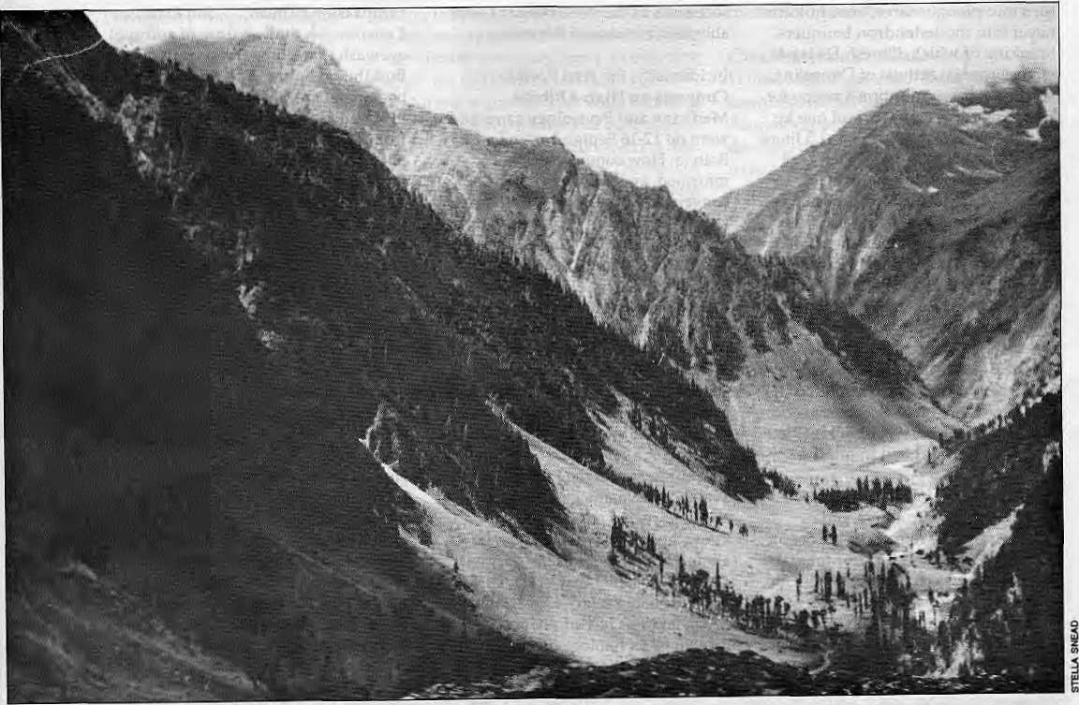

Killing Fields of Kashmir
How do we resolve the Kashmir problem? Ask the Kashmiri.
by Praful Bidwai
"...while the accession [of jammu and Kashmir to India] was complete in law and in fact, the other fact which had nothing to do with the law remains, namely our pledge to the people of Kashmir—if you like, the people of the world—that this matter couldbeaffirmed or cancelled by the people of Kashmir according to their wishes. We do not wish to win people against their will with the help of armed force; and if the people of Kashmir wish to part company with us, they may go their way and we shall go ours. We want no forced marriages, no forced unions." - Jawaharlal Nehru in August 1952
Forty-two years later, the consequences of brazen and repeated breaches of that pledge by theGovemment of India are starkly obvious. For the past five years, New Delhi has by and large done exactly what Nehru said it should not do: try to win the Kashmiri people over with the help of armed force. Nehru's words constrast sharply with Prime Minister P.V.Narasimha Rao's speech on the occassion of India's latest Indepen-
dence Day. Making a combative reference to Pakistan, Rao said: "With you, without you, in spite of you, Kashmir will remain an integranlpartof India." It is remarkable that he did not once refer to the people of Kashmir.
It is equally clear that the majority of the3.5 million inhabitants of the Valley of Kashmir are unhappy with what they regard as a "forced marriage" and want to re-work their relationship with India, even though there are growing signs that they are fed up with Islamic-militant secessionist groups too. This explains the strength of the sentiment in favour of azadi (variously translated as autonomy, freedom, independence and sovereignty) that has marked the Valley for the past few years, and which has sustained more than 20 guerrilla groups of differing ideological hues. It also explains why the Government, which precipitated thecrisis around the Hazratbal shrine in October last year, had to beat a retreat and remove the bunkers that its security forces had put up in the compound of the monument that is supposed to house the Holy Prophet's relic.

40 . H1MAL Sep/Oct 1994

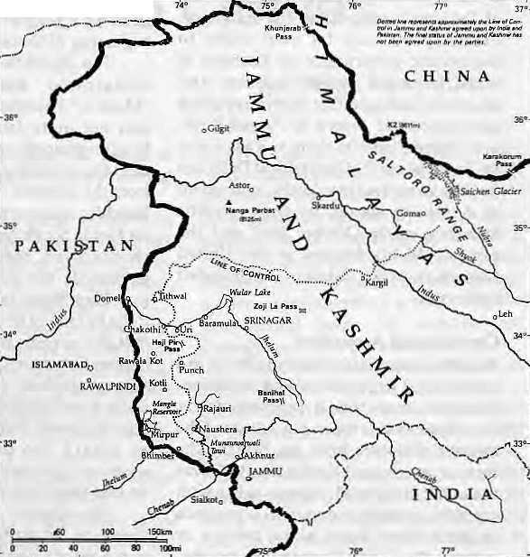
The Hazratbal episode served to exposethegrim leadership crisis and lack of coherence that wrack the Indian state. It highlighted the bankruptcy and unsustainability of India'sKashmir policy. The Government is trying to cover its failure by deploying an altogether different tactic: of holding elections in Jammu and Kashmir, and thus hoping to gain some legitimacy for itself. It is unlikely to succeed.
Constitutionality to the Winds
What is the Kashmir crisis about? What explains the eruption of the azadi movement? What i s th e natu re of th e f o rces arrayed for and against? And where do the elements of a possible resolution lie?
The present Kashmir crisis, the result of growing popular alienation from the rest of India, is traceable to the failure of official policy, especially since 1983. The year marked a turning point, when Indira Gandhi effected a major change in her electoral strategy in Jammu and Kashmir. Her Congress party's alliance with the Valley-based, broadly secular and then fairly popularNationalConferencebroke down. Gandhi resorted to a sectarian Hindu religious appeal in the predominantly Hindu Jammu region of the state.
Bitter at her electoral loss, and paranoid about "destabilising forces" at work in India's border states, she had the National Conference government in Srinagar dismissed in 1984 by Jagmohan, the centrally-appointed Governor of her choice in the state. That same year, a Kashmiri nationalist, Maqbool Butt, retried for a 1966 political offence, was hanged and the Jammu and Kashmir Liberation Front QKLF) was formed. With this, Gandhi's approach progressively hardened. She threw legality, even constitutionality, to the winds. From 1984 onwards, Kashmir would be ruled directly from New Delhi by retired (or serving) army generals and through tough policemen.
The deterioration of the 1980s was preceded by whatKashmiris perceived as apathetic and unjust treatment at the hands of the New Delhi Government: repeated rigging of elections (except in 1987); imposition of "outsiders" as leaders; unbalanced financial devolution; repeated breach of the Constitution which grants exceptional autonomy to Jammu and Kashmir under Article 370 and prohibits the extension of Central legislation to the
state without its consent; and growing human rights abuses, and in many instances, outright butchery of innocent civilians (such as the killing of 37 people inBijbeharainOctoberlastyear,wnenthe Border Security Force resorted to unprovoked firing.)
The Kashmir problem was aggravated by growing loss of authority of the Central Government, the political vaccuum created by the death in 1982 of the legendary independence leader (and onetime Nehru ally) Sheikh Abdullah, the rise of communal politics in South Asia—first in the early 1980s in Pakistan and then with the Ayodhya agitation in India. The problem was exacerbated by deterioration in India-Pakistan relations, particularly on the nuclear arms and boundary issues. The last is gorily exemplified by Siachen in the undemar-cated Himalayan boundary of Ladakh, where thousands of lives have been lostin a military confrontation at 26,600 feet. Over 250 Indian soldiers die here every year, and a similar number of Pakistanis, mostly due to altitude sickness and frostbite.
Trampling the Valley
AFG HAN1SIAN
Kashmir Valley's experience these past decades has therefore been disastrous: popular alienation and disenchantment; administrative breakdown; suppression of legitimate protest and brutalisation of civilians; rise of guerrilla groups and violent resistance; transformation of popular Kashmiri Islam, which also drew from Hinduism and Buddhism, into a harsh, alien, militant mutant; emergence of pro-Pakistani militant groups in competition with the pro-azadi, broadly secular JKLF; Pakistan's attempts to arm and train such groups; India's use of the exaggerated "Pakistani hand"
to justify repression and increase its military presence in the Valley, now estimated at 300,000-plus troops.
In 1989-90, the situation took a particularly ugly turn when Governor Jagmohan launched an all-out military onslaught. In a diabolical move, he proceeded to build a case for forcibly resettling the Valley by encouraging and contriving the transfer of the minority Hindu community out of it. Since then, at least 3000 people have been reportedly killed in "encounters" with the security forces. Over 15,000 suspected "militants" (many of them unknowing civilians) have been detained. This repressive policy in turnhasprovokedahostileresponsefrom the militant groups: revenge killings, ambushes and mindless violence against moderate and sensible elements. Highly Tespected citizens who could have provided bridges between the state and the people have been eliminated.
The Indian state, unrestrained by a largely apathetic public opinion on Kashmirand encouraged byjingoists,has trampled upon the Kashmir people's rights as inhabitants of a region enjoying a special status under the Constitution's citizens of India, and above all, as human beings. With itslongandshockinghuman rights record, New Delhi cannot invoke a serious moral or political right in support

Sep/Oct 1994 HIMAL . 41

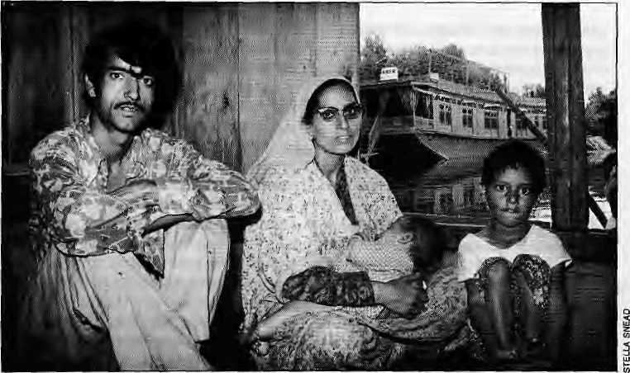
of its claim to Kashmir as an "inalienable" and "integral" part of India, which it says domestically, is not open to discussion, leave alone negotiation.
Internationally, where this is untenable, New Delhi says its is prepared to discuss all outstanding issues with Pakistan, including Kashmir, within the framework of theSimla agreement signed with Pakistan after the 1971 Bangladesh War, which commitsboth sides to mutual negotiations on all disputed issues. New Delhi still pretends, ostrich-like, that it can counter adverse international opinion by citing (authen tic, butlimited) evidence of Pakistan's support to the militancy. Precisely because its own claim to democratic governance in Kashmir is weak, it cannot isolate Pakistan and effectively castigate itf or its own appalling anti-democratic record in "Azad-Kash-mir". To reinforce its claim to Kashmir as an "integral part" of India,New Delhi can do little more than invoke the Instrument of Accession signed by the erstwhile Maharaja on 26 October 1947 and the early (19484:9) debates in the United Nations, in which Pakistan was branded aggressor.
Conditional Accession
The official case is ultimately reduced to a purely legal argument about accession. However, even this is problematic foT reasons related to the messy nature of the transfer of power from the British. The State of Jammu and Kashmir in 1947 was not a well-integrated, organic entity with any homogeneity or common experience of governance, leave alone politics or culture. The Hindu Dogra rulers purcha-
sed the Kashmir Valley from the British only in 1846, TheJagirofPoonch (now the core of "Azad Kashmir") came under their control as late as 1936.
TheDogra regime was narrow-based and intensely unpopular. By the mid-1940s, it faced a powerful secular opposition led by the National Conference. Maharaj Hari Singh did not accede to India before her independence on 15 August 1947. He vacillated and had a distinctly pro-Pakistani tilt till mid-October. He changed his mind when confronted with a popular uprising in the Poonch region and a tribal invasion from Pakistan's Northwest Frontier Province beginning 22 October.
The Radcliffe Commission which demarcated boundaries between "Muslim" Pakistan and "Hindu" India was not quite fair in awarding three Muslim-majority parts of aborder district to India, involving as it did a departure from the accepted norms of the Partition. Radcliffe, a lawyer who had not previously set foot in South Asia (and who left these shores even before his award was published) was probably influenced to give Hari Singh the option to accede to India by having territory contiguous with it It also appears that Mountbatten, who becameGovemor-General of India in 1947, was sympathetic to the Indian leaders' claim at Independence that India was the sole legitimate heir to the Raj, especially as regard the defence of the Sub-continenfsNorthem Frontier against alien (at that time Soviet Russian) influence.
Mountbatten accepted Hari Singh's accession by writing tq him that "the question [of accession]...should be settled
by a referendum to the people". This can legitimatelybeinterpretedastheaccession being conditional upon consultation with the people.Thisflowed from theCongress party's — and the Nehru government's — position that sovereignty rested not with feudal princes but in the people. This stand alone had enabled the integration of Hyderabad {one of the biggest princely states, in India's south), and Junagadh (in the west) into India, despite their rulers' wishes to the contrary.
Mahatma Gandhi was even more explicit on Kashmir. He declared thatwith the lapse of British paramountcy, the Maharaja's claim to decide the fate of Kashmir would stand nullified. The people alone had the sovereign power to decide on accession.
Kashmir's accession was a feather in India's cap: a culturally unique, Muslim-majority state and its popular leadership under Sheikh Abdullah joined India because of her secular and republican credentials. Indian leaders readily offered a plebiscite to the Kashmiri people. They foresaw no problem in the nature of the plebiscite (to choose between India and Pakistan; with no independence option) or in India's ability to win it.
This changed dramatically in 1947-48 with the first India-Pakistan war and Pakistani occupation of a part of the original state of Jammu and Kashmir. The issue went to the United Nations, which was ineffective. Divided Kashmir had to forget about independnce. The division has remained a fact, with "Azad Kashmir", a narrow strip of territory, and Gilgit and the Northern Areas becoming a part of Pakistan. After themessofthe early 1950s, the plebiscite never took place. And now it is irrevelant.
Kashmiri to Center-stage
Today, the people of Kashmir want something else, azadi. This does not necessarily mean full independence: the content of the term still remains to be determined on the ground. There are numerous possibilities, including a return to the pre-1953 situation, when India reneged on plebiscite, an agreement on an exceptional degree of autonomy within a loose, federal structure; a Trieste-type solution to be negotiated between Kashmiris, India and Pakistan, which would allow free movement and the creation of a demilitarised zone to which

42 . HIMAL Sep/Oct 1994

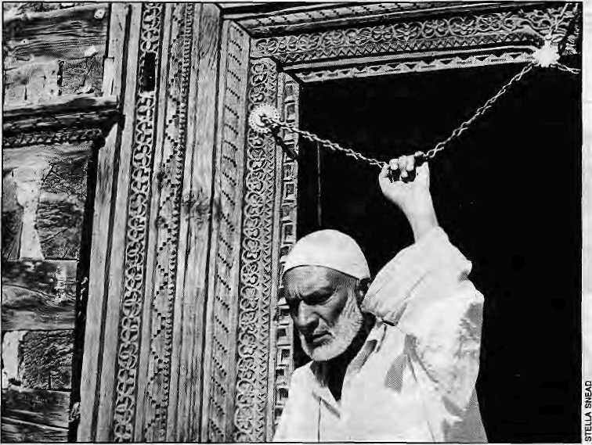
people from both sides of the border would ha ve access irrespective of their nationality (as in the case of the disputed territory between Italy and Slovania); or an alto-gethersuigenerisautonomyarrangement.
The central question is how to bring the Kashmiri people into a discussion of their own fate. Itis morally and politically imperative that they are recognised as a legitimate party to thedisputeand that, in the last instance, their will prevails.
Going by state positions, neither New Delhi nor Islamabad welcomes such a prospect. Each claims Kashmir to be its territory; and netiher would like to open up the whole issue. Both are sensitive to and fear external interference. The Indian Government is reluctant to concede greater autonomy to Kashmir for fear that that would trigger off similar processesin the Indian Northeast and potentially lead to India's disintegration. Public opinion in India is extraordinarily ill-informed and insensitive on Kashmir. For instance, an opinion poll in Delhi last October
showed that 70 percent believed that Pakistan masterminded the Hazratbal crisis.
The situation in Pakistan does not seem much better: the Pakistan Government's claim to Kashmir has been based wholly on the ground that over 70 percent of Kashmiris are Muslim; its human rights record in the Poonch area is
indefensible; and popular perceptions in Islamabad mirror Indian paranoia and suspicions. From the point of view of the Pakistan ideology, and the two-nation theory, it is extremely difficult for Islamabad to resist the temptation of playing the Islamic card to exploit the alienation of Kashmiris from India to its own advantage.
There is convincing evidence that Pakistan has stepped up its support to hardline Islamic secessionist groups such as Hizbul Mujaheedin and Harkatul Ansar, and is pitting them against the JKLF, the People's League, and other secular-minded, more deeply-rooted, pro-autonomy {asopposed to pro-Pakistan) groups.
However, amidst all this there is a ray of hope, and perhaps more. Since March-April this year, when a Pakistani effort to get India reprimanded at the UN Human Rights Commission in Geneva was defeated, there has been growing realisation among the militants in the
Valley that there can neither be a military solution to the Kashmir problem, nor a quick peaceful solution catalysed by the intervention of Islamic states, led by Pakistan. This has strengthened the hands of those who stand for a negotiated solution and unconditional talkswithNew Delhi and Islamabad. A certain kind of fatigue has set in among some militant
groups; and there are growing signsthat ordinary citizens are tired of the violence.
Secondly, pro-reconciliation tendencies within the Government of India have grown in strength in recent months. An advisory group has been set up which favours talks and elections rather than the use of force. The government still lacks direction and a coherent policy, and it can make bellicose noises as Rao did on Independence Day about regaining "Azad Kashmir". But it has released important JKLFleaders like YasinMalik, who stands for unconditional talks and for a non-sectarian, an ti-communal approach. This has further raised the chances of conciliation.
And thirdly, a great deal of differentiation is occuring among the azadi groups.Ontheonehand,secular-pluralist tendencies such as the JKLF and the People's League (whose long-incarcerated leader Shabir Shah commands great respect) are emerging stronger. On the other hand, the more communal-Islamic, pro-Pakistan forces are getting weaker and losing such limited support as they enjoyed.
If thedifferentiation proceeds further, and the Government does release Shabir Shah and starts negotiating with the pluralist-secular groups, it could achieve a genuine breakthrough. It will,however, have to resist the twin-temptations of reacting belligerently to Pakistani moves on Kashmir and holding elections prematurely, which it is under some pressure to do from some advisers. Even if there is a breakthrough, groups like the Hizbul Mujaheedin and Harkatul Ansar will remain active for some time. But it will become progressively easier to isolate them.
Ultimately, the key to a solution to the Kashmir problem lies in just howbold New Delhi is in offering the Kashmiris a truly generous degree of autonomy, even at the cost of losing full and total sovereignty over the Kashmir Valley, by moving to a federal arrangement. New Delhi will have to do a lot to convince Kashmiris that it is serious about autonomy and about putting its ill-conceived Kashmir policy behinditself. A history opportunity staresNew Delhi in the face. It would beunwise to let it slip.
P. Bidwai contributes opinions to over 20 newspapers, including 17ie Times of India, where he was Senior Editor till August 1993. He is a Senior Fellow at the Nehru Memorial Museum and Library in New Delhi.

Sep/Oct 1994 HIMAL . 43





Scholarly Books on Nepal, Tibet, Bhutan etc. Latest Trekking Books & Trekking Maps
MANDALA BOOK POINT
,, Kantipath, G.P.O. Box:528, Kathmandu, Nepal, Tel: 227711, Res: 216100 Fax: +977-1-227372 NP NATARAJ & 227600 MANDALA, Attn: Madhab, BK PT
Proceedings of the International Seminar on Edited by
ANTHROPOLOGY OF NEPAL: Peoples, Problems & Processes Michael Allen SPIRIT POSSESSION IN THE NEPAL HIMALAYAS John Hitchcock & Rex L Jones
- DEMOCRACY IN NEPAL, 1950-1994 (ForthCamming) M.Hoftun.W.Raeper&J.Whelpton
- THE SACRED MOUNTAIN: The complete guide to Tibet's Mt.Kailash John Snelling
- TALES OF THE TURQUOISE : A Pilgrimage in Dolpo Cornneille Jest
Mountaineering Books Guide Books of all Countries

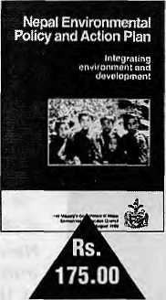
Nepal
Environmental Policy and Action Plan
Integrating environment and development
published by Environment Protection Council
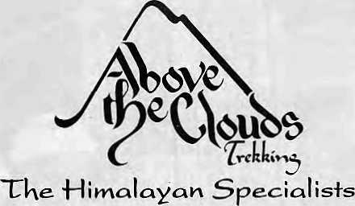
Want to ir&U. ^Knnapurna?^ Sorry, we
won't take you +ke»*e. 40,000 +^el<!<ers _{a}
year means you cou]*^ cneei
+k ll d we

for.
available at
Educational Enterprises, 223749 Himalayan Book Centre, 224191
Mandate Book Point, 227711 Ratna Book Distributors, 223026
f cultuccil
amidst +Ke- most sp&ctacwar
on
Above the Clouds Trekking
P.O. Box 398, Worcester, MA 01602 USA {800)233-4499; fax (508)797-4779

Save the Nepali Tiger
Their open habitat having vanished, the best hope for Nepal's tigers is within
reserves. There, they have to be protected from inbreeding, the poacher's
rifle, and the demands of the surrounding villages.

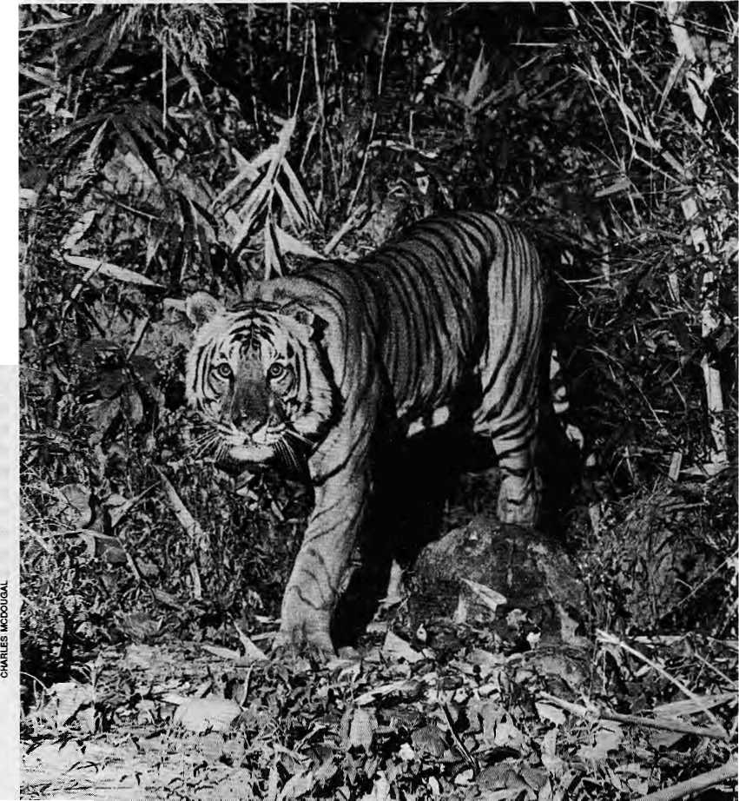

A
t one time the Tarai lowlands of Nepal were a paradise for tigers, and for tiger hunters. During the Rana period, the vast tracts of forest and grassland were the stage for grand shoots, or shikars. These hunting expeditions were carried out not only because it benefitted the rulers themselves, but also because it formed an important part of state hospitality.
Although archival photographs give the impression of reckless hunting by the Ranas, tigers were harvested on a
Bangey Bhaley: male
tiger, antecedents
unknown. Became a
'resident'in 1981,
faced with
competition with other
mates in early 1984.
Photograped a month
before he became a
man-eater in April
1984. Killed three
persons by mid-1984,
Darted and
transferred to
Jawaiakhel Zoo in
Lalitpur on 31
December that year.
Died a couple of
years ago.
by Charles McDougal
sustained yield basis, and the shikars in any one locality were spaced out at intervals of several years. Thus, tigers werestill plentiful as late as in 1950, and a continuous belt of habitat stretched the length of the kingdom along theTarai and Inner-Tarai valleys.
I madea dozen trips to different parts of the western and far western Tarai between 1967 and 1972. Travelling by foot and bicycle and staying mainly in Tharu villages, I had opportunity to see things at first hand.
In the far west, resettlement from the hills was only beginning to make an impact. Huge unbroken stretches of the Tarai forest remained. During the late 1960s, it might still have been possible for an energetic tiger to walk all the way westward from Chitwan, in central Nepal, to India's Corbett Park, without ever leaving decent habitat.
But the picture changed rapidly. By the beginning of the 1980shaIf of theTarai forests had been cleared for settlement and cultivation. By then two gaps had

A Buffer for the Tiger

Many, if not most, of the local people living around parks, far from holding the tiger in esteem, consider it a threat to life and property. Cats that kill village livestock on the park's edgeare often poisoned, notforcommerrialgain,but simply to eliminate a problem animal. Man-eating tigers, in particular, give the species a bad press. If tigers are to be conserved, ultimately, the locals must have a vested interest in the future of the parks and reserves, in general,and of the tiger, at the apex of the ecosystem, in particular.
The local inhabitants must be convinced that the tiger is an asset rather than a menace, and that its conservation is in their long term interests..This is the only way to halt poaching. Failure means not only the end of the tiger but of its entire ecosystem.
Employment of local people by tourist lodges is important, especially in Chitwan, where there are seven tourist concessions within the national park, as well as numerous hotels and lodges just outside. Nevertheless, the majority of the 42,950 householdsbelonging to the 23 villages
surrounding the park are dependent on agriculture, and it is their basic needs that must be addressed. While these villagers are allowed to harvest grass from the parks for thatch and construction, their requirements for fuel and fodder have not been met.
In 1993, there was an important amendment to the National Parks and Wildlife Conservation Act, whereby provision ismadeforthe creation of buffer zonesatfhe edge of parks and reserves, with the express purpose of fulfilling the local needs for natural produce. Art amount of 30 to 50 percent of the income generated by the protected area would be used for community development. The big question that remains is, can buffer zones be implemented in such way that local people feel the benefit?
Above all, buffer zones must be planned in such a way that they do not escalate tiger-man conflict. We know from bitter experience that tigers and people, in particular grass-cutters, do not mix.
- Charles McDougal

occurred in the hitherto continuous forest belt. During and after the completion of the Sunauli Pokhara Highway, forest were cleared and settlements increased on either side of Butwal, creatinga migration barrier for tigers. At the same time, there was rapid deforestation in Kanchanpur District, again in the wakeof road building activities. The result was a gap isolating the tigers at Sukla Phanta in the southwestern corner of the country from those further east.
Fortunately, during the 1960s, tigers had been provided special protection in three places: a rhinoceros sanctuary at Chitwan (1962), and royal shikar reserves atKamali (1969) and Sukla Phanta (1965).
Island Populations
By the 1980s, there was no longer any habitat between the Chitwan Valley and the extreme western end of the Deukhuri Valley. In eastern Nepal, there was no viable tiger population all the way from the Bagmati to the Mechi river on the eastern border. The building of the East West Highway had destroyed the forests between Janakpur and Hetauda, while the Janakpur-to-Biratnagar stretch was settled much earlier.
In 1987, wildlife biologist David Smith and I conducted a survey of tigers in the far western Tarai and found the situation heartening. We found a continuous habitat all the way across Banke, Bardia, and Kailali districts. But the link with Sukla Phanta had already
been broken. And by 1991, a new gap had developed on the west bank of the Karnali; a thin migration corridor that had existed till 1987 has since been destroyed by human activity.
What had been a continuous stretch of habitat the length of Nepal is thus today dismembered into four isolated chunks. While three of these are centered on parks and reserves, that in Kailali is relatively unprotected and can be written off as having only a short-term future. Eventually, all that will be lef tis the habitat inside the protected areas of Nepal. Most of Nepal's tigers are to be found in these parks and reserves.
The largest protected area is that which includes the Royal Chitwan National Park, gazetted in 1973, and the Parsa Wildlife Reserve, a de facto eastern extension of the national park created in 1984. Adjacent to the national park, in Bihar, is the Valmiki Tiger Reserve, established in 1989. These protected areas providea total of 1875 sq km of continuous tiger habitat. Then there are 968 sq km of the Royal Bardia National Park, established in 1988. Finally we have the 155 sq km Royal Sukla Phanta Wildlife Reserve; an eastern extension, which will double its size, is in the process of being added.
Carrying Capacity
Chitwan's tigers are the best and longest-studied anywhere. Two decades of research conducted in the national park
has helped in understanding how many tigers a protected area can support.
The density of the tiger's population depends on the quality of the habitat. Chitwan's alluvial floodplain/a mosaic of grassland and riverine forest, together with the Sal forest edge, contains a great variety and abundance of prey. It is here thatthe tiger density ishighestand where most of the reproduction takes place.
In Chitwan, we have individually identified all the resident animals in a given study area and monitored them overtime. This wasdone both usingradio telemetry and by developing a reliable technique for identifying tigers by their tracks or pug marks, which involves recording the impressions of all four of a tiger's feet. Photographs obtained from camera traps set up along the tiger trails serve as a cross check for identification.
Chitwan's tigers have a polygynous matingsystem. Resident females compete for resources, establishing mutually exclusive territories to support themselves and raise their offspring. Males, on the other hand, compete for females of reproductive age, successful ones carving out territories from those of two to seven tigresses. Other males are denied access to this territory. At any given time the breeding segment of the population will contain more females than males, at a ratio of 3:1 or more. The mean breeding life for males is 2.8 years, that for females 6.1 years.
Monitoringovertheyearshas shown

46 . HIMAL Sep/Oct 1994

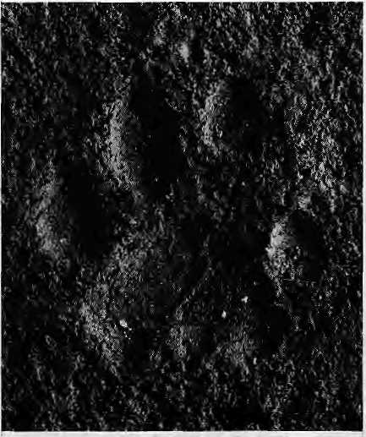
Pug mark of Bangey Bhaley showing injury to the right forefoot resulting in deformity, which helped identify him. The third toe is pushed in advance, resulting in an unnatural gap between ft and the fourth toe to the right.
that a study area of 100 sq km consisting of 70 percent riverine habitat and 30 percent Sal forest will support amaximum of six reproductive tigresses. In less suitable habitat, where prey is less varied and abundant, one tigress alone may require 50 sq km. The point to make is that inagivenhabitatthereisanupperlimitto the number of reproductive animals that can be supported. This is an important consideration for wildlife managers. Depleted populations when given protection can be expected to rise, but only until saturation is reached, after which they will level off.
Having discovered the capacity of different habitats for tigers, we can interpolate for other areas with a good deal of accuracy even without carrying outa census. Monitoringthe resident tigers in the Karnali floodplains of Bardia was begun last year, and the findings so far corroborate those from Chitwan.
In 1989, at a time when saturation can be said to have been achieved, we estimated there were 65 breeding adults (40 females and 25 males) in the 'greater Chitwan' population. In an ideal world of negligible poaching and encroachment, Chitwan/Parsa, that portion of the protected area inside Nepal, can support 45-50 breeding tigers. The Banke/Bardia population presently holds 30-35 breeders; the capacity of the Royal Bardia National Park itself is probably 20-25. At Sukla Phanta the capacity is 10-15. Excluding theisolatedtigersinKailaliand elsewhere in the kingdom, there are probably not more than 100 tigers of breeding age in all of Nepal, and a maximum of 250 tigers of all ages, includingdependent young ones.
Genetic Considerations
Migration barriers between island populations preclude the exchange of genes. In the long run, when there are small,isolated populations of tigers, there is a loss of genetic variability which lessens the population's ability to adapt to changing environmental conditions. To avoid such an eventual decrease in diversity, the effective population size in one reserve or area should not decrease below 500. Since all existing tiger populations are already below tha critical level, this issue is, for course, academic.
Of more practical concern is the danger of reduced fitness caused by inbreeding, as well as reduced litter size.
lower birth rate, and a higher cub mortality. To avoid this, inbreeding should not exceed one percent per generation; as a general rule, the effective population size of breed ersshouldnotdropbelow50.
A number of factors may combine to make the effective population size less than the actual number of individuals of breeding age present. A major one is the variance in lifetime reproduction, as measured by the number of young that survive. A study in Chitwan determined that the variance there was very high. Thus,al though the number of breeders in the greater Chitwan population was taken to be 65, the effective population size was determined to be only 26, and the annual rate of inbreeding calculated at two percent.
Although the inbreeding rate in Chitwan is thus twice that recommended, so far there is no evidence of inbreeding-related problems. But this should be no cause for complacency, especially when we consider the smaller sizes of the Bardia and Sukla Phanta populations. And bear in mind that the Chitwan population is the second largest in South Asia (the largestisinSunderbanofBangladeshand West Bengal).
What are the options for injecting new genes into a population? Artificial insemination would seem to hold outsome hope, but there has been only one successful case, and that too in captivity. The technology needs to be refined and it
will probably be some years before it can be used as a viable tool for improving the gene pool of a wild population. An alternative might be the translocation of individual wild tigers between reserves. Such an operation would not be a light-hearted undertaking, and would involve certain risks.
Man-Tiger Conflict
Another difficulty with 'island populations' is that they create problem tigers. Good reproduction in the protected areas leads to intense competition for limited space. The more vigorous animals win, and the young, the old, and the disabled are pushed out into marginal habitat. Where natural prey is scarce, tigers supplement their diet by preying on village livestock. Occasionally people are killed and eaten. Considering the frequency of interactions with humans, the incidence of attacks is amazingly low. Human beings do not form part of the natural prey of the big cats; During the course of its evolution, the tiger learned that avoiding the bipedal human was the best strategy for survival.
Since 1978, 21 villagers have been killed in or at the edge of the Royal Chitwan National Park. In all cases where the kill was undisturbed, the catfed on thehuman body. Most of the victims were grass-cutters who penetrated thick cover where tigers were resting. The victims were in the wrong place at the wrong time, and in some cases probably mistaken for a .quadruped while squatting on the grass. Thehuman kills were madeby seven different known tigers; only two were believed to have been injured while fighting with other tigers. An uninjured male was pushed out of his area by a larger tiger; during this six month period, he was involved in five man-eating cases. Subsequently, he established a territory containing two tigresses; during a ten month period he made no further attacks on humans, despite the presence of thousands of grass-cuttersallowed to enter the park in January 1982 to collect thatch. He subsequently disappeared, and his territory was occupied by a new male.
It is possible that the increased aggression that takes place during intra-specific (within the species) competition isdirectedathumans. In all cases recorded,

Sep/Oct 1994 HIMAL . 47

man-eating was 'opportunistic' in nature; thetigersdidnotgoouttohuntforpeople, but did attack them when encountered unexpectedly at dose quarters.
In March and April of this year, a male tiger killed and partly consumed three persons at the edge of Royal Bardia National Park, where very few such cases have been recorded. The tiger had a deformed rear leg that had healed itself after a possible bullet wound. After killing his last victim the tiger was captured and translocated to the Jawalakhel Zoo in Lalitpur. There, in a desperate attempt to regain his freed om,hebToke all four of his canine teeth besides destroying his front claws.
In the interests of the local people, it is imperative that tigers that kill peoplebe dealt with without delay by the authorities. It is also important, however, that the right tiger be killed or captured.
Tiger Bones
Asthedecadeofthel980swasdTawingto a close, conservationists were optimistic about the future of the tiger, especially in South Asia. For over nearly two decades, tigers had prospered in the special reserves that had been set up for them. Then suddenly, a horrendous threat emerged from an entirely unexpected quarter. Once poached for their skins, tigers were now being poisoned for their more valuable bones, Thetigerreservesinnorthern India began to experience (rippling losses. Almost overnight, the tiger population in Ranthambore,a tiger reserve in Rajasthan where many tigers have been filmed and photographed, was down from an estimated 44 to only 15. Around Dudhwa National Park (adjacent to Bardiya in Nepal), 23 tigers were poisoned in just two years. Serious poaching losses were also reported from Corbett Park.
Nor were theprotected areas inNepal spared. In western Chi twan where I have been monitoring tigers since 1980, a large number of known tigers suddenly disappeared. In several cases, wholelitters of cubs vanished along with theirmothers, pointing almost certainly to poisoning. Between 1989 and 1991 one-third of the resident females of breeding age were lost. Although there was no direct evidence of poaching in Bardia and Sukla Phanta, this did not mean they were free from poachers.
The upsurge in poaching coincided
with a sharp rise in the demand for tiger bones, hitherto supplied from local stockpiles, in the traditional Chinese medicine market. Prosperity in East Asia put tiger bone products (and rhino horn, the other valuable 'product' of the Chitwan and Bardiya national parks) within the reach of more consumers, increasing the demand and driving up the price. The threat from poaching was serious enough for Peter Jackson, Chairman of the IUCN's Cat Specialist Group, to state in 1992 that the tiger possibly faced extinction in the wild within a decade.
Tiger bones, both from Nepal and India, are being smuggled northward through Nepal to Tibet, and from there on to China, Taiwan and South Korea. In 1988,250 kg of tiger bone, representing at least 20 tigers, were seized by the authorities in Simikot, dose to Nepal's north-western border with Tibet.
The Royal Nepalese Army is responsible for the protection of the parks and reserves. Despite the large number of troops deployed, a full battalion in the case of the Royal Chitwan National Park, they have been unable to prevent poaching. Approximately 80 percent of the budget of the parks and reserves goes to pay for the upkeep of the military protectors, but they are not subject to the orders of the wardens and only obey those of their own commanders.
There is often little coordination between the Army and the wildlife authorities. Since the Army does very limited patrolling, the wardens of the Royal Chitwan National Park and the Royal BardiaNationalParkhavefoundit necessary to set up and equip their own anti-poaching teams, composed of game scouts and hired villagers, to patrol vulnerableareas,suchastheBandarjhula Island in Chitwan, with its pristine habitat.
In 1991, the warden of Royal Chitwan National Park, with financial support from IUCN, established an intelligence network; rewards were offered tolocal people whocame forward with information leading to the arrest of poachers and traffickers. Almost immediately, six men who had just poached a tiger were arrested; they confessed to having killed two others earlier. Unfortunately, at that time, the penalties were light. The men served 18
months and were released; one of them is believed again to have joined thegame. In 1993 the Government legislated stiffer penalties for poachers of tigeTsand rhinos, as well as traffickers of their products, with a minimum five-year jail term (and up to 15 years), and fines of NRs 50,000 to NRs 100,000.
Without arrests and confessions, evidence of tiger poaching is difficult to obtain. If a tiger is poisoned and thebones and skin removed, the little meat that remains can be easily disposed of. As of May 1994, there were 47 poachers and dealers in Bharatpur Jail. Unfortunately, none of the kingpins in the smuggling network has been arrested, although in some cases their identity is known.
While Indian tigers continue to be killed right up to the present, in Nepal there seems to have been less tiger poaching in 1992 and 1993 than during the previous three years. In fact, some of the earlier losses have been replaced (by newborns). However, rhino poaching increased during the same period, which may have temporarily taken pressure off the tiger. Certainly, there is no room for complacency so long as the demand for tiger bones continues. What happened to Ranthambore could easily happen here.
C, McDougal is a Research Associate with frie Smithsonian Institution and works at the Tiger Tops Jungle Lodge.
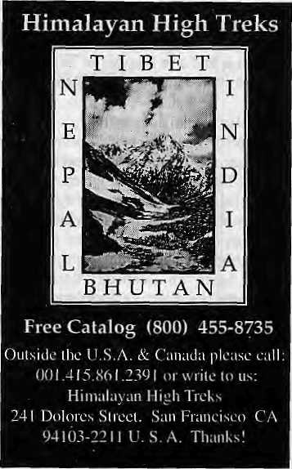

48 . HIMAL Sep/Oct 1994

-:- :,, if f W.
a m > * 3

m

Ill
IT IS ONE THING TO BLOW ONE'S OWN TRUMPET,
::;.;:;SuT QUITE;: ANOTHER TO BE AWARDED FOR IT

$&
iff*
£S*


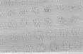

f. f ■&: * X -f!
j
'Himal'equals Cluster, Chain, Group

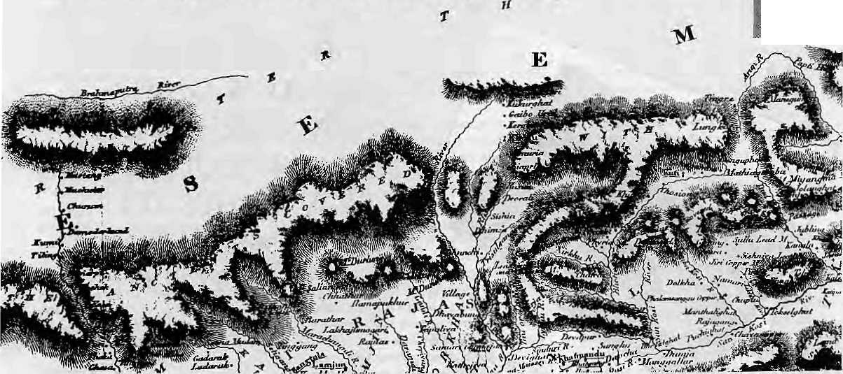
HIMAL

A term developed in the Nepal Himalaya can be extended to cover the whole Himalaya.

T
he indifference with which the Himalayan peaks were treated by the people of the Himalayan mid-hills is clear from the fact that most of the great massifs did not have names. (Even today, only 20 percent of Nepal's above-6000ers are thus fortunate.) Other than a source of religious folklore, no attempt was made to understand their structure geographically,to find outthe peculiarity of a peak or range, or to climb and explore thissnowbound environment. All thishad to wait for the arrival of the European explorersand climbers.
Conditions have changed agreatdeal in recent years. Mountain enthusiasts, climbers or otherwise, from either side of the Himalaya have taken to climbing the mountains or exploring their lower reaches. Others are acquainting themselves with mountain literature or brushing up on their knowledge, both useful andesoteric,ofthemountains.Onerelated development is that the locals have also taken to naming the peaks.
This naming game, although far from being complete or sometimes even correct, is, however, a healthy sign after centuries of reverential aloofness. At the same time, it must be mentioned that those who would christen Himalayan massifs have
contented themselves thus far with finding names for individual mountains.
As the Himalaya becomes more a subject of study, a term that applies to a cluster of peaks has become necessary. For, the Himalaya is not an unbroken line of peaks stretching from the Indus to the Brahmaputra Bend in Arunachal, but rather a range that is made up of smaller chains that are divided either by the mighty Indus, Ganga and the Brahmaputra tributaries or by lower ridges that barely qualify as mountains.
This singularity of the Himalaya— that of being a broken collection of jagged edges rather than a broad plateau—can be found in various forms. While the Ganesh Himal, seen directly north-east of Kathmandu,isbounded on either sideby the Trisuli and Budi Gandaki rivers, the Kanchenjunga chain is distinct by its breaking off to the south from the main east-west march of the Himalaya; and the Nanda Devi Sanctuary by its conglomeration of peaks around glaciers heading in all directions.
It would thus seem logical that such groups, chains, clustersor mini-ranges be considered similar in that they represent part of thegreater Himalaya butalso retain their own individuality. And to extend
by Deepak Thapa
the reasoning further, a common name to denote such groupings would be but natural.
For close to three decades some writers on the Nepal Himalaya have been referring to such a group of mountains as himal. While the term is also used more simply to denote "a snow mountain" (which is also the meaning of the title of this magazine), it has come to refer to mountain clusters. Theorigin of thisusage cannot be pinned down, but it is safe enough to surmise that it came into vogue by the two ranges north of Kathmandu being pointed out as Ganesh Himal and Jugal Himal, without particular reference to individual peaks. (Early British map above shows Ganesh separated from Langtang/Jugal.)
In both cases, while the original use was surely to denote these peaks generically as one "snow mountain" (given our ancestors' lack of interest to detail), when it was time for modern-day mountaineers and cartographers to name the chains, the term 'himal' came to refer to chains and clusters, which is what both Ganesh and Jugal are.
Nepal has 28 such himals, each separate from the rest and each with its own proliferation of high peaks. For

50 . HIMAL Sep/Oct 1994

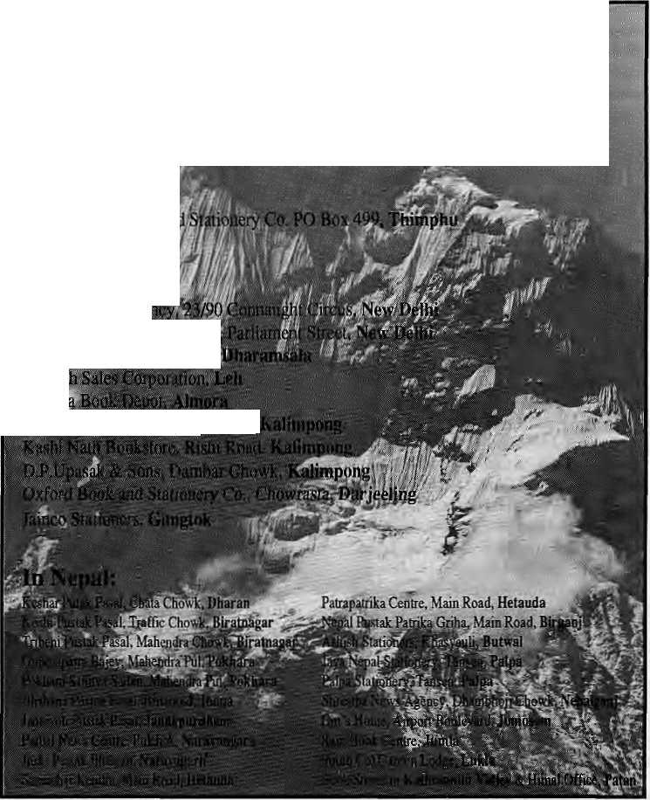
instance, the Rolwaling Himal in eastern Nepal with Gaurishanker and Menlun-gtse, the Byas Himal in the west with Api, and the Manaslu Himal of central Nepal with Manasulu, Himal chuli and Baudha.
This nomenclature for clusters makes a lot of sense if the alternatives are considered. 'Range' and 'chain' envision a continuous line; 'cluster' sounds like a jumble (and much too pedestrian to use for Himalayan peaks!); and 'such-and-such peaks' (for example, the Swarga-Tohini peaks of Garhwal) seems to belittle the personality of the great ones; whereas himal seems to respect the individual peaks, while at the same time delivers a sense of a chain that is more than the sum of its parts. The term also somehow seems more attuned to mountain groupings, be they standing in a line or ranged about a glacial valley.
The need to suffix such Asian names as Nanga Parbat with a completely foreign term as 'range', when 'Nanga Parbat Himal' has such a natural ring to it can also be argued. Perhaps one should not stretch the argument too far, for before those mountains were known as the Nanga Parbat Range, they were probably notknownatall! And whileone has always to guard against regional (Himalayan) chauvinism, one must still say that 'himal' isbetterthan 'cluster'or 'shain' or 'range'.
The use of the term himal also facilitates ready identification and location of peaks, particularly the less known ones. It is more useful to say that TukuchePeak is in the Dhaulagiri Himal than to scratch one'shead and say that it is somewhere in the mid-Nepal Himalaya. At present, lesser mountains tend to be known by their proximity to a dominant peak. For example, the relatively well-documented Garhwal Himalaya has the Trimukhi Parbat Croup and the Sudarshan Parbat Area. Calling them instead the Trimukhi Parbat Himal or the Sudarshan Himal would lend consistency to the naming of mountains. And if one is to follow the Nepali example, such himals need not even depend upon the highest peak in the group. The Khumbu Himal (with the enviable Chomolongma in its line-up) is named after the region it lies in, and the Jugal Mimal probably takes its name from the twin (jugal) peaks of Dorje Lakhpa.
Having said so much, perhaps one needs to look at the distinguishing features of a himal. Where the distinction is clear, asintheAnnapurna Himal, interposed as
it is between the Marsyangdi and Kali Gandaki rivers, it is easy enough. But natureand geology does notalways allow for such clearcut demarcations, and one has to look for delineations as and where they present themselves. A definitive turn in direction from the main range, as in the case of Damodar Himal in Mustang's east (it turns northwards) isone such. Another is the sheer rise in height from a lower ridge, like the Jugal Himal. A third is a distinctive grouping of peaks as is found in the Khumbu Himal.
Mountain clusters like the ones mentioned above can be had all over the Himalaya, and thus all the more reason to seek a more uniform terminology to differentiate one from other.

IirBhi$an: ■>,
:Y'angchenma.,£nok;

In India:
Central News Age!
k;tilha Mohan House. Hcili {<<Md
Since the usage of himal has been accepted for three decades or more in Nepal in the Central Himalaya, which
houses the greatest profusion of peaks high and low, it is perhaps not illogical to propose that this term cover the whole Himalaya as well. Indian Himalayophiles may not have too much of a linguistic problem because of the Sanskrit root of the term, and the rest of the countries of South Asia and Tibet/China might also go along for the cause of regional solidarity. The sound of Panch Chuli Himal (Kumaun), Chomolhari Himal (Bhutan), or Namcha Barwa Himal (Tibet) is certainly more pleasing than what they are presently known as—this or that 'group'. Who knows, this might be such a good idea that 'himal' might soon be used in the Alps, theDolomites, the Atlas and the Andes.
,-C ;,
D.Thapa, is Himal's one of two "Know Your HimaP columnists.

Sep/Ctt 1994 HIMAL ■ 51

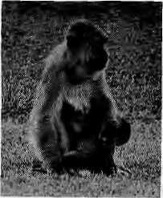
Abominably Yours,
Us members of the female species ought to teach apeman a lesson. They never get it do they, sister? They are just so dense and full of themselves you need to keep massaging their egos, and if you don't do it they will trudge off to Num and get themselves an onanistic special.
It is a clear pattern across the board for all higher primates: the male gorilla, male orangutan and male South Asian could all be members of the same species (or the same upper caste). They have more in common with each other than they do with females from their own species (or caste). Next time you visit the Hanuman temple, take a look at the rhesus dhedoo who holds court there; doesn't he remind you of the part-chewing superintendent at the Bhairawa checkpost? Or the bored, crotch-scratching minister of social welfare who elbows stewardesses on air taxis? Or the vacant-eyed, nose-picking bus driver in Samastipur?
Everywhere, the uncouth male tries to ride roughshod over the female, and the results are obvious in the higher birthrates. Socio-sexual analysts have named this phenomenon the Khyber Factor. Demographers have long noticed how fertility rates rise the closer you get to the Hindu Kush (which is also where bus conductors are most given to fingering lone female budget travellers). In fact, if you made a fertility' map of South Asia, the countour lines would go around in near-concentric circles around the Khyber Pass and dip eastwards and south.
The peak, an average of 7,1 children per woman in purdah, is in the vicinity of Peshawar-Kabul, into Baluchistan and along the foothills of the Karakoram. The next level, 5.5 to 6.5, traverses the Hindu belt—Bihar, Rajasthan, Uttar Pradesh, the western fringes of both Madhya Pradesh and Nepal. Urban Punjab is an exception, so are the Himachal hills. But from these heights, the fertility plateau plunges to near-replacement levels of Kerala, Tamil Nadu and Sri Lanka,
Any population expert, and Nafis Sadik in the Cairo population conference last month, will tell you fertility rates are directly linked to the
status of the
female, and so the
closer you get to
the Khyber the
more suppressed our sisters are.
Conservative Hindus and conservative
Muslims seem to share the same gender
attitudes to keep their women down—
keep them pregnant.
Forget fatalism and development, the key to the future is female empowerment. Let's not waste time submitting to painful laproscopy, norplant implants, or depo provera's abomination. The only solution, really, is for males to submit to the simple slit and snip known as vasectomy. Now, isn't it revealing that we never heard this from the Pope, the mullahs, the pandits, or Al Gore? I wonder why.
The Ninth Five Year Plan of Nepal, Bhutan, Tibet and all of India must have VASECTOMY printed in big bold (red) colours on the covers. The family planning jingles in Radio Nepal, Radio Lhasa, the Bhutan Broadcasting Corporation and All India Radio, rather than entrap women into surgery, should run commercials with virile voices saying, "I've had it done, but I am still man enough."
Remember, sisters, despite their larger size, mate primates are afraid of us. It is a terror that springs from a vestigial evolutionary memory of Female Energy, shakti. The Male Member knows that this primeval power lies dormant underneath our collective submissive crust. All sisterhood is waiting for a sign before they erupt in unison and drag their malefolk to the temporary camp in the next village to have them all vasectomised.
We need to rediscover this shakti core so that female foetuses will be allowed to be bom, girls will not be the last to eat or go to school, young women will decide their destiny. The moron who deigns to call himself a spouse must clean up in the kitchen without us having to threaten to cut his wee wee off.
The Upper Barun females have registered an NGO with the CDO at Chainpur. We have named ourselves Sisters for Himalayan'Equality (SHE), and intend to do our own solidarity
work. We think the struggle has to go global, and some of us didi bahinis have already started packing up for the long trek to the Fourth World Conference on Women in Beijing next year, although we have not yet heard from the International NGO Steering Committee about whether we will be allowed to register. Territorial Han males are pressuring the Committee not to allow delegates from anywhere near the Tibetan plateau.
Here at SHE, we do female bonding, getting giddy pleasure from picking nits from each other's backs. Once in a while, we throw back our heads and scream with glee at our own very female jokes that the Tarzans over there will never understand. They awake from their slumber, and give us half-eyed quizzical looks and return to their sulk. We have stopped picking their lice, and next will be to have them man the washing machine.
They will never understand us because they don't want to. The experience of carrying another life for nine months, the tenderness at childbirth towards the fluffy newborn, is denied them by evolution. Then there are the peculiar she-problems. How, while running downhill to chase the snow-leopard that has carried off the pet baby jhokpa, we have to sling our pendulous units over our shoulders so they don't get in the way. Of everyday hassles like finding a large enough moraine wall to squat behind, while those abominable males can just unzip on the wayside in full view of the Makalu Base Camp, and watch the yellow snow melt.

Reader, you had always presumed that this columnist was male. My attempt to remain annonymously gender-neutral was overturned by that thoughtless goof-up in the last issue by the dimwit who edits this magazine. Now, you'reis going to flip back over my columns of these past seven years and read them for insight, right? Forget it

52 H1MAL , Sep/Oa 1994

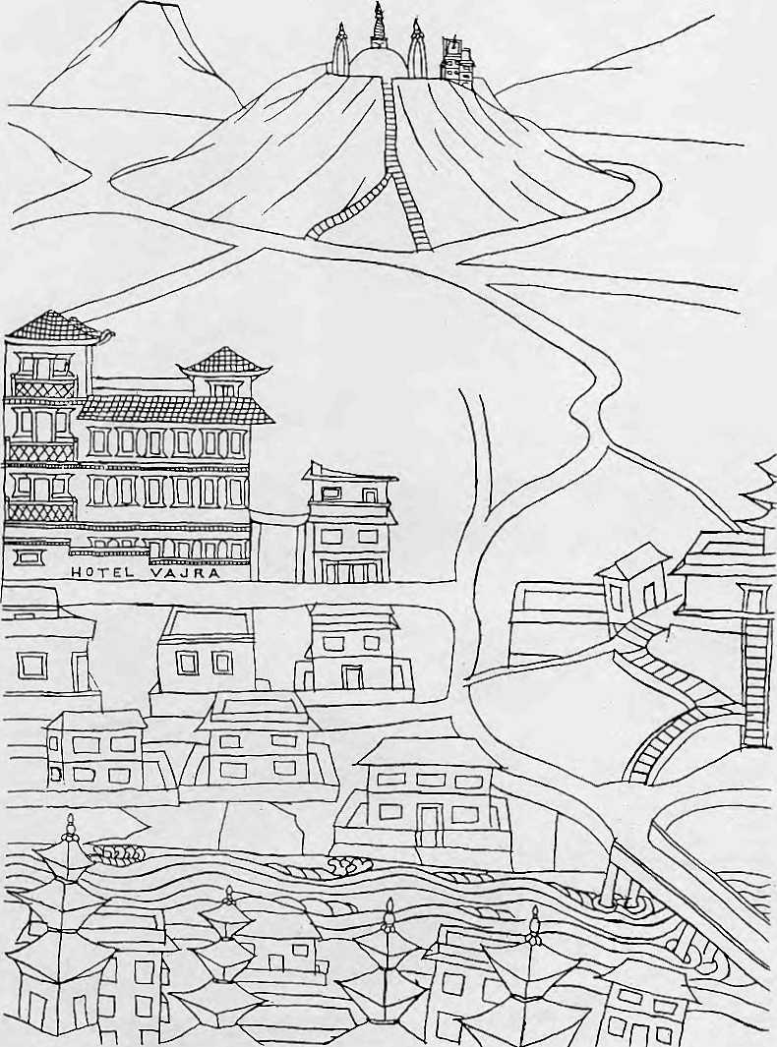
Vajra (literally-flash of lighting), is an artists¹ condominium, a transit home for many, providing a base during months of hibernation and creative inspiration. its isolation, graphic splendour and peaceful ambience, make an ideal retreat from the clock of pressure.
KetakiSheth Inside Outside
I stayed a week at the Vajra, by which time I had become so fond of it that I stayed another.
John Collee The London Observer


in Kathmandu, the Vajra

Swayambhu, DaHu Bijyaswori, PO Box 1084, Kathmandu Phone 271545,'272719 Fax 977 1 271695 Telex 2309 HVGHPL



- r. -'' V" s^- \i-' i+f-y* ^{v}' '■ ■
^Jj:ifc-:Xyf--:. '^T^*'*¹*"":><T.i*V

-i-'-^-V- ■>-■•


[-";-.
You've just spent hours inching around a space barely-enough to accommodate
the human body.
Odd, that's what climbing in
most sleeping bags is like.


■■-;■;■■■»:.;■

The New Sleeping Bag Collection
For our free catalogue call 707 544-4590

