HIMALAYAN MAGAZINE
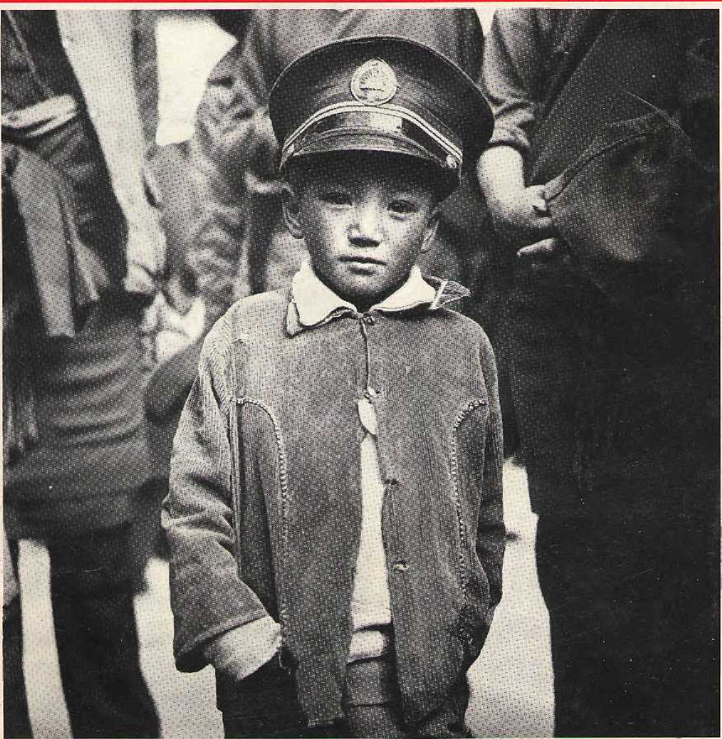
The New Lhasa
Kai lash Trashed • Dirty Kathmahdu



Northwest makes it easy to go to America. With a choice of 8 gateways. And connection to 200 cities beyond.
Choose a connecting city that suits you best : Bangkok, Hong Kong or Singapore.
generous free flight plan there is. General Sales Agent in Nepal :
Ma I la Treks,
Malla Hotel Arcade,
Kathmandu, Tel. 418 389
Northwest has daily 747 flight via Tokyo or Seoul straight to the U.S.A.
Be sure to ask about WorlclPerks, the most


NORTHWEST AIRLINES
SOME PEOPLE JUSF KNOW HOW TO FLY*"


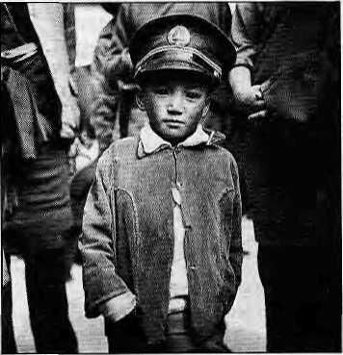


HIM

V0I8 No 1 January/February 1995
The Abode of Gods, King of
Mountains, Himalaya You bound the oceans from
east to west A northern yardstick To measure the Earth Kaltdasa (Kumara Sambhavaj
Editor
Associate Editor Photography Manager Administration

Kanak Mani Dtxit Manisha Aryai Bikas Rauniar Kiran Shrestha Balaram S harm a Mamata Manandhar
Subscription Rales
Only Bank-drafts acceptable for subscription orders
made 10 Himal in Nepal. Do NOT send cash iri mail.
D E
Mdernise, Or Else! Building the New Lhasa
by John Grey
The modernisation offensive in Tibet today has largety bypassed the Tibetans themselves.
Cover picture by Kevin Bubriski
shows a Lhasa child with a mock Chinese ?nilitary headgear.

20
23
29
41

Individual |  | 1 year | 2yrs
Nepal | NRs | 220 | 4oa
India | IRs | 140- | £60
Bhutan | Nlj | 175 | 330
OlherS, Asian Countries | U$ | 12 | 20
North America | u$ | 22.50 40
Germany | DM | 60 | 90
United Kingdom & Ireland | E | 20 | 35
Netherlands | D)l | 45 | 80
Elsewhere | U$ | 25 | 45
institutional
Nepal | NRs | a oo | 1100
India | IRs | 260 | : son-
Bhutan | Nu | 330 | 640
Other S. Asian Countries | U$ | 25 | 45
North America | U$ | 35 | 60
Germany | DM | 70 | 120
United Kingdom & Ireland | £ | 30 | 50
Netherlands | Dll | 100 | ISO
Elsewhere | Ut | 45 | SO
Send subscriptions & rotate | ii rnrrr | tspondenteto:

South Asia: P.O. Box 42, Laliipur. Nepal
[1619771 523845, fax 977 1 521013), or
Central News Agency, 23/90 Connaught
Circus, New Delhi 110001
Japan: Akio Horiucl.i,
P.O.BoxS, Kiyose, Tokyo, 204 Japan.
Australia: Indra San, 12 Norfolk SI.,
Paddingtsn 2021, Sydney, Australia.
North America: Barbara Bella & Associates,
500 Sansome Sireat, Suite 101, PO Box 470758
San Francisco, CAB4H7
United Kingdom & Ireland: Jcli Girl (Rat: H),
221 Ashly Gatdens, Emery Hill Street, London SWI 1PA

The Netherlands: C. F. de Stoppelaar,
Foundation Himalaya, Keizersgracth 463,
1017DKAmsterdam
Switzerland: Helene Sngg, Tamenweg 18,
CH-3073, Guemilgen, Switzerland
Europe: Dutga Press (Himal), LuitpoUsir. 20.
D-82211, Herrsching, Germany
Himal© 1995 is published every two months by
KImal Association, PO Box 42, Patan Dhoka, Laliipur, Nepal
Tel: 9771533845, Fax: 521013,ema>: himal® mosnepal.emat.ki
LbaryotCongrass Card, Catalogue Number 88 912882
ISSN401296Q4
PrinSng: Jagadamba Offset Pvt. Ltd. Tel: 521393.


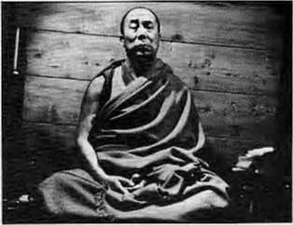
An Elegant Return
by Roger L. Plunk
The Dalai Lama's presence in Lhasa would help the Tibetan people face their day to day problems with confidence and resolve.
Departments
Kang Rlmpoche Trashed and Commercialised

uy junn v. oeiieiid | 3 | Briefs
 |  | Haiti Cuisine, Kuinauri Fashion
 |  | Biofencing Elephants
 |  | Climbing Unopened Peaks
 |  | Tourism, Bali Style
 |  | Placename: Kanchenjunga
 |  | Notes from the Karakoram
 | 26 | Voices
Asia's holiest place is turning into a dirty Disneyland. | 33 35 | Review 1994 Himal Index
 | 36 | Himalaya Mediafiie
 | 39 | Know Your Himal
Kathmandu, Uailo Kathmandu | 44 | Opinion
A Photo Essay | 47 | Abstracts
 | 49 | Mail
 |  | No Sops for Uttarakhand
Citizenship Made Simple |  | Intellectual Challenge
Katha |  | Gurkha Sorrow
by Prem Krishna Gongaju | 52 | Abominably Yours
Newsstand Rates
DM 9 £ 4 U$ i
Canada $ 5.75
NRs40 IRs 25 Nu30 United States $ 4.75

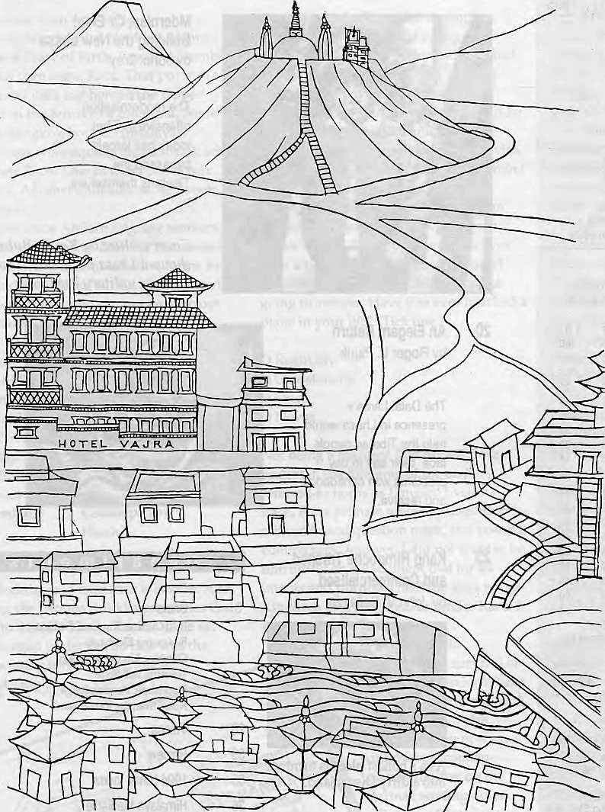
Vajra (literally-flash of lighting), is an artists' condominium, a transit home for many, providing a base during months of hibernation and creative inspiration. Its isolation, graphic splendour and peaceful ambience, make an ideal retreat from the clock of pressure.
Ketaki Sheth Inside Outside
I stayed a week at the Vajra, by which time I had become so fond of it that I stayed another.
John Collee The London Observer


in Kathmandu, the Vajra

Swayambhu, Dallu Bljyaswori, PO Box 1084, Kathmandu Phone 271545, 272719 Fax 977 1 271695 Telex 2309 HVGHPL

B
f

Himalayan Chic for the Upper Crust

Elephant Menace? Try Bio-Fencing
I am enclosing an entirely r
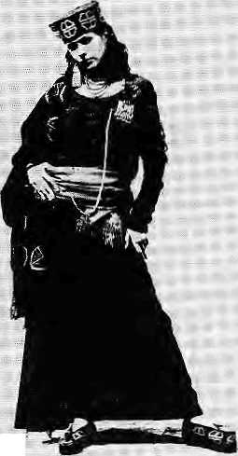

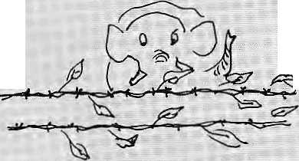

B
alti cuisine is all the rage-in London, and Kinnauri fashions have caught the i ma gi na t > o n of Delhi's beautiful people. The Himalaya is suddenly coming in from the cold as far as the Upper Crust is concerned. Should We be worried? Or should we just have fan?!
Sunday of Calcutta reports that "the Balti curry is sweeping the British Isles in the 1990s the way tandoori did two decades earlier". Balti restaurants have sprouted all over, and at last count there were over 100 in Birmingham alone. The dish is a type of Kashmiri curry which is served hot in karahis. It is more Asian nouvelle cuisine than authentic fare from the Northern Territories.
li
Inew concept in controlling the elephant menace," writes Umesh Dwivedi, Darjeeling environmental activist and editor of the magazine Himalayan Paryaxwran. "I have been experimenting with it in my farm which is in the Bhabar area in Garhwal. It was extremely effective, I have suggested it to the Government of India and the Government
A good question to ask. would be; is there a'Balti' ■■■:■ restaurant in Skardu? Would the locals recognise what is put in front of them?
But who cares about authenticity when there is money to be made! Today, even British pubs deign to have the odd Balti Jamb or chicken on the menu, arid a : . range of frozen, readyrcooked dishes have been added to Marks and Spencers'curry department.
Scene shifts to New Delhi's Siri Tort auditorium; where the National Institute of Design is presenting its ^nnual collection. Models shashay down the ramp and flashguns ..■■. go off as the graduating class of India's topmost fashion school showed off their work.;
of West Bengal."
Dwivedi calls his new concept -bioifencing' and it is intended to create a barrier against encroachment into
Critics and
others in ihe.. 1 ■■■■■
audience cc>nceded:
that the most
striking fashion
statement was that
oftheburty
sardarji Tejinder ■= ■■■■■■■:■
Si nghj whose
collection Was,'.
entitled¹
"Kirmaur—The
Pream Revisited".
Drawing... .;.... ., ,
inspiration from
the weaving "..
traditions of the
Kinnauri peasants,
Singh paraded a
summerand
winter collection
which included a
centrepiece which
was an adaptation of the dqhru
hill sari. He and included
traditionaUy crafted brooches,
with motifs for shawls, caps
and shoes borrowed from
Buddhist and Hindu symbols
such as the swastika and trisul.
The natural greys of Himalayan w6ol without dye
villages and fields by wild elephants, a grobjem in West Bengal and Assam.
"I made a fence of the succulent century plant {Agapeamericatia); TThis plant belongs to the k family Agavaceae and ^ has a rosette of leaves which have sharp' margirts. The elephants were notable to cross it jas they cannot raise their
"looks classy and lends sophistication to the costume", explained Singh to the Pioneer critic. The designer bagged four awards at the gala.
If Kinnaurand Baltistan have made it, can Dolpoand Lo be far behind?
feet very high and were scared of the sharp margins. Apart from preventing the elephant menace, this plant is a very good soil binder and has fibre value, which will also promote the rural economy."
Dwivedi also suggests certain "alternative plants" which can be used for bio-fencing: prickly pear, aloe and yucca.
. S.,:..

H1MAL January/February 1995
,w ♦ *

.... .... Sow to use wormsfc produce .
fertiliser arid how to dry" vegetables. In Colombia they I observed the finer points about 'raising pigs and livestock marketing.
Wecan only peer over at
If the Andeans Can,
Why Can't the Himalayans?
legumes and indigenous fruits.
The Peru group used its prize
money tti visit women's groups this sistei- region of the Andes,
in Ecuador and Colombia, and wonder when inter-people
From the peasant women in exchanges will begin to happen
Ecuador, the Peruvians learned on this hemisphere.
Sunder Lai's Rebuke
Sunder Lai BahugOria, Chipko guru andTehri's nemesis, has aimed his walking stick at NGOs arid NGSism io aDeeembar 12 note entitled "To the Social Workers of Himalaya". Excerpts from his lengthy broadside:
Cooperation among people's groups strung out across the Himalaya seems harder to start and sustain than in the Andean region, where cross-cultural and exchange programmes appear to happen spontaneously. One such programme, as reported in the United Nations magazine Cooperation South, was a recent "women and food technology contest".
UNIFEM, the organisation which supports women's activities, estimates that the Andean women produce, process and sell close to 80 percent of the region's food, products and run 70 percent of the small enterprises. Yet they have little or no access to land, credit or technical support.
To highlight the fact that women play a key role in promoting food security and developing small business, a Latin American network of women's groups has already organised two contests, in 1992 and 1994.
These competitions have attracted more than 50 societies engaged in a wide range of activities, from agricultural production to agro-processing, distribution and marketing. One award-winning group from central Ecuador's Tungurahua Province was rewarded for successful cultivation of highland crops and fodder on terraced Jand, and using indigenous organic farming techniques.
Another award went to an indigenous women's milling and baking group from Peru's central highlands, which concocts nutritious candy bars from local cereals, protein-rich

I was fortunate to live with three dedicated souls to the service of the Himalaya, Martyr Shri Dev Suman, Mira Bchn and Satla Behn—and get inspiration from them for awakening the masses living in the remote corners of the Himalaya. Sairla Behn was the last in this trinity of servants of the Himalaya to live amongst us. The new crisis of establishing pur identity, which is confronting us today, was not there in those days. We were known as the social activists free from power and party politics, who had launched non-violent struggles to.solve the burning problems of society.
The Chinese aggression in 1962 drew the country's attention towards the security of the northern borders. One of the defence measures was; khadi village industries and other constructive activities. To carry on these activities a group of institutions and their paid workers eajne. Though it had no effect upon the small group of activists inspired by Sarla Behn, she became suspicious about the future* She said, "We shall fight the ideological invasion
(communism of China) of the north with the stronger ideology of Gram swaraj,but the invasion of social work controlled by the institutions of south is more dangerous."
The flood of new institutions after 1980, which has certainly attracted the youth desirous-to serve, is an unprecedented event. The roots arid sources of nourishment of these institutions were somewhere else> so the place of Sarla Behn's hill lifestyle and dedicated work style was taken by NGQs born and bred in the West; The number of these in the Himalaya is in the hundreds, but in thousands all over the countryi
(These) NGOs are functioning as supplementary to the governments and organisations like the World Bank. They have played the same role in extending the sphere pfjnfluence of state power as was played by the Church in the Medieval Age. Being part of the establishment* they get finances from the government, and _{f}the governments of the rich countries now distribute money through these to the
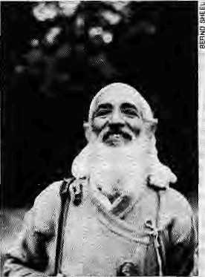
NGOs of the poor countries. They create a favourable atmosphere for the spreading and thriving of their mercantile civilisation.
These new institutions required a new type of workers, technical and professional, and gradually the place of 'dedication' was taken by 'profession'. It was not necessary that their living standard, life and work style resembled the dedicated workers, because for professionals it is not essential to maintain the oneness of personal and public Hfc.
There is a tradition of voluntarism in this country founded by Gautam Buddha and Gandhi. They were practical revolutionaries who wanted to bring total change iii the system. In his daily prayers, Gandhi used to say, "Oh Lord, give me strength and eagerness to identify myself with the common masses of India." This is the source of sustenance of the social activist. In the Himalayan scene, where both poverty and suffering are pert of life, adoption of the standard of life of the common people is a practical necessity.
It should not be difficult to decide whether we are

1995 HIMAL

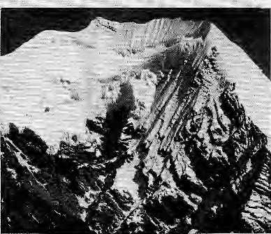
Clandestine Climbing
rJGOs> or voluntary agencies, or workers of the Garidhi-Buddha lineage. There is a need for; hundreds of life-workers in the Himalaya who by identifying themselves with the common people may worship the living idols and make themselves confident about their bright future.
The development policy whose goal is economic: growth regards nature as a commodity. It believes in squeezing everything out of it. With the extension of the means of transport, there is not a single corner of the Himalaya left; where nature has not been invaded by development in the form of felling of trees or
T
he climbing accident that tookll lives on Pisang Peak last November (see Himal Nov/Dec 1994) had the value of raking up matters that have gone unaddressed in the past. Among the many issues that the Pisang accident threw up was the open flouting of Nepal's climbing regulations by agencies in the business. The Pisang incident indicates that the government is prepared to iopk the other way while some trek agencies take their clients up pretty much any peak that catches their fancy.
The ill-fated group of climbers that tumbled down the icy slopes of the northwest face of Pisang had a 24-day trek itinerary which included climbing of Pisang and two other peaks, both of which have not been 'opened' by His Majesty's Government. Eight days before tackling Pisang, the group had climbed Rambrung peak (4440m), ostensibly for acclimatisation.
extraction-of medidna] herbs, hunt of wild animals, arid minihg. With the groWing demand for water and: electrieity, cbnstructionio£ dams first began in the foothills arid now has been extended to the middle Hi rna] aya. The government s are promoting luxury tourism in the Himalaya, which is 'regarded as eco^ friendly; For. this,air Strips arid five-star hotel s are being coris tf ucted. People are beirigejected from thelirnitM flat land. This is a conspiracy to demoralise the people;
Mountain people are :freedom-loving by nature, but the centralised system has robbed them of this freedom.
Six days later,, ■they were scheduled to have climbed the 6200m ThorungRL
In their press note released in Kathmandu after the tragedy, the company Deiitscher Alperiverein (PAV) Summit Club indicated that :they had been selling the same itinerary for at least ten years.
Neither Rambrung nor Thprang Ri appear on the long ■list of 141 peaksoperito foreign expeditions, including the 18 'lesser peaks' tinder the purview of the Nepal Mountaineering Association (NMA) of which Pisang is one, Climbing any unopened peak is illegal under Nepali law.
It might be argued that Rambrung is not a peak of substance arid Thoning Ri is frequently tackted even by individual trekkers on the way; over the Thpnjng La to Muktiriath. And it is true that neither the Tourism Act nor the mountaineering regulations explicitly define
Legislation declaring , natural resources as national property has been forced upon them. These are exported in tfie name of national interest. The local people do not get water for drinking and irrigation, but it is exported 300 km away to abig city and to grow cash crops like sugarcane;
Who elsewtfl care a.bout these issues if the voluntary orga ni sat ions 'arid' the workers do not awaken the people against these disastrous activities, which are alluring the people with immediate gairts? There is no alternative except direct action...
what constitutes a 'peak'. However, no matter how inexplicit, the rules encompass all hittiaJchuli,of snowy peaks> of Nepal,
A look at DAV's glossy tour Catalogue for 1995 reveals that it plans to continue offering itineraries that are not in conformity with the law of the land. On a 24-day trek to the Langtang region, clients can climb Yala Peak (5520m), Big Surja Peak (5144rn> and Small Surja Peak (5000m). Another trek of similar length to Khurnbu offers a chance to top SanuTaboche (53QSm>.
The round-Manasuiu trek includes Larky a PeakNorth (6065m) arid Saitido Peak (5100m). If one is climbing Parchamo, an 'NMA peak' in Rolwaling Himal, Yalung Ri is provided as a bonus. The real highlight of the 24^day trek to Yalijng Glacier in the Kanchenjunga region is £he climb of 52Q0m-high Itamze peak. Similarly, a 31-day trek to Kanchenjutiga Base Camp culminates with the climbing
qi Drohmo" peak (6100m) up the Kangpachen valley.
- None of the peaks, named above are open to climbers".
If Nepal's climbing regulations do not make sense, and if they actually have the effect of retarding the growth of elimbing-activities, powerful agencies like the DAV should be in the forefront of trying to change those regulations, not flouting them.
It is intriguing that no eyebrows were raised in the Ministry of Tourism or the N^IA over the years that the' DAV has been conducting clandestine climbing. It required a tragedy of massive proportions for the public gaze to skim even momentarily over issues important to the healthy growth of guided mountaineering in the country.
The open disregard for Nepal's mountaineering regulations shows insensitivity towards the host country. At the same time, it causes massive loss of revenue to a country that seeks to earn income from mountain tourism as one Of its few resources.
There are sure to be other overseas tour agencies as Well who are quietly applying the modus operand! of DAV. The German operator just got caught in the act. It is now up to the Nepali authorities to wake up, and either change the laws or apply them.
-Basanta Thapa

HIMAL January/February 1995

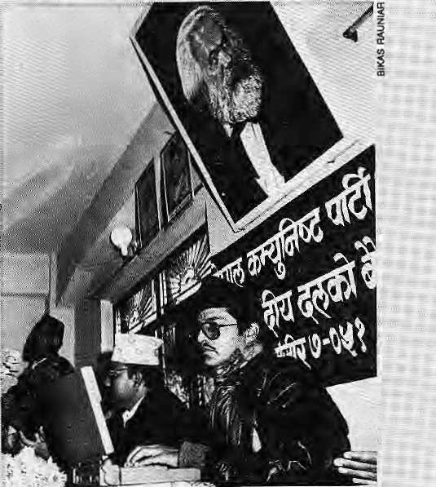
Kathrnandu government goes com mil nist »nd hi-tech.
Both Karl Marx and Deputy; Prime Minister Madhav Kumar Nepal look the other way as Nepal's new Mnister of Communications Pradeep Nepal keys in vital data into his Apple PowerBook during a Parliamentary Board Meeting of (he Communist Party of Nepal (United Marxist-Leninist) in Kathitian-du, Nepal. (Editors' note:five Nepa/s in-brie sentence is a record.)
but f or theGrace of Lord Pashupatinath Goes tKe Himalaya
/
hat to do: when the.;eyer-expanding tide of tourism thieateiis to swamp the core of one's culture? In Nepal, where visitors are allowed to photograph funeral pyres close-up as a touristic draw, this is a question that is not eyisrt asked, leave alone addressed. The Hindu Indonesian island of Bali, however, has seen it all before; How Bali has fought and has adjusted to the tourism JHggernautshould.be educational rpr budding tourism-and>culture activists in the Himalaya.
Fears that tourism would cause basic changes to Balinese society have been around for long,reports:TWpf Features. [ The anxiety was heightened in
the■ 1970s, when the hippies arrived at Kuta beach, and later when unmarried Balinese coupies started to live together, and when boys started to work as gigolos in the 1980s, New concerns also arose: drugs, the commercialisation of art for the tourists'sake, and problems with tourists entering temples to'witness'rituals.
The Baliriese regional government reacted with regulations: Nude sunbathing was prohibited, and citizens were exhorted to preserve tradition as the final fortress against the impact of the Western way of life. At the same time, the locals seem to have maintained their ritual and traditional activities if only because this attracted visitors^ In major tourist areas such as Kuta, the Balinese New Year, " Nyepi, is strictly observed; Thus, outside culture seems to have touched, but not penetrated, the core of Balinese life.
Fears that tourism would

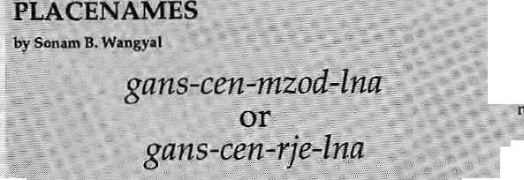
■ng^(hm^^-}^^Tp^^^J^':'^^^r^^^'l^^¥^
Gepgra^h;kally,B^ncriertji4ng Nepal'and: Sil*:im for a short distant Mowever, the world Of tourismrecognises it as the mouiitainotl^tjeeling,:smcethey^ew of the elongated; massif from, this; hill town is rr\agnificertUy jifisurpassedi Tlie people of I)arjeeling are given to referring to the :: mountain as hamro J^/^flLlTi;^ five summit of Kari<heriju:ngaaretp:: Darjeeling wrjat Ehafara is to Kaihmandu; or Tashicho Dzong to
ph _{v} .. , :
■; Asiftakingihecue from itsim'ult,iplepeaks,K:arichenjungahas: endowed with as many forms Of spelling, nurnerpus etlinic names, and their equally abundant interpistations. Schoi!ar,s haye _{:S}n^ only, been ^azzted^
equally baffled by this prpfusjorr of nairtes and
', W.KfresM^
sheer ftustfation, i-wrbte, fThe najne' Kanchenjpnga (however ft may be spelled) js fairly, familiar.?' In fact in his,book oF.nearly 400 pages; he avbided cdntroyersyvby not even attempting fo *xpkin
pg
H.H₅Ri%|ey, in The Gazetteer of Sikkim (1894), writes, 'Tn the mountains ^nd passes we .have-such names as Kanchihjingna '^ :png-di^,"grWf_{l}snow.''/T^2^,."^
legend has 'ftthere are five[treasures fe) be found in' the mountain;: but itmay have referenc<*to: thefivepeaks formingthe moun^in." - : ■■'..' -A>.v elaborate,exglafiarion with minor Va fiat ioifis irj interpretationand speptig is gi^'en byjGolvL. A. Waddell inAmong' "tfeJtimnltyas U&V); which Teads* ^'The highest peak oi ::Kariehartjunga and the true summit (28156 ft), is called" by the Tibetans, The Repository of Gold', This name, it seems to rne,iias ■ .arisek ftpntfjieir(terpT^at|Qnt>t.t^
intco Hteraland mytrtQlogicalmahner^The na-me^Kanchanjuhga is
Tibetan and means; JiteraUy, 'The Five Repositories of the iQreat
Glaciers/..and it is physicaliy descriptive of the-nyepeaks., Whea,-
: however^ rhepatron saint of Sifekim wrote the manual for wbtship*
for this mountain-god Jte converted, these five 'reposijtories' fet©
f real Storehouses, of thc"gQd's,.treasures,.. la this way t^e Ibjftaest

Jmary/Fabwaiy 1S95 HtMAL

A Revolving Restaurant on Nuptse
I fit''happened on this side of i
destroy the moral foundations of the Balihese society have been assessed as being too alarmist and unjustified. As Ida Bagus Oka, the Governor ©f Bali, says, "Bali will always be Bali."
But there has been no let up as to now threats; In the 1980s, there was a land boom fueled by tourism. Many Balinese became :rich: overnight as their land was sold for previously unimaginable sums. There was also concern over non-Baliriese being allowed to own land for hotel development: Meanwhile, those who sold the land moved into the interior,''buying coffee and clove plantations, while those from the interior left Bali altogether and moved to other islands.
The latest focus of controversy are plans to built the Bakfie Nirwana Resort at Tanah Lot in Tabanan, Never before has a tourist resort development been so widely and unanimously rejected, for
Tanah Lot is a sacred site for Balinese Hindus! It is also a major draw for the tourist, with millions of images of the main temple sold as postcards and between coffee table book covers. While no one in tanah
I Chomolpngma, it had to happenoti the other side as well: a luxury hotel up close by the mountain. Climber Stephen Venables reports M the O£t0b6rissueof ffigk'graplans to build a five-starrer at Rongbuk BaseCamp- The Chi n a Tib et Mouritai neering Assoc iation ha s already taken the decision, and the plan is being chaperoned by New Zealand mountain guide Russell Bnce/remernbeced for his balloon flight over Chofnolorigrna in 1991.
Veitables is a pragmatist-fatalisti While conceding that traditiorialists wjil! balk at the
Lot wants to be described as anti-tourist, they are ncverthel ess gripped by doubt.
Those who worry about tourism and Balinese culture have begun to ask
idea of a hotel at the hallowed site, he maintains that "whatever one's opinion of the place, the fact is that Everest is • increasingly a commodity, ori sale to ever larger numbers of '.. people, putting ever greater pressure on a fragile desert environment/'
He continues, "Brice's view isthafr, rather than bury our heads in the Tibetan sand, we should accept the reality of theproblerh arid cater for it effectively; if the GTMA wants :to build a lodge it might as well be a really good lodge." "The, entrepreneur Brice is said to be anxious thatthe hotel be built of local stone and that the
themselves; Does the increase in tourism activity have to give birth to a never-ending succession of ah>deties? A question that is increasingly relevant in parts of the Himalaya as well.
buildings do not project over the moraine, disturbing the famous view southward from Rongbuk gomba.
The hotel's clients will be tourists traveling the overland Lhasa^Kathmandu route. Mountaineers will get spin-offs from the hotel's presence: vehicle servicing, telecommunications, 24-hour monitoring of climbers' radios, and emergency services. Venables reports that Brice is negotiating with Asian Helicopters in Kathmandu to fly its Russian whirlybirds over the border on rescue missions.
Next, obviously, will be*a funicular up to the North Col and a rotating restaurant atop Nqptse.

crest; Which was most conspicuQ«sly: glided !by the rising; ami setting- sun, was rriade the treasury of gcUd;: the southern peak---which ternairted in cold grey shade tillitwhitened in the rising sun was made¹ the treasury of silver, arid the remaining peaks were made respectively the treasures of gerns, grain s a ft d hplybooks;'., "■:■ 'According toff. A.jaschke' sA Tibeta h ^ngtishOicfwita nji 19S8 J,,. there a^ two names.t. in Tibetan: Y_{r:}gQns-ceti~^{i}m7i.£>d~hia, the pye rfeceptactes of the vast glaciet ice> and 2: ga^ceH-rjc-lnd^tkc five kings of the vast glacier ice. It is interesting that the above nanies carry no mention of the Tibetan word rDzoriidzong), meaning castle or fortrfess, Jn The Jrido-Ti&etans tJ954)> Hermann's Tibetan yersiori is similar to Jaschke's, where kati^pitati-trtdzGd-ingq isgiven as 'Great glacier ice of the five store-rooms'. ..: . ■■■■ ''".'"■'■ .■
The Le^cha; ind igehous pet^ple of the Sarjefeling¹jiilifey have itneir own riain^ for this toi^moiintam.T^e closest to the Tibetan name is tofig-cfei?or kang'-chen wMch is Wrrowe'd from the Tibetan/' Sikkimese pronunciation gaftg£-cb£n: Actjordiiig to Lepcha dictionary (riow iri-print), the L£]^na^{s}riatfieis ■: zong<tbu<u, in wruchte5E^-te(i»f: means "fate; fortune prdesfiny. Qn; theotherhand, Fr.M'.JierntaRS claimslhai thejLepcha>namei^{s}^^{1K}^ tzum-$oug^{z}bu_{f} meaning: 'tlie highest over pur■ih^ad'_{i} His booi^. The indo-TibelanS: (1954) explains that kirig'tzuin- (the highest part of ■■■■ihe-f.o£ehea,d,
«A pother %ep.cha rigme^pw Ju^ctiit he highest.curtain pi snow)
is cited frorn Wacldell in C.-B; Mairiwarirtg^s': A Dictwrmry of t!fe~
Lepdui Langwge tf 898),. Prdi. K.K. Sprigg believes that few is a
mistekerL reiference to- kangjkmig (snow) and Jo also a iriistakeii
referefice t(j lha(a high tfioiiniairi), While £« w*puld mean the snowy
raiigeofsnowypeak. .,.. ■■■"..■■ ■■■.■■■■ *-"■' " ■ " ^{:i}- ..
¹ According to another researcher; T, Chattbpadhay (tepchiis, wtdTHmr Heritage, 1990) th^feis yet another interprefatipn: kdnff-ctizn-fcorigAlp, in which the lastiw6: words are Lepcha/as given by ErpL Spriggp^arid. the first two have been borrowed from Tibetan¹..
'■'is etymologically of Lepcha oriein witlt the phonetic reprociuctiofL in Tibetan havings co-incidentally, s'ferikingly meaningful' intefpretatiOns, ■" ~ ■ "■■ ?;::'
Jn this writers opiijiein, the name is b£ Tibetan origiri, and^ Waddell's explanatiort (quoted above) has too nvudi in it to be just' astrikingcpincidfitce.^yenMainwanrig, whom" mariy consider to be the fath erof th e Lepcha la nguage, hi his d i c.t ionaty ofthc-Lf^cha^ gives kgn-ceihjoir~iia and gfm$^c(w~tJQns-lvn& as Tibetan equivalent of a'". He'even adds for iwrfien prdpium another variant," ii which is alsp Tibetan.

HIMAL January/February 1995.

Notes f rom jtlte Karakaranx
Gitgtt and Hunza have seen a dacade of steady growth since the opening of the Karakoram Highway (KKH)Jjt 1978. Kathmandu-based writer John Mock, who was in \h& Northern Areas recently, shares his notes on Gifgit's development, the accompanying environmental woes, plus some encouraging signs of activism.
Khunjerab Stutdents Federation

Gilgitto the Sea With the KKH, once-isolated GiLgit was linked by road to the major population centres of Pakistan; Overland ?. trade, which had previously been mostly with nearby Kashgar,, shifted to down-country Pakistan, an 18-hour drive through the Indus River
In 1984, foreigne allowed on the stretch of the KKH north of Gilgit, through Hunza and over the Kh-unjerab Pass into China,The number of foreign tourists rose to 4137 annually by 1989, but that was a small number compared to the 24,054 Pakistanis who crossed into Tibet that very year. Drawn by the profits to be made importing Chinese consumer goods and silk cjoth' for sale in down-country bazaars, Pakistani traders swarmed to the modern-day Silk Route entrepot of Kashgar.
This year, representatives of Kazakhstan and Uzbekistan visited Gilgit to study the prospects of establishing a direct overland trade route from their capitals to the sea poTt of Karachi. This will require the widening of the 1300 km-long stretch between Kashgar and Rawalpindi to accommodate higher volume of heavy traffic. Once-remote Gilgit is well on its way to becoming a centre of Central Asian trade.
Bad Water. In 1993₍ some ■■■
Gilgit residents formed the Karakpram Society for I^atural ^nd Environmental: : Rehabilitation (KASQ>JER), The nonprofitgroup wants to promote awareness and educat io n to eqrnbat environmental problems before
KRONER has opened an information centre at the A1-

Kamal House in central Gilgit, held anti-pollution marches through the main bazaar-, surveyed the town water supply systerrVand led a protest action at this past sumrner'S: Shanctur Polo ' Tournament,
The Gvlgit water supply is fed by two main channels constructed back ial^25. the town has expanded along these channels, which have become the garbage disposal 'sites for the expanding population. People dump their refuse directly into the watercourses: old batteries, shoes, plastic bags and everything else.
Drivers cleari theirvehicles ... here, and stable boys wash their horses: Fertilizer; and pesticide runoff from the fields wa sh directly i nto the flowing wat^r.
■.. Gilgit does not have a waste treatment system and" raw sewage flows directly into: the two.channels..Even as ,, K&s'QNER is pushing, for quick action,, the .incidenceof enteric-fever and hepatitis is increasing in Gilgit,
Shallow Polo, The Shandiir Polo tournament is a VveUr-publicised four-day tourist eistravaganza that draws upjto fifty thousand spectators and I merry-makers to the Shahelur "Pass, at3800 m .and lying" between Gilgit and GhitraL

Star polo players from all over Pakistan compete in this high-altitude polo, with even the incumbent Prime Minister occasionally making a guest appearance/by helicopter, At the 1994 event in July, KASONER activists protested the lack of adequate sanitation at the tournament site and the trashing of the alpine meadows and a nearby lake by the careless revellers. Police lathi-charged the protesters and removed them forcibly. After the revellers had gone home, the activists regained behind to clean up the paper and plastic refuse.
Says KASONER organiser
Ashiq Hussain, "The influx of, outsiders is commercialising this region faster than we can accomodate. At the same time, the rapidly growing population is disturbing the natural cycles of our sensitive ecosystem." J
Khurijerab Glean-Up. North of Giigit along the ..KKH, in the region of upper Hunza called Gojal, srudent activists have formed the Khunjerab. Student Federation (KSP). Although initially begun in199Q to ..; promote education, the group" has turned towards green work because of the ecological degradation along the KKH. The KSF has launched a campaign to ban the use of plastic bags and to stop the
burning of plastic. Litter containers have been placed m areas where villagers gather, particularly at the customs and border post in Soust village. The group has also branched into eco-tqurism, training local guides to be ecologically responsible during treks.
Whether another eco-friendly culture of the South Asian mountains will be overwhelmed by progress will largely depend on the success of grassroots organisations like KSF:and KASONER.

Contact: KSF, po Soust, Village Morkhun, Oojaf, Hunza District, GUgit. Northern Areas. KASOhJER, PO Box 551. GiSgil, Northern Areas.

O9S HIMAL

For once, Think twice !

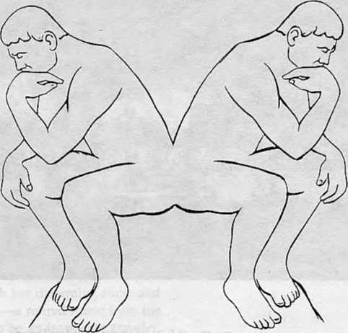

Are you looking for the cheapest rates ? Or, do you want value for your money ?
At Summit Nepal Trekking we design our programmes that ensure you get full value for your money.


MMIT NEPAL TREKKING
Write or call us at:

P.O.Box 1406,Kupoiidol,Kathmandu,Nepal
Tel:525408,521810 Fax: 977 1 523737

Modernise, Or Else!
Building the New Lhasa

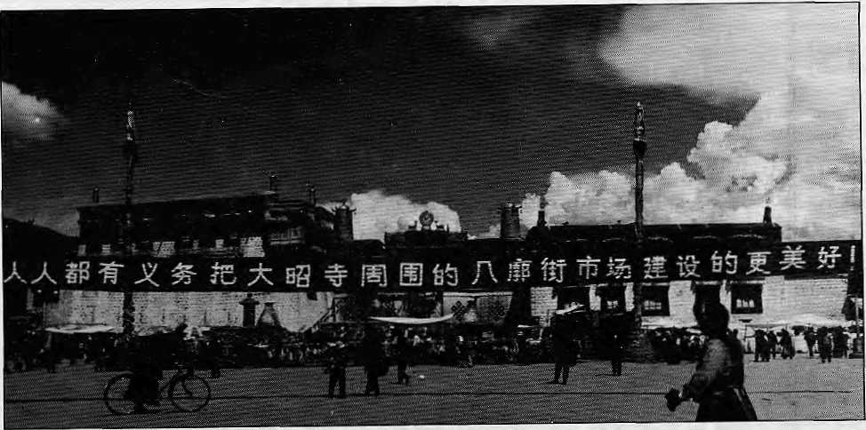
Propaganda
banner in front of
the Jokhang
temple.

The 1990s has seen an
unprecedented
modernisation offensive in
Tibet, and an attempt to
transform the ancient
capitai into a frontier
boom-town. But how much
say do Tibetans have in
the future of their
country?
Text and picture by John Grey

W
hen supreme leader Deng Xiaoping toured China's southern provinces in early 1992 and launched the now famous 'Spring Tide' initiative, it was a signal of the central leadership's vigorous support for liberal economic reforms. Since thattime, many of China's southern and eastern provinces have experienced unprecedented economic growth, with the development of free enterprise and the emergence of domestic consumerism, fuelled both by foreign investment and greater internal mobility of capital and labour. In the same period, party and government officials in the Tibet Autonomous Region (TAR) unleashed a new 'Socialist Modern-isation' programme that emphasised urban construction, improved infrastructure, and development of a market economy while maintaining the ongoing imperative to 'crush separatism' and ensure 'stability¹. The now frequently cited 22-character
guideline handed down from the PartyCentralCommitteereads, "Seize the Opportunity, Deepen Reform, Open up Wider, Promote Development, Maintain Stability."
The grandiose language of the socialist planners can be hard to fathom, but TAR's Deputy Party Secretary Raidi (Rakti in Tibetan), addressing cadres in the Tibetan capital in early 1994, spelled the policies out in clearer terms. In the Xizang Ribao of 2 August 1994, he described 'reform' as "linking Tibet's economic restructuring with the whole country", and 'stability' as "stepping up construction of contingents of troops stationed in Tibet, armed police, judicial, procuratorial and public security workers."
A few days later, Raidi's colleague Danzim (Tib: Tettzin) told a visiting delegation from Macao, as reported in Xizang Ribao: "We firmly believe that a united, prosperous and civilised Socialist New Tibet will

10
January/February 1995 HIMAL

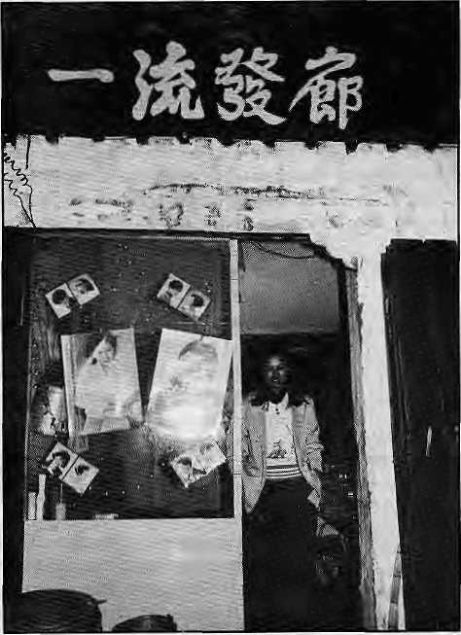
surely be able to stand firm on the Tibet plateau—the roof of the world." During their stay, the delegation had negotiated a contract worth 600 million Yuan (Y8=U$1, approximately) to build an entertainment park on an island on Lhasa river.
In Lhasa city itself, 'socialist modernisation' policies since the spring of 1992 have had some highly visible effects. Firstly, a significant increase in the city's population, principally due to an influx of Han economic migrants from mainland provinces. Secondly, a marked increase in urban growth, including a burst of new construction projects— commercial, residential, official, military—throughout the city.
Neither are exactly new developments. One of the authoritative city planning documents {CCP Central Committee Document No. 31-1980) finalised in 1985 and subsequently leaked to western researchers states that "the population of the city has developed from 30,000 at the beginning of the Liberation to some 110,000 now. The built-up area has increased from less than 3 sq km to 25 sq km. The newly constructed area is ten times that of the old city... By the year 2000 population should be controlled so as to be 200,000. The area for construction should be 42 sq km by this time... (We shall) create a city that is relatively perfect, beneficial for production, convenient for daily life, rich, civilised and clean."
In fact,official population figures are notoriously unreliable throughout the People's Republic of China (PRC); official sources still give figures from 120,000 to 180,000 for the Lhasa of today, also claiming that 87 percent are Tibetan. The Han population of TAR is said to be merely three percent. Unofficial estimates of Lhasa's civilian population range from 300,000 to 400,000, perhaps 20-30 percent Tibetan.
Thedramatici ncrease in the Han population since 1992 is due to the influx of migrant entrepreneurs attracted by the new economic climate and the relaxation of controls on
internal movement. Roadblocks between TAR and neighbouring provinces were reportedly lifted in December 1992, and bureaucratic controls such as residence permits are now waived in favour of such migrants, according to an independent 1994 survey on Chinese economic migrants by a Western group, the Alliance for Research in Tibet (ART). A considerable number of the new arrivals, perhaps 20-30 percent, are Hui-zhou Muslims from the north— western provinces of China, noted for their willingness to travel in pursuit of business opportunities—but the majority, about 45 percent of those questioned in the survey, are from the populous Sichuan province bordering eastern Tibet.
The majority of the new migrants are engaged in the commercial and retail sectors. They have swollen the city's Han population, formerly composed of soldiers, officials, technicians, engineers and cadres posted here. Inl993,an unofficial head count of shops and businesses in Lhasa found that Tibetan-owned concerns accounted for 10-15 percent of the total, government-owned concerns 8-9 percent, with the remainder being run by ethnic Han or Hui entrepreneurs. The Xinhua news agency reported in August that 1700 new businesses had opened in Lhasa since January. It added: "A series of preferential policies have been stipulated which encourage the rapid growth of the private sector."
The Four Modernisations
Other effects of 'socialist modernisation' in Lhasa are less visible and more difficult to assess, but they are matters of some concern to Tibetan residents. These could be considered in four categories: inflation and price rise, privatisation of public services and increasing official corruption, Tibetan unemployment and economic polarisation, and pollution—both environmental and spiritual.
Inflation. Tibet is increasingly linked with the dynamic mainland economy, which has been character-
ised by spiralling inflation and 'oveT-heating' in recent years. The current rate of inflation in the PRC, as reported by Newsweek in September 1994, is estimated at 30 percent. The prices of many bask commodities have soared since 1991-92, but this is also partly due to the cancellation of subsidised rations.
According to localsources, butter went from Y5 per gyama (500 gm) in 1990 to Y15-17 in 1994; wheat flour from Y30 per 50 gyama to Y77, kerosene from Y0.8 per litre to Y2.8, sugar from Yl per gyama to Y3, electricity from Y0.05 per unit to Y0.4, petrol from Y1.7 per litre to Y3, tea from Yl per brick to Y3, dried milk from Y4 per packet to Y7.5, tomatoes from Y0.5 per gyama to Y2.7, and blue canvas boots from Y4 per pair to Y9.5. Inaddition,thecosts of rent, transport and consumer goods have increased sharply, as has the need to bribe officials to obtain permits or receive public services.
Privatisation, corruption. Although senior PRC officials frequently refer to the large subsidies lavished on Tibet as a "special consideration"
Hair salon opened
by new arrivals
from Sichuan. Of
more than SO such
establishments in
Central Lhasa, not
one is Ttbelan-
owned.

HIMAL January/February 1995
11

B
\ ■, ■. Lfiasa1950 I I Lhasa Municipal 1980 CZL—J General plan 2000
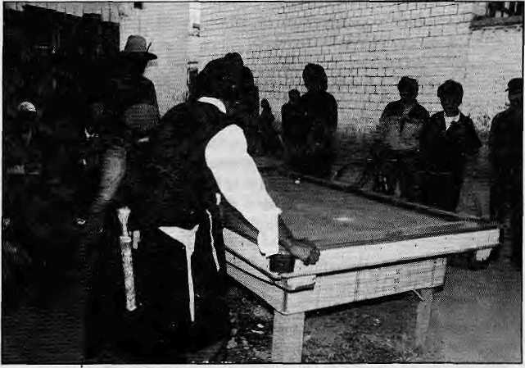
Map of Lhasa,
baaed on official
information, shows
the size of Old
Lhasa, Us
dimensions in
1980, and the
dimensions the
eite will attain by
the year 2000.
Pool tables in
the Tibetan
quarter,
where the
game is a
favourite
pastime of
unemployed
youth.
to ensure free medicalcare,education, tax exemptions etc., these benefits have now effectively given way to market forces. Private clinics have appeared on the street corners as health workers desert the poorly-funded and demoralised state hospitals. Nearby, one may find a pharmacy illicitly selling off 'surplus' hospital drugs.
Meanwhile, the legions of regulatory officials encountered in everyday life are by no means always well-paid or scrupulous. It seems that any new business in the Tibetan quarter of Lhasa can expect extortionate demands from tax officials, fire and health inspectors and others for concealed bribes or spurious payments of one kind or another. Citi zens may find themselves obliged to bribe officials with sums stretching into thousands of Yuan for anythingfromreallocation of housing to birth or marriage certificates and residence permits (still mandatory for Tibetans). With the average Tibetan monthly wage at around Y200-300, this can be expensive.
Economic Polarisation. While surveys or statistics are not available, there is little doubt that unemployment is increasing among Tibetans in
Lhasa. The current economic boom has excluded them for two main reasons. First, jobs and advancement in Chinese economic life usually depend on guangxi or personal connections, and Han people naturally prefer their own kind. Second, Tibetan workers generally cannot compete on the modern sector's terms-—economic efficiency— with their Han counterparts, who are fully accustomed to the cut-throat competition and ruthless commercial ethics of mainland China.
Inability to compete has led to
marginalisation of the traditional Tibetaneconomy.Tibetanproducts— whether it is dri butter, woollen carpets, wooden tables or leather boots—tend to be more natural and of higher quality than Chinese consumer goods, but they are increasingly unaffordable. Artisans must adapt to competition with the mainstream mass-production economy,, while consumers must adapt to cheap and shoddy imported products. Those still engaged in the traditional economy— artisans, shopkeepers, traders, farmers—cannot keep up with the rising cost of urban living. To make ends meet, many have resorted to renting their homes and fields to Han migrants
Pollution. According to official reports {carried in the Xizang Rilao) it is only in the last year that Lhasa's municipal authorities have sought foreign contractors to build a sewage plant in the city. Until now, such facilities have remained limited, and the bulk of the untreated sewage has been dumped directly in the Kyichu river. Rubbish and wastes are routinely dumped alongthe highway east of the Lhasa bridge. A municipal 'clean-up' campaign in August 1993 apparently did not even address the issue of pollution, but concentrated instead on erecting railings and traffic barriers, and on clearing beggars and itinerants from the alleys of the old city.
Nonetheless, the TAR govern-

12
January/February 1995 HIMAL

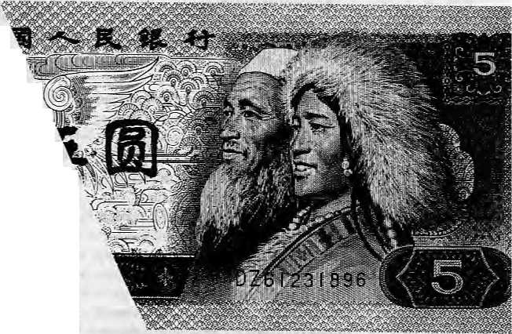
ment does have a bureau responsible for environmental protection. Its report for! 993 states that discharge of waste gases in Lhasa increased by 40 percent over the previous year, discharge of waste water by 133 percent (including the Yangpachen geothermal plant), and discharge of industrial solid wastes by 17 percent. Environmental noise was measured at above 60 decibels in Central Lhasa, exceeding permitted national levels.
Some Lhasa residents regard 'spiritual pollution' (a communist phrase applied mostly against 'degenerate Western values') as the real downside of modernisation, Lhasa's streets, formerly d eserted a fter nightfall, now buzz with nightclubs, Karaoke bars, video hallsand brothels. By day, the young, the idle and the footloose dawdle around pool tables and game machines, or gaze at crude martial arts videos blaring from dismal screens. Alcoholism, street crime, robbery^and violent behaviour are all said to be increasing.
Overall, one has the firm impression that few Tibetans in Lhasa are enthused with the 'socialist modernisation' policies, and that many regard them as official encouragement for Han migration to the TAR and domination of the local economy. A leaflet produced by the underground group Cholsum Thuntsokand distributed in August 1992 reads: "Nowadays China is opening up the whole of Tibet on the pretext of economic development, but in reality it is in order to deny Tibetans rights and work through theendless transfer of Chinese people to live here... Anyone who has eyes can see houses for Chinese being constructed everywhere in great haste."
Patriotic License
It is not easy to get a clear picture of what is happening in Tibet, simply because despite the 'open polic/ it remains a tightly closed country in many respects. Information is hard to obtain under a regime that forbids open discussion of public policy, zealously withholds news and
information from the public domain, incarceratesandbrutalisesdissenters, and brands foreign critics as "enemies". If even the population figures for Lhasa are considered controversial, how much more so are investigation and analysis of public opinion and social trends!
In the prevailing climate of rumour, suspicion and secrecy, doc umentary evidence of behind -the-scene controversy and discontent is especially interesting. A recent example was the proceedings of the second session of the sixth assembly of the TAR branch of the Chinese Peoples' Political Consultative Conference (CPPCC) held in Lhasa in May 1994. The CPPCC (TAR) is largely composed of senior Tibetan'patriots'such as high lamas and former aristocrats. They are usually called upon to endorse official policy, but they also have some license to articulate the views and sensibilities of the Tibetan nationality in official fora. Documents from the May session show that some delegates availed themselves of this license, using moderate and patriotic language to criticise the excesses of the modernisation drive and toappeal for corrective measures.
Remarks jointly attributed to several deputies in the conference reports of the May session state the following: "...carrying out the economic development reforms is a major task for the Party and regional government and there is no doubt as to the importance and benefit of deepening and strengthening reform work for the national and regional aspirations for economic growth and development. Meanwhile, economic sta bility cannot beensuredsinceprices depend on market fluctuation. However, Tibet is a special minority region, very backward in development, and many of its people remain in a condition of poverty. Thus the people's government should act to survey and stabilise prices of items essential to the needs of the Tibetan masses—such as grain, oil, meat,
butter, tea etc..."
Deputy Namgyal, a Lhasa delegate, pointed out that "workers' monthly salaries are very low compared with the rising cost of living. Price rises should be more gradual and carefully planned... there is now a strong tendency for the gap between rich and poor to widen. This is a matter of great concern, and planning must make provision for the income available to the ordinary masses."
Other Lhasa delegates complained: "Naturally we can expect to have the national inflation rateof 10 percent, but while last year a gyama of onions cost no more than Y0.3, this year it is Y5, and that is a severe excess. The cost of staple foods consumed by the Tibetan masses such as tea and butter have risen sharply, and

Lhasa's markets are full of phoney and low-quality products... the authorities should keep a vigorous check on prices and clamp down on illegal market practices in accordance with law."
Other concerns raised by Tibetan delegates included corruption, under-funding and mismanagement of State educationandhealth services, cultural degeneration, and disregard of the Tibetan language. On several occasions during the two-week session, Lhasa delegates issued forthright denunciations of the city's new 'cultural markets'. The spread of bars, karaoke, video halls, dancing

A Kbampa woman and a Hui mustim sham apace in a five Yuan note.

HIMAL January/February 1995
13

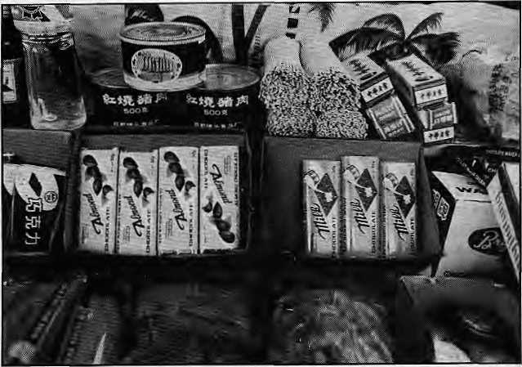
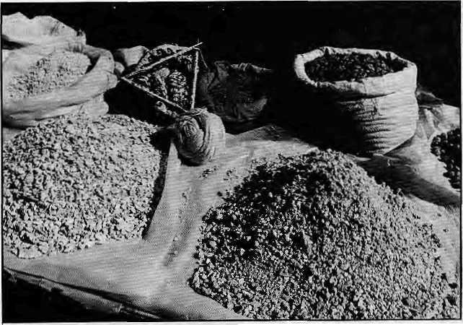
Tibetan commodities
on sale.
Chinese
commodities
on sale.

clubs, prostitution and alcohol was described as a new and unwelcome trend, harmful to youth and offensive to Buddhist values.
Lhasa's city government respond ed to these complaints within three months by introducing yet another echelon of business regulations. According to the Xizang Ribao of 14 August, the 'cultural business permit' now requires all operators in the entertainment sector, on pain of losing their licenses, to "undertake to serve the people and socialism, pay attention to social benefits and provide the people with rich, colourful, healthy and beneficial cultural life."
Tibetan MarginalIsation
While new regulations have been enacted to control the entertainment industry, it seems unlikely that the authorities will act to redress the more substantive concerns raised by CPPCC (TAR) members—many of which are shared by ordinary Tibetan citizens. In the case of Lhasa, they can be divided into four main areas: housing, health, education and employment.
Housing. A large number of traditional houses in the Barkhor area of old Lhasa have been demolished since 1992. According to the city planning document cited earlier, the majority of traditional buildings still remaining in Lhasa's historic city centre will be gone by the year 2000, with the exception of designated
'cultural relics' such as the Jokhang and Ramoche temples.
Official sources claim that the destruction is necessary to improve infrastructure—facilities such as electricity, water, sewerage and roads in the city centre. However, an ART survey of construction in the Barkhor neighbourhood in 1993, which surveyed 67 construction sites, found not only that many of the buildings being demolished wereboth attractive and structurally sound, but that provision of modern facilities was minimal, and had even worsened since a similar survey was conducted in 1990. New public housing units were being installed with a meagre electricity supply, and low gauge, unsafe wiring—as little as 200 watts
per family apartment, insufficient for cooking or heating. About 30-40 apartments in each housing unit had to share a single courtyard tap. Commercial premises and privileged housing units, meanwhile, were liberally supplied with electricity.
The new construction employs abysmally lowstandards of safety and workmanship. As art historian Heather Stoddard points out in Tibet Transformed: A Pictorial Essay (The International Campaign for Tibet, 1994), thesquare, regimented concrete of socialist China that is replacing characteristic Tibetan architecture is not even utilitarian. The new houses, unlike the old, cannot withstand earth tremors, and the breeze blocks and cement used in construction are quite unsuited to the extremes of Tibet's climate.
Tibetan families in public housing are now obliged to pay around Y400-500 in annual rent for lesser space, greater discomfort and poorer facilities than before—roughly atenfoldincreasesincethe demolition project began in 1990. At the May session of the CPPCC (TAR), Lhasa delegate Jampal described the new housing in Lhasa as "unsuitable for local conditions and not in accordance with Tibetan culture" and "an architectural travesty".
Finally, it is significant that 19 of the 67 surveyed sites were private Tibetan homes, employing Tibetan

14
Jamiaty/Februajy 1995 HIMAL

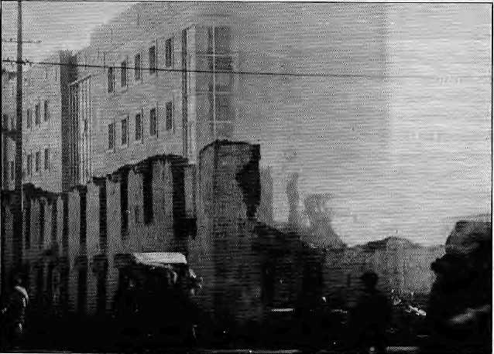
labour and materials—earth, wood and stone. Several of these were found to be well-built, harmonious dwellings, well-serviced with electricity and piped water. Tibetan houses are more costly and time-con sum i ng to bui Id, but they are ot herwise unquestionably superio r i n the view of most Tibetans—and the skills required to build them are still available in Lhasa today.
Health. In recent years, there has been some ambiguity over the provision of state medical care in Lhasa. Official sources still claim that basic medical care is freely available to holders of residence permits, while local Tibetans frequently complain of corruption, exorbitant payments, ethnic discrimination, and lack of care at the city and regional hospitals. A deposit of Y1000 is said to be a prerequisite for serious treatment.
Mismanagement and poor morale among the health care staff seem to be as much of a problem as under-funding. In May, according to conference reports, Thubten Buchung of Lhasa's city hospital told fellow CPPCC (TAR) delegates: "Of the 105 hospitals and clinics in Lhasa prefecture, the majority are not functioning. Some have medicine but no equipment, others even lack medicine due to inadequate funds... I have been complaining about this for years, but nothing has been done."
In June 1994, the authorities seemed to beabandoning the pretence of free medical care when a new official cost structure and booklet issue was announced at a series of local meetings. But there seems to have been no attempt to clamp down on theblack-maTket in drugsand services or on corrupt practices.
About the same time, there was a popular rumour that a Tibetan policeman had shot dead two Han Chinese doctors after his wifedied in childbirth in the city hospital's reception area. Despite the woman's emergency condition, she had been denied entry to the building until she produced Y1000—by the time her husband returned with the money,
both the mother and the baby were dead. It is difficult to ascertain the veracity of this report, but even as legend it is indicat ive of so me pop ula r perceptions—ethnic discrimination, i ntra nsi gen t of finals, and corruptio n. And Tibetan anger.
Alternatives to conventional medicine are available in Lhasa—the traditional Ment sikhang hospital was reopened during the 1980's, and there are training programmes in Tibetan medicine in all areas of the TAR. However, few skilled practitioners remain in Tibet—many are in South Asiaandinthe West—and the limited
instruction received bytraineedoctors in Tibet represents but a paltry fragment of the traditional medical system. Despite its popularity, the authorities have not conspicuously awarded the traditional sector of the health service with funds or encouragement.
Ed uca tio n. State education i n the TAR has been a subject of some controversy, arising from Tibetan allegations of ethnic discrimination and Mandarin linguistic domination, as well as claims that the Tibetan nationality is effectively excluded from the higher levels of the party, government, military, scientific and professional establishments by educational disadvantage. Official sources insist that the Tibetan language is widely taught in schools,
that'education is free for Tibetans, and that 'positive discrimination' policies assist disadvantaged minoritiestocom pete forofficialposts. In practice, Mandarin is the language of instruction at the secondary level and above, and access to higher education is uncommon. Only 45 percent of last year's entrants to Tibet University were Tibetan, according to a June 1994 report of the Tibetan Information Network (TIN).
Lhasa's schools, like its hospitals, suffer from lack of funding, mismanagement and demoralised staff. In theory they are still free.
although some changes have been introduced, such as exam fees, charges for retaking failed exams, and so on. Lhasa delegates at the CPPCC session spoke of inadequate funds, lack of teachers and, among those available, lack of qualification. An appeal was issued for teachers to be given longer tenures so as to provide continuity and allow them to work effectively. Several suggestions were made for augmenting Tibetan language instruction at the primary level.
In the prevailing climate, it is not surprising that private schools— usually running evening classes in language and vocational skills—are becoming popular. Perhaps it is no more surprising that the authorities seem to have treated these schools with suspicion rather than encourage-
Demolition and reconstruction in Central Lhasa.

HIMAL January/February 1995
15

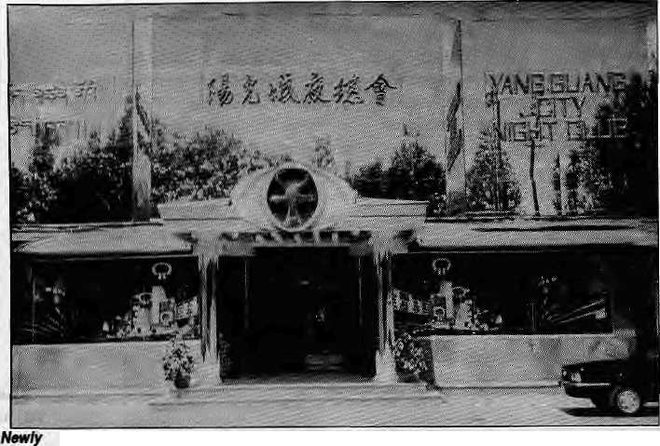
constructed ^{ment}- ^ ^{earl}y ¹⁹⁹⁴' ^{one} ^{of} ^{the} ^{morc} 'NlghtClub'. prominent ones—Siljong Keyig Lopdra—was closed down and its director arrested, reports the Tibetan Review. The charges were unclear but may have been political.
Employment. Official figures or statements are unavailable, but available evidence suggests that Tibetans in Lhasa suffer unfair competition for jobs in the modern sector. What is more, there appears to be little or no official sponsorship or protection of workers in the traditional economy, including those in construction, artisans, and local commodity traders. In the face of overwhelming pressure from the modern sector,
Notes on sources:
Xizang Ribao (Tibet Daily) is the TAR edition of Renmin Ribao. "(China Daily).
All reference to reportage in the tiiatrig Ribao, Tibet JV and TibetRadio is sourced to the Sammmyof World Broadcasts from the BBC: Monitoring Service in London.
tCCP Central Committee Document No. 31 (1980) is an internal J
Party document leaked to Tibetan interest groups in the West
: It ig in Chinese.
i documents ffbm the Afcy 1994 Session of the CPFCC (TAR), intended for internal use only, were obtained unofficially by thewriter,
:ite Tibet Information Network (TIN) is a Lbndpnrbased agency ■Hhat provides news on Tibet fr6rfl various sources.⁸ Its : Coordinator is Robbie Barnett.
[' t.ibetatt Review is a New D^lhi-based journal of Tibetan exiles! and & edited by Tsering Wangyal.
Xinhua is the government-owned news agency of China, with ; headquarters in Beijing.; ^
Lhasa's local economy may soon be extinct.
All this was demonstrated in a dramatic fashion in early June 1994, when 200-300 Tibetan traders from the Barkhor area gathered in front of the m unicipal government com pound to protest against new increases of up to 50 percent in the local business tax. The demonstration was quickly and ruthlessly suppressed, and in subsequent days, the authorities refused to back down on the increase, despite the protester's closure of Barkhor shops.
There seems littledoubt that TAR leaders felt emboldened in their hardline positions following the announcement in early June by the United States government that China's most-favoured-nation status renewal would no longer be conditional on human rights issues. A business tax of between Y100-200 per month is a considerable burden for most Tibetan shops and restaurants, but for the small stores and stalls in old Lhasa selling chang, butter, dried cheese, tsampa and so on, it is unpayable.
An October 1992 article in the Xizang Ribao actually celebrates the fact that Tibetans are increasingly found in demeaning, unskilled jobs as 'revolutionary'. An educated Tibetan man cleaning shoes outside the Workers' Cultural Palace in Lhasa
was "revolutionary" because "in the past, Tibetan people never would do this kind of very low class work". The piece reflects a more general belief, rooted in Han chauvinism, that Tibetans are inefficient, unskilled and superstitious—"they lack the qualification" to competeina modern economy.
This was also the view, albeit more elegantly expressed, of Chinese economists Wang Xiaoqang and Bai Nanfeng in their 1991 study The Poverty of Plenty (MacmilltLn, London). There, it is argued that the Tibetan nationality mustdevelop "commodity consciousness" beforeit can enter the modern economy as a competitive force. In other words, backward nationalities first have to become proletarianised before they can enter modern socialist society on an equal footing and enjoy its benefits.
Autonomous Tibet
The principle of autonomy for Tibet on the basis of its unique cultural heritage and physical environment is guaranteed by the PRC constitution. However, in recent years at least, the principle has had few supporters and no champions in the Beijing leadership. When the 'socialist modernisation' policy was launched in Lhasa in 1992, it included an attack on local off icials who allegedly wished "to dilute the reforms and preserve Tibet's uniqueness."
Tibet Radio, 30 May 1992: "If we only stress the uniqueness of Tibet and are timid in carrying out reform and opening up, the existing gap between us and other provinces and regions...will become wider, we will become more and more backward and Tibet will become more and more unique." In a piece carried by the Xizang Ribao in May 1992, the TAR government was ridiculed for lacking ambition when its annual budget fixed the projected growth rate at "only 5.8 percent". The current target is 10 percent.
The appointment of Chen Kuiyuan as new deputy party secretary in the same period was

16
January/FBbruaty 1995 H1MAL

and government workers were intensified during 1994. Although party members always had to accept the commitment to atheism, the liberalisation policies of the 1980s had reintroduced the principle of tolerance for the beliefs of national minorities. Last June and July, however, both government and party workers were told to eliminate even the vestiges of religious faith—shrines, rosaries, incense, hearths, prayer-flags—from their homes and their lives and those of their families, or face losing their jobs. They were also told to recall
China's Tibet
China's Tibet is a bimonthly magazine, yellow-bordered; likejthe
National Geographic and aimed at ih&byahieas English-reading
market, Itcoverstourism, culture and economy-reiat&d issues, The;
litest issue {No.3,1S94) carries a special feature oh governmental
policy, human rights and *1he policy on Dalai iarna''.8etowafe1wo;
' excerpts,.... . ;.;'; IZ,. , ■, -
Oil Han influx: Raidi> Chairman of theStanding Committee ofthe Tibet People's Congress, referred to settlement of Han Chinese in art interview while attending the Second'Session; of the Eighth National People's Congress in Beijing: '",,, "...
There are indeed rumours that the Central Government has
moved 7.5 million members of the Han nationality into Tibet.
However, before expanding my views, I must make it^iear that:
Tibet is part of China and thus it is perfectly proper for the Han fo:
move into Tibet. People in all sovereign countries oftenipoyafrom
one region to another. Therefore,whaCthert is wrongof the Han to
do the same? Moreover, the majority of Haii in Tibet afeskiUed
workers, technicians and scientists. ;They have come to Tibet to
workfor specified periodsof time/during Which they mu$t endure
the hardships resulting from the high altitude. They areinTibet to
help us build our economy, with many having contributed their
youth, the most precious period of their lives. Some rjave.even died-
heroic deaths. In order to further develop our economy, culture,
science and education, and public health_{j:}weneed more people like
these to move to Tibet. They are by no means what the Western
press call "immigrants". ;. .".
Over the past few years; Tibet has witnessed a huge influx of traders and builders frbrh China's hinterland .'They in fact come and go in torrents, and are by no means what the Western media also calls "immigrants". It is therefore groundless for the Western media to make such accusations.
The composition of Tibetans in the Tibetan population also
of the Dalai Lama...TheCet»tt^lGoveramehthasnever formulated ■ a plan to move members of the Han nationality into Tibet;: which in fact is a much less than ideal place for Hart to settle.
^{r}- *■:'«.,, . ■ ■ . ■■■■ ":. ■"" -';;" " :': * - 'I ■■ 1 i- MH
followed byaclampdown on Tibetan cadres, who began to be openly suspected of disloyalty. Their failure to soften the thrust of the 'socialist modernisation' programme strongly indicates that Tibetan cadres have no substantive influence on the formulation of policy for the region, and that the issue of autonomy for Tibet within the PRC—the issue at the centre of Tibet-China relations since Liberationinl951—is not being taken seriously by Beijing.
Movesaimed at undermining the unity and morale of Tibetan party

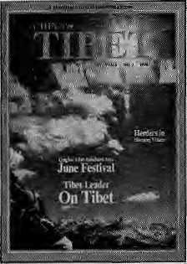
Human rights: Basang Norbu,
Deputy -Secretary-GenerfiIT q f the
Standing Ctimmittee of the Tibet
People's Congress, on hiitnan nghts
; in Tibet:"; '; " " 7 '...'.,. .,, ■■■■ :- ■
In bailding democratic politiGs> Xhina has absorbed all the civilized achieyeinfents of mankind,including; the positive factors" uriiJerlyirigi: bourgeois human rights ideas; In? China,, the people, and only the people, are the masters of the'state and society. Th^ system of people's congresses has proved tobean ■; effecUye form and functioned as the countrv's .supreme powef ^{-:} organ in which people ^vieldjtheir power as masters-of the¹ state.,,. ThrougKdep^tiesslecf^ in a democratic way^citizerisexert'-i their sway, organiset|jegovernment and administer state affaire., They are empowered to supervise andremoyegbyernment mem- "* •bersataltlevels.Thiscbri^tjtutesprimaryandfi^damGntairights, * and ah embodiment of the fundamental spirit of human rights.:; The 1993 electidn| |t four levels in Tibet were conducted in, accordaricewiahiEheConstitution../Sta*isticsforthel993elections< : ; indicate that there were 1,311,08$;voters in Tibet, or S7.3&pertefit^ •of the regional population and* 98.6 percent of citizens above lfe yisarsoid.Tlhose stripped of orfetnpOrarilydenied their democratic * rights accounted for only 0.34 percent of potential voters. Specifically; thbsewho had their poh'tical rights taken away came . toonlyO.tft percent...
According'; to an analysis-of the election resuUs> the * composition of deputies is; becoming more reasonable. Deputies * of Tibetan and other ethnic groups amountedto 99$t percent at town and township levels, 92.62 at county level, 82,35 at city level, and 82.44;pefi:enta|t&ejevelof the Tibetan Atit6n"om6us Region. ..<■ Some people at home and abroad' have h'ttle knowledge * about socialist democracy and human rights in Tibet. The truth • aboutthe 'situation there hasbeendistorted. But those who failed toi winappst had totally different feelings, saying, "Democracy is truly carried out in the people's congress*''
their children from schools in India by the end of the year or face the same penalty—a bitter bio w since education abroad is often considered the best prospect for a Tibetan child's future. Various reports on the enforcement of these measures were circulating in Lhasa during the autumn of 1994, including accounts of compulsory meetings and house inspections for the members of a wide range of work units and government offices in the city (from the Bank of China and the post office to the Uayi' and 'Chiyi' agricultural units) as well

HIMAL January/February 1995
17

as in the provinces. The insistence on absolute loyalty to the Party, so reminiscent of the Maoist era, has re-emerged, and the witch-hunt is on.
The Xtzang Ribao of 4 October 1994 states: "We should recognise the fact that the Dalai clique [a phrase referring to the exile government and its supporters in Tibet] is the main source of Tibet's instability and lack of development.''
Both the refusal to compromise on 'socialist modernisation' in the TAR, and the effective dominance of Han cadres in the regional administration were firmly underlined in July 1994 at the high-level Third National Work Conference on Tibet, held in Beijing,
Speaking about the meeting on
Tibet TV on 8 September 1994, Chen Kuiyuan said: "In line with comrade Deng Xiaoping's theory on building socialism with Chinese characteristics, the speeches given by comrades Jiang Zemin, Li Peng and Li Ruihan and in the 'Opinion on accelerating Tibet's development and maintaining its social stability¹ adopted by the CPC Central Committee and State Council analysed the new situation in Tibet and came up with new solutions to Tibet's problems..." These solutions would, he said, "Open a new chapter in the modernisation drive in the snowy plateau."
In fact, the meeting endorsed rapid economic development and renewed attention to religious and
nationalities policy. President Jiang Zemin's speech included remarks on the continuing necessity of Han cadres to develop and administer Tibet. Meanwhile, according to a Tibet TV report of September 1994, the CPC Committee "specifically stipulated that party members must not have religious beliefs."
Much frustration and resentment is developing among Tibetans in Lhasa, and although its expression is for the moment curtailed by vigilant security measures, it cannot remain so forever.
The writer Is an independent researcher on Himalayan and Tibetan affairs and a frequent visitor to Tibet. 'John Grey' is a pseudonym.

i
The Third Work Conference
.......

These occasional events are useii by Beijing to mark important moments in Tibet policy—the first followed on Hu YaoMng's reform initiative'in 1980 and the second; in 1984; announced a series (43) of mostly prestige projects in Tibet; sonWvMe financed by various Chinese provinces in ;art initiative -called the/Help
support of the central leadership for rapid economic growth and hardlinepositionsonreligioM&and nationalities policy.Unllke thft 1984 meeting, emphasis was placed on "strengthening ba«ie industries and th& improvement of infrastructurai facilities". As' President Jiang Zemin explained to Xittftwa; "a relatively longer ^period at time is needed to lay the foundation of $6tiali$t marked economy in Tibet, due to the undeveloped commodity economy and other reasons".
several already implemented since; 1992, represent an
unprecedented and ambitious attempt to make⁵ Tibet more
accessible and profitable for the mainland economy, through
infrastructure development. Energy generation and improved
facilities for road and air travel will increase the pro Stability^ of
resource extraction, allow for greater population density and
reduce Tibet's remoteness,. ......'[ "
The Work Conference iinveiled'62 projects as its development flagship, half of them funded or supported by provincial and municipal governments (24 percent of the total 2.3 billion Yuan investment). Included are three high-prpfUe and somewhat controversial schemes, the power station at Yarndrok .take (opposed by the latePanchen Lama); thePangda airporttenovation inChamdoPrefedtar^and'China'slafg^S^ as 'Narbusa' in Lhoka Prefecture; Also? prominent is -highway construction on the Nepal and QLnghai routes.
: * surfaced-road; to Tsethang (Lhoka) has already beprj
cornpl^tldV As reported by Tibet Press Watch in October, the US* ii
based pressure group International Campaign, for Tibet has also '"'
picMd :up a report that the long-mooted Qiitghai-Tibet railway _{m}
(dreaded by Tibetans, longed'for by Beijing planners, and *
conspicuously absentfromth^ *
projected cost of 20 billion Yuan; However, this, has not beerj
. confirmed and seems iotebeyeSby^ *
^piJirnitted to road construction.
■-■ ?Among-the 62 projects are also included the construction o| middle schools, cbmmurtications development such as tel^hpne- ~, exchanges and a TV receiyipg Station, a new Xinhua bookstore in¹ * Lhasa, agricultural development, and a water.supply.schemem, ,
: Shigatse, TouTisrri and food Processing are also covered.
Overall;¹ the development: aims are «lear: generating energy, and irnproyirig infrastructure mmtuyfb'rirtdiastnaluseandfosteriiigj an ecpnomic climate favourable to economic migration front the* I mainland. Virtually all of the projects have been awarded to** non-Tibetan contractors, and several-have gone to the People's Liberation Army and the People's Armed Police (Wujihg).
"" THeffistdfSepterriber, 1995, will be the 3Gfch anniversary of. , the foundingof theTARj. and its offeial celebrafion will be used to' ' Inauguratethe New Lhasa, with its gleaming modern architecture and wide boulevards. There is presently a construction frenzy in die city as wcffkers struggle to meet the deadline.
For devout Tibetans, however, the wood-pig year (beginning in Marchl995) is an inauspicious time for any such undertaking, * since it is the khak or obstacfe year in the personal astrology of the i Dalai Lama, a time when the whple country is prone to disaster, * The "New Tibet" isfoundedonsuchcGntrastsandcontradicHons, * and the latest series of ostentatiously modern chrome and glass * facades in Lhasa will be rto exception^
-John Grey

18
January/February 1995 HIMAL

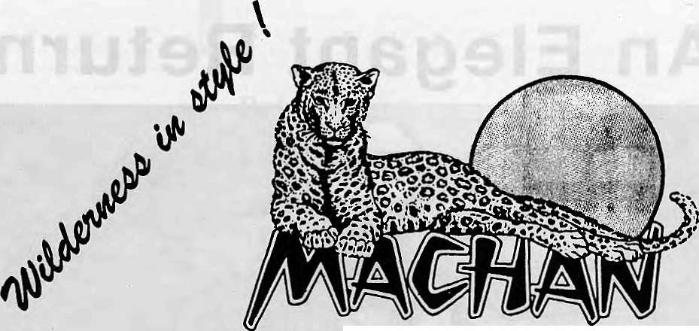
WIIPUFB fZtSOfZT
ROYAL CHITWAN NATIONAL PARK
Durbar Marg Reservation Office P.O. Box 78, Kathmandu, Nepal Tel: 225001, 227099 Telex: 2522 BODWAY NP Fax: 977-1-231957/419749

Chessler Books
Send for our free Mail Order catalog of the world's largest selection-of Mountaineering Books.
New, out-of-print, and rare. Also Tibet, Nepal, Polar, Exploration.
I Guidebooks, trekking maps, videos and more! \
r

I

\ Please write or call for your free catalog today. |j
Chessler Books
P.O. Box 399-112
Kittredge, Colorado 80457 USA (303) 670-0093 FAX (303) 670-9727
L___J

'Karakoram
EXPERIENCE
 |  | Pakistan
 | Join us on a Trekking,
 | Climbing or Mountain | Nepal
 | Biking Adventure*** | India
 | .. .to the world's most exotic
 | mountain ranges. | Bhutan
 | Specializing in the unusual | China
 | and unique, as well as the >
 | Himalayan classics. | Tibet
 | FOR A FREE, COLOR | Russia
 | "GUIPE TO ADVENTURE" CONTACT:
 | ^{f}Karakgmm T,?(perience 1 | South
 | TO. BOX 10538 • ASPEN, CO S1612 | America
 | [&0O) 497-9675 ■ (303) 925-a368>
 | FAX (303) 925-6704
 |  | Alaska

An Elegant Return

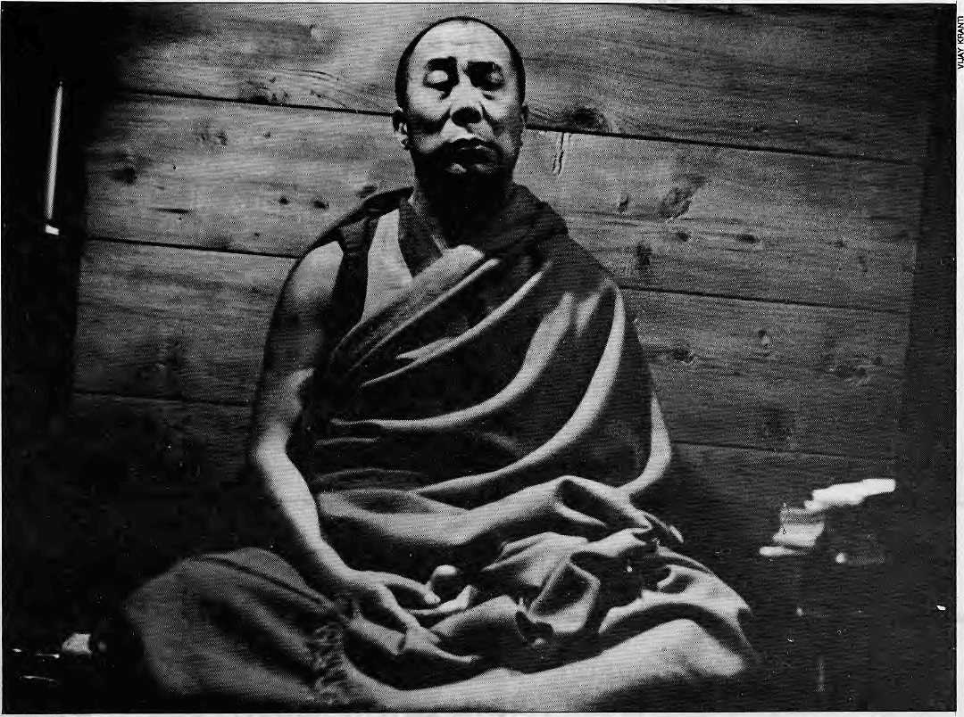

The Dalai Lama's presence
in Lhasa would provide the
Tibetan people not only
wisdom and spiritual
sustenance, but
also help them face
their day-to-day problems
with confidence
and resolve.
by Roger L Plunk

O
ver the decades, the constant stream of writings, seminars, workshopsand demonstrations on the Tibet issue—by the Tibetan government-in-exile, various support groups, and interested scholars, journalists, and activists—have all centered around the issue of Tibet independence. In fact, so much so that they have drowned out the one voice that matters most: that of the Dalai Lama.
Over the last 16 years, the Dalai Lama has not advocated Tibet independence. He has advocated the Middle Way Approach. The Dalai Lama's motive is pure: the welfare of individual Tibetans. He is not concer-
ned with abstract and antiquated notions., of independence and sovereignty. He is concerned with the quality of life of individual persons.
The Middle Way Approach seeks to balance and harmonise the interests of the Tibetans and the Chinese. The Chinese are not inherently evil, nor the Tibetans inherently saintly. They are two different cultures whichmust learn to live together in peace. Not a forced peace, but a natural and just peace: a peace with dignity. As such, this approach could just as well be termed the "Taoist Approach", for it seeks to balance opposing forces.
The Middle Way Approach can be realized as a consequence of one

20
January/February 1995 HIMAL

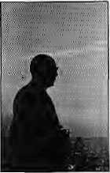
simple event: The elegant return of the Dalai Lama. China's main condtion for the return of the Dalai Lama is that he accept China's claim of sovereignty over Tibet. The Dalai Lama would be willing todo this. But, only upon China's guarantee that the interests ofTibetanswillbead ecjuately addressed.
There are, perhaps, as many Tibetan interests as there are Tibetans. Essentially, however, the interests of Tibetans are effective political partiripationonissues of local concern (self-government); economic and social welfare; religious freedom;and cultural preservation.
Because the Chinese Constitution already provides for these guarantees, China would find it easy to re-assert them. In addition, because of the unique status of the Dalai Lama in the world community—he has followers worldwide—the Dalai Lama must have guarantees for his freedom of movement and freedom of speech. Thus, we have an agreement (or understanding) that must, by implication, evolve out of the simple Tetum of the Dalai Lama: the Dalai Lama's acceptance of China's sovereignty in return for guarantees of Tibetan self-government and the independence of the Dalai Lama.
The most important element of the agreement is the guarantee for the Dalai Lama's independence, preferably through a "Vatican" model arrangement. Otherwise, the actual content of the agreementis less important than the willingness of China and the Dalai Lama to achieve real and lasting reconciliation, versus mere appeasement and window-dressing.
Such an agreement would not be an end to the long drama of Tibet, but the beginning of a new era. It would be the foundation upon which the Middle Way Approach could fulfill itself. After all, social, economic and political development is a process. It does not occur magically at one moment in time through one agreement. It occurs by a constant evolutionary process propelled by persons of energy and vision. The
very presence of the Dalai Lama would act as a catalyst for such a development. Those who believe that Tibetans and Chinese can never live together in harmony and happiness are wedded to the past and have no vision of the future.
There are two basic roles that the Dalai Lama would play upon his return. The first involves economic and social development. The Dalai Lama could utilise his resources and international support to infuse a fresh energy into the social and economic fabric of Tibetan areas. This may translate, for example, into attracting talent and funds for developing Tibetan businesses such as the wool and handicraft industries; for developing Tibetan educational, health, and welfare services; and for promoting public awareness on issues ranging from environment to the art s.
The second role of the Dalai Lama upon his return would involve his 'good offices'. Tibetans would pour out their grievances and aspirations, and the Dalai Lama would communicate these concerns to appropriate authorities at the local and central levels, along with suggestions. He would not be a political activist, but a discreet and responsible facilitator, ensuring that the interests of the Tibetans are being properly addressed.
Among the many "hats' that the Dalai Lama currently wears is that of the head of the Tibetan government-in-exile. This government has evolved over the decades to become very self-reliant, where the Dalai Lama plays an increasingly nominal role. The Dalai Lama would relinquish this role upon his return. He would return as a spiritual and cultural leader, not a political leader. However, the real power of the Dalai lama is moral and spiritual, not political. By withdrawing from the government-in-exile, he will be raising his status (not being weighted down by a worldly office), and be equally available to both exiled Tibetans and the non-exiled Tibetans in Tibet (the vast majority, numbering about six million).
Upon the return of the Dalai Lama, t he go vernment-in -exile would continue as it is, making it s own policy decisions. It can be expected to maintain a wait-and-see position regarding a proposed return of the Dalai lama; and it would most likely, for some time to come, act asa'shadow government', scrutinizing the administration of Tibet.
The return of Tibetans in exile would occur over a long period of time, and would be on an individual basis. Some Tibetans, having been born and raised in other cultures may not want to return. Others would return only cautiously. Long term visas could be obtained, allowing Tibetans to establish homes and busines ses without surrendering their rights to leave. There can be considerable flexibility in this regard.
The Dalai Lama came into exile 35 years ago. During this time, he has presided over the development of a nation of peopl e,builtfromthousands of destitute refugees, and sprinkled around the globe. He has continued to effectively head a major religion; has provided an unending stream of inspiration to Tibetans (and others); and has significantly contributed to the world dialogue on peaceful coexistence of peoples and human rights. It is on the crest of these accomplishments anddignitythattheDalaiLama will return, bringing the Tibetan people not only wisdom and spiritual sustenance, but also providing them with practical measures that will help them face their day-to-day problems with confidence and resolve.
It is acknowledged that not only Tibetans, but the world community as well, deeply respects and admires the Dalai Lama. What is less appreciated is that the Chinese people al so respect the Dalai Lama. The return of the Dalai Lama will not be a small event. It will be an elegant return that will create ripples of compassion throughout Asia.
R.L Plunk JDUJWlsalegal scholar providing independent counsel in public international law, constitutional drafting, and human rights. He is presently practicing in New Delhi.

HIMAL January/February 1995
21



Vocabulary Lessons

vvelcome to IS epal in treach is Ijienvenue ati O hangri-Lia. Welcome to IS epal in Spanish is JJienvenido al o hangri-L/a. Welcome to IS epal in iLnglish is Vv elcome at o bangri-Lta. Welcome to IS epal in Italian is IJenvenuto al O hangri-Lja. Welcome to IS epal in (jerman id Willkommen in O hangri-A/a. Welcome to IS epal in Japanese id V h-> t^-Vt^ o hangri-Lda.

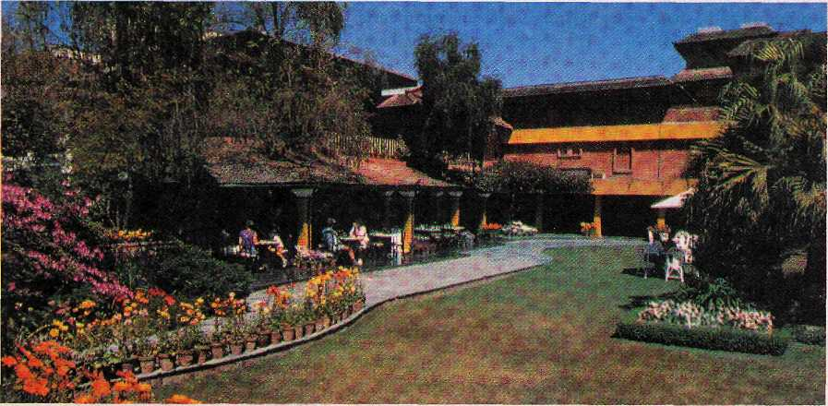

Hotel SHANGRI-LA
82 Deluxe Roonu

SHANGRI-LA
KATHMANDU
Your private paradise



LAZIMPAT. G.P.O. BOX 655. KATHMANDU. NEPAL - TEL : (977.1) 412999 - FAX: (977.1) 414184 - TELEX: 2276 HOSANG NP

Kang Rimpoche Trashed and Commercialised
The holiest spot in Asia used to be the unfrequented
destination of hardy pilgrims. It is fast
becoming a dirty Disneyland.
by John V. Bellezza

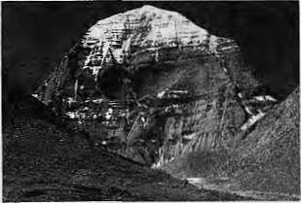

ell Kailash!" This is the battle cry of the Luyu Chu, Tibet's government-owned and controlled tourism organisation. The Luyu Chu has issued a directive to Tibet Kailash Travel, its branch agency in Ngari Prefecture, orderingit tobringin more tourists to Mount Kailash. The target set for 1995 is 1500 overseas tourists, a 50 percent increase over 1994.,The quotas set by the Luyu Chu are mandatory, yet the burdenof meeting them falls on the branch department. Tibet Kailash Travel has had to scramble to fulfil its mission. It has endeavoured to establish better contacts in Nepal. During the last year, its sales representatives met repeatedly with Nepal's Minister of Tourism and various tour operators. A concerted effort is being made to market Kailash as a overseas tourist destination.
It all began in 1984, when a handful of hardy Western travelers made it to the holy mountain. In 1985, a Japanese expedition and a
smattering of foreign individual tour-ists had the privilege. In 1986, the first tour groups began arriving at Kailash. Approximately 100 people of non-Himalayan countries came that year. The number of tourists visiting has increased steadily since.
By 1989,300-400 travellers from non-Himalayan countries were visiting a year, and 1000 made the journey in the 1994 season. If the Chinese have their way, 2000 such tourists will be tramping around Asia's holiest place by 1997.
The majority of tourists arrive in organised tour groups, each member paying on an average U$ 150 a day. Income from Kailash tourism therefore represents a substantial source of revenue for the government.
The Southern Yatrl
The situation foT Indian tourists and pilgrims is quite different from that of overseas tourists. Indians were first permitted to travel to Kailash by the Chinese government in 1981. From 1981-1992, the number of Indians allowed to visit was doubled to 400 as per a renewed- bilateral agreement between India and China. In 1995, 1000 yatris will be permitted to travel to the sacred mountain.
In 1986, it cost an Indian IRs 11,000 to make the journey from Dharchuia in Kumaon to Kailash and back. In 1992, the cost was up to IRs
25,000. Next year, it is expected that the cost of the pilgrimage will rise to IRs 40,000 with much of the increase due to fees levied by the Chinese.
Froml981 through 1994, Indians could only enter Tibet from the Lipu Lekh pass in Kumaon. This year, three new routes—Niti La in Garhwal, Shipki La in Himachal Pradesh, and the Demchok border point in Ladakh—are slated toopen. Of these, the Demchok border is the most promising as it is the only one with a motorable road link. Using this route, an Indian could reach Kailash from Delhi in three days. The only obstacle to developing this route, which follows the Indus River, is that the Indo-Tibetan frontier was mined during the period of bad relations between China and India. The land mines will have to be cleared in order to make Demchok a viable pilgrim route to Kailash.
Nepalis have had the easiest time making it to Kailash. They are allowed to make their own travel arrangements, which for the poor means walking or travelling in the back of trucks. It is rumoured that even Nepalis will have to form expensive tourgroups, but there is no evidence of this as yet. In 1994, the Simikot-to-Khojernath transborder route from Nepal was opened to foreign tourists. This route to Kailash could become popular with those on

HIMAL January/February 1995
23

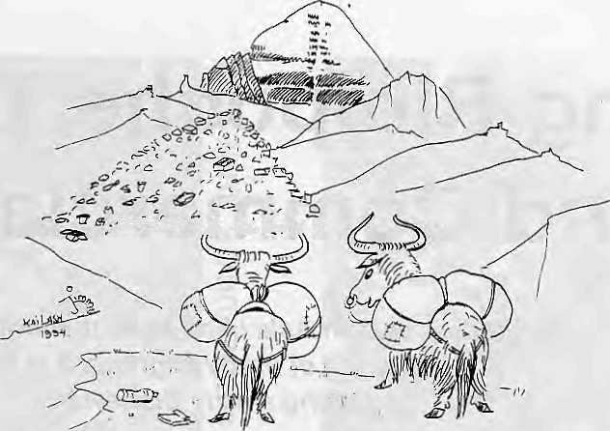
=*~ « ^ b. i= it •=
lavish budgets. A helicopter service has been opened from Nepalganj to Simikot, the headquarters of Humla District. Helicopter operators are lobbying the Nepal government to permit flights right up to the frontier, a move that is being resisted by the Central District Officer (CDO) at Simikot, who wants to protect portering and other service jobs for Hum la's population. It is unclear which side will win, but what is clear is that Kailash is becoming more and more accessible.
Five-Star Pilgrimage
The Chi ne se G overnmen t' s grand i ose plans to transform erstwhile inaccessible Kailash into a popular tourist resort area include the construction of a five-star hotel and restaurant at Darchen, at the foot of the holy mountain. There will be two airports, one at Burang and the other at Ali, the prefectural capital. There is talk of improving the three link roads to Kailash, which are presently in a terrible condition.
These ambitious projects remain on the drawing board as there is no commitment on the part of the Chinese government to free up funds to realise them. The objective evidently is to maximise profits without making significant investment. Infrastructure at Kailash remains quite primitive. In 1989, a 14-room lodge was built to handle tour groups, and work will begin next year on a better appointed ten-room facility. Most tourists, however, will continue to camp.
Vendors have lost no time capitalising on increased traffic to the region. In 1985, there were no vendors; now there are as many as 40 operating out of tents. These itinerant hawkers sell sundry foods and household items. The trend unquestionably is for more and more vendors to set up shop. In 1989, the Peoples Liberation Army set up a restaurant to cater to tourist s. Also in 1989, to better monitor and control the growing tourist and commercial traffic, a permanent police checkpost was set up in Darchen. Since that time, it has been increasingly difficult for low budget tourists and
pilgrims to visit because these kinds of visitors are officially discouraged.
With increased commerce, environmental problems have burgeoned. Darchen (4800 m), the staging point for visits to Kailash, has an inherently fragile ecology. Just a little more than a decade ago, the only rubbish around was the organic castaways of Tibetans. Since that time, garbage has been accumulating at an alarming rate. The Darchen Chu, a sacred stream representing the central channel or nadi of Kailash, is now choaked with plastic, glass, metaland other trash.
The refuse around Kailash is not only an eyesore, some of it is also hazardous. One comes across hundreds of discarded batteries containing heavy metals, and there is significant pollution of petroleum products from vehicles. Toilet paper is strewn around the Kailash circuit, an aesthetic distraction and irritant to the local people. There are no cleanup or waste management plans in place, consequently the problem worsens year by year. With maximisation of profits the priority, environmental protection has fallen by the wayside.
Kang Rimpoche
To the native Drokpa, Kailash or Kang Rimpoche is the crown of the world and in it the oceans have their source. Kailash is the fount of all life, they believe, feeding the continents with both precious water and pure consciousness. The Tibetans maintain that to pollute the water at its spurce
poses a grave danger to the entire world. For this reason, they are unhappy with tourist s who leave their refuse behind.
It is true that, contrary to their own beliefs, the Tibetan people tend to be just as sloppy as tourists and travellers. Nevertheless, the Western tourists are the champions when it comes to the volume of waste generated. The holy mountain is becoming a garbage dump.
Unfortunately, some tourists have squandered their welcome in other ways as well. The open sexuality that Westerners are prone to demonstrate shocks the sensibility of the natives. The worst was when back in 1992 a group of Americans tried to make a pornographic film at Kailash. They wereprevented from completing the filming, but not without a fight.
Visitors demonstrably lack even basic respect for the sanctity of Kailash. For instance, there is the obnoxious tendency to point the barrel of one's camera at people and holy spots as if it were an assault weapon. A proper cultural orientation should be part of the tour agenda, but neither the government nor tour operators seem concerned. Kailash is sold and marketed, but the local people are being estranged.
Dealing with Scum
Sadly, even darkerdepths of depravity have been reached, in conjunction with tourism. The last ten years has seen a rash of robberies in the Kailash region, some of it with Western

24
January/February 1995 HIMAL

complicity, which has impoverished local monasteries, Nepali and Tibetan criminal rings have stolen priceless statues from the gombas, sometimes at the behest of Western criminals posing as tourists.
Recently, some notorious European art thieves visited Kailash in theguiseof tourists. Wherever they go in Tibet, the priceless heritage of the country disappears. In 1993, five bronzes were stolen from the Zuthulphuk Gomba on the Kailash parikrama. The thieves were apprehended along with photographs taken by the Westerner who commissioned the theft.
Nothing has so damaged relations between the natives and tourists as the robbing of the monasteries. As a result, Gomba caretakers are now hesitant to open chapels to visitors and an air of suspicion and mistrust exists where earlier there was a warm and easygoing relationship. Major thefts
in the last few years include Chako Gomba (18 statues in 1992), Tashigang (three large Lokeshwaras in 1989), and Yin Gomba (15 bronzes in 1991). In 1990, a gang of robbers relieved pilgrims of their money and jewellery in the middle of the night. Kailash has attracted scum along with bonafide visitors and pilgrims.
The goodwill, the coming together of people at Kailash in peace and mutual respect, is disintegrating. Cynicism is surfacing with the increased exploitation. While some might accept this as a normal part of change and modernisation, it is that much more tragic when it happens at the location considered the most sacrosanct on the planet. What are the long-term impacts of mental and physical forms of pollution at Kailash?
With money as the prime motivating force that spurs tourism, there is little regard for cultural or ecological values. Kailash becomes another commodity to be marketed
and exploited, diminishing its religious aura. Visitors could be educated so that they develop a healthy attitude and awareness, but where will the resources for this come from?
The native people and the true pilgrims suffer the most from the commercialisation of Kailash. They have little choice but to watch the debasement of their holiest sites. Dissent is not encouraged by the Chinese. The native people are the losers in every way, for they do not even benefit significantly from the money generated by their holy mountain. How far will this onslaught on Kailash go? How long will the visions and needs of the Drokpa and pilgrims be drowned out by the mushrooming commercial interests? For now, at least, the most strident voice that drowns out all others is "Sell Mt. Kailash!"
J. BellGzza f'Jungli John'} Is a traveller of the Western Himalaya and Tibet.


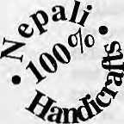
A fine range of
Made by low-income women
Retailers:
Dhukuti
Kupondole, Kathmandu Ph:523147
Exporters: Manufacturers :
Nepali Craft Trading (P) Ltd. Association for Craft Producers

G.P.O Box 3701, Kathmandu, Nepal Ph : 270721,272676 fax : 521880

G.P.O Box 3701, Kathmandu, Nepal Ph : 270721,272676 fax : 521880

HIMAL Januaiy/Febnaty 1995
25

V
o
I

THE INDIA OF NEHRU, thatpoetand romancer, would have been different from the intolerant nation-state that it has become today, writes O.V, Vijayan in tlte Times of India of14 January.
Imagine India still a colony and Jawaharlal Nehru editing the National Herald, We might have had a different Discovery, for the poet and romancer in him would have certainly glamorised the Naga and the Mizo and the Bodo. He would have disapproved of the Hindu hegemony in the Kashmir Valley, and discovered India'sethnicities in their joyful becoming. He kept his tryst with destiny, but it was a lesser destiny, and around him lay the countless unborn embryos of the Indian ethnos, Panditji was denied this discovery, as he was by then swamped by the regalia of the nation-state.
Yet, where it concerned the tribals he let himself be guided by liberal anthropologists; he went into Kashmir withan eclectic agenda of internal coexistence. We who were a generation transiting into freedom would like to recall not the midnight toll of bells, but the graphic picture of another freedom, another assertion:Jawahararm inarm with his comradeSheikh Abdullah. Jawahar wounded by the ragtag guards of Kashmir's Hindu maharajah.
These were pictures of heroic dimension, the stuff of epics and sagas. And yet they were also cameos of innocence, and their hero a poet and romancer. It is only the joy of this romance and poetry that can sustain so varied a polity of ours. But we have instead a sordid mass of imagined subversions and enmities which are met with hysteric reprisals. It has all escalated into something worse than war, and therefore something our war-makers cannot understand. This non-understanding has been written into the statutes, and its application made into something horrendous that demolishes our clumsy accumulation of democracy.
A little reflection, a little humility, is all that is needed to understand that this is a crisis of unknown dimensions, that it is not the work of militants and sabotuers, that a few crumbs of power would not pacify this unrest. This is a crisis of the nation-state. Once the state rested on the nation, now it does not, and as new identities emerge, as the identities proliferate, the state paralyses itself with the very power it unleashes.
True, this is happening the world over, in some form or other. But that is no consolation. What is of concern is the consequences to our federal entity, to the Indian psyche. Decades of suspicion have conditioned our reflexes to the extent of condoning the deployment of the Armed Forces to run parts of the country. We must be regretting that there is no sea in Kashmir, or we would have deployed the Navy as well.
Armed presences are the surest way of ensuring the permanence of bitter memory, and that is preceisely what we havedone. We have militarised ourselves. These words are written not from pacifist fundamentalism, but from a sense
of waste; we have drained the joy of becoming, the joy in which many a dormant nationality wakes to the awareness of itself...
A MULTIGENIUS PERSONALITY is how
"Namrata" in an Indian Express "space marketing supplement" on Nepal of 9 November profiles the Managing Director of Royal Nepal Airlines, perhaps by virtue of the half-page ad from the airline in the. previous page,
Nepal the mountain Island in the Indian subcontinent harbouring natural beauty and property is equally rich in MULTIGENIUS personalities. Classical literatures like "Padma Purana, Nepal Mahatma" etc. A richness in culture as well, the entire island is dotted with temples and sculptures of various Divinity, the saying, that a count ry possessing such natural glamour naturally commands special dimensions in the field of architecture and cultural wealth very well empties to this country.
Naturally in such an environment personalities of multiments crop up and enhance the prestige of the country by their various meritorious contributions. Mr Pradeep Raj Pandey is one of them born in the well cultured, educated and high familyof Nepal received his education in Cambridge University, Tribhuvan University and Delhi University.
Reaching the prime age of 42 he has shown his exceptional brilliance in the field of art and administration. A creative mind adorned with polite and charming personality has placed him on such a high dimension which is rarely found at this age.
Thecredit of organising and managing the Royal Nepal Airlines goes to Mr Pandey despite of this he has represented Nepal in several countries like Japan, Germany, Britain, Hongkong, former USSR, France and India etc. in different capacities very successfully and thereby he is responsible for raising the prestige of Nepal in the world. Not only this, he has shown his versatile knowledge in marketing, planning, capital budgeting decisions and budgeting verses corporate planning etc.
He was not satisfied with the management of RNAC He initiated starting of different flights to various countries in the world for effective utilization of tourist potentialities, natural beauties and cultural wealth of this mountain island, which shows his creative and scholarly mind. His capabilities are not limited only to the above contributions, he is equally efficient in the field of sports also. At present, he is a member of National squash team and an accepted sportsman in the field of culture. He is very particular with Indian music and musical instruments. It is no exaggeration in saying that Indian music/Classical music has become part of his life.
Shri Pandey is a rare personality which Nepal has been endowed by nature. We hope Nepal will ever receive perennial impetus and able guidance in the development of Nepal as a whole.

26
January/February 1995 HIMAL

c
E
S

LORD GURU RIMPOCHE will evidently be none too happy with the editors ofHimalfor not sending out this chain ktter, which arrived in the mail in late December. Perhaps the fate of Mr, Robertson (before he redeemed himself) awaits us all,
Oma A Hum Bingra Guru Padma Sedhe Hum,
Trust the Lord Guru Rimpoche with most Devotion
The Rimpoche will acknowledge and enlighten your ways.
- This letteT has come to you for good luck from the original
course of Lord Guru Rimpoche. You will receive good luck after
four days of receiving this letter. Good future awaitsyou if upon
you to receive.
- Please make 27 copies of this letter and send them out to 27
people who you needs luck. You must not delay in sending the
letter.
- This letter has been received from U.S.A.
- Since the chain around you, you must make 27 copies identical
to this letter and send them to your friends after four days you
get a response, this is true,
- Mr. Ben got this letter in 1958. He asked his secretary to type
out 27 copies and send them out. After four days he won
75,000.000.
- Mr, Robertson, an officer's, got this letter and forget it to send.
He lost his job. He found the chain and send 100 copies. Four
days letter he got a better job.
- Please make sure that this chain must not broken to avoid bad
luck. You must send them out 27 copies and send them out
within four days. Your problems will banish.
- Lord Guru Rimpoche hear your prayer.

- Om A Hum Benza Guru Padma Sedhe Hum
- Om A Hum Benza Guru Padma Sedhe Hum
- Om A Hum Benza Guru Padma Sedhe Hum
CLIMBING VOCABULARY from a serialised spoof of mountaineering terms by Steve Ashton in the magazine High. These selections are from the magazine's September and October 1994issues.
Talus: Exotic scree. Sounds vaguely Greek, anatomical and
rude, doesn't it?
Tenzing Norgay: Went up Everest with Edmund Hillary to keep
him company.
Terminal moraine; An incurable and fatal aversion to glacial
debris.
Thermal underwear: Under garments which, having been worn
for an extended period by a perspiring mountaineer, have
exceeded their capacity for odour retention and, somewhat like
vegetable matter in a compost heap, begin a process of
spontaneous internal combustion. Underwear having reached
this state is said to have 'gone thermal'.
UIAA: Union of Indecisive Alpine Associations. In addition to
talking about having talks about talking about safety
recommendations and grading matters, the UIAA is also
pondering the possibility of promoting harmony among the
global climbing community by introducing political correctness
into route names.
Vegetation: Plant growth which encroaches upon the climbing
line. A climber who has a penchant for exploring overgrown
cliffs is known as a vegetarian.
Waterproof: Convincing evidence for the presence of water,
such as that provided by the rain which pisses through the seams
of your two-hundred-quid mountain jacket.
White-out: Does this mean what I think it means? I'm trying to
imagine a conversation between two winter climbers waking up
in their mountain hut. One says to the other, "What's the
weather like today, Jim?" To which theother—Jim presumably—
replies, after rubbing the frost from the window and peering out
on to a landscape of glistening snowfields, "It's white out."
Hmmm. Yes, I'll go for that: white-out means that... er, that's it
white, out.
Wind-chill: Not another one. I mean, it's not as if there's such a
thingas'wind-warm'. Winds are chilly,forgod'ssake.Do Ihave
to spell it out?
ME NEPALI, ME WORK could be the motto of the Nepal Association of Foreign Employment Agencies (NAFEA), going by its slick colour brochure. Comprising of 27 manpower agencies, NAFEA seeks "to legally provide employment opportunities to various categories of labour force and professional personnel to overseas countries."
Categories Personnel: Engineers, draftsman, overseers,
mechanics, fitters, mason, electrician, foreman, heavy vehicle
drivers, carpenters, crane/forklift drivers, helper and unskilled
labour.
Hotel Restaurant Personnel: Trained and experienced managers,
executive chefs, cooks, captains, waiters and utility workers,
housekeepers, roommates, house boys, cleaners, accountants
and clerks, telephone opera tors, secretaries, drivers, laundry man,
electrician, plumbers.
Supermarket Personnel; Managers, accountants, storekeepers,
salesman, salesgirls, helpers, butchers.
Hospital Personnel: Doctors, nurses, staff assistants, health
assistants, helpers.
Security Guards: Personal bodyguards, presidential security
guards, embassy security guards, banks and industrial security
guards.
Marine: Security workers, shipyard guards, dock workers.

HIMAL January/February 1995
27


IIMOD
Vacancy Announcement

The International Centre for Integrated Mountain Development (ICIMOD) with its headquarters in Kathmandu, Nepal, was established in 1983 to address problems of economic and environmental development in the Hindu-Kush Himalayas (HKH) covering pans of Afghanistan, Bangladesh, Bhutan, China, India, Myanmar, Nepal and Pakistan. ICIMOD is an independent organisation governed by a Board of Governors and funded by some 15 countries and donor organisations. Its mandatory activities are <i) Documentation and Information Exchange, (ii) Research, (iii) Training and (iv) Advisory Services. Activities are implemented in close collaboration with partner institutions in the regional member countries. The present annual budget is $ 3 million. The Centre has 3 thematic divisions and 3 support services :

- Mountain Farming Systems Division (MFS)
- Mountain Natural Resources Division (MNR)
- Area Planning, Infrastructure and
Enterprise Development Division (AIE)

- Mountain Environment and Natural Resources
Information Systems Services (MENRIS)
- Documentation, Information and Training Services (DITS)
- Administration, Finance and Logistics Services (AFLS)

Of the 26 internationally recruited positions, 14 have been filled at present. During the first half of 1995 the Centre intends to fill in six additional positions for its regular programme and two coordinators for separately funded projects, for which applications are now invited. The common requirements for all of the posts are :
A. Post Graduate degree in the related field from an internationally recognised university
B. Good writing, presentation and communication skills in English including knowledge of word processing
C. Proven capabilities through publications and experience to take up the respective responsibilities.
D. Willingness to travel frequently in the region and work harmoniously with persons of different nations and cultures.
E. A major part of the work experience should have been obtained in the Hindu Kush-Himalayan Region.

Vac.95/1. Head, Area Planning, Infrastructure and Enterprise Development Division/ Enterprise Development and Marketing Specialist - 15 years' experience in economic development work, focussing Ion income generating enterprises and activities. Demonstrated managerial competence and capacity for intellectual leadership.
Vac .95/2. Head, Documentation, Information and Training Service/Information and Communication Specialist - 15 years' experience in information management and use of modern communication technology. Demonstrated managerial competence and capacity for intellectual leadership.
Vac.95/3. Agricultural Extension and Training Specialist, MFS Division - 10 years' experience in agricultural extension and/or training, including preparation of extension and training material
Vac.95/4. Pasture Specialist, MNR Division - 10
years' experience in analysis and management activities related with pasture and range development
Vac.9S/S. Energy Specialist, AIE Division - 10 years' experience in energy planning and management, in particular non-conventional energy resources for rural development.
Vac.95/6. Remote Sensing Specialist, MENRIS- 10
years' experience in the field of remote sensing, preferably with several years in relation to mountain resources of the HKH.
Vac.95/7. Project Coordinator ,"Promotion and Development of Beekeeping through conservation of native Apis Cerana Bees", MFS Division - 10 years' research and/or extension experience in apiculture, preferably with Apis Cerana. Management experience desirable.
Vac.95/8. Project Coordinator, "Mountain Risk Engineering", AIE Division (Pending final approval of project) - 10 years' experience in road construction or other infrastructure development in fragile mountain areas, including some exposure with risk and hazard management related with infra-structure development. Management experience is desirable.

Female candidates are strongly encouraged to apply.
Remuneration : Salaries and benefits are based on a modified UN system.
Duration : Three years, of which one year is probational, and subject to continuation of present funding levels of
ICIMOD. Starting date : 1st June 1995.
Applications : Applications should be received before 20th March 1995
M.R. Tuladhar, Head, Administration and Finance
ICIMOD, G.P.O. Box 3226, Kathmandu, Nepal
Fax : (977-1) 524509/524317
Detailed Terms of Reference for each position are available on request.

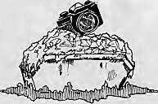

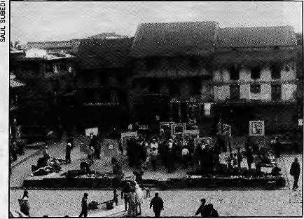
In mid-December, Himal magazine organised a photo exhibition, Kathmandu, Mailo Kathmandu ('mailo' = dirty, soiled) which travelled through the public spaces of Pa tan, Kathmandu and Bhaktapur towns.
We hoped that disturbing 'freeze frame' images reflecting the weakening spirit of Kathmandu Valley would provide shock therapy to the public as well as the political, business and non-governmental bosses. If the Valley is not to choke in its own refuse, our leaders have to dirty their hands. They must understand the here-and-now dangers that a dirty Kathmandu poses to public health, aesthetic and touristic sustainability.
In this photo-essay, we present some of the 42 pictures that were part of Kathmandu, Mailo Kathmandu. The chaitya-and-garbage photograph below, by Chandrasekhar Karki, was Editors' Choice for the image that said the most, Himal also held a poll in each of the locations, and the Public's Choice was the picture on page 33 of the tourist memorialising pigs and garbage at Thamel.

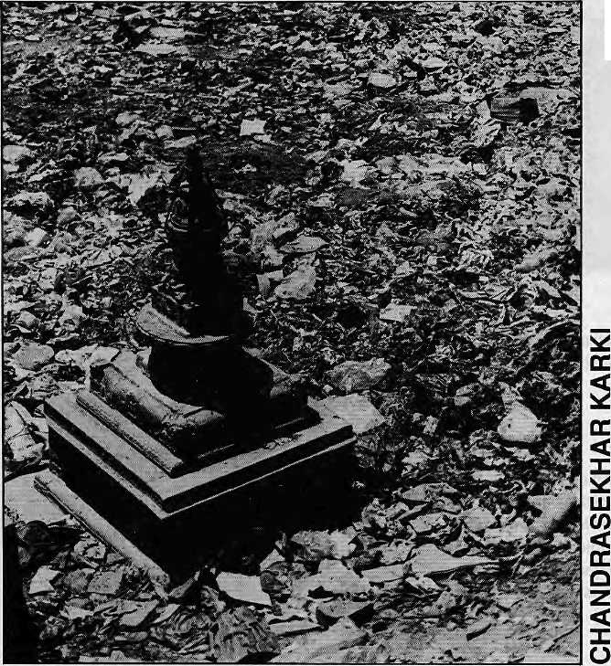
The shame of all Kathmandu in the neglect ol one chaitya.

HIMAL Januafy/Februaiy 1995
29


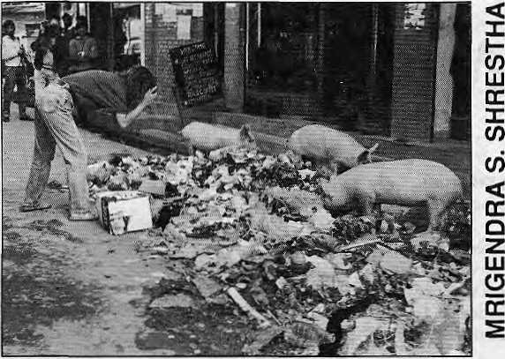
Alternative Tourism
What happens to the economy when tourists begin to aim cameras at pigs amidst garbage rather than the tempiescape?

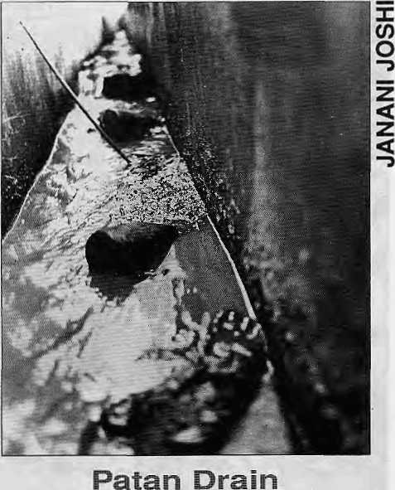
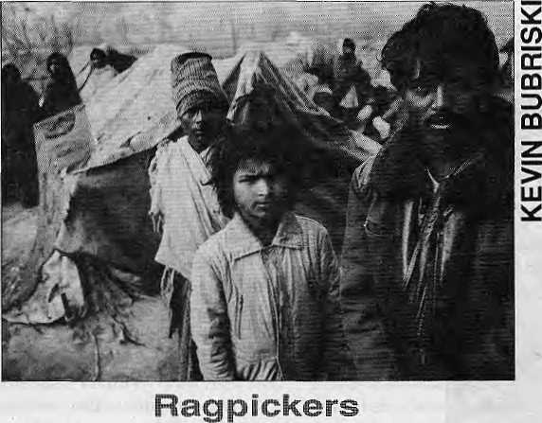
The ragpicker underclass of Teku provide some breathing space
for a valley that would otherwise already have choaked in plastic,
rubber and metal discards of over-affluence.
An open drain in Patan
carries a thick and fetid brew,
a khichadiof raw sewage,
motor oil from a nearby
garage, and urine. Beer
bottles mark the passage.
In the beginning, there was organic waste. Then
came plastic. The trusty Kathmandu sungur
takes it all in stride.

30
January/February ms HIMAL

The Day Before 4 May 1994, 4:30 pm

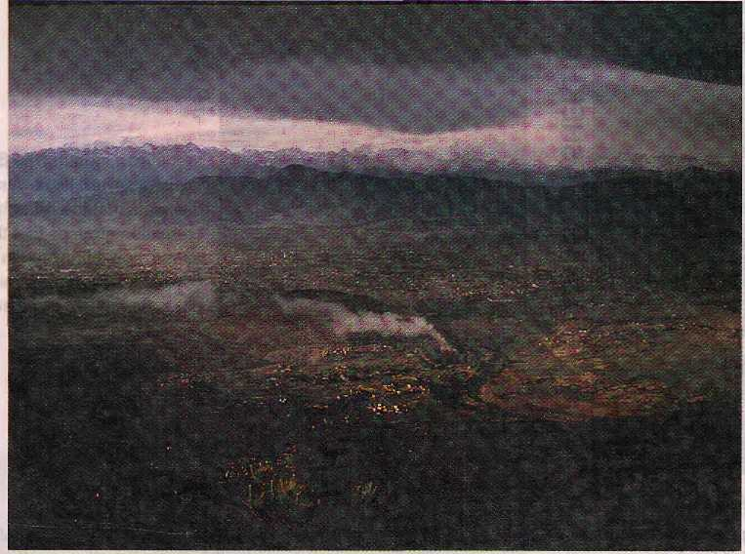
The view from Champadevi hill. An afternoon thunderstorm has just washed Kathmandu Valley's atmosphere, with only the Chobar cement factory's chimney plume indicating that all is not well.

The Morning After 5 May 1994, 9:30 am
both pictures, RAJIV CHANDRA

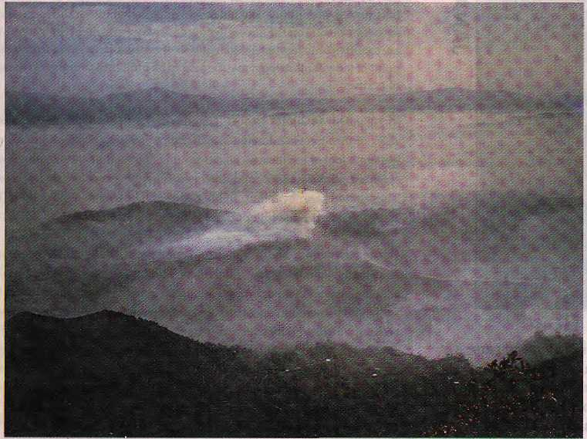
The lethal air within this cauldron is what Kathmandu's inhabitants breathe during much of the winter. Temperature inversion keeps the atmosphere socked in, allowing the dust, smoke and gases from industries, brick kilns, motor vehicles, and constructions to generate a witch's brew. The smog could be mistaken for Kathmandu's winter fog, but it is already late in spring.

HIMAL January/February 1995
31


In the lean months, the Bagmati is just a sewer. Its flow is so diminished at the Aryaghat cremation grounds that the ashes, spent firewood, and flowers from funeral pyres do not even make it downstream.
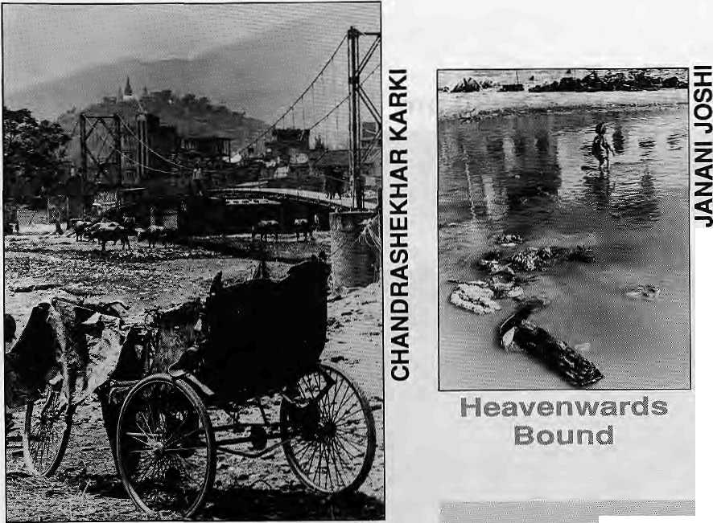
A RIeksa to Swayambhu
From alar, Swayambhu's all-seeing eyes look down
upon Bishnumati —a landscape that has become
unrecognisable within a decade.
AWistoiy of Filth
JGsthmaridu filth^not a recent phenomenon. The valley towns were already dirty more than a century ago, according Western travelers' reports. Presented here is aselestitm, compiled by Abana Onta*

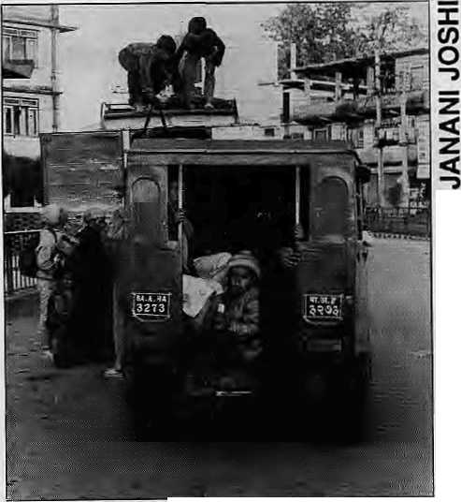
ins of the Road
The worst affected by air pollution in Kathmandu are
these young conductors who perch at the back of the
Vikram Tempos. As the three wheelers make their rounds,
they breathe in carbon-laden deisel exhaust as well as the
dust and gases of Kathmandu's busiest thoroughfares.
Very narrow, mere lanes iti fact; and.-the whole town iavery dirty. Inevery lane there is a stagnant ditch, full of putrid mud, and no attempt is eveir made to clean these thoroughly. Thestreets,it is true, are sweptin the centre, and part ^fthefilthfc carried'offby the sellers ofmanure; fcuttodean the draws would nowteimpQSsiblewith out knockiiigdowntheentiirecity^asthewholegrourid issaturatedwithfiltTi... Thehousesare generally built in the form of hollow sqttarts, opening off the streets bylow doorways; andthese eetitral courtyards are l^ of ten only receptacles for rubbish of every sort. In short, from a saw tary point of view, Kathmandu may be said to be built on a dunghill in themiddle of latrines.
In 1880, G.H.D.Gimlet wrote: The filth of the city is abominable. Along the sides of the streets and lanes, which are paved with brick or stone, lie deep gutters, a foot or eigh teen inches wide and of about the same depth, filled with stagnant, stthkjng black mud, into which every sort of refuse finds its way. These gutters are iievef thorou^ily cleansed. The foundations of the city must be saturated -With the filth of more than thousand years;
Henry Ball an tine, another visitor, reported jn 1885: Oh the opposite sicte from theesplanadelaythecapitalcityof50,bfX)inhabitahtswedgedmbetween the Bagmati and yishnumatt, extending up fj-omthe point Where these streams unite, andpresenting a most picturesque appearance outwardly, but in wardly reekirig withfilth;adty which has dunghills for its foiindations,stagD ant pools for ornamental lakes, whose streets do duty for drains and latrines, where the widest thoroughfares are harrowlanes wretchedly paved, only fit for inoculated pedestrians. Such is Kathmahdu with its ever present effluvia and stench, so that it is no wonder that during the summer just closing ten thousand, or one fifth of its population had fallen victims to cholera;

32
January/February 1995 HIMAL

V
w

Being Previous...
Doig's Kathmandu

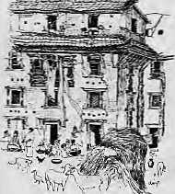
K
athmandu residents have become a little disinterested in their home valley. But ask most visitors or returning natives what it is about the place they find most memorable, and the answer will invariably be the colours.
That explosion of emerald as the aircraft suddenly breaks through monsoon clouds on final approach, the ochre-and-white dolls' houses on the edge of terraces, blinding white cumulus towering over purple hills on the valley rim, terra-cotta temples reflecting the pale sun of a winter afternoon...
Desmond Doig's artist eyes were mesmerised by this beauty and light. It was love at first sight, and his view of Kathmandu is coloured by this affair.
When he died in 1983, the artist and writer left behind a folder-full of sketches and watercolours and the text for a book which languished in a publisher's attic in England. Ten years later, Desmond's friends in Kathmandu have helped retrieve the manuscript and artwork and publish My Kind of Kathmandu.
In the text, Desmond is constantly "being previous"—some sixth sense must have told him that by the time it saw the light of day the book itself would document a previous Kathmandu, an ex-Kathmandu. It was a Kathmandu that was already, in the late 1970s, decaying in front of his eyes as its colours faded, to be finally smothered by malignant concrete monochrome. The Valley's transformation in the decade since Desmond passed away has made this book one artist's celebration of what was Kathmandu. The pages of My Kind of Kathmandu are like a pilgrimage to the past and a glimpse at the vanishing treasures of Asia's Florence. They fade even as we talk.
Desmond knew what was going on. He fled Calcutta to escape the squalor because, as he said in a conversation in 1981, he was "neither a charity"worker nor a revolutionary". But in the late 1970s he saw the blight was spreading to Kathmandu as well. In his text, Desmond grieves for a Kathmandu where the "desire to be modern hashit... and the rich arehurtlingto pull down their centuries-old houses and replace them with concrete and glass".
He yearns for a less-concrete Kathmandu of as recent as the 1960s where there were no straight lines, the streets were still flagstoned and the houses were "all mellowed brick and russet tile and weathered wood". Toyotasand Datsuns had not madetheir appearance and out-of-the way shrines of Dhum Barahi, Maiti Devi and Kwa Bahal were still shrouded in hoary legends and awaiting discovery.
Call it romanticism. But then Desmond was a
My Kind of Kathmandu
An Artist's
Impression of
the Emerald
Valley
Desmond Doig
Indus, 1994
Pages:208
Price: NRs 2072
Review by KundaDlxIt
K. Dlxl! Is Asia-Pacific
EcHoroi Inter Press
Service.
romantic. His drawings studiously avoid the ugly. The loving linesof the portrait of Sweta Bhairav meti-culously detail the tufts of grass growing out of the tiles, but blot out the squalor of the adjoining square.
Elsewhere, Desmond was there before the rot set
in. Bucolic scenes of Swayambhunath from the Ring
Road capture the texture of the fields, trees and hills that
have now been washed away by Kathmandu's trans-
Bishnumati sprawl. Ten years after Desmond's eyes
and fingers scanned the scene, the spot is unrecognisable.
Desmond's roof of the ChobarGanesh temple still glistens
in the afternoon sun, and is not coated in cement dust. The
hill beyond does not yet carry the scar of a limestone
quarry.
There is an evening view of Patan's old bridge sitting on "a forest of wooden legs" as the Bagmati flows silently belowreflect ing the sun set off JugalHimal peaks. The water and colour evoke a languid sky that has long disappeared under Kathmandu's smog. The dream-like quality ofbright afternoon light on GaneshHimal framed in red-yellow cottages and harvests suffused in gold is impressionistic—recording for posterity the light and colours that struck the retina of an artist's eye a decadeor more ago. The sepia dawn on a Bhaktapur street is timeless. Desmond wrote as well as he painted, and does not try to hide that he is looking at Kathmandu with the blinkers of an outsider, tourist-guide's eye. But as a perfectionist he would have frowned at the sloppy editing, distracting proof errors and odd words that appear disconcertingly in bold throughout the book. As artist, he would be pained by the ungainly size, poor layout and uneven printing which stand out despite the publisher's lavish efforts.
The text weaves in the tale of two coronations (Mahendra and Birendra), introduces us to celeb expats like Boris Lissanevitch, Han Suyin, Barbara Adams, Marshall Moran SJ, Col. Jimmy Roberts and local luminaries like Field Marshal Kaiser Shumshere and Prime Minister Tanka Prasad. It reveals the secrets of Thecho village's mustard presses, Taleju's barking bell, the hill of the camphor tree, and a temple where a god lies sleeping... On the rare clear evening these days when the cement plant is not belching dust, you can still stand below the Bridge to Ye Rang and see what Desmond saw: "The snow ridge to the north turning from silver to gold to rose and fading lavender and the flaming sky reflecting in the shallow river."
Sometimes in the midst of Kathmandu's mad
dash into a nondescript future, the past shines through
the smog and grime. k

HIMAL January/Palmary 1$95
33

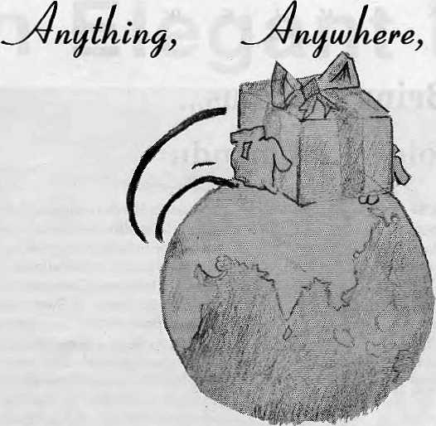

ume

Overseas Cargo Service and J.F.N. Exports, Thamel, Kathmandu
P.O. Box 8621, Kathmandu. Phone: 977 1 413391 Fax: 416850

Visit Mandala
Scholarly books, maps and guides on ' Tibet, Nepal, Bhutan and the Indian Himalaya
li 1 FORTHCOMING 1 |  | WE ACCEPT AMERICAN EXPRESS VISA CARD & MASTER CREDIT CARD | 1 RECENT ARRIVALS 1
Civilized Shamans 1 Buddhism in Tibetan Societies by Geoffrey Samuel  Mandala Edition 1 (Original edition published ! by Smithsonian Institution Press, Washinton DC. USA)  Jhankri: Chamane de 1' Himalaya  (In French Language) Eric Chazot |  | WE ACCEPT AMERICAN EXPRESS VISA CARD & MASTER CREDIT CARD | Proceedings of the International Seminar on Anthropology of Nepal: People, Problems and Processes Edited by Michael Allen  Tales of Turquoise: A Pilgrimage in Dolpo Cornneille Jest  Nepal: A Guide to the Art and Architecture of the Kathmandu Valley Michael Hirtt
mm MANDALA BOOK POINT
^hS#&/ Phone: 977-1-227711/216100{R), Fax: 221129/227372 , "^■^wLrt^/ Kantipath, Post Box Ho. 528, Kathmandu, Nepal

N D E X
Vol 7 No 1 through Vo! 7 No 6
The 1994 Himal Index makes accessible to readers and researchers information on articles and news items appearing in the last six issues of Himal magazine. Regular departments such as Voices, Himalaya Mediafile, Abominably Yours and Abstracts are not included in the Index, 'Bx¹ in the list below refers to box-items within larger features.
A computerised index of Himai'm diskette or printed form (WordPerfect 6) is avaliable at Himal Office. This Index contains details on Himal's total output to date—35 issues {Vol 0 through Vo) 7 No 6) and has all the tools (or retrieval and sorting using UNESCO's CDS/ISIS library package. Data input by Piush Mani Dahal.

Jsn/Fet 19M Voi 7 No 1 (Red)
745. Axing Chijsko
Aryal, Manisha
Bui: Forest Policies and Ihe Seeds of Discord
B*2: The Skeplios Chipko
Bx3:'PedKato'
Chp ko/Act iv is m/Urtarakhand/Fores I
- Portraits t>[ Nepal
Bubfiski. Kevin
Photography
- Tailing Gyatso on Saddam Hussein and
Gorman U-Boats
Dalai Lama'lnterview
74*, Discussing the "Tinkering Approach"
and the "Grand Plan"
Pistes h, Sanjasu
TiboL'Dev slop menVConfersnoe
- Ladakh on the Schedule
Srinivas, Smrilp
LadakWEthnicity
- Peace Conference in Shillong
Meg halaya/Nlorlheast/Conlerence
- Phoenix Journal
Journal/Research
762, Zapping Poop with Solar Power Conservalion/Solar
753. A Nalivs by Any Other Name...
Pradhan, Rajendra
Bxi: The Government vs. the Indigenous PeoplB(s)
T> ibaVEthn icity/Di so r i min at ion
754. Slave Wages on the Trails
Soott. Doug
B*t: The No-Pain-No-Gain Trekking Anli-
Brachure
Porter/Trek/Wana/M ountaineering
MarWpt 1094 Vol 7 No 2 (Purple)
755. On lha Way Up
uiiit, Kanak Mani
756. Notss from the festival
Prasad¹, Anmole
FilnvDoou mentaiy/Festival
757. ...because they are the re
Verma, Sanjeef
Film/Doeurmntary/Feslival
756. Delinquent Documentary
Dbqt, Kanak .Manl
Fi Im'Doeu mantary/Lynx/Crttique
- Tibetan Renaissance
TibetfCuHure/Relig ion/A mnye Machen
- Brother to Another Planet
Siosphsre/T ham/Arizona
761. Tourism a Genetic Resourcel
Bioph ilia'Natu raTour is m
761. Himalayan Cyberspace Tiwari, Ashutosh E-MaiVTibet/Oharams hala
7*3, Gorkhali Honours Gurkha/Recruitmenl/World War/Victoria Cross
7M.KhimtitoQo Hydropower/KhinrtiWater
- Northern Forests on the Way Out
Ghaley, Padam Singh
Humla/TimberfForests/Tbel
- Wealth of Study
Northeasl/FSajiv Gandhi FoundatiorVFellowship.
7(7. Rimpoche Wrangle at Rumtek ReincarnationMagyu/Religion
768. The Original irekkar and the In-llighl
Connoisseur
Toni Hagen/Dubby Bhagat/Flighl
76S. The Storm Raged All Night Long Rai, India Bahadur
Katha'Slory
- Hostage in Thimphu
Bhandari. Bhakti Prasad
Bxl: The House of Punishment
Refugee^ hutanfPrison
- Mistaken Amiquhy
Messerschmidt, Don
Antiq us/Sou Iptu re/Ag h ori
772. A False Harmonising ol Himalayan
Experience
Jhaveri, Nay no J.
Deg radationf E nology/Critiq ue
773. Bahuns in the Nepali Slate
Sha/ma. Prayag Raj
B rahmartf Eth n city/ Janajati
May/Jun 1994 Vol 7 No 3 (Gray)
- A Fate Other than Msrginaiily
Gyawali. Dipak
Periphery/Economiy/P lains
- Tho Next Great Earthquake
Bilharn. Roger
Eart hq u ake/Ssismicily
- Tarai with Blinkers
Meyer, Kurt W.
Ftesearch/M Shiia'Tti anVC rili q u a
- Teacher
Tselen, Kesang
Katria/Story
- The Loss of a Mother's Son
ShroH. Satis
PoerrVGurkha
- Stories from the Heart of Nepal
United Mission&tory/Education

- Nagas descend on Kathmandu
Northeast/TourisrrVCuHure
- Shahtoosh
Wildtife/AntelopetndangueoVChang Tang
- Nar Bahadur Bhandari
Sikki m/Etod ionftsaambly
703. Some Tea and PestBtdes Please Darjeeli na'Garmany/Pestioide/Fertilisor
- Disastrous Sedimentation
KulekhanirSed imentation/RBervoirA^kiudburst/
Silt
- Austrian3 an Vamdrok Tso
Frimmel. Martin
Dam/Panchen Lama/ReservoirrTibel
786. Discord in Dharamsala Gadd^Dharamshala/Riol/Tibet
7fl7. Are Tame Rhinos Real Rhinos? Research/Rhino/TourisnVCh itwan
TBS. Deconstiucting MythsAbout People of India Tribe/Ethnog raphy/Diversity/flesearch
799. Dhupi Not Welcome in Darj Darjeeling/Tree
- The Value of Dung
Dung/Energy/Cattle
- Cranes Don't Come Here Anymore
Sberian Cranes/Rajasthan/Migralion
- Cost-Benefit of a Health Caie Centre
Healthcare/ResearcrVGarhwayUttarakhand
Jul/Aug 19MVol7Ht>4(Orma«)
793. House of Cards
Discit. Kanak Uani
Bxi: Kalhmandu and Thimphu BxZ: Garganda to Beldangi Bx3: The View from South Block Bi4; Rongthong Kunlay Dorji Bx6: "I Don't Know BhularV Ret ugees/Geo-Polhies/Media
794. Lyonpo Dawa Tsering
Interviaw/Dawa Tsering/Bhutan
795, Shame on SAARC
Cupla. Anirudha
S AA nC! Retugee^ hutan/UNHCR
79S. On the way up Dnit, Kanak Mani
797. When a GLCF Bursts its Banks Mool, Pradeep Kumar GLOF/RoJwalingTso Rota
79B. Noriheasterners Resist the Lollypop Trbe^Northeasl/DanVGrah msputra
799. Snow Leopard Menace Gurung, Gehendra/Ale, Som Snow Leopard/Manang'Film-makincj'Research
300. MeghalayaCoal CSE/Down To Earth Fsatures Khssi Hills/Meg.haJaya'Mining/Coal
801. Elephant Corridars in Western Tarai E (ephant/Tarai/Corbett
902. Dabur wants Taxus baccata CSBDown To Earth Features Taxus/Oabur/TaKol^Yew
Trees and the Caste Barrier Shimla'ForesVCaste
804. PLACENAMES
Wangyal, Sonam
Kurseong
605. Back Breaking Rotors
(Jpadhyay. Akhiiesh
Kh umbu/Helicopters/Porters/Tourism
606. The Price of a Rooster
Prasad, Anmole
Katha/Story
807. Writing in Monochrome Ramble, Charles fiaviaw/Travsl Literature/Guides
805. The Northern Passage
Shrestha, Manesh
Feak/Exped ition/Mountaineering
Sep.'Oc11994 Vol 7 No 5 (Green)
609. Euddhiiibi: Intelligentsia Has No Clothes
Gyawali, Dipak
Intelligent^ ia'lnte II set uais/Soc isty/C hangs
810. Speak Truth to Power Shaha, Rishikesh Politics/Stabil ity/lntellectual
311. A Generation Lost Trwari. Ashulosh Education/lntellectual
612, Contemporary Concerns
Sharma. Pitamber
Nationals nVLiberaliaation/l ntelleetual'Gender
813, The Road to Nowhere"
Malla, Kama) Prakash
Inlelleduab/Scholarship'Caste
814. Hunter and the Hunted
Magar, Ranaprasad GhaKi
Hunting/Magar/Dhorpatan/Tou rism
SIS. Is Khumbu Garbage Tamed? Upadhyay, Akhilssh Sherpa'Gaibao&'Khunibu/Trek/Tourism
- Rupshu Opens to Its Fate
Gupta, Ranu
TourisnVLadakh/Tso-Morari/Pollulion
- Blama the Mountains No More
Himalayan Degradation/Floods
616. Broadcasting Tongue Twister Shrestha, Manesh Ethnicity/Language/Radio
- Placenamos
Wangyal, Sonam
Bhutan
- Busing it to Lhasa
Shrestha, Manesh
H ig hways/Trade/Tfeel
621. BLs, RLs, BCs and Sikkims Communal Politics
Kazi, Jigme N. Elections'Ethnioity/Sikkim'Polilics
822. Uttatakhand oul of UHar Pradesh
Nautiyal, Navin Uttarakhand/Uttar Pradesh/ AetivisnVStatehood
- Kali with Crows
Isaacson, J. Morton
Kalha/Story
- Kitting Fields of Kashmir
Bidwai, Praful
Kaahmir/Autonomy/JKLF
- Save the Nepali Tiger
McDougal, Charles
Bxi: A Buffer tor the Tiger Tigers/Reserves/Poach ing/Wild lile
828. 'HimaJ- equals Cluster. Chain, Group
Thapa. Deepak
M ountai ns/Ranfles/Peaks/Tamli nology
Nav/Dac 1994 Vol 7 No 6 (Blue)
627. Angry Kills/An Uttarakhand State of Mind
Aryat. Manisha
BJC1:KimachaliTopi
Bi2: Regional Press
BX3: Dalit Dabao Andolan
Bx4: Vou Kumaoni, Me Garhwali
BxC: Women to the Back, Please
Uttarakhand/Statehood/Activism/ldentity/Media
623. Dukha during the World War
Onta, Pratyoush
Bjc1:Dafending Bharat
Bx2: A Splinter in the Mother's Heart
Gurkha/Work) War/Hislory/Suflering
- Thick but Incomplete
B»!ll an a, John V.
Review/Tibet/G u ido
- How the Crescent Fares in Nepal
Shainia, Sudhindra
M usIim/Hindu/ComrnunalisnVSecularis m
- The Soldier ("Sfcahi")
Koirala, Bisweswor Prasad
Katha/Story
- Said the Woodcutter
Rao, Maj. Arun
Po«m
- ChomoJongma in b/w
Everest/Photograph
- At Last, aPopulation Breakdown
Popu lation^ensus^thnioity
635. LobaArt Antiqua/Photograph'Mustang
836. Placenamas Wangyal, Sonam Kalimpong
- A Star was Born
Upadhyay.Akhilesh
Firm/UNICEF/Girlohild
- That Trse Can Do No Wrong
CSE-Down To Earth Feature Service.
Seabuckt horn.'H i machal/
ICIMOD/Deserts
839. Is this Rape? Forest/Timber/Tibet
340. Disaster on Pisang Peak Ghaley, Padam Singh Climbing/Accident/P is ana
641. Quiet South Asian Coup SAARC'EnvironmenVUNEP/Data
841A Trekking Peak - Sy any Olher Name O'Connor. Bill Trekkinp/AecidantfCli mbing

HIMAL January/February 1995
35


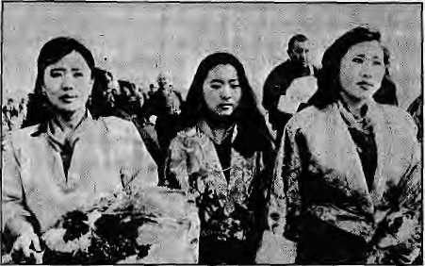
o
CO
ca
Himalayan beauty caught the eye of practically every major Indian daily, when two of the four first ladies of Druk Yul chose to alight from an airplane in Patna with thecrown princeon apilgrimage to Buddhist sites in Bihar. Well, if the Times of India, The Telegraph and The Statesman thought it was okay, who is Chhetria Patrakar to act squeamish? Herewith I present the queens. And speaking of pictures, check out the one of King Jigme Singye Wangchuk embracing P.V. Narashimha Rao soon after the Congress Party's devastating showing in the December polls. An ace at public relations, the Druk Gyalpo knows well the importance of friendship shown in times of trouble— he made it a point to visit Indira Gandhi when she was out of power. The divi-dendsare His Majesty's forthe reaping.
For three decades we have played around with the term forest degradation without really trying to understand what it means. This point isconfirmed by forestry scholar Deepak KC, who writes in the latest issue of the newsletter Habitat Himalaya that "the deforestation and extent of forest degradation in Nepal are practically unknown". KC is to-the-point, "Although theterm 'forest degradation' is widely used, no standardized definition of the term exists to date. In the absence of scientific attempts to quantify and/or classify forest degradation, there is no basis for assessing the extent or rate of degradation of forests, comparing differentially-degTaded forests across time and space, and subsequent targeting of appropriate management programs fora certain class of degraded forests." That this is being said in 1995 is a shame on the very discipline of Nepali forestry and all who have practiced it in last four decades.
Hypothesis: if uranium is found and is beingextracted along theShivalikTange both in Himachal Pradesh and in
Pakistan, then it stands to reason that the rad ioacti ve lode i s also lurking about in Nepal, which is host to the entire eastern half of the Shivalik range (the Churia). Nepali physicist Binil Aryal, writing in Kantipur, considers that this hypothesis is proven. Gamma-ray spectrometer studies along the Tinbhangale Khola in Makwanpur District south of Kathmandu, he writes, ind icate that there is extractable quality uranium in Nepal's Churia. Right, so let's call in the IAEA and let Nepal consider signing the Nuclear Non-Proliferation treaty for starters.
The letters column of The Statesman, more than others, provides esoteric tidbits to sharpen the mind. A 12 December letter, from Kalyan Kumar Datta from Nadia discusses the proper address for the historic Buddha. He says that the name should he Siddhartha Gautam (the Buddha), "since Gautam is only a family name and Siddhartha was his personal name." Datta is firm that the common usage of 'Gautam Buddha' is incorrect
Two recent items proveonce again that the American media just cannot cover the Himalaya with any amount of diligence.TakealookataJanuary issue of Newsweek, which identifies the well-known wooden twosome of Shiva-Parvati peering out of a carved window at the Kathmandu Durbar Square as "Kathmandu dancers". Or how about John F. Burns's report in the 16 December New York Times on the death of eleven climbers on Pisang Peak in the Manang Himal (see Himal Nov/ Dec 1994). The main question is ho w all could have died in one incident, and suspicion is that the party was tied to
one rope. But Burns prints the story he has been fed by interestedparties: "...with bad weather closing in, the party began to descend. Below the summit, with the party roped together in groups of three and four, some members of the party began to slide on a steep, icy slope. In seconds, the entire party was swept 1,500 feet down the slope, then over a sheer 500-foot drop." How?! Sloppy, sloppy, Mr. Burns.
Some military details that have caught Chhetria Patrakar's eye this past month. One is the announcement that China and India have agreed to hold joint military exercises this summer in their first combined defence manoeuvres since they fought the border war in 1962. The exercises are planned to be held around Pangong Lake east of Leh, an Indian defence official told Reuters in Jammu mid -December. "It'spartof a friendly, mutual confidence-building measure," said he. If theLadakh manoeuvres prove successful, subsequent joint exercises are slated for the Northeast. I'm all for renewed bhai-bhaism, as long as we know where we're going.
The other item that caught my eyes is Manoj Joshi's piece in The Sunday Times of India on elite commando battalions of the Indian Army, which are being reconstituted as a new 'Special Forces' unit. The Special Forces are the outcome of the belief that India is likely to face more threats from low intensity conflicts rather than general war. Meanwhile, there is already a Special Frontier Force, writes Joshi, which is under the Research and Analysis Wing, India's external intelligence arm, but is officered by the Ind ian Army, Thi s force is successor to the 'Establishment 22' that was set up by the CIA in the 1950s, comprising of Khampas and raised for sabo fcage operations in Tibet. This force was disbanded after 1962 and reconstituted as the SFF.
Might as well empty my ammo while I'm at it. Here is another militaresque snippet from a mid-January Times of India piece by O.V. Vijayan, which relates an anecdote narrated by B.P. Koirala concerning his brief tenure as

36
January/February 1995 HIMAL


Prime Minister back in 1960. "Koirala suggested at a conference of his generals, in jest obviously, that the Nepalese army be demobilised. Even as a joke it was taken ill, Then he asked them if they could beat the Indian Army. The answer obviously was no. Could they take on the Chinese army? The answer was an even more embarrassed no. Then what was Nepal spending a fortune building its combat manpower and stockpile for?" More than four decades later, the question remains relevant...
"If the Hindu and the Buddhist belief of the rebirth is true, these brave mountaineers must be climbing somewhere today. Perhaps it is true, the Sherpa belief, that the mountain gods gather to themselves those they love." This is Harish Kapadia's deeply felt requiem to three Sherpas who died in an early expedition of which he was part, as described in High Himalaya, Unknown Valleys (Indus, New Delhi), Chhetria Patrakar has not met Kapadia, who is Honorary Editor of the Himalayan Journal, but from the writing he must be a cut different and above the stuff-shirt military men and former bureaucrats who have a lockhold on Indian mountaineering.
Someone hereabouts should subscribe to Travel Medicine News, a quarterly journal that deals with diseases that tourists encounter or bring into foreign lands. Our touristifying region is increasingly exposed to viruses, microbes and kitandus (say that nasalised) brought in by the Western traveller. In the latest issue of the magazine, Jonathan M. Mann, well known former chief of WHO's HP// AIDS programme and no w at Harvard, writes that "tourism and travel are inextricably linked with the history of infectious agents and epidemic diseases". Historically, travellers have been notorious carriers of smallpox, plague, syphilis and measles, and today HIV/AIDS, various STDs, meningococcal meningitis and others are added to the list. While the tourist might turn u p his nose at typically Third World predilections such as the Delhi
HIMAL January/Fobruary 1995
Belly, Jiardia and Hepatitis-B, perhaps the vectors that he/she brings in are more dangerous—just that no one talks about it.
Old news, but interesting nonetheless. Last year, the British Mountaineering Club organised a conference on environmental and social development impactof mountain-related tourism in the 'greater ranges'. The term refers to the Andes and Himalaya, home to 55 million. The Conference was chaired jointly by Paul Nunn, Chair of BMC's International Committee, and Peter Mould, Chair of the Access and Conservation Committee, and was introduced by Chris Bonnington. Specialist presentations were made by Doug Scott, Steve Bell, Elaine Brook, PeteT Stone (Editor of The State of the World's Mountains) and Isobel Shaw from the Aga Khan Foundation. Notice something amiss? Yes, yes! There seems to have been no native Andean or Himalayan present!
Other than the fact that the ADB is in cahoots with Jakarta in trying to dump DDTwhichthelndonesiansthemselves would have nothing to do with on Nepal, it would seem that landlockedness has its pluses. This is because of the sheer difficulty of lugging low-cost high-volume wastes far inland when there are so many poor coastal countries willing to take in the trash for penny. Check it out: the world waste trade is proliferating as the 24 states of the OECD dump on the non-OECD among us. The Dutch export ten million tons of pig and chicken manure to Gujarat every year, toxic copper smelting furnace dust is shipped to Bangladesh by a US firm as part of a fertiliser consignment, and plastic, cadmium, nickel and zinc wastes, computer scrap, ash residues are finding their way all over the coastal entry points of South Asia, all part of the 300 to 400 million tonnes of hazardous waste that is generated globally every year. Trade and transit treaties be damned, as far as hazardous wastes are concerned, Nepal and Bhutan (andTibet??) shouldbepleased that they are bhuparibestitl
While onthesubjectof grueso me health hazards, chanced upon an advertisement in an adventure magazine placed by Katadyn Ceramic Water Filters, with claims that it will convert contaminated H2O into "safe, bacteria-free drinking water". The makers claim that their filter can tackle any of these yuck matters: Sepsis, Giardia, Micro-organisms, Rancidity, Spoilage, Muck, Bugs, Scurf, Decay, Retchedness, Soilure, Republicans, Bilge, Mire, Slime, Sludge, The Media, Crytosporidium, Vibrio Cholerae, Schistosoma, Sphacelus, Democrats, Feculence, Sordes, Corruption, Offal, Colluvies, Scum, Flux, Marcescence, Pseudamonas, Pus, Decomposition, Bog, Big Business, Purulence, Gleet, Nastiness, Struwwelpeter, Shigella, E. Coli, Gangrene, Mold, Rust, Necrosis, Guano, Putrefaction, Peccance, Slough, Salmonella and Turbidity. Republicans?
A massive infusion of World Bank money in India's forestry sector just reported: a cool U$ 54 million in IDA soft loans (35-year maturity period) handed over to the Indian Council of Forestry Research and Education in Dehra Dun. The purpose is to reorient forestry research from basic to applied research, "making forestry research more production-oriented and user-friendly" by turn-of-century, fine-tune forestry policies, and enhance "consonance" between Government departments, ecological, wildlife and watershed agencies and the "affected local populace", reports The Statesman. That's a lot of money WB has shelled out, but then India is abig country. One major beneficiary of this largesse will be Himalayan woodlands, which make up a good chunk of what remains green in Bharat. But don't expect Sunderlal Bahuguna to applaud.
Khushwant Singh, in his column With Malke Towards One and All repeats with approval this proverb, contained in Lhamo Pemba's new anthology of Tibetan sayings translated: A big yak doesn't Mean bigger dung.
- Othetria Patrakar 37

The First Indo-Nepal Joint Venture Bank



inrosnD

An Associate of State Bank of India- India's Premier Bank
Jointly promoted by State Bank of India, Employees Provident Fund & Agricultural Development Bank
ANNOUNCES
fast & cheapest
MONEY TRANSFER SERVICE
With our network in major business centres in India through State Bank Of India,
NEPAL SBI BANK offers fast transfer of your money to following places at the cheapest rates.
Be it Trade Account, Personal Account and Capital Account
(subject to the prevailng local laws).

AHMEDABAD CIRCLE
BANGALORE CIRCLE BENGAL CIRCLE
BHOPAL CIRCLE BHUBANESWAR CIRCLE BOMBAY CIRCLE
CHANDIGARH CIRCLE DELHI CIRCLE
HYDERABAD CIRCLE LUCKNOW CIRCLE
MADRAS CIRCLE
NORTH EASTERN CIRCLE
PATNA CIRCLE
Ahmedabad Main Branch; Anand; Baroda; I.P.C.L., Koyali, Bajwa; Rajkot; Surat; Vapi Industrial
Township.
Overseas Branch, Bangalore; Dharwad; Mangalore; Mysore.
Overseas Branch, Calcutta; Commercial Branch, Calcutta; Calcutta Main Branch, Chowringhee,
Calcutta; Darjeeling; Dhakuria; Gangtok; Kalimpong; Kurseong; Port Blair, Siliguri.
Bhopal Main Branch; Gwallor; Indore; Jabalpur.
Bhubaneswar Main Branch; Cuttack
Overseas Branch; Bombay; Backbay Reclamation, Bombay; Commercial Branch, Bombay;
In ternational Service Branch, Bombay; Kolhapur; Nagpur; Opera House; Bombay; PanaJI; Pune
Ambala; Amritsar; Bhllwara; Bhiwani; Chandigarh; Faridabad; Hissar; Jalandhar; Jammu;
Ludhlana; Panipat; Srinagar
Overseas Branch, New Delhi; New Delhi Main Branch; Agra; Ajmer; Bikaner; Central Secretariat,
New Delhi; Dehradun; Jaipur, Jodhpur; Meerut; Mussoorie; Nehru Place, New Delhi,
Hyderabad Main Branch, Guntur, Secunderabad; Visakhapatnam.
Overseas Branch, Varanasi; Kanpur Main Branch; Lucknow Main Branch; Allahabad; Baharich;
Barabankl; Bareilly; Basil; Gorakhpur; Modi Nagar; Moradabad; Nainital; Nanpara; Palia Kalan;
Tanakpur, Gonda; Satna.
Overseas Branch, Madras; Overseas Branch; Cochin; Calicut; Coimbatore, Coonoor; Karur; Kodai
Kanal; Madurai; Pondicherry; Salem; Sivakasi; Tiruchirapalli; Trirupur; Trivandrum/
Udhagamandalam (Ooty); Vellore.
Agartala; Dibrugarn; Dimapur, Guwahati; Imphal; itanagar; Kohima; Shillong; Tezpur
Patna Main Branch; Bella, Darbhanga; Dhanbad; Forbesgan|; Hazaribagh; Jamsedpur; Jogbani;
Kishangartj; Muzatfarpur; Purnea; Raxaul; Sitamari Bazar

If you want us to add other cities for money transfer services, we solicit your suggestions
Our association with SBI, which has worldwide connections, will enable us to transfer money to any part of the world efficiently


Rock Summit, Snow Summit
Diehard scientific positivism is confusing the public by constantly revising the height of Chomolongma. On behalf of the peoples of the world, it is time to call a halt to this tomfoolery.
by Deepak Thapa



I
n August of 1994, the China State Bureau of Surveying and Mapping reported its latest measurement of Chomolongma/ Sagarmatha/Everest. The venerable mountain, it was revealed, is shorter than the 8848 metres it has been credited with all these years. Tobe precise, the previous height of 8848.13 m as ascertained by the Bureau in 1975 had not taken into account the depth of snow on the summit. And so, when the re-measurement was done recently using a satellite-aided global positioning system and laser measurement technology, the level of snowwasalsodiscounted.Ofthe8848.82m that was calculated, 2.55 metres was subtracted for the snow deposit on the summit. This snow depth was determined by the tried and tested method of sinking a steel rod into the snow. Everest stands at exactly 8846.27 m, the Bureau reported.
One would immediately like to question, when confronted with this assertion, why this micro-specificity down to the last centimetre about a mountain which by its very loftiness makes such an exercise seem slightly ridiculous. As we delve deeper, the exercise actually does begin to look farcical, as should any scientific endeavour taken to illogical limits.
In the case of Everest's height, it is certainly important to know the exact height of the mountain. However, it seems that our friends in Beijing have gone overboard in decreeing a specific height when, as we shall see, the debate has not even begun as to the approach tobetakento measure thelastfew inches and centimetres of mountain-tops. If the Bureau had chosen not to go to down to the second decimal point, there would have been no reason to fault it.
As we shall see, the only finding that the Bureau's scientists can justify is the following: "at a specific time and at a specific
Chinese methodology.
point under the snow at the summit pyramid of Everest, not necessarily the highest point, subtracting the snow accumulated (which fluctuates with season, snowfall, wind velocity), the elevation above sea-level was found to be 8846.27 metres."
That would have been the scientist's report, whereas it is the chaps at public relations that seem to have the upper hand. Which is why at every turn we are con fronted with banner headlines announcing "new height of Everest". Since the Sagarmatha summit is shared equally with Nepal, perhaps in future the Royal Nepal Academy of Science and Technology should be consulted before announcements are made.
True Height
To state the obvious, all major Himalayan peaks have snow on their summits. This might not be true with certain lower mountains with extremely steep summit outcrop-pings, but generally it can be expected that thereissnowat the top. The problem tackled and inadequately answered by the Chinese on Everest is something that has to be considered as one gauges the height of every other himal. This is as best a place as any to consider the issues that are thrown up.
Since all Himalayan massifs have snow at the top, does the height of the mountain
have to include the thickness of snow invariably found on the summit, or does the 'true' height extend only up to the top of the rock that makes the mountain. Accepting the former is also conceding that practically none of the measurements made of mountain heights are accurate, bearing in mind the fluctuation in the amount of snow that accumulates on mountain tops. The snow's height at the summit would depend upon the strength of the Jetstream (that famous plume on Everest and other SOOOers, which is snow being whipped away by the high winds), time of year, angle of sun, level of snow precipitation, and number of climbers tramping about at thetop packing the snow. On the day 34 climbers were waiting at the Hillary Step for their turn on the tourist trail to the top, the height of Everest would have decreased by at least five cm.
Those who believe that true height should refer only to the rock tip under the snow have even more explaining to do. True, only the bald know exactly how tall they are, and immovable rock provides a scientific specificity that even packed snow could never match. However, rocks in the natural state do not form perfect pyramids that taper up to a perfect tip. Jagged points vie with each other for supremacy.
Admitting this, how can one be sure the end of the rod used on Everest by the Chinese scientists to plumb the depth of snow came to rest on the highest point of rock? The rod sunk into the snow could easily have missed a higher protuberance (if only by a centimetre) on any side.
Furthermore, where does one begin probing? Snow keeps on shifting following the mood of the winds. The (momentarily) highest point on a snow mound does not necessarily indicate that it is directly on top of the conical tip of the rock underneath,

HIMAL Januaiy/Febmary 1995
39

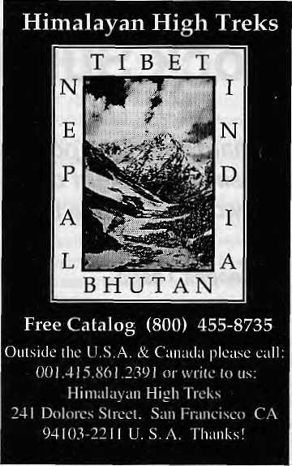
assuming such a conical tip exists under Everest or any other peak.
There are, of course, ways to find out the highest point of the rock lying under the snow, although the likelihood is that the Chinese did not try them on Everest. An expedition can be mounted with climbers equipped with shovels to clear the snow off the top and having accomplished this, the topmost rocky section of the mountain can beidentified.If shovels are too cumbersome, the climber-scientists could demarcate a 10 by 10 feet squareon the summit mound and poke (the aforementioned) rod all over to figure out the highest point. Another method would be to take a lateral sonogram of the mountain top.
The sheer impracticality of trying to decide on the true snow summit and rock summit, therefore, encourages us levelheaded landlubbers to search for the Middle Path, which shuns misplaced scientific positivism on the one hand and those who couldn't care less on the other.
An Everest Mean
Rather than allow the scientists the leeway to continuously come up with new heights
to confuse the world's public with, it is important once and for all to decree a mean for Everest and leave it at that, at least for a decade, after which we can revise the figure taking into account the rising height of the Himalaya due to plate tectonics.
This mean height must be calculated for the snow on Everest-top, and not the rock, for it is show that makes the summit of Everest. If God and Geology had wanted to measure the top accord i ng to the rock height, we would have been given a rock pinnacle where no snow accumulates. Instead, the Third Pole has been endowed with generous snow even though much of the mountain, especially the southern flanks, is mostly dark granite and sandstone.
The exactitude of the Bureau scientists
in coming up with the 8846.27 m height is,
therefore, to be appreciated but not believed.
Since their reading of the snow-laden summit
was 8848.82 m, this writer would suggest
that we round it off at 8849 meters for the
sake of the mass public. Let this figure be
reconfirmed by one more look at the
mountain, and then let it stand for at least a
decade before we decide to confuse the
public once more. t*

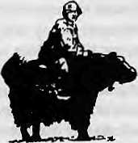
HIMALAYAN KINGDOM OF NEPAL, BHUTAN

Let TIBET TRVELS AND TOURS.The
leading tour operator
in Nepal unfold for you the inner secrets & mystries of these fascinating lands, people & culture - so different from anything you have ever imagined .
For details contact:
TIBET TRAVELS & TOURS (P) LTD.
P.O. Box 7246, Tridevi Marg, Kathmandu, Nepal Tel; 231130,228986, Tlx: 2672TIBTVL NP Fax: 977-1-228986/415126

40
January/February 1935 HIMAL

K
"citizenship made simple"
(Notes to my Brother from Fanueil Hall)
by Prem Krishna Gongaju

(Thinking of you while I sit on the balcony ofFaneuil Hall filled with the cacophony of tongues accented in so many rhythms glazed with the great expectation of... dreams.)
J.J. sits on a pew, hands folded across his chest, muffling perhaps the beat of Bharat.
And I—a Himali witness to our Hindustani Jason about to duly tradein his native shawl fora Yankee fleece—survey the faceof the people.
The official roll call begins: Tran Van Joo, Soo Young Long, Wilder Pinash, Danielle Doming, Patrick John Dorvan, Tony Fong Tan, Jean Goo Yu, Soo Fan Yon, Angela Marion Nickelson, Star Inez Dealer...
Five White ladies, holding five certificates each, march toward the people soon to be anointed politically, standing to receive the gift of prized laminated proof of their new beginning, proof of their new life in the New World...
.,. Janet Omera Blanco, Jesus Olfrain, Fong Fy Nyan, Galina Patricia Fauboski, YusefAuf, Salvatore Rousseau ...
A child in the front row seat, all dressed in a baby Navy outfit, waving a tiny Old Glory, smiled at me; I smiled back at him.
. ..An QuLee,JeselBassacio,Lasine Vladkor Placjda, Natalia Marauez Toralio, Moo W<? Yan, Wilson Matthew Lee, Lin Yang, Upendar Singh, WiLeeTan...
(Tan, Tan. The Reverend Tan! Of course, the name rings a bell. He is pastor of the Church of All Nations on Tremont Street, whose tower-like architecture belies her pastoral function as a sanctuary to sinners and seekersalike. A converted cleric from the Philippines, Wi Lee Tan is a nice man. However, we failed to see eye to Christological eye when he asked me my thoughts on the divinity of the Son of Man. I said that is nice. The Rev. wanted more. A Hindu who grew up kissing bhat and the Bhagbat Gita, I told him that we are the flickers of the Flame, we are the souls of the Oversold. He was not moved. Religious conversion tends to seduce human souls with the most addictive holier-than-thou drug. Hence my internship with the Morgan Memorial Goodwill Industries, Inc., Boston, where the diversity of becomingis celebrated in theunity of being.)
Roll call continued, naming names no longer exclusive to the denizens of the Caucasus. Those names, beguiling and beautiful, belonged to the four winds of Mother Earth.
Though herded into the Ellis Island of the Commonwealth of Massachusetts, they were far from being sheepish. Unlike Aesop's crow, they camedignifiedintheir native colours: golden, blackand
HIMAL January/February 1995
cinnamon brown. And a pinch of white. They were plumes from myriad branches bearing notes of their native songs to the land of the free and the home of the brave. All songs lead to the Boabab Tooted in the primal loam of our humanity.
America, you, too, sprang from the upturned tree of Africa; America, you, too, have sapblackas the primal night in your blood, of Africa. Wasn't your great-great-great-grand-mother's name Lucy?
America, you are a part of the tesserae of humanity. And see in its mosaic your own face. And the faces you disowned and continue to disown are those of your brothers and sisters, those of your kith and kin, culled from the geography of species.
Sing. America.
Sing in the bard ic baritone o f Grandpa Whitman, while waltzing to
different drummers.
To different dreams.
Sing. America.
Sing the lyric of Langston Hughes, while tolling out wonder and pain and terror in his Montage of a Dream Differed, And celebrate in duet with your Black Brother; /, too, sing America. And live out the true meaning of its creed.
Sing. America.
Sing the Negro spirituals, while dipping your hand—stained from picking strange fruits—in the Mississippi of repentance. Behold your deliverance when theGeorgia clay dons thecolour of ihefruits you picked.
The roll call tolled for my friend: John John Thatanumil.
My friend from the southern tip of India stood, smiled. No, he beamed at me, his upturned face receiving my congratulatory nod and smile from the balcony of Fanueil Hall. Our friendship was a splash of Asian pollen upon the blooming brown-eyed Susan of his cherubic face.
I was happy for J.J. Whatever stamp he may bear on his brown skin, his heart—dipped long ago in the Holy Gangajee—will forever beat, I hope, with the rhythm of the East. He may prove to be a reincarnation of Ga nga Din—who was a better ma n than his creator— in the West; and, subsequently, he may ennoble our humanity bifurcated by Briticism laced with the just so witticism of the peripatetic bard of the Raj.
Left behind in an infant ark of life, six-year-old J.J. waited for his parents to return waving olive branches from the New World.
41

Holding his younger sister by her hand, J.J. steadied the vessel of his fate unmoored, drifting in the seeming calmness of his father's kith and kin. Assailed with fears and doubts, he trembled. Yet he remained unruffled for his little sister's sake. After all, J.J. is of India, and India commands that a child become a veritable adult the next day. Fate allows so precious little silk to the Indian boys and girls that they are denied the luxury of the warmth of their respective cocoon of boyhood and girlhood. Fly or fall. Swim or sink. J.J. chose to swim. J.J. chose to fly as soon as his father returned with the transatlantic plane ticket to the United States of America to begin his occidental odyssey.
Who he was by the age of nine, J.J. transformed it, transmuted it, translated itintoa much larger script by accommodating America's mandates, mores, and madness;by accommodating his dreams as well as his parents' wishes, against the backdrop of Marthomic collective memory. After ha vinghad an ample taste of "Mississippi Masata", J.J. chose to adorn the historic Faneuil Hall, reasserting the family boabab by reclaiming the Thatamanil name circumcised by his forefathers under the spell of Marthomic conversion, once upon a messianic time, thousands of historic miles away.
What is true of J.J. must be truein certain individual ways of all the soon-to-be-ncrtwraltzerf U.S. citizens, the adoring subjects of the judgeofficiating the ceremony. The judge cheerfully acknowledged this one special function of his office that he enjoyed the most. And cheerfully did he greet and welcome the candidates and their families and friends. Attested by his tone and body language, the judge appeared sincere. As was his wont, the judge overdid the bit about "justice, freedom and the pursuit of happiness". (Holy Buddha!, now there's a phrase—the pursuit of happiness—which sums up the existential mirage in the materialistic Sahara of America.) Since he was addressing Uncle Sam's newest recruits, thequestion of his captive audience going bored onhim was moot. Besides, there was a sort of alchemic momentum in the air that something was going to happen which would change the participants'lives forever. Hence the presiding judge's mellifluous tone lent credence to his sapiency during the sharing of the choice morsels from the myth-kitty of America. Nevertheless, he overlooked one of the dire dictates of the law of migration: The predators follow you wherever you go. To and fro.
I remember. This country was indifferent
to the plight of those hungry, tired and persecuted,
permitted to sail on the SS. St. Louis by Paul Joseph Goebbels.
Denied moorings by Cuba, by America, the ship returned to the
Hadean waters. Save a handful, her human cargo
succumbed to the asvastt maw of the Aryan inferno.
I remember. This country was indifferent.
Commit it to memory!—a must
by the sentinelling Belle Bedloe as well as her callers:
their adoptive country denied entry to the 937 kith and kin of the
Son
of their Man, under the deal newly made with e pluribus unum.
It ought to be tattooed in the linings of naturalized lungs,
so it may not repeat on their watch.
Commit it to memory!—a must.
(Cap ling, compelling, en ticing, the songline of the hutna n dra ma unfolding before me tugged my heart kindred to the novitiates of novus ordo seclorum. I may not be oneoftliem. But I am with them.)
Come home
away from home from across the Atlantic,
fromacross the Pacific. Youare the salmon of variegated humanity.
Migration is a movable feast. For some
this country is the deep, for others the shore.
You come ashore heeding the wisdom
of the deep: you come ashore seeking
the altar in the stream. Come home away from home
so that the oceans be replenished, renewed,
with the cyclical certitude of creation.
You come to the deep singing the song
of the stream: you come to the deep carrying
the missal of the stream. Come home away from home
so that the oceans be sanctified, purified,
with the latitudinal liturgy of one great Nation.
I, too, am a salmon.
I dream of the pebbled streams fed by the melting
snows of Sagarmatha.
Finally, the anticipated moment arrived: the administering of the Oath of Allegiance.
Right hand raised. Uncle Sam's adopted children intoned after the judge:
I hereby declare, on oath,
I HEREBY DECLARE, ON OATH,
that I absolutely and entirely renounce and abjure
THAT I ABSOLUTELY AND ENTIRELY RENOUNCE AND ABJURE
(Though merely a witness to others' renunciation and abjuration, those two words stung my heart, stung my soul. Subsequently, I was somewhat hindered from beingcarried away by the momentous current of the ceremonious occasion for naturalization. Besides, I felt nothing unnatural about my self, about my soul.)
all allegiance and fidelity to any foreign prince, potentate, state or sovereignty,
ALL ALLEGIANCE AND FIDELITY TO ANY FOREIGN PRINCE, POTENTATE, STATE OR SOVEREIGNTY,
of whom or which I have heretofore been a subject or citizen; OF WHOM OR WHICH I HA VE HERETOFORE BEEN A S UBJECT OR CmZEN;
Votively, hundreds of yearning mouths gave voice to their newfound allegiance.
A greencarded man whose back is neither wet nor dry, I am more amused than amazed by anydomestic or foreign princeor potentate. Or president. Nehru's Letters from a Father to His Daughter had immunised me during my scholastic infancy at Shanti Nikunja Vidyalaya, against the affliction of falling prey to trumped-up powers of prince or potentateorpresidentinvoked under the aegis of the divine, demonic or democratic right. To allegiance and fidelity to state or sovereignty I, therefore, answer with the conviction of E.M. Forster: ...bull shall fight for one human being.
1 cannot go against the milk that sustained me during my infancy; I cannot go against the bosom that housed me against the cold.

42
January/February 19S5 HIMAL


f .
If I did lam nothing but a shell of a man devoid of the spirit of my native soil, devoid of the esprit of my Nepali soul.
If I did I am nothing but a gong hollowed out of my natal vitals.
I shall merely be an echo of
the birth of a nation, whose pang
wasn't my mother's pang. Nor her joy my mother's joy.
I can not go against the imprint of my mother's lactating breasts.
I seek the musk rising from the bosom of my native land.
'Tis not for me, I realise, to be bottle-fed on homogenised milk and be naturalized.
. . , and that I take this obligation freely without any mental reservation or purpose of evasion;
.. . AND THAT I TAKE THIS OBLIGATION FREELY WITHOUT ANY MENTAL RESERVATION OR PURPOSE OF EVASION;
The onlookers were treated to the plangent promissory accents rising from the hall below in their adoptive land of Canaan. The crescendo appeared nigh.
To my right and left were two ladies from Guatemala and Ireland, respectively. The cinnamon sun poured out of the plump, youthful skin of the Guatemalan lady. And the salt and the sea from the Irish face imprinted with crows's feet. Shy, sparse with Anglo tongue, the lady to my right buffered me with her disarming smile and dignified silence. The lady on my left—a retired nurse from the Brigham and Women's—happened to be an inveterate traveler. "O. I have been to your country," she said with a bit of nostalgic glee. I told her that the Ireland I knew came from the Yatesian metier and the Joycean might, as well as the swords of Sinn Fein. "O!" And her sea-green eyes looked away briefly. "Are you a citizen?" she asked, tilting her head toward me. "Neither am I," she said with a splash of green pride.
Gradually, my mind took measure of the issues of mentalreservatton. It is humanly inconceivable, I profess, not to entertain mental reservation, especially in natal matters concerning one's love and land, concerning one's blood and bond, (Is the United States of America, then, the benign equivalent of Albionised Australia, for mental Artful Dodgers!)
The monarch flies away enchanted by the migratory call of Mother
Nature,
but it retains the potency of the milkweed that sustained it during
its larval stage.
Nepal! My janmabhoomi.
She sits unfurled from East to West—Nature's silver shawl
hemmed by the henna of the south and the crimson of the north—
helping to separate a pair of giant flanks
often at odds with each other in the stride
for Asiatic peace and progress. I will
forever entertain one thousand thousand percent mental reservation
when the integrity and honor of my motherland is questioned.
I am amazed by the horde of people
from the four comers of the world down below
the balcony in Faneuil Hall, not entertaining even a sliver of mental reservation*. Even R-2 D-2 would stumble on such a monumental mission. Impossible!— my soul cried out.
However hallowed, Faneuil Hall is
a holding cell for chosen flock, where they are shorn
of their heritage and stamped with the Seal of
Good Housekeeping. Never having been asked once
what cultural richness and native gifts do these seafarers bear,
they are sent out on the conveyer belt of Capitalism
capable of dashing one thousand thousand labouring souls,
who are to this behemoth "as flies are to wanton boys..."
... so help me God. ... SO HELP ME GOD.
k
P.K. Gongaju is a student of literature and theology He fives in Boston and serves as a counselor at a home for persons with psychiatric disabilities. The historic Fanueii Hall in Boston's old quarter is used today for naturalisation ceremonies.

HIMAL Januaiy/Februaiy 1995
43

o
n
o
n

Environmentalism

Southern governments are not well-prepared for the international environmental negotiations that are taking place, and the nongovernmental organisations have not been of much help either.
by Jayanta Bandyopadhyay
T
he volume of environmental literature coming out these days is quite impressive. In bookstores all over, environmental publications—the mild, the strongand the provocative—from the countries of both North and South vie for the readers' attention. Sustainable development quotes from Mahatma Gandhi to Maurice Strong, and from Chief Seattle to Gro Harlem Brundtland, pop out of every page. There seem reason enough to believe that the problems of the environment worldwide are being tackled adequately and to be optimistic that we are about make fundamental changes in our unsustainable patterns of natural resource consumption.
Outside the bookstores, however, the hope and confidence evaporates. Much of today's environmental writing remains confined toabstract ideas and remote from real-life situations. The books, articles and newsletters are mostly part of reactive protests against problems, and carry little proactive prescriptions. The call for 'alternative development', so strong in the aftermath of the Stockholm Conference in 1972, is today but a whimper. The enthusiasm rekindled in Rio de Janeiro in June 1992 is also being wasted.
Yet, in no other period of human history has the future of the globe and
all its living beings been so much in need of alternative lifestyles based on our environmental knowledge and wisdom. Action taken or postponed today will cast a long shadow into the next century. One may think that these changes are relatively easy to identify and prescribe, but that does not seem to be the case. Transformation is required at different levels, from changing of personal habits to changing the 'global habits'.
Data? What Data?
In a world which is becoming economically integrated and in which global negotiations have already become powerful instruments of decision-making, effective access to information is essential in order to support respective negotiating positions. Indeed, how doyou bargain without information on what you want and knowledge of how to get it?
While a few countries of the North have access to this information base, the countries of the South are by and large ill-equipped for discussion. Neither governments nor NGOs have paid heed to the need for information and databases to support the Southern viewpoints. As a result, the job of defending southern interests tends to be taken up by interested Northern groups, which is not the same, and surely risky.
The scientific gap is serious. And it extends to many country delegations at the important decision-making inter-governmental forums in New York, Geneva and elsewhere where the environmental policies and programmes of the next century are being charted.
Representatives, particularly from small Southern countries, lack vital information on the scientific and policy dimensions. Un familiarity with the global and local issues extends
across the board, from the law of the sea,to intellectual property rights, and biodiversity. Many do not even have basic data, say, on global climate change, or in-country genetic resources of flora, fauna or microorganisms. Without an information base of their own, the delegates of many Southern countries are reduced to looking over the shoulders of other country representatives, whose interests need hardly coincide.
The South Asian sub-continent is a good example of a region which, due to lack of expertise as well as the constant need to respond to natural disasters, finds it impossible to focus on the global environmental issues that will have a direct bearing on the lives of its population in the next century. What little expertise does exist, and the lobbying clout that the region would enjoy if it were united, is frittered away due to geo-political suspicions and rivalries.
In a period of accelerating global and regional integration. South Asian governments have managed to keep the walls of mistrust and hostility intact. Himalayan rivers, one of the richest water resources of the world, are made the cause of political disunity while other regions which have seen majorwaterconflicts,like Europe and West Asia, are moving fast towards economic integration. Under existing circumstances. South Asian governments can hardly be expected to collaborate to get the best out of global bargaining o n the environment. And if the situation is not corrected South Asia will become less and less capable of bargaining globally. The result is marginalisation in the negotiations of today and in the world of tomorrow.
South Asia's challenges are also those of the southern hemisphere asa whole. Referring to the signing of the

Januaty/Febwaty 19% HIMAL

Uruguay Round of the GATT in Marrakesh last year, Julius Nyerere, former President of Tanzania and presently Chairman of the South Centre, conceded that many of the signatory countries of the South were not even aware of the implications of GATT for their economies.
Many of the environmental activist groups which have taken it upon themselves to speak up for the South have not prepared themselves for the arena of international negotiation and decision-making either. One basic weakness is that advocacy groups have progressively released themselves from the need to understand the science behind environmental problems. Many fundamentalist groups of the North prefer to approach the media with sensation rather than sense. Their Southern NGO counterparts, propped up with liberal international funding, are following suit. The voice of the independent Southern NGO can today barely be heard in international platforms.
Culture of Consumption
On the whole, the fewNGOs which do take part in global meetings as representatives of the South present a sorry spectacle. There is little interest inbuiiding competence on specialised issues. A few 'permanent representatives' have emerged among these NGOs, who aTe seen in most global platforms, be it in the population conference in Cairo, GATT and the environment in Geneva, women and development in Beijing, biodiversity in Bahamas, etc. etc.
These groups are capable of producing reams of generalised polemic, but a topic-by-topic and poi nt-against-point argumentation on behalf of the South against a well-prepared North is beyond them.
The problem is not, however, merely the inability of governments and groups to accessandusedatabase and information. The central issue is of altering the culture of the consumption society in both hemispheres. Can the governments
of the South, unable to change the wasteful consumption patterns of their own elites, put any pressure on the North to do the same?
The communication revolution has suddenly exposed the low consumption societies of the world to the images, real or otherwise, of the high consumption Northern countries. Commercials and advertisements do not encourage austere lifestyles and reduced consumption. While Northern governments will find it very difficult to move towards policy changes and structural transformations in their own societies, governments in the South seem powerless against the social forces that are pushing their countries relentlessly towards the mechanical duplication of Northern lifestyles and consumption patterns.
The core of the global challenge lies in changing the existing paradigmatic lifestyles and searching for alternatives. In this search, a complex web of relationships have to be addressed, among them dichotomous issues such as national sovereignty and global responsibilities, and liability for damage to the global commons, the rights over intellectual properties and the question of biosafety, the transfer of technologies, and so on.
Without waiting for their governments to take the lead, environmental movements of the South must wake up and begin to play a key and independent role in the search for the alternative para-digm. In a future that will increasingly be influenced by global conventions and agreements, there is an urgent need for proactive environtnentalism all over the South.
Environmentalism in a country like India hasbeen very successful as a reactive mechanism, as much as it has been conspicuous by its inability to be proactive. This weakness has been most vividly exposed in the post-GATT anti-GATT debate in India. Notwithstanding some exceptional proactive steps in rural India, like the formation oipani-panchayats in Maharashtra or forest protection commi-
ttees all over, the more visible and more propagandised environmental mobilisations have been reactive.
Even the movement that arose from the industrial disaster in Bhopal has remained reactive for over a decade. The focus has been almost exclusively on the question of compensation, and there has been no proactive movement demanding an open assessment of all industrial technologies and free and prior availability of information on the hazardous technologies.
The consistently reactive nature of Indian envi ronmental ism indicates the hold of the middle class intellectuals who otherwise live a comfortable urban life but rush to take a stand against plans and proposals that threaten other peoples' lives. This characteristic has dominated the intellectual movement in India on'alternative development' over decades. The dynamism of the integrated global economy and its enormous reach today have made the erstwhile mode of 'alternative development' concepts outdated. Time has come for less abstract environmental movements to move into the future as positive actors and not consistent reactors.
South Asian groups who would represent the population from the Himalaya to the southern-most point of Sri Lanka and from Baluchistan to Tripura must think for themselves andnotbeguidedby reactive protests, on subject as varied as tourism and modern agriculture, GATT and climate change. This, of course, applies not only to South Asia, but to all the South.
J. Bandyopadhyay is an ecologist with special interest In natural resource conllicts and sustainable mountain transformations.
Announcement of Subscription Agent
Himai announces the appointment erf - Mahashakti and Tirupatj Enterprises as its subscription agent for the Kingdom of Nepal, individuals/institutions wishing jb'sisbscribe may henceforth write toj call or fax their offices at: p o. Box i6fl

HIMAL Januaiy/Febivaiy 1995
45

■ .■■■.■■.:

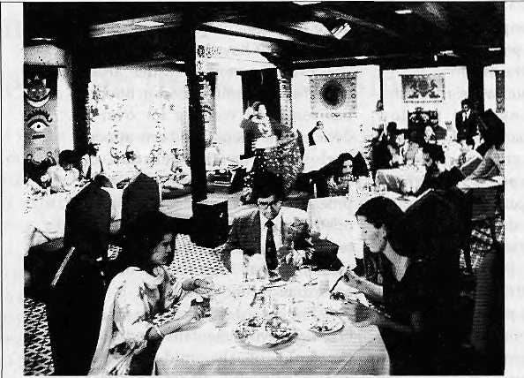
FALL UNDER THE SPELL OF

MYSTICAL

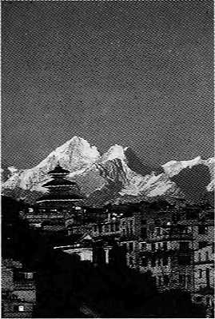
NEPAL
Kathmandu. The very name evokes exotic temples, incense aromas and the towering Himalayas. And to add to its lure, there is now the Soaltee Holiday Inn Crowne Plaza Kathmandu. Built in traditional Nepalese style, this magnificent hotel will welcome you with impeccahle service and the city's finest facilities — four speciality restaurants, a Beauty Salon and Health Club, a Tennis Court and outdoor Swimming Pool...even an in-house Casino.
SOALTEE




CROWNE PLAZA
Kathmandu
The Business Class Hotel^
FOK KKSTCRV.-
'ATlOiNS CALL atJALTtt HOLIDAY INN CROWN£ PLAiA kATHMANDU_{H} TEL 977-1-273 55*, FAX: 977-1-272 201/203, OUR BOMBAY RESERVATION OFFICE ON &22 22 1378/22 1331, NEW DELHI RESERVATION OFFICE ON 01 I 3755S&I /3755502, YOUR TRAVEL AClfNT OR ANY HOLIDAY INN HOTEL

Wanted: Staff Writer
Himal magazine is looking for someone who can write, edit and report in flawless English. S/he will be based in Kathmandu butmust like oceassionaily rugged travel. We prefer applicants to be from South Asia or Tibet. Apply with biodata and writing samples by 20 May 1995. Mark 'Staff Writer' on envelope.
Essays on North-East India Milton. S, Sangnta, Editor Indus Publishing Company, Delhi, 1994 ISBN 81 7387 015 2 IRs400
Published to commemorate the life and works of the late V. Venkata Rao (a Gujarati scholar who researched identity, nationalism and sub-nationalism in India's northeast), this volume contains 16 essays on planning, development, historical economy, tribal life, frontier policy, tradition, leadership, insurgency, etc. It also contains B. Pakem's essay on application of tribal research studies in planning, development and administration; R. Gopalakrishnan on political regionalism and development; T.B Bhattacharjee on pre-colonial political structure of Barak Valley; and T.B Mukheriee on the early history of Koches of North Bengal. The volume also carries Sajal Nag's "Withdrawal Syndrome: Secessionist!! in Modem North-East India". People who demand secession from the Indian Union, writes Nag, have specific grievances against it. That their grievances are not being addressed has caused them to reject the political community of which they form such a marginal part and fueled their desire to withdraw from it and form new alliances among themselves. Secessionist)!, according to Nag, is only a revolt against such marginalisation.
Kirtipun An Urban Community in Nepal Mehrdad Shokoohy and Natalie H. Shokooity, editors Araxus Books, London, 1994 ISBN 1 870606 02 7 £43
This book is the result of a University of Greenwich project to study the historic heritage and present condition of the Kathmandu Valley town of Kirtipur, with a view to its conservation and development. A team of experts, many from Nepa! and some from Kirtipur, present detailed studies covering a wide range of subjects including the vernacular and monumental architecture, art and antiquities, history and epigraphy, social organisation and community, and recent changes in the urban fabric.
A ma in America
A Pilgrimage of the Heart
by Broughton Coburn
Anchor/World view Books
Pub date: May 1995
ISBN 0365 47417 2
U$ 22.95
Coburn, when a Peace Corps volunteer in Central
Nepal, lived in Vishnu Maya Gurung's hay loft
aboveher wa ter buffalo shed. Over time, friendship
developed between the two which Coburn
celebrates in his Nepali Ama: Life Lessons of a HtTtutiayan Woman, a photographic book containing Coburn's accounts of living, working and travelling with Vishnu Maya. Fifteen years later, Coburn returned to Vishnu Maya's villa ge wi th a n in vi ta tion for her to join him and his future wife, Didi, on a trip through the United States. What results from the 25 state, coast-to-coast adventure is Ama in America: A Pilgrimage of the Heart. "An offbeat American travelogue", according to a promotional flier the book is also "an exploration of beliefs and values and a rediscovery of the spiritual that lies beneath the surfaceof America... A singular account of the meeting of the two widely divergent cultures."
Indian Forestry through the Ages
by S.S. Negi
Indus Publishing Company, New Delhi, 1994 ISBN 81 7387 020 9 IRs300
Written by an Indian Forest Service Officer from Himachal, the book records the history of forest conserva tion in India and follows the de velopinen t of scientific forestry. Forest conservation started in India with Emperor Ashoka, writes Negi, when certain trees were declared protected and their felling was forbidden; the appointment of Dietrich Brandis as the Inspector General of Forests in 1964 heralded the era of scientific forestry in India. The book discusses the history of forestry in states and the union territories; lists the people associated with the history of Indian forestry and their contributions; history of forest policy, legislation, management; and fores try research, education and training. Classification of forests according to various scholars over the last century is also included. The annexure lists the forest cover situation in the different states (1988 and 1989).
Lahouk The Mystery Land in the Himalayas
by Ram Nath Sahini Indus Publishing Company, 1994 ISBN 81 9387 017 9 IRs395
Saliini explores "the beauty and the development potential" in 300 pages of a book that is divided into four sections—the mountains and gladers of Lahoul; history; social customs, occupation, festivals and languages; and religious beliefs, temples, monasteries and mythological stores. With two annexes—on folksongs of Lahoul and family trees of local Ranas and Thakurs—the book is a useful guide for people looking for more than just touristic treatment of the valley. Lahoul has a great potential for build ing itself and becoming a model, states the epilogue. "The sincerity, hard work and intelligence of the people who live here can lead Lahoul towards this direction."
North-Eastern Frontier of India Structural Imperatives and Aspects of Change by AC. Sin to
Indus Publishing Company, Delhi, 1994 ISBN 61 7367 009 8 IRs300
North-EasternFrontier of India looks at the structural
imperatives and the components of social change
in the Indian North east. The volume is divided in to
two parts: the first provides geograplucal, historical,
ethnic and religious ba ckground of the region, and
the second records the agrarian, urban and
environmental transformations taking place. "It is
high time that we realize that the Indian union does
notbelong only and even mainly to the mains (ream
and the frontiers are to be ruled and subjugated
and treated as supplicant," writes Sinha. "It must
also be borne in mind that frontiers do not need
pa tern alistic proppin gs, but a recognition that they
are trusted to take significant decisions affecting
national life and that they are capable to continue
in the national common-weal th as equal and proud
partners." .
Consolidated Index to The Himalayan journal
(Voll to 50,1929-1994)
Dhiren Toolsidas, compiler
The Himalayan Club, Bombay, 1994
This index to the Himalayan Journal makes it
possible for mountaineers, journalists and
researchers to access to people, events, mountains
and information appearing in Volume 1 to Volume
50 of the hallowed mountaineering publication of
the Himalayan Club. The index is user-friendly,
with articles, expeditions and notes listed under
author, peak and region.
Nepali A Guide to the Art and Architecture of the Kathmandu Valley
Michael Hutt with David Gellner, Axel Michaels, Greta Ratia and Govinda Tandan Kiscadale Publications, Oxford, 1994 ISBN 01865 67575 £ 25
This guide begins with an overview of history of Nepal, followed by an introduction to religion and architecture. The rest of the book consists of descriptions of specific sites within the Valley. There is a chronology and a full glossary of Nepali, Newari and Sanskrit terms. Written by academics, the book is intended for a general readership, and seeks to give "more informa tion than is imparted by the average tourist guidebook."
Younghusband: The Last Great Imperial Adventurer
by Patrick French
HarperCollins, United Kingdom, 1394
£20
Sir Francis Younghusband spent his early years as
a leading player in thebattleof wits for control over
the unknown territory of High Asia. Yet, he was
also a soldier, explorer and philosopher, often
compared to Marco Polo and Lawrence of Arabia.
In 1903, he single-handedly turned a small
diploma tic mission to Tibet into a full-scale military
invasion; found a new route to India from China;

HIMAL January/Febniary 1935
47

andin the post-First World War era, led the way in religious and sexual free-thinking. He was also Tfie Times' correspondent during the siege of Chitral and held the world record for 300-yard dash. French travelled in the Gobi, Sikkim and Tibet to research Younghusband. He weaves his own adventures with Younghusband's exploits, and using his subject's letters and papers—many previously unseen by historians—pays tribute to this remarkable personality. In a blend of historical biography and travel writing, the book celebrates the last of the great imperialists. The Manchester Guardian critic says this is an "excellent and entertaining biography".
Cairn
No.1 October 1994 Amnye Machen Institute Mdeod C Sanj
Cairn is a newsletter of the Amnye Machen Institute, the independent research centre established by Tibetans in exile in Dharamsala. This first issue contains information on lectures and seminars on Tibet, plans to open a Centre for Occupied Tibet Studies, and information of books in Tibetan just released (including a translation of Animal Farm). Contact: Amnye Machen Institute, Mdeod Ganj 176 219, Dharamsala, Himachal Pradesh. Email: ami@cta ,und. ernet .in.

Mountain Research and Development
Vol 14 no 4, November 1994 Jack and Pauline lves, Editors University of California Press This issue of MRD takes a look at natural hazards and catastrophic geomorphic events in mountain terrain. While most of the papers concern the Alps, there are also contributions on the Andes, the Himalaya, the Hengduan mountains and New Zealand. The editors have sought to "present our collective experience relating to a series of mountain events that occurred during the past 10,000 years or so, and that are occurring today." An article on the growth of a lake on the Imja Glacier (below Ama Dablam in Khumbu) states that there is rapid expansion of the lake toward the west. "As this proceeds, the possibility for catastrophic outburst will
become greater, even if the lake is lowered... The potential for a major outburst is much higher than previously anticipated." (Subscription: UJ38 annual. University of California Press, 2120 Berkeley Way, Berkeley, CA 94720 USA.)
Indigenous People; Mobilization and Change
by Ganesh M. Gurung Hisi Press, Katmandu, 1994, NRsl60
Sociologist Gurung presents a collection of seven papers on the various ethnic groups of Nepal, providing descriptions of the customs and traditions in the light of social change, mobility and development. The author also discusses the questions of ethnic identity, politics and inter-ethnic relationships. Among the papers presented are ones on: the adaptation of poly androus practice to local conditions; the process of identification andsanskritisation among the Duras of West Nepal; the formation of 'mothers groups' among the Gurung in the Annapurna Conservation Area Project region; economic modernisation among the Chepang; socio-economic networks a mong the Rana Tharu; and the phenomenal rise of ethnic forums and parties since 1990. Critic Saubhagya Shah says this book is "a useful handbook for students of Nepali society and culture".
Bhutan: Perspectives on Conflict and Dissent
Michael Hutt, Editor Kiscadalc Asia Research Series Oxford, 1994 ISBN 1 870838 02 5 £ 17.50
Since 1990, the lastShangri-La'kingdom of Bhutan has been undergoing political crisis. Camps in neighbouring Nepal now accommoda te thousands of refugees and a dissident movement in exile is calling for radical changes in the political system. There is increasing insecurity in the country's southern districts. In order to discuss these and other questions, a conference on contemporary Bhutan was held at the School of Oriental and African Studies (SOAS) in London in March 1993. Theauthorsofthetenessays presented in this book (239 pages) include academics, journalists and a representative of the Bhutanese government. There are also summaries of reports produced by the Royal Government, human rights groups, and refugee organisations.
Bhutan: Aspects of Culture and Development
Michael Aris, Michael Hutt, editors Kiscadale Asia Research Series Oxford, 1994 ISBN 187083817 3 £ 17.50,
Since Bhutan turned away from isolation in the 1960s, theWngdom has consistently pursued "the worthy but difficult goal of harmonizing a programme of modern development within the country's traditional Buddhist culture". This 239-page volume, which considers a selection of issues relevant to this policy, is the second to result from the SOAS conference on Bhu tan, menti oned above. Eight specialists focus in on the decentralisation of
development, the growth of diplomacy, language policy, context of religion, and the material culture embodied in architecture and textiles.
Himalaya Today
(An Indian Quarterly) Vol5no3,Oct-Decl994 Mahendra P. Lama, Editor New Delhi, IRs 15
The latest issue of Himalaya Today features the Uttarakhand movement for statehood in its cover, with articles by Navin Chandra Joshi and Annapurna NautiyaL Also featured are articles on "the ethnic cauldron in Bhutan" by Mat thew Joseph C; Mizoram in geopolitical perspective by S.N.Singh; tourism in Himachal Pradesh by Manoj Jreat; the Gaddi heritage byS.N.Sachar; and on the Himalayanist Rahul Sankrityayan by Rattan Lat Bisotra. The issue also carries articles on the vpgeta tionalwealthofUttarakhand,agriculturein Ladakh, Kedarnath shrine, and themonal pheasant. (Subscriptions: IRs 55 annual. 145 South Avenue, New Delhi 110 011.)
REFLECTIONS
Vol No. 1 and 2
Raina Nakari, Knnchan Vertna Lama, editors Sodety for Partners in Development and Utthan, publishers, Kathmandu This journal has been brought out to dear up "confusion and misunderstanding of the concept of gender and development in the context of Nepal". The latest issue contains articles on the girl child in South Asia by Kamla Bhasin, women's perspective on a sustainable future by Arja Vainio-Mattila, the statusofwomenintheHindureligionbySangeeta R. Thapa, women's life in Nepal by T. Nakari and "Reminiscences of a Rural Nepalese Woman" by K.V.Lama. (PO Box 2594, Kathmandu)
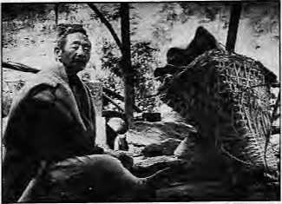
Hard Livelihood
Conference on ihe Himalayan Porter
3,4 August 1995, Kathmandu
Hirnal is organising a two-day meeting to discuss portering in the mountains. Topics will include: portering life and changing economy; impact of roads and air cargo; health, nutrition, physiology; load, muscle and bone; equity and collective bargaining; future of portering; etc. Contact: Kanak Mani Dixit P.O. Box 42, Lalitpur Phone: 977 1 523845, Fax: 521013 e mai I: h i m al @mo snepal. e met. in

48
January/February 1995 HIMAL

M

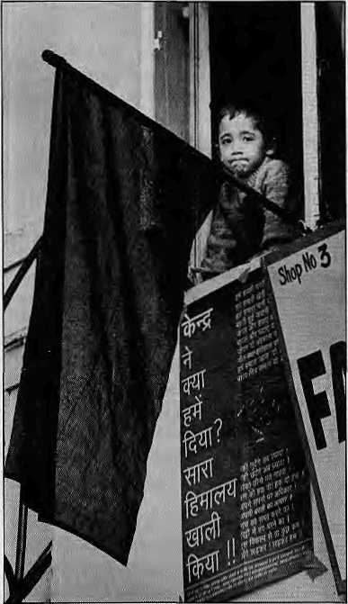
No Sops for Uttarakhand
Manisha Aryal's "Angry Hills: An Uttarakhand State of Mind" (Nov/Dec 1994) should be accepted in Dev Bhoomi as a good chronology of our loss of innocence, laced as it has been with the deadly ingredients of government intransigence and ambivalence, peddled propaganda, rumourmongering, damaging exaggerations, opportunistic leaders, irresponsible press, puffed-up egos, haywire priorities, and ill-considered demands. The good and gently brave people of these hills have been deflowered.
In many ways, we only have ourselves to blame for being so poorly informed about the world around us today, and for not knowing how to participate in it. Of course, we hope that history-will not judge us too harshly, but will consider that by our very nature, we mountain people are hermits—aloof as are our peaks from the rush and tumble of life down there! One cannot be blamed for believing that, somehow, we are untouched by travails of the cut and thrust of today's society.
All of this now seems to have changed, and the silver lining to the apparently dark cloud of the past few tumultuous months in Dev Bhoomi is a growing pragmatism—god willing!
Instead of the
unplanned, angry and single-point agenda of a demand for statehood, which saw us led like lambs to slaughter, people everywhere in Dev Bhoomi have begun to sit down to explore what we 'know¹ we want—economically and culturally. In the larger scheme of affairs, the Dev Bhoomi may be geographically too small to counter overriding interests and concerns of the Uttar Pradesh State and Centre, but the emotional and spiritual support it has throughout the Subcontinent can give it a clout that could surprise many a Goliath!
A dominant and spontaneous theme of the agitation has been the total rejection of current political leadership and a disenchantment, expressed
vociferously by the young, of the goals and values of the sort of progress they stand for.
In the process of getting to know what kind of Dev Bhoomi we want (and currently there is a great deal of introspection going on), it is just possible that this 'Abode of the Gods' may lead the way—inspiring the rest of the apathetic national policy to think and act for themselves in partnership with the leaders of the country. The UP hills, historically famous for not taking things lying down, could usher in an era of genuine participation all over the country.
It isn't time to be fooled anymore by the politics of subsidies. It is time to move away from the economics of welfare towards the economics of empowerment. The UP hills will not be interested in accepting truncated sops to 'bachao' its 'izzat'. They will speak and negotiate through a group of representatives (recently agreed upon at a meeting in Kausani, Almora) with earthy wisdom which appreciates the constraints of its tormentors. We will demonstrate that the andolan in this pristine, last-bastion of peace and good neighbourliness is not just another fanatic effort of a region trying to splinter the nation asunder, but is rather a movement of sincere nationalism designed to achieve the goals of equity and justice in a world that has for too long forgotten what such a concept means anymore.
Cyril R. Raphael
Hill Employment Labour
Production Academy
Anjanisain, Tehri Garhwal
Stagnant Grief
Your timely issue on intellectuals ("The Intelligentsia Has No Clothes", Sep/Oct 1994) brings to mind many thoughts. In a world in which modernisation has been equated with Westernisation, our Nepali intellectuals, as well as many of their counterparts in other Third World' countries, have rushed to embrace ideas of rationalisation and the universalisation of social life. Whilst primordial ties have been portrayed as merely prolonging the agony of traditional societies, paradoxically, Nepal's dependence on tourism has ensured the com modification of a narrowly conceived and a historical *Nepali' culture that appears embedded in the past.
Moreover, it has been intellectuals, quick to become part of the tourism and development bureaucracy, that have served to categorise or more glaringly 'help', 'feed', or 'guide' the

HIMAL January/February 1995
49

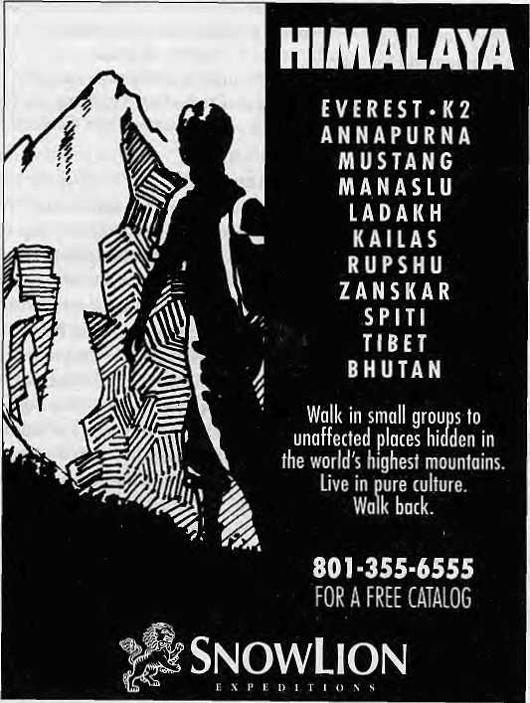
50
'Other'—the poor natives with whom they have imagined themselves to have so little in common. In the same breath, they have lamented the onslaught of Star TV, capitalism and globalisation in general. To lament over the loss of 'our culture' in this manner is to grieve over a stagnant concept of culture, which is ever-changing. Culture has never been and can never be frozen in a timeless manner.
The challenge for intellectuals should thus be not the internalisation of Western goods and ideas, but a reconstituting of them in a selective manner. Ideals' of secularisation and all of its modernisation baggage must be balanced within the context of our history of tolerance and pluralism. Indeed, much can be learnt from the experience, both successes and failures, of our South Asian neighbours. To be a copy-cat appears to have worked remarkably well in economic terms for the NICs. Culturally, this has been more problematic.
Whilst globalisation cannot be reversed or halted, our interpretation of it need not be linear, or 'Western'. The role of intellectuals must be, as it has always been, to question, interpret and reconstitute that which is old with that which is new, without losing sight of what we collectively imagine ourselves to be.
Seira Tamang Washington DC
Refugee's Lament
The rhythmic singing of our sweet national anthem sung by the students during assembly time brings back peace to their fragile and rather wounded hearts. Thinking of Bhutan early morning makes us Bhutanese even outside Bhutan.
The serene atmosphere and the sky painted in peaceful colours within the camp territory makes us realise the we come from a place where milk used to trickle down rather than tears. Our heart brims with contentment, silently wishing to go back home which gives a hidden gesture and emphatically beckons us. Heaven help us to keep the flame of progress burning.
Lila Ballab Dahal
Beldangi Camp
Damak, Jhapa
Brain Drain to Brain Gain
Even by the consistently high standard of journalism for which Himal has now come to be known to mountain-lovers worldwide, your article "Dukha during the World War" by Pratyoush Onta (Nov/Dec 1994) stood out. As a longtime trekker in Nepal with a special interest in the Gurkhas and Gorkhas, and as a longtime reader of Himal, I found the article to be an eye-opener.
The research is ground-breaking, the de-mystification and de-mythification of Nepalese mercenarism is devastating and complete. Gurkha heroism was not glory, it was gory. But it was sanitised and ruthlessly used, like Sagarmatha, Tenzing Sherpa, danfe, monal and gums as a unifying symbol for your nascent nation. It was used by your slavish Anglophile feudocrats as a sop for sovereignty.
At best, Nepal's soldiers fighting for foreign governments can be seen as overseas contract workers who bring in revenue to the national exchequer. They are in the same category as Nepalese sex slaves in Bombay's Falkland Road or their brothers in the sweatshops of South Korea or the garages of the Gulf.
At worst, the Myth of the Brave Gurkha, glorified in countless songs and speeches can lead to a dangerous romanticism of conflict—especially when ascribed to a particular ethnic group or nation. A nation whose collective conscience is not pricked by the misery of its men used as cannon fodder or its women used as rags is a nation numbed by fatalism.
I found Onta's article especially poignant since I had just finished reading The Sorrow of War, the brilliant anti-war book by Vietnamese war veteran and author, Bao Ninh. In his own way, Bao breaks
January/February 1995 HIMAL


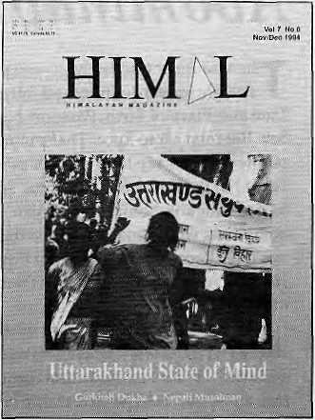
his country's taboo on the war by puncturing the myth of the great Vietnamese war machine that used bicycles to defeat B-52s. The semi-autobiographical book shows that the Vietnamese solider was as frightened, homesick and demoralised as the American enemy — or for that matter the Gurkha soldiers in Flanders Field whose censored letters Onta has brought to our attention.
As 1997 draws near and the brave lahureys head home from the further reaches of our erstwhile empire, it may be a good time to see how Nepal can use this 'brain gain'.
Ronald Burroughs
Edinburv. ScoAmd
Disinformation
An item in the Himalaya Mediafile column of Himal's Sep/Oct 1994 issue refers to an article in the Calcutta Telegraph alleging that Dr. Michael van Walt and myself have helped Mr. T. Muivah of the NSCN to establish links with the United National Conference on Indigenous People, Just for the record, I would like to categorically state that as far as lam concerned I have never even met Mr. Muivah nor any of his associates at any time.
The Telegraph has been misinformed and I would not be surprised that this act of disinformation was done on purpose by certain vested interests. I read Himal faithfully and find it very informative. I do hope that you will verify stories you carry in the future, in order to maintain the integrity of your journal.
Lodi G. Gyari
Special Envoy of
His Holiness the Dalai Lama
Washington DC
fielders are tnytteid to comment, ■ criticise or a^Cto iRtenaBon afid' ^pinions appearing in Hi ma I. Letts r s should be'briefj: toffte point and ma/
be edited. Letters which are unsigned : and/or without addresses will not be
entertained, include daytime telephone number, if possible.
email;hirnal@mqsnepaJ.8rnet in. .= :■:


Get Connected to the
Information Highway !

Now you have a local access into the Internet in Kathmandu. *
Call Mr. Kiran Gautam or Mr. Deependra Basnyat at Mercantile Office Systems (9:3(M7:00HRS); Tel: 220773
Fax: 225407 ore-mail: Postmaster®MosNepaJ.ernet.in * Currently E-Mail Services available.
H1MAL January/February 1995 51

Abominably Yours,



T
he visa form was fairly straightforward. I filled out Name, Date and Place of Birth, Passport Number, Sex. But then came Race. That put me (as perplexed yaks say here in the Upper Barun) in the homs of a dilemma. Some fellow Bangkok-bound Himalayan hominoids were equally flummoxed: what kkjs their Race? One of them put down: Human. Another chuckled as he wrote: Marathon.
Not since African migrant workers chained to the lower decks of transatlantic sailboats filled disembarkation forms have race and creed been such a strong criteria to choose those who can or cannot cross national frontiers.
Name:
Obinna Okonkwo
Place of Birth: Ferkessedougou Destination Port: Baton Rouge, Louisiana Type of Visa:
Tourist
Transit
Business
Slave V
Profession: Cotton picker
Race: Hunh?
The Buddha said existence is dukkha. And among the various dukkha memories that tried to distract Keanu Reeves as he sat crosslegged under the bo tree was the excruciating torture of getting a visa. As the
cosmic special effects died down, it dawned on Reeves that if young Siddhartha was alive today and if he had a Nepali passport, Buddhism perhaps would never have reached Japan and Thailand. For a start, what Race would he say he was in the visa form?
And when he applies for his US visa this fall before his New York trip to attend the regular session of the General Assembly, what is Prime Minister Man Mohan Adhikari going to write down where it says: Are you or have you ever been a member of a Communist Party? For that matter, how is Chakra Bastola going to answer: Have you ever hijacked a plane in your life? (Tick one.)
Q Regularly
- Ocassionally
- Once
- Never
Not being a frequent flier myself, I was caught in the dilemma of the earlier-referred-to horns as I mulled over my Race. For a primate whose species itself is a taxonomical question mark, this posed a conundrum. And yet, I did not want to be untruthful on a document that for all intents and purposes held the keys to the Kingdom of Ayutthaya. So, under Race, I wrote: Against Time.
The symbolic
ambivalence on the survival of the species seems to have been lost on the visa officer who promptly issued a visa.
So, here I am now on a window seat contemplating the dog on the tarmac wolfing down Business Class lunch discards. Miss Prangtip closed the hatch, welcomed us all to her "Loyal All-Kid Service" and gave purple
all-kids to us
women on board and anyone else who wore an ear-ring—regardless, I am glad to add, of race or ethnicity.
"The pleasure in this cabin is automatically controlled," Prangtip whispered in her delightful Indochinese lilt. 'If the pleasure should fall, pull the oxygen mask to your face, clobber your nose and mouth and bleed normally."
Now, I know exactly what you are thinking: you are thinking that our feminine, feminist columnist has finally succumbed to the temptations of Asia's foremost fleshpot and is flying Thigh to get there. Was the promise of carnal tourism too much for her to resist?
Rightaway let me put all rumours to rest, I am on a fact-finding mission to discover for myself how a country where golf courses regularly steal water from drinking water reservoirs has become Nepal's latest donor—funding a water supply project for Kathmandu.
By this time, the pilot was leaning on his right aileron trim to balance the bank caused by passengers migrating en masse to the left-hand side of the plane to see Mt Everest. I had never seen my home from this perspective, tracing the Arun Valley to the confluence of the Barun, up Tilman La and past Chamlang and tiny Tutse to the looming pink granite of Makalu.
Nature's awesome architecture made these frozen water towers a natural storage system for water that negate the need for reservoirs and expensive dams. That little speck on the side of Baruntse — no it couldn't be — but yes! just below the seracs of the western saddle. My cave. Hello, ama!

We flew over Bangladesh, then SLORC-desh. They brought around the arrival forms as Prangtip came on once more to tell us to be careful when opening the "oval-head rockers". Thigh will mail this column for me while I hightail it into the City of Flesh, from which I may or may not emerge, given my race and sex.

52
January/Febwary 1995 HIMAL

 | Hi
 | SHANGHAI
 |  | KATHMANDlf- | W:: . :-^:;::'" ■■:■■ .
 | LONDON | ".■ | DELHI
 | PARIS |  | CALCUTTA
 | FRANKFURT DUBAI | - | PATNA BANGKOK :  I .. ,. ■■:'■■■  SINGAPORE
 | BOMBAY |  | HONG KONG J
 |  | . ..'
HPnH
K,[:.l
BHsflBHtlinSHBinllllWHKBnMiQMBHVni
 | inn 4/nra«i • *ti |  | i.. 3.. I..TTjl^% ¥ i t Tn'ml
NOW DIREQ TO SHANGHAI & OSAKA
Royal Nepal-Nepal's own international Airlines operates regular flights to Kathmandu from 13 cities. You can warm to the gentleness of Nepali culture, tradition and the authentic spirit of
Nepali hospitality aboard.
Royal Nepal Airlines
RNAC, Building, P.O. Box: 401, Kathmandu, Nepal Tel.: 220757, Fax: 977-1-225348

Hongkong . 37S91S1
Singapore
3395535
Osaka 2292545
Bangkok 2333921-4
Kathmandu 220757
Shanghai 2558899

The New Sleeping Bag Collection
For our free catalogue call 707 544-4590

