Nrs 40 DM 9
IRs 25 £ 4
Nu 30 US S
US J4 75 Canada S5.75
LO
Q.
<
HIM ALAYAN MAGAZINE

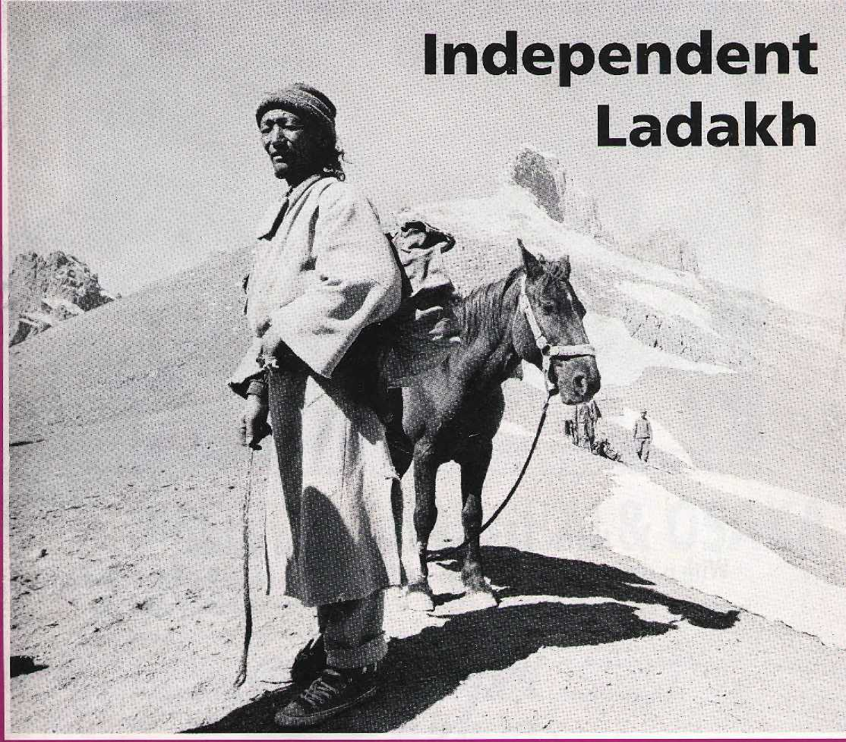

Rhino Surgery Lima Meeting French Imaginings


^^^^^^^^

Northwest makes it easy to go to America. With a choice of 8 gateways. And connection to 200 cities beyond.
Choose a connecting city that suits you best : Bangkok, Hong Kong or Singapore.
generous Free flight plan there is. General Sales Agent in Nepal :
Malla Treks,
Malla Hotel Arcade,
Kathmcmdu, Tel. 418 389
Northwest has daily 747 flight via Tokyo or Seoul straight to the U.S.A.
Be sure to ask abour WorldPerks, the most


NORTHWEST AIRLINES
SOME PEOPLE JUST KNOW HOW TO FLYi"


HIM
SIDE

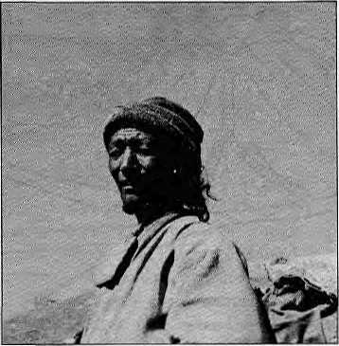
V0I8 No 2 Marsh/April 1995
The Abode ot Gods, King of .
Mountains, Himalaya .. ' .... ■■ You bound the ob$ari$ from "
easl to west
A northern yardstick . .-.■ To measure the Earth ...
-Kaiidasa(KumaraSambnaya) : '..
Editor :
Associate Editor Manager Administration

Kan^k Maxti Dixit Mahisha Aryai Kirah Shrestha Bafaram Shafrria Mamata Manandhar
SubscriptionRates
drily barik-draftsacceplahle for subscription orders ■
madatoHma/ in Nepal. Op NOT send cash in mall.
Ladakh:
'Independence' is Not Enough
by Martijn van Beek Kristoffer Brix Bertelsen
The politics of modern-day Ladakh is marked by communalism and the belief that an autonomous hill council will set things right. It will not.
At the political watershed. Cover picture by Philip Lieberman shows Ladakhi horseman atop Sengge La,

1 year
NRs. ■ ■ 220 Ifls 140 Nu
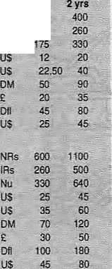
Individual Nepal
India ■
Bhutan
Other S. Asian Countries
North America
Germany
United.Kingdom & Ireland
Netherlands
Elsewhere
Institutional Nepal
India
Bhutan
Other S. Asian Countries
North America
Germany
United Kingdom & Ireland
Netherlands
Elsewhere
Send subscriptions a related correspondence to:
South Asia; P.O. Box 42, Lalitpur, Nepal
(tei 977.1 523845, fax 977 1 521013}, or
Central News Agency, 23/90 COnnaught
Circus, Nsw Delhi 110001
Japan: Akio Horiuchi,
P.O.Box 9, Kiyose, Tokyo, 204 Japan.
Australia: IndraBan, 12 Norfolk Si.,
Paddington 2021, Sydney, Australia.
North America: Barbara Bella & Associates,
500 Sansome Street, Suite 101, PO Box 470758.
San Francisco, CA 94147
United Kingdom & Ireland; Joti Giri {Fief: H),
221 Ashly Gafdens, Emery Hill Street, London 3W1 1 PA
The Nettiartands: C. F. de Stoppelaar,
Foundation Hi malaya.Keizersgracht 463,
1017OKAmsterdam
Switzerland: Helens Zingg, Tahn^nweg 18,
CH-3073, Guemligen, SwitzBriand
Europe: Durga Press (Himalj.Uiiipoldstr. 20.
p-82211, Herrsching, Germany
Notice:
Hackers please note Himal's new email address:
himal@himpc.mos.com.np
Himal© 1995 la publishad.every Iwoirionlhs by ■■■■ ■ Himal Association, PO Box42,PalanDhoka', Ulitpur,. Nepal. ■■ Tel:9771523B45,Fax:521p13,email:hrmal9hirr!rx;jiio.s.Kinri.np. Libary of Congress Card, Catalogue Number 88 912883' ISSN 1012 9804 Printing; Jagadaniba Olfset Put, Ltd. Tel; 521393,
23 An Open and Shut Case for Uttarakhand
Opinion
by Bhairav Dutt Pande
26 Rhino Surgery
Photo Essay byKMD
32 Wild Imaginings:
French Anthropology in the Himalaya
by Anne de Sales
A lot of accumulated knowledge is unavailable to native scholars because they're written in French.
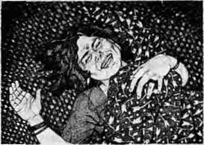
35 Love Marriage
Katha
by Manjushree Thapa
40 Mountain Meeting by the Beach
by Kanak Mani Dixit
Everyone went to lima to attend a conference. They came back well-traveled, but not necessarily wiser.
17
30 38 45
51 52
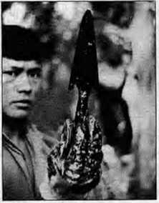
Departments
Mail
Grand Design for Lhasa Castrated Bullocks Dalai Lama's Return Investigate Accidents Who Won Uttarakhand? Present-day Dukha Much Ado on Roop Kund
Briefs
The Andes' Deep Origins Breathing Fire Development Thespians Objects of Desire Refugee Microscope Scandinavian Scandal PLACENAMES-Sikkim
Voices Himalaya Mediafite
Special Review Section Large Dams are Essential Beyond Gentle Laments Anthropological Roundup Encapsulated Wisdom
Know Your Himal Abominably Yours

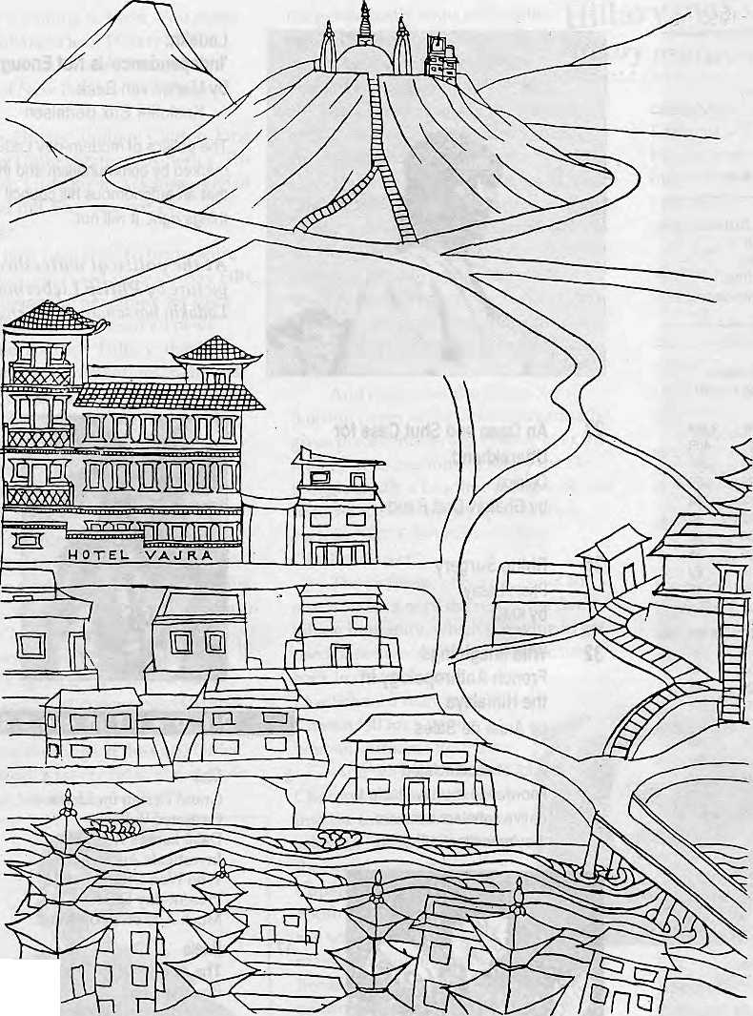
■Jill
Vajra (literally-flash of lighting), is an artists' condominium, a transit home for many, providing a base during months of hibernation and creative inspiration. Its isolation, graphic splendour and peaceful ambience, make an ideal retreat from the clock of pressure.
Ketaki Sheth Inside Outside
I stayed a week at the Vajra, by which time I had become so fond of it that I stayed another.
John Collee The London Observer


in Kathmandu, the Vajra

Swayambhu, Dallu Bijyaswori, PO Box 1084, Kathmandu Phone 271545, 272719 Fax 977 1 271695 Telex 2309 HVGHPL

M ail


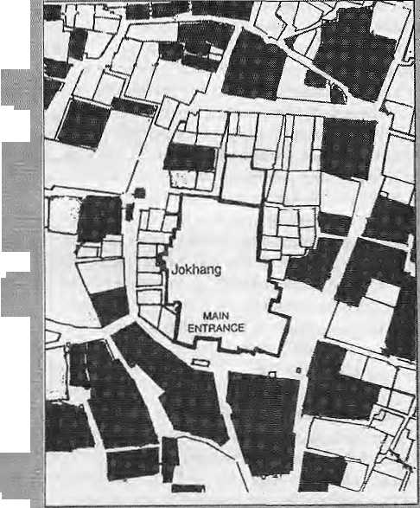

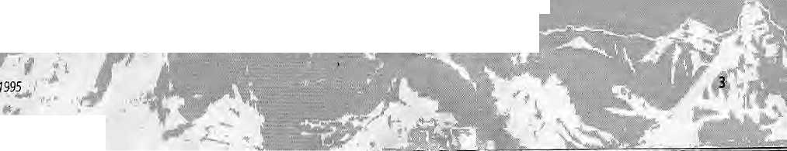

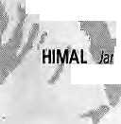
Grand Design for Holy City
We would like to congratulate Himal for the : : ■ ■■ ■:.:
well-researched article on Lhasa ("Modernist Or
Else" Jan/Feb: 1994); Allow us to offer a few :; : .::.::
comments as individuals who have been ■ ■
campaigning since 1993 for preservation of Lhasa's:
old town; ■■■:■■ :
Lhasa is one of the holy dties ofthe world, Oiv par with the Vatican, Jerusalem and Mecca; :.-.-...:.. Buddhist principles have guided the construction, maintenance and development of Lhasa for ■ - ■ 1300 years/Lhasa was founded in 633 Ap,:wheri the Tibetan emperor SrongtsanGampo shifted: his royal capital to the Kyiehu Kiyer valley. In 641,;theLhadenTsuglakhang temple wasbuilt: there, and the royalcapital of Ra~sa subsequently ::. became Lha-sa, the Place of the Gods. Since then, the Tsugiakhang temple has been considered the very heart not only of Lhasa, but of all Tibet.
According to Buddhist custom,, the city began to grow in a circular pattern around the Tsuglakhang, following pilgrim's circuits. The: general pattern of the inner city has not changed much since perhaps the 12th,-.century-. It is this historic area that is being affected by the current modernisation schemes, and the result is catastrophic for Lhasa's cultural and architectural heritage.
No doubt the inhabitants of Lhasa would welcome a higher standard of living provided by modern-equipped housing. Citing impressive statistics, 'John Grey^{J} argues in his article that the average Tibetan is not benefit ting at ail from the modernisation. Whether this is or is not the case, the demolishing of the historic centre of any city should be considered a blunder.
A development parallel to that of Lhasa has taken place in Kathmandu, to the effect that in a few years it will be impossible to find a non-concrete building in the inner lanes of the Valley towns. The difference is that in Kathmandu new housing grows organically, whereas in Lhasa a 'grand design' is being carried out, resulting in disappointing uniforrnness.
iVarylFebruary
r
According to a 1994 survey of O!d Lhasa, less than 200 old houses remain standing today, or less than 35 percent of all pre-1950 buildings. The Lhasa "'manor style has become endangered. The house fromwhere the Buddhist monk PelgyiDorje set out ■in 842 to assassinate King Langdarrna, the persecutor of Tibet, was demolished in 1984 and
replaced.witha; shoppirigvarcade;:The1993-94 period saw the erection of high-rise department stores inJthe-BarkorareaVori the-mainpilgrim: ■■"■ routearoundtheTsuglakBarig,replacing ■ buildings that were eehruries-old.Lotearig"- ■ phundup, the Mayor of Lhasa,admitted in
'-'■ '-'■ Scheduled for demolition in 1995: are: a:14th
century building-in which the great reformer ■
Tsbrtgkhapa once gave Buddhist discburses; a ■ :
house-in Barkorbelonging to thedescendantsof the
maawho invented tt\e Tibetan alphabet; and many
otherpriceless embodiments of Tibetan cultural
riMdry and identity. . : . .. .

The UNESCO, accepting China's application which followed numerous international appeals, has inscribed Potala on its World Heritage List. However, theLhasa authorities'approach to preservation continues to he ambiguous. For example, the demolition of the Shoel district has been halted, but the old houses just outside the giant walls of Shoel are going to be pulled down to create a great square. A 17thcentury stonebridge : has been reconstructed, but only tobeusedasa public pool hall.
Professor Guan Zhaoyie, of the Department of Architecture of Qirtghai University, has written: "There is only one Lhasa in this world. It is a
Map ifcdlM the Barkor nsighboOrhood of old Lhasa, around the Jokhang temple (Tsuglakbang). Shaded sections indicate ancient buildings that have been demolished, mostly in the 1990s, to make way for modern housing, shops, department stores and squares.

I
m.
a

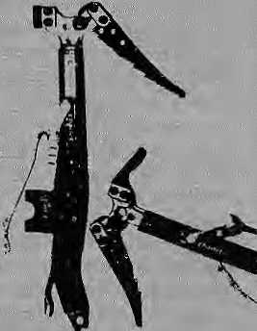
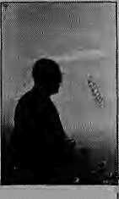
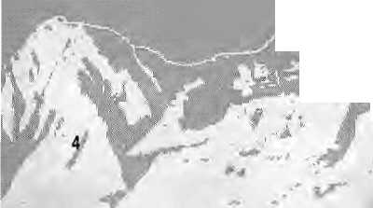

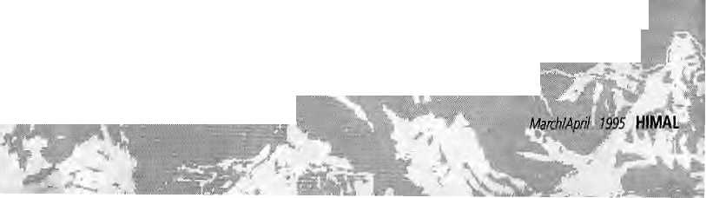
paramount duty for the architects to preserve the ; ;
flavour of Lnasa and to make it last forever/'
. Andrew Anders, .... ■■ ■
: : Max Martin ...:.. ■ ■■.:; \ :::; ;■:■;■;■:':... ..."■■
The KyichoKuntun Society, England
Castrated Bulibcks : -
Prem Krishna Gongaju's "Citizenship made: : Simple" 'AKaika', jan/feb 1995) is undeniably among the finest writings iri English by aNepali.! eagerly anticipate ttie unveiling of more of Gpngaju's: writings and more Gongajus; wherever they are.
Hosannas aside,: the jKsrte actually throws a serious challenge to the; forthcoming; Nepali Hhrtal. Can Himal come up with a translation of this very moving story in Nepali,: whichconveys at leasthalf its artistic merit? This isnecessary to save Nepal's human capital from being consumed as the proverbial moth into the flame, by the conveyor belt of the "satanic mill" which strips the bark of heritage and converts humans into mass lumber;
WeMve lost too many of pur best and brightest to the banality of a credit card life oil the treadmill. They have become socially castrated bullocks that trudge the commuter bell, to-and-fro-ing in an ever-receding quest to beat the mortgage:: and insurance payments, unable to inject any life or joy into the angst of culture they left behind.: : ;
Can the upcoming MTV generation in Nepal,
currently mesmerised by the glitter of El Dorado,
be saved from this fate? Nepali Himal should try.
Dipak Gi/aivali :
Kathmandu :
Dalai Lama's Political Return
Regarding Roger L. Plunk's "An Elegant Return" (jan/Eeb 1995), he writes that the Dalai Lama : should returnasa "spiritual" and "cultural" leader to Tibet and that his return won't be a political event- How is this possible?
First of aU, do weaccept Tibet as an independent country? Only if we accept Tibet's sovereigni-ty, is advocacy for the Dalai Lama's return useful.
The Dalai Lama.heads the Tibetan Government in Exile: And heading a government is a political thing. How can his return, then, be non-political?
Elvisjoshi Bhotaliity, Kathmandu
Investigate Climbing Accidents
"Inquesintledita fair shootin', but nobody pati\tnuch-MXnd-NobodywmUgthemquesi,im'youneverheard
7 ^fl . ■ ■ ' . .. ■
:hsstalk about anything. Seemedlike'they wastill'too : anxious[to get theirfisis:into the hotiey-pot."
LouisL* Amour in The High Gmtiers^
After reading the articles published in Flimal (Mf$j Nov/Decl9Mand Jan/Feb 1995) and reviewing; official reports: of the accident that took place bri Pisang Peak last autumn, I perceive an urgent need to standardise "adventure accident" investigations in Nepal.
\ Like the medical
: doctors whose :
involvement is
necessairy in post
mortem analyses^ or
engineers without
whom:causesof:
faulty construction
: cannot be diagnosed,
it is only the :
■ competent and experienced mountaineer who can provide insight into climbing accidents. That a few climbing buddies do a quick
"reccy" and get together for a few hours every couple of weeks to sip tea does not make for an official investigation!
As somebody who has led trek groups for a number of years and worked as a safety, loss and risk management consultant,! would like fa offer some thoughts on alternative investigation strategies in mountaineering accidents. An adequate system should exist for search and rescue operations, and field tested procedures must be in place for investigative forays that are necessitated by unusual incidents or insurance requirements. A professional approach; I feel, needs to look at fourareas.
Terms of Reference: Without a clear mandate from the government and explicit directions from a mountaineering association, there can be no hope of conducting efficient and effective investigative consultations. These "directions" have to include policies, procedures, norms, disciplinary measures, as well as ethical guidelines. Such categories would explain, among other factors, sensitive investigative team composition; approved actions; reporting time frames; interaction with government, public and other appurtenant agencies, and communication and public relations.

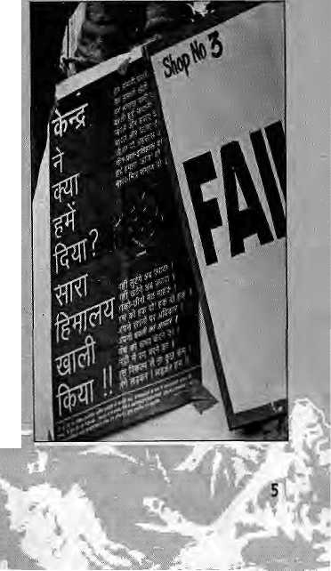

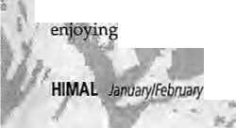

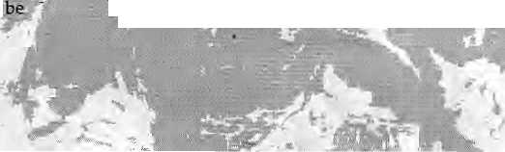
Investigation Team: Screened and designated individuals must he used for investigations. : ;: Eligibility to be on an "on-eall": list would be determined by stringent criteria regarding • • personality factors, people skills, as well as technical competence. Obviously, associated-with effectiveness of such a team are: measures for communication and transportation whennecessary.
Toolkit; So the team is on site. Now What? A detailed toolkit with a variety of probing and information collecting techniques arid achecklist of necessary processes needs to be provided to those involved. Securing the area;: taking photographs; going through log books, diaries, etc.; checking materials arvd equipment; and documenting and crass-checking all informa tion for accuracy and relevancy through structured on-site meetings are the aspects that need to be addressed. The types and range of questions to ask and the people to whom they should be directed are partially established at the start of an investigationjbut should increase exponentially as information comes to light
Report Composition: The report of the-findings must be ethical and just. Repercussions, especially if the affair is drawn into the juridical forum, can affect the persons involved for life. Anyone who is unwilling to be thorough, reasoned/ empathetk and upright should not be considered for the team and never fof compilation of official reports.
Ivan Gyozo Somiai Lalitpur
Who Won in Uttarakhand
"An Uttarakhand State of Mind" {Nov/Dec 1994) vividly portrays the state of Kumaon and Garhwal in the second half of 1994. However, to be able to ; understand the Uttarakhand agitation in its totality, we feel, some other points need to be considered as well.
In March 1994, the Mulayam Singh Yadav Government of Uttar Pradesh decided, to raise the percentage of reservation in jobs and education institutions for.people from economically: and socially backward castes and classes. The quota for Scheduled Castes went up from 18 to 21 percent and for the Other Backward Classes (OBC) from 15 to 27 percent. (The existing 2 percent reservation Scheduled Tribes was left untouched.)
* f 1995 )
' %pr

While this came well under the Supreme Court directives of riot exceeding the 50 percent reservation limit, someSCs and-STs-alreidy -. reservation benefits nowcarnfeto
v included also in- ftiefresh list of OBCs. However, in thi s hew scheme of thi rigs, there was no place for
; pqlitical;sufferers,::physicaily disabled, retired military personnel and their widows arid children. Also, a recent survey €0ndueted by the Panciiayat "Raj Department showed that only 2 percent of the listed OBCs lived in Utfarakhand hills.
Thus, under the pretext of implementing the Mandai Commission recommendations, Mulayam SinghYadavwasbuildmghiscaste/class-based : vote base) The Congress and the Bharatiya Janata Party, meanwhile, tried using the hill peoples' feeUngsto further their own ends. And even as: agents of different political parties infiltrated sflttgare/issflmihs (nqn-politicalaction groups) and corrupted the movement,the Uttarakhind intellectuals just looked on;
■ThepeoplemUttarakharid were aware of all that was. happening around them, Butawareness alone. Unfortunately, is not enough to achieve an objective. Students, government officials, businessmen, ex-military people, teachers, professors, lawyers,eic., formed different factions and came up with different pirograms for Uttarakhand. Some said Uttarakhand should be declared a backward region so that people living below the poverty line could also enjoy reservation benefits; others insisted that reservation percentage be reduced to 2 percent on the basis of OBCs living in the hilb; some others; wanted the agitating government employees to be taken back without harassment; and still others wanted the Uttar Pradesh parliament to be dissolved and Chief Minister MulayamSingh ousted.
In short, the movement lacked a common charter of demands and was also misled and misdirected right from the beginning. The agitation lasted for ail of four months and then the movement wound up. Politics of the day won, but no one knows who the beneficiaries are. N.S.Bisht,KrantiBlmtt Chambli, Uttarakhand
UP, Economics
As usual, Himal's reporting on
Uftarakhand—a confused and a confusing
issue-^was thorough. However, in Manisha
Aryal's article, I would have liked to have
seen more on Various economic and
political forces involved and on their
material reasons for taking the stands they
have over Urtarakhand.' :


I
a



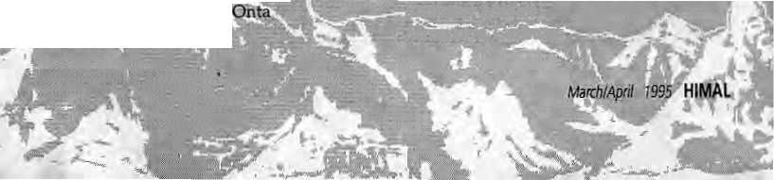
While Aryalconcentrates on the politics of reservation, which is more receilt, I recall that in 1988; over half of the forest earnings of the 'revenue-., poor state; of Uttar Pradesh (over 100 crores) came :. from the eightMl districts, despite all sorts of: felling restrictions. For a state tlW is perpetually ori the verge of bankruptcy, and often cannot pay government salaries on time, I think that is quite a significant factor,
. SanjeevPrakash Saket, New Delhi
Present-day Dukha
Pratyoush Orita's "Dukha during the World War" should be considered a milestone in the writing of Gurkha history. What should have been written a long time ago seems finally to be coming to the notice of scholars and researchers.
Sainik hfwrti forms an important part of the social structure of rural Nepal, especially among the Limbu, Rai, Magar and Gurung, As the subject concerns a big segment of Himalayan peoples, society and economy it is indeed high time thaf we discussed Gurkha recruitment and analysed its merits and demerits— the bTain and muscle drain, opportunity, economic prosperity, arid trie exposure it provides the Gurkhas and their families.
But perhaps what is even more important to discuss is the present day dukha of the serving: Gurkhas. British law states that a British soldier can not be separated from his spouse for more than six months at a stretch; his Nepali counterpart gets: to keep his wile with him for less than three years in his entire 15 years of service. The pension received by a Nepaii is pathetic compared to what his English counterpart takes home;
How the reduction in the number of Gurkhas in the British Army affects the soldiers aod their families, could be another article for Himal to do. Mahendra Lawoti Puldwwk, Laliipur
Gurkha Dukha is Not New
May Jadd a. note to Pratyoush Onta's "Dukha during the World War" (Nov/Dec 1994) and Ronald Burroughs' fetter in the subsequent issue of Himal? If only the latter were better read, he would have seen that there is nothing new in what ^rritten: Philip Mason iri his 1974 book.
A Matter of Honor: An-account of the Indian Army, its 'Officers and Men, goes into great detail on the whole subject of unpleasantness in tattle and the reaction of troops from the Subcontinent; So what is new?
Before Burroughs: indulges in comparing heros with harlots, lethim analyse the percentage of those who were not wounded or killed; those who benefited from the service; those who enhanced themselves—and in the case of Gurkhas, became world-famous, in less shrill a tone, let him remember that wha tever the other factors involved, there is no: legal need for any Indian or non-Indian national to join a volunteer army.
I do not, of course, know if Burroughs has served in an armed force and knows what he is talking about, orif he ts one of those shrill outsiders who is willing to wound but afraid to fight. But it might be pertinent to note here that that rare ; breed, "professional killers of the psychopathic type" are not Welcomed in the army, as they do hot make good soldiers. j.P, Cross Pokhara
Much Ado about Roop Kund
Apropos Gerald Berreman's letter in the Nov/Dee 1994 Himal, why all this fuss over a simple dpcu^ mentary? Victor Banerjee's Splendor of Roop Kund and Garhwal was meant to arouse peoples' interest in these mountains, specially those who knew nothing about them. And it seems to have worked!
The film was made to attract tourists and trekkers to these lesser known regions of Uttarakhand, not to produce a tedious tome for some glassy-eyed students. The lands traversed in the film included regions like "Sahastra Tal" where there are no inhabitants, just ionely nomadic shepherds, and that too for a few months each year. With delicate weaving-in of Kotkandhara, tata and the Nanda Devi Jaat Yatra, Victor was able to enrich what would otherwise have been only pretty pictures of Garhwal.
Perhaps one day Victor will make a film on the peoples of Garhwal because he has the sensitivity, warmth, talent and understanding to do the place justice. Maybe then Berrerhan will understand the difference between the icing and the cake.
Ganesh Shaili, Ruskin Bond and
Sudhakar Mishm
Mussoorie, Garhwal

Ladakh

I |  |  | : rftt
 | - ■. .. ..,. . . .. | ■ .. ■:■..:. . . . -»^:;. :■:■.:: | " ■■' . | . ■ ..,, |  | ...'
 | S3: | .,■■■:■ ■ .- .iff •••<-. ;■■ < *  :--7-^:«■:;;.-.. ..,:>■/-,«*:' ; v;-, ;- ■■ ■■ |  | ,^;' :' I . | *£ J-'jjT, ""■."
 | ■■■*■ - ■ ■;<» *l i-,> (-. ■ ■ | • • ■..- ■ ,:l> :- ^" "-^{J}i: |  | ' "Sg If • - . i^
 |  | ■ W dK ~ -"-; ■ , |  |  | , »
- y—t | ■■'- . ^{A} ^iktiiMa^: ^{v}-"
■ |  | — . ■ ■ v .iiS*v |  |  | ■
■ |  | ■ :■:;■' •■ ■' .' : '

'Independence* is Not Enough
7/je autonomous council proposed for Leh will resolve only some of the problems engendered by the modern-day Ladakhi politics. While the ties to Srinagar will be severed, the formula will not rid the region of homegrown communalism.
by Martijn van Beek
Kristoffer Brix Bertelsen

I
n the near future, Leh District in the Ladakh region of Jammu and Kashmir will be governed by an Autonomous Hill District Council. The relevant legislative bill, lying with Prime Minister P.V. Narasimha Rao could, at any time of his choosing, be signed into law by the
President of India.
The granting of the Hill Council will fulfil a long-standing demand of Ladakh's population for "independence" from the state of Jammu and Kashmir. It will devolve far-reaching powers of a dministration—except law and order and the judiciary—to local
politicians. But will the Council be a panacea for all the ills of Ladakh? In somerespects,itismorelikea placeb o.
Following Gorkhaland
The framework for the Leh Council was drafted after the model of the Darjeeling Gorkha Hill Council.

HIMAL

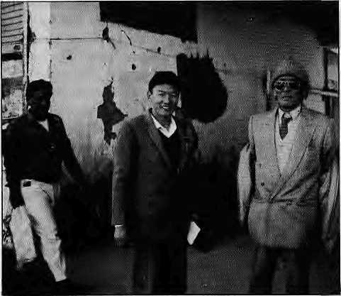
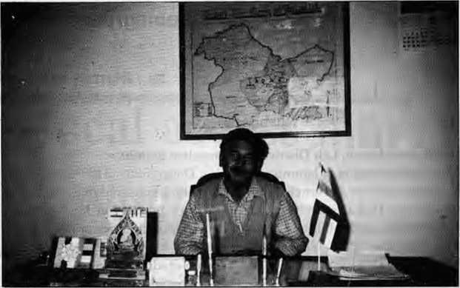
Tsering Samphel, ex-MLA, Congress (I) - Leh fleftj and Mohd. Akbar Ladakhi, President oftheLadakh Muslim Association.
Thubstan
Chhewang,
President of the
Ladakh Buddhist
Association, under
a map indicating
"Union Teritory of
Ladakh".
Subhas Ghising's Hill Council was the first of a kind of institution that is becoming popular in the reorganisation of centre-state-community relations in India. Similar semi-autonomous councils have been created, or are under discussion for Uttarakhand, Jharkhand and parts of India's Northeast. Some have even suggested that the hill council formula could be used to find a satisfactory solution to the problem in Kashmir proper.
Although demands for greater local autonomy have become a prominent and recurring feature of Indian (and indeed global) politics in recent years> it must be remembered that most of the struggles which they represent have older antecedents predating the nation states inside which they are being carried out. Given its present popularity as a formula for the resolution of regional and ethnic imbalances and conflicts, we must ask whether the hill council concept, based as it is on an imagining of regions and communities as homogeneous, unambiguously bounded and stable, delivers what it promises: a fuller, more just participation of 'the people' in local decision-making.
In the case of Ladakh, the struggle for 'freedom' from Kashmir has a history that cannot be ignored amidst of the present campaign for autonomous status. At the same time,
one must examine the recent communalisation of politics in Ladakh, and the potential as well as the dangers for regional 'communal' peace that come with the institution of the Hill Council as proposed. In brief, the Ladakh Hill Council formula replicates a logic of fragmentation along regional and/or communal lines that has fostered the communalisation of politics in India.
(Elsewhere, the term 'communal' carries the connotation of cooperative feeling. In South Asia, however, the word refers to the evils of group partisanship.)
Ladakhi Equals Buddhist
Ladakh has suffered from the Lost Horizons syndrome which afflicts journalists,aca demi csandpoliticians whenever they turn their eyes up to the Himalayan region. In particular, Ladakh's modern-day politics has been completely ignored by scholars and journalists, whose tendency is to focus exclusively on the historical, the cultural and the 'touristic'.
Indeed, the region has been caught between the Scilla and Charybdis of 'Shangri-la' and 'backward tribals' labeling. On the one hand, we hear of the oft-repeated descriptions of Ladakh's peaceful, cheerful, and ecologically-sound society and economy. On the other hand, there are those—a dminis tra tors in particular—who emphasize its economic backwardness. While it would be going too far to designate
these imaginings as the primary cause for the contemporary political conflict in Leh/theyhaveprofoundly affected not only the administrative policies towards the area, but also the perceptions Ladakhis have of themselves.
The central complaint voiced by Ladakh's political leadership since the 1930s is that the region has not received its fair share of resources, particularly at the hands of the State Government in Srinagar. While it is important to note that this sense of discrimination is shared throughout Ladakh, the grievances and demands have mainly been voiced by the Buddhist leadership. It is significant that all-Ladakh issues have increasingly been represented along 'communal' lines, that is, by the vocal Buddhist groups. The less well-organized Muslim groups are not heard.
Thecommunalisation of Ladakhi poli tics cannot be understood without going back to the historical roots which were sprung in the late-nineteenth and early-twentieth century political setup of British India. The British imagined India to be comprised of a series of distinct communities made up of castes, tribes, and religions. The fundamental division, in their eyes, wasbetweenMuslimand Hindu.This vision was formalised and quantified in the Census, and became the basis for the reorganisation of Indian politics under colonial rule. When the British initiated assemblies to represent the population, they were

March/April 1995 HIMAL

defined on religious basis as Muslim and Hindu constituencies. The Praja Sabha, or the Kashmiri Assembly, was also organised along this religious divide.
Although the State of Jammu and Kashmir was never an integral part of British India, democratisation of the political organisation of the State in the 1930s replicated this communal frame, which emphasised the difference between two religions, Ladakh, which became part of Jammu and Kashmir after its conquest by the Dogras, even though it had a Muslim-Buddhist rather than Hindu-Muslim mix of population, became incorporated into this political frame defined by the British. In the process, Ladakh was communalised.
The first formal representation of demands and grievances from Ladakh was made in November 1931 totheGlancy Commission of Enquiry, which was instituted after repeated communal clashes in the Kashmir Valley and extended protests against the rule of the (Hindu) Maharaja. The Glancy Commission, which was ' organised and solicited representations on the basis of religious community, became the proximate cause of the organisation of the Buddhist elite in Ladakh.
Contacts between the religious elite of Ladakh and Buddhist revivalists among converted Kashmiri Pandits (organised in the Kashmir Raj Bodhi Maha Sabha) went back as far as 1917. The Pandits who had embraced Buddhism viewed Ladakh as the last haven of the religion in India. Familiar with the scramble for numbers in the politics of modern India and J&K, the Pandits successfully presented Ladakh as a predominantly Buddhist area to the Glancy Commission. Throughout the final report of the Commission, therefore, 'Ladakhi' came to be used as synonymous with 'Buddhist'. As the Muslims of Ladakh did not enjoy the same kind of patronage from the outside, their case remained unrepresented.
In 1934, the Young Men's
Buddhist Association, later renamed the Ladakh Buddhist Association (LBA) was founded. Its primary aim was the protection and promotion of the interests of the Buddhists of Ladakh. No formal organisation of such a kind has existed among the Muslims of Ladakh. There is now a Ladakh Muslim Association (LMA), but it has never been much more than an ad hoc body activated in times of communal trouble. One important reason for this dormancy in Muslim activism is the deep divisions between Shia and Sunni Muslims of Ladakh.
Thus in the 1930s, Ladakhi participation in formal politics was along religious lines. Based on the recommendations of the Glancy Commission, Ladakh obtained two seats for its Buddhist community in the Praja Sabha, while Ladakhi Muslims—who at the time formed somewhat less than 50 percent of the population—received no representation. It is quite irrelevant to discuss whether at that time Ladakhis saw religion as the fundamental division amongst themselves; the institutional setup and the way that Ladakh was understood by outsiders were such that there was no escaping a practice of such a differentiation.
While the underlying organisation of formal politics was along communal lines, however, there was no overt use of the communal card over the decades, until it was briefly played in 1969, when there was a short-lived agitation. Subsequently, religion was used consciously in the agitation for autonomy that ran from 1989 through 1993 and whose reverberations are still being felt to this day.
It is significant that the Hill Council covers only Leh District (including Leh town). It does not include Kargil, the other district of Ladakh, which has preferred to wait and watch. Leh District is more than 90 percent Buddhist, while Kargil is about 80 percent Shia Muslim. (The Muslim minority of Leh, known as the Arghon, is Sunni. Kargil's small Buddhist population is found in
Zanskar.)
The Hill Council, then, will be the successful result of a sustained campaign in which Buddhist Ladakhis highlighted Buddhist demands to get New Demi to listen to Ladakh'sgrievancesagainstJ&K.The leaders in Leh began to use religion when they realised that the national-level politicians would listen to Ladakhonly when voices were raised along communal lines, vis-a-vis "Muslim Kashmir". Inevitably, this strategy antagonised local Muslims. With the conscious use of the Buddhist

p |  | E
I I  r | LA DAI TAKEN | (HIS FOR | .CANNOT BE IB  \ \m
1:1: |  |  | BiiiWUIMMk
I  HI |  |  | HHHHH
card the communalisation of Ladakhi politics took a momentum all its own. The Hill Council does not have a mechanism to put this genie back into the bottle.
Bakula's Faction
In spite of the early communalisation of Ladakh's political structure, local politics, including the various agitations that took place, was not usually communal in form or content. For at least the last four decades, the main dividing line in Ladakhi politics has been one between supporters and opponents of Kushok Bakula Rinpoche, 'head lama' of Ladakh and currently Indian ambassador to Mongolia.
Bakula rose to power in June 1949 when he replaced Kalon Tsewang Rigzin, a Ladakhi aristocrat, as District President of the Kashmir

HIMAL March/April 1995
9

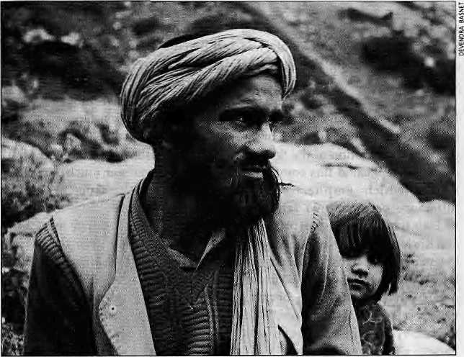
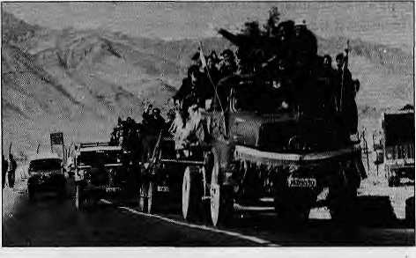
Shia man and
daughter of
Kargil.
Celebrations in Leh after the
homecoming of a negotiating team from Delhi, 15 October, 1993.
National Conference, Sheikh Abdullah's party. Baku la was elevated to this position by Jawaharlal Nehru and Sheikh Abdullah after what is known as the 'Coup at Choglamsar Bridge'. The two leaders were visiting Ladakh when a group of young, educated Ladakhis—including Buddhists, Muslims, and a Christian—approached them and demanded an end to domination by the Kalon family. Tsewang Rigzin, they maintained, was too dictatorial for the new democratic era and should be replaced by a figure with a more popular base of support-Bakula.
Today, many Ladakhis tend to interpret the overthrow of Tsewang Rigzin, like practically everything else, along communal lines, reducing it to a Muslim conspiracy. However, historical evidence indicates that the move to replace the Kalon was not a communal event.
In any case, the politics of Ladakh since the 1949 coup has been characterised by jockeying between the ruling Bakula faction and its challengers. Bakula and his followers have been the subject of two main criticisms. First, they have dragged prominent religious leaders into what should have been a secular political arena. Second, many of the political actors lack modem education and an under-standing of changes that are over-taking Ladakh and South Asia.
Given the role of religion in Ladakhi society, among both Buddhists and Muslims, it is very difficult to raise objections to the decisions taken by religious leaders in the realm of politics, the critics
argue. The price to pay for those who dared to go against the politico-religious leadership has often been social alienation for long and short periods, and physical violence. The people who put up a counter-candidate to Bakula in Ladakh's first real elections in 1960—all of whom came from families that are patrons (chindak) of Drukpa Kargyud monasteries, whereas Bakula heads theGelugpascho ol—were faced with a "social boycott" which lasted for several months.
As for the lack of education, the critics claim that Ladakh's decision-makers have been unable to understand the complex aspects of economic and social life. Forexample, Bakula is said to have declined Scheduled Tribe status for Ladakh in the 1950s when it was offered by Nehru because he felt it meant lowering the status of Ladakhis. While there is no evidence to prove this tale, it is often brought up to illustrate Bakula's limited understanding of worldly affairs.
Because of the tight links between religious leaders and the dominant political grouping in Leh, Bakula has been able to ride over criticism with relativeease. Even with Bakula based for the last few years in distant Ulanbaatar, his faction
continues to dominate the political agenda of Ladakh.
Opium for the Masses
Even though the internal power struggle within the political establishment of Leh District has had very little to do with communal ism, the communal card can be and is being played. This was most evident during the agitation for local autonomy, 1989-1993, which eventually led to the agreement on the formation of the Leh Autonomous Hill District Council.
Ever since the 1947 Partition of British India, the relationship between the State Government in Srinagar and the Ladakh region has been marked by deep mistrust. The assumption inherent in much political thinking, especially among the Buddhists, is that since J&K is dominated by Muslims, the state administration's policies and programmes in Ladakh are bound to be biased in favour of Muslims. This is a claim that has been made since the first representation by the Buddhists in 1931. Over the years, the sense of acute discrimination has been fueled by outside intervention— not only by Kashmiri Pandits, but Sri Lankan Buddhists, Western travelers, and Indian and Western academics.
The economic development of

10
MdKblApril 7995 HIMAL

Ladakh has been so tardy that many young Ladakhis receive education without being able to find a job upon graduation. Government statistics show that the number of unemployed in Ladakh has not increased dramatically, but the number of educated unemployed has risen sharply. Faced with social tensions which result from such a situation, Ladakhi leaders tend to put the blame for underdevelopment and unem-
ployment squarely on the shoulders of the State Government, which is seen as the main provider of jobs and resources.
Both Muslims and Buddhists of Ladakh recognise that the agitation which began in 1989 was aimed primarily at the Government in Srinagar. The problem was how to mobilise a large enough section of the pop ulation in spite of the deep internal divisions, A conscious decision, was
taken by the Buddhist leadership to use religion, as one of the key Ladakhi leaders behind the agitation, a Buddhist admitted. It was decided that the Muslim-Buddhist divide would be highlighted, to prove that a Muslim -domi n a ted s ta te go vernment was discriminating against a Buddhist Ladakh, This would be a much better a ttention-grabb er exte rnally, w hile at the same time it would make it possible to mobilise the Buddhists in

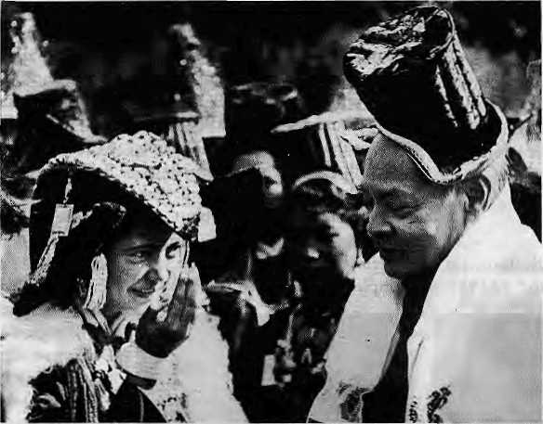
Waiting for Rao
Somewhere in P. V.NarasimhaRao'soffice, under a pileof papers, is a bill, approved by the Governor of J&K, the Union Ministry of Home Affairs, and the Kashmir Affairs Desk in the PM's Office. The bill, declaring Leh District's Autonomous Hill Council, has—one imagines—a dotted line at the bottom. That dotted line awaits the signature of the Prime Minister. It has been lying on his desk for months, much to the disillusionment of the leadership in Leh.
In sharp contrast to the mood today, there was great optimism last October among Leh leaders that the Hill Council was at hand. Within a matter days, the bill would go from the Prime Minister to the President for final approval. The change in mood by January was dramatic among the key players, including the former MP and Union Minister P. Namgyal, Mohd. Akbar Ladakhi, and Rigzin Jora, General Secretary of the LBA. Below, are excerpts from a conversation with Rigzin Jora.
"We have been quite unfortunate. Every time we feel things are picking up, something happens that derails the process. The whole affair seems jinxed. Last September/ October we were quite optimistic. P. Namgyal told us that it was go ing to the Cabinet, so we were all excited. Then we realized that the entire department dealing with Kashmir was taken from Home Affairs to the PM's office, so it had to go through the whole process again.
"The Home Minister and all the people who matter have given assurances before. This has not been going on just since last year, but for five years now. At one point, even the Government seemed to be in haste, when the issue wasbeingraisedinParliament. But now, I think they are trying to push the election in J&K. We mentioned in the mem o th a t the mu ch- talked -about political process i n J&K can be initiated from Ladakh, You grant the Hill Council and hold elections in it. And the misguided youth of Kashmir could also be encouraged to accept a system on the basis of the Hill Council. We wrote this in our memo, but no one bothers.
"This PM only does things at his own convenience, never mind what. He has his own speed. The PM seems to thinkonlyoftheKashmirissuetakenasawhole.Whenwe met the Minister, we made the point that in Kashmir the people who raise secessionist slogans are being attended to. And us Ladakhis—we got nothing! The problem is, when you go to the PM's office, he hardly gives you two or threeminutes. The Governorhas been very keen on giving the Hill Council. There has been no let-up from his side. That is the problem. If we go to the ministers, the Governor, they will say that they have done their share, that it is up to the PM now.
"By March we should come up with some concrete action plan. It will take quite some time before we can prepare the people for another agitation. Unlike in the past, we can't just snap our fingers. We may begin with a pen-down strike for a week or ten days, and then take another step.
"In India nothing seems to move. I guess we'll have to get in touch with the ISI now. Go to Kathmandu to the Pakistan Embassy (laughs)."
- Martijn van Beek
Wearing Ladakhi headgear, Rao greets Ladakhi belie at Republic Day ceremony in New Delhi, 26 January 1995.

HIMAL March/April 1995
11

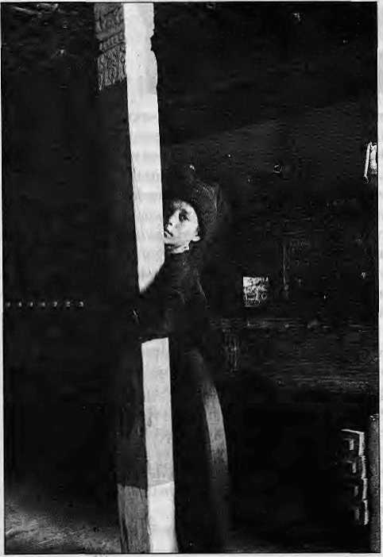
Tsering Dorje
Langrook,
President of Youth
Wing of the
Ladakh Buddhist
Association.

In a Zanskar gomba.
the name of religion.
As was to be expected, this communalisationwasresentedbythe local Muslims, both in Leh and Kargil districts, even though they recognised the strategy behind it. Essentially, the Ladakhi Muslim felt as if he was caughtin a cross-fire between Srinagar and Leh. In an interview in 1989, the late Agha Hyder, one of the most powerful Shia leaders in the Sum Valley (south of Kargil town), expressed his distress over the issue. He said, "We are all Ladakhis. We all suffer under the Kashmiris. We should fight them together, instead of each other."
Kacho Mohammed All Khan, a former politician of Kargil, says: "It was communalised, but really it was aimed at the J&K Government. Here in Kargil there were repercussions, but we kept it under control. The people here are angry about the communalisation and the forced conversions that took place, for example at Sakti (in Leh District). On
the whole, in India, all the media took a high pitch and blew it out of proportion. Communal parties from Jammu and India made it a bigger thing. It was communalised here in Ladakh because without opium the masses can't stir."
Using religion to plead Ladakh's case conformed not only to a century-long tradition of administrative classification and practice, but also glossed over the internal differences between and among the Buddhists and Muslims. Applying a method of carrot and stick—and big sticks were used to great effect—Budd hist leaders managed to mobilise a large section of the Buddhist community around the demand for greater autonomy,
A social boycott of the local Muslims was ordained by the Buddhist leadership. Beginning in 1989, it lasted for three full years. It was the first time that this traditional Ladakhi 'tool' for dispute settlement was applied to an entire community. The boycott was lifted in November 1992 after pressure was applied by the Congress government in New Delhi, and after the Muslims agreed to work for a Hill Council.
In October 1993, the Central Government, the State Government and the leaders of the Buddhists and Muslims of Leh District worked out a framework for the future council. A Solomonic deal was struck in which Srinagar agreed to have word 'autonomous' attached to the Council, in return for the Buddhist leaders acquiescing to the Council being placed within the framework of the J&K Constitution. All matters, except the police and the judiciary, were to be relegated to the Council's portfolio.
Since the paperwork for the Hill Council is ready and all that is required is a signature in New Delhi, the only remaining question is whether the formula is conducive to the solution of the communal and developmental problems of Ladakh.
HHI Council Communalism
The Hill Council does nothing to address the problems of power
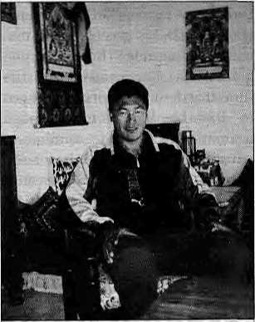
sharing within Ladakh. The longstanding tension between religious and political leaders, between the educated and less-educated classes, andbetweenpartakersof the 'modern' Leh lifestyle and village-based living, cannot be resolved by merely introducing yet another administrative layer.
What the imminent advent of the Hill Council does make clear is that henceforth all important administrative responsibilities will lie firmly with the people of Leh District.
The movement of 1988-1993 created a deep rift between the two communities, and it is not clear that the HillCouncil, dominated, as it will be, by the Buddhist political leadership that led the agitation, will be willing or able to bring about a reconciliation. Many Muslim families who had to flee their villages in 1989 and 1990 have yet to return.
When asked whether the Hill Council has a responsibility for the rebuilding of communal harmony, Tsering Samphel, ex-MLA and presently District President of the Congress Party, says, "Our ethnic identity is Buddhist, but also Ladakhi. The problem is the emergence of Muslim fundamentalism. Baltis [a term often used to refer to the Shia of Kargil] and Ladakhis have much in common, but when religion comes in, they forget this link. If we in Leh and Kargil were together, we'd have a much greater impact."
From the other side of the

12
March/April 1995 HIMAL

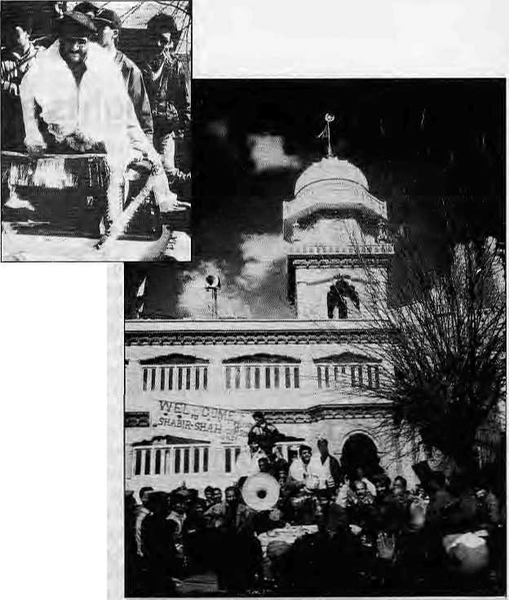
communal divide, this sense of a greater Ladakhishared identity is also emphasized by Kacho Mohammed Ali Khan: "We have the same culture, same tongue, same stock. Divisions are due to religious fanaticism. I think religious fanaticism is not a good thing, in whichever religion or community it occurs."
However, among the youth of both communities, there is little evidenceofanawarenessof this m uch -vaunted 'Ladakhirtess' which unites Buddhists and Muslims. The Ladakh Buddhist Association has had problems controlling its Youth Wing. The gangs of radical youths that were used toenforce the socialboycott and carry out various activities of the agitation today may pose a serious hindrance to the process of healing in. Ladakh. For example, young Buddhist Ladakhis who came of age during the agitation tend to blame Muslims for every ill that befalls their community.
Even today, it is not clear that the radicalised Buddhist youths can be controlled. The continuing series of blasts in Leh, which the LB A denies it has anything to do with, has not caused material or personal damage. However, it does nothing to help restore aclimateof confidence among the communities.
Const ituentification
Mistrust of the J&K government is deep-seated in Leh, and both Muslim and Buddhist leaders doubt that Srinagar's misrule will end with the Hill Council. "The Hill Council is required desperately. But J&K government can play even more games than before. They will have 36 people to pull strings with..." says Pinto Norbu, an ex-MLC and minister. There is also concern that granting of the Hill Council by the Centre does not secure the future entirely. Under the law, Ladakh will continue to be regarded as part of the State of J&K, which has a constitution of its own unlike theother states of the Indian Union. Ladakh's fate is therefore tied to J&K and the
Waved off with
a khatag,
Shabir Shah in Leh.
adjustments that are to be made between Srinagar and New Delhi. Even if the Hill Council is granted today by the Centre, it would still have to be ratified if and when an elected government takes power in J&K. There is little that could stop that future government from reversing the Hill Council decision, which seen in this light begins to look more like an interim measure rather than a final solution. Some Buddhist leaders see the Hill Council as merely a step towards ultimate Union Territory status, which was the original demand of the 1989 agitation.
As for the structure of Hill Council, it contains measures for the protection and representation of minorities, i.e., the Muslims. It also envisages the break-up of Leh District into more than 20 constituencies. This 'constituentfieation' of the district does allow for anew (or perhaps older) kind of communalism—along regional lines—as the differences within the district are greater than the recent agitation might suggest. The nomadic herdsman in Changthang does not have much in common with the hotel owner in Leh, or the peasant of Sham, and the rifts are bound to float to the surface as soon as the Hill Council is activated.
In the words of Mohammed Akbar Ladakhi, the former president of the LMA: "Unless responsibility is given to honest people, the Hill Council will be a big failure and can create more divisions than we have today, for example between Changpa, Shamma, Nubrapa, and so on. The Hill Council is more of a test than an achievement. Even today the contestation of elections is not settled,
, Kashmir and Ladakh"
After being released from prison, where he had spent mostofhisadulUife, Shahir Shah, leaderof the People's League> began an extended tour of Jammu and Kashmir : to 'consult with the people/ The former Amnesty International Prisoner of Conscience was greeted upon arrival in Leh by a few dozen Kashmiri merchants. In the days that followed, Shabir Shah apologised profusely and repeatedly for the ill-treatment Ladakh had received over the years from the Kashmir Government. Emphasizing the need for unity among the* different communities of what he consistently referred to as " Jamm u> Kashmir arid Ladakh", he invited Ladakhis to join him in his (non-violent) struggle for
Leh's locals were duly impressed by Shah's sincerify,but they would notplayballDurmgamee ting with theCoordination Committee forthe Hill Council— which includes representatives from all three communities of Leh—Shabir Shah was politely informed that as far as Ladakhis were concerned they had made their decision back in 1947, so the issue of 'Azadi', whatever it might mean, did not figure on the political agenda of Ladakh. In recognitionof his sincerity ¹ and courage, however, the Committee offered ShabirShah &hhatag and he left a happy man, as he had expected that Ladakhis would refuse even tomeethirrti *■
■■■■... ■ « * » ..-.. ..;.. ™ .... . :■ *■* V

HIMAL MarchlApriH995
13



right Lights aHd Gold Feet in Leh

The Ladakh Buddhist Association (LBA), the standard-
bearer for the Ladakhi agitation since 1989, has been
branching put into new activities, extending the scope of
its fight against "social evils". , ..... ... ... ... . :. .. ":
On 1 January, theLadaldi Ecological Development Group (LEDeG) called a meeting of representatives of * theLB A, trie local administration, village headmen, and the police and power de pa rtments .The topic of discussion was the problem of illegal consumption of electricity in thetown.ThedieselgeneratorthaUuppliespovvertothe Valley has a very limited capacity. Its power supply is supposed to be supplemented by a line from the Stakna Hydel Project, However, in summer it silts up, and in winter it freezes. So, most of the time it falls on the diesei generator to fulfilLeh's demand for electricity,
Leh winters are cold. Fuel for heating, be it wood, cpal_{f} or kerosene, is expensive. The low electricity rates make electric space heaters attractive, and thear.overuse.. by practically every household drains the power supply. Even though the rules ban use of electricity supply for more than a few light-bulbs and the odd TV or VCR> the lights in Leh were burning dim. And even this poor trickle was rior always available dueto the load-shedding which was rotated among the various localities.
LEDeG figured, correctly, that if there were no illegal heaters, everyone would have power every day, and at higher voltage. The lights would burn brighter. All present at the meeting agreed, and the LBA stepped forward and■ volunteered to-go around 'educating' ffie populace:
The next day, eager volunteers of the LBA's Youth WinggatheredatCompaS©ma.U;nforrunately,thepoJice and electricity deparfrrients, Who were supposed¹ to prdvide the necessary legal back-up,; seemed to have developed, cold feet and didn't show up. Bat it was impossible to control the enthusiastic volunteers, according to LBA organiser TseringDorje.
The job was thorough. The volunteers raided ■people's houses, irrespective of class, caste, or community. They entered without asking and certainly without a search warrant, peering into rooms; under beds,, in cupboards, and collecting whatever electrical equipment they could firtd. Operating in small groups, some members carrying sticks, 'the Youth Wing swept Leh clean of electrical appliances One of them explained the purposeof theraid: "This is anew idea of Buddhism." The young man asked one owner of a heater to sign 'receipt'; y^hicri he took with him...
of life went to Cdmpa Soma: to enquire about the fate of the seized goods. It was cheerfully explained that the 1400-odd heaters {averaging 1500-200G watts) Would be smashed on the main streets soon-as the little trouble with the police was straightened out (It turned out that in ffieo-enthusiasm, some volunteers had beaten up & high-ranking police officer.) The District Commissioner'■ hadbeeri threatened, even thoughhehad parted withhis ₍ heater-without resistance.
In the afternoon, as promised, the of fending objects were publicly smashed. Many onlookers wore a forlorn look; and more than a few expressed their disagreement With the procedures of the Youth Wing. In fact, the people from the telecommunications compound—most of whom were; from: the plains and having a hard time adjusting to Ladakh's winter temperatures, whkhatthe:timehqveredaround-3D^{tl}Cr—wenton strike ..fora day, '
While the LBA seemed aware of the shaky legal basis for its campaign, theexpected result wasachieved: bright lights in every home, with no brownouts. Was this; a harbinger of the procedures tobe employed by the Hill Council that was to come? And didJhe Buddha ever say « an ything ab out sp ace heaters >..
- Martijn vanBeek

because one cannot use religion [as a basis forformal political organisation]. We must use regional or existing parties. Regionalisation is strong, but many are aware that this can't solve our problems."
The challenge to the political elite inLehis obviously to createa political platform which can gain support at the district level. So far, only the local Congress (I) branch seems to have taken up this challenge. The absence of open, public political debate in Leh District is another factor which may
make it difficult for local politicians to part from the old ways of pursuing politics. Currently, there is a wait-and-see attitude among the agitation leaders. So far, none of the LBA and LMA leaders have openly joined any political party, but there is a lot of jockeying for position going on behind the scenes. There is much speculation about who will join which party. The Congress party leaders have announced that they will make the Hill Council their own. During the agitation, there were frequent contacts
between LBA leaders and the BJP. However, the party cannot gain much of a foothold in Ladakh, given its conspicuous communal Hindu stance.
It appears that Ladakhis fromall communities, including the Christians who were the target of an agitation in 1988, want to rid the region of communal politics. Whether they will succeed simply though the Hill Council formula is questionable. Asked whether the Hill Council can play a role in de-communalising

14
1995 HIMAL

Ladakhi politics, Tsering Samphel says: "Yes, that is ou r duty. But we are part of a system, an undeclared law, that everything is decided along communal lines."
The problem is, indeed, that the Indian polity has been based on comniunalisation right from the pre-lndependence period. This communal frame, which permeates everything from the Man da 1 Commission to the Census, remains firmly in place. And as part of the system, Ladakhis, whether they like it or not, may have to play the political game along communal lines, both within Ladakh and in their representations to the outside. They had to do it to get attention in the past, and they might have to continue to do it in the future.
The logic of communalism is not resolved, by the Hill Council formula, not in Ladakh, nor anywhere else. In fact, this formula is a 'natural'
development of the communal frame, based as it ison the institutionalisation of difference of community, culture, and religion, and obscuring and ignoring divisions within and across these communities, cultures, religions. Devolution and decentralisation of decision-ma king poweris desperately needed in many parts of the subcontinent.
The Hill Council formula offers one approach to a redistribution of economic and political power in Ladakh and the larger Indian Union and the State of J&K. But it is not a panacea for the problem of communalism. The Hill Council does take the struggle over allocation of resources one step closer to the ground, but it does not end the struggle, and it will not take away the incentives for communalism and regionalism within Ladakh. At best, as one Ladakhi stated, "if we make mistakes, from now on at least it will
beourownmistakessothatwedonot have to go looking for villains outside Ladakh."
The Hill Council formula is an improvement over the centralised rule from the state and national capitals, where there is little sympathy and lessunderstandingformarginalareas and populations. But to think that here lies the key to resolving the problemofcommunalismwouldbea mistake. It will be up to those in charge of the councils to create such solutions, which are not included in the deal.
M. van Seek is completing a PhD in Development Sociology at Cornell University. His research is supported by a Peace Scholar Award fromthe United States Institute of Peace. K. Brix Bertelsen is finishing a PhD in Social Anthropology at Denmark's Aarhus University. The two writers are also working on a book on modern Ladakhi politics.

„„„„
Chessler Books \
Send for our free Mail Order catalog of the world's largest selection of Mountaineering Books.
New, out-of-print, and rare. Also Tibet, Nepal, Polar, Exploration.
Guidebooks, trekking maps, videos and more! Please write or call for your free catalog today,
Chessler Books
P.O. Box 399-112
Kittredge, Colorado 80457 USA
(303) 670-0093 FAX (303) 670-9727

Himalayan High Treks
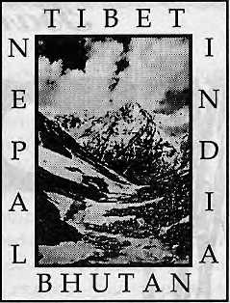
Free Catalog (800) 455-8735
Outside the U.S.A. & Canada please call¹:
001.415.8fiI.239] or write to us:
Himalayan Hi'gh Treks
241 Dolores Street. San Fnmdseo CA
94103-221 I U. S. A. Thanks!

HIMAL March/April 1995
15

Visit Mandala
fa*
■ Scholarly books, maps and guides on Tibet, Nepal, Bhutan and the Indian Himalaya
1 FORTHCOMING 1 |  | WE ACCEPT AMERICAN EXPRESS VISA CARD & MASTER CREDIT CARD | I RECENT ARRIVALS I
Civilized Shamans Buddhism in Tibetan Societies by Geoffrey Samuel  ' Mandala Edition (Original edition published by Smithsonian Institution Press, Washinton DC. USA)  Jhankri: Chamane de 1' Himalaya  (In French Language) EricChazot |  | WE ACCEPT AMERICAN EXPRESS VISA CARD & MASTER CREDIT CARD | Proceedings of the Internationa! Seminar on Anthropology of Nepal: People, Problems and Processes  Edited by Michael Allen  Tales of Turquoise: A Pitgrimage in Dolpo Cornneille Jest  Nepal: A Guide to the Art and Architecture of the Kathmandu Valley Michael Hutt
Wjm MANDALA BOOK POINT
^SSlSpw' Phone: 977-1-227711/216100 (R), Fax: 221129/227372 "^j^^y^y Kantipath, Post Box No. 528, Kathmandu, Nepal
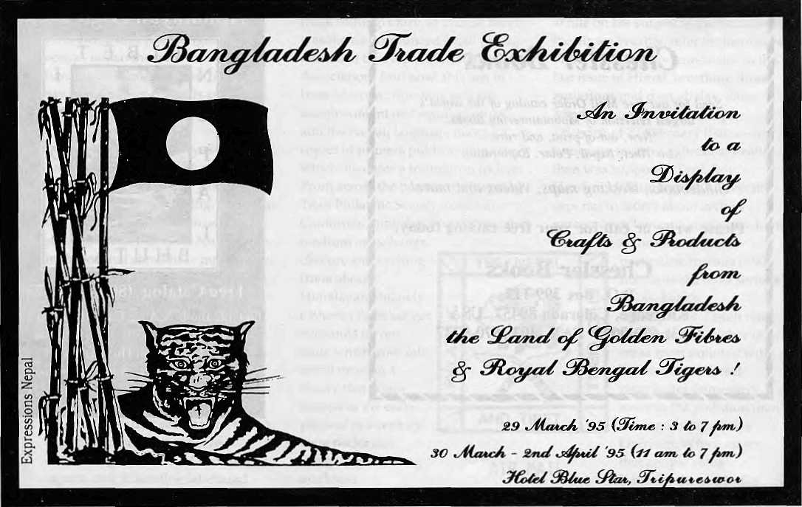


ES
B

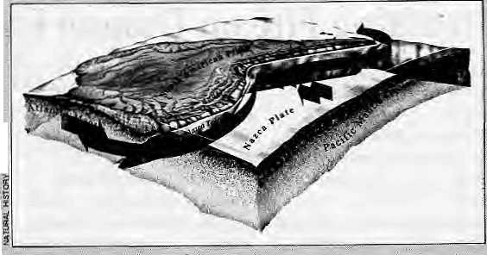
The Andes' Deep Origins
Himalayan geology buffs will find the latest issue of Natural History, magazine interesting for its report on how the Andes came to be so high and so shaped. It has all to do,with the magma flow underneath,
'Basing themselves on the theory of continental drift> researchers Raymond Russo andPaul Silver in the article "The Andes' Deep Origins" maintain that convection currents of magma deep underneath the earth are at work creating the mountains above and giving shape ii> continents. The Andes are
. formed a sa-result of the .alow* motion crash, of the JJ az.ca plate '{the floor of the east
■ Pacific) which is pusKirig... "■ ■■■:-
. eastward, to meet the westward flow of South America, the ;
. mantle under the.Nazca pia'te. backs up due to the westward push of the landmass, andit is this backing up which forms the Andes all along the western rim of the continent.
Write the authors, "We suspect that the pressure that me flow exerts on the Nazca .. '.... slab is transmitted to the leading edge of South America, And halfway down the coast;

Wherethe pressure is greatest, the Andes are the most deformed, in both Horizontal shortening and vertical uplift. The gr^at bend in the : mountain chain is probably also a consequence of the great pressure.'""
Besides backing up, the mantle flow also travels

around the ritjrth and southern¹ edges of South America, much like snow being pushed around a snowplow's shovel. It is this flow oftHe mantle that has sculpted the very distincHve eastward curvature of the southern tip of South America and the rounding of its northern coast.



PtACENAMES by Sonam B. Wangyaf
Sikkijn:
A New and Comfortable House pfl a Crest
,TI\e -fairy" tale, state of bwtte.rfliei; 6rC|iidlH. and■.iftpuHtains-has-
on. the difficulty of etvmolising the name 'Si
in his Among theBittialaya;_{r} published in i.898,.Wadep wrcrtey..
"This I think, isAeetymoiogyoftheNepalrnarneforthecburitry
'(namely 'Sikhim' 'and not. 'Sikkiir/=.a| is soraetime? misspelt in
EngHshbooks). This seerns to Trie to be derived ftoni the Hepailese
of Parbatiy a Sikhin, 'the crested', which welt denotes theleadmg
^{f} featu.re'of (he dpyritry as' seen fr^m Nepal, Where its rri.Quritain
:' ridge? runniftg tifcansvefsely to tho.^ of Eastern t^epalseem to
forma bristling sertes of crests" ' ■ ~ .. "■ - :.■"..
Risfey in ^is Gazetteer cfSikUim (1894) quotes from a much
' , earlier work of Wadde.ll: "I venture to suggest: lhat its mosi
< prbbable. derivation is from the Sanskrit:.-Sikhim - crested..Nor..
■ :'.d6eft the conjecture se^rhtenable thatitis'a.parbatiyatrari.slafiori'
of one of the vulgar forms of Bhutea name for the coyntry■; _{s}viz:~._{t}
/Datro>jong^{r}'Or 'the happy country' from'-. ^li^frVhappy, as the
' word is never Spelt with a u..." \ , ' , '■■■■■ ,; ■ /; ■ "■■ ;
The last part.of Waddell's interpretation doesjrtpt stand up '•« to scrutmy, 'for'even today old-hmers, prefer,. -Sodkhim' (or-
HlWIAl ■MarchiApdl
'Sukhinf) to 'SiKkiiri', It probably was thafway during Waddell's |ime,v© We}!/fpr-eysrias far back as 1793,. Kirkpatrick in his -An Account ■■■■of, the...Kmgdgtri of Heptiul used _{s} 'Sbokhim', Even ..Rahul Sarikritayan, the traveller and writer; in his J95Q DbrjdingParkhayii rrten.tions..th.atN.epaJis,use the term ,'Sukhim';. ...
A reasoh.ablts suggestion is found ip Risley.'s GaZ6tteer, where it is clairried that in the Limbu language sji tnearts 'new' and khim , means'hoQse':RNvSKppra's l91?9.bo6|c'5tfe|fim supports this K;"Ihj the.rerhdte.pas t, the Lepcfias of 0ten?:png and thfe Linibus of eastern N^pal-f^elyrriixedwiih'each other/' he write5,:"Mai'nageswith in the 'two'clans were aiso:common^When a Limb u girlmarried a Lepcha arid arrived at herhusbimd's house she would call it ^Su Hiii\^{r}; i.e., newhouse-'"'"-. . :. .....
)ay,a Dhaitiala's Sikkiin ~ko Itilwds, (1983) supports this with events fromhishiryvASikkiineseking, TertsungNanigyal, married . t:he..d:aughterofCim.buruje'r.of^^A
■■ S.B:Warfayal pr
Sevefai tiimbu 6hie h'd aughters were 'id so nrarried of f toSikkim e'se Kazis (ministers)^Th e new fe rid\scalle d the ir new h omes'Suhim'^ whichthe Gorkhascorrupted tcv'Sukhim' and the British anglicised¹ to 'Sikkim', Risley's khim is more of a Sikkimese-Bhutia word for . ariduse: According to Senior's A Vocabulary of the Limbu Im^ttagt c/ps%r?rKfe]t'fl/.Ct%8),.thf.t6rrectwordfpfh>use.is/(!/H There are ■'oi thers/ who beli eve th a f ...the name" is. a mix oi Nep a li and Limbu: ":'"$ukhiik brjrfpwedi from, the former (meaning, "happy' or p rtable'h arid h im f roni, the la tier.

B

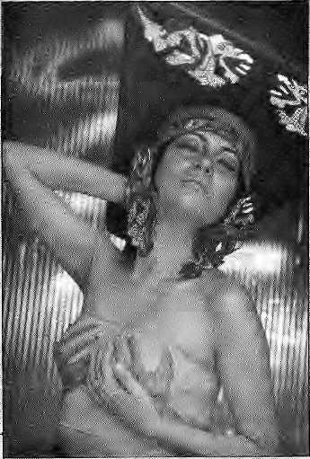
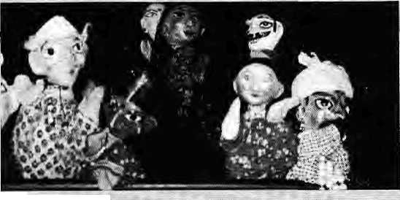
Breathing Fire on Dragon Fashion
In the last Briefs Qan/Feb I
Development Thespians
1199S)_{f} we expressed approval of Delhi's high society's discovery of Himalayan (Kinhaur) motifs for haute couture. This tithe, we take the floor to protest the use of the traditional (and religious) Sikkimese motifs by fashion designer Parikaj Sabharwal. Sabharwali's Autumn-Winter Collection for 1994, titled "Sukhim" is said to have drawn inspiration froift Sikkimese clothing, and includes "a whole range of sensual suits and sarees." Me has subsequently coine up
It is 10:30 at night, but every villager of Kaphlana is still awake. Not only are they up, they are leaning forward with rapt attention, eagerly taking in a wide-ranging discussion about forest protection, alcoholism, legal rightsand women's drudgery.
No high ranking officials nor politician would be able to command such attention of the villagers of Tehri Garhwal. Andy sure enough, the master orators are a bunch of handmade papier-mache puppets.
While' communk ation' tends to be the stepchild component of all development projects, not so in this corner of theUttar Pradesh hills. Here, drama,music, dance and puppetry are being used effectively to spread social awareness and development messages.
Puppet shows tend to be viewed as 'hokey dokey' by many planners, workers and funders of development. Even as they mouth the standard
with a primarily Western .... collection called/'Sukhim II", whose emphasis is on "fabul-; ous headgear and bustiers to give a bold and sexy look"'
There is nothtng wrong with sexy clothing, and it is not possible to bai\ use of religious symbols m the market place entireiy--see the use of the all-seeing eyes of Baudhaby 'NIepal's tourism traders But^ .: we mUst object when a fashion .,., designer uses the traditional dragon symbol of Sikkim in ..' bare-it-rall dresses worft by models in suggestive postures.
The traditional dragon
refrain of the need to haye 'cultural sensitivity' and to do away with 'elitism', stahd-up lectures remairi the favoured means of getting the :: development message across.
However, the activists of the Shri Bniivneshvtrari Mahila Ashram are without cultural blinders, They'imderstand that rruEormationis-moreeffectively transmitted by a puppet than by a social scientist armed with' charts arid tables. The villagers enjoy this form of rural theatre^ which includes stoxy-teljmg^ music and drama.
Puppets of Anjanis&n.
In September 1994, a ' communications teafti from the
symbol carries significance in Tibetan Buddhism as one of the four guardian spirits, which include the srtqw '
.. Jiort, makaraandgariida. The dragon motif used by SabKarwai is to be seen in the coat ofarms of the
. foyalhousepf SildtimvA variation is the national symbol of neighboring Dnik Yui, land of the
■■ fhund>r Dragon. 1
DoesSabharwal,: 1 know the meaning of the hyphenated term 'cuMre-sensitivity'?
Ashram> an NGO that has long be^ti active in Anjajiisain> Tehri Garhwal, toured 11 villages With a trunk-full of puppets. Theygavethree-hour performances; which managed to attract a lot of attention and not aiittle controversy.
In one instance at the ■ village of BensoliTailij one elder refused to allow a woman development worker to participate in the ceremony that opens each puppet perfomiance. This prompted the Women of the village to band together and defend their women's group in front of the entire village. In another instance^ at Koti Village, some
of those present accused atnan of selling alcohol to local youths. The problem was tackled and settled right away in the presence of two hundred villagers.
Thus, the puppet shows have become useful not only for the information they provide, but also as fora where the locals get talking (and shouting) about day-to-day issues that touch their lives.
... It is now after midnight in Kaphlana, and a drama has just ended. Ramlal, head of the puppeteers, is asking the people what the forests mean to them. The responses come from an elderly woman, a small boy, a schoolgirl, and from a mother of five. The interaction is direct and to the point, To end the night's performance, the team sings a traditional Garhwali song about the villagers' bond with the forests. The drums fall silent, and the villagers hum a tune from the show as they head back home in the dark.
- Evan Goldsmith

MsKh/April 1995 H1MAL


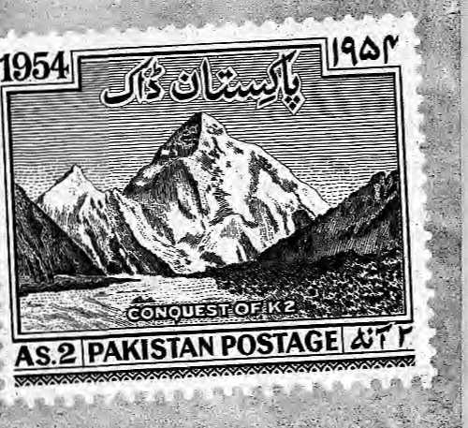
Karakorarn Notes
Objects of Desire in the Northern Areas
i .. or
Inaflurry of activity over the last18 months, Pakistani administrators have' established four high mountain national parjcs in rfie Northern, Areas. Previously, there was^{j} only one, the Khunjerab National Park, gazetted in 1975.
Ttje .governmental action to bring more areas under protection seems directed at heading off a potentially uncontrolled rush to develop the alpine meadows pf'the Northern Areas. With the extension of the Karakofam Highway over the Khunjerab Pass into China in 1982, the area has seen more than a ,. decade of steady growth. The summer grasslands, valued over the centuries only as pasture lands,/have now become the objects of desire among a number of competing interests—resort hotels, polo tournaments, adventure tourism, big game hunting, and the military.
Three of the new "parks have" been established by the Chief Commissioner of the Northern Areas. They are the Shandur-Hundmp National Park, Fairy Meadows National Park, and the Deosai Plateau Wilderness Park. Shandur is where over 50,000 people converge on the high meadows for ari annual polo tournament. By declaring the area a national park, the Chief Commissioner with one stroke reined in the polo players and fans, a group ' not prone to be respectful towards the fragile mountain" ecology. Future tournaments will now be forced to clean up - .ajter themselves*

Fairy Meadows, an alpine ' area on the western slopes of .. Nanga Pafbatihasbeealortg covetedby iShangrilaResorts^ This company, formed by a retired Pakistan Army general, has already constructed a jeep rpad to feity tourists to the meadows, and had plans to build a resoft.hotel: Shangrila. ■.■■■ Resorts was checkmated by the establishment dfthe national park, apd any resort will now have to be located oytside the park boundaries.
The Deosai Plateau is a ■■■-.*■ 3464 sq km high-altitude plain bordering on Indian Kashmir
1 ■-.-'
Uninhabited and lit the area has the largest brown bear population in Pakistan. The riew national park, which is thought to strengthen Pakistan's claim to the territory, reserves ihe entire area fdr preservation andJ research-By fer the most importarit:: of the new reserves, however, is the Central KarakOrairi
National...Park, which includes die Baltorcs, Biafo and Hispar glaciers and their tributaries. Towering over it all at 8616m ■■■is,- of course, the mountain K2, ' The Ba l£oro: Gl a per is already the most popular climbing and' trekking destination in Pakistan,-In 1934 27 out of 50
the Balloro, arid 93 out of 128
the gkc-ier to a spot known as Coricprdia and onward to the K2 Base Camp,
The'move to establislithe CKNP was begun in late 1993 in response to growing
environmental pressures on the once^prisjine BaltorO; Though the park is established, however, several problems of management remain, the most important being the government's attitude. At a workshop orgajiised inSkardu last September by the World Conservation priirin(IUCN). to discuss the park management, go vernmehf representa ti ves
refused to m&ke a Gommitmerit ■• t© share revenue from the park entrance fees with the surrounding Balti and Hunza villages. One researcher ascribed this to "a lingering, attitude-of prejudice towards local communities'-.
Clearly, the "co-manageirie;nf approach" which Kas found favour withNepali park administrators has yet to find a firm foothold in Pakistan. This approach is characterised by a willingness -of government to share power and responsibility for the running of parks management with local communities and other user groups.
Yet, the biggest problem facing the CKNP is the presence of Pakistan Army troops on the Baltoro Glacier. In 1982, the indeterminate status of the northern end of the 1949 India-Pakistan ceasefire !ine prompted Indian troops to move up the Sjachen Glacier, which Pakistan had regarded as part of its Northern Areas. There has been a huge military buildup on both sides and the two armies have fought skirmishes over the Siachen since. On the Baltbf o, as is also happening ,on the mdian side, the -hardware and debris of this "long-simmering wa r continue to accumulate.
Whether the exercise of government control over these hew mountain parks will resolve conflicts resulting. from the multiple users remains to be seen. With the government as. owner, and others as users, no one has sufficient control over resources. U.ntO this gap' between usage and control is resolved, effective management of the parks of the Northern Areas seems unlikely,
- John Mock

HIMAL MmhlApd 1395
19

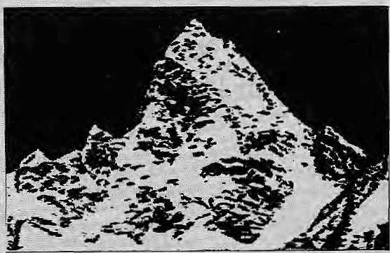
B
Scandinavian Scandal

Norges konsul i Nepal:
- FjeUet
erikke
hellig
pabuddhlslfT Oft Ube- l2 tflfl±lte luna-huddhLstr-
n*liHujjikriv€ratf—* '^ -
•The peak Is not footy" • Norwegian consul.

Over the month of February .and March, a media storm shook Norway regarding a climbing expedition to Nepal's Rolwaling region. The fight was between Norwegian social scientists, philosophers and environmentalists who feel a special affinity for Rolwaling/ and mountaineers whohad targeted Dragnag Ri (6801m), a previously unclimbed peak in the area which was opened fpr expeditions a year ago.
The controversy managed to get threes of Norway's;. .biggest newspapers and two television stations involved, and dragged in Prime Minister Gro Harlem'Our Common Future' Br undtlandarj d m any others. Much ink and air time was used up, but Kathmandu never even felt a ripple of the, waves, emanating in Oslo:"
The opposition's charge was led by Arne Naess^ an 82-, year-old pliilosopher who developed his well-known "deep ecology" thesis two decades ago based on his>kidy of man-and-nature relationships in Rolwaling.
AtErikSteineg
bo«m°"JSJS
ulalal'i>^{lfl[1!leI} cUElltoIJpmW!
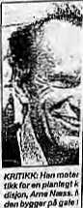
KeligiBse giupper i Nepa] awiser over-Tor den norske kon-sufen i Katmandu
20
Brundtland
Pitted against hirn washis
nephew; also named Arne
Naessj a"flamboyant
mountaineer who makes ,his
name and living through vvell-
publicised blitzkrieg assaults
onunsuspectinginountahv .,..
peaks, ■ . :-: " ; , ■■■■■■■■. ;
After his first request for , permissiorito climb Dragnag Ri was refused by Kathmandu's Ministry of Tourismv(when the peak; was still out-of-bound), Arne Naes£ the climber approached Prime. Minister Bfundtland for help. She wrote a letter to then-.... Nepali Prime Minister Girija ". Prasad Koirala, stating that the expedition application was " a matter tharis potentially of great interest to,the ^people, of: both countries".
Tfipse Wh6 opposed the expedition read this as a not-scHsubtle threat by a.powerful''.. Northern dortor eountfy against an aid-receiving Southern one, (Kathmandu receives a little under 50 milUon kroner; or NRs 200 million,;in.foreignaid-frorri, ■■■■■ Osloannuaiy.) Thte expedition
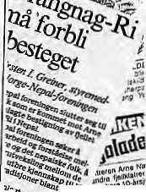
n£ J^ft^fl?,
Koitim⁶¹¹-.
BragnagM 6801 m.
leader even daimed an : tel|vision that "he had Itojd,, Bmndtlahd to use the issue oJF'. Norwegian aid toiget ... permission for the.peak.
'".. Dragriiag Ri is a peak up ' the side^v alley bf liimu, jtist off the main valley of Rolwaling .. northeast of Kathmandu. Eco-phiiosophef Sigmund Kvloy, who also has longstanding links to Rolwalirig, derides the /'culturally ignorant mountaineersand toiir operators" who make up and support the expedition. Going in with television crews and extreme media hype; he say^, the expedition is set to expose a saered Himalayan Buddhist valfey to a deluge of tourists. ; " According to Kvloy, Rolwaijng is one of trts beyiils, (areaSiOf refuge), blessed 1200 : years ago by Guru Rimpoche (Padin^sambava) as "a place to: seek refuge from war, violence, competition, selfishness, to live in harmony with people and nature,*' He adds, "Even among the. beyul valleys of Himalaya, Rbl>yal ing is special, since one of its mountains is Tserihgma (Gauri;Shahkar),ihe abode of the universal mother earth spirit, revered throughout the the entire Tibeto-Himalayan Buddhist '.region:'"
PierKuayarne; an ethno-linguist; adds, "Dragnag Ri is
not more holy than other mountains, but it is situated in art areawhere both mountains and the valleyand the surrounding areas are' considered protected: and holy in jhe local Sherpa culture." The opposition believed that a Norwegian expedition had no role in disturbing the peace of Rolwaling in such a manner that the region would become a magnet to mass tbunsnif like adjoining Khutribu.
The battle lines were drawn, and a free-for-aU ensued in the tabloids and on television. In response to the Norwegian Nature Conservancy's demand that she withdraw support from the expedition, Brundtland issued a press release stating that "there has been no information available that Dragnag Ri is holy or on the special nature of the area", and that "requests about the Nepali mountains should be directed to the Nepali authorities."
In Nepal, reported one 'Oslo tabloid, the entire controversy was being viewed : as a storm in a teacup. "The opinion that the mountain is holy is incorrect," was how one paper quoted Gunyor Heiene, the Norwegian Consul General in Kathmandu. A Ministry of Tourism official said he saw no problem with the expedition
1995 HIMAL

Conference Report
Refugee Situation ufiderthe JVJicro^j>e
A one-day seminar on Bhutanese refugees was held at Columbia University in ,New York on 28 February, where some 140 scholars, students and activists .discussed issues of equity and fairplay as they apply to the 87,000 plus refugees in the camps of south-eastern Nepal-The participants were concerned that the demands of
"as the Rolwaling area has been Opened." One Rofwalirtg Sherpa hoped that the Norwegian expedition would not cancel its trip: "The "Sherpas have opportunity to climb and earn income." To buttress their position, the organisers pointed out ftait the expedition was blessed by the" respected British Mountaineering Council, and had as members big names like
,Chris Bonnington and ■Perteniba, the famous clirrtber of Khumbu.
On a television talk show in which both appeared, the philosopher Ame Naess leaned towards his nephew, and said,, "Okay Arne, if you really want to climb the mountain, why
-don't you just gcrhalfway?" That wpuld, Of course, defeat the purpose of the nephew, who complains of being constantly harassed by
'.Norway'sgreens. He maintains that all mountains are holy to Himalayan
¹¹ Buddhists, and"that while some might be extra;holy DragnagRi is not one of them. "The Nepali authorities would never have given permission if Dragnag Ri was considered
, holy,* he added,
expediency not sideline the interests of the Lhotsh^Lmpa refugees.
Among its
recommendations, the m eeting stressed that in seeking a settlement the parties involved take account of international norms concerning citizenship and immigration; talks : between Bhatan and Nepal include "active input" from the
Nild Faarlund, Director of the Norwegian Mountaineering School; is ho fan bf'the climber, Faarlund, who backs low-impact' climbing, told the journal ■ Norwegian Climber tha(.he was .. aga'mstttte expedition; "He (Arne 'Nae^s) is a person/iyho ' uses big mountains to make himself bigger, and who cannot go tin a trip without " telling 1h*e mass media*" ■
Why should the Oslo
scholars be worried about a
climb in the Himalaya if the
Nepali Government itself has
no objection? Says Stein , !
Malkenes, President of the
Nature Conservancy, ''The
basic feeling is that ■
Norwegians should riot be
doing these kinds of«yuppie
activities. It is very ■ .,.
embarrassing and people
at the grassroots here ije^cfe ~
to it mentally." JiMa
Particularly because of the ■ special links they have wifiti the Rolwaling region^ says : Malkenes; Norwegians should rtd*t rush into; pristihe, areas just: because they are opened gnd "everyone else does it". He :; ,, added, "We must hold' ottrsejves to ^higher" standard."
refugees themselves; a thijcd vparty be brought in to mediate
■' the bilateral talks as well as to monitor the ve riff cation procedures for ascertaining refugee status; and tbat there be institutional safeguards to ensure safe return of refugees
■s as iyell as their security after repatriation.
■ Panfelisfs 6f the meetingi (which had be,en Co-sponsored by the' New York-based advocacy group the Alliance for Human Rights and Democracy in Nfepal) included political scientists, human rights.activists, and representatives of Agencies like Amn&sty Interna tionaj. Cb. axles Graybow, of the conservative thinktank Ereedorn.House, proposed thai Bhutan was "among the worst violators of human rights in the world" ahd maintained that Thimphu's emphasis on "cultural identity" was ?'a euphernism'for staying in
: power". From the other end of' the political sipectnan, the Iridian jurist Clarerice Dias maintairted that Bhutan's pplicfes regarding its Nepali-speakmg population violated each of the 30 articles-in the .Universal Declaration of Htjrhan Rights,
Dias said whether the refugees were,citizens of
, Bhutan 6t not should be decided und^¹ accepted international standards. To accept Thimphu's claims on
"Citizenship "would be to impart the utter inecjuality
„ and discrimihation of B|iutanes^ law and perpetuate it in'an iriternational
v set|lertwnt,"hesaid.
Le6 Ii. Rose, the South Asian'
scholar from Berkeley, expressed the, opinion that Western governments should not get involved in trying to resolve the refugee matter. He said both Bhutan and India were deeply suspicious of UNHCR's role, in particular b ecause Us repres entative in JCathmandu was a Pakistani.
While Rose expressed ' optimism that the bilateral talks of the Nepal-Bhutan Joint Ministerial Committee were moving along well, the rest of the participants agreed that there has been little to show for the four rounds of negotiations that have taken place thus far. (The fifth round, which met in Kathmandu a week later; was equally unproductive.}
Narendra Bikram Shah, Nepal's Ambassador to the United Nations and formerly a member of the Joint Ministerial Committee, expressed concern about the problems that would arise if Thimphu were to insist on the applicability of its Marriage and Citizenship Acts. "I will be straightforward in saying that the laws of Nepal and Bhutan on these matters do not form a seamless web, and the discrepancy leaves room for the creation of statelessness on a massive scale."
Summarising the recommendations made by the seminar discussion groups, Paul Martin, who heads Columbia University's Center for the Study of Human Rights, said that non-governmental organizations must piay a role in monitoring the observance of international human rights laws arid ensure that the long-term interests of the refugees are protected in the Nepal-Bhutan negotiations,
- Ashok Gurung

HIMAL March/April 7595"


FOR THOSE WHO WANT TO SEE
- ■
THE DOLPHINS LIVE
Program yourself to a different wildlife atmosphere at
DOLPHINS MANOR
(A wildlife resort in West Nepal) BARDIYA NATIONAL PARK
The Manor actively supports NEPAL CENTER FOR RIVERIAN LIVES
(an N.G.O. working on the conservation of Nepali river dolphins and other aquatic wildlife in Nepal)
FOR EXCLUSIVE COMBINATION OF TREKS AND RAFTING IN WEST NEPAL
Contact
P.O. Box.: 3769, Lazimpat, Kathmandu, Nepal
Phone : 420308, G.S.A. Office Thamel - 417191
Fax ; 977-1-220143 FOR MENUKA


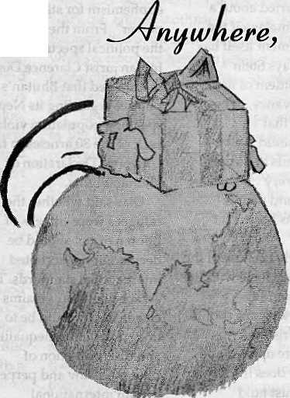

nuthlnq,
a 0'
nu ti
ime

Overseas Cargo Service and J.P.N. Exports, Thamel, Kathmandu
P.O. Box 8621, Kathmandu. Phone: 977 1 413391 Fax: 416850

I
o
n i
n

An Open and Shut Case for Uttarakhand
by Bhairav Dutt Pande

A
s someone emotionally involved with the Uttarakhand agitation, I have followed, with interest the articles and correspondence published in the last three issues of Himal. I was born in Uttarakhand, and after a long career with the Government of India/ have now, for the past 20 years, been living in my ancestral home in Almora. Several people have asked me to pen down my thoughts on the Uttarakhand agitation; I refrained. I think I should do so now.
Six months ago, an agitation eruptedinUttarakhand, following the announcement of a 27 percent reservation for people from Other Backward Castes and Classes (OBCs). The agitation was immediately dubbed anti-social, anti-reform, unprogressive, pro-high caste, pro-manu-wdi, backward looking, etc.
This propaganda, unfortunately, did not take into account the fact that the people of this region had played an active part in the independence movement and various other social reform movements. They did: not oppose OBC reservation just for the
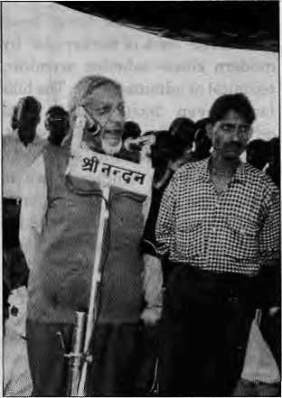
sake of opposing it. What the students, and later the teachers, government employees, ex-servicemen, etc., demanded was that reservation reflect the region's population ratio. The OBC population in Uttarakand is estimated to be not more than two percent.
Twenty-Seven Percent
Why was 27 percent reservation so vehemently opposed here, especially when earlier, the hill people had supported reservation for scheduled caste and schedule tribes? No attemp t, I feel, has been made to understand this. Unlike in other parts of rural India, agriculture does not provide even basic sustenance in Uttarakhand. Land holdings are meager and fields are actually narrow terraces in steep hills. If high mountains and steep hillsides are not considered, and only agricultural land taken into account, the density of population per hectare is even higher than in eastern U.P. And what are called canals in the hills are actually a misnomer for drains.
It is a rare family in the hills which has food for more than six months from their land; most get even less. But {oT&tewatta-chakkis and saw mills, and that too in the Tarai, there are few employment opportunities in Uttarakhand. As soon as a male child becomes 15, he migrates down to the plains; other members of his family back home survive on what is called the "money order economy". A large number of households have only their old and very young living at home. There are many villages where the entire population has moved out and many fields lie abandoned as there is no one to cultivate them.
If migration is the only solution for survival, preparation for it is necessary, which means a basic education to enable the migrant to
obtain suitable employment outside the region. This the new reservation policy denied the local youth because people from outside the region, at the expense of people living here, could benefit from the reservation quota. When all this was building up, the State Government announced that it was not possible to have a separate reservation for this region. The demand for a separate state gathered momentum.
The formation of a separate Uttarakhand is a very old demand. Even before Independence, it was made at the time of the Second Round Table conference and again when Cabinet Mission visited India. It was also raised before the States Reorganisation Commission in the 1950s and was endorsed by Sardar K.M. Panikkar. Unfortunately, he was overruled by the other members, on the grounds that the area would develop better if it remained part of the bigger state of U.P.
Comparisonsstarted to be drawn with neighboring Himachal Pradesh, whereconditionsaresimilar. The OBC population there is also very small and reservation for them is, accordingly, only 10 percent. Thus, when the Uttar Pradesh State Government said that a separate quota would not be possible for Uttarakhand, the demand for a separate state gained momentum.
Separate but Unequal
Even before Independence, Uttarakhand has been treated differently from the rest of U.P. For example, while the Mitakshara system under Hindu law prevailed in U.P. and most of India, it was the Dayabhag system that prevailed in Uttarakhand. Even this was modified by special customary laws applying to "khasa" fami-
8.D. Pande addressing a Uttarakhand rally in Almora.

HIMAL MarzhlApril 1995
23

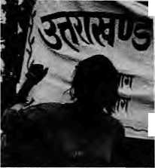

lies. And among several communities their customary law had precedence over the Hindu traditional laws.
The revenue law was also different. There was no zamindari system as in the plains. Thus when the Zamindari Abolition Act of 1950 was passed by the U.P. legislature, it did not extend to Uttarakhand. A separate and very different law was passed for this area in 1960, which came into force in 1966. The police system is different even today. The village revenue officials have police powers of registering and investigating. In addition to these, over the last 20 or more years, a separate hill department has been created in the U.P. Secretariat with a separate Minister-in-Charge.
There are separate heads of various departments—education, health, agriculture, etc.—for this region and there is now a separate additional Chief Secretary, and a separate budget for the region sanctioned by the Planning Commission. Thus, for all practical purposes, while the local government of U.P. (and even the Govt. of India through the Planning Commission) recognised this region as separate, on the reservation issue it was not considered so.
At the same time, two separate governments—the Bharatiya Janata Party in 1991 and the Samajwadi Party and the Bahujan Samaj Party in 1993, supported by all other political parties including the Congress—adopted unanimous resolutions for the creation of Uttarakhand by adopting the necessary amendments under Articles 2 and 3 of the Constitution. The boundaries of this proposed new state were also clearly defined in the resolutions.
The Government of India, however, has not heeded this d emand. Unfortunately, legitimate and reasonable demands do not seem worthy of consideration without an 5 agitation. Acceptance of such demands, it issaid, will lead tosimilar demands elsewhere in the country.
There is, however, a clear difference. In no other case are there two resolutions by different governments unanimously adopted by the state legislature. In other places, there is no such agreement among different political parties. Secondly, administering large states with big populations is becoming an impossible task. Progress made by small states like Punj ab,Haryana,and Himachal Pradesh corroborates this.
Sometime in the near future, in five years or less, a second States Reorganisation Commission should be (or will have tobe)setupto examine the whole question of state boundaries de novo. This commission can also consider other cases such as those of Vidharba, Telangana, Chattisgarh,etc. But Uttarakhand need not wait for this just as other states (Arunachal Pradesh, Meghalaya, Nagaland, etc. in the Northeast and the states of Goa and Pondicheny) did not have to wait for a new States Reorganisation Commission.
Part of India
Demand for a separate Uttarakhand is also labelled secessionist or divisive. This argument is also totally without merit and does not take into account the strong historical ties of this region with the rest of India. From Vedic times, to the days of Mahabharat and Kalidas, right up to the present, this has been an integral part of India. Even today, for example, the chief priest of the famous Himalayan shrine of Badrinath is a Namboodri Brahman from Kerala—a custom that has been in place for the last 13 centuries.
A question often asked is whether a separate Uttrakhand will be an "economically viable" entity. In the classical sense, the answer is "no". But then, which Himalayan state is economically viable in that sense? In any case, formation of states is not based on this criteria. Many factors, some enumerated earlier, have to be taken into account. One has also to consider the fact that even the states not so well endowed at the time of
formation have prospered subsequently.
The very unsatisfactory development of this region in the 40 years since Independence also supports this demand. Before 1947, this area was the most advanced in all of the Himalaya. It had advanced horticulture, veterinary and other institutions. But recent data points out that this region has lagged behind. Comparison of data for Himachal Pradesh and Uttarakhand illustrates this well. Special consideration was given to the needs of local people even in pre-independence days, in. forest laws, agriculture, land tenures, etc. New restrictions have now been placed on peoples' rights and privileges. These developments have belied the expectations of the last States Reorganisation Commission.
The new state of Uttarakhand will be larger in population than Himachal Pradesh and almost equal in area, larger than all other Himalayan states except Jammu and Kashmir. This will enable the formation of a responsive Government, and lead to quicker and better growth—as those incharge will then live and work here and understand the people better. They will go through the changes of seasons, and not pay a merely passing visit during the months of May and June or October— or merely be on a pilgrimage to the holy shrines.
This area has long been considered "back of the beyond" by modern elites—whether scientific, technical or administrative. The hills lacks even basic health and educational facilities, transport, communications, and so on. To overcome these handicaps and to achieve the formation of a separate state, the people of Uttarakhand are prepared to make whatever sacrifices necessary.
b
B.D. Pande has served as Governor of West Bengal and of Punjab, and before that was Cabinet Secretary to the Union Government of India. He lives in Champanaula, Atmora.

24
March/April 7995 H1MAL

■



Vocabulary l^essons
lv elcome to ly epal in L' re neb u IJ ienvenue au £> bangri~±ja. Vv elcome to JS epal in O pan'uh U Ijienvenido al S hangri-Lja. Welcome to JSlepal in Knglub u Vv elcome at Shangri-La. Welcome to Ps epal in Italian u Henvenuto al & bangri-La. Welcome to IS epal in (jerman U willkommen in O bangri-La. Welcome to JSepal in Japanese id X' h-> I.*-v3 -£ Sbangri-JUa.

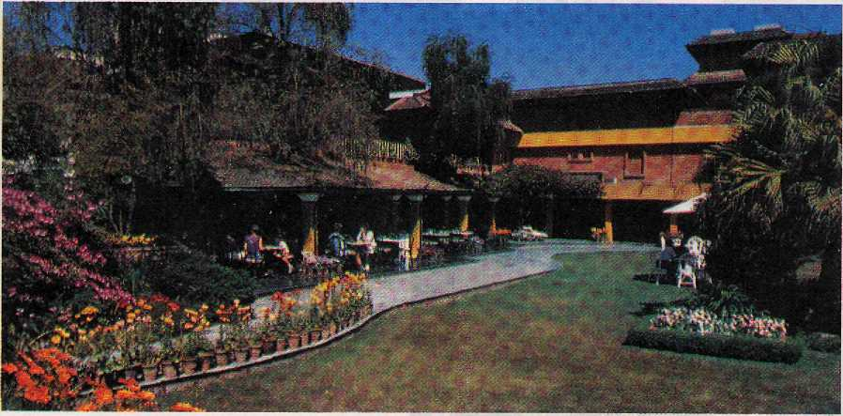

Hotel SHANGRI-LA
82 Deluxe Rooitut

SHANGRI-LA
KATHMANDU
Your private paradise



LAZIMPAT. G.P.O. BOX 655. KATHMANDU. NEPAL - TEL: (977.1) 412999 - FAX: (977.1) 414184 - TELEX r 2276 HOSANG NP

I
Photo Essay



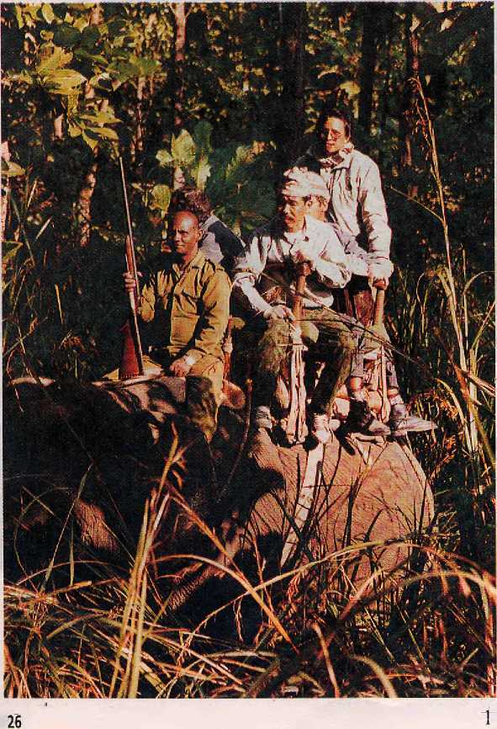
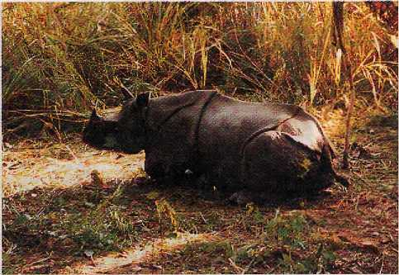
On 18 December, a 15-year-old male rhinoceros from the eastern precincts of the Royal Chitwan National Park forded the Rapti river to raid the fields of Pyaredhap village. It was the season for wheat, mustard and chili pepper (khursani), which the rhinos relish.
In trying to shoo the rhino away, the villagers used iron-tipped spears of the kind found in most Tarai villages. One throw opened a gash on the rhino's rear left flank, while another spear lodged itself deep in the soft cartilage of the right foot. The wooden shaft dropped off, leaving the tip firmly in place.
March/April 1995 HIMAL

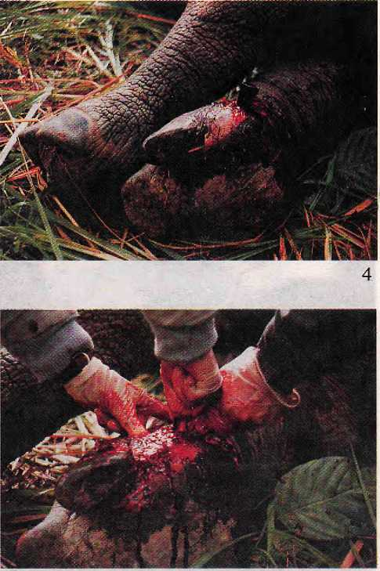
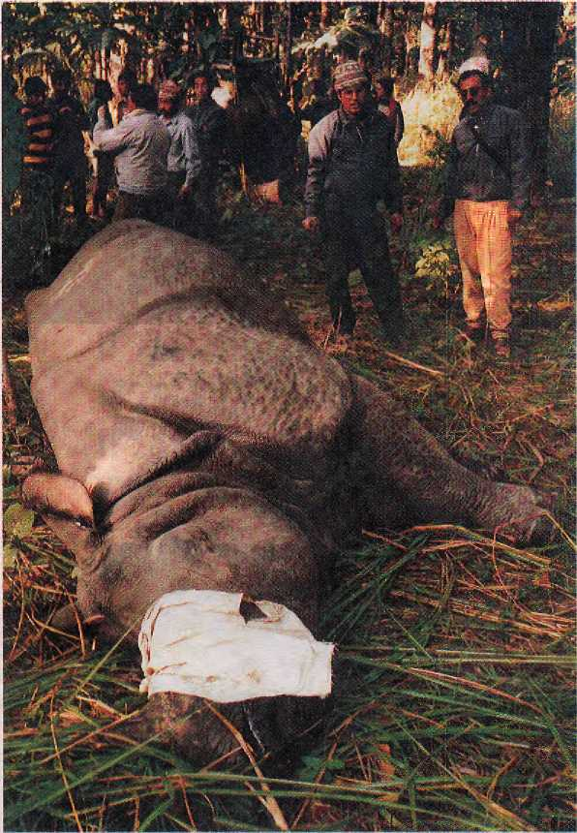

On the morning of 19th, elephant drivers from the Chitwan Jungle Lodge taking tourists for a morning of sightseeing in the riverine forest noticed the rhino in the undergrowth. As the rhino tried to move away from the elephants, they noticed the two-ton animal's heavy limp. Upon closer scrutiny, the sharp-eyed ele-phant drivers noticed the metal imbedded in the front right instep.
The Lodge manager alerted the Park headquarters at Kasara, 15 km to the west, downstream along the Rapti. Assistant Warden Tikaram Adhikari arrived the next morning with vets Kamal Gaire and Balakrishna Giri 1. The Park's most experienced shot, Bal Bahadur Lama, propelled a tranquiliser dart towards the rhino's backside. Before ten minutes had passed, the beast began to sway
on its feet and then went down to a crouch 2. In another few minutes, he was out.
When the rhino did not stir in response to a smart kick from Adhikari, the rest of the party quickly got off the elephants to complete work before the tranquiliser wore off. The rhino was rolled over so that the wounded leg showed. A salve was applied on the open eyeballs to ensure that they did not get dry. Cloth was used to cover the eyes and plug the ears to reduce the sensations affecting the heavily breathing animal 3.
The vets first tried to pull the spear point out of the swollen, puss-laden foot, but the arrowhead was stuck in the tendons and was impossible to free up despite ,furious tugs 4. After several minutes of heaving at the

HIMAL March/April 1995
27

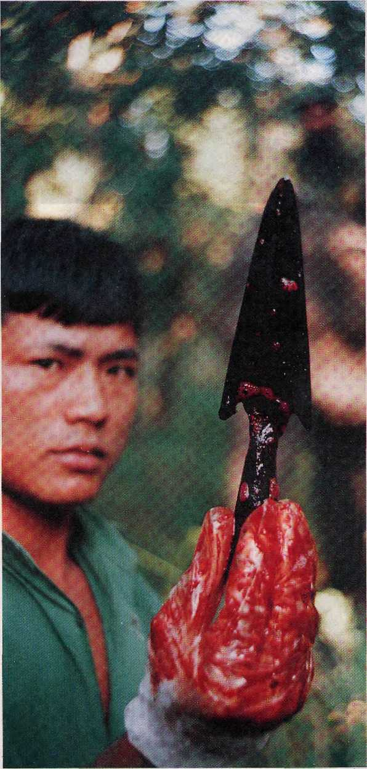
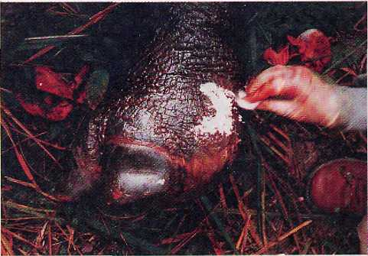
metal shaft, Gaire and Giri decided to operate. Using scalpels, they cut into the bloody foot and pried out the long arrowhead 5,6.
Antiseptic powder was applied to the wound 7 and the rhino woke up with an antidote injection that countered the effect of the tranquiliser. The Park staff scurried up their elephants and within two minutes the rhino was on his feet. Swaying and leaning against nearby trunks for support, the patient limped into the Chitwan undergrowth.
Spotters from the Lodge reported a few days later that the rhino was doing fine, in place once again in his role as dominant species of the Chitwan jungle. He might or might not go back to raid the khursani fields which beckon from across the Rapti.

pictures and text by Kanak Mani Dixit

28
MaKhlApril 1995 HIMAL

For once, Think twice !

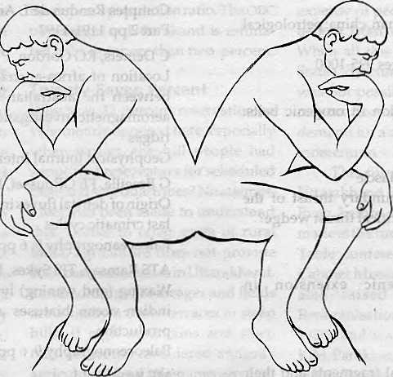

Are you looking for the cheapest rates ? Or, do you want value for your money ?
At Summit Nepal Trekking we design our programmes that ensure you get full value for your money.


MMIT NEPAL TREKKING
Write or call us at:

P.O.Box 1406,Kupondol,Kathmandu,Nepal Tel:525408,521810
Fax: 977 1 523737

V
o
I

A MO UTHFUL OF ROCKS is what one gets in the "Latest Himalayan Papers Found" listing in HimNet, the internet bulletin board on the Himalaya that can be accessed by dialling HimNet@erdw,elhz.ch. The papers listed are those that appeared in print during November and December 1994.
HP Schertl, AI Okay
A coesite inclusion in dolomite in dabie shan, china; petrological
and theological significance
European Journal of Mineralogy 6:6 Pages 995-1000
Singer
Magmagenesis associated with extension in orogenic belts:
examples from the himalaya and tibet
Tectonophysics 238:1-4 pp 183-197
JL Mugnier, P Huyghe, E Chalaron, G Mascle Recent movements along the main boundary thrust of the himalayas: normal faulting in an over-critical thrust wedge? Tectonophysics 238:1-4 pp 199-215
JCMareschal
Thermal regime and post-orogenic extension in
collision belts
Tectonophysics 238:1-4 pp 471-484
LERicou
Tethys reconstructed: plates, continental fragments and their boundaries since 260 ma from central america to southeastern asia Geodinami^a Acta 7:4 pp 169-218
DM Winslow, PK Zeitler, CP Chamberlain, LS Hollister Direct evidence for a step geotherm under conditions of rapid denudation, western himalaya, pakistan Geology 22:12 pp 1075-1078
MG Kogan, JD Fairhead, G Balmino, EL Makedonskii Tectonic fabric and lithospheric strength of northern eurasia based on gravity data Geophysical Research Letters 21:24 pp 2653-2656
RK Vishwakarma
Fluid inclusion evidence for amphibolite-granulite facies transitional metamorphism in delhi supergroup of rocks Journal of the Geological Society of India 44: 6 pp 691-692
MT Shah, M Ikramuddin, JW Shervais
Behaviour of tl relative to k, rb, sr and ba in mineralized and unmineralized metavolcanics from thedirarea,northern pakistan Mineralium Deposita 29:5 pp 422-426
JM Stock, J Lee
Do microplates in subduction zones leave a geological
record?
Tectonics 13: 6 pp 1537-1546
N Harris, J Massey
Decompression and anatexis of himalayan metapelites
Tectonics 13: 6 pp 1537-1546
JP Pupin
Characterization of sources of migmatities and crustal anatectic
granites from zircon studies
Comptes Rendus de L Academics Des Sciences Serie II319:10
Part 2 pp 1191-1197
C Demets, RG Gordon, P Vogt
Location of africa-australia-India triple junction and motion
between the australian and indian plates: results from an
aeromagnetic investigation of the central indian and carlsberg
ridges
Geophysical Journal International 119:3 pp 893-930
G Braeille, FE GRousset, M Labracherie, LD Labeyrie, JR Petit Origin of detrital fluxes in the southeast indian ocean during the last crimatic cycles Paleoceanography 9:6 pp 799-819
ATS Ramsay, TJS Sykes, RB Kidd
Waxing (and waning) lyrical on hiatuses: eocene-quaternary
indian ocean hiatuses as proxy indicators of water mass
production
Paleoceonography 9:6 pp 857-877
ME Brookfield
Problems in apply ing preservations, facies and sequence mo dels tosinian(neoproterozoic) glacial sequences in australia and asia Precambrian Research 70:1-2
AK Singvie, D Banerjee, K Pande, V Gogte, KS Valdiya Luminescence studies on neotectonic events in south-central kumaun himalaya - a feasibility study Quaternary Science Reviews 13; 5-7 pp 595-600 MP Segall, SA Kuehl
Sedimentary structures on the bengal shelf - a multi-scale approach to sedimentary fabric interpretation Sedimentary Geology 93: 3-4 pp 165-180
The LHENGYAL SHUNGTSOG, Bhutan's
Cabinet, met for its 109th session on 26 January 1990, to discuss the emerging problem of southern Bhutan. Kingjigme Singye Wangchuk chaired the meeting. Excerpt from the minutes, kept by Foreign Minister Dawa Tsering, provides a window on Druk concerns.
His Majesty was pleased to say that the present discontent in southern Bhutan is not due to the policy on dress. People would not agitate over such a small thing. Rebellion starts in the mind and the dress policy only brought this out into the open. If the agitation had not started now but came after ten years, the

30
March/April 1995 HIMAL

c
E
S

situation would be extremely grave. It is better to tackle the problem now when the situation is favourable, rather than in the future when we will not be able to control it. His Majesty said that everybody blames Tek Nath Rizal, but in actual fact Rizal had only articulated the aspirations of the Southern Bhutanese. That is why what he said had received such a favourable response in southern Bhutan. The main problem is that the aspirations of the nor them and southern Bhutanese are different. It is highly important for the nation that the aspirations of all Bhutanese should be the same. As such, we should not delay in implementing the policy on national integration even by one day. The responsibility of the Lhengyal Shungtsog members is to implement this policy with firm and unwavering resolve in order to remove the great danger facing the nation. For His Majesty's part, he will fully discharge his responsibility of safeguarding the kingdom's security and independence. His Majesty was also pleased to say that in view of the overriding importance and urgency of the policy of national integration, other policies will have to be set aside for the time being,
THE MURMURING MAN is the titk of the book by
A.N.Purohit (Bishen Singh Mahendm Pal Singh, Dehra Dun 1995), in which he uses the Bhagwad Gita to deconstruct the modern-day quest for sustainable development, Man will continue to "murmur" because he is never satisfied, he says.
Development is the expression of environmental evolution. However, its rate is controlled by the life style of the elites in society. This idea has not emerged recently but probably is another universal truth as is apparent from Sloka 21 of the 3rd Chapter of the Gita. In the present day context, Radhakrishnan (1970) has interpreted this sloka as: "common people imitate the standards set by the elect."
Today the cry about environment and development is being raised by those who are on the way to the peak of a mountain of development or those who have already reached the peak, whether it is a society or an individual. Those who are developed are the ones who are talking of the danger of an environmental catastrophe. Because they are afraid of the fall they apprehend, they are trying to convince others to either move slow, or not to climb up the mountain. However, they themselves are still trying to go up. Is it possible that these people will be able to convince those who have yet to start climbing up? The masses will be convinced only if those who are at the peak start retreating and those who are on the way, stop where they are. They unite and give one and only one definition of'rightand wrong" with respecttotheuseofeachenv ironmental component. In other words, preachers of today become teachers by demonstrating that they mean what they say. If such a
precedent is set then only we will be able to delay the "thing which can happen" which may exterminate us.
In case the philosophy of self-control does not penetrate the heads of elites in the society or the elite societies, the rate of retrogressive development will be faster and extermination will be quicker, especially for those who are near the peak of the mountain of development. Therefore, the elites need to develop self-reverence, self-knowledge and self-control, if we want to have environmentally-sound development for the future.
INTHEBEAUTIFULKATHMANDUVALLEY,
the title of her poem in the Dhaka Club Sovenir, Bangladeshi junketeer Tahmina Ahmed pontificates as she awaits yet another environmental media workshop.
In the hotel garden
Was a huge Babla tree
With two eagles sitting on its top branches
Screeching from time to time
Letting the birds and the bees know
That winter was soon to come
In late November in the beautiful Kathmandu Valley.
It was the day before the media workshop
While waiting for the participants to pour in
From Asia Pacific region,
I walked in the hotel garden
Smelled the sweet flowers, looked at the well cared plants
And felt at peace with myself
Surrounded by birds and bees and the Himalayan Range.
I remembered my home, my garden in Dhaka
Red Roses, white Beli, pink Orchids in bloom
Green coconuts hanging from above, swishing mango trees
But with no time to see them
Rushing in and rushing out
Press conferences, Deadlines to meet,
Seminars, Workshops, Meetings
Parties, Birthdays, Weddings
Kul Khanis, Milad Mehfils,
Family gatherings and Board Meetings
While the garden stood by.
Years back I remember
I used to care for my garden
Watching the buds bloom
While the birds and the bees sang.
Tomorrow when the workshop starts I will turn into a robot, Dipping myself in a mountain of words While the Himalaya stands by.

HIMAL March/April 1995
31

Wild Imaginings


French Anthropology in the

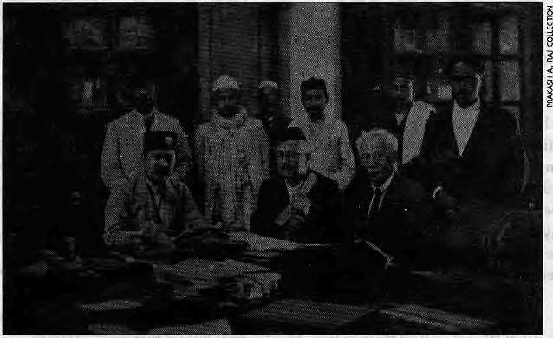
Sealed from right to left Sytvain Levi, Hem Raj Pandey (Mahila Guruju) and Keshar Shumshere at government library in Kathmandu, circa 1923.
,

by Anne de Sales

I
n 1898, a French scholar came to Nepal in order to study ancient monuments, inscrip tions, texts and m anuscripts. They hadbeenpreservedherebetterthaninlndia, thanks to the mountain climate and benevolent political and religious institutions. In spite of a policy of isolation, the Rana Prime Minister Bir Shumshere granted Sylvain Levi permission to spend two months in the country. S. Levi's short visit led to the publication, in 1905, of Le Nepal: Etude historicjue d'un royaume hindou (Nepal: A Historical Study of a Hindu Kingdom).
Le Nepal was the first historical synthesis of the country inaEuropean language, based on the works of British officials as well as the author's own research. This remarkable book isnot free from the prejudices of a Sanskritist who looked at Nepal from an Indian perspective, and its forthcoming translation into English will no doubt lead to controversial commentaries. However, Le
Nepal may be considered as the pioneering work of French anthropology in Nepal. Because there are now numerous French works concerning Nepal in print, it is worth examining the direction that the research has taken.
Levi describes himself as "a philologist in the field (en mission)/ being obliged by profession to go about with princes and pandits, halted at the threshold of thesociety by tremendous caste prejudices, but who from the outside observes passionately the stream of men and things as if it were the living commentary of vanished ages." For him, "the past remains an incomprehensible enigma if isolated from the present."
Half a century later, when French researchers—institutionally consecrated anthropologists—started visiting Nepal, they took up with Levi's statement, even if in their approach they inverted the terms of the enigma; thepresent remains indecipherable if isolated from the past Right from the
beginning, these French-speaking researchers in Nepal tended to distance themselves from the positivist and scientific trend that was dominating the theoretical debate in the 1 %0s. The structuralist methods that were flourishing in France at that time did not seem to appeal to them; neither did the quest for formal models and general laws. Most of their work is therefore characterised by an ethno-historical approach.
Region of Multiple Contacts
When in 1973 A.W. Macdonald was appointed to head INAS {now CNAS, the Centre for Nepal and Asian Studies at Tribhuvan University), he stressed the need for students of Himalayan communities to combine ethnography and textual research and to study events that transform structures. Later on in France he would train several students in this perspective. Most of Macdonald's papers, written between 1952

32
March/April 1995 HIMAL

and 1984, have been translated into English and are easily accessible. The widesweep of the subjects he wrote about, ranging from Southeast Asia to Tibet, from Buddhism to local jhankris, and from the MuhikiAin (the civil code of Nepal) to the Tamba Kaiten (a collection of Tamang genealogies, customs and songs), indicates that Macdonald saw the Himalaya as an area of multiple contacts, intelligibleonlyiftheresearcheriswillingto go beyond the small-scale studies and specific research.
However, the genre of literature through which nearly all researchers first pass is the monograph, the obligatory beginnings of an anthropologist's career. Weowe the first monographs on the Gurung to Bernard Pignede (1966), on Tibetan speaking communities to Corneille Jest (1974, 1975), and on the Limbu to Philippe Sagant (1976). Gerard Toffin has published two monographs on the Newar, the first one on the material life (1977) and the second on social organisation and religion (1984). In studying non-ethnic minorities, Marc Gaborieau and Veronique Bouiller adopted a more global approach to Nepali society. Gaborieau looked at the society through the mediumofMuslims(1976,1994)andBoullier through the Sanyasi (1979).
More recent years have seen a second batch of monographs, which all give greater place to rituals. Brigitte Steinmann is interested in the way Tamang religiosity is rooted in the most prosaic daily practices of the people. Questioning the opposition between the profane and the sacred that underlines the earlier studies, she offers a new approach to the study of religion (1987). Giselle Krauskopff on the Tharu (1989) and Marie Lecomte-Tilouine (1993) on the Magar examine rituals in order to analyse the evolution of the social and political organisation of the communities. This writer has published a monograph on shamanic ri tua Is among theNorthernMagarofcentral Nepal (1991).
Enriched Translations
Only the first of these monographs, Pignede's on Gurungs, has been translated into English (RatnaPustak, 1993). One wonders whether this is the case because, regardless of its recognised ethnographic value, this work has with time (30years) acquired thequality of a historical account, or perhaps even
because the author died shortly after it was written: monographs are usually the first workman an thropologist'scareer,and their authors may lack the confidence to put them to the test of translation.
Pignede's trans! ated volume is enriched with the comments that a few learned Gurungs have made on a book made accessible to them in translation. Alternative interpretations areprovided concerning the early history of the Gurung that can be read alongside those given by the author. This is an exemplary attempt to confront observers from the outside with members of the observed community. The book is not a precis of Gurung culture raised to the status of dogma, but rather a prelude to further research.
Future translations of French monographs into English would become more than the result of an author's own study and biases if (in the case of some) additions were made from the host community as in the case of Pignede's book. This would make the translations even more valuable to Nepalis and others.
Handbook to a Culture
There is always the danger that the anthropologist's accounts will interfere in the life of the people who are the subjects of study. Often based on the memories of the most ancient members of the community, these descriptions ten d to be used by younger generations in search of an identity, as a kind of handbook of their own culture. The anthropologists' wild imaginings or hypothesis, likely to be determined by the theoretical trendsin the Western universities where they will eventually be discussed, are adopted sometimes with amazing rapidity by the people whom they concern.
The research may actually be presenting, at best, another good story to be included in an ever-receptive folklore. But they can also contribute to the stultification of threatened cultures and even add fuel to the flames of dissension. The dramatic political and social changes which Nepal has undergone over the last five years have engaged certain communities to express thei r identity more firmly than before. In this process, they see theirethnic traditions, their legends of origin and their language as evidence that the group to which they belong has always been a well-defined
and homogenous entity.
Theuniquecharacterofthe community is almost conceived of as a "substance" that would be genetically transmitted in a sort of historical isolation. This "substantialist" conception of the ethnic group is not very different from that which pervades the accounts of the 19th century British officials who presented a preliminary classification of the populations of Nepal based on language and legends of origin. Reality is not that simple. Populations migrate, contract matrimonial alliances, and make war. Legends alone do not make history.
In point of fact, anthropologists have subjected the concept of'tribe'to systematic deconstruction. The concept is now understood as a kind of label that has been imposed from the outside on a set of various groups, or claimed by a community whose heterogenous members are in search of a collective identity. It is to the credit of the ethno-historical approach of French researchers that they have been primarily concerne dwithtracingbacktheprocessesat work in the formation of the communities which they study.
Giselle Krauskopff has deepened our comprehension of the Tharu in this respect. The Dangaura Tharu social units, originally unstable, were shaped and stabilised within theframeworkoftheoldHinduprincipality of Dang. The traditional Tharu chiefs appear to have been essential links between the king, who exercised economic dominance over the territory, an d the local communities. Moreover, the ancestors of these chiefs were conceived to be spiritually related to the tutelary deity of the country (desa). In spite of the inherent instabi lity of the ruling power (one dynasty gave way to the other), the principality of Dang remained united under the guardianship of its god and centered on the god's sanctuary.
The endogamous area of the Dangaura Tharu, then, is precisely the result of the integration of various groups in a desa which is united under the tutelage of a divinity. There is no ethnic substance to be transmitted.
India, Tibet, Himalaya
Among the many articles published by French anthropologists, a fair number are in English. They are, however, scattered in various scientific journals and are often not

HIMAL MaithlApri! 1995
33

Field notebook: ftudra Bahadur Khatri's description of the Limbu, from his Mero Bhot-Dosandhi ko Anubhav, translated by Brigitte Steinmann in Les Marches Tibetalns du Nepal f 1988).
easily accessible. Many of these works converge on the idea that poli tics a nd religion are two facesof the samecoin.Butthe sources providing comparative elements necessary for further analyses differ. Some are tempted toseeinNepal a "India in making", according to the often quoted formula of Sylvain Levi, whereas others turn towards Tibet.
In his latest work on kingship in the Kathmandu Valley, from the MaHa period to the present day, Toffin considers Nepal as "an exceptional laboratory" in which, the representations attached to Indian kingship maybe studied.This country, the last Hindu kingdom, has never been under either Muslim or colonial rule. Moreover, Hinduism and Mahayana Buddhism flourished side by side, a sin medieval India. Toffin's collection of essays shows how building a temple may be a token of devotion as much as a political act, and how important economic goods were transferred during religious festivals.
Against fundamentalist interpretations of both Hinduism and Islam, Gaborieau and Bouiller teach us that renouncers in both religions, sufis and yogis, should not be relegated to the other-worldly sphere. Bouiller, for example, reveals the presence of the ascetic on the side of the conquering king. During the Gorkha conquest, the Kanphatta Jogis played an important political role, combining on the one hand conciliatory missions and matrimonial arrangements, and on the other hand exercising magical control over the spiritual forces of a newly conquered place. This association- of the Kanphatta Jogis with political power that lies at the root of local chiefdoms is a distinctively Himalayan phenomenon.
Little has b een said here of Tibetologica 1 works that are primarily concerned with the study of texts, although these works provide constant references to the anthropologist. It is from the northern side of the Himalaya that Philippe Sagant draws his inspiration in order to bring out two contrasting political ideologies current in Tibet as well as among certain Tibeto-Burman populations such as the Limbu, According to one of these ideologies, in keeping with non-centralised or non-state societies, the selection of a chief is conceived as being dependent upon the soil or the mountain deity. This deity will show its preference by making the person of
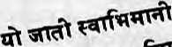
its choice successful in various fields of social life.
The second kind of ideology goes with political centralisation. Access to political functions is then determined by age and its privileges and by clan affiliation, rather than by personal charisma and high deeds as tokens of divine favour. Here, too, the author shows how the history of a community, along with its values, can be reconstructed from the study of rituals. For a long time, rituals retain the traces ofpoliticalandsocial organisation that they have underpinned. To some extent they are for the ethnographer what the written document may be for the historian.
Country-in-Making
The ethnographic experience is far from being the prerogative of professional anthropologists, French-speaking or otherwise. A Nepali administrator, Rudra Bahadur Khatri, was sent in 1930 to the easternmost bounds of the country with the task of settling conflicts between Bahun-Chettris and Tibetan minorities. His diary, translated and commented upon by Brigitte Steinmann in French, is nothing less than a field notebook, The description of the confrontation between these groups over questions of ritual purity and etiquette reveals how deeply religion is rooted in daily life. In the same way, the account of Tamang culture by Santabir Lama, governor of Ham, translated and presented
by Macdonald, is effectively a short monograph.
These last two works have more than an ethnographic quality to them. They are attempts to reflect on the authors' own culture and to present it to compatriots. For foreign researchers, whatever their personal involvement may be, the search for indigenous forms of knowledge remains an academic exercise. For those who are themselves part of the subject people, however, it lies at the heart of the creation of one nation out of multilingual and cultural entities. There may exist much more such indigenous research that needs to be discovered and brought out. This non-official literature, so to speak, may be a mine of original information, a valuable part of Nepal's heritage.
Whether it is in a country in the making like Nepal, or in an old nation like France, identity is the subject of a never-ending debate, a debate that may be triggered by the slightest event, and an always complex debate that must remain so. If French anthropologists could contribute to enriching this debate in Nepal, their work will have been more than academic exercise.
A. de Sales is an anthropologist associated with the National Centre for Scientific Research. She lives in Lalitpur.

34
MantilApril !995 HIMAL

fj
a f h q

Love Marriage
by Manjushree Thapa

She giggled, then moaned, then hissed out laughter through her tightly clenched teeth. So many things were so, so urgently funny that day. Oh, everything was. Everything? She snorted deeply and flung her arms over her head. Seemingly everything, yes. The surface of things, for sure. The depths, who knew; but the surfaces were hysterical.
The top-most funny thing being, of course, her husband's nostril. Can you believe? She had noticed it this morning while he mixed his rice with the lentils she had burned—again. His left one was narrower than the right one, swear to God! And it wasn't a distortion of the angleat whichhe was sitting, turned slightly away at the new dining table. No. She had circled him to serve more eggplant, some water, a cup of tea, and she had confirmed the odd, lopsided truth of the matter. She had been this close to burs ting out in glee when her eyes had landed upon the lack of definition to the bridge of his nose. Wait, wait, now. She had stared at him wide-eyed, taking advantage of his averted gaze, trying to understand how she could have failed to notice until now. He was one of those men, she was finally forced to admit, who seemed to have a sharp bridge of the nose but had, in fact, an ambiguously shaped, some might say vague, bridge of the nose.
She cooed in celebration. One of those men. That type! The indistinct nose-bridge type, the whole brigade of them! She rolled onto her side and shoved her face into thebedspread to muffle her squeals of delight. Ooophh—just in time. Her body squirmed, her fists beat down on the bed, her legs kicked their way out of her sari, She raised her head gasping for air.
It's all right, she told herself. It's okay, fine. Despite all indications, pf-pf-ffi-th! It had been days since she had spent her mornings possessed by reckless, ungracious laughter which was, as far as she could see in the flashes of clarity that sometimes followed, directed at nothing in particular. Well, at every thing, but where did grand statements like that get her? Hoping to achieve enlightenment via light fixtures, water bills, the dust that settled inside the television's ventilation grills. Had she become mad? She contorted her face and crammed her eyes shut and pursued that thought no further; it threatened darkness, and she was in no mood to cry.
She flopped over to stare at the merciful blank white field of the ceiling. She spread apart her arms and legs. Took a few deep breaths, which seemed soothing. She savored this respite.
It had taken eight nauseating months for everything to lose coherence, for the whole point of life to become obscured by the delectable chaos of everyday details. Take, for example, her husband. He used to make sense both materially and non-materially. The unfettered roundness of his face and the delicate turn of his brows had once expressed his gentleness. The scar under his chin had
hinted at mysterious wounds in his heart which would be her duty to heal. She had even understood why thehairatthetopof his head stood up: to echo the straightness of his heart, of course.
But—so quickly—his brows, scars, hair, moles, the uneven stubble on his face each morning, had stopped revealing the truth ofwhohewas. First, his features had started acting out of harmony with each other: some days his lips would dominate his face, other days his earlobes, his forehead, his chin, with no consideration whatsoever for the overall effect. Then his looks had stopped correlating to his soul. I mean, how could that insistent wagging of his chin signify the inner nature of the poor man? Or those white dots of grease blocking the pores of his skin? No. She refused to believe.
She had lost sight of his essence, and all that remained was the surface of who he was. Well, not quite. He had a terrible way of being somewhat expressive, and this, she could not tolerate. How could she live, for instance, with the downward curl of his lips and the disappointed lumps that formed at their edges? Or the way his arms folded when she entered the room? The way—with a heart-chilling offer of love—he would come too close to her and lay a thick, heavy hand on her? And now his nostrils and bridge of the nose. Things are adding up, she thought, breaking into a wide grin. Up, and up, and up.
A low rumble surfaced from the hollow of her chest: an immodest gurgle. She had never heard herself sound like this: to gurgle, shriek, yelp, scream, chortle, snort, hiss, moan and groan and cackle—this was not herstyle. Hoo-hoo is not an attractive way to laugh, hoo-hoo. Ya-kha-kha-kha-kha. Wack. Burp. She roared in triumph at her own horridness.
To be honest, she didn't want to see beyond the surface of things. Who knew what those murky depths contained, and what for should she suffer potentially distressful clarity when the clutter around her was so frightfully engaging? Like the pressure cooker: had it always gleamed so? Last week she hadn't cleaned it for days just to watch it grow dull and encrusted with food scraps. Then on Friday she scrubbed it with half a bottle of liquid soap and compared it to the shine in her memory: the pot was undeniably becoming tinnier by theday. What did thismean? Possibly nothing. Thank God.
The week before that, she had managed to squeeze a fingernail into the widest of the cracks in the living room wall; she was curious to see if it could widen. It wouldn't. She had measured the crack for future reference and had composed a poem to help her remember:
First measurement is one cm, but
Will second measurement be too? ' This poem, she had titled "I Wonder".

HIMAL MdKhlApril 7995
35

We have been helping
World Mountaineers, Trekkers &
Family Adventurers
realise their life long
dreams into Reality.,...
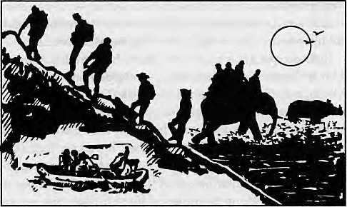
Organising their Expeditions, Treks & Tour Itineraries
in Nepal, Tibet and Indian Himalaya
with our 20 years perfected professional Service.
Let HE also help you fulfil your
Himalayan Dreams,
be it just a normal holiday or
full scale Himalayan
Expeditions
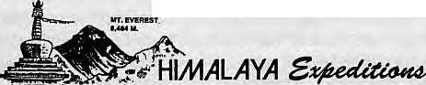
, inc.

Call or Fax today
Adventure Travel I™
(Earth House) JP Street Thamel Chowk
GPO Pox # 105
Kathmand u/Nepal
Tel #22 66 22, 22 90 31
Fax # 22 88 90, 52 65 75
She had fostered such lively interactions with much of her surroundings, but the telephone was the best. She loved it when it rang. She would come to sit beside the machine, studying its cream-colored contours, wondering where that shrill noise came from, who was on the other side. Sometimes the caller would execute six obliging, dutiful rings and at other times up to thirty hopeful, patient, or willful rings. Whoever could it be? Her life partner? One of her family members or friends from her life before marriage? They would ask: how was he, how was she, when was the good news due—even though they had called just to remind her that arrangedly-married couples all over the city wanted to know what their brash love marriage had amounted to.
She rarely answered the phone anymore, but when she did, she prayed for the caller to be a stranger, like someone who had dialled the wrong number. People often mistook their number for that of some government office responsible for fruit. In such cases, "Hello?" she would say. "Department of Fruit Development?" a gruff male voice would inquire. "Wrong number," she would respond. The caller would sometimes hang up without ceremony and at other times ask, with astonishment, where he had called. She would simply say, "It looks like you've dialled the wrong number." The Fruit Department's number, you see, was 412348 while theirs was 412438.
She rubbed her face and smoothed her hair, pushed a few bobby pins back into place. She inhaled a lungful of air.
At the heart of things was certainly a big, bad communication problem. So? She should talk to her husband, begin dialogue anyhow, tell him, for instance, the truth about his nose. You must understand how I feel about this, and I must understand your views; they say it is vital to communicate.
Yeh-heh-heh-heh.
But the things they wouldn't say to eachother contained more life than the things they would: "Is there enough sugar in the tea?" "This bulb burned out," "Shall I chop the tomatoes?" For he had countered her growing eccentricity with aggressive incomprehension. Before and after office, and on Saturdays, he would edge around her, placing her movements under wary surveillance, sometimes rattling on belligerently about one or another irrelevant topic. Lately he'd focused on the power shortage. Before that it was air pollution.
She burst out with a bobbling belly-laugh. Her pooT old man: he is tyrannized by me. She must support him in fearing her; God knew what she was capable of. I have failed to piece together you and your worldly possessions, she should announce tomorrow morning during his meal. Let us declare our life together bewildering. Andstop eating those lentils; they werebumedby the fire in my heart. There is danger ahead!
She could even sing the national anthem, but you know what he would say? Try to be simple! Bll-11-gg-khh! Wah-hah-hah! Try to be simple, he would say. He may follow with a plea for her to go ahead, do whatever she wanted. Why didn't she apply for a position at the bank? Why not learn how to use a computer? Why not, indeed? He would never think of ruining her life. Sometimes tentatively, other times confidently, mostly with routine in his voice, he would conclude; you muse feel free to do what you want.

36
March/April t995 HIMAL

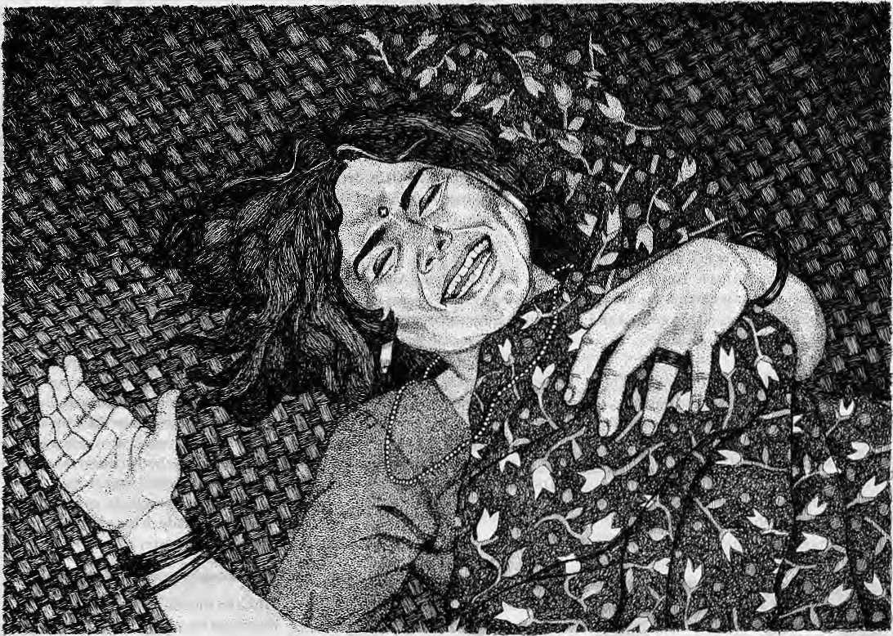

Do you mind if I leave you, then? Hoo-hoo! Hoo-hoo-hoo! My dear husband, do you mind if I leave? Her stomach convulsed as though it had a life of its own. She hacked and sniggered and writhed in asphyxiated panic as a mute, gut-wrenching laughter engulfed her. How silent was suffocation.
She began to howl for air. Just joking. Just. Joking. Ooof—be careful of what youth ink, wretched woman. Ungrateful, depraved, complicated, sullen, prickly little wretch. You should love him. Look: you ask one hundred people and aH of them would say he was a good man. It was true; hadn't he fallen in love with her despite her caste? He needn't have married her just because her brother had spotted them at the Shangrila Restaurant. But he had, hadn't he? And hadn'the defiantly walked out of his family, hadn't he defended her against all kinds of judgement, hadn't he started working at the consultancy just to support her? Krishna Khadka's only son sacrificing everything for love! What more could a woman ask for? He was a saint. It was shocking to see how good he was. His goodness was killing her, in fact.
But how could he not understand? ThaHt wasn't you—dear husband—I fell in love with, in that dark corner of that restaurant. I was seduce d by li fe, by every least thing tha tsparkledof adventure. Being a girl, in this shackled city, to go to a restaurant to meet a
boy!—you know. Lipstick, powder, dangling earrings, patent-leather shoes? The thrill of discovering how unlimited life couldbe. You should have heard thebea ting of my heart as Istepped into the Shangrila. I thought: I am finally living.
That was, of course, before Kathmandu closed in on me, before my brother reviled me, before my parents claimed I had destroyed our family's honour, before my relatives and friends and every last acquaintance agreed that I was debauched. I made you want to marry me; how else could I defy such degradation? Love marriage? How could you not see—you simpleton—that our marriage was the punishment for my one petty rebellion.
She convulsed. Pain stabbed into her depths, A mass of emotions welled up and dissipated noiselessly. Her legs doubled over her stomach, and her sari fel 1 away from them. Her mouth fell open to gasp in more air.
If they could see me now, she shrieked inside herself, kicking her legs in the air. They'd seehow desperately happy I am, waiting for the birth of our child. Proof enough of marital bliss? Would anyone ever guess that my husband and I, we made abadmis take?
She exhaled till she thought she would die.
IS M. Thapa is author of Mustang Bnotin Fragments {H'\tna\ Books, 1993),

HIMAL March/April 1995
37

THE NEPAL
o
ELI
5
PHIL
AND TIBET
AIR MAIL



0)
The secret is out on yaks who think they are masters of the trail. Advice to trekkers along narrow Himalayan footpaths confronted by excited yaks with sharp horns comes from a correspondent to Summit magazine, who suggests rj that "all you have to do is bend over and reach for the ground and the yak falls all over itself to get out of your way. Why? Just watch a yak herder with his flock. You'll see that the herder directs the animals by picking stones off the ground and beaning the unruly beasts..."
Used to think from my readings of Thimphu handouts that ngolops were terrorists. How, then, does this sentence from Tibetan Environment and Development News (TEDN) make sense? "With entrance to a cash economy as a lure, the Ngolops have been actively encouraged by the Chinese government to build up the sizes of their sheep and yak herds..." Why would Beijing want to encourage terrorists by plying them with sheep and yaks? 'Ngolops', it seems, is also the term for nomadic herders of Amdo. Oh well, as they say, one man's terrorist is another's freedom fighter-While still on Tibet and yaks, another juicy morsel from TEDN; statistics show that population of yaks in the Tibetan plateau is growing, but not as fast as the pig population, which reached 200,000 in 1994. No mention in the journal about how many yaks, though, other than a mention that 15,000 heads of yaks of improved strains were bred during 1994. We have to know how many yaks there are in Tibet. The total.
He must be doing other things as well, but as Chief Minister, Pawan Kumar Chamling seems to be taking a special responsibility for re-christening roads. On 24 February, reports UNI, Chamling felicitated
Ganju Lama (VC) by naming the 20 km Rabongla-Tarku road in South Sikkim after the tank-killer of the
Burma front. Soon after, Chamling also announced that the Sombaria-Soreng road would be known as the Shahid Dharamadatta Path, after the Youth Congress (1) leader allegedly killed in police custody in 1988 during the rule of Nar Bahadur Bhandari.
About the Pepsi Annapuma Triathlon 1995, in a press release, R. Parthasarthy, CEO, PEPSI-Nepal, explains the reason he is sponsoring the triathlon, thusly, "Pepsi's association in the beverage business is with the youth and the key imperatives are 'young', 'fun' and 'choice'. Pepsi in Nepal therefore looks at this sponsorship of the Triathlon as its association with youth, sports and fun."
If the editors of Himal ever thought that they had a monopoly on the term 'Himal', aha do they have another think coming! Once, of course, there was the well-produced Nepal-Himal, journal of the Nepal Mountaineering Association. And now, this just in from Moscow: Russians seeking enlightenment on Nepal's culture and the Nepali language may pick up copies of primers published by Himal, which also uses a triangle on its logo. From across the oceans, the Nepal Tibet Philatelic Society, based in California, publishes Postal Himal the medium to exchange obscure and exciting trivia about Himalayan philately. Chhetria Patrakar got his hands on one issue which goes into detail proving a theory that Lhasa stamps in the early years of this century were perforated using Singer sewing machines.
In an article that lambasts Western environmental groups (now apparently called 'enviros') for crying wolf, Gregg Easterbrook in the New York Times Magazine reminds us that many more people die each year from filthy air and dirty water than from asbestos, dioxin, electromagnetic radiation, nuclear wastes, FCBs, pesticide residues and ultraviolet rays. Nepali researchers who studied acute respiratory illness (ARI) in Jumla will agree that the most insidious form of air pollution is rural smog—from fuelwood, cowdung and agricultural wastes used in the stove. Easterbrook blames enviros present at the 1992 Rio Summit for giving more importance to global warming than to the death of over 7.8 million children every year from water and air pollution. Nobody notices, he writes, when Nepali women die of a disease similar to anemia, caused by carbon monoxide in the bloodstream, a result of long-term exposure to kitchen smoke.
While on the subject of particulates in the air we breathe, refer to the picture of the young tempo conductor in the last issue of Himal, breathing dies el emissions and dust all day. Here comes a report in the Sunday Telegraph of 27 February that diesel fumes are more of a threat to health than was supposed. Prof. Roy Harrison of Birmingham University says not to worry about carbon monoxide or benzene emissions, for it is the emission of particulate matters (PM) that have the most serious public health consequence. Death rates are 26 percent higher in areas most polluted with PM, he says. "Diesel contributes immensely more to PM pollution than other pollution," says Harrison. Which means that people along Kathmandu and Delhi

March/April 1995 HIMAL


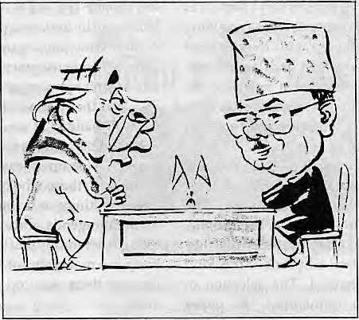
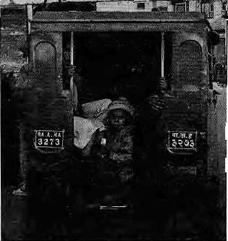

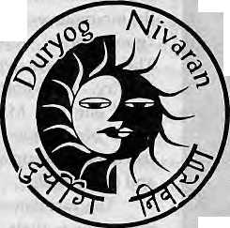
thoroughfares (and the little tempo conductors) will die quicker than the rest of us.
A blow was struck for inter-Himalayan air travel in mid-February without the media noticing. Himachal Helitours, based in Shimla, was able to convince both Kathmandu and New Delhi authorities to allow them to rent a Nepali helicopter and fly it across to Mandi to service the ski slopes. The whirly-bird of Himalayan Helicopters has already completed this path-breaking stint over Indian airspace and returned to Kathmandu. Now, if Asian Helicopters succeeds in its negotiations in Beijing and is allowed to conduct Kathmandu-based rescue operations for mountaineering teams in Tibet, Nepal will truly emerge as a Himalayan helicopter hub.
Every other ngo, consultancy and
networking group in South Asia has
to come up with a cute English
acronym before it can start work. To
break the trend, and with much relief,
comes the group Duryog Nivaran,
which is "a network of individuals
and organisations working in South
Asia who are committed to
promoting the alternative
perspective on disasters
and vulnerability."
The term, which is
Sanskrit for
"disaster
mitigation", works
for all South Asian
countries other than
Pakistan, including
Bangladesh and Sri
Lanka.
Give credit to Madhav Kumar Nepal for daring to bell the cat, when he raised the issue of reviewing the 1950 Indo-Nepal Peace Treaty when he met P.V. Narasimha Rao in India in February. This was something that no Kathmandu government had dared do for the last four decades, fearing
Indian wrath and geopolitical j catastrophe, Lo and behold, I New Delhi agreed to a secretary-level committee to discuss (or perhaps shelve) the matter. But at least the cat that needed belling is out of the bag. The best cartoon to come out of the M.K.Nepal-P.V.N.Rao meet appeared in The Pioneer, presented herewith.
Both Kalimpong and Kathmandu will be losers in the guessing game of who is going to benefit from the opening of Himalayan passes to Lhasa, according to J.M. Singh in The Telegraph. He writes that it is the Siliguri route via Natu La or Lachen La (rather than Jalep La via Kalimpong) that is the most logical, and that Sikkim will be the marshalling point for all goods traffic to Tibet. Writes Singh, "If the magnitude of trade lives up to expectations, a few hundred trucks are slated to crowd the routes daily." Siliguri would be the railhead, because "any attempt to build a handling infrastructure in the moutains will be both economically unsound and ecologically a disaster. Therefore, it is clear that the de facto hub of all trade will be Siliguri. A long term plan must hence be set in motion to develop the largely untamed north Bengal plains." Once such a route is opened, writes Singh, the Siliguri-Gangtok-Lhasa highway would be the preferred overland route for tourists, "since it will be much
shorter and easier than
the existing one, which passes
through Nepal."
Biodiversity has thus far been calculated through a simple species score card, which means that all eyes are turned to the tropical rainforest. Now here is a report in The New York Times which speaks up for the mountains and deserts as strong repositories of biodiversity. According to writer Natalie Angier, ecologists and biologists are now
suggesting that "many species in rain forests are closely related to each other and hence not as indicative of true diversity as it appears in first blush." They argue that "ecosystems like deserts, temperate forests or high-altitude grasslands may house comparatively fewer species but offer more genera, families or phyla... (In) the end, a habitat with more families or phyla may be a locale of greater genetic diversity than the tropical rainforests in all their chlorophyllic, speciated abundance." Chhetria Patrakar had always thought something was amiss in the worldwide focus on rainforests to the exclusion of other biomes. Well, here it is, quoting Angier again, "As a general rule, lower altitudes are more species-rich than higher ones, but birds and butterflies, in fact, become more various as one climbs from sea level..." Hooray!
- Chhetria Patrakar

HIMAL March/Aprs 1995
39

Mountain Meeting by the Beach
A meeting of mountain representatives from far corners of the globe ended a hollow exercise. Was this the way to lobby for the world's highlands?
by Kanak Mani Dixit

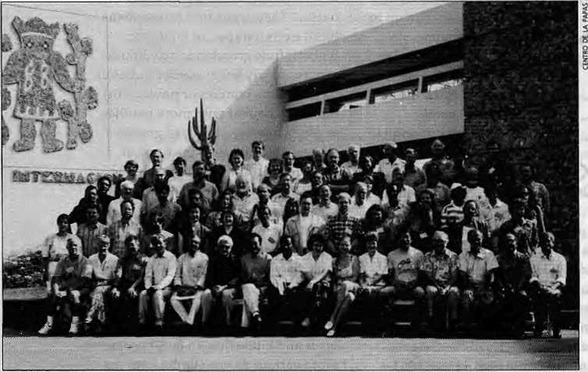
I
n the last week of February, some 120 academics, bureaucrats and a sprinkling of activists gathered at the International Potato Center in Ltm atotryandflag attention to the special development needs of the world's highland communities. However, the poorly organised conference did no t even add up to the sum of its parts.
The "funding sources" had asked the Woodlands Mountain Institute of West Virginia (recently re-christened 'The Mountain Institute') to convene the meeting, The Institute's organisers confessed that they had never organised an event of this kind before, and it showed. The selection of participants was uninspired, the paper presentations were disappointing, and, most importantly, a symbiosis did not occur among those gathered.
Lima participants, iacilitators and all.
The participants, however, found their
feet despite the organisational stumbling blocks and by the last day had even managed to adopt wide-ranging recommendations for appropriate development of mountain areas. The organisers were pleased.
Was the effort worth it? As the participants disbanded, it was clear that they did not have the necessary unity and clout to make a sustained case for mountains. There were those who questioned extravagant meetings as a means to push the mountain agenda, and even one or two who thought heretically that there was no need to bring the mountains of the world together because there was too much to set them apart.
Is there anything that makes "mountain development" inherently special compared to other backward and marginalised regions of the world? This question was not even
explored in Lima as the participants in Lima were the converted; it is the rest of the world that needs convincing.
Affirmative Inquiry
Under its new Director fresh from the World Bank, Jane Pratt, Woodlands would like to develop as a central despatcher for mountain-related work. The Lima meeting offered the Institute the chance to set some of the agenda, using funds from aid agencies to stage-manage the first international ngo consultations on the mountains.
One of Pratt's initiatives, which brought t the conference close to disaster, was to fly in a team of "facilitators" to run the meeting. These five American feel-good therapists took over the conference a few minutes into the opening ceremony on 22 February.
The unsuspecting audience was told that they would have to be friendly to each other, to discuss only positive examples on the mountain experience, and to share only "good stories" during their time in Lima. The procedure was called Affirmative Inquiry. "Be heliotropic, look towards the sun," one Jane M. Watkins admonished, but a black mood descended upon her listeners, made up as it was of the wizened and the cynical.
The facilitators had the participants write down their innermost desires for mountains on three-by-five index cards, which were posted on a side wall. Next, they were asked to draw images of mountain themes that came to mind, on more index cards, which were then posted on a "Wall of Wonder" up on the stage. These were supposed to be reference points as to "why we are here", but few bothered to go back to the Wall of Wonder.

40
March/April 1995 HIMAL

ARE
owr now?
*£

By the end of the second night of the four-day meet, it was clear that the facilitation was. killing the conference. A breakaway faction calling itself the "Red Rebel Group" decided to make a point by going out to dinner in downtown Miraflores rather than suffer more late-night facilitation.
On the whole, the participants seemed too polite to remonstrate. And so it was up to Carol de Raedt, a Filipino activist, to voice the developing mood. Asking everyone to remember why they were in Lima, she said, "You're stand ing up against powerful forces, and there is going to be a lot of pain. People die when they speak up for their demands. Let us stop playing around."
As the general attitude towards the meeting's organisation beacme clear, thankfully, the facilitators were pulled back on the third day and they retreated to the background. The Woodlands organisers refused to say how much they had spent for the facilitators, and insisted that it had been "independently paid for" by USAID. The cost for the rest of the conference was said to be upwards U$ 220,000, shared between the Swiss Government, UN agencies, and others.
Papers and Participation
For a meeting that went under the title "Global NGO Consultation on the Mountain Agenda", there were very few ngos represented—if the term 'non-governmental' refers to organisers at the grassroots. Most of those present were from university departments, research institutes, private consultancies, aid agencies, and semi-official bodies like Nepal's King Mahendra Trust for Nature Conservation.
Many organisations and individuals who might have played a key role in Lima were either not invited or chose to stay on the sidelines. The International Center for Integrated Mountain Development (ICIMOD), set up to address the very issues that were the focus of the conference, kept a low profile in Lima.
While ICIMOD might have lain low, the Himalayan region was clearly over-represented in Lima, somewhat to the detriment of the other major mountain regions, including the Andes, the Central Asian mountains, and Africa. There was, in fact, a bias towards the Nepal Himalaya at the meeting—with 15 out of the 120 participants having close ties with Nepal
either through research or nationality.
The Spanish speakers were present but mostly silent, stymied by lack of English. Japan, a country that is two-thirds mountainous and a source of funding to boot, was not present. The neglect of the Caucasus and the Central Asian states (Tadjikistan, Kazakhstan, Khyrgystan) was such that Yuri Badenkov, the Moscow geo-scientist, made a point about the "domination of the Himalaya".
Many of the invitees in Lima seemed to be working associates or prospective partners of Woodlands rather than independent-minded mountian activists come to share ideas.
¹ ["'&
There was general agreement that the papers presented were not up to par. A paper on global wanning was presented by a non-climatologist, and the one on cultural diversity spoke instead of gender issues in the Garhwal Himalaya. The one on water resources was obviously written in a hurry, and another that took an overarching but unsuccessful look at the issue of sustainable mountain development was presented by the husband of the paper-writer. Then there were extracts from books which were palmed off as papers.
One of the discussion groups went to the extent of formally asking that the papers submitted not be published as part of the conference proceedings unless they were rewritten and rigorously reviewed.
Good Stories
Although the meeting certainly was not generating any energy, it would have been doubly unfortunate if all the experience gathered in Lima were to be completely wasted. After the hurdles set by the organisers were shrugged off, it was possible for the participants to divide into groups tha t discussed manyoftheissuesthat concern mountain environment and societies. Discussions were held and recommendations adopted in subject areas such as production systems, cultural diversity, sustainable development, climate change and natural hazards, and water resources, biodiversity, energy demand and supply, cultural and spiritual .significance of
mountains, and tourism.
The recommendations of these groups were many, and so were the "needs". Significant ones included the need for "decisional autonomy" for mountian peoples; the need for mountain languages to beprotectedasprimarycarriersof traditions and identity; the need to recognise intellectual property rights for indigenous knowledge systems; the need to recognise "true value" of mountain resources in terms of economic return; and the need to recognise and take advantage of the fact that up to 80 percent of the world's fresh water comes from the mountains. The meeting also called for protection of mountain regions' unique biodiversity, and to ensure that economic benefits from biodiversity resources stay with the local people and communities.
More than the recommendations, however, were the snippets and statements gathered in the days together that indicated
*¹
kiMD OF ittUP ' you

C
\\ti\
EXFERT'!..
**K
REAW FoRTHffT
COffrEREKCE
>

the diversity and depth of experience gathered at Lima.

Jim Enote, a thoughtful representative of the Zuni tribe in New Mexico, who has also worked in Tibet, spoke of the treasuries of knowledge developed by native people over thousands of years. "Culture plays out like a film," he warned, and when the last spool is used up the unique mountain cultures of the world will vanish.
Jack D. Ives, the geographer who has chaperoned the mountain agenda over the last twenty years, said that all the world's great biomes that are environmentally threatened—the oceans, the arid lands, the tropical rainforests, and Antarctica—have attracted powerful constituencies, but not

HIMAL March/April 1995
41

Lunch Hour

The Lima meet had been called to generate a constituency with which to approach the United Nations Council for Sustainable Development (CSD), and to lead towards a summit meeting of mountainous countries. It was planned that the recommendations from Lima would feed into the Open Ended Ad-Hoc Working Committee of the CSD, which was meeting at the UN Head quarters in New York around the same time.
Although the CSD meeting in New York was to have been discussing mountains, the focus seemed to be almost entirely on forestry. Those with clout in the committee, such as the representative of the European Community, made clear that they were opposed to a world mountain summit, an idea originally mootedby the Food and Agriculture Organisation (FAO),whichis the designated "focal point" for mountain activities among the UN agencies.
One diplomat in New York 'sympathetic' to the highlands said many Western states were opposed to giving mountain
countries special status because they might emerge as yet another block with power out of proportion with economic clout. Fears of a rise in the sea-level as a result of global warming has apparently given island states disproportionate bargaining power in UN forums. "They fear that the same will happen with the mountain countries if they are allowed to form a block," said the diplomat.
Jane Pratt of Woodlands came up from Lima on 1 March to address the New York meeting of the Ad Hoc Committee. ICIMOD's Director General Egbert Pelink flew in from Kathmandu. Unfortunately, there were only eight country representatives in the empty hall to hear the distilled wisdom of Lima's confabulations. The session had been called during lunch hour.
As anyone who knows the United Nations system will tell you, never call a meeting of diplomats during lunch hour.

the mountains. "Unlike the oceans, the mountains have no Jacques Cousteau," Ives said.
Mario Tapia, a Peruvian agronomist, pointed out how geographic orientation of the Himalaya and the Andes differed dramatically. While the Himalaya keeps more or less to the same latitude, the Andes "is a totally different kind of mountain system, going from north to south, from the tropics to temperate zones, creating conditions for great diversity," he said.
Sophie Moreau, an agricultural scientist from Bolivia, complained of parachute scientists from the North who flew in with thick wallets for short periods, to do high profile research of limited value in the Andes. Meanwhile, Southern scientists worked with little resources. For example, Bolivian scientists who were studying frost on the altiplano faced great difficulty because no no one was assisting them.
Virendra Painuly, an excitable activist from Uttarakhand, insisted that the Conference learn to distinguish between "mountain development" and the "development of themountain people" and favour the former, which hesaidemp owered the local people.
Jorge Lopez Bain, of Chile, expressed concern at the eco-fundamentalist position being pressed by some who preferred to see the mountains as the holdouts of nature rather than regions which had resources
required by nations. He objected to a recommendation that the mountains be reserved for "non-extractive industries", reminding those gathered that the Andean countries relied on large scale mining. The relevant recommendation was adjusted to read, "non-extractive and controlled extraction..."
Many Southern participants argued that mountain peasants were not docile creatures who preferred to live life as museum pieces for the edification of those that were modernised. They, too, wanted modernisation, and access to highways, cars, consumer goods, and other modern amenities. Mountain societies should be provided with the information about the changes that are set to overtake them, but ultimately they have to take their own decisions on how to cope with change and outside influence.
Mountain Mafia
The Lima meeting seemed to mark the passing of the baton from the Mountain Mafia to a larger group of individuals representingdisparatebackgroundsandnot necessarily similar agendas. The term Mountain Mafia, which the members themselves use with relish, includes Jack D. Ives, editor of the journal Mountain Research and Development; forester Larry Hamilton, who has worked both in islands and mountains; Yuri P, Badenkov, of Moscow's
Institute of Geography; Bruno Messerli, a geographer and mountain ecologist at the University of Berne; and New Zealander Kevin O'Conner, who was absent in Lima.
It is the effort of this group that saw the establishment of ICIMOD in 1985, and the organisation ofthefirstmountain conference at Mohonk in upstate New Yorkin 1986, and organised the effort to highlight mountain issues through Chapter 13 of Agenda 21, the declaratory document of Rio. All that had led to Lima.
From a group of Northern physical scientists, Lima seemed to open up the field to a larger community of social scientists, semi-bureaucrats and ngo workers. The "initial organising committee" which was formed to work towards an International Mountain Forum was now made up of a muchmore diverse group, including a native American, a Nepali biodiversity expert, the chief of the G.B. Pant Institute of Himalayan Studies in Almora, representatives of Latin American groups, and an American come in from the World Bank. While the torch has been passed, it remains to be seen whether this larger, more disparate and necessarily more political group holds together, and is able to generate wider support for the highlands.

42
March/April 1995 HIMAL

We Trek Everest
Every Wednesday,
Annapurna Every Friday
and Langtang Every Monday
Fax or call us today for your
free copy of our Nepal or Tibet
fixed departure Programmes.
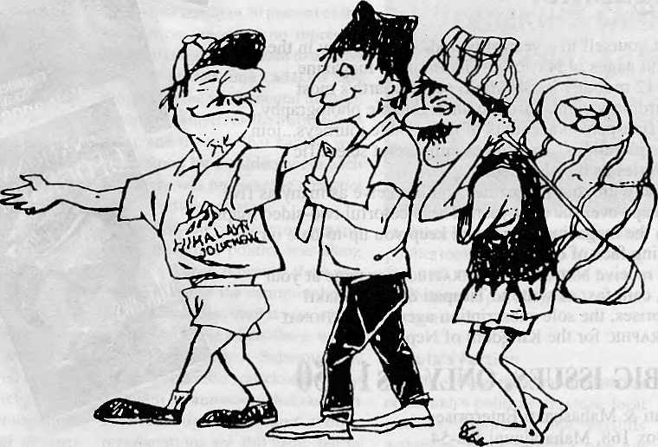
■ H i m a I a y a "n J o u r h i y s
Kantipath,Kathmandu, Nepal. Tel: 226138,226139, Fax: 977-1-227068,418182

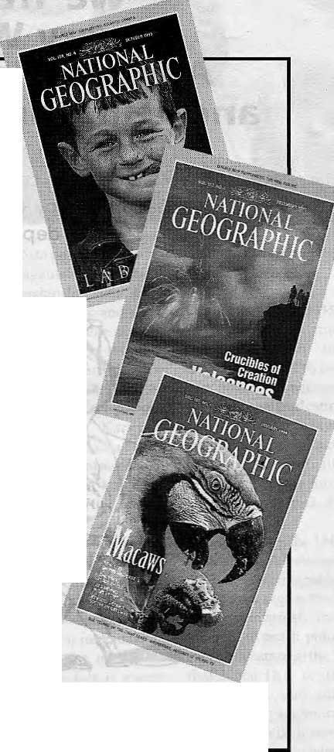
Explore the earth from your home with the world-famous National Geographic magazine.
1 reat yourself to a year of incredible discovery in the colorful pages of National Geographic magazine.
In 12 monthly issues you'll see the earth's most extraordinary sights through unforgettable photography... enjoy first-person accounts of remarkable journeys...join bold explorations...and witness important scientific discoveries as they happen.
And with your magazines you'll receive as many as five wall maps over the next year. These colorful two-sided maps enrich the magazine stories and keep you up-to-date on the changing face of our planet.
To receive National Geographic magazine at your home, call, fax, or write to Tirupati & Mahashakti Enterprises, the sole subscription agent for National Geographic for the Kingdom of Nepal.
12 BIG ISSUES, ONLY Rs 1,950
Tirupati & Mahashakti Enterprises P.O. Box 168, Maharajgunj Jha-54 Kathmandu-3
Telephone: 01-977-1-413009
Fax: 01-977-1-227919

D
R
v
w

Native Scholarship: Beyond Gentle Laments

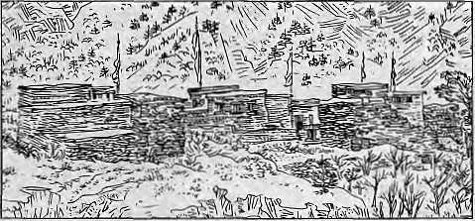
T
he Kali Gandaki Valley, for long oneofNepal's princip al trade links with Tibet, has in recent times become the country's most popular trekking route. As travellers ascend from the gorges below Ghasa and enter the more rarefied air of the Thak Khola, they encounter the first signs of Tibetan cultural influence: temples, monasteries, stupas and gateways painted with Buddhist motifs, through which they pass on entering andleaving villages. Many traders and trekkers alike will undoubtedly have wonderedaboutthesedecayingstructures: the identity of the divinities and mandalas adorning these crumbling walls, and that of the people who built and painted them. Ratan Kumar Rai's Along the Kali Gandaki is the most substantial attempt to date to address these questions. It is, in a sense, a natural sequel to his earlier book of pen-and-ink drawings, Along the Kali Gandaki: the Old Salt Trade Route. The elegant sketches of that collection portrayed the settlements of the valley in their overwhelming landscape. In the present work, the author follows his artist's gaze behind that landscape to find the human agency that modified it, laid the stones for the buildings and brought their interiors to life with sacred art.
Non-specialist visitors to the Thak Khola who simply want to know something of local art and archi tecture will make heavy weather of the author's purist approach to the rendering of local names and other expressions. This may be especially true of Tibetan terms, the presentation of which is frequently unorthodox, as in the case of words such as Bon-gNak (for Bon-nag), bLo (for lHo) and so forth. Readers may have difficulties with follow ing up some of the sources: articles are not identified in the references by their authors but by the journals in which they appear, so that one would look in vain for, say, Vinding in the bibliography. While the acknowledgement of sources is sometimes a tedious business for both writer and reader, especially where minor observations are concerned, the habit does at least enable an author to avoid the charge of originality in coining errors. The translation of the word Tsangpo (Tib. gTsang-po), the Tibetan name of the Kali Gandaki, as "the clear one", is a mistake that probably derives from Michel Peissel's Mustang: a Lost Himalayan Kingdom, presumably by association with gtsang-ba/ma, "clean, pure". In fact, in choosing the name Tsangpo for both the Brahmaputra and the Kali Gandaki, the Tibetans showed aboutasmuch poetic flair as the Celtsdidin christening a local watercourse the "Avon": in their respective languages, both names simply mean 'river'.
The bulk of thebookis occupied by the third and
The Thakalis, Bon
dKarand Lamaist
Monasteries
along the Kali
Gandaki
Ratan Kumar Rai Book Faith India,
Delhi
1994, NRs 950 ISBN 81 7303 0219
by Charles Ramble
C Ramble is an
anthropologist who
has done research in
Mustang.
last chapter, entitled simply "Art: painting". The chapter includes descriptions of the interiors of the gompas located in the two main divisions of the Thak Khola, Thaksatae and Panchgaon, and a few of those immediately to the north in Baragaon. The section provides an interesting insight into the lives of some of the local artists, who conform uncannily to the popular image of their Western counterparts. The highly gifted Khaipa (Tib. mkhas-pa) Kancha "was helpless without drink and tobacco. He often climbed trees and indulged in his cherished fancy, the fantasy of flying through the air, like the great Lamas who were capable of doing this. The fantasy finally cost him his life." The last sentence is a reference to his early death when he fell, drunk, from a precipitous trail, a victim to exactly the same fate as his hard-drinking father and teacher, Lama Jamyang.
The untimely demise of these two exponents of the gTsang school left the field open for the Mon-bris, whose principal heir at the present time is Sashi Dhoj Tulachan. Among the commissions that the latter has received in Mustang was the task of repainting the interior of Phuntsholing monastery in the Bonpo village of Lubra in 1966. Rai includes a quite detailed and interesting description of the murals, but he does not mention one oddity that has often intrigued me about his little gompa. Amid the saints, divinities and mandalas of Bonpo inspiration, is a peculiar detail: a European robin sitting on a holly bush against a background of snow. An uncommon touch of syncretic inventiveness, this, that inserts among standard Tibetan imagery what is surely a scene from an English Christmas card.
The first two chapters, which deal respectively with the Kali Gandaki as a historical trade route and with the mythology and history of the Thakalis, provide a helpful background to the artistic heritage, To the extent that these chapters draw widely on secondary sources, they bring together and make accessible much that is to found in the scattered material on the region. For example, there is a very welcome and informative list of the customs contractors—the pivotal figures in the salt-grain exchange—spanning the century from 1862 to 1962. But these chapters are more than just a compilation of already published miscellanea. They contain much original work. Of particular interest to anthropologists of the region is the suggestion, based on the claims of an elderly informant, that "the early Dhyatan of Thasang ... were the genuine forebears of the modern Tamang Thakali, and that they WereprobablyMagars{andGurungs)",aview"notshared by other Tamang Thakali of his generation". That the

H1MAL Much/April 7995
45


relatively low status accorded to the Dhyatan derives from their membership in an indigenous stratum which was incorporated into the emergent Thakali people is a suggestion that, to my knowledge, has not been advanced elsewhere. Another interesting contribution is the description and summary of a bem-chag (in this case, a sort of chronicle) said to be from Cimang (Appendix B). A Cimang bem-chag has already been published in facsimile and translation by Michael Vinding and the present reviewer (Kailash 1987, vol. 13), but Rai devotes several pages to the version obtained by him on the grounds that it contains "some elements not accounted for in the translation by Ramble/Vinding". There do indeed appear to be substantial differences in the structure and content of these two works,whichinmyopinionwouldh ave justified an even more extensive treatment of the subject by the author. A number of variants of this bem-chag have come to light in different villages of Panchgaon, and it is to be hoped that the author includes photographs of the text (as he does of several other inscriptions) in any future editions of this book. As it is, Rai's summary provides useful accounts of relations between neighbouring principalities in the region.
The prosperity that came from the lucrative customs contract resulted in raised standards of architecture and wood-carving, and the author gives credit where it is due. But for the most part he is bitterly critical of the
wealthier Thakalis' abandonment of their older faiths, Lamaism (Buddhism and Bon) and the indigenous religion. "Tamang Thakali culture was already meeting its death at the hands of those who nurtured it, and it is quite unlikely to be revived through the existing policy of the government of Nepal"; "the increasing Hinduistic pressure on the traditional Tamang Thakali culture, resulted in the dereliction of the indigenous Thakali civilization"; the partyless Panchayat system "denied the religious and political aspirations of the non-Hindu people who constitute more than 70% of the total population of the country. ...It is in accordance with democratic principles that Nepal be declared a 'secular' state". And if these excerpts do not make the author's political alignment sufficiently clear, we may note his preference for the term 'Kirati' ("an ancient people (who) were the legitimate rulers of Nepal" over 'mongoloid', "which is a vague anthropological expression". Interestingly, Rai includes within the category of Kirata the Gurung, Thakali, Tamang and Bhutia. Foreign academics who deplore the changes in the Thak Khola and other Himalayan communities have usually been dismissed as neo-colonial romantics; but the critics will obviously have to find a new rhetoric to deal with the growing number of native writers such as Ratan Kumar Rai, whose readiness to invoke, in scholarly works, the politics of cultural oppression, far surpasses the gentle laments of their Western predecessors. ^


Get Connected to the
Information Highway !

Now you have a local access into the Internet in Kathmandu. *
Mercantile Office Systems (9:30-17:00 HRS); Tel: 220773, Fax: 225407 ore-mail: Postmaster@mosxom.np
* Currently E-Mail Services available.

46
1995 HIMAL

Large Dams are Essential

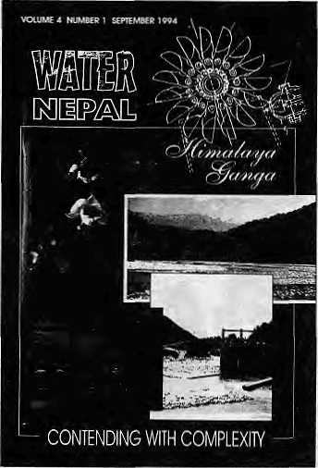
T
ill about two centuries ago, the natural resources, the land, water, and flora and fauna, made the Ganga-Brahmaputra one of the most prosperous regions. Perhaps it was this very richness which kept the region from being part of the process of social development which was overtaking the West.
After 1947, it was assumed that the basin states would, individually and collectively, make concerted efforts to make up for the many decades of neglect. But the results have been disappointing, even while other developing regions have made spectacular progress.
To meet the challenge of the future, new concepts, policies, technologies, planning approaches, social organisations and social commitment are required. A tremendous responsibility rests with the intellectuals, particularly the scientists working in the multi-disciplinary area of environmental systems management. In that context, the present special issue of the journal Water Nepal makes a valuable contribution, carrying papers from scientists present at the February 1993 Kathmandu Meeting on Cooperative Development of the Himalayan Water Resources.
The organisers of the conference acknowledged that environmental processes do not recognise man-made boundaries. Himalaya Ganga is the generic name given to the highland-lowland interactive complexity of South Asia. The papers, which are of high calibre, cover a wide range of issues grouped into four themes: Social and Economic Challenges; Technology and South Asia; Institutional Articulation; and Conflict and Cooperation.
The editors present an excellent overview of the complexity of the Himalaya-Ganga system, emphasising the need for it to be considered in terms of three interlinked and interacting elements—thebiophy-sical, human-built and symbolic environment. Harmony needs to be maintained amongst the three sub-systems.
Ten initial papers critically take up matters such as sharing the costs and benefits of water resource projects between Nepal and India; displacement and resettlement management in the context of the South Asian hunger for land;environmen ta 1 concerns; private sector versus public sector involvement in water resource management; and international financing.
Several authors tackle the controversial question of building large dams, but to this writer they seem
Himalaya Ganga:
Contending with
Complexity
Water Nepal
Vol4No.1,
September 1994
Ajay Dixlt, Dipak
Gyawsli, editors
Nepal Water
Conservation
Foundation
Kathmandu,
NRs 500
by M.C Chaturvedi
M.C Chaturvediis Professor Emeritus at
the Indian Institute
of Technology, New
Delhi.
almost to have a bias against technology. No one, for example, mentions that the problem of uprooting people from their natural habitats is intrinsic to the process of population explosion and poverty. Technology is definitely an answer to these problems, but there will of course be side-effects, which can be minimised using appropriate policies and planning.
Thirteen papers on Technology and South Asia deal witn data requirement; debates on 'large versus small'; 'appropriate versus high-tech'; irrigation management; seismic iry and river morphology; and groundwater-surface water conjunctive use. The case for decentralised power for enhancing local capability in hydropower development was competently presented by Bikash Pandey. However, it must be mentioned that micro-hydro development can move in tandem with macro-development, in which developing the local capability would be central. Developing countries must take major strides to catch up, and it will not do to think otherwise. Finally, major projects are essential not only for rapid development and speedy eradication of poverty, but for environmental conservation as well.
The question of scientific development and environmental conservation are complex issues which require decision support systems. Two papers which illustrate their importance are one on water resources development in Bangladesh and another on the multi-criteria analysis technique in the context of the Chisapani Project on the Kamali. Some more papers on the importance of this approach would have been useful.
The section on Institutional Articulation discusses important issues such as the legal aspects of cooperation in trans-boundary water resources, institutional dimensions of power exchange arrangements, and development of navigation systems. By and large, however, the discussion here is rudimentary.
On Conflict and Cooperation, the papers call for new thinking and approaches which look at conflict resolution on a basin-wide and region-wide basis. In this context, the ideas of Trijogi Prasad (initiator of the Patna Initiative which led to the Kathmandu Himalaya-Ganga gathering) are important. All in all, for its important insights and judgements, this book provides an excellent analysis of past neglect and the agenda for the future.

HIMAL Manch/Apnl 1995
47

Review
Anthropological Roundup

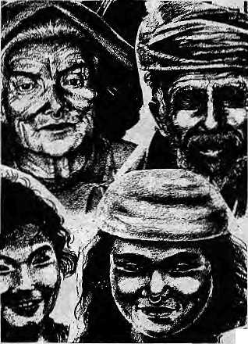

T
his is a collection of 34 essays presented at an international seminar organised by the University of Sidney and the Centre for Nepal and Asian Studies in September 1992 in Kathmandu.
The most outstanding feature of this book is the variety of topics it presents. This diversity illustrates the trajectory that the anthropology of Nepal has spanned in the last three decades, from its initial obsessions with caste, social structure, and religion to issues concerned with development, the nation-state, and the politicsof culture. The essays collectively show how Anthropology as a critical discipline can contribute to a better understanding and perhaps resolution of Nepal's numerous societal problems. They also illuminate how theory and practice of anthropology must not be separated as they have so far been among its practioners.
The papers on 'Anthropology of Resource Management' highlight the links between forestry and anthropology, providing useful insights into understanding the politics of development, local cultural practices, and social change in Nepal. While exploring issues such as indigenous and community forestry management and farming systems, writers have simultaneously pointed out the importance of understanding the gender dimension in the "eco-crisis" (Sumitra Gurung); the historical dynamics of environmental degradation (OmGurung);and the labour and forest use strategies (Ben Campbell, Ephrosine Daniggelis). Papers under this heading,except the one by Om Gurung, however, focus on micro level institutions. Absent is a critical look at the relationship between international donor agencies, state policies, NGOs, powerful persons in the community, and the local users of natural resources.
On women and gender, some of the common themes evoked are women's resistance, power, and the relationship betweensJiafcii {femaleform of transformative power), kingship and the state. Barbara N. Aziz presents a biography of a dissident and progressive woman in the Arun River Valley and critiques the patriarchal processes of hi story-making which have obliterated women's contribution. Aziz indicates the potential of both oral sources and biographical information to reconstruct something that has been sidelined. Julia Thompson delineates women's use of rituals and religious activities as forms of overt or covert resistance. Through a close reading of Swasthani textual and ritual traditions, Linda Iltis argues that shakli is evoked in rituals performed by
48
women to empower individuals, families, communities, the king, and ultimately the state. Tordis Korvald and Bert van den Hoek also share Iltis' concern about female power, but in the context of Newar dance rituals.
Anthropology of
Nepal; Peoples, Problems and
Processes Michael Allen,
editor
Mandala Book
Point, Kathmandu
1994
The book also contains essays dealing with the nation-state, collective identity and action, and urban problems. A new form of collective identity known as jana-shokti and certain modalities of action have become widespread after the 1990 movement argues Vivenne Kondos. But increasing state control over local resources has disempowered local organisations according to Stephen Mikesell's close reading of Nepal's new local government law of 1992. State-subject relations is also highlighted by Kondos et al. in their analysis of ■A industrial workers'political action and thestate's response. While the variety of topics discussed has certainly enriched the Anthropology of Nepal, there are remnants of "gatekeeping concepts", with Newar culture portrayed as the only culture of Kathmandu. Although topics such as musical genres, changing family patterns in urban areas, urban traffic behaviour, and actions of Bahun and Chhetri women are explored, there are at least six papers based on field work among the Newars of Kathmandu. In addition, essays (except Prayag Raj Sharma's) dealing with urbanism focus only on the towns of Kathmandu Valley and therefore leave the theoretical problem of conceptualising the relationship between old and new urban centres and processes of urbanisation unresolved.

by Lazima Onta | 'l^m *«^l<a HhHNi mH
L Onta is a student of anthropology currently working
with Katmandu's street children. | Now you can read Himal regularly in Nepali as well. Keep a lookout for the quarterly Nepali Himal.
MBKhlApril 1995 HIMAL

One Level of Encapsulated Wisdom

T
he environment," writes Anil Agarwal, "is an idea whose time has come in India." This is the opening line of "An Indian Environmentalist's Credo", from Aga-wal's "The Fifth World Conservation Lecture: Human Nature Interactions in a Third World Country ", published in The Environmentalist in 1986. It is reprinted in Ramachandra Guha's edited volume Social Ecology. Guha obviously agrees with what Agarwal had to say almost a decade ago. So, how much has the world changed or how much have the academics not changed with the passage of years?
The collection, boasts the hard-back jacket, seeks to bring together "a selection of pioneering essays" on a subject of increasing interest to sociologists and social anthropologists. The blurb claims that the contributions assembled provide a 'state of the art' survey of the field as well as an orientation to future research. Produced as part of the Oxford in India Readings in Sociology and Social j4fiffrropo/ogi/, the volume, weare told, is carefully planned to suit the needs of the general reader, students, teachers, as well as scholars from other disciplines. It is a pity that, somewhere along the way, the second objective was lost sight of.
It is difficult to imagine how articles written more than a decade ago can survey the present 'state of the art'. True, there are some gems likeRadhakamal Mukerjee's "An Ecological Approach toSociology" (first published in The Sociological Review in 1930, pioneering and hard to get). However, most others only reflect the interests of specialist scholars.
An example is Verrier Elwin's "Civilising the Savage", written almost half a century ago. Elwin's work might have been significant for policy formulation then, but the Beiga way of life has so traumatically changed that the piece is only of academic interest to researchers like Guha, who also happen to be researching Elwin's biography.
"Bewar is still practiced by the Kawardha State, of Pandaria Zamindari, in many parts of Bilaspur, in the Beiga Chak of Mandala, and until quite recently in Rewa," wrote Elwin in 1939. Is it still practiced? One would have appreciated a note on the present situation,
Guha's "Colonialism and Conflict in the Himalayan Forest" is excerpted from his own "Forestry and Social Protest in British Kumaon: 1893-1921 ",originally published in Subaltern Studies in 1985. Whileother articles in this volume take care to explain in some detail the methodologies and approach used, it is not clear why Guha chooses to omit all notes and references in Social Ecology.
Guha seeks to examine the "trajectory of social protest inKumaon during the early decade of the century".
Social Ecology:
Oxford India
Readings in
Sociology and
Social
Anthropology
Ramachandra
Guha, editor
Oxford University
Press, India, 1994
ISEMO 19 563113 7
[Rs42S
by Puspesh Pant
P. Pant, a Kumaoni, teaches International
Relations at Jawaharlal Nehru
University, New Delhi. (
He begins by recalling that since 1973 Kumaon has been the epicenter of the Chipko Andolan, possibly the best known social movement against the exploitation of forests by outside agency. The author's sympathetic interest in this movement seems to have coloured his vision, and the not so distant mirror he holds up to illumine the present, to my mind, only succeeds in distorting the images.
Guha's paper does evoke, as does his other work The Unquiet Woods, the excitement of the Kuli U tar agitation which shook Kumaon in the 1920s and the Chipko of later decades, (Kuli Utar was the subject of a PhD dissertation by Shekhar Pathak, a Kumaon University historian and the editor of the Himalayan journal Pahar, who was involved with Chipko from his undergraduate days.) Guha reachesmany of Pathak's conclusions and traverses the same routes as followed by Pathak. (That doctoral work has since been published in Hindi but is as yet untranslated in English.) It is difficult to agree with many of Guha's interpretative comments as it is impossible to distinguish between 'shared views' based on extended conversation between him and Pathak, and data generated from first-hand fieldwork and archival research.
Much water has gushed down Himalayan streams since, A recent reassessment of Chipko (Himal, Jan/Feb 1994), is far more stimulating and invites the reader to take a more insightful, detached and sympathetic look at the movement. It is less nostalgic/romantic and much more realistic. Euphoria of the Chipko days cannot be so conveniently linked to a colonial past.
There are other articles like the one especially written for the volume by R. Sukumar, which leave one quite disturbed. Sukumar has written that wonderful book on the Indian elephant, Elephant Days and Nights, which attains the poignancy of poetry. Unfortunately, the short command-performance in Social Ecology does not give the reader any idea of the passion of this scientist and the grace that his prose can attain. Telegraphic sentences are strung together mechanically to prompt us to think seriously about wildlife and human conflict in India:
We live in a rapidly changing society. It is too much to expect the poor to remain as si lent spectators. Conservation can succeed only if legitimate aspirations of people dependent on forests for their livelihood can be met by the rest of the society. Today the local people see sanctuaries or national parks as simply the pleasure resorts of the affluent. There is urgent need to orient management of our wildlife resources so as to pass on economic benefits to local communities. It is time that we also take bold new approaches towards combining economic development with conservation. In the words of ecologist Norman Meyes conservation should not only sustain the spirit but also the stomach.

HIMAL March/April 1995
49

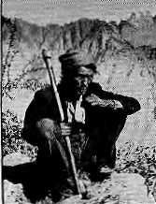
At that level of encapsulated wisdom and generalisation, it is difficult to disagree with anything at all.
The pulls of ideology, interest and scholarship do not always coincide, and the discourse, as a result, is not always coherent. Scholarship in the field of social ecology seems to follow the trends in eco-politics and is tinted in similar hues—red, green and brown. It is a difficult to maintain the delicate balance between the logic of science and socially relevant emotion. The result, often, is not satisfactory.
Sukumar, usually so scintillating on animal population management, is reduced here to oversimplification and equivocation. "The tiger is highly endangered and every effort should be made to avoid culling of these animals. However, there would be no other option but tocaptureor shoot identified man-eaters. The decision could be easier to take if the offender is known to be a male tiger. There is a pressing need to both conserve wildlife and to minimise its impact on human lives and property."
Stating the obvious has the advantage of preempting disagreement.Thenatural scientist cannot enrich the work of social scientists in this vein.
The volume also does contain some fascinating articles like the one on the sacred uses of nature by Madhav Cadgil and V.D. Vartak, who frankly preface some conclusions as pure speculation—"more tantalizing than fruits of field work". The duo is also candid enough toadmit that how far the taboos were observed in the past
is "difficult to ascertain".
Charming candor apart, here too, one finds many of the assertions difficult to accept uncritically, "Present-day India still abounds in many forms of nature worship. All forms of life forms—hedges to figtrees,and from crabs to peacocks and tigers—continue to be considered sacred and inviolable in relation to a variety of primitive cults. With deforestation proceeding at a rapid pace, the sacred groves are assuming a far more important role in the daily life of local population as the only remaining source of forest produce."
It is difficult to comprehend how such perceptive scholars can overlook the transparent loss of faith and desecration which has kept pace with and fuelled deforestation.Thecommercialexploitation,profitabIefor some members of the local forest communities and collaborating elites in the short term, has demystified the sacred groves and led to reckless exploitation of these and other community property resources. The tiger is the vehicle of Durga, but this association does not save Ranthambore's denizens. Gadgil and his associates have done extensive fieldwork in the Western Ghats. The experience of peoples elsewhere, say for example in the Himalaya, may not necessarily bear out the same conclusions that they have reached.
Those interested in the state of Himalayan
environment today would do well to mull over the
complexities and not yield to the temptation of seeing the
world in a grain of sand. ^





Not To Miss A Single
issue of
' HIM
Subscribe Your Copy Through
n & Mahsukii E
Delivery At Your
nisB
DOOR
"■ SofVDBtnbutor_{I}& Subscription Agent fop ■■■ "'. ■■■
Asiaweek, Asian BDsine5S,<Japi^[MafKet,: Sown,to■ Eartfi, feriefgy fqr.SuSttairiab.le Development, Himal, World. Executive's Digest, Study Abrdal, tiatiohal Geographic,
P.O.Box;168, Maharajgunj, Jha-54 ■ ■ '. ■- ■" Katjiniandii -3, 'Nepal,. ■■■ ":; "■; "
V ;i\

50
Mart/April 1995 HIMAL

Know Your H i m a I

Rescue in Name Only
Mountain rescue facilities in Nepal need to be built up from scratch.
by Deepak Thapa
When considering 'mountain rescue infrastructure' in Nepal and the institutions dealing with accidents in the Nepal Himalaya, the name that immediately springs to mind is the Himalayan Rescue Association (HRA), in existence for more that 20 years.
This, despite the word 'rescue' in the Association's name being problematic. 'Preventive rescue' is more in its line, concerned as the HRA is with the health of tourists and with dispelling their ignorance about mountain sickness. Running two health posts during the peak trekking seasons at Pheriche in Khumbu and in Manang, plus an information centre in Kathmandu,theHRAishardlyapan-Nepal Himalaya rescue association.
The Association's outposts serve more to complement the nominal government health services in their areas of operation. Manned wholly by volunteer doctors from the West (no Nepaii has served a full season), the HRA posts do fulfil one essential need. Radio contacts are made by them on a daily basis withtheKathmandu office. Asa result, the HRA has often helped in getting SOS's across to the concerned agencies and authorities.
Acting on the notice of accident received through the HRA, the police wireless network, or other mediums, the host trek agency in Kathmandu generally activates the evacuation. The expensive choppers are paid for through insurance. In the case of individual trelckers, the concerned embassy is contacted, and the ensuing paperwork and helicopter disp atch is a m ess-ier process. The Nepali staff of trekking and climb ing expeditions genera llyhavenothing to fall back upon, and have to rely on the benevolence of the trekker/climber sahibs.
One outfit that can claim to be a rescue team is the Himalayan Rescue Dog Squad (HRDS). Based in the Sundarijal locality of Kathmandu Val ley and wi th four base camps
in the hills, HRDS hasa team of eight German shepherds as well as paramedics trained by volunteer doctors. The outfit has made a name for itself over the years by seeking out people both lost or dead in the mountains.
Besides dogs, helicopters are the other prominent feature of the rescue business in Nepal. It all began in 1962 when an American expeditionhadtoabandonitsillegal attempt to climb Chomolongma and had to be ferried out to Kathmandu (by heavy Russian helicopters that were flying then).
Western trekkers certainly prefer helicopters to porter-back as the mode of mountain rescue, even if they are only simple case of headaches or heart flutter, exacerbated by a sense of discomfort and remoteness up some high valley. While it is true tha t some of the undeserving do manage to hitch a chopper ride back to Kathmandu, helicopter evacuation has saved many lives over the decades. The Royal Nepal Army's Alouette choppers have been the mainstay of mountain rescue since the early 1970s.
But "helicopter rescue" inNepalmeans nothing more than the evacuation of an injured climber to Kathmandu. There is no stand-by rescue facility, and the helicopters donotcarrytrainedparamedicsqualifiedto treat trauma. These are not flying ambulances, they are more like ferries. There isno record of anyone having been winched off a mountain in the Nepal Himalaya.
Even so, with the advent of private helicopter operators in Nepal thelastcouple of years, rescue by chopper seems to have become more efficient. There are more helicopters available at any given time, and there is also more variety in the machines. The French-made Ecureuils, for example, are faster than the trusty Alouettes, with a rotorsystemsaidtobedesignedtowithstand severe air turbulence. The Russian MI-17, meanwhile, is certified to land at 20,000 feet, and the ability to maneuver and hover somewhat up to 23,000 feet.
There are some problems in using these versatile additions to Nepal's chopper fleet, however. New regulations brought out by the Department of Civil Aviation inFebruary 1995 state that only if army helicopters are unavailable may private ones be commissioned for rescue. The regulations also make it inconvenient to mount swift evacuations because even rescue flights are required to present their flight plans in writing before take-off.
Such incongruous situations arise because those who are mandated to look after the development of the trekking and mountaineering industry, even after decades on the job, fail to understand the need for visibly efficient rescue facilities. It is quite interesting that 45 years after mountaineering began in Nepal, the Ministries of Tourism, Home and Health together, the HRA, and the Nepal Mountaineering Association have yet to come up with even a blueprint for an emergency medical rescue unit.
The one 'professional' organisation which does exist, the HRDS, has no legitimacy to speak of, in that its Director of Operations has not had his visa extended and has been living in Nepal 'illegally' for the past two and a half years.
Amidst all this inaction, there is still some hope for a change for the better. One positive development is the reduced cost of helicopter rentals. Till not so long ago, you could not get a helicopter for less than U$ 1500 an hour. The rental costs have plummeted in the last couple of years, and the actual operating costs (which should be the asking price for rescue flights) are much lower. The Ecureuil, for example, can fly at operating cos ts of as low as U$ 600 per hour.
Provided there is some interest on the part of the government, an emergency helicopter service along the lines of the Royal Flying DoctorService of Australia is hardly unfeasible. And we may even look forward to the day when helicopter rescue in Nepal is notonlythepreserveof insurance-paying Western tourists. One day, the sight of a chopper with the trademark red cross painted on its belly may bring hope to a dangerously ill or seriously injured Nepali as well.

HIMAL March/April 1995
51



Abominably Yours,
Hillary is coming to town. You mean our Hillary? He of Hillary and Tenzing? The lanky one? The one who peers out of New Zealand's five pound note?
Nope. Hillary Rodham Clinton, First Lady of the United States of America. The lawyer from Little Rock, Arkansas. She of Hillary and Bill. She, you see, of Whitewater.
Well how dare she? To begin with, we have been confused since the day HRC began grabbing the headlines, for since then we have had to re-read all news items to check which 'Hillary' they're referring to. Hillary headlines in the past were always about He Hillary. He might be a New Zealand bee-keeper, and I for one was never invited to even one honey tasting session, but all Himalayans were proud whenever he made news.
Then, three years ago, the other Hillary, the feminine Hillary, arrived to cloud up matters. New Zealand and Himalayan media were no match against the American media jagannath (you mean juggernaut? yes I mean jagannath). She came up with a health plan to make Americans fighting fit; changed her hairstyle and went classic; posed, some would say suggestively, for Vogue; and sat in on policy meetings at the Oval Office, She was steel; a far cry from our mellow giant from Maori country.
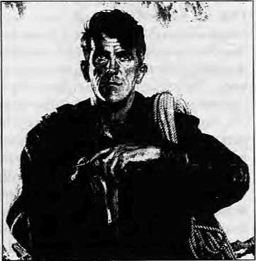
Our Hillary
With the headlines she made, the First Lady changed our response to 'Hillary'. The term had always denoted
the gentlemanly ways of the tallei
one of the Sagarmatha duo. He
was not given to steely ways, he
brought education to the Sherpa
of Khumbu and Solu. He kept his word
with Tenzing and refused to divulge info
on who topped Chomolongma first.
And then came this woman, Rodham Clinton, with chaos in her wake. It is quite a bitter pill. Our calm, well-ordered lives lay shattered. Hillary never meant Hillary any more. A lady from a little rock of a town in an underdeveloped Midwestern state had managed to dislodge the man who had conquered the biggest rock of them all.
And now, even the Rising Nepal, flagship paper of the land of Sagarmatha, gives precedence to Ms. Hillary over Mr. Hillary in its headlines. Hillary the He, though hardly a headline monger, is now reduced to reference by qualification, such as "Sir" Edmund, or Hillary "the Everesteer".
The problem, of course, is not so much Sir Ed's as of the rest of the five billion humanity, which is having to get used to the word all over, just because back in the Sixties at Yale Law School a rising-star Bill Clinton fell for a young woman, surname Rodham.
Bill's Hillary
And why is Rodham Clinton now making a foray into the international arena, I ask you, flying all the way to the Social Summit in Copenhagen and then to South Asia? Hypothesis A: she wants to log the maximum distance between herself and the scandal-sniffing pandits inside the Beltway. Hypothesis B: (following on A) in order regain her earlier can-do image, Bill's spouse needs all the props she can belay. So, she has come here to raid on the goodwill that exists here for Sir Ed.
HRC needs to show the American audience that she is not the manipulative player The Washington Post paints her to be, and that the world beyond the Eastern Seaboard is able to discern her kinder, gentler edges. As I see the scenario
unfolding, it will not be long before Edmund will be invited to endorse Bill's bid for re-election, and our Everesteer might even be invited to stump with the President in the New Hampshire primaries.
Don't do it, Sir Ed! You are made of sterner stuff! You do not need the media and the way the Arkansans do!
Meanwhile, what do we do with HRC as she relentlessly wings her way hither? Together with her visa form, the USA First Lady should be asked to fill the following.
Welcome to the Himalaya. Kindly tick one before you pass through customs!
- change your name
- use 'Mrs. Cunton'
- go under 'Ms. Clinton'
- leave the headlines to Sir Ed by con
vincing husbawd Bill not to run again.
There is always the possibility that
the First Lady will pull rank and
diplomatic immunity and refuse to tick
any or all of the above. She might cause a
diplomatic incident and embarrass a Communist government which wants so much to be cuddled by Uncle Sam.
If the First
Lady will not play ball or jog along, we should fight fire with fire by immediately flying in Sir Ed. Our man can fight the good fight without the aid of spin doctors and photo
opportunities. We have to bring back
Edmund the Everesteer, if only to show
that we can do without the new,
improved marketed version. Meanwhile, we must

head Hillary off at
the Lamjura Pass,
before she arrives
in Khumjung to
hug Sherpa
children studying
in the school built
by—Hillary!

52
March/April 7995 HIMAL

■ | - | ■ | f
SHANGHAI | I « | | | ■ ■
 | \KATHMANDU | •ill |  |  | 1
LONDON |  |  |  | :_{LHj}
PARIS |  |  |  | CALCUTTA
FRANKFURT . DUBAI |  |  |  | PATNA BANGKOK SINGAPORE ;
BOMBAY | ., .» «> ! f |  |  | HONG |  | ■■: ■: ■■ ■■■. ■ I  KONG
 |  |  |  |  |  | >
 |  | I |  |  |  | \
aiii 111 til i i ffr i |  |  |  | iH_{t} .inn |  | 1 1 Ultil
NOW DIRECT TO SHANGHAI & OSAKA
Royal Nepal-Nepal's own international Airlines operates regular flights to Kathmandu from 13 cities. You can warm to the gentleness of Nepali culture, tradition and the authentic spirit of
Nepali hospitality aboard.
Royal Nepal Airlines
RNAC, Building, P.O. Box: 401, Kathmandu, Nepal Tel.: 220757, Fax: 977-1-225348

Hongkong 3759151
Singapore 3395535
Osaka 2292545
Bangkok 2333921-4
Kathmandu 22O7S7
Shanghai 2558899

You've just spent hours inching around a space -barely
enough to accommodate
the human body. Odd, that's what climbing in
most sleeping bags is like.
The New Sleeping Bag Collection
For our free catalogue call 707 544-4590

