
S~. M ■::. HHf. W? "".:... ■
Si-¹ '^...VK.'SltVwl

?£. ™ .^. ■:?:■: :-:::' .^.
Himalaya
.:".. ?; "■".!.. .™: ■■■■■■* '":... V.V.- "■■ "... :~. ■■■■■ !~. #■ .™.

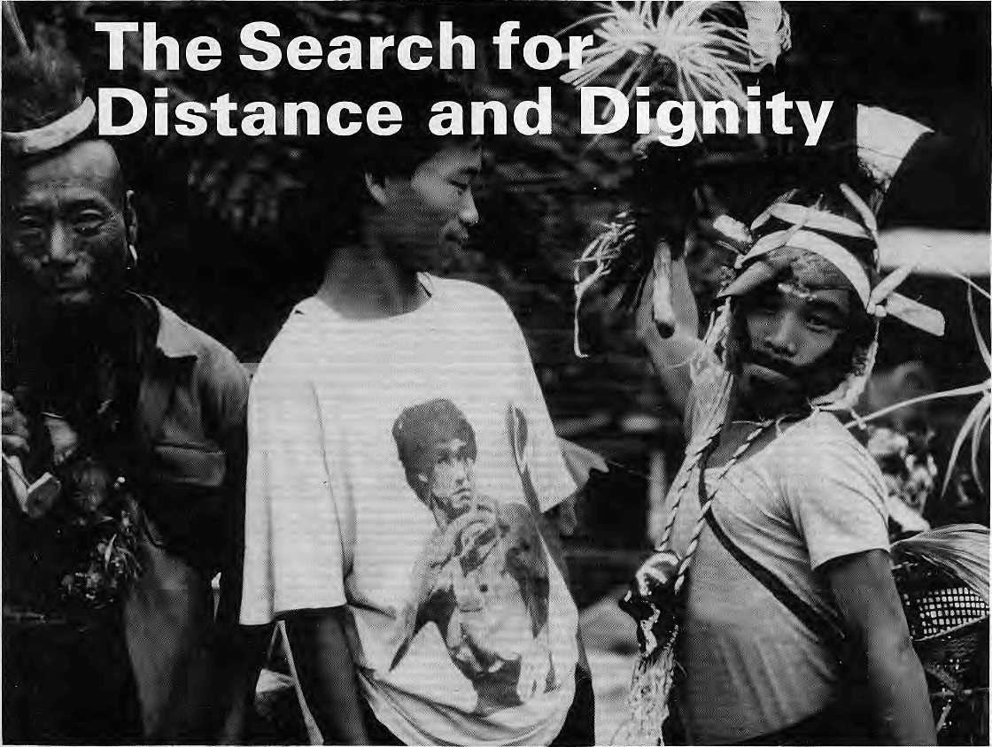

Megalith to Chorten Speak up for the Khas



iiiliiilli
AX
Northwest makes it easy to go to America. With a choice of 8 gateways. And connection to 200 cities beyond.
Choose a connecting city that suits you best: Bangkok, Hong Kong or Singapore.
generous free flight plan there is. Genera] Sales Agent in Nepal :
Northwest has daily 747 flight via Tokyo or
Seoul straight to the U.S.A. Malla Treks,
Malla Hotel Arcade,
Be sure to ask about WorldPerks, the most Kathmandu, Tel. 418 389


NORTHWEST AIRLINES
SOME PEOPLE JUSJ KNOW HOW TO FLY.^{S}'

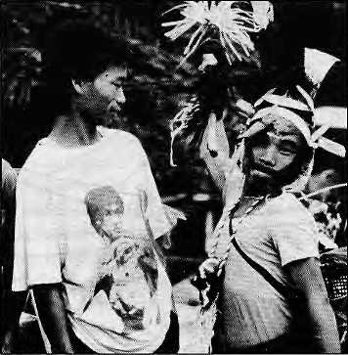

VotS No 3 May/June 1995
The Abode of Gods, King of
Mountains, Himalaya You bound the oceans from:
east to west
A northern yardstick
to measure the Earth
- Kalidasa (Kumara Sambhava)
Editor
Associate Editor Manager Administration

Kanak Manr Dixit ManishaAryai KirartShrestha Balaram Sharma Mamata Manandhar
Subscription Rates
Only bank-drafts acceptable lor subscription orders
SIDE
Far Eastern Himalaya
The Search for Distance and Dignity
by Sanjoy Hazarika
Why is the region of the Far Eastern Himalaya so mired In conflict? Because the people here do not feel part of the various nation states under whose boundaries they happen to fat).
Cover picture by Sanjay Acharya.
Bruce: Lee in t-shirt meets zVarrior in traditional attire in Arunachal Pradesh.

Mtvfdusf  Nepal ndta | NRs IRs | 1 yoar  ■■"': I.*-.' | 260- | 26 Vishnu Maya in Amrika Photo Essay
Jhutan | ■ Nil- | 175 | v 930. - " | A Gurung lady travels over the
Cithers. Asian Countries | US-" | ■■ ^{)?}.. | ■ .v jig _{v}. * | seven seas to see whats out there
Sorth America | U$ |  | 3-- ■^{v}40.. "■ ,,
Germany | DM | 50 | " SO ■:■■ '"
Jnlted Kingdom & Ireland fatherlands | £  Oil | .20" 46' | ■ 3.5.  - _ so ■■ :;. | 29 Doring Revisited
Elsewhere | u$ | 25 | ■■■ 45 '■■ | by John Vincent Bellezza
hstttuUotwt |  |  | ■■' ■■■■"'_.. i
"Jepai | NRs | 600 | 1100\ ' | A prehistoric aboriginal site in
ndfa | IRs | 260' | ... 500 | Tibet's Chang Thang has
Bhutan Other S. Asian Countries | Nu  u$ | 330 25 | 640-  45 ■ | apparently been taken over
North America |  | 35 | 60 ^{v}- | by later devoulees.
Germany | DM | 70 | 130 .. ■#■
United KliTfldorn & Ireland | £ | 30 | .■ 60.. ■■■
Netherlands | Ofl | 100 | ;.. ieo ■" | 42 J'Wai
Elsewhere |  |  | eo | Katha
Send subscrlpttons d related correspondence to: ; : |  |  |  | by Anadi Pawan Chhetrr
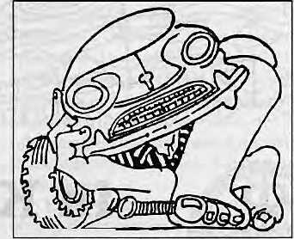
Sooth Asia: P.O. Box 42, Lalltpur. Nepal
(tel9771 52384$, tax977 1521013), or:.
Central Nbws Agency, 23.'90 Cormaught
Circus, New Delhi 110001
Japan: AKio Hgriuchl,
P,O.Bbx9, Ktyose; Tokyo, 204 Japan.
Australia: tndra Ban, 12 Norfolk Si,
Paddhgton 2021, Sydney, Australia.
North America: Barbara Bellas Associates,
500 Sansome Street, Suite 501, PO Box 470758
San Francisco, CA94H7
United Kingdom & Ireland: Joti Gin (Ref: l-Q.
S21 Mhly Garttens, Emery Hill Street. London SWi 1PA
The Netherlands: C. F. de Stoppelaar,
Foundation Hlmafaya, Kelzersgracht 463.
1017DKArnstefdam
Switiertand: Helena Sngg. Tannenwog 18,
CH-J073, Gl«mllgen, Switzerland
Europe: Dyrga Press (Himal), LuhpaEdstr. 20.
D-82211, Herrschlno, Germany
Hirnal© 1995 Is published every two months by Hmal Association, PO Sox 42, Palan Dhoka, Lalrtpuf. Nepal Tel: 9771523S45, Fax: 521013. email: himal® Nnipc.rnos.corn.np Libary of Congress Card, Catalogue Number 88 912952 ISSN 1012 9804
Printing: JagadambaOfisetPvt. Ltd. Tel: 521393^
P.O. BOX 42, LALITPUR, NEPAL FAX: +B77-1 -521013 TEL: 523B45
himal@himpc.mos.conLnp
45 Khas of Chaudabisa
by Dor Bahadur Bista
Economically exploited, socially oppressed, the Khas ot Nepal's northwest also suffer from a severe case of identity crisis.
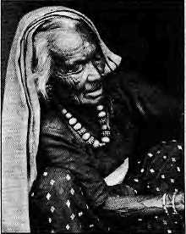
Departments
Loud Tourism, Untrodden Peaks Hillary's Spoof Delirium in Uttarakhand Inevitable Theocracies Faraway Mountains Governmental NGOs The Gore and Glory Worm As Editor

8 | On the Way Up
23 | Review Ama in America
24 | Voices
34 | Himalaya Mediaiile
37 | Briefs  Karakoram Sky Dance Pot Profits Lost They Hate Swidden Challenging Uncle Chips Beijing Targets Dalai PLACENAMES - Sikkim
50 | KnowYourHimal  Making Criminals of Climbers
52 | Abominably Yours

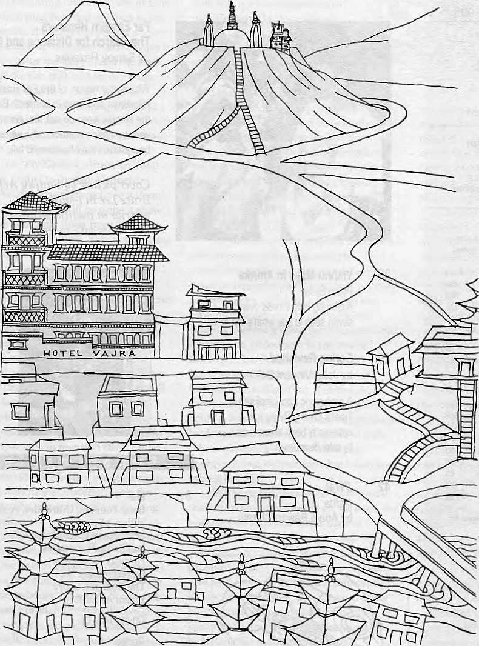
Vajra (literally-flash of lighting), is an artists' condominium, a transit home for many, providing a base during months of hibernation and creative inspiration. Its isolation, graphic splendour and peaceful ambience, make an ideal retreat from the clock of pressure.
KetakiSheth Inside Outside
1 stayed a week at the Vajra, by which time I had become so fond of it that I stayed another.
John Collee The London Observer


in Kathmandu, the Vajra

Swayambhu, Dallu Bijyaswori, PO Box 1084, Kathmandu Phone 271545, 272719 Fax 977 1 271695 Telex 2309 HVGHPL

a

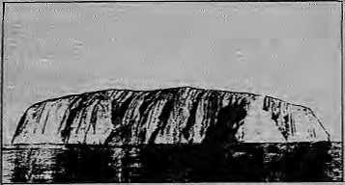


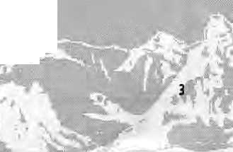

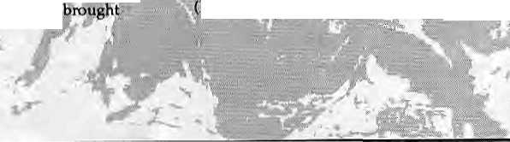
Loud Tourism, Untrodden Peaks
Fu rt her to '^Scand ina v ian Scandal" (Mar/Apr 1995), could it be that this RolwaJing episode heralds change for the 'management' of the: great peaks?
In the centre of Australia standsthe greatest ; monolith in the world and for years tourists went there for the sole purpose of'climbing the Rock', a sort of pilgrimage that changed orie from an ordinary citteeiv to'one who had done it*. The fact that some lost their lives in the process made it : seemingly more attractive,
Thel980s saw the area declared a national park and the monolith's name changed back from Ayer's Rock to Ks indigenous name Uluru. T.he traditional aboriginal owners took over its management, as it is one of their sacred places.; They never climb it. They hadlong disagreed with the climbing of the Rock and now they began to : hand put information, encouraging touriststo share the indigenous view of Uluru and to refrain from climbing it. They report that the number of climbers is gradually dropping, but not the nu mber of tourists,
I am not a climber myself, simply ahill dweller. But I have looked up at the great mountains and haveflowh over the Himalaya; I regard those events as the highlights of rny life, from which I continue to extract a deep, spiritual clarity. Even though aeroplanes are an intrusion, being enabled to look put over a landscape free of human habitation was an unforgettable experience. I would gladly pay for a permit to sit at the foot of a peak whose slopes are untrodden by human feet.
I'd even dare to predict that the time is not far off that the Government of Nepal and other Himalayan states can expect more foreign revenue from advertising and selling permits to view a sacred pristine peak> untrodden by mountaineers, than they make from climbing permits, But in order to be ready for that imminent change in the market, they cannot afford to lose a day and must start 'reserving' peaks now. If they could hear what tourists talk about, they'd understand that many object to wildcat commercial intrusions and spend less the more they encounter it.
Although many Sherpas make a precarious living with mountaineering, I have heard that their parents and grandparents were deeply puzzled by Western competition to get to the top of their mountains. It created an industry which
\995
WMAL
*>*
theSherpacertain benefits,, but it obscured the possibility that there might be other ways to share their environment and sell their services to travellers, ■
In'a: slow sort of way, mountaineering is hot a renewable activity. Few mountaineers climb the same peak over and over again, and those who reach high peaks are less interested in lower peaks, unless it has a notoriously difficult approach: Physical ability aside, mountaineering remains a very costly sport, far out of most people's reach-But sitting at the foot of an untrodden peak, viewing it from the beyul, would attract many . people—the ■typethat do not run tq prime ministers to get access^ : ■
: Rolwaling seems more suitable to become a: Buddhist pilgrimage destination. There are now more western Buddhists in the world than there are fleas on a dog. Mainy are professional people with short holidays arid not all can or want to go on pilgrimage to Tibet.:
Not that hordes of tourists are appropriate in these wonderful places. Mass tourism iri the long run brings less profit because of its costly infra structure and the fickleness of tourists, who turn away from a place as soon as it hecomes overrun With fellow tou n sts. But: ca reful ly licensed tourism needs very special places, whose uppermost attraction is that their mountains are unsuliiedby human traffic. This will ensure generations of Sherpa people a stable income and the government a revenue that does not need to be wholly ploughed back to repair the damage.
In other words, the government and the people of Nepal should not think only of the people who are now clamouring for access to Rblwaling and similar places, but also consider those who would stay away in droves from a place, however sacred or special its history, once it has been: overrun. A country can have any type of tourism it wants/but it seems that the loud variety is often the only type recognised. LotoHoubein Bridgewater, Australia
Hillary's Spoof
Thiscamefo my notice after I read theYeti's ^thoughts on "our Hillary" and "Bill'sHillary" Mar/Apr1995). Thetiew York Times of 3 April has

M.



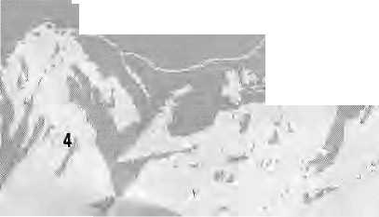
This is a
dalitdabao andolan, meant to keep the backwards in their place. No movement that is directed against the poor and the oppresed can be called revolutionary.
Hillary Rodham Clinton confessing that her mother, Dorothy Rodham, had read ah article' : :: about Edmund Hiliary-^a one-time beekeeper who had taken to mountain climbing—when she was: pregnant with her daughter inl947 and liked the name. "It had two l's, which is how she thoughtshe was supposed to spell Hillary,,. So when I was born, she called me Hillary, and she aiwaystbld me it's because of Sir Edmund Hillary/'quoth the First Lady. Edmund Hillary climbed Everest with: : Tenzing Nqrgay in May 1953, Isn't this alia -: little fanciful¹?:
ArunitnaRay '■"■„'
Delirium in Uttarakhand
Manisha Afyal's: controversial report on the Chipko movement (janflFeb 1994) had put the leaders who : preferred 'Chipko' to Chipko in a difficult position.. Her report Oft the Utfarakhand agitation CNov/Dec 1994) once again succeeds in addressing underlying issues: Aryal hastaken great pains in her reporting, and the article "An Uttarakharid State of Mind" is probably the only report that properly gauges the: depth of the people's anger; While one might not agree with all of her conclusions^ it has to be said that Aryal has tried to shed light-on ailaspecta of the Uttarakhand agitation. ■-.
The article's conclusion that in the absence of leadership:the movement would quickly die down has been proven by subsequent events, ft is also true that most of the so-called leaders of the agitation took refuge in misinformation: so that the public's anger would be kept at a high pitch aind there would be violence all round.
The people have now begun to understand that the leaders are out to fool them. The Mu2zafarnagar incident of 2 October 1994 served to open their eyes, and the people have now realised that the violence occurred because of the lack of foresight in the leadership. While the rallyists were stuck in Muzzafarnagar, the leaders were already in Delhi, because they had to make sure that they had access to the rally podium from which to lambast the Central Government. There was not a single responsible person present when the incident with the police occurred in Muzzafarnagar. The hill women who were headed to gherao Parliament were abandoned.
But when the Central Bureau of Intelligence conceded in its report that there had been rapes at Muzzafarnagar^ the reaction of the leadership left a lot to be desired. Some even asked how itwas
possible that women were raped and the activists came back without making a fuss. The women who returoedfrom Muzzafarnagar have now become : passive recipients of people's ridicule. They were garlanded: upon their return, yet when the CBI ■report was made public the local people started to call them ''Muzzafarnagarwali". Meanwhile, tneUttarakhandiwhoIivedirithe plainssaid that the report's being made public had shamed: them! \' '
: I have always maintained that this agitation is not to demand a state. The agitatipnists' activities have constantly proven this point. As has also been pointed out in Hirrial, this is a 'dalit dabao andolan', meant to keep the backwards in their place. At the beginning of the agitation, the folk poet Ghaitashyam Sailani had noted that the people of Uttarakhand seemed to be suffering from sahnipat (delirium). Nobody wants to listen to logic, however.
Some cali the movement a social revolution, but I term it reactionary. No movement that is directed against the poor and the oppressed can be called a:revolution> for do not the Dhunarj Tamota, Beda and Koiai figure among the dalit communities of Uttarakhand? Thescheduled castes and : backward classes in every district have been attacked in the course of the Uttarakhand agitation.
Meanwhile, the target of the hill people's ire continues to be Mulayam Singh Vadav's government in Lucknow. How ironic, that the very government which set up two committees for the creation of a Uttarakhand state and which had a resolution on the subject adopted by the State Assembly and forwarded to Parliament, should be the first target of the agitationists. Is there not a contradiction here? Meanwhile, the hill people support Congressman Narayan Dutt Tiwari knowing full well that he firmly opposes statehood for Uttarakhand. He receives support only because he is leading the charge to bring down Mulayam's government. This alone proves that the demand for statehood is hollow.
The Chipko leader Sunderlal Bahuguna was once a supporter of the statehood movement, but he too has how begun to worry that the natural resources of the region will come under greater threat after statehood is achieved. He is not wrong, for those who will rule over Uttarakhand state will be firmly in the grip of the forest and liquor mafias. Their first task will be to finish off what little forest tracts remain in Uttarakhand. The destruction ot forests after neighbouring Himachal Pradesh
' f



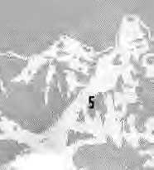

achieved its statehood is still fresh in memory. Also, when the Supreme Court banned the limestone mining in Doon, the quarry people all moved their operations to Hirnachal. Perhaps this is all that statehood achieves. ./:
Navin Nautiyal
Dharmapur, Dehra Dun
Inevitable Theocracies
In response to the letters appearing subsequent to Himal's Jaii/Feb 1995 issue on Lhasa, 1 would respectfully state the following, absent the blunting language of political correctness.
- The People's Republic of China's efforts to
reconfigure Lhasa as a high-altitude mall reflect the
absolute failings of the PRC to do anything other
than repeat its own domestic disasters.
- The ABC's of actual humanity require, as
predicate, factoring into any discussion the ethical
and the spiritual. In that sense, all nation states are
inevitable theocracies, regardless of what the
guiding moral force is named; otherwise, the state
rules in a moral vacuum. Evidently, the policy
makers of the PRC are morally bankrupt, failing to
comprehend that Lhasa, like Mecca and Jerusalem,
is as much a state of mind, heart and soul as it is a
physical locus. In that light, one understands, if one
has not been fenced in by the hideous depredations
of a failed tyranny, that Lhasa is where one holds it
dearest, and assuredly, Lhasa exists wherever His
Holiness the Dalai Lama resides.
- Considering the above, what point is there
in belabouring a largely irrelevant political issue-^
the return of the Dalai Lama to Tibet? After all, for
those who are fully human, Tibet is where one
finds His Holiness, the symbol for al) human beings
of the difficulties of living as human in a world also
peopled with the inhuman arid the inhumane. For
those who are not human, this argument is moot.
One supposes, among other thingS> that the
functionaries of the PRC imagine that the Tibetans'
"standard of living'' might be improved by the
appearance of plazas, concrete and malls. As an
American surfeited by concrete, plazas and malls, I
would proffer that convenience is no assurance of
overall quality of human life and that technology
does not equate with progress.
- Finally, the PRC deserves no thanks for the
current pittance of crumbs from the already sparse
table in its inane attempt to obliterate, once and for
ajl, the moral paradigm of Lhasa, done in the guise
of improving the standard of living. The world is
an indifferent place, on balance. Children
everywhere routinely starve to death while the so-called good people pay only lip service to the horror, Perhaps, while the PRC has its bulldozers running, it might want to turn them next on the remaining cultural heritage of Peking's Forbidden City. Godknows,: we hear of a rotten standard of living in Peking.
Icanonly wohderat theshortnessofmemory. The Chinese are no strangeTstp suffering as victims of irrational subjugation. I indeed wonderat those officials in the PRC who are more to be pitied than despised^ as they have so readily become all which they onceclaimed to hate.
tinda Kay Newnunt
Retto^evada
Faraway Mountains
I thought that Kanak Marti Dixit had a higher than reasonable expectation of;the "Mountain Meeting by the:Beach" organised in Lima by the Mountain Institute (Mar/Apr 1995). We all-know" that conferences do riot move mountains, whether they be held at their pinnacles or down bytheocean>-front. All they do is provide ah opportunity to meet and exchange ideas. We have a song in Sherpa: "Far-awiay mountains may be visible to each other, yet they cannot meet." Therefore, a mere meeting is in itself a major feat when it involves people from different mountain regions of the globe.
As Dixit rightly points out, composition of the participants is important. If the participants shared common feelings, challenges and concerns which cultivate further future exchanges, then the objective of conferences are partially fulfilled. In this sense, only true mountain people can evoke real feeling of commitment and partnership to support a common mountain agenda. Unfortunately, there are very few academies, scientists and activists from the high mountain region who are able to take part in such meetings.
The Lima mountain meeting, I understand, was primarily-organised for NGOs. But even NGOs do not flourish under the harsh mountain environment of Nepal. They are better adapted to therriild valley climate of Kathmandu, where they maintain visibility and develop a symbiotic relationship with thedpnor agencies. A key prerequisite for the success of the "Mountain


I
a

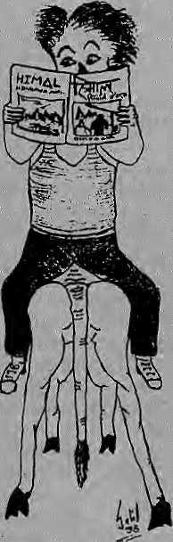
Agenda" is going to be cultivation and nurturing of Much closer'in their attitudeto delegates from the
tmertiountain NGOs, activists, and academics,- South. At the same time, however, there were : ■
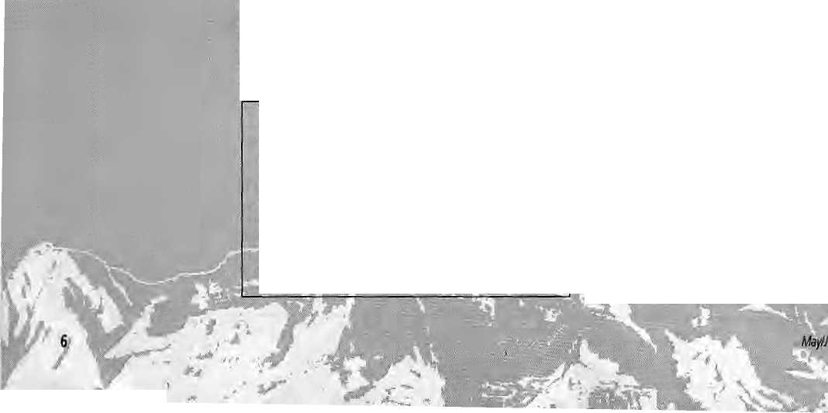

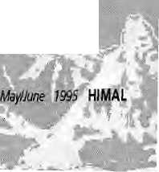
Sketch sent in by a Kathmandu readaf, the Nepali HiMAL quarterly and English HIMAL bimonthly well.
participation. : ■ ■ ■■■■■■...■.■■■■■■■;■„.■■■■■:.. ;••
Meanwhile, as a: follow-up, we may have to be
content with en exchange between, mountain:
subsistence farmers (withoutthe"feel-good
therapists" who Dixit so detests). The Himalayan
farmer can teach the Andean how tp malke potato
pancakes,.and trieAndean former can teach his :
counterpart how to feeze-dry potatoes! They can
compare yak and alpaca breeding techniques,
discuss coping strategies to deal with high :
altitude environments and l&wland brothers,
and can even educate the rest of the world by ■■■■■.:
explaining the difference between 'lama'
and'llama't ■■■■■
UwkpaSherpa
A Governmental NGO Meeting
Regarding the conference organised by the Mountain Institute in Lima ("Mou ntaiin Meeting by the Beach"), it is true that-the meeting started off on a somewhat disturbing note when the proceedings were taken over by a group of facilitators, Iii fact, feelings against the facilitators ran so high that one participant refused to distribute her card because it stated she was a "facilitator" back homel The "facilitator jokes" that emerged at Lima promise to endure.
Readers are invited to comment, criticise or add to information and opinions appearing in Hlmal. Letters should be brief, to thepoint and may be edited. Letters which art; unsigned and/orwith out ad dresses will be entertained. Include daytime telephone number, if possible.
email: himal@himpc.mos.com. np
But whereas this was irritation at the superficial level, unfortunately^ more fundamental differences started surfacing among the delegates. Though this was primarily a gathering of NC5P representatives, some of the splitsthat emerged were reminiscent of global gatherings of national governments. While there were of course -exceptions, there was a broad divide between the perceptions of those representing Southern NGOs and those from the North. As usual, many of the Scandinavians and East European delegates were
whofor ideological or personal reasons sidled
albngwith-theNorth, :■•/■:■ '.
Strong sentimentSj strongly expressed, that mountain agendas must be built from:the bottom up, from villagesito nations; and from nations to regions and to the world, were suirrmarily dismissed by the organisers. It was argued that national regional meetings have already taken place and this was was a global meeting. When the representative from IOMpD pointed out that the Asian regional meeting, which was hosted by them, had actually been a nteeting of governments and that the NGO viewpoint had not been repre-sentedj^ her: intervention was brushed aside. The demand that the reaimmeiidaiions of those regional meetings, if they had taken place, also be made available to the participants also fell ondeaf ears:
Based on the somewhat inappropriate resource papers produced by a few 'experts', the meeting brought out a set of such general recommehdations for the global Mountain Agenda that, amazingly, not one of the over 40 points attracted any significant dissent or debate. The language was sweeping; enough to accommodate all shades of thought, regardless of the diversity of opinion that existed among the participants:
Certainly, the recommendations that emerged from Lima contained very little that was new. They also captured little of the rich experience of the participants, essentially because the useful experience was all local while the recommendations were global. Indeed, in the various working groups there had been interesting discussions of down-to-earth case studies, but these were lost in the irrational process that was adopted of synthesising recommendations into bullet points. It was an indictment when one participant got up to say that the recommendations sounded almost identical to the ones that emerged from intergovernmental meetings.
Having said all this, one cannot disregard the fact that the exceptional group of people who gathered at Lima, even with all the constraints, could not but help move the Mountain Agenda forward. Strong, informal bonding took place, and addresses and fax numbers were eagerly exchanged. Despite the superficial and nan-so-superficial irritants, the Lima conference



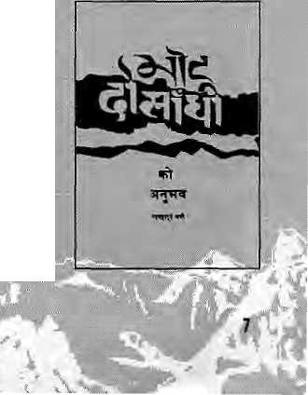


represented a unique meeting of mountain people : who were, at the end of the day, committed to : focussing their formidable energies at moving the Mountain Agenda.
Shekhar Singh
Indian Institute for Public Administration
New Delhi
The Gore and Glory
As soon as I arrive in Kathmandu in my twice-yearly visits, I always buy those back numbers of Himal which I have missed. So it is that I have just read "Dukha During the World War"(Nov/Decl994) and' Ronald Burroughs's response (Jan/Febl995):
A few weeks ago, I stood on the hill at Kalanga among the sal trees and the rubble that had once been the fort where the inspired Balbhadra Kunwar held out against a far stronger British force at the Siege of Nalapani. Then I moved on to the Malaun Ridge, where Bhakti Thapa gave his life ait trie very cannon's mouth at Deothal. I felt as much pride as any Nepali to be at those places where the Gbrkhas showed their mettle, and about whose courage pupils still learn in the schools of NepaL So why should Mr. Burroughs find it disgraceful for a Nepali, wearing his Gurkha hat; to have a wbrid-wide reputation as a brave and reliable soldier?
As an officer who commanded Gurkhas in World War 11,1 can tell Mr. Burroughs that when the time comes the Gurkha does not fight for the :; money—although why it should be a disgrace to be paid I do not know!—but for the family honour of his regiment. And he is no fool; like any soldier in any army, of course, he is afraid, arid he tries not to: show it although he knows he can be killed or wounded. And he fights with the skill of good training and not, as John Cross so rightly says in his splendid letter (Mar/Apr 1995), as a psychopathic killer.

Although I found Pratyoush Onta's article most moving, as any ex-Gurkha officer would, it came as no surprise. As John Cross says, it has been written about in other books. With a complete lack of modesty, I would mention my own book of a year or so ago, Beyond the Threshold of Battle, in which I described my personal experiences with Gurkhas on Wingate's First 1943 'Expedirion into Burma where, as we were fighting far behind Japanese lines., any soldier
H1MAL May/Aw 1995
7
Burmese village arid had totakehis chances with the Japanese—a touch-and-go situation; Gr> if '.. mortally wounded, treated with compassion and given a lethal dose of: morphia.-A fate; I would add, which was iexaetlythe same for the British soldiers. : In the face of this terrible adversity, my Gurkhas: showed; great courage, although obviously disturbed and apprehensive, "-- :
How can Mr. Burroughs have the gall to compare such brave men to prostitutes! I know that if he had; told them this to their-faces, and (here happened to be a khukuri handy, he might well have discovered the true difference between glory:and; gore.
Finally, I have absolutely no hesitation in ending this letter with a resounding: AYOGORKHAL1!!;; Harold james PO Box 9101, Kaihmandu '.
Shocked over Reprint
Anne de Sales in ''Wild Imaginings: French Anthropology in the Himalaya" (Mar/Apr 1995) quotes a book called Mero Bhot-DoshitndiKo AniibkiiV: (1972) bythe iateRudra Bahadur Khatri, as transiatedin French by Brigitte Steinmann in her work LesMarches Tibetaihs du Nepal (1988). It is said that Khatri's book has more than an ethnographic quality to it and that it is an attempt to reflect on the country's culture and to present it to his compatriots.
It is indeed so, but what is Jacking in Brigitte Steirimahh seemsto be intellect ualsihcerity and and a sense^of fairness. The translator, whiie seemingly concerned enough about the need to preserve Nepali heritage to want to translate Khatri's book into French, did not bother to take permission from the publisher.
As that publisher, I was unaware of the French publication of 1988 until 1 was referred to the Himal issue and de Sales' article. Although I have not had the opportunity to see Steinmann's work, I am informed that she has carried the Nepali text in toto alongside with her translation.
While I am happy that my effort to briiig out Khatri's work to the notice of Nepali readers many liow also behifit Western scholars, I am perturbed that Steinmann has not shown the sensitivity to a publisher's concerns over copyright. This, lam



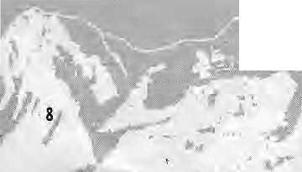

a
M
told, is an important priority among Western scholars, Or could it be that the scholar believed so much on the inherent goodness of her deed as far as Nepal was concerned that she thought the matter of copyright inMngment irrelevant?
I would very much likeSteinmariri to get in touch with me through Himal as soon as possible. With this letter I include a copy of the book A^era Bhoi-Dosandhrka Anublwv.
Umesh Rimal .,-..-■ Balttju, KMhinandu :
Worm As Editor
Kanak MariiDixit, editor of Himal, has found a pet enterprise of late: Bhutan-bashing. Nothing is allo^ wed to come in. his way/not eventhe hallmark of his profession: objectivity. Anybody who says anything remotely positive about Bhutan is a worm. A person who has riot been able to get into the country is a "Bhutan Expert" on a sanctified pedestal from which scathing and spurious charges can be launched against the Bhutarjese Government, I have news for Mr. Dixit, Thousands of requests from people who want to come to Bhutan are on hold; hot out of distrust or enmity, but simply because the ■ country cannot cope with as many visitors as it would like to have in the country at any given time. The editor of Hsmalneed Only look at his own backyard to see the tragic impact of lousy gate-keeping on a small, traditional, developing country.
The first time I read one of his voluminous works on Bhutan, I was highly entertained. This guy writes good stories, I thought. With titles such as "Dragon Bites Its Tail" and "House of Cards", they evoked images of Hong Kong martial arts and spaghetti western pot-boilers. But I was shocked to hear that they were hot supposed to have been works of fiction. Some kind of temporary affliction causing delusion,! thought.
But he keeps churning out major productions in the same vein: And I think I finally know his game. He is doing exactly what he has consistently accused others of: iising the exoticism and the 'sexiness' of Bhutan to get attention and sell his magazine.
"Duhta"
The fast paragraph of the letter has been dropped due to
use ot obscenities Eds.

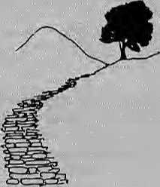
the
This issue of Himal has a more than our usual variety of articles, traversing as we do the Far Eastern Himalaya toJumla,theNepaltarai,ahd Chang Thang.
Or
political base of the Indian Northeast, to feudal roadblocks in the path of progress, the violation of a prehistoric site, and the origin of a species.
Delhi-ba sed wri terSanjoy Hazarifca p resentsthe cover feature, on a region that is fast overtaking the rest of South Asia as a place where vioience is a part of daily life. Unfortunately^ more rather than less savagery seems to be written into the region's future.
Dor Bahadur Bista, the guru of Nepali Anthropology^ has spent the last three years trying to ; puthistheoriesoffatalismanddevelopmenttotestin Jumla. Trust the professor to speak it like it is. Whenever Jahgali John (alias John Vincent Bellezza) turnsup in Kathmandu on his way from Himachal to Tibet or Tibet to Himachal, we get an article. His investigation of the conversion of an aboriginal site into a modern Buddhistic one is the kind of writing that Himal's hopes to present more of. From the high plateau to the tarai: with origins in Los Angeles as an architectwho used to design great office towers, Kurt W. Meyer has evolved into aresearcher of Tharuiife, spending much of his time jostling through tarai backroads in his red Maruti jeep.
If you have noticed some changes for the better in Himal's layout and design,; including a slight but significant change in the font used on the Himal logo and the addition of the band on which it sits, the man to credit is Amsterdam-based designer Frans Meijer. Overthe course of the last two issues,Meijer provided us with just the amount of new design elements that he felt a short-staffed Himal could handle. We also thank Cas de Stoppelaar and the Netherland-Nepal Friendship Association for making Metjer available to us.
Readers should perhaps be told that in mid-April, Himai's Associate Editor Manisha Aryal got married to Himai's Board Member Bikas Pandey. Their individual links to Himal, we are told, was coincidental.

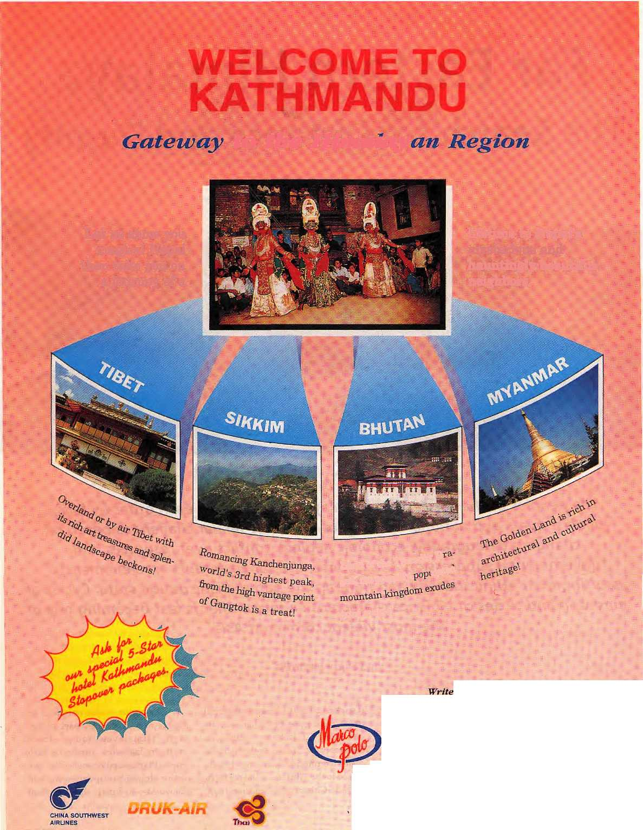
to: She Mimtmrn^,
lifetime to Nepal's mysterious and hauntingly beautiful neighbors.
Let us show you magical Nepal
then take you on a journey of a
Land of the Thunder t) gon, the sparsely ***
pure magic'.
to us for our color brochure and detailed tour itineraries.
Marco Polo Travels Nepal Pvt. Ltd.
Head Office: P.O. Box 2769, Gyaneswor,
Opposise German Embassy, Kalhmandu, Nepal.
Fax; 977-1-418479, 413641, Tel: 418832, 414192, 411780
Branch Office: Kalhmandu Guest House, Thamel, Kathmandu, Nepal.
Fax: 977-1-417133, Tfll; 414013

Far Eastern Himalaya
The Search for Distance and Dignity

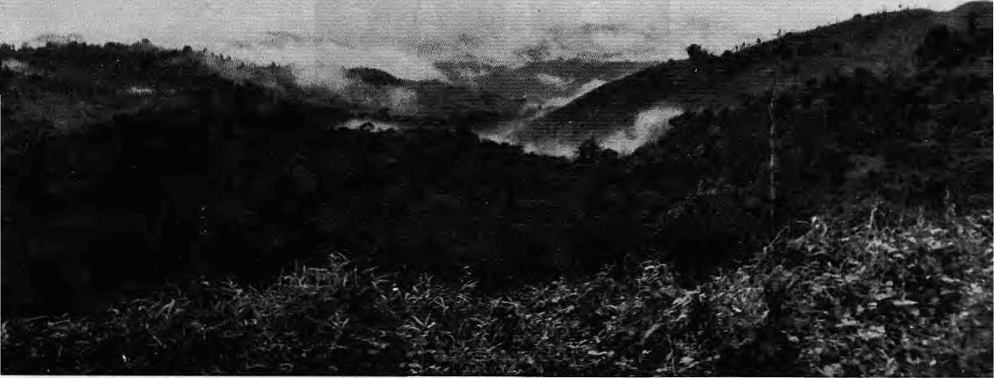

Arunathal roadside at Tbankip.
The peoples of the Far Eastern Himalaya, isolated from each other by hills, jungles, rivers and national boundaries, confront similar challenges based on
changing demography, economic neglect, conflict over resources and
governmental suppression. In response, the Far Easterners are vehemently
asserting their ethnic identity and fighting the paternalistic nation state. Cycles of
unreason and circles of violence characterise a region that is fast becoming one of
the most violent corners of Asia.
by Sanjoy Hazarika

T
he stretch of the Far Eastern Himalaya from Sikkim eastward is significantly different from the rest of the mountain range. The reach of the Ganga plains—of Hindu ethos and historical Moslem influence—is much more muted here.
If anything, many oftheanimistichill tribes have gone the other way by embracing Christianity. Unlike the cu It ures of the faraway flatland s, these eastern communities are more directly linked to the Tibetans of the north, or the indcnChinese of the south and east.
The region is also unique in its geography. Although part of the same Himalayan range, these southern latitudes nurture a lush tropical landscape drenched by one of the highest precipitation rates in the world—strikingly different from

10
May/June I99S HIMAL

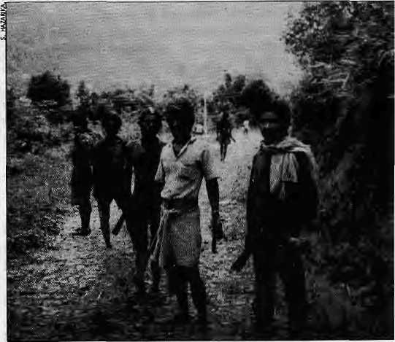
the high desert of Ladakh or the dry terraces of West Nepal. The High Himalaya itself is lower at these extremities; with the peaks descending eastward from Mount Everest (8848m) in the Khumbu, to Kanchen-junga (8598m) at the Nepal-Sikkim border, to Namcha Barwa (7756m), standing guard as the great bend of the Tsangpd. .About here, the Himalaya breaks southward into Burma and dwindles away eastward into hills of the Hengduan mountains of Sichuan-Yunnan.
From Sikkim, with Tibet a constant companion to the North, the political boundary snakes across Bhutan and Arunachal Pradesh, where it makes a sharp southern twist to plunge along the edges of Yunnan Province into Burma's Chili and Kachin hills, with spurs roping in the states of Meghalaya, Nagaland, Mizoram and Manipur, before meandering through Tripura into the Chittagong Hill Tracts of Bangladesh, close by the sea.
The western part of the Himalayan range is neatly packaged into a progression of states from Pakistan to Nepal to Bhutan. But here in the east the range becomes a geopolitical jigsaw, crossing national frontiers with impunity. The rectangle of the Far Eastern Himalaya is broken up among five nationstates: little Bhutan, the Northeast of India, the Chittagong Hill Tracts of Bangladesh, the Arakan region of Northern Burma, the southeastern tip of Tibet and the hills ofYunnan.
Compared to the peopled Himalayan hills of Himachal Pradesh, Uttarakhand, Nepal and Sikkim, this is a region that is still und er-populated with natural resources largely unexploited. Natural gas, petroleum, rushing water, minerals, tea, fish and timber—the wealth is there, largely un-exploited, due to reasons of history and geography. The bounty that was bypassed by the colonial rulers is eyed lustfully by today's market forces.
One potential source of wealth lies in the rivers that slice through the
deep gorges and green valleys. Travelling eastward all the way from Mount Kailash, the great Tsangpo takes its 180 degree bend beneath Namcha Banva, descending through vertical canyons into Arunachal Pradesh before disgorging into the Assam plain. Here are some of the most powerful rivers on earth, going by volume and gradient: the Brahmaputra (Tsangpo), Chin and Dibang.InthegorgecountryofBurma and Southeastern China are the headwaters of the I rra wady, Salween, Mekong and the Yangtze Kiang.
Asia in Miniature
While the geography and fractured frontiers of this region are fascinating in themselves, it is the population that holds evenmore interest: the cultural diversity and shared history, the deep animosities within and the xenophobia as far as outsiders are concerned. Ruled by the forest and inhabited by an endless procession of Tibeto-Burman tribes, the belt is a region of unceasing conflict, violence, anger and grief. Modern times seem only to have exacerbated the situation.
The babel of languages heard along this Himalayan flow includes the guttural Tibetan and its offspring Dzongkha, the sweeter Assamese in the Brahmaputra valley, and the lilt of Tibeto-Burmantonguesinthehillsof Nagaland, Manipur and Mizoram. Each step of the way, the ju ngles seethe with unrest and rebellion, as diminutive men and women, some in battle fatigues and others in tattered clothing, some with modern weapons, others with crude arms, fight for ideals, fund s, d rug profits, or lost causes. They confront the military might of their respective governments.
This region is Asia in miniature, a place where the brown and yellow races meet. Taking a south-north transect, for example, you encounter the Bengal i migrants in Assam, Tibeto-Burmans in the Himalayan midhills, and the Khampa of the high plateau. Going west to east, the spectrum is even morediverse: from the peopleof
Tibetan stock—the BhutiaandLepcha of Sikkim and the NgalongDzongkha-speaking people next door in Bhutan—the population takes on Tibeto-Burman hues with the Sarchop of Eastern Bhutan, who have affinity with the tribes of neighbouring Arunachal. Eastward, the communities become progressively less 'Tibetan' and more 'Btirman'. The variety is astounding.
The tiny state of Manipur, bordering on Burma, has a population ofl.8million,yetitshelters more than 30 separate linguistic and ethnic groups, including the Tarao whose number is down to less than 400. The forested frontier between Yunnan and Burma is host to 15 distinct groups, including the Yi, Naxi, Bai and Lisn.
Several communities of Arunachal Pradesh, such as the Abhor and the Mishing, are also to be found northward in Tibet.
Straddling the ages and the mou ntains, the people of this w indi ng trail form an anthropological bridge to Southeast Asia, where the roots of many still lie. TheKhasi of Meghalaya are believed to have come from Kampuchea and still speak a form of Mon-Khmer, although because of British missionary influence they use the English alphabet. The Thai Ahom migrated from Thailand to Assam 600 years ago and settled in a land they
Node tribe members of Arunachal with daos in hand going foraging.

HIMAL May/June 1995
11

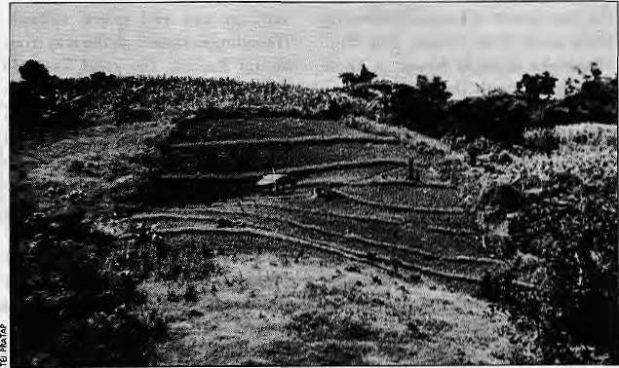
Jhumming in
a Chittagong
hill tract.
reported was as valuable as gold. The numberof Thai speakers in Assam is small, but there is a Thai Association and the community is politically active.
There are Garos in Meghalaya and in Bangladesh; there are Nagas and Mizos in India and in the neighbouring hillsof Burma. Festivals, liquor, dance, and music shape approaches to life and habitat of the tribes. History and contemporary experiences also forge attitudes, affinity and identity, the latter being regarded as the most crucial in maintaining both distanceanddignity in the face of intrusion of the larger cultures of South Asia. Convictions about the sanctity of borders are weaker here than elsewhere. Many Nagas still refer to their own region as "Western Nagaland", referring to areas with Naga communities in Burma as "Eastern Nagaland". Guwahati, the capital of Assam, is closer to Hanoi than it is to Delhi. Watching graceful young women in sarongs, skirts and blouses pedal to work in Imphal, the capital of Manipur, one could easily imagine being in Vientiane or Rangoon. There is a fierce pride and independence that marks the tribes. And a disdain— despite using the good things that moneycanbuy and Centralfundscan achieve—for the national elites and locals who they patronise.
This bewildering medley and mosaic is dear to the social scientist, but makes administration and political control extremely complex for the faraway capitals, be it New Delhi, Rangoon or Dhaka.
Shadow Play
What the constituent regions of the Far Eastern Himalaya also have in common is scarcity of information and difficulty of access. Southeastern Tibet, northern Burma, the Yunnan highlands, theChittagong Hill Tracts, and Northeastern India—these are areas with negligible international profile. There is no other region this large in all of Asia of which as little is known. The fierce independence, deep
enmities and seemingly eternal violence all occurs in a kind of a vacuum as far as the outside world is concerned. Relegated to the far comers of each of the nation states of which they form a part, the inhabitants live in a media shadow.
The recent outflow of the Rohingya and newsabout drug trade keeps northern Burma in the news pages, but on the whole this region is out of the information map. The same is true for the Chittagong Hill Tracts, whose sole claim to fame seems to be the outflow of Chakmas. Southern Bhutan is in the news only because that is where the Lhotshampa refugees emerge from. Compared to the detailed social science and other research that has gone on in, say, the Uttarakhand or Nepal hills, researchers have left the Far Eastern Himalaya largely alone. Even here, however, the south-eastern extremity of Tibet is unique for the absolute unavailability of information.
One of the reasons there is little reporting and research is because outsiders face restrictions in travel everywhere in the Far Eastern Himalaya. Nowhere do the national authorities of Burma, Bangladesh, India, Bhutan, and China allow free movement of outsiders, and in many cases there are restrictions even on citizens. Everywhere, diplomats, journalists scholars and independent travellers face special problems.
Thus have national governments successfully shielded the brutal
military operations they have taken against the locals—often rebellious minorities seeking to preserve their identities—from outside eyes. By restricting access and travel,they have obscured this region from the ears and eyes of their own people as well.
It is by the choice of the locals that Indian citizens from the 'mainland' require special permits to enter the Northeast. However, this exclusivity is a double-edged sword, for it is due to this very lack of access that infbrmationabout theuniqueness and aspirations of the Northeast is kept from the larger India,
Nevertheless, more news about the Northeast gets into the press than any of the other regions. In comparison to the news blackout as far as Southeast Tibet or Northern Burma are concerned, the Indian Northeast comes across as a very 'open' society indeed. Perhaps, as the rest of the region struggles to catch up, they too will be dogged by the problems that India's Northeast today faces. Perhaps, in that sense, the experience of the Northeast will be instructive for thoseelsew herein the Far Eastern Himalaya, the rulers and the ruled alike.
Unity in Adversity
A shared ecology and geography, and a history of isolation, has given rise to lifestyles and languages that link the tribes and communities behind the five frontiers. In fact, many of these tribes have more in common with

12
May/June 1995 HIMAL

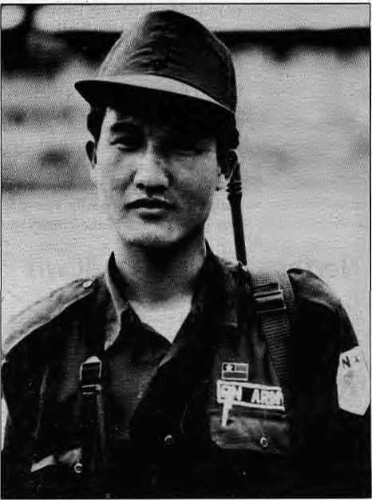
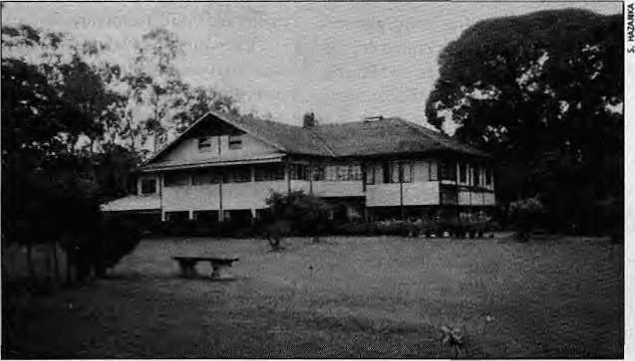
each other than with the nation states of which they form distant appendages.
The cultural chasm between the people of Northeastern India and those of the 'mainland' issodeep,and the leap through time that they have to take to catch up with the national cultural mainstream so great, that this region is unlikely to be psychologically integrated with India for some time to come. If the Sikkimese even tod ay refer to the border point at Rongphu Bridge as the place where "India begins", the feeling of distance is much more palpable in the hill states that lie to the east of Bhutan. Perhaps the map, too, aids in developing this mental state: every other part of India, including Kashmir, is joined integrally to the mainland, whereas the Northeast hangs on a 14 km neck of land between Nepal and Bangladesh.
The entire Far Eastern Himalaya is peopled by marginalised communities. These are peripheral groups, distant from the levers of governmental power. Much of their economic and political affairs are controlled and manipulated by all-powerful central entities. In most cases, tiny powerful local elites have emerged, patronised by the Centre, but these are invariably alienated from their own communities.
The failure to cope with change, an inability to deal with the major forces of economic and social transition that are transforming our world, is creating a deep sense of unease among this population.
A region that is used tooral traditions is beingasked to turn to the newspaper and satellite television, one which used the traditional tribal methods of dispensing justice through village councils and chiefs is having to embrace British jurisprudence.
Vibrant communities are therefore turning inwards and nurturing deep resentment towards what they perceive to be colonial behaviour by central governments and national elites. This is true of the Nort hea sterner's a tti tude to wa rd s the Hindu-dominated and Hindi-speaking belt of the Canga plain, of the Chakma's towards Dhaka's rulers, and of the Tibetan's towards the Han cadre who call the shots from Lhasa.
Seen in reverse, loyalties of Nepali speakers being questioned in Thimphu,oft he Cha kma in Dhaka, of the Naga in Delhi, of the Rohingya in Rangoon. The domestic policies of the national governments to the marginal peoples are almost identical, varying perhaps only in the intensity of violence with which rebellions are crushed.
Th e problem pro file of the region is also similar: a lack of industrial development, sluggish economic growth, a tattered infrastructure of roads, telecommunications and power, escalating demographic change, inadequate use of natural resources such as water, environmental degradation, low per capita income, and poor agricultural practices. Added to all this, of course, unrest and insurgency.
Because national authorities seem unable to recognise the cultural chasm, to meet basic needs, nor to devise a formula for sharing of the natural resources in which the region is so rich, there will be no peace in the Far Eastern Himalaya. While the people agitate for their identity, government is perfectly willing to exploit mineral reserves, al low forest s toberazedfortimber, and rivers to be dammed. A withering away of national boundaries is not in sight, but as long as the reality of separateness is not understood, the problems of the region will remain unaddressed and the inhabitants will continue to su f fer under-development and violence.
Fractured World
Demographic change is the most immediate source of conflict in the Far Eastern Himalaya. Unwanted migrants are on the move across the region, in tens of thousands, trailing confrontations in their wake. Mass movement in a traditionally insular area invites linguistic, ethnic and religious strife. Settlement of an alien
Insurgent militiaman in Burma's Shan mountains.
Tea garden life is very un-aboriginal.

HIMAL May/June J995
13

population leads to battle over resources, particularly land.
South Asia saw its largest migration during the Partition, and the Northeast was not spared. Though not on the same scale, exoduses and influxes continue, of both political refugees and economic migrants. National governments, which have their own political calculations to make, are not necessarily averse to population movements, for they can
Northeast Rebel Rundown
.
The first to rise against independent India were the )
Ntagaj whose movement is today split into thrbe major
factions. The most powerful is the leftist NSCK UxLby I
Isak Swu and Thenguil&ng Muivah. The" K#izo and'
'■ Manipuri revoltsfollowed in quick succession; Whereas.: ■
the Naga and Mizo rebels were Christian hillfolk, the:
Manipttri troubles were led by young militants of the
Hindu plains-dwelling Meitei. They had a working :
aUiancewith the Kachin Independence Army in Burma
andat least one group has ties with the NSCN. The Mizo
(also known as the Lushai) insurgency lasted from-1966
and 1986, and in their initial success they captured
several towns Including the capital of MizMam,
Atzawal, and a radio station. The end of Pakistani
support after 1971 led to a weakening of the force, and
by 1980 the rebels were negotiating a surrender. An
accord was signed in 1987 between Rajiv Gandhi and
Laldenga, President of the Mizo National Front. The
Tripura insurgency was a reaction against the arrival of
Hindu Bengalis from Bangladesh and ended after New
Delhi offered more representation for tribals in the:
state legislature and a pledge to stop illegal migration
and land alienation. However, this political
arrangement has not been satisfactory and militant '
activity has resumed, aimed at Bengali settlers and ,
security troops. Assam, which had long been untouched
by violent rebellion and wasalways regarded as part of
the Indian "nationalmainstream", also sawinsurgency
with the rise of the United liberation Front of Asom
(ULFA), which pledged armed struggle for
independence. The organisation fell apart under
sustained military operations in 1991, but is said to be
regrouping in Bangladesh and in parts of Assam. The
most recent rebellion is that of the Bodo, an indigenous
tribe of 1.1 million that lives in pockets along the
northern Brahmaputra Valley. They want a separate
state. An autonomous council was hastily announced
by New Delhi in 1992 but it has not worked. The
militant-minded Bodo Security Force is trying to force
non-Bodos to flee its region with a series of well-
planned attacks on vulnerable targets. - S.H,
be used ad vantageo usly as vote banks, to open up frontier lands to economic exploitation, or as part of pacification and assimilation policies towards hostile local populations— as evident in the 'Han-isation' of Tibet by the China.
Indeed, the best orchestrated, and ongoing, migratory pattern is to be found north of the Himalayan divide, where people from mainland China are moving all the way into the TibetanheartlandofUTsang,andnot just the outer provinces of Kham and Amdo. The Dalai Lama's aides maintain that the original population of six million Tibetans is being overwhelmed by the Han invasion. The official Chinese figures are far lower: they put the population within the Tibet Autonomous Region {excluding large sections who live in Kham and Amdo) at 2,12 million, and the number of Han Chinese at 79,000 {but excluding the tens of thousands of troo psandChinesecadreswholive without permanent resident status).
Once the migrants or refugees arrive,theimmediatecauseofconflict is the question of land and its control. For host communities whose very cultures are derived from the soil and forests, the loss of land to migrant groups means a shedding of cultural identity. Population movements have affected every state in the Indian Northeast, and in two of them the original inhabitants have by now become minorities in their own land— which is the fear that impels all Northeasterners to react against migration.
One state whose indigenous inhabitants are now tiny minorities is Sikkim, where the Lepcha and Bhutia were overwhelmed over the course of the first half of the century by an inflow of Nepali-speakers. In was manipulation of the Nepali majority by New Delhi's political leadership which led to the kingdom's merger with the Indian Union in 1973.
The other state where the locals have become a minority is Tripura, the narrow thumb that juts into Bangladesh from the southeast of
Assam. Once dominated by 19 Buddhist and Christian tribes, the state has been swamped by Hindu refugees from Bangladesh since the 1950s. In 1947, Tripura had a population of 600,000of whom 93 percent were from the indigenous tribes. By 1981, the tribes had been reduced toa minority of 28.5 percent, out of a population of 2.06 million. Political power slipped out of the tribals' hands as they were displaced by the settlers. An insurgency began against the Bengali settlers in 1980 but it had ended by 1988.
Rejected Peoples
Numerous comm uni ties in th is region constitute what political scientist Myron Weiner refers to as "rejected peoples". Count among them the Bangladeshi migrants in Assam, Chakma refugees in Arunachal and Tripura, the Rohingya refugees from Burma now taking shelter in Bangladesh, and the Lhotshampa refugees of Bhutan.
Bangladeshi. In few regions has the impact of population movement been as vivid, painful or divisiveas in Assam. Its wide and fertile valley watered by the Bra hm aputra, the state has long suffered from the depredations of migration, settlement and subsequent conflict. The place of origin for most of the migrants has been Bangladesh, which has a population density of more than 800 persons per sq km—the highest in the world. The corresponding density in the Northeast is 284 for Assam, 262 for Tripura and 33 for Mizoram. The "push" and "pull" factors are obvious.
Even unskilled labourers find a ready market asconstruction workers, porters and maids in the Northeast. Language is the key factor favouring Bangladeshi migrants, for Bengali is widely spoken in Assam and understood in the hinterland. The biggest outflow of Bangladeshis took place in 1970, whena brutal Pakistani army crackdown sent more than 10 million fleeing into India. Most went back, but more than a million stayed behind in West Bengal and Assam.

14
May/June T995 HIMAL

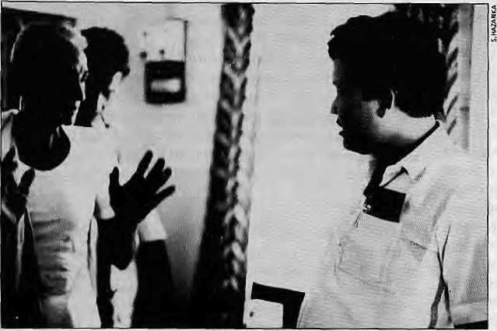
Influx into Assam continues today, largely due to economic and environmental conditions within a Bangladesh which seems to lurch through an unending cycle of flood, cyclone, drought and famine.
Reaction against immigrantshas exploded several times in bloodshed and rioting. Movements against 'Bangladeshis' have shaken the Northeast since 1979, particularly in Assam, which has taken the brunt of the immigration. The c on flict has been exacerbated by the fact that the migrants and their descendants are predominantly Muslim whereas
the Assamese are largely Hindu. Today, the very word 'Bangladeshi' has taken on a pejorative meaning in Assam.
Attempts to get the refugees to return have only resulted in more tension and violence. Meanwhile, for decades, police and high officials— and especially politicians—have actively encouraged illegal migration because of the profits involved and the advantages of engaging in "vote bank politics".
The price, as always, is paid by innocent people, mo st brutally i n 1983 when more than 4000 men, women and children, mostly Muslim settlers, were slaughtered in a series of pogroms in Assam during an election. The worst killings occurred in rice fields of the village of Nellie, where at least 1,700 were butchered.
Land was the source of conflict: the settlers had taken over—bought or bartered—property from locals even though such transactions were prohibited for non-tribals. However, there was poor implementation of land and tenancy laws, and there were politicianswhodependedonsupport from the Muslim vote bank. Over the years, resentment over dispossession built up in the Lalung tribe, until it finally exploded in 1983.
Although the violence against the Bangladeshi has ebbed, the settlers continue to be targets of distrust and political abuse. Lately, they have
fallen victim to insurgency in the region, with frequent attacks on them by armed members of the Bodo Security Force in western Assam.
Chakma. Population movements are fed by remorseless factors. Take the case of the Chakma; they seek refuge in Tripura because they area religious minority, because their rights are being trampled upon, because their lands are being settled by Bengal i-speakers in the Ch ittagong Hill Tracts, and because their loyalty is questioned by Dhaka. Even after decades, in some cases, the Chakma refugees have not been able to settle down in the host region, whether it is Arunachal Pradesh or Tripura.
Chittagong's hill tracts cover 5093 sq miles, or 16 percent of Bangladesh's surface area. Marked by
teak forests, swift streams, and undulating valleys, the area is bounded by Assam to the north, upper Burma to the east, the Arakan of Burma to the south, and Chittagong District to the west. There are 12 major tribes, largely Buddhist, who practice jhumming, or swidden agriculture.
When the Pakistan government completed the Kaptai hydro-electric project in 1964, the reservoir flooded about 40 percent of the arable land in the region and displaced more than 100,000 tribals. An estimated 20,000, mostly Chakmas but also some Mogs and Jajongs, moved across the frontier into Tripura. The refugees were first moved to the Lushai Hills, now Mizoram,and then offered achoiceof three locations by the Indian authorities. They chosetheNorthEast Frontier Agency (NEFA), which is now Arunachal Pradesh.
While lightly populated Arunachal Pradesh—which was attacked and briefly annexed by China during the Indo-China war of 1962— has been one of the more quiet places of the Northeast, over the past year it too has become tense. The immediate reason is that the migrant Chakmas already make up seven percent of the population of 700,000. Student organisations have started a sustained campaign to oust the migrants, who have been threatened and intimidated, thou sand s fleeing to the relative safety of Assam.
Among the many contradict ions that remain unresolved in the Northeast is the question of nationality. While the Indian Constitution states that any child born in India is a citizen, thousands of Chakma offspring who have been born in Arunachal since the 1960s have not been absorbed by India. On the other hand, if the children are to be accepted, where are the parents to go? The state which they fled does not exist, and the successor state of Bangladesh does not recognise them as nationals.
The larger and more recent influx of Chakmas has less to do with the
Bengali Muslim complaining to Assamesse politician.

HIMAL Mayta? 1995
15

Kaptai Dam and more with population movements within Bangladesh. The root cause lies in Dhaka's programme to settle the Chittagong hills with Muslim Bengalis from the over-populated delta region. This concerted move to
'Bengalise' the region drew sharp reaction, culminating in an armed revolt in the 1970s by an armed group calling itself the Shanti Bahini. There have been several bouts of conflict in the past 20 years between the Bangladeshi armed forces and the tribal
nationalists, who have received armed and training support from New Delhi's security agencies.
The Dhaka government's crackdown was been brutal. It devastated culture, kinship ties and tradition, which resulted in refugee

Concern for the Northeast

Aseries of reports in recent weeks in thelndian press indicates that . concern for the Northeast situation is :at a; heightened ley el among Indian policy-^makers.
The Chief of Army Staff GeneralShankar Rbychowdhury said on ^February in Guwahati that a "Northeastern coordination council of security forces" should be formed immediately to tackle the; insurgency problem. 'He Said the Inter Services IntelligenQeOSI)of Pakistan was providing support to the rebels, but refused to elaborate. The situation in both Kashmir and the.Northeast was assuming the dimensions of an external aggression, anditwould be short-sighted to treat it merely as a law and order situation. .Withthe NSCN (Mui vah group) extending its activities to Nagajand ?and parts of Assam, it was necessary to look at the entire Northeastern region as one unit as far as security was concerned. , Earlier, General Roychowdhury had stated that the insurgency problem in the Northeast was as sensitive as the terrorist activity in Kashmir,, with external forces playing an equally disruptive role.
On 29 April, the Union Home Secretary K-
stated in Shillong that: "self-Imposed isolation" of the pepplejpf the Northeast punctuated with "some extent of negligence ©f the Centre" was the main cause of the prevailing uncertainty. An "action-oriented coordinated and concentrated'⁵plan was requiredi to solve the burning probelms in the region: there was a need to boost the morale of the police force by providing them with bask facilities, and the Northeastern Police Academy should provide proper training. Other than in Nagatand; the insurgent groups of *^^ie region had no ideology and represented nothing but "lawlessness". The media, meanwhile; should'highlight genuine problems of the region without projecting only the (negative aspects. While there were some genuine grievances of the people of the region, it did not mean that one should "retreat from the spirit of oneness with India".
A study prepared by the 1993 batch of the Indian Administrative Service (IAS) officials titled Umierstatuting Ethnic Unrest in: Indian :• Werfyheries—1994, which was released on 2 May> asserts that political parties are responsible for fuelling ethnic unrest in the Northeast. The paper also points the finger at the absence of development, exploitation by outsiders, and absence of! policy decisions. Among other things, the paper states: "The central leadership of mainstream political parties has manipulated ethnic
symbols;.. The; frequent imposition of President's rule has also reinforced'the: imperialist imaige of the Centre.,. The political bosses have failed to establish psycho^motional links with the historically insulated population... The influx of 'outsiders' has altered the demographic pattern and reduced the local population toa jTiihbrity:.. External material and moral support has sustained ethnic movements in border areas;.." To contain external interference, the study suggests that India improve its bilateral relations with its neighbours. The IAS officials suggest "a single-jnindiSci devotion to economic development" in the Northeast, stating that "the population should derive meaningful benefits from economic activities rather than being exploited by them,.. Ethnic violence is the manifestation of a. deeper malaise in the system and can hardly be: contained by military or political action."
Qn5 May intiuivahati, the Union Finance Minis ter Manmohan
Singh stressed the need for "serious analysis of the underlying causes of unrest and insurgency in the Northeast so that the developmentpnt>ce$scouldbeacceleratedintheproperdirecHoni It would be a ttagic mistake to regard the problem created by secessionist foreesas meretya^w and order situation, he warned, and s^id "the design and style of a social, economic and pol stical evolution of a good society must fully take into account the multiethnic, multi-cultural and multi-religious characteristics of the societies of the region..." Subsequent to identifying the root eausespfdMcontent.intheNortheast/'wecahand we must evolve imaginative approaches to deal with them," said: the Finance Minister, who represents Assam in the Rajya Sabha. In view of the pluralism and diversity of the societies of the Northeast, special arrangements had to be made in the form of autnomous district councils with powers to protect the interests of tribal communities, their social customs and customary laws, The quality of public, administration must be" toned up, and civil servants should have an incentive to serve in the Northeast rather than treating the region as a-"punishment posting". The proposed Northeast Development Bankshould beable to provide the regional economy with a much-needed boost, he said.
The Finance Minister was giving the keynote address at a regional conference organised by the Indira Gandhi Memorial Trust. Sonia Gandhi,Chairperson of the Trust, toldthe gathering that both Indira Cahdhi and Rajiv Gandhi had deep interest in the peopleof theNortheastand their "aspirations,concerns, problems and hopes..."

16
May/June 7995 HIMAL

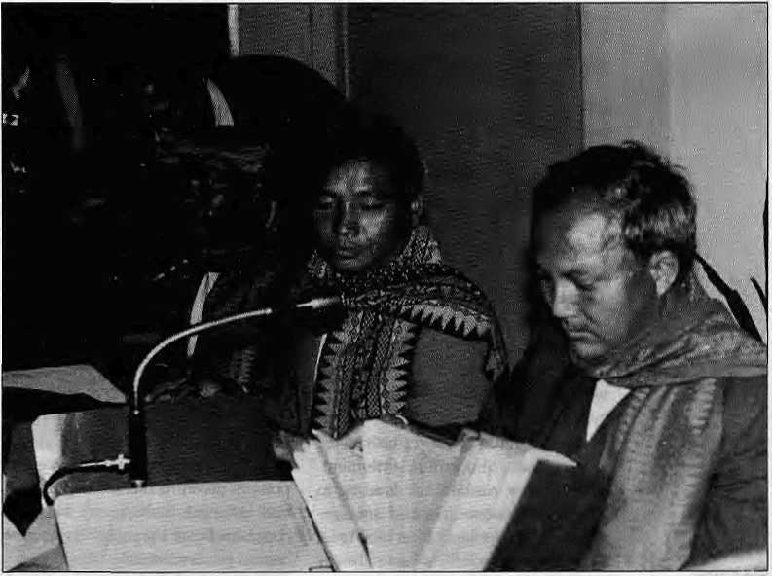
surges across into Tripura in 1978, again in the early 1980s,, and most recently in 1989. While New Delhi and Dhaka have been engaged in talks and there has been some repatriation, about 50,000 refugees remain in camps on the Ind ian sid e, u nw illing to belie ve Dhaka's assurances of security. It is not even clear that the two countries are genuinely interested in solving the problem; for Indian security agencies, particularly the Research and Analysis Wing (RAW), the Shanti Bahini remains a pawn in the power game.
Rohingya, Bangladesh plays host to its own 'Chakma situation' in thecaseofthe Rohingya. Over a period of a quarter century, first in 1978 and then in 1992, the Burmese mil ita ry has swept into the Muslim dominated Arakan Province in drives against Rohingyas. These Arakanese are regarded as not sufficiently Burmese as more Islamic than nationalist. The Burmese authorities, who are predominantly Buddhist, have claimed that many of those in the Arakan area are not reaily Burmese and that they have illegally crossed over from Bangladesh.
The Rohingyas' low-level rebellion has existed for decades but not much information is available, other than that the government crackdowns were vicious. The military regime in Rangoon has always been wary of the Muslim population for having independent leanings. Its actions have led to two waves of refugees into Bangladesh, totalling more than 200,000 Rohingyas each time. Not surprisingly, Rangoon claims that those driven out are Bangladeshi, a charge the Rohingya strongly deny. Efforts to repatriate them have not succeeded, although lately Burma has agreed to international monitoring of a future repatriation process.
For all their genuine grievances, the Rohingya too have been enmeshed in regional geopolitics. The troubles with the military and the Rohingya is seen by many as part of the larger confrontation between
Burma and Bangladesh, which views with unease Beijing's military assistance to Rangoon. There are credible accounts of Rohingyas ..receiving military training from Bangladeshi intelligence and military agencies.
Lhotshampa.ThestoryofNepali settlement in Bhutan is less than a hundred years old. Encouraged by the Bhutanese Governor of Western Bhutan, in the late 19th century Nepalis from the over-populated hillsofthehomecountrymovedinas labourers and farmers. Over the decades/ they prospered and their numbers grew in settlements and jungle clearings along the Dragon Kingdom's southern border. These frontiersmen and women who helped create today's rich farmlands and orchards came to be known as the Lhotshampa, the people of the south.
Whenacensusin 1988 turned up many more Nepali-speakers than the authorities had expected/ Thimphu's fears of the being overwhelmed by a Nepali swamping and going the way of the Chogyals' Sikkim were heightened. In an interview in 1993, King Jigme Singye Wangchuk,
Bhutan's absolute monarch, said that as many as 113,000 had been identified as illegal migrants in a newly calculated national population of 600,000. The anti-royalist agitation in Nepal which reduced the once-absolute monarch King Birendra to a titular head of state, also clearly worried Thimphu.
Like elsewhere intheNortheast, the fear of losing their 'Drukpa' identityledtheBhutaneseauthorities to engage in a fierce anti-migrant reaction. Unlike the other communities of the Northeast, who are battling the establishment, however, here it was the Government itself, representing the dominant community, that oversaw the process with the resources at its command.
As the pressures grew in southern Bhutan, the first refugees fled into the Jalpaiguri tea belt of India, and from there transited to eastern Nepal's Jhapa District. The first surge of exiles, of about 35,000, might be called true "political refugees": terrorized, famished, and very sick. Those who came later constitute a amorphous category, for it seems that they departed not becauseof political
Bodo leaders at negotiation in
New Delhi.

HIMAL May/June 1995
17

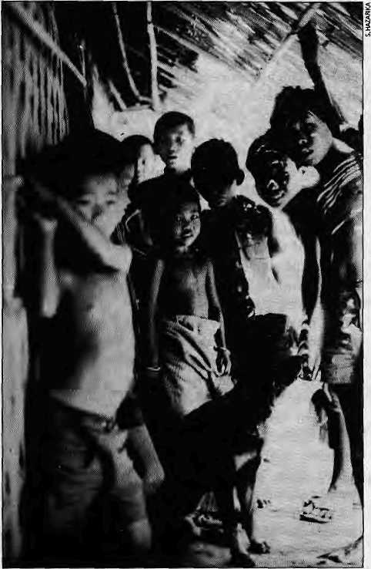
In search of citizenship: Chakma children of Tripura.
repression but because life was becoming too difficult to manage in isolated farms and hilltop hamlets.
There are today more than 110,000 Lhotshampa refugees, both in the camps of Jhapa and scattered across Nepal and neighbouring areas of India. Kathmandu has been roundly outmaneuvered by Thimphu in bilateral talks that have gone on for three years. The Bhutanese government has managed to rid the countryofa seventh of its population, and controlling the remaining Lhotshampa will be that much easier.
The process is the same everywhere: mass movement into a lightly populated region from regionsof high density. The cycle consists of displacement, migration, settlement, identity loss, resentment, leading to violence on the settlers and counter-violence by settlers. It is not true, however, that conflicts have always been between hill tribals and invading plains folks from outside the region.
The fratricidal confrontation between the Kuki and Naga tribes is a case in point. Over the course of the past three years, more than a thousand Kukis and Nagas are known to have been killed in increasingly violent attacks and counter-attacks on each ot her. Th e bitterness between the two sides, too, is 1 inked to migration, Kukis settled t raditional Naga lands several decades ago, and the memories linger.
Strategic Compulsions
It is strategic compulsions that drive rulers of nation states to seek control over distant communities and to s nuff out the insurgencies and agitations which resist such control. No one has much time for critical questions relating tohuman rights,the sweeping powers given to the security forces, and inherent disharmony between communitiesoftheperipheryandthe central governments.
Why do nation states attach such importance to these peripheral areas? In one phrase, it is fear of disintegration of the nation state, which can never be allowed, for no national leader wants to be accused of having dismembered the motherland. Another reason is the vast natural bounty of these places: the oil, gas and other minerals, the timber, hydropower, fertile soil, and the biodiversity.
Men in uniform and those from security agencies swarm over the region. India, for one, justifies their presence not merely because of the insurgencies it faces but the presence of tens of t housands of well -equ ipped Chinese troops on the other side of the mo untai nousborder.The strategic importance given to the Northeast can be seen in the fact that large state of Arunachal Pradesh does not have a single civilian airport. Meanwhile, the military helps in the expensive task of airdropping food and consumer goods to scattered civilian communities.
It is not just Central neglect and lack of vision that is holding the Far Eastern Himalaya back. The extensive and deep-rooted insurgencies also
have a role. In all cases, the earlier convictions and total commitment to independence from the nationa state no longer hold good. Often, the violence-for-violence's-sake ethos among the insurgents coupled with the rigid stance of government keeps moderates from finding a voice. Many in surgent s stay on to fight in the ju ng le simplybecausethey know of no other way. Also, new equations have developed in these wooded hills of the Far Eastern Himalaya. Drug smuggling has become one of the major sources of funding for the guerillas in the woods, which fuels insurgencies and maintains the circle of violence. Meanwhile, much of the halo of the insurgents has dimmed. Many are feared, even among their own people, as ruthless figures who will kill if the price is right.
The most enduring conflicts are in India's Nagaland and Manipur, and inBurma between Rangoon's generals and the Kachin and Karen, whose rebellions have lasted half a century. In the Northeast, the Naga and Bodo of Assam present the biggest challenges to the state security apparatus. The National Socialist Council of Nagaland (NSCN) and the Bodo Security Force have established common training camps and often work together to ambush security forces.
The trend for the future is clear: an increasingly sharp delineation between areas of governance by the state and ungovernable areas where the political vacuum is filled by powerful dissident groups like the NSCN and the Bodo Security Force. The Indian state has failed to ensure stability in parts of Manipur and Nagaland, and to a lesserdegree along the northwestern edge of Assam where it touches Bhutan. As a result, the NSCN controls parts of Manipur, especially the Ukhrul and Sena pat i districts;it levies taxes, recruits people (often forcibly) into its army, and harasses businessmen.
Likewise, the Bodo Security Force has the ru n of parts of Kokra jhar District of Assam, and uses the forests

18
May/June 1995 HIMAL

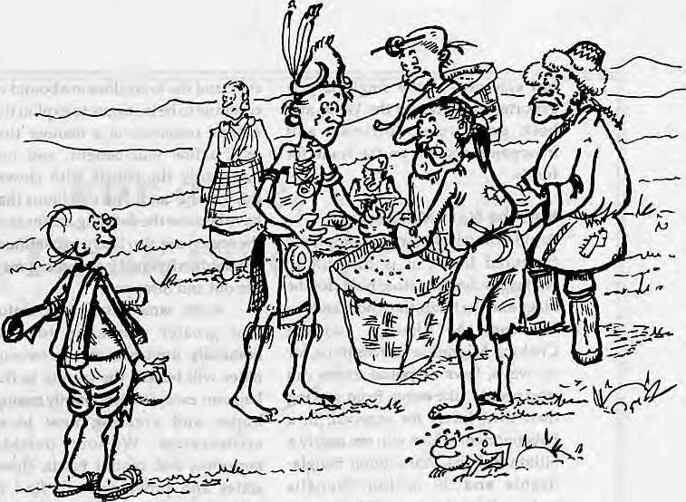
of southern Bhutan as a hideout. The Bhutanese are disinclined to act against the Bodos because they are outgunned, and several operations mounted by the Indian Army with King Jigme's permission have failed to flush them out. In recent months, theNSCN seemstohaveexpandedits base and madeinroadsinto the Naga-dominated district of North Cachar hills, ambushing troops and engaging in major gun battles. It has access to funds through the fear it inspires among the tea planters, who pay protection money much as they did to the ULFA when it held sway between 1988 and 1992.
Mother of Insurgencies
Every state in the Indian Northeast, barring Arunachal Pradesh and Meghalaya, has seen major armed insurrections against the Indian state. The response of the state has been, as usual, to call in the army and invoke sweeping powers of search and detention. Once, it even flung the Air Force against Mizo rebels.
The entire region is heavily militarised, from Tibet through the Indian Northeast and into Bangladesh and Northern Burma, Firstly, there is the military presence to guard the borders, particularly along the Indo-Tibetan frontier. And then there is the heavy military presence to maintain order over a sullen populace, as in the case of the People's Liberation Army in Tibet, or to pacify rebel groups, as with SLORC's forces in northern Burma and the Indian Army's extensive presence in the Northeast.
The role of the unfriendly neighbour, which Indians euphemistically call "the foreign hand", is also significant in sustaining militant organisations. The Shanti Bahini operates in the Chittagong hills with help from Indian agencies, and the rebels in northern Burma are said to receivesupportfromDhaka.Asfaras the Northeast is concerned, in the 1960s, it was Pakistan and China that were providing sustenance to the Naga and Mizo rebels. This support
ended with the 1971 Indo-Pak war. In the late 1970s and early 1980s, the Kachin Independent Army was providing support, training and weapons to the NSCN, the United Liberation Front of Asom {ULFA), and to various Manipuri groups. This backing faded after New Delhi threatened to oust Burmese refugees who had fled the repressive SLORC regime and were staying in India. Subsequently, the NSCN,basing itself along the Bangladeshi and Burmese bordeirs, has used its own skills to forge a leadership of the Northeastern rebellions. As faras the Northeast is concerned, says one intelligence specialist, the NSCN is "the mother of all insurgencies".
Another pattern that seems to characterise the regional rebellions is the breakdown of "accords", when agreements between rebel forces and governments go sour. The only successful agreement between militants and the Indian state seems to have been the Mizoram Accord of 1987, which enabled insurgents to surrender, receive an amnesty, and start life afresh.
Most of the other agreements have been fatally flawed, beginning with the Shillong Accord of 1975 between one group of Naga rebels and the Indian Government, which fell apart and led to the growth of the
NSCN. The pattern of breakdown of accords tends to be similar: acceptance of accommodation by moderates and subsequent rejection by hardliners. This has happened in Tripura and in Assam, especially with regard to the Bodo. The hard core of the ULFA leadership also rejected peace moves by their colleagues, and the organisation suffered a split from which it has yet to recover. When the Bodo struck a deal for greater autonomy with the Government of Assam in 1993, the package of promises began to unravel because the Bodo homeland's borders had been left undefined, as had been the all-important question of power-sharing. The extreme Bodo Security Force, which seeks full independence from India, struck at security forces and vulnerable targets such as unarmed Bengali settlers, in order to demonstrate its power and its rejection of the accord.
In Burma, the Rangoon government has followed a policy of punitive action against rebel groups combined with efforts to buy them out. This has worked with some groups, including a prominent Communist faction, and failed with others. One of the key factors about insurgencies and governmental response in Burma is that both have their fingers in the drug trade. Over the decades, Burma

HIMAL Mayllune J99S
19

has emerged as the single largest exporter of heroin to the West, and both government officials and insurgents depend on the trade for funds.
Into the Next Millennium
Am idst the crises overwhelm ing these fractured lands, it is difficult to env i sage w hat the future holds for the Nagaand theMizo, the Ahom and the Mishing, the Khampa and the Chakma.Migrationwillcontinue,for no walls, laws or police forces can stop people, like water, from seeking their own levels for survival. In a Subcontinent which will see nearly a billion Indians, 220 million Bangladeshis and 30 million Nepalis (inNepal) by the year 2020, it is not feasible to hope that population flows will cease entirely.
Likewise, the nationalistic grip on the region by each of country capitals will continue,constricting the space for autonomy and seif-determination. The market forces, the
state and the local elites are bound to continue to be in league to exploit the natural resources in a manner that only a few will benefit, and not necessarily the tribals with closest links to the land. The rebellions that have become the defining attribute of the region are also likely to continue, although individ ual insurgencies may tire out and disappear.
At the same time, it is doubtful that greater autonomy to economically unviable, small communities will benefit the people in the long run, except in temporarily raising hopes and creating new local aristocracies. Without outside personnel and central funds, these states and provinces will find it difficult to fulfil modern desires that have grown over the decades. Some of these might still be forest societies, but everyone wants to modernise.
The choice for the Far Eastern Himalaya is clear. It is either to throw up one's hands in despair at the
problems associated with divided geography, migration, reaction and military presence. Or it is to try to chart a path that involves joint planning for economic growth. If massive inflows of migrants and refugees are to be reduced, and the people of the region are to be saved from endless rebellions, the economies of the Far Eastern Himalaya, relegated to the periphery for too Jong, must expand, and expand on all sides.
Economic development, rooted in the sharing of water and other natural resources, multilateral trade, and assisting communities at the micro level—instead of imposing centrally sponsored schemes—seems to be the way out. A sense of inclusion and participation of local communities is critical in making programmes work. Paternalism only provokes bitterness. Locals need to be given effective control over resources, and development schemes must havetheir participation and not be devised and dictated by central authorities. An

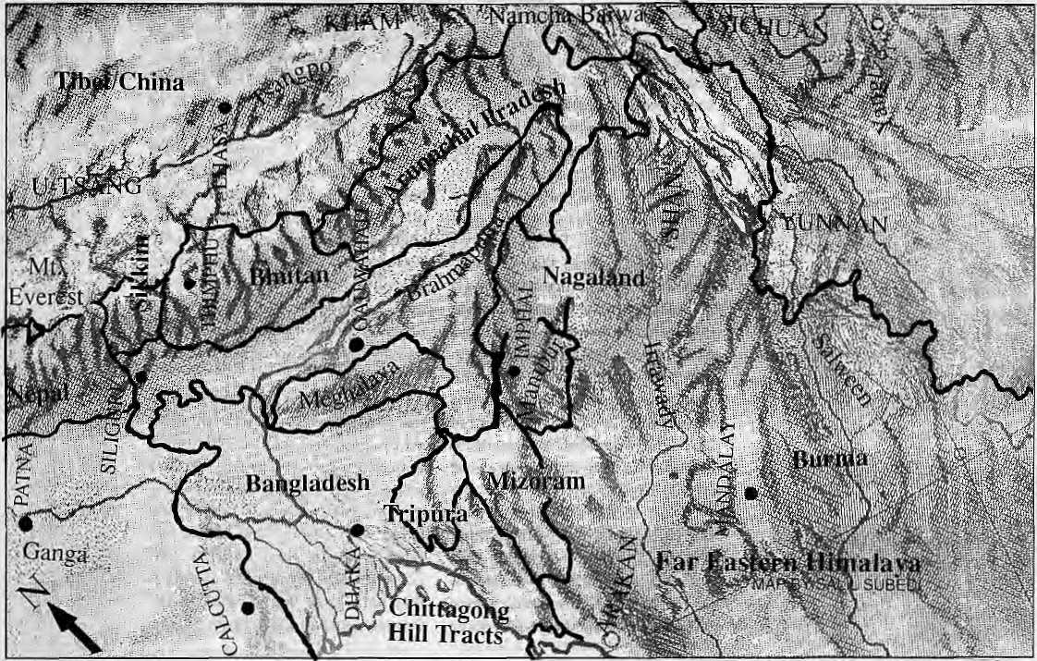
May/June 7995 H1MAL

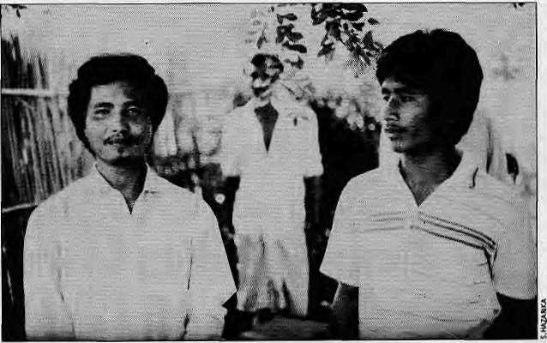
example of effective local institution-building is the system of Block Development Villages in Nagaland, where locally managed schemes are working where larger top-down schemes have not.
In Delhi in early May, South Asia'sleaders decided tomoveahead with the South Asia Preferential Trade Zone (SAPTA). In fact, the region of the Far Eastern Himalaya, so different from the rest of South Asia and so much like each other across the borders, would seem to make a coherent trading block in its own right. The absurdity of national boundaries that divide similar peoples and breaks up viable economic units is nowhere more clear than it is here, which is why this eastern Himalayan stretch could constitute a suitable aTea to make regional cooperation begin to work.
A formula has to be found where it is possible to workacross the borders while maintaining the sanctity of frontiers. The possibilities are endless, if the vision exists. True, it wil 1 require the national government s which have barely begun to address some ofthese issues to put their heads together, and for moderates among the regional leadership to make a show of their strength. In the end, only regionalism spurred by the search for economic possibilities will bring peace and progress to the Far Eastern Himalaya.
A network of small and medium dam projects in parts of Bhutan, Sikkim and Arunachal Pradesh would tap the explosive power of the rivers and streams disgorging from the Himalaya. The production of hydro energy would spur economic growth in both hill and plain. The reduction of flood damage would open up new lands for cultivation and ease some of the demographic pressures in the Bengali-speaking lowlands. Power could also be exported to other parts of India and Southeast Asia, for energy hunger isdestined to grow rapidly in the next decades as unshackled economies surge forward.
One may be forgiven for looking ahead to the day when workers from differentpartsof the region participate in economic activity under strict migrationand employment laws. The economies cannot expand without better roads, railways and communication facilities, and these arteries should be intra-regional and not merely for maintaining linkswith the individual national mainlands. Opening up of port and transit facilities in Bangladesh and Burma would itself, in one stroke, provide economic fillip to the hinterland.
With a loosening up of border restrictions, numerous cross border contacts would be resumed. To use just one example, the Garo and the Khasi of Meghalaya would restart their trade routes with Bangladesh, facilities that they enjoyed for centuries before Sir Cyril Radcliffe drew the line that divided British India. Rather than transport their goods to Assam using unreliable public transport, they would, like in the past, simply march "down the hill" into Bangladesh.
Development of tourism and promotion of handicraft and handloom industries will also make an impact. In India, the marketing of products should involve much more than displaying local items at the state emporiums in New Delhi, and must involve a look at national and international possibilities. Improved agriculture and water-use strategies
will strengthen community-based economies, and there should be a major emphasis in adding value to exported items, so that it is not only raw products such as timber, and crude petroleum that exit the region.
This is not to say that insurgencies will end. Ethnic aspirations and questions of identity will remain. But at a time when the world has recognised that mere political independence does not necessarily lead to a better future, ultimate peace to the Far Eastern Himalaya will come when a measure of autonomy is accompanied by access to markets, and the definite possibilities of improving the economic conditions of one's life.
A period ofeducationis required, both for the regional leadership as well a s the national elites, in the search for peace and prosperity in the Far Eastern Himalaya. The people have spanned more than a thousand years in a lifetime, and they, more than anyone else, would like to see the creation of a new and revitalised region.
S. Hazarika is Delhi-based author of several books, including Strangers of the Mist (Viking), on migration and insurgencies In the Indian Northeast and Bangladesh. He has beena correspondent^ T/jeWewVorfc Times since 1989, recently co-authored The Degeneration of India (Viking) with T.N. Seshan, and is working on a follow-up book on 'the agenda for change*.
Bodo activists.

HIMAL May/June 199S
21

Not To Miss A Single
issue of
Subscribe Your Copy Through



tipmses
i

&


Delivery At Your
DOOR
Sole Distributor & Subscription Agent for:
Asiaweek, Asian Business^ Capital Market, Down To Earth, Energy for Sustainable Development, Himal, World Executive's Digest, Study Abroad, National Geographic, and "many-other renownedpublications.■■'■
P.O.Box; 168, Maharajgunj, Jha-54
Kathmandu - 3, Nepal Tel: 413009 Fax: 227319



vme

Overseas Cargo Service and J.P.N. Exports, Thamel, Kathmandu
P.O. Box 8621, Kathmandu. Phone: 977 1 413391 Fax: 416850

Rev

Aama's-Eye View of America

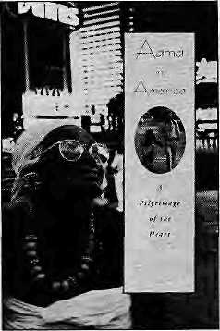
B
roughton Coburn's Aama in America is the tantalising follow-up to Nepali Aama (1982), his lyrical text-and-photo portrait of the woman from Syangja, Vishnu MayaGurung. Aama in America is the chronicle of octogenarian Vishnu Maya's unlikely pilgrimage to the United States. In addition to being a portrait of the United States—-as seen through Vishnu Maya'sdisplaced but perceptive eye—the book is also the story of the author's relationship with Vishnu Maya (who is hisdharma mother), and with hisnatural mother whose death left him with troubled, unresolved emotions, and with his girlfriend, to whom he is not sure he wants to commit. The book has a large and wide-ranging premise which Coburn tries to resolve, sometimes erratically but mostly engagingly, over a journey that starts in Syangja and goes through the Tokyo airport lounge on to Seattle, Washington, California, Maine, Montana, Washington DC, New York and back to Nepal.
The most luminous parts of Aama in America come from theobservationsmadebyVishnuMaya, whose cultural references are so far removed from those of the country she is visiting that her pronouncements on American cultural artifacts and behaviour are deconstructively incoherent and, at times, visionary. In particular, her encounters with the mundane aspects of American life such as public toilets, safety belts and ice cream abound with wit.
In a grocery store for the first time, Vishnu Maya exclaims, "Mero baajey... look this bazaar, I can't believe it—all the food is lined up, one kind of meat in this line, another kind in thatline, fish set out over there. You would think it would all spoil before people had a chance to eat it."Once, as the author drives by some sheep on acouniry road, she says, "Boy, [a small question of idiom here], those sheep are moving fast—no, wait, we're moving fast." It is precisely this disorientation which gives way to her back-door insights about the United States: at one point, the drab homogeneity of the American highway and the similarity of every Chevron gas station leads Vishnu Maya to believe that Coburn and his girlfriend have been driving her around in circles.
Coburn is sensitive in following the logic of Vishnu Maya's observations. At every sea-shore she searches for Malaysia, which she has been told about by a Gorkha sold ier. She cannot believe that there are no Gorkha soldiers to be met in the country she supposedly calls "Amrita", especially after she meets one quite by chance. She is disdainful of the American custom—or at least oversight—of having toilets on topof kitchens. Her visitto American sacred sites like a Catholic church, the Pacific Ocean, or a meteorite exhibit in New York, capture vivid encounters between ardent, unquestioning Nepali-style worship and the starry-eyed new-age spiritualism, or the
IMS
HIMAL
Aama in America: A Pilgrimage of the
Heart by Broughton
Coburn
Anchor/Doubleday
New York
May 1995
U$ 22.95
ISBN 0 385 47417 2
by
Manjushree Thapa
M. Thapa is author of Mustang Bhot in
Fragments (Himal
Books, 1992). She is
currently working on
her first novel.
United States' boundless profanity. It is especially heartening to read about Vishnu Maya observing, analyzing and passing confident judgement on a land that has intimidated many lesser immigrants. As in Nepali Ama, Coburn portrays Vishnu Maya as a person of rare self-possession. Her response to the United States is like a summons to Nepalis to be confident in ourselves, and in the cultural references we operate in, when confronting seemingly overpowering foreign ways.
Equally charming are snippets of American reactions to Vishnu Maya, who seems to have travelled throughout in velvet blouse, patuka and lungi set off by acoral necklace and medallion-shaped earrings of gold. At the slot machines in Las Vegas, a man recognises her as Mother Teresa. This isolation of many Americans, which leads toa particularly American brand of uninformed but enthusiastic friendliness, is familiar to any Nepali who has been there and tried to explain where heor shecomesfrom.Onechild is inspired by his encounter with VishnuMaya to ask what itisliketodie, followed by, "Has Aama ever died before?" Another child exclaims, 'She lives just like the Flintstones!"
Situations which provide the most dramatic possibility, such as Vishnu Maya's visit to Disneyland or to the casinos of Las Vegas,are, not surprisingly, more flat and cumbersome. Perhaps the contrasts are simply too overwhelming to portray, for the moral gravity of the juxtaposition of Vishnu Maya and Mickey Mouse—when the two meet,oreven when they are worldsapart—cannot be easily expressed with grace. As such, the book might not have lost much had the author refrained from writing about these sections of the journey, and kept the book's premise smaller, more intimate. The reader in search of insight should look to the more low-key but epiphanic segments of the book, such as Vishnu Maya's triumphant, quite logical rejection of the authenticity of whales, or her reaction to large-scale mechanised farming.
The resolution of personal issues regarding the author's mother and girlfriend takes over at the end of Aama in America, which keeps Coburn from ending on a broad philosophical note about the crisis of spirit in the United States, or about the spiritual resilience of Nepalis. In choosing to settle the issues raised by the book only within therealmof his personal experience, Cobum leaves the reader wanting,but not receiving, a forceful conclusion about the way things are or ought to be in one of the world's most spiritually impoverished countries, the United States, and one of the world's most materially impoverished countries, Nepal. This omission, and occasionally strained writing, are the weak points of this otherwise well-conceived book.
23

V
o
I

SEED IN SAMADHI, from a speech by H.Y. Mohan Ram, Professor of Botany at the University of Delhi, at a treeplanting ceremony organised by Tibet House in New Delhi to mark the 59th birth anniversary of Tenzirt Gyatso, the Dalai Lama,
A tree is a perfect example of an organisation with its own rules and relationships among the component parts, A tree represents a decentralised democratic system. If a young branch is lopped, another takesits place. Parts of two different trees can be grafted. They will unite and function as one. Another miracle that has baffled scientists is that all flowering plants, including trees, spend a part of their life as seeds. There is no equivalent of a seed in the entire living world. A seed is neither the beginning nor the end. It contains the future plant in the form of an embryo and stored food. A seed looks dead; it has no apparent attributes of life such as respiration, metabolism, growth or responses to stimuli. It can awaken from, this state of suspended animation— or satnadhi—when sownand watered. Evenatiny seed hasbuilt-in genetic potential to grow into a particular tree—be it the stately Bodhi tree, the evergreen mango, or the majestic sal.
CHRIST IS MATTREYA BUDDHA, writes
Benjamin Creme of London in the Notes and Queries column of The Manchester Guardian, responding to the question: "If Christ returned, how likely is it that he would become a Christian?"
Very soon, I believe, your readers and the world will know the answer. For 20 years, I have sought, by worldwide lectures, books, Share International Magazine {as editor) and innumerable TV and radio interviews, to make known the imminence of His return and, since July 191977, the fad of His presence in the Asian community of London.
He has come, as He predicted through Jesus, "like a thief in the night, in such an hour as you think not," and not from "heaven"but from His ancient spiritual retreat in theHimalayas; from where, as the Embodiment of the Christ Principle or Consriousness,His mind "overshadowed" that of Jesus from the Baptism to the Crucifixion. This time, He has come Himself as the leader of a large group of spiritually enlightened men, including Jesus.
He is not a religious teacher per se, but an ed ucator in the broader sense, showing the need for spiritual, political, economic and social structures if we are to survive. He has not come to found a new religion nor to create followers, but to teach humanity "the Art of Self or God, Realisation". Awaited by Christians as the Christ, by Jews as the Messiah, by Muslims as the Imam Mahdi, by Hindus as Krishna, and by Buddhists under His personal name as Maitreya Buddha, He is the World Teacher for all groups.
DIALOGUE WILL NOT WORK, writes
Sankarshan Thakur in The Calcutta Telegraph of 5 May 1995, reacting to the announcement that India and Pakistan are to resume high-level discussions on Kashmir. In the meantime, he writes, "paradise must suffer its season in hell".
If conflict is the essential truth of our lives and of most of our history, the essential myth about it is that dialogue can resolve conflict. That great and dangerous myth—great because of its sheer size and longevity and dangerous because like all duplicitous things/it wears the mesmeric cloak of virtue—has let us down a million times and a millions times we have fallen. Look at the body of history and you will see how riddled it is with war. If dialogue could resolve conflict, history would be made up of conciliatory whispers, not the sound of gunfire.
The thing about conflict is that it turns on power and powerturnsonits own d ynamic s; dialogue is, at best, a cog i n the workings of those dynamics, it is not power itself. Dialogue is not, and cannot be, essential to conflict resolution;onlypoweris, in whatever manner used. The twist and grip of power can dictate asituation of dialoguebutdialogueitself,andonitsown, cannot achieve much.
This is theessentialthingNew Delhi should remember in the context of Kashmir and Pakistan: dialogue will take it nowhere, only assertion of its power—essentially political and military power—will. If India wants to keep Kashmir, and quite clearly it very much does, it cannot afford any dialogue with Pakistan on the issue. Imagine high level delegations of India and Pakistan ranged—suspicious eyeball to suspicious eyeball, false smile to false smile—across a long table in a long, aloof room in New Delhi or Islamabad. Imagine them starting a dialogue on Kashmir. However they might choose to couch it in diplomatese and however many roundabout ways they might take to say what they have to, the two sides will, in substance say just this: Kashmir is ours, lay off. India will say it is an integral part of the country whose future is not negotiable; Pakistan will say it is psychologically (and historically) part of Pakistan and must be ceded over. (This sort of dialogue, of course, takes place with full prejudice to the people of Kashmir who, in their heart of hearts might be with neither India nor Pakistan, but that is another matter.)
BACK TO THE FUTURE is the title to a chapter written by geographer Jack D. Ives in Mountains: The Illustrated Library of the Earth, a coffee-table book tliat presents the world's highlands from the pens of experts. Ives is editor of the volume.
Is complacency warranted—because of the supposed indestructibility of mountains—or should we give up in despair because mountain topsoil will all be washed into the oceans shortly after

24
May/June T99S HIMAL

c
E
S

the turn of the century and mountain decertification will prevail? Neither complacency nor despair is in order. The answer lies somewhere between the two extremes; in some mountain ranges the situation is close to crisis, whereas in others a healthy relationship between human activities and the environment seems to prevail...
Despair is not called for. Mountain environments and mountain peoples are far more resilient than is often believed. The word 'fragile' is overused and counter-productive. Mountain forests do grow back on their own, and mountain farmers, without government or international aid, do plant trees and tend them. Perhaps one of the most important needs is to recognise that mountain peoplecan do much for themselves and have much tooffer the world at large. After all, they have already provided us with potatoes, coffee, maize, and many domesticated animals; and there are indigenous crops as yet untapped commercially, suchasquinoa, amaranth, and literally hundreds of species and varieties of tubers and leaf vegetables.
Mountains have been a major influence on the human mind since our ancestors first looked up to them and gloried in their splendour, placed their gods and goddesses among them, and accepted their challenges. They continue to inspire a large sector of society—an inspiration that is greatly needed today. Perhaps the so-called new world order will become a reality as the Cold War and superpower competition fade from memory. Then perhaps the mountain problems can be wisely and effectively addressed. This will never come about, however, until the mountain issue is clearly identified and until mountain people, scholars, and decision-makers are working together on a fully international scale.
CULTURE QUIZ in Culture Shock by Jon Burbank ("A guide to customs and etiquette of Nepal", Times Book International,1994) contains a test section which challenges travellers to get undertheskinoftbewtive$.Belowis"Situation5",withcommentary.
The office storekeeper on your construction project is discovered stealing from the project—about 100 bags of cement and some tools are missing and have been traced back to him. You call in your excellent Nepali project manager and ask him to start placing police charges against the storekeeper. A week later, when you ask what's happened, you are amazed to hear your manager hem and haw before he admits nothing has happened. Maybe, he says, it's just better to let the storekeeper go and forget about things.
You ask your Nepali program officer. He doesn't give a direct answer, but just says what a difficult process arresting and prosecuting someone is. The storekeeper has a wife and three small children, he adds, and the cement
is long since gone, too. You:
A. Call in the police yourself and ask them to arrest the store
keeper and you start to investigate the program officer and
project manager yourself.
B. Have the storekeeper arrested and bring ina new expat as boss
above the Nepali project manager.
C. Call in your Nepali project and program officers and ask for
their recommendations. They recommend giving the store
keeper a chance to replace the missing stock and dismissing him
if he can't. They say give him a month to do it, you say a week.
Everybody agrees on two weeks.
Comment: The large amounts of aid coming into Nepal are a temptation some people succumb to. Corruption can be a problem. With the large amounts of materials used in aid projects, it isn't uncommon for some of them to disappear into other people's homes. A tight inventory control system will help remove some of the temptation.
Nepalis are very reluctant to press charges for several reasons. You can never tell where the case will lead to. The trail could lead to government staff or politicians who could make it very difficult to finish the project. Jails in Nepal are not pleasant and neither is being in police custody. Locking the storekeeper in jail puts extreme hardshiponhis whole family.In cases where their own money or safety is not involved, Nepalis are very reluctant to inflict that on somebody else.
You hurt yourself and your office if you call the police without exhausting all other possibilities first. No one will trust that they can speak in confidence to you anymore. Option B doesn't get the cement back and everyone in theoff ice will resent the lack of faith you show in your Nepali staff. With C, at least everyone will see you are giving the storekeeper a fair chance, even if you don't get the cement back. The storekeeper, with no job, no chance of a recommendation, and three kids and a wife to support, is being punished fairly severely, anyway.


HIMAL May/June 1995
25

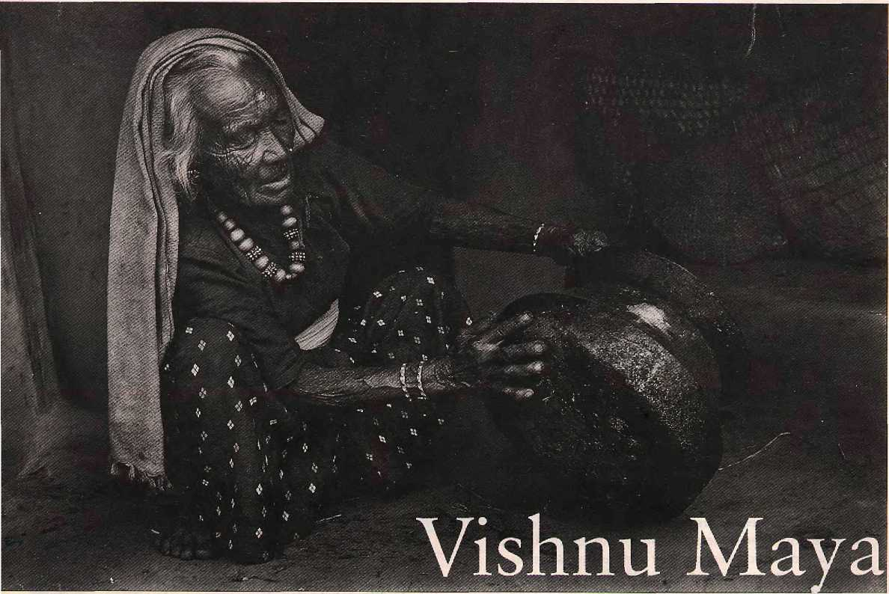


In 1973, when Broughton Coburn arrived as a Peace Crops volunteer in the village of Danda, a day's walk south of Pokhara town, he lodged in a loft provided by Vishnu Maya Gurung. She became his 'Nepali Aama' and he, her adopted American son. In 1988, 84-year-old Vishnu Maya agreed to make a trip to the United States with Coburn. Travelling coast-to-coast through 25 states, along the way Vishnu Maya met Mickey Mouse, California Redwoods, Old Faithful, Native Americans, an orca whale, Mid-Western farmers, and curious children.
Coburn might or might not have done right in exposing an elderly Himalayan village woman to such a surfeit of alien stimuli, but the images of Vishnu Maya in America are a unique record of a Nepali woman's odyssey. (See book review on page 23.) Back in her village, Vishnu Maya died a couple of years after her Amrika trip.
in Amrika
_jfess-
"So much stuff is for sale—where are all the people to buy it? Maybe word hasn't yet travelled that a bazaar has been set up here."

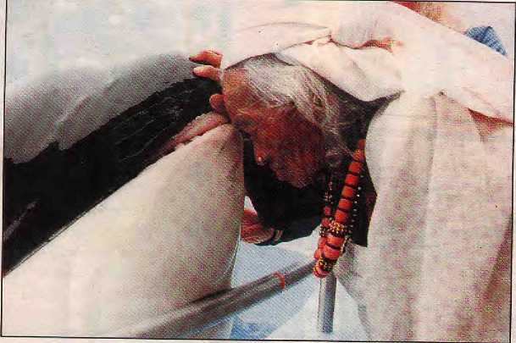
"May you be healthy, have many children, live to be a hundred years old, and live in peace and harmony with all the fish and animals of the sea. May you not eat people—and not be eaten by people—but rather find plenty of smaller fish to feed on..."

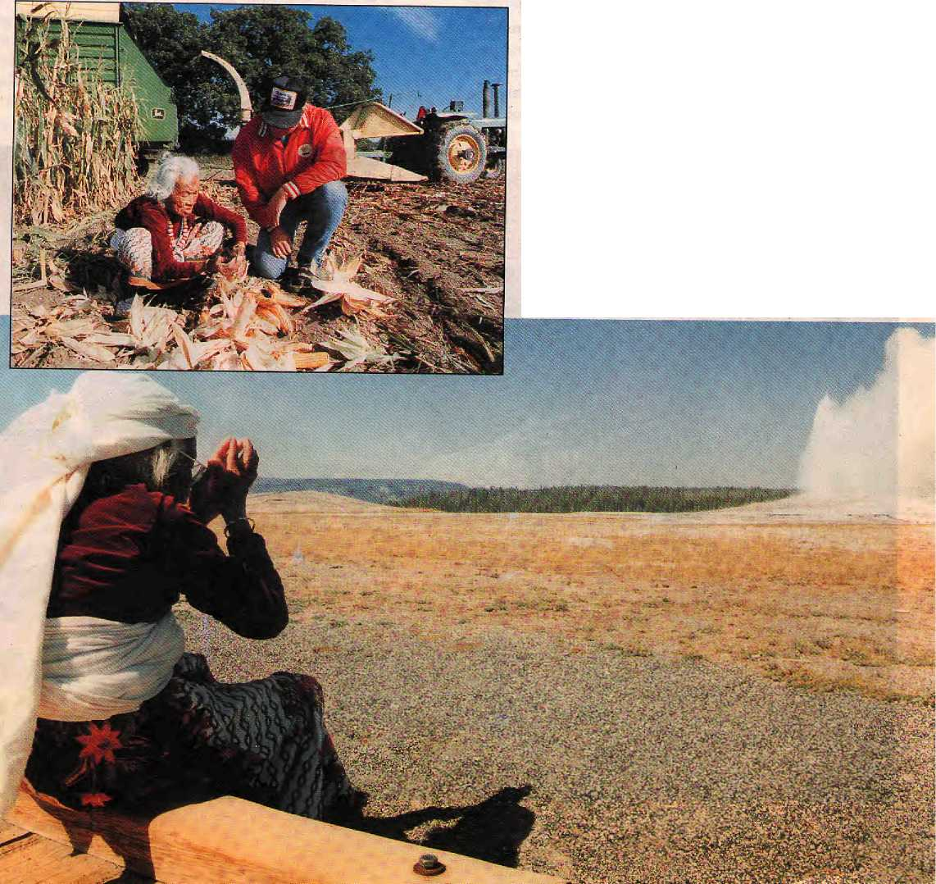
"It is a sin to leave grain on the ground to rot like this—whole ears being trampled by machines meant to harvest it. We pick up every single kernel when we see it spilled or left on the ground. The land here is crying..."
"If your ancestors knew what was underneath the
ground—here and throughout America—this
generation shows no indication of that knowledge.
This place should have a shrine."

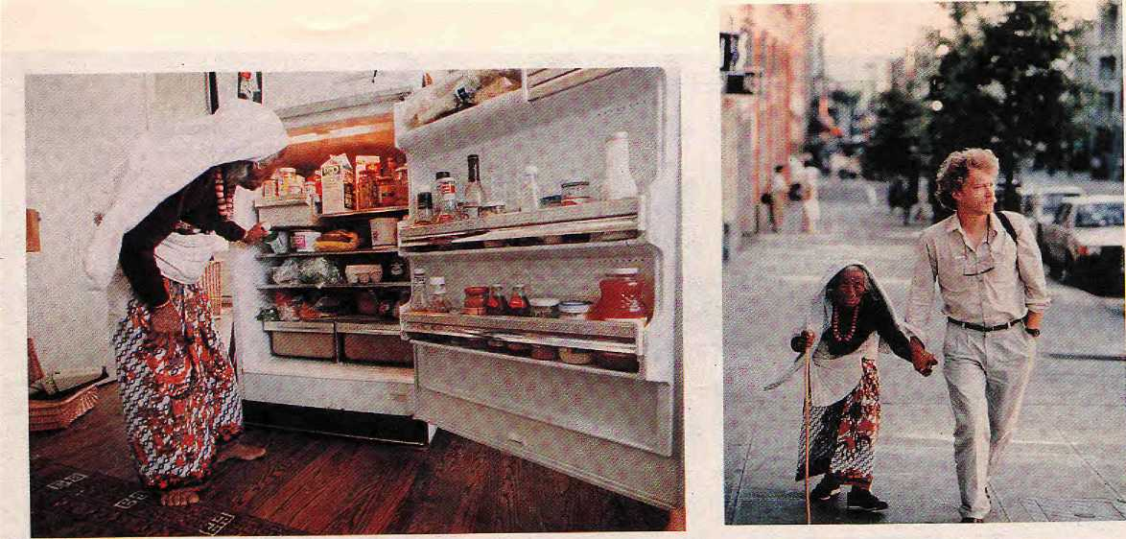

"Are you selling all of this? This looks like a shop front.'
With Broughton Coburn in Seattle.

A well-deserved rest with family friends.
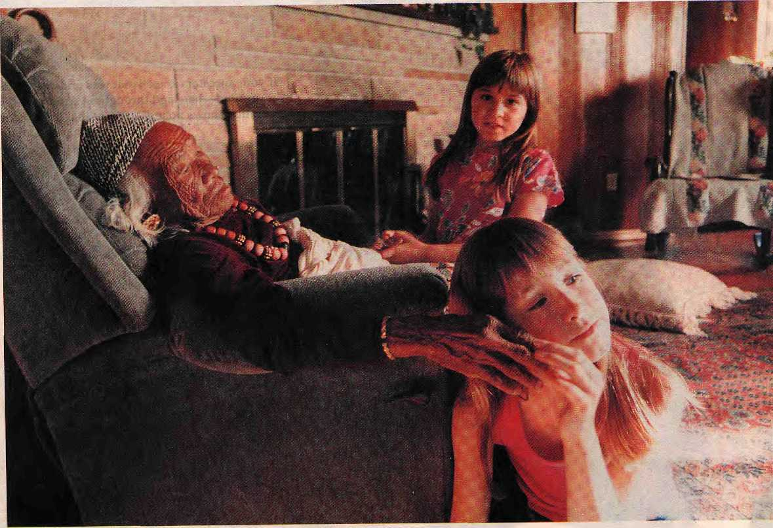


Revisited

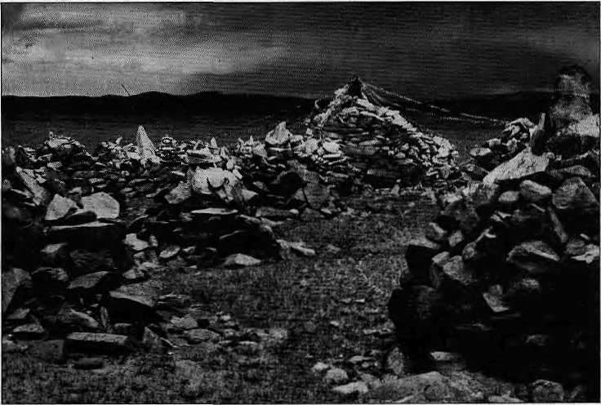

A prehistoric site of megaliths was discovered in Tibet's Chang Thang in
the 1920s. A traveller who goes in search of it seventy years later comes up
with chortens, and more chortens. What had happened?
by John Vincent Bellezza

T
'ibetisalandthatpopular imag ination has associated with magic and mystery. Even at an age when science dominates and the frontiers of the planet are clearly delineated, Tibet still shrouds a number of mysteries. This is nowhere more true than in the field of prehistory. While the first Tibetan historical documents, the Dunhuang manuscripts, date back to the 8th century, the Tibetan human legacy extends deep into the stone age. Bronze, Neolithic, Mesolithic and Palaeolithic sites have been discovered scattered across Tibet, from Ngari in the far west to Khani and Amdo in the east.
One of the first scholars to explore the prehistory of Tibet was George Roerich, the Russian-born son of the famous painter Nicholas Roerich. Between 1925 and 1928, George Roerich embarked on an ambitious journey to survey the prehistoric sites in the nomadic areas of the Asian hinterland. He mou nted expeditions in search of p reh istoric monuments to the Altai, Mongolia, Eastern Turkestan and Tibet. A major objective of these journeys, which together came to be known as the "Central Asiatic Expedition", was to explore "nomad barrows" (barrow = ancient grave mound).
Among the extensive discoveries of Roerich were 'slab graves' in Mongolia and
Namru in the Chang Thang, and the widespread incidence of a genre of ornamentation found throughout the nomadic regions in Central and North Asia which Roerich called the "Central Asian Animal Style". In addition, his expeditions discovered megaliths in Mongolia and on the Chang Thang.
Megalithic sites have also been located in Tibet by Dav id Snellgrove, GiuseppeTucci and Sonam Wangdu, but none have matched the spectacular site discovered by Roerich in 1928, in Namru, about 300 km northwest of Lhasa. Discovery of this site,ataplace called Doring, became the crowning achievement ottheCentral Asiatic Expedition, whichhad

HIMAL May/June 7995
29

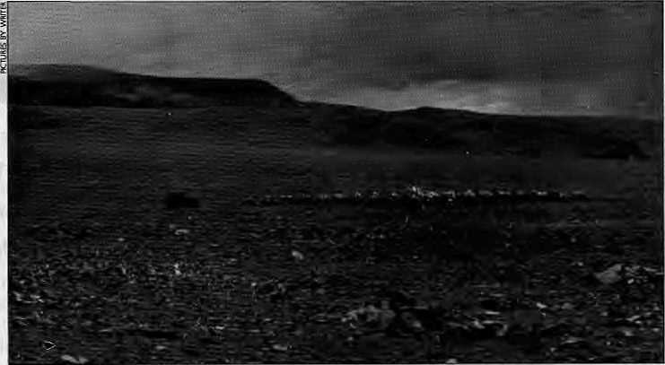
The patch to the right of the jeep constitutes the hundred cairns of Chorten Gyapa,
already accomplished so much groundbreaking work in archaeology and ethnology. In 1930, Roerich published a monograph with the Seminar-ium Kondakovianum, entitled "The Animal Style among the Nomad Tribes of Northern Tibet", describing the striking megalithic site of Doring.In the monograph, Roerich wrote: "The expedition...was fortunate in discovering several megalithic monuments to the south of the Great Lakes. These were the first megalithic monuments discovered north of the Himalayas. In a place called Do-ring, situated some 30 miles to the south of the Great Salt Lake Pang gon tsho-cha, the expedition found important alignments consisting of 18 rows of stone slabsor menhirs, placed in parallel rows and running East and West. At the Western extremity of the alignment, was placed a cromlech or stone circle consisting of two concentric circles of menhirs or stone slabs. Inside the cromlech were situated three menhirs with a crude stone-table (Ihatho) or altar in front of them. The central menhir was some 2.75 metres in height, had traces of butter libations, and I was told by a local headman that the stone was the abode of a lha or god protecting the route and travellers. The place is named Do-ring, after this menhir. The headman considered the alignments to be natural formations. Ifonecomparesthefamousmegalithic monuments of Carnac in France with the megaliths discovered in Tibet, one is at once struck by the remarkable similarity of the two sets of monuments. The Carnac alignments run from east to west and have at their Western extremity a cromlech or circle of stones. The Dori ng monuments have-precisely the same arrangement."
Zhangmo Gonpa
Upon reading this account of Doring, this writer became excited with the idea of visiting the site and carefully documenting it. The thought of a megalithic site in Chang Thang resembling another in the north of Francewas intriguing, and Doring was well worth a trip. As a traveller and writer of Tibet, I also hoped by visiting Doring to
cometoabetterunderstandingoftheancient origins of Tibetan civilisation.
To my knowledge, no Westerner had visited the Doring site since George Roerich first discovered it nearly 70 years ago. I only hoped that it had withstood the ravages of the Cultural Revolution. Roerich had believed that Doring was a kind of temple used by a "native cult". With the strides made by Tibetan studies in the fields of archaeology, mythology, religion and cosmology since Roerich'stime,it should be possible to present a more detailed picture of Doring.
On 7 May 1994, 1 left Katmandu overland for Tibet with full expeditionary gear and research materials. In Lhasa, I sought out and metSonam Wangdu, Director of the Administrative Commission for Museums and Archaeology Data in the Tibetan Autonomous Region, and Adjunct
Professor in the History Department of Sichuan University. Wangdu, who is recognised as the foremost authority on the archaeology of Tibet, told me that there were megalithic sites inSaga and Nagarzecounties as well as in Lhatse and Nagtshang, but that he was not familiar with one called Doring, nor with any megaliths south of the Pangong and Ziling lakes. He did not have knowledge of Roerich's work and its reference to Doring. I reasoned that Doring could have been discovered by a mapping team and never reported to the archaeological establishment.
In 1931,GeorgeRoerich published Trails in Innermost Tibet (Yale University Press),
which includes an account of the discovery of Doring. This book would serve as my guide to rediscover Doring. The 1928 expedition, with fully laden camels and yaks, headed in a westerly direction from the capital of Namru Province called Namru Dzong, which is today the county seat of Palgon. Armed with the geographic data encapsulated in Roerich's detailed work, I too arrived in Palgon, and set out to find Doring.
I travelled aloneon foot, quite a contrast to Roerich's heavily laden expedition, but very effective in terms of the distance one can cover. Travelling solo, I found, also facilitated contact with the drokpa, the nomads of the Chang Thang plateau. Following the directions given in Traits in Innermost Tibet, I skirted the northwest corner of Namtsho Jake, passed the drokpa settlement of Shungchen, and made it to the
Bonpo enclave of Potshe, with its landmark blue-grey mountain with a flat top. Arriving on the northern shores of Chum Tsho (Coral Lake), which until the Chinese invasion of Tibet had supported several Bonpo hermitages, I followed Zhang Chu upstream. Climbing up a small pass called Marokhumchen La, I had an excellent view of the snow giant NyechenthangLha, 85 km to the south-east. I was now in the Zhang Chu basin, utterly enveloped by the vast Chang Thang landscape.
I figured my best chance of reaching Doring was to seek g u id ance at the Zhangmo Gonpa, which by correlating Roerich's route descriptions with my maps I estimated was

30
May /June 1995 HIMAL

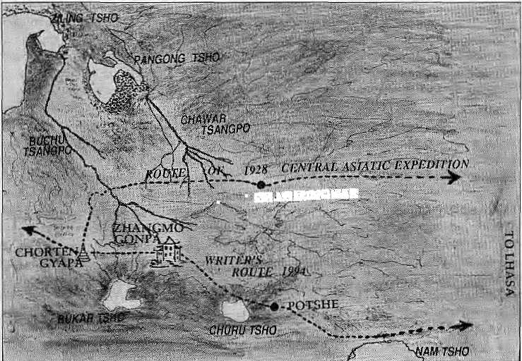
. • CH.VCU1KGKAK
no more than 40 km east of Doring—a short distance on the Chang Thang.
Zhangmo is a Nyingmapa monastery that is in the process of being rebuilt. The two young reincarnate lamas of Zhangmo, Lama Gochen and Lama Gochung, were welcoming and patiently answered all my questions. I was disappointed to learn that they did not know of the existence of a site such as the one described by Roerich. Mot only was an authority like Sonam Wangdu in Lhasa unaware of Doring, but the same was the case here in the very area where Doring is supposed to be, with two of the most knowledgeable men of the region.
Over the course of the day, Lama Gochen and Lama Gochung summoned drokpas from the area to inquire about Doring, a supposed complex of menhirs laid out in rows and circles, they explained to the locals. With utmost deference, the lay folk would approach the t wo tulku sand humbly insist on their ignorance about Doring. That evening, the two lamas confronted me and stated that positively no such place, nor any complex of menhirs, existed thereabouts. Lama Gochung then added, as an aside, "Remember when you came I said that you must have come looking for G uru Einpoche's Chorten Gyapa?"
I was perplexed. I had located the rivers and valleys and other landmarks which led the way to Doring, but Doring itself seemed to have vanished into the rarefied Chang Thang air. Still, having come this distance, it would be interesting to visit Chorten Gyapa.
The next morning, the two reincarnate lamas, three attendants and myself sq ueezed into a Chinese-made jeep and headed westward across a bone-rattling plain, towards Chorten Gyapa. Leaving the Zhangmo basin, we entered the Burkar take basin. To the north of our line of travel was a distinctive granite ridgeline, which surely was the "granite massif" circumvented by Roerich. On its summit are five pinnacles called Khadrode-Nga Choechen, "The Mountain of the Blissful Five Dakinisof the Great Dharma". This is the most obvious landmark of the vicinity. We then entered a narrow valley, described by Roerich as "sheltered by undulating hills". Precisely where Doring was to have been, was where Chorten Gyapa was located.
The paths taken by Roerich and writer Bellezza.
Megaliths and Chortens
Chorten Gyapa, "One Hundred Chortens", consists of a hundred cairns (called lap.se in Tibetan) in ten rows of ten. Each cairn is built of flat rocks heaped together with a small slab of rock sticking out of the top. The u pper sections of the cairns are whitewashed. Thereis a cent ralcaim which is built likethe others but is bigger,almost three meters tall. It is surmounted by a vertical stone projecting half a meter beyond. Prayer flags are strung from it to adjoining cairns, and yak homs and yarn are placed on its side as votive offerings.
Lama Gochung explained the significance of Chorten Gyapa to me. Each of the 100 cairns represents a bead of Guru Rinpo-che's mala. The central caim represents the bindu, or largest bead, of the mala. Oneday, a srinmo or ogress living in Burkar Tsho threatened to flood the entire region and displace the encamped drokpa. The locals, whowereatthe mercy of the srinmo, sought help from Guru Rinpoche, Padmasambhava, the tantric adept and exorci st. Guru Rinpoche agreed to help the besieged people and travelled to Burkar Tsho. He neutralised the power of the Srinmo by determining where the heart or life-force of the ogress was loca-ted. It happened to be where Chorten Gyapa now stands. The small hills on either side of Chorten Gyapa are the srinmo's breasts, hence called Numari ("Breast Mountain").
Guru Rinpoche, with the assistance of his tutelary deities, bound the ogress to the earth by pinning her heart down. This he accomplished by striking his mala on the ground which magically was transformed into the hundred cairns of Chorten Gyapa, From that time on, the srinmo, representing one of the many malevolent forces subdued by Guru Rinpoche in Tibet, could cause no more harm to the drokpa. One of the most important Guru Rinpoche sites of Namru, C horten Gyapa was ne vertheles s overlooked by the Red Guards during the Cultural Revolution because they regarded it as worthless and remote.
The story of theogress and local beliefs notwithstanding, geographic evidence suggests that Chorten Gyapa is the site of Doring. The location of key landmarks, valleys, passes, rivers and lakes leaves no doubt that this was the location identified by Roerich in 1928. The field data I have compiled on the geography of Chorten Gyapa correlates with the physical and cultural data derived from the U.S. Defence Agency 1:50,000 Tactical Pilotage charts, as well as the Tibetan language maps published by the Chinese. The evidence is irresistible; Doring is Chorten Gyapa. However, by no stretch of imagination does Chorten Gyapa resemble a megalithic site. Here there were no cromlechs, menhirs or circles of stone as per Roerich's description. Furthermore, the chortencomplexisconceivedasaunitoflOO

H1MAL May/June 1995
31

caims. It is not round with rows of upright stones radiatingout Also, ChortenGyapais built ofsmallstones,each of which could be handled by a single man, and there is no evidence of the monolithic stones which Roerich describes. Though Doring and Chorten Gyapa occupy the same geographic coordinates, they share little resemblance. What happened to Roerich's megalithic site?
Mic-hos, Lha-chos
There is only one explanation. Sometime in the last 70 years, Doring was purposely altered to create Chorten Gyapa. Using the old megaliths as the root stones at their base, the drokpas of the region built the hundred cairns of Chorten Gyapa. The original character of what might have been a stone age site has been altered to the point of being unrecognisable. In order to invest new meaning and significance into Doring, the site was transformed into a testament of Guru Rinpoche's magical powers and prowess. The haunts of a local aboriginal deity was elaborated upon to better conform with the tenets of Vajrayana
Buddhism. The architecture and mythology was altered.
The p roces s of legend-build ing arou nd Padmasambhava and his exploits is something that has gone on for 1300 years. In the complex set of factors that come into play, at some juncture, the Guru Rinpoche connotation of the Doring site, related to a more 'modern religion', eclipsed the more primitive layer of beliefs. This is a process evident elsewhere in Tibet as well, where themi-c/ios,thereligionofthepeople,orfolk religion with its aboriginal as pert s, is eclipsed by the more organised modern lha-chos. It was Guru Rinpoche who was instrumental in taming the chaotic terrestrial forces which inhabited the landscape and who tamed these elemental forces and brought order to the world, which led to the spread of Vajrayana Buddhism. This victory of one force over the other also seems to have occurred in Doring as well, in the way cairns have overwhelmed the megaliths.
There is no question of fraud or m is representation onthepartof Roerich, for the site was photographed by his team.
This is a case of planned and purposeful modification of the architectural character of an ancient monument by those who set about building the hundred cairns.
How many other such prehistoric monuments may have been effaced, not by the ravages of time nor the violence of the Cultural Revolution, but by the overweening efforts of the Tibetans themselves, to rewrite their history in order to bring it more in line with Vajrayana orthodoxy? This is an important question if we are to better understand how cultures remould themselves, reflecting changing conditions and values. At some time, someone made a decision that Doring should be more than the dwelling place of an aboriginal deity. Through this effort, the hold of Buddhism on Tibet has increased by a small measure, but at the same time a vital link of the people to their ancient history was obliterated.
J.V. Bellezzaisa traveller of the Western Himalaya and Tibet.

s- Tableware * Floormats * Bedcovers * Cushion Covers # Pillows * Kitciien textiles * Cloth by the meier * Cloihing * Bags * Toys



Fair traded and
environment friendly
handicrafts for the
family
Made by low-income Nepali Women

Retailers :
Dhukuti
pii, Kathmandu Ph:535107
Exporters :
Manufacturers:
Nepali Craft Trading (P) Ltd. Association for Craft Producers
G.P.O Box 3701, Kathmandu, Nepal Ph : 270721,272676 fax : 521880

G.P.O Box 3701, Kathmandu, Nepal Ph : 270721,272676 fax ; 521880

32
Knitwear Jfc X'mas items ¥i Clay ■# Copperwarc # Paper Crafts # Wooden items # Baskeiry # Leather items 1/t Sarees 3fr Felt items —
May/June 1995 HIMAL

For once, Think twice !

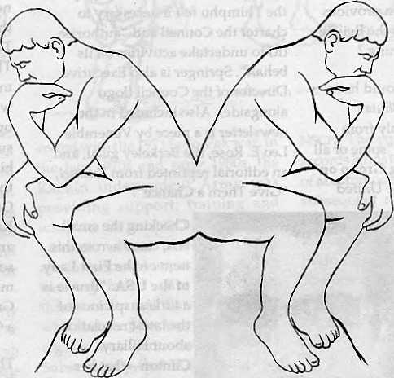

Are you looking for the cheapest rates ? Or, do you want value for your money ?
At Summit Nepal Trekking we design our programmes that ensure you get full value for your money.


MMIT NEPAL TREKKING
Write or call us at:

P.O.Box 1406,Kupondol,Kathmandu,Nepal
Tel:525408,521810 Fax: 977 1 523737
i



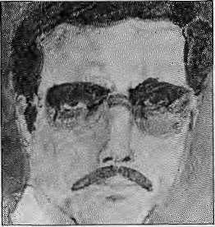



t3
CO
CO
In Meghalaya, the Association for the Reformation of the Family Structure is fighting a reverse gender battle, campaigning to change the traditionally matrilineal Khasi society into a patrili-neal one, reports The Indian Express. Claims the Association, 'The Khasi men have to fight for equal opportunity with women. Here the women have all the rights and opportunities." Predicatably, the Meghalaya Women's Alliance pooh-poohs the campaign, claiming that the existing matrilineal system provides for "genetic perfection". Is the Beijing women's conference listening ?
Here is something that should have made the headlines. The Bhutan Review, the refugee monthly from Kathmandu, has accused "some or all members" of the Working Group on Arbitrary Detention of the United Nations Commission on Human Rights, of "connivance and complicity" with the Government of Bhutan when it decided that the detention of Amnesty International Prisoner of Conscience Tek Nath Rizal was not "arbitrary". The Working Group also decided that "there is nothing to suggest that the trial of Tek Nath Rizal was not fair and in derogation of acceptable international standards." For the information of the three committee members—made up of a Frenchman, an Indian and a Senegalese—the refugee journal points out that Rizal was abducted from Nepali territory, that Rizal was punished retroactively on the basis of legislation enacted years after he was put in prison, and that the )egal system of Bhutan by no stretch of the imagination can be said to be at par with "international standards". The editors claim that they have no choice but to believe that the Committee members have received a payoff.
For those who think they has been too much Bhutan bashing and not enough propagandising on behalf of
Druk Yul, comes a new quarterly newsletter, The Thunder Dragon, published by the American-Bhutan Council (founded 1993), which is based in Ojai, California. It is a handsomely produced effort, with lots of black and white pictures, and includes an article "Bhutan Deals with Difficult Problem" by Editor-in-Chief Karl Springer which makes clear why the Thimphu felt it necessary to charter the Council and "authorise {it} to undertake activities on its behalf". Springer is also Executive Director of the Council (logo alongside). Also included in the newsletter is a piece by Venerable Leo E. Rose, the Berkeley guru, and an editorial reprinted from Kuensel, "Give Them a Chance".
Checking the email-box, came across this item on the First Lady of the USA: "Brucie is a little suspicious of the latest revelation about Hillary Clinton—that her mother named her after Sir Edmund Hillary. He points out that Hillary was born in '47, whereas Hillary didn't hit his peak till '53." A witticism accompanies the sign-off, unrelated to Hi-11-ary: Question: "Is that Sherpa Tenzing?" Answer: "Looks perfectly relaxed to me!"
A documentary film, The Kashmir Story, apparently hangs in limbo due to trembling hands over at Doordarshan. Made by cinemato-grapher-couple Gopal Sharman and Jalabala Vaidya, the film probes the history of insurgency in the Valley and describes the suffer-ings and aspirations of all—Sunni, Shia, Hindu and Buddhist, with the camera crew travelling from Jammu to Banihal to Leh and Kargil and all corners of the Valley. Already said to have been cleared by the Indian Foreign and Home ministries and by the all-
powerful "PMO", Door-darshan should show some guts and air the film.
There are some who dream of a Greater Nepal, while there are others who are working for a Greater Nagaland. The Telegraph reports that some Nagas of Nagaland would like to incorporate into their state the Naga-inhabited areas of neighbouring Manipur, particularly the four hill districts of Ukhrul, Tamenglong, Chandel and Senapati. The Kuki minority as well as the majority Meitei of Manipur, meanwhile and understandably, are firmly opposed to the idea. While still on the subject of greater this or that, little bird that flew in from Leh tells me that Ladakhis too have an eye for a Greater Ladakh, to include Leh and Kargil, certainly, but also Himachal and (no!) Tibet. Now, that will require some serious geopolitical realignment. There will probably be a Greater Maldives before there will be a Greater Ladakh.
The Indian Army has suddenly become a protector not only of Bharatbarsa, but also of traditional Tibetan medicine as practised by the amchis of Ladakh. The Army has embarked on a project to study herbal medicine in the Ladakh region for possible application in treating soldiers of high altitude illness, reports The Times of India. The study is headed by Maj. Gen. Vombatkere, the Additional Directory General (Directorate of Vigilance), who had this to say: "Patenting this indigenous system is necessary since it could be under threat from some interested multi-nationals in the wake of the recently signed World Trade Organisation Agreement". The study that the General heads forms part of the Great Himalayan Expedition (HIMEX), which is "a multi-national, multi-dimensional and multi-disciplinary adventure conceived by the Army with the larger aim of developing an understanding of the ecology and
May/June 1995 HIMAL


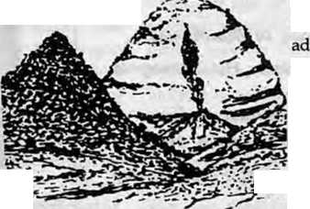
adventure potential of the Himalayan range." Ambitious.
According to the Agence France Presse, the Communist Party of China has picked an ethnic Han Chinese man as Tibet's model hero. On 21 March, the Tibet Daily called on the people of Tibet to follow the example of Kong Fansin, a party official originally from the eastern Shangong province and former mayor of Lhasa, who died in a car crash in December 1994. The daily noted that "by modesty, integrity, hard work and devotion, he is an example to all cadres in Tibet and a symbol of the unity of all of China's races." Somewhat like holding up John Wayne as the paragon of virtues for Native Americans to emulate.
Did you know of the existence of a Council of North Indian States for Cooperation and Regional Development, which even has its own cute acronym—CONCORD? Tired of the Central Government's disinterestedness, the five states of Uttar Pradesh, Haryana, Rajasthan, Himachal Pradesh and Delhi have banded together to forge a inter-India common market. They plan to coordinate inter-state highways, set up a transportation grid, cooperate on tourism circuits, optimise water resource management, promote cross-border economic growth, etc. etc. If the Europeans can do it, why can't the North Indians, as long as they do not forget to take the Himalayan region along for the ride. May CONCORD push the throttle and take off like the Concorde!
What to make of the Xinhua news item which states that "scientists have discovered some 3500 species of plants in a virgin forest in southeastern Tibet"? Do they mean that these previously known plants have now been discovered in this virgin area, or that these are 3500 newly discovered species? Must be the former. The report is ominous when it states that the virgin forest has "a living timber reserve of 1,5 billion
cubic meters, making it the second largest forest in China". Even a news report on a scientific subject is written with an eye of "timber reserves" and don't we all know about Chengdu's timber merchants and how they have raped the rest of Tibet's woodlands. Please spare this
one corner)
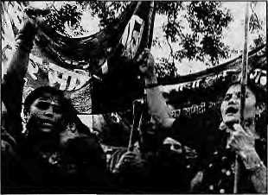
Speaking of which (Greater Nepal), Chhetria Patraka'r noticed that sever Indian papers have recently carried photographs of demonstrations by Indians of Nepali origin in New Delhi. Now here is a community that seems to feel that it has spent enough time in the doghouse and is finally testing its vocal chords. Their demand is to be recognised as full-fledged Indians and not as surrogate Nepalis of Nepal. A picture in The Telegraph showed women activists of the All-India Nepalese Unity Society demanding "redressal of their grievances".
Some treacly verbiage I picked up from a press handout distributed by Pakistan International Airlines about its Air Safari, which is described elsewhere in this magazine: "The invincible majesty, the irrevocable beauty, the awesome
splendour of one of "7? Nature's grandest feats—the snow-capped peaks, in all their glory and grandeur, provide one of the most moving and awe-inspiring mo-ments of your lives. A close visual, though intangible, contact with the manifestations of Nature is a mysti-fying, mystical, experience—that transcends
one from the peripheral to the spiritual." Clearly, lines written by a plainsman copywriter!
As the column goes to press, the Dalai Lama has named the new Panchen Lama, and he is six-year-old Tenzing Gedhun Yeshe Thrinley Phuntsog Pal Sagpo from Lhari district in Nagchu province. The previous incarnation passed away in January 1989. The good news is that the reincarnation has been located firmly within Tibet and not in some new age family in Seattle or Madrid. Now comes the part where one bites one's nails and nervously wonders, "What will the Chinese say?" For his part, the Dalai Lama says, "It is my hope that the Chinese government will extend its understanding, cooperation and assistance to the Tashi Lunhpo monastery in enabling Rinpoche to receive proper religious training and to assume his spiritual responsibilities."
Saw this plug for a Kailash trek in
the 16 May Times of India, which presents Indian pilgrims {"whether you are young or old") with a Delhi-Kathma-ndu-Kailash itinerary for IRs 46,666. The trip is organised by Vishnu Inter national Tours, whereas you and I know that it would have been better if the deity were Shiva. For the first time ever, the
succeeds in presenting Mount Kailash as if it were shaped like a beehive turned upside down.
& ^{And}'^{by} ^{the} ^{way}'
what is that logo of Vishnu International all about? A fighter plane—looks like a Mig 21—being tagged by an arrow, which could only be a ground to air missile. Is this a coded insert? Am I missing something?
- Chhetria Patrakar

HIMAL May/June 1995
35

ose who want to see DOLPHINS LIVE

- Flutter with the butterflies
- Sing with the birds
- Growi with the tigers
- Trumpet with the elephants
- Roam in Tharu dwellings
- Frolic with the dolphins
Plus so many other activities in
DOLPHINS MANOR
(A Wildlife Resort in West Nepal)

BARDIYA NATIONAL PARK
For details: P.O. Box 3769, Lazimpat, Kaihmadnu, Nepal
Phone: 420308, GSA Office Thamel: 417191
Fax: 977-1-220143 For MENUKA, 977-1-415401 DOLPHIN

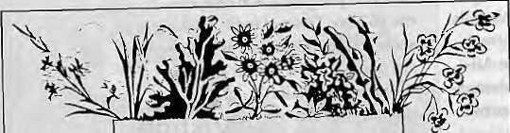
MADHUMAS
Asha Kaji Byanzankar, Gardener, Hotel Shangri-ta
Rajendra Rat, Floriculturist, Parijat Nursery
Nabin SJB Rana, Director, Reliable Builders Pvt. Ltd.
Distributor in Nepal: Shangri-la Trade Links Bakundol, Pulchowk GPO Box: 1726, Kathmandu Tel: 524429, Fax: 227058

'Kamkomtn I
EXPERIENCE
 | Pakistan
I I Join us on a Trckkins, | | Nepal
\\ I Climbing or Mountain | Nepal
ij Biking Adventure..* | India
H .. Xo the worlds most exotic | Bhutan
\,\,t mountain ranges. j
| j \\ Specializing in the unusual | China
H I and unique, as well as the
■j ^{r}\ Himalayan classics. | Tibet
,' 'i FOR A FREE, COLOR | Russia
j "GUIDE TO ADVENTURE" CONTACT;
I I %arai<&ram^{r}£?(perience | South
I? 1 F.0. BOX 10533 -ASFEN, CO &1612 | America
[I , {800) 4-97-9675 • (303) 925-&S6&
\. | FAX (303) 925-6704 | Alaska <
¹ | Alaska <



Slcy I> ance

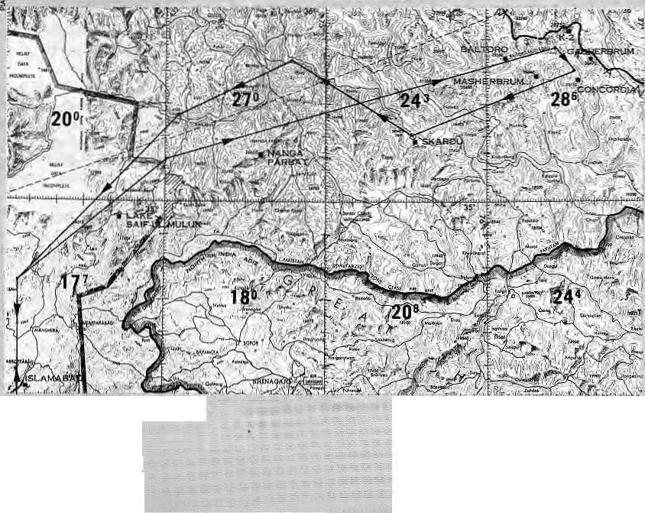
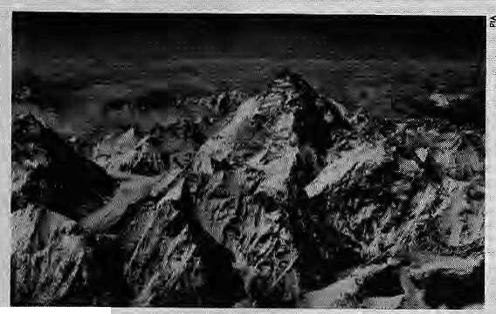

F
or those who thought only Royal Nepal Airlines and if s private sector siblings in Nepal conductedmountain Sights, there is some.pews. Since August 1993, Pakistan International Airlines has been conducting "air safari" flights '.. Over the Karakoram,
Unlike Nepal's tarbo^prop Avros and Danders, which fly lower and slower,PIA uses its Boeing 737-300 jets to wing it over the Karakoram. Taking off from Islamabad's airport, the plane banks northwards, following the Indtis River and the Karakbram Highway straight into the mountaincountry.
Before you know it, the plane is overflying the Northern Areas, and the steep ramparts tit Naiiga Parbat (8125m) come upastride the starboard windows, This is where the serious business begins. The pilot banks the plane to the right and heads straight for the Baltorb Glacier and the distinctive pyramid of Mount K2 {8611m) which lies at its head. The mountain, still 200 km away standing on the frontier with China, is already visible.
After turning the corner at Nanga Parbat, the pilot begins aivhour4ong figure-of-eight which will regale passengers on both sides with breathtaking vistas of the hallowed peaks of the Karakoram and their attendant glaciers: Masherbum (7831m), Rakaposhi (7788m), The Ogre (7300m), Chogolisa (7400m), Mustagh Tower (7284), and the Gasherbum group that huddles close to K2. PIA's Boeing has been known tQ fly
HIMAL May/June ISSS
withinl .5 km }^
.tioseenough to spot mountaineers, whereas the mountain
K-2Jnmi..737...
flights in Nepal keep a respectful distance.
FligbtpathotKarakaram mountain flight.
■trr
Unlike ):he onesided view of the singlerfile Himalayan .crest that is available in the e^-K^thmandu mountain flights, the Karakoram ^{r}s scattered peak arrangement and the flight-path PlA's pilots
have selectedensure that passengers on both sides benefit.(LatheEverest ;

mountamfiight; passengers oh the starboard side have to wait for the ttetu rti leg to view the tine of peaks.)
After one has had one's fills of the mountains, it is time to look further afield. Beneath ■ the; fuselage, there is the progression of towns and
vajleys whose names are straight out of the books of colonial adventurers: Hun2a^ Chilas, Astor, ?kardu,.,fp the north, where the iruauntains give away to ari undulsitihg yelliftwrtessin the horizon, lies the Taklamakan desert of Western China. Beyond the Hindu Raj mountains in the: northwest is the Wakhan Corridor-where Pakistan, China, Afghanistan and [Tadjikistan] meet. And there, a couple of hundred kilometres away towest-West-north,, stands Tirch Mir (7708km), the highest mountain of the Hindu Ktish:
3?'
FIA's Air Safari charges U$225orPRs6225fora window se^f. For those travelling together.and willing to share a window, aft aide seat is sold for half the priee. The flights fake off at 10 a.m. eyery alternate Saturday,

B

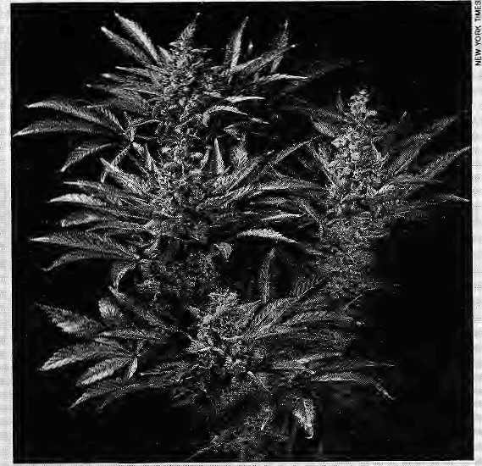
Pot Prof its Lost
They Love to Hate SwI4den
R A ^{ar}'j^{ualla} '^{las} become the IVI United States' number one cash crop, reports the New York Times Magazine, If only Richard Nixon had not forced Nepal's government to
make marijuana cultivation illegal back in the early 1970s, would Nepal's hill peasants be reaping great and
: legitimate profits from cannabis today?
In retrospect, all that has been achieved by the ban forced on Nepal is that what was legal became illegal in a remote Himalayan kingdom while the consumer demand for grass in the great consuming nation never dipped. Rather than import from the far pot^growing corners of the world, cannabis cultivation went domestic.
US President Bill Clinton might have claimed on the campaign trail that he had "smoked but never inhaled" pot, but his contemporaries and the following generation did not abandon marijuana. In fact, they helped make the plant what if is today, a genetically engineered breed that would stand as an example of efficiency of the free market, were it not illegal.
According to writer Michael Pollan, 20 years ago virtually all the marijuana consumed in the US was
... imported. "Today, thanks in no small part to the Pederal war on drugs (which prevented imports), American marijuana cultivation has developed to
. the point where the potency, quality and consistency of the domestic product are considered as good as, if not better than any in the world. In an era of global competition, the rise
of a mad e-in-America rhari-juana industry is one of the most striking economic success;stpnespfiHe.l980s;;; 11 andl990s>
From a hobby ol aging hippies; pot farming has burgeoned into a high-tech cottage industry with earnings estimated at US 31 billion a year. "That makes if easily the '". nation's biggest cash crop," writes Pollan. Com is the next largest cash crop at U£14 billion, and soybean is next at U$/it billion.
At first, American growers were familiar with only one kind of marijuana/ Cunmbissativa, a strain that could not stand the cold northern climate, By the late 1970s, however, they had discovered Camutbis indies, a stout, frost-tolerant species cultivated for centuries by
I
ndia's bureaucracy continues to buy the colonial myth that shifting cultivation, a traditional farming practice among forest dwellers in much of South Asia, is an unsustainable practice that should be eradicated. India's draft Conservation and Natural Ecosystems Acf^ proposed >" 1994, seeks to give more teeth to the prohibitory powers of forest officers to help curb shifting agriculture,
"the draft legislation, essentially built upon earlier acts;qf island: 1927|eft : behind by the British when the understanding of forests and forest peoples was still
Himalayan peasants. A-riiericari growers were soon producing hybrids of the two plants, hardy as well as providing
All in all, what seems to have happened is that (he
rudimentary, ignores a large body of scientific findings which defend flium, or swidden, agriculture; Work by erriinerit Indian ecolbgists siich as PS. Ramakrishnan seems to have made no impact with the : foresters who drafted the Act. Historically,the Mughal, Maratha and other rulers of India were content with collecting tributes from tribal and forest peopled Thfe forests themselves had littli; value. However, the:adYent of the British Raj and the railways transformed trees into vital raw material. It was about this time that, conveniently, the exploitation of tribaTlands was begun by propagating
profits from a plant which was reared and nurtured for thousands of years by the South has been cornered by (illegal) growers of the North: Did anyonesay Intellectual Property Rights?
the myth of the ill effects ofjhum.
The colonial theories have now been su fficiently debunked by Indian ecplogisfs, with a recent study by Ramakrishnan indicating that jhum even contributes to plant diversity: Indian scientists say that traditional forms of production like shifting cultivation hold critical lessons for the sustainable use of marginal lands, A total ban on swidden agriculture would be retrogressive, a message that should be sent to the devotees of British Raj in theforest bureaucracy'.
(CSE-Down To Earth Feature Servics)

38
1995 HIMAL

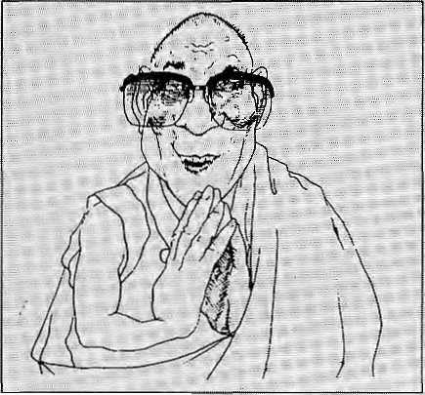

T
ie Chinese authorities have : stepped up their campaign to discredit the Dalai Lama a$ a leader of Tibetan Buddhism, faking specific aim at his "I spriltial standing. In the past, fearful of rousing more anti-: Chinese resentment in Tibet than already exists, Beijing had beep content in deriding 'the Dalai Lama clique'and the 'splittisis' oJEDharamsala. However, it had tended to stop ^hort of virulent personal attacks. That threshold now seems to have been passed^
Since April, Chinese television broadcasts in Tibet have accused the Dalai Lama of "blaspheming Buddhism, flagrant deceptiveness and demagoguery, and pretending to be a spiritual leader while actually being a separatist chieftain."
In reports carried simultaneously by the official Tibet Daily, the Dalai Lama was accused of 'forging' Buddhist texts, altering the teachings,

gipn," the papersaid.
■ Accprdingthe '_{v} .... ...... ■■■■ ■■■■
Lpndon-'based Tibet Inforriia-tion Network (TIN); ^etjing's 'change of srrategy.tG incfud^ "'
and violating the principles of Puddhism; At the National '" People's Congress session in Beijing in March, Baidi, the Chairman of the Tibet People's Congress Standing Committee, referred to the dual role of "jppiitical hdbilgSn-.. and spiritualJeader" played by the Dalai
Lama. ■■■ ■■ . ...-.■
Recent articles in the Tibet DaHy reveal official concern overthe tendency of the : population to equate Tibetan Buddhism with Tibetan national ism, warning that such "erroneousconcepts Politicathoofigan?
were gaining a following"/ especially among theyoung. "We must make a serious-distinction between correct.... religious activities and cp u nter-re volutipnary activities under the cloak of reli-
personal attacks on the Xenzin Gyatso, the Dalai Lama, were taken in July at a policy-rrtaking conference of the Third National Forum on Work inTibet. TIN quoted an unidentified Tibetan party
member as saying: "The main spirit of the Third Forum is to.., separate tjie^DaJai Lama from Tibetan Buddhism." .■•:• As it evolves, the strategy seems tp-be to try and prove that the Oelugpa school whjch the Dalai Lama leads is not the : leading sect ^mong the four ■ -main sects of Tibetan Buddhism; And; as the word goes'; even among the Gelugpa the Dalai Lama is only one of ; • ^eyeral leaders.
Attempts have been made to promote leaders of ot her s^cts- as the $pritua! leader of all/ Tibet: particular !y the Karmapa, the li-yearKjidieaderof the Kagyu school of ". Tibetan Buddhism. The present Karmapa is considered to be the 17th incarnation in a line stretching back to the 12th century, while the present Dalai Lama is the 14th in a line going back to the 14ttt century.
• Yojana Sharma (IPS}

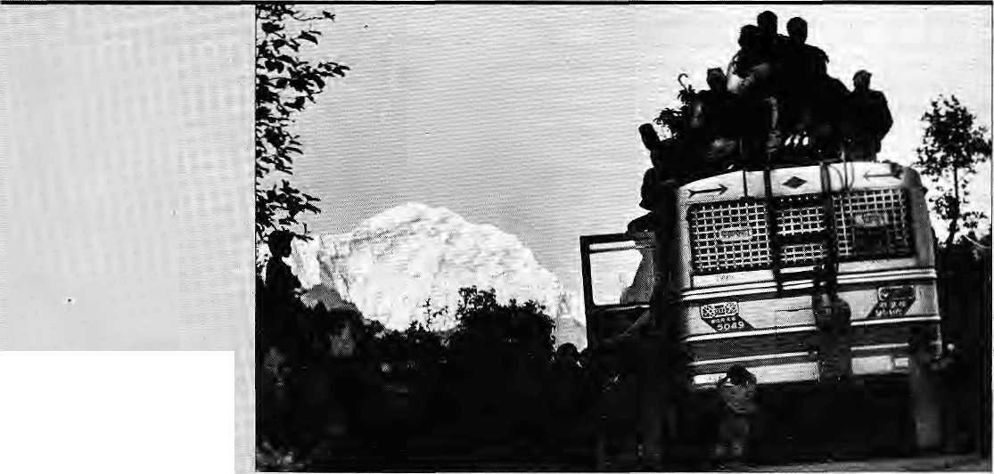
"Chyoputsering Himal"
fromHanwvane Bhanjyang.
Bus riders are bound for Jiri to
celebrate Vharwith their families.
Picture by Chandra Shektiar Karki.

HIMAL Maytlune 1995
39

I
B

If 'Uncle Chips¹ Can Do it So Can Garhwali Women
Asocial action group called theHimalay? Environment Study and Conservation Organisation has been successfully using science to make villagers' lives easier in the Garhwal h ill %, reporters the CSE-Dawn to Earth Feature Service, Established in1979, HESCO has trted to introduce innovations that improve the living standards of Garhwalis without forcing the villagers to take a big leap away from their traditional practices.
At the hamlet of Gholtir, for instance, HESCO scientists modified the traditional gbarat water mill to increase efficiency. A: teflon bush was attached to the mill's shaft to increase the spin, and a flume reduces friction of the rushing water. "Earlier I used to grind 15 kg of wheat in an hour, but now I get double that," says Narayan Rana, the mill's operator.
"We do not want td impose alien technology on the villagers. We suggest best alternatives and let them decide on what they want," says Kiran Rawat, who modified the water mill at Ghoitiiv
HESCO's assistance goes beyond mere techno-fixes, however, and includes marketing support. Realising that the residents of Bilagarh were being cheated by middlemen of earnings from a bumper potato crop, the group trained BUagarh's women
oh the finer points of making potatachjps. It also provided a packaging -machine. Now BilagarhVchips; priced at IRs6 for a 100 gm pack against an ; input of IRs 20 per kg, are sqld all over the region. Says : Sangita Dhobhal an active member of Bilagarh's mfthild mangtil dal (women's welfare group), "We ar^ now in competition with Uncle Chips and Pepsi Foods!"
In Animath/ an isolated village of 20 households which was not connected to the electricity grid, HESGO has put up a gasifier plant that generates 3.5 kw electricity out of briquettes (loose biomass: converted into splidfuei by tamping). Thegasifier wa? developed bythe'Indian Institute of Technology,(HT) Delhi; and the villagers have been trained to make briquettes and to'run¹ ■" i the gasifier.
In the same village, HESGO has shownilje villagers the uses of rambans (agave), a commonplace thorny fibrous plant which has traditionally be considered useles's other tharVtp line field perimeters, lndira'DeviRawat,|i : weaver, now earns IRs 600 a month selling r^rnbans fibre products.
Elsewhere, 12-year-old KuideepTSrngh Negiof Gwar viOage has learned how to grow mushrooms on the skiri of the sullu plant (Wuphorhw toylem). In^hisfirst mpnthof production_{f}:the boy'gave life 45 to his mother, who was doubtless pleased with this turn of technology in the GarhwialMls.

...In ihe. fest issue,we pirobeii thelppssible origins ofthe t^rm '; > We iiqvv study ihJ
=As--Wadde!l has it_{(;} '*tHe^boriginies; the tepc'Ms^ «jM ii.:
6r"The Place «£. €aves'v white the Tibetans »c3ll ib-
JgarPemo-jong, or 'The Cciunticy of &sce and FHiit'as'it'
is^a granary for bleak'Tftilt." MaiRwaring^in ftt&'Dictiofiarifcij-ihe*
l$9§)i agrees; giving:the nottieti prpprium as»
mj ^or 'thecouBtrfof caves' (jVg =,apkee,a cave; a cavern;^{f}
*earth).:/: /:/ ^{T} ... . ;..: ,-. *? s ■:. ■■■■ :- '■'
errthusiast;KiD.Tamartg;
Lepdkti$ (1983)states, "Hiis region was knowniniheaHcient times
bythenameof MyeJ ^yang, which means 'the Jaftd of Ijiddfrt..
paradise' 6? 'the delightfttlsregioh or abVide'"- Sjrpibii views are"
a)sp expressed by another tepcha writer; Foning, in Lepchal M^
■;.;■ Vanishing Tribe%i987% who equatesM^e? hyangvfMy, tEeGarden,
"of EJfii; Meanwhile/the-scholar Ta pan Chattqpadhyay iLepdns *
■Qqd:~Tkeir Heritage, 19S3|: ihcpfppr^tes almost everything "
the very complicated : form of .spelling used. The
used Tibetan term is De(ipJQtigi Which jn Tibetan would -.be spelt as ■kSres-lJSngs l?ut other use Gres-'gbgn (Rev. Deli a 712% Bm-wa?scJQM (Van rfe Puttfc 1730)^ and Bms-jong* Sandbergt J904).:T%)rj those unfamiliar with Tibetan^ : orthography,;it is d|fficuH to make sense out ofRiMftah translii-* e|atians. Asa. sampler, 'consider Rijstey's remarks'The Tibetan vnames for Si&Rim |r^ pKJRounced Eteijong, perridjong and . DfemqshpRg, thpughactually spelt hBTa s-jjcmgs,. lBmsjima*lJon^, ■ on,d JiBrasrgShongs, and meanThe country ^d^ valley of rice";"* •TJie:Tibet^«s^eiling is sp confounding, onecaii sympathise withSir Richard Tdfnj)fe,|hpugh not nec^sariiy comply with 1|«&. choiceoCspelSing, whenm'TitoVete. mN^palfind^ikkimilS&T},he* Fesortstothe father inaccurate Pinjing&Vid Dinfaiig.Nar r^ustbe given^hepfeee-of honour for brevity,*aecaracy
:s^fcs;;tKa|t|ie.traditional mmsU'Denjmg, or 'Valley office".
5 liv~ec| up^tdhis reputation of creating ? ^Otiteoversies by sf a^ing ihatthcvsry name of Sikfcim is *^c
f Kve'^{f}. So far, he jias not elacjdatfedon the. matter andpne-can'OTtlys t presume, thai he/means :the ^arne ought to ,hav« beeri Sukhmfi \. instead of SiJ^iwi (see!P7s&riiiffies, WE?u|/A|M^{l}t995).,W*hfleGhisihg ::s doesiseem fo have the_{v}uncan.ny genius of pulling" out an ace from» : where pone seems to exist, arid till |.e;eal%htens us,, suffice it to »say that the last wordfjhas^neifeherhbeen spoken br\vritten, . , ; i. ■....,. , -i; ~ i;' ::- ■■'■■'■■ ;■ ;. .. ., . . ■ ■ ■ ■■ ■ .
'pi, $-B. Wsatgyatpmsll6s« rrMfdji^Iri J§l^aon,-West Bengal.
i ss.-. ^i- :« :± iS:-

HIMAL

Chessler Books
Send for our free Mail Order catalog of the world's largest selection of Mountaineering Books.
New, out-of-print, and rare. Also Tibet, Nepal, Polar, Exploration.
\ Please write or call for your free catalog today, i
Chessler Books i
P.O. Box 399-112 I
Kittredge, Colorado 80457 USA j
(303) 670-0093 FAX (303) 670-9727 J
[

Cafe Lungta
Garden Restaurant
^& ■ '■'''■
 | I'lUnhyrfied meals
 | • tjuite ciTy Tiiaeaway rjproi Garden.at 4200 ft.
i | » Organic food on demand
 | » Lunch Boxes
 | i: Phone orders & out door catering
... | » Weekend special brunch
Cafe Lungta Garden Restaurant
¹ $^w j/\. Kantipath, Kathmandu, Nepal ^<^^^fcl Xw^ G.P.O. Box: 4573, Tel: 217804 ^^VWS-^U^ ^{Telex:} ²⁶⁸⁵ MANDALA NP ^^^aMjj^^^d^^ Fax:977-1-227600
v ^^ ^^—^>


Get Connected to the
Information Highway !

Now you have a local access into the Internet in Kathmandu.
Mercantile Office Systems (9:30-17:00 HRS); Tel: 220773, Fax: 225407 or e-mail: Postmaster@mos.com.np
* Currently E-Mail Services available.

K a
a

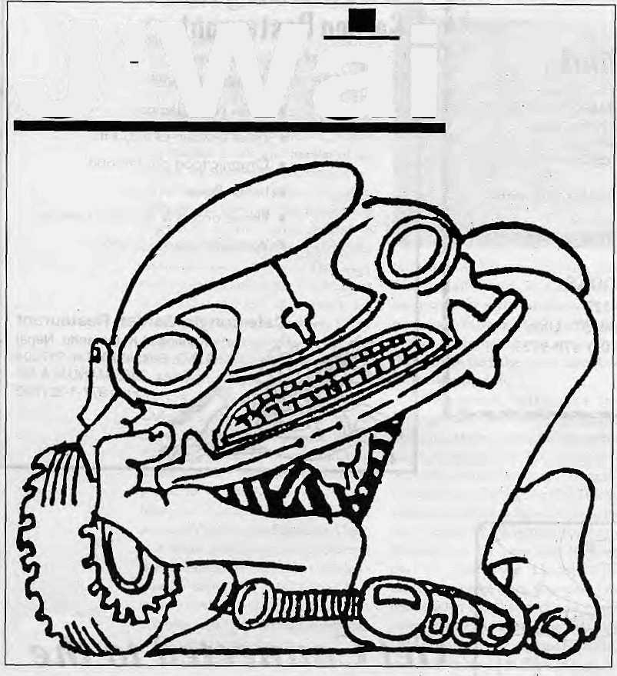
J'Wai
The dream haunted her. Several times, she caught herself thinking about it; in the middle of her cooking, her washing. But try as she might, she came no nearer to an understanding of her unease.
Vaguely she discerned that the root of it lay in the increasingly bitter quarrels that had begun. It was then that she had started seeing the dreams.
Kamala dreamt it again that night. She was standing with her daughter before the dark doorway of the house. Rohini slips from her graspartdrunsin shouting BahaBaba, where are you! Sheruns after her. Inside, the walls are weeping and mouldy. She holds her struggling daughter fiercely, almost cruelly, as the windows swing open letting in a blast of wind; she can hear a howling outside, she flailsat the window. Three black Ambassadors are crouched before the porch. Another snarls up, horn blaring, tires screeching; followed by another, and still another, until, as far as the eye can see, the ground is flooded by a sea of cars with steaming black bonnets.
Then she woke up.
by Anadi Pawan Chhetri
1 came home with the shopping. There is no one in the kitchen. My mother and the family were gathered in her bedroom. A wall of grave faces. I look my surprise.
"Ganesh phoned from Darjeeling; Jwai has met with an accident." The faces closed in.
Sympathetic arms fluttered about my shoulders, led me to a chair. Through the murmur of commiseration I make out the fragments of a conversation.
"Icouldnotgettherestofthe message... the line went dead halfway through... only made out that it was a serious accident..."
So that's it, I thought, that's what the dream was all about. He must be dead. Why are they going on so, do they take me forastupid woma n who keeps on hoping against hope till the end? Yes, accident, that's how they would describe it, trying to break the news 'gently' so that I will not faint or haveafit.Oramlsupposedtotearmy hairand rend my clothes? That's what they called it too, when Bua's body was brought to the police station. Just an accident, they said, nothing to worry about.
"Don't take it so seriously, I'm
sure Jwai is all right," my mother is at point of blubbering.
"C'mon, didi, you're getting needlessly worried, he's
probably hadafewcutsandbruisesattheworst," said Sisir,but the
furrow between his eyebrows will not go away.
That dream. 1 should've known it was coming, that he would
die. O, why didn't I see it then! No wonder I've been uneasy all this
time. I remember Ama seeing dreams just before Bua was run over
by that truck-But now I must get into the car; it's time to go. Why do they
break off their hushed conversation at my approach? Why do
they revert to inconsequential remarks in overbright tones?
They all think he's dead—no, they know he's dead, they've
known it all along.
What a tedious journey this is. I wish this old Land Rover
would move faster. If Bishnu is alive, he'll need me there by his side.
O God, I wish I knew for certain whether he's alive. Heaven knows
what I'll find. Perhaps an end to many things including my ordeal.
How swirling and chaotic are the waters of the Tista. Not like the
e^rly days of our marriage...

42
May toe 1995 HIMAL

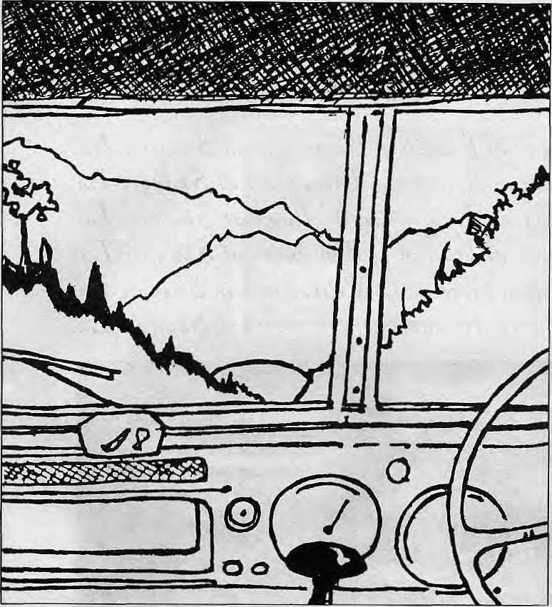
No, those were happy days when we were so close to each other, Bishnu used to help me then, in little ways, at home, in the kitchen,outside,everywhere!Itcouldn'tlast—it didn't. Something happened which changed him. Not suddenly. Not overnight. But gradually his kindness and consideration evaporated. When I asked for his help, he responded with a gruff, Do let me finish this newspaper in peace! Or a plaintive, Just when I want to watch the news! Ididn't mind though,did I? Iputup with it all doggedly, did all the housework, helped Rohini with her lessons.
But I couldn't buy peace; he became more ill-tempered and impatient. And cruel. I still cringe at the memory of his sarcasm over my stupidity or ignorance and his wounding remarks about my family. How silly I was to be provoked into defending them. But he has a way of drawing out the worst in me. We quarrel as never before. 1 break into tears afterwards. And then he's contrite and makes ituptome.Why do Ismileatthethought? Do I still love him? Do I miss his bumbling pawing and clumsy timing? Hewould want todo it justas I was dressing to go to work, or when I'd left something on the chuJha. Idared not refuse. I would submit to his selfish thrusting rather than bear the vicious lash of his
tongue about my frigidity or about how I secretly hated him. Occasionally, when I didn't respond, he relapsed into a sulky silence, refusing to speak to me for the rest of the day. My days now coalesced into an endless agony. Sometimes, I was on the point of leaving him but the thought of Rohini stopped me; I couldn't afford to be selfish.
It's cold...we're almost there. There are only a few people on the streets. The shopfronts are already shuttered. And now we've arrived. Everyone is getting out. I've come back home. But why home? Why not the hospital? I ask Sisir. We had to come home and find out, he explains rather lamely. My dread issour in my mouth. He must be dead. That's why we have come home. I am alone now. I must work harder. I have a daughter to look after. I'll put Bishnu's life insurance into a deposit in the bank for her. I'll take boarders, do tuitions, knit sweaters. lamfullof plans—and guilty about such unholy thoughts at a time like this.
My sasura is at the door. He doesn't speak to me—he thinks its my fault the marriage broke down. He thinks I walked out onhis son. Silently, he leads us into the bedroom.
Dea r God, he's alive! Bi sh n u' s alive! His leg is in a cast, his head is bandaged, but he is leering at me. "Surprised, eh? Thought you were well rid of me?" Why are my legs giving way, why are they helping me once again intoa chair? Why, deepdown insideam I devastated by my disappointment? And why am I gripped by this nausea?
b
A. P. Chhetri is a writer who works for the Kalimpong Municipality. This story first appeared in Flatfile.
CALL FOR SHORT STORIES
Rupa Publications and Himal Books are jointly publishing a collection of pan-Himalayan short stories in English, Writers interested in submitting manuscripts of originals/translations please write to the series editor, Anmole Prasad, Radhamohan House, Retli Road, Kalimpong 734 301, Darjeeling District, West Bengal, India. All manuscripts should be legibly typed double space on foolscap paper. Please include full particulars of writeis/lranslators.
T\MflCL
KMfyl
books'

HIMAL Mayft/ne 1995
43



Vocabulary Lessons

[Velcome to Nepal in treach id Jjienvenue an Ohangri-Lja. \V elcome to IS epal in Opanidh id Jj'wnvenLdo al ohangri-Lta. Welcome to JVepal in £Lnglidh id W elcome at &kangri-Lja. vv elcome to IS epal in Italian id iJenvenuto al O hangri-Lua. W^elcome to Nepal in Cierman id WiUkommen in ohangri-Lja. Welcome to Nepal in Japanede id V^Uvi^o hangri-Lja.

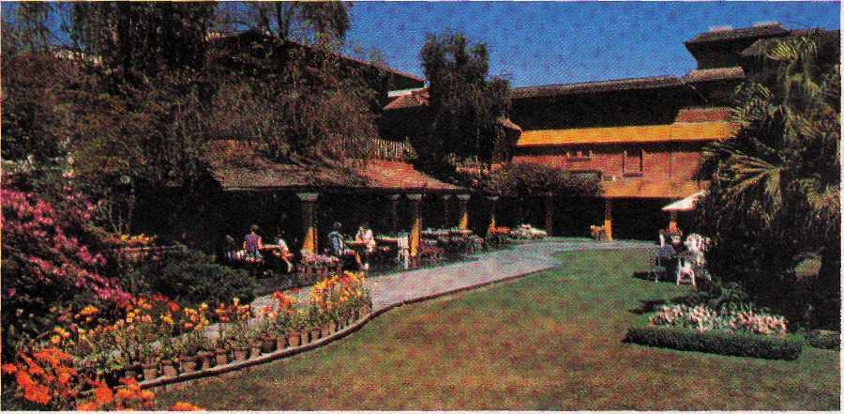

Hotel SHANGRI-LA
82 Deluxe Roonu

SHANGRI-LA
KATHMANDU
Your private paradise



LAZIMPAT. G.P.O. BOX 655. KATHMANDU. NEPAL - TEL : (977.1) 412999 - FAX: (977.1) 414184 - TELEX: 2276 HOSANG NP

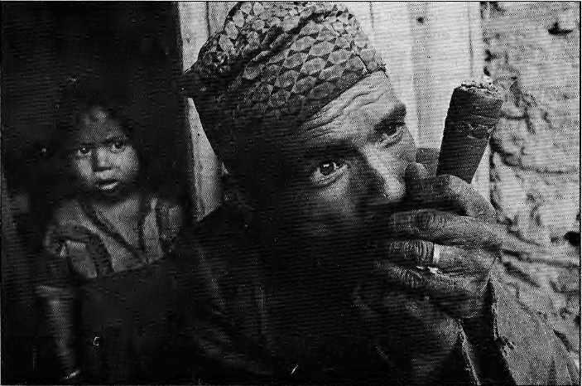
In northwest Nepal
lives a group that is
economically
backward, socially
oppressed, and
psychologically
pressured. The Khas
ofJumla are a group
that fell through the
cracks of history.
by Dor Bahadur Bista


Khas

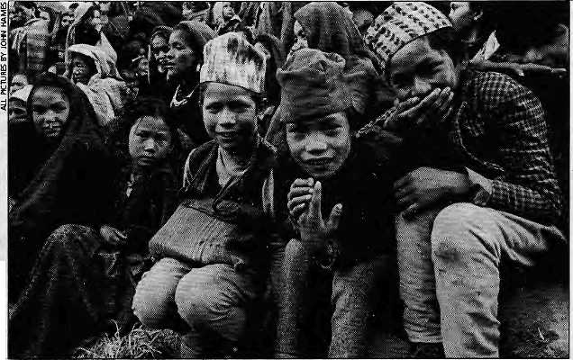
Y
ou wouldn't know it when you meet them today, but the Khas people of jumla District are descendants of proudrulersofan empire that once stretched all the way from here to Kashmir, and from the Tibetan plateau to the inner tarai. The Khas are the progenitors of the Thakuri-Chhetri and of some of the hill Bahuns who traveled eastward to conquer the lands that would ultimately form the Kingdom on Nepal. The Nepali language,onceknownas Khas-kura, owes its origin to them, and the Khas al so lent thei r style of adopting Thakuri and Chhetri titles to other ethnic groups of the Nepali hills.
Despite the accomplished past with which they are associated, this once-proud people today survive asadocileand unaware class relegated to an undeveloped comer of the country, exploited by those who know better, and burdened by an identity crisis that is unique in all Nepal.
As an anthropologist who has studied and written about the people of Nepal for fou r decades, I have over the past three years been doing 'applied research' amongst these Khas of Jumla. My work proceeds under the umbrella of the Karnali Institute, based in
the Chaudabisa Valley, whose efforts have been geared to applying the theories of the social sciences and development studies to raise the social and economic conditions of the Khas community.
Above
and Right
Khas smoker
and Khas
schoolkids.
Working in Chaudabisa, it has become clear to me that sincere efforts to develop awareness, self-confidence and a sense of worth among backward populations immediately brings forth a reaction from the privileged classes. The more effective the
development activity, the more virulent and reactionary is the response. For an academician who decided to try and practise what he preached, it came as a shock to learn that the political, economic and priestly forces are predetermined to join hands to prevent empowerment of the downtrodden. This happens because true development work has the effect of snatching away privileges and income that these forces have enjoyed without

HIMAL May/June J995
45

challenge for centuries.
The experience of the Kamali Institute will doubtless apply to other pockets that exist all over the Nepal Himalaya, where g rou ps of people continue to s uffer from the yoke of feudalism, and wherever efforts are being made to shake up the old and in order to bring in the new.
Chaudabisa
Chaudabisa valley used to come under a separate district called Tibrikot until some 12 years ago, but now it forms the eastern part of Jumla District. The area lies east of Jumla town, at the headwaters of the Tila and the Chaudabisa beneath Kanjiroba and Patrasi himals.
I was drawn to selecting Chaudabisa as the area for applied research because of an incongruous situation that exists here. The indigenous Khas live in absolute poverty even though their region itself is rich in natural resources and should be delivering a much higher standard of living. In fact, encouraged by the high demand for herbal raw material in the plains market, the locals were engaging in indiscriminate plunder of the very resource base which promised them a better future.
My interest also has a personal element, for my ancestors came from this area more than 300 years ago to settle down in the kingdom of Patan in Kathmandu Valley. I wanted keenly to gauge the distance that had developed between myself and this region of my purkha.
Jumla used to be the .center of the powerfulKhas kingdom of the western hills of Nepal from around the 14th century until the close of the 18th century. It is a region with interesting historic vestiges. Sinja, which formed the northern part of today's Jumla district, has interesting archaeological remains, including records of the Khas kingdoms of yore. The earlier Khas kings were Buddhist (while the public was shamanistic) and employed lamas to keep their records in the Tibetan language. Subsequent infiltration of Hinduism led to destruction of much of these Khas records, although some are still available for scholars, scattered in monasteries and other repositories of Mugu, Humla, Dolpa and Dailekh.
The Khas people were of pastoral
nomadic background and were spread widely inmanypartsof present-day western Nepal. Thei r tribal character began to change from around the latter part of the 14thcentury when Brahmin pand its began arriving at the court of the Khas kings. The illiterate kings and courtiers with their rustic lifestyle must have liked the idea of a Hindu caste framework based on the principles expounded in Manusmriti, as this would give them a permanent high status based on birthright rather than on personal ability and competence.
The unravelling of the Khas empire accelerated with the seizure of the throne of Delhi by the Mughals, as more displaced Brahmins came up to settle in the Khas territory. More Thakuris and Chhetris had to be created as clients for the incoming Brahmins to cater to. That was the beginning of the end of the Khas people's collective strengths.
Agents and Profiteers
Fora social scientist, Chaudabisa was also a place of interest because its nature had not been overly affected either by tourism or the negative effects of modernisation and its attendant material culture. Many other High Himalayan areas of Nepal such as Solu-Khumbu, Mustang and Langtang have been influenced beyond recall, but Chaudabisa provided laboratory conditions for the social sciences and development studies together to engage a region in genuine and long-lasting efforts at social and economic transformation. Hopefully, if the workhere is successful, the model can be used with modifications in other similarly situated hill areas of Nepal.
In recent years, because of increased population, the local people have been pressuring the surrounding natural environment. Part of the reason for the population increase is the success of child survival programmes in an area which did not receive family planning help, which was refused on grounds of political ideology. (Funds for the programme came from USAID, which could not allow family planning programmes under directives formulated by a Republican United States President.)
The agents and profiteers in the herb trade are lined up all the way from Delhi's
Khari Bauli bazaar, across the border, and up to Jumla town. With a pittance of money, these people lure Chaudabisa's population into destroying the fragile natural base of their hillsides, uprooting herb plants roots and all.
The Khas have been exploited historically by all kinds of people, including government employees and local feudals, such as in their being forced to provide free labour. The first time the Khas of Chaudabisa recall receiving payment for work done was when King Mahendra made his famous trek to Rara Lake three decades ago. In was only then that the system of wage labour began to be implemented.
More than 30 years of educational programmes at the primary level and more than 12 years of secondary education have done nothing for the Khas. Education has not been meaningful.
Child marriage is a bane of Chaudabisa's Khas. It often leads to disenchantment when the bride and groom comes of age. About fifty percent of early marriages in Chaudabisa end in elopement of either partner, with the new husband being made topaycompensationtotheformerhusband. Women suffer grievously from loss of status in the process.
Janajati Khas
The irony is that many Nepalis and most western scholars think that all Khas are Chhetri and that therefore they are not one of the so-called janajati, or ethnic, communities of the country. To be qualified as janajati, is the understanding, one has to have Mongoloid racial background and must speak a Tibeto-Burman mother tongue.
The fact is that a vast majority of the Khas have never been Hinduised, let alone 'Chhetri-ised'. Thus, while it may be true that today's Chhetri of Nepal branched off from the Khas, what has happened is that the descendants of the original Khas remained distinct, remote and deprived like other janajati groups of the country. The status of the Khas has dipped so low that the very term 'Khas' is today used by the upper classes as an insult. This is why the Khas people tend to style themselves as Chhetri, even though the tagadha ri (thread-wearing) Chhetirs treat the Khas as low caste shudra.

46
MaylJune 1995 HIMAL

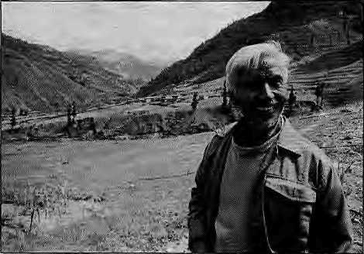
The bulk of Jumla's Khas continue to live with their shamanic ritual practices, make alcohol at home, offering it to their deities, and drinking themselves. Nevertheless, due to historical and political reasons, their racial background d isquali fles them from being called' jana jati'. All this has left the Khas with an identity crisis unique even in Nepal, and a total loss of self-esteem and self-confidence.
To be jana jati in present-day Nepal isat least to have the ability to demand that mainstream society recognise the existence and rights of your tribe or community. While this right might have little use other than bring some peace of mind to ethnic activists, the Khas do not even have this on their side. They do not have an existence: their language is not even recorded in the national census even though they have a tongue that is distinct.
Fatal Legacy
Mostly, the problems of the present-day Khas of Chaudabisa reflects the exploitative traditions maintained to this day by the upper caste people of Jumla town, also known as Khalanga, and of the surrounding hills. Jumla town and Sinja retain the vestiges of the former exploitative feudal structure perhaps more than do most other hill regions of Nepal. This explains why the people here remain so poorwhereastheregion itself hasabundant economic potential.
The writer at field site.
Some members of the sixteenth century converts to high caste are still struggling to maintain and assert their caste and class status. This, by definition, means the mistreatment of the Chaudabisa population, "which is homogeneously Khas.
TheBahunsofJumlacontinuetocollect their dues of blankets, rugs, calves, goats, shanks of mutton, and cereal grains once a year from every household in Chaudabisa valley that hasadeath, a debilitating illness, a birth, or a marriage. They collect without having to provide any of the ritual services of a priest. Wedding, funeral,birth or illness, meanwhile, go on without the appearance of a priest. The Bahuns arrive in Chaudabisa at their convenience during fair weather. They visit their clients, collect the goods, and make them carry them to their homes in and around Jumla town.
Having lost this self-confidence and self-esteem over the course of centuries, the Chaudabisa Khas is will ing to submit to this kind of exploitation. Having sunk to the lowest rung of the economic, cultural, religious and social hierarchy, there is little self-respect left. To the Jumla people, these are the barbarious Khas, "khaspavai"—aterm that is still in use.
In Chaudabisa, it is common to hear the locals go on and on: "hami garib, hami dukhi, hamimurkha" (we are poor, we are hopeless, we are ignorant) .Partandparcelof accepting their lowly position, they continue to wear filthy rags, and maintain dirty habits. It is this syndrome of absolute apathy that the Institute hopes to attack.
The fatalistic philosophy is insidious because it destroys optimism and the ability to take the initiative. Fate is blamed for anything that they do not get, even though they may not have worked for it. The locals do not want to work beyond the absolute minimum required. With the pracitice of the government providing money for all kinds of development work, Chaudabisa's people have found it easy to sit back and show even less initiative.
Chaudabisa does not represent an isolated pocket of exploitation: its situation is multiplied many times over in otherKhasvalleysofthe Kama li region. Among this population, fatalism generates the view that one's entire life is a continuous present and is fated to be what it is. Instead, if the people could be persuaded to accept only the past as a n important ed ucator to provide gui dance for future, and treat the so-called present as the
flicker of the monfent that continuously moves along with the progression of our lives, we could probably have a healthy, future-oriented society led by optimistic political and cultural leaders. This, at any case, is the goal set by the Karnali Institute for itself in Chaudabisa.
At Cross Purposes
When the Institute landed in the midst of this caste- and class-ridden exploitative stru cture,it began work by trying to helpthe Chaudabisa Khas to learn to help themselves. The existing high school was expanded, health services were made regular, and training of locals began with carpentery and Stonework classes. Two micro-hydropower stations were installed in the valley.
The Institute is spearheading efforts to help local people to become optimistic and look into a possibly prosperous future. Besides helping raise the living standards and educational level, the Institute also hopes to cleanse them of the ways of child marriage, cow worship coupled with cow starvation (and no milk at all!), and ill-treatment of women including the selling of wives.
Perhaps inevitably, the Institute and whol will call the "Jumlalords" are working at cross purposes. The Institute is treated as a rival not only by these lords, but also some politicians who style themselves as progressive leftists. The Institute has had to face continuous attack from these forces, who feed contrived stories to population and do not miss an opportunity to put things in a bad light. Quite a few of the Chaudabisa locals were themselves initially suspicious of the Institute's motives, for they found it hard to comprehend why an outsider would want to help them without obvious benefit.
Those who do not wish the Chaudabisa Khas well can be categorised into three groups. Firstly, there are the political leaders whoareconcernedthattheymightlosetheir influence in the area. Politics providing the fastest route to in fluence; it remains the most appealing vocation for many. Because I was seen as a 'democrat', both the extreme left and extreme right decided that they would lose their vote bank if the Institute's work became popular.
Secondly, there are the economic leaders who feel that their base of economic exploitation will be pulled away by any

HIMAL May/June J995
47

activity aimed at developing self-awareness in Chaudabisa. Thirdly, are the priests whose role in Chaudabisa society would rapidly diminish if the people were to be educated. The priests, on the whole, work the most insidiously to undo the process of positive change.
Various strategems have been used to poison the minds of the Chaudabisa locals against the Institute, including the spreading of a rumour that the research work was only a cover for propagating Christianity. The canard is also doing the rounds that the Institute will exploit and hurt the population because it favours a specific political ideology. One political candidate during the general elections in November campaigned to throw the Institute and its founder out of the Valley (he lost). Jumla's inhabitants are know all over to be avid litigants, and two cases have been filed in the courts against the Institute. One of them has been won by the Institute and the other is still being heard.
Things will not remain static in Jumla district forever, however. The Karnali Institute, plus several other organisations are committed to widening the horizons the people of Chaudabisa. The economic lords who used to exploit the labour and the
valuable herbal resource of the region are watchinginten sely over aprocessing factory that has just been completed in Chaudabisa by the Agricultural Development Bank's Small Farmers Development Programme.
The two micro-hydropower units that have been set up will change lifestyles and expand horizons as children begin to read in theevening, as mothers begin to useelectric cookers, and as fathers get engaged in producing craft items at home.
Enrolment in the Chaudabisa schools has doubled over the last three years, and the number of girls attending classes is also up considerably. Plan International is supporting adult literacy classes at the high school during off hours. The Chaudabisa population is beginning to wake up to the possibilities that are open to them.
The overt and covert opposition of the Jumla lords notwithstanding, the Khas of Chaudabisa will have their day in the sun.
D.B.Bista, author of the longtime classic Hie Peop/e of Nepal and the best-selling Fatalism and
Development, spends his time between Chaudabisa and his home in Paten.

Himalayan High Treks

 | T I | B | E T
N | *■ |  | J | I
E |  | ¥ |  | N
P |  |  |  | D
A |  |  | ^^ | I
L |  | ^^ |  | A
 | BH | UT | AN
Free Catalog (800) 455-8735
Outside the U.S.A. & Canada please call
001.415.861.2391 or write to us:
Himalayan Hisih Treks
es Street, San rraneisco 3-2211 U.S.A. Thanks!

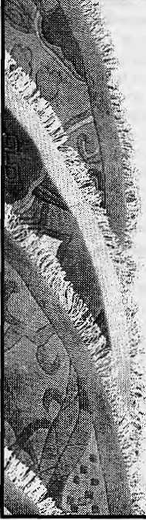
CARPET AND WOOL DEVELOPMENT BOARD, NEPAL
Carpet ond wool development board, an organization established with the joint cooperation and participation of the concerned private sectors and His Majesty's Government of Nepal, always aims at the development of the quality and market promotion for the Nepalese woolen products, especially Hand Knotted Carpets. To achieve its goal, the Board undertakes the following various functions and activities.
- Product development and quality control
- Training on various aspects of quality
development like wool dyeing, washing,
knitting, graphic design, weaving
- Research and studies
- Market development and diversification
- Publication and dissemination of
Information

- Participate & organize trade fairs,
exhibition, seminar and workshops
- Provide consultancy services on produc
tion & export aspects of woolen products
including carpet
- Promotional services
- Provide up-to-date information on carpet
export and wool import statistics and
trends
For further inquiries write or contact
CARPET AND WOOL DEVELOPMENT BOARD
P.O. Box No. 8975/EPC No. 4050
Lazimpat, Kathmandu, Nepal, Tel: 411286
Fax: 977-1-411286, Telex: 2321 BASS NP (ATTN. CARPET)

48
May/June 1995 HIMAL

Visit Mandala
Scholarly books, maps and guides on Tibet, Nepal, Bhutan and the Indian Himalaya

RECENT ARRIVALS
WE
ACCEPT AMERICAN
EXPRESS VISA CARD
&
MASTER
CREDIT
CARD
FORTHCOMING
Proceedings of the International
Seminar on Anthropology of Nepal:
People, Problems and Processes
Edited by Michael Allen
Civilized Shamans Buddhism in Tibetan Societies by Geoffrey Samuel
Mandala Edition
(Original edition published
Tales of Turquoise:
A Pilgrimage in Dolpo
CornneiMe Jest
by Smithsonian Institution Press, Washinton DC. USA)
Jhankri: Chamane de 1' Himalaya
{In French Language) Eric Chazot
Nepal: A Guide to the Art and
Architecture of the Kathmandu Valley
Michael Hutt

MANDALA BOOK POINT
^{Phone:} 977-1-227711 / 216100 (R), Fax: 221129/227372 Kantipath, Post Box No. 528, Kathmandu, Nepal

We service Himal's computers

Bropby our front office and" workshop* at the Naxal Cross-roads. Let's discuss a package arrangement for prompt and efficient servicing of your computers (Macs and IBM ;Gompatibles), Iphpto copiers, video recorders, television sets, and everything else electronic^We specialise in providing one-stop* hassle-free support to institutional customers.

Should'nt we be looking after yours'as well?
Tel: 411201
■ Balmandir Road, Naxal
Kathmandu Electronics and Computers, the one-stop electronic support P.O. Box 3846, Kathmandu.

Know Your H i m a I
Making Criminals of Climbers
by Deepak Thapa

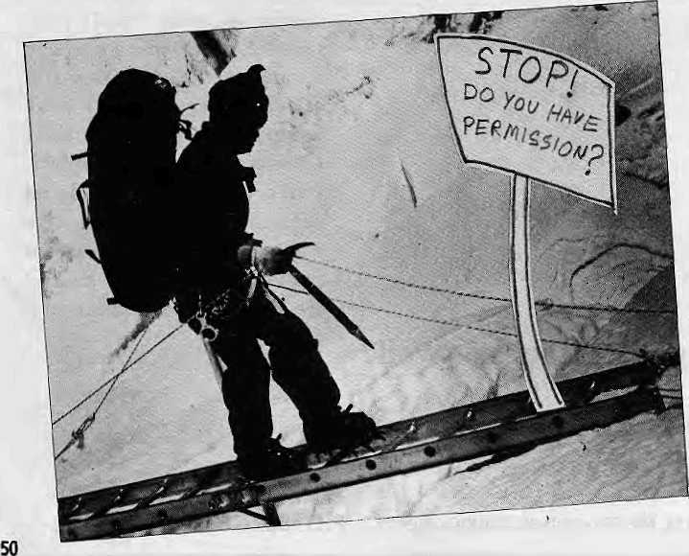
T
here are thousands of above-5,000mpeaks in NepaLof which only 142 are open for climbing after permission has been received from the concerned authorities. Anyone who climbs one of these 142 without a permit or climbs any of the other remaining of 'un-opened' peaks will be doing so illegally. And climb illegally is precisely what hundreds of visitors do every mountaineering season in Nepal.
These are facts known to everyone associated with the climbing trade in Nepal. The Ministry of Tourism (MoT) does not deny it, nor does the Nepal Mountaineering Association (NMA). Yet, clandestine climbing continues unchecked.
Tourism Act
Climbing permits for Nepali summits are issued at two different places. The NMA has jurisdiction over 18 peaks and is concerned with only these so-called 'trekking' or non-expedition peaks. The rest are dealt
with by the MoT, which does not have resources or the manpower necessary to keepathoroughcheckonwhatgoesonhigh up in the mountains.
Legislation to address climbing without permission does exist in Nepal and despite the erroneous language it uses, manages to convey the message. The Tourism Act, 2035, states unequivocally: "No any mountaineering expedition team shall be entitled to climb any Himalayan-Peaks without permission under this Act." Failure to comply can result in various penalties on which, too, the Act is clear. But enforcement is another matter¹ altogether.
The MoT relies on external sources for information on climbs that take place in contravention to the rules. There was just one complaint the Ministry received in all of 1994 and even that was not acted upon on the grounds that further information requested was not forthcoming. The NMA is equally hapless. Having no legal authority, the Association cannot take any
action against clandestine climbers without the involvement of Ministries of Tourism and Home, neither of which seem to have the interest or manpower.
To go back to the Tourism Act provisions, it seems important to define the term "Himalayan peak": does it include high spurs of the Mahabharat range, are high and distinctive ridge-tops such as Lhotse Shar to be considered independent summits or appendages of the main peak? The Act obviously refers to the snow mountains that range the northern part of Nepal, but the fact that the regulations do not state explicitly what constitutes a Himalchuti creates a problem for climbers and allows flexibility to those agencies who do not mind cutting comers.
The grey definition also makes it possible for trekking agencies in Kathmand u and their partners abroad to sell climbs to lesser peaks which are not on the permitted list. Unfortunately for one of them, International Trekkers of Kathmandu, the furore that followed the Pisang accident of last November forced the authorities to engage ina closer reading of the Actand follow it up with a penalty. The agency has been barred from any mountaineering activity for a period of two years, an action that some industry analysts believe is unfair given that "everybody does it". Meanwhile, the ba n o n Intemat ion al Trekkers does not seem to have made an impression on its peer agencies, whoseitinerariesstillfeaturesuch peaks to be climbed without permission while on trek.
It is not only 'closed' peaks that are being climbed on the sly. The 6183-metre-high Imja Tse (Island Peak) in the Khumbu is one such peak that sees over 15 groups every season attempting it without permission.There are known attempts even on the higher peaks, such as Cho Oyu (8201m), whose "tourist route" up from Nangpa La has been known to attract
May/June 1995 WMAL

itinerant climbers. Even on Chomolongma, there have been reports of lone alpinists piggy-backing on fixed ropes of large expeditions and bivouacking on well-stocked camps up the mountain. However, there are no reports of successful climbs of Sagarmatha by such illegal climbers.
Aesthetics vs. Morality
Why does illegal climbing take place after all? One reason is the savings in fees and on the bureaucratic hassles involved. The royalties charged—for example, the U$ 150 to U$ 300 charged by the NMA—may seem a pittance to an organised trekking group,, but could be a hefty sum for a backpacking alpine-style climber. The free spirit that is the genuine mountaineer obvio usly di slikes the shackles placed on his ability to climb a peak, and he may deliberately set about evading the regulations. From a purely aesthetical (not moral) stand point, whether a Himalayan peak is climbed with permission or without does not make that much of a difference.
Most illegal climbing in Nepal takes place along the popular trekking routes, viz., the Annapurna circuit, the Langtang and and Khumbu valleys. It is easy to go about one's business quietly in these areas amidst the hundreds of trekkers swarming the trails. It i s possible to reach an impromptu decision to climb in Khumbu, for Namche Bazaar's climbing bazaar offers climbing gear of the same range and quality found at any outfitters in Chamonix. Lending a helping hand arc mountain guides and trek operators without whose complicity it would be quite difficult to climb a Himalayan peak, however small.
The interest in enf ore in g the regu lation is mainly that of the host country, for the lost income that clandestine climbing represents. It is therefore in Nepal's interest that illegal climbing be checked. The NMA alone, it is estimated, loses more than NRs 5 million annually from unauthorised climbing of the peaks at its command. By the same reckoning, the central exchequer is losing many more millions of rupees from all the peaks that are being climbed without permission.
In this perspective, one would assume that serious steps would be taken to prevent
illegal climbs. Predictably enough, this is not the case. No one even knows where to begin.
Question of Virginity
Another issue thrown up by illegal climbing—which almost by definition is undocumented—is whether or not to believe that the "virgin peaks" are really untrodden. Given the hundreds of peaks available in Nepal, and the inability of the authorities to check what the adventurous climbers do oncetheyareintheHighHimaland beyond the range of the base camp-based liaison officers, it is quite likely that many more "virgin peaks" have been climbed than even the climbing world knows of.
Those who climb a virgin peak are not likely to turn up at the NMA or MoT to register their feat. Those who would want to come again to the Nepal Himalaya might not even own up to their triumphs in one of the world's many mountaineering journals. Besides, the Nepali authorities certainly do not have the ability nor the interest in perusing the world's these journals to maintain an updated list of illegally climbed peaks. The problem here is not only that of the Nepali Government: climbers in years will obviously attempt newly-opened peaks believed to be unclimbed, whereas the summits might already have been violated.
The different organisations concerned with climbing in Nepal do not seem to view the matter seriously apart from pointing fingers at each other. The MoT places blame on unscrupulous trekking agents; the established agencies see small-time operators and individual tour leaders as the culprits; the NMA perceives both trekking companies and the MoT responsible—the Ministry for not setting out dearly-defined rules and trekking companies for looking at the regulations in ways that best suit their interests.
However, as the theoretical protector of Nepal's mountaineering trade, NMA cannot shirk its responsibility so easily, especially because it and the Trekking Agents Association of Nepal (TAAN) share a close, almost incestuous, relationship. The NMA should, at the very least, be able to keep a check on what itineraries
are being sold by trekking agents. Amid all this passing of the buck, the main issue of how to stop unauthorised climbing is being forgotten.
The NMA did make an attempt at monitoring back in 1991 by placing a representativeeachinManangand Namche Bazaar but the operation floundered within a year. It proved impossible to confirm that a climb had taken place once the climbers had descended. The Association is once again said to be thinking of a similar operation, this time with two person teams which can act as a roving patrol.
There are other method s that have been suggested to check illegal climbing. One is to mobilise the local administrative bodies such as village development committees with the incentive that they receive part of the finerealised from those caught climbing without permission. Another is that national park personnel be utilised, since many peaks fallwithintheboundariesofoneparkorthe other. Meanwhile, trekkers entering the country need to be notified about Nepal's mountaineering regulations, for many might forgo illegal climbs if only they knew what their agencies were putting them up to. Permits can also be issued, say at Namche Bazaar, Kyanjin Gomba, Manang and Jomosom, albeit at a higher rate than what they cost in Kathmandu, so that those who get the climbing bug while on a trek will have a way out rather than having to make an illegal bid.
Stricter rules and serious enforcement of them are also being advocated, Sardars could forfeit their NMA registration if found taking part in illegal climbs. Trekking companies could losetheir licence altogether instead of only having to suffer temporary suspensions. However, rules will not solve the problem if they are impractical. Many trekkers climb peaks illegally just because they involve mere side trips from the main trail and can be done with equipment on hand.
Making permits unnecessary for peaks such as Thorung Rion the Annapurna trek, which is being climbed allthe time anyway, should not be much to Nepal's loss. After all why make criminals of climbers if it can be helped?

HIMAL May/June 1995
51

Abominably Yours,
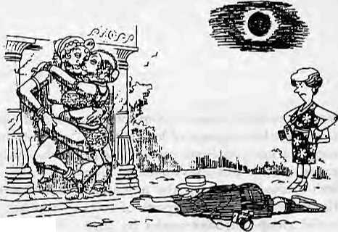
Instead of whining on and on about how the Indian plague killed tourism in the Subcontinent, it is time the region's planners came up with innovative ways to boost the visitor industry. Take the total eclipse of the sun that will traverse the Ganga basin east to west in October. Where is our forward-looking strategy? We should be blitzing prospective tourists in Europe and Japan with catchy commercials that go: "See The Taj Mahal in Eclipse", or "Fly Delhi-Calcutta In Total Darkness, Only On Indian Airlines".
In the Himalaya, the eclipse will only be partial, but it will still be quite a show as the sun suddenly dims from 220 volts to 110. Here in the Upper Barun, scientists are planning to study the effect of solar brownout on the gliding ability of the Himalayan chough. German geologists will observe temperature change in glacial lakes during eclipses. In Chitwan, researchers are preparing to monitor how mating behaviour of rhinos adjusts to solar darkness.
If the scientists are so engaged, why is the tourism trade lagging? There is still time to plan for the First Ascent of Mt. Everest Via The Southeast Pillar Without Oxygen And Without Sherpas During A Solar Eclipse, not to mention the Around Annapurna Penumbra Trek, which should have many takers. Nepal's unique flag is ideal as promotional material, with the moon from the upper triangle occluding the sun below.
The selling point about total eclipses, of course, is their timing. There won't be another one to cast a shadow over the Taj Mahal in quite such a fashion till the year 2353 or thereabouts, by which time most of our great-grandchildren will have gone on to be reincarnated as Sandflies or Thermophilic Bacteria, depending on how they behave themselves. The rarity of total solar eclipses also limits their potential for tourism promotion.
Sex, on the other hand, has a certain timeless quality to it, and sex sells. As a region, we have not done enough to promote Sex Tourism. Befoie politically correct readers dash off angry letters to my editor recommending that he gag his ab(ominab)le columnist, let me hasten to
add: this is not a suggestion to tum Connaught Place into a naughty place.
Seeing the contemporary squeamishness and taboos on sex in the Subcontinent, it is hard to believe that we were once the world's Sex Superpower. No one else in world history had been as obsessed with The Birds and The Bees as the Subcontinentals of the last millennium, not even birds and bees. South Asia's glorious tradition of wanton lust has shrunk to a tiny speck of its former self. Today, India is to Sex what Portugal is to Colonialism.
While pne cannot help but observe a certain contradiction between the copulation taboo and the population boom, a serious scientific study is needed to explore the correlation between sex, economic development and political stability. Recent studies have linked social decline and joblessness to the rise of fascism in Europe and of white anti-government militants in the American heartland. An idle mind, it seems, is the fundamentalist's workshop. Similarly, could it be argued that sexual suppression leads restless South Asian males to seek other onanistic avenues to dissipate energy: razing shrines, burning buses and calling bandhs?
We have historical records to prove that the explosion of erotic art between the years 800 to 1200 was also a time of extraordinary social harmony and cohesion. There was less crime, prostitution was unnecessary, wars were rare, and there was no censorship. As Shri Rajneesh re-discovered a thousand years later, sexual intercourse as a source of pleasure and mode for procreation is the most tangible manifestation of the existence of the Supreme Being. Sex also made people tolerant.
Sexiness used to be right up there on a pedestal with godliness. Hindu philosophers like Vatsayayan wrote tomes on sex—including the world's oldest and bestselling lovemaking manual. Kings commissioned elaborate temples of love that have survived monsoons and vandals to this day. Voluptuous

sandstone apsaras guard divinities engaged in foreplay, their bodies tangled in formidable feats of sexua] acrobatics. From a gender perspective, here are women as equal partners and not just submissive pleasure-givers.
So what happened to this rich heritage, huh? Somewhere along the way, the role of women became subordinate, and sex became power play.
But all is not lost. We see today the birth of India's Second Sexual Revolution. Aided and abetted by satellite television, promiscuity is once again sweeping the land from Kanya Kumari to Kailash. Nikki Bedi and Imran Khan are the new role models as the channels borrow and mix the Old East with the New West.

Catching up with the times, the Subcontinent's tourism operators must gear up to market the region's historical erotica. A series of sex tourism itineraries will have to be developed for the foreign tourist. The Tantric Tour can take the traveller from the architectural relics of Khajuraho to the Tibeto-Nepali temple art where Tantra reached its climax. The Kamasutra Special can explore the emergence of erotica in religion, incorporating a train tour of the main temples of love in the plains.

Better still, let the SAARC governments give up all this SAPTA business and join in a cooperative programme to take advantage of the upcoming October eclipse as occasion to launch the South Asia Lovers' Paradise Tour Package (SALPTP). After all, darkness and love-making evolved together.

52
May/June 19SS HIMAL

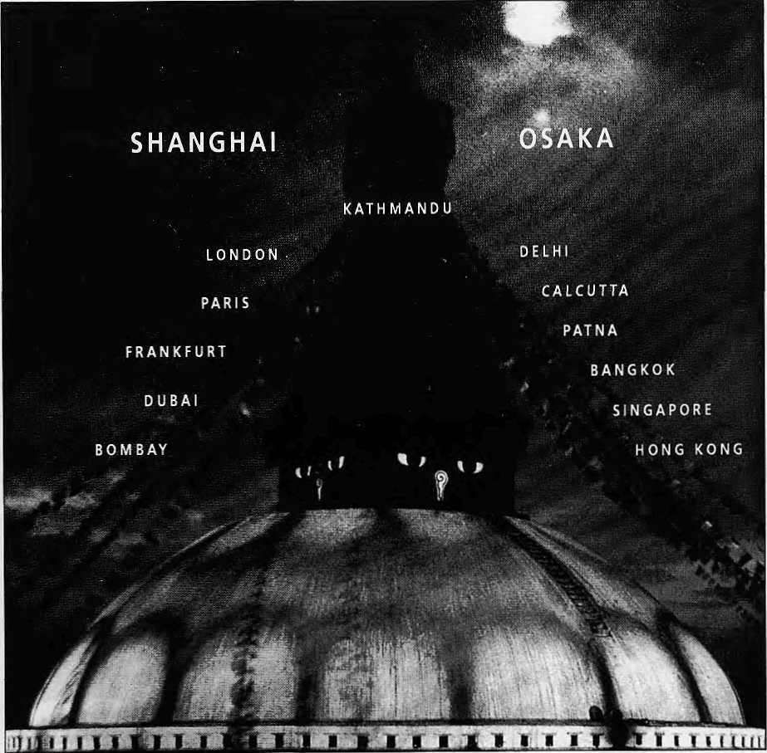

DIRECT TO SHANGHAI & OSAKA
Royal Nepal-Nepal's own international Airlines operates regular flights to Kathmandu from 13 cities. You can warm to the gentleness of Nepali culture, tradition and the authentic spirit of
Nepali hospitality aboard.
Royal Nepal mmmm* Airlines
RNAC, Building, P.O. Box: 401, Kathmandu, Nepal Tel.: 220757, Fax: 977-1-225348
Shanghai 2558899
Osaka 2292545
Bangkok
2333921-4
Singapore 3395S3S
Hongkong
3759151
Kathmandu 220757

You've just spent hours
inching around a space barely
enough to accommodate
the human body.
Odd, that's what climbing in
most sleeping bags is like.
The New Sleeping Bag Collection
For our free catalogue call 707 544-4590

