
CD

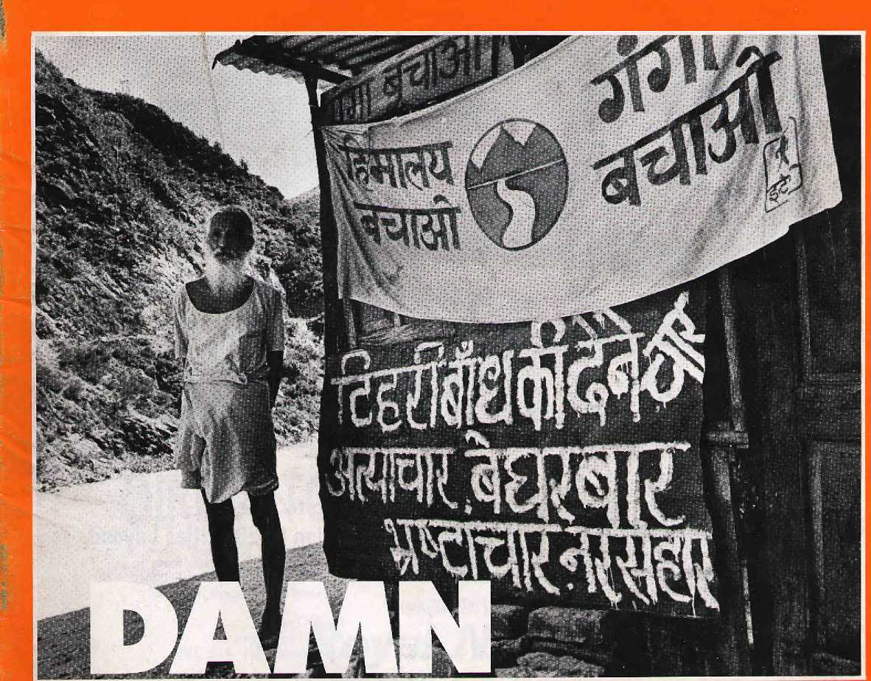

OPPOSITION!

NRs 40 DM 9
Rs 25 E 4
'Mu 30 U$ 5
US S4.75 Canada $5.75
Tharu Origins Tense Tibet Reviews


, Northwest makes it easy to go to America.

Be sure to ask about WorldPerks, the most
there is. General Sales Agent in Nepal :
Malla Treks,
Malla Hotel Arcade,
Kathmandu, Tel. 418 389


NORTHWEST AIRLINES
SOME PEOPLE JUST KNOW HOW TO FLY.SM

HIM L
SIDE

Voi 8 No A M/Mj I1J995
The Abode of Gods, King cf: ...
Mountains, Himalaya You bound the oceans from
east to west
A northern yardstick
Torneasum trie Earth
- Kalidasa (Kumara Sarnbhava)
Editor
Associate Editor Marketing Administration

Kanak Mani Drxit f Manisha! Aryal Suiata Chhettri Baiaram Sharrna MarnataManahdhaf
Subscription Rates
Only bHnk-drafts acceptable for subscription orders
made to Himat in Nepal. Do NOT send cash [nmajj.

Individual |  | 1 year | 2yrs
Nepal | NRs | 220 | 400
India | Ifls | 140 | 260
Bhutan | 'Nu | 175 | 33&
Other S. Asian Countries | U$ | ■■ ^ ': | 20
North America | U$ | 25.5(5 | '■ 46
Germany | , ...DM | 50 | 90
United Kingdom & Ireland | E.: | 20 | 35
Netherlands | DH |  | ":m
Elsewhere | US |  | ■; 45
Institutional
Nepal | NRs | 600 | 1100
India- . . | IRs | 260 | 500
Bhutan | Nu | 330 | 640
Other S. Asian Countries | U$ | ■25 "■ | 45
Mortli America | tl$ | 35 ;.. | ■:■. eo
Germany | DM | 70 | 120
United Kingdom & Ireland | ■ £ | 30 | SO
N el norlands | Dfl | 100 | 180
Elsewhere | US | 45 | 80
Send subscriptions & related correspondence to:
South Asia: P.O. Box 42, Lalitpur, Nepal (lei 9771 523845, lax 977 1 521013) or Central News Agency 23/90CpnnaughlCircus, NewDelhi 110001 Japan; Akio Horiuchi, P.O.Box 9, Kiyose, Tokyo, 204 Japan! Australia: tnd.ra.8ar>,. 12 Norfolk St, Raddington 2021, Sydney, Australia, Worth America: Barbara Bella & Associates, 500 Sansome Street, Suite 101, PO Box 470758 San Francisco, CA 94147 United Kingdom & Ireland: Jott Giri (Ref: H), 221 Ashly Gardens, Bnery Hilf Street, London SWV1PA : The Netherlands: C. F de Stoppelaar, Foundation Himalaya, Keizersgracht 463, ■■ 1017DKAmsterdam Switzerland: Helene Zingg, Taraienweg 18,
CH-3073, Guemtigen, Switzertand
Europe: Durga Press (Himai), Luitpoldsir. 20. D^8Z211, Herrschlng, Germany:
HimalB 1995 is published every Iwo monlhsby Hrm^ Association, PO Box 42, Patair Dhoka, Lalilfiur, Nepal -: ..Tel:9771523845, Fax:S2iO19;eniai(:hlfflaieNmpamos,coni;np ■■ Libary of Congress Card, Catalogue Number S ISSN1012 9B04
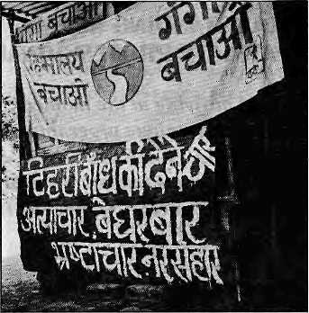
50 The Flying Doctor
Katha
by Jerry Rolls
53 The Origin of the Tharu
by Kurt Meyer
Everyone wants to know where
the Tharu came from.
Departments
Centre and Periphery Honest Brokers Working for Mountains Banner of Independence Arbitering Officers
40 Briefs
Lhasa is Tense Deadly Sex TTBP at the Border PLACENAMES - Phalut Unequal Intestines Leh's Got it! Ladakhi Rock 'n' Roll Cremation Technology Gurkha Alma Mater
45 Review
Strangers of the Mist
Mustang: A Rediscovered Kingdom

48 | voices
56 | Himalaya Mediafile
58 | Know Your Himal  Market Forces on Everest
50 | Abominabiy Yours
Dams: The Vocabulary of Protest
by Manisha Aryal
Hill people have realised the value of their flowing rivers and want to be paid.
Before the fast: Sunderhl Bahuguna stands by his ramshackle hut on the banks of the Bhagirathi,protesting construction of the Tehri dam. Cover picture by Btkas Rauniar.
23 Mapping Nepal's Water Resource
by Ajaya Dixit
Reservoirs will change how Nepal looks.
24 Gunning for Kosi High
by Rajendra Dahal
Patna wants the Sapta Kosi tamed by a high dam.
29 Because It is There
Foreign Money, Foreign Advice and Arun III by Bikash Pandey
The history of the Arun III opposition, starting from when the government ignored a public hearing.
36 Flood of Hope
by Dipak Gyawali
A review of the output of
the techno-exuberant school of thought
contained in four recent books.
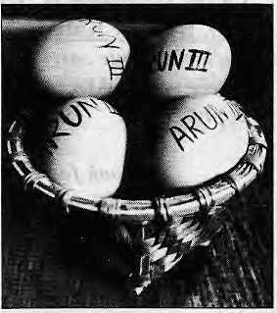

Printi)g:Jaaa()ambaOt(sBlPvt.

OUTSTANDING NEPALI EXPATRIATE PROFESSIONALS
Wherever you may be working or living at the moment, I would like to invite you, on behalf of UNDP Nepal, to be apart of our unique programme known us "TRANSFER OF KNOWLEDGE THROUGH EXPATRIATE NATIONALS" (TOKTEN> A brain-child of UNDP, TOKTEN seeks to mitigate the adverse impact of the brain-drain syndrome which is depriving many developing countries of the expertise they so crucially need for their socio-economic development
In Nepal, the TOKTEN programme was launched in Feburary 1991. The programme urges outstanding Nepali professional expatriates living and working abroad to volunteer their services for well-prepared consultancy missions, for a period of three weeks to three months, in their home country, UNDP pays for the travel and living expenses. Besides having wider international experience, Nepali expatriate professionals have the added advantage of speaking the local language and sharing the same cultural values with personnel in the recipient local institutions, thus facilitating communication, mutual understanding and ease in the work environment
So far twenty-seven Nepali expatriate experts have served under the TOKTEN programme in various fields, such as, among others, Environmental Planning, Urban Policy and Planning, Biotechnology, Plastic Reconstructive Surgery, Psychiatry, Anaesthesiology, Animal Science and Genetics, Health Services Delivery Planning, and Financial Management Some of them, to name only a few, are Mr. Naresh Amatya (USA), Prof Tara K. N. Baidya (Brazil), Dr, Chuda B. Karki (UK), Dr. Sambhu Nath (Zambia), Prof Uttam Rajbhandary (USA), Dr. Ram Manohar Shrcstha (Thailand), Dr. Tara Upreti (USA), and Dr. Ramesh Vaidya (USA). Many more are in a roster which is made available to prospective host institutions.
To qualify for inclusion in our roster, you should have at least a Master's degree from an internationally recognised educational institution and at least eight years of full-time work experience, at least five years of which has been in a senior position with an organization outside of Nepal You should also have the willingness and commitment to offer your services for the betterment of Nepal. If you think you Jit the description, please write to us at UNDP. P.O. Box 107 Kathmandu. Nepal, or better yet send us a fax at (977-n 523991 or 523986. enclosing your curriculum vitae and a brief statement on the problems/institutions in Nepal where you feel your expertise could be of use. Nepali women professionals are encouraged to apply.
We look forward to hearing from you.
Yours sincerely,
Resident Representative UNDP Nepal
a



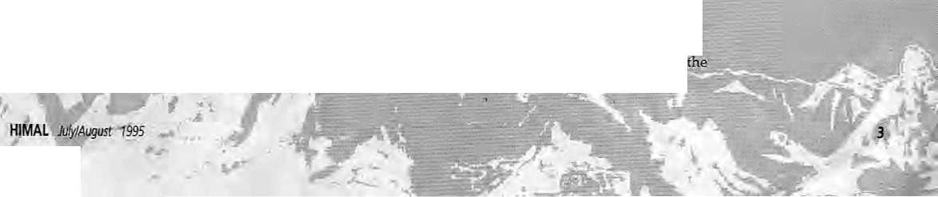
Not Just Centre & Periphery
Let me first congratulate Hima If or covering the Far
Eastern Himalaya for the first time since its :
inception eight years ago ("The Search for Distance and Dignity" May/Tim 1995). Sartjoy Hazarika was-the appropriate choice far the task,: and he does a commendable job of collating information ori the entire region and presenting complex issues lucidly in a single article. However, as a researcher ori this region for quite Some time npvy/J cannot resist making some comments on the writer's premises;
What struck me immediately was Hazarika's : conception of a homogenised Par Eastern: Himalaya, which suits his analysis of this region^as a periphery vis-a-vis Delhi, Dhaka and Rangoon. But if one zooms in oh the region, one finds there are peripheries rather than periphery_{t} because this is the meeting place of so many countries from all directions. Further; there are significant religious,: political, economic and cultural differences within this region, which have been underplayed b"y.. the-writer.
Hazarika considers the separateness of this: region from the nation states of which they are part as a reality that must be understood in order to know the region. However, this formula allows us to understand only one;aspect of the region, forit is also important to fathom the separateness within the region, not only geographical but cultural, : religious, linguistic, etc. The emphasis on the latter does not suit the centre-periphery theory of Which the writer seems a keen advocate. Such an : ideological bias can be pursued only at the cost of fuller understanding of a region or a people.
Hazarika's "Far Eastern Himalaya" also seems: to include the plains of Assam and the hills of Meghalaya, Nagaland, Mizoram, Tripura and Bangladesh, I can understand his lesser acquaintance with Sikkim, East Nepal, Tibetand even Amnachal Pradesh in comparison to the regions mentioned above, but does this justify the inclusion of the former areas within the term 'Himalaya? Should we then refer to the Nilgiri as "Southern Himalaya"? I think a distinction should
Editors' Note
*:'
In the cover article "Far Eastern Himalaya: The Search forOtstanceandDignity"(May/Jun1995),wfiterSanjoy Hazarika asks readers to read "100,000 Lhotshampa refugees/asylum seekers" In place of his reference to "100,000 Lhotshampa refugees*. Also, he has been correspondent of The New York Times since 1981, not 13S9, as appears in the auihor intro.
be drawn between the 'Himalaya' and the 'hills¹, the former comprising the high:peaks and the deep : valleys beneath them.
: fquote from the article: "It is not just Central neglect and lackof vision thatis holding the Far Eastern■■ Himalaya back- The extensive and deep-rooted; insurgencies also have a role." Notwithstanding the use of the word 'insurgencies', which" has an administrative, if not colonial flavour (or odour?), is the latter not rdated ta, or is it not a consequence of, the former? :::
Finally, Hazarika suggests a number of :.: soliitions to bring peace back ;to the region^and he includes economic development; regionalism, construction of smaij and medium scale dams; Openingup of port andtransit facilities in : Bangladesh and Burma, and development-of tourism and: promo don of Handicraft and handloom industf ies. Most of these solutions seem: to be based on already outdated Keynesian economics whiett-spawned more disparities than-bridged existing ones. ■:■
: the exploitation of natural resources has, more often thannot, meant displacement and : dependency for the local people. Even tourism,; that smokeless industry, benefits more the capitalist dassin the plains than the local highland ers, as is: evident from thestudles of tourism inDarjeeling and HjrnachalPradesh. Economic development : without social justice and without considering culture can only lead to the emergence,of growth-poles and create farther divisions in the minds-of the people,
A proper development perspective of a region should depend not only oh a neutral understanding (which is normally missing) of issues but also on a vision lhat is based on the principles of^ humanity, un-constrained by the compulsions of keeping a nation-state intact;'In the absence:of this almost Utopian requirement in our exercises in development or nation-building, we are forcing the 'nation' and the 'state' towards a collision, which in the end will destroy both!
TankaB.Sttbba
Department of Anthropology.
North-Eastern Hill University
Honest.Brpkersfor the Far East
Allow me to'add tome points to SanjoyHaiarika's cover article on the Far Eastern Himaiaya, Since middle of this century, South Asia has seen the
Shillong

I
a
■<v. ■ ■:/


Himal's friend and supporter Rajiv Tiwari died suddenly In Moscow on 10 March, and we miss him. In his first article for Himal, on Tehri dam project ("Tehrl: Temple orTomb", VolONoO, May 1987), Rajiv ended by saying:
"The controversy is not peculiar to India. Critics say planners, engineers, contractors and politicians always unite the world over on big projects where the stakes are high. Inaugurating the country's first large hydro-electric project that led to the Green Revolution, India's former Prime Minister Jawaharlal Nehru once called large dams "the temples of the modern age." Twenty years later, there are many here in Tehri who think large dams are not temples, but tombs."




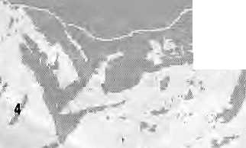

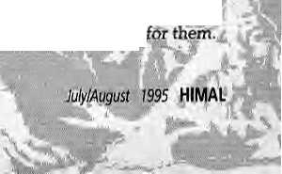
emergence of the nation states
centred on ethnic dominance-
of one kind or another—in
Nepal,theBahurt^Chhetri^ ~.~~
Newar combine; in Bhutan, the
DzOngkhavspeakiftgNgalok;
in Bangladeshthe Bengali :
Muslims; in Myahmar the
Burmese-speakingBuddhists;
and in India the 'Hinglish-
speaking' upper and middle .:. ..:
classesi The distribution of
power among; these various groups has beefl:
relatively stable, inspiteof some disputed --:.■-
boundaries. :
A broad erhrtic territorial appropriation is evident in the Par Eastern Himalaya. All high altitude areas were left to relatively smaller tribal
using primitive tedinology^ The entire flooded delta and river banks were taken over by the Bengali wet paddy cultivators and buffalo keepers. Iri between these two belts* right from Limbuari in Nepal through the Duars, Arunachal, the Naga hills andasfar'as Arakart, theonceHininhabitedlaifdsof: wild beasts, malaria and evergreen forests Were taken ever by Nepali farmers arid herdsmen of
Five decades after the departure of the '■■ ; ;■. classical political and economic empire from the scene, all the five countries of the region are engaged in nation-building efforts centred on their dominant ethnic-linguistic-religiouselites, The.; ....'■ agenda is to incorporate all territories and c6mmu-nifies into the structure of the nation state; in which ethnic plurality may be acknowledged but not allowedmueh play. The realityris that in the absence of patronage (a colonial hangover), minority communities are now being aslted to cornpete for limited space. Unable to cope with the situation,, many of these have inevitably lost their identity, languages, tribal religion, etc, : ■
Across the Himalayan rim, ethnic groups with all their cultural nuances intact are facing the traumatic experience of incorporation in the organised state system. Ethnic movements in the region may be seen essentially as exercises in search of identity, which may be cultural, racial, linguistic or political in nature. Whilethe states arepassmg : through a period of transition from a prescriptive past to nationhood and civic societies, small ethnic groups are totally bewildered as to how to cope : with the changing realities i
: : ; States are■ turning more and more to thei ^frontier: regions such as the Hirhalayan rim. With a view to appropriating'the natural resources for theii commercial exploitation, invariably at the cost of the local communities. In this way, a contradic-Hon emerges between theneeds of the regional communities and the national economic requirements, occasionaOy leading to ethnic displacement.
" Today,; besides thje state-sponsored welfare schemes and development projects-with all their : deficiencies, themarket economy has penetrated the farthest cornersof the Far Eastern Himalaya. ■: Ait the: resources, including humarg river water and wildlife", have become economic commodities with market value, arid outside thei control of the state. Appropriation ofpast plentiful but how limited reSOUrcesr-riiicliicUrtg territory—holds the key to economic affluence for these poorest communities.
This is where problems emergebetween the minority peoples on the one hand and the State and forces of the; world market economy on the other. In a subsistence economy where nature was bounti-: ful, technology simple, and real and imagined human needs limited, a variety of peoples lived in their various zones and pockets without much antagonism. This is no longer the given.
The problem is accentuated, firstly, by the existence of relatively small communities divided across, international frontiers, such as the Lissii, Sihgphos, Nagas,Mizos, Kukis, Chakmas^ Khasis and Garos; and, secondly, by the existence of economic andpolitical migrants such as the Bengalis in the Brahmaputra valley, the Nepali-speakers/Lhbtshaihpas in the Northeast hills and in Bhutan, Tibetans inlndia, and the Rohingyas in Baiigladesh. The migrants have a blurred identity, sometimes with double or even multiple claims. While internal migrants have at least some representation within their countries, immigrants from a competing nation state suffer from greater disadvantages as there is no one to speak



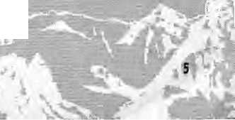

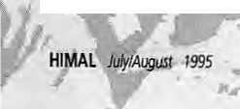
There is a clash between the interests of the states and ethnic groups on the one hand, and between the interests of the host communities and : the migrant ethnic groups on the other. In such a situation, is there space for an honest broker? And who couid it be? There can be a.way but m the Far ■ Eastern Himalaya, giventhe complementary geography; a shared past, similar problems of poverty, exploitation, under-deyeiopment arid Overall all-pervasive human suffering.
There is an urgent need for 'peoples'of the region to meet beyond the state-sponsored fora and develop an appreciation of the issues involved. The : totally ignored, sensitive and relatively sniall frontier communities need urgent attention, perhaps along the lines of the Scandinavian experience of cross^frontier living of individual communities. On the issue of ethnic migrants, the cautious diplomacy applied by the 'states' have proved ineffective, to put it mildly. As Hazarika also suggests, there is an urgent need forthe SAARC community to discard its forrhalistic stance and initiate dialogue to develop a regional perspective on ethnic issues and resource sharing for the Far Eastern Himalaya,
Why should we, the peopJe of the region, remain helpless spectators to fhese critical issues? The corridor mentality which pervades the regional psyche must be discarded* and effective dialogue must be opened so that there is a sense of sharing.
Awadesh Rimutr Sinha
School of Social Sciences
North Eastern Hill University
Shillong, Msghalaya
Sex Tourism
Having been impressed by Yeti's tongue-in-cheek proposal to promote 'sex tourism' in South Asia (Abominably Yours May/Jun 1995), I was struck the next day to read a poem, which I have enclosed, on sex tourism by Phewa Tal in Pokhara by Shakti in the Kathmandu journal Shakti ("a magazine for women, by women, and on women"). For your information, it is stated there that "The Red light Lake" is based on the poet's reaction to reading a poem by the Bangladeshi firebrand Tasleema Nasreen printed last year in The Kathmandu Post, with an accompanying piece criticising Tasleema's piece as "cannibalisation of men" and as "obscene".
Matta Mart Singh
Latitpitr
.■ %f^
The poem is reproduced below, courtesy ShaktL Eds,
The Red Light Lake
: Some time back, I recall For a brief spe!i A momentous flash I lifted my head From the article I read Arid-wondered if PHEWA Could or should ever be Tlie red-light lake!
Imagine what the country could offer : To adventurous tourists from all over As longas wecduldsafeguard Professional: practitioners on either side Frum the fatal rav/AIDS
We could outsmart any nation With -this rare Himalayan concoction Where, by night, PHEWA could emerge In sensuous, seductive sub-serve Liftingali to nirvana
Teetering tourism could rejuvenate : AID agencies could truly participate Traffickers ■would; have a better ehoice 'Poor' young women could be retained ■ Why should we hesitate?
Yet today, there is unleashed anger In her raven hair and warning finger Spits out accusation ai eye-teVel To df own you in a pool of hate The lake is seething red!;
I wrench myself away From weaving a watery dream That digs out a black hole Inthe core of one's soul So was this a poet's fantasy or man's undue .-.liberty Licensed by society
stine purity,..?
Working Hard for Mountains
1 write onbehaif of a nurnber.of participants in response to Kanak Marii Dixit's report on the International NGO Consultation on the Mountain Agenda ("Mountain Meeting by the Beach" Mar/Apr 1995). The output of tnis meeting, the achievements of the Mountain Agenda at th^ meeting of the UN Commission on Sustainable Development in April and many follow-up activities underway are likely to be of general interest to readers of HimaL As the article contained factual errorSj we hope you will publish

The roof of'the 'world.
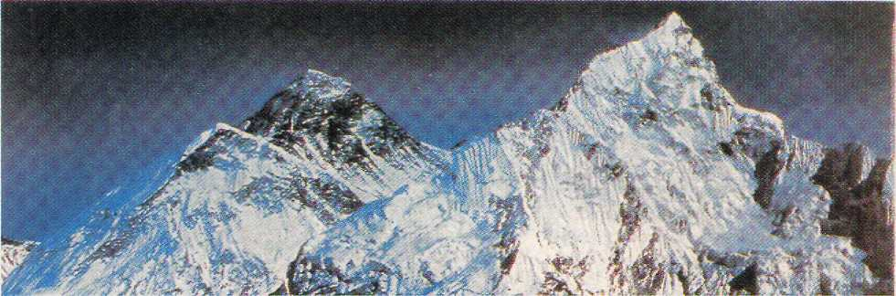
Mt Everest. 8848 m . 29 may 1953

A roof for the world.
iSim iiii^Mili i^bh
Hotel SHANGRI-LA . 82 Deluxe Rooms. i^{il} July 1979

SHANGRI-LA
KATHMANDU
Your private paradise in Nepal UZIMPAT. G.P.O. BOX 655, KATHMANDU. NEPAL - TEL i (977.1) 412999 - FAX; (977.1) 414184 - TELEX : 2276 HOSANG NP


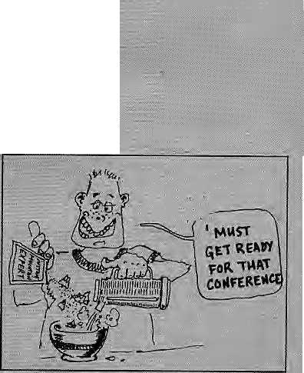

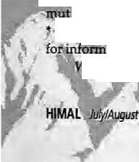

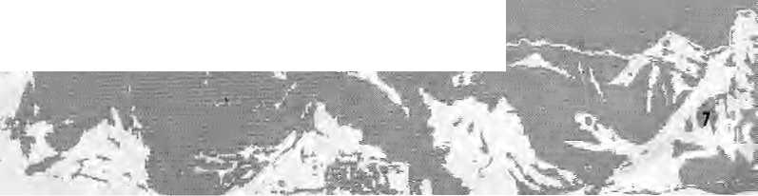
this summary for clarification. -
At the 1992 Earth Summit in Rio de Janeiro;;:: :
the largest gathering of heads of state and govern-
ment ever before assembled in human history, enr .:
dorsed Agenda 21, including the chapter entitled
"Managing Fragile Ecosystems: Sustainable :■:"
Mountain Development". We now call this the
'Mountain'Agenda". ..-.- ............. .■ .■■.:■
While inclusion of mountain ecc&ystems was a significant accomplishment, the Mountain Agenda.: chapter was drafted late in the preparations for the Earth Summit and thus could not benefitfrbui the full participation of NGQs arid; people working iri : the world's remote mountainous regions. Therefore, the mountain community felt a strong need to come together to build a consensus toward concerted action on the Mountain Agenda. :;.::....".
The United Nations, under the leadership .of the Food and Agriculture Organisation, took on the job of coordinating the follow-up to the Mountain Agenda. In this work, FAO took the¹ virtually unprecedented step of including NGOs iniull partnership. At the UN interagency meeting in: Rome in March 1994, official representatives asked NGQs to review the Mountain Agenda to develop : recommendations on implementation. The Mountain Institute was asked to organise this process, but declined, offering instead to facilitate a participatory planning meeting in July 1994 which gathered some 30 NGOleaders from all parts of the world to plan the NGO Consultation.,It was this group—not any individual or insHtution-r-which decided on Peru as the preferred site of the : conference, established task forces to coordinate the preparation of background papers, and develop a participant's list that would reflect the full diversity: of the mountaincommunity.
The meeting was jointly organised by CONDESAN, a consortium of Andean NGGs, the ; -International Potato Centre (CIP), and the Mountain ' Institute. The group aJso voted unanimously to use ■ the same facilitators and process—"Appreciative Inquiry"—that had provedso successful in the : planning process. Most importantly, the group agreed on both goals and rationale: for the meeting: * to develop consensus on a prioritised action plan to implement the Mountain Agenda and disseminate if throughout the off idalj academic and NGQ communities to build agreement and ual support over time; and
to create an ongoing forum of ttiountain NGQs :
atiort-sharirig and mutual learning.,; ;: ^e continue to believe that- the case for special :
1995
I
■ -consideration of mountain ecosystems and: people
; is compelling. The'.world's mountains are home to.': unique cornmunities:and cultures whose;lifestyles are intimately interwoven with these fragile ■ ■
■ ecosystems. Mountain ehvirohmerits are sensitive
livinglaboratories for rrioni toring clirrtate change, •
are ofhighest significance for'biological diversity,
■ and ar&the source of over 80percentof the world's
: fresh surface water resources. The cultures of : :
mountain peoples; are mtimaidy mterwqyenwith their natural environmentj, and merit respect both -for their intrinsic value and for (heir prerogatives: .:■ to manage their own lands and resources; :: :
::: The tiirveior preparation was much too short—Hanly six monthsr—arid there was no money. Yet; if we could manageto bring the interested : parHes and poterttiai partners together, we would have a tniiy unique opportunity to insert some of the collective wisdom and experience of ■ practitioners, scholars and activists intq tfeofficial priorities of governments and UN agencies as they : craftedtheir plans for mouritairi protection and developmentlnthis^-wesuceeeded. V-
■LastSebruary, some 11Q rBpresenfatives of ■cirganisationsGOffinTlttedtocons^r^ enviroriments, improving :ftie:Hv,e* of people in the most remote, rtiggedahdimpovenshed areas of : the: world, and prompting the: unique; and diverse cultures: of mountain peoples came together in Peruior the first-ever International Consultation on the Mountain Agenda. :::
Our action-recommendations were summarisedfirst in an ; informal briefing at the UN in early March. This was not a rrteetag of the UN -Commission on Sustainable Develbpmerit (CSD)^ .but an inter-sessional planning meeting. The report of the NGO Consultation ■ was prepared in record tintfe.and: distributed to every delegiation a t: : the opening session of the GSD' Ministerial level meetinginrnid-Apfii. Participants: from the Lima meeting, worked hard and late with ; the drafting committee: to prepare'drafts for consideration o'f the assembled Mintetersrthat reflected the consensus of the'Lima meeting.-We prepared a paper putlining our recommendations, which was introduced'by the Swiss delegation and distributed to all participants. We weregiven an unprecedented opporturiity tospeakin the'offtcial sessipri to ministers of 182 countries, swmmarising^ the key jsctton priorities agreed to by the

a

paTticipants at Lima, and calling upon governmerifs "talking heads".The .-approach weplannedto use,:
and UN agencies: to recognise mountains as a.: "appreciatiye inquiry", was developed by Southern
special concern, and to increase the attention and NGOs and academics: Its methodology offers a way
: support they provide for the Mountain Agenda. ; ■ to avoid focussing on Western traditions¹ at critical
the Secretary General, along withrepresentatives 'analysis, that result too oftenin a litany ofwrongs
of governments and UN agencies, lauded our" ■ and alisting of problems to be solved. Rather,it
efforts as one of the;"saJien:t:achieyements"Df the ■: seeks to build on the positive energyof what
high level meeting,:especially as anexample of works, and people's individual dreams and visions
innovative partnerships that are: evolving among .:of a better future for themselves and their
governments, agencies and NtGOs; and they called communities. When the organisers recognised that
for their continuation and emulation as a model for someof the participanis:{^{l}'the wizened and the
other sectors. .: cynical"referred toby Dixit)—both from Northand
The full report of the NGO Consultation has rj;; South-^-eould not or. would not break out of the
been provided to Himal, and wehope yonrreaders ^-adirional mould, the facilitators did not
will be interested irt the summaries of key issues Vithdraw". Rather, they responded flexibly, and
and prioritised recommend a ti cms in each of the ; ^worked late into the night toredesign the entire..:.'
nine: thematic areas identified by participants in meeting, It wastheir work, together With members
Lima: cultural diversity;sustainable development; of lhe:plannirig team, and efforts of the very
production systencis and alternative¹ Hve;ljhoods; diverse group of participants, that ensured we
local energy demand and supply in mountains; could get agreements on prioritised action
tourism; sacred, spiritualand symbolic significance recommendations, the type of on-going network :
ofmountSihs; water towers; mountain Biodiversity; we envisage, and an enthusiasticandhighly
and climate change and natural hazards. Copies of: diverse group of people committed to furthering
this report may be obtained from The Mountain the Mountain Agenda.
Institute, PO Box 907, Franklin; WV 26807, USA (Tel Those .who want to work for the preservation
304^358-2401; Fax 304-358-2400; Email : : of mountaiiVenvironments and the advancement of
summit@igc.apc.org}. : mountain people a re encouraged and welcomed to
In addition, participants in the LimaNGO ::: : join this work. We recognise and value the
meeting agreed on the-need for a forum for mutual: importance of advocacy and protest in raising
support and exchange of ideas/experiences and :: awareness, the crucial role of academia in
peoples to raise mountain issues arid uriderstah- expanding our knowledge about mountain
ding on local, regional arid national and environments and cultures,, the contributions of
international agendas; and to promote policies and goyerntrient officials charged with establishing

actions fot equitable and ecologically sustainable : policies and implementing large-scale resources
mountain development. The meeting therefore- management in remote mountainous areas, and
selected 12 people, nominated by tiiJeir own : complementary efforts of ^fiSOs working in fiel
regional groups, to serve On an initial organising operations. We need- all these elements working in
committee, The group was charged with seeking partnership to achieve progress in understanding,
the fullest cooperation and support of all interested valuing, and preserving mountain cultures and
parties to recommend priorities, mechanisms, ecosystems, and improving the quality of life of
and initial work plan for the Mountain Forum, mountain peoples,
and to-seekfundingfor establishing such a _{D} j_{ane} p_{rUttr} p^jy
decentralisfed network.-Theigroup requested President and CEO
The Mountain institute to help convene the initial The Mountain Institute

meeting. We would welcome suggestions from Franklin, West Virginia
Himal and its readers of groups to include in
this emerging network.
The work we are doing is difficult given the Last Banner of Independence
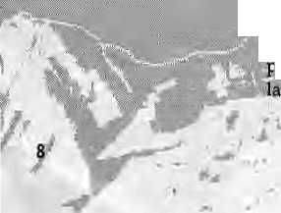
holistic, complex and diverse nature ,of mountain In May 1995, my husband and I drove across the
environments and peoples. Those who are Changtang plateau in western Tibet,and performed
committed to;a truly participatory andinclusive theJ&ra—circumambuiation—of Mt. Kailash (Kang
•roeess recognise thatitiss messy business, \ Rimpoche). Should .we havevisited Kailashat all?
<^{iri}S the orderly nature of traditional meetings of A styiish'new"literature of travel-guilt has sprung
T'it :i W'" "
mm

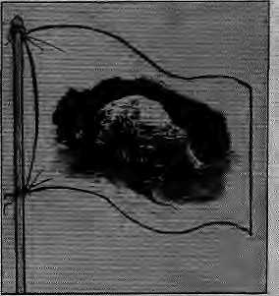


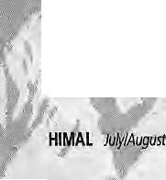


up; its authors, who have already been to the site you want to go to, inform you that foreign tourists have fouled the place with garbage and offended the iocai people with disrespectful behaviour. A recent example Df the trayel-guilt genre was John V. Bellezza's "Kang Rimpoche Trashed and Commercialised" (Himal Jait/Febl995); :
Kailash is not easy to reach, and the foreign; traveller who gets there is not usually the kind of: person to throw trash on the trail and batteries m the stream; indeed, sad to say, this is much more likely to be the work of Tibetans. Nor did we find the mountain becoming "a garbage dump'¹, as Bellezza maintains. His unsubstantiated statement : mat "Western tourists are the champions'- when it comes to strewing waste is contradicted by even casual observation.
Two days after making the kora, we climbed a ■ small ridge overlooking Lakei Manasarovar. Mi. kailash rose across the intervening plain, its shape an unmistakable print Upon the vast landscape. I : sat quietly, looking at the holy mountain, Xheard no sound but skylarks and occasional cries of waterfowl below at the lake shore, and I began to understand what this mountain means.
Mount Kailash is one of the few mountains in the world that can be immediately tecognised by people who have seen it only in photographs. Its shape is unique^ distinctive enough to be unmistakable. A few other mountains have this visual cachet; and of ten they too are the focus 6f legend—the sphinx-like profile of the Matterhorn, the perfect cone of Mt. Fuji, Chomolongma's tilted summit—because df their height, or the difficulty of climbing them, or their mythic associations.
At 6714 m, Kailash is not especially tall within the Himalayan context, but it is among the world's most beautiful mountains. A pyramid of snow, yet gently softened by its slightly curved flanks, its tap delicately rounded. The most striking f eatuTe are the concentric bands of dark rock that ring the mountain; snow accumulates on this striations, forming stripes of black and white.
Regarded since time immemorial as the home of gods, a holy mountain for three religions, Kailash in our time takes on a new significance. Because it is sacred, it has neverbeen climbed. The mountain is virgin. It is the one place untouched by what has gone on in its sad country. Its pure white form is the last banner of independence. Some mountains get 'conquered¹, other peaks are 'bagged'; no feats of extreme willpower will ever be performed to scale the walls of KaiSash, no clash of
if £
f995
r
egos wiU jar its tranquillity.:::~ ■■■..'.:. '..'■ ' -..' ~ -:-^{L}-::
KiaiJash remains inviolate; Never climbed; ■ never mastered. And all who love mountains and mountain people, who honour the faith and soul of Tibet, must hope it remains forever untouched, virginal, its sanctity unbreached. ■ ---■■■
At Darchen,; the small village at the base of : the mountain that serves as the starting poinifor the kora/ we sawlessof the Chinese presence than anywhere els& We had been in Tibet, Great destruction was unleashed around the mountain, many . gombas destroyed, but the occupiers appear to:: have withdrawn at least any obtrusive presence, and have left the mountain to the Tibetans. We saw none of the otherwise ubiquitous Chinese • soldiers, no concrete fortifications'and ugly ■ ■"";..'. communication centres. The faithful still flock here to worship in-their pure faith, and here they are left alone.: ; ;
After thekora, we went south across the plain to Lake Manasarovar, At CfiiuGomba, recently rebuilt we found a large group of nomads- .-.. travelling together on a pilgrimage to the holy lake and the mountain.JPor them, as for us^ it ;may have: foeena bnce-in-a4ifetirhe experience. We took out place in the orderly line the nomads had formed to enter the smallprayer hall, and once, inside we performed the ritual prostrations. We were greeted with warm smiles; Our reception had been the same on the kora-at KailasK; smiles and: encouraging glances,:
The literature of travel-guilt tells us that we are voyeurs, intruding on another people's privacy in these holy places, fostering the commercialisation of the sites, corrupting the culture. My experiencetellsme otherwise. The pilgrims around us were markedly welcoming, proud to have us witness them revere what they hold sacred, : pleased to have us join them in mutual celebration and mutual honour.
Visit Kailash? By all means. Join the Tibetans and let them see that the world beats a passage fo stand with them before the home of the gods, now also the symbqlof their national soul. Marcia hdbsrrmn Shode Island
Officers as Arbiters
Two letters from former British officers of Gurkhas (Cross Mar/Apr 1995; James May/Jun 199.5) have claimed that Pratyoush Onta's Himal article, "Dukha during the World War" (Nov/Dec 1994),

D
Ma



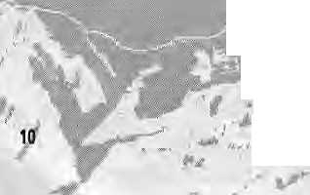

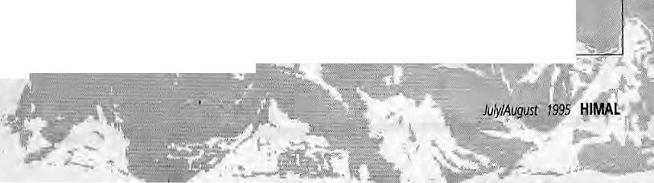
said nothing new. 1 disagree. They coricen-tme on a letter (Burroughs; JanJEeb 1995) that piqued their ire by likening lahureys'labour to that of Nepali prostitutes in India, While I think - -they miss the intent, which was to highlight ■; economic imperatives, I am troubled that the main point, dukha, is being lost in this correspondence. -
What was: new in Onta's article? First, the : ■
discussion of Nepali language writings on Gurkhas
IS new except for a survey by Michael Hutt. Second,
the questions raised about the Kathmandu elites'
views on Gurkhas in the Great War are new and:
important. RammaniA.D., Hemraj Pandey and -
Balkrishna Sama have certainly not beeitheard from:
in British sources, official or unofficial. Third, the
extensive quotation from and reflection on the :
censored letters of World War I lahureys:: '".:..'
provides insight into Gurkha dukha that is, contrary to their claims, also new.; One learns more about the dukha of the Indian Expeditionary Force in Prance from Mulk Raj Anand's novel, Across the Black ■. Waters, than from all that has been written, in any genre, on Gurkhas' participation in that force: Indeed, there is no reason to think, as On ta claims, that references in the letters to "divine wrath" and:". the destruction of the whole world" were: meant metaphorically:
Cross implies that Mason's A Matter of Honor exhausts the subject of "unpleasantness in battle and the reaction: of troops from the Subcontinent". While "unpleasantness" in no way exhausts the meanings of 'dukha', Mason's book could certainly have been discussed, particularly the sixpages of his532-page text that deal with the censored: letters and disaffection among Indian troops; Yet since no Gurkha's letters are quoted, it seems odd that a former Gurkha officer thinks there is nothing to add-A discussion of Mason's book would havenoticed, as Cross says, that he describes hardship in the
trenches, but also that he uses extracts from th^{e} letters themselves to counter the impression of the censor's reports that depression and disillusion-ment had set in amongst the wounded. He concentrates on "positive expressions of loyalty".
T5
I have read much of the literature written by former officers and others about Gurkhas' service. Ihave also talked with many former lahureys about their army.■years./P.erhaps the most striking difference is the centrality of raahy kinds of dukha in tahurey's reminiscences, and its relative absenceinaccounts writtenby their-officers. It is: .
also striking that, although British officers' accounts quite uniformly celebrate the special, even unique, qualities of Gurkhas, when tine subject is Gurkha dukha,theyquickly claim that itis. nothing special—: just the same as their own and that of any serving soldier. While economic tiecessity is not the only reason, by their own accounts, that lahureys have .:. joined foreign armies, I would wager that no British officer of Gurkhas has made the decision to enlist under comparable conditions. Cross- observation that there is -'"no-legal heed... to join a volunteer: army" hides ratherthan illuminates the social terrain that produces recruits.
It is a central trope of off ieers' accounts thatthey ■were ther^khew their men, and have a special bond which renders them the privileged disseminators of truth about Gurkha experience. Without denying that they have often had great respect for their men, their vantage point is one among others; any effort tbdaybyofficers to be the sole arbiters of the Gurkha public image isout of place. Some former "lahureys : are now speaking for themselves in publications such as the Gorkha Sainik Azvaaj, and much of what they say resonates .more closely with Onta's accounts than with tales of the somewhat phlegmatic, but ever-cheerful and always brave Johnny Gurkha. Gurkha dukha is indeed not new; it is of long standings anctmuch remains to be known aboutit Lahureys arecGmplex people with complex life experiences, and no one voice willsum up "the Gurkha story'¹. The letters through which Onta helped us Hear a few of those voices were addressed to Nepal but never arrived. They were censored onee irt the interest of management of public opinion. Let them not be censored again.
Maty Des Chene : Baltimore_{r}Maryland ■'
Readers are invited to comment, criticise or add to information and opinions appearing in Himal. letters should be brief, to the point, and may be edited. Letters which are unsigned and/or without addresses will hot be entertained. Include daytime telephone number, if possiblej
PO Box 42, Laiitpur, Nepal Tel 977-1-523845 Fax 521013 email: himal® himpc.mos.com.np

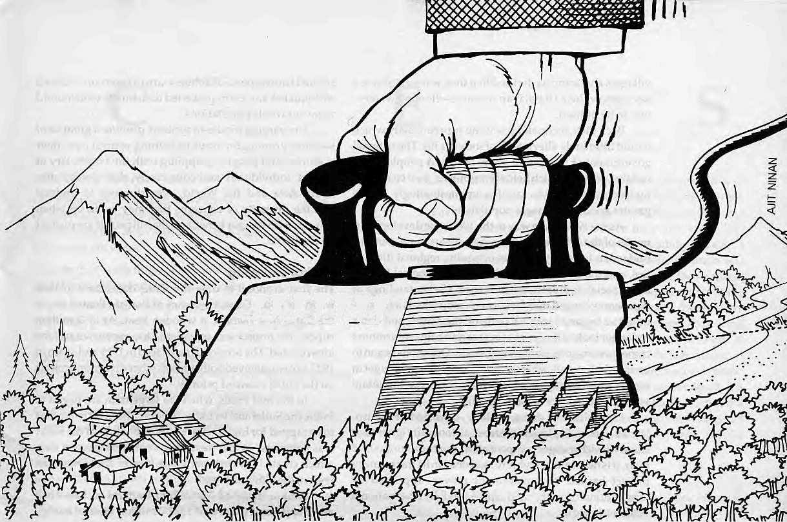
JJJJJfJ

Dams: The Vocabulary of Protest

While opponents of dam-building
base their protests
on issues of compensation,
rehabilitation, submergence,
seismic hazards, religious sentiments
and cultural intrusion,
in essence what is happening is that
highlanders have understood
the economic value
of the rivers flowing
through their valleys.
They are seeking fair payment
by Manisha Aryal

W
hen World War II ended in 1945 and the British left South Asia two years later, the rivers of the Himalaya were still unbound by the high dams already ubiquitous in North America and Europe. Not for long, however. The new rulers of the Indian Union were convinced that rapid industrialisation was the path to progress, andhydropowerwas to fuel that growth. Dams, decreed independent India's first Prime Minister Jawaharlal Nehru, would serve as the temples of modern India, and in the decades to follow, these temples were consecrated in river after Himalayan river.
The dam builders moved earth, raised scaffolding, poured concrete, and tunneled through rock with missionary zeal. Their mission was "development" of the masses. Electricity, irrigation and flood control were the mantras. The dams provided all the answers.
Years passed before economists and political scientists began to challenge the "development paradigm" which strove for economic growth as the exclusive goal to be achieved at all cost; before geologists raised fears of earthquakes and "seismic gaps"; before environmentalists stood up to protect endangered species and habitats; and before

HIMAL JulylAuguit (995
11

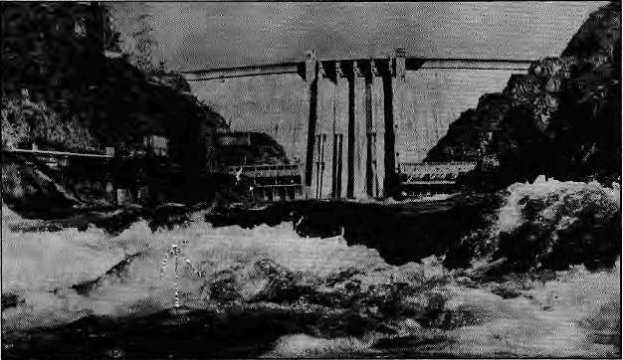
Concrete gravity Bhakra dam.
villagers and activists decided that they wanted to have a say on how their Himalayan resource—flowing water— was to be utilised.
Back then, technology was the supreme deity which would ultimately alleviate all of society's ills. The national government at the Centre knew best, and peoples from isolated pockets which held the resourcesbe it coal, oil or hydropovver—were to sacrifice unquestioningly for the greater good of the larger population.
As the 1970s gave way to the 1980s, the development myths of the 1950s began to make way for more complex understandings of the issues of equity, regional disparities, and the limits to the ability of technological fixes to bring social and economic advance. Understandings of democracy seeped into far corners, individuals and communities began to take a handle on their lives, and dams no longer looked the knights in rock and concrete armours come to rescue populations in distress. Questions began to be asked: above all, what do we the mountain people get in return for allowing you plainsfolk to use our mountain waters and inclines for your benefit?
Opposition to dams, initially, consisted of the isolated voices of displaced "oustees", all too easily ignored or silenced with meager compensation. For the unorganised poor, it is next to impossible to stop dead inits track amega project backed by government power, approved by intern a tional donors, and applauded by the national elites and media.
Over the years, however, this situation has changed. Education and exposure to the plains economy have made the highlandeTS more informed of the value of what they have and aware of the possibilities of questioning and opposing projects. Today, opposition to dams take on many forms, and with the help of academics and others in the plains centres, hill activists are questioning the technical risks, ecological costs, social justification, and economic rationale for doing dams which in an earlier era would have been built without a murmur from the mountainside. Some dam opponents argue on the basis of fairplay and payment according to value of resource (water) used. Others speak of the spiritual sanctity of de-
spoiled landscapes. Still others warn of reservoir-induced earthquakes and earthquake-led dam bursts which could wipe out whole populations.
The varying modes of protests provide a glimpse of societies groping for ways of gaining control over their resources and peoples grappling with the vocabulary of protest. Individually and collectively, their voices offer South Asia and the World, opportunities to underst and the diversity of concerns that may come up when projects with unclear benefits to the hill people are pushed on their land.
Bhakra and Pong
The first proposal to dam the Sutlej dates back to 1908 when Sir Louis Dane, Governor of Punjab, floated down the Sutlej in a khatnau, a wooden boat. At 37.2 million rupees, the project was considered too expensive and the idea rejected. The proposal resurfaced in 1919 and again in 1927, but was shelved bo th times as other diversion projects on the Sutlej received priority.
In the mid 1950s, when the large dam era began in India, the Sutlej and its Indus tributary Beas were the first to be tapped for high, darns. By 1963, Bhakra on the Sutlej was complete—a 226 metre high concrete gravity dam which created the first marunade lake in the Himalayan region, the Govind Sagar.
Bhakra irrigated 3.5 million hectares in Rajasthan and Punjab and generated 13,000 million units of energy annually. A projec t that boosted the economy of the plains, Bhakra submerged 17, 864 hectares of 371 villages and displaced 36,000 people. These belonged to the erstwhile State of Bilaspur, which today falls in Himachal Pradesh.
The experience of the Bilaspuris indicated how future dam projects would treat "oustees"—a recurring issue in the opposition to dams. Their area was merged to a newly created Himachal Pradesh State which felt no responsibility for the rehabilitation of the oustees. With the Central Government not living up to its promises, the Bilaspuris were left on their own. Their demands were modest, but their sacrifices were not compensated even by a fraction.
The families that stayed back in Bilaspur were each given 167 square metres of land—hardly enough for families which on average had three sons. They were entitled to loans, but lacked the means to pay them back. A generation of Bilaspuris has lost its most productive years fighting for compensation. From the oustee township of New Bilaspur, when the water level of Govind Sagar goes down before monsoon, the Bilaspuris can see the gates of the palace of Anand Chand, Bilaspur's raja, and roofs of a dozen temples.
It was not that the displaced Bilaspuris were passive victims to what visited them, but their voices were drowned together with homes and hearth. They were a powerless minority whose interest disappeared in the face of the

12
July/August /995 H!MAL

the old Man and the Dam

benefits that millions stood to gain from the regulated Sutlej waters. Without lobbying power, their concerns remained local.
IfBhakra illustrates how power politics sidelines the interests of those displaced by development projects, the Pong dam on the Beas, completed in 1974, is astudy of how local interests are ignored in inter-state wrangling. The second large reservoir project in the Indian Himalaya, Pong submerged 29,000 hectares of land in Himachal Pradesh and displaced 150,000 people from 94 villages. The dam's benefit was to be distributed downstream between Rajasthan,Haryana and Punjab. New Delhi gave Rajasthan the responsibility to provide rehabilitation to those displaced, as the state was the main beneficiary of a project that would produce 360 MW of electricity and irrigate 1.62 million hectares.
In 1970, as the dam construction was in full swing, 4000 people marched to the dam site. Work on the project halted as the Pong Dam Oustees' Samiti demanded their resettlement before they would let the work continue. Faced with this collective force, the Pong project authorities reassured them that they would get land in the project's command area in Rajasthan.
It is 25 years since those promises were made and repeated again and again, but more than half of the Pong oustees remain in limbo. They have not been resettled, and Rajasthan continues to shirk the responsibility of delivering the promised 91,056 hectares of land to them. Meanwhile, Shimla lacks sufficient clout in either Jaipur or New Delhi to resolve the problem of the oustees, a quarter of century after their property went underwater.
Tehri
The dam site at Tehri lies just half a day east of Bhakraby bus. The Uttar Pradesh government gave clearance for a project on the Bhagirathi in 1976, but it had bargained without Uttarakhandi activism. The Garhwal hills had a history of activism that Himachal never did, and Pong and Bhakra had already shown the activists here what all they should guard against.
Tehri contains all the problems apparent in the two earlier projects in Himachal Pradesh. Its 260.5 metre high rockfill dam, with its reservoir stretching 44 kilometres up the Bhagirathi valley towards Uttarkashi, will submerge 43 villages fully and some 80 villages partially, forcing the relocation of more than 85,000 people.
For all that it does not do for the hills, Tehri is to provide 8.5 cumecs of drinking water for New Delhi, a powerful and well known water guzzler. It will provide 'stabilised irrigation' for over 600,000 hectares in the Uttar Pradesh plains and bring an additional 270,000 hectares under irrigation. Uttar Pradesh will also receive 12percertt free power for letting its territory be used, but as Tehri forms just one of the 63 districts of the sprawling Uttar Pradesh state, it is unlikely that it will receive a significant share (of the power).
after Uttar Pradesh Governor Mottlal Vora arrived by helicopter froiri liUC.kriQw with assurances that Prime Minister P.V\ Narasimha Rao had 5 agreed to look into issues raised By activists fighting the Tehri darn,:
";' While. ^pX'capitulation' to domestic public opinion and internal
;.tioisal pressure did signala loss of facefor the Tehri Hydro Development
■Corporation £THDC)3t^remainedunclear exactly what the dam's oppcK
merits should becelebrating; Prime Minister Rao, by keeping his promises
:■■•deliberately vague and at second hand, seemed,to have defused a situation
I without committing himself to anything'concrete. : , „
!■:■:■ ■;■■■■ Bahuguna w|is pers.ugcled to give up his 49-day hunger Strike by'th&!
Lbanks of the Bhagirathi; but news reports' carried hints frdfri thi; Prime
Minister's-Office and the Ministry of Power m Istew Delhi that Rao had
intended that only issues left uncovered by earlier reappraisals of the
scheme would-be dealt with. This would rule Out a review of the safety of
the dam, whereas a Seismic review has. been the primary demand of
Bsmiguna arid Fello;w-actiyistST There is no taped: or written record of
± Bahuguna had been ehgagecl in dharna at the dam site since mid* ;Ajpnlv"Th|s is.: pur last battle* We will not let Tehri drown," he deel^rect beforehis fast, sittingcross-leggediujn4e£ a;makeshjfttarpaulin sheltera net Surrounded by--supporters. He maintained that the project must be::exam-, irted notorily for its strengfhjfo withstand the greatest of possible earthquakes, §utalsoioseewhether/thebenefite'fromTehfi wouldjds^fy the
• economic, environmental¹ ancl Socmliiqste to be borne by the Garhwal
■■■ hills, "We want the right which nature has given us: to use the water of our rivets.:;Ouii main opposition::to the project is that it will transfer our...
■■:, resources downhill." ■■■ """":: " ""Z I ' .. .... ... ...
More fhan a hundred ant|-dam campaigners fromthe Uttar Pradesh hrtlfeand other s£aieso£Iridia^m^
;. "legalised robbery" which¹ would ortly wftrseti the lot of the marginalised region. !i^edhaPafJ:ar, grand lady of the Narmada Bachap Andotan,
■ visited the protesters camp by the Bfh^girathi and advised them not to accept ait aiyy cost rehabiiitation offered by: the government,
■■::■■ - Bahuguiia has en de'd hisifast, but at th^ end o f.theday it seemed likely
■that the wi|y Prime Minister might just have diiped tWe wizeriec! nil! Garidlrianv In early July, Bahii-guna Was ih Delhi to try and meet Ra©. At : the momcnrof gping^tpp'resSj, he stillhad not beengiven an appdirttmer/Lt.
| * .,:,,.,,:,■ :■ ■■■:■■', ■"■■.■■■ ■ .;. -rrMahesh Uniyat
■ ■&;■ ■■>■■ ■■ ■■■ ■■■ ■ ■■■■■ ^ ■■■■■ ■■■ ■■ ■ ■■ ■ ■' " ^{v} HHHHBBB^w ■■ * ■ ■■ '~ "■ ^{v;}
The battle in Tehri has been long-drawn, with Lucknow'sstategoverrimentbackedbytheCentreonone side and a handful of activists and a few scientists on the other, with moral support from dam opponents elsewhere in India and overseas. The first protests in Tehri had spiritual underpinnings. "We tried to appeal to the religious sentiments of our poli ticians," recalls journalist Sardar Prem Singh, a member of Tehri Bandh Virodhi Sangharsha Samiti, formed in 1978, as its name suggests, to "oppose" and "agitate" against the dam. The Tehri project would submerge, along with Tehri town, the old route to the four pilgrimage sites in Uttarakhand—Yamnotri, Gangotri, Badrinath and Kedarnath. If the dam were to break, the flood waters would carry away the Hindu heritage of India as represented by Rishikesh and Hardwar in one devastating sweep.

H1MAL JuljilAugust 1995
13

i

As the opposition began and was sustained, the history of Tehri has been an endless procession of committees and commissions. In 1980, the Central government appointed a committee headed by Sunil Kumar Roy, a former bureaucrat, to look into the environmental impact of Tehri dam. Roy's report, submitted six years later, referred to seismic hazards and environmental problems and recommended that Tehri's design parameters be re-examined. It suggested "arevised project either with a low dam or a modified run-of-the-river project." After the report was submitted, some members of Roy's committee disclaimed their involvement in it. A working group set up that year to evaluate the seismicity and safety aspects of the dam, also pronounced the dam unviable.
In 1985, the Tehri Bandh Virodhi Sangharsha Samiti filed a petition with the Supreme Court asking that the work on Tehri be halted. The petition raised the issue of dam safety, citing the threat of earthquakes. Five years later, the court dismissed the petition, stating that in view of the material on record, it did not find any reason to stop construction of the dam.
Tehri dam site, showing crane, the dhagirathi and
In 1989, an Environment Appraisal Committee headed
by D.R. Bhumbala, an agricultural scientist, was set up to
look into the ecological and social impacts, costs and
benefits of the Tehri dam project. The committee also
rev iewed the geological and seismic factors and concluded
that the Tehri dam did not merit environmental clearance.
The following year, a Committee of Secretaries was
asked to review the recommendations of the Appraisal
Committee. It turned the responsibility over to a High
Level Committee of Experts headed by D.P, Dhoundial,
Sundartal Bahuguna's Director General of the Geological Survry of India, who in
shack and April 1990 pronounced the dam safe. A member and
guest tent eminentgeophysicist,V.K.Gaur,expresseddisagreement
with the conclusion and asked that the matter be referred to an independent seismologist of international repute. Jai Krishna, a professor and former President of International Association of Earthquake Engineering, was chosen for the purpose, and he pronounced the dam safe against the strongest expected earthquake in the region . The Ne w Delhi-based Indian National Trust for Art and Cultural Heritage challenged Jai Krishna's objectivity, on the ground that he had earlier been associated with the Tehri project.
Geologists have predicted an earthquake of M-8.5 or more in the area in the next few decades and afternearby Uttarkashi was hit by an earthquake in 1991, the seismicity argument appeared more compelling than ever. Environmental guru Sunderlal Bahuguna, who had been camping on the banks pf the
Bhagirathidemandingahalttotheworkonthedam,went on a fast demanding that construction on the project be stopped and the project be reviewed for its safety aspects. A committee of seismologists, geophysicists and others was set up, and in 1992 they concluded that the dam, as designed, was safe from earthquake risks.
Work on the dam was slated to resume when in mid-1994 the movement for statehood erupted all over Uttarakhand and construction activity ground to a halt. The agitation had lost steam by January 1995, and the Tehri Hydropower Development Corporation took advantage of the lull to resume the construction. In May, Bahuguna, went on fast again, demanding an independent review of the Tehri dam project. He broke his fast on the forty-ninth day, when he was assured by the Prime Minister of India that the concerns he had raised would be looked into (see box, page 13).
This w ill be the eighth committee setupbytheCentre to look into the safety aspect of the Tehri Dam project. The pattern is by now familiar: the opposition will continue to demand committees and the Indian government will continue to set them up. Both sides, however, will pick and choose from the recommendations. The government will highlight the reports which declare the dam safe, viable and necessary, while the activists will condemn reports that underplay the seismicity, rehabilitation and environmental aspects.
Bo th sides, in the end, will hear only what they want to hear in the war of attrition between the state apparatus and the opposition. In essence, the government fights to maintain the status quo, in which a decree from Lucknow or New Delhi is to be followed in the mofiissil for "the greater good", which it is the government's role to define. The opponents, meanwhile, are in essence fighting a battle to ensure—whatever arguments they may use—that the region that has the dams also benefits from their largesse.
During the Uttarakhand agitation's peak, from mid-to late 1994, there was much talk in NainiTal and Dehradun about how the hills must ensure proper income from Tehri. Every other person cited Tehri as an example of exploitation in the hands of the plains and the bypassing of development in the hills. "A dam like Tehri is being pushed on Garhwal because we are the powerless hill districts of a politically powerful state," said Bahuguna.
Indeed, the benefits of the Tehri dam as it is planned today will mainly go to Delhi in the form of drinking water and to the Uttar Pradesh plains in the form of irrigation and energy. There is no mechanism in the project document or in the minds of the planners to pay for a resource which, after all, is hill property. The place-specificity of natural resources is not an idea that is accepted either by India or by any of the other nation states in South Asia, as this would go to the very core of the government's ability to control and define nationhood.
While the statehood agitation has subsided momentarily, it is bound to rise again. "When the statehood

14
luty/August 7995 HIMAL

demand in Uttarakhand comes up again," says Rajiv Lochan Sha,editorof the fortnightly NainitaiSamachaar, "it will be because the people will want answers to the question of Uttarakhand's control over its resources. And water will be the most important among them,"
Rathong Chu
It is not only major engineering projects such as Tehri which will arouse the locals. If the Tehri opposition represents the hill people's resentment of the powerful plains players, that against the Rathong Chu project in West Sikkim indicates that the historically docile Bhutia-Lepcha community has finally found a voice vis-a-vis the dominant Nepali-speakers of the state.
The project under fire is the 30 MW run-of-river scheme on the Rathong river, the first independent power venture of Gangtok's government, being built to sell electricity to India's Eastern Grid. The project had received the go-ahea d when three trib at organisations (the Association of Buddhist Monks of Sikkim, the Bhutia-Lep cha Association, and the Tribal Women's Association) submitted a writ petition in August 1994 to the Sikkim High Court stating thattheprojectwouldcauseirreparabled amage to the distinct cultural identity of Sikkim.
The Yuksum area beneath the Kangchendzonga massif holds enormous historical and religious significance for the Bhutia-Lepcha, the original inhabitants of the former kingdom before Nepali migration swamped the lower hills. Of all the deities of the land, the most important is the mountain god Khangchen Dzonga, who is considered the head of all territorial deities and spirits of Sikkim. The area below the range is the most sacred area of Sikkim, and the Rathong Chu project is located at the very heart of this region, where the first king of Sikkim was crowned in 1642 and Sikkim was born as a kingdom.
Construction was started at the project site even while the writ petition was pending, which prompted a group, the Concerned Citizens of Sikkim (CCS) to be formed. CCS believes that "the project's cost in terms of environmental and socio-cultural impacts are too high a price to pay for its hypothetical financial benefits." Besides, stated the CCS, "one cannot help notice that all new sites which ha ve be en selected for the construction of large hydro-electric projects in Sikkim are either located in areas inhabited by Bhutias, Lepchas and Tsongs [Limbus], or are located near sites which are sacred to the Buddhists."
While Sunderlal Bahuguna was undertaking a much better publicised fast over in Tehri, a similar exercise was underway in Gangtok. With the Power Department pro-

The Denzong
Nesul, a rare
Buddhist
scripture, which
deals with
worship of
Sikkim's deities.
The text refers
to the places of
religious
significance in
West Sikkim.
ceeding wj th the work on Rathong Chu despite the protests, Sonam P. Denzongpa, US-returned member of the CCS, went on hunger strike. He ended his fast after 28 days when the Chief Minister Pawan Kumar Chamling reportedly promised to set up an independent review committee to study the project (see box).
The opposing point of view on Rathong Chu is expressed by R.B. Bhattarai, Executive Engineer of the project: "If you look at it that way, every stone, tree, rock, hill, lake, in Sikkim has religious value. This is not how you bring development; you can't let all that precious white gold [flowing water] go to waste."
The opposition in Sikkim seems to have borrowed tactics from the other sideof Nepal and has looked to Tehri as a model of sophisticated protest. The Rathong Chu opposition has highlighted the religious significance of the Yuksum region—Sikkim's own Dev Bkumi. They warn of environmental degradation by the project's earthworks and road construction, and of the cultural degradation
Satyagraha in Sikkim
We are calling off the hunger strike as our conditions have been fulfilled by the Chief Minister and the Power Minister who have assured us that they will set up an impartial review committee to study the project. The committee will consider the evidence of illegal actions and serious flaws of the project placed before them by the Concerned Citizens of Sikkim (CCS). The project will have to be reviewed in light of it being environmentally unsound, economically disastrous and imposed on the public as a 'fait accompli'. All this was due to the conspiracy of corrupted officials and well-connected commission agents and contractors whose greed proved no match for the negative environmental, historical, religious and socio-economic consequences the projects will cause. We are confident that the Chief Minister and his Government will order a review of the project by an independent, impartial and qualified body of experts. We hope that the committee will carry out its assignment in a professional and ethical manner and that we will not have to resort to a second hunger strike. - press release brought out by the ccs on S July after Chief Minister Pawan Kumar Chamling agreed to a demand for review of the Rathong Chu project
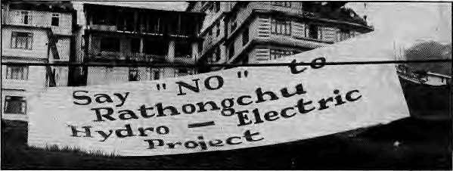

HIMAL JuiylAugust 1995
15

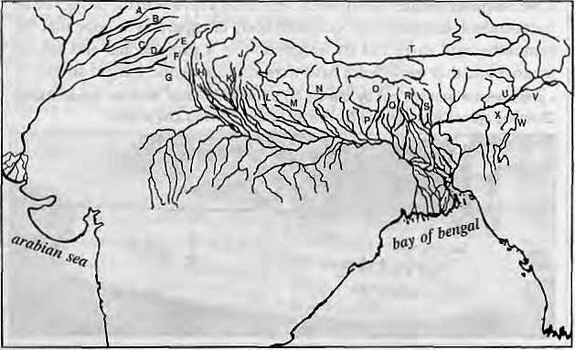

West to east,
the dams of
the Himalaya,
some built.
others
designed:
A | - Dulhasti
e | - Uri
c | ■ Bhakra
D | ■ Pong
E | ■ Chamera
F | - Salal
G | Thein
H | Tehri
 | Vishnu prayag
J ■ | Pancheshwor
K | Tanakpur
L | Kamali
M | WestSeti
N | Gandaki
0 | - Arun III
P | - Kosi High
Q | Rathong Chu
R | Teesta
S | Chukha
T | Yamdrok Yumtso
U | Dihang
V | Tipaimukh
w | Thoubal
X | Subansifi
that will occur once hard hats ascend by the thousands into the region and the market economy is thrust upon these isolated tribal lands. Much better to have tourism provide perennial income from these unspoilt region with so much natural and cultural attractions, say the activists.
Says Col. Yap Sonam Yongda, once aide de camp to the late Chogyal of Sikkim, "There will be upward migration to West Sikkim as people come in search of job opportunities from West Bengal and as far as Bihar. The Bhutia-Lepchas will then become minorities in what is left of their land."
The case of Rathong Chu is aharbinger of the days to come. Dam planners cannot expect to get the easy ride that they have had in the past, when all that was required to build a project was governmental approval. Even a community as widely known for docility as the Bhutia-Lepcha is now able to organise and oppose a project which in earlier times would have faced no picket lines. Rather than wish such opposition away as irritants, or suggest that state power ignore or crush them, the planners of future projects must understand the need for dialogue with communities in situ.
Gandaki, Kosi, Karnali
Many more dams would have been built in the Himalaya if governments got along better—for one of the main objections to building certain dams a certain way comes not from anti-dam activists but from governments, whose motives for opposition can be quite different. Suspicions of another government's intent, geo-political considerations, and bureaucratic hurdles have done more to block dams than activism, at least in the case of Nepal-India.
For those who accuse activists of being "anti-development" and even "anti-national" for opposing dams, therefore, it will come as a surprise that governments are also capable of opposing dams, although their consideration tends to be more strategic than based on questions of equity, environment or economics.
For half a century, Nepal and India have been engaged in talks on harnessing Nepal's much-vaunted theo-
retical capacity of 83,000 MW for sale to India. To date, while ahandful of medium sized plants have been builtto supply Nepal's domestic demand, some of them with Indian aid, not one hydropower plant has been built which exclusively exports electricity. The waters of the Gandaki, Kosi and Kamali—Nepal's three main river systems—continue their energy-laden journey to the plains without Indiagetting the poweritneeds to spark development in eastern Uttar Pradesh and Bihar. And, hundreds ofmillions of dollars that Nepal couldhavemade through sales over the decades have gone un-earned.
The major reason for failure of dam negotiations is the Nepali suspicion that India is out to swindle it on hydropower just as it has supposedly duped Nepal in the two major water projects that they have done together thus far. These are barrage systems on the tarai border— one the Gandak Barrage where the Narayani exits the Churia range to enter India, and the other on the Kosi near Hanuman Nagar.
Ithasbeen an unquestioned gospel of modernNepali thought that Nepal has been 'cheated' on these two barrages, whereas given the incline of the tarai land southwards—after having agreed on their location—there is not much more that Nepal could have expected than what it has gotten. Nevertheless, the Nepali grouse has been that Nepal's gesture of goodwill in allowing these barrages to be built has not been reciprocated by India in negotiation on subsequent projects.
Such is the level of suspicion of India's designs that the framers of the new Nepali constitution of 1990 included a section which states that all treaties which deal with natural resources (read 'water sharing') have to be ratified by a two-thirds majority in the Parliament if they are of a "comprehensive, serious, and long term nature." This is meant to be an automatic trip mechanism to prevent dam projects not considered to be in Nepal's interests.
While on one side is Nepali suspicion, on the other is the inability of New Delhi bureaucrats to come to terms with Nepal's desire to control its resource and demand market value for it. For New Delhi, this is a geo-strategic consideration; Nepal would have the potential to 'blackmail' India once it held the key to the hydro-power on which the industrialised plains had become overly dependent.
Then there is the Indian negotiator's inability to comprehend buying electricity at more than token rates from another country. The Indian negotiator fails to realise that rivers outside India's borders cannot be exploited on the same basis as rivers inside the country (such as the Bhagirathi or Sutlej), and that they have to pay realistic rates for using Nepal's rivers. The conviction in New Delhi is that as long as India makes the investment on the dam structure and pays (cheaply) for the electricity utilised, it does not have to pay anything extra to use Nepal's sites for flood control and irrigation in the plains.
As India plans for and proposes storage schemes in

16
July/August 7995 HIMAL

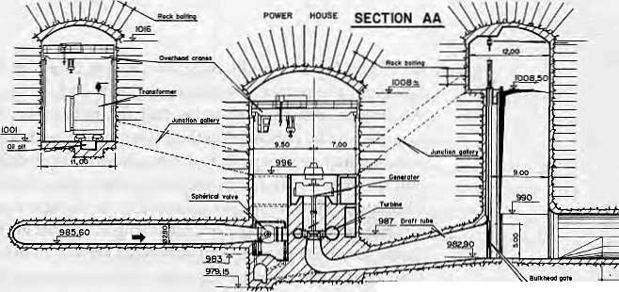
T9801ft
Nepal such as Kosi High,Karnali, West Seti, Pancheshwor and Budhi Gandaki, in order to benefit from flood control, irrigation and electricity,sayNepaliplanners,ithas first to reconcile itself to the idea of paying for what it gains.
West Seti
Those who keep up with the news in Kathmandu know more about Tehri than about West Seti. Both are high dams, within 300 km of each other, one in Uttarakhand and the other in West Nepal. Both fall within the much-talked-about 'seismic gap' said to existbetween Kathmandu and Dehra Dun, where a sudden and devastating movement of tectonic forces is said to be more than likely in the next half century. Tehri has a high media profile while West Seti is unknown. This ignorance is due, basically, to the fact that the Nepali media has been unable to cover issues of this nature.
For opposition to germinate, basic information is required, and often it is the media that generates information by keeping an eye on developments. In South Asia, however, many dam projects do not receive coverage because journalists consider them "development subjects", that are invariably less than exciting.
In June 1994, Nepal government signed a Memorandum of Understanding with the Snowy Mountain Engineering Corporation of Australia, within three weeks of receiving the formal proposal—a record of sorts, to construct a 360 MW project on the Seti river. Nepal would get lOpercentofthe power free of char ge, while the rest would be sold by the private company. If Nepal had an alert media which focused on important socio-economic issues rather than exclusively on political sensationalism, West Sett would be reported, and views of critics would be discussed and debated. The media has not even covered the possible conflict of interest whan an Australian ambassador, a few months after relinquishing his post in Kathmandu, returns as a key lobbyist for West Seti.
Ananda Bahadur Thapa, Director of Kathmandu's Water and Energy Commission, is critical of the West Seti project because it is being developed only as a power project. "The vast irrigation benefits accruable from the West Seti High Dam Project will completely slip out of our hands forever" if this is done, he wrote in the WECS Bulletin in May 1995. The Nepali media has yet to pick up on his point, though it is a subject of national interest.
And then, there is the issue of the media's constituency. A journalist of a Calcutta-based newspaper might well decide to ignore the opposition to the Teesta project, which has been simmering in Sikkim hills for more than a decade, because it would go against the plans of the Calcutta state government and, by extrapolation, Bengali interests.Bythesametoken,itwasalsonatural,backinthe 1960s, that the metropolitan media was more interested in the benefits of Bhakra and Pong to the Punjab economy than what happened to a handful of Himachali villagers.
An independent and inquisitive media is a prerequi-
site for the development of any country and the Hima- Powerfiotwe design
for West Seti
Hydropower
Project
layan region loses out in the absence of an effective, homegrown press. In a region which has only a handful of activists opposing bad projects, and where power projects get built with little or no scrutiny, the role of the press is all the more important. When the press fails in its job, projects slip through the fingers.
Tipaimukh
Those who protest dams are regularly asked why they did not protest projects in the beginning, why they did not raise their voice in the planning stages. Such questions fail to perceive the many hurdles lying before those who choose to stand up and fight dams. First, there is the social disapproval in being against what everyone else is supposedly for. Then there is the natural timidity of populations in remote hill regions, which is where dam projects are invariably located.
Again, the few educated and aware persons from these regions who might have had the potential to speak up for the interest of the people living in the hills are easily co-opted, or havetheir plates so full with other important issues that they fail to raise their voice. While in Tehri, Bahuguna sits in protest against the dam that will create havoc downstream if it breaks, small contractors in Chamma in Tehri District, see no point in opposing the project. There is even resentment against Bahuguna as he is seen to be taking away their source of income.
Unless opponents have access to a well-organised network of supporters with expertise in different areas— from engineering to economics to organising a populace—it is extremely difficult to maintain an opposition against the entrenched forces of government, business and the technocracy. With international institutions picking up ever-larger pieces of the financing packages on dam projects, friends abroad to provide information not easily available to activists on the ground are essential. A document that is said to be impossible to lay hands on in Kathmandu, for example, may be easily accessed by NGOs in Washington DC or Tokyo.
Project reports are rarely available, and it is normally too late for the local people to raise an effective opposition by the time they realise that their lifestyle, culture and economy have been disrupted. The Indian Planning Commission approved the Tehri dam project in 1972. By the

HIMAL July/August 7995
17

time Tehri Bandh Virodhi Sangarsha Samiti, could lay its hands on the report, it was already 1978. India's Land Acquisition Act of 1894 states that the notification to acquire land be published in the government gazette and two regional newspapers. However, gazettes were difficult to come by and regional newspapers had limited circulation. Many of the people living in the villages to be submerged by the Pong dam, for example, did not get to know about the project until surveyors arrived to mark their land. Even after the Supreme Court in Kathmandu directed the Nepal Electricity Authority to disclose its list of documents on the Arun III, its Public Information Centre lists only 151 documents and does not mention another 147 which are known to exist.
Governments are notorious for their reluctance to share information—even when ordered by the courts. In South Asia, where so many projects are located in frontier regions, the secrecy slapped on dam projects is legendary. This secrecy on the part of the state inhibits open debate and ultimately rebounds against the planners. In the future, thjsneed for extreme confidentiality is bound to ruin theprojects which might have been savedif there hadbeen dialogue and transparency from the start. One of the reasons that the Tanakpur Project on the Mahakali rankles Nepali officials as much as it does, even though it is built mostly on Indian territory, is that India planned and built the project without informing the Nepali government, and feigned ignorance when asked.
When the secrecy is carried over to a project that requires inter-country participation, it is the one element which could kill the entire programme. Take the case of the Tipaimukh project on the Barak River in CachaT, close to the Manipur,Mizoram and Assam border, for which India has approached the Japanese-backed Global Infrastructure Fund (GIF), stating that it would benefit both India and Bangladesh. Except for a five-page document listing rudimentary data such as the height of the reservoir and the construction materials tobe used, says Ainun Nishad, a Bangladeshi member of the India-Bangladesh Joint Rivers Commission, no other information was shared with Dhaka.
When in January this writer visited the Brahmaputra BoardinGuw ahati toseekmore information on Tip aimukh, its chairman (who refused even to allow his name to be used!) said he could not provide information on the project—no, not even the height of the dam. "The matter is now with the Ministry of External Affairs," he said, "Unless I receive clearance from the government, I cannot speak to you." It seems that if the water bureaucrats had their way, they would implement the entire project without letting anyone know of their existence.
Meanwhile, opposition brewing in Bangladesh could backfire on thefaceofthelndianproponents of theproject because they have kept information under their hats. Two Bangladesh based organisations, the Jamat-e-Islam and the Briha tter Sylhet Gana Dabi Parishad, haveclaimed that
Tipaimukh is another 'Farakka' being foisted by New Delhi, which will turn the Sylhet region into desert. That may or may not be true, but the right lips in Guwahati and New Delhi are not helping matters.
Thoubal, Dulhasti, Uri
In the days to come, Tipaimukh could bring forth dam buildingproblemsthataremoredire.Theproject,basedin the increasingly-violent Northeast of India, could be the harbinger of dam opposition that decides to go beyond satyagrahas and argumentation—to violent reaction. Thus far, dam oppositionin the Himalaya hasbeen overwhelmingly peaceful; if any thing it is the state that has used force to quell demonstrations and jail activists. However, given the plans for dams in areas that are full of disquiet, there is every likelihood that some of the opposition of the future will speak a different language than a fasting Bahuguna.
Tipaimukh, whose rockf ill dam would generate 1500 MW of power, threatens to submerge 31 villages and displace 3000 famines. The oustee people, of the Hmar tribe, want the governments of Manipur, Mizoram and Assam (which will all benefit from the project) to rehabilitate them in one Hmar area with adequate plans for economic support. Given the accelerating violence in the region, it is not unlikely that one faction or another will use the occasion for violence.
In nearby Nagaland, there has already been violent reaction to a dam, Naga insurgents, dissatisfied with sops offered them by the state government on the Thoubal multi-purpose dam, have decided to take matters in their ownhands.TheNagaNationalistSocialistCouncil(NSCN) opposed theproject on the grounds that it would displace 1750 people from six villages and submerge 1400 hectares, including 800 ha of agricultural land.
The government had agreed to pay IRs 24,300 per submerged hectare, but NSCN demanded IRs 40,500 per ha, and that the compensation be paid in advance. Unhappy with the response, the NSCN in September 1990 set ablaze IRs 20 million worth of construction equipment. In February 1992, a bus owned by the construction authorities was set on fire, and in June two workers were killed at the construction site. In face of the escalating violence, the Thoubal project has been halted.
While the authorities tend to press ahead with construction of projects where the opposition is peaceful, it is practically impossible to go ahead with a project once it has become violent. Large projects cannot be built under armed guard. This is why, at the other end of the Himalaya from Tipaimukh, the Dulh a sthi project in strife-torn Kashmir ground to a halt in 1992. The French consortium involved in constructing the 390 MW project pulled out after one of their engineers was kidnapped by militants. Today, some 700 armed Central Industrial Security Force guard the project site. Similar is the case with Uri project in Jammu & Kashmir, being built by Swedish engineers.

13
July/August !995 H1MAL

The Power of a Lake
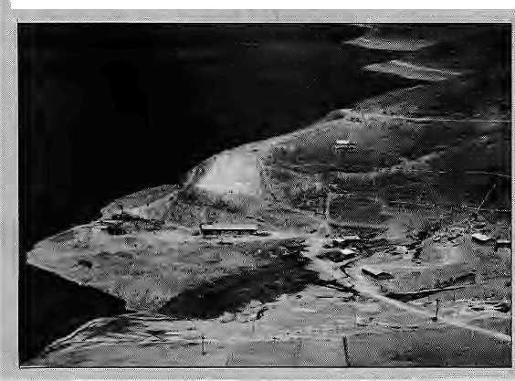
for Tibetans, Yarndrok Yumtso is a 'La- ■ iso'( repository of spiritual power) mystically linked with the fortunes of their land and nation. 'Yumtso' or 'turquoise lake' is the term for fresh-water lakes whose iift-•usjiai mineral composition often lends them a brilliant colour.
For the Chinese authorities, Tibet is ia wilderness with no intrinsic value except for the industrial 'resources' that .can be extracted from if. The sacred take is now a reservoir to be drained for /generation of power.
Says a May 1993 Xinhua news agency Jeahjre, "Despite the cold and lack of oxygen at high altitudes, and despite a shortage of construction equipment and ineff i: dent logistical support, the detachment's officers and men pitched tents, sjept oh the ground and exhibited a spirit of working %i unity and dedicating oneself selflessly": The dedicated empire-builders thatXirihua refers to are from aa engineering division of the Peoples' Armed Police^ which is a principal contender for large civil projectsinChina, andnodoubtconsidered a particularly appropriate contractor in Tibet.
The plan_{y} which several independent hydropower experts describe as unrealis-tically ambitiou§, is to bore anineldloitietre long tunnel through the northern mountain wallandfomakethelalce water tumble , jnto turbines almost iOuO metres below in ^the main Tsangp a, valley. During "off-peak .hours", Tsangpo river water will be
by John Grey
pumped back up this massive incline to
replenish the lake-.-....,-..... '.'. ......... '.'. , ..... '".. "..
This'pump-storage' scheme, evenifit were to work (it has never been attempted! imder such challengmg conditions before), wou td have enormous enyironmentai: impact on the lake/ and it is likely to be entirely drained ui time: A contingency plan" to bujld a further tunnel to Puma Yumtso (about 30 km:south of ¥amdrok)artd use: that late as a reserve tank Has riof been' taken seriously by international experts.
TlieYamdrok:pK>jectisa*eorecoffipo-: nent of the overall development plan for central Tibet in the 1990s' Official sources speak or4he creation of an "industrial cor-fidbr" in the central Tsahgpp ancl Lhasa valleys, consisting mainly of primary pro^ cessmg facilities Which; together with improved highways and communications, will make Tib et's raw materials (especially minerals ajid ores) more accessible to the mainland economy. Resource extractions especially mining, will become more profitable. Xhel/$ lObmifiipn-pjus investment j in Yamdrok wasundoubtedlymadewstha yiew to industrial application.
The settler population will also increase; the hunci recfe of thousands of gepple displaced from the Three Gorges, for ex-an>ple, will haye to be re;setried iri: jifcet. All of this needs power-^the power from fhe Yamdrok Yurritsa
The ^cherne, the officials claim, will enormously benefit Tibetan'villagers. Another Xinhua feature on the project (June
site
.-, ,. by the banks of the Yamdrok Yumtso.
.. 1992) stated that "Tibetans will never hiive to cookon yak dungagain" once the "Yanfu
the Chinese say "Yamdrok"). But ajl this». does hptsoundplausibie/as me electricity * in newly built public houses in Lhasa and , other cities are insufficient eVfin; fpr a one f hot-plate per family apartment .... "[ Yariidrok is for the rrioinient the only * large-scale hydro: project in central Tibet, „ Other major installations a re being built to **
^ harness Tibefs great rivers as they fall off ^ the platea«:s eastern rim; one across the •* Mekong atManwanih Yunnan provirice, * one compjeted {at Lpngyangxia) and ,
■:■: another being built in Gansu (at Lijixia). ** It is ;not known whether plans to j>uild ^ a 40,006 MW power station oh the Tsangpo " gorge in south-eastern Tibet; referred t& * in official statements'from the 1980^, are
... to.be.revived. .. ...
A number of small hydfo-electric **
" power stations, in fact, have been,built in _{m}
■■■ TibetwIththegenUineifttentionofprovid- * ing towns and yiPªg?!= ?^{cro}5^{s} *h^{e} Country with reliable electric supply. However., | according to: a-1991-survey by Chinese ' economists Wang Xiaoqiang and Bai » Nanfeng, at least 40 percent of them wei^ * not running.
ThelatePanchen Larria was opposed to the Yamdrok project. Partlyln response tohisandgeneral Tibetan dismay, workon * the project stopped in 1986. When work «
^recommenced in 1991,two ye^rs after thi larria died, it was understood as asignal: ( that Tibetan misgivings about economic* 4 development would no longer be eftter-*:" tained^ A year later, the Party launched a. : campaign against cadres who it said were* ; "dragging ttieir feet" instead oi enthusias-* tieally-embracing development.
More recently, some senior ^Tibetan i, officials are said to have voiced criticism of '*• thisprdJKt ("onpurely technical grounds")., fhroughthechannelsopentothem,but, as * with Three Gorges, no real debate hasbeen . permitted .^Aricl as. in the case of Three * Gorges, Yamdrok Yumtso too has been • forced through in the face of opposition, and will enjoy foreign cooperation. The . Austrian-Elin/Veith consortium (Hirnal May/June 1994) has already supplied : Yamdrok's turbines.
J.Greyts a pseudonym for a writer Who regularly i/isife Tibei

HIMAL luty/August ms
19

The localpopulation was dissatisfied with the authorities' dithering on property rights, and some militants decided to tackle the matter head on and kidnapped two Swedish engineers from the project site.
Chukha, Yamdrok Tso
The Nepali Constitution of 1990 guarantees Nepalis both the right to development and the right to information. This allowed the Arun Concerned Group, a coalition of human rights NGOs, to file a case in the Supreme Court demanding that the government make available all documents relating to Arun III. The Court ruled for the petitioners, stating that Nepalis had the right to be fully informed about development projects.
In Bhutan and Tibet, opposition of the kind that is now possible in neighbouring Nepal and Sikkim is unthinkable. One is autocratic and the other ruled from a Beij ing which wi 11 brook no resistance. The Chukha Project, a 336 MW run-of-river project in West Bhutan, is held up as a shining example of India-Bhutan friendship. The Chukha Accord was signed between India and Bhutan in 1974 and built entirely with Indian technical and financial support. India pays Nu 29 per unit for the "clean" Chukha energy, which by international standards is considered extremly cheap.
While Thimphu officials would certainly seek to maximise the benefits of the dam projects they have on hand, it is unclear how much leverage they have with India to stand resolute in their country's long-term interests. India presently has a powerful bargaining chip on its
hands: it is the only power which can force Bhutan to take back the Lhotshampa refugees Thimphu has ejected, but has maintained a deliberate silence on the subject till now.
Does this weaken Thimphu'shand on thebargaining table? Is this why, goaded by India, Thimphu is involved in an accelerated programme of turnkey dam projects, all proposed and to be built by India? It is impossible to say, but one can conjecture that the Bhutanese bargaining position is weak and cannot be strengthened merely by smart diplomacy. Is the Bhutanese government, then, looking at the long term interests of the Bhutanese population when it negotiates these projects with India and decides on the per unit price of the exported power? There is no space for open questioning in Bhutanese society, and nooppositionwill be heard mThimphutothegovemment's power planning decisions.
In Bhutan, even if mistakes are made, they are made by Bhutanese officials who presumably have the country's interests at heart. In Tibet, neither is there space for opposition, nor is it at all clear that decisions to proceed with dam projects are made for the benefit of the Tibetans. Clearly, if there were the ability, there would be some open opposition in Lhasa to the audacious "pump storage" scheme which would empty the Yamdroklaketoproduce electricity during peak hours and reverse the flow to fill the lake up with Tsangpo water during off-peak hours. The lake is considered holy, and the Chinese heeded the late Panchen Lama's displeasure and halted work. With his passing, however, work began once again, and the open opposition to the Yamdrok Tso project is today

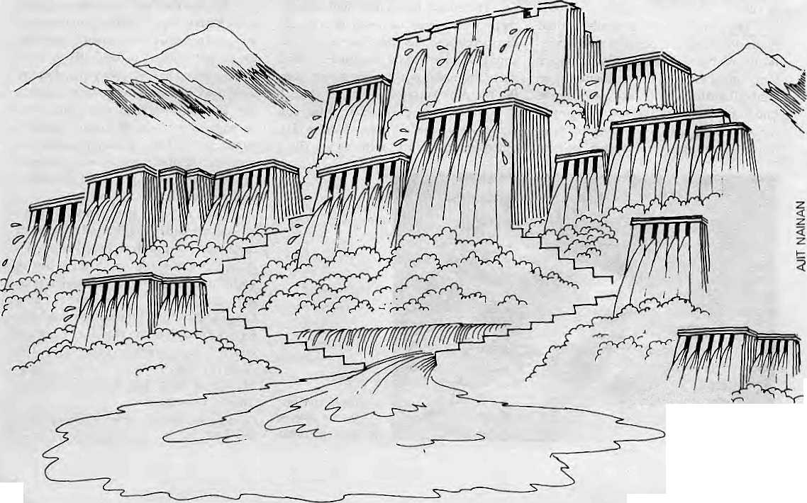
^pLu^^
iuty/Auguit 1995 HIMAL
20


.Hfmacha) Wants Gash
limited to overseas newsletters and word-of-mouth (see box,pagel9).
In the Panchayat era in Nepal not so long ago, as in Bhutan and Tibet today, it was not possible to question projects. Today, one can say that even if mistakes are made in Nepal in future, it will not be for want of discussion.
Pay Up
The moment today is in the hands of the dam busters rather than thedam builders. IBs unclear, though, thatthis is the end of the road. Those who question dams out of principle rather than just for the sake of opposition, know that there are also dams which can be built taking into account the concerns of equity, economy, seismicity, culture or environment. After having won their ground against the mindless dam builders and having made sure that the governments will listen to their arguments, these opponents, too, have the responsibility to use all their skills— and power—to help good dams be built even while preventing bad dams from getting past the drawing table.
The response to theneed for power in the modernising societies of South Asia cannot always be the refrain, "No Dams!"Thissingle-noterefrainmaynotberealistic,forthe demand for power from the fast-growing market economy of the plains is going to be too overwhelming to resist. The challenge is therefore for those who have been opposing damstosetupcriteriathatcanhelpdifferentiatebaddams from good dams.
Indeed, dams should be allowed once it is clear that they are sound economically, environmentally and in terms of seismic and other hazards. Over and above these elements, however, the principle to guide dam building in the Himalaya should be the maximising of the income to the hili people from the economic resource represented by flowing water. Neither the Centre, of whichever nation state, nor the dominant communities, can regard Himalayan waters as their birthright. The 'owners', if they are to be found anywhere, live up in the hills, and as it is they whoarequickly learning the language of the marketplace. They are realising that these rapids and waterfalls, or the height differentials on two sides of a mountain, have value. That people have ways of converting these into hydro energy which will command a price is no longer a remote concept.
The skills of opposing bad dams and judiciously supporting good dams will be vital in the decade ahead, for the liberalisation of the South Asian market is going to result in skyrocketing demand for electric power. The newly unleashed private sector power developers and government power departments are making a beeline for the Himalayan gorges, desirous of building an endless lineof power projects fromPeshawar to Aizawal.Scoresof dams are in various stages of implementation or planning along the Himalayan rim, among them Uri, Dulhasthi, Salal, Thein, Vishnuprayag, Tehri, Pancheshwor, Seti, Kamali, Kosi High, Teesta, Tipaimukh, Dihang, Subansiri and Thoubal.
For the most di rect conversion of Himalayan water into cash income, one has* to look to Him achal Pradesh. The state; which has always beena step aheacL of other h|l( regkms in dealings with the plains, recently deridfed to charge ce&son Himachiil's waters usedby the power'producing co rporatioris¹. Thi^ plan Carrie into being after theCentral Government accepted Himachal's claim m 1993 that water used ^
... Pollution Cess Act 6il9p, , ,■ ■■■ ■■■- \ ' ' ,
*
fpr every kilo liter of wafertaken from Himachali rivers in a project reservoir, the state's PollutionControl Board {HPSPCB), in Shimla, has decided to charge 4 pajsa per annuiri. While trie Himachal Pradesh State-Electricity Board ha| 4ireadj^deposited aimridred thousand rupees each for three projects that it has; the Bivakra Beas Management Board* the National Hydet Power Corporation and Punjab State Electricity Board have not paid tip. The BBMB has appealed thl HESPCB decision.
These are the::teefhmg problems of an idea whose time has come:*
:payment for flowing water'as■ aresource asifit wereoilorcoal: Arid the ■process is on. New Delhi recently issued a directive allowing each state; government to Claim 12 percent free power from projects located iri its-territory built after hily 199Q. Initself, this must be considered a major'
: concession/ but it was not good enough for Himachal/ afl bt whose power
ra II were built before 199Q, Shimla wants thfe 12 percent formula to apply to afl project in ite* territory, including Bhakra arid Pong;
With this article and with this issue Manisha Aryal leases Himal lo travel and pursue further studies overseas.
The Panes Instiiuie provided support for researching this article.
When governments build dams, their hand can be stayed by the politician's concerns for lost votes, the diplomat's strategic interests, and bureaucratic rigidities. But, when the market forces want somethingb adly enough, they usually get it. This is all the more reason for the dam opponents of today to gear up for the battles of the future. As they do so, they will have to thank those who went before them—inNarmada, Tehri and Arun in particular— for having dared to stand up when very few understood why it was they were fighting something as "innocuous" as a dam.
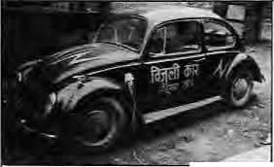
Until now, the power planners in the plains have
looked the other way when the issue of compensating the
hills came up. But no more. Increasingly, they will have to
learn tostrikecommercialdealsandpay commercial rates
if they want to use the Himalayan waters for flood control,
irrigation, power and drinking water. This, after all, is
what the market economy that everybody wants is said
to be all about. ^
Wanted
An enthusiastic and committed person to work on developing electric vehicles lor Kathmandu. Preferably an engineer wilh zeal and commitment lo clean up the Valley environment. Please contact at earliest:
Sanjib Rajbhandary. Electric Vehicle Development Group PO Box 876, Kathmandu.Tel 220773 Fax 225407 Email sanjib@mos.com.np

HIMAL July/August 1995
21

FORTHCOMING
Civilized Shamans: Buddhism in Tibetan Societies Geoffrey Samuel (Mandaia Edition is being published by arrangement with Smithsonian institution Press, Washinton DC. USA)
RECENT ARRIVALS
1. Proceedings of the International Seminar
on Anthropology of Nepal:
People, Problems and Processes Edited by Michael Allen
- Tales of Turquoise: A Pilgrimage in Dolpo Cornneille Jest
- Jhankri: Chamance de I' Himalaya (In French Language) Eric Chazot
- Nepal: An essential hand book for Trekkers
Amy R. Kaplan & Michael Keller
- A guide to the Art and Architecture of the Kathmandu Valley
Michael Hutt
- KIRTIPUR: An Urban Community in Nepal
Its People, Town Planing, Architecture and Arts
Editors Mehrdad Shokoohy and Natalie H. Shokoohy

Visit Mandaia
for
Scholarly books, maps and
guides on Tibet, Nepal, Bhutan
and the Indian Himalaya

NEPAL


MANDALA BOOK POINT
Kantipath, Post Box No.: 528, Kathmandu, Nepal. Tel + 977-1-227711 (0) 216100 (R) Fax + 00977-1-227600, 227372 Attn: Madhab

We accept

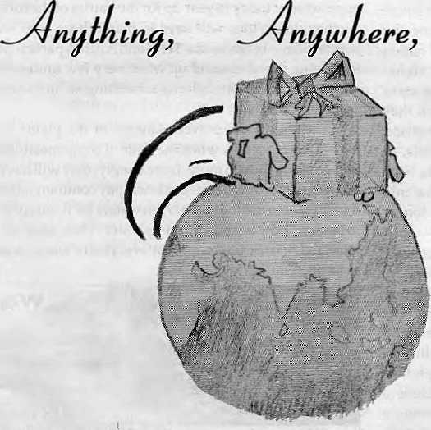

V
Overseas Cargo Service and J.P.N. Exports, Thamel, Kathmandu
P.O. Box 8621, Kathmandu. Phone: 977 1 413391 Fax: 416850

Mapping Nepal's

The changed map of Nepal, if the proposed 30 dam/ reservoir projects were to be built The dark blue patches indicate the approximate location and size of the proposed reservoirs.
by Ajaya Dixit

Water Resource

Harnessing all of Nepal's hydropower resource would require the building of about 60 run-of-river power plants and 30 reservoir/dam projects in the middle hills. The construction of the high dams and reservoirs would, among other things, require the re-drawing of the physical map of Nepal to show the large bodies of water which would become part and parcel of the Mahabharat and Churia landscape.
Seven of the 30 reservoir/dams proposed—in various studies and reports over the last four decades—would be between 50-100 meters in height; 12 would be between 100-200 m; and 11 of the 'high dams' would be of more than 200 m.
Upon completion, the 90-odd projects would generate about 145,000 GWh (giga-watt hours) of electricity annually. The energy produced would be sufficient to meet the needs of'700 million average-sized South Asian families. If one were to complete all the projects and export the energy, it would provide the Nepali state with millions of dollars revenue every year. Irrigation for millions of hectares in the Ganga plain, command area development, regional flood mitigation, and navigation would be the additional benefits.
Construction of these projects would require about five million tons of steel, 100 million cubic metres of concrete, and 1000 million cu m of "rip-rap rocks" and filler materials gouged from nearby hills and mountains. Several hundred kilo-metres of conduits would have to be tunneled through the mountainsides. (For comparison's sake.
the 60 MW Kulekhani hydropower project southwest ofKathmandu has 10 km of tunnels, and used about 70,000 cu m of concrete, 4500 tons of steel, and 3.5 million cu m of rocks and filler material.)
At current rates, about U$ 300 billion would be required to tackle these 90 projects, which cumulatively would take a total of about 500 'nation years' to complete. Kulekhani took six 'nation years' to build, and cost U$ 125 million. It generates 165 GWh of energy, which is 0.11 percent of Nepal's total potential.
Storing a total of144,000 million cu m of water, the 30 reservoirs would regulate the seasonal high discharge of the rivers into constant flows. They would also trap the bulk of the over 700 million tons of sediment transported downstream annually by Nepali rivers, eventually filling each reservoir 30 to 75 years after impoundment has begun.
When all the projects have been completed, 2200 sq km of Nepal's surface area will be under water. This translates to about 1.5 percent of the country's surface, including 20 percent of all irrigable land in the hills, besides forests, bari (unirrigated land), homesteads, and community land. At least 100,000 families (about 600,000 individuals or 3 percent of the present-day population) would have to be moved from the submergence zones.
b A. Dixit is water resource engineer and editor of the journal. Water Nepal.

HIMAL My/August 1995

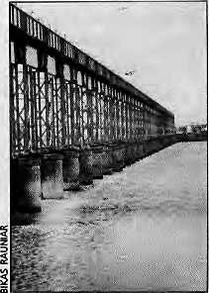
Gunning for Kosi High
There is a plan to tame the Kosi river with a high dam, and the engineers of Bihar are all for it. Nepalis and some other Biharis, however, are not so sure.
T
■ U!
The
Kosi Barrage
'he dam era in the United States is now over," were the words usedbythe United States Bureau of Reclamation in a report of May 1994. It was the Bureau, together with autonomous bodies like the Tennessee Valley Authority, thathad developed 'super dams' such as the Hoover Dam, the first of its kind which converted vast desert areas of America into productive lands. It was the success of high dam building in North America which spawned similar massive exercises in concrete and steel elsewhere in the world. Subsequently, the World Bank, the Inter-American Bank, and other lending and development agencies took the assistance of the Bureau and the TVA in proposing and financing high dams as the harbingers of development for the countries of Latin America, Africa and Asia.
Exactly a year after the era of dams was declared closed in the United States, there met in Kathma-ndu a planning group to look into the construction of the first high dam in the Nepal Himalaya. The meeting, in the first week of June, was sponsored by the Global Infrastructure Fund (GIF), an agency created by the Japanese government and business to build large infra-structural projects in developing countries. In attendance at Kathmandu 's Holiday Inn were water experts from Bangladesh, India and Nepal. Although the programme called for discussion of the "Eastern Himalayan water resource", every-one's attention was riveted on the river Kosi.
by Rajendra Dahal
As the river with the largest flow in the Himalaya a fter the Brahmaputra and Indus, combining as it does the streams of seven massive tributaries lying between Kathmandu Valley and Sikkim, it was natural for the Kosi to command attention. Indo-Chinese relationswillhavetothawsomemore before doing something on the Brahmaputra's main channel can be contemplated. Kosi therefore provides the one opportunity for those who have the money and enthusiasm to build mega projects. The unannounced agenda for the Kathmandu meeting, in fact, was to lay the groundwork for building of the Kosi High Dam. The main 'interested parties' were India (as promoter) and Japan (as investor).
Patna Desires
A group of journalists, who had toured Bihar a few weeks earlier as part of a Bihar-Nepal academic collaboration known as the "Patna Initiative" had found that Patna residents were aware of the Kosi High Dam. Now that is a structure, they all said, which will finally rid North Bihar of the sorrow visited it yearly by the Kosi, which is presently very unsatisfactorily restrained by the Kosi Barrage and associated embankments.
Patna's water engineers and water bureaucrats say there is no alternative to Kosi High. Patna's politicians have long sold North Bihar's impoverished millions promises of the brave new world that will open up after the Kosi is finally tied up behind the high dam. The arguments are especially strident at election time.
The water experts and bureaucrats of Patna are firm in their belief that the Kathmandu government is blocking progress on the Kosi High Dam. At the Irrigation Department Headquarters in Patna on 26 April, Chief Engineer Parmeswar Prasad Sinha urged the Nepali journalists to inform the Nepali public about the importance and advantages of the high dam project. The Patna belief was that the high dam could do no wrong: itwould provide eternal peace and prosperity to Bihar without harming anyone else's interests.
This was also the refrain of each and every Patna professor, politician, journalist, and civil servant—other than one senior bureaucrat who asked that his identity not be disclosed because it would not do to live and work in Patna and yetbe openly sceptical of the promises of Kosi High.
While the demand for Kosi High rolled off the Bihari tongues as easily as one bites into fresh paan, the questioning Nepali journalists found that these vehement proponents had actually done little homework on the technical aspects of their favourite future project. Carried away by the populist political advantages and career prospects th at the project represented, and relying solely on easy assurances coming from the direction of New Delhi, the Biharis were unable to respond to detailed queries on economic feasibility, seismicity, sedimentation and alternatives. Independent of the merits of the project, it was clear that Bihar's enthusiastic embrace of the Kosi High Dam was based on political and professional expediency rather than a clear appreciation of all aspects of a project as big and as important.
River and Dam
The Sapta Kosi, made up of seven kosis (the word is often used synonymously for 'river' in East Nepal), is the larges t Himalayan river to descend to the plains between the Brahmaputra and the Indus. The Ganga's flow becomes larger than the Kosi's only when it collects the waters of several Himalayan tributaries in the plains.

24
July/August 7995 HIMAL

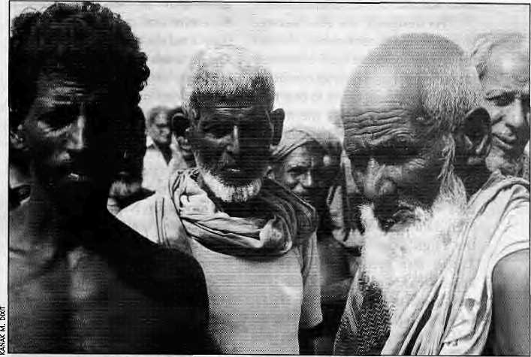
The Kosi's water come from as far away east as the Panch Pokhari area northwest of Kathmandu Valley, and the southern watershed of Kanchen-junga to the east. Northwards, the main stem, that of the Arun, emerges from deep within Tibet.
From the upper reaches north of the Himalayan divide to Kursela in Bihar where it meets the Ganga, the Kosi travels 720 kilometres. The Kosi watershed covers an area of 72,538 sq km, out of which 41,333 sq km falls within Nepal. The river carries about 50 billion cubic meters of water into the Ganga every year. The flow at Chatara where it emerges from the mountains is 1730 cubic metres per second during the rains and 280 cumecs in winter. According to one estimate, the river conveys on average of 119 million cu m of Himalayan sediment down to the Ganga every year. Altogether, the entire Kosi system has the potential of producing 10,860 megawatts of electricity.
For good reason, the Biharis know Kosi as "the river of sorrow". As the flow of this Himalayan river slackens when it reaches the Bihar plain, part of its massive silt load settles down. The riverbed rises, which forces the channel to shift its course. This is the reason why the Kosi has been historically wayward, once upon a time having flowed all the way eas t-wa rd to join up with the Brahmap utra. Over the course of the last 200 years, the river has shifted in a 114 km arc westwards, away from today's Purnea townand towards Saharsa.Since 1954, the river has been 'tamed', even if temporarily—bound within 125 km long e mbankments builtaspartofthe Kosi Barrage project which goes nearly all the way to the Ganga at Kursela.
The Kosi High Dam is the engineer's answer to the river's unpredictability and potential to devastate. Itis regarded as the brainchild of A.N. Khosla, one-time Chairman of the Central Water Commission. Even as the Second World War ended, the Bihar Government put forward a IRs lOOmillionprojectwhosegoalwasto guide the Kosi from where it emerges
at Chatara all the way to Kursela by confining it between high embankments three kilometres apart. This plan was shot down by Khosla, who scoffed at the idea that a river like the Kosi could ever be tamed by embankments alone. Instead, he suggested building a high dam, and himself led the first field survey to the area. The team, made up of 10 members, including two Nepalis, arrived in the Kosi hills in January 1946.
Forty years after the Khosla's team studied the site, on the basis of its work the Central Water Commis-
sion prepared the High Dam Feasibility Study Report in 1981. That report itself is already 15 years old. The Feasibility Study proposed a dam of 269 m height on the Kosi gorge at a site eight kilometres above Chatara, where the river enters the plains. (The site was moved slightly upstream so as to save the Baraha Chetra pilgrimage site from submersion.) The project would yield 3000 MW of electricity and irrigate 1.5 million hectares. It would hold back the monsoon floods and regulate the flow, while at the same time keep the sediment from reaching the plains, thus making the river more predictable. The proposal also calls for a conservation programme for the entire Kosi watershed to reduce erosion and runoff.
The high dam, which would be
double the height of Kathmandu's Dharara tower, will create a reservoir of 256 sq km area up along the valleys of the Tamur, Arun and Sunkosi from where they meet at Tribeni (see page 23). Occupyingabouthalftheareaof Kathmandu Valley, this reservoir would have a capacity {before sediment starts collecting) ofl3.45 billion cu m, holding back about a fourth of the river's annual discharge. The impoundment would be 180 times larger than Indra Sarovar of the Kulekhani, the only reservoir project in Nepal.
India, Nepal and Bihar
The first Indo-Nepal discussions on the Kosi High Dam were held 49 years ago in Kathmandu, at which time Nepal had actually given the green signal to the Indian side. While India subsequently took the position that it was Nepal which has consistently blocked progress of the project, it is clear from available information that back then it was New Delhi which backed out, due to the high cost of the project. Originally estimated at about IRs 1 billion, the planners decided to give the project up after calculations showed the cost would come to IRs 1.77 billion.
Unwilling to make the effort to raise the money for the high dam. New Delhi began to set up one committee after another, slowly
Living
with the
Hood.
Bihar's
villagers
who live
within the
Kosi
embankment.

HIMAL lulylAugustmS
25

Kosi High's weeding out the diehard proponents
primary of the high dam. After a decade of
benifit to dilly dallying, thehighdarnproposal
Nepal would got converted to one for the Kosi
be from Barrage.InordertoundercutKhosla's
electricity recommendation, the Government
sales and not used his colleague in theCentral Water
from Commission, K.L. Rao, to argue that,
irrigation or a5withtheHwangHo,theanswerto flood control. the Kosi's woes lay in embankments. Rao was used successfully by New Delhibureaucrats to undercut Khosla, but to this day Bihar's engineering fraternity maintain that the Rao's barrage was meant only to complement Khosla's dam, not to replace it. As designed, the Kosi Barrage was expected to confine and channel the river's sediment load effectively for no more than a quarter century— the apparent plan being to buy time with the barrage while the money was found to build the expensive dam. As it happened, the Indian side let the official lifespan of the Barrage to run out complete before it woke up—in 1981—to the need to brush up the high dam proposal. This was when the High Dam Feasibility Study Report was prepared. It does not appear that Nepal was consulted or involved in preparation of this study, whereas Nepalis had been part of the original field team back in 1946. The 1981 report put the estimated cost of the high dam at IRs 40.74 billion.
Because Kosi is primarily a
Nepali river and because the high
dam would be built well within Nepali
territory, the need to involve Kath-
mandu right from the initial dis-
The Kosi cussions is obvious. In the days after
with Baraha Chetra the Kosi Agreement of 1954 on the
in background. building of the Kosi Barrage, Nepali
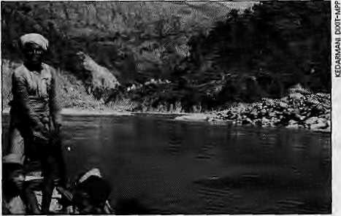
ardour for adventure with India on the Kosi—including a high d am—had ebbed considerably. One reason is that theBarrageiswidely believed in Kath-mandu to have failed to deliver promised benefits to Nepal in terms of irrigation and power generation. While New Delhi has for the last decade and half constantly pushed for the Kosi High Dam, enthusiasm is distinctly lacking among most Nepali planners and engineers.
The KosiBasin Master Plan, prepared by the Japan International Cooperation Agency QICA) for the Nepali government in 1985 and looking at the entire Kosi catchment area, also supported the concept of ahigh dam. The Japanese proposed a dam of 239 m height and their estimate for the project was more than double the Indian estimate ofl981, at U$ 2.77bill-ion in 1985 prices. The Master Plan differs from the Indian feasibility study in its support for the sma-ller Sunkosi Diversion Scheme, a proposal put forward by Nepal's Irrigation Sector Master Plan Study of 1972. An idea that was first put forward by American geologist F. A. Nicklewhen hecamewiththeKhoslateaminl947, the Sunkosi Diversion today constitutes a major element in Nepali demands in the Kosi negotiations.
The Sunkosi is a major tributary of the Kosi that travels in an east-west direction through much of eastern Nepal with only a ridge of the Maha-bharat separating it from the plains to the south. The diversion scheme would build al6.6km tunnel through this ridge from a point known as Kuruley, and drop the Sunkosi waters into the headwaters of the Kamala River. In the process, 93 MW would be generated and 175,000 ha of land irrigated in the tarai districts of Siraha, Sarlahi, Dhanush a, Rautahat and Ba ra. Always having been saddled with barrages at the border from where the natural slopes take irrigation channels away from Nepali territory, the attraction of the Sunkosi diversion to Kathmandu planners is obvious.
The Sunkosi Diversion does not hold much charm for the Indian side,
however, which would rather control floods in North Bihar with the High Dam than irrigate the Nepali tarai. The JICA proposal was for reducing the Kosi High's height in order to keep the intake point at Kuruley from getting submerged.
The Nepali side has a strong p ro-moter of the Kosi High in the person of Ananda Bahadur Thapa, thepresent Director of Government's Water and Energy Commission Secretariat. While he supports the Kosi Diversion, Thapa believes that the height of the dam should notbereduced."Infact,it should be increased to 350 metres or higher so that there are advantages in terms of power generation, irrigation and flood control." Thapa also believes in the navigation benefits to Nepal and Bihar, both of which are landlocked. "At an. additional cost of just three percent of the total project, it will be possible to build a 165 km-long canal from Chatara down to the Ganga. This will make it possible to lift cargo from as far away as Haldia and Calcutta ports."
Thapa belie ves that the Kosi High Dam will have a catalytic effect on the economies of Bihar and Nepal, both of which will ultimately have to sink or swim together. Thapa's views can alsobesaid to reflect the policy of His Majesty's Government. The Inception Report prepared by Kathmandu for the ongoing consultations with New Delhi calls for both the Sunkosi Diversion and the Kosi Waterway.
Rajiv to Rao
During the 30 years that Kosi High Dam was in the backburner, Nepal had turned its attention and resources to Pancheswor and Karnali projects, the former to be built on the Mahakali river along the western border. On Karnali, Nepal spent about NRs 1 billion of its own money for an international study. India went along while the study was being conducted, but ultimately withdrew itssupport from Karnali citing various objections it had, including lack of flood control and irrigation benefits, and that the power house would not be under

July/August 1995 HIMAL

p\"H i't' 1,1 ... ^ ;
Nepal's
Deputy Prime
Minister Madhav
Kumar Nepal
addressing
inaugural function
of GIF-sponsored
conference
which discussed
Kosi High.
Indian control. Nepali negotiators insisted on doing Karnali first, to be followed by Pancheswor and Kosi High, whereas the Indian officials wanted Kosi before any of the others.
For nearly three decades, the Nepal-India talks on the Kosi had led nowhere. The High Dam came back into the picture in 1991 when then-Prime Minister Girija Prasad Koirala agreed to New Delhi's proposal for a joint study. The Indian side had earlier chosen to regard Nepal's proposal on the Sunkosi Diversion and the Kosi Waterway as preconditions for the talks, but it was now more amenable. With the political leadership having passed from Rajiv Gandhi to P.V. Narasimha Rao, there seemed to be a change of heart. Rao agreed during hisl992visitto Kathmandu to includ e Kosi navigation in the discussions. In December 1993, Indian Water Resources Minister Vid y a Charan Shukla agreed that any exercise on utilising theKosiwatersmustgive first priority to Nepal's water needs. Finally, the Indian willingness to consider the Sunkosi Diversion was conveyed to Kathmandu only a few months ago.
Cold Warriors
The lack of progress that havemarked the Kosi negotiations for nearly half a century could be ascribed to the undeclared cold war between Kathmandu and New Delhi. By the same token, the recent movement in negotiation may be put at the door of the change in leadership in India and a new political regime in Nepal. It is clear that there wouldhavebeen even less progress had matters been left entirely in the hands of government bureaucrats. Nepali officials, even today, suffer lackof expertise, and show extreme timidity. In India, even though the last Himalayan war was in 1962, South Block bureaucrats continue to look at Himalayan projects from astrategic rather than economic and humanitarian perspective. Take, for example, the issue on how to u tilise the electricity to be generated by the Kosi High Dam.
The Indian side has made it clear that India does not plan to base its power planning on the Kosi High Dam's energy output. The millions of units tobeproducedwillsupposedly play only a supplementary role to India'sprimarysourcesof power. No matter how reliable, cheap and abundant, India refuses to make the Kosi dam's electricity output a mainstay of its grid for North India, which would be the obvious thing to do from a purely economic perspective.
This position of New Delhi's is regarded in Kathmandu with displeasure, if not suspicion. Kosi High's primary benefit to Nepal would be from electricity sales and not from irrigation or flood control, and India's unwillingness to give primacy to the High Dam in its power planning obviouslymeansthatitdoes not plan to pay the price Nepal expects.
Adding 3000 MW of power into Bihar's power grid would certainly increase the state's {and thereby India's) reliance on a dam in Nepali territory. It is likely that the Indian negotiators would have set morereliance on the high dam were they in a position to control its running, like they do the Kosi and the Gandak barrages.
Speaking of economics, Nepal wants that in costing the benefits from Kosi High, the auditors should calculate the advantages other than electricity and irrigation, including flood control and the advantages of regulated waters. Nepal's Inception Report argues that as things stand India will share in all the benefits of the Kosi High, while ill effects would all be Nepal's to suffer. White thousands of hectares will be submerged in Nepal, Bihar will be able to reclaim vast stretches due to regulation of the flood waters.
Taking advantage of the Indian recalci trance on thispoint, the Nepali side has been quick to try to drag New Delhi negotiators back to the KarnaJi. The argument runs thus: if you want to consider only irrigation and electricity benefits and do not regard flood control as a tangible benefit of
Kosi High, why go for this project when the Karnali (Chisapani} dam is so much more attractive? The height of the Chisapani dam, at 270 m, is the same as that of Kosi High, but you are able to collect three time as much water in the reservoir, generate three times more electricity, and irrigate three times the area. However, the Indian side has not bought the argument.
Buddhijibi vs. Activist
The engineers of the Bihar Irrigation Department, the professors and politicians or Patna are all Kosi High fans. In discussion withNepalis, the Bihar officials invariably divert conversations towards the need for the Kosi High Dam, at which point they become animated. However, the level of ignorance among those who argue so vociferously for the dam is astounding. The engineers see no prob lems with the fact that the high sediment-carrying capacity of the Kosi would severely cut short the life span of the reservoir. Wh a t would you do 40 years from now if the reservoir were to fill up completely? "Oh, then we would build another high dam," said one senior official nonchalantly.
Within hearingofadozensenior water officials at the Department of Irrigation's meeting room in Patna, one engineer maintained that many check dams should be built in the entire Kosi catchment to block the sediments from getting to the main reservoir. "These small dams will trap the sediments and make the moun-tainslopes lesssevere, and hence there will be less erosion," he said, to an agreeable silence all around.
Similarly, the water experts of Bihar had nothing to say about the devastation Bihar's millions might face if there were tobe a dam break in this seismic zone of the Himalaya. As for learning to live with floods, which is one of the major points of discus-

HIMAL July/August 1995
27

In case of a
great flood-related disaster in Bihar, the political pressure on the Indian Government to do
something would be unprecedented.
sion in Bangladesh today, nothing could be further from the interests of bureaucrats and politicians. Similarly, no one is willing to talk of alternatives to Kosi High, such as the proposal that the Kosi's flood waters be guided through its five or six former channels. This would diffuse the floodwaters in the plains without having to back them up with a barrage or dam.
If the situation among the Patna buddhijibi who want the dam, and want it now, is marked by disinterest on the key details, in the Kosi floodplain of North Bihar, however, the questioning seems to have begun. This is particularly true in the region that falls under the "command area" of the eastern canal of the Kosi Barrage. In and around the towns of Saharsa, Purnea, Katihar and other towns, one hears a different tune than that which is heard in Patna meeting halls.
Ranjeev, who as a member of the Ganga Mukti Andolan helped organise the fisherfolk of the Ganga, is sceptical of the promises made on the Kosi High Dam. The activist, who runs the Jayaprabha Research Centre in Madhupur, says, "All those who have suffered from the Kosi Barrage are going to oppose the KosiHighDam." Asked how this will happen, he replies staunchly, "We will. The dam is a conspiracy hatched bythosewhodonotcarefor the people of North Bihar."
Ranjeev (who uses no surname) and his associates—journalists, teachers, scholars—maintain that the Kosi Barrage has brought more sorrow to the command area inhabitants than benefits. They do not believe promises of technical fixes and largesse from dams, and are convinced that Biharis should learn to live with floods rather than go for ever-more grandiose schemes whose fallout is unclear andlikely to be negative forthepopu-lation of the immediate plains.
Technological Neanderthals
How could anyone be against a dam, one which delivers electricity, irrigates land, controls floods, and pro-
vides navigation. That mega projects can invite mega problems rather than solutions is something that politicians and bureaucrats are inherently loathe to accept. The former is programmed to look only as far as the next elections, and the first concern of off icials is expanding their feif doms and strengthening their career ladders. The volume of money involved and the power one will enjoy, as well as the kickbacks that are part and parcel of building a large project, are further elements that make supporters of big dams so vehement. It is so easy to dismiss all those who would raise a cautionary finger as technological neanderthals, as anti-development cranks.
In defence of the Kosi High Dam, it has been said that "big problems require big solutions". This was also the argument of Mao Zedong in the 1960s, when he was ordering his cadres to control the Hwang Ho. Mao directed the building of a series of dams on the river, one of which was the Sanmenxia Gorge Dam Project, which uprooted three hundred thousand people. Soviet engineers had predicted a life span of 50 years for the dam, but within two years the Sanmenxia Reservoir was all silted over, such was the volume of sedimentation of the Hwang Ho. The 106 m high dam had to be dynamited.
Closer to home, the Kulekhani reservoir has had its life span drastically reduced (it issaid from 100 years to 15) mostly due to one extended cloud burst in the surrounding Mahabharat hills in July 1993. None of these examples, plus examples of recent cloud-bursts in the Kosi hills of eastern Nepal, seem to have made a dent on the Bihar engineers' convictions as far as the Kosi High Dam is concerned.
The Feasibility Study Report predicts that the reservoir will fill up in a hundred years, but it is more than likely that the reservoir could be an albatross within 25 to 50 years. When that happens, what is to be done with the flood problem, and what is one to do with the huge silt basin that will
have been created behind the dam? This issue is yet to be discussed by anyone. While the entire opposition to the Tehri project seem to revolve around the issue of seismicity, it is enigmatic, to say the least, that it is hardly mentioned as part of the Kosi High discussions.
It is possible that due to the high profile opposition to the Narmada and Tehri projects in India, and the West's changing attitude towards high dams, lending agencies like the World Bank would be reluctant to fund a project like Kosi High, which would mean that the project would be limited for the m om ent to the draw-ing board.
On the other hand, if there is a great flood-related disaster in Bihar, such as if the Kosi were to jump its embankments, the political pressure on the Indian Government to do something would be unprecedented. At that point, whichever government is in power in Kathmandu would not be able to withstand New Delhi's pressures, and work on the Kosi High Dam would most likely begin. At that point, Kathmandu's preference for Pancheswor or Karnali, geologists' concerns with seismicity, activists' concerns with social issues, and the planners preference for run-of-river projects would all be moot. The Kosi Barrage was built on the rebound as the Government of India felt the pressure after a massive and "historic" flood devastated Bihar on 23 August 1954. Similarly, might another similarly historic catastrophe force the Nepali and Indian government into constructing a Kosi High Dam, whether or not it is feasible, or desirable?
It is in the interest of both Bihar and Nepal to discuss, debate and decide on whether or not to go ahead withKosiHigh at a time when political and populist pressures are still manageable. A decision that is pushed as a reaction to disaster might not be in the interest of either side, leas t of all the people of Nepal and Bihar.
R. Datial is a journalist w'rth the Deshantar weekly and has been following water Issues closely since 1989.

28
July/August 1995 HIMAL

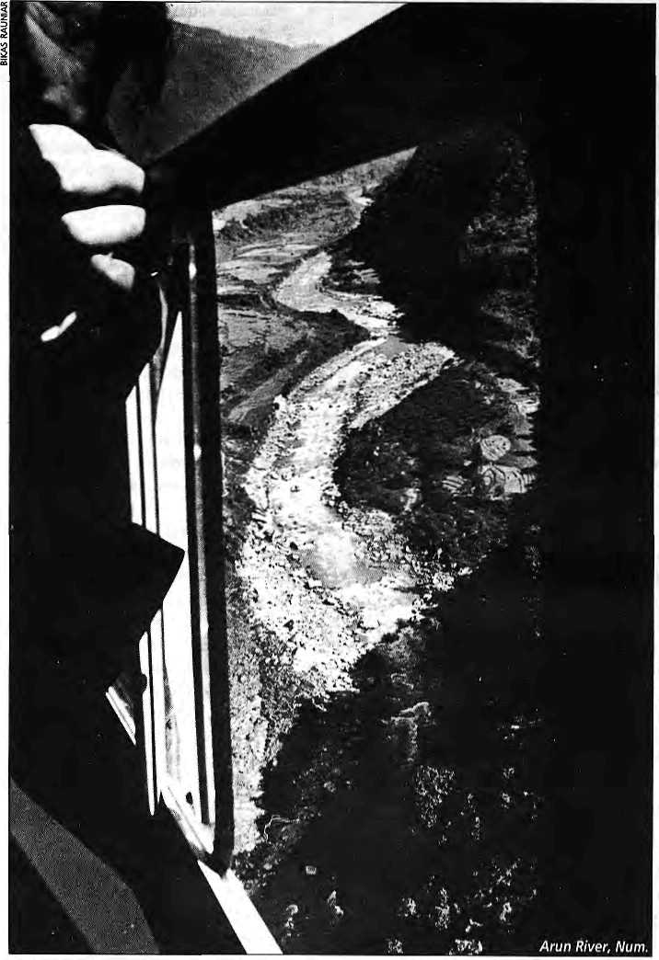
Because It Is There
Foreign Money, Foreign Advice and Arun III
The Arun project has been in gestation for eight years and will take another eight years to build,
if and when approved. Better to build a basket of smaller schemes throughout Nepal, to produce the same amount of power in the same number of years.
by Bikash Pandey

T
he debate swirling around the Arun III project has been the first controversy about a major development project in Nepal. The democratic changes of 1990 allowed the public to speak up on matters on which they had remained silent for decades, and this dam project planned for the Arun Kosi river in east Nepal provided the first opportunity for
those who were concerned enough to question the mistaken developmental path that had led to a project such as this.
Since 1987, this one project has become synonymous with hydro-power development in Nepal, as the government and donor agencies seemingly want to consider nothing else. Conceptualised as a 402 mega-
watt project at the outset, for a site known as Arun III (third of the six sites initially identified in the Arun Valley), the Nepali Government decided in 1992 to proceed with the first half of Arun III, to provide 201MW of power. The final decision on funding this oversized "Baby Arun" has yet to be taken by the donors.
Internationally, the Arun oppo-

H1MAL July/August 7995

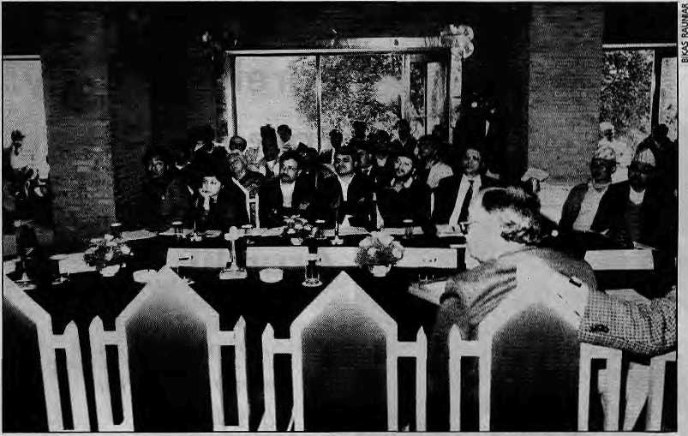
Empty chairs at the public hearing.
The Arun controversy is not about opposing dams as much as it is about how foreign aid defines development priorities of aid-dependent countries like Nepal.
sition distinguishes itself by being a dam protest with a difference: clear alternatives have been presented that no one has been able to dismiss. In f ac t, the Arun controversy is not ab out opposing dams as much as it is about ho w forei gn aid defines development priorities of aid-dependent countries like Nepal. It is about the condition-alities countries like Nepal must submit to in order to receive aid, and about how these conditions can inhibit real development of the country. The criteria being used by its critics to assess Arun will in future be used for other areas of development and foreign aid-giving in Nepal. In this sense, some new ground has been broken by the opposition.
Constitutional Guarantee
The first public attempt to question the Arun project was at a hearing organised in February 1993 at Hotel Kathmandu by the Nepal Forum of Environmental Journalists (NEFEJ) and ten other organisations. "In keeping with the healthy democratic atmosphere prevailing in Nepal, the promises of the Constitution both on the right to development and the right to information, as well as the exceptional dimensions of Arun III itself, it is appropriate that the project be discussed and debated openly with rel-
evant information at hand," stated the organisers of the public hearing.
Apanel of experts had questions ready for the officials invited, ranging from the environmental safeguards being followed to how equity was going to be ensured in rehabilitation. The hundred or so lay persons who attended wanted answers on why hydropower was so expensive in Nepal compared to neighbouring Bhutan, India and China; why all of rural Nepal must bear the burden of providing electricity to urban dwellers; and why Nepali engineers seemed incapable of developing small hydropower plants as a substitute to perpetual dependence on international contractors.
Only the representatives of the Nepal Electricity Authority (NEA) arrived to take their seats at the podium, and their answers were limited to technicalities of the project. There was no one to respond to questions on the issues of national hydropower policy, as the chairs set aside for officials of the National Planning Commission, the Ministry of Water Resources, and the Ministry of Finance remained empty.
Judging that the main problem lay in the absence of a coherent hydropower policy in the country, with the result that no serious thought
would be given to smaller alternatives when a project like Arun was proposed, a group of Nepali professionals, some of whom had met for the first time at the February hearing, formed a group the following month called the Alliance for Energy.
In a series of white papers and newsletters over the next two years, the Alliance put forward its concerns regarding the high cost of energy from the Arun project, highlighted the risks to the national economy from investing in a single overwhelmingly large project, andlaid out what it called the "alternative approach" to Nepali hydropower development.
Towards the end of 1993, the Arun Concerned Group, a coalition of human rights organisations, which included activists from the Arun river valley, was formed. One of the first actions of the Group was to file a case with the Supreme Court demanding information from the Ministry of Water Resources andNEAontheArun project. In a ruling that will no doubt set a precedent for development debates of the future, the Court ruled that the Nepali public had a right to be fully informed about the details of development projects. I£ directed the government to make available to those who made the request a list of all the documents on the project. Only thereafter could it declare which documents were classified and could not be given out.
The World Bank
As the lead donor organisation in Nepal's power sector, the World Bank has been the project's chief defender. The Alliance first encountered the 'donors' in the form of the Bank's Appraisal Mission for the Arun project at a stormy meeting in the Bank's Kathmandu office in May 1993. The Asian Development Bank (ADB) and the German Bank of Reconstruction (KfW) were also represented in the Mission, whose job was to collect information and appraise the latest developments on Arun. The members' attitude was thatthey would be happy to listen to alternatives the Alliance

30
JulylAugust 1995 HIMAL


NEPAL 4 TIBET PHILATELIC STUDY CIRCLE
International, non-profit society devoted to the study of the stamps and postal history of Bhutan, Nepal, Tibet and related areas. Membership includes the Postal Himal - our quarterly journal. Please contact: Roger Skinner, 102D Couington Road, Los Altos, Cfi 94024 U.S.A.
might present but it was not their job to answer criticisms on Arun III. The government of Nepal must do that.
After hearing the presentation on alternatives, Donal O'Leary, leader of the Mission and the Bank's Task Manager for Arun who had chaperoned the project from the start, argued that there were not enough feasible small schemes in Nepal to produce the power of Arun, and certainly none were studied in enough detail to come on line before Arun. Secondly, he argued that capability within Nepal was limited and what was there could not be built up fast enough to supply Nepal's power requirements. NEA, O'Leary argued, did not have enough capable experts to be spread over a number of construction sites, and involving the private sector would only increase the cost of energy for the Nepali consumer, as it would have to take loans at commercial rates and also plan to make a profit.
The Investment Planfor the NEA prepared in May 1993 with approval from the World Bank had Baby Arun coming on line in 2002, with over 100 MWofdiesel-generatedp o wer filling the rising demand during the interim nine years. O'Leary's Mission defended this Plan as the most cost effective solution for power generation in Nepal, as also verified by the Least Cost Generation and Expansion Plan (LCGEP), an earlier exercise sponsored by the Bank which concluded that Arun provided the least cost energy addition to Nepal's grid.
The Mission members were forthright in stating that arranging financing for one large 200 MW project was a lot less work for them than arranging financing of a basket of ten 20 MW projects, which would mean ten funding packages, ten panels of experts, ten detailed feasibility studies, and as many contractors. They argued that it takes six years to complete studies and to arrange funding for any hydropower project no matter what its size and four more years to construct it, thus there was little point in looking at small schemes.
With Nepal's annual power requirement growing at around 25 MW per year, clearly, schemes of smaller than 200 MW capacity wereof little interest to the appraisal team.
Interestingly, when the Appraisal Mission returned to Kath-mandu for its next visit in September 1993, they had made one significant addition to the NEA Investment Plan. The new plan had the 100 MW (first phase) of the Kali Gandaki 'A' project coming on line in the year 2000, two years before Arun. It also acknowledged that Khimti (60 MW) and Modi Khola {14 MW) in the private sector would be on line before Arun III. This modified Investment Plan was based on a revised projection of annual growth in power demand from eight percent to ten percent. This represented amajor reversal from a position the Bank had held as recently as May that no other hydropower scheme would be able to come on line before Arun. However, by notching up the growth rate of demand. Kali Gandaki, KhimtiandModi were no w presented as complementing Arun, rather than as alternatives.
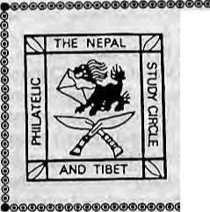
The Arun opposition's dialogue with the Bank culminated in a meeting chaired by Joe Wood, Vice President for the South Asia Region, atthe Bank's Headquarters in Washington DC on 28 June 1994. The meeting concentrated on the issues of alternatives to Arun, environmental mitigation and social equity issues and, finally, access to information and public participation. At the end of the day. Wood promised to take into account the issues raisedby the NGOs. Thereafter, the NGOs also met with the major Executive Directors of the Bank, who are the ones that actually vote on
projects once they are brought to the Board by the Bank management.
The Staff Appraisal Report which was presented by the South Asia Region office at the end of August 1994 was disappointing. Wood's office had merely used the NGOs' reasonings to polish its own arguments and had not made any change in the strategy and investment plan of hydropower schemes for Nepal.
While in Washington DC, the NGOs also met and challenged Richard Stern, Director of the Bank's Department of Energy and Industry, on the Bank's LCGEP exercise. It was Stern's department which had provided the professional input to the South Asia office in analysing the best power investment for Nepal. It emerged that the Bank had actually done an internal comparative study in the summer of 1993 to compare costs of two plans, known as Plan A and Plan B. Plan A represented the investment plan asitstoodwithBaby Arun coming on line in2002_{r} and Plan B looked at a basket of six schemes in the 30 MW to 80 MW range supplying power to the grid till the year 2010, when Arun would come on line.
Evidently, the comparison was not at all conclusive, showing that in a high grow th scenario, Plan A wou Id be five percent cheaper for the country and in a low growth scenario. Plan B would be cheaper by the same amount; and this too after an arbitrary 20 to 40 percent cost addition was made to the smaller schemes to account for the "uncertainty" of less detailed studies. In May 1993, the Bank had favoured the lower (eight per-

HIMAL JutylAugust 1995
31

"The terms of funding are too good to turn down. We cannot let go of the bird in hand in anticipation of two in the bush."
Ram Sharan Mshat
cent) demand growth scenario which would have proved Plan B was cheaper, but by September it had accepted the high growth (ten percent) scenario, which meant an immediate construction schedule for Arun.
Director Stern conceded to the Nepali NGO representatives that "to the limit of economic and scientific analysis my department is not able to recommend one plan over the other." So what did then determine which Plan the World Bank is finally prepared to fund for Nepal? Said Stem: "Government of Nepal's strong commitment to the (Arun) project is the determining factor for the Bank's support".
Inspection Panel
Upon their return from Washington DC, the Arun Concerned Group filed the first-ever case with the Inspection Panel of the World Bank on 24 October 1994. The Panel is an independent body, newly established by the Executive Directors of the Bank, to investigate claims from people affected by the Bank funded projects on whether the Bank Management has followed its own Operational Directives and Policies.
The ACG claim cited violations, in the Bank's preparations of Arun III, of the Bank's Operational Directives and Policies on Environmental Assessment, Indigenous Peoples, Involuntary Resettlement, Disclosure of Information, and Economic Evalua-
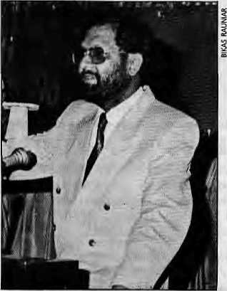
tion of Investment (Alternatives). Unfortunately, the Executive Directors clipped the wings of the Panel by limiting its inquiry to only the first three directives. The Bank's policy on disclosure of information, the Directors claimed, was evolving so quickly that it was difficult to judge violations; on the question of inadequate analysis of alternatives, they passed judgement that "the most appropriate alternative is ultimately a matter of judgement as to when enough information is available to make a prudent decision."
By not including the issue of alternatives in the authorisation of investigation by the Inspection Panel, the Executive Directors side-stepped theneed to inquire into whether Arun represented the best investment in the power sector for Nepal.
The Panel finished its report and submitted it to the Executive Directors on 21 June. The report is said to be critical of the Nepali government's progress so far on rehabilitation and involuntary resettlement of those displaced by the access road to the dam site. According to reports, the inspectors have also criticised the Bank itself, for having failed to follow its own policy on resettlement by not supervising this component. The issue of alternative economic analysis, being kept out of the ambit of investigations, was left untouched by the panel.
The Bank management is now expected to pressurize the government of Nepal to take action on the issues of environmental mitigation and rehabilitation pointed out by the Inspection Panel so that the project can be taken to the Board of Executive Directors for approval sometime in October 1995.
All Those In Favour Ram Saran Maha t, the Vice Chairman of the National Planning Commission under the Congress government till October 1994 and arguably its loudest development ideologue, puts forward most clearly the position of those in Nepal who supp ort the Arun project
in its present configuration. His arguments are as follows:
International experts say this is best for us. All aspects of the Arun project have been studied to the greatest detail by renowned international experts who have found the project to be sound on account of risk from glacial lake outburst floods, environmental issues, affordability, and 'crowding out' of other sectors. Arun provides the least cost energy for Nepal. The Bank's LCGEP studies in 1987, 1990 and 1994 have all confirmed this.
We need big power projects. Nepal has no choice but to develop large projects if it wants to supply urban centres, promote industrialisation, and export power. We cannot wait 50 years for Nepali capability to be built so that it can construct the large schemes we need today.
Money from donors is available. International sources have committed money for Arun and this money is not transferabletootherprojects, as alternatives have not been studied. Banks provide money on a project-by-project basis and do not give chunks of money to countries to spend at will. Donors are prepared to fund this project, we cannot afford to lose the funding by asking a lot of questions on the project and proposing alternatives that are only theoretical. Endless protests by NGOs and the arrivalof newly elected governments that want to review the project again and again might well result in 'donor fatigue'. Eighty percent of the funding of the project is in grant form and does not need to be returned. The terms of funding are too good to turn down. We cannot let go of the bird in hand in anticipation of two in the bush.
Across the political spectrum, similar sentiments continue to be heard. The Left government, while it did come to power full of scepticism about the project's appropriateness, has quickly joined the ranks of those who see no alternative to Arun. Prime Minister Man Mohan Adhikari reportedly said recently in Copenhagen: "The donors are ready to fund

32
July/August 1995 HIMAL

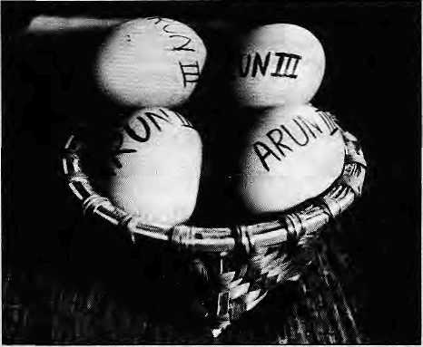
this project. We will proceed with it. We do not have a lot of choices." Pashupati SJB Rana of the Rastriya Prjatantra Party, a Minister for Water Resources under the Panchayat, has stated from a number of public platforms: "One has to think big to make progress in this world. If Prithvi Narayan had not thought big where would Nepal be today? We would do Karnali if we could get funding for it."
Neo-Gandhians of Nepal
Thearguments of Mahat and his peers are quite coherent in themselves, and the dominant developmental culture finds them convincing if not compelling. It would be surprising if this were not so. After all, in Nepal, these same arguments—use foreign aid because it is there, ask the foreign consultant, do not ask the locals— have been used in almost 40 years of development to justify projects as diverse as the Prithvi Highway, the Marsyangdi Hydroelectric Project, the Narayani Lift Irrigation, and the Karnali Bridge.
Except for persons such as Devendra Raj Panday, former Finance Secretary and subsequently Finance Minister in the hiatus after the people's movement of 1990 (see "The Enigma of Aid", Himal Mar/Apr 1992), few Nepalis in or out of government have questioned the debilitating impact that foreign aid has had on the country's progress or asked if the prevailing aid and development paradigm can be challenged in favour of one that benefits Nepal more.
The Arun debate represents the first instance where the challenge is specific and asks the question, "Does Baby Arun in its present form represent the best use of aid money for the development of hydropower in the co«nrn/?"Thecontroversy challenges all political parties to look within themselves, to go back to their defining ideologies, and to provide answers on the path of hydropower development the country should follow—the prevailing approach or the "alternativeapproach".
When asked if the Arun project was not contrary to the Nepali Congress Party's ideology, which was Gandhian and in line with E.F. Schumacher's SmallisBeautiful,Maha\. clarified, "My leader B.P. Koirala believed in a Gandhian economy. I disagreed with him and have consistently argued that in today's world we will isolate ourselves with a Gandhian economy." As if to stress the point, the Ministry of Water Resources sent a fax on 8 February 1994 threatening to close down the Kathmandu office of the Intermediate Technology Development Group (founded by Schumacher in 1965), for suggesting to donors that they support small and medium hydro alternatives in place of the Arun project.
The Eggs in the Basket
The arguments against the project are that Arun puts the country in grave economicrisk,andthatthecondition-alities are unacceptably severe and restrictive.
Risk to the social sector. Martin Karcher, former Division Chief for Population and Human Resources in the Bank's South Asia Region office resigned from the World Bank after 29 years of service because he objected to the Bank's handling of Arun. He makes the following point: a large project like Arun only starts to produce power once it is 100 percent finished. A 90 perce nt completed project still produces no power. Imagine a scenario where in the stipulated eight years of construction the project might be 75 percent complete and have a 20 percent cost overrun (not an unusual situation, as Bank records show that 40 percent of the Bank funded schemes have significant cost and time overruns). With load-shedding building up, the government of that time will be under tremendous pressure to take resources out of whatever sectoritcan—health, education, rural transport—to complete this project, especially if this is the only major power plant under construction.
Risk to the national economy. Simply put, the danger is that of
putting all eggs in one basket. Like other hydropower schemes in the deep Himalaya, Arun would also be under risk of being washed away by GLOFs and other kinds of sudden flood. From a national strategic point of view, it is dangerous to build a single large project at one end of the country. It becomes even more risky when by the time the Lower Arun and Upper Arun projects are completed, the Arun valley could be supplying over two-thirds of the power on the national grid. One flood of great intensity of the kind that has occurred in the Arun could wipe out theNepali economy. A sound strategy requires dividing the power plants among a number of river valleys.
Riparian risks. An additional problem with the Arun project not shared by others in Nepal is that over 80 percent of the waters at the project site have their origins in Tibet. The 500 km stretch of the Pengqu (Arun) as it flows through Tibet provides numerous opportunities for irrigation projects to withdraw water. One such project, the Changsuo Basin Irrigation project inside the Qomolongma (Mt. Everest) Nature Preserve, meant ¹ to irriga te 9000 hecatres, has been operational for the second dry season this year. A diversion across the Fengqu and the main canal have been constructed; once the proposed 227 km canals of the distribution system are built, this one project alone can draw up to a third of the dry season flow of the Arun. China has report-
Arun puts the
country in
grave
economic risk.
The condi-
tionalities are
unacceptably
severe and
restrictive.

HIMAL July/August 1995
33

Arun comes edlyappliedtotheUNDPforfundsto
packaged develop this distribution netwo rk.
With Condi- China has thus been actively
tionaiities planning to withdraw water upriver
which on the very river on which Nepal
represent a plans to place its only major power
threat to the scheme. This is unacceptable risk, as
country's there is not an international court
development where a lower riparian can contest the consumptive use of water by an upper riparian.
Risk of dooming the hydropower sector. The Arun project represents a serious threat to the future of hydropower development in Nepal because it will siphon funds away from other prospective investments. Arun is to be funded jointly by all four of Nepal's largest donors (the World Bank, ADB, the Germans and the Japanese) and will consume a very large part of what hydro money is available to Nepal in the coming decade. There simply will not be money for two parallel paths of hydropower development.
If the country does not begin to build small and medium hydropower schemes today, Nepali engineers and consultants will never get the opportunity to fully design and execute their own schemes. Nepali contractors will never get a chance to construct them, and Nepali banks will lose the opportunity to finance schemes supplying power to the national grid. This in turn will mean
Chessler Books
Send for our free Mail Order catalog of the world's largest selection of Mountaineering Books.
New, out-of-print, and rare. Also Tibet, Nepal, Polar, Exploration.
Guidebooks, trekking maps, videos and more! Please write or call for your free catalog today.
Chessler Books
P.O. Box 399-112
Kittredge, Colorado 80457 USA
(303) 670-0093 FAX (303) 670-9727
that hydropower produced in Nepal will never be competitive.
Condition alities. Arun comes packaged with condition alities which represent an insidious threat to the country's development and to its democracy. The two most immediate conditions, set by the Bank, are that NEA increase electricity tariff by a further 124 percent before Arun comes on line, and that the Authority take permission from the Bank before it builds power plants of more than 10 MW capacity.
Because of the size of project, the conditional! ties go beyond the hydro-power sector and into the running of the Nepali economy as a whole. The bank has made'structural adjustment reform' a precondition for Nepal to receive loans to build Arun III. If the Nepali government and NEA, for a whole host of potential political, economic and other societal reasons, cannot maintain managerial ari'd budgetary discipline as detailed in the project financing and loan documents, then the Bank will slash credit flows to Nepal by half to one-third of current levels—and not just in the power sector.
If the electricity tariff is not increased as per the schedule set by the Bank, Nepal risks losing funding not only for Arun but all other sectors that the Bank funds—by up to two-thirds as a penalty. Similarly, if the World Bank is unhap p y with the Min-istry of Finance budget which is announced every July, ongoing funding for Arun can come to a grinding halt. Finance Minister BhaTat Mohan Adhikari's 11 July budget announcement for the financial year 1995/96 is a major test case. Will the Bank considerNepal'sdevelopmentbudget for this year (which has dramatically increased spending through direct rural disbursements and by initiating a host of new social welfare programmes) to be at variance with the Bank's reform programme?
According to the existing agreement (of June 1994) on the project, the cost of taking on Arun is that no matter which government comes into
power, the real macro-economic policies of the country for the next decade will be fixed and tied to a reform programme, one that has been set by the Bank. Few governments would be willing to challenge the Bank, for fear of having funds withdrawn from the country's largest ongoing development project. Essentially, elected representatives who make up the Nepali government would not be free any more to evolve innovative stra-tegiesofd evelopment for the country. Their hands would have been tied by the Bank.
The Alternative Approach
The alternative approach espoused by the Alliance for Energy is based on the premise that hydropower should be cheap for the Nepali consumer and competitive to sell to India. Nepali engineers and workers should gain the capability to build power plants, the sector should use Nepali money, it should create jobs for Nepalis, and power projects should be spread out across the country.
Inexpensive kWh. There is only one way to make hydropower inexpensive in Nepal, to make it affordable to Nepali consumers, and competitive for sale to India. And that is to get Nepalis to build the plants themselves. In India, if the cost of installing 1 MW of hydropower crosses the NRs 10 crore mark, it is considered a risky investment. In Nepal, rates are routinely twice as high as this. In the case of Arun, it comes to NRs 27 crore. However, the Butwal Power Company, using Nepali engineers, has built the 5 MW Andhi Khola Project andthel2MWJhimrukatratesofNKs 5 crore and NRs 8 crore per MW respectively (1995 rates).
Decentralised hydropower development. The alternative approach envisions small hydropower schemes of less than 20 MW size built in a number of districts spread throughout the country. These schemes could be owned by private companies who would sell power to the national grid. They could also be owne dbymunicipalitiesanddistricts

34
July/August 1995 HIMAL

which would generate power, consume what they need, and sell the remainder to the national grid. These decentralised producers would sell power to the NEA grid at a publicly announced fixed buy-back rate. NEA should make up the shortfall of what the private sector and the districts cannot build, but would otherwise concentrate on managing the national grid and distribution networks. This model has worked in all the major hydropower producing countries, including Switzerland, China and Norway.
Use Nepali money. As far as possible, these schemes would be funded by commercial banks in the country or by the sale of national hydropower bonds in which Nepalis can invest. In the same way that Nepali engineering capability is not being used and thus is not enhanced within the prevalent paradigm of building large schemes through foreign aid, similarly, Nepali money is sitting idle when it could be used to develop hydropower in the country. Stagnant money that is presently merely helping increase real estate prices in Kathmandu Valley can easily provide the engine for hydropower development.
Hydropower must create jobs. The construction of hydropower schemes is an industry in itself. If a decentralised, labour-intensive hydropower strategy is employed, within a decade this industry could be employing as many as 35,000 people directly and 200,000 people in support activities. The added advantage is that workers would not crowd the cities, and they would be employed in rural areas all over the country.
District development. Imagine a situation where each of the 75 districts in Nepal received 72 crore rupees over the next eight years for hydropower development from the central government. With that much money, each district could develop its own hydro station of 7 to 10 MW. On average, a hydro scheme of this size will generate NRs 10 to 15 crore worth
of electricity a year at present rates. If the initial investment were provided to the district on loan terms similar to what NEA receives, the repayment on this would be around NRs 7.5 crore each year and the rest would be income for the district.
The district would use the money it earns from electricity sales to the grid to electrify itself as well as to spend for education,health, roads and other development activities for which presently it depends totally on grants from Kathmandu. Hydropower is one of the few resources that mountain districts can sell to urban markets. Use of an investment equivalent to what is proposed for Arun would enable all 75 districts to graduate "from being given a fish every day to lear-ning how to fish". Because road connection is needed to build a hydropower scheme, this strategy will also provide the district with two pillars of the modern economy at one stroke—roads and electricity.
Where the Decision Lies
The final argument of Mahat and others who support the Arun project is that Nepal cannot afford to refuse money received on concessional terms, and that the donors will not agree to substitute alternatives that are not well studied. This supposedly clinching argument holds no strength.
Of the four largest donors who have committed money for Arun, Germany provides the only grant, amounting to around 11 percent of the entire cost of the project. This grant was earmarked by the Bundestag for the Arun project. However, consider the following exchange between MP Chris top h Matschie of the Social Democrats and the German Parliamentarian State Secretary of the Ministry for Economic Cooperation:
Question: If a decision is made not to s upport Arun 111, is it possible to redirect the grant of DM 235 million of Germany for other development projects in Nepal?
Answer: On principle this is possible. Yet DM 23.5 million of the DM 235 million assigned for Anin III have been spent for engineering services. For the
remaining DM 211,5 million, the replacement clause for the benefit ofother projects is valid and binding by international law if the project is not realised. However, Nepal's limited absorption capacity should be mentioned in this context.
Clearly, the remaining DM 211.5 million is available for other projects as long as Kathmandu is willing to make a case. The warning to be heeded is that Nepal's absorptive capacity is so low that there is a d anger the money would be frittered away in the absence of a large project like Arun to use it up completely.
The money from the two multilateral banks and Japan are concessional soft term loans. It is difficult to predict what the Japanese will do, but it is a fact that they have not yet committed in writing that they will provide money for Arun. The World Bank and the Asian. Development Bank lend Nepal money to a level they consider the economy is able to handle. Within this resource envelope, a certain level of investment is considered affordable for investment in the power sector, immaterial of which specific projects are included.
There is thus every likelihood that donors and financiers will continue to support Nepal's hydropower development even if the Arun project is turned down. So the decision, in a real sense, still lies with Nepal. If we are confident that we can develop the alternatives within the next couple of years, none of the money that is committed to Nepal need lapse or go waste. If we are not prepared todo the homework required for this, and expect that the donors will continue to spoon-feed us and prepare the alternative projects for us just as they prepared the Arun package, however, there is really little sense in rejecting Arun.
B. Pandey, an engineer who is a member of the Alliance for Energy, was till recently with the Intermediate Technology Development Group in Kathmandu..
There is thus
every
likelihood
that donors
and
financiers will continue to support Nepal's hydropower development even if the Arun project is turned down.

HIMAL luty/AuguitmS
35

B
Review

Flood of Hope
A Review of the Output of the Techno-Exuberant School of Thought

B
y the mid-1980s, it was already apparent that something was seriously amiss with the much-vaunted Himalayan hydro bonanza. The Farakka Barrage was souring relations between India and Bangl adesh a s the impasse over lean se as on water sha ring became more intractable. Nepal was wasting its available soft credit on the fourth feasibility study of a high dam on the Karnali with a multi-billion price tag, even though few really believed that the effort would bring India and Nepal any closer to meaningful agreement.
Within India itself, social and environmental activists were challenging conventional and official thinking on the Tehri and Narmada dam projects and highlighting hitherto hidden costs. It was obvious that the conventional school had failed to deliver, but what could be a new approach? There were two schools of thought beginning to develop: one (towhichthis revi ewer belongs) said we need to try something different that is less centralised or bureaucratised, more sensitive to the grassroots farmers or consumers, and appreciative of the tremendous uncertainties in Himalayan waters and societies; the other said let's move on the same track charted earlier, but faster, more massively.
It was at this moment of quandary that a three-country non-governmental study, funded by The Ford Foundation, was initiated on regional cooperation in harnessing what is now called the "Eastern Himalayan" rivers, namely the Ganga, the Brahmaputra and the Barak-Meghna.
Hopeful Waters
The output of this effort has been in the form of four books: three country perspectives, published or in draft form by 1993, and one joint synthesis volume in 1994. But in a conceptual sense, all four books present themselves as annexes to B.G. Verghese's 1990 volume entitled Waters of Hope, {see Himal review May/Jun 1991). In that 446-page work, Verghese attempted an ambitious task of transcending national segmentation and departmental myopia to put forth a regional perspective—covering
review
by
Dipak Gyawali
Nepal, India, Bhutan and Bangladesh as well as sectors such as electricity, irrigation, flood control, navigation, fishery, pollution, water laws, displacement and seismic hazards—that would highlight the limitless cornucopia in the waiting and simultaneously help overcome mistrust and fears of the regional riparians.
Given that he came from the old school of thought based on technological exuberance, Verghese achieved a remarkable success within the limitations posed by that school, to propose grandiose possibilities of regional cooperation in alleviating poverty in the region through water resources development.
In dealing with the problems of India's riparian neighbours—Farakka with Bangladesh and storage dams as well aspastprojects such as the Sarda, Gandakand Kosi with Nepal, India's knee-jerk panic denunciation of the Barcelona Convention on navigable waterways—Verghese sounds much more symp afhetic and adm itting of problems than India's water bureaucracy. However, in his lucid arguments for water transfer from the Brahmaputra west to the Ganga or for large dams in the Nepal Himalaya, in his dismissive treatment of fears of resettlement, seismicity, and macro-economic risks as "exaggerated", or in his oversimplifying social and environmental concerns as "romanticising the noble savage", Verghese articulates the perspectives and interests of water bureaucrats as they themselves have never managed to. These arguments and viewpoints are merely updated in the Indian country perspective presented in Harnessing the Eastern Himalayan Rivers.
Except for a faint note of dissent in a chapter by Khattri on Seismic Hazards in the Himalaya, this school of thought rolls on in the Indian volume like a juggernaut that would crush all cynics under its weight of high hopes and dreams. Given India's dismal record of irrigation, embankment-build ing or resettlement, the constant refrain in these volumes that all fears are exaggerated, that the situation is quite under control requiring only some tightening of rules and tinkering with procedures, that past mistakes will not be repeated on a larger scale.

Resources, Environment and
National Development
with Particular Reference to the
Ganges-Brahmaputra-Barak Basins
Q.K. Ahmed, Nilufur Ahmad,
K.B. Sajjadur Rssheed (eds.)
Bangladesh Unnayan
Parishad (BUP) Academic Publishers, Dhaka, 1993
Harnessing the Eastern Himalayan Rivers - Regional Cooperation In South Asia
B.G. Verghese,
Ramaswamy R. Iyer (eds)
Center for Policy
Research (CPR),
Konark Publishers
New Delhi, 1993
Water Resources Development:
Nepalese Perspectives
Bhekh B. Thapa,
BharatB. Pradhan
(study directors)
Institute for Integrated
Development Studies,
Konark Publishers
New Delhi, 1995
Converting Water Into Wealth: Regional Cooperation in Harne-ssing the Eastern
Himalayan Rivers
Q.K. Ahmed, B.G. Verghese,
Ramaswamy R. Iyer, B.B. Pradhan,
S.K. Malla(eds)
BUP Dhaka, CPR New Delhi,
IIDS Kathmandu, 1994

36
July/August 1995 HIMAL


sounds convincing only to water bureaucrats and none else in India's riparian neighbourhood, perhaps even less so in the Indian alternative community.
One can hardly blame Verghese for choosing like-minded experts to represent as the Indian perspective, views only of this particular school of thought. No Lokayan or Down-to-Earlh here, in case you were wondering. No discussion of how Nepalis can hope to increase affluence under a monopsony cost-plus development regime of power pricing by selling electricity to Indian state electricity boards which have arrears of billions in unpaid bills to Government of India-owned power companies.
Despite evidence to the contrary, as has happened with the Japanese Global Infrastructure Facility or World Bank funding for Arun III as well as Narmada, no offer here of proof that "there is sufficient indication that international funding and technical assistance will be forthcoming in ample measure if the Basin-states decide cooperatively to harness the waters of these mighty rivers". With S A ARC forbidden to look at controversial issues, no convincing insights as to how cooperative institutional mechanisms would be established when the water bureaucracies of all three riparians are in an intractable impasse, spending more energy justifying their past and protecting their narrow turfs than forging new paths.
Himalayan Uncertainties
On the whole, in the books under review, the Indian concerns are well articulated and a way forward is sought by highlighting the benefits from Utopia and, in parallel, trying to make sceptics feel guilty of preventing such bounty from accruing. One is, however, terribly disappointed with the Bangladesh and Nepal volumes. They donotsucceed in bringing forth the official stances of their countries nor do they come up with new approaches.
One of the best argued chapters in the earlier and the updated Indian presentations is the rationale behind Farakka, the historical antecedents that relate to the partition of Bengal and the adjudication that favoured flushing Calcutta port, and why water transfer from Brahmaputra is both in Indian and Bangladeshi interests. The Bangladesh country presentation, on the other hand, is so laconic and bland on Farakka as to give a third-country reader the impression that Bangladesh has given up arguing its case altogether. For the garrulous Bengalis, the concerns colourlessly expressed over water reductions in Sylhet from the Tipaimukh storage project verge on near-acceptance, especially when contrasted with the Indian offer to Bangladesh for joint participation in the project.
Moreover, the Bangladeshi book repeats the standard scientific myth of flood ills emanating from deforestation in the hills, something that the Indian presentation no longer presses in the update and is instead quite well versed with the scientific debate on this topic.
The Bangladesh volume brings between two covers a large volume of data but fails to synthesize lessons for regional cooperation in water management or elucida tea Bangladeshi perspective that could elicit sympathy in a third country.
The Nepali presentation exposes an equally sorry picture. The chapters by different authors are lumped together without a uniting thread. The conclusion of one contradicts the conclusion of another, justifying fears that the different members of the research team never talked to each other or the editors. References are listed that are not referred to in the text, and, vice versa, those in the text are not found in the reference list, indicating a very sloppy cut-and-pastejob.
One simple example of inconsistencies is the use of five different figures in five chapters for the annual run-off out of Nepal, ranging from 125 to 209 billion cubic meters. One author of two chapters goes on to use two different numbers—175 and 207—in two places. Three authors use three rates of sediment yield for the Kosi that differ by a hundred percent. Admitted that there is great uncertainty on a Himalayan scale when it comes to water and land data—which is a point made well in the book— the reader is entitled to expect from such a research endeavour a minimum of consistency and reasons given for discrepancies in the original sources.
As an exposition of Nepali viewpoints, the book is not very helpful. The consensus in Nepal behind Clause 126 of the 1990 Constitution is not explained in a manner that would tell Verghese and Iyer that conclusions in their book are faulty. What is written about solving the Tanakpur imbroglio is more a collage of press statement platitudes than an analytical framework to move beyond the impasse. For example, instead of saying "get adequate water for irrigation of the total command area of Kanchanpur district", or "increase Nepal's entitlement of power generation from Tanakpur keeping in view the flow and site contribution of Nepal to the project", the researchers should have come up with specific proposals on how precisely to do what they suggest.
Sacrificial Paragraph
At a conceptual level, the bookon"Nepalese perspectives" fails as a research effort. While relying heavily on consultancy-genera tedpapers and donor documents, it is unable to critically assess the numbers or conclusions therein. For example, the chapter onhydropower simply pulls out the tables and conclusions from the World Bank funded consultancy study Reconfirmation of Arun 3 Hydroelectric Project without attempting even back-of-the-envelope analysis of the numbers to see their obvious flaws. The book misleads when it states that "agreement has recently been reached between the governments of the two countries in this respect (sale of Arun III power to India)."

H1MAL JulylAugust 7995
37



Gateway to the^{f}

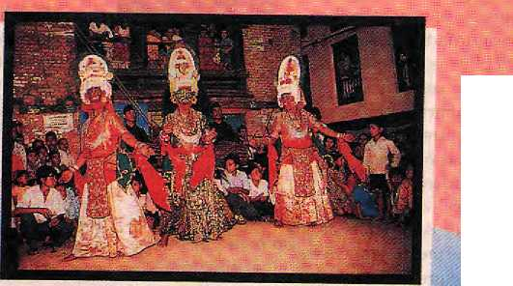

lifetime to Nepal's mysterious and hauntingly beautiful neighbors.
Land o
gon,the sparse moun
pure magic
Write to us for our color brochure and detailed tour itineraries.
CHINA SOUTHWEST AIRLINES
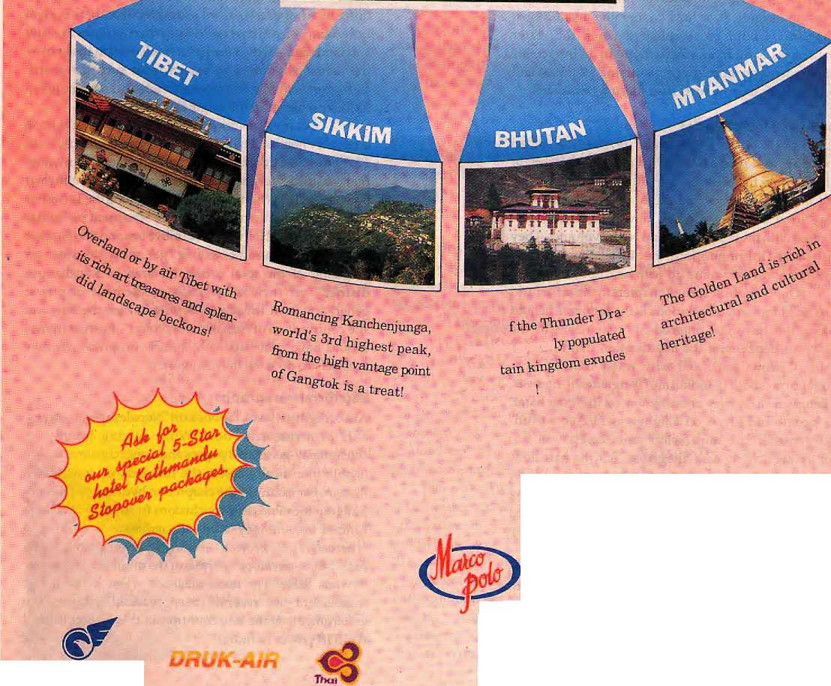
Let us show
magical Nepal then take you on
a journey of a
Marco Polo Travels Nepal Pvt. Ltd.
Head Office: P.O. Box 2769, Gyaneswor,
Opposite German Embassy, Kaihmandu, Nepat.
Fax: 977-1-418479, 413641, Tel: 418832, 414192, 411760
Branch OBice: Kattimandu Guest House, fhamel, Kathmandu, Nepai.
Fax; 977-1-417133, Tel: 414013

The chapter on irrigation seems to have been culled from several government documents with no underlying theme. Thechapter on water transport claims that it is the cheapest mode without looking at its infrastructure development costs. It is based on a table taken out of an unpublished and unrefereed work with no explanation of underlying assumptions.
The introductory chapter on macroeconomics of megaprojects is in the name of a macro-economist with conclusions at such wide variance with hispast pronouncements that one asked around, and investigations revealed that changes which went to the heart of the argument had been made apparently without his knowledge. The original paragraph in his' 'conclusions" where the macroeconomist had offered his ideas on the Karnali and on the proper development of Nepal's hydropower resources appears nowhere in the book. Instead, in its place one finds a paragraph bland as it is subservient to the dominant themes espoused by all the books under review. The original paragraph (made available to this writer) and the one that replaces it have nothing in common—the rewrite is complete.
In the original, the economist states: 7s it wise for a small country like Nepal to undertake a singleprojecl which is larger than its current GNP? The Nepalese economy is likely to be held has tage by such a project, given all its technical and financial risks. Secondly, the opportunity cost of projects such as Karnaliin terms of other econom ic projects and social programmes that will have to be foregone will be enormous, no matter how generous and concessional theoutsidefunding arrangements muy be,... A Kamatiproject may make the government of Nepal rich but not necessarily its people. Increasing financial resources in the hands of the government is not what economic development is all about.... Asthemiltionsofdollaj-sofunutilizedforeignaidmoney committed to Nepal show, the lack of financial resources in the hands of the government has not been the critical factor leading to Nepal's current low levels of development. Conversely, we should not expect much if such financial resources available to the government be vastly increased with Karnali type power sales revenue.
In its place, we are now given the following: One of the principal attractions that Nepal sees in these mega-projects is the revenue to be earned from the sale of power which can make positive contribution to the long-term economic growth and structural transformation of the Nepalese economy. Increasingfinancial resources in the hands ofthegovernment can augment investment capability which in turn can be channelled to critical sectors of the economy thereby contributing to the social andeconomicdeaelopment.,,,lfoneweretoforwardacaseandlook at one project as being ahead of others, the Karnali project would be the choice in the immediate future.... A lot of time and money has gone into it. It is time a breakthrough is made before long to facilitate entry into another phase of cooperation leading to improved socio-economic well-being of the people of the region.
What could thus have been a major exposition of a sound and well-articulated. Nepali perspective on macro-economic uncertainty was sacrificed at the altar of conventionality. It is grossly unfair to the researcher, and unfair to the basin riparians and the financial
Big Brother comes out the winner in the exercise as his is the only voice that is well-articulated.
community at large asitgivesfheimpressionof unanimity about the Nepali macroeconomic scene which does not exist in reality.
In sum, because the output of the entire exercise emanates from the conventional rather than the alternate school o f thought, it m isses v ital Sou th Asian perspectives which will decide much of the future inthisarena,asArun m andTehrihave already shown. Even as this collaborative study was being undertaken, there were other viewpoints in the region spearheaded primarily by social activists whose fears and concerns remain unanswered.
All in all, this exercise supported by The Ford Foundation would have been a useful exercise if team-members from South Asia's smaller riparians had used Verghese's 1990 book as a starting point to conduct a dialogue on those issues with which they agreed and others with which they did not—without wasting time and pages on culling tables from myriad documents. The Centre for Policy Research Verghese's institution in New Delhi, could have come out more convincing if it had included, besides theofficial and conventional viewpoints, the Indian alternative schools which are already interacting intensively with other like-minded professions elsewhere in South Asia. As such, it is only Big Brother who comes out a winner in this exercise, as his is the only voice that is well articulated.
In a deeper sense, failures of this kind lie really at the doorsteps of the grant-making agencies, The Ford Foundation in this instance. Because of their penchant for "policy studies" to influence policy-makers while neglecting basic scientific research, because of their predilection for ex-bureaucrats with access to public data, they get, for all their dollars, a reiteration of the conventional past.
Howsoever talented and experienced ex-bureaucrats may be, the more senior they are upon retirement, the more they need to justify a lifetime of conventional performance. This predilection does not allow wholesome academia to flourish. Rather, it promotes a bureaucratised intelligentsia anxious to uphold a failed order even at the expense of discomfitting truth. It also starves the alternative schools and denies them access to funding. South Asia ultimately remains poorer than before, with poverty in thought and initiatives added to its already empty rice bowl.
English-to-Nepali Translations
We do the best English-to-Nepali translations. Our work is valued for advertising copy, project documents, literary works and international agency reports. If you want only the best, and are willing to pay for it, then call 'Viplab' in Patan attel: 522113, office hours.

HIMAL Jufyflugust 1995
39



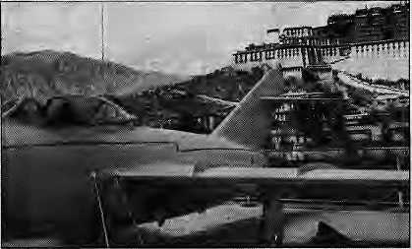

On 1 September 1965_{f} six years after the: Chinese introduced what they still refer to as 'democratic reforms' irt Tibet, the central and western regions of the plateau were formally constituted as the Autonomous Region of the Peoples Republic of China {Chinese: Xizang Zizhiqu, Tibetan: PoRarigkyongJOng),
Thirty years later/Beifing and Lhasa are planning to celebrate the anniversary in conspicuous style with much official pomp arid ceremony. The intention is to'd£irtonstrate Tibet's closer integration "with the "motherland" through rapid economic development and, in particular, to display "modern, clean and civilised" Lhasa, most of which has been (re)buiit since 1990:
Chinese construction teams are working night arid day and in great haste tp ensure completion of a number of prestigious ventures—a new TV station, hotels, department stores, a grand avenue through the city's western suburbs, and a series of neo-Cornmuriist plinth statues at the main intersections, the latest of which shows bold and patriotic mountaineers suminitting 'Mt. Qomolangma'.
40
The high point of tifus year's construction will be a new touristic plaza with a Chinese-style ornamental
gateway at the foot of the Total a pa foce, a highly s y mb otic statement of-ownership in an areaso charged with associations and historical legacies. By September, state guests arriving from the mainland-will find (arid presumably approve of) a Lhasa filled with the same shopping malls, banks and office^ the same kitsch-m odernistic arthite.ctuEe that now characterises mostof China's regional capitals.
Much works remains to be dcme./however, and in June Lhasa still looked nothing so much as a huge:construction site. There was little electricity available for those not engaged in conSjtruction-and all traffic in arid out of the city (now a considerable volume) was obliged to use an uripaved backroad with ankle^deep dust In haste for quick results, lfttle at'teHtion has been paid to such details as adequate sewerage, public health or Safety.
Meanwhile, the security agencies and their wide circle of informers are exercising their duties with particular : vigilance. Policingactivity* both in and out of uniform, has intensified. The imperative is, clear— no one is going to spoil: : theshow^
It might not be evident at first glance, but beneath the surface of rigidly enforced normalcy Lhasa is seething
Fighterjet guards tfie Petaia.
withunrest. Atleast 12incidents of protest have b^en repor^ ted inthecity in the twornonths leading up to the TiBetaft New Year. During the same period, the authorities launched high-profile, military-style raids on , a number of Buddhist monasteries and herm itages i n the Phenpo and Drigungareas. Over iri 5hlgatse, the seat of the Panchen Lama, the residents are also being subjected":t6 an unusual degree of surveillance arid control diie to controversy over the selection of the
in such fearful circurasta-^-nces₇ Tib elans are under considerable pressureto do as they are tpld. Those iri government service received stem watriings not to engage in activities expressing their ethnic identity and religious faithj,such as performing ritual-circumarn-... bulafjpn during the full moon or the holy month of Saka Dawa (i3 June). They were not to be seen attending the traditional mass picnic to celebrate the birthday of the Dalai Lama (6 June).
Even foreign toMrists haye not been exempt from the current zeal for total control: it is no longer permitted for them to leave the capital except ui an, authorised vehicle accompanied by a 'guide'. It is widely believed that all but the most innocuous of tour groups and a tiny handful of resident expatriates will be barred from entering the country from mid-August to rnid-September. Hotel accomm od ation will, iri any case, be entirely taken up by visiting Chinese delegations celebrating the 50 years of the Tibetan Autonomous Region;
— John Grey

The only, way to save rhinos from the poachers is to tackle,the sex-urge among East Asians, which.lies at the source of the demand for rhino horn. That is the idea behind an ad campaign unleashed recently by The Humanist Association of Hong Kong, Unless the demand for rhino horn is ■ demolished, rhinos of South Asia and Africa wijl continue to fall victim to not so much the poacher's gun as to the unfulfilled and/or disabled libidos of East Asians. Through its ads, The Humanist Association demands thatthe eoinsumers of rhino horn potions understand that their desires are leading rhinos down the path of oblivion. s Says the text in one of the ads; "Only a very sick.man could \<>ant a rhino sexually, but for decades, rhinos have been systematicaUy butchered for precisely that reason, Their horns are hacked off, dried, powdered and used asacure for impotence and as an aphrodisiac. But, while one kind of impotence is actually responsible for the decimation of the world's rhino population, another kind simply allows it. It dofesn't have to be that way..."
JufylAugiist 1395 H1MAL



;;::■:.;; ■

force's name refers not ^{v} to the makeups! the" ■■■ ..rank andfile but the ,; geographical area the force was originally gathered to guard- .. / vWhjile the sipahis bf thelTBPdotendto ; havetheirorigins irv^ the hills; the easier to patrol high terrain, the of fleer sahibs are plains regulars.
Given the reality of ■completely: cipenbordet
Nfepal its due?! Given, the Indian armed forces'penchant ' for terminological inexactitude^ however, a re-naming.o/the ITBP is highly tinlikely. Acase_ irt point is the AssarniRifSesi There is nothing Assamese about fhis para-military unit, which has a khukuri in its insignia and is headquartered ' iri Meghaiaya—
■"-!DeepakThapk
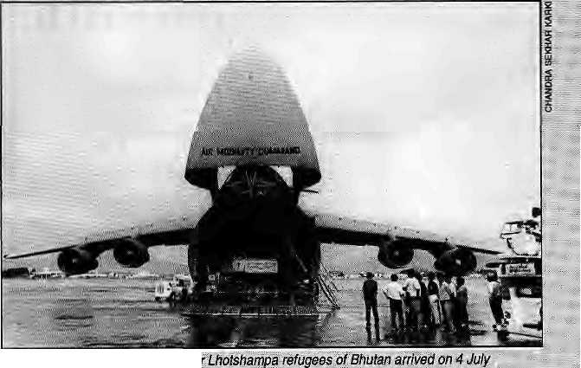

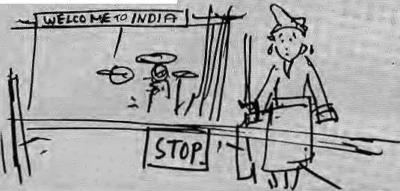
Iiido--Tibetais at te Border
in[the hot plains of Bihar and Uttaj I Pradesh? Not Exactly.:
. fief a couple of years, of it-so-subtle hints that Nepal isf being i^sed as a transit 'point by militantsoj allhues bert op 'destabilising'India, the'Indiangbvernmerit seems to have decided to go aheaii and do something gboxtt it.A proposal that was first made in; 1991 has been revived at the Home Ministry irt New Delhi. It calls for the deployment'of six battalions of the Indo-fibetart Border Police (ITBP) f along the 'critical; areas' of the Nepal-India border..
So, will Tibetans exiles hired by the Indian Gover^ ranent now be...standing guard
A %'afiow ofAn&flcaft suppQrtjiv
In the lorw"of aU.S; AiiMobility ComitandC^SA Galaxy cargo^pranat l^thmandu
aitport carrying relief supplies. ... '. ...
betvyeen India and Nepal, ■■■ hc«W: effective can policing by "thetTEP be? According to one I^epali analyst, no less thanv31 hattalions would be required to do fe job properly.
Andshouldsuchalarge: force be raised, why not : christen it the "Indo-Nepali ■ Border Police", which would at least have ttie merit of giving

PLACINANfES by Dr. SonamBi Wangyal
"The upper part of the ascending ravine that is beaten by the: winds."
ThV-majority of visijtors to.D^rjeeling simply travel up to the hill station and stop there. Theyventureno further^ as thepoint of the exercise is merely to escape the heat and humidity of the (hdian plains: Howevef, there is a small ntanher who-will; battle fte piercing cold and gasp in the pxygen-depleted air to reach Phaiut {12,000 ft) for a few hours of visuaidelight.
It i$ a delight which the old Darjeeling scribe K.C Bhanja thus.describecl ift MysticTibeland the Hhnateyas(1948), "the view <ofthe vast snowy range has undoubtedly no parallel a lithe world ■over in beautyand massiveness, height and extensiveness."
One of the early references to the hiE of Bhalut ism The' Himalayan Journals (1855) by J,D. Hool«r, where Phulioot is .mentioned—anattempt to render thelepeha tiarneiFak-M orFok-: dU;AftHi^(1899)ithis
;§:/()/gg "the peeled summit", and this is corroborated by Risley {r Gazetteer ofSiMm, 1894) as "the bare or denuded peak". As it is bereft of vegetetioh, in striking contrast toits neighbours' Sir Richard fempte/^^^
Nepal-VoiU (1875), described the peak as "bare of forest, andeven oi shrubs, except rhododendrons of sriiailer species..."
Priqrto 1873, the British seemed tohave adopted theTibetan naMe of Phulungdung (ref: Darjeetin% District Records, General Department, English Correspondence, Commissioner's Circular Nd, -■96,8 Oct 1873, unpublished) whose spelling waslater changed fo Fullaloon iphu *= the Upper part of an ascending valley /ravine;, lung- wind; dung f beat or hit). By the turn of the century, ttie name had become Phalilung/Phaiatutn ipha-li s< shield, buckler; Itmg = windJvThe longish name had been reduced in size and meaning from Phuhtngdung ("the upper part of the ascending ravine that is beaten by the winds") to Pftalilung ("the shield q| the' ;; wind"), whichO'Malley in The Bengal Gazetteer (Darjeeling, 1907}/ : iiiterpretedas "....apparently referring tothe fact that the mountain helps sh|i!d lower Sikkim ftom the souih-west monsoon."
13\er^ has beefi some corttroversy as to whether the name is origmaUy Lepcha or Tibetan., Obviously, both the communities had their owtitiames With persuasive meanings. I would credit them both as having coined the original h'ame(s), though the Lejpcha term, of its distortion Phaiut, has become th& nomemproprium.
Dr. Waogyal practices
in Jalgaon, West Efen^al.

HINIAL JuiylAugust ~ms

B
B
f

Unequal Intestines



A
diarrhoea-causing Bacteria, which has always swum around in Nepali bellies, has just beenidentified; , and a cure has been found, but only because expatriate residents in Kathrnandu fell yictirns to its predations,; Medical science has benefited* from this research and the expats have started on their pills, but will any of this make a difference for the Ideals?
The villain of the piece is a parasite first identified as the "b|ue green algae". It now has a scientific name: cyclpsppra. The parasite became world-famous—a news report in The New York times, a paper in The Lancet* etc.—after the Kathmandli-based CIWEC Clinic, which specialises in treating foreigners, identified it.
CIWEC, which gets its name from the Canadian International Water and Energy Consultants which established the clinic in 1982, tooka closer look at the blue green algae seen in stool samples in 1989. Because> this fairly common algae was abundant in water, doctors had not considered it to be pathogenic until the GIWEC's laboratory established the link with diarrhoea.
Although it was identified in expat stools, the parasite does not spare Nepalis; A test done at Kathmandu's Teaching Hospital on 180 stool samples from diarrhoeal children indicated cyclpsppra infection in 15 of them. Kathmandu hospitals are crowded with diarrhoea patients every rainy season. The faecal samples of all diarrhoeal patients are scanned but amidst the
abu n dance of worms and; othe r.:■ common parasites visible in :
the ^lides^ there'll npf.much .....
time to locate the elusive ■■> eytlospora.
The slides are hurriedly scanned to cope with the volume.of cases to be handled; "Mostof the' clinics generally...
hijstolytica,
and pinworms in the routine examinations," says Dr. fusp Raj Shanna/.a pediatrician,. These are parasites which, : according to a i98Q-study pn enteropathogensin Bangladesh, can be rated as
least important; considering the incidence pf; other diarrhoea^auEing organisms such as the Eschef ichia C0I4 Stj Rptavirps> etc, ■.■■:■■ ■.-■. .■>.■ ;: " :- ■•
Says Jeevan Bahadur Sherchand, MedicalKesearch Scientist at the Teaching-Hospital, "It takes careful observation of about 20 minutes under a high-powered microscope to spot cyclosp pra.''
The C1WEC dime was definitely ;in a better position in this respect, as its lab technicians have little in the form of distraction in the relatively 'clean' stool of foreigners; This helped them zero in on the imideritified organisms that showed up under the microscope. It was Ramachandra Rajah, chief of the CIWEC lab, who identified
the pollen-like particles^-the algae—as the possible culprit causing diarrhoea among resident foreigners!"Cyplospoja y/a$ finallyisolated on lettuce : leaves stored inthe refrigerator of a Western diplomat who was down with the disease. A team of Nepali and overseas specialists researched medication for the "special diarrhoea'' in patients at CIEWC and the US;: Emb assy^Peace : Corps clinics ih May-August J99|.They "reported their : iindings at a?travel medicine-coniereiice in Acapulcp, Mexico, earlier this¹ year. : :

. Cyclospora infecis the upper intestine and causes fatigue^ I0M0I appetite and ■■■■■.■. jSevere, prolonged diarrhoea: Tliose afflicted dp hpt Respond to: normal diarrhoea medication. It is a seasonal

mid-April, is njost active in early July, and disappears altogether by November.. According to the ciWEG Clinic, the disease is. self-limiting,and does not kill, put the risk of
i^en to
t of all Westerners in Kathmandu are affected eaeh year;
The micro-organism is waterbome-'artd¹ is resistant to both iodine and chlorine, and it seeps through normal Water filters; The parasite is killed bv boiling water and cooking
leafy vegetables. Effective medication for cyclospora: irifectioft is ii Week's'treatment with the antibiotic 'co-trimoxazole' or 'trimethp-p riirisiilfa me^ dhoxasole', available in themarketas Bactrim or Sulpha. ^{J} Will this distoyery of the ciisease-cavising agent and its cure be of much benefit to Nepalisy Whoseirtfestmes are the frolicking grounds of . myriads of germs and parasites? 'We have'seen
Nepaljs but we are not sure whethertli
Kathmandu lab report indicating [ cyciospora.
carriers or are affected by the parasite," says Dr. Prativa Fandey, a physician at CIWEC. Says Dr, Siiarma/Though only 1.5 samples were" reported positive, we suspect the cyclospora infections to be higher. That may be confirmed Pnly after stool concentrates are thoroughly analysed."
There is enough reason to worry, because cyclospora is found in water of the ponds and wells which are a major-source of drinking water in the villages^ Yet, given the challenge lab technicians face as they peer down at the* stppl samples of Nepalis, it is more than likely that cyclospora will go un-notked, let alone be identified and attacked.
- Binod Bhattarai

42
■ .

since 1989, emphasizes this point: "We didn't create this cominunaUsm. It was brought from the outside. If we are left tp ourselves we can manage to live together in harmony. That has been our tradition, and it is becoming visible again now." ....'.. Among Muslims, too, the fear of continued eomrnu-nalism seems to have died down: According to Mohd. Aisisar Ladakhi, President of the present! y d ef urict l^adakh Muslim: Asspciation, "The Council is actually the best prfitector of isur interests, for it could be revoked at any time. Asa result, the Buddhists Will take great care iiottOigo



Letts Got It!
A
fter a struggle that lasted more than three decades and hearty three years of delay in implementation of the tripartite agreement between Ladakhis, the Central Government and the Government of Jammu and Kashmir state, the President of India pn 9 May sanctioned tht formation of th£ autonomous hill council ior LeJv
The law is called "The Ladakh Autonomous Hill Development Council Act 1995". The inclusion of ^development'in the title is thought to be ameans to reduce the political fallout of this decentralising law. The Council will have 3D members, out of whom 26 will be elected from as many constituencies, while four are reserved forprincipal minpf-ities and women. Elections are set for September.
The final stages of JBe struggle were far from easy. There were times when Lad a-kh's leadership despaired because of ever-new obstacles put in the way of the Council's formation (see "Ladakh: independence is Not Enough" Mar/ Apr 1??5). When representatives from the three religious communities of Leh met him in February, Prime Minister P.V. Narasimha Rao assured them that the Government would riot go back on its commitment. However, because there were important "national and international implications¹' that needed to be considered, he asked for more time tp reach a decision.
Remembering the many unfulfilled promises of the past, the Ladakhis were not in a mood to sit back and wait. Moreover, as Thupstan Chhewang, the President °$ £h& Ladakh Buddhist Association said, "We were suspicious that
the Centre w^xild link it up with the overall Kashmir issue, and we feared that if there is a popular government in Kaslv-mir the Hpl Council might Se shelvedpermanently," The Kashmiris have not been sympathetic to the idea of an autonomous LadakTi?
....Tp put pressures.pri the ... Centre, arid despite Rao's plea, the agitation was re-launche^j With a massive rally on 6 March. The Ladakhi leaders made it dear that they would boycott the political process in Kashmir until the Hill Council was granted. The mood .....'; was fierce, and the speeches inereas-
militant Two students volunteered tp commit suicide if the Hill Council was not a reality hefpre 15 May. :
The day before a planned youth march, a high level delegation arrived with a messagefrom Prime Minister that a Hill Council ^voul&be notified within a month-The Lada-khis agreed tp pull back until 15 May. Thai was the situation when the President signed the notification on 9 May.
An Advantage of the long : delay in the implementation bf the tripartite agreement was that it provided time to "bridge the gap between the communities of Ladakh"j s^ys Rig?in' Jora, Secretary of the LBA. The 1989 agitation and the three-year socialboyeott of Muslims had created deep rifts between the majority Buddhist community and the Muslim minority. This time, a major: effort was made by the LBA and other organisations to involve all communities in the demand for autonomy.
Thupstan Chhewang, the central leader of the agitation
against the Muslims."
The challenge before the 24-member Council will be addressing the high expectations of the populace. There is a belief that the Council will ■ provide jobs for everyone. Thupstan Chhewang: "It Will teke years to undo .the wrongs and ilU that have come into Ladakh, IS the longer term, the Council shpuld beable to meet the expectations of the people. Ladakh will be a test case^ If it succeeds, it can become a model for not;pnly Kashmir; : bat for other parts of the , country and arpund the world as wellv" '
—MartijnvanBvek
LadakM Mock *n^{f} Roll
For better-or worse,; Lsdakh will have its mela. The advertising for this year's The Ladakh Festival, 1-15 Se-ptember,hasjust'been rolled oat, with a dedicated logo, a tag line ("The Land of Endless Discovery"), anS smart copywriter's talk* "...jKe traditional dances; you see, enact the fables and le-gepds of Ladakhv Alifethat often revolves around the rocky earth and the rolling of the prayer wheels.'.. So travelback in time and celebrate with one of the richest, the most exotic, cultures in the world; Contact your travel agent of call any J&K, Tourism office today."
There is more where that ' came froin, and the ad contains a sketch of a monk twirling' his prayer wheel, with an accompanying line ^ which reads; '.'The ^ge-oid dancesof j Ladakh. have their origjn inrock'n' roll." A forced imagery, thlsi linking prayer wheels to Tibetan Buddhist dance sequences;
"With the Kashmir Valley even more out of bounds than before, what With more tourist kidnappings in early July, J&K Toiirism has decided.that Ladafehis itsraison d'etre of the moment, It is thereforesgpirig all out to get record numbers of "hofhe tourists" to visit a Ladakh which is suddenly peaceful, withjts Autonomous Hill Council granted,
..: which begs the question, how long before Ladakh gets its own tourism agency, say, the Ladakh Mandal Vikas Nigam (a h GMVNand KMVN in Garhwal and Kumaun)?!

HIMAL JufylAugust 1995


B
B

iMfi

They Biirn Well
Alma Mater No More
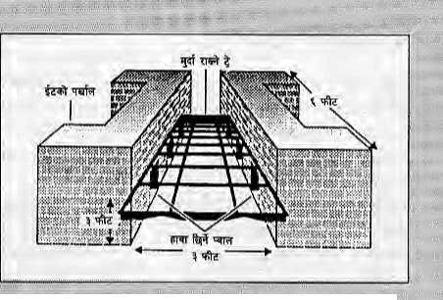

T
he subject can-be • considered morbid: cremation technology. Every three years or so, in these pages, Hiraal has raised the matter of fuel-efficient burning of the departed that SudhirehdarShafmaofthe : Energy and Environment Group in New I3elhi-proposess
The EEG promotes a design that burns the body more efficiently because if allows air circulation to fuel the fire. The cremation unit is a cradle-like structure consisting of two low-fired clay brick Walls three feet ■■ apart and six feet long with vents along the side. A wire mesh or "dead tody tray" is fixeda foot above the ground between the two walls. "The improved crematorium cuts by half the average wood consumption per body of 400 to 600 kgs," says Sharma.
Over to the burning ghats-of Pashqpati, where atavistic Western tourists continue ....-.-, to "be allowed to take funeral footage in close-up and real time, as flesh sizzles and reduces to ash. Here-at Pashupati, the technology has regressed rather than progressed. The structure of the pyre has been traditionally robust because of the triangula r cross-section of the cut logs that were used. As the burning progressed and the body caught on, the pyre basically settled dowh into itself with the presiding ghatey pandit having little to do but to stok&the fire.
The forests have disappeared and with them the ideal logs for cremation. Now, the pandits have to do with imsecdoned round eucalyptus
logs which have toie stacked precariously fOWiakV'thV ..... " funeral pyrg. These rounded logs make for an inherently; "" unstable structure, as the ■■:■ tender's job is now also to be a b alancing specialist as; the logs roll the disintegrating corpse ..one way theft the other'.
"As long-as the attention is on the Fashupati ghats, there is one more thing"that needs to be said. It is clear that: Kathmandu Valley^ inhabi: taftts arid their leaders will not be goaded to clean up-the Bagmati, evenif these ■ : ghats areiobeconverted
: Nepali media remains moire or less oblivious to ;:' the phasing put of a grand tradition in Hong Kong; as the'wind-down df Pntjfeh Gudcfia garrison stationed there continues. :As announced a cbuple of years ago, She-Gurkha strength is to be whittled down from |50Q -fij .2500 by 1997.. ■'...,....'."
Together with their: parents' being made redundant, Gurkha children too will have to leave their ',. Hong Ko^ig Gurkha scho&ls and head back to-Nepal or : wherever their fathers find employment. Come November 1996, and all but one of these soldiers-' children's schools will pull down their shutters-
The schools^-six primaiy arid one secondary till last year—rwere opened in the 1970s to cater tp Gurkha ■■■■:■ chUdreri who followed thfeir families to Hong\Koiigin,the aftermath of the Malaysian
weirSiSueh is^{i}
'. feathmandu's citizens iake.. . in their heritage."In
: monsooninohths; what' flows here is raw sewage,hardly the stuff to have your ashes swept into for the journey to the hereafter .Perhaps; as a last-ditch measure, Kath-martdu's knqvring and concerned should sign and cojffitrdt theiHs^lves to a form which states: "As long as the
campaign. An entire geheration of servicemen's have since passed out 6f these" establishments.
Theseschools hgve .
follpwe<i the Nepali government curriculum in order to inake it easier for the children to rejoin the Nepali educatjion system upan their re^im. This was thought necessary because only soldiers of senior" rank (sergeant and above) were allowed tohave their families over ihf pughout jL^_{e} _{serv}j_{ce}
period; thoseof junior rank could keep their children for no more than two and half years out of a service period of 15 years.
lit view of the clpstire the schools in Hong Kong, the Brigade of Gurkhas is assisting soldiers in theif search for schools, back in the home :■country Major David , Whitfield, a former teacher, has been involved in this
Bagmari carries more sewage ttiain vrater, each of the undefsigaed_{i}wishes lobe cremated on~a moutitath top, in a crematorium, or by the waters of .the Trisali-, Indrawatior another river with adequate perennial flow."
[. Thisisan idea whose tirne has come.

assistance programme for more* than two years, travelling between Kathmaiidu and Hong Kortg.
Whitfield has drawn up a list of 90 schools based on the soldiers' preference of

Pokhara, Dharan or Darjeeling. His "good schools guide", he says, is not a comprehensive tally of the "best" establishment, but only a reference book for the soldiers to work from.
This year, 115 of the Gurkha kids got into schools of their choosing in Nepal, havirjg taken their admission tests in Hong Kong as arranged by Whitfield. A similar exercise is planned for the coming September;, A commendable job, nodoubt, but one does feel for the hundreds of Gurkha ; high school graduates who now have no place to call their alma mater.
- Deepak thapa
•m


.. . , , _{t} ^
July/August ms HIMAL
* s»

R
Review

Stranger to the Land

T
he sub-title of the book promises tales of war and peace from the Northeast of India. Yet, more than 130 irrelevant pages are devoted to Bangladesh and Bhutan. The chapters on Bangladesh—three in the beginning and one at the end—do not have much connection with insurgencyintheNortheast.Afetishwithlebensraumhas led Hazarika to waste many pages on Bangladesh when a couple of paragraphs would have been sufficient.
Despite this prolixity, he is not convincing. Assam being swamped by Bangladeshis may have been the immediate reason for some dissatisfied youths to combine asULFA,butthiswasjustoneofthemany experiences that had convinced Assam of the Centre's indifference. His account about Bhutan isdasho-sided. Even for a dilettante liberal that Sanjoy Hazarika is, his comments on the Lhotshampa's predicament show lack of sympathy, research and objectivity. Why should people desert the house of their forefathers unless forced to do so? Would anyone voluntarily opt for the squalor of a refugee camp?
Hazarika is gentle towards the insurgents, ignoring their indiscriminate extortions and assaults on innocents, and more than considerate towards the armed forces, commenting generally on their tactless excesses. Only from the safety of the Annexure does he include a litany of their human rights violations. Otherwise, he suffers from amnesia as far as the uniformed forces are concerned. In his anxiety not to offend the powers that were, he has not given a credible explanation for the rise of insurgents in Na gal and, Manipur and Mizoram. In Nagaland, it was the wanton killing, by some trigger happy army soldiers, of an aged and deaf Dr. Harallu who was taking a walk with his six-year-old grand-daughter one morning in 1956 that revulsed many young Nagas and convinced them that arms were the only way to seek justice against unsympathetic authority. Till then, the situation was not hostile to India and with some forbearance (such as not increasing armed forces, which was not done till now and has only helped heighten the alienation) the damage could have been limited.
Similarly, Hazarika has avoided mentioning that the sole reason for insurgency in Mizoram was not the outbreak of famine, the 1960 mautam, as he would like us to believe. It was instead the Government's indifference to the mautam ^{r}s precisely predicted approach that upset the Mizo. In Mizoram, mautam occurs every 50 years or so, and in 1910 the British had prepared for it even though they had been there for only two decades. The Assam Government reacted only after the famine had gripped the entire state. This callousness was what caused the
Strangers of the
Mist: Tales of War and
Peace
from India's North East
by Sanjoy Hazarika
Viking, Penguin
Books India
New Delhi, 1994
ISBN 0 670 85909
IRs 295
review
by
Romesh Bhattacharji
youth to revolt. What embittered Mizos most was that in 1947 their young had welcomed the union with India as they saw in the merger an end to the autocracy of their chiefs. Of all the 200 or so tribes in the Northeast, the Mizo were the least democratic. Another opportunity lost-Only in his description of insurgency in Assam, including the Bodo, is Hazarika accurate, but then it was closer to his time and he seems to have preserved his news-clippings. However, he does not say anything more thanhasalreadyappearedinthepress.Hedoesnotdothe required research. He has ignored most incidents of brutality inflicted by 'the insurgents, each of which diminished the number of their sympathizers. And as to when uniformed forces of the Indian Army (who are trained to be disciplined) went berserk during the Bajrang and Rhino operations, Strangers of the Mist avoids mentioning even oneincident. The author tends to ignore the suffering of ordinary people.
From- the book, Hazarika emerges as a person who is anti-communal and anti-racist, but timid. He writes about the Northeast insurgency without bothering to understand the causes and conditions that supported it. He repeats the usual platitudes of exploitation and indifference, but is more impressed with the spit and polish of army brass and the power that flows from the gun. The fact that Hazarika treats all authority tenderly and has a sneaking admiration for those in "power sticks out like an obelix over the landscape. He comes across as very pro-establishment, respectful of money-power, and incapable of understanding the desire to change Centre-state relations. This reading is reinforced when he glowingly describes a shady industrialist from Bombay setting up a synthetic yarn plant at Sipajhar near Tezpur, but nowhere in the book mentions the sole reason for Sipajhar's notoriety in the Assamese mind—the brutal and unprovoked killing by the Army of two Guwahati veterinary surgeons and a child (all unarmed) one night in April 1992 when they were accompanying a wedding party. This selectiveness recurs throughout Hazarika's book, and each time the lapses are to the benefit of the authority.
It is incidents like these in which innocents suffered that fed the insurgency and attracted converts. This is the nexus that Hazarika ignores or fails to detect. He is so confused about its origins that in pg. 120 he credits the need for ethnic identity as being behind the insurgency, and by pg. 283 he is claiming that hunger for land is what causeditall.Also,hecouldhavedealt more informatively with the history of Assamese and Naga student politics. Since 1920, the students in these two regions have been in

HIMAL MylAugust 7995
45

I
R
v
e w

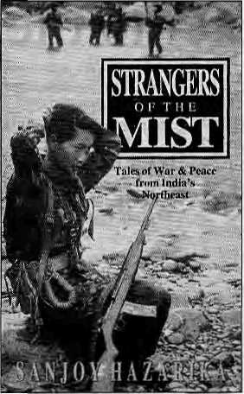
the forefront of a 11 struggles, and it is not surprising that students still provide the main support for insurgency in the Northeast. When the best and the brightest prefer a life in the jungles, there must be something wrong in our system of governance.
Hazarika's book may be useful for a non-Northeastemerto consult, but for those who know the region and its peoples he has nothing new to say. Insurgencies do not begin in a year or five. They simmer for years before the flashpoint is reached. In all cases, except that of Assam, the author has been blinded by flashes and fails to search out the origins.
I often wonder how altered the history of India's Northeast would have been had we had more honest and humane administrators, such as Nari Rustomji, up and down the line, and less Army presence. Our present-day bureaucrats and politicians can learn from the restraint displayed by the then Governor J.D. Daulatram after the August 1953 Aching Mori incident in Upper Subansiri in Arunachal. Some Tagins, a fiercely proud and intractable tribe, on a misapprehension, attacked an Army escort column, killing45 soldiers. Predictably, the Army wanted to retaliate forcefully, but the Governor prevented it and a flashpoint was avoided. Today the Tagins seem to be a well-adjusted community.
Unfortunately, no lessons were learnt from this and other examples of restraint by those who came later to the Northeast. Violence is answered by excessive brutality, usually on innocents, and the people of the Northeast are left with faded dreams of economic justice, clean government and, simply, peace.
.If corruption, inequity and prejudice were reduced in the Northeast, insurgency could be contained. Despite so much provocation, exploitation and indifference, it is surprising that not one of the insurgencies in the Northeast has become a people's movement. Only sporadically have they attained that status, whenever there are blatant violations of human rights by the uniformed forces. Without these violations, the angry youth would be isolated. The people in all seven states want peace, and an end to military-raj and insurgents' writ. A sympathetic administration could use this latent yearning for law and order constructively. But so far, it is only the Rambos who dominate the policy chambers. This is another aspect that Hazarika has ignored.
Another amazing deficiency is Hazarika's lack of knowledge of the topography of the area. He says that most Assamese homes have pukhris (ponds), whereas the ratio would be more like 1:50. Akhaura is not 150 km from Giittagong but more like 300 km, and Digboi is not 1000 km from Delhi, but 2500. Lakhipathar forest is close to Digboi but very far from Dibrugarh. These are minor errors, but when they are so numerous the fact is
inescapable that Hazarika does not know the land well. And if an author does not know the land he cannot write convincingly about the insurgency. This seems to be the reason why he has missed many significant factors. ULFA survived for so longbecause Assam is predominantly rural. More important tactically, its villages blend into one another, with very few blank stretches on the roads, in the South Bank at least. This significant Assamese feature enabled the "the boys" to flit from one village to another, escaping detection till the Army adroitly neutralised this sanctuary by conducting a house-to-house survey based on land records, voters lists and ration cards.
Hazarika prefers not to go by significant dates and locations. Lungshim Shaiza's killing in Ukhrul inl990andChah'eKevichusa'smorethanadecade earlier were milestones, and their mention was mandatory. And then, for a region that is as unknown to the rest of South Asia as is the Indian Northeast, Hazarika does not provide useful maps. The only one included is practically blank, and is aptly sourced to the Ministry of Home Affairs.
In the chapter "A Security Doctrine for the East" at tb,e end of the book, Hazarika suggests fatuously that Indian forces should invade Burma to destroy the "drug factories" there. Is he ignorant of the fact that heroin can be produced with kitchen utensils and that these labs' can be moved about a t will? Besides, most of these establishments are on the far (eastern) side of that country, which would mean traversing 1000 km of Burmese territory to begin the adventure. The rest of this chapter is similarly pointless and unfocussed.
What is also shocking is that even though the book was published in 1994, Hazarika has completely ignored the terrorism of the SULFA (surrendered ULFA), which by then was two years old. They extort and they kill, and they strut about as if they have been subsidised by the Government. This officially condoned reign of terror in Assam has not yet ended, but, unforgivably in a book that seeks to study insurgencies, it has been ignored completely.
Hazarika is fawning when he quotes KFS Gill about insurgents leaving behind "residual criminality". This might have been true for Punjab, which was afflicted not by insurgency (which has some cause) but by terrorism (which is unprincipled and brutal), but does not apply to the Northeast, where, additionally, the armed forces are equally guilty of this charge.
An author of a book on insurgency who can thank Gill in his acknowledgement will not have any startling tales to tell. The bottom line is that the truth is not yet out on the Northeast of India. We will have to wait for a braver person to do that.
h

46
1995 HIMAL

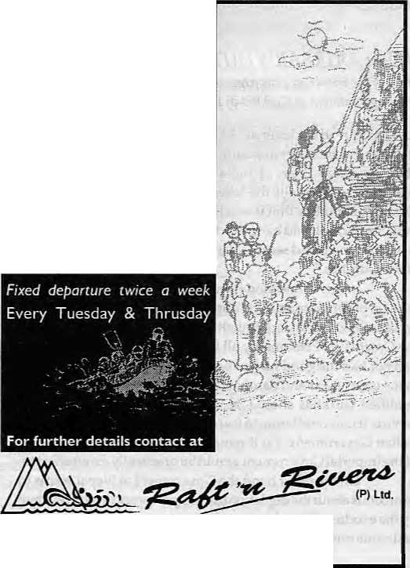

Neo-Colonialist in Lo
S
oon after Upper Mustang opened to tourism in 1992, a number of travel guides surfaced in the market. Promising to lead the German speakers up to the walled city of Lo Manthang came Gudrun John, a self-appointed Himalayaspecialistclaim ing to be am ong the f irst Ge rm ans to have obtained the rare and expensive trekking permit to Lo Manthang.
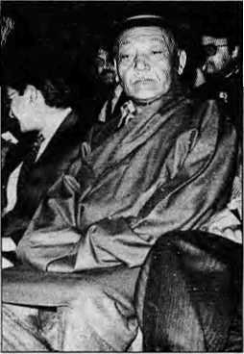
Em
wiederentdecktes Konigreich in
Nopal
(Mustang: A
Rediscovered
Kingdom in
Nepal)
by GudrunJohn
Artcolor-Vertag
Hamm (Germany)
1993
review by Colin Goldner
Would he be amused 7
John casts herself in the role of a modern-day Wilhelm Humboldt, but breaks all commandments of ecologically and socio-cultu rally decent trekking tourism. Mustang: A Rediscovered Kingdom in Nepal reads like a lifeless diary, one monotonous anecdote after another and written in embarrassing neo-colonialistic language. Without any knowledge of medicine, for example, she attempts "medical treatment" of sick villagers. "...I pulled the boy's earlobe and immediately a stream of heavy puss b ro ke i ts way. "Indiscriminately, sh e distributes pain kil lers and antibiotics from her travel kit and proceeds to advise village women on how to use different local herbs as remedies.
This kind of short-sighted, pseudo-humanitarian "Albert Schweitzer attitude" is bound to cause even more fatal consequences than tourists playing Santa Claus, handing out candies and pens to village children. Distributing Western medicine to villagers without diagnosis by a trained medical practitioner is a mortal sin. Whether acting out of 'compassion' or latent cultural arrogance, tourists and tourist guide-book writers who do this must be censured without reservation.
Not only does the book ignore the rich religious, cultural and historical heritage of Upper Mustang, it also gives a distorted picture of the Loba. As for the author, there couldn't be a worse person to give advice on how to trek in an ecologicaly and socio-culruraly fragile region.
t
Cafe Lungta
Garden Restaurant
■■■;■:*■! Unhurried meals ;;• .-Quite city hideaway •^T.aroi Ggjfcl^p.at 4200 ft.
• Organic food on demand
■■■■■■' •:, Lunch Boxes
f f\ Phone orders & out door catering
• Weekend special brunch
Cafe Lungta Garden Restaurant
wide variety of thrilling rafting adventure on different rivers of Nepal, and in addition to river rafting we also organize other packages. Well every body
guided tours, we are specialised in white water, rock climbing, and trekking peaks.
GPO. Box:66l5, Kantipath, Kathmandu, Nepal. Tel: 977-1-220474, Fax: 977-1-227600 Attn: R'nR
Kantipath, Kathmandu, Nepal G.P.O. Box: 4573, Tel: 217804 Telex: 2685 MANDALA NP Fax:977-1-227600

HIMAL July/August 1995

V
o
I

BIRTHNOTUKEBIRTHSALLAROUND,birthdny
greetings to Nepal Crown Prince Deependra Bir Bikram Shah, who turned 24 on 27 June 1995, by Md. Abdus Salam and printed in The Kathmandu Post.
Your Highness touch the height of the high skies, Your glories spread over the vast green pastures, Your praises are sung by the mountain streams, Your Royalty is the purest like the Everest snow. Up from the Himalayas down to the plains, From the land of rising sun to the land of setting, Your valour spreads over like the golden rays, Your kindness drops to all like the monsoon rain. Your birth is not birth like births all around, Your birth is a boon to the nation of Nepal... A symbol of revival with grace and dignity, A cycle of peace, progress and prosperity. May your glories soar up to the Zenith, May your life be as long as the sun remains, May your valour grow with the passage of time, Wish you humbly a many returns of the day, Your Highness, my humble greetings for acceptance.
NEPAL DURBAR'S DUTY is the headline of a letter to the editor of the Forward newspaper of 18 September 1927, which refers to the appointment of Gurkhas in British India.
Sir,~I have read the letter of "A Gurkha" published in your issue of the 9th instant on the app ointment of Gurkhas by Government. The Associated Press of India sent out a report from Simla denying semi-officially the "allegations" of the "Indian National Herald" of Bombay that it was the policy of the Government of India "to bar,bolt andbang the door of the civil appointments in all Government and semi-Government departments in the face of the Gurkhas."
In this connection it would be interesting to know the number of appointments, civil or military, offered to the educated and qualified Gurkhas of British nationality after the cessation of the Great War. Presumably all Gurkhas, educated or illiterate, had not had the good luck of being created for cannon-fodders in the time of war and danthawala in peace-time! Educated and qualified Gurkhas should be debarred from entering higher service. It is a consolation to learn that this is not the policy of the Indian Government. Yet it remains to be seen when this desire of the Imperial Government would be practically given effect to.
On the other hand the Government at Nepal seems to be anxious about the depletion of man-power and loss of revenue by the exodus of its subjects and the non-Teturn of the men who had come out of the country during the War. If the Government
at Katmandu were really anxious about it, it should have concentrated the attention on the opening out of fresh avenues for employment, under modern conditions, of her subjects. Europe-returned Gurkhas could hardly be expected to return to their mother-country to Live the life of serfdom, however patriotic their feelings might be. If conditions in the mother-country were at all inviting, who would have the foolhardiness to sacrifice the salubrious climate of the Himalayas to the roasting heat of the plains of Hindoos tan?
Nepal is rich in mineral wealth; she is abundant of raw
products; and her children one of the best on earth. Let the
Government make an honest attempt to utilise them, Themoment
this is done the whole atmosphere of the only Hindu Raj will be
entirely changed and the Nepal Durbar will have no cause to
complain of the depletion of manpower or the loss of revenue.
All the Gurkhas outside Nepal will sing "Home sweet home" and
double march back home.
Yours etc.,
A GURKHA ABROAD. 10/9/27
A TRUTH ABOVE MY SENSE OF BELONGING
is a poem by Pazuan Chamling (Kiran), Sikkim's Chief Minister and poet, from his collection Perennial Dream, It appeared in a "space marketing feature" on Sikkim in The Indian Express of 29 June, The translator is not named.
In this wide world of ours This world where we act and act We can live with honour and dignity, With high optimism and joviality, With sprightliness and jollity.
When our ranks we all close up, Remain united firmly and indissolubly As one impregnable fortress And with only one objective
The objective to march ahead hand in hand for progress and prosperity
But our sense of divisiveness and exclusiveness Our fragmentation, separatism and aloofness Have eroded our identity and sense of being. To ourselves we are lost And we are nothingess.
Engulfed we are in a void
And we know not where we exist
Or if whether we exist at all.
Non-existence is our identity And our history is blank;

48
July/August 7995 HIMAL

c
E
S

It is a history of our non-existence
Our homeland is a land of destitution Of insecurity, dismay and despair. And humiliation and denial of human rights Are meted out to us.
Unquenched is the thirst of our souls And it remains unendingly unquenched.
Despite being oppressed and exploited
Inert and voiceless we are.
Home have we none and homeless we are.
Run through your history of pathos,
And search yourselves even once amid your heart's throbbing.
And if ever in the world of your unconsciousness Your life has become vibrant and effulgent, Then you and I or we united together
Have we to erect a dome of our history and identity
On the peaks of Tendong and Mainum
Live we must and self respect, dignity and bravery
Like towering Mainum and Tendong
And ceaselessly must our life flow.
Like the perennial flow of the Rongynyit and the Rongnyu
In this beautiful world of ours
Must we live with manliness and valour.
Unfailing optimism.
Unflagging will and unyielding spirit.
FEAR IS THE COMPANION in the m_{g}a mis, says an
8 April piece in The Economic and Political Weekly by Sajal and Tejimala Nag, as the ferocity and frequency of the Indian Army's human rights violations escalate.
The total disregard for human rights by the army in the insurgency affected regions of India and the murder of civilians, not to talk of fake encounters, torture of innocent young men, custodial deaths, are nothing new. But going by the developments inNagalandinthe past months, the ferocity and frequency of such human rights violations has shot up to gigantic proportions. Caught between the underground who virtually run a parallel government and the army men, the battered populace of the Northeast seems to have no respite. The heavy presence of the army and the intensification of insurgent activities in Nagaland, Manipur and North Cachar Hills in recent times has tremendously affected the normal life of the people. 'Fear' has become their constant companion.
As far as the Indian army is concerned, it is not really known for 'restraint', but what is dangerous is the psychology of 'revenge' which it seems to have developed recently. The
underground militants attack symbols and representatives of the Indian state. As such the Indian army is their prime target. But avenging the death of a colleague by killing civilians and destroying civilian habitats seem to be their new tactic. The Indian state cannot absolve itself of the responsibility for such a development. It has sent the army into the area activating a 'war psychology', not as protectors. Like most Indians, the people of the Northeast—most of whom are Indo-Mongoloids speaking Tibeto-Burman language, the army men also view them as non-Indians who are to be taught a lesson for harbouring secessionist ideas. Hence, they consider the entire area of operation as enemy country and even ordinary Naga and Meithei villages as hostile. Such a mentality is at the root of their frequent panic' and murder of innocent civilians without any sense of guilt. It is obvious that the Indian state is not unaware that by such acts it is further alienating the people of the region. But it does not appear to be unduly perturbed. The point, it seems, is to make these alienated people "behave themselves".
100 HIMALAYAN QUIZ is the name of a primer by Mussoorie-based Himakyaholic Bill Aitken(Rupa Paperback, 1995). The following is a selection from the 12 sections in the book, which go from Ladakh toArunachal
Questions:
- What does the name 'Garhwal' signify?
- What is the first recorded ascent of a Himalayan peak?
- Latitudinally, which is further north, Chandigarh or Lhasa?
- What unique feature is created by the Subansiri in Arunachal?
- What is considered the world's rarest plant?
- What is the name of the ridge dividing Sikkim and Nepal?
- Where are the temple priests of Pashupatinath from?
- Name the private bus company that is associated with
Kumaun.
- What river does the Kangra fort overlook?
10.What is the winter-time reputation of Drass in Ladakh?
Answers:
- The land of {52} forts.
- A 19,411 ft prominence near Reo Parigal attained in 1818 by
the Gerard brothers.
- Chandigarh.
- The largest river island in the world, Majuli.
- Lady's Slipper orchid.
- Singhalila Range.
- Karnataka.
- Kumaun Motor Owners' Union.
- Banganga
- The coldest place outside Siberia.

HIMAL July/August 1995

K a t h a

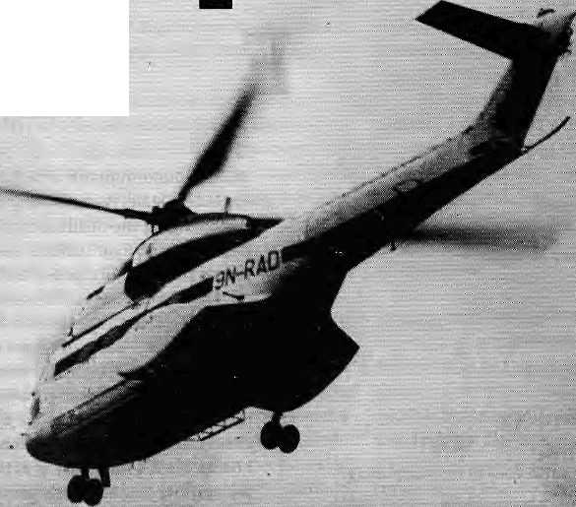
cIfie flying doctor
by Jerry Rolls



"The plane should come tomorrow," Hari was explaining patiently. "It left Nepalganj on time this morningbutithad to turnback over Kalikot. The reported visibility there is only five hundred metres in this haze. But they'll try again tomorrow."
"But I want a char-ter hel-i-cop-ter." The Italian woman spoke each syllable distinctly, as if to a child. Hari resented her tone. "Please tell me if they can send a helicopter from Nepalganj for us."
"If the scheduled flights cannot make it, neither can the helicopter." Hari was getting tired of this.
"I can pay dollars. I have four thousand dollars to charter a helicopter. You must tell them that, now."
Hari looked out over the runaway, at the kids playing soccer on the dirt strip, at the snow-capped mountains beyond, their outlines now blurred in the mist rising slowly from the Karnali. A couple of griffons circled idly, far below. He tried again.
"Madam, it doesn't ma tterhowmuchmoneyyouhave,Ican't permit the helicopter to fly. Anyway, now it's gone to Jumla to pick up other tourists. You have to be patient."
The woman was not to be placated so easily. She took off her Gucci sunglasses to emphasise her mood. Rich bitch. Hari smiled easily at her.
"There is a child. A seek child. Very seek." Hari translated rapidly, 'sick' she means. He'd heard them say in town she was a doctor, and she came trekking to Nepal every year, always travelling with the same group of Sherpas from Khumbu. She used to hold impromptu clinics in the villages.
"Today I geeve some medicine. The child get better." She gestured impatiently, gold earrings sp arkling in the weak a fternoon sunlight that filtered through the dusty windows and cobwebs of the control tower. "But tomorrow may get seek again. Need
helicopter to fly to hospital."
Hari weighed this new information. There was a hospital in Simikot, but the doctor hadn't yet arrived, preferring the familiar food and culture of the scorching tarai to the uncertainties of existence up here among the Humli people. Hari didn't blame him. He couldn 'twait to getout himself, toa cushy post at the international airport in Kathmandu. He deserved it. Two years in this freezing hellhole; he'd been very patient, he decided.
"But the situation is very normal now madam. There is no sick child. The Army helicopter can come in an emergency, but there is no emergency now, and conditions are too dangerous to fly." Hari allowed himself a tiny smirk. This isn't Khumbu, lady, with eight flights a day whisking tourists back to Kathmandu.
The doctor's eyes flashed in anger. She placed her palms together, bowed low, in the kind of namaste foreigners make when they first arrive in Nepal. But she'd been here before. This wasn't culturally amusing.
"Thank you, kind sir, for spending you r valuable time helping me." She stalked out, quickly followed by the other Italians in her party. They were all exhausted by the heat and dust of the Tibetan plateau, the flies and garbage of Kailash, and the grinding trek up the hill to Simikot from the Karnali, one kilometre below. Their flight back to Milan was the day after tomorrow, for God's sake, and they'd still got to get out of here, and then fan around in Nepalganj in temperatures of 43 degrees.
Traces of rain fell overnight, in answer to the villagers' rain dance performed a few days ago, on the now dry Simikot marsh. The winter barley was desiccating before the grains were fully formed, and even the marijuana which grew wild along the field edges was wilting in the heat, releasing a soft, sickly smell. The villagers had offered a goat to the rain gods, danced,beaten drums,

50
Juty/August J995 HIMAL

and partied all night. It had worked. In the morning the conifers on Raniban were covered in wisps of moist clouds, and you couldn't see down the valley to Kalikot. No way was the plane coming this morning.
A mournful crowd of would-be travellers were gathered at Hari's residence behind the control tower, drinking hot tea and peering hopefully through the mist. Hari had been on the radio from the tower since 6 a.m., confirming what everyone could see, the monsoon's arrival in Humla. Simikot was running tow on rice, vegetables, eggs, sugar—you name it. Everything arrived from Nepalganj by air. But the weather had grounded all air traffic. He was sharing this news when a Sherpa from the Italian's camp came in. The sick child needed urgent medical attention, and the doctor had asked Hari to arrange a medical evacuation. The doctor would pay the costs, he added needlessly.
Hari went out to inspect the runway. The rain had barely wetted the surface, no problem there. Bloody woman, now he'd have to try and raise the Army base at Nepalganj. But he had contacts there, and maybe they could throw on a few bags of rice, and maybe the sun would bum off the clouds. Maybe.
At 4 o'clock, the sun was shining brightly and Hari passed along the welcome news that a Nepal Airways helicopter had left Nepalganj with a load of rice for Simikot. The Army rescue mission would follow. TheNepal Airways helicopterwould take passengers to Nepalganj, and their office was now open for ticketing. The Sherpas had already broken camp, and the Italians were joyfully planning the next stage of the journey. It would be tight, but they should now make the afternoon flight to Europe tomorrow. Sitting on the ground among the Sherpas' gear was a very dirty Humli woman with a large coral and turquoise necklace cradling a filthy
blanket in which, presumably, was the sick child.
In a swirl of grey dust, the orange Nepal Airways helicopter landed. Rucksacks, dokos and bedrolls were quickly loaded and the passengers prepared to board, while a young policeman with a clipboard scurried about noting down their names. The Italian party boarded the Nepal Airways chopper; the doctor and her patient would travel in the Army copter which could now be seen as a speck in the sky down the valley.
Another dust cloud and the Nepal Airways was off in a rhythmicpulseofrotorblades. Yet another, and the Army chopper settled in. The doctor, archly efficient in stratched blue blouse and matching Gortex pants, ushered the Humli woman and child on board and snapped her passport number at the little policeman. She could almost tasted the expresso coffee she'd be sipping in the Lufthansafirstdasscabintomorrow,afterthreeweeksofsicklytea and trekker soup. Hari was standing by, chatting with the crew,
"Only one passenger permitted, madam." The Army doctor glanced up at the clouds drifting across the runway. "We will now be taking care of the child and her mother."
"No! I must go with them. I am doctor. She is my patient. I pay the charter." The taste of Humli 'dust that still hung in the air now masked the expresso.
"Madam, I am also a doctor, and we cannot take any more weight in this weather. We must be off now."
The Italian watched numbly as the rotor blades began to turn. She turned beseechingly to Hari.
"The plane should come tomorrow," Hari smiled at her.
h
J. Rolls is Chief Attvisorto the Co mm unity Forestry Training Project of Dan ida in Kathmandu.

Trainer for UMN Required
United Mission to Nepal's Rural Development Department has started a programme to help village-based organisations strengthen their institutional capabilities.
UMN is looking for a Senior Trainer who has:

United Mission to Nepal
Good training skills Experience/knowledge in matters of organisational development Commitment to work with grassroot organisations
MA, MBA or equivalent.

Himalayan High Treks
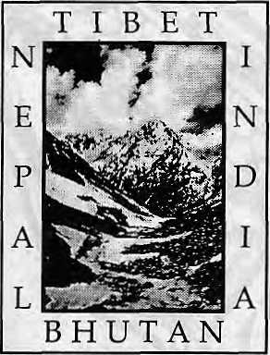

S/he will be Kathmandu-basecl and will have to travel to rural areas frequently.
Please apply by 31 August to:
I UMN NGO Project
PO. Box 126
Kathmandu

Free Catalog (800) 455-8735 Outside ihe U.S.A. & Canada please call;
00l.4l5.86l.239l orwrite m us:
Himalayan Hitih Treks
241 Dolores Street. San Francisco CA
94103-2211 U.S.A. Thanks!

H1MAL JutylAugust 1995
51


Not To Miss A Single
■■■ I" issue of ■■, r ;';; - - ■
HIM L



1'iKiihivra
ffl

■.-: Subscribe Your Copy Through :::
"Jk
Delivery At Your
p
/Sole bisfibutor&SL(bscHptian Agenffor: - -,'.'': Asiaweek,. Asian Business,-GapitarMarket,"Down toJarfh; Energy for,Sustatnab1e: Development^ Himal, World.: ExecutB/e's^Digest^Sjudy Ab/oad, National Geographic, ■ and many other fenowned pubitcafons. - '

P.O.Box;16^, Mah^rajgunj, Jha-54
Kathriiandu - 3, Nepal Tel: 413009 Fax: 227919 ■

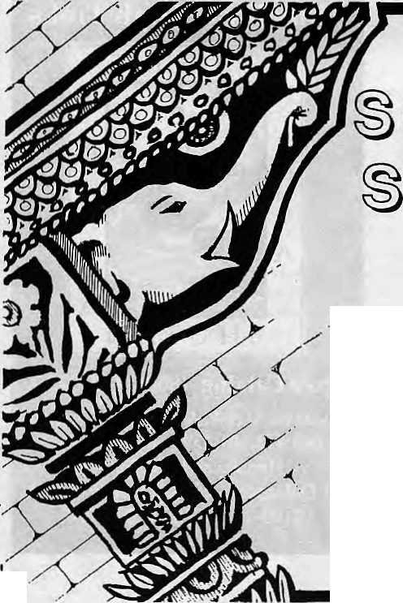









KUPONDOLE HEIGHT, LALITPUR P.O. BOX 1406, KATHMANDU, NEPAL
TEL: 521894, 521810 FAX: 977-1-523737, TLX: 2342 SUMMIT NP
V
SUMMIT HOTEL
and SUMMIT TREKKING PVT. LTD.
Q Q

The Origin of the Tharu

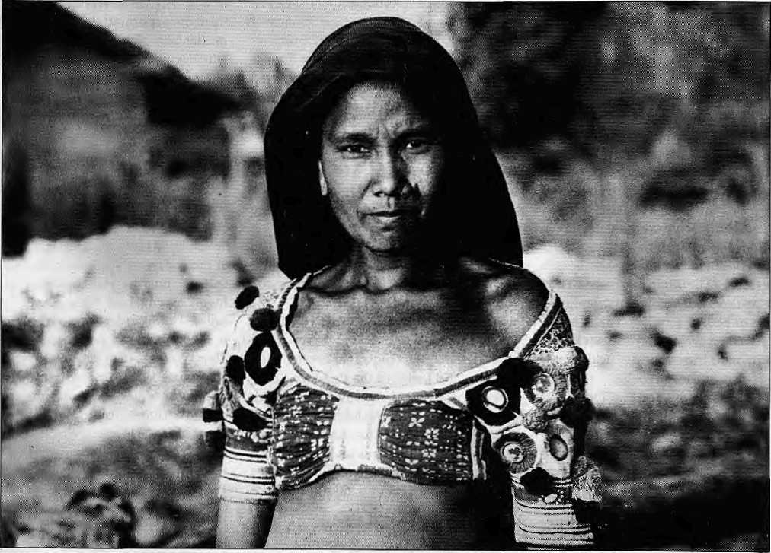

The extraction of the Tharu is veiled in the haze of undocumented history. It is
true that life is not permanent and history is not destiny but it is
nevertheless useful to ask, Who are the Tharu?

Once upon a time in the remote past when the kingofthesepartswasdefeatedby the forces of an invader, the women of the royal palace, rather than fall into the hands of foe, fled into the jungles with the Saises and Chamars belonging to the palace. From these sprang the Tharus.
R.H. Neville, 1904.
This is the real story of the Tharu: "...four sons a ndfive dough ters ofKingOkam ukha ofBa na res left the kingdom in a huff and moved to Kapil's Ashram. Kapil allowed them to clear the land and settle there on the condition that Ihe new state be named after him, 'Kapilvaslu.'. The Tharu are their descendants and have spread over the entire length of the Tarai."
Ramanand Prasad Singh, 1982.
HIMAL JutylAugustim
by Kurt W. Meyer
P
ieople everywhere have an insatiable desire to identify their roots, and the rharu are no exceptions. They, too, want to know about their tribe's past travails and triumphs. In response, many theories have come up to shed light on the early history of Tharus. It has, however, been a difficult task, for semi-nomadic peoples leave few tracks behind; maybe somecoins, some pottery shards.
When studying the history of great civilisations, we can fall back upon written texts and contemporary writings. Unfortunately, it is not so with the Tharu, in whose case we have had to remain content with analysing tidbits of information located at random. Archaeologists have a hard time looking for clues: thatch-covered
bamboo and mud structures leave no trace when abandoned. They literally revert back to earth.
Some of the theories that are pu t forth arebased on word-of-mouth recitals by old tribesmen, a type of oral history which certainly cannot be overlooked and needs to find its proper place in search of Tharu history. Other sources can be found in the early writings, oftenby British explorers or civil servants. Some are of recent origin, based on more current evaluations by scholars.
Jungle Halt
Besides R.H. Neville and Ramanand Prasad Singh, many more legends can be found in references by others. In the Census of India
53

(1961), R.C. Sharma quotes Tharus in the village of Rajderwa (northeast ofLucknow, just by the Nepal border) claiming to be Rajputs who had migrated from Dang, "but their features are Mongoloid". Writes Sharma, "The Tharu are a jungle tribe. According to some, the word Tharu is derived from the Hindi word 'Thahrey', halted, because they are said to have halted after the alleged flight into the forest... The origin is also traced to the Hindi word 'tarhua', wet, an allusion to the swampy land they live in... Some say the name simply means 'resident of the tarai'".
J.C. Nesfield wrote in the Calcutta Review (1885): "The origin is the word 'thar', which in the lowest colloquial language (but not in books) signifies 'a man of the forest', a name which correctly describes thestatus of the tribe, considering the name as sprung from the language of the tribe itself, which is now for the most part obsolete. An aboriginal name derived from Sanskrit is the fit appellative of an aboriginal, casteless, un-Brahmanized tribe whose customs have been only slightly modified by contact with those of the Aryan invaders."
Nesfield continues, "Another tradition is that after the fall of the Buddhist dynasty of Kannauj, the Tharu descended from the
hills and occupied Ayodhya (only to be driven out by R aj a Sri Chandra from Srin agar)."
In his book Eastern India, Buchnan refuted the often-heard claim that Tharus are descendants of Rajputs who were evicted from Rajasthan by Moslem invaders. "No Moslem historian has made the slightest allusion to the Tharus in connection with these events (expulsion by Moslems). The fiction of having migrated from Rajputana into the Tarai, therefore, must have been invented by some of the clansmerely to raise themselves in their own and their neighbour's estimation."
An analysis, titled "The Tharus and Their Blood Group", isfoundin the Journalof the Royal Asiatic Society of Bengal (1942), The writer, D.N.Majumdar, found that the Tharu are definitely a Mongoloid tribe. "They cannot be placed in any other constellation of tribes and castes of the Province, Indo-Aryan or Australoid, Also the Rajput origin is not supported on the basis of serology. Thus it is concluded, on the basis of the evidence, that the Tharus are a Mongoloid people, or predominantly so, who have successfully assimilated non-Mongoloid physical features as well."
As we wish, therefore, we can accept that the Tharu are a Mongoloid tribe which has assimilated non-Mongoloid features—
or that they are of Aryan background and have incorporated Mongoloid features. Incidentally, Maj umd ar is the only researcher who begins to use scientific tools to answer our question, tools availablein 1942. Today, far mo re advanced techniques are available, such as research based on comparative DNA studies.
Push and Pull
Having travelled the Nepal tarai east to west, from the banks of the Mechi to those of the Mahakali, over the last two years, visiting about 150 Tharu villages, this writer was impressed not only with the ri chness of Tharu culture, but the extraordinary diversity found amongst all these people who are called 'Tharu'. Indeed, it is a whole lot easier to see the differences between the various Tharu cultures than it is to find similarities.
This, then, immediately begs the question: are they really one tribe or are they several tribes brought together over a thousands years or more by common fate? Let us set free our memory and let it roam through history and recall in our mind's eye Tharus as we have encountered them and postulate these thoughts:
The 'Forest People' are comprised of more than one tribe and they may well have come from manyregionsatdijferenttimes,thuscontributing

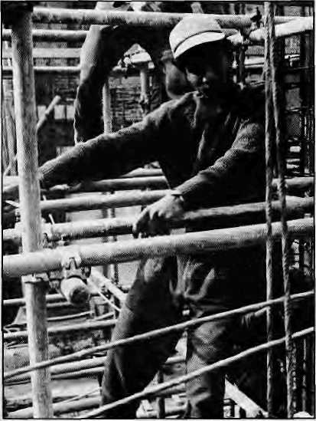
Jungle to Concrete
The Tharu appear to have had a very mobile past, which is also evident in population movements of recent times, Fatehnagar in Bake district is one such example. In 1972, an entire village left the inner tarai valley of Dang to settle under better conditions in the tarai plains. Others moved westward to Kanchanpur, Kailali and Bardiya. There are also movements within the same region, such as in Deukhuri, where a whole village decided that it could only escape from under the yoke of a heavy-handed landlord by moving to virgin territory and rebuilding their village.
Over the course of the last two generations, many Tharu from Saptari moved to Sunsari, Morang and Udayapur. And lately, there has been a mass movement to Kathmandu in response to overpopulation, underemployment in the farm, and economic opportunities in the Valley, particularly in construction. Over the last five years, Tharus have replaced hill people and Indians in 12 of the major construction sites, making up to 50 percent of the workforce in these sites. They are highly valued by supervisors for their diligence and ability to work with their hands.
One more example of mobility in pursuit of a better life—these peoples of the Tarai forests found in Kathmandu's jungle of concrete, cement and brick.
-KWM

54
1995 HIMAL

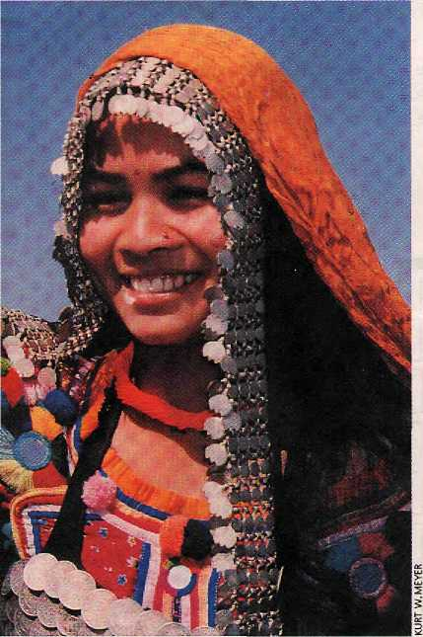
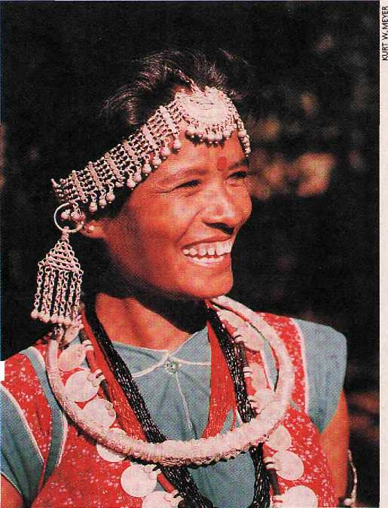
to the diversity of culture, facial features and customs found in today's population; the environment then moulded them over a very long period of time into a special group of people, the Tha ru, a people who, therefore, not surprisingly, are comprised of many subgroups, such as the Rana, Dangaura, Kochila and others.
And suddenly it all comes together... There are many events in the history of human behaviour which help us understand this set of circumstances. Most indigenous people around the world, when faced with similar circumstances, when in a similar environment, develop parallel lifestyles and cultures. Thus, when the ancestors of the Tharu moved into the forests of the tarai region at different times, coming from different places, this adjustment process began to take place.
Forest dwellers all around the world become skilled hunters and gatherers, and build houses out of available materials such as trees, branches, grass. When living conditions change for the worse, people move to new locations, and when settled in the new environment, they often also adopt some of the ways of their new neighbours,
for the sake of social acceptance as well as to add new spiritual powers to their own lives. These new deities just might prevent a repetition of the tragedies that made them migrate in the first place. To assure good karma, they also keep alive many of the mythologies and beliefs that they grew up with, the beliefs of their parents and grand-parents, and of their guthiar clansmen. This, then, is a straightforward explanation for the differences found in the belief systems and practices among the Tharu across the Nepal tarai. And why did ? various groups move into the forest in the first place? History the world over shows that people pull up the stakes for many different reasons: the search for fresh fertile land; to escape violence, destruction and war; a prolonged drought; overpopulation...In response to these push and pull factors, some people migrate voluntarily, others involuntarily.
The Dark People
After the Aryaninvasion destroyed the Indus civilisation, one verse in the Rig Veda states, "Through fear of you the dark people went away, not givingbattle, leaving behind their possessions, when, O Vaisvanara, burning brightly for Puru, and destroying the cities, you did shine." And in another context it is written, "The people to whom these ruined sites, lacking posts, formerly belonged, these many settlements widely distributed, they, O Vais-vanara, having been expelled by thee, have migra-ted to another land."
Did Ashoka's empire-building affect the corn-position of the people of the tarai, and did it lead to shifting of populations? How much damage did the Huna warlords do when they terrorised western India, and was there a flight towards fhe east and north? What was the status of the indigenous population of the tarai during the

rule of the Guptas in Uttar Pradesh, Bihafr and Bengal, circa 400 AD? Likewise, how many Tibetans and the Han moved into Nepal around 700 AD? Did Mongolian tribes indeed enter the tarai around 1200 AD, coming along the southern Himalayan foothills all the way from Assam? And how about the Sultanate of Delhi and Babur, and did they have a role in changing the population mix of the faraway tarai region? What, indeed, of the Dravidians?
So many questions, so much uncertainty, so few records, so many possibilities.
The 'Forest People' came from many regions at different times to seek the peace and shelter of the jungle; the environment then moulded them, over a very long period of time, into groups of special people, all of them called the Tharu.

K.W. Meyer, an architect in Los Angeles for the better part of his life, has devoted his "second lifetime" tothestudy and recording of the physical culture of Tharus.

HIMAL July/August 1995
55


"5
"■5 o
(0
.2
CD
Was glad to note that Kalimpong has finally made it into the calculations of the babus at the West Bengal Tourism Development Corporation, who put out a full page ad in The Telegraph extolling a township "Where The Mountains Meet The Sky". We, who have more friends in Kalimpong than in Darjeeling or Gangtok, had always thought that the "den of spies" {Nehruvian words) would have its day as the exclusive destination for high-end tourists. May it be so. Tathastku.
Angrita Sherpa deserves a hundred khadas for having made it to the top of the world once again, but no thanks to the Rising Nepal daily, which carried the following news: Angrita Sherpa Saturday scaled Ml. Sagarmatha for a record ninth time, a feat no other mountaineer Ms equalled after Tenzing Norgay Sherpa reached the top of the world with a New Zealander in the early fifties. Several difficulties with this item, which was obviously prepared by a xenophobic sludge with origins in the midhills of Nepal. If it is "record ninth time" the feat could not have been equalled by another mountaineer, could it? Tenzing Norgay was famous for having climbed Sagarmatha with you-know-who the first time, not for having topped it nine times. And why this inexplicable reluctance to name Edmund Hillary other than by nationality? Perhaps the reporter simply forgot Hillary's name, just as he forgot the date 29 May 1953 of the first topping. Early fifties, my grandmother's gout!
If few people remember Tenzing Norgay in Nepal—once (so briefly) a household word bandied about with nationalistic pride—it was touching to see his children bring out an advertisement in the Kathmandu papers in commemoration. Why has Himal, the Himalayan magazine, not done a posthumous profile of a man who, clearly, seems to have been a cut above all native climbers who have come after him? Could it be that they just made them better in the
fifties—adm inistrators, educators, politicians and mountain climbers?
"Fires ravage Garhwals", stated The Telegraph, with the headline-writer clearly being one who prefers the plural form, both, for fire and Garhwal, to the singular. There was, of course, more than one fire, but two Garhwals? Most likely a colonial hangover dating back to the days when Garhwal was, indeed, divided into Tehri Garhwal which was under a raja and the rest of Garhwal which was administered by the British.
Do we like the use of this traditional
Sikkimese dancer
motif to sell
Sikkim State Lotteries
to plains people? No,
and I wonder if the
Lepcha or Bhutia are
complaining. The winners
for 26 different draws
between 1-10 June 1995,
as advertised in the Indian
dailies, one notices, are all
from the Calcutta, Asansol
and Burdwan areas. Looked
at from one angle, it is good
that the Sikkimese seem not to have
taken to playing the numbers. Little
birdie tells me that the Sikkim State
Lotteries {managed by K & Co. of
Noida, U.P.) is a Himalayan
conspiracy to reverse the resource
flows and bring money up to the
Himalaya from the Ganga maidan.
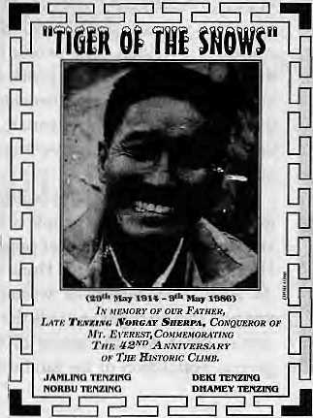
For the geopolitically-minded, hear ye that South Block in its wisdom has undone what it had once done. It used to be that the "Secretary North" over in the Indian Foreign Ministry used to handle Bhutan and Nepal, while China was over with the East Asia desk. Then, during the barony of J.N. Dtxit, China was clubbed with Nepal and Bhutan because supposedly the policy towards the three countries had to be "integrated" An impossible task, so Salman Haider, the newest baron of South Block, has decided to revert to the old setup, with China going back to the East Asia desk

where it belongs, and a joint secretary assigned to look at Nepal and Bhutan exclusively.

Time to let some air out of the tyres of the U ttarakhandi agitators who insist they have been left at the bottom of the heap of Bharatbarsha. Gautam Vohra of the Development Research and Action Group (DRAG), in a report on Uttarakhand to the government NGO-funding agency CAP ART, states that the hills of U.P. are no more neglected than other regions of the country. In fact, it is "better placed economically, socially and culturally than many other regions." The lament that the development programmes do not reach the people is also not specific to Uttarakhand. As elsewhere, "the marginalised sections are the ones who remain neglected. And they will continue to remain neglected, unless they decide to do something about it." But Vohra-saab, you cannot have

56
Juiy/August 1995 HIMAL

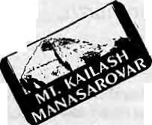


it both ways. The Uttarakhand agitation was what they were doing about it!
A report in the Gorkhapalra dated 13 Asar on "young cheats" of Nepalganj provides an interesting Himalayan morsel on the side. This hottest plains township of Nepal's southwest is the also one that is farthest from any Himalayan peak. However, it hosts an establishment which goes by the name "Ganesh Himal Rice Mill". Ganesh Himal is the spectacular range just north of Kathmandu Valley. We thank the proprietors of the Ganesh Himal Rice Mill for their Himalayan frame of mind, commiserate with them for the un-Himalayan 45 degrees Celsius temperatures they have had recently, and wish them a good threshing season when the paddy comes in.
While he may indeed have returned
after having engaged in—as the
Press Trust of India put it in
lachrymose terms—"a saga of
sustained human endurance and
unconquerable spirit", Major Harish
Kohli gets no
prizes on the
side of
imagination.
The major led a
high-altitude ski
expedition that
traversed the
Garhwal
Himalaya and
discovered and
christened two
new passes. One'
was named
Rajiv because
the former
Prime Minister of India was an
enthusiast of all adventure sports.
The second, and this is the choice that
has to be met with strident
opposition, was christened "Dennis
the Menace." Why? Because,
explained Major Kohli with evident
earnestness, "Dennis is the epitome
of youth in every human
being." Aaaaarggh-Oh, don't
tell me that this column by Chhetria
Patrakar is actually read and has
influence¹. On second thoughts, please
tell me that is so. Vishnu
International, lampooned in my last
for mistaking a beehive for Mount
Kailash, now shows a sketch of the
real Kailash in its ads. As
for the shape of things
to come in high
pilgrimages, and for_,
the ultimate
degradation of
what was once
remote and holy,
here is the punchline in Vishnuji's
latest ad; "Travel by private jeep. No
need to walk," Aaaaarggh.
Ishanya is a Sanskrit term which refers to the northeasterly direction. Ishani ("The North-Eastern") is an occasskmal journal published by Natwar Thakkar of the Nagaland Gandhi Ashram, seeking to promote discussion on development issues of "this fascinating, bewildering mosaic that is Northeast India." In an article, former Chief Justice of India P.N. Bhagwati laments that there is only one high court for the entire region comprising seven states, and declares that henceforth each state must have its own high court. (Ishani, Nagaland Gandhi Ashram, Chu-Chu-Yimlang village, Mokokchung District, Nagaland.)
About a year ago Himal did a cover feature on Film Himalaya '94, in which one article dealt with "delinquent documentaries", in which a film-maker taking liberties to create an artificial sequence with a lynx in Mustang had been exposed. The Banf Festival of Mountain Films is one of the more prestigious events of its kind. Chhetria Patrakar has just learnt that the 1994 Grand Prize for Best Film went to that very film that Tony Miller was shooting, Mustang The Hidden Kingdom. The lynx sequence might well have ended up in the editing room floor, but the fact that Miller won rave reviews in the West proves the point made again and again at the Himal-organised-
film festival last year: the views of the subject peoples will differ significantly from those of the audiences and film critics in the West for whom most Himalayan films are packaged. Someone should ask Miller to submit his new film to Film Himalaya '96...
It is cold comfort, but comforting nonetheless, to learn that it is not only Himalayan hill stations that are succumbing to the concrete jungle. According to Ananta Krishnan of The Indian Express, Mount Abu, the only hill resort in the Aravali hills of Rajasthan, is fast being overrun by a population and construction boom. The number of hotels doubled within 1985 and 1992, to cater to a tourist inflow that is now up to 5000 a day {the permanent residents number 16,000). There are 104 hotels, several public schools which accomodate 10,000 students in the area, and numerous unregistered guest houses. The nature of tourism has also changed, say the locals, with leisure visitors giving way to weekenders who come in a tearing rush and depart in a cloud of diesel fumes. Now where have I heard of this before?
Billy Arjan Singh, the famous conservationist of Tiger Haven at the Dudhwa National Park, is a morose and embittered recluse who fears that the countdown for the end of the tiger has begun, reports Tariq Hasan in the TOL "The tiger as a species is not likely to last more than five to ten years," says Singh, who believes that the official count of 4000 tigers in India is way off the mark because of "the inherently faulty system of counting tigers on the basis of pug marks". Like Chuck MacDougal who wrote in Himal a few issues ago, Singh believes that there is not a large enough "contiguous tiger population" anywhere in South Asia now to maintain a viable gene pool.
- Chhetria Patrakar

HIMAL July/August 1995
57

Know Your H i m a I

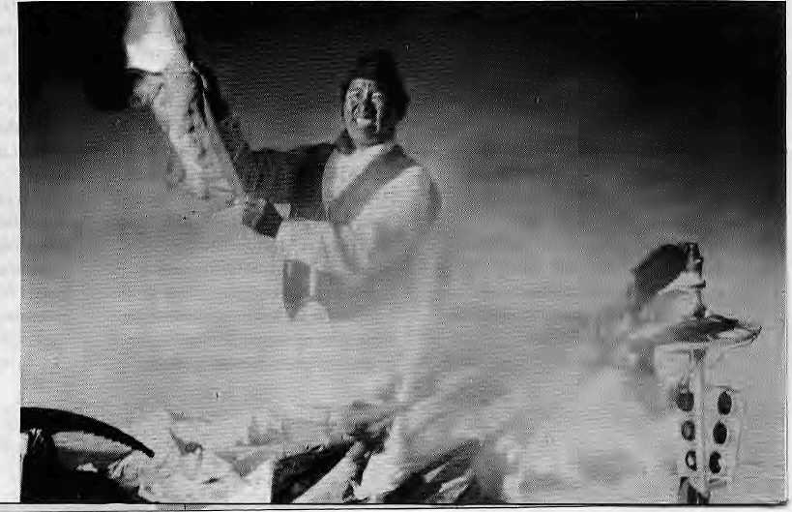
Market Forces on Everest
Climbing Everest has become commercialised,
and you need more money to climb from the south.
So the climbers all go north.
by Deepak Thapa
Mountaineering goes nationalistic. Kazi Sherpa, oILoding, Khumbu, sports Nepatflabeda surwal attire, the Nepali flag, and bare hands on top of Chomolongma, 14 May 1995.Mera and Thamssrku peaks visible below.
H
I is Majesty's Government, taking into consideration the pressure on the environment of theKhumbu region and to lessen the pressure in the area and to conserve the environment, has decided to regulate the number and size of expeditions." So reads the official explanation for the decision taken in 1993 to restrict the number of members on mountaineering team s going to the Khumbu region, while limiting the number of teams on Everest itself, and to raise the royalty for climbing Everest from U$ 10,000 to U$ 50,000.
For quite a while there had been a clamour for a restrictive policy, including from Edmund Hillary, who had called for a five-year moratorium on Everest, although this would have been quite hard to achieve since the Chinese had no intention of closing the mountain from their side, international opinion notwithstanding. Thus, long overdue' was what many people concerned with mountains in Nepal felt about the change in the regulations.
The government's logic was simple. Instead of ha ving a dozen or so teams paying ten thousand dollars apiece, if two or three expeditions paid fifty thousand each, the national treasury would still be receiving more or less the same amount. Mountaineering activities would be diverted elsewhere in Nepal to compensate for business lost from Everest by trekking agencies. The local economy would suffer a bit due to the absence of the hundreds of porters that swarmed up to Khumbu every climbing season (that was partly what the new regulations were designed to check), but would benefit from the increasingly popular policy of 'ploughing back' the revenue into the area earned from the peaks. And all would be well,
A rosy scenario, indeed! Unfortunately, mountaineering hasnotshiftedto elsewhere
58
within Nepal, It has instead shifted to Tibet. This past spring saw 11 expeditions tackle Everest from the northern side against only three from Nepal. (Of those three, two had to be billed 'clean-up' expeditions in order to get around the 'one-route-one-team' rule, since all three took the South Col route. The regulations clearly state: "Only one team shall be permitted to climb Sagarmatha by each separate route in one season. "But this being a policy matter' it can easily be circumvented by a cabinet decision. Why the council of ministers should be called upon to look into such inconsequential matters of deciding whether an expedition is a 'clean-up' or not,, beats reason, since clean-up or otherwise, the U$ 50,000 royalty has to be coughed up.)
The fact that there are more exp e ditions going to Tibet is lost on the Ministry of Tourism, It points out that there has been no decrease in the number of expeditions— around 100 every year—coming to Nepal over the last decade. Stagnation is better than decline.
When questioned why no effort has been made by the government to market other mountains of Nepal while Everest is being kept at abeyance, Prachanda Man Shrestha, Acting Director General of the Department of Tourism, threw the ball to private operators, saying that the private sector expects everything to be served on a platter. For their part, the operators throw the ball right back, retorting that all the publicity Nepal has received thus far has been due to their efforts and no thanks to the Ministry or its Department.
Everyone agrees that climbers cannot be forced to scale this mountain or that. If they want to climb Everest, does it do to offer a substitute mountain even if it is for free? Besides, it is certain that Nepal is losing out on the Everest market. For one thing, China's fee of U$ 5500 for an Everest expedition is a sure draw even without considering the added charm of going to Tibet.
U$ 45,000 or U$ 13,000
Contributing to the declining numbers on Everest from the Nepali side, is the quite recent development of 'commercial climbing'. Since climbing Everest has become such a regular affair, corporate sponsors are becoming as scarce as yeti footprints. Most of the expeditions on Everest nowadays are 'guided climbs,' operated like any other tour, with paying clients.
Commercial climbs go for the South Col route, which is booked in advance for years to come. The only way to get out-of-

turn permits is to don the clean-up garb. Tour operators cannot, for obvious reasons, afford to stand in line for years but that could not be helped till this year since it used to assumed that the northern route was not viable for paying climbers because of the longer dimb it entailed.
This spring, however, saw 19 clients put on the Everest summit by five different operators from the Tibetan side, while both commercial expeditions from the south were unsuccessful. Henceforth, more such expeditions can be expected to go north where there is no queue. As for the clients, unless they have a specific reason to go from the south, such as wanting to retrace the footsteps of Tenzing and Hillary or something else, it is a matter of simple economy to prefer Tibet. To take an example, a Germany-based operator is selling Everest climbs for U$ 45,000 from Nepal and a mere U$ 13,000 from Tibet.
Besides the steep royalty, climbing Everest from Nepal has other attendant encumbrances as well, like the garbage deposit and the more troublesome bureaucratic red tape. Kathmandu-based
trekking agents complain of the stonewalling tactics of the Ministry of Tourism regarding issuance of permits, so much so that they claim it is easier for them to get a permit from Lhasa than from the Nepali authorities.
The operators are not happy with the 1993 regulations and remember being taken unawares when the announcement was made. No attempt was made to list their views on the matter, and it seems that the then Minister decided to go for the decision on the basis of a few environmentalist climbers who got his ear. A few of the businessmen even suspect a sinister vested interest in making it so difficult for climbers to dimb in Nepal while China welcomes them with open arms. Keeping the mountain clean is fine, they say, but that can only be done with strict adherence to rules, which is not happening.
For the moment, trekking/mountaineering agencies do not have much to complain about. Mountaineering might not be picking up in Nepal but it is certainly growing across the border to the north, and it is mostly the Nepali operators who go over to provide the services. The Tibetans
do not have the required infrastructure to manage expeditions and so this aspect is still completely in the hands of Nepali agents. But the Tibetans are learning fast and very soon the Chinese are likely to come up with regulations similar to Nepal's that require a local handling agent. That will mean good-bye to Kathmandu's domination of the mountaineering trade in the plateau.
There remains one more legacy of the new regulations that has not been addressed. Kathmandu agents and their employees might be flying high for now but no one pauses to think about the hundreds of porters who have lost their seasonal livelihood of carrying loads up to the Everest Base Camp. On average, 250 porters are required by an Everest expedition and hundreds of porters from the lower hills have them selves earned cash income while providing stimulus to business in Khumbu and the approach route.
About this, everybody in the trade and in the government seems apologetic: it is not possible to please everyone at the same time. That is about as far as it goes.
A

Above all, with dominating views

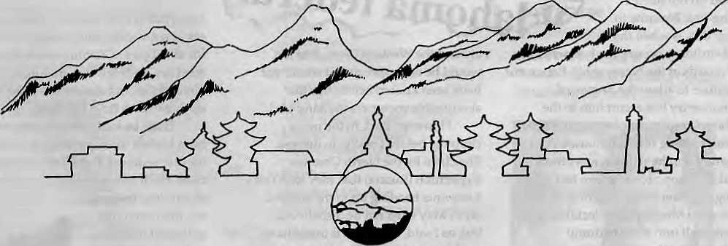

HOTEL SUMMIT
KUPONDOLE HEIGHT, LAUTPUR
KATHMANDU NEPAL
TEL 521894. 521810
FAX 977 . 1 , 523737. TLX 2342 SUMMIT NP

HIMAL JulylAuguti 7995
59

Abominably Yours,

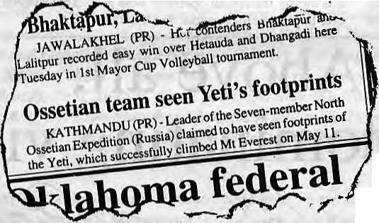

D
id you see the Kathmandu Post item on Yeti successfully climbing Mount Everest on 11 May? Several pertinent points that I wish to bring up here which, basically, amounts to a critique of reporting and writing in the Himalaya.
We all know that "man bites rasgollas" makes no news, but "rasgollas bite man" does. Something out of ordinary must happen for your newspaper hack to lift pencil from ear and deign to scratch out a story and pass it on to the sub-editor at the night desk.
In Kathmandu's dailies of English, however, this sarbottam (supreme) principle of news-gathering does not apply. Here, man bites (into) rasgollas is regularly served up as stimulating information that we should inform our neighbours about and discuss animatedly over daal bhat. His Majesty the King accepted credentials from the Ambassador Plenipotentiary of Transvaal, the Prime Minister met with a delegation from Sankhuasabha District, or the Kathmandu Mayor ranted and raved yet again about the garbage pileup... This is news?
News, dear reader, and you do not need a missing-link Barunite to tell you this, is when the out-of-ordinary occurs. Such as when the royal guards at the Narayanhiti Palace not only refuse to allow the Transvaal diplomat entry but escort him to the CDO karyalaya at gunpoint; or the Prime Minister's telling the Sankhuasabha delegation that he will not meet them even if they hop about on one feet singing "Reshamfee ree ree"; or the Kathmandu Municipality deciding to convert itself into a waste dump in order to end the endless search among hostile surrounding Valley villages for a dump site for all the urban dirt.
Now, you might think that I have lost my train of thought, but I haven't. It is chugging along on its track. I never lose my train of thought.
The news clipping which refers to Yeti successfully climbing Mount Everest is of the same ilk as the news about the King, the Prime Minister and the Mayor. They were all born out of the newsman's need to fill newsprint with text. Yeti always climbs Chomolongma, so where's the news in that? She has to do that route to go down to Rongbuk for her facials from Slothful the snow leopard, or to Kangshung to maroguff with Kagkagkauwa, the extremist chough with such high airs. She even has to use that route to go to the loo when the regular one in the Baruntse moraine is clogged up.
If Yeti had been caught incognito at the Super Market in New Road—dressed as a casino-hopping Sikh from Pilibhit— now that would have been news. If she were photographed hang-gliding

around the Western Cwm, that too would be news, because it would not have been known before this that abominable snowpersons hang-glid.
However, back to the news clipping, before I really do digress. The claim by the North Ossetian Expedition (Russia) that they saw Yeti's footprints heading up to the summit on 11 May need not be disbelieved, but, as I said, ho hum... It would have made an epoch-making scoop, however, if the reporter had got the story from Yeti's point of view.
YETI SEES OSSETIAN TEAM FOOTPRINTS
BARUN (PR) - Abomi Nable, the recluse of the Upper Barun, claimed yesterday to have seen footprints of the seven-member North Ossetian Expedition (Russia), which successfully climbed Mount Everest a jew minutes after she came across their tracks on 11 May. Ms. Nable said the seven had done the First Step on the Northeast Ridge and were negotiating the Norton Couloir when her path crossed theirs. She helped carry some stragglers over theSecond Stepandshooedthemonto the summit, she said.
Asked wfiether she was not worried that her legendary reclusiveness might be put in jeopardy by this act of good samaritanship at 8000'plus metres, Ms. Nable replied, "No, at this height memory plays tricks on humans and more go back down saying they did not see me when they did than those who go back saving they saw me when they didn 't. Soldo not have to worry about those who say they saw me. Most of them will not have."
Asked about her views on the advent of democracy in Nepal, Ms. Nable replied that shewishedthat this form of social organisation, including the healthy process of voting representatives to power through the ballot box,would be incorporated in the order ofthings for those "both up and down the evolutionary ladder."
On a question on the skyrocketing price of newsprint in India, Ms.Nablesaidshe preferred not to make a comment on the sensitive matter at this date.
Now, that is a news story of the rasgollas-eats-man variety, and it would do good for all editors of Kathmandu's dailies, weeklies, fortnightlies, monthlies, bimonthlies and quarterlies to be able to shift the news from the chaff.

Truth be told, though, rasgollas have been known to eat persons in certain gullies that come off Rasbehari Avenue in Calcutta. So, if you are filing a news story about those few gullies, then even "rasgollas eat husband and wife in a night of merry frolicking" does not make the news.

60
July/August 1995 HIMAL

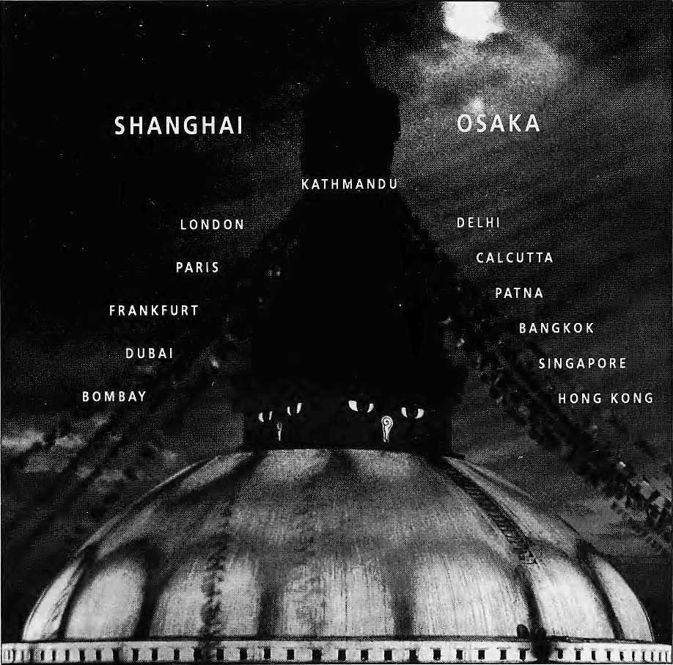

DIRECT TO SHANGHAI & OSAKA
Royal Nepal-Nepal's own international Airlines operates regular flights to Kathmandu from 13 cities. You can warm to the gentleness of Nepali culture, tradition and the authentic spirit of
Nepali hospitality aboard.
Royal Nepal Airlines
RNAC, Building, P.O. Box: 401, Kathmandu, Nepal Tel.: 220757, Fax: 977-1-225348

Hongkong
3759151
Singapore 3395535
Osaka
2292545
Bangkok 2333921-4
Kathmandu 220757
Shanghai 2558899

sill,* J7CJI J—/11G«

i iy ;^WM P->^
You've just spent hours
pinching around a space barely
enough to accommodate

i

the human body.


Odd, that's what climbing in

'SM

■ -: ■ '. ,. ■
mm
s; y?•!:■:.,■.?■:■-.> ■■■•■.
; mm&M?.
.■■■r -* v.

The New Sleeping Bag Collection
For our free catalogue call 707 5^{/l}

