. .

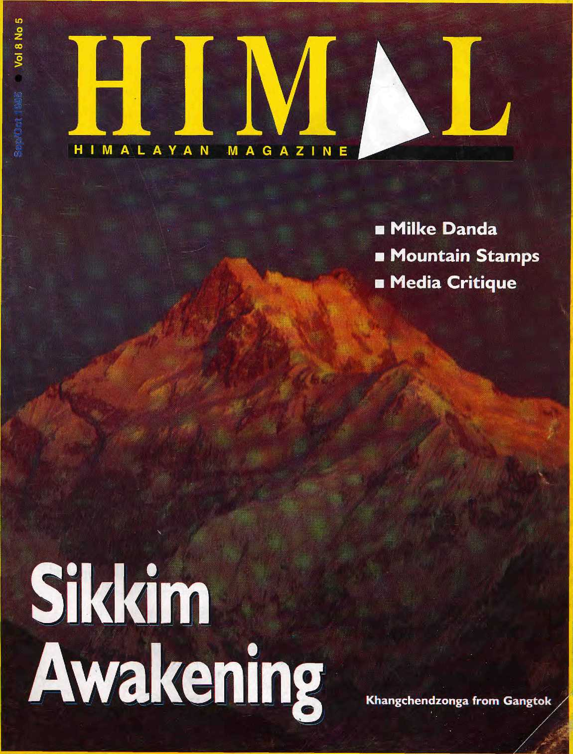
NRs 40 irs 25 Nu 30 dm 9 £ 4 U$ 5 US $ 4.75 Canada $ 5.75

With

t0 9° t0 Ameri«-
?.•? ²⁰° ^ beyond.
^{9enerous}

*
^{Agenl} ^{in} ^{Nepal:}
|

Be sur, ,o
Wo,ldPe,b. the _{m}os,
₃₈₉


NORTHWEST AIRLINES
SOME PEOPLE JUST KNOW HOW TO FLY.^{!M}


HIM
INSIDE

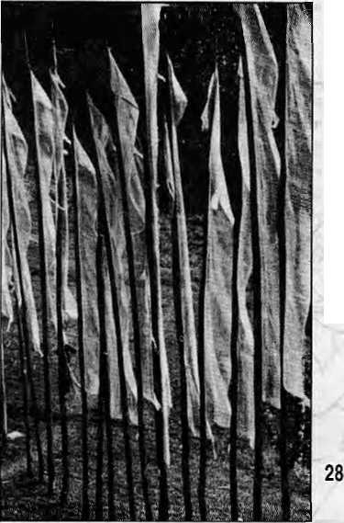
21
18 24 38
48 50
Vol 8 No 5 Sep/Oct 1995
Tf)e Abode o{Q6ds,Kmgof:
Mountains, Himalaya You bound the oceans from
east to west
A northern yardstick
To measure the Earth-
- Kalidasa (Kumara Sambhava)
Editor
Associate Editor Marketing Administration

Kanak Mani Dixit MamshaAryal Sujata Chhettri Balaram SNarma,12 Mamata Manandhaf
Subscription Rates
Only bank-drafls acceptable for subscription orders
made KfHitnal- in Nepal. Do NOT sand cash in mail.

individual |  | 1 year | 2yrs
Nepal | NRs | 220 | 400
 | ■ IRs | 14D | 260
Bhutan | Nu | 175' | 330
Other SfAslar) Countries | IJ$ | 12 | 20
North America | U$ | 22.50 | 40
Germany | DM | ■ .. 50 | 90
United Kingdom & Ireland | £ | 20 | 35 .
Netherlands | Dll | 45 | 80
Elsewhere | US | 25 ■ | ::- 45,,
Institutional
Nepal | NRs | 600 | 1100
Sndia | ins | 260 | 500 .,..
Bhutan | Nu | 330 | £40 :,
Other S. Asian Countries | . U$ | ■ 25 | ■■ 45- ,
North America | u$ | ■"35.,.. | ■ "60"
Germany ■ | DM | ■ 70.:. j- | " 12& }
United Kingdom & Ireland | E | 3Q ,' | . #:
Netherlands | Dll | 100 | lao:
Elsewhere | US | .. 4S-"
Send subscriptions 5 related correspondence to:
a: P.O. 6ox42, Lalitpur, Nepal (te!977 1 523845, fax 977 1 521013) or Central Mews Agency 23/90 Connaugh! Circus, New Oethi 110001 Japan: Akio Horisjtfhi P.O.Box 9, Kiyose, Tokyo, 204 Japan. Australia: Indra Dan. 12 Norfolk St. Paddington2O2t _{t} Sydney. Australia North America: Barbara Bella & Associates 500 Sansbme Street, Suits 101, PO B6x 470758 San Francisco, CA 94147 United Kingdom & Ireland: Joti Gin (Re!: H), 221 Ashly Gardens, Emery Hill Street, London SW1 1PA The Netherlands: Frans Meijer Foundation Himalaya, Kerzersgracht 463 1017DKAmsterdam
Switzerland: HeleneZingg. Tannenweg 18 CH-3073, Guemligen, Switzerland ■:■: Europe: Durga Press (Himal). Luitpoidstr. 20 0-8221 t.Herrsching. Germany
Himal© 1395 is published every two months by
Himal Association, PO Box 42, Palaci Dhaka, Lalitpur, Nepal
Tel:* S77-1 -523845.522113 Fax; 521013,
emaiiitirmalfthimpc.mos.cbra.np
Library of Congress CartJ, Galalogue hlumixir S3 912&B2 -
i
Printing: JagattambflOtfstjIWt.Ltd.Tet 521393,

3
Departments
Alternative to Mainstream Dissatisfied in Dang Hanoi is Closer No Aryan Invasion Search for a Gazetteer Trek Abuse Gorkha Dukha Sparrow and Arun III
Voices
Abstracts
Briefs
Appeal for Thame Monastery
Tibetan Women Manipulated
Banmara, Die!
Rhino Horns for Sale
Congress Got Leh
FLACENAMES-Siliguri to Darjeeling
Hindukush
Squatting a Kind of Human Right
Himalaya Mediafile Know Your Himal
Fame Still Eludes Sherpas
52 Abominably Yours
33
45
A Sikkim Awakening by Ludwig Schaefer
The Bhutia and Lepcha gird up to challenge the SikkimGse status quo and, decades late, demand a hearing.
Cover picture by Arthur Pazo, Dawn over Khangchendzonga, as seen from Gangtok.
A National Forest for the National Flower
by Salil Subedi
Milke Danda, in the eastern hills, is a place of rare beauty, repository of the rhododendron.
Confessions of a Himalayan Philatelist by Armand E. Singer
Stamps from the Himalaya are as alluring as the mountains.
Media and Himalaya
A Workshop in Kathmandu
by Deepak Thapa
Himalayan journalists meet in Patan to exchange ideas.
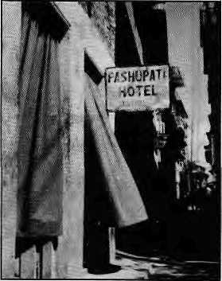
Pashupati Hotel
Katha
by Narayan Dhakal
(translation by Manjushree Thapa)

For once, Think twice !



Are you looking for the cheapest rates ? Or, do you want value for your money ?
At Summit Nepal Trekking we design our programmes that ensure you get full value for your money.


MMIT NEPAL TREKKING
Write or call us at:

P.O.Box 1406,Kupondol>Kalhmandu,Nepal Tel:525408,521810
Fax: 977 1 523737
'

B
m a

the maidan as; well—to become: a truly South Asian magazine. -_{r:}i\ ■ ■ ■.: .::.:::::-:--:- ----- ■" -' ■
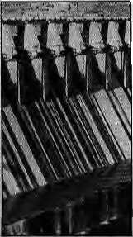

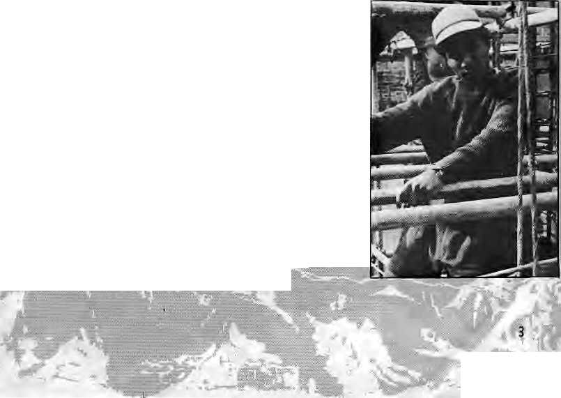


Alternative to Mainstream
Most of the articles, including the book review:, that '■ appeared in the July/Aug 1995 issue of Mimal superbly articulated the "alternative" perspective on water resource development. Manisha Aryal's probing of the language of protest on the high darns .:.: throughout the Himalaya, Rajendra Dahal's foray: into the psyche of Biharis on "Koshi High", Bikash Pandey's recapitulation of the Arun III story, and DipakGyawali's succinct review of the output of the "techno-exuberant" school of thought (another-example of his penchant fox coining new terms), adequately represent the alternative perspective.
The only article in the whole issue that veered towards the mainstream view, but whose ultimate result is: devastating, was Ajaya Dixit's depiction of what Nepal would look like were all the proposed reservoir projects to be built.
What is missing in the issue is a "square mainstream" view of water issues. Isn't it time for Himal to invite diehard proponents of the mainstream Nepali development thinking and project-building, such as Ram Sharan Mahat,, Laxman Ghimire and Binayak Bhadra, to express themselves in your magazine? Bringing forth their views in these pages would also allow these gentlemen to engage in some intellectually significant activity rather than go mud-slinging in exclusively political forums against the non-political alternative school.
Himal has over the years emerged as one of the best n on-esoteric and non-academic forums for looking into serious ethnic, cultural and economic issuesof the Himalayan region. The;opinions for and against Dor Bahadur Bista's thesis on fatalism and development and the tirade for arid against bahunbaad that these gave rise to, have strong resemblances with the long drawn-out battle between ArunShouri and Tariq All in the pages of the Illustrated Weekly of India in the early eighties. ;

HltyfAL "September/October 1995

Aside from the Political and Economic Revieiv (which unfortunately tends to become too dense and limited to the academia), good magazines which delve into underlying social, economic and political themes, and which lay readers can easily follow, are lacking in the Subcontinent. Given the niche that Himal has built for itself as a forum for generating lively public debate, it is high time for ■ this, pahadi magazine to take into its purview all of
We are turning to the maidaF. Kindly turn to page ip, Eds. ;
Dissatisfied in Dang ■:
j In "The:Origin of the Tharu" (Jtil/Aug 199S},^K«rt ■:[ W, Meyer let mHshy speculation trail his archival account in a way that left this reader wholly dissatisfied: Meyer gives the impression that the Tharu are a. casteless people. They are not. Among: one group ofThiarus alone-7-the Dangaura—castes and sub-castes exist in I- ways similar to, but not as rigidas, those of Patan's JSfewars. Tme> the generic surname 'Ghaudhary' may in a ke one glossover the ; subtle occupational/r&ligious/sociai hierarchies within each Thara group. But that does notmean that differences based on castes are not there for the Tharu. Meyer cited a text that depicts the Tharu as : an:"uh-Brahmanised tribe whose customs have only been slightly modified by contact with those of the Ar)'an invaders". Assuming this to be true, how then:to account for the fact that the Tharu of today avidly observe the lunar calendar-based Krishna Astami, the Maghe Sakranti and other. Hindu festivals, during which [even] Tharu men piously observe fasts? If the Tharu's contact with the Aryans was limited, when and under what conditions did Hinduism, especially the sect devoted to Lord Krishna, influence them?
Meyer speculates upon the evolution of the "jungle dwelling Tharu" as mobile groups, escaping bad karma and subsisting through the centuries by hunting and gathering. Absence of evidence may make such thinking appealing, but it really leads to this sort of Simplistic conclusion: that the Chepang, the Raute and the Tharu, to name a few groups, are all alike. Why? Because they all survive in the jungle...
Finally, from someone who claims to have travelled to about 150 Tharu villages and is clearly impressed by their diversity, how is it that all three pictures showing Tharu women are limited to the Rana Tharu?
Ashutosk Tizoari Tulsipur, Dang

The selection ot pictures was made by the editors and not by. Meyer, Eds.

B
M


September/October 095 HIMAL ;I

Hanoi is Closer ;■;- ■.-.■■.. ■ ■:-^/';; :.-
Sanjoy Hazarika in his article on the "Far Eastern Himalaya" (May/Jun 1995), is incorrect when he : says that Gaiihati is closer to Hanoi than to Delhi.: One could perhaps say that Gauhatt, and I use the
ft
halfway between Delhi and; Hanoi. It is really closer to Delhi than to Hanoi, though only by 69.3 km; ■which-is still a: sizeable4,7 percent.
OMricH Bemnk
'' ■■. v.. ■ Kathfttandu .-'■■■"■'■ .
Roll Back the Aryan Invasion
Upon reading Kurt W. Meyer's article on the origin ; of the Tharu (Jul/Aug: 1995), Ifound that he relied■■.'.:' on assumptions of an "Aryan invasion"—the ope that supposedly destroyed the Indus civilization,
I am surprised that the Aryan invasion theory is still unquestkmingly accepted by most South Asian historians. The theory, however;, represents a misinformed and out-of-diateexplanation of the origin of Indo-European civilisation. It credits Europeans with the establishment of India's rich Vedic cultural heritage and has also had the result of causing antagonism between northern and southern India. Following is a brief refutation of the prevalent invasion theory.
The theories of India's origins in most text
books discuss the Indus Valley Civilization's two ■
primary cities—Harappa and Mohenjodaro. These
were highly advanced societies, though they jacked
literary records. Harappan civilisation had disap
peared by 1500 BCdue to the alleged invasion of
India by Aryans, who were nomadic tribes from the
northwest. :
As the biond arid blue-eyed Aryans moved into the northern half of the Subcontinent, the dark-ski nhedand snub-nosed nativesDravidians shifted to southern India. The Aryan invaders began the composition of the Vedas in 1200-1000 BG, Aryan civilization, thus, is not native to India; the Vedas and Sanskrit are post-Aryan. Indian history generally begins with this idea of origin.
Much of the evidence of an 'Aryan invasion' is interpreted from Indo-European linguistic similarities, and through the Kigveda's alleged discussion of the racial differences between the invading Aryans and the ravidians.Tnthe 18th century. Sir
William Jones established the remarkable similarity which existed between Indian and European languages, and this sparked much researehon questions of the origin of Indo-European civilization,
The conclusion to be derived from the linguistic similarities is that a single, Indo-European language originated in a given place, and then dispersed, and altered. Frederick Max Muller, the leading Sanskrit scholar and invasion theorist, believed that India was not the homeland of the original -language,
The prevailing invasion theory; the chronology, the evidence from the Rigveda, and the: linguistic and 'racial' .evidence; though widely :. accepted, are replete with contradictions. Although Harappa and Mohenjodaro are considered the two founding cities, they were actually part of more than 2,500 settlements that stretched nearly 1.5 sq km: Also, most of these settlements were concentrated along: the Saraswati river, not the Indus or Ganga. Satellite photographs, hydrological and archeologica) studies have shown that the Saraswati changed its course several times before drying up. The Rigveda confirms this, as it mentions Ganga only once while it mentions the Saraswati at least 30 times.
If Aryans invaded in 1500 BC and composed the Rigveda near 1200 Bq, how did they describe a river arid geography as it was before 1900 BC? Harappan society must have been Vedic Aryan. The Indus Civilization, which should properly be called the 'Saraswati Civilization'-, ended because the river dried up, not because of a European invasion.
Another problem with the invasionist theory is that there exists evidence of two fundamental aspects of Vedic religion and ritual—fire worship in elaborate yagnas, and somit ritual use—before the supposed invasion. Excavations at the Harappan sites have yielded fire-altars, terra-cotta ladles used in yagnas, and pieces of bangles, pottery and animal bones in these altars as in certain Vedic sacrifices. Use of soma is documented only in Vedic and Iranian mythologies. The mention of soma is telling, in that it is "distinctly the plant growing in the mountains of northernmost west Punjab and the adjoining areas of Kashmir" (S.C.Talageri, 1994). This strongly suggests that the Vedic civilization originated in India, not Europe.
Also, the word 'Aryan¹, now synonymous with light skin and Nordic features, does not have racial connotations irt Sanskrit. In Sanskrit, the word Aryan is defined as: nobility, or as those who want

equality, or as a culture and society from the Vedas. One line from the Ramayana, describes Rama as: aryah sarva-samascaiva adaiva priyadarsanah - arya who cared for the equality of all and was dear to everyone. The Rigveda also states; praja arya jyoliragrah - children of arya seek and are led by jyoti (RV VII.33.7). Jyoti means light, which refers to sunlight, enlightenment, learning—not to skin colour. (N.S.Rajaram, 1994). Europeans have falsely constructed a racial myth through linguistic similarities.
Undoubtedly, the Rigveda and other Hindu texts are about conquering and spreading Vedic-Aryan culture. (The Ramayana and the Mahabharata are interpreted as accounts of Aryan expansion and colonisation). The frequent mention of Asura-Dasa conflicts is misinterpreted as 'civilised' Europeans (Asuras) invading and bringing down the Dravidians (Dasas). An alternate and more credible theory posits that the conflicts were between Indo-Aryans and Iranians. The Iranians (Dasas) were the enemies of the composers of the Rigveda. They are the ones characterised as asraddha (faithless), ayagna (offering-less or non-sacrificing), and avrata (without rituals). They were in constant conflict with Vedic Aryans and this enmity caused the division of the two groups. Iranians in their own books refer to their enemies as the Vedas (Rajaram, 1994).
Back to Meyer's article: I do not disbelieve that the Tharu came from "many regions at different times". I do disagree with Meyer's Aryan invasion premise, his use and interpretation of the word 'dark', and his reifying the Rigveda to support his claims. It is time to question the discrepancies in this racially-motivated theory, and reconstruct an explanation for the origins of our South Asian civilization.
Rachana Pathak Kathmandu
Search for a Gazetteer
Himal continues to get better all the time, which is pretty remarkable considering how long you've been publishing. I've been particularly enjoying the photo essays as well as the usual excellent insights into local and regional politics. Just one request, however: could you include a few more maps for those of us who are just beginning to gain familarity with the region and cannot afford expensive coffee table atlases? And while on the subject, can you recommend a book to identify all the various geographic regions, placenames, ethnic groups,
perhaps even conspicuous historical figures, mentioned in the articles you publish? There must be a gazetteer with this sort of information available somewhere.
Argon Steel
Seattle, Washington
Genera! information on the Himalaya can be obtained from a couple of tourist guide books which look at ths whole range. We have yet to come across a comprehensive publication containing the details Steel looks for. Gazetteers go back to British times, are divided among the various regions, and do no! exist for large sections including Nepal. Eds.
Trek Abuse
Last year, I took nine Alaskan women to Nepal for my 50th birthday celebration. Our guide was a beautiful person, a Sherpa woman who did a magnificent job for us, but the trekking agency which our tour organiser used never paid our guide her salary for her three-week trek, nor reimbursed her for the porters' salaries, nor our luggage costs from Phaplu which our guide also paid for.
Our guide was a single parent, one of her daughters being disabled, who lives in a concrete two-room walkup. The owner of the trekking agency is among the Kathmandu elite with a beautiful home and grounds. There is no question that the agency can afford to clear the NRs 10,950 they owe. Over the past year and a half we have repeatedly written, faxed, called and even visited the home of the Managing Director of the agency, but this person and the company have refused or ignored every attempt to clear up the problem.
The issue is greater/however, than this individual instance. I am hearing that such treatment of rural Nepalis, especially women, by the moneyed and powerful people in Kathmandu who use their status to take advantage, is not uncommon. I am asking your readers if this has been a
Readers are invited to comment, criticise or add to information and opinionsappearing in Himal. Lettersshould be brief, to the point, and maybe edited. Letters which are unsigned and/or without addresses will not be entertained. Include daytime telephone number, if possible.
PO Box 42, Lalitpur, Nepal
Tel 977-1-523845, 522113, Fax 521013
email: himal® himpc.mos.com.np

HIMAL SeptemberlOctober 7995

M ^{r}-a i I


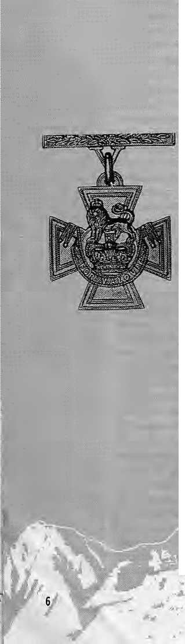

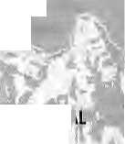


problem for them, as we would like to begin to document this kind of abuse,;especially of women, who are becoming more and more involved as porters and guides to foreign trekkers.
We are very embarrassed to feel weimposed upon and took advantage of friendships made along the way, as we also feel imposed arid dishonoured by the trekking;: agency's failure to pay our staff.
tipping the trekking staff; which may take many unawares.
Susan R. Clark
Juneau, Alaska
Gorkha Dukha, what?
I chanced upon a few copies of Himal and read with interest PratyousfiOnta's "EHikha during the; World'Wars" (NoWDec 1994) and also the -letters by Ronald Burroughs (Jan/Feb 1995) and MahendraLawoti(Ma*/Apr 1995). Having shared with rny wonderful comrades-in-rarmMhe joys of life and the trials and tribulatioris in war and peace, may I share some of my views with your readers. Orvta has not spelt out what the aim of his research on duWia was. If it was his intention to highlight bodily pain, mental suffering, extreme hardship and death during war with a view to stop our young boys : from Nepal from joining-the army, then lam afraid his aim was without any basis and a futile effort. : ....... \
Everyone'knows that war is a dirty game. : There is certainly no; sukha in wars of any kind arid certainly riot in a warof such intensity and magnitude a* the two world wars. During both these wars troops from all over the World suffered great hardship. Letters of dukha had been written not only by a few Gorkha soldiers but also by British soldiers and their officers, lam sure different archives of many nations in the wortdhave such letters of dukha that were intercepted by censors:; While dukha expressed by a fewhasto be taken » its stride; Brig. E.D. Smith, 7th Gqrkha; Rifles,;:

Most trekkers have no idea how much their Staff is-receiving; Our guide: received a mereNRs 150 a day, the 'sherpas' NRs75, andthe porters :. even less, yet we paid U$ 2Q50 each in land costs alone^a mere one-quarter of which met expenses. Those who use tour agencies need to expect to::: verifystaff payment before leaving the country,
in hisbpok Even the Brave Falter, has very rightly mentioned that courage is unpredictable and even the bravest and the toughest of Gorkha were sometimes overcome by fear in the face of danger and death. He has also quoted Mark Twain:: "Courage isresistance to fear, mastery of fear—-not absence of fear". Fear stimulates dukha and for those who understand the psychology of war it is pertinent to-mention that it is wise to let soldiers give vent totheir feehngs—be it a feeling of dukha oriof sukhaarid the expression of dukha should not beconstrued as an extraordinary matter to feel strongly about.
I will has ten to shower kudos on Onta if his intention was to improve the lot of Our suffering old soldiers by spreading a rhessage of camaraderie and harnessing help from all quarters. Rather than go nit-picking on the dukha of the distant World War T soldiers, Onta should turn his attention to relatively more recent World War II veterans (most of whom are in their seventies) who were sent home as a result of the general demobilisation at : the end of the war and are now languishing in their villages without any pension. Many states in India give these old warriors monthly allowances. The British Army also looks after some of these veterans;. Let Onta mull over this problem and use his pen to highlight the dukha of these soldiers in Nepal, This dukha hurts more than a splinter in a mother's heart—
Now, on to Burroughs. He has done great injustice by branding Gorkhas as mercenaries. What is a mercenary but a soldier hired into foreign service for monetary gain, and often it is for price demanded by the mercenary? After completing the assigned task they collect their price arid start searching for another paymaster. Our brave Gorkhas from Nepal join She Indian Army as raw recruits and are systematically trained to become efficient soldiers, They become part of a very professional and disciplined: army and share all the privileges and prospects. Soldiers from Nepal have risen to senior ranks in the Indian army even in the corps of officers. Can Burroughs's mercenaries hope for such profound privileges? The answer is a positive NO, and hence, it is unjust to slot Gorkhas in that category.
Onta's rhetoric of the forgotten past and even Burroughs' remarks: cannot stop our indomitable Gorkhas from donning military uniforms and blazing trails of glory.
September/October 1.995- BW
Brig. UK. Gurung, VSM (teSAl) Kalimpong



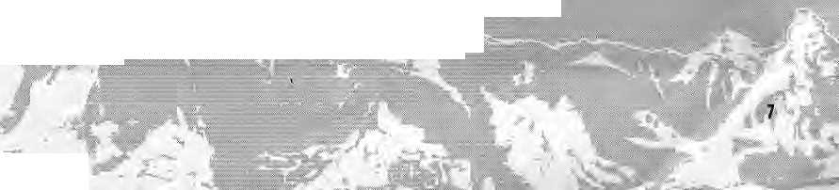


The Sparrow and Arun III A Bird's Eye View
In defiance of the age-old tradition of annual winter migration, a sparrow decided to chaUerige the system by staying bade He was a nonconformist*:
Before long, all the others having left, the sparrow was all alone in the vast Siberian plain. He flew around for some time, foraging for food, but as Winter became increasingly severe,he realised the, bitter truth. Remaining behind any longer meant :: certain death from cold and starvation. The lor* sparrow finally began his long journey, as was the ■ proper thing to do, but after a few hours, weak from hunger and cold, he plummeted to the earth/ exhausted. Soon his wings were frozen stuck.
Just then, a eow passing by dropped a pile of manure on the dying lump of misery. Ah, well, this is the end^ thought the sparrow. So much for my foolhardy nonconformist beliefs. I challenged a system, without adequate knowledge, for which I am paying the ultimate price of death, and that too in a pile of shit!
However, things were really ndf that bad.The heat from the dung soon warmed his little body. The frozen wings got loosened and strength crept slowly back to the weary limbs. What fantastic luck, thought the sparroW. A few moments back it was the end of the world, but this pile of shit has in fact saved my life. I'm going to make it after all, I survived the winter! What a story I'll have for my ' friends. He trilled with joy and sang loud and clear a melody orv that frozen Siberian plain.
A curious cat, cold and hungry, chanced to .: hear the sparrow's song. He decided to investigate the particular pile of manure which was producing such wonderfully familiar music. A few frantic digs revealed the sparrow—who was quickly gobbled up to end this story.
The moral: One, anyone who shits on you is not necessarily an enemy. Two, anyone Who rescues you from a pile of shit, is not necessarily a friend. Three, if you are nice and warm, even in a pile of shit, it is better to keep your mouth shut.
THE MORAL IN RELATION TO ARUN: lUi
HIMAL SeptembylQctober 1995

Moral One: The eight years of official studies and active endorsement of the ArunIII project were challenged by a handful of Nepali intellectuals, whose findings and conclusions, presented in a few articles and circulated internationally to selected personalities and organisations, were forceful enough to shake the very foundations of this project, resulting in its ultimate collapse. One can only
conclude that the project must have suffered from significant fundamental flaws. : ..-..'..:
Those myolyedinexposirig the absutdity of Afuft III, or the ones that dropped the shit on Arun III, have probably done the country a lot of gopd. They may, therefore; not necessarily be branded as: renegades and traitors. Their actions have, in fact,: compelled the planners as well as the government to seriously reconsider the: long-suppressed alternative projects, all: of which promise: far greater cost-benefit returns as compared to Arun III,
; Moral Two: Anyone arid everyone, attempting.£-, to revive me Arun 111, or any other similar project, involving totalmtemal expertise andmulti-financing, where Nepal has very little or no say, need not necessarily be doing the country any good. Nepal cannot afford to create another 'Monster in the Himalaya'.
It is therefore essential to very sincerely reassess Nepal's capacity «nd commitment in
identifying andpromoting cost-effective: and modest-sized projects, capable af being completed within; three to four years. The Kali Gandaki, Khimti; West Seti could be serious contenders to; ft the void created by Arun III; Meanwhile, the cancelled project could be reconsidered, in its original capacity (402 MW), sometime during: the firsfdecade of 2000.. ■:■
Moral Three: The Arun III was conceived some eight"years' back. The Panchayat, the Nepali Congress aiid later the UML governments have all been actively involved: in promoting the project. Yet, in spiteof such support the project was : unceremoniously abandoned, once confronted with the slightest resistance; Logically, such things do not happen to sound projects'.
Aruri III, or worse still 'Baby Aruri', was conceived and nurtured throughout with intentions certainly not compatible with rational development planning. Now that the project is dead, there is Httle sense in political mud-slinging in an effort to find a scapegoat to hide one's involvement. Baby Arun died, becauseit was a bad'project It deserved to be killed. Ji is therefore better to keep our mouths shut and concentrate seriously on alternative options, to salvage some credibility.
This is;my a reaction to the numerous articles appearing in the press (including Bikash Pandey's in the .J.ul/Aug 199$ Himal) just prior to and after the Afuti III cancellation by the World Bank,
Just remember the sparrow in that pile of shit! °rabhuRumBhandtmj Jilli Bazaar, Kathtnandu

IS*


/;

A Sikkim Awakening

Docile even in the face of the loss of a kingdom, could it be that decades later the Bhutia and Lepcha are finding their voice, to try and protect what remains of their precious land?
by Ludwig Schaefer

F
or the first time in Sikkim's recent democratic history, the Sikkimese Bhutia-Lepcha have come forward to defend what remains of their original homeland. This sudden awakening of Sikkim's indigenous population, otherwise renowned for its timidity, was prompted by the construction of a hydro-electric project in the very heart of Sikkim's most sacred region.
The docile Bhutia-Lepcha have little tradition of protest and tend to shun confrontation even when

September/October 1995 HIMAL

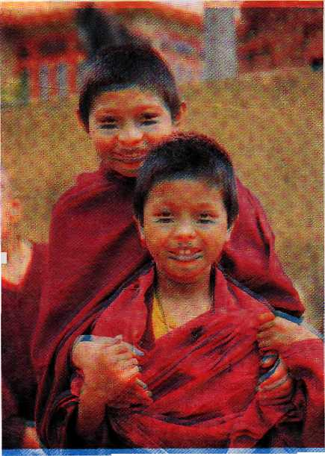

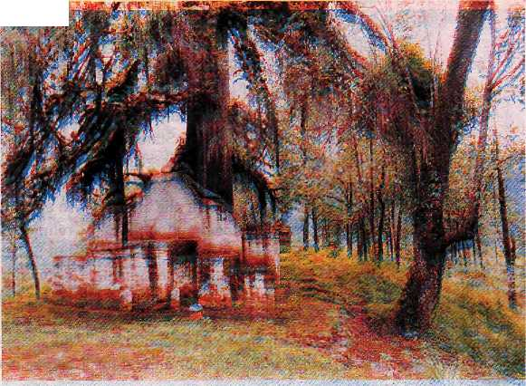
things turn unpleasant. Even the integration of the kingdom into the Indian Union in 1975 was carried out without much resistance, with Sikkim literally handed over with only one casualty among the Sikkim Guards.
It was to be a full 20 years before Sikkimese lamas would take to the streets of Gangtok, demanding that their land and heritagebe protected.On 29 July this year, representatives from 1 all the monasteries of the former kingdom marched through Gangtok, beating drums and cymbals and carrying banners. They were demanding that work on the Rathong Chu hydroelectric project be stopped and the whole exercise be abandoned immediately.
Why were the Bhutia Lepcha, original inhabitants of Sikkim, now representing only 20 percent of Sikkim's population (which has registered a Nepali majority for over a century), suddenly rising in opposition to a relatively small project of no more than 30 megawatts?
On the one hand, the Rathong Chu project touched a combination of religious, cultural, environmental, political and economic issues, actual and sensitive enough to find some echo in many Sikkimese hearts. On the other hand, the activists' tactics, history and personality were sufficiently genuine to gain the trust and support of Bhutia-Lepchas, uniting them and prompting them into action.
Why Say No?
The central argument -against the Rathong Chu is based on the cultural and religious significance of the project's location, which is the area of Yuksum beneath Mount Khang-chendzonga. This is where the first Chogyal was crowned in 1642 AD, leading to Sikkim's birth as a kingdom. The area, known as Demojong, is the abode of Sikkim's protective deities, who stand at the core of what
is left of the Bhutia-Lepcha's distinct identity.
Bhutia-Lepchas were offended, as the project would in many ways desanctify the region of Demojong> and they thought it unjust that the basic foundation of their history, culture and religion should be sacrificed in the name of 'development' and for the benefit of others.
One cannot help but notice that all three new sites which have been selected for the construction of large hydroelectric projects in Sikkim (Yuksum, Tashiding and Dzongu) are either located in areas in- ;_{t} habited by Bhutias, Lepchas or Tsongs (Sikkimese Buddhist Limbus), or located near sites which are holy to the Budd-hists. There is also resentment against the migration of thousands of outside workers who will come to Yuksum in search of job opportunities once the project is in full swing.
Yuksum is one of the last stret-ches of land where Bhutia-Lepchas and the Tsongs are still in a ma-
id rity, and it is feared that the g outsiders will import an alien £ culture, degrade the environ- jE ment, cut the forests, vandalise the stupas, exploit the ethnic minorities, and eventually build mandirs and mosques next to the stupas.
Although the religious argu
ment is what eventually moti
vated the Bhutia-Lepcha activ
ists, the project will have seri
ous environmental conse
quences for one of the richest
areas of the world in terms of
biodiversity. The project is lo
cated near a virgin forest, and _{Wov/ce} _{monfrs} _{at}
part of its catchment area lies t_{ne} Nyingmapa
within the Khangchendzonga Sheda Institute at
National Park. Deorali, Gangtok.
Those Who Oppose
The first objection to Rathong
Chu was expressedby the Asso-
ciation of Buddhist Monks of Sikkim
on 24 July 1994, before work had been
started at the dam site. The memoran
dum submitted then was ignored even
as the formalities to start the project
were accelerated. In August 1994,
three tribal organisations (the Bhutia
Lepcha Association, the Tribal
Women's Association, and the Asso
ciation of Buddhist Monks of Sikkim)
submitted a writ petition to the Coronation dias
Sikkim High Court. Unfortunately, _{on} _{wn}-_{icn} _{tne}
the court case led nowhere, with first Chogyal of
hearings delayed and the construe- Sikkim was
tion work continuing. crowned in 1642.

HIMAL September/October 1995
9

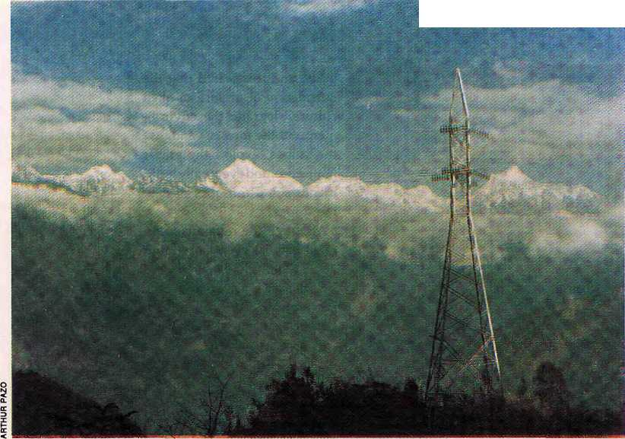
:.= ,,.=■■
■■.-■■
High tension
beneath
Khangchendzonga.
Sonant Paljor
Denjongpa
at Qangtok
demonstration
In May 1995, the Concerned Citizens of Sikkim (CCS) was formed to fight the project. This group of Bhutia activists started a peaceful protest and a movement to educate, with the intention of getting theproject scrapped. They were firm in the belief that the environmental andsociocultural costs of the project would be too high a price to pay for its hypothetical economic benefits.
Sensing that drastic measures were required, the CCS staged a hunger strike in Gangtok demanding that work at the project site be suspended while an independent team of experts reviewed the entire project. CCS member Sonam Paljor Denjongpa, a Sikkimese businessman who had returned from the United States as a lama, fasted for 28 consecutive days. Finally, on 5 July, Chief Minister Pawan Kumar Chamling and Power Minister Yeshe Lachungpa assured Denjongpa that work would indeed be suspended and that "the State Government would constitute a high level committee which will thoroughly examine all the aspects of the project duly taking into consideration the effect of the project over the environment, religion, social and historical sites of the area."
Unfortunately, three weeks later, work still had not been suspended but was instead intensified, and the state
government had yet to appoint members to the committee. The Concerned Citizens felt they had been cheated and started preparing the next phase of their movement. Meanwhile, the hunger strike had established the newly-formed CCS and particularly its three core members, Sonam Paljor Denjongpa, Chukie Tobden and Pema Namgyal, as persons who were ready to speak up and take risks in order to defend what remains of Sikkim's cultural and religious heritage.
The Demonstration
All India Radio's Gangtok station, which is the main source of news for theremotevillagesofSikkim, has been broadcasting the developments in the Rathong Chu protest in the Bhutia and Lepcha languages. When the CCS decided that the time had come for the lamas to defend the land, it only took one letter addressed to the 60-odd monasteries of Sikkim for the lamas to descend on Gangtok in large numbers.
The monks were the right group to appeal to, not only because of the religious aspect of the controversy, but because they are one of the only segments of Bhutia-Lepcha society which can still unite and see beyond political and other differences. Sikkimese lamas do not live their lives segregated from society, but are mar-
ried family men and respected elders with enormous influence over their communities. The lamas also enjoy traditional organisational power and in the past have come forward to defend their country. When they took to the streets of Gangtok on 29 July, they came with the sa nga, twin drums which are traditionally beaten before going to war.
On the day of the demonstration, some 500 lamas walked through Gangtok town carrying banners with the demand, "Please protect our sacred land." They were followed by hundreds of Sikkimese women chanting prayers. Thirty elderly lama-representatives from all the monasteries of Sikkim, along with CCS member Denjongpa, met the Chief Minister and presented him a statue of Guru Rimpoche (Padmasambhava) and a Nay Sol textwhichspeaksofYuksum's sanctity. The elderly lamas expressed their views against the Rathong Chu project, explained why the sanctity of Yuksum must be preserved, and requested the Chief Minister to immediately abandon the project. Some of the more radical monks were ready to burn their scriptures, as the Nay Sol would become redundant if the hydropower project were to come up.
The Nay Sol instructs the Sikkimese to refrain from carrying out certain actions within Demojong, such as cutting down trees, polluting lakes, destroying hills, rocks and cliffs, using explosives, as well as burning meat. It is believed that such actions
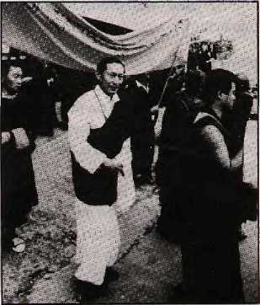

10
September/October 1995 HIMAL

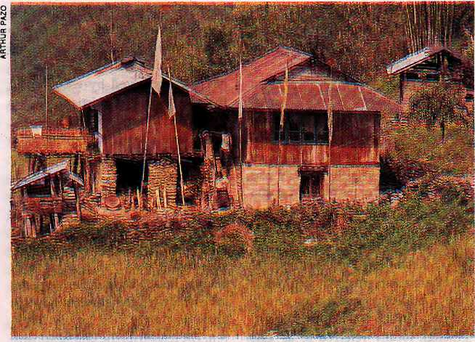
would directly affect the deities of Sikkim and provoke disasters in the form of natural calamities, disease and bloodshed.
When a series of accidental deaths took place throughout Sikkim during the hunger strike by Den-jongpa, many were quick to attribute the cause to the hydro-electric project and the dynamiting of the deities' abode. Fear grew among the local population that anyone actively contributing to the implementation of the project would be the future victims of the deities' anger.
The Importance of Demojong
For the united action of the lamas to be understood, one must first take a look into some peculiarities of Sikki-mese Buddhism and Sikkimese society. When Buddhism took root in Sikkim in the 17th century, it integrated the original animist religion of the early inhabitants. As a result, all Bhutia-Lepchas worship deities and spirits of the land who reside in the mountains, rocks, caves, trees, lakes and streams. These local deities, who are usually worshipped during harvest offerings, ancestor worship and healing rituals, were also incorporated into Sikkimese Buddhist rites.
Of all the deities of the land, the most important is the mountain god Khangchendzonga. Being "Sikkimese" itself may in fact be defined by the
worship of this mountain god. During the old days, the national festival of Pang Lhabsol was a celebration of Dzonga, whose invocation as a national symbol served to create the Sikkimese identity, uniting the territorial deities, the Chogyal, and his people under the Sikkimese flag. Dzonga has other aspects as well. To name a few, he may be worshipped as the owner of the land, as the one who faithfully carries out the orders of Guru Rimpoche, as protector of Sikkim's nay (sacred locations) and ter (hidden treasures), and as head of all territorial deities and spirits of Sikkim.
The Nay Sol ritual text, which is an offering to Dzonga and the local deities, is the most important indigenous Buddhist ritual performed in the state, in monasteries as well as households. The Nay Sol describes the area of Demojong beneath Mount Khangchendzonga and mentions the abode of Sikkim's deities in the name of mountains, hilltops, lakes and caves which form a circular area around the Rathong Chu project site.
The plateau of Yuksum is considered to be a Umkhang (house of gods) in the shape of amandala where the protective deities are made offerings to. The nay and ter in and around Yuksum as well as their religious significance are not known to the lay Buddhist public and their locations
are considered secret knowledge. Consequently, only certain lamas are capable of understanding the inner, outer and secret meanings of the scriptures, and have access to the nay of Demojong.
The mountain god Khangchendzonga and his role as a national symbol is only the apex of a pyramid of territorial and ancestral deities who influence all aspects of Sikkimese village life. Only a small percentage of village lamas have had access to Buddhist philosophical teachings, and most serve their communities with a limited understandingofhigherforms of Buddhism. Thus, territorial, ancestral and Buddhist deities form a single hierarchy and are propitiated at the same time by lamas and shamans. While this syncretism may well be criticised by outside purists, it has nevertheless evolved as a Sikkimese religious culture rooted deep in the topography and history of the land. It has served to forge a particular form of Buddhism that is unique to Sikkim and its neighbouring areas.
The influx of highly knowledgeable Tibetan lamas and tulkus into Sikkim following China's takeover of Tibet has had a significant influence on the practice of Buddhism within the .state. Sikkim has no tradition of tulku, and Sikkim's revered masters of the past have always been enlightened practitioners (Gomchen) who lived in retreat on the top of mountains. The elusive Gomchens of the past, with their secret level of self-realisation and rumoured power, have been replaced by Tibetan rimpoches, who have now become the most respected Buddhist figures in Sikkim.
In the rimpoches' efforts to 'purify' Buddhism, the traditional patterns of learning and practice were changed and a new breed of educated and well-dressed lamas came to the fore, with little, if any, understanding of Sikkim's territorial and ancestral deities or of how to serve the simple needs of their fellow villagers. These new lamas study in large monastic institutes instead of under village lama-teachers and meditate in
Middle class Bhutia house of rural west Sikkim.

HIMAL September/October 1995
11

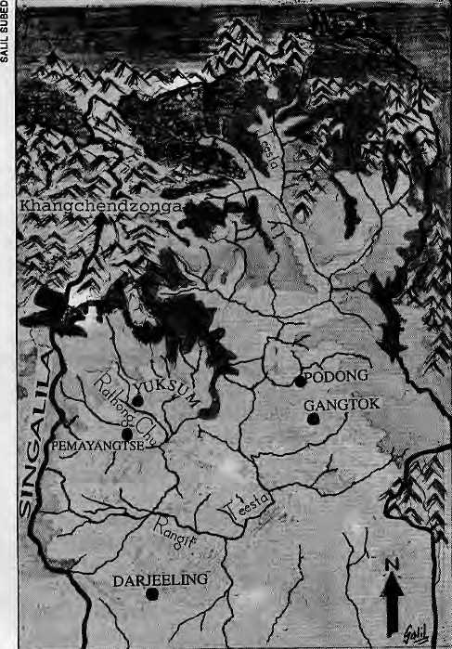
special centres instead of joining their Gomchen ancestors on the moun-tains above their villages. They have been segregated and elevated above their community and now look down upon the senior lamas of their own village gompas.
The demonstration in Gangtok ■' thus also served the purpose of returning the place of honour to the seniorvillagelaTnasofSikkim,sothat they may express a wisdom which does not come from books but from the heart, of what they have inherited and what their ancestors have stood for as being purely Sikkimese.
Problems of an Internal Nature
The Bhutia-Lepcha's timidity and accommodating nature, which have made the hunger strike and the demonstration seem like such departures, may not only be due to their compassionate Buddhist background. They have always lived in a valley of abundance, in lush and underpopulated forests and jungles. From the
end of the last century, when life became more competitive following British dominion and Nepali migration, the expansion of cardamom cash crop farming smoothly carried them through from a subsistence to a market economy. Although they had to defend themselves against Gorkha, Bhutanese and British forces at different times in history, there was never any need for the Bhu tia-Lepcha to conquer or look beyond their borders. Rather, their problems have been, and still are, internal in nature.
Sikkim was founded as a multiethnic state which from the beginning had a mixed population of Bhutia (Lhori), Lepcha (Menri) and Limbu (Tsong), locally referred to as 'Lho Men Tsong Sum'. The task of uniting Sikkim's communities and creating a Sikkimese national identity was not an easy one for Sikkim's Chogyals. While Sikkim's specific form of Buddhism served as a common symbolic platform to unite its original communities, it was not strong enough to sustain Sikkim's fragile ethnic cohe-siveness against the British divide-and-rule policy, nor the aggressively productive and overwhelming migrant Nepali population.
When Nepali-speakers eventually took over the running of the state, Bhutia-Lepchas had no resistance to offer as they hadby then already been fragmented as a community. The first division among the Bhutia-Lepcha is the one which still exists between the kazi (feudal landlords) and their ten-antsubjects,theinistra><zitosofthepast. Landlordism was abolished only as late as 1951 and the kazis, many of whom are of mixed Bhutia-Lepcha descent, form a social class of their own who have at times preferred to associate with high-caste Nepalis rather than with non-kazi members of their own ethnic community.
The second division is the one fvisting between the Bhutia and Lepcha communities themselves. Although they have lived side by side for centuries and do inter-marry, the Bhutia-Lepcha do not always stand together. The Bhutia blame Nepalis
for having recently antagonised the Lepcha against them in order to weaken the grouping as an electoral force. Specifically, they claim that this has been achieved by encouraging the migration of Christian Lepchas from West Bengal into Sikkim.
These Christian Lepchas, who generally feel closer to Nepali-speakers with whom they have widely inter-married, tend to portray the Bhutia as ruthless exploiters who have kept Sikkimese Lepchas under slavery for over three centuries. Although there is some degree of truth in these accusations, Bhutia bustiwallas were not necessarily treated any better by the kazis than were their Lepcha breth-ren. The reason for the Bhutia's downfall in this respect is the superiority complex which many have displayed as a "civilised community" which had to educate the "untrustworthy and happy-go-lucky forest dwellers".
The third division is created by the fact that few Bhutia le aders would consider working under a potential rival. Ever since the Bhutia lost their Chogyal in 1975, they have had a definite problem uniting under a single leader,becauseitmeantelevatingone above all the others. As evidence, Sikkim has never had a Bhutia Chief Minister. It would seem that the Bhutia's trust and the legitimacy to rule may only be inherited by rights of descent or gained through external intervention. Failing these, the Bhutia seem to fee! more comfortable with an apparently impartial outsider as head of the state who may give the impress! on offairarbitration between their various factions.
The staggering number of cultural, religious or welfare associations that exist among Bhutias and Lepchas in Sikkim is enough to illustrate the point that any person with an idea and a goal feels it a duty to form a new association rather than join, and come under, an already existing association with similar purposes.
Protected Lands
Despite these differences, the Bhutia-Lepcha are beginning to realise that

September/October !995 HIMAL

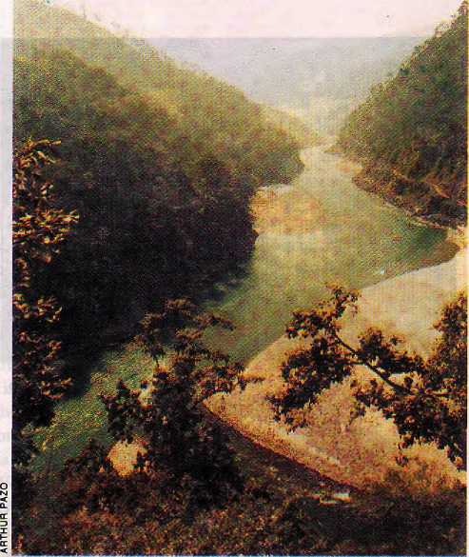
they have more in common than they might have been led to believe and that only by working together can they defend their common interests. However, the idea of uniting is such a foreign concept that they need time to get used to it. Recently, Bhutia-Lepchas have come together on three , separate issues.
Without going into too much detail, one concerned the reservation of 13 seats for the Bhutia-Lepcha in Sikkim's 32-member Legislative Assembly. The provision had been challenged in the Supreme Court by a Nepali politician. The second was over the "income tax issue", when New Delhi proposed to introduce central income tax in Sikkim but to exempt the Bhutia-Lepcha community. This created an uproar among the Nepalis, which triggered another one among the Bhutia-Lepcha, which eventually brought down the 14-year-old government of Nar Bahadur Bhandari.
The third issue to unite the Bhutia-Lepcha was an ambiguous case over land rights. A wise Chogyal at the beginning of this century had issued Revenue Order Number 1 of 1917 to prevent any other community from acquiring Bhutia-Lepcha land. Now that they only represent 20 percent of the population, there are thousands of Limbus, Gurungs and Tamangs pressing the Indian Government to grant them the status of Scheduled Tribe, which they assume would be sufficient to allow them to acquire protected Bhutia-Lepcha land. These political and economic rights which had been granted by their Chogyals and secured by the Indian Constitution have in a way even protected the Bhutia-Lepcha from themselves, by keeping them united over essential issues.
Yet another issue which may bring the Bhutia-Lepcha even closer is the proposal for Rathong Chu, and a mega-hydroelectric project on the Teesta (phase III, 1200 MW) still in its planning stages. These two projects do not only challenge Bhutia-Lepcha religious rights but also question the delicate matter of protected Bhutia-
Lepcha lands. Teesta will bring in thousands of outside workers into the protected area of Dzongu, a Lepcha reservation created by Chogyal Tashi Namgyal in order to protect the vulnerable Lepchas of North Sikkim. Non-Lepchas are forbidden to settle in Dzongu and may only enter with permits for seasonal agricultural work. This restriction will have to be lifted if the mega-project is to come up, and the Lepcha would soon lose what is left of their culture and territory.
The Teesta project has been opposed for some five years by the Sikkim Tribal Salvation Council chaired by ex-Minister Athup Lepcha. Over the years, theCouncil has gained widespread support among Lepchas of North Sikkim who are ready to voice theirobjectionsbutuntil recently lacked the organisational power to muster quick and effective resistance. The Lepcha from Dzongu who visited the site of the CCS hunger strike in Gangtok, just sat there in silence to observe the hunger striker and were clearly puzzled as to how on earth anyone could stop a project at one end of the state by starving himself and lying down on a camp bed in the middle of Gangtok town. Their techniques had been of a totally different kind: on three occasions, they had chased away the first road workers by rolling boulders down on them.
Since then, the Sikkim Tribal Salvation Council has held an important meeting on 20 August at Mangan, the North District headquarters, where all the panchayats of the district signed a representation opposing the Teesta project. In a significant move, all politicians originally from Dzongu, whatever party they represent, have united against the Teesta project. Now. that Bhutia and Lepcha lamas have also looked beyond their differences and joined hands during the demonstration against Rathbng Chu, closer cooperation between the two communities in opposing Teesta and defending the common interests is more likely.
Thinkers and Pessimists
When the CCSwasstilldebatingwhich form of protest to adopt, they watched a video relating the story of how the Kayapo Indians of the Amazon had successfully opposed the construction of a World Bank-funded hydro-electric dam which would have submerged their territory. The isolated tribe tapped its own social organisational power and myths in order to organise and motivate themselves effectively. After the screening, all CCS members felt immensely depressed as they knew very well that the Bhutia-Lepcha had long lost their power to unite for reasons more recent than the ones discussed above. First, the affected ethnic minorities are hesitant to voice their objections, even on simple environmental grounds, because they still fear the abuse of power which was rampant in Sikkim until last year. Such were the times that no one could voice his resentment against the state government without fear of violent repression. Although the newly-elected Sikkim Democratic Front (SDF) government is encouraging democratic procedures, 15 years under Nar Bahadur Bhandari's autocratic rule is not likely to be forgotten overnight.
Teesta, where
it meets the
Rangeet

HIMAL September/October 1995
13

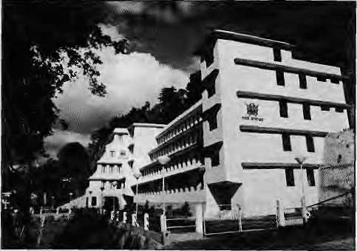
The Department of Power, Gangtok.
Second, Sikkim is well-known for the high level of corruption which plagues its administration and political parties. Embezzlement of public funds is practised from the highest levels of the government down to the village panchayats, and a widespread culture of corruption has taken root within the state. Over the years, this practice has contributed to the ero-. sion of any sense of unity and trust among Sikkim's residents. It has not only widened the gap between the rich and the poor, but has also divided the population of Sikkim along class and ethnic lines and has even managed to divide people of the sameethnic and socioeconomk background as well as close family members. Elections are fought and won. on the basis of the purchasing power of the political leadership rather than on issues and principles. As aresult, anyone who raises an opposing voice is automatically identified as doing so for some hidden financial benefit.
There are very few people in the state who still have any sense of pride and moral obligation towards Sikkim and who would risk their reputation, theirjob, and their security fora cause. A primary reason behind this state of affairs is that the government is the one major employer in the state. In a landlocked agricultural state withbut a handful of small industries, the government employs practically every educated soul, none of whom dares express his opinion for fear of losing his sinecure. As a result there are no independent thinkers, no intellectual circles, and only a few isolated indi-
viduals capable of openly analysing and expressing a critical opinion for the benefit of the state's development.
The Power Department's inefficiency and great capacity for wasting moneyhasalreadybeenexposedwith the publication of a "White Paper", an analysis of the Government of Sikkim's financial position brought out by the SDF. For the Rathong Chu project alone, the Power Department will eventually receive IRs 200 crores (U$ 65 million) from the Central Government, which is not a loan but a gift from Delhi in an effort to help develop Sikkim's economy. It is well-known that massive fund allocation from donor agencies opens the door for kickbacks and commissions which then leads to the concentration of wealth and power in the hands of a few. This system destroys society's moral and ethical values and encourages corruption, maladministration, injustice and crime.
Some Sikkimese feel that the massive allocation of development fundsby the Central Government has gradually turned Sikkim into a welfare state and made beggars out of the state's population. Under such conditions, Sikkim has bred a host of well-known politicians and administrators who have mastered the art of embezzling public funds and who take pride in getting away with it. The resulting institutionalised corruption has created problems of leadership and has eroded the potential for genuine development, unity and trust.
Indeed, many Sikkimese have takena fatalistic attitudeand attribute their passivity to the fact that there is no better alternative for the Bhutia-Lepcha under the present conditions. They believe that the ethnic community as a whole has no security or even a chance to survive, and that the only possibility left is to at least try and amass as much wealth as possible for oneself.
While pessimism is thus quite common among the Bhutia-Lepcha, in every hea rt there remains hope that something can be done. Thus, they have followed the hunger strike, they
have seen the demonstration, they have witnessed their own grandfathers coming out with banners, and they are now starting to think that perhaps this movement might be genuine and that indeed something could and should be done. Following the demonstration and the screening of the Kayapo documentary, senior Bhutia-Lepcha lamas went back to their villages saying that everyone must agitate. "If the naked Nagas [meaning the Kayapo] can do it, so can we!"
Courts and the Department
As the next step of their campaign; CCS members filed a new writ petition in the Sikkim High Court demanding cancellation of the entire project. The protest took a decisive turn after the first hearing on 14 August, when the Sikkim High Court fixed 20 September as the date for final disposal of the case. The bench also mentioned that they would award the litigants a stay order should the respondents fail to file their counter-affidavit on time.
The casewasarguedonbehalfof the CCS by eminent Supreme Court lawyer Rajeev Dhavan, whose three-hour argumentation focused on what he called the "avalanche of illegalities" surrounding the hydel project. Dhavan contended that Rathong Chu's implementation infringed the people's fundamental right to preserve their religious and cultural identity . Dhavan has been deeply involved in several social and environmental movements across the country. Litigations he has been involved in include Ayodhya and Tehri, and his intervention in the Rathong _Chu issue seems to have decisively tilted the balance of the controversy in favourof the CCS. TheBhutia-Lepchas have now become hopeful that the destruction of Yuksum could perhaps be stopped.
Agencies intending to build a hydro-electric project usually first assess the project against ethical-environmental andsocio-cultural criteria. Failing to do this could resu It in expen-

14
September/October I395 HIMAL

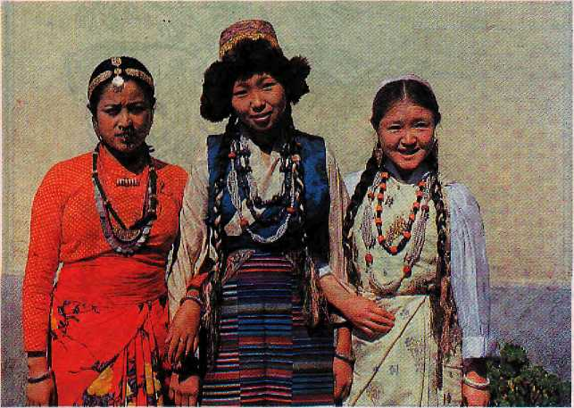
sive clashes over environmental issues and ethnic minority rights. The Ministry of Environment and Forests (MoEF), New Delhi, has issued a list of safeguard conditions to be implemented along with the preliminary environmental clearance given for projects.
As confirmed by the regional office of the MoEF, the State Power Department has gone ahead with the execution of the work at Ra thong Chu without implementing the great majority of these safeguard conditions and without having obtained the final clearance. Further, the CCS has evidence that the Power Department has submitted false reports to the MoEF in order to obtain the conditional clearance.
For example, the Power Department stated that the area of Yuksum has only three species of birds, while an independent survey carried out in the neighbouring area of Rabdentsi revealed that there are no less than 47 species. It is indeed surprising that one of the richest areas for biodiversity would have fewer bird species than does Calcutta! When seeking clearance, the Department also "forgot" to mention that the catchment area of the project area lies within the Khang-chendzonga National Park, and that Yuksum is a sensitive location from a religious point of view and potentially an important tourist destination.
The Power Department's mistake regarding the choice of project site could have been avoided had they initiated a debate with the local population with the aim to select, by general consensus, the site with the least damaging consequences. It was in the Department's interest to have initiated the debate since ethical and environmental preconditions are highly cost-effective.
Electricity is only needed in Sikkim for household purposes as there is no heavy industry and water pumps are not being used for irrigation. The in-state demand for electricity may easily be met by renovating and upgrading the many existing power houses, the great majority of which are either defunct or not producing to full capacity due to high siltation and poor maintenance. Rehabilitating these power houses and initiating new small projects would protect the environment as well as the way of life of the ethnic minorities, while meeting the energy needs of the state.
If the Rathong Chu project were to be built, Sikkim would forever destroy one of the best areas in the state which could bring in a much higher income, in foreign currency, through well-organised eco-tourism in the Yuksum-Dzongri region. Income through tourism has the potential to benefit all levels of society and also offers fewer incentives
for people to indulge in corruption.
Why is the Power Department so eager to start new hydroelectric projects despite their obvious negative consequences for the Sikkimese people? The answer is simple. Money is the only language currently understood in Sikkim and the Rathorig Chu project alone will eventually bring in some U$ 65 million which will be digested through the money-starved bowels of the Power Department. Meanwhile, the Power Secretary's comments not long ago that the project was "too small a venture to justify such a dialogue" clearly underestimated the depth of feelings it had aroused. His accusations which referred to the CCS' concerns as "emotions getting in the way of development" and to the CCS' activities as being "anti-people" now sound rather out of place and hollow.
The members of CCS say that they are not against development per se, but that they do oppose illegal projects which are not cost-effective and cause irreparable damage to Sikkim's bio-physical and socideul-tural landscape. A good example of the type of projects they do not welcome is the 60 MW hydroelectric dam at Legship below Tashiding. High rimpoches and monks had formally objected to the project in 1988, as the waters would submerge eight stupas which had been built for world peace and prosperity in Sikkim. Unfortunately, the rimpoches did not even receive an acknowledgement of their representation. Instead, as with Rathong Chu and Teesta, people were assured that the project would be successful and was needed for the development of Sikkim. But now, and for the second time, flood waters have washed away the temporary coffer dam of Legship and abulldozer, causing more than IRs two crore worth of damage.
No to Party Politics
The monks of Sikkim were traditionally consulted on all matters of state relating to religion and were represented at the Palace by a monk body
STOP PRESS!
On 20 September, the Sikkim High Court granted the Concerned Citizens of Sikkim an interim stay order on the Rathong Chu hydro-electric project, asking that all work be stopped. The final disposal of the case has now been set for 8 November.
Left to right Nepali, Bhutia andLepcha ladies.

HIMAL September/October 1995
15

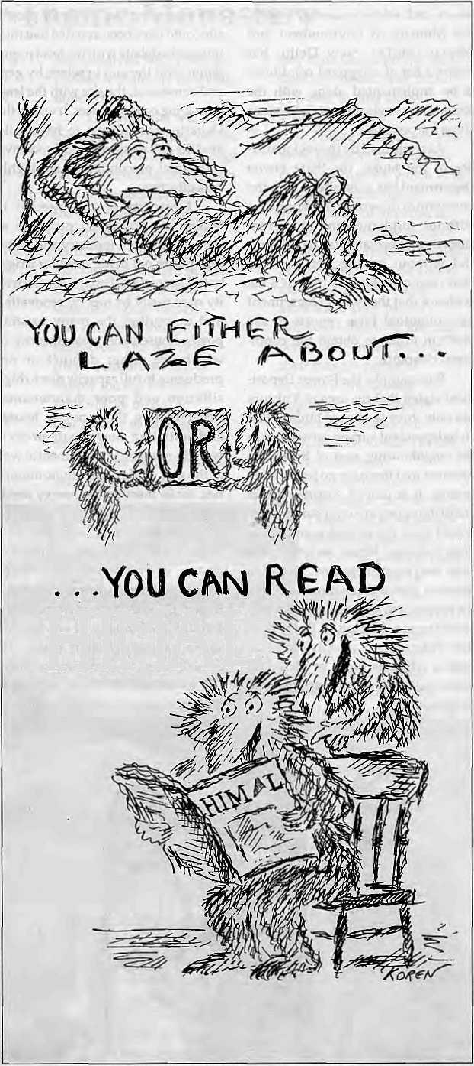
HMAL
called Lhaday. Even today, Sikkim is the only Indian state where a religious body has been given political recognition. In February 1993, the Supreme Court of India issued a verdict which upheld the validity of the 36th Constitution (amendment) Act 1975, which provided for special provisions in Article 371F of the Constitution to accommodate certain incidents in the evolution of the political institutions of Sikkim.
The verdict upheld the validity of the reservation of one seat in the State Legislative Assembly for the Sangha (Lhaday monk body). Since the Buddhist voice is recognised by the Constitution of India, it would seem the duty of the government to take into consideration what the Sangha has to say about Rathong Chu. Indeed, the Ecclesiastical Department has submitted an adverse report on the project, which the Power Department has seen fit to ignore.
Religious sentiments need not be disregarded for states to develop. Small and prosperous nations of the world such as Japan and Israel are also among the most religious. The role of Buddhism in Sikkimese society is enormous and extends to all spheres of life, from defining true knowledge to codes of behaviour regulating relations with others and the environment.
Now that some Bhutia-Lepchas have shown that they will not let others destroy the foundation from which such a society has evolved, there is hope that this is only the beginning of a movement which will take on other issues to check the decline of the indigenous community. For its part, the CCS says it is prepared to continue work to help preserve the religious, economic and political rights of the Bhutia-Lepcha, but this will probably happen in a very unconventional manner for Sikkim, since it does not plan to join the local game of party politics.
i
Ludwig Schaefer is the pseudonym of a writer who has travelled and written about the Himalaya for over a decade.

16
September/October I995 HIMAL

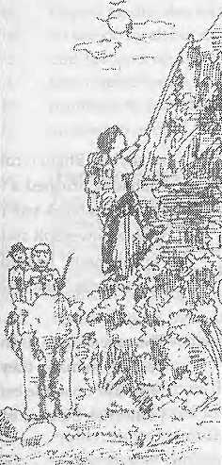

wide variety of thrilling rafting adventure on different rivers of Nepal, and in addition to river rafting we also organize other packages. Well every body else does trekking, safari and guided tours, we are specialised in white water, rock climbing, and trekking peaks.
Fixed departure twice a week Every Tuesday & Thrusday
For further details contact at
GPO. Box:66IS, Kantipath, Kathmandu, Nepal. Tel: 977-1-220474, Fax: 977-1 -227600 Attn: R'nR

Himalayan High Treks
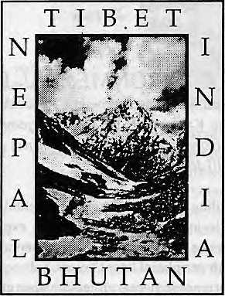
Free Catalog (800) 455-8735
Outside the U.S.A. & Canada please call: 001.415.861.2391 or write to us:
Himalayan Hiyh Treks
241 Dolores Street, San Francisco CA
94103-2211 U.S. A. Thanks!


rop by our front office and -workshop, at the Naxal Crossroads. Let's discuss a package arrangement for prompt and efficient servicing of your computers (Macs and IBM Compatibles), photocopiers, video recorders, television sets, and everything else electronic. We specialise in providing one-step, hasslefree support to institutional customers.
D

Shouldn't we be looking after yours' as wall?

tit ovit-stop eitttaovdt support ^ Kathmandu Electronics & Computers
Tel: 411201
Balmandir Road, Naxal P.O. Box 3846, Kathmandu.

V
o
I

THREE ENVIRONMENTAL BREEDS pro-
Hferate in Nepal, according to Surendra Raj Devkota editorial page article in The Kathmandu Post of 15 September 1995 entitled "Bewarefrom Environmentalism", which blames environmentalists for the Arun III debacle.
In this prevailing circumstance, environmental professionalism in Nepal is losing its ethics. Rather than expressing the true picture, it seems that so-called environmentalists are used to verbalizing in peripheral latent voices. Subsequently, there are three typesofenvironmentalprofessionalismgrowinginNepal. The number one breed is donor supported elites with louder voices who vocalize global issues and confuse locals. They have expertise in talking and knitting the complex web of problems rather than seeking relevant solutions. Basically, this category constitutes individuals who are fond of talking environment and lack of basic knowledge of thesubject matter. Anotherstrain of environmentalists is due to the chair that individuals occupy, bureaucratic environmentalists, who are available inbothdonor and governmental units. They are very much fond of files and paper works so that income source does not get aborted. The third type is a true environmental professional who is either marginalized or exploited. Lack of opportunities in proper field, limited scope of the environmental discipline and wrong man in right place are major hurdles for genuine individuals. Environmentalists should not be biased to review the governmental work and have to abandon their ideological differences while talking about environment. Environmental issues should be raised for any developmental activities but owing to environmental consideration, developmental process should not be closed, because most of human-induced activities have certain mitigation options and these must be sincerely adopted wherever required. The ethics of environment does not mean that we thepeople be ruled under therepub lie of grasses, insects and litters.
CURSES ARE CURES when coming from a jhankri (shaman), writes Gregory G.Maskarinecin Rulingsofthe Night An Ethnography of Nepalese Shaman Oral Texts (The University of Wisconsin Press 1995 ISBN 0 19914490 0). Some excerpts, whichare Mahadev's curses asrecited by GumaneMohar Kami ofSyaula Village ofjajarkot District, West Nepal.
He joined hands, joined feet, joined a head, joined legs.
"Well, put in a full breath," so saying,
he put in a full breath, left it a bloodline.
"Well, now on the sixth night, look man, your share,"
so saying, Bhabi wrote, 'The day of birth yields fate." Mahadev brushed a white yak tail at the head, brushed a black yak tail at the feet, with a powerbolt staff delivering seven blows, "Speak, man," he said, "Ha, ha, hu hu," it went. "Go and die," said Mahadev, gave a curse.
* * *
The race of man didn't die,
became so many they didn't fit, didn't diminish. "The soft unstable earth is finished. I will trick the race of man."
* * *
Flowers that you picked and put on your head,
they are miscarriages;
tiny ones you picked and put in your mouth,
they are infants' deaths;
half ripe cucumbers you picked,
they are three- and two-year old's deaths;
those the size of sickle handles you picked,
they are adolescents' deaths;
those with a yellow shadow you picked.
they are thirty-six, thirty-two-year-olds' deaths;
those that were completely yellow you picked,
they are middle-aged deaths;
split open ones you picked, they are old ones' deaths.
GURKHA TAKEOVER OF MONTANA is
imminent, according to Mark Koernke, an American radio personality whose preoccupation is with right-wing conspiracy theories. One of these has to do with the Gurkha takeover, writes Time in its 26 June 1995 issue (page 61).
... And that's just for starters. Reliable sources have detected 300,000 foreign troops on American soil, including a contingent of Nepalese Gurkhas in Montana, this doctrine holds. Soon they will attempt an outright takeover of America, dispersing countless Patriots to dozens of detention camps already built for the purpose by the Federal Emergency Management Agency. (FEMA's employees are the new world order's shadow government: "Only 59 to 63 out of 3,060 actually deal with storms, disasters, hurricanes and nuclear attack."} Once the nation is supine, it will be carved into large regions ruled through terror by new-world-order proconsuls. Microchips enabling the government to track each move by a new generation of citizens. Americans will live in slavery. Unless.,.

18
September/October 1995 H1MAL

c
E
S

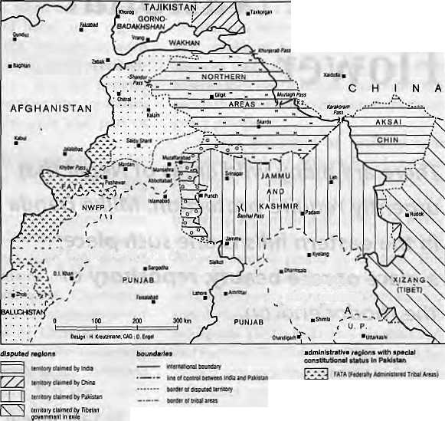
* « j. * * * —; i
V><->? A ,K I S T A N .
BHUTAN AND B URMA have more in common than consonants andvowels, according to this editorial excerptfrom August 1995issueoflheBhutenReviewmonthty,piiblishedbyLhotshampa refugees in Kathmandu.
To the average Bhutanese, Burma might as well be millions of miles away—and vice versa—as the two countries have never had direct trade or diplomatic relations. But there is a connection, and Suu Kyi is both a link in the limited interpersonal relationship that exists between Bhutan and Burma as well as the common denominator highlighting similarities in the prevailing political situations in the two nations, as also in underscoring the often glaring dissimilarities in the way the world has ventured to view the two parallel situations,
Suu Kyi spent a year in Bhutan in 1971-72 and worked as a general research assistant in the then Department of External Affairs. Her husband Michael Aris, a renowned scholar of Tibetan and Bhutanese history and author of several books on Bhutan, whom she married in 1972, was a royal tutor and government translator in Thimphu between 1967 and 1972. But Suu Kyi's ties to Bhutan go back much earlier as her family had known theDorji family in Kalimpong, India, since thelate 1940s. This relationship was further strengthened when Suu Kyi's mother Daw Khin Kyi served as Burmese ambassador to India from 1961 to 1967.
In 1948, six months after the assassination of Suu Kyi's father General Aung San, national hero acknowledged as the father of the nation, Burma which was made a part of the British. Empire in 1885 became an independent republic. The country had a parliamentary democracy until 1962 when the elected government of U Nu was overthrown by a group of army officers led by Ne Win, the commander-in-chief. Since then, Burma has been under army rule.
The announcement by Ne Win in July 1988 of his retirement and his promise of a referendum for Burma's political future was followed by an upheaval when his party refused to relinquish control. Suu Kyi, visiting her ailing mother, was drawn into the struggle for reforms and became the focal point of the dissident movement...
■ The Bhutanese crisis also surfaced in 1988 with the petition submitted to the King by Royal Advisory Councillors Tek Nam Rizal and B.P.Bhandari in April. The petition was deemed seditious and treasonous; Rizal was arrested, forced to sign an agreement-cum-confession before his release on June 4, and removed from his elected position. Unable tc abide by the restrictive conditions of the agreement, Rizal fled the country in July 1988, Rizal was abducted from Nepal by agents of the Royal
Government and brought back to the country on November 16, 1989. For four full years, Rizal was kept in continuous solitary confinement. For two years, from the date of his arrest until October 10,1991, he was continuously kept in iron shackles. In January 1993, three years after his abduction, Rizal was brought before the High Court charged with crimes based on the National Security Act promulgated only in 1992. He was found guilty and sentenced to life on November 16,1993. Three days after this verdict the King granted Rizal a bizarre conditional amnesty, promising to free him after the crisis in the country was resolved. The problem remains, and so does Rizal's fetters.
Both Suu Kyi and Rizal were compelled by circumstances, coinci den tally at about the same time, to throw themselves into the struggle against state injustice and repression; both were incarcerated at around the same time; both spent six long years away from family and friends. The uncanny similarities in the two cases has now ended—only one is free.
XINJIANG _{<Hion}
^ HIMACHAL
\ """■ PRADESH
I N\ 0 I
I - ■ 'I PATA\PKfn\\fa\ifUminiitiredTnnaltv |_{H} " _{H}| Nnrihein*im<prn*iKljfs1alus(lH--<td| | ° q | Au<; Unhmir |te|i*i*le tmjut-Jpo.il
provincial twunduy
MAP SAYS IT ALL about the territorially problematic "Western High Ask", as Hermann Kreulzmann calls the Kashmir region, in the August 1995 issue of Mountain Research and Development. Even the Tibetan government-in-exile in Dhammsah, it seems, has its claims on the table.

H1MAL SeptemberlOctober J99S
19



V.;--' '■'*.

i

A National Forest for the National Flower
There are many wild areas of Nepal that urgently require protection. Milke Danda in the eastern hills is one such place, a place of rare beauty, repository of the rhododendron.
by Salil Subedi

M
ilke Danda is a 25-km-long north-to-south ridge that divides the Arun and Tamur river valleys, an elongated mountain in the Mahabharat belt which stands like an eastern counterpoint to the Khaptad plateau of far west Nepal. Khaptad is the only national park in the Nepali midhills, and increasingly there is a demand for Milke Danda to be protected as well.
Milke Danda is known to the locals and a few aficionado trekkers fontsuniquecloud forest and its incredible variety of rhododendron species. The area is easily accessible, as the southern limit of the ridge is Tsute Deurali (2460m), barely three kilometres from Basantapur, which is the roadhead extension of the Dharan-Dhankuta highway. In one long swing, the ridge extends all the way up to Milke Bhanjyang (2970m), which merges further on with the lower flanks of Jaljale Himal.
The diversity of the rhododendron genus is most dramatic on the hump of Tinjure (2870m), where up to 25 species are found. The tTees flower simultaneously and the profusion of colours makes it seem as if the whole Milke Danda is abloom. Only the fall colours of New England can match the sight in terms of dramatic effect, except that there it is dying leaves that provide the attraction, whereas in Milke Danda it is living colour—all the shades of pink, purple, scarlet and white. The period for viewing Milke Danda rhododendrons is all of April and into early May.

20
September/October 1995 HIMAL

The cool temperate forests of these parts offer botanists and plant lovers alike a sumptuous Garden of Eden where they are likely to wander about in amazement for days on end. Unique species harboured and protected by Mi Ike Danda include the Himalayan musk rose, giant bramble,largethicketsof Pipthanthusnepakusis ,ihecrearny white flowering Elshottziafruiticosa, as well as Mahonia sp., Castanopsis tribuloides and Spimnthus sinensis.
Beyond rhododendrons and other wildflowers and plants, the appeal of Milke Danda lies in its jungle which remains dense (and the inner parts, still virgin) unlike so many other parts of the midhills that have been denuded. A wide panorama spanning (east to west) Kanchenjunga, Kumbhakama Himal, Makalu and. the Khumbu Himal adds another dimension to Milke Danda's attractions. A proper end point to the trip to the ridge is the lake of Gupha Pokhari (2840 m.) at its northern extremity.
Rhododendron Firewood
One reason the Milke Danda ridge has been preserved better than others is that there are few settlements on it. However, human encroachment is getting to be a problem, mainly because the porter trail from Basantpur to Taplejung follows the ridgeline. There are eleven trail stops on the route up Milke Bhanjyang alone, with an increasing number of households establishing themselves here. They arrive with the intention of servicing the porter trade with teashops and lodges, but before long are homesteading and clearing forests for firewood, lumber and farming.
The upsurge in new construction is also the result of this region coming to the notice of trekking groups travelling from the airstrip at Tumlingtar to Basantpur via Chainpur and Gupha Pokhari. This walk is especially popular with elderly and retired tourists, as it is less taxing than high Himalayan treks.
Unfortunately, while some of the trekking groups might use kerosene for the sahibs' kitchen, the porters all use rhododendron firewood for cooking and warmth. There is no one here to protect the rhododendron trees, which at this height take decades to mature.
Besides such fellings by outsiders, local woodcutters have been clear-felling the rhododendron forest to supply wood to the two larger settlements on the trail,
Gupha Pokhari and Mangalbare Chauki. The trailside having been exhausted, tree cutting is extending deeper into the jungle.
Cattle grazing poses another threat to the vegetation of Milke Danda. The rapid increase in population, with the corresponding increase in cattle herds, is proving more than the forest can sustain. The old craft of khukuri-making is also contributing in its own way to the loss of trees, for the wood of the Rhododendron arboreum is valued for making khukuri handles.
Recently, probably due to better bridges on rivers further north, mules and dzos have begun to replace porters on the trail to Basantapur. This means fewer porters on the trail, since ten animals can carry more loads than 20 porters. This development, as well as the recent introduction of helicopters for cargo operations in East Nepal based in Dhankuta, means that firewood consumption will be somewhat reduced. Perhaps with some protection measures, the forest of Milke Danda can make a recovery.
Millevilleon Milke
Among specialists, there is growing understanding of the need to declare Milke Danda a protected area—a national park or conservation area. Should this be done, Nepal would have a protected area devoted specifically to the rhododendron.
Wildlife is not Milke Danda's strong point in terms of touristic attraction as it houses the 'regular' Mahabhara t species rather than exotic High Himalayan ones. (However, migratory birds are known to pass through the area in winter.)
Rene de Milleville, a Frenchman who has studied Nepali rhododendrons for over 15 years, is the person who has to be credited for drawing attention to Milke Danda, Having watched the ridge's decline over the years, there is a note of urgency in de Milleville's voice as he pleads for a national park to be established promptly.
Not that this is a new idea. Tirtha B. Shrestha, the well-known Nepali botanist, recommended that Milke Danda be made a conservation area more than a decade ago in the book Nepal: A Nature's Paradise. Shrestha supported his recommendation with three points. First, the rhododendron is part of Nepal's heritage, having been

PHEDI

MILKE DANDA
ALTITUDE 3500 * m
3000
2500 i
2000 ,
MANGALBARE 2570

10
15
20
15
30
-Km

HIMAL SeptemberlOtiober 7995
21

raised to the status of national flower in 1962 (it is also Bhutan's national flower). Second, the genetic diversity of rhodendrons on Milke Danda cannot be found anywhere else, either in Nepal or adjoining Sikkim and Bhutan. Finally, says Shrestha, the Milke ridge provides rare ecological variation, as it stretches from the tropical climes of the Arun and Tamor valleys all the way up to the alpine stretches of Jaljale Himal and the Tibetan plateau beyond.
Pralad Yonzon, a wildlife biologist, holds a somewhat different view. While agreeing that Milke Danda should be preserved for the sake of the rhododendrons, he believes that it does not have the potential to sustain itself as a national park. "Milke Danda cannot attract touristson the strength of rhododendrons alone. They bloom once a year and for the rest of the year, a rhododendron forest is no different from any other."
While granting Milke Danda's uniqueness as a rhododendron haven, Yonjon believes it would make more sense to establish a national park further east in the Mai River valley with its 297 species of rare birds. However, the outspoken wildlife biologist is also a strong believer in the need to expand protected areas in the middle hills of Nepal, which, after all, make up the largest portion of the Nepali landmass. Preserved areas of Nepal are presently concentrated in the Tarai and the High Himalaya. The rhododendron belt lies in the middle hills, between 2500 m and 3500 m. "If rhododendrons provide the motivation to protect a tract in the middle hills, then I would say go for it," says Yonzon.
Chandra Prasad Gurung, who helped set up the pioneering Annapurna Area Conservation Project ( ACAP) in cenrral Nepal, feels that Milke Danda should be preserved for the sake of the national heritage that the rhododendron represents. He advocates the ACAP approach, which involves the local people in forest protection, and firmly believes that imposition of rules without local participation will merely generate local antagonism.
Baburam Yadav and Puran Shrestha, longtime wardens in Nepal's national parks, agree with Gurung. They maintain that sending in army personnel or forest guards to protect the Milke Danda forests would be a sure way to invite alienation. Bishnu Prasai, a lodge-keeper in Basantapur, agrees, stating that the people of the area must see benefit from protecting an area. "Conservation will be more effective if there is a watchdog body within the community itself," says Prasai.
Pull of the Rhododendron
The government in Kathmandu has sat on the national park idea long enough. No one picked up Shrestha's suggestions of the early 1980s, and it is already three years since de Milleville's detailed proposal has been with the Ministry of Forests. Governments have changed, officials have been shifted, and nothing has happened. For his part, de Milleville says he is waiting for Nepali politics to settle down before making a second presentation.
Gurung concurs with the view that political uncertainty is keeping many innovative ideas from proceeding ahead in the conservation field. Manzol Haque of the Department of Forests had initiated moves in tandem with the King Mahendra Trust for Nature Conservation (KMTNC) towards the conservation of Milke Danda, but all that came to a stop after Haque's exit from government service.
National parks or conservation areas for rhododendrons have been touted for some time in and around the Himalaya. China alone has about 200 species of the 800 species of rhododendron found worldwide but its efforts at starting a preserve have not been successful because of the species being scattered all over the country. While Sikkim issaid to have a protected area for rhododendrons, the area is too small and it lacks a real variety of species. In central Nepal, in the Ghorepani area that falls within ACAP, rhododendron forests are under conservation but these trees are of the same species with just a few variations in colour.
Withitslargevariety of rhododendron species,Milke Danda is a natural for a rhododendron national park, the first such protected area to be established after the end of the Panchayat era in Nepal. The fact that the ridge itself is devoid of traditional habitation means that the people-park conflict is not an issue here. Lastly, here would be a large and representative section of the Mahabharat belt of the central Himalaya, properly protected, and a Hima-layan heritage that would be a gift for generations to come.
The trekking trade could be expected to take full advantage of this heritage. Tour operators see in the Milke Danda ridge a potential for diversification into a niche market that focuses on Mahabharat trekking, based on the pull of the rhododendron. Prajapati Prasai, a well-known Kathmandu travel operator, says that Milke Danda has the potential for tourism despite some of the drawbacks mentioned by Yonzon.
To begin with, there is no reason why the period of rhododendron bloom, brief though it may be, should not itself be able to bring in significant income which would benefit the tourism trade as well as the local communities. Besides, Milke Danda, especially after it has seen conservation for a few years and with the swift regeneration that is possible in the forests of the Eastern Himalaya, would boast the largest stretch of cloud forests easily accessible for trekkers who are not up to strenuous hiking.
"A national forest for the national flower is an idea
whose time has come," says botanist Shrestha. Using
external funds for a national park is not a sustainable
activity. Along with local participation, he suggests the
involvement of the district forest officers (DFOs) from the
districts adjoining the Milke Danda ridge (Tehrathum,
Sankhuwasabha, Dhankuta and Taplejung). "Nepal has
the technical knowhow to establish a park and controlled
tourism could provide the means to run it." .
S. Subedi lives and works in Kathmandu.

22
SeptemberlOctober !995 HIMAL





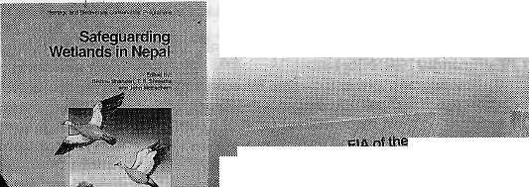
New Publications in the Market

For a free copy of 11O IMepaf Publications Catalogue, contact:
SUCN Nepal, i?.O.. Box 3923.'Kattimandu. Phone: 526391, 522712, 527781
IUCN
Tim WniM CniBemtlon Union

Tableware # Floormats * Bedcovers # Cushion Covers # Pillows # Kitchen textiles # Cloih by the meter * Clothing * Bags * Toys -s.

#'
G.P.OBox 3701, Kathmandu, Nepal Ph : 270721,272676 fax : 521880

Fair traded and
environment friendly
handicrafts for the
family
Made by low-income Nepali Women
Retailers :
Dhukuti
Kupondole, Kathmandu Ph: 535107
Exporters : Manufacturers:
Nepali Craft Trading (P) Ltd. Association for Craft Producers
G.P.O Box 3701, Knthmandu, Nepal Ph : 270721,272676 fax : 521880
- -die—


Knitwear # X'mas items # Clay # Copperware # Paper Crafts ¥ Wooden items # Basketry # Leather items # Sarees # Felt items

D
A b
a

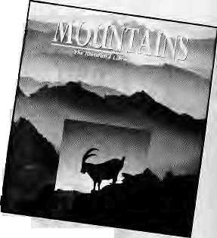
Himalayan Buddhist Villages
John Crook, Henry Osmaton, editors Motilal Banarsidass, Delhi, 1994 [SBN 81 208 1201 2, IRs 800 This book is the result of an interdisciplinary survey begun in 1980 in Zangskar Valley, Ladakh. The editors offer a series of reports by 17 contributors based on a survey which was completed justbefore a road came to the valley, bringing inevitable changes. Initiated to investigate the "energy flow" of human activity in the mountain-locked subsistence lifestyle of the valley inhabitants, the research diverted inlo other projects aimed at understanding why the people lived so well in their high and remote region. The book's main theme is the interdependence between resources, social organisation, demography and culture. It has information for specialists who want to leam about a Himalayan Buddhist population before it became, economically, a part of modern India.
The Buddhist Forum (Volume HI) Tadeusz Skorupski, Ulrich Page!, editors Heritage Publishers, New Delhi, 1995 ISBN 81 7026195 3, IRs 495 This is yet another in the series of papers presented at meetings of the Forum held at the School of Oriental and African Studies in London. The papers in the volume, which has been brought out to honour SOAS Professor David Seyfort Ruegg's "contribution to Indological, Buddhist and Tibetan Studies", include papers by leading Asian, European and American scholars dealing with the status of Pramana Doctrine according to Sa skya Pandita and other Tibetan masters; a survey of research on the Bon religion; mistaken ideas about nibbana; observations on "the notion Tathagatagarbha; Tibetan mortuary practices; and continuity and change in Buddhist sutras.
Nepal-India Border Relations
Hari Bansh ]ha, editor CETS, Lalitpur, 1995, NRs 100 This is the result of a two-day international seminar held in Kathmandu on "Nepal-India Border Relations" in 1994, The book contains five papers presented by both Nepalis and Indians which identify and analyse the historical, sociocultural, economic and political relationships among the border inhabitants. The papers are by Ram Niwas Panday (historical perceptions), Gopal Singh Nepali (social relations), Hari Bansh Jha (economic relations), Parmanand (political relations), and Deepak Goel (cross-border crime).
Mission to Bhutan: A Nation in Transition
fry B.S. Das
Vikas, New Delhi, 1995 ISBN 0 7069 9470 1, IRs 225 The author was sent as Special Officer to set up Independent India's first Resident Mission in Bhutan. That was in 1968 and the book is a personal account of Das' years there-1968 to 1972, which saw Bhutan evolve from a suzerain state linked to India to an independent sovereign entity which joined the United Nations in 1971. Das provides a first-hand account of the closeness between the then Bhutanese king and Indian leaders which madesuchatransitionpossible. The author says he
also hopes, with his reminisces contained in Mission to Bhutan, "to provide food for thought to the younger generation who rule Bhutan today."
Agricultural Statistics in Nepal: A Users' Assessment Gerard j. Gill el al, editors Min. of Agriculture/Winrock International Kathmandu, 1994, NRs .160 This monograph presents papers by economists who crunch agricultural statistics in Nepal. Included is a report by consultant Govind Koirala, providing an overview of the nature and extent of the "data problem" with Nepali agriculture.
Rafting Nepal: A Consumers' Guide
by Peter Knowles Rivers Publishing UK, Surbiton 1994, NRs 280
After the unexpected success of White. Water Nepal, a guidebook for both kayaking and rafting, the publisher was asked to produce a cheaper guide for the local rafting "consumer". Knowles has been exploring and running the rivers of the Himalaya since 1983 and was recently given the title "modern explorer" by the Royal Geographical Society (together with 19 others).
Source Materials of Kumauni History by N.N. Misra, et al
Shree Almora Book Depot, Almora, 1994 ISBN 81 85865 24 8, IRs 200 N.N. Misra is an octogenarian research scholar based in Almora. The book is dedicated to his "mentor" J.C. Powell Price of the UP Historical Society, who first encouraged Misra to do research work on Kumauni history back in 1934. The book is a step towards fulfilling that need for a collection of source material on the history of Uttarakhand. Misra begins with an essay entitled "Source Materials of Kumauni History," in which he underlines the importance of Buddhist and Jain texts and accounts by Greek and Roman writers. Other chapters deal with various aspects of Kumauni history such as notes on the Dhikuli and Ujihani ruins, the Jageswara Temple and Lakhamandal sculptures, copperplate grants of the Chand Rajas of Kumaon, and the early history of the Garhwal Rajas.
An Outline of the Himalayan Upheaval: A Case Study of the Nepal Himalayas
by Koshiro Kizaki JICA, Kathmandu, 1994
This book is based on the result of collaborative research done in the 1980s by Japanese and Nepali geologists on "Crustal Movement of the Nepal Himalayas." The researchers tried to verify present-day crustal movements by means of a geodetic survey and active fault observations. River terrace research was undertaken to understand how the area has uplifted since the late Pleistocene period. Studies were also made on sed i mentary basins and their changes, which signify the altitude variation and the relative uplift rate since the Miocene period. Besides presenting a synthesis of the results of the survey, the author, who is associated with the geology department of Tribhuvan University, has incorporated some of his own ideas. The book is also intended to serve as lecture notes
for undergraduate and graduate geology students at TU.
People of India: Meghalaya K.S. Singh, editor ASI/Seagull Books, Calcutta, 1994 ISBN 817046123 5, IRs 250 This is the thirty-second volume in the People of India series begun in 1985 by the Anthropological Survey of India to profile the different Indian communities and to assess the impact of change and the development process on them. This edition deals withvariousaspectsofMeghalaya'sculture, which includes the unique institution of matriliny, and is divided into separate chapters on 25 communities (both tribal and non-tribal) that inhabit this northeastern Indian state. While there is a lot of information on the Khasi communities by virtue of their being in the majority, other resident communities in the state like Bengalis, Biharis, Marwaris and Nepalis are also given due attention. There is also a map showing the distribution of communities in the state and also a few pictures depicting people and their lifestyles towards the end of the book.
Mountains: The Illustrated Library of the Earth
Jack D. Ives, consulting editor Rodale Press, 1994 ISBN 0 87596 633 0, U$ 35
This book brings together the views of geomor-phologists, environmentalists, anthropologists and mountaineers in one single volume. The opening section profiles the mountains of the world and examines the forces deep within the Earth's Crust that formed the world's mountains and continue to shape i them today. The
second section describes how mountain inhabitants-plants, animals, and people-interact, survive, and thrive in often harsh mountain environments. The final section analyses the ways people have worked with the mountains, from farming them to mining and climbing them. The text is supported by more than 150 colour photographs and specially commissioned illustrations and maps. A welcome addition to mountain literature providing an informative guide to mountains and mountain-related issues for both adults and the young.
Mountain Research and Development
Vol 15, No 1, February 1995 Vol 15, No 2, May 1995 Vol 15, No 3, August 1995 Jack and Pauline Ives, editors University of California Press ISSN 0276 4741
The February issue o/MRD covers: Himalayan Forest-Cover Changes in Historical Perspective: A

24
September/October 1995 HIMAL

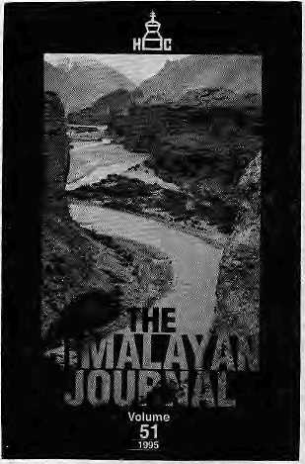
case Study in the Kaghan Valley, Northern Pakistan; Agro-Ecological Zonation along an Altitudi-nal Gradient in the Montane Belt of the Los Santos Forest Reserve in Costa Rica; Traditional Water Management and State Intervention: The Case of Santo Antao, Cape Verde; Time Allocation and Fuel Usage in Three Villages of the Garhwal Himalaya, India; Estimating Flood Magnitude in Ungauged Mountain Channels, Nepal; The Regional Economic Impacts of the Swiss National Park.
The May issue; Environment and Economic Growth in the Atlas Mountains, Morocco: A Policy-oriented Research Agenda; The Taif Escarpment, Saudi Arabia: A Study for Nature Conservation and Recreational Development; National Parks Policy and Mountain Depopulation: A Case Study in the Abruzzo Region of the Central Apennines, Italy; A High-Andean Toposequence: The Geoecology of Coalescent Paramo Rosettes; The Economics of Extraction in Philippine Forests: When Timber Turns to Gold; Geoecology of the Norra StorfjalletArea, Northe m Swe den; An Evaluation of Soil Conservation Techniques in the Ecuadorian Andes; Florisfic Composition of Dakata Valley, Southeast Ethiopia: An Implication for the Conservation of Biodiversity.
The August issue is a collection of studies about geoecology and sustainable development in middle and high mountains worldwide. The well researched studies cover the areas of northern Pakistan, the Kunlun Mountains in China, the Australian Alps, and the Spanish Pyrenees. This issue also deals with topics such as mountain agricultural systems, sediment yield, cloud forest conservation, and geomorphic processes in mountains-
Guests in this Country by Greta Rana
Book Faith India, Delhi, 1994 ISBN 81 7303 034 0
Based on the Kathmandu-based author's own experiences of working in different aid agencies in Asia, this novel is a spoof of colonisation by development aid, A young British woman lands a job in an international aid agency to work in a fictional country named Lapalistan, which is meant to be anywhere in Asia. Her desire to escape the life at home gets the woman involved in everything from tennis matches to revolution to pregnancy, Quick to learn, she goes through a whole gamut of third world experiences of a development expatriate wanting to expose the mismanagement of red tape bureaucracies in charge of development aid in developing countries.
The Himalayan Journal
Vols. 50 & 51,1992-1993 & 1995 Harish Kapadia, editor The Himalayan Club, Bombay Oxford University Press, Delhi, 1994 ISBN 0 19 563574 4/0 19 563734 0 The Journal brought out by the Himalayan Club (established in 1928 in Bombay) is an authoritative and reliable record of worthwhile events in Himalayan mountaineering. Among other articles, Vol. 50 con ta ins bi ogra phical essay s on Tenzi ng Norgay and other Sherpas who have made a name for
themselves as climbers, under the title 'Tenzing Norgay and the Sherpa Team', a nostalgic piece Return to Everest' by George C. Band, of the 1953 Lord Hunt-led ex-p edi t ion, and a n accoun t by H iromi Otsuka on the first ascent of Namcha Barwa. Both volumes contain a chapter ^{r}Expe-dition and Notes', giving short descriptions of climbing expeditions of the past year or so, In-dudedarebook reviews as well as memorial pieces on mountain lovers, climbers or others.
Public Political Opinion Survey in Nepal
Deepak Tamang, executive editor SEARCH-Nepal, 1994
This is a report that came out of a political opinion poll undertaken jointly by SEARCH-Nepal and USAIDin the districts of Gorkha, Dang and Si rah a to assess people's attitudes, perceptions and opinions towards pluralism, democracy, parliament, judiciary, local government and the media after the restoration of multi-party democracy. Many tables and graphs supplement the text.
Forests and Forestry in Nepal
by S.S. Negi
Ashish Publishing House, New Delhi, 1994
ISBN 81 7024 581 8, IRs 250
Negi, an Indian Fores t Officer from Himachal, sees
the forests of Nepal as unique in that they extend
from the southern Gangetic plains to the alpine
zone below the snow line in the north. The book
discusses Nepal's forest types, their utilisation and
management, forest products and their economic
utility and also forest degradation.
The Himalaya: Aspects ot Change
J.S. hall, editor
Oxford University Press, Delhi, 1995 ISBN 019 563263 X, IRs 155 First published in 1981 by the India International Centre, this selection contains 13 essays, dealing with flora, fauna, birds, art, mountaineering, agriculture and social change in the Himalaya. The environment and the ecology of the region may be severely imbalanced, warns the book, as economic development proceeds apace and lifestyles and values of the Himalayan peoples change.
Development Trends in Dolakha and Sindhupakhok, Nepal (1975-1995) by Sushma Bajracharya, et a! INFRAS for SDC, Zurich/Kathmandu, June 1995 ISBN 3 9520824 14
This report, prepared by six professionals in different fields, looks at the major social, economic and ecological changes during the past 20 years of observa tion in th ree moni toring s tu di es con d ucted
in the Lamosangu-Jiri Road Project area. The impact of the road in terms of newer aspirations and the import of alien technological knowhow is questioned. One section is made up of "before and after" photographs showing the regeneration of forests in the project area.
New Directions in Nepal-India Relations
by Rishikhesh Shaha Nirala Publications, New Delhi, 1995
ISBN 81 85693 53 6 IRs 65 This book looks at the changes in Nepal-India relations that have come about since the establishment of the multiparty system in Nepal. Shaha, eminent scholar and statesman, looks at some of the links the Nepali political parties have forged with their Indian counterparts and how they have been shaping the present relationship between the two countries. The book also covers some of the issues of contention and the difficulty of the governments at resolving them in this new-found Nepali times of public accountability.
High Priorities: Conserving Mountain Ecosystems and Cultures
by Derek Denniston
WorldWatch Institute, Washington DC, 1995 ISBN 1878071 24 6
"Mountains make up one-fifth of the world's landscape and are home to at least one-tenth of the world's people." With this introduction, the author goes on to examine mountain community-based initiatives that integrate conservation and sustainable development and also offers priorities for effective action at the regional, national and global levels,
A Study on Pesticide Pollution in Nepal by Leela Dahal
National Conservation Strategy Implementation Project, Kathmandu, 1995 ISBN 92 9144 0019
This study on pesticide pollution was undertaken by NPC/IUCN National Conservation Strategy Implementation Project responding to an increased awareness of the pesticide problem in Nepal. The topics deal with the use of pesticides and its environmental effects, the factors contributing to pesticide pollution, the survey itself, along with a seE of recommendations to limit such pollution. Included also is a chapter dealing with natural alternatives to chemical pesticides.
Herb Industry for Biodiversity Conservation
and Sustainable Development in Garhwal
Himalaya {in Hindi)
by Arun Kumar Badoni
Society for Himalayan Environmental Research,
Dehradun, 1995, IKs 225
Approximately 80 herbs found in the Garhwal
Himalaya are listed in this large-format volume
which takes a herb-by-herb look at their etymo-

HIMAL September/October 1995

B
A b
t r a

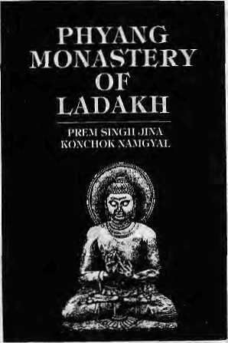
logical origins in Sanskrit, physical dimensions, area found in, traditional and scientific uses, and harvest periods. This comprehensive tally is supported b y colou r an d black-a n d-wh i te p hotog ra phs.
Offerings from Nepal
by Craig Potton, Lisa Ckoegyal Craig Potton Publishing, Nelson, New Zealand, 1995
ISBN 0 908802 25 0
This latest picture book on Nepal leaves a lot to be desired. Some of the images are artistic enough, which is to be expected from a professional, but the material does not offer a wide cross-section of Nepal, either in terms of terrain or culture. In his seven t rips, the New Zeal ande r phot ograp her ma de it to the standard places: Kathmandu, Chitwan and the two regulatory treks of Upper Khumbu and the Annapurna circuit-The captions are uninspiring in their matter-of-facmess and equally so is the introductory essay by Choegyal. Potton's photographic notes, which is the saving grace of the book, will endear him to Nepal-lovers.
Du
(The Magazine of Culture) Heft Nr. 7, July 1995 Zurich
This issue of the magazine from Switzerland (in German) features Tibet, with several articles written by Tibetans covering the history of the Chinese takeover. Buddhism, and exile issues. It contains striking and unusual photography of Tibet, as well as some poignant shots that are rarely associated with Lhasa. Most impressive are photographs by Manuel Bauer, who travels to the interior of Tibet taking pictures incognito of provincial towns, and accompanying a father-daughter team on their long march over the Nangpa La into Nepal and down to India.
The Rulings of the Night An Ethnography of Nepaiese Shaman Oral Texts by Gregory G. Maskarinec University of Wisconsin Press, 1995 ISBN 0 299 14494 1, U$ 22.95 Based orx research dealing with fifteen shamans, Maskarinec attempts to explain the world of the blacksmith jliankri in the Jajarkot and Kukum districts of West Nepal. He empathises with these "low caste" peoples, and records a lifestyle that is often undervalued or ignored. Much attention is paid to documenting excerpts of shamanic chants. The researcher's extensive fieldwork with the ethnographic and linguistic details he includes help prov i de the unders t a nd i ng of the sha m an's p ray ers and rituals and their other social roles.
The Quest for Health Dr. Hemang Dixit
Educational Enterprise, Kathmandu, 1995, NRs 210
A study of Nepal's health field, this book begins with a historical analysis and eventually covers contemporary issues such as health rights, primary health care, hospital services, family planning, insurance, diseases, policy-making and medical research. Dixit provides statistics but cautions
the reader about their reliability. He ends with an appraisal of the current medical system in the Kingdom.
Over the Mountains
by Mani Dixit
Ekta Books, Kathmandu, 1995, NRs 175 Partly based on Nepal's historical past, this fictional work is about Nepali migration down through the centuries. It describes the ordeals poor mountain people endure which lead them to leave their ancestral land in search of sustenance.
Cold Deserts of India by S.S. Negi
Indus Publishing Company, New Delhi, 1995 ISBN 81 7387 029 2, IRs 350 These "cold deserts" refer to those trans-Himalayan parts of India—Lahaul, Spiti, Kinnaur, Bharmour, and parts of Uttarakhand and Sikkim. These regions, lying in the rain-shadow of the Himalaya, are quite different from the other parts to the south, and Negi deals with the regional geography, climate, soils, rivers, lakes, glaciers, geology, vegetation, pasturelands, wildlife and protected areas, history, communities, religion, festivals and fairs, socioeconomic set-up, environmental problems and places of interest.
The Abode of Mahashiva: Cults andSymbol-ogy in Jaunsar-Bawar in the Mid-Himalayas
by Madhu Jain
Indus Publishing Company, New Delhi, 1995 ISBN 81 7387 030 6, IRs 350 The geographical area demarcated by the Satluj in the west and the Jamuna in the east has thro ugh the centuries been associated with Mahasu devta-the dialectal distortion of the Mahashiva. This area is known a s Jaunsa r-Bawa r. Jai n, a I o rme r Un iversi ty Grants Commission fellow, offers an analytical study of the cultic manifestations of Mahashiva with its complex structure of symbology. Besides this, other cults, antiquated and living, have also been analysed.
Phyang Monastery of
Ladakh
by Prem Singh Jina and Konchok Namgyal Indus Publishing Company, New Delhi, 1995 ISBN 81 7387 028 4, IRs 250 The Phyartg Monastery of Ladakh is an Important centre of learning of the Drigung Kagyu-pa order. This book, by two scholars from Leh, looksintothedevelopmentof the ord er and i ts h isto rical tra-ditions and rituals and also gives a description of the chams, statues, murals, thankas and inscriptions in the monastery. Included in the book are 26 photographic plates depicting the artwork and murals held by the monastery.
Natural Resources and Sustainable Development in Himalaya
by P.C. Tiwari
Shree Almora Book Depot, Almora, 1995 ISBN 81 85865 44 2, IRs 250 The author, formerly a Government of India official, deals with the recent techniques of analysis, productivi ty and efficiency, utilisation pattem,and growth generating potentials of different environmental resources. It offers a methodological framework for the demarcation of conservation and development areas, optimum landuse planning, delineation of viable ecological-resource development programmes in Himalayan watersheds. Supporting material is in the form of tables and figures.
Teku Thapathali Research Group Report
by John Sanday, et al Teku Thapathali Research Group, 1994 This is a report of the identification stage of a proposal to revitalise and rehabilitate the temple complexes, shrines and riverbank ghats in Kathmandu, from Teku to Thapathali along the sacred Bagmati. In order to provide a framework into which individual projects can be implemented and to protect the environment in general, this report describes a Monument Zone with recommendations for its immediate establishment. There are a host of other recommendations contained in the report which are practical and demand moderate national and international support and focus on local community involvement. The short-term goal envisaged by the report is the motivation of the local people into developing and conserving their own environment; the long-term goal being ensuring the future self-sustainability of the project area.
Uttaranchal Himalaya Maheshwar P. joshi, Lalit Prabha Joshi, editors Shree Almora Book Depot, Almora, 1995 ISBN 81 S5S65 28 0, IRs 650 This volume, which is a collection of original research papers on the Kumaon-Garhwal Himalaya, is a commemorative issue in memory of Ghananand Pande and Soban Singh Jina, founding president and vice-president respectively of Uttarakhand Vikas Sans than. The papers of 17 scholars, mostly from Uttarakhand, have been included in this book, which deals with topics as varied as the geographical analysis of the Kumaun Himalaya, the menhirs and depressions in Western Garhwal, caste formation in the region, regional vegetable production, health and disease among the Uttarakhand tribals and mechanical strategies in folk medicine in Garhwal, among others.
Himal -would like !o thank Mandate Book Point, Kaniipath, Kathmandu, for providing nmmj of the books presented here for abstracting.

26
September/October 1995 HIMAL

FORTHCOMING
Civilized Shamans: Buddhism in Tibetan Societies Geoffrey Samuel (Mandala Edition is being published by arrangement with Smithsonian Institution, Press, Washinton DC. USA)
RECENT ARRIVALS
1. Proceedings of the International Seminar
on Anthropology of Nepal:
People, Problems and Processes Edited by Michael Allen
- Tales of Turquoise; A Pilgrimage in Dolpo Cornneille Jest
- Jhankri: Chamance de I' Himalaya (In French Language) Eric Chazot
- Nepal: An essential hand book for Trekkers
Amy R. Kaplan & Michael Keller
- A guide to the Art and Architecture of the Kathmandu Valley
Michael Hutt
- K1RTIPUR: An Urban Community in Nepal
Its People, Town Planing, Architecture and Arts
Editors Mehrdad Shokoohy and Natalie H. Shokoohy

Visit Mandala
for
Scholarly books, maps and
guides on Tibet, Nepal, Bhutan

XEPAL
and the Indian Himalaya


MANDALA BOOK POINT
Kantipath, Post Box No.: 528, Kathmanau, Nepal. Tel + 977-1-227711 (0) 216100 (R) Fax + 00977-1-227600, 227372 Attn: Madhab

We accept


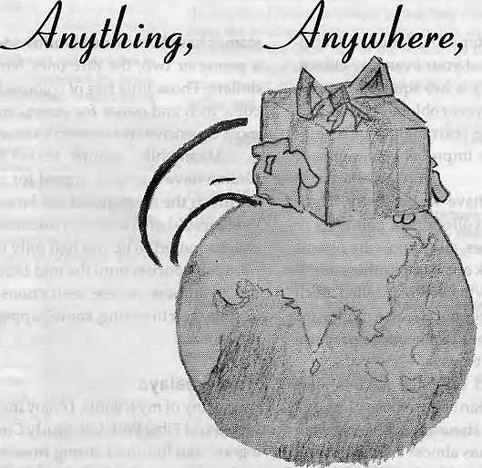
<J
rne

Overseas Cargo Service and J.P.N. Exports, Thamel, Kathmandu
P.O. Box 8621, Kathmandu. Phone: 977 1 413391 Fax: 416850


Confessions of a Himalayan Philatelist
There are those who
would die—and some who
would kill—for old stamps
from Nepal, Tibet and Bhutan.
by Armand E. Singer

Chinese overprinted stamps for use in 1911 in Tibet Part of a long set of 11 values. The "S" in bottom left stamp is inverted and too large. Famous, rare error. Smaller frame is of stamp used by the 1924 British Everest Expedition.

A
true philatelist (Webster's: phi-lat-e-list, "a collector of stamps") is not your everyday citizen. He or she (it's usually a he) squirrels away a prodigious amount of little squares or oblongs of coloured paper, in the gathering, studying, rearranging, and exhibiting of which he/she expends improbable amounts of time, ingenuity and money.
The bits of paper don't have to be pretty. Here, philatelists part company with collectors of paintings or sculpture or antique automobiles, all supposedly objects of beauty. Many philatelists seek out stamps others might regard as ugly, "marred" by having been cancelled. Such stamps were probably produced, not to raise money for some cash-strapped treasury, but for the more practical purpose of sending a letter on its way.
Communist, socialist, and capitalist nations alike cater to philatelists. One European stamp society boasts a membership in the hundreds of thousands. The largest in the United States, I can attest, has almost sixty thousand members. There's a lot for them to collect.
Since Great Britain first began printing stamps in 1840, something like two hundred thousand different
stamps havebeen issued worldwide. Thecheapest sell for a penny or two; the rare ones fetch over a million U.S. dollars. Those little bits of coloured paper, cubic inch for cubic inch and ounce for ounce, are in all likelihood the most expensive treasures in existence.
Meanwhile, stamps issued by Tibet, Nepal and Bhutan have a unique appeal for collectors. One reason for this is the mystique of the faraway, the aura of lands long forbidden to accessby outsiders, Lhasa traditionally was supposed to be reached only in disguise. Nepal did not allow tourists until the mid 1950s, and Bhutan continues to impose severe restrictions on travellers. Thus, despite their towering, snow-capped peaks, the Himalaya are hot.
Hot Himalaya
Likemany of my friends, 1 enjoy membership in the lively Nepal and Tibet Philatelic Study Circle (Bhutan included), a good two hundred strong from all over the world. We have access to knowledgeable dealers specialising in our area, such as Robson Loweof London, George Ale vizos of Santa M onica, California, and Geoffrey FI a ck of Vancouver.

28
\
September/October 1995 HIMAL

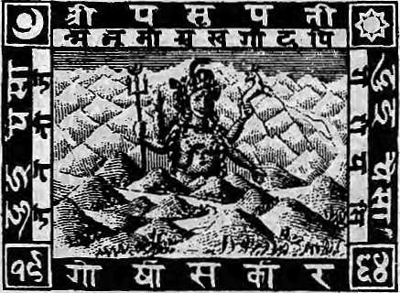
Nepal, 1907-1929. 2-pice brown, engraved by Perkins-Bacon, the London firm. Set of 4-2, 4, 8 and 16-pke, depicts Shiva+Himalaya.
Fine scholars—the likes of Frank Vignola, Wolfgang Hellrigl, Dick van der Waterern, Frealon Bibbins, and the late Arnold Waterfall—research the books that have become our bibles. We exhibit and meet at national and international philatelic exhibitions. We have our own quarterly, Postal Himal, which began as a newsletter in November, 1976, and assumed its present, enlarged format five years later. Philately, the voice of the Kathmandu-based Nepal Philatelic Society, and specifically devoted totheissues of Nepal, also first appeared on the scene in the 1970s.
Luckily for this retired professorof foreign languages (teachers' salaries being what they are), Himalayan material does not have to be stalked among the rarefied million-dollar heights, but can be found in the more modest one-to-ten-to-fifteen-thousand-dollar foothills. (Ido know, however, of one Himalayan item for which the owner is asking twenty-five thousand.)
Supplies of these stamps are relatively scarce, even for the cheaper stamps. In Bhutan and Tibet, printings of a few hundred of many of the denominations satisfied the domestic need for sending letters. Even in Nepal, issues were relatively minuscule compared with, let us say, the millions printed for European or American use. Part of the lure of hunting in the Himalayan preserves is the difficulty of finding the prey.
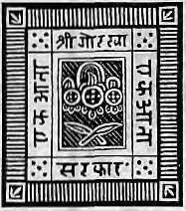
Tibet no longer has its own stamps, being forced to use those issued by China. Its own issues began only in 1912, Between that date and about 1956, when its stamps were superseded by those of China, Tibet turned out barely 20 different stamps, in just three sets meant for regular postage, along with a dubious group of items, supposedly for official use, which most collectors consider bogus. All have but one basic design: the Tibetan lion.
• Nepal,too,betweenl881and 1907 was satisfied with one design, a sripech (the royal and noble jewelled headdress) above crossed khukuris. Between the years 1907 and 1948 only one more was added: the god Shiva sitting atop the Himalaya. Now, ha vingjoined the Uni ver-saIPostalUnionandgonemodern,Nepalputsoutscenics, depicts its rulers and famous citizens, and commemorates all manner of events and places, as do most of the world's stamp-issuing nations.
Killer Instinct
Serious collectors—the kind who would kill to acquire a real find, pawn family jewels for starters, sell their only child into slavery—usually prefer stopping with Tibet 1956 and Nepal 1948, that is, with what we call the classic period. Bhutan's short stamp history (hardly thirty years, none of them in the classic period) has less
to offer, Sikkim's even less, but more can be said about Nepal and Tibet.
Tibet offers the most variety. Omitting the pre-stamp (before 1840) period, one might start with soldiers' mail connected to various British military campaigns in and near Tibet. I have one example in my own collection dated 1861, the earliest I know of.
The Sikkim Campaign of 1888-89 occasioned a fascinating correspondence to and from a certain Lieutenant (later, Captain) Sandbach, at least one piece of which was sent from within Tibet. Better known is the relatively voluminous body of letters resulting from Young-husband's 1903-4 expeditions into Tibet and the following period of occupation by the British Raj, 1904-10. The English were in turn superseded by the Chinese, 1909-1919, whose increasing influence, culminating in a war, resulted in occupation and a postal regime that actually put out its own overprinted stamps strictly for use in Tibet.
There are as well private items, not connected with wars or invasions, such as, for instance, the extensive Sven Hedin correspondence sent by the Swedish explorer to his father back in Europe.
Nepal, 1-anna blue.1881(setof 3-1,2,8,4 annas}.
Nepal's philatelic history is somewhat less varied, yet still fascinating. The postal service's original single design still allowed for a great number of colour shades, several colour errors (notably a two-anna denomination printed in the colour of the one-anna blue, and a one-anna green), and some interesting plate flaws. I must describe a phenomenon that is characteristic of the first Nepali design, that of tete-beche.
Head to Foot
The issues up to 1907 (and for telegraphic use, up to around 1930) were printed in sheets of eight rows of eight individual stamps each. Each separate cliche" (as they are most properly called) is fitted into a form by hand and locked into place by the printer. The stamps are modest in
Cubic inch for cubic inch and ounce for ounce,
stamps are the most expensive
treasures in existence.
size and the design looks pretty much the same, right side up or upside down, especially in the later, more worn printings, which used the same old plates. Should the individual cliches fall out or be removed for cleaning.

HIMAL September/October 1995
29

#■■■,-
 |  |  | EK
M  m |  |  | EK
m trangka, 1933 (set of five-1/2,2/3, 1,2 and 4 tr).
there was a good chance they could be reinserted upside down with reference to adjoining stamps, thus creating what are called tete-beche pairs (loosely translated from the French, the term means "head-foot"). Collectors salivate at the thought, not to mention the sight, of one of the very early examples. The 1881 issue has only three values (one, two, and four annas) and only the two annas shows an inverted pair (three mint and one used examples known). Rarest of the rare!
These, then, are the specimens to die for (along with one of the early two-colour postal cards—oneexamplehas surfaced in which the paper was inserted in the press upside down for the second colour; thus, the orange half^{j} anna value panel appears, inverted, at the lower left instead of the upper right of the card). Later printings provide increasingly common examples, occurring in all three values up to 1907 and beyond. There is also a half-anna black stamp intended for official government use, in a dozen and more printings, replete with flaws.
sheet borders, inverts, and a fabulously rare orange-vermillion variety. Such are the minutiae that mesmerise Nepal specialists.
The second design, 1907-29, and two similar ones of 1930 and 1935, beautifully executed and printed in London by Perkins-Bacon, pretty well end the classic period. However, some collectors continue with the typographed reprints of these engraved stamps, effected by the Nepali government itself because supplies were difficult to obtain from England during World War II. Various printings with a great number of missing perforations and numerous shades were in use up to 1948, and even later. In 1949, the modern period maybe said properly to begin.
Readers of this account of Himalayan collecting may be pardoned for concluding that philately is an addiction, and that Nepal-Tibet-Bhutan collectors rank among the most seriously addicted. But before condemning us, the reader might want to consider that, while our addiction may be hard on the pocketbook, it beats drugs, tobacco and alcohol, is neither illegal, immoral nor fattening—and takes one around the world in a most colourful way.
Who could ask for anything more?
t>
Armand E. Singer is an Emeritus Professor of Romance Languages, West Virginia University, Morgantown, West Virginia, USA.

;A Iwsh garden and tt*aditiona Kana/y\)ewar KoKne are me setting for AAiUe's Breakfast aftcl Jndigo C^alleryy two of Kath^nandw's most deligh+ful destinations. £njoy finecwrsine and soft music in the gav^{i}<i&^ and co*y\& up to wander through the gallery which showcases traditional AJewari painting and bronze arts, as well as showing a diversity of modern exhibitions.

's Breakfast Ope.n Sun - Sa\ 7:00am - 5iOO p "P\zza nigkt Tuesday & FViday 5 -
'Phone.: 421-581
Open Tuesday & Fnday 9'00 am - 9.00
days 9>00 aw - 7*00 p*n ; 421-581 "Fax 411-724-

September/October 1995 HIMAL

Chessler Books
Send for our free Mail Order catalog of the world's largest selection of Mountaineering Books.
New, out-of-print, and rare. Also Tibet, Nepal, Polar, Exploration.
Guidebooks, trekking maps, videos and more! Please write or call for your free catalog today.
Chessler Books
P.O. Box 399-112
Kittredge, Colorado 80457 USA (303) 670-0093 FAX (303) 670-9727


%Sito 'Bangala School
Excellence in Learning
Teachers Wanted
Rato Bangala is a co-educational day school established to fulfill the long-felt need of Kathmandu parents and educators for a school with a creative curriculum and up-to-date teaching methods, good facilities, and self-confident teachers.
Rato Bangala will have Grades I through VITJ in 1996. The school seeks teachers for the coming academic year. Applicants must have fluency in English, an ability to relate to children, and a willingness to learn. Lack of teaching experience is not a bar. Interested candidates please visit the school to pick up application forms.
Rato B;»»gala School
Patan Dholta, PO Box 42, Lalitpur
Phone; 522614



• . there is marc Tr^^'^t^^^^^if^^Mtl.C^t^ .£tt*

*4ir Ticketing ttes
* litterttfltiotutl
1 : £■ gi si:s:ii:;g;^^=S:SS:;^

■ ■ i
Hill : ;S : !; I i H
■Sri

■.: :■.:,.:■.;■■; ;:::::::?:.?:..-:. : ;: ■■..:::■:.:;:. ::- ■■■.;■ :■ :-r\:r y\:--■■:■■■:■
|i||:i:|S|:N|:S::SlS:i;y;::;;!||;i;|i;|i
lliiliSllliliiiiiiliiiiiili
»0
■I



Dear readers of Himal:
After eight years of serving the Himalaya, your magazine is about to make a decided shift in focus. As of the new year (1996), Himal will metamorphose from a 'Himalayan journal' into a monthly 'South Asian magazine'. The forthcoming Nov /Dec issue will contain more details about this metamorphosis, as well as information on what to expect from Himal South Asia and about subscription carry-overs.
South Asia is home to 1.3 billion people who share a common history but are divided by political boundaries created for the most part after the Second World War. This is a region of great cultures, varied geography, and a huge human and economic potential as yet largely untapped.
While similar regions inLatin America and Southeast Asia achieve progress, why does South Asia falter? One reason is that South Asians do not talk to each other over their recently erected frontiers. There is no other region in the world where there is so much socio-cultural affinity and yet so much division.
With Himal South Asia, there is now a magazine come to assist South Asians in communicating with each other, and for the rest of the world to try and understand this region which harbours a fifth of all humanity.
As a monthly, Himal South Asia will follow the economic, political, cultural and environmental developments in the subcontinent from a non-nationalistic, regionwide perspective. Himal South Asia fills a long-felt need for a journal that is both objective and in-depth on the issues and trends of concern to South Asians.
While this region falls in the blind spot of all Western print media, the Hong Kong-based 'Asian' weeklies still regard South Asia as peripheral to their concerns. This is because South Asia is a part of the world that belongs neither to the ASEAN region nor to West Asia. Hirnal's southern Asia stretches beyond the members of SAARC and includes the arc from Afghanistan to Burma.
Keeping in mind the challenges facing a region that is Asia's most underdeveloped, Himal South Asia will zero in on economic and financial developments and highlight initfetives to spur the region's growth. We believe that the cooling of existing tensions is essential for all South Asians to advance in the social and economic spheres.
Himal South Asia will go beyond day-to-day reporting to look at the vibrant cultural traditions of South Asia, and serve as an intellectual bridge between divided peoples, in much the way Himal has so far done for the Himalayan region. The magazine will also have a strong literary accent, and will review books, art, theatre, film and satellite broadcasts.

A South Asian magazine is an idea whose time has come...

Media and Himalaya
A Workshop in Kathmandu

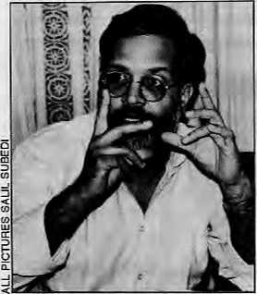
K.S. Tomar
J
ournalists from across the Himalayan region convened at the Hotel Summit in Patan on 22 and 23 June to examine "Media and the Himalaya". The 17 participants arrived from as far afield as Imphal and Islamabad to evaluate the mainstream press' coverage of Himalayan trends and issues.
To facilitate what turned out to be two days of intense discussions, the Himalaya was divided into political regions, each characterised by some homogeneity. The Indian Northeast formed one part, Bhutan another, Sikkim and Darjeeling the third, and Nepal, Uttarakhand, Himachal and North Pakistan completed the chain, while Tibet provided the counterweight to the north.
Praful Bidwai
Although the agenda was specifically geared towards media coverage of regional events, there was a natural tendency among all participants to delve into the issues during the presentations and subsequent discussions. Digression often stemmed from the fact that the journalists themselves were not fully aware of underlying issues in regions other than their own. This fact itself underscored the consensus that the Himalayan zone is getting short shrift from the mainstream media—generally understood to mep the Delhi press by virtue of
by Deepak Thapa
Delhi's geo-political importance vis-a-vis the region.
Thelndiannationalpresswas perceived to be over-involved in sensational reporting and neglectful of hill issues. It was pointed out that while coverage about the former Miss Universe Sushmita Sen's 'idiotic' utterances or the Indian Chief Election Commissioner T.N, Seshan's every self-serving pronouncement regularly secured front-page prominence, the plight of environmentalist Sunderlal Bahuguna, who at that very moment was observing a protest fast against theTehridamproject,wasvirtuallyignored. This was similar to the Indian press's cursory notice of the 1993 floods that wreaked havoc in Nepal, and of the innumerable other Himalayan news events, trends and issues that were, as a matter of course, ignored.
The hills make headlines only in times of political crisis or when law-and-order situations go out of hand. In a region shimmeringly volatile throughout, such event-based reporting completely overshadowed other 'stories', was the general view, and those present writing for Indian national newspapers were also part of this consensus.
On the flip-side, it was felt that this indignation directed at the plains media, righteous though it may sound from a hill perspective, might only be aggrieved posturing—since the mainstream media usually treats staid news from any quarter, whether the mountains or the plains, perfunctorily. In that sense, Chattisgarh or Jharkhand received the same treatment as did Gorkhaland or Uttarakhand. It did not really matter, was the cautioning note by Mukul Sharma of the Navbharat Times, among others, that the subject area was in the Deccan, the Ganga plain or the Himalaya.

If | 1;
1 1 | li |  | %
 | 1
re 'Mi- |  | 1 Jki | ft.
 | i |  | ■"'■ • ^(k i.l
Problem with Facts
While mainstream media's reporting on the Himalaya illustrates general indifference, the little reporting that is done is generally replete with factual errors. This is particularly true for areas where secessionist movements or violent agitations occur, with the authorities handing out well-chosen cues to journalists to disseminate select news.
Yambem Lawa, correspondent for the Statesman in Imphal, and secretary of the Manipur Working Journalists' Association, spoke of how Indian intelligence agencies feed journalists with information to serve their own interests. This results in a backlash against the journalists from insurgency groups.
Lawa recounted an incident near Kohima,Nagaland,where400soldierswere moving in a convoy of lorries. Confusion arose when one lorry burst a tyre. Mistaking the sharp report for a gunshot, the jittery soldiers opened fire, which was returned by 200-odd sentries posted in the area. This 'friendly fire' resulted in several deaths which the Deputy Commissioner of the area stated was the result of an 'exchange' with insurgents. The United News of India ( UNI) and the Press Trust of India (PTI) carried this version, but soon had to retract their bulletins under pressure from the insurgents. Journalists suffer tremendous tension in the Indian Northeast, said Lawa, as they are

HIMAL SeptembeflOdober 1995
33

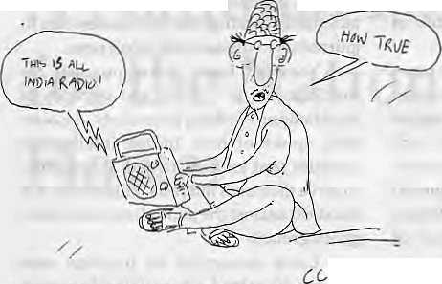
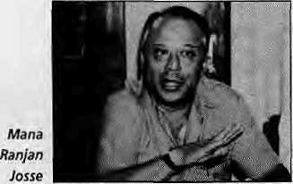
pulled in different directions by the state government, the Army, and the insurgents.
Harka Bahadur Chhettri, editor of Kalim pong-based Praft'twri, cited theexample of the widely-publicised "arms surrender" in Darjeeling at the end of the GNLF movement in 1988, which he said was a farce. "Water-pipe guns and utility pole bazookas" were among the 'weapons' surrendered to make the event appear significant, and the press was blissfully unaware of the deception.
In a lighter vein, Anmole Prasad, lawyer and writer from Kalimpong, recalled that the only part of the Kurseong AIR news bulletins that the hill people believed during the period of the Gorkhaland agitation was the beginning, which went, "This is All India Radio..."
Manisha Aryalof Himal mentioned how during the anti-alcohol movement in

Uttarakhand, which went under the slogan "Nasha nahi, vojgar do" (give us work, not alcohol), journalists who came from the plains provided distorted coverage because each of them used separate groups as informants—government employees, students, and women. This led to the movement being seen to be fragmented and directionless. This kind of unbalanced coverage by journalists all too ready to go back to New Delhi after collecting a few quotes overnight from the nearest available source also had the effect of dividing the movement itself, she said. Given the clout of plains media in the
hills, there was resentment against groups which received selective prominence.
Incorrect reporting often was due to lack of initiative on the part of journalists, said Ashwani Sharma, Indian Express correspondent in Shimla. He said that most news of the Himachal countryside originated at the Shimla desks of correspondents, who rarely left the state capital. Laziness and lack of accountability on the part of correspondents were a major problem.
Bedabrata Lahkar, of the Assam Tribune, reminded participants that it was not merely jaundiced reporting or manipulative authorities that resulted in poor coverage of the hills. In the Indian Northeast, problems of adequate coverage had primarily to do with insufficient manpower and logistical shortcomings, including severe communication problems that were unique to the Northeast.
Lahkar said that most Indian national dailiesmadedowithasinglecorrespondent in Guwahati whose responsibility was to cover all seven states. "Even my paper, which is regional and has the highest circulation in the Northeast, has only five reporters, of whom only one is based in another state capital,"he said. Regional newspapers often relied on stringers for gathering news, the majority of whom are teachers or lawyers, he added.
Question of Objectivity
Mana Ranjan Josse, consulting editor of People's Review, Kathmandu, and a former editor of the Rising Nepal, raised the issue of bias with gusto. He illustrated his point by citing the coverage of the Southern Bhutan crisis by the Statesman under the one-time editorship of Sunanda K. Datta Ray, whose Calcutta flat was reportedly given him by King Jigme of Bhutan.
The Statesman was on the rack once again with Chhettri quoting two of its editorials of some years back, which many felt proved this paper's "bias" against the Darjeeling hills. On 23 December 1987, the lead editorial had expressed the view that draconian measures by the state to suppress the Khalistan movement in Punjab might provide short-term relief, but would eventually risk alienating the common man. On 7 January 1988, however, the same column
urged the administration to come down heavily on the Gorkhaland agitators in the Darjeeling hills. "The double standard from this Calcutta paper became obvious to all at that time," said Chhettri.
Praful Bidwai, columnist for The Times of India and former associate editor of that newspaper, said that most of the journalists who proposed to write on Kashmir were themselves unaware of the conditions under which Jammu and Kashmir acceded to India. "By and large, these press people are reporting from the Bharatiya Janata Party stance that Article 370 of the Indian Constitution be abrogated," without realising that this abrogation would mean the separation of Jammu and Kashmir from India itself. "Patriotism is the bane of a free press/' warned Bidwai, providing one of the many quotable comments that emerged from the two-day meeting.
Bidwai was even-handedly critical of the mainstream Pakistani press coverage of Kashmir as well. In an effort to serve the "larger interests" of their respective countries, Indian and Pakistani newspaper reports on Kashmir have become mirror images of each other, he said. Delhi papers referred to 'Pakistan-occupied Kashmir' (POK), while the Islamabad press reciprocated by writing about 'Indian-held Kashmir'(IHK). "Collusion of thepress with their respective governments is most hideous in the case of Kashmir," was Bidwai's view.
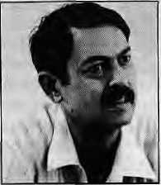
Rajiv Lochan Sha
Rajiv Lochan Sha, editor of Nainitai Times, was firm in his view that the regional vernacular papers (based in the plains of Uttar Pradesh) had sensationalised the Uttarakhand movement and sometimes obscured information, to the detriment of the movement itself. He gave the example of Amar jwala, a Lucknow newspaper, which has two editions printed from Meertit and Bareilly for Garwhal and Kumaon, respectively. While much of the content was similar in b oth editions, news about Uttara kh a n d

34
September/October 1995 HIMAL

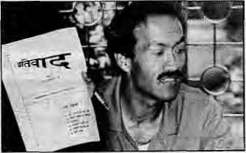
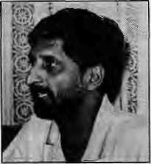
Harks Bahadur Chhettri
was parcelled out differently. People in Almora did not know of happenings in Nainitalandviceversa,eventhoughthetwo towns are only 63 kilometres apart by road. While part of the problem was no doubt logistical, it was also true that the publishers, editors and reporters had a 'plains perspective' (be it one of Lucknow, Meerut or Bareilly), which hardly helped in creating empathy for Uttarakhand.
Nepal's press fared the worst on the objectivity chart, said Basanta Thapa, editor of Himal (the Nepali-language quarterly). "The reading public and the newspapers are obsessed with politics. Nepali newspapers are polarised in the extremes of political opinion. By following the turn of events, one can easily predict what line a paper will take." Even though press freedom has levelled the playing field between the state and the fourth estate, said Thapa, journalists in Nepal had yet to take advantage of this freedom to do justice to their calling. Regarding Nepali newspapers' political coverage, he said, "There is no need to read them if your search is for objectivity."
Kanak Mani Dixit of Himal said that even though the Bhutan Government should be properly lambasted for its policy of depopulating its hills of Nepali-speakers, the Nepali newspaper accounts of the crisis had beenextremelyinadequateandbiased.With the crisis in Southern Bhutan coming soon after Nepal's successful transition into a democracy in 1990, the press reports on Bhutan were marked by a holier-than-thou attitude and by lofty calls for 'democracy' and 'human .rights'. Few papers thought it necessary to delve into the historical, economic and sociological factors leading up to the crisis in Southern Bhutan.
Muku! Sharma
Dixit said that the loss of credibility of the Nepali press as far as Bhutan was concerned had in the end done harm to the refugees themselves and their hopes for an early return to Druk Yul. He added that the
Nepali media also had fallen down on the job by all but dropping stories and features on the refugees in the last couple of years, even though their numbers in the UNHCR camps had swelled to over 87,000.
'Foreign Press'
The Himalayan region was recognised as an area of relative underdeve-lopment, lacking substantial industrial base and consumer demand. Lacking the financial backing of advertisers and large readership, it was understandable that only a few newspapers are published from within the region.
Although more than 600-plus newspapers are registered in Nepal, said Josse, in reality, only a handful could claim the status of'newspaper'. Indianpapers filled the void to such an extent that "Indian media fears of a foreign press invasion in India are a laughing matter for us here in Nepal," said Josse.
K.S.Tomar, Hindustan Times correspon-dentbasedinKathmandu,said!ndiannews-papers coming into Nepal had to be viewed differently from these papers going to other foreign countries. In Nepal, they are the staple for a large portion of the intelligentsia, whereas in other countries, only the Indian consular staff and correspondents tended to react them. Tomar felt that Indian newspapers did not recognise this reality in their coverage of Nepal. There had, in fact, been an accelerated loss of interest in Indian editorial offices since the India-China entente had begun and the geopolitical role of Nepal diminished.
Ashwani Sharma, of the Hindustan Times, pointed out that Himachal Pradesh had no major publication of its own, although the Himachal Times, edited in Shimla and printed in Dehra Dun, claimed that status. Generally, the state intelligentsia relied on the Chandigarh and Jullundhur papers and a recent development had been the publication of a Himachal edition of the Hindi daily Jansatta, Himsatta, printed in Chandigarh.
The popularity of newspapers from elsewhere also influences the vernacular press. Tomar, a native of Himachal, was of the view that the "Punjabi press is polluting HLmachali literature." Mahesh Uniyal, a Garwhali who writes for the Inter-Press
Service (IPS), said theinflux of theexpatriate press in Uttarakhand was eroding the rich literary traditions of Garhwal. Sha, from Nainital, recalled that the Uttarakhand journal Karmdbhumi, at one time was so popular and influential that it used to be presented as gifts at weddings. Such local publications had now died because of the dominance of regional and national newspapers and magazines.
Government Mouthpiece
The fact that newspapers are still being used aspropagandatoolsbytheregionalauthori-ties also came under discussion during the meeting. The official press coverage of the participants' meeting with Nepali Prime Minister Manmohan Adhikari on June 22 was seen as an apposite example. This meeting was picked up as headline news by the state-controlled radio, television and print media (the Corkhapatra and RisingNepal) the following day. The Prime Minister having just made his controversial call for midterm elections (recently quashed by the Supreme Court), the state media utilised the opportunity provided by the press meeting "with Indian and Pakistani journalists" to carry at length the Prime Minister's views on the political scenario of Nepal,
Also criticised was the Bhutanese newspaper Kuensel, ostensibly an independent corporation but jokingly called the Rising Bhutan by one participant. Referring to the Kuensel stories and photographs depicting the Bhutanese king "begging" Lhotsamphas not to leave Bhutan, Sanjoy Hazarika of The New York Times said, "No one buys that picture of a 'humble king' anymore."
Nazir Kamal, a free-lancer from Islamabad,admittedthatthe Pakistani press toes the government line on relations with India, whether on Kashmir or otherwise. "This is because the press in Pakistan is not used to being free," he said. "At the same time, the press knows that its freedom may be curtailed at any time."

HIMAL September/October 1995
35

Taking OrdersforHimalayan Anthology
The Himalayan People: An Anthology Selections and Editing: H.K. Kaul
Virgo Publications c375pp; iilus; 23 cm x 18 cm; IRs 700; U$ 40
(Pre-publicalion price: IRs 500; U$25. Trade discounts will apply on orders of SO or more copies.)
This well-researched, informative anthology contains 325 extracts from travellers and scholars who visited the Himalaya or wrote on the region from the earliest times to the present century, on subjects as diverse as royal ceremonials, religious life, customs and rituals, justice, fairs and dances, food habits, costumes and sports. The accounts cover the Western Himalaya (including Northeastern Afghanistan, the Frontier Provinces, Kashmir, JammuandLadakh), the Central Himalaya (Uttarakhand and Nepal), and the Eastern Himalaya (Darjeeling, Sikkim, Bhutan and the Indian Northeast).
H.K. Kaul is author of more than 20 books, including two popular anthologies, Traveller's India, and Historic Delhi (Oxford University Press). He is Chief Librarian at the India International Centre, New Delhi and Director of the Delhi Library Network.
Rush your pre-publicalion orders to:
Virgo Publications
L-67A Malviya Nagar, New Delhi 110 017 Tel: 6217455
Participants from Nepal, Pakistan, Darjeeling (with Stibhas Ghising's hill council as the governing authority) and the Indian Northeast all agreed that many journalists had got into the journalism profession in order to get close to politicians and to land government contracts or advertisements.
The existence of two large refugee groups in the Himalaya—the Tibetans and the Lhotshampa—had spawned refugee journalism as a means to discuss Tibetan and Bhutanese issues, said Dixit. He found it interesting that two of the best-edited English language journals of the region were brought out by refugees, Bhutan Review and Tibetan Review, both of them monthlies.
Odds and Ends
Besides the specific issues of bias, lack of rigour, disinterest, governmental control, and remoteness, several other topics were discussed at the workshop. Nazir Kamal, journalist from Islamabad, noted that Pakistani newspapers only featured Nepal in relation to India, for example, on whether any new government in Kathmandu was "pro- or anti-India". During the 1989 Indo-Nepal trade and transit dispute, he recalled, there was a spate of reports with an anti-India thrust in the Pakistani press.
It was Hazarika's complaint that the international press had pre-conceived notions about India's human rights record in Kashmir. Many reports were filed by journalists without even fulfilling the most fundamental of journalistic practices—checking with the Indian government, he said.
During the entire Uttarakhand agitation, with demands being made for autonomy from Lucknow and for statehood, there seemed to have been no analysis in the press about the experience of Darjeeling on a similar issue just half a decade previously, stated the gentlemen from Kalimpong. Anmole Prasad also made the point that the Indian national media as a whole had failed to follow up on its coverage of the Gorkhaland agitation by taking a serious look at how the situation had developed following the formation of the Darjeeling Gorkha Hill Council. "With the end of the violence, media interest in Darjeeling died completely. If there had been more news about the DGHC experiment, it might have proved instructive to those
demanding regional councils in Jharkhand and Ladakh."
Harkha Bahadur Chhettri said that previously no newspaper published from Darjeeling could dare write anything against GNLF leader Subash Ghising, but the situation has now turned around. He put forward the example of articles attacking Ghising's stand on the 'greater Nepal' issue which now regularly appear in the vernacular press. However, the national press did continue to ignore Darjeeling, he said.
DixitmadethepointthattheBhutanese probably had the most public relations-minded government in all of South Asia, using every opportunity that was offered to get its views across to and through the press. Thimphu's tactics ranged from outright bribery, to all-expense-paid trips to the charming kingdom that tended to be vacations rather than news-gathering exercises, visa refusals for journalists (either Western and South Asian) perceived to be of the investigative kind, and controlled access to the hinterland for those who were allowed in. The Lhotshampa refugees, as well as the Nepali Government which is being forced to act as their host, were easily being out-manoeuvred by the media-savvy Bhutan-ese, Dixit maintained.
Hazarika agreed with Dixit, stating that the ministers regularly travel to Calcutta, Delhi and even Guwa-hati to brief the press.
Bidwai, for his part, blamed the Indian media for its 'failure' to expose the plight of the nearly 100,000 Bhutanese refugees in Nepal. "The Indian press had shown an utter lack of respect for the human dimension of this particular refugee problem, which is not known to even exist as far as the Indian newspaper reading public is concerned," he said.
The first-ever gathering of press people

;
s |  | Si
I
Yambem Lawa
from or writing about the Himalayan
region, the two-day workshop organised by
Himal proved enriching for the participants.
As the goal of the meeting was limited to
getting together the regional journalists for
the first time, there was no conclusion or
'declaration' to emerge from the meeting.
This report, which deals perhaps cursorily
with all that came up for discussion, will
have to suffice for the moment. Perhaps
more can be expected two years from now,
in the summer of 1997, when all present
agreed to meet again. >
Support for organising the "Media and Himalaya" workshop was provided by ICIMOD, The Ford Foundation, SNV-Nepal and Inter Press Service.The meeting was coordinated by Manisha Aryal.

36
September/October 1995 HIMAL

ton
us show you magical Nepal then take you on a journey of a
ifetime to Nepal's mysterious and hauntingly beautiful
neighbors.
(o us for our color brochure and detailed tour Itineraries.
CHINA SOUTHWEST AIRLINES
Thfil

Marco Polo Travels Nepal Pvt. Ltd.
Head Office: P.O. Box 2769, Gyaneswor,
Opposite German Embassy, Kathmarsdu, Nepal.
Fax: 977-1-418479,413641, Tel:418832, 414192, 411780
.Branch Office: Kathraandu Gues! House, Thamef, Kathmandu, Nepal.
Fax: 977-1-417133. Tei: 414013

□
B

An Appeal for Thame Monastery

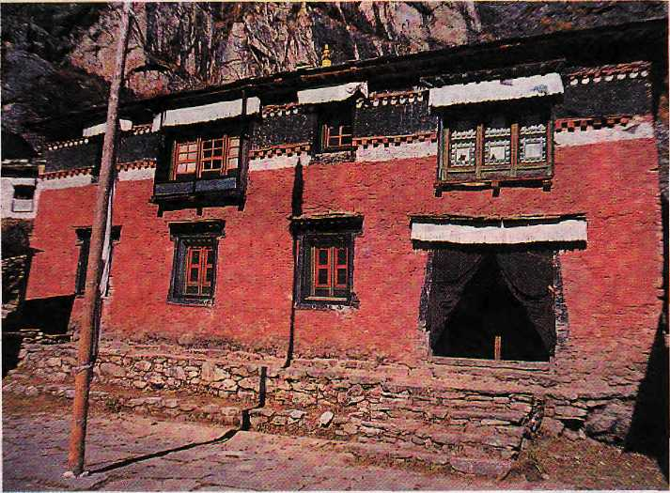
U
p in Khumbu, at 3,900 metres and standing guard over the village of Thame, is an ancient ochre-coloured monastery, tucked under a mighty rocky overhang. Little stone huts, where the monks live, cluster on the talus slope beneath the monastery.
While monsoon clouds swirl around in the valley, opening and closing the view of the surrounding snow mountains, 30 maroon-robed monks step out of their tiny quarters and assemble in the monastery courtyard for their annual Ynrne (summer retreat) prayer. This retreat coincides with the peak monsoon period, which is biologically the most active time of the year when even the most desolate highlands of Upper Khumbu become vibrant with greenery and life.
The Thame Gomba, established in 1667, is one of the oldest and most venerated monasteries of Khumbu. Gombas are an important source of spiritual guidance to the local communities and a major influence in shaping their attitude towards life, and the Thame Gomba is one of the pillars of the Buddhist faith as practised by Sherpas as well as a cultural treasure of incalculable importance.
The rich smell of burning incense, the guttural chanting of monks and the sweet monastic music permeates the ancient building. The strong
spiritual power of the place is
palpable. However, a glance
at the physical conditions of
the monastery reveals
bulging walls, leaning
windows and decaying
frescos. It isobviotts that the
inner spiritual
strength of the monastery
is no longer matched
by its outer physical structure.
The monks accept that monasteries are always at risk of destruction by the four jhungwa (elements)— fire, wind, water and earthquake. Driving home this point, the monastery rests frailly on its ancient seat, dangerously predisposed to earthquake damage.
The Tengboche Gomba received welcome
international support for reconstruction and renovation after it was destroyed by a fire in 1989. As one of the primary cultural centres of the Khumbu, Thame Gomba's rehabilitation too should
have received high priority. Instead it is quietly decaying, unnoticed.
Timely action will save the valuable structure and its priceless relics. The challenge for the moment is reconstruction of the structure before the inevitable collapse. Superficial renovation will hardly stave off the danger, and the monks want to see the monastery restored with its original design and structural integrity preserved. The size of the project, unfortunately, is simply too big for the poor village monastic community to fund and manage.
Thame Gomba does not own any land, property or
business. It does not collect taxes or demand obligatory support from the community, and is dependent entirely upon voluntary support and donations, which have remained stagnant. The annual income of the monas-
tery from this source, in fact, does not exceed NRs 10,000 <U$ 200), mostly from visitor donations.
Thame village is located away from the main tourist trails of Khumbu, which is an advantage for religious application but hopeless in terms of generating tourism revenue. The resident monks are taught to have no attachment and no materialist ambitions. They have a different mission in life, and continue to invest most of their meagre personal savings in the upkeep the important local religious traditions and festivals such as Mani Rimdu, Dorsem, Yarne and Ningne.
The community of
subsistence farmers in
Thame valley, although |
limited by resources, £
education, political clout f or contact with the outside world, has shown its eagerness to help the monastery in whatever humble way it can. But the support of the wider Khumbu community, the government, and national and international organisations and individuals is important if Thame Gomba is to regain its firm physical foundations so that it can continue to provide spiritual sustenance to Upper Khumbu. The Reincarnate Rimpoche and the monks of the Thame Monastery are anxiously praying for generous helping hands, for time is running out for this repository of a timeless tradition.
-Lhakpa Norbu

September/October 1995 HIMAL

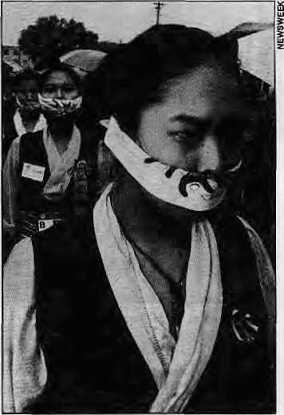
Tibetan Women "Manipulated"
Banmara, Die!
T
ibet had a high profile during the week of the Fourth United Nations Conference on Women in Beijing in early September.
The-fortnight before, a handful of Nepali journalists on a junket to Lhasa came back to Kathmandu and told their readers what a marvellous job the Chinese were doing in Tibet—the usual slavery-is-banished, wide-boulevards, rosy-cheeked-children, and modernisation-has-dorte-away-with-the-feudal-structures
U
mesh Dwivedi, the environmentalist / edu-cator of Darjee-ling who says never say die, has passed a death sentence on the Banmara {Euphatorium Menophorum) weed.
Numerous agencies in India and Nepal have tried to tackle this alien invader, and till now the only use that had been developed was for the leaves (not the stalks) to make compost, for the plant is not good as fodder nor as fuel, and takes over forests whenever given the opportunity. Dwivedi and some colleagues now propose that the baiunara leaves and stems be processed to produce handmade paper.
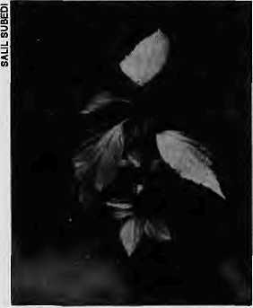
story peddled by the Chinese. The journalists also seemed proud to tell fellow Nepalis about how the Lhasa authorities wined and dined them, with endless "gambay" rounds—downing of the rakshi accompanied by paens to Nepali-Chinese friendship.
Over in Huairou, where the NGO Women met, however, nine foreign passport-holding women of Tibetan
They also say commercially viable green dye can be extracted from the plant.
The Banmara weed, a native to Mexico, is believed to have arrived in South Asian shores in the late sixties when its seeds came mixed with wheat shipments under the United States food aid programme known as PL480, Within a decade, the plant had spread all over Eastern Nepal and Sikkim/Darjeeling, affecting woodlands, pastures and tea gardens.
Dwivedi, who is ready with samples of the Banmara paper and a jute cloth piece coloured green with Banmara dye, says that his innovations have the potential "to turn this ecological menace into a resource which can be used for the economic upliftment of rural folks, employment generation, and eco-friendly industrial development of the Eastern Himalaya."
We might have cause to thank Mexico, after all.
Contact: c/o Umesh Dwivedi St. Paul's School, Darjeeling. Tel: 2840
origin managed to stage a demonstration and provided one of the most potent photographic symbols of the entire Women's Conference. In that sense, the Tibetan exiles had a propaganda victory over the Chinese Government even though official exiled Tibetan delegations were not allowed in. The Chinese Embassy in New Delhi rejected the visa applications of 12 applicants from the Tibetan Women's Association, whose plank is that Tibetan women face double discrimination "first as Tibetans, then as women".
In Huairou, the authorities had organised a Tibet Tent, and Xinhua carried the story which was dutifully picked up by the Rising Nepal daily. Xinhua quoted several approving visitors to the blue and white tent. Barbara Middleton, from Texas, reportedly said, "I'm surprised. It's very developed and quite different from what others told me." Lucy Xavier, from India: "I can see they come up in all fields, still preserve their tradition."
Cering Zhoigar, honourary chairperson of the Tibet Regional Women's Federation, was there to provide visitors with an idea of the advances made by Tibetan women in the modern era. She noted that women were not allowed to participate in political and administrative affairs prior to Tibet's "peaceful liberation". Today, women hold 30
percent of the leading positions in the Tibetan Autonomous Region.
About the nine demonstrating women of Tibetan origin, Soinag, a council member of the Regional Association for Cultural Exchanges with Foreign Countries (who said that she had the experience
of living in the old period when 95 percent of the population of Tibet were serfs), expressed her regret that these women who had been in exile abroad knew little about the development in their home region.
Soinag believed that these exiled women were being manipulated by others. 'These women cannot speak the Tibetan language and many of the young people who have grown up abroad have never been to Tibet. How do they know whether there are human rights or not?"

HIMAL SeptemberlOctober 7995
39

D
B

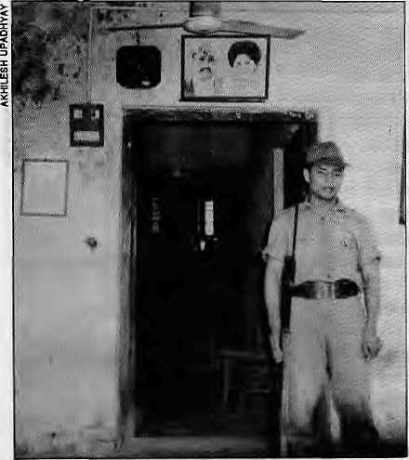
They Sell Rhino Horns, Don!t They?
Congress Got Leh
Over 40 kg of rhino horns, worth over U$ 1.2 million in the black market, is stacked away in a couple of storerooms in Chitwan amidst heavy security. How long should this day-night vigil continue?
Strong-room at Gaida Gasti, Chitwan.
In an interesting turn of events, some Nepali wildlife scientists now propose that these rhino horns, as well as other seized wildlife contraband such as musk and tiger bones, be sold in the open market for all they are worth, and utilise the income towards the protection, and conservation of the very species whose body parts are being sold.
CITES, the international convention governing the trade in wild animals and plants, prohibits the commercial sale of any product from the rhino, which is listed as an endangered species. But Nepali wildlife experts and government officials alike are increasingly concerned over the growing stockpile of animal parts which have
become an expensive nuisance.
"We aren't able to store them properly, and we can't get rid of them either," says one official who asked not to be named. A government task force that submitted its
findings in late May reported that the condition of the stored material is poor; the hides stink, furs have disintegrated beyond recognition, and the rhino horns are under constant onslaught from parasites. The highly volatile musk kept in pouches have
lost much of their mass. While some of the stored cache is from natural animal deaths, most were confiscated from poachers and smugglers.
The task force wrote to the CITES secretariat in Switzerland early this year seeking assistance in deciding the fate of the stockpile. It also sought clear policy guidelines on what to do with future catches. CITES has not responded with satisfactory answers, and the matter hangs in limbo even as the contraband rots further.
Prior to the collapse of the Panchayat system in 1990, all confiscated animal contraband used to find its way to the Royal Palace. Asked as to what happened thereafter, government officials are evasive. As
the stockpile of horns, bones, skin and musk has increased over the last five years of democracy, the problem has become critical enough to demand a procedure to deal with these highly 'sensitive'products.
Says one of the Nepali wildlife specialists, none of whom want to be named because of what they propose is radical, "Selling the accumulated contraband would provide a massive one-time infusion of funds for conservation in Nepal, whose disbursement would be decided by Nepali specialists themselves
O
n 3 September, the first Ladakh Autonomous Hill Development Council (LAHDec) was formally inaugurated. The 22 elected and four nominated members were sworn in during a ceremony at the polo ground at Leh in the presence of the Governor of Jammu and Kashmir, K.V. Krishna Rao. In spite of incessant rain, the mood was jubilant. After many decades of struggle, it was felt, Ladakh or rather Leh District, has regained a significant measure of autonomy.
Ironically, the Hurriyat Conference in Kashmir Valley had called for a bandh and organised a large demonstration to protest the formation of the LAHDec. Moreover, there is an unconfirmed report that the Hurriyat leaders have called for an economic boycott
rather than under the direction of donor agencies."
According to this lobby, the international community should not for the sake of philosophical purity ignore the plight of poor countries like Nepal, which should be allowed to explore every opportunity to boost its underfunded and ailing conservation efforts. "These were Nepali animals that were killed by poachers, and it is logical to use the income so that their death was not in vain," was the view of one expert. "The alternative is to destroy these valuable products on the altar of foreign sensitivities."
Pralad Yonzon, a wildlife biologist who recently returned
of Ladakh. It seems Ladakhis are not to be allowed the "freedom" that the Kashmiris seek for themselves.
The composition of the Council did not come as a surprise. Once the key leaders of the 1989 agitation resigned from their positions in the Ladakh Buddhist Association and joined Congress (I), it was to be expected that the party would do well in the election in August. There is some unhappiness, particularly among the youth, with the fact that the agitation leaders joined the Congress party instead of forming a new regional outfit. The former LBA leaders, however, point out that it was necessary to maintain a link with the Centre, especially in view of the opposition to the Council in Kashmir.

September/October 1995 H1MAL

from a stint as advisor in Vietnam, when asked to comment on the proposal, concedes that the issue is problematic. "There is no easy answer. As long as demand exists in Indo-China for tiger bones and rhino horn, poaching will continue. So, legalizing the movement of the rhino horn being held by the Nepali authorities is one answer, as long as the trade is carried out by an authorised body under strict international supervision."
Yonzon admits that there is risk attached to any policy deviation; "If Nepal somehow devises a policy and secures international market for its horns, India is going to raise
The manner in which the "Congress bulldozer", as one leader phrased it, managed to win every elected seat and three out of four nominated ones was surprising, except perhaps to Tsering Samphel, the District Congress President, who had predicted the outcome more than six months ago. Twenty two seats were won by default as no opposition candidates had come forward. Fear among villagers also seems to have played a part.
That this fear was not entirely misplaced was made clear by an incident in the constituency of Martselan, which includes among others the large villages of Stok and Matho. Here, the independent candidate was 'kidnapped' on the eve of the election and beaten up by a number of youths. Villagers from Matho staged a demonstration in Leh on August 31 in protest, which no doubt came as a shock to
hell. Tomorrow, every horn seized in Taiwan will be reported to have Nepali origin. Besides, we cannot say that decisions taken in Kathmandu will not affect the well-being of the surviving rhino population from India to Indonesia."
Of the hundreds of rhino species that once roamed the earth only five species survive: the white and black African rhinos; the two-homed Sumatran rhino; the lesser one-horned Javan rhino; and the greater one-horned Indian rhino, of whom 1500 remain with about 400 in Nepal.
While from an economic and nationalistic standpoint, the sale of accumulated contraband might be an
the former LBA leaders, now at the receiving end of the people's ire.
At the same time, the considerable effort put into preventing political infighting among Ladakhis in this first council appears to have paid off. The Council is characterised by a high level of education and a good balance of youth and experience. Four Muslim members (two Shia, one Sunni, one Nurhakshia) are to represent the interest of their communities, a proportionate share.
A surprise was in the Governor's nomination of Tsechu Lamo, the most famous folk singer of Ladakh and winner of the National Sangeet Academy Gold Medal. Although her voice is much loved in all of Ladakh, her community of Beda suffers a severe social stigma. It is generally assumed that she was nominated to represent the interest of her
appealing idea, the diplomatic, political and public relations challenges of such a policy put on the Nepali government are enormous. "Getting cash in return for the stockpile would be tantamount to commercial use of the rhino horn," says Shyam Bajimaya at the Department of National Parks and Wildlife, leader of the task force. "A better bargain would be sending some of our stocks to Western museums to be used for educational purposes in return for funds for our conservation projects which urgently require support."
It is not even that CITES has been totally rigid about the disposal of illegal animal
own and other low caste' groups such as the Mon and Garra. Mohd. Shafi Lassu was nominated to represent the Sunni community of Leh, known as Arghun, which he is trying to get listed as a Scheduled Tribe.
A building has now been found to house the Council, and a first draft budget drawn up—representing a 400 percent increase over the current annual outlay. The success of the Council will depend on the members, in particular the Chief Executive Councillor, Thupstan Chhewan, and his four executive Councillors, Sonam Dawa, Mohd. Akbar Ladakhi, Khampo Rimpoche, and Rigzin Jora.
The swearing in took place during the annual Ladakh festival. For the first time, an international polo tournament was held. Local teams thrashed the outsiders. And so, Ladhakis are winning. And the omens are positive.
- Martijn van Beek
products, and there is a precedent to which the Nepali experts can point to. In 1994, succumbing to pressure from some member states, CITES did allow the disposal of contraband under certain conditions: that disposal should not adversely affect the status of the species in question; it should discourage the unregulated and illegal trade; and such a transaction should be devoid of commercial benefits.
These conditions are stringent, and Nepal would face an uphill task convincing other member states as well as donor agencies (which have a lot of clout in Kathmandu corridors) that there will be no negative fallout if it were to sell off its cache. The international resistance to any such move would be immediate and enormous.
Some African countries, which together have much more clout than Nepal, once had harboured hopes of commercially exploiting their vast stockpiles of ivory. However, they were cold-shouldered in a 1992 CITES general meeting that was held in Kyodo, and the ivory remains shelved.
Yonzon feels that there is no harm for Nepal to at least float the idea of sale or exchange. A controversy would certainly erupt, but the need for change is pressing. "It may give us a bad name initially. But if we do our homework well we may even offer a new model to the world."
It is unlikely, however, that the officials of Nepal's wildlife bureaucracy will find the strength to stand up against the world, even for one point two million dollars.
-Akhilesh Upadhyay

HIMAL September/October (995
41

D
B
i e f $

Hindukush Towards the New Millennium
Squatting a Kind of Human Right
A centre for interdiscipli nary research to promote the distinct culture of the Hindukush region is to be set up in Chitral, the political and cultural nerve-centre of this mountainous area, lying between the Himalaya and the Pamirs in northern Pakistan. This was one of the decisions reached at the Third International Hindukush Cultural Conference, held recently in Chitral.
The five-day conference was organised by Anjuman-e-Taraqqui Khowar, an association of writers, poets and intellectuals belonging to Chitral,, and besides attracting scholars from Pakistan, Afghanistan, Europe and North America it also stirred a great deal of interest among the locals.
A library containing primary source material is to
be developed at the proposed research centre and eventually, there will be a museum where Hindukush artefacts will be collected and preserved. Both Pakistani and overseas scholars are expected to be engaged in research at the centre, whose scope, it is expected, will extend to the adjacent Karakoram region as well. Importance is being placed on the grooming of young local scholars.
In one resolution, the conference called for spreading awareness about the close interlinkage between the physical and cultural environments of the Hindukush region. It called for reliance on renewable energy and on simple environment-friendly technologies such as small-scale hydro-electric projects and the use of solar power. It also suggested improving the
communication and transport system in the region, which is an acute problem facing the people of Chitral. The Conference also urged early identification of endangered plant and animal species, as well as tough legislation to protect them, as they have seen great harm over the
No, the subject is not of squatters who set up shanties in public lands, but the human right of "open defecators"— people who go out to the maidan either because this is what has always been done, or because they have no choice due to lack of public latrines. As .the migrant population in the cities increases, the number of those using the commons as toilets is also on the rise, and, at least in India, the state's reaction is getting
last 15 years of opening up.
The first conference on the people of the Hindukush was held in Moesgaard, Denmark, in 1970, and the second one was held in Chitral in 1990. The next conference, also to be held in Chitral, is scheduled for 2000.
- Nazir Kamal, Islamabad
increasingly harsher. On 31 January, the police fired into a crowd of protesting open defecators in North Delhi, killing four. There is also an increasing trend of those caught enflagrante using public or private property being taken to the courts.
The Delhi-based Energy and Environment Group has taken up the fight on behalf of these squatters, stating that it is the state structure that is to blame if there are no public

FLACENAMES
by Dr. Sonam Wangyel
En Route Siliguri to Darjeeling
This journey, from the railhead of Siliguri to the hill station of Darjeeling, is a delight in many ways, one of which is the richness in the meanings of the names of the places one passes en route.
Starting from Siliguri, the stony site (Koch: sil - stone; guri = site), one crosses the Mahananda river (Bengali: maha = great; ananda - pleasure orbliss), which the Nepaliscall Mahanadi or the great river (Nepali: maha - great; nadi=river) to reach a small hamlet called Sukna, the dry place (Bengali: sukna = dry). From Sukna, one negotiates a gentle ascent passing the village of Rongtong, the southern river (Lepcha: run - river; tan = lower direction or south) to arrive at lime kiln or Chunbhatti (Nep: chuna = lime; bhatti - kiln).
The climb gets a bit more tortuous and the air correspondingly crispier, for the traveller has now gained altitude (2,500ft) to arrive at the famous locomotive station on the three ridges of Tindharay, which has been corrupted by plainsmen to Tindharia {Nep: teen =
three; dhar = ridge). Many Nepali writers confuse dhar with dhara, which means 'stream' or 'water spout'.
The traveller is now passing through the tea zone and before long one arrives at Gayabari. O'Malley in Bengal District Gazetteer, Darjeeling writes, "Gayabari (N), - The cow-shed. The word may also be a corruption ofGehunbari or the place of wheat,," This 'cowshed version', developed in 1907, is still in voguenearly 90 years later. Actually, the Nepali word for cowshed is goth and it is likely that the origin of Gayabari is 'Ghaiyabari' or paddy fields. The Nepali ghaiya means 'paddy grown on dry land' and bari is 'dry field', as opposed to khet, which ts 'wet field'. (Ref: Dr. Parasmani Pradhan: Nepali-Nepali-English Dictionary)
Traversing a wide and sweeping curve, the traveller leaves Gayabari to approach an innocuous-looking rivulet which swells into a destructive torrent during the monsoon. Its name, Pagla Jhora or the mad torrent (Nep: pagal - mad; jhora = torrent), is a reflection of the river's rabid manners during the monsoon. A little beyond this point is the town and railway station of Mahanadi (see above) which got its name, according to Darjeeling and its Mountain Railway (1921), from the source of the river which "looms above the railway station".
We are now 4000ft above sea level and in the distance one can seeGiddhay Pahar (Nep: giddha = vulture; pahar = hill) and the town

42
September/October 1995 H1MAL

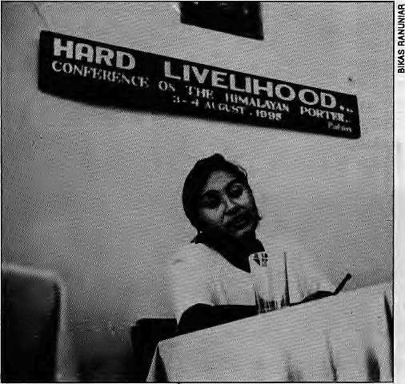
heterogenous cultural mix and fluid migrant movement, neighbourhood ties are still one of tension and suspicion. Beneficiary families do not have faith, in community action."
The situation is bleak, and because it is bleak Sharma wants harassment of the "open
toilets available for when nature calls. According to EEG's Sudhirendar Sharma, "With public lavatories too few in number and a majority often clogged due to overuse, life for hundreds of jhuggi-dwellers in the metropolitan cities begins on a painful note each morning. Consequently, unfinished flyovers, multistorey ed buildings and railway tracks become the convenient hunting grounds for squatters."
Sharma believes that the entire public services system of the fast growing metropolis is geared against the interests of the poor, mostly jhuggi dwellers, including the refusal to set up toilet facilities. The amount required to provide public toilets to the public is, of course, staggering. For the rural sector alone, where 41 million families have to be served, the investment required is IRs 82,000 million. Multiply this figure by 20 and you. have a sense of the money
required for the urban sector. "Even if the money were to be available, where is the space and the water?" asks Sharma.
Public activism is required on behalf of the poor, but the question of bathrooms does not seem to excite community action. Besides, in the jhuggies, "given the
Himal organised the first-ever conference on pottering in Patan on 3-4 August A report of the conference will be presented in the Nov/Dec 1995 issue.
defecators" to cease until such time that alternatives are made available. "Till the answers are found, should the squatters not be allowed to continue defecating in the open spaces? If nothing else, this is a right the society must not snatch from the poor at that crucial moment."

of Kurseong (Himal Jul/Aug 1994). Leaving Kurseong, one can catch a glimpse of the Nagri spur (Tibetan: nagpo - black; ri - hill), but since the journey is Darjeel ing-bound, the traveller arrives at Sepoydhura {Nep: sepoy - soldier; dhura = barracks) which once billeted the old Pioneer Sepoys.
A few kilometres uphill, and the traveller is in Toong where the Cedrelia toona trees once grew in abundance. From here (at 5,500 ft plus),Gorabari is approached; the name has been translated to white or European fields (Nep: gora = European). Actually, the translation ought to be 'European brewery', for the place obtains its name from the disbanded Victoria Brewery which once brewed beer for the British soldiers stationed in Darjeeling. 'Brewery¹ was obviously asking too much of Nepali tongues, which opted for the easier "bari¹, hence 'Gorabari'.
The next town is the bears' lair or Sonada {Lep: sana - bear; da - lair) which yields to a thick forest area once famed for magnolias and rhododendrons but now monotonously covered with Cryp-tomeria japonica (Nep: dhupi). We are now under the shadow of Tiger Hill which the Lepchas of yore called satan hlo {sa-tan = tiger; hlo = hill). A few sharp bends and Jorebungla (Nep: Jore — twin; bungkt = house) is reached, where the highway divides into the Alubari (Nep: aloo = potato) Road, the Jalap ahar {Nep: Jaleko—burnt;
pahar = hill) Road and the Hill Cart Road. The latter has now been rechristened after Everest hero Tenzing Norgay.
Almost adjoining Jorebungla is the Ghoom railway station, Ghoom (Nep: ghoom - turn, rotate) is the point where one makes an acute 'u' turn towards Darjeeling while coming from Nepal. Some {including Waddell in Among the Himalayas, 1891) believe the name owes its origin to the Nepali waterproof matting made of bamboo framework laced with leaves, called ghoom.
Leaving controversies and the dizzy heights (7,400ft plus) theroad is now downwards all the way. Almost midway downhill the windy place or Batasay (Nep) is passed. It is worth the effort and time to tarry here for some time, for the views are not only unquestionably magnificent, the railway loop here too is aesthetically pleasing as an engineering marvel.
Further downhill, Kagjhora is approached. This place once was the dumping ground for municipal waste which attracted a lot of crows and, appropriately, the name translates as the river of crows (Nep: kag = crow). The traveller is very near his destination and if he is travelling by bus the journey will terminate at a place called Barrick which is how Nepali-speakers prefer to say 'barrack'. You are now properly in the heart of Darjeeling, the land of the mystic thunderbolt (see Himal Jul/Aug 1994).

HIMAL September/October 1995
43

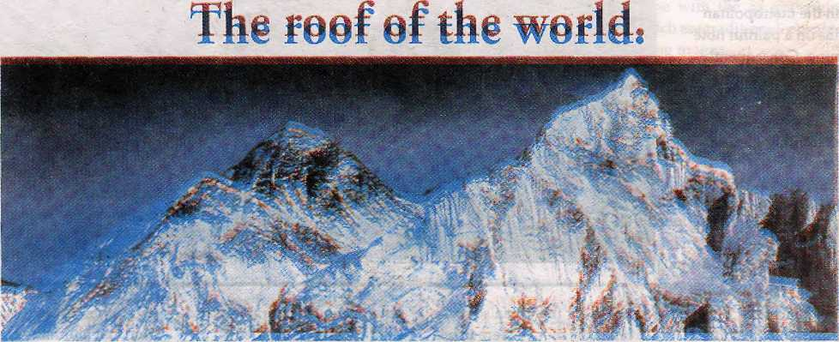
Mi kmi: ml a ■. $ mm
Af§§#i9f thewariiL

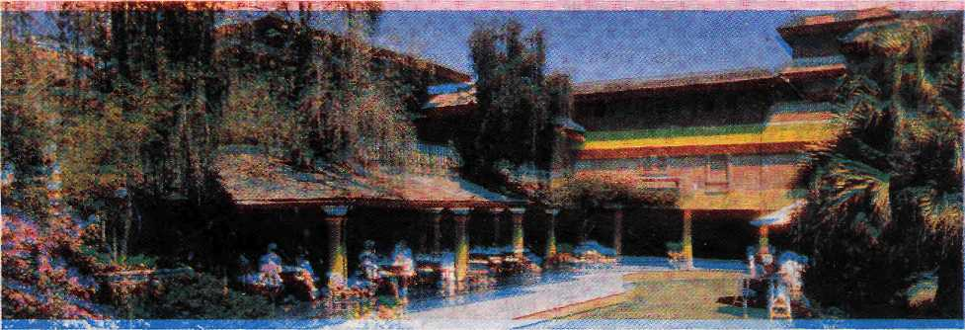

iio(el SHAMGRLLA , K2 Dieiuxe Rooms. 1^{S}S inly IH-J^ Wulel SHAnoRj-LA . S2 uetuxe Kooms. r'-jiay ly/y



11 ■> nil B y

: g:P:8:
PM: lit \ WiM&m - M: $??:BM1§I" SIM! 227^ fl8i#jg

K a
h a


9-loteC

by Narayan Dhaka!

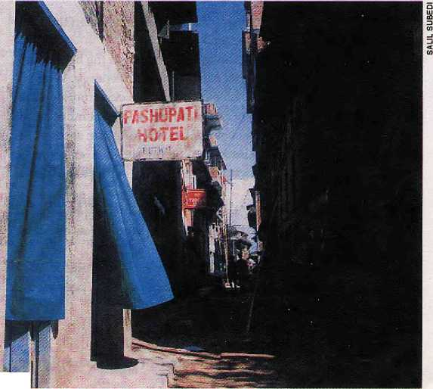
■■:■:-.'.%
We spent the evenings before the People's Movement in that hotel, killing time. It wasn't much of a hotel, despite its name: Pashupati Hotel. Even the signboard that hung above its black, smoke-charred doorway was rusty, sub-standard, and ill-matched with the rest of Kathmandu. The address on it, beneath the hotel's name, had been scraped off; the board had been used before, somewhere else.
From the first evening we went there, we saw that the hotel traded in sex. The women who sold their bodies came after dark and vied for some earnings in the dark, cave-like room upstairs. That was the only real room in the house. The landlord lived somewhere in Tahachal and came only at the end of the month, to collect rent.
The men who came to exchange their money for some pleasure with these women were mostly soldiers from the barracks, or policemen, or drivers who had arrived in the valley after dusk. Local hooligans and impressionable, newly-teenage boys also came to the hotel to debauch themselves. The hotel also attracted a steady stream of people who came to eat their meals and drink their afternoon tea, and, at night, to drink liquor. Load carriers, workers, cart pushers, and alcoholics came, had their fill, then returned to the city. The hotel was usually teeming with people.

When my friend and I began to go there, I was unemployed. I lived in the lodgings of this friend, a newspaper editor who had none of the skills of an editor. He could talk very eloquently, but he couldn't write a correct sentence. I thrived on his incompetence; I did all his newspaper's work by myself, and wrote, under different pen-names, about politics, sports, worn en's rights, and the latest films. In a sense, I was the paper's underground editor. In return for my work, I got two meals a day, enough liquor to get me drunk eve-ry now and then, and a chance to sleep in a much-used, dirty bed.
The owner of the Pashupati Hotel was a Gurung from around Pokhara who drove trucks, a rude man who drank heavily and neglected his work, and who had, over the years, caused almosttwenty large and small accidents. Somehow, none of them had killed him. But he'd had to change trucks over a dozen times because each new truck owner fired Gurung as soon as he got to know his ways.
Gurung was known for having changed as many wives as he had trucks; I no woman ever stayed with him for longer f than fifteen days. His latest wife, though, |'
who stayed at the Pashupati Hotel, had been with him for over a year—this said quite a lot about her.
Regulars to the hotel called Gurung's wife Susma Bhauju. Gurung was Susma Bhauju's second husband. She had eloped with him when her first husband was jailed on trafficking charges. At that time, Susma Bhauju had operated the Pashupati Hotel in Butwal for about two years. When she came to Kathmandu with Gurung, she brought the signboard with her.
When the Peoples' Movement started, the editor and I began to go to the hotel as soon as evening fell, and we came back to our lodgings only late at night. There was a reason for this: policemen searching for those involved in the movement often arrested ordinary people walking in the streets, and we saw no better way to avoid being arrested than to don the guise of alcoholics.
Among those who came to the hotel each night was a poet with a long face and a thin build, who always looked flushed with emotion. He must have had another name, but everyone simply called him the poet. The editor and I befriended him; we formed a regular group of three.
Then Susma Bhauju also started to join us. The editor and she discovered that both of them were originally from Arghakhaanchi. Susma Bhauju was elated; I suppose any woman in her position would be, to meet someone from her maiden home district. Within days, the two of them became familiar enough to call each other Didi and Bhai. After this, Susma Bhauju stopped bantering in her bawdy way with the other customers, and a hint of politeness crept into her manners. She would excuse herself by saying, "I'm actually

HIMAL SeptemberlOctomber 1995
45

I
K a
a

not that kind of woman. Circumstance brought me to a place like this—must have been fate. If I was fated for this kind of life, how could 1 have avoided it?"
It became clear, soon enough, that SusmaBhaujudespisedher husband. One day, she cursed her past, saying, "Fate must have tied a bandage around my eyes. Why else would I have run off with a monster like him?"
"Why, doesn't Gurung Dai love you?" I asked.
"Love?" she cried, "Is there any space in that hustler's heart for love?"
I goaded her on, "Then why not run off with someone else? Why stay with him?"
"Better to die young! What guarantee is there that a man who'd take afallenwomanlikemewouldbeagod?Whatif he were more of abastard than my husband? I've already gone through one hell, what's the point of trading it for another?"
I wanted to continue, but saw that the poet, listening to her reply, had became aroused with emotion.
One day the poet rested his eyes on Bhauju's and said, "Susma! I will gaze upon you until I've had my fill. The anguish in your eyes is the emotional terrain of my poetry."
His words surprised the editor and me, but moved Susma Bhauju. She and the poet took a liking to each other. She began to join us as soon as we came to drink. Then she began to sit by the poet's side and swig a few shots with him. Their intimacy grew. One evening, after two glasses the poet said to Susma, "I can decipher peoples' happiness or unhappirtess from their eyes, Susma. I have read the agony in your eyes and I have transported myself to its unknown depths. My own soul has gained endless peace in this."
Susma began to sob into her arms. The editor and I looked on, amused.
"Are all poets like this?" I asked the editor.
He said, "I think it is dispositions like this that lead them towards poetry."
Gurung was out of town, and the romance between the poet and Susma progressed unhindered.
There was another woman who helped out in the hotel, who I began to notice. She was about forty, and full of energy. While it was light, she exchanged raunchy jokes with the customers, and at night, she sold herself to them. Her manners were a bit more blunt than most women's. When a customer asked for meat, she would ask, "Cooked or raw?" She kissed men on the cheek, in everyone's view, if she liked them. She wouldn't even look at those she didn't like. I named her Jangimaya.
"A fitting name, friend," the editor said, watching her antics.
"She's an iron woman," I said. "The man who makes a wife of her will be extremely fortunate."
"I wonder if you're beginning to love her?" the editor said. "Have you begun viewing her in the same light the poet views Susma in?"
"If I marry, I'll give first priority to a woman like her."
"Which means you'd want your wife to earn a lot, like her?"
"What more profitable dream for an unemployed youth like me?"
After somedays, Gurung dragged back his battered old truck. He realized, soon enough, that his wife was beginning to devote herself to another man. One day he got drunk and beat Susma until her bones gave way. She cried all night and broke out in a fever'.
When the poet heard about this, he flew into a rage. Even before he finished his first glass he cried, "I can no longer tolerate Susma's suffering. Either I should flee the city or I should rise to the challenge of tying the wedding knotwith her."He went on todrink three times his usual amount.
It was a week before Susma joined the customers again. When she met us, she unleashed her hatred towards her husband. "I'm not going to spend any part of my life with that monster! If I have to be a whore, why not do my trade openly, in Ratna Park? The hell of freedom is better than the hell of disgrace."
Her eyes watered in anguish. The poet, tormented by her grief, got drunk and began to cry.
My own life wasn't charged with emotion, like Susma Bhauju's and the poet's. Nor was it full of grace, like the editor's. I was different: a boy from the far west hills whose calves were sore from job hunting, for whom that un-found job had become like an enemy's secret weapon, a weapon I'd never be able to possess. I had scraped by in Kathmandu for four years. My aged father and mother in the hills lived on false dreams that their son would become a big man one day, make a house in the city, and call them on a pilgrimage to the Pashupati temples. From time to time I got a letter from them. In response I wrote, "Your dear son will surely succeed one day." I wrote so, but saw no moment ahead when this might become true.
One day, I said to Jangimaya, "People trust you becauseyou' re still young. They see your radiant eyes, and they're ready to enslave themselves to you. But what is to happen when you grow old?" I was actually asking myself: what will happen to me when I grow old?
Jangimaya just said, "I don't live on tomorrow's dreams. I live today, I eat today, I enjoy myself today. Tomorrow is in God's hands. Whatever God does, I'll do."
"You're not scared of the future?"
"What good will fear do? It won't solve any problems! Aaa... why fear? I'm not just living off the desire of men, or for the price of meat. If anyone really likes me, and respects me, I return their affection and respect. I'd give myself up in a priceless embrace to someone like that. To those I don't like, I wouldn't sell myself for a thousand rupees. God has seen my inner purity, so why should I live in fear of tomorrow?"
Listening to her, a few rays of sunlight began to glimmer in the darkness of my heart. And time raced by, unnoticed. In the beginning of March, when the year's cold waned, the Peoples' Movement became more active. Demonstrations took place, and the government arrested thousands of people. The shots that were fired martyred hundreds. And the fervour of the movement passed from students, political workers, and intellectuals to each village, each neighbourhood. Even local hooligans began to say that the Panchayat was doomed.

46
September/October 1995 HIMAL

Attheendofthe month, talkof the Panchayat rose in thehotel. The poet spoke up, impassioned, "There's no possibility that this system will last. Even the strongest dictatorship shortens its life when it plays holi with the blood of its people."
Jangimaya shrugged. "What difference does itmake whether the system stays or not?"
"I don't know about anything else," a customer, the hawaldar from Sorhakhutte jail, called out from the crowd. "But our own king is right for us."
The others became agitated. The poet cried, "I don't like it when policemen get too clever. Who said anything about the king?"
A flood of dissension swept through the room. Soon, everyone was on one side, and the hawaldar on the other. The hawaldar couldn't counter the shrill cries directed at him. He finished off two glasses and left.
At ten, when we left the hotel, we were arrested. Whether or not the hawaldar from the Sorhakhutte jail was responsible for this, we never found out.
The Peoples' Movement lasted seven weeks, and we spent twenty days of it in jail. When the three-way agreement to end the Panchayat system was reached, the editor, the poet, and I were released. That day, we went towards Pashupati Hotel. We had survived the barrenness of jail, and we planned to quench our twenty days¹ thirst by drowning ourselves in liquor.
It was getting dark by the time we reached Kalimati Chowk. People were returning home, tired after celebrating the restoration of democracy. We walked along a vegetable market, into a narrow
alley. Past the vegetable market, it usually took about two minutes to reach the hotel. We rushed along and reached our destination, and all three of us stopped, lost. The house that lodged Pashupati Hotel no longer had that signboard, and the dark, smoky door was dead still.
The poet was distressed. "Since when did the hotel close?" he asked a nearby shopkeeper.
"Four days before the curfew. The police said it supported anti-Panchayat activities. They came by every day and pestered them to leave."
The editor and I exchanged glances. We hadn't thought our past rulers to be as foolish as that.
The poet turned towards the wall of the old Pashupati Hotel and started to wail. "Where do you think they went? How is Susma living? Is she still with Gurung, or did she go elsewhere? Will we ever meet them again?" But no matter how emotional he got, no matter how eloquently he expressed his grief, we didn't get any answers to his questions. There was no option but to return in emptiness.
When we passed through the alley and reached the main street, night had embraced Kathmandu. In that darkness, the memory of the hotel that had shared in the suffering of our lives began to erase itself from our hearts.
N. Dhakal is the author of Irfan Ali (Lahar Prakashan, 1994) and the Vice-Chairman of the Kathmandu District Development Committee. This story was translated from the original Nepali by Manjushree TTiapa. who is the author of Mustang Shot in Fragments (Himal Books, 1992).


I Slimline easy-access enclosure i486DX2/66MHz m 4/8MERAM I 270/540 MB hard, drive (enhanced IDE
on local bus) ■ 14" color monitor ^Integrated 32-bit graphics accelerator
witblMBDRAM ■ ZIP Pentium™ Over
Drive™ processor upgrade socket
13 ISA expansion slots
I Plug mtd Play integration
14 storage bays (2 ext., 2 int.)
I Multi-level security features
iPrc-instaUedMS-DOSP6.22
& Windows™ for Wori&mtps 3.11
If youVe considering PCs other than ours.

may be you should consider an analyst.



Authorized Distributor:
CIS Traders (Pvt.) Ltd. (Subsidiary of Computer Information Systems) Jamal, Kantipath, Kathmandu, Nepal. Tel: 222-714, Fax:977-1-419-419
Service Center & Denier Associate:
Kathmandu Electronic & Computer Pvt. Ltd., Naxal, Karhrriahdii Tel: 411-201
Authorized Reseller:
ComHome (P) Ltd., Mahabouddha, Kathmandu. Td: 223-.741
PC

HIMAL Septetfiber/Octomber 1995
47

ering ) ISTER'
(Dawa Tsering) Minister for Foreign Affairs
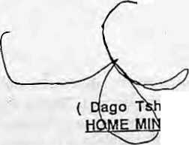
<D
m

It might not be a bad idea to collect signatures of famous or infamous Significant People of the Himalaya. Got the idea when two Bhutanese signatures came my way, that of Dago Tsering the Home Minister (rough-hewn, means business) and Dawa Tsering (suave, smooth, as befits world's longest-serving foreign minister). These signatures are produced here strictly for reference, and not to encourage forgery.
I had to wait for my May 1995 issue of High magazine to leam that Druk Yul had placed a ban on all mountaineering on peaks above 6000m, which pretty much means curtains for climbers salivating over those virgin peaks in the Bhutan Himalaya. The ban is total, says the magazine, and "no further permits will be issued for peaks in the forseeable future and although trekking will continue, no trekking' peaks can be scaled." Could it be that Thimphu is planning for the day when Nepali, Tibetan and Indian peaks are all soiled, at which point the premium commanded by Bhutanese massifs will be higher than Chomolhari? There is only one hitch, methinks: all these peaks are along the northern frontier, and as we all know, the entrepreneurial communists are currently engaged in a perm it-giving spree.
Burma (sorry Myanmar) has cracked down on betel nut addicts, reports the New York Times, in order to keep the streets of Rangoon dean for foreign tourists who are seen as the saviours of the national economy, A press release from the Rangoon City Development Committee stated that 'betel chewers are tarnishing the beauty of the capital by spitting unceremoniously on roads, pavements, overpasses and other places." Singapore bans chewing gum, Rangoon the innocent supari— these are the benefits of benevolent and not-so-benevolent dictatorship. With democracy doing the rounds in Kathmandu, no wonder nobody's picking up the garbage.

It could be a play entitled "The Sant and the Wily Fox". Tehri dam activists seem to have been had by doubletalk. Remember how the venerable Sunderlal Bahuguna broke his protest fast because P.V. Narasimha Rao offered a review of the project? Well, after some weeks of hemming and hawing by the Centre, Minister of State for Power Urmila Ben Patel tells the Lok Sabha in early August that the Prime Minister had not promised suspension of work, but only "to examine any new issue brought forward by environmentalists on the safety of the project". Before Madame Patel was through, Monsieur N.K.P. Salve announced to the House that "the dam is absolutely safe". So that's that, the wind is out of Bahuguna's sail and round in favour of plains interests.
Is this the beginning of the disintegration of the nation state that all establishmentarians fear so much? First, there was a Jammu and Kashmir state, which although not mentioned also included Ladakh. Now, Ladakh has its Autonomous Hill Development Council, with the first elections held in late August. Kashmir Valley, of course wants out. Now here come the intellectuals, members of the Jammu Mukti Morcha, who want a three-way division of Jammu and Kashmir. This is a fallout of the events in Ladakh, and a long-harboured feeling of neglected regional aspirations by Jammu-ites, reports The Telegraph. The buildup of resentment has to do with low representation in the services {compared to Kashmiris), poor budgetary allocations, and the neglect of historic places and tourist resorts.
While the Ladakhis were heaving a sigh of relief that they finally got to vote in the Hill Council, something
which Srinagar would never have allowed if it had a say, the dissidents of Kashmir Valley were leading demonstrations against the creation of the Council. The leaders included Yasin Malik, Abdul Gani Lone, Shakeel Bakshi and Shabir Shah, the last having visited Ladakh and made some sympathetic noises with the Ladakhi activists only this; past winter. Circles within circles, is what politics is all about. I have always believed that if Bertolucci (to rake up the Good Director's name yet again) had really been interested in describing the life of the Buddha (big and small), he should have shot his The Little Buddha in the hot plains of Bihar (where the Sakyamuni preached and prayed) rather than in the Shangrilaesque heights of Thimphu and Bhatgaon. Therefore, I am happy rather than dismayed to learn that Shree Lallu Prasad Yadav, Chief Minister of Bihar, intends to "invoke Buddha for tourism", as reported in The Telegraph. Read on.
Apparently, the Patna Museum discovered a couple of years ago that it had in its possession an Asthi Kalash containing some mortal remains of the Sakyamuni. Some Department of Tourism officials wanted to transfer the container to Bodh Gay a to be displayed to pilgrims. The Director, however, preferred to keep it in Patna with the hope of attracting tourists to the city, which is otherwise shunned by travellers like Gujarat during the plague. The Director had visions of Patna matching the touristic attraction of Kandy in Sri Lanka's central highlands, which is a proud possessor of one of the Buddha's molars. Are we even sure that the remains within the stone casket (discovered by archaeologists in
September/October 7995 HIMAL


Dalai Lama voices support for Tibetans
31*1 ■■-■■-_ = ■-■:-=! .r.:l iiiiL-i .ii.ii--.n-iJ Ii-.jif.:u, righis Ia*fc are dfnply nm irut."
For Tih^lnn
in Ex]\6f ChimL Thilrnki1_{r} ricni it ^Lis crucial th_{h}i( UN Males "S-Upfifirt TiheUn und iSlfwr wctmen under tCufiation in r^iinin£ ifCMS
i'i.i:'!:!! CyrUI[LS yx:: aS llii'
c[jnfcn;noc."
liJUiTiiJlud li'r tltar jjuiiicl irici
tJjj^i^nj.CiiNte i>MAlbratL
net ^{rt}Unfort«FKHcly,agains(ilic UN's
in spirit iimJ puqujS'; v\ holding Llns us cnHfcrem-c. El^L>ing hiLS. denied iltc
l> wtimcn nind mlwr gjn.iup^_{r}7 said ihc
enilcrt yovcmrrwnL's nijniucr uT
of ctlucatiufi, rUnchen Chucuyal:
.Tt Chi(c|[yal atsy nailed on ihc
UniLcdl Nu ions to send liiCnminifiii)Jii hur-fml Ftif hlj; ipexjat ranpirlCLtr
Vaishali) are those of the Buddha? Well, there is "circumstantial evidence", we are told. Ahem, ahem, ahem.
The Battle of the High Passes
continues. Sikkim Chief Minister Pawan Kumar Chamling would like P.V.Narasimha Rao to obtain an agreement from the Chinese as soon as possible to open the Nathu La passage to Lhasa. Jyoti Basu, meanwhile, would rather that Jelep La was opened first, as that would benefit Kalimpong and the state. Who will win? All said and done, methinks, Siliguri merchants.
Had referred in the last column to resurgent identity as seen in news photographs of demonstrations by Indians of Nepali origin appearing in the New Delhi papers. Have just come across another picture, this one by Sanjeev Rastogi of The Pioneer, which shows a boy at a march organised by the "All India Nepalese Unity Society".
You have seen it all when the lowly dhaba, or roadside eateries, rather than global warming and ozone holes, are being blamed for the retreat of glaciers. N. Suresh reports in The Times of India that the Gangotri glacier at the source of the Ganga has retreated nearly 800 metres in the last four years, mainly because seven dhabas have sprung up near its mouth at Gaumukh. The claim is made by Iqbal Hasnain, leader of a study team from the Jawaharlal Nehru University. The team found that the dhabas burn 200 litres of kerosene daily, which leads to a rise in the ambient temperature, accelerating the melting of ice blocks. "The distance between the Bhojbasa and Gaumukh should be declared a non-dhaba zone," the JNU chieftain told the TOl. Yes, stop the dhaba invasion of the Himalaya!
Someone had to do it and Dr. Dadi Balsara has done it. The subject is the marketing of bottled water, said to be

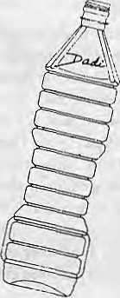
from the Himalaya, and to sell it to the hot and thirsty in the plains and elsewhere. During the pre-monsoon months, you could sell the fluid from a discarded dishrag in the plains if you gave it a cachet that brings up associations with snow, ice, gurgling brooks and splashing water. Dr. Balsara is "an eminent NRI businessman from Singapore," says a newspaper ad, who claims that he is setting up a fully integrated plant for the "manufacture of pure Natural Mineral Water sourced from the Himalayan region". Not a man who needs to be taught marketing, Balsara calls his company Mount Everest Mineral Water Ltd. No, it will not be based in the Khumbu. Himachal Pradesh.
When they are not smuggling heroin out through the Indian Northeast, they are making away with wildlife, sometimes live, destined for markets in Thailand, Singapore and Japan, some to be displayed, others to be eaten, reports The Telegraph. The most sought-after species are Assam's famous hoolocks {white-browed gibbons), the Himalayan black bear, musk deer, leopard cats and goral go at/antelopes. Birds which carry hefty price tags among the Asian tiger states include hill mynahs, parakeets and hornbills. Even if the gibbons reach the destination alive, their life expectancy is nil. Their blood is considered a delicacy.
ft EM ING (AF^J Tlic Dtfliu which [hey wefC sul
Lama hun voiced his ufWuUivii^Jil iMirnSi: survei] I a net: i
Suppo*¹! for ovcrsCUH
pf UirrtKjng ^wareiiCS!i ufhurtkin nj;hr,s
armses in Tir«r,_{L}in the fate"of iKivy lolcll
poliL-c ifiiiinidnrion at Lht World our Iwfnclnnd undiif hitch siipaii*
Women¹¹! Cunrcrvjnec here. inJdji^fiiliisdaniijMyixl^rrtiartrME
limp AiW srnniuul ItinJcr Said
;»Im) An'.liMiillulCtl 7j tnembtiTS
,yniLcd Nations
~~ .U1I
The Centre of South Asian Studies of SOAS has announced its Autumn 1995 lectures, and I wish I were in London to attend. On Thursday 28 September, Kersti Assmann (University of Berlin) takes up the much-neglected-by-ac a demia topic: "The Gorkhaland movement in Darjeeling: a nationalist movement?"
Does the Indian environmental movement have a symbol, someone asked environmentalist Anil Agarwal, He has finally decided, yes, it does, and it is gobar (cowdung or bull shit, depending on how you see it). In the latest issue of CSE-Down To Earth Features Service, Agarwal offers his reasons: cowdung is a waste product, but it is highly useful, as disinfectant, fertiliser and fuel. There is even sacredness attached to it. "Someone must have watched cowdung with great interest and noticed that it had certain qualities which were worth experimenting with. This person was probably a woman...(who) was inspired instinctively by the best principles of recycling..,"
govern ni c ni ■ t n-c * l Le. irm's cidu*i»n or
The Dalai Lama voices support for Tibetans, so reported The Kathmandu Post, and am I glad! For a while I had thought that His Holiness might have decided to give up on the cause and run for mayorship of Chengdu. But hosannas to TKP for being, as an ad stated, "the first newspaper in Asia to be available for free on the World Wide Web". You can now access the newspaper's Nepal-based reports the very next day anywhere in the world. The email address is http:// w ww.cen. uiuc.edu/~rshresth/ Nepal.html. Who says Nepal is the laggard of Asia?

HIMAL September/October J995
49

Know Your H i m a I

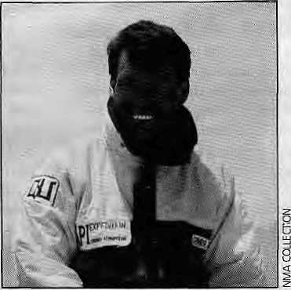
Fame Still Eludes Sherpas
by Deepak Thapa
A press conference was held earlier this year in Kathmandu to publicise thesuccessof the national team from North Ossetia, Russia, on Everest. The obvious pride the Ossetians felt about their feat was only understandable. Equally understandable wa s the m atter-of-f actness wi th which the invited Nepali press-persons regarded the whole affair.
After all, Everest is in Nepal and successful ascents are only too routine. What was of interest during the press meet, however, was that the excitable Russians didnot even refer to the fact that one of their expedition members had achieved a ninth scaling of the mountain. Celebrated mountaineer Ang Rita Sherpa was part of the team, and it was only after pointed questions from the reporters that the Ossetians expressed their 'happiness' at being associated with Ang Rita's record-setting climb.
This episode is a good illustration of how notable achievements of Nepali (read Sherpa) climbers receive no attention from foreigners and, by extension, the foreign press. Another incident this year highlights this fact. When Allison Hargreaves, the British alpinist, was lost on K2, it made news world-wide but the same cannot be said of Pasang Lhamu Sherpa's disappearance during her descent from the Everest summit in 1993. Of course, abasic difference existed in that Hargreaves was pretty well-known in mountaineering circles while Pasang Lhamu was hardly a climber. But one can easily assume that their respective climbing resumes were not the only factor that affected the column inches they deserved when they died.
Sherpas have always been given short shrift in terms of media exposure. Expedition stories that appear in foreign newspapers and periodicals usually list them as two, three, or four Sherpas, as the case may be, who were there, relegating them to exotic anonymity. That is one reason why most people interested in climbing worldwide know that New Zealander Rob
Hall has climbed Everest four times, but cannot say who the dozen or so Sherpas that have made it to the top five times or more are.
There are many reasons for the casual-ness with which Sherpas are treated by the foreign media. On the lighter side, it can be said that keeping track of Sherpa names is a near-impossible task for Western writers. When a Sherpa is not a Dorje Lhakpa, he is a Lhakpa Dorje. Moreover, the Sherpa custom of naming children after the days of the week leads to too many Pasang Sherpas, Pemba Sherpas, and Phurba Sherpas.
Looked at another way, climbers become heroes or heroines in their own countries because of the natural pride their com-
Lhakpa Nuru Sherps of Khari Kbola, Solu.
patriots take in their achievement. What if there were some Sherpas climbing with them? Aren't they always there? Let their country take glory in them while we fete our countrymen, is the attitude that exists, even if not fully articulated. Cross-border admiration for mountaineers hardlyexists except for someone like Reinhold Messner. Even Jerzy Kukuckzkd, who raced Messner to be the first atop all 14 eight-thousanders, is practically unknown among non-climbers. Frenchman Marc Batard may have made it to the Guinness Book by his 22.5-hour as-
cent of Everest, but how many ordinary Germans have heard of him?
Sherpa and Sahib
The perfunctoriness with which the world at large views Sherpas is also understandable when looked at in the perspective of mountaineering history. Ever since the British first found, towards the end of the last century, in the Darjeeling Sherpas the physical stamina to match their sporting zeal, Sherpas have become an integral part of expeditions. For Sherpas, climbing was, and still is in most cases, a wage-paying occupation. Reaching the top was not on their agenda. While it is true that some like Tenzing Norgay become full-fledged expedition members (that too only on the last three of his many attempts on Everest), it takes a lot of hard work and experience to attain that position.
The status of Sherpas in an expedition is a major factor that leads to their rolebeing overlooked. Until the late sixties and even afterwards, each climber in an expedition had a 'personal' Sherpa. The Sherpa and the sahib shared a relationship comparable to that of abatman and his officer in the British and Indian armies. What in essence a 'personal' Sherpa did was make life comfortable for the sahib, in many cases all the way to the top. And, when it came to fame, it is only too easy to guess who got it. A prime example of this Sherpa-sahib bond canbeseen in Maurice Herzog's Annapurna, in which Herzog consistently refers to Ang Tharkay Sherpa as 'my Sherpa'.
With time, a change has come about in the Sherpa's role vis-a-vis the expeditions they join. Earlier, although Nepali government regulations called them mountain guides, Sherpas hardly did any guiding, high-altitude portering being more their forte. But lately, specialisation on the biggest draw still—Everest—has become a common phenomenon among Sherpa climbers whose skills as climbers are being sought by groups from countries which have not yet developed a pool of experienced climbers.
A case in point is LhakpaNuru Sherpa, In May of this year, he reached the Everest summit via the till-then-unclimbed Northeast Ridge with a Japanese group. This was his sixth success on Everest, having climbed

50
September/October 1995 HIMAL

the peak twice in 1992, twice again the following year, and once in 1994. However, Lhakpa Nuru could not boast of having any other 8,000er summit under his belt. It was probably because of his prowess as a climber that a Korean team attempting the same northeast route commissioned him to guide them in late summer 1995. Unfortunately, Lhakpa Nuru was killed by an avalanche on the mountain on 10 September.
Everyone knows who made the first successful ascent of the Southwest Face of Everest but ask a mountaineer who first climbed Everest by the Northeast Ridge, and more likely than not he or she will say
the Japanese, period. Both Lhakpa Nuru's pioneering climb and his death went unnoticed. Sherpas have moved from portering to climbing, but their feats still do not make the news.
Stunt Climbers
There is, of course, a new breed of Sherpa climbers who are beginning to climb for fun too. Had they had the financial backing, recordsof many kinds would doubtless have been established by now. However, reduced to climbing as part of the team to which they areattached, these Sherpas have had to keep their ambitions under wraps.
Media-savvy Sherpa climbers who know the value of trumpeting their achievements is another new development. Foremost among them is Kaji Sherpa, who tried, and failed, to break Batard's Everest speed climb record last year. His attempt was preceded by much fanfare in the Nepali press and his daura-suruwal-on-Everest stunt this year received wide coverage, including an appearance on Nepal TV.
There may be some who decry such methods of personal aggrandisement, but then aren't these Sherpas just late in a game that the sahibs have played all along?





BOSCH INJECTION PUMP
2 Unit ofBansban Car Service Station
DJesd Pump Testing & Repairing Center
WHEN YOU HAVE:
- Excess Fuel Consumption,
-Bod Performance by your
Diesel Engine, or
-a Pollution Problem
YOUR DIESEL PUMP NEEDS TO BE EXAMINED PROPERLY.
We now provide you with ■ a genuine hydraulic machine brought directly from Germany

- a well-trained team of engineers
- a quick and efficient detection of fault
- a good location
- competitive rates.
Ring Road (Chakra Path), Mahrajgunj, P.O. Box 861, Tel: 226432, Fax: 977-1-229380

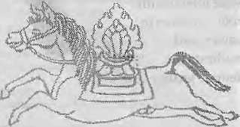

Cafe Lungta
The Kathmandii Rendezvous
Hideway for unhurried meals Tarai garden at 4200 ft Ideal for outdoor parties Organic food^n demand
Cafe Lungta Garden Restaurant
Kantipath, Kathmandu, Nepal
G.P.O. Box: 4573, Tel: 217804
Telex: 2685 MANDALA NP
Fax:977-1-227600

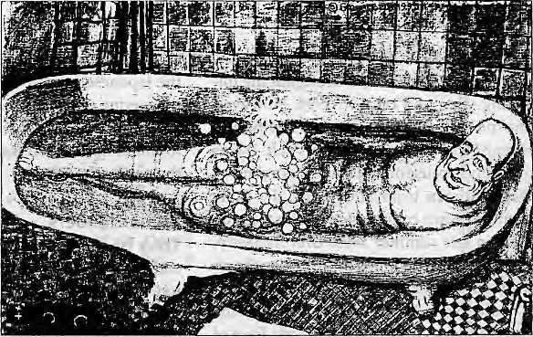
Abominably Yours,
If it had not been the dengue fever that laid me low at the Fourth World Conference on Female Primates, I would have come home more empowered from Beijing.
At no other time in this planet's herstory have members of the female species felt so One with One Another, joined in an unbroken spiritual chain with females from the beginning of time to females of the future.
Yes, at Huairou we womyn finally realised a truth that had been staring us in the face since Eve: we have been a different species all along. A human female has more in common with a female gibbon than a human male: in intellect, in care and compassion for the young, and in the ability to prepare an eggplant casserole in fifteen minutes flat.
On the other hand, the male baboon with his absurdly ostentatious nostril decorations and colour-coordinated crotch has more in common with the hegemo-nistic sexualism of the human male. The male baboon's foolish territorial whoops, his obsession with the urinary demarcation of the perimeter of his spheres of influence, and the silly wrestling rituals designed to impress the females all have their human equivalents.
Just as the baboon turns on his sprinkler at the edge of the forest to spread the olfactory message about his territory, Jacques Chirac needs to show periodically that his domain extends up to the edge of the Pacific. And so he makes the Muraroa lagoon boi] just so that the Kiwis get the message about who is boss. There goes Chirac, swinging from vine to vine, letting off his blood-curdling: "Ohoooot, ohoooot, ohoooot. C'est a' moi, c'est tout a' moi!"
You see, in the Great Game of getting to the top of the international geo-political food chain, France had to show it could create a bigger bang than China, which a week or so previously had pulverised the dunes at Lop Nor with its own 20 kiloton hard-on.
Needless to say, it needs a reptilian brain with a lot of vestigial traits of the male trilobyte to think of setting off a nuclear blast just before a conference on
women so that the fairer sex gets the message about just who is boss: if we are what we eat, then all those pickled tiger wee-wees we consumed to fortify our libidos must be having some effect on our national ethos. And the detonation should teach all those pro-Tibetan lesbians from Greenpeace a lesson not to fool around with our national integrity, territorial sovereignty, and the five sacred principles of peaceful coexistence.
The female baboon, of course, couldn't be bothered with all that hooting and peeing: it's all so adolescent, why don't the dumb apes just impregnate us and get it over with for Christ's sake?! Why do they have to waste time with ritual comparisons of the redness of each other's gluteus maximus and the colour stripes on their nose cones to determine who gets to ma t e? Why do they have to go war to make love?
An energy use analysis of the mating process of primates shows that males squander energy in senseless competition, expend vigour on unproductive rivalry with other males. And to what end? To make sure that only the 'strong' genes are transmitted to the next generation. With all this eugenics going on, Nature seems to be imitating the state of Singapore.
The purpose of natural selection, as has evolved, seems to be to pick an Arnold Schwarzenegger chromosome each time over, say, a Daniel Day-Lewis chromosome. That explains why the human race has never evolved beyond the reptilian phase in evolution of its courtship rituals and its capacity for war.
Male sexual entropy actually brings down the productive capacity of the whole species to take the quantum leap into the next evolutionary plane. Don't you see, the criteria for natural selection is all wrong: the selection process for "strong" genes is skewed in favour of brain-dead muscle heads instead of genes favouring the development of an ex-
panded cerebellum with a higher capacity for innovation, creativity and contemplating the ethics of corporate mergers.
Whereas human beings have evolved beyond the apes to develop a brain capacity to contemplate the rational, have consciousness, and argue for a One-China Policy, the role of the courtship ritual in selecting "strong genes" is still stuck somewhere in the Jurassic. May the stronger Tyrranosaurus rex win its mate. But look at where it got rex—as an extra in a Spielberg movie who got to eat the lawyer in the lavatory.
As was evident from the she-conference in Beijing, not all our sisters have the milk of human kindness oozing out of their mammaries. Many of us have gone on to think that equality means beating the men at their own game by being even more like them. As my fevered brain hallucinated with the dengue xiao-ping virus at Huairou, my thought turned to the Aedes aegypti which had gorged on my ankle a week previously. It saddened me to think that it had to be a female mosquito that did me in.
And as the haze of the fever lifted, it dawned on me that we are doomed if we leave the spread of genes to the male of our species. Their concept of 'strong¹ is outmoded, it is no longer suited to confront the survival of the planet. What's worse, adolescent nuclear states are behaving like macho males hooting at the edge of the forest.

You want to change the world? Mate intelligently, vote womyn to power, and eradicate the dengue virus.

SeptemberlOctober 1995 HIMAL

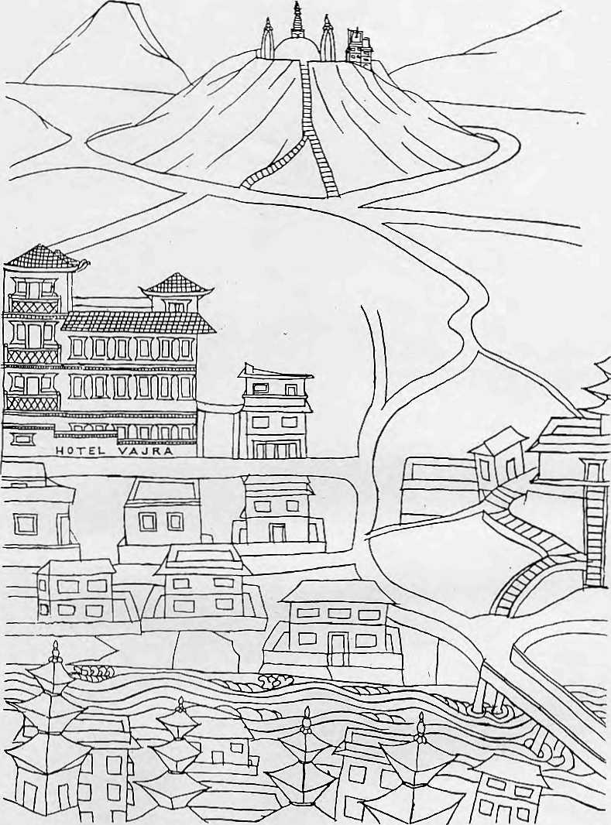
Vajra (literally-flash of lighting), is an artists' condominium, a transit home for many, providing a basaduring months of hibernation and creative inspiration. Its isolation, graphic splendour and peaceful ambience, make an ideal retreat from the clock of pressure.
Ketaki Sheth Inside Outside
I stayed a week at the Vajra, by which time I had become so fond of it that I stayed another.
John Collee The London Observer


in Kathmandu, the Vajra

Swayambhu, Dallu Bijyaswori, PO Box 1084, Kathmandu PhOhe 271545, 272719 Fax 977 1 271695 Telex 2309 HVGHPL



You've just spent hours inching around a space barely
enough to accommodate
the human body. Odd, that's what climbing in
most sleeping bags is like.

-- ^. -"i ' j^. - .~ ^:'-

.."'■■i|7j
_{H}^-_{B}
The New Sleeping Bag Collection
\ For our free catalogue call 707 544-4590

