MALAYAN MAGAZINE

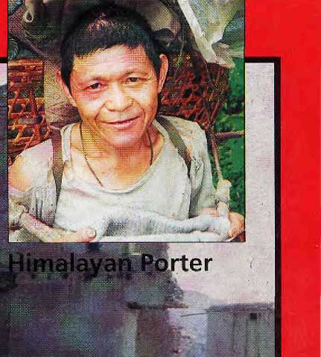


RHP
Lumbini Messed Up • Waiting on Burma Doon School • Buddhist Women

For our free catalogue call 707 544-4590
T H IS IS T H E LA S T ISSUE OF
AND THE TRANSIT I ON ISSUE FOR



SOUTH ASIA

L A U N C H I

NG ON
MARCH 1996

Notice to readers and subscribers


As announced in our last issue, Himal is to transform from a Himalayan journal to the first and only South Asian magazine. We invite readers and subscribers to stay with us through this transition.
Himal South Asia will be amonthly magazine, and the first issue will be on the newsstands and mailboxes by I March 1996. The subscription of current Himal subscribers will be continued, with an added attraction. You will be receiving double the number of issues remaining on
your subscription as of December 1995. For example, if you are owed another five issues of the H imalayan H imal, be prepared to receive ten issues of Himal South Asia. We trust you will appreciate this arrangement.
Please contact your regional representative or Himal directly if you have questions.
GPO Box 725], Kathmandu, Nepal
Tel: +977-1-523845, 522! 13. Fax: 521013
Email: himal@himpc.mos.com.np



OMEGA - ON THE ROOFTOP OF THE WORLD
Omega Constellation. Steel and 18k gold. Swiss made since 1848.

Opened in 1994, the prestigious Omega Showroom offers a vaste range of genuine pieces for sophisticated tastes : from the famous Constellation and De Ville to the sporty Seamaster and Speedmaster collections — select your favourite Omega in 18 k gold, steel-gold or stainless steel with the choice of a diamond-studded bezel. The watch you have long been dreaming of -available at an attractive price.
Omega Showroom
Ratna Plaza, Dharmapath
New Road, Kathmandu
Phone: 22 11 50

Make your journey to Kadimandu an unforgettable one. Visit the new Omega Showroom at Ratna Plaza :
Q
OMEGA
The sign of excellence

' Service Agentfor India: .Arthur; teid Pvt. Ltd., 7Q Jaispath, New Delhi- 110 001. Phaner332 07 91- Fas 335 16%. Wit(> ServiceiCektres at: Ahmedabad: Kenya Watch Co,, 4 Swastik Supermarket, Asftam Road, Ahmedabad - 380 0Q9- Ehoine: 448 035, Bangalore: Everjoy & Co:, Everjoy Buildings, 37 Comtnefcial Stree|, Bangalore - 5f>0 001-. Phone: 558 7M7: Bombay! Msrcks & Co., 97/103 M.G. Road_{t} ippp. University, Bombay - 400 023, Phone: 267 0999.Cateirtt& Arthur Reid Pvt. Ltd., 2/1 Loudon Street, Calcutta - 500 016. Phone: 405 934! if ochiti: Swiss Time & Electronics, XL/1831 WaKf Building,: Broadway, Ernakulam, Cochin.- 682 031. Phone: 368.709. Hyderabad: Khaieel & Co., 4-1-848 Abid Road, Hyderabad - 500 901: Phone: 233 297.tucknow: Rupani Bros, Hazarat Ganj, Phone: 245=619; Madtas: Doshi^i Doshi, 3 Blaokers Road, Madras - 600 002. Phone: 833 658. Pune: C.T, Pundole §c Sons, 262 M,G. Road, Purse -411 001. Phone: 643 685,, Trivandriun: Krishnan Nair|c SonsJeweliers,,M.; G.& P&dmavilasqm Road, frivandaim;-- 695 023,.Phone;: 451 252.

HIMM
In si d e

VolS No 6
Nov/Dec 199S

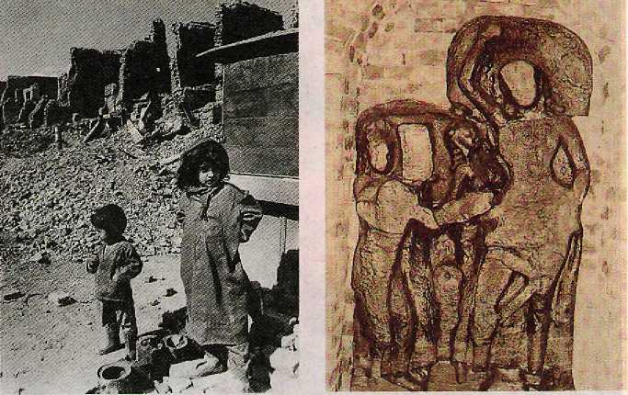
The Abode of Gods, King of
Mountains, Himalaya You bound the oceans from
east to west . A northern yardstick To measure the Earth - Kalidasa (Kumara Sambhava)
COVER
10 Deadly Afghan Deja Vu by Zahid Khan
Afghanistan's neighbours play a Not-So-Great Game for control of Kabul.
Features

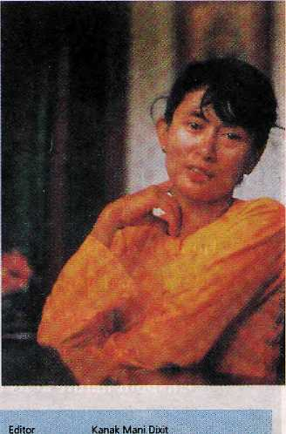
18 The Power of Compassion or the Power of Rhetoric by Kim Gutschow
Buddhist women from 14 countries meet in Ladakh.
21 A South Asian in American Academia by Binod Bhattarai A conference in Wisconsin has its ups and downs.
24 Lumbini as Disneyland by Rachana Pathak Archaeologists run amok and monasteries outspend each other at the Sakyamuni's birthplace.
30 From Sea to Shining Sea by Mahesh Uniyal Elite Doon School wants to gfl South Asian.
32 The Porter's Burden by Kanak Mani Dixit Nobody works harder and longer than the Nepali bhariyct.
40 Say When, Burma by Satya Sivaraman Burma awaits freedom; the Indians are coming back.
Cover picture by Arun Jetlie.
A tanga passes bombed-out building in
Kabul, September 1995.

r t m e n t s
5 Mail
Missed Pakistani Nuances Tibetans Did It Government Babu Bangla Objection Cyclospora Correction No Gender Sensitivity Aryan Theory Don't Go South Asian
9 On the Way Up 16 Himalaya Mectiafile 44 Abstracts
46 Briefs Two in One Kaiiash of the East This Ship of Nepal! South Asian Refugees Born-Again Thangkas Investing on Ama Dablam Happy Birthday, King tion Icon
New, Improved Biblotheca Gurkha Collects His Dues
PLACENAMES - Sikkim
52 Voices 55 Reviews
Rape for Profit
Warrior Gentlemen
Power Places of Kathmandu
- Know Your Himal .
Mountains of South Central Asia
- Abominably Yours
_
Associate Editor :MantsbaAryal :. : Staff Writer . Deepak Thapa°; Editorial Assistant Rachana fathak
: Marketing ,J Administration
Suman Shakya, Sujata Chhetri Bataram Sharma, Mamata Manandha.r
is published every two months by Hintal .Association
GRQ Box 7251, Kalhmandu, Nepal.
T#:+9774-523845,522113
Fax: S21013 email: IfimalOhiropc.mo^.com.np
library of Congress Card Catalogue Number €$912882
ISSN.1012 9BC4
Design: WorclScape, Kathmandu
Special thanks to frani Mei|eF . Printing; Jagadam^a Offset FVUtd. Tel: 521393. 536390

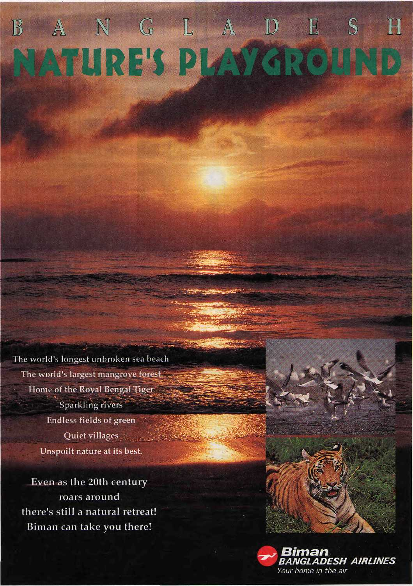

M a

I \

Missed Pakistani Nuances
The quotation that has been attributed to me in the Sep/Oct 1995 report on the Himalayan media workshop conveys a distorted impress; on o f what I said.'ft is unfair to regard anything [hat: is written by the Pakistani press by Pakistani writers that is critical of Indian policy as being "anti-India". As by far the biggest country in: [he : region, India has much to account for in its overbearing dealings with its smaller neighbours. To give you an example, the report in Himal dubs the Pakistani press's coverage of India's economic blockade of .Nepal in 19g9 as "anti-India": In fact, 1 was -one of the writers covering Indians extremely: high-handed attitude towards Nepal in 1989 where I happened to be at the time. I saw the misery and trauma that it caused to a small land-locked country.
Similarly, the Pakistani press has.corne a long way in recent years as a respected institution in the country. If it exercises restraint on certain issues, this does not mean that it "toes the government's line", as the report quotes me as having said. It must also be remembered that the democratic system in Pakistan is in its infancy and if the Pakistani press tends to show deference on some issues, this is understandable since the system's long-term stability cattnot as yet be taken for granted, Nor is such deference confined to the Pakistani press. It can be found in India, which has beenunder a democratic set-up for much longer.
HIMAL
The nuances that I have mentioned are important to remember when a report is written on such matters, I note that no mention is made in the report on my
extempore presentation on the Northern Areas of Pakistanj for which 1 attended the
seminar;. :
. NazirKamal ::..:;:.......
■. ■■ Islamabad .:-... ;'"""'.'."
The Tibetans Did It
On my return, to Kathmandu: from: a : . five-week tour tp Western Tibet during September-October, I read Erie Jan/Feb .1995 Himal with the::anicle:."Kang :..:......
Rimpoche Trashed and^Commericaiised¹^ It . contains crucial inaccuracies which need. .. cdrrectiom-Oneis the state of affairs in Tarchen and along, the Korlam around Kailas.
Tarcheri is indeed an ecological mess, a . vast irashpile of broken beer bottles, cans of Chinese soft drinks, discarded sneakers, clothes, paper, and human excrement: It is a.. sorry sight, but the source of this mess is clearly the nearby Tibetan pilgrims'camp and not the foreign tourists. Evenlarger : number of. Tibetan pilgrims are driven here in overcrowded trucks, camp intents, and: : simply thmw away anything they no longer need; Some of the most beautiful camps around Kailas are similarly, despoiled. fey...: -.- ■ detritus left behind by. Tibetan pilgrims. In contrast, we witnessed Western tourist groups meticulously torching any burnable garbage and.burying or carrying out all ■ other-trash. :-..-. ■ ■
As for the: sensational numbers of "foreign tourists" reported by your corre-spondenti did he fall for die inflated numbers projected by the Chinese torn operators, or does he count the Indian pilgrims as foreign tourists as well? The : ......biggest joke was
^M/B;
the fears expressed . about an airport- ' - "coming- up. The ■ nearest, feasible location would be Tholmg, :200km from Tarchen and two 6000m passes away. Besides, 3800m isabit too ■ high for commercial jet operations!
Why do yon ■ ■ -print-such' .:."obviously sensationalist writmgs? Itdbes.
ndbody.any..useful service, least of all the
. serious ecological cause that you presum
ably espouse. :
As tang as 1 have your attention, let me publicise one positive development in ■ Western-Tibet,.Tsaparang; which was
the Cultural Revolution, has been restored in an-exemplary, way, presumably by the Chinese. By contrast, the other great West Tibetan site of spectacular murals, Alchiin Ladakh, has been crumbling unchecked for years, because of political wrangling among the ministries in New:'Delhi. So much for the "bad" Chinese and the "bad! ■ Western tourists. ■■■■■■■■ : MjW. F. Gross Pacific Palisades, California.
Government Baku's Review
Romesh Bhattacharji has attacked me personally as well as my book -Strangers qf the Mist in what is: best described as a diatribe but can hardly be; bestowed the dignity of being defined as a review (Jul/Aug 1995). -: ■ According to him, I am a ^{lr}dilletante liberal", "gentle toward the insurgents", thai: I have depended extensively on news clippings, that I "ignore the suffering of innocent people", that "Ihave a sneaking admiration for ..those in power", that I am, above all, uninformed of the "causes and conditions" that back insurgency. He criticises me for quoting K.P.S. Gill during the. book and dismisses the troubles in the Punjab as plain and simple "terrorism" and not insurgency. With that one remark, Bhsttacharji reveals that his knowledgeof the Punjab is as poor as his comprehension of the Northeast
First of all, I must place on record my strong objection to what he terms as my timidity and hiscaU fora "braver.person" to tell the truth about the Northeast. Throughout my career as a journalist and writer, 1 have beenin extremely difficult and dangerous situations in Afghanistan, Sri Lanka, the Northeast and elsewhere. 1 tfiink it is in extremely poor taste for a government babu sitting in a safe job to make such sweeping remarks.
Insensitivity and ignorance are two major flaws in most Indian government officials who talk, work, live and write about the Northeast, Bhattacharji is no exception. But this is not what I take serious objection to. Bhattadiarji has been more than

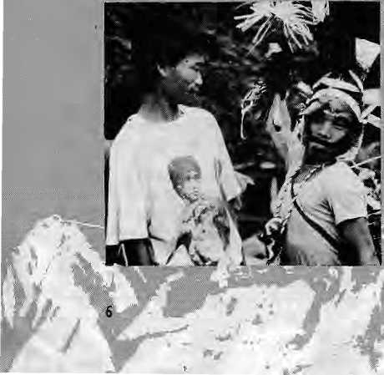




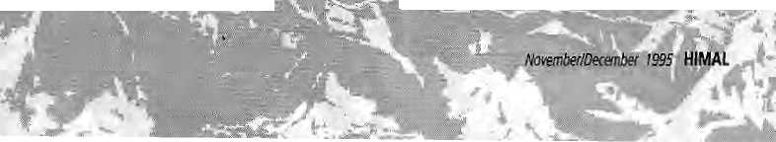
insensitive and ignorant in his approach; he has been dishonest, while all the firne seeking to straight] aeket this book arid the : beliefs that I passionately hold to his pedantic vision. 1 will take four examples. :
First, his statement that there are
"minor inaccuracies" in the book. In the
very next paragraph he makes a critical and
insensitive statement .that I do not go by ■
significant dates and Iocs!lions such as the:
assassinations of Cungshim Shariza in 199Q
and that of Chalie Kevichusa ''more than a
decade earlier." 1 knew bothmen personally
and was saddened by their sense less, deaths ...
Chalie wasfelledby a hail of bullets in 4992
and figures on page 141 and 242 of the .
ok. Lungshim is on page 240. :..
Two, the killing of Dr. Hsralu created revulsion across the Naga hills but it was : not the trigger for insurgency: That had been set by the prophetic: work of AX Phizo and the power lie drew from his people as well as the blind responses of the government of India, Anyone whodpesnot know even that lives in.an unreal world,. .
Three, Mizoram and the famine which catapulted the Mizo Famine Front (later the Mizo National: From) and its leader, Laldenga, to positions of influence. I am accused of underplaying the failure of the Assam government to react in time to the: crisis, Bhattacharji should read pages 111 and 112.
Tour, his remark that I have- ignored the questions of corruption, military excesses, inequity and prejudice which sustain, insurgency. Pages 249 to 275: "A. Stepmother in Delhi".
The core of the book lies in its approach to the crisis that is aYewhelrrjing the eastern quadrant of the Subcontinent. Only someone who is totally blind would say that die issues of demography, population, explosion, environmental crisis, displace-
oi people byftoodihg arid, other . factors, migration, and pressures on land,; water-and the habitat leading to and caused by uns^stainabk development strategics are irrelevant, They-cannpt be. :dismissed tna-
y
couple of paragraphs as Bhattacharji fatuously said: ■..-.... ■■■■■■.:„ . ■ :" ■■ ■■ ■■ ■ ■ ■
": ■ -As for fny reference to Bangladesh/ ■ Myanmar; Bhutan and Eastern Nepal, only a . regional approach can work,:.whether it is ; economic cooperation, at-the border village: '. and community level, the revival :of. the : water transport systems, tapping the energy.. sou fees,, or preparing the. communities of the region for the sweeping changes that
■; a re...co fining.^{v}- ;■■■■ ■ ■. ■
■: Let me, before dosing, refer, to Tanka B. Subba's letter oh,my article; White I respect his. views as a'scholar who :has followed the issues before the region for many years but 1 do not think that What 1 have articulated are "outdated Keyrjesian econoitiics." I think they: make sound.common, arid economic. : sense lor: ultimately, it is cooperation at the .. micro arid macro level that will generate the prosperity and growth needed to pull the .region out ef the;abyss. That this is already happening at the border region, that it has existed for.decades at the informal level is an
. indication of the changes that must continue to take place."
Sanpy fJazarifea ■■ .■'." New Delhi... ..:. ':
Baiigla Objection
Atteraionof this Embassy has been drawa to Saiijoy Hazarika's "Far Eastern.Himalaya -the Search for Distance and Dignity". In order toassist in 'understandingdie various -.measures Bangladesh has .been'undertaking (or the development of the Chittagong Hill Tracts districts; two copies ol a recent publication a about life in the Chittngong Hill Tracts are enclosed.. This'research-based book, it is hoped, shall dispel the wrong and distorted impressions that uniortti-nately result irt articles of the type written: by Hazarika.
Embassy of Bangladesh
Katfimarcdu
In Hazarika's Defence
1 had great difficulty with Romesh Bhattacharji's review "Str^ngajc to the Land" of Sanjoy Haiarika's Sicangerstothe Mist (\^{r}iking 1994). I have not seen a more hostile revigsy in recent years, and I fail to ■understand Hirreil's..purpose in carrying such a review. If the "book:-was so bad, why waste two pages on it?
Bhattarcharji unfairly accuses ■Hazarika of everything from amnesia to being.pro-estijbltshmerit; Tlae verdict in the last paragraph is: i'The reader will have to wait lor a braver person to: tell the tale of insurgency in North-East India." I would say . we have towait for a better person to review the book. .
As someone who has lived and worked in the Northeast, I found Strangers of (he Mist ol great interest and very satisfying in its overall treatment of theme, style of presentation, and coverage,
Ha^trika, anative expatriate of the . Northeast, lias produced a readable book with care and passion! Mis book is unique, for he has written a sensitive tale of an unsettled: time in a largely unknown region that is rife with insurgency. The presentation, Which weaves in views of actors oi\ the spot, edinic politics,.and history, is fascinating awl provides a. holistic vista;
The Brahmaputra watershed, right from the Tista basin to the Patkai ranges jn the Brahmaputra-Irrawady water divide and from the southern extension of the Tibetan plateau to the Bay of Bengal, is one natural geographical region supporting some of the world's most isolated ethnic groups. Though nature has endowed the Northeast with ■ plentiful treasures,.its history has been punctuated: by havoc, and today the region is experiencing tumultuous times
Problems of insurgency, immigration, fl.oods.and, of late, drug and narcotics trafficking, demand a regional treatments Perhaps it was only natural that a 'purist' like Bhattacharji should miss the regional perspective presented so lucidly by Hazarika. Instead, Bhattaeharji's world is apparently divided into devils (such as Gill and SUI.FA) and angels (such as the insurgents). Both categories are human and therefore fallible^ The next time Himal considers a title worthy of review, please find sottieone who is knowledgeable and capable of providing balanced opinlotis.
AC. Sin ha
Dean, School of Social Sciences
: North fasteftt Hill University, Shi/long
Cyclospora Correction
As Medical Director of the CIWEC Clinic, I was pleased that Himal provided a nice introduction of the organism that has come to be called 'Cyctospora' ("Unequal Intestines" .Jul/Aug 1995). The organism has a confusing history, and 1 would like to make a correction. After we discovered the organism in Kathmandu in 1989, we sent it

■ r..T :..:.:..

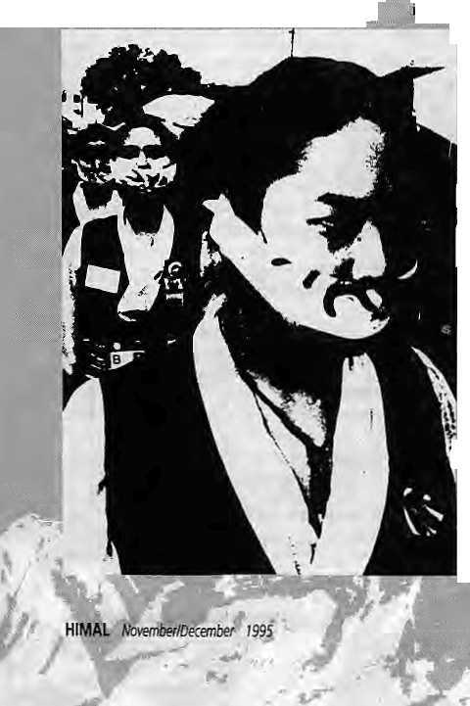
to some experts in the United States. No one was sure what it was, but. it seemed to resemble an organism called the CryptosporidiuM, which is a protozoa like the more familiar Giardia lamblia, and the amoeba Entampefra histolytka. However, a researcher at the Center for Disease Control in Atlantai Georgia, thought that the organism resembled a blue-green algae, This possibility persisted forseverat years, with no proof either way, Then^in1993, researchers to Peru proved that it was not the blue-green algae, but was in fact a protozoa similar to Cryptosporidium. So, in the end, the organism has no connection to pond water, or any other form of algae.
In 1994, we saw a letter in a medical journal that suggested that trimethoprirnsul-famethoxasole {Bactrim or Septra) was effective in killing the organism. We did a Study that proved this conclusively, and this research is now referred In whenever the organism pops "up somewhere. Last summer, an outbreak of Cyclospe-ra involving at least 200 people occurred in Florida, and a smaller outbreak occurred in New York. Because of the Nepal research, everyone could be easily treated.
We have tried for several years to study the magnitude of the problem among the Nepali population: We did a small study in a children's clink: injorpati that demon-
strated the presence of Gyelospora in five percent of the.children.with diarrhoea; and two percent of those -who did not have diarrhoea. Children under the age of .18 monthsdid[not have Cyciosppra, suggesting that breast milk may offer some antibody : protectipriiOrthatbreaSl-feedihg children drink less untreated water thanolder ■children.": "::
Although Cyclospora does not cause: life^threate.ning diarrhoea, it dees cause a prolonged (average sis weeks) infection, with loss of appetite; riiaiabsorptibn of food, and loss of weight. ..Children with already marginal nutritional status could then be at risk for a^more serious infection. The other riskaf Cyclospora infection,. a$:pointe.d out. to me by Dr. M.P, Shrestha, retired head of the Teku Infectious Diseases Hospital in Kathmandu, is that a child with projonged diarrhoea and weight.lqss.'.mgy e.nrfup being incorrectly treated for tuberculosis of the intestine, which involves taking medicine for up to a year. Thus, die ability to easily diagnose Cyclospora could prevent children, from a deterioration in overall health, or prevent unnecessary and costly treatment.- ;
The .Cyclospora orgariisrri is not particularly difficult to identify in stool. examinations: However, it is often preseni in small numbers, and does require a careful search. The. presence of other stool organ-'smsihatesuse diarrhoea in Nepali patients does hot make it more difficult to spot Cycipsp.ora, but ft may ■. ■ prematurely end the search for the ■cause'of diarrhoea before the real culprit is identified In other words, the overworked technician may find it enough to spot worm eggs Dr. C'iardia, and not keep, looking for I something else, ,.'.;::.'.
The recent publicity From
j Himat magazine and other sources
j will raise awareness about
Cyclospora, and in a short time we
may know whether or not this is an
important problem for the citizens
ot Nepal. In the meantime, Nepal
can take pride that most of the
important work on this organism
was performed here and thenshared
with the rest of the world,
DavidR.Schlim.MD
■ M«iica! Director,
CWEC Clinic, Katlimandu
No Gender Sensitivity
t could not help but be irritated by your tongue-in:cheek coverage of
the Beijing Conference on Women {.Sep/Oct 1995), for 1 believe that by its belittling coverage Himal short-changed the interests of all South Asian women, and iR particular women all over Nepal, There are numerous questions you should have been asking. What were the issues women from this part of the. worlci were most concerned about? 1 know, but do you or many of your readers? What gains have women in this part of the. world made m the last ten years? Are they : active participants in development en are they being.left behind? In health, in education, in legal status, in decision-making, in employment?
Women's issues' are seldom just women's issues: What affects women invariably affects the communities they live in: Ignoring, those issues is ignoring half the community and can never be good for any society. I think Himal should give serious consideration to devoting a whole issue to women of the region and their : issues. There are many women, who could be invited to shed light on many of the questions and greatly enrich you and your readers.
One little piece on Tibetan women's involvement and a few snide references in Abominably Yours don't do justice to the serious efforts women in this part of the world made to participate La the Beijing conference and are making to improve their future and the future of their daughters, families and communities.
Helen Sherpa
Kaihmandu
The Way of Himalayan Inventions
That's the way of star Himalayan inventions: they're co-opted by larger regional claims. First Buddhism, then Himal—what next? We at the Himalayan Research Bulletin are awfully nervous about what this new incarnation maymean for those of us who've found the old Himal. such a useful, even inspiring, resource. If you'd seen how gleefully people at the last South. Asia conference at Madison snatched up the few Nepali HimaIs,, you'd have thought twice, I'm sure, about the change you have announced. Maybe the HRB could try to serve as some sort of stopgap for your writers or readers. Meanwhile, we hope, that Himal Svuth Asia is so successful that you can piggyback the old Himal onto it, and we'll all be happy!
Barbara Brower
Portland State University


Send subscriptions & related correspondence to;
' South:'Asia:.GPOBox7251, Kathmandu, Nepal ..(tel.977..i 523645, 522113, fax 977 1 521013) . or Central News Agency 23/90 Connaught Circus, New. Delhi 1 IGOOj
Japan; Akio Horiuchi, ■
PiQBox 9, Kiyose, Tolc>'o, 204 japan
'. Australia: indra Ban., 12 Nc PaddihgLori 2021, Sydney, Australia.
■ North America: Barbara Bella & Associates, 500Sansome Street, Suite. 101, PO.Box 4707.5.8 Satj Francisco, Q\ 94147
United Kingdom & Ireland: jotiGiri(Ref; H),
221 A,shly Gardens, Emery Hill Street, London SWl 1PA
The Netherlands: C, F. de 5ppelaar,
. Foundation Himalaya, Keizersgracht 463,
1017 t>RAmsterdam- ■
Switzerland' Helene Zingg, Tarinenweg 18,
.Europe: Durga.Press CHimal), Luitpo.ldstr. 20. D—82211, Herrschin^, Germany




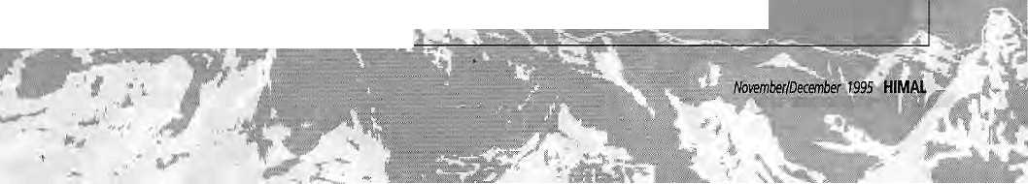
J

Rewriting Aryan History
Rachana Paihak correctly exposes some inconsistencies in the 'Aryan invasion' theory (Mail, Sep/Oct 1995). 1: agree that I ndolbgists. are ..ethnocentric when crediting Europeans for India's Vedic past. Question-ing. the 'Aryan Invasion' -theory is therefore: ' '■ useful, but advocating historical 'reconstruction' or revision is. more tricky.. Any revision of.history demands evidence tefutingan ■ existing theory or promoting a plausible alternative arid,..tnforfunately.Pat.kakprcivl-. des neither. Historicalinterpretation reflects bias, whether from an ethnocent fit-Euro- : pean, or a politically correct/South Asian; Re-writing history is an ambitious'task,. .'. which must, be Conducted with caution.
Yogesh Dhurigel
McLtan, Virginia.
■ On the matter of Himal's change of ■ ■ ■ ■
focus, let Himal be. confined exclusively to
the mighty Bitnakya-mountains: Hirhal is ■' ■
uniqiieand outstanding, and. frota. the very
; heart of the Himalaya, jf you wish, to include plains and make it:a South Asian magazine,, you are welcome to start a fresh one, instead
■ of changing Himal, ■;■■■■■■ ' ■ . ■ .:
■ ZahidRusaiin ■ ■''" ■' '■ ' " '..'..■ ''.:
■ "AnthropologicalSurvey of India .:: :■■ -
SJiiflong
Squandered influence
Aryan Theory
1 do agree with Rachana Pathak's letter refuting the theory of the so-called Aryan invasion. Migration of human groups in iht past and decline of river valley civilsatLons .. cannot be understood in the light of one or two explanations, and an objective and systematic multi-disciplinary study is ;ded in this regard.
. As a 'London-based" journalist, specialising in ■■ mountain areas arid a "regular-reader of ' Kimal, I read: of your proposed editorial shirt-.with5ome'coricerh.:l in'ri sad; that such ■ a valuable, source of information :and understanding about the Himalaya is to be.lbst. Himalistheorrly.; ■;. : ■...
'.magazine! read that ■■ ■ ■■
■begins to make sense of the polaical situationin HimalayancDuntries,:sthe.only -magazine
Subscription Rates
Only bank-drafts acceptable for subscription orders made to Himal in Nepal. Do NOT send cash in mail.
. that regularly covers Hitnalayan cultural issues, arid is one-of the few magazines: that addresses envjronrnental concerns with anything like .the urgency .that is required, 1

Individual |  | 1 year | 2yrs
Nepal | ' NRs .. | 220 : | '400'
India | rss | 140 | 260
Bhutan | Nu" | 175 | 330
Other S. Asian Countries | US | .. :: 12 | 20
North America | US | 22.50 ■ | 40
Germany | DM | 50 . | 90
United Kingdom & Ireland | £ | ■ 20 ' . | 55
Netherlands | Dfl. ■ | 45 | ■80
Ebewhere | U$ | 25 ■ | 45
Institutional
Nepal | NRs. | 600 | 1100
India | IRs | 26ff | 500-
Bhutan | Nu . | 330 | 640
Other S. As tan Countries | u$ ■ | 25 | 45
North America | ■ U$- | 35 | 60
Germany | DM | . .70 | 120
United Kingdom & Ireland | £ ' | 30 | .'.' -.50
Netherlands | Dfl | 100"., . | 180.
Elsewhere  ■ ■ ■ | U$  j-i- .J, | .':.% ' | 80 ^__
do appreciate that Himal wasnot startea to
ease the professional burden of Western" journalists, but.l do:hope that ..the scaleol
your influence in North America and
Europe has not escaped your attention,. 1 think thai5preadingy.0ur.net wi!l serve only to tiilute tfiat influence. Perhaps ..there, are commercial'' ' pressures, on you.- ...-. ■.... '■

to broaden your scope, 1 do hope, at the'very least, that : your liberal political outlook will remain-Ed Dougios London
Sober in the Maidan The news that Himal will soon cease being a purely Himalayan magazine fills me with.a mixture of dismay and anticipation. Dismay; because the whole.point of Himal is its uniqueness as the magazine of the Himalaya.

JW

Anticipation, because it will be interesting to see how Himal's enjoyable mixture of irreverent commentary and sober analysis is applied to the maidan. I've canvassed the opinions of several other Himakyophiles this side of the Kalo Pant, and the consensus is that we're not sure why you're doing this, and we're not sure that we like it, but for the time being we'll give you the benefit of the doubt.
Michael Hurt
Editor 'South Asia Research'
School of Oriental andAjrican Studies
London
Periphery's Voice
I wish you well for a pan-South Asian magazine, but what about the folks like me who wanted to hear a voice from the periphery—a voice that did not emanate from the capitals of South Asian countries? 1 think the success of Himal was based on the fact that it appealed to the periphery, both the people and the environment. Perhaps the profits were not there, or rather the losses too great. How about putting out a news e-mail group newsletter to retain the interest of Himalayan folks?
NigelJ. R. Allan
Professor of Geography
UC Davis, California
Ground for Divorce
While 1 wholeheartedly agree with youi case for a magazine for South Asia, I cannot quite come to terms with your decision to. 'upgrade' Himal itself to fill this void. All the forceful arguments for a magazine dedicated to the South Asian region as a whole, however compelling, do not obviate the need For continued focussed reporting on the Himalaya. Indeed, it was most telling that you carried your notice of desertion facing a report highlighting the lament that "the Himalayan zone gets short shrift from the mainstream media." You will concur that despite the extraordinary coverage of the region by Himal over the years, the Himalaya still needs nurturing. With your decision to venture out onto a larger playing field, one gets the sinking feeling that the convincing arguments for a South Asian magazine were solely conceived by you, having decided that Himal has now outgrown even the mighty Himalaya, only to justify the divorce.
Bftim Subba
camp: Kathmandu
Way Up
Kanak Mani Dixit
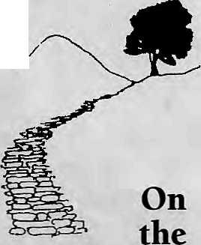

I HIMAL HAS WORKED single-mindedly i over the last eight years to address the concerns of the inhabitants of the Himalaya. What it did was necessary and important, delving deep into the Himalayan psyche and landscape and raising issues to challenge government, academia, and those engaged in development.
Rather than go about it as a scholarly journal or newsletter, Himal sought to address the issues in magazine style and format, something that has its own economics. The response was gratifying, and over time Himal collected a dedicated readership.
As it turned out, the audience was as
small as it was committed. The numbers did
¹ not add up to sustain the magazine, and
Himal Association, the non-profit publisher,
always had to go in search for funds beyond
subscriptions and advertising. Because of
die low level of English use in the Himalaya,
| the lack of a developed Himalayan market
! to support a homegrown journal, and, most
! importantly, Himal's own determination to
i cover serious issues rather than the news-of-
: the-day, sustainability proved elusive.
After eight years on the road, it was clear that the only way to remain a Himalayan magazine was for Himal to begin to serve the tourist, tapping into the world's never-satiated demand for a romantic Himalaya. There was good money to be made in that direction, but we have decided
to take the trail less travelled by.
Indeed, it is a path that has not been taken by anyone before—a South Asian magazine to straddle the region from the Sea to the Bay, and from Tibet's Chang Tang plain to Sri Lanka's coconut plantations. The prospects are challenging, but the rewards are those that come from opening doors, lifting barriers, and lettings ideas run free. South Asia's conversations on Himal's pages, we think, will be worth listening to.
To our faithful readers whoprovided the Himalayan Himal the strength to publish until the end of 1995, we say: the Himalaya, from Namcha Barwa to Nanga Parbat, is like a clothesline on which South Asia hangs. Himal will continue to cover these ranges with undiminished commitment, with the added consideration that this region is also a part of South Asia. Decisions taken in the maidan have a lot to do with what happens in the pahad. As the excitement of publishing a first-time magazine for one of the most populated yet neglected regions of the world carries us forward to Himal South Asia, we know that even though there will be less coverage of the Himalaya in Himal henceforth, that coverage will have more impact.
As Himal prepares for its re-launch, a
thanks from the heart to all friends who
have helped the magazine since 1987, With
out trying to be exhaustive, and in no order,
Himalayan Himal salutes Raj iv Ti wan, Rob
ert Cohen, Shanta Dixit, Miriam Poser,
Milan Dixit, Bikas Rauniar, Manoj Basnet,
Rupajoshi, Bharat Upreti, Bharat Koirala,
Padam Singh Ghaley, Basanta Thapa, Suman
Basnet, PrakritiKarmacharya.Ratna Kumar
Sharma.KesangTseten.Manjushree Thapa,
Omar Sattaur, Stan Armington, Sanjeev
Prakash, Sita Maiya Thapa, Bikash Pandey,
Anmole Prasad, Frans Meijer, Dipak
Gyawali.Pratyoush On ta.Ajaya Dixit, Halle
Jom Hansen, Anup Pahari, Anil Chitrakar,
Claus Euler, Adolf Odermat, John
Baccaglini, Sujeev Shakya, Helene Zingg,
Akio Horiuchi, Indra Ban, Halle Jom
Hansen, Joti Giri and Jon Swan. And
Jagadamba Offset. t
Stay with us...

HIMAL November/December 1935

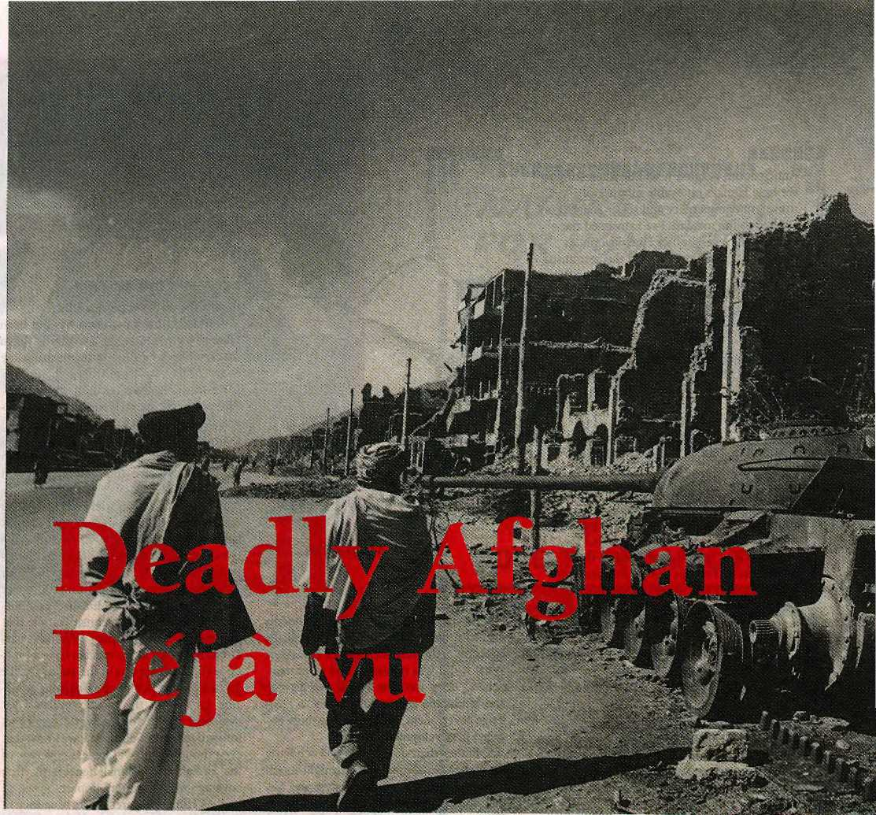

Afghanistan's neighbours play a Not-so-Great Game for control of a country that is too geo-strategically important for its own good.
by Zahid Khan
Pictures by Arunjetlie

IN THE SIDE STREETS of Kabul, the angry crowd had been gathering since nightfall. Daggers drawn, they advanced menacingly up to the gates of the mission. Taking cover of darkness, some Afghans entered the compound and set fire to a building. Embassy staff confronted the intruders and engaged in hand-to-hand combat. Several were cut down by swords. This was the attack on the British garrison in Kabul on 1 November 1841, in which the
famousBritish explorer-diplomat Sir Alexander Bumes and his staff were hacked to death. But it could very well fit the description of the attack on the Pakistani embassy in Kabul in September 1995, in which diplomats were lynched and the mission burnt to the ground. In Afghanistan, history is always repeating itself—in the same place. In this land of deadly deja vu, fresh blood of 20th century wars are spilt on earth that contains the
bleached bones of warriors who fell in battles centuries ago. Scenes of historic carnages with place names like Gandamak, BolanPass, Herat, Charasyab are today's new battlefields. The crackle of jezails (long-barrel musket used with deadly accuracy against the British) and the glint of blood-stained swords are replaced by helicopter gunships, stinger missiles and 'Stalin's Organs'—the dreaded multiple-rocket launchers. Afghanistan today is a theatre of

10

November/December 1995 HIMAL

:.::":L" :>::-":":-■-::.":!":"■":I-1:-::'-::::"-: | ilii-i | iliiil | iiiSSil
Kabul's | people | do not | watch 0
the news much |  | : news | is all
around | them. |  | ' ;1  _■. "UsH^HH^BiStB
war where medieval rivalries are being fought out with the most efficient killing machines ever designed.
The ignominious retreat of the British officers and their families with Gurkha and Sikh guards from Kabul in 1842 remains a reminder of the fierce xenophobia that fuelled Afghan resistance against outsiders. Of the 16,000 soldiers, civilians, women and children who left Kabul on foot in the bitterly cold morning of 1 January 1842, one British doctor rode into Jalalabad a week later. He told a horrifying tale of how the retreating garrison was cut to pieces one by one as it struggled through snow-bound passes.
Today, down the hill from where British lookouts atjalalabad Fort 150 years ago spotted the lone survivor emerge through the
snow, charred shells of burnt-out aircraft litter the side of the runway at Jalalabad's airport. One layerofwreckage dates back to mujahideen attacks on the Soviet bases that existed here, white the layer above it is the detritus of the fearsome battles between rival factions after the Soviet withdrawal.
Kabuli People
The Afghan airline Ariana stilt flies Jalalabad-Kabul, but that is about the only domestic route it still does. Kandahar, Herat and Mazar-e-Sharif are all controlled by anti-govemment forces of the Uzbek general Rashid Dostam to the north and the Pakhtun-led student soldiers of the Taliban to the south. Dostam and the Taliban, as they advance in a pincer towards Kabul, together contro! half of Afghanistan.
The other half of this fragmented country is still in the hands of the government led by the Tajik president Burharmddin Rabbani and his Defence Minister.'the former guerrilla commander, Ahmad Shah Masoud. With the fall of the western city of Herat to the Taliban in October, the government in Kabui has no land links to the outside world. Ariana's cargo flights to New Delhi provides a vital last life-line. Meanwhile, the Taliban uses its own captured airliners to fly in consumer electronics from Dubai and carry on a thriving smuggling business into Pakistan to finance its war effort.
Kabul's war-weary citizens are hunkering down for another dark and heatless winter as the Afghan factions drag the country into its 16th year of war. For an outside visitor, it is hard to imagine the deprivation of this once-proud capital, which has been a stopping-off point for Subcontinent-bound overland travellers from the middle ages till the hippy era. One-third of the city lies in ruins' that are so absolute that even long-time locals cannot tell street comers anymore. The neighbourhoods
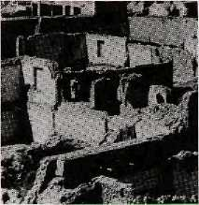
that are relatively intact are peppered with landmines.
Kabul survived intact during the Soviet-mujahideen war from 1979 till 1990. Since then, however, it has been rocketed and shelled into rubble: first during die siege by thePakhtun Hezb-e-Islami chieftain, GulbadinHekmatyar, and more recendy during the Taliban bombardments of the southern suburbs.
Since 1992, Kabulis have had virtually no power and no water supply. Even kerosene lanterns are a luxury and water has to be pumped from wells. Food is scarce, but thanks to smuggling across the battle-front south of the city, edibles are still trickling into the capital. However, the people have to pay exorbitant prices in hard currency. Yet, some locals still seem to have die fuel to run generators to tune into satellite television.
Kabul's people do not watch the news much: news is all around diem. Television-watching is an escapist exercise, providing a flicker of sanity amidstnever-ending mayhem. They have learnt to live with fear. The whoosh of an incoming rocket, or puffs of artillery from beyond the Bala Hissar fortress overlooking the city, now elicit little more than a raised eyebrow.
The Pakthun Factor
The Russians were badly mauled because they underestimated Afghan resistance and failed to learn from the mistakes of the British a century ago. The fight with the Pakistan-based mujahideen was a superpower proxy war, but the civil war after the Soviet withdrawal in 1990 has been fuelled by regional rivalries. Afghanistan is at the vortex of the geo-strategic interests of Iran, Saudi Arabia, Pakistan, India, Russia and the new Muslim republics of Uzbekistan, Tajikistan, Turkmenistan and Kirghizia.
Overlapping ethnic, sectarian and ideological rifts are tugging at Afghanistan, with a

HIMAL NovemberlDecmber 1995
11

was sidelined by Rabbani and Masoud, and the insult became too much for Pakhtuns on both sides to stomach. The Taliban, then, is their joint instrument to overthrow the Tajiks. The trouble is that the Taliban is mostly made up of young conservative Sunnis from the madrasas of Baluchistan, which means that they are anathema to Iranian-backed Afghan faction leaders like Ismail Khan of Herat. This tangle has brought Teheran-Islamabad relations to their nadir, and squandered decades of careful nurturing of Iran by successive Pakistani governments.
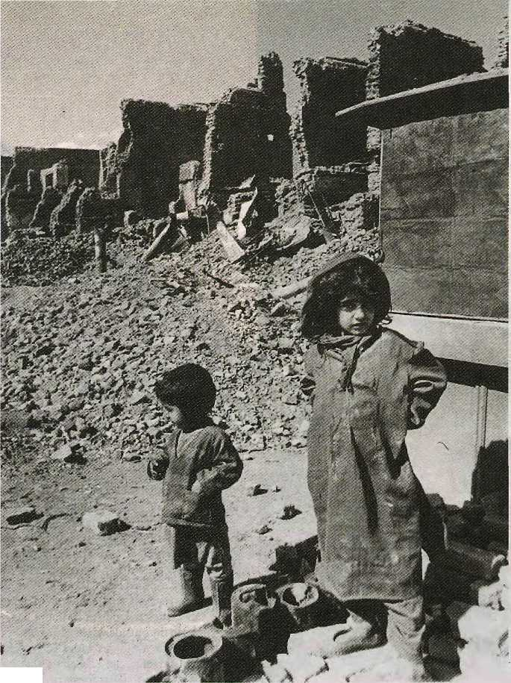
foreign backer standing firm behind each party. Historical vendettas and bad blood tinge ties between domestic factions, and to make things more complicated, groups change their allegiance with confusing regularity. Gen. Dostam used to be a key Soviet ally, but switched allegiance to the mujahideen in the nick of time. He protected the government in Kabui from Hekmatyar's onslaught in 1992, thenfeUoutandalliedhimselfwithHekmatyar. At the moment, Dostam is on the same side as the Taliban because Afghan Uzbeks (Dostam is one) cannot stand Afghan Tajiks (Rabbani).
The dramatic rise of the Taliban in Afghanistan, its blitzkrieg-like advance from Kandahar to Herat and now to Kabul's outskirts , ha ve provoked speculation about where their support comes from. There are clues. "We want to form an Islamic government based on the precepts of the Holy Koran and recommendations of the Prophet," explained a Taliban commander in Herat, Sayed Abdul Malek, to a visiting French j ournalist recently. Since the fall of Herat, women there can no longer go to school or work,
r
There is now general agreement thai, the Taliban has been trained, funded and guided primarily by the Pakistani military, and in particular, its powerful security wing, the Inter-Services Intelligence (ISO. The reason is largely the so-called 'Pakhtun Factor¹. Afghan Pakhtuns have blood ties with Pakistani Pakhtuns of the Northwest Frontier Province (N WFP). Afghan Pakhtuns had ruled Kabul in an almost unbroken line since the 18th century, until they were replaced by Rabbani's Tajik-dominated government in 1992. During the Soviet war, Western aid channeled through the IS1 in Pakistan mostly ended up with Afghan Pakhtun mujahideen groups, primarily Hekmatyar's Hezb-e-Islami.
In the post-Soviet power struggle in Kabul, Pakistani Pakhtuns backed their compatriots across the border. But then Hekmatyar
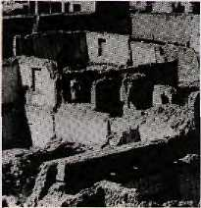
Bad blood marks -ties between domestic factions. Af g han Uzbeks cannot stand Afghan Tajiks'■ ',■'.:■■'/.;■'. \-.-::■ '■:;. ■ -: -::■ i/7

The Taliban's first rush towards Kabul in March was stopped on its tracks by a massive counter-attack by Rabbani's largely-Shi'ite Jamiat Islami. This time, they have been more successful. Even so, one learns quickly in Afghanistan that nothing is what it seems. The Taliban is divided into two factions: the Durranis and theGhilzai. The ISI has coddled the Ghilzai tribes across the border from Peshawar, but presently Taliban is dominated by the royalist Durranis from southern Afghanistan.

It is difficult to say how the ISI plans to tackle this complication, but the Taliban cub could grow into a ferocious adult that ignores its commands. Meanwhile, the Pakistan foreign office and Prime Minister Benazir Bhutto are making desperate attempts at damage control by mending fences with Iran. Bhutto's visit to Tehran in early November did little to allay Iranian fears, however. Official Teheran newspapers shed traditional diplomatese to biast Taliban and its Pakistani supporters—even accusing Pakistan of collaborating with the United States to sabotage Asian solidarity!

12
November/December 1995 HIMAL

Cover Feature

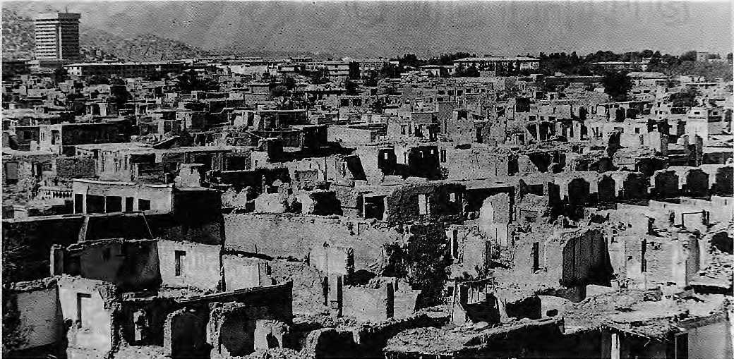

Even long-time locals cannot tell street corners anymore
Pakistan's diplomatic isolation, many agree is caused by its overplaying the Pakhtun card in backing Taliban. And the policy has come in for stinging attack even within Pakistan. "Most thinking Pakistanis are far from euphoric about the Taliban's military prowess and its recent, somewhat over-publicised successes," says Pakistani scholar Eqbal Ahmad. "They are seriously worried about the consequences of Pakistan being drawn into the Afghan quagmire."
Pakistan Isolated
Just as the Afghan crisis has been blamed for the explosion of sectarian violence in Karachi, the rise in the power of the drug barons in the Taliban issue shows signs of spilling over and destabilising Pakistan's politics. Reports of an abortive coup by generals sympathetic to the religious radicals sent jitters throughout the Country. According to Pakistani commentator M. B. Naqvi, many army officers are believed to be sympathetic to the "fundamentalist agenda" in the military, which is a legacy of the Islamisation process started by the late President Zia-ul Haq. This is the background to the support provided to the Taliban in Afghanistan.
Ironically, by wrecking Iran-Pakistan relations the Taliban has undermined another Zia-ul Haq strategy; to give Pakistan 'strategic depth' by bending over backwards towards the west (Iran) in order to balance India's overwhelming presence to the east. Today, not only are relations frosty with Iran, but much to Islamabad's consternation, the Indians have been busily repairing and refurbishing the Afghan Air
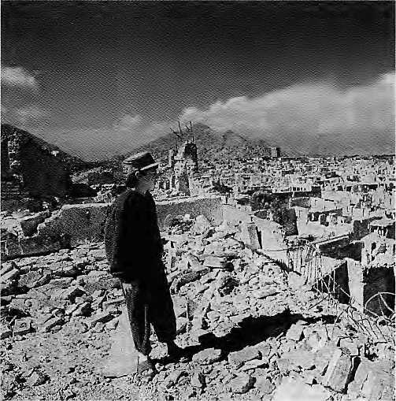
Force at its base in Bagram oUtside Kabul. The Mig-21s flying out of Bagram have already proved their worth in blasting the Taliban frondines. This unlikely convergence between the strategic interests of Iran, the United States, Russia and India has isolated Pakistan.
Says Eqbal Ahmad: "Moscow has been supportive of Rabbani and views both Taliban and Hekmatyar with apprehension. The role of India and the United States is minimal, and Washington knows that whoever rules in Kabul will be amenable to U.S. influence."
Islamabad's original economic game-plan was to bring peace in

HIMAL November/December 1995

Cover Feature

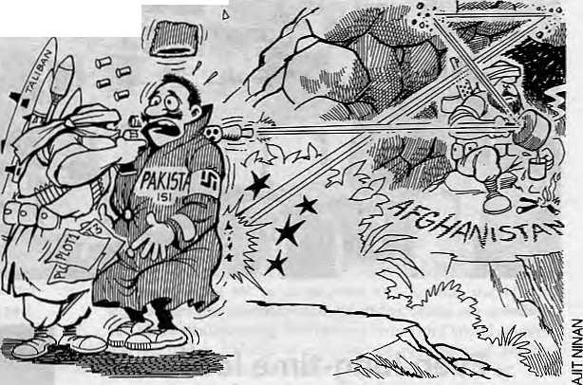
Afghanistan so it could profit from being the conduit for Central Asian trade, It would then offer Karachi as the access to the sea. But Afghan peace has become a distant dream, and with a whole chunk of southern Afghanistan in its hands, it is the Taliban rather than Pakistan that is profiting from Central Asian trade, which continues clandestinely. Some Taliban-watchers say the group is also financing its war by taxing the smugglers: a revenue source that gives it greater independence from its Pakistani mentors.
For the moment, the focus is on Kabul and which way the front line will move in coming months. If Hekmatyar joins forces with Taliban from the south, and if Dostam can deploy his newly-acquired weaponry from Uzbekistan, the battle for Kabul will have begun in earnest. But even if Taliban succeeds in taking Kabul, the Tajiks under their warrior chief Masoud will just take the war to the mountains and keep on fighting guerilla-style, much the same way he battled the Russians. Looking down from the Khyber Pass at the rugged, barren valley tfiat descends down to Jalalabad, visitors are whipped by a bitter
winter wind that howls down from the Hindu Kush. It is a blast from the past, bringing back ghosts of history's travellers who have passed this spot. Today's developments in Afghanistan have become inextricably linked Lo events on this side of the Khyber, and to the Subcontinent beyond
With rqjgrisfrom Becna Sarwar in Lahore* PrafvlBtdwai in New Delhi, Wilhum van Jen Rijt in Herat, and Naseem Zebra in Islamabad. The photographer Arun Jetlie ii with The Indian Express.

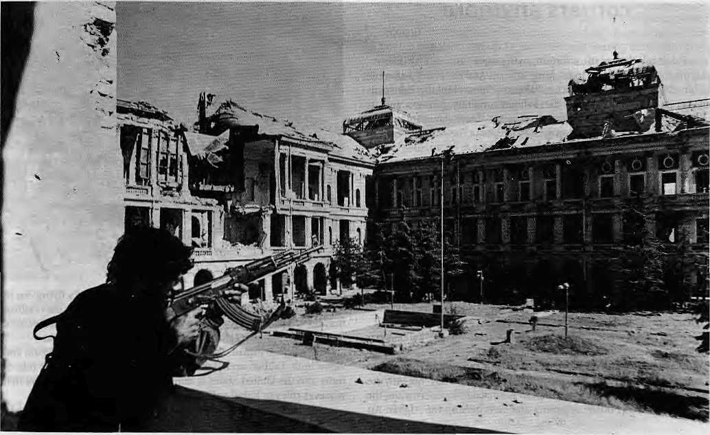

14
November/December 1995 HIMAL

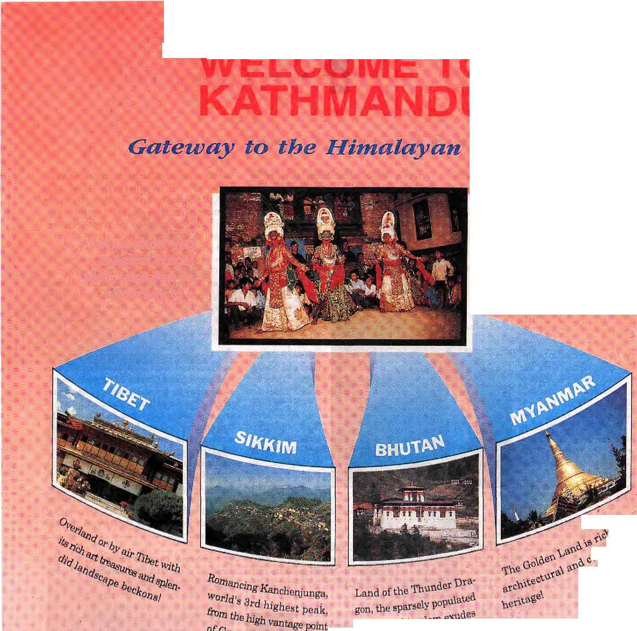



* ■ HiL iiill :ll|l iiil: iilli: : ■;!:■ .■ , %
■ * In. iii: in:. : Hii: ■* %
'■''■■ :iiii Hi! ■¥■ ■:!{{= ¥ <§ m hip iiilji iii||i =ill|= i|||i; liiii: :iiiii
:, Illl : : = I: Ills :l||: III;. ijjjj % III: =!!!; Illlj H- :^{E}:I| % ■■■l|: ll|| ' Ih-:
-■ -■ ;i: :i|ll :!!!» ^ill ijill ^{:E}!ii: iiih lill- :i!ii:. :;iill :iiii.. 'iiii :iiii;: iiii: ; :
^{:E}i ili: ii" -ii; * iii:: + iiii- K ^ * ::: k k. "'■ -II :i|l: *r i ^
e ii: :::. II Hh: ill h nil i;;;; :i|:. i: ij:: ^ ;iii: ^: .;||. hi;: _--
^ ::;: ^{E}iii: ^ 1^ ;:
^ :|l:. :||| ■:!;. -I:;- %■
::i ii|: :!- Hi !!!i ii: ii: iii|. =!== %|
^{E}ii- '- ■ iiii- iii|: :iii * iiii:
:|!i ■ ^{E}i!ji ^{E}i|h 4 ijii. | 4
i ^ %'**^ in :H::%:;h k - ■< - « .;,: ,
:l: jiiii iii||
:i:: i! -He- i» =:!; %:
^ofi
Let us show you magical Nepal
then take you on a journey of a
lifetime to Nepal's mysterious and teuntmgly beautiful neighbors.
^ >
*\e*
.mountain ■pure
if
CHINA SOUTHWEST AIRLINES
Write to us far our color brochure and detftitek tour itineraries.
•

Head Office: P.O. Box 2769, Gyafleswbi', Opposite German Embassy, Kathrnandu, Napal. Fax: 977-1-416479, 413641, Tel: 418832, 414192, 411780 Branch Slfloe: Kathmandu Guest House! Thamel, Kaihmanctu, Nepal. ; fax; 977-1-417133, Tel: 414013

D
M
af

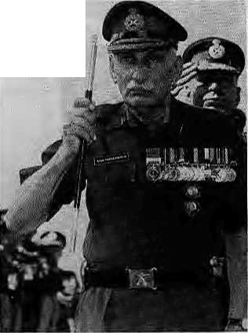
■ Field Marshal S.H.FJ.Manekshaw, deliv
ering a lecture on The Quality of Leadership in
Delhi on 27 October, blasted India's political
top rung with heavy verbal artillery, inflicting
severe casualties on a lot of egos inside the
conference hall. Sam Bahadur, as the gutsy
former Chief of Army Staff
has been known since he served with the Indian Gorkhas,said that in the four decades since the British left India, "people have done nothing except make excuses and procreate." In fact, the only people to get a thumbs up from the couldn't-care-less commander were the martial hillmen. Fearlessness is an attribute of leadership, he said, and "a man who says he is not frightened is either a liar or a Gorkha." But Sam Bahadur dai, eutai kura, where are these fearless Gorkhas in the leadership echelons of the Indian army? What use is fearlessness without rank?
■ "India, Australia drifting apart", said the
Times of India headline of 31 October, Sure,
Canberra and New Delhi, both land-locked
capitals, have eyes on the Indian Ocean and
are engaged in a geopolitical shadow dance.
But it turns out what the Columbia University
scientists meant was that the Subcontinent
and the Island Continent were floating apart in
geological time, at a rate of a few centimetres
every year. This is because the crustal plate on
which both landmasses rest is cracking up. Oh
well, plate tectonics do have this uncanny
ability to divine geopolitical shifts.
The column-inches devoted to SAPTA say it all—who is keen on a South Asian preferential trade arrangement and who not. Pakistan ratified SAPTA on 23 October. The Rising Nepal headlined it. The Indian Express buried it as a two-column-inch item deep in page 11 (see right). Incidentally, all South Asian countries have now ratified SAPTA. The knot is to be tied on 7 December when SAPTA becomes operational, but when is consummation?
H The Kashmir story is all about the "quantum of autonomy" that is feasible to provide the Valley's clamouring masses, writes B.G.
Verghese. The one-time dragon-slayer editor has longgiven up daily journalism to focus on long-term issues of development and politics. He is presently engaged with harnessing the waterresourcesofthelndianNortheastatone end of the Himalaya and seeking answers to Kashmiri problems on the other. Inanarticlein The Indian Express, Verghese suggests that there is no reason not to restore the J&K flag or to let the state issue its own currency notes and postage stamps. These are critical times for LheKashmirissue, and he believes that "the haze could be lifting." Adds an optimistic Verghese, "The direction is set. It is time to commence the journey. Only those who dare to travel may hope to arrive.¹¹
B It does not hurt to have a Minister one knows serving as Information and Broadcasting top boss, and P.A.Sangma certainly knows that there is more to Nepali-speakers than bahadurs and chaprasis. In fact, Sangma cares

deeply about election arithmetics and the importance of Nepali-speakers of the Indian Northeast. And so when the union minister from Meghalaya recently was given the I&B portfolio, he promised more Nepali programmes on the air for the Northeast and North Bengal. Speaking to a delegation of the Assam Gorkha Sammelan, he said Siliguri's AIR radio station would be spruced up, and more time would be allotted to Nepali language programmes from Guwahati as well. If all these promises are kept, don't you think there will be too much Nepali on air?
Us Do motorcycle rallies promote language and culture? Gert-Matthias Wegner, the Bhaktapur-based German ethnomusicologist, thinks they do just the opposite. The annual rally by the Nepal Ehasha Parishad, he wrote in a letter to The Kathmandu Post, "gives us the impression that the end of Newari Culture has arrived." The motor-cyclists who invaded Bhaktapur on the Nepal Sambat New Year polluted the town with the exhaust fumes and sound blasters playing commercial Hindi film music and American pop. Wegner's suggestion to the easy riders: "How about talking Newari with your children and encouraging them to learn one of the Newari musical traditions?"
D In Nepal, Paradise Partly Lost, was the headline of the lead article in the 15 October New York Times Sunday travel section. This is probably the most important travel page in the world, which does the work of a million-dollar advertising campaign, Rather than a glowing account of a new travel destination, the norm for the section, the piece by a former British volunteer in Kathmandu named Susan Ram, offers a sober and essentially correct reading of Nepali tourism. Ram directs tourists away from the polluted and garbage-ridden lanes of Kathmandu and directs instead to outlying Valley towns such as Bungamati and Kirtipur. She might have added that, despite the relentless architectural devastation that is overtaking Kathmandu and Patan, there remain neighbourhoods and monuments that have resisted the trend. The best guide to these gems, of course, is Desmond Doig's, My Kind of Kathmandu, and now (although 1 have yet to see it) Keith Dowman and Kevin Bubriski's The Power Places oj Kathmandu.

16
November/December f99S HIMAL

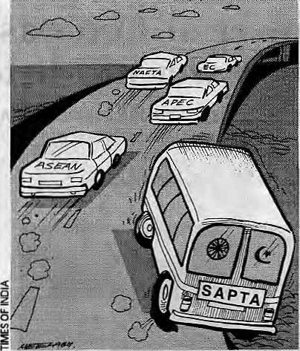
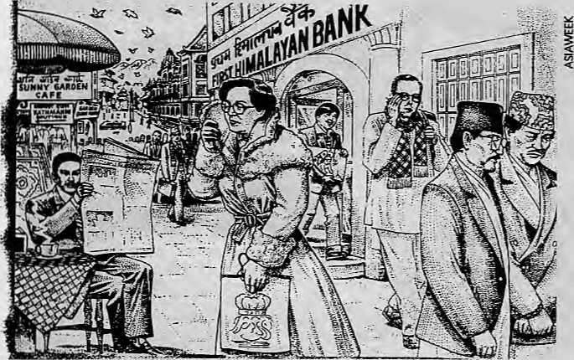
■ Himal's State Demand Counter, sensitive
to the slightest tremor brought about by agi
tation for autonomy and/or self-determina
tion, has registered one more epicenter on
the Indian landmass. The Garo have just put
in their request: they want to break away
from Meghalaya, which they do not like
because it is dominated by the Khasi. Chief
Minister S.C. Marak, however, was curt in his
reply: "A further division of Meghalaya is not
possible." The demand for a separate Garoland
has not yet picked up enough steam to cause
concern to the law-enforcement authorities,
says the Director General of the state's police,
D.N. Srivastava. Oh, shall just we wait, then?
$£ "The Case for Uttarakhand" is a study by B.K. Joshi, Director of the Girl Institute of Development Studies, according to which a separate hill state of Uttarakhand is perfectly viable in terms of area and population, and naysayers be damned. He says the Uttaiakhand state would be larger than Punjab, Haryana, or Kerala, and the 16th largest in the India. Financial viability cannot be a criterion, says Joshi, for then most states would fail the test. The revenue and expenditure of Uttarakhand would be significantly higher than Himachal Pradesh's. Okay, we get the gist, Joshisaab. But the fire seems to be nearly out in U tiarakhand. What to do?
■ Here's something we already knew but it
bears hearing once more. "School textbooks
and media coverage in India and Pakistan
perpetuate and sustain a negative image of
relations between the two countries." This in a
study on Confidence-building in South Asia,
published by a Washington, D.C. think tank
and prepared by Samina Yasmeen and Aabha
Dixit, who claim that "dissenting voices" can
nevertheless be heard in both countries about
the "persona" of its neighbour. However, these
voices are hushedup by the respective govern
ments and consciously or unconsciously
marginalised by the media, "The myth of the
enemy" is alive and well in India and Pakistan,
according to Yasmeen and Dixit.
The Asiaweek cartoonist was prophetic in more ways than one. A couple of months before the new Finance Minister of Nepal, Ram Sharan Mahat, announced his plans to convert Nepal into a international financial centre, Asiaweek carried in its cartoon column "The Illustrated Prophesies" a Kathmandu street scene circa 2003. Shady customers approach the First Himalayan Bank, King Tribhuvan appears in mufflers, a Nepali politico is led away in handcuffs, and various
recognisable honchos hide behind upturned collars and newspapers. In Kathmandu 2003, "Direction was guaranteed, no questions were asked. Soon people from, all over were finding Asia's own Switzerland a better place to stash their, urn, extra cash."
M The parting shot of Molly Moore andjohn Anderson, the husband-wife South Asia correspondents for The Washington Post who flew back home recently, was a series of long and detailed articles on Subcontinent Social Sorrows. One article reported on "Nepal's Shame:
Girl Trafficking Meets a Determined Roadblock," and another, a photo essay, looked at India's child labourers-carpet weavers of Uttar Pradesh and matchstick makers of Sivakasi. "KashmirinFlames: Why India Hides from the Truth," reported on the six-year strife in the Valley from the perspective of a doctor in the Government Hospital for Psychiatric Diseases in Srinagar. According to Dr. Abdul Baig, Kashmiris who used to shun psychiatric help because it was embarrassing, today line up at his clinic, sometimes a hundred deep.
■ SAPTA Sceptics is the term for those who feel that preferential trading among South Asian countries is for the birds, and will never make it to the ranks of ASEAN, NAFTA, AFEC, EC, and other such acronymous gathabo.ndho.ni. Shobhan Saxena, writing in TO! is not a SAPTA Sceptic. He believes that if a seven-member agreement is not possible due to the embedded Indo-Pak animosity, then Bangladesh, Sri Lanka, and Nepal should go for an economic alliance of their own. Now, now, Mr. Saxena, does the yearning for SAPTA mean that we should tuck our heads in the Thar desert sand? How much copra do you think Nepal can buy from Sri Lanka, and how many bushels of high-altitude barley would Serendib want in return?
- Chhetria Patrakar

HIMAL November/December !995
17

a t u
The Power of Compassion or The Power of Rhetoric
A Report on the Fourth International Conference on Buddhist Women

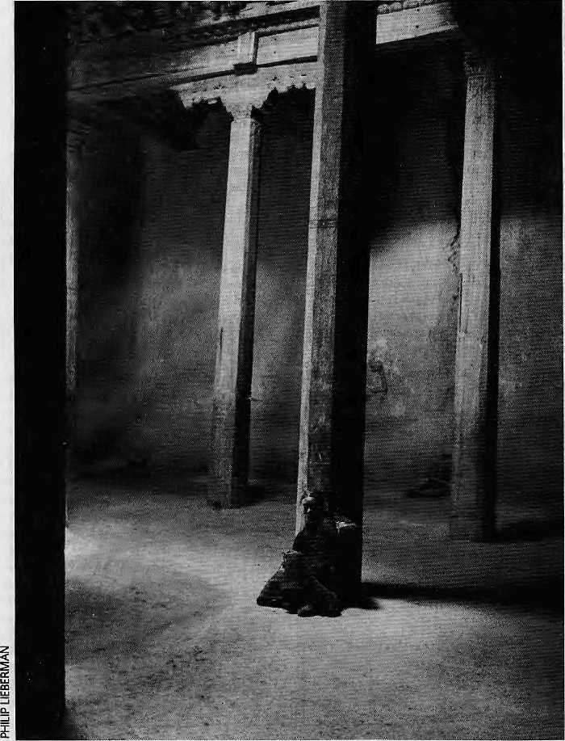
Devotee at Thupchen Gumba, Lo Manthang.
by Kim Gutschow
WHILE THE HILL COUNCIL elections in Ladakh made the headlines, the summer of 1995 also saw in Lehthe Fourth International Conference on Buddhist Women, under the aegis of Sakyadhita, an international organisation of Buddhist women founded in 1986 by Ven. Karma Lekshe Tsomo. Opened with much pomp and ceremony, the conference soon got down to business, that of stimulating discussion among Buddhist women from many different traditions and nationalities.
The conference boasted a wide range of speakers from all over Buddhist Asia, as well as Europe and North America, The diverse topics addressed included establishing a lineage of female teachers; life among Burmese, Ladakhi, Zangskari and Nepali mans; prostitution in Thailand; empowering strategies for women in the Netherlands; Tibetan women in exile; as well as the question of why there were no female geshes in traditional Tibet.
Although topics and paper styles ranged widely, three key themes kept cropping up in the discussions: education of Buddhist women, difficulties faced by Buddhist women today, and the appropriation of the Asian Buddhist experience by Western Buddhists.
"The iBurmese! nuns derive their stdtusfrom association with the monks andfwm the part they play in enabling the monks to separate from the worldly. Therefore, equality and independencemay notbeanattractive proposition for them, but rather threatening and ton/using to their basic seme of religious identity..."
-HirokoKawanami in "Buddhist Nuns in Transition: The Case of Burmese Thil A-Shin"
Many Western and Asian women spoke with urgency for improved education for Buddhist nuns and laywomen in a rapidly modernising world. Hiroko Kawanami, however, cautioned that such changes might be detrimental to the

18
NovemberlDetmber 1995 HIMAL

very community that was supposed to benefit. Kawanami pointed out that it is not enough to recommend improved education; one must also consider how these 'improvements' would change the status of the participating women. Unless there were concrete plans for new social roles, and a correspondingly flexible society accepted women in new positions, the changes introduced may be disastrous at worst or ineffectual at best. Kawanami noted that since Burmese nuns serve as invaluable mediators between monks and lay people an education that 'frees' them of this status simultaneously deprives them of their critical niche in that society.
This p oint direc tly challenged Ven. Lekshe Tsomo's view that Buddhism must adapt itself to the changing times to remain popular and viable in Asian as well as in Western societies. Since the focus of Lekshe's paper was on making Buddhism attractive for young Asians, it touched only briefly on how rapidly changing Asian societies might find new roles for revamped Buddhist nunneries.
One Ladakhi nun, Jamyang Palmo, stressed the need for nunnery reforms, but provided few suggestions for the religious roles of nuns in the future. Ani Palmo noted: "Evolutionofa well-considered socio-economic and monastic educational plan for the nuns seems to be the crying need of the hour..." Yet her pleas for the uplifting of Ladakhi nuns rang somewhat hollow, given the strange silence of Ladakhi women throughout much of the conference, with the exception of the renowned physician Dr. Lhadrol Khalon.
The same could not be said for Ladakhi men: Dr. Tsering Norbu, Tashi Rabgyas, Lobsang Tsewang and Jamyang Gyaltsan all contributed to the debate on how to "uplift" the status of women in Ladakh. Seeing these men, eloquent as they were, propound upon the situation of Ladakhi women, while the well-edu cated and mellifluous Lada"khi women who had organised the conference sat. at the back, was disheartening.
Of course, one might consider from the contribution of the Ladakhi men that the issue of women's education has at last achieved a level of awareness which means that action might actually be taken. As Ant Palmo pointed out, the move towards educating and modernising Ladakhi nuns will need the wholehearted supponof the Ladakhi Buddhist Association (LBA) as well as the AB-LadakhGompa Association. Interestingly, neither the newly elected head of the LBA, nor Stogldan
Rimpoche, head of the Gompa Association, had concrete suggestions to offer for modernising the roles of nuns in Ladakh.
In fact, the Stogldan Rimpoche seemed more concerned about preserving his own order of Mahayanism than helping nuns effect social change. At the ground-breaking ceremony for a new Mahabodhi Nunnery, Rimpoche mentioned the need to preserve Ladakh's ancient religious lineages (i.e., Mahayana), thereby implying that Mahayana traditions be included in Mahabodhi's Theravada education curriculum.
"Buddhist women are casting off traditional and outmoded restraints to dedicate themselves to implementing and promoting Buddhist practice... Remembering the kind influence of my own mother, I pray that women working jor inner peace, and through that peace in the world, may be blessed with success." - message from the Dalai Lama
While the Dalai Lama optimistically offered his words of wisdom, many speakers repeated tales of woe concerning Buddhist women today. C, Kabilisingh from Thamnrasat University in Thailand presented a controversial paper on Thai Buddhism and prostitution, which was welcomed for its unflinching portrayal of the darker side of one Buddhist society.
Ani Palmo's paper lamented the fact that Ladakhi nuns were at present "no better than household maid servants", while K Devendra spoke passionately about the loss of the Bhikunni (nun) order in Sri Lanka, and the difficulties encountered in efforts to reintro-duce it. She noted that the present-day order of Bhikkus (monks) in Sri Lanka was reintro-duced from Burma and Thailand by Dutch and British trading ships only two centuries ago, the leaders in this order were fiercely opposed to the resurrection of a sister order of nuns. She also referred to her current research into die deadly eight Gurudhamma vows, which the Buddha supposedly gave to the first nuns. In fact, these could be shown to be "later interpolations by Brahmin misogynists," Devendra said.
The founder of Ladakh's Mahabodhi Centre and of its recently proposed nunnery, Ven. Sanghasena, speaking on women's rights, stated that Buddhist women "generally live their lives with a compartmentalised mind", dividing their time between the temple, the home and the supermarket. He concluded that "this gives rise to much tension and conflict in life", but
failed to point out that Buddhist men may face the same tensions. This writer has observed that monasteries have more difficulty in balancing their 'worldly' obligations (collecting taxes, running shops, hiring water carriers) with'otherworldly¹ spiritual pursuits than nunneries do, simply because the monasteries have more wealth to manage.
"It appears that very jew Buddhist Western women want to describe what they see in contemporary Eastern women's realities because it challenges their faith in Western Buddhism's egalitarian potential, ■ - 5, Schneiderman in "Appropriate Treasure? Self-Reflections on Women, Buddhism, and Cross-Cultural Exchange"
An issue that lay at the heart of the conference, but which barely drew a murmur of discussion from the audience, was the question of West-em women's appropriation of the Eastern Buddhist practice. The dialogue between two very different experiences of Buddhism, the Western and the Eastern, is problematic in light of the imperialistic and orientalistic strategies that have accompanied Western knowledge in the past and present.
Schneiderman's paper, while provocative, had its shortcomings. It began by reifying the divide betwee n Western and Asian women to a void an essentialism that assumes all women have solidarity based on gender alone. However, by stressing the divide between Eastern and Western Buddhist women, Schneiderman overlooked the cross-cutting identities ofmany women today. There are Asian women who live and teach in the West, Western women who live in the East, and many other women who occupy the imaginary community stretching from Zangskar to Cambridge, Canberra to Calcutta. Some of these women may reject the 'strategic essentialism' of Gayatri Spivak and other feminists, while others might applaud the gender solidarity efforts to assist the struggles of Asian women.
Schneiderman's talk also demands comment in other respects. She noted that "our contemporary Eastern Buddhist sisters remain at worst mute, atbest anomalous participants in what, from one perspective, can be seen as a primarily male-dominated religious power structure." In direct challenge to Schneiderman's allegation, the conference boasted several Asian Buddhist women who were eloquent proponents of feminism in their respective Buddhist traditions. The nuns and laywomen from Burma, Nepal, Thailand,

HIMAL November/December 1995
19

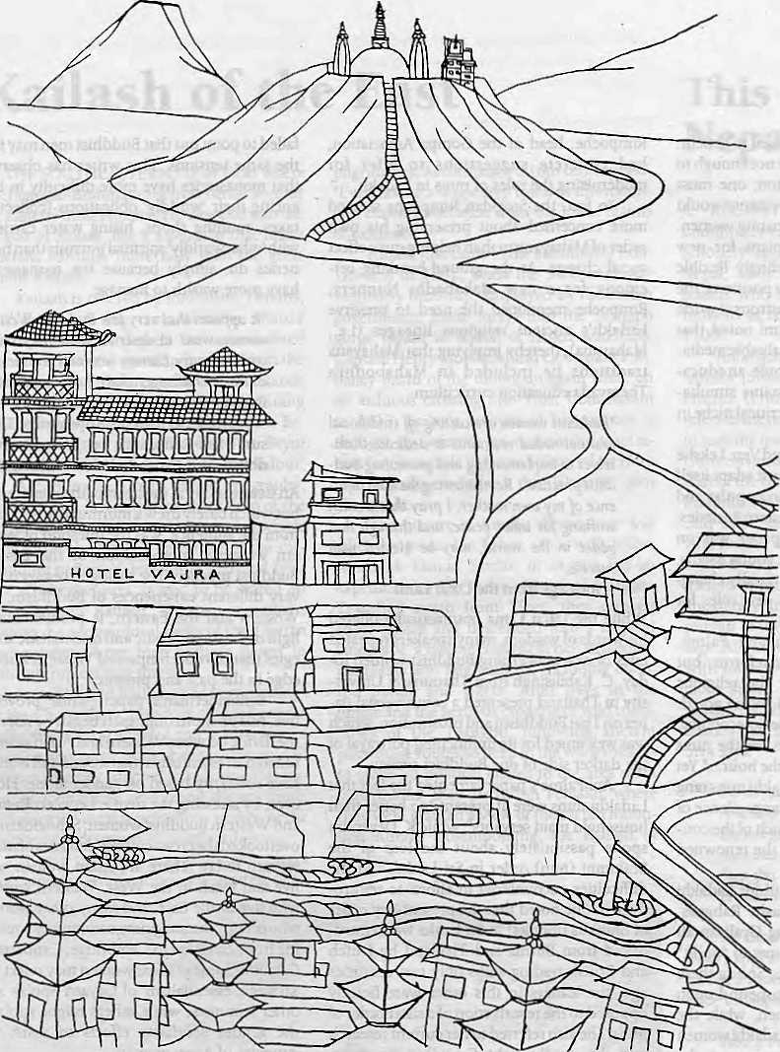
Vajra (literally-flash of lighting), is an artists' condominium, a transit home for many, providing a base during months of hibernation and creative inspiration. Its isolation, graphic splendour and peaceful ambience, make an ideal retreat from the clock of pressure.
KetaktSheth Inside Outside
I stayed a week at the Vajra, by which time I had become so fond of it that I stayed another.
John Collee The London Observer


in Kathmandu, the Vajra

Swayambhu, Dallu Bijyaswori, PO Box 1084, Kathmandu Phone 271545, 272719 Fax 977 1 271695 Telex 2309 HVGHPL

a t u

A South Asian in American Academia
An annual conference which has its downside, but the ups seem to more than make up for it.
by Binod Bhattarai
Sri Lanka, Tibet, Ladakh, and Bhutan who spoke at the conference are neither mute nor anomalous, nor are their Buddhist traditions as male-dominated as Western feminists initially might assume. Although Schneiderman warned against patronising Western attitudes that presume to'know'AsianBuddhist women's experience, her own paper came perilously close to such a stance.
The dialogue be tween Asian and Western Buddhist experiences will be more fruitful if each side truly makes an effort to understand the other's tradition, before coming to conclusions. Lekshe Tsomo, who has lived and practiced for years in both Asian and Western contexts, had some interesting advice. She noted that Asian Buddhist leaders might team something from the trials teachers Face in adapting Buddhism in Western post-industrial societies. While Asian Buddhists are not stumbling over each other to tell Western Buddhists how best to spread the Dharma, Westerners often take their appreciation of Buddhism a step too far and become back-seat drivers in the Buddhist chariot.
Thankfully, these Western 'friends of the Dharma' were few and far between at die conference, as was the attempt to 'speak for¹ Asian women. There were so many speaking for themselves at the conference already.
While one might have expected more debate about these central issues, the torpid audience seemed content to bask in silent appreciation or (perhaps?) bored resignation. Perhaps a wider and more diverse audience might have boosted participation. While the speakers came from over 14 countries, and over 100 nuns from a variety of Buddhist traditions were present, the audience turnout was somewhat disappointing. The result was a conference in which speakers addressed an already converted audience.
However, the organisers must be com
mended for bringing so many Buddhist tradi
tions under one roof. In the discussion groups,
a free-flowing dialogue between Buddhist
women of different traditions did emerge,
which alone made the conference worthwhile.
To sit in a circle with Sri Lankan matriarchs,
Zangskari nuns, and a Ladakhi nurse, discuss
ing the question of whether motherhood or
celibacy offered a better chance to leam the
true meaning of compassion, was a fascinating
experience. fc.
K. Gutschow is a Harvard anthropologist who has worked in Zangskar and Ladakh since 1989.
DOES CONFERENCING ON South Asia provide "intellectual fun?" It does, says Prof. Joseph W. Elder of the University of Wisconsin in Madison, the acknowledged centre of South Asian learning in North America. The "fun" event which brou ght over 460 academics from all over the U.S. to this midwestem city in late October was the annual meeting on South Asia, which will celebrate its 25th anniversary next year.
There are enough reasons to criticise this annual gathenng of PhDs—that it is North America-dominated, that the subjects are India-centric, or that the region's own voice is absent. There is also grumbling that the organisers favour theory rather than "action-research" or policy prescriptions. However, the three-day affair is the only conference in the world that looks at Soudi Asia with any continuity. The papers may be theoretical, but they provide analytical insight that people closer to the ground may well miss and whose views may reflect nationalist or other biases.
Despite the obvious gaps, the sheer volume of papers presented and discussed in simultaneous forums was impressive. There was something for everybody, and topics ranged from Laloo Piasad Yadav's Bihari Raj to the Bharatiya Janata Party's ascendance in Gujaratand Maharashtra; froman ethnographic discussion based on conversations between women in a Kathmandu beauty parlour discussing the why a lady named Indira had shaved her head and lit her mother's funeral pyre, to a paper analysing 110 love tetters to explore "the issues of incipient literacy and social change" among Magars in a Nepali village called Junigaon,
The papers dealing with India took up, among other things, "Hindu-Muslim Land-
scapes of the 18th and 19th Century India", "Cultural Movement for Autonomy in Jharkand", "Cultural Geography of Khush: A Cybernetic Place for South Asian Lesbigay Interactions", "The Press and the Foreign Policy Change in India", and "The Endurance of Nargis."
One researcher traced how grandparents on extended visits from India tend to mould their grandchildren's sense of self as Indian-Americans, Another investigated what was authentic and what impure in Indian dance, delving into Kathak-tap, Kathak-jazz, and Kathak-FlamencoandKathakBharat-Natyam. The researcher questioned if a bal ance o f" das-sical purity and artistic integrity" could be maintained while participating in the "technological processes of a growing public culture. Polk beliefs and practices were not left out either: one researcher discussed "Why Some Tibetan Babies Change Sex After Birth: Popular, Religious and Medical Explanations in Exile."
Beyond forays into always-interesting psycho-social research, the conference had its share of technical, subject-focused inquiry, such as "Species Composition and Dynamics of Temperate and Sub Alpine Forests in West-central Nepal," or "Population and Habitat of the Saurus Crane in Nepal's Taiai," or "Patterns and Sources of Variation in Bihari Hindi."
SAARC at Madison
The annual conferencebeganasaninitiativeof some scholars .including Elder, who had come together with high school teachers to find instruction material on South Asia. Within two years, the group changed focus to become a full-fledged conference on South Asia. "This

HIMAL November/December 1995
21

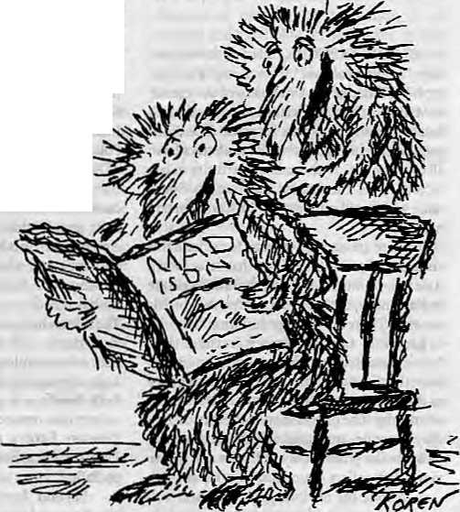
is one of the few conferences which is just sheer intellectual exchange," says Elder. "There are no business meetings, no membership drives, just intellectual fun."
The only other regular forum in which South Asia is discussed in North America is at the annual meeting of the Association of Asian Studies, organised by the University of Michigan. However, Japan, China and East Asia dominate the discourse at the AAS, and South Asianists prefer the cosier climate at Madison.
The deliberations in Madison covered all SAARC countries except Bhutan—no, there was no paper on either the Druk Yul's much touted tourism successes or the question of Bhutanese refugees. Pakistan lagged far behind India in the number of papers presented, but the Mohajirs did maintain a presence through a paper on "Re-forming of Pakistani (Mohajir) Nationalism" after the 1972 Karachi riots. On Sri Lanka, the scholars went for post-colonial identity, the "Third Elam War", and Jaffna nationalism. The panel on Maldives had one paper on "Ritual Politics, Islamic Identity and Island Nationalism," and another on "Sixteenth-century Nationalism in an Indian Ocean Nation State."
The Nepal studies papers comprised mainly of research by foreign scholars. Selma Sonntag, of California State University at Humboldt, analysed the difficulties faced by ethno-linguistic groups as they compete for state recognition and resources. The case of the Tamang is one of a language in search of an ethnic group or pan-Tamang identity, she argued, while with the Tharu it is a case of an ethnic group searching for a language. A Nepali faculty member of the University of Wisconsin, Gau tarn Vajracharya, discussed the "Vedic Axis Mundi and Ashokan Pillar", and there was considerable interest in another paper on "Authenticity and Authority in the Imagination of the Buddha's Birthplace.¹' Striking one blow for SAARC scholarship, a Sri Lankan named Arjun Guneratne presented a paper on "the Vicissitudes of the Tharu identity in Nepal."
The large r issues of contemp orary Nepali society, such as acrimonious debate surrounding the recent Arun III project cancellation, or the pains of democratic transition in different aspects of Nepali life, were conspicuously absent. The same was the case of many contemporary issues that national scholars in the various South Asian countries arc grappling with. The same was the case with the broader issues of contemporary South Asian discourse, such as sharing water resources, trade and regionalism. SAPTA, about to go into force, might as well have been the name for a newly discovered planet as far as the conference was concerned.
India Dominates
Even though it is the conference of choice for South Asia scholars, the attendance of scholars from the Subcontinent has always been low at Madison. The organisers estimate that about 15 percent of those who attended Madison this year were based in and working in South Asia, That the sessions appear to be "India-dominated" might also explain the low turnout of scholars. The number of papers on India is only a reflection of who sends the proposals, says Elder. "We don't structure the area emphasis,"
Actually, there is a simple reason for the tilted focus: there is more money to study India, says Prof. Robert Goldman of the University of California at Berkeley. "People often tend to use India interchangeably with South Asia. This is a problem and other countries need better representation," The makeup of Madison's South Asia faculty, which screens presentations, also probably plays a part, says anthropologist Beatrice D. Miller.
India studies received an initial boost when they were funded with the surplus non-convertible rupees earned from U.S. wheat exports in the late 1950s under the programme known as PL-480 (PL for 'public law¹). Today, the American Institute for Indian Studies, a consortium of 47 American colleges and universities, has its own endowment. There is an association for Pakistan but it is not as large or as well-funded as the Indian one. The Bangladeshi studies group has been around for only a few years and the Sri Lankan one is not operating. Nepal has a study group which usually meets at Madison during the conference, but it has no money either to fund research or to invite Nepali academics to meetings..
Miller says that the Madison conference serves as a forum for scholars to test research ideas, and many books have been nurtured in the Madison's meeting halls. Among the cutting-edge research to be presented at the annual meetings have been those on Harappa and Mohenjodaro archaeology and on Tibetan Buddhism.
But how relevant is Madison to the "real" South Asia? Scholars in South Asian universities rarely get to see the papers presented here, which means that the research will rarely receive peer review from those on the ground. But Frank F. Conlon of the University of Washington, Seattle, thinks the Madison conference is useful regardless. "This is a one-stop chance to see what other people are talking about or are interested in. I come here to recharge my batteries," says Conlon. "We arc always trying to refine our knowledge, and these discussions eventually become part of what is taught about South Asia at U.S. universities"
D. Bhattarai is a Kalhmandu journalist attending the University of Wisconsin at Madison as a Fulbrighl scholar.

22
November/December 1935 HIMAL

The roof of the world.
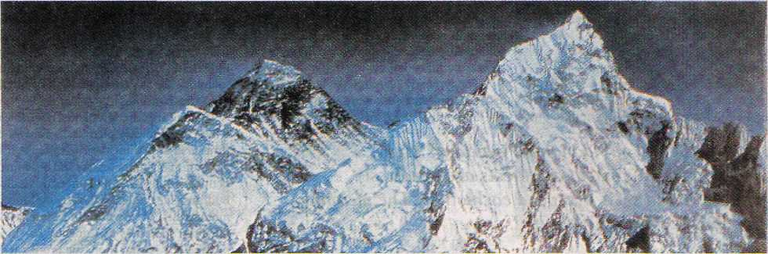
Mt Everest, 8848 m . 29 may 1953
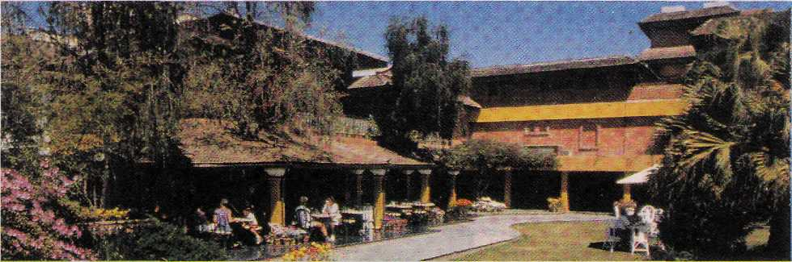
Hotel SHANGRI-LA . 82 Deluxe Rooms. I^{s}'July 1979
A roof for the world.

SHANGRI-LA
KATHMANDU
Your private paradise in Nepal LAZ1MPAT. G.P.O. BOX 655- KATHMANDU. NBPAJL - TEL : (9774) 412999 - FAX : (977.1) 4(4184 - TELEX : 2276 HOSANG NP
e a t u

At the sacred site of SiMhartha Gautam's birth, archaeologists run amok, architects are needlessly ostentatious and sects outspend each other. The meaning of the dharmais greatly diluted.
by Rachana Pathak
I
t all began with a Buddhist from Burma named U Thant. As UN Secretary General, he made a pilgrimage to Lumbini in 1967 and reportedly wept at seeing the sorry condition of the Buddha's birthplace. His heartache woke Nepalis up to the fact that the preservation of what was clearly an international heritage was an urgent responsibility,
A committee, which is now called the Lumbini Development Trust (LDT), was formed to look into ways to develop Lumbini. In
1978, a master plan backed by the UN and designed by world-renowned Japanese architect Kenzo Tange provided the outline for preserving the ancient ruins as well as turning an inaccessible, barren site into one thatwould appeal to pilgrims and tourists alike. This ambitious plan was to bring much pride to Nepal's Buddhist legacy.
Today, nearly 20 years later, little progress has been made in the effort to develop Lumbini. The Lumbini Development Project has been
marked by negligence and corruption, and the lethargic implementation of the grandiose scheme has brought little benefit to the locals, many of whom were displaced by the Project. Archeological work has caused great upheaval within the sacred garden and some of the devout speak of desecration. There seems little doubt that the excavations, which were to unlock the Sakyamuni Buddha's past, have been irresponsible.
There are other problems, not the least of which is the master plan itself. Tange's blueprint is ill-suited for the site because it indirectly promotes unnecessary andboastful competition among sects, and forces this hallowed Buddhist site to be crowded by buildings and monuments. Meanwhile, and more relevant, the Trust's idleness and docility has made it possible for several monastic groups to flout design parameters.


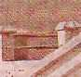

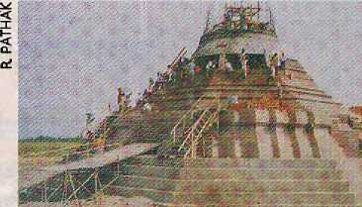
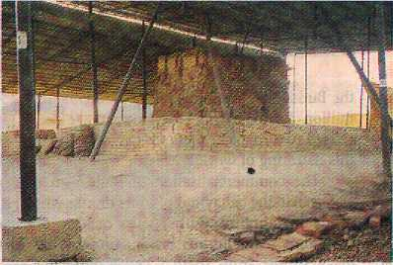
A commemorative pillar of ungainly marble tiles put up in memory of King Mahendra back in 1964 seems to have begun the avalanche of inappropriate architecture. This was followed by an eternal flame that was lit to commemorate a disconsolate United Nations anniversary that no one even remembers. Lumbini, the pride of Nepal, birthplace of the Light of Asia, has brought out the darker side of those very administrators, professionals—and monks—who ostensibly seek to honour the Buddha.
Birthplace
Siddhartha Gautam's date of birth is disputed, ranging anywhere from 623BC to 543BC. On her way from King Suddhodhana's palace in Kapilvastu to Dewadaha, which lies about 40km east of Lumbini, Queen Mayadevi stopped in Lumbini and gave birth to the prince, who was later to renounce materialism in pursuit of spiritual wealth, and give to the world the philosophy that later was called Buddhism.
Emperor Ashok made a pilgrimage to Lumbini in 249BC and erected three pillars in the area. The most famous of these stands in Lumbini's Sacred Garden, near the pond and Mayadevi temple. Its inscription reads: "Twenty years after his coronation, King Priyadarsi, Beloved of Gods, visited this spot in person and offered worship at this place, because the Buddha, the Sage of the Sakyas, was bom here." What exactly the emperor meant by 'here' is contested, but the pillar remains the strongest evidence that the Sakyamuni was bom in this area.
Chinese travellers Fa Hsein (5th century AD) and Hsuan Tsang (7th century AD) visited Lumbini and left detailed accounts that provide further clues about the Buddha's birthplace and the location of King Suddhodhana's palace where the prince lived the first 29 years of his life. These sites were lost for eras, to be discovered only in 1895. Khadga Shumsher, the then governor of Palpa, and archaeologist P. C. Mukherji were among the first to excavate the site before the turn of century. Excavations have continued throughout this century.
lange's Designs
The Tange master plan divided the eight square km of land into three zones, which were designed to assure the peace and spirituality that are implicit in Buddhism. The tourist village was to be comfortable, yet affordable. The monastic zone's 41 plots would allow
different sects of Buddhism to have their place in Lumbini, the Theravadins in the western part separated from the Mahayanans in the eastern part. Groups that purchased plots signed 99-year contracts and agreed to abide by the rules set by the LDT. The central zone of the Sacred Garden was to be maintained as a sal and sisau forest around a central waterway, in an attempt to recreate the ancient surroundings.
While the Tange plan has helped to protect the Sacred Garden from gracious donors who are busy bestowing brick and concrete structures in the area, it has its shortcomings. The most grievous is that it is expensive, requiring US$ 58 million in present-day prices for its completion. While Nepal claims to have spent the equivalent of USS10 million to provide infrastructure,, the project is overwhelmingly donor-dependent.
Marked by corruption, malfeasance and bad management of a politicised leadership and uninterested bureaucrats, less than 15 percent of the Tange plan has been completed. Most of the construction is not yet finished, not all plots have been let, and infrastructural problems remain. While monastic groups all seem keen to set up loud structures, no one wants to pay for a sewage system that would have little observable credit. Given the reliance on donors' generousity, the time frame for Lumbini's development is indefinite. The expectation of Japanese assistance flooding Lumbini with easy money (which did not happen) hindered realistic planning.
The master plan gives preference to those with money, and this has led to unfair representation of Buddhism's various branches. This is reflected in Nepal's own embarrassingly small patch, and by the fact that the monastic zone is dominated byjapanese Mahay ana sects. Vajrayana, the Himalaya's own distinctive contribution to Buddhism, is the most neglected, and a Nepali rimpoche complains that the Bhotiya population of the High Himal has to make do with visits to the shrines of other sects,
Some Kathmandu planners are concerned that Lumbini will not look 'Nepali' by. the time Lumbini is fully developed, due to the absence of Vajrayana monuments and the predominance of contemporary architecture in the complex. Lok Darshan Bajracharya, King Mahendra's private secretary who was appointed chairman of the LDT after the king's death in 1972, does not see this as a problem because "Buddhism does not bejong to one
Concrete Burmese stupa under construction in Lumbini (top), and the stripped-down Mayadevi temple structure.
country. It belongs to the whole world." Bajracharya served as the LDT's chairman for a decade, and, as a result, is praised and blamed for much of what has happened or not happened at Lumbini.
Promoting a multi-million dollar enterprise representing spiritual enlightenment, the Tange plan has sparked competition among sects and brought out 'un-Buddhistic' tendencies such as factionalism—that, too, based on nationality. Visiting pilgrim and tourist groups tend to be restricted to their national monasteries.. Korean pilgrims stay in Korean temples, Thais in Thai, making quick forays into the Mayadevi temple, which is really the only 'secular' place amidst the tussle of nationalities.
A type of militant Buddhism is emerging in relations between Theravadins and Mahayanans at Lumbini, which seems to reflect developing rivalry between these two branches and the trend toward aggressive proselytising in the larger world. The minority Thai Theravadan monks, to strengthen their position, offer fellowships to young Nepalis to study in Thailand, with the hope to 'purify' other types of Buddhism. Sri Lankan Theravadins are doing the same. The Thais are also building one of the largest icons statues of

HIMAL NovemberlDecemb& 1995
25

 |  |  |  | mi |  |  |  | ■BRHH |  | HHBBHHHH
 |  |  |  |  |  |  |  |  | ;*:
 | ,,.... .- | 1 |  |  |  |  | ■■ .: ■..:'■ - ::-^: ■■ |  | ;*:
 |  |  |  |  |  |  | ■  ■ . i .'■ ■/  ir.f;.;'■: | / ■ ■ ■■ . : .  : | ;*:
'■■ ■ i | iri
i | iri |  |  |  |  | * i L W.."*M | ■  ■ . i .'■ ■/  ir.f;.;'■: | / ■ ■ ■■ . : .  : | ." ■ | is
. i ■  ■ :j : ..-■.'■■ ■]  ■ | | | / | I'" iSllB  TESKfrVaSi ■- .j. .-n.-BB¹ - | ..:: ..... ■ |  | 1
. i ■  ■ :j : ..-■.'■■ ■]  ■ | | | / | I'" iSllB  TESKfrVaSi ■- .j. .-n.-BB¹ - |  |  | | |  |  | / ■ ■ ■■ . : .  : | ." ■ | is
 |  |  |  |  |  |  |  |  | '_[--■ | .. |...... /ill-j :iv:(-i:
. i ■  ■ :j : ..-■.'■■ ■]  ■ | | | / | I'" iSllB  TESKfrVaSi ■- .j. .-n.-BB¹ - | './■■': : i^{s} Si •■  ■■:"-; £?!_£, |  |  | ■■.:_■;:=■ ■:! ■ ;*;■■■ ;;-=■/: |  | /■l | ■ ^ *—"
 | r | I'" iSllB  TESKfrVaSi ■- .j. .-n.-BB¹ - | './■■': : i^{s} Si •■  ■■:"-; £?!_£, |  |  |  |  | /■l

the Buddha in Lumbini, at a cost of USS 1.6 million. Burmese and Thai groups have purchased two adjacent plots for construction in this flaunting of worldly wealth.
The commercialisation of Buddhism is also seen in the behaviour of some monks who reside in Lumbini. Rather than making do with alms that pilgrims bring, some monks make profits from them. Locals who live outside the Lumbini perimeter maintain that there is immoderate wining and womanising, and one bhikshu is even called Ghatiya Baba ('the lowly one¹) for his questionable conduct.
Disney's World
As the competition between countries and sects is measured in money and monuments, Lumbini is well on the way to becoming a "religious Disneyland", observed a Western scholar of Himalayan Buddhism who was part of a UNESCO-sponsored trip to the site in October.
Some monasteries have clearly forsaken their ascetic ideals and taken on a commercial atmosphere in their projected guest houses and curio shops. The Chogye Order monastery of South Korea, when completed, will be able to bed 300 visitors. The W. Linhson Buddhist Congregation of France, and Bauddha Dharmankur Sabha of Calcutta also have plans for large guest houses.
The rule meant to keep buildings heights below 60 feet so as not to detract from the Ashok pillar and Mayadevi temple has already been flouted by the Vietnam Phat Quoc Tu. Meanwhile, a Japanese sect that wants to go even higher, Nipponjan Myohoji, has received special permission to purchase land in the tourist zone. It has started construction of a peace pagoda that upon its completion in the year 2000 will soar 155 feet. This project also
will block the direct north-south view from the Ashok pillar, "This is a travesty, but there is nobody watching, least of all the Lumbini Development Trust," says a despairing Nepali architect.
Mature trees have been cut down. A plan to build a high school for locals, promised at the time of land acquisition, hasbeenscrapped. The Yong Do monastery of South Korea has been built in the middle of a greenery zone. The two monasteries actually within the Sacred Garden (Mustang and Theravada), which were there before the Tange plan was drafted, were supposed to have been relocated but this has not been done. Instead, the Mustang one has started building a restaurant.
All these changes are occurring without control, widiout restriction, and with indirect support of the LDT, who is paying the infrastructure costs. Nothing more vividly highlights the Lumbini guardians' vulnerability to foreign money than the Trust's inability to enforce the Tange plan. If this laissez-faire attitude continues, with overseers from abroad building according to their whims and fancies, the world will have gained a tourist site, but have lost a spiritual centre.
Irresponsible Archaeology
Questionable archaeological work marks the activities within the Sacred Garden, which holds the Mayadevi Mandir and its nativity statue, the pond, the pillar put up by Emperor
The world is gaining a tourist site, but losing a spiritual ceritre.
Design violations: Kenzo Tange's Master Plan for turnbini.
Ashok, and the (onetime) sacred pipal tree. At the Mayadevi temple, pilgrims who arrive to pay homage to the Buddha's birthplace currently find an excavation site.
Three years ago, a contract was signed between the Japanese Buddhist Federation (JBF) and LDT to excavate the temple. The work plan called for keeping precise records relating to the original structure, reassembling the temple using the same bricks in the same positions, publishing frequent progress reports, and finding ways to safeguard the pipal tree, which grew over the temple and was the distinctive feature of the complex.
The archaeology team of Satoru Uesaka (Japan) and Babu Krishna Rijal (Nepal) seems to have broken almost every provision in the original contract. The work progresses with bureaucratic smugness, without any reports being made public and little review of the work that has been done. The team includes no anthropologist, no Buddhist scholar, and no historian either, though the inclusion of experts from the various fields would have added much insight and perspective. The only thing that is more surprising is the absence of remonstrations from the national and archaeological community and the lack of press coverage of the goings-on in the Sacred Garden.
So far, the JEF-LDT partnership has moved the Mayadevi nativity scene to a temporary shelter, ignoring its locational significance. The cutting down of the sacred pipal tree has provoked greater consternation. They are also planning to build a replica of the Mayadevi mandir somewhere nearby in the Sacred Garden, to house a modern-day replica of the nativity statue that someone made.

26
November/December (995 HIMAL

t u

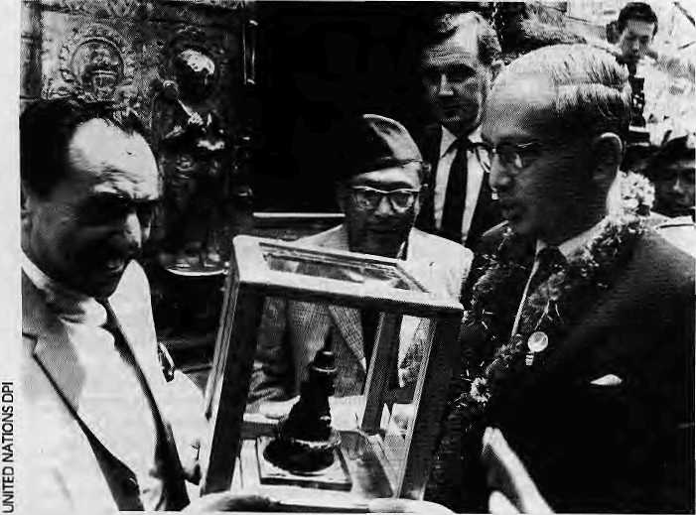
As with the overall schedule of Lumbini, the excavation seems to proceed without a timeframe. Three years of work are said to have yielded Mauryanpunchmark coins, terracotta pieces, and northern blackware pottery, but not a single report has been published. This excavation has extraordinary potential because it holds the possibility of finding pre-Buddha remains, which would provide new information about that earlier era. The archeo-logical world and the public deserve to know about what is probably one of the most important digs in the world.
"They are raping the Mayadevi Mandir," exclaims Basanta Bidari, a Nepali archeologisr. who has been working in the area for eleven years. He feels that Uesaka's team is reckless, adding that their excessive secrecy strengthens speculation that smuggling is going on. "Why are they doing their work behind a sheet? What have they got to hide?" he asks.
Smuggling of artefacts has a !ong history in Lumbini, as elsewhere in South Asia. Back in 1897, German archeologist Dr. A. A, Puhrer, is thought to have taken many pieces. The 17 stupas of Sagarhawa, about 20 km from Lumbini, mentioned in Mukheiji's excavation records, are all gone. Archaeologist Debala MitrareportedlSvotive stupas in the Mayadevi
U Thant receives stupa offering in 1967.
Mandivin 1957, all of which had disappeared by 1962, Many artefacts from Lumbini and its surroundings dating from the Buddha's time are today said to be in museums in India.
Recently, the JBF stopped its excavation work, having been ordered by Bimal Bahadur Shaky a, the previous LDT Member-Secretary, to hand over all slides, videos, negatives and pictures, and to write a report. The archaeologists' team has started working on a report, but Uesaka seems flustered by this demand and makes the point that "archaeology cannot be rushed".
Pipa! Tree
Perhaps the most tragic action was trie 1993 felling of the pipal, which formed an integral part of Lumbini's mental image for millions. Its age was a matter of dispute—claims ran anywhere from 80 to 500 years old. Mukherji's records show that it was at least a hundred years old. The tree definitely did not exist during the Buddha's lifetime, but since Lumbini's discovery in the modem era the tree has had a unique religious significance for standing over the Mayadevi temple. No Lumbini photograph, artwork or mental recollection is without diis majestic pipal overspreading the rather drab white-washed structure of the temple.
The JBF-LDT team claims that the roots
were penetrating the mandir and that the tree had to be destroyed in order to preserve the temple. Also, the brick building (built by the Rana, Keshar Shumsher, in the 1920s) stood atop at least six different structures, and, according to the team, could not be excavated without felling the tree.
John Sanday, a British architect and restorer who has worked in Kathmandu's Hanuman Dhoka and Cambodia's Angko r Wa t, believes inadequate research was done on preserving the tree. There are ways to kill certain roots or to control root growth, says Sanday, who had suggested a work plan to save the pipal as early as 1983. He is clearly disturbed with what has happened. Puma Man Shakya, the then LDT field manager and the man who was ordered to axe the tree, however, feels that there was no way around doing away with the pipal. He is combative: "As a botanist with 30 years' experience, I challenge anyone anywhere in the world to show me how you could have saved that nuisance tree."
There is the unconfirmed report that JBF paid LDT one lakh rupees for the felling, and then used the tree to make dharma bead necklaces and small sculptures to sell injapan and elsewhere. Bimal Bahadur Shakya, die previous LDT member-secretary, wrote an article in Sadhana, a Nepali digest, stating that wood from the felled tree was being used for such commercial purposes. Ram Briche, a local from Lumbini, says he was one of those who helped make planks for export. But Uesaka of the JBF vehemently denies these charges, insisting that he is being defamed by those who are jealous of his team's work.
Uesaka says that the tree trunks have been replanted on either side of the eternal flame, and that saplings have been nurtured from that same tree. The replanted stumps he points to, however, are dead.
Withoutgoing into veracity of the charges that have been made, suffice it to state that the archaeological team of JBF-LDT has caused rapid and unwelcome alterations in Lumbini. Both the tree and earlier temple are gone. For the moment, pilgrims are left to view the Mayadevi image in a temporary shelter.
Amidst the Mosques
It is striking that Lumbini, what hasin modem times become the major Buddhist pilgrimage destination, is surrounded by a Muslim population. The road from Lumbini to Kapilvastu is lined with 11 newly-built mosques, and more

HIWIAL November/December 1995
n

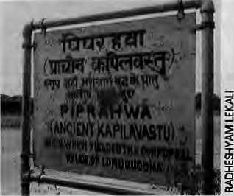
and more permanent," says Sakya.
But the instability of government, actions of foreigners, religious apathy, can only go so far to explain the rot in Lumbini. The persons who have held the chairs and membership of the Trust thus far, whether Hindu or Buddhist, and die mostly unimaginative bureaucrats who have run Lumbini, must be held accountable more than any other group.
U Thant would still weep today, and Nepalis have to blame only themselves.
are to follow. Muslims, and a scattering of Hindus, make up the population of the nearby villages of Buddha Nagar, Padaria, and Parsia, Less than 20 years ago, many of these people lived in what is now the Lumbini compound.
Today, the Lumbini villagers say that they received inadequate compensation when their land was taken, and that the promised schools, health posts, water system, electricity, and better roads never materialised. The handover happened during the Panchayat years when they could not protest and they say, because of the assurances that were given, they moved without much fuss.
The Muslim villagers feel that they have been exploited. Their conviction is only reinforced when they see the vast Buddhist wealth being ostentatiously displayed in Lumbini by rival monasteries. The sluggish implementation of the master plan has brought little income to the villagers, who are employed only as day labourers. Their familiarity with the area could enable them to be earn income from the pilgrim and tourism trades, but they are excluded as outsiders benefit.
The villagers are obviously frustrated at their condition, and the seven large fires that have occurred in the Lumbini grounds in the last few years are thought to be acts of arson, presumably motivated by resentment.
The pace of life and level expectations are at such variance within and without the Lumbini complex, that one does wonder at the cocoon that those inside—including the insular monasteries and their heads and hinders— have created for themselves. Rijal of the LDT maintains that it is the government's responsibility to care for areas outside Lumbini, but this outlook ignores the dislocation which the LDT itself ordered. Displaced Muslim peasants are suffering in the name of Buddhism.
Trust Violation
Foryears.the Lumbini Development Trust has looked the other way or not looked at all while an international heritage was beingdespoiled. At the same time, the Trust has done little to fulfill its responsibilities of preservation and conservation of other Sakyamuni-related areas such as Kapilvastu, Niglihawa, Gotihawa, Sisahania, Kudan and Dewadaha, to which it was recently given the mandate. Important relics are carelessly thrown about, and some of these sites do not even have controlled boundaries,
Lok Darshan Eajracharya, who chaired the Trust from 1975 to 1985, blames LDT's lacklustre performance on the indifference of the present leadership. Speaking of Lumbini,
he says, "This kind of negligence did not occur in my time. We planted most of the trees then, and there was no violation of the master plan." There are those who blame the Lumbini mess on the fact that the government in Kathmandu is consistently Hindu-dominated. Others, including Asha Ram Sakya, a former LDT Member-Secretary, single out for blame the political instability of recent years. "Board members change along with governments, and are dius hindered in taking action. Currently, no board is in session, I would wish that the LDT management were less politicised,
The Battle of Kapilvastu
The long-standing controversy about the location of the palace where the Buddha spent his princely years continues. Where is Kapilvastu, the capital of King Suddhodhana?
A credit-claiming game is being played out between archaeologists on eidier side of the border, with Nepalis maintaining that the palace site was in Tilaurakot, and Indians insisting that it was across in Piprahawa or Ganwaria. The controversy has escalated during the last year.
In a sense, the debate is an empty quibble, since when the Sakyamuni lived there was no Nepal and no India either. But modem-day archaeology is imbued with nationalist purpose, and tourism to the authentic Kapilvastu means yen with a capital Y, and hence the battle over Kapilvastu.
Historical Buddhist literature and accounts of Chinese travelers Fa Hsein and Hsuan Tsang mention Buddha's palace as having high walls, a sal forest nearby, a clear view of the Himalaya, and the Bhagirathi river flowing nearby. Nepali archaeologists maintain that these are all evident in present-day Tilaurakot.
Indian archaeologists DebalaMitra and K.M. Srivastava, on die other hand, maintain that Kapilvastu straddled where Piprahawa and Ganwaria are today. Their arguments are based onsealsonacasket found in Piprahawa in 1988, which read"OmDeveputraVihare Kapilvastu Bhikshu Mahasanghasa".
Critics of the Indians' thesis maintain diat the small rooms at the Piprahawa and Ganwaria excavations as well as inscriptions prove beyond doubt that these were monastic sites rather than a palace complex. Some even claim that the casket in question was stolen from Nepal by archaeologists keen on claiming Kapilvastu for India.
Nepali archaeologists Basanta Bidari and Kosh Prasad Acharya add a further twist by maintaining that the brick types found in the sites in question could not have been made before the 3rd century BC.
It would therefore not be possible to place die brick-structures in eidier Nepal and India as the palace site, they argue. Their point complements the view of scholar Rhys David, who suggested some hundred years ago that the palace must have been made of wood, and would not have survived.
While the archaeological debates go on, the signboard painters south of the border are active (see picture), and mere is anecdotal information that some people are presently digging a ditch in Piprahawa to create a river to be called the Bbagirathi. Zee TV, the channel beamed to India by Star TV, is working on a movie diat depicts a Gau tarn Buddha born and raised south of the line which in the 20th century would become an international border...

28
NwmberlDecembet 1995 HIMAL

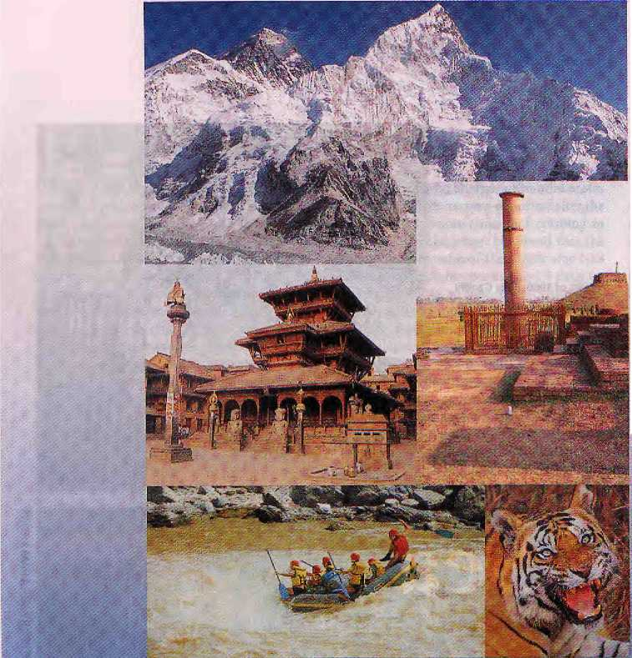
• The Himalayan Spectacular •
the flight for breathtaking views of Mount Everest and the Eastern Himalayas.
> The Himalayan Awakening -
the early bird flight from Pokhara, for a ring side view of the Annapuma Range and Western Mountains,
• Pokhara- Phewa Lake
gloriously reflecting the Majesty of Fish Tail Mountain.
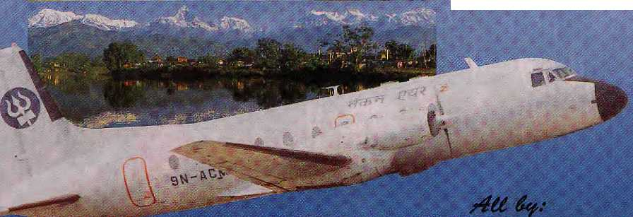
- Lumbini - Serene and
beautiful. Birthplace of Lord
Buddha.
- Royal Chit wan National
Park - Exhilarating Elephant
rides and wild animal sightings.
- Kuthinandu - Centre of
magnificent ancient temples
and stimulating Casino Action.

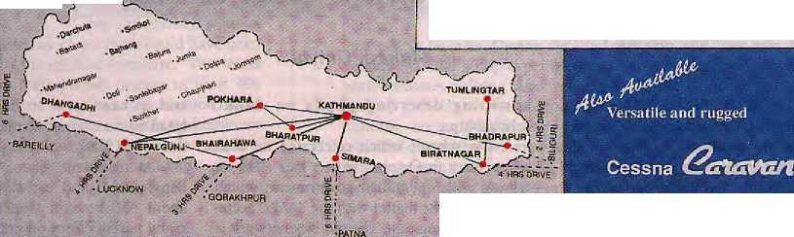
i
ROUTE MAP

For Passengers & Cargo Charters to remote destinations*
NEC&N AIR

Feature
.

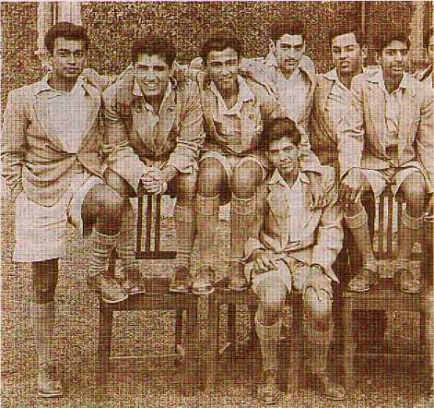
Class of I960: Rajiv Gandhi
(fourth from left) at Doon.
Class of 1995, betow.
From Sea to

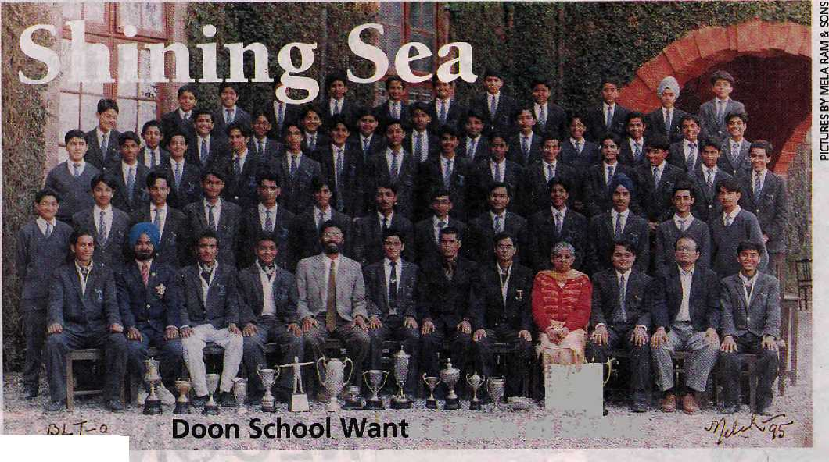
m
s a Taste of SAARC
■ '■■,-.-■

INDIA'S ELITE send their children to the Doon School, at the idyllic foothills of Garhwal, so that they are groomed to become the country's future leaders. Soon, Doon may be churning out leaders for all of South Asia.
The Doon, pre-eminent among India's exclusive public schools, plans to start
by Mahesh Uniyal
admitting deserving pupils on SAARC scholarships.
The school, which celebrated its 60th anniversary in October with a gala affair, is talking with the Indian government, which will take up the matter with the SAARC Secretariat in Kathmandu. The old boy network is
said to have come in handy when Doon's Headmaster Shomie Ranjan Das approached the South Block with the proposal.
At present, there are only eight Bangladeshis and eight Nepalis among the about 450 boarder students. "We feel that many parents from other South Asian coun-

30
NovmberlDecmber 1995 HIMAL

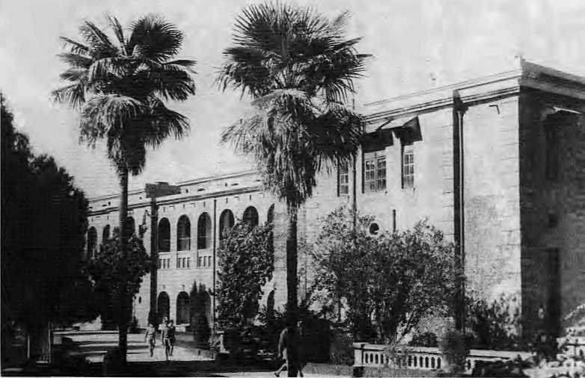
tries who send their children overseas would prefer to send them to India, where they face less cultural alienation," says Das.
Secular School
Public schools, patterned on boarding schools for boys in 19th century England, are an enduring legacy of colonial British rule. Their graduates have ascended to the topmost rungs of India's and Pakistan's political, military, and business leadership.
Nostalgic old boys from Pakistan are now setting up their own version of Doon on the outskirts of Lahore. Named the Chandbagh after the estate on which the original is located, the school will open for admissions next year. The moving force behind the Pakistani school is Doori old boy Lt. General Ghulam Zilani Khan, a former army general and governor of Pakistan's Punjab province.
"The greatest thing about Doon School was that it was secular, with no feelingsof caste or creed," recalls Miangul Aurangzeb, Class of 1945. He is a prominent Pakistani lawmaker and member of the Parliament's Public Accounts Committee. Aurangzeb, considered to be close to former Premier Nawaz Sharif, even believes that the Doon old boy ties have helped maintain a modicum of understanding between the rulersin New Delhi and Islamabad.
"I have many friends in India. Hatred is created by politicians and priests, big people with small minds," he says. S.N. Taiukdar, Class of 1943 and a former consultant to India's oil exploration industry, agrees. "They are very nice to me in Lahore. 1 find it difficult to understand, how they (Pakistanis) can hate us," he muses, puffing at his pipe as he watches a school-alumni cricket match.
Aurangzeb fears that the increasing hold of the clergy in his country could undermine religious neutrality in public schools. He says the government in Islamabad is likely to insist on religious instruction in the Chandbagh school.
The Pakistan 'old boys' at the celebrations included the School's first girl pupil, Muin Vahid. Girls are not admitted unless they are daughters of school teachers. Vahid and Aurangzeb were among the 11 Pakistanis who attended the 60th anniversary celebration in Dehradun, which was inaugurated by Indian Finance Minister Manmohan Singh, not an old boy. However, he had in tow his assistant and the country's second-most influential economic policy-maker, Finance Secretary and old boy Montek Singh Ahluwalia.
Elite, Not Elitist
Doon enforces a spartan regimen. Boys wake up to 'choti hazri', a cup of milk or tea, at six in the morning, followed by physical exercise till seven o'clock. They troop into classrooms from the exercise field at 7:30a.m. Breakfast is at 8:50a.m. There is a compulsory one and a quarter hour of rest after lunch. Compulsory games in the evening are followed by a bath, dinner, and an hour and half of study time. Lights-out is at a quarter of ten.
Boys cannot keep money on their person and allowances are not supposed to exceed IRs 50 a month. Like the school-supplied regulation clothes, this is meant to ensure equality among the boys, a large number of whom come from affluent families. The school charges an annual fee of IRs 48,000. However, 45 students are on scholarships ranging from IRs 20,000 to IRs 30,000 a year. Another 75 pupils are entitled to annual bursaries of between IRs 8000 and IRs 15,000.
However, none of this has succeeded in dispelling Doon's elitist image. School teachers, requesting anonymity, lament the growing waywardness of their wards. There are tales of rich parents opening accounts for their children in Dehradun's luxury hotels. Coming to the institution's defence, one senior master repeats a well-used tine, "We are trying to maintain Doon as an elite school, but defi-
nitely not an elitist school."
"They are playing with words," responds another, more cynical, teacher.
Headmaster Das, a grandson of the school's founder, has heard the criticism often and thinks it is unfair. Recently, his office even prepared an audio-visual presentation to correct the impression of an upscale school. "A successful institution always acquires the image of elitism, without its wishing to do so," he explains. "The School was always supported by the middle class and those who were interested in good education."
In an average year, only two out of every 10 students come from very rich business families, says Das, and the rest are children of government and defence personnel and other professionals.
Old boy Bunker Roy, recipient of the Magsaysay Award for his community empowerment work among the villagers of Rajasthan, is not kind to his alma mater. In the school magazine's diamond jubilee special, Roy charged Doon with "producing disoriented celebrities—certainly not men of character, of compassion, of humility..."
Oh-oh. Are these, then, the ones who will rule South Asia, if those scholarships are forthcoming?
M. Uniyal is a Delhi-based journalist.

HIMAL November/December 1995
31

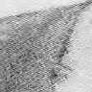
fefitfr
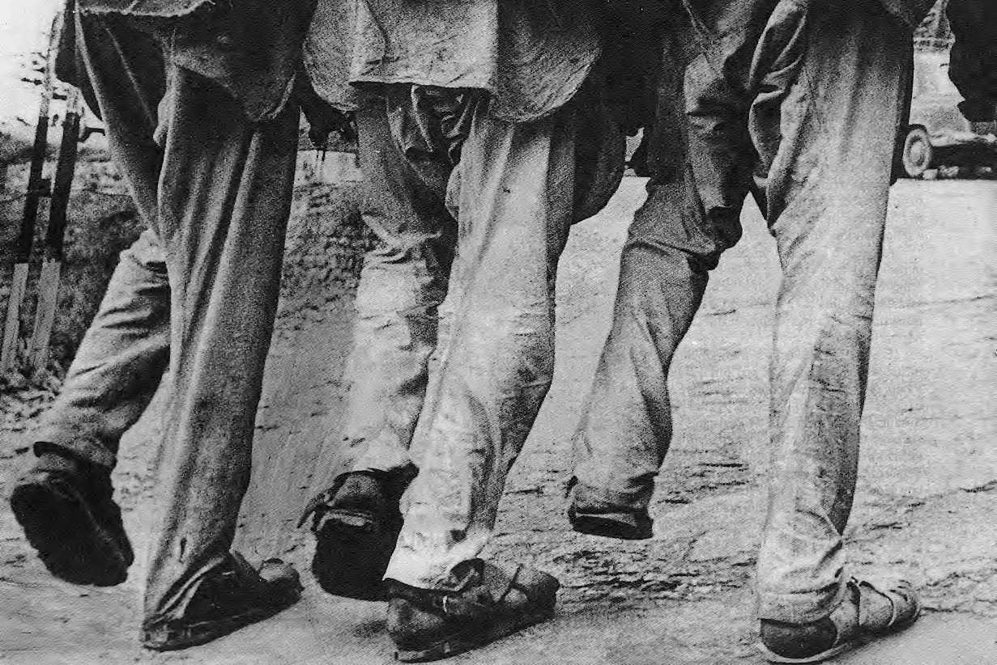

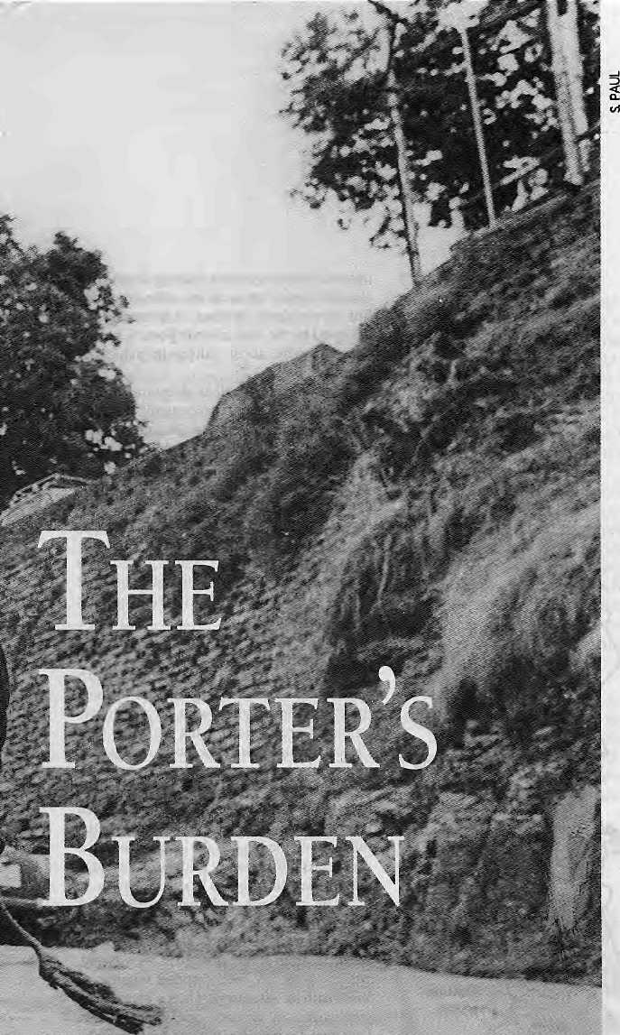

Bearing loads on the back the way his ancestors did fifteen thousand years ago, the Nepali porter carries an evolutionary legacy as well as amodern-day burden. Treating his conditien-would also cure the socio-economic ills of Nepal's hill peasantry.
by Kanak ManiJDixit
THREE RAGGED LABOURERS, hailing from the hills of far-west Nepal, haul a drum full of truck diesel up from the Lakadi Bazaar depot in Shimla, On the 15 km trail up from the Gaurikund bus stop in Garhwal, a Nepali 'kandiwala' carries his 2000th pilgrim up to Gaumukh, where the Ganga has her source. He earns ninety rupees for the effort. On the Lamjura Pass, the high point on the trail to the Khumbu in east Nepal, a 44-year-old Rai man is in the middle of a ten-day haul with a load that is more than twice his own weight.
Every day, tens of thousands of Nepali porters in the middle hills carry excruciating loads on their spines, for the sdhu merchants, for trekkers and mountaineers, and for development agencies. Hundreds of thousands more heave the basket as part of their daily household chores, fetching water, firewood and fodder.
Carrying goods on the back widi the help of a tumpline (namlo) is the most ancient, and taxing, of human labours. While the loads carried by the Nepali porter are the heaviest anywhere in the world, the feat is doubly impressive when one considers his diminutive size and body weight. Himalayan back-loading is also distinctive because it is a continuous, unremitting activity, unlike, for example, the stevedore's momentary toil.
Watch the Nepali porter, otherwise called a bhariya or dhakrey, on the trail as he grunts and sweats his way up a 50 degree switchback. Spine bent to receive the basket, hands clutching the namlo which distributes the load over his vertebrae, the muscles of the neck, calves and thighs tau t—this is how diey carried goods 15,000 years ago, before there were pulleys, levers and wheels.
Bhariya-work is a holdover from the evolutionary past of humans, a heritage which every other hill society has discarded for more modern forms of haulage. In the central Himalayan hills, the Nepali peasant's namlo remains firmly in place as a stark reminder of the region's economic history and geography.
As botanist Tirtha Bahadur Shrestha points out, porters have moved millions ■upon millions tons of goods up and down the central Himalayan mountains over millennia. The sheer volume of physical pain and mental suffering that has been expended on these mountain trails over the centuries is massive. And yet, this way of life and work has attracted scant attention from social scientists and development workers in Nepal and elsewhere.

;
33

*"<*.

Hard Livelihood
On August 3-4 in Pa tan, Himal organised what turned out to be the first-ever meeting on the subject—"Hard Livelihood: Conference on the Himalayan Porter". Worldwide, no more than a handful of researchers have taken an interest in the subject, and almost all attended to share notes and express strongly-held views.
Much of what emerged from the conference was new and surprising. Participants learned why collective bargaining has not worked for Himalayan porters, why Sherpas are better on the job in high altitudes, and how the philanthropic tradition of maintaining pad and chatxtari rest -stops for porters has died out. They also learned that modem transportation in the form of Tata trucks, Russian jeeps, Canadian Twin Otters and, lately, Mil7 helicopters, were engaged in wresting cash income froni farhilies surviving at subsistence-through portering. And they learned that supposedly porter-friendly suspension bridges were actually taking away jobs as yaks and mule trains took over.
One paper suggested that backloading was part of hominid evolution, and that it probably promoted "upright bipedalism" in humans—why we walk on two feet, A neurosurgeon's report held out the possibility of using the namlo as a physiotherapy aid for those with degenerated upper spines. Another researcher was of the view that, despite the spread of roadways, portering would remain significant for at least 30 percent of the Nepali hills beyond 2015.
Most importantly, it became clear that, economically as well as symbolically, the carrying of other people's loads for an income is more than anything else a manifestation of hill poverty and the failure of the Nepali state to be responsible for its underclass. These mountains would 'develop¹ only when the namlo was finally separated from hundreds of thousands of Nepali thaplos (foreheads). The eradication of portering would indicate that the country was finally making progress.
Riding the Porter's Back
Every hill family, other than the few well-to-do which are able to hire others to do the lugging, porters. The daily trudge to the spring or water spout, is portering, as is carrying a year's supply of salt from roadhead to homestead, which may take as long as a week, or carrying kerosene or corrugated sheets for the hill market sahu. Trekking is the only business that offers porters the chance of some form of
■ w.J£ Forsign travel agent
' ^{v}*\) Local
Trekking agent
2 2
upward mobility—graduating from low altitude porter to cook to na\ke to sirdar. The stratospheric reaches of portering are occupied by the high altitude porters, mostly Sherpas, who assist sahibs in achieving summits.
Eackloading, for all its ubiquitousness, is not visible in the country's economic statistics, It is a commentary on how Nepali planners plan that this activity has no profile in national programmes, other than what benefits perco- lates down through general 'village development¹ programmes. Pitamber Sharma, an economist with IC1MOD in Kathmandu, agrees that portering's contribution to the economy goes unacknowledged, "While portering is contributing to about a third of household income of marginal families, it is economically invisible," he says.
Why does human-b ack p ortaging survive in Nepal when it has disappeared elsewhere? In the Indian Himalaya, the need for human carriers was reduced drastically after the Border Roads Organisation went on a highway-building frenzy following the 1962 war with China. The high cost of roadway construction, meanwhile, has prevented Nepal from developing a large network. As late as 1991, ii had only 8328 km of roads of all types, which meant a density of 3.5 km per 100 sq km in the hills. Above and beyond the lack of roads, the precarious humans-only bridges of the gorge country denied access to beasts of burden.
The chief reason Nepalis porter is, of course, that they are poor, across the breaddi of the country. Take the example of Prem Bahadur, from Rolpa district of west Nepal, who says he has been carrying pilgrims to Kedarnath for 49 seasons. He is a 'kandiwala', who carries on the back. Speaking to Dehra Dun-based researcher Ramamurthy Sreedhar, Prem Bahadur said he had taken up portering to supplement his family's income as the fields did not provide enough. He said: "1 am cursed to cany human beings. I have carried thousands to the house of god, but bhagwan still will not see my plight."
Nearly all the kandiwalas Sreedhar encountered in the Garhwal dhams (pilgrim destinations) were from the poor western hills of Nepal. On average, a porter ferries 700 well-fed pilgrims for darshan every season, earning about IRs 7000. What he saves after expenses is his 'profit',
"Because a porter by definition carries someone else's burden, portering has re- mained symbolic of an inherently exploitative

34
NwmbertDec&ntxr 1995 HIMAL

a t u

arrangement," says Pitamber Sharma. "The true rural proletariat of Nepal is made up of those who porter for others."
Bishnu Bhandari of the International World Conservation Union (1UCN), who this spring conducted a day-long workshop of bhariyas in north Gorkha, found that even the food they would save at home by joining a trekking group was part of the economic calculation of the peasants. Said one porter, "If 1 go carrying loads, at least 1 am eating as 1 go."
According to environmental activist Anil Chitrakar, "Portering is one of the few professions in the world where the more experienced you are, that is, the older you get, the less is the pay. Porters have neither insurance nor any political leverage. There is no pension scheme. They are on their own."
Lhakpa Norbu Sherpa, a Khumbu ecolo-gist, calculated the income of porters after the helicopters sent poner incomes crashing in the Jin to Namche route. He found that the average daily income of the porter was NRs 155, out of which he spends NRs 74 daily on subsistence. "It is no longer worth the pain, but they still continue to porter," says Sherpa.
One community which has historically been relegated to the portering life is the Tamang, living in the hills that surround Kathmandu Valley. Since ancient times, these people have been maintained as an exploited, unskilled underclass for use by Kathmandu's cultured urban classes. Ben Campbell, an anthropologist from the University of Manchester noted, "The strategic role of Tamang communities in central Nepal was as an underde-
veloped reserve of labour power at the service of the central elites. Their marginal niche and subsistence economy were treated with neglect."
Even though the trekking industry now provi des work to many Tamangs, the Tamangs do not get rich from trekking, said Campbell. "Many of the villagers who go 'to carry Foreigners' loads' come back with little to show for their work, at most a few hundred rupees, some new clothes, or some stainless steel plates. The details may have changed but the Tamangs are still carrying loads to make profits for the Kathmandu elite."
What, No Union?
If the porters are at the bottom of the labour ladder and make up a rural proletariat, why

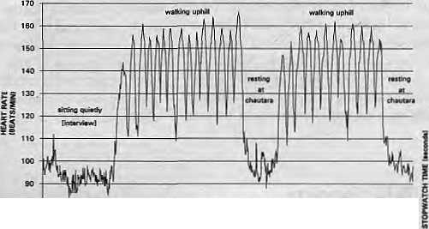
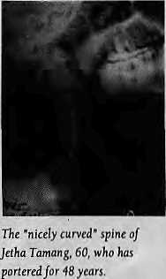
IH M htHtHHHIIHHillHIIIIIIIIIIIIillllHIIIIIIHMHIIIIIUIimilllHimiillllHIIIIIIIIIIIIIIUIIlJllllJ
Namlo for Spondylosis
UpendraDevkota.Kathmandu-basedneurosurgeon, presented preliminary results of a study on the upper (cervical) spine of the male Nepali porter, stating that he had found significantly less degeneration than expected, Spondylosis is the wear and tear of the cervical spine that comes with age, and it would seem that a porter's neck would be more susceptible than others'. "There was reason to expect that there would be accelerated degeneration, but these preliminary results indicate otherwise," says Dr. Devkota, who expects to present conclusive findings after further research. "The porters seem to have significantly better necks compared to sedentary populations."
In the age group 40-49,
_{a} _{[he} _{4Q}
spondylosis, whereas 25 percent would have been normal according to medical literature. "This tends to suggest that male Nepali porters in their 40s have significantly less spinal degeneration compared to their Western controls." If his preliminary findings are confirmed, then the namlo tumpline should be the suggested physiotherapy aid for spondylosis patients.
Stress and Recovery on the Trail
Heart-rate monitoring of commercial porters conducted in August 1995 demonstrated the importance of the tokma to the technique of carrying very heavy loads over long distances. The tokma is the sturdy T-shaped walking stick used by commercial porters in eastern Nepal to provide temporary support under the doko basket during frequent rest stops along the trail. The heart rate plot shown here, recorded at 5-second intervals, presents a typical heart rate pattern for a commercial porter walking uphill. In this case, the poner is a 33-year-old Magar walking up the Kenje hill carrying a 87-kg load (169 percent of body weight). While walking uphill, this porter stops every 135 seconds, on average, and rests for 60 seconds, placing his tokma under his doko and removing the namlo from his forehead as he rests. During the brief rest stop, the heart rate decreases quickly by 30 to 50 beats per minute, then increases again as soon as the porter resumes walking. After walking for half an hour, the porter sets his load on a chautara (rest platform) along the trail and relaxes for 10-12 minutes, during which times his heart rate drops to the initial level recorded during the interview session in Kenje. This technique of intermittent stress and recovery enables the porter to pace his exertions throughout the 10-day journey from Jiri to Namche.
- Nancy Mahille

HIMAL November/December 1995
35

don't they organise? Theseare the people who, after all, literally earn by the sweat of their brows. And yet, several factors conspire to ensure that Nepal's porters have no collective voice.
Overwhelmingly, the porters of Nepal are uneducated and unrepresented. Because the workforce greatly exceeds demand, they have little or no bargaining power. They are divided among themselves by region, ethnicity and caste. Furthermore, there is no 'factory floor' where porters can gather, which facilitates organisation. By its nature, portering is a solitary rather than collective assignment.
The advent of democracy in 1990 did see some scattered work stoppages called by the Trekking Workers' Association of Nepal, but organising efforts quickly fizzled out. The Rolwaling region and some villages elsewhere in the High Himalaya do guard their trails to ensure high rates from trekking groups, but this has not been feasible elsewhere in Nepal.
Even in Baltistan in the Northern Areas of Pakistan, where self-awareness of porters is much better articulated than in Nepal (and where pay scales are about ten times higher), collective bargaining is absent. According to Kenneth MacDonalcl, a University of Toronto
researcher, "There are no unions or association of porters among the Balti, as collective identity stems from the village and kinships rather than from the occupation."
While trekking might see some collective bargaining before long, this is not even a remote possibility in commercial portering, which involves the heaviest loads and many times the number of porters engaged No government agency or NGO has yet stepped forward as an advocate for the inhumanely exploited commercial porter.
From Dehydration to Hypothermia
The myth is that only plainsmen and tourists get acute mountain sickness. Not true, says Dr. Buddha Basnet, Medical Director of the Himalayan Rescue Association (HRA). Dr. Basnet says midhill porters venturing up the high valleys are equally susceptible. "The worst cases of altitude sickness—full blown pulmonary or cerebral edema-brought down to HRA's posts tend to be trekking staff."
By and large, hill porters are unprepared for die demands of high altitude travel. Encountering unique terrain of the highhimals, they become disoriented and often suffer psychological stress. Symptoms of AMS are dis-
missed as bohsi lagyo, witch's curse. Untreated bruises, lacerations and abrasions that are part and parcel of load-carrying lead to frequent infections. Porters suffer from hypothermia, caused by exposure to the elements without warm clothing, while they are also victimised by dehydration from drinking contaminated stream water and eating unhygienically on the trail.
"Even at high altitude, trekking is a 'hot weather activity¹ Heat is as much a problem as cold, and it is important to get the message across to porters that they must drink plenty of fluid replacement," says Dr. John Dickenson, a pioneer of trekking medicine. There are places where the porter must be encouraged to carry a water canteen, even if this means adding to his load.
According to studies cited by Dr. Basnet, high himalayan populations such as Sherpas seem to enjoy physiological advantages over their midhill counterparts. As part of evolutionary adaptation, for example, Sherpas seem to have higher oxygen levels in their blood stream because they breathe ('ventilate') more. Thigh muscle biopsies of Bhotiya populations show that they have a higher capillaries-to-fiber ratio than hill people. They also have less

Women as Porters
Porteringas a money-earning proposition presents to women an escape from the drudgery of their village existence, their continuous unpaid labour, and their poverty. These apparent gains—hard cash, freedom, exposure and new confidence—are what portering can give them. And in reality, they have no other option, as no employment comes their way. Under these circumstances, they should be encouraged, especially since they have proved themselves capable of the labour required. For women in the occupation, therefore, portering is an employment opportunity which they do not want jeopardised by well-meaning activists. Any action on their behalf must be taken only with careful forethought and sensitivity. However hard the life of women porters may be, it is one that they have chosen because they had no other alternative. But that does not mean that we should stop after telling the story...
- Dibya Gurung and Tsering Tenpa
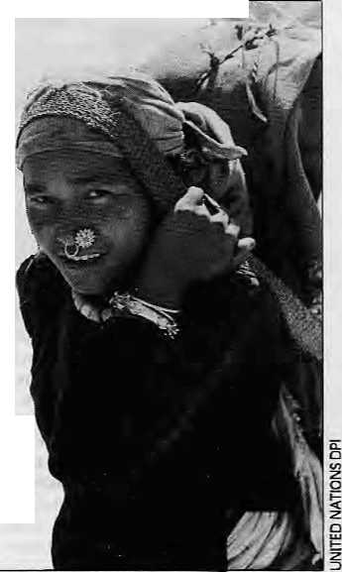
On Balti Notoriety
The words used to typify the Balti porter in travel, exploration and mountaineering literature include garrulous, belligerent, greedy, unreliable and cowardly. Re gardless of the individu al exp eriences that generate this image, the power system that sustains and extends it has produced a stereotype of Balti porters as unreliable.
1 would suggest that acts diat have led people to label Balti people as unreliable, cowardly and so on, are actually acts of resistance carried out in an effort to exercise a degree of self-determination and retain an element of dignity in a task that can be most degrading. What has been transmitted among travellers as a bad reputation is actually a racist misinterpretation of the actions of a subordinate group involved in continuous resistance against domination and the appropriation of their labour.
- Ken MacDonald
mm

36
November/December 1995 HIMAL

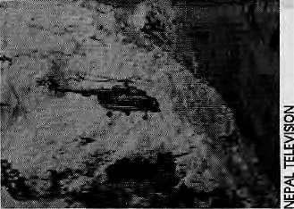
Dead Porters don't Protest
pulmonary artery constriction at high altitude than hill porters, who are therefore more prone to waterlogged lungs (pulmonary edema).
When a dhakrey stops his heaving and halts to catch his breath, is he following a cardio-vascular dictate or is he stopping to relieve pain? This is a question that researchers have yet to study, but the porter has other things on his mind... When University of Colorado scholar Nancy Malville asked a Rai porter on the Jiri trail, "Where does it hurt most?", the quick reply was: "At the Lamjura Pass!"
Load and Body Mass
East African women typically carry loads equivalent to about 70 percent of their body mass (about 40 kg), and the heaviest baggage carried elsewhere using a tumpline seem to have been by the Canadian voyageurs, who transported heavy loads for short distances while portaging their canoes and goods from one lake to another. The average load carried by the voyageur, whose days are long past, was 80 kg.
Only in Nepal does the porter's toil continue. Unlike other load carriers, and even Olympic weight-lifters, the bhariya's exertion is sustained over days on end. The porter trail studied by Nancy Malville, which leads from the Jiri roadhead eastward to Narnche, takes ten days of continuous carriage For a fully laden dhakrey. He returns in four days, to repeat the cycle. His total elevation gain over the route is 21,000 ft and total loss 16,500 ft.
Nancy Malville, assisted by her astronomer husband Kim, focussed her inquiry on the relationship between the porter's body mass and his load. She found that youngest porters (11-15 years) carried an equivalent of 135 percent of their body mass, and men in their sixties were still hauling goods of up to 60 kg, or 116 percent of their body mass.
Males in their late 20s carried the heaviest loads_{T}83kg(182 lbs), in relation to their own size, equivalent to 159 percent of body mass. The heaviest load encountered was 108 kg (238 lbs), carried by a 44-year-old Rai trader, Bhim Bahadur Sunwar, who stood 146 cm tall (4'9") and weighed a mere 47 kg (104 lbs). Bhim Bahadur was carrying 228 percent of his own body mass.
Malville also reported that, overall, the heaviest loads (an average 160 percent of body weight) are carried by dokay sakus, merchant-porters who seek profit for themselves and hence have the strongest motivation, Porters
The freak storm that hit the Nepal Himalaya from 9th to 10th earlier November saw prompt helicopter evacuation on an unprecedented scale coordinated by a government-tourism industry task force. It was a well-re ported, commendable job. However, while reports are sketchy, it seems clear that porters, forming the lowest strata of trie trekking trade, were neglected in the rescue operation.
Altogedier 549 people were airlifted out of the mountains, of which 250 were foreigners and 299 Nepalis. It is a ratio of almost one-to-one, which itself indicates that something is amiss. On average, the client-to-porter ratio for organised treks in the high Himalaya is 1:4, which means that many more porters must have been left stranded or dead on the mountain than were airlifted out.
The fact that the number of Nepalis reported dead is almost twice that of foreigners is similarly illuminating. The government's figure on whose bodies have been found is 22 foreigners and 42 Nepalis. The Trekking Workers' Association of Nepal (TWAN) claims that many more Nepalis have died.
While the foreigners are normally well-equipped for even tualities up on the mountain, Nepali porters do their jobs with the hope that the weather will stay friendly while going over the pass. Only a handful of the more expensive trekking agencies are known to provide porters with the minimum required clothing and gear.
Inadequate clothing and equipment is the main reason so many Nepalis succumbed to the killer storm, says Padam Singh Ghate of Mandala Trekking. At one point, there were said to be fifty porters suffering from snow blindness registered at the Kunde Hostpital above Namche Bazaar.
TWAN officers are indignant that their group was kept out of the task force, and that they were unable to board helicopters to ensure that porters were not. neglected by the rescue effort. They also claim that there was discrimination in identifying and bringing back the dead.
This information is mostly anecdotal, but rings true Dead bodies of foreigners were put into wooden boxes, while Nepalis were slipped into sacks. Initially, only the bodies of foreigners were brought to Kathdmandu while the Nepali dead were said to have been dumped into rivers. "I've heard similar reports," says Ang Gyaltsen Sherpa, Trekking Director for Trans-Himalayan Tours, a group diat lost 13 Japanese tourists and 10 Nepali staff in the disaster. "Most probably it would be Nepali porters whose bodies are being thrown away."
In die Kanchenjunga region, it is said, a helicopter landed and took off without taking in anyone, with the pilot saying, "There are only Nepalis here," Elsewhere, the going rate for helicopter evacuation was said to be US$400 for the eight minute [light from Gokyo to Pangboche in Khumbu, and US$200 equivalent for Nepalis.
The government has stopped counting bodies, and the trekking industry is almost back to business as usual. No one knows how many bodies of Nepali midhill porters strew the mountain passes, as most trekking agencies find it convenient not to report their dead. All across the middle hills, however, there will be men (and some women) who will never return to the homestead.
No one will be counting, either, when the spring thaw most likely reveals bodies all across the high passes of Nepal.
Helicopter an rescue mission aver Gakya.
-Ramyata Limbu

HIMAL November/December 1995
37

hired by shopkeepers were routinely carrying 145 percent, while thosedoing'self-portering', i.e. carrying goads for their own households, heaved the equivalent o f their own body mass. "The normal value for non-commercial load carrying in rural Nepal seems to be 80 percent of body mass," says Nancy Malville.
Clearly, the Nepali porter would win the gold in any Olympic competition if the criterion were load-to-body mass and endurance. While beefy weight-lifters can hoist carry heavier weights, they do not carry twice their own body mass. As Kim Malville says, "It is important to note that weight-lifters lift, and that, too, momentarily, but they do not transport!"
Rotors vs. Porters
The political and economic collapse of the Soviet Union has had a direct and reverberating impact on Nepali porters, for it made helicopters availabile to the Third World at cheap prices.
Over the last two years, Russian-made Kazan Mil7 helicopters, with the ability to lift up to four tons from a runway and three tons vertically, have devastated the portering market of the eastern Nepal hills. As the thudding
rotors ferry food grains, construction goods and development material to far-flung outposts, whole villages lose their only source of cash income down below.
Technology and the market when they work together become an unbeatable combination, and perhaps going back may indeed be retrograde. However, in Nepal there has not even been the semblance of a debate as the copters wrest away livelihoods of thousands. The loud members of the Nepali Sansad's government and opposition benches have not found the need to address this issue, although it is subject for both the socialists of the Nepali Congress and the communists of the United Marxist Leninists.
What is the solution to this gruelling occupation, if it is not to be helicopters? The one cautionary note that Dibya Gurung and TseringTenpa made in theirpaper on "Women as Porters" is that there should be no misplaced charity. Just because porters issues are being highlighted does not mean that a simplistic solution be sought to abolish portering by fiat. The job is one that women and men have taken up because of economic necessity, they say, and the supposedly demeaning act of "carrying another's load" is academic as far as
the porters are concerned. The focus, instead, should be to search for the interest of the porter—female, male and child—while generally working to develop the socio-economic status of the hinterland hill population.
There is no interim panacea to genuine development of the country taken as a whole, with the hills near and far taken along with prosperous Kathmandu Valley and the tarai. The moment the peasant has work that provides an alternate source of income, he will stop portering. Says Anil Chitrakar, "Portering is the starkest symbol of failed development after four decades of trying. Only when we have succeeded in removing the namlo from the thaplo, can we sit back satisfied that bikas has arrived in Nepal."
Until that time comes, we can, at the very least, notice the porter's burden the next time we pass him on the trail. Says Pitarnber Sharma, "The sweat the porter expends is in the hope for a better tomorrow for his progeny. For his efforts, the Nepali porter is a hero. He deserves the respect that is his due."
k
Himal plans lo publish in paperback the proceedings of Hard Livelihood: Conference on Himalayan Portering.


_{J} Katmandu. Ph C.

£)o(zs it sotirui
Mystical, Magical.. Exciting, Exotic, Enchanting.
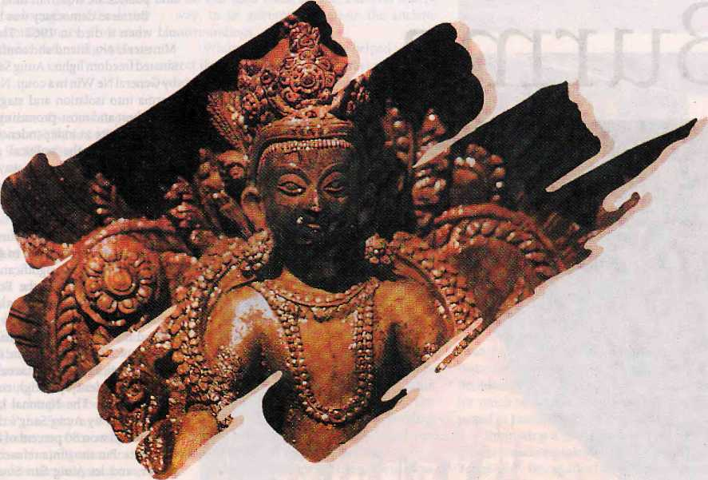
Royal Nepal - Nepal's own international Airlines operates regular flights toKathmandu from London, Paris and Frankfurt, You can warm to the gentleness of Nepalese culture, tradition and the authentic spirit of Nepatvse hospitality aboard.
Zf^oyal ⁽IMepal io jeel ilie difference
Royal Nepal SSaSEAh lines
RNAC BUILDING, P.O. BOX 401, KATHMANDU, NEPAL. TEL; 220757, FAX: 977-1-225348
BANGKOK BOMBAY CALCUTTA DELHI DUBAi FRANKFURT HONGKONG KATHMANDU LONDON OSAKA PARIS SINGAPORE TOKYO
. ■ : ;■ ■•• 2SH489 Sa8S3'! 338*572 387122 fi3«75 3?63lS2 220757 7572525 3S5S353 43299450 3395535 3508B41I
2632438 298549 3323«? 375915.! ?14e^0 3671391 35749292
a t u

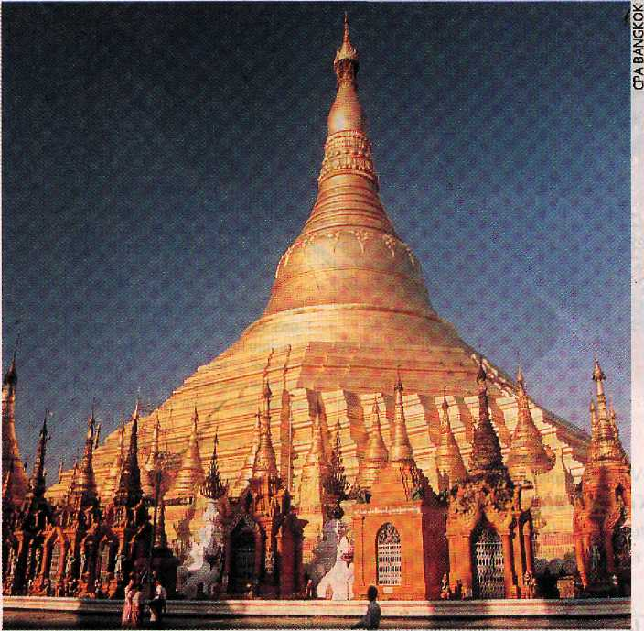
Say When,
Burma
Burmese democrats seem confident that their day is coming, but the Rangoon junta is busy establishing military and economic alliances. Meanwhile, returned Indian exiles are back in business.
by Satya Si\araman
IF YOU WANT TO SEE Calcutta as it was in the 1950s, visit Rangoon. With its crumbling Victorian buildings and leafy boulevards, Rangoon feels like a backwater, and in many ways it is. Burma's post-colonial history has not evolved as has happened elsewhere in the South Asian subcontinent; the architecture and politics are frozen in time.
Burmese democracy was barely 14 years old when it died in 1962. That year, Prime Minister U Nu, friend and confidante of assassinated freedom fighter AungSan, was toppled by General Ne Win in a coup. Ne Win plunged Burma into isolation and stagnation: one of the richest and most-promising regions of the British empire at independence virtually dis- appeared from the political and economic map. Ne Win's "Burmese way to socialism" brought the country to its knees.
8-8-88
Opposition to Ne Win's Burmese Socialist Programme Party climaxed in August 8,1988 (the date 8-8-88 has significance among diehard numerologists in the Burmese junta). The generals defused the crisis by shuffling the deck: Ne Win slid out of view while lurking behind the throne as a kingmaker.
SLORC (the State Law and Order Restoration Council, as the junta has called itself since the 1988 student uprising), conducted elections in 1990. The National League for Democracy led by Aung Sang's daughter Aung San Suu Kyi won 80 percent of the parliamentary seats. But the junta refused to relinquish power, and let Aung San Suu Kyi languish under house arrest for five years until setting her free in August this year.
The release of the Nobel Peace Prize winner was a deft public relations move on the part of SLORC, which is wooing East Asian investors in a big way. Burmese generals today like to point out that their role model is the Indonesian formula of military involvement in politics. And they tell disapproving Westerners who harp on human rights: If it is okay for Indonesia, why isn't it all right for Burma?
In any event, the economic future today looks less bleak than it did five years ago, or even last year. The country is eagerly awaiting membership in the Association of Southeast Asian Nations (ASEAN) in which it already has observer status, and it has thrown open its doors to trade and investments from Thailand, Singapore, Malaysia and Indonesia. Shops are beginning to fill up with imported goods, and sleek glass-and-concrete buildings are

40
Alorember/Decemter 1995 HIMAL

starting to alter the city's musty charm, Moreover, with Suu Kyi's release, there is at least a glimmer of hope of the restoration of long-lost freedoms.
But, while hope glimmers on the horizon, the continuing rule by fossilised political figures means that things remain uncertain— enough to provide full employment to the country's palm readers, numerologists and astrologers. And uncertain enough to make a magazine that specialises in astrology and black magic the most widely read (with weekly sales of 50,000) in the nation. It is not only ordinary people in Burma who are superstitious. Ne Win himself believes in numbers and nine is his favourite. After the 1988 pro-democracy uprising, Ne Win chose 18 September as the date to reconstitute the junta: the logic was that this was the ninth month and one plus eight was nine... Most state functions still begin at 0909 a.m. sharp.
Then there was the incident involving the 'miraculous' appearance of an idol of the goddess 'Pollamma' in a military base in Rangoon a few years ago, Soldiers who dug out the idol and sent it off to a local South Indian temple were said to have vomited blood, then died. There seems to be nothing in Burmese military training on how to deal with vengeful Indian goddesses.
Burma's cultural substrate has a strong Hindu influence, and ■ many of the deities worshipped by the Burmese originate in the Hindu pantheon, including Shiva, Vishnu and Brahma. Belief in these deities dates back a thousand years, when much of the country was controlled by the Takings, a tribe with close cultural Sinks to the Hindu Khmer kingdoms. Like the Thais, today most Burmese are Theravada Buddhists, but continue to worship a large number of lesser Hindu deities.
Historical Links
Burma's cultural and religious heritage reflects the powerful influence of the Subcontinent that lies to the west, which came in two waves—first the Hindu wave, then the Buddhist. But if, in the distant past, the Burmese attitude toward the culture of India was one of respect and reverence, the attitude of the Burmese people towards Indians has often been that of outright hostility.
During the Anglo-Burma wars of the mid-19th century, the British used Sikhs and Gurkhas to help subdue the Burmese, so that their neighbours to the west were cast not as friends but as enemies. Later, early migrations
of Indian 'coolies' during the British days helped to forge a stereotype of the Indian as dirty and uncouth. In the early years of this century, it was the South Indian Chettiars who were particularly loathed.
When the international price of rice collapsed in the 1930s, the Chettiars controlled more than half of all arable land in the country. In the 1930's, by when roughly a million Indians had settled in the country, anti-Indian pogroms broke out, and, as a result, many Indians returned to their homeland. At the beginning of the next decade, many more—an estimated 400,000—fled ahead of the Japanese invasion, a quarter of them perishing during their trek to India.
Before the outbreak of the war, South Asians formed the maj ority of Rangoon's population. A. Duriaswamy, a Tamil business man who was bom and grew up in a village just outside of Rangoon, recalls, "In those days, Hindustani was spoken all over the city." There was even a village of 100,000 fanners from Bihar who had settled down in Ziyawad, 200 km north of Rangoon, he adds,
When the military j unta came to power in 1962, it began to systematically nationalise all wealthy businesses, a measure that was intended to drive the Indians out of the country. Those who fled left their property in the care of relatives and friends who stayed on.
Money
As his plane came in to land at Rangoon a year ago, gliding over the familiar river-front settlements and the golden pagoda, S.P. Goenka remembers the hard lump that grew in his throat. His ancestors first came to Burma in 1862, and Red to India two decades ago. He was among many Indians whose businesses were nationalised in the 1960s, and-who were returning to make a new start. Even though very few of those who returned have managed to recover their property, they are not complaining—Burma is today the land of opportunity. There is new money to be made even if old money has been lost.
"We are not here to reclaim our property but to start our business afresh," says Madhusudhan Kansara, whose family also fled to India in the 1960s. Kansara says anti-Indian feelings have dissipated and many government officials privately admit that the nationalisation policy was a mistake.
S.S. Sharma of the trading company Yamona International, maintains that Indians themselves are partly to blame for the animos-
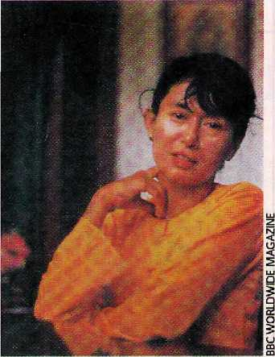
ity of the Burmese. Early migrants were rich traders with feudal backgrounds who lived'off the Burmese, but treated the locals as untouchables. Indian businessmen repatriated most of their profits, and rarely ploughed their profits back into the local economy.
The Goenkas' interest in Burma was rekindled because of SLORC's openness to outside investors. One of the Goenka brothers has now obtained Burmese citizenship, enabling the family to buy property and enter businesses forbidden to foreign citizens.
"As of now there are not more than 20 business families that have returned but the numbers are growing rapidly," says Sharma, who was one of the few Indians who never left Burma. He believes the country has the potential of being Southeast Asia's richest.
Blind Emperor
The junta's get-tough policy back in the 1960s not only hit Indian economic interests; it also affected South Asian cultural life. Urdu has a special significance in Rangoon because the city was the final resting place of India's last Moghul emperor andpoet, Bahadur ShahZafar. The blind emperor, who lived in abject poverty inside the ramparts of the Red Fort in New Delhi, was punished for his role in supporting the 1857 military rebellion against the British. First banished to Kidderpore near Calcutta, the emperor was finally brought to Rangoon where he died in 1862.
Says Nana Bawa, general secretary of the Bazm-e-Gulshan-e-Urdu in Rangoon: "Sometimes when we read the poetry of Bahadur Shah Zafar in his last days we cannot distinguish whether the subject was colonial oppression in India or the situation of ordinary Burmese People."
Urdu publications have been shut down along with other private media, even though

HIMAL ItivemberlDecmber 1995
41

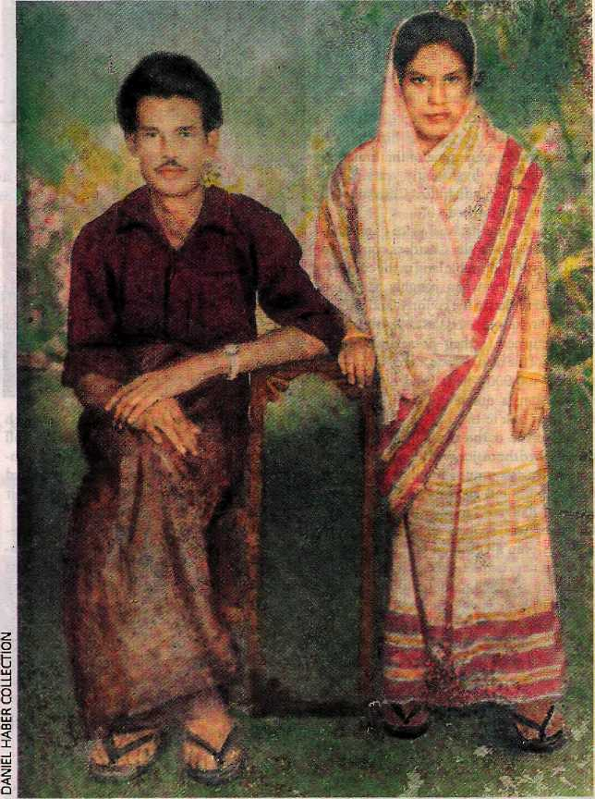
Nepali couple in semi-Burmese attire, c. i960.
The settlement of Burma by Nepali-speakers was, firstly, an extension of the British colonial policy of opening up the Indian Northeast with peasantry from the central Himalaya. It was also a result of the homesteading by families of Gurkha soldiers. By the early 1940s, there were a sizeable number of farmers and business families in Burma of Nepali origin, and interestingly, a large number of gwalas, or milk suppliers.
The silent exodus of Nepalis from Burma occurred in two waves, during World War II as they fled the Japanese advance, and in the 1960s following Ne Win's bhumiputra policies. There was no count kept of the numbers, but the 'Burmeli' arrived back in time to settle Nepal's tarai lands that were being freed of malaria.
Unlike the case with the Lhotshampa of Bhutan, who constitute the next big refugee influx into Nepal, there was no United Nations High Commissioner for Refugees to aid and protect the Burmeh, They had to make do the best they could, and many of them did very well in a Nepal that was just opening up to the outside world. Having been exposed to modern colonial times in Burma, and many of them having had business experience, many Burmelis started successful careers in Nepal. For their small numbers, they have been prominent in government service, in the Nepali police, and as entrepreneurs.
While a significant number of Burmese Nepatis have also migrated to neighbouring Thailand, enough remain behind to benefit from Burmese democracy, when it arrives.
there are thousands of Burmese who still speak and write Urdu. Every year, Bahadur Shah Zafar's anniversary is marked at his tomb, which has become a meeting place for Burmese of South Asian descent over the past century. Bahadur Shah's famous Urdu couplet resonates for those who remember the days of hostility:
Do gaz zomin bhi
aaj na mili ku-e-yaar mein.
(1 didn't even get two yards of earth in my beloved homeland to be buried in.)
The latest is that Rangoon city authorities plan to take over the tomb site, which is located in prime real estate. Bahadur Shah would be moved, once again.
President Suu Kyi
On a geopolitical plane, the Burmese junta has cosied up to the Chinese, in whom they find an ideological ally, in confronting Western criticism of human rights and democracy. New road and air links between northern Burma and China have connected the two economies. The Chinese have supplied some US$ 1.2 billion worth of arms to the junta to fight ethnic insurgents, and Rangoon is said to have given the Chinese navy access to strategic listening posts in the Bay of Bengal near the Andamans.
India, on the other hand, came out openly in support of the democracy movement and of Aung San Suu Kyi, selecting her as the recipient of the Nehru Peace Award in 1995. But New Delhi's pro-democracy stance took an about turn with a secretive trip to Rangoon two years ago by then Indian Foreign Secretary J.N. Dixit. On a state visit to Rangoon earlier this year, Indian Commerce Minister P. Chidambaram even cancelled a scheduled wreath-laying ceremony at the tomb of U Nu, who had been a close friend of Jawaharlal Nehru's, for fear of angering SLORC. To pro-democracy activists, the incident confirmed New Delhi's willingness to abandon both its old friends and its principles for short-term gain. They say it is only a question of time before Suu Kyi leads a democratic Burma, at which point India's betrayal will come to haunt it.
Despite Suu Kyi's release and her confidence in ultimate triumph, Burmese dissidents in exile in India and Thailand have watched in dismay as SLORC gains increased

42
November/December 1995 HIMAL

t u

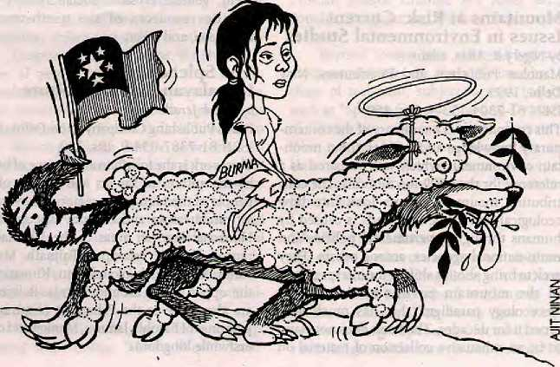

international acceptability, and as Asian neighbours revise their views and suggest that the junta can be reformed. Though Suu Kyi has sounded conciliatory in her calls for dialogue with the junta, she says: "People have to accept we are nowhere near democracy yet. 1 have been released, that's all... the situation has not changed."
Like Suu Kyi, who was a student in New Delhi while her mother was posted there as ambassador, hundreds of young Burmese dissidents are studying in India. They are unwilling to be identified since the military back home has visited their families and knows exactly who is where. But the students are bitter over how things have turned out.
"We left our country to end the domination of the military... we cannot go along with that level of reconciliation. We cannot forget how ruthless the military leaders were. There has to be a trial of top generals, the military has to go back to the barracks. These are matters on which we cannot compromise," says one student activist (requesting anonymity) who has lived in New Delhi for more than five years.
Back home, Suu Kyi's cautious moves after her release reflect the dichotomy within the dissident movement—between those who want to forge a political alliance and others who demand a complete withdrawal of the military from politics.
According to the older generation of political activists, such as NLD candidate Tin Swe, the student exiles and dissidents in India, Thailand, and elsewhere will have to accept reality and follow Suu Kyi's call for dialogue and national reconciliation.
Tin Swe was reelected general secretary of the NLD in October, but the junta-run Election Commission has declined to recognise it. She is now a minister in the Burmese govemment-in-exile. In New Delhi, Tin Swe told Himal: "From the beginning we wanted to fight SLORC. But now our political wisdom indicates that in Burma's politics, armed struggle is no more."
U Nu's daughter Than Than Nu, also in
New Delhi, says Suu Kyi is determined to carry
on the dialogue she started with General Than
Shwe and intelligence chief Gen Khin Nyunt
because she believes reconciliation rather than
recrimination is the best way to resolve the
political stalemate. fr
S. Sivaraman is a Bangkok-based journalist. With repcms from Samir Pal in New Delhi.
Burma or Myahinar?
When, a country' decides to change its name,: the rest of the/world^usually goes, along;■;!
.: Mpper:Volta said henceforth it wanted to beealled Burkina Faso.and so Burkina Faso it :
v.: ?iyas. Cambodia switched mKarripucheaandbacfc to Gambqdia;, and the;world obediently;:
:: switched with it; ; ■ ' ■■■■'.... ! ■:. ■ ■:: :. : ■ : .'.. : ■ / ; .::. :;:; ' : ■ ■-,, ; '■:- ■■'-.>
■ Yetwhenthe military junta to Burma decided to go.Myanmar in:l989.; the world was■:;
"divided: Except for the: Umted Nations,.multinational companies that value their;!
Hi;: business links !with;Ratigopn{now Yangbn) and the Indian press, justabputeveryqne else ;■
iffibepf on calling Biirma Burma!: ■ :;.. . : ■ . ■:'--'.-'. . \
■■ '■■:, :.::■; True,theBatniesepeopfehavecalled theircouMryMyanmarmthepast. European¹;!
; colbrriserscaUeditBuraiaorBinna,anditspeopleBunnahorBinnan^Inthepi^JolonialP
P ■ i! days, what is nowBurma used to be made up of four rival kingdoms: the Mon in the ;
: ^southeast, thenorthern ShaPi the central Myarunararid trie, eastern Arakan. (Arakan.is
: ■ thename given by British India:.to Rakhaitig.) / : : ■■■. \ :: : ..
:;::;:::. . By 1557, theShanand theMonbad beeh subdued by ariexpansionistdyriastybased; :;: in Shwebp near Mahdaiay.: The Arakan fell in 1784, and tte occupation of Manipur and::; : !i Incursionsltitp Assam brought (he kings into direct conflict with British India. The Moris, y ;::; Arakans and other minorities sided with the British in the three Anglo-Burmese wars, : .from: 1825.to 1842, at the end of which the British had conquered a big chunk of Burma.. ;:::;: ; The British rewarded the minorities for their support, which the.independehce-■;: ::minde:d Burmans considered part of the colonisers: divide-and-rule policy, Atjnd^pen- '-< ■:;-idenee, the 1Q47 constitution gave the country its official narne: The: Unipriof Burma,!;; s:V while ;the minorities made it. clear.they would,have preferred 'federation' teistead : ;:! of'union¹.: '.;• ' .;/::; .■:. . ::': /.".:. ;:-'. ■. ■ ..; ■
; ^Tensions between; Rangoon and the. mmojines remained. Unresolved after indepen-:
i : dence,:and the civil War that¹ broke:out in i948corj!:inues to this day throughput the;:
:: ^eastern border regions. :: ■ ■ ... ':■■ .[; ' ' . ■ .. :.
; H::: .Todays the rniftoritiesi feel more comfortable witli'Burma! than with. 'Myannjar' since i!
:;: they consideredMyartmars their equal partners in the Union of Burma, They suspect::
I-;¹ :SLOEC is trying^b ignore the existencepi Burma'scmltural diversity. Changing the name:"
■ : ^tpMy.anmar is seen to be part ofthatattempt. ... ■ ■ .. .'■■■' ; ' ... :::
■:■&:■ Onthebtherharid,:tftechangesfrpmRangobntpYarigbn:,MoulmeiritoMawlamyine,:! : ■'. i and: the irrawady-to: Ayeyarwady, areless problematic arid represent the indigenous:: : [■ phonetics of anglicised names, much, in thesame way Bombay is going back to Mumbai.:

- Hla Phay in Bangkok¹^
::;: -:;.:::: ■:■■■::■:■.:.■::■: .■■:,:■::■■:
"."':: :': I I ": : '-.'-'.'-.ir'.::!"!!:":'..": :-! ':-[- - - .'-"::.
: !■.:■:: : :.:■::::■:.:::■:: :U!'iJ.: !..:'.:: y :■':

HIMAL Norember/Decemfaer 1995
43

Abstracts

Forests, People & Profit
by N.C. Saxena
Natraj Publishers, Dehra Dun, 1995 ISBN 81-85019-51-7, IRs. 295 Keeping in mind the successive forest policies of the Indian Government and the major role such policies play in Forest resources, a workshop on 'Policy and Implementation Issues in Forestry' was organised by the Lai Bahadur Shastri Academy of Administration in Mussorie in 1994. This book is the outcome of that workshop. It covers such topics as deforestation, rural poverty, unemployment, tribal unrest, equity issues, and policy implementation.
Karakorum Himalaya Sourcebook for a Protected Area
by Nigel J.R, Allan 1UCN, Pakistan, 1995 ISBN 969-8141-13-8
lnAUan's update of the entry on the Karakorum for Encyclopedia Britannica, a major portion of his literature references were omitted while the list he was keeping continued to grow. The University of California geographer has made use of it in the form of this sourcebook, in the hope that it will be "an aid to formulating how the Karakorum Himalaya might emerge under the category of being a 'Protected Area'" and also "bring to the readers's attention the rich literature that exists on the Karakorum Himalaya and the adjacent territory." Allan's list includes hundreds of titles and consists of five chapters on history, description and inventory, photographic and cartographic documentation, public awareness and related bibliographic materials.
Mountains at Risk: Current Issues in Environmental Studies
by Nigel J.R Allan, editor Manohar Publishers and Distributors, New Delhi, 1995
1SBN 81-7304-133-4, IRs. 450 This compilation is a summary of the contemporary knowledge and debates about mountain environments which was prepared as a reference for the 1992 Rio Summit. The contributing mountain experts look into how ecological risk in the highlands is caused by humans through governmental policies and multi-national agencies, among others. They seek to bring about a shiftin the interpretation of the mountain environment from the 'geoecology paradigm' that has much governed it for decades. The book does not claim to be an exhaustive collection of material on
the subject nor has it included all the mountains of the world, but rather simply takes another look at all the information that has been generated in the past decade,
Bangladesh: Reflections on the Water
by James J. Novak
The University Press Limited, Dhaka, 1994 ISBN 984-05-1251 X, Taka 200 Novak, a columnist and reporter, was Resident Representative o f The Asia Founda tion in Bangladesh from 1982 to 1985. In this book, he presents his personal overview of Bangladesh and its people. He examines the economy, the importance of seasonal fluctuation in the lifestyle and psychology of the people, geography, history, music, art, poetry, ways of thinking, and political life. He also offers his own interpretation of the Bangladesh independence movement and the nationalism that spawned it, and the effect this nationalism has had on every aspect of Bangladeshi life.
Ecological Carnage in the Himalaya
Vir 5ingh et al, editors
International Book Distributors, Dehra Dun, 1995
ISBN 81-7089-226-0
The book, in 15 chapters, attempts to present the scenario of ecological change in the Himalaya with suggestions to avert and reverse the process. The contributors include Sunderlal Bahuguna of the Tehri Dam protest fame. The chapters deal with subjects like the seismic hazard at Tehri, the Chipko movement, genetic erosion, social forestry and aquatic resources of the north-western Himalaya, and so on.
The Splendour of Himalayan Art and Culture
by Ashok Jeraih
Indus Publishing Company, New Delhi, 1995 ISBN 81-7387-034-9, IRs. 350 This work is the fourth in a sequence of books by the author on the art and culture of the people of the Himalayan region. It covers the art, architecture and cultural aspects of the Himachal Pradesh areas of the Dhauladhar ranges, Kangra, Palampur, Baijnath, Mandi, Kullu, Manali, Lahaul and Spiti, Kinnaur and the upper region around Shimla. References are also made to the Pahari art of miniature paintings of Basohh, J ammu, M anke t and other erstwhile kingdoms.
Widening Perspectives on Biodiversity
AnatoleF. Krattiger, Jeffrey A. McNeely, editors
Natraj Publishers, Dehra Dun, 1994 ISBN 81-85019-46-0, IRs. 395 A reviewer has written, "This book expands the information base on which we ground our conservation response. It is a timely contribution to scientific, technical and socio-economic endeavours aimed at mounting an effective attack on the environmental problem that will most impoverish our planet, viz., the massive destruction of biodiversity." This first Asian edition of the book published in arrangement with IUCN and The International Academy of the Environment, Geneva, has a foreword by the (former) Indian Minister of Environment and Forests, Kamal Nath.
Indus Books
October 1995 Catalogue New Delhi
The Indus Publishing Company, in its October 1995 catalogue, has listed all its publications on the Himalaya, The sections are divided intoHirnachal Pradesh,U.P, Himalaya, Eastern Himalaya & North-East, Kashmir and Ladakh, and "Himalayas-Overall". The books listed cover a variety of topics—culture, ethnography, sociology, geography, development, forestry, gazetteers, etc. The authors are overwhelmingly Indian, though a few Nepali and western writers are also included.
Water and the Quest for Sustainable Development in the Ganges Valley
G.P.Chapman and M.Thompson, editors Mansell Publishing Limited, UK, 1995, ISBN 072-0-121914
This publication of the Global Development and the Environmental Series is the outcome of a conference on "Environmental Problems in the Ganges-Brahmaputra Basin'" held in London. The editors present approaches by experts from both the social and physical sciences which help in reaching understanding of how society and water interact in the upstream-downstream complexity of the Himalaya-Ganga. The challenge, write the editors, rests on encouraging "institutional plurality". From the perspective of the Himalaya, the chapter "Disputed Facts: A Countervailing View from the Himalaya" is succinct in its articulation of the highland views.

44
November/December 1995 HIMAL

Mountain Research and Development
Vol 15, No 4, November 1995 Jack and Pauline foes, editors University of California Press ISSN 0276-4741
This issue includes papers on: the dangers of "lake drainage" with special reference to the Imja glacier in Khumbu; a case study of landslide hazard donation in Garhwal; deforestation and forest Policy in "the Lesser Himalayan Kumaun" and their impact on peasant women and tribal populations; and glaciological studies in the High Central Andes using digital processing of satellite images.
Famous Western Explorers to Ladakh
by Prem Singh ]ina
Indus Publishing Company, New Delhi, 1995 ISBN 81-7387-031-4, Ifo. 250 The first record of a European visitor to Ladakh dates back to the 17th century. Since then this secluded region has attracted a multitude of travellers, adventurers, mountaineers and scholars from both the East and the West. Among them, a few did noticeable work in Ladakh. This book by an academic, who has been living in Ladakh for the past 15 years, collects the experiences of these visitors in one
place and also covers the gap of information regarding nature, culture, socio-economic activities, and problems and prospects of Ladakh.
Himalayan Research Bulletin
Volume XIV (1-2), 1994 Volume XV (1), 1995
HRB has finally caught up with its schedule. A double issuefor 1994 was produced this spring, and the first number of 1995 came out in the summer. "Widi luck the second issue will even make it out before the year's over," says Barbara Brower, Editor. The topics covered in the two recent issues are listed below.
Volume XIV (1-2), 1994 An Appeal for the Abolition of Slavery, Chandra Shumsher Jung Bahadur Rana Himalayan Religionain Comparative Perspective: Considerations Regarding Buddhism and Hinduism across their Indie Frontiers, Todd Lewis
BOOK REVIEWS
Body and Emotion: The Aesthetics oj Illness and Healing, Robert Desjarlais (Christine Greenway) Tibetan Thangka Painting: Methods and Materials, David and Janice Jackson (Yin Peet) Himalayan Buddhist Villages: Environment, Resources, and Religious Life in Zangskar, Ladakh,
John Crook and Henry Osmaston, (eds) (Nigel Allan)
A Descriptive Grammar of Nepali and an Analyzed Corpus, jayaraj Acharya (David Red) Mesocosm: Hinduism and the Organization oj a Traditional Newar City in Nepal, Robert Levy (Todd Lewis)
Golu Devata, The God oj Justice oj Kumaun Himalayas, C. M. Agarwal (Linda Stone)
Volume XV (1), 1995
Roundtable: Perspectives on the Development
of Himalayan Studies
BOOK REVIEWS
Les dkux du pouvoir: Les Magar et ITimdouisme
au Nepal central, Marie Lecomte-Tilouine
(Laura Aheam)
Nepalese Textiles, Susi Dunsmore (Kathryn
Hartzell)
Children of Tibet: An Oral History oj the First
Tibetans to Grow Up in Bale, Vyvuan Cayley
(Kiela Diehl)
plus, Cumulative Contents of HRB 1981"
to 1994
Write to: Barbara Brower, Department of Geography, Portland State University, Box 751, Portland, OR97207-0751 Tel (503) 725-8044; Fax (503) 725-3.166

RECENT ARRIVALS
- Civilized Shamans: Buddhism in Tibetan Societies Geoffrey Samuel
(Mandala Edition is being published by arrangement with Smithsonian Institution
Press. Washinton DC, USA)
- Proceedings of die International Seminar
on Anthropology of Nepal:
People, Problems and Processes Edited by Michael Allen
3. Stories and Customs of the Sherpas
NgawangTenzin Zangbu - Tenboche Reincarnate Lama and Frances Klatzel
- Tales of Turquoise: A Pilgrimage in Dolpo Cornneille Jest
- Jhankri: Chamance de I' Himalaya (in French Language) Eric Chazot
- Gods, Men and Territory: Society and Culture in Kathmandu Vallley
Anne Vergati
- Auspicious Music in a Changing Society: The Damai Musicians of
Nepal Carol Tiiigey
- A guide to the Art and Architecture of the Kathmandu Valley
Michael Hutt
- KIRTIPUR: An Urban Community in Nepal
Its People, Town Planing, Architecture and Arts
Editors Mehrdad Shokoohy and Natalie H. Shokoohy

Visit Mandala
for
Scholarly books, maps and
guides on Tibet, Nepal, Bhutan
and the Indian Himalaya

NEPAL



MANDALA BOOK POINT
Kantipath, Post Box No.; 528, Kathmandu, Nepal. Tel +977-1-227711 (0) 216100 (R) Fax + 00977-1-227600, 227372 At t n : MarJhab
We accept

B

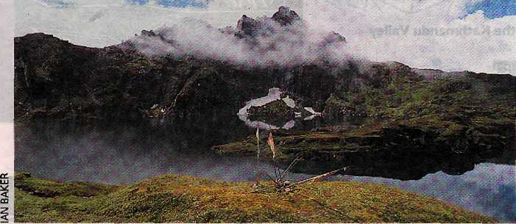
Kailash of the East
AT THE SOUTHEASTERN TIP of Tibet where the Tsangpo-Brahmaputra river bends around the eastern-most Himalaya to descend into the jungles of Assam, lies a mountain that many Tibetans consider more holy than the great Mount Kailash.
Kailash is revered by Buddhists, Hindus, and Jains as the axis-mundi, whose circumambulation dispels the accumulated sins of a lifetime. A thousand miles down the Tsangpo from its source near Kailas.h, stands the mountain called Kundu Dosempotrang (The All-gathering Palace of Adamantine Being), in a region Tibetans revere as Beyul Pemako, the Hidden Land of Lotus Splendour.
According to Tibet's sacred geography, the mountain lies at the 'heart chakra¹ of the tantric meditational deity Vajravarahi, whose body forms the esoteric landscape of the surrounding region. Vajravarahi's spiritual consort, Chakrasamvara, is said to be seated on top of Mount Kailash. The two mountains conjoin the geographical poles of the Tibetan environment—from high altitude desert to lush subtropical rain forest.
In contrast to Kailash¹ arid surroundings on the Chang Tang, Kundu is situated amidst dense subtropical jungles and a labyrinth of swamps and lakes. Only the most intrepid of Tibetan pilgrims succeed in reaching this holiest of mountains, and many die en route, victims of the terrain, poisonous snakes, or the aconite tipped arrows of hostile tribes.
It was the great sage Padmasambhava who pronounced Kundu as the greatest of all

pilgrimages. According to a 16th century text, "Even taking a single step towards this mountain ensures liberation from the lower realms of existence."
Kundu first came to the attention of non-Tibetans in 1881, when the Sikkimese surveyor-spy Kinthrup, employed by the British government, made forays into the Tsangpo gorge region in search of fabled waterfalls. Captain Henry Morshead and Lieutenant F.M. Bailey heard of the mountain again while on an arduous crossing into Tibet from Assam in 1913. Bailey's account of his journey is thought by some to have been the inspiration for Shangri-la in James Hilton's Lost Horizon, Pemako is indeed the Tibetans' own Shangri-la.
The picture of Kundu shown here was taken by writer Ian Baker, who, with fellow American Hamid Sardar, in August led an expedition to the inner regions of Pemako. Traveling south from Tibet, they crossed snow passes and descended into a tropical landscape, a unique ecosystem rich in medicinal plants and rare animals, including takin, red panda and tigers. After days in the jungle and the perilous crossing of wild tributaries of the Tsangpo, following ancient pilgrimage routes so deep in the wilderness as to make all politica! claims to the area seem superfluous, they arrived in Pemako, where they were granted a view of the sacred mountain Kundu Dosempotrang, the Kailash of the East.

This Ship of Nepal!
A RECENTLY-PUBLISHED book on Buddhism's early days seems to confirm the scholarly speculation that merchants from Nepal, most likely Newars, were seafaring, traders who sailed from the ports of North India to as far away as Sumatra around AD 1100.
An article by scholar Hubert Decleer on "Atisa's Journey to Sumatra" in Buddhism in Practice (Princeton University Press, 1995), refers to the master's j oumey to Southeast Asia to seek the teacher Dharmakrti (also known as Guru Suvarnadvipa). Atisa, who lived at the start of the century that saw the destruction of Buddhism in the Subcontinent, is seen historically as a champion of the Buddhist dharma who helped in its spread to Tibet.
Atisa's journey over the sea to Sumatra is fraught with danger, because Mahesvara (Siva), apparently angry that Atisa has left India in pursuit of the dharma, tries to block his pas-sage. At one point, Siva appears on board and with foreknowledge proposes to end a ferocious storm if Atisa promises to return to northern India, and not to go to Tibet or visit islands like Sri Lanka. As reported by Atisa, Siva says:
Do not ever travel to the Land of the Snows;
And stop your journey on this Nepalese ship.
Do not go to either Copper Island or any oj
the other small islands
Stop this continuous roaming!
Bfirum hri yaksa, listen to this!
At another point, Tara, Atisa's personal deity, appears before him simultaneously in all her 21 forms. They make the second reference to Nepal found in Atisa's account:
Also if that child with the blue face again recovers, beat her! They said, adding: "From this day forward, do not allow her outside this ship of Nepal!"
There seems no doubt that Nepali ships,
indeed, rode the high seas in the time of sage
Atisa. Back then, land-lockedness was less a
problem than it is now. b
The first published photograph of Kundu Dosempotrang and the 'soul lake' at its base.

46
NovemberiDecmber J995 HIMAL

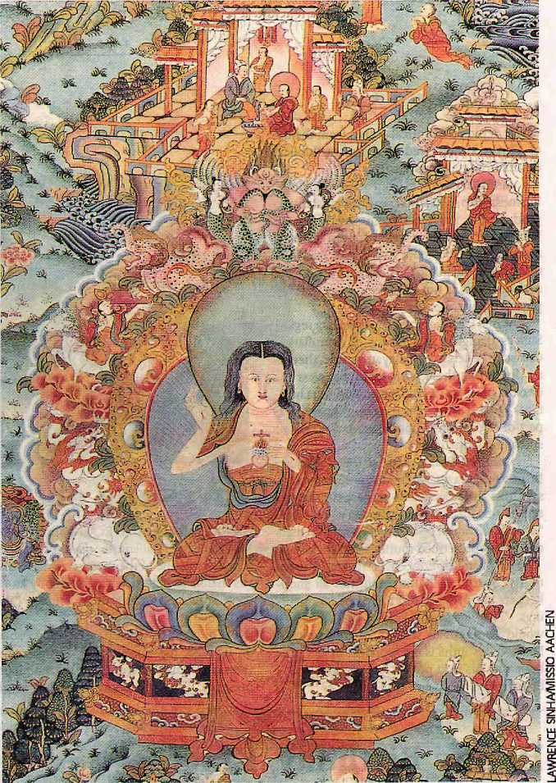
NOT LONG AGO, an American visitor to a Dolpo village gomba, noticed a thangka painting hanging, not in the shrine, where such paintings are traditionally hung, but in the bedroom, alongside non-religious posters. A closer look explained why this was the case. It was a Christian thangka, which some travelling Westerners had given to the gomba residents.
Thangkas, the distinctive Buddhist wall hangings of the Himalaya, evidently are rapidly evolving. The traditional thangka is characterised by the mandala, or bhavachakras (wheel of life), done in intricate red, blue or gold. They functioned as aids to enlightenment, and for centuries, religipus artists created meticulous paintings in which each hand gesture, facial expression, posture, colour and accoutrement had symbolic significance.
Refugee Generators of South Asia
WHILE CERTAIN African countries have long dominated press coverage, South Asian countries with much smaller areas and populations generate an unexpectedly high number of refugees. This is clear from the The State of the World's Rtju.ge.cs, released by the United Nations High Commissioner for Refugees in late November.
Afghanistan tops the list for the country of origin of the highest number of refugees: 2.7 million. Tiny Burma, Sri Lanka and China/ Tibet, and tinier Bhutan, make the top-20 worldwide list of refugee exporters. The figures become even more interesting when you compare the refugee numbers according to each country's population size. Thimphu, for example, claims a population of 700,000, which means that a seventh of all Bhutanese are presently refugees.
Nepal, which does not generate any refugee flow, makes the top-25 list as a recipient nation, housing 103.3 thousand Lhotshampa refugees. The UNHCR report, however, does not count Tibetans refugees being hosted by Nepal.

 | I | \ |  | Jill
 | Afghanistan Burma Tibet Bhutan Sri Lanka Bangladesh
Born-Again Thangkas
As tourism fuelled the demand for thangkas, the supply increased. Mass production meant deteriorating quality, but the motifs remained firmly Buddhistic. The recent injection of the biblical theme, however, takes thangkas in a wholly different direction. Christian thangkas are now available in specialist shops in Kathmandu, and are popularised in postcards and calendars published by Missio Aachen, a Germanproselytismg group. Depictions of Jesus, Mary, the crucifixion, and the baptism provide the subject.
Many of these thangkas were painted by Lawrence Sinha, born a Christian in Darjeeling, who became inspired after seeing tourists eagerly purchase Buddhist thangkas. He decided that Christian paintings done in the traditional genre would be a worthy, and lucrative, addition to the proselytising cause. Sinha says it tookhimsixyears to complete his first thangka,

HIMAL NwemberlDecember 1995
47

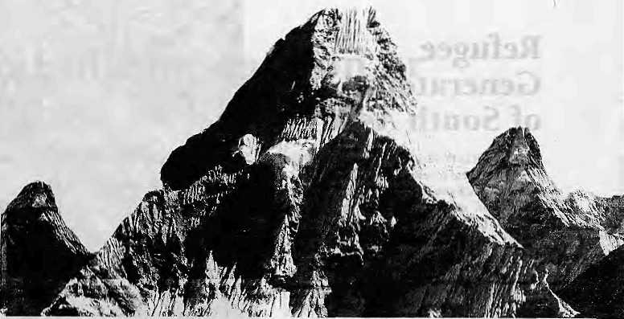
which depicted historical scenes from the life of Christ. He received guidance on biblical details from missionaries.
Sinha takes orders from across the globe. Business is up, and Sinha now has assistants to produce the paintings at his workshop in Baneswar. Prices range upwards from US$300, making his works more costly than Buddhist thangkas in the market. The main purpose, he says however, is not to make money, but "to preach the word of god."
While Christian missionaries may regard Sinha's thangkas as a means of assimilating Christian beliefs to Himalayan culture, there is no doubt that these born-again thangkas cut into the heart of the Himalayan Buddhist heritage. What has for centuries been an integral part of Buddhism is now a pictoral means of spreading Christianity.
Min Bahadur Sakya, of the Nagarjuna Institute of Exact Methods in Kathmandu, says this new departure represents the destruction of Buddhism's very essence. "Thangkas should be based on canonical texts and follow prescribed routines," Sakya insists.
In Thangka Row, over in the Thamel
tourist quarter of Kathmandu, not all shop
keepers are dying to sell the Christian paint
ings. "Paap laagchha!" one of them cried. It
would be sinful to sell Christian thankgas.
Meanwhile, Sinha is not worried. In fact, he's
busy with his next project, which he says will
be (surprise) a Muslim thangka. b
Investing on Ama Dablam
GIBRALTAR HAS THE ROCK, and Nepal its Mountain. Ama Dablam, the queen of Khumbu, is becoming one of the most recognised massifs thanks to big-buck advertising by an offshore investment management company called Perpetual.
The company, which carries Ama Dablam on its logo, has a multi-year, big-spread ad campaign that relies entirely on the mountain's presence. The series shows 'Mother's amulet
for deities' in different guises—as a rock being chiselled to shape, or as the frilly frock of a flamenco dancer. At other times, Perpetual uses photographic manipulation to show a mountain range made up entirely of look-alike Ama Dablams, or an Ama Dablam archipelago. Ceri March, a Perpetual spokeswoman in London, told Himal that back in 1983, the company decided that a mountain would best symbolise the growth of its portfolio of funds.

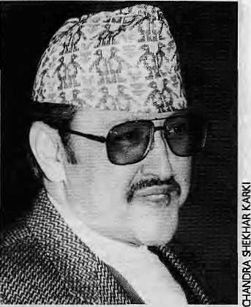
Happy Birthday, King!
SHREE PANCH Birendra Bir Bikram Shah Dev, whose 50th birthday is to be marked with much fanfare on 29 December under the direction of a 170-member celebration committee headed by the Prime Minister and including all living past Prime Ministers, seems well-ensconsced in his constitutional throne. As he attains half-century, and his reign approaches 25 years, King Birendra has reason to be satisfied with having successfully overseen his kingdom's transition from absolute monarchy to petulant democracy. While talk of the sinister "palace hand" continues to occassionally titillate the marketplace and the king's presence in Nepali politics remains palpable, the conventional wisdom at Putali Sadak is that monarchy is the one constitutional entity in the new dispensation that has played its part without major lapse. May it remain so in the next half century as well, Your Majesty. t
Lion Icon
A STYLISED LION waving from his 15-foot granite pedestal is about to join the all-seeing Buddha eyes and the pagoda temple as a immediately-recognisable Kathmandu icon.
The lion was placed on the Kathmandu side of the Bagmati river by Nepal's first Prime Minister, Bhimsen Thapa, in AD1810, to mark the construction of a wooden bridge across the Bagmati river. Even though the gold-leafed statue is not of real antiquity, and does not have religious significance unlike most other Kathmandu statuary, it is well-crafted. The lion stands in dramatic pose, paw raised in greeting to those crossing over from Patan.
For many years, the statue escaped notice because it stood along the approach to the old bridge. The construction of the new bridge, built withjapanese aid, which opened in early December, led to changes in the approach

48
November/December 1995 HIMAL

New, Improved Bibliotheca

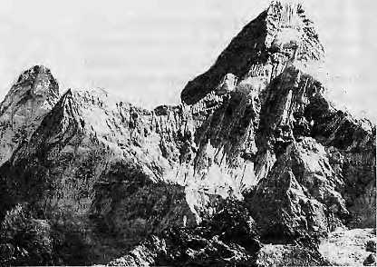
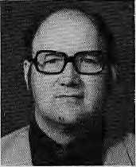
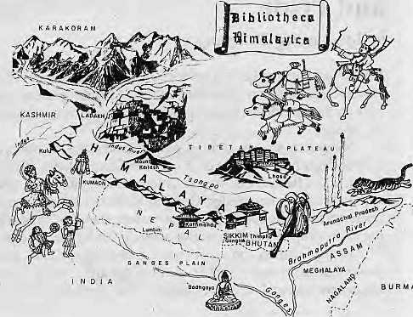
"It was then decided to look for a visual device, in the Form of a photographic image, that represented strength, solidity and durability." All these qualities were found in Ama Dablam, says March. "This mountain gives meaning to the proposition that we are offering stability, durability and challenge. Ama Dablam's shape is now instantly recognisable as 'The Mountain' within financial circles in the West,
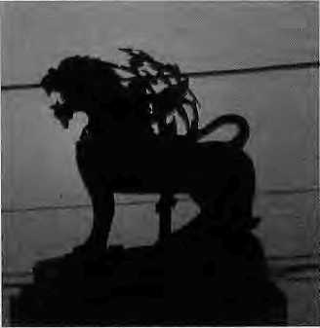
roads, which has resulted in the lion's new prominence.
Kathmandu commuters have just begun to discover the lion as he waves them past, b
HIMALAYAN BIBLIOPHILES can rejoice-Bibliotheca Himalayica is back! Connossieurs who had despaired at the comatose status of the series have ample reason Lobe pleased with the publication of two new books in a 'modernised¹ format, The Treasure Rzvealerof Bhutan by PadmaTshewang eta!, and Development Studies by Don Messerschmidt.
The series was conceived in 1969 by Hallvard K. Kuloy of Norway, who worked with UN1CEF in India and Nepal from 1968 to 1979. As he told Himal, was a result of the fact that Kuloy had time to spare during his stint in New Delhi. "I did not play golf nor had a family to worry about, so 1 spent a good deal of time reading among the cool stacks of the Indian National Archives, and the somewhat wanner library of the Archaeological Survey of India," Through a large circle of "witty, generous and knowledgeable friends", Kuloy was introduced to the wonde r of Himalayan civilisations. Soon, he was preparing an anthology of old writings on Tibet and the Himalaya, but the material was so overwhelming that he abandoned the project. "I thought, why not reprint the books instead? That is how we first published Colonel Kirkpatrick's An Account of the Kingdom ofNepaul, which ■was an instant success," Kirkpatrick was followed by Sarat Chandra Das'Jou r-ney to Lhasa and Tibet and John Ware Edgar's very rare Report on a Visit to Sikhim and the Thibetan Frontier.
Kuloy
" In retrospec t it is easy to see why we succeeded: we used better than average paper, found a good bookbinder, and we charged a modest price in relation to quality," says Kuloy.
t= When Kuloy was
q transferred to Nepal in
§ 1972, he approached
■s Ratna Pustak Bhandar,
< the Kathmandu pub-
2 Usher, and asked them to take up Bibliotheca Himalayica. "We were a bit wary at first, but it worked outbecause back then it was easier to sell
specialised books on the Himalaya," says Govinda Shrestha of Ratna.
Bibliodieca Himalayica began to lose steam in the late 1970s, Himalayan overexposure resulted in a surplus of touristic publishing which cashed in on exotica, and scholarly works remained on the shelves. At the same time, publishers from India learned that a market existed for long-forgotten books, and they started issuing reprints of their own. What Kuloy calls the "reprint avalanche" swept his pioneering series out of the market.
Never one to give up, during a visit to Kathmandu in 1993 Kuloy discussed strategy with Ratna. Recalls Kuloy, "The answer was cooperation between small publishers, not competition, and to bring our published material up to contemporary standards." Enter, EMR Publishing House, a collaborative effort of three Kathmandu-based publishers— Educational Enterprises, Mandala Book Point and Ratna. Together with a new lease of life, Bibliotheca Himalayica was also given a new look.
The newly energised Bibliotheca
Himalayica plans to bring out three titles in the
next few months, including the 'bestseller' of
the series, Ekai Kawaguchi's Three Years in
Tibet. The new volumes retain the
Bibliotheca Himalayica trademark picture
map of the region on its inside covers, but
everything else is different. The sleek pa
perbacks are a far cry from their stodgy
hardcover forbears. They are also more
expensive, but the Western booklover, at
least, does not seem to mind. is

HIMAL November/December 199S
49

Gurkha Collects His Dues

"YOUR heart must be as big and brave as a lion's. I am so glad you and the other Gurkhas were on our side," said Prime Minister John Major to Victoria Cross winner Havaidar Lachhiman Gurung. Major then gave Gurung a check for £100,550, which the latter accepted with his one good hand.
The ceremony held on the steps of 10 Downing Street on 19 August was the culmination of a Gurkha fund-raising drive that coincided with the fiftieth anniversary celebrations of the Second Great War's ending, and the havaldar from Chitwan was at it center. The sum he received was collected by the readers of the Sunday Express of London.
Lachhiman Gurung is
one of the 13 Nepali recipi
ents of the Victoria Cross. He
received the honour forhold-
ing his bunker and killing 31
enemy soldiers in Taungdaw, -
Burma, against a ferocious
Japanese attack. He fought
alone for four hours, even
though his right hand was
shattered by a grenade 5
explosion. g
After the war, having z also lost the use of an eye and jr
an ear besides his hand, Lachhiman left the army and retreated to his village of Dahakhani, 13,000 feet high up in the Mahabharat Lekh. He farmed to provide for a family of six, traveling down to Bharatpurto collect askimpy pension. In recent years, due to advancing age he had to ride piggy-back on one of his sons for his pension trips.
All that has changed now. As the Gurkha grapevine spread die word about Lachhiman's state, his regimental comrades decided to do something about it. It helped that his regiment had served under both the Indian and British
flags, as the 8th Gorkha/Gurkha Rifles, and Lachhiman is the only one in the whole lot to hold a VC.
The 8th Gurkha Rifles Association of UK was able to raise {pounds} 4,000 and the 8th Gorkha Rifles Association of India (which includes Field Marshal Sam "Bahadur" Manekshaw) collected NRs. 700,000. It was decided that a house should be built for Lachhiman in Bharatpur itself, between the Indian and British pension camps.
Enter, the Sunday Express came in. Reporter Deborah Sherwood arrived in Lachhiman's village to do a writeup, and she delivered an evocative tale of an old warrior whom- the world had forgotten. The article asked for contributions to build the house in Bharatpur, to £16,000, with surplus funds to be ploughed into the Gurkha Welfare Trust to help other hapless Gurkhas. The story struck the right lag chord with Express readers, and a magnificent total of £100,550 was raised, which was what passed hands on the 10 Downing Street steps as part of the V-J Day events.
When it rains, it does pour, even
on old Gurkhas. b
tachhiman and his wife outside their Dahakhani house.


Sikkim with Love, Respect and Pride
\>y Lyangsang Tamsang
; Unsatisfied with the Lepcha names for Sikkirn published in Himal's
iPLACENAMES column (May/June. 1995). 1 hereby present a short
note on the true meanings and pronunciations of the Lepcha names
: for Sikkirn. !:..:
Numerous writers, authors, scholars and anthropologists have published on the Lepcha, the original inhabitants of Sikkim, Darjeeling :: District, arid Ham in east Nepal. Unfortunately, most have written ;: without in-depth knowledge.¹ Quoting inaccurate information from .;: reference books by non-Lepchas has become the norm, thus distorting the appropriate and attractive names given by the Lepcha.
In fny opinion, only two non-Lepcha writers have written ■ books that throwuseful light on our language and culture. They are: ; .[ lieutenant General G.B.Mainwaring (The Grammar of the Song.
(Lepcha) Language, Dictionary of Welttpcha Language, 1876); and^
Rudranand Thakur (Himalayan Lepehas, 1988},:
Letmeclarifythetrue meaning of the two Lepcha names for .;
Sikkim and their correct pronunciations. We, the Lepcha, call;
Sikkim Nye Maayel Lyaang. 'Nye' means¹ holy, sacred, paradise..;
'Maayel' means hidden. 'Lyaang' means land.countryor earth. : Two Lepcha authorities, K.P. Tamsang(please; not 'Tamang') i:
and A: ppning agree that Nye MaayeJ Lyaang means'The.Land of the-;
Hidden Paradise' and 'The Garden of Eden', respectively,¹ in their"
books the Unknown and Untold Reality tibout the Lepchas (1983) and ;
Lepcha, My Vanishing Tribe (1987). . Another Lepcha name for Sikkim is 'Renjong Lyaang.' Here, ;
'Ren' meanshonourable, respectable. 'Jyqng'means, living, or 'those :
whblivem¹. 'Lyaang'; meansland, country, or earth. Thus,Renjyong ;■
: Lyaang means 'The: Landof the Honourable People'.ie., the Lepcha; ?.
During ceremonies and functions, :we :use! and: say, loud and clear,^{i:}
'Nye Maayel Renjyong Lyaang>: to denote the greater Sikkim, with
love, respect, and pride, strictly in that order. '.: May li on behalf of the Lepcha people, appeal to those inter-.:
ested, up-and-coming writers to cany out an intensive field study :
aboiit our corrrmunity under an able Lepcha informant, to study the '. Lepcha language, and then Avrite the truth about the .Lepcha.: : : £

50
l.
November/December !995 HIMAL





V

SUMMIT HOTEL
and SUMMIT TREKKING PVT. LTD.
KUPONDOLE HEIGHT, LALITPUR P.O. BOX 1406, KATHMANDU, NEPAL
TEL:521894, 521810 FAX: 977-1-523737, TLX: 2342 SUMMIT NP
ran


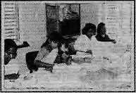
Himalayan High Treks
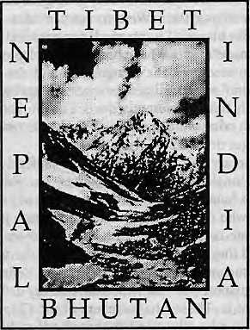
Free Catalog (800) 455-8735
Outside the U.S.A. & Canada please call: 00l.4l5.86l.2391 orwnletous:
Himalayan Hitzh Treks
241 Dolores Street, San Francisco CA
94103-221I U.S.A. Thanks!

■■■■I
Stationary ana* Decorative Handmade Nepati paper products I
Saue the Under-Priuileged
people of Nepal.
hAndmade
Paper products
P O Box # 10243 Kalankisthan,
Kathmandu, Nepal
Tel / Fax: 00977 -1 - 278 088

V o



BONDA HIGHLANDERS' CONDITION, as
they tachh linear time, is discussed by the late Indian sociologist Bikram Namyan Nanda (1954-1994) in Contours of Continuity and Change: The Story of the Bonda Highlanders, Sage Publications, 1994 pp 208-209.
Given (such) a void in the structure of consciousness, and the myth of development which returns the highlands rs to the mythical world of spirits, any attempt by the highlanders to escape their present predicament arising out of their own involved discourses of space, time, work and experience of their meanings would indeed be vain. Lacking their grip over their own language of description of their present, the minimum, margin to decide their existential conditions in the present, that is so necessary a precondition to decide their destiny, the Highlanders are unable to project a notion of the future--a future in which anything is possible insofar as the impossibilities are everywhere. The islands of linear time that strike tike match-sticks in the dark landmass of life shed light upon segments, but not on the whole continuous process of which these segments are a part. That they can themselves take control of and thereby decide the future of the highlands is unknown to them. Perhaps capable of revolt at the official wickedness, their living social and symbolic conditions do not provide the possibility of a critical consciousness. Will the highlanders be able to impute their sufferings to a system explicitly understood as unjust and inadmissible? Or will they accept their suffering as natural and so total that there is no possible escape from the 'natural' order of things.
The political conceptions and symbolic associations of the highlanders are locked up in the logic of the social transformation... This process of transformation subjectively denies and objectively prohibits the possibility for highlanders to view their situations and figure out sufferings. Between their attitude to their circumstances and their material conditions falls the veil of a diabolical development. The discourse of such a development denies them their time and leisure. It devalorises the values of their labour power and vociferously violates their collective values associated with labour. It privatises their collective and symbolic environment and campaigns for the pragmatism of privatised production. Ironically, or not so ironically, in undermining the traditional production practices in the highlands, it would probably unfurl the flagofwhat is truly tribalism, as we see in some other parts of the country.
Quivers of agony Puts poetry Upon supple steel What is theory? Pathos... Versifies verbs Memorises melancholy Comments on metaphor!
Well, what of the possible. When pathos is inevitable?
If impure poetry
Offends mastery in theory
How can the victim
In the given
Vocalised in the vernacular,
Proficient in the particular.
Trumpet the song of silence.
Listen to what seems unfamiliar;
Voice the possibility of an impossibility?
■ HIGGELDY-PIGGELDY DEVELOPMENT is
better lhanjorce-jed Westernised models, writes cultural theorist Michael Thompson in Water and the Quest for Sustainable Development, edited with Graham Chapman (Mansell, London, 1995, ISBN 0 7201 2191 4).
We in the West are so accustomed to offloading our obsolete technologies (car assembly lines, for instance) and our unfashionable ideologies (planning, for instance) on to Third World countries that we find it difficult to entertain the possibility of anything valuable ever coming the other way: 'from them, to us'. That, however, is what is happening now with the contradictory certitudes approach. While U.S. Congressmen continue to demand 'one-armed scientists' (so they cannot say 'on the other hand'), and British MPs still rant on about "bogus professors'(by which they mean those recognized experts who happen not to share their particular certainty), social foresters in Nepal are actually getting the trees to grow systematically modifying their 'Western science' idea of what a healthy forest looks like until it can mesh constructively with the villagers' 'home-made' idea of what a healthy forest looks like. Out go the eucalyptus seedlings, the straight line and the boundary fences; in come wind-seeded indigenous species, higgeldy-piggeldy layouts, and locally funded forest guardians. The plurality of problem definitions, in other words, is seen as a valuable resource, not something to be got rid of before work can begin.
This is not to say that all the Himalayan policy actors have abandoned their 'single definition¹ approaches, but only that the plural rationalities framework is now in place: both in practice and in theory. Those who define the problem as 'too many people¹ are now able to debate constructively with those who see it as 'not enough food', and they are able to agree that, given the scale of the uncertainty that surrounds the facts at issue, both definitions are legitimate. The situation is similar with contradictory definitions of what development is. Those (the members of the Chipko Movement, for instance) who advocate land-based self-sufficiency are able to countenance those (the 'Trade Not Aid' campaigners, for instance) who favour a resurgence of the intensive trading that lay behind the original emergence of the Nepalese kingdoms, and both are then able to connect their arguments with the views of those (the Hunzas of the Pakistan Himalaya, for instance) who see development aid as a way of expanding their agricultural production, not in order to become self-sufficient, but in order to break out of their mountain fastness and into the global market-place.

NovembetlDezmber 1995 HIMAL

.

Nor are the pluralized people of the Himalayan region just sitting there waiting for the debate over what development is to be resolved before they can start to do it, The self-sustainers (the 'tree-huggers' of the Indian Himalayas, for instance) are getting on with sustaining themselves; the traders (the Manang-bhotis who live in the remote valley behind Annapuma, for instance) are merrily flying Apple computers into Kathmandu from Thailand and Tibetan carpets out to New York; and the exuberant agriculturalists of Pakistan have been so successful in breaking oik that Hunza apricots can now be found on the shelves of any London wholefood store.
That all this is happening in the Himalayas is not in dispute. The dispute is over whether or not it is sustainable and, if it is not, what needs to be done about it. However, since the facts that would decide that are well inside the pale of uncertainty, each actor is free to construct his or her own answer.
■ THE CORRUPTIONS OF BUDDHISM, as de-
scribed in The Outline of History by H. G. Wells, Gassel! and Company, London 0951) (revised edition, pp 408-409), provides an alternative view of Buddhism to that of Bernardo Bertolucci's The Little Buddha,
...Except for Gautama's insistence upon Right Views, which was easily disregarded, there was no self-cleansing element in either Buddhism, Taoism, or Confucianism, There was no effective prohibition of superstitious practices.spirit-raising, incantations, prostrations, and supplementary worships. At an early stage a process of incrustation began, and continued. The new faiths caught almost every disease of the corrupt religions they sought to replace; they took over the idols and the temples, the altars and the censers.
Tibet today is a Buddhistic country, yet Gautama, could he return to earth, might go from end to end of Tibet seeking his own teaching in vain. He would find that most ancient type of human ruler, a god-king, enthroned, the Dalai Lama, the "Living Buddha". At Lhasa he would find a huge temple filled with priests, abbots, and lamas-he whose only buildings were huts and who made no priests--and above a high altar he would behold a huge golden idol, which he would learn was called "Gautama Buddha!" He would hear services intoned before this divinity, and certain precepts, which, would be dimly familiar to him, murmured as responses. Bells, incense, prostrations, would playtheir part in these amazing proceedings. At one point in the service a bell would be rung and a mirror lifted up, while the whole congregation, in an access of reverence bowed lower...
About this Buddhist countryside he would discover a number of curious little mechanisms, little wind-wheels and water-wheels spinning, on which brief prayers were inscribed. Every time these spin, he would team, it would count as a prayer. "To whom?" he would ask. Moreover, there would be a number of flagstaffs in the land carrying beautiful silk flags, silk flags which bore the perplexing inscription, "Om Marti padme hum," "the jewel is in the lotus." Whenever the flag flaps, he would learn, it was a prayer also, very beneficial to the gentleman who paid for the flag and to the land generally. Gangs of workmen employed by pious persons, would be
going about the country cutting this precious formula on cliff stone. And this, he would realize at last, was what the world had made of his religion! Beneath this gaudy glitter was buried the Aryan Way to serenity of soul.
i BUT THIS WVERWAS ALWAYS FILTHY, wrote
Kabir, the fifteenth century saint-cum-poet ofBenaras who ridiculed all formalised religion, who was wiiling to say it out loud that the Ganga stank. Bach then, you could be politically incorrect. (Re/: Hess and Singh, 1986.)
Pandit think before you drink
that water The house of clay you are sitting in —
all creation is pouring through it.
Fifty-five million Yadavs soaked there,
and eighty-eight thousand sages,
At every step a prophet is buried.
All their clay has rotted.
Fish, turtles and crocodiles
hatched there. The water is thick
with blood. Hell flows
along that river, with
rotten men and beasts.
Hi HIMALAYAS, a poem by Eelum in Cornice 1995, annual magazine of the Rato Bangala School in Patan,
The thing 1 always love to see, Which always fills me up with glee. The thing which tourists love to climb. And have the most tremendous time.
It reaches out to touch the sky, It's higher than a bird can fly, Here lies the tall Mount Everest, Which is taller than all the rest.
In the northern part of Nepal it lies. Quite of a lot of space it occupies, It's full of glaciers, rivers, ice and snow. If the sky is clear, we can see them in a row.
It has very cold weather. It is whiter than a dove's feather, There we find many yaks, Carrying loads of heavy sacks.
i
Here we find our national flower. It is higher than the Twin Tower, It is bordered by Tibet, And as a mountain range it's perfect.

HINIAL November/December !995
S3


Northwest makes it easy to go to America. With a choice of 8 gateways. And connection to 200 cities beyond.
Choose a connecting city that suits you best: Bangkok, Hong Kong or Singapore.
generous free flight plan there is. General Sales Agent in Nepal :
Ma I la Treks,
Malta Hotel Arcade,
Kathmondu, Tel. 418 389
Northwest has daily 747 flight via Tokyo or Seoul straight to the U.S.A.
Be sure to ask about WorldPerks, the most


NORTHWEST AIRLINES
SOME PEOPLE JUST KNOW HOW TO FLY.⁵'

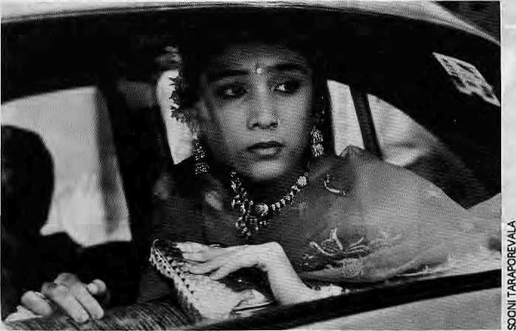
are effective organisations, but all are Kathmandu-based. On-the-ground rural organizations such as SAFE, General Welfare Pratisthan, MANK, EASE, Tripura Sundari and DSS weren't consulted. Why? Because they don't speak polished English?
The researchers visited Kathmandu as usual, Nuwakot as usual, and border towns as usual. Wake up, folks. Trafficking from Nuwakot and the districts around the Kathmandu Valley still exists, but it is no longer the main show. Pressure on traffickers and increased market demand has spread girl collection all over the country, especially into the Western, Mid-Western and Far-Western Regions.
Check it out in Bombay. The majority of new girls are not Tamangs anymore—in fact a high proportion are from poor Bahun and Chhetri families. In Calcutta, too, there are fewer Tamangs; many are Bahun-Chhetris and Rai-Limbus funnelled through Dharan, one of Nepal's sin cities. The trafficking industry has aggressively evolved, and it is time to focus interventions beyond Nuwakot.
Sniffing for traffickers, the researchers went touring to three "border towns", one of which, Butwal, is nowhere near the border. But think a minute. No self-respecting
Human Rights Flavour of the Month
Rape for Profit: Trafficking of Nepali Girls and Women to India's Brothels
Human Rights Watch/Asia 1995
Review by John Frederick
This book is about tragedy, major cragedy. Unfortunately, Rape jar Profit is also a tragedy, and not a minor one. The world listens to Human Rights Watch and HRW wasn't watching, it was dozing. The book will have impact, and will solidify an obsolete perception of the trafficking industry in Nepal.
The book is a competent summary of a handful of reliable data and a shovelful of questionable data and outdated conventional wisdom. You've seen it on TV, you've read it in Newsweeh: poor Tamang girl from Nuwakot gets abducted to India and ends up an HIV-positive brothel slave. It is clearly a good story, it keeps selling. However, it is a portrait of trafficking circa 1989, and doesn't reflect the radical changes the trafficking industry has undergone since—changes we must be aware of if trafficking is to be confronted.
The onus must be put upon the researchers, who followed the well-worn path of journalists and production crews pursuing the human rights flavour of the month. They chose the usual sources for their information: the NGO's that show up at all the seminars. All
Chanda Sharma 35 Solassal \nSalasm Bombay by Mlra Nalr. Sharma's portrayal introduced the prototypical Nepali prostitute in Bombay to an international audience for the first time.
trafficker is going to be hanging out in a border town, except for a 2 a.m. cup of tea on the way south with his prize. We don't yet know the trafficking hubs, but we can guess, and the towns selected by Human Rights Watch probably aren't high on the list.
If trafficking is to be stopped, we need to know where to stop it. We also need to know what causes it_'poverty' is a lazy answer. The vast majority of Nepalis are impoverished, but we don't see girls lined up hooking along the roadsides. To design intervention, we have to look further: at the pervasive discrimination against females, at the disruptionof traditional family structures, and at violence against women and girls in their own communities.
Rape for Profit's recommendations are limited to central government and police activities. They are viable recommendations, although neither party gets a medal for outstanding devotion to citizens¹ welfare. The only reference to community activities is negative: local opposition to anti-traffickers in Nuwakot. In Nuwakot, selling daughters is an established business—of course, there's opposition. In the other 90 percent of the country, trafficking is new and communities are angry. They can resist trafficking, especially with support.
UNICEF, with Nepali NGO collaboration, is promoting the establishment of a community-based sentinel system. Local NGOs are conducting legal education at the grassroots level, to empower communities to bust traffickers if the cops won't. Communities can't wait while first-world nations and the central government investigate, monitor, establish, accede to and ensure. Traffickers, sex-starved clients and HIV aren't waiting.
The scene has changed , and Human Rights Watch/Asia should have picked that up. Rape /orPro/itpaintsahorrific portrait of trafficking in Nepal. Unfortunately, the reality is farworse. The book prescribes New York solutions to the problem. Fortunately, grassroots solutions are possible. The researchers did a skilful, sensitive job of presenting the facts they collected. Wish they'd do the book again, and collect up-dated facts this time.
t>
John Frederick Is a Kathmandu-bused writer specialising in gender and children's Issues, Including prostitution anil trafficking.

HIMAL November/December J9S5
55

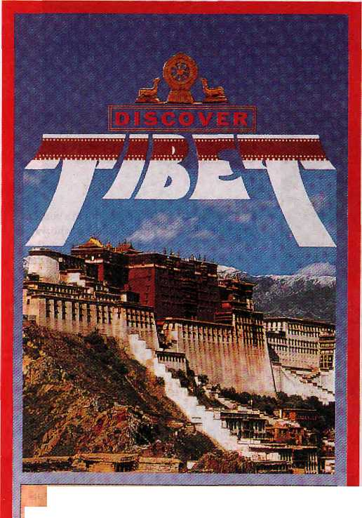
i
THE ULTIMATE ADVENTURE DESTINATION
&
THE HIMALAYAN KINGDOM OF NEPAL, BHUTAN & SIKKIM
Let TIBET TRAVELS &: TOURS, the Leading Tour Operator, in Nepal unfold for you the inner secrets & mysteries of these fascinating lands, people & culture - so different from anything you have ever imagined......
For details contact;

■■■mi iiiiiii
in ■iiiisiiiiiiiiiiiiiiiii in
" AJATUKFS GIFT '■
.;
for youn cup
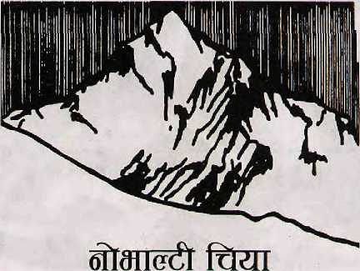
NOVELTY ORGANIC TEA
Hygienic Fresh Leaf & CTC
Consumers need to know
what they eat everyday
First time in Kathmandu
A beverage free from
pesticides and chemicals
Out motfo : (fiow, <z*td Aelfr
Organically grown tea from
Kanchenjunga T.G. Ranitar (Nepal)
owned by small farmers community.

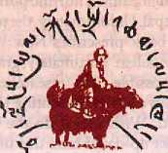
TIBET TRAVELS & TOURS (P) LTD.
P.O. Box 7246, Tridevi Marg, Kathmandu, Nepal
Tei: 231130, 228986, Tlx: 2672 TiBTVL NP
Fax: 977-1-228986/415126
(ALSO AVAILABLE IN TEA BAGS.)

Mktd. By:
Highland Tea Trading Co.
Kathmandu, Tel: 423309
Fax:977-1-419371
Available in Dept. Stores & Tea Houses.
III
■■■ iiiiiiiiiiiiiiinieiiii in
iiiiiii iiiiiii

Gurkhas of Imagination
Warrior Gentlemen: "Gurkhas" in the Western Imagination by Lionel Caplan
Berghahn Books, Oxford 1995 ISBN 1-57181 -852-9, £26
A book about the marginalisation oj a people at home and abroad.
Review by Harka Gurung

Warrior Gentlemen is not merely an addition to the voluminous literature on the Gurkhas of Nepal (see 'The Gurkha Guide' Himaljul/Aug 1991). It presents an entirely new perspective that will provoke those attuned to the stereotyped genre. The term 'Western imagination' in the sub-title of the book may invoke Edward Said's Orientalism (London, 1978), but the reference here is entirely to English or British imagination. After all, the Gurkhas have never served under officers other than British (and Indian after 1948). The extensive bibliography the author provides includes 311 published entries of which only three are non-English.
Caplan's book is well-researched and organised. The introduction is a review of Gurkha texts and Gurkha involvement in British service. The second chapter relates Gurkhas to their homeland in economic, social, and political context. The third chapter is an interesting description of that particular species of British officers who lead Gurkhas. The next two chapters are essays into the image construction of stereotyped Gurkhas. The concluding chapter attempts to synthesise how the text and colonial power are interlinked to produce the imagined Gurkhas.
To begin, the author relates available literature to the social and cultural settings from which the officers themselves come. In this discourse, there are only romantic approvers, since the same 'tatterdemalion bands' (Pemble, 1971, p.28) as Nepalese soldiers are transformed into beau ideal soldiers under the British. One of the most distinguishing features of this literature is the strong sense of disciplined continuity. The series of Gurkha handbooks include Buchanan-Hamilton (1819), Hodgson (1833), and
Vansittart (1894) and their versions on ethnic qualities. Early Gurkha heroic tales and their loyalty to the British are recounted as sacral mantra. The author discovers that the Gurkha is a creation of military ambience.
Caplan, an anthropologist, explains that Nepal has no category of people referred to as 'Gurkhas', only certain ethnic groups preferred in military service. These Mongoloid tribals constitute an overwhelming majority in foreign armies but in Nepal itself Caucasoid Chhetris

predominate. He also clarifies anglophile Jung Bahadur's ambivalent role in restricting Gurkha recruitment by the British. Formal agreement was reached only in 1886, with the accession of Bir Shumshere who sought British support in his power struggle against Jung Bahadur's son.
Gurkha Economy, Gurkha Society
The chapter on 'Gurkhas at home' is of much interest from the Nepalese perspective. Caplan cites anthropological studies and official data on the economic benefits from Gurkha service. On the latter, the officially quoted are some £22 million as annual pay and approximately £,5.6 million as pension. It would be much higher in the case of pay and pension from the Indian army, as Gulmi district alone receives an annual pension of Rs 1,5 crore in Indian currency.
Caplan raises the question of the annual subsidy paid by the British for permission to recruit Gurkhas, a subject on which the Nepal government has remained silent. According to available information, this amounted to Rs 10 lakh annually since 1919 and Viceroy Wavell raised it to Rs 20 lakh per year in 1945. The last time this amount was transferred from the State Bank of India to the Nepal Rastra Bank was in 1976/77 (B. Lai, Himal 2047, Nepali edition, p. 15). However, some information on the British grant made in recognition of the "service rendered by her people and her rulers during World War I" (see Pahari, Himal, Jul/ Augl991) may be useful here. Part of this grant was used for the construction of the Bir Military Hospital in Kathrnandu. This was followed by a grant of IRs 76 lakh after World War II and known as the Post-War Reconstruction Fund, initially handled by a joint Nepal-Indian committee, the Central Coordination Board. It is now operated by India, and the Sainik Nivas building at Thamel and the various District Soldiers' Boards are the outcome.
Gurkha remittance has much economic significance, and the increasing pressure for army service suggests the deteriorating economy of the hills. Caplan cites Macfarlane (Resources and Population, 1976) and Des Chene (In Service of Coionialism, 1988) about past negative attitude to enlistment among the Gurungs. In early days, the headman used to assign youths from poor and indebted households as recruits to the gallawala (recruiting agent). Nowadays, the recruiters are bribed by the wealthy to send their sons to the foreign army.
Another important change is in the direction of flow of army income. Once, the only form of cash flow to rural areas, it is now being diverted to urban areas for investment in real estate and new enterprises. As Caplan points out, there has been considerable migration of ex-Gurkhas to Kathmandu, but they have also spawned colonies in Pokhara, Butwal,

HIMAL November/December 1995

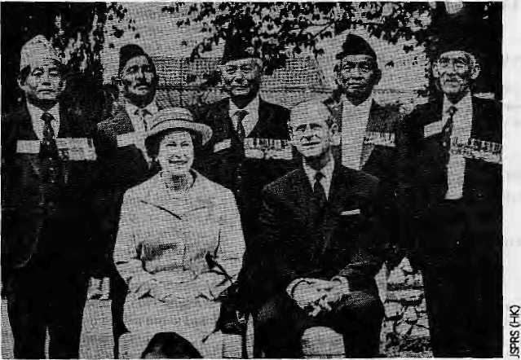
Five Gurkha Victoria Cross holders with Queen Elizabeth and Prince Philip in 1986.
Chitawan, Dharan and elsewhere.
Captantouches on [he social effect Gurkha service has had on rural Nepal. Although there is no clear evidence of demographic disequilibrium on the fertility level, large-scale male out-migration increased the auto nomy o f women of t he soldie ring communities, but also increased their burden. The role of ex-servicemen in spreading education has been noted by several observers. Once illiterate tribal youths, the soldiers exposed to Roman Nepali and the regimental Brahmin chaplain, return home as role models of Nepali speakers and neo-Hindus along with economic resource.
What has remained problematic is the political implication of Gurkha service. The ex-servicemen have co-existed with traditional elites or taken over leadership roles according to local circumstances. In the majority of cases, they have emerged as community leaders. At the national level, they are handicapped by the power strucmreofhigh-castedominance,both in politics and administration. The very fact that military service abroad drains the best talent from their community makes them unable to compete for positions of power within Nepal, This long tradition of seeking the external alternative has certainly marginalised them within Nepal.
On the sociology of Gurkha officers, while the chroniclers continue to emphasise peculiarities of Gurkha ethnicities, the Gurkha soldiersare not necessarily concerned with the pedigree of their officers. Caplan, however, enlightens us on their public school heritage and empire model in education. The accounts of hierarchy among Royal and Indian officers, elitism of Gurkha regiments, their corporate identity, and'muscular Christianity'epitomised in sports, make interesting reading.
The very fact that military service abroad drains the best talent from the martial communities makes them unable to compete for positions of power within Nepal.
Biological Determinism
Some Nepalese were categorised as 'martial races' based on the doctrine of biological determinism. Thisethnic classification was based on hearsay, as only a few mi litary officials were permitted to visit Nepal Despite the close ties of die Rana regime with British India, Nepal had only 153 European (mostly British) visi-toreduring the period 1881-1925 (P. Landon, Nepal, Vol.II, 1928).
Gurkha lite ra tu re consisten tly emphasises the utter loyalty of the soldiers to their British officers, and the bond of trust between them. That the handbooks emphasised simple youths from remote pans as ideal recruits fit well with the pervasive anti-imellectualism of the army. To gain unquestioning allegiance, the Gurkha authors contrasted the colonial subjugation of India with Nepal's spirit of independence The mystic bond was based on paternal patronage in which the British led and the Nepalese followed. A feature article in The Economist (London) last year, suggested raising a UN peacekeeping force of Gurkhas with British officers. The myth of unique loyalty was ex-plodedby the'comparatively dour and quicker anger' of an eastern regiment at Honolulu in 1986, however.
Another burden is the blind bravery of Gurkhas that Sir Ralph Turner memorialised as 'bravest of the brave'. Indeed, since the Victoria Cross was instituted in 1856, Gurkha regiments have claimed 26, and half of these were awarded to Gurkhas rather than to their British officers. These include six Magar, four Gurung.andoneeachLimbu.RaiandTamang.
However, Caplan recounts the fearful memories of ex-servicemen he met in Ham who equate bahaduri (bravery) with medals and not of theBaynes (fro Reward but Honour?) variety, Gurkha courage seems to be related to absolute obedience; and that Gurkhas also experienced fear is clearly presented by P, Onta (Himal,Nov/Dec 1994), referring to the French front during World War L
The 'miniaturisation' process of Gurkhas that evolved from long association with the British is being replicated in the Indian army. In essence, whatever you call it—Gurkha project or Gurkha syndrome—is an expression of Nepal's dependence. Caplan makes reference to Nepali intellectuals who decry Gurkha service as a vestige of colonialism. They need to consider the exploitation that compels these hill men to fight and die for others. Nepalese elites should have certainly realised that 'foreign is not familiar¹ as when, abroad they all have had to resort to Mount Everest, Sherpa or Gurkha to locate their Nepalese identity!
This book is about the marginalisation of
a people at home and abroad. Gurkhas do not
have the choice of mercenaries epitomised in
SirWatterScott'sQuentinDurwarci. Their sup
posed juvenility and exoticism are ideological
constructions harking back to an imagined
time. As analysed by Caplan, Gurkha litera
ture is basically a colonial discourse, t>
li.Gunaig went (oKfng Oeo rge'i Military School, Juttundcr.
His father, aSubedat of 1/3 GurkhaRlfles, fought in Gollipoli
during World War landvtas mentioned In dtspcilthes during
the Wazir'man campaign (1919),

58
November/December 1995 HIMAL






g views

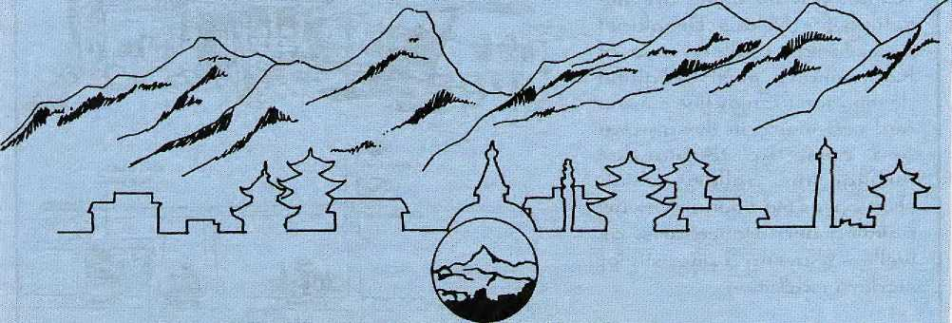

HOTEL SUMMIT
KUPONDOLE HEIGHT, LAUTPUR
KATHMANDU NEPAL
TEL 621894, 521810
FAX 977 , 1 . 523737. TLX 2342 SUMMIT NP

I
1
Chessler Books
Send for our free Mail Order catalog of the world's
largest selection of Mountaineering Books.
New, out-of-print, and rare. :
Also Tibet, Nepal, Polar, Exploration:
. ' I
Guidebooks, trekking maps, videos and more! |
I Please write or call for your free catalog today. |

I Chessler Books
fc P.O. Box 399-112
k Kittredge, Colorado 80457 USA j.
£ (303) 670-0093 FAX (303) 670-9727 {i

1^<z£t'& ^CiteM Lead a wide variety of thrilling rafting adventure on different rivers of Nepal, and in addition to river rafting we also organize other packages. Well every body else does trekking, safari and guided toui"5, we are specialised in white water, rock climbing, and trekking peaks.
Fixed departure twice a week Every Tuesday & Thrusday
For further details contact at

'■A »W



(P) Ltd.

GPO. Box:66l5, Kantipath, Kathmandu, Nepal. Tel: 977-1-220474, Fax: 977-1-227600 Attn: R'nR

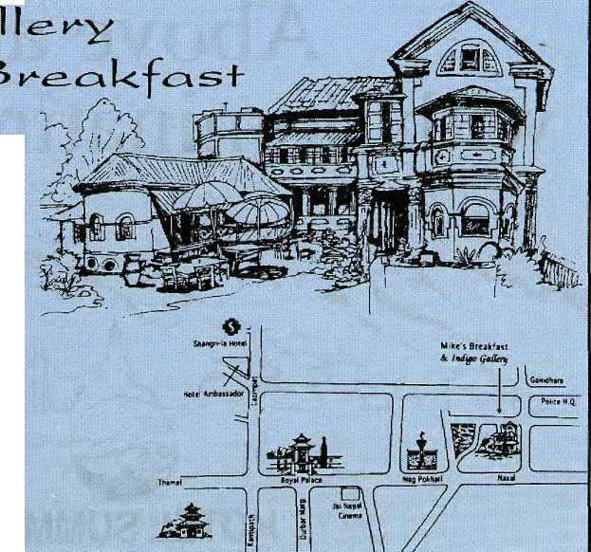
■jA lush goraen qkvci traditional HRanaY/Slewat* Kome aee the setting |oi* A^il<e's Breakfast dnH Jnciigo: CaHeey, two o-^
g
destinations. £Lv\joy fine cuisine and sd|+ music in rt\e ga**cfer\ and coyy\& up to wande*¹ tk^ougk +ke showcases
painting and bronze arts, as Well as showing a divei>si+y of
■:":: x ::: ■::■■ .'■: '..■:'■'. ■ .■! ■' ■ ■': ■' :.' ■:' ..:.. ■:

's Breakfast Opet.A Sun - Sat 7:00am - 5<O0 pm Pizzrt nigKt Tuesday & 1-i-iday 5 f- 9pm Pkone. A2T-58T :
Open Xtiesday & HHctay 9'00 offl.- 9:00 pen jAII dtKei-days 9=00 am-7.00 pw PKone: 421-5S1 Fajc 411-724

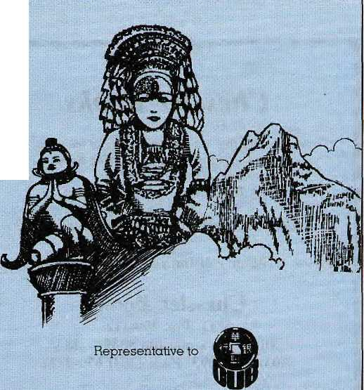
Besides travel related services, we offer Visa and Mastercard services representing Overseas Union Bank, Singapore; for cash advances, travellers cheques and : travel related services.


It's time you knew more about us.
Office hours:
Head office: 9.30 am- 5.30;pm
Branch office: 8.00 am - 8.00 pm
Saturdays & Public Holidays: 10.00 am - 5.00 pm

Alpine Travel Service
■ PRIVATE LiMfTED
KATHMANDU, NEPAL
OVERSEAS UNION BANK LIMITED SINGAPORE

PO Box 1787, Durbar Marg, Kathmgndu, Nepal, Tel: 225020, 2Z5362, Fax: 977-1-223814, Telex: 2409 ALPINE NP BranchQfflce; ^GroundFloor,iSagarrndthdOiuest House,Tharhel, Kgthrnandu :

Review

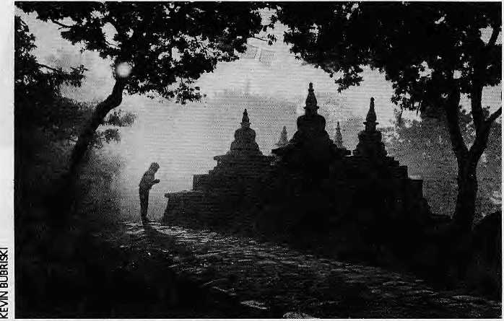
stupas in Kathmandu, Patan, Bhaktapur, and their environs. There is also a glossary of Sanskrit and Newari terms, and a Valley map showing the location of each site.
The hook is the result of Dowman's love of the special ambience of the Valley and its people, blessed by gods and buddhas. He defines a power place as "a focal point of divine energy, where humans can make contact with the realm of the gods" These are sites where "geomantic forces, divine myths, and human history and legend combine to make these locations sources of spiritual revitalization and psychic renewal."
Dowman¹ is particularly good at describing the religious tapestry of myth and custom, woven by various ethnic and religious groups, which covers the Valley and its power places.
Powerful Valley
Power Places of Kathmandu
Hindu and Buddhist Holy Sites in the Sacred Valley of Nepal
Text by Keith Dowman
Photography by Kevin Bubrishi
inncr Traditions International, Vermont ISBN 0-89281-540-X US$39.95
Review by William B. Forbes
Keith Dowman is a well-known translator of Tibetan texts, and a writer on Buddhist lore. Kevin Bubriski is an award-winning photographer, recognise d for his stark, black- and-white portrayals of the face of Nepali dukha. After penning his pioneering guidebook, Power Places of Central Tibet, Dowman has been focusing his research on the "power places" of Kathmandu Valley. In the meantime, Bubriski has turned on to the magic of colour transparency, and taken a new look through the lens at his old hometown and surroundings.
The result of Bubriski's conversion to less harsh realities, and Dowman's continuing research into the less obvious ones, is a handsome over-sized volume, Power Places of Kaihmandu. The text consists of 19 entries detailing a selection of temples, shrines and
Swayambhu stupas in early morning.
Each place is described on several levels of detail. First come the myths and legends, after that a history of the particular site, and finally a detailed description of it, explaining its various features and constructions, and highlighting the artwork in and around the shrine. All in all, this is text to enlighten the layman and stimulate the scholar.
Bubriski's offering is a portfolio of beautiful photographs, some of them quite memorable. The close-ups of the gods, the details of temples and stupas, emerge from the mist of time, fixed, at least for a moment, against the accelerated blur of modern vision. Bubriski is particularly inspired when he catches the divine elation of street festivals, and the serene acts of human devotion.
Here is a photo album which will add significance while adorning the book-lover's cocktail table. Frankly, though, this book only whets one's appetite for a complete treatment of the subject with the photos paying a little more attention to the text. One picture is worth many words, and when one reads that a certain sculpture is "the most impressive of its type in the subcontinent", it would be nice to see it on the page. Also, the camera could have paid more attention to the geomantic parameters (geomancy - divination by means of lines andfi.gu.res), which in some respects are of primary importance, of some of these power places. Swayambhu, Changu,Sankhu,Chobar are all there, but one does not see the hill, the grove, the gorge, etc. There are no sangams, tinhas, or kundas, either.
These and other shortcomings of this
book might be due to its "cocktail table"
presentation. Ke game, as they say in Nepal,
what to do? Now that we have had our cock
tail, we look forward to a full bhoj... b
W.P.Forbes is a Sanskrittsl.

HIMAL November/December 1995
61




Three Exclusive Floors, Each Floor Offering the Widest Selection of Designer Wear and Accessories for Gents, Ladies & Children.
FASHION W E A R H 0 U 5 E
Meera Home, Khichapokhari, Kathmancfu, Tel: 228402

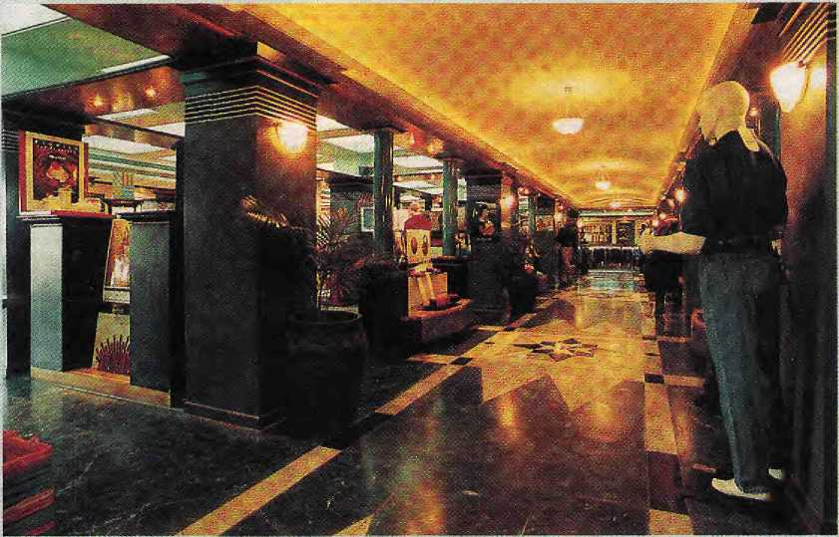

en, women, children's fashionwear, sarees, shoes, linen; cosmetics, perfumes, watches, books, crockery, tools, crystalware, stationery, toys and accessories, electrical appliances, car accessories, household items, kitchenware, general provision, etc.


DEPARTMENT STORE
Tripureswar. Kathmandu Tel: 212826, 215505 Branch outlet - Lazimpat Tel:-415181, 415334 .

M
Know Your Himal

Himals, Mustaghs and Shans of South Central Asia
High magazine has made its second attempt (the first being in 1993) to make one. comprehensive list of all the mountain ranges of the world and their more prominent peaks. Introducing "High Mountain Ranges 1995" in the. July issue, Editor Geoff Hirtles says even this newinventory is not necessarily complete or final.
This seems indeed to be the case, as the High list has 11 himals in Nepal, while Nepali geographers agree that the country's mountains can be divided into at least 23 distinct himals. This could, of course, be nothing more than different readings of what, constitute a mountain range (himal in the Nepal Himalaya, mustdgh in the Karakoram, and shan in Tibet and bordering areas). Similarly, the Western Ghats is included, but its eastern counterpart, having a lower elevation no doubt, is ignored.
On the whole, however. High has made a worthwhile contribution to the greater understanding of the world's mountains and as pan of this last Know Your Himal column, we have decided to print a somewhat lengthy extract of the High compilation including the highest peak in each himal. It is limited to the mountains of Central-South Asia, with the final section referring to himals of other continents for the sake of comparison.
/Ifrun i'UT'i
Tibet, 39"18N/93°40E
Ailim Shan 6.025m
H(!i!.n:' .Hli.'Jrl! S>,'..':
Tibei, 3^{I}i⁰50N/96^{s}0OE Kekesaijimen 6,224m
Garsgdiic Shan
Tibet, 31°00N/81°2On
l.i'!iii-.:> Kangri 7,093m
Ghats (Weilem) India, i r20N/76°30E Dodabeii.ii 2,633m
Htmalaya-Annapurna Himal Nepal. 2B°33N/83°49E Annapumal 8,07ftm
Him alaya-Assam Assam, 29"3BN/95"03E Namche Banva 7.756m
Ilirriii!.:v'i B
Bhutan, 2S°06N/90°25E
Ganpar Punsum 7,541m
rl-Dt:u!iI.-j Jiiimil
Wtsr Nepal, 28^{t}'45N/83⁰45E Dtl [ 8,167m
Himalaya-Cwantsh Himal Nepal. 28°23N/85°07E Gancsh I (Yangra) 7,406m
Hlmalaya-GaThv/al-East India, 30⁽22N/79°58E NandiDevi 7,f)17m
lilmalaya-Garhvial-Weti (Cangotri) India, 30[>46N/79^{l1}'58E Chaukhamba 7,138m
Him alaya-Garhwal-Ccntral Indiii, 3O°55N/79°35E Kamet 7.736m
u i .inWin Himal Nepal, 2B^{O}33N/84"33E Muniiihi 8,156m
Himalaya-Gurla Maruil\ata Tibet, 30"26N/Sl¹'iaF. tiurla Mandhata 7,728m
Hiniiilayii-.J;u;aI Hi ma! Nepal, 28⁰12N/85^{u}48li Lonpo Gang 7,083m
linrwlaya-Knnjirobii Himni West Nepal, 29⁰24N/82⁰42E Kanjircba 1 6.682m
Hlmtlldya-Kaihtni rtZa mkar India, 34^{(p}O0N/76"02E Nun 7,135m
Himalaya- Klnntiu r-Spitl India, 32⁽¹J0N/78°2OE Gya 6,794m
Himalayn-Kulu-lMhui India, 77°4;N/32°05E Parbari Peak 6,633m
tiimdlaya-Lnngtang tiimnl NcpaVTibri. iVHN/asHTE Shisha Pangma 8,046m
, ,vi,/in.,',■..-...ui Himal
p, Everest (Chomnlungma) 8,846m
Himalaya-Nanga Parbat Pakistan. 34^{O}14N/74"35E Nsngi Parbut 8,125m
y waltfiB Hlmdl Nepal, 27°58N/86*26H Mtnlungtst 7,181m
Himalaya-SQikim Nl^ikkLm, 2
cnjunpa 1 H,5y5m
West Nepal, 30"OON/aO°56E Api 7,132m
Hindu Kbln Afghanistan -Pakisian
Tirith Mir 7,706m
Jiin,u< Raj
Pakis[an, 36M5N/73^{n}10E
Koyo Zom 6,689m
HoJuri! Shun
Tibet, SS^ON/SS^OE
KangihagRI 6.415m
Jurhen (71 Shan Tibet, 33⁽¹30N/9]"00E Gcladaingong 6,525m
Karakoram-Balloro Mustagh Pk/Ch/ld
K2S,fillm
I vn i ■( i !;i' r« ru -ft] (u to
Pakistan, 36°31N/74⁰3lE Batura 1 7,785m
Karakoram-Haramcsh Pakisun, 35"5ON/74°54E Haramosh 7,409m
KamkoTam-Hispar Mwstagh Pakistan, 36^{O}2ON/75°11E Dtsughtl Stir 7,884m
Karalwram-KishSwar-Pada r India. 33"30N/76^{c}O0E Sickle Moon 6,575m
Karakoram-Panmah Mlistngli Pakistan, 35^{i}57N/75⁰45E Balmha Brakk (Ogte) 7,285m
Karakoram-Rakapashi Pakistan, 36º0UN/74^{u}30n Rakflposhi 7,788m
Kaiabirflfn-Suftiiro and Mashtrbrum India/Pakistan, 35°38N/76"19E Masbcrbrum 7,821m
KarakoTam-Saicr Muslujh India, 34^{O}52N/77°45E SaserKangri I 7,692m
Ka rakoram Sakhm and iii rri. i Muttdgh India, 35"09N/77"35E Mamostonf; Kangri 7,525m
Kathgar Ronft (Kun Lun) Sinkiang, SSHfiN^S'lS Kongur 7,719m
Afghanistan, 34"30N/67°O0E ShahFuladi5,B4m
Kun Liw Shan
Tibet. 35"22N/81"10E
Peak 7,120m
hletinglnne Kangrl Tibet, 38³48N/81"0OE NRan^lonR Kanpri 6,450m
■'.■■;'i.¹ k'j■■».',.i■...;.'J.vi 5han Tibet, 30°24N/90"36E Peak 7,353m
Pamirs
Tadiitklstan, 38°56N/72^{u}00t;
Pik Kommunizma 7_{h}483m
Tit.it Shan
Kyrgli yzsi an-Sinkiang
42⁰O2N/B0º08E
Pik Pobeda 7.439m
Other Continent*
AFRICA
tApunt Kilimanjaro Tanzania Kibo 5,895m
ANTARCTICA Mt, Vitison 4,H97tn
AUSTRAUA S.iufin. m Alps New ZfjiliUui Mt. Cook 1,755m
EUROPE Caucasus
Ceorgi a- Ait rbaljan Elhius 5,633m
NORTH AMERICA
Alaska Range
USA
Mt. McKinlcy 6,195m
SOUTH AMERICA Cordiller Argentina Acaneagua 6,960m

HIMAL Nowmber/Dewmbw 1995

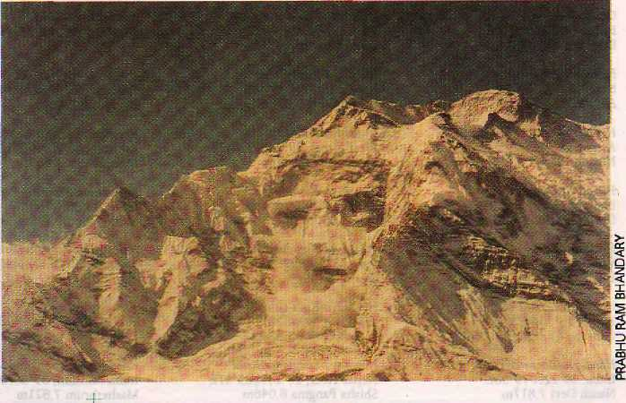
Abominably Yours,

Having achieved fame of sorts following word in the mountains that humans believed the last page of Himal was the best, I was taken completely by surprise, and was acutely embarrassed, to read about this drastic change affecting not just my own budding career but the lives of all who live in the high himals.
Himal going South Asian, hmpfh! Now 1 see the wisdom of our foremothers who declared humans untrustworthy, especially' editors and publishers. They use columnists just as long as they need you, she had said before she was called away.
I hope you realise that 1 am really annoyed. At the least, you could have extended the basic courtesy and informed me of the change. And you cannot hide behind Nepal's poor mail service because Langur is a pal of mine.
But no, in your excitement, all wrapped up in media-moghul visions of a huge market a la the Americans on China, colour spreads, many-fold increase in circulation, etc, etc, my page was completely forgotten. 1 was dispensable. In any case, you probably reckoned, if the need arose you could get any one of my worldlywise cousins in the plains to take my place and do your bidding for the price of a solitary banana.
Or could it be, Editor Saheb, that have you finally tired of this hairy feminist columnist from Upper Barun? And have you plans to get a spineless, submissive mermaid as a replacement for your Himai (god forbid) South Asia? I am convinced that you have decided to go South Asian only to get rid of your back page columnist. 1 smell a conspiracy, I sniff perfidy, and, let me add, 1 see the foreign hand.
Your pitch says you plan to write and report about 1.3 billion humans in South Asia. But in a magazine called Himal? Of the total simian population of the Subcontinent, what percentage do you think lives in the himal? Like humans, only-afraction. And still you think you can get away with calling your magazine Hima!? Your plot is easily discemable—it is to use the mystical charm associated with the name of our revered
homeland only to sell your magazine and make piles of money.
Look, Mister, we have never gotten along, you and I, and we have hung out our dirty laundry before this, so let me tell you what I think. I think this is a colonial plot to get back the empire. Otherwise, why should your 'South Asia¹ go beyond the staid region of the staider SAARC, and neatly encompass the imperial South Asia, roping in "the arc from Burma to Afghanistan"? Aha.
The news of this dastardly decision to abandon the mountains for the more lucrative plains has rapidly spread from peak to peak, and I can rightly tell you that all the himals of the Himalaya are properly miffed. Old Annapurna One, for one, is so angry he avalanched uncontrollably. You'd better avoid all areas north of Pokhara for the next few decades, though 1 do not know why I say this because obviously the only direction you plan to head is south.
As a (former) columnist, I am being forced to listen to an endless number of messages from himals, tall and vertically challenged, some of them from as far away as the Hindukush, who a) berate me for having associated with you in the first place, b) poke fun at me for being made to look like a fool by a human, and c) advise me on
future course of action. This last includes keeping close watch on your movements so that when the council decides, an earth tremor, GLOF, mudslide, flashflood or avalanche-can be sent down to complicate your progress.
In view of our long association, and also to protect our mutual interests, I have, however, suggested to the warring himats that we should see if this mess might be sorted out amicably. Firstly, 1 can hardly argue with your business sense regarding the retention of the heavenly name of Himal. But it would be odd to pick up a copy after your relaunch and read about every other topic and place except the Himalaya.
The lowlanders have invaded every sphere of our lives. Be forewarned. Your flyer promised to cover their issues, their trends and their money, but this can only encourage an early coup. What you need. Mister, therefore, is a watchdog. An ombudsman-like ombudswoman who will call a himal a himal even as you strain to go where the market pulls.
Are you getting what I am suggesting, as they say in Muzzafarpur?. What I am suggesting is a continuation of a certain column on a certain page, you are agreeable, then I can confirm that we have a deal. If not, Hanuman forbid but we may have a crisis on our hands, as all himals will surely decide to go in for global warming. Then, just watch your South Asia flood!

64
NwemberlDecember 1935 HIMAL


La Coupole 'Ceramique¹.
Scratchproof high-tech ceramics bracelet.
In three sizes.
Fascinating beauty. Imperishable material.
A sure feel for the aesthetically perfect, a personal style and a purposeful differentness: these are the characteristics of people who wear the La Coupole 'Ceramique'. A watch whose true nature you experience when you put it on for the first time: soft as velvet, supple, incomparable. And imperishably beautiful, thanks to the slightly curved sapphire crystal and the scratchproof high-tech ceramics bracelet. Rado La Coupole 'Ceramique' - a beautiful watch that stays beautiful - a watch that fits as though moulded to your wrist.
Switzerland
-/I different world
SULUX CENTRE
KHICHA POKHARI, P.O. BOX: 3659 KATHMANDU, NEPAL, TEL: 222539

faitirig on Burma Himalayan Porter Do€>n School South Asia Meet Buddhist Women

NOVEIWER / DECEMBER 1995 • Vol 8 number 6
.... -:. .:■■-::' ,
O U T H A S I A

